Volume 10 Robot DevOps and MLOps

12. DevOps Case Studies

12.1. Indoor AMR ROS2 CI CD Pipeline Build and Operation
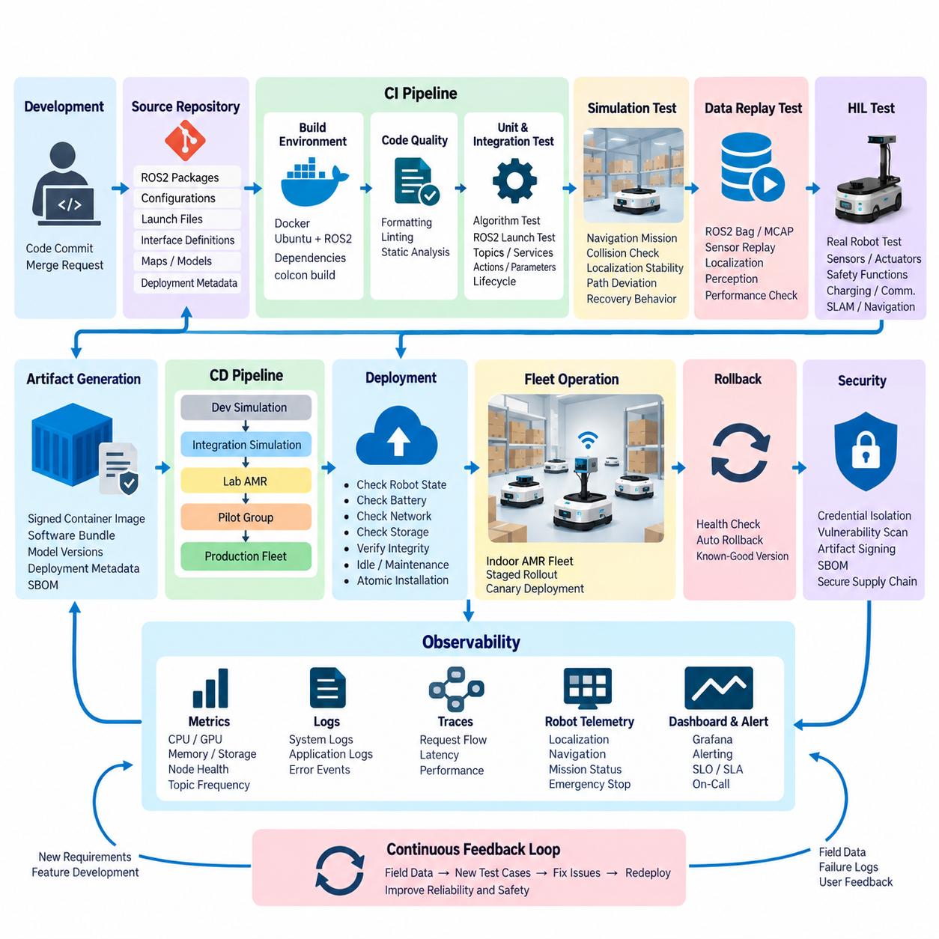
An indoor Autonomous Mobile Robot (AMR) provides a useful case study for applying DevOps principles to a cyber-physical system. Unlike conventional web software, an AMR software release directly affects localization, navigation, motion control, sensor processing, and interaction with people and equipment. A ROS2 CI/CD pipeline must therefore validate not only whether software builds correctly, but also whether the integrated robot behaves predictably and safely after every change.
The software repository typically contains multiple ROS2 packages representing hardware interfaces, localization, mapping, Navigation2 components, mission management, diagnostics, and fleet communication. Source code, configuration files, launch descriptions, interface definitions, and deployment metadata should be versioned together according to clearly defined dependency relationships. This structure allows a specific software revision to be reconstructed and tested consistently across development computers, simulation systems, and physical AMRs.
Continuous Integration begins when developers push commits or submit merge requests. The pipeline creates a clean ROS2 build environment, installs declared dependencies, and builds the workspace using tools such as colcon. Compilation failures, missing package dependencies, malformed interface definitions, and incompatible API changes should terminate the pipeline immediately. Automated formatting, linting, and static analysis are executed before expensive integration tests so that simple defects are detected early and computational resources are conserved.
Unit testing verifies individual algorithms and software components independently from the complete robot. Examples include coordinate transformations, velocity constraints, trajectory calculations, state-machine transitions, map utilities, and message-processing functions. ROS2 components can additionally be tested through launch-based integration tests in which multiple nodes are started together and their topics, services, actions, parameters, and lifecycle transitions are inspected. This reflects the broader DevOps structure in which automated unit and integration testing form explicit CI stages.
Reproducibility becomes especially important because AMRs frequently operate on heterogeneous computing platforms. Development may occur on x86-64 workstations while production robots use ARM64 edge computers. Containerized build environments can fix the Ubuntu distribution, ROS2 release, compiler, libraries, and third-party dependencies used by the pipeline. Multi-stage container builds further separate compilation tools from runtime components, reducing deployed image size while making the resulting artifact easier to reproduce and audit.
After basic integration tests pass, simulation provides the next validation layer. A representative warehouse environment can contain walls, racks, narrow aisles, intersections, docking stations, and dynamic obstacles. The CI system launches the AMR model and executes predefined navigation missions automatically. Rather than merely checking whether the navigation stack remains alive, tests should evaluate measurable behavior such as mission completion, localization stability, collision occurrence, path deviation, recovery behavior, and navigation timeout.
Recorded sensor datasets provide another important regression mechanism. ROS2 bag or MCAP recordings containing LiDAR, camera, odometry, IMU, and other sensor streams can be replayed against candidate software versions. Because identical input data can be processed by both the previous and candidate builds, engineers can identify changes in localization estimates, obstacle detection, CPU utilization, memory consumption, or processing latency. This creates repeatable regression tests without requiring a physical robot for every software commit.
Hardware-in-the-Loop testing bridges the gap between simulation and actual deployment. A controlled AMR or robot test station can automatically receive a candidate build and execute predefined hardware scenarios involving sensors, motor controllers, emergency interfaces, charging systems, and communication devices. Navigation and SLAM regression, sensor replay, actuator testing, and safety-function validation can therefore become formal pipeline stages rather than irregular manual activities.
The pipeline should treat safety-related tests differently from ordinary application tests. Maximum velocity limits, command timeouts, watchdog behavior, emergency-stop handling, obstacle-stop logic, and loss-of-communication responses should become mandatory release gates. A navigation improvement cannot compensate for a regression in a safety mechanism. Consequently, failure of a safety-critical test blocks promotion even when all functional navigation benchmarks have improved.
Successful validation produces an immutable deployment artifact rather than rebuilding software separately on each robot. The artifact may be a signed container image or versioned software bundle containing ROS2 applications, configuration, compatible model versions, and deployment metadata. Its identifier should remain connected to the Git commit, build job, test results, dependency versions, and software bill of materials, enabling engineers to determine exactly which software configuration is operating on any robot.
Continuous Delivery then promotes the verified artifact through deployment environments. A practical sequence may progress from developer simulation to integration simulation, a laboratory AMR, a small pilot group, and finally the production fleet. Staged rollout limits the operational impact of defects that were not reproduced during testing. Canary deployment is particularly useful because telemetry from a small number of robots can be compared with the established release before fleet-wide promotion.
Deployment itself must account for unreliable wireless communication and the possibility that a robot is executing a mission. An update manager should verify battery level, robot state, network connectivity, available storage, artifact integrity, and compatibility before installation. Updates are preferably performed while the robot is idle or located in a controlled maintenance state. Atomic installation mechanisms reduce the possibility of leaving the system partially updated when power or network connectivity is interrupted.
Rollback is an essential part of AMR continuous deployment. The previous validated software version should remain available until the new release has demonstrated stable operation. If startup health checks fail, required ROS2 nodes disappear, localization cannot initialize, communication with the fleet manager is lost, or critical diagnostics exceed defined thresholds, the deployment system can return the robot to the previous known-good version instead of attempting uncontrolled operation.
Observability continues the CI/CD process after deployment. Robot telemetry should expose CPU and GPU utilization, memory consumption, storage status, ROS2 node health, topic frequency, communication latency, localization confidence, navigation failures, emergency-stop events, and mission completion statistics. Centralized metrics, logs, and traces allow engineers to correlate operational failures with software versions and identify regressions that appear only under real warehouse workloads.
Fleet deployment also requires configuration management to be separated carefully from executable software. Parameters such as velocity limits, footprint geometry, planner settings, localization thresholds, and site-specific maps may vary between robot models or facilities. These configurations should nevertheless be version controlled and traceable. A robot should therefore be identifiable not only by application version but by the combination of software, configuration, map, firmware, and relevant AI-model versions used during operation.
Security must extend across the complete software supply chain. CI credentials and signing keys should be isolated from ordinary build jobs, dependencies should be scanned for known vulnerabilities, and generated artifacts should be authenticated before installation. An SBOM records the third-party components incorporated into a release, while artifact signing provides evidence that the deployed package originated from the authorized pipeline. These mechanisms complement the repository's dedicated treatment of CI/CD security and automated SBOM management.
Operationally, the most effective pipeline is therefore not a single automated script but a sequence of progressively stronger evidence gates. A code change moves from static verification and unit testing through ROS2 integration, recorded-data regression, simulation, HIL validation, pilot deployment, and monitored fleet rollout. Expensive physical tests are reserved for candidates that have already survived cheaper automated checks, allowing development speed to increase without removing engineering controls.
The resulting workflow creates a continuous feedback loop between development and real robot operation. Field telemetry and failure logs become reproducible test scenarios, discovered defects produce new regression tests, and validated fixes travel through the same pipeline that exposed the problem. Over time, the CI/CD system becomes an accumulated engineering knowledge base describing not only how the indoor AMR software is built, but also the behavioral conditions that every future release must continue to satisfy.

12.2. Outdoor AMR Embedded SW Multi Target CI Pipeline
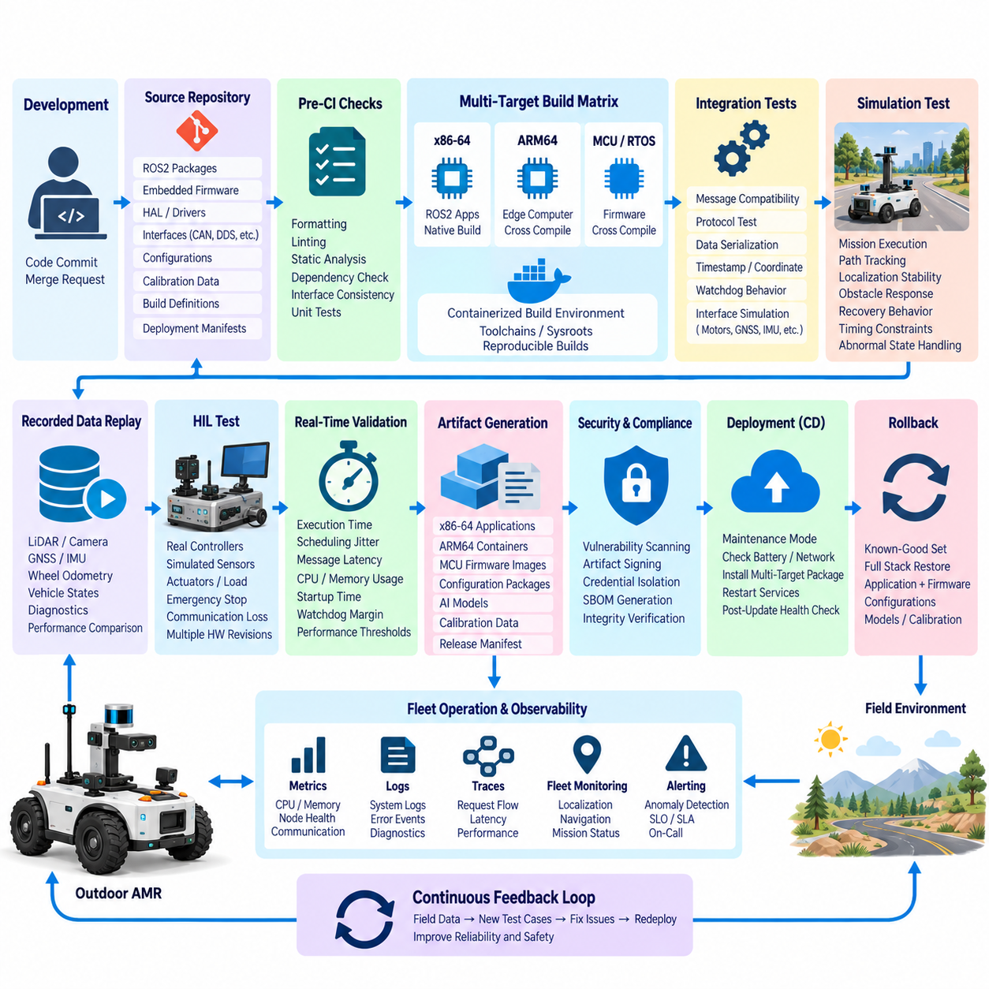
Outdoor Autonomous Mobile Robots (AMRs) introduce a more complex software integration problem than indoor platforms because their embedded systems must operate across heterogeneous processors, operating systems, communication buses, sensors, and real-time controllers. A multi-target Continuous Integration (CI) pipeline therefore treats every software change as a candidate for several hardware targets rather than producing a single executable. The objective is to maintain one controlled software baseline while continuously verifying compatibility across the complete outdoor AMR computing architecture.
A typical outdoor AMR may combine an x86-64 industrial computer for high-level autonomy, an ARM64 edge computer for perception and AI inference, and microcontrollers for deterministic motor, steering, braking, power, or safety functions. ROS2 applications may execute on Linux while lower-level firmware runs on an RTOS or bare-metal environment. The CI architecture must represent these targets explicitly so that software intended for one processor cannot accidentally be released using incompatible libraries, compiler options, middleware, or hardware interfaces.
The source repository becomes the common entry point for this heterogeneous software stack. ROS2 packages, embedded firmware, hardware abstraction layers, communication interfaces, configuration files, calibration parameters, deployment manifests, and build definitions should remain traceable to specific revisions. Interface specifications for CAN, Ethernet, serial links, DDS, and custom protocols are especially important because independently compiled components must continue exchanging commands, states, timestamps, diagnostics, and safety information without incompatible schema changes.
When a developer submits a commit or merge request, the CI pipeline first performs platform-independent quality checks. Formatting, linting, static analysis, dependency validation, interface consistency checks, and unit tests identify defects before target-specific compilation begins. This early stage should also detect unintended modifications to communication definitions, configuration schemas, safety parameters, or shared libraries. Fast failure at this level prevents expensive cross-compilation and hardware testing from being consumed by elementary software defects.
After common validation, the pipeline expands into a build matrix representing the supported targets. Native x86-64 builds can validate high-level ROS2 components, while ARM64 builds or cross-compilation jobs generate binaries for edge computers. Separate toolchains compile firmware for microcontrollers or real-time processors. Each target should use a controlled compiler, SDK, operating-system image, dependency set, and build configuration so that successful CI results can be reproduced outside the original developer workstation.
Cross-compilation is particularly valuable when embedded targets have limited processing capability. Instead of compiling large ROS2 workspaces directly on the robot, powerful CI runners generate ARM64 or other target binaries using defined sysroots and toolchain files. Containerized build environments can encapsulate these toolchains and prevent accidental dependency differences between developers. The resulting artifacts must retain metadata identifying architecture, compiler version, source revision, target board, build options, and compatible runtime environment.
Multi-target CI must verify more than successful compilation because many outdoor AMR failures occur at boundaries between computing domains. Automated integration tests should confirm message serialization, endian assumptions, timestamp handling, coordinate conventions, command ranges, watchdog behavior, and protocol compatibility. Simulated interfaces or software stubs can emulate motor controllers, battery management systems, GNSS receivers, IMUs, LiDAR devices, and other hardware so that interface regressions are detected before physical hardware is required.
Recorded field data provides another layer of repeatable validation. Sensor logs collected during outdoor operation can contain LiDAR point clouds, camera streams, GNSS observations, IMU measurements, wheel odometry, vehicle states, and diagnostic events. Replaying identical datasets through candidate builds makes it possible to compare localization, perception, sensor fusion, navigation, and resource utilization against a known software baseline. Difficult field conditions can therefore become permanent regression scenarios rather than one-time engineering observations.
Simulation extends testing from individual interfaces to complete vehicle behavior. Outdoor environments should represent uneven terrain, slopes, intersections, obstacles, changing traction conditions, GNSS degradation, sensor noise, and communication disturbances where appropriate. Candidate software can execute predefined missions while the CI system evaluates mission completion, path tracking, localization stability, obstacle response, recovery behavior, timing constraints, and abnormal-state handling. Simulation failures block promotion to hardware-dependent stages.
Hardware-in-the-Loop (HIL) testing verifies interactions that software-only environments cannot represent adequately. Real embedded controllers can be connected to simulated sensors, loads, networks, and actuator feedback while automated test sequences exercise steering, propulsion, braking, emergency-stop chains, watchdogs, communication loss, and degraded sensor conditions. Different hardware revisions should be represented as separate test targets when electrical interfaces, firmware behavior, timing characteristics, or supported peripherals differ between platform generations.
Real-time behavior requires dedicated acceptance criteria. A binary may produce correct functional results while violating control-cycle deadlines, communication latency limits, CPU budgets, or memory constraints. Multi-target CI should therefore measure execution time, scheduling jitter, message latency, processor utilization, memory consumption, startup duration, and watchdog margins on representative hardware. Performance regression thresholds prevent gradual software growth from silently reducing the timing margin required for reliable outdoor operation.
Artifact management becomes critical once the pipeline produces binaries for several processors. A single release may contain x86-64 applications, ARM64 containers, MCU firmware images, configuration packages, AI models, and calibration data. These components should be assembled into a versioned release manifest that describes their compatibility relationships. The manifest allows deployment systems and engineers to reconstruct exactly which combination of software components constituted a validated outdoor AMR release.
Security controls should operate across every target pipeline. Third-party libraries and container images require vulnerability scanning, firmware and application artifacts should be signed, and CI credentials must remain isolated from ordinary jobs. Software Bill of Materials (SBOM) information should cover both high-level applications and embedded dependencies whenever practical. Release promotion should verify artifact integrity so that binaries installed on the vehicle can be traced back to authorized source revisions and controlled CI jobs.
Continuous Delivery (CD) begins only after the complete multi-target release has satisfied its required gates. Deployment should respect dependency ordering because updating only one processor can create temporary interface incompatibility. The system may first place the AMR into a controlled maintenance state, verify battery and communication conditions, install compatible software and firmware components, restart required services or controllers, and execute post-update health checks before returning the vehicle to autonomous operation.
Rollback must also consider the release as a coordinated multi-target configuration. Returning only the ROS2 application to an earlier version while retaining incompatible controller firmware can produce a configuration that was never validated. A robust rollback mechanism therefore records the complete known-good combination of application software, embedded firmware, configuration, models, and calibration assets. Recovery restores a compatible release set rather than treating each computing device as an unrelated update target.
Fleet operation closes the engineering loop. Telemetry from deployed outdoor AMRs can reveal processor overload, communication errors, localization degradation, controller resets, sensor faults, navigation failures, or environmental conditions that were not adequately represented during laboratory testing. These events should be associated with vehicle hardware revision and software release so engineers can distinguish general software defects from target-specific or platform-specific failures.
The resulting multi-target CI pipeline transforms heterogeneous embedded development into a controlled release process. A change begins as shared source, passes common quality gates, branches into architecture-specific builds, converges through integration, simulation, replay, and HIL validation, and finally becomes a coordinated deployment package. Field evidence then returns to the pipeline as new regression tests, allowing each outdoor AMR release to preserve compatibility, timing behavior, safety functions, and operational reliability across an evolving hardware platform.

12.3. Mobile Manipulator MLOps Grasp Model Deploy Case
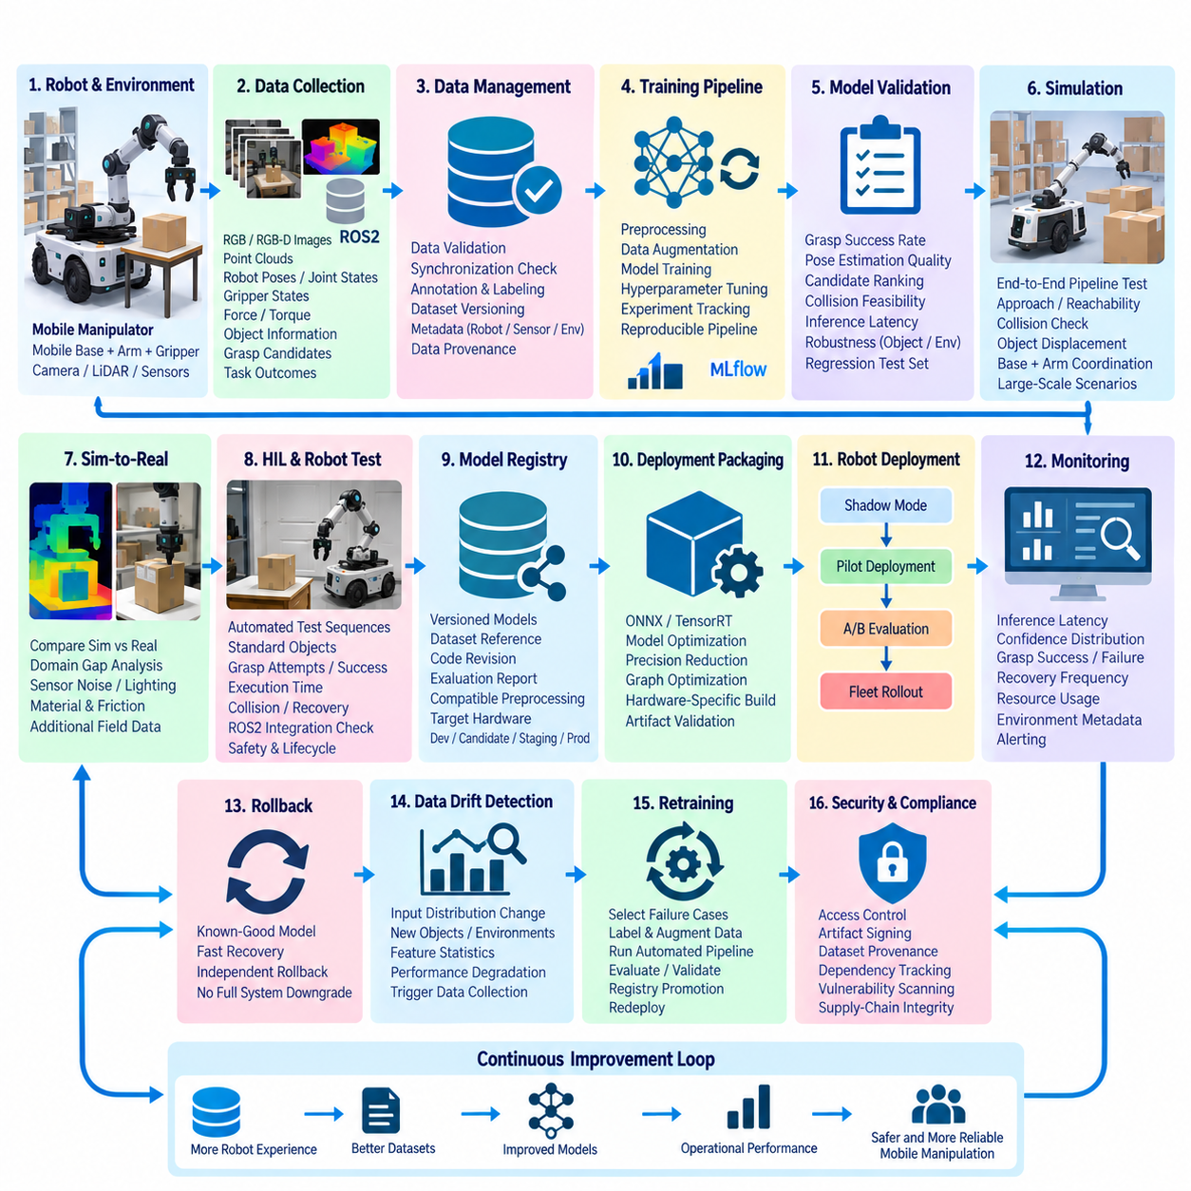
A mobile manipulator combines autonomous mobility with robotic manipulation, making its machine-learning lifecycle substantially more complex than that of a fixed industrial arm. A grasp model must operate while perception conditions, robot pose, object arrangement, illumination, and viewpoint continuously change. MLOps for grasp deployment therefore connects data collection, training, validation, model registration, edge deployment, monitoring, and retraining into a controlled lifecycle rather than treating model training as an isolated development activity.
The operational data pipeline begins with synchronized observations collected from the mobile manipulator. RGB or RGB-D images, point clouds, robot poses, joint states, gripper states, force or torque measurements, object information, grasp candidates, and task outcomes can be recorded together. Successful and failed grasps are both valuable because failures reveal difficult geometries, occlusions, reflective surfaces, localization errors, or unstable contacts that may not be sufficiently represented in the original training dataset.
Raw robot data must be transformed into reproducible training datasets before entering the learning pipeline. Data validation checks sensor synchronization, missing frames, corrupted measurements, coordinate-frame consistency, annotation quality, and label completeness. Dataset versions should preserve provenance linking samples to robot configuration, sensor calibration, environment, collection session, and preprocessing logic. This enables engineers to reconstruct which data produced a particular grasp model and to compare experiments without silently changing the training distribution.
The training pipeline converts versioned datasets into candidate grasp models through repeatable preprocessing, augmentation, training, and evaluation stages. Image augmentation, point-cloud perturbation, object-pose variation, and synthetic examples can broaden the range of conditions encountered during training. Hyperparameters, random seeds, software dependencies, dataset identifiers, model architecture, checkpoints, and evaluation results should be recorded automatically so that promising experiments can be reproduced rather than depending on manually maintained development notes.
A candidate model should not be promoted merely because its training loss decreases. Offline validation must evaluate metrics related to the actual manipulation task, including grasp success prediction, pose estimation quality, candidate ranking, collision feasibility, inference latency, and robustness across object categories or environmental conditions. Validation datasets should remain separated from training data, and difficult scenarios should be retained as regression sets so that later models cannot improve average performance while losing capabilities required in production.
Simulation provides an intermediate validation environment where candidate models can interact with complete manipulation pipelines. The mobile base, manipulator, gripper, sensors, objects, and workspace can be represented together so that perception output is evaluated through resulting actions rather than only static prediction metrics. Large numbers of grasp attempts can expose failure modes involving approach direction, reachability, collisions, object displacement, and coordination between base positioning and arm motion before physical hardware is used.
Sim-to-real validation becomes important because simulated perception and contact dynamics cannot perfectly reproduce physical operation. A model that performs well with synthetic depth images or ideal object poses may degrade when exposed to real sensor noise, calibration error, reflective materials, compliant objects, gripper wear, or imperfect friction. Controlled physical tests should therefore compare simulation results with real grasp outcomes and identify domain gaps that require improved randomization, additional field data, or model adaptation.
Hardware-in-the-Loop and robot-based evaluation form a deployment gate for candidate grasp models. Automated test sequences can present standardized objects and manipulation scenarios while recording grasp attempts, execution times, collision events, recovery actions, and final outcomes. The evaluation should verify not only model accuracy but also integration with ROS2 perception nodes, motion planning, transform trees, gripper control, safety logic, and lifecycle management. A model that cannot operate reliably within the complete robot stack must not be promoted.
Models that satisfy validation requirements are stored in a model registry together with immutable metadata. Each registered version should reference its training dataset, source code revision, framework version, hyperparameters, evaluation report, compatible preprocessing pipeline, expected input format, and target hardware. Promotion states such as development, candidate, staging, and production can separate experimental models from operationally approved versions and provide a controlled path toward deployment.
Deployment packaging transforms the registered model into an artifact suitable for the robot's edge computer. Depending on the target platform, this may include conversion to ONNX, TensorRT, or another optimized runtime representation. Precision reduction, graph optimization, operator fusion, or hardware-specific engine generation can reduce inference latency and memory consumption. Because optimization can alter numerical behavior, the optimized artifact must be evaluated again rather than assuming equivalence with the original training checkpoint.
The packaged grasp model should be integrated with the robot through a stable inference interface. A ROS2 AI node can receive sensor observations and return grasp poses, confidence values, object information, or ranked candidates without exposing internal model implementation details to downstream components. Separating the model interface from the model version allows the manipulation stack to replace or update models while preserving communication contracts, provided that input preprocessing and output semantics remain compatible.
Production deployment should proceed gradually rather than replacing the current model across every robot simultaneously. A candidate can first operate in shadow mode, processing real observations without controlling the manipulator, so its predictions can be compared with the active model. It can then move to a limited pilot deployment or controlled A/B evaluation before wider rollout. This staged approach reduces operational risk while generating evidence about performance under real workloads that laboratory datasets cannot completely reproduce.
Rollback capability is essential because model failures may appear only after deployment. The robot should retain a known-good model and compatible preprocessing configuration so that it can recover when the new model produces abnormal latency, repeated grasp failures, invalid outputs, excessive resource usage, or integration errors. Model rollback should be independent enough to restore grasp functionality without requiring a complete robot software downgrade when the surrounding ROS2 stack remains compatible.
Model monitoring extends evaluation into production. The system can record inference latency, confidence distributions, grasp attempts, success and failure rates, recovery frequency, rejected candidates, resource utilization, and relevant environmental metadata. Where immediate ground truth is unavailable, operational outcomes such as successful pickup, object retention, placement completion, or repeated retry behavior can provide indirect performance signals. Monitoring should distinguish software faults from changes in the data distribution encountered by the robot.
Data drift occurs when production observations differ from the distribution used during training. New objects, packaging, lighting conditions, camera positions, sensor degradation, workspace layouts, or customer-specific environments may gradually reduce grasp performance. Monitoring pipelines can compare feature or input statistics with reference datasets and associate detected changes with operational failures. Drift detection does not automatically prove that a model is incorrect, but it provides evidence for targeted investigation and data collection.
Failure cases should return to the data pipeline through a controlled feedback loop. Selected images, point clouds, robot states, and grasp outcomes can be reviewed, labeled, and incorporated into a new dataset version. Retraining should then execute through the same automated pipeline used for previous releases, followed by offline evaluation, simulation, physical validation, registry promotion, and staged deployment. This prevents emergency field fixes from bypassing the controls required for reproducibility and reliability.
Security and supply-chain integrity apply to grasp models as they do to conventional software artifacts. Training code, datasets, pretrained weights, third-party libraries, conversion tools, and runtime dependencies all contribute to the deployed behavior. Model artifacts should therefore be versioned, access-controlled, integrity-checked, and preferably signed. Dataset provenance and dependency records provide additional evidence about how a production model was created and support investigation when unexpected behavior or vulnerabilities are discovered.
The resulting MLOps architecture establishes a continuous evidence chain from physical interaction to model improvement. Robot experience produces data, controlled datasets produce candidate models, validation produces deployment evidence, staged rollout produces operational measurements, and monitoring identifies new learning requirements. By preserving traceability across these transitions, the mobile manipulator can improve its grasping capability while maintaining reproducibility, rollback, safety integration, and operational control throughout the model lifecycle.

12.4. Quadruped RL Policy Automated Training Deploy Case
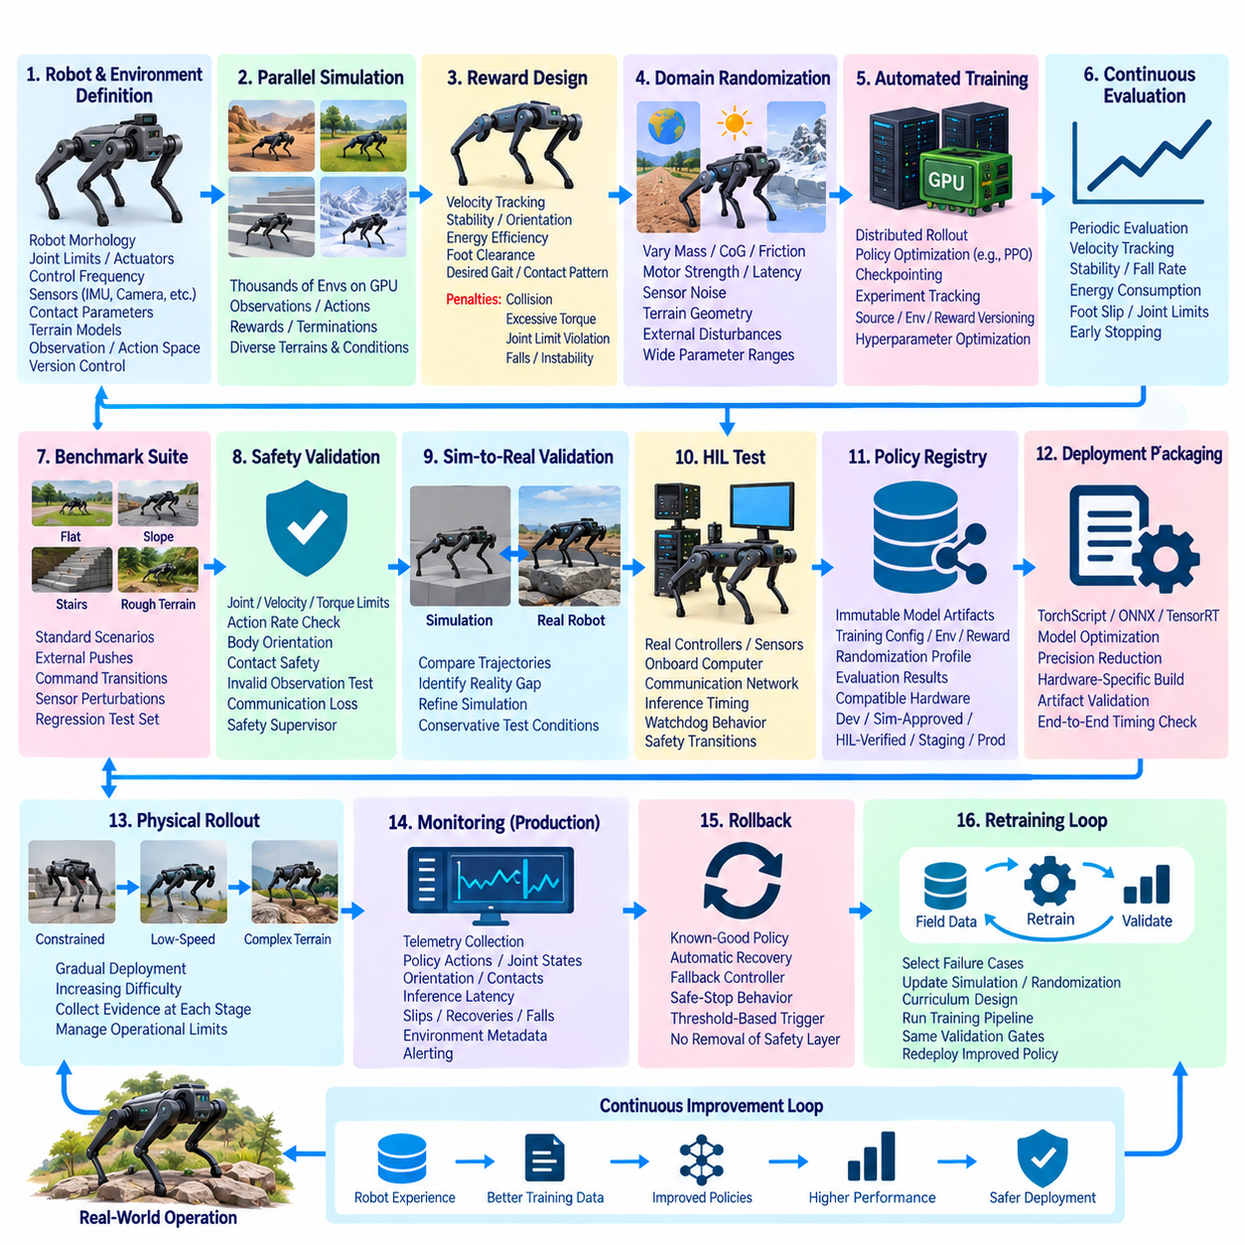
Reinforcement Learning (RL) has become an important approach for quadruped locomotion because walking, running, turning, balancing, and terrain adaptation require coordinated control of many joints under rapidly changing physical conditions. Unlike conventional model deployment, an RL policy is produced through interaction with an environment. An automated training and deployment pipeline must therefore manage simulation environments, reward definitions, policy checkpoints, evaluation scenarios, hardware constraints, and operational feedback as interconnected lifecycle components.
The training lifecycle begins with a reproducible representation of the quadruped and its environment. Robot morphology, joint limits, actuator characteristics, control frequency, sensor models, contact parameters, terrain properties, and observation and action spaces must be versioned alongside the training code. Changes to any of these elements can significantly alter learned behavior even when the policy network architecture remains unchanged. Environment configuration must consequently be treated as a first-class training artifact rather than temporary experimental metadata.
Large-scale parallel simulation provides the computational foundation for automated locomotion training. Thousands of simulated robot instances can execute simultaneously on GPUs, collecting experience much faster than a physical robot could. Each environment produces observations, actions, rewards, termination states, and trajectory information that feed the learning algorithm. Parallel execution allows the system to explore diverse velocities, headings, disturbances, terrain conditions, and robot states while reducing the wall-clock time required to generate useful experience.
Reward design defines which behaviors the automated training system encourages. Locomotion policies may receive rewards for velocity tracking, orientation stability, energy efficiency, foot clearance, smooth actions, or desired contact patterns while receiving penalties for collisions, excessive torque, joint-limit violations, unstable motion, or falls. Because small reward changes can produce unexpected strategies, reward definitions and coefficients should be version controlled and linked to every experiment so that behavioral changes can be traced to their training conditions.
Domain randomization is essential for preparing policies for physical deployment. Simulation episodes can vary mass, center of gravity, motor strength, friction, latency, sensor noise, terrain geometry, external disturbances, and other physical parameters. Instead of learning one idealized robot, the policy learns to operate across a distribution of possible dynamics. The randomization ranges themselves become important configuration data because overly narrow distributions reduce robustness while unrealistic ranges can make optimization unnecessarily difficult.
Automated training infrastructure orchestrates environment generation, distributed rollout, policy optimization, checkpointing, evaluation, and experiment tracking. Training jobs should record source revisions, simulator versions, environment definitions, reward parameters, randomization ranges, neural-network configurations, optimization settings, random seeds, hardware resources, and resulting checkpoints. This metadata allows engineers to reproduce promising policies and distinguish algorithmic improvements from changes caused by environments or infrastructure.
Policy checkpoints should be evaluated continuously rather than waiting until training completes. Periodic evaluation jobs can execute standardized terrain and command scenarios without exploratory behavior and measure velocity tracking, stability, fall rate, energy consumption, foot slip, joint-limit violations, and episode completion. Early stopping can terminate experiments that fail to improve or develop unstable behavior, conserving GPU resources while preventing weak candidates from consuming later validation capacity.
A benchmark suite provides consistent comparison between policy generations. Evaluation scenarios can include flat ground, slopes, stairs, irregular surfaces, low-friction regions, external pushes, command transitions, and sensor perturbations. Performance should be examined across multiple episodes and randomized initial conditions because a single successful trajectory does not demonstrate robustness. Difficult scenarios discovered during development should remain in the benchmark suite as regression tests for subsequent policies.
Automated hyperparameter optimization can explore learning rate, batch size, discount factors, entropy coefficients, network dimensions, rollout lengths, and other training parameters. Rather than selecting a policy only from final reward, the optimization process should consider deployment-oriented evaluation metrics. A policy with slightly lower simulated reward may be preferable for further validation when it exhibits smoother actions, lower torque demand, fewer falls, or greater robustness across randomized conditions.
Before physical deployment, policy outputs must pass safety-oriented validation. Joint position, velocity, torque, action-rate, body orientation, and contact-related limits should be checked across evaluation trajectories. The policy should also be tested against invalid observations, delayed sensor updates, communication interruptions, and abnormal initial states where applicable. Safety supervisors remain independent from the learned policy so that commanded actions can be constrained or rejected when they violate operational limits.
Sim-to-real validation determines whether behaviors learned in simulation transfer to the physical quadruped. Differences in actuator dynamics, mechanical compliance, communication latency, contact behavior, sensor characteristics, battery condition, and structural tolerances can produce a reality gap. Initial tests should therefore use controlled environments and conservative operating envelopes. Recorded physical trajectories can be compared with simulated trajectories to identify systematic mismatches and refine simulation parameters or randomization distributions.
Hardware-in-the-Loop testing adds another gate between simulation and unrestricted robot operation. Real motor controllers, onboard computers, communication networks, or sensor interfaces can participate in automated tests while parts of the physical environment remain simulated. The pipeline can verify policy inference timing, observation synchronization, actuator command rates, watchdog behavior, communication latency, and safety transitions before executing demanding locomotion on the complete physical robot.
Policies that pass validation are registered as immutable model artifacts. A policy registry should connect each version with its training configuration, simulator environment, reward specification, randomization profile, source revision, evaluation results, compatible robot hardware, and required preprocessing logic. Promotion states can distinguish experimental checkpoints from simulation-approved, hardware-tested, staging, and production policies, preventing an arbitrary training checkpoint from reaching operational robots.
Deployment packaging converts the selected policy into an efficient representation for the onboard computing platform. The training framework checkpoint may be exported to TorchScript, ONNX, TensorRT, or another supported runtime format. Optimization can reduce inference latency and memory usage, but the converted model must be revalidated because numerical changes can alter control outputs. End-to-end timing must include observation processing, inference, command generation, and delivery to the low-level controller.
Physical rollout should progress through increasingly demanding stages. A new policy may begin with the robot supported or constrained, continue to low-speed flat-ground walking, and then advance to turning, disturbances, slopes, irregular terrain, and mission-level operation. Each stage generates evidence before the next operating envelope is enabled. Automated deployment should therefore manage not only policy files but also the approved operational limits associated with each policy version.
Rollback is critical because unstable locomotion can create immediate physical risk. The robot should retain a known-good policy and configuration that can be restored when inference timing, stability metrics, actuator behavior, or safety monitoring exceeds defined limits. A fallback controller or safe-stop behavior should remain available independently of the learned policy. Policy replacement must never remove the lower-level mechanisms responsible for enforcing actuator and system safety.
Production monitoring transforms physical operation into a source of training evidence. Telemetry can record observations, policy actions, body orientation, joint states, actuator loads, foot contacts, inference latency, intervention events, slips, recoveries, and falls. These measurements should be associated with policy version, robot hardware revision, environment, and mission context so that engineers can determine whether degradation originates from the policy, platform, terrain, or changing physical condition.
Operational failures and difficult terrain can feed an automated retraining loop. Selected physical trajectories become reference scenarios for simulator refinement, domain randomization, curriculum design, or targeted evaluation. New training jobs then produce candidate policies that pass through the same benchmark, safety, HIL, sim-to-real, registry, and staged deployment gates. Field experience therefore improves future policies without allowing uncontrolled online learning to bypass validation requirements.
The resulting architecture turns quadruped RL development into a continuous engineering process rather than a sequence of isolated experiments. Parallel simulation generates experience, automated training creates candidate policies, evaluation gates establish evidence, hardware testing verifies execution, staged deployment controls physical exposure, and telemetry identifies new learning requirements. Traceability across this loop enables locomotion capability to improve while preserving reproducibility, rollback, safety supervision, and controlled deployment throughout the policy lifecycle.

12.5. Humanoid Foundation Model Fine Tuning MLOps Case
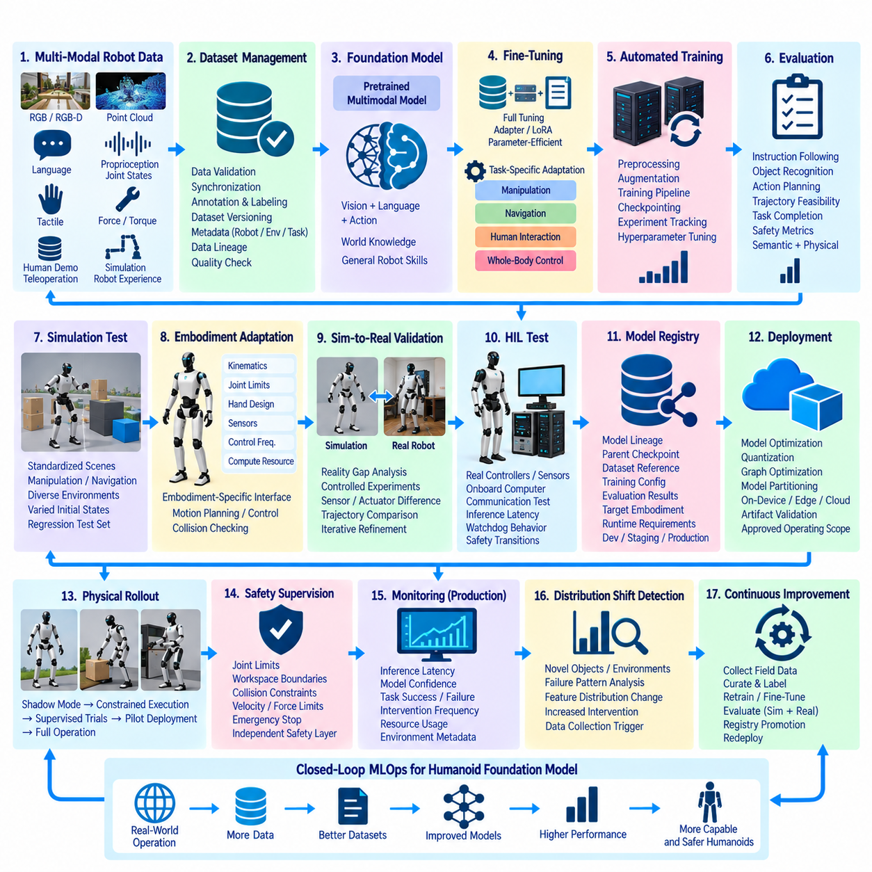
A humanoid foundation model extends robot intelligence beyond a single perception or control task by combining multimodal observations, semantic knowledge, reasoning, action representations, and embodied experience within a reusable model architecture. Fine-tuning adapts this broad capability to specific humanoid tasks, hardware, environments, and operational constraints. MLOps provides the engineering framework required to connect foundation-model data, adaptation, evaluation, deployment, monitoring, and continuous improvement without losing reproducibility or traceability.
The data layer must represent the multimodal nature of humanoid interaction. Training examples may combine RGB or RGB-D video, point clouds, language instructions, proprioception, joint states, force and torque signals, tactile observations, robot trajectories, object states, and action sequences. Human demonstrations, teleoperation sessions, simulation trajectories, and autonomous robot experience can contribute complementary information. Accurate synchronization is essential because observations, language context, and physical actions must describe the same temporal interaction.
Dataset management becomes more difficult as heterogeneous data sources are combined. Every dataset version should preserve information about robot embodiment, sensor configuration, calibration, task definition, environment, collection method, annotation process, and preprocessing pipeline. Data quality checks should detect corrupted sequences, missing modalities, timestamp inconsistencies, invalid robot states, and incomplete action labels. Dataset lineage allows engineers to determine which physical experiences contributed to each fine-tuned model and reproduce later experiments.
A pretrained foundation model provides the starting checkpoint rather than training the complete intelligence stack from scratch. The base model may already contain visual, language, spatial, temporal, or action-related representations learned from large datasets. Fine-tuning specializes these representations for the target humanoid embodiment and task distribution. The original checkpoint, tokenizer or observation encoder, model architecture, license information, preprocessing rules, and dependency versions should therefore become immutable references within the MLOps pipeline.
Fine-tuning strategies depend on available data, computational resources, and the degree of specialization required. Full-parameter tuning can modify the entire model but demands substantial memory and computation. Parameter-efficient fine-tuning methods such as adapters or Low-Rank Adaptation (LoRA) update a smaller subset of parameters while preserving most pretrained weights. Different adaptation strategies should be represented as reproducible experiments rather than manually modified model copies distributed across development machines.
The automated training pipeline transforms a selected base model and versioned dataset into candidate humanoid models. Preprocessing, batching, augmentation, fine-tuning, checkpoint generation, evaluation, and experiment tracking should execute through controlled workflows. Each run records dataset identifiers, source revision, base-model version, hyperparameters, random seeds, compute environment, training metrics, and produced checkpoints. This establishes an evidence chain from the original foundation model to every specialized derivative.
Task-specific evaluation must measure more than conventional training loss. A humanoid model may need to interpret instructions, identify objects, estimate spatial relationships, select actions, generate trajectories, or coordinate whole-body behavior. Evaluation should therefore combine semantic correctness with physical feasibility and task completion. A response that is linguistically plausible but produces an unreachable grasp, unstable posture, collision, or incorrect manipulation sequence cannot be considered successful in an embodied system.
Simulation provides a scalable environment for evaluating candidate models before exposing physical humanoids to new behavior. Standardized scenes can test object manipulation, navigation, reaching, handover, tool interaction, and coordinated mobile manipulation. Variations in object placement, lighting, obstacles, instructions, and initial robot state reveal whether fine-tuning has produced genuine task robustness or merely memorized narrow demonstrations. Failed scenarios should become persistent regression cases for subsequent model generations.
Embodiment compatibility is a central concern when transferring a foundation model to a specific humanoid. Robots differ in kinematic structure, degrees of freedom, joint limits, hand design, actuator capability, sensor placement, control frequency, and onboard computing resources. Model outputs must therefore be mapped through embodiment-specific interfaces and constrained by the physical robot. Fine-tuning cannot eliminate the need for motion planning, control constraints, collision checking, or independent safety mechanisms.
Sim-to-real validation evaluates the gap between simulated behavior and physical execution. Sensor noise, calibration errors, actuator latency, compliance, contact dynamics, object properties, and environmental variation may cause behaviors that succeeded in simulation to fail on hardware. Controlled experiments should progressively expose candidate models to real tasks while recording observations, predictions, planned actions, controller responses, and task outcomes. These records provide evidence for further adaptation and simulator refinement.
Hardware-in-the-Loop testing creates an additional deployment gate. Real onboard computers, controllers, sensors, communication interfaces, or actuator subsystems can participate while dangerous or difficult interactions remain simulated. Tests can verify inference latency, data synchronization, resource consumption, communication timing, model-server availability, watchdog behavior, and transitions to safe states. This stage is particularly important when large foundation models interact with deterministic real-time control components.
Validated candidates enter a model registry that distinguishes the base foundation model from its fine-tuned derivatives. Each model version should reference its parent checkpoint, dataset lineage, adaptation method, training configuration, evaluation results, target embodiment, runtime requirements, and approved task scope. Relationships between models form a model lineage graph, allowing engineers to determine how a production policy evolved and which data or fine-tuning procedure introduced a particular capability.
Deployment packaging converts the selected model into a representation appropriate for the humanoid computing architecture. Depending on model size, inference may execute entirely onboard, across multiple edge accelerators, or through a partitioned architecture separating high-level reasoning from low-level control. Quantization, graph optimization, caching, model partitioning, and hardware-specific runtimes can reduce latency and memory requirements. Every optimized artifact must be revalidated because deployment transformations can alter numerical behavior.
Production rollout should expand gradually from controlled laboratory operation to increasingly complex tasks. A new model can initially operate in observation or shadow mode, followed by constrained execution with restricted actions, supervised task trials, pilot deployment, and broader operational use. The approved operating envelope should be associated with the model version so that deployment automation cannot silently enable capabilities that were never validated during testing.
Safety supervision must remain outside the foundation model's authority. Independent components should enforce joint limits, workspace boundaries, collision constraints, velocity and force limits, emergency-stop behavior, and communication watchdogs. High-level model outputs should be treated as proposals that pass through deterministic validation and control layers before physical execution. This separation prevents semantic or generative model errors from directly becoming unrestricted actuator commands.
Production monitoring should observe both artificial-intelligence behavior and physical robot outcomes. Relevant signals include inference latency, model confidence, task completion, action rejection, planning failures, intervention frequency, collision avoidance events, resource utilization, communication errors, and recovery behavior. Model version, robot hardware revision, task type, environment, and relevant dataset context should accompany telemetry so that failures can be associated with the correct combination of software and embodiment.
Distribution shift can occur when humanoids encounter objects, instructions, layouts, users, or interaction patterns that differ from fine-tuning data. Monitoring can identify unusual inputs, increased task failures, repeated safety interventions, or changes in internal feature distributions. These signals do not automatically justify immediate retraining, but they identify situations requiring review. Selected failures can be converted into curated examples for targeted data collection, evaluation, and future adaptation.
Continuous improvement closes the MLOps loop. Field demonstrations, corrected trajectories, simulation failures, human interventions, and successful recoveries can contribute to new dataset versions. Fine-tuning then produces another candidate derived from a controlled base checkpoint, and the model repeats semantic evaluation, simulation, embodiment validation, HIL testing, physical trials, registry promotion, and staged deployment. No field-generated model should bypass these gates simply because new data is available.
The resulting MLOps architecture treats humanoid foundation-model fine-tuning as a governed evolution of embodied intelligence. Foundation models provide reusable knowledge, multimodal robot experience provides specialization, automated pipelines provide reproducibility, evaluation establishes evidence, deployment controls operational exposure, and monitoring returns physical experience to the learning process. Maintaining lineage across data, models, hardware, validation, and deployment allows humanoid capabilities to evolve while preserving traceability, rollback, safety boundaries, and operational control.

12.6. Cargo UAV Safety Critical SW CI CD DO 178C Case
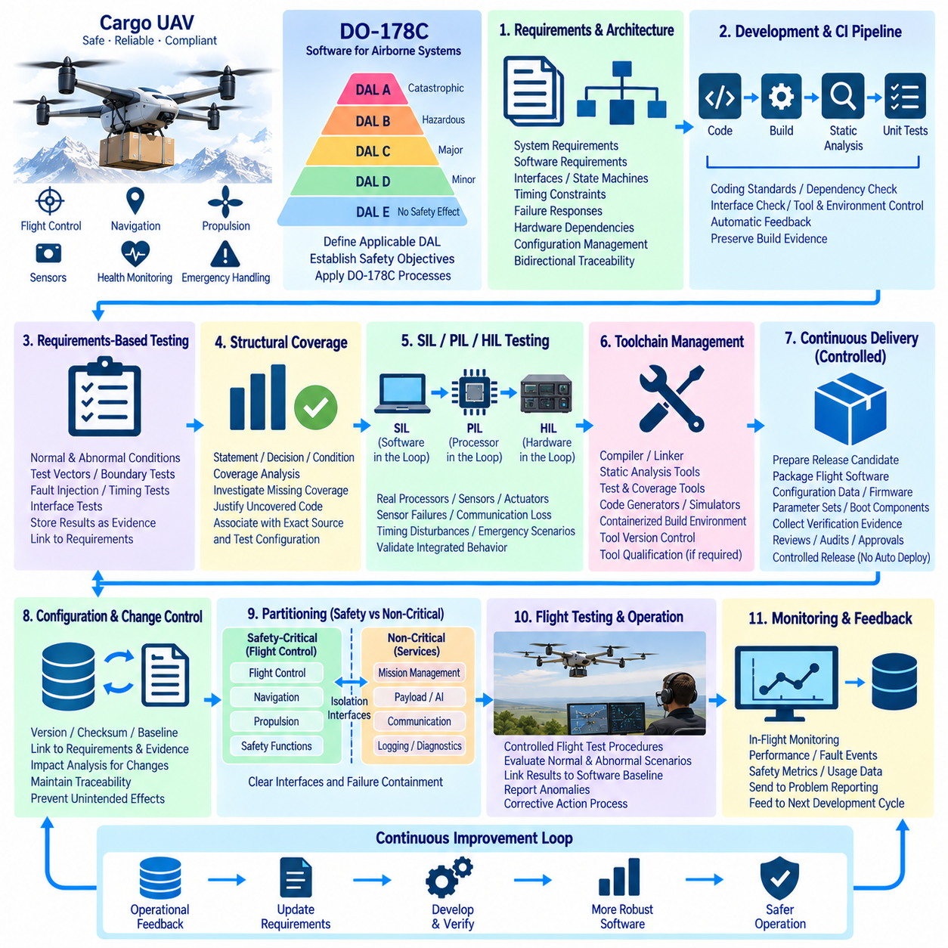
A Cargo Unmanned Aerial Vehicle (UAV) requires a software engineering process that treats flight functions as safety-critical systems rather than ordinary application software. Flight control, navigation, propulsion management, sensor processing, health monitoring, and emergency handling can directly influence aircraft behavior. A CI/CD architecture for such a platform must therefore combine rapid automated engineering feedback with disciplined verification, configuration control, traceability, and evidence generation appropriate to the applicable assurance level.
DO-178C provides guidance for the development and verification of airborne software and defines objectives according to Design Assurance Level (DAL). The level depends on the consequences associated with software failure, ranging from catastrophic conditions at DAL A to less severe conditions at lower levels. A Cargo UAV development program should establish the applicable DAL and system safety objectives before defining its CI/CD gates. The pipeline should then enforce those development and verification objectives rather than treating DO-178C as simply another software testing checklist.
The development baseline begins with controlled requirements and architecture. High-level system requirements, low-level software requirements, interfaces, state machines, timing constraints, failure responses, and hardware dependencies must be maintained under configuration management. Each software change should remain traceable from an approved requirement through implementation, verification results, and the released binary. This bidirectional traceability is essential because a successful build alone does not demonstrate that the intended airborne behavior has been correctly implemented and verified.
The CI pipeline should provide early feedback without weakening formal verification activities. Source-code checks, compilation, static analysis, coding-standard analysis, dependency validation, unit-level tests, and interface checks can execute automatically after each controlled change. The pipeline should preserve the exact source revision, compiler version, build configuration, toolchain, and test environment used for every result. Fast automated feedback identifies defects early, while formal review and approval gates remain responsible for changes that affect safety-related requirements or verified baselines.
Requirements-based testing forms the core of software verification. Test procedures should demonstrate that implemented software satisfies its allocated requirements and behaves correctly under both normal and defined abnormal conditions. Automated test execution can run deterministic test vectors, boundary conditions, fault-injection scenarios, timing checks, and interface tests. Test results should be stored as controlled evidence rather than temporary CI logs, allowing engineers to identify the exact software version, requirement, test procedure, expected result, and observed result associated with each verification activity.
Structural coverage provides another important verification dimension for applicable assurance levels. Coverage analysis can identify which statements, decisions, conditions, or other required structural elements were exercised by the verification set. Missing coverage should trigger investigation rather than simply increasing the number of tests. Engineers must determine whether the uncovered structure represents inadequate requirements-based testing, defensive code, unreachable code, or another justified condition. Coverage evidence should remain associated with the exact source and test configuration from which it was generated.
Hardware and flight-control behavior require testing beyond conventional host-based CI. Software-in-the-Loop (SIL), Processor-in-the-Loop (PIL), and Hardware-in-the-Loop (HIL) environments can progressively introduce real target processors, sensors, communication interfaces, and flight-control components. HIL scenarios can reproduce sensor failures, actuator limitations, communication loss, navigation errors, timing disturbances, and emergency transitions. The objective is to demonstrate that the integrated software behaves according to its requirements under controlled and repeatable conditions before flight testing.
The CI/CD environment must also control the software toolchain and verification infrastructure. Compilers, linkers, static-analysis tools, test frameworks, coverage tools, code generators, simulators, and build containers can influence verification results. Tool versions and configuration should therefore be identified and controlled. When a tool is relied upon for development or verification objectives, the development process must address the applicable tool-assurance considerations rather than assuming that an automated tool output is automatically equivalent to independent engineering evidence.
Continuous Delivery for safety-critical Cargo UAV software should not mean unrestricted automatic deployment to an aircraft. Instead, CD should automate the controlled preparation of release candidates and the collection of required evidence. A release package may contain flight software, configuration data, firmware, parameter sets, boot components, and associated verification records. Promotion should occur only after required reviews, tests, traceability checks, configuration audits, and approval activities have been completed for the applicable release baseline.
Configuration management and change control remain active throughout the CI/CD lifecycle. Every released software item should have an unambiguous identity, version, checksum, configuration baseline, and relationship to its requirements and verification evidence. Changes to flight software should generate a controlled impact analysis that identifies affected requirements, interfaces, tests, coverage results, and certification-related artifacts. This prevents apparently small code changes from silently invalidating previously established verification evidence.
A Cargo UAV also requires explicit separation between safety-critical flight functions and non-critical services. Mission management, payload applications, communications, logging, diagnostics, and AI-based functions may operate under different assurance constraints from primary flight-control software. The architecture should establish clear interfaces and failure-containment boundaries between these domains. A non-critical component should not be able to bypass safety constraints or directly issue unrestricted actuator commands simply because it has passed its own functional tests.
Operational flight testing provides the final evidence layer for software behavior in the physical aircraft. Controlled flight-test procedures can evaluate navigation transitions, propulsion responses, sensor degradation, communication failures, emergency procedures, and mission-level behavior under approved conditions. Flight-test results should remain linked to the software and configuration baseline used during the test. Any discovered anomaly should enter a controlled problem-reporting and corrective-action process before the affected software is considered for further operational use.
The resulting CI/CD architecture is therefore better understood as a continuous evidence pipeline rather than a conventional software delivery pipeline. Requirements establish intended behavior, controlled implementation creates the software baseline, automated CI detects defects, requirements-based testing verifies behavior, coverage analysis examines exercised structure, SIL/PIL/HIL stages validate increasingly realistic execution, and configuration management preserves the resulting evidence. CD then packages only an approved baseline for controlled release, while operational findings feed the problem-reporting and change process for subsequent development.
For a Cargo UAV, this approach allows modern DevOps automation to coexist with safety-critical software discipline. Automation can reduce repetitive engineering effort, accelerate defect detection, standardize builds, execute large verification suites, and preserve evidence automatically. It does not remove the need for defined requirements, independent verification where applicable, configuration control, formal reviews, safety analysis, or authorized release decisions. The central principle is that automation accelerates the production of trustworthy evidence while the safety process determines whether that evidence is sufficient for the intended airborne function.

12.7. Fleet Wide Observability Stack Implementation Case
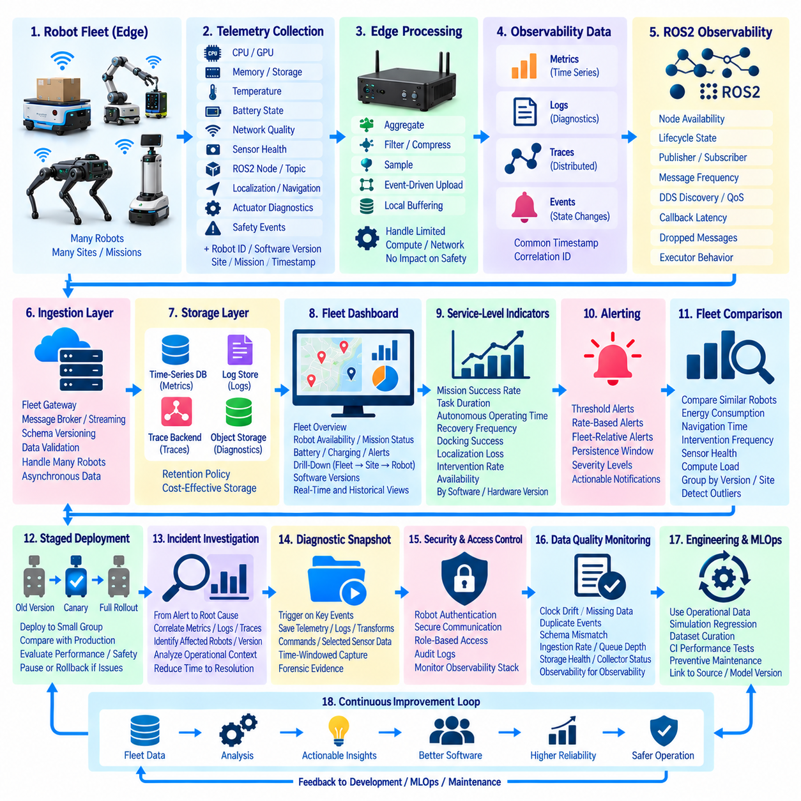
Fleet-wide observability extends robot monitoring from individual machines to the behavior of an entire operational fleet. A single robot may appear healthy while systemic problems emerge only across dozens or hundreds of units, software versions, sites, or missions. An observability stack must therefore correlate metrics, logs, traces, events, robot states, and mission outcomes so engineers can move from a fleet-level symptom to the responsible robot, software component, hardware condition, or operational context.
The architecture begins at each robot with a standardized telemetry layer. CPU and GPU utilization, memory pressure, storage capacity, temperatures, battery state, network quality, sensor health, ROS2 node status, topic frequency, localization quality, navigation state, actuator diagnostics, and safety events can be collected continuously. Each observation should carry contextual labels such as robot identifier, hardware revision, software release, site, mission, and timestamp so fleet data remains comparable after aggregation.
Telemetry collection must respect the limited computing and communication resources available on mobile robots. High-frequency sensor streams cannot normally be transmitted continuously to a central platform, so edge collectors should aggregate, filter, compress, and sample data before transmission. Critical events can be forwarded immediately while routine metrics are summarized over time windows. Local buffering allows telemetry to survive temporary wireless outages and upload later without blocking navigation or other safety-relevant robot functions.
A practical observability implementation separates metrics, logs, traces, and events while preserving relationships among them. Metrics provide efficient numerical time-series data for fleet health and performance trends. Logs capture detailed software and diagnostic messages. Distributed traces reveal timing and dependencies across services, while events record operational transitions such as mission start, docking, recovery, emergency stop, or software update. Shared timestamps and correlation identifiers allow engineers to reconstruct a complete incident across these different signals.
ROS2 systems require additional observability because failures may originate from communication behavior rather than application code alone. The stack can monitor node availability, lifecycle states, publisher and subscriber counts, message frequency, DDS discovery, Quality of Service settings, callback latency, dropped messages, and executor behavior. These signals help distinguish a navigation algorithm failure from middleware congestion, overloaded computation, sensor publication loss, or an incorrectly configured communication policy.
At the fleet gateway or backend, telemetry enters an ingestion layer designed to handle asynchronous data from many robots. Message brokers or streaming infrastructure can decouple robot connections from downstream storage and analysis. Data schemas should be versioned so older and newer robot software can coexist during staged deployments. Validation at ingestion prevents malformed timestamps, invalid labels, duplicate events, or incompatible payloads from contaminating fleet-wide monitoring and analytics.
Different observability signals require different storage strategies. Time-series databases are suitable for numerical metrics, indexed log stores support diagnostic search, trace backends preserve distributed execution paths, and object storage can retain large diagnostic bundles or selected sensor recordings. Retention policies should reflect operational value and storage cost. High-resolution data may be retained briefly, while aggregated statistics, incidents, safety events, and release-level performance summaries remain available for longer-term analysis.
Fleet dashboards transform raw telemetry into operational views. An overview can show robot availability, mission completion, battery condition, charging status, localization failures, navigation recovery, communication quality, software versions, and active alerts. Engineers should be able to drill down from the entire fleet to a site, robot group, individual robot, mission, ROS2 node, or time interval. This hierarchy prevents operators from manually examining hundreds of independent robot dashboards.
Service-level indicators can translate robot telemetry into measurable operational performance. Useful indicators include mission success rate, task duration, autonomous operating time, recovery frequency, docking success, localization loss, intervention rate, and availability. These measures should be associated with software versions and hardware revisions. A release that appears functionally correct in laboratory testing may reveal increased recovery behavior or reduced mission throughput only after deployment across a statistically meaningful fleet population.
Alerting should focus on actionable conditions rather than every telemetry anomaly. Threshold alerts can detect overheating, low storage, repeated node crashes, communication loss, or excessive localization uncertainty. Rate-based and fleet-relative alerts can identify increases in navigation failures or unusual behavior affecting a subset of robots. Alert rules should include persistence windows and severity levels so short-lived fluctuations do not create excessive notifications that eventually cause operators to ignore important alarms.
Fleet-wide comparison provides information that cannot be obtained from isolated robot monitoring. Robots performing similar missions can be compared by energy consumption, navigation time, intervention frequency, sensor health, or compute load. Outliers can reveal mechanical degradation, calibration problems, network issues, or software regressions. Grouping by hardware revision, software release, facility, or operating condition helps engineers determine whether a problem is local to one robot or systematic across a larger population.
Observability becomes especially valuable during staged software deployment. A new release can first be installed on a small canary group while dashboards compare its behavior with the established production version. Mission success, latency, resource consumption, recovery events, and safety indicators can be evaluated before wider rollout. If the candidate exhibits abnormal behavior, deployment can be paused or rolled back while the known-good version continues operating on the remainder of the fleet.
Incident investigation requires movement from symptoms to correlated evidence. An operator may begin with a fleet alert showing increased mission failures, then narrow the problem to one software version, site, or robot model. Metrics may reveal CPU saturation, traces may expose delayed processing, logs may identify repeated node errors, and mission events may show the operational consequence. Correlation across these signals reduces the time required to isolate root causes compared with manually collecting data after a failure.
Diagnostic snapshots can preserve high-detail evidence around important events without continuously storing all raw robot data. When a collision avoidance event, emergency stop, localization failure, controller reset, or repeated recovery occurs, the robot can preserve a bounded window of relevant telemetry, logs, transforms, commands, and selected sensor data. These incident bundles provide engineers with richer forensic evidence while keeping normal network bandwidth and storage requirements manageable.
Security and access control are part of the observability architecture because telemetry may expose operational details, software configurations, locations, or diagnostic interfaces. Robot identities should be authenticated, communication channels protected, and backend permissions separated according to operational roles. Audit records should show who accessed sensitive diagnostic data or modified dashboards and alert rules. Monitoring infrastructure itself must also be observed because loss of telemetry can otherwise be mistaken for healthy robot operation.
Data quality must be monitored alongside robot quality. Clock drift, missing telemetry, duplicate events, inconsistent labels, schema mismatches, and collector failures can produce misleading dashboards even when the robots operate correctly. The observability platform should therefore expose its own ingestion rate, queue depth, dropped-data count, storage health, processing latency, and collector status. This creates observability for the observability system and prevents decisions from being based on incomplete or corrupted fleet evidence.
Operational telemetry should feed engineering and MLOps workflows rather than remaining only in dashboards. Repeated navigation failures can become simulation regression scenarios, perception anomalies can produce dataset candidates, latency regressions can enter CI performance tests, and hardware faults can refine preventive-maintenance rules. Linking incidents to source revisions, model versions, configuration baselines, and deployment history turns fleet operation into a continuous source of engineering evidence.
The resulting fleet-wide observability stack creates a feedback loop connecting robots, operations, software development, and model improvement. Edge collectors transform robot behavior into structured telemetry, centralized services correlate fleet signals, dashboards and alerts expose operational conditions, and incident analysis identifies actionable causes. When these findings return to CI/CD, simulation, MLOps, and maintenance processes, observability becomes more than monitoring: it becomes the evidence infrastructure for continuously improving fleet reliability, safety, and operational performance.

12.8. HIL Robot Farm Build and Continuous Test Case
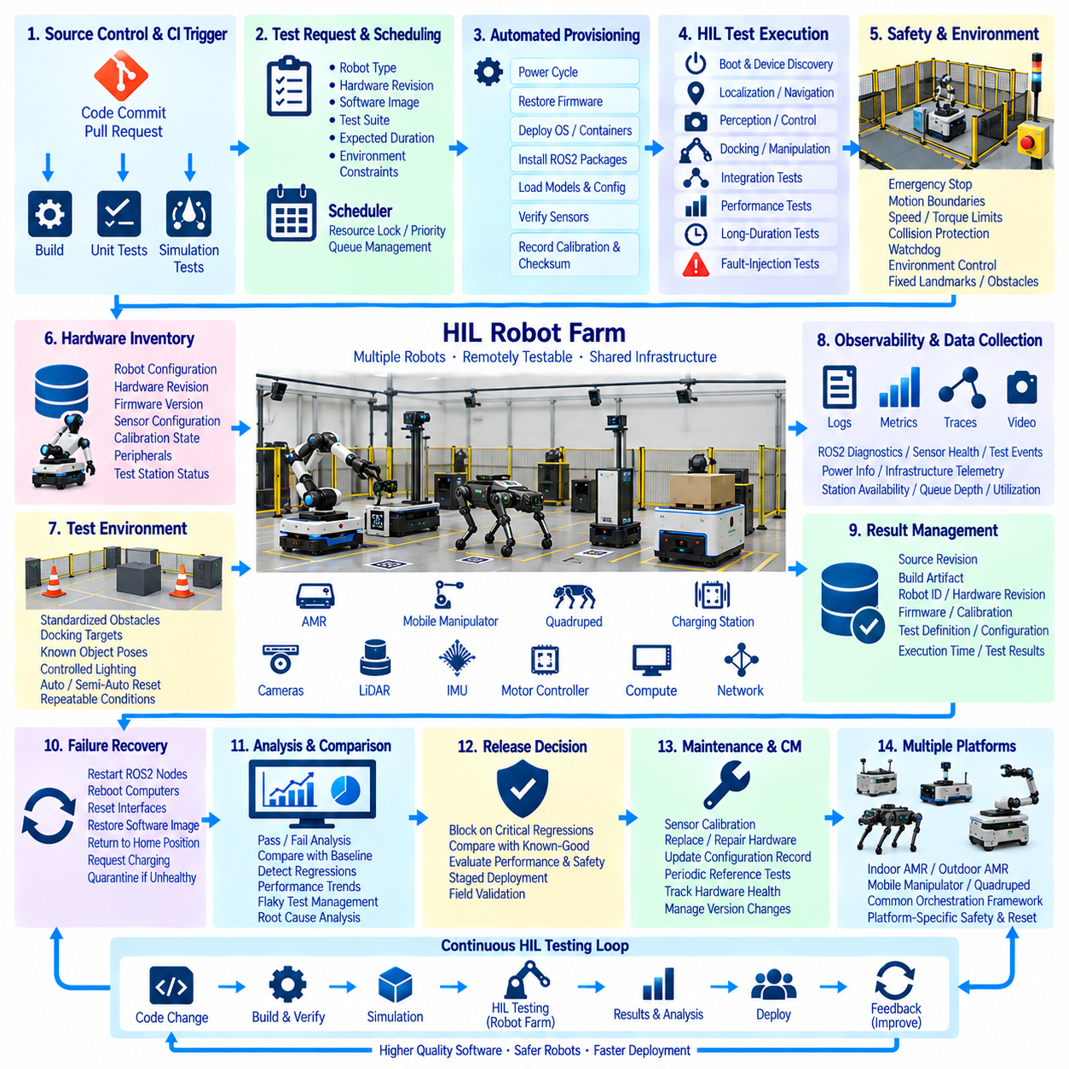
A Hardware-in-the-Loop (HIL) robot farm extends continuous integration from software-only validation into repeatable testing on real robotic hardware. Instead of relying on engineers to manually prepare individual robots for every build, a shared facility maintains multiple robots, controllers, sensors, compute modules, and supporting infrastructure as remotely schedulable test resources. The objective is to detect integration failures that simulation cannot fully reproduce while preserving the automation, traceability, and repeatability expected from modern CI/CD workflows.
The robot farm should be designed as infrastructure rather than a collection of independently operated machines. Each test station requires a defined robot configuration, target computer, network connection, power control, charging capability, safety interface, and environmental setup. Hardware revisions, firmware versions, sensor configurations, calibration states, and attached peripherals must be recorded. This inventory allows the scheduler to select hardware that matches the requirements of a particular software build or regression scenario.
A centralized orchestration layer manages access to the physical resources. CI jobs submit test requests containing required robot type, hardware revision, software image, test suite, expected duration, and environmental constraints. The scheduler reserves an available station and prevents conflicting jobs from controlling the same hardware simultaneously. Resource locks, leases, priorities, and timeouts are important because physical robots cannot be duplicated instantly like virtual machines or software containers.
Before testing begins, automated provisioning places the selected station into a known baseline state. The pipeline can power-cycle devices, restore firmware, deploy operating-system images or containers, install ROS2 packages, load model artifacts, apply configuration files, and verify sensor connectivity. Calibration identifiers and configuration checksums should also be recorded. Establishing a deterministic starting condition prevents residual state from previous experiments from producing misleading test results.
The HIL test environment should reproduce the interfaces that the robot encounters during actual operation. Real motor controllers, embedded computers, communication buses, cameras, LiDAR, IMUs, safety controllers, or battery-management interfaces can participate while selected environmental components remain simulated. This hybrid architecture allows deterministic fault injection and scenario control while preserving real timing, device drivers, communication behavior, and hardware-specific execution characteristics that are difficult to reproduce in pure simulation.
Continuous testing can cover multiple layers of the robotic software stack. Basic tests verify boot behavior, device discovery, firmware communication, ROS2 node startup, and topic availability. Integration tests examine localization, navigation, perception, control, docking, manipulation, or mission orchestration. Performance tests measure callback latency, control-loop frequency, inference time, CPU and GPU utilization, network delay, and memory consumption. Long-duration tests expose resource leaks, thermal problems, timing drift, and intermittent communication failures.
Physical motion requires stronger safety mechanisms than conventional CI infrastructure. Each station should include independent emergency-stop capability, motion boundaries, speed or torque limits, collision protection, watchdogs, and mechanisms for remotely removing actuator power. Test software must not be the only safety layer because the software itself may be the component under evaluation. Safety controllers should therefore remain independent from experimental builds and force the robot into a safe state when predefined operational limits are violated.
Environmental control improves repeatability. Mobile robot stations can use fixed landmarks, fiducial markers, standardized obstacles, docking targets, floor regions, or controlled lighting. Manipulation stations can provide known object poses, fixtures, and reset mechanisms. Where complete physical reset is impractical, automated or semi-automated procedures should restore the environment between runs. A test that depends on an unknown object position or changing floor condition cannot provide reliable regression evidence.
Robot-farm testing should be connected directly to source-control and CI events. A pull request may trigger simulation and unit tests first, while successful candidates proceed to HIL validation. Nightly pipelines can execute larger regression suites, and release candidates can receive extended endurance and safety tests. Because physical capacity is limited, inexpensive software tests should normally reject defective builds before scarce robot time is allocated, creating a progressive validation funnel from virtual to physical environments.
Test scheduling must account for the scarcity and heterogeneity of physical hardware. Some jobs may require a specific actuator revision, sensor configuration, GPU module, payload mechanism, or robot model. Capability labels allow the scheduler to match jobs with compatible stations. Queue policies can prioritize release validation or safety regressions over exploratory experiments. Historical execution time can also help allocate test windows efficiently and reduce idle hardware between scheduled jobs.
Automatic reset and recovery determine whether the farm can operate continuously without constant human supervision. A failed test may leave a robot stopped, disconnected, displaced, or in an invalid software state. Recovery procedures can restart ROS2 nodes, reboot computers, reset communication interfaces, restore software images, return manipulators to home positions, or request charging. When automated recovery fails, the station should be quarantined and removed from scheduling until an operator verifies its condition.
Observability is required for both the software under test and the robot farm itself. Every execution should collect logs, ROS2 diagnostics, metrics, traces, sensor health, controller states, test events, power information, and relevant video or diagnostic snapshots. Infrastructure telemetry should also record station availability, queue depth, provisioning time, test duration, recovery frequency, hardware failures, and utilization. These signals distinguish product defects from failures caused by the test facility.
Test results must remain linked to the exact software and hardware configuration used during execution. A result record should identify source revision, build artifact, container or package version, robot identifier, hardware revision, firmware, calibration, test definition, configuration checksum, and execution time. This traceability allows engineers to reproduce failures and determine whether a regression follows a software change, hardware variation, firmware update, or environmental condition.
Flaky physical tests require systematic management because uncontrolled variability can quickly reduce trust in automation. Repeated failures should not simply be hidden through unlimited retries. The system should measure pass consistency, classify infrastructure failures separately from product failures, and identify tests sensitive to timing or environmental variation. Quarantining unstable tests while preserving their evidence allows engineers to improve them without allowing unreliable results to block every development pipeline.
A mature robot farm supports fault-injection testing that would be difficult or unsafe during normal field operation. Controlled scenarios can introduce sensor dropout, delayed messages, degraded networks, processor load, localization loss, communication interruption, actuator faults, or simulated battery conditions. The expected software response can then be evaluated automatically. These scenarios are particularly useful for validating watchdogs, recovery logic, degraded operating modes, and transitions to safe states.
Continuous HIL testing also provides evidence for software deployment decisions. A candidate release can be compared with a known-good baseline across identical hardware and scenarios. Navigation success, perception latency, controller stability, docking accuracy, resource consumption, recovery behavior, and safety events can be evaluated before fleet rollout. Significant regressions can automatically block promotion, while approved artifacts advance to staged deployment or field validation.
The robot farm itself requires configuration management and maintenance. Sensors drift, batteries age, wheels wear, connectors loosen, calibration changes, and compute hardware may be replaced. Maintenance events must therefore update the station's configuration record. Periodic reference tests can detect changes in the physical test infrastructure before they are mistaken for software regressions. A robot farm is only useful as a verification platform when the condition of its hardware is known and controlled.
As the number of stations grows, the farm can represent multiple target platforms and deployment generations. Indoor AMRs, outdoor AMRs, mobile manipulators, quadrupeds, embedded controllers, and edge-compute configurations can share a common orchestration framework while maintaining platform-specific safety and reset procedures. This transforms HIL from an occasional final-stage activity into a reusable validation service supporting multiple robotics programs and software branches.
The resulting architecture creates a continuous physical verification loop. Software changes move through static analysis, unit tests, simulation, and integration checks before reaching scheduled robot hardware. Automated provisioning establishes a known state, HIL scenarios execute repeatable tests, observability captures evidence, recovery prepares the station for the next job, and results feed release gates and engineering analysis. By treating real robots as managed CI resources, the organization can discover hardware-dependent regressions earlier while improving reproducibility, utilization, safety, and confidence in every software release.

12.9. SBOM Compliance Program Implementation Case
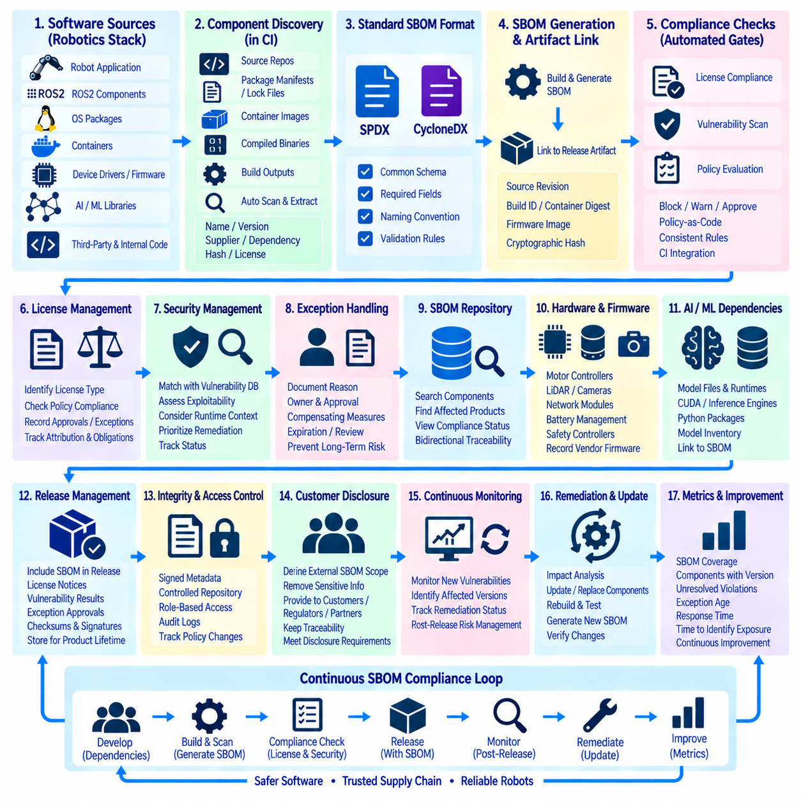
An SBOM compliance program transforms software component visibility from an occasional release activity into a controlled lifecycle process. In a robotics organization, deployed products may combine operating-system packages, ROS2 components, middleware, device drivers, AI frameworks, third-party libraries, firmware, containers, and internally developed software. The Software Bill of Materials (SBOM) provides a structured inventory of these components so engineering, security, legal, and operations teams can understand what software exists inside each released system.
The program begins by defining the scope of software assets that require SBOM coverage. Robot applications alone are insufficient because vulnerabilities and license obligations may originate from lower layers such as Linux packages, container base images, GPU runtimes, communication libraries, embedded firmware, or build dependencies. The organization should define which products, repositories, images, firmware packages, deployment bundles, and release artifacts belong to the controlled software supply chain and identify responsible owners for each asset.
Component discovery should be integrated into normal development rather than performed manually near release. Source repositories, package manifests, lock files, container images, compiled binaries, operating-system packages, and build outputs can be scanned automatically during CI. The resulting inventory should capture component names, versions, package identifiers, suppliers, dependency relationships, hashes, and available license information. Automated discovery reduces dependence on individual developer knowledge and improves consistency across large software stacks.
A standardized SBOM format allows information to move between engineering tools, security systems, customers, and external partners. Formats such as SPDX and CycloneDX can represent software components and their relationships in machine-readable structures. The organization should select supported formats, required fields, naming conventions, and validation rules. Consistent generation is especially important when multiple development teams produce software for different robots but the resulting products must be governed by one compliance program.
SBOM generation should be tied to reproducible build and release identities. Each generated document must correspond to a specific source revision, build artifact, container digest, firmware image, or software release rather than representing a continuously changing repository. Cryptographic hashes and immutable artifact identifiers can connect the SBOM to the exact binary or package delivered. This relationship prevents ambiguity when engineers later investigate which components were actually present in a deployed robot.
License compliance forms one major use of the SBOM. Components may be distributed under permissive, weak-copyleft, strong-copyleft, proprietary, commercial, or other licensing conditions. Automated scanners can identify declared licenses and compare them with organizational policies, but ambiguous or conflicting results may require legal review. The compliance workflow should record license findings, approvals, exceptions, attribution requirements, source-disclosure obligations, and other actions required before distribution.
Security management forms another major use case. SBOM components can be correlated with vulnerability intelligence to identify whether newly disclosed vulnerabilities affect released products. Matching should consider component identity and version while recognizing that a database match does not automatically prove exploitability in the deployed configuration. Security teams can combine SBOM information with reachability, runtime exposure, architecture, compensating controls, and vendor analysis to prioritize remediation according to actual product risk.
The CI pipeline should enforce policy through automated compliance gates. A build may be rejected when required SBOM fields are missing, prohibited licenses are detected, critical components lack identifiable versions, or policy-defined vulnerability conditions are violated. Other findings may generate warnings or require explicit approval. Policy-as-code approaches help ensure that the same rules are applied consistently across repositories instead of depending on manual interpretation by individual development teams.
Exceptions require a controlled workflow because real products cannot always satisfy every policy immediately. A legacy dependency, unavailable replacement, vendor-supplied binary, or temporarily unresolved vulnerability may require documented acceptance. The exception record should identify the affected component, product, reason, responsible owner, compensating measures, approval authority, and expiration or review condition. Time-bounded exceptions prevent temporary decisions from becoming permanent undocumented weaknesses in the software supply chain.
The SBOM repository becomes a central record connecting products, releases, and components. Engineers should be able to query which products contain a particular library, which versions are deployed, and which releases are affected by a newly discovered issue. Conversely, each robot software release should expose its complete component inventory and associated compliance status. This bidirectional relationship is essential when hundreds of deployed robots operate different hardware generations or software baselines.
Robotics products require careful treatment of firmware and hardware-associated software. Motor controllers, LiDAR devices, cameras, network modules, battery-management systems, safety controllers, and compute platforms may contain vendor firmware outside the primary application build. Where component information is available, these dependencies should be linked to the product inventory. Where suppliers do not provide sufficient transparency, the limitation should be recorded rather than silently assuming that the device introduces no software supply-chain risk.
AI and machine-learning deployments add another layer of dependency management. An inference service may depend on model files, preprocessing code, CUDA libraries, inference runtimes, Python packages, optimized engines, and hardware-specific drivers. The conventional SBOM can describe the software environment, while model inventories or complementary metadata can identify model versions and associated artifacts. Linking these records provides stronger traceability between an AI function and the software stack required to execute it.
Release management should treat the SBOM as part of the release evidence package. When a software candidate passes functional, integration, security, and compliance checks, the pipeline generates or finalizes the SBOM and associates it with the approved artifacts. Release records can include SBOM files, license notices, vulnerability assessment results, exception approvals, checksums, and signatures. The evidence should remain retrievable for the supported lifetime of the product rather than disappearing with temporary CI job logs.
SBOM integrity is important because an inventory that can be modified independently of its release provides weak evidence. Documents can be stored in controlled repositories and associated with signed or otherwise verifiable release metadata. Access controls should distinguish generation, review, approval, and publication responsibilities. Audit logs can record changes to compliance policies and exceptions, allowing the organization to demonstrate how a release satisfied the rules that were applicable when it was approved.
Customer disclosure requires a separate policy from internal SBOM generation. Internal records may contain build details, development dependencies, proprietary component names, or security-sensitive information that is inappropriate for unrestricted distribution. The organization should define which SBOM views can be provided to customers, regulators, integrators, or partners and under what conditions. External documents should remain traceable to the same release baseline without exposing information beyond the intended disclosure scope.
Continuous monitoring extends the value of an SBOM after release. A software version that passed every security check on its release date may become affected when a new vulnerability is disclosed months later. The compliance platform can periodically correlate stored component inventories with updated vulnerability information and identify affected product versions. This turns the SBOM from a static document into an operational index for post-release vulnerability response and maintenance planning.
When an issue requires remediation, the SBOM supports rapid impact analysis. Teams can identify affected repositories and deployed releases, update or replace the vulnerable component, rebuild the product, execute regression and security tests, and generate a new SBOM for the corrected version. The previous and updated inventories can be compared to confirm the intended dependency change. This creates a traceable chain from vulnerability discovery through engineering correction to verified software deployment.
Program effectiveness should be measured rather than assumed. Useful indicators include SBOM coverage across released products, percentage of components with identifiable versions and licenses, unresolved policy violations, exception age, vulnerability response time, and the time required to determine product exposure after a new advisory. These measurements reveal whether the organization merely generates SBOM files or actually maintains an effective software supply-chain governance process.
The resulting implementation creates a continuous compliance loop across development, release, deployment, and maintenance. Developers introduce or update dependencies, CI discovers components and generates the SBOM, automated policies evaluate licenses and security conditions, reviewers resolve exceptions, and approved evidence accompanies the release. Post-release monitoring then detects newly relevant risks and feeds remediation back into development. In this architecture, the SBOM becomes a living connection between software engineering, cybersecurity, legal compliance, configuration management, and long-term robot fleet support.

12.10. DevOps MLOps Convergence Roadmap
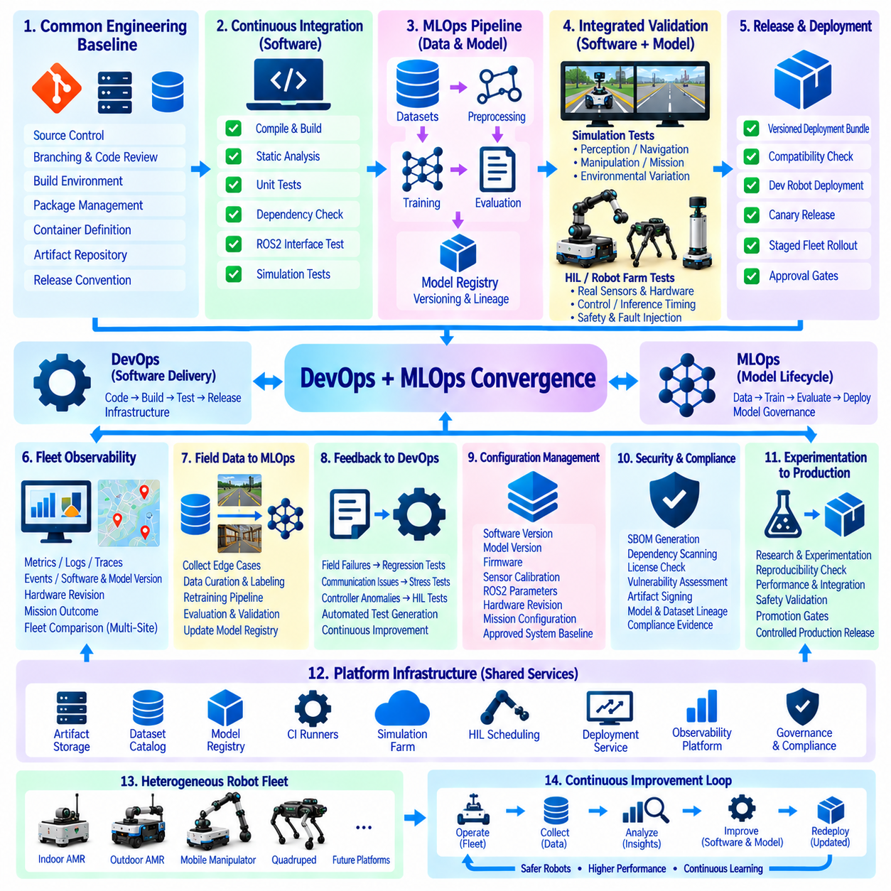
Robotics can treat DevOps and MLOps convergence as the operational foundation for evolving from individually developed robots into continuously improving Physical AI systems. Traditional DevOps manages source code, builds, tests, releases, and infrastructure, while MLOps governs datasets, training pipelines, models, evaluation, and deployment. Their convergence creates one engineering lifecycle in which robot software, AI models, configurations, and hardware-dependent artifacts advance through coordinated validation and release processes.
The roadmap begins by establishing a common engineering baseline across robotics programs. Source repositories, branching policies, code reviews, build environments, package management, container definitions, artifact repositories, and release conventions should be standardized where practical. Indoor AMRs, outdoor AMRs, mobile manipulators, and future robotic platforms can retain platform-specific components while sharing common CI/CD principles. This reduces duplicated infrastructure and allows engineering practices proven on one platform to migrate to others.
Continuous Integration provides the first automation layer. Every controlled software change can trigger compilation, static analysis, unit tests, dependency checks, ROS2 interface validation, and simulation-based regression tests. Reproducible containers or defined build environments reduce differences between developer machines and deployment targets. Build artifacts should be associated with source revisions, dependency versions, configuration identifiers, and test results so every executable deployed to a robot can be traced back to its engineering evidence.
MLOps introduces a parallel lifecycle for perception, prediction, planning, and other learned functions. Dataset versions, preprocessing pipelines, training configurations, source revisions, random seeds, checkpoints, evaluation results, and model artifacts should be tracked together. A model should not be identified only by a filename such as “best.pt.” Its identity should describe the data, code, parameters, environment, and evaluation process that produced it, allowing experiments to become reproducible engineering assets rather than isolated research results.
The convergence point occurs when software and model artifacts enter the same release qualification process. A perception model may pass offline accuracy evaluation but still fail because inference latency, GPU memory consumption, ROS2 timing, or sensor preprocessing changed. Conversely, application software may pass conventional CI while degrading model behavior through altered inputs. Integrated pipelines should therefore validate the complete executable AI function rather than independently approving code and models that have never been tested together.
Simulation provides a scalable verification layer before scarce physical hardware is used. Navigation, perception, manipulation, fault handling, and mission logic can be evaluated across repeatable scenarios, while synthetic variations expose the system to environmental diversity. Simulation results can become regression gates for both software and models. Failed field scenarios can later be reconstructed as simulation cases, creating a growing validation library derived from actual robot operation.
Hardware-in-the-Loop and robot-farm testing form the next validation layer. Candidate releases that pass software and simulation gates can be scheduled automatically on representative robot hardware. Tests can verify sensors, embedded computers, ROS2 communication, control timing, GPU inference, navigation, docking, manipulation, and safety responses. This progressive pipeline moves validation from inexpensive virtual tests toward increasingly realistic physical tests while reserving limited robot resources for candidates that have already passed earlier gates.
Deployment should evolve from manual installation toward controlled fleet release. Software packages, containers, firmware, models, calibration data, and configuration files should form versioned deployment bundles with explicit compatibility information. A candidate can first reach development robots, then a small canary group, followed by staged fleet expansion. Deployment gates can compare mission success, latency, recovery behavior, resource consumption, and safety indicators with the established production baseline before broader promotion.
Fleet-wide observability closes the gap between development assumptions and real operational behavior. Robots should report structured metrics, logs, traces, events, software versions, model versions, hardware revisions, and mission outcomes. Engineers can then compare behavior across platforms, sites, and releases. A problem observed across several robots can be correlated with a particular software build, model version, sensor configuration, or hardware revision instead of being investigated as unrelated failures on individual machines.
Operational data should feed directly into the MLOps lifecycle. Difficult perception examples, navigation failures, unusual terrain, manipulation errors, and other edge cases can be identified from fleet telemetry and diagnostic snapshots. After privacy, quality, and relevance checks, selected samples can enter curated datasets. Training pipelines then produce candidate models that undergo offline evaluation, simulation, HIL testing, and staged deployment before becoming production models, creating a controlled data-to-model feedback loop.
The same operational feedback should improve conventional robot software. Repeated localization failures can become regression scenarios, communication problems can become middleware stress tests, and controller anomalies can become HIL fault-injection cases. DevOps and MLOps therefore share a common evidence loop: field behavior produces engineering cases, engineering cases become automated tests or training data, and improved software or models return to the fleet through controlled release pipelines.
Configuration management becomes increasingly important as the number of robot variants grows. A deployed behavior may depend simultaneously on software revision, model version, firmware, sensor calibration, ROS2 parameters, hardware revision, and mission configuration. These elements should be represented as a reproducible system baseline rather than managed independently. A fleet management system must be able to determine exactly which combination is running on each robot and whether that combination has been approved.
Software supply-chain governance should be integrated into the same lifecycle. SBOM generation, dependency scanning, license checks, vulnerability assessment, artifact signing, and provenance records can execute during CI/CD rather than being performed separately before delivery. Model artifacts and datasets require comparable lineage information. Combining security, compliance, software traceability, and model traceability creates a stronger release evidence package for enterprise and industrial robotics deployments.
The roadmap should also separate experimentation from production control. Researchers need flexible environments for new architectures, reinforcement learning, world models, perception models, and optimization methods, while operational robots require stable and controlled releases. Promotion gates provide the bridge between these domains. Experimental artifacts become production candidates only after reproducibility, performance, integration, safety, and deployment requirements are satisfied, preserving research speed without transferring uncontrolled changes directly into the fleet.
As Hills Robotics expands toward heterogeneous fleets, the platform layer becomes increasingly important. Common services can manage artifact storage, experiment tracking, CI runners, simulation jobs, HIL scheduling, deployment, observability, dataset catalogs, model registries, and compliance evidence. Individual robot programs then consume these shared capabilities instead of rebuilding their own engineering infrastructure. Platform standardization allows a relatively small engineering organization to support increasing numbers of robots and software variants.
The convergence roadmap can mature progressively rather than requiring a single large transformation. Early stages establish source control, reproducible builds, automated tests, artifact management, and basic model tracking. Intermediate stages connect simulation, model evaluation, HIL testing, staged deployment, and fleet observability. More advanced stages automate field-data selection, retraining, regression generation, cross-fleet comparison, compliance evidence, and release qualification while maintaining explicit human approval for safety-critical decisions.
At higher maturity, deployment information and operational evidence can support continuous improvement across the entire robot fleet. A newly observed failure can be linked to its robot configuration, reconstructed in simulation or HIL, converted into a regression test or dataset example, corrected through software development or model training, and validated before redeployment. The important transition is from isolated development projects toward a persistent learning infrastructure in which each operational experience can improve future releases.
This architecture supports Hills Robotics' progression from individual autonomous robots toward coordinated Physical AI systems. Indoor AMRs can establish the initial CI/CD and fleet-management foundation, while outdoor AMRs introduce greater environmental variability and stronger field-data requirements. Mobile manipulation and increasingly intelligent platforms add model-intensive workflows, and larger heterogeneous fleets require unified orchestration, observability, governance, and lifecycle management across many hardware and software configurations.
The final objective is not simply faster software deployment or more frequent model training. It is an integrated engineering system in which code, data, models, simulation, hardware validation, fleet deployment, observability, security, and operational feedback remain connected by traceable evidence. DevOps supplies software delivery discipline, MLOps supplies learning-system discipline, and robotics validation connects both to the physical world. Their convergence enables Hills Robotics to build a scalable foundation for safer, reproducible, continuously improving robot intelligence.

