Volume 10 Robot DevOps and MLOps

5. Observability

5.1. Observability Pillars Metrics Logs Traces for Robotics
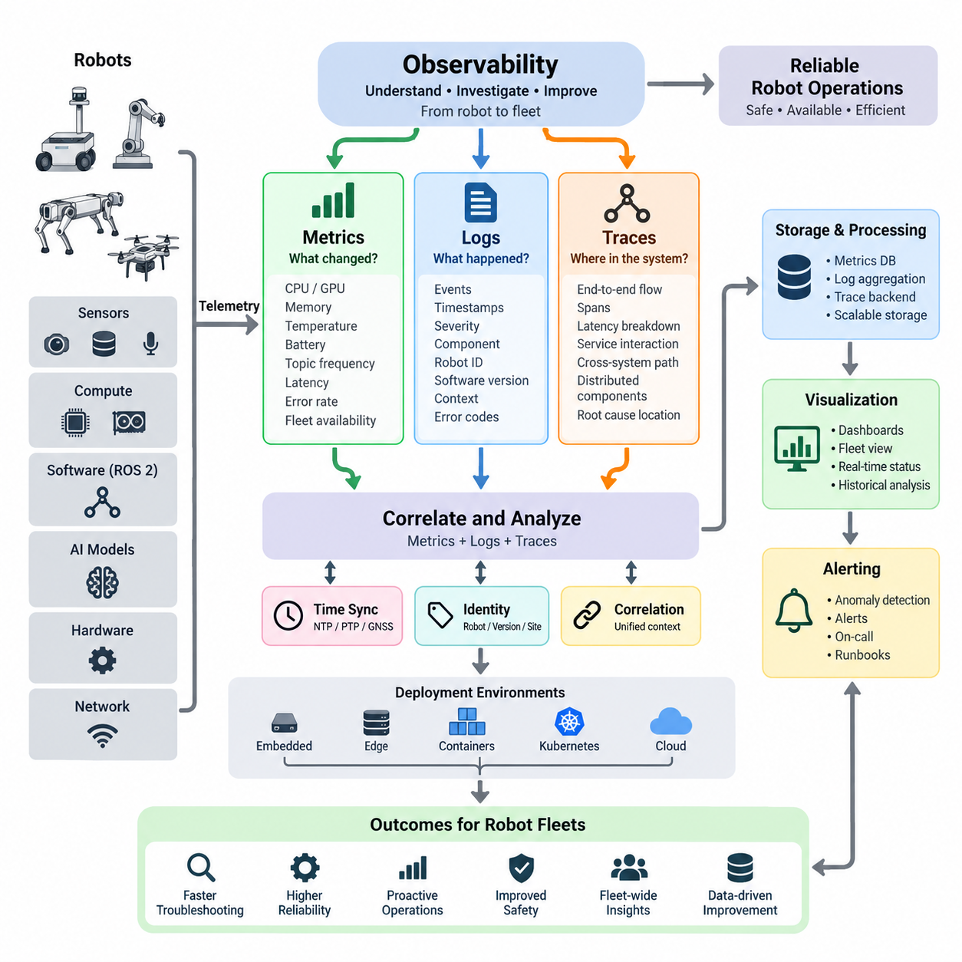
Observability in robotics is the ability to understand the internal state of a robot software system by examining the signals it produces during operation. Unlike simple monitoring, which checks predefined conditions, observability supports investigation of unexpected behaviors whose causes may not be known in advance. This distinction is important because robots combine software, sensors, networks, AI models, computing hardware, and physical mechanisms in continuously changing environments.
The classical observability model is built around three complementary pillars: metrics, logs, and traces. Each pillar describes the system from a different perspective. Metrics quantify behavior over time, logs record discrete events with contextual information, and traces reconstruct the execution path of operations across distributed components. Together they transform raw runtime telemetry into evidence that engineers can use to detect anomalies, diagnose failures, and understand system performance.
Metrics are numerical measurements collected repeatedly and represented as time-series data. In a robot, useful metrics include CPU and GPU utilization, memory consumption, temperature, battery state of charge, network latency, ROS 2 topic frequency, message loss, localization error, planning latency, motor current, and inference time. Fleet-level metrics may additionally measure robot availability, mission completion rate, charging utilization, intervention frequency, and failure rates across deployed units.
A major advantage of metrics is their efficiency. Thousands of robots can continuously report compact numerical values without transmitting every internal event. Aggregation functions such as averages, percentiles, rates, and histograms reveal patterns that are difficult to recognize from individual measurements. Engineers can therefore observe both individual robots and fleet-wide behavior while establishing baselines that distinguish normal variation from operational degradation.
Logs provide event-oriented descriptions of what occurred inside software components. A ROS 2 node might report that a sensor connection was lost, a localization process restarted, a navigation goal was rejected, or a safety controller entered a degraded state. Effective logs normally include timestamps, severity levels, component identities, robot identifiers, software versions, correlation identifiers, and structured fields that allow events to be searched and analyzed systematically.
Robotic logging requires greater contextual discipline than conventional server logging because physical events and software events are tightly connected. A message such as “navigation failed” is insufficient without information about robot pose, planner state, obstacle conditions, sensor availability, map version, and relevant error codes. Structured logging makes these relationships machine-searchable and enables fleet operators to compare similar failures across robots, sites, software releases, and operating conditions.
Distributed traces describe how an operation propagates through multiple software components. A navigation request, for example, may travel from a fleet management service to a mission manager, behavior tree, global planner, local planner, controller, and hardware interface. By assigning trace and span identifiers to related operations, engineers can reconstruct this sequence and determine where latency accumulated, where execution failed, or which dependency produced an abnormal response.
Tracing becomes particularly valuable as robot architectures become distributed across embedded computers, edge GPU systems, containers, Kubernetes services, and cloud infrastructure. A single user-visible delay may originate from network communication, inference processing, database access, ROS 2 middleware, or an overloaded edge service. Distributed tracing exposes these boundaries and creates an end-to-end timeline rather than forcing engineers to inspect each subsystem independently.
Metrics, logs, and traces become substantially more powerful when they are correlated. A temperature metric may reveal that GPU temperature increased before perception latency degraded. A trace can identify which inference operation became slow, while logs may show thermal throttling or resource allocation events occurring at the same time. The three signals therefore answer related questions: what changed, what happened, and where the behavior propagated through the system.
Time synchronization is essential for this correlation. Robots generate telemetry across sensors, embedded controllers, edge computers, and remote services, so timestamps must represent a sufficiently consistent temporal reference. Technologies such as NTP, PTP, or GNSS-derived synchronization may be applied according to precision requirements. Without reliable timing, apparently related events can be incorrectly ordered, making root-cause analysis difficult or even misleading.
Robot identity and software identity are equally important dimensions of observability. Telemetry should indicate which robot generated a signal, where it operated, which software and configuration versions were active, and which hardware or AI model versions were involved. These attributes allow engineers to distinguish a fleet-wide defect from a problem associated with a particular robot, deployment group, environment, firmware revision, container image, or model release.
Observability architecture must also account for intermittent connectivity. A cloud server normally assumes persistent network access, whereas mobile robots may enter elevators, warehouses, underground facilities, remote outdoor areas, or congested wireless networks. Robots therefore need local buffering and resilient telemetry pipelines that can preserve important information during disconnection and forward it after communication is restored without overwhelming limited network bandwidth.
Not every telemetry signal deserves identical retention or transmission priority. Safety events, critical faults, mission failures, and diagnostic context may require durable storage, while high-frequency debugging information can often be sampled, aggregated, filtered, or retained locally for shorter periods. Designing observability therefore involves balancing diagnostic value against storage capacity, wireless bandwidth, edge computing resources, cloud ingestion costs, and operational requirements.
ROS 2 systems introduce observability requirements at both application and middleware levels. Engineers may need to observe node lifecycle states, topic publication frequencies, subscriber counts, message latency, DDS discovery behavior, QoS incompatibilities, executor delays, service response times, and action execution. These signals complement application metrics such as localization quality, navigation success, perception throughput, actuator state, and mission progress.
Observability should also span the physical layer because software health alone cannot describe a robot's operational condition. Battery voltage, motor current, wheel velocity, actuator temperature, emergency-stop state, vibration, communication errors, and sensor health can provide early evidence of hardware degradation. Correlating these signals with software telemetry helps determine whether an observed failure originates in algorithms, computing resources, networking, electronics, or mechanical behavior.
Fleet observability extends the concept from individual machines to populations of robots. Operators need to identify whether failures are isolated or correlated across a site, software release, robot model, or operational scenario. Aggregated telemetry can expose systematic patterns such as increasing navigation failures after deployment, abnormal battery consumption at one facility, or elevated inference latency among robots using a particular hardware configuration.
A mature observability system ultimately supports both reactive troubleshooting and proactive operations. Real-time telemetry enables alerts and incident investigation, while historical data supports reliability analysis, capacity planning, regression detection, and engineering improvement. Observability can also provide evidence for defining service indicators and operational objectives, connecting low-level technical behavior with robot availability, mission success, safety, and fleet service quality.
For robotics DevOps, observability should therefore be designed as part of the software architecture rather than added after deployment. Instrumentation conventions, timestamps, identifiers, metadata, telemetry schemas, retention policies, and correlation mechanisms should evolve together with robot software. When metrics, logs, and traces share consistent context, engineers gain a coherent operational view extending from physical hardware and ROS 2 processes to edge services and cloud systems.
This foundation also prepares the system for specialized observability technologies introduced later in the lifecycle. Metrics can be collected and queried by platforms such as Prometheus, dashboards can visualize fleet behavior, centralized logging can consolidate events, and distributed tracing can reconstruct service interactions. OpenTelemetry-style instrumentation can further standardize signal generation and propagation across heterogeneous software components without tying application logic to one backend.
The central objective is not to collect the largest possible volume of telemetry, but to preserve enough meaningful context to explain robot behavior. A well-designed observability architecture enables engineers to move from a fleet-level anomaly to an affected robot, from that robot to a subsystem, and from the subsystem to the specific execution path or event associated with the failure. This capability is fundamental to operating increasingly autonomous and distributed robot fleets reliably at scale.

5.2. Prometheus Metrics Collection for Robot SW Stacks [w/Code]
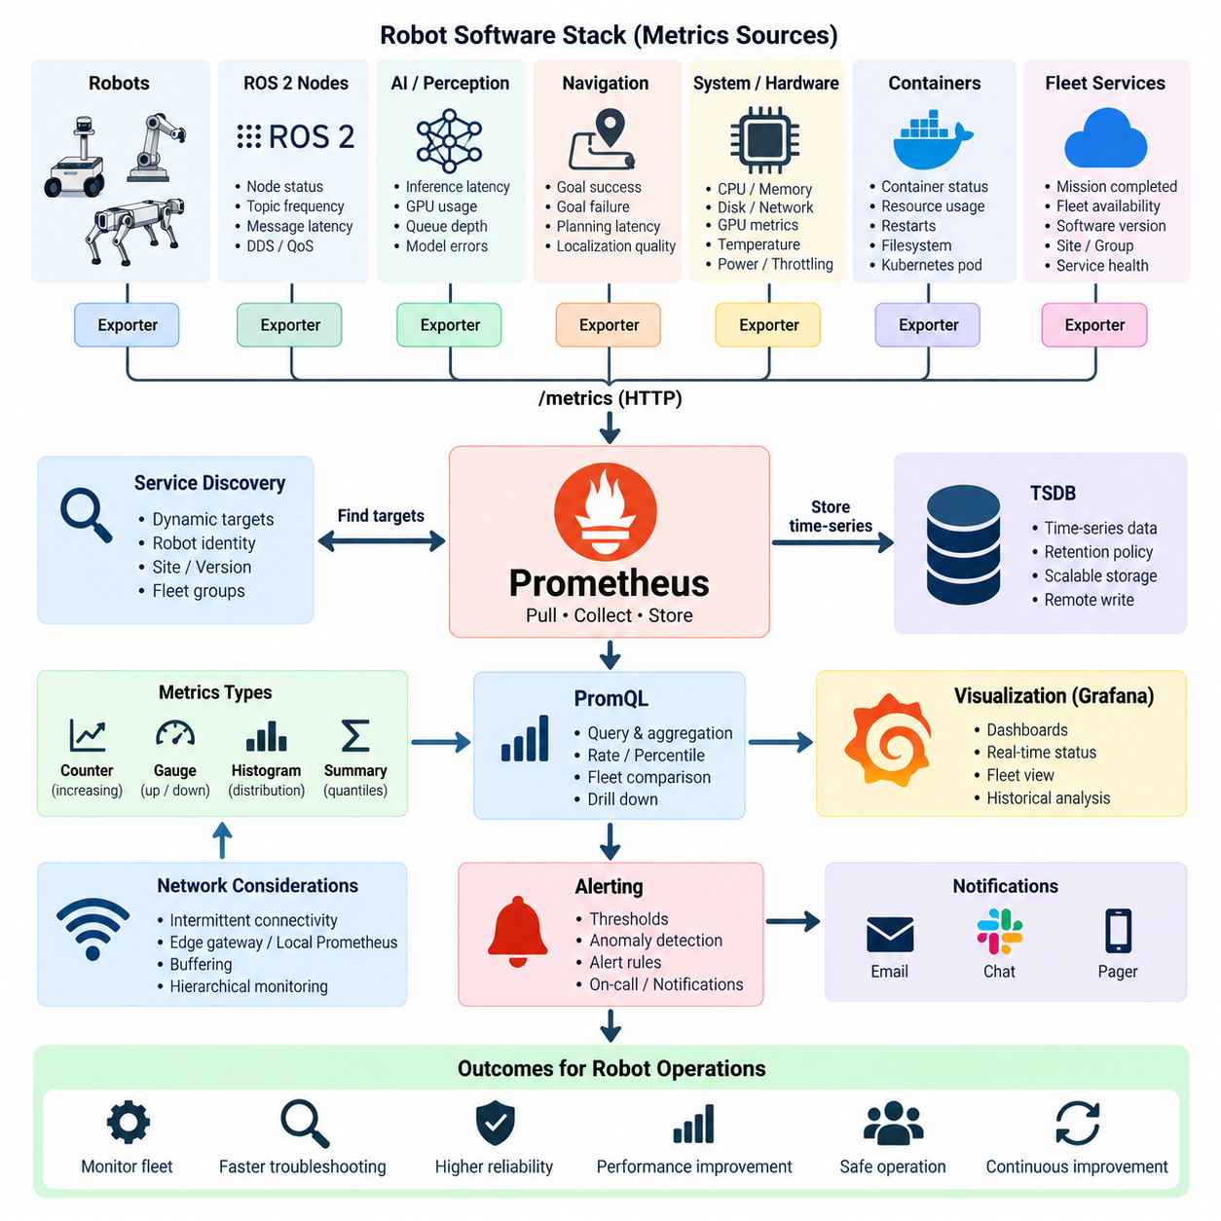
Prometheus is a monitoring and time-series metrics platform well suited to robot software stacks because it provides a consistent mechanism for collecting numerical measurements from distributed components. In a robotic system, metrics may originate from ROS 2 nodes, navigation processes, AI inference services, embedded computers, GPU systems, operating systems, containers, and fleet services. Prometheus brings these heterogeneous measurements into a common model that supports monitoring, analysis, and automated alerting.
The fundamental Prometheus architecture is based primarily on a pull model. Instead of every robot application continuously pushing monitoring data toward a central server, Prometheus periodically requests metrics from configured HTTP endpoints. Each monitored component exposes measurements through an exporter or application endpoint, commonly using a `/metrics` interface. This approach separates metric collection from application execution and allows the monitoring system to control collection intervals and target discovery.
Prometheus represents measurements as time-series data identified by a metric name and a set of labels. A metric such as `robot_cpu_usage` can be associated with labels describing the robot ID, site, software version, computing device, or deployment group. The same logical metric can therefore represent thousands of individual series across a fleet. Labels provide powerful multidimensional analysis, but their design must be controlled carefully because excessive label combinations can create very high cardinality.
Several metric types are useful when instrumenting robot software. A counter represents a cumulative value that normally increases, such as completed missions, navigation failures, dropped messages, or emergency-stop events. A gauge represents a value that can increase or decrease, such as battery state of charge, CPU utilization, GPU temperature, localization uncertainty, or the number of active tasks. Histograms and summaries describe distributions such as planning latency, inference duration, network delay, or mission execution time.
Robot software can expose application-specific metrics directly through Prometheus client libraries. A navigation component, for example, can publish counters for successful and failed goals, gauges for localization quality, and histograms for planning latency. An AI perception service may expose inference frequency, processing latency, GPU memory utilization, queue depth, and model errors. Instrumentation should focus on measurements that reveal operational behavior rather than simply exporting every internal software variable.
ROS 2 introduces another important layer of metrics. Operational monitoring may track whether expected nodes are alive, whether lifecycle nodes are active, how frequently topics are published, how long messages take to propagate, and whether expected publishers or subscribers are present. DDS and QoS-related problems may also appear indirectly through message loss, frequency changes, or communication errors. These measurements help distinguish application failures from middleware and communication problems.
System-level exporters complement application instrumentation by exposing operating-system and hardware measurements. CPU load, memory usage, filesystem capacity, network traffic, process state, and host availability provide essential context for diagnosing robot software behavior. GPU-equipped robots additionally require measurements such as GPU utilization, memory consumption, temperature, power usage, and throttling conditions because perception and AI workloads can degrade when computational resources become constrained.
Containerized robot software adds another monitoring boundary. Metrics should make it possible to distinguish the health of the physical computer from the resource consumption of individual containers and services. CPU throttling, memory limits, container restarts, filesystem utilization, and network activity may explain failures that appear at the ROS 2 or application level. When Kubernetes or lightweight edge orchestration is used, pod state and resource allocation can also become part of the monitoring model.
A typical robot-side metrics architecture therefore contains multiple exporters and instrumented applications. ROS 2 nodes and AI services expose domain-specific measurements, while host and GPU exporters describe computing resources. A local monitoring agent or Prometheus instance can collect these signals before they are transferred to a central infrastructure. This local layer is particularly useful when robots operate across unreliable wireless, LTE, 5G, or intermittently connected networks.
Network conditions require special consideration because the conventional Prometheus pull model assumes that monitoring targets are reachable. Robots may temporarily disappear from the network while moving between access points, entering elevators, traveling underground, or operating at remote sites. Edge gateways, local Prometheus instances, buffering mechanisms, or hierarchical monitoring architectures can therefore be introduced so that temporary connectivity failures do not automatically result in the permanent loss of operational metrics.
Service discovery becomes increasingly important as the number of robots grows. Manually maintaining static monitoring targets may be practical for a laboratory with a few robots but becomes difficult for fleets containing hundreds or thousands of dynamically connected devices. Robot identity, site, hardware class, software release, and fleet group should therefore be represented consistently so monitoring infrastructure can discover targets and aggregate metrics according to operational boundaries.
Prometheus Query Language, commonly called PromQL, transforms collected measurements into operational information. Engineers can calculate rates from counters, aggregate measurements across robot groups, compare software versions, calculate latency percentiles, or identify robots whose behavior differs from fleet baselines. Instead of examining thousands of individual measurements, queries can summarize the fleet while preserving the ability to drill down into a specific robot, process, or subsystem.
For example, navigation reliability can be represented as a relationship between completed navigation goals and failed goals over a selected time interval. CPU or GPU saturation can be evaluated across specific robot models, while inference latency can be compared between software releases. These queries become the analytical foundation for dashboards and alerting rules, allowing the same underlying metrics to support developers, fleet operators, reliability engineers, and maintenance personnel.
Metric naming and labeling conventions should be established early. Names should clearly describe the measured quantity and, where appropriate, communicate units such as seconds or bytes. Labels should represent stable dimensions that engineers actually need for aggregation and diagnosis. Robot identifiers, deployment sites, software versions, hardware classes, and service names are useful dimensions, while highly dynamic values such as timestamps, request identifiers, or arbitrary error messages should generally not become labels.
Cardinality management is especially important in large robot fleets. If every metric contains many labels with thousands of possible values, the number of resulting time series can grow dramatically. This increases memory consumption, storage requirements, query cost, and network traffic. Metrics should therefore capture reusable operational dimensions, while detailed event-specific information is better stored in logs or traces. Prometheus should summarize system behavior rather than become a replacement for event logging.
Scrape intervals should also reflect the dynamics of the measured subsystem. CPU utilization or robot health may require relatively frequent sampling, while slowly changing information may be collected less often. Very high-frequency control-loop data should generally not be exported directly as Prometheus metrics because millisecond-level actuator or sensor streams can create excessive telemetry volume. Such data is better handled through specialized robot data recording mechanisms when detailed analysis is required.
Alerting converts metrics from passive observations into operational actions. Rules can detect conditions such as low battery charge, unavailable robots, repeated navigation failures, excessive CPU or GPU temperature, abnormal inference latency, disk exhaustion, or missing telemetry. Effective alerts should represent conditions requiring attention rather than every transient deviation. Time windows, thresholds, persistence conditions, and fleet context help prevent short-lived variations from producing excessive alarm noise.
Prometheus metrics become more useful when correlated with software and deployment metadata. If navigation failures increase immediately after a new release, labels can separate the affected software version from previous versions. If GPU temperature problems appear only on one hardware configuration, fleet-wide queries can expose the pattern. Metrics therefore provide not only current health information but also quantitative evidence for regression detection, staged deployment evaluation, and operational comparison.
Retention strategy depends on how metrics will be used. Recent high-resolution data may be required for incident diagnosis, while long-term trends can often be stored at reduced resolution or transferred to scalable remote storage. Large fleets may use hierarchical or remote-write architectures to separate robot-local collection from centralized historical analysis. The objective is to retain sufficient operational evidence without allowing telemetry storage and transmission costs to grow without control.
Security must also be considered because monitoring data can reveal robot identities, software versions, network structure, resource capacity, and operational patterns. Metrics endpoints should not be exposed unnecessarily, and communication between robots, edge infrastructure, and monitoring servers should follow appropriate authentication, authorization, and network security policies. Monitoring infrastructure itself becomes an important operational service and should therefore be protected and observed like other production components.
Within a robotics DevOps architecture, Prometheus provides the quantitative foundation of observability. Metrics collected from ROS 2, AI workloads, operating systems, GPUs, containers, networks, and fleet services can be combined into a consistent time-series model. Dashboards can visualize these measurements, alerting systems can detect abnormal conditions, and engineers can correlate changes with deployments, hardware configurations, and operating environments.
The ultimate goal is not simply to install Prometheus but to design a meaningful metrics system for the complete robot lifecycle. Well-selected measurements allow engineers to move from fleet-level indicators to an individual robot and then to the responsible software or hardware subsystem. When instrumentation, labels, collection intervals, connectivity handling, retention, and alerting are designed together, Prometheus becomes a practical foundation for reliable operation and continuous improvement of large-scale robot software stacks.

5.3. Grafana Dashboard Design for Robot Fleet Monitoring [w/Code]
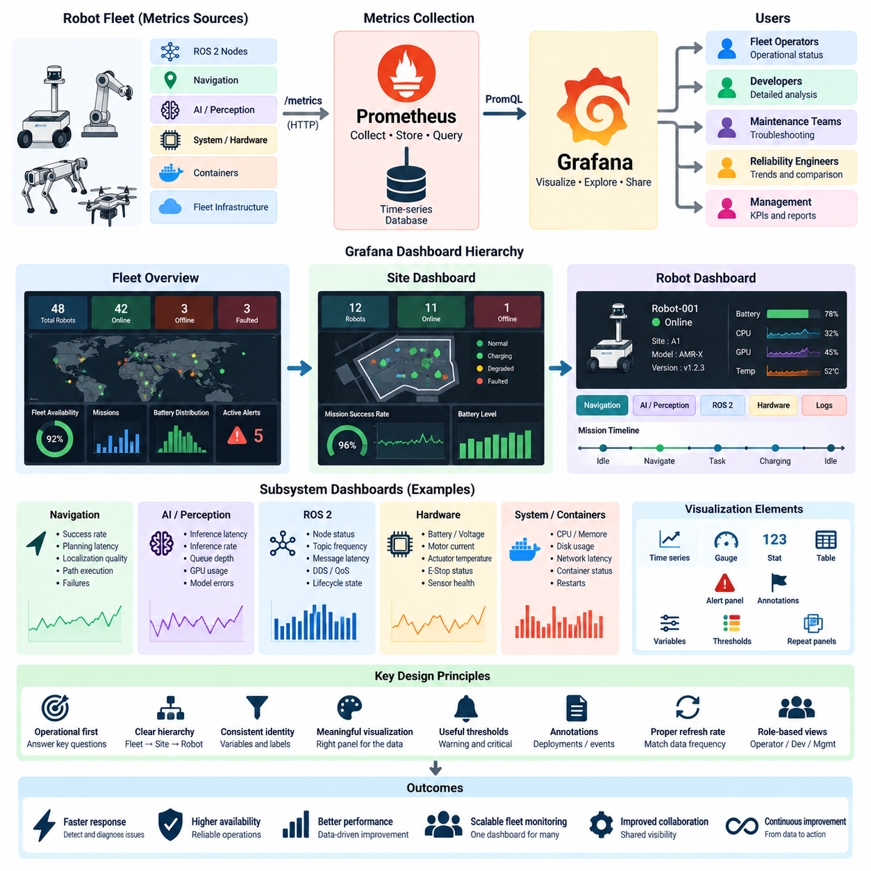
Grafana is a visualization and operational dashboard platform that transforms robot telemetry into views that engineers and fleet operators can interpret quickly. In a robot fleet, dashboards may combine infrastructure metrics, ROS 2 status, navigation performance, AI inference behavior, battery condition, mission progress, and fleet availability. The objective is not simply to display measurements, but to organize them into operational information that supports rapid understanding and decision-making.
A robot fleet dashboard should be designed around operational questions rather than around every metric available in the monitoring system. Operators typically need to know whether the fleet is healthy, which robots require attention, what subsystem is responsible, and whether a problem is isolated or widespread. Grafana panels should therefore create a hierarchy that moves from fleet-level indicators toward individual robots, software processes, computing resources, and detailed diagnostic measurements.
Grafana commonly receives robot metrics from time-series systems such as Prometheus. Prometheus collects measurements from ROS 2 nodes, operating systems, GPUs, containers, navigation components, AI services, and fleet infrastructure, while Grafana queries and visualizes those measurements. This separation allows metric collection and visualization to evolve independently and enables the same underlying telemetry to support multiple dashboards designed for developers, operators, maintenance teams, and management.
The highest-level dashboard should provide an immediate fleet overview. Useful indicators include the number of online and offline robots, fleet availability, active missions, completed and failed missions, robots requiring intervention, battery distribution, and current alerts. These indicators should answer whether operations are generally normal before presenting detailed technical information. Excessive detail at this level can obscure the operational state instead of clarifying it.
Dashboard hierarchy becomes especially important as fleets scale. A fleet overview can link to site-level dashboards, which can then link to individual robot dashboards and subsystem-specific views. This drill-down structure allows an operator to begin with an abnormal fleet indicator, identify the affected site or robot, and then inspect navigation, perception, compute, network, or hardware measurements without searching manually through unrelated telemetry.
Robot identity must remain consistent throughout the dashboard architecture. Variables and labels can allow users to filter views by robot ID, site, robot model, deployment group, hardware configuration, or software version. A dashboard designed in this way can represent many robots without creating a separate static dashboard for every unit. Template variables also allow engineers to reuse the same diagnostic structure across development systems, test fleets, and production deployments.
Status panels should emphasize information that requires rapid interpretation. A robot may be represented as available, busy, charging, disconnected, degraded, or faulted according to the fleet's operational state model. These states should originate from defined telemetry rather than subjective visual assumptions. Consistent status definitions are important because operators may otherwise interpret similar colors or labels differently across dashboards, reducing the reliability of operational decisions.
Time-series panels are useful for understanding how robot behavior changes over time. Battery state of charge, CPU and GPU utilization, temperature, memory usage, network latency, localization uncertainty, inference latency, topic frequency, and mission throughput can be plotted across selected intervals. Historical context allows engineers to distinguish temporary spikes from persistent degradation and to determine whether abnormal behavior began before or after a deployment, mission, or environmental change.
Navigation dashboards can combine mission success rates with planner latency, localization quality, path execution state, recovery behavior, and navigation failures. Fleet-level aggregation may reveal whether failures are concentrated at a particular site or software version, while robot-level views can expose the detailed behavior of an individual platform. This relationship between aggregated and detailed views is essential for moving efficiently from detection toward diagnosis.
AI and perception dashboards require measurements that reflect both model execution and computing resources. Useful signals include inference latency, inference frequency, queue depth, GPU utilization, GPU memory consumption, temperature, model errors, and model version. Monitoring only GPU utilization is insufficient because a model can produce degraded operational behavior even when hardware resources appear healthy. Model-level and infrastructure-level metrics should therefore be visualized together.
ROS 2 dashboards can provide visibility into node and communication health. Panels may show node availability, lifecycle state, topic publication frequency, message latency, subscriber or publisher presence, and selected DDS or QoS-related indicators. A decrease in sensor topic frequency, for example, can be correlated with navigation or perception degradation. Grafana therefore becomes a point where middleware behavior can be connected to application-level symptoms.
Hardware monitoring should extend the dashboard beyond computing infrastructure. Battery voltage and state of charge, motor current, actuator temperature, emergency-stop state, sensor health, communication faults, and other available hardware signals can provide important operational context. When physical and software measurements share timestamps and robot identifiers, engineers can investigate whether a software symptom corresponds to power limitations, thermal conditions, sensor degradation, or actuator problems.
Panel selection should match the semantic meaning of the data. Time-series charts are appropriate for trends, gauges can communicate bounded measurements such as battery charge, stat panels can highlight current values, and tables can summarize many robots simultaneously. A visualization should make the intended comparison obvious. Adding unnecessary panels, decorative graphics, or redundant representations increases cognitive load and can make critical abnormalities harder to identify.
Thresholds provide visual context but must be based on meaningful operating limits. CPU temperature, battery level, disk capacity, latency, or localization uncertainty may require warning and critical regions, but thresholds should reflect hardware characteristics and operational requirements rather than arbitrary values. Dynamic or robot-specific limits may be necessary when a fleet contains multiple hardware generations, payload configurations, computing platforms, or operating environments.
Color should reinforce operational meaning consistently. Normal, warning, critical, disconnected, and unknown states should use a stable visual convention across dashboards. However, color should not be the only carrier of information because operators may view dashboards on different displays or have difficulty distinguishing particular colors. Text, icons, state labels, and numerical values can provide redundant cues while maintaining rapid visual interpretation.
Grafana variables and repeated panels support scalable fleet monitoring. Selecting a site or robot can automatically update related queries and panels, while repeated structures can show comparable information for multiple units. This approach reduces dashboard duplication and helps maintain consistent operational views. Care is still required when displaying very large fleets because rendering hundreds of panels simultaneously can reduce readability and increase query load.
PromQL queries used by Grafana should perform aggregation at the appropriate level. Fleet dashboards may calculate availability ratios, mission failure rates, latency percentiles, or resource utilization across robot groups, while diagnostic dashboards preserve individual time series. Query design affects both interpretation and system performance. Expensive queries over high-cardinality metrics can slow dashboards, particularly when operators request long historical time ranges.
Dashboard refresh intervals should reflect operational requirements and data collection frequency. A rapidly changing robot status may justify frequent updates, whereas long-term reliability trends do not require second-by-second refreshes. Refreshing every panel faster than the underlying metrics are collected provides little additional information and can unnecessarily increase load on Grafana and its data sources. Different dashboards may therefore use different update strategies.
Annotations provide valuable context for interpreting telemetry. Software deployments, configuration changes, model updates, maintenance events, tests, and operational incidents can be marked on dashboard timelines. If navigation failures increase immediately after a release, a deployment annotation makes the relationship visible without requiring engineers to consult another system. Annotations connect DevOps activities with observable changes in physical robot behavior.
Alert information should be integrated with dashboards without turning the dashboard itself into an uncontrolled alarm surface. Operators should be able to see active alerts, affected robots, severity, duration, and related measurements, then navigate directly to diagnostic views. Dashboards provide context for alerts, while alerting rules determine when operational attention is required. Maintaining this separation helps prevent visual monitoring from becoming a substitute for structured incident management.
Different audiences require different dashboard views. Fleet operators need concise operational status and actionable exceptions, while developers may require detailed ROS 2, process, latency, and resource measurements. Reliability engineers may focus on failure trends and historical comparisons, while management may require availability and mission-level indicators. Reusing common telemetry while providing role-oriented dashboards prevents a single interface from becoming overloaded with incompatible levels of detail.
A mature Grafana architecture ultimately creates a navigable operational model of the robot fleet. Users should be able to move from fleet health to a site, from a site to a robot, and from that robot to navigation, AI, ROS 2, computing, network, or hardware diagnostics. When dashboard hierarchy, variables, PromQL queries, thresholds, annotations, refresh intervals, and alert context are designed coherently, Grafana becomes an effective interface between raw observability data and reliable robot fleet operations.

5.4. Distributed Tracing with Jaeger and OpenTelemetry [w/Code]
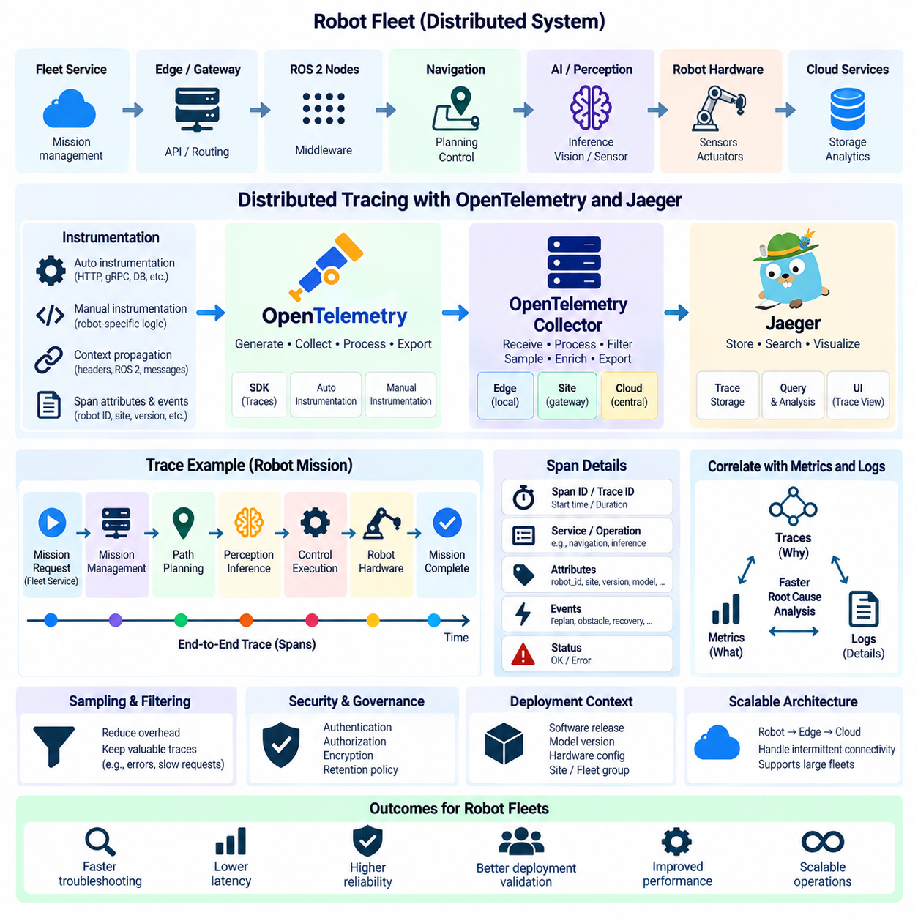
Distributed tracing provides a method for reconstructing how an operation travels through multiple software components in a robot system. Modern robots rarely execute a mission inside one process; commands may pass through fleet services, ROS 2 nodes, navigation modules, AI inference services, databases, edge computers, and cloud applications. Tracing connects these interactions into an end-to-end execution timeline, allowing engineers to identify where latency, errors, or unexpected behavior originated.
The fundamental unit of distributed tracing is the trace, which represents the complete execution path of one logical operation. A trace is composed of spans, where each span describes an individual unit of work such as receiving a mission request, calculating a route, performing inference, calling another service, or accessing a database. Parent-child relationships between spans reconstruct the sequence and concurrency of operations across distributed components.
Each trace normally carries a trace identifier that remains associated with the operation as it crosses process and service boundaries. Individual spans receive their own span identifiers and contain attributes such as start time, duration, service name, operation name, status, and contextual metadata. This shared identity is essential because timestamps alone are insufficient for reliably determining which events belong to the same robot mission or software transaction.
Trace context propagation transfers identifiers and related metadata between communicating components. When one service invokes another, the outgoing request carries enough context for the receiving component to create a related span. In conventional distributed applications this propagation commonly occurs through HTTP, gRPC, or messaging headers. Robotics requires similar propagation across middleware boundaries, ROS 2 communications, edge services, and fleet APIs when end-to-end correlation is required.
OpenTelemetry provides a vendor-neutral framework for generating, collecting, processing, and exporting telemetry. Its tracing APIs and software development kits allow applications to create spans without embedding dependencies on a specific tracing backend. This separation is valuable in robotics because ROS 2 applications, AI services, cloud components, and supporting infrastructure can use a common instrumentation model while the telemetry storage and analysis platform can evolve independently.
Instrumentation may be automatic or manual. Automatic instrumentation can capture supported frameworks, HTTP requests, gRPC calls, database operations, and other common software interactions with relatively little application modification. Manual instrumentation is required when engineers need traces that represent robotics-specific semantics such as mission execution, localization recovery, path planning, perception inference, docking, charging, manipulation, or safety-related state transitions.
Span design determines whether traces are operationally useful. Creating a span for every low-level function call can generate excessive telemetry while providing little diagnostic value. Instead, spans should represent meaningful boundaries in the robot workflow. A navigation trace might contain mission dispatch, goal acceptance, global planning, local planning, controller execution, recovery behavior, and completion spans, allowing engineers to understand the mission without exposing every internal calculation.
Span attributes provide the context needed to compare traces. Useful attributes may include robot identifier, site, software version, service name, mission type, navigation mode, model version, hardware platform, and deployment group. These dimensions allow engineers to search for traces associated with particular configurations or failures. Attributes should remain controlled because unrestricted high-cardinality metadata can significantly increase telemetry processing and storage requirements.
Events can be attached to spans when an important occurrence happens during an operation without requiring a separate span. A navigation span might record events for replanning, obstacle detection, recovery activation, or goal cancellation. Status information can indicate whether a span completed successfully or encountered an error. Together, span timing, attributes, events, and status create a structured explanation of how a distributed operation behaved.
The OpenTelemetry Collector provides an intermediate telemetry processing layer between instrumented robot applications and observability backends. Applications can export trace data to a collector, which can receive, process, batch, filter, sample, enrich, and forward telemetry. This architecture reduces direct dependencies between robot software and external monitoring systems and provides a centralized location for controlling telemetry behavior before data leaves the robot or edge environment.
Collectors can be deployed at several levels of a robotics infrastructure. A collector may run directly on an edge computer, at a site gateway, inside a Kubernetes cluster, or within centralized infrastructure. Robot-local or site-local collectors are particularly useful when connectivity is intermittent because they can aggregate telemetry close to its source and reduce the number of direct connections between individual applications and remote observability services.
Jaeger provides a distributed tracing backend and user interface for storing, searching, and analyzing trace information. Engineers can search traces using service names, operation names, durations, tags, and other available metadata, then inspect individual traces as timelines of related spans. The resulting visualization makes it possible to identify slow operations, failed dependencies, unusual execution paths, and components that contribute disproportionately to end-to-end latency.
A robot mission can illustrate the relationship between OpenTelemetry and Jaeger. A fleet service creates the initial mission span and propagates trace context toward the robot. Mission management, navigation, planning, perception, and supporting services create additional spans as the operation progresses. OpenTelemetry instrumentation and collectors transport this telemetry, while Jaeger reconstructs and presents the resulting trace for investigation.
Tracing is particularly useful for latency analysis because total execution time can be decomposed across multiple components. If a navigation request requires several seconds, a trace may reveal whether time was consumed by communication, global planning, perception inference, map access, local planning, or another dependency. Engineers can therefore investigate the critical execution path instead of optimizing a component simply because its resource utilization appears high.
Distributed tracing also supports failure analysis. A mission failure may appear at the fleet management layer even though its actual cause occurred deeper inside the robot stack. A trace can show that planning called a localization service, localization reported degraded confidence, a recovery behavior was triggered, and the navigation operation eventually failed. The relationship between these events becomes visible without manually aligning independent logs from multiple processes.
ROS 2 creates special tracing challenges because communication is mediated by publishers, subscribers, services, actions, executors, and DDS. Trace context does not automatically represent every robotics-level relationship unless instrumentation is designed to preserve it. Engineers must determine which communication paths require end-to-end correlation and where spans should represent ROS 2 operations without creating excessive overhead in high-frequency message pipelines.
High-frequency sensor and control paths require particular caution. Creating and exporting a detailed span for every camera frame, LiDAR message, IMU sample, or control-loop iteration can produce enormous telemetry volumes and may interfere with real-time workloads. Tracing should therefore focus on diagnostically meaningful operations, while sampling, filtering, and aggregation are used to limit overhead. Detailed sensor data belongs in specialized recording systems rather than general-purpose distributed traces.
Sampling controls how many traces are retained or exported. Head-based sampling makes a decision near the beginning of an operation, while more advanced processing can preserve traces based on characteristics observed later, such as errors or unusually long durations. For robot fleets, sampling strategies should retain diagnostically valuable abnormal operations while reducing routine successful traces that provide little additional information.
Tracing becomes significantly more useful when correlated with metrics and logs. Metrics may reveal that navigation latency increased across a fleet, traces can identify the execution stage responsible for the increase, and logs can provide detailed error messages from the affected component. Shared robot identifiers, service names, software versions, timestamps, trace identifiers, and span identifiers allow engineers to move between these observability signals during root-cause analysis.
Deployment metadata should also be incorporated into trace analysis. Software releases, AI model versions, hardware configurations, sites, and robot groups can explain why execution paths differ across a fleet. If traces from one software release consistently show increased planning duration, engineers gain quantitative evidence of a possible regression. Tracing therefore contributes not only to incident investigation but also to deployment validation and performance engineering.
Trace data can expose sensitive architectural and operational information, including service relationships, robot identities, internal endpoints, execution patterns, and error details. Collection pipelines should therefore apply appropriate authentication, authorization, encryption, access control, and retention policies. Attributes should avoid unnecessary secrets or personally identifiable information, and telemetry infrastructure should be treated as part of the production security boundary.
The operational objective of distributed tracing is not to trace every internal operation, but to make important robot workflows explainable across component boundaries. OpenTelemetry provides standardized instrumentation and telemetry transport, while Jaeger provides trace-oriented storage, search, and visualization capabilities. Combined with metrics and logs, distributed tracing enables engineers to move from a fleet-level symptom to the precise execution path that produced it.
In a mature robotics observability architecture, traces connect cloud services, fleet management, edge computing, ROS 2 applications, AI workloads, and selected hardware-facing operations into coherent operational narratives. Careful context propagation, meaningful span boundaries, controlled attributes, appropriate sampling, and correlation with other telemetry make tracing scalable. This capability becomes increasingly important as robot software evolves from individual machines toward distributed, heterogeneous, and large-scale autonomous fleets.

5.5. Centralized Log Aggregation ELK Loki for Robot Fleets [w/Code]
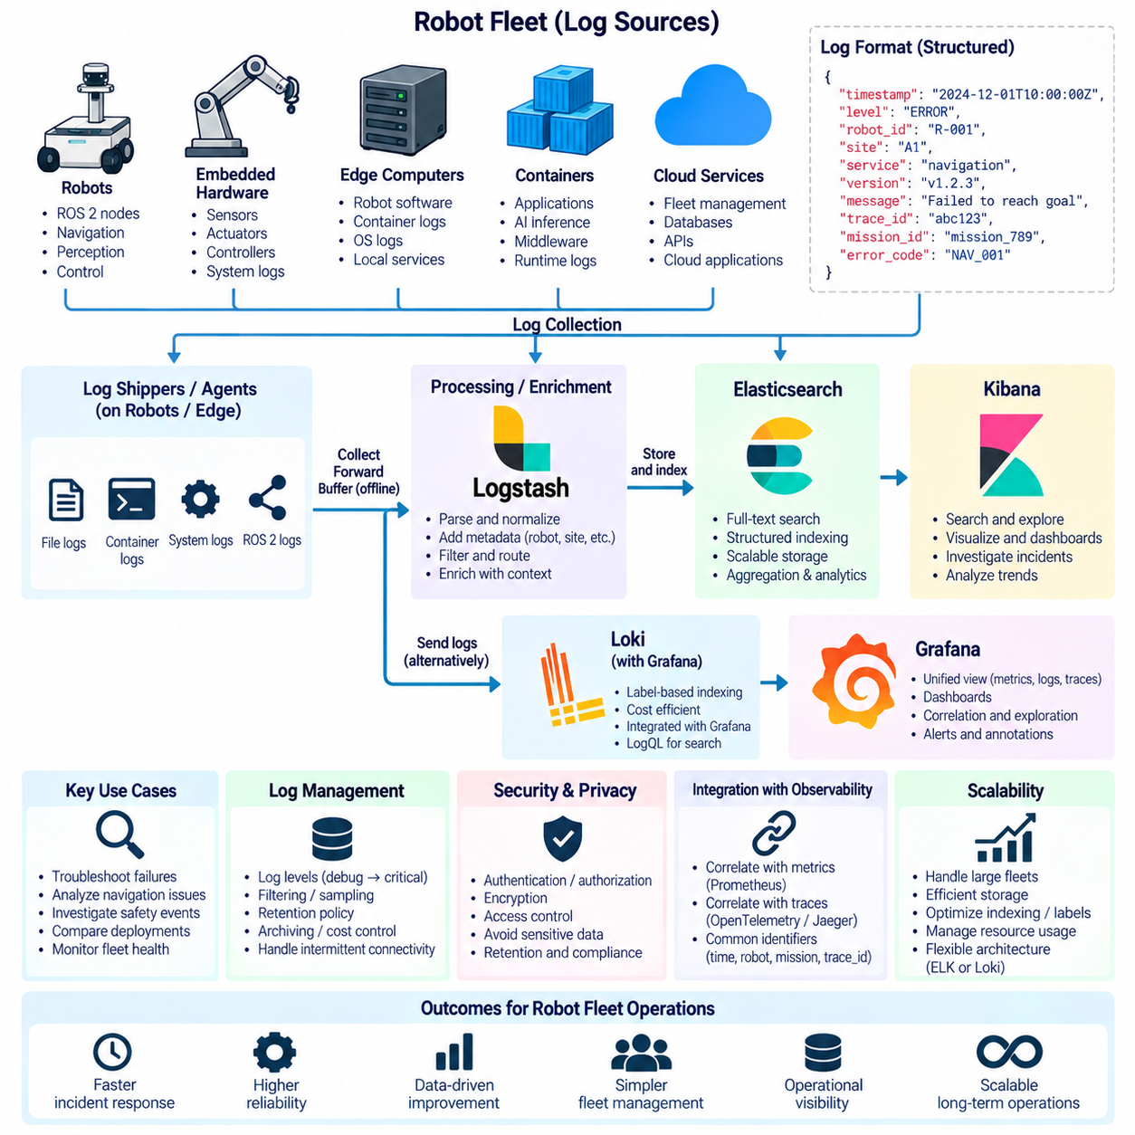
Centralized log aggregation is the practice of collecting logs generated by distributed robot software, computing platforms, and fleet services into a unified system for storage, search, analysis, and operational investigation. A robot fleet can generate logs from ROS 2 nodes, navigation modules, AI inference services, operating systems, containers, embedded controllers, edge computers, and cloud services. Centralization allows engineers to investigate these sources together rather than accessing each robot individually.
Logging is particularly important in robotics because failures frequently emerge from interactions between software and the physical environment. A navigation failure may involve localization uncertainty, sensor degradation, network interruption, planner errors, or actuator conditions. If these events are recorded independently on different devices, reconstructing the incident becomes difficult. Centralized logging creates a common chronological record that helps engineers connect related events across components and robots.
A useful robot log should contain more than a human-readable message. Structured fields can include timestamp, severity, robot identifier, site, software component, software version, process or container identity, event type, error code, and contextual information. When appropriate, trace identifiers and mission identifiers can also be recorded. Consistent metadata transforms logs from isolated text messages into searchable operational data that can be correlated across a fleet.
Structured logging commonly represents records in formats such as JSON so that fields can be processed independently. Instead of embedding every detail inside an unstructured sentence, the application can explicitly represent attributes such as `robot_id`, `node`, `severity`, `version`, and `error_code`. This approach improves filtering and aggregation and allows queries to identify patterns such as repeated failures associated with a particular robot model, deployment site, or software release.
An ELK-based architecture combines Elasticsearch, Logstash, and Kibana to provide centralized log processing and analysis. Logstash receives or processes log records, transforms and enriches them, and forwards them toward storage. Elasticsearch indexes the resulting documents for search and aggregation, while Kibana provides interfaces for querying, visualizing, and exploring the stored data. Additional lightweight log shippers can collect logs close to robot or edge applications before forwarding them into the pipeline.
Elasticsearch provides powerful full-text search and structured-field analysis, making the ELK approach useful when operators require extensive investigation across large collections of heterogeneous logs. Engineers can search error messages, filter events by robot or service, aggregate failures by software version, and analyze patterns across time. This flexibility can provide substantial diagnostic value, although indexing large volumes of detailed robot logs can require significant computing and storage resources.
Logstash acts as a processing stage that can normalize records arriving from different software stacks. A fleet may contain ROS 2 applications, system services, container logs, AI processes, and legacy software that generate different formats. Processing rules can parse messages, add robot or site metadata, normalize severity fields, remove unnecessary information, and route records toward appropriate destinations. Consistent normalization makes fleet-wide analysis substantially easier.
Kibana provides the exploration and visualization layer commonly associated with Elasticsearch deployments. Engineers can inspect individual events, build searches around error conditions, visualize event frequency, and create dashboards for recurring operational investigations. A developer diagnosing a navigation regression, for example, can filter logs by software version and robot group and then compare error patterns before and after a deployment.
Loki follows a different design philosophy that is closely integrated with the Grafana ecosystem. Instead of extensively indexing the complete contents of every log record, Loki emphasizes indexing a controlled set of labels while storing log content separately. Labels can identify dimensions such as robot, site, application, namespace, service, or deployment environment. This design can reduce indexing overhead when compared with architectures that create searchable indexes over large portions of log content.
The labeling strategy in Loki must be carefully controlled. Stable dimensions such as service name, site, environment, or bounded robot groups can be useful labels, while highly dynamic values such as timestamps, unique request identifiers, arbitrary error messages, or continuously changing identifiers can produce excessive cardinality. Detailed information can remain inside the log record and be filtered during queries instead of becoming an indexed label.
LogQL provides a query language for searching and analyzing logs stored in Loki. Operators can select streams through labels and then filter or parse their contents to locate relevant events. This makes Loki particularly useful when Grafana already provides dashboards for Prometheus metrics because operators can move between quantitative metrics and corresponding log streams within a common operational interface.
Robot-side log collection requires lightweight agents that can gather information from multiple sources. Depending on the architecture, collectors may read application files, container output, operating-system journals, or standardized log streams. A local agent can attach metadata and forward records toward an edge gateway or centralized backend. The collection layer should minimize resource consumption because CPU, memory, storage, and network bandwidth on mobile robots may be constrained.
ROS 2 logging requires consistent treatment of node identity and runtime context. Messages should identify the originating node and severity and, where useful, include namespace, robot identity, software version, mission context, or lifecycle state. Logs from navigation, perception, localization, hardware interfaces, and safety components can then be searched together. Consistent conventions are especially important when the same ROS 2 package runs simultaneously across many robots.
Containerized deployments add another source of logs and metadata. Containers may restart, migrate, or be replaced during software updates, making static host-based identifiers insufficient for long-term investigation. Log records should preserve useful application and deployment context such as service name, container identity, image version, robot identifier, and environment. This enables engineers to distinguish application failures from container lifecycle or orchestration problems.
Connectivity is a major design constraint for centralized robot logging. Mobile robots can temporarily lose communication while moving through warehouses, elevators, outdoor environments, or wireless coverage boundaries. Log agents should therefore tolerate intermittent connections through buffering or local persistence where appropriate. When connectivity returns, queued records can be forwarded while respecting available bandwidth and avoiding disruption to safety-critical or mission-critical communication.
Not every log deserves identical transmission and retention treatment. Critical safety events, mission failures, hardware faults, deployment errors, and security events may require reliable retention, whereas repetitive debugging messages may be filtered, sampled, rate-limited, or stored for shorter periods. Log levels such as debug, information, warning, error, and critical should be applied consistently so collection policies can distinguish operationally important information from diagnostic noise.
Large robot fleets can generate enormous logging volumes, making cost control an architectural requirement rather than an optimization performed later. Excessive debug logging increases robot-side storage, network traffic, ingestion load, indexing cost, and backend capacity requirements. Retention periods, compression, filtering, sampling, archival policies, and log-level controls should therefore be designed according to operational value and investigation requirements.
ELK and Loki represent different architectural tradeoffs rather than a universal winner. ELK is well suited to rich document indexing, flexible full-text investigation, and complex analysis of heterogeneous records. Loki emphasizes label-based organization and close integration with Grafana, making it attractive for observability environments where metrics and logs are investigated together. The appropriate architecture depends on query requirements, telemetry volume, operational complexity, infrastructure resources, and retention strategy.
Metrics, logs, and traces become substantially more powerful when they share correlation information. Prometheus may reveal an increase in navigation failures, Grafana can identify the affected robots, centralized logs can expose detailed error events, and distributed traces can reconstruct the execution path surrounding the failure. Shared timestamps, robot identifiers, software versions, mission identifiers, and trace identifiers allow engineers to move efficiently between these observability signals.
Security and privacy requirements apply to centralized logs because records may expose internal network information, robot identifiers, software versions, operational locations, service relationships, or application data. Collection and storage pipelines should use appropriate authentication, authorization, encryption, access control, and retention policies. Applications should also avoid recording secrets, credentials, tokens, or unnecessary sensitive information in log messages.
A mature centralized logging architecture creates a searchable operational history of the robot fleet. Engineers can begin with an alert or abnormal metric, identify the affected robot and time interval, inspect relevant logs, correlate them with traces, and compare similar incidents across deployments. This transforms logging from local debugging output into a fleet-scale reliability tool supporting incident response, regression analysis, maintenance, and continuous software improvement.
The ultimate objective is not to preserve every message indefinitely but to retain the information required to explain robot behavior. ELK provides a powerful indexed search and analytics architecture, while Loki offers a label-oriented logging model closely aligned with Grafana-based observability. When structured logging, metadata conventions, edge collection, connectivity handling, retention, cost control, and telemetry correlation are designed together, centralized logs become a fundamental component of scalable robot fleet operations.

5.6. ROS2 Node Health and Topic Frequency Monitoring [w/Code]
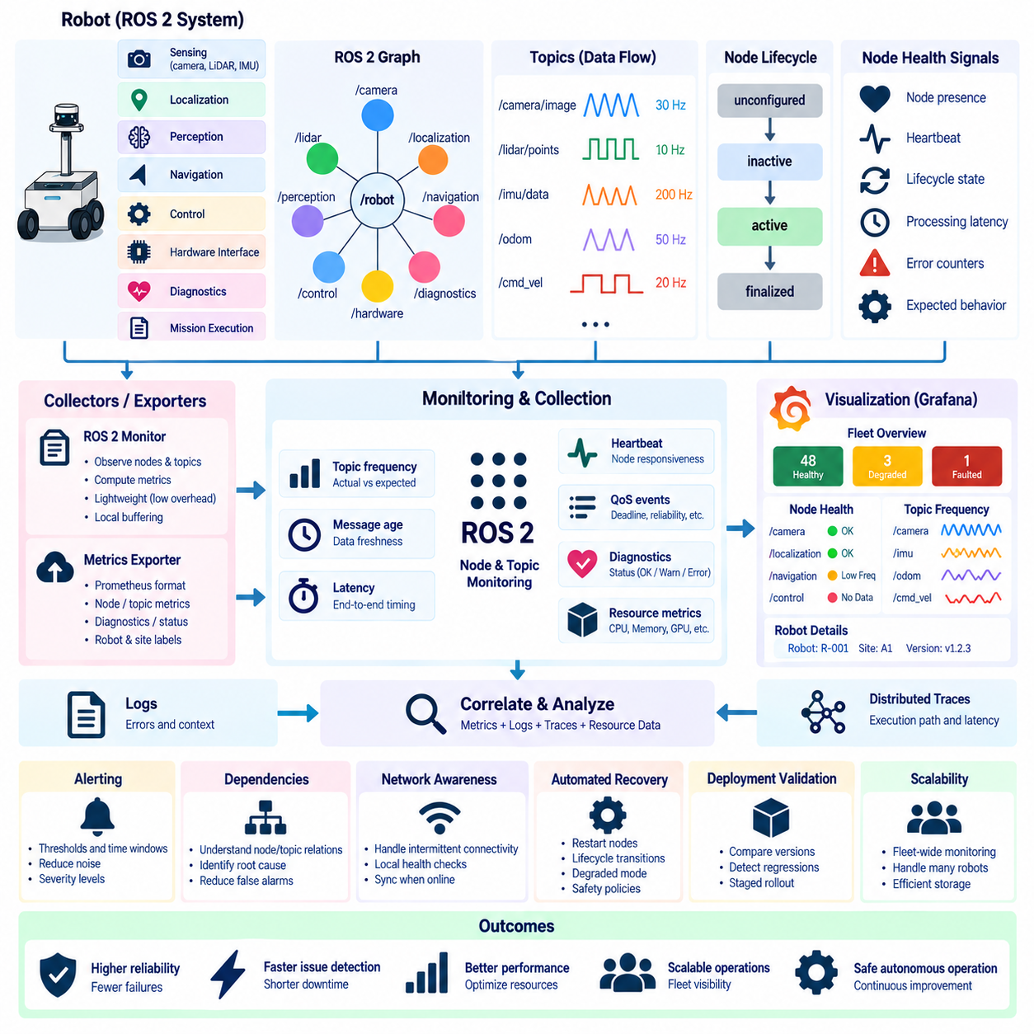
ROS 2 node health monitoring provides continuous visibility into whether the software components responsible for robot behavior are present, responsive, and operating in their expected states. A robot may contain nodes for sensing, localization, perception, navigation, control, hardware interfaces, diagnostics, and mission execution. Monitoring these nodes helps engineers distinguish a software component failure from broader communication, computing, or physical-system problems.
Node presence is the most basic health signal, but presence alone does not guarantee correct operation. A node may remain visible in the ROS 2 graph while its processing loop is stalled, callbacks are delayed, or required data is no longer being produced. Effective health monitoring therefore combines graph-level discovery with application-level signals such as heartbeat messages, lifecycle states, processing latency, error counters, and expected communication behavior.
Lifecycle nodes provide explicit operational states that can improve health interpretation. A managed node may transition through unconfigured, inactive, active, and finalized states, with intermediate transition behavior determining whether the component is ready for operation. Monitoring lifecycle state allows a supervisory system to distinguish a deliberately inactive component from one that unexpectedly failed to activate or transitioned into an undesired state during runtime.
Heartbeat mechanisms provide another method for confirming that a node remains responsive. A node can periodically publish a lightweight status signal containing its identity, timestamp, operational state, and selected diagnostic information. Monitoring software can detect when expected heartbeats stop arriving within a defined interval. Heartbeats are especially useful for critical components whose process existence alone does not indicate whether their internal execution is progressing normally.
Topic frequency is a fundamental ROS 2 health indicator because many robot functions depend on data arriving at predictable rates. Cameras, LiDARs, IMUs, odometry sources, localization systems, planners, and controllers normally publish within characteristic frequency ranges. A significant reduction or complete loss of topic frequency may indicate sensor failure, CPU saturation, blocked callbacks, network congestion, middleware problems, or upstream node failure.
Frequency monitoring should compare observed publication behavior with expected operating ranges rather than assuming one universal threshold. A camera intended to publish at 30 Hz has different requirements from a global planner publishing only when replanning is required. Continuous sensor streams can be evaluated against nominal frequencies, while event-driven topics require monitoring rules based on their semantics. Correct interpretation therefore depends on understanding the expected behavior of each topic.
Topic monitoring should also consider message age and freshness. A topic can appear active while delivering delayed information that is no longer suitable for control or perception. Comparing message timestamps with the receiving system's current time can expose stale sensor data, buffering delays, synchronization problems, or overloaded processing pipelines. For autonomous robots, data freshness may be more operationally important than publication frequency alone.
Latency measurements complement frequency and freshness monitoring by describing how long information takes to move through the software stack. Engineers may measure transport latency between publisher and subscriber or application-level latency across perception, localization, planning, and control stages. Increasing latency can reveal resource contention or scheduling problems before a complete failure occurs, making it a useful indicator of gradual system degradation.
ROS 2 communication depends on DDS discovery and Quality of Service settings, so node and topic health cannot always be interpreted purely at the application level. A publisher and subscriber may both be running while communication fails because of incompatible QoS policies, discovery problems, network segmentation, or middleware configuration. Monitoring should therefore preserve enough communication context to distinguish missing applications from connectivity and configuration failures.
QoS characteristics such as reliability, durability, history, and deadline behavior can influence what constitutes healthy communication. Deadline policies are particularly relevant because they can express expectations about how frequently data should be produced or received. Missed deadline events can become useful diagnostic signals when timing expectations are explicitly configured. These middleware-level signals can complement independent frequency measurements performed by monitoring components.
ROS 2 diagnostics can provide structured health information beyond raw logs. Hardware drivers and software components can publish diagnostic status describing normal, warning, error, or stale conditions together with key-value metadata. Aggregating these diagnostics creates a standardized mechanism for representing sensor faults, actuator problems, communication failures, temperature conditions, or application degradation without requiring operators to interpret arbitrary textual messages.
A monitoring architecture should associate every signal with consistent robot and component identities. Node names, namespaces, topic names, robot identifiers, site identifiers, software versions, and hardware configurations provide the context required for fleet-level analysis. Namespaces become particularly important when identical software stacks run on many robots because monitoring infrastructure must distinguish equivalent nodes and topics belonging to different physical platforms.
Metrics exporters can translate ROS 2 health information into time-series measurements suitable for systems such as Prometheus. Node availability may be represented as a binary or state metric, topic frequency as a gauge, missed deadlines as counters, and callback or message latency as histograms. Once exported, these measurements can be queried across individual robots or entire fleets and visualized through dashboards such as Grafana.
A fleet dashboard can summarize node and topic health without exposing every measurement simultaneously. Operators may first see the number of healthy, degraded, disconnected, or faulted robots and then drill down into the affected platform. Robot-level dashboards can show missing nodes, abnormal lifecycle states, low-frequency topics, stale messages, latency increases, and communication errors, allowing investigation to proceed from fleet symptoms toward specific ROS 2 components.
Alerting rules should distinguish transient variation from sustained failures. Wireless congestion or temporary CPU load can briefly reduce topic frequency without creating an operational incident. Alerts can therefore use time windows, persistence conditions, and severity levels so that short deviations generate limited noise while prolonged data loss or failure of safety-critical nodes produces immediate attention. Different topics should use thresholds appropriate to their operational importance.
Dependencies between nodes and topics should also be considered when diagnosing failures. If a camera driver stops publishing, downstream perception and navigation components may generate secondary errors even though they are functioning correctly. A monitoring system that understands these relationships can identify the upstream loss of sensor data as the probable initiating event rather than presenting every downstream symptom as an independent failure.
Resource metrics provide additional context for ROS 2 health. CPU saturation, memory pressure, GPU overload, disk exhaustion, thermal throttling, or network congestion may cause nodes to miss deadlines or reduce publication frequency. Correlating ROS 2 measurements with host and container metrics helps engineers determine whether degradation originates inside application logic or results from insufficient computing and communication resources.
Logs and distributed traces further strengthen node-health diagnosis. A metric may show that localization frequency dropped below its expected range, centralized logs may reveal repeated sensor timeout messages, and a trace may show increased processing latency before the degradation. Shared timestamps, robot identifiers, node names, software versions, and trace context make it possible to correlate these signals during root-cause analysis.
Monitoring itself must impose limited overhead on robot execution. High-frequency topics such as camera images, LiDAR point clouds, IMU measurements, and control commands should not be duplicated or fully transmitted merely for health analysis. Monitoring components can calculate frequency, age, latency, counters, and statistical summaries locally, then export compact metrics. This preserves observability without consuming excessive CPU, memory, storage, or network bandwidth.
Intermittent connectivity requires local health evaluation because a robot may remain operational even when its connection to central monitoring infrastructure is temporarily unavailable. Robot-side supervisors can continue checking critical nodes and topics, store recent diagnostic information, and trigger local recovery or safety behavior where appropriate. Once communication is restored, summarized telemetry and important events can be forwarded for fleet-level analysis.
Health monitoring also supports automated recovery when carefully integrated with robot supervision. A failed noncritical node may be restarted, a lifecycle node may be transitioned through a controlled recovery sequence, or a subsystem may enter a degraded operating mode. Recovery policies should distinguish between faults that can be safely handled automatically and conditions requiring the robot to stop or request human intervention.
Software deployment introduces another important use case for node and topic monitoring. After a new ROS 2 release is deployed, fleet telemetry can reveal whether node availability, topic frequency, latency, or communication errors changed relative to previous versions. Comparing these indicators across deployment groups supports regression detection and staged rollout validation before a software problem propagates throughout the entire fleet.
The objective of ROS 2 health monitoring is therefore not merely to verify that processes exist, but to determine whether the robot communication graph is functioning as intended. Node state, heartbeat signals, topic frequency, message freshness, latency, QoS behavior, diagnostics, and computing resources provide complementary evidence. Together they create a practical operational model of the software stack from individual ROS 2 components to fleet-wide behavior.
In a mature robotics observability architecture, ROS 2 health information becomes part of the same telemetry environment as infrastructure metrics, centralized logs, and distributed traces. Engineers can begin with a fleet-level alert, identify a robot with abnormal topic behavior, inspect the responsible node, correlate resource and diagnostic information, and trace the failure toward its origin. This integrated approach supports reliable, scalable, and continuously improving robot fleet operations.

5.7. Alerting Rules and On Call Runbooks for Robot Ops
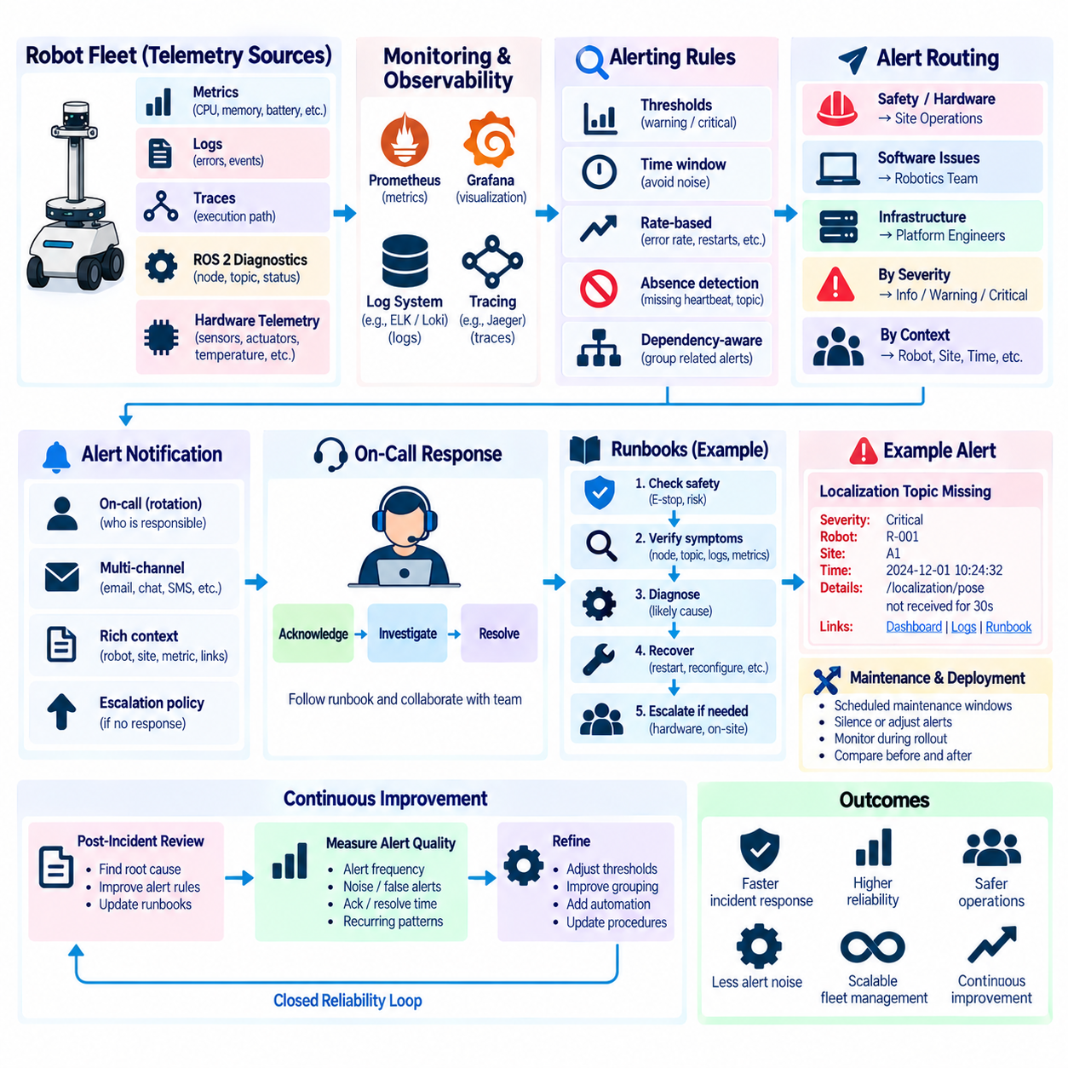
Alerting in robot operations converts observability signals into actionable notifications when a robot, subsystem, or fleet enters a condition that requires attention. Metrics, logs, traces, ROS 2 diagnostics, and hardware telemetry may expose thousands of changing values, but operators cannot continuously inspect them all. Alerting rules identify meaningful abnormal conditions and route them toward people or automated systems that can respond before operational degradation becomes a prolonged failure.
A useful alert represents an operational condition rather than a raw measurement crossing an arbitrary threshold. High CPU utilization alone may not require intervention, while sustained CPU saturation accompanied by increasing navigation latency can indicate a real service risk. Robot alert design should therefore connect technical signals to consequences such as mission interruption, reduced autonomy, unavailable sensors, unsafe operating states, communication loss, or inability to complete assigned work.
Alert severity should reflect the required response rather than simply the magnitude of a metric. Informational events may require recording but no immediate action, warnings may indicate developing degradation, and critical alerts may require rapid operator intervention. A safety-related controller failure, emergency-stop condition, or loss of essential localization can demand a different response from a temporary increase in GPU utilization or a brief reduction in wireless signal quality.
Thresholds should be derived from expected operating ranges, hardware limits, software requirements, and service objectives. Battery state, actuator temperature, disk capacity, inference latency, localization uncertainty, and topic frequency may each require different warning and critical boundaries. A heterogeneous fleet may also require thresholds that vary according to robot model, hardware generation, payload, mission type, software version, or operating environment.
Time windows and persistence conditions are essential for reducing alert noise. Mobile robots frequently experience short-lived variations caused by wireless transitions, temporary computational load, obstacle avoidance, charging transitions, or environmental changes. Triggering an alert for every brief deviation creates unnecessary notifications. Rules can instead require a condition to persist for a defined duration or occur repeatedly within a window before escalation.
Rate-based alerts are useful when individual events are normal but increasing frequency indicates degradation. A single navigation recovery, dropped message, sensor timeout, or container restart may not represent a serious incident. A rapidly increasing rate of these events can reveal an emerging problem. Counters collected through systems such as Prometheus can therefore be transformed into rates that better represent changing operational reliability.
Absence is itself an important alert condition in distributed robot systems. A missing heartbeat, disappearing ROS 2 node, stopped sensor topic, unavailable metrics endpoint, or silent robot can indicate failure even when no explicit error has been reported. Monitoring systems should therefore detect expected signals that stop arriving. This is particularly important because severe failures may prevent the affected component from producing its own final error message.
Alert rules should understand dependencies where possible. If a LiDAR driver fails, localization, perception, and navigation may all report secondary problems. Generating separate high-severity alerts for every downstream symptom can overwhelm the operator and hide the initiating fault. Dependency-aware alerting groups related symptoms or emphasizes the upstream failure, helping responders focus on the condition most likely to explain the broader incident.
Fleet-scale alerting requires aggregation because hundreds of robots can experience related failures simultaneously. A software regression may cause the same navigation error across an entire deployment group, while a site network outage may disconnect many robots at once. Instead of generating an independent page for every affected robot, alerting infrastructure can group incidents by site, software version, subsystem, or probable shared cause while preserving access to individual robot details.
Alert routing determines who receives each notification and through which operational channel. Safety-critical hardware faults may be routed immediately to site operations, while software regressions may require the robotics software team and infrastructure failures may belong to platform engineers. Routing policies should reflect ownership, severity, location, time of day, and escalation requirements so that alerts reach responders capable of taking meaningful action.
On-call operation provides a defined human response path when automated systems cannot resolve an incident safely. An on-call rotation identifies who is responsible for receiving urgent notifications during a given period and how responsibility transfers between team members. For robot fleets, the rotation may involve software engineers, fleet operators, site personnel, or hardware specialists depending on the operational model and the types of failures that require intervention.
An alert should contain enough context for the responder to begin investigation without first reconstructing basic information. Useful fields include robot or fleet identifier, site, severity, affected subsystem, start time, current state, software version, relevant metric values, and links or references to diagnostic dashboards and logs. Clear alert descriptions reduce the time between notification and useful investigation, particularly when the responder is unfamiliar with the affected robot.
Runbooks convert operational knowledge into repeatable response procedures. A runbook describes how to verify an alert, gather diagnostic evidence, determine likely causes, apply safe recovery actions, escalate when necessary, and confirm that service has returned to normal. The objective is not to replace engineering judgment but to prevent responders from rediscovering the same troubleshooting process during every incident.
Robot runbooks should begin with operational safety. Before restarting software, moving actuators, clearing faults, or returning a robot to autonomous operation, the responder must understand whether the action could create physical motion or affect nearby people and equipment. Procedures should clearly distinguish remote software actions from steps requiring local inspection, physical isolation, emergency-stop verification, or authorized site personnel.
A runbook for a missing ROS 2 sensor topic, for example, can guide the responder through checking node presence, lifecycle state, heartbeat, expected topic frequency, DDS communication, device connectivity, host resources, and relevant logs. If the problem cannot be resolved through approved software recovery, the procedure can escalate toward hardware inspection. This creates a consistent path from observable symptom to progressively deeper diagnosis.
Automated remediation can be integrated with alerting when recovery actions are predictable and safe. A noncritical service may be restarted after repeated failures, a lifecycle node may be reactivated, or a robot may enter a controlled degraded mode when a redundant sensor becomes unavailable. Automation should use explicit limits and escalation conditions so repeated recovery attempts do not hide persistent faults or create uncontrolled restart loops.
Escalation policies define what happens when the first responder cannot resolve an incident or when severity increases. An unresolved software problem may move from fleet operations to a robotics engineer, while suspected hardware damage may require site maintenance. Safety-related conditions may require immediate escalation regardless of duration. Clear escalation paths prevent incidents from remaining indefinitely with responders who lack the authority or expertise to resolve them.
Alert acknowledgement and incident ownership are necessary to avoid duplicate or conflicting responses. Once a responder accepts an incident, other team members should be able to see that ownership has been established. If the responder does not acknowledge the alert within the expected interval, escalation can transfer responsibility. This process becomes increasingly important when robot fleets operate continuously across multiple sites or time zones.
Maintenance windows and deployment activities should be reflected in alert behavior. Planned robot shutdowns, software upgrades, sensor calibration, charging maintenance, or site network work can intentionally create conditions that would otherwise trigger alerts. Temporary silencing or maintenance-aware routing prevents unnecessary pages while preserving visibility into unexpected failures that occur outside the planned scope.
Observability correlation accelerates incident response. An alert may originate from a Prometheus metric, Grafana can show the affected robot and historical trend, centralized logs can provide detailed error messages, and distributed traces can reveal the execution path around the failure. Consistent timestamps, robot identifiers, mission identifiers, software versions, and deployment metadata allow responders to move between these signals without repeatedly reconstructing context.
Alert quality should itself be measured. Useful operational metrics include alert frequency, duplicate-alert rate, acknowledgement time, resolution time, escalation frequency, recurring incident patterns, and alerts that repeatedly require no action. These measurements reveal noisy rules, missing automation opportunities, ineffective thresholds, and weak runbooks. Alerting systems therefore require continuous improvement just like the robot software they monitor.
Post-incident review can feed directly back into alert rules and runbooks. If an incident was detected too late, additional signals or earlier thresholds may be required. If responders spent significant time identifying a known failure mode, the runbook can be improved. If multiple alerts described one root cause, grouping logic may need refinement. Operational experience progressively converts previously unexpected failures into known and manageable conditions.
Software deployments should also interact with alerting strategy. During staged rollout, alerts can compare navigation failures, node health, inference latency, resource consumption, and mission success between deployment groups. A significant degradation after a release can trigger investigation or halt further rollout. This connects observability and incident response directly to continuous delivery and reduces the risk of propagating defects throughout a fleet.
The goal of robot alerting is not to maximize the number of notifications but to minimize the time between meaningful failure detection and safe recovery. Well-designed rules identify actionable conditions, suppress transient noise, account for dependencies, and provide sufficient context. On-call ownership ensures that important incidents reach responsible people, while runbooks transform accumulated operational experience into repeatable and safer response procedures.
In a mature robot operations environment, alerting, on-call processes, and runbooks form a closed reliability loop. Telemetry detects abnormal behavior, alert rules determine operational significance, responders or automation execute controlled recovery, and incident outcomes improve future monitoring and procedures. This loop enables robot fleets to evolve from reactive troubleshooting toward disciplined, scalable, and continuously improving operational reliability.

5.8. SLI SLO SLA Definition for Robot Fleet Services
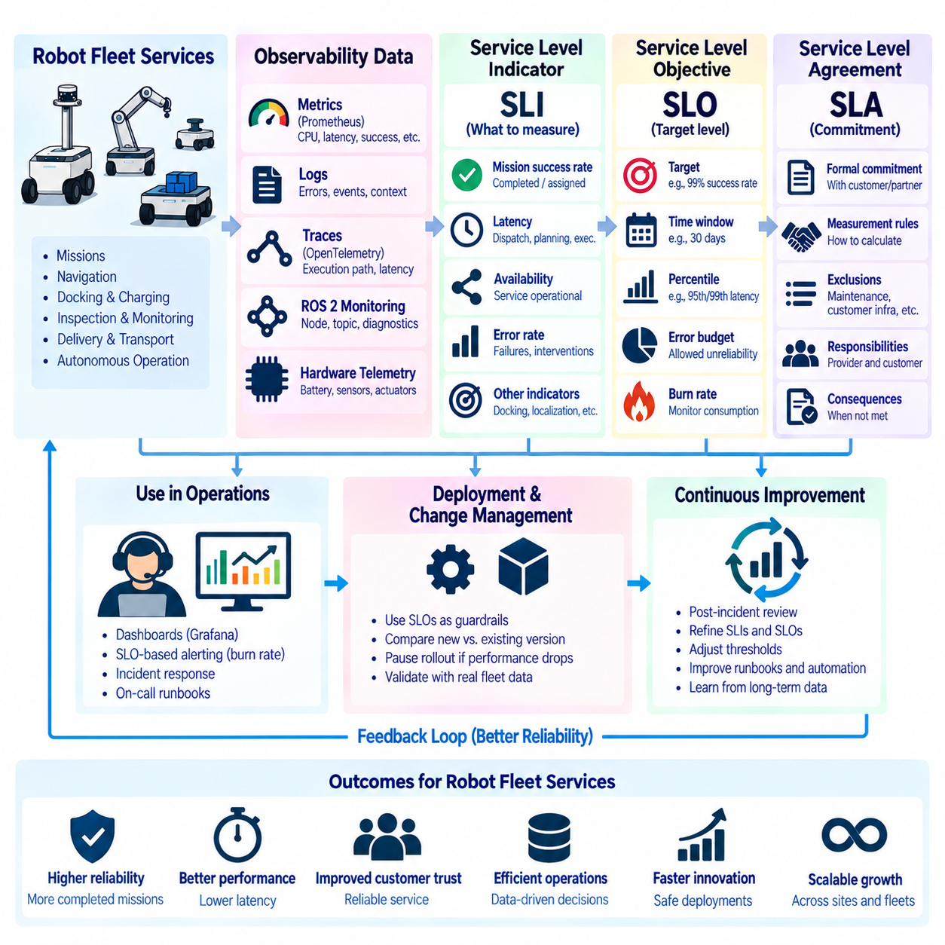
Service reliability for robot fleets requires explicit definitions of what should be measured, what level of performance is considered acceptable, and what commitments are made to users or customers. Service Level Indicators (SLIs), Service Level Objectives (SLOs), and Service Level Agreements (SLAs) provide a structured framework for expressing these concepts. In robotics, they must represent both conventional software services and the physical outcomes produced by autonomous machines.
A Service Level Indicator (SLI) is a quantitative measurement describing an aspect of service behavior. Traditional distributed systems commonly measure availability, latency, throughput, and error rates. Robot fleet services extend this concept toward mission completion, navigation reliability, localization quality, docking performance, command response, telemetry delivery, and robot connectivity. An effective SLI converts operational behavior into a measurable signal that can be evaluated over time.
SLIs should represent outcomes that matter to the operation rather than metrics that are merely easy to collect. CPU utilization, memory consumption, and network traffic are valuable diagnostic measurements, but they do not directly describe whether a fleet is delivering its intended service. Mission success rate, autonomous operation availability, dispatch latency, successful docking rate, and time required to recover from operational faults can provide stronger representations of service quality.
An SLI requires a precise definition of successful and unsuccessful events. Mission success, for example, might require that a robot accepts an assigned task, reaches the destination, performs the requested operation, and reports completion within defined constraints. Without such definitions, different systems or teams may calculate the same indicator differently. Consistent event semantics are therefore essential for comparing robots, sites, releases, and time periods.
Availability in robotics requires more careful interpretation than simple process uptime. A robot can be powered on and connected while remaining unable to execute useful missions because localization is unavailable, a safety fault is active, a critical sensor has failed, or the battery is below an operational threshold. Service availability should therefore describe whether the robot or fleet is actually capable of providing the intended autonomous function.
Latency SLIs can be defined at several layers of a robot fleet. Infrastructure latency may measure API response time or telemetry transport, while robot-level latency can measure mission dispatch, perception inference, path planning, command execution, or response to safety events. End-to-end latency is particularly valuable because it captures the complete delay experienced by the operational workflow rather than the performance of only one software component.
Reliability indicators can measure whether repeated robot operations produce expected results. Examples include mission completion ratio, navigation success ratio, docking success ratio, localization recovery frequency, intervention rate, and mean distance or operating time between mission-affecting failures. The selected indicators should reflect the robot's actual operational purpose and should distinguish normal recoverable behavior from failures that materially reduce service quality.
A Service Level Objective (SLO) defines the desired target for an SLI over a specified evaluation window. An availability SLO may specify the proportion of time that a fleet service should remain operational, while a latency SLO may specify the proportion of requests or missions that must complete within a defined time. The objective transforms raw measurements into an explicit reliability expectation that engineering and operations teams can manage.
SLO evaluation requires both a target and a time window. A target evaluated over five minutes represents a different operational expectation from the same target evaluated over thirty days. Robot fleets often experience daily workload cycles, charging periods, planned maintenance, environmental variation, and site-specific operating schedules. The evaluation window should therefore correspond to how the service is actually consumed and how reliability decisions are made.
Percentile-based latency objectives are often more informative than averages. An average can appear acceptable even when a smaller but operationally important fraction of missions experiences severe delay. Percentiles such as the 95th or 99th percentile describe the tail of the latency distribution and help identify whether most operations meet expectations while a subset suffers unacceptable performance. The appropriate percentile depends on the operational consequences of delay.
Error budgets translate an SLO into the amount of unreliability that can be tolerated during an evaluation period. If the objective requires a defined level of successful service, the remaining fraction represents the available error budget. This creates a practical connection between reliability and development velocity. When the fleet operates comfortably within its budget, teams may continue deployment activity; rapid budget consumption indicates that reliability work should receive greater attention.
Error-budget consumption can also be evaluated through burn rate, which describes how quickly the available reliability budget is being exhausted. A sudden increase in mission failures may consume the budget much faster than expected even before the full evaluation window has elapsed. Burn-rate monitoring therefore allows operations teams to detect meaningful reliability degradation earlier than waiting for the final SLO calculation at the end of the period.
Robot fleet SLOs should distinguish service-wide objectives from subsystem objectives. Fleet mission availability represents an external operational outcome, while localization availability, navigation latency, sensor freshness, or inference performance describe internal dependencies. Subsystem SLOs are useful when they explain and protect the higher-level service objective, but optimizing internal measurements without connecting them to fleet outcomes can create misleading impressions of reliability.
Dependencies between cloud, edge, network, and robot components complicate service-level measurement. A fleet management service may remain available while robots cannot communicate because of a site network outage. Conversely, cloud connectivity may be temporarily unavailable while robots continue executing locally assigned missions. SLI definitions should identify the service boundary clearly so responsibility and measured availability reflect the actual architecture rather than assuming every component shares the same failure domain.
Planned maintenance should be explicitly represented in service-level definitions. Charging, calibration, scheduled inspection, software deployment, and hardware replacement may temporarily remove robots from service. Whether these periods are included or excluded from availability calculations should be defined consistently. Otherwise, reliability reports can change simply because different teams classify maintenance time differently rather than because operational performance actually improved or degraded.
Fleet-level aggregation requires careful statistical interpretation. A fleet with many healthy robots can hide persistent failures affecting a small subset, while one problematic site can distort a global metric. Reliability should therefore be observable at multiple dimensions such as fleet, site, robot model, robot identifier, software version, mission type, and deployment group. Aggregated SLOs can describe overall service while segmented views reveal localized reliability problems.
An SLA, or Service Level Agreement, formalizes service commitments between a provider and a customer or another organizational party. While an SLO is primarily an operational reliability target, an SLA can define externally meaningful commitments, measurement rules, exclusions, responsibilities, reporting expectations, and consequences when agreed service levels are not achieved. The SLA should therefore be based on measurable service behavior rather than ambiguous descriptions of system quality.
Not every internal SLO should become an external SLA commitment. Engineering teams may intentionally operate with stricter internal objectives so degradation can be detected and corrected before contractual commitments are threatened. For example, internal reliability thresholds can trigger investigation while the externally agreed service level remains satisfied. This separation creates operational margin and prevents every internal fluctuation from becoming a customer-facing service violation.
Robot SLAs require clear boundaries around conditions outside normal autonomous service. Customer infrastructure failures, inaccessible operating areas, blocked routes, unauthorized environmental changes, emergency-stop activation, scheduled maintenance, or unsupported payload conditions may affect robot performance. Agreements should define how such conditions are classified and measured so service reliability reflects responsibilities that can reasonably be controlled by each party.
Observability provides the evidence required to calculate and explain service levels. Prometheus metrics can measure availability and latency distributions, ROS 2 monitoring can expose node and topic health, centralized logs can explain failures, and distributed traces can identify where delays occur. Grafana dashboards can combine these signals into SLI and SLO views that show current performance, historical trends, error-budget consumption, and affected fleet segments.
Alerting should be connected to SLO risk rather than relying exclusively on isolated infrastructure thresholds. A temporary CPU spike may have little service impact, while rapidly increasing mission failures can threaten the reliability objective even when individual infrastructure metrics remain within limits. Burn-rate alerts and service-level indicators help operators prioritize conditions according to their effect on the robot fleet's ability to deliver useful work.
Software deployment can use SLOs as operational guardrails. During staged rollout, mission success, navigation latency, intervention frequency, or other relevant SLIs can be compared between the new release and established deployment groups. If reliability deteriorates beyond defined limits, rollout can be paused or investigated before the release reaches the entire fleet. Service objectives therefore connect observability directly with continuous delivery decisions.
SLO design should evolve with operational experience. Initial objectives may be based on engineering requirements and early field data, but fleet behavior can reveal which indicators actually predict customer-visible degradation. Incident reviews, maintenance records, deployment outcomes, and long-term telemetry can refine definitions and thresholds. Objectives that are permanently exceeded or constantly violated without meaningful operational consequences should be reconsidered rather than preserved mechanically.
The purpose of SLI, SLO, and SLA management is not to create arbitrary reliability percentages but to establish a common language connecting robot behavior, engineering decisions, operations, and service expectations. SLIs define what is measured, SLOs define the intended level of performance, and SLAs formalize selected commitments. Together they transform reliability from an informal judgment into an observable and manageable property of robot fleet services.
In a mature robot fleet platform, service-level management forms a feedback loop connecting telemetry, operational outcomes, reliability objectives, alerting, deployment, and continuous improvement. Fleet behavior generates SLIs, SLOs establish acceptable operating boundaries, error budgets guide engineering priorities, and SLAs communicate appropriate external commitments. This framework enables robot operations to scale while preserving measurable expectations for availability, performance, reliability, and service quality.

5.9. Chaos Engineering for Robot SW Resilience Validation [w/Code]
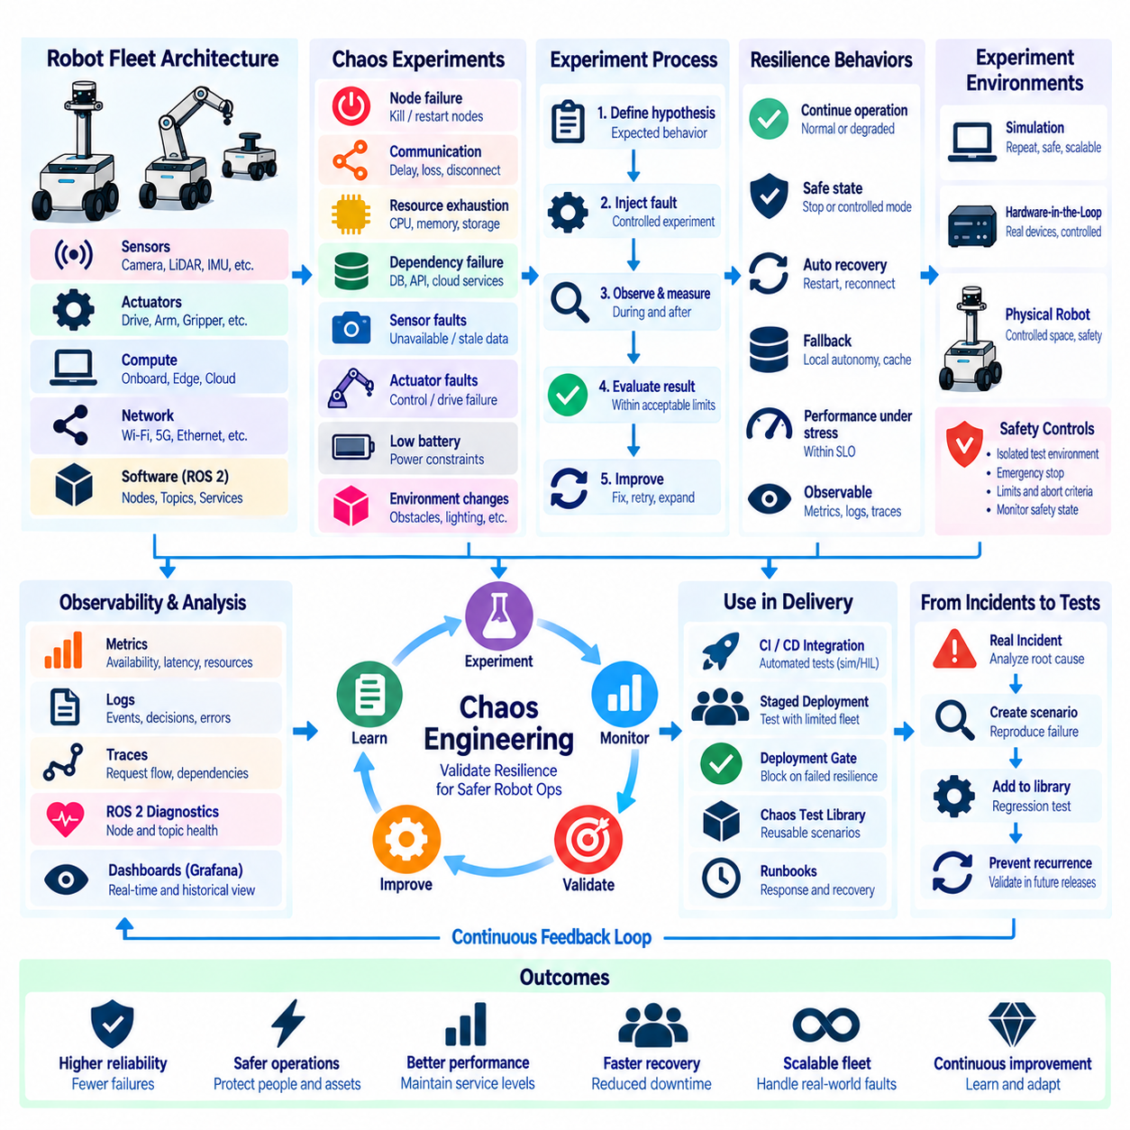
Chaos engineering applies controlled failure experiments to robot software so resilience can be evaluated before unpredictable faults occur in production. Instead of assuming that redundancy, retries, watchdogs, recovery logic, and degraded modes will work correctly, engineers deliberately introduce realistic disruptions and observe the system response. For robots, this approach extends conventional distributed-system testing into software that interacts continuously with sensors, actuators, networks, compute resources, and the physical environment.
The objective is not to create random instability but to test explicit hypotheses about system behavior under failure. An experiment may ask whether navigation remains available after a noncritical perception node terminates, whether telemetry recovers after temporary network loss, or whether a robot enters a safe state when localization becomes unreliable. Each experiment should define the expected steady state, injected fault, observation period, and acceptable recovery behavior before execution begins.
A steady-state hypothesis establishes measurable evidence that the robot or service is operating normally. Useful indicators can include mission success rate, navigation availability, localization quality, control-loop timing, topic freshness, command latency, fleet connectivity, and intervention frequency. The same indicators are monitored during and after fault injection to determine whether the system remained within acceptable operational boundaries or recovered within the expected time.
Failure scenarios should represent conditions that can realistically occur throughout the robot software stack. Engineers can terminate ROS 2 nodes, delay messages, interrupt topics, exhaust CPU or memory resources, disconnect devices, introduce packet loss, block service dependencies, restart containers, or temporarily remove cloud connectivity. Hardware-related experiments may simulate unavailable sensors, stale measurements, actuator communication failures, low battery conditions, or abnormal device responses.
ROS 2 provides several important targets for resilience validation because robot behavior depends on distributed nodes and middleware communication. Chaos experiments can examine node disappearance, lifecycle transition failures, incompatible or degraded QoS behavior, missed deadlines, discovery interruption, delayed callbacks, and topic-frequency reduction. These experiments reveal whether supervisors, diagnostics, watchdogs, and dependent nodes correctly recognize communication degradation rather than silently continuing with invalid assumptions.
Network failures are particularly important for mobile robot fleets because connectivity can vary as robots move through physical environments. Controlled experiments can introduce latency, jitter, packet loss, bandwidth reduction, DNS failure, or temporary disconnection between robots, edge systems, and cloud services. The expected behavior may involve local autonomy, buffered telemetry, delayed synchronization, controlled mission continuation, or transition into a defined degraded mode rather than immediate total failure.
Resource exhaustion testing evaluates how software behaves when computing capacity becomes constrained. CPU saturation can delay callbacks and planning, GPU contention can increase perception inference latency, memory pressure can terminate processes, and storage exhaustion can disrupt logging or model updates. Resilience requires more than surviving these conditions; the system should expose degradation through observability signals and protect safety-critical workloads from less important processing where possible.
Dependency failures should be injected at different architectural boundaries. A robot may depend on local map services, fleet management, authentication, databases, cloud APIs, edge inference, or mission orchestration. Temporarily making one dependency unavailable helps determine whether timeouts are bounded, retries use appropriate backoff, queues remain controlled, and fallback behavior operates correctly. Poorly designed retry logic can transform a small dependency failure into broader resource exhaustion or cascading failure.
Chaos experiments are especially valuable for validating degraded operating modes. A robot may be designed to continue at reduced speed after losing a redundant sensor, finish a locally cached mission during cloud disconnection, or stop safely when localization confidence falls below an acceptable boundary. Injecting the corresponding failures verifies that these transitions actually occur and that recovery to normal operation does not introduce inconsistent state or unexpected physical behavior.
Safety boundaries must govern every robotics chaos experiment. Fault injection should never create uncontrolled physical motion or disable safety mechanisms merely to observe the result. Experiments involving actuators, navigation, localization, or safety-related communication should first be validated in simulation or isolated test environments. Physical testing should use controlled spaces, appropriate supervision, emergency-stop capability, restricted speeds, and clearly defined abort conditions.
Simulation provides an efficient environment for early chaos testing because failures can be repeated without risking equipment or people. Sensor dropout, localization degradation, communication delay, obstacle changes, actuator limitations, and computing disturbances can be combined with simulated missions. Large numbers of scenarios can be executed automatically, allowing resilience weaknesses to be discovered before the same experiments are promoted to hardware-in-the-loop or physical robot environments.
Hardware-in-the-loop testing extends resilience validation by including real computers, controllers, sensors, or communication devices while maintaining control over the surrounding scenario. This stage can expose timing, driver, middleware, thermal, and hardware-interface behavior that simulation may not reproduce accurately. A progressive strategy from simulation to HIL and then carefully controlled field experiments reduces risk while increasing confidence that recovery mechanisms operate under realistic conditions.
Observability is fundamental to chaos engineering because an injected failure is useful only when its effects can be measured. Metrics can reveal availability, latency, resource saturation, and recovery time; logs can explain component decisions and errors; distributed traces can expose propagation through service dependencies; and ROS 2 diagnostics can describe node and topic health. Shared timestamps and robot identifiers allow these signals to be correlated with the exact fault-injection timeline.
Recovery time is an important resilience measurement. A system may tolerate a temporary failure but still be operationally unacceptable if recovery takes too long. Experiments can measure fault-detection time, transition time into a degraded mode, restart duration, reconnection time, state resynchronization, and restoration of mission capability. These measurements can become SLIs and support SLOs that define not only availability but also expected resilience and recovery behavior.
Blast radius describes how much of the system can be affected by an experiment. Chaos testing should begin with the smallest practical scope, such as one process, robot, simulation instance, or test environment. After behavior is understood, experiments can expand toward groups of robots or shared infrastructure. Limiting blast radius prevents a poorly understood failure from affecting unrelated missions and allows engineers to stop the experiment quickly when unexpected behavior appears.
Experiments require explicit safeguards and abort criteria. Monitoring can automatically terminate an experiment when safety state changes, mission failure exceeds a defined boundary, localization becomes invalid, resource consumption becomes dangerous, or unexpected robots are affected. A kill switch should restore the injected condition where possible. These controls make chaos engineering a disciplined validation practice rather than uncontrolled fault generation.
Fleet-scale resilience requires testing correlated failures in addition to isolated robot faults. A site network outage, defective software release, cloud-service failure, map corruption, or shared infrastructure overload can affect many robots simultaneously. Controlled fleet experiments can verify whether alert aggregation, local autonomy, workload redistribution, incident routing, and recovery coordination remain effective when multiple platforms experience the same disturbance.
Chaos engineering can be integrated with continuous integration and deployment pipelines. Lightweight software-level experiments may run automatically against simulation environments for every relevant change, while more expensive HIL experiments can execute periodically or before major releases. Selected resilience tests can become deployment gates, preventing software from progressing when recovery behavior, fault detection, or safety transitions no longer satisfy defined acceptance criteria.
Staged deployment provides another opportunity for controlled resilience validation. A new release can first be exposed to a limited robot group where telemetry, error budgets, mission success, and recovery behavior are closely observed. Carefully selected fault experiments can verify assumptions about the new software before wider rollout. This connects chaos engineering with observability, SLO management, and progressive delivery rather than treating resilience testing as an isolated activity.
Experiment results should feed directly into engineering improvement. A failed hypothesis may reveal missing timeouts, unsafe assumptions, weak monitoring, excessive coupling, poor fallback logic, or incomplete runbooks. The corrective action may involve architecture changes, improved supervision, additional telemetry, new automated recovery, or revised operational procedures. Repeating the experiment after correction verifies that the weakness has actually been removed rather than merely documented.
A reusable chaos experiment library can preserve organizational knowledge about known failure modes. Experiments can be parameterized by robot type, subsystem, software version, environment, and fault intensity, then executed consistently across releases. Over time, this library becomes a resilience regression suite covering communication failures, process crashes, resource pressure, dependency loss, sensor degradation, and recovery scenarios that previously caused operational incidents.
Post-incident analysis can generate new chaos scenarios from real fleet failures. If an unexpected network condition, ROS 2 communication problem, sensor fault, or deployment regression caused an incident, engineers can reproduce the essential failure mechanism in a controlled environment. Turning production incidents into repeatable experiments ensures that future releases are tested against previously observed weaknesses and reduces the probability of recurrence.
Chaos engineering therefore complements conventional functional testing rather than replacing it. Functional tests verify that software behaves correctly under expected conditions, while chaos experiments examine whether the system remains safe, observable, and recoverable when those conditions break down. Combined with simulation, HIL, monitoring, alerting, runbooks, and SLOs, it provides a systematic method for validating resilience across the complete robot software lifecycle.
In a mature robot operations platform, resilience validation becomes a continuous feedback loop. Real incidents identify failure modes, controlled experiments reproduce them, observability measures their effects, recovery mechanisms are improved, and automated tests prevent regressions. This process transforms failure from an unpredictable production event into an engineering input that can be studied repeatedly, helping robot fleets achieve safer, more reliable, and more scalable autonomous operation.

5.10. Observability Data Cost Optimization Sampling Filtering
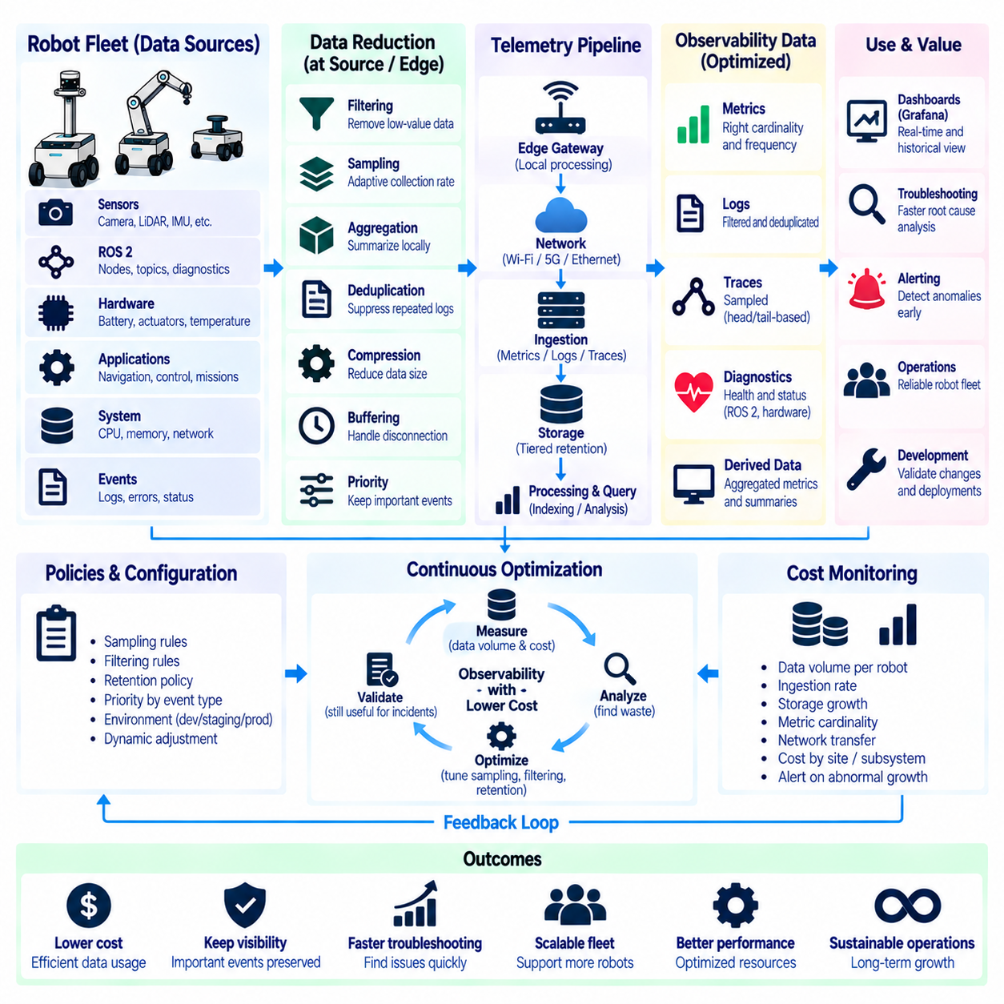
Observability provides the evidence required to understand robot behavior, but collecting every possible signal at maximum resolution can create substantial operational cost. Robot fleets generate metrics, logs, traces, ROS 2 diagnostics, sensor status, hardware telemetry, and application events continuously. As fleet size and software complexity increase, observability architecture must balance diagnostic visibility with network bandwidth, storage capacity, processing overhead, retention requirements, and monitoring-platform cost.
Robotics creates particularly demanding telemetry patterns because each robot contains many distributed software and hardware components. Cameras, LiDARs, IMUs, localization, perception, navigation, controllers, GPUs, batteries, networks, and mission services can produce data at very different rates. Transmitting every raw event to centralized infrastructure is rarely necessary. Observability systems should instead preserve information that explains operational behavior while reducing redundant or low-value data as close to the source as practical.
Cost optimization begins by understanding telemetry volume. Engineers should measure how many metrics, log records, trace spans, diagnostic events, and bytes each robot generates over time. These measurements can then be segmented by robot model, software version, site, subsystem, and telemetry type. Without this baseline, optimization decisions may reduce useful information while leaving the largest sources of storage, network, or processing cost unchanged.
Metrics are generally compact, but uncontrolled metric cardinality can become expensive. Labels such as robot identifier, site, node, topic, software version, mission type, and error category are valuable dimensions for analysis. However, labels containing highly variable values such as timestamps, request identifiers, file names, or arbitrary messages can create enormous numbers of unique time series. Metric design should therefore preserve useful operational dimensions while controlling high-cardinality labels.
Metric collection frequency should match the dynamics of the measured system. CPU utilization may justify frequent sampling, while software version, hardware configuration, or slowly changing temperature information may require much lower rates. Collecting every signal at the same interval wastes resources and can hide the distinction between fast operational behavior and slow configuration state. Adaptive collection policies can allocate higher resolution to signals that change rapidly or become important during incidents.
Logs often represent one of the largest observability data sources because applications can produce verbose textual records continuously. Production systems should distinguish operational events from debugging detail and avoid repeatedly recording information that can be represented more efficiently as metrics. Repeated status messages, successful polling events, or identical warnings can be suppressed, aggregated, or rate limited while preserving significant state transitions, failures, and diagnostic context.
Log filtering should occur as early as possible in the telemetry pipeline. Robot-side collectors or edge gateways can remove known low-value messages before they consume wireless bandwidth and centralized storage. Filtering rules may consider severity, component, event type, repetition rate, or operating state. The objective is not simply to discard logs, but to preserve information that supports incident investigation while preventing routine software behavior from dominating the observability system.
Deduplication can further reduce repeated telemetry. A failing sensor may generate the same timeout message hundreds of times per second, even though the diagnostic value of each individual record is minimal. Collectors can retain the first occurrence, count repeated events, and periodically emit a summary. This preserves evidence that the failure persisted and its approximate frequency without storing thousands of nearly identical records.
Distributed tracing requires explicit sampling because recording every request or execution path can generate large volumes of spans. Head-based sampling decides whether to record a trace near the beginning of an operation, often using a fixed probability. This approach is simple and inexpensive but may discard rare failures. A low sampling percentage can provide representative performance data while reducing storage and processing requirements for routine successful operations.
Tail-based sampling makes decisions after enough of the trace has been observed to understand its outcome. Traces containing errors, unusually high latency, retries, safety-relevant events, or other important characteristics can be retained while ordinary successful traces are sampled more aggressively. This provides greater diagnostic value than purely random sampling, although it requires temporary buffering and additional processing before the final retention decision can be made.
Sampling policies can also depend on robot operational state. During normal autonomous operation, the system may retain only a small percentage of detailed traces and debug events. When a robot enters a degraded state, experiences repeated mission failures, or triggers a critical alert, telemetry collection can temporarily increase. Dynamic sampling preserves low operating cost during normal periods while providing richer evidence around abnormal behavior.
ROS 2 monitoring should avoid copying high-bandwidth topics merely for observability. Camera images, point clouds, radar data, and high-frequency sensor streams can consume far more bandwidth than conventional metrics or logs. Monitoring components can calculate topic frequency, message age, dropped-message counts, latency statistics, and QoS events locally. These compact summaries usually provide sufficient health information without transmitting the original sensor payload.
Edge aggregation is especially valuable for robot fleets operating over wireless or constrained networks. Robot-side or site-level collectors can calculate statistical summaries, aggregate counters, compress logs, batch events, and buffer telemetry during temporary disconnection. Only processed observability data needs to cross the expensive network boundary. This architecture also allows robots to continue local monitoring even when centralized observability services are unavailable.
Data reduction should preserve temporal information required for diagnosis. High-resolution metrics may be useful for recent incidents but unnecessary months later. A tiered retention strategy can keep detailed telemetry for a short period and retain downsampled summaries for longer-term capacity planning, reliability analysis, and trend detection. Older one-second measurements, for example, may be converted into minute-level or hourly aggregates rather than stored indefinitely at original resolution.
Retention policies should reflect the value and purpose of each telemetry category. Critical safety events, deployment records, major incidents, and reliability indicators may require longer retention than routine debug logs. Development environments can often use shorter retention than production fleets. Explicit policies help prevent storage growth from becoming an accidental consequence of collecting data without deciding how long that information remains operationally useful.
Compression and batching reduce both storage and transport overhead. Structured logs and telemetry records often contain repeated field names, identifiers, and similar values that compress efficiently. Sending many small network requests also introduces protocol overhead, so collectors can batch records before transmission where latency requirements permit. These techniques are particularly useful for robots connected through cellular, Wi-Fi, or intermittently available site networks.
Local buffering requires storage limits and backpressure policies. A disconnected robot cannot retain unlimited telemetry while waiting for connectivity to return. Buffers should define maximum size, retention priority, and behavior when capacity is exhausted. Critical events and recent failure context can be preserved while low-priority routine data is discarded first. This prevents observability from consuming storage needed by robot software or destabilizing the platform during prolonged disconnection.
Telemetry pipelines should classify data by operational value. Safety events, mission failures, software crashes, deployment changes, and recovery actions generally deserve high retention priority. Routine successful operations can often be represented through aggregated metrics or sampled traces. This value-based approach ensures that optimization reduces low-information volume rather than indiscriminately reducing visibility across all data sources.
Cost controls should be applied across the entire pipeline rather than only at centralized storage. Robot CPU and memory usage, network transfer, edge processing, ingestion services, indexing, database storage, query execution, and long-term archives all contribute to total observability cost. Moving filtering closer to the robot can reduce several downstream costs simultaneously, but local processing must remain lightweight enough not to interfere with autonomy workloads.
Dashboards and queries also influence infrastructure cost. High-cardinality queries across large time ranges can consume substantial compute resources even when stored data volume is reasonable. Dashboards should use appropriately aggregated metrics, bounded time windows, and efficient dimensions. Frequently used fleet summaries can be precomputed or recorded as derived metrics so operators do not repeatedly execute expensive queries over raw telemetry.
Optimization should never remove the evidence required to investigate critical incidents. A telemetry pipeline that is inexpensive but cannot explain mission failures provides little operational value. Teams should identify minimum diagnostic datasets for important failure classes and test whether incidents can still be reconstructed after sampling, filtering, aggregation, and retention policies are applied. Chaos experiments and incident simulations can help validate that optimized observability remains diagnostically effective.
Software deployments can temporarily justify higher telemetry resolution. During canary or staged rollout, additional logs, traces, and metrics may be collected from the limited deployment group to detect regressions. Once the release demonstrates stable behavior, sampling rates can return to normal. This makes observability resolution responsive to engineering risk rather than permanently paying the cost of maximum diagnostic detail across the entire fleet.
Cost itself should become an observable property. Dashboards can track telemetry bytes per robot, log ingestion rate, trace retention percentage, metric cardinality, storage growth, network transfer, and cost by site or subsystem. Sudden increases may indicate a software regression such as uncontrolled logging or newly introduced labels. Alerting on abnormal telemetry growth can prevent observability infrastructure problems from expanding unnoticed.
The goal of observability cost optimization is therefore not minimum data collection, but maximum operational information per unit of resource consumed. Sampling reduces unnecessary detail, filtering removes low-value events, aggregation summarizes repeated behavior, retention controls historical resolution, and edge processing limits expensive transport. These mechanisms should be coordinated so important failures remain visible while routine operation remains economically scalable.
In a mature robot fleet platform, observability policies adapt to operational context. Normal robots generate compact telemetry, abnormal robots temporarily provide richer diagnostic information, edge systems summarize high-rate signals, and centralized platforms retain data according to long-term value. This adaptive architecture allows observability to scale from individual robots to large fleets without allowing monitoring overhead and data cost to grow at the same rate as raw telemetry generation.

