Volume 10 Robot DevOps and MLOps

9. Automated Training

9.1. Automated Training Infrastructure Overview
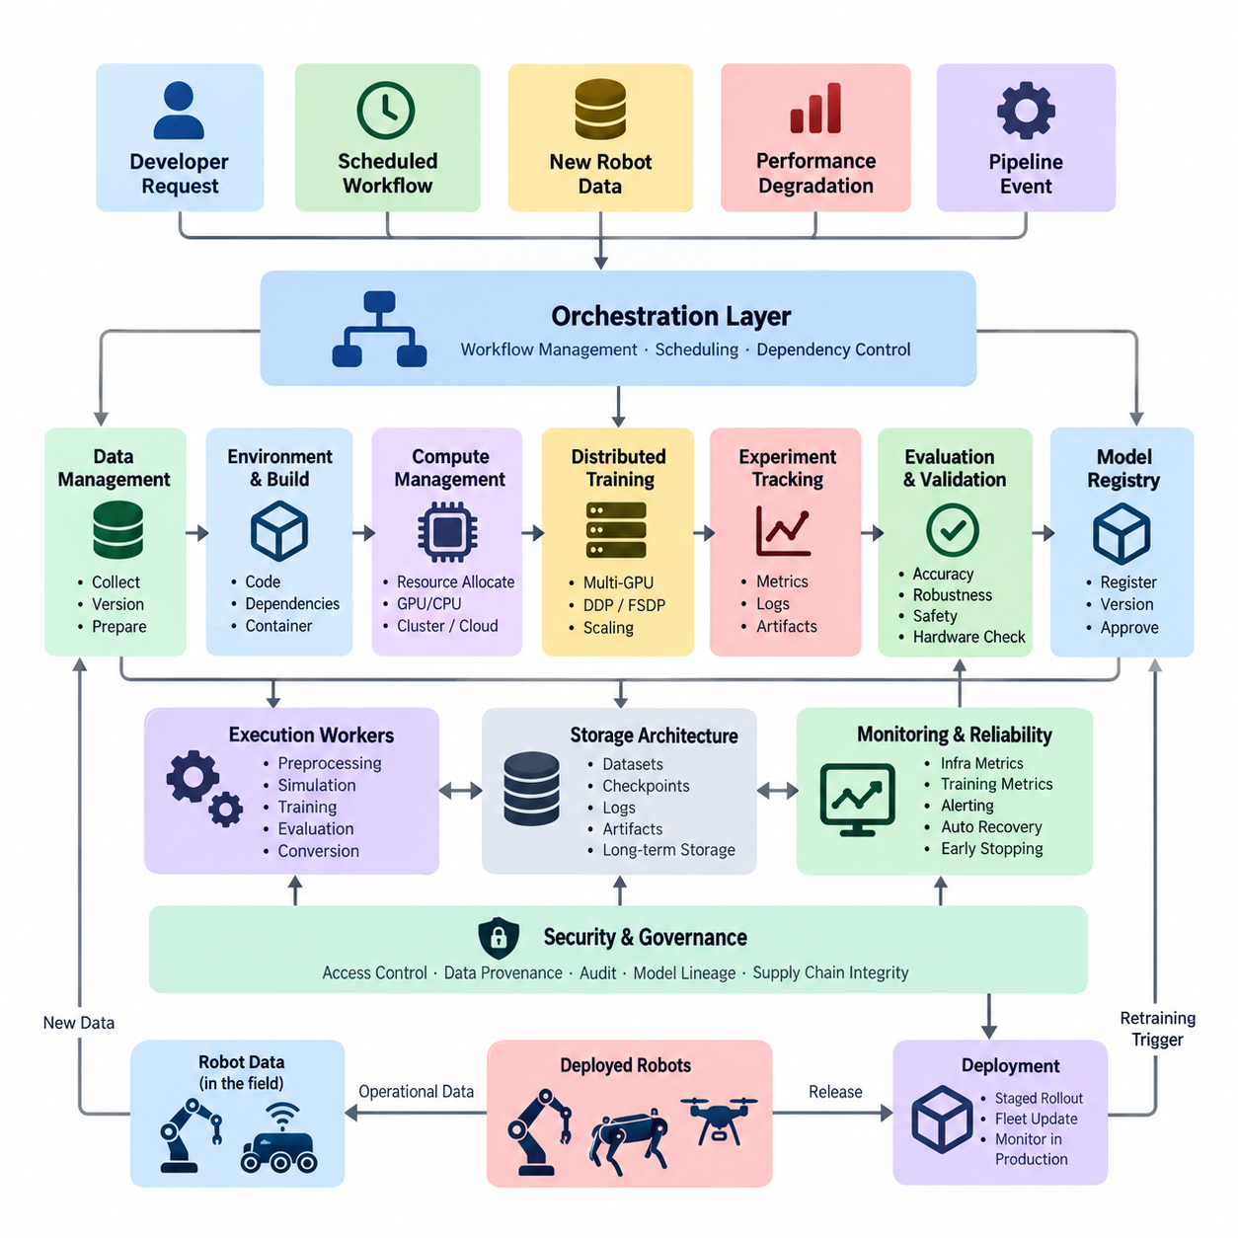
Automated training infrastructure provides the computational and operational foundation required to execute machine-learning training workflows repeatedly with minimal manual intervention. In robotics, this infrastructure must coordinate datasets, training code, model configurations, compute resources, experiment metadata, validation procedures, and resulting artifacts as parts of one reproducible pipeline.
Unlike a manually executed training script, an automated infrastructure treats training as a managed system. A training request may originate from a developer, a scheduled workflow, newly collected robot data, model-performance degradation, or another pipeline event. The infrastructure translates that request into controlled stages for data preparation, resource allocation, execution, evaluation, artifact registration, and downstream deployment qualification.
The architecture normally separates orchestration from execution. An orchestration layer defines dependencies among jobs and determines when each stage should run, while execution workers perform preprocessing, simulation, training, evaluation, or conversion tasks. This separation allows the same logical workflow to operate on a workstation, an on-premise GPU cluster, Kubernetes infrastructure, or scalable cloud computing resources without redesigning the complete training process.
Data management is the first major foundation of automated training. Robot datasets can contain camera images, LiDAR point clouds, radar measurements, IMU signals, localization information, control commands, semantic annotations, ROS2 bags, simulation trajectories, and operational metadata. Training automation must associate every experiment with identifiable dataset versions so that a model can later be reproduced using the same inputs rather than an unknown snapshot of continuously changing data.
The training environment must also be reproducible. Source-code revisions, Python packages, CUDA libraries, deep-learning frameworks, preprocessing implementations, model definitions, and system dependencies can all affect training results. Containers and immutable environment specifications therefore provide an important boundary around training jobs. A successful experiment should be reconstructable from versioned code, configuration, dataset references, environment information, and controlled random seeds.
Compute management becomes particularly important when robotics teams share expensive GPU resources. Automated infrastructure should discover available CPUs, GPUs, memory, storage, and accelerator capabilities and assign workloads according to their requirements. Small perception experiments may use one GPU, while large multimodal or foundation-model workloads can require multiple GPUs or multiple nodes. Resource scheduling prevents uncontrolled competition between experiments and improves utilization of limited hardware.
Distributed training extends this resource layer by coordinating computation across accelerators. Data-parallel and model-sharding strategies allow workloads to exceed the performance or memory capacity of a single device. The chapter structure therefore places distributed training with PyTorch DDP and FSDP immediately after the infrastructure overview, followed by hyperparameter optimization, AutoML, retraining automation, reinforcement-learning automation, and Sim-to-Real pipelines.
Automation also requires standardized configuration management. Learning rate, batch size, optimizer, model architecture, augmentation policy, dataset location, checkpoint frequency, and evaluation thresholds should be represented as explicit configuration rather than hidden inside source code. A pipeline can then generate multiple controlled training runs from configuration changes while preserving a traceable relationship between each model artifact and the parameters that produced it.
Experiment tracking provides this traceability at runtime. Each training job should generate a unique run identity and record parameters, source revisions, dataset versions, resource information, training curves, evaluation metrics, logs, checkpoints, and final artifacts. This information converts a collection of GPU jobs into an auditable engineering process. It also connects automated training with the broader MLOps mechanisms of experiment tracking, data versioning, model registries, pipeline orchestration, and validation gates.
Storage architecture is another critical component because robotics training can generate large intermediate and final artifacts. Raw sensor datasets, transformed datasets, cached features, checkpoints, optimizer states, simulation outputs, logs, and trained models may consume substantially more storage than source code. Automated infrastructure therefore needs policies for persistent storage, temporary high-speed storage, artifact retention, dataset caching, checkpoint cleanup, and transfer between storage and compute nodes.
A robust training pipeline must assume that individual jobs can fail. GPU errors, node failures, exhausted memory, corrupted samples, network interruptions, and software defects should not require the entire workflow to restart manually. Checkpointing enables long-running jobs to resume, while retry policies can recover transient stages. Failure information must remain visible to operators so that automation improves reliability without concealing systematic defects or repeatedly consuming resources on invalid experiments.
Monitoring operates at both infrastructure and model-training levels. Infrastructure telemetry includes GPU utilization, GPU memory, CPU load, system memory, storage throughput, network traffic, temperature, and job queue status. Training telemetry includes loss, learning rate, validation metrics, convergence behavior, gradient statistics, and checkpoint progress. These signals support operational diagnosis and enable automated actions such as early stopping when additional computation is unlikely to improve the model.
Automated training should not imply automatic acceptance of every resulting model. The output must pass defined validation gates before it can progress toward deployment. Depending on the robot application, these gates may evaluate perception accuracy, robustness, latency, memory consumption, safety-related scenarios, regression against an existing model, and compatibility with target edge hardware. Training automation therefore belongs upstream of controlled model deployment rather than bypassing engineering review.
Robotics introduces additional complexity because useful training data often originates from both physical systems and simulation. Automated pipelines may combine fleet-collected sensor data, curated failure cases, synthetic scenes, reinforcement-learning trajectories, and domain-randomized simulation episodes. This relationship explains why automated training includes dedicated stages for reinforcement-learning automation and Sim-to-Real pipelines, while simulation and digital-twin capabilities remain a separate major software domain.
Event-driven retraining closes the loop between deployed robots and training infrastructure. Production monitoring can identify degraded performance, unfamiliar environments, or newly accumulated data and create a candidate training workflow. The pipeline can select data, retrain a model, execute evaluation, compare the candidate against established baselines, and register acceptable artifacts. Model monitoring and automated retraining are therefore closely connected rather than independent operational activities.
Security and governance must extend across the entire infrastructure. Training services require controlled access to datasets, repositories, GPU clusters, registries, credentials, and model artifacts. Dataset provenance, software dependencies, configuration history, model lineage, and artifact integrity should remain traceable. These controls become especially important when trained models eventually operate physical machines, because an incorrectly sourced dataset or unauthorized artifact can propagate from the training environment into real-world robot behavior.
At scale, automated training becomes a resource-management problem as much as a machine-learning problem. Teams must decide which experiments deserve scarce accelerators, how long jobs may run, when idle resources can be reclaimed, and whether workloads should execute locally or on external infrastructure. Resource scheduling and cost management therefore form an explicit part of the automated-training architecture, rather than being treated as an administrative concern outside the ML pipeline.
The ultimate objective is a closed and reproducible engineering loop in which robot data can become validated model improvements through controlled automation. Data acquisition feeds versioned datasets; orchestration launches reproducible training environments; schedulers allocate computation; monitoring observes execution; validation determines whether results satisfy requirements; and registries preserve approved artifacts. Deployment systems can then consume those artifacts through separate controlled release mechanisms.
For Physical AI and increasingly capable robotic systems, this infrastructure becomes essential because model diversity, dataset volume, simulation scale, and computational demand grow faster than manual processes can manage. Automated training does not remove engineers from model development. Instead, it converts repetitive execution into infrastructure, allowing engineers to concentrate on data quality, model architecture, validation criteria, failure analysis, safety, and the design decisions that determine whether learned behavior is suitable for real robots.

9.2. Distributed Training with PyTorch DDP and FSDP [w/Code]
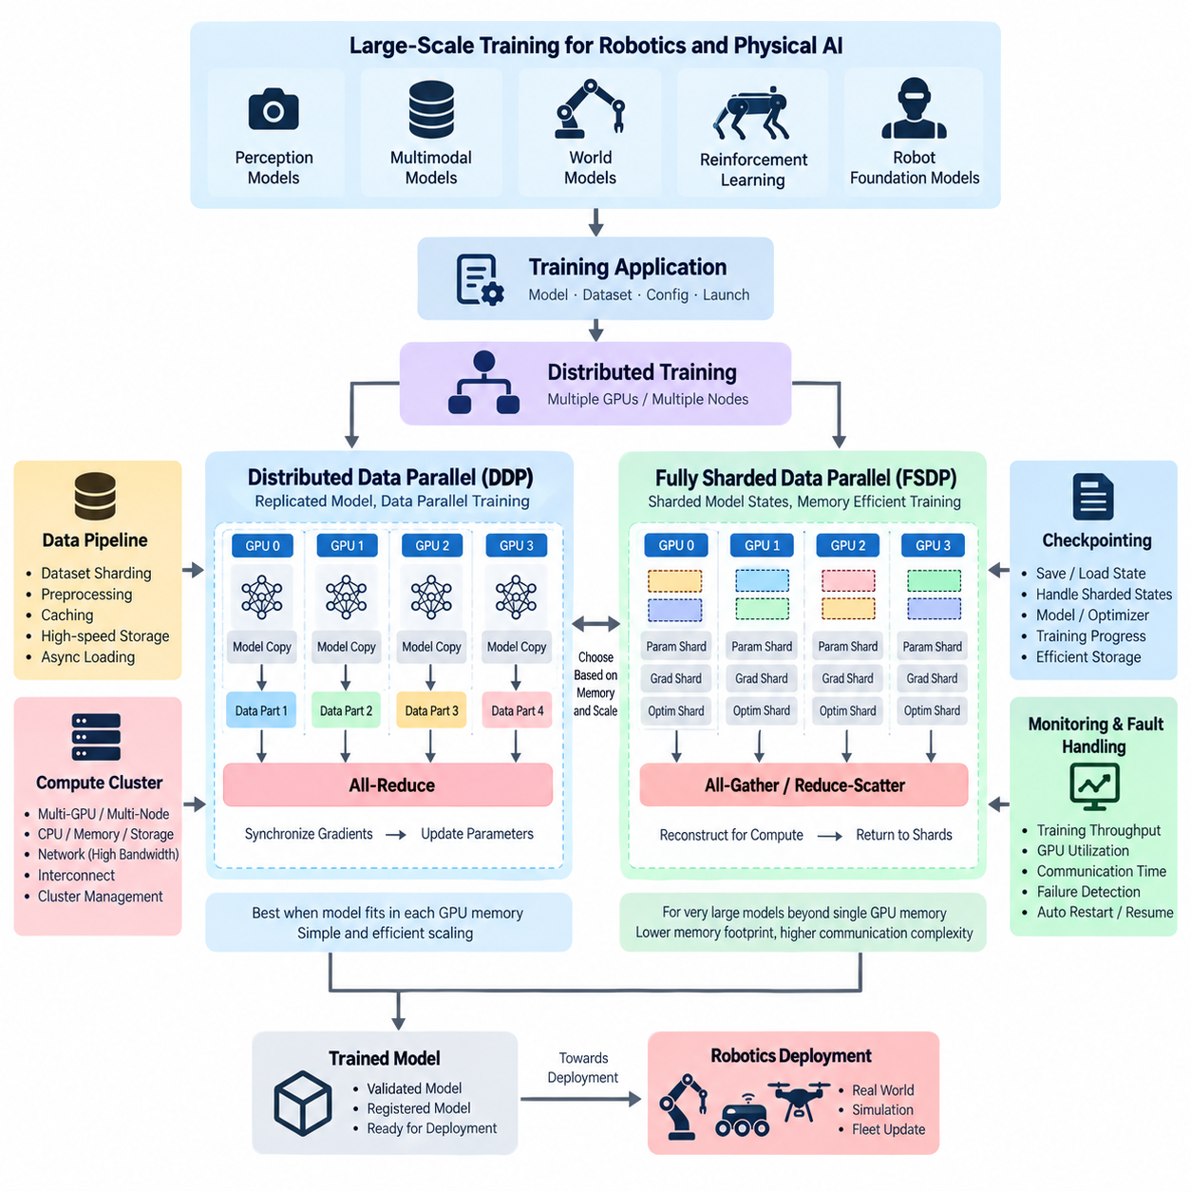
Distributed training enables robotics and Physical AI models to use multiple GPUs or compute nodes as a coordinated training system rather than treating each accelerator as an independent resource. It becomes important when datasets, neural networks, batch requirements, or training duration exceed the practical capability of a single GPU. PyTorch provides Distributed Data Parallel and Fully Sharded Data Parallel as two major approaches for scaling such workloads.
Distributed Data Parallel, commonly called DDP, follows a replicated-model architecture. Each participating process normally owns one GPU and maintains a complete copy of the neural network. Training data is divided among processes so that each GPU performs forward and backward computation on a different portion of the global batch. After gradients are calculated, synchronization operations combine them so that every model replica applies equivalent parameter updates.
A typical DDP execution environment consists of multiple worker processes organized into a distributed process group. Each worker is assigned a global rank identifying its position within the training job and a local rank identifying the accelerator used on its host. The world size represents the total number of participating processes. These identifiers allow PyTorch to coordinate communication consistently across single-node multi-GPU and multi-node configurations.
Data distribution is essential because identical input batches on every worker would waste parallel computing capacity. A distributed sampler partitions the training dataset so that each process receives a distinct subset while preserving the intended sampling behavior. The effective global batch size therefore depends on the per-GPU batch size and number of participating workers, which can influence learning-rate selection, convergence behavior, memory consumption, and training reproducibility.
During backward propagation, DDP synchronizes gradients among participating workers using collective communication operations. Rather than transferring all gradients to one central process, efficient implementations commonly rely on all-reduce communication so that gradient information is aggregated across workers and returned to each replica. Gradient communication can overlap with backward computation, reducing synchronization overhead when network bandwidth, model structure, and bucket configuration are suitable.
DDP is especially effective when a complete model and its optimizer state fit comfortably within the memory of each GPU. Adding accelerators increases available compute throughput, but it does not fundamentally reduce the memory required to store each complete model replica. Consequently, very large transformer, multimodal, world-model, or robot foundation-model workloads can reach GPU memory limits even when a cluster contains substantial aggregate memory.
Fully Sharded Data Parallel, or FSDP, addresses this limitation by distributing model-related states across multiple workers instead of permanently replicating all of them on every GPU. Parameters, gradients, and optimizer states can be sharded across the distributed group, significantly reducing the persistent memory footprint per accelerator. This allows the aggregate memory capacity of multiple GPUs to support models that would otherwise exceed the capacity of an individual device.
FSDP dynamically reconstructs the parameter data required for computation and subsequently returns states to their sharded representation. Collective communication such as all-gather and reduce-scatter therefore becomes central to its execution model. The resulting system exchanges additional communication complexity for lower per-GPU memory requirements, making careful decisions about wrapping strategy, sharding configuration, mixed precision, and communication topology important for efficient operation.
The choice between DDP and FSDP should therefore reflect the actual bottleneck. When model memory is manageable and the primary objective is faster data-parallel training, DDP offers a relatively direct scaling architecture. When model parameters, gradients, and optimizer states approach or exceed accelerator memory capacity, FSDP provides a more memory-efficient strategy by distributing these states, although configuration and communication behavior become more complex.
Mixed-precision training can complement both approaches by executing selected operations with lower-precision numerical formats while retaining higher precision where necessary for numerical stability. Reduced precision can decrease memory traffic, lower tensor storage requirements, and increase accelerator throughput on compatible hardware. Loss scaling and precision policies must nevertheless be managed carefully because numerical instability can invalidate the apparent performance benefits of faster distributed execution.
Multi-node training adds network infrastructure to the performance equation. GPU-to-GPU communication within one server can differ substantially from communication between servers, so interconnect topology, network bandwidth, latency, and collective communication efficiency can determine whether adding nodes produces useful scaling. A training cluster must therefore be evaluated as an integrated combination of accelerators, CPU resources, memory, storage, networking, and communication software.
Distributed training also places additional pressure on the data pipeline. Multiple GPUs can consume samples faster than a storage system can supply them, leaving expensive accelerators idle while workers wait for input. Dataset sharding, preprocessing parallelism, caching, local high-speed storage, asynchronous loading, and appropriate worker counts are therefore part of distributed-training design rather than secondary data-engineering concerns.
Checkpointing becomes more complicated when model states are distributed. DDP can often save a conventional model state from a designated process, whereas FSDP may require explicit handling of sharded or reconstructed state dictionaries. Checkpoints must preserve enough information to resume training reliably, including model parameters, optimizer states, scheduler state, training progress, and relevant configuration, while avoiding unnecessary duplication across workers.
Fault handling is equally important because a distributed job contains more components that can fail. A single GPU process, compute node, network connection, storage service, or synchronization operation can interrupt the entire training group. Automated training infrastructure should therefore capture distributed logs, identify failed ranks, preserve usable checkpoints, clean up abandoned processes, and support controlled restart or resumption instead of requiring engineers to reconstruct failed experiments manually.
Performance measurement should focus on scaling efficiency rather than simply counting GPUs. Useful observations include training throughput, samples processed per second, accelerator utilization, communication time, memory consumption, synchronization overhead, data-loading latency, and time required to reach a target model quality. Comparing these measurements across different world sizes reveals whether additional accelerators provide meaningful acceleration or merely increase communication and infrastructure overhead.
For robotics workloads, distributed training can support large perception networks, multimodal sensor models, world models, reinforcement-learning policies, and robot foundation models trained from heterogeneous physical and simulated data. DDP can accelerate experiments that naturally fit into data-parallel execution, while FSDP becomes increasingly relevant as transformer-based Physical AI architectures grow beyond the memory capacity of individual accelerators.
Within an automated training infrastructure, DDP and FSDP should ultimately appear as selectable execution strategies rather than isolated training techniques. The orchestration layer prepares datasets and environments, the scheduler allocates GPUs and nodes, distributed workers execute synchronized optimization, monitoring observes performance and failures, checkpoint services preserve state, and validation evaluates the resulting model before registration or deployment.
A mature distributed-training system therefore combines parallel computation with reproducibility, resource scheduling, storage architecture, observability, and fault recovery. Successful scaling is not achieved merely by connecting more GPUs; it requires balancing computation, memory, communication, and data delivery throughout the pipeline. DDP primarily scales computation through replicated data parallelism, while FSDP extends scalability by distributing memory-intensive model states across the available accelerator pool.

9.3. Hyperparameter Optimization Optuna Ray Tune [w/Code]
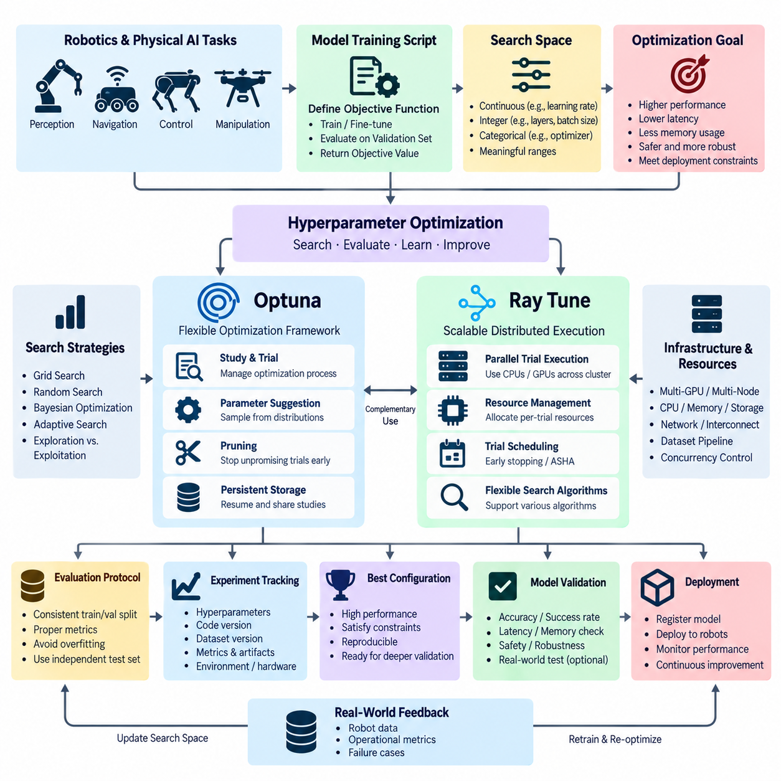
Hyperparameter optimization is the systematic process of searching for training configurations that produce better model performance than manually selected settings. In robotics and Physical AI, important hyperparameters can include learning rate, batch size, optimizer configuration, weight decay, network depth, augmentation strength, scheduler parameters, and reinforcement-learning coefficients. Automated optimization converts these choices into a measurable and repeatable search process.
A hyperparameter optimization workflow begins by defining an objective function that represents one complete model-training experiment. The function receives a candidate configuration, trains or fine-tunes the model, evaluates it using selected validation metrics, and returns an objective value. The optimization system repeatedly executes this function with different configurations, allowing experimental evidence rather than manual intuition alone to guide the search.
The search space defines which parameters may change and the range or set of values available to each parameter. Continuous variables can represent learning rates or regularization coefficients, integer variables can control layer counts or batch sizes, and categorical variables can select optimizers, architectures, or augmentation policies. Search spaces should reflect technically meaningful limits because excessively broad spaces can waste substantial GPU time on configurations that are unlikely to be useful.
Traditional grid search evaluates predefined combinations systematically but becomes expensive as the number of hyperparameters increases. Random search explores configurations more flexibly and can often cover large spaces more efficiently. Modern optimization frameworks extend these approaches with adaptive search algorithms that use observations from previous trials to determine which configurations should be evaluated next, concentrating computational resources on more promising regions.
Optuna provides a study-and-trial abstraction for automated hyperparameter optimization. A study represents the overall optimization process, while each trial represents one evaluation of a particular hyperparameter configuration. During a trial, parameters are suggested from defined distributions, the model is trained and evaluated, and the resulting metric is reported to the study. This structure makes optimization logic relatively easy to integrate into existing PyTorch training code.
An important Optuna capability is pruning, which terminates unpromising trials before they consume the full training budget. Intermediate validation metrics can be reported during training, allowing the pruner to compare the current trial with previous results. If the experiment is unlikely to become competitive, execution can stop early and computational resources can be reassigned to another candidate. This is especially valuable when individual robotics models require long GPU training cycles.
Optuna samplers determine how new hyperparameter candidates are selected. Depending on the optimization strategy, sampling can range from random exploration to algorithms that learn from previous observations. The optimizer therefore balances exploration of unfamiliar regions with exploitation of configurations that have already demonstrated useful performance. Persistent study storage can preserve trial history so that interrupted searches can resume and multiple workers can contribute to a shared optimization process.
Ray Tune approaches hyperparameter optimization from a distributed experiment-execution perspective. It can coordinate many training trials across available CPUs and GPUs while managing resources assigned to each trial. Instead of manually launching independent scripts, developers describe the trainable workload, parameter search space, resource requirements, search algorithm, and scheduling strategy, allowing the framework to execute experiments concurrently across a workstation or compute cluster.
Trial scheduling is particularly important when GPU resources are limited. A scheduler can observe intermediate training results and decide whether a trial should continue, pause, or terminate. Early-stopping strategies such as asynchronous successive halving allocate larger training budgets to promising configurations while eliminating weaker candidates progressively. This changes hyperparameter optimization from exhaustive full-length training into adaptive allocation of computational resources.
Optuna and Ray Tune address overlapping but complementary aspects of optimization. Optuna emphasizes flexible definition of optimization studies, parameter suggestion, sampling, pruning, and experiment history, while Ray Tune emphasizes scalable execution, scheduling, and resource-aware parallel trials. Depending on the training architecture, either framework can operate independently, or optimization logic can be combined with distributed execution infrastructure when large numbers of experiments must be evaluated.
Parallel optimization introduces an important tradeoff between search speed and resource efficiency. Running many trials simultaneously can reduce wall-clock search time, but every trial may require substantial GPU memory, CPU preprocessing capacity, storage bandwidth, and dataset access. Automated infrastructure should therefore define resources per trial and limit concurrency according to actual cluster capacity rather than launching the maximum possible number of processes without considering system bottlenecks.
Hyperparameter optimization must also preserve experimental reproducibility. Every trial should record its hyperparameters, dataset version, source-code revision, random seed, environment, hardware allocation, intermediate metrics, final metrics, and generated model artifacts. Without this metadata, discovering a strong configuration has limited engineering value because the team may be unable to reproduce the result or determine which changes were responsible for the observed improvement.
Robotics optimization often requires multiple objectives rather than a single accuracy metric. A perception model may need high detection accuracy while also satisfying latency and memory limits on an edge computer. A navigation or control model may need task success while maintaining safety, smoothness, and computational constraints. Multi-objective optimization can expose tradeoffs among these criteria instead of assuming that the model with the highest offline accuracy is automatically the most suitable robot model.
The evaluation protocol must remain consistent across trials because optimization can exploit weaknesses in the measurement process. Training and validation datasets should remain properly separated, preprocessing must be controlled, and evaluation metrics should represent the intended robot task. Repeatedly selecting configurations against the same validation data can also overfit the optimization process itself, making independent test data or final validation procedures important before deployment decisions.
For reinforcement learning, hyperparameter optimization can become even more expensive because performance depends on stochastic environment interactions and may vary substantially across random seeds. Learning rate, discount factor, rollout length, entropy coefficients, reward parameters, network size, and simulation parallelism can interact strongly. Reliable optimization may therefore require repeated evaluations, aggregated statistics, and carefully defined stopping rules rather than trusting one unusually successful training run.
In Physical AI pipelines, optimization can extend beyond conventional learning parameters to system-level design choices. Candidate configurations may vary sensor preprocessing, multimodal fusion settings, simulation randomization, model size, precision, sequence length, or training-data mixtures. The objective can consequently represent not only model quality but also deployment requirements such as inference latency, GPU memory consumption, energy constraints, and compatibility with target robot hardware.
Hyperparameter optimization should integrate with the broader automated training infrastructure rather than operate as an isolated experiment tool. The orchestration layer creates optimization jobs, the scheduler allocates compute resources, Optuna or Ray Tune manages candidate trials, distributed training executes expensive configurations, experiment tracking records results, and model validation determines whether the best candidates satisfy engineering requirements before registration.
A mature optimization pipeline therefore transforms model tuning into a controlled search-and-validation loop. Candidate configurations are generated, resources are assigned, trials execute, intermediate metrics enable pruning or early stopping, results update the search strategy, and promising models undergo deeper validation. The objective is not simply to discover the numerically best trial, but to efficiently identify reproducible configurations that balance model quality, computational cost, robustness, and real-world deployment constraints.

9.4. AutoML for Robot Perception Model Selection [w/Code]
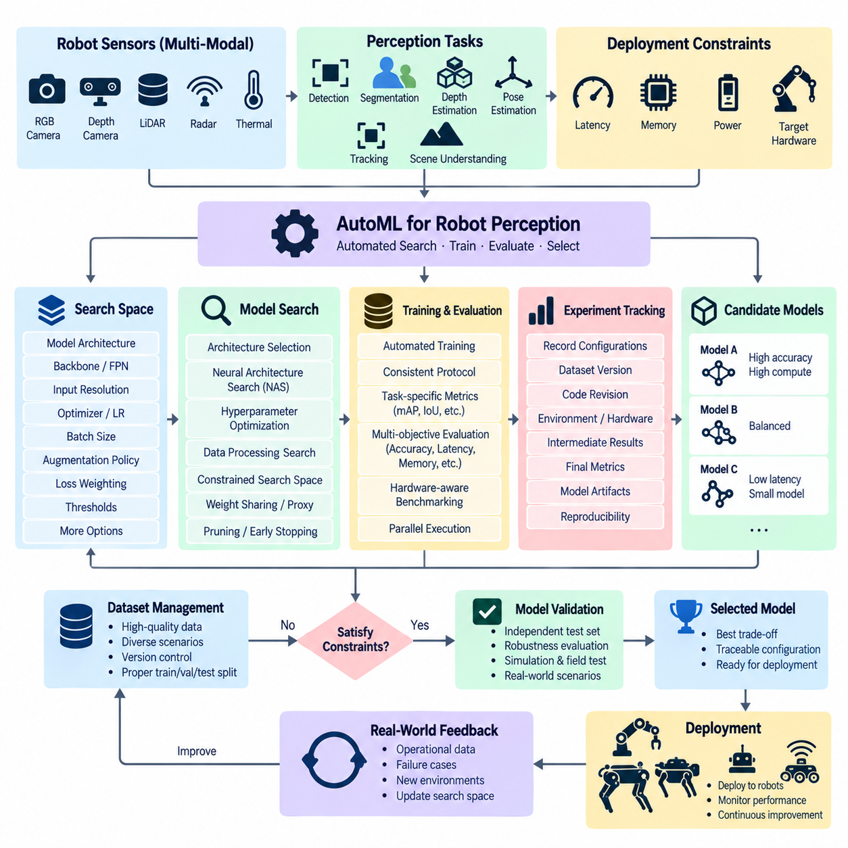
Automated Machine Learning, or AutoML, applies systematic automation to model design, training, evaluation, and selection. For robot perception, its purpose is not merely to discover the model with the highest offline accuracy, but to identify architectures and training configurations that satisfy perception quality, inference latency, memory consumption, computational cost, robustness, and target-hardware constraints simultaneously.
Robot perception creates a particularly demanding model-selection problem because sensing pipelines may combine RGB cameras, depth cameras, LiDAR, radar, thermal sensors, or multimodal inputs. Candidate models can perform object detection, semantic segmentation, instance segmentation, depth estimation, pose estimation, tracking, or scene understanding. Each task introduces different architectures, input resolutions, preprocessing requirements, loss functions, and evaluation metrics.
A conventional development process often begins with engineers manually selecting several familiar architectures and repeatedly modifying their hyperparameters. AutoML converts this process into a structured search problem. The system defines candidate model families, training configurations, data-processing alternatives, and deployment constraints, then automatically executes comparable experiments and records their results under a consistent evaluation protocol.
The search space can include model architecture, backbone network, feature-pyramid configuration, input resolution, batch size, optimizer, learning rate, augmentation policy, loss weighting, and confidence thresholds. More advanced searches may also vary network depth, channel width, attention mechanisms, fusion strategies, or pretrained initialization. The search space must remain technically meaningful because unconstrained combinations can generate invalid or unnecessarily expensive experiments.
Architecture selection differs from ordinary hyperparameter optimization because the structure of the neural network itself becomes a variable. Candidate perception models may provide different tradeoffs between representation capacity and computational efficiency. Larger architectures can improve difficult recognition tasks but increase latency and memory usage, while compact architectures may execute efficiently on robot edge computers but sacrifice accuracy under complex environmental conditions.
Neural Architecture Search, or NAS, extends AutoML by automatically exploring architectural alternatives. Instead of choosing only among complete predefined networks, NAS can search combinations of blocks, layers, operations, connectivity patterns, or scaling parameters. However, training every candidate architecture from the beginning can be extremely expensive, so practical systems may use constrained search spaces, weight sharing, proxy tasks, partial training, or performance predictors to reduce search cost.
Data processing is another important dimension of robot perception AutoML. Image resizing, cropping, normalization, geometric transformations, color augmentation, synthetic corruption, point-cloud sampling, and sensor-specific preprocessing can strongly affect model behavior. Automated search can evaluate selected augmentation and preprocessing policies together with model configurations, allowing the training pipeline to discover combinations that improve robustness rather than optimizing architecture in isolation.
Evaluation metrics must reflect the actual perception task. Object detection may use precision, recall, and mean average precision, while segmentation can use intersection over union and class-specific metrics. Tracking, pose estimation, depth prediction, or multimodal perception require different measurements. AutoML therefore depends on a clearly defined evaluation protocol so that candidate models are compared using metrics that represent the intended robot capability.
For robotics, accuracy alone is usually insufficient. A candidate model must execute within the timing and resource limits of the deployed system. AutoML can therefore treat inference latency, throughput, GPU or accelerator memory, model size, and computational complexity as optimization objectives or hard constraints. A model that achieves slightly higher validation accuracy may be rejected if it cannot maintain the required perception frequency on the target robot.
Hardware-aware AutoML incorporates characteristics of the deployment platform directly into model selection. Performance measured on a training GPU does not necessarily predict behavior on an edge accelerator. Candidate models should therefore be benchmarked or estimated against the intended hardware environment, including execution frameworks, numerical precision, memory limitations, and supported operators. This makes model selection a hardware-software co-optimization problem rather than a purely algorithmic search.
Multi-objective optimization is well suited to this environment because perception model selection often involves competing requirements. Accuracy may improve as model complexity increases, while latency, memory usage, and energy consumption become worse. Instead of reducing every requirement to one arbitrary score, AutoML can preserve multiple objectives and identify configurations representing useful tradeoffs, after which engineering constraints determine which candidates deserve deeper validation.
AutoML experiments require substantial computational resources because many candidate models may need to be trained and evaluated. Parallel trial execution can distribute experiments across multiple GPUs or compute nodes, while resource-aware scheduling limits the CPU, GPU, memory, and storage assigned to each trial. Early stopping and pruning can terminate weak candidates before full training, allowing the available compute budget to concentrate on more promising configurations.
The automated search must remain reproducible. Every candidate should retain its architecture definition, hyperparameters, dataset version, preprocessing configuration, augmentation policy, source-code revision, training environment, random seed, hardware allocation, and evaluation results. Experiment tracking transforms thousands of individual trials into a searchable engineering record and makes it possible to reconstruct the configuration that produced a selected perception model.
Dataset quality remains critical even when model selection is automated. AutoML cannot compensate for systematically incorrect annotations, missing operational scenarios, severe class imbalance, or validation data that does not represent deployment conditions. Robot perception datasets should therefore cover relevant lighting, weather, viewpoint, motion, object scale, occlusion, sensor noise, terrain, and environmental variation according to the intended operating domain.
Overfitting can occur at the AutoML level when many candidate configurations are repeatedly compared against the same validation set. The optimization system may eventually select a model that matches peculiarities of that validation data rather than generalizing to real operation. Independent test sets, scenario-based validation, simulation evaluation, and field testing should therefore remain outside or downstream of the primary search loop for final model qualification.
Robustness evaluation is especially important for physical systems. A perception model may perform well on nominal datasets while failing under motion blur, low illumination, sensor contamination, unusual weather, partial occlusion, or previously unseen environments. AutoML pipelines can incorporate robustness tests into candidate evaluation so that fragile models are filtered before deployment, rather than allowing nominal accuracy to dominate the selection process.
AutoML should ultimately integrate with the broader automated training infrastructure. Dataset management supplies versioned perception data, orchestration launches search jobs, resource schedulers allocate accelerators, distributed training executes expensive candidates, optimization frameworks manage trials, experiment tracking preserves results, and validation gates determine whether selected models satisfy both AI performance and robot-system requirements.
The final output of AutoML is therefore not simply a model with the largest metric value. It is a traceable candidate whose architecture, training configuration, data lineage, performance characteristics, and deployment requirements are known. For robot perception, successful automated model selection connects machine-learning search with hardware-aware evaluation, robustness validation, and operational constraints, creating a repeatable path from perception data to deployable Physical AI models.

9.5. Scheduled and Event Triggered Retraining Pipeline [w/Code]
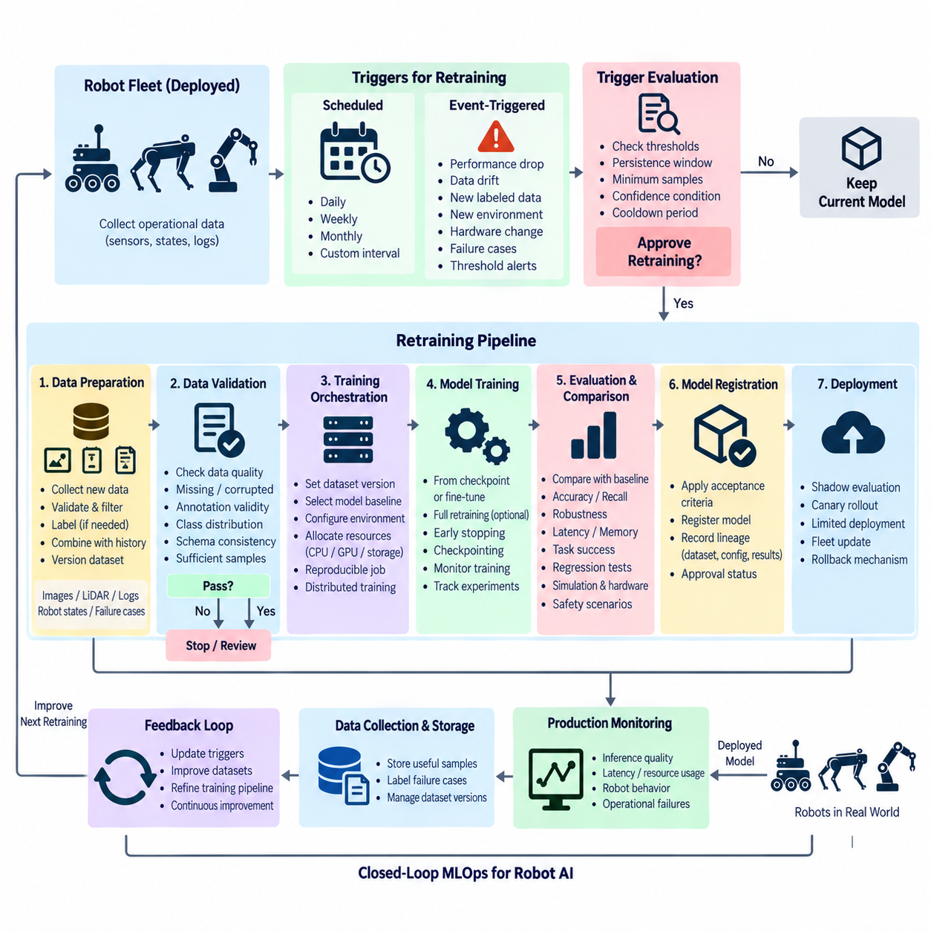
Scheduled and event-triggered retraining pipelines automate the process of updating machine-learning models as robot data, environments, and operational requirements evolve. Instead of relying on engineers to manually decide when every model should be retrained, the pipeline defines explicit triggers that initiate controlled training workflows. These triggers can operate according to time schedules or observable changes detected in deployed robot systems.
Scheduled retraining executes according to a predefined time interval such as daily, weekly, monthly, or another operationally appropriate cycle. This approach is useful when robot fleets continuously accumulate new sensor observations and the organization expects data distributions to evolve gradually. A scheduler initiates the workflow at the defined time, allowing model updates to become a predictable part of the normal MLOps lifecycle.
The retraining frequency should reflect how quickly useful data accumulates and how expensive the training process is. Retraining too frequently can consume GPU resources without producing meaningful model improvement, while excessively long intervals can leave deployed models behind changing operational conditions. Scheduling therefore requires balancing model freshness, dataset growth, computational cost, validation effort, and deployment risk rather than selecting an arbitrary calendar interval.
Event-triggered retraining responds to conditions detected by monitoring, data, or operational systems. Typical events can include model-performance degradation, significant data drift, concept drift, accumulation of sufficient new samples, newly labeled failure cases, expansion into a new operating environment, or changes in robot hardware. The event becomes a signal to evaluate whether a new training cycle should begin rather than automatically replacing the deployed model.
A trigger layer should distinguish between detection and retraining authorization. A temporary change in input data or a small metric fluctuation should not necessarily launch an expensive training job. Trigger logic can therefore use thresholds, persistence windows, minimum sample counts, confidence conditions, and cooldown periods to determine whether an observed event is sufficiently meaningful. This prevents noisy production signals from creating repeated or unnecessary retraining cycles.
Data preparation begins after a retraining request has been accepted. Newly collected robot data must be identified, validated, filtered, labeled when necessary, and associated with existing training datasets. Camera images, LiDAR point clouds, sensor fusion records, ROS2 bags, robot states, trajectories, operator interventions, and failure cases may all contribute to the new dataset. Dataset versions should remain immutable and traceable once used for a training run.
A retraining dataset should not simply replace historical data with the newest observations. Recent samples may represent only a narrow portion of the operating environment and can cause the updated model to lose capabilities learned from previous conditions. Dataset construction therefore often combines new operational data with representative historical samples, difficult cases, safety-critical scenarios, and curated reference data to preserve performance across the intended operational domain.
Before training starts, the pipeline should validate both data quality and training eligibility. Automated checks can detect missing files, corrupted sensor records, invalid annotations, unexpected class distributions, schema changes, or insufficient sample counts. If the dataset fails these gates, the retraining workflow should stop or enter a review state rather than consuming computational resources on an invalid experiment whose results cannot be trusted.
Once data validation succeeds, the orchestration system creates a reproducible training job. The job should reference the exact dataset version, source-code revision, model baseline, configuration, container environment, random seeds, and target hardware assumptions. Resource schedulers then allocate CPUs, GPUs, storage, and distributed-training capacity according to workload requirements, allowing retraining to use the same automated infrastructure as other controlled model-development experiments.
Retraining can begin from different initialization points depending on the model and objective. Some workflows continue training from an existing production checkpoint, while others fine-tune a pretrained model or perform a more complete retraining cycle. The choice influences training cost, convergence speed, stability, and the risk of forgetting previous capabilities. The initialization strategy should therefore be recorded as part of the model lineage rather than treated as an implicit implementation detail.
During execution, experiment tracking records training metrics, validation metrics, configurations, resource usage, checkpoints, and artifacts. Monitoring should identify abnormal loss behavior, failed workers, exhausted GPU memory, stalled data pipelines, and inefficient resource utilization. Early stopping can terminate runs that fail to improve, while checkpointing allows long-running jobs to resume after recoverable failures without repeating the entire training process.
Completion of retraining does not mean that the candidate model is ready for deployment. The new model must be compared with the currently deployed baseline under a consistent validation protocol. Depending on the application, comparison can include accuracy, recall, robustness, latency, memory consumption, task success, regression tests, safety-related scenarios, and performance across different environmental conditions or robot configurations.
Regression protection is especially important because retraining can improve performance on newly collected data while degrading previously solved scenarios. A candidate should therefore be evaluated against historical benchmark sets and known failure cases as well as recent data. For Physical AI systems, simulation scenarios and hardware-aware tests can supplement offline evaluation by exposing behavioral or computational regressions before the candidate reaches operational robots.
The validation gate should apply explicit acceptance criteria rather than assuming that the newest model is automatically superior. A candidate that fails required metrics should be rejected while the current production model remains active. Successful candidates can be registered with their dataset lineage, training configuration, evaluation results, and approval status, creating a traceable relationship between the trigger that initiated retraining and the resulting model artifact.
Deployment should remain a separate controlled stage after retraining and validation. An accepted model can first enter shadow evaluation, limited deployment, canary rollout, or another staged-release mechanism before broader fleet distribution. Production monitoring then observes inference quality, latency, resource consumption, robot behavior, and operational failures. Rollback mechanisms should preserve the ability to return to the previous validated model when unexpected degradation appears.
Scheduled and event-triggered approaches can coexist within the same architecture. Scheduled retraining provides a predictable baseline cycle, while event-triggered workflows respond more quickly to significant operational changes. For example, a perception model may normally retrain on a regular schedule but initiate an earlier workflow when monitoring detects persistent data drift or when the fleet accumulates a sufficient number of newly labeled failure cases.
The feedback loop between deployment, monitoring, data collection, and retraining creates the foundation for continual model improvement. Deployed robots generate operational observations, monitoring systems identify changes, data pipelines preserve useful samples, trigger logic determines when retraining is justified, automated training produces candidate models, and validation determines whether those candidates should progress toward deployment. Each stage remains controlled and independently observable.
A mature retraining pipeline therefore does more than repeatedly execute a training script. It coordinates scheduling, event detection, data governance, reproducible training, resource allocation, experiment tracking, regression testing, validation, model registration, staged deployment, and rollback. The result is a closed MLOps loop in which robot AI can evolve with new data while preserving traceability, operational stability, computational efficiency, and deployment safety.

9.6. RL Training Automation Isaac Gym Parallel Env [w/Code]
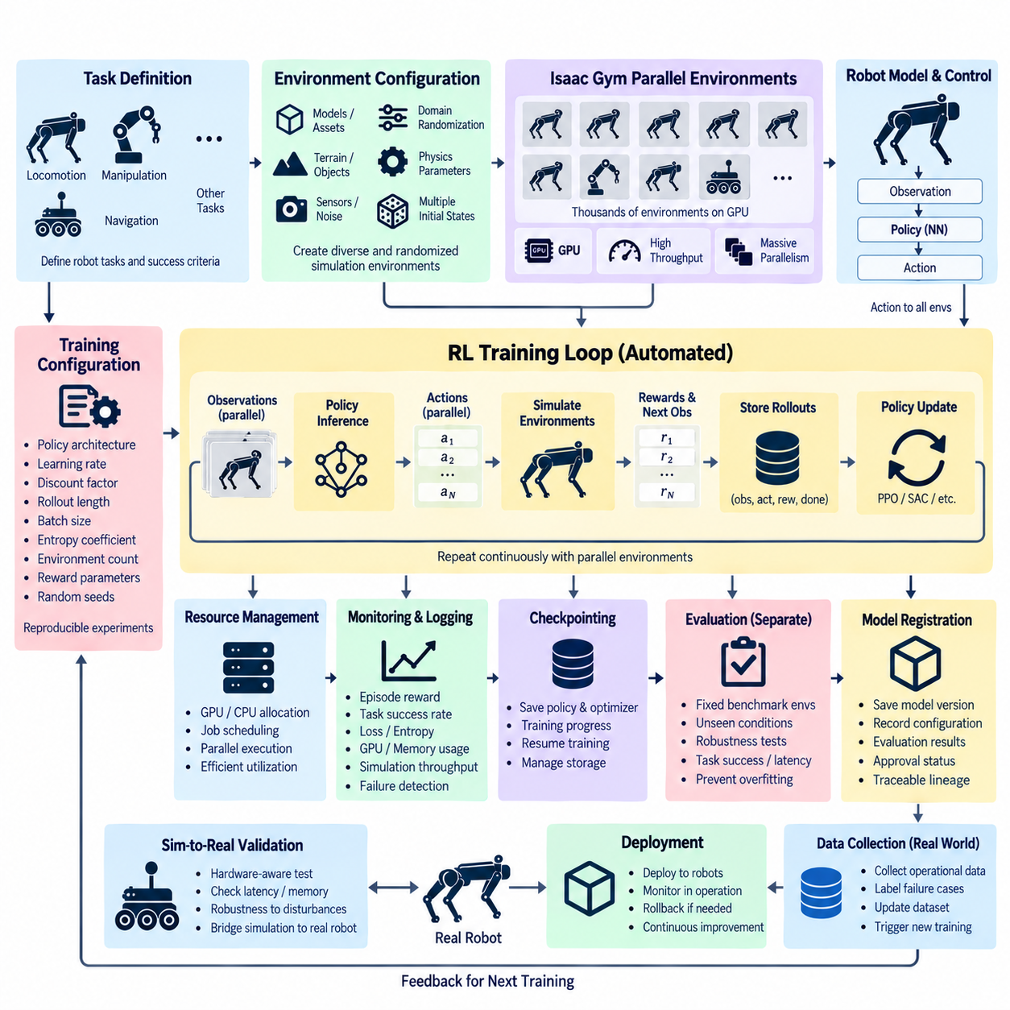
Reinforcement-learning training automation for robotics focuses on executing large numbers of environment interactions efficiently while keeping experiments reproducible and measurable. Unlike supervised learning, where datasets provide fixed training examples, reinforcement learning generates experience through repeated interaction between an agent and an environment. For robot learning, automated infrastructure must therefore coordinate policy execution, environment simulation, reward calculation, rollout collection, optimization, evaluation, checkpointing, and resource management.
Isaac Gym provides a simulation-oriented approach in which many environments can run in parallel, allowing a reinforcement-learning agent to collect experience from numerous simulated robots simultaneously. Instead of waiting for one environment to complete an episode before starting another, thousands of environment instances can progress concurrently on available GPU resources. This parallelism can substantially increase experience collection throughput and is particularly valuable for locomotion, manipulation, navigation, and other tasks requiring large numbers of interaction samples.
The central training loop connects observations, policy inference, environment dynamics, rewards, and policy updates. At each simulation step, parallel environments produce observations that are processed by the policy, actions are generated and applied to the simulated robots, and the environments return new observations and rewards. The collected trajectories are then used by the reinforcement-learning algorithm to update the policy. Automation makes this loop execute continuously without requiring manual intervention between individual training runs.
Parallel environments must remain sufficiently independent while sharing the same training infrastructure. Each environment can represent a different robot state, initial condition, terrain configuration, object arrangement, or randomized physical parameter. This allows a single training iteration to expose the policy to many variations simultaneously. Domain randomization can further vary friction, mass, sensor noise, lighting, disturbances, or other simulation parameters so that the learned policy is less dependent on one fixed simulated condition.
The number of parallel environments is an important infrastructure parameter because it directly affects experience throughput and GPU memory requirements. Increasing the environment count can improve utilization when the workload is sufficiently parallel, but excessive parallelism can increase memory consumption or reduce efficiency through resource contention. Automated training infrastructure should therefore treat environment count as a configurable resource parameter and evaluate its relationship with simulation frequency, policy inference cost, rollout length, and available GPU capacity.
Reinforcement-learning algorithms require consistent handling of trajectories and training batches. Experience collected from parallel environments must be organized into observations, actions, rewards, termination signals, and other algorithm-specific information. The training system then calculates quantities such as returns or advantages before updating the policy. Automation should ensure that these operations follow a consistent configuration so that differences between experiments can be attributed to intentional changes rather than accidental differences in data handling.
Reward design remains a critical component even when training execution is completely automated. The reward function determines which behaviors the policy is encouraged to learn, while penalties can discourage unstable, inefficient, or unsafe actions. For physical robots, rewards may represent task completion, motion quality, energy usage, stability, collision avoidance, or tracking accuracy. Automated training can execute thousands of experiments, but it cannot automatically determine whether a poorly designed reward expresses the intended physical behavior.
Training configuration should be explicitly represented rather than hidden inside implementation code. Policy architecture, learning rate, discount factor, rollout horizon, minibatch size, entropy coefficient, reward parameters, environment count, simulation parameters, and random seeds can all influence the resulting policy. Recording these values together with source-code and environment versions allows each training run to become a reproducible experiment rather than an isolated execution whose conditions are difficult to reconstruct.
Large-scale reinforcement learning can require substantial GPU resources because both simulation and policy optimization may execute continuously. A training scheduler can allocate GPUs and CPUs according to the requirements of each experiment while preventing multiple jobs from competing uncontrollably for the same resources. When multiple training configurations are evaluated, the infrastructure can also combine parallel execution with hyperparameter optimization, early stopping, and experiment tracking to concentrate resources on promising policies.
Monitoring is essential because reinforcement-learning training can fail in ways that are not immediately visible from a single final metric. Training infrastructure should observe episode reward, task success, episode length, policy loss, value loss, entropy, simulation throughput, GPU utilization, memory consumption, and other relevant signals. Abnormal reward collapse, unstable losses, simulation stalls, or resource exhaustion can then trigger controlled termination, checkpoint recovery, or investigation rather than allowing a failed experiment to consume the full training budget.
Checkpointing allows long-running policies to be preserved at meaningful stages of training. A checkpoint can contain policy parameters, value-function parameters when applicable, optimizer state, learning progress, configuration, and other information required for continuation. Automated checkpoint management should preserve useful recovery points while controlling storage consumption. This is particularly important when reinforcement-learning experiments run for long periods or when multiple policies are trained concurrently.
Evaluation should be separated from the training environments used to optimize the policy. A policy that achieves a high reward under training conditions may exploit characteristics of those environments without demonstrating robust behavior. Evaluation environments can therefore use fixed benchmark configurations, unseen randomized conditions, different initial states, disturbances, or task variations. Maintaining separate evaluation conditions provides a stronger indication of whether the learned policy generalizes beyond the exact experiences used during optimization.
For robotics, simulation performance alone is not sufficient to qualify a policy for physical deployment. A trained policy should be evaluated for stability, task success, control frequency, computational latency, memory requirements, and behavior under relevant disturbances. Hardware-aware testing can determine whether the policy can execute within the constraints of the intended robot controller or edge computer. The resulting evaluation creates a bridge between large-scale simulated training and later Sim-to-Real validation.
Sim-to-Real automation extends the training pipeline by connecting simulation configuration with physical robot requirements. Simulation can generate large amounts of experience at lower operational risk, while physical testing reveals discrepancies in dynamics, sensing, actuation, timing, and environmental interaction. Automated pipelines can preserve the simulation configuration, policy version, evaluation results, and deployment assumptions so that differences observed on the real robot can be traced back to the corresponding training experiment.
Reproducibility becomes especially important because reinforcement learning is sensitive to stochasticity. Random seeds, environment initialization, randomized physical parameters, simulator settings, policy initialization, and training configuration can all influence results. Repeating an experiment with controlled seeds and recorded configurations allows engineers to distinguish genuine improvements from statistical variation. Multiple evaluation runs may also be necessary when a single episode or training run does not adequately represent policy behavior.
The automated workflow can ultimately connect environment generation, parallel rollout collection, policy optimization, monitoring, checkpointing, evaluation, and model registration into one continuous pipeline. A training request selects the task and configuration, the infrastructure creates parallel simulation environments, GPUs execute policy interactions, experience is collected and optimized, and the resulting policy is evaluated against defined criteria. Approved policies can then proceed to further simulation, hardware-in-the-loop testing, or controlled physical-robot evaluation.
A mature reinforcement-learning training system therefore treats Isaac Gym-style parallel simulation as part of a broader automated MLOps architecture rather than as an isolated simulator. The objective is to maximize useful experience generation while maintaining reproducibility, resource efficiency, observability, evaluation discipline, and a clear transition toward physical deployment. Parallel environments accelerate learning by increasing interaction throughput, while automated orchestration ensures that the resulting policies remain traceable, measurable, and suitable for systematic Sim-to-Real development.

9.7. Sim to Real Training Pipeline Automation [w/Code]
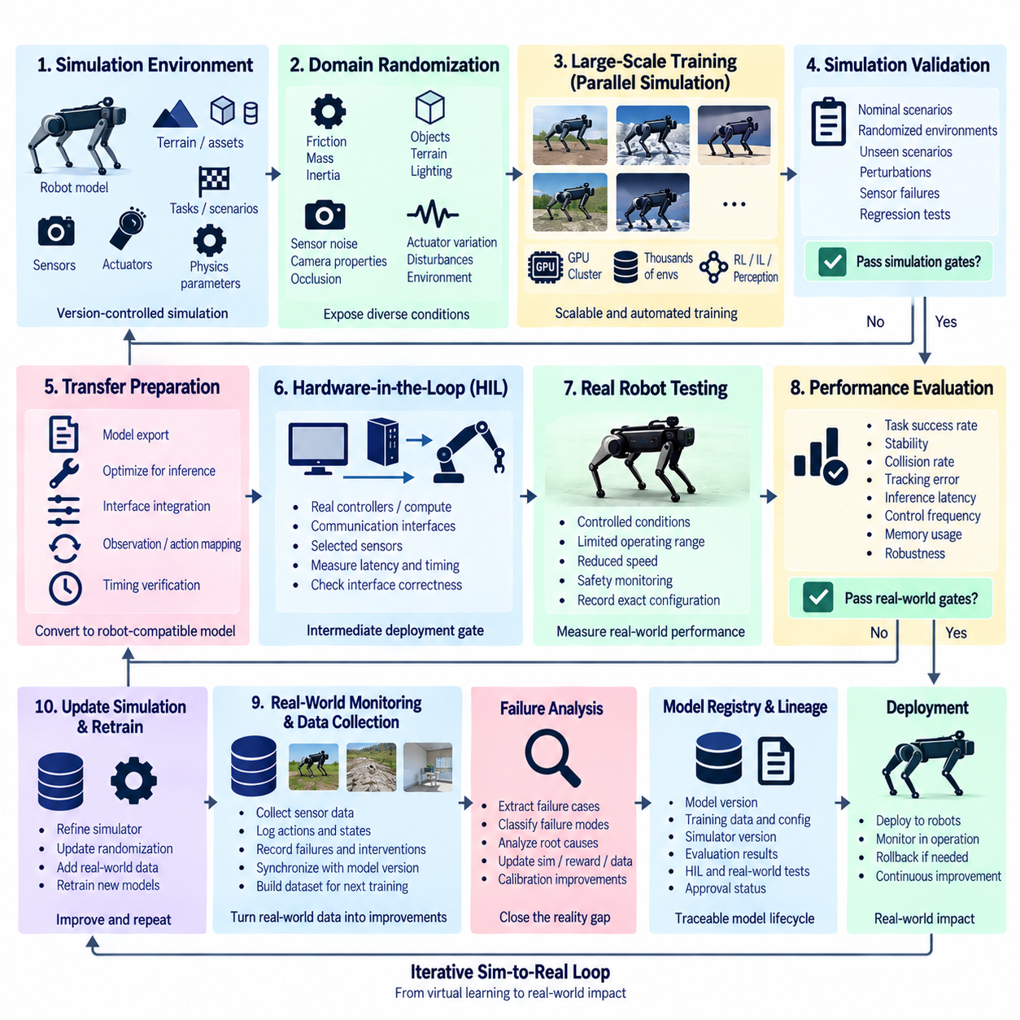
Sim-to-Real training pipeline automation provides a systematic process for transferring models and policies developed in simulation into physical robots. Simulation enables large-scale experimentation without exposing hardware to continuous wear, collisions, or unsafe exploratory behavior, but simulated environments cannot perfectly reproduce real-world dynamics and sensing. Automation therefore coordinates simulation training, validation, transfer preparation, physical testing, data collection, and iterative improvement as one traceable workflow.
The central challenge is the reality gap between simulated and physical systems. Robot mass, inertia, friction, actuator response, joint compliance, contact behavior, sensor noise, communication latency, and environmental interactions may differ from their simulated representations. Small discrepancies can accumulate into substantial behavioral differences, particularly for manipulation, locomotion, navigation, and other tasks involving complex physical contact or rapid closed-loop control.
A Sim-to-Real pipeline begins with a version-controlled simulation environment containing the robot model, sensors, actuators, task definition, physical parameters, assets, and evaluation scenarios. These components should be treated as reproducible training inputs rather than informal simulator settings. Recording simulator versions and environment configurations makes it possible to determine which virtual conditions produced a particular model and to reproduce experiments when transfer failures are discovered later.
Domain randomization reduces dependence on a single idealized simulation by varying relevant parameters during training. Friction coefficients, masses, center-of-mass positions, actuator strength, sensor noise, camera properties, lighting, textures, object poses, terrain, and external disturbances can be randomized within defined ranges. The objective is to expose the model to sufficient variation that the physical robot appears as another plausible condition rather than an entirely unfamiliar domain.
Randomization ranges should not be selected arbitrarily. Excessively narrow ranges may fail to cover real-world variation, while unrealistically broad ranges can make learning unnecessarily difficult or produce overly conservative policies. Automated pipelines can use measured robot parameters, engineering tolerances, calibration results, and operational observations to define distributions, while maintaining explicit versions of these distributions so that changes remain traceable across experiments.
System identification complements domain randomization by estimating parameters of the real robot and using them to improve simulation fidelity. Measurements from physical tests can be used to estimate actuator response, friction, delays, inertial properties, wheel behavior, joint characteristics, or other dynamic parameters. The resulting estimates can update the simulator or adjust randomization distributions, creating a feedback path in which physical observations continuously improve the virtual training environment.
Sensor simulation requires similar attention because perception models can fail even when robot dynamics are represented accurately. Real cameras exhibit exposure changes, blur, distortion, noise, occlusion, and lighting variation, while LiDAR, depth cameras, radar, and inertial sensors have their own error characteristics. Automated Sim-to-Real workflows can introduce calibrated noise models and synthetic perturbations so that training data better represents the uncertainty encountered by physical sensors.
Large-scale simulation training can use parallel environments to generate diverse experiences efficiently. Reinforcement-learning policies may interact with thousands of simulated robot instances, while perception systems can train on large synthetic datasets generated from varied scenes. Distributed training and automated resource scheduling allow these workloads to scale across available accelerators, while experiment tracking preserves the relationship between simulation configuration, training parameters, checkpoints, and resulting model artifacts.
Simulation validation should occur before any candidate reaches physical hardware. Policies and models can be evaluated against nominal conditions, randomized environments, previously unseen scenarios, perturbations, sensor failures, and known difficult cases. Regression suites can ensure that improvements in one scenario do not degrade previously successful behavior. Candidates that fail defined simulation gates should be rejected before consuming scarce robot-testing time or introducing unnecessary hardware risk.
Transfer preparation converts a simulation-trained artifact into a form compatible with the target robot. This stage may include model export, numerical precision conversion, inference-engine optimization, control-interface integration, sensor normalization, observation mapping, action scaling, and timing verification. Automated checks should confirm that tensor shapes, coordinate conventions, control rates, supported operators, and hardware resource requirements remain compatible with the physical execution environment.
Hardware-in-the-Loop testing provides an intermediate stage between pure simulation and unrestricted robot operation. Real controllers, compute hardware, communication interfaces, or selected sensors can participate while other components remain simulated. This allows engineers to measure inference latency, control timing, communication behavior, resource utilization, and interface correctness without immediately exposing the complete robot to every candidate model. Automated HIL tests can therefore serve as another deployment gate.
Initial physical evaluation should use controlled conditions and limited operating envelopes. A transferred policy can begin at reduced speed, restricted workspace, limited actuator authority, or simplified task complexity while monitoring safety and performance signals. The purpose is to measure the actual transfer gap rather than immediately maximizing task performance. Each physical run should preserve the exact model version, configuration, robot hardware revision, calibration state, and test scenario.
Real-world monitoring generates the evidence required for further improvement. Logs can contain sensor observations, commanded and measured actions, robot states, timing information, task outcomes, operator interventions, safety events, and failure cases. These records should be synchronized and associated with the corresponding model and robot configuration. Without this lineage, physical failures become isolated observations rather than useful information for improving simulation and subsequent training.
Failure cases are particularly valuable because they identify regions where the simulator, training distribution, or learned model does not adequately represent reality. Automated data pipelines can extract relevant episodes, classify failure modes, preserve difficult sensor sequences, and route them toward analysis. Engineers can then determine whether the appropriate response is simulator refinement, new domain randomization, reward modification, additional supervised data, calibration improvement, or model architecture changes.
The Sim-to-Real process should therefore operate as an iterative closed loop rather than a one-directional deployment path. Physical observations update simulation parameters and training datasets, revised environments generate new experiences, automated training produces new candidates, simulation and HIL validation filter those candidates, and controlled robot testing measures the next transfer. Each iteration reduces uncertainty while preserving evidence about which changes produced measurable improvements.
Automated acceptance gates prevent iteration from becoming uncontrolled deployment. A candidate can be required to satisfy thresholds for task success, stability, collision rate, tracking error, inference latency, control frequency, memory consumption, and robustness before progressing between stages. Different criteria can be applied at simulation, HIL, limited physical testing, and broader deployment. Failure at any gate should preserve the previous validated model and return diagnostic information to the development pipeline.
Model registration and lineage management connect all stages of the workflow. Every candidate should be associated with its training dataset, simulator version, randomization configuration, source-code revision, training parameters, evaluation results, hardware assumptions, HIL results, and physical-test outcomes. This lineage allows teams to reproduce successful transfers, compare iterations, investigate regressions, and avoid deploying artifacts whose origin or validation history is uncertain.
For Physical AI systems, Sim-to-Real automation ultimately connects scalable virtual learning with controlled physical adaptation. Simulation provides speed, diversity, and safe exploration; system identification and real-world data improve fidelity; validation gates manage transfer risk; and physical testing supplies evidence that cannot be obtained from simulation alone. Automation makes these stages repeatable and measurable rather than eliminating the engineering judgment required to interpret them.
A mature Sim-to-Real training pipeline therefore forms a continuous bridge between digital and physical environments. Simulation, domain randomization, automated training, regression testing, HIL validation, controlled robot trials, operational monitoring, and real-world feedback operate as coordinated stages of one lifecycle. The result is a traceable learning loop in which virtual experience accelerates development while physical evidence continuously corrects the assumptions used to train future robot intelligence.

9.8. Training Resource Scheduling and Cost Management
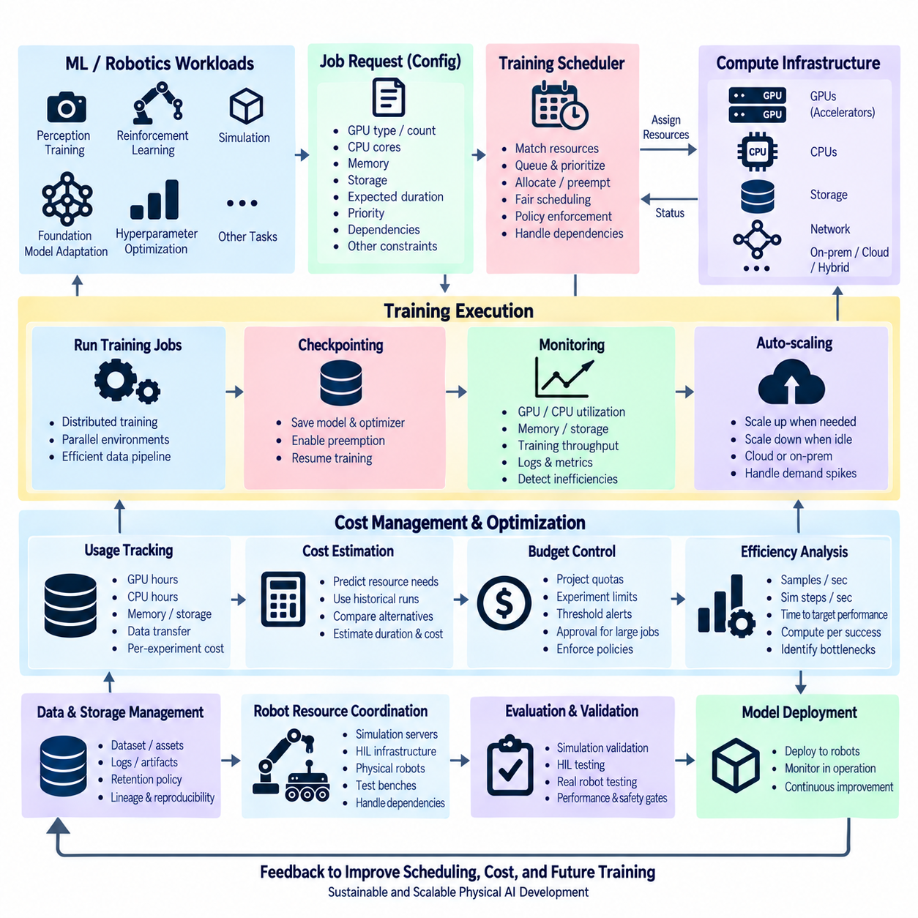
Training resource scheduling and cost management ensures that automated machine-learning workloads receive sufficient compute capacity without allowing GPU, CPU, memory, storage, and network consumption to grow without control. Robotics and Physical AI pipelines may combine perception training, reinforcement learning, simulation, hyperparameter optimization, and foundation-model adaptation. Because these workloads differ greatly in duration and hardware demand, resource allocation must become an explicit part of the training architecture.
A training scheduler converts workload requirements into executable resource assignments. Each job can declare the number and type of GPUs, CPU cores, system memory, local storage, expected duration, and other execution constraints. The scheduler then matches these requirements with available infrastructure and places jobs according to capacity and policy. This separates training logic from hardware allocation, allowing researchers to request resources through reproducible configurations instead of manually selecting machines.
Resource requests should reflect actual workload characteristics rather than simply reserving the largest available hardware. A small perception experiment may require one GPU, while distributed foundation-model fine-tuning may require several accelerators with substantial memory and high-speed communication. Reinforcement-learning workloads can additionally consume large CPU or GPU capacity for parallel environments. Accurate requests improve utilization and reduce situations in which expensive resources remain reserved but mostly idle.
GPU scheduling becomes particularly important because accelerator resources are often the most constrained and expensive component of AI infrastructure. Jobs can be assigned according to GPU memory requirements, accelerator capability, topology, and expected communication patterns. Distributed training may benefit from GPUs located within the same node or connected through high-bandwidth links. Scheduling decisions should therefore consider not only GPU count but also whether the selected hardware configuration supports efficient execution of the requested workload.
Queues provide a controlled mechanism for handling more training requests than the infrastructure can execute simultaneously. Jobs can wait until suitable resources become available rather than competing directly for hardware. Priority policies can distinguish urgent validation, production retraining, exploratory experiments, scheduled jobs, and long-running research workloads. Fair scheduling is also necessary so that one user, project, or large experiment does not continuously consume all available accelerators.
Preemption can improve utilization when infrastructure must support workloads with different priorities. A lower-priority experiment may be paused so that an urgent training or validation job can use its resources, provided the interrupted workload can later resume safely. Reliable checkpointing is therefore closely related to resource scheduling. A job that periodically saves model, optimizer, configuration, and progress state can tolerate interruption more effectively than a job whose entire training history is lost when resources are reclaimed.
Autoscaling extends scheduling by adjusting compute capacity according to workload demand. When the queue grows, additional workers can be activated where infrastructure permits; when demand decreases, unnecessary capacity can be released or powered down. Cloud environments can provide elastic resources, while on-premises clusters operate within fixed physical capacity. Hybrid architectures may use local infrastructure for predictable workloads and external capacity for temporary peaks, subject to data, security, and cost constraints.
Cost management begins by making resource consumption measurable. Each experiment should record GPU-hours, CPU-hours, memory usage, storage consumption, data-transfer volume, and execution duration together with the training configuration and resulting model. This converts compute spending from an infrastructure-level total into experiment-level information. Engineers can then compare not only model accuracy or reward but also the amount of computational resource required to achieve the result.
Utilization metrics reveal whether allocated hardware is actually contributing to training. Low GPU utilization may indicate slow data loading, insufficient batch size, synchronization overhead, simulation bottlenecks, or inefficient preprocessing. High memory reservation with low computational activity can similarly indicate over-allocation. Monitoring utilization together with training throughput allows teams to distinguish workloads that genuinely require larger resources from workloads that should first be optimized at the software or data-pipeline level.
Training efficiency can be evaluated through normalized metrics such as samples processed per second, simulation steps per second, time to target performance, or compute consumed per successful experiment. These measures are more informative than hardware occupancy alone because a fully utilized GPU does not necessarily imply productive training. Resource management should therefore connect infrastructure telemetry with model-training metrics so that scheduling decisions reflect useful progress rather than raw device activity.
Hyperparameter optimization creates a special cost challenge because many experiments may execute concurrently and some configurations become unpromising early. Resource-aware optimization can limit the number of simultaneous trials, assign smaller initial budgets, and terminate poor candidates before they consume full training resources. Promising trials can receive additional epochs, simulation steps, or accelerators. This approach connects scheduling with pruning and early stopping so that compute capacity is concentrated where additional training is likely to provide useful evidence.
Distributed training also requires cost-aware scaling because adding GPUs does not guarantee proportional reduction in training time. Communication, synchronization, data loading, and model structure can limit scaling efficiency. The scheduler should preserve measurements of throughput and completion time at different GPU counts so that future jobs can select appropriate configurations. Using twice as many accelerators for only a small speed improvement may increase total compute consumption even when wall-clock training becomes slightly shorter.
Storage is another component of training cost. Datasets, simulator assets, checkpoints, logs, intermediate artifacts, and experiment outputs can accumulate rapidly when automated pipelines execute continuously. Retention policies can distinguish temporary checkpoints from validated models, preserve important lineage information, and remove redundant intermediate artifacts after defined periods. Cost management should reduce unnecessary storage without deleting information required for reproducibility, auditing, rollback, or future comparison.
Budget controls can be incorporated directly into automated training workflows. Projects may receive compute quotas, experiment limits, or resource budgets that determine how much infrastructure can be consumed within a defined period. The orchestration system can warn when usage approaches a threshold, delay low-priority work, or require additional approval for unusually expensive jobs. Such controls make cost an operational constraint that is visible before execution rather than a financial consequence discovered after training has completed.
Cost estimation before execution can further improve planning. Historical runs provide information about training duration, memory demand, GPU utilization, dataset size, and scaling behavior for similar workloads. The system can use these records to estimate the approximate resource requirement of a new job and compare alternative execution configurations. Estimates should remain distinguishable from measured results because training behavior can change with model architecture, dataset size, simulator complexity, or hardware configuration.
Robotics workloads require additional coordination because training resources may interact with simulation servers, HIL infrastructure, physical robots, or data-generation systems. A model-training job can run whenever GPUs are available, but a validation stage may depend on a limited robot platform or test bench. End-to-end scheduling should therefore understand dependencies between compute jobs and scarce physical resources so that models do not accumulate indefinitely while waiting for downstream validation capacity.
A mature resource-management layer connects job configuration, scheduling, monitoring, checkpointing, utilization analysis, cost attribution, and budget policy into the automated training lifecycle. Every training artifact can be associated with both its technical results and the resources consumed to produce it. This provides the evidence required to improve infrastructure planning, select appropriate hardware, identify inefficient workloads, and balance experimentation speed against operational constraints.
For Physical AI, training resource scheduling and cost management ultimately enables continuous experimentation to scale sustainably. The objective is not simply to minimize compute usage, because insufficient resources can slow development and reduce experimental coverage. Instead, the system should allocate the right resources to the right workload at the appropriate time, measure whether those resources create useful learning progress, and preserve enough flexibility for simulation, robot learning, validation, and future model development.

9.9. Training Pipeline Monitoring and Early Stopping [w/Code]
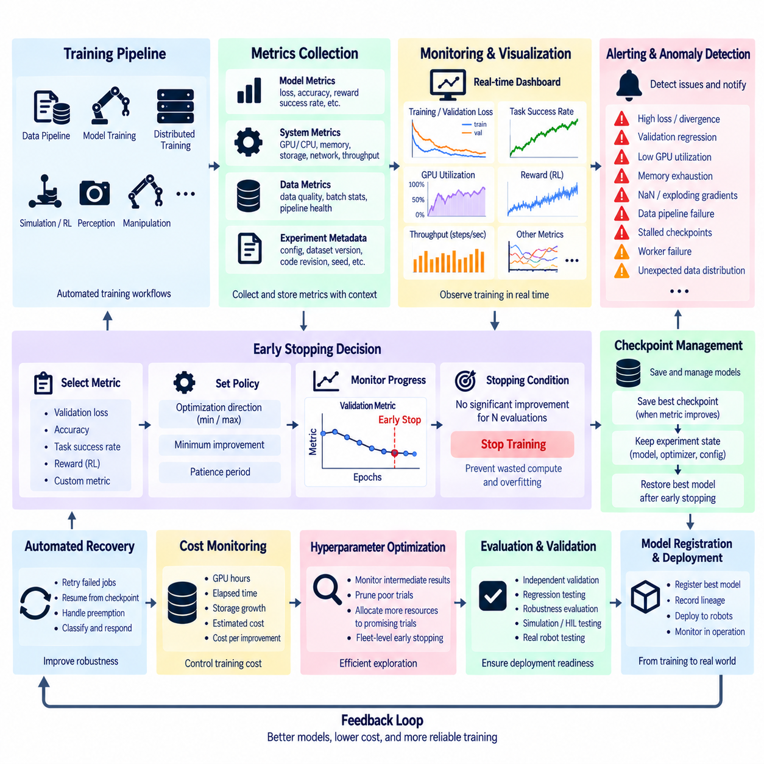
Training pipeline monitoring provides continuous visibility into whether an automated learning job is progressing correctly, efficiently, and toward the intended objective. A training process can continue consuming substantial compute resources even when optimization has stalled, validation performance has degraded, or the input pipeline has failed silently. Monitoring therefore connects model metrics, infrastructure telemetry, data-pipeline health, experiment state, and automated control actions into one operational view.
The monitoring system should collect metrics from the complete training lifecycle rather than observing only the final model score. Training loss, validation loss, accuracy, precision, recall, task success rate, reward, learning rate, gradient statistics, and other task-specific indicators describe learning behavior. At the same time, GPU utilization, memory usage, CPU load, storage activity, network throughput, and training speed reveal whether infrastructure is supporting that learning efficiently.
Metric collection should preserve the relationship between measurements and the exact training configuration that produced them. Model architecture, dataset version, hyperparameters, source-code revision, random seed, hardware configuration, environment version, and checkpoint identifiers provide essential experiment context. Without this metadata, a learning curve may show that one run performed better than another while providing insufficient evidence to explain or reproduce the difference.
Real-time dashboards make long-running experiments observable while they are still executing. Engineers can inspect loss curves, validation metrics, learning rates, throughput, GPU utilization, memory pressure, and task-specific performance without waiting for completion. For robotics workloads, dashboards may additionally display simulation steps per second, episode return, success rate, collision statistics, perception quality, or other signals associated with robot behavior and environment interaction.
Monitoring should distinguish normal variation from meaningful failure conditions. Short-term fluctuations in loss or reward are common, particularly in reinforcement learning, while persistent divergence may indicate unstable optimization. Sudden throughput reduction can reveal data-loading problems, communication bottlenecks, or simulation slowdown. NaN values, exploding gradients, exhausted memory, failed workers, corrupted batches, or stalled checkpoints can indicate failures requiring immediate intervention rather than continued execution.
Alerting converts monitored conditions into actionable events. Threshold rules can detect excessive loss, insufficient GPU utilization, memory exhaustion, validation regression, missing checkpoints, or training jobs that stop reporting progress. Alerts should contain experiment identifiers and relevant diagnostic context so that engineers can determine which run is affected. Repeated transient conditions may require persistence windows or cooldown periods to prevent excessive notifications from harmless fluctuations.
Early stopping extends monitoring from observation into automated training control. Instead of executing a fixed maximum number of epochs or optimization steps regardless of progress, the system observes a selected validation metric and terminates training when additional computation is unlikely to provide meaningful improvement. This reduces unnecessary resource consumption while allowing productive experiments to continue until their performance has stabilized.
A typical early-stopping policy defines a monitored metric, optimization direction, minimum improvement, and patience period. The system records the best observed value and determines whether subsequent evaluations provide sufficient improvement. If performance fails to improve beyond the configured minimum for the specified patience interval, training can stop. Patience is important because temporary plateaus or noisy validation measurements should not automatically terminate an experiment that may still improve.
Selecting the correct monitoring metric is more important than simply enabling early stopping. Training loss may continue decreasing while validation performance worsens because the model is overfitting. For this reason, early stopping commonly relies on an independent validation metric that reflects expected model behavior. Robotics applications may use task success, perception accuracy, navigation completion, manipulation success, reward, collision rate, tracking error, or a composite metric depending on the objective.
The best checkpoint should normally be preserved independently from the final training state. If validation performance peaks and later deteriorates, the model produced at the final epoch may be inferior to an earlier version. Automated checkpoint management can save candidates when the monitored metric improves and associate them with the corresponding experiment state. When early stopping occurs, the pipeline can restore or register the best validated checkpoint rather than automatically selecting the last one.
Early stopping also provides protection against overfitting, although it should not be treated as a complete solution. Validation degradation can indicate that the model is increasingly adapting to characteristics of the training data that do not generalize. Stopping near the point of best validation performance can reduce this effect, but robust generalization still depends on representative datasets, appropriate regularization, correct evaluation design, and independent testing against conditions not used for optimization.
Reinforcement-learning pipelines require special treatment because reward and success metrics can be highly stochastic. A single evaluation episode or temporary reward decrease may not provide sufficient evidence for termination. Monitoring can therefore use moving averages, multiple evaluation episodes, confidence measures, or longer patience intervals. Training should also distinguish between exploration-related variability and persistent performance collapse so that early stopping does not eliminate potentially successful policies prematurely.
Distributed training introduces additional monitoring requirements. Individual workers may slow down, fail, lose network connectivity, or become inconsistent with the rest of the training group. Monitoring should track worker health, synchronization time, communication overhead, data throughput, and accelerator utilization across nodes. A distributed job may appear active while one slow worker reduces overall throughput, making system-level telemetry necessary alongside model-level metrics.
Automated recovery can complement early stopping when the detected problem is operational rather than algorithmic. A failed worker, interrupted node, temporary storage error, or preempted job may justify restarting from the latest valid checkpoint instead of terminating the experiment permanently. The monitoring system should therefore classify events where possible and distinguish conditions requiring retry, rollback, pause, investigation, or final termination.
Training pipeline monitoring should also observe the data path feeding the model. Missing files, unexpected class distributions, malformed samples, delayed preprocessing, changed feature statistics, or corrupted simulation outputs can invalidate an experiment even when the training process itself continues running. Data-quality checks and dataset statistics should therefore become part of monitoring so that apparently successful optimization is not performed on unintended or damaged inputs.
Cost-aware monitoring connects training progress with resource consumption. GPU-hours, elapsed time, energy-related telemetry where available, storage growth, and estimated experiment cost can be evaluated alongside model improvement. If an experiment consumes increasing resources while producing negligible performance gains, early stopping can become an economic control as well as an optimization mechanism. This relationship is particularly important when large hyperparameter searches execute many trials simultaneously.
Hyperparameter optimization systems can use intermediate monitoring results to prune weak trials before they complete. Each trial periodically reports validation performance, and a scheduler compares its progress with defined criteria or other experiments. Poor candidates can be terminated while promising configurations receive additional resources. This transforms early stopping from a single-model mechanism into a fleet-level strategy for allocating compute toward experiments that provide the strongest evidence of useful progress.
Evaluation gates should follow early stopping rather than treating termination itself as evidence that a model is ready for deployment. The selected checkpoint still requires independent validation, regression testing, robustness evaluation, and any robotics-specific simulation, HIL, or physical testing required by the deployment process. Early stopping determines when optimization should end; acceptance gates determine whether the resulting artifact satisfies the technical and operational requirements for promotion.
A mature monitoring and early-stopping architecture therefore forms a closed control layer around automated training. Metrics and logs describe learning and infrastructure behavior, alerts expose abnormal conditions, checkpoints preserve recoverable states, and early-stopping policies prevent unproductive computation. Combined with experiment tracking, resource scheduling, validation, and model registration, this layer enables Physical AI training pipelines to operate continuously while remaining observable, efficient, reproducible, and governed.

9.10. Foundation Model Fine Tuning Automation for Robots [w/Code]
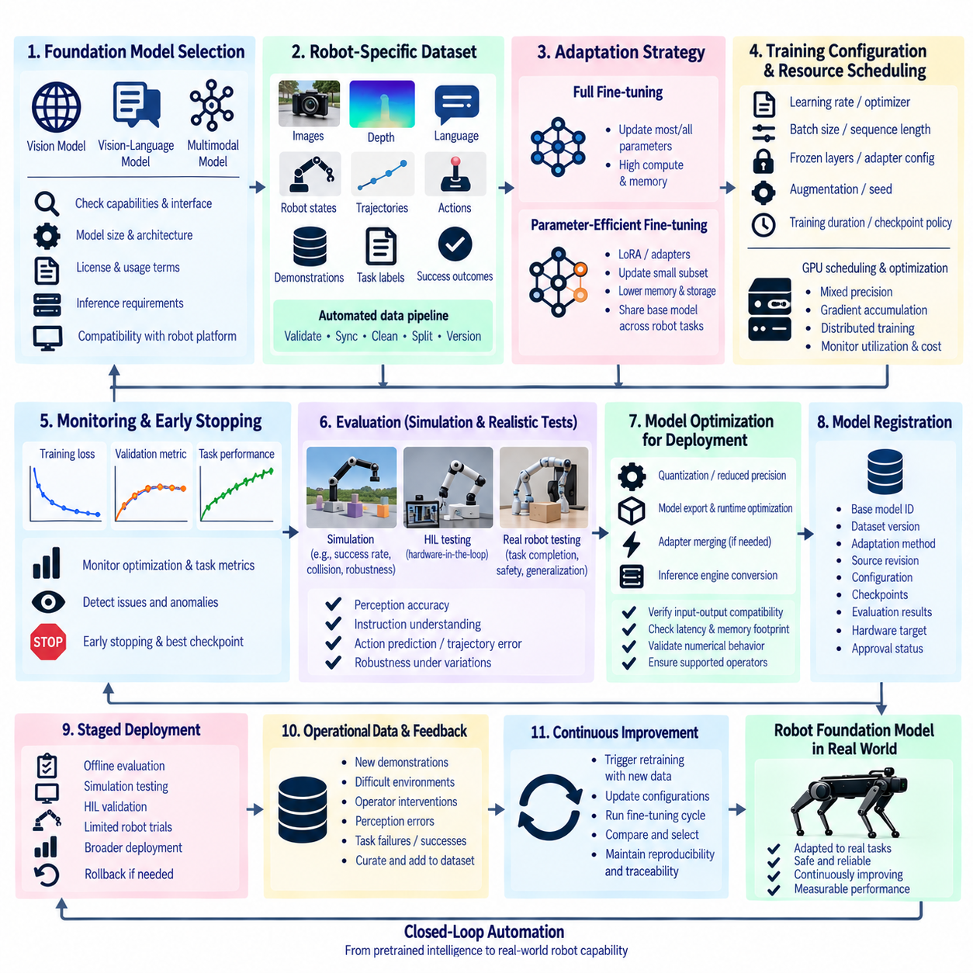
Foundation model fine-tuning automation for robots adapts large pretrained models to robot-specific perception, language, planning, and action tasks through a repeatable training pipeline. Instead of training every capability from scratch, robotics teams can begin with models that already contain broad visual, linguistic, or multimodal representations. Automation then manages dataset preparation, adaptation strategy, training, evaluation, checkpointing, registration, and deployment while preserving the lineage of each resulting robot model.
The first stage is selecting a foundation model whose capabilities and interfaces match the intended robotic task. Vision models can support perception and scene understanding, vision-language models can connect images with semantic instructions, and multimodal models can combine visual, textual, proprioceptive, or other sensor information. Selection should also consider model size, architecture, license constraints, supported input modalities, inference requirements, and compatibility with the target robot computing platform.
Robot-specific datasets transform general pretrained knowledge into operational capability. Training examples may combine camera images, depth information, language instructions, robot states, trajectories, actions, demonstrations, task labels, or success outcomes. Automated data pipelines should validate formats, synchronize multimodal observations, remove corrupted records, create training and validation splits, and assign explicit dataset versions. The resulting dataset becomes a reproducible input to every fine-tuning experiment.
Data quality is particularly important because robot datasets are often smaller and more expensive to collect than general Internet-scale datasets. Demonstrations may contain inconsistent actions, sensor dropouts, failed trajectories, or environment-specific biases. Automated validation can detect missing modalities, invalid timestamps, unusual action distributions, duplicated sequences, or incomplete episodes. Human review remains valuable for determining whether demonstrations actually represent the behavior that the robot is expected to learn.
Full fine-tuning updates most or all parameters of the pretrained model and can provide substantial adaptation capacity, but it also requires significant accelerator memory and computation. Large foundation models may therefore make full-parameter training impractical for routine robotics experiments. Automated pipelines should treat the adaptation method as a configurable decision rather than assuming that every experiment requires modification of the entire pretrained network.
Parameter-efficient fine-tuning reduces this requirement by updating only a small portion of the model or introducing trainable adaptation parameters. Techniques such as low-rank adaptation can preserve the pretrained backbone while learning task-specific changes with lower memory and storage requirements. This enables multiple robot tasks or platforms to maintain separate lightweight adapters while sharing a common foundation model, simplifying experiment management and reducing duplicated model artifacts.
Fine-tuning configuration should be explicitly versioned with the model and dataset. Learning rate, optimizer, batch size, sequence length, precision, frozen layers, adapter configuration, augmentation parameters, training duration, random seed, and checkpoint policy can all affect the final behavior. Capturing these settings in configuration files allows automated orchestration systems to reproduce experiments, launch controlled variations, and compare adaptation strategies without relying on undocumented manual changes.
Resource scheduling is critical because foundation-model workloads can exceed the memory capacity of a single accelerator. Mixed-precision training, gradient accumulation, activation checkpointing, distributed data parallelism, and parameter or optimizer-state sharding can reduce or distribute memory requirements. Automated scheduling can match each experiment to suitable GPU resources while monitoring utilization, memory pressure, communication overhead, throughput, and total training cost.
The fine-tuning pipeline should continuously monitor both optimization and task-level performance. Training loss alone does not establish that the model has acquired useful robotic capability. Validation can measure perception accuracy, instruction understanding, action prediction quality, trajectory error, task completion, or other application-specific metrics. Early stopping and checkpoint selection can prevent unnecessary computation when validation improvement stalls or when additional optimization begins to reduce generalization.
Catastrophic forgetting is an important concern when a broadly capable model is adapted to a narrow robot dataset. Excessive specialization may improve one target task while degrading useful pretrained capabilities. Evaluation should therefore include both robot-specific benchmarks and selected general capabilities that should remain intact. Dataset mixing, conservative learning rates, parameter-efficient adaptation, or regularization strategies can help balance specialization with retention of useful pretrained knowledge.
Multimodal robot models require careful interface alignment because each modality may operate at a different rate and representation. Camera frames, language commands, proprioceptive states, force measurements, maps, and action sequences must be synchronized and transformed into the expected model inputs. Automated preprocessing should preserve coordinate conventions, normalization rules, temporal alignment, tokenization, and sensor metadata so that training and deployment interpret observations consistently.
For models that generate robot actions, evaluation must extend beyond prediction similarity. A predicted action sequence may appear numerically close to demonstration data while producing unstable or unsafe behavior when executed in closed loop. Simulation can therefore evaluate task completion, collisions, constraint violations, recovery behavior, and robustness under environmental variation. Candidate models should pass these behavioral tests before progressing toward HIL or controlled physical-robot evaluation.
Simulation also provides a scalable environment for evaluating foundation-model adaptations across many robot states and scenarios. Automated evaluation can replay benchmark tasks, vary objects and environments, introduce sensor perturbations, and test previously unseen instructions. Failures can be stored as structured examples and routed back into dataset preparation. This creates a feedback mechanism in which difficult scenarios discovered during evaluation become training material for subsequent fine-tuning cycles.
Hardware-aware optimization prepares validated models for deployment on robot compute platforms. Model export, quantization, reduced precision, runtime optimization, adapter merging where appropriate, and inference-engine conversion may reduce latency and memory consumption. Automated checks should compare optimized artifacts with their training versions and verify input-output compatibility, numerical behavior, execution latency, memory footprint, and supported operators before deployment approval.
Model registration should preserve both the foundation model and every adaptation applied to it. The registry can associate each artifact with its base-model identifier, dataset version, adapter or fine-tuning method, source revision, configuration, checkpoints, evaluation results, hardware target, and approval state. This lineage becomes essential when many robot types, tasks, environments, and model variants share the same pretrained foundation but evolve through different adaptation paths.
Deployment should normally progress through controlled stages rather than moving directly from training to unrestricted robot operation. A candidate can pass offline evaluation, simulation testing, hardware-in-the-loop validation, limited robot trials, and broader operational testing. Each stage produces evidence that can approve, reject, or return the model for further adaptation. Rollback capability should preserve a previously validated model if the new version shows unexpected behavior after deployment.
Operational robot data closes the automation loop. New demonstrations, difficult environments, operator interventions, perception errors, task failures, and successful trajectories can be collected and transformed into future training examples. Data-quality and governance rules determine which observations enter the curated dataset. When sufficient new evidence accumulates or performance conditions trigger retraining, the pipeline can initiate another controlled fine-tuning cycle using updated data and configuration.
A mature foundation-model fine-tuning system therefore connects pretrained intelligence with robot-specific experience through a governed lifecycle. Dataset versioning, parameter-efficient adaptation, distributed training, monitoring, simulation evaluation, hardware optimization, model registration, staged deployment, and operational feedback operate as coordinated components. Automation makes repeated adaptation practical while maintaining reproducibility, traceability, resource efficiency, and measurable evidence that each model is suitable for its intended robotic task.

