Volume 10 Robot DevOps and MLOps

11. SW BOM and License Management

11.1. Software BOM SBOM Concepts SPDX CycloneDX Formats
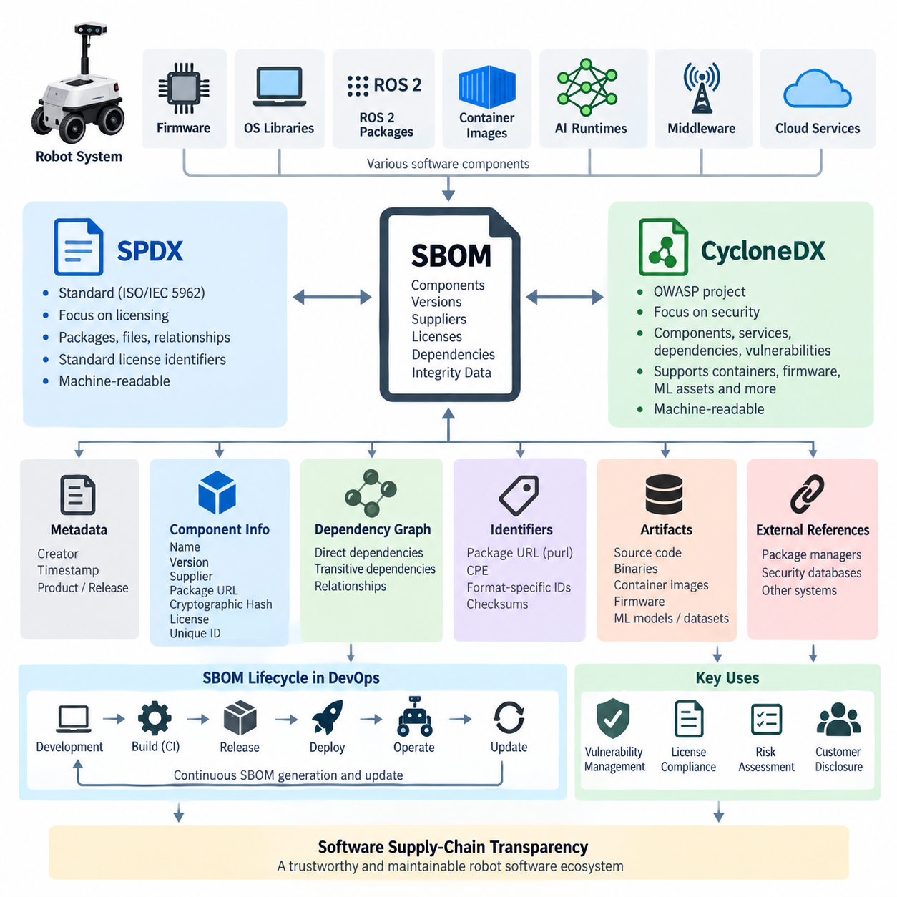
A Software Bill of Materials, commonly called an SBOM, is a structured inventory describing the software components contained in a product or software system. It records information such as component names, versions, suppliers, licenses, package identifiers, dependency relationships, and integrity data. In robotics, an SBOM may cover ROS 2 packages, operating-system libraries, firmware components, container images, AI runtimes, communication middleware, and third-party utilities deployed across robot and cloud systems.
The fundamental purpose of an SBOM is software supply-chain transparency. Modern software is rarely developed entirely from proprietary source code; instead, applications combine open-source libraries, commercial SDKs, operating-system packages, middleware, container layers, and externally maintained dependencies. Without a structured inventory, engineering teams may not know exactly which third-party components are present in a released robot, making vulnerability response, license compliance, and long-term maintenance significantly more difficult.
An SBOM should be understood as more than a static list of libraries. Dependency relationships are particularly important because software packages frequently depend on other packages that developers did not explicitly install. These transitive dependencies can extend through many levels of the dependency graph. A useful SBOM therefore represents both components and relationships, allowing engineers to trace how a vulnerable or license-sensitive package entered a deployed software image and which higher-level applications depend on it.
Robotic systems make this problem especially complex because their software stacks span heterogeneous computing environments. A single autonomous robot may contain embedded firmware, Linux edge computers, ROS 2 middleware, navigation packages, GPU libraries, AI inference frameworks, containerized applications, and cloud-connected fleet services. The surrounding curriculum therefore treats SBOM management as part of Robot DevOps and MLOps rather than as an isolated security activity, alongside CI/CD, containerization, deployment, monitoring, and HIL testing.
SPDX, originally developed within the Linux Foundation ecosystem and standardized as ISO/IEC 5962, provides a machine-readable framework for communicating software component, licensing, copyright, security, and provenance information. SPDX documents can identify packages and files and describe relationships among them. SPDX identifiers also provide standardized expressions for software licenses, reducing ambiguity when automated systems analyze the licensing obligations associated with complex dependency trees.
An SPDX representation typically models elements such as documents, packages, files, snippets, licenses, checksums, external references, and relationships. A package can declare that it contains particular files or depends on another package, while external references can connect components to package managers or security databases. This relationship-oriented structure enables an SBOM to represent software composition as a graph rather than merely as a flat spreadsheet containing package names and versions.
CycloneDX is another widely adopted SBOM specification, developed through OWASP with a strong focus on software supply-chain and application security use cases. It represents components, services, dependencies, vulnerabilities, licenses, hashes, and related metadata in standardized machine-readable structures. CycloneDX can describe conventional software packages as well as containers, services, firmware, hardware-related elements, machine-learning assets, and other artifacts relevant to modern software-intensive systems.
Although SPDX and CycloneDX overlap substantially, their historical emphasis differs. SPDX developed strongly around software licensing, intellectual-property information, and software composition exchange, while CycloneDX emerged with a security-oriented bill-of-materials approach. In practical DevSecOps environments, however, both formats now support broader software supply-chain use cases. The appropriate choice therefore depends on customer requirements, regulatory expectations, existing security tools, and interoperability with the organization's development infrastructure.
An SBOM document normally contains metadata identifying who created it, when it was generated, and which software product or release it describes. Component records then provide attributes such as package name, version, supplier, package URL, cryptographic hash, license information, and unique identifiers. Dependency information connects these records so automated tools can determine direct and transitive relationships. These identifiers are essential because package names alone are often insufficient to correlate components reliably across repositories and vulnerability databases.
Package URL, or purl, is commonly used to identify software packages according to ecosystem, namespace, name, version, and related qualifiers. Other identifiers may include Common Platform Enumeration references or format-specific identifiers. Cryptographic hashes provide additional evidence that a recorded artifact corresponds to a particular binary or package. Together, these fields improve machine-to-machine correlation among SBOM generators, vulnerability scanners, artifact repositories, CI pipelines, and security-management platforms.
The lifecycle of an SBOM should follow the lifecycle of the software itself. A development branch, release candidate, production container, robot firmware image, and deployed fleet version may contain different dependency sets. Consequently, an SBOM generated once during initial development quickly becomes obsolete. Mature DevOps processes generate or update SBOMs during builds and associate them with immutable release artifacts, container digests, firmware versions, or software release identifiers.
This lifecycle integration connects directly with automated SBOM generation in CI pipelines, which is treated as the next topic in the chapter structure. The same structure subsequently extends SBOM concepts into open-source license classification, compliance scanning, ROS 2 package auditing, AI model and dataset provenance, dependency vulnerability tracking, customer disclosure, internal intellectual-property management, and integration with cybersecurity standards.
For a ROS 2 robot, the resulting inventory can span ROS packages, Debian packages, Python modules, C/C++ libraries, DDS implementations, CUDA-related libraries, inference runtimes, device SDKs, and container base images. Merely examining a ROS workspace is therefore insufficient. Dependencies may originate from the operating system, package managers, source builds, vendor SDK installations, or container layers, so SBOM generation should observe the actual build and deployment environment rather than relying exclusively on manually maintained dependency declarations.
Containerized robot software adds another dimension because an application image inherits components from its base image. A small application layer can therefore contain hundreds of packages inherited indirectly from Ubuntu, CUDA, ROS 2, or another runtime image. SBOM tooling must identify these inherited components and preserve the connection between the generated inventory and the exact image digest. This makes it possible to determine whether a reported vulnerability actually affects the image deployed on a particular robot fleet.
SBOMs also provide the foundation for vulnerability management. When a new Common Vulnerabilities and Exposures entry is published, security systems can compare affected package identifiers and versions against stored SBOMs. Instead of manually inspecting every repository, operators can identify which products, software releases, containers, or robots contain the affected component. The SBOM does not itself prove exploitability, but it dramatically narrows the scope of investigation and supports systematic vulnerability triage.
License management uses the same component inventory for a different purpose. Organizations can identify components governed by permissive, weak-copyleft, strong-copyleft, proprietary, or other licensing conditions and determine which obligations apply to distributed products. Because robotic products combine software from many ecosystems, this process should be automated wherever possible. SBOM information can provide the evidence layer from which dedicated compliance systems generate notices, review exceptions, and maintain release-specific license records.
SBOM completeness is therefore as important as SBOM format. A syntactically valid SPDX or CycloneDX file may still provide little operational value if significant components are missing, versions are inaccurate, dependency relationships are incomplete, or the document cannot be linked to the deployed artifact. Organizations should treat SBOM quality as measurable engineering data, checking coverage, identifier accuracy, dependency depth, provenance, freshness, and reproducibility rather than assuming that successful file generation automatically means complete software transparency.
For robotics DevOps, the most useful model is to regard the SBOM as a continuously maintained digital inventory of the software supply chain. Source control identifies what developers changed, CI records how software was built, artifact repositories preserve what was produced, and the SBOM describes what the resulting artifact contains. Vulnerability and license systems can then evaluate that inventory, while deployment records identify where each artifact is operating across robots, test systems, edge computers, and cloud infrastructure.
Ultimately, SPDX and CycloneDX provide standardized languages for expressing this software composition information so that it can move between development, security, compliance, manufacturing, and customer environments. Their value comes not simply from producing an SBOM file, but from connecting component identity, dependency relationships, provenance, licensing, vulnerabilities, and released artifacts into a traceable software lifecycle. This foundation enables the subsequent automation of SBOM generation, compliance analysis, vulnerability tracking, and software supply-chain governance throughout robotic systems.

11.2. Automated SBOM Generation in CI Pipeline [w/Code]
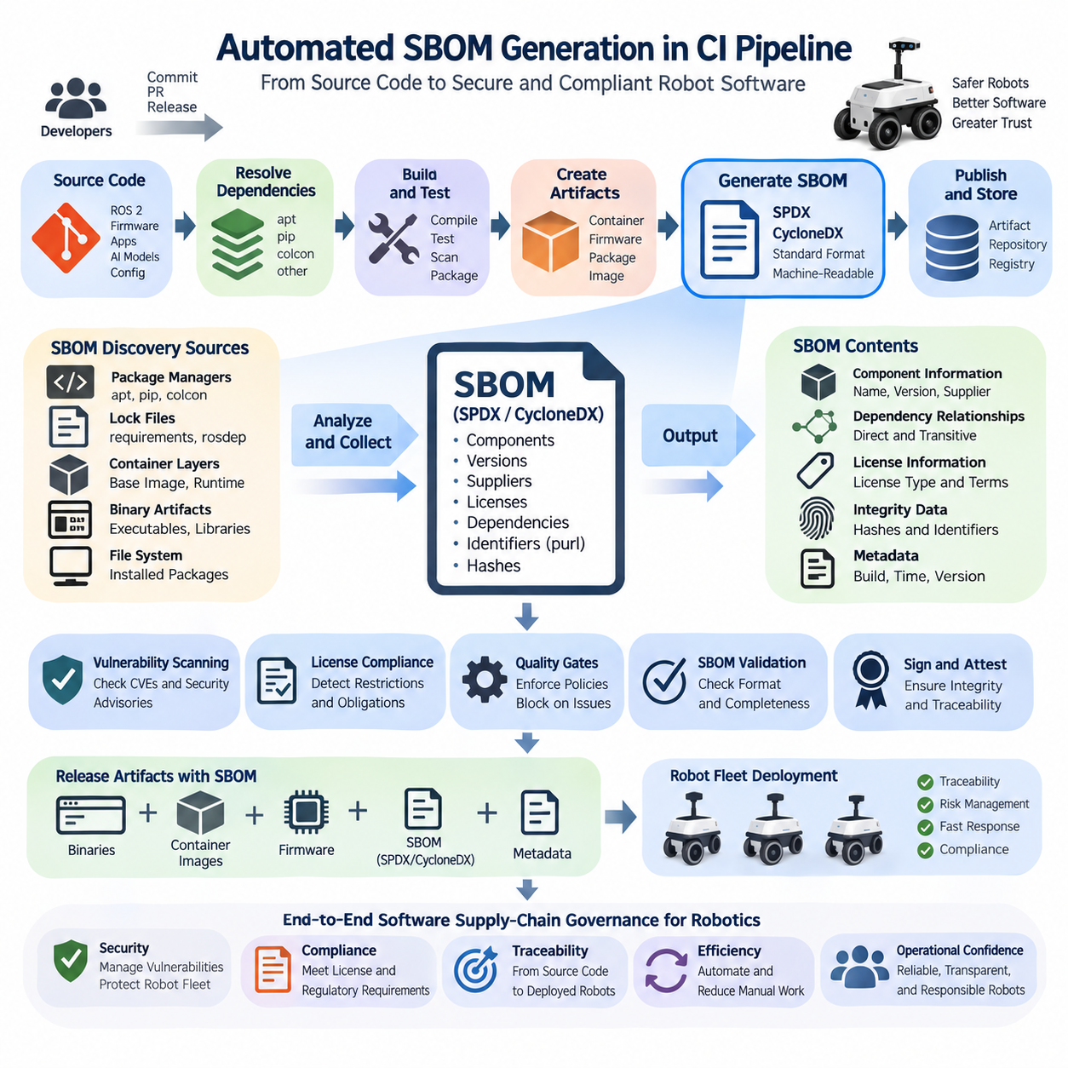
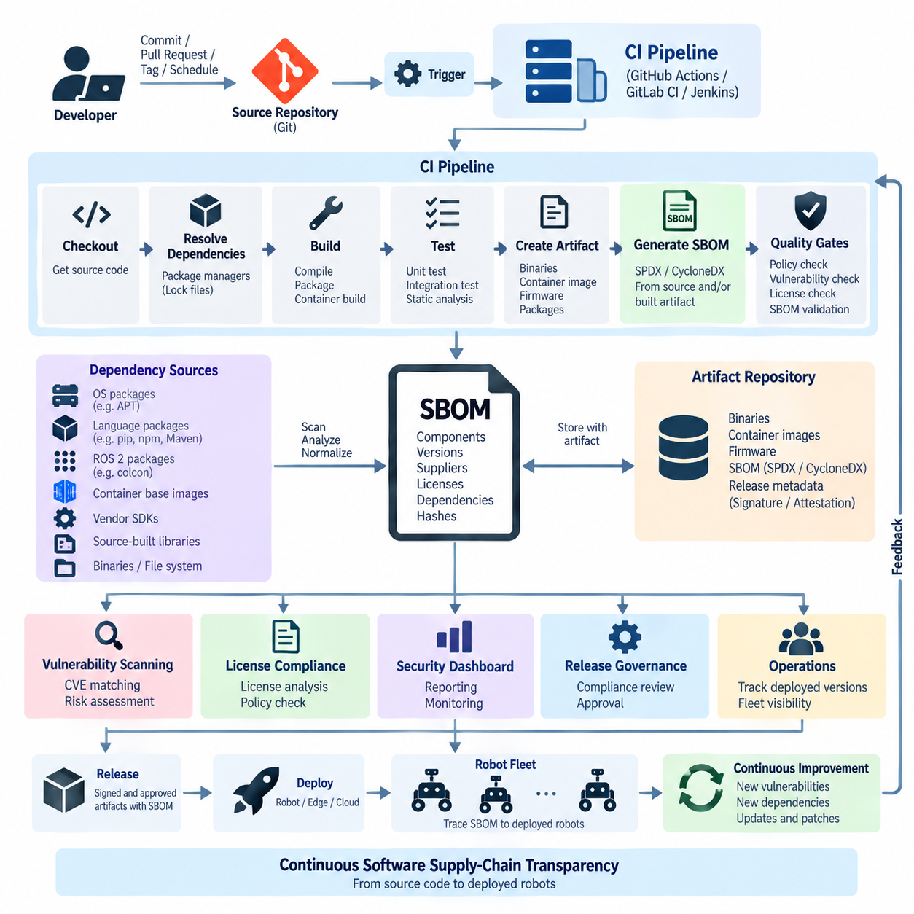
Automated SBOM generation in a Continuous Integration pipeline transforms software inventory creation from a manual documentation activity into a repeatable part of the build process. Whenever source code is compiled, packaged, or assembled into a release artifact, the pipeline can inspect dependencies and generate a corresponding Software Bill of Materials. This approach keeps software composition information synchronized with the actual binaries, containers, firmware, and packages delivered to robotic systems.
The CI pipeline is an effective location for SBOM generation because it already represents the controlled transition from source code to deployable artifacts. Source repositories, dependency managers, compilers, container builders, and packaging tools converge during this stage. By placing SBOM generation after dependencies have been resolved and artifacts have been assembled, the system can describe the software that was actually produced rather than relying only on developer-maintained dependency declarations.
A typical automated workflow begins when a commit, pull request, release tag, or scheduled build triggers the CI system. The pipeline retrieves the source code, resolves dependencies, executes compilation and tests, and creates the target artifact. An SBOM generation stage then analyzes the workspace, package databases, container filesystem, or resulting binary artifacts and produces a machine-readable inventory in a standardized format such as SPDX or CycloneDX.
The location of the SBOM generation stage influences the accuracy of the resulting inventory. Generating an SBOM directly from source manifests can provide early visibility into declared dependencies, but it may not capture everything contained in the final product. Generating it from a built container image or filesystem can reveal installed and transitive packages. Mature pipelines may therefore combine source-level and artifact-level analysis to obtain broader software composition coverage.
Automated generation tools discover components through several mechanisms. They may inspect package-manager metadata, lock files, language-specific dependency databases, operating-system package databases, container layers, compiled binaries, and filesystem contents. The discovered information is normalized into component records containing names, versions, suppliers, licenses, package identifiers, hashes, and dependency relationships. The resulting document becomes a structured representation of the build's software composition.
In robotics, SBOM discovery must account for heterogeneous dependency sources. A ROS 2 application can include packages built with colcon, Debian packages installed through APT, Python modules installed through pip, C and C++ libraries built from source, DDS middleware, GPU runtimes, vendor device SDKs, and custom robot software. An automated CI workflow should therefore examine multiple dependency domains rather than assuming that a single package manager represents the complete robot software stack.
Containerized robot applications provide a particularly useful boundary for automated SBOM generation. Once a container image has been built, an SBOM scanner can inspect the final image and identify packages inherited from the base image together with application-specific components added during the build. Associating the generated SBOM with the immutable container digest allows security and operations teams to determine exactly which software inventory belongs to a particular deployed image.
The generated SBOM should be treated as a release artifact rather than temporary CI output. The pipeline can preserve it alongside binaries, container images, firmware packages, deployment manifests, and release metadata in an artifact repository or registry. Linking the SBOM to a commit identifier, release version, build number, image digest, or cryptographic hash creates traceability between source code, build execution, software composition, and the artifact ultimately deployed to a robot.
Standardized output formats enable downstream automation. SPDX and CycloneDX documents can be consumed by vulnerability scanners, license-compliance systems, software composition analysis platforms, artifact repositories, and security dashboards. This allows the CI pipeline to become the starting point of a larger software supply-chain workflow in which generated component information automatically flows into security assessment, compliance review, release governance, and operational monitoring.
SBOM generation and vulnerability scanning are related but distinct activities. The SBOM records which components are present, while a vulnerability analysis system compares those components against vulnerability intelligence such as known CVEs and security advisories. Separating these functions allows the SBOM to remain a durable description of software composition while vulnerability findings evolve as new security information becomes available after the original software release.
License analysis can be integrated in a similar manner. Once the CI pipeline identifies software components and their associated licenses, automated policies can detect missing license information, prohibited components, incompatible licensing conditions, or packages requiring additional review. Instead of discovering licensing problems near product shipment, teams can introduce compliance checks earlier in development and continuously evaluate changes as new dependencies enter the robot software stack.
Quality gates can determine whether an SBOM-related finding should block a build or release. For example, a pipeline may reject artifacts when required component metadata is missing, prohibited dependencies are detected, or security policies identify unacceptable vulnerabilities. However, automated blocking should be governed by explicit policies and exception mechanisms because component presence alone does not necessarily establish exploitability, operational exposure, or actual licensing noncompliance.
Reproducibility is another important requirement. If the same source revision and locked dependencies are rebuilt under equivalent conditions, the resulting SBOM should remain substantially consistent. Dependency lock files, immutable container base images, pinned package versions, deterministic build practices, and controlled CI environments improve this property. Reproducible SBOM generation makes unexpected changes easier to identify and strengthens confidence in software supply-chain records.
CI pipelines should also validate the generated SBOM itself. Validation can confirm that the document conforms to the selected SPDX or CycloneDX specification, contains required metadata, identifies the intended product and version, and includes expected component categories. Organizations can additionally measure completeness, dependency coverage, identifier quality, and the percentage of components with known licenses or hashes, treating SBOM quality as an observable engineering metric.
Security of the SBOM generation process is important because the inventory becomes evidence about the contents of released software. Generation tools and their versions should therefore be controlled within the CI environment, and generated documents should remain linked to trusted build outputs. Cryptographic signing or attestation mechanisms can further associate an SBOM with a specific build and artifact, reducing ambiguity about whether the inventory corresponds to the software that was actually released.
Multi-architecture robotics pipelines introduce additional complexity. An AMD64 development or cloud image may not contain the same packages as an ARM64 image deployed on Jetson or another edge computer. Firmware targets can introduce still different dependencies. Consequently, the CI system should generate SBOMs for the actual target artifacts rather than assuming that one inventory represents every platform. Release metadata can then associate each architecture and hardware target with its corresponding SBOM.
Robot fleet deployment extends traceability beyond the CI environment. If deployment systems record which software version, container digest, or firmware image is installed on each robot, an SBOM can be connected to operational assets. When a vulnerable component is later discovered, teams can move from a package identifier to the affected artifact and then to the specific robots running that artifact, supporting targeted remediation instead of indiscriminate fleet-wide updates.
Automated SBOM generation therefore fits naturally between build automation and downstream software supply-chain governance. Source control establishes what changed, CI establishes how the software was built, the artifact identifies what was produced, and the SBOM establishes what that artifact contains. Vulnerability scanning, license management, provenance tracking, customer disclosure, and deployment records can subsequently consume this information without repeatedly reconstructing the software inventory.
For Robot DevOps and MLOps, the long-term objective is a continuous chain of traceability from source code and third-party dependencies through build, test, release, deployment, operation, and update. Automatically generating an SPDX or CycloneDX SBOM for every relevant release artifact turns software composition into versioned operational data. This enables security, compliance, engineering, and fleet operations to share a consistent view of the software supply chain throughout the robot lifecycle.

11.3. Open Source License Classification GPL Apache MIT BSD
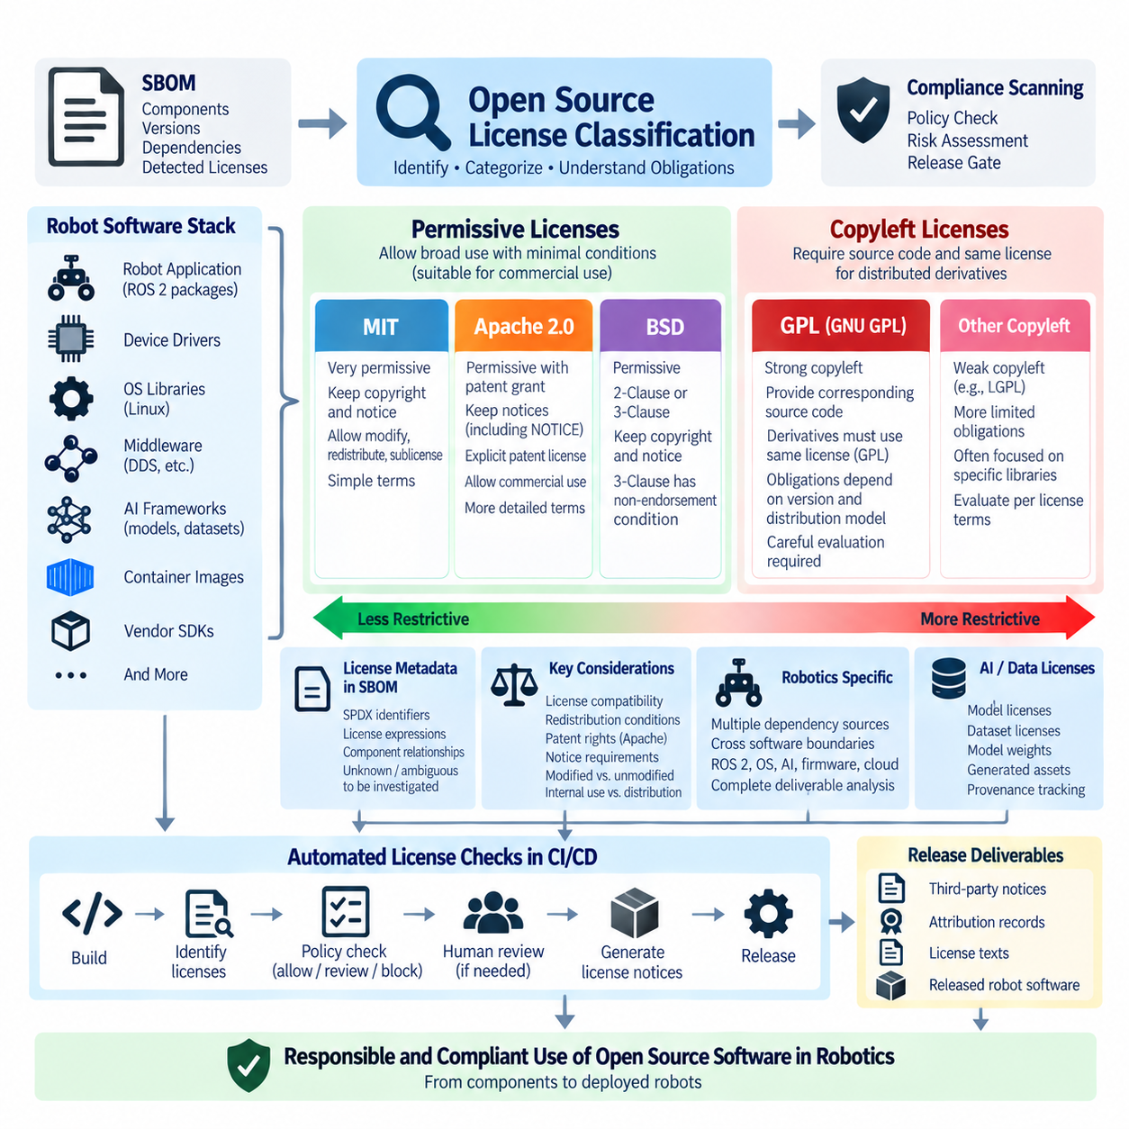
Open-source license classification provides a structured way to understand the legal permissions, obligations, and redistribution conditions attached to software components. In Robot DevOps, this classification is essential because a single robot software stack may combine ROS 2 packages, Linux libraries, device drivers, AI frameworks, middleware, container images, and vendor SDKs. The chapter therefore places license classification directly after automated SBOM generation and before automated compliance scanning.
Open-source licenses generally grant broad rights to use, study, modify, and redistribute software, but the conditions attached to those rights differ substantially. A useful engineering classification separates permissive licenses from copyleft licenses and further distinguishes weak from strong copyleft behavior. GPL, Apache, MIT, and BSD illustrate important points within this spectrum and demonstrate why identifying only whether a component is “open source” is insufficient for release governance.
Permissive licenses impose relatively limited conditions on redistribution and generally allow licensed code to be incorporated into proprietary or closed-source products. MIT, BSD, and Apache licenses belong broadly to this category, although their exact terms differ. Organizations normally need to preserve specified copyright, license, and notice information, while the surrounding proprietary software can generally remain under a separately chosen license when the original conditions are satisfied.
The MIT License is intentionally short and permissive. It permits use, copying, modification, merging, publication, distribution, sublicensing, and sale of copies, subject primarily to preservation of the copyright notice and permission notice. It also contains warranty and liability disclaimers. Its simplicity makes MIT-licensed components comparatively straightforward to integrate into commercial robot software, but required notices must still be retained when applicable.
BSD licenses follow a similarly permissive philosophy but exist in several forms. The widely encountered 2-Clause BSD License requires preservation of copyright, license conditions, and disclaimers in source and binary redistributions. The 3-Clause BSD License adds a non-endorsement condition restricting the use of contributor names to promote derived products without permission. Consequently, license scanners should identify the actual BSD variant instead of treating every “BSD” declaration as identical.
The Apache License 2.0 is permissive but contains more explicit legal mechanisms than MIT or BSD. It provides broad copyright permissions and includes an express patent license from contributors, together with conditions related to redistribution, notices, modifications, and patent litigation. When a project includes a NOTICE file, redistribution may also require preservation of relevant attribution notices according to the license terms, making accurate metadata and release documentation important.
Apache-2.0 is particularly relevant to commercial engineering environments because patent rights can matter alongside copyright permissions. The license includes a patent grant covering certain contributor patent claims and specifies circumstances under which those patent rights can terminate. This distinguishes Apache-2.0 from simpler permissive licenses whose texts do not contain an equivalent explicit patent grant, although actual legal obligations should always be evaluated from the applicable license text and distribution context.
Copyleft licenses use a different model. Rather than merely requiring preservation of notices, they can require corresponding source code and specified licensing conditions when covered software or derivative works are distributed. The GNU General Public License, or GPL, is the most prominent strong-copyleft family. GPL obligations therefore require careful evaluation when GPL-covered components are modified, combined with other software, or incorporated into distributed robot products.
GPL compliance cannot be reduced to the rule that “using GPL software makes everything GPL.” The applicable obligations depend on factors such as the GPL version, whether software is distributed or merely used internally, whether covered code has been modified, and how other code interacts with it. Engineering teams should therefore record exact license expressions and component relationships rather than making compliance decisions solely from package names or informal license labels.
The distinction between strong and weak copyleft becomes important in complex software stacks. Strong-copyleft licenses such as GPL can impose broader reciprocal licensing obligations on covered derivative works, whereas weak-copyleft licenses generally limit those obligations more narrowly, often around particular libraries or modified components. Although this section focuses on GPL, Apache, MIT, and BSD, this classification framework prepares the software inventory for later analysis of additional licenses encountered in real robotic systems.
License compatibility is another important consideration because a product can combine components governed by different terms. Compatibility does not simply mean that two licenses are both open source. Their redistribution, notice, source-disclosure, patent, and reciprocal licensing requirements must be capable of being satisfied together in the intended software arrangement. Dependencies should therefore be evaluated as relationships within the software architecture rather than as isolated entries in a license spreadsheet.
Robotics introduces additional complexity because open-source components cross software boundaries. ROS 2 packages may depend on system libraries and DDS implementations, perception applications may incorporate computer-vision frameworks, and AI inference services may depend on GPU runtimes and container base images. Firmware, embedded Linux, cloud services, and fleet-management software can introduce further license sets, meaning that compliance analysis must cover the complete deliverable rather than only the primary application repository.
An SBOM provides the technical foundation for this classification process. Each component record can associate a package and version with detected or declared license information, while dependency relationships show how that component enters the final product. Standardized license identifiers and expressions make this information easier for automated systems to process. Unknown, ambiguous, or conflicting license metadata should be treated as information requiring investigation rather than silently assigned a convenient classification.
License identification and license compliance are related but separate tasks. Classification determines which license applies and what general category it belongs to, while compliance determines what obligations arise in the actual use and distribution scenario. A package marked Apache-2.0, MIT, BSD-3-Clause, or GPL-3.0 provides essential input, but engineering teams still need information about modifications, linking, redistribution, source availability, notices, and product delivery models before making release decisions.
CI/CD systems can use these classifications to establish automated policy checks. Permissive components may pass automatically when required metadata is present, while copyleft components can be routed for additional review depending on organizational policy. Components with missing licenses, custom terms, conflicting metadata, or unapproved license categories can trigger warnings or quality gates. Automation therefore reduces repetitive inspection while leaving context-sensitive legal interpretation to appropriate review processes.
License classification also supports generation of release documentation. When the software inventory is connected to accurate license metadata, organizations can assemble third-party software notices, attribution records, copyright statements, and applicable license texts for a specific release. Because robot software changes continuously, these documents should be derived from versioned build information rather than maintained as disconnected manual lists that can easily become inconsistent with deployed software.
AI-enabled robotics extends license management beyond conventional source-code packages. Robot systems increasingly incorporate pretrained models, datasets, model weights, generated assets, and specialized inference libraries whose licensing conditions may differ from traditional open-source software licenses. The chapter structure therefore follows conventional license classification and compliance with explicit AI model license and dataset provenance tracking, extending software supply-chain governance into the broader Physical AI artifact lifecycle.
For practical Robot DevOps, GPL, Apache, MIT, and BSD should therefore be understood not merely as license names but as different governance patterns affecting how software can be integrated, modified, redistributed, documented, and maintained. Accurate classification within the SBOM allows compliance tools and engineering processes to apply appropriate policies consistently while preserving traceability from individual dependencies to released robot software.
A mature license-management program ultimately connects component discovery, SBOM generation, license classification, automated scanning, human review, release documentation, and long-term provenance records. This transforms open-source compliance from a late-stage legal checklist into a continuous engineering process. For robotics organizations managing rapidly evolving software fleets, that integration reduces uncertainty and provides a repeatable foundation for responsible reuse of open-source software throughout development, deployment, and maintenance.

11.4. License Compliance Scanning FOSSology FOSSA [w/Code]
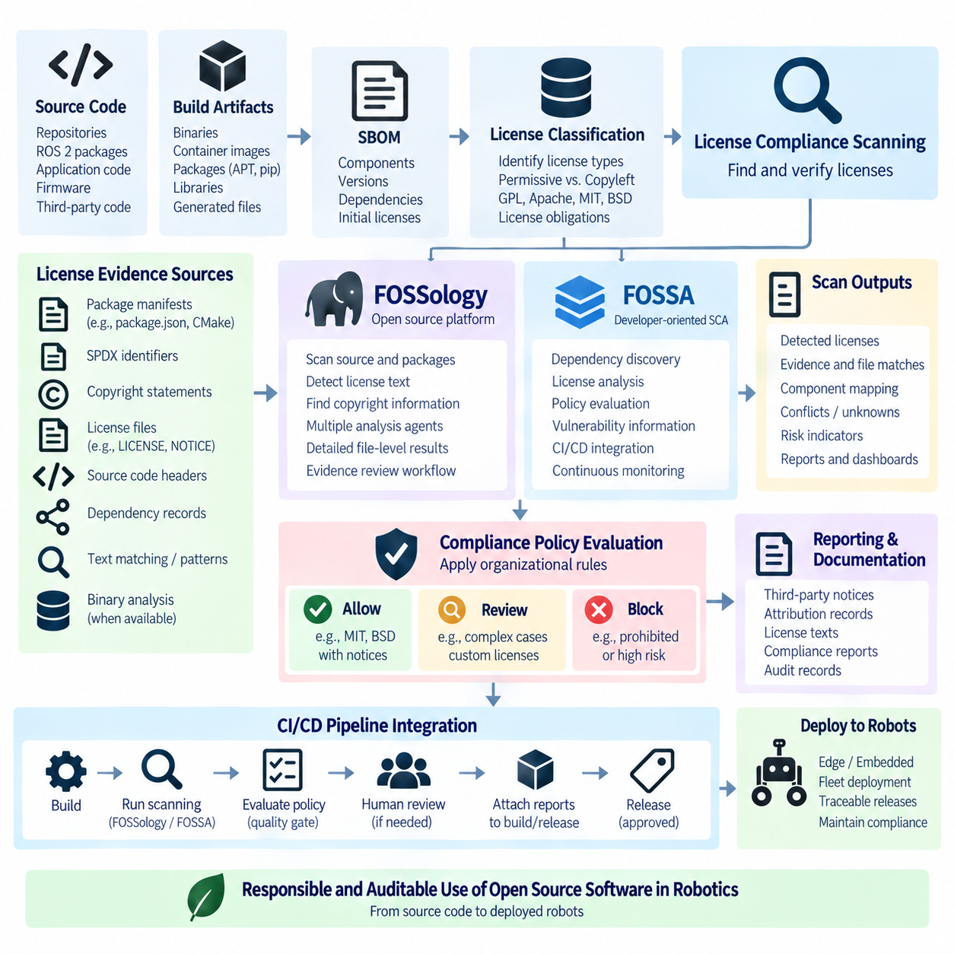
License compliance scanning converts open-source license management from a manually maintained checklist into a repeatable software engineering process. After an SBOM identifies components and license classification establishes their general obligations, scanning systems examine source code, dependencies, package metadata, notices, and other artifacts for licensing evidence. In Robot DevOps, this process helps maintain traceability across rapidly changing ROS 2, embedded, AI, container, and cloud software stacks.
A compliance scanner attempts to determine which licenses are associated with software entering a product and whether the available evidence agrees with declared metadata. Detection can use package manifests, SPDX identifiers, copyright statements, license files, source-code headers, dependency records, and textual license patterns. The result is not simply a list of license names but an evidence set that engineering and compliance teams can review before software is released.
Scanning is necessary because dependency metadata is frequently incomplete or inconsistent. A package manifest may declare one license while bundled source files contain code governed by additional terms, or a repository may include third-party components copied into its source tree. Generated SBOM information therefore provides an important starting point, but file-level and dependency-level inspection can reveal licensing information that package-level metadata alone does not expose.
FOSSology is an open-source platform designed for software license and copyright analysis. It can analyze uploaded source packages and repositories using multiple specialized agents that detect license-related text, copyright information, and other compliance evidence. Its workflow supports detailed inspection of findings, allowing reviewers to examine files and resolve detected license information rather than treating automated detection as an unquestionable final legal conclusion.
A major strength of FOSSology is its evidence-oriented analysis model. Large source trees can contain thousands of files with different origins, license notices, and copyright statements. Automated agents reduce the search space by locating relevant material, while reviewers can inspect findings and record decisions. This makes the platform useful where organizations require auditable license-clearing processes and need to preserve the reasoning behind compliance conclusions.
FOSSology can also support structured compliance workflows in which uploaded software is scanned, findings are reviewed, decisions are recorded, and reports are produced for downstream release processes. In a robotics organization, source snapshots of ROS 2 workspaces, firmware packages, vendor-delivered source code, or third-party libraries can be analyzed before incorporation into controlled releases. The resulting evidence can complement SBOM records maintained by CI/CD systems.
FOSSA approaches software compliance through a developer-oriented software composition analysis workflow. It integrates dependency discovery, license analysis, policy evaluation, vulnerability information, and project monitoring into development processes. Rather than limiting analysis to periodic source archives, it can be incorporated into repositories and CI/CD pipelines so that dependency changes are evaluated as part of everyday engineering activity.
This continuous model is particularly useful when software dependencies evolve rapidly. A pull request that introduces a new package can change the licensing profile of the final product even if only a few application lines were modified. Integrating compliance analysis with CI allows organizations to detect such changes before they become part of a release, reducing the cost of resolving problematic dependencies late in the development lifecycle.
FOSSology and FOSSA therefore represent related but different operational approaches rather than interchangeable implementations of exactly the same workflow. FOSSology is commonly suited to detailed source inspection, evidence review, and license-clearing activities, while FOSSA emphasizes integration with dependency management, developer workflows, policy enforcement, and continuous software composition analysis. Organizations may use one approach or combine multiple tools depending on governance requirements.
The scanning pipeline should distinguish license detection from compliance policy. Detection attempts to identify licenses and supporting evidence, whereas policy determines whether a detected condition is acceptable for a particular product. For example, discovering GPL, Apache-2.0, MIT, or BSD code is a factual classification step. Whether the component can be approved depends on its usage, modification, distribution model, linking relationships, and organizational compliance rules.
Policy engines can classify findings into actions such as automatically allowed, requiring review, or release blocking. Permissive licenses may often require only preservation of notices, while copyleft licenses can require more detailed analysis of source-distribution and integration conditions. Unknown licenses, custom terms, conflicting detections, or missing attribution data should normally trigger investigation because automatically guessing a convenient license classification can create unreliable compliance records.
False positives and false negatives are unavoidable concerns in automated scanning. License text may be modified, abbreviated, embedded in comments, or combined with additional terms, while generated files and test assets can introduce irrelevant detections. Conversely, binary-only components may contain little textual evidence for a scanner to examine. Automated results should therefore be treated as machine-generated evidence that supports, rather than replaces, appropriate engineering and legal review.
Robotics adds significant complexity because the software deliverable extends beyond the main application repository. ROS 2 packages may pull dependencies from APT and pip, containers inherit packages from base images, firmware can include vendor libraries, and GPU or sensor SDKs may carry separate terms. Compliance scanning should therefore align with the actual build graph and SBOM so that source-level findings can be correlated with the components that enter released robot artifacts.
CI integration makes this correlation repeatable. A pipeline can generate an SBOM, execute license and vulnerability analysis, evaluate policy rules, and attach the resulting reports to a build or release. When a violation exceeds the defined policy threshold, the pipeline can fail a quality gate or request human approval. Approved exceptions should be recorded explicitly so that future builds distinguish intentional decisions from newly introduced compliance problems.
Baseline management helps prevent teams from repeatedly reviewing unchanged findings. Once existing components have been analyzed and accepted under defined conditions, subsequent scans can focus attention on newly introduced dependencies, changed licenses, or modified source files. This differential approach is valuable for large robot software stacks because thousands of stable components may otherwise obscure a small number of meaningful changes introduced by a new release.
Compliance results should remain connected to immutable release identifiers. A scan performed on a development branch does not necessarily describe the container image or firmware package eventually shipped to customers. Linking reports to commit hashes, build identifiers, SBOM versions, container digests, and release tags establishes evidence that a particular compliance decision corresponds to a particular software artifact rather than to an approximate source snapshot.
The output of license scanning can also support third-party notice generation and customer disclosure. Confirmed license information, copyright records, attribution requirements, and applicable license texts can be assembled into release documentation. Automation reduces manual transcription errors, but generated documents should still be validated because scanners may detect multiple candidate licenses or fail to understand unusual licensing conditions that require contextual interpretation.
AI-enabled robotics further expands the scope of compliance. Traditional source-code scanners primarily address software packages, while modern robot products may also contain pretrained models, model weights, datasets, generated assets, and specialized inference components. These artifacts may use terms that do not map cleanly onto conventional open-source software licenses, so compliance systems must eventually connect software scanning with AI model licensing and dataset provenance management.
A mature Robot DevOps workflow therefore combines SBOM generation, license classification, FOSSology or FOSSA-style scanning, policy evaluation, human review, exception management, release documentation, and long-term traceability. No individual scanner establishes compliance by itself. The engineering objective is to create a controlled evidence chain showing what components were used, which terms were detected, how findings were evaluated, and which approved artifacts were ultimately deployed.
When integrated into continuous development, license compliance scanning becomes part of software supply-chain governance rather than an activity performed only before shipment. Developers receive earlier feedback, compliance specialists obtain structured evidence, and release managers gain repeatable quality gates. For robotic systems that combine open-source software across edge, embedded, AI, and cloud environments, this continuous process provides a scalable foundation for responsible software reuse and auditable product releases.

11.5. ROS2 Package License Audit and Compliance Report
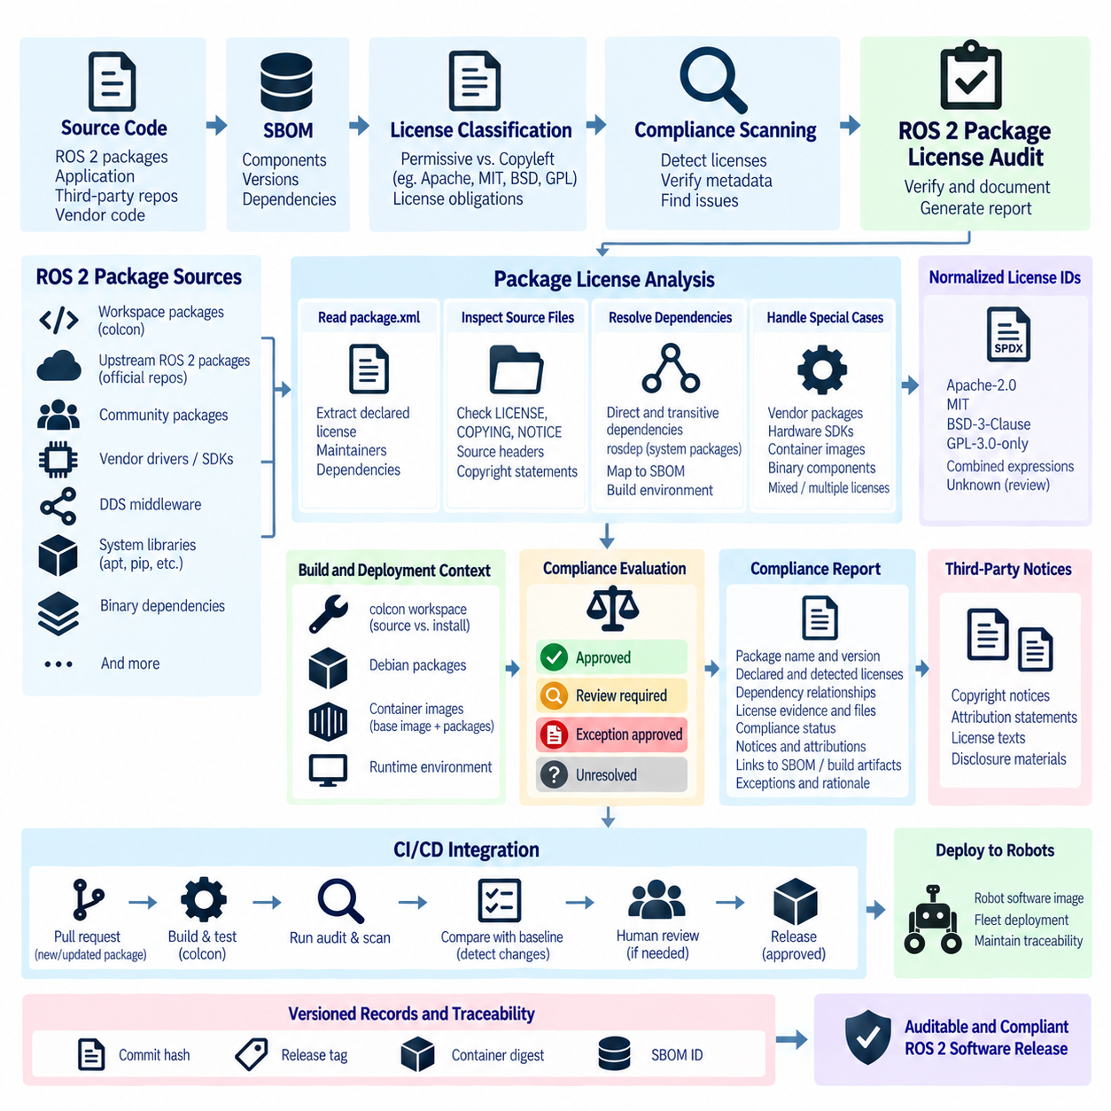
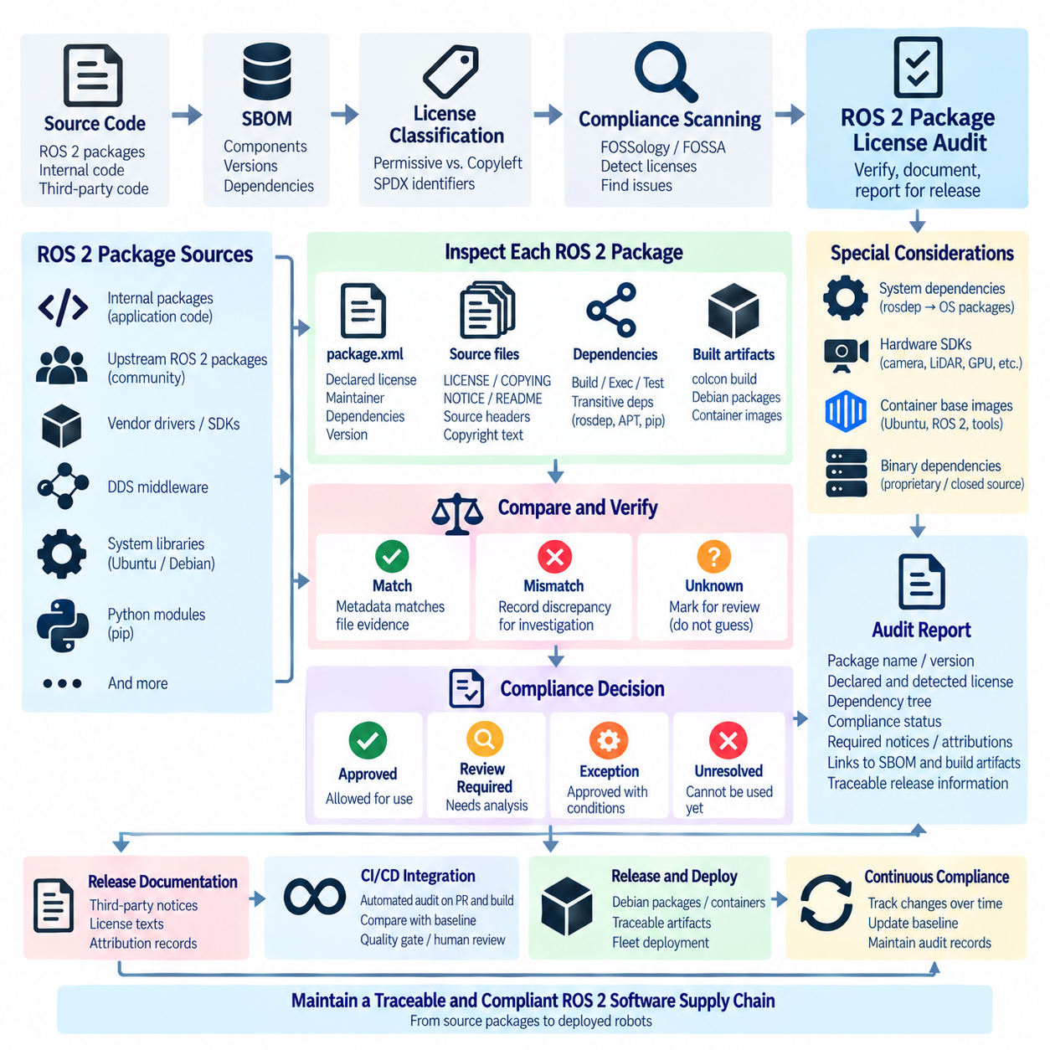
A ROS 2 package license audit is a systematic process for identifying, verifying, and documenting the licensing conditions associated with packages used in a robot software stack. Within the broader Robot DevOps structure, it follows SBOM generation, license classification, and automated compliance scanning. The audit converts package-level license information into release-oriented evidence that can support engineering review, compliance decisions, and long-term software traceability.
ROS 2 environments require dedicated auditing because a workspace rarely consists only of packages developed by one organization. A robot application may combine internally developed packages, upstream ROS 2 packages, community repositories, vendor drivers, DDS middleware, system libraries, Python modules, and binary dependencies. Each component can introduce separate licensing conditions, so auditing only the application's primary repository does not represent the complete software delivered to the robot.
The package.xml manifest provides an important starting point for ROS 2 license analysis. ROS packages normally declare metadata describing the package, maintainers, dependencies, and license information. Audit tooling can extract these declarations across a workspace and associate them with package names and versions. However, declared metadata should be treated as evidence rather than absolute proof because the repository contents or bundled third-party files may contain additional licensing conditions.
A practical audit therefore compares package metadata with the actual source tree. LICENSE, COPYING, NOTICE, README, source headers, copyright statements, and bundled dependency information can provide evidence about applicable terms. When the license declared in package.xml differs from the files contained in the repository, the discrepancy should be recorded for investigation rather than automatically resolved by selecting whichever value appears more convenient.
Dependency resolution significantly expands the audit scope. A ROS 2 package can declare build, execution, test, or other dependencies that ultimately resolve to additional ROS packages or operating-system components. Transitive dependencies can introduce software that does not appear directly in the application's source repository. The audit should therefore correlate ROS dependency information with the SBOM and actual build environment to determine which components enter the released artifact.
The ROS 2 build workflow also creates a distinction between source packages and installed artifacts. A colcon workspace can contain source directories, build outputs, installation trees, and generated metadata, while deployment may use Debian packages or container images rather than the original workspace. Compliance evidence should therefore identify which source packages correspond to the binaries and runtime components actually distributed as part of a robot release.
System dependencies introduce another important boundary. rosdep can resolve ROS dependency keys into operating-system packages, meaning that a package with apparently simple ROS dependencies can indirectly rely on numerous Debian or platform-specific libraries. A complete compliance report should distinguish ROS package metadata from system-package information while maintaining relationships between them. This prevents dependencies outside the workspace from disappearing from the compliance view.
Vendor packages and hardware SDKs require particular attention because robotics frequently integrates cameras, LiDARs, motor controllers, GPU platforms, communication devices, and other hardware-specific software. A ROS wrapper may use a permissive license while depending on a separately distributed proprietary SDK with different redistribution conditions. Auditing only the wrapper package can therefore create an incomplete picture of the licensing obligations associated with the deployable robot system.
Containerized ROS 2 deployments further expand the analysis boundary. A container can inherit Ubuntu packages, ROS 2 distributions, middleware, development utilities, and GPU libraries from its base image before application-specific packages are added. The audit should connect workspace-level findings to container-level SBOM information so that the compliance report describes the actual image being distributed rather than only the source code maintained by the application team.
License identifiers should be normalized whenever possible. Standardized SPDX identifiers such as Apache-2.0, MIT, BSD-3-Clause, or GPL-3.0-only make automated comparison and reporting more reliable than arbitrary textual labels. Compound licensing situations may require SPDX license expressions representing alternatives or combinations. Unknown or custom license statements should remain explicitly marked for review instead of being silently mapped to an approximate standard license.
The audit process should also distinguish detected licenses from approved licenses. Detection answers what licensing evidence exists, whereas approval records the organization's decision about whether a component can be used in a particular product and distribution model. This distinction allows automated tools to collect evidence without converting every detection into a legal conclusion and provides a controlled point where engineering, compliance, or legal review can be applied when necessary.
A ROS 2 compliance report should preserve enough information to reproduce the analysis. Useful records include package identity, version or revision, source location, declared license, detected license evidence, dependency relationships, review status, applicable notices, and links to the corresponding SBOM or build artifact. The objective is not merely to produce a readable document but to maintain an auditable connection between the report and the exact software release it describes.
Compliance status can be represented through controlled categories such as approved, review required, exception approved, or unresolved. The meaning of each state should be defined by organizational policy rather than inferred independently by individual developers. Packages with missing license declarations, conflicting evidence, custom terms, or unexpected copyleft conditions can then be routed to review without preventing automated processing of components that already satisfy established policy.
Third-party notice generation is a natural output of the audit. Once package identities and licensing information have been verified, the release process can assemble required copyright notices, attribution statements, license texts, and other disclosure material. Generating these records from versioned audit data reduces the risk that manually maintained notice files drift away from the dependencies actually contained in a released robot software image.
Continuous Integration can transform the audit from a periodic exercise into continuous compliance. When a pull request adds or updates a ROS 2 dependency, the pipeline can regenerate the SBOM, inspect package license metadata, execute compliance scanning, compare findings with an approved baseline, and flag meaningful changes. This allows developers to address licensing issues near the point where the dependency enters the project instead of discovering them shortly before release.
Baseline comparison is particularly valuable for large ROS 2 systems. Hundreds of packages may remain unchanged between releases, making full manual re-evaluation inefficient. A versioned compliance baseline allows automation to identify newly introduced packages, license changes, updated dependencies, or previously unresolved findings. Review effort can then focus on the delta while retaining historical evidence for components whose approved conditions remain unchanged.
Release traceability requires the final report to be associated with immutable software identifiers. Commit hashes, repository revisions, release tags, container digests, firmware versions, build identifiers, and SBOM identifiers can establish this relationship. Without such linkage, a compliance report may accurately describe a workspace at one moment but provide weak evidence about the software actually installed on customer robots or distributed through a fleet update.
The report should also preserve exceptions and their rationale. Some components may be approved under specific conditions, such as internal-only use, a particular distribution architecture, preservation of designated notices, or replacement before external release. Recording these decisions prevents future engineers from repeatedly rediscovering the same issue and allows automated pipelines to determine whether an existing exception still applies when package versions or deployment conditions change.
ROS 2 license auditing ultimately connects package management with broader software supply-chain governance. Package manifests identify declared metadata, dependency tools reveal relationships, SBOMs provide standardized inventories, scanners collect additional license evidence, policies determine review requirements, and compliance reports preserve approved conclusions. Together, these mechanisms create a traceable path from an individual ROS 2 package to the robot software artifact in which it is deployed.
For Robot DevOps, the compliance report should therefore be treated as a versioned engineering artifact rather than a one-time legal document. Maintaining it alongside the SBOM, build records, release artifacts, and deployment metadata enables licensing decisions to evolve with the software. This continuous approach supports responsible reuse of ROS 2 and third-party software while providing auditable evidence from source packages through build, release, and deployed robot fleets.

11.6. AI Model License and Dataset Provenance Tracking
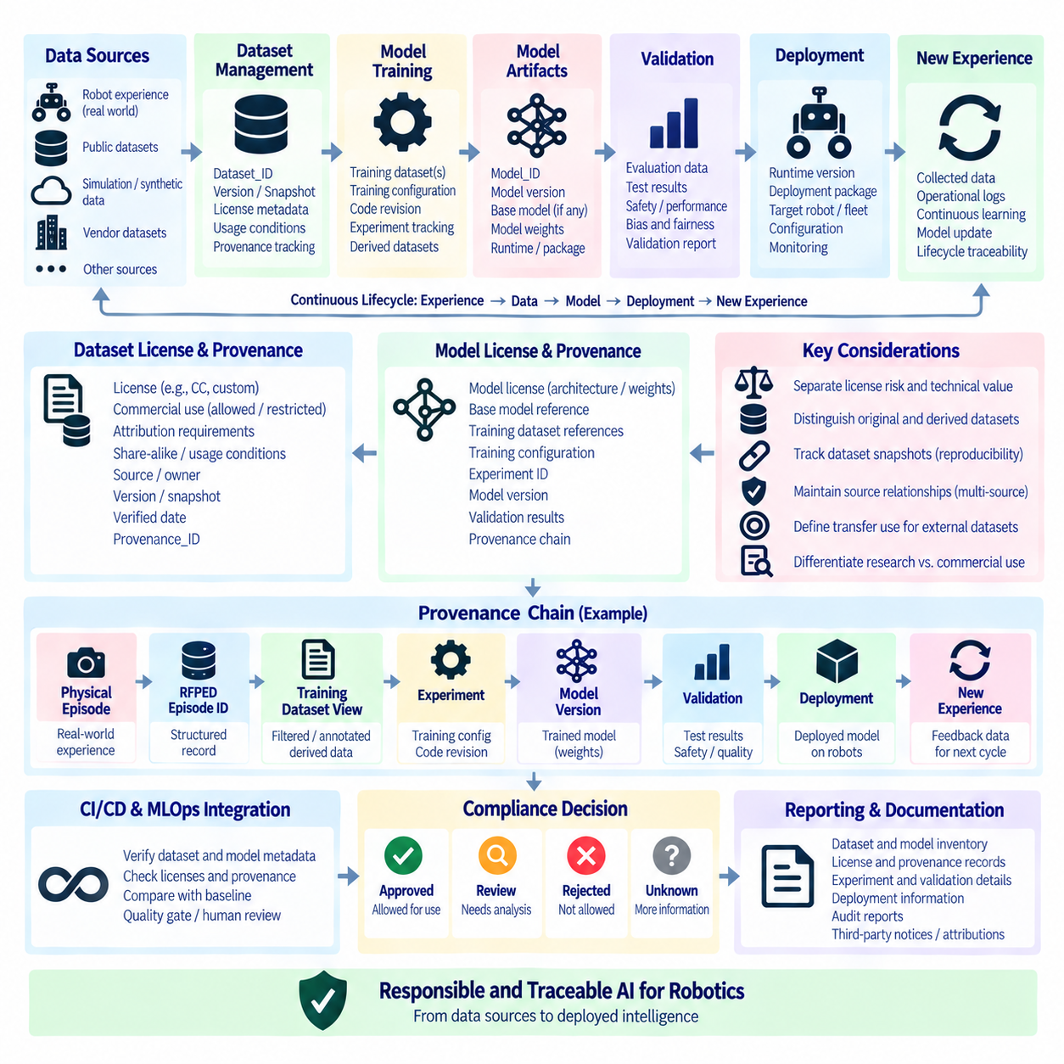
AI model and dataset license management extends software supply-chain governance beyond conventional source code and packages into machine-learning artifacts. A robot may depend on pretrained models, model weights, training datasets, derived datasets, embeddings, evaluation data, generated assets, and inference runtimes. Each artifact can have different ownership, licensing, usage restrictions, and provenance requirements, so the model and dataset must be tracked as identifiable lifecycle objects rather than treated as anonymous files.
An AI model should have a persistent identity that remains associated with its versions throughout development and deployment. Useful metadata includes Model_ID, Model_Version, source or repository reference, training dataset references, runtime version, deployment package, and validation information. A model version should not be considered independently from the data and software that produced it because reproducing or auditing the model requires knowledge of the inputs, transformation process, training configuration, and resulting artifact.
Dataset identity should likewise remain stable while different training or derived views are created. A canonical dataset can maintain its original Dataset_ID while derived training views receive their own versioned identities. This distinction prevents the raw experience dataset from being confused with a filtered, annotated, transformed, or training-specific representation. The principle is particularly important for Physical AI systems because the same physical experience may support multiple learning objectives without becoming a fundamentally different native dataset.
Dataset licensing should be represented as structured metadata rather than a simple statement that a license “needs to be checked.” Relevant fields can include License, Commercial Use, Attribution, Share-Alike, Source, Verified Date, usage conditions, and Provenance_ID. Commercial-use status can be represented through controlled values such as ALLOWED, RESTRICTED, NON-COMMERCIAL ONLY, and UNKNOWN or REVIEW REQUIRED. This structure makes licensing information machine-readable and suitable for automated compliance workflows.
License risk and technical usefulness should be evaluated separately. A dataset can be technically valuable for perception, navigation, manipulation, or world-model development while still having restrictions that prevent a particular commercial use. Therefore, technical priority must not automatically imply production-learning permission. The software supply chain should preserve both dimensions independently so that engineering teams can understand what a dataset is useful for and compliance teams can determine whether the intended usage is permitted.
Dynamic datasets require additional version control because their contents can change without their public name changing. A dataset obtained from an external repository or continuously updated platform should record its name, version when available, snapshot or commit identifier, source location, and verification date. Recording only the dataset name is insufficient for reproducibility because a future download may contain different samples or metadata. A specific snapshot therefore becomes part of the provenance record for a training experiment.
Model provenance should connect the physical or operational experience used for learning to the resulting deployed intelligence. A useful lineage can follow the sequence Physical Episode → RFPED Episode ID → Training Dataset View → Model Version → Validation → Deployment → New Experience. This creates a continuous relationship between collected experience, the representation used for training, the resulting model, its validation evidence, and subsequent operational data. Such lineage provides the foundation for later Intelligence Lifecycle Management.
For Physical AI, provenance becomes especially important when a model is derived from multiple sources. Training may combine internal robot experience with public datasets, simulation data, synthetic data, or vendor-provided resources. Each source should remain identifiable rather than being collapsed into a single generic training-dataset label. The resulting model record can then preserve which datasets contributed to a particular version and which source restrictions may continue to apply to the resulting artifact.
Public datasets should also be classified according to how their information is transferred into the target robot capability. A dataset created for autonomous driving, manipulation, or another robotic platform may provide useful perception or representation information without constituting native action ground truth for a different robot. Maintaining an explicit transfer classification helps prevent engineering teams from treating an externally sourced dataset as if it directly represents the target robot's physical actions, missions, or operating conditions.
Dataset provenance and license information should be connected rather than maintained as independent records. A dataset registry can identify the source, owner, license, commercial-use condition, attribution requirement, version, snapshot, and verification date, while provenance records identify how that dataset was transformed and used. The resulting chain provides both legal traceability and technical reproducibility. When a model is later deployed, the model registry can reference the corresponding dataset and provenance records.
The same principle applies to model weights. A model architecture may be publicly available under one set of terms while its pretrained weights are distributed under different conditions. Consequently, the architecture, source code, checkpoint, and final fine-tuned weights should not automatically be assumed to share identical licensing terms. Each artifact should have an identifiable record and an explicit relationship to its source and transformation history.
Fine-tuning introduces additional provenance requirements because a new model can inherit characteristics from an original checkpoint while incorporating organization-specific training data. The record should identify the base model version, additional datasets, training configuration, code revision, experiment identifier, resulting model version, and validation result. This allows an organization to determine which external assets contributed to a deployed model and which internal assets were added during adaptation.
Generated and derived datasets require similar treatment. Annotation, filtering, augmentation, simulation, preprocessing, and transformation can produce a new training view without necessarily creating a new canonical source dataset. The relationship between source data and derived data should therefore be recorded explicitly. This preserves the distinction between Dataset Identity and Dataset Profile and prevents derived training artifacts from being mistaken for independently collected physical experience.
SBOM concepts can be extended to AI artifacts by treating models, datasets, and related resources as traceable components of a larger AI software supply chain. A release record can associate the robot application, inference runtime, model package, model version, dataset references, and provenance metadata. This makes it possible to determine not only which software libraries are present in a robot but also which model and data assets contribute to its behavior.
CI/CD and MLOps pipelines can automate many of these checks. A training or release pipeline can verify dataset identifiers, snapshot references, license metadata, model versions, provenance links, and deployment targets before an artifact is promoted. Missing provenance, unknown licensing conditions, or inconsistent version references can trigger review. Approved exceptions should be recorded explicitly rather than silently bypassing the policy mechanism.
Model and dataset governance should also distinguish development use from commercial deployment. A dataset or model may be available for research or evaluation while having restrictions on commercial use, redistribution, modification, or derivative works. The intended usage context therefore needs to be recorded alongside the license itself. A model that passes a technical validation gate is not automatically cleared for every distribution scenario.
Traceability should continue after deployment. The deployed model version, runtime version, deployment package identifier, target robot or fleet, and relevant provenance references should remain associated with operational records. When a new model is promoted or an older model is rolled back, the system should preserve the relationship between deployment state and model provenance. This creates an auditable history of which intelligence version was used at a particular point in the robot lifecycle.
The provenance chain also supports investigation when operational behavior changes. If a deployed model produces an unexpected result, engineers can trace the model version to its training view, dataset snapshot, source episodes, software environment, and validation result. This does not automatically establish the cause of the behavior, but it provides the evidence required to investigate changes systematically instead of reconstructing the training history from memory.
AI model and dataset governance therefore extends the SBOM and license-management framework into the broader Physical AI lifecycle. Software components describe the execution environment, model records describe learned intelligence, dataset records describe learning inputs, and provenance records connect these artifacts across transformations. Maintaining these relationships enables security, compliance, engineering, and MLOps teams to share a consistent view of how an AI-enabled robot's capabilities were created and deployed.
The long-term objective is a continuous and reproducible lineage from physical experience to deployed intelligence. The essential chain is Physical Experience → Dataset Identity → Dataset Snapshot → Training View → Experiment → Model Version → Validation → Deployment → New Experience. License information and usage constraints remain attached to the relevant source artifacts throughout this chain. This approach turns AI model and dataset governance into a versioned engineering discipline that supports responsible reuse, reproducibility, compliance analysis, and traceable Physical AI deployment.

11.7. Third Party Dependency Vulnerability Tracking [w/Code]
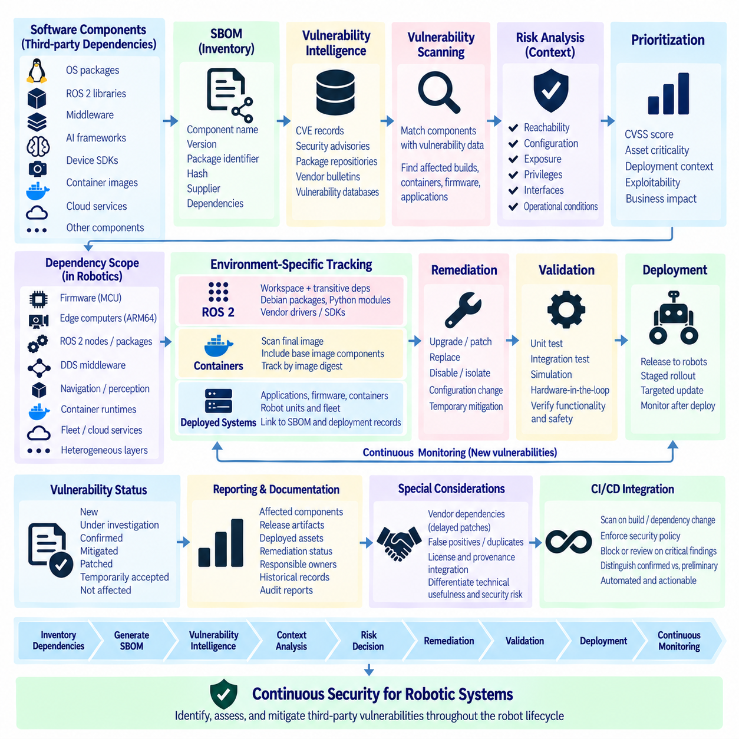
Third-party dependency vulnerability tracking is the continuous process of identifying security weaknesses in external software components used by a robotic system and determining which released or deployed artifacts are affected. Modern robots depend on operating-system packages, ROS 2 libraries, middleware, AI frameworks, device SDKs, container images, and cloud services. Tracking these dependencies throughout their lifecycle is therefore a fundamental part of software supply-chain security and Robot DevOps.
A vulnerability-tracking process begins with an accurate inventory of third-party components. The Software Bill of Materials, or SBOM, provides this foundation by recording component names, versions, package identifiers, hashes, suppliers, and dependency relationships. Without reliable component identity, vulnerability intelligence cannot be correlated accurately with deployed software. SBOM completeness and version accuracy therefore directly influence the effectiveness of downstream security analysis.
Vulnerability information is continuously published through sources such as Common Vulnerabilities and Exposures records, security advisories, package repositories, vendor bulletins, and vulnerability databases. Automated systems compare this intelligence against component identities recorded in SBOMs or dependency inventories. When a match is found, the organization can determine which builds, containers, firmware packages, robot applications, or fleet deployments may require further investigation.
Package identifiers are essential for reliable correlation. Package URL, or purl, can describe ecosystem, namespace, package name, and version, while Common Platform Enumeration identifiers may identify affected products in other vulnerability records. Package names alone can be ambiguous because similarly named components may exist in different ecosystems. Normalized identifiers improve matching among SBOM generators, vulnerability scanners, artifact repositories, and security-management platforms.
A detected vulnerability should not automatically be interpreted as an exploitable vulnerability in the deployed robot. A vulnerable library may be present but an affected function may never be invoked, the vulnerable feature may be disabled, or system architecture may prevent the required attack path. Vulnerability tracking therefore combines component detection with contextual assessment of reachability, configuration, exposure, privileges, interfaces, and operational conditions before remediation priority is determined.
Severity scores provide useful information but should not be the only basis for prioritization. Common Vulnerability Scoring System metrics can describe technical characteristics of a vulnerability, while the actual robot environment determines operational relevance. An externally reachable vulnerability in fleet-management software may require different treatment from the same severity finding in an isolated development tool. Asset criticality and deployment context therefore need to complement generic vulnerability scores.
Robotics creates distinctive vulnerability-management challenges because dependencies are distributed across heterogeneous computing layers. An autonomous robot may include microcontroller firmware, ARM64 edge computers, GPU libraries, ROS 2 nodes, DDS middleware, navigation software, perception frameworks, container runtimes, and remote fleet services. A single vulnerability-management process must therefore correlate findings across embedded, edge, application, AI, networking, and cloud components.
ROS 2 dependency tracking should extend beyond the packages visible in a workspace. ROS packages can introduce transitive dependencies through other ROS packages, Debian packages, Python modules, C/C++ libraries, and DDS implementations. Vendor drivers may additionally depend on proprietary SDKs. Combining ROS dependency information with the SBOM and actual deployment artifact helps reveal vulnerable components that would remain invisible if analysis were limited to package.xml files or source repositories.
Containers provide a useful but complex vulnerability boundary. Application images inherit operating-system libraries and runtime components from their base images, meaning that vulnerabilities can exist even when application source code has not changed. Container scanning should therefore examine the final image and associate findings with its immutable digest. Rebuilding an application against an updated base image may eliminate vulnerabilities without requiring modifications to the application's own source code.
Continuous Integration pipelines can perform vulnerability analysis whenever dependencies or build artifacts change. After generating an SBOM, the pipeline can compare identified components with current vulnerability intelligence and apply defined security policies. New critical findings can trigger review or prevent promotion to a release stage. However, pipeline policies should distinguish confirmed exposure from preliminary matches so that automated security gates remain useful rather than becoming dominated by unactionable alerts.
Continuous tracking must continue after release because vulnerability knowledge changes over time. A software artifact that contained no known vulnerabilities when released may become affected months later when a new CVE is disclosed. Stored SBOMs therefore enable retrospective analysis without rebuilding the original product. Security systems can repeatedly evaluate existing release inventories against updated vulnerability information and identify previously deployed artifacts that require reassessment.
Fleet-level traceability converts vulnerability information into operational action. If deployment records associate each robot with its software release, container digest, firmware version, and SBOM, a newly disclosed vulnerability can be traced from the affected component to the artifact and then to individual robots. This enables targeted remediation, staged rollout, or temporary mitigation instead of assuming that every robot in the fleet has the same exposure.
Remediation can take several forms depending on the affected component and operational constraints. A vulnerable dependency may be upgraded, patched, replaced, disabled, isolated, or mitigated through configuration changes. In some cases, immediate replacement may introduce greater operational risk than temporary containment. The selected action should therefore be recorded together with the affected version, remediation decision, responsible owner, validation result, and target deployment.
Dependency updates themselves require verification because upgrading a security-sensitive library can alter interfaces, timing, resource usage, or behavior. This is especially important for robots, where middleware, perception, navigation, and hardware drivers interact with physical systems. A security patch should therefore pass appropriate unit, integration, simulation, and Hardware-in-the-Loop testing before fleet deployment when the affected subsystem can influence robot behavior.
Vulnerability status should be treated as versioned information rather than a permanent property of a package. Findings may be newly discovered, under investigation, confirmed, mitigated, patched, accepted temporarily, or determined not to affect a specific configuration. Maintaining this state allows engineering and security teams to distinguish unresolved exposure from findings that have already undergone technical assessment and documented risk treatment.
False positives and duplicate findings require systematic handling. Different scanners may report the same underlying vulnerability using different package evidence, while inaccurate version detection can associate an advisory with an unaffected component. Suppression should therefore require documented justification and remain linked to the relevant package version and deployment context. Permanent global suppression can hide future exposure when the component or configuration changes.
Vendor dependencies introduce another challenge because patches may not be immediately available. Camera, LiDAR, GPU, communication, motor-control, or embedded-device SDKs may depend on vendor release schedules. Organizations should track the vulnerable component, vendor advisory, available mitigation, expected update path, and affected products. This information makes vendor dependency risk visible rather than allowing unresolved vulnerabilities to disappear outside internally maintained source repositories.
Vulnerability tracking should also connect with license and provenance management. The same third-party component inventory can support security analysis, license compliance, supplier identification, and release documentation. SBOM records therefore act as a shared evidence layer across multiple governance processes. When component identity is maintained consistently, security teams and compliance teams can analyze different risks without independently reconstructing the software supply chain.
Reporting should focus on actionable relationships rather than raw vulnerability counts. Useful views connect vulnerability identifiers to affected component versions, release artifacts, deployed assets, remediation status, and responsible owners. Historical records can show when a vulnerability was detected, evaluated, mitigated, and closed. This evidence supports operational security management while providing an auditable record of how software supply-chain risks were handled.
A mature Robot DevOps workflow therefore links Dependency Inventory → SBOM → Vulnerability Intelligence → Context Analysis → Risk Decision → Remediation → Validation → Deployment → Continuous Monitoring. This chain transforms vulnerability management from occasional scanning into an ongoing lifecycle process. Each stage preserves evidence so that newly disclosed weaknesses can be traced from external security intelligence to the exact software and robotic assets that may be affected.
The ultimate objective is continuous awareness of third-party security risk throughout the robot lifecycle. Dependencies should remain identifiable from development and build through release, deployment, maintenance, and retirement. By combining SBOM-based inventory, automated scanning, contextual risk analysis, controlled remediation, testing, and fleet-level traceability, organizations can respond systematically to vulnerabilities while maintaining the reliability and operational continuity required by deployed robotic systems.

11.8. SBOM Distribution and Customer Disclosure Policy
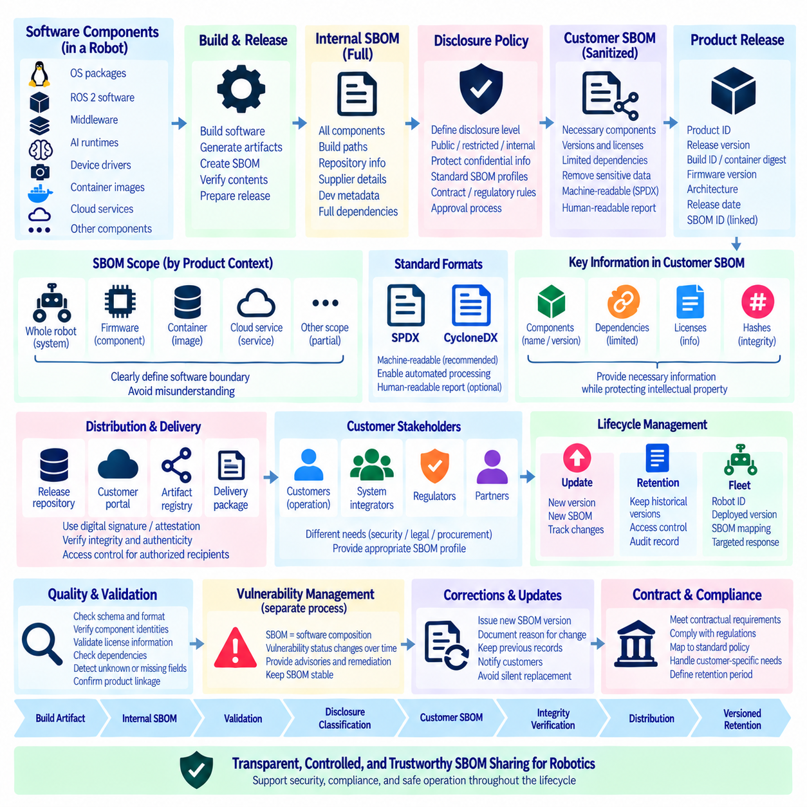
SBOM distribution is the controlled process of delivering Software Bill of Materials information to customers, partners, regulators, integrators, and other authorized stakeholders. Generating an SBOM is only the first step; organizations must also determine what information can be disclosed, to whom it should be provided, in which format, and at what point in the product lifecycle. A defined disclosure policy turns the SBOM from an internal inventory into a governed supply-chain communication artifact.
The disclosure policy should distinguish internal SBOM records from externally distributable SBOMs. Internal records may contain detailed build paths, repository locations, proprietary component names, supplier information, development metadata, and security-sensitive relationships. A customer-facing SBOM may expose only the information necessary for software composition, license compliance, vulnerability management, and contractual requirements while protecting confidential engineering information and intellectual property.
Disclosure scope should be defined according to the product and delivery context. A complete robot may include embedded firmware, operating-system packages, ROS 2 software, middleware, AI runtimes, container images, device drivers, fleet-management applications, and cloud-connected services. The distributed SBOM should clearly indicate which software boundary it represents so that customers do not incorrectly assume that a partial component inventory describes the entire robotic system.
SBOMs should be associated with specific product releases rather than distributed as generic documents. Useful references include product identifier, software release version, build identifier, container digest, firmware version, architecture, release date, and SBOM identifier. This relationship allows a customer to determine whether an SBOM corresponds to the software actually installed on a robot and prevents later revisions from being confused with the inventory of an earlier deployment.
Machine-readable formats such as SPDX and CycloneDX provide a practical foundation for SBOM exchange. Standardized formats enable customers and security platforms to process component identities, versions, licenses, hashes, package identifiers, and dependency relationships automatically. Human-readable reports may accompany the machine-readable artifact, but they should not replace the structured SBOM when automated vulnerability correlation, compliance analysis, or integration with customer security systems is required.
Distribution mechanisms should preserve integrity and authenticity. SBOM artifacts can be stored in controlled release repositories, artifact registries, customer portals, or product-delivery packages. Cryptographic hashes, digital signatures, or attestations can help recipients verify that the SBOM has not been modified and that it corresponds to an authorized release. Access controls should be applied when disclosure is restricted to customers, integration partners, or other approved recipients.
A customer disclosure policy should define the expected disclosure level before delivery rather than deciding it independently for every request. Organizations can establish standard external fields, restricted fields, and internal-only information. This classification reduces inconsistent responses between projects and prevents accidental disclosure of proprietary information. Exceptions can still be approved when contractual, regulatory, or customer security requirements demand additional detail.
Component names and versions are generally central to vulnerability management, but dependency relationships may require additional consideration. Detailed dependency graphs can improve security analysis by showing how components are incorporated into the product, yet some relationships may reveal internal architecture. The disclosure policy should balance customer security requirements with intellectual-property protection and document which dependency information is included in each external SBOM profile.
License information is another important part of customer disclosure. Third-party software may require copyright notices, license texts, attribution, source-code offers, or other redistribution obligations. The SBOM can identify relevant components and licenses, while separate third-party notice documentation can provide required legal information in a human-readable form. SBOM distribution and license disclosure should therefore be coordinated rather than managed as unrelated release activities.
Vulnerability information should not be confused with the SBOM itself. An SBOM identifies software composition, whereas vulnerability status changes continuously as new security information becomes available. A product may therefore retain the same SBOM while its vulnerability assessment changes. Customer communication should distinguish the relatively stable component inventory from dynamic vulnerability advisories, remediation notices, security updates, and risk assessments.
The timing of SBOM delivery should be integrated with release management. An external SBOM can be generated or derived from the verified internal SBOM when a release candidate is approved. The artifact should then be validated, classified according to disclosure policy, associated with the final product version, and distributed together with the appropriate release records. This approach prevents manually created customer documents from diverging from the software that was actually built and deployed.
Updates require explicit version management. If a robot receives new firmware, an updated container, a patched ROS 2 package, or a new application release, the corresponding SBOM may also need to change. Customers should be able to distinguish the previous SBOM from the updated one and understand which product version each artifact describes. Immutable SBOM identifiers and release references make this history auditable across maintenance and upgrade cycles.
Fleet environments make distribution more complex because different robots may temporarily operate different software versions. A fleet-management system should therefore maintain the relationship among Robot_ID, deployed release, firmware versions, container digests, and relevant SBOM identifiers. Customer disclosure can then describe the approved release inventory while operational records identify which physical assets currently run each version, supporting targeted security investigation and maintenance.
Customer requests may also vary by purpose. Procurement teams may need evidence of supply-chain governance, security teams may require machine-readable component inventories, legal teams may focus on license obligations, and system integrators may need dependency information for vulnerability analysis. A disclosure policy can support these needs through defined SBOM profiles without generating an unrelated inventory for every stakeholder.
Confidentiality classification should be applied before distribution. Information such as private repository addresses, internal package namespaces, unreleased modules, build infrastructure, credentials, development paths, or detailed proprietary architecture should not be exposed merely because it appears in an internal SBOM. Sanitization should be controlled and reproducible, however, because manually deleting fields can damage dependency relationships or produce inconsistent customer artifacts.
Automated transformation can create customer-facing SBOMs from an authoritative internal source. A release pipeline may validate the internal SBOM, apply disclosure rules, remove or transform restricted metadata, verify required component fields, and produce an approved external profile. Maintaining this transformation as code or policy makes disclosure repeatable and reviewable while preserving the internal SBOM as the more complete evidence source.
Quality checks should occur before an SBOM leaves the organization. Validation can confirm schema correctness, component identifiers, version information, license fields, required relationships, product references, and integrity metadata. The process should also detect unknown components or missing fields that require review. A syntactically valid SBOM is not necessarily a useful SBOM if important components cannot be identified or associated with the delivered product.
Customer disclosure should include a method for handling later corrections. Component information can occasionally be incomplete or incorrectly classified when a release is produced. If an SBOM is corrected, the organization should preserve the previous record, issue a new version, document the reason for the change, and communicate the correction through the established customer channel. Silent replacement weakens traceability because recipients cannot determine which information was available at an earlier time.
Access and retention policies are also part of distribution governance. Organizations should define how long SBOMs are retained, which customers can retrieve historical versions, who can authorize external disclosure, and how access is recorded. Long-lived robotic systems may remain operational for many years, making historical SBOM availability important when vulnerabilities are discovered after the original product release.
Contractual and regulatory requirements can influence the disclosure profile, delivery format, timing, retention period, and level of detail. These requirements should be mapped to the organization’s standard SBOM policy rather than implemented through isolated manual processes. Where customer-specific obligations differ from the standard profile, the difference should be documented as an approved disclosure rule associated with the relevant product or contract.
A mature release workflow therefore connects Build Artifact → Internal SBOM → Validation → Disclosure Classification → Customer SBOM → Integrity Verification → Distribution → Versioned Retention. Vulnerability advisories and remediation communications operate alongside this chain rather than being embedded permanently into the SBOM. This separation preserves a stable software inventory while allowing security status to evolve throughout the operational lifecycle.
The objective of SBOM distribution is not maximum disclosure, but accurate, controlled, useful, and traceable disclosure. Customers should receive sufficient information to understand third-party software composition and support their security and compliance responsibilities without exposing unnecessary proprietary details. By integrating SBOM generation, classification, validation, release management, access control, and customer communication, Robot DevOps can extend software supply-chain governance from internal engineering processes to the operational ecosystem surrounding deployed robotic systems.

11.9. Internal Component IP Management and Classification
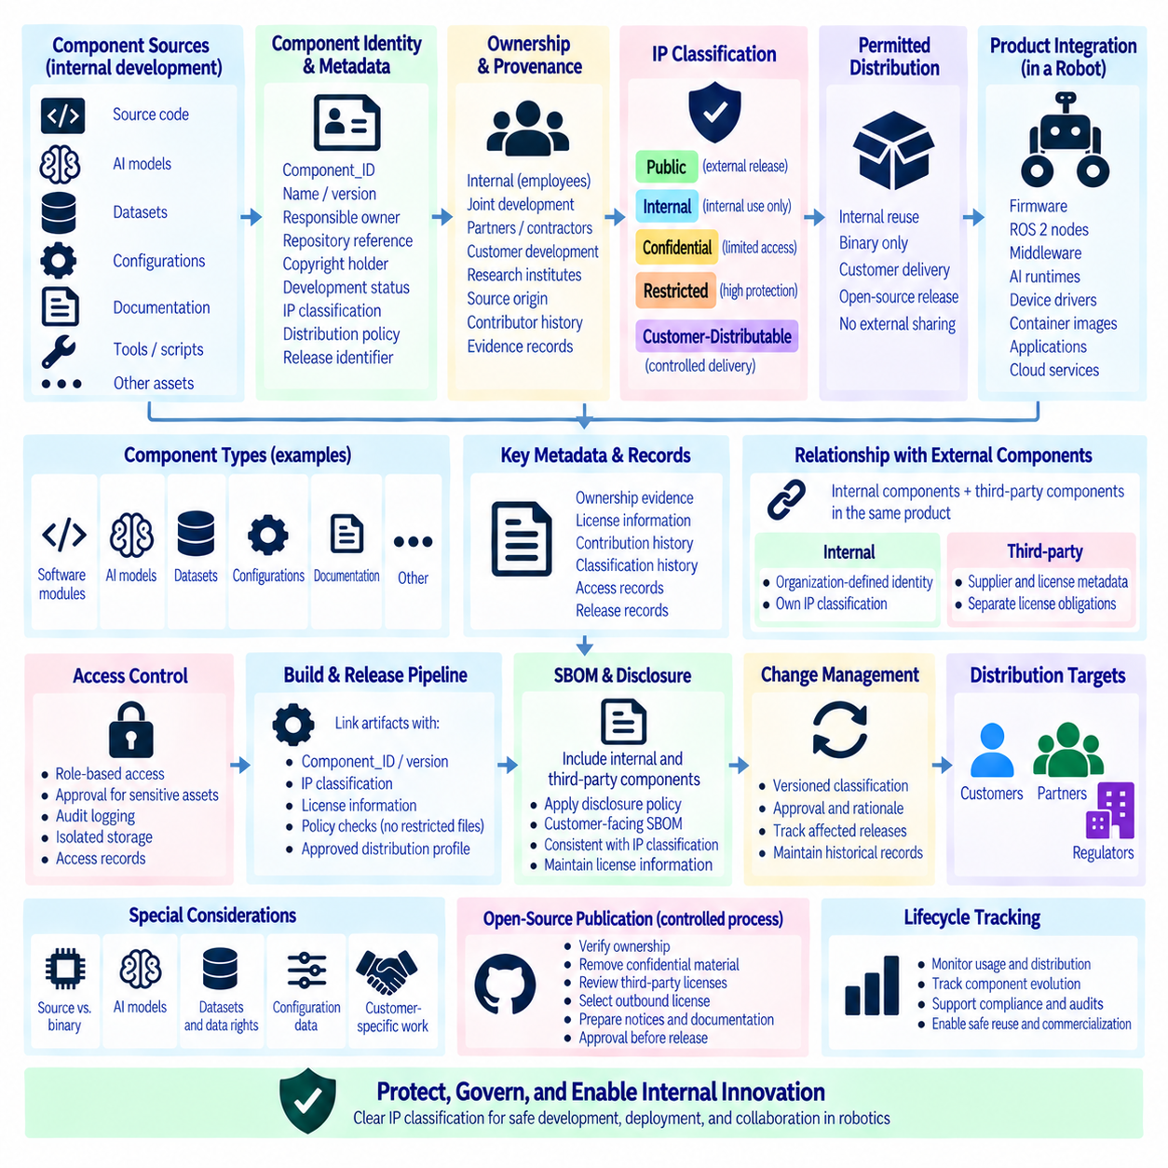
Internal component intellectual property management establishes how organization-created software, models, algorithms, configurations, documentation, and engineering assets are identified, owned, protected, and released. In robotics, internally developed components often coexist with open-source packages and vendor software inside the same product. Explicit IP classification prevents proprietary assets from becoming indistinguishable from externally licensed components as systems move through development, integration, and deployment.
An internal component should receive a persistent identity when it becomes a reusable engineering asset rather than remaining identifiable only by a repository or directory name. Useful metadata includes Component_ID, component name, version, responsible owner, repository reference, copyright holder, development status, IP classification, distribution policy, and release identifier. Maintaining this metadata creates a consistent relationship between engineering configuration management and intellectual-property governance.
Classification should describe both ownership and permitted distribution. A component may be internally owned and unrestricted for internal reuse while remaining prohibited from external disclosure. Another component may be approved for customer delivery only in binary form, while selected libraries may eventually be approved for open-source release. Separating ownership from distribution rights prevents the simplistic assumption that organization-owned software can automatically be shared outside the organization.
A practical classification model can distinguish Public, Internal, Confidential, Restricted, and Customer-Distributable assets according to organizational policy. Public assets are approved for external release, while Internal assets remain within the organization. Confidential or Restricted components require stronger controls because they may contain proprietary algorithms, product architecture, security-sensitive implementation details, or strategic technology. Customer-Distributable assets are explicitly approved for defined delivery conditions.
Classification should be applied at an appropriate component boundary. A repository can contain source code, configuration files, trained models, calibration data, deployment scripts, test tools, and documentation with different disclosure requirements. Assigning one classification to an entire repository may therefore be insufficient. Component-level or artifact-level classification enables the organization to release approved deliverables without unintentionally exposing internal development assets that happen to share the same repository.
Ownership records should identify the legal or organizational origin of an internal component. Software written entirely by employees may have a different ownership history from code developed jointly with universities, contractors, customers, research institutes, or consortium partners. Joint-development agreements, government-funded projects, and customer-funded development can introduce specific rights or restrictions. The IP record should therefore preserve ownership evidence rather than inferring ownership from the current repository location.
Contribution provenance is important when internal software evolves through multiple developers and external collaborators. Commit history, contributor identity, project agreements, source origin, and review records can provide evidence of how a component was created. Code copied from examples, external repositories, vendor SDKs, or previous projects should not automatically be classified as internally owned. Provenance review helps distinguish original organizational IP from incorporated third-party material.
Internal IP management must therefore connect directly with open-source license management. A proprietary ROS 2 node may contain organization-owned logic while depending on Apache-2.0, BSD, MIT, LGPL, or other licensed components. These dependencies do not automatically have the same ownership or distribution policy as the internal code. Maintaining separate component identities and license records prevents proprietary classification from obscuring third-party obligations embedded in the delivered product.
Source code and binary distribution should also be classified separately where necessary. Some components may be approved for deployment as compiled binaries or containers while their source code remains confidential. Firmware, hardware drivers, inference engines, and customer-specific modules can require similar treatment. Release metadata should record which artifact form is approved for distribution so that a valid binary release does not implicitly authorize source-code disclosure.
AI and Physical AI systems expand the IP boundary beyond conventional software. Internally trained model weights, model architectures, prompts, reward definitions, simulation environments, synthetic-data generators, dataset transformations, calibration procedures, and robot behavior policies may represent valuable intellectual property. These artifacts should receive explicit ownership and disclosure classifications instead of being treated as incidental outputs of the machine-learning pipeline.
Datasets require additional distinction because ownership of the processing pipeline does not necessarily imply ownership of the underlying data. An internal dataset may combine organization-collected robot experience with public datasets, customer data, simulation outputs, or vendor-provided assets. Dataset identity, provenance, license, collection source, permitted use, and IP classification should therefore remain connected. Derived datasets should preserve relationships to their source assets and associated restrictions.
Configuration data can also contain significant proprietary knowledge. Navigation parameters, perception thresholds, controller tuning, calibration profiles, mission logic, safety settings, deployment topology, and fleet orchestration rules may encode engineering know-how even when they are not conventional source code. IP management should recognize these artifacts as potential protected assets and apply classification, access control, versioning, and release rules appropriate to their operational significance.
Access control should reflect classification rather than relying only on repository membership. Internal components may require role-based access to source code, models, datasets, build artifacts, or documentation. Highly restricted assets can require additional approval, audit logging, or isolated storage. Access records provide evidence of who could retrieve sensitive assets and support investigation when proprietary information is transferred outside its intended development boundary.
The build and release pipeline provides an important enforcement point. CI/CD systems can associate artifacts with Component_ID, version, IP classification, license information, and approved distribution profile. A release intended for customers should verify that restricted source files, development tools, private configuration, credentials, or unapproved models are not included. Automated policy checks reduce dependence on individual developers remembering disclosure restrictions during packaging.
SBOM generation should preserve the distinction between internal and third-party components. An internal component can appear in the product inventory with its organization-defined identity while external dependencies retain their supplier and license metadata. Customer-facing SBOM transformation may then apply the established disclosure policy to determine which internal details are exposed. This creates continuity between IP classification, SBOM governance, and customer disclosure without treating them as separate processes.
Changes in ownership or classification should be versioned and auditable. A component initially classified as Internal may later be approved for customer distribution or open-source publication, while another component may become Restricted after incorporating sensitive technology. Classification changes should record the decision, approver, effective version, rationale, and affected releases. Historical records prevent current permissions from being incorrectly applied to older artifacts.
Open-source publication requires a deliberate release process rather than simply making an internal repository public. The organization should verify ownership, remove confidential material, review third-party licenses, confirm contributor rights, select an appropriate outbound license, prepare notices and documentation, and approve the exact release content. This process ensures that external publication represents an authorized transfer of defined intellectual property rather than an accidental disclosure of a development workspace.
Customer-specific development requires similar controls. A component created for one customer may contain reusable organization IP together with customer-owned requirements, data, configurations, or integration logic. Separating these elements at the component and artifact level makes future reuse safer and simplifies contractual compliance. The release record should identify which assets are organization-owned, customer-specific, externally licensed, or subject to additional contractual restrictions.
IP classification should also participate in engineering review and architecture decisions. When teams choose between developing a capability internally, adopting open-source software, licensing vendor technology, or collaborating with an external organization, the decision changes future ownership, maintenance, disclosure, and commercialization options. Recording these relationships early reduces the need to reconstruct IP boundaries after the technology has already become deeply integrated into the robotic system.
A mature governance workflow therefore connects Component Creation → Identity → Provenance → Ownership → IP Classification → Access Control → Build → Release Review → Distribution → Lifecycle Tracking. License records, SBOM information, model and dataset provenance, and customer disclosure policies interact with this chain. Together they create a traceable evidence structure showing what the organization owns, what it licenses, what it may distribute, and under which conditions.
The objective of internal component IP management is not to restrict engineering collaboration unnecessarily, but to make intellectual-property boundaries explicit and enforceable throughout the Robot DevOps lifecycle. Persistent identities, provenance records, classification, access controls, automated release checks, and versioned approvals allow internal innovation to move safely from research to production while preserving third-party obligations, contractual restrictions, customer rights, and the organization's proprietary technology.

11.10. SBOM Integration with IEC 62443 and ISO 21434
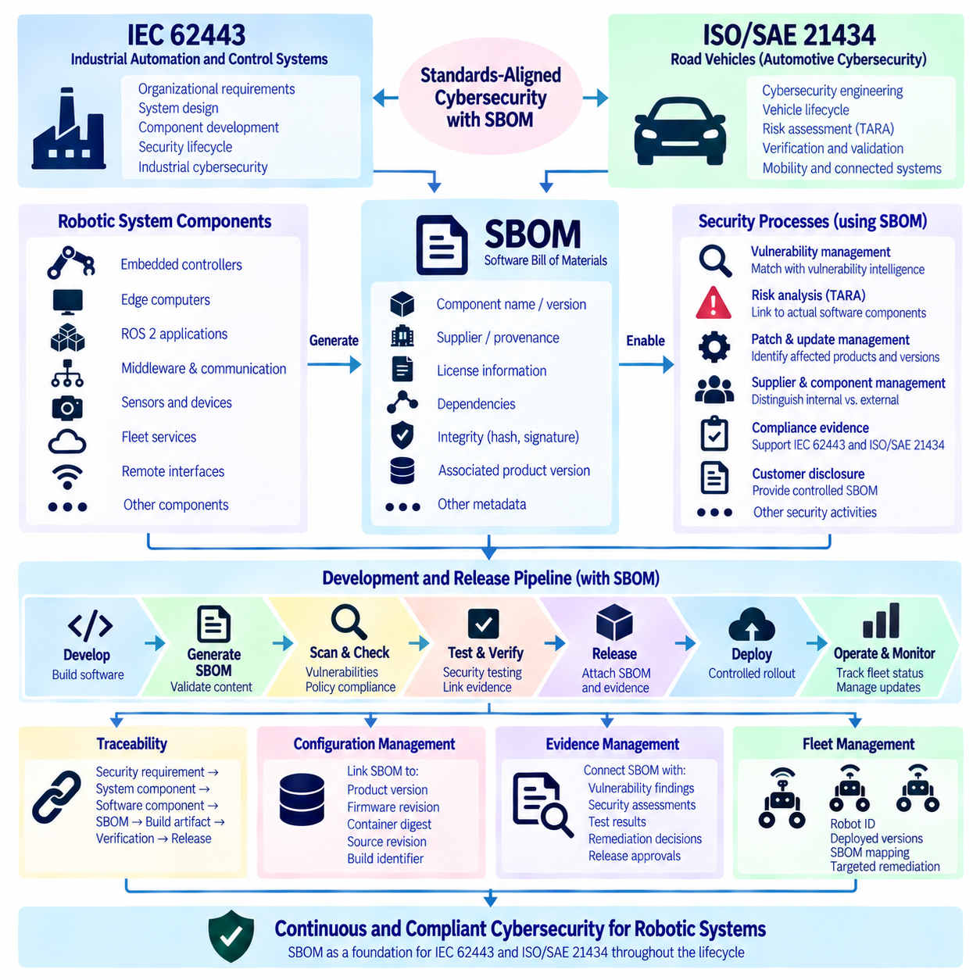
A Software Bill of Materials can support cybersecurity governance by providing a structured inventory of software components that can be connected to security activities defined by standards such as IEC 62443 and ISO/SAE 21434. The SBOM does not replace either standard or demonstrate compliance by itself. Its value comes from supplying component, version, supplier, license, dependency, and integrity information that security processes can use throughout development, release, operation, and maintenance.
IEC 62443 addresses cybersecurity for industrial automation and control systems through requirements covering organizations, system design, component development, and security lifecycle activities. Robotic systems increasingly operate as connected industrial assets containing embedded controllers, edge computers, ROS 2 applications, communication middleware, sensors, fleet services, and remote interfaces. SBOM information helps make the software composition of these heterogeneous assets visible to cybersecurity management processes.
Within an IEC 62443-oriented development environment, the SBOM can serve as evidence supporting secure product development rather than as a separate documentation exercise. Component identities can be associated with design records, security requirements, vulnerability assessments, patch decisions, and release artifacts. When a third-party dependency changes, the organization can determine which product configuration is affected and initiate the appropriate security review before the modified software reaches production.
IEC 62443 emphasizes systematic management of vulnerabilities across the product lifecycle. SBOM-based inventories strengthen this process because newly disclosed vulnerabilities can be correlated with software already released or deployed. Instead of searching source repositories manually, security teams can compare vulnerability intelligence with stored SBOMs and identify affected products, firmware packages, containers, or robot applications. The resulting findings still require contextual analysis before remediation decisions are made.
An SBOM can also support component and supplier management. Industrial robotic products commonly incorporate operating-system packages, open-source libraries, commercial middleware, vendor SDKs, firmware, and externally developed modules. Recording supplier and component provenance makes these dependencies visible and enables security teams to distinguish internally controlled software from components whose maintenance and patch availability depend on external organizations.
ISO/SAE 21434 addresses cybersecurity engineering for road vehicles across the vehicle lifecycle. Its relevance becomes particularly important when robotic platforms overlap with vehicle architectures, connected mobility systems, autonomous transport platforms, or automotive-derived electronic and software technologies. As with IEC 62443, an SBOM can provide structured technical evidence, but cybersecurity engineering still requires risk analysis, requirements, verification, validation, monitoring, and documented lifecycle decisions beyond the inventory itself.
In an ISO/SAE 21434-oriented workflow, SBOM data can contribute to identifying software assets associated with cybersecurity-relevant functions and components. Package versions, firmware revisions, communication libraries, operating-system modules, and externally sourced software can be connected to system architecture and configuration records. This allows cybersecurity analysis to reference the actual software composition of a vehicle or robotic platform rather than relying only on high-level architectural descriptions.
Threat Analysis and Risk Assessment, commonly referred to as TARA, should remain distinct from SBOM generation. The SBOM describes what software components exist and how they are related, while TARA analyzes cybersecurity assets, threats, attack paths, impacts, and risks. Linking the two improves traceability because identified threats can be associated with concrete software components, but an inventory of packages cannot independently determine cybersecurity risk or establish whether an attack scenario is feasible.
The distinction between vulnerability severity and system risk remains important in both standards-oriented environments. A component may contain a published vulnerability, but actual risk depends on configuration, accessibility, privileges, interfaces, operational exposure, and the surrounding architecture. SBOM information identifies the candidate component and version, while system cybersecurity analysis determines whether the vulnerability is relevant and what mitigation, patching, isolation, or acceptance decision is appropriate.
Traceability can connect security requirements with implementation evidence. A useful relationship may follow Cybersecurity Requirement → System Component → Software Component → SBOM Entry → Build Artifact → Verification Evidence → Released Configuration. Maintaining these links enables engineering teams to determine which software realizes a security-related function and which test or assessment evidence applies to the exact version incorporated into the released system.
Configuration management is essential because cybersecurity evidence loses value when it cannot be associated with a reproducible product version. Each SBOM should therefore be linked to identifiers such as product version, software release, firmware revision, container digest, source revision, architecture, and build identifier. Immutable references make it possible to reconstruct the software configuration that was evaluated and distinguish it from later updates that may contain different security characteristics.
Secure development pipelines can automate portions of this traceability. CI/CD processes may generate an SBOM, validate its schema and completeness, scan components for known vulnerabilities, check approved dependencies, associate security-test results, and attach the resulting evidence to a release candidate. Policy gates can prevent promotion when required security information is missing or defined vulnerability conditions remain unresolved, while approved exceptions remain documented and auditable.
Patch and update management benefits directly from persistent SBOM records. When a new vulnerability is disclosed after release, stored SBOMs can identify potentially affected product versions without rebuilding them. Engineering teams can then determine whether an update is required, validate the replacement component, test the resulting system, and issue a controlled release. This supports continuous cybersecurity maintenance rather than treating security evaluation as an activity completed at initial product launch.
Fleet-operated robots require an additional link between product cybersecurity evidence and physical deployment state. Robot_ID, software release, firmware versions, container digests, and SBOM identifiers can be maintained in deployment records. When vulnerability intelligence identifies an affected component, the organization can trace the issue from the SBOM to the corresponding release and then to individual robots, enabling targeted remediation rather than unnecessary fleet-wide assumptions.
SBOM integration should also account for embedded and proprietary components that may not be represented by conventional package managers. Motor controllers, sensor firmware, communication modules, GPU software, proprietary device SDKs, and vendor binaries can influence the cybersecurity posture of a robot. Where detailed composition is unavailable, the inventory should preserve available product, supplier, firmware, and version information and explicitly identify visibility limitations rather than silently omitting the component.
Evidence management should preserve the relationship among SBOMs, vulnerability findings, security assessments, test results, remediation decisions, and release approvals. These records may originate from different engineering systems, but stable identifiers allow them to form a connected evidence chain. Such traceability helps demonstrate that cybersecurity activities were performed against defined configurations and provides a basis for later audits, incident investigation, and maintenance decisions.
The same SBOM can support multiple governance processes without implying that their requirements are identical. Software composition information may contribute to IEC 62443-oriented industrial cybersecurity activities, ISO/SAE 21434-oriented vehicle cybersecurity engineering, open-source license compliance, supplier management, and customer disclosure. A shared component inventory reduces duplicated evidence while each governance framework retains its own scope, terminology, risk methods, and required engineering activities.
Organizations should therefore avoid representing an SBOM scanner or vulnerability report as proof of standards compliance. Compliance depends on the applicable scope and the broader set of organizational, engineering, verification, operational, and documentation requirements. The SBOM is better understood as an enabling evidence artifact that improves visibility and traceability across those activities. Its effectiveness depends on completeness, accuracy, version control, and integration with actual cybersecurity workflows.
For robotic platforms spanning industrial and mobility domains, a unified evidence architecture can connect Product Architecture → Cybersecurity Assets → Software Components → SBOM → Vulnerability Intelligence → Risk Assessment → Security Requirements → Verification → Release → Deployment Monitoring. IEC 62443-oriented and ISO/SAE 21434-oriented processes can reference this shared evidence chain while applying the security concepts and lifecycle controls appropriate to their respective domains.
The long-term objective is continuous cybersecurity traceability from development to deployed operation. SBOM information establishes what software is present; cybersecurity engineering establishes why it matters, what risks exist, and how those risks are controlled. By integrating component inventory, configuration management, vulnerability tracking, risk assessment, verification evidence, release control, and fleet monitoring, Robot DevOps can make the SBOM a practical foundation for standards-aligned cybersecurity lifecycle management.

