Volume 10 Robot DevOps and MLOps

6. MLOps Fundamentals

6.1. MLOps Maturity Model and Robot AI Lifecycle
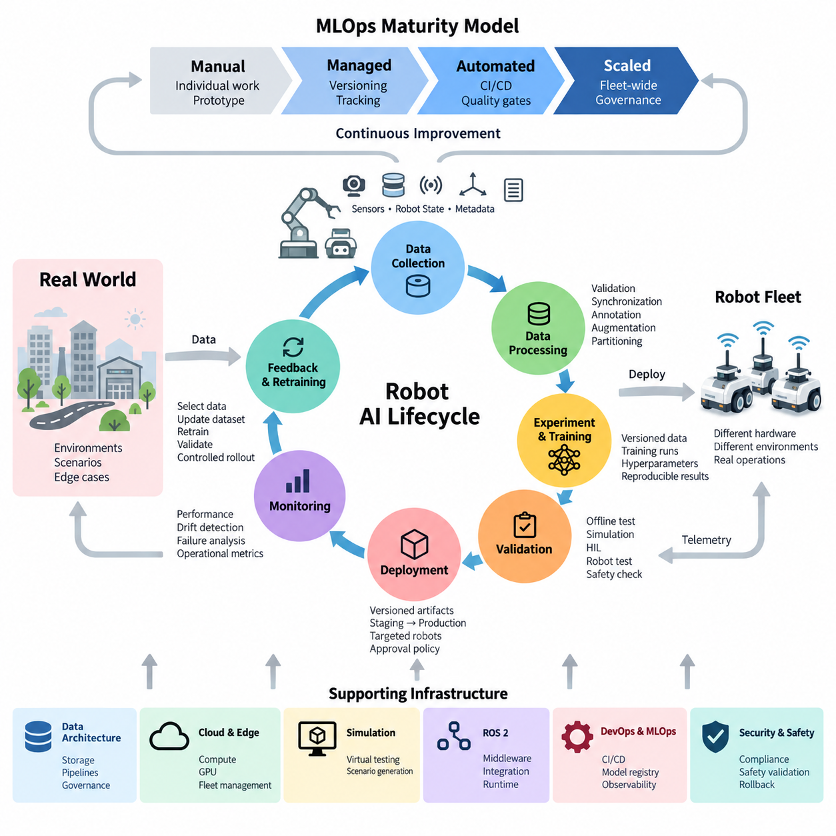
MLOps extends DevOps principles to machine learning systems by treating data, experiments, models, deployment configurations, and production feedback as managed engineering artifacts. In robotics, this discipline becomes especially important because an AI model does not operate only inside a cloud service. It interacts with sensors, compute hardware, middleware, control software, actuators, physical environments, and humans, making the lifecycle inherently cyber-physical.
A robot AI lifecycle typically begins with operational requirements and data acquisition rather than model training itself. Cameras, LiDAR, radar, IMUs, force sensors, telemetry, and robot states generate heterogeneous datasets under changing environmental conditions. These datasets must be collected with contextual metadata such as robot configuration, sensor calibration, location class, software version, mission type, and operating conditions so that later experiments remain reproducible.
The next stage transforms raw robot data into training-ready datasets through validation, synchronization, filtering, annotation, augmentation, and partitioning. Dataset versions should be traceable to the source observations from which they were created. This lineage becomes essential when a deployed model fails because engineers must determine whether the problem originated in sensor data, annotation quality, preprocessing logic, training configuration, model architecture, or deployment conditions.
Experimentation introduces another layer of lifecycle management. Each training run may depend on a specific dataset version, source revision, container image, framework version, hyperparameters, random seed, GPU configuration, and preprocessing pipeline. Mature MLOps therefore records experiments systematically instead of relying on manually maintained notebooks or filenames. The resulting model artifact should be reproducible from an identifiable combination of code, data, configuration, and computational environment.
An MLOps maturity model describes how organizations progress from manual experimentation toward increasingly automated and governed AI operations. At an initial maturity level, individual engineers prepare datasets, execute training jobs, copy model files, and deploy them manually. This approach can support prototypes, but knowledge remains dependent on individuals and reproducing an earlier model may become difficult as datasets, software dependencies, and robot configurations evolve.
At the next maturity level, teams introduce consistent repositories, dataset versioning, experiment tracking, artifact storage, and standardized training environments. Models become identifiable assets rather than anonymous binary files. A model can be connected to its training dataset, experiment metrics, source revision, dependencies, and intended robot platform. This establishes the traceability foundation required for systematic validation and controlled deployment across multiple robots.
Pipeline automation represents a further maturity transition. Data preparation, training, evaluation, packaging, and registration are connected into repeatable workflows triggered by code changes, new datasets, schedules, or operational events. Automated execution reduces procedural variation, but automation alone does not define mature MLOps. Quality gates must determine whether a candidate model satisfies predefined accuracy, robustness, latency, memory, compatibility, and safety-related requirements.
Robotics adds an important distinction between offline model quality and physical deployment readiness. A perception model may achieve excellent benchmark accuracy yet consume excessive GPU memory or violate the latency budget of an edge computer. A navigation or manipulation policy may perform well in simulation but behave unpredictably under sensor noise, mechanical tolerances, illumination changes, terrain variation, payload changes, or previously unseen objects. Validation must therefore progressively approximate real operation.
A mature validation chain can move from offline datasets to simulation, software integration tests, hardware-in-the-loop evaluation, controlled robot tests, and limited fleet deployment. The broader software structure places MLOps alongside observability, model deployment, model monitoring, automated training, and hardware-in-the-loop CI, reflecting that robot AI cannot be validated independently from the surrounding software and hardware stack.
Deployment introduces another maturity dimension because a validated model must be associated with a known runtime environment. The deployment artifact may include model weights, inference engines, preprocessing logic, configuration, dependency versions, and hardware compatibility information. Instead of copying a model directly onto every robot, mature systems promote immutable, versioned artifacts through development, validation, staging, and production environments under explicit approval policies.
Fleet deployment also changes the meaning of production. A cloud AI service usually runs in relatively standardized infrastructure, whereas robots may operate with different sensor revisions, GPU generations, firmware versions, mechanical configurations, and environmental conditions. Model compatibility must therefore be evaluated against robot configuration. Deployment policies may restrict a model to particular hardware revisions or operational domains rather than assuming that one artifact is universally interchangeable.
Production operation closes the lifecycle through observability. Robots should report not only conventional software metrics such as CPU, GPU, memory, latency, and process health, but also AI-specific signals describing input distributions, confidence, prediction statistics, failure events, and operational outcomes. The surrounding volume explicitly separates observability, model monitoring, fleet-wide AI health, drift detection, and automated retraining, showing that production feedback is a core lifecycle component rather than an afterthought.
Monitoring enables engineers to distinguish infrastructure failures from model degradation. A perception pipeline may fail because a ROS 2 node stopped, because GPU inference latency increased, because camera calibration changed, or because the operational environment drifted beyond the training distribution. These failure classes require different responses. Effective MLOps therefore correlates model telemetry with robot software versions, hardware states, sensor health, mission context, and operational events.
Higher maturity introduces controlled feedback loops. Production data associated with difficult or failed cases can be selected for review, annotation, dataset updates, retraining, and validation. The objective is not unrestricted autonomous retraining followed by immediate deployment. Each iteration should preserve lineage so that engineers can determine which operational observations produced a dataset revision, which dataset produced a model, which validation evidence approved it, and which robots subsequently received it.
Continual learning makes governance increasingly important because model improvement and operational stability can conflict. A new model may improve average accuracy while degrading performance for a rare but important scenario. Mature systems therefore compare candidate and production models across representative scenarios, regression datasets, hardware constraints, and safety-relevant conditions. Shadow evaluation, staged rollout, canary deployment, rollback mechanisms, and fallback policies limit the impact of unexpected behavior.
At advanced maturity, MLOps becomes a fleet-scale learning infrastructure rather than merely a model-training pipeline. Robots operate as distributed data-producing edge systems, centralized infrastructure manages datasets and experiments, GPU resources perform training and evaluation, registries maintain approved artifacts, and deployment systems distribute validated models back to selected robots. Monitoring then generates evidence for subsequent development cycles, forming a controlled learning loop between field operation and engineering.
This lifecycle also connects MLOps to the wider robotics software architecture. Robot data architecture governs sensor and telemetry flows, cloud and edge infrastructure supplies computation, simulation provides scalable validation environments, ROS 2 integrates AI functions with robot services, and testing infrastructure verifies behavior before release. The overall software tree therefore positions MLOps as one layer of a broader engineering system spanning embedded software, data, cloud, simulation, perception, learning, security, and validation.
The practical goal of MLOps maturity is consequently not maximum automation. It is controlled repeatability: every important model should have identifiable origins, measurable validation evidence, a defined deployment target, observable production behavior, and a recoverable previous state. As robot fleets and Physical AI models increase in scale, these properties allow AI development to evolve from isolated experiments into a reproducible engineering process capable of supporting continuously improving physical systems.

6.2. ML Experiment Tracking MLflow Weights and Biases [w/Code]
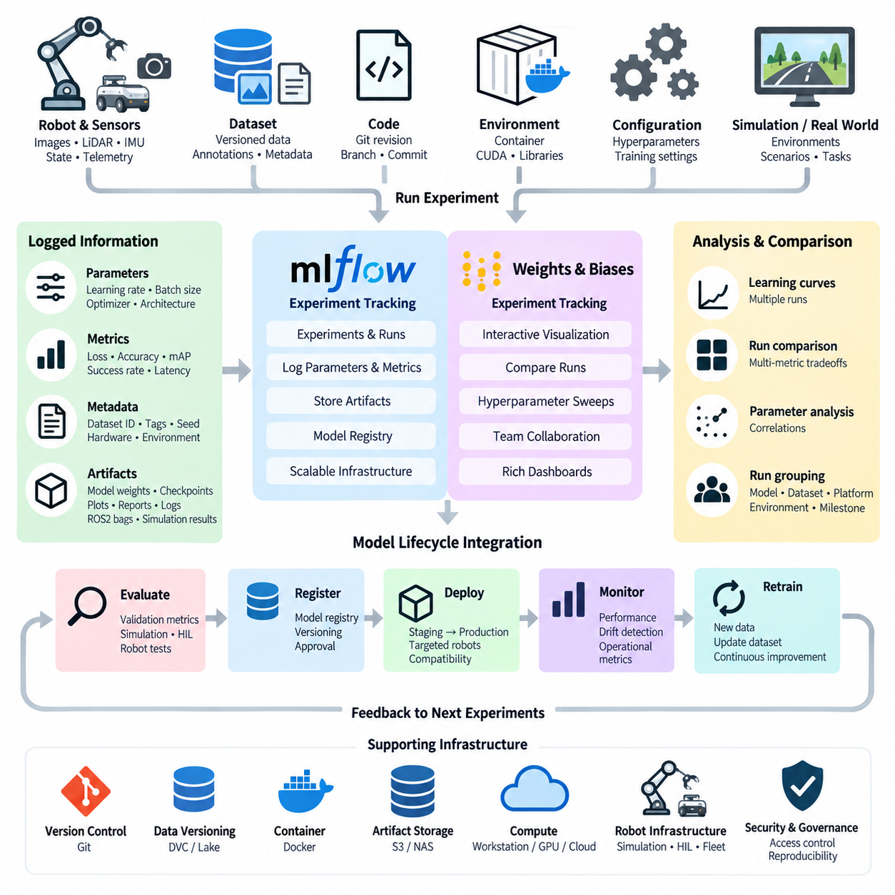
Machine learning experiment tracking is the systematic recording of everything required to understand, compare, reproduce, and audit model development. In robot AI, a single experiment may involve dataset versions, preprocessing parameters, neural network architectures, hyperparameters, source code revisions, GPU environments, evaluation metrics, and generated artifacts. Without structured tracking, hundreds of training runs quickly become difficult to distinguish or reproduce.
Traditional experimentation often begins with notebooks, shell scripts, spreadsheets, and model files named manually by engineers. This approach may work during early prototyping, but it becomes fragile when several developers train models simultaneously or when experiments run across workstations, GPU servers, and cloud infrastructure. Experiment tracking replaces these informal records with a centralized history in which each training execution becomes an identifiable and searchable run.
A tracked experiment normally contains parameters, metrics, metadata, and artifacts. Parameters describe the conditions under which training occurred, including learning rate, batch size, optimizer, model architecture, augmentation settings, random seed, and dataset identifier. Metrics record measurable results such as training loss, validation loss, precision, recall, F1 score, mean average precision, success rate, or task-specific robot performance indicators.
Artifacts represent the files generated by an experiment. These can include trained model weights, checkpoints, configuration files, plots, evaluation reports, confusion matrices, TensorRT engines, sample predictions, and diagnostic logs. For robotics, artifacts may additionally contain ROS 2 bag references, simulation results, trajectory evaluations, perception outputs, or failure-case datasets. Storing them with the corresponding run prevents results from becoming separated from their experimental context.
MLflow provides an experiment-tracking architecture centered on experiments and runs. A training application can log parameters, metrics, tags, and artifacts through tracking APIs, while a tracking server provides centralized access to experiment history. Artifact storage can be separated from metadata storage, allowing organizations to keep large model files and evaluation outputs in object storage or shared storage while maintaining searchable experiment records.
This separation is valuable for robot AI infrastructure because training may occur on heterogeneous compute resources. An engineer can initiate a small experiment on a workstation, execute larger training on multi-GPU servers, and later evaluate the resulting model on an edge platform. If these environments report to the same tracking system, their results can be compared through common experiment identifiers instead of being fragmented across individual machines.
MLflow also supports the transition from experimentation toward lifecycle management. A successful training run can produce a model artifact that is subsequently evaluated, registered, versioned, and promoted through later MLOps stages. Experiment tracking therefore serves as an upstream source of provenance for model registration and deployment. The deployed model can be traced backward to the run that produced it and ultimately to its parameters, metrics, code, and dataset references.
Weights & Biases, commonly abbreviated as W&B, approaches experiment tracking with strong emphasis on interactive visualization and collaborative machine learning workflows. Training scripts can report metrics continuously, allowing engineers to inspect learning curves, compare runs, organize experiments, visualize parameter relationships, and share results with team members. This is especially useful when model development involves many rapidly changing experiments and frequent comparison.
Visualization becomes important because model selection rarely depends on a single metric. A perception engineer may compare accuracy against inference latency, GPU memory consumption, model size, and robustness under environmental variation. A manipulation model may require comparison of task success rate, collision frequency, trajectory duration, and generalization. Experiment dashboards make these multidimensional trade-offs visible rather than reducing model selection to the lowest validation loss.
Run grouping provides another useful capability for robot learning. Experiments can be organized according to model family, dataset revision, robot platform, sensor configuration, environment, or development milestone. Hyperparameter sweeps may generate dozens or hundreds of related runs, while reinforcement learning can produce repeated trials across different seeds and simulation conditions. Structured grouping allows these experiments to be analyzed as related populations rather than isolated executions.
Experiment tracking should also capture the software environment. Two runs using identical hyperparameters may produce different behavior if they use different CUDA, PyTorch, driver, preprocessing, or library versions. Container images can reduce this variability, but the container identifier itself should still be recorded. Combining source revision, environment information, dataset version, and training configuration creates a reproducibility chain connecting software engineering practices with machine learning operations.
Dataset identity is particularly important because experiment tracking alone does not version the underlying data. The run should reference an immutable or otherwise traceable dataset revision managed by the surrounding data pipeline or data-versioning system. This allows engineers to distinguish improvements caused by model architecture from improvements caused by changed annotations, additional training samples, modified augmentation, or corrected sensor preprocessing.
Robot AI experiments require hardware-aware metrics that conventional ML projects may overlook. A candidate model intended for Jetson or another edge computer should not be evaluated solely by offline accuracy. Tracking can include inference latency, throughput, GPU utilization, peak memory, power-related measurements, initialization time, and model size. These metrics reveal whether an apparently superior model is practical within the computational constraints of the target robot.
Simulation experiments can also be incorporated into the same tracking structure. Reinforcement learning policies, navigation algorithms, and manipulation models may be evaluated across thousands of simulated episodes. Environment versions, physics parameters, randomization settings, reward configurations, success rates, collision statistics, and policy checkpoints can be attached to individual runs. This creates traceability between simulation conditions and the resulting robot behavior.
As development progresses toward physical validation, experiment records can incorporate results from software integration, hardware-in-the-loop testing, and controlled robot trials. A model originally identified by a training run can accumulate evidence showing its behavior under increasingly realistic conditions. Rather than treating training accuracy as the final result, the experiment lineage can connect offline evaluation to deployment-oriented measurements obtained from actual robot hardware.
MLflow and W&B therefore overlap substantially but can fit different operational preferences. MLflow is frequently used as an extensible tracking and model-lifecycle foundation that can be integrated with organization-controlled infrastructure, while W&B emphasizes rich experiment visualization, collaboration, and rapid analysis of large collections of runs. Teams may select one platform or design workflows in which experiment metadata remains interoperable with broader artifact and model-management systems.
The tracking platform itself should not become the only source of reproducibility. Source code belongs in version control, datasets require explicit version management, containers define executable environments, and model registries govern deployable artifacts. Experiment tracking connects these components by storing their identifiers and relationships. Its role is therefore not to replace Git, data versioning, artifact storage, or deployment systems, but to provide the contextual record that binds them together.
In a mature robot MLOps pipeline, experiment creation can be automated. A pipeline receives a dataset version and training configuration, records the source revision and environment, starts the training run, streams metrics, stores resulting artifacts, executes evaluation, and attaches validation results to the run. Candidate models satisfying predefined gates can then advance toward registration, while failed experiments remain available for comparison and engineering analysis.
Consistent naming and metadata conventions become increasingly important at fleet scale. Tags can identify robot family, sensor suite, target hardware, operational domain, model purpose, dataset generation, and release candidate status. Engineers can then search historical experiments when investigating field failures or preparing a new deployment. Instead of repeating old experiments, they can locate previous evidence and understand why earlier model candidates were accepted or rejected.
Experiment tracking ultimately converts machine learning development from a sequence of transient training jobs into an engineering knowledge system. Every meaningful model result becomes connected to the conditions that produced it, the evidence used to evaluate it, and the artifacts required to reproduce it. For robot AI, this traceability forms a critical bridge between research experimentation and controlled deployment, enabling model development to scale across teams, compute infrastructure, robot platforms, and continuously evolving datasets.

6.3. Data Versioning and Reproducibility DVC [w/Code]
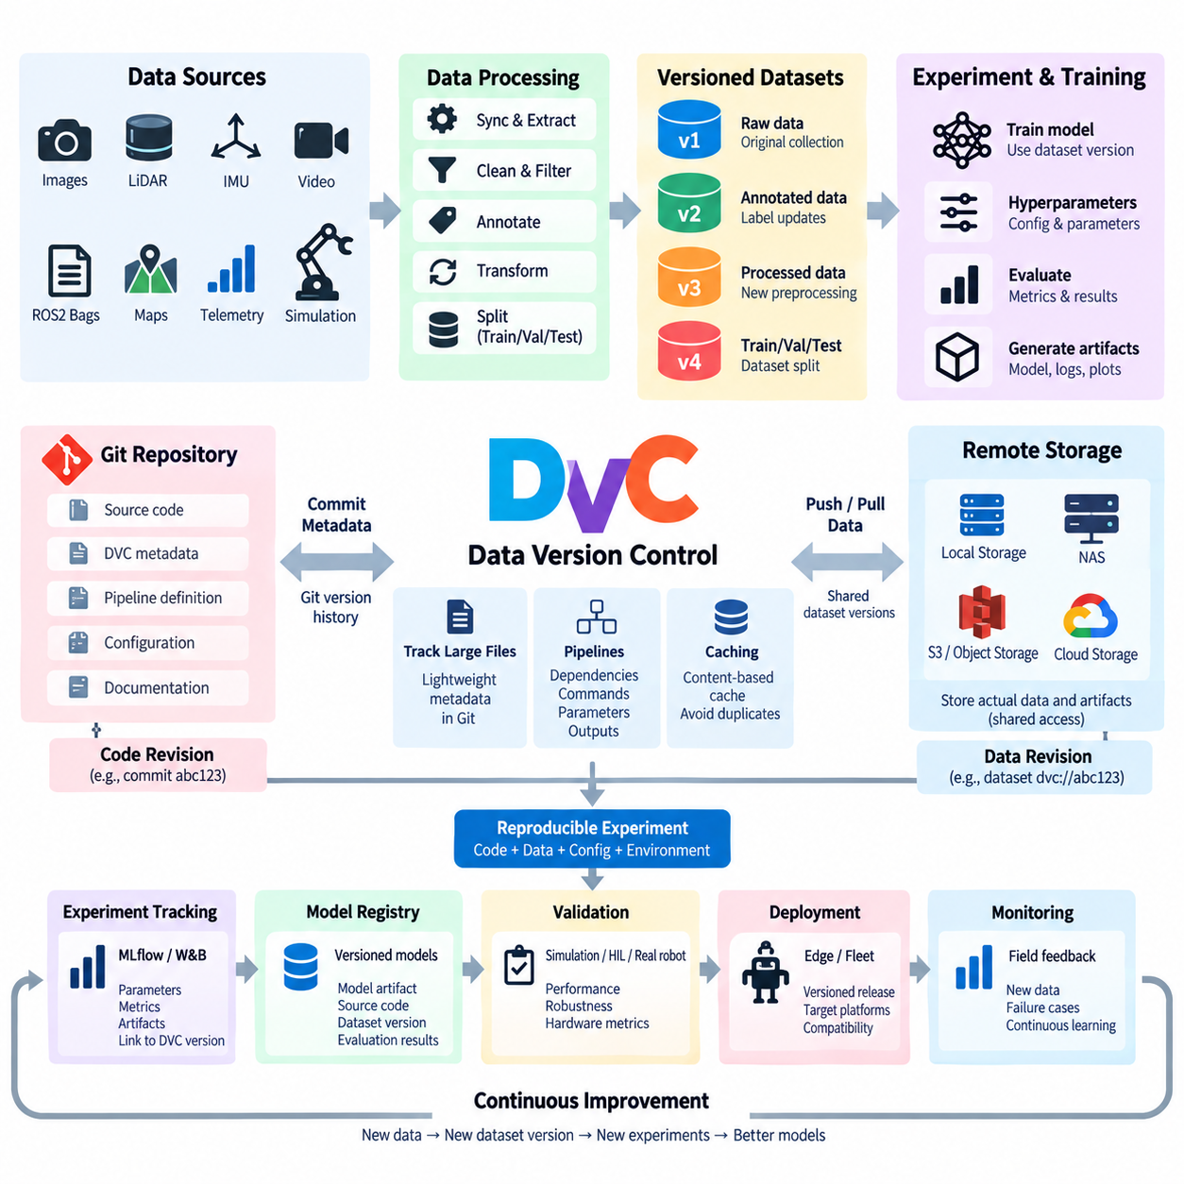
Data versioning is the practice of assigning identifiable states to datasets so that machine learning experiments can be reproduced, compared, and audited over time. Unlike source code, robot datasets often contain gigabytes or terabytes of images, LiDAR point clouds, ROS 2 bags, video, telemetry, maps, and simulation outputs. Storing these large binary assets directly in Git is inefficient, so MLOps requires a mechanism that connects lightweight version metadata with scalable external storage.
Reproducibility means that an engineer can reconstruct the data, code, configuration, and environment associated with a particular experiment or released model. A Git commit alone cannot guarantee this because the training dataset may have changed independently from the source code. A reproducible robot AI workflow therefore records both the software revision and an exact dataset revision, allowing the training inputs used months earlier to be restored even after newer data has been collected.
Data Version Control, commonly known as DVC, extends Git-oriented development workflows to datasets, models, and other large artifacts. Instead of placing large files directly inside the Git repository, DVC stores lightweight metadata files that describe the tracked content while the actual data can reside in local storage, network storage, object storage, or cloud services. Git then versions the metadata, connecting each source-code revision with the corresponding state of the data.
This architecture separates version history from bulk data storage. A repository can contain source code, configuration files, DVC metadata, and pipeline definitions while hundreds of gigabytes of sensor recordings remain outside Git. When another engineer checks out a particular Git revision, the associated DVC metadata identifies the required dataset state. The corresponding data can then be retrieved from configured storage, reconstructing the experiment inputs without duplicating large binary histories inside the source repository.
DVC tracks files and directories through content-based information rather than relying only on human-readable filenames. When tracked data changes, its corresponding metadata changes as well. Committing that metadata to Git creates a relationship between a source revision and a specific data state. Consequently, dataset_v3 or final_dataset_new names are no longer the primary mechanism for identifying training data; reproducibility is based on version-controlled metadata and content identity.
A DVC remote provides shared storage for versioned data and artifacts. Depending on infrastructure design, this remote can be located on a shared filesystem, NAS, object storage, or supported cloud storage. Developers keep manageable working copies while the remote acts as a common source for required dataset objects. This model is especially useful in robotics laboratories where workstations, GPU training servers, simulation nodes, and edge-development machines need controlled access to common datasets.
The basic workflow parallels Git. Engineers modify or generate data, update the DVC-tracked state, commit the resulting metadata through Git, and transfer required data objects to shared storage. Other systems can retrieve the repository revision and synchronize the corresponding data. This creates coordinated versioning without requiring Git itself to transfer every camera frame, point cloud, model checkpoint, or recorded robot episode.
Robot datasets are rarely static collections. Field robots continuously generate new observations, failure cases, unusual environments, and sensor recordings. Annotation teams may correct labels, calibration procedures may change, and preprocessing pipelines may remove invalid samples or generate new representations. Each of these operations can produce a new dataset state. Versioning makes these changes explicit and allows engineers to compare models trained before and after a particular data modification.
Dataset provenance goes beyond identifying a file collection. A useful version should be associated with information describing where the data originated and how it was transformed. For robotics, this can include robot platform, sensor suite, calibration revision, recording session, operational environment, annotation version, preprocessing configuration, and filtering criteria. DVC can participate in this provenance chain by connecting versioned inputs and outputs with reproducible pipeline stages.
DVC pipelines represent data and model workflows as dependencies, commands, parameters, and outputs. A pipeline may begin with raw robot logs, continue through extraction and synchronization, generate annotations or processed tensors, execute model training, and finally produce evaluation results. When dependencies or parameters change, the affected stages can be identified and reproduced. This converts data preparation from an undocumented sequence of manual commands into an explicit computational workflow.
Pipeline reproducibility is particularly important because preprocessing can influence model behavior as strongly as architecture changes. Camera resizing, image normalization, point-cloud filtering, coordinate transforms, temporal synchronization, class balancing, augmentation, and train-validation splitting can all alter experimental results. If these transformations are represented as versioned pipeline stages, engineers can determine exactly how a particular training dataset was derived from its original sensor data.
DVC parameters provide another connection between data pipelines and experimentation. Values controlling preprocessing, training, or evaluation can be stored in structured configuration files and referenced by pipeline stages. Changing a parameter creates a detectable modification to the experiment definition. Combined with Git revisions and DVC-tracked artifacts, this helps establish a reproducibility chain from source data through processing configuration to the final model and evaluation output.
Caching improves efficiency when large datasets are used repeatedly. DVC can maintain a content-addressed cache so that unchanged data does not need to be copied unnecessarily between versions. Multiple dataset states may share common underlying objects, reducing redundant storage and transfer. This is valuable for robot learning because successive dataset revisions often add or modify only a fraction of a much larger collection of images, trajectories, or sensor recordings.
Reproducibility also requires careful separation between raw, processed, and derived data. Raw sensor observations should generally remain stable after ingestion, while corrected metadata, annotations, processed representations, and training subsets can evolve through controlled versions. Preserving this distinction makes it possible to regenerate downstream datasets when preprocessing logic changes rather than permanently overwriting the original evidence collected from robots.
DVC complements experiment-tracking platforms rather than replacing them. Experiment tracking systems such as MLflow or Weights & Biases record training parameters, metrics, runs, and model-related artifacts, while DVC focuses on reproducible versions of data and computational pipelines. A training run can record the Git revision and DVC dataset revision it consumed, creating a direct connection between experimental results and the exact training data that produced them.
The same principle applies to model registries. A registered model should ideally reference not only its model artifact and evaluation metrics but also its source-code revision, dataset version, preprocessing pipeline, and training configuration. When a model later produces unexpected behavior on a robot, engineers can reconstruct its development lineage. They can restore the relevant data state, repeat evaluation, compare it with newer datasets, and determine whether data evolution contributed to the failure.
Simulation introduces additional versioning requirements. Synthetic datasets depend on simulator versions, environment assets, robot models, sensor configurations, domain-randomization parameters, and scenario definitions. Changes to any of these components can alter generated data. Treating synthetic datasets and their generation configurations as versioned artifacts allows simulation-based experiments to be reproduced and compared with the same discipline applied to physical robot data.
At fleet scale, dataset versioning supports controlled learning loops between deployed robots and centralized AI infrastructure. Fleet telemetry and selected field observations can be ingested into candidate datasets, reviewed, annotated, and promoted into new training versions. Models trained from those versions can then pass validation and deployment gates. The relationship between field evidence, dataset revisions, experiments, model versions, and deployed robots remains traceable throughout the lifecycle.
Storage governance becomes increasingly important as datasets grow. Versioning does not mean preserving unlimited duplicate copies of every intermediate file. Organizations need policies defining authoritative raw data, reproducible derived artifacts, cache retention, remote-storage replication, access permissions, and archival rules. DVC provides technical mechanisms for tracking and synchronizing data, while broader data architecture determines how storage capacity, security, backup, and lifecycle policies are managed.
Data versioning ultimately transforms datasets from mutable folders into controlled engineering assets. DVC provides a Git-compatible mechanism for connecting large data, reproducible pipelines, parameters, and artifacts with software revisions while allowing bulk content to remain in appropriate external storage. For robot AI, this capability forms a foundation for trustworthy MLOps because every important model can be linked to the exact data state and processing workflow from which it was created.

6.4. Model Registry and Artifact Store Design [w/Code]
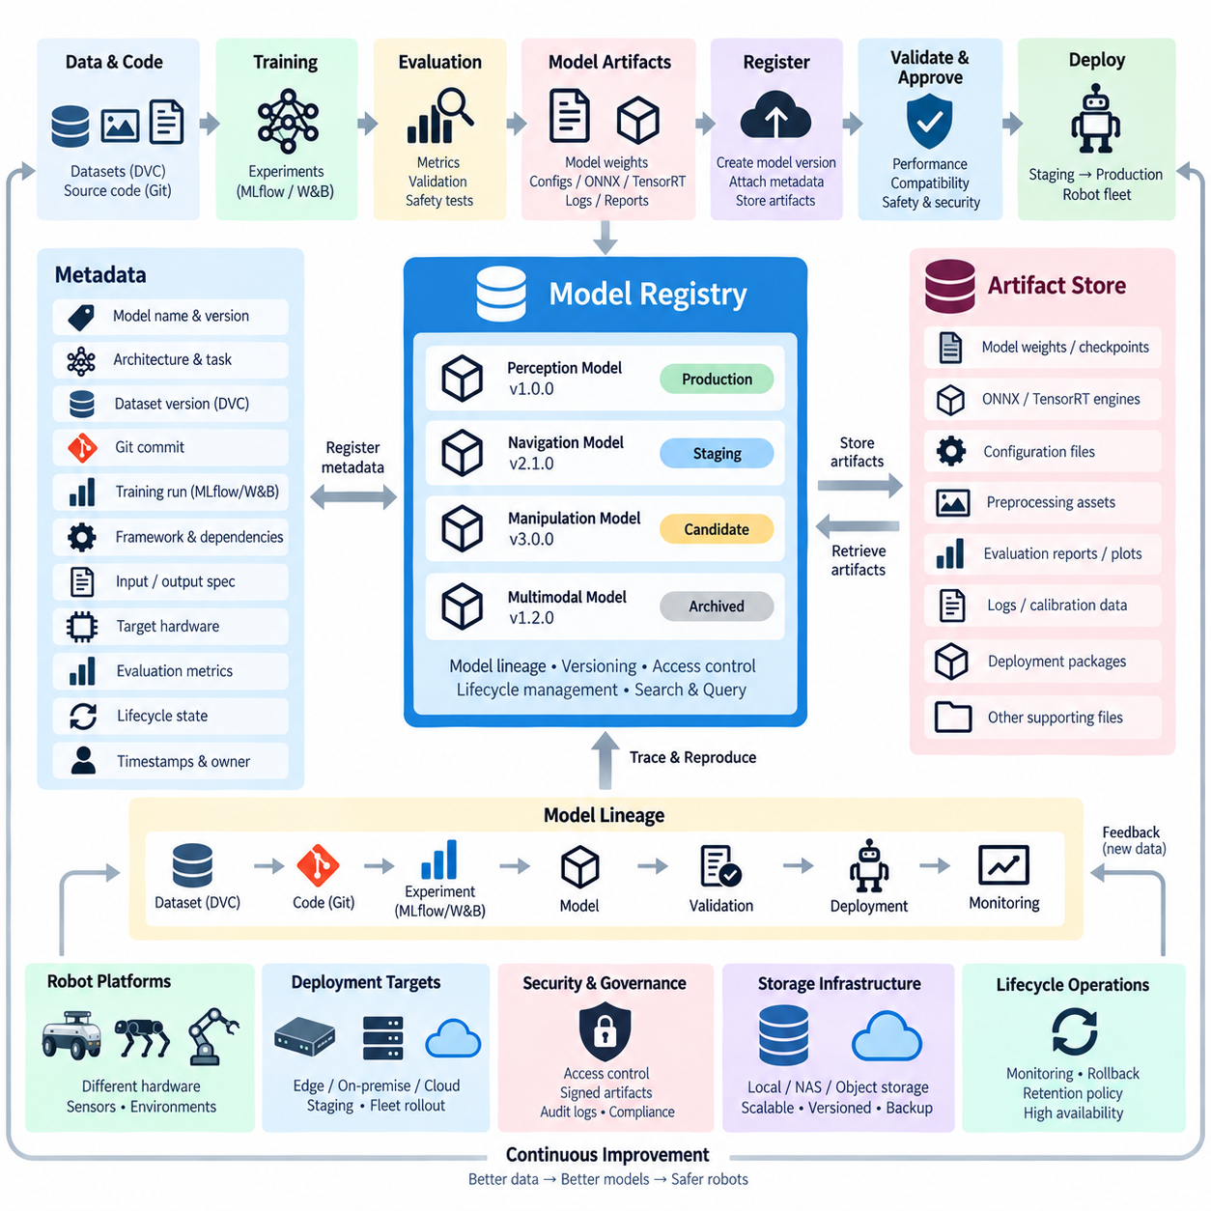
A model registry is the controlled system of record for machine learning models that have progressed beyond temporary experimentation. In robot AI, trained models may exist as PyTorch checkpoints, ONNX graphs, TensorRT engines, policy networks, perception models, or multimodal components. A registry gives these artifacts explicit identities, versions, lifecycle states, metadata, and relationships so teams can determine which model is approved for which robot and operating environment.
An artifact store provides the physical storage layer for the files produced throughout the machine learning lifecycle. These artifacts can include model weights, checkpoints, configuration files, evaluation reports, preprocessing assets, TensorRT engines, logs, plots, calibration information, and deployment packages. The model registry manages the logical identity and lifecycle of models, while the artifact store preserves the actual binary objects and supporting files associated with them.
Separating registry metadata from artifact storage is an important architectural principle. Registry records are relatively small and require efficient querying, lineage tracking, access control, and lifecycle management, whereas model artifacts may range from megabytes to many gigabytes. Large foundation models can be substantially larger. Keeping these responsibilities separate allows metadata services and storage capacity to scale independently while maintaining references between model versions and their corresponding files.
A registered model should have a stable logical name representing its purpose rather than a filename generated during training. Individual versions then represent immutable model candidates created from particular experiments. Metadata can describe architecture, task, dataset revision, Git commit, training run, framework version, input and output specifications, target hardware, evaluation metrics, and creation time. This converts an anonymous binary file into a traceable engineering asset.
Model lineage connects the registry to the broader MLOps lifecycle. A model version should be traceable backward to the experiment that created it, the source-code revision used for training, the dataset version consumed, and the configuration that controlled preprocessing and optimization. It should also be traceable forward to validation results, deployment packages, robot releases, and operational observations. This bidirectional lineage is essential when investigating unexpected behavior in deployed robots.
The artifact store should use immutable or strongly controlled objects whenever possible. If a file referenced by model version 12 can later be silently overwritten, the registry no longer guarantees reproducibility. Content hashes, immutable object paths, versioned storage, or equivalent integrity mechanisms can ensure that an artifact retrieved later is identical to the one originally evaluated. Human-readable names remain useful, but they should not be the sole identity mechanism.
Storage design depends on model scale and infrastructure topology. A small development team may use a shared filesystem or NAS, while larger systems commonly use object storage because it provides scalable namespaces, API-based access, lifecycle management, and distributed availability. Robot MLOps may combine local caches for high-speed training with centralized artifact storage that acts as the authoritative source for models, evaluation outputs, and deployment packages.
The registry should distinguish model registration from model approval. Training a model successfully does not mean that it is ready for deployment. A newly registered version may remain a candidate until automated and human validation confirms required performance, robustness, compatibility, and safety-related characteristics. Lifecycle states can represent progression through development, validation, staging, production, archived, or rejected conditions according to organizational governance.
Validation evidence should remain attached to the model version rather than being stored as an unrelated report. For robot perception, this may include accuracy, precision, recall, mAP, robustness tests, inference latency, GPU memory, and scenario-specific results. Navigation, manipulation, reinforcement learning, and Physical AI models may require different metrics. Hardware-in-the-loop and real-robot evaluations can provide additional evidence before a model becomes eligible for operational deployment.
Robot hardware compatibility is particularly important in registry design. Two robots performing the same task may use different Jetson generations, GPU architectures, cameras, LiDAR configurations, firmware, or preprocessing pipelines. A model version should therefore describe its expected runtime and hardware constraints. Compatibility metadata prevents deployment systems from treating every registered model as universally executable across every robot configuration.
A registry may also reference multiple representations of the same logical model. Training can produce a framework-native checkpoint, while deployment preparation generates ONNX, TensorRT, quantized, or hardware-specific variants. These should not become disconnected files with ambiguous relationships. The registry and artifact store can preserve their derivation chain so engineers know which optimized artifact originated from which validated source model and optimization process.
Artifact packaging should capture dependencies required to reproduce inference behavior. Model weights alone may be insufficient if inference depends on tokenizer files, class mappings, normalization parameters, calibration data, preprocessing graphs, post-processing logic, or runtime plugins. For multimodal and foundation models, several components may operate together. Treating the deployable unit as a structured artifact package reduces hidden dependencies and inconsistent runtime behavior.
Model promotion is the controlled transition of a validated model toward operational use. Promotion should reference explicit evidence rather than copying files into folders named production or final. Automated gates may verify accuracy, latency, memory consumption, artifact integrity, hardware compatibility, security checks, and regression results. Approval information can then be recorded in registry metadata, providing an auditable explanation of how a model reached its deployment state.
Deployment systems consume approved registry entries rather than arbitrary training outputs. A deployment pipeline can resolve a logical model version, retrieve its artifacts, verify integrity, build or select the appropriate runtime package, and deliver it to staging robots or selected fleet groups. This creates a controlled boundary between model development and robot operations, reducing the risk that an experimental checkpoint is accidentally deployed to production hardware.
Rollback requirements should influence registry architecture from the beginning. A robot fleet may need to return quickly to a previously validated model if a new version produces degraded behavior. Previous production versions and their deployment artifacts must therefore remain identifiable and retrievable. Rollback is not simply restoring old weights; the compatible preprocessing logic, runtime configuration, dependencies, and hardware-specific artifacts may also need to be restored together.
The registry can support staged deployment strategies such as shadow evaluation, canary rollout, and fleet segmentation. A model version may initially run without controlling the robot, then be activated on a small subset of compatible platforms before broader release. Deployment metadata can record which robot groups received which versions. Operational telemetry can then be correlated with registry information to compare candidate and established models under real-world conditions.
Monitoring closes the connection between registry design and continuous learning. Production metrics, drift indicators, failure events, and field observations can reference the exact model version operating on each robot. When performance degradation is detected, engineers can retrieve the corresponding model lineage, dataset revision, validation evidence, and deployment history. Selected field data may then enter a new dataset version and training cycle, producing a subsequent registered model candidate.
Security is another core artifact-store concern. Model files can represent valuable intellectual property and can also become a software supply-chain attack surface. Access controls should restrict who can publish, approve, modify metadata, retrieve sensitive artifacts, or promote models. Integrity checks, signed artifacts, audit logs, encrypted transport, storage policies, and controlled service identities can strengthen trust between training infrastructure, registries, deployment systems, and robot fleets.
Retention policies should distinguish temporary experimental artifacts from long-lived release assets. Keeping every checkpoint generated during every training epoch indefinitely can consume enormous storage capacity, particularly for large robot foundation models. Organizations can retain selected checkpoints and evaluation evidence while expiring redundant intermediate artifacts. Production releases, provenance information, validation evidence, and rollback-critical packages generally require stronger preservation policies.
High availability and disaster recovery become important when the registry serves an operational fleet. The registry database, artifact metadata, and authoritative model objects should be backed up according to their recovery requirements. Artifact storage may use replication or redundant storage tiers, while registry metadata requires consistent database protection. Losing either side can break lineage: metadata without artifacts cannot reproduce models, while artifacts without metadata lose their operational meaning.
Integration with experiment tracking and data versioning creates a complete provenance chain. MLflow or Weights & Biases can identify the training run and its metrics, DVC can identify the exact dataset and processing state, Git identifies source code, and the model registry identifies the resulting deployable model versions. The artifact store preserves the associated binaries and evidence. Together these systems connect data, code, experiments, models, validation, and deployment.
At fleet scale, the model registry becomes a coordination layer between centralized AI development and distributed physical systems. Different robot families may require different models or optimized variants while still sharing common model lineage. Registry metadata can associate versions with robot classes, sensor configurations, operational domains, deployment channels, and release policies, enabling deployment automation to select compatible artifacts without losing centralized governance.
A well-designed model registry and artifact store therefore provide more than organized model storage. They establish identity, provenance, integrity, approval state, compatibility, deployment history, and recoverability for robot AI assets. By connecting experimentation with validation and fleet deployment, this architecture transforms trained models from temporary research outputs into governed software-defined components that can be safely reproduced, distributed, monitored, and evolved throughout the robot AI lifecycle.

6.5. Automated ML Pipeline Orchestration Kubeflow Airflow [w/Code]
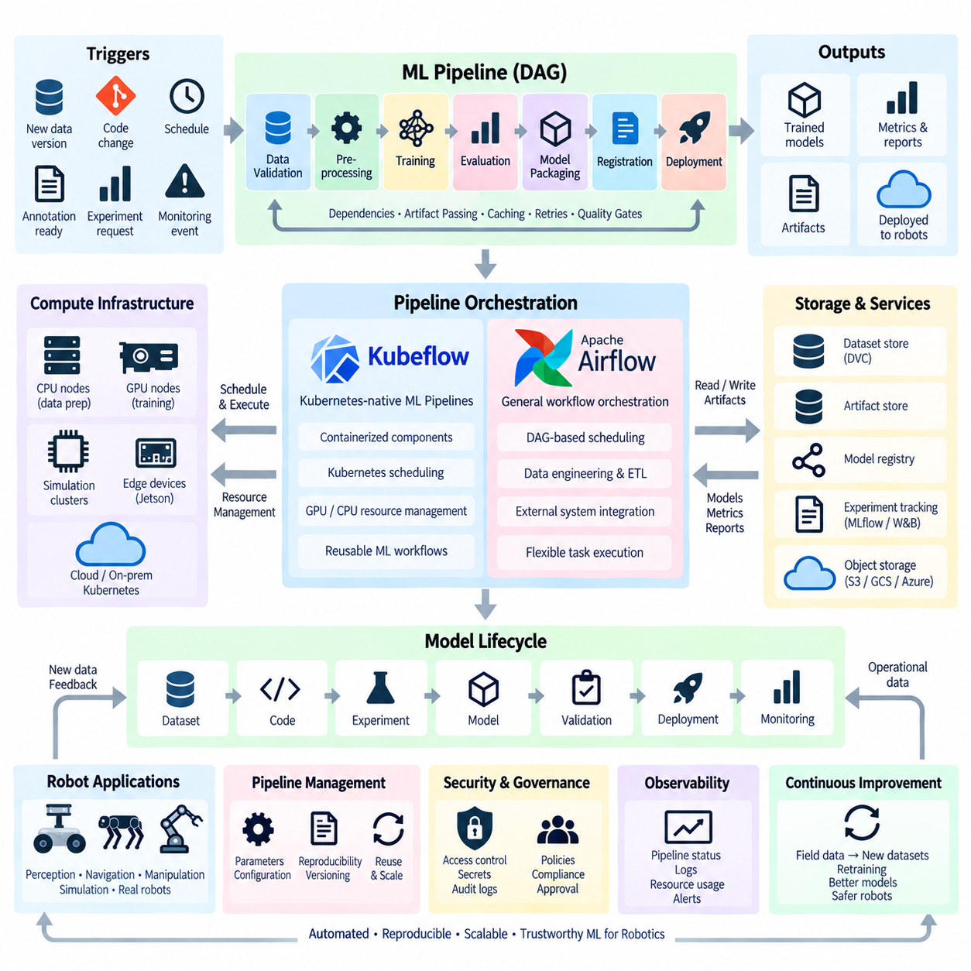
Automated ML pipeline orchestration coordinates the sequence of activities required to transform data into validated and deployable machine learning models. Instead of engineers manually executing preprocessing, training, evaluation, packaging, and registration commands, an orchestrator represents these operations as connected pipeline stages. In robot AI, this creates a repeatable workflow linking sensor data, datasets, compute resources, models, validation evidence, and deployment artifacts.
A machine learning pipeline is commonly represented as a directed acyclic graph, or DAG, in which individual tasks form nodes and dependencies define execution order. Data validation may precede preprocessing, preprocessing must finish before training, and evaluation requires a completed model. The orchestrator interprets these dependencies, schedules executable tasks, transfers references to intermediate outputs, monitors execution state, and determines how failures or retries should be handled.
Automation becomes particularly important because robot AI workflows combine heterogeneous workloads. Data preparation may execute on CPU servers, perception training may require GPUs, reinforcement learning may use large simulation clusters, and deployment optimization may target Jetson-class edge hardware. Pipeline orchestration provides a common control layer capable of coordinating these different resources while preserving the dependency relationships between each stage of the ML lifecycle.
A typical automated workflow begins when a trigger identifies work that should be performed. The trigger may originate from a new dataset version, source-code change, scheduled retraining interval, approved annotation batch, experiment request, or model-monitoring event. The pipeline then resolves the required data, code, configuration, and execution environment before launching processing and training stages. This makes pipeline execution event-driven and reproducible rather than dependent on manual procedures.
Each pipeline stage should ideally operate as an independently executable component with clearly defined inputs and outputs. A preprocessing component may receive a dataset reference and configuration, then produce a processed dataset. A training component consumes that dataset and generates checkpoints, while an evaluation component produces metrics and reports. Explicit interfaces make individual stages replaceable, testable, cacheable, and reusable across multiple model-development workflows.
Kubeflow Pipelines provides pipeline orchestration designed around containerized machine learning workloads and Kubernetes infrastructure. Pipeline components can execute as isolated container-based tasks while Kubernetes provides scheduling, resource management, storage integration, and workload isolation. This architecture is suitable for ML environments in which different stages require different container images, CPU and GPU resources, memory allocations, or execution policies.
Containerization helps preserve reproducibility because each component can specify the software environment required for execution. A data-processing stage may use one Python environment while training uses a CUDA-enabled PyTorch image and model optimization uses TensorRT tooling. Rather than installing every dependency into one shared machine, the orchestrator launches the appropriate environment for each task, reducing dependency conflicts and making execution environments easier to reproduce.
Kubernetes resource scheduling allows pipeline stages to request resources according to workload requirements. Lightweight validation may use CPU nodes, while large training jobs can request GPU-enabled workers. Labels, node selection, resource limits, persistent storage, and scheduling policies can direct workloads toward appropriate infrastructure. For robot AI organizations, this enables shared clusters to support dataset processing, simulation, training, evaluation, and model packaging without treating every workload identically.
Kubeflow is especially useful when machine learning workflows are deeply integrated with Kubernetes-native infrastructure. Training components can interact with persistent storage, object stores, experiment metadata, distributed compute resources, and model-serving systems. Pipelines can also represent reusable ML workflows rather than isolated scripts. The resulting architecture connects model development with the same scalable infrastructure principles used elsewhere in cloud-native and on-premise platforms.
Apache Airflow approaches orchestration from a general workflow scheduling perspective. Workflows are defined as DAGs containing tasks and dependencies, while the scheduler determines which tasks are ready to execute. Airflow is widely applicable to data engineering and scheduled workflows, making it useful when ML pipelines depend heavily on ingestion, ETL, database operations, batch processing, reporting, and coordination with systems outside the machine learning environment.
Airflow tasks can invoke scripts, containers, external services, cluster jobs, or other processing systems, allowing it to coordinate heterogeneous infrastructure without requiring every computation to execute directly inside Airflow itself. In a robot data platform, a workflow might ingest fleet telemetry, verify uploaded sensor logs, start preprocessing, request a GPU training job, collect evaluation results, and update downstream systems after successful completion.
The distinction between Kubeflow and Airflow is therefore primarily architectural rather than a simple comparison of features. Kubeflow Pipelines naturally aligns with Kubernetes-based ML execution and containerized model-development workflows, whereas Airflow provides general-purpose orchestration suitable for complex data and operational workflows. Some architectures may use one system exclusively, while others may use Airflow for broader data workflows and Kubernetes-oriented ML tooling for computationally intensive training stages.
Pipeline parameters make automated workflows reusable. Instead of creating a new pipeline for every experiment, engineers can supply dataset versions, model configurations, training parameters, target hardware, or evaluation profiles as inputs. The same pipeline definition can then produce different model candidates while preserving a consistent execution procedure. Parameterization separates workflow logic from experiment-specific values and reduces uncontrolled duplication of scripts.
Artifact passing connects individual stages into a coherent lineage. A preprocessing stage produces a dataset reference, training generates a model artifact, evaluation produces metrics, and optimization may generate ONNX or TensorRT variants. The pipeline should record these relationships rather than treating outputs as unrelated files. Combined with data versioning, experiment tracking, and a model registry, orchestration establishes traceability across the entire automated execution path.
Caching can significantly reduce repeated computation. If a pipeline stage receives the same inputs and configuration as a previously completed execution, its existing outputs may be reused when the orchestration environment supports deterministic caching. This is particularly valuable for expensive preprocessing or large robot datasets. However, caching requires careful identification of dependencies so that changed code, data, parameters, or environments do not incorrectly reuse obsolete results.
Failure handling is another fundamental orchestration capability. Training may fail because of exhausted GPU memory, corrupted data, unavailable storage, node failures, or software exceptions. An orchestrator records task state and can apply retry, timeout, notification, or termination policies. Failures therefore become observable workflow events rather than leaving engineers to determine manually which command completed and where a long multi-stage process stopped.
Quality gates prevent automation from turning failures into automated deployments. After training, evaluation stages should verify predefined requirements before a model advances. These gates may examine accuracy, robustness, inference latency, memory consumption, regression tests, simulation performance, HIL results, or hardware compatibility. A pipeline can stop a candidate that fails validation while preserving its experiment records and artifacts for later analysis.
Robot AI adds simulation and physical validation stages that conventional ML pipelines may not require. A candidate navigation policy might first be evaluated across simulation scenarios, then tested through HIL infrastructure, and finally deployed to a controlled robot environment. These stages can be represented as dependencies within a larger pipeline, although physical tests may require resource reservations, robot availability, safety procedures, and asynchronous execution rather than conventional compute scheduling.
Pipeline orchestration also supports distributed and parallel execution. Independent preprocessing partitions, hyperparameter experiments, simulation scenarios, or evaluation datasets can execute concurrently and later converge into an aggregation stage. Parallelism can reduce development time significantly when sufficient compute resources are available. The orchestrator provides the dependency model required to coordinate these tasks without forcing engineers to manage individual processes manually.
Observability should cover both individual ML tasks and the orchestration system itself. Engineers need visibility into pipeline status, execution duration, resource consumption, logs, retries, failed stages, queued workloads, and generated artifacts. Historical execution records help identify bottlenecks such as slow data transfer, underutilized GPUs, repeated preprocessing, or overloaded cluster resources, allowing the ML infrastructure itself to be optimized.
Security and governance must remain part of automated pipeline design. Pipeline tasks may access datasets, GPU clusters, artifact stores, model registries, and deployment systems, making service identities and permissions important. Secrets should be managed outside pipeline source code, and tasks should receive only the permissions required for their functions. Audit records should show which pipeline version produced a model and which automated or human approvals allowed it to progress.
At higher MLOps maturity, orchestration connects continuous data collection with continuous model improvement. New field observations can enter a controlled data pipeline, generate a new dataset version, trigger training, execute automated evaluation, register successful candidates, and prepare them for staged validation. Monitoring information from deployed robots then becomes another input to future workflows, closing the operational learning loop without eliminating validation and governance controls.
Automated orchestration ultimately converts a collection of ML scripts into a managed production workflow. Kubeflow provides a strong Kubernetes-oriented foundation for containerized ML pipelines, while Airflow provides flexible DAG-based orchestration across data and operational systems. For robot AI, the central objective is not automation alone, but reproducible coordination of data, computation, experiments, validation, artifacts, and deployment so that increasingly complex learning systems can evolve under controlled engineering processes.

6.6. Feature Store Integration in Robot ML Pipeline [w/Code]
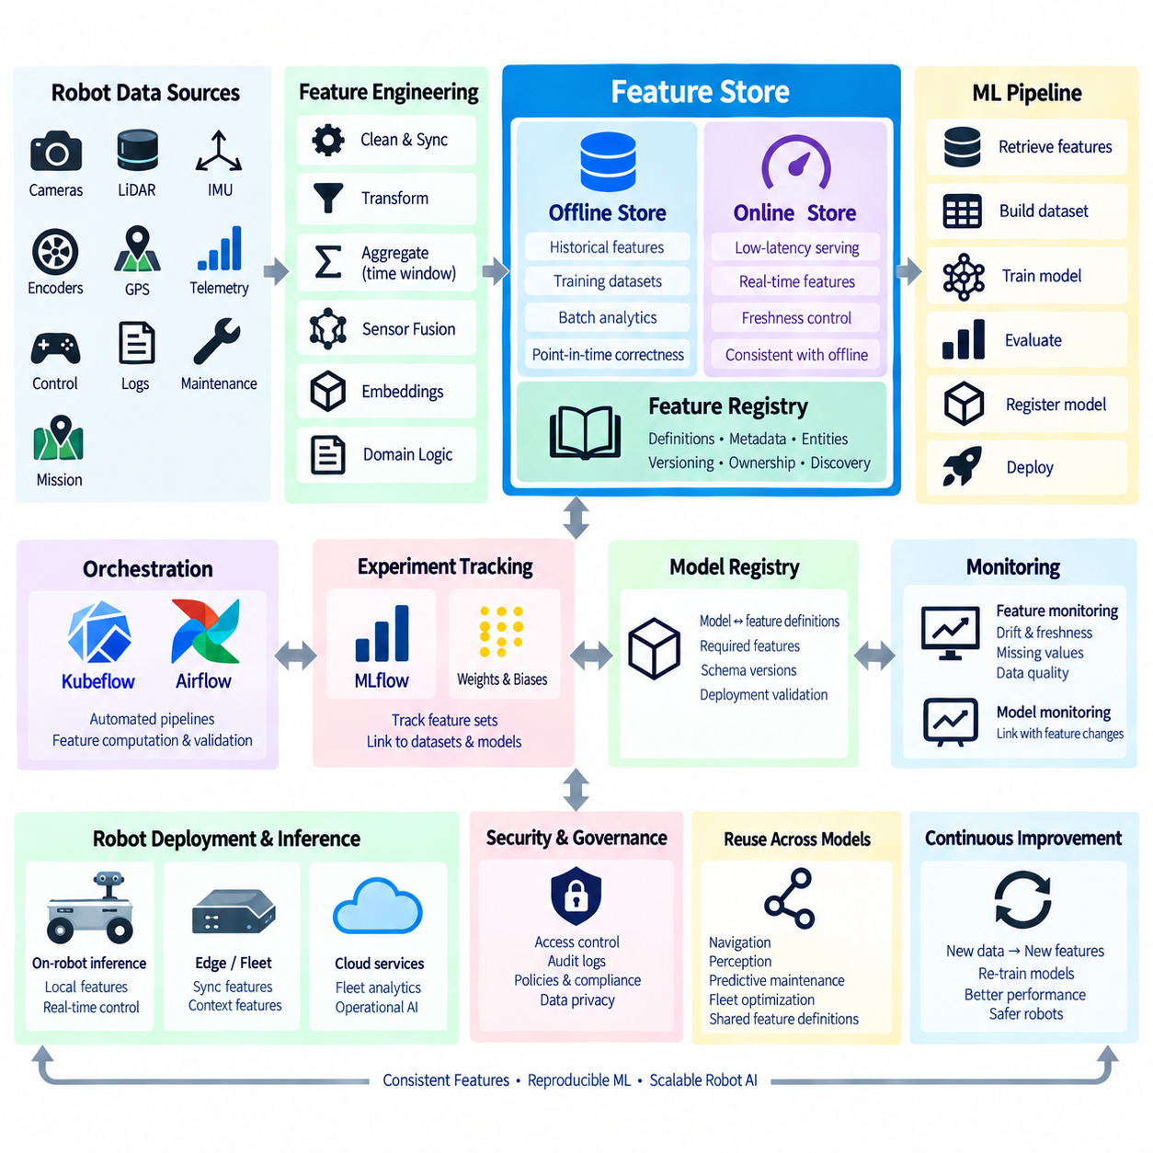
A feature store is a managed layer for defining, computing, storing, discovering, and serving machine learning features consistently across training and inference. In robot AI, raw sensor streams are rarely consumed directly by every model. They are transformed into reusable representations such as object statistics, localization quality, motion history, terrain descriptors, battery state, mission context, or fleet-level operational indicators that can support multiple learning tasks.
A feature represents a measurable or derived property used as an input to a machine learning model. Robot features may originate from cameras, LiDAR, radar, IMUs, encoders, GNSS, maps, control systems, telemetry, maintenance records, or mission-management software. Some features are directly observed, while others are calculated through aggregation, filtering, temporal windows, sensor fusion, embeddings, or domain-specific transformations performed by upstream data pipelines.
Without a feature store, individual teams often implement similar transformations independently in notebooks, training scripts, and production services. A perception experiment may calculate environmental context one way while the deployed inference pipeline calculates it differently. These duplicated implementations increase maintenance cost and create training-serving skew, where a model receives feature values during operation that differ systematically from those used during training.
The primary purpose of feature-store integration is therefore consistency rather than simply additional storage. Feature definitions, transformation logic, schemas, ownership, metadata, and serving interfaces are managed as reusable assets. Training pipelines retrieve historical features according to controlled definitions, while production systems obtain equivalent features for current observations. This shared feature contract connects data engineering, model development, and inference operations within the MLOps lifecycle.
Feature stores commonly distinguish offline and online access patterns. The offline store maintains historical feature values used for dataset construction, training, batch evaluation, and retrospective analysis. It can contain large volumes of robot observations accumulated over weeks or months. The online store provides low-latency access to recent or current feature values required by operational inference services, decision systems, or other applications that cannot wait for large analytical queries.
Offline features are particularly useful for constructing reproducible robot training datasets. An engineer can request features for a defined population of robot observations and a specific historical interval, then combine them with labels or task outcomes. The resulting training dataset should preserve references to feature definitions and data versions so that the same feature computation can be reconstructed when an experiment needs to be repeated or audited.
Time is a critical dimension in robotics feature engineering. Many features depend on temporal history, such as average wheel slip during the previous five seconds, obstacle density over a recent window, localization confidence trends, battery discharge rates, or repeated navigation failures. Training data must ensure that features are calculated only from information that would have been available at the prediction time, otherwise future information can leak into the model.
Point-in-time correctness addresses this problem by reconstructing historical feature values as they existed at the relevant event time. When labels describe future outcomes, the training pipeline must not accidentally join them with feature values generated after the prediction timestamp. This requirement is important for predictive maintenance, anomaly detection, navigation-risk prediction, battery estimation, and fleet analytics where temporal relationships strongly influence model validity.
Online feature serving introduces different engineering requirements. A robot or inference service may need the latest feature vector within milliseconds, making latency, availability, and freshness important. Frequently accessed values can be materialized into low-latency databases or key-value stores, while slower historical storage remains optimized for analytical workloads. The feature store coordinates these representations so that online values remain semantically consistent with their offline counterparts.
Not every robot model requires an online feature store. End-to-end perception networks may process camera or LiDAR tensors directly on the robot, and real-time control loops often cannot depend on a remote feature service because network delays and failures would violate deterministic timing requirements. Feature-store integration is most valuable when structured or reusable derived features are shared across models, especially for fleet intelligence, predictive maintenance, operational optimization, and contextual AI.
Edge deployment therefore requires careful architectural boundaries. Safety-critical or high-frequency features may need to be computed locally and retained in robot memory, ROS 2 nodes, or edge databases. Less time-critical features can be synchronized with centralized infrastructure and served through fleet or cloud services. A robot ML architecture can combine local feature computation with centralized feature governance without forcing every inference request to cross a network boundary.
Feature freshness defines how recently a value must have been updated to remain useful. A robot’s current battery state may require near-real-time updates, while a seven-day maintenance statistic can tolerate slower refresh intervals. Feature definitions should therefore include freshness expectations and update semantics. Monitoring stale values is essential because a technically available feature may still produce incorrect model behavior if its operational meaning has expired.
Feature transformation pipelines can operate in batch, streaming, or hybrid modes. Batch processing is suitable for historical aggregations and large training datasets, while streaming systems can update features from telemetry and event streams as robots operate. Hybrid architectures may calculate expensive historical statistics offline and combine them with real-time state online. Orchestration systems coordinate these computations and ensure that dependent feature sets are updated in the correct order.
A feature registry provides metadata describing feature names, types, entities, owners, descriptions, transformation logic, sources, and expected freshness. Entities identify the objects to which features belong, such as robot_id, mission_id, component_id, location_id, or map_region. Standardized metadata improves discoverability and reduces redundant feature engineering because engineers can search for existing features before creating another implementation of the same concept.
Versioning becomes necessary when feature definitions evolve. Changing a rolling window from ten seconds to thirty seconds, modifying a normalization method, replacing a localization algorithm, or adding a new sensor source changes the semantic meaning of the resulting feature. Existing models may depend on the previous definition, so feature versions should remain identifiable and connected to experiments, datasets, and deployed models rather than being silently overwritten.
Feature validation protects downstream models from corrupted or incompatible inputs. Pipelines can verify data types, ranges, missing-value rates, categorical domains, update frequency, and statistical distributions before publishing features. Robot-specific validation may detect impossible velocities, invalid poses, abnormal sensor timestamps, missing transforms, or inconsistent mission states. Invalid features should be quarantined or flagged before they propagate into training or production inference.
Feature monitoring extends validation into operation. Distribution shifts, increasing missing values, stale updates, or unexpected correlations may indicate sensor degradation, software changes, environmental drift, or upstream pipeline failures. These signals can be connected with model monitoring so engineers can determine whether degraded predictions originate from the model itself or from changes in the features supplied to it.
Feature stores also improve reuse across multiple models. Localization quality features may support navigation-risk prediction, autonomous recovery, fleet monitoring, and maintenance analysis. Battery features may support remaining-runtime prediction, charging optimization, mission assignment, and anomaly detection. Reusing governed feature definitions reduces duplicated processing and helps different AI services interpret robot state using consistent semantics.
Integration with experiment tracking establishes traceability between features and model results. A training run can record the feature set, feature versions, dataset revision, code revision, and parameters used to construct its inputs. MLflow or Weights & Biases can then associate performance metrics with this configuration, while DVC or related data-versioning mechanisms preserve the underlying dataset state. This creates a reproducibility chain across data, features, experiments, and models.
Pipeline orchestration connects feature computation with the wider automated ML workflow. Kubeflow or Airflow pipelines can validate source data, calculate or materialize features, construct training datasets, launch experiments, evaluate models, and register successful artifacts. Feature computation therefore becomes a governed pipeline stage rather than hidden preprocessing embedded inside individual training scripts, complementing the surrounding MLOps orchestration architecture.
The model registry should preserve the relationship between a deployed model and the feature definitions it expects. A model package can specify required feature names, schema versions, freshness constraints, preprocessing assumptions, and compatibility information. Deployment validation can then verify that the target robot or serving environment can supply the required features before activation, preventing models from being deployed into incompatible data environments.
Security and governance are important because feature stores may aggregate operational information from an entire robot fleet. Access policies should control who can create, modify, read, and publish features, while audit records preserve important changes. Sensitive operational or customer-derived information may require additional protection. Governance also establishes ownership so that teams know which group is responsible when a feature becomes stale, invalid, or deprecated.
At fleet scale, feature stores can become a semantic bridge between distributed robots and centralized learning infrastructure. Robots generate observations and telemetry, data pipelines convert them into governed features, training systems use historical feature sets, and deployed services consume current values. Monitoring feeds new evidence back into the system, allowing feature definitions and models to evolve while retaining lineage across the complete robot AI lifecycle.
Feature-store integration ultimately transforms repeated feature engineering into shared ML infrastructure. Its value comes from consistent definitions, point-in-time-correct historical data, controlled online serving, versioning, validation, discoverability, and lineage rather than from storage alone. Within robot MLOps, the feature store connects raw physical observations with reproducible learning pipelines and operational inference while respecting the latency and reliability constraints of real robotic systems.

6.7. Model Validation Gates Before Robot Deployment
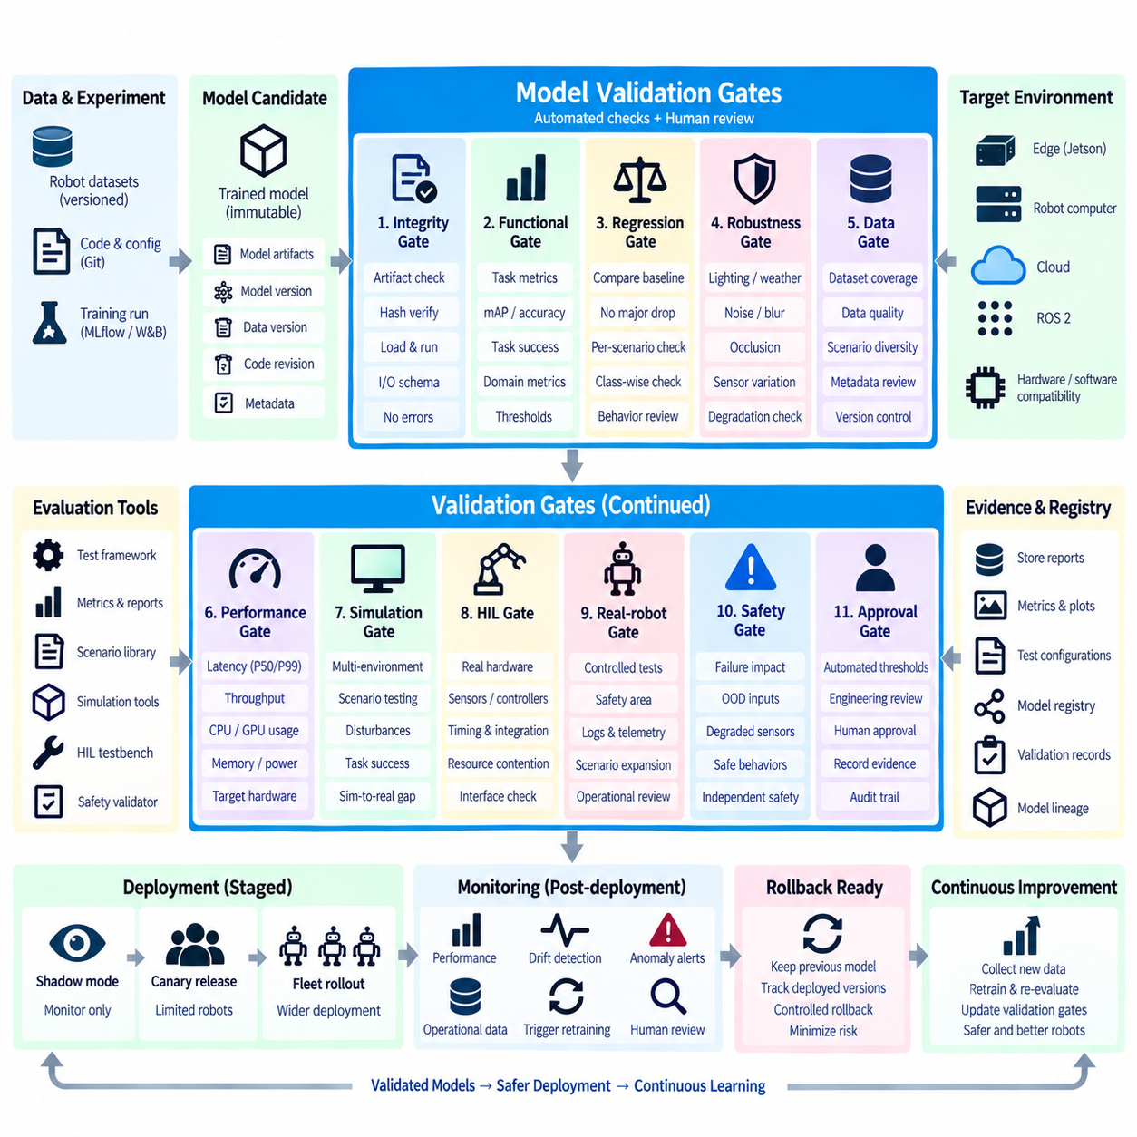
Model validation gates are controlled decision points that determine whether a trained machine learning model is allowed to progress toward robot deployment. A successful training run alone is insufficient because a model may achieve strong benchmark accuracy while failing under latency, memory, robustness, compatibility, or safety constraints. Validation gates convert deployment readiness into explicit engineering criteria rather than relying on informal judgment.
In conventional software, testing verifies whether defined logic behaves as expected. Machine learning introduces additional uncertainty because behavior depends on training data, model parameters, operating conditions, and statistical generalization. Robot AI adds physical interaction to this uncertainty. An incorrect prediction can influence navigation, manipulation, motion, or mission decisions, so validation must examine both predictive quality and operational consequences before deployment.
A validation pipeline begins with an immutable model candidate whose identity is linked to its training run, source-code revision, dataset version, configuration, and artifacts. Evaluation should operate on this exact candidate rather than on a separately exported or manually modified file. Maintaining this lineage ensures that the model approved by the validation process is identical to the model eventually packaged and considered for robot deployment.
The first gate normally verifies artifact integrity and basic correctness. Model files must exist, hashes should match expected values, required dependencies must be available, and input and output schemas must be valid. The model should load successfully in the intended runtime and complete basic inference tests without exceptions, NaN values, corrupted tensors, or incompatible operators. These checks eliminate defective artifacts before expensive evaluation begins.
Functional model evaluation measures whether the candidate performs its intended AI task. A perception model may be evaluated using precision, recall, mAP, segmentation quality, depth error, or tracking metrics, while navigation and manipulation models require task-specific measures. Validation thresholds should be defined according to the model's operational purpose rather than assuming that a single generic accuracy metric represents deployment readiness.
Regression validation compares the candidate against an established baseline or current production model. A new model may improve an aggregate metric while degrading important scenarios, classes, environments, or robot behaviors. Evaluation should therefore examine both overall performance and relevant slices of the validation dataset. A candidate can be blocked when improvement in one dimension introduces unacceptable regression in another operationally important dimension.
Robustness gates examine performance under conditions that differ from ideal benchmark data. Robot perception may encounter illumination changes, motion blur, partial occlusion, sensor noise, weather, vibration, reflective surfaces, or unusual viewpoints. Navigation and manipulation systems may encounter localization uncertainty, object variation, dynamic obstacles, or imperfect calibration. Validation should measure degradation patterns rather than testing only nominal conditions.
Data quality and coverage must also be examined before interpreting evaluation results. A validation dataset that lacks important operational scenarios can produce misleading confidence even when measured scores are high. Dataset metadata should describe environments, sensor configurations, classes, operating domains, and known limitations. Versioned validation sets allow teams to determine exactly which evidence supported a deployment decision and how that evidence changes over time.
Performance gates evaluate whether the model satisfies real execution constraints. Measurements may include inference latency, throughput, GPU utilization, CPU utilization, memory consumption, startup time, and power-related behavior. These measurements should be performed on representative target hardware because workstation performance does not guarantee equivalent behavior on Jetson, embedded GPU, edge computer, or other robot compute platforms.
Latency validation should consider distributions rather than only average values. A model with acceptable mean inference time may still produce occasional long delays that disrupt perception or planning deadlines. Percentile latency, worst-case observations, warm-up behavior, sustained-load performance, and interactions with other robot processes can provide a more realistic view. Real-time or near-real-time systems require limits that reflect their actual scheduling and control architecture.
Hardware and software compatibility form another deployment gate. The candidate may depend on a particular CUDA version, TensorRT version, GPU architecture, preprocessing implementation, sensor resolution, ROS 2 interface, or runtime library. Validation should confirm that the intended robot configuration satisfies these assumptions. Compatibility metadata prevents a model validated on one platform from being automatically treated as valid for every robot variant.
Simulation provides a scalable intermediate validation environment between offline metrics and physical testing. Models can be evaluated across many environments, trajectories, object arrangements, disturbances, and failure scenarios without exposing hardware to unnecessary risk. Simulation is especially useful for navigation policies, reinforcement learning, manipulation, and integrated Physical AI systems where isolated dataset metrics cannot represent the complete closed-loop behavior.
Simulation results should not be interpreted as proof of real-world performance. Differences in sensor characteristics, contact dynamics, environment complexity, timing, and unmodeled disturbances create a sim-to-real gap. Simulation therefore acts as one validation layer rather than the final gate. Candidates that satisfy simulation criteria can progress toward hardware-based evaluation, while failures can be rejected before consuming limited robot testing resources.
Hardware-in-the-loop validation introduces actual compute devices, controllers, sensors, interfaces, or robot subsystems into the automated test process. HIL testing can reveal timing problems, communication failures, hardware-specific inference behavior, resource contention, and integration defects that offline evaluation misses. It creates an important bridge between reproducible software validation and more expensive full physical robot testing.
Real-robot validation evaluates the candidate under controlled physical operating conditions. Testing should begin within bounded scenarios where robot state, environment, speed, workspace, and human access can be managed. Logs, telemetry, sensor streams, predictions, and safety events should be recorded for later analysis. A candidate should progress to broader deployment only after predefined physical validation evidence has been collected and reviewed.
Safety-related gates evaluate whether model failures can propagate into hazardous robot behavior. The validation process should consider confidence limits, out-of-distribution inputs, degraded sensors, missing data, communication loss, invalid outputs, and unexpected environmental conditions. AI validation should work together with independent safety mechanisms so that model acceptance does not become the sole protection against unsafe physical actions.
Automated pass-or-fail thresholds make validation reproducible. A pipeline can compare measured metrics with predefined acceptance criteria and stop promotion when requirements are violated. However, not every deployment decision can be reduced to one numerical threshold. Complex failures, novel operating conditions, safety implications, or unexplained regressions may require engineering review before a candidate is approved for the next lifecycle stage.
Human approval can therefore complement automated gates at defined transition points. Reviewers can examine evaluation summaries, regression reports, failed scenarios, simulation evidence, HIL results, and real-robot observations. The approval itself should be recorded as lifecycle metadata rather than communicated only through email or conversation. This creates an auditable record of who approved a model, when approval occurred, and which evidence was considered.
Validation evidence should be attached to the model registry entry for the exact model version. Reports, metrics, test configurations, target hardware information, simulation results, and approval records then become part of the model's deployment history. A registry can distinguish candidate, validated, staging, production, rejected, and archived states, ensuring that deployment automation consumes only models that have passed the required gates.
Staged deployment extends validation into increasingly realistic operational environments. A validated model may first operate in shadow mode without controlling the robot, then progress to a limited robot group through canary deployment before wider fleet release. Telemetry from each stage can be compared against the established model. This approach limits exposure while generating evidence under conditions that cannot be completely reproduced in laboratory testing.
Rollback readiness should itself be treated as a deployment requirement. Before releasing a new model, the system should verify that the previous validated model and its compatible runtime package remain available. Deployment infrastructure must know which robot groups received each version and support controlled restoration. Validation is incomplete if a model can be deployed but cannot be safely replaced when unexpected field behavior appears.
Monitoring continues validation after deployment because no pre-deployment test can represent every physical environment. Production systems should track model performance, feature distributions, latency, resource usage, failures, and operational outcomes. Detected drift or abnormal behavior can trigger investigation, rollback, data collection, or a new training cycle, turning deployment validation into a continuous lifecycle process rather than a one-time certification event.
A mature robot MLOps pipeline therefore connects training, automated evaluation, robustness testing, target-hardware benchmarking, simulation, HIL, controlled physical testing, approval, staged deployment, and monitoring through explicit validation gates. The objective is not to prove that an AI model can never fail, but to establish traceable evidence that each model satisfies defined requirements before gaining greater authority over physical robotic systems.

6.8. Continual Learning Pipeline for Robot AI Models [w/Code]
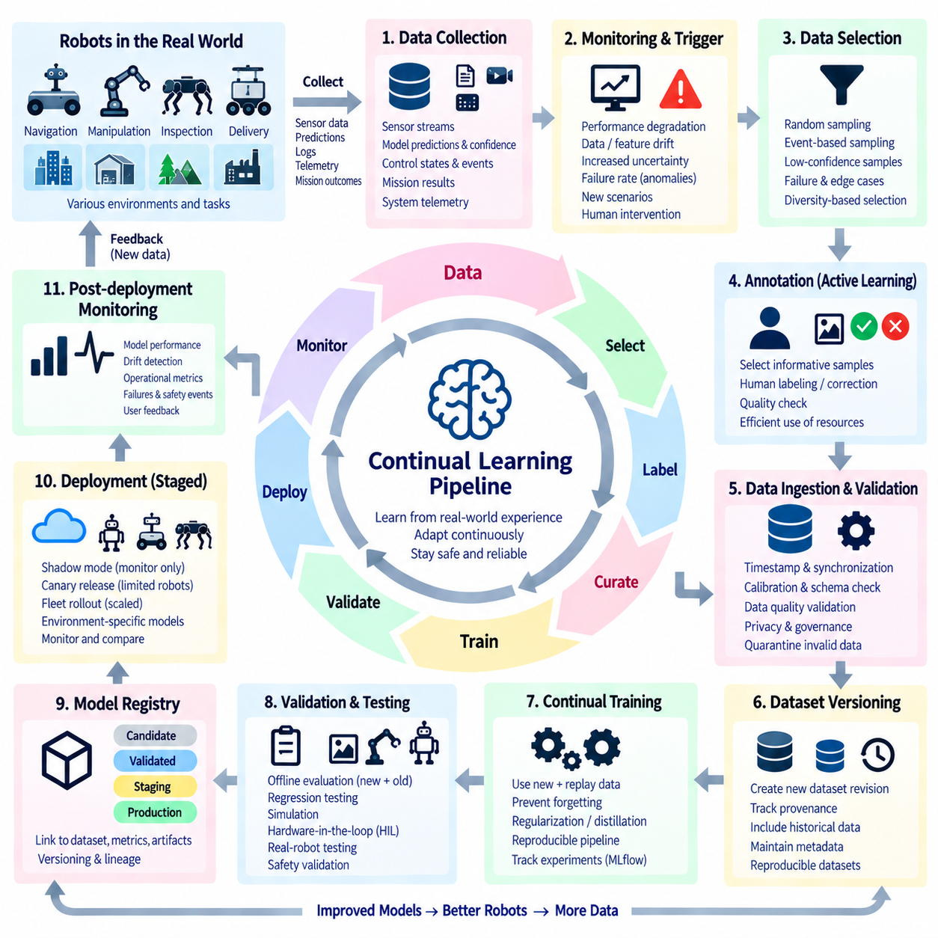
Continual learning enables robot AI models to improve as new operational data becomes available after initial deployment. Unlike conventional training, where a model is trained once on a fixed dataset and periodically replaced, continual learning establishes a controlled cycle connecting field observations, data selection, retraining, validation, and redeployment. The objective is to adapt to changing environments and tasks without sacrificing previously acquired capabilities or operational reliability.
Robots continuously encounter conditions that may be poorly represented in their original training datasets. New buildings, objects, lighting conditions, terrain, sensor configurations, user behaviors, mission patterns, and failure cases can gradually change the distribution of operational data. A continual learning pipeline converts selected evidence from these experiences into new training opportunities rather than assuming that the original dataset will remain representative throughout the robot lifecycle.
The process begins with systematic collection of operational data. Robots can generate sensor streams, model predictions, confidence values, control states, mission outcomes, fault events, and system telemetry. Collecting everything indefinitely is rarely practical because fleet-scale data volumes can become enormous. Data collection policies should therefore determine which observations are retained, at what resolution, for how long, and under which operational or model conditions.
Monitoring provides an important trigger for continual learning. Model-performance degradation, feature drift, data drift, increased uncertainty, repeated intervention, abnormal failure rates, or newly encountered scenarios may indicate that existing models no longer represent the operating environment sufficiently. These signals should initiate investigation and data collection rather than automatically causing unrestricted retraining and deployment of a replacement model.
Data selection determines which field observations are valuable enough to enter the learning pipeline. Random sampling can preserve broad operational coverage, while event-based sampling focuses on failures, low-confidence predictions, safety interventions, rare objects, difficult environments, or disagreement between models. Diversity-based selection can reduce redundant examples, allowing limited annotation and storage resources to focus on observations that provide greater learning value.
Active learning can further prioritize samples for human annotation. Instead of labeling large quantities of routine robot data, the system identifies uncertain, novel, or informative examples and submits them to annotation workflows. Human reviewers provide labels or corrections, after which quality checks verify consistency. This approach can make continual learning more efficient when field data grows much faster than the organization’s capacity to label it.
Collected data should not immediately become trusted training data. Ingestion pipelines need to verify timestamps, sensor synchronization, calibration information, file integrity, schemas, metadata, and privacy or governance requirements. Invalid or incomplete observations can be quarantined before dataset construction. Robot-specific checks may also verify coordinate frames, localization state, sensor health, mission context, and software versions associated with each recorded event.
Dataset versioning establishes a reproducible boundary between operational data and training. Newly accepted samples are combined with selected historical data to produce an identifiable dataset revision rather than silently modifying an existing dataset. The dataset version should preserve provenance linking observations to robot configurations, collection periods, environments, annotation states, and preprocessing logic so that future experiments can reconstruct the exact training inputs.
A central challenge in continual learning is catastrophic forgetting. When a model is trained primarily on recent observations, it may improve on new conditions while losing capabilities learned from earlier data. Robot AI systems cannot assume that yesterday’s environments and tasks have permanently disappeared. Training strategies therefore need mechanisms that preserve important historical knowledge while introducing sufficient new information for adaptation.
Replay is one practical strategy for reducing forgetting. A replay dataset retains representative examples from previous training distributions and mixes them with newly collected data during retraining. The replay set may preserve important environments, object classes, edge cases, safety-critical situations, and known difficult scenarios. Its composition should be governed carefully because an unbalanced replay buffer can either prevent adaptation or fail to protect older capabilities.
Other continual learning strategies can complement replay. Regularization methods constrain updates to parameters important for previous tasks, while knowledge distillation can encourage a new model to preserve selected behavior of an established model. Architectural approaches may isolate task-specific parameters or introduce expandable components. The appropriate strategy depends on model architecture, task boundaries, computational resources, and the degree of environmental change.
Retraining should occur inside a reproducible MLOps pipeline rather than through manual modification of a deployed model. The pipeline resolves the new dataset version, historical replay data, source-code revision, model configuration, pretrained checkpoint, and execution environment. Experiment tracking records parameters and metrics, while orchestration systems schedule preprocessing, training, evaluation, packaging, and registration as controlled stages.
Continual learning does not necessarily mean continuous weight updates on the physical robot. Online learning may be appropriate for carefully bounded applications, but uncontrolled self-modification can make validation, rollback, and reproducibility difficult. Many robot systems benefit from a centralized or on-premise learning cycle in which field data is collected from robots, candidate models are retrained under controlled infrastructure, and only validated versions return to the fleet.
Candidate models must be evaluated against both new and historical requirements. A model that improves performance on newly collected scenarios but degrades established capabilities should not automatically replace the production model. Validation datasets should therefore include recent data, stable benchmark sets, historical edge cases, and safety-relevant scenarios. Regression testing measures whether adaptation has introduced unacceptable losses in previously validated behavior.
Simulation can expand continual learning validation beyond recorded field samples. Newly trained navigation, manipulation, or Physical AI models can be exposed to diverse environments, disturbances, sensor variations, and rare scenarios before physical testing. Simulation also allows repeated comparison between the production model and the candidate under controlled conditions. However, simulated improvement must still be followed by appropriate hardware and real-world validation.
Hardware-in-the-loop and real-robot testing provide additional gates before redeployment. A candidate may pass offline evaluation but introduce unexpected latency, memory pressure, timing behavior, sensor-interface problems, or closed-loop interactions on the actual platform. Controlled physical tests can verify that adaptation improves the intended scenarios without creating new integration failures or unsafe behaviors in the robot system.
The model registry provides the lifecycle boundary between retraining and deployment. Every continual-learning candidate should receive a unique model version linked to its dataset revision, experiment, validation results, runtime artifacts, and target hardware. Failed candidates remain traceable without becoming deployable, while approved candidates progress through defined lifecycle states. This prevents continual learning from bypassing the governance established for normal model releases.
Deployment should proceed gradually rather than updating an entire fleet immediately. A candidate can first run in shadow mode, where its predictions are observed without controlling the robot. It can then progress to a small canary group before broader fleet rollout. Operational metrics from the candidate and established model can be compared, allowing unexpected behavior to be detected while exposure remains limited.
Fleet segmentation makes continual learning more flexible when robots operate in different environments. A warehouse robot, outdoor delivery robot, manufacturing AMR, and inspection platform may encounter distinct data distributions even when they share a common model family. The pipeline can maintain shared foundation capabilities while producing validated variants for particular robot classes, sensor configurations, regions, missions, or operational domains.
Rollback remains essential because field deployment provides evidence unavailable during development. The system should retain the previous validated model, runtime package, preprocessing configuration, and compatibility metadata so that affected robots can return to a known state. Deployment records should identify exactly which model version operates on each robot or fleet segment, making rollback and incident investigation deterministic rather than dependent on manual reconstruction.
Observability closes the continual learning loop. After deployment, monitoring systems associate predictions, latency, drift indicators, failures, interventions, and mission outcomes with the exact model version operating on each robot. These observations provide evidence for determining whether the new model performs as expected and identify additional data worth collecting. Monitoring therefore becomes both a safety mechanism and a source of future learning signals.
Governance controls how quickly the learning loop is allowed to evolve. Dataset changes, annotation policies, training configurations, validation thresholds, model approvals, and deployment decisions should remain auditable. Security controls protect uploaded field data, training infrastructure, model artifacts, and deployment channels. For safety-relevant robotic systems, automation should accelerate repeatable engineering processes without eliminating explicit accountability or independent safety mechanisms.
At fleet scale, continual learning becomes a closed data-and-model lifecycle: robots generate operational evidence, monitoring identifies important changes, data pipelines select and validate observations, versioned datasets support retraining, validation gates evaluate new candidates, and controlled deployment returns approved models to selected robots. Each cycle creates additional evidence that can improve both the model and the learning process itself.
A mature continual learning pipeline therefore balances adaptation with stability. Its purpose is not to make robots change their models as frequently as possible, but to transform valuable field experience into validated improvements without losing established capabilities. By combining monitoring, data curation, replay, reproducible training, regression testing, simulation, physical validation, model registry governance, staged deployment, and rollback, robot AI can evolve continuously while remaining traceable and controllable.

6.9. MLOps for Physical AI Foundation Models Scale
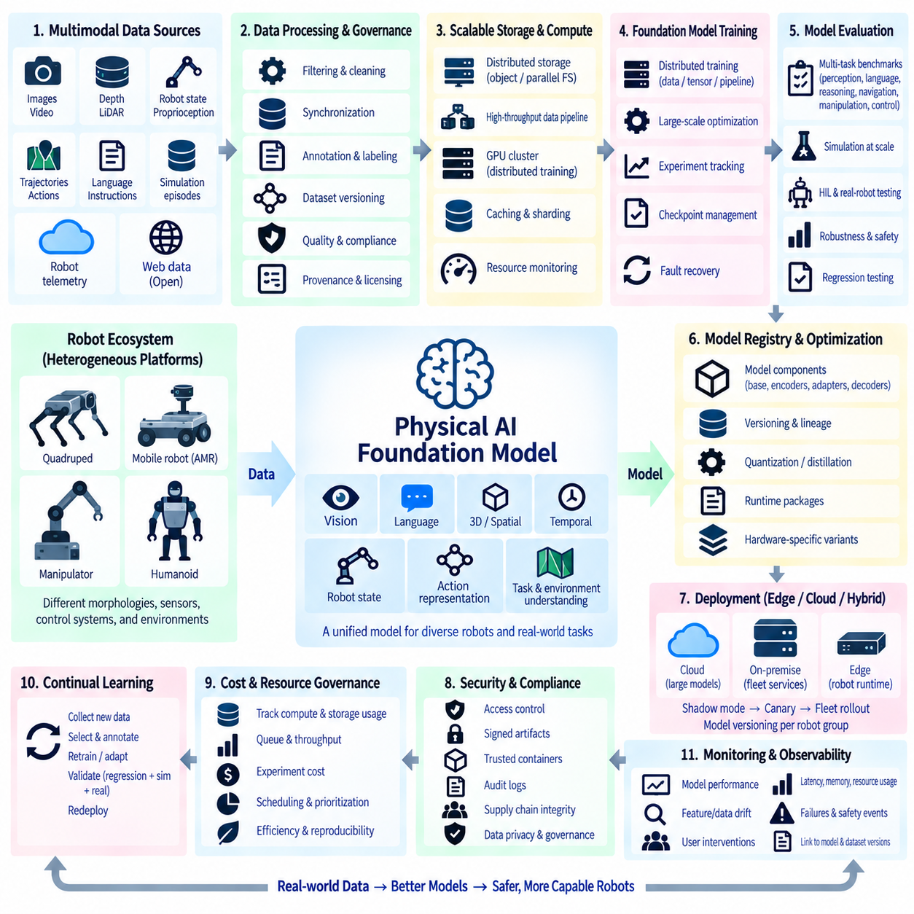
Physical AI foundation models extend MLOps beyond the lifecycle of conventional task-specific models. Instead of managing a single perception network or navigation policy, the infrastructure may support large multimodal models that combine vision, language, spatial understanding, temporal context, robot state, and action representations. MLOps must therefore coordinate massive datasets, distributed training, model variants, evaluation systems, and heterogeneous robot platforms as parts of one governed lifecycle.
Scale begins with data. Physical AI foundation models can consume video, images, depth, LiDAR, proprioception, trajectories, actions, language instructions, simulation episodes, and robot telemetry collected across many platforms and environments. These modalities differ in sampling rate, format, quality, synchronization, and semantic structure. The data platform must preserve relationships among observations, robot states, actions, tasks, environments, and outcomes rather than treating them as unrelated files.
Dataset governance becomes increasingly important as training corpora grow from individual datasets into large mixtures of heterogeneous sources. Every dataset component should retain provenance, licensing information, schema, preprocessing history, quality metadata, and version identity. Mixture definitions should also be versioned because changing the proportion of manipulation, navigation, human demonstration, simulation, or web-derived data can substantially change the behavior of the resulting foundation model.
Physical AI datasets frequently contain temporal and embodied relationships that conventional image datasets do not capture. A video frame is meaningful in relation to previous observations, robot motion, action commands, and future outcomes. Training pipelines must preserve sequence boundaries, timestamps, coordinate frames, sensor calibration, action alignment, and episode structure. Incorrect synchronization can silently damage learning even when individual sensor files appear valid.
Data preparation at foundation-model scale requires distributed processing. Large raw datasets may need decoding, filtering, deduplication, normalization, annotation, embedding generation, sequence construction, or conversion into optimized training formats. These operations can consume substantial CPU, GPU, storage, and network resources before training begins. MLOps orchestration should therefore treat data processing as a first-class distributed workload with its own versioning, monitoring, caching, and failure recovery.
Storage architecture must support both capacity and throughput. Training workers may simultaneously request large volumes of multimodal samples, creating bottlenecks if storage cannot sustain aggregate read demand. Object storage, parallel filesystems, local caches, dataset shards, and optimized sequential formats can be combined according to infrastructure requirements. Storage monitoring should distinguish insufficient model compute from data starvation caused by slow I/O or network transfer.
Distributed training introduces another layer of operational complexity. Large models may require data parallelism, tensor parallelism, pipeline parallelism, sharded parameters, or combinations of these techniques. MLOps must capture the distributed configuration as part of experiment provenance because worker count, parallelization strategy, precision mode, batch construction, and communication settings can affect performance, reproducibility, resource consumption, and checkpoint compatibility.
GPU utilization alone is not sufficient for managing large training workloads. Infrastructure monitoring should include accelerator memory, compute utilization, interconnect traffic, host memory, CPU load, storage throughput, network bandwidth, data-loader performance, checkpoint duration, and failed workers. A cluster can contain expensive accelerators while achieving poor effective training throughput if any supporting subsystem becomes a bottleneck.
Experiment tracking also changes at foundation-model scale. Recording only final accuracy and a few hyperparameters is insufficient. Training runs may generate learning curves, throughput statistics, gradient information, validation suites, checkpoint histories, data-mixture definitions, distributed configurations, and resource metrics over long execution periods. Experiment metadata should allow engineers to reconstruct not only what model was trained, but also how the complete training system behaved.
Checkpoint management becomes a major infrastructure concern as model size increases. Distributed training may produce large sharded checkpoints at regular intervals, and retaining every checkpoint indefinitely can consume enormous storage capacity. Policies should distinguish temporary recovery checkpoints, evaluation checkpoints, milestone releases, and long-term model assets. Checkpoints also require integrity verification so that a failed or partial write is not mistaken for a valid recovery state.
Failure recovery must be designed into long-running training jobs. Hardware faults, worker termination, storage interruptions, network failures, software errors, or scheduler events can interrupt training after substantial computation has already been consumed. Reliable checkpointing and restart mechanisms allow the job to resume from a known state. The orchestration layer should record failure context and recovery history so repeated infrastructure problems can be identified rather than hidden by automatic retries.
Model evaluation must expand beyond a single benchmark because Physical AI foundation models are expected to support multiple tasks, embodiments, and environments. Evaluation suites may include perception, language grounding, spatial reasoning, temporal understanding, navigation, manipulation, action prediction, and closed-loop control. Results should be segmented by task and operating domain so that aggregate scores do not conceal serious regressions in particular capabilities.
Embodiment diversity creates a distinctive MLOps challenge. Robots may differ in morphology, degrees of freedom, sensors, actuators, coordinate systems, control frequencies, payloads, and compute platforms. A shared foundation model may therefore require embodiment descriptors, adapters, action tokenization, task heads, or hardware-specific runtime variants. Registry metadata must preserve which model components and configurations are compatible with each robot family.
Simulation becomes essential for evaluation at scale because testing every model candidate physically across a large robot fleet is impractical. Simulation can execute many environments and scenarios in parallel, measuring task success, robustness, recovery behavior, and generalization before scarce physical resources are used. Synthetic data can also expand training coverage, although simulated observations and behaviors must remain identifiable so their influence on training and evaluation can be analyzed.
Real-robot evaluation remains necessary because simulation cannot fully reproduce sensing, contact, timing, hardware degradation, communication behavior, or environmental complexity. Physical evaluation should therefore be treated as a scarce validation resource managed by scheduling and orchestration systems. Candidate models that pass offline and simulation gates can progress to HIL and controlled robot testing, concentrating physical resources on the most promising versions.
The model registry must represent more than a single weight file. A Physical AI foundation model may include a base checkpoint, vision encoder, language component, action decoder, adapters, tokenizer, normalization parameters, embodiment configuration, quantized variants, and optimized runtime engines. These artifacts should remain connected through explicit lineage so that a deployable package can be traced back to its validated foundation-model source.
Model optimization creates multiple deployment branches from a common model lineage. A high-capacity model may run on centralized GPU infrastructure, while compressed, quantized, distilled, or specialized variants operate on robot edge computers. MLOps should record how each variant was derived, which evaluation evidence applies to it, and which hardware it targets. Optimization should create a new traceable artifact rather than silently replacing the original model.
Hierarchical deployment can distribute intelligence across edge, on-premise, and cloud infrastructure. Time-critical perception and control components remain close to the robot, while computationally intensive reasoning, fleet learning, or large-model services may execute on centralized resources. MLOps must manage compatible versions across these layers because a robot-side model, local service, and centralized foundation model may evolve at different rates while participating in the same AI system.
Fleet-scale deployment requires segmentation and staged rollout. Model versions can be assigned according to robot family, sensor configuration, operating domain, geographic environment, or mission type. New candidates may begin in shadow mode, progress to canary groups, and then expand to larger populations. Deployment metadata must identify which combination of foundation model, adapters, runtime artifacts, and configurations is operating on each fleet segment.
Observability must connect infrastructure metrics with model and robot behavior. Training systems require monitoring of compute efficiency and failures, while deployed systems require monitoring of latency, memory, feature distributions, confidence, task outcomes, interventions, and safety events. Linking these observations to exact model and dataset versions allows engineers to distinguish infrastructure problems, data drift, model regressions, and embodiment-specific failures.
Continual learning closes the Physical AI MLOps loop. Fleet observations can identify novel environments, difficult interactions, failure cases, and underrepresented tasks. Selected data is validated, annotated when necessary, incorporated into new dataset revisions, and used in controlled retraining or adaptation. New candidates must still pass regression, simulation, HIL, and physical validation gates before returning to operational robots, preventing continuous learning from becoming uncontrolled self-modification.
Security and supply-chain integrity become more important as the number of datasets, dependencies, model components, training systems, and deployment targets increases. Access control, signed artifacts, trusted containers, dependency inventories, audit logs, secret management, and integrity verification help protect the lifecycle. Provenance should make it possible to determine which data, code, environment, and model components contributed to a deployed Physical AI system.
Cost and resource governance are also fundamental at foundation-model scale. Training, simulation, evaluation, checkpoint storage, and repeated experimentation can consume large amounts of accelerator time and storage capacity. MLOps systems should expose utilization, queue time, throughput, storage growth, and experiment cost indicators so teams can identify inefficient workflows. Reproducibility and caching reduce unnecessary repetition while scheduling policies prioritize high-value workloads.
At scale, Physical AI MLOps becomes the coordination fabric connecting multimodal data, distributed compute, foundation-model training, simulation, evaluation, model registries, heterogeneous embodiments, edge deployment, fleet monitoring, and continual learning. Its purpose is not merely to automate larger training jobs, but to preserve traceability and control as AI expands from individual models into distributed physical intelligence operating across many robots and environments.

6.10. MLOps Security Model Signing Supply Chain Integrity
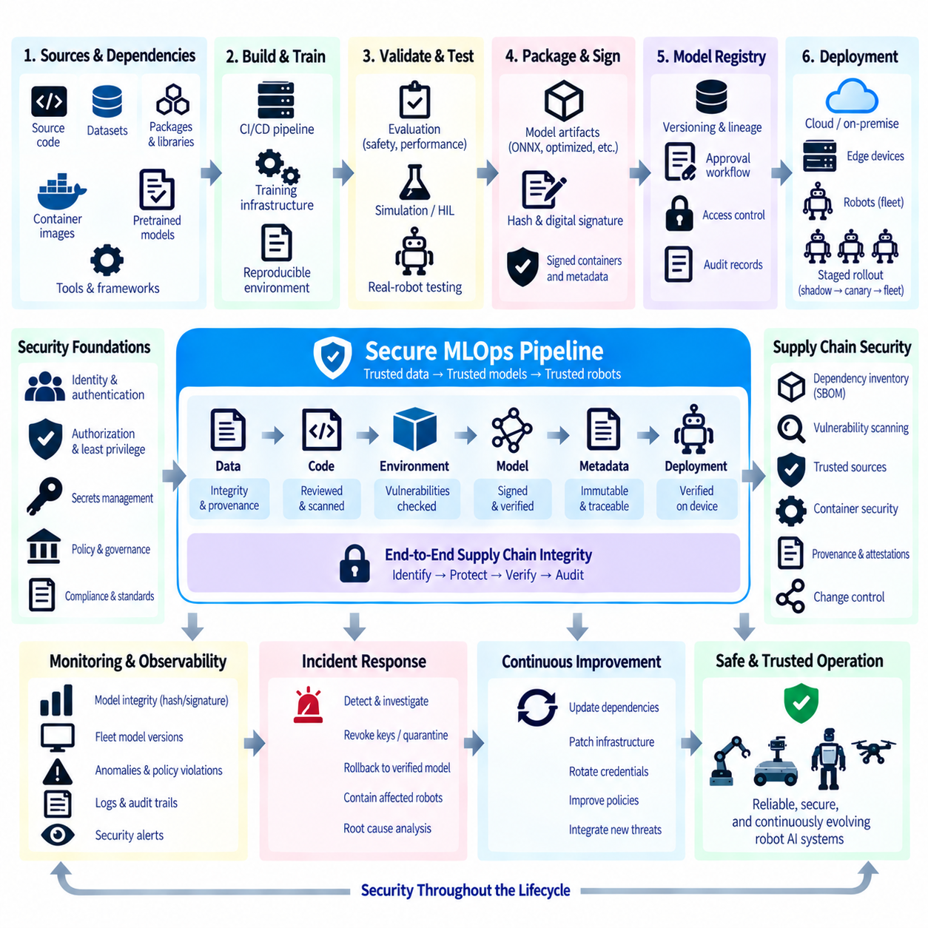
MLOps security protects the complete machine learning lifecycle rather than only the deployed model. Robot AI pipelines connect source code, datasets, training infrastructure, containers, model registries, artifact stores, deployment systems, edge computers, and physical robots. A compromise at any stage can propagate downstream. Security therefore requires verifiable relationships between the data, software, models, environments, and identities participating in each release.
Machine learning introduces supply-chain risks beyond those found in conventional application development. A model may depend on pretrained checkpoints, open-source frameworks, Python packages, CUDA libraries, container images, datasets, preprocessing tools, and optimization engines. Each dependency becomes part of the effective AI supply chain. MLOps must identify these components and preserve enough provenance to determine exactly what contributed to a deployed robot model.
Threat modeling provides a structured starting point for protecting this lifecycle. Relevant threats include unauthorized modification of training data, malicious dependencies, compromised build environments, stolen credentials, model replacement, corrupted artifacts, unauthorized deployment, and manipulation of configuration files. Robot systems also require consideration of physical consequences because compromised AI artifacts can influence perception, navigation, manipulation, or autonomous decision-making.
Identity should be established for users, services, workloads, and devices participating in the pipeline. Training jobs, CI/CD systems, model registries, deployment services, and robots should authenticate using controlled identities rather than shared credentials embedded in scripts. Authorization policies can then restrict which identities are permitted to read datasets, execute training jobs, publish artifacts, approve models, or deploy releases to operational robots.
Least-privilege access limits the impact of compromised accounts or services. A training process that only requires read access to a dataset should not automatically receive permission to modify the model registry or deploy software to robots. Similarly, a robot that downloads approved inference artifacts does not necessarily require permission to publish new production models. Separating privileges creates security boundaries between development, validation, release, and operation.
Secrets such as API keys, access tokens, certificates, and signing credentials should not be stored directly in source repositories, configuration files, or model packages. Secret-management systems can provide credentials dynamically to authorized workloads and support rotation or revocation when necessary. Signing keys require particularly strong protection because possession of a trusted signing identity could allow an attacker to make malicious artifacts appear legitimate.
Model signing establishes cryptographic evidence that a model artifact originates from an authorized release process and has not been modified since signing. A cryptographic hash represents the exact artifact contents, while a digital signature binds that digest to a trusted signing identity. Any change to the model file produces a different digest, allowing deployment infrastructure to reject an artifact whose integrity or origin cannot be verified.
Signing should normally occur after the artifact intended for deployment has been finalized. If an approved model is subsequently converted to ONNX, optimized with TensorRT, quantized, or repackaged, the resulting artifact differs from the original signed object. Each deployable representation should therefore retain explicit derivation information and receive integrity protection appropriate to its release stage rather than assuming that a signature on an upstream checkpoint covers every downstream transformation.
Signature verification belongs at trust boundaries. A model registry can verify artifacts during publication, a deployment service can verify them before release, and a robot or edge runtime can verify the package before activation. Multiple verification points reduce reliance on any single infrastructure component. A failed signature, unknown signer, invalid certificate, or mismatched digest should prevent the artifact from silently entering an operational environment.
Model metadata should also be protected from unauthorized modification. An intact model file can still be dangerous if an attacker changes its declared version, target hardware, preprocessing requirements, approval state, or deployment channel. Integrity mechanisms should therefore cover the release manifest containing the model identity, hashes, dependencies, configuration, compatibility information, and other metadata required to interpret and deploy the artifact correctly.
Software dependencies form another major attack surface. Training and inference environments can contain hundreds or thousands of transitive packages. Dependency inventories and software bills of materials can identify components included in containers or runtime packages, while vulnerability scanning can detect known issues. Version pinning and controlled repositories reduce unexpected dependency changes and make build environments more reproducible.
Container security is important because containers frequently define training, evaluation, and inference environments. Base images should come from controlled sources, unnecessary packages should be removed, and images should be scanned and versioned. Immutable image references or content digests are preferable to ambiguous mutable tags. Container signing and verification can extend the same chain of trust used for model artifacts to the software environment executing them.
Build and training infrastructure must also be trusted. Signing an artifact does not prove that the system that created it was uncompromised. CI runners, orchestration services, GPU clusters, storage systems, and training containers require access controls, patch management, logging, and isolation. High-value release pipelines may separate experimental infrastructure from controlled production build environments to reduce the probability that exploratory workloads affect trusted releases.
Data integrity is part of model supply-chain integrity because manipulated training or validation data can alter model behavior without modifying the final model artifact directly. Dataset versions should therefore preserve provenance, checksums, access history, preprocessing information, and validation status. Important datasets can be treated as governed artifacts whose identities are referenced by experiments and model registry entries, creating traceability from training data to deployed models.
Model registries become security control points when they define which artifacts are eligible for deployment. Registry permissions should separate model publication, validation, approval, and promotion where appropriate. Lifecycle states must not be changeable by arbitrary users or training jobs. Audit records should capture important operations so investigators can reconstruct when a model was registered, evaluated, approved, promoted, downloaded, or replaced.
Provenance connects the individual security controls into a verifiable chain. A production model should be traceable to source-code revisions, dataset versions, training configuration, execution environment, experiment records, evaluation evidence, optimization steps, and deployment artifacts. Provenance does not itself guarantee that every component is trustworthy, but it provides the evidence required to determine what was used and where security verification should occur.
Attestations can provide structured statements about steps performed during the lifecycle. A build service may attest that an artifact was produced from a particular source revision, while a validation pipeline may record that defined tests were completed. Deployment policy can evaluate these statements together with signatures and registry state. This creates policy-driven promotion based on verifiable evidence instead of relying only on filenames or manually communicated approvals.
Security gates should be integrated into automated MLOps pipelines. Before promotion, automation can verify artifact hashes, signatures, approved identities, dependency status, container provenance, model validation results, and target compatibility. A failed security requirement should stop promotion in the same way that a failed performance or regression test does. Security consequently becomes part of release qualification rather than a separate inspection performed after deployment preparation.
Robot deployment creates an especially important trust boundary because digital artifacts begin influencing physical systems. Edge devices should accept only authorized release packages and verify their integrity before activation. Secure communication protects artifacts in transit, while local access controls protect stored models and configuration. Where platform capabilities permit, secure boot and hardware-backed trust mechanisms can strengthen confidence in the software stack executing the model.
Rollback artifacts require the same integrity controls as new releases. An older model may be operationally trusted but become unsafe to use if its stored package has been modified or its dependencies are no longer valid. Rollback procedures should therefore reference preserved, verified release packages rather than arbitrary historical files. The registry should maintain the relationship between approved versions, signatures, compatibility metadata, and deployment history.
Audit logging supports incident investigation and accountability. Logs can record authentication events, artifact publication, signature operations, registry state changes, approval actions, deployment requests, verification failures, and robot update results. These records should be protected against unauthorized alteration and correlated across services where possible. An incident can then be traced through the pipeline instead of being investigated as an isolated robot failure.
Monitoring continues security controls after deployment. Unexpected model changes, repeated signature failures, unusual download patterns, unauthorized configuration changes, abnormal deployment activity, or differences between expected and observed model versions can indicate compromise or operational errors. Fleet observability should identify the exact model and software package active on each robot so discrepancies can be detected and affected systems isolated.
Incident response should define how compromised models, credentials, dependencies, or infrastructure are handled. Signing keys may need revocation, deployment channels may need to be paused, vulnerable artifacts may need quarantine, and affected robots may require rollback to a verified release. Preserved provenance and audit information make it possible to determine the scope of exposure and identify which models, robots, datasets, or environments require remediation.
At fleet scale, MLOps security becomes a continuous chain of trust from data and source code through training, validation, packaging, signing, registry promotion, deployment, and runtime verification. Model signing is one important mechanism, but it is effective only when combined with identity, least privilege, dependency control, provenance, secure infrastructure, auditability, and monitoring. Together these controls allow Physical AI systems to evolve while preserving confidence in what software and models are operating on physical robots.

