Volume 11. Simulation and Digital Twin

Chapter 02. Physics Engines

02.01. Physics Engine Landscape Bullet ODE Mujoco PhysX
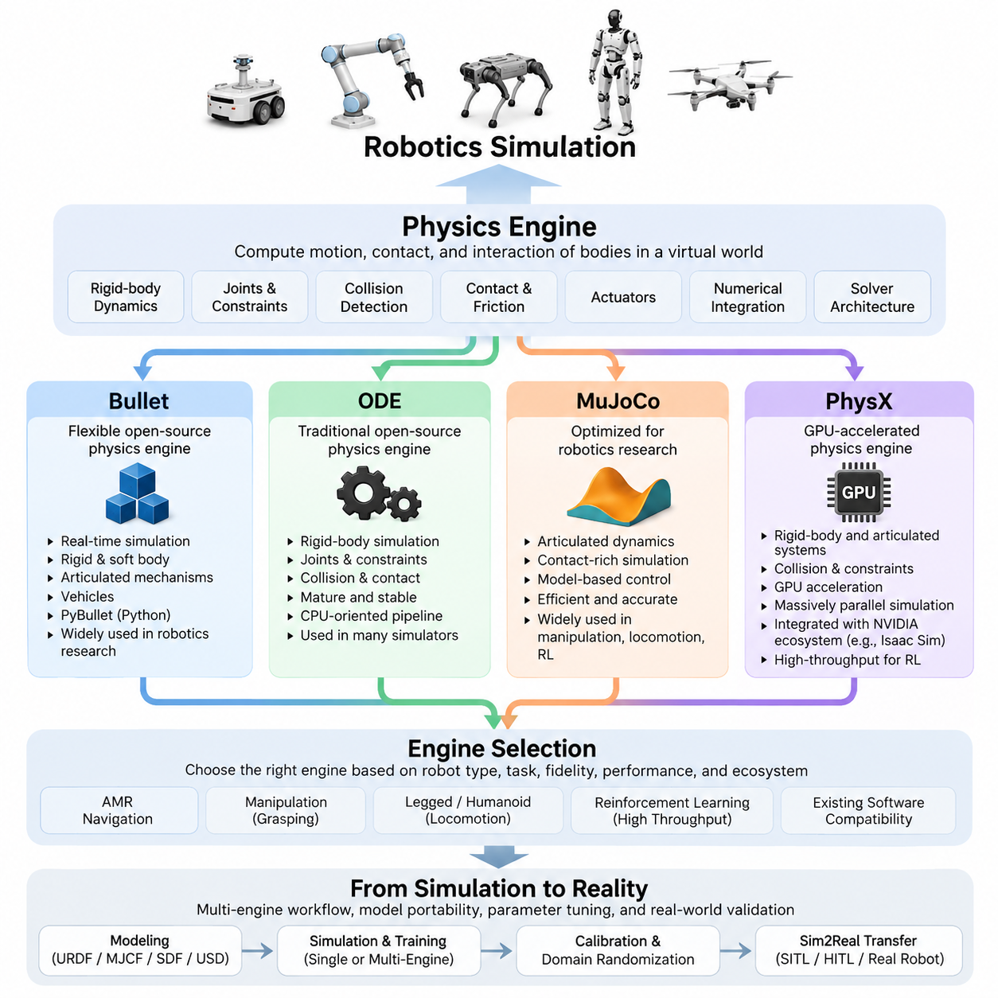
Physics engines form the computational foundation of robot simulation by approximating how bodies move, collide, interact, and respond to forces in a virtual environment. They numerically solve equations governing rigid-body dynamics, joints, constraints, friction, contacts, and actuators. In robotics, engine selection affects not only visual plausibility but also controller behavior, reinforcement learning, system identification, validation accuracy, and the difficulty of transferring algorithms from simulation to real hardware.
A physics engine normally advances the simulated world through discrete time steps. At each step, it integrates body states, evaluates forces and actuator commands, detects collisions, constructs physical constraints, and solves the resulting equations to determine accelerations, velocities, positions, and contact forces. Differences in numerical integration, constraint formulation, collision detection, and solver architecture explain why identical robot models can behave differently when executed in different engines.
Bullet is a widely used open-source physics engine designed around real-time collision detection and rigid-body simulation. It supports articulated mechanisms, constraints, contact dynamics, vehicles, and several forms of deformable-body simulation. In robotics, Bullet became particularly accessible through PyBullet, whose Python interface enables researchers to construct environments, control robots, collect observations, and execute repeated experiments without building a complete graphical simulation application.
Bullet is attractive for rapid robotics experimentation because it balances computational efficiency, flexibility, and relatively simple integration. Manipulators, mobile robots, grasping experiments, and reinforcement-learning environments can be created with modest infrastructure. Its collision system and configurable dynamics parameters make it useful for prototype development, although accurate reproduction of real contact behavior still requires careful tuning of friction, restitution, damping, solver iterations, and simulation time steps.
Open Dynamics Engine, commonly called ODE, is another established open-source rigid-body dynamics engine. It provides rigid-body simulation, joints, constraints, collision handling, and contact modeling and has historically been integrated into several robotics simulators. ODE is particularly important from an architectural perspective because it illustrates the traditional CPU-oriented physics pipeline in which articulated dynamics, collision detection, and iterative constraint solving are executed within a general-purpose simulation loop.
ODE remains useful for understanding conventional robotics simulation and for maintaining systems that already depend on its interfaces. Its mature architecture can handle many mobile-robot and articulated-body scenarios, but newer workloads increasingly demand large numbers of parallel environments, high-throughput learning, complex contacts, and GPU acceleration. Consequently, the suitability of ODE depends more strongly on the surrounding simulator, required fidelity, existing software compatibility, and computational scale than on raw feature count alone.
MuJoCo, originally developed for model-based control and robotics research, places strong emphasis on articulated mechanisms, contact-rich dynamics, optimization, and computational efficiency. Its modeling approach is closely aligned with robots consisting of kinematic trees, joints, actuators, tendons, constraints, and contact geometries. These properties have made MuJoCo especially influential in manipulation, locomotion, optimal control, reinforcement learning, and research involving humanoid or legged systems.
A major strength of MuJoCo is the close relationship between model representation and dynamics computation. Robot properties such as mass, inertia, joint limits, damping, actuator characteristics, equality constraints, and contact parameters are represented explicitly in the model and participate directly in simulation. This makes MuJoCo valuable when researchers need systematic control over physical parameters rather than treating the simulator merely as a visualization environment.
Contact modeling is particularly significant for manipulation and locomotion. Grasping objects, maintaining a quadruped foothold, balancing a humanoid, or pushing against an environment creates coupled contact constraints that can dominate system behavior. MuJoCo provides configurable mechanisms for representing and solving such interactions efficiently. Nevertheless, high simulation quality still depends on realistic geometry, inertia, actuator dynamics, friction parameters, controller timing, and numerical configuration rather than the engine alone.
NVIDIA PhysX represents a different trajectory in the physics-engine landscape because it combines mature rigid-body simulation capabilities with strong GPU-oriented computation. PhysX supports rigid bodies, articulated systems, collision detection, constraints, and other physical interactions while fitting naturally into NVIDIA's simulation ecosystem. In robotics, this becomes especially important when simulation must scale from one detailed robot to hundreds or thousands of concurrently evaluated environments.
GPU acceleration changes the role of simulation in robot learning. Traditional simulation frequently treats one environment as the primary computational unit, whereas modern reinforcement-learning systems may execute large batches of environments simultaneously. PhysX-based GPU pipelines can process many physical interactions in parallel, reducing the time required to gather experience and evaluate policies. This approach is central to high-throughput simulation workflows used by platforms such as NVIDIA Isaac Sim and related robot-learning frameworks.
The engines therefore should not be viewed as interchangeable implementations of exactly the same physics. Bullet emphasizes accessibility and flexible open-source experimentation, ODE represents a mature conventional dynamics architecture, MuJoCo is strongly oriented toward efficient articulated and contact-rich robot dynamics, and PhysX provides an important foundation for GPU-accelerated simulation at scale. Their mathematical formulations, contact models, APIs, hardware assumptions, and integration ecosystems create meaningful differences in practical robot development.
Engine selection should consequently begin with the robot and experiment rather than with a universal ranking. An AMR navigation project may prioritize stable wheel-ground interaction and ROS integration, while manipulation requires reliable multi-contact behavior. Legged and humanoid robots place stronger demands on articulated dynamics and contact stability, whereas reinforcement learning may prioritize simulation throughput across thousands of environments. These requirements are explicitly separated later in the volume through engine comparison for AMR, manipulators, and legged robots.
Performance and physical fidelity also form a trade-off rather than independent objectives. Smaller time steps, additional solver iterations, detailed collision meshes, and complex contact models can improve certain physical behaviors while increasing computational cost. Conversely, aggressively simplified geometry and dynamics can accelerate training while creating unrealistic policies. Effective simulation therefore identifies which physical phenomena influence the target task and allocates computational fidelity primarily to those phenomena.
Determinism is another practical consideration. Robotics development frequently requires experiments to be repeated while changing only one controller, policy, or physical parameter. Floating-point execution, parallel processing, collision ordering, solver convergence, and GPU computation can introduce differences between runs. Engineers should therefore distinguish strict numerical reproducibility from statistical reproducibility and define validation procedures appropriate to the simulator and learning pipeline.
Model portability also deserves attention because robotics projects increasingly use multiple simulation environments. URDF, MJCF, SDF, and USD represent different modeling philosophies and may not preserve every physical property identically when converted. Mass and inertia, joint definitions, collision geometry, actuator characteristics, friction, and constraint parameters should therefore be validated after migration. The surrounding volume accordingly treats URDF and MJCF modeling as a separate stage following physics-engine fundamentals.
Modern robotics simulation increasingly uses several engines across one development lifecycle rather than selecting a single engine permanently. A lightweight environment may support algorithm prototyping, another engine may provide high-quality articulated dynamics for controller development, and a GPU-oriented platform may perform massive reinforcement-learning experiments. Production validation can then combine simulation with software-in-the-loop, hardware-in-the-loop, and physical robot testing.
This multi-engine perspective becomes especially important for simulation-to-real transfer. No general-purpose physics engine reproduces every property of real motors, transmissions, tires, compliant structures, surfaces, latency, backlash, or sensor timing automatically. The simulation must therefore be calibrated through measured parameters, system identification, and real-world experiments. Domain randomization can subsequently vary uncertain parameters so that learned controllers do not depend excessively on one idealized simulated configuration.
Ultimately, Bullet, ODE, MuJoCo, and PhysX represent different engineering approaches to the same central problem: computing useful approximations of physical interaction fast enough for robot development. Understanding their solver architectures, computational characteristics, modeling assumptions, and ecosystem roles enables engineers to select simulation technology according to application requirements instead of brand familiarity. This foundation supports the volume's later progression into engine-specific configuration, robot modeling, sensor simulation, Sim2Real transfer, and massively parallel simulation.

02.02. MuJoCo Architecture and Model Description [w/Code]
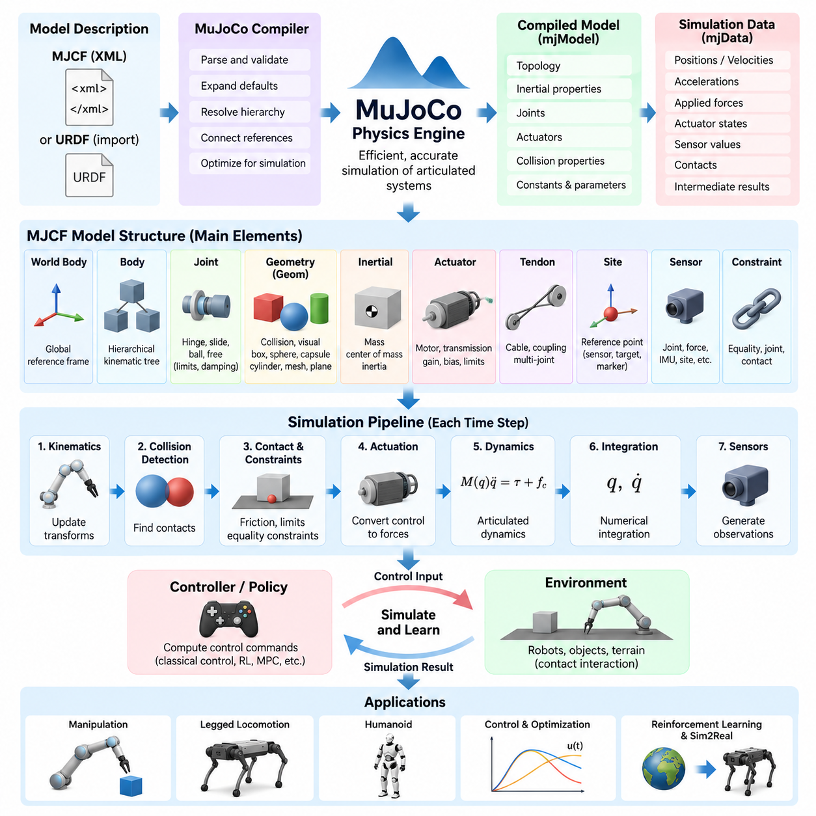
MuJoCo is a physics engine designed for efficient and accurate simulation of articulated mechanical systems, with particular emphasis on robotics, biomechanics, control, and machine learning. Its architecture integrates model compilation, forward dynamics, constraint solving, collision detection, actuation, and numerical integration into a unified simulation pipeline. This makes it especially suitable for robots whose behavior depends strongly on joints, contacts, actuators, and dynamically coupled motion.
A MuJoCo simulation begins with a model description that defines the physical structure and properties of the simulated system. The primary native representation is MJCF, or MuJoCo Modeling XML Format, although other model formats such as URDF can also be imported through supported workflows. MJCF provides a hierarchical representation in which bodies, joints, geometries, sites, cameras, sensors, actuators, tendons, and constraints are organized into a structured model of the robot and its environment.
The distinction between the model and simulation data is fundamental to MuJoCo architecture. The compiled model contains largely constant information describing topology, dimensions, inertial properties, joint definitions, actuator parameters, collision properties, and other configuration data. Simulation data represents the changing state of the system, including generalized positions, velocities, accelerations, applied forces, actuator states, sensor values, contacts, and intermediate quantities calculated during dynamics evaluation.
MuJoCo compiles the human-readable model description into an optimized internal representation before simulation begins. During compilation, hierarchical relationships are resolved, default parameters are expanded, object references are connected, and physical properties are transformed into structures optimized for dynamics computation. Detecting many modeling errors at this stage prevents invalid configurations from propagating into long-running control, optimization, or reinforcement-learning experiments.
The world body forms the root of an MJCF model and establishes the global reference frame for the simulated environment. Bodies are then arranged hierarchically beneath this root. A child body is defined relative to its parent, producing a kinematic tree that naturally represents robot structures such as serial manipulators, quadrupeds, humanoids, and mobile manipulators. Transformations propagate through this hierarchy as joint configurations change during simulation.
Bodies define coordinate frames and carry physical components rather than necessarily representing visible objects themselves. Geometries attached to a body can provide collision surfaces, visual appearance, or both, while inertial properties describe mass distribution. Separating body frames from geometry allows complex physical systems to be represented efficiently. Multiple geometries can therefore belong to one body without requiring unnecessary additional dynamic bodies or joints.
Joints determine the degrees of freedom through which one body can move relative to its parent. MuJoCo supports joint types appropriate for rotational, translational, spherical, and unconstrained motion. Joint definitions may include axes, limits, damping, stiffness, reference configurations, and other parameters affecting dynamics. The resulting generalized coordinates provide the mathematical state representation used by the engine when calculating articulated motion.
Geometry elements, commonly represented as geoms, define shapes used for collision detection, contact generation, mass-related modeling, and visualization. Primitive forms such as boxes, spheres, capsules, cylinders, and planes can be combined with mesh-based geometry for more complicated objects. Efficient collision geometry is particularly important because excessively detailed meshes can increase contact computation while providing little benefit to the physical phenomena relevant to a controller.
Accurate inertial modeling is equally important. Each dynamic body requires physically meaningful mass, center of mass, and rotational inertia. Unrealistic inertia values can produce unstable or misleading behavior even when the visible robot model appears correct. MuJoCo can derive some inertial information from geometry under appropriate configurations, but engineering models should ultimately reflect measured values, CAD-derived properties, or validated estimates when physical fidelity is required.
Actuators provide the interface between control commands and simulated mechanical motion. Rather than assuming that every joint is directly driven by an ideal torque source, MuJoCo provides a configurable actuation framework that can represent motors and other transmission relationships. Control inputs are transformed through actuator dynamics, gain mechanisms, bias terms, transmission definitions, and force limits before contributing to generalized forces acting on the simulated system.
This separation between joints and actuators is important for realistic robotics modeling. A joint describes allowable mechanical motion, whereas an actuator describes how control effort is applied to that motion. A robot can therefore have passive joints, multiple actuation mechanisms, coupled transmissions, or actuator limits independent of joint limits. Such distinctions become essential when studying manipulation, legged locomotion, compliant mechanisms, or Sim2Real transfer.
Tendons extend the model beyond simple one-actuator-to-one-joint relationships. They can represent mechanical couplings in which forces depend on combinations of joints or spatial paths. This is useful for cable-driven mechanisms, biomechanical systems, robotic hands, and coupled actuation architectures. Equality constraints and other constraint mechanisms can additionally impose relationships between model components without requiring every dependency to be represented through explicit rigid connections.
Sites provide lightweight reference locations and orientations attached to bodies. They are commonly used to define sensor positions, measurement points, tendon routing locations, end-effector references, targets, and visualization markers. Because sites do not need to introduce additional rigid bodies, they provide a convenient method for associating functional reference frames with a robot while keeping the underlying dynamic model compact.
MuJoCo also integrates sensor definitions directly with the physical model. Sensors can observe quantities associated with joints, actuators, bodies, sites, forces, accelerations, velocities, orientations, and other simulation states. This enables simulated observations to be organized around the same mechanical structure used by the controller. Sensor outputs can then serve as inputs to classical control algorithms, state estimators, reinforcement-learning policies, or data-collection pipelines.
Contact dynamics connect the model description to environmental interaction. Collision-compatible geometries are tested for intersection or proximity, after which contacts contribute constraints to the dynamics problem. Friction and contact parameters influence whether surfaces slide, stick, roll, or separate. For locomotion and manipulation, these parameters can substantially alter robot behavior because ground reaction forces and object interactions directly affect the equations of motion.
The simulation pipeline evaluates kinematics, applied forces, actuation, contacts, constraints, and articulated dynamics before advancing the state through numerical integration. Position and velocity variables are therefore not updated independently of the physical model. Instead, they emerge from a coupled computation involving robot structure, inertia, control input, external forces, and environmental interaction. This integrated formulation is central to MuJoCo's usefulness for control-oriented simulation.
MJCF also supports reusable modeling mechanisms that reduce duplication in complex robot descriptions. Default classes can apply shared properties to groups of elements, while assets can define reusable meshes, textures, and materials. Model composition mechanisms allow larger systems to be constructed from reusable components. These capabilities become increasingly important when maintaining robot families that share links, actuators, sensors, or environmental objects.
For robotics development, a practical MuJoCo architecture therefore separates several concerns while keeping them computationally connected. MJCF describes the physical system, the compiler converts that description into an executable model, simulation data stores the evolving state, the dynamics pipeline calculates physical interaction, and controllers modify actuator inputs over time. Sensors and logging systems then expose simulation results to higher-level robotics software and learning algorithms.
Model quality ultimately determines how useful this architecture becomes. Detailed visual meshes cannot compensate for incorrect inertia, unrealistic friction, idealized actuators, inaccurate joint limits, or inappropriate control timing. A reliable MuJoCo model should therefore be treated as an engineering representation whose parameters are progressively validated against the real mechanism. This approach provides a foundation for control development, reinforcement learning, system identification, and subsequent Sim2Real calibration.

02.03. MuJoCo Contact Solver and Constraint Configuration [w/Code]
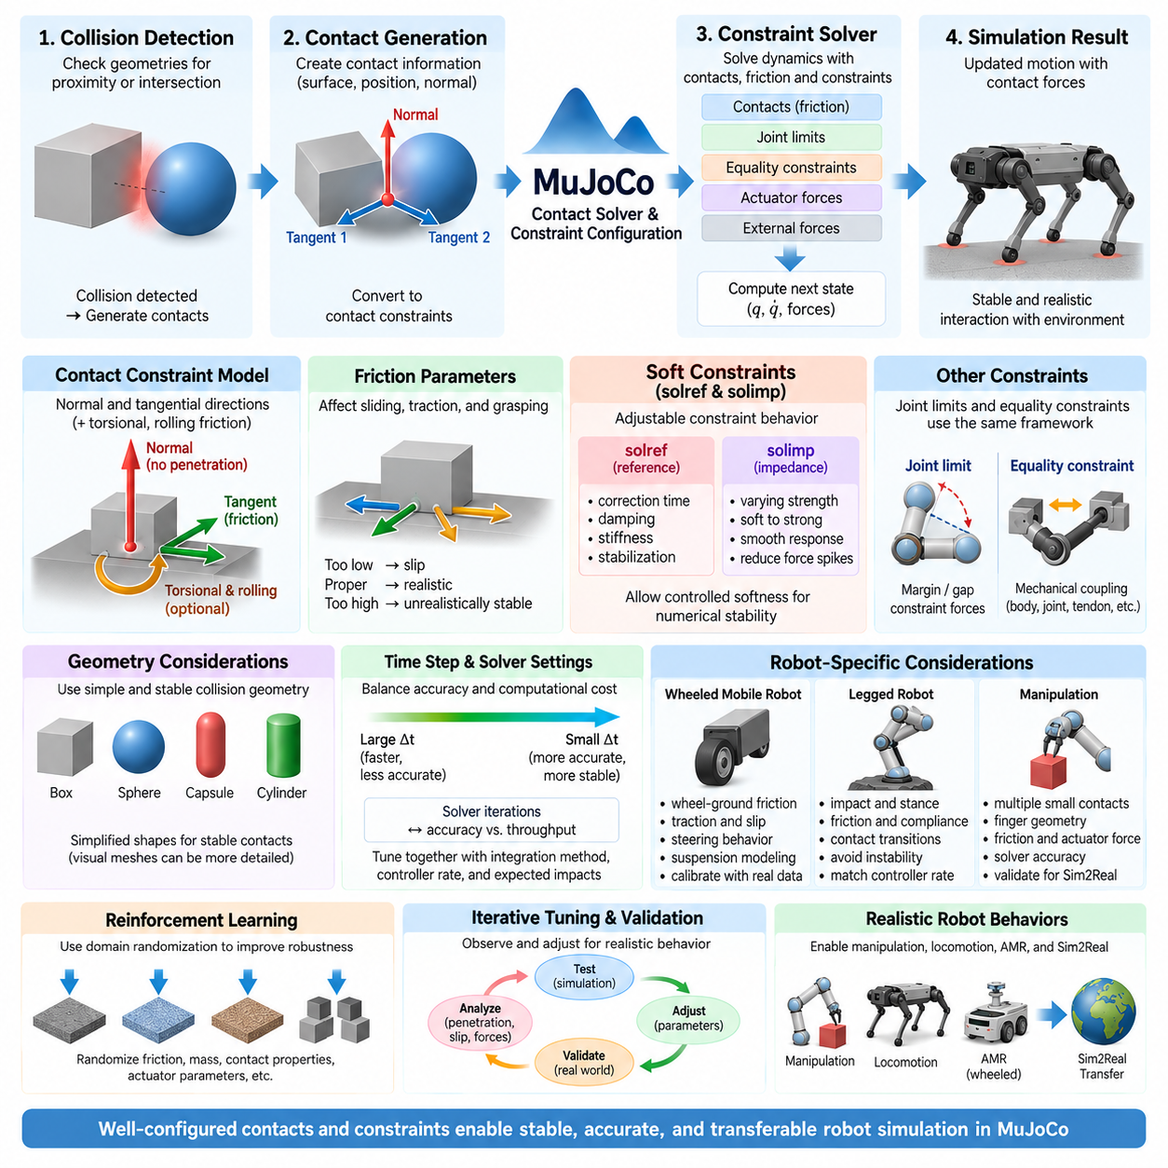
Contact solving is one of the most important numerical processes in MuJoCo because robot behavior often depends on repeated interaction between rigid bodies and their environment. Walking, grasping, pushing, balancing, rolling, and object manipulation all generate contacts that introduce forces and constraints into the equations of motion. MuJoCo treats these interactions within a unified constraint framework, allowing contacts, joint limits, equality constraints, and friction-related effects to participate in the dynamics solution.
When collision detection identifies geometries that are sufficiently close or intersecting, MuJoCo generates contact information describing the interacting surfaces. These contacts are transformed into mathematical constraints that influence allowable motion and resulting forces. Instead of simply preventing geometric penetration after it occurs, the solver incorporates contact behavior into the dynamic computation so that contact forces, friction, inertia, actuator forces, and external forces collectively determine the next system state.
A contact constraint normally contains a direction perpendicular to the contact surface and additional directions associated with friction. The normal component resists penetration, while tangential components represent resistance to sliding. Depending on configuration, frictional behavior can also include effects associated with torsional and rolling motion. This multidimensional representation is particularly important for robot feet, wheels, grippers, and objects whose stable behavior depends on more than simple normal contact.
Friction parameters strongly affect simulated robot behavior. Too little friction may cause a quadruped foot to slide, a mobile robot wheel to lose traction, or a grasped object to escape from a gripper. Excessively high friction can create unrealistically stable contacts and hide deficiencies in controllers. Friction coefficients should therefore represent plausible physical interfaces and should eventually be calibrated against measurements when simulation is intended for control validation or Sim2Real transfer.
MuJoCo uses soft constraint formulations that allow constraint behavior to be adjusted rather than treating every contact as perfectly rigid. This is useful because ideal rigid contact creates difficult numerical problems, particularly when many bodies interact simultaneously. Controlled softness allows the solver to approximate real compliance while improving numerical stability. The objective is not necessarily to simulate material deformation directly, but to produce stable and physically meaningful constraint behavior at practical simulation time steps.
Two important configuration concepts for this behavior are solver reference parameters and solver impedance parameters, commonly exposed through solref and solimp. The reference parameters influence how constraint violations evolve toward their desired state, while impedance parameters control how strongly a constraint behaves across its operating region. Together they provide a flexible mechanism for configuring contact softness, damping, penetration response, joint limits, and other constraint behavior.
The solref configuration can be understood as defining the dynamic response of a constraint. Depending on the selected parameterization, it determines characteristics related to correction time, damping, stiffness, and constraint stabilization. A contact configured for rapid correction can behave more rigidly but may require smaller time steps or stronger numerical convergence. A softer response can improve stability while allowing greater penetration or displacement before the constraint force restores the desired condition.
The solimp parameters determine how constraint impedance changes as the constraint moves away from its reference condition. Rather than applying one constant stiffness-like response everywhere, MuJoCo can smoothly vary constraint strength according to violation magnitude. This makes it possible to configure contacts that remain relatively soft near initial engagement but become progressively stronger as penetration increases, reducing abrupt force changes while still limiting excessive constraint violation.
Joint limits use the same general constraint architecture. When a joint approaches or exceeds its permitted range, the solver can generate forces that resist further motion instead of simply clipping the joint coordinate after integration. Margin and gap-related settings determine when constraints become active and how contact or limit conditions are interpreted. This approach allows joint-limit behavior to interact consistently with inertia, actuator forces, external loads, and other constraints.
Equality constraints represent relationships that should be maintained between components of the model. They can be used for mechanical coupling, body connections, joint relationships, tendon relationships, or other dependencies that are not conveniently represented by the ordinary kinematic tree. Because equality constraints participate in the same overall solver framework, they can interact dynamically with contacts, actuators, joint limits, and external forces during each simulation step.
Constraint configuration must also consider collision geometry. Highly detailed visual meshes can generate complicated or rapidly changing contacts that increase solver workload and introduce numerical noise. Robotics models therefore often use simplified collision shapes such as boxes, capsules, spheres, cylinders, or carefully designed convex approximations while retaining detailed meshes for visualization. Stable contact geometry is often more valuable for dynamics than visually exact surface representation.
Time step selection has a direct relationship with contact solver behavior. Large simulation steps reduce computational cost but can allow bodies to move significantly before the next contact evaluation, increasing penetration and making constraints harder to resolve. Smaller steps generally improve temporal resolution and contact stability but require more calculations. Solver parameters should therefore be tuned together with the integration method, controller update rate, expected impact velocity, and mechanical stiffness.
Solver iterations and convergence settings provide another balance between accuracy and computational throughput. Complex contact scenes involving humanoid feet, dexterous hands, stacked objects, or multiple simultaneous collisions may require greater computational effort than simple free-space motion. Increasing solver effort can reduce residual constraint errors, but excessive computation may limit real-time operation or reinforcement-learning throughput. Appropriate settings depend on both the physical task and simulation scale.
Contact configuration for wheeled mobile robots requires particular attention because locomotion depends on persistent wheel-ground interaction. Friction must support longitudinal traction while allowing the modeled steering and lateral behavior to remain realistic. Simplified wheel geometry, suspension assumptions, surface properties, and solver settings can substantially affect acceleration, braking, turning, and slip. Outdoor AMR simulation may therefore require calibration against measured vehicle behavior rather than relying on default parameters.
Legged robots impose different requirements because contacts repeatedly appear and disappear during gait cycles. Foot impact, stance stability, friction, compliance, and contact transition timing directly influence balance and locomotion policies. Contacts that are too stiff can generate numerical instability or unrealistic impact impulses, while overly soft contacts can make the robot appear to sink or bounce. Solver settings must therefore match the intended controller bandwidth and expected ground interaction.
Manipulation introduces additional challenges because several small contact regions may determine whether an object is successfully grasped. Finger geometry, friction, actuator force, contact softness, object inertia, and solver accuracy interact strongly. A grasp that succeeds only because of unrealistically high friction or excessive constraint stabilization may fail on the real robot. Contact parameters should therefore be treated as model parameters requiring validation rather than convenient values chosen only to make a demonstration succeed.
For reinforcement learning, the fastest stable configuration is not automatically the best configuration. Policies can exploit numerical artifacts, excessive friction, unrealistic compliance, or deterministic contact behavior. Parameter randomization can vary friction, contact properties, object mass, actuator characteristics, and other uncertain quantities during training. This encourages policies to tolerate physical variation and reduces dependence on a single precisely tuned but potentially inaccurate simulated environment.
Effective MuJoCo contact configuration is therefore an iterative engineering process combining model design, solver configuration, numerical testing, and real-world validation. Engineers should observe penetration, slipping, oscillation, impact response, constraint forces, and controller behavior rather than tuning parameters solely until the simulation appears visually stable. Changes should be tested systematically because time step, friction, geometry, damping, actuator behavior, and constraint parameters can influence one another.
Ultimately, MuJoCo's contact solver provides a configurable bridge between ideal mathematical rigid-body dynamics and the imperfect physical interactions encountered by real robots. Contacts, friction, joint limits, equality relationships, and other constraints become coupled components of the dynamics solution rather than isolated corrections. Careful configuration of geometry, solref, solimp, friction, solver effort, and time step creates a stronger foundation for manipulation, locomotion, AMR dynamics, reinforcement learning, and reliable Sim2Real transfer.

02.04. NVIDIA PhysX GPU Accelerated Simulation [w/Code]
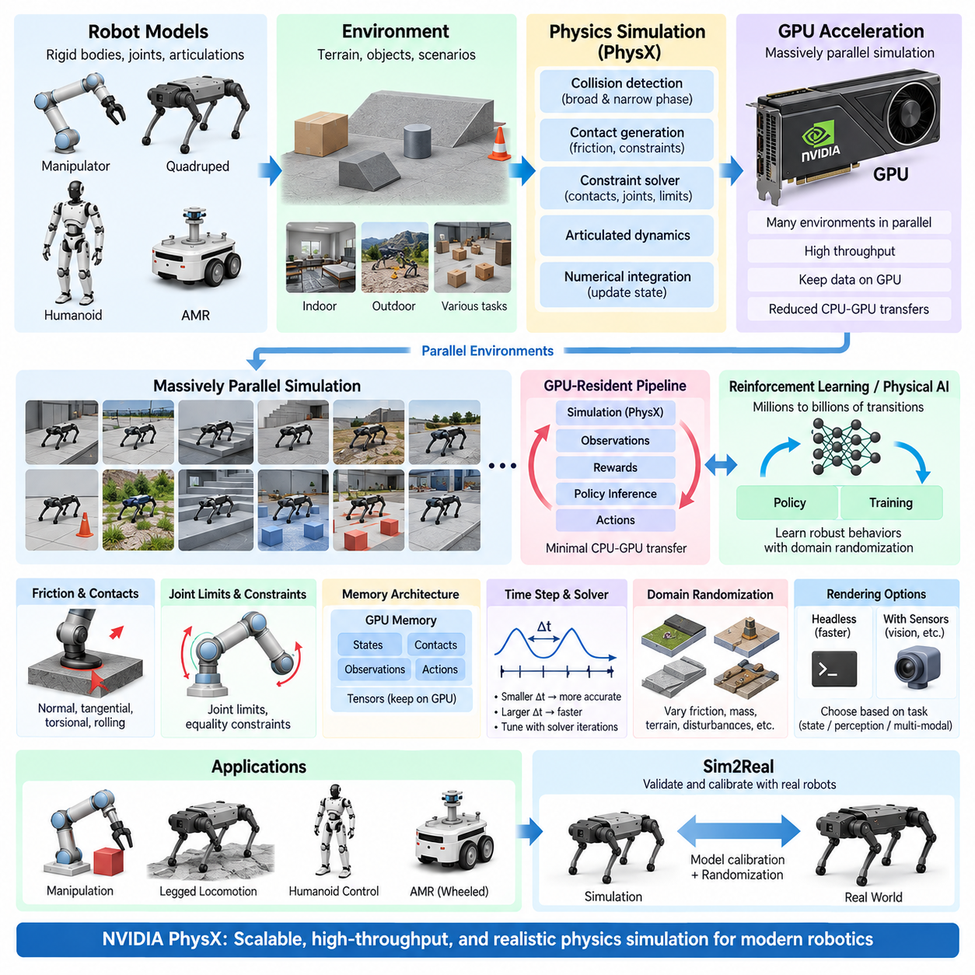
NVIDIA PhysX is a real-time physics engine designed to simulate rigid bodies, articulated mechanisms, collisions, contacts, constraints, and other physical interactions efficiently. In robotics, its importance extends beyond conventional real-time simulation because modern PhysX implementations can exploit GPU parallelism. This capability supports simulation workloads ranging from individual robot validation to large batches of environments used for reinforcement learning and Physical AI development.
Traditional CPU-oriented physics simulation processes much of the dynamics workload through a limited number of processor cores. This approach is effective for many engineering applications, but it becomes a bottleneck when hundreds or thousands of similar environments must be evaluated simultaneously. GPU-accelerated PhysX addresses this problem by mapping suitable physics operations onto massively parallel GPU hardware, increasing aggregate simulation throughput for large-scale robotic experiments.
The fundamental simulation loop remains based on physical state propagation. Robot bodies contain mass, inertia, pose, and velocity, while joints and articulations define permitted relative motion. Collision detection identifies interacting geometries, contact generation establishes candidate interaction points, and the constraint solver determines forces required to satisfy contacts and mechanical relationships. Numerical integration then advances positions and velocities to the next simulation state.
GPU acceleration does not mean that every physics operation automatically becomes faster. Performance depends on workload size, object count, contact density, articulation complexity, memory movement, solver configuration, and the degree of available parallelism. A small simulation containing only one simple robot may not fully utilize a high-performance GPU. The greatest advantage appears when many environments or physical interactions can be processed concurrently with similar computational structure.
This characteristic is particularly important for reinforcement learning. A learning policy may require millions or billions of simulation transitions before achieving useful behavior. Running environments sequentially can make data collection prohibitively slow. GPU-based simulation allows many robot instances to generate observations, execute actions, calculate rewards, and advance physics simultaneously, transforming simulation throughput into a major component of the overall learning-system architecture.
PhysX represents robot mechanisms using rigid bodies, joints, constraints, and articulation structures. Articulations are especially important for robots because manipulators, quadrupeds, and humanoids contain chains or trees of dynamically coupled links. Efficient articulated-body processing allows forces applied at one joint or contact point to influence the motion of the complete mechanism while maintaining the mechanical relationships defined by the robot model.
Collision detection is another major computational stage. Broad-phase processing identifies object pairs that might interact, while more detailed narrow-phase calculations determine actual geometric contact. Large parallel environments may contain enormous numbers of potential collision pairs, making efficient spatial organization essential. Simplified collision geometries and appropriate collision filtering can substantially reduce unnecessary calculations without sacrificing the physical interactions required by the robotic task.
Once contacts are generated, the solver calculates responses consistent with non-penetration, friction, joints, limits, and other constraints. For locomotion, this determines how feet interact with terrain; for manipulation, it influences grasp stability and object motion; for AMRs, it affects wheel-ground interaction and obstacle contact. Solver accuracy must therefore be balanced against computational cost, particularly when thousands of environments are executed for training.
GPU simulation introduces memory architecture as an important design consideration. Physics states, contacts, observations, actions, and learning tensors may need to move between computational components. If data repeatedly travels between CPU and GPU memory, transfer overhead can reduce the benefit of acceleration. High-throughput robot-learning architectures therefore attempt to keep physics state, policy inference, reward computation, and observation processing on the GPU whenever practical.
This GPU-resident workflow is a major architectural advantage when PhysX is integrated with modern robot-learning frameworks. Simulation can produce state tensors directly for learning algorithms, while policy outputs can be returned as actuator commands without repeatedly converting large datasets through CPU-side structures. The result is not merely faster collision processing but a more tightly integrated simulation-and-learning pipeline optimized around parallel tensor computation.
NVIDIA Isaac Sim builds on PhysX as part of a broader robotics simulation environment. Physics simulation can be combined with robot models, environments, sensors, rendering, ROS-related integration, and synthetic-data workflows. This allows the same virtual scene to support dynamics testing and perception-oriented simulation. Within the volume structure, PhysX therefore forms a physics foundation that later connects naturally to dedicated Isaac Sim and Omniverse topics.
Isaac Lab extends this direction toward robot learning by organizing environments, tasks, observations, actions, rewards, randomization, and training workflows around scalable simulation. A robot model can be instantiated repeatedly across many environments, with each instance experiencing different states or randomized physical parameters. Such vectorized execution is particularly useful for locomotion, manipulation, humanoid control, and other tasks requiring large amounts of interaction data.
Parallel simulation changes how environments should be designed. Instead of constructing one visually complex world and duplicating every unnecessary feature, engineers should identify which physical elements affect the learning objective. Collision geometry, articulation properties, actuator models, contacts, and task-relevant objects deserve computational resources, while decorative geometry may be simplified or disabled when it does not influence observations or dynamics.
Time-step configuration remains important even when large GPU resources are available. The physics time step determines how frequently dynamic states are advanced, while control actions may be updated at a lower frequency through control decimation. Smaller physics steps can improve contact resolution and stability but increase computation. The selected values should reflect actuator dynamics, controller bandwidth, expected impacts, contact stiffness, and the accuracy required by the task.
GPU throughput must therefore be evaluated together with simulation fidelity. Maximizing environments per second while using unrealistic friction, inaccurate inertia, idealized actuators, or unstable contacts can generate enormous quantities of low-quality experience. For Physical AI, useful simulation performance is better understood as the rate at which physically meaningful training experience can be generated rather than the raw number of simulation steps alone.
Domain randomization benefits strongly from massively parallel simulation. Different environments can simultaneously vary friction, mass, center of mass, actuator strength, terrain properties, disturbances, object positions, or other uncertain quantities. The policy is consequently exposed to a distribution of physical conditions rather than a single deterministic world. This approach can improve robustness and forms an important component of many Sim2Real workflows.
Large-scale GPU simulation also introduces resource-management challenges. Increasing the number of environments consumes GPU memory for rigid-body states, articulation data, contacts, sensors, observations, and learning tensors. Rendering can impose additional memory and compute requirements. Engineers therefore need to profile GPU utilization, memory consumption, simulation throughput, solver cost, and training performance instead of assuming that the maximum environment count provides the best configuration.
Headless simulation can improve throughput when visual rendering is unnecessary. Reinforcement-learning experiments often require physical state transitions rather than continuously rendered images, allowing graphics workloads to be reduced or eliminated. Conversely, vision-based policies require camera or other simulated sensor data, introducing rendering cost into the pipeline. The optimal architecture therefore depends on whether the learning problem is state-based, perception-based, or multimodal.
For AMRs, PhysX can model rigid-body motion, suspension-related mechanisms, wheel interaction, collisions, payload effects, and environmental contacts. For quadrupeds and humanoids, articulated dynamics and repeated foot-ground contacts become central. Manipulators require accurate joint behavior and object contacts. These different workloads illustrate why GPU acceleration should be combined with application-specific physics configuration rather than treated as a universal preset.
Validation against real hardware remains necessary despite high simulation throughput. Physical parameters such as mass distribution, friction, motor response, joint damping, latency, compliance, and terrain interaction should be measured or identified whenever possible. Differences between simulated and real behavior can then guide model calibration and randomization ranges. GPU acceleration enables more experiments, but it does not eliminate the fundamental requirement for physically credible models.
NVIDIA PhysX therefore provides more than a fast physics solver for modern robotics. When combined with GPU-resident computation, parallel environments, articulated robot models, learning frameworks, and domain randomization, it becomes part of a scalable simulation infrastructure. Its primary value emerges when physics computation is designed together with the complete training pipeline, allowing large quantities of useful interaction data to be generated efficiently for control, reinforcement learning, validation, and Sim2Real transfer.

02.05. Bullet Physics Rigid Body and Soft Body Setup [w/Code]
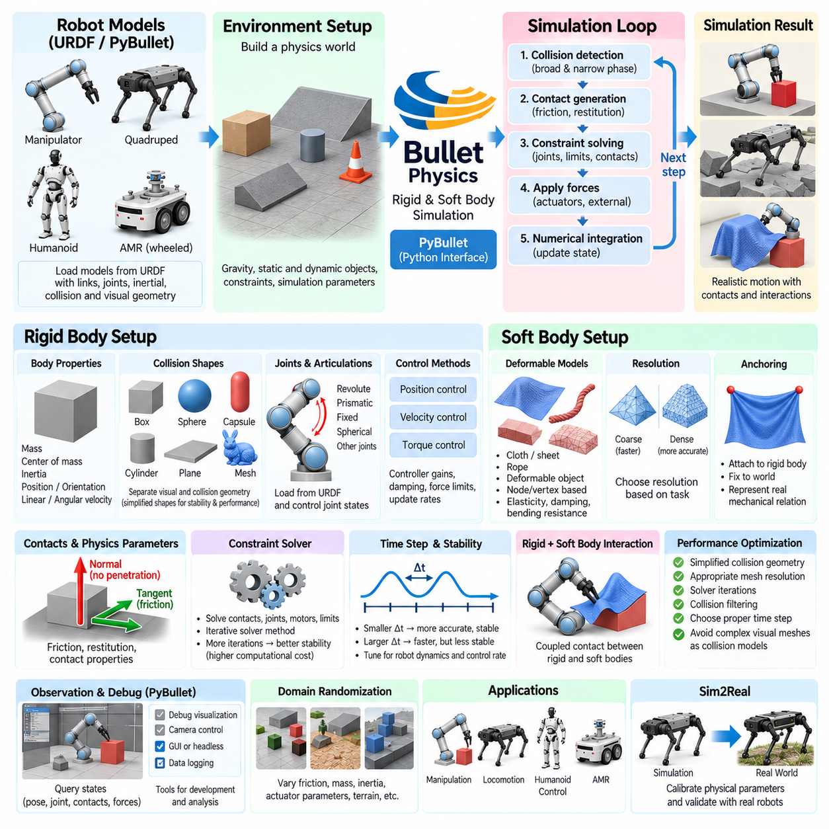
Bullet Physics provides a flexible simulation framework for modeling rigid bodies, articulated mechanisms, collisions, constraints, and deformable objects. In robotics, it is commonly accessed through PyBullet, which exposes physics functions through a convenient Python interface. This combination allows researchers to construct robot environments, execute control algorithms, evaluate contacts, and generate simulation data without developing a complete physics application from the underlying C++ engine.
A Bullet simulation typically begins by establishing a physics world containing gravity, collision objects, dynamic bodies, constraints, and simulation parameters. Each simulation step evaluates collision relationships, calculates contact and constraint responses, applies forces and actuator commands, and integrates body states forward in time. The quality of the resulting behavior depends on physical parameters, collision geometry, solver settings, and the selected simulation time step.
Rigid-body simulation assumes that an object's shape does not deform significantly under applied forces. Each rigid body is therefore represented through properties such as mass, center of mass, inertia, position, orientation, linear velocity, and angular velocity. Static objects such as floors or fixed obstacles normally have no dynamic motion, while dynamic objects respond to gravity, contacts, externally applied forces, and interactions with other bodies.
Collision shapes define how bodies participate in collision detection. Bullet supports primitive shapes such as boxes, spheres, capsules, cylinders, and planes, together with mesh-based and compound representations for more complicated objects. Separating visual geometry from collision geometry is good practice because detailed rendering meshes may contain unnecessary triangles. Simplified collision shapes often improve simulation performance, contact stability, and reproducibility while retaining the physical features required by the robotic task.
Mass and inertia must be configured consistently with the intended physical system. A body with realistic dimensions but incorrect inertia may rotate, accelerate, or respond to impacts unrealistically. For robot links, inertia values can be obtained from CAD models, measurements, or validated engineering estimates. The center of mass is equally important because even a modest displacement can significantly affect balancing robots, manipulators carrying payloads, and mobile platforms operating on slopes.
Bullet represents articulated mechanisms by connecting rigid bodies through joints or constraints. Revolute, prismatic, fixed, spherical, and other mechanical relationships can be used to construct robot structures. URDF models are frequently loaded through PyBullet, allowing links, joints, inertial properties, collision geometry, and visual geometry to be described externally. Once loaded, joint states can be measured and controlled while the physics engine calculates the resulting coupled motion.
Joint control can be implemented using position, velocity, or force and torque related commands depending on the model and interface. Position or velocity control provides a convenient abstraction for many robotics experiments, while torque-oriented control exposes more of the underlying dynamics. Controller gains, joint damping, motor-force limits, update rates, and mechanical constraints should be selected carefully because unrealistic actuator assumptions can dominate simulation behavior even when the rigid-body model itself is accurate.
Contact generation occurs when collision detection determines that two compatible shapes interact. The physics solver calculates responses that prevent excessive penetration while considering friction, restitution, body inertia, applied forces, and constraints. Surface properties strongly affect robotics applications. Wheel traction, foot stability, object sliding, grasp success, and impact behavior can all change substantially when friction or restitution parameters are modified.
Constraint solving is therefore central to stable Bullet simulations. Multiple contacts, joints, motors, and mechanical limits may need to be satisfied simultaneously during each simulation step. Iterative solver methods approximate a physically consistent solution within available computational time. Increasing solver effort can improve some contact-rich scenarios but also increases computational cost, making solver configuration a balance between stability, accuracy, and throughput.
Simulation time step is closely related to numerical stability. A smaller time step allows collisions, rapidly changing forces, and articulated motion to be evaluated more frequently, but requires more computation for the same simulated duration. Large steps can increase penetration, oscillation, or unstable contact behavior. The appropriate value depends on robot dynamics, control frequency, impact severity, joint stiffness, and the level of accuracy required by the experiment.
Bullet also supports soft-body simulation, extending the environment beyond the rigid-body assumption. Soft bodies can deform in response to contact, gravity, internal forces, and external loading. Typical examples include cloth-like surfaces, ropes, deformable sheets, and other flexible structures. This capability is useful when robot interaction cannot be represented adequately using rigid objects alone, although deformable simulation generally introduces additional computational complexity and parameter sensitivity.
A soft body requires a representation of its deformable structure rather than only one rigid transform and inertia tensor. Nodes or vertices can move relative to one another while structural relationships resist deformation. Depending on the model, elastic behavior, damping, bending resistance, and other properties determine how the object changes shape. Consequently, soft-body configuration requires attention to both geometric resolution and mechanical parameters.
Resolution has a particularly strong influence on deformable simulation. A dense mesh can represent local deformation more accurately but increases the number of degrees of freedom and physical relationships that must be calculated. A coarse representation is computationally cheaper but may miss important folds, bending, or local contacts. The appropriate resolution should therefore be chosen according to the manipulation task rather than simply maximizing mesh detail.
Soft-body contact with rigid robots creates a coupled interaction problem. A manipulator pressing or grasping a deformable object generates forces that alter the object's shape, while the resulting deformation changes subsequent contact geometry and forces. Stable simulation may require careful adjustment of collision margins, damping, stiffness, solver parameters, and time step. Visual plausibility alone is insufficient evidence that the modeled material behavior is physically accurate.
Anchoring provides a mechanism for attaching selected regions of a soft body to rigid bodies or fixed locations. This can represent cloth held by a gripper, a flexible component attached to a structure, or a deformable object constrained at specific points. Correct anchor placement is important because unrealistic boundary conditions can dominate deformation behavior. The attachment should represent the mechanical relationship that exists in the intended real system.
Rigid-body and soft-body models can coexist in one Bullet environment, enabling simulation of robots interacting with both conventional objects and deformable materials. A robot arm may manipulate boxes in one task and flexible sheets in another, while environmental structures remain rigid. This mixed simulation capability broadens the range of robotics experiments that can be constructed within a common programming interface and control architecture.
PyBullet provides practical tools for observing these simulations. Users can query body poses, joint positions, velocities, contact points, applied forces, and other state variables while commanding actuators and external forces. Debug visualization and camera functions can support development and inspection. For large automated experiments, the simulation can also operate without an interactive graphical interface, reducing unnecessary rendering overhead.
Performance optimization should focus on the physical features that materially affect the experiment. Simplified collision geometry, appropriate mesh resolution, reasonable solver iterations, collision filtering, and carefully selected time steps can substantially reduce computation. Complex visual assets should not automatically become complex collision models. This distinction becomes especially important when many robot episodes must be executed for optimization, dataset generation, or reinforcement learning.
For Sim2Real development, Bullet parameters should be calibrated rather than treated as exact representations of reality. Mass, inertia, friction, damping, actuator response, joint behavior, contact characteristics, and soft-material properties contain uncertainty. Measurements and system identification can narrow these uncertainties, while parameter randomization can expose controllers or learned policies to plausible variation during training.
Rigid-body simulation is generally appropriate when deformation has negligible influence on the robot's task, while soft-body simulation should be introduced when deformation itself affects perception, contact, manipulation, or control. Adding deformable physics without a task-driven reason increases computational cost and calibration requirements. A layered modeling strategy therefore begins with the simplest physically meaningful representation and adds complexity only when validation demonstrates that it is necessary.
Bullet Physics ultimately provides a versatile environment in which conventional rigid robot dynamics and deformable-object interaction can be modeled within a shared simulation workflow. Reliable results depend less on maximizing geometric or numerical complexity than on selecting appropriate representations and validating their parameters. Carefully configured bodies, joints, collisions, contacts, constraints, soft-body properties, and solver settings create a practical foundation for robot prototyping, control development, learning, and Sim2Real experimentation.

02.06. Flex and Warp Deformable Object Simulation [w/Code]
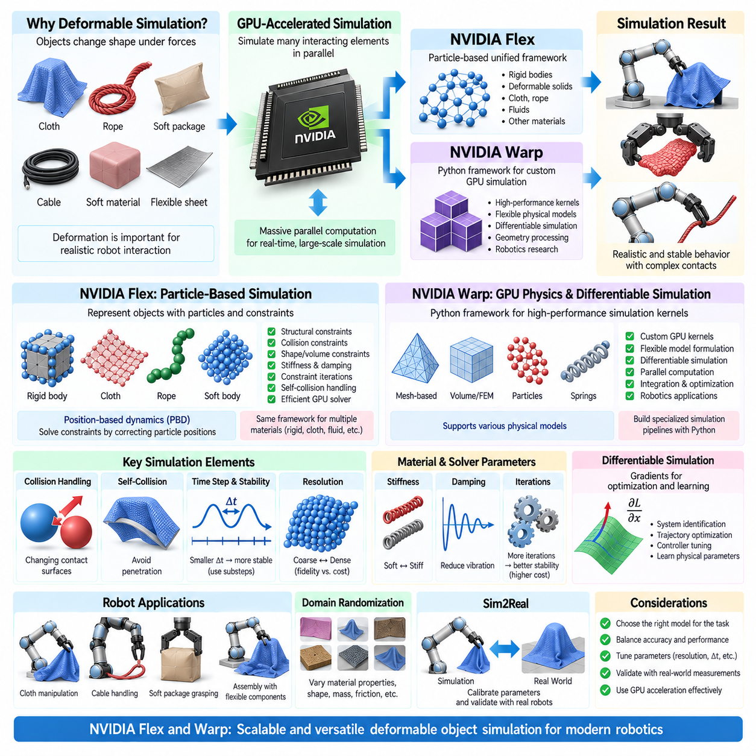
Deformable-object simulation extends robotics beyond the rigid-body assumption by representing materials whose shape changes significantly under contact, gravity, actuation, or external loading. Cloth, cables, flexible sheets, soft packages, elastic components, and compliant structures cannot always be approximated adequately as rigid objects. NVIDIA Flex and Warp represent two approaches to computationally intensive simulation in which parallel GPU processing is used to accelerate large numbers of interacting physical elements.
NVIDIA Flex was developed as a particle-based simulation framework capable of representing several physical phenomena through a unified computational model. Instead of treating every object exclusively as a conventional rigid body, Flex describes physical systems using particles connected through constraints. By changing the relationships among particles, the same underlying solver concept can represent rigid objects, deformable solids, cloth, ropes, fluids, and other materials within a shared simulation environment.
The particle-based representation is important because deformation naturally emerges from relative motion among particles. A flexible sheet can bend and stretch as neighboring particles move while structural constraints resist excessive deformation. A rope can be represented as a sequence of connected particles, while a soft volume can use internal relationships that preserve shape or volume. The physical behavior therefore depends strongly on particle spacing, constraint configuration, stiffness, damping, and collision properties.
Flex uses a position-based dynamics approach in which constraints are solved primarily by correcting particle positions rather than directly integrating complex force-based material equations. This formulation can provide stable behavior for interactive and real-time applications, especially when many contacts or deformable elements are present. The method prioritizes robust numerical behavior and computational efficiency, although its parameters should not automatically be interpreted as direct measurements of real material properties.
Constraint iterations play an important role in Flex simulation. During each time step, structural, collision, shape-preserving, and other constraints may be solved repeatedly to reduce violations. Increasing the number of iterations can make a material appear stiffer and improve constraint satisfaction, but it also increases computation. Consequently, material behavior depends not only on nominal stiffness settings but also on time step, particle resolution, solver iterations, and constraint topology.
Collision handling becomes more complex for deformable objects because the contact surface itself changes during interaction. A robot gripper compressing a soft package changes its geometry, which changes subsequent contact locations and forces. Cloth can fold onto itself, ropes can wrap around objects, and flexible components can produce many simultaneous contacts. Efficient broad-phase and local collision processing are therefore essential for maintaining practical simulation performance.
Self-collision is especially important for cloth, cables, and other thin deformable structures. Without appropriate self-collision handling, different regions of the same object may pass through one another, producing physically implausible configurations. Enabling self-collision improves realism but can substantially increase the number of potential interactions. Particle spacing, collision radius, filtering, and solver parameters must therefore be configured together to balance stability and computational cost.
NVIDIA Warp approaches GPU simulation from a different direction. Warp is a Python framework for writing high-performance simulation and numerical kernels that can execute on CPUs and NVIDIA GPUs. Rather than providing only a fixed physics engine, it allows developers to express computational operations using Python-oriented programming while compiling suitable kernels for parallel execution. This makes Warp useful for custom differentiable simulation, geometry processing, robotics, and physics research.
Warp's kernel-based architecture maps naturally to problems containing large numbers of similar operations. Particle updates, mesh processing, contact calculations, integration, optimization, and other numerical procedures can often be evaluated in parallel. This allows researchers to construct specialized simulation pipelines without implementing all GPU kernels manually in low-level CUDA code, while still exploiting hardware parallelism for computationally demanding workloads.
For deformable simulation, Warp can support formulations based on particles, meshes, springs, continuum mechanics, or other numerical representations depending on the implemented model. A deformable object may be represented using surface triangles, volumetric elements, nodes, or particles whose states evolve according to physical equations. This flexibility is valuable because cloth, cables, soft solids, and compliant robotic components do not necessarily require the same mathematical representation.
Finite-element-style methods can represent deformation by dividing a body into smaller elements and evaluating how those elements stretch, compress, shear, or bend. Compared with simplified particle constraints, such formulations can provide a closer connection to continuum material parameters, but they generally require more computation and careful numerical treatment. GPU parallelism can reduce this cost by processing large numbers of elements simultaneously when the formulation exposes sufficient parallel structure.
Differentiable simulation is another important capability associated with Warp-based workflows. When a simulation can provide derivatives describing how outputs change with respect to parameters or control inputs, gradient-based optimization becomes possible. Robotics researchers can use such information for system identification, trajectory optimization, controller tuning, or learning physical parameters. This connects physical simulation directly with optimization and machine-learning pipelines.
The usefulness of differentiability depends on the modeled physics. Contacts, friction, discontinuities, topology changes, and large deformations can create difficult gradient behavior. A mathematically differentiable implementation does not guarantee that every optimization problem will be stable or physically meaningful. Engineers must therefore examine model assumptions, gradient quality, parameter scaling, and contact formulation when using deformable simulation as part of an optimization pipeline.
Mesh and particle resolution strongly influence both Flex- and Warp-style deformable simulations. Increasing resolution can represent local bending, folding, compression, and contact more accurately, but it also increases state size, collision candidates, memory consumption, and solver workload. The appropriate resolution should be determined by the physical scale relevant to the robot task rather than by the visual appearance of the object alone.
Time-step selection is similarly critical. Soft materials may contain fast elastic responses that become unstable when simulated with excessively large steps. Smaller steps can improve stability and contact resolution but increase computational cost. Substepping provides a practical compromise by evaluating the physics several times within a larger control interval. Solver iterations, damping, stiffness, mass distribution, and time step should therefore be tuned as an interconnected numerical system.
Robotic manipulation of deformable objects creates a coupled perception-and-control problem. Unlike a rigid object whose pose can often be represented with six degrees of freedom, a deformable object may require many state variables to describe its shape. A controller may therefore need information about keypoints, mesh states, particle distributions, folds, tension, or contact regions rather than only position and orientation. Simulation provides a controlled environment for developing these representations.
Deformable simulation is also valuable for generating training data. Virtual robots can interact with cloth, cables, packages, or flexible components under many configurations while recording geometry, forces, contacts, actions, and resulting deformation. Randomization can vary material stiffness, damping, friction, mass, object dimensions, initial shape, and environmental conditions. Such variation can help learning systems avoid depending on one idealized material configuration.
However, Sim2Real transfer for deformable objects is generally more difficult than for rigid objects because real materials exhibit complex behaviors such as nonlinear elasticity, hysteresis, anisotropy, plastic deformation, internal damping, and manufacturing variation. A simulator may reproduce task-relevant behavior without reproducing every material phenomenon. Validation should therefore focus on measurable quantities that affect the robot task, such as deformation, contact response, bending, tension, or grasp stability.
System identification can be used to estimate deformable-object parameters from experiments. A known load can be applied to a material while displacement, shape change, oscillation, or force response is measured. Simulation parameters are then adjusted so that simulated observations reproduce relevant real behavior. Differentiable or gradient-based methods can potentially accelerate this calibration when the simulation formulation and measured quantities support reliable derivatives.
Flex and Warp should therefore be understood as representing different levels of abstraction rather than as identical interchangeable engines. Flex emphasizes a unified particle-and-constraint approach designed for efficient simulation of multiple physical material classes, whereas Warp provides a programmable GPU computing framework from which specialized physics and differentiable simulation workflows can be constructed. The appropriate choice depends on the required physical model, development flexibility, computational scale, and integration environment.
In robotics, deformable-object simulation should be introduced when deformation materially affects perception, planning, contact, or control. The objective is not to maximize physical complexity but to represent the phenomena necessary for successful robot behavior. GPU acceleration makes increasingly detailed models practical, while careful selection of resolution, constraints, material parameters, collision handling, solver settings, and validation procedures determines whether the resulting simulation is genuinely useful for Physical AI and Sim2Real development.

02.07. Fluid and Granular Material Simulation for Robots
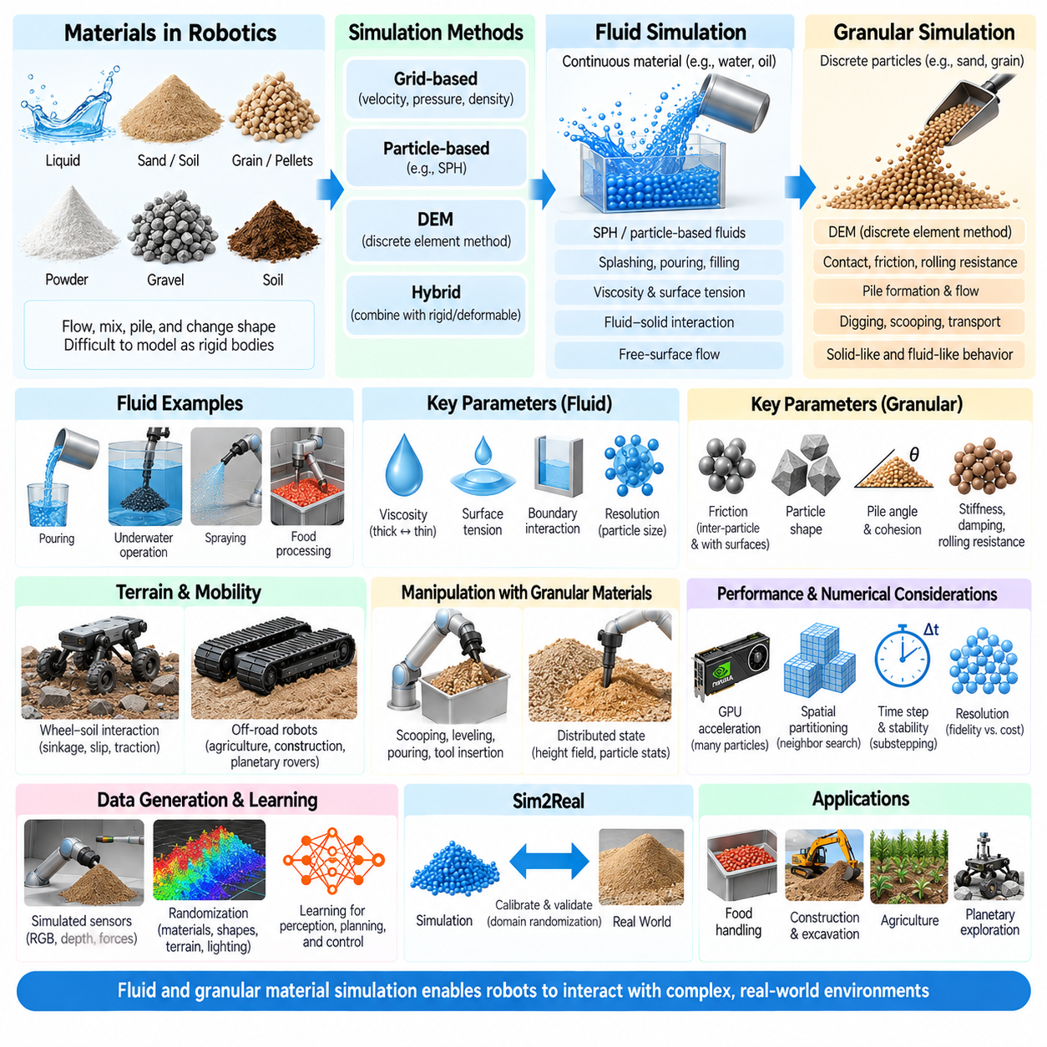
Fluid and granular material simulation extends robotic physics beyond conventional rigid and deformable objects into environments where matter continuously flows, separates, mixes, piles, or changes its effective shape. Liquids, powders, sand, soil, grain, pellets, and similar materials create interactions that cannot be represented adequately by a small number of rigid bodies. Robots working with these materials require simulation methods capable of representing distributed motion, contact, pressure, friction, and material transport.
Fluid simulation describes materials whose particles or volume elements move continuously relative to one another. For robotics, relevant examples include water handling, liquid pouring, container filling, cleaning, spraying, food processing, and interaction with submerged or partially submerged mechanisms. The robot may need to predict not only object motion but also how the fluid responds to container orientation, acceleration, obstacles, tools, and changing boundary conditions during manipulation.
Several numerical approaches can be used to represent fluids. Grid-based methods describe velocity, pressure, density, and related quantities over spatial cells, while particle-based approaches track moving material samples. Smoothed Particle Hydrodynamics, commonly called SPH, is particularly intuitive for free-surface liquids because fluid elements can move through space without requiring a fixed surface representation. Each approach introduces different tradeoffs among accuracy, stability, memory consumption, and computational throughput.
Particle-based fluid simulation is well suited to situations involving splashing, pouring, separation, and complex moving boundaries. Each particle represents a portion of the material and interacts with neighboring particles according to density, pressure, viscosity, and other physical relationships. The apparent fluid surface emerges from the particle distribution. Resolution is therefore strongly related to particle spacing, with smaller particles providing greater detail while substantially increasing computation and memory requirements.
Viscosity determines resistance to relative motion within a fluid and has major consequences for robotic manipulation. Water-like liquids flow rapidly, whereas oils, sauces, gels, or industrial fluids may respond much more slowly. Surface tension can also become important when droplets, thin streams, or small quantities are manipulated. Accurate simulation requires selecting physical effects according to the task rather than applying the same fluid model to every material.
Boundary interaction determines how fluids respond to containers, robot tools, pipes, surfaces, and moving mechanisms. A robot pouring liquid from one vessel into another creates continuously changing fluid-solid boundaries. Contact conditions, wall friction, adhesion assumptions, collision resolution, and numerical boundary treatment can influence whether simulated flow resembles real behavior. Reliable manipulation therefore depends on both fluid parameters and accurate representation of surrounding solid geometry.
Granular materials exhibit a different combination of behaviors. Sand, soil, rice, grain, powders, pellets, gravel, and similar materials consist of many discrete elements that interact through contact and friction. A granular material may behave like a solid when supporting a load, flow like a fluid when poured, and reorganize locally when disturbed. This mixed behavior makes granular simulation especially relevant to robots operating in agriculture, construction, logistics, mining, food handling, and unstructured terrain.
The Discrete Element Method, commonly abbreviated DEM, represents granular matter as collections of individual particles or elements whose contacts are explicitly evaluated. Forces can depend on overlap, stiffness, damping, friction, rolling resistance, and other contact properties. DEM provides a conceptually direct representation of particle interaction, but computational cost grows rapidly as the number of particles and potential contacts increases.
Particle shape has a significant influence on granular behavior. Spherical particles are computationally efficient but may roll too easily compared with irregular sand, gravel, grain, or industrial material. More complex particle shapes, clusters, or additional rolling-resistance models can better reproduce bulk behavior while increasing solver cost. The required representation should therefore be chosen according to task-level properties such as flow, pile formation, traction, excavation resistance, or grasp stability.
Friction is one of the dominant parameters in granular simulation. Inter-particle friction influences the angle at which material forms a stable pile, while friction between particles and robot surfaces affects digging, pushing, scooping, and transport. Rolling resistance, cohesion, particle stiffness, and damping can further alter bulk behavior. Calibration against measurable material responses is essential because different microscopic parameter combinations may produce visibly similar but mechanically different results.
Granular simulation is particularly valuable for mobile robots interacting with deformable terrain. A wheel or track moving over loose soil does not encounter a fixed rigid surface. Particles shift, compact, shear, and accumulate around the contact region, producing sinkage and changing traction forces. Consequently, terrain geometry and vehicle dynamics become coupled. Such simulation can support research into off-road AMRs, planetary rovers, agricultural robots, construction machines, and autonomous excavation systems.
For wheeled robots, the relationship among wheel load, slip, soil deformation, and traction is critical. A rigid-ground model may predict sufficient traction while a loose granular surface produces substantial wheel sinkage or slip. Particle-based or terramechanics-informed simulation can represent these effects at different levels of fidelity. The appropriate approach depends on whether the objective is detailed soil interaction, controller development, route planning, or large-scale learning.
Robot manipulation of granular material creates additional challenges because the material state is distributed across many particles. Scooping grain, leveling sand, pouring pellets, or inserting a tool into soil changes local density and particle arrangement. The state cannot be represented adequately by one object pose. Perception and control may instead rely on height fields, occupancy distributions, particle statistics, estimated volume, surface geometry, or learned latent representations.
GPU acceleration is highly valuable for both fluid and granular simulation because interactions are distributed across large numbers of computational elements. Neighbor searches, collision tests, particle updates, constraint evaluation, and field calculations can often be parallelized. Modern GPU frameworks make it possible to simulate much larger particle populations than conventional sequential implementations, although performance still depends strongly on memory access, neighborhood density, synchronization, and solver complexity.
Spatial partitioning is essential for efficient particle simulation. Testing every particle against every other particle would become computationally impractical as particle count increases. Grid structures, spatial hashing, bounding volumes, and neighborhood-search algorithms restrict interaction calculations to nearby elements. Efficient neighborhood construction can therefore be as important as the physical solver itself when designing high-throughput fluid or granular simulation.
Time-step selection is tightly coupled with material stiffness and collision dynamics. Large steps may cause particles to penetrate boundaries, miss fast interactions, or generate unstable pressure and contact responses. Smaller steps improve numerical resolution but multiply computational cost. Substepping, adaptive strategies, and carefully selected stiffness or compliance can help maintain stability while preserving practical throughput for robotic experiments.
Simulation resolution should be determined by the scale of interaction that matters to the robot. A manipulation task involving a small scoop may require substantially finer particles than a navigation study concerned primarily with large-scale terrain deformation. Excessive resolution consumes computation without necessarily improving task-level accuracy. Multi-resolution or hybrid methods can sometimes combine detailed local interaction with simplified representations of distant material.
Fluid and granular simulations can also support synthetic data generation for perception systems. Simulated cameras, depth sensors, force measurements, and robot states can be recorded while material configurations change across many trials. Randomization of material properties, particle distributions, container geometry, lighting, terrain, and robot actions can create diverse training conditions for segmentation, state estimation, manipulation planning, or learned control.
Sim2Real transfer remains challenging because real fluids and granular materials exhibit variability that is difficult to capture with a single parameter set. Moisture can alter soil cohesion, particle size distributions change granular flow, and temperature can affect fluid viscosity. Instead of expecting one perfectly calibrated simulation, robotics workflows can combine measurement, system identification, parameter distributions, and domain randomization to represent uncertainty relevant to the target task.
Validation should focus on observable physical behavior rather than visual similarity alone. For fluids, useful measurements may include flow rate, fill level, splash distribution, settling time, or poured volume. For granular materials, validation can examine pile angle, sinkage, traction, force response, material displacement, or excavation resistance. Matching these task-relevant quantities provides stronger evidence of simulation usefulness than simply producing realistic-looking animations.
Hybrid simulation can be valuable when robots interact simultaneously with rigid bodies, deformable structures, fluids, and granular materials. A construction robot may combine articulated rigid-body dynamics with soil interaction, while a food-processing robot may manipulate rigid containers containing liquids or granular ingredients. The simulation architecture must coordinate these physical domains while controlling computational cost and maintaining sufficiently consistent coupling between them.
Ultimately, fluid and granular material simulation provides robots with a computational environment for studying interactions in which the world cannot be reduced to fixed rigid surfaces and discrete solid objects. Particle, grid, DEM, and hybrid approaches offer different levels of fidelity and computational cost. When combined with GPU acceleration, calibration, appropriate resolution, and real-world validation, these methods provide an important foundation for manipulation, off-road mobility, industrial automation, and Physical AI operating in complex material environments.

02.08. Physics Engine Comparison AMR Manipulator Legged
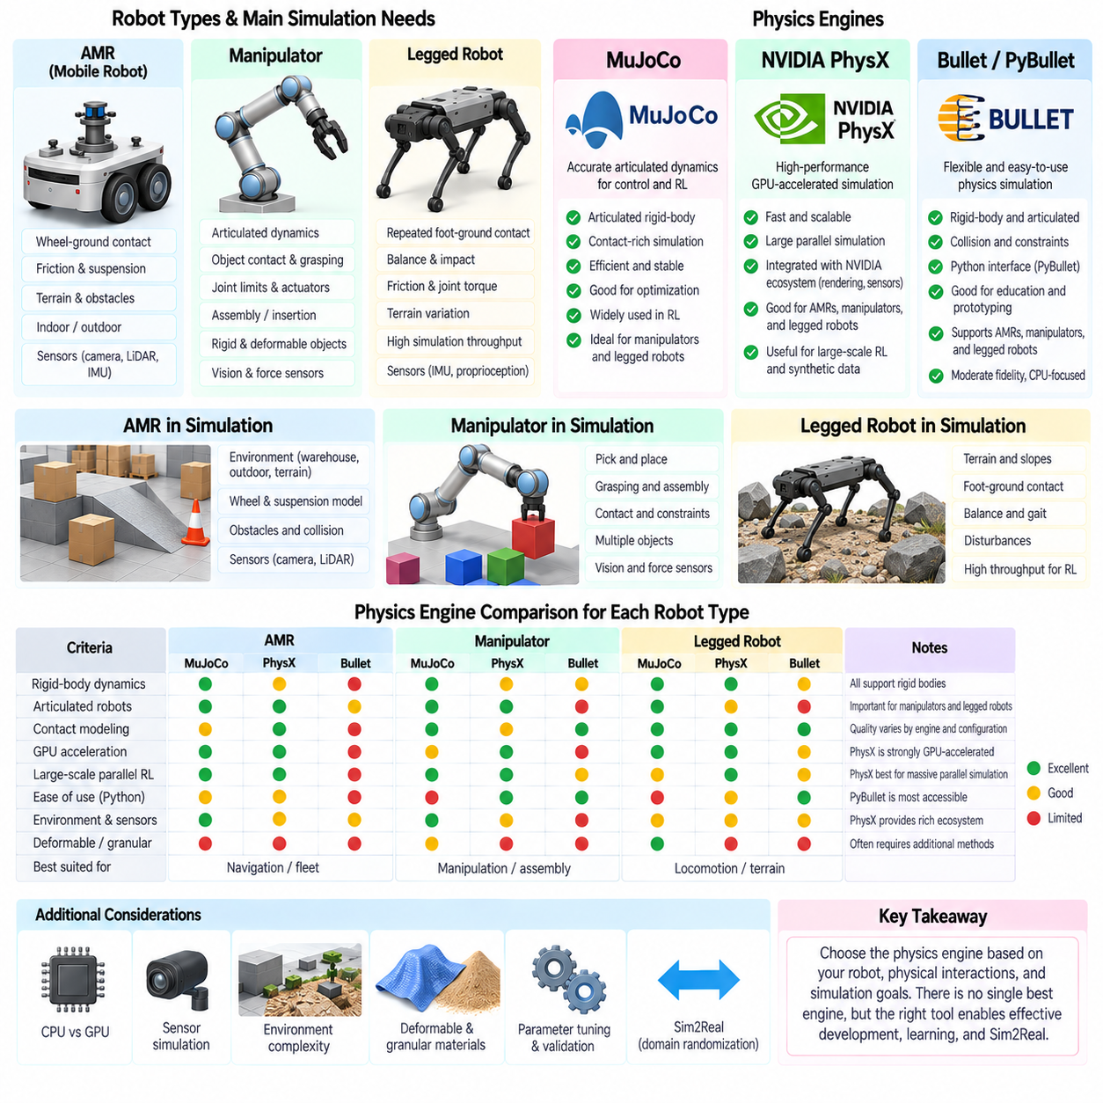
:::
Selecting a physics engine for robotics should begin with the robot's dominant physical interactions rather than with engine popularity alone. An autonomous mobile robot, an industrial manipulator, and a legged robot place different demands on contact modeling, articulated dynamics, numerical stability, terrain representation, sensor simulation, and computational throughput. The most appropriate engine is therefore determined by the experiments, controllers, learning workloads, and Sim2Real objectives that the simulation must support.
AMRs operate primarily through persistent wheel-ground contact. Their simulation requires stable rigid-body dynamics, wheel and caster modeling, friction, suspension behavior, collision detection, and interaction with floors, ramps, curbs, obstacles, or deformable terrain. For conventional indoor navigation, extremely detailed contact physics may be unnecessary, while outdoor mobility can require substantially richer representations of tire slip, terrain geometry, suspension travel, and changing surface properties.
Manipulators present a different physics problem because articulated dynamics and object contact dominate their behavior. Accurate joint motion, inertia, actuator limits, collision geometry, friction, grasp contacts, and payload dynamics are central requirements. Pick-and-place applications may operate effectively with relatively simple rigid objects, whereas assembly, insertion, dexterous manipulation, and deformable-object handling require increasingly precise contact and constraint behavior.
Legged robots impose particularly demanding contact conditions because locomotion depends on repeated creation and removal of foot-ground contacts. Balance, impact, friction, joint torque, actuator dynamics, body inertia, and terrain geometry interact continuously. Small numerical errors can influence gait stability or learned control policies. High simulation throughput is also important because reinforcement-learning workflows may require millions or billions of simulated control steps.
MuJoCo is particularly strong in articulated rigid-body dynamics, contact-rich control research, and optimization-oriented robotics. Its model representation, efficient dynamics computation, actuator framework, constraints, and contact solver make it well suited to manipulators and legged systems. It is also widely useful for reinforcement learning because many robot instances or episodes can be evaluated without requiring a visually complex simulation environment.
For manipulators, MuJoCo provides a compact environment for studying joint-space and task-space control, grasping, contact, force interaction, and dynamic motion. Robot models can include inertial properties, actuators, joint limits, tendons, sensors, and contact parameters. This makes the engine attractive when the primary objective is dynamics and control rather than photorealistic scene generation or very large GPU-parallel synthetic-data pipelines.
Legged robotics is another natural MuJoCo application because stable articulated dynamics and efficient repeated simulation are essential for locomotion research. Quadrupeds, bipeds, and humanoids can be trained or evaluated across different terrain and contact conditions. Nevertheless, simulation parameters such as friction, actuator response, latency, joint damping, and contact characteristics still require calibration or randomization before learned policies can be expected to transfer reliably to physical robots.
NVIDIA PhysX emphasizes high-performance rigid-body simulation with strong GPU acceleration and integration into NVIDIA simulation ecosystems. This becomes particularly valuable when large numbers of robots, environments, contacts, or objects must be simulated in parallel. In Physical AI workflows, GPU-based simulation can connect physics, rendering, synthetic sensor generation, and learning infrastructure within a scalable computational environment.
For AMRs, PhysX is attractive when navigation and mobility experiments must coexist with complex 3D environments, many dynamic objects, or GPU-generated sensor data. Warehouse fleets, logistics environments, and large synthetic datasets can benefit from scalable simulation. Outdoor AMRs can additionally combine articulated vehicle models, suspension, collision geometry, and terrain representations, although specialized tire-soil physics may still require additional modeling.
Manipulator simulation also benefits from PhysX when workloads involve large-scale parallel learning, synthetic-data generation, or integrated perception and manipulation. Multiple robot instances can interact with many objects while cameras and other simulated sensors produce observations for training. This makes GPU-accelerated environments particularly useful when the objective extends beyond one high-fidelity dynamics experiment to thousands of repeated manipulation episodes.
PhysX can similarly support legged-robot reinforcement learning by executing many environments concurrently on GPUs. Large parallel populations allow policies to experience variations in terrain, friction, disturbances, robot parameters, and commands. The advantage is not simply the speed of one robot simulation but the aggregate throughput obtained when many independent environments are processed together for policy optimization.
Bullet Physics and PyBullet provide a flexible and accessible environment for rigid-body dynamics, articulated robots, collision handling, constraints, and experimental robotics. Their Python-oriented workflow lowers the barrier to constructing robot simulations and integrating algorithms. Bullet can support AMRs, manipulators, and legged robots, making it useful for education, prototyping, algorithm validation, and research where rapid implementation is more important than maximum GPU-scale throughput.
For AMRs, PyBullet can model wheeled platforms, obstacles, ramps, joints, suspension elements, and basic wheel-ground interaction with relatively little development effort. It is suitable for testing navigation logic, robot kinematics, collision behavior, and moderate-fidelity dynamics. When detailed terramechanics, highly accurate tire models, or extremely large parallel environments become essential, additional tools or more specialized simulation approaches may be required.
For manipulator applications, Bullet supports URDF-based articulated models, joint control, collision queries, contact forces, grasping experiments, and interactions with rigid or soft bodies. This provides a practical platform for developing manipulation algorithms before moving to more specialized environments. The same Python interface can connect simulation with computer vision, planning, reinforcement learning, and robot-control software.
Bullet can also simulate legged robots and has been widely used for locomotion experiments, but solver configuration becomes increasingly important as contact complexity grows. Time step, friction, joint damping, actuator limits, contact stiffness, and solver iterations can significantly alter gait behavior. The engine remains valuable for prototyping, although locomotion studies should validate that the chosen configuration reproduces the physical phenomena relevant to the controller.
Engine selection also depends on whether simulation is CPU-oriented or GPU-oriented. A highly efficient CPU engine may be ideal for optimization, controller development, or moderate-scale reinforcement learning, while GPU simulation becomes increasingly advantageous when thousands of environments or massive numbers of physical elements must be evaluated concurrently. The correct comparison should therefore consider total workload rather than only the execution time of a single simulation step.
Sensor requirements introduce another selection dimension. AMRs often depend on cameras, depth sensors, LiDAR, IMUs, and localization systems, while manipulators may require RGB-D cameras, tactile observations, force-torque sensing, and precise object states. Legged robots depend strongly on proprioception, IMUs, joint sensing, and terrain observations. Physics and sensor simulation should therefore be evaluated together when perception is part of the learning or control loop.
Environment complexity also changes the preferred architecture. A control researcher may need accurate dynamics but only minimal visual geometry, whereas an autonomous robot developer may require warehouses, factories, outdoor terrain, lighting, semantic labels, and synthetic camera data. In the latter case, integration among physics, rendering, assets, sensors, and data generation can be as important as the underlying rigid-body solver.
Deformable and granular interactions further complicate the comparison. Manipulators handling cloth, cables, food, or soft packaging require physics beyond conventional rigid bodies. Outdoor AMRs operating on sand or loose soil may require terrain deformation and traction models. No single general-purpose rigid-body engine automatically provides the highest fidelity for every material, so specialized particle, FEM, DEM, or custom physics components may need to complement the primary simulator.
Sim2Real performance ultimately depends less on the engine name than on the quality of the complete model. Mass, inertia, friction, actuator dynamics, controller timing, latency, contact properties, sensor noise, terrain, and object parameters must represent the physical system sufficiently well. System identification and validation should determine which parameters require accuracy, while domain randomization can represent uncertainty that cannot be calibrated reliably.
A practical robotics organization may therefore use multiple physics engines rather than standardizing every task on one platform. MuJoCo can serve dynamics-intensive control and locomotion research, PhysX-based environments can support GPU-scale simulation and integrated Physical AI pipelines, and Bullet or PyBullet can provide accessible prototyping and algorithm experimentation. Specialized solvers can then address deformable, fluid, granular, or other task-specific physics when required.
For AMRs, the decision should emphasize wheel-ground interaction, terrain, collision environments, sensor integration, and fleet-scale testing. For manipulators, articulated dynamics, contact quality, grasping, object diversity, and perception integration become central. For legged robots, stable repeated contacts, actuator dynamics, terrain variation, control frequency, and learning throughput dominate. These different priorities explain why physics-engine selection should be made per robot class and development stage.
The strongest simulation strategy is therefore not to search for a universally superior physics engine, but to match simulation architecture to the physical phenomena and computational workload that determine robot performance. MuJoCo, PhysX, and Bullet each provide useful capabilities across AMRs, manipulators, and legged robots, but their practical value changes with the task. Validation against real robots remains the final criterion for determining whether the selected physics environment is sufficiently accurate for development, learning, and Sim2Real transfer.

02.09. Custom Physics Plugin Development for Simulators [w/Code]
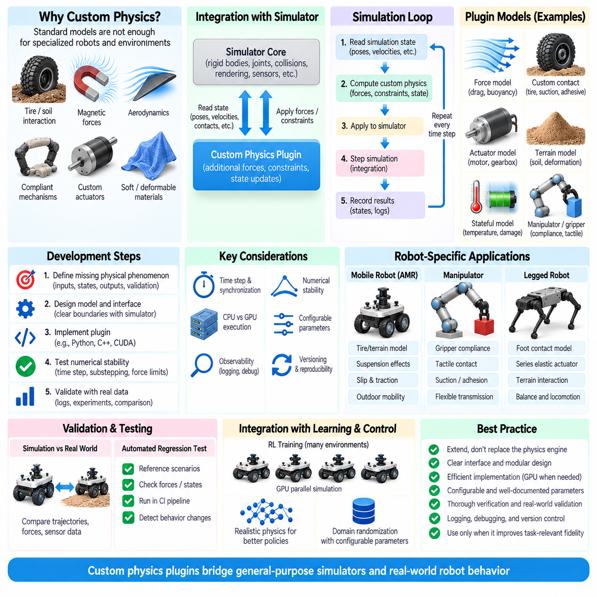
Custom physics plugins become necessary when a simulator’s built-in models cannot represent the physical behavior required by a robot application. Standard engines provide rigid-body dynamics, joints, collisions, friction, and common constraints, but specialized robots may require tire models, soil interaction, magnetic forces, compliant mechanisms, aerodynamic effects, unusual actuators, or proprietary hardware behavior. A plugin extends the simulator while preserving its existing scene, control, and visualization infrastructure.
The first step in plugin development is to define the physical phenomenon that is missing from the baseline simulator. The objective should be expressed through measurable inputs, states, outputs, and validation criteria rather than through visual behavior alone. For example, an off-road wheel model may receive wheel load, angular velocity, terrain properties, and slip while producing longitudinal force, lateral force, resistance, and terrain-dependent effects.
A custom model should interact with the simulator through a clearly defined interface boundary. The simulator normally maintains body poses, velocities, joint states, collision information, and integration timing, while the plugin calculates additional forces, torques, constraints, or state transitions. Keeping this responsibility explicit prevents the plugin from duplicating functions already handled by the physics engine and reduces inconsistencies between the custom model and the core solver.
Plugin execution must be synchronized with the simulation loop. A typical sequence reads the current simulation state, evaluates the custom physics model, applies forces or constraints, advances the engine, and records resulting states. The exact ordering matters because applying a force before integration is different from correcting a state afterward. Deterministic timing is particularly important for controller testing, reinforcement learning, and Hardware-in-the-Loop workflows.
The simulator time step must also be considered when designing the custom physics calculation. A model that is stable at a small integration interval may become unstable when executed less frequently. Fast dynamics can require substepping or an internal solver that operates at a higher rate than the robot controller. Plugin developers should therefore distinguish simulation frequency, control frequency, sensor frequency, and any internal model update frequency.
Force-based plugins are among the simplest forms of custom physics extension. The plugin observes the state of a body or joint and calculates additional forces or torques according to a mathematical model. Aerodynamic drag, rolling resistance, custom actuator forces, magnetic attraction, buoyancy, and specialized suspension effects can be implemented in this manner when they do not require modification of the engine’s fundamental constraint formulation.
More complex interactions may require custom constraints or contact models. Standard Coulomb friction, for example, may be insufficient for tire-road interaction, tracked vehicles, suction grippers, adhesive contacts, or anisotropic surfaces. A specialized model may calculate forces from relative velocity, normal load, contact orientation, material parameters, and internal state. Care is required to avoid applying responses that conflict with forces already generated by the native contact solver.
Stateful physical models maintain internal variables across simulation steps. Temperature, hysteresis, actuator pressure, tire deformation, battery-dependent motor behavior, soil compaction, or material damage cannot always be calculated from the instantaneous robot state alone. The plugin must therefore manage its own state and update it consistently over time. Reset behavior must also be defined so repeated experiments begin from controlled initial conditions.
Custom actuator modeling is particularly important for Sim2Real development. Ideal position or torque commands often fail to represent motor saturation, gearbox friction, backlash, delay, current limits, thermal behavior, or controller bandwidth. A plugin can transform high-level commands into more realistic joint forces and internal actuator states. This allows control software to experience limitations that more closely resemble those encountered on the physical robot.
Outdoor mobile robots frequently motivate specialized physics extensions. Conventional rigid contact may approximate indoor wheels on flat floors but may not capture sinkage, slip, soil deformation, or load-dependent traction on loose terrain. A custom terramechanics model can estimate wheel-ground forces from terrain parameters, wheel geometry, normal load, and slip conditions while allowing the main simulator to continue handling chassis dynamics, suspension, collisions, and articulated motion.
Manipulator applications can require plugins for gripper compliance, tactile contact, suction, flexible transmission, or specialized end effectors. Instead of replacing the complete physics engine, the custom component can augment only the interaction that requires additional fidelity. This modular strategy reduces development effort and allows standard collision detection, articulated dynamics, rendering, and sensor simulation to remain available.
Legged robots may benefit from custom actuator, foot-contact, compliance, or terrain models. Series elastic actuators, nonlinear joint friction, deformable foot pads, or unusual ground materials may require behavior beyond default joint and contact parameters. The custom model should be introduced only when experiments show that the missing phenomenon materially affects locomotion, balance, energy consumption, impact response, or controller transfer.
Implementation language and execution location influence plugin performance. High-level Python interfaces accelerate experimentation but may become expensive when thousands of contacts or simulation instances require per-step processing. Performance-critical models can be implemented in C++, CUDA, or compiled kernels while retaining Python bindings for configuration and experimentation. The interface should minimize unnecessary data transfers and repeated memory allocation.
GPU-based simulators introduce additional architectural considerations. Moving simulation state repeatedly between GPU and CPU memory can eliminate the performance advantage of parallel physics. Custom GPU kernels can evaluate forces or state updates directly on device-resident data when supported by the simulator architecture. Batch-oriented implementations are particularly important for reinforcement learning where thousands of environments may execute simultaneously.
A plugin should expose physical parameters separately from implementation details. Parameters such as stiffness, damping, friction coefficients, motor constants, terrain properties, aerodynamic coefficients, or compliance should be configurable without changing source code. Structured configuration also enables parameter sweeps, system identification, domain randomization, and experiment reproducibility across different robots and simulation scenarios.
Numerical stability must be evaluated independently from physical accuracy. A theoretically appropriate model can still destabilize the simulator if it introduces excessively stiff forces, discontinuities, or poorly scaled parameters. Force limiting, smoothing, regularization, implicit formulations, substepping, or compliant approximations may be required. Stability testing should include extreme states rather than only nominal robot operation.
Verification and validation serve different purposes during plugin development. Verification determines whether the implementation correctly solves the intended equations, while validation determines whether those equations reproduce relevant real-world behavior. Unit tests can verify mathematical functions and parameter handling, whereas comparison with measurements from physical experiments is required to establish whether the model is useful for the target robot.
Validation datasets should be designed around the phenomenon represented by the plugin. A suspension model can be compared with measured wheel displacement and chassis acceleration, while an actuator model can be evaluated using commanded torque, measured current, velocity, and output force. A soil interaction model may be validated against wheel slip, sinkage, drawbar force, or traction measurements under controlled terrain conditions.
Automated regression testing is important because physics plugins can change behavior when the simulator, GPU driver, compiler, dependency, or plugin code is updated. Reference scenarios can record expected trajectories, forces, energies, contact events, or statistical ranges. Continuous Integration pipelines can execute these tests and identify unexpected changes before a modified physics component is used in large-scale training or robot deployment.
Observability should be designed into the plugin from the beginning. Internal forces, intermediate states, constraint errors, saturation events, contact variables, and solver diagnostics should be accessible for logging and debugging. Without these signals, an apparently unstable robot may be incorrectly attributed to the controller when the actual cause is a numerical or modeling problem inside the custom physics component.
Versioning is essential when custom physics becomes part of dataset generation or machine-learning experiments. Changes to equations, parameters, solver behavior, or numerical implementation can alter the distribution of generated experience. Simulation results should therefore record the plugin version and relevant configuration alongside robot, environment, and training metadata so experiments can be reproduced and compared reliably.
A robust architecture keeps custom physics modular and replaceable. The robot controller should not depend unnecessarily on one plugin implementation, and the plugin should communicate through stable simulator abstractions whenever possible. This separation allows alternative physical models to be compared, enables migration between simulator versions, and reduces the risk that experimental physics code becomes inseparable from the larger robotics software stack.
Custom physics plugin development ultimately connects general-purpose simulation with the specific physical behavior of a real robot and its environment. The goal is not to replace a mature physics engine, but to extend it only where task-relevant fidelity is missing. Carefully defined interfaces, stable numerical integration, configurable parameters, efficient execution, observability, verification, real-world validation, and version control make custom physics a practical component of advanced robotics and Sim2Real development.

02.10. Real Time Physics Simulation Performance Tuning
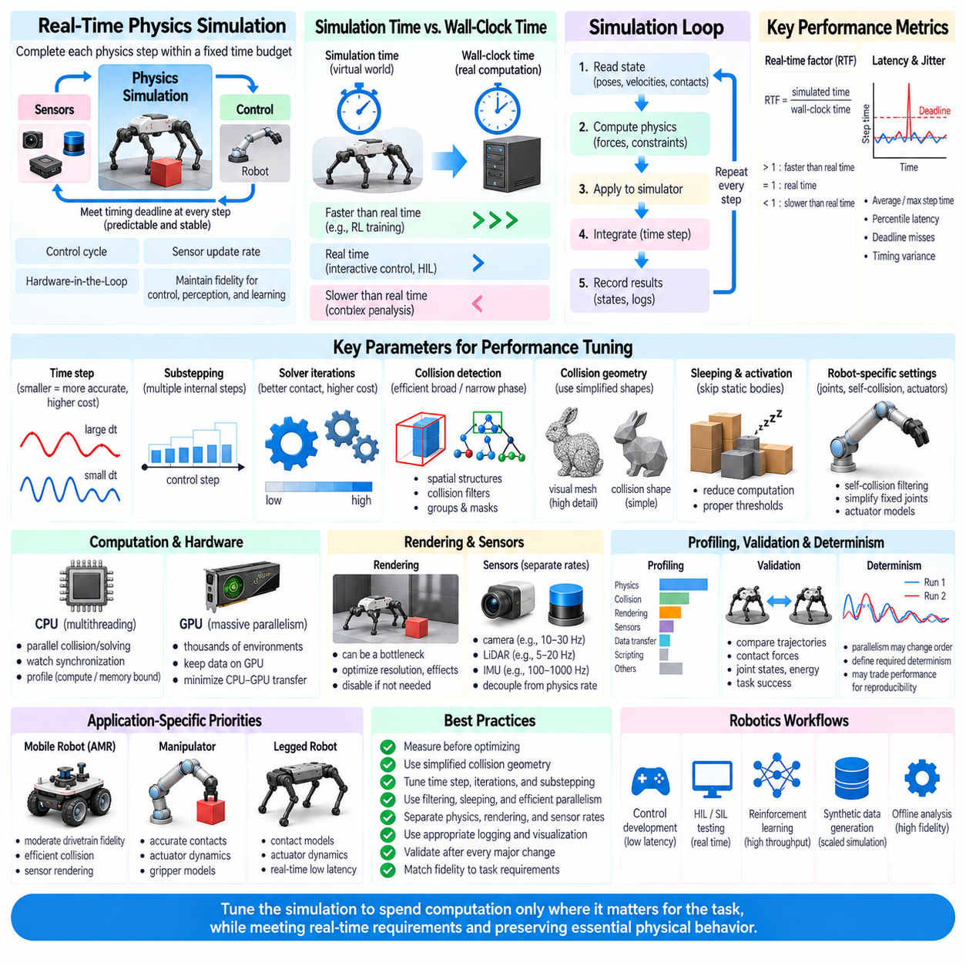
Real-time physics simulation requires the simulator to complete every required physics update within a fixed computational budget. In robotics, this budget is usually determined by the control cycle, sensor update rate, or Hardware-in-the-Loop interface. Performance tuning therefore does not simply mean maximizing frames per second. It means maintaining predictable simulation timing while preserving the physical fidelity required by control, perception, learning, and validation tasks.
A fundamental distinction exists between simulation time and wall-clock time. Simulation time represents the virtual progression of the physical system, whereas wall-clock time measures actual computation duration. A simulator can operate faster than real time for reinforcement learning, slower than real time for complex offline analysis, or synchronized with wall-clock time for interactive control and Hardware-in-the-Loop experiments. Real-time operation requires each simulation cycle to meet its timing deadline consistently.
The physics time step is one of the most influential performance parameters. Smaller time steps improve temporal resolution and can increase stability for fast dynamics, stiff contacts, and high-frequency mechanisms, but they require more solver executions per simulated second. Larger steps reduce computation but can introduce penetration, oscillation, inaccurate impacts, or unstable constraints. Time-step selection must therefore balance numerical stability, physical accuracy, and computational cost.
Substepping provides another mechanism for controlling this balance. A simulator may expose a relatively slow external control interval while executing several smaller internal physics steps within that interval. This approach allows controllers to operate at their intended frequency while the physics engine resolves faster contact or mechanical dynamics. Excessive substepping, however, multiplies computational workload and can prevent the simulator from satisfying real-time deadlines.
Solver iterations directly influence both contact quality and execution cost. Iterative physics solvers repeatedly refine joint, contact, friction, and constraint solutions. Additional iterations may reduce constraint error and improve stability, particularly in contact-rich articulated systems, but the improvement eventually becomes smaller than the added computation. Performance tuning should identify the minimum solver effort that produces acceptable task-level behavior rather than automatically selecting the maximum available setting.
Collision detection can consume a substantial fraction of simulation time, especially in scenes containing many objects. Broad-phase collision detection first identifies potentially interacting object pairs, while narrow-phase processing calculates detailed contacts for those candidates. Efficient spatial structures, collision groups, masks, and filtering can prevent unnecessary tests. Objects that can never physically interact should not continuously participate in expensive collision calculations.
Collision geometry should also be simplified whenever task fidelity permits. Detailed visual meshes may contain hundreds of thousands of triangles even though their physical function can be represented by boxes, capsules, cylinders, convex hulls, or simplified meshes. Separating rendering geometry from collision geometry reduces contact-generation cost and often improves solver stability. High geometric detail should be retained only where it materially changes robot interaction.
Sleeping and activation mechanisms can reduce computation by temporarily excluding stationary bodies from repeated dynamic updates. Warehouse objects, environmental props, or inactive mechanisms may remain unchanged for long periods and do not require full physics evaluation during every step. Correct sleep thresholds can substantially reduce workload in large scenes, although overly aggressive sleeping can suppress small but physically relevant motions or contact responses.
Articulated robots introduce additional computational costs through joints, constraints, actuator models, and self-collision. Self-collision filtering is particularly important because many pairs of links can never contact during valid robot motion. Excluding adjacent or mechanically impossible link pairs reduces collision checks without sacrificing useful behavior. Similar simplifications can be applied to fixed joints, static structures, and unnecessary degrees of freedom.
Contact count is often more important than object count alone. A scene containing many separated objects may simulate efficiently, while a smaller scene with dense stacks, granular material, complex meshes, or multiple simultaneous robot contacts may become expensive. Profiling should therefore measure active contacts, constraint rows, collision pairs, solver workload, and integration cost rather than relying only on the total number of simulated bodies.
CPU performance depends strongly on workload distribution and memory behavior. Physics engines may parallelize collision detection, island processing, constraint solving, or independent simulations across multiple CPU threads. Increasing thread count does not guarantee proportional acceleration because synchronization, memory bandwidth, and serial solver stages can become bottlenecks. Profiling is necessary to determine whether the workload is compute-bound, memory-bound, or synchronization-bound.
GPU acceleration becomes particularly valuable when physics workloads expose large amounts of parallelism. Thousands of robot environments, particles, contacts, or independent simulations can be processed concurrently. However, repeatedly transferring state between CPU and GPU memory can eliminate these gains. High-performance architectures keep simulation state, observations, rewards, and learning tensors on the GPU whenever possible and minimize synchronization with the host processor.
Batch simulation changes the optimization objective from the latency of one environment to the throughput of many environments. Reinforcement-learning systems may tolerate slightly higher latency per individual environment if thousands of environments advance concurrently. Real-time robot control has the opposite requirement: predictable low latency may be more important than aggregate throughput. Performance metrics must therefore correspond to the actual deployment or training workload.
Rendering can become a separate bottleneck even when physics simulation itself satisfies real-time requirements. High-resolution cameras, shadows, reflections, ray tracing, segmentation outputs, and multiple sensor viewpoints can consume significant GPU resources. Physics and rendering performance should be profiled independently. Control experiments that do not require visual observations can disable rendering entirely, while perception experiments should allocate explicit budgets to sensor generation.
Sensor simulation should operate at realistic frequencies rather than automatically matching the physics rate. A physics engine may execute at hundreds or thousands of steps per second while cameras operate at tens of frames per second and LiDAR or other sensors use different update rates. Decoupling these schedules prevents unnecessary sensor computation and more accurately represents real robotic systems in which sensing, control, and physical dynamics operate asynchronously.
Real-time factor is a useful system-level metric defined by the ratio between simulated time and elapsed wall-clock time. A value of one indicates real-time execution, values above one indicate faster-than-real-time simulation, and values below one indicate slower execution. Average real-time factor alone is insufficient for real-time control because occasional long frames can violate deadlines even when the long-term average appears acceptable.
Latency jitter should therefore be measured alongside average performance. A simulator that normally completes a step in one millisecond but occasionally requires twenty milliseconds may be unsuitable for a deterministic control loop. Percentile latency, maximum step time, deadline misses, and timing variance reveal behavior that averages can hide. This is particularly important for Hardware-in-the-Loop and Software-in-the-Loop validation.
Profiling should precede optimization. CPU time, GPU time, collision processing, solver execution, rendering, sensor generation, data transfer, logging, and scripting overhead should be measured separately. Optimization based on assumptions can waste engineering effort on components that contribute little to total runtime. Representative scenarios should be profiled because bottlenecks can change dramatically with robot count, contact density, environment complexity, and sensor configuration.
Logging and visualization can unexpectedly reduce real-time performance. Recording every state variable, contact, image, and diagnostic value at every physics step generates memory traffic, storage operations, and synchronization overhead. Data collection should use appropriate sampling rates, buffering, asynchronous writing, and selective signals. Debug visualization should similarly be disabled or reduced during performance measurements intended to represent production operation.
Determinism and performance can sometimes conflict. Parallel execution may change operation ordering, producing small numerical differences between runs. For many learning workloads this variation is acceptable, while regression testing or safety-related validation may require stronger reproducibility. The required determinism level should therefore be defined explicitly, because enforcing strict ordering or synchronization can reduce available parallelism and increase execution cost.
Model fidelity should be allocated according to sensitivity. Detailed actuator dynamics may be essential for a legged robot while photorealistic rendering is irrelevant to its torque controller. An AMR perception experiment may require sophisticated sensor rendering but only moderate drivetrain fidelity. Performance tuning should preserve high fidelity where errors affect task outcomes and simplify physics, geometry, sensors, or environment details where sensitivity is low.
Adaptive simulation can allocate computation according to current conditions. Stable free motion may tolerate larger steps or reduced solver effort, while impacts and dense contacts may require finer resolution. Such approaches can improve efficiency but complicate deterministic timing and validation. For hard real-time applications, predictable fixed computational bounds may be preferable to adaptive algorithms whose execution cost changes substantially with scene conditions.
Performance tuning should be validated after every significant optimization because faster execution is not useful if robot behavior changes beyond acceptable limits. Reference trajectories, contact forces, joint states, energy behavior, controller outputs, and task success metrics can be compared before and after optimization. This establishes whether reduced resolution, simplified geometry, fewer iterations, or different execution settings preserve the phenomena required by the application.
A practical optimization process therefore progresses from measurement to targeted simplification rather than from indiscriminate reduction of fidelity. Time steps, solver iterations, collision geometry, filtering, sleeping, threading, GPU execution, rendering, sensor rates, and data logging should be treated as parts of one computational system. Their interactions determine whether simulation achieves the required combination of accuracy, throughput, latency, and stability.
Real-time physics performance tuning ultimately means matching simulation complexity to the timing requirements of the robotics workflow. Control development, Hardware-in-the-Loop testing, reinforcement learning, synthetic-data generation, and offline engineering analysis each require different performance characteristics. A well-tuned simulator spends computation only on physical and sensory phenomena that affect the task, while continuously measuring timing and validating that optimization has not compromised meaningful robot behavior.

