Volume 11. Simulation and Digital Twin

Chapter 11. Massive Scale Parallel Simulation

11.01. Massively Parallel Simulation Motivation and Architecture
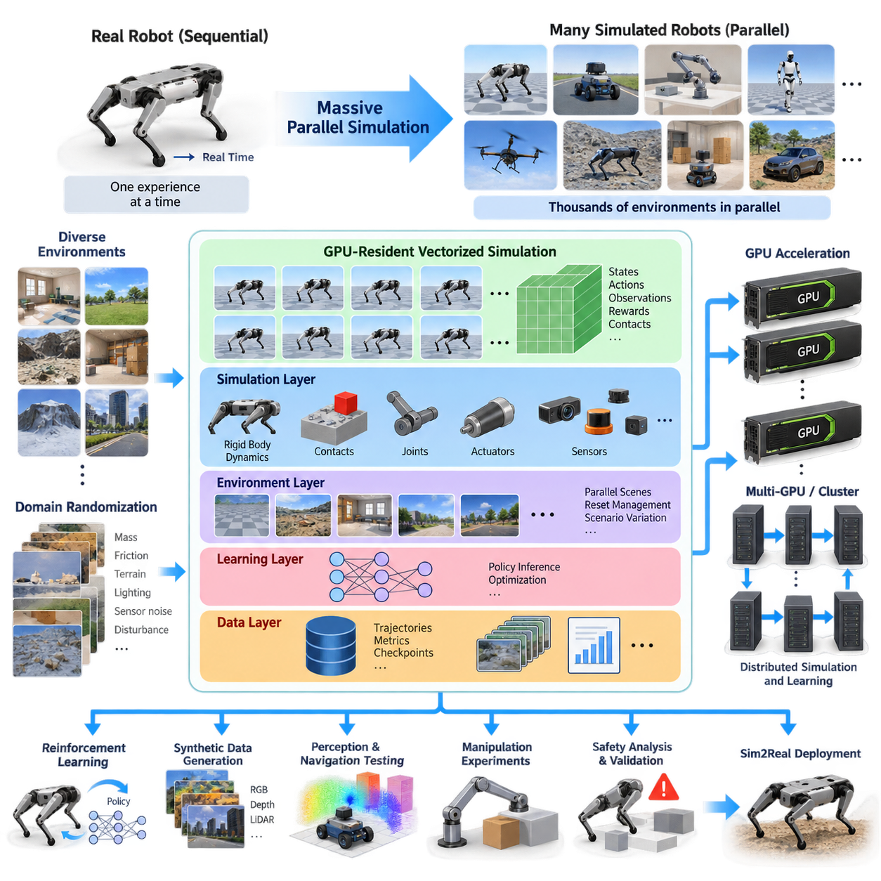
Massively parallel simulation addresses one of the fundamental bottlenecks in modern robotics and Physical AI: the enormous amount of interaction experience required to train, test, and validate intelligent behavior. A physical robot can collect experience only at the rate permitted by real time, while simulation can create many independent virtual robots and environments that execute simultaneously. Parallelism therefore converts simulation from a single experimental tool into a scalable computational infrastructure for generating robot experience.
The motivation becomes particularly important for reinforcement learning, where policies may require millions or billions of state transitions before stable behavior emerges. Running one simulated robot sequentially can make this process impractically slow. Massively parallel simulation instead replicates the environment hundreds, thousands, or even tens of thousands of times, allowing different trajectories to be generated concurrently and dramatically increasing the rate at which observations, actions, rewards, and transitions are produced.
This approach extends naturally beyond reinforcement learning. Large simulation populations can support synthetic data generation, perception testing, navigation validation, manipulation experiments, domain randomization, system identification, and safety analysis. Each environment can contain different terrain, lighting, objects, sensor parameters, robot configurations, disturbances, or failure conditions. Parallel execution therefore explores a much broader portion of the operational space than repeated execution of a single deterministic simulation.
The architectural foundation is usually a vectorized environment model. Instead of treating every simulator instance as an isolated application with its own process, rendering loop, and communication stack, the system represents many environment states as large tensors or structured arrays. Robot poses, joint states, velocities, actuator commands, contact forces, rewards, and termination flags can then be processed collectively. This organization maps naturally onto the highly parallel execution model of GPUs.
GPU-resident simulation further reduces a major source of overhead: movement of data between processors. Traditional pipelines may compute physics on a CPU, transfer observations to a GPU for neural-network inference, return actions to the CPU, and repeat this cycle at every simulation step. At massive scale, these transfers become expensive. GPU-centric architectures attempt to keep physics state, observation generation, policy inference, reward computation, and environment reset operations on the accelerator whenever possible.
A typical architecture contains several logical layers even when they execute on the same device. The simulation layer advances rigid-body dynamics, contacts, joints, actuators, and sensors. An environment layer manages thousands of independent scenes and their reset conditions. The learning layer performs batched neural-network inference and optimization, while a data layer collects trajectories, metrics, checkpoints, and selected simulation outputs. Efficient interfaces between these layers are essential for maintaining high throughput.
Vectorization changes how simulation software must be designed. Operations that are inexpensive for one environment can become serious bottlenecks when repeated thousands of times through sequential loops. Efficient implementations therefore favor batched tensor operations, GPU kernels, shared model representations, asynchronous execution, and memory layouts optimized for parallel access. Environment initialization and reset mechanisms must also avoid unnecessary reconstruction of complete simulation scenes whenever individual episodes terminate.
Memory capacity is as important as raw compute performance. Every parallel environment requires state information for robots, objects, constraints, sensors, observations, rewards, and learning buffers. High-resolution cameras, LiDAR simulation, complex articulated bodies, and detailed contact models can rapidly increase memory consumption. Consequently, the maximum number of environments is determined by a balance among simulation fidelity, state size, sensor complexity, neural-network workload, GPU memory, and required simulation throughput.
Massively parallel architectures must also distinguish between physics-intensive and rendering-intensive workloads. Thousands of relatively compact physics environments may execute efficiently on a single GPU, while photorealistic camera simulation can consume substantially more computation and memory. Practical systems therefore often separate high-throughput policy training from high-fidelity visual validation. Lightweight simulation generates enormous quantities of interaction experience, while selected scenarios are later evaluated using richer sensors and more realistic rendering.
Scaling beyond one GPU introduces another architectural level. Multiple GPUs can each host independent groups of environments, while distributed learning mechanisms aggregate gradients, model parameters, trajectories, or statistics. A compute node may contain several accelerators, and multiple nodes can form a simulation cluster. This hierarchy transforms parallel simulation into distributed simulation infrastructure in which environment execution, policy optimization, data collection, and checkpoint management must remain coordinated.
The architecture must minimize synchronization because global barriers can eliminate much of the benefit of parallel execution. Different environments terminate at different times, contacts produce variable computational loads, and complex scenes may require more processing than simple ones. Asynchronous or partially synchronized execution allows resources to continue working rather than waiting for the slowest environment. Effective workload partitioning and scheduling therefore become central scalability concerns rather than secondary implementation details.
Randomization is especially powerful when combined with massive parallelism. Instead of changing simulation parameters sequentially between experiments, each environment can simultaneously represent a different combination of mass, friction, actuator response, terrain geometry, sensor noise, lighting, latency, or disturbance. A policy trained across this distribution is exposed to a wide range of physical conditions during every optimization cycle, connecting massive simulation directly with robustness engineering and Sim2Real transfer.
Large-scale simulation also changes validation methodology. Rare collisions, unstable configurations, localization failures, perception ambiguities, and unusual environmental combinations can be searched across enormous numbers of virtual episodes. Parameter sweeps and scenario generation can systematically explore operating boundaries that would be expensive, slow, or unsafe to reproduce physically. Simulation thus becomes not only a training engine but also a statistical testing infrastructure for robot software and autonomy.
The overall architecture should therefore be understood as a pipeline for converting computational resources into diverse physical interaction experience. GPUs provide vectorized physics and AI computation, environment managers create independent experimental worlds, distributed infrastructure expands capacity across accelerators and nodes, and data systems preserve useful trajectories and metrics. These components collectively form the foundation for the later topics of GPU vectorization, multi-GPU training, cloud simulation farms, scheduling, distributed data collection, fault tolerance, and cost optimization.
For Physical AI, the significance of massive-scale parallel simulation is ultimately the ability to explore physical possibility at computational speed. A single real robot experiences one trajectory at a time, whereas a parallel simulation platform can explore many alternative actions, environments, failures, and physical parameter combinations simultaneously. This computational multiplicity provides the experience scale required for increasingly general robot policies while preserving real-world experiments for calibration, verification, and final deployment validation.

11.02. Isaac Gym Thousands of Parallel Envs on Single GPU [w/Code]
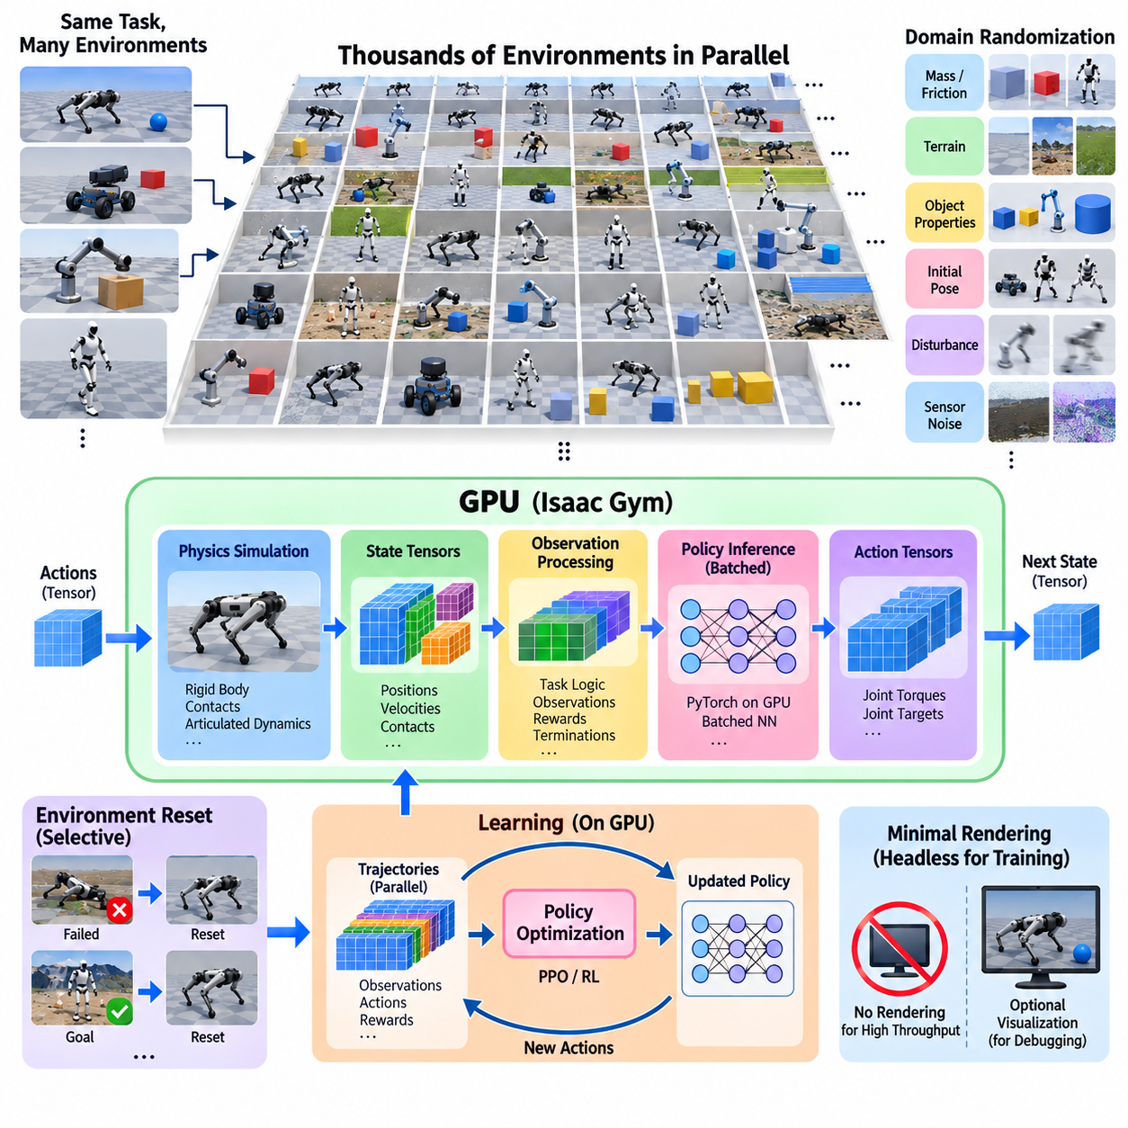
Isaac Gym is designed around a fundamental idea: reinforcement learning for robots becomes dramatically faster when physics simulation and neural-network computation remain on the same GPU. Instead of executing a small number of simulator instances through separate CPU processes, Isaac Gym can represent large populations of environments as GPU-resident data. Thousands of robots can therefore advance their simulated dynamics concurrently while producing experience for policy learning at very high throughput.
Traditional reinforcement learning pipelines often introduce substantial communication overhead. Physics may run on the CPU, observations are copied to the GPU for policy inference, actions are transferred back to the CPU, and the next physics step begins. Repeating these transfers across many environments limits scalability. Isaac Gym reduces this bottleneck by exposing simulation states directly as GPU tensors, allowing physics, observation processing, policy inference, reward calculation, and learning operations to remain largely within GPU memory.
Parallel environments are commonly organized as replicated instances of a robot task. Each instance may contain the same robot model and basic task structure while maintaining independent positions, velocities, contacts, actions, rewards, and episode states. Thousands of these environments can coexist within a single simulation process. The GPU processes their dynamics in parallel, transforming what would otherwise be thousands of sequential simulation steps into highly vectorized computational workloads.
The environment population is typically arranged spatially so that individual simulated worlds do not interfere with one another. Each environment receives its own robot and relevant objects while sharing common asset definitions whenever possible. Although the environments may use identical geometry and robot models, their dynamic states remain independent. This architecture avoids the overhead of launching thousands of separate simulator applications while preserving the logical independence required for reinforcement learning.
At every control step, the simulator advances the physics state for the complete environment batch. Joint positions, joint velocities, rigid-body poses, contact information, and other physical quantities can be exposed as tensors. Task logic transforms these tensors into policy observations, and a neural network evaluates many environments simultaneously through batched inference. The resulting action tensor is then applied back to the simulated robots before the next physics step begins.
This tensor-oriented workflow is particularly well matched to PyTorch-based reinforcement learning. Observations can be represented directly as GPU tensors, processed by neural networks, and converted into actions without repeatedly serializing or transferring data between unrelated software components. Reward functions and termination conditions can also be implemented through vectorized tensor expressions. Consequently, the simulation loop increasingly resembles a large GPU computation graph rather than a conventional collection of independent simulator processes.
Environment reset is another important component of high-throughput execution. In reinforcement learning, different robots may fail, reach their goals, fall over, collide, or exceed an episode time limit at different moments. Restarting the entire simulation whenever one episode ends would waste considerable computation. Instead, reset logic identifies only the affected environments and restores their robot states, object configurations, targets, and episode variables while the remaining environments continue operating.
Massive environment replication also provides an efficient mechanism for domain randomization. Robot mass, friction, actuator properties, initial pose, target position, terrain characteristics, disturbances, and selected sensor properties can vary across environments. Thousands of parameter combinations may therefore be evaluated simultaneously. A learning policy is exposed to a distribution of physical conditions rather than repeatedly experiencing one nominal simulator configuration, improving the foundation for robust policy learning and Sim2Real transfer.
The achievable number of parallel environments depends strongly on task complexity. A relatively compact locomotion task with simple observations can support far more environments than a scene containing complex contact interactions, large numbers of articulated bodies, or computationally expensive sensors. GPU memory places another practical limit because every environment requires dynamic state, observations, actions, reward variables, and potentially additional buffers used by the reinforcement learning algorithm.
Physics simulation throughput and learning throughput must therefore be balanced. Increasing the environment count can produce more experience per unit time, but the policy network must also process larger observation batches and the learning algorithm must consume the resulting trajectories. Beyond a certain point, additional environments may provide diminishing benefit if neural-network inference, optimization, memory bandwidth, or trajectory processing becomes the dominant bottleneck. Maximum environment count alone is therefore not an adequate performance metric.
Rendering is generally minimized during large-scale reinforcement learning because visual display can consume resources that would otherwise support physics and policy computation. Headless execution allows the simulator to advance environments without continuously producing images for a human viewer. Visualization can instead be enabled selectively for debugging, evaluation, or demonstration. This separation allows thousands of physics environments to operate efficiently while retaining the ability to inspect representative trajectories when necessary.
The same principle applies to sensor fidelity. Proprioceptive observations such as joint position, velocity, orientation, contact state, and force information are comparatively compact and suitable for massive parallel training. High-resolution cameras or sophisticated ray-based sensors can significantly increase GPU workload and memory consumption. Training architectures therefore often use the minimum observation representation required by the task and introduce more expensive sensing when perception itself is part of the learning problem.
Isaac Gym's single-GPU parallelism is especially important for locomotion and control problems. Quadrupeds, humanoids, manipulators, and other articulated robots can accumulate enormous quantities of simulated motion experience without requiring an equally enormous CPU simulation farm. Different environments can expose the policy to varied initial conditions and disturbances, allowing successful and unsuccessful behaviors to emerge concurrently and providing dense training data for policy optimization.
This architecture also changes the practical iteration cycle of robot learning. Hyperparameters, reward formulations, control frequencies, randomization ranges, and actuator models can be evaluated using much larger experiment populations than would be feasible with real robots. Researchers can observe statistical behavior across thousands of episodes instead of drawing conclusions from a few trajectories. Simulation therefore becomes an experimental engine for rapidly testing hypotheses about both robot dynamics and learning design.
Isaac Gym should consequently be viewed not merely as a simulator capable of displaying many robots, but as an architecture that couples GPU physics with GPU-based machine learning. Its central advantage comes from vectorized environments, GPU-resident state tensors, batched policy inference, selective environment reset, and minimized CPU-GPU communication. These principles establish the computational foundation for extending reinforcement learning from a single GPU toward multi-GPU and distributed training architectures.

11.03. Isaac Lab Multi GPU Distributed RL Training [w/Code]
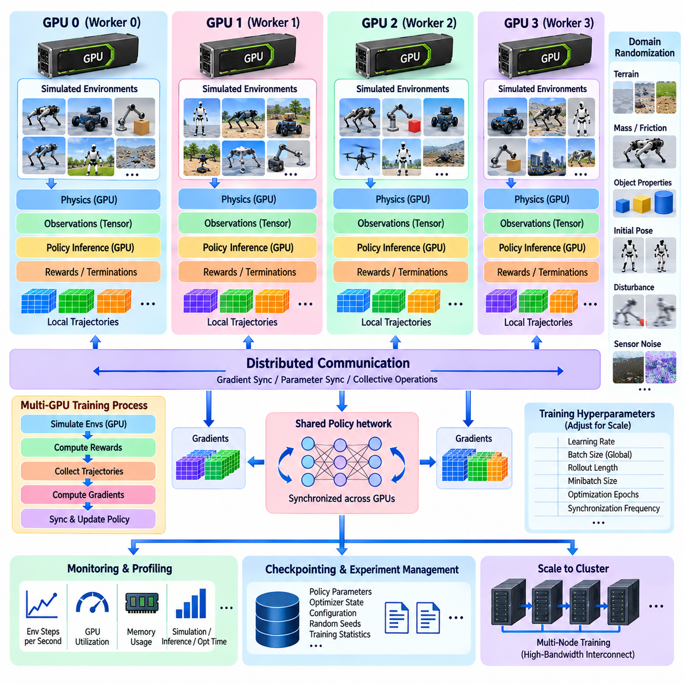
Isaac Lab extends GPU-accelerated robot simulation from single-device parallelism toward multi-GPU distributed reinforcement learning, where larger populations of simulated environments can be divided across several accelerators. Instead of forcing one GPU to execute every environment and learning operation, distributed training assigns groups of environments to separate GPU workers. Each worker generates experience locally while participating in the optimization of a shared robot policy.
The basic scaling unit is a training process associated with a GPU. Each process owns a subset of simulated environments, executes physics simulation, constructs observations, evaluates the policy, calculates rewards, and collects trajectories. If four GPUs are available, for example, the total environment population can be partitioned into four groups. This architecture preserves efficient GPU-local simulation while increasing the aggregate amount of experience generated during each training interval.
A distributed reinforcement learning architecture must coordinate simulation and learning without reintroducing the communication bottlenecks that GPU-resident simulation was designed to eliminate. Environment states normally remain local to the GPU responsible for their simulation rather than being continuously copied between devices. Only information required for distributed learning, such as neural-network gradients, parameters, or selected training statistics, needs to be exchanged among workers.
Data-parallel training is a natural model for this architecture. Each GPU maintains a replica of the policy network and processes observations generated by its local environment population. During optimization, workers calculate gradients from their own trajectory batches. A distributed communication mechanism then aggregates or synchronizes these gradients so that the policy replicas remain consistent. After synchronization, each worker continues simulation using the updated policy parameters.
This design separates environment parallelism from model synchronization. Environment parallelism increases experience throughput by executing more robot instances simultaneously, while distributed optimization combines learning information produced by those independent populations. The two forms of parallelism must be balanced carefully. Excessive synchronization can reduce scalability, whereas infrequent synchronization can cause workers to train on increasingly different policy states depending on the reinforcement learning algorithm.
Isaac Lab environments are particularly suitable for this organization because robot states, observations, actions, rewards, and termination signals can be represented through batched tensor operations. Each GPU can therefore execute a complete local simulation-learning pipeline with limited dependence on the CPU. Physics computation and policy inference remain close to the environment data, while communication between GPUs is concentrated around the information that must be globally coordinated.
The total number of simulated environments does not need to be concentrated on a single accelerator. A complex robot task that reaches the memory or computation limit of one GPU can distribute its environment population across multiple devices. This becomes increasingly important for humanoids, quadrupeds, mobile manipulators, and other articulated systems whose state dimensions, contact calculations, observations, and policy networks may require substantial GPU resources.
Multi-GPU scaling is not automatically linear. When the number of GPUs increases, communication and synchronization costs also increase. Gradient exchange, collective operations, trajectory preparation, checkpointing, and coordination between processes consume time that does not directly advance simulated physics. The practical objective is therefore not simply to maximize GPU count but to increase useful environment steps and policy updates per unit of wall-clock time.
Communication topology becomes important as training systems grow. GPUs connected through high-bandwidth device interconnects can exchange learning data more efficiently than accelerators communicating through slower paths. When training extends across multiple compute nodes, network bandwidth and latency become additional constraints. Distributed reinforcement learning architecture must consequently consider GPU topology, interconnect performance, process placement, and communication frequency as part of simulation-system design.
Batch size also changes with distributed execution. Every worker contributes trajectories from its local environments, so the effective global training batch may grow as additional GPUs are introduced. Larger batches can improve computational efficiency but may alter optimization behavior. Learning rate, rollout length, minibatch size, number of optimization epochs, and other reinforcement learning hyperparameters may therefore require adjustment when moving from single-GPU experiments to distributed training.
Randomization benefits directly from the larger environment population. Different workers can simulate distinct combinations of terrain, robot parameters, friction, actuator characteristics, initial conditions, disturbances, and task configurations. The combined experience presented to the learning algorithm can therefore cover a broader distribution of physical conditions during the same wall-clock interval. This is particularly useful for robust control policies intended for eventual Sim2Real deployment.
Distributed training also requires deterministic experiment management where reproducibility matters. Random seeds, environment identifiers, configuration files, policy versions, checkpoints, and training statistics should be tracked across processes. Without coordinated experiment configuration, differences between workers can become difficult to distinguish from intentional domain randomization. Large-scale training therefore combines simulation architecture with disciplined configuration and data management.
Failure handling becomes more significant as the number of processes and GPUs increases. A single-device experiment has relatively few components that can interrupt execution, whereas distributed training introduces multiple workers, communication groups, storage operations, and synchronization points. Periodic checkpointing allows policy parameters, optimizer states, and relevant training progress to be preserved so that expensive long-running experiments do not necessarily need to restart from the beginning after interruption.
Monitoring should distinguish simulation performance from learning performance. Useful measurements include environment steps per second, physics step time, policy inference time, optimization time, GPU utilization, GPU memory consumption, synchronization overhead, and communication latency. Reward curves alone cannot reveal whether distributed resources are being used efficiently. Performance profiling is therefore necessary to identify whether simulation, neural-network computation, communication, or data handling limits scalability.
Multi-GPU training is especially valuable when a single GPU already executes a well-vectorized workload and additional throughput is genuinely required. Poorly vectorized environments, expensive CPU callbacks, excessive rendering, or frequent host-device transfers should generally be addressed before distribution. Adding GPUs to an inefficient pipeline may simply reproduce the same bottlenecks across more hardware rather than delivering proportional acceleration.
The resulting architecture forms a hierarchy of parallelism. Within each GPU, thousands of environments may execute through vectorized physics and batched policy inference. Across GPUs, multiple workers generate experience concurrently and synchronize learning updates. Across compute nodes, the same principle can expand into cluster-scale training. Isaac Lab therefore provides a path from local GPU simulation toward distributed robot-learning infrastructure while preserving the GPU-centric principles established by massively parallel simulation.

11.04. GPU Vectorized Physics Simulation Custom Kernels [w/Code]
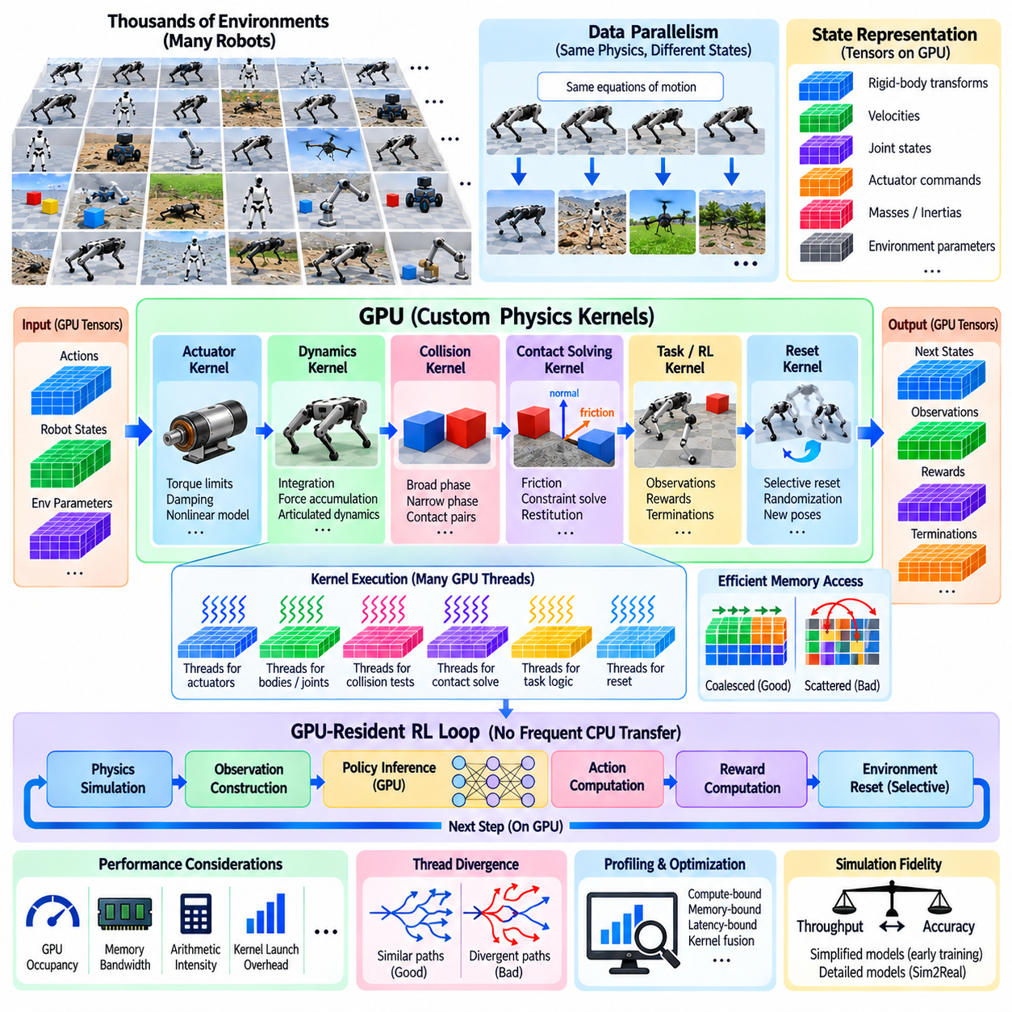
GPU-vectorized physics simulation transforms robot dynamics from a sequence of per-environment calculations into large parallel numerical operations executed across thousands of GPU threads. Instead of advancing each robot independently through CPU loops, states from many simulated environments are organized into tensors or structured buffers. Position, velocity, force, joint, constraint, and contact data can then be processed concurrently, enabling massive simulation throughput for reinforcement learning and Physical AI workloads.
The central principle is data parallelism. Thousands of simulated robots may share the same equations of motion while operating with different numerical states. A GPU can assign these similar calculations to many parallel threads, allowing integration, force accumulation, actuator evaluation, and constraint processing to occur across large batches. The simulation workload therefore becomes a collection of vectorized numerical kernels rather than repeated calls to independent robot simulators.
Efficient vectorization begins with the organization of simulation state. Rigid-body transforms, linear and angular velocities, joint coordinates, actuator commands, masses, inertias, and environment parameters should be stored in layouts that permit efficient parallel memory access. Poorly arranged data can force GPU threads to perform scattered memory transactions, while contiguous or coalesced access patterns allow the memory subsystem to deliver substantially higher effective bandwidth.
Custom GPU kernels provide a mechanism for implementing simulation operations that are not efficiently expressed through general-purpose simulator interfaces. A kernel can execute a specialized computation across every robot, joint, contact, or environment simultaneously. Typical examples include custom actuator dynamics, reward calculations, observation construction, terrain interaction logic, state filtering, reset operations, or application-specific physical approximations required by a particular robotic system.
Kernel design normally maps individual computational elements onto GPU threads. One thread may process a rigid body, joint, contact candidate, or environment state, while thread blocks coordinate groups of related calculations. The appropriate mapping depends on workload structure and data dependencies. Highly independent calculations parallelize naturally, whereas algorithms containing sequential dependencies, irregular branching, or extensive synchronization require more careful decomposition to obtain useful GPU acceleration.
Rigid-body dynamics illustrates the challenge. Some operations, such as applying gravity or integrating independent body states, can be parallelized easily. Articulated robot dynamics introduces dependencies through kinematic trees and joint constraints, while collision and contact processing creates dynamically changing interaction graphs. Efficient GPU physics therefore combines straightforward data-parallel kernels with specialized algorithms for constraint solving, articulated systems, collision detection, and contact response.
Collision detection is commonly divided into broad-phase and narrow-phase processing. Broad-phase algorithms identify potentially interacting object pairs while attempting to avoid unnecessary geometric tests. Narrow-phase algorithms then determine detailed contact information for candidate pairs. In massively parallel environments, these operations must handle different numbers of objects and contacts in each scene, creating irregular workloads that can reduce GPU efficiency if not carefully organized and scheduled.
Contact solving presents another computational challenge because contacts couple physical bodies through constraints. Friction, penetration correction, restitution, joint limits, and other constraints may require iterative numerical solution. Parallel solvers attempt to expose as much independent work as possible while preserving acceptable physical accuracy and numerical stability. The objective is not merely to execute many threads, but to organize constraint computations so that synchronization and memory contention remain manageable.
Custom kernels are particularly valuable when robot models contain specialized actuator behavior. Real motors may include torque limits, velocity-dependent output, gearbox effects, compliance, damping, command latency, thermal restrictions, or nonlinear response. Instead of processing these effects through CPU callbacks for every simulated robot, a GPU kernel can evaluate the actuator model across thousands of joints simultaneously and write the resulting forces or torques directly into simulation buffers.
The same approach can accelerate reinforcement-learning task logic. Observation vectors may require coordinate transformations, velocity normalization, terrain sampling, contact-state extraction, target-relative features, and history processing. Rewards may combine tracking error, energy consumption, stability, collisions, joint limits, and task completion. Implementing these operations as batched GPU expressions or custom kernels avoids repeatedly transferring simulation state to the CPU merely to calculate learning signals.
Environment reset is another highly parallel operation. When hundreds of environments terminate during the same training interval, their robot poses, velocities, object locations, targets, and randomized parameters can be regenerated simultaneously. A vectorized reset kernel modifies only the selected environment indices. This selective GPU-side reset prevents the entire simulation population from stopping and avoids reconstructing complete scenes through expensive sequential control logic.
Performance depends heavily on minimizing CPU-GPU transfers. A fast physics kernel provides limited benefit if simulation states are copied to host memory after every step. High-throughput architectures therefore keep physics buffers, observations, actions, rewards, termination masks, and learning tensors on the GPU whenever possible. The ideal control loop advances physics, constructs observations, performs policy inference, computes actions, evaluates rewards, and resets environments without requiring routine host synchronization.
Kernel launch overhead also matters when simulation time steps are short. Executing many tiny kernels can introduce substantial scheduling overhead relative to the useful computation performed by each kernel. Kernel fusion can combine compatible operations, such as observation transformation and normalization, into fewer launches. However, excessive fusion may increase register pressure or reduce flexibility, so kernel boundaries should reflect both algorithmic structure and measured GPU performance.
Thread divergence is another source of inefficiency. GPU threads execute most efficiently when neighboring threads follow similar control paths. Robot simulation often contains conditional behavior caused by contacts, failures, different terrain types, or varying joint configurations. If threads within the same execution group follow many different branches, hardware utilization decreases. Vectorized physics implementations therefore attempt to organize workloads so that similar computational paths are processed together whenever practical.
GPU occupancy, memory bandwidth, arithmetic intensity, and synchronization cost provide more useful optimization information than raw thread count. A kernel may launch millions of threads while still performing poorly because it is limited by memory access or synchronization. Profiling tools can reveal whether execution is compute-bound, memory-bound, latency-bound, or dominated by kernel launches. Optimization should consequently be driven by measured bottlenecks rather than by parallelism alone.
Numerical accuracy must remain part of the design. Aggressive optimization, reduced precision, larger integration steps, simplified contacts, or approximate custom physics can improve throughput but may alter learned robot behavior. The required fidelity depends on the purpose of the simulation. Early policy exploration may tolerate simplified dynamics, while final Sim2Real validation may require more accurate actuator, contact, friction, delay, and sensor models.
GPU-vectorized physics ultimately provides the computational foundation for scaling robot simulation beyond conventional sequential execution. Efficient state layouts expose data parallelism, physics kernels advance thousands of systems concurrently, and custom kernels move robot-specific calculations directly onto the accelerator. Combined with GPU-resident learning and distributed execution, these techniques enable the massive parallel simulation architecture required by subsequent cloud-scale simulation, scheduling, data collection, and large robot-policy training workflows.

11.05. Cloud Scale Simulation Farm AWS Azure GCP [w/Code]
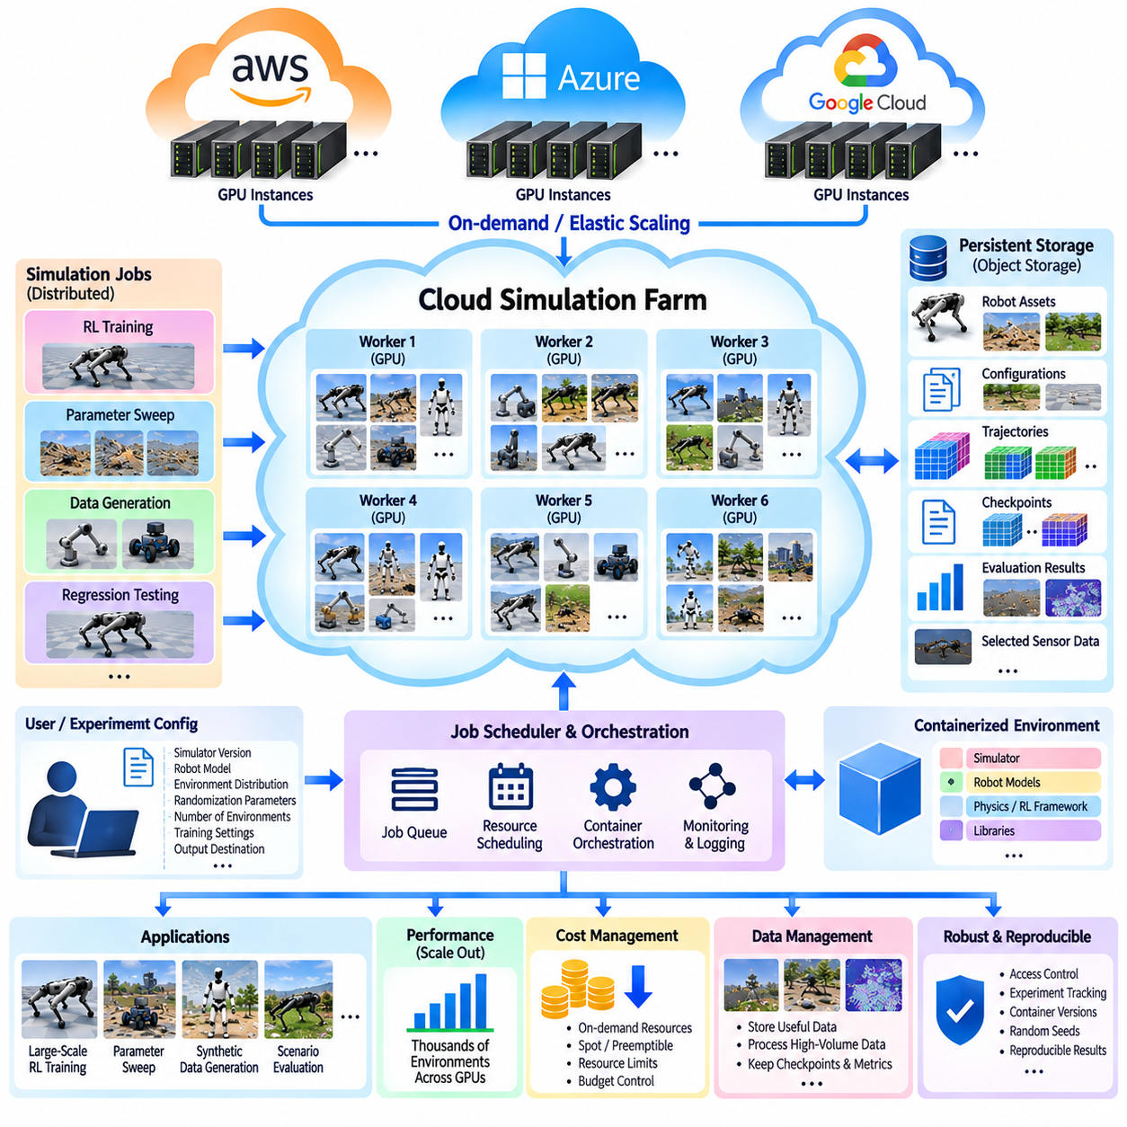
Cloud-scale simulation farms extend robot simulation beyond the capacity of a local workstation or on-premise GPU cluster by combining many compute instances into an elastic simulation infrastructure. Instead of maintaining a fixed number of GPUs that must remain available even when experiments are inactive, cloud resources can be allocated when large simulation workloads are required. This model is particularly useful for reinforcement learning, synthetic data generation, large parameter sweeps, regression testing, and other workloads that benefit from massive parallel execution.
A cloud simulation farm typically separates the workload into independent simulation jobs that can be distributed across virtual machines or GPU-enabled compute instances. Each worker executes a defined set of simulation environments, collects trajectories or evaluation results, and reports them to shared storage or a central coordination service. The architecture therefore transforms simulation into a batch-computing problem in which thousands of environments can be distributed across many GPU workers without requiring every simulation to run on the same physical machine.
AWS, Azure, and Google Cloud Platform provide different combinations of GPU-enabled virtual machines, object storage, networking, container orchestration, monitoring, and job-management services that can support this architecture. The specific service names and available GPU configurations change over time, so the architectural principle is more important than dependence on one provider. A portable simulation system should define workloads, containers, data interfaces, checkpoints, and job metadata independently from the underlying cloud infrastructure whenever practical.
Containerization is a fundamental component of a reproducible simulation farm. A simulator, robot model, physics configuration, reinforcement-learning framework, and required libraries can be packaged into a container image. Workers can then launch the same software environment across many cloud instances. This reduces configuration differences between machines and makes it easier to reproduce experiments, migrate workloads between infrastructure providers, and maintain consistent simulation versions during long-running research programs.
Object storage provides the persistent data layer for large simulation workloads. Robot assets, environment models, configuration files, generated trajectories, evaluation results, checkpoints, and selected sensor data can be stored independently of the compute instances executing the simulations. This separation is important because cloud workers may be created and terminated dynamically. Persistent storage therefore preserves experiment outputs even when the temporary compute resources used to generate them are released.
A job-management layer coordinates the simulation farm. An experiment can be described by a configuration containing the simulator version, robot model, environment distribution, randomization parameters, number of environments, training settings, and output destination. The scheduler converts this experiment description into executable jobs and assigns them to available GPU workers. Large experiments can consequently be divided into many smaller tasks that execute concurrently rather than requiring one extremely large machine.
Cloud-scale simulation is especially useful for parameter sweeps and scenario exploration. Different workers can evaluate different combinations of friction, mass, actuator characteristics, terrain properties, initial states, disturbances, sensor noise, or control parameters. Instead of changing one parameter at a time on a local machine, thousands of combinations can be evaluated concurrently. The resulting dataset can then be analyzed to identify robust configurations, failure regions, performance boundaries, or promising learning conditions.
Reinforcement learning introduces a slightly different workload pattern because simulation and policy optimization are coupled. Workers may generate trajectories locally while a learner aggregates experience and updates the policy. Depending on the architecture, workers can periodically receive new policy parameters, calculate local rollouts, and return experience to the training system. The communication pattern must be designed carefully because excessive network synchronization can consume the performance gained from adding more cloud GPUs.
Cloud networking therefore becomes part of simulation architecture rather than merely an infrastructure detail. Large distributed training jobs may exchange model parameters, gradients, trajectory metadata, checkpoints, or monitoring information between workers. High-bandwidth communication can be important when synchronization occurs frequently, while independent batch simulation can tolerate much weaker coupling. Workload architecture should consequently match network requirements to the actual dependency structure of the simulation and learning algorithm.
Elastic scaling is one of the principal advantages of cloud execution. A small development workload can use a single GPU instance, while a large experiment can temporarily expand to dozens or hundreds of workers. After the experiment finishes, unused instances can be released. This allows computational capacity to follow experimental demand rather than requiring permanent ownership of the maximum hardware capacity. However, scaling should be controlled through explicit resource limits, job priorities, and budget policies.
Cost management becomes essential when simulation workloads operate at large scale. GPU instances can be expensive, particularly when high-end accelerators are used continuously. Simulation jobs should therefore measure useful throughput rather than simply total compute consumption. Metrics such as environment steps per second, successful training updates, completed experiments, and useful evaluation scenarios provide a better basis for determining whether additional cloud resources produce meaningful benefits.
Preemptible or spot-style compute resources can reduce costs for workloads that tolerate interruption. Such resources are appropriate when simulation jobs can periodically save checkpoints and resume from previously completed work. Fault-tolerant job design is therefore closely connected to cloud cost optimization. A worker failure should ideally terminate only a portion of the experiment rather than invalidate the entire simulation campaign.
Cloud-scale simulation also requires careful data-volume management. Storing every rendered frame, point cloud, contact state, and internal physics variable from millions of simulation steps can quickly become impractical. A useful architecture distinguishes between information required for learning, information required for validation, and information required only for debugging. High-volume intermediate data can be processed locally, while compact trajectories, metrics, checkpoints, and selected failure cases are transferred to persistent storage.
Security and reproducibility must remain part of the simulation-farm design. Access to simulation assets, experiment configurations, trained policies, and generated datasets should be controlled according to project requirements. Experiment identifiers, container versions, configuration files, random seeds, simulator versions, and checkpoints should be recorded so that results can be traced back to the exact computational conditions that produced them. This becomes increasingly important when many workers execute different experiments concurrently.
A mature cloud simulation farm therefore behaves more like a distributed computational platform than a collection of remote GPU machines. Containers provide reproducible execution, object storage provides persistent data management, scheduling distributes workloads, GPU workers execute parallel environments, networking supports required synchronization, and monitoring measures utilization and performance. AWS, Azure, and Google Cloud Platform can provide the underlying infrastructure, while the simulation architecture determines how effectively those resources are converted into robot-learning experience and validation results.
For Physical AI development, the ultimate purpose of cloud-scale simulation is not simply to rent more GPUs. The objective is to create an elastic experimental system capable of generating large quantities of diverse physical experience, testing broad scenario spaces, training policies, evaluating failures, and preserving reproducible results. When combined with vectorized GPU simulation and multi-GPU distributed learning, a simulation farm provides the infrastructure needed to move from individual experiments toward systematic, large-scale robot intelligence development.

11.06. Simulation Resource Scheduling and Job Queue [w/Code]
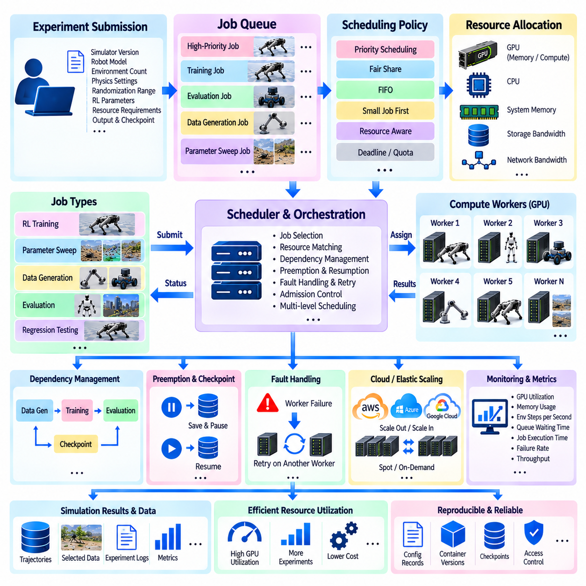
A large-scale simulation system may contain thousands of environments, multiple GPU workers, different simulation models, and many experiments competing for the same computational resources. Without resource scheduling, jobs can consume GPUs unpredictably, memory can become oversubscribed, and high-priority experiments may be delayed by long-running background workloads. Resource scheduling therefore provides the control layer that determines which simulation jobs execute, where they execute, how much hardware they receive, and when they should be paused, resumed, or terminated.
A simulation job should be treated as a structured computational unit rather than simply as a program that occupies a GPU. Its configuration can describe the simulator version, robot model, environment count, physics settings, randomization range, reinforcement-learning parameters, required GPU memory, expected execution time, output location, and checkpoint policy. The scheduler uses this information to determine whether a job can be placed on an available worker. This makes resource allocation more predictable and allows different experiments to coexist within the same simulation infrastructure.
The job queue provides an intermediate layer between experiment submission and actual execution. When researchers submit more experiments than the available GPUs can immediately execute, jobs are placed into a waiting state rather than launching indiscriminately. The queue can maintain metadata such as priority, resource requirements, submission time, experiment owner, dependency status, and estimated duration. Workers retrieve eligible jobs as resources become available. This separates experiment demand from instantaneous hardware availability and creates a controlled execution model.
Scheduling policy determines the order in which waiting jobs are selected. A simple first-in-first-out strategy can provide predictable behavior, but large robotics projects often require additional policies. High-priority validation experiments may need access to resources before exploratory training, while small jobs may be scheduled alongside large jobs to improve overall utilization. Fair-share scheduling can prevent one user or project from continuously occupying the available GPUs. The scheduler should therefore balance priority, fairness, resource efficiency, and project deadlines.
GPU allocation must consider more than the number of available devices. Different simulation jobs may require different amounts of GPU memory, compute capacity, CPU resources, system memory, storage bandwidth, and network bandwidth. A lightweight physics workload may efficiently share a machine with another compatible workload, while a large simulation requiring most of the GPU memory should receive exclusive access. Resource-aware scheduling prevents situations in which a GPU appears available but cannot actually execute the requested workload because of memory or compute constraints.
Simulation environments themselves can also become scheduling units. A large experiment containing tens of thousands of environments can be divided into smaller batches and distributed across multiple workers. The scheduler may assign a fixed number of environments to each GPU according to available memory and measured simulation throughput. This approach makes it possible to scale an experiment gradually rather than requiring a single machine capable of hosting the complete environment population. The resulting allocation can also adapt to heterogeneous GPU resources.
Dependencies are important when simulation is part of a larger experimental pipeline. A policy-training job may depend on a dataset-generation job, while evaluation may depend on a completed training checkpoint. A simulation farm can represent these relationships explicitly so that downstream jobs are released only when required inputs become available. This prevents wasted computation caused by launching an evaluation job before its policy or data has been generated and supports automated experiment pipelines.
Long-running reinforcement-learning experiments introduce another scheduling consideration because their resource demand may persist for many hours or days. The scheduler should distinguish between jobs that require continuous execution and workloads that can be interrupted safely. Checkpoint-enabled jobs can potentially be paused when higher-priority work arrives and resumed later. This form of preemption allows scarce GPU resources to be dynamically reassigned while protecting previously completed training progress.
Fault handling should be integrated with queue management. A worker may fail because of hardware problems, software errors, memory exhaustion, network interruption, or simulator instability. The scheduler should detect abnormal job termination and record the failure state rather than treating the worker as permanently available. If a valid checkpoint exists, the job can potentially be returned to the queue for recovery on another worker. Retry limits are useful because repeatedly restarting a fundamentally defective configuration can waste substantial computational resources.
Resource scheduling also benefits from separating development, training, validation, and production-style workloads. Interactive debugging generally requires rapid access to a small amount of compute, whereas large reinforcement-learning experiments can tolerate queue delays if they receive substantial GPU capacity later. Regression testing may require predictable execution windows, while parameter sweeps may consist of many independent jobs that can fill otherwise unused resources. Different queue classes allow the same infrastructure to support these distinct operating patterns without treating every workload identically.
Monitoring provides the feedback required to improve scheduling decisions. The system can measure GPU utilization, memory consumption, environment steps per second, job execution time, queue waiting time, failure frequency, simulation throughput, and resource allocation efficiency. These measurements reveal whether GPUs are being underutilized, whether jobs are waiting excessively, or whether particular workloads consistently consume more resources than expected. Historical measurements can also improve future resource estimates and scheduling decisions.
A useful scheduler should support admission control so that resource demand does not exceed practical system capacity. If every submitted experiment immediately attempts to reserve large numbers of GPUs, the system can become unstable even when individual jobs are valid. Admission control can limit the total number of active environments, GPU reservations, memory consumption, storage traffic, or concurrent jobs. This provides a controlled boundary between experiment demand and available infrastructure and is particularly important in shared cloud or on-premise environments.
Cloud-based simulation farms introduce additional scheduling dimensions because resources can be created dynamically. A scheduler may decide whether to wait for an existing GPU, start a new cloud instance, use a lower-cost preemptible resource, or postpone the workload until a suitable resource becomes available. These decisions should consider expected job duration, urgency, checkpoint capability, GPU requirements, and cost constraints. Resource scheduling therefore becomes closely connected with elastic scaling and cloud cost optimization.
For massive simulation campaigns, the scheduler can operate at several levels simultaneously. A project-level scheduler may allocate a total GPU budget to an experiment, while a cluster-level scheduler distributes individual jobs across machines. Each worker can then perform local scheduling of simulation environments and training batches. This hierarchy prevents every environment from competing directly for global resources and allows local execution mechanisms to remain optimized while higher-level systems manage fairness, capacity, and experiment priorities.
The ultimate purpose of simulation resource scheduling is to convert limited computational capacity into predictable experimental throughput. A well-designed system does not simply maximize instantaneous GPU utilization; it coordinates job priority, resource requirements, queue behavior, environment allocation, dependencies, checkpointing, fault recovery, monitoring, and cost. When integrated with GPU-vectorized simulation, distributed reinforcement learning, and cloud-scale infrastructure, the job queue becomes an essential control mechanism for operating massive robot simulation workloads reliably and efficiently.

11.07. Parallel Sim Data Collection Pipeline for RL [w/Code]
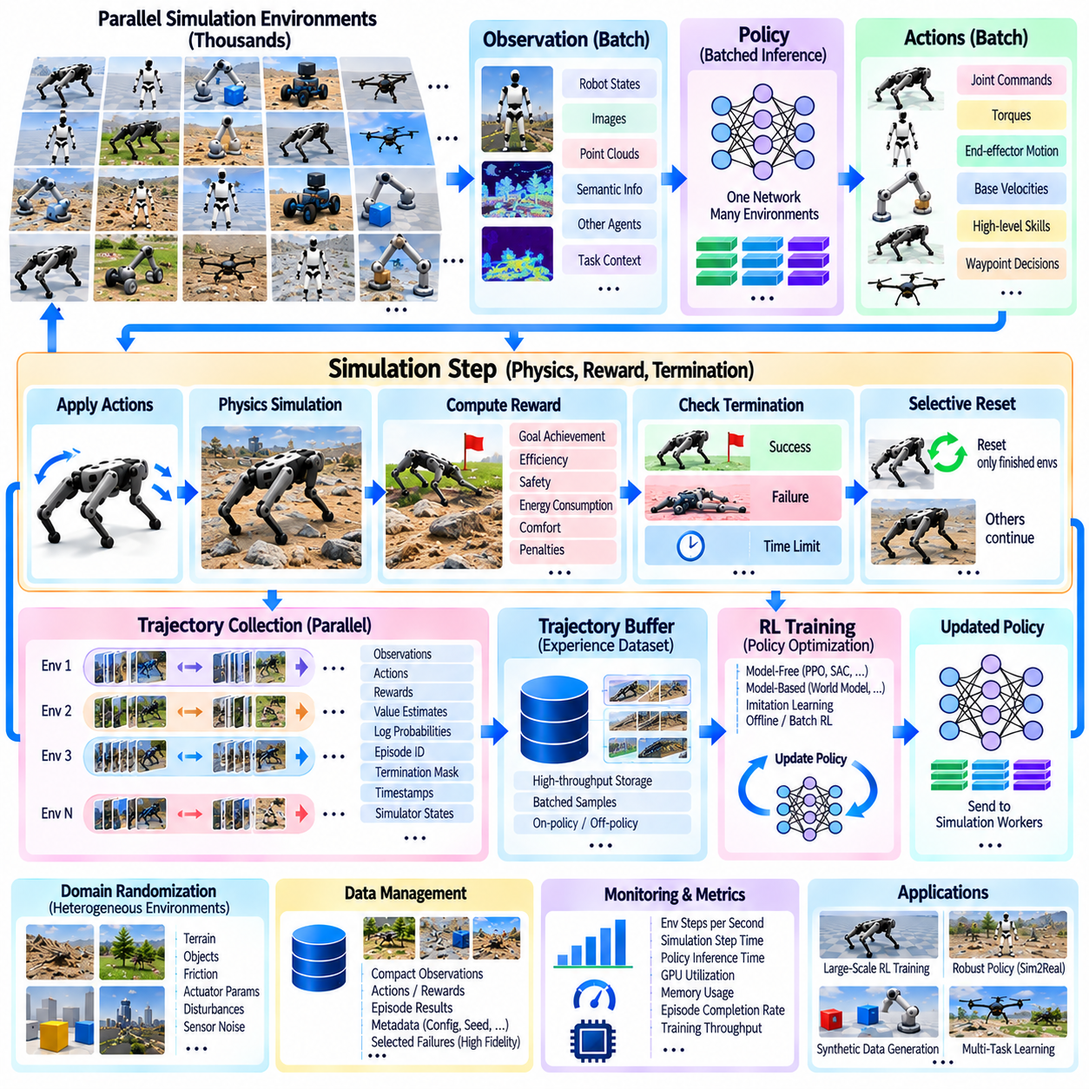
Parallel simulation changes reinforcement learning data collection from a sequential interaction process into a high-throughput experience generation pipeline. Instead of allowing one robot environment to produce one trajectory at a time, thousands of simulated environments can operate concurrently. Each environment repeatedly produces observations, actions, rewards, and termination signals, creating a large stream of experience for policy optimization. This approach is particularly important for Physical AI because learning complex robot behaviors requires diverse interaction data covering different states, tasks, environments, and physical conditions.
The pipeline begins with a population of parallel simulation environments containing robots, objects, terrain, sensors, and task definitions. Each environment maintains an independent physical state while sharing common robot and simulation assets whenever possible. At every simulation step, the physics engine advances the environment and produces the current state. The observation layer then converts physical information into the representation consumed by the policy. Depending on the task, observations may include robot states, images, point clouds, semantic information, localization, other agents, mission context, or multimodal sensor representations.
The policy receives a batch of observations from many environments and produces a corresponding batch of actions. For continuous-control robots, actions may represent velocities, torques, joint commands, end-effector movements, or other control quantities. For higher-level systems, actions may represent modes, skills, tasks, or waypoint decisions. Batched policy inference allows one neural-network execution to process observations from a large environment population. The resulting actions are returned to the corresponding environments, closing the interaction loop while keeping the major computation on the GPU whenever possible.
After actions are applied, the simulator advances the physical state and calculates task-specific rewards. Reward design can represent goal achievement, efficiency, safety, energy consumption, comfort, collaboration, and penalties for undesirable or risky behavior. The reward signal should remain synchronized with the observation and action that produced it. In parallel collection, every environment can generate its own reward and termination state, allowing successful episodes, failed episodes, and time-limited episodes to coexist within the same batch without stopping the complete simulation population.
Each environment generates a trajectory containing a sequence of observations, actions, rewards, and associated state information. Depending on the learning algorithm, additional information may include value estimates, log probabilities, hidden states, episode identifiers, termination masks, timestamps, or simulator-specific physical quantities. The trajectory buffer organizes these records into batches suitable for policy optimization. Because thousands of environments can produce data simultaneously, the system can accumulate substantial experience within a relatively short wall-clock interval compared with real-robot interaction.
Parallel collection is especially effective when the environment population is heterogeneous. Different instances can begin from different initial states and use different terrain, object configurations, friction values, actuator parameters, disturbances, or sensor noise. Domain randomization can therefore be applied during data generation rather than as a separate sequential experiment. The resulting experience represents a distribution of physical conditions, helping the policy learn behavior that is less dependent on one fixed simulation configuration and providing an important foundation for Sim2Real adaptation.
Episode termination introduces an important implementation requirement. In a large environment batch, some robots may complete their tasks while others continue operating. The data pipeline should therefore identify terminated environments independently and reset only those instances. New initial states, targets, objects, and randomized parameters can be generated while the remaining environments continue collecting experience. This selective reset mechanism prevents computational resources from being wasted and maintains a continuous flow of training data across the complete simulation population.
The collected experience can be processed using different reinforcement learning paradigms. Model-free methods learn directly from sampled interaction experience, while model-based methods can use collected trajectories to improve a learned dynamics or world model and subsequently support prediction and planning. Imitation learning can incorporate demonstration trajectories, while offline or batch reinforcement learning can train from previously collected datasets. The same parallel simulation infrastructure can therefore support multiple learning approaches by changing how trajectories are stored, sampled, and consumed.
Data management becomes increasingly important as the simulation scale grows. Not every internal simulator variable needs to be permanently stored. High-frequency physics states may be retained only when required for training or debugging, while compact observations, actions, rewards, episode outcomes, and metadata can form the primary learning dataset. Selected failures and unusual scenarios can be preserved at higher fidelity for later analysis. This distinction prevents storage requirements from growing unnecessarily with the number of simulated environments and simulation steps.
The pipeline should also maintain reproducibility across large experiments. Simulation version, robot model, environment configuration, randomization parameters, random seeds, policy checkpoint, control frequency, environment count, and training configuration should be associated with collected trajectories. Consistent timestamps and identifiers are particularly important when multimodal observations are involved. Such metadata allows a trajectory to be traced back to the computational conditions that produced it and makes comparisons between experiments more meaningful.
Performance monitoring connects data quality with computational efficiency. Important measurements include environment steps per second, simulation step time, policy inference time, GPU utilization, memory consumption, trajectory-buffer usage, episode completion rate, and effective training throughput. A system that generates enormous quantities of data but spends most of its time transferring tensors or waiting for synchronization may not provide useful scaling. Profiling should therefore examine the complete path from physics simulation through observation construction, policy inference, reward computation, trajectory storage, and learning.
The complete pipeline can be viewed as a continuous loop: parallel environments generate physical states, observations are constructed, the policy produces actions, the simulator advances, rewards and termination signals are calculated, trajectories are stored, and the learning algorithm updates the policy. The updated policy is then returned to the simulation workers for another collection cycle. This creates the foundation for large-scale reinforcement learning and connects naturally with Isaac Gym, Isaac Lab, GPU-vectorized physics, distributed training, synthetic data generation, Sim2Real adaptation, and continuous Physical AI learning pipelines.

11.08. Fault Tolerant Distributed Simulation Checkpointing [w/Code]
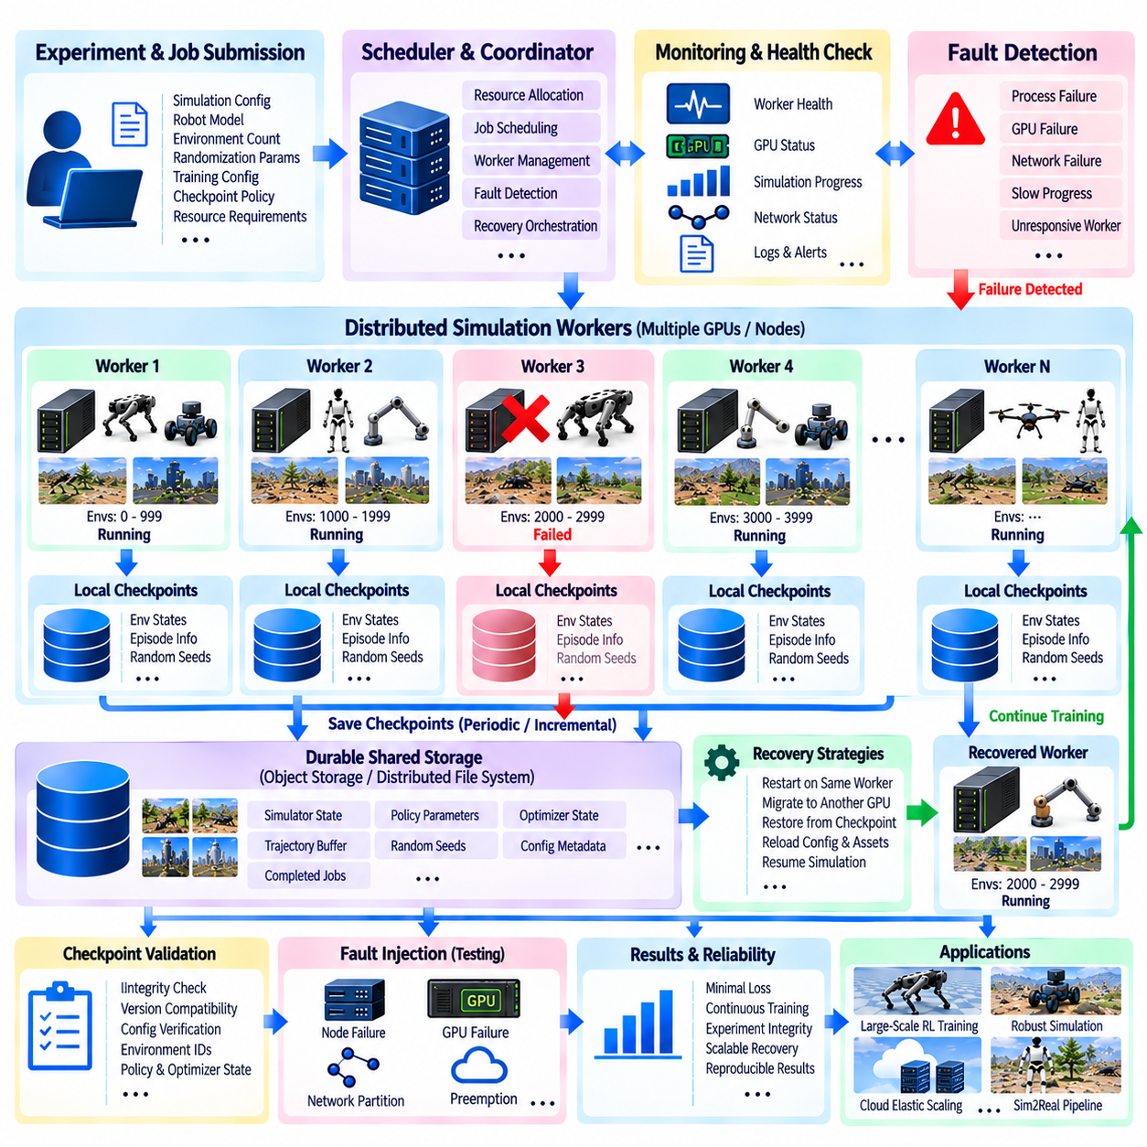
Fault-tolerant distributed simulation is designed to maintain useful simulation progress even when individual compute workers, GPU devices, network links, or software processes fail. As simulation farms grow from a few GPUs to many machines and distributed nodes, the probability of encountering an individual failure during a long experiment also increases. A reliable architecture therefore treats failure as an expected operating condition rather than an exceptional event. The objective is not necessarily to keep every worker running continuously, but to preserve experiment integrity and recover useful computation with minimal loss.
A distributed simulation workload is normally divided among multiple workers, with each worker responsible for a subset of simulation environments. Each worker maintains local physics states, observations, actions, rewards, episode information, and other runtime data. A central coordinator or distributed control layer tracks worker health, job status, progress, and resource allocation. When one worker becomes unavailable, the system should determine which simulation environments were affected and whether their computation can be reconstructed or resumed without invalidating the results generated by other workers.
Checkpointing provides the primary mechanism for preserving distributed simulation progress. A checkpoint records sufficient state to restart an experiment from a known computational point rather than beginning again from the initial configuration. Depending on the simulation and learning algorithm, this may include robot states, environment states, randomization parameters, episode counters, policy parameters, optimizer state, trajectory buffers, random seeds, configuration metadata, and completed-job information. The required checkpoint contents should be defined according to the recovery objective rather than storing every internal simulator variable indiscriminately.
Checkpoint frequency represents a tradeoff between recovery capability and storage overhead. Very frequent checkpoints reduce the amount of computation that can be lost after a failure, but they increase storage traffic and may interrupt simulation or learning performance. Infrequent checkpoints reduce overhead but can result in substantial recomputation. A practical system therefore selects checkpoint intervals according to job duration, failure probability, storage bandwidth, simulation cost, and the ability to regenerate lost experience.
For large parallel environment populations, global checkpoints are not always necessary. A worker-level or shard-level checkpoint can preserve the state of only the environments assigned to that worker. If one GPU process fails, other workers can continue operating while the failed shard is recovered from its most recent checkpoint. This localized recovery strategy prevents a single failure from forcing the entire simulation campaign to restart and is particularly valuable when thousands of environments are distributed across many independent workers.
The checkpoint must also preserve consistency across simulation and learning state. Saving only the simulator state may be insufficient when reinforcement learning is running concurrently because the policy parameters, optimizer state, rollout position, and trajectory buffers may no longer correspond to the saved physical state. Conversely, saving only the neural-network model cannot reconstruct the exact simulation population. A consistent checkpoint therefore defines a recovery boundary at which the relevant simulation, learning, randomization, and data-collection states are mutually compatible.
Distributed synchronization introduces another consistency requirement. Workers may progress at slightly different speeds because their environments have different computational complexity. If checkpoints are created independently without recording the corresponding global progress, recovery can produce duplicated or missing experience. The system should therefore associate checkpoints with global experiment identifiers, worker identifiers, environment ranges, training iterations, timestamps, and other metadata required to determine exactly what computation has already been committed.
Random-number state is especially important for reproducibility. Large-scale simulation frequently uses random initialization and domain randomization for terrain, friction, actuator parameters, disturbances, object placement, and sensor characteristics. If the random-number generator state is not preserved, restarting from a checkpoint may generate different physical conditions and therefore produce a different trajectory. Exact reproducibility may not always be required, but the architecture should explicitly distinguish deterministic recovery from statistically equivalent recovery.
Worker failure detection normally depends on health monitoring and heartbeat mechanisms. A coordinator can track process liveness, GPU status, simulation progress, communication state, and expected update intervals. If a worker stops responding or its progress falls outside an acceptable range, the system can mark it as failed and prevent additional work from being assigned to it. This allows the remaining workers to continue while the failed workload is isolated and prepared for recovery.
Network failures require different treatment from compute failures. A temporary communication interruption does not necessarily mean that the simulation worker itself has failed. The system should distinguish latency, packet loss, temporary disconnection, network partition, and complete worker failure because each condition requires a different recovery response. In distributed multi-robot and multi-node simulations, network degradation can itself be part of the scenario being evaluated, so infrastructure-level communication faults should not automatically be confused with application-level simulation failures.
Recovery can use several strategies depending on the experiment architecture. A failed worker may restart locally from its latest checkpoint, migrate its simulation shard to another GPU, or reconstruct the affected environments from a durable checkpoint stored in shared or object storage. The replacement worker should receive the correct simulator version, configuration, environment definition, and checkpoint metadata before resuming execution. Recovery should therefore be treated as a controlled state transition rather than simply restarting a process.
Preemption and cloud infrastructure failures make checkpoint-based recovery particularly valuable. A cloud worker may be interrupted because of resource reclamation, infrastructure maintenance, or intentional cost optimization. If the simulation job has periodically preserved valid checkpoints, the scheduler can release or replace the affected resource without discarding the complete experiment. This creates a direct relationship between checkpoint design, fault tolerance, elastic scaling, and economical use of large GPU simulation farms.
Checkpoint storage should be separated from temporary compute resources whenever practical. A checkpoint stored only on the local disk of a failed worker may become inaccessible at precisely the moment it is required for recovery. Durable shared storage or object storage provides a more reliable recovery boundary. At the same time, large checkpoints can generate significant storage and network traffic, so compression, incremental checkpoints, state partitioning, and retention policies can be used to control the resulting data volume.
Recovery validation is necessary before a restored simulation is allowed to continue producing training data. The system should verify checkpoint integrity, simulator and software versions, configuration compatibility, environment identifiers, policy versions, and relevant state metadata. A corrupted or mismatched checkpoint should not silently enter the training pipeline because it could introduce inconsistent trajectories or invalidate experimental conclusions. Recovery should therefore include explicit integrity checks and a controlled transition back to normal execution.
Fault injection can be used to validate whether the distributed simulation architecture actually provides the intended resilience. Workers can be intentionally stopped, communication links can be degraded, network partitions can be introduced, and resource contention can be simulated. Relevant evaluation scenarios include node failure, agent failure, network degradation, network partition, compute migration, recovery and rejoin, and mission continuation or abort. These scenarios are consistent with distributed capability validation requirements where failure and recovery behavior must be observed rather than assumed.
The complete architecture forms a resilient loop in which simulation workers generate experience, checkpoints preserve recoverable state, monitoring detects abnormal conditions, the scheduler isolates failed resources, recovery mechanisms restore affected workloads, and the simulation continues from a controlled state. This approach allows massive parallel simulation to scale without making the entire experiment dependent on uninterrupted operation of every GPU and node. When integrated with distributed reinforcement learning, cloud-scale scheduling, durable data management, and systematic fault injection, checkpointing becomes a fundamental reliability mechanism for large-scale Physical AI simulation infrastructure.

11.09. Simulation Cost Optimization Spot Instances [w/Code]
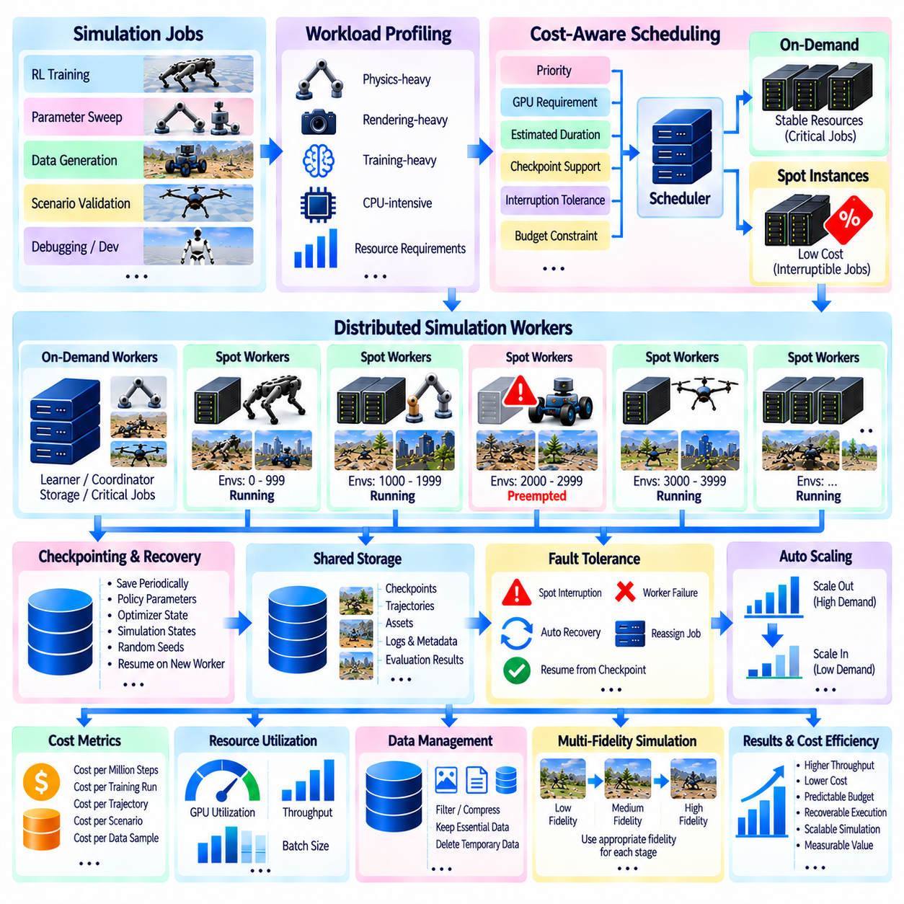
Large-scale robot simulation can consume substantial computational resources because reinforcement learning, synthetic data generation, parameter sweeps, and validation campaigns may require thousands of GPU-hours. Cost optimization therefore becomes an architectural concern rather than a final accounting task. The objective is to maximize useful simulation throughput for a given budget by matching workload characteristics to appropriate compute resources, reducing idle capacity, controlling data movement, and selecting economical execution models without sacrificing experiment integrity.
Simulation cost should be measured relative to useful computational output rather than hardware usage alone. Metrics such as cost per million environment steps, cost per completed training run, cost per generated trajectory, cost per validated scenario, or cost per synthetic-data sample provide a more meaningful view of efficiency. A cheaper GPU instance may become more expensive overall if its lower throughput substantially increases execution time, while a higher-cost accelerator can be economical when it completes significantly more useful simulation work per hour.
Workload profiling provides the foundation for cost-aware resource selection. Physics-heavy simulations, rendering-heavy sensor workloads, neural-network training, and CPU-intensive preprocessing can have very different hardware requirements. A workload limited by GPU memory bandwidth may not benefit proportionally from a more expensive accelerator with greater arithmetic performance. Similarly, lightweight simulation environments may achieve better economics by packing multiple jobs onto moderately sized resources instead of reserving the largest available GPU instance.
Spot or preemptible compute instances provide an important mechanism for reducing the cost of fault-tolerant simulation workloads. Cloud providers can offer unused compute capacity at lower prices while retaining the ability to reclaim that capacity. These resources are therefore best suited to simulations that can tolerate interruption. Parameter sweeps, independent scenario evaluations, synthetic-data generation, and checkpoint-enabled reinforcement-learning jobs can often exploit this model effectively because interrupted work can be restarted or reassigned.
Checkpointing is the key architectural requirement for safely using interruptible resources. A long-running training process that stores no intermediate state may lose hours of computation when a spot instance is reclaimed. Periodic checkpoints preserve policy parameters, optimizer states, simulation progress, randomization information, and other required recovery data. The scheduler can then move the workload to another available resource and resume from a recent recovery point rather than restarting the entire experiment.
Checkpoint frequency itself has an economic dimension. Saving state too frequently consumes storage bandwidth, network traffic, and simulation time, while saving too infrequently increases the amount of computation lost during interruption. The optimal interval depends on checkpoint size, workload cost, expected interruption behavior, storage performance, and recovery time. Cost optimization therefore connects directly with the fault-tolerant checkpointing architecture used by large distributed simulation systems.
Not every workload should use spot capacity. Short interactive debugging sessions, tightly synchronized distributed training, deadline-critical validation, or jobs with expensive recovery procedures may benefit from stable on-demand resources. A mixed-capacity strategy can therefore be more effective. Stable resources can host coordinators, learners, storage services, and critical jobs, while interruptible workers execute independent simulations or expandable portions of the environment population.
Job queues and schedulers enable this mixed-resource strategy. Each simulation job can include information describing priority, GPU requirements, estimated duration, checkpoint capability, interruption tolerance, and budget constraints. The scheduler can use these attributes to determine whether the job should execute immediately on stable capacity, wait for a lower-cost resource, or run on interruptible workers. Cost consequently becomes another scheduling dimension alongside performance, priority, fairness, and resource availability.
Elastic scaling prevents organizations from paying continuously for maximum simulation capacity. Development may require only a small number of GPUs during normal operation, while major training or validation campaigns may temporarily require many workers. Cloud resources can expand during these peaks and contract when jobs finish. The economic advantage depends on releasing resources promptly, because idle GPU instances continue accumulating cost even when no useful environment steps are being generated.
Autoscaling policies should therefore respond to meaningful workload signals. Queue depth, waiting time, GPU utilization, environment throughput, job priority, and budget limits can determine whether additional workers should be started. Scaling down should occur when workers become idle or when queued workloads no longer justify their operating cost. Poor autoscaling can create unnecessary instance churn or maintain excess capacity, so scaling decisions should consider startup time and the expected remaining workload.
GPU utilization is another major cost factor. An expensive accelerator operating at low utilization can provide poor economic efficiency even when its simulation runs correctly. CPU bottlenecks, excessive rendering, inefficient data transfers, small batches, synchronization barriers, or poorly vectorized environments can leave GPU resources idle. Performance optimization and cost optimization are therefore closely connected. Improving vectorization or removing a CPU bottleneck may reduce total infrastructure cost more effectively than selecting a cheaper instance.
Multi-GPU jobs require additional attention because inefficient scaling can increase cost faster than performance. Doubling the number of GPUs does not guarantee that training time will be reduced by half. Gradient synchronization, communication latency, duplicated data, and workload imbalance can reduce scaling efficiency. The relevant metric is therefore the improvement in useful throughput relative to the additional cost. Beyond a certain scale, fewer GPUs running slightly longer may provide better overall economics.
Storage and network traffic can also become significant components of simulation cost. Continuously saving rendered images, point clouds, physics states, and trajectories from thousands of environments can create large persistent datasets. Data should therefore be classified according to its value. Essential checkpoints, compact learning trajectories, evaluation metrics, and selected failure cases can be retained, while temporary intermediate data can be filtered, compressed, aggregated, or deleted after local processing.
Simulation fidelity should also be matched to the development stage. Running every experiment with maximum rendering quality, complex sensor models, and the smallest physics time step can consume unnecessary resources. Early algorithm exploration can use simplified physics, reduced sensor fidelity, or compact observations, while high-fidelity simulation is reserved for selected policies and final validation. This multi-fidelity strategy concentrates expensive computation where increased realism provides meaningful engineering value.
Experiment reuse can further reduce unnecessary computation. Previously generated trajectories, trained checkpoints, validated scenarios, cached assets, and reusable environment configurations should be cataloged rather than regenerated automatically. Parameter sweeps can avoid combinations that have already been evaluated, and failed experiments can resume from known checkpoints. Reproducible metadata makes this reuse possible because engineers can determine exactly which simulator version, policy, configuration, and randomization settings produced an existing result.
Cost governance provides the final control layer for large simulation infrastructure. Projects can define GPU-hour budgets, maximum concurrent workers, spending thresholds, queue priorities, and automatic termination policies for idle or abnormal jobs. Monitoring should connect financial consumption with technical metrics such as environment steps, completed episodes, training progress, and validation coverage. This allows teams to identify workloads that consume significant resources without producing proportional engineering value.
Simulation cost optimization ultimately combines infrastructure economics with simulation architecture. Spot instances reduce the price of interruption-tolerant computation, checkpointing protects progress, schedulers place workloads on suitable resources, autoscaling adjusts capacity to demand, profiling improves hardware utilization, and data policies control storage overhead. Together, these mechanisms allow massive Physical AI simulation campaigns to increase computational scale while maintaining predictable budgets, recoverable execution, and measurable value from every allocated resource.

11.10. Massive Parallel Sim for Humanoid Policy Learning Case
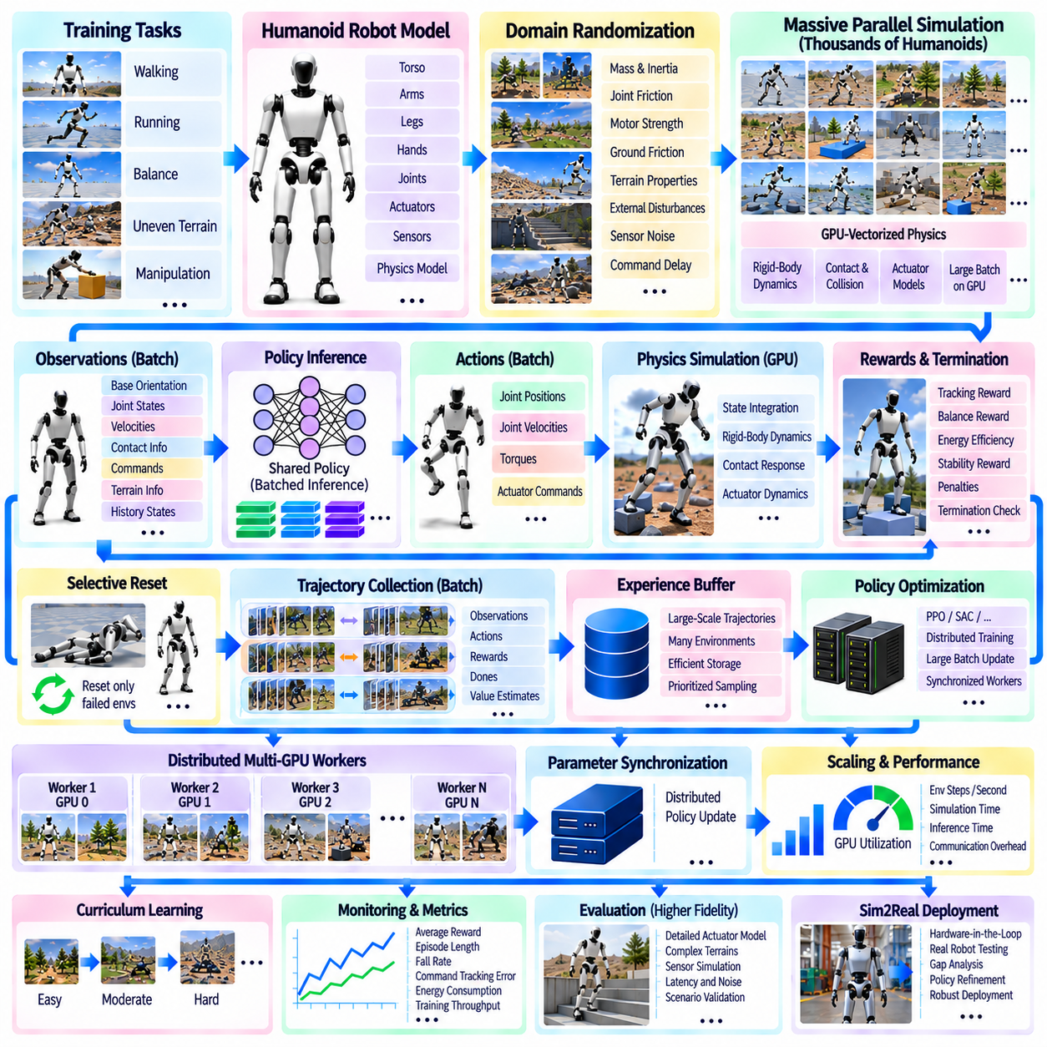
Humanoid policy learning is one of the most demanding applications of robot reinforcement learning because a humanoid combines many actuated joints, unstable whole-body dynamics, frequent contacts, and a large action space. Learning robust behaviors from a small number of simulation environments can require excessive wall-clock time and may expose the policy to insufficient state diversity. Massive parallel simulation addresses this limitation by allowing thousands of humanoid instances to generate physical experience simultaneously.
A typical humanoid training environment contains an articulated robot model with torso, legs, arms, feet, and potentially hands or additional joints. Each environment maintains joint positions, velocities, rigid-body poses, contact forces, actuator states, commands, rewards, and termination conditions. Thousands of independent copies can be placed into a vectorized simulation batch. Although they share the same robot definition and policy network, every humanoid evolves according to its own physical state and randomized conditions.
GPU-vectorized physics provides the computational foundation for this scale. Rigid-body dynamics, joint constraints, actuator forces, collision detection, contact response, and state integration are evaluated across large batches rather than through sequential CPU simulation loops. The resulting physical states remain in GPU memory and can be converted directly into policy observations. This architecture minimizes CPU-GPU transfers and allows simulation and neural-network computation to operate as one high-throughput learning pipeline.
The observation space for humanoid control commonly represents body orientation, joint configuration, joint velocity, base motion, contact information, commanded motion, and task-related state. Additional representations may describe terrain, target direction, reference motion, or recent state history. Observations from all active humanoids are organized into a large tensor and evaluated through batched policy inference. The resulting action tensor provides commands for the complete simulated population during the next control interval.
Actions may represent target joint positions, joint velocities, torques, or parameters interpreted by lower-level actuator models. Humanoid learning is sensitive to actuator behavior because unrealistic control authority can produce motions that cannot transfer to a physical robot. Simulation can therefore include torque limits, damping, motor strength variation, latency, compliance, and other actuator characteristics. Applying these models in parallel allows thousands of humanoids to experience slightly different control dynamics during the same training cycle.
Reward design guides the population toward desired behaviors. A locomotion policy may receive rewards for tracking commanded velocity and orientation while additional terms encourage balance, smooth motion, appropriate foot placement, energy efficiency, and stable body posture. Penalties can discourage excessive joint motion, undesirable contacts, slipping, or unstable actions. Because reward terms are evaluated across the complete environment batch, their implementation should use vectorized operations that avoid environment-by-environment CPU processing.
Falling is a normal part of early humanoid learning and must be handled efficiently. Different humanoids lose balance at different moments, so restarting the complete simulation batch whenever one robot falls would waste substantial computation. Termination masks identify failed or completed environments, and selective reset operations restore only those humanoids. New initial poses, commands, terrain conditions, and randomized physical parameters can then be assigned while the remaining environments continue generating experience.
Domain randomization becomes especially important when the learned policy is intended for physical deployment. Robot mass, center of mass, joint friction, motor strength, ground friction, command delay, disturbances, terrain properties, and selected sensor characteristics can vary across environments. Instead of learning one perfectly known simulated humanoid, the policy experiences a population of related physical systems. This encourages behavior that remains effective under modeling uncertainty and supports subsequent Sim2Real transfer.
Curriculum learning can be combined with massive parallel simulation to manage task difficulty. Early environments may begin with stable poses, moderate velocity commands, flat terrain, and limited disturbances. As training progresses, other environments can introduce faster motion, stronger perturbations, uneven surfaces, or more demanding tasks. Different difficulty levels may coexist within the same population, allowing the learning system to continuously generate both achievable experiences and challenging examples.
The resulting trajectories contain observations, actions, rewards, termination states, value estimates, and other algorithm-dependent information. Rollouts from thousands of humanoids can rapidly form large training batches for policy optimization. Algorithms such as policy-gradient methods can update the neural network using this aggregated experience before the revised policy is returned to the simulation population. The cycle of parallel rollout, optimization, and policy redistribution continues until the required behavior reaches suitable performance.
Scaling beyond one GPU allows the humanoid population to increase further. Each GPU can execute its own vectorized group of environments while maintaining a replica of the policy network. Workers generate local trajectories and participate in distributed policy optimization through synchronized learning updates. The architecture therefore contains two levels of parallelism: thousands of environments within each accelerator and multiple accelerators operating concurrently across a node or compute cluster.
More GPUs do not automatically produce proportionally faster learning. Humanoid simulation can be limited by contact computation, policy inference, GPU memory, trajectory processing, or synchronization between workers. Very large global batches can also alter optimization behavior. Environment count, rollout length, minibatch size, learning rate, communication frequency, and policy-network complexity must therefore be tuned together rather than maximizing the number of simulated humanoids as an isolated objective.
Monitoring should measure both learning quality and computational efficiency. Reward progression, episode duration, fall frequency, command-tracking error, energy consumption, and task success describe policy behavior, while environment steps per second, physics time, inference time, optimization time, GPU utilization, memory consumption, and synchronization overhead describe infrastructure performance. Examining both groups of metrics helps determine whether additional simulation resources are producing useful learning progress.
Checkpointing protects expensive training campaigns from worker failures, software errors, or infrastructure interruptions. Policy parameters, optimizer state, training iteration, randomization configuration, and other required recovery information can be stored periodically. In distributed execution, worker or environment-shard information can also be tracked so that interrupted computation can be reassigned. This enables long-running humanoid experiments to use large clusters or interruptible cloud resources without making all previous training progress dependent on uninterrupted execution.
After simulation training, policy evaluation should progressively increase physical realism and scenario difficulty. High-throughput training can first explore broad behavior distributions using efficient simulation, while selected policies are later evaluated with more detailed actuator, contact, sensor, delay, and terrain models. Hardware-in-the-loop or real-robot testing can then examine discrepancies that remain between simulation and reality. This staged workflow prevents maximum-fidelity simulation from becoming the computational bottleneck during early policy exploration.
Massive parallel humanoid learning therefore combines vectorized GPU physics, batched policy inference, selective reset, domain randomization, curriculum learning, distributed optimization, monitoring, and checkpoint-based recovery into one continuous training system. Thousands of simulated humanoids collectively explore the control problem while a shared policy learns from their combined experience. The case demonstrates how massive-scale simulation transforms humanoid learning from slow sequential experimentation into a scalable Physical AI development process.

