Volume 11. Simulation and Digital Twin

Chapter 03. Robot Modeling URDF MJCF

03.01. URDF Format Specification Links Joints Gazebo Tags [w/Code]
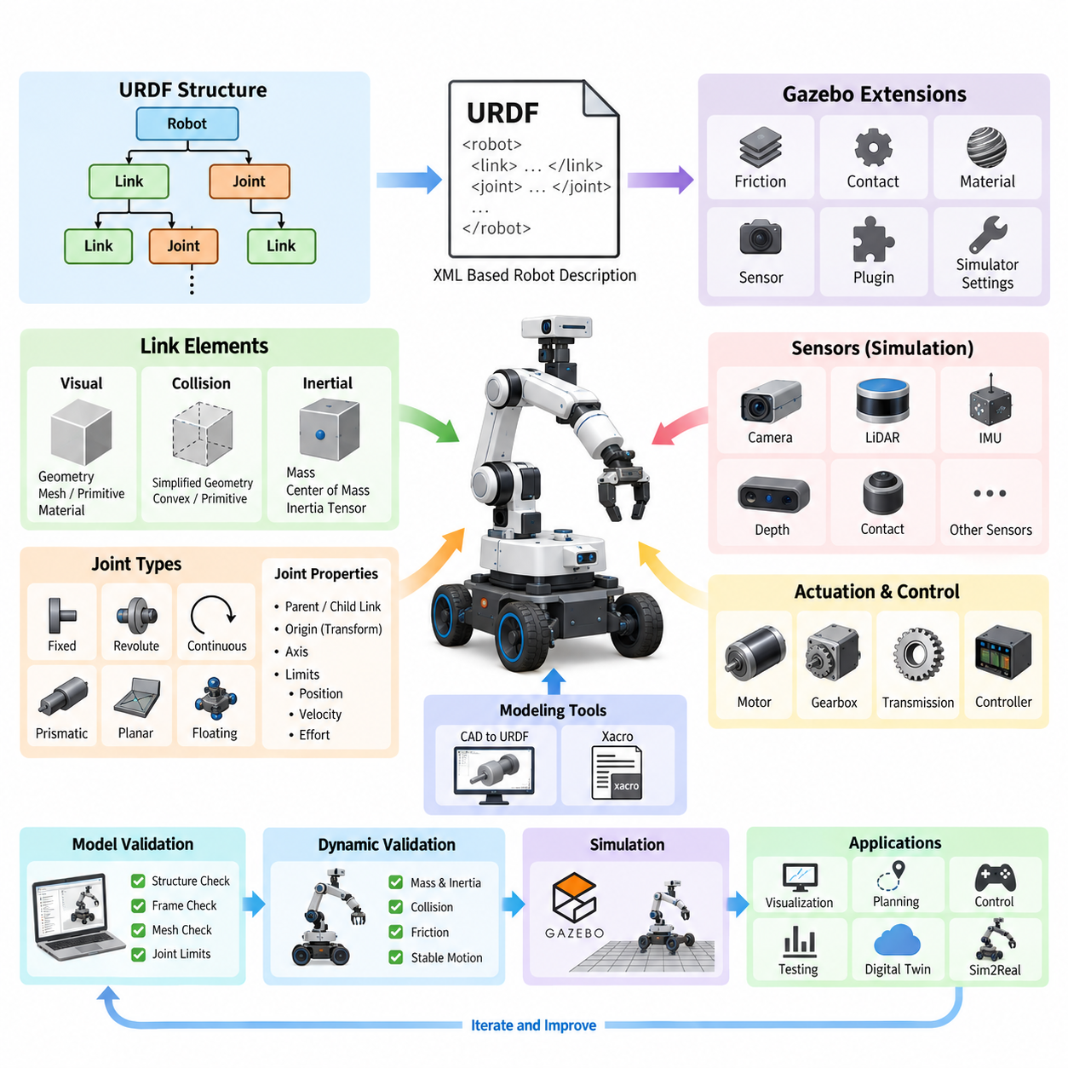
URDF, or Unified Robot Description Format, is an XML-based representation used to describe the physical and kinematic structure of a robot. Within the simulation and digital-twin workflow, URDF provides a machine-readable definition that connects robot geometry, coordinate frames, joints, inertial properties, and collision models. It is especially important in ROS and ROS 2 systems because the same structural description can support visualization, kinematics, planning, control, and simulation.
A URDF model is fundamentally organized as a tree of links connected by joints. A link represents a rigid body such as a chassis, wheel, manipulator segment, sensor housing, or gripper component. Each link can contain visual, collision, and inertial descriptions. This separation is important because the geometry displayed to a developer does not necessarily need to be identical to the simplified geometry used by a physics engine for collision detection.
The visual element defines how a link appears in visualization and simulation environments. Geometry may be represented using primitive shapes such as boxes, cylinders, and spheres, or by external mesh files representing detailed CAD geometry. An origin transform specifies the position and orientation of the visual geometry relative to the link frame. Material information can additionally define basic colors and textures when supported by the consuming application.
Collision geometry defines the physical shape considered during contact and collision calculations. Although it can reference the same mesh used for visualization, production simulation models frequently use simplified primitives, convex approximations, or reduced meshes. Complex CAD meshes can significantly increase collision-detection cost and may introduce numerical problems. Separating visual and collision representations therefore provides an effective balance between graphical realism and computational efficiency.
The inertial element specifies the mass properties required for dynamic simulation. It normally contains the link mass, the position and orientation of its center of mass, and a three-dimensional inertia tensor. These values strongly influence acceleration, joint forces, contact behavior, and overall stability. Approximate or physically inconsistent inertia parameters may allow a URDF to load successfully while producing unrealistic oscillation, instability, or unexpected motion during simulation.
Joints define the relationships between links and determine how the robot can move. Common URDF joint types include fixed, revolute, continuous, prismatic, floating, and planar joints. A revolute joint rotates within specified angular limits, while a continuous joint permits unrestricted rotation and is commonly used for wheels. A prismatic joint provides linear translation, whereas a fixed joint rigidly attaches two links without introducing an additional degree of freedom.
Every joint identifies a parent link and a child link, creating a directed kinematic tree. The joint origin defines the transform from the parent frame to the joint frame, while the axis specifies the direction of permitted motion. Joint limits can constrain position, velocity, and effort. Correct frame definitions are critical because even a small axis or orientation error can propagate through the kinematic chain and produce incorrect wheel motion, manipulator poses, or sensor coordinates.
URDF's tree structure makes robot descriptions relatively simple to parse and process, but it also introduces structural limitations. A standard URDF model cannot directly represent arbitrary closed kinematic loops in the same way that more general multibody formats can. Mechanisms containing parallel linkages, complex suspensions, or closed-loop transmissions may therefore require approximations, simulator-specific extensions, or alternative representations depending on the intended physics environment.
Coordinate-frame discipline is essential when building large URDF models. A mobile robot might contain frames for base_link, chassis, wheels, LiDARs, cameras, IMUs, GNSS antennas, manipulators, and tool centers. These frames form the geometric reference system used throughout the robotics software stack. Consistent axis conventions and carefully defined transforms reduce integration errors when perception, localization, navigation, control, and simulation modules exchange spatial information.
A typical robot description is rarely maintained as one large static URDF file. In ROS-based development, Xacro is commonly used to generate URDF through macros, parameters, properties, and reusable components. Repeated structures such as wheels, suspension assemblies, sensor mounts, or manipulator links can therefore be defined once and instantiated multiple times. Parameterization also enables related robot variants to share a common structural model instead of maintaining duplicated descriptions.
Simulation requires information beyond the core URDF specification. Gazebo-related extensions can associate simulator behavior with links, joints, and the robot as a whole. Gazebo tags have traditionally been used to specify properties such as friction, contact parameters, material appearance, sensor configuration, and plugins. This allows a basic URDF model to remain focused on robot structure while simulation-specific parameters augment that structure for execution inside Gazebo environments.
Sensor simulation can also be attached to the robot description through simulator-specific configuration. Cameras, depth sensors, LiDARs, IMUs, contact sensors, and other virtual devices require parameters that are not fully represented by basic URDF elements. Their simulation definitions may describe update rates, fields of view, resolution, noise characteristics, measurement ranges, and communication interfaces. The corresponding sensor link and joint establish the physical pose of each sensor relative to the robot.
Actuation introduces another layer between structural modeling and executable simulation. A joint definition states how two links may move, but a simulator or controller still needs information describing how that joint is driven. ROS 2 control architectures commonly connect URDF-described joints with hardware interfaces, transmissions, controllers, and simulator integration components. This separation enables similar control software to operate against simulated hardware interfaces and later against physical robot hardware.
Gazebo plugins historically provided mechanisms for implementing behaviors not expressed by basic URDF, including drive systems, controllers, sensors, and custom dynamics. A differential-drive mobile robot, for example, requires more than two wheel joints: the simulator must translate velocity commands into wheel behavior and publish corresponding motion information. Modern Gazebo integration has evolved beyond older Gazebo Classic conventions, so model authors should distinguish structural URDF information from simulator-version-specific extensions.
Model validation should begin with structural correctness before physics tuning. The link-joint graph must form the intended hierarchy, referenced meshes must be accessible, origins and axes must be consistent, and joint limits must reflect the mechanism. Visualization tools can then verify geometry and frame placement before dynamic simulation is introduced. This staged process prevents physics parameters from masking fundamental modeling errors and makes debugging considerably more systematic.
Dynamic validation requires additional checks for mass distribution, inertia tensors, collision geometry, friction, joint limits, and actuator behavior. A model that looks correct in a visualizer may still behave incorrectly under gravity or contact. Wheels may slip excessively, a manipulator may oscillate, or a robot may become unstable because its center of mass or inertia is unrealistic. Robot modeling should therefore be treated as physical system engineering rather than merely geometric conversion from CAD.
The chapter structure places URDF beside MJCF, inertia calculation, mesh optimization, actuator modeling, AMR modeling, mobile manipulation, quadrupeds, humanoids, and cargo UAV modeling. This progression reflects an important engineering principle: a robot description format is the foundation upon which increasingly accurate mechanical, actuator, and application-specific simulation models are constructed.
For digital-twin and simulation-driven development, a well-designed URDF can become a shared structural reference across multiple engineering activities. CAD-derived geometry, sensor placement, kinematic relationships, control interfaces, and simulation configuration can be maintained around a consistent robot hierarchy. The broader software architecture explicitly positions robot modeling within the Simulation and Digital Twin volume, connecting it with physics engines, sensor simulation, environment modeling, Sim2Real transfer, and validation workflows.
The most maintainable approach is therefore to treat URDF as a structured engineering model rather than a visualization file. Link frames should follow documented conventions, joints should correspond to real mechanical constraints, inertial parameters should originate from reliable CAD or measurement data, and collision geometry should be optimized deliberately. Simulator-specific Gazebo tags should be isolated where practical so that the fundamental robot description remains understandable, reusable, and portable across development tools.
Ultimately, URDF provides the bridge between a robot's mechanical architecture and the software systems that must reason about its physical structure. Links establish rigid bodies, joints define allowable motion, inertial and collision properties enable physics, and Gazebo extensions add simulation-specific behavior. When these elements are modeled consistently, the same robot description can support visualization, ROS 2 integration, controller development, simulation-based testing, digital twins, and later stages of Sim2Real engineering.

03.02. MJCF Format Deep Dive Body Geom Joint Actuator [w/Code]
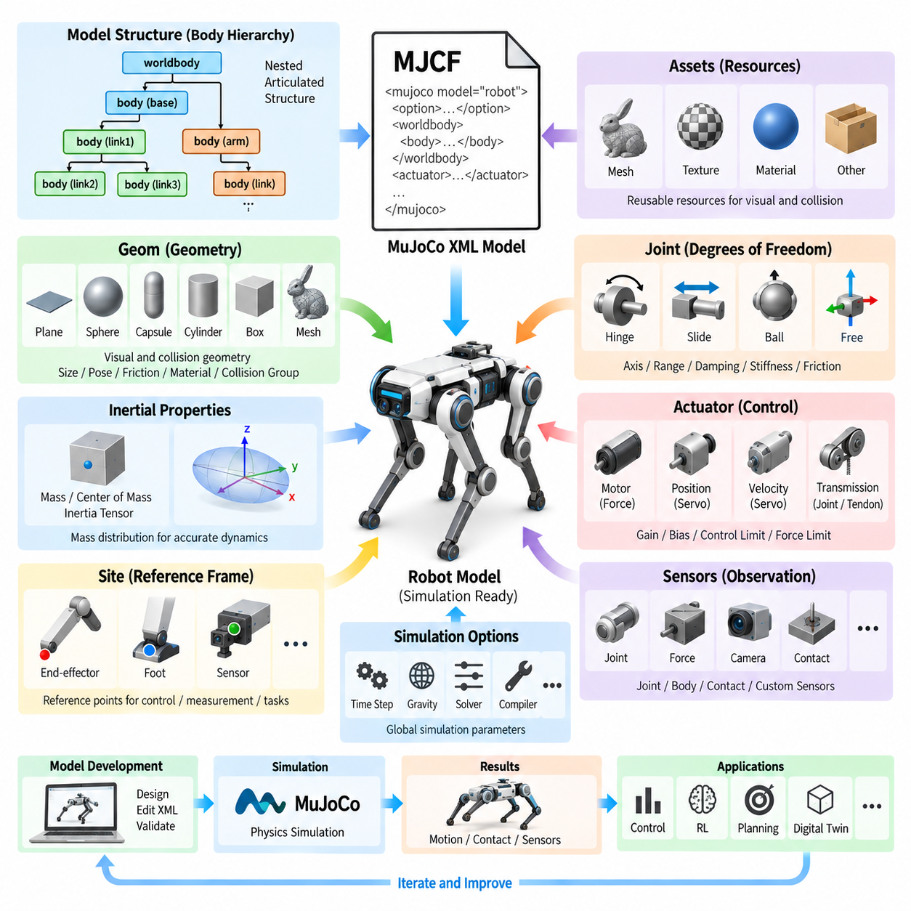
MJCF, or MuJoCo XML modeling format, is a hierarchical model-description language designed for constructing dynamic systems directly around the concepts used by the MuJoCo physics engine. Within robot simulation, it describes bodies, geometry, joints, inertial properties, actuators, sensors, constraints, and simulation-related parameters in a unified XML structure. This makes MJCF particularly suitable for articulated robots whose dynamic behavior is as important as their geometric appearance.
The fundamental structural element in MJCF is the body. Bodies form a nested hierarchy representing the robot's physical and kinematic organization, with each child body defined relative to its parent. A body can contain geometry, joints, sites, cameras, lights, and additional child bodies. This recursive organization allows complex mechanisms such as manipulators, quadrupeds, humanoids, and mobile manipulators to be represented naturally as articulated multibody systems.
The worldbody element provides the root of the physical scene and contains the bodies and geometry participating in simulation. A robot base may appear directly under worldbody, while links belonging to arms, legs, wheels, or other mechanisms are nested beneath it. Position and orientation attributes define transformations between parent and child coordinate systems, allowing the XML hierarchy to encode the spatial relationships required for forward kinematics and dynamic calculations.
Geometry is represented primarily through geom elements. A geom defines physical shape and can represent primitives such as planes, spheres, capsules, ellipsoids, cylinders, boxes, or mesh-based geometry. Geoms may participate in both visualization and contact computation, depending on their configuration. Their properties can include dimensions, position, orientation, density, mass, friction, collision filtering parameters, material references, and appearance information.
Primitive geometry is particularly valuable for dynamic simulation because it can provide efficient and numerically robust collision calculations. Detailed mesh assets remain useful when a robot requires realistic appearance or when its physical shape cannot be approximated adequately with simple primitives. Practical MJCF models often combine detailed visual geometry with simplified collision geometry so that graphical fidelity does not unnecessarily reduce physics simulation performance.
Bodies require physically meaningful mass and inertia properties for accurate dynamics. MJCF can obtain these properties from explicitly specified inertial information or derive them from attached geometry under appropriate settings. Mass distribution, center of mass, and rotational inertia determine how each body responds to gravity, joint forces, impacts, and contact forces. Incorrect inertial parameters can therefore produce unstable or unrealistic behavior even when the kinematic structure appears correct.
Joints determine the degrees of freedom between a body and its parent. MJCF supports joint types including hinge, slide, ball, and free joints. A hinge joint introduces rotational motion around an axis, while a slide joint introduces translation along an axis. Ball joints permit three-dimensional rotational freedom, and free joints provide unrestricted translation and rotation, making them useful for floating-base systems such as legged robots, free-moving objects, and aerial platforms.
Joint configuration includes more than simply selecting a motion type. Attributes can define the joint axis, reference configuration, motion range, damping, stiffness, friction loss, and other dynamic characteristics. These parameters allow the model to represent mechanical behavior that is difficult to capture using purely kinematic descriptions. Joint damping and friction are especially important when matching simulated motion to the response of a physical robot.
MJCF also provides sites, which are lightweight reference frames attached to bodies. Sites do not need to represent physical mass or collision geometry and can instead identify important spatial locations such as end-effectors, foot contact points, sensor origins, tendon attachment locations, or control targets. This makes them useful for measurement, control, inverse kinematics, reinforcement-learning observations, and task definitions without adding unnecessary rigid bodies.
Assets allow reusable resources to be declared separately from the physical body hierarchy. Meshes, textures, materials, and other resources can be defined once and referenced by multiple model elements. This separation helps maintain complex robot descriptions and reduces duplication. CAD-derived mesh resources can therefore coexist with procedural geometry and simulation-oriented primitives while remaining logically separated from the robot's kinematic organization.
A major strength of MJCF is its explicit actuator model. Joints define permitted motion, but actuators define how control inputs generate forces or motion within the system. Actuators can represent motor-like force generation, position servos, velocity servos, and more general control relationships. This separation between mechanical freedom and actuation makes it possible to model both passive joints and actively controlled joints within the same articulated mechanism.
Motor actuators commonly convert a control signal into generalized force applied through a joint or transmission. Position and velocity actuators can instead represent servo-like behavior in which control inputs correspond to desired positions or velocities. Gain, bias, control limits, and force limits influence how commands are transformed into physical action. These parameters are essential when the simulation must approximate the behavior of real motors, drives, and embedded controllers.
Transmission relationships connect actuators to the mechanical components they drive. Although direct joint actuation is common, MJCF can represent more sophisticated relationships involving joints, tendons, and sites. This is useful for mechanisms where actuator coordinates do not correspond directly to individual joint coordinates, including cable-driven systems, coupled mechanisms, robotic hands, and biomechanical models. The actuator layer therefore forms an important bridge between robot mechanics and control.
Contact behavior depends strongly on geom configuration. Friction coefficients, contact dimensionality, collision groups, and solver-related parameters influence how bodies interact when they touch. For a mobile or legged robot, these parameters affect wheel traction, foot-ground interaction, slipping, and stability. For manipulators, they influence grasping and object handling. Accurate contact modeling therefore requires both suitable geometry and physically reasonable contact parameters.
MJCF supports defaults and reusable configuration patterns that reduce repetition across large models. Common properties for related joints, geoms, or actuators can be grouped into default classes and inherited by individual elements. A quadruped, for example, may reuse similar properties across four legs while overriding only the parameters that differ. This approach improves consistency and makes large robot models easier to modify, review, and maintain.
The equality, tendon, sensor, and contact-related portions of MJCF extend the model beyond a simple rigid-body tree. Equality constraints can impose relationships between model components, while tendons can represent spatial or fixed-length transmission structures. Sensors can expose quantities needed by control algorithms and learning systems. These mechanisms make MJCF useful for models involving coupled dynamics, complex actuation, contact-rich manipulation, and advanced locomotion.
The compiler and option sections influence how the model is interpreted and simulated. Compiler settings can define conventions for angles, mesh processing, inertia handling, and related model-building behavior. Simulation options control global characteristics such as time step, gravity, numerical integration, and solver behavior. Separating these global settings from individual body definitions helps engineers tune numerical behavior without restructuring the complete robot hierarchy.
Model development should proceed from structural validation toward dynamic validation. The body hierarchy, joint axes, geometry transforms, and actuator connections should first be verified. Mass, inertia, damping, friction, actuator limits, contact properties, and solver settings can then be tuned progressively. This staged process is particularly important for high-degree-of-freedom systems because structural errors can otherwise be mistaken for controller instability or poor physics parameters.
MJCF is especially effective for reinforcement learning and control research because observations, actuators, contacts, and dynamic parameters are represented close to the physics model. Robot policies can interact with actuator control variables while receiving simulated joint, body, contact, and sensor states. Parameters such as friction, mass, damping, and actuator characteristics can also be varied to create diverse simulation conditions for robust policy training and Sim2Real transfer.
For quadrupeds and humanoids, the nested body hierarchy naturally represents legs, arms, torso structures, and floating bases, while hinge joints describe individual articulated degrees of freedom. Geoms establish collision and contact surfaces, and actuators provide the control interface for locomotion policies. This relationship explains why MJCF modeling is closely connected with later topics such as quadruped structure, humanoid modeling, actuator modeling, and massively parallel reinforcement-learning simulation.
MJCF should therefore be understood as more than an XML representation of robot geometry. The body hierarchy establishes the multibody system, geoms define physical and visual shapes, joints establish degrees of freedom, and actuators transform control commands into mechanical action. In combination with inertia, contacts, constraints, sensors, and solver configuration, these elements form an executable dynamic model suitable for simulation, control development, reinforcement learning, and Sim2Real engineering.

03.03. Inertia Property Calculation from CAD meshlab [w/Code]
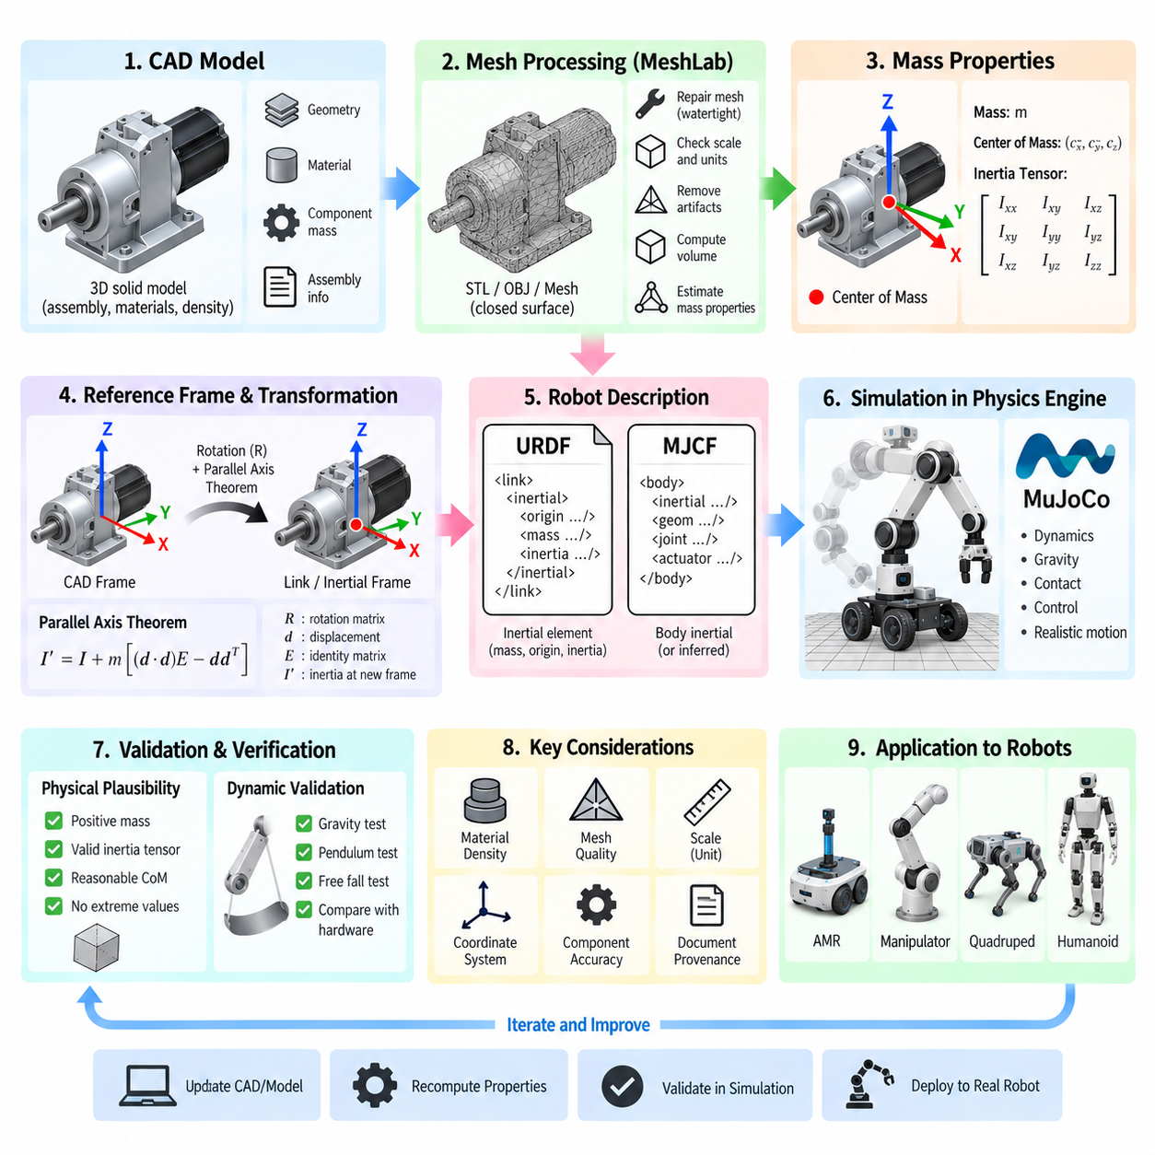
Accurate inertia properties are fundamental to physically meaningful robot simulation because every rigid body responds to forces and torques according to its mass distribution. A robot link therefore requires more than an approximate total mass: its center of mass and inertia tensor must represent the actual geometry and material distribution. Errors in these values can produce unrealistic acceleration, oscillation, contact behavior, and controller response even when the robot geometry and joints appear correct.
The principal mass properties required by rigid-body simulation are mass, center of mass, and the inertia tensor. Mass describes resistance to linear acceleration, while the center of mass identifies the point at which the distributed mass can be represented for translational dynamics. The inertia tensor describes resistance to angular acceleration around three-dimensional axes and therefore determines how the link rotates when external forces, actuator torques, gravity, or contact forces act upon it.
The inertia tensor is represented by a symmetric three-by-three matrix containing the principal terms Ixx, Iyy, and Izz and the cross terms Ixy, Ixz, and Iyz. The diagonal terms describe rotational inertia around the coordinate axes, while the off-diagonal products of inertia describe coupling caused by asymmetric mass distributions or coordinate frames that are not aligned with the principal inertia axes. Correct interpretation of these components is essential when transferring properties between CAD, URDF, MJCF, and physics engines.
CAD software provides one of the most reliable starting points for calculating robot mass properties because the original three-dimensional solid model contains geometric volume and assembly information. When appropriate materials and densities are assigned to components, CAD tools can calculate total mass, center of mass, principal axes, and inertia tensors. These results are generally preferable to manually estimating inertia from simple geometric formulas when a robot link contains complex housings, brackets, motors, batteries, gears, or structural cavities.
CAD-derived values are only as reliable as the source model. Missing internal components, incorrect material densities, simplified assemblies, fasteners excluded from the model, or placeholder geometry can shift both the center of mass and inertia significantly. Engineers should therefore distinguish between geometry intended only for mechanical packaging and a mass-representative CAD model intended for dynamics. For critical robot links, measured component masses can be used to verify or correct CAD-derived properties.
Coordinate systems are a major source of errors during inertia transfer. A CAD application may report the inertia tensor relative to the global assembly frame, the component origin, the center of mass, or the principal inertia frame. Robot description formats may expect values relative to another link or inertial frame. The engineer must therefore record both the reference point and orientation associated with the reported tensor instead of copying numerical values directly into a robot model.
When inertia is known about one point but required about another, the parallel-axis theorem provides the necessary transformation. The inertia tensor changes according to the mass and displacement between the original reference point and the new reference point. This is particularly important when CAD reports inertia around an assembly origin while the simulation model defines its inertial frame at the center of mass. Ignoring this transformation can create a numerically valid but physically incorrect model.
Rotation of coordinate frames must also be handled explicitly. If the CAD coordinate axes differ from the robot link axes, the inertia tensor must be transformed into the destination coordinate system. Merely reordering Ixx, Iyy, and Izz is generally insufficient when the frames contain arbitrary rotations because the complete tensor, including off-diagonal terms, must be transformed. Aligning the inertial frame with principal axes can simplify the representation by making products of inertia close to zero.
MeshLab can support inertia-property estimation when a clean polygon mesh is available instead of the original solid CAD model. A mesh-based workflow can estimate geometric volume, center of mass, and inertia-related quantities from a closed surface representation. This is useful when robot assets originate from STL, OBJ, or other polygonal formats. However, the mesh must represent a watertight physical volume rather than merely a visual surface if volumetric mass properties are expected to be meaningful.
Mesh quality directly influences calculated properties. Holes, duplicated faces, self-intersections, non-manifold edges, inconsistent face orientation, disconnected fragments, and degenerate triangles can corrupt volume calculations. Before extracting mass properties, the mesh should therefore be inspected and repaired where necessary. A visually correct model is not automatically suitable for physical computation, because rendering can tolerate geometric defects that invalidate enclosed-volume calculations.
Scale is another critical issue in CAD-to-mesh workflows. STL files, for example, do not inherently provide a universal physical unit convention, so a model exported in millimeters may be interpreted as meters by another application. Because volume scales with the cube of linear dimension and inertia scales with mass and squared distance, a unit error can produce enormous differences in calculated physical properties. Dimensions should always be verified against a known physical measurement before accepting mesh-derived results.
Mesh-based inertia calculation also requires an assumption about density. For a homogeneous component, geometric volume can be multiplied by material density to obtain mass, after which the corresponding inertia values can be scaled consistently. Alternatively, if the actual component mass is known, the geometric calculation can be normalized to that measured mass. This approach is often more practical for assembled robot parts whose internal electronics, motors, wiring, and cavities cannot be represented accurately by a single material density.
A robot assembly containing several materials should not automatically be treated as a uniform-density mesh. Aluminum frames, steel shafts, plastic covers, motors, batteries, computing hardware, and sensors can produce a highly nonuniform mass distribution. A better approach is to calculate component-level properties and combine them mathematically or preserve the relevant components in CAD. Simplified collision geometry may be appropriate for simulation efficiency, but it should not necessarily be used as the source of mass properties.
URDF represents inertial information within the inertial element of each link. The mass value defines link mass, the inertial origin identifies the center-of-mass frame relative to the link, and six independent inertia values describe the symmetric tensor. These parameters should be generated from the physical model rather than inferred from the visual mesh whenever possible. Visual, collision, and inertial representations serve different engineering purposes and should therefore be managed independently.
MJCF provides related mechanisms for defining body mass properties and can also infer certain properties from geometry depending on model configuration. Explicit CAD-derived inertia remains valuable when the real robot contains internal mass distributions that cannot be reconstructed from external geometry alone. Whether URDF or MJCF is used, the objective is the same: the simulator should receive a rigid-body representation whose translational and rotational response approximates the actual mechanical system.
Physical plausibility checks should be performed before running complex simulation scenarios. Mass values must be positive, principal moments of inertia must be physically valid, and the tensor should correspond to a realizable mass distribution. Extremely small inertia values can cause numerical instability, while unrealistically large values can make joints respond sluggishly. Simulation engines may issue warnings or modify invalid inertia internally, but automatic correction should not replace engineering verification.
Visualization of the center of mass provides a simple but effective validation method. The calculated center should appear in a physically reasonable location relative to motors, batteries, structural members, payloads, and other heavy components. For an AMR, for example, a large battery pack can move the center of mass substantially toward the lower chassis. For manipulators and legged robots, incorrect centers of mass can strongly distort gravity compensation, balance control, gait behavior, and actuator loading.
Dynamic validation should follow static property verification. Individual joints can be exercised under gravity, known forces, or known torques while simulated acceleration and motion are observed. Pendulum-like tests can expose rotational inertia errors, while free-fall and gravity compensation tests can reveal incorrect mass or center-of-mass definitions. Comparing simulation behavior with measured hardware responses provides a practical route toward system identification and progressively higher model fidelity.
Inertia accuracy does not need to be identical for every component. Small cosmetic covers may tolerate approximation, whereas batteries, motors, gearboxes, payload modules, long manipulator links, wheels, and major structural assemblies often require greater attention because they contribute significantly to system dynamics. Modeling effort should therefore be concentrated on components whose mass and spatial distribution materially affect motion, balance, contact forces, or actuator requirements.
A maintainable engineering workflow preserves the source and provenance of every important mass property. CAD revision, material density, measured mass, mesh scale, coordinate convention, center-of-mass reference, and tensor transformation should be documented alongside the robot model. When mechanical components change, these properties can then be recalculated systematically rather than manually patched. This becomes increasingly important when one robot platform has multiple payload, battery, sensor, or actuator configurations.
The complete CAD-to-simulation workflow therefore connects mechanical design with dynamic robot modeling. CAD or a validated mesh provides geometry and mass distribution; MeshLab can assist when polygonal geometry must be analyzed; coordinate and scale transformations align the results with simulation frames; and the final mass, center of mass, and inertia tensor are incorporated into URDF or MJCF. Careful validation then ensures that the resulting robot model behaves as a physical system rather than merely resembling one visually.

03.04. Mesh Optimization for Simulation Convex Hull LOD [w/Code]
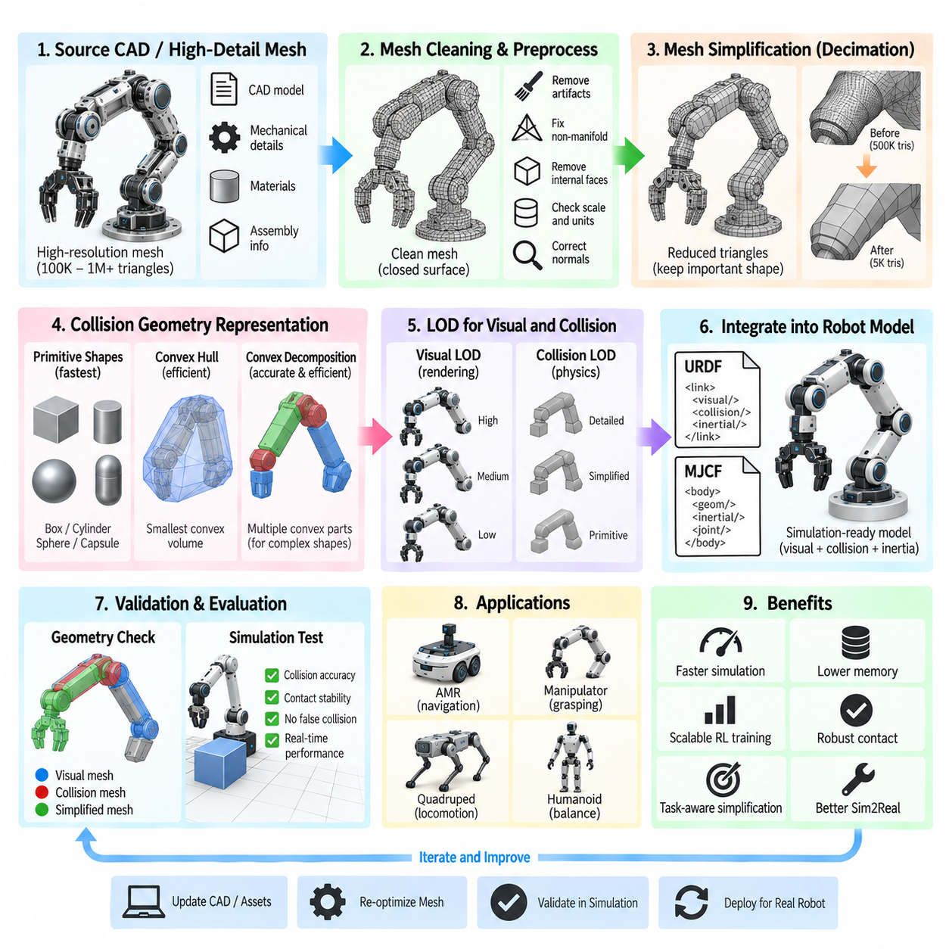
Mesh optimization is a critical step in preparing robot models for physics simulation because geometry created for mechanical design or visualization is rarely optimized for real-time collision detection. Detailed CAD-derived meshes may contain hundreds of thousands or millions of triangles, small mechanical features, internal surfaces, and manufacturing details. Using these meshes directly can increase memory consumption, collision-processing cost, simulation latency, and numerical instability without providing meaningful improvements in physical behavior.
A simulation model should therefore distinguish between visual geometry and collision geometry. Visual geometry determines how the robot appears and may retain relatively detailed surfaces, textures, and recognizable mechanical features. Collision geometry represents the shapes evaluated by the physics engine during contact detection. Because collision calculations are repeatedly performed during simulation, simplified collision meshes can produce substantial performance improvements while preserving the mechanical interactions that matter to the simulated task.
Mesh optimization begins by understanding the intended use of each component. Large chassis surfaces, wheels, manipulators, sensor housings, grippers, and structural members have different requirements. A decorative cover may require detailed visual geometry but only a simple collision box, whereas a gripper finger interacting with small objects may require a closer approximation. Optimization should therefore preserve geometrical features that influence contact while aggressively simplifying features that have little effect on physical interaction.
Triangle reduction, commonly called mesh decimation, decreases polygon count while attempting to preserve the original shape. Algorithms progressively remove vertices, edges, or faces according to geometric error criteria and reconstruct the remaining surface. The objective is not simply to achieve the smallest possible mesh but to find a representation whose geometric error remains acceptable for simulation. Excessive decimation can distort contact surfaces, wheel dimensions, joint clearances, or grasping geometry.
Before decimation, the source mesh should be cleaned. CAD exports frequently contain duplicated vertices, overlapping faces, isolated fragments, extremely small triangles, internal surfaces, non-manifold geometry, or inconsistent normals. These defects may have little visible impact during rendering but can cause problems for collision processing and subsequent optimization. MeshLab and similar tools can support inspection, cleaning, simplification, normal correction, and conversion during the CAD-to-simulation preparation workflow.
Convex geometry is particularly important because many physics engines can perform collision detection more efficiently and robustly between convex objects than between arbitrary concave triangle meshes. A convex hull is the smallest convex volume enclosing the original geometry. Replacing a complicated component with its convex hull can dramatically reduce collision complexity, making it useful for housings, structural blocks, payloads, and components whose small concave features are not important to physical interaction.
A single convex hull, however, can overestimate the occupied volume of strongly concave objects. Open frames, U-shaped brackets, grippers, wheel structures, and complex chassis assemblies may contain empty regions that a single hull incorrectly fills. This can create false collisions or prevent objects from entering spaces that should physically be accessible. In such cases, the geometry can be represented by several convex components rather than one global convex approximation.
Convex decomposition divides a complex non-convex mesh into multiple approximately convex pieces. This approach provides a compromise between the efficiency of convex collision and the accuracy of the original geometry. The number of generated pieces should remain controlled because every additional convex component increases broad-phase and narrow-phase collision workload. The engineering objective is therefore to use the smallest set of convex parts that preserves task-relevant contact behavior.
Primitive collision shapes can provide even greater efficiency than convex hulls. Boxes, cylinders, spheres, capsules, and combinations of these shapes can approximate many robot components with very low computational cost. Wheels can often use cylinders, links can use capsules or boxes, and sensor enclosures can use simple rectangular volumes. Primitive approximations are particularly effective when exact surface detail does not affect navigation, balance, manipulation, or safety-clearance evaluation.
Level of Detail, or LOD, extends mesh optimization by providing multiple representations of the same object at different geometric resolutions. A high-detail mesh may be used when an object is close to a camera or required for high-quality rendering, while medium- and low-detail versions can be selected when the object is distant or when many instances must be simulated. LOD is therefore especially valuable for large environments, digital twins, synthetic-data generation, and multi-robot simulations.
Visual LOD and collision LOD should be treated as related but separate optimization problems. Rendering complexity depends on visible triangles, materials, textures, lighting, and GPU workload, whereas collision complexity depends on physical geometry and the number of candidate contact pairs. A visually distant object may use a low-resolution rendering mesh while retaining collision geometry appropriate to robot interaction. Conversely, visually detailed components may still use extremely simple collision primitives.
LOD transitions should avoid introducing distracting visual changes or inconsistent physical behavior. Switching between rendering meshes can be based on camera distance, projected screen size, or performance requirements. Collision representations should generally change more conservatively because modifying physical geometry during active contact can alter penetration, forces, and constraints. For deterministic robotics experiments, a fixed collision representation is often preferable even when visual LOD changes dynamically.
Mesh scale and coordinate conventions must be verified during optimization. Geometry exported from CAD may use millimeters while a simulator expects meters, and transformations introduced during mesh processing can shift origins or rotate axes. A simplified mesh that is geometrically accurate but incorrectly scaled or positioned is unusable. Optimized assets should therefore be checked against known dimensions, link frames, joint locations, and the original engineering model before integration.
The location of the mesh origin is also important. Robot links rotate and translate according to coordinate frames defined in URDF, MJCF, or another model format. If optimization software changes the mesh origin or applies transformations directly to vertices, the visual or collision geometry may become misaligned with joints and inertial frames. A robust workflow preserves transformation metadata or explicitly records every translation, rotation, and scaling operation performed during asset preparation.
Collision geometry and inertial geometry should not be confused. A simplified convex hull or primitive may be ideal for collision detection but may not accurately represent the real mass distribution. Mass, center of mass, and inertia tensors should originate from validated CAD data, measured hardware, or an appropriate physical model rather than automatically from aggressively simplified collision meshes. Geometry optimization should improve computational efficiency without silently changing the intended rigid-body dynamics.
Optimization quality should be evaluated using both geometric and simulation-level criteria. Polygon count, vertex count, file size, surface deviation, and convex-piece count provide useful asset metrics, but they do not reveal every practical consequence. Engineers should also examine collision accuracy, contact stability, penetration behavior, solver workload, simulation step time, and real-time factor. The best mesh is therefore not necessarily the smallest mesh, but the simplest representation that preserves required behavior.
Different robot applications demand different optimization priorities. An AMR navigating corridors can use highly simplified chassis collision geometry because centimeter-scale exterior details rarely influence navigation. A manipulator performing grasping may require accurate fingertips and object-contact surfaces. A quadruped requires reliable foot and terrain interaction, while a humanoid may require carefully simplified feet, hands, limbs, and self-collision regions to balance computational efficiency against contact fidelity.
Environment meshes require similar treatment. Factory CAD, warehouse layouts, buildings, terrain, machinery, shelves, and infrastructure can contain far more geometry than the robot itself. Unnecessary internal faces, bolts, pipes, decorative structures, and invisible surfaces can overwhelm collision and rendering pipelines. Separating static visual assets from simplified collision structures and applying LOD to large scenes can substantially increase the number of robots or environments that can be simulated simultaneously.
Mesh optimization becomes even more important in reinforcement learning and massively parallel simulation. When hundreds or thousands of environments are executed concurrently, a small unnecessary cost per collision object can multiply into a significant GPU or CPU burden. Simplified geometry can increase simulation throughput, allowing more policy-training samples to be generated within the same computing budget. However, contact-critical geometry must remain sufficiently accurate to avoid learning behavior that depends on unrealistic simulation artifacts.
For Sim2Real transfer, simplification should preserve the physical interactions that influence the learned or tested behavior. If wheel radius, foot shape, ground clearance, gripper dimensions, or obstacle geometry are altered excessively, policies may exploit conditions that do not exist on the real robot. Optimization must therefore be task-aware: irrelevant geometric detail can be removed aggressively, while dimensions governing contact, clearance, stability, and manipulation should remain within defined tolerances.
A maintainable asset pipeline should preserve the original CAD or high-resolution mesh as the authoritative source while generating optimized derivatives for specific purposes. Separate assets may be maintained for high-quality visualization, normal simulation rendering, collision detection, and low-detail large-scale execution. Naming conventions, source revisions, reduction settings, scale, coordinate transforms, and convex-decomposition parameters should be recorded so optimized meshes can be regenerated when mechanical designs change.
The overall workflow therefore moves from detailed engineering geometry toward purpose-specific simulation assets. Source CAD is cleaned and converted, visual meshes are decimated according to rendering requirements, collision meshes are replaced by primitives, convex hulls, or controlled convex decomposition, and LOD variants are produced where scalability requires them. The resulting assets are integrated with URDF or MJCF and validated through contact tests and performance measurements.
Effective mesh optimization is ultimately an engineering tradeoff among fidelity, robustness, and computational cost. Preserving every CAD triangle does not make a simulation inherently more accurate, and excessive simplification can remove the geometry responsible for important physical interactions. By separating visual and collision requirements, applying convex representations intelligently, using LOD where appropriate, and validating behavior after optimization, robot simulations can remain both physically useful and computationally scalable.

03.05. Actuator Modeling Motor Gearbox Compliance [w/Code]
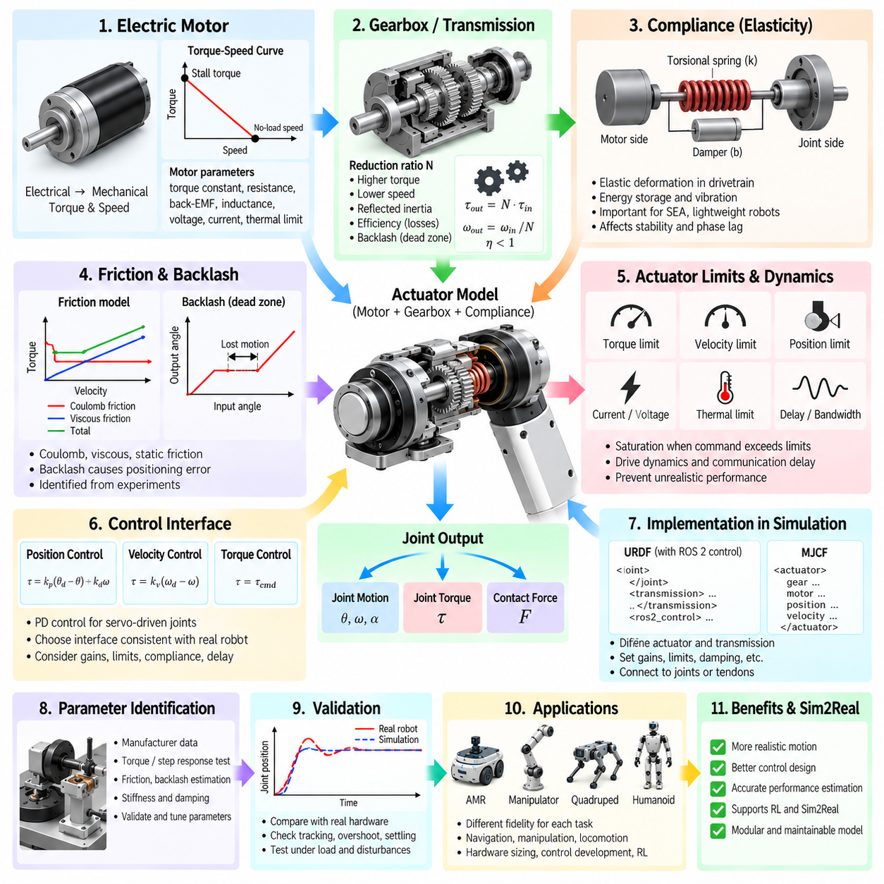
Actuator modeling connects the mechanical structure of a simulated robot with the forces and torques that generate motion. A purely kinematic joint defines where movement is permitted, but it does not describe how a real motor produces that movement. Realistic simulation therefore requires models of motors, gearboxes, transmissions, friction, compliance, limits, and control dynamics so commanded motion produces physically plausible joint behavior.
An electric motor converts electrical energy into mechanical torque and rotational velocity. In a simplified simulation, the actuator may be represented as an ideal torque source, but real motors have finite torque, speed, current, voltage, and thermal capabilities. Motor characteristics determine how quickly a robot accelerates, how much load it can move, and whether commanded trajectories remain physically achievable under changing operating conditions.
For many robotics simulations, the motor torque-speed relationship provides a useful first approximation. Available torque generally decreases as rotational speed approaches the motor's operating limit, while current is closely related to generated torque. Representing this behavior prevents a simulated actuator from producing unrealistic combinations of high torque and high speed. More detailed models may additionally incorporate winding resistance, back electromotive force, inductance, voltage limits, and drive electronics.
Rotor inertia is another important actuator property because the motor rotor itself must accelerate whenever joint velocity changes. Although rotor inertia may appear small compared with link inertia, its effect can become significant after transmission through a high gear ratio. Neglecting reflected rotor inertia can make simulated joints accelerate too easily and respond more aggressively than physical hardware, particularly in manipulators, humanoids, and high-reduction robotic joints.
Gearboxes transform motor speed and torque into values appropriate for robot joints. An ideal gearbox with reduction ratio N approximately multiplies output torque while reducing output angular velocity by the corresponding ratio. The gearbox therefore allows a relatively fast motor to drive a slower, higher-torque joint. However, this transformation also affects reflected inertia, friction, efficiency, backlash, and the dynamic response observed by the controller.
Gearbox efficiency should be considered when actuator power and joint torque are important. Mechanical losses in gears, bearings, seals, and lubrication mean that output power is lower than input power. Efficiency may also vary with direction, speed, temperature, and load. A simplified model can use a constant efficiency coefficient, while higher-fidelity models can represent operating-condition-dependent losses when energy consumption or actuator sizing is part of the simulation objective.
Backlash represents lost motion caused by clearance between transmission components. When torque reverses direction, the motor may rotate through a small angle before the output responds. This dead zone can degrade positioning accuracy, create impacts, and cause oscillatory controller behavior. Backlash is particularly relevant to geared manipulators, steering mechanisms, and transmissions where repeated direction reversals occur, although it can often be neglected in lower-fidelity simulations.
Friction also influences actuator response across the complete drivetrain. Coulomb friction produces an approximately velocity-independent resisting force, viscous friction increases with velocity, and static friction can prevent initial motion until sufficient force is applied. Real mechanisms may exhibit more complex behavior near zero velocity. Even simplified friction models can significantly improve agreement between simulated and measured joint motion when parameters are identified from hardware experiments.
Compliance describes elastic deformation between actuator input and mechanical output. Real robot transmissions are never perfectly rigid because shafts, belts, gears, harmonic drives, structural members, bearings, and couplings deform under load. A common approximation models transmission compliance as a torsional spring and damper between the motor side and joint side. The resulting system can store energy, oscillate, and exhibit phase lag that an ideal rigid transmission cannot reproduce.
The spring-damper representation introduces stiffness and damping parameters. High stiffness makes motor and joint motion closely coupled, while lower stiffness permits measurable relative displacement under torque. Damping dissipates oscillatory energy and determines how rapidly vibration decays. These parameters become particularly important for series-elastic actuators, lightweight manipulators, legged robots, compliant grippers, and mechanisms experiencing impacts or rapidly varying contact forces.
Series Elastic Actuators intentionally place an elastic element between the motor-transmission assembly and the driven joint. Measuring deformation of this element provides an indirect estimate of transmitted force or torque. Such actuators can improve force control, impact tolerance, and interaction safety, but they introduce additional dynamics that must be represented in simulation. The actuator can no longer be treated simply as an ideal position-controlled joint.
Actuator limits define the feasible operating envelope of the simulated mechanism. Torque or force limits prevent unlimited mechanical output, while velocity and position limits restrict motion according to motor, gearbox, and joint capabilities. Acceleration, current, voltage, and power constraints may also be included when greater fidelity is required. Correct limits are essential because controllers and learned policies may otherwise exploit actuator capabilities that the physical robot cannot reproduce.
Saturation occurs when a requested actuator command exceeds one of these limits. A controller may request more torque than the motor-drive system can supply, causing the actual response to diverge from the commanded response. Modeling saturation is particularly important during rapid acceleration, heavy payload operation, disturbance rejection, steep terrain traversal, and dynamic locomotion. Without saturation, simulation can substantially overestimate robot performance.
Control interfaces determine how higher-level commands reach the actuator model. A simulation may expose direct torque control, desired joint position, desired velocity, or combinations of these variables. Position-controlled actuators typically use feedback to generate internal torque, while torque-controlled systems expose more of the mechanical dynamics directly to the controller. The selected interface should correspond to the control architecture expected on the physical robot whenever Sim2Real behavior is important.
Position control is often represented using proportional-derivative behavior in which torque depends on position error and joint velocity. This provides a convenient approximation for servo-driven mechanisms, but unrealistic gains can make the simulated actuator artificially stiff or unstable. Controller gains should therefore be considered together with motor limits, gearbox properties, compliance, damping, simulation time step, and solver configuration rather than tuned independently.
Actuator dynamics also introduce delay and bandwidth limitations. Real motor drives require finite time to measure states, compute control commands, regulate current, and generate mechanical response. Communication buses and embedded controllers add further latency. A simulation intended for controller validation or Sim2Real transfer may therefore include command delay, filtering, current-loop dynamics, or low-pass actuator response instead of applying commands instantaneously.
URDF-based systems separate much of this information across joints, transmissions, control interfaces, and simulator-specific extensions. The robot description establishes the mechanical relationship between links, while ROS 2 control components or simulation plugins can provide command interfaces and actuator behavior. This modular organization allows the same structural robot model to be connected to different simulated or physical hardware implementations without redefining the complete kinematic model.
MJCF provides actuator definitions more directly within the dynamic model. Motors, position actuators, velocity actuators, and transmission relationships can connect control inputs to joints, tendons, or other mechanical elements. Gain, bias, control ranges, force ranges, damping, and joint properties can then be combined to represent actuator behavior. This close integration is especially useful for control optimization and reinforcement-learning environments.
Parameter identification is necessary when simulation must reproduce a specific physical actuator. Motor constants can originate from manufacturer data, while gearbox ratio and rated efficiency may come from drivetrain specifications. Friction, backlash, effective stiffness, damping, delay, and unmodeled losses often require experimental estimation. Step responses, torque tests, free-motion measurements, load tests, and frequency-response experiments can provide data for fitting these parameters.
Validation should compare simulated and physical behavior under representative operating conditions rather than only checking nominal specifications. Useful comparisons include joint acceleration, steady-state velocity, positioning error, torque response, overshoot, settling time, energy consumption, and response under external load. Disagreement can indicate incorrect motor parameters, transmission losses, controller gains, compliance, friction, or delay, enabling systematic refinement through system identification.
The required actuator fidelity depends on the simulation objective. Basic navigation may only require approximate wheel torque and velocity limits, while manipulation can require gearbox friction and compliance. Dynamic quadruped or humanoid locomotion may depend strongly on torque bandwidth, reflected inertia, saturation, delay, and contact-driven actuator loading. Modeling every electrical detail is unnecessary when those details do not materially affect the behavior being studied.
For Sim2Real transfer, actuator modeling is particularly important because a policy trained with idealized motors may learn movements that real hardware cannot execute. Randomizing strength, damping, friction, latency, and other uncertain actuator parameters can improve robustness, but randomization should surround a physically meaningful nominal model. A realistic motor-gearbox-compliance representation therefore provides the foundation upon which actuator-domain randomization can be applied.
A maintainable actuator model should preserve the relationship between physical hardware specifications and simulation parameters. Motor model, torque constant, rotor inertia, gearbox ratio, efficiency, joint limits, stiffness, damping, friction, controller gains, and identified delays should be documented with their sources and revisions. When a motor or gearbox changes, the simulation can then be updated systematically instead of relying on undocumented tuning values.
Actuator modeling ultimately transforms a geometric robot description into a machine capable of physically meaningful motion. The motor generates torque, the gearbox transforms torque and speed, transmission losses modify available output, compliance introduces elastic dynamics, and the controller converts commands into actuator effort. When these effects are modeled at an appropriate level of fidelity, simulation becomes substantially more useful for control development, hardware sizing, reinforcement learning, and Sim2Real validation.

03.06. AMR URDF Modeling Differential Drive Ackermann [w/Code]
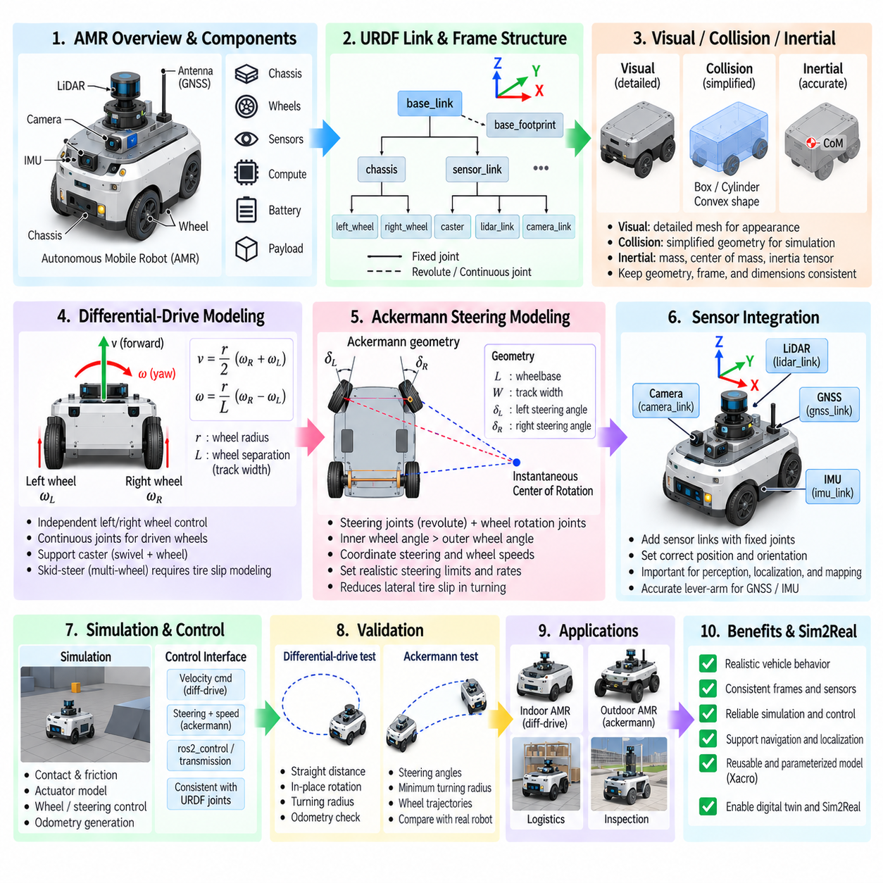
An AMR URDF model should describe more than the external shape of the vehicle. It must establish the kinematic relationships among the chassis, wheels, steering mechanisms, sensors, and reference frames used by localization, navigation, control, and simulation. Differential-drive and Ackermann-steered platforms require different joint structures because they generate vehicle motion through fundamentally different combinations of wheel rotation and steering geometry.
The model normally begins with a base reference frame representing the mobile platform. In ROS-based systems, base_link is commonly used as the primary body frame, while an additional base_footprint frame may provide a ground-projected reference for navigation. The chassis, battery enclosure, computing module, payload structure, and other rigidly attached components can be represented as links connected through fixed joints when separate coordinate frames are useful.
Visual, collision, and inertial descriptions should be separated for the main chassis. Detailed CAD-derived meshes can provide recognizable visual geometry, while simplified boxes, cylinders, or convex shapes are usually more suitable for collision detection. The inertial definition should reflect the actual vehicle mass, center of mass, and inertia tensor rather than the simplified collision geometry, particularly for heavy AMRs where mass distribution strongly affects acceleration, braking, and stability.
Wheel modeling requires accurate wheel radius, width, location, orientation, and rotation axis. Small errors in wheel dimensions can accumulate into substantial odometry errors because wheel angular displacement is converted directly into traveled distance. Wheel origins should correspond to the physical axle locations, and joint axes must follow the coordinate convention used by the robot model. Collision geometry should preserve the effective rolling radius even when the visual tire mesh is highly detailed.
A differential-drive AMR generates planar motion by independently controlling the angular velocities of wheels or wheel groups on the left and right sides. Equal wheel velocities produce approximately straight motion, while different velocities generate yaw rotation. Opposite wheel velocities can allow rotation near the vehicle center. The URDF must therefore define driven wheel joints so the simulator and controller can apply independent left- and right-side commands.
The two essential geometric parameters for differential-drive kinematics are wheel radius and wheel separation. Wheel separation represents the effective lateral distance between the left and right rolling paths. Together with wheel angular velocities, these parameters determine linear and angular vehicle velocity. Incorrect values can cause discrepancies between commanded motion, simulated motion, wheel odometry, and the trajectory estimated by localization and navigation systems.
Driven wheels are commonly connected to the chassis through continuous joints because they can rotate indefinitely. Each joint specifies the parent chassis link, child wheel link, origin, and rotational axis. Depending on the simulator and control architecture, transmission or ros2_control information can associate these joints with velocity or effort command interfaces. The structural URDF and the actuator-control configuration should remain logically consistent.
Many differential-drive AMRs require passive support wheels such as casters. A caster may require both a steering swivel joint and a wheel rotation joint if its passive dynamics are modeled explicitly. Simplifying a caster as a fixed support can reduce simulation cost, but it may hide effects such as caster alignment, oscillation, friction, and resistance during turning. The required modeling fidelity depends on whether the objective is navigation testing or detailed vehicle-dynamics analysis.
Skid-steer vehicles extend the differential concept to platforms with multiple fixed-orientation wheels, such as four-wheel or six-wheel outdoor AMRs. Wheels on each side may receive similar velocity commands, but turning requires tire slip because all wheel axes remain parallel. A realistic simulation must therefore consider lateral friction and contact behavior. Treating a multi-wheel skid-steer platform as an ideal two-wheel differential robot can underestimate turning resistance and energy loss.
Ackermann steering uses a different mechanical principle. Instead of generating yaw primarily through left-right wheel-speed differences, the vehicle changes the steering angles of its wheels so their rolling directions approximately intersect at a common instantaneous center of rotation. This arrangement reduces lateral tire slip during normal turning and is widely associated with road vehicles and larger outdoor mobile platforms operating at higher speeds.
An Ackermann URDF therefore requires explicit steering joints in addition to wheel rotation joints. A typical front-steered configuration contains left and right steering knuckle links connected to the chassis through revolute steering joints. Wheel links are then attached to the steering knuckles through continuous rotation joints. The resulting hierarchy allows steering orientation and wheel rotation to be represented as separate mechanical degrees of freedom.
Wheelbase and track width are fundamental Ackermann geometry parameters. Wheelbase is the longitudinal distance between front and rear axle references, while track width represents the lateral separation between wheels. During a turn, the inner steering wheel generally requires a larger steering angle than the outer wheel because the two wheels follow circles with different radii. Using identical steering angles is a simplified approximation rather than true Ackermann geometry.
The steering controller must therefore coordinate the left and right steering joints according to the desired curvature. A higher-level command may specify steering angle, curvature, or linear and angular velocity, after which the control layer computes individual wheel steering targets. Depending on implementation, the URDF provides the mechanical joint structure while ros2_control, simulator plugins, or vehicle-control software implements the steering relationship and actuator commands.
Wheel-speed coordination is also required during Ackermann turning because inner and outer wheels travel different path lengths. An idealized low-speed model may tolerate simplified wheel velocities, but higher-fidelity vehicle simulation should account for the different rotational speeds required by each wheel. This becomes increasingly important as wheelbase, track width, steering angle, speed, and tire-road interaction increase the difference between individual wheel trajectories.
Steering limits must correspond to the physical mechanism. Revolute steering joints should include realistic angular limits, velocity limits, and effort limits derived from the steering actuator and linkage. Unrealistically large steering angles can create impossible turning radii or geometric interference. Steering rate is also important because an Ackermann vehicle cannot instantaneously change curvature, particularly when steering inertia and actuator dynamics are included.
Differential-drive and Ackermann platforms therefore have different maneuverability characteristics that should be reflected in simulation. Differential drive can support very small-radius or near-zero-radius turns, making it attractive for indoor environments. Ackermann steering generally requires a finite turning radius but provides rolling geometry better suited to vehicle-like motion. The robot model should represent the actual mechanical architecture rather than forcing both systems into the same kinematic abstraction.
Sensor frames should be integrated into the same URDF hierarchy. LiDAR, depth cameras, RGB cameras, IMUs, GNSS antennas, ultrasonic sensors, and other devices can be represented as dedicated links connected through fixed joints. Accurate sensor position and orientation are essential because perception measurements are transformed through the robot frame tree. Small mounting errors can become significant when projecting distant observations or combining multiple sensors.
For outdoor AMRs, GNSS and IMU frames require particular attention because localization depends on their physical placement relative to the vehicle reference frame. The GNSS antenna position may be offset from the vehicle center, while the IMU may be mounted elsewhere on the chassis. These lever-arm relationships should be represented accurately so localization, sensor fusion, simulation, and real hardware share consistent spatial assumptions.
Ground clearance, wheel contact location, overhang, and chassis dimensions should also be preserved when the model is intended for terrain simulation. A collision model that is excessively simplified may incorrectly clear obstacles or collide with terrain that the real vehicle could traverse. Outdoor AMRs operating on slopes, curbs, uneven surfaces, or rough terrain therefore require collision geometry that retains task-relevant dimensions without reproducing unnecessary CAD detail.
Suspension can be represented when vertical wheel travel and terrain contact are important. A simple navigation model may rigidly attach wheel axle locations to the chassis, while a higher-fidelity model can introduce suspension links, prismatic or revolute joints, spring-damper behavior, and wheel assemblies. Such modeling becomes valuable for outdoor AMRs because suspension motion influences tire contact, chassis attitude, sensor orientation, and traction over uneven terrain.
The TF frame hierarchy generated from the robot description should remain clear and deterministic. Navigation and localization modules depend on transformations among frames such as map, odom, base_footprint, base_link, and sensor frames. URDF normally defines the robot-internal fixed and articulated relationships, while localization or odometry systems provide dynamic world-related transforms. Mixing these responsibilities can produce duplicated or conflicting transformations.
Simulation integration adds contact, friction, actuator, and controller behavior to the structural model. Differential-drive systems require appropriate wheel commands and odometry generation, while Ackermann systems require coordinated steering and wheel actuation. Physics-engine parameters should provide sufficient longitudinal traction without introducing unrealistic lateral constraints. These parameters should be validated through straight driving, turning, acceleration, braking, and trajectory-following tests.
Validation should compare geometric expectations with simulated behavior. For differential drive, useful tests include commanded straight distance, in-place rotation, turning radius, and wheel-odometry consistency. For Ackermann steering, steering angles, minimum turning radius, wheel trajectories, and curvature response should be checked. Unexpected errors often originate from incorrect wheel radius, separation, wheelbase, track width, joint axis, friction, or controller configuration.
A maintainable AMR description should parameterize repeated and configuration-dependent elements using Xacro where appropriate. Wheel dimensions, axle positions, sensor mounts, track width, wheelbase, payload modules, and optional sensors can then be generated from a consistent set of parameters. This approach is particularly useful when one platform family contains multiple wheel arrangements, sensor packages, or chassis variants while sharing a common architectural foundation.
Ultimately, AMR URDF modeling establishes the physical reference model connecting vehicle mechanics with robotics software. Differential drive relies on coordinated left-right wheel motion, while Ackermann steering combines wheel rotation with mechanically constrained steering geometry. Accurate links, joints, wheel dimensions, inertial properties, sensor frames, collision models, and control interfaces allow the same structural description to support navigation, physics simulation, controller development, digital twins, and Sim2Real validation.

03.07. Mobile Manipulator URDF Arm on Base [w/Code]
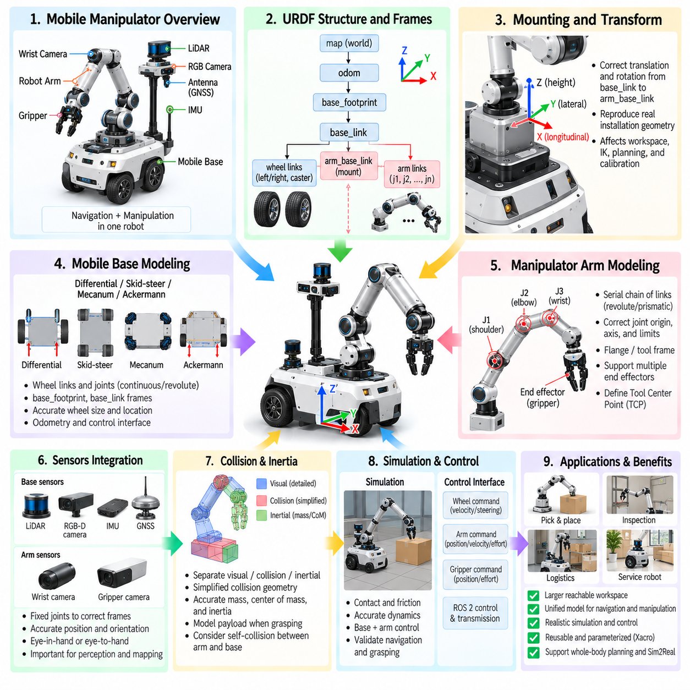
A mobile manipulator combines a mobile base with one or more robotic arms, creating a system that can navigate through an environment and perform manipulation tasks beyond the fixed workspace of a conventional industrial robot. Its URDF must represent these subsystems as one coherent kinematic structure. The model must connect base motion, arm joints, end effectors, sensors, collision geometry, and inertial properties while maintaining consistent coordinate frames across the complete robot.
The mobile base normally forms the root of the robot description. Frames such as base_footprint and base_link establish references for navigation and physical modeling, while wheel links and joints define the locomotion mechanism. Differential drive, skid steer, mecanum, or other mobile configurations can be represented beneath this base structure. The manipulator is then attached above the chassis through a mechanically meaningful mounting frame rather than modeled as an independent robot.
A dedicated arm mounting frame provides a clean interface between the mobile platform and manipulator. Names such as arm_base_link, manipulator_mount, or pedestal_link can represent the physical structure connecting the arm to the chassis. This interface is useful because the same arm may later be installed on another base, or different manipulators may share the same mobile platform. Modular frame organization therefore improves reuse, maintenance, and configuration management.
The transform between base_link and the arm mounting frame must reproduce the physical installation accurately. Translation defines the arm's longitudinal, lateral, and vertical offset from the mobile base, while rotation defines its mounting orientation. Even small errors can shift the entire manipulation workspace. Incorrect mounting geometry can consequently produce errors in inverse kinematics, motion planning, collision checking, object reaching, and sensor-to-manipulator calibration.
The arm itself is represented as a serial or branched chain of links connected by revolute, continuous, prismatic, or fixed joints. A typical six-degree-of-freedom manipulator contains shoulder, elbow, and wrist joints that progressively transform the pose from arm_base_link toward the tool. Each joint requires a correct origin, axis, motion limit, and parent-child relationship so forward kinematics reproduce the physical robot accurately.
Joint limits are especially important for mobile manipulators because motion planning must respect the actual mechanical workspace. Position limits prevent impossible joint configurations, velocity limits constrain achievable motion speed, and effort limits approximate actuator capability. These limits should correspond to the physical manipulator rather than generic values. Otherwise, a planner or controller may generate trajectories that are mathematically valid but impossible or unsafe for the real mechanism.
The terminal portion of the arm normally includes a flange or tool frame that provides an interface for end effectors. Grippers, suction devices, cameras, inspection tools, or application-specific mechanisms can be attached through fixed or articulated joints. Maintaining a stable tool interface allows the same manipulator model to support multiple end effectors while preserving the arm's core kinematic definition and simplifying tool-center-point configuration.
Tool Center Point, or TCP, definition is essential for manipulation. The TCP represents the operational point used for reaching, grasping, insertion, or process execution and may differ significantly from the final wrist-link origin. A gripper might define the TCP between its fingers, while a suction tool may define it at the suction surface. Accurate TCP placement allows motion planning and task commands to correspond directly to the physical interaction point.
Visual and collision geometries should be managed independently throughout the combined robot. Detailed meshes may be retained for realistic visualization, while collision geometry can use simplified primitives, convex hulls, or optimized meshes. Manipulator collision models require particular attention because planning algorithms repeatedly evaluate collisions between the arm, mobile base, environment, payload, and sometimes different parts of the robot itself.
Self-collision modeling becomes more complex when an arm is mounted on a mobile base. The manipulator may collide with the chassis, sensor mast, wheels, battery enclosure, payload racks, or other structures during large joint motions. A collision matrix can exclude link pairs that can never collide while retaining checks for physically meaningful combinations. Efficient self-collision configuration reduces planning cost without allowing dangerous configurations to pass undetected.
Inertial properties must represent both the mobile base and manipulator accurately when dynamic simulation is required. Each link should contain appropriate mass, center of mass, and inertia tensor values. The arm can significantly alter the total system center of mass as it extends, lifts payloads, or rotates. This effect is particularly important for compact mobile bases where manipulator motion can reduce stability margins or increase wheel loading asymmetrically.
Payload modeling extends the inertial chain beyond the robot itself. When an object is grasped, its mass and inertia effectively become part of the manipulation system. A lightweight empty gripper and a heavily loaded gripper produce substantially different actuator demands and base stability conditions. High-fidelity simulations should therefore represent payload mass, center of mass, and attachment location when evaluating manipulation performance or mobile-platform stability.
The interaction between arm motion and base stability is a defining characteristic of mobile manipulation. Extending the arm horizontally moves the combined center of mass toward the edge of the support region, while rapid arm acceleration can generate reaction forces and moments on the chassis. A URDF provides the structural and inertial foundation for analyzing these effects, although detailed stability behavior ultimately depends on the physics engine, actuator models, contact parameters, and controller.
Sensors mounted on the base should be represented within the same frame hierarchy as the arm. LiDAR, RGB cameras, depth cameras, IMUs, and other sensors require fixed transforms relative to the chassis. Manipulation systems often add cameras near the arm, wrist, or gripper. Because perception results must be transformed into coordinates usable by motion planning, accurate extrinsic relationships among camera frames, base frames, arm links, and the TCP are essential.
Eye-in-hand configurations place a camera on a moving wrist or end-effector link. In this arrangement, the camera transform changes continuously as the arm moves, but its rigid relationship to the mounting link remains fixed in URDF. This allows the TF system to calculate the camera pose relative to the base or world from the current joint states. Accurate mounting calibration is essential for visual servoing, grasp estimation, and close-range inspection.
Eye-to-hand configurations instead place cameras on the chassis, mast, or surrounding environment. A base-mounted depth camera can observe the manipulator workspace while remaining independent of arm motion. The URDF should accurately represent cameras physically attached to the robot, while external infrastructure sensors are normally handled through separate world or calibration frames. Maintaining this distinction helps prevent ambiguous or duplicated transforms.
Mobile manipulation introduces two coupled workspaces: the navigation workspace of the base and the manipulation workspace of the arm. A fixed manipulator can reach only objects inside its local workspace, but a mobile manipulator can reposition the base to create new feasible arm configurations. The combined reachable region is therefore much larger. Robot modeling should support planners that reason about both base pose and arm configuration rather than treating them as unrelated systems.
Whole-body planning considers the mobile base and manipulator as a combined configuration space. A task such as reaching an object may be achieved by driving the base, rotating the chassis, moving the arm, or coordinating all of them. The URDF provides the kinematic tree required for these calculations, while planning frameworks define which joints are included in planning groups and how constraints are applied to the combined system.
A common software architecture nevertheless separates navigation and manipulation controllers. The mobile base controller handles wheel motion and odometry, while arm controllers manage manipulator joints and the gripper. Higher-level task software coordinates both subsystems. This separation allows mature navigation and manipulation components to be reused, while the unified robot description maintains a common geometric reference connecting their outputs.
ROS 2 control interfaces can expose different hardware command modes for the base and arm. Wheel joints may use velocity commands, steering mechanisms may use position commands, and manipulator joints may use position, velocity, or effort interfaces. The URDF-related control description should remain consistent with the real hardware architecture so simulation controllers can later be replaced by physical hardware interfaces with minimal structural changes.
Motion planning requires more than correct kinematics. Planning groups, end-effector definitions, virtual joints, collision rules, and named configurations are typically maintained alongside the robot description. For a mobile manipulator, the arm may form one planning group, the gripper another, and the combined base-arm system an additional group when whole-body planning is required. This modular structure allows different planning complexity according to the task.
The relationship between map, odom, base_footprint, base_link, arm links, and tool frames should remain unambiguous. Localization normally determines the mobile base pose relative to the environment, wheel odometry provides local motion estimates, and the robot-state system propagates joint transformations through the manipulator. Maintaining clear ownership of each transform prevents multiple components from publishing conflicting relationships within the TF tree.
Simulation validation should begin by checking the two subsystems independently. The mobile base should reproduce expected straight-line motion, rotation, steering, and odometry behavior, while the manipulator should reproduce joint limits, forward kinematics, reachable poses, and controller response. Once these functions are verified separately, combined tests can evaluate navigation to manipulation poses, collision avoidance, grasping, payload handling, and coordinated base-arm motion.
A particularly useful validation scenario is navigation-to-grasp. The robot approaches an object, stops at a feasible base pose, detects or receives the target pose, plans an arm trajectory, performs the grasp, and then moves while carrying the payload. This workflow exercises frame consistency across navigation, perception, manipulation, and control. Errors in mounting transforms, TCP definitions, sensor calibration, or base localization often become immediately visible during such integrated testing.
Parameterization with Xacro can make the mobile-manipulator description substantially easier to maintain. Base dimensions, arm mounting pose, manipulator type, sensor packages, gripper model, wheel configuration, and optional payload structures can be exposed as reusable parameters or macros. A product family can then generate several robot variants from a shared architectural description while preserving consistent naming and frame conventions.
Ultimately, mobile-manipulator URDF modeling creates a unified physical and kinematic representation of mobility and manipulation. The mobile base expands where the robot can operate, while the arm determines how it physically interacts with objects. Accurate mounting transforms, joint definitions, inertial properties, collision models, sensors, TCP frames, and control interfaces allow these capabilities to function as one system for navigation, manipulation, digital-twin simulation, whole-body planning, and Sim2Real deployment.

03.08. Quadruped MJCF Modeling 12 DOF Leg Structure [w/Code]
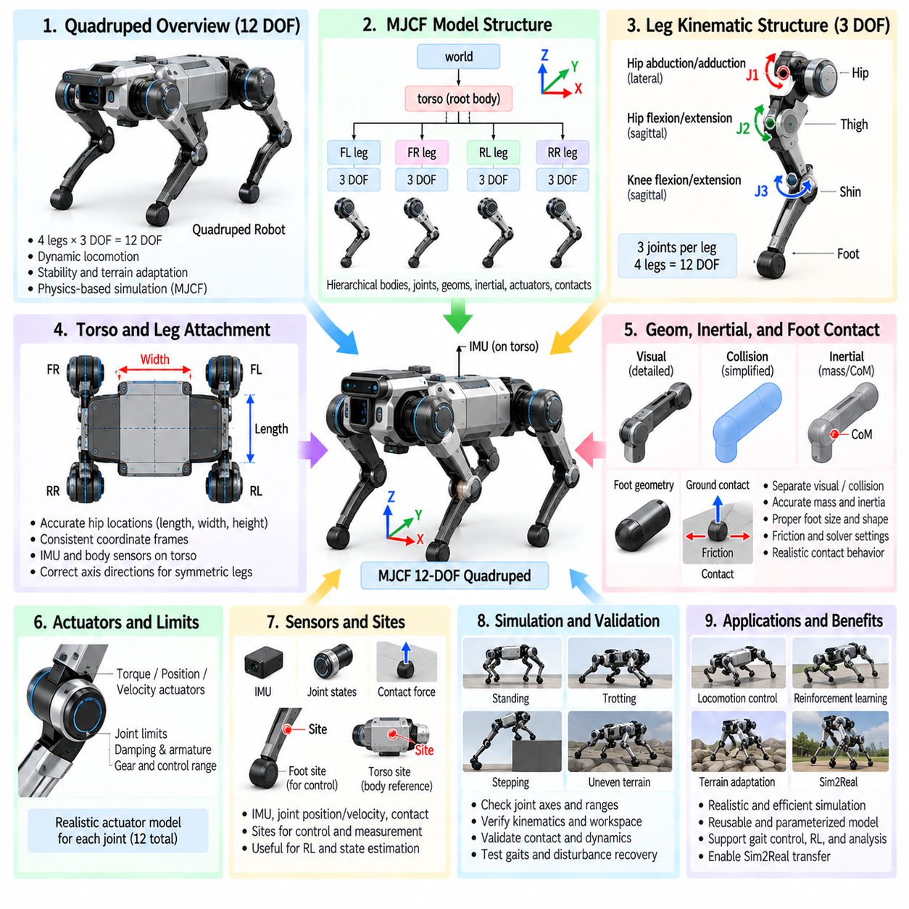
A quadruped robot with 12 degrees of freedom typically distributes three actuated joints to each of its four legs, creating a compact structure capable of supporting dynamic locomotion, body stabilization, and terrain adaptation. In MJCF, this architecture is naturally represented through hierarchical bodies, joints, geoms, inertial properties, actuators, and contact elements. The model must preserve symmetry while allowing each leg to move independently under physics-based control.
The torso normally forms the root body of the quadruped model. It contains the primary mass and inertia of the robot and provides attachment frames for the front-left, front-right, rear-left, and rear-right legs. The torso coordinate frame should follow a consistent convention so forward direction, lateral direction, and vertical direction remain unambiguous. Sensors such as an IMU can also be referenced relative to this central body.
Each leg is commonly modeled as a three-joint serial chain consisting of hip abduction-adduction, hip flexion-extension, and knee flexion-extension. Four identical three-DOF chains produce the complete 12-DOF leg structure. The first joint moves the leg laterally, while the second and third primarily control motion in the sagittal plane. Together they allow the foot to be positioned throughout a three-dimensional workspace relative to the torso.
MJCF's nested body structure is particularly suitable for representing this hierarchy. A hip body can be placed relative to the torso, followed by an upper-leg body and then a lower-leg body. Each child body inherits the transformation of its parent, so movement of a proximal joint automatically affects all distal segments. This tree structure corresponds closely to the physical kinematic chain and simplifies both forward dynamics and control.
The four hip attachment locations must accurately represent the physical dimensions of the robot. Longitudinal offsets determine the separation between front and rear legs, while lateral offsets establish the body width and stance geometry. Incorrect hip placement changes the support polygon, reachable foot workspace, turning behavior, and dynamic stability. Symmetric parameterization is useful, but mirrored joints must still preserve correct signs and axis directions.
Joint axes are fundamental to quadruped modeling because apparently symmetric legs may require different axis conventions depending on how local frames are mirrored. The hip abduction joint usually rotates around a longitudinal axis, while hip and knee flexion joints rotate around a lateral axis. Axis errors can produce reversed or coupled-looking motion that is difficult to diagnose later. Each joint should therefore be tested individually before locomotion control is introduced.
Joint ranges should reproduce the mechanical limits of the real leg. Hip abduction limits constrain lateral motion, while hip and knee limits determine reachable leg extension and folding. Excessive ranges may allow physically impossible postures or self-intersection, whereas overly restrictive ranges reduce the feasible locomotion workspace. MJCF joint range settings should therefore be coordinated with actuator limits and controller assumptions.
Geometric modeling should distinguish visual appearance from physical collision requirements. High-detail meshes can represent covers, motors, and structural components for rendering, while simpler capsules, cylinders, boxes, or convex geometries are often preferable for collision. Leg links especially benefit from simplified collision geometry because four moving chains create many possible contact pairs and can substantially increase collision-detection cost.
Inertial properties strongly influence quadruped dynamics. Every torso and leg segment requires appropriate mass, center of mass, and inertia tensor information. Distal leg mass is particularly important because heavy lower legs increase swing inertia and actuator demand. Unrealistic mass distribution can make a simulated robot appear excessively agile or sluggish even when its total mass is correct, so link-level inertia should reflect the intended hardware.
The foot represents the principal interface between the robot and terrain. It may be modeled as a sphere, capsule, small box, or more detailed collision shape depending on the physical foot design and simulation objective. Foot dimensions influence contact area, terrain penetration, friction, and stability. For locomotion research, a simple but physically meaningful foot geometry is often more useful than a visually accurate mesh with unnecessarily complex contact surfaces.
Ground contact depends not only on foot geometry but also on friction and solver parameters. Longitudinal and lateral friction must provide sufficient traction for propulsion while still allowing physically plausible slip. Excessive friction can make locomotion unrealistically easy, whereas insufficient friction causes unstable sliding. Contact softness, damping, penetration tolerance, and solver settings may also influence impact behavior during touchdown.
MJCF sites can be placed at feet, joints, the torso center, or other locations to provide reference points for control and measurement. Foot sites are particularly useful for tracking desired trajectories, computing contact locations, and visualizing stance geometry. A torso site can represent a body reference or center used by locomotion controllers. Sites add negligible physical complexity because they function primarily as spatial markers.
Sensors can be incorporated directly into the MJCF model. An IMU-like configuration may provide orientation-related, angular-velocity, and acceleration information associated with the torso, while joint position and velocity states are available for proprioceptive control. Foot contact information can be derived from contact forces or dedicated sensing arrangements. These observations form the state representation used by model-based controllers or reinforcement-learning policies.
Actuators connect control commands to the 12 leg joints. Each hip and knee joint may receive torque commands directly or be controlled through position- or velocity-oriented actuator models. Direct torque control exposes more of the physical dynamics to the controller, while position actuators can approximate embedded servo behavior. The actuator type should correspond to the control abstraction expected in the physical robot.
Torque limits are critical because locomotion performance depends directly on available joint effort. Hip and knee joints experience different loads during stance, acceleration, jumping, and disturbance recovery. Unlimited simulated torque allows policies to exploit physically impossible actions. Actuator force ranges, gear effects, damping, armature, and control ranges should therefore be selected consistently with the intended motor and transmission characteristics.
Joint damping and armature can improve both physical realism and numerical behavior. Damping represents energy loss associated with mechanical and actuator resistance, while armature can approximate reflected rotor inertia through the transmission. These parameters affect oscillation, joint acceleration, and control response. Excessive values can artificially stabilize the robot, so they should not be used merely to compensate for poor controller or solver configuration.
The quadruped's floating base introduces six additional unactuated spatial degrees of freedom even though the leg mechanism itself contains 12 actuated DOF. The torso must translate and rotate freely in the simulated world as a result of gravity, contact forces, and leg actuation. This distinction is important: a 12-DOF quadruped generally refers to its actuated leg joints rather than the complete generalized coordinate dimension of the floating system.
Initial pose configuration should place the robot in a physically valid stance without excessive ground penetration or joint-limit violation. Hip and knee angles can be selected to create a nominal standing height and support polygon. Starting from an unstable or geometrically inconsistent configuration can produce large contact impulses immediately after simulation begins, making controller debugging difficult and potentially masking errors in the physical model.
Leg naming conventions should remain systematic across the complete model. Prefixes such as FL, FR, RL, and RR can distinguish front-left, front-right, rear-left, and rear-right components, followed by consistent hip, thigh, calf, foot, joint, and actuator names. Predictable naming simplifies controller mapping, observation-vector construction, logging, debugging, and conversion between simulation frameworks.
MJCF defaults and reusable classes can reduce duplication across four structurally similar legs. Common joint damping, geom properties, actuator settings, contact parameters, and visual attributes can be defined once and reused. Leg-specific body positions and axis signs can then be parameterized separately. This organization improves maintainability and reduces the risk that one leg accidentally receives different physical parameters from the others.
Self-collision should be configured according to realistic mechanical interaction. Adjacent links within a leg may not require every possible collision test, while collisions between feet, opposing legs, or legs and torso may need to remain active. Unnecessary contact pairs increase computational cost and can introduce solver artifacts. However, disabling too many collisions allows the robot to exploit physically impossible configurations during optimization or reinforcement learning.
Locomotion emerges from coordinated control of all four leg chains rather than from individual joint motion alone. Walking, trotting, pacing, bounding, and recovery behaviors differ in the timing and distribution of stance and swing phases. The MJCF model provides the physical structure on which these controllers operate. Accurate geometry, inertia, actuator limits, and contacts are therefore prerequisites for meaningful gait development and comparison.
Reinforcement learning often uses many parallel instances of the same quadruped model, making simulation efficiency important. Simplified collision geometry, carefully selected contact pairs, stable solver parameters, and compact observation definitions can substantially increase training throughput. However, optimization should not remove physical properties that determine locomotion behavior, particularly foot geometry, leg inertia, torque limits, friction, and actuator dynamics.
Validation should proceed from individual components toward whole-body behavior. Each joint can first be actuated independently to verify axis direction and range, followed by tests of leg forward kinematics and reachable foot positions. Static standing can then validate mass distribution and contact behavior. Dynamic tests such as stepping, trotting, turning, disturbance recovery, and uneven-terrain traversal expose errors that remain hidden during isolated joint testing.
For Sim2Real transfer, the model should reproduce the physical relationships that most strongly affect locomotion while acknowledging uncertain parameters. Link masses, centers of mass, joint limits, motor strength, damping, friction, latency, and ground interaction can be measured or identified where possible. Domain randomization can then vary uncertain quantities around meaningful nominal values rather than compensating for an unrealistic baseline model.
A well-structured 12-DOF quadruped MJCF therefore combines a floating torso, four symmetric three-joint leg chains, physically meaningful collision and inertial properties, realistic actuators, and carefully configured terrain contact. This structure provides a reusable foundation for gait control, reinforcement learning, stability analysis, terrain adaptation, digital-twin simulation, and Sim2Real validation while keeping the mechanical hierarchy understandable and computationally manageable.

03.09. Humanoid URDF MJCF Full Body 30 Plus DOF [w/Code]
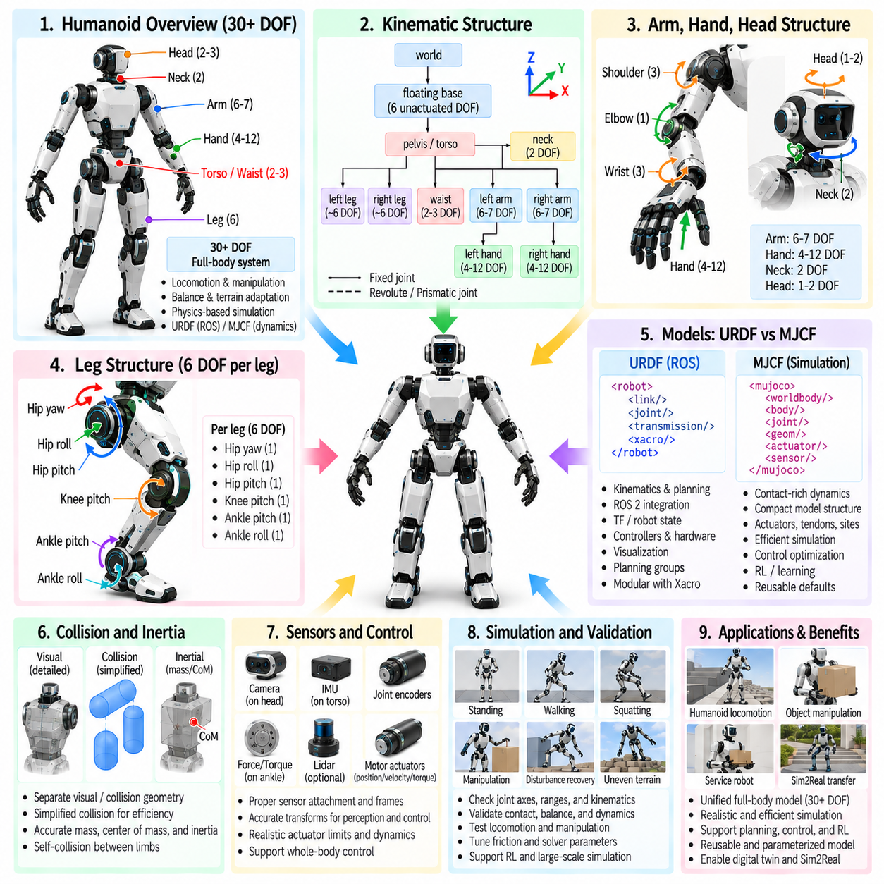
A humanoid robot with more than 30 degrees of freedom requires a full-body model that represents the coordinated motion of the torso, head, arms, hands, pelvis, and legs as a single articulated system. URDF and MJCF provide complementary approaches for describing this structure. URDF integrates naturally with ROS-based kinematics and planning, while MJCF provides a compact representation suited to contact-rich dynamics, control optimization, and physics-based learning.
The pelvis or torso commonly serves as the central body from which the humanoid kinematic structure branches. Two legs extend downward from the pelvis, while the upper torso supports the arms, neck, and head. Unlike a serial manipulator, a humanoid therefore contains several articulated branches sharing a common floating body. A clear hierarchy is essential because every joint transformation affects downstream links, sensors, collision geometry, and control calculations.
A floating-base humanoid has six unactuated spatial degrees of freedom in addition to its actuated joints. The entire robot can translate along three axes and rotate about three axes as a consequence of gravity, contact forces, and joint actuation. Therefore, a humanoid described as having 30 or more DOF usually refers primarily to actuated joints, while the generalized dynamic state also includes the floating-base position and orientation.
Each leg commonly contains multiple joints at the hip, knee, and ankle. A representative structure may provide three rotational DOF at the hip, one at the knee, and two at the ankle, producing approximately six actuated DOF per leg. This arrangement allows the foot to be positioned and oriented relative to the pelvis while supporting walking, balancing, turning, crouching, stair negotiation, and recovery motions.
The hip is especially important because it transfers forces between the torso and legs while permitting motion in multiple directions. Hip yaw, roll, and pitch can represent rotation around approximately vertical, longitudinal, and lateral axes. The exact joint order and coordinate frames must correspond to the mechanical design because different rotation sequences produce different kinematic behavior even when the nominal number of DOF is identical.
The knee is frequently represented as a primarily pitch-oriented revolute joint, although the physical mechanism may contain more complex linkages. Its range strongly influences leg extension, crouching, stepping, and foot clearance. Simplifying a coupled mechanical knee into one equivalent joint may be appropriate when the external kinematics are preserved, but dynamic modeling should still reproduce relevant inertia, transmission behavior, and actuator limits.
The ankle generally requires pitch and roll motion to regulate foot orientation and shift the center of pressure during balance and locomotion. These joints allow the robot to adapt its feet to changing body posture and terrain geometry. Accurate ankle axes, limits, actuator strength, and foot dimensions are particularly important because small modeling errors near the ground can significantly alter balance, contact forces, and walking stability.
The upper body introduces additional degrees of freedom through the waist, shoulders, elbows, wrists, neck, and potentially articulated hands. A waist may provide yaw, roll, or pitch motion, while each arm may contain six or seven DOF for human-like reaching. Neck joints orient the head and sensors. When dexterous hands are modeled explicitly, finger joints can rapidly increase the complete robot beyond 30 DOF and substantially increase simulation complexity.
Humanoid joint naming should follow a systematic convention that identifies body side, anatomical region, and motion axis. Names such as left_hip_pitch, right_shoulder_roll, or neck_yaw make controller mapping and debugging easier than arbitrary identifiers. Consistent naming is particularly valuable when the model contains dozens of joints and must be shared among URDF, MJCF, controllers, motion planners, datasets, and learning environments.
Coordinate-frame conventions must remain consistent throughout the entire body. Mirrored left and right limbs require careful treatment because identical-looking joints may require opposite axis signs depending on their local frames. Incorrect axis definitions can remain unnoticed in a static visualization but become obvious during coordinated motion. Every joint should therefore be exercised independently before whole-body control or locomotion is attempted.
Joint limits must reflect the physical humanoid rather than an idealized human anatomical range. Mechanical stops, cable routing, actuator packaging, link interference, and transmission design may constrain motion well before human-like limits are reached. Position, velocity, and effort limits prevent planners or learned controllers from exploiting impossible configurations and provide a realistic boundary for whole-body motion generation.
Visual and collision models should be separated to control computational cost. Detailed meshes can preserve the external appearance of the humanoid, while collision representations can use capsules, boxes, cylinders, convex hulls, or simplified meshes. With dozens of articulated links, unrestricted mesh-to-mesh collision testing can become expensive. Collision simplification is therefore essential for efficient motion planning, reinforcement learning, and real-time simulation.
Self-collision requires particular attention because humanoid limbs can interact with many other body regions. Hands may contact the torso or opposite arm, knees can approach each other, and legs can collide during complex stepping. Collision pairs that are physically impossible or permanently adjacent can be excluded, while meaningful interactions remain active. The objective is to reduce computation without allowing the robot to pass through itself.
Accurate inertial modeling is fundamental to whole-body dynamics. Every major link requires mass, center of mass, and inertia tensor values consistent with its physical construction. The distribution of mass among the torso, pelvis, limbs, batteries, computers, and actuators determines balance and momentum. Matching total robot mass alone is insufficient because incorrect link-level distribution changes joint torques, impact response, and dynamic stability.
The humanoid's combined center of mass changes continuously as limbs move. Raising an arm, bending the torso, lifting one leg, or carrying an object alters the relationship between the center of mass and the support region. A physically meaningful URDF or MJCF model therefore provides the foundation for balance controllers that regulate body posture, contact forces, momentum, and foot placement according to the current full-body configuration.
Feet require carefully designed collision geometry because they form the primary contact surfaces during standing and walking. Foot length, width, sole thickness, heel and toe geometry, and contact locations influence the support polygon and pressure distribution. Excessively simplified feet can distort balance behavior, while unnecessarily detailed surfaces may produce unstable contact calculations. The representation should preserve dimensions important to locomotion.
Humanoid locomotion involves changing contact conditions rather than a fixed kinematic chain. During double support both feet contact the ground, while during single support only one foot carries the primary load. Walking repeatedly transitions between these states, and dynamic motions may introduce toe, heel, hand, or knee contacts. MJCF contact definitions and physics parameters must therefore support stable but physically plausible transitions among multiple contact configurations.
Friction, contact stiffness, damping, penetration behavior, and solver settings strongly affect simulated humanoid stability. Excessive friction or artificial damping can hide weaknesses in a controller, while insufficient friction may prevent stable walking even with correct control commands. Contact parameters should be selected as physical properties rather than tuning mechanisms used solely to make the robot remain upright.
Actuator models connect control commands to the humanoid's many joints. Different joints may require substantially different torque capabilities because hips, knees, and ankles support body weight while wrists or neck joints operate under smaller loads. Position, velocity, or torque actuators can be represented depending on the intended control architecture. Torque limits and actuator dynamics should correspond to the real motor, gearbox, and transmission system.
Sensors are distributed throughout a humanoid and should be attached to appropriate body frames. An IMU is commonly associated with the pelvis or torso, while cameras may be mounted in the head. Joint encoders provide proprioceptive states, and force or torque sensing may be associated with ankles, wrists, or other interfaces. Accurate sensor transforms are necessary for state estimation, visual perception, balance, manipulation, and whole-body control.
Whole-body control coordinates multiple joints while satisfying several objectives simultaneously. The robot may need to maintain balance, control its center of mass, preserve foot contacts, orient the torso, position a hand, and avoid joint limits at the same time. The URDF or MJCF model supplies the kinematic and dynamic relationships required to formulate these tasks, constraints, Jacobians, inverse dynamics, and optimization problems.
Humanoid manipulation introduces additional interaction between upper-body motion and balance. Reaching for an object shifts mass and generates reaction forces, while lifting a payload changes the system inertia and center of mass. Whole-body manipulation may therefore coordinate arm, waist, legs, and foot forces rather than treating the arm as an isolated manipulator. Payload properties should be represented when their influence on stability is significant.
URDF is particularly useful when the humanoid must integrate with ROS 2, TF, robot-state publishing, visualization, motion planning, and hardware interfaces. Links and joints establish the primary kinematic tree, while additional configuration can define controllers, transmissions, collision rules, and planning groups. Xacro can parameterize mirrored limbs and repeated structures, reducing duplication and improving consistency across large full-body descriptions.
MJCF provides a compact mechanism for representing nested bodies, joints, geoms, sites, sensors, actuators, tendons, contacts, and reusable defaults within a physics-oriented model. This makes it suitable for humanoid control research in which contact dynamics and repeated simulation are central. Shared classes can define common joint, collision, and actuator properties while body-specific parameters preserve differences among individual links.
Conversion between URDF and MJCF should not be assumed to preserve every physical feature automatically. Differences in actuator definitions, contact configuration, joint representation, default parameters, inertial handling, and simulator-specific extensions may require explicit verification. When both formats are maintained, they should represent the same mechanical reference model even if their implementation structures differ.
Simulation efficiency becomes increasingly important as humanoid complexity grows. A full model may contain dozens of actuated joints, numerous collision bodies, multiple sensors, and several simultaneous contacts. Reinforcement learning may multiply this cost across thousands of parallel environments. Simplified collision geometry, selective self-collision, reusable defaults, appropriate solver settings, and carefully chosen model fidelity help maintain computational scalability.
Validation should progress from individual joints to complete whole-body behaviors. Joint axes, limits, and actuator directions can be checked first, followed by limb kinematics and reachable workspaces. Static standing tests can validate mass distribution and foot contact. Squatting, single-leg support, stepping, walking, arm reaching, disturbance recovery, and combined locomotion-manipulation tasks then expose increasingly complex modeling errors.
For Sim2Real transfer, the model should prioritize parameters that strongly affect balance, locomotion, and physical interaction. Link masses, centers of mass, actuator strength, reflected inertia, damping, joint friction, latency, foot geometry, and ground friction should be measured or identified where possible. Domain randomization can represent remaining uncertainty, but it should vary parameters around a physically credible nominal humanoid model.
A maintainable humanoid model should preserve traceability from mechanical design to simulation parameters. CAD dimensions, link masses, inertia estimates, motor specifications, gearbox ratios, joint limits, sensor mounting transforms, and identified dynamic parameters should have documented sources and revisions. This becomes increasingly important above 30 DOF because undocumented manual tuning can make model errors difficult to locate and reproduce.
Ultimately, full-body humanoid modeling combines a floating central body, articulated legs, torso, arms, head, hands, realistic inertial properties, actuators, sensors, and multi-contact interactions into one coherent system. A well-structured URDF supports robotics software integration, while a carefully constructed MJCF supports dynamic simulation and learning. Together they provide the physical foundation for balance, locomotion, manipulation, whole-body control, digital twins, and Sim2Real validation.

03.10. Cargo UAV Aerodynamic and Multirotor Modeling [w/Code]
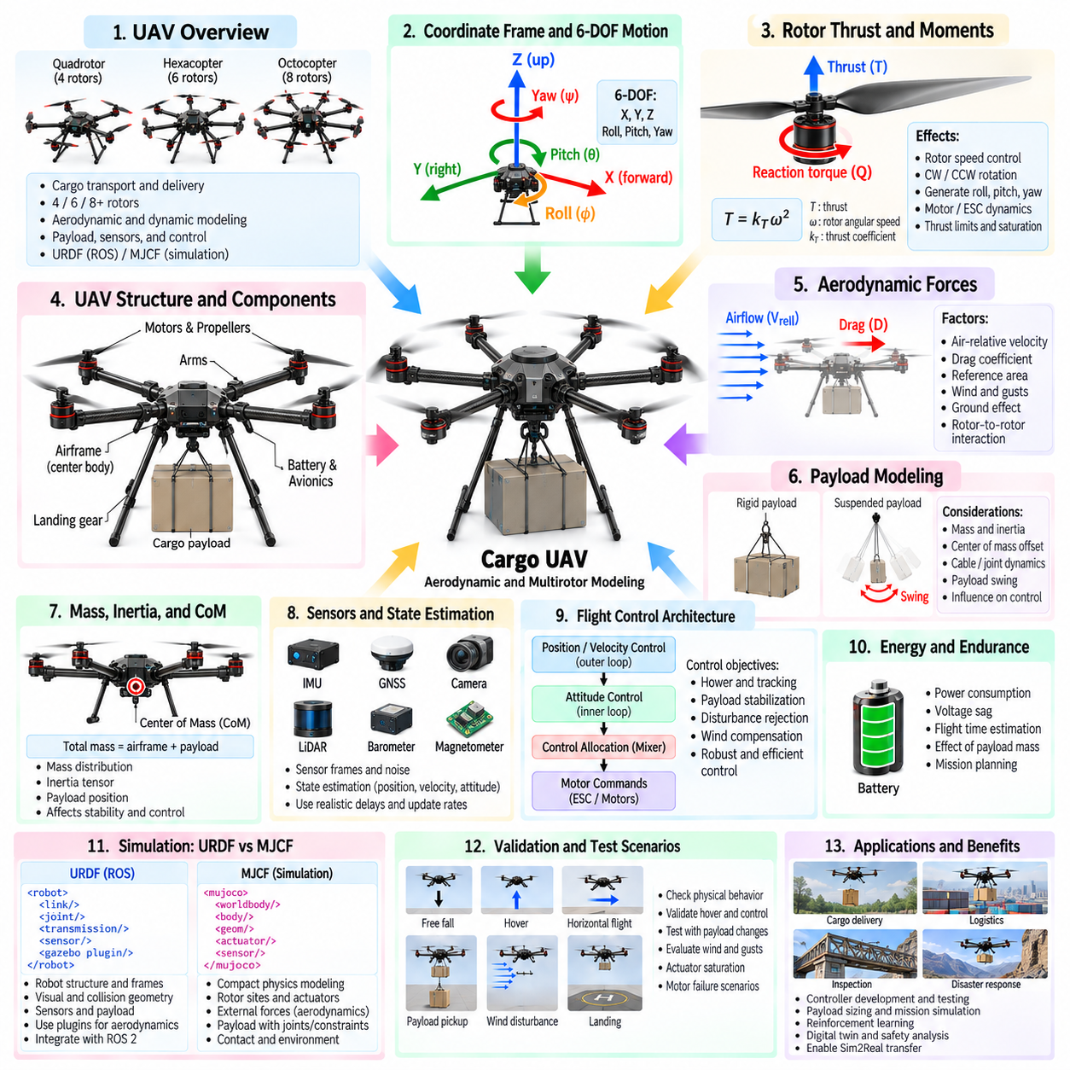
Cargo UAV modeling extends conventional robot simulation into a domain where rigid-body dynamics must be coupled with aerodynamic forces, propulsion, payload effects, and flight-control behavior. A multirotor cargo UAV may use four, six, eight, or more rotors depending on payload and redundancy requirements. The simulation model must represent the airframe, rotor locations, motor dynamics, mass distribution, aerodynamic effects, sensors, and payload as one physically consistent flying system.
The central airframe normally forms the primary body of the UAV model. Arms, landing gear, battery modules, avionics, payload structures, and rotor assemblies are positioned relative to this body through fixed or articulated relationships. Accurate coordinate conventions are essential because thrust directions, aerodynamic forces, IMU measurements, and controller calculations all depend on consistent body axes. Small frame errors can produce major errors in simulated flight behavior.
A multirotor is fundamentally a six-degree-of-freedom rigid body moving freely in three-dimensional space. It can translate along three axes and rotate through roll, pitch, and yaw. Unlike a ground robot, it has no persistent support contact during normal flight. Gravity continuously accelerates the vehicle downward, while rotor thrust and aerodynamic forces must generate the forces and moments required to hover, accelerate, maneuver, and stabilize the aircraft.
Each rotor generates thrust approximately along its rotational axis. In simplified models, thrust is commonly related to the square of rotor angular velocity through a thrust coefficient. Increasing rotor speed therefore increases lift contribution, while differences among rotor speeds generate control moments. The exact relationship depends on propeller geometry, air density, motor behavior, inflow conditions, and operating regime, so the appropriate fidelity depends on the intended simulation objective.
Rotor placement determines how individual thrust forces produce moments around the vehicle center of mass. A rotor positioned away from the center generates roll or pitch torque when its thrust changes. Multirotor control exploits these moment arms by varying rotor thrust collectively and differentially. Accurate rotor coordinates are therefore essential, particularly for large cargo UAVs where long arms and distributed propulsion can produce substantial moments.
Yaw control is typically produced by aerodynamic reaction torque associated with rotor rotation. Adjacent rotors are commonly assigned alternating clockwise and counterclockwise directions so their nominal reaction torques approximately cancel during hover. Differential changes between the two rotation groups then create a net yaw moment. The model must preserve rotor direction because incorrect signs can make the simulated mixer or flight controller behave incorrectly.
The control-allocation or mixer model converts desired total thrust and body moments into individual rotor commands. Collective rotor changes primarily regulate vertical force, while differential combinations generate roll, pitch, and yaw. Quadrotors have relatively compact allocation matrices, whereas hexacopters and octocopters introduce additional actuators and potential redundancy. Cargo platforms may exploit this redundancy for load capacity, control authority, or fault tolerance.
Motor and propeller dynamics should not always be treated as instantaneous. Electric motors, electronic speed controllers, and propellers require finite time to change rotational speed. A first-order response can approximate this delay, while higher-fidelity models may include motor electrical dynamics, rotor inertia, ESC limits, voltage effects, and saturation. These dynamics influence attitude response and become increasingly important during aggressive maneuvers or disturbance rejection.
Propeller thrust cannot increase without limit. Maximum rotor speed, motor torque, electrical current, battery voltage, thermal limits, and propeller capability define the propulsion envelope. Saturation becomes especially important for cargo UAVs because heavy payloads reduce the remaining thrust margin available for maneuvering. A vehicle that can barely hover at maximum thrust has little control authority for acceleration, wind rejection, or emergency recovery.
Hover provides a fundamental validation condition for the propulsion model. At steady hover, the total upward thrust should approximately balance vehicle weight while roll, pitch, and yaw moments remain near equilibrium. For a symmetric vehicle, rotor thrust may be distributed approximately evenly when the center of mass is centered. Payload displacement or asymmetric hardware can require unequal rotor thrust even during apparently stationary flight.
Mass modeling is particularly important for cargo UAVs because payload can represent a large fraction of total takeoff mass. The airframe, batteries, motors, avionics, landing gear, cargo mechanism, and payload should contribute to the overall mass and inertia. Modeling only total mass is insufficient because the center of mass and inertia tensor determine rotational response, controller demand, stability, and the distribution of thrust required among rotors.
Payload position can change the center of mass substantially. Cargo mounted below the vehicle, placed asymmetrically, or shifted during operation alters the relationship between the center of mass and rotor thrust plane. The flight controller must compensate by generating different rotor forces and attitude corrections. A simulation intended for cargo operations should therefore represent payload mass, attachment position, dimensions, and inertia rather than treating cargo as a purely visual object.
Suspended payloads introduce additional dynamics because the cargo can swing relative to the UAV. A cable or flexible suspension creates a coupled pendulum system in which vehicle acceleration excites payload motion and payload motion generates reaction forces on the aircraft. This behavior can reduce tracking accuracy and destabilize aggressive maneuvers. Higher-fidelity cargo simulation may therefore include cable constraints, payload joints, damping, and swing-angle sensing or estimation.
Aerodynamic drag opposes vehicle motion relative to the surrounding air. A simplified model may approximate drag as a function of air-relative velocity, reference area, drag coefficient, and air density. Because cargo UAVs can have large frames and bulky payloads, drag may differ significantly among body directions. Direction-dependent drag models can therefore improve trajectory and energy predictions compared with a single isotropic resistance term.
Wind must be treated relative to vehicle velocity rather than simply as an external force. The difference between UAV velocity and local air velocity determines aerodynamic relative motion. Constant wind can produce steady attitude offsets and additional power demand, while gusts create transient disturbances. Turbulence and spatially varying wind fields can be added when evaluating controller robustness, outdoor navigation, landing, or operation around structures.
Rotor aerodynamics can be modeled at several levels of fidelity. A basic thrust model is computationally efficient and often sufficient for control development and reinforcement learning. More detailed models may represent induced velocity, rotor drag, ground effect, blade flapping, translational effects, or interactions between neighboring rotors. The appropriate model should preserve the physical effects relevant to the intended flight envelope without introducing unnecessary computational complexity.
Ground effect occurs when a rotor operates close to a surface and its induced airflow is altered by the ground. The resulting thrust characteristics can differ from free-air operation, affecting takeoff, landing, and low-altitude hover. For cargo UAVs that repeatedly approach loading platforms or landing pads, ground-effect modeling can improve realism. However, its complexity should match the required accuracy of the operational scenario.
Rotor-to-rotor and rotor-to-body aerodynamic interactions can become important in large multirotor configurations. Propeller wakes may influence neighboring rotors, structural arms, payloads, or the fuselage. Coaxial rotor arrangements introduce particularly strong aerodynamic coupling because one rotor operates within the disturbed flow of another. Simplified efficiency corrections may be sufficient for many simulations, while detailed aerodynamic analysis may require specialized models.
The UAV's inertia tensor influences angular acceleration in response to rotor-generated moments. Large cargo platforms typically have higher rotational inertia than small drones, and payload placement can change inertia significantly between missions. Correct roll, pitch, and yaw inertia values are therefore required for controller tuning and dynamic validation. CAD-derived estimates can provide an initial model, followed by refinement using measured mass properties when hardware becomes available.
Sensors should be attached using accurate coordinate frames. An IMU typically provides angular velocity and linear acceleration measurements, while GNSS supplies global positioning information outdoors. Barometers, magnetometers, cameras, LiDAR, radar, and range sensors may support altitude estimation, obstacle detection, navigation, and landing. Sensor offsets, orientation, noise, bias, delay, and update rate influence the behavior of state-estimation and control systems.
State estimation combines these sensor measurements to estimate vehicle position, velocity, orientation, angular velocity, and potentially wind or payload states. The simulation model should distinguish the true physical state from noisy sensor observations so navigation and control algorithms are tested under realistic information constraints. Perfect ground-truth feedback can be useful during early development but may conceal weaknesses that appear when real sensor measurements are introduced.
Flight control is usually organized into nested control loops. An outer position or velocity controller generates desired accelerations or attitudes, while an inner attitude controller generates desired body moments and collective thrust. The control-allocation layer then maps these commands to individual rotors. The dynamic model must provide realistic actuator authority and delays so controller performance reflects the behavior expected from the physical propulsion system.
Cargo operations introduce additional control objectives beyond ordinary flight. The vehicle may need to maintain stable attitude while lifting a payload, limit acceleration to suppress cargo swing, compensate for changing mass, or perform precise vertical approaches for pickup and delivery. Payload-aware control can use estimated mass, center-of-mass offset, or swing state to modify trajectory generation and attitude commands.
Energy modeling is important because payload directly affects required thrust and mission endurance. Increased mass raises hover power and typically reduces available flight time, while forward speed, wind, maneuvering, and aerodynamic drag modify power demand further. A simplified battery model can track energy consumption, whereas higher-fidelity models may include voltage sag, internal resistance, discharge characteristics, temperature, and power limitations.
URDF can represent the structural hierarchy, visual geometry, collision geometry, inertial properties, sensor frames, and payload attachments of a UAV within ROS-based software. Aerodynamic forces and propulsion behavior generally require simulator plugins or additional dynamics components because basic URDF does not itself define a complete aerodynamic model. The structural description and flight-dynamics implementation must therefore use consistent frames and physical parameters.
MJCF can represent the free-flying rigid body, rotor sites, actuators, payload bodies, joints, sensors, and contact geometry within a compact physics model. External forces or custom actuator relationships can implement simplified propulsion and aerodynamic effects when required. For suspended cargo, articulated bodies and constraints can represent payload motion. The exact implementation should remain consistent with the same mass, geometry, rotor, and actuator reference data used elsewhere.
Collision modeling remains important even though normal flight is contact-free. Landing gear must interact with the ground during takeoff and landing, while the airframe and payload may encounter obstacles during navigation. Simplified collision primitives usually provide sufficient performance. Suspended cargo requires additional consideration because both the vehicle and load may collide independently with the environment or landing infrastructure.
Validation should begin with basic physical tests such as free fall, symmetric hover, vertical climb, and controlled descent. Subsequent tests can examine roll, pitch, yaw response, horizontal acceleration, braking, and trajectory tracking. Payload changes, center-of-mass offsets, wind disturbances, actuator saturation, and motor failure scenarios can then reveal whether the model remains physically credible outside nominal operating conditions.
A cargo UAV model should ultimately connect airframe geometry, propulsion, aerodynamics, payload dynamics, sensing, estimation, control, and energy into a coherent simulation system. The objective is not to reproduce every fluid-dynamic phenomenon, but to capture the forces, moments, constraints, and uncertainties that materially affect flight. A well-structured model supports controller development, payload sizing, mission simulation, digital twins, reinforcement learning, safety analysis, and Sim2Real validation.

