Volume 11. Simulation and Digital Twin

Chapter 10. Sim2Real Transfer

10.01. Sim2Real Gap Sources Physics Sensor Appearance Delay
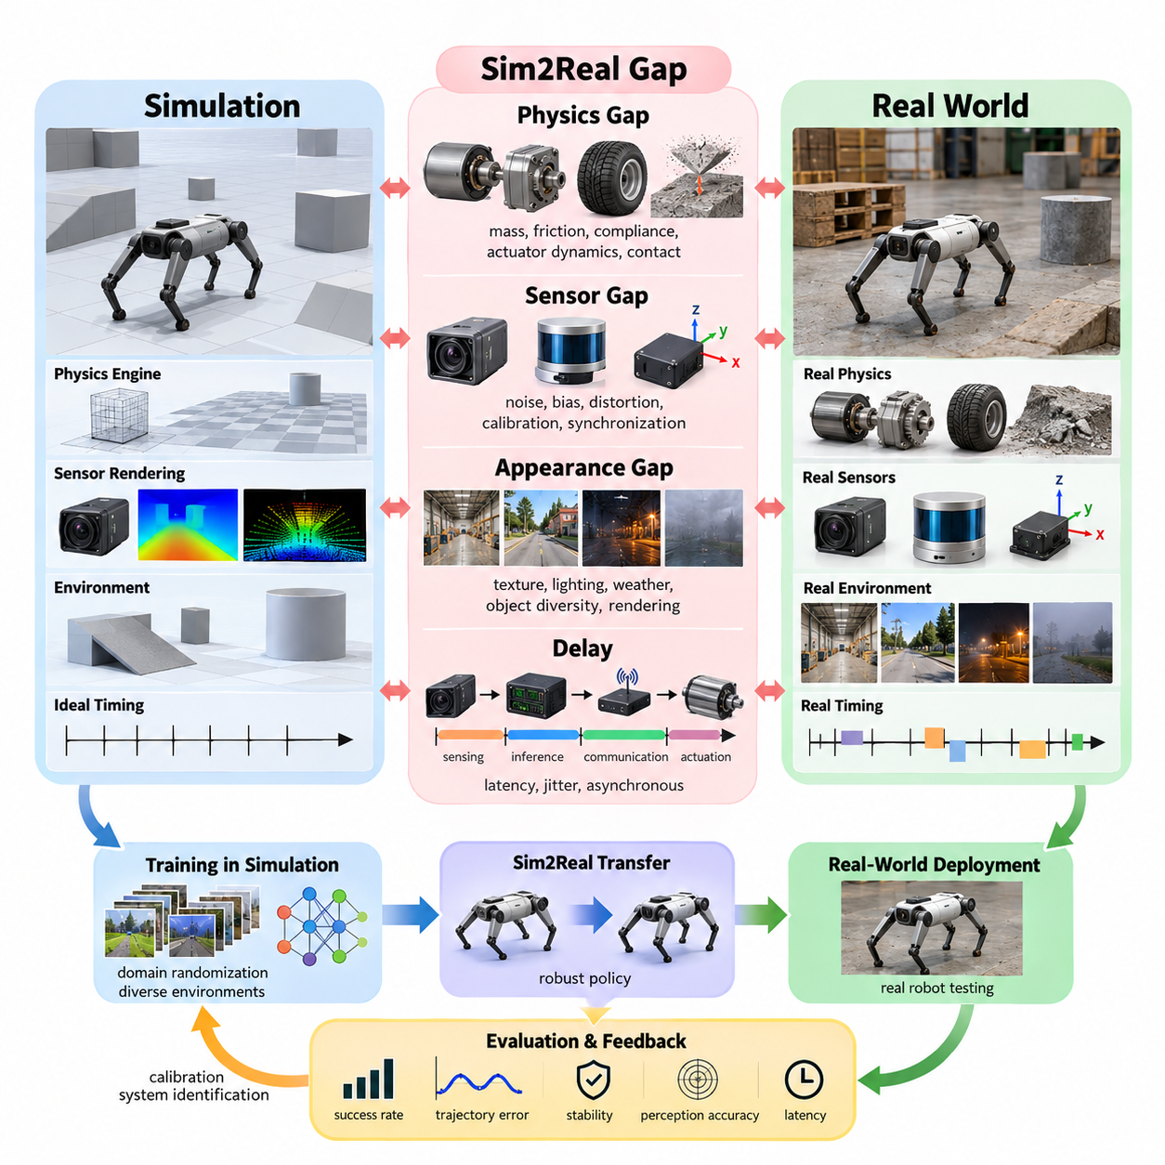
Sim2Real transfer addresses the problem of moving robot behaviors, perception models, and control policies developed in simulation into physical systems. A simulator represents reality through mathematical models and approximations, so even a highly detailed environment cannot reproduce every property of the real world. The resulting discrepancy is called the simulation-to-reality gap, or Sim2Real gap, and it directly influences whether a policy that performs reliably in simulation remains stable, accurate, and safe after deployment.
Within the simulation and digital twin workflow, Sim2Real transfer follows physics modeling, sensor simulation, environment modeling, synthetic data generation, and simulator-based training. The chapter structure therefore treats the Sim2Real gap as a multidimensional problem involving physics, sensing, appearance, and delay before introducing domain randomization, system identification, actuator modeling, Real2Sim calibration, and transfer evaluation.
The physics gap originates from differences between simulated dynamics and the behavior of actual mechanical systems. Robot mass, center of gravity, inertia tensors, friction coefficients, restitution, joint damping, compliance, backlash, tire deformation, motor characteristics, and contact forces may all differ from their simulated values. Small errors in these parameters can accumulate through closed-loop control and produce substantially different trajectories, particularly during high-speed motion, manipulation, locomotion, or operation on irregular terrain.
Contact dynamics are an especially important source of physics mismatch because real contact involves complex material deformation, surface roughness, vibration, impact, and nonlinear friction. Physics engines approximate these phenomena using discrete time steps, collision geometries, constraint solvers, and simplified friction models. A simulated wheel may therefore maintain ideal traction where a physical tire slips, while a simulated robotic hand may establish a stable grasp that fails on the real object because of compliance or uncertain friction.
Actuators introduce another major gap. Simulated joints frequently receive ideal torque, velocity, or position commands, whereas physical actuators contain motors, gearboxes, transmissions, current controllers, mechanical elasticity, saturation limits, dead zones, thermal effects, and internal control loops. Commanded torque is consequently not identical to delivered torque. This discrepancy becomes particularly significant for dynamically controlled quadrupeds, humanoids, manipulators, and high-performance mobile robots whose policies exploit rapid actuator responses.
The sensor gap arises because simulated observations are generated from idealized computational models while physical sensors interact with complicated optical, electrical, mechanical, and environmental processes. Cameras experience exposure variation, lens distortion, motion blur, rolling-shutter effects, noise, reflections, and limited dynamic range. LiDAR systems exhibit range uncertainty, missing returns, multipath effects, material-dependent reflectivity, and interference, while IMUs accumulate bias, noise, scale-factor error, temperature effects, and drift.
Sensor mismatch is not limited to measurement noise. Calibration and coordinate transformations can also differ between simulation and hardware. A camera, LiDAR, radar, or IMU mounted a few millimeters or degrees away from its modeled pose changes the spatial relationship between observations. Timestamp errors and synchronization differences further distort multi-sensor fusion. A perception or localization system trained with perfectly aligned simulated measurements can therefore become unexpectedly sensitive when deployed on a physical robot.
The appearance gap concerns differences between rendered simulation and visual observations from the physical environment. Geometry, textures, materials, illumination, shadows, reflections, weather, object diversity, clutter, and camera response determine the statistical distribution of images. Even photorealistic rendering cannot guarantee that these distributions match every deployment environment. Neural perception systems may learn simulation-specific visual cues that correlate with labels during training but disappear when the same model observes real warehouses, roads, factories, or outdoor terrain.
Appearance mismatch can also arise from insufficient environmental diversity rather than poor rendering quality alone. A visually realistic warehouse containing only a small set of floor textures, pallets, lighting configurations, and obstacle arrangements may provide less transferable training data than a less photorealistic environment with broad randomized variation. Sim2Real design therefore focuses not only on reproducing one real environment precisely, but also on exposing models to enough variation that irrelevant visual properties are not treated as reliable features.
Delay represents a less visible but equally critical dimension of the Sim2Real gap. Simulation pipelines often execute sensing, inference, planning, communication, and actuation with deterministic timing or unrealistically small latency. Physical systems introduce camera exposure time, sensor acquisition delay, network transmission, middleware queues, GPU inference time, operating-system scheduling, controller execution, fieldbus communication, actuator response, and timestamp jitter. The robot therefore acts on information describing a world that has already changed.
Latency becomes particularly dangerous when a control policy depends on high-frequency feedback. A policy trained with nearly instantaneous state observations may oscillate or become unstable when deployed with tens of milliseconds of end-to-end delay. Variable delay can be even more difficult than constant latency because the controller cannot compensate using a fixed offset. Accurate simulation must therefore represent both average latency and its temporal distribution, including jitter, dropped messages, asynchronous sensors, and computation spikes.
These gap sources interact rather than operating independently. Incorrect tire friction changes vehicle motion, which changes camera and LiDAR observations; sensor latency causes perception to represent an earlier vehicle pose; actuator delay alters the commanded trajectory; and appearance changes affect perception confidence. The final deployment error is therefore not simply the sum of isolated modeling errors. Sim2Real must be treated as a system-level problem spanning the complete perception, estimation, planning, control, communication, and mechanical loop.
The relative importance of each gap depends on the robotic application. For an AMR, wheel-ground friction, payload-dependent dynamics, LiDAR characteristics, localization uncertainty, and communication delay may dominate. Manipulation emphasizes contact mechanics, actuator behavior, object properties, and camera calibration. Legged robots are highly sensitive to contact, actuator dynamics, latency, and state estimation, while UAVs require accurate aerodynamic forces, motor response, inertial sensing, environmental disturbances, and timing behavior.
A practical Sim2Real workflow begins by identifying which simulated parameters have the greatest influence on real-world performance rather than attempting to reproduce reality perfectly. Measurements from the physical robot can be compared with simulation trajectories, sensor outputs, actuator responses, and timing traces. These differences provide evidence for system identification and Real2Sim calibration, while uncertain parameters become candidates for domain randomization. The objective is a simulation distribution that adequately contains realistic operating behavior.
Domain randomization deliberately varies uncertain properties such as mass, friction, lighting, textures, sensor noise, actuator strength, and latency during training. Instead of optimizing a policy for one nominal simulator configuration, training exposes it to a family of possible worlds. System identification serves a complementary purpose by estimating physical parameters from real measurements. Together, calibration and randomization can reduce dependence on inaccurate assumptions while improving robustness against variations that cannot be modeled exactly.
The Sim2Real gap should ultimately be evaluated through measurable differences between simulation and physical deployment. Trajectory error, task success rate, control stability, energy consumption, perception accuracy, localization error, contact behavior, intervention frequency, and latency distributions can reveal different failure modes. Evaluation should examine not only average performance but also difficult boundary conditions where combinations of modeling errors cause failures that were absent during simulation.
Sim2Real transfer is therefore not a single conversion step performed after simulation training. It is an iterative engineering loop connecting simulation, physical experiments, parameter estimation, calibration, randomization, policy training, deployment, and validation. As real-world observations reveal new discrepancies, the simulator is updated and training is repeated. This feedback process gradually transforms simulation from an isolated virtual environment into an engineering instrument for developing robot intelligence that remains effective under real physical uncertainty.

10.02. Domain Randomization Theory and Parameter Ranges [w/Code]
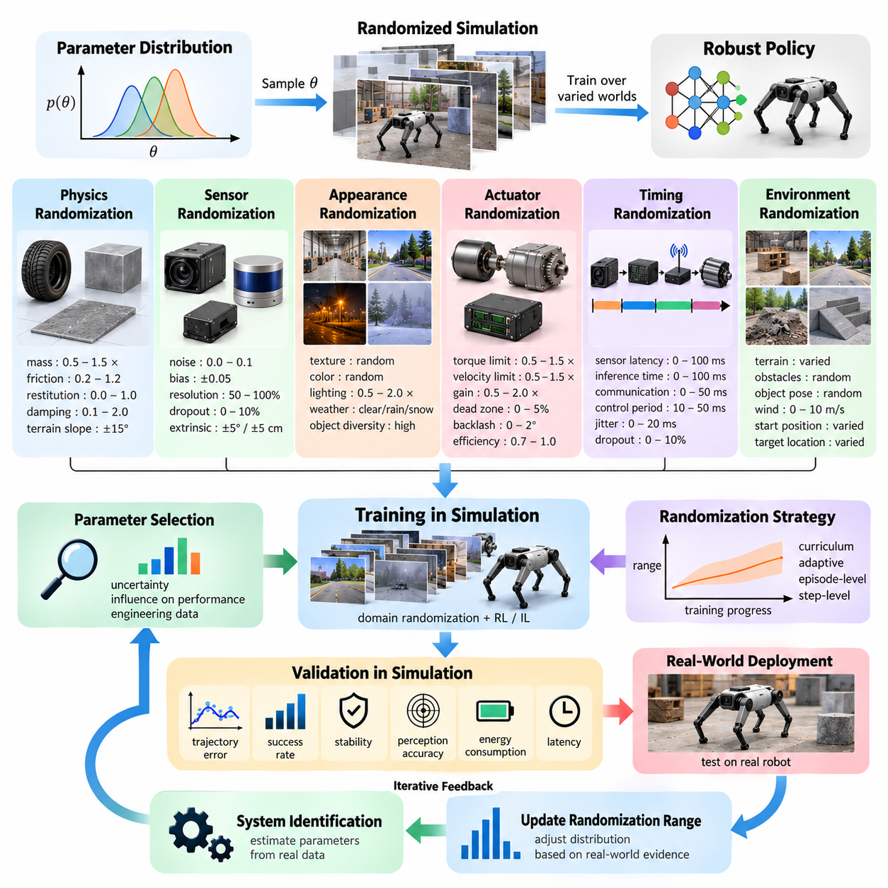
Domain randomization is a Sim2Real technique that trains a robot policy or perception model across a distribution of simulated worlds rather than a single nominal environment. Parameters describing physics, sensors, appearance, actuators, timing, and environment configuration are deliberately varied during training. The objective is not to reproduce one physical system perfectly, but to make the learned model robust to the uncertainty and variability encountered when simulation-trained intelligence is deployed on real hardware.
The theoretical foundation of domain randomization can be expressed by treating simulation parameters as random variables. Instead of training under one fixed parameter vector θ, each simulation episode samples θ from a probability distribution p(θ). The policy therefore experiences different dynamics, observations, disturbances, and environmental conditions throughout training. Optimization seeks behavior that performs well over this distribution, reducing dependence on specific assumptions embedded in the nominal simulator.
A useful interpretation is that the real system represents an unknown point, or a changing region, within a larger family of possible systems. If the randomized simulation distribution adequately covers this region, a policy trained across that distribution has a greater probability of functioning on the real robot. This idea is sometimes described as making reality appear as another variation of simulation rather than treating the physical system as an entirely separate domain.
Parameter selection is therefore central to domain randomization. Randomizing every simulator property indiscriminately can make training inefficient or produce physically unrealistic experiences. Parameters should instead be selected according to their uncertainty and their influence on task performance. System identification, engineering tolerances, sensor measurements, CAD data, hardware specifications, and field experiments can provide initial estimates for determining which parameters require randomization and how broadly they should vary.
Physics randomization commonly includes mass, center of gravity, inertia, friction, restitution, damping, compliance, joint limits, terrain properties, and contact characteristics. For a mobile robot, wheel radius, wheel-ground friction, payload mass, rolling resistance, and terrain slope may be important. For manipulators and legged robots, link inertia, joint friction, contact stiffness, foot friction, object mass, and surface properties can strongly influence learned behavior.
Parameter ranges should normally be centered around physically plausible nominal values. A parameter with nominal value θ₀ may initially be sampled from an interval such as [θ₀−Δ, θ₀+Δ], where Δ represents expected uncertainty. Equivalent multiplicative ranges can be used when uncertainty scales with magnitude. The appropriate range should originate from measurement uncertainty, manufacturing tolerance, operating variation, or observed differences between simulation and hardware rather than an arbitrary percentage.
Probability distributions determine how frequently different parameter values appear during training. Uniform distributions provide equal exposure across a bounded interval and are simple to configure. Gaussian distributions concentrate samples near nominal values while still presenting moderate deviations. Log-uniform distributions can be useful for parameters spanning orders of magnitude, while categorical distributions can represent discrete alternatives such as different terrain types, sensor modes, materials, or payload configurations.
Correlated parameters require special attention because physical variables are not always independent. Increasing payload changes total mass, center of gravity, wheel loading, suspension behavior, braking response, and sometimes actuator demand simultaneously. Sampling these quantities independently may generate physically inconsistent robots. Structured randomization preserves relationships between variables by sampling higher-level physical conditions first and deriving dependent parameters from those sampled conditions.
Sensor domain randomization introduces uncertainty into observations presented to the learning system. Camera parameters can include exposure, gain, focal length, distortion, blur, resolution, mounting pose, and image noise. LiDAR randomization may alter range noise, dropout probability, intensity, beam characteristics, extrinsic calibration, and measurement rate. IMU models can vary bias, drift, noise density, scale error, mounting orientation, and sampling frequency to approximate realistic sensing uncertainty.
Appearance randomization modifies visual characteristics that should not determine the desired behavior. Textures, colors, materials, illumination intensity, light direction, shadows, object models, background geometry, weather, clutter, and camera properties can all be changed between scenes or episodes. The goal is to prevent perception models from relying on accidental correlations, such as associating a particular floor texture, wall color, or lighting pattern with a specific class, location, or action.
Appearance ranges must nevertheless preserve task-relevant semantics. Excessive randomization can destroy relationships that the robot genuinely needs to learn. If every object receives arbitrary colors, dimensions, reflectance, or geometry regardless of its physical identity, training data may become inconsistent with deployment conditions. Effective domain randomization therefore separates nuisance variables, which should vary broadly, from task-critical variables whose physical or semantic structure must remain valid.
Actuator randomization is particularly important for policies controlling physical motion. Motor strength, torque limits, velocity limits, damping, gearbox efficiency, controller gains, command scaling, dead zones, backlash, and response dynamics can vary across hardware units and operating conditions. Battery voltage, temperature, payload, wear, and manufacturing differences may further modify actuator behavior. Training with such variation discourages policies from depending on unrealistically precise actuator responses.
Timing randomization addresses differences between ideal simulation timing and real computing systems. Observation latency, action delay, inference time, communication latency, control period, sensor synchronization error, and timing jitter can be sampled during training. Some observations or commands may occasionally be delayed or dropped. This forces the policy to tolerate stale or asynchronous information and can be essential for high-speed locomotion, manipulation, autonomous driving, and distributed robotic systems.
Environmental randomization extends beyond visual appearance to operational conditions. Terrain geometry, obstacle placement, object pose, pedestrian motion, wind, slopes, floor irregularities, available free space, starting position, and target location can be varied. For outdoor robots, weather and terrain conditions may also influence physics and sensing simultaneously. Environmental randomization therefore provides both geometric diversity and behavioral diversity rather than merely changing rendered images.
Randomization can be performed at different temporal scales. Episode-level randomization samples parameters when an environment is reset and holds them constant throughout the episode, making each episode represent a different robot or world. Step-level randomization changes selected quantities during execution and can represent disturbances or time-varying uncertainty. Some parameters, such as robot mass, are usually episode-level variables, while wind, sensor noise, or communication delay may vary continuously.
The width of the randomization range creates an important tradeoff. A range that is too narrow may fail to contain the real system, leaving a residual Sim2Real gap. A range that is excessively broad can make the learning problem unnecessarily difficult and produce conservative or low-performance policies. The objective is therefore not maximum randomization but sufficient coverage of credible real-world uncertainty while retaining a learnable and physically meaningful training distribution.
Curriculum strategies can progressively expand parameter ranges as learning advances. Training may begin near nominal simulation conditions so that the policy can discover useful behavior, after which friction, mass, sensor noise, disturbances, latency, and other uncertainties are gradually increased. This avoids exposing an untrained policy to extreme variability immediately and provides a controlled transition from easier nominal environments toward the broader conditions required for robust deployment.
Adaptive domain randomization extends this idea by modifying parameter distributions according to training or real-world performance. Parameters that are already handled reliably may be expanded, while difficult dimensions can receive targeted sampling. Real-world evaluation can reveal where the current simulation distribution fails to represent physical behavior, allowing subsequent training cycles to shift or widen relevant ranges rather than manually adjusting every parameter.
Domain randomization and system identification are complementary rather than competing approaches. System identification attempts to move the simulator toward measured reality by estimating accurate physical parameters, whereas domain randomization acknowledges that many parameters remain uncertain or change during operation. A practical Sim2Real pipeline can first calibrate nominal simulation parameters from real measurements and then randomize around those calibrated values according to measured uncertainty.
Validation should verify both parameter coverage and resulting policy robustness. Engineers can sweep individual parameters, test combinations near distribution boundaries, compare simulated and real trajectories, and evaluate success rate, stability, perception accuracy, energy consumption, and safety-related behavior. Failures observed on physical hardware should be mapped back to relevant simulation parameters whenever possible, creating evidence for adjusting the next randomization distribution.
Domain randomization is ultimately a method for managing uncertainty rather than simply adding noise to simulation. Its effectiveness depends on identifying meaningful variables, defining physically justified parameter ranges, preserving important correlations, choosing suitable probability distributions, and continuously refining those distributions using real-world evidence. When integrated with system identification, Real2Sim calibration, evaluation, and iterative retraining, it provides a systematic mechanism for producing robot policies that remain robust beyond the exact conditions represented by the original simulator.

10.03. System Identification for Accurate Simulation [w/Code]
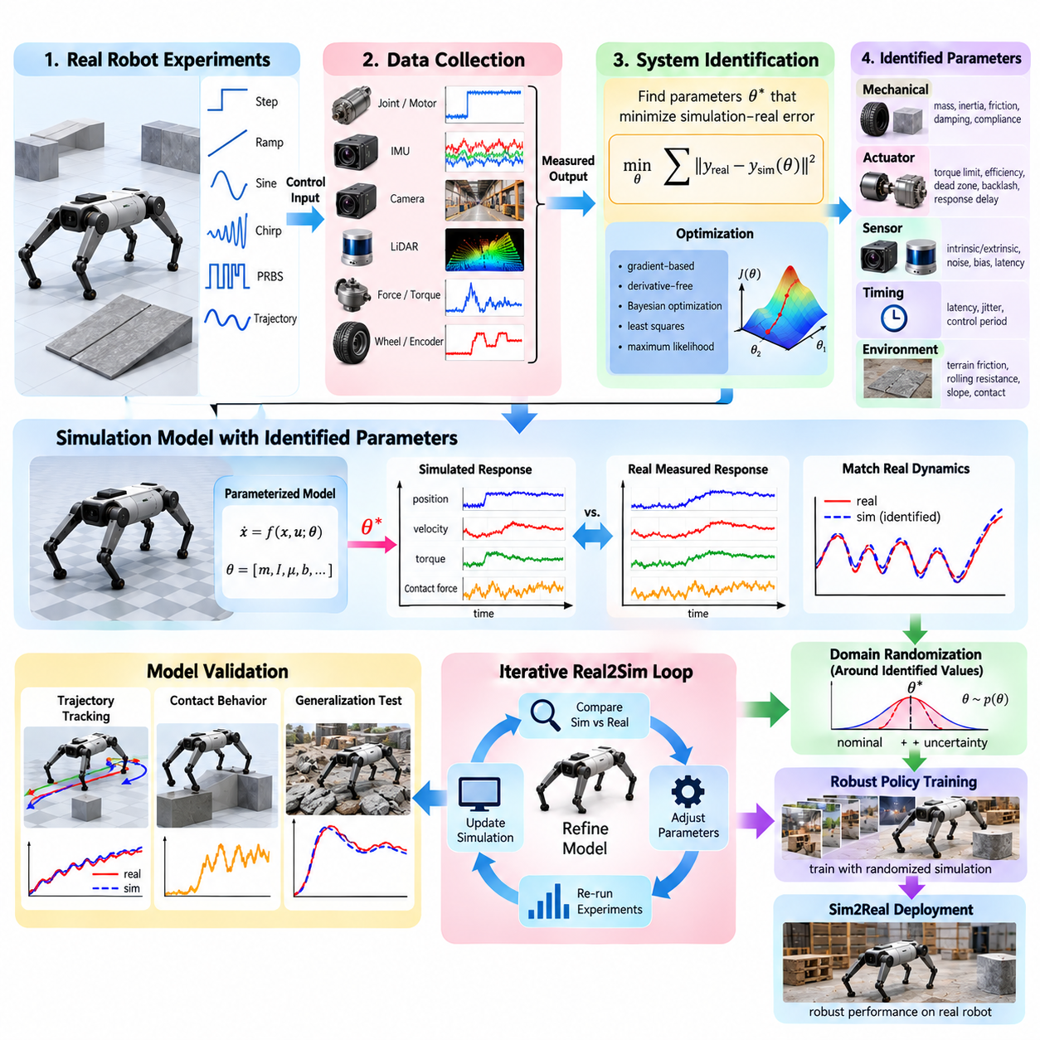
System identification is the process of estimating mathematical models and physical parameters from measured input-output behavior of a real robot or subsystem. In Sim2Real engineering, it provides a systematic way to reduce differences between simulated and physical dynamics. Rather than assuming that CAD values, datasheets, or nominal specifications perfectly describe the deployed machine, system identification uses experiments to determine how the actual system responds under representative operating conditions.
A simulation model can be expressed as a parameterized system whose behavior depends on a vector θ containing quantities such as mass, inertia, friction, damping, actuator characteristics, sensor bias, and delay. The real robot produces measured trajectories when known control inputs are applied. System identification searches for parameter values that cause simulated trajectories to reproduce these measurements as closely as possible, converting real-world observations into calibrated simulation parameters.
The identification problem typically begins by defining measurable inputs and outputs. Inputs may include motor current, commanded torque, wheel velocity, steering command, joint position command, or thrust request. Outputs may include position, velocity, acceleration, orientation, force, torque, motor speed, or sensor observations. The selected signals should expose the dynamics of interest while remaining observable with sufficient accuracy and sampling frequency.
Experimental excitation is critical because parameters cannot be estimated reliably if the robot is operated only under nearly constant conditions. Step inputs, ramps, sinusoidal signals, chirps, pseudo-random sequences, controlled trajectories, and repeated maneuvers can stimulate different dynamic modes. Excitation must remain within safe hardware limits while providing enough variation to distinguish effects such as inertia, friction, damping, actuator lag, and structural compliance.
Data quality strongly influences identification accuracy. Measurements should use synchronized timestamps and consistent coordinate frames, while sensor calibration, sampling frequency, filtering, dropped samples, and communication latency must be considered. Noise can obscure dynamic relationships, but excessive filtering can remove important high-frequency behavior or introduce phase delay. The data acquisition pipeline should therefore preserve both signal magnitude and temporal relationships required by the model.
Mechanical parameters form one major identification target. Robot mass may be measured directly, while center of gravity and inertia can require dedicated experiments or optimization against measured motion. Joint friction, viscous damping, rolling resistance, tire-ground friction, suspension characteristics, contact stiffness, and restitution may also require empirical estimation. Payload changes can alter several of these quantities simultaneously and should be represented explicitly when they affect operational behavior.
Actuator identification is particularly important because ideal actuator models often create substantial Sim2Real errors. Physical motors and transmissions exhibit torque saturation, velocity limits, gearbox losses, dead zones, backlash, compliance, current-control dynamics, and response delays. Experiments relating commands to measured motion or force can estimate these effects. For learning-based controllers, accurate actuator dynamics can be as important as rigid-body parameters because policies frequently exploit fast transient responses.
Mobile robots require identification of wheel and terrain interactions in addition to rigid-body dynamics. Effective wheel radius, rolling resistance, longitudinal and lateral friction, steering response, drivetrain efficiency, and slip behavior influence trajectory prediction. Outdoor AMRs may require separate parameter sets or parameter distributions for asphalt, concrete, gravel, soil, wet surfaces, slopes, and payload conditions because a single deterministic contact model may not describe all environments.
Manipulators introduce identification problems associated with multi-link dynamics and contact. Link mass and inertia, joint friction, motor constants, gearbox behavior, gravity compensation, structural flexibility, and controller gains affect end-effector motion. When manipulation involves physical contact, object mass, surface friction, contact stiffness, gripper compliance, and force-sensor characteristics also become relevant. Identification may therefore combine free-space motion experiments with controlled contact experiments.
Legged robots place particularly strong demands on system identification because locomotion depends on rapid interaction among actuator dynamics, rigid-body motion, contact, state estimation, and control latency. Small errors in foot friction, joint damping, motor response, link inertia, or communication delay can alter gait stability. Identification experiments commonly examine joint responses, body motion, ground contact, and actuator behavior across multiple poses and loading conditions.
Sensor parameters can also be identified as part of simulation calibration. Camera intrinsic and extrinsic parameters, LiDAR mounting transforms, IMU bias and scale factors, encoder offsets, GNSS uncertainty, sensor noise, and measurement latency influence the observations available to perception and control algorithms. Estimating these properties allows simulated sensors to reproduce not only ideal geometry but also realistic uncertainty, calibration offsets, and temporal behavior.
Timing identification should be treated as a system-level task rather than a minor implementation detail. The complete sensing-to-action path can contain acquisition delay, timestamp generation, middleware transport, queueing, inference, planning, controller execution, network communication, and actuator response. Measuring timestamps at multiple points allows engineers to estimate both fixed latency and jitter. These measurements can then be incorporated into simulation to reproduce realistic closed-loop timing.
Mathematically, identification can be formulated as an optimization problem. A candidate parameter vector θ is applied to the simulator, the same or equivalent input sequence is executed, and an objective function measures the discrepancy between simulated and real outputs. Position error, velocity error, orientation error, force difference, frequency response, or combinations of several metrics may be used. Optimization then searches for parameter values that minimize the selected discrepancy.
Different optimization methods are suitable for different models. Gradient-based optimization can be efficient when the simulation model is differentiable and sufficiently smooth. Derivative-free methods such as evolutionary optimization, Bayesian optimization, or direct search can be useful when contact, discontinuities, or complex simulator behavior make gradients unreliable. Parameter estimation can also employ classical least-squares, maximum-likelihood, filtering, or probabilistic inference depending on the available model structure.
Identifiability is a fundamental limitation. Different parameter combinations can sometimes produce nearly identical measured behavior, making it impossible to estimate each value independently from a given experiment. For example, increased mass and reduced actuator strength may create similar acceleration changes. Experimental design should therefore excite conditions that separate parameter effects, while poorly identifiable parameters may need to be constrained using engineering measurements, manufacturer data, or physically plausible bounds.
Overfitting is another important risk. Parameters optimized against one trajectory, payload, speed, or surface may reproduce that experiment extremely well while failing under different conditions. Identification should therefore use separate calibration and validation datasets. A calibrated simulator should reproduce multiple trajectories and operating regimes that were not directly used during optimization, demonstrating that identified parameters represent physical behavior rather than one specific experiment.
System identification does not imply that every physical phenomenon must be represented by one exact deterministic value. Real robots change with temperature, battery state, payload, wear, terrain, and component variation. After estimating nominal parameters, engineers can measure residual variation and represent it as parameter distributions. This creates a natural connection between system identification and domain randomization: identification determines where simulation should be centered, while randomization represents remaining uncertainty.
An iterative Real2Sim workflow can continuously improve model fidelity. Initial parameters are obtained from CAD, specifications, and engineering estimates, followed by controlled experiments on the physical robot. Measured data are compared with simulation, parameters are optimized, and the updated model is validated using independent experiments. Remaining discrepancies reveal missing dynamics or uncertain parameters, leading to additional experiments and another calibration cycle.
Validation should consider task-level behavior as well as parameter-level accuracy. A model can reproduce individual motor responses yet still predict robot trajectories poorly because contact, timing, or sensing is inaccurate. Conversely, some parameter errors may have little effect on the intended task. Simulation fidelity should therefore be evaluated using metrics relevant to deployment, including trajectory error, control stability, contact behavior, energy consumption, perception consistency, latency, and task success.
For production Sim2Real systems, identified parameters, experimental datasets, simulator versions, robot hardware revisions, and calibration conditions should be managed as traceable engineering artifacts. A parameter set valid for one robot revision or payload may not remain valid after changing motors, tires, sensors, firmware, or mechanical structure. Version-controlled identification data enables simulation models to evolve together with the physical platform rather than becoming disconnected from deployed hardware.
System identification ultimately provides the measurement-driven foundation for accurate simulation. It connects physical experiments with mathematical models, transforms observed discrepancies into calibrated parameters, and identifies uncertainty that cannot be eliminated through deterministic modeling. Combined with domain randomization, Real2Sim calibration, robust policy training, and repeated validation, it turns simulation into an evolving representation of the physical robot suitable for reliable Sim2Real transfer.

10.04. Sim2Real Transfer for Locomotion Policies [w/Code]
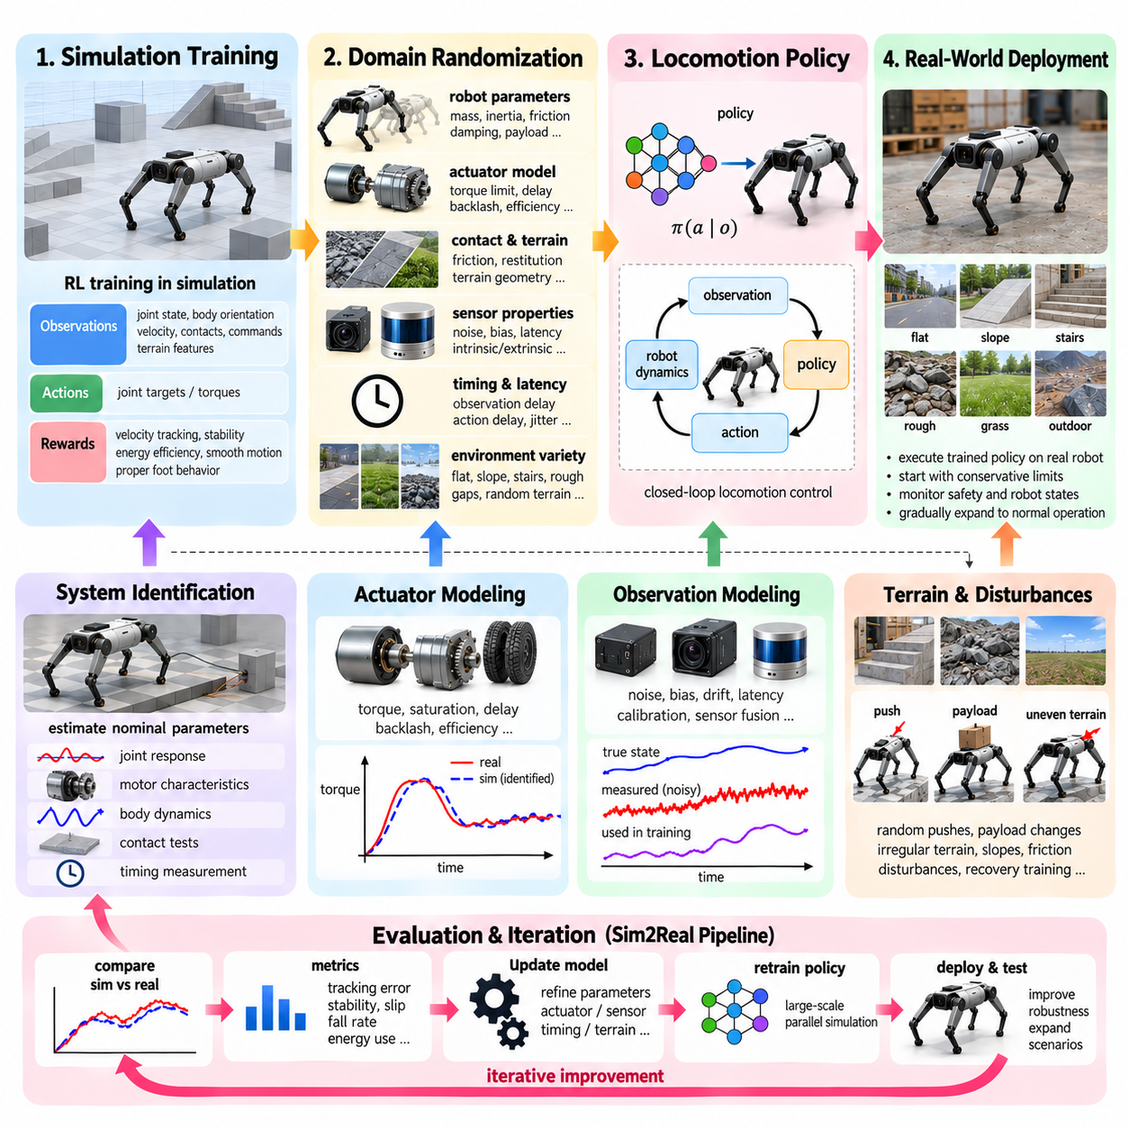
Locomotion policies control how legged robots generate coordinated motion while maintaining balance, stability, and task-directed movement. Policies trained in simulation can acquire complex behaviors such as walking, running, turning, climbing, recovering from disturbances, and traversing irregular terrain without exposing physical hardware to millions of risky training interactions. Sim2Real transfer makes these simulation-trained behaviors executable on real robots despite unavoidable differences between simulated and physical dynamics.
The locomotion Sim2Real problem is particularly demanding because locomotion forms a tightly coupled closed-loop interaction among robot dynamics, actuators, ground contact, state estimation, sensing, and control timing. A small discrepancy in joint torque, foot friction, body inertia, or observation latency can change foot placement and contact forces. These changes affect the next robot state, causing errors to propagate rapidly through subsequent control cycles and potentially destabilize the entire gait.
Simulation training commonly represents locomotion as a reinforcement learning problem in which a policy maps observations to actions. Observations may contain joint positions and velocities, body orientation, angular velocity, estimated linear velocity, previous actions, contact information, commanded velocity, and terrain features. Actions often represent desired joint positions, joint torques, or targets for lower-level controllers. Reward functions encourage velocity tracking, stability, energy efficiency, smooth motion, and appropriate foot behavior.
A nominal simulation model alone is rarely sufficient for reliable transfer. Real robots differ from their simulated counterparts because of uncertain mass distribution, link inertia, joint friction, structural compliance, gearbox behavior, motor characteristics, battery state, and mechanical wear. Locomotion policies can exploit small inaccuracies in simulation to discover behaviors that achieve high simulated reward but depend on dynamics unavailable on physical hardware. Such simulator-specific strategies often fail immediately after deployment.
Accurate actuator modeling is therefore one of the most important components of locomotion Sim2Real. Physical actuators exhibit torque limits, motor saturation, transmission losses, backlash, damping, command tracking error, thermal variation, and response delay. Instead of assuming that requested actions are executed perfectly, simulation should approximate the relationship between controller commands and actual joint response. Identified actuator models or learned actuator networks can reproduce nonlinear behavior that simple idealized models cannot capture.
Contact modeling creates another major transfer challenge. Real feet deform, surfaces have spatially varying friction, and impact generates vibration and transient forces that simplified contact solvers cannot reproduce exactly. Terrain may also contain small geometric irregularities absent from the simulated mesh. Rather than relying entirely on highly precise contact simulation, locomotion training can randomize friction, restitution, contact stiffness, terrain geometry, and disturbance forces so that the policy learns behaviors tolerant of contact uncertainty.
Domain randomization expands this robustness across the robot itself. Link masses, center of gravity, inertia, motor strength, joint damping, controller gains, payload, foot friction, and other physical parameters can be sampled around identified nominal values. Each simulated environment effectively represents a slightly different robot. A policy trained across this population is discouraged from depending on one exact dynamic model and instead learns control strategies that remain effective over a family of plausible physical systems.
Timing and latency randomization are equally important because real locomotion controllers operate under finite computation and communication delays. Sensor acquisition, state estimation, neural-network inference, middleware communication, motor command transmission, and actuator response all consume time. Training with observation delay, action delay, control-period variation, and jitter helps prevent policies from depending on unrealistically instantaneous feedback and improves tolerance to the timing characteristics of the deployed computing platform.
Observation robustness must also be addressed. Simulation can provide exact body velocity, orientation, joint states, and contact information, while a physical robot obtains these quantities through encoders, IMUs, force sensors, kinematic estimation, and sensor fusion. Estimated states contain noise, bias, drift, and delay. Training should therefore expose the policy to realistic observation noise and uncertainty, and privileged simulator-only information should be prevented from becoming an input required during real-world execution.
Privileged information can nevertheless be valuable during training through asymmetric learning. A critic or teacher may receive complete simulator state, terrain properties, contact forces, or other quantities unavailable on the robot, while the deployed actor receives only realistic observations. This allows simulation to accelerate learning without requiring impossible measurements at deployment. Teacher-student methods can similarly transfer behaviors from a policy with privileged perception to a policy operating with onboard sensing.
Terrain diversity is essential for locomotion policies intended for real environments. Training environments can include flat floors, slopes, stairs, blocks, gaps, uneven surfaces, loose-looking terrain geometries, and randomly generated height fields. Terrain difficulty can be increased progressively using curriculum learning. The policy first develops stable locomotion under simple conditions and is subsequently exposed to larger slopes, obstacles, disturbances, and geometric variation as its performance improves.
External disturbance training improves recovery behavior. Random pushes, impulses, payload changes, unexpected contact, or temporary command perturbations can be introduced during simulation. The objective is not merely to maintain nominal walking but to teach the policy how to return toward a stable state after deviations. This capability is important because real-world locomotion continuously experiences disturbances that are difficult to predict or reproduce exactly during simulator construction.
System identification provides the nominal foundation around which locomotion randomization can be constructed. Joint response experiments, motor characterization, body motion measurements, contact tests, and timing traces can estimate actuator dynamics, friction, inertia, damping, and delay. Simulation parameters are then calibrated against physical measurements. Randomization ranges should represent residual uncertainty around these identified values rather than compensate for an arbitrarily inaccurate nominal model.
Policy architecture and action representation also influence transferability. Policies that directly output highly dynamic torque commands may be sensitive to actuator mismatch, while policies producing joint targets for a stable low-level controller can sometimes isolate learning from part of the hardware dynamics. The appropriate interface depends on robot design and performance requirements. In either case, policy frequency and lower-level control frequency must be represented consistently between simulation and physical deployment.
Safety constraints become critical when the trained policy first reaches hardware. Initial tests should operate within conservative velocity, torque, joint-position, and terrain limits while monitoring body orientation, contact behavior, actuator load, temperature, and communication health. Emergency stopping and fallback control should remain independent of the learned policy. Deployment can then expand gradually from supported or constrained tests toward normal locomotion as simulation-to-real behavior is validated.
Transfer evaluation should compare more than whether the robot can walk. Command tracking error, body stability, foot slip, fall rate, energy consumption, joint torque, impact behavior, gait consistency, disturbance recovery, and performance across terrain conditions provide a more complete view. Simulation and real-world trajectories can be compared to identify where the policy or simulator diverges, providing evidence for another system-identification or randomization cycle.
A useful locomotion Sim2Real pipeline is therefore iterative rather than one directional. Physical experiments improve system identification, identified parameters update the simulator, domain randomization covers remaining uncertainty, large-scale simulation trains the policy, and controlled hardware testing reveals residual gaps. These observations return to simulation as updated actuator models, parameter distributions, delay models, terrain conditions, or training objectives.
Large-scale parallel simulation makes this process especially powerful for legged robots. Thousands of randomized environments can execute simultaneously on GPUs, exposing a policy to different robot parameters, terrains, disturbances, and initial conditions in a relatively short training period. This diversity allows reinforcement learning to search for behaviors that are not merely optimal for one simulated robot but robust across a broad distribution of possible physical conditions.
For quadrupeds and humanoids, successful transfer ultimately depends on combining model accuracy with learned robustness. Accurate system identification reduces unnecessary mismatch, actuator and timing models reproduce critical hardware behavior, and domain randomization prevents excessive dependence on uncertain details. Terrain curricula and disturbance training broaden operational capability, while careful validation ensures that improved simulated performance corresponds to meaningful physical behavior.
Sim2Real locomotion should therefore be understood as continuous co-development of simulation, learning, and hardware rather than as a final policy-export operation. The simulator provides scalable experience, the physical robot provides evidence about reality, and repeated comparison connects the two. Through this cycle, locomotion policies can evolve from behaviors optimized for virtual dynamics into robust controllers capable of maintaining stable and adaptive movement under the uncertainty of real physical environments.

10.05. Sim2Real Transfer for Manipulation Policies [w/Code]
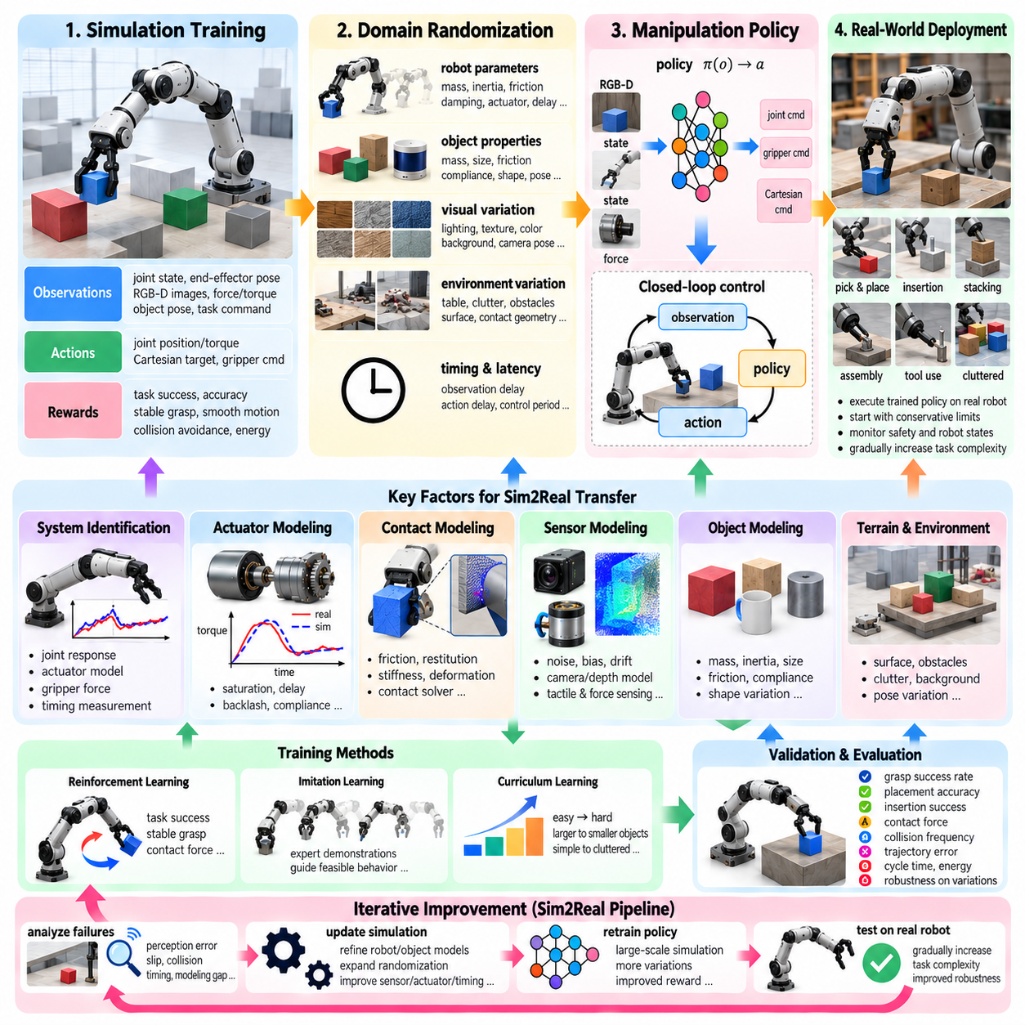
Manipulation policies enable robots to perceive objects, select grasps, coordinate multiple joints, regulate contact forces, and complete physical tasks such as picking, placing, insertion, assembly, and tool use. Simulation provides a scalable environment for training these policies without repeatedly risking expensive hardware or objects. However, transferring a manipulation policy from simulation to a real robot is difficult because manipulation depends strongly on contact mechanics, object properties, sensing accuracy, actuator behavior, and precise timing.
Manipulation differs from locomotion because the robot must establish and maintain controlled physical contact with external objects. A small error in object pose, gripper position, friction coefficient, contact stiffness, or actuator response can change whether an object is successfully grasped or inserted. These errors can propagate through the entire task sequence. A policy that achieves nearly perfect simulated success may therefore fail on the physical robot when the object slips, deforms, collides unexpectedly, or is positioned slightly differently.
A manipulation policy generally maps observations of the robot and environment to actions that control the manipulator. Observations may include joint positions and velocities, end-effector pose, camera images, depth information, force or torque measurements, object pose estimates, and task commands. Actions can represent joint positions, joint velocities, torques, Cartesian targets, gripper commands, or parameters for a lower-level controller. The policy must transform uncertain perception into precise physical interaction while continuously responding to changes in contact state.
The simulation model should represent the complete manipulation loop rather than only the robot geometry. Robot kinematics, dynamics, joint limits, actuator behavior, gripper geometry, object mass, inertia, friction, restitution, contact stiffness, collision geometry, and environmental constraints all influence task execution. Sensor models must also reproduce realistic camera, depth, tactile, and force measurements. The objective is not necessarily perfect physical reproduction, but sufficient fidelity in the variables that determine manipulation success.
Object modeling is particularly important because the manipulated object is part of the dynamic system. Its mass, center of gravity, inertia, dimensions, surface friction, compliance, and contact geometry influence grasp stability and motion. Objects in real applications also exhibit manufacturing variation, wear, deformation, and uncertain placement. A policy trained only on one exact object model may learn highly specific contact strategies that fail when the physical object differs from its simulated representation.
Grasping creates a strong dependency between perception and contact dynamics. The policy must estimate where the object is, determine a suitable grasp configuration, move the end effector toward the target, establish contact, and generate sufficient gripping force without damaging or excessively displacing the object. Simulation can expose the policy to many grasp configurations, but the transfer process must account for camera calibration, depth uncertainty, gripper compliance, friction variation, and actuator limitations that determine whether the planned grasp can actually be achieved.
Contact modeling is therefore a central Sim2Real challenge for manipulation. Physics engines approximate contact through collision geometries, constraint solvers, friction models, and discrete integration. Real contact includes deformation, surface roughness, microscopic geometry, material compliance, vibration, and transient impact forces. The difference becomes especially important for insertion, sliding, stacking, pushing, and precision assembly, where millimeter-level changes in contact configuration can produce qualitatively different outcomes.
Domain randomization can make manipulation policies less dependent on one precise physical configuration. Object mass, friction, restitution, contact stiffness, dimensions, pose, robot dynamics, actuator strength, sensor noise, lighting, camera pose, and control latency can be varied during training. The ranges should remain physically plausible and should reflect measured uncertainty whenever possible. Randomization encourages the policy to discover strategies that remain effective across a family of possible objects and robot configurations.
Object pose randomization is particularly useful because real objects are rarely presented in exactly the same location and orientation as simulated training examples. Initial translation, rotation, height, graspable region, and relative position between robot and object can be varied. The policy then learns to compensate for spatial uncertainty rather than memorizing a fixed trajectory. This approach becomes increasingly important when manipulation is performed in cluttered environments or when objects arrive from upstream processes with variable placement.
Visual domain randomization complements physical randomization. Camera exposure, lighting direction, texture, material appearance, background, object color, shadows, depth noise, blur, and camera extrinsic parameters can be varied. The purpose is to prevent the policy from depending on visual features that are specific to the simulator. At the same time, task-relevant appearance must remain meaningful so that the policy can still distinguish object boundaries, graspable regions, holes, insertion features, and other information required for successful manipulation.
Force and tactile sensing introduce another important transfer dimension. Simulated force measurements may be clean and perfectly synchronized, while real force-torque sensors contain bias, noise, calibration error, drift, quantization, and mechanical vibration. Tactile sensors can also exhibit nonlinear responses and spatially varying sensitivity. Policies trained with ideal contact information may therefore react incorrectly when real measurements indicate a slightly different force or contact state. Realistic sensor models and noise injection can reduce this dependency.
Action execution must also be modeled realistically. A simulated command may instantly produce the requested joint position or torque, whereas a real manipulator has servo dynamics, gearbox friction, backlash, compliance, saturation, current limits, and communication delay. The resulting end-effector motion may differ from the commanded trajectory. Including actuator dynamics and lower-level controller behavior in simulation helps the learned policy account for the actual response characteristics of the robot.
Timing errors can become critical during contact-rich manipulation. Camera acquisition, image processing, object detection, pose estimation, policy inference, communication, controller execution, and actuator response introduce latency. When an object is moving or contact is changing rapidly, an outdated observation can cause the policy to act on an incorrect estimate of the current state. Simulation can randomize observation delay, action delay, control period, and jitter so that the policy becomes more tolerant of realistic temporal uncertainty.
Privileged information can accelerate training while maintaining realistic deployment inputs. During simulation, a teacher or critic may access exact object pose, contact forces, object velocity, surface properties, or complete simulator state. The deployed policy, however, should operate using only the measurements available from real sensors. This asymmetric learning approach can help the training process exploit information that is useful for learning while preventing the final policy from becoming dependent on information that cannot be measured on the physical robot.
Manipulation policies can be trained using reinforcement learning, imitation learning, or combinations of both. Reinforcement learning can optimize task completion, grasp stability, collision avoidance, force behavior, and motion efficiency through large numbers of simulated trials. Imitation learning can provide useful demonstrations that guide the policy toward feasible behaviors before reinforcement learning performs further optimization. The choice depends on task complexity, availability of demonstrations, simulation speed, and the degree of contact uncertainty.
Reward design has a strong influence on transfer. A reward based only on final task success may encourage inefficient or physically aggressive behavior, while a reward containing intermediate objectives can guide the policy toward stable manipulation. Position accuracy, orientation alignment, grasp stability, contact force, collision avoidance, smoothness, energy use, and task completion can be incorporated when appropriate. However, excessive shaping can cause the policy to optimize artificial simulation-specific objectives rather than the intended physical task.
For precision manipulation, curriculum learning can gradually increase task difficulty. Training may begin with large objects, simple backgrounds, accurate initial poses, and generous tolerances. Later stages can introduce smaller objects, clutter, uncertain poses, tighter insertion tolerances, lower friction, moving targets, sensor noise, and actuator delay. This progressive strategy allows the policy to first acquire basic manipulation skills and then develop robustness against the conditions that dominate real-world deployment.
System identification provides the physical foundation for this process. Real robot experiments can measure joint response, actuator behavior, gripper force, end-effector accuracy, object motion, contact response, and timing characteristics. These measurements can be used to calibrate the simulation before policy training. Remaining uncertainty can then be represented through domain randomization. This creates a practical combination in which system identification establishes realistic nominal behavior while randomization covers variations that cannot be represented by one fixed parameter set.
Real2Sim calibration should include both robot and object properties. Robot-side calibration may estimate joint friction, actuator response, kinematic offsets, compliance, and controller behavior. Object-side calibration can estimate mass, dimensions, friction, and contact characteristics. Sensor calibration should align camera and depth observations with the robot coordinate system. When these elements are jointly calibrated, the simulated manipulation scene becomes a more useful approximation of the physical task rather than an isolated virtual experiment.
Validation should compare task-level behavior between simulation and hardware. Important measures include grasp success rate, placement accuracy, insertion success, contact force, object slip, collision frequency, trajectory error, cycle time, energy consumption, and recovery behavior. Repeating the same task under different object poses and environmental conditions can reveal whether the policy has learned a general manipulation strategy or has simply memorized a narrow simulation configuration.
Real-world deployment should proceed progressively. Initial experiments can use simple objects, low speeds, large workspace margins, and conservative force or torque limits. Once the policy demonstrates stable behavior, task complexity and operating range can be increased. Monitoring should include robot state, joint loads, end-effector position, contact forces, sensor quality, and communication status. Independent safety mechanisms should remain active so that a learned policy cannot command unsafe motion outside the permitted operating envelope.
Failure analysis is an important part of manipulation Sim2Real development. A failed grasp may originate from visual pose error, incorrect friction, inaccurate object geometry, actuator delay, gripper compliance, or an unsuitable policy action. Instead of treating every failure as a generic policy problem, engineers should trace the failure through perception, estimation, planning, control, and physical interaction. The identified cause can then be converted into a better simulation parameter, a broader randomization range, a revised reward, or additional training scenarios.
Large-scale simulation can provide substantial diversity for manipulation policy learning. Many environments can vary object models, initial poses, robot parameters, lighting, sensor conditions, contact properties, and task configurations simultaneously. Parallel training allows the policy to experience a large number of manipulation attempts without corresponding physical hardware usage. The resulting policy can therefore be evaluated over a distribution of conditions before being transferred to the real manipulator.
For mobile manipulators, Sim2Real transfer becomes a combined problem involving base motion, arm dynamics, grasping, and environmental interaction. Errors in the mobile base pose can propagate directly into end-effector placement, while arm motion can shift the center of mass and affect base stability. Simulation should therefore represent the coupling between the mobile platform and manipulator, particularly for tasks involving navigation to an object, reaching, grasping, transporting, and placing it at another location.
A robust manipulation Sim2Real pipeline is ultimately iterative. Simulation generates large-scale experience, system identification improves physical fidelity, domain randomization represents remaining uncertainty, and real-robot testing exposes discrepancies that simulation did not capture. Those discrepancies are converted into updated robot parameters, object models, sensor models, actuator dynamics, timing models, or training conditions. The revised simulation is then used for additional policy training and validation.
The objective is not to make a manipulation policy believe that simulation and reality are identical. Instead, the policy should learn behaviors that remain successful when the simulated assumptions are imperfect. Accurate modeling reduces systematic error, domain randomization provides robustness, realistic sensing and timing prevent dependence on ideal observations, and iterative hardware validation closes the remaining gap. This combination allows manipulation intelligence developed at simulation scale to become practical physical behavior on real robotic systems.

10.06. Actuator Net and Delay Modeling for Sim2Real [w/Code]
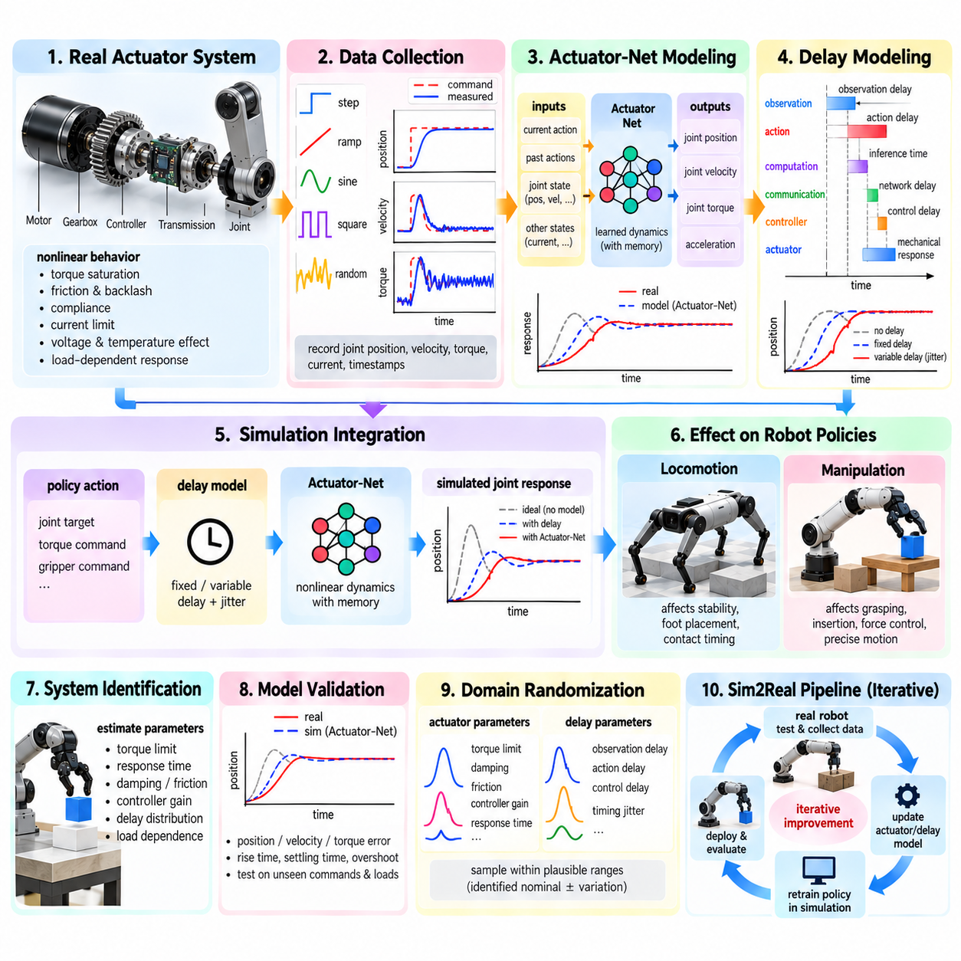
Actuator dynamics are a critical source of the Sim2Real gap because a simulated robot often assumes that commanded actions are applied almost instantaneously and accurately, while real actuators respond through motors, gearboxes, controllers, transmissions, and mechanical structures. The difference between commanded and delivered motion can significantly change a learned policy. Actuator-Net modeling addresses this problem by learning or approximating the physical input-to-response relationship and embedding that behavior into simulation during policy training.
A useful actuator model represents the relationship between the policy action, the lower-level controller, the actuator state, and the resulting joint motion. The input may be a desired joint position, velocity, torque, or motor command, while the output can include actual position, velocity, torque, and acceleration. Instead of assuming an ideal mapping such as direct action-to-torque conversion, the model introduces realistic dynamics between command and physical response. This allows the simulated policy to experience behavior closer to the hardware.
Real actuators contain several nonlinear effects that are difficult to reproduce with a simple first-order model. Motor torque may saturate, gearboxes introduce friction and backlash, mechanical structures exhibit compliance, and controller gains determine how quickly commands are followed. Current limits, voltage variation, thermal conditions, and load-dependent behavior can further modify the response. An actuator model should therefore focus on the dynamic characteristics that materially influence the robot policy rather than attempting to reproduce every internal motor phenomenon.
Actuator-Net can be implemented as a learned neural network that approximates the relationship between recent command and state history and the next physical actuator response. The network may receive current and previous actions together with joint position, velocity, and other available states. By using temporal information, it can represent effects such as delayed response, hysteresis, saturation, and short-term actuator memory. The trained network can then replace or augment an analytical actuator model inside the simulator.
Training an Actuator-Net requires paired command and response data collected from the real robot. A known command sequence is applied while joint position, velocity, torque, current, and timing information are recorded. The resulting dataset should contain sufficient excitation to expose both steady-state and transient behavior. Step commands reveal response time and settling behavior, while ramps, oscillatory commands, and varied loads provide information about nonlinear response and frequency-dependent behavior.
The quality of actuator identification depends strongly on synchronized measurements. A command timestamp must be related accurately to the corresponding physical response because an apparent actuator characteristic can actually be caused by communication or sensing delay. Measurement systems should therefore record controller commands, sensor observations, actuator feedback, and relevant middleware timestamps using a consistent clock whenever possible. This allows actuator dynamics and system-level latency to be separated rather than incorrectly combined into a single learned response.
Delay modeling is closely related but conceptually distinct from actuator dynamics. Actuator dynamics describe how the physical system responds after receiving a command, whereas delay describes when that command or observation becomes effective. A robot may have computation delay, communication delay, controller delay, sensor delay, and mechanical response delay. Separating these components makes the simulator easier to calibrate and allows different timing conditions to be randomized independently during Sim2Real training.
A simple delay model can represent a fixed number of simulation steps between command generation and command application. However, real systems rarely have perfectly constant latency. Operating-system scheduling, GPU inference, network traffic, middleware queues, sensor acquisition, and controller execution can introduce jitter. A more realistic model can therefore represent delay as a distribution rather than a single value. During training, the policy can experience different delays so that it does not depend on unrealistically synchronized feedback.
Actuator-Net and delay modeling can also be combined into a unified temporal model. The network can receive a sequence of recent commands and states and predict the actuator response after an explicit or learned delay. This architecture can represent both dynamic response and temporal dependency. Care must be taken, however, to avoid hiding all timing effects inside a black-box network because explicit latency parameters remain useful for debugging, validation, and domain randomization.
For locomotion policies, actuator and delay errors can have a strong effect on stability. A small delay in leg movement changes foot placement, contact timing, and body momentum. The resulting state difference affects the next policy action, creating a feedback loop in which a small initial mismatch can rapidly increase. Training with realistic actuator dynamics and latency can therefore encourage policies to develop behaviors that remain stable even when commands are not executed exactly as they are in the nominal simulator.
For manipulation policies, actuator modeling affects grasping, insertion, force regulation, and precise end-effector motion. A simulated gripper may close exactly according to a commanded trajectory, while the physical gripper responds more slowly or exhibits compliance and backlash. During insertion, even a small delay can cause the end effector to contact an edge before the controller reacts. Including actuator response and timing uncertainty during training helps the policy learn to tolerate these differences rather than depending on idealized instantaneous motion.
Actuator models should also account for operating conditions when they materially affect response. Battery voltage can change available motor torque, temperature can alter resistance and controller behavior, and payload changes can modify acceleration and settling characteristics. Mechanical wear can increase backlash or friction over time. Instead of building one actuator model that assumes permanent nominal behavior, a calibrated nominal model can be combined with parameter randomization to represent plausible variation across hardware units and operating conditions.
System identification provides the initial parameters and training data for Actuator-Net construction. Physical experiments can establish nominal torque limits, response times, damping, friction, controller gains, and delay distributions. The learned network can then model residual nonlinear behavior that is difficult to describe analytically. This creates a hybrid approach in which known physical structure is preserved while data-driven modeling captures complex effects. Such a combination can be more interpretable and easier to validate than relying exclusively on a black-box model.
The actuator model should be validated independently before being used for policy training. Commands not included in the training dataset should be applied to the real actuator and simulated actuator, and their responses should be compared. Position error, velocity error, torque error, rise time, settling time, overshoot, steady-state error, and frequency response can reveal different types of mismatch. Validation should also cover different command amplitudes, directions, speeds, loads, and operating conditions when those factors are relevant.
Model complexity should be controlled carefully. An excessively simple actuator model may leave a large Sim2Real gap, while an excessively complex neural model can overfit the identification dataset or behave unpredictably outside its training distribution. A useful model should reproduce the dynamic characteristics that influence policy behavior while remaining computationally efficient enough for large-scale parallel simulation. This is particularly important when thousands of environments are executed simultaneously for reinforcement learning.
Actuator-Net training data can be augmented through controlled variation and simulation-assisted generation, but real measurements should remain the reference for physical behavior. Synthetic data can help cover combinations that are difficult or unsafe to measure, yet simulated actuator responses inherit the assumptions of the simulator. Real-to-simulation calibration should therefore be performed first where possible, followed by model fitting and residual analysis. Differences that remain after calibration can guide additional experiments and refinement of the learned actuator model.
Domain randomization can be applied to both actuator parameters and delay characteristics during policy training. Motor strength, torque limits, damping, friction, controller gains, command scaling, response time, observation delay, action delay, and timing jitter can be sampled within physically justified ranges. The purpose is not to make the actuator arbitrarily unpredictable, but to expose the policy to credible variations around the identified physical behavior. This improves robustness while preserving a meaningful relationship between simulation and hardware.
A curriculum can gradually introduce actuator uncertainty during training. Early training may use a calibrated nominal actuator model so that the policy first learns useful behavior. Later stages can increase response variation, saturation, friction, backlash, delay, and timing jitter. This progression prevents excessive uncertainty from making initial learning unnecessarily difficult. As the policy becomes competent, broader actuator variation can be introduced to test whether the learned behavior remains stable across the expected physical operating range.
The final Sim2Real workflow connects real-robot measurement, actuator identification, Actuator-Net training, delay estimation, simulation integration, domain randomization, policy learning, and hardware validation. Real commands and responses establish the physical reference, while the learned model reproduces important actuator behavior inside simulation. Explicit delay models represent temporal uncertainty, and randomized parameters broaden the training distribution. Physical deployment then provides new evidence that can be used to refine the actuator model and repeat the cycle.
Actuator-Net and delay modeling should therefore be regarded as an important bridge between high-level AI policies and real robot hardware. The policy does not directly control an ideal mathematical actuator; it interacts with a dynamic, delayed, nonlinear physical system. Representing that system realistically during training reduces the tendency of policies to exploit simulation artifacts. Combined with system identification, domain randomization, and iterative Real2Sim calibration, actuator and delay modeling provides a practical foundation for transferring learned robot intelligence from simulation to physical operation.

10.07. Real2Sim Calibration LIDAR Camera Physics Match [w/Code]
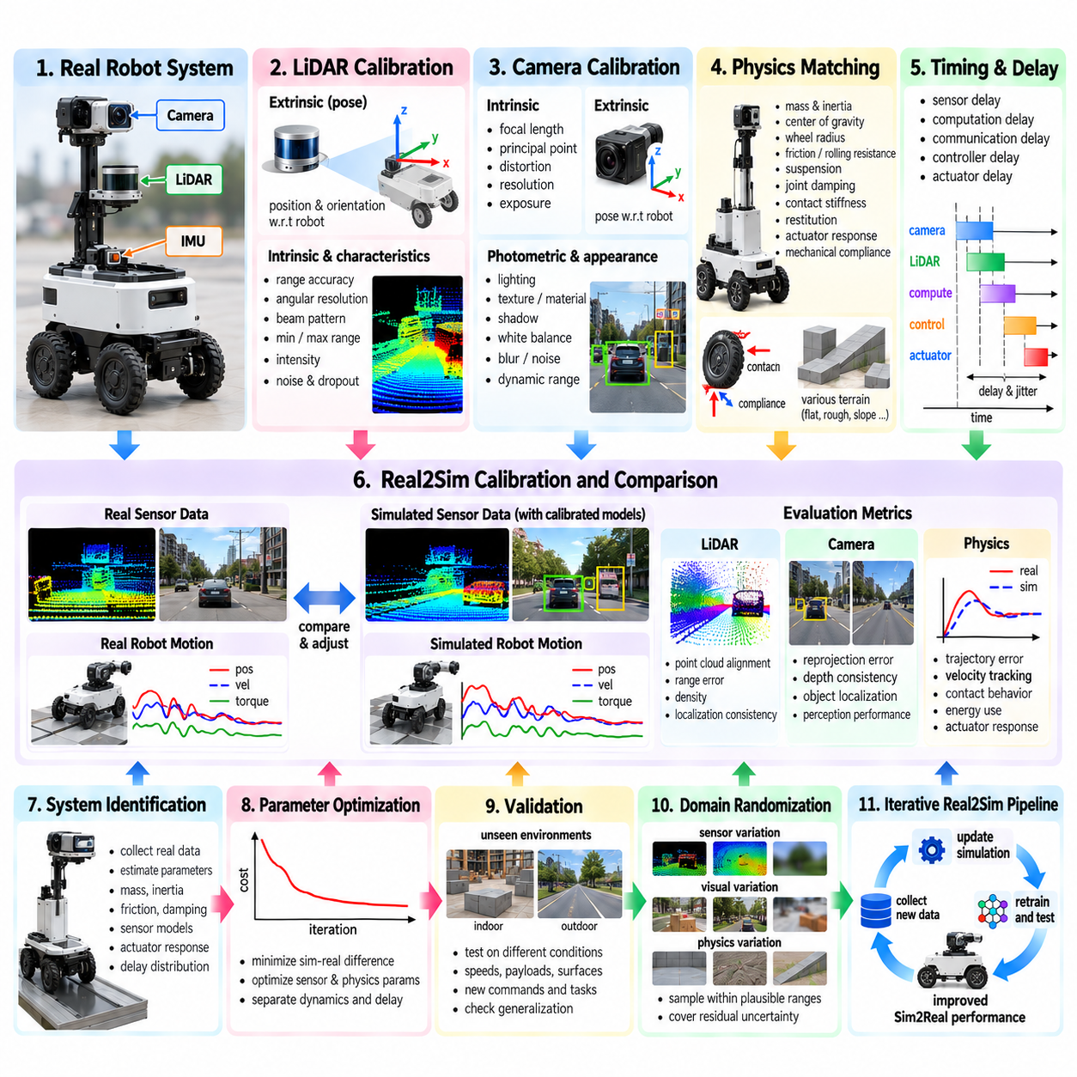
Real2Sim calibration is the process of adjusting a simulation so that its sensor observations and physical behavior correspond closely to measurements from a real robotic system. For LiDAR, camera, and physics matching, the objective is not to reproduce every microscopic property of reality, but to align the simulation variables that strongly influence perception, localization, planning, control, and learned policies. A calibrated simulator should therefore reproduce the geometry, sensing characteristics, timing, and dynamic response that the robot actually experiences during representative operation.
LiDAR calibration begins with the geometric relationship between the sensor and the robot coordinate system. The LiDAR extrinsic transformation must represent its exact position and orientation relative to the robot body, while intrinsic characteristics such as range accuracy, angular resolution, beam pattern, minimum and maximum range, intensity behavior, and dropout characteristics should also be considered. Small errors in extrinsic calibration can produce systematic displacement of point clouds, which can subsequently affect localization, obstacle detection, mapping, ground segmentation, and collision avoidance.
Real LiDAR observations contain uncertainty that should be reflected in simulation. Range noise, angular noise, missing returns, multipath effects, reflective surfaces, limited resolution, and environmental occlusion can cause measurements to differ from ideal geometric ray intersections. A useful calibration process compares simulated and real point clouds under the same robot pose and environment. Differences in range distribution, point density, surface coverage, and spatial alignment can then be used to adjust sensor parameters rather than assuming that the simulator already provides realistic measurements.
Camera calibration requires both geometric and photometric matching. Intrinsic parameters include focal length, principal point, resolution, distortion, exposure, and other imaging characteristics, while extrinsic parameters define the camera pose relative to the robot and other sensors. The simulated camera should reproduce the field of view and projection behavior of the physical camera. Even a small camera pose error can create significant differences in object position, depth estimation, and multi-sensor fusion, especially when the camera is mounted far from the robot reference frame.
Visual appearance should also be calibrated because a physically correct camera model can still produce unrealistic images. Illumination, material reflectance, texture, shadow, exposure, white balance, blur, sensor noise, and dynamic range influence the appearance received by perception models. Real2Sim calibration should therefore compare real and simulated images under corresponding viewpoints and environmental conditions. The purpose is not necessarily pixel-perfect reproduction, but sufficient similarity in the visual characteristics that affect object detection, segmentation, depth estimation, localization, and policy decisions.
Camera and LiDAR calibration become more important when their observations are fused. The relative transformation between the sensors must be consistent with the physical robot, and their timestamps must correspond to the same or appropriately interpolated state. A point projected from LiDAR into the camera image should align with the corresponding physical surface. Calibration can therefore use common targets, geometric features, or naturally occurring scene structures to verify spatial alignment. Temporal misalignment should also be measured because even a correctly calibrated transformation can produce apparent spatial errors when the robot or environment is moving.
Physics matching extends Real2Sim calibration from sensing to the physical behavior of the robot. Relevant parameters can include total mass, center of gravity, inertia, wheel radius, friction, rolling resistance, suspension characteristics, joint damping, actuator response, contact stiffness, restitution, and mechanical compliance. For mobile robots, wheel-ground interaction is particularly important because small differences in friction or wheel radius can change acceleration, turning behavior, stopping distance, and trajectory tracking. The calibrated model should reproduce the behavior that matters for the intended operating conditions.
System identification provides the measurements required for physics calibration. Controlled experiments can apply known velocity, torque, steering, or joint commands while recording position, velocity, acceleration, current, torque, and orientation. Real trajectories are then compared with simulated trajectories under equivalent initial conditions and commands. Parameter optimization can minimize differences between the two systems, while independent validation experiments determine whether the resulting parameters generalize beyond the measurements used for calibration.
Actuator and timing behavior should be included in the physics match because an apparently incorrect physical parameter may actually be caused by delay. Motor response, controller dynamics, command latency, sensor latency, communication delay, and inference time can all influence observed trajectories. A useful Real2Sim model separates physical dynamics from temporal effects whenever possible. This allows engineers to determine whether a trajectory mismatch originates from incorrect friction or inertia, for example, or from a delayed command that reaches the physical actuator later than expected.
Calibration should be performed under representative operating conditions rather than a single ideal experiment. Different speeds, payloads, surface types, lighting conditions, sensor viewpoints, and environmental configurations can reveal variations that are hidden under nominal conditions. For an outdoor AMR, calibration may need to consider asphalt, concrete, gravel, slopes, wet surfaces, and different payload states. For manipulation, object mass, friction, compliance, and grasp configuration can similarly change the relationship between commanded motion and physical response.
The calibration objective should be defined using task-relevant metrics rather than relying exclusively on parameter-level similarity. LiDAR calibration can evaluate point-cloud alignment, range error, density, and localization consistency. Camera calibration can evaluate reprojection error, depth consistency, object localization, and perception performance. Physics calibration can evaluate trajectory error, velocity tracking, contact behavior, energy consumption, and actuator response. This makes it possible to prioritize parameters that have the greatest effect on actual robot performance instead of spending excessive effort on variables with little operational significance.
Real2Sim calibration should be followed by residual analysis and uncertainty modeling. Even after careful calibration, some differences will remain because real environments contain manufacturing variation, sensor noise, temperature effects, surface variability, mechanical wear, and unmodeled dynamics. These residual differences should be measured rather than simply ignored. Their observed ranges can then become the basis for domain randomization, allowing the simulator to represent both a calibrated nominal system and a realistic family of possible physical conditions.
A practical calibration loop connects real-world measurement, parameter estimation, simulation comparison, validation, and iterative refinement. Real sensor data and robot trajectories establish the physical reference, while the simulator reproduces the corresponding scenario using candidate parameters. Differences are analyzed across LiDAR, camera, timing, and physics domains, and the parameters responsible for significant discrepancies are updated. New real-world experiments then test the updated model. This cycle continues until the simulation provides sufficiently accurate and robust behavior for the intended Sim2Real application.
For Physical AI development, Real2Sim calibration should therefore be treated as a continuously maintained engineering asset rather than a one-time simulator setup. Changes to camera or LiDAR mounting, robot geometry, tires, actuators, payload configuration, firmware, computing hardware, or environmental conditions can invalidate previously calibrated parameters. Versioning sensor models, extrinsic transforms, physics parameters, datasets, calibration experiments, and simulator configurations makes the relationship between a specific physical robot and its corresponding simulation traceable and reproducible.
The final objective is a simulation in which LiDAR observations, camera images, robot dynamics, contact behavior, actuator response, and timing characteristics are sufficiently consistent with the physical system for meaningful training and evaluation. Exact identity between simulation and reality is neither necessary nor generally achievable. Instead, Real2Sim calibration establishes a physically grounded nominal model, while uncertainty modeling and domain randomization cover the remaining variation. Together, these mechanisms reduce the Sim2Real gap and create a reliable foundation for perception, planning, control, and learning-based robotics.

10.08. Adaptive Domain Randomization Auto DR Methods [w/Code]
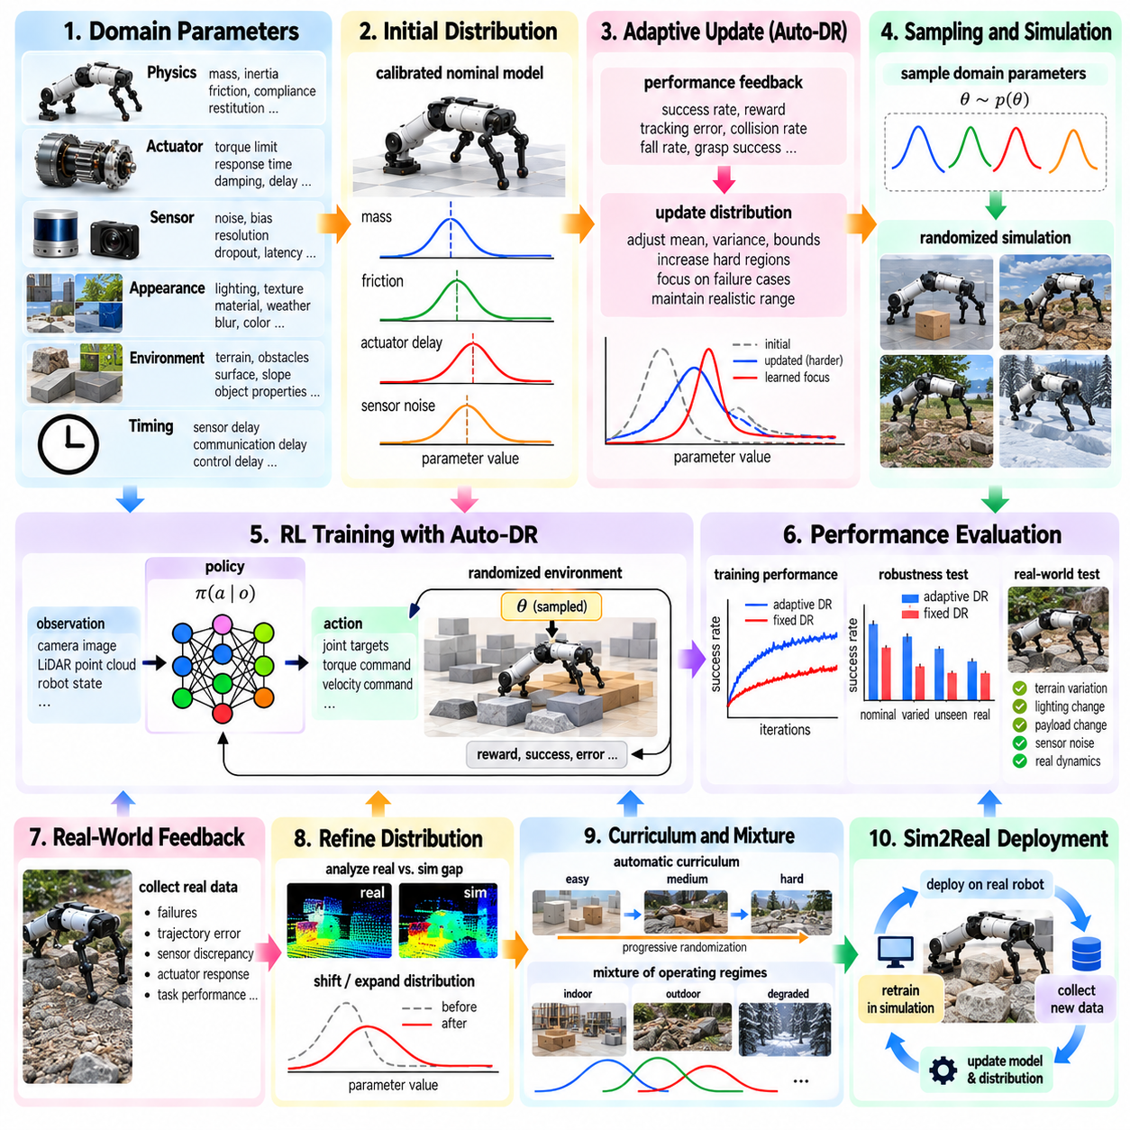
Adaptive Domain Randomization (Auto-DR) extends conventional domain randomization by automatically adjusting the simulation parameter distribution according to training progress and real-world performance. Instead of selecting fixed randomization ranges manually and keeping them unchanged throughout training, Auto-DR observes how the policy responds to different domains and modifies the sampling distribution accordingly. The objective is to concentrate training effort on challenging but relevant regions while maintaining sufficient diversity for robust Sim2Real transfer.
Conventional domain randomization usually defines a parameter vector θ and samples it from a predefined distribution p(θ). Parameters may include mass, friction, actuator strength, sensor noise, lighting, latency, terrain properties, and object characteristics. The effectiveness of the policy therefore depends strongly on whether the chosen distribution contains the important real-world conditions. If the range is too narrow, the policy may overfit to simulation. If it is too broad, training may become unnecessarily difficult and computationally inefficient.
Adaptive Domain Randomization treats the randomization distribution itself as a variable that can be optimized. The center, variance, bounds, sampling probability, or mixture weights of selected parameters can be updated according to policy performance. The system can identify which simulated domains are already mastered and which domains expose weaknesses. Training resources can then be redirected toward difficult regions instead of spending equal effort on conditions that the policy already handles reliably.
A practical Auto-DR system requires a definition of domain parameters and measurable performance signals. Domain parameters may describe physics, sensors, appearance, environment, timing, and actuators. Performance signals can include episode reward, task success, tracking error, collision rate, fall rate, grasp success, trajectory deviation, or stability metrics. For Sim2Real development, real-robot evaluation results can provide an additional signal indicating which parts of the simulation distribution remain insufficiently representative of physical behavior.
One important strategy is to begin with a calibrated nominal simulation and gradually increase uncertainty. System identification provides realistic starting values for mass, inertia, friction, actuator response, sensor characteristics, and delay. Auto-DR then expands or shifts the corresponding distributions according to observed learning behavior. This avoids the common problem of starting training with extremely broad randomization ranges that contain many physically possible but operationally irrelevant conditions.
Performance-driven adaptation can be implemented by monitoring how policy performance changes across sampled domains. If performance remains high across a parameter interval, the system may expand that interval to test greater robustness. If performance collapses in a particular region, that region can receive additional samples or be introduced more gradually through a curriculum. The adaptation mechanism should distinguish between useful difficulty and pathological simulation conditions that do not correspond to credible real-world states.
Curriculum-based Auto-DR provides a controlled progression from simple to difficult environments. Early training can emphasize nominal dynamics and moderate sensor uncertainty, allowing the policy to establish basic task competence. As performance improves, the system can introduce larger variations in friction, mass, terrain, latency, actuator response, visual appearance, or disturbances. The curriculum can be automatically advanced when predefined performance conditions are satisfied rather than relying entirely on manually selected training stages.
Adversarial or failure-focused sampling provides another form of adaptive randomization. Instead of sampling domains only according to their prior probability, the system searches for conditions under which the current policy performs poorly. These difficult domains are then added more frequently to training. For locomotion, such domains may contain unfavorable friction, unexpected terrain geometry, actuator delay, or external disturbances. For manipulation, they may involve difficult object poses, low friction, inaccurate perception, contact uncertainty, or insertion tolerances near the failure boundary.
The relationship between difficulty and realism must be carefully controlled. A domain that causes policy failure is not automatically useful for training if its parameters are physically impossible. Auto-DR should therefore operate within credible parameter bounds derived from measurements, engineering specifications, environmental observations, or previously validated models. This creates a constrained adaptive distribution in which the system can search for difficult cases without generating arbitrary physics that have no relationship to the intended deployment environment.
Real-world feedback can make Auto-DR especially powerful. After deploying a policy on physical hardware, engineers can collect failures, trajectory errors, sensor discrepancies, actuator responses, and task-level performance. These observations can be compared with the simulated parameter distribution to determine where reality appears to lie outside the current training coverage. The randomization distribution can then be shifted or expanded toward those regions, creating a feedback connection between physical experiments and subsequent simulation training.
A useful architecture separates nominal calibration, adaptive distribution control, and policy learning. The calibrated simulator provides the baseline physical model, the Auto-DR controller determines how domain parameters are sampled, and the learning algorithm updates the policy from the resulting experiences. Evaluation provides feedback to the Auto-DR controller. This separation makes it easier to determine whether a performance change originates from the policy, the simulator, or the randomization strategy.
Auto-DR can also use multiple domain variables simultaneously, but correlations should be preserved. Real changes often affect several parameters together. Increasing payload can modify mass distribution, wheel loading, actuator demand, and motion response. Lower battery voltage can reduce available torque while changing acceleration behavior. Weather can simultaneously affect appearance, sensor quality, terrain friction, and visibility. Adaptive sampling should therefore modify structured parameter groups when physical relationships require them rather than independently changing every variable.
Mixture distributions can provide an efficient way to represent multiple operating regimes. One component may represent nominal indoor operation, another may represent rough outdoor terrain, and another may represent degraded sensing or actuator conditions. Auto-DR can modify the mixture weights according to policy performance, increasing exposure to regimes where additional learning is needed. This approach is useful when the deployment environment naturally consists of several distinct operating modes rather than one continuous parameter space.
For reinforcement learning, Auto-DR can be integrated with the training loop without changing the fundamental policy optimization algorithm. At environment reset, the adaptive sampler selects a domain configuration, initializes the simulator, and executes an episode. The resulting performance contributes to both policy learning and domain-distribution updates. Over many iterations, the policy becomes stronger while the sampling strategy increasingly focuses on informative domains. Care must be taken to prevent unstable feedback between policy improvement and domain difficulty.
Evaluation should therefore use a separate validation distribution rather than measuring progress only on the adaptive training distribution. A policy may appear to improve because Auto-DR has stopped sampling difficult cases, while its actual generalization capability remains unchanged. Fixed benchmark domains, unseen randomized conditions, boundary cases, and real-robot tests provide independent evidence of robustness. Comparing training performance with validation performance helps determine whether adaptive randomization is genuinely improving transfer.
The stopping condition for Auto-DR should be defined in terms of deployment requirements rather than unlimited robustness. Once the policy achieves acceptable performance across the validated operating distribution, continuously expanding the domain may provide diminishing returns and increase training cost. The target is sufficient robustness within the expected physical envelope. For safety-critical robotics, additional stress testing can still be performed separately to understand failure boundaries without necessarily incorporating every extreme case into normal policy training.
Auto-DR also provides a systematic mechanism for discovering missing simulation coverage. If repeated real-world failures cannot be reproduced within the current randomized parameter space, the problem may indicate an omitted variable or an incorrect simulation assumption. Engineers can investigate whether the missing factor is related to contact behavior, sensor timing, actuator dynamics, environment geometry, calibration, or another system component. The discovery can then lead to a new simulator parameter, measurement experiment, or model refinement.
The complete Auto-DR cycle can therefore be viewed as a closed-loop process connecting real-world evidence, system identification, calibrated simulation, adaptive sampling, policy learning, validation, and deployment. Real measurements establish the physical reference, while simulation provides scalable experience. Auto-DR continuously adjusts where that experience is generated, emphasizing uncertain and informative regions while remaining within physically credible bounds. The resulting policy is repeatedly evaluated against both simulated and physical conditions.
Adaptive Domain Randomization should ultimately be understood as a mechanism for allocating learning effort intelligently rather than simply increasing randomization. Fixed randomization assumes that engineers already know which variations matter and how frequently they should occur. Auto-DR allows the training system to learn more about this distribution from policy behavior and real-world evidence. Combined with system identification, Real2Sim calibration, curriculum learning, failure-focused sampling, and independent validation, Auto-DR can make Sim2Real training more efficient while improving robustness to the uncertainties that matter most in physical robot deployment.

10.09. Sim2Real Evaluation Metrics and Benchmark Protocol
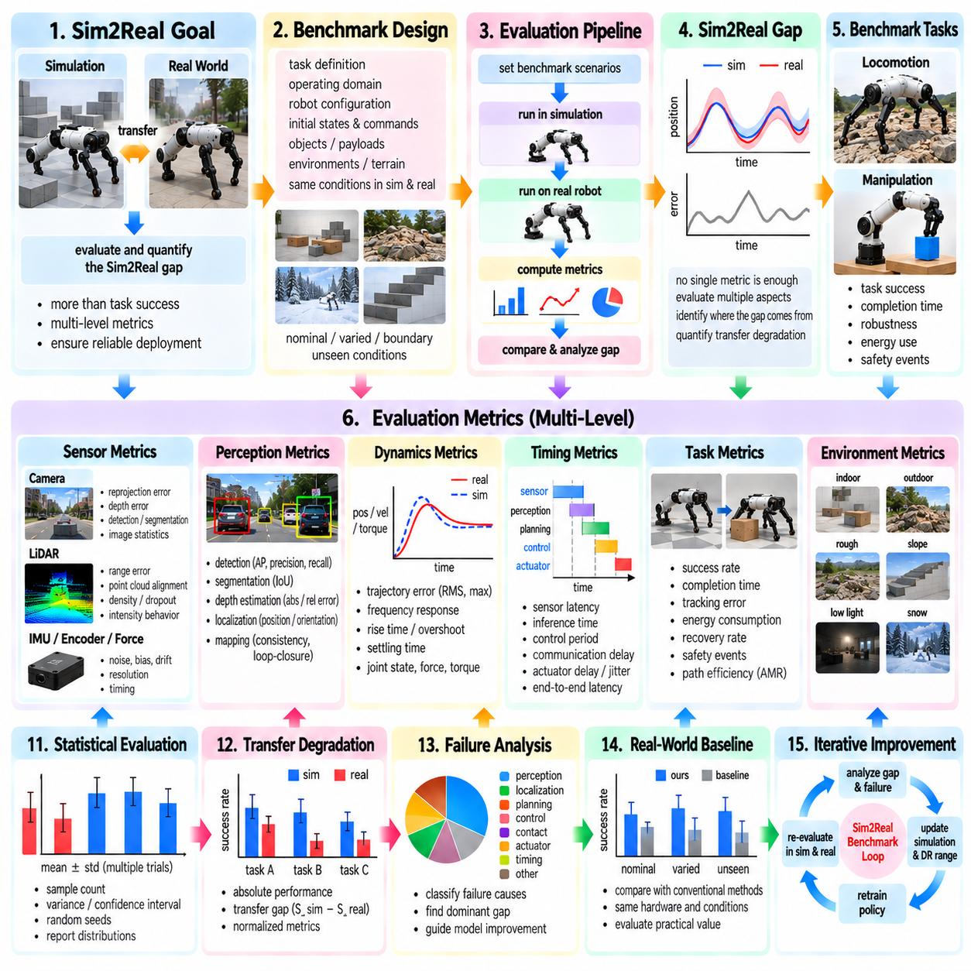
Sim2Real evaluation determines whether a system developed in simulation preserves its intended behavior after deployment to physical hardware. Evaluation should measure more than simple task completion because successful execution can hide important differences in perception, dynamics, timing, energy use, or safety margins. A rigorous protocol therefore compares simulation and reality at multiple levels, from individual sensor and actuator responses to closed-loop trajectories and complete task performance.
The central concept is the Sim2Real gap, which can be represented as a measurable difference between corresponding simulated and real observations, states, actions, trajectories, or task outcomes. No single metric fully describes this gap. A perception system may produce similar detection accuracy while generating different depth errors, and a control policy may achieve the same success rate while consuming more energy or operating closer to stability limits on hardware. Evaluation should therefore use a structured collection of complementary metrics.
Benchmark design begins by defining the task, operating domain, robot configuration, and conditions under which simulation and reality will be compared. The same initial states, commands, objects, trajectories, payloads, terrain classes, and environmental conditions should be reproduced as closely as practical. Exact duplication is rarely possible, so the protocol should document unavoidable differences. Without controlled correspondence, measured performance differences may reflect different test conditions rather than an actual Sim2Real transfer gap.
Sensor-level metrics evaluate whether simulated observations reproduce characteristics relevant to algorithms operating on real data. Camera evaluation can include reprojection error, depth error, image statistics, detection accuracy, segmentation quality, feature consistency, and calibration residuals. LiDAR evaluation can measure range error, point-cloud alignment, point density, dropout rate, intensity behavior, and geometric consistency. IMU, encoder, force, and tactile sensors require corresponding noise, bias, drift, resolution, and timing measurements.
Perception-level evaluation examines the outputs of algorithms rather than comparing raw sensor data alone. Object detection can use precision, recall, average precision, localization error, and class-specific failure rates. Segmentation can use intersection over union and boundary accuracy, while depth estimation can use absolute and relative depth errors. Localization and mapping can be evaluated through position error, orientation error, trajectory drift, map consistency, and loop-closure behavior under equivalent simulated and physical scenarios.
Dynamics-level metrics quantify how closely the simulated robot reproduces physical motion. Position, velocity, acceleration, orientation, angular velocity, joint state, force, and torque trajectories can be compared over time. Root mean square error, maximum deviation, integrated error, frequency response, rise time, overshoot, and settling time reveal different forms of mismatch. These measurements help distinguish systematic modeling errors from short transient differences that may have limited influence on task performance.
Timing metrics are essential because two systems with similar geometric trajectories can behave differently when their temporal characteristics differ. Sensor latency, observation age, inference time, planning time, control period, communication delay, actuator delay, and jitter should be measured where relevant. End-to-end sensing-to-action latency is particularly important for closed-loop control. Both average latency and distribution statistics should be reported because occasional large delays may create failures that are hidden by mean values.
For locomotion policies, evaluation should include command tracking, body stability, gait consistency, foot placement, contact timing, slip, energy consumption, disturbance recovery, and fall frequency. Tests should cover different velocities, turning commands, terrain types, slopes, payloads, and external disturbances. Comparing simulated and physical performance across these conditions reveals whether the policy has learned robust locomotion or depends on contact and actuator properties that exist only in simulation.
Manipulation benchmarks require metrics appropriate to contact-rich interaction. Grasp success, placement accuracy, insertion error, object slip, contact force, collision frequency, completion time, recovery behavior, and object damage risk can be measured. Precision tasks should report translational and rotational tolerances rather than success alone. Repeated trials with varied object poses, friction conditions, payloads, and sensor uncertainty help determine whether successful transfer generalizes beyond one favorable configuration.
Task-level metrics provide the most direct measure of deployment utility. Success rate, completion time, intervention frequency, recovery rate, energy use, throughput, mission completion, and safety-related events can be evaluated under equivalent test scenarios. For autonomous mobile robots, additional measures may include path efficiency, obstacle clearance, localization failure, replanning frequency, docking accuracy, and mission interruption. These metrics connect low-level simulation fidelity to operational performance.
A useful Sim2Real benchmark should separate absolute performance from transfer degradation. Absolute performance describes how well the physical system performs, while transfer degradation measures how much performance changes when moving from simulation to reality. If a simulated policy achieves a task success rate S_sim and the physical system achieves S_real, the difference or normalized ratio can provide a simple transfer measure. Similar comparisons can be constructed for tracking error, energy consumption, latency, or other task-specific quantities.
Normalized metrics are useful when different tasks operate at different physical scales. A five-centimeter trajectory error may be insignificant for a large outdoor vehicle but unacceptable for precision insertion. Errors can therefore be normalized by path length, object dimension, workspace scale, command magnitude, or task tolerance. The normalization rule should be defined before evaluation so that results cannot be selectively rescaled after observing performance.
Statistical reliability is important because physical robot experiments contain natural variation. A single successful or failed trial provides weak evidence about transfer quality. Benchmark protocols should use repeated trials and report sample count, mean, variance, standard deviation, confidence intervals, or other appropriate uncertainty measures. Random seeds, initial conditions, and domain parameters should be recorded in simulation, while corresponding environmental and hardware conditions should be documented for physical experiments.
Benchmark scenarios should include nominal, varied, and boundary conditions. Nominal tests measure performance near the calibrated operating point. Variation tests change parameters within the expected deployment distribution, including payload, friction, lighting, sensor noise, object pose, or terrain. Boundary tests approach the limits of the intended operating envelope. Separating these categories helps distinguish basic transfer capability from robustness and prevents extreme stress cases from being confused with normal operational evaluation.
Unseen conditions are valuable for testing generalization. If every benchmark condition was repeatedly used during policy training or simulator calibration, strong benchmark performance may reflect overfitting. A portion of environments, object configurations, terrain layouts, disturbances, or parameter combinations should therefore remain hidden from training. Performance on these held-out conditions provides stronger evidence that the policy has learned transferable behavior rather than memorized a known simulation distribution.
Real-world baseline comparisons improve interpretation. A learned Sim2Real policy can be compared with a conventional controller, manually tuned policy, previous system version, or other appropriate reference operating on the same hardware. The purpose is not merely to demonstrate that transfer occurred but to determine whether the transferred system provides meaningful operational capability. Baselines should use equivalent sensors, hardware constraints, task definitions, and evaluation conditions whenever possible.
A benchmark protocol should also define failure taxonomy. Failures can originate from perception, localization, planning, control, contact, actuator response, timing, communication, or safety mechanisms. Recording only a binary task failure hides information needed to improve the system. Classifying failure causes allows engineers to determine whether the dominant Sim2Real gap originates from sensor modeling, physics modeling, policy robustness, system integration, or another component.
Correlation analysis between simulation and reality can provide deeper evidence than comparing average values independently. If simulation predicts that one terrain, object configuration, or parameter regime is more difficult than another, physical tests should show a similar trend. Rank correlation, trajectory similarity, and condition-dependent performance relationships can indicate whether the simulator preserves meaningful relative behavior even when exact numerical values differ.
Evaluation should also examine calibration and randomization coverage. Real measurements can be mapped against the distributions used during domain randomization to determine whether deployed conditions lie inside the training envelope. Frequent physical observations near or outside distribution boundaries indicate that the randomization range may require adjustment. Conversely, extremely broad simulated ranges that are never observed physically may consume training capacity without improving deployment robustness.
Reproducibility requires strict management of benchmark artifacts. Simulator version, physics engine configuration, robot model, policy checkpoint, sensor parameters, domain-randomization ranges, software revision, hardware revision, firmware, calibration data, benchmark scenes, and random seeds should be recorded. Real-world tests should additionally document payload, surface, environmental conditions, battery state, and sensor configuration when these factors materially affect results.
A benchmark report should present both aggregate results and condition-specific results. Overall success rates can summarize performance, but breakdowns by terrain, object type, payload, speed, lighting, disturbance, or other relevant variables reveal where transfer succeeds or fails. Distributions and worst-case behavior can be as important as averages for robotic systems because rare failures may dominate operational risk even when mean performance appears strong.
Regression testing turns Sim2Real evaluation into a continuous engineering process. When the simulator, robot hardware, sensor calibration, policy, or control software changes, a standardized subset of benchmark scenarios can be rerun. Differences from previous validated results reveal whether the change improved transfer, introduced regression, or shifted failure modes. Automated simulation benchmarks can run frequently, while selected physical tests provide periodic confirmation that virtual improvements remain meaningful on hardware.
For safety-related systems, benchmark results should not be interpreted as proof that all possible physical conditions are safe. Testing demonstrates performance only within the evaluated scenarios and statistical coverage. Safety validation may require additional hazard analysis, independent safety mechanisms, fault injection, boundary testing, and applicable engineering standards. Sim2Real metrics should therefore contribute evidence to a broader verification and validation process rather than replacing system-level safety engineering.
A complete benchmark protocol ultimately forms a closed loop between simulation, physical testing, analysis, and model improvement. Simulation predicts behavior across controlled conditions, physical experiments measure corresponding outcomes, metrics quantify the gap, and failure analysis identifies its sources. The resulting evidence updates calibration, domain randomization, sensor models, actuator models, policy training, or system integration before the benchmark is repeated.
Sim2Real evaluation should therefore be treated as a multidimensional engineering discipline rather than a single success-rate comparison. Sensor fidelity, perception accuracy, dynamic response, timing, task performance, robustness, statistical confidence, failure modes, and reproducibility together determine the quality of transfer. A standardized benchmark protocol makes these differences measurable and traceable, providing the evidence required to improve simulation systematically and deploy learned robotic systems with greater confidence.

10.10. Production Sim2Real Transfer Case Studies Quadruped Humanoid
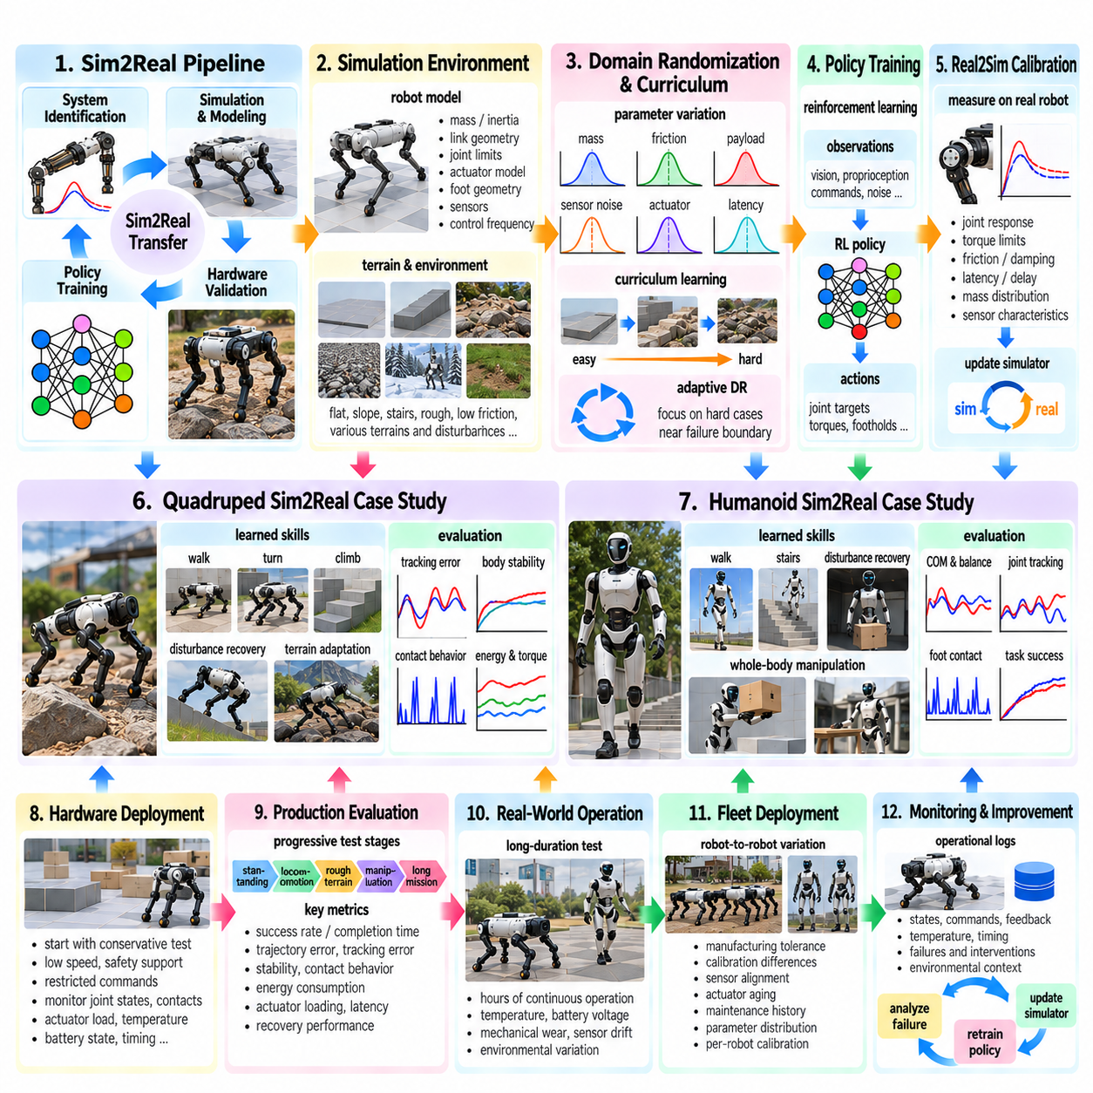
Production Sim2Real transfer moves beyond laboratory demonstrations by requiring learned robot policies to operate repeatedly, safely, and predictably on physical hardware under real deployment conditions. Quadruped and humanoid robots are demanding examples because their behavior depends on continuous balance, dynamic contact, actuator response, state estimation, and rapid closed-loop control. A successful production pipeline must therefore integrate simulation fidelity, domain randomization, system identification, policy training, hardware validation, and operational monitoring.
Quadruped locomotion provides a representative case because four-legged robots must coordinate multiple joints while repeatedly establishing and breaking ground contact. Simulation enables millions of locomotion episodes across different commands, terrains, disturbances, and robot parameters. Policies can learn walking, turning, climbing, disturbance recovery, and terrain adaptation without exposing physical hardware to the wear and failure associated with early-stage learning. The main challenge is ensuring that these simulated skills remain stable when transferred to the real robot.
A production quadruped simulator should represent robot mass, inertia, link geometry, joint limits, actuator characteristics, foot geometry, friction, contact behavior, control frequency, and sensing. Terrain models should cover the expected deployment envelope, including flat surfaces, slopes, steps, rough ground, and changes in surface friction. The simulator does not need perfect reproduction of every physical phenomenon, but errors affecting foot contact, body stability, actuator loading, or state estimation must be sufficiently controlled for reliable transfer.
System identification establishes a realistic nominal model before large-scale policy training. Engineers can measure joint response, torque limits, motor dynamics, damping, friction, latency, body mass distribution, and sensor characteristics on the physical quadruped. These measurements are used to calibrate simulation parameters and actuator models. Remaining uncertainty can then be represented through domain randomization rather than forcing one fixed simulator configuration to approximate every physical operating condition.
Actuator modeling is especially important for dynamic quadrupeds. A policy may command joint targets at high frequency, but the physical motor and transmission respond with finite bandwidth, saturation, friction, delay, and temperature-dependent behavior. Learned actuator models or calibrated analytical models can reproduce these effects during simulation. Randomizing motor strength, response time, damping, command latency, and joint friction further reduces the possibility that the locomotion policy exploits unrealistically ideal actuator behavior.
Domain randomization broadens quadruped training beyond the calibrated nominal robot. Mass, center of gravity, payload, ground friction, terrain geometry, external disturbances, sensor noise, actuator parameters, and latency can vary between simulated episodes. The ranges should reflect plausible physical conditions rather than arbitrary extremes. A policy exposed to structured variation learns locomotion strategies that tolerate uncertainty while maintaining balance, command tracking, and contact stability across the intended operating envelope.
Curriculum learning can make this process more efficient. Initial training may use flat terrain, moderate velocity commands, nominal dynamics, and limited disturbances. As locomotion becomes stable, the curriculum can introduce slopes, stairs, rough terrain, reduced friction, payload changes, pushes, sensor uncertainty, and actuator variation. Adaptive domain randomization can further concentrate training on conditions near the current policy's failure boundary while keeping parameter values physically credible.
Hardware deployment should begin conservatively. Early quadruped tests can use low velocity, flat terrain, safety supports, restricted joint commands, and conservative torque limits. Joint states, body orientation, foot contacts, actuator loads, temperatures, battery state, and control timing should be monitored. Differences between predicted and observed behavior provide evidence for Real2Sim calibration. Hardware failures should therefore become structured data for simulator refinement rather than isolated trial-and-error events.
Humanoid Sim2Real transfer increases the challenge because balance, locomotion, upper-body motion, manipulation, and whole-body coordination are tightly coupled. A humanoid may contain dozens of actuated degrees of freedom, creating a large state and action space. Small modeling errors in foot contact, joint response, center of mass, or timing can propagate through the entire body. Simulation is therefore essential for generating sufficient experience while avoiding the cost and safety risk of learning unstable behaviors directly on hardware.
Humanoid locomotion requires accurate representation of whole-body dynamics. Link masses, inertia tensors, joint axes, transmission behavior, foot geometry, contact friction, compliance, and control delays influence balance. The policy must regulate the center of mass and momentum while coordinating feet, legs, torso, and often arms. Domain randomization across these properties helps prevent dependence on one exact model, while calibrated nominal parameters keep the randomized distribution anchored to the physical robot.
State estimation is another critical transfer component. Simulation can provide exact base position, velocity, contact state, and joint information, but production robots depend on IMUs, encoders, force sensors, cameras, and estimation algorithms. Policies trained exclusively with perfect simulator states can fail when exposed to noisy and delayed measurements. Training should therefore reproduce observation noise, bias, drift, latency, and estimation uncertainty, while privileged simulator information can be reserved for training components such as critics or teachers.
Humanoid recovery behavior deserves particular attention because small disturbances can lead to large whole-body failures. Training can expose the policy to pushes, uneven contact, imperfect foot placement, payload variation, and temporary state-estimation errors. The objective is not only to maximize nominal walking performance but also to develop behaviors that restore stable motion after perturbations. Recovery capability can substantially increase practical deployment reliability even when simulation and physical dynamics do not match perfectly.
Whole-body manipulation introduces another layer of coupling. When a humanoid reaches, carries, pushes, or lifts an object, the object's mass and interaction forces modify balance and actuator loading. Simulated training should therefore vary object properties, grasp configurations, contact forces, and payload distribution while preserving physically realistic relationships. Policies may need to coordinate locomotion and manipulation simultaneously rather than treating the upper and lower body as independent control problems.
Production systems generally benefit from hierarchical control. A learned high-level or mid-level policy can generate desired motion, joint targets, footholds, or task commands, while lower-level controllers enforce actuator limits and stabilize execution. Independent safety mechanisms can constrain joint position, velocity, torque, workspace, and other operational boundaries. This architecture prevents the learned policy from being the only layer responsible for maintaining safe physical behavior during deployment.
Sim2Real validation should proceed through increasingly difficult test stages. Initial tests can verify standing, joint tracking, state estimation, and low-speed motion before progressing to dynamic locomotion, terrain variation, disturbances, manipulation, and longer missions. Each stage should compare simulation and reality using trajectory error, command tracking, stability, contact behavior, energy consumption, actuator loading, latency, recovery performance, and task success. Repeated trials are required because individual demonstrations provide limited evidence of robustness.
Production evaluation must also consider duration. A policy that succeeds for several minutes may still fail during hours of continuous operation because actuator temperature, battery voltage, mechanical wear, sensor drift, or environmental conditions gradually change. Long-duration tests expose these effects and can reveal variables missing from the simulation distribution. Such observations can be converted into additional domain parameters or operating regimes for subsequent policy training.
Fleet deployment introduces robot-to-robot variation. Two nominally identical quadrupeds or humanoids may differ because of manufacturing tolerances, calibration, joint friction, sensor alignment, actuator aging, or maintenance history. A production Sim2Real strategy should therefore avoid tuning exclusively for one prototype. Parameter distributions can represent measured fleet variation, while per-robot calibration can update selected parameters without requiring complete policy retraining for every physical unit.
Monitoring continues after deployment. Operational logs can capture state estimates, commands, actuator feedback, temperatures, timing, failures, interventions, and environmental context. These records support regression analysis and identify conditions where the policy approaches its performance boundary. Representative failures can be reconstructed in simulation, allowing engineers to determine whether the cause is missing domain coverage, inaccurate physics, perception error, actuator behavior, or policy limitations.
The resulting development process forms a continuous Real2Sim-to-Sim2Real loop. Physical measurements calibrate the simulator, simulation generates large-scale experience, domain randomization exposes the policy to uncertainty, and hardware testing measures transfer quality. Deployment then generates additional real-world evidence that updates the simulator and training distribution. Each cycle improves the correspondence between the virtual development environment and the conditions encountered by physical robots.
Quadruped and humanoid case studies demonstrate that production Sim2Real transfer is not achieved by one algorithm or one highly realistic simulator. Reliable transfer emerges from the coordinated use of system identification, actuator modeling, sensor modeling, timing models, domain randomization, curriculum learning, robust policy optimization, staged hardware testing, safety constraints, and continuous operational feedback. Each component addresses a different source of uncertainty between simulated and physical operation.
The final objective is not perfect equality between simulation and reality, but reliable physical behavior despite their remaining differences. For quadrupeds, this means maintaining stable and adaptive locomotion across terrain, payload, disturbance, and hardware variation. For humanoids, it additionally requires whole-body balance, high-dimensional coordination, recovery, and interaction with objects. A production Sim2Real pipeline transforms simulation from a training environment into a continuously calibrated engineering system that supports development, validation, deployment, and improvement of Physical AI robots.

