Volume 11. Simulation and Digital Twin

Chapter 07. Gazebo and Open Source Sim

07.01. Gazebo Sim vs Classic Gazebo Architecture Differences
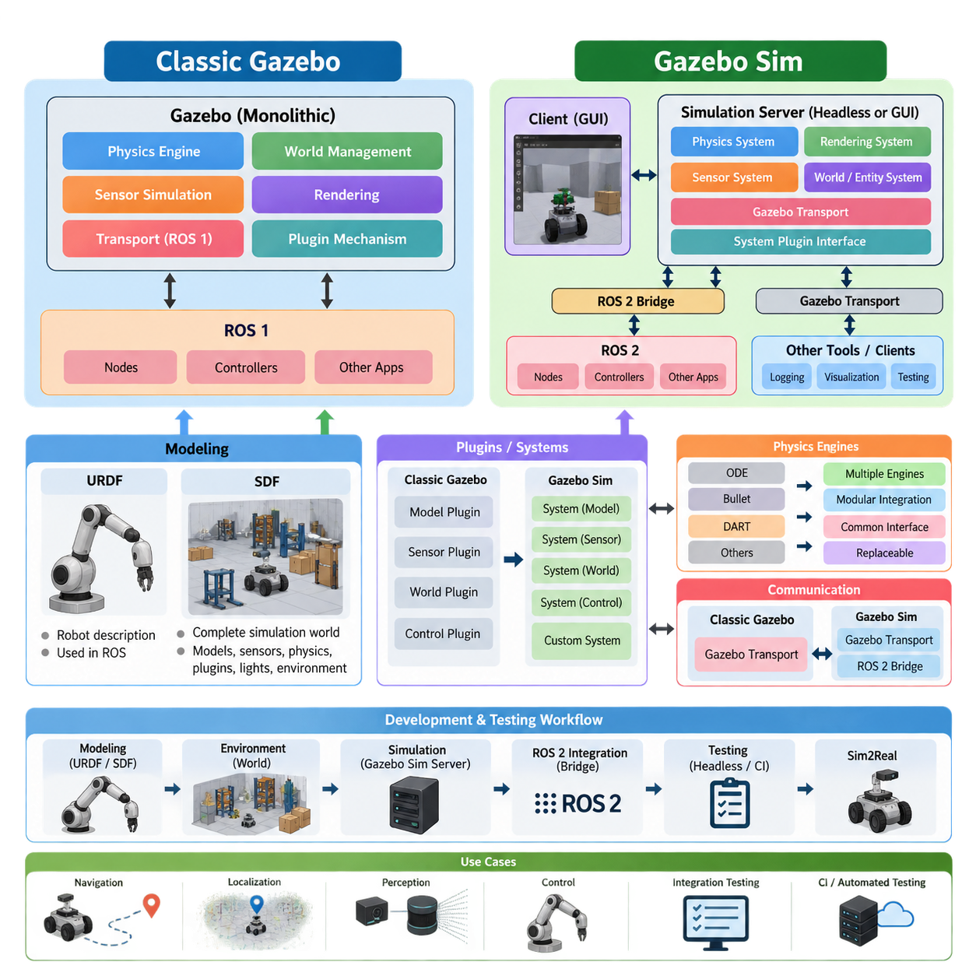
Gazebo has evolved from the architecture commonly associated with Classic Gazebo into a newer simulation architecture generally referred to as Gazebo Sim. The distinction is important because the change is not simply a new graphical interface or a renamed software package. It reflects a broader restructuring of the simulator around more modular services, modern middleware integration, and clearer separation between simulation components. This evolution is particularly relevant when Gazebo is used as part of a modern robot software architecture rather than as an isolated visualization tool.
Classic Gazebo was built around a relatively centralized simulation architecture in which the physics engine, world management, sensor simulation, rendering, transport, and plugin mechanisms were closely integrated. Its development history is strongly connected with ROS and ROS 1 workflows, and many existing robot projects still contain Classic Gazebo models, plugins, launch files, and integration code. This ecosystem became highly mature and widely adopted, making Classic Gazebo an important reference point for understanding existing robotics simulation assets.
Gazebo Sim adopts a more modular architecture in which the simulation server, physics systems, rendering systems, sensor systems, and other functions can be treated as distinct components. Instead of relying on one large monolithic simulator structure, functionality is organized through systems and services that interact through defined interfaces. This architecture makes it easier to replace or extend individual simulation capabilities without requiring the entire simulator to follow the implementation assumptions of an older integrated design.
One of the most visible architectural changes is the separation between the simulation engine and the graphical client. In Gazebo Sim, the simulation server can execute the world and physics independently from the graphical interface, while a client can connect to the running simulation for visualization and interaction. This separation is useful for headless execution, automated testing, remote simulation, and continuous integration because simulation does not fundamentally depend on a graphical desktop being present.
The underlying physics architecture is also more explicitly modular. Gazebo Sim can work with supported physics engines through a common simulation framework, while physics-related behavior is exposed through system interfaces. This allows robot models and environments to be constructed independently from many implementation details of the physics backend. The practical benefit is that a simulation application can maintain a stable higher-level structure while physics configuration and related components evolve.
The transition also changes the role of plugins. Classic Gazebo commonly used plugins that were tightly associated with particular model, sensor, world, or control functions. Gazebo Sim retains an extensibility mechanism but organizes functionality around systems and modern plugin interfaces. A system can implement behavior associated with entities in the simulated world, allowing developers to add custom sensors, actuators, controllers, environmental behavior, or other simulation logic while maintaining a more structured architecture.
The communication layer has also changed significantly. Classic Gazebo used its own transport architecture, which became deeply embedded in many older workflows. Gazebo Sim uses modern Gazebo Transport and related interfaces, while ROS 2 integration is provided through dedicated bridges and packages. This distinction is important because Gazebo Transport and ROS 2 are not identical communication mechanisms. A modern robot application may therefore contain Gazebo-native communication internally and use a ROS 2 bridge where simulation data must enter the robot's ROS 2 software architecture.
The modeling workflow is centered on SDF, or Simulation Description Format. SDF is not merely a replacement for URDF; it is designed to describe complete simulation worlds, including models, links, joints, sensors, physics properties, plugins, lights, and environmental elements. URDF remains highly important in ROS-based robot description workflows, but Gazebo Sim can use SDF as a richer simulation-oriented representation. This distinction becomes particularly important when moving from a robot description to a complete simulation environment.
For ROS 2-based development, Gazebo Sim therefore provides a useful boundary between robot software and simulation infrastructure. ROS 2 nodes can continue to implement perception, localization, planning, control, navigation, and other robot functions, while Gazebo provides simulated physics and sensors. Bridges and control integrations connect these domains. This supports the broader software-architecture principle of separating robot application logic from the underlying simulation implementation.
The architectural difference is especially valuable for automated testing. Because Gazebo Sim can operate without continuously running its graphical client, the same simulation environment can be executed as a headless process in a test or CI environment. Robot software can then receive simulated sensor data and publish control commands in a manner similar to operation with physical hardware. This makes simulation suitable not only for demonstrations but also for regression testing, integration testing, and repeatable validation.
For AMR development, the distinction can be viewed in practical terms. A Classic Gazebo project may contain an established world file, robot model, plugins, ROS 1 nodes, and launch configuration that were designed around the older architecture. Migrating such a system is therefore not simply a matter of opening the same files in a newer simulator. Model descriptions, plugins, transport interfaces, ROS integration, controllers, and launch mechanisms may all require examination and adaptation.
Gazebo Sim is particularly suitable when the simulation environment is intended to become part of a larger Simulation-Driven Development workflow. The simulator can provide repeatable environments for validating navigation, localization, sensor processing, controller behavior, and robot-system integration. This aligns with the broader simulation structure in which fidelity, physics, sensors, environment modeling, automated testing, and eventually Sim2Real transfer are treated as connected engineering activities rather than independent experiments.
The distinction between Classic Gazebo and Gazebo Sim should therefore be understood as an architectural transition rather than a simple product-version change. Classic Gazebo remains relevant because of its large installed base and existing robotics software, while Gazebo Sim represents the newer modular direction for open-source robot simulation. For a new ROS 2-oriented project, understanding the newer architecture helps developers design simulation interfaces that remain independent from individual physics engines, rendering clients, and simulator-specific implementation details. This approach also fits the broader robotics software architecture principle of separating application functions from infrastructure components.

07.02. Gazebo SDF World and Model Creation [w/Code]
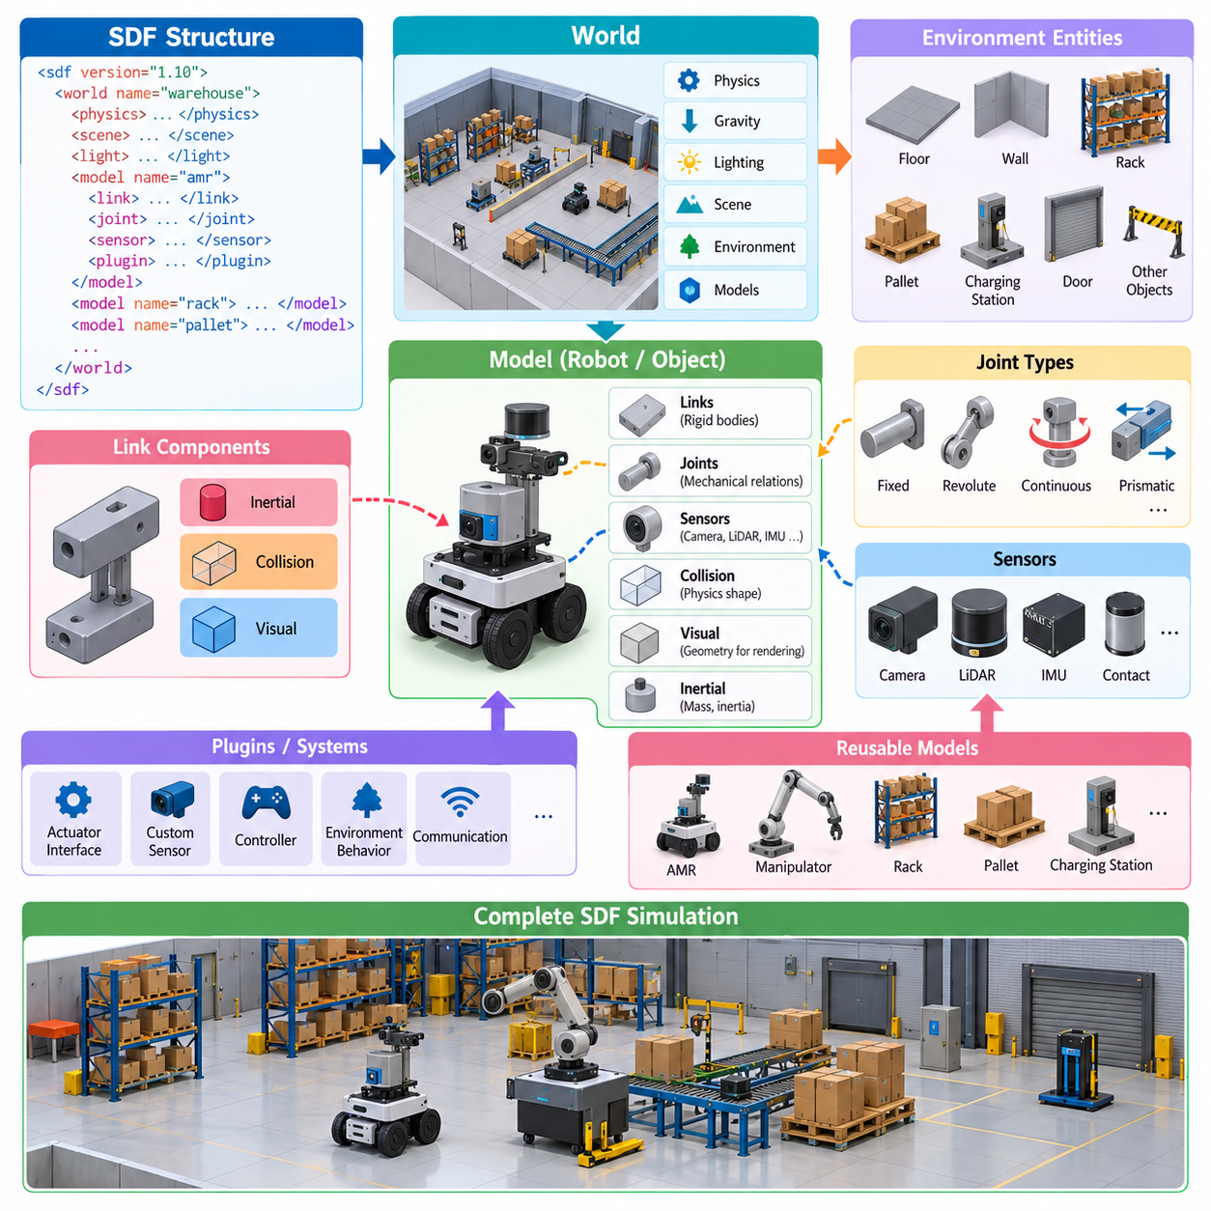
SDF, or Simulation Description Format, is the primary scene-description format used by Gazebo to represent robots, objects, sensors, and complete simulation environments. Unlike robot-centered formats that mainly describe links and joints, SDF provides a hierarchical structure capable of defining an entire simulated world. A world can contain multiple models, lighting, physics configuration, environmental properties, plugins, and other entities required to reproduce a robotics scenario.
An SDF document is organized as a hierarchy of elements. At the highest level, the SDF element specifies the format version and contains a world or model definition. A world acts as the container for the complete simulation scene, while a model represents an individual physical system such as an AMR, manipulator, vehicle, rack, pallet, or obstacle. Models are further decomposed into links, joints, sensors, collision geometries, and visual geometries.
World creation begins by defining the global properties of the simulation. These properties can include gravity, physics-engine parameters, scene configuration, lighting, and environmental entities. A warehouse world, for example, may contain a floor, walls, racks, pallets, charging stations, and multiple robots. Organizing these components as reusable models allows the same assets to be assembled into different test environments without reconstructing every object for each simulation.
The model element represents a logical physical object within the world. A model may contain a single rigid object or a complex articulated mechanism consisting of many links and joints. Each link represents a rigid body with physical properties such as mass and inertia, while joints define mechanical relationships between links. This structure allows SDF to represent everything from simple obstacles to differential-drive AMRs and multi-joint robotic manipulators.
A link normally combines inertial, collision, and visual information. The inertial description determines how the physics engine calculates dynamic motion, while collision geometry defines the shape used for contact and collision calculations. Visual geometry determines how the object appears in the rendering system. Separating collision and visual representations is important because highly detailed graphical meshes can often be replaced by simpler collision shapes to improve simulation performance.
Pose definitions determine where entities are located and how they are oriented relative to reference frames. Correct pose management becomes increasingly important as models become more complex because robots may contain sensors, wheels, manipulators, payloads, and nested subassemblies. Modern SDF supports structured frame semantics that help developers express relationships among coordinate frames rather than relying only on manually accumulated transformations.
Joints connect links and constrain their relative motion. Common joint types include fixed, revolute, continuous, prismatic, and other mechanical relationships supported by the simulation environment. Joint definitions specify properties such as axes, limits, dynamics, and relationships between connected bodies. For mobile robots, wheel joints translate actuator commands into simulated movement, while manipulator joints reproduce the articulated structure of the physical arm.
Sensors can be incorporated directly into SDF models so that simulated robots expose measurements corresponding to their physical sensor configurations. Cameras, depth sensors, LiDAR, IMUs, contact sensors, and other sensor types can be attached to appropriate links with defined poses and update characteristics. The simulator then generates observations based on the evolving virtual environment, enabling perception and localization software to operate against simulated sensor streams.
World and model descriptions should distinguish reusable assets from scenario-specific configuration. A robot model should normally describe the robot itself, while a world should determine where that robot operates and which external objects surround it. This separation allows the same AMR model to be inserted into a warehouse, hospital, factory, outdoor test area, or synthetic validation environment without duplicating the robot description for every scenario.
Reusable models can also be composed from smaller components. A mobile manipulator, for example, can conceptually combine a mobile base, robotic arm, sensor mast, compute enclosure, and payload interface. Maintaining these components with clear reference frames and interfaces reduces duplication and simplifies configuration management. Changes to a sensor mounting position or collision geometry can then be propagated without rebuilding every simulation world that contains the robot.
Plugins and systems extend the static SDF description with executable simulation behavior. They can implement actuator interfaces, custom sensors, environmental behavior, controllers, or communication functions that cannot be represented only through geometry and physical parameters. In Gazebo Sim, this mechanism supports a modular relationship between declarative scene description and runtime simulation functionality, allowing SDF to define entities while systems provide their dynamic behavior.
SDF model creation therefore requires more than visually reproducing CAD geometry. Mass, center of gravity, inertia tensors, joint constraints, friction, collision geometry, actuator behavior, and sensor placement influence whether simulated behavior resembles the physical robot. Excessively detailed meshes may reduce execution speed without improving useful physical fidelity, while inaccurate inertial or collision properties can produce unrealistic motion even when the rendered robot looks geometrically correct.
A practical model-development process typically begins with a minimal structure and progressively adds physical and sensing detail. Developers can first verify links, poses, and joints, then validate collision behavior and dynamics before introducing sensors and application-specific systems. This incremental approach makes errors easier to isolate because problems in coordinate frames, inertia, contact, or plugins can otherwise interact and make complex simulation failures difficult to diagnose.
For AMR simulation, the resulting SDF environment can combine the robot model with structured infrastructure such as walls, aisles, racks, doors, docking stations, ramps, and dynamic obstacles. Sensor models generate observations from these surroundings while wheel dynamics and contact models determine vehicle motion. Navigation and control software can therefore be evaluated against repeatable scenarios before equivalent experiments are performed on physical hardware.
SDF world and model creation ultimately forms the structural foundation of a Gazebo-based Simulation-Driven Development pipeline. Robot models define physical and sensing characteristics, world descriptions provide operational context, and runtime systems add dynamic behavior and software interfaces. These elements can then support automated testing, ROS 2 integration, synthetic scenario execution, regression validation, and later Sim2Real activities within the broader simulation architecture described by the volume structure.

07.03. Gazebo ROS2 Integration gz ros2 control [w/Code]
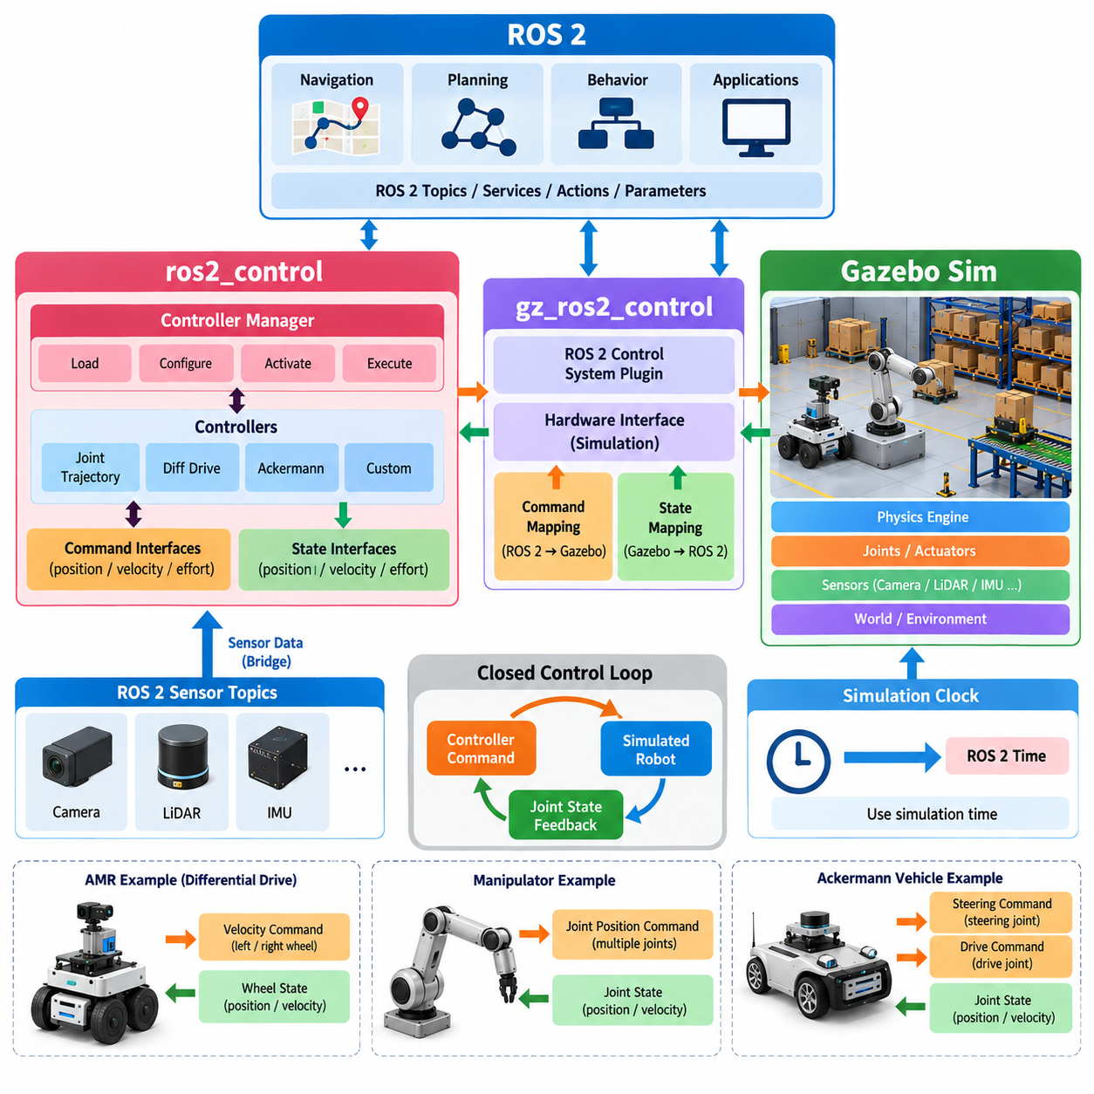
ROS 2 integration with Gazebo Sim creates a structured connection between the simulated robot and the same control software architecture used for physical hardware. Gazebo provides physics, joints, sensors, contacts, and simulated actuators, while ROS 2 provides communication, lifecycle management, controllers, planning, and higher-level robot applications. The integration boundary is important because simulation-specific implementation can remain separated from robot control logic.
The ros2_control framework provides a standardized architecture for connecting ROS 2 controllers to robot hardware through defined command and state interfaces. Instead of allowing every controller to communicate directly with individual motors or simulation joints, ros2_control introduces a hardware abstraction layer. Controllers operate against standardized interfaces, allowing similar control software to be reused across simulated robots, test systems, and physical hardware.
Within Gazebo Sim, gz_ros2_control provides the integration mechanism that connects simulated joints and actuators to the ros2_control ecosystem. It implements the simulation-side hardware interface required by ros2_control and maps commands generated by ROS 2 controllers to Gazebo entities. Joint states calculated by the simulator are returned through corresponding state interfaces, producing a bidirectional control path between ROS 2 and the simulated physical system.
The resulting architecture can be understood as a closed control loop. A ROS 2 controller generates commands such as position, velocity, or effort references. ros2_control routes these commands through its resource and hardware interfaces, and gz_ros2_control applies them to simulated joints. Gazebo advances the physical simulation and calculates new joint states, which are then returned through gz_ros2_control and made available to controllers and other ROS 2 components.
The Controller Manager is a central component of ros2_control. It manages controller loading, configuration, activation, deactivation, and execution while coordinating access to available hardware interfaces. Different controllers can therefore be assigned to different robot resources without embedding controller management inside the Gazebo model itself. This separation improves modularity and allows the controller configuration to evolve independently from much of the simulation environment.
Robot descriptions typically define the interfaces required by ros2_control alongside the mechanical structure of the robot. Joints can expose command interfaces such as position, velocity, or effort and state interfaces representing measured joint position, velocity, or other quantities. The simulation integration interprets these definitions and associates them with corresponding simulated joints, creating the software contract between the controller architecture and the Gazebo model.
For a differential-drive AMR, for example, left and right wheel joints can expose velocity command interfaces and position or velocity state interfaces. A suitable ROS 2 controller generates wheel commands from higher-level motion requests, while Gazebo calculates wheel rotation, contact forces, and resulting base movement. The control architecture therefore remains separated from the physics responsible for determining how commanded wheel motion affects the simulated vehicle.
The same principle extends to Ackermann vehicles and robotic manipulators. Steering and drive joints can be represented through appropriate interfaces for mobile platforms, while articulated robots may expose position, velocity, or effort interfaces for multiple joints. Controllers can then execute trajectories without needing direct knowledge of Gazebo's internal physics representation, which makes the control layer more portable between simulation and real robot implementations.
Sensor integration follows a related but distinct communication path. Cameras, LiDAR, IMUs, and other simulated sensors generate data inside the Gazebo environment, while ROS 2 applications typically expect ROS-compatible topics and message types. Gazebo-to-ROS bridges can translate relevant simulation messages into ROS 2 communication. Consequently, actuator control through gz_ros2_control and sensor communication through bridging mechanisms can coexist within the same simulated robot architecture.
This distinction is useful when designing the software boundary. gz_ros2_control primarily connects the ros2_control hardware and controller architecture with simulated actuation and joint state, whereas general Gazebo and ROS 2 communication may use bridge mechanisms for sensors, clocks, poses, or other simulation information. Keeping these responsibilities explicit prevents the integration layer from becoming a collection of tightly coupled simulator-specific interfaces.
Simulation time is another important integration consideration. Robot algorithms may depend on timers, timestamps, controller update periods, sensor rates, and transform synchronization. When simulation does not run at exactly wall-clock speed, ROS 2 components should consistently use the intended simulation clock where appropriate. This allows algorithms to behave according to simulated elapsed time even when the simulator runs slower or faster than real time.
Controller update rates and physics time steps should also be coordinated carefully. The Gazebo physics engine may update at a high internal frequency, while ros2_control controllers execute at another configured rate. An inappropriate relationship between these rates can produce unstable control, delayed responses, or unnecessary computation. Simulation design should therefore consider physics integration, controller frequency, sensor update rates, and ROS 2 timing as parts of the same timing architecture.
A major engineering advantage of this integration is software reuse between simulation and hardware. Higher-level components such as navigation, trajectory generation, behavior control, and mission logic can interact with standard ROS 2 interfaces rather than simulator-specific APIs. When the physical robot provides compatible ros2_control hardware interfaces, much of the controller and application architecture can remain unchanged while the backend changes from Gazebo simulation to real devices.
This approach also supports automated validation. Gazebo Sim can execute headlessly while ROS 2 launches controllers and robot applications around it, enabling repeatable test scenarios to be executed without a graphical client. Tests can verify controller activation, command execution, joint response, navigation behavior, fault handling, and system integration. Such scenarios can become part of continuous integration pipelines and regression testing for robot software.
For AMR and mobile-manipulator development, the architecture provides a practical path from virtual prototypes toward physical systems. An AMR base, wheel controllers, manipulator joints, sensors, and navigation software can first be integrated in Gazebo, while ROS 2 preserves consistent application-level interfaces. As hardware becomes available, simulated interfaces can progressively be replaced by physical drivers while retaining substantial portions of the controller and application software.
Gazebo, gz_ros2_control, ros2_control, and ROS 2 therefore form complementary layers rather than competing control frameworks. Gazebo represents the simulated physical world, gz_ros2_control connects simulated resources to the hardware abstraction, ros2_control manages standardized controller interfaces, and ROS 2 provides the wider distributed robot software environment. Together they establish a reusable integration architecture for simulation-driven development, automated testing, and eventual Sim2Real deployment.

07.04. Gazebo Plugin Development Sensor Actuator [w/Code]
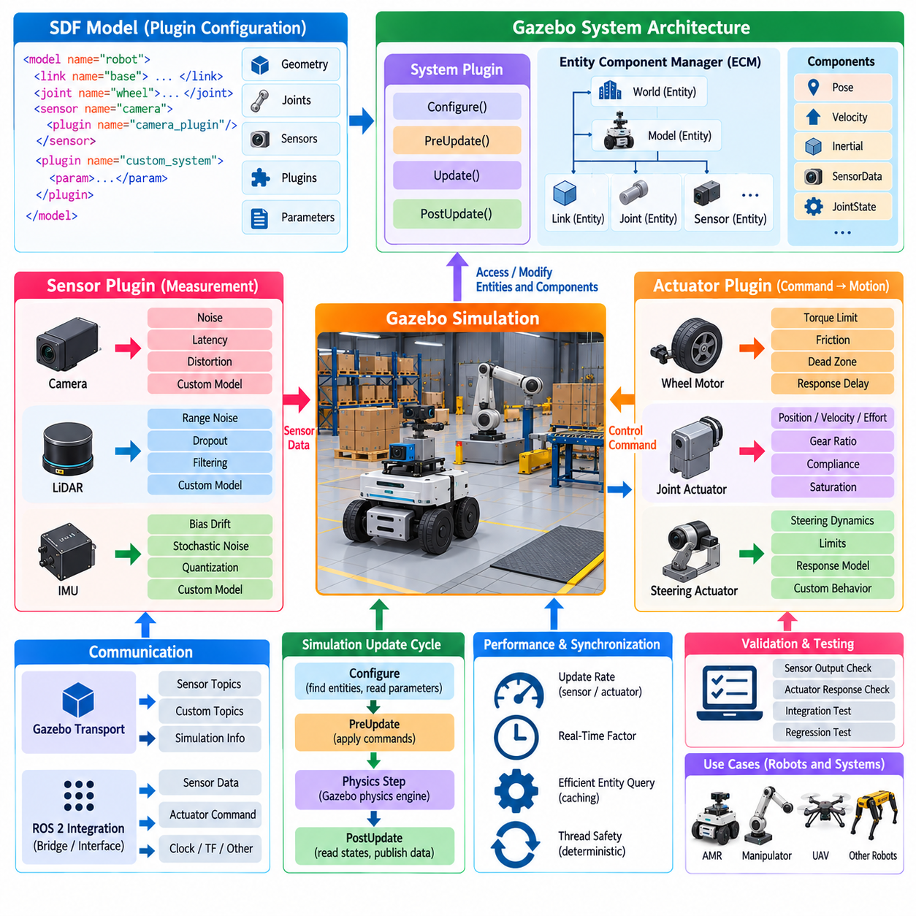
Gazebo plugin development provides a mechanism for extending simulation behavior beyond the capabilities available through static SDF model descriptions. An SDF file can define geometry, mass, joints, sensors, and physical properties, while a plugin or system introduces executable logic that interacts with the evolving simulation state. This separation allows custom robot functionality to be implemented without modifying the core simulator and supports reusable simulation components for sensors, actuators, environments, and control systems.
In modern Gazebo Sim, extensibility is organized primarily around the system architecture. A system plugin can access entities and components representing models, links, joints, sensors, poses, velocities, and other simulation properties. Rather than embedding all behavior inside a monolithic simulator process, developers implement specific functionality as systems that participate in the simulation lifecycle. This architecture makes custom functionality easier to isolate, maintain, test, and reuse across different worlds and robot models.
The Entity Component Manager provides a central abstraction for accessing simulation objects. Entities identify objects such as models, links, joints, and sensors, while components store associated state or configuration information. A plugin can query relevant entities, inspect their components, and update permitted simulation data. This entity-component approach reduces direct dependency on internal object hierarchies and provides a structured interface between custom systems and the simulator.
System execution is synchronized with the simulation update cycle through defined callbacks. Configuration logic initializes the plugin and locates required entities, while update callbacks allow computation before or after a simulation step. Pre-update processing is useful for applying actuator commands before physics calculation, whereas post-update processing can observe resulting states after the simulation has advanced. Correct placement of operations is important for deterministic and physically consistent behavior.
A sensor plugin extends or customizes how simulated measurements are generated and delivered. The plugin may obtain the pose, velocity, acceleration, environmental state, or other information associated with a sensor entity and convert these values into a measurement representation. Additional logic can model noise, bias, latency, quantization, saturation, failure states, or device-specific behavior that is not sufficiently represented by a basic idealized sensor model.
For example, an IMU extension can introduce bias drift and stochastic noise into simulated acceleration and angular-velocity measurements. A LiDAR-related system can apply range-dependent uncertainty, dropout behavior, or application-specific filtering, while a camera extension may emulate timing or exposure-related effects. Such additions are valuable when the objective is not merely visualization but validation of perception and estimation algorithms under realistic sensor imperfections.
Sensor plugins should preserve a clear distinction between ground-truth simulation state and observable measurements. The simulator may know the exact pose and velocity of every object, but real robot software normally receives uncertain and delayed sensor information. A well-designed sensor extension transforms ideal simulation state into an observation that reflects the intended sensor characteristics. This distinction becomes increasingly important for localization, sensor fusion, autonomy validation, and Sim2Real experiments.
Actuator plugins operate in the opposite direction by converting commands into physical effects within the simulation. A simple actuator system may receive a desired joint position, velocity, or effort and apply the corresponding command to a simulated joint. More advanced models can represent motor torque limits, gearbox ratios, friction, dead zones, saturation, compliance, thermal constraints, response delay, or other characteristics that affect the relationship between commanded and actual motion.
For an AMR, actuator logic can represent wheel motors and steering mechanisms. A command from the robot control stack can be translated into wheel velocity or torque, after which the physics engine determines vehicle motion from contact, friction, inertia, and environmental geometry. For manipulators, the same architecture can represent joint motors, transmissions, and limits. This preserves the distinction between control commands and the physical response generated by the simulated mechanism.
Communication is another important responsibility of plugin design. Custom systems may exchange data through Gazebo Transport, while ROS 2 integration can expose selected information to external robot applications through appropriate bridges or control interfaces. The plugin should avoid unnecessary coupling to higher-level application logic whenever possible. Keeping simulation-specific behavior behind stable interfaces improves portability and allows the same robot software architecture to operate with simulation or physical hardware.
Plugin configuration can be associated with SDF entities so that reusable behavior is instantiated as part of a model or world description. Parameters can specify topics, entity names, update rates, noise properties, gains, limits, or other characteristics without hard-coding them into the implementation. This separation between executable code and configuration allows one plugin implementation to support multiple robot variants, sensor configurations, and experimental scenarios.
Performance must be considered when plugins execute at high simulation frequencies. Sensor processing, actuator calculations, message publication, and entity queries may occur hundreds or thousands of times per second. Expensive operations inside every update callback can reduce the real-time factor of the simulator. Developers should therefore minimize repeated searches, cache stable entity references where appropriate, control publication rates, and separate high-frequency physical operations from lower-frequency monitoring or logging.
Threading and synchronization also require careful design. Simulation state may be updated according to a defined execution sequence, while communication callbacks or external interfaces can operate asynchronously. Shared command and state data should therefore be handled in a manner that prevents race conditions and inconsistent updates. Deterministic simulation is particularly important when plugins are used for regression testing because identical scenarios should produce behavior that can be meaningfully compared across software revisions.
Validation of a custom sensor or actuator plugin should occur at multiple levels. The implementation can first be tested with simple models where expected behavior is analytically understandable, followed by integration with realistic robot models and controllers. Sensor outputs can be compared with configured noise and timing characteristics, while actuator responses can be evaluated against expected limits, dynamics, and command tracking. This prevents visually plausible behavior from being mistaken for physically meaningful simulation.
For Simulation-Driven Development, plugins provide an important bridge between generic simulator capabilities and the characteristics of a target robot. Standard physics and sensor models establish the basic virtual environment, while custom systems introduce hardware-specific behavior needed for meaningful engineering validation. The same plugin architecture can support AMRs, manipulators, legged robots, UAVs, industrial equipment, and specialized payloads without requiring modifications to Gazebo's core architecture.
Gazebo sensor and actuator plugin development therefore should be treated as interface and behavior modeling rather than merely simulator customization. Sensors transform simulated physical state into realistic observations, actuators transform software commands into simulated physical actions, and system plugins coordinate these interactions with the simulation lifecycle. Together with SDF, Gazebo Transport, ROS 2 integration, and physics simulation, these extensions create a modular foundation for robot validation, automated testing, and Sim2Real development.

07.05. PyBullet Rapid Prototyping for Manipulation [w/Code]
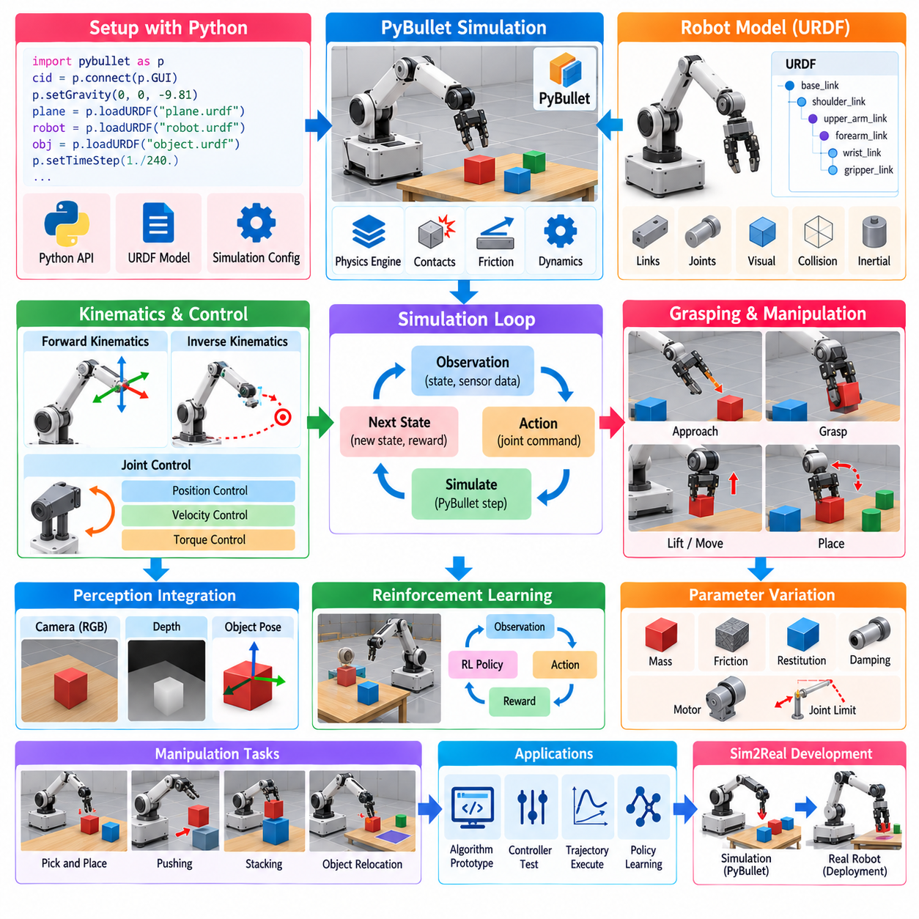
PyBullet is a Python-oriented interface to the Bullet physics engine that enables rapid development and evaluation of robotic manipulation systems. Its main value is the ability to construct a simulation, load robot models, apply joint commands, observe contacts, and collect state information with relatively little infrastructure. For manipulation research, this makes PyBullet useful for quickly testing kinematics, dynamics, grasping, trajectory generation, inverse dynamics, and reinforcement-learning environments before moving to more complex simulation platforms.
A typical PyBullet manipulation workflow begins by creating a physics client and configuring the simulation environment. The developer can load a robot model, ground plane, objects, and supporting fixtures using available model descriptions. Robot structures can commonly be represented through URDF files, allowing links, joints, visual geometry, collision geometry, and inertial properties to be loaded into the simulator. This provides a practical connection between robot modeling and executable manipulation experiments without requiring a large simulation infrastructure.
Robot joint control is central to PyBullet manipulation experiments. Joints can be commanded using position, velocity, or torque-oriented control mechanisms depending on the experiment. A controller can calculate a desired joint configuration and send commands to the corresponding simulated joints, while PyBullet advances the physical simulation and returns updated joint states. This closed-loop interaction allows researchers to prototype low-level control, trajectory tracking, and higher-level manipulation behaviors using Python-based experimentation.
Forward and inverse kinematics can be incorporated into the manipulation workflow. Forward kinematics determines the end-effector pose from a given set of joint values, while inverse kinematics estimates joint configurations that achieve a desired end-effector position or orientation. PyBullet provides practical functions for these calculations, allowing a developer to connect target poses with joint commands quickly. Although such functions simplify prototyping, the resulting solutions should still be evaluated against joint limits, singularities, collision constraints, and the actual kinematic structure of the physical robot.
Contact and collision modeling are particularly important for manipulation. A gripper must interact with objects through physical contact rather than simply moving through them as independent geometric entities. PyBullet's physics simulation can calculate contacts between collision bodies and provide information about contact points and related physical quantities. This enables experiments involving grasping, pushing, placing, object manipulation, and interaction with constrained environments, although contact behavior remains sensitive to physical parameters and solver configuration.
Grasping experiments can be constructed by combining a robot arm, end-effector, and target object inside a controlled scene. The gripper can approach the object through a planned trajectory, close its fingers, establish contact, and then attempt to lift or move the object. The experiment can evaluate whether the object remains stable under the simulated forces and whether the robot reaches the intended target pose. Such experiments are valuable for testing manipulation logic before implementing equivalent behavior on physical hardware.
PyBullet also supports rapid experimentation with different physical parameters. Mass, friction, restitution, damping, joint limits, motor characteristics, and object geometry can be varied between experiments. This enables researchers to examine how manipulation behavior changes when object properties or robot parameters are uncertain. Parameter variation can also be used to generate diverse training environments for learning-based manipulation policies, although simulation results should not automatically be interpreted as equivalent to real-world performance.
The Python interface is particularly useful for research workflows that combine simulation with machine learning. A reinforcement-learning environment can reset the scene, generate an observation, apply an action, advance the simulation, calculate a reward, and return the next observation. This interaction naturally forms the environment loop required by many learning algorithms. PyBullet can therefore serve as a lightweight experimental platform for studying grasp policies, reaching, pushing, object relocation, and other manipulation tasks.
For perception-driven manipulation, simulated camera observations can be combined with robot state and object information. A virtual camera can generate images or depth information that are processed by a perception model, while the resulting object pose or target location is passed to the manipulation controller. This creates an integrated perception-to-action loop in which sensing, estimation, planning, and control can be evaluated together. Such a workflow is useful for testing AI-based manipulation concepts before integrating physical cameras and robot hardware.
PyBullet is also suitable for testing trajectory generation and control algorithms independently from the final robot platform. A developer can generate joint-space or Cartesian trajectories, execute them in simulation, and examine tracking errors, joint velocities, accelerations, and contact behavior. Different control gains or trajectory profiles can be compared rapidly because simulation resets are inexpensive. This makes PyBullet valuable during the early stage of algorithm development, when the primary objective is to determine whether a proposed approach is conceptually workable.
However, rapid prototyping should not be confused with high-fidelity physical validation. Simplified contact models, actuator representations, sensor assumptions, friction parameters, and numerical integration can create differences between PyBullet and a physical robot. A manipulation policy that succeeds consistently in simulation may fail when applied to an actual gripper because of compliance, backlash, calibration error, unmodeled friction, sensor noise, latency, or object variability. Simulation should therefore be treated as an experimental approximation whose limitations must be explicitly considered.
A useful engineering strategy is to begin with a simple PyBullet model and progressively increase the level of physical realism. Basic kinematic behavior can be validated first, followed by joint dynamics, collision behavior, grasping, sensor observations, and actuator characteristics. Once the algorithm demonstrates stable behavior, more detailed simulation or hardware-in-the-loop testing can be introduced. This staged process reduces development time while avoiding the assumption that every simulation parameter must be perfectly accurate at the beginning.
PyBullet can also serve as a reference implementation when transitioning to larger simulation environments. Manipulation concepts developed with a lightweight Python simulation can later be reproduced in Gazebo, Isaac Sim, MuJoCo, or another simulator when higher sensor fidelity, larger environments, GPU acceleration, or more advanced digital-twin capabilities are required. The important engineering principle is to keep manipulation logic, observation definitions, action interfaces, and evaluation criteria sufficiently independent from simulator-specific implementation details.
For mobile manipulators, PyBullet can combine a mobile base, robotic arm, end-effector, and manipulation objects in a single experimental environment. This enables early investigation of coordinated navigation and manipulation behaviors, including approaching an object, positioning the base, reaching with the arm, grasping the object, and transporting it. Such experiments can help identify interface requirements between navigation, motion planning, manipulation, and control before these components are integrated into a more complex production architecture.
The overall role of PyBullet in manipulation development is therefore rapid algorithm prototyping rather than replacing every stage of a complete simulation and validation pipeline. Its lightweight Python workflow makes it effective for quickly testing robot models, joint control, kinematics, contact, grasping, trajectory execution, and learning environments. These experiments can then provide a foundation for more detailed simulation, automated validation, Sim2Real calibration, and physical robot testing within a broader simulation architecture. The volume structure places PyBullet specifically within the open-source simulation section alongside Gazebo, Webots, CoppeliaSim, and AirSim, emphasizing its role as one component of a broader simulator ecosystem.

07.06. Webots Cross Platform Robot Simulation [w/Code]
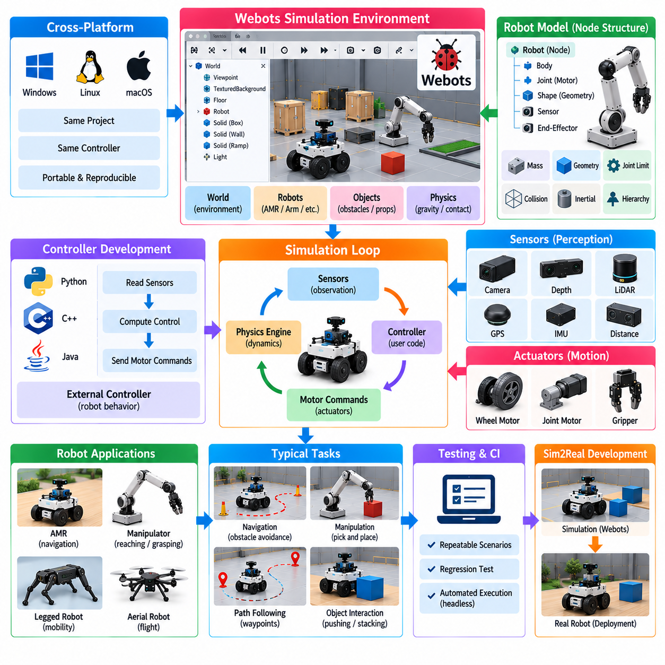
Webots is an open-source, cross-platform robot simulator designed to support robot modeling, physics simulation, sensor simulation, controller development, and experimental validation within a unified environment. Its cross-platform design allows the same simulation projects and controller concepts to be developed across commonly used desktop operating systems. This makes Webots useful when portability, reproducibility, and relatively straightforward setup are important requirements for robotics education, research, and early-stage development.
A Webots simulation is organized around a virtual world containing robots, objects, environments, sensors, actuators, and physical properties. The world defines the spatial and physical context in which robots operate, while individual robot models describe their mechanical structure and attached devices. This separation allows a single robot configuration to be evaluated in different environments without rebuilding the complete simulation from the beginning.
Robot models in Webots are composed from hierarchical nodes representing bodies, joints, shapes, sensors, motors, and other simulation entities. A robot can therefore be constructed from a mobile base, wheels, arms, cameras, LiDAR devices, inertial sensors, and additional components. Physical properties such as mass, geometry, joint limits, and collision characteristics contribute to the dynamic behavior of the simulated system, allowing controller software to interact with a model that has explicit physical structure.
Webots provides a controller-based programming model in which robot behavior is implemented externally from the world description. Controllers can be developed using supported programming languages and communicate with simulated devices through defined interfaces. A controller can read sensor measurements, calculate a control response, and send commands to motors or other actuators. This structure makes it possible to test robot software while keeping much of the application logic independent from the graphical representation of the simulated world.
Sensor simulation is an important part of the Webots workflow. Virtual cameras, depth sensors, LiDAR, GPS, IMU, distance sensors, and other devices can provide observations to the controller. These measurements can then be processed using the same general perception and control concepts applied to physical robots. By changing sensor placement, field of view, measurement characteristics, or environmental conditions, developers can examine how robot behavior changes under different sensing configurations.
Actuator simulation provides the corresponding connection from software commands to simulated physical motion. Motor commands can drive wheels, joints, or other mechanisms, while the physics engine determines the resulting movement based on the robot's mechanical configuration and environmental interactions. For an AMR, wheel motors can generate vehicle motion, while for a manipulator, joint motors can execute articulated movements. This enables controller algorithms to be evaluated before connection to physical actuators.
Webots is particularly useful for cross-platform development because the simulation environment and controller workflow can be maintained consistently across development machines. A robotics team may use different operating systems during development while maintaining a common world, robot model, and experimental configuration. This reduces dependence on a single development platform and can simplify the sharing of simulation scenarios among researchers, students, and engineering teams.
Cross-platform simulation also supports reproducibility. A well-defined world file, robot model, controller, and parameter configuration can describe an experiment sufficiently for another developer to recreate the same basic scenario. Reproducibility is important when comparing navigation algorithms, control strategies, sensor configurations, or robot behaviors. It also provides a useful foundation for regression testing when software changes need to be evaluated against previously validated scenarios.
Webots can be applied to several classes of robots, including wheeled mobile robots, robotic arms, legged systems, aerial robots, and educational platforms. The same general simulation concepts can be used to construct environments and controllers for different robot configurations. This flexibility makes it useful as a general-purpose robotics simulator rather than a platform dedicated to only one type of robot or application.
For mobile robot development, Webots can represent indoor environments containing walls, corridors, obstacles, rooms, and other structures. An AMR controller can use simulated range or vision sensors to estimate its surroundings and generate motion commands. Navigation experiments can therefore examine obstacle avoidance, waypoint following, localization concepts, and motion control within repeatable virtual environments before equivalent tests are performed on physical robots.
For manipulation, a robot arm can be constructed with multiple joints, motors, end-effectors, and sensors. Controller software can generate joint trajectories or end-effector motions while the physics simulation determines the resulting articulated behavior. Objects can be placed within the environment to create reaching, grasping, pushing, or placement experiments. These experiments provide an accessible way to evaluate manipulation algorithms before moving to more detailed simulation or physical hardware.
The controller architecture also makes Webots useful for integrating external robotics algorithms. A controller can process simulated observations and invoke perception, planning, or machine-learning components implemented outside the simulator's world description. This allows the simulator to serve as a controlled environment in which algorithms can be exercised repeatedly. For learning-based systems, the simulation can also provide observations and actions suitable for constructing training or evaluation loops.
An important consideration is the relationship between simulation fidelity and portability. A cross-platform simulator can provide an efficient development environment, but the simulated physical and sensor behavior remains an approximation of the real system. Differences in friction, actuator dynamics, contact behavior, sensor noise, latency, calibration, and mechanical compliance can create a Sim2Real gap. Webots experiments should therefore be interpreted as controlled simulation results rather than direct evidence that an algorithm will perform identically on physical hardware.
Webots can occupy an intermediate position within a broader simulation strategy. Lightweight experiments can be developed and tested in a portable environment, while more demanding applications can later be transferred to simulators offering different physics, rendering, GPU acceleration, sensor fidelity, or large-scale parallel execution. Maintaining clear interfaces between robot application logic and simulator-specific components makes such transitions easier and reduces unnecessary redevelopment.
For CI and automated testing, a cross-platform simulator can also provide repeatable execution of robot scenarios. Controllers can be started with predefined worlds and parameters, simulated sensors can provide deterministic or controlled inputs, and resulting robot states can be evaluated against expected behavior. Headless or automated execution can be incorporated into software validation workflows where appropriate, allowing changes to navigation, control, perception, or robot integration software to be tested systematically.
The broader value of Webots is therefore its combination of accessible robot modeling, physics-based simulation, sensor and actuator modeling, controller integration, and cross-platform operation. Within an open-source simulation ecosystem, it provides an alternative development environment alongside Gazebo, PyBullet, CoppeliaSim, and other simulators. The chapter structure places Webots specifically within this open-source simulator ecosystem, emphasizing its role as a cross-platform robotics simulation option rather than as a replacement for every other simulation platform.

07.07. CoppeliaSim V REP Industrial Robot Simulation [w/Code]
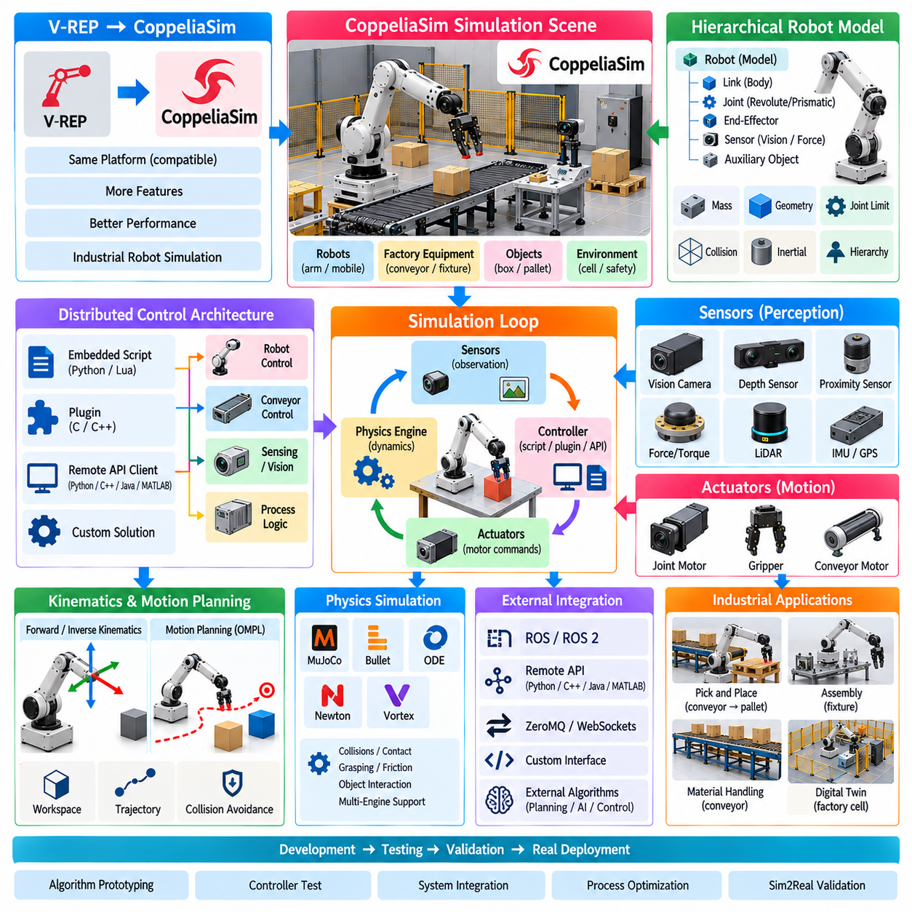
CoppeliaSim, formerly known as V-REP, is a robotics simulation platform designed for rapid prototyping, testing, and validation of complex robotic systems. Its architecture emphasizes distributed control, allowing individual objects or models to be controlled through embedded scripts, plugins, remote API clients, or custom solutions. This structure is particularly useful for industrial robotics because robot behavior, auxiliary equipment, and simulation logic can be developed as relatively independent components rather than being forced into a single centralized control program. ([Coppelia Robotics][1])
The V-REP to CoppeliaSim transition should be understood primarily as an evolution of the same simulation platform rather than an entirely unrelated simulator. Coppelia Robotics describes CoppeliaSim as fully compatible with V-REP while providing additional capabilities and performance improvements. Consequently, existing V-REP concepts remain important when studying industrial robot simulation, particularly embedded scripts, plugins, remote APIs, scene models, and distributed control. ([Coppelia Robotics][1])
CoppeliaSim represents a simulation scene as a collection of objects and models arranged in a hierarchical structure. A robot can contain links, joints, end-effectors, sensors, and auxiliary objects, while an industrial cell can additionally contain conveyors, fixtures, pallets, safety structures, and other equipment. This object-oriented scene representation makes it possible to compose a complete automation cell from reusable components and then modify individual elements without reconstructing the entire environment.
A major characteristic of CoppeliaSim is its distributed control architecture. Individual objects or models can be controlled through embedded Python or Lua scripts, C or C++ plugins, remote API clients, or other custom mechanisms. This allows different parts of an industrial cell to have separate control entities. For example, a robot controller can operate the manipulator while another component controls a conveyor and another process manages sensing or production logic. ([Coppelia Robotics][1])
Embedded scripting is useful when control logic must operate closely with the simulation scene. Scripts can access simulation objects, read sensor information, calculate trajectories, modify object properties, and issue actuator commands. Python and Lua provide relatively rapid development, while C or C++ plugins can be used when higher performance or deeper integration is required. This separation between the simulation scene and executable behavior supports iterative development of industrial automation algorithms.
CoppeliaSim also provides external control through APIs. A remote application can communicate with the simulator and control objects from outside the simulation process. Supported approaches include Python, C, C++, Java, MATLAB, and other interfaces, depending on the API mechanism and current version. This is particularly useful when the robot controller, planning algorithm, or AI model is developed independently from the simulator and needs to interact with the simulated industrial cell through a defined software interface. ([Coppelia Robotics][1])
Physics simulation is another important capability for industrial robot validation. CoppeliaSim currently supports multiple dynamics engines, including MuJoCo, Bullet, ODE, Newton, and Vortex, allowing users to select different physical simulation characteristics for particular experiments. Physics calculations can represent collision response, grasping, object interaction, and other dynamic effects. This multi-engine architecture also provides an opportunity to investigate how sensitive an algorithm is to the selected physical model. ([Coppelia Robotics][1])
Industrial robot applications often require a combination of kinematic and dynamic reasoning. CoppeliaSim provides forward and inverse kinematics capabilities for different mechanical structures, including branched, closed, redundant, and nested-loop mechanisms. An industrial manipulator can therefore be evaluated for reachable workspace, end-effector positioning, joint configuration, singularity-related behavior, and trajectory generation before equivalent operations are performed on physical equipment. ([Coppelia Robotics][1])
Collision and distance computation are particularly important in industrial automation. A robot operating near fixtures, conveyors, pallets, or other manipulators must maintain appropriate spatial relationships throughout its motion. CoppeliaSim provides collision checking and minimum-distance calculations for supported geometric representations such as meshes, octrees, and point clouds. These capabilities can be integrated into motion planning and safety-related validation workflows. ([Coppelia Robotics][1])
Sensor simulation allows industrial robot algorithms to be tested with virtual observations rather than relying exclusively on perfect internal state information. CoppeliaSim supports vision sensors and volumetric proximity sensors, as well as force/torque sensing and other perception-related functionality. Sensor outputs can be processed by robot control software to create perception-driven behaviors such as object detection, localization, approach, grasping, and placement. ([Coppelia Robotics][1])
A typical industrial manipulation scenario can therefore combine robot kinematics, physics, sensors, motion planning, and control. Consider a robot that must pick a box from a conveyor and place it on a pallet. The simulation can represent the robot, gripper, conveyor, box, pallet, collision geometry, and sensor configuration. The controller can detect the target, calculate a suitable approach trajectory, close the gripper, transport the object, and release it at the destination while the simulator evaluates the corresponding physical and geometric interactions.
CoppeliaSim is also designed to allow different simulation mechanisms to be enabled according to the requirements of a particular model or experiment. An industrial process does not necessarily require full dynamic computation for every component at every stage. A robot's grasping operation may require detailed dynamic interaction, while another part of the process may be adequately represented through kinematic or event-based behavior. This flexibility can reduce unnecessary computation while maintaining the physical detail required for the specific engineering question. ([Coppelia Robotics][2])
Motion planning can be integrated into this environment through available planning functionality and the OMPL-based planning interface. A planner can generate collision-free paths while considering the robot's configuration space and environmental constraints. The resulting path can then be executed through the robot's controller and evaluated inside the simulated industrial cell. This creates a useful relationship between planning, kinematics, collision checking, and physical execution rather than treating each function as an isolated algorithm.
ROS and ROS 2 integration provides another route for connecting CoppeliaSim with broader robotics software architectures. ROS interfaces can exchange information between simulated robots and external ROS nodes, while other communication mechanisms such as ZeroMQ, WebSockets, and remote APIs can be used for different system designs. This allows CoppeliaSim to function as a simulation component within a distributed robotics architecture rather than requiring all robot intelligence to be implemented inside the simulator. ([Coppelia Robotics][1])
For industrial digital-twin development, CoppeliaSim can reproduce a robot cell together with equipment, processes, sensors, and control logic. The virtual model can be used to study alternative configurations, test algorithms, and investigate operational scenarios before physical installation. Coppelia Robotics also identifies digital-twin creation, factory automation simulation, algorithm prototyping, and verification among CoppeliaSim's application areas. ([Coppelia Robotics][1])
A significant engineering consideration is the separation between simulation fidelity and production validation. Even when robot geometry and motion appear realistic, differences in actuator dynamics, friction, gearbox behavior, compliance, sensor latency, calibration, payload properties, and contact conditions can produce a Sim2Real gap. CoppeliaSim should therefore be used to answer clearly defined engineering questions, while physical experiments remain necessary for validating behavior that depends strongly on hardware-specific characteristics.
For an industrial robotics workflow, CoppeliaSim can consequently serve as a flexible prototyping and integration environment. Robot models, factory equipment, sensors, controllers, planners, and external applications can be composed into a single simulation scenario while retaining relatively independent control paths. This architecture is well suited to experiments involving robotic arms, assembly cells, material handling, conveyor systems, grasping, motion planning, and automation logic.
CoppeliaSim therefore occupies a distinctive position within an open-source and commercial-capable simulation ecosystem. Its V-REP heritage, distributed control architecture, multiple programming interfaces, multiple physics engines, kinematics, sensor simulation, collision analysis, motion planning, and ROS/ROS 2 connectivity make it particularly relevant to industrial robot prototyping and system integration. Within the simulation volume structure, it belongs alongside Gazebo, PyBullet, Webots, and AirSim as one of the complementary simulator options available for different robot-development requirements.

07.08. AirSim UAV and Ground Vehicle Simulation [w/Code]
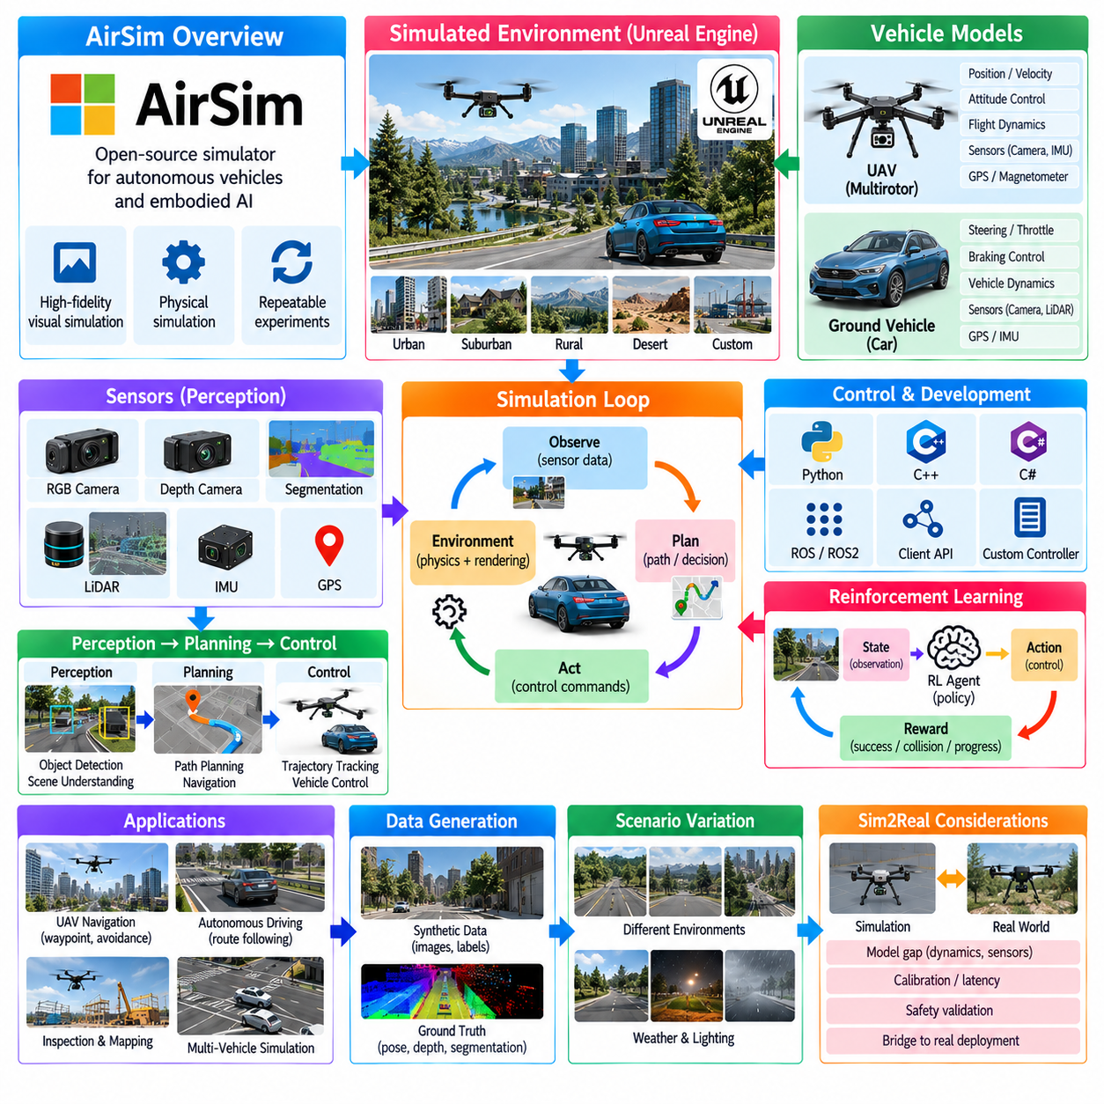
AirSim is a simulator originally developed for research in autonomous vehicles and embodied AI, with particular relevance to unmanned aerial vehicles and ground vehicles. Its design emphasizes high-fidelity visual and physical simulation so that autonomous systems can be developed and evaluated without immediately relying on physical platforms. The simulator can provide virtual environments, vehicle dynamics, cameras, and other sensing capabilities that allow perception, planning, control, and learning algorithms to operate within repeatable simulated conditions.
A central characteristic of AirSim is its ability to simulate different vehicle types within a common simulation framework. UAVs such as multirotor aircraft can be represented alongside ground vehicles, allowing researchers to study aerial navigation, autonomous driving, and related robotic behaviors. This makes AirSim different from simulators designed around only one robot morphology. The same general development philosophy can therefore be applied to aerial and terrestrial autonomous systems while adapting the vehicle-specific dynamics and control interfaces.
For UAV simulation, AirSim models the relationship between vehicle commands and resulting motion through a simulated physical environment. A multirotor controller can generate commands associated with position, velocity, attitude, or other flight-control quantities, while the simulation calculates the resulting vehicle state. The virtual vehicle can then provide updated observations to the control and perception stack. This creates a closed-loop process in which sensing, estimation, planning, control, and vehicle dynamics interact continuously.
AirSim's visual simulation capability is particularly relevant to autonomous UAV research. Virtual cameras can provide images from viewpoints attached to the simulated aircraft, allowing computer-vision algorithms to process observations while the vehicle moves through the environment. Perception algorithms can estimate scene structure, detect objects, track motion, or identify navigable regions. These outputs can then be supplied to planning and control algorithms, creating an end-to-end autonomous-flight experiment without requiring physical flight testing for every development iteration.
Ground-vehicle simulation follows a similar closed-loop principle but uses vehicle dynamics appropriate to terrestrial motion. A simulated vehicle can receive steering, throttle, braking, or related commands and produce corresponding motion through the virtual environment. Cameras and other sensors provide observations for perception and navigation. This makes AirSim relevant to autonomous-driving research as well as robotic ground-vehicle experiments in which the vehicle must follow routes, avoid obstacles, and respond to changing environmental conditions.
The physical and visual simulation layers should be considered together. Autonomous systems do not respond only to ideal vehicle state; they normally operate from sensor observations affected by viewpoint, lighting, environmental structure, and measurement limitations. By combining vehicle dynamics with simulated sensing, AirSim can provide a more complete experimental loop in which perception errors can influence planning and control, and vehicle motion can in turn change subsequent observations.
AirSim is also useful for reinforcement learning and learning-based autonomy. A learning agent can receive observations from the simulated vehicle, produce an action, advance the simulation, and obtain the resulting state or reward. Repeating this interaction creates an environment loop suitable for training and evaluating policies. The simulator can therefore support experiments in autonomous navigation, vehicle control, obstacle avoidance, and other sequential decision-making problems. The broader embodied-AI literature identifies AirSim as a simulator used for drone simulation, autonomous driving, and reinforcement learning.
One important advantage of simulation is the ability to perform experiments that would be expensive, difficult, or unsafe to reproduce repeatedly with physical vehicles. Autonomous UAV experiments may involve flight conditions, obstacle configurations, or failure situations that require substantial preparation in the physical world. Ground-vehicle experiments can similarly require controlled environments and repeated vehicle operation. A simulator allows many such scenarios to be reset and reproduced while keeping the experimental conditions under software control.
Scenario variation is particularly useful for evaluating autonomous behavior. The virtual environment can contain different roads, obstacles, structures, terrain conditions, and object configurations. A UAV can be tested in environments that require waypoint following, obstacle avoidance, or visual navigation, while a ground vehicle can be evaluated under different routes and traffic-like situations. Repeating these scenarios helps expose algorithmic behavior that may not be visible in a single manually configured experiment.
AirSim can also contribute to synthetic-data generation because the simulator has access to internal information about the virtual world. Camera images can be associated with simulated vehicle poses and environmental states, providing structured information for perception experiments. When the simulation environment exposes corresponding ground-truth information, it can support the generation of training or evaluation data without requiring every observation to be manually annotated. This principle is consistent with the broader role of simulation environments in automatic labeling and synthetic-data generation.
For autonomous-driving research, the combination of visual simulation and vehicle dynamics enables an integrated perception-to-control workflow. A ground vehicle can observe the virtual scene through cameras, estimate road structure or obstacles, generate a driving decision, and send control commands back to the simulated vehicle. The resulting vehicle motion changes the next visual observation, closing the loop. This allows perception and control algorithms to be evaluated as an integrated system rather than as independent modules.
For UAV applications, the same concept extends into three-dimensional navigation. The vehicle must reason about position, altitude, orientation, obstacles, and motion through a three-dimensional environment. A perception system can interpret camera observations while localization and planning components estimate the vehicle state and generate a safe trajectory. The flight controller then converts the planned behavior into vehicle commands. AirSim can therefore provide an experimental environment for studying the complete chain from visual sensing to autonomous flight behavior.
AirSim's role is not limited to testing a final autonomous policy. It can also be used during algorithm development to investigate individual components. Perception algorithms can be tested against simulated camera observations, planning algorithms can be evaluated using predefined vehicle states, and control algorithms can be exercised against simulated vehicle dynamics. This layered approach makes it possible to identify whether a failure originates from sensing, estimation, planning, control, or vehicle-model assumptions.
At the same time, simulation fidelity must be interpreted carefully. A simulated vehicle may reproduce important aspects of visual appearance and physical behavior without reproducing every characteristic of a real aircraft or ground vehicle. Real systems contain actuator limitations, sensor noise, calibration errors, latency, mechanical variation, environmental disturbances, and hardware-specific behavior. Consequently, successful AirSim experiments should be regarded as evidence within the simulated conditions rather than as automatic proof of equivalent real-world performance.
The Sim2Real transition therefore requires additional validation. Policies or controllers developed in AirSim can be transferred conceptually toward physical vehicles, but the interface between simulation and hardware must be examined carefully. Sensor coordinate systems, vehicle dynamics, control rates, command conventions, timing, and safety constraints should be aligned before deployment. Differences between simulated and physical systems can then be measured and used to refine the model, controller, or policy.
AirSim can also be positioned within a broader simulator ecosystem rather than treated as a universal replacement for other platforms. The literature categorizes it as a general-purpose simulator with particular application areas in drone simulation, autonomous driving, and reinforcement learning, while other platforms emphasize robotics navigation, multi-robot systems, manipulation, or high-performance learning. This makes simulator selection a matter of matching the simulation architecture and experimental requirements to the intended robot and workload.
For a Physical AI development workflow, AirSim can therefore provide a bridge between vehicle-level simulation and learning-based autonomy. UAVs and ground vehicles can operate in repeatable virtual environments while perception, planning, control, and reinforcement-learning components are developed around simulated sensor and vehicle interfaces. The resulting experiments can contribute to synthetic-data generation, algorithm validation, scenario testing, and preparation for physical-system deployment.
AirSim ultimately represents a simulation approach centered on autonomous vehicle interaction with visually and physically simulated environments. Its significance within the open-source simulator ecosystem comes from combining vehicle simulation, high-quality visual sensing, autonomous-driving research, UAV experimentation, and reinforcement-learning workflows. In the broader simulation structure, it complements Gazebo, PyBullet, Webots, CoppeliaSim, and other platforms by providing a vehicle-oriented environment in which perception, dynamics, control, and learning can be evaluated together.

07.09. Open Source Sim CI Integration Headless Batch [w/Code]
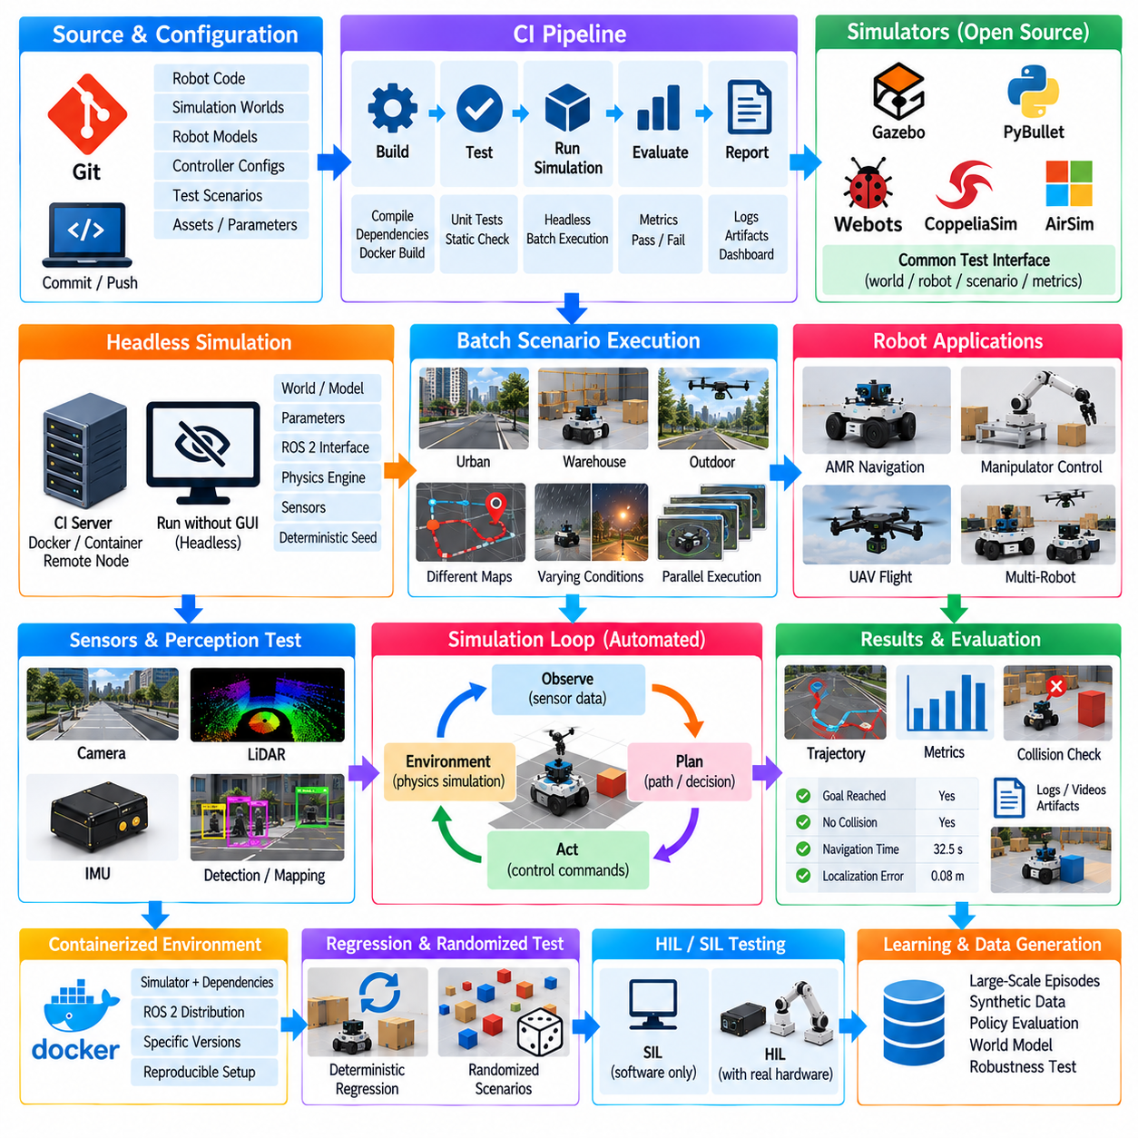
Continuous Integration (CI) integration for open-source robot simulators provides a way to execute simulation-based validation automatically whenever robot software, models, configurations, or simulation assets change. Instead of relying only on manual execution through a graphical simulator interface, the simulation can become part of an automated software pipeline. This approach is especially useful for robotics because navigation, control, perception, sensor processing, and robot integration can be repeatedly evaluated under predefined virtual conditions.
A CI-oriented simulation workflow normally begins with source and configuration management. Robot application code, simulation worlds, robot models, controller configurations, test scenarios, and supporting assets should be version controlled so that a particular test can be associated with a known software state. A commit can then trigger an automated pipeline that validates the software, builds the required components, launches the simulator, executes predefined scenarios, evaluates results, and reports whether the expected behavior was maintained.
Headless execution is a central mechanism for this workflow. A simulator operates without opening its normal graphical user interface, allowing it to run on a CI server, workstation, container, or remote compute node. The simulation process receives its world, robot model, parameters, and test instructions from the automation environment. This removes the requirement for a developer to interact with the simulator manually and makes repeated execution practical for regression testing and batch experiments.
The separation between simulation server and graphical client is particularly valuable for Gazebo Sim. A simulation can execute its physics, sensors, robot systems, and world logic without requiring a visualization window. Developers can still use a graphical client during interactive debugging, but automated validation can use the same underlying simulation in headless mode. This creates a useful distinction between development-time visualization and machine-executed validation.
Batch simulation extends this concept by executing many predefined experiments automatically. A test suite can contain different maps, robot configurations, sensor parameters, initial poses, obstacle arrangements, payload conditions, or controller settings. The CI system can run these cases sequentially or in parallel depending on available resources. Results from each case can be collected into structured logs and metrics, making it possible to compare behavior across software revisions.
For an AMR, a batch test might execute the same navigation stack across multiple warehouse layouts. Each scenario can specify a starting pose, goal position, obstacle configuration, sensor setup, and expected outcome. The test can measure whether the robot reaches the goal, whether collisions occur, how long navigation takes, and whether localization remains within a defined tolerance. Repeating the same suite after a software change provides a practical regression mechanism for autonomous-navigation development.
Simulation tests can also be applied to controllers and actuators. A predefined command sequence can be sent to simulated joints or wheel motors, while the test system records resulting positions, velocities, accelerations, and other states. Expected trajectories or acceptable error bounds can then be used as validation criteria. This makes it possible to detect changes in controller behavior without requiring physical hardware for every software revision.
Sensor and perception pipelines can similarly be tested through recorded or procedurally generated simulation scenarios. A simulator can produce camera, LiDAR, IMU, or other sensor outputs under controlled conditions, and the resulting data can be passed through the perception stack. Automated tests can examine detection results, localization estimates, map construction, sensor timing, or other measurable outputs. This connects simulation with the broader testing strategy for perception and autonomy rather than treating the simulator only as a visualization environment.
Containerization can further improve reproducibility. A CI job can execute the simulator and robot software inside a defined software environment containing specific dependencies, configuration files, and runtime tools. This reduces differences between individual development machines and automated test environments. Containers are particularly useful when several simulator versions, ROS 2 distributions, physics engines, or supporting libraries must coexist within a larger robotics development workflow.
Build and simulation stages should remain logically separated even when they are executed within the same CI pipeline. The build stage verifies that source code and dependencies produce valid artifacts, while the simulation stage verifies that those artifacts behave correctly in predefined scenarios. A typical workflow can therefore move from source validation and compilation to unit tests, simulation startup, scenario execution, result evaluation, artifact collection, and final reporting. This layered structure makes failures easier to localize.
Simulation startup should also be deterministic and explicit. The automation system should specify the simulator version, world file, robot model, configuration parameters, random seed when applicable, simulation time, physics settings, and required ROS 2 interfaces. Hidden dependencies on a developer's desktop environment should be avoided. The objective is to ensure that a test represents a defined experimental condition rather than an informal collection of manually configured settings.
The simulation clock and execution speed require particular attention in automated environments. A headless simulation may run faster or slower than real time depending on physics complexity, sensor generation, rendering requirements, and available CPU or GPU resources. Tests should therefore rely on simulation time and explicit completion conditions rather than assuming that a scenario will always take the same amount of wall-clock time. Timeouts can still be used as protection against stalled simulations.
Randomized testing can be added after deterministic regression scenarios are established. Random seeds can generate variations in initial poses, object locations, sensor noise, environmental conditions, or other parameters. Each test should preserve the seed and configuration used for execution so that an observed failure can be reproduced. This creates a useful relationship between stochastic scenario generation and deterministic failure reproduction.
Result evaluation should produce machine-readable outputs whenever possible. Instead of relying only on screenshots or human interpretation, the simulation can generate structured logs, metrics, trajectories, sensor statistics, collision events, and pass/fail indicators. These outputs can then be consumed by CI tools or stored for later analysis. A robotics simulation test therefore becomes a measurable software artifact rather than simply a visual demonstration.
The concept also extends to multiple open-source simulators. Gazebo, PyBullet, Webots, CoppeliaSim, and other platforms can occupy different roles depending on the physical model, sensor requirements, robot type, or research objective. The CI framework should therefore separate common test definitions and evaluation criteria from simulator-specific launch mechanisms. This makes it possible to maintain a common validation philosophy even when different experiments use different simulation platforms. The source material identifies these simulators as complementary general-purpose embodied-simulation platforms with different capabilities and application areas.
A multi-simulator CI architecture can define a common scenario specification containing the robot, environment, initial state, action interface, observation requirements, and evaluation metrics. Each simulator adapter then translates this specification into its own world format, launch procedure, controller interface, and data-extraction mechanism. Such an adapter-based design reduces direct coupling between the CI system and a particular simulator and supports gradual migration when a project adopts a different simulation platform.
Hardware-in-the-loop (HIL) and software-in-the-loop (SIL) testing can also be connected to the same strategy. A simulation-only test can validate application behavior against a virtual robot, while HIL can introduce physical controllers or hardware interfaces into the loop. The same scenario definition and evaluation concepts can be retained where appropriate, while the execution backend changes. This creates a progression from software validation to increasingly hardware-representative testing.
For learning-based Physical AI systems, headless batch simulation provides an additional capability: large-scale experience generation. A simulator can execute many episodes with different initial states and environments, collect observations and actions, and store successful and unsuccessful outcomes. These episodes can later contribute to policy evaluation, world-model experiments, synthetic-data generation, or robustness analysis. General embodied-simulation research emphasizes simulation as a means of controlled experimentation, training-data generation, evaluation, and standardized benchmarking.
The final objective is not simply to automate simulator startup but to make simulation a repeatable engineering test layer. Source changes should lead to reproducible builds, predefined simulations should execute without manual intervention, measurable results should be collected automatically, and failures should be traceable to specific software, model, configuration, or scenario changes. This transforms open-source simulation from an individual developer tool into an integrated component of continuous validation.
Open-source simulation CI therefore connects version control, automated builds, headless simulation, batch scenario execution, metric extraction, regression analysis, and deployment validation into one repeatable workflow. Gazebo and other simulators provide the virtual physical environment, while the CI infrastructure provides automation and repeatability. When combined with ROS 2, robot controllers, perception pipelines, and learning systems, this approach supports a broader Simulation-Driven Development process in which virtual experiments become continuously executable tests rather than isolated manual demonstrations.

07.10. Open Source Sim Community and Ecosystem Leverage
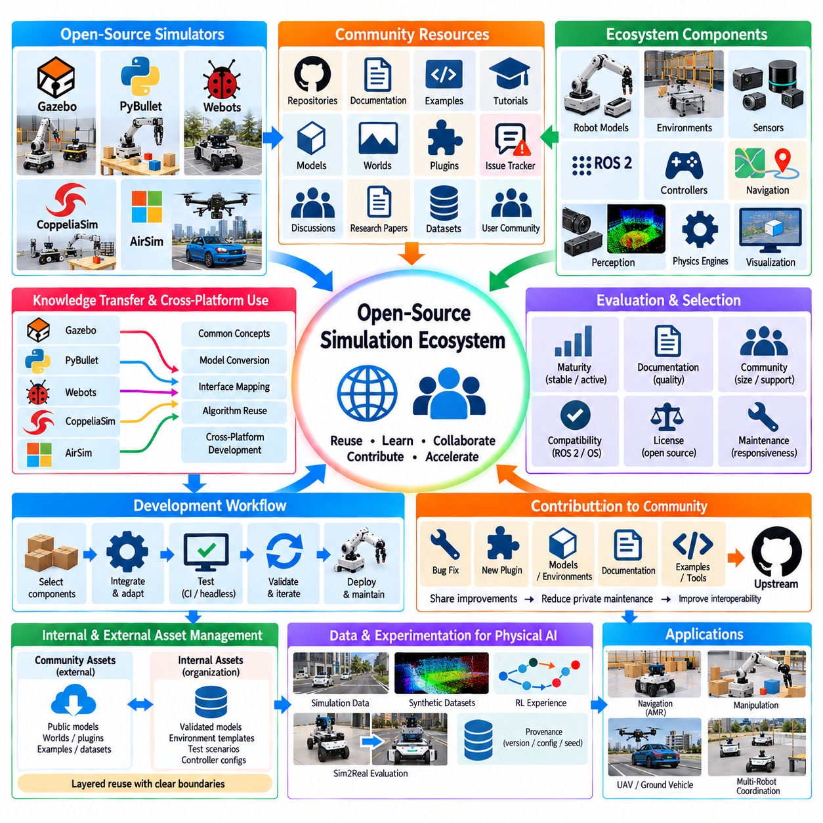
Open-source simulation communities provide an important engineering resource because robotics development rarely depends on a single simulator, library, or organization. Platforms such as Gazebo, PyBullet, Webots, CoppeliaSim, and AirSim are surrounded by repositories, documentation, examples, plugins, models, issue trackers, tutorials, academic publications, and user communities. Effective ecosystem leverage therefore means treating these resources as reusable engineering assets rather than rebuilding every simulation capability independently.
A community-driven ecosystem can significantly reduce the initial development effort for robot simulation. Existing robot models, world files, sensor configurations, controller examples, ROS 2 interfaces, physics settings, and utility libraries can provide starting points for new experiments. Developers can inspect established implementations, adapt them to the target robot, and validate the modified behavior. This approach is particularly valuable during early prototyping, when the objective is to establish a functional simulation workflow before investing in highly customized infrastructure.
Gazebo and related open-source projects demonstrate the value of reusable software components. A robot application can combine a simulator with ROS 2 packages, robot descriptions, navigation components, controllers, sensor-processing libraries, and visualization tools. Instead of considering the simulator as an isolated application, the development team can construct a broader simulation stack from interoperable community-maintained components. The resulting architecture can then be adapted as the robot platform, sensor configuration, or software requirements evolve.
Repositories are another important source of practical knowledge. Public source code can reveal how simulation worlds are organized, how robot models are constructed, how plugins communicate with the simulator, and how controllers interact with sensors and actuators. Reading repository history, documentation, examples, tests, and issue discussions can also expose implementation assumptions that may not be visible from a high-level tutorial. However, reused code should be inspected for licensing, dependency, maintenance, compatibility, and security considerations before being incorporated into an engineering product.
Community examples are particularly useful for learning simulator-specific conventions. A developer may understand the general principles of physics simulation but still encounter practical questions involving SDF structure, URDF integration, ROS 2 topics, plugin interfaces, sensor configuration, controller timing, or simulator launch procedures. Existing examples can provide concrete reference points for these implementation details. The purpose is not to copy an example blindly, but to understand its assumptions and adapt the relevant pattern to the target system.
Issue trackers and community discussions can also function as engineering knowledge bases. Simulation problems often arise from interactions between multiple software layers, such as the simulator version, ROS 2 distribution, operating system, physics engine, graphics driver, robot model, and plugin implementation. Previous reports may reveal known compatibility conditions or workarounds. When using such information, developers should distinguish an officially documented behavior from an individual user's workaround and verify that the information applies to the current software versions.
Academic research provides another layer of ecosystem leverage. Robotics simulation methods are often described through papers, benchmark datasets, open-source implementations, and reproducible experiments. These resources can provide theoretical foundations for physics modeling, reinforcement learning, sensor simulation, domain randomization, motion planning, and Sim2Real transfer. A practical development process can therefore connect community software with academic methods rather than treating research publications and engineering repositories as completely separate information sources.
Open-source communities also enable knowledge transfer between different simulation platforms. A manipulation algorithm developed in PyBullet may provide a conceptual reference for implementation in Gazebo or CoppeliaSim. A robot model developed for Gazebo may be adapted to another simulator after the relevant geometry, dynamics, sensor, and control representations are translated. The exact implementation cannot always be transferred directly, but separating application concepts from simulator-specific mechanisms makes cross-platform reuse more practical.
Standard interfaces are especially important for this ecosystem strategy. ROS 2, common robot-description formats, messaging conventions, controller interfaces, and standardized data representations can reduce the coupling between robot software and individual simulation platforms. When these interfaces are maintained consistently, the simulator can become an interchangeable execution backend for selected workloads. This supports a broader architecture in which navigation, perception, planning, control, and AI modules are developed independently from the simulation engine whenever practical.
Community leverage should also include systematic evaluation of software maturity. An open-source project may have a large number of users but still contain components that are experimental, poorly maintained, or incompatible with the required production environment. Conversely, a smaller project may provide a highly relevant component for a specialized workload. Evaluation should therefore examine release activity, documentation quality, test coverage, issue responsiveness, compatibility, license conditions, dependency health, and the availability of maintainers or contributors rather than relying only on popularity.
Version management becomes critical when community components are integrated into a robotics system. Simulator versions, ROS 2 distributions, plugins, Python packages, physics engines, and robot models can change independently. A configuration that works today may behave differently after an upstream update. Pinning important versions, recording dependencies, maintaining reproducible environments, and testing upgrades through CI can reduce this risk. The community ecosystem becomes more useful when external changes are incorporated deliberately rather than automatically.
Open-source contribution can also become part of an organization's engineering strategy. When a team develops a generic bug fix, simulator plugin, model conversion utility, documentation improvement, or reusable integration component, contributing appropriate changes upstream can reduce the need to maintain a long-lived private fork. Upstream contribution can also improve interoperability with future versions. However, proprietary algorithms, confidential robot configurations, customer-specific information, and security-sensitive components should remain separated from public contributions.
For a robotics organization, an internal simulation asset library can complement the external community ecosystem. Public components can provide general-purpose foundations, while internally maintained repositories can contain validated robot models, environment templates, sensor configurations, test scenarios, controller interfaces, and CI procedures. This creates a layered reuse model in which community resources form the external foundation and organization-specific assets capture verified engineering knowledge.
The relationship between external and internal assets should be controlled through clear boundaries. A public simulator package can remain an upstream dependency, while a validated internal adapter provides the interface required by the organization's robot platforms. Similarly, a public robot model can be used as a reference, while the internal version contains calibrated mass properties, sensor locations, actuator parameters, and validated configuration. This prevents uncontrolled external dependencies from becoming embedded directly into production-critical software.
Community ecosystems are also valuable for troubleshooting and accelerated learning. When a developer encounters a simulation problem, searching existing documentation, examples, issue discussions, source code, and related research can often narrow the problem space before custom debugging begins. The resulting knowledge should then be converted into internal documentation or automated tests when it represents a recurring engineering condition. This turns temporary community assistance into reusable organizational knowledge.
The ecosystem approach becomes particularly important when multiple simulators coexist in the same Physical AI development environment. Gazebo can support ROS-oriented robot integration, PyBullet can support lightweight manipulation experiments, Webots can provide cross-platform simulation, CoppeliaSim can support industrial robot and automation scenarios, and AirSim can support UAV and ground-vehicle research. The goal is not to force every workload into one platform, but to define common interfaces and validation practices that allow the appropriate simulator to be selected for each experimental purpose.
CI integration provides the mechanism for maintaining this multi-platform ecosystem over time. Community-derived components and internally developed adapters can be continuously tested against predefined simulation scenarios. Headless execution, batch testing, dependency pinning, structured metrics, and regression tests can detect when an upstream update or local software change modifies expected behavior. In this way, community reuse becomes compatible with disciplined engineering rather than depending entirely on manual validation.
For Physical AI, ecosystem leverage extends beyond software reuse into data and experimentation. Open-source simulators can provide environments for generating trajectories, sensor observations, synthetic datasets, reinforcement-learning experiences, and Sim2Real evaluation cases. Public models and environments can be combined with internally developed scenarios to increase experimental diversity. The resulting data and experiments should retain provenance information such as simulator version, model version, parameter configuration, random seed, and scenario definition so that results remain reproducible.
The most effective ecosystem strategy is therefore based on selective reuse, verification, abstraction, and contribution. External projects provide mature foundations, examples, research implementations, and collective troubleshooting knowledge. Internal engineering adds robot-specific models, calibrated parameters, validated interfaces, production constraints, and automated tests. A clear boundary between these layers allows an organization to benefit from community development while maintaining control over the components that are critical to its own systems.
Open-source simulation communities ultimately function as an extended engineering ecosystem rather than merely a collection of free software packages. Gazebo, PyBullet, Webots, CoppeliaSim, AirSim, ROS 2, related repositories, research communities, and user knowledge can collectively accelerate simulation development when their components are selected and validated systematically. Within the structure of this volume, this ecosystem perspective follows the simulator-specific chapters and the CI integration chapter, providing the foundation for moving from individual simulation tools toward reusable, maintainable, and continuously validated simulation infrastructure.

