Volume 12. Autonomous Driving Software

Chapter 11. SOTIF and Safety Validation

11.01. SOTIF ISO 21448 Framework and Intended Behavior
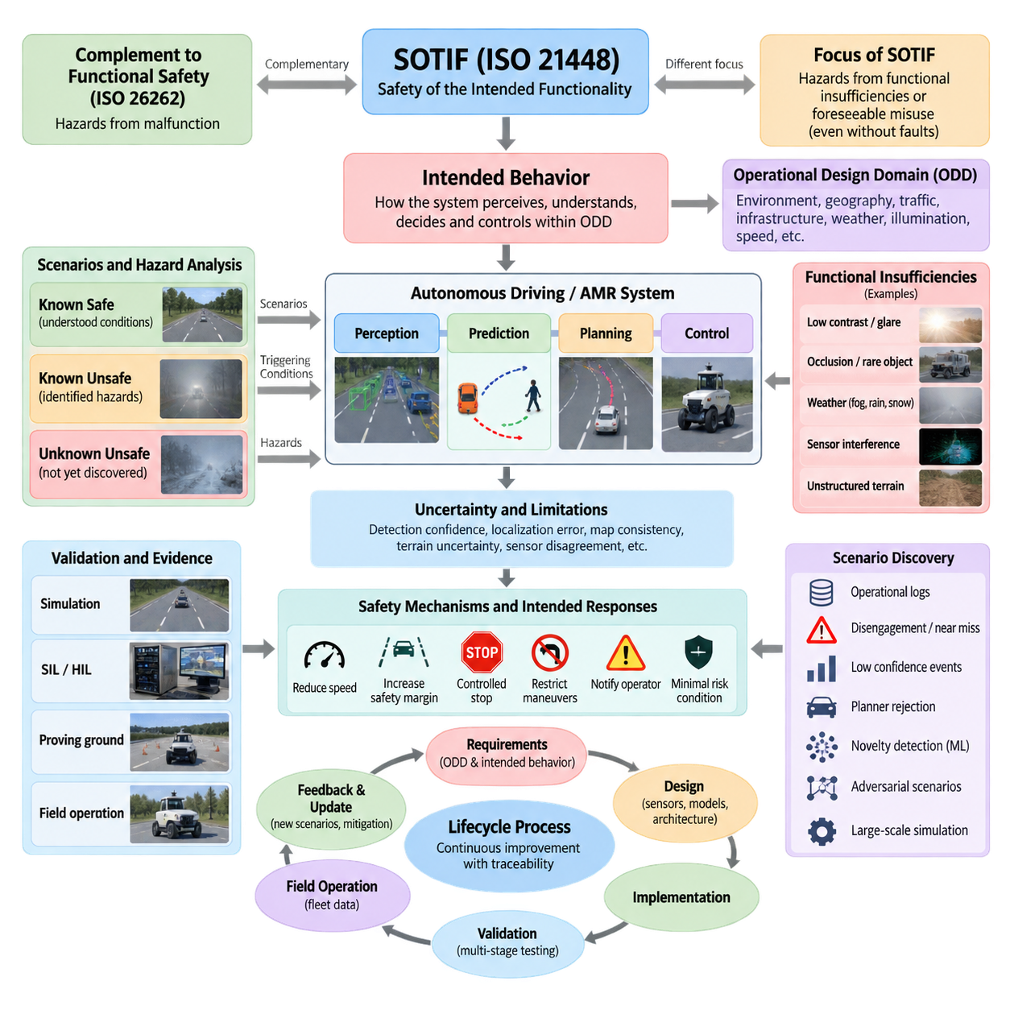
Safety of the Intended Functionality (SOTIF), standardized in ISO 21448, addresses hazards that can arise even when an automated driving system contains no conventional hardware or software fault. The central concern is whether the intended functionality itself can produce unsafe behavior because of performance limitations, insufficient situational understanding, foreseeable misuse, or operating conditions that exceed the capabilities assumed during system design.
This perspective complements functional safety. ISO 26262 primarily addresses hazards caused by malfunctioning behavior of electrical and electronic systems, whereas SOTIF focuses on hazards caused by functional insufficiencies or reasonably foreseeable misuse when components are operating as designed. For autonomous driving and outdoor AMRs, both perspectives are necessary because a technically healthy perception or planning module may still produce an unsafe decision when confronted with ambiguous or unfamiliar conditions.
The concept of intended behavior is fundamental to SOTIF. Intended behavior describes how the system is expected to perceive its environment, interpret situations, select actions, and control the vehicle within defined operating conditions. It includes normal driving behavior, interaction with other road users, responses to uncertain perception, transitions between operating states, and fallback actions when confidence or environmental conditions become unacceptable.
Intended behavior must therefore be connected explicitly to the Operational Design Domain (ODD). The ODD defines the environmental, geographic, operational, traffic, infrastructure, weather, illumination, speed, and other conditions within which an automated function is designed to operate. A behavior considered sufficiently safe inside this domain may become inappropriate outside it, making ODD monitoring and boundary detection important elements of the safety architecture.
SOTIF analysis distinguishes situations according to whether they are known or unknown and whether they are safe or unsafe. Known safe scenarios represent understood operating conditions in which the intended functionality behaves acceptably. Known unsafe scenarios are hazardous conditions already identified during development. Unknown unsafe scenarios are particularly important because they contain hazardous combinations or triggering conditions that developers have not yet discovered.
This classification creates an iterative safety objective. Development seeks to demonstrate acceptable behavior in known scenarios, identify and mitigate known unsafe conditions, and systematically reduce the space of unknown unsafe conditions. Complete elimination of uncertainty is generally unrealistic for complex autonomous systems, so SOTIF engineering emphasizes structured evidence that residual risk has been reduced and that limitations are detected, controlled, or bounded appropriately.
A triggering condition is a specific circumstance that exposes a functional insufficiency and may lead to hazardous behavior. Examples include low contrast, glare, fog, partial occlusion, unusual object geometry, degraded road markings, sensor interference, ambiguous free-space boundaries, or unexpected pedestrian behavior. The triggering condition is not necessarily a component failure; rather, it reveals a limitation in perception, prediction, planning, localization, or control.
For outdoor AMRs, triggering conditions extend beyond conventional road-driving assumptions. Gravel, mud, slopes, curbs, potholes, vegetation, construction materials, reflective surfaces, loading equipment, irregular pedestrian movement, GNSS degradation, and rapidly changing work zones can alter the relationship between perception and actual traversability. Safety validation must consequently represent both semantic scene understanding and the physical interaction between the robot, terrain, payload, and environment.
Functional insufficiencies can originate throughout the autonomy pipeline. A camera may correctly operate yet fail to provide sufficient information under glare. A LiDAR may return valid measurements that are difficult to interpret around reflective or absorptive materials. A neural network may produce a plausible but incorrect classification, while a planner may generate a mathematically valid trajectory based on incomplete predictions. SOTIF considers how such limitations propagate toward hazardous vehicle behavior.
Perception uncertainty is especially significant because downstream modules often consume estimates rather than direct knowledge of the environment. Detection confidence, localization covariance, object-track stability, map consistency, terrain uncertainty, and sensor disagreement can therefore become safety-relevant information. Instead of treating uncertain inputs as ordinary measurements, a SOTIF-oriented architecture can propagate uncertainty and use it to restrict speed, increase safety margins, trigger redundancy, or initiate fallback behavior.
The intended behavior specification should define more than nominal motion. It should describe what the autonomous system does when evidence is incomplete, contradictory, delayed, or outside validated limits. Conservative speed reduction, increased following distance, trajectory rejection, controlled stopping, restricted maneuvering, operator notification, or transition to a minimal risk condition can become explicit behaviors associated with uncertainty thresholds and operational boundaries.
Safety validation consequently requires scenarios that connect operating conditions, triggering conditions, functional limitations, system responses, and potential hazards. A scenario is valuable not simply because it produces many kilometers of simulated or physical operation, but because it exercises meaningful combinations of parameters near behavioral boundaries. Parameterized scenario families allow weather, illumination, object motion, terrain, sensor quality, localization uncertainty, and interaction patterns to be varied systematically.
SOTIF validation therefore benefits from multiple complementary sources of evidence. Simulation provides scalable exploration and controlled parameter variation, software-in-the-loop and hardware-in-the-loop testing expose implementation and integration effects, proving-ground tests reproduce selected critical scenarios, and field operation reveals naturalistic situations that may not have been anticipated. Fleet data can then feed discovered edge cases back into simulation, regression testing, and model improvement.
Scenario discovery is particularly important for reducing unknown unsafe behavior. Operational logs, disengagements, emergency stops, near misses, low-confidence perception events, planner rejections, unusual controller interventions, and sensor disagreement can be mined for candidate corner cases. Machine learning, clustering, novelty detection, search-based testing, adversarial scenario generation, and large-scale simulation can expand this process beyond manually designed test catalogs.
The relationship between SOTIF and machine learning deserves special attention because learned functions derive behavior from data rather than exclusively from deterministic requirements. Dataset coverage, labeling quality, class imbalance, domain shift, rare-object representation, environmental diversity, and model uncertainty can influence intended functionality. Safety engineering must therefore connect data governance and model evaluation to system-level scenarios instead of relying only on aggregate metrics such as average detection accuracy.
A perception model with high overall accuracy can still be unacceptable if its errors concentrate in safety-critical regions of the operating domain. Validation should examine performance conditioned on distance, relative velocity, illumination, weather, object type, occlusion, terrain, and other relevant variables. These conditional analyses reveal performance boundaries that aggregate metrics may hide and help establish operational constraints or mitigation mechanisms around identified limitations.
SOTIF is also closely related to architectural monitoring. Runtime safety monitors can observe confidence, sensor consistency, localization integrity, trajectory feasibility, stopping distance, ODD compliance, and communication health independently from the primary autonomy logic. When monitored variables approach validated boundaries, the system can progressively degrade functionality rather than waiting for an unmistakable failure, thereby converting uncertainty into controlled operational behavior.
For an outdoor AMR, this may produce a layered response strategy. Normal operation is permitted when perception quality, localization confidence, terrain assessment, and predicted clearance satisfy validated limits. Increasing uncertainty can reduce speed or enlarge obstacle margins. Persistent uncertainty can restrict available maneuvers, while severe or unresolved uncertainty can initiate a controlled stop or another defined minimal-risk behavior appropriate to the operational environment.
SOTIF engineering should be treated as a lifecycle process rather than a final validation activity. Assumptions about intended behavior and the ODD influence requirements, sensor selection, perception architecture, planning constraints, simulation design, data collection, and field testing. Evidence collected during validation can reveal previously unknown limitations, which then modify requirements, models, safety mechanisms, scenario libraries, and operational constraints in subsequent development iterations.
Traceability is essential throughout this lifecycle. Identified hazards should be connected to triggering conditions, functional insufficiencies, safety requirements, mitigation mechanisms, validation scenarios, test results, and residual-risk arguments. This creates an auditable chain from a potential unsafe behavior to the engineering evidence used to control it, supporting both technical decision-making and construction of a coherent safety case.
For autonomous driving software and outdoor AMRs, the practical value of the ISO 21448 framework is therefore not limited to compliance documentation. It provides a systematic way to ask whether correctly functioning autonomy can still behave unsafely, where its performance boundaries exist, which conditions expose those boundaries, and how the system should respond. The resulting process links intended behavior, ODD definition, scenario discovery, uncertainty management, validation, and operational feedback into a continuous safety-engineering loop.

11.02. Hazard Analysis HARA for AV AMR Systems
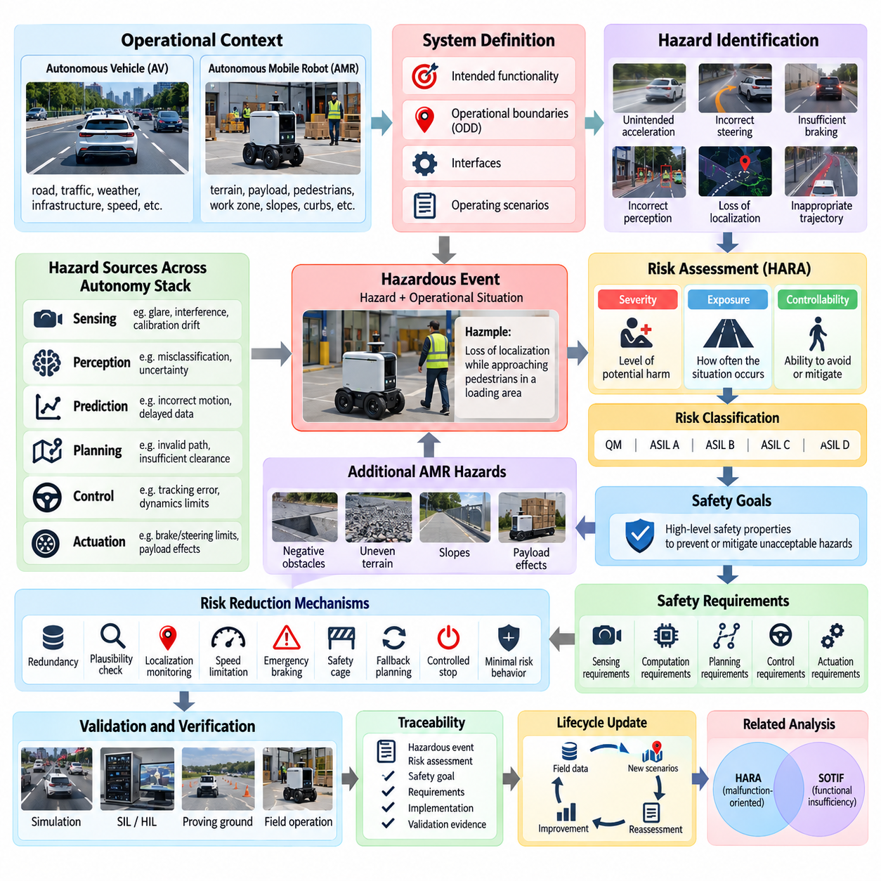
Hazard Analysis and Risk Assessment (HARA) provides a systematic method for identifying hazardous behavior, evaluating its potential consequences, and deriving safety requirements for autonomous vehicles and autonomous mobile robots. Within AV and AMR development, HARA connects operational situations with possible system behavior so that safety engineering begins from hazards experienced at the vehicle level rather than from isolated component failures.
The analysis normally begins by defining the system, its intended functionality, operational boundaries, interfaces, and relevant operating scenarios. For an autonomous driving system, these may include road type, vehicle speed, traffic interaction, weather, and infrastructure. For an outdoor AMR, additional factors such as terrain, payload, pedestrian proximity, work-zone structure, slopes, curbs, and mixed human-machine traffic become important parts of the operational context.
A hazard represents a potential source of harm resulting from system behavior under a particular operational situation. Hazard identification therefore considers more than whether an individual sensor, processor, or actuator fails. Unsafe acceleration, unintended steering, insufficient braking, incorrect free-space estimation, loss of localization, delayed obstacle response, or inappropriate trajectory generation can all become hazardous behaviors when combined with relevant environmental conditions.
Hazardous events are constructed by combining a hazard with an operational situation. Loss of localization alone describes a system condition, but loss of localization while an AMR travels near pedestrians or approaches a loading area forms a more meaningful hazardous event. This scenario-oriented representation helps engineers reason about consequences at the system level and establishes a direct connection between autonomy behavior, operating context, and potential harm.
Traditional automotive HARA commonly evaluates hazardous events through severity, exposure, and controllability. Severity represents the potential level of harm if the hazardous event occurs. Exposure describes how frequently the relevant operational situation may be encountered, while controllability estimates the ability of affected persons or other participants to avoid or mitigate the resulting harm. These dimensions provide a structured basis for risk classification and safety requirement derivation.
For AV and AMR systems, these factors require careful interpretation because autonomy changes the role of the human operator. A highly automated robot may operate without a driver who can immediately intervene, and pedestrians near the robot may have little knowledge of its internal state. Consequently, assumptions about controllability should reflect the actual operating environment, available supervision, robot speed, stopping capability, warning mechanisms, and expected human response.
Severity analysis should consider the physical characteristics of the autonomous platform. Vehicle mass, maximum velocity, braking distance, payload, geometry, kinetic energy, and interaction with vulnerable road users influence the potential consequences of hazardous behavior. Outdoor AMRs operating at relatively low speed may present different risks from passenger vehicles, yet heavy payloads, steep terrain, confined spaces, or industrial equipment can still create severe hazardous situations.
Exposure must similarly be evaluated against the Operational Design Domain (ODD) rather than treated as a generic probability. An AMR deployed in a warehouse yard may frequently encounter forklifts, workers, loading bays, temporary obstacles, and changing traffic flows. A security patrol robot may instead experience nighttime operation, low illumination, weather variation, isolated pedestrians, and repeated routes. Risk assessment must therefore reflect the actual mission profile.
Controllability is particularly challenging for autonomous systems because avoidance may depend on both the robot and surrounding participants. A pedestrian may be able to move away from a slowly approaching robot in an open area but have little opportunity to react when visibility is obstructed or space is constrained. The system architecture should therefore avoid relying excessively on external human intervention when autonomous mitigation can reasonably be provided.
HARA results are used to derive safety goals that describe high-level safety properties required to prevent or mitigate unacceptable hazardous behavior. A safety goal may require prevention of unintended acceleration, maintenance of safe stopping capability, detection of invalid localization, or avoidance of trajectories entering occupied space. These goals are subsequently refined into functional and technical safety requirements distributed across sensing, computation, planning, control, and actuation.
For autonomous systems, hazard analysis should consider propagation across the complete perception-prediction-planning-control chain. An incorrect object classification may alter motion prediction, which can change planner decisions and ultimately produce unsafe control commands. Similarly, delayed timestamps or inconsistent coordinate frames can create errors that appear individually small but combine into significant spatial or temporal deviations at the vehicle level.
Sensor-related hazards require analysis of both complete failures and degraded information quality. Camera glare, LiDAR degradation, radar interference, GNSS multipath, calibration drift, timing misalignment, and partial field-of-view obstruction may not immediately trigger conventional fault detection. Their safety significance depends on how the autonomy stack interprets the resulting information and whether redundancy, uncertainty monitoring, or fallback mechanisms prevent unsafe behavior.
Planning and control introduce another class of hazards. A planner may generate a collision-free path that nevertheless violates vehicle dynamics, stopping-distance constraints, terrain limitations, or acceptable clearance margins. A controller may accurately track a requested trajectory while tire slip or changing payload alters the physical response. HARA therefore needs to connect software decisions to the actual dynamic capabilities and constraints of the platform.
Outdoor AMRs require additional hazard categories associated with traversability and terrain interaction. Negative obstacles, loose gravel, mud, slopes, drainage channels, curbs, vegetation, construction debris, and uneven surfaces can cause instability, immobilization, collision, or rollover. Payload position and mass distribution may further modify braking and stability characteristics, making mission configuration an important parameter in the hazard analysis.
HARA and SOTIF analysis are closely related but address different sources of unsafe behavior. HARA traditionally provides a structured framework for identifying hazardous events and assessing their risk, while SOTIF emphasizes hazards arising from functional insufficiencies and foreseeable misuse even when no conventional malfunction exists. Autonomous-system safety therefore benefits from linking malfunction-oriented analysis with scenario-based examination of performance limitations.
This connection is especially important for machine-learning-based perception. A neural network can execute exactly as implemented while producing an incorrect result for a rare object, unusual lighting condition, or unfamiliar environment. Such behavior may not fit naturally into a simple component-failure model. The hazardous consequence can still be analyzed through HARA, while SOTIF-oriented scenario analysis investigates the triggering conditions and performance limitations responsible for the behavior.
Risk reduction mechanisms should be derived from identified hazardous events rather than added independently at the end of development. Redundant sensing, plausibility checking, localization integrity monitoring, speed limitation, emergency braking, safety cages, watchdogs, fallback planning, controlled stopping, and minimal-risk behavior can each address different hazard pathways. Their effectiveness must be validated against the operational situations for which they were introduced.
Traceability connects hazard analysis to implementation and verification. Each significant hazardous event should be associated with assumptions, risk evaluation, safety goals, derived requirements, architectural mechanisms, and validation evidence. When the ODD, sensor configuration, vehicle dynamics, payload limits, or autonomy software changes, this traceability allows engineers to determine which hazard analyses and safety arguments require reassessment.
HARA should consequently evolve with the autonomous system rather than remain a document produced once during initial design. Simulation results, field tests, disengagements, near misses, fleet logs, newly discovered corner cases, and operational incidents can reveal hazardous situations that were previously underestimated or absent. Feeding this evidence back into hazard analysis creates a closed safety-development loop connecting design assumptions with actual system behavior.
For AV and outdoor AMR development, the practical objective of HARA is to transform broad safety concerns into explicit engineering obligations. By connecting operational situations, hazardous behavior, severity, exposure, controllability, safety goals, mitigation mechanisms, and validation evidence, the process creates a structured foundation for designing autonomy that remains acceptably safe across its defined ODD and throughout its operational lifecycle.

11.03. Scenario Based Testing Methodology for SOTIF
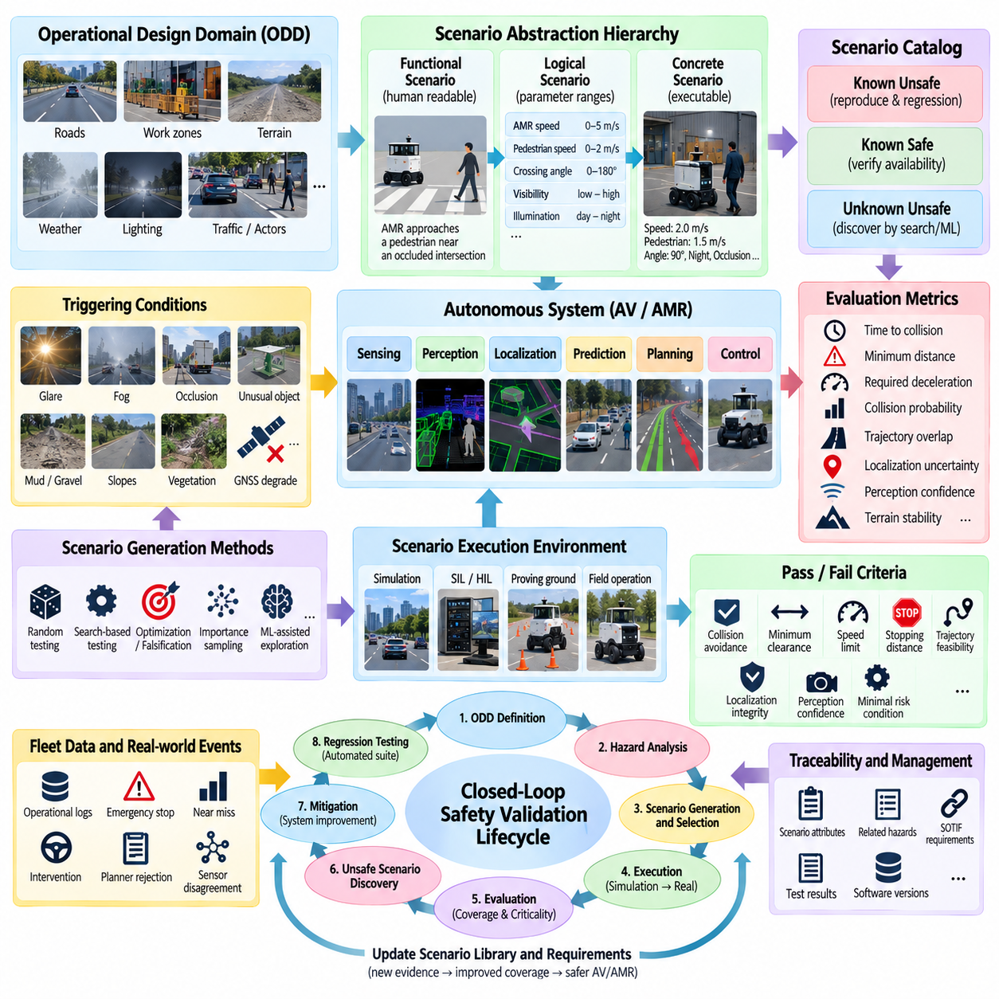
Scenario-based testing is a core methodology for evaluating Safety of the Intended Functionality (SOTIF) because autonomous systems must be assessed against meaningful combinations of environmental conditions, traffic interactions, system limitations, and triggering events. Rather than relying only on accumulated driving distance, the methodology organizes validation around situations that can expose unsafe behavior even when hardware and software operate without conventional faults.
A scenario represents the evolution of an operational situation over time. It describes relevant actors, infrastructure, environmental conditions, system states, trajectories, interactions, and events that influence autonomous behavior. For an autonomous vehicle or outdoor AMR, a scenario may include pedestrians, vehicles, obstacles, terrain, weather, illumination, localization quality, sensor visibility, speed, and available maneuvering space.
Scenario-based testing typically progresses through different levels of abstraction. A functional scenario expresses the situation using human-readable concepts, such as an AMR approaching a pedestrian near an obstructed intersection. A logical scenario converts these concepts into parameter ranges and relationships, while a concrete scenario assigns specific numerical values that can be executed repeatedly in simulation, proving-ground tests, or field experiments.
This abstraction hierarchy enables systematic expansion of a relatively small set of safety-relevant situations into large test spaces. A logical pedestrian-crossing scenario, for example, can vary robot speed, pedestrian velocity, crossing angle, visibility, braking distance, illumination, sensor confidence, and obstacle occlusion. Each parameter combination becomes a candidate concrete scenario that explores a different region of system behavior.
Scenario selection should be closely connected to the Operational Design Domain (ODD). The ODD defines the conditions in which the autonomous function is intended to operate, while the scenario catalog describes representative and challenging combinations within or near those boundaries. Roads, work zones, terrain types, weather, lighting, traffic density, pedestrian behavior, infrastructure, speed limits, and communication conditions can therefore become scenario parameters.
SOTIF testing gives particular attention to triggering conditions that expose functional insufficiencies. Glare may reduce camera perception quality, fog may limit effective sensing range, partial occlusion may delay pedestrian detection, and unusual object geometry may cause incorrect classification. For outdoor AMRs, mud, gravel, curbs, slopes, vegetation, reflective surfaces, GNSS degradation, or temporary construction layouts may similarly expose limitations.
Known unsafe scenarios provide an important starting point because their hazardous characteristics are already understood. Engineers can reproduce these situations, verify mitigation mechanisms, and establish regression tests that prevent previously identified unsafe behavior from reappearing. Known safe scenarios are also required because excessive safety intervention can reduce availability, mobility, and mission performance even when the environment remains within validated operating conditions.
The more difficult objective is discovering unknown unsafe scenarios. Random testing alone is inefficient because safety-critical combinations may occupy very small regions of a high-dimensional parameter space. Search-based testing, optimization, falsification, importance sampling, novelty detection, adversarial scenario generation, and machine-learning-assisted exploration can direct computational resources toward boundaries where unsafe behavior is more likely to emerge.
Criticality metrics help prioritize this exploration. Time-to-collision, time-to-react, minimum distance, required deceleration, predicted collision probability, trajectory overlap, stopping margin, localization uncertainty, perception confidence, and terrain stability can indicate whether a scenario approaches an unsafe state. No single metric captures every hazard, so scenario evaluation normally combines physical, behavioral, perception, and system-level indicators.
Scenario coverage is fundamentally different from simple mileage coverage. Millions of kilometers may repeatedly exercise common conditions while providing little evidence about rare but safety-critical combinations. Scenario-based validation instead asks which relevant parameter regions, interaction patterns, ODD conditions, functional boundaries, and triggering conditions have been exercised, allowing test effort to be related more directly to identified safety concerns.
Coverage models can divide scenario parameters into ranges or equivalence classes and track which combinations have been tested. Boundary conditions deserve particular attention because autonomy performance often changes rapidly near sensing limits, stopping-distance thresholds, localization tolerances, terrain constraints, or ODD boundaries. Combinatorial testing can further expose interactions among parameters without requiring exhaustive enumeration of every possible configuration.
Simulation is especially valuable because large numbers of concrete scenarios can be executed safely and reproducibly. Weather, lighting, actor trajectories, sensor characteristics, friction, terrain, communication delay, and localization quality can be varied under controlled conditions. Accelerated and parallel simulation can evaluate thousands or millions of scenario variants, while deterministic replay supports debugging and regression analysis after unsafe behavior is discovered.
Simulation results must nevertheless be interpreted with respect to model fidelity. An apparently safe result may be misleading if sensor noise, vehicle dynamics, terrain interaction, pedestrian behavior, or environmental effects are represented unrealistically. Scenario-based SOTIF validation therefore benefits from combining simulation with software-in-the-loop, hardware-in-the-loop, proving-ground testing, and carefully controlled field operation.
A multi-stage validation strategy can progressively move scenarios from scalable virtual testing toward physical confirmation. Large scenario populations are first explored in simulation, critical cases are reproduced with increasingly realistic system integration, and selected safety-relevant scenarios are finally validated on physical platforms. This approach concentrates expensive real-world testing on cases that provide the greatest safety information.
Pass and fail criteria should be defined before scenario execution whenever practical. Criteria may include collision avoidance, minimum clearance, maximum allowable speed, stopping distance, trajectory feasibility, localization integrity, perception confidence, intervention timing, or successful transition to a minimal risk condition. Clearly defined criteria prevent ambiguous interpretation and allow automated evaluation across large scenario populations.
For outdoor AMRs, scenario criteria should also reflect mission and terrain characteristics. A robot may avoid collision yet still enter unstable terrain, exceed allowable slope, approach a negative obstacle too closely, lose sufficient traction, or create unsafe clearance around workers. Payload mass, center of gravity, braking performance, surface friction, and available escape space can therefore become safety-relevant scenario variables.
Scenario-based testing should evaluate the complete autonomy chain rather than isolated algorithms alone. A perception error may be harmless if prediction and planning remain conservative, while a small localization error may become hazardous when combined with narrow clearance and high speed. End-to-end scenario execution reveals these interactions by observing how sensing, perception, localization, prediction, planning, control, and safety mechanisms behave together.
Operational fleet data provides another important source of scenarios. Emergency stops, planner rejections, low-confidence detections, localization degradation, operator interventions, near misses, unusual trajectories, and sensor disagreement can identify conditions that deserve further investigation. Recorded events can be reconstructed, parameterized, and added to the scenario library so that real-world experience continuously expands validation coverage.
A scenario library should therefore be treated as a continuously evolving engineering asset. Each scenario can retain its origin, ODD attributes, parameter definitions, associated hazards, triggering conditions, criticality measures, expected behavior, test results, and software versions. Traceability allows engineers to connect scenarios with SOTIF requirements and determine which tests must be repeated after models, sensors, algorithms, or operating conditions change.
Regression testing transforms discovered safety knowledge into persistent protection. Once an unsafe scenario has been identified and corrected, representative variants should remain in the automated validation suite. Future software or machine-learning model updates can then be evaluated against these scenarios, reducing the possibility that performance improvements in one operating region unintentionally reintroduce previously mitigated hazardous behavior.
The overall methodology forms a closed safety-validation loop linking ODD definition, hazard analysis, scenario generation, execution, criticality evaluation, unsafe-scenario discovery, mitigation, and regression testing. Simulation and operational data continuously supply new evidence, while discovered limitations refine both the scenario catalog and system requirements. Scenario-based testing thus becomes a lifecycle mechanism for progressively reducing known and unknown unsafe behavior in AV and AMR systems.

11.04. Unknown Unsafe Scenarios Discovery Methods
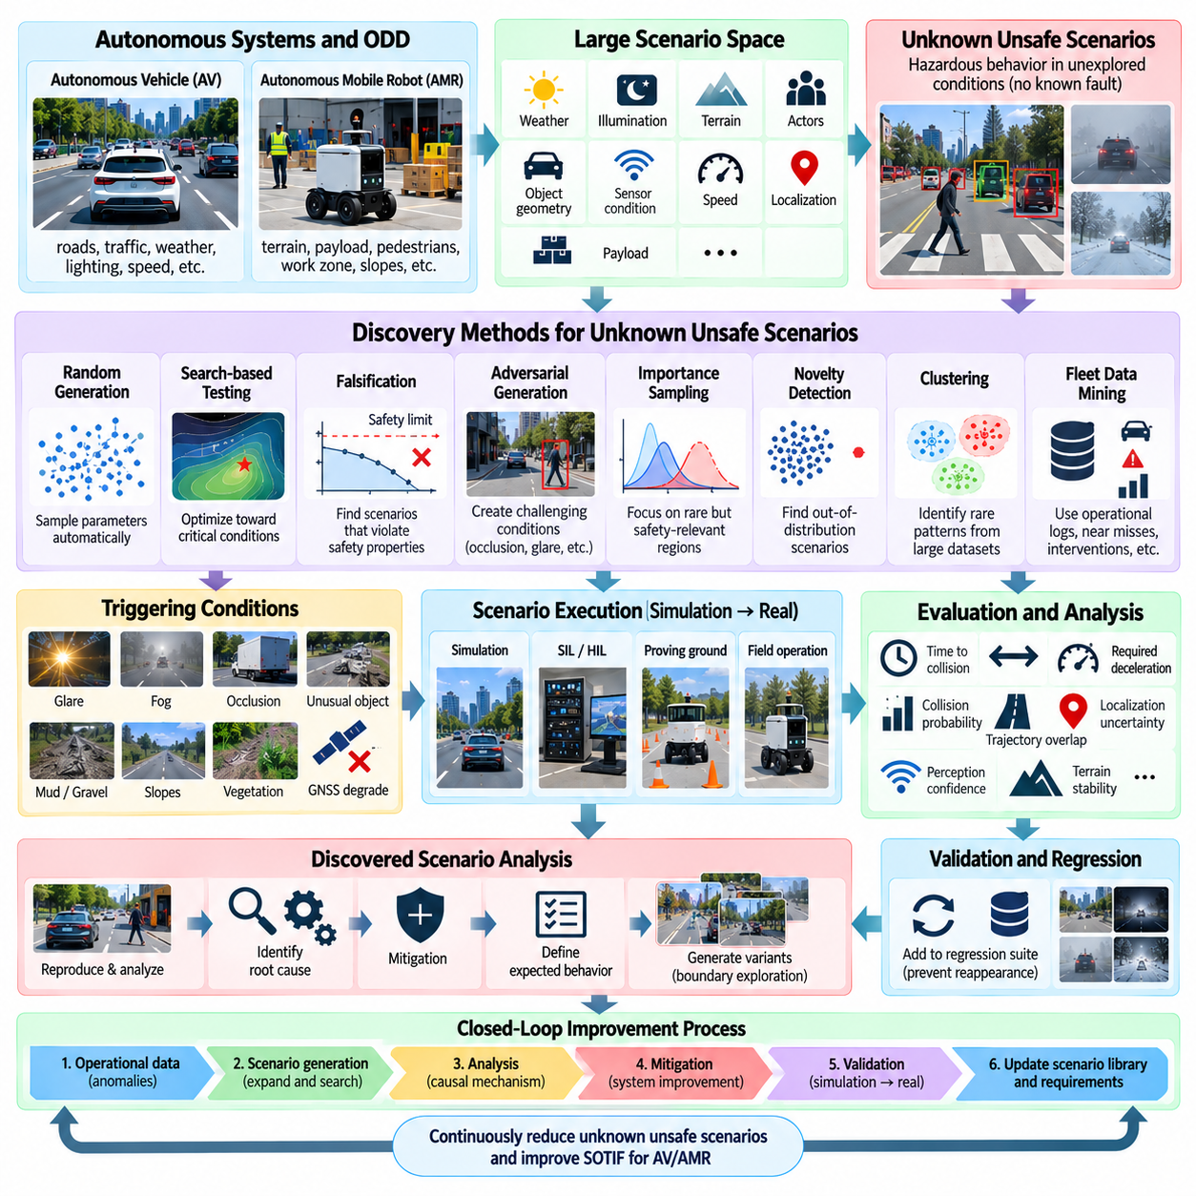
Unknown unsafe scenarios are operating situations in which an autonomous system can produce hazardous behavior even though the scenario and its triggering conditions have not yet been identified during development. Within SOTIF, discovering these scenarios is essential because conventional validation naturally concentrates on known requirements and anticipated conditions, while serious residual risk may remain in unexplored combinations of environment, actors, system limitations, and operational states.
The discovery problem is difficult because autonomous vehicles and AMRs operate in extremely large scenario spaces. Weather, illumination, terrain, traffic participants, object geometry, sensor conditions, vehicle speed, localization quality, payload, and behavioral interactions can vary simultaneously. Even when each parameter appears safe independently, particular combinations may expose perception, prediction, planning, or control limitations that were not visible during ordinary testing.
Unknown unsafe scenarios should therefore be treated as a search problem rather than as a fixed checklist. The objective is to explore regions of the Operational Design Domain (ODD) and its boundaries where system behavior becomes uncertain, unstable, or safety-critical. Discovery methods attempt to move testing away from frequently observed nominal situations toward rare parameter combinations, transitions, interactions, and functional boundaries where previously unseen hazards are more likely to emerge.
Random scenario generation provides a simple baseline for exploration. Parameters such as vehicle speed, pedestrian position, visibility, friction, sensor noise, or obstacle configuration can be sampled automatically and executed in simulation. Random testing can reveal unexpected interactions, but its efficiency decreases rapidly as dimensionality grows because most samples remain in ordinary regions rather than reaching the narrow conditions that trigger critical behavior.
Search-based testing improves efficiency by using safety-related objectives to guide scenario generation. Optimization algorithms can vary scenario parameters to minimize distance, time-to-collision, stopping margin, perception confidence, or another criticality measure. Instead of exploring the scenario space uniformly, the search progressively concentrates on configurations that move the autonomous system toward unsafe boundaries and therefore provide greater information about potential weaknesses.
Falsification provides a more formal version of this concept. Rather than simply asking whether the system performs well, falsification attempts to find parameter combinations that violate a specified safety property. A requirement such as maintaining minimum pedestrian clearance can be translated into a measurable condition, and the search process deliberately seeks scenarios that minimize the robustness of that condition until a counterexample or critical boundary is discovered.
Adversarial scenario generation deliberately creates challenging conditions for the autonomy stack. Small changes in object placement, occlusion, illumination, actor trajectories, sensor visibility, or environmental structure may produce disproportionately large changes in system behavior. For machine-learning perception, adversarial exploration can reveal regions where model confidence remains high despite incorrect interpretation, making such scenarios particularly valuable for SOTIF investigation.
Importance sampling concentrates simulation effort on rare but safety-relevant regions rather than sampling according to normal operational frequency. Candidate scenarios associated with collision proximity, emergency braking, unusual interactions, or degraded perception can be sampled more frequently, while statistical weighting accounts for their actual occurrence probability. This technique is useful when direct observation of rare events would otherwise require impractically large amounts of testing.
Novelty and out-of-distribution detection provide another path to unknown-scenario discovery. Feature representations derived from sensor observations, perception outputs, trajectories, or internal model states can be compared with previously observed data. Events located far from known clusters may indicate unusual environments, objects, interactions, or system responses and can be prioritized for human review, replay, simulation reconstruction, and additional validation.
Clustering can organize large operational datasets into recurring behavioral or environmental patterns. Common clusters describe well-represented situations, while small clusters and isolated samples can reveal rare combinations worthy of investigation. The objective is not to assume that every unusual sample is unsafe, but to reduce massive fleet datasets into manageable groups from which safety engineers can identify conditions insufficiently represented in existing scenario catalogs.
Fleet operation is especially valuable because real environments contain complexity that is difficult to anticipate manually. Emergency stops, operator interventions, planner rejections, sudden trajectory changes, low-confidence detections, localization degradation, sensor disagreement, and near misses can serve as discovery signals. These events can be extracted from operational logs and transformed into candidate scenarios even when no collision or explicit system failure occurred.
Near-miss analysis provides information that conventional incident analysis may miss. A robot that narrowly avoids a pedestrian, obstacle, unstable terrain region, or moving vehicle may satisfy the immediate safety criterion while revealing inadequate margins. Minimum distance, required deceleration, rapid control intervention, trajectory oscillation, or sudden confidence reduction can identify scenarios that deserve investigation before similar conditions produce an actual hazardous event.
Runtime uncertainty can also function as a discovery trigger. High localization covariance, disagreement between sensors, unstable object tracks, low perception confidence, inconsistent map observations, repeated replanning, or rapidly changing predictions may indicate that the system is operating near the limits of its validated knowledge. Recording the surrounding scenario context converts internal uncertainty signals into evidence for future SOTIF analysis.
For outdoor AMRs, discovery should include physical interaction with terrain and payload conditions. Unknown hazards may emerge from combinations of slope, surface friction, loose gravel, mud, negative obstacles, wheel slip, payload mass, center-of-gravity changes, and restricted maneuvering space. These factors can interact with perception and control, creating unsafe states that would not be discovered by road-scene analysis or object-detection metrics alone.
Simulation enables these discovery methods to operate at a scale impossible in physical testing. Large numbers of scenario variants can be executed in parallel while optimization algorithms modify parameters automatically. Once a critical case is discovered, deterministic replay can reproduce it, sensitivity analysis can determine which variables caused the behavior, and neighboring parameter regions can be explored to estimate the size and shape of the unsafe region.
Simulation fidelity remains important because discovery is useful only when the identified behavior corresponds meaningfully to the physical system. Sensor artifacts, vehicle dynamics, terrain interaction, friction, latency, and actor behavior should therefore be modeled at sufficient fidelity for the targeted hazard. Critical scenarios discovered virtually should be progressively confirmed through software-in-the-loop, hardware-in-the-loop, proving-ground, or controlled field testing when appropriate.
Machine learning can support prioritization by estimating scenario novelty, criticality, or similarity to known hazardous events. Learned representations can help search millions of recorded or simulated scenarios, while active learning can identify cases for which additional labeling or testing would provide the greatest information. These methods should assist rather than replace explicit safety criteria because unusual behavior is not automatically hazardous and familiar behavior is not automatically safe.
Discovered scenarios should be converted into structured engineering assets rather than remaining isolated test failures. Relevant ODD parameters, triggering conditions, system states, criticality metrics, sensor observations, software versions, and observed outcomes should be preserved. The scenario can then be connected to hazards, SOTIF requirements, mitigation mechanisms, validation results, and regression tests through a traceable scenario management process.
After an unknown unsafe scenario is understood, it effectively becomes a known unsafe scenario. Engineers can identify the responsible functional insufficiency, introduce mitigation, define expected behavior, and create representative test variants around the discovered boundary. These variants should remain in the regression suite so that future changes to perception models, planners, controllers, sensors, or platform configuration do not recreate the same hazardous behavior.
Discovery is therefore an iterative reduction of uncertainty rather than a one-time search for a complete list of hazards. Operational data generates anomalies, simulation expands them into scenario families, search algorithms explore nearby boundaries, engineering analysis identifies causal mechanisms, and mitigation produces new validation requirements. The updated system then returns to operation, where additional evidence may reveal previously unexplored limitations.
Within SOTIF, the practical objective is not to claim that every unknown unsafe scenario has been eliminated, which is generally impossible for complex autonomous systems. The objective is to demonstrate a systematic and continuously improving process for finding safety-relevant unknowns. Combining fleet data, criticality analysis, novelty detection, search, falsification, adversarial generation, simulation, physical validation, and regression testing progressively reduces the unexplored unsafe region of AV and AMR operation.

11.05. Corner Case Mining from Fleet Operational Data [w/Code]
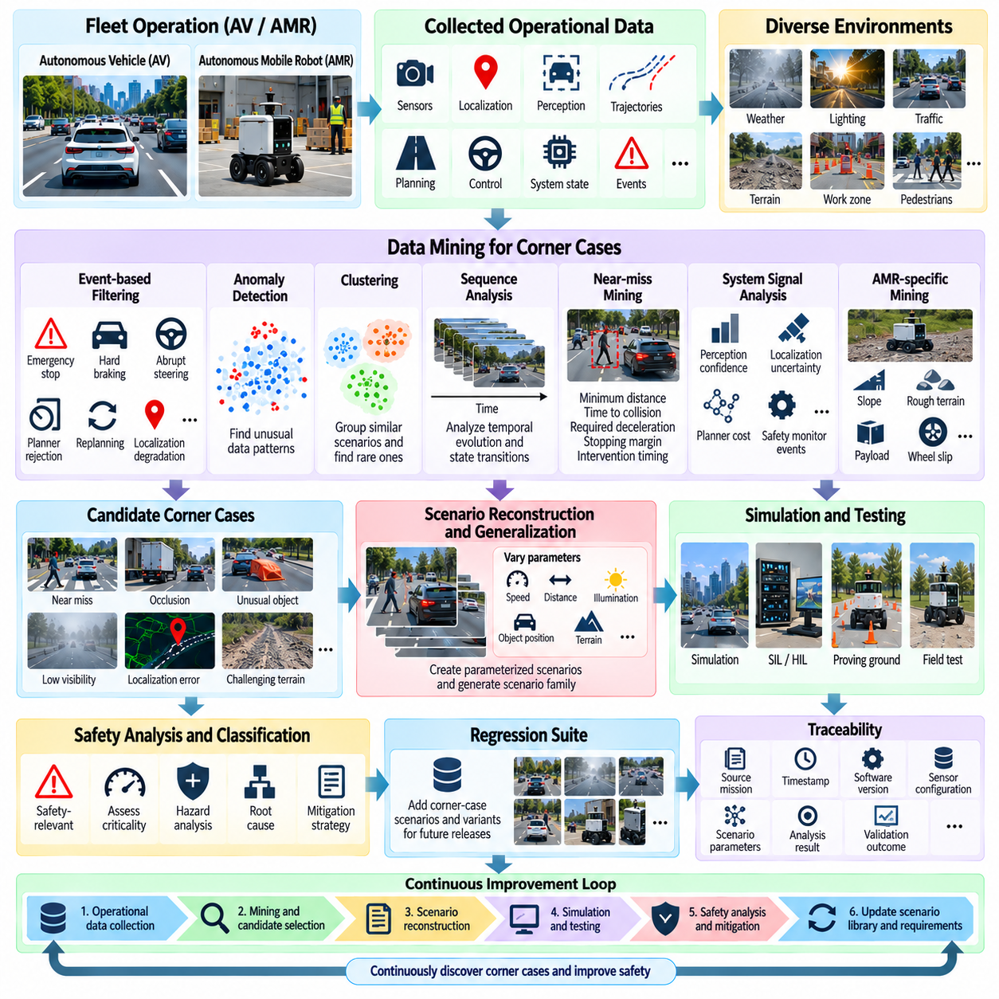
Corner-case mining from fleet operational data is a practical method for discovering safety-relevant situations that are difficult to identify through manually designed tests. Autonomous vehicles and outdoor AMRs continuously generate operational data containing sensor observations, localization states, perception outputs, trajectories, planning decisions, control commands, and system events. Mining this data allows engineers to identify unusual conditions, near misses, abnormal system responses, and rare combinations that may indicate previously unknown safety limitations.
The central objective is not simply to collect unusual data, but to transform operational observations into structured corner cases that can support SOTIF analysis and validation. A corner case may involve an uncommon environmental condition, an unusual object configuration, an unexpected interaction between road users, degraded sensing, or a combination of individually acceptable conditions. The mining process therefore connects real-world fleet behavior with scenario discovery, hazard analysis, simulation, mitigation, and regression testing.
Fleet data becomes especially valuable when the system operates repeatedly in diverse environments. Individual missions may appear routine, but thousands of missions can expose variations in weather, illumination, traffic density, terrain, object behavior, localization quality, and sensor conditions. The accumulation of these observations creates a large empirical representation of the operational domain, allowing engineers to investigate not only failures but also situations where the autonomous system approached an unsafe boundary.
A useful mining pipeline begins with synchronized operational records. Sensor data, timestamps, localization information, perception results, object tracks, planned trajectories, vehicle state, control commands, safety-monitor outputs, and operator interventions should be aligned into a common temporal representation. Without reliable synchronization, an apparently abnormal event may simply result from timestamp errors or inconsistent coordinate frames. Data quality and provenance are therefore fundamental to meaningful corner-case mining.
Event-based filtering provides an efficient first reduction of large fleet datasets. Rather than examining every recorded frame, the system can identify events such as emergency stops, sudden braking, abrupt steering, planner rejection, repeated replanning, localization degradation, sensor disagreement, low perception confidence, unexpected speed reduction, or operator intervention. These events act as discovery signals that identify time windows requiring deeper analysis.
Near misses are particularly valuable because they may reveal inadequate safety margins even when no collision occurs. A robot that narrowly avoids a pedestrian or obstacle may technically satisfy a collision-avoidance requirement while operating close to its physical or perception limits. Metrics such as minimum distance, time-to-collision, required deceleration, trajectory deviation, stopping margin, and intervention timing can be used to identify these situations and prioritize them for further investigation.
Anomaly detection can extend event-based filtering beyond predefined rules. Statistical methods and machine-learning models can identify observations that differ significantly from established operational patterns. Unusual trajectories, rare combinations of object classes, unexpected sensor distributions, abnormal localization behavior, or unfamiliar environmental features can be flagged for review. An anomaly should not automatically be classified as unsafe; rather, it represents evidence that the corresponding situation deserves additional safety analysis.
Clustering can organize millions of operational observations into groups with similar environmental, behavioral, or system characteristics. Large clusters may represent common and well-understood operating conditions, while small clusters or isolated observations can reveal rare scenarios. Feature representations may include scene characteristics, object configurations, trajectory geometry, vehicle speed, sensor confidence, localization uncertainty, and system state. This reduces a massive dataset into manageable scenario families for engineering analysis.
Sequence analysis is important because many corner cases are defined by temporal evolution rather than by a single observation. A pedestrian may initially remain outside the robot path and then suddenly enter it, while localization quality may gradually deteriorate before a planner rejects a trajectory. Mining should therefore preserve temporal sequences and transitions among system states. The relationship between preceding conditions, triggering events, system response, and final outcome often provides more safety information than any individual frame.
For outdoor AMRs, corner-case mining should include physical operating conditions that strongly influence vehicle behavior. Terrain slope, surface type, loose gravel, mud, vegetation, curbs, negative obstacles, wheel slip, payload mass, and changes in center of gravity can be correlated with vehicle dynamics and autonomy behavior. A rare combination such as reduced perception confidence together with high payload and low-friction terrain may represent a safety-relevant scenario even when none of these factors alone appears abnormal.
The autonomy stack provides another important source of mining signals. Perception confidence, object-track stability, localization covariance, map consistency, prediction uncertainty, planner cost, trajectory rejection, controller error, and safety-monitor activation can reveal when the system approaches its validated performance boundaries. Cross-module analysis is particularly useful because a corner case may emerge from the interaction of several small deviations rather than from one obvious failure.
Once candidate events are identified, they should be reconstructed into scenario descriptions. The reconstruction should capture the relevant ODD conditions, actors, environment, system state, triggering conditions, observed behavior, and safety-related metrics. Raw fleet records can then be transformed into parameterized scenarios that are reproducible in simulation or physical testing. This conversion is critical because an isolated operational event becomes much more valuable when it can be systematically replayed and varied.
Scenario generalization allows engineers to determine whether a discovered event is an isolated incident or part of a broader unsafe region. Parameters such as speed, distance, illumination, object position, terrain condition, sensor degradation, and actor behavior can be varied around the original observation. If similar unsafe behavior occurs across neighboring parameter combinations, the original corner case can be expanded into a scenario family and incorporated into broader SOTIF validation coverage.
The relationship between fleet mining and simulation is therefore iterative. Real-world data provides authentic examples that may be difficult to anticipate, while simulation allows those examples to be expanded far beyond the conditions originally observed. A mined scenario can be reproduced, its parameters systematically varied, and its critical boundaries explored. The resulting scenarios can then be evaluated against safety requirements and used to test whether mitigation mechanisms remain effective.
Traceability should be maintained from the original operational record through the final validation scenario. Each mined case can retain information about its source mission, timestamp, software version, sensor configuration, ODD context, triggering condition, detected anomaly, associated hazard, analysis result, mitigation, and validation outcome. This information allows engineers to determine why a scenario was created, what evidence supports it, and whether future software or hardware changes require renewed testing.
After a corner case is confirmed as safety-relevant, it should become part of the permanent regression suite. The original event alone may not be sufficient; representative variations should also be retained to prevent overfitting the mitigation to one exact occurrence. Future perception models, planners, controllers, sensor configurations, and vehicle platforms can then be evaluated against the discovered scenario family before deployment.
Corner-case mining should also distinguish between safety-critical anomalies and operational inefficiencies. Excessive replanning, unusual trajectories, or frequent interventions may indicate a safety limitation, but they may also result from conservative behavior, poor mission configuration, or performance optimization issues. Classification therefore requires engineering interpretation using system context and safety criteria rather than treating every anomaly as a hazard.
The complete process forms a continuous fleet-to-validation feedback loop. Operational data produces candidate events, event filtering identifies anomalies, clustering and sequence analysis organize them, scenario reconstruction converts them into reproducible cases, simulation expands the surrounding parameter space, and safety analysis determines whether functional insufficiencies or hazardous behaviors exist. Confirmed cases then generate mitigations, requirements, and regression tests that improve the autonomous system.
The long-term value of corner-case mining is the progressive reduction of the gap between designed behavior and real-world behavior. Manual scenario design begins with what engineers expect to encounter, while fleet mining exposes what the system actually encounters during operation. By continuously feeding operational evidence into scenario libraries, SOTIF analysis, simulation, and regression validation, AV and AMR development can systematically discover rare conditions and convert real-world experience into reusable safety knowledge.

11.06. Simulation Based SOTIF Validation Coverage [w/Code]
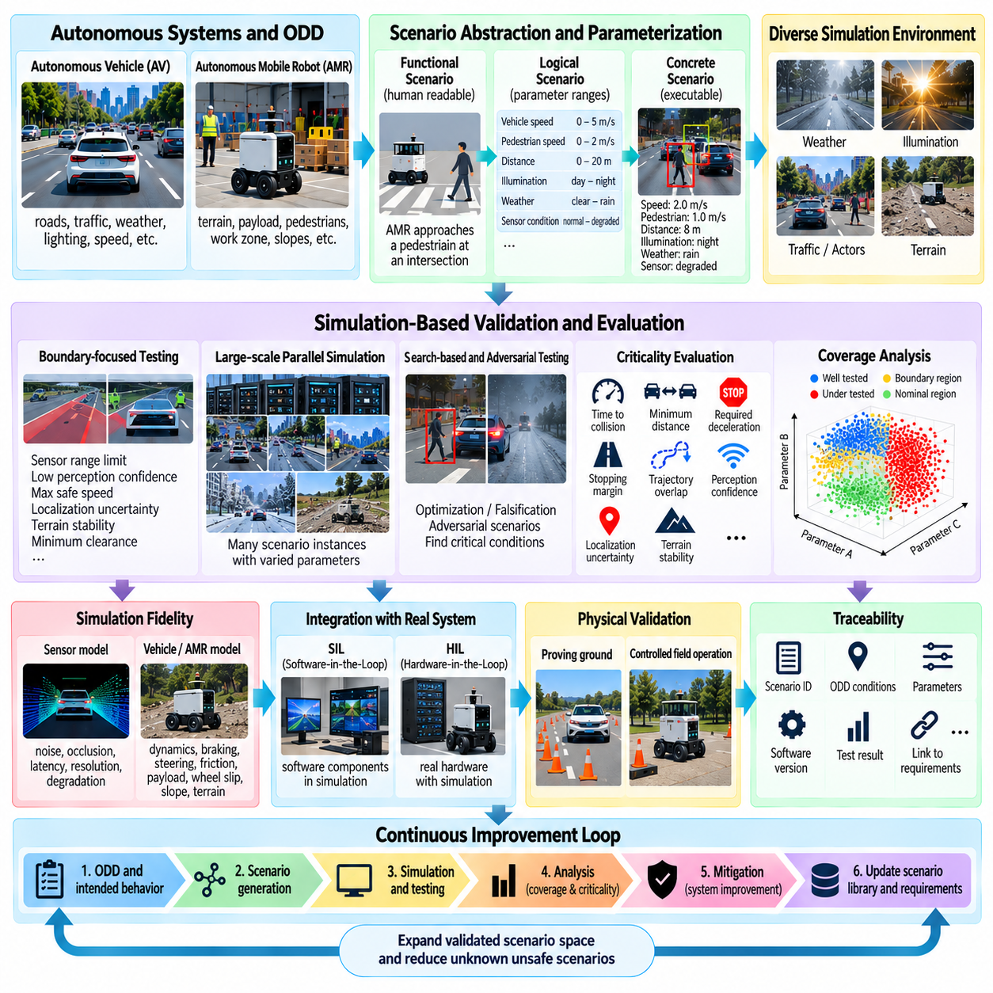
Simulation-based SOTIF validation uses simulation to systematically evaluate whether an autonomous driving or autonomous mobile robot system behaves safely across a broad range of operating conditions. Its primary purpose is not simply to demonstrate that the system works in nominal situations, but to explore functional limitations, triggering conditions, boundary conditions, and hazardous scenarios that may be difficult, expensive, or unsafe to reproduce repeatedly with physical vehicles.
Simulation is particularly valuable for SOTIF because autonomous systems operate in a large multidimensional scenario space. Weather, illumination, traffic participants, object geometry, terrain, vehicle speed, sensor quality, localization uncertainty, payload, and system state can all vary simultaneously. Simulation allows these variables to be controlled independently or in combination, making it possible to investigate how particular conditions influence perception, prediction, planning, control, and overall system behavior.
A meaningful simulation validation framework begins with the Operational Design Domain (ODD) and the intended behavior of the system. The ODD defines the environmental and operational conditions in which the autonomous function is expected to operate, while intended behavior defines how the system should perceive, decide, and act within those conditions. Simulation scenarios should therefore represent both normal operating regions and boundary regions where environmental or system conditions approach the limits assumed during design.
Scenario parameterization is essential for achieving useful coverage. A functional scenario can be transformed into a logical scenario containing ranges for variables such as speed, pedestrian position, object distance, visibility, illumination, road or terrain conditions, and sensor degradation. Concrete scenarios are then generated by assigning specific parameter values. This structure allows one conceptual situation to become a large family of executable test cases without manually defining every individual scenario.
Coverage should be considered in terms of safety-relevant scenario space rather than simple simulation mileage. A simulator may execute millions of kilometers while repeatedly testing common situations and leaving rare combinations unexplored. SOTIF-oriented coverage therefore examines which ODD regions, triggering conditions, interaction patterns, parameter combinations, and functional boundaries have actually been exercised. Coverage metrics should help identify both well-tested regions and areas where additional exploration is required.
Boundary-focused testing is especially important because unsafe behavior may emerge near performance limits. Examples include minimum sensor detection range, low perception confidence, maximum safe speed for a given stopping distance, localization uncertainty limits, terrain stability thresholds, or minimum obstacle clearance. Simulation can systematically move parameters toward these boundaries and determine whether the system maintains acceptable behavior, gradually degrades performance, or enters an unsafe state.
Criticality measures provide a mechanism for automatically evaluating large numbers of simulated scenarios. Time-to-collision, minimum distance, required deceleration, stopping margin, trajectory overlap, localization uncertainty, perception confidence, and terrain stability can be monitored during execution. These measures can be combined with system-level safety requirements to identify scenarios that approach or violate defined safety conditions and should therefore receive additional analysis.
Search-based simulation can make this process substantially more efficient. Instead of sampling every parameter uniformly, optimization and falsification methods can search for conditions that minimize a safety margin or violate a specified safety property. Adversarial scenario generation can intentionally combine difficult conditions such as occlusion, glare, unusual objects, degraded sensing, or unexpected actor behavior. These approaches are particularly useful for exploring regions where unsafe behavior is rare.
Large-scale parallel simulation further expands the discovery capability. Multiple scenario instances can execute simultaneously with different combinations of environment, actors, sensors, vehicle states, and system parameters. Once a critical scenario is discovered, neighboring parameter values can be explored to determine whether the behavior is an isolated point or part of a larger unsafe region. This process converts individual failures into scenario families that can support more systematic SOTIF analysis.
Simulation must nevertheless maintain sufficient fidelity for the safety question being investigated. Sensor models should represent relevant noise, occlusion, latency, resolution, and degradation characteristics, while vehicle models should represent appropriate dynamics, braking behavior, steering response, friction, and payload effects. For outdoor AMRs, terrain interaction, wheel slip, slopes, loose surfaces, negative obstacles, and changing payload conditions may also need to be represented when they influence the targeted safety behavior.
The simulation environment should be connected to the actual autonomy software whenever practical. Software-in-the-Loop (SIL) can evaluate the behavior of software components within a simulated environment, while Hardware-in-the-Loop (HIL) introduces actual computing or control hardware and exposes implementation and timing effects. This progression helps reduce the gap between abstract scenario exploration and behavior that can be reproduced on the physical autonomous platform.
Simulation results should be followed by targeted physical validation when scenarios are safety-critical or when simulation assumptions introduce significant uncertainty. Selected cases can progress from simulation to SIL and HIL, then to proving-ground testing and controlled field operation. The purpose is not to reproduce every simulated scenario physically, but to confirm important behaviors and validate that the simulation models provide sufficient evidence for the specific safety argument being developed.
Traceability is required to make simulation evidence useful over the system lifecycle. Each scenario should be associated with its ODD conditions, parameters, triggering conditions, expected behavior, safety requirements, software version, simulation configuration, evaluation metrics, and test result. When a perception model, planner, controller, sensor configuration, vehicle platform, or operating condition changes, this information allows engineers to identify which scenarios require regression testing or renewed validation.
Simulation-based SOTIF validation is ultimately a continuous process rather than a final test stage. Operational fleet data can reveal new corner cases, which can be reconstructed and added to the simulation scenario library. Search algorithms can expand those cases around their boundaries, while safety analysis determines whether newly discovered behavior represents a functional insufficiency or hazardous condition. Mitigation mechanisms can then be evaluated against the original case and its generated variants.
For autonomous vehicles and outdoor AMRs, the objective is therefore to use simulation as a scalable mechanism for reducing uncertainty about intended functionality. Effective coverage combines ODD representation, scenario parameterization, boundary exploration, criticality evaluation, large-scale execution, physical confirmation, traceability, and regression testing. By continuously expanding the validated scenario space and feeding newly discovered evidence back into requirements and system design, simulation-based validation becomes an important part of the SOTIF lifecycle.

11.07. Statistical Safety Validation Confidence Intervals
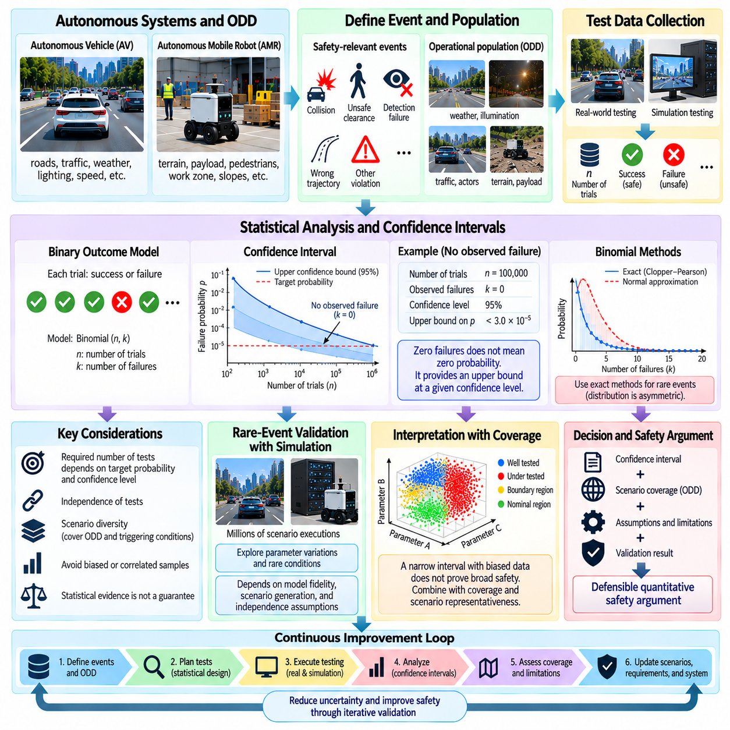
Statistical safety validation provides a quantitative framework for estimating how much evidence is obtained from repeated autonomous-system testing. In SOTIF, the objective is not merely to count successful trials, but to determine what the observed test results imply about the underlying probability of an unsafe event. Confidence intervals are important because a finite number of successful tests can never prove that the true probability of failure is exactly zero.
A validation campaign begins by defining the event of interest and the population to which the evidence applies. For an autonomous vehicle (AV) or autonomous mobile robot (AMR), the event may be a collision, unsafe clearance, failure to detect an obstacle, incorrect trajectory selection, or another violation of a safety requirement. The tested population must also be characterized through the Operational Design Domain (ODD), because statistical evidence from one operating population cannot automatically be generalized to substantially different conditions.
When a safety-relevant event is modeled as a binary outcome, each trial can be classified as success or failure. If a large number of independent trials are performed and no unsafe event is observed, the measured failure rate is zero, but the true failure probability is not necessarily zero. Statistical analysis therefore uses the number of trials and the confidence level to calculate an upper confidence bound on the unknown probability of failure.
For example, if an autonomous system completes many independent tests without observing the defined hazardous event, a confidence interval can establish an upper bound on the event probability under the assumptions of the statistical model. The important distinction is between observing zero failures and demonstrating that the true probability is below a specified target with a stated confidence level. This distinction prevents zero observed failures from being incorrectly interpreted as proof of perfect safety.
Binomial models are commonly relevant when each trial produces a clearly defined success or failure outcome. If the number of trials is represented by n and the number of observed failures by k, statistical estimation can be used to determine an interval for the underlying event probability. When failures are rare, exact methods such as the Clopper–Pearson interval may be preferred over approximations because the distribution is strongly asymmetric near zero.
Confidence level expresses the statistical coverage associated with the interval construction rather than the probability that a particular fixed parameter lies inside an already calculated interval. A 95% confidence procedure, for example, is designed so that repeated application of the procedure would contain the true parameter at the stated long-run rate under its assumptions. This interpretation should be communicated carefully in safety documentation to avoid treating confidence intervals as guarantees.
The required number of tests depends strongly on the acceptable event probability and the desired confidence level. Demonstrating evidence for a very rare event requires substantially more observations than demonstrating evidence for a relatively frequent event. Consequently, a requirement for extremely low residual risk cannot normally be satisfied simply by accumulating a modest number of ordinary test runs. Statistical planning should be performed before the campaign so that the collected evidence has a defined quantitative purpose.
Independence is a critical assumption in many statistical calculations. Repeating the same scenario under nearly identical conditions does not necessarily provide the same evidential value as testing genuinely independent realizations. Correlated samples may arise from repeated routes, identical environmental conditions, the same actor behavior, the same software state, or duplicated simulation seeds. If such dependencies are ignored, the effective sample size may be much smaller than the recorded number of trials.
Scenario-based SOTIF validation therefore needs to connect statistical evidence with scenario diversity. A large number of executions should cover relevant ODD regions, triggering conditions, actor interactions, environmental states, and system configurations rather than simply repeating nominal cases. Confidence intervals calculated from highly concentrated samples may be statistically correct for that sample population while providing limited evidence about untested regions of the broader operational domain.
For rare-event validation, simulation can provide a practical mechanism for generating large numbers of controlled trials. Millions of scenario executions can be used to estimate event frequencies, explore parameter distributions, and identify conditions associated with unsafe behavior. However, simulation results remain conditional on the validity of the scenario generation process, physical models, sensor models, actor behavior, and independence assumptions. Statistical precision cannot compensate for systematic modeling errors.
Confidence intervals should therefore be interpreted together with coverage analysis and scenario representativeness. A narrow interval based on a large but biased dataset does not establish broad safety evidence. Conversely, a wider interval may honestly reflect limited evidence. SOTIF validation should preserve the relationship between the statistical population, scenario definition, observed outcomes, test conditions, and intended operational domain so that the meaning of the resulting confidence bound remains explicit.
Statistical evidence also becomes more useful when combined with Bayesian or sequential approaches where appropriate. Prior engineering knowledge can be incorporated into a Bayesian model, while sequential testing can update evidence as additional trials are completed. These approaches can support efficient test planning, but their assumptions and prior choices must remain transparent. They should complement scenario-based discovery and engineering analysis rather than replace direct investigation of newly identified unsafe behaviors.
For outdoor AMRs, statistical validation should consider mission-specific populations such as pedestrians, terrain types, payload conditions, weather, lighting, and localization states. A low observed incident rate on flat dry surfaces cannot automatically represent operation on slopes, loose terrain, wet surfaces, or heavily loaded configurations. The statistical population should therefore be partitioned or stratified when materially different operating conditions influence the safety behavior being evaluated.
The final objective is to build a defensible quantitative safety argument rather than to produce a single statistical number. Test counts, observed events, confidence intervals, scenario coverage, ODD representation, independence assumptions, model limitations, and validation results should be traceable to the relevant safety requirements. Statistical safety validation is consequently one component of a broader SOTIF evidence framework that combines quantitative uncertainty estimation with scenario discovery, simulation, physical testing, and continuous regression validation.

11.08. SOTIF Documentation and Safety Case Build
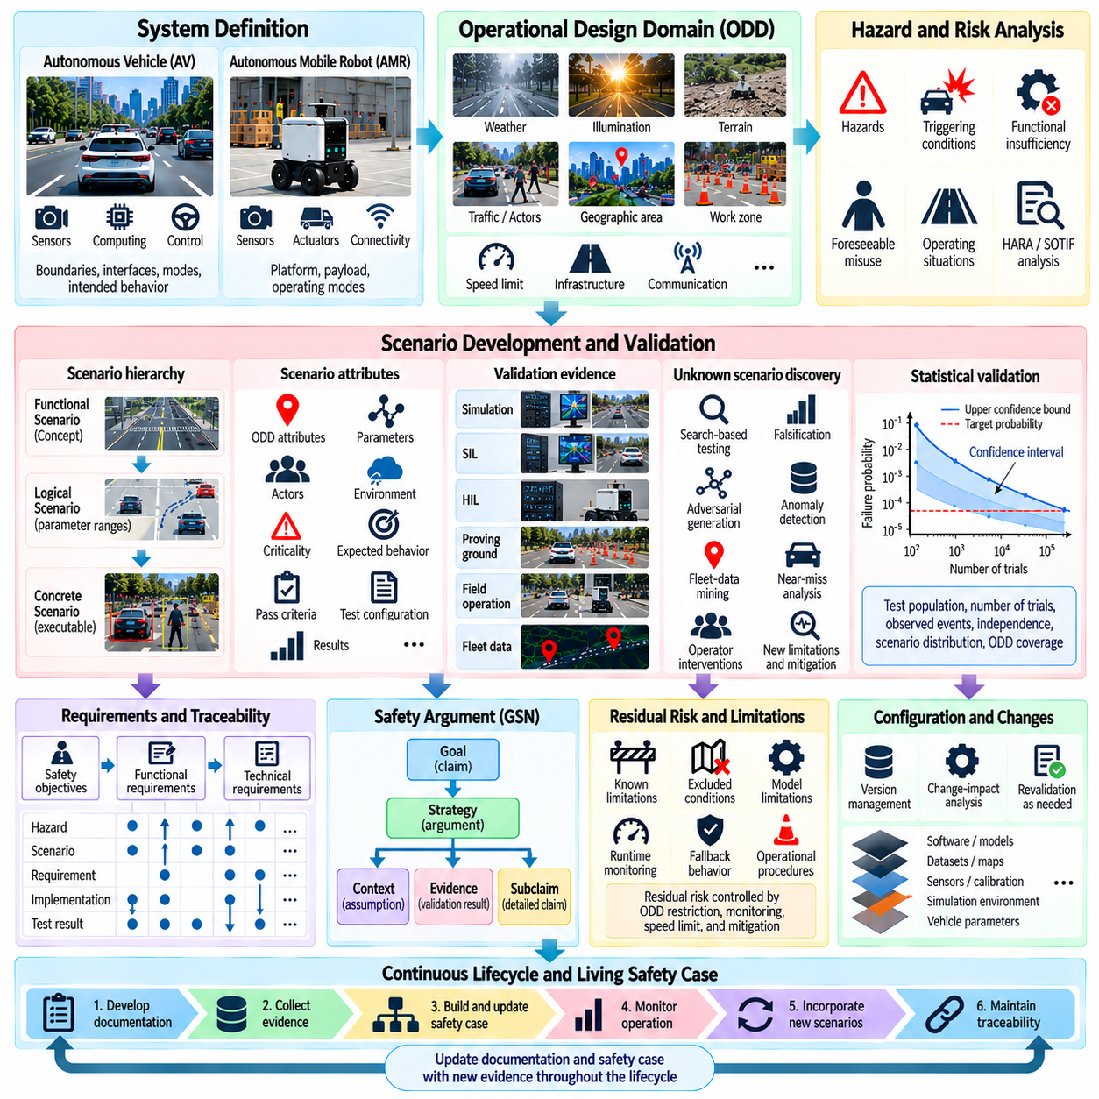
SOTIF documentation transforms safety engineering activities into structured evidence showing how risks associated with intended functionality have been identified, analyzed, mitigated, and validated. For autonomous vehicles and autonomous mobile robots, documentation should not be treated as an administrative record created after development. It should evolve with the system and maintain traceable relationships among assumptions, hazards, scenarios, requirements, verification results, operational limitations, and residual risk.
A safety case provides the structured argument explaining why the available evidence supports a claim that the system is acceptably safe for its defined application and Operational Design Domain (ODD). The safety case does not establish absolute safety or prove that every possible unsafe scenario has been eliminated. Instead, it organizes claims, arguments, assumptions, and evidence so that the reasoning behind the safety assessment can be reviewed, challenged, maintained, and updated throughout the system lifecycle.
The documentation process begins with a clear description of the system and its intended functionality. System boundaries, interfaces, operating modes, autonomy functions, sensors, computing platforms, actuators, communication dependencies, human interactions, and external infrastructure should be identified. Intended behavior must describe what the system is expected to accomplish and how it should respond when information becomes uncertain, contradictory, degraded, or outside validated operating conditions.
The ODD provides another fundamental part of the documentation baseline. Environmental conditions, geographic constraints, terrain, weather, illumination, infrastructure, traffic participants, operating speed, communication availability, and other relevant restrictions should be explicitly defined. For outdoor AMRs, payload range, slope, surface condition, pedestrian interaction, work-zone configuration, GNSS availability, and traversability constraints may also form important parts of the documented operational envelope.
Hazard analysis establishes the connection between system behavior and potential harm. Identified hazards, hazardous events, triggering conditions, functional insufficiencies, foreseeable misuse, and associated operating situations should be recorded with their underlying assumptions. HARA, SOTIF analysis, and related safety activities should remain connected so that hazards caused by conventional malfunctions can be distinguished from unsafe behavior caused by limitations of correctly functioning autonomous capabilities.
Scenario documentation converts these safety concerns into reproducible validation conditions. Functional scenarios describe situations conceptually, logical scenarios define parameter ranges and relationships, and concrete scenarios specify executable parameter values. Each safety-relevant scenario should retain information about its origin, associated hazard, ODD attributes, triggering conditions, criticality measures, expected behavior, pass criteria, test configuration, and observed result.
Unknown unsafe scenario discovery should also leave an auditable evidence trail. Search-based testing, falsification, adversarial generation, simulation exploration, anomaly detection, fleet-data mining, near-miss analysis, and operator interventions may reveal previously unknown limitations. Once such a scenario is understood, documentation should capture how it was discovered, why it was considered safety-relevant, which functional insufficiency was identified, and what mitigation was introduced.
Requirements traceability connects safety analysis to implementation. High-level safety objectives should be refined into functional and technical requirements allocated across sensing, perception, localization, prediction, planning, control, monitoring, and actuation. Bidirectional traceability is valuable because engineers should be able to move from a hazard to its requirements and validation evidence, and from an implemented safety mechanism back to the hazard or safety argument that justified its existence.
Evidence should represent multiple validation levels rather than a single test environment. Simulation can provide large-scale scenario exploration, Software-in-the-Loop (SIL) can evaluate integrated software behavior, Hardware-in-the-Loop (HIL) can expose hardware and timing effects, and proving-ground or controlled field testing can confirm selected physical behavior. Fleet operation can provide additional evidence about real-world conditions and reveal scenarios that were not sufficiently represented during development.
Simulation evidence requires explicit documentation of its validity and limitations. Simulator versions, physical models, sensor models, environmental assumptions, vehicle dynamics, latency characteristics, scenario-generation methods, random seeds, and configuration parameters may influence results. A safety case should therefore explain not only what simulation results were obtained but also why the simulation environment is considered sufficiently representative for the particular safety claim supported by those results.
Statistical validation evidence should similarly preserve its assumptions. Test population, number of trials, observed unsafe events, confidence intervals, independence assumptions, scenario distributions, ODD coverage, and sampling strategy influence the interpretation of statistical results. A large test count or narrow confidence interval should not be presented independently from scenario representativeness because statistical precision cannot compensate for systematic gaps in the tested operational space.
Safety arguments can be organized hierarchically from top-level claims toward increasingly specific subclaims and evidence. A top-level claim may state that the autonomous function achieves an acceptable level of safety within a defined ODD. Supporting arguments can address hazard mitigation, intended-behavior adequacy, scenario coverage, perception limitations, localization integrity, trajectory safety, fallback behavior, simulation validity, physical validation, and operational monitoring.
Structured argumentation methods such as Goal Structuring Notation (GSN) can help make these relationships explicit. Claims or goals are connected to strategies, contexts, assumptions, justifications, subclaims, and evidence. The value of such notation is not graphical presentation itself but disciplined reasoning: an unsupported claim, undocumented assumption, missing validation result, or incomplete logical connection becomes easier to identify when the safety argument is decomposed systematically.
Residual risk should be documented explicitly rather than hidden behind successful validation results. Known limitations, excluded operating conditions, unresolved uncertainties, assumptions about external actors, model limitations, and restrictions on deployment should remain visible. The safety case should explain how residual risks are controlled through ODD restrictions, runtime monitoring, speed limits, fallback behavior, minimal-risk conditions, operational procedures, or other mitigation mechanisms.
Configuration management is essential because autonomous systems change frequently. Perception models, datasets, maps, planners, controllers, sensor calibration, computing hardware, firmware, simulation environments, and vehicle parameters may all evolve. Safety evidence should therefore be associated with identifiable versions and configurations. A change-impact process can then determine which assumptions, scenarios, requirements, analyses, and validation activities must be revisited after a modification.
Machine-learning components introduce additional documentation requirements because behavior depends on training and validation data as well as executable software. Dataset provenance, labeling processes, coverage characteristics, known distribution gaps, model versions, evaluation conditions, uncertainty behavior, and relevant performance boundaries should be linked to system-level safety evidence. Aggregate model accuracy alone provides insufficient information for reasoning about safety across the complete ODD.
Operational monitoring extends the safety case beyond initial deployment. Emergency stops, operator interventions, localization degradation, perception uncertainty, planner rejection, near misses, unusual trajectories, and newly observed environmental conditions can provide post-deployment evidence. These observations should feed back into hazard analysis, scenario libraries, model evaluation, regression testing, and safety requirements when they reveal new limitations or invalidate previous assumptions.
A living safety case therefore changes together with the autonomous system and its operational evidence. Newly discovered corner cases can modify existing claims, new mitigations can create additional requirements, software updates can invalidate previous test results, and expansion of the ODD can require new evidence. Maintaining this relationship prevents safety documentation from becoming disconnected from the configuration that is actually deployed.
For AV and outdoor AMR systems, effective SOTIF documentation ultimately forms a continuous evidence chain from intended functionality and ODD definition through hazards, triggering conditions, requirements, scenarios, implementation, validation, residual risk, and operational feedback. Building the safety case around this traceable chain provides a disciplined mechanism for demonstrating what has been validated, what assumptions remain, where limitations exist, and how continuing evidence is used to maintain the safety argument throughout the autonomous system lifecycle.

11.09. Continuous Safety Monitoring in Production [w/Code]
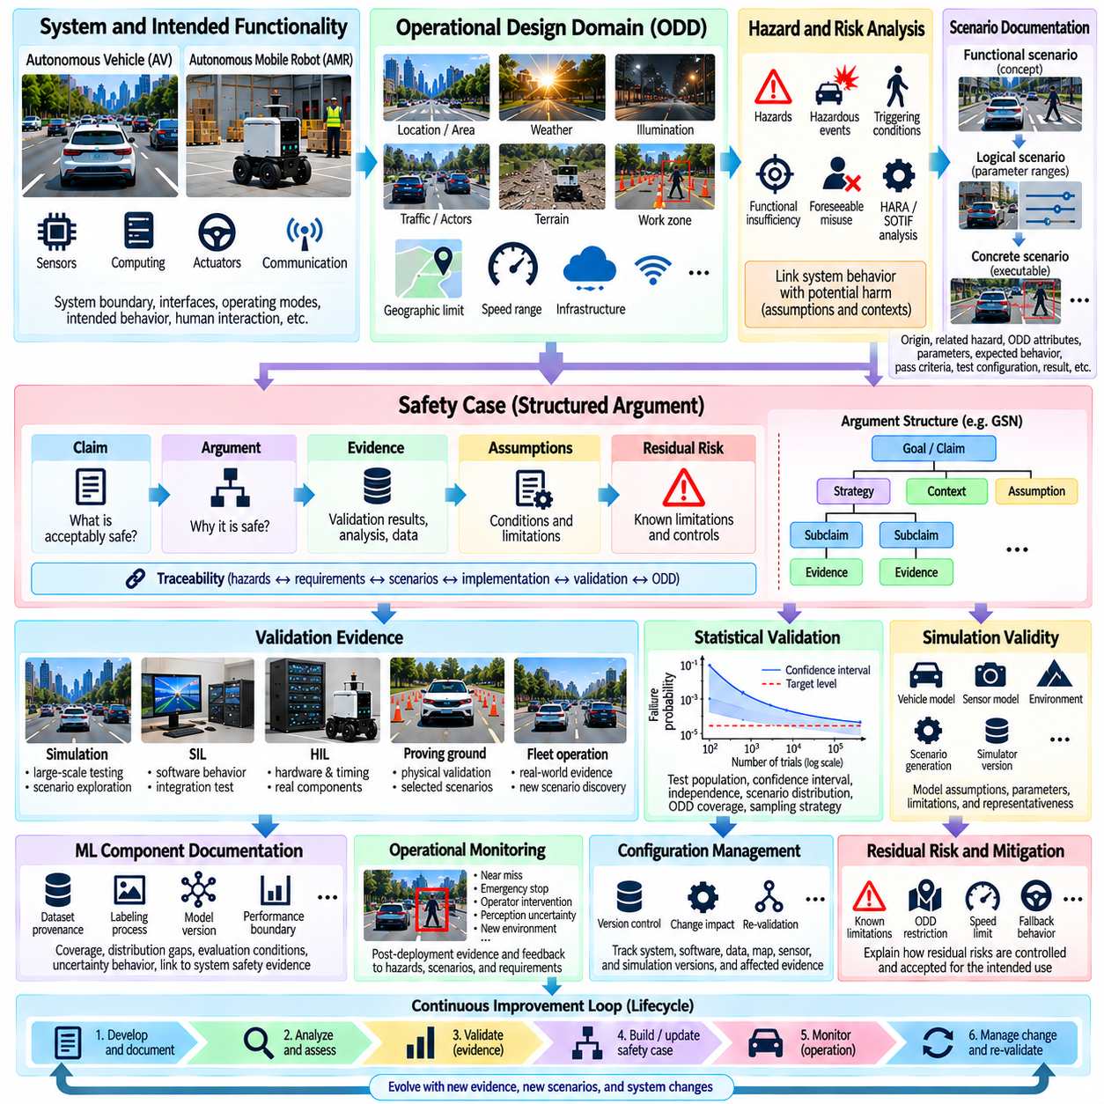
Continuous safety monitoring in production extends SOTIF activities beyond development and pre-deployment validation into real-world operation. Autonomous vehicles and autonomous mobile robots encounter environmental combinations, human behaviors, infrastructure changes, and system interactions that cannot be completely represented before deployment. Production monitoring therefore provides an ongoing source of evidence for detecting emerging hazards, functional limitations, and changes in the operational risk profile.
The monitoring architecture should observe both external operating conditions and internal system behavior. Relevant information may include sensor status, perception confidence, object tracks, localization uncertainty, prediction outputs, planned trajectories, controller errors, vehicle dynamics, safety-monitor states, communication quality, and environmental conditions. For outdoor AMRs, terrain state, wheel slip, payload condition, GNSS quality, slope, and traversability can provide additional safety-relevant signals.
Monitoring should be closely connected to the Operational Design Domain (ODD). The system needs to determine whether current operating conditions remain within validated boundaries and whether assumptions used during safety validation continue to hold. Weather, illumination, terrain, geographic area, speed, pedestrian density, infrastructure, communication availability, and localization quality may change during operation. Approaching or crossing an ODD boundary should therefore become an explicit runtime event.
Runtime safety indicators can transform continuous telemetry into interpretable evidence. Examples include minimum obstacle distance, time-to-collision, stopping margin, required deceleration, perception confidence, localization covariance, trajectory feasibility, controller tracking error, and sensor disagreement. These indicators allow the monitoring system to identify gradual degradation and safety-margin reduction before the situation develops into a collision, emergency stop, or other hazardous outcome.
Threshold-based monitoring provides a straightforward mechanism for detecting predefined abnormal conditions. A safety event can be generated when localization uncertainty exceeds a limit, sensor confidence falls below a threshold, braking margin becomes insufficient, or the robot approaches an excluded terrain condition. Thresholds should be linked to validated requirements and system capabilities rather than selected only from nominal operating statistics, because safety limits represent engineering constraints.
Not every production safety issue can be represented by predefined thresholds. Anomaly detection can identify operating patterns that differ substantially from the data used during development and validation. Unexpected sensor distributions, unfamiliar objects, unusual trajectories, abnormal combinations of environmental conditions, or atypical interactions among autonomy modules may indicate previously unexplored situations. Such anomalies should trigger investigation rather than automatically being classified as hazardous.
Near-miss monitoring is particularly valuable because it captures information before actual harm occurs. A vehicle may avoid a collision while requiring extreme braking, unusually small clearance, aggressive replanning, or last-moment intervention. Recording these events preserves evidence about conditions where safety margins became small. Repeated near misses with similar characteristics may reveal systematic functional insufficiencies even when conventional incident statistics remain low.
Operator interventions and autonomous fallback actions are also important monitoring signals. Manual takeover, remote assistance, emergency stopping, mission cancellation, degraded operating modes, and transitions to a minimal-risk condition indicate situations where nominal autonomous operation could not continue as expected. The context surrounding each intervention should be preserved so that engineers can distinguish genuine safety limitations from operational, mission-planning, or infrastructure-related issues.
Fleet-level aggregation allows patterns to emerge that may not be visible on an individual robot. Similar perception uncertainties, localization failures, planner rejections, or emergency stops occurring across multiple vehicles can indicate systematic limitations associated with a software version, sensor configuration, geographic region, weather condition, or scenario type. Fleet analytics can therefore convert isolated events into statistically and operationally meaningful safety evidence.
Production monitoring requires reliable event recording and data provenance. Safety-relevant records should preserve synchronized sensor observations, timestamps, system states, software and model versions, calibration information, maps, configuration parameters, safety-monitor outputs, and relevant operator actions. Without this context, reproducing an event may become difficult after the deployed system has been updated, and the relationship between observed behavior and a particular system configuration may be lost.
Data prioritization is necessary because continuously storing every sensor stream from an entire fleet may be impractical. Event-triggered recording can preserve detailed data around emergency stops, near misses, ODD boundary events, uncertainty spikes, planner failures, or interventions. Lower-resolution summaries can describe normal operation, while selected high-value windows retain detailed information before and after important events. This approach supports scalable fleet monitoring without losing critical diagnostic evidence.
Detected events should feed a structured triage process. Engineers can classify whether an event represents expected behavior, operational inefficiency, sensor degradation, a known limitation, a new corner case, or a potentially unsafe scenario. Safety significance can then determine the urgency of investigation and whether deployment restrictions, additional monitoring, simulation reconstruction, software correction, or immediate mitigation are required.
A production event becomes especially valuable when it can be reconstructed as a reproducible scenario. Relevant actors, environment, ODD conditions, system states, triggering events, and safety metrics can be extracted from the operational record and converted into a parameterized test case. Simulation can then replay the original situation and vary neighboring parameters to determine whether the event was isolated or belongs to a broader region of unsafe behavior.
The resulting scenario should enter the existing SOTIF validation process. Search-based simulation can explore its boundaries, Software-in-the-Loop and Hardware-in-the-Loop testing can reproduce system interactions, and selected cases can be confirmed through controlled physical testing. Once mitigation is implemented, the original scenario and representative variants should become regression tests so that future system updates do not recreate the same safety limitation.
Continuous monitoring is also necessary for detecting distribution shift. Environments can change through construction, seasonal weather, new infrastructure, different traffic patterns, vegetation growth, sensor aging, or changes in user behavior. Machine-learning components may therefore encounter data distributions that differ from those represented during training and validation. Monitoring should identify these changes and determine whether existing performance and safety assumptions remain credible.
Software and model updates create another important monitoring dimension. A new perception model, planner, controller, map, calibration, or firmware version can alter behavior even when the physical platform remains unchanged. Safety indicators should therefore be compared across identifiable configurations. Unexpected changes in intervention rate, uncertainty, trajectory behavior, or critical-event frequency can trigger change-impact analysis and targeted revalidation.
Monitoring mechanisms must themselves be designed so that they do not become uncontrolled dependencies in the safety architecture. Safety-critical runtime monitors should have clearly defined inputs, outputs, timing requirements, failure behavior, and authority over system actions. Depending on the detected condition, responses may include warning, speed reduction, increased safety distance, degraded mode, controlled stopping, mission termination, or transition to a defined minimal-risk condition.
Statistical analysis can support interpretation of production evidence, but raw event rates require context. A reduction in incidents may result from safer behavior, different ODD exposure, fewer operating hours, or changes in mission composition. Exposure measures such as operating time, distance, scenario frequency, terrain class, and environmental conditions should therefore accompany event counts. This allows trends to be interpreted relative to the actual operational population.
Production evidence should continuously update the safety case. Newly discovered scenarios may challenge existing assumptions, repeated interventions may expose insufficient validation coverage, and distribution shifts may require modification of the documented ODD. Conversely, accumulated operational evidence can strengthen claims when it is traceable to specific configurations, operating conditions, safety requirements, and validated scenario classes.
The overall process forms a closed-loop safety lifecycle connecting deployment, monitoring, detection, investigation, scenario reconstruction, validation, mitigation, regression testing, and redeployment. Production is therefore not the end of SOTIF validation but another source of safety evidence. By continuously comparing actual fleet behavior with intended behavior, validated ODD assumptions, and established safety margins, AV and AMR systems can progressively identify emerging risks and maintain a living safety case throughout operational life.

11.10. Outdoor AMR SOTIF Compliance Roadmap
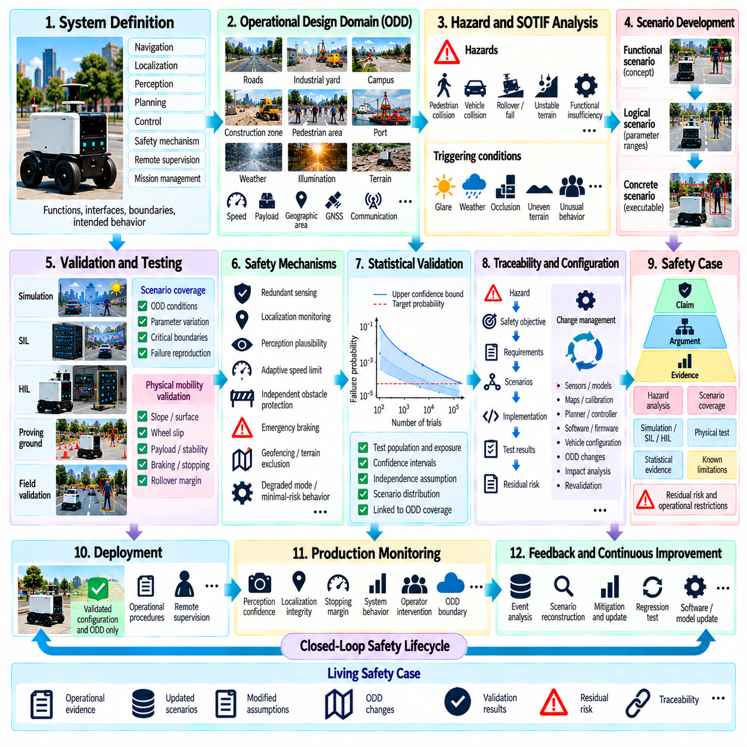
A practical SOTIF compliance roadmap for outdoor Autonomous Mobile Robots (AMRs) should translate safety principles into a lifecycle process covering system definition, hazard analysis, scenario validation, deployment, and continuous monitoring. ISO 21448 was developed primarily for road vehicles, so its application to outdoor AMRs requires engineering adaptation rather than simple procedural transfer. The central objective remains controlling hazards caused by functional insufficiencies when the system operates without a conventional malfunction.
The roadmap begins by defining the intended functionality and system boundary. Navigation, localization, obstacle detection, terrain perception, path planning, motion control, emergency behavior, remote supervision, and mission management should be described together with their interfaces and dependencies. The definition should distinguish normal autonomous functions from independent safety mechanisms so that later analysis can determine which behavior is intended, which behavior is protective, and which assumptions support safe operation.
The Operational Design Domain (ODD) provides the foundation for the entire roadmap. Outdoor AMRs may operate across paved roads, industrial yards, campuses, ports, construction zones, or mixed pedestrian environments. Terrain slope, surface condition, weather, illumination, temperature, GNSS availability, communication quality, pedestrian density, vehicle interaction, maximum speed, payload, and geographic restrictions should therefore be expressed as measurable operating conditions wherever practical.
Intended behavior should then be defined for relevant ODD conditions. The robot must have explicit expectations for obstacle avoidance, pedestrian interaction, stopping distance, speed adaptation, traversability assessment, localization integrity, route selection, and fallback behavior. Intended behavior should also specify responses to uncertainty, such as reducing speed when perception confidence deteriorates, stopping when localization integrity becomes insufficient, or rejecting terrain whose traversability cannot be established reliably.
Hazard identification connects these behaviors to possible harm. Outdoor AMR hazards can include collision with pedestrians or vehicles, unintended motion, insufficient braking, entry into unstable terrain, rollover, falling from an edge, incorrect localization, unsafe path generation, payload instability, and failure to recognize an obstacle. Analysis should consider both conventional malfunctions and situations where all components technically operate but the resulting autonomous behavior remains unsafe.
SOTIF analysis should focus particularly on functional insufficiencies and their triggering conditions. Camera glare, LiDAR degradation, GNSS multipath, partial occlusion, unfamiliar objects, poor illumination, reflective surfaces, mud, vegetation, negative obstacles, wheel slip, unusual pedestrian behavior, and changing terrain can expose limitations without producing a conventional component failure. Each limitation should be linked to operating conditions in which it can become safety-relevant.
A structured scenario framework converts these concerns into executable validation assets. Functional scenarios describe safety-relevant situations conceptually, logical scenarios define parameter ranges, and concrete scenarios provide specific values for execution. A pedestrian emerging from behind an obstacle, for example, can be expanded through robot speed, pedestrian velocity, visibility, surface friction, payload, sensor confidence, and stopping distance to create a systematic family of validation cases.
Known unsafe scenarios should first be converted into repeatable tests and associated with explicit mitigation requirements. Known safe scenarios should also be evaluated to ensure that conservative safety mechanisms do not unnecessarily prevent valid missions. The roadmap must then extend toward unknown unsafe scenarios using search-based testing, falsification, adversarial scenario generation, anomaly detection, simulation exploration, fleet-data mining, and near-miss analysis.
Simulation provides the scale required for broad SOTIF exploration. Large scenario populations can vary weather, illumination, terrain, actors, sensor degradation, localization uncertainty, friction, payload, and vehicle dynamics under controlled conditions. Search algorithms can concentrate execution near critical boundaries instead of repeatedly exercising nominal cases. Discovered failures can then be reproduced deterministically and expanded into scenario families through parameter variation and sensitivity analysis.
Simulation coverage should be measured against safety-relevant scenario space rather than accumulated virtual distance. The validation program should determine which ODD regions, triggering conditions, parameter combinations, functional boundaries, and hazard-related scenarios have been exercised. Particular attention should be directed toward limits such as sensing range, stopping margin, localization uncertainty, maximum slope, minimum clearance, terrain stability, communication degradation, and transitions between valid and invalid operating conditions.
Simulation evidence should progressively connect with the actual system through Software-in-the-Loop (SIL), Hardware-in-the-Loop (HIL), proving-ground testing, and controlled field validation. Each stage addresses different uncertainty. SIL evaluates integrated software behavior, HIL introduces computing and timing characteristics, and physical testing confirms vehicle dynamics, sensing, terrain interaction, braking, and other real-world effects that may not be represented perfectly in simulation.
Outdoor AMR validation requires special attention to physical mobility. Terrain perception and collision avoidance alone cannot guarantee safety if the robot loses traction, exceeds a stable slope, encounters a negative obstacle, or becomes unstable because of payload distribution. Validation should therefore combine autonomy metrics with physical variables such as vehicle mass, center of gravity, payload, wheel slip, braking capability, ground clearance, surface friction, suspension behavior, and rollover margin.
Safety mechanisms should be derived from identified hazards and functional limitations. Depending on the application, these may include redundant sensing, localization integrity monitoring, perception plausibility checks, adaptive speed limits, independent obstacle protection, emergency braking, geofencing, terrain exclusion, degraded operating modes, controlled stopping, and minimal-risk behavior. Each mechanism requires defined activation conditions, expected responses, interfaces, and validation evidence.
Statistical safety validation can complement scenario-based evidence by quantifying uncertainty in observed event rates. Test populations, exposure, confidence intervals, independence assumptions, and scenario distributions should be documented explicitly. Large numbers of successful tests alone are insufficient if they repeatedly cover similar operating conditions. Statistical evidence should therefore remain connected to ODD representation and scenario coverage rather than being treated as an independent proof of safety.
Traceability should connect hazards, triggering conditions, safety objectives, requirements, scenarios, implementation, test results, and residual risk. When a sensor, machine-learning model, planner, controller, vehicle configuration, payload limit, or ODD condition changes, engineers should be able to identify which safety arguments and validation activities are affected. Configuration management is therefore a fundamental part of the roadmap rather than a documentation activity performed only before release.
The safety case should organize this evidence into a reviewable argument explaining why the outdoor AMR is acceptably safe within its defined operational envelope. Claims should be supported by hazard analysis, scenario coverage, simulation evidence, SIL and HIL results, physical tests, statistical evidence, and documented limitations. Residual risks and excluded conditions should remain visible, together with the operational restrictions and runtime mechanisms used to control them.
Deployment should occur only within the validated configuration and ODD represented by the safety evidence. Runtime monitoring should observe ODD boundaries, perception confidence, localization integrity, stopping margin, controller behavior, safety-system activation, operator intervention, and other application-specific indicators. When operating conditions exceed validated assumptions, the robot should transition according to predefined behavior such as speed reduction, degraded mode, controlled stopping, or mission termination.
Fleet operation then becomes part of the validation process. Emergency stops, near misses, operator interventions, localization degradation, planner rejection, sensor disagreement, unusual terrain interactions, and newly encountered environments should be recorded and analyzed. Safety-relevant events can be reconstructed as scenarios, reproduced in simulation, expanded around neighboring parameters, and added to regression testing after appropriate mitigation has been implemented.
Software and machine-learning updates require change-impact assessment before deployment. New perception models, training datasets, maps, calibration parameters, planners, controllers, firmware, or hardware configurations may invalidate portions of previous evidence. The roadmap should therefore define which changes require targeted regression testing, broader scenario revalidation, physical confirmation, or revision of the safety case and ODD assumptions.
The resulting process should operate as a closed lifecycle rather than a linear certification project. Intended functionality and ODD definition lead to hazard and SOTIF analysis, scenario generation, simulation, SIL/HIL testing, physical validation, safety-case construction, controlled deployment, production monitoring, and operational feedback. Newly discovered limitations return to the analysis and validation stages, continuously expanding the body of safety evidence.
For outdoor AMRs, SOTIF compliance should therefore be approached as an evidence-driven engineering roadmap rather than a checklist. The strongest framework combines explicit ODD boundaries, intended behavior, functional insufficiency analysis, scenario coverage, simulation, physical validation, runtime monitoring, configuration control, traceability, and a living safety case. This creates a practical pathway for progressively demonstrating and maintaining safe autonomous operation as the robot, software, environment, and mission evolve.

