Volume 13. Mapping Localization and SLAM

Chapter 10. Long Term Map Management

10.01. Long Term Map Challenges Dynamic Changes Drift
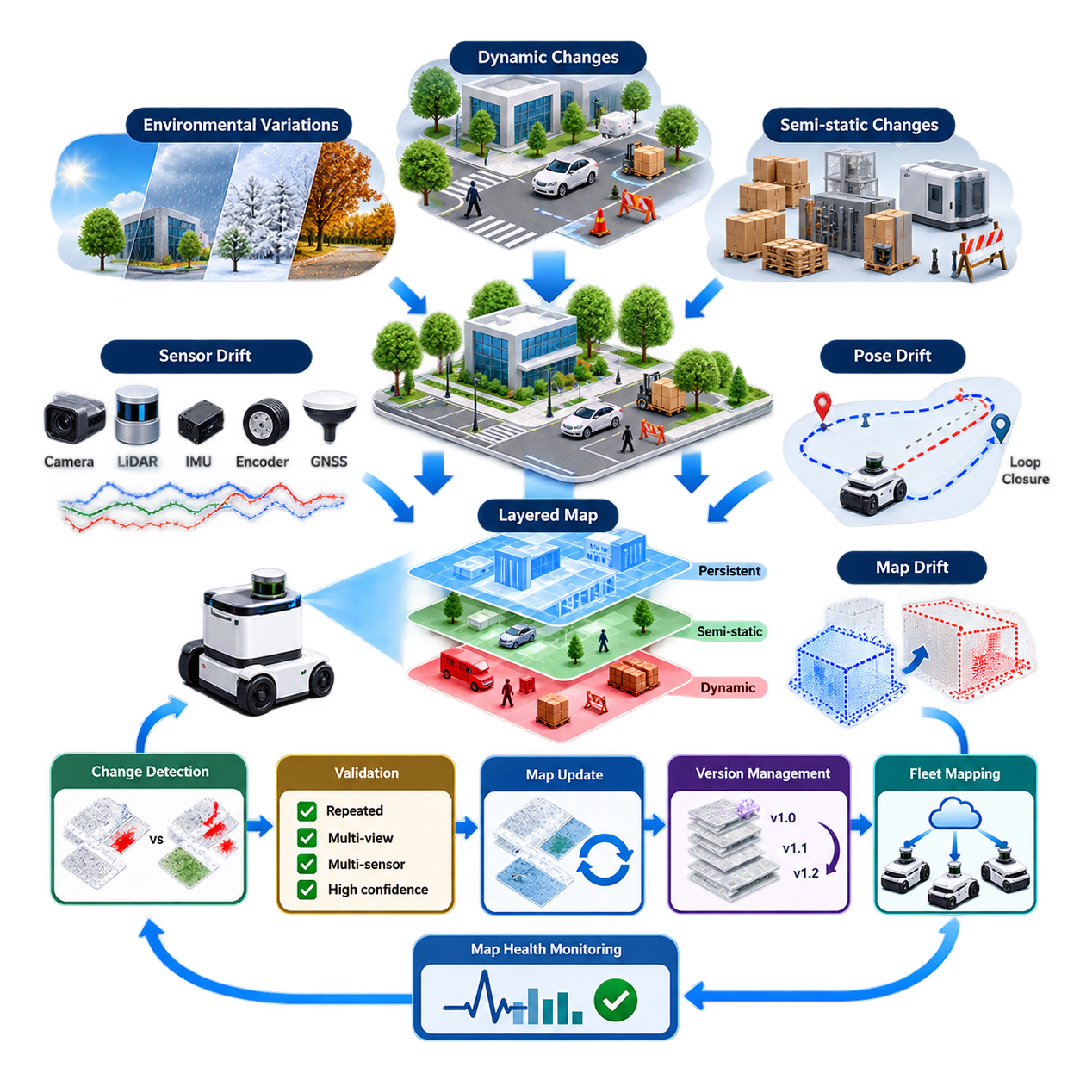
Long-term map management addresses the problem of maintaining a reliable spatial representation when a robot operates in the same environment for weeks, months, or years. A map created during initial deployment is only a snapshot of the world at that moment. Buildings, factories, warehouses, campuses, and outdoor areas continuously change, so the mapping system must distinguish persistent structure from temporary observations.
A fundamental difficulty is that environmental change occurs at several temporal scales. People, vehicles, doors, carts, and movable equipment may change within seconds or minutes, while shelves, workstations, vegetation, road markings, and construction zones may evolve over days or months. A long-term mapping system must therefore reason not only about where an object or feature exists, but also about how stable that observation is over time.
Dynamic objects create immediate inconsistencies between live sensor measurements and the stored map. A LiDAR scan may contain a parked vehicle that was absent during mapping, while a camera may observe pallets or machinery occupying previously free space. If these observations are incorporated without filtering, temporary objects gradually contaminate the persistent map and can degrade localization, path planning, and obstacle interpretation.
Semi-static changes are more difficult because they cannot easily be classified as either permanent or temporary. A pallet may remain in one position for several weeks, a production machine may be relocated for a month, or a construction barrier may exist throughout a project phase. Long-term mapping therefore benefits from temporal persistence models that estimate whether observed structures should become part of the stable map or remain in a temporary layer.
Outdoor environments introduce additional long-term variability through weather, illumination, vegetation, and seasonal conditions. Rain, snow, fog, fallen leaves, shadows, and changing sunlight can significantly modify sensor observations without changing the underlying geometry. Vegetation may physically change its shape, while snow can alter the apparent ground surface. Robust mapping must separate environmental appearance variation from genuine structural modification.
Sensor drift is another major source of long-term map degradation. Small calibration errors in cameras, LiDARs, IMUs, wheel encoders, or GNSS systems can accumulate through repeated operation. Even when each individual error is small, systematic bias can gradually distort estimated trajectories and map geometry. Long-term systems therefore require continuous monitoring of sensor calibration, localization residuals, and consistency between independent sensing modalities.
Pose drift occurs when localization errors accumulate as the robot moves through environments with weak or repetitive features. Long corridors, large warehouses, tunnels, parking facilities, and open outdoor spaces can provide insufficient constraints for reliable pose estimation. Loop closure can correct accumulated error, but incorrect loop closures may introduce severe global deformation. Long-term operation therefore requires both drift correction and validation of the corrections themselves.
Map drift can also emerge through repeated incremental updates. If every new observation is accepted as slightly more accurate than the previous representation, small localization errors can become embedded in the map. Subsequent localization then uses this distorted map as a reference, producing a feedback process in which localization error and map error reinforce each other. Stable reference features must therefore be protected from uncontrolled modification.
A practical architecture separates information according to temporal stability. A persistent layer can contain walls, columns, fixed infrastructure, curbs, and other highly stable geometry, while a dynamic or transient layer represents vehicles, people, movable equipment, and temporary obstacles. Intermediate layers can represent semi-static structures. This layered representation prevents short-lived environmental changes from unnecessarily rewriting the long-term spatial reference.
Change detection becomes a central function rather than a secondary mapping operation. Current sensor observations are compared with expected observations derived from the stored map, and persistent discrepancies are accumulated across repeated traversals. A single mismatch should rarely trigger a permanent update. Confidence should increase only when the same change is observed repeatedly, from different viewpoints, sensors, or robot missions.
Map maintenance must also preserve localization continuity during updates. Replacing an entire map whenever the environment changes can invalidate coordinates used by navigation routes, mission definitions, charging stations, inspection points, and fleet-management systems. Incremental map evolution is therefore preferable when possible. Stable coordinate frames and persistent landmarks should remain fixed while modified regions are updated with controlled spatial and temporal boundaries.
Multi-robot fleets make long-term map management more powerful but also more complex. Different robots may observe the same area at different times, viewpoints, sensor configurations, and localization accuracies. Their observations can provide strong evidence for environmental change, but inconsistent data can also corrupt a shared map. Fleet mapping therefore requires observation provenance, confidence estimation, spatial alignment, and rules governing which updates are accepted.
A shared map should not be treated as an unrestricted database into which every robot writes directly. A safer architecture allows robots to submit candidate changes while a map-management process evaluates their consistency against historical observations and other robots. Updates can then be promoted from provisional information to validated map content. This approach separates operational perception from authoritative map modification.
Version management is essential because map updates can affect robot behavior in unexpected ways. Each production map should have an identifiable version, creation history, validation status, and relationship to previous versions. If a newly updated map causes localization instability or navigation failures, the fleet must be able to return to a known-good version. Map evolution should therefore resemble controlled software configuration management rather than uncontrolled data accumulation.
Long-term localization should also evaluate map health continuously. Useful indicators include localization covariance, scan-matching residuals, feature correspondence rates, GNSS disagreement, loop-closure consistency, and the percentage of observations that conflict with the reference map. Trends are often more informative than isolated values. Gradual deterioration across many missions may reveal calibration drift or environmental change before localization fails completely.
Not every detected change requires modification of the localization map. Some changes matter primarily to navigation, semantics, or mission planning. For example, a newly installed temporary barrier may belong in an operational obstacle layer while the underlying geometric localization map remains unchanged. Separating localization, navigation, semantic, and operational representations reduces unnecessary coupling and makes long-term maintenance more robust.
The central objective is therefore not to keep a map permanently identical to the physical world at every instant. Instead, the system must maintain a trustworthy spatial reference while allowing controlled adaptation to meaningful environmental change. Effective long-term map management combines temporal reasoning, change detection, drift monitoring, layered maps, validation, version control, and rollback so that autonomous robots can remain reliable throughout extended deployment.

10.02. Map Change Detection from Scan to Map Diff [w/Code]
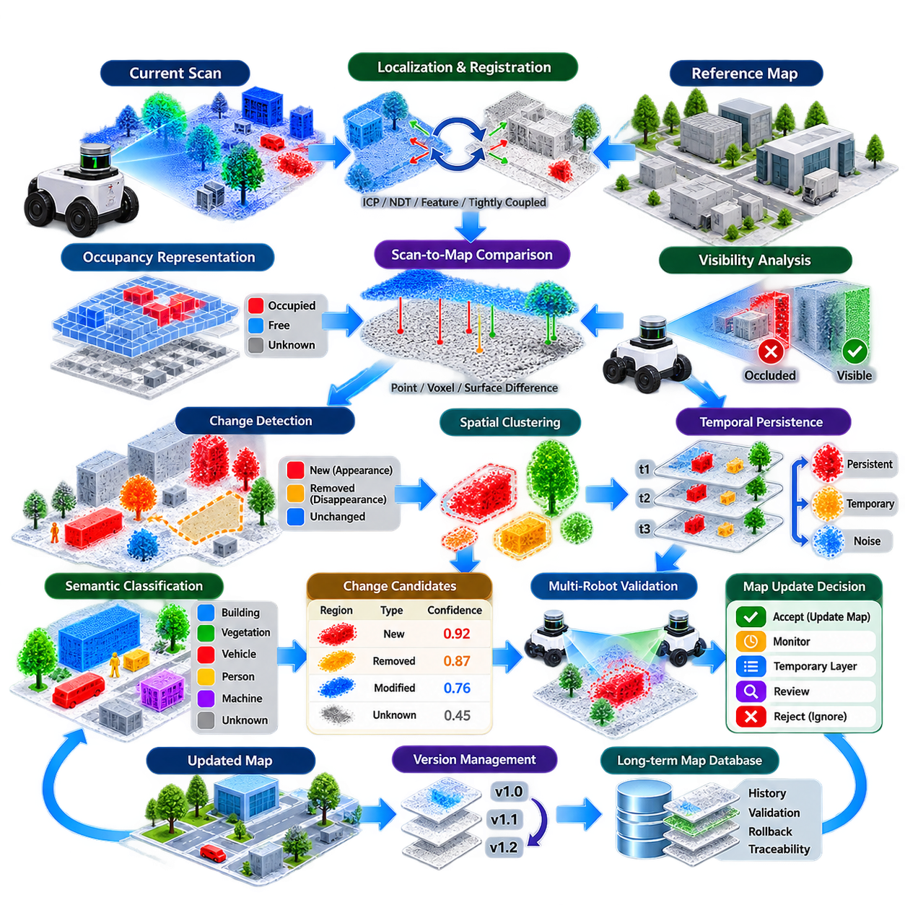
Map change detection is the process of identifying meaningful differences between a previously established reference map and observations collected during current robot operation. In long-term autonomous systems, the reference map cannot be assumed to remain perfectly consistent with the physical environment. Scan-to-map differencing provides a systematic mechanism for detecting where, how, and potentially why the environment has changed.
The basic pipeline begins with a current sensor scan and a reference map representing previously validated geometry. The scan may originate from a 2D or 3D LiDAR, depth camera, stereo system, or fused perception pipeline. Before differences can be evaluated, the new observation must be transformed into the same coordinate frame as the reference map. Accurate localization is therefore a prerequisite for reliable change detection.
Registration quality directly determines the credibility of a scan-to-map difference. Even a small translation or rotation error can make unchanged walls, columns, curbs, and equipment appear to have moved. The system should therefore estimate registration uncertainty and reject or down-weight comparisons made under poor localization conditions. ICP, NDT, feature-based registration, or tightly coupled localization can provide the geometric alignment required for comparison.
After alignment, the current scan and reference map can be compared at the geometric level. For each observed point, voxel, grid cell, or surface element, the system evaluates whether corresponding geometry exists within an acceptable spatial tolerance. Small residual differences are normally treated as sensor noise or registration uncertainty, while larger and spatially coherent discrepancies become candidates for environmental change.
A scan-to-map difference should distinguish between newly appearing and disappearing structures. An appearance event occurs when the current scan contains persistent geometry that does not exist in the reference map, such as a newly installed machine, wall, barrier, or storage rack. A disappearance event occurs when expected reference geometry is repeatedly absent, indicating that equipment, structures, or other mapped elements may have been removed.
Occupancy-based representations provide a convenient framework for this comparison. The environment can be divided into grid cells or three-dimensional voxels containing free, occupied, unknown, and potentially probabilistic states. Current observations update evidence for these states, while differences from the reference occupancy map reveal candidate changes. Probabilistic occupancy prevents a single noisy measurement from immediately becoming a permanent structural modification.
Ray-based reasoning is particularly important when detecting disappearance. Failure to observe a mapped surface does not necessarily mean that the surface has disappeared because another object may be occluding it or the sensor may not have sufficient visibility. A stronger disappearance hypothesis is obtained when sensor rays repeatedly pass through a region that the reference map classifies as occupied without encountering the expected surface.
Visibility analysis therefore reduces false change detections. Before declaring a difference, the system can determine whether the reference structure should actually have been observable from the robot's current viewpoint. Sensor field of view, maximum range, incidence angle, occlusion, reflective properties, and environmental conditions can all affect observability. Only sufficiently visible regions should contribute strong evidence to structural change decisions.
Change detection also requires spatial clustering because individual point differences are rarely meaningful. Residual points can be grouped into connected components, voxel clusters, surface patches, or object-level regions. Cluster size, density, geometry, persistence, and semantic information help distinguish real structural changes from isolated sensor noise. This converts millions of raw point comparisons into a manageable set of candidate change regions.
Temporal persistence is one of the strongest indicators of genuine map change. A discrepancy detected during a single traversal may result from a pedestrian, vehicle, pallet, rain, dust, or localization error. If the same discrepancy is observed during many missions and from multiple viewpoints, confidence increases substantially. Long-term systems should therefore accumulate change evidence rather than immediately rewriting the map after each scan.
Multi-session comparison extends scan-to-map differencing beyond a simple current-versus-reference decision. Observations from different days or missions can form a temporal history for each region of the map. A structure continuously observed for months can receive high persistence confidence, while rapidly changing areas can be classified as unstable. This temporal representation helps separate permanent infrastructure from dynamic and semi-static content.
Semantic information can improve geometric change interpretation. A geometric difference classified as a person or moving vehicle should normally remain outside the persistent map, whereas a newly detected wall, machine, charging station, or fixed cabinet may represent a legitimate structural update. Combining geometry with semantic segmentation or object recognition therefore allows the system to assign different update policies to different categories of change.
However, semantic classification should not replace geometric evidence. Recognition systems can fail because of lighting, viewpoint, partial occlusion, or unfamiliar objects. A robust system uses semantics as additional evidence while retaining geometric consistency, temporal persistence, and observation confidence as primary criteria. This prevents an incorrect object label from automatically causing an inappropriate modification of the authoritative map.
Threshold selection strongly influences detection performance. A very small distance threshold makes the system sensitive to calibration errors, sensor noise, surface roughness, and localization uncertainty. An excessively large threshold can hide meaningful changes. Adaptive thresholds are often preferable because acceptable geometric deviation can depend on sensor range, incidence angle, map resolution, localization covariance, and the characteristics of the mapped surface.
The output of change detection should therefore contain more than a binary changed-or-unchanged flag. Each candidate region can carry its location, spatial extent, change type, confidence, observation count, timestamps, sensor source, localization quality, and persistence history. Such metadata allows downstream map-management systems to determine whether the change should be ignored, monitored, temporarily represented, reviewed, or promoted into the reference map.
For robot fleets, observations from multiple platforms provide independent evidence. If several robots detect the same structural difference at different times and viewpoints, the probability of a genuine environmental change becomes much higher. Conversely, a discrepancy reported by only one robot may indicate sensor miscalibration or localization failure. Cross-robot validation therefore transforms fleet operation into a distributed mechanism for maintaining map reliability.
Map updates should remain separate from change detection itself. The detector identifies and characterizes discrepancies, while a controlled map-management process decides whether those discrepancies modify the authoritative map. This separation prevents transient observations from directly corrupting production maps and supports validation, approval, versioning, rollback, and traceability throughout the operational life of the robotic system.
In production AMR and autonomous robot systems, scan-to-map difference analysis can operate continuously in the background while normal localization and navigation continue. Detected changes can be accumulated into regional confidence maps and evaluated during scheduled maintenance or automatically under defined policies. The objective is not maximum sensitivity, but reliable identification of changes significant enough to affect localization, navigation, safety, or mission execution.
Ultimately, scan-to-map change detection converts a static mapping system into an environment-aware long-term mapping process. Accurate registration establishes a common reference, geometric differencing identifies discrepancies, visibility reasoning rejects invalid comparisons, temporal and multi-robot evidence determines persistence, and controlled validation decides what becomes permanent. Together, these mechanisms allow autonomous robots to recognize environmental evolution without sacrificing the stability of their spatial reference.

10.03. Incremental Map Update Adding Removing Obstacles [w/Code]
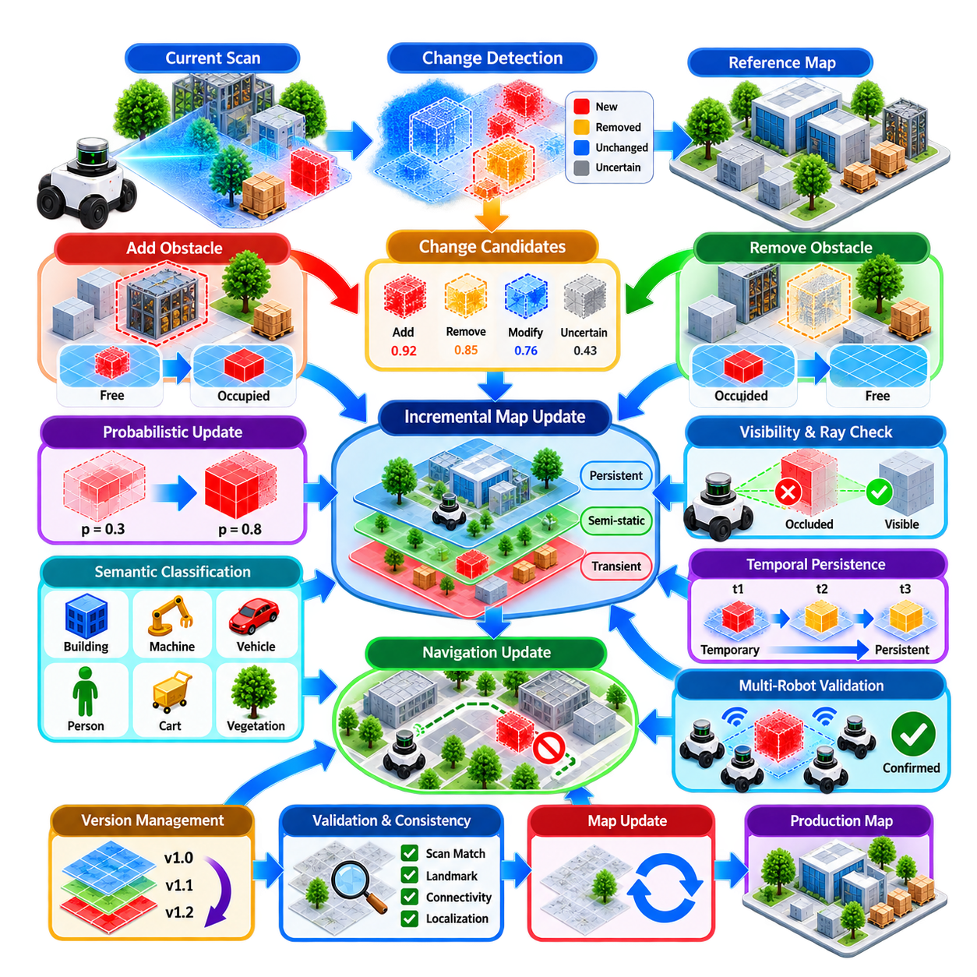
Incremental map update is the controlled process of modifying only the portions of a map that have changed while preserving the stable spatial structure already validated during previous operations. Unlike complete remapping, incremental updating avoids rebuilding the entire environment whenever an obstacle appears, disappears, or moves. This is essential for robots operating continuously in factories, warehouses, campuses, and outdoor facilities.
The process normally begins after a map change detection system has identified a candidate difference between current sensor observations and the reference map. The update module should not directly interpret every new measurement as a map modification. Instead, it receives validated change candidates containing spatial location, change type, confidence, observation history, and localization quality, allowing map modification to remain separated from raw perception.
Obstacle addition occurs when a previously free or unknown region becomes persistently occupied. Examples include newly installed machinery, storage racks, safety barriers, walls, charging stations, containers, or other structures. Before inserting the new geometry into the persistent map, the system should verify that the observation is spatially consistent across multiple scans and is unlikely to represent a temporary vehicle, person, pallet, or other dynamic object.
Obstacle removal requires a different reasoning process because absence is more difficult to verify than presence. A mapped object may simply be hidden by another structure or outside the effective sensing range. Removal should therefore be supported by repeated free-space observations, visibility analysis, and ray traversal through the previously occupied region. Only after sufficient evidence has accumulated should the corresponding map cells, voxels, or surfaces be cleared.
The map representation determines how additions and removals are implemented. In a two-dimensional occupancy grid, updates modify the occupancy probability of individual cells. Three-dimensional systems may update voxels, surfels, point-cloud regions, meshes, or signed-distance fields. Regardless of representation, modifications should preserve spatial consistency with neighboring geometry and avoid producing isolated artifacts caused by sparse or noisy observations.
Probabilistic updating provides a useful mechanism for gradual map modification. Instead of changing a cell immediately from free to occupied or occupied to free, each new observation contributes evidence to an accumulated probability. Repeated observations progressively strengthen the new state, while contradictory measurements reduce confidence. This approach creates hysteresis that prevents unstable environments from causing rapid oscillation between competing map states.
Temporal persistence can further regulate the transition between map layers. A newly detected obstacle may initially enter a transient layer, then move to a semi-static layer if it remains present across multiple missions. Only after satisfying stronger persistence and confidence requirements should it be promoted into the persistent map. The reverse process can be applied when a previously stable object begins to disappear consistently from repeated observations.
Spatially bounded updates are preferable to broad map reconstruction. Once a changed region has been identified, the system can define a local update window around the affected geometry and modify only that area. Neighboring stable landmarks remain unchanged and continue to constrain localization. This localized strategy reduces computation, limits the propagation of errors, and preserves compatibility with previously defined routes and mission coordinates.
Coordinate-frame stability is particularly important during incremental updates. Map modification should not unintentionally shift the global origin, rotate the reference frame, or move established landmarks. If the coordinate system changes after every local correction, navigation goals and mission definitions become unreliable. Stable anchors such as surveyed points, fixed infrastructure, GNSS references, or highly persistent landmarks can protect the global map frame.
An update must also account for localization uncertainty. When robot pose covariance is high, the apparent location of a newly observed obstacle may be inaccurate. Writing such geometry directly into the map can create duplicated walls, thickened surfaces, or displaced structures. Update confidence should therefore depend partly on pose quality, and observations collected during localization degradation can be retained as candidates until stronger measurements become available.
Semantic classification provides another mechanism for deciding how map elements should evolve. A detected wall or permanently mounted machine may qualify for persistent-map insertion, while a person, forklift, cart, or parked vehicle should normally remain in dynamic or operational layers. Semantic information does not replace geometric validation, but it helps determine appropriate persistence thresholds and update policies for different categories of objects.
Adding and removing obstacles also affects navigation representations. A structural map used for localization may not need to change every time a temporary obstacle blocks a route. Instead, local and global costmaps can represent short-term occupancy while the persistent localization map remains stable. When a blockage becomes sufficiently permanent, the navigation map and eventually the structural map can be updated according to separate policies.
Incremental map updates must preserve topological connectivity as well as geometry. Removing an obstacle may open a new corridor or passage, while adding a wall or machine may eliminate a previously valid route. The navigation graph should therefore be reevaluated after significant changes. Connectivity, clearance, robot footprint, turning radius, one-way constraints, and safety zones may need to be recalculated around the modified region.
Safety-critical regions require more conservative update policies. Changes near charging docks, elevators, narrow passages, pedestrian crossings, doors, hazardous equipment, or emergency routes can directly affect robot safety. Such regions may require stronger confidence, additional observations, cross-robot verification, or human approval before permanent modification. Incremental automation should therefore support region-specific update policies rather than applying one global threshold.
Multi-robot fleets can accelerate incremental map maintenance by collecting independent observations of the same change. If several robots repeatedly detect a newly installed obstacle from different directions, confidence in the addition increases rapidly. Similarly, repeated free-space observations from multiple robots strengthen evidence for removal. Fleet-based validation also reduces the probability that a single robot's calibration or localization error will corrupt the shared map.
Concurrent updates introduce another challenge when several robots report changes to overlapping regions. A map server must prevent conflicting modifications from being committed simultaneously without validation. Candidate updates can be timestamped, spatially indexed, and merged according to confidence and consistency. Transaction-like mechanisms or controlled map commits can ensure that the authoritative map remains coherent even when observations arrive asynchronously.
Every accepted modification should generate a traceable update record. The record can include the changed region, previous state, new state, contributing observations, confidence, robot identifiers, timestamps, and validation method. This information enables operators to understand why the map changed and supports debugging when unexpected localization or navigation behavior occurs after an update.
Version control provides protection against incorrect incremental updates. Rather than continuously overwriting a single map with no history, the system can maintain map revisions or regional snapshots. If an accepted obstacle addition later proves temporary, or a removal was caused by sensor failure, the affected region can be restored from an earlier validated version. Rollback therefore becomes an important component of autonomous map maintenance.
Map consistency should be checked after each significant update. The system can evaluate scan-matching residuals, landmark alignment, occupancy conflicts, navigation connectivity, and localization performance before promoting the new revision to production use. A geometrically plausible update may still degrade localization if it removes distinctive features or introduces ambiguous structures, so operational validation is as important as geometric correctness.
Production systems benefit from separating candidate, staging, and production maps. Candidate changes accumulate from robot observations, a staging map incorporates sufficiently confident updates for testing, and the production map remains the authoritative reference used by the fleet. After validation, approved changes are promoted into production. This workflow reduces the risk associated with continuous autonomous modification of mission-critical spatial data.
Incremental map updating ultimately allows a robot system to adapt without losing the stability accumulated through previous mapping and validation. Persistent additions are incorporated, confirmed removals are cleared, uncertain changes remain temporary, and stable regions are protected from unnecessary rewriting. Combined with confidence estimation, semantic reasoning, versioning, fleet validation, and rollback, this approach enables maps to evolve safely with the physical environment.

10.04. Semantic Layer Management Labels Zones POI [w/Code]
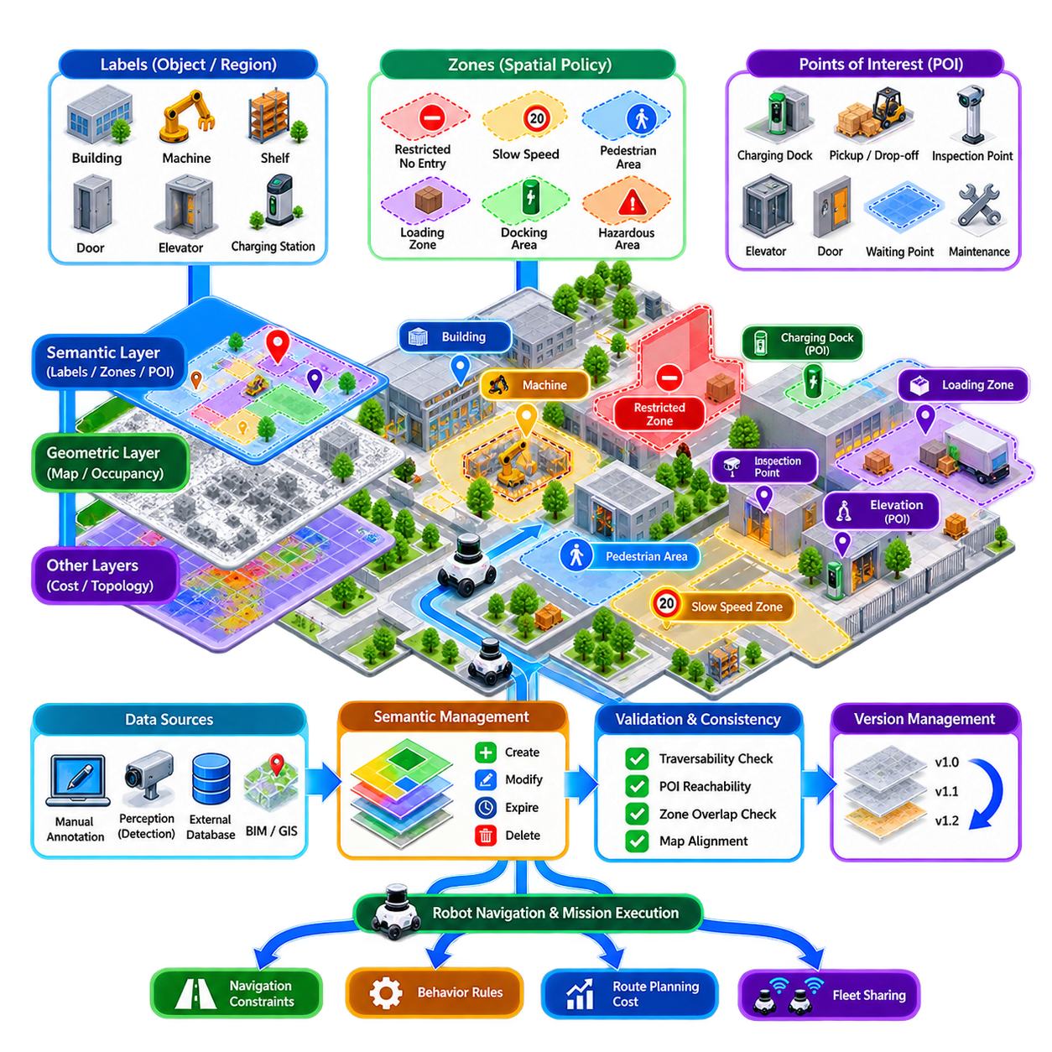
Semantic layer management extends a geometric robot map by attaching meaning to locations, objects, regions, and operational features. Geometry tells the robot where surfaces and free space exist, while semantics describe what those elements represent and how the robot should interact with them. Labels, zones, and points of interest transform a localization map into an operational representation that can support navigation, planning, missions, and fleet coordination.
A semantic layer should remain logically separated from the underlying geometric map. Walls, occupied cells, point clouds, meshes, or landmarks may change according to mapping algorithms, while semantic information follows operational rules defined by applications and users. This separation prevents geometric reconstruction from unintentionally deleting mission information and allows semantic data to evolve without repeatedly rebuilding the localization map.
Labels provide the simplest mechanism for assigning meaning to mapped entities. A region can be identified as a corridor, warehouse aisle, production cell, loading area, office, parking space, or outdoor road segment. Objects can similarly receive labels such as door, elevator, charging station, machine, shelf, gate, fire extinguisher, or inspection target. These labels allow planning systems to reason beyond raw coordinates and occupancy values.
Semantic labels can exist at several levels of abstraction. A point may identify a specific docking connector, while a polygon represents an entire charging area. A room can belong to a larger production zone, which itself belongs to a building or site. Hierarchical semantics allow robots and fleet-management systems to interpret locations according to mission context rather than relying on a single flat collection of names.
Zones represent spatial regions associated with specific operational properties. Common examples include restricted zones, slow-speed zones, pedestrian areas, loading zones, docking areas, inspection regions, hazardous spaces, clean areas, and robot-only corridors. A zone can be represented as a polygon, volume, or collection of map cells and can carry rules that automatically modify robot behavior when the robot enters or approaches it.
A speed-control zone may reduce the robot's permitted velocity near pedestrians or sensitive equipment, while a restricted zone can prevent entry unless a mission has appropriate authorization. Hazardous areas may require additional sensing, warning signals, or specific safety states. Semantic zones therefore act as spatial policies, connecting map coordinates directly to navigation constraints and operational behavior.
Points of interest, commonly represented as POIs, define locations that have specific mission significance. Examples include charging docks, pickup and drop-off stations, inspection points, elevators, doors, waiting positions, maintenance areas, loading bays, and emergency locations. Unlike arbitrary navigation goals, a POI can contain both a pose and contextual information describing how the robot should approach and use that location.
A POI should generally include position, orientation, identifier, semantic type, and reference coordinate frame. Additional metadata can describe approach direction, allowable robot classes, docking parameters, required accuracy, preferred path, safety clearance, or associated equipment. This converts a simple coordinate into a reusable operational object that mission planners can reference consistently across many robot tasks.
Orientation is particularly important for POIs associated with physical interaction. A robot arriving at a charging dock, conveyor, elevator, inspection station, or loading interface often requires a precise final heading rather than merely reaching a position. Approach poses and staging poses can therefore be associated with the primary POI to guide the robot through a controlled sequence before final alignment.
Semantic regions can also influence route planning costs without completely prohibiting traversal. A pedestrian area may remain traversable but receive a higher planning cost, encouraging robots to select alternative routes when available. Similarly, rough terrain, ramps, narrow passages, wet surfaces, or high-traffic regions can carry cost modifiers. Semantic information thus supplements geometric traversability with operational preference.
The semantic layer should support robot-specific interpretation because different platforms may interact differently with the same environment. A narrow corridor may be accessible to a small AMR but prohibited for a large transport robot. A slope may be acceptable for a wheeled platform but unsuitable for another vehicle configuration. Semantic attributes can therefore include robot class, dimensions, payload state, mobility type, or mission-specific restrictions.
Outdoor autonomous robots require additional semantic categories. Roads, sidewalks, crossings, curbs, grass, gravel, slopes, drainage channels, construction areas, parking zones, GNSS-degraded regions, and communication shadow zones can all influence autonomous behavior. Combining these semantic regions with geometric terrain maps enables planning systems to distinguish between physically traversable space and operationally appropriate routes.
Semantic information may originate from manual annotation, perception algorithms, external databases, or infrastructure systems. Operators can define safety zones and mission POIs, while cameras and LiDAR perception may automatically identify doors, road markings, machines, or parking areas. Building information models, facility databases, GIS data, and digital twins can provide additional semantics that would be inefficient for robots to rediscover independently.
Automatically generated semantics require confidence management. An object classifier may incorrectly identify equipment, or a temporary object may be interpreted as permanent infrastructure. Each automatically generated semantic element can therefore contain confidence, observation source, timestamp, and validation status. High-impact labels such as hazardous, restricted, or emergency regions should generally require stronger verification than descriptive labels.
Semantic data also changes over time. A production area may be reassigned, a charging station may move, a temporary construction zone may appear, or a corridor may become restricted during certain hours. Semantic elements should therefore support creation, modification, expiration, and deletion without requiring geometric remapping. Time-dependent attributes can represent temporary or scheduled operational rules.
Version management is important because semantic modifications can directly alter robot behavior. Moving a POI by one meter, changing a zone boundary, or modifying an access rule may affect navigation and mission execution even when the geometric map remains unchanged. Semantic map versions should therefore record who or what created each change, when it occurred, what was modified, and which robot fleet or mission configuration uses it.
Consistency between geometry and semantics must be checked after map updates. If a wall moves or a corridor disappears, a previously valid POI may become unreachable or a semantic zone may overlap newly occupied space. Automated validation can test whether POIs remain in traversable regions, approach paths remain valid, and zone boundaries correspond to the latest geometric map. Invalid semantic elements can then be flagged for review.
Multi-robot systems benefit strongly from centralized semantic management. Instead of each robot independently storing names, zones, and mission locations, a shared semantic map can provide a common operational vocabulary for the fleet. A command such as “inspect Machine A,” “go to Loading Bay 3,” or “avoid Pedestrian Zone B” can then be translated consistently into spatial constraints and navigation goals for different robots.
However, centralized semantics should not eliminate local autonomy. Robots still require local perception and safety systems capable of responding to unexpected obstacles or temporary hazards that are absent from the shared semantic map. The semantic layer provides contextual knowledge and operational policy, while real-time perception determines immediate environmental conditions. Both layers must cooperate without allowing stale semantic information to override current safety observations.
A robust semantic architecture therefore combines geometric maps, labels, zones, POIs, operational rules, temporal metadata, confidence, and version control while maintaining clear interfaces between them. Geometry provides the spatial foundation, semantics provide meaning, and mission logic determines behavior. This layered organization allows autonomous robots to understand not only where they are, but what surrounding places represent and how they should behave within them.
In long-term map management, semantic layers become the bridge between mapping and real-world operations. They preserve mission knowledge while geometry evolves, allow operational policies to be expressed spatially, and provide stable references for fleet-level coordination. Properly managed labels, zones, and POIs transform a map from a passive representation of space into an active operational model that supports reliable autonomous behavior.

10.05. Map Versioning and Rollback for AMR Fleets [w/Code]
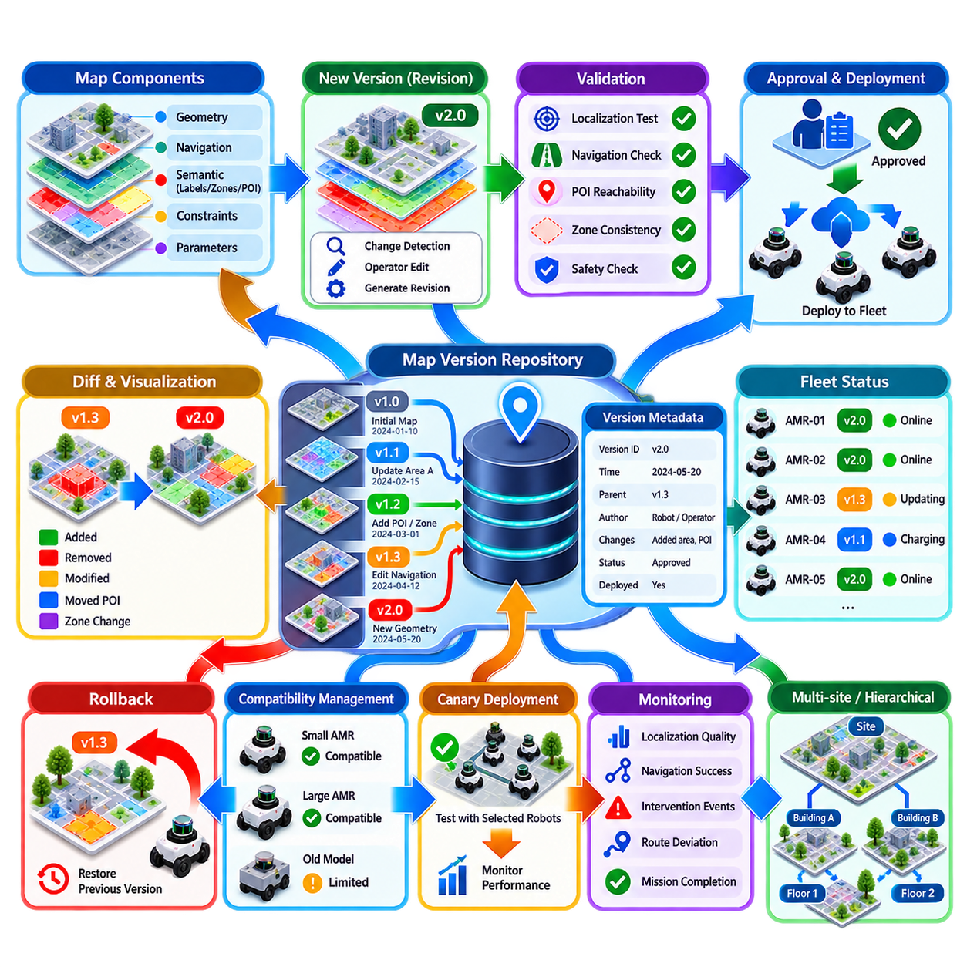
Map versioning provides a controlled method for managing the evolution of spatial information used by autonomous mobile robot fleets. A production map is not a static file that remains unchanged after commissioning. Geometry, navigation constraints, semantic zones, points of interest, and operational parameters evolve over time. Versioning records these changes so that every deployed robot operates against an identifiable and recoverable map state.
A map version should represent a coherent operational configuration rather than an arbitrary snapshot of files. The version may include geometric localization data, occupancy information, navigation layers, semantic annotations, zones, POIs, and relationships to external coordinate systems. Keeping these elements associated with a common version prevents robots from combining incompatible geometry, navigation rules, and mission definitions.
Each version requires a unique identifier and metadata describing its origin. Useful information includes creation time, parent version, changed regions, author or generating robot, validation status, deployment status, and reason for modification. Automated updates should additionally record contributing observations and confidence. Such provenance allows engineers to reconstruct how the map reached its current state when operational problems occur.
Version creation normally follows a change-management workflow rather than directly overwriting the production map. Candidate modifications generated by change detection or operator editing can first create a new revision. The previous production version remains intact while the new revision undergoes geometric, localization, navigation, and semantic validation. Only a successfully validated revision should become an approved deployment candidate.
Map differences should be stored or computable between versions. A diff can describe added or removed occupancy, changed surfaces, moved POIs, modified zone boundaries, or updated navigation restrictions. Visual and machine-readable differences help operators understand whether a revision contains the intended changes. They also allow automated systems to estimate which robots, missions, or routes may be affected before deployment.
Versioning can operate at several granularities. A complete-map version provides a simple immutable snapshot, while regional versioning records changes only for selected spatial areas. Layer-level versioning can independently track geometry, semantics, navigation costs, or operational policies. The architecture should balance storage efficiency against the need to guarantee that deployed combinations of layers remain compatible and reproducible.
Rollback is the mechanism for restoring a previously validated map when a newer version causes unacceptable behavior. A revision may appear geometrically correct but still degrade scan matching, invalidate routes, move mission targets, or create unexpected navigation costs. Rapid rollback allows the fleet to return to a known-good configuration without requiring emergency remapping or manual reconstruction of previous spatial data.
A rollback operation should restore all dependent information required for consistency. Reverting only the geometric map while retaining POIs or zones from a newer version may create mismatched coordinates and unreachable mission targets. The rollback unit should therefore include compatible localization, navigation, semantic, and mission references, or explicitly define dependency relationships that determine which components must be reverted together.
Before deployment, a new map version should pass automated validation. Localization tests can evaluate scan-matching residuals, landmark correspondence, pose stability, and loop consistency. Navigation validation can verify traversability, connectivity, clearance, and route availability. Semantic checks can confirm that POIs remain reachable and that zones do not conflict with newly occupied geometry. Failed validation should block promotion.
Fleet deployment introduces additional complexity because hundreds of robots may not update simultaneously. Some robots may be charging, offline, executing missions, or operating in different areas. The fleet-management system therefore needs to know which map version each robot currently uses. Version awareness prevents mission allocation from assuming that every robot has already received the same spatial configuration.
Map distribution should use controlled synchronization. Robots can receive version metadata first, determine whether an update is applicable, download required map data, verify integrity, and activate the revision at an appropriate transition point. Activation may occur while idle, at a docking station, after completing a mission, or when entering a defined synchronization area. This avoids changing critical spatial references during sensitive maneuvers.
Atomic activation is desirable because partially applied updates can create inconsistent robot states. A robot should not use new geometry with old semantic zones or updated POIs with an obsolete navigation graph. The required map components can be downloaded and validated in advance, then switched as one logical configuration. If activation fails, the robot should continue using the previous verified version.
Compatibility management becomes important when fleets contain different robot types or software generations. A map revision may introduce semantic attributes or navigation features unsupported by older robots. Version metadata can therefore include minimum software requirements, robot classes, sensor assumptions, and supported map schemas. Incompatible robots should retain an approved compatible version or receive an appropriate transformed representation.
Canary deployment can reduce fleet-wide risk. Instead of immediately assigning a new map to every AMR, the system can first deploy it to a small number of selected robots or a limited operational zone. Their localization quality, navigation success, intervention frequency, and mission performance can be monitored. Successful results provide evidence for broader deployment, while failures trigger rollback before affecting the entire fleet.
Operational monitoring should continue after promotion because some problems appear only under real traffic and environmental conditions. Useful indicators include localization confidence, recovery events, path-planning failures, route deviation, unexpected stops, obstacle conflicts, and mission completion rates. Comparing these metrics with the previous version helps determine whether the new map genuinely improves or degrades fleet operation.
Rollback triggers may be automatic or operator initiated. A severe localization failure, widespread route invalidation, or statistically significant degradation can trigger an automatic return to a known-good version under predefined policy. Less critical anomalies may generate alerts for engineering review. Safety-related rollback rules should be conservative and designed so that reverting the map does not itself create an unsafe transition.
Multi-site fleets require clear version scope. A map version may apply to one building, floor, warehouse, outdoor sector, or complete facility. Robots moving between areas may need different map packages while maintaining a common global site reference. Hierarchical version identifiers can describe site, region, layer, and revision, allowing large deployments to evolve individual areas without rebuilding unrelated maps.
Map history also supports auditing and incident investigation. When an AMR behaves unexpectedly, engineers should be able to identify exactly which map version, semantic configuration, and navigation constraints were active at that time. Combining map version records with robot logs and mission history enables reproduction of the operational context and helps distinguish mapping defects from perception, planning, or hardware problems.
Storage management should preserve important history without allowing uncontrolled growth. Recent production versions, known-good baselines, safety-certified revisions, and versions associated with incidents may require long-term retention. Intermediate experimental revisions can be archived or removed according to policy. Delta storage and content-addressed data can reduce duplication while preserving the ability to reconstruct complete historical configurations.
Access control protects authoritative map data from unauthorized modification. Operators may be allowed to create POIs, mapping engineers may modify geometry, and safety personnel may control restricted zones. Promotion to production can require defined approval authority. Recording user identity, automated process identity, timestamps, and change justification provides accountability comparable to configuration management in other safety-relevant systems.
Map versioning should integrate with fleet orchestration rather than exist as an isolated mapping function. Mission planners, traffic managers, charging systems, digital twins, and monitoring services may all depend on spatial identifiers and semantic information. When a version changes, dependent systems should either consume the compatible revision or receive explicit notification of changed interfaces and affected operational regions.
Ultimately, versioning and rollback transform map maintenance from uncontrolled file replacement into disciplined configuration management. Immutable history, validation, controlled deployment, robot-level version awareness, monitoring, and recoverable baselines allow AMR fleets to adapt their maps without sacrificing operational stability. The objective is not merely to preserve old maps, but to ensure that every spatial change remains identifiable, testable, deployable, and reversible.

10.06. Automated Map Maintenance Scheduled Re Mapping [w/Code]
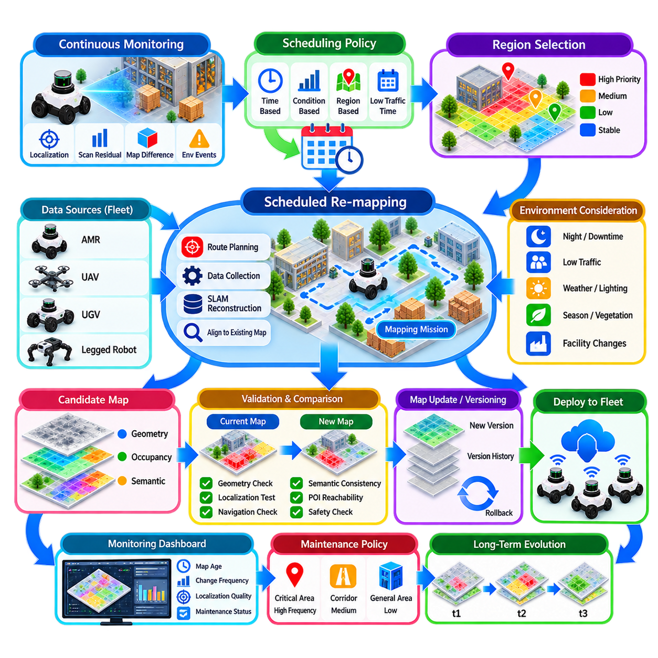
Automated map maintenance allows a robot system to preserve map accuracy over months or years without depending entirely on manual remapping campaigns. Instead of assuming that a map remains valid after initial commissioning, the system periodically evaluates environmental changes and executes controlled maintenance procedures. Scheduled re-mapping complements incremental updates by providing systematic opportunities to refresh areas whose accumulated changes, uncertainty, or drift have become significant.
A maintenance architecture normally separates continuous monitoring from scheduled reconstruction. During ordinary missions, robots collect localization statistics, scan-to-map residuals, change observations, and environmental metadata. These signals provide evidence about map health without immediately rebuilding the map. A scheduler then uses time intervals, accumulated degradation, operational priorities, or predefined policies to determine when particular areas should undergo more comprehensive re-mapping.
Time-based scheduling is the simplest maintenance strategy. A warehouse may schedule map inspection weekly, monthly, or after a known facility modification period. However, fixed intervals should not imply that the complete environment must always be remapped. Stable areas can remain unchanged, while frequently modified production cells, loading areas, construction zones, or outdoor routes can receive shorter maintenance cycles according to their expected rate of change.
Condition-based scheduling improves efficiency by triggering maintenance when map quality indicators cross defined thresholds. Increasing localization residuals, repeated recovery events, declining scan-matching scores, persistent scan-to-map differences, or growing numbers of unresolved change candidates may indicate that a region requires attention. This allows the maintenance frequency to reflect actual environmental evolution rather than relying exclusively on calendar intervals.
Scheduled re-mapping should be spatially selective whenever possible. A map-health layer can divide a facility into regions or tiles and maintain quality statistics for each one. Areas with stable geometry and strong localization performance require little intervention, whereas degraded regions receive higher maintenance priority. Regional re-mapping reduces computation, network traffic, storage requirements, and operational disruption compared with reconstructing an entire site.
Maintenance missions can be integrated with normal robot operations. An AMR traveling between production tasks may collect additional LiDAR or camera data along routes that require verification. Dedicated mapping missions are necessary only when ordinary trajectories provide insufficient coverage or viewpoint diversity. This opportunistic approach converts fleet operation into a distributed sensing process and reduces the need to remove robots from productive service solely for mapping.
Dedicated re-mapping missions should be planned to maximize useful spatial coverage. Routes can target regions with poor observation history, high change probability, weak localization features, or unresolved conflicts. Sensor visibility, viewing direction, range, overlap, and loop-closure opportunities should influence route generation. The objective is not merely to drive through an area, but to collect observations capable of reliably validating or reconstructing its geometry.
Re-mapping should distinguish between temporary operational conditions and persistent structural changes. A warehouse scanned during peak activity may contain forklifts, pallets, workers, and temporary inventory that should not become permanent map geometry. Multiple observations, semantic filtering, occupancy persistence, and measurements collected during lower-traffic periods can reduce contamination. Scheduling can therefore consider not only where to map, but also when environmental conditions are favorable.
Industrial facilities may intentionally schedule maintenance during production downtime. Mapping during nights, shift changes, planned maintenance windows, or low-traffic periods reduces occlusion and interference while improving sensor coverage. For outdoor systems, weather, illumination, seasonal vegetation, GNSS conditions, and site activity can also affect mapping quality. The scheduler can incorporate environmental constraints when selecting suitable maintenance windows.
Before a scheduled mapping task begins, the system should establish the reference configuration against which new data will be evaluated. The active map version, coordinate frame, calibration state, sensor configuration, and relevant semantic layers should be recorded. This ensures that newly generated geometry can be compared with the correct baseline and prevents maintenance results from becoming detached from the operational configuration used during data collection.
Coordinate stability remains essential during partial or complete re-mapping. Reconstructing a region should not arbitrarily shift the global map frame or invalidate existing mission coordinates. Persistent landmarks, surveyed references, fixed infrastructure, GNSS anchors, or overlapping unchanged map regions can constrain the new reconstruction. The updated geometry should align with the established operational frame before it is considered a candidate replacement.
Automated reconstruction can use accumulated sensor observations to generate a candidate map rather than modifying the production map directly. LiDAR scans, camera observations, odometry, IMU measurements, and GNSS information can be processed through the appropriate SLAM pipeline. Loop closure and pose-graph optimization can improve global consistency, while regional alignment can preserve compatibility with stable portions of the existing map.
The candidate map should then be compared with the current production version. Automated difference analysis can identify added structures, removed obstacles, shifted surfaces, altered corridors, and regions with significant geometric disagreement. Changes already supported by long-term observations can receive higher confidence, while unexpected differences can be flagged for additional verification. Re-mapping therefore acts as both reconstruction and independent map-health validation.
Map validation should occur before any automatically reconstructed result is promoted. Geometric checks can evaluate alignment, completeness, density, continuity, and residual error. Localization tests can replay recorded sensor data against the candidate map and compare pose stability with the previous version. Navigation validation can examine connectivity, clearance, reachable goals, and collision-free routes, ensuring that improved geometry does not unintentionally damage operational usability.
Semantic layers require separate validation after geometric reconstruction. Existing POIs, restricted zones, speed zones, docking positions, inspection targets, and mission regions must remain correctly aligned with the updated geometry. A structural change may make a POI unreachable or move a zone boundary relative to physical infrastructure. Automated consistency checks should identify such conflicts before the new map enters fleet operation.
Scheduled maintenance should integrate naturally with map versioning. Every accepted reconstruction can create a new candidate revision containing its parent version, mapping time, affected regions, sensor sources, validation results, and change summary. The existing production map remains available as a known-good baseline. This makes maintenance reversible and prevents an automated process from permanently overwriting validated spatial information without traceability.
Not every scheduled mapping run needs to produce a new production version. If the environment remains consistent and map-quality indicators stay within acceptable limits, the maintenance task can simply confirm the validity of the existing map. This negative result is operationally valuable because it provides evidence that the map remains trustworthy. Version creation should therefore depend on meaningful validated change rather than on the execution of a schedule alone.
Multi-robot fleets provide substantial advantages for automated maintenance. Different robots naturally observe the same regions from different positions and at different times, creating independent evidence about environmental stability. A central map-maintenance service can aggregate these observations, detect areas with insufficient coverage, and assign targeted verification tasks to suitable robots. Fleet activity thus becomes a continuous source of map-health information.
Robot selection for maintenance tasks can consider sensor capability, battery level, current location, mission load, and platform geometry. A robot equipped with higher-resolution LiDAR may be preferred for detailed structural verification, while another platform may provide useful camera semantics. Assigning mapping tasks according to available fleet resources prevents maintenance from unnecessarily disrupting production and allows heterogeneous robots to contribute complementary observations.
Failure handling is necessary because automated maintenance missions may encounter blocked routes, sensor faults, localization degradation, or incomplete coverage. An unsuccessful mapping run should not generate a production update merely because the scheduled task completed. Coverage and data-quality criteria must determine whether collected information is sufficient. Failed or partial missions can be rescheduled, supplemented by another robot, or escalated for operator review.
A monitoring dashboard can provide visibility into the maintenance process without requiring operators to inspect raw maps continuously. Useful information includes regional map age, last verification time, change frequency, localization quality, unresolved differences, scheduled maintenance tasks, candidate revisions, and validation status. Such information allows engineers to focus attention on degraded areas while stable portions of the environment remain largely autonomous.
Maintenance policies should reflect operational criticality. Areas around charging docks, narrow corridors, elevators, production interfaces, emergency routes, or safety-sensitive equipment may require more frequent verification and stricter validation than open storage areas. Region-specific policies allow maintenance resources to be concentrated where map errors would have the greatest effect on localization, navigation, safety, or mission continuity.
Over long periods, automated maintenance creates a temporal record of how the environment evolves. Repeated map versions and regional observations reveal which structures remain permanent, which areas change frequently, and where localization quality tends to degrade. This history can improve future scheduling by predicting maintenance demand and distinguishing inherently unstable regions from abnormal changes requiring engineering investigation.
Ultimately, scheduled re-mapping transforms map maintenance from an occasional manual recovery activity into a managed lifecycle process. Continuous health monitoring identifies degradation, scheduling determines when and where additional observations are needed, automated reconstruction creates candidate updates, and validation protects production operation. Combined with versioning and rollback, this workflow allows long-lived AMR fleets to maintain reliable spatial knowledge while their physical environments continue to evolve.

10.07. Map Quality Metrics and Monitoring Dashboard [w/Code]
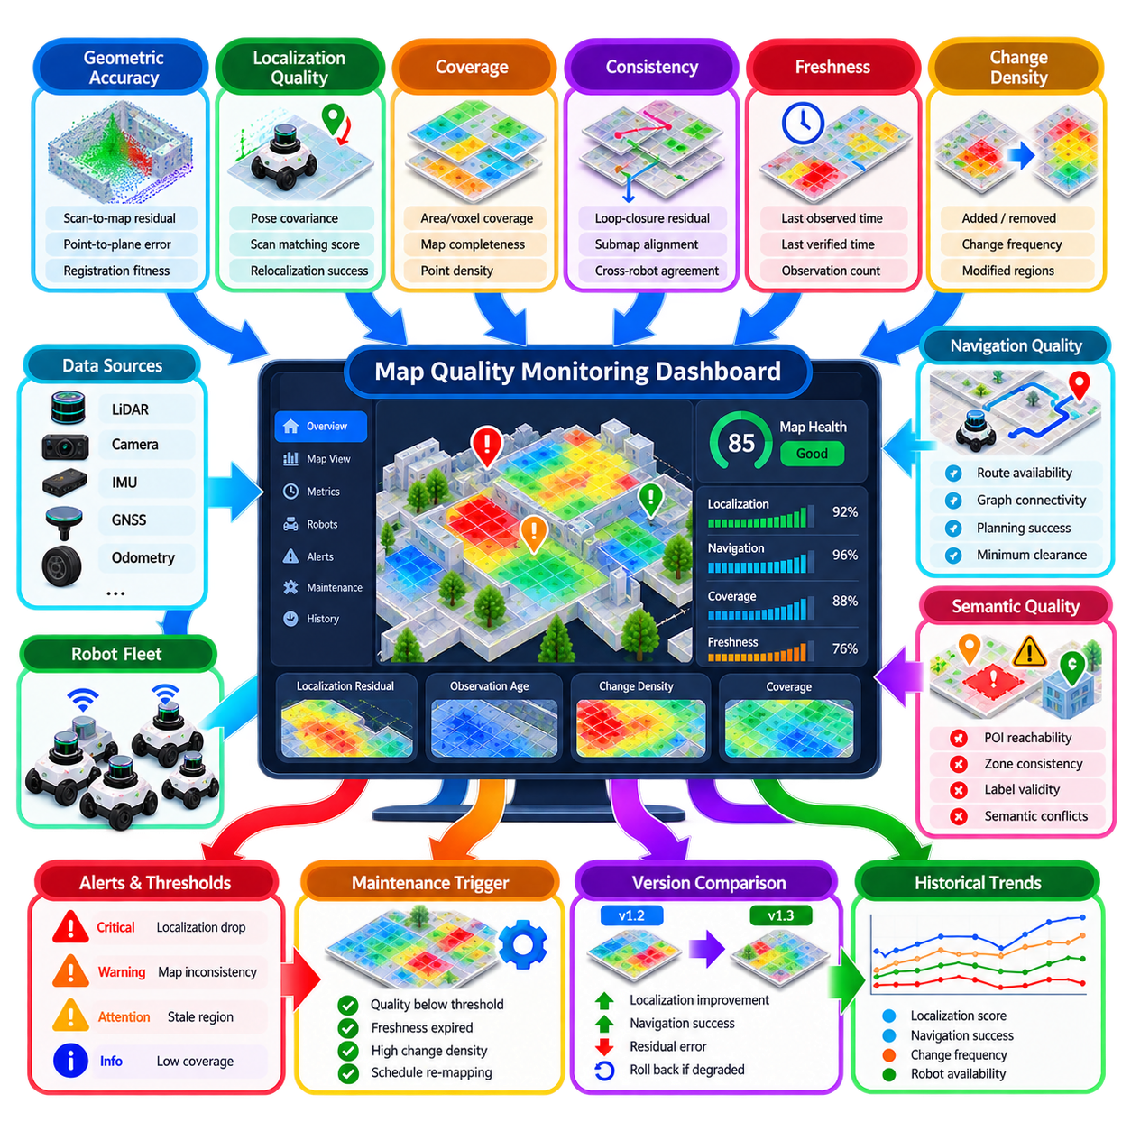
Map quality metrics provide quantitative evidence about whether a map remains suitable for localization, navigation, and autonomous operation. A map that appears visually correct can still contain geometric distortion, stale regions, weak localization features, or semantic inconsistencies. Continuous quality monitoring therefore converts map reliability from a subjective engineering judgment into a measurable operational property that can be tracked throughout the map lifecycle.
Map quality should be evaluated from several perspectives rather than represented by a single score. Geometric accuracy, localization performance, coverage, consistency, freshness, navigation usability, and semantic validity describe different aspects of map health. A map may have excellent geometric accuracy but contain outdated obstacles, while another may appear incomplete yet provide highly reliable localization in the regions actually used by robots.
Geometric accuracy measures how closely mapped structures correspond to observed physical surfaces. Scan-to-map residuals, point-to-plane distances, landmark alignment errors, surface deviation, and registration fitness can reveal local distortions. These metrics should be evaluated spatially because a global average can hide severely degraded regions. Regional statistics allow maintenance systems to identify exactly where map reconstruction or verification is required.
Localization quality provides one of the most operationally meaningful indicators of map performance. Pose covariance, scan-matching score, feature correspondence rate, localization residual, recovery frequency, and relocalization success can be monitored during normal robot missions. A gradual decline in these values may indicate environmental change, sensor calibration drift, map aging, or insufficient distinctive geometry even before complete localization failure occurs.
Absolute trajectory error and relative trajectory error can be used when reliable reference trajectories are available. Absolute trajectory error evaluates global pose consistency against ground truth or a trusted reference, while relative trajectory error measures local motion accuracy over intervals. These metrics are particularly useful during map validation, benchmarking, and controlled maintenance missions where RTK GNSS, motion capture, surveyed landmarks, or other references are available.
Coverage metrics describe whether the map sufficiently represents the operational environment. In 2D systems, coverage may be expressed as the percentage of required navigable cells that have been observed with adequate confidence. In 3D systems, voxel coverage, surface completeness, point density, or observation count can be used. Coverage should focus on mission-relevant regions rather than rewarding unnecessary mapping of inaccessible or irrelevant space.
Map consistency evaluates whether different observations and map regions agree with one another. Loop-closure residuals, overlapping submap alignment, repeated-session agreement, and cross-robot registration error can reveal internal inconsistencies. A map may locally match sensor data while still containing global deformation. Monitoring both local and global consistency is therefore necessary for large warehouses, campuses, tunnels, and multi-floor facilities.
Map freshness measures how recently a region has been observed or validated. Each tile, zone, or semantic region can maintain a last-observed timestamp, last-verified timestamp, and accumulated observation count. Frequently changing areas should age faster from an operational perspective than stable infrastructure. A freshness model can therefore combine elapsed time with historical change frequency instead of treating all regions as equally stale.
Change density provides another useful long-term indicator. The system can measure how many scan-to-map differences, candidate updates, obstacle additions, removals, or semantic modifications occur within each region over time. Areas with persistently high change density may require shorter verification intervals or different map representations. Stable regions can remain on longer maintenance cycles, reducing unnecessary computation and mapping activity.
Navigation quality metrics evaluate whether the map supports actual robot motion rather than only geometric correctness. Important indicators include route availability, graph connectivity, minimum clearance, planning success rate, path length, detour ratio, recovery events, and frequency of blocked planned paths. These metrics reveal cases where small map errors create disproportionately large operational effects, especially around narrow passages or docking interfaces.
Semantic quality should also be monitored because labels, zones, and POIs directly influence mission behavior. Useful metrics include POI reachability, semantic-to-geometry consistency, zone overlap conflicts, missing labels, invalid references, and outdated semantic elements. A charging station POI that remains stored after the physical station has moved represents a serious map-quality defect even if the surrounding geometric map is otherwise accurate.
Fleet-level monitoring provides stronger evidence than measurements from a single robot. Multiple robots observing the same region can contribute localization scores, scan residuals, change detections, and navigation outcomes. Agreement across robots increases confidence that a problem belongs to the map rather than to one platform. Conversely, degradation reported by only one robot may indicate calibration, sensor, wheel odometry, or hardware problems.
Metrics should retain spatial context instead of existing only as fleet-wide averages. A map-health layer can associate quality values with tiles, polygons, corridors, floors, or operational zones. Heatmaps then reveal areas with high residuals, poor localization confidence, stale observations, or frequent changes. Spatial quality representation directly supports targeted inspection and regional re-mapping rather than unnecessary full-site maintenance.
Temporal trends are equally important because gradual degradation may not violate any individual threshold immediately. A localization score that decreases slowly over several weeks can indicate map aging long before a robot begins failing missions. Time-series monitoring allows the system to calculate moving averages, rates of change, persistence, and anomaly patterns, providing earlier warning than isolated instantaneous measurements.
Thresholds should be adapted to operational context. A small localization degradation near a charging dock or narrow production interface may require immediate attention, while the same degradation in a large open storage area may remain acceptable. Quality limits can therefore depend on region criticality, robot type, required positioning accuracy, speed, payload, and mission function rather than using one universal threshold.
A monitoring dashboard should summarize complex map-health information without hiding the underlying evidence. A high-level view can show overall map status, active version, regions requiring attention, recent changes, maintenance schedule, and fleet localization performance. Operators should then be able to inspect individual regions, metrics, robots, and historical trends when investigating a warning or degradation event.
Visual map overlays are particularly useful for understanding spatial quality. Colored heatmaps can represent localization residual, observation age, change density, confidence, or coverage directly over the facility map. Operators can quickly identify clusters of degradation that would be difficult to detect from numerical tables alone. Different overlays should remain selectable so that unrelated metrics do not become visually confused.
Dashboard alerts should distinguish severity and persistence. A single poor scan-matching result should not necessarily create a critical alarm, while repeated localization degradation across several robots in the same region should receive higher priority. Alert logic can combine threshold exceedance, duration, affected robot count, spatial extent, and operational criticality to reduce nuisance alarms while preserving sensitivity to meaningful deterioration.
Quality metrics can directly feed automated maintenance decisions. When regional localization performance declines, observation freshness expires, or persistent map differences exceed defined criteria, the affected region can enter a maintenance queue. The scheduler can then request additional observations or initiate a dedicated re-mapping mission. Monitoring therefore becomes an active control input to the map-maintenance lifecycle rather than merely a reporting function.
Version comparison should be integrated into the dashboard. When a new map revision is deployed, quality metrics before and after deployment can be compared using the same operational regions and robot populations. Improvements in localization, navigation success, and residual error provide evidence that the revision is beneficial. Significant degradation can trigger investigation, halt wider deployment, or support rollback to a known-good version.
Data provenance is essential for interpreting map-quality measurements. Each metric should retain information about the contributing robot, sensor configuration, map version, timestamp, region, and relevant operating conditions. Without provenance, a poor localization score could be incorrectly attributed to the map when it was actually caused by sensor contamination, unusual weather, calibration error, or an incompatible robot configuration.
Long-term storage of quality history supports predictive maintenance and engineering analysis. Repeated degradation patterns can reveal regions that systematically require remapping, seasonal changes, structural modifications, or sensor-specific weaknesses. Historical data also enables comparison of maintenance policies and map revisions, helping engineers determine whether changes improve map reliability across months of real operation rather than only during short validation tests.
A mature monitoring system should connect map quality with operational outcomes. Localization confidence becomes more meaningful when correlated with mission failures, navigation recovery, intervention frequency, travel time, and robot availability. This relationship helps determine which mapping defects actually affect productivity or safety and prevents engineering resources from being consumed by numerical anomalies that have little operational consequence.
Ultimately, map quality monitoring establishes a continuous feedback loop between robot operation and map maintenance. Robots generate localization, navigation, change, coverage, and semantic evidence; the monitoring system converts these observations into spatial and temporal health indicators; dashboards expose degradation; and maintenance policies trigger verification, re-mapping, version updates, or rollback. This feedback loop allows long-lived robot fleets to treat maps as continuously managed operational assets rather than static files.

10.08. Map Distribution OTA to Robot Fleet [w/Code]
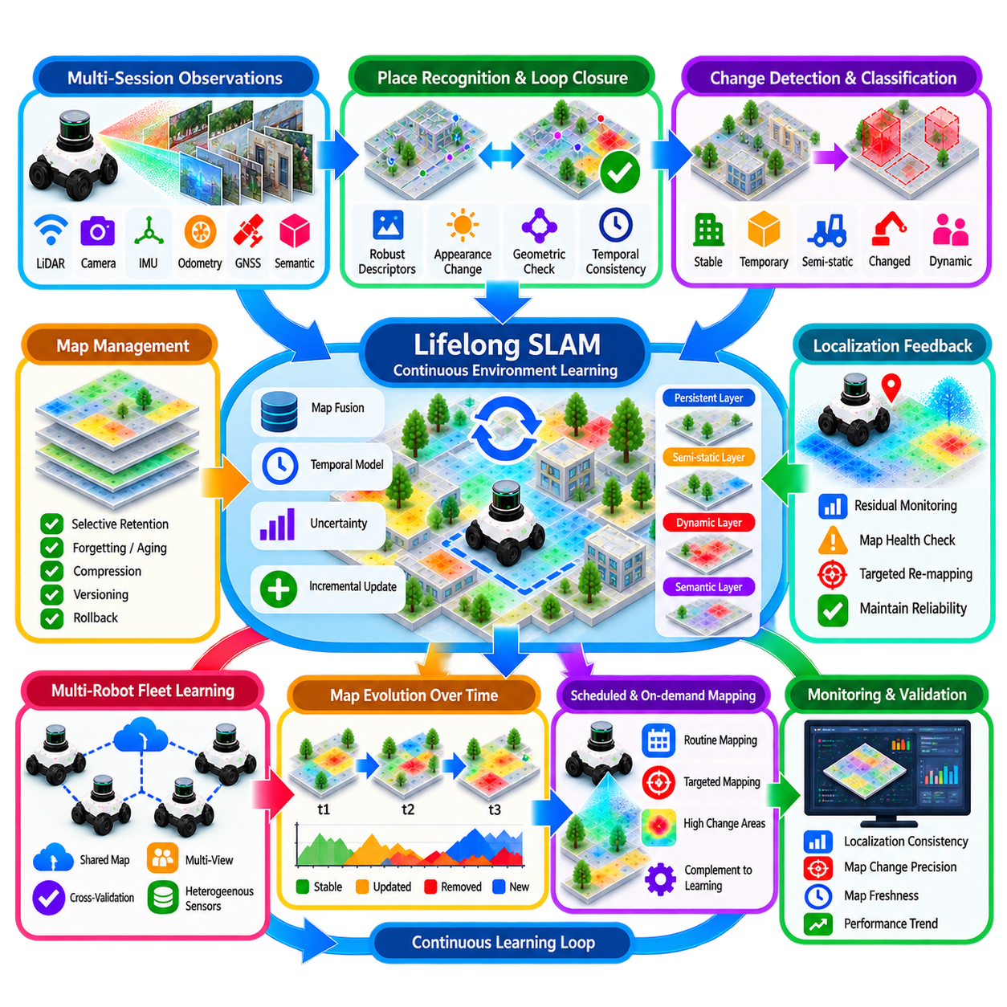
Map distribution over the air enables a robot fleet to receive validated spatial information without manually transferring files to individual platforms. In long-term operation, maps evolve through change detection, incremental updates, scheduled re-mapping, and semantic modification. OTA distribution connects this map-management lifecycle to deployed robots so that approved map revisions can be delivered consistently, securely, and with minimal interruption to missions.
The distribution process should begin from an authoritative map repository rather than from individual engineering workstations. Approved production maps, navigation layers, semantic information, POIs, zones, and associated metadata can be packaged as controlled releases. Each package should identify its map version, target site, coordinate frame, compatible robot classes, software requirements, dependencies, creation time, and validation status before becoming eligible for fleet deployment.
A map package may contain more than geometric localization data. Depending on the robot architecture, it can include occupancy grids, point clouds, voxel maps, navigation graphs, cost layers, semantic zones, docking poses, speed restrictions, and configuration metadata. Treating these elements as one compatible release prevents a robot from receiving new geometry while continuing to use outdated POIs or navigation constraints associated with an earlier map.
Package integrity must be verified before and after transmission. Cryptographic hashes can confirm that downloaded map data is identical to the approved source, while digital signatures can verify that the release originated from an authorized map-management service. Robots should reject corrupted, incomplete, or unauthorized packages rather than attempting to activate them. Distribution reliability is therefore part of map safety, not merely a networking concern.
OTA delivery should support heterogeneous communication environments. Indoor AMRs may normally receive maps through facility Wi-Fi, while outdoor robots may depend on private 5G, LTE, or intermittent wireless links. Network bandwidth, latency, coverage gaps, and connection stability can vary significantly. The distribution mechanism should therefore tolerate interrupted transfers, resume incomplete downloads, and avoid requiring continuous connectivity throughout the entire update process.
Large 3D maps can make full-package transfer inefficient. Delta distribution can reduce bandwidth by transmitting only blocks, tiles, layers, or objects that differ from the robot's currently installed version. Content-addressed storage can further prevent identical data from being transferred repeatedly. Full packages should remain available when the installed baseline is unknown, incompatible, or too old to safely apply a sequence of incremental updates.
Spatial partitioning is useful for large facilities and multi-site operations. Maps can be divided into buildings, floors, outdoor sectors, corridors, or tiles so that robots download only the regions required for their missions. A robot operating in one warehouse does not need every detailed map from an entire industrial campus. Regional packages reduce transfer size, storage consumption, synchronization time, and unnecessary exposure to unrelated configuration changes.
The fleet-management system should maintain explicit knowledge of the map version installed on every robot. Version inventory can include downloaded version, active version, pending version, synchronization state, and last successful update time. This prevents the control system from assuming that all robots share identical spatial information and enables mission allocation to consider whether a robot possesses the map required for its assigned operating region.
Downloading and activating a map should be treated as separate operations. A robot can retrieve a new package while continuing to operate with its current validated map. After download, the package can be checked for integrity, compatibility, storage availability, and internal consistency. Only when these checks succeed should the robot mark the revision as ready for activation, allowing network transfer to occur without immediately changing localization or navigation behavior.
Activation should occur at a controlled operational transition. Suitable moments include idle periods, charging sessions, mission completion, startup, or entry into a designated synchronization zone. Switching maps while a robot is docking, navigating a narrow passage, or executing a safety-sensitive maneuver can introduce discontinuities. Fleet orchestration should therefore coordinate map activation with robot state rather than treating deployment as an independent background file operation.
Atomic activation ensures that dependent map components change together. Geometry, navigation graphs, semantic zones, POIs, and configuration metadata can be staged locally and then switched as one logical release. If any required component is missing or fails validation, the previous active configuration should remain unchanged. This avoids hybrid states in which parts of two incompatible map versions are simultaneously used by the robot.
Coordinate continuity should be verified before activation. A new map revision may contain improved geometry while still being required to preserve the established operational coordinate frame. The robot can compare known anchors, transformation metadata, localization initialization points, or persistent landmarks between versions. Unexpected coordinate shifts should block automatic activation because they can invalidate mission goals, docking positions, and fleet traffic-management references.
Robot compatibility must be checked explicitly. Different platforms may use different sensors, localization algorithms, map resolutions, navigation stacks, or semantic capabilities. Map metadata can specify supported robot classes, required schema versions, minimum software releases, and necessary localization features. The fleet server should distribute only compatible packages, while each robot performs an independent compatibility check before accepting the update.
Deployment policies can control how quickly a new revision spreads through the fleet. A newly approved map can first be delivered to test robots or a limited operational group. After successful localization and navigation performance is confirmed, deployment can expand gradually to larger groups. This staged rollout limits the operational impact of defects that passed offline validation but appear under real traffic, lighting, sensing, or environmental conditions.
Fleet segmentation allows different groups of robots to remain on different approved versions when necessary. Robots assigned to separate buildings, floors, mission types, or hardware generations may not require the same map revision. Deployment groups can therefore be defined by site, region, robot class, software generation, or operational role. Controlled segmentation is preferable to forcing unnecessary fleet-wide synchronization when spatial requirements differ.
Post-activation validation should confirm that the robot can actually operate with the new map. The robot can monitor initial localization confidence, scan-matching residuals, pose discontinuity, route availability, and access to required POIs. A short verification procedure may be performed before normal missions resume. Successful file installation alone does not prove that the new map is operationally valid for the physical robot.
Rollback capability should remain available after OTA activation. The robot can retain at least one known-good map package locally so that it can return to the previous configuration if localization or navigation deteriorates. Fleet management should record which robots rolled back and why. Repeated rollback across several robots may indicate that deployment should be stopped and the new map revision returned for engineering investigation.
A failed update should not leave a robot without a usable map. Interrupted downloads, insufficient storage, checksum mismatch, incompatible schema, activation failure, or unexpected reboot should result in a controlled recovery state. The existing validated map remains active until the new release has been completely installed and accepted. Transaction-like deployment behavior prevents partial updates from compromising fleet availability.
Bandwidth management becomes important when hundreds of robots receive large packages simultaneously. Uncontrolled distribution can overload facility networks and interfere with mission communication. Updates can be scheduled in batches, prioritized by operational urgency, or performed while robots are charging. Local edge servers or site caches can distribute frequently used map packages within a facility, reducing repeated transfers from a central cloud or enterprise server.
Security controls should protect both the distribution service and robot endpoints. Authentication determines which robots may request a package, authorization controls which maps they may receive, and encrypted transport protects data during transfer. Signed releases, certificate management, audit logs, and restricted promotion rights reduce the possibility that unauthorized or modified spatial data can enter production robot systems.
Distribution events should be fully traceable. The system can record package identifier, source version, destination robot, download start and completion times, verification result, activation time, previous version, new version, and rollback events. This history allows engineers to reconstruct the spatial configuration used by a robot during an incident and provides evidence that the intended map was actually deployed rather than merely approved on the server.
OTA map distribution should integrate with mission and traffic management. A robot should not be assigned to a newly modified area until it possesses a compatible map, while traffic coordination should account for robots temporarily operating on different revisions. When spatial changes alter routes, zones, or POIs, dependent mission definitions can be synchronized with the corresponding map release to prevent references to unavailable or obsolete locations.
Offline robots require explicit synchronization handling. A robot that reconnects after days or weeks should not automatically assume that its previous map remains current. The fleet service can compare its active version with the approved version chain, determine whether delta updates remain valid, and provide either the necessary revisions or a complete replacement package. Mission execution can be restricted until required spatial data has been synchronized.
Monitoring dashboards can expose the fleet-wide distribution state. Operators can view active map versions, robots awaiting updates, download progress, failed installations, incompatible platforms, rollback events, and deployment groups. Spatial visualization can also show which regions and robots have adopted a revision. This visibility becomes increasingly important as fleet size grows and manual verification of individual robots becomes impractical.
Ultimately, OTA map distribution converts an approved map revision into a controlled fleet configuration. Authoritative packaging, integrity verification, compatibility checking, resumable transfer, staged deployment, atomic activation, post-update validation, and rollback ensure that map evolution reaches physical robots without sacrificing operational stability. Combined with fleet orchestration, OTA distribution closes the loop between long-term map maintenance and reliable autonomous operation.

10.09. Lifelong SLAM Continuous Environment Learning
Lifelong SLAM extends conventional simultaneous localization and mapping from a finite mapping session into a continuous learning process that operates throughout the lifetime of a robot system. Instead of assuming that the environment becomes fixed after an initial map is created, lifelong SLAM treats physical space as an evolving source of observations. The robot continuously evaluates what remains stable, what has changed, and what knowledge should be retained.
Traditional SLAM commonly focuses on estimating robot trajectory and map structure during one mission or a limited collection of sessions. Long-term operation introduces a different problem because factories, warehouses, campuses, roads, and outdoor facilities continuously evolve. Equipment moves, layouts change, vegetation grows, surfaces deteriorate, and temporary objects appear. Lifelong SLAM must maintain localization reliability while learning these changes without rebuilding everything from the beginning.
The central challenge is distinguishing persistent environmental evolution from temporary variation. A pallet occupying a corridor for several hours should not necessarily become permanent map geometry, while a newly installed machine may need to be incorporated. Repeated observations, temporal persistence, semantic classification, visibility reasoning, and confidence accumulation help determine whether detected differences represent noise, dynamic activity, semi-static conditions, or genuine structural change.
Continuous environment learning begins with observations collected during ordinary robot operation. LiDAR scans, camera images, depth measurements, wheel odometry, IMU data, GNSS observations, and semantic perception can contribute evidence. The robot does not need to perform a dedicated mapping mission every time the environment changes. Normal fleet missions can continuously provide new information while localization and navigation remain active.
A lifelong map should preserve stable spatial anchors while allowing selected regions to evolve. Walls, columns, surveyed landmarks, permanent infrastructure, and other highly persistent features can establish a long-term coordinate reference. More variable elements can be represented in separate layers or assigned lower persistence. This separation prevents frequent local changes from destabilizing the global reference frame required by navigation, POIs, missions, and fleet coordination.
Temporal modeling becomes a fundamental component of lifelong SLAM. A conventional map describes where structures exist, whereas a lifelong map should also represent how consistently and how recently they have been observed. Map elements can maintain timestamps, observation counts, persistence probabilities, change frequencies, or temporal states. Such information enables the system to reason about environmental history rather than treating every observation as equally permanent.
Multi-session SLAM provides the foundation for accumulating experience across days, weeks, and months. New sessions can be aligned with an existing reference map through persistent landmarks, place recognition, GNSS anchors, or scan registration. Once aligned, the system can compare current observations with historical representations. The objective is not simply to merge all sessions, but to determine which information strengthens the long-term model and which should remain session-specific.
Place recognition must remain reliable despite environmental appearance changes. Lighting, weather, seasonal vegetation, furniture arrangements, parked vehicles, or production activity can significantly alter sensor observations without changing the underlying location. Robust descriptors and multimodal sensing can help recognize previously visited places from persistent structural information. Failure to handle appearance change can create duplicate map regions or incorrect loop closures.
Loop closure in lifelong operation requires stronger validation than in short mapping sessions. Historical places may have genuinely changed, so similarity alone is insufficient evidence that two observations represent identical geometry. Geometric consistency, temporal context, semantic compatibility, and localization uncertainty should be considered before accepting a long-term loop constraint. Incorrect loop closures can distort not only the current session but an accumulated map containing months of operational history.
Map growth must also be controlled. Continuously storing every scan, keyframe, image, landmark, and submap would eventually produce an impractically large representation. Lifelong SLAM therefore requires selective retention. Redundant observations can be compressed or discarded, while informative keyframes, stable landmarks, rare viewpoints, change evidence, and safety-relevant events are retained. The objective is to preserve useful knowledge rather than unlimited raw history.
Forgetting is therefore as important as learning. Map elements that have not been observed for a long period, have repeatedly been contradicted, or no longer contribute to localization may be archived or removed from the active representation. However, deletion should be controlled because temporarily invisible structures may later reappear. Aging policies, confidence decay, historical archives, and reversible map versions provide safer mechanisms than immediate permanent deletion.
Semantic information improves continuous learning by explaining the likely persistence of observed entities. Walls, columns, charging stations, and fixed machines generally have different expected lifetimes from people, forklifts, pallets, or parked vehicles. Semantic categories can influence update rates, confidence decay, and retention policies. Geometry should still provide primary spatial evidence, while semantics help the system determine how different environmental elements should evolve.
Dynamic and semi-static environments benefit from layered representations. A persistent structural layer can support localization, a semi-static layer can represent objects that remain for hours or days, and a dynamic layer can contain short-lived obstacles. Semantic and operational layers can independently represent zones, POIs, and mission constraints. Lifelong SLAM can update these layers at different rates instead of forcing every environmental observation into one permanent map.
Localization and mapping should interact through map-health feedback. When localization residuals increase in a particular region, the system can investigate whether the map has become outdated rather than immediately attributing the problem to sensors or algorithms. Persistent scan-to-map differences, repeated recovery events, and declining feature correspondence can trigger additional observations or targeted reconstruction. Localization performance therefore becomes evidence for continuous map learning.
Uncertainty must accompany learned changes. Newly observed geometry should not immediately receive the same authority as infrastructure verified over hundreds of missions. Map elements can carry confidence derived from observation count, viewpoint diversity, sensor quality, localization covariance, and agreement across sessions. Confidence-aware updating allows uncertain information to remain provisional until sufficient evidence supports promotion into the persistent representation.
Multi-robot fleets significantly expand lifelong learning capability. Different robots observe the same environment at different times, positions, and viewpoints, producing distributed evidence about stability and change. A shared map service can combine these observations while tracking their robot and sensor origins. Agreement across independent platforms strengthens change hypotheses, while disagreement can expose calibration errors, localization failures, or platform-specific sensing limitations.
Heterogeneous robots can contribute complementary environmental knowledge. A LiDAR-equipped AMR may provide accurate structural geometry, while a camera-rich inspection robot contributes semantic labels and visual appearance information. Outdoor platforms can add GNSS-referenced observations unavailable indoors. Lifelong mapping architecture should preserve sensor provenance and uncertainty so that information from different platforms can be fused without assuming identical measurement characteristics.
Continuous learning should not imply uncontrolled modification of the production map. Observed changes can first enter candidate or staging representations, where persistence, consistency, and operational effects are evaluated. Validated changes can then create a new map revision that is tested before deployment. This separation between learning and authoritative map publication prevents perception errors or temporary environmental conditions from directly altering fleet-critical spatial information.
Map versioning provides historical memory for lifelong SLAM. Each accepted revision records how the environment was understood at a particular time, while rollback protects operation when a learned update proves incorrect. Version history also enables engineers to analyze environmental evolution, compare localization performance, and determine when important structures changed. The map therefore becomes both an operational model and a temporal record of the physical facility.
Scheduled re-mapping and lifelong SLAM serve complementary roles. Continuous learning identifies gradual changes and accumulates evidence during normal missions, while scheduled mapping provides controlled opportunities to obtain dense coverage and resolve uncertain regions. Areas showing high change frequency or deteriorating localization quality can receive targeted mapping missions. Stable areas can remain largely untouched, reducing unnecessary reconstruction and operational interruption.
Long-term learning also requires mechanisms for detecting abnormal change. A sudden disappearance of infrastructure, unexpected blockage of an emergency route, or major geometric shift may indicate an operational incident rather than normal map evolution. Such events should be distinguished from routine adaptation and escalated to monitoring or safety systems. Lifelong SLAM therefore contributes not only to mapping but also to environmental awareness.
Computational resource management is essential because continuous learning competes with perception, planning, and control for onboard processing capacity. Immediate localization and safety functions should retain priority, while expensive map optimization, historical comparison, or global reconstruction can run asynchronously on edge or central servers. Distributed architecture allows robots to collect evidence locally while fleet infrastructure performs heavier long-term analysis.
Evaluation of lifelong SLAM should consider stability as well as adaptability. A system that updates rapidly but frequently corrupts reliable geometry is not effective, while a perfectly stable map that never accepts legitimate environmental change will eventually become obsolete. Useful metrics include localization consistency, map-change precision, false update rate, memory growth, map freshness, rollback frequency, and operational performance across extended periods.
The ultimate objective of lifelong SLAM is to create spatial knowledge that evolves at approximately the same timescale as the environment while preserving the stable references required for autonomous operation. Continuous observations provide experience, temporal reasoning separates persistent change from temporary activity, selective memory controls growth, and validation protects production maps. The robot therefore learns the environment continuously without forgetting the reliable spatial foundation on which its autonomy depends.

10.10. Large Scale Warehouse Map Management Case
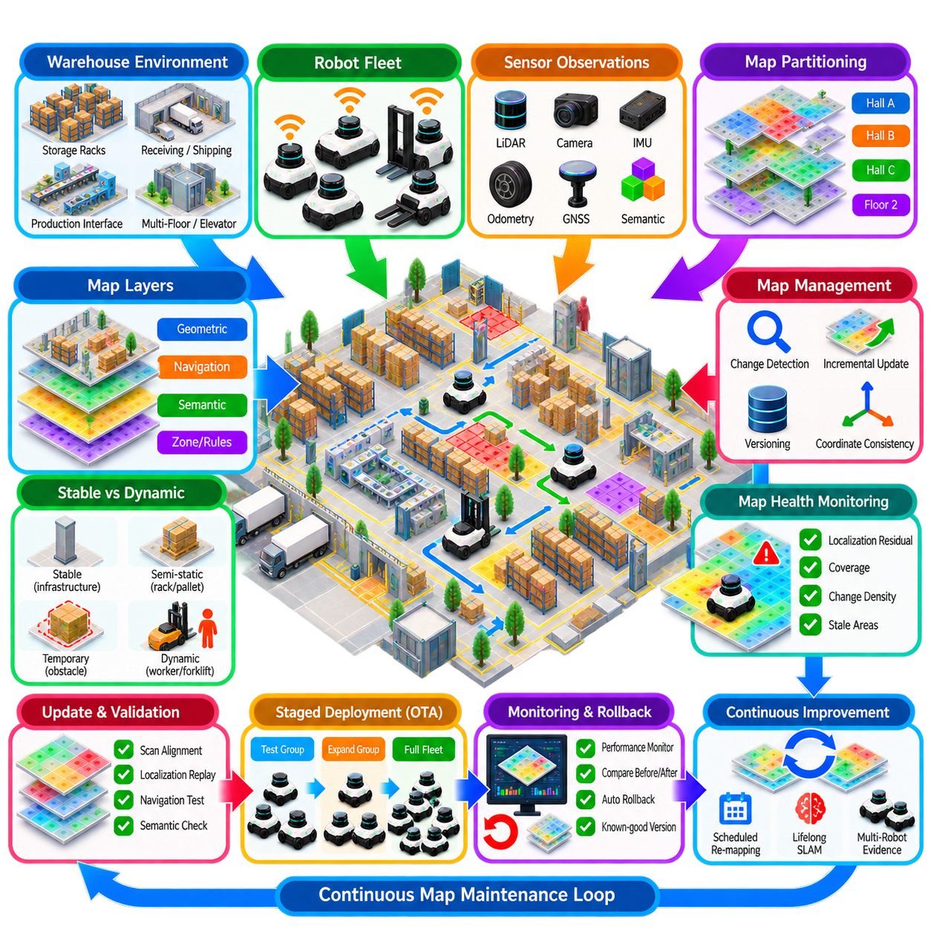
A large-scale warehouse presents a demanding long-term map-management environment because autonomous mobile robots operate continuously while racks, pallets, staging areas, production interfaces, and traffic patterns change around them. The operational map must therefore remain sufficiently stable for localization while adapting to legitimate physical changes. Map management becomes a continuous fleet function rather than a one-time commissioning activity.
Consider a warehouse containing multiple storage halls, receiving and shipping zones, charging areas, narrow rack aisles, cross-aisles, elevators, and automated production interfaces. Hundreds of AMRs may share this environment while performing transport missions. A single monolithic map can become difficult to update and distribute efficiently, so the facility can be divided into logical regions, floors, operational zones, or spatial tiles.
The warehouse map can be organized into several coordinated layers. A persistent geometric layer contains walls, columns, rack structures, and other stable localization features. Navigation layers represent traversable space, traffic corridors, costs, and connectivity. Semantic layers define loading zones, charging stations, restricted areas, speed zones, docking locations, and other operational meanings required by mission and fleet-management systems.
Stable infrastructure should form the spatial reference for long-term operation. Columns, structural walls, fixed machinery, surveyed landmarks, and permanent rack frames can provide reliable localization anchors. Pallets, forklifts, temporary inventory, workers, and movable equipment should not immediately modify this persistent representation. Separating permanent, semi-static, and dynamic information prevents ordinary warehouse activity from continuously corrupting the localization map.
During normal missions, each AMR can contribute evidence about map health. LiDAR scan-to-map residuals, localization confidence, recovery events, camera observations, obstacle persistence, and route-planning outcomes can be associated with the regions traversed by the robot. Instead of requiring dedicated inspection of the entire warehouse, normal logistics activity becomes a distributed sensing process that continuously evaluates whether the operational map still represents reality.
A regional map-health model can aggregate these observations. Each tile or operational zone can maintain localization statistics, observation age, change density, coverage, and unresolved differences. Stable storage areas may remain valid for long periods, while receiving docks, staging zones, frequently rearranged rack sections, or construction areas may accumulate changes quickly. Maintenance priority can therefore reflect actual environmental behavior rather than a uniform schedule.
Scan-to-map difference detection provides early evidence of physical change. When multiple robots repeatedly observe geometry that disagrees with the current map, the system can create a change candidate rather than immediately modifying production data. Temporary pallet stacks may disappear after several hours, while a newly installed rack remains consistently observable across missions. Temporal persistence and multi-robot agreement help distinguish these cases.
Incremental updates are appropriate when confirmed changes affect limited areas. If several racks are relocated within one warehouse sector, only the corresponding region needs to be reconstructed and validated. Unchanged sections retain their established geometry and coordinate references. Regional updates reduce processing and validation effort while avoiding unnecessary modification of map areas that continue to support reliable localization.
Coordinate continuity is especially important because warehouse missions depend on persistent operational locations. Charging docks, conveyor interfaces, pickup stations, inspection points, and waiting positions may be referenced by many workflows. Updating local geometry must not arbitrarily shift the global warehouse coordinate frame. Persistent anchors and overlapping unchanged geometry can constrain regional reconstruction so that existing operational references remain stable.
Semantic information requires independent lifecycle management. A physical rack relocation may require geometric modification, while a temporary restricted zone may require only a semantic update. Similarly, a charging station can be moved without rebuilding unrelated warehouse geometry. Separating semantic and geometric layers allows operational policies to evolve rapidly while protecting the stable spatial representation required for localization.
Every accepted change should create a controlled map revision. The revision can identify its parent version, modified regions, contributing observations, validation results, affected semantic elements, and responsible automated process or operator. The currently deployed map remains available as a known-good baseline. This version history allows engineers to understand how warehouse spatial knowledge evolved and to reverse problematic changes when necessary.
Candidate revisions should undergo automated validation before fleet deployment. Geometric validation can evaluate scan alignment, residual error, continuity, and overlap with unchanged regions. Localization replay can determine whether recorded sensor sequences remain stable against the candidate map. Navigation tests can verify corridor connectivity, clearance, and route availability, while semantic checks ensure that POIs and operational zones remain valid.
Critical warehouse locations require stricter acceptance criteria than ordinary open areas. Errors near charging docks, narrow rack aisles, elevators, conveyor interfaces, or high-traffic intersections can cause disproportionate operational disruption. Map-management policy can assign higher criticality to these regions, requiring stronger localization performance, additional observations, or explicit approval before a revision affecting them is promoted.
A new revision should normally be introduced through staged fleet deployment. Selected AMRs can receive the candidate map first and operate within representative areas. Their localization confidence, route success, recovery frequency, and mission completion can be compared with robots using the previous version. If the candidate performs correctly, deployment can expand progressively; otherwise, the test group can return to the previous validated map.
OTA map distribution allows revisions to reach a large fleet without manual robot-by-robot maintenance. Robots can download map packages while continuing to use their current active version. Integrity, compatibility, storage availability, and coordinate consistency are checked before activation. The new map can then be activated while the robot is idle, charging, or between missions, avoiding uncontrolled spatial changes during critical navigation.
Large warehouse maps benefit from regional and delta distribution. A robot assigned to one hall may need only the modified tiles relevant to its operating area rather than a complete facility map. Delta packages can transfer only information changed since the installed version. This reduces network load when hundreds of AMRs share facility Wi-Fi and prevents map synchronization traffic from interfering unnecessarily with operational communication.
Fleet management must maintain version awareness for every robot. At any moment, some AMRs may use the previous map while others have already activated a new revision. Mission allocation and traffic management should account for this transitional state. Robots should not be assigned to newly modified areas unless their active map contains the compatible geometry, navigation constraints, and semantic references required for those missions.
Post-deployment monitoring determines whether a revision remains successful under real warehouse conditions. Localization residuals, relocalization events, planning failures, blocked routes, unexpected stops, travel time, and mission completion can be compared before and after deployment. Spatial heatmaps can reveal whether degradation is concentrated around one aisle or interface rather than distributed across the entire warehouse.
Rollback provides protection when a revision causes operational degradation. Robots can retain a known-good previous package locally and return to it if predefined validation criteria fail. If multiple robots report similar problems after activation, fleet management can halt further rollout and initiate broader rollback. Because geometric, navigation, and semantic components are versioned together, rollback restores a coherent operational configuration.
Scheduled re-mapping complements continuous monitoring in regions that cannot be reliably maintained from normal mission observations. Low-traffic aisles, rarely visited storage areas, modified production cells, or regions with persistent localization degradation can receive dedicated mapping missions. These missions can be scheduled during low-traffic periods to reduce occlusion from workers, forklifts, and temporary inventory.
Lifelong SLAM extends this process by accumulating environmental experience across months or years. Repeated observations reveal which structures remain stable and which warehouse regions change frequently. Persistent features strengthen the long-term localization representation, while repeatedly contradicted elements lose confidence or move into historical storage. The system gradually learns the temporal characteristics of the warehouse instead of treating every map revision as an isolated event.
Multi-robot evidence improves confidence in long-term changes. If one AMR reports a mismatch, the cause may be sensor contamination, calibration drift, or temporary occlusion. If many independently localized robots observe the same geometric difference from different viewpoints, the probability of a genuine map change increases. Fleet-scale observation therefore provides a practical mechanism for separating platform-specific problems from environmental evolution.
A map-management dashboard can integrate these processes into one operational view. Engineers can inspect active versions, regional map health, localization quality, change candidates, stale areas, pending revisions, OTA deployment status, and rollback events. Spatial overlays allow degraded regions to be identified directly on the warehouse map, reducing the need to manually inspect large quantities of raw SLAM data.
The complete workflow forms a closed map-maintenance loop. Fleet operation generates observations, monitoring identifies degradation or change, candidate updates are constructed, validation protects the production baseline, versioning preserves history, OTA distribution deploys approved revisions, and post-deployment monitoring confirms performance. Scheduled re-mapping and lifelong learning provide additional evidence whenever ordinary operation is insufficient.
In this large-scale warehouse case, successful map management depends on balancing stability and adaptation. The map must remain stable enough to preserve localization, POIs, traffic rules, and mission references, yet adaptable enough to reflect genuine physical and operational changes. Regional maintenance, fleet-scale sensing, controlled versioning, validation, staged OTA deployment, rollback, and continuous monitoring together transform the warehouse map into a managed operational asset that evolves with the facility.

