Volume 19 Robot Machine Learning and AI

01. Machine Learning Fundamentals

01.01 ML Problem Taxonomy Supervised Unsupervised RL
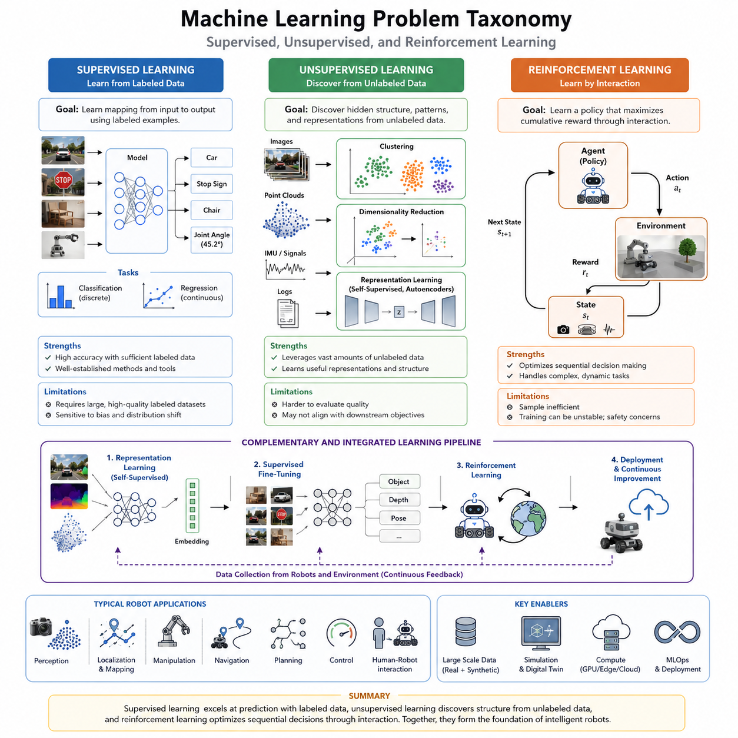
Machine learning forms the mathematical and computational foundation of modern artificial intelligence. Rather than explicitly programming every decision rule, machine learning enables computer systems to discover patterns, relationships, and decision strategies directly from data. As robots become increasingly autonomous and Physical AI systems operate in dynamic real-world environments, machine learning has become the central mechanism for perception, prediction, planning, adaptation, and intelligent control. Understanding the taxonomy of machine learning problems is therefore essential for designing effective AI systems for robotics, autonomous vehicles, industrial automation, healthcare, logistics, and human-robot collaboration. Within the broad landscape of machine learning, three primary paradigms dominate practical applications: supervised learning, unsupervised learning, and reinforcement learning. Each paradigm addresses fundamentally different problem formulations, requires different types of data, optimizes different objectives, and produces different forms of intelligence. Selecting the appropriate learning paradigm is often one of the earliest and most important architectural decisions in AI system development.
Supervised learning represents the most mature and widely adopted category of machine learning. Its primary objective is to learn a mapping between input variables and known target outputs using labeled training data. Every training example consists of an input observation together with the correct answer, allowing the learning algorithm to minimize prediction errors through optimization. During training, the model gradually adjusts millions or even billions of parameters until its predictions closely approximate the provided labels. After successful training, the learned model generalizes its knowledge to previously unseen data, enabling accurate predictions in production environments. The effectiveness of supervised learning depends heavily on the quality, diversity, consistency, and quantity of labeled datasets. Incorrect annotations, dataset bias, class imbalance, or insufficient coverage frequently become limiting factors for model performance.
Supervised learning problems are commonly divided into classification and regression tasks. Classification predicts discrete categories, while regression estimates continuous numerical values. In robotics, classification models identify objects, recognize traffic signs, detect obstacles, classify terrain, or recognize human activities. Regression models estimate depth, object positions, joint angles, vehicle trajectories, battery degradation, force estimation, or localization uncertainty. Both problem types rely on minimizing carefully designed loss functions that measure discrepancies between predictions and ground truth labels. The optimization process usually employs stochastic gradient descent or its variants to iteratively improve model performance over large datasets.
The success of supervised learning has been accelerated by deep neural networks capable of extracting hierarchical feature representations directly from raw sensor data. Modern convolutional neural networks, transformers, graph neural networks, and multimodal architectures have dramatically improved robot perception accuracy across diverse sensing modalities including RGB cameras, depth cameras, LiDAR, radar, tactile sensors, force sensors, thermal cameras, and audio streams. These models enable robots to perceive complex environments with accuracy that often surpasses handcrafted computer vision algorithms while significantly reducing manual feature engineering.
Despite its remarkable success, supervised learning has several inherent limitations. Large-scale labeled datasets are expensive and time-consuming to collect, especially for robotics applications requiring expert annotations or dangerous operating conditions. Industrial robots may require millions of accurately labeled images, while autonomous vehicles may require thousands of hours of manually verified driving data. Furthermore, supervised models cannot naturally discover entirely new structures beyond the provided labels and often struggle when encountering novel environments significantly different from the training distribution. Consequently, supervised learning performs best when sufficient labeled data accurately represents future deployment scenarios.
Unsupervised learning addresses an entirely different learning objective. Instead of predicting predefined labels, unsupervised algorithms discover hidden structures, statistical regularities, latent representations, and intrinsic organization within unlabeled datasets. Since no explicit supervision exists, the learning process attempts to explain the underlying distribution of observed data. This capability becomes especially valuable because the overwhelming majority of real-world robotic sensor data is unlabeled. Every autonomous robot continuously generates enormous amounts of images, point clouds, IMU measurements, force signals, audio recordings, GPS trajectories, and operational logs that can potentially contribute to learning without requiring costly human annotation.
One major category of unsupervised learning is clustering, where similar observations are automatically grouped together according to feature similarity. Clustering enables robots to discover semantic regions, identify recurring environments, organize object categories, segment operational conditions, and detect behavioral patterns without predefined labels. Another important category is dimensionality reduction, where high-dimensional sensor observations are transformed into compact latent representations while preserving meaningful information. Techniques such as Principal Component Analysis, Autoencoders, Variational Autoencoders, and manifold learning simplify downstream learning tasks by reducing computational complexity and eliminating redundant information.
Representation learning has become one of the most influential areas within unsupervised learning. Rather than solving a specific downstream task directly, representation learning constructs feature embeddings that capture meaningful semantic relationships between observations. High-quality representations significantly improve classification, detection, planning, localization, manipulation, and reinforcement learning performance because they provide compact, informative descriptions of complex sensory inputs. Recent advances in self-supervised learning further extend this concept by generating supervisory signals automatically from raw data through prediction tasks, contrastive objectives, masked reconstruction, temporal consistency, or multimodal alignment.
Generative modeling also belongs to the broader unsupervised learning family. Generative models estimate the probability distribution of observed data and learn to synthesize realistic samples. Variational Autoencoders, Generative Adversarial Networks, diffusion models, and autoregressive architectures have demonstrated impressive capabilities for image synthesis, synthetic data generation, anomaly detection, environment simulation, and world model construction. In robotics, these models support simulation, domain randomization, sensor completion, trajectory generation, scene reconstruction, and predictive planning.
Although unsupervised learning eliminates the need for labeled datasets, evaluating model quality becomes considerably more difficult because no ground truth labels exist. Learned representations may not align perfectly with downstream objectives, requiring additional fine-tuning or supervised adaptation. Nevertheless, the abundance of unlabeled data makes unsupervised learning an increasingly important component of modern AI systems, particularly for Physical AI and foundation models that must scale across diverse environments.
Reinforcement learning represents a fundamentally different machine learning paradigm inspired by sequential decision-making. Instead of learning from labeled examples or discovering static data structures, reinforcement learning trains an intelligent agent through continuous interaction with an environment. At every decision step, the agent observes the current state, selects an action, receives a numerical reward, and transitions to a new state. The objective is not simply maximizing immediate rewards but maximizing the cumulative long-term reward across entire sequences of actions. This sequential optimization distinguishes reinforcement learning from supervised and unsupervised learning.
The mathematical framework underlying reinforcement learning is typically formulated as a Markov Decision Process. States describe the current environment, actions define possible decisions, transition dynamics determine environmental evolution, reward functions quantify task success, and policies specify the agent's decision strategy. Value functions estimate expected future returns, while Bellman equations provide recursive relationships enabling efficient policy optimization. These concepts collectively form the theoretical foundation upon which modern reinforcement learning algorithms are constructed.
Reinforcement learning is particularly well suited for robotics because many robotic tasks require continuous sequential control rather than isolated predictions. Walking robots must maintain balance while adapting to changing terrain. Manipulators must coordinate complex arm movements to complete assembly operations. Autonomous vehicles must continuously plan safe trajectories while responding to dynamic obstacles. Drone navigation, warehouse logistics, industrial automation, and humanoid locomotion all naturally fit the reinforcement learning framework because decisions influence future opportunities and long-term performance.
Modern reinforcement learning algorithms can generally be divided into value-based, policy-based, and actor-critic approaches. Value-based methods estimate expected future rewards for each action, while policy-based methods directly optimize the decision policy itself. Actor-critic methods combine both approaches by simultaneously learning policies and value estimators, providing improved sample efficiency and stability. Recent algorithms such as PPO, SAC, TD3, Dreamer, MBPO, and offline reinforcement learning methods have significantly expanded the practical applicability of reinforcement learning for real-world robotic systems.
One of the greatest challenges in reinforcement learning is sample efficiency. Real robots cannot safely execute millions of random trial-and-error interactions because physical hardware experiences wear, consumes energy, and may encounter safety risks. Consequently, large-scale simulation environments such as Isaac Sim, Isaac Gym, MuJoCo, and other physics engines play an increasingly important role by enabling billions of safe training interactions before transferring learned policies to physical robots through Sim-to-Real methodologies. Domain randomization, system identification, and adaptive control further improve transfer robustness between simulation and reality.
Comparing the three major machine learning paradigms highlights their complementary strengths. Supervised learning excels when abundant labeled datasets exist and precise prediction accuracy is required. Unsupervised learning leverages vast quantities of unlabeled data to discover representations and hidden structures. Reinforcement learning optimizes sequential decision-making through interaction and delayed rewards. Rather than competing approaches, these paradigms increasingly cooperate within integrated AI architectures. A robot may first learn visual representations through self-supervised learning, fine-tune perception modules using supervised learning, and subsequently optimize manipulation or navigation policies using reinforcement learning. This layered learning strategy combines the advantages of each paradigm while minimizing their individual limitations.
The future of machine learning taxonomy is gradually evolving beyond strict categorical boundaries. Foundation models, multimodal transformers, world models, Vision-Language Models, and Vision-Language-Action architectures increasingly integrate supervised objectives, self-supervised representation learning, imitation learning, reinforcement learning, and continual adaptation into unified training pipelines. Instead of viewing supervised, unsupervised, and reinforcement learning as isolated disciplines, modern AI research increasingly treats them as complementary components of a comprehensive learning ecosystem capable of supporting general-purpose robotic intelligence. Future Physical AI systems are expected to continuously combine these learning paradigms throughout their operational lifecycles, enabling robots to perceive, reason, plan, adapt, and improve autonomously while interacting safely and effectively with the real world.

01.02 Bias Variance Tradeoff and Generalization Theory
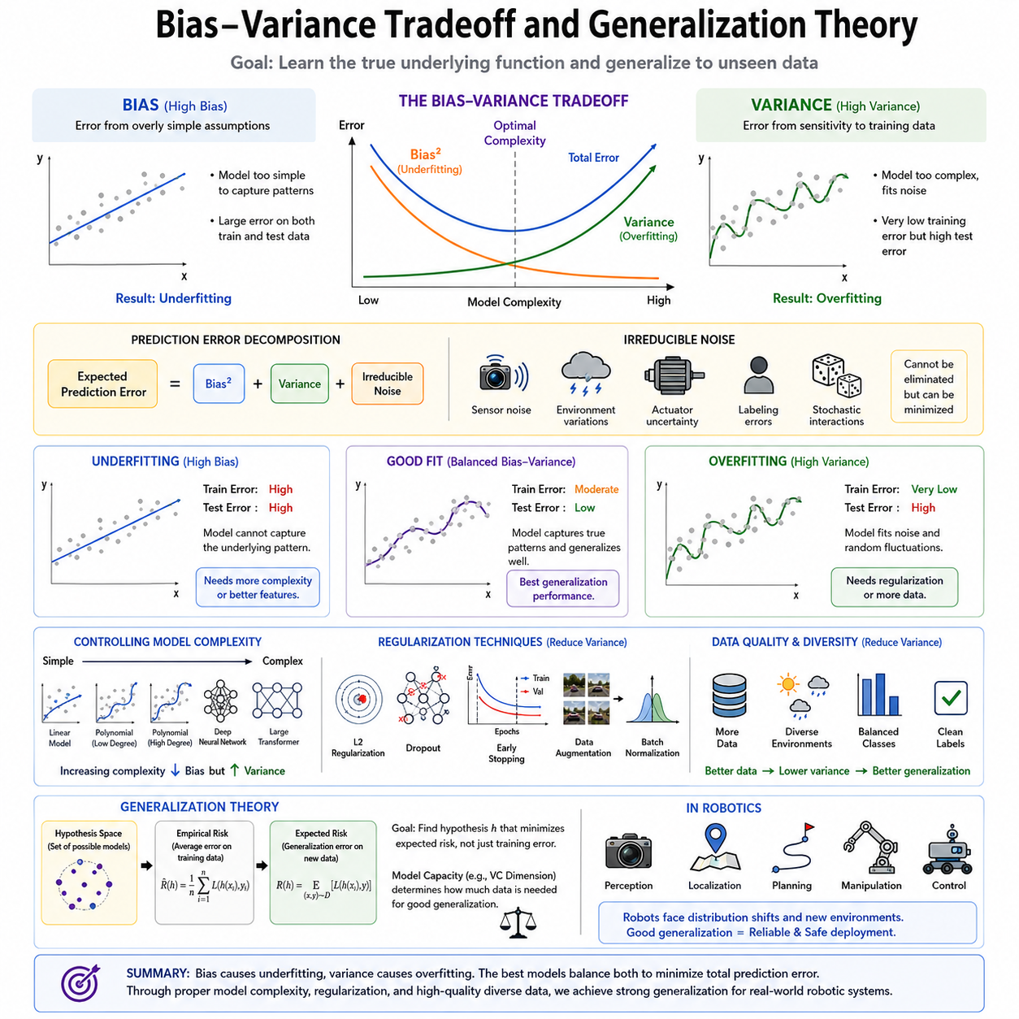
Bias-variance tradeoff is one of the most fundamental concepts in machine learning because it explains why some models generalize well to unseen data while others fail despite achieving excellent performance on the training dataset. The ultimate objective of machine learning is not merely to memorize training examples but to learn the underlying patterns that govern the data generation process. A model that perfectly predicts every training sample but performs poorly on new observations has not truly learned the task. Instead, it has simply memorized the available examples. Generalization theory provides the mathematical and conceptual framework for understanding this phenomenon and guides the design of models that balance learning capacity with robustness. In robotics, where autonomous systems must operate safely under changing environmental conditions, understanding bias, variance, and generalization is essential for building reliable perception, localization, planning, manipulation, and control systems.
Machine learning can be viewed as the process of approximating an unknown function that maps inputs to outputs. Since only a limited number of observations are available during training, the learned model inevitably contains errors. These errors originate from multiple sources, including measurement noise, insufficient training data, imperfect model assumptions, and optimization limitations. Statistical learning theory decomposes prediction error into several components, among which bias and variance are the most influential. Their interaction determines whether a model underfits, overfits, or achieves good generalization.
Bias refers to the systematic error introduced by simplifying assumptions made by the learning algorithm. High-bias models assume that the relationship between inputs and outputs follows relatively simple patterns, even when the true underlying process is considerably more complex. As a result, these models consistently produce inaccurate predictions regardless of the amount of training data available. High bias typically leads to underfitting because the model lacks sufficient capacity to represent the complexity of the target function. Linear regression applied to highly nonlinear data provides a classic example. Although optimization may converge successfully, the resulting model cannot accurately capture nonlinear structures, causing large prediction errors on both training and testing datasets.
Variance represents the sensitivity of a learning algorithm to fluctuations within the training dataset. High-variance models possess enormous representational capacity and can fit extremely complex patterns. However, they often learn not only meaningful structures but also random noise, accidental correlations, and dataset-specific characteristics. Consequently, small changes in the training dataset may produce substantially different learned models. High variance therefore causes overfitting, where training accuracy becomes exceptionally high while test performance deteriorates because the learned knowledge fails to generalize beyond the observed examples.
The bias-variance tradeoff emerges because reducing one source of error often increases the other. Extremely simple models exhibit high bias and low variance because they make strong assumptions and remain relatively stable across different datasets. Extremely complex models exhibit low bias but high variance because they can represent intricate functions while becoming increasingly sensitive to random variations. The optimal machine learning model lies between these two extremes, achieving sufficient complexity to capture meaningful relationships without memorizing noise. Finding this balance represents one of the central challenges in machine learning system design.
The total prediction error can be conceptually decomposed into bias, variance, and irreducible noise. Irreducible noise originates from randomness inherent in the data generation process and cannot be eliminated regardless of model complexity. Sensor measurement uncertainty, environmental disturbances, actuator inaccuracies, human annotation errors, and stochastic physical interactions all contribute to this unavoidable component. Machine learning research therefore focuses primarily on minimizing the controllable bias and variance terms while recognizing that perfect prediction remains impossible in noisy real-world environments.
Underfitting occurs when model capacity is insufficient to capture the complexity of the target function. Both training error and testing error remain relatively high because the model fails to represent important relationships within the data. Increasing model capacity, collecting richer features, improving input representations, or adopting more expressive architectures generally reduces underfitting. In robotics, underfitted perception systems may fail to recognize objects under varying illumination, while underfitted localization models may inadequately represent complex environmental geometries.
Overfitting represents the opposite problem. Here the model learns the training dataset almost perfectly but fails to generalize to new observations. Training error becomes extremely small while testing error increases significantly. Overfitted robot perception models may identify training objects with remarkable precision but perform poorly when deployed in different factories, hospitals, warehouses, or outdoor environments. Such failures often arise because the learned model relies upon irrelevant background textures, lighting conditions, camera viewpoints, or sensor artifacts rather than truly meaningful semantic features.
Model complexity strongly influences both bias and variance. Complexity may increase through deeper neural networks, larger transformer architectures, additional parameters, higher-order polynomial functions, or richer feature spaces. Initially, increasing complexity improves generalization because bias decreases faster than variance increases. Beyond a certain point, however, further complexity produces diminishing returns and eventually causes excessive variance. Understanding where this transition occurs is a critical aspect of model selection and hyperparameter optimization.
Generalization theory investigates why certain machine learning models successfully transfer knowledge from finite training datasets to unseen data. Classical statistical learning theory characterizes generalization using concepts such as hypothesis spaces, empirical risk minimization, expected risk, and structural risk minimization. Rather than optimizing only training performance, learning algorithms seek hypotheses that minimize expected future prediction error. This perspective emphasizes that evaluation should always prioritize performance on independent validation and testing datasets rather than training accuracy alone.
One influential theoretical framework introduces the concept of model capacity, describing the flexibility available within a hypothesis class. Models with enormous capacity can represent a vast number of possible functions, while simpler models represent relatively limited solution spaces. The Vapnik-Chervonenkis dimension historically provided one mathematical measure of model capacity, explaining why larger hypothesis spaces generally require larger datasets to achieve reliable generalization. Although modern deep learning often exceeds the assumptions underlying classical VC theory, the fundamental intuition remains highly valuable.
Deep neural networks present an interesting challenge to traditional bias-variance intuition. Modern transformer models frequently contain billions of parameters, greatly exceeding the number of training examples, yet still generalize remarkably well. This apparent contradiction has motivated extensive research into implicit regularization, optimization dynamics, overparameterization, neural tangent kernels, double descent phenomena, and information-theoretic learning principles. Contemporary generalization theory therefore extends beyond classical statistical learning to incorporate optimization behavior, data geometry, and representation learning.
Regularization techniques are among the most important practical methods for controlling the bias-variance tradeoff. L1 and L2 weight penalties discourage excessively large parameters, thereby reducing model complexity. Dropout randomly disables neurons during training, preventing excessive co-adaptation between features. Early stopping terminates optimization before the model begins memorizing noise. Data augmentation artificially increases dataset diversity through transformations such as rotation, scaling, cropping, illumination changes, noise injection, and geometric perturbations. Batch normalization, weight decay, stochastic depth, label smoothing, and mixup further improve generalization by encouraging more robust internal representations.
Dataset quality plays an equally important role in achieving good generalization. Increasing dataset diversity generally reduces variance because the model encounters broader environmental conditions during training. Balanced class distributions prevent excessive specialization toward dominant categories. High-quality annotations reduce label noise and improve optimization stability. For robotics applications, collecting data across different weather conditions, seasons, lighting environments, sensor configurations, robot platforms, and geographical locations substantially improves deployment robustness.
Cross-validation provides another important mechanism for estimating generalization performance. Rather than evaluating models on a single train-test split, cross-validation repeatedly partitions the available dataset into multiple training and validation subsets. This procedure produces more reliable estimates of expected future performance while reducing sensitivity to accidental characteristics of any individual data partition. Cross-validation is particularly valuable when robotics datasets remain relatively small due to expensive data collection procedures.
Generalization becomes especially challenging in robotics because deployment environments continuously evolve. Distribution shifts frequently occur as lighting conditions change, sensors age, weather varies, objects move, or entirely new environments emerge. A perception model trained in one warehouse may experience significant performance degradation when deployed in another facility with different shelving layouts, camera placements, or illumination patterns. Robust machine learning systems therefore require not only strong statistical generalization but also resilience to domain shifts and out-of-distribution scenarios.
Modern robotics increasingly addresses these challenges through domain adaptation, transfer learning, continual learning, self-supervised pretraining, foundation models, and synthetic data generation. Large-scale representation learning enables models to acquire broadly applicable visual, spatial, and semantic knowledge before fine-tuning on task-specific datasets. Simulation environments generate enormous quantities of diverse training examples that improve robustness through domain randomization and Sim-to-Real transfer methodologies. These techniques effectively reduce variance by exposing models to much broader experience than would otherwise be available.
The bias-variance tradeoff also influences reinforcement learning, although the relationship becomes more complex due to sequential decision making. High-bias value estimators may produce overly simplistic policies, while high-variance policy gradient estimates may destabilize optimization. Numerous modern reinforcement learning algorithms incorporate variance reduction techniques, entropy regularization, trust-region optimization, advantage estimation, replay buffers, and ensemble methods to improve both learning stability and policy generalization.
In Physical AI systems, generalization extends beyond statistical prediction to encompass safe decision making under uncertainty. Robots must recognize unfamiliar objects, navigate previously unseen environments, recover from unexpected failures, and adapt to changing operational conditions without compromising safety. Consequently, generalization is not merely an academic property but a fundamental engineering requirement for dependable autonomous systems. Robust AI architectures increasingly combine supervised learning, self-supervised representation learning, uncertainty estimation, continual adaptation, and reinforcement learning to achieve broad generalization across diverse tasks and environments.
As machine learning continues to evolve toward foundation models and general-purpose Physical AI, the traditional bias-variance tradeoff remains one of the most important conceptual tools for understanding model behavior. Although modern deep learning introduces new theoretical questions regarding overparameterization and scaling laws, the central engineering objective remains unchanged: construct models that learn meaningful patterns rather than memorizing data, minimize prediction error on unseen environments rather than only training datasets, and maintain reliable performance throughout long-term deployment. Generalization theory therefore continues to provide the intellectual foundation for building intelligent robotic systems capable of operating safely, efficiently, and adaptively in the complexity of the real world.

01.03 Loss Functions for Robot Perception and Control [w/Code]
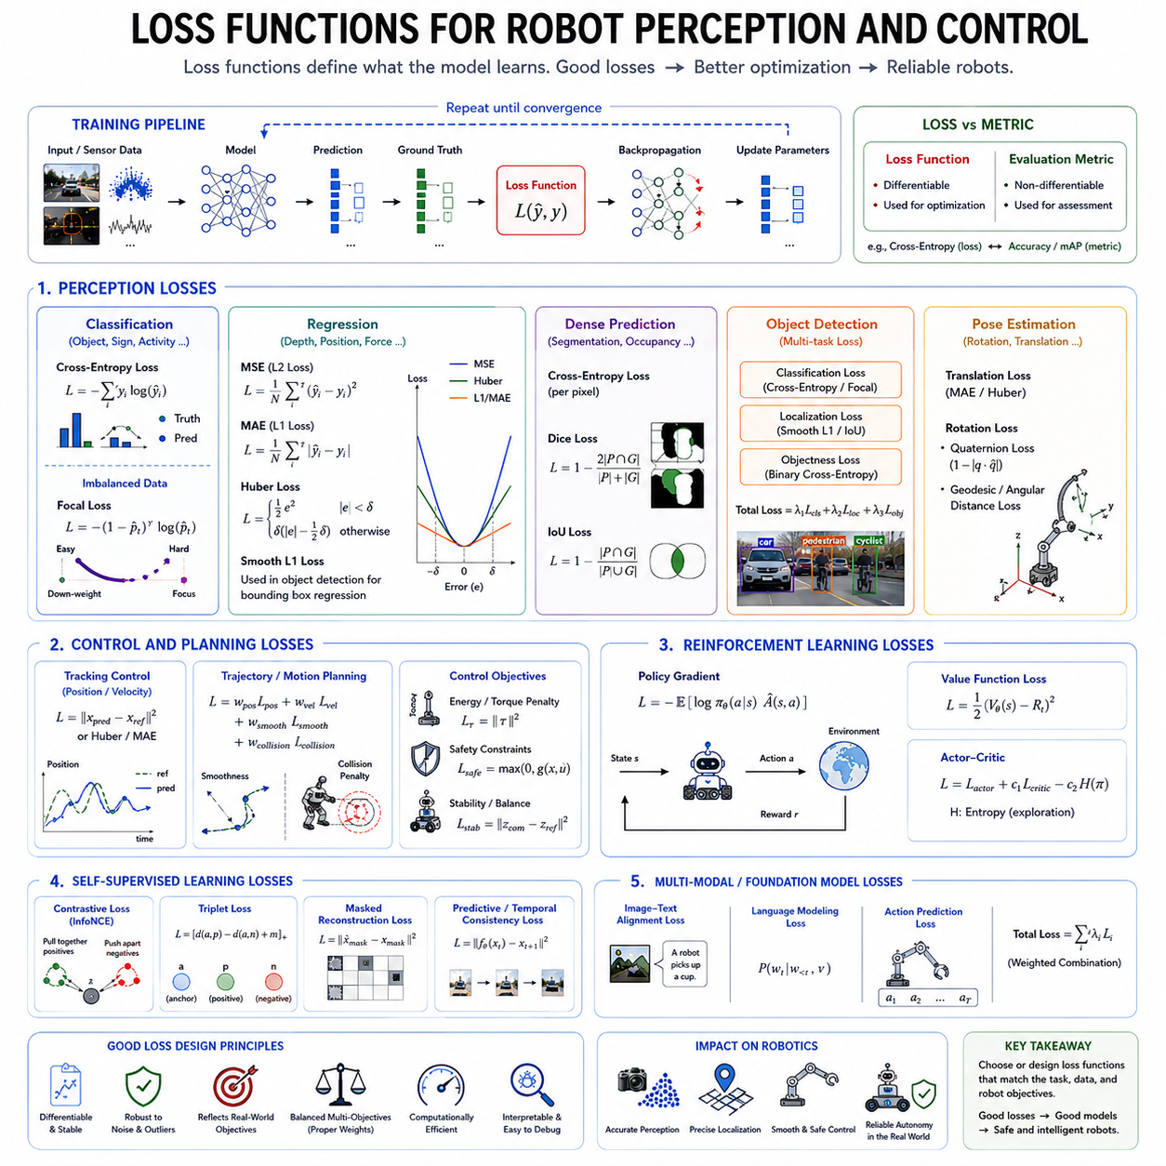
Loss functions are one of the most fundamental components of machine learning because they define what a model should learn during training. Every optimization algorithm ultimately minimizes a loss function, making it the mathematical objective that guides parameter updates throughout the learning process. In robotics, the design of an appropriate loss function is especially critical because robot perception and control systems operate in dynamic, noisy, and safety-critical environments. A poorly designed loss function may produce models with excellent numerical performance during training but unacceptable behavior during deployment. Conversely, a well-designed loss function aligns optimization objectives with real-world task requirements, enabling robust perception, accurate prediction, smooth control, and safe autonomous operation. Understanding the characteristics, advantages, limitations, and practical applications of different loss functions is therefore essential for developing reliable robot intelligence systems.
A loss function measures the discrepancy between a model's prediction and the corresponding ground truth observation. During each training iteration, the neural network produces an output, compares it against the target value, computes the loss, and uses gradient-based optimization to adjust its parameters. This process repeats over millions or even billions of training examples until the model converges toward an optimal solution. The choice of loss function directly influences convergence speed, optimization stability, numerical robustness, and ultimately the quality of the learned representation.
Loss functions differ from evaluation metrics. Evaluation metrics such as accuracy, precision, recall, F1-score, mean average precision, or success rate describe model performance after training, whereas loss functions provide differentiable mathematical objectives that can be optimized through backpropagation. Although evaluation metrics determine whether a model satisfies deployment requirements, they are often non-differentiable and therefore unsuitable for gradient-based optimization. Consequently, machine learning practitioners frequently optimize one objective while evaluating another.
For classification problems, Cross-Entropy Loss has become the standard objective for modern deep learning. Classification tasks require predicting discrete categories, including object recognition, semantic segmentation, traffic sign classification, terrain identification, gesture recognition, fault diagnosis, and robot activity recognition. Cross-Entropy Loss measures the difference between the predicted probability distribution and the true probability distribution. Rather than rewarding only correct predictions, it encourages high confidence for correct classes while penalizing incorrect confidence assignments. This probabilistic formulation leads to stable optimization and rapid convergence across a wide variety of classification problems.
Binary Cross-Entropy Loss represents a specialized version designed for two-class classification problems. Examples include obstacle versus free space detection, collision prediction, human presence detection, anomaly identification, safety boundary monitoring, and binary quality inspection. Multi-class Cross-Entropy extends naturally to problems containing multiple mutually exclusive categories, while multi-label classification frequently employs independent Binary Cross-Entropy objectives for each possible label.
Robot perception frequently encounters severe class imbalance, where certain object categories appear much more frequently than others. For example, autonomous vehicles observe road surfaces continuously while pedestrians or emergency vehicles appear relatively infrequently. Standard Cross-Entropy may therefore bias optimization toward dominant classes. Focal Loss addresses this challenge by reducing the contribution of easily classified examples while emphasizing difficult or rare observations. This mechanism significantly improves detection performance for small objects, distant pedestrians, defects, medical abnormalities, and other infrequent events that remain critically important despite their rarity.
Regression problems require predicting continuous numerical quantities rather than discrete labels. Mean Squared Error, commonly abbreviated as MSE, remains the most widely used regression loss. MSE computes the average squared difference between predicted values and target values, assigning increasingly larger penalties to larger prediction errors. Because the squared term amplifies large deviations, MSE strongly encourages accurate predictions and smooth optimization. Applications include depth estimation, object localization, joint angle prediction, force estimation, trajectory prediction, battery health estimation, and robot state estimation.
Root Mean Squared Error shares similar properties with MSE but expresses prediction errors in the same physical units as the original measurements, making interpretation more intuitive. Although RMSE is frequently used as an evaluation metric, differentiable formulations also appear during optimization in certain regression tasks requiring direct physical interpretation.
Mean Absolute Error, abbreviated MAE, computes the average absolute difference between predictions and targets. Unlike MSE, MAE penalizes all prediction errors linearly rather than quadratically, making it substantially more robust against outliers. When sensor measurements occasionally contain large disturbances or annotation errors, MAE prevents these isolated observations from dominating optimization. However, its constant gradient may slow convergence compared with MSE near the optimal solution.
Huber Loss combines the strengths of MSE and MAE by behaving quadratically for small prediction errors and linearly for large errors. Small deviations receive smooth gradients that promote efficient convergence, while large outliers receive reduced influence that prevents unstable optimization. Consequently, Huber Loss has become highly popular for robotics applications involving noisy sensors, imperfect measurements, and occasional extreme disturbances. Autonomous driving, robot localization, visual odometry, inertial navigation, and sensor fusion frequently benefit from this balanced behavior.
Smooth L1 Loss represents a closely related formulation commonly adopted in modern object detection systems. Algorithms such as Faster R-CNN employ Smooth L1 Loss for bounding box regression because it provides stable gradients while remaining robust against annotation inaccuracies. In robot perception systems where object positions must be estimated precisely, Smooth L1 frequently outperforms pure MSE by reducing sensitivity to imperfect ground truth labels.
Perception systems often solve dense prediction problems where every image pixel contributes to the optimization objective. Semantic segmentation typically combines Cross-Entropy Loss with region-based objectives such as Dice Loss or Intersection-over-Union Loss. Dice Loss directly measures overlap between predicted and ground truth regions, making it particularly effective for highly imbalanced segmentation tasks involving thin structures, road markings, medical images, robot grasp regions, or navigable free space. IoU-based losses similarly optimize geometric overlap rather than individual pixel accuracy, producing segmentation outputs that align more closely with deployment requirements.
Object detection introduces multiple prediction objectives simultaneously. Modern detection networks generally optimize a combination of classification loss, localization loss, confidence estimation loss, and sometimes auxiliary feature consistency losses. Multi-task learning therefore combines several independent objectives into a weighted composite loss. Selecting appropriate weighting coefficients becomes an important hyperparameter optimization problem because excessive emphasis on one objective may degrade another.
Robot pose estimation frequently requires predicting rotations, translations, and articulated joint configurations. Rotation estimation introduces unique mathematical challenges because rotational spaces are non-Euclidean. Quaternion Loss, Geodesic Loss, Angular Distance Loss, and rotation matrix consistency objectives explicitly account for rotational geometry, preventing discontinuities that arise when conventional Euclidean losses are applied to orientation estimation. Accurate pose estimation directly influences manipulation precision, navigation accuracy, visual servoing, and autonomous inspection.
Trajectory prediction and motion planning require losses that evaluate temporal sequences rather than isolated predictions. Sequence losses compare entire predicted trajectories against expert demonstrations or optimal reference paths. Besides minimizing positional errors, these objectives often incorporate smoothness constraints, velocity consistency, acceleration limits, curvature penalties, and collision avoidance terms. Such composite objectives encourage physically feasible robot motions that satisfy both accuracy and safety requirements.
Robot control systems frequently employ task-specific control losses that extend beyond conventional prediction accuracy. Position control minimizes tracking errors between desired and actual positions. Velocity control minimizes speed deviations while maintaining smooth acceleration. Torque control optimizes actuator outputs subject to physical limitations. Energy-aware objectives penalize excessive power consumption, whereas safety losses discourage unstable motions, abrupt accelerations, excessive joint torques, or unsafe interactions with nearby humans. Multi-objective optimization therefore becomes central to intelligent robot control.
Reinforcement learning introduces an entirely different perspective on loss functions. Rather than directly comparing predictions against labeled targets, reinforcement learning optimizes expected cumulative rewards. Policy gradient methods maximize expected future returns, value function losses estimate long-term state values, actor-critic methods jointly optimize policy and value objectives, while entropy regularization encourages sufficient exploration. Although these objectives differ mathematically from supervised losses, they ultimately serve the same purpose of guiding optimization toward improved robot behavior.
Self-supervised learning similarly employs specialized objectives derived from the data itself rather than manually provided labels. Contrastive Loss encourages similar observations to produce nearby feature representations while separating unrelated examples. Triplet Loss explicitly compares anchor, positive, and negative samples to construct discriminative embeddings. InfoNCE Loss, cosine similarity objectives, masked reconstruction losses, and predictive coding objectives have become fundamental components of modern representation learning. These techniques enable robots to exploit enormous quantities of unlabeled sensory data before fine-tuning on downstream tasks.
Multi-modal robot foundation models often optimize numerous objectives simultaneously. Vision-language models combine image-text alignment losses, masked language modeling losses, contrastive representation objectives, autoregressive prediction losses, and sometimes reinforcement learning objectives within a unified optimization framework. Similarly, Vision-Language-Action models jointly optimize perception accuracy, language understanding, action prediction, temporal consistency, and policy optimization. These composite training objectives allow foundation models to acquire general-purpose knowledge transferable across many robotic tasks.
Designing an effective loss function requires balancing multiple engineering considerations. Numerical stability prevents exploding or vanishing gradients during optimization. Differentiability enables efficient backpropagation. Robustness against noisy labels improves deployment reliability. Computational efficiency supports large-scale distributed training. Physical consistency ensures that optimization aligns with real-world constraints rather than purely mathematical objectives. Interpretability further assists debugging by allowing engineers to identify which components contribute most significantly to overall optimization.
Weighted loss functions provide one practical mechanism for balancing competing objectives. Individual loss components receive adjustable coefficients reflecting their relative importance. During autonomous driving, safety-related penalties may receive substantially larger weights than aesthetic trajectory smoothness. During robotic manipulation, grasp stability may outweigh execution speed. Curriculum learning further modifies loss weighting dynamically throughout training, allowing models to master simpler subtasks before progressively addressing increasingly difficult objectives.
The emergence of Physical AI has significantly expanded the complexity of loss function design. Future autonomous robots must simultaneously perceive complex environments, understand natural language, reason about long-horizon goals, generate physically feasible actions, and satisfy safety constraints. Consequently, optimization increasingly relies upon hierarchical multi-objective loss formulations integrating perception, planning, manipulation, navigation, language grounding, uncertainty estimation, and reinforcement learning into unified training pipelines. Rather than optimizing isolated prediction tasks, next-generation robotic foundation models optimize comprehensive behavioral objectives that better reflect the complexity of real-world autonomous intelligence.
As robot intelligence continues evolving toward increasingly capable foundation models, the importance of carefully designed loss functions will only grow. The loss function defines what knowledge is ultimately acquired by the learning algorithm. Regardless of network architecture, computational resources, or dataset size, optimization cannot produce desirable behavior unless the learning objective accurately captures the desired task. Effective loss function design therefore remains one of the most influential factors determining the performance, robustness, safety, and generalization capability of intelligent robotic systems operating in real-world environments.

01.04 Optimization Algorithms SGD Adam AdamW [w/Code]
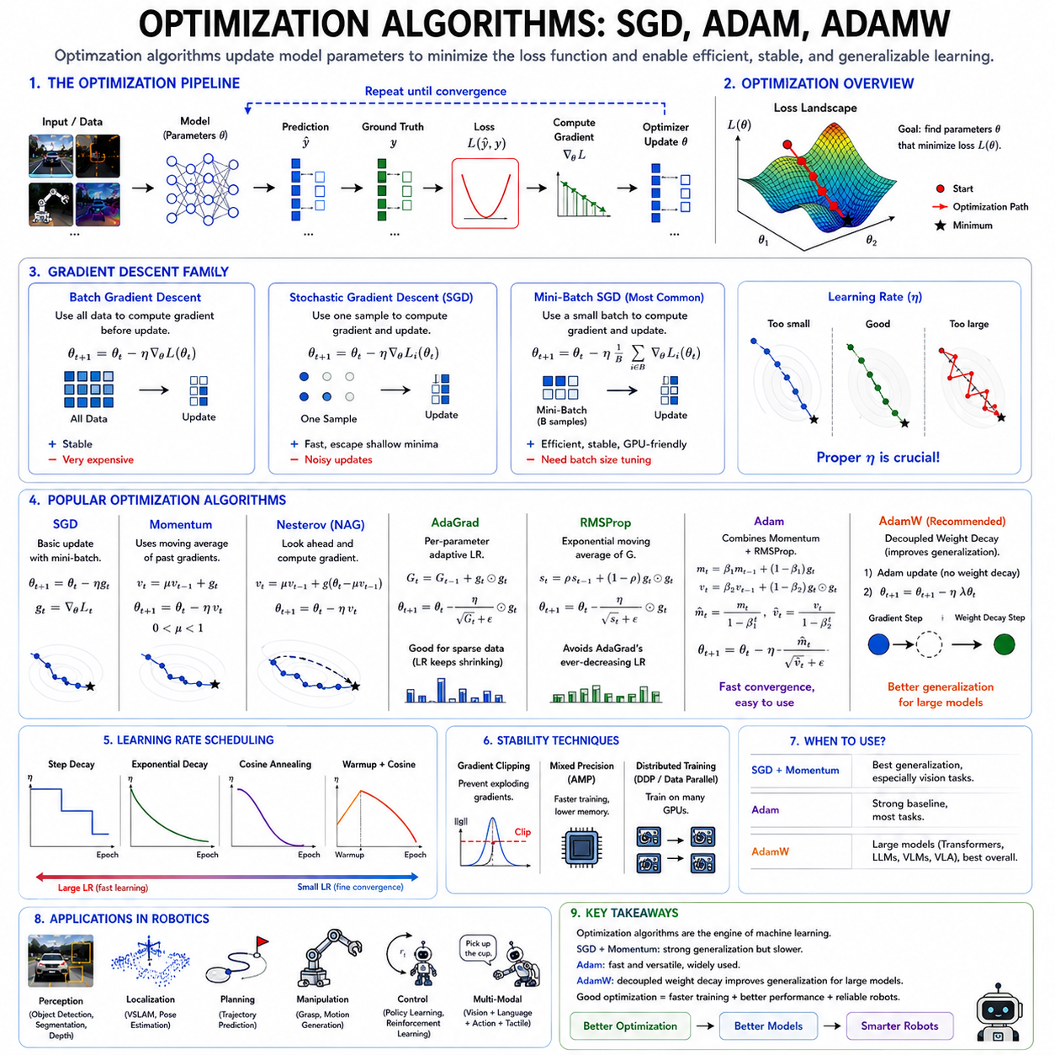
Optimization algorithms form the computational engine of modern machine learning by determining how model parameters are updated during training. Regardless of the neural network architecture, dataset size, or learning objective, successful learning depends on an optimization algorithm capable of efficiently minimizing the chosen loss function. In deep learning, models often contain millions or even billions of trainable parameters, making manual optimization impossible. Instead, optimization algorithms automatically compute parameter updates using gradients obtained through backpropagation, gradually reducing prediction errors until the model converges toward an optimal solution. In robotics, optimization algorithms are particularly important because perception, localization, planning, manipulation, and control models must learn from massive multimodal datasets while achieving high accuracy, numerical stability, and efficient convergence. Selecting an appropriate optimizer directly influences training speed, final model quality, generalization capability, and deployment reliability.
Optimization in machine learning can be viewed as a search process over a high-dimensional parameter space. Every trainable parameter defines one dimension within this optimization landscape, while the loss function defines the surface that the optimizer attempts to minimize. The objective is to identify parameter values corresponding to the lowest possible loss, thereby producing accurate predictions on both training and unseen data. Since modern neural networks often possess highly non-convex loss surfaces containing numerous local minima, saddle points, plateaus, and narrow valleys, optimization algorithms must navigate extremely complex landscapes efficiently without becoming trapped in undesirable regions.
Gradient Descent provides the theoretical foundation for nearly all modern optimization algorithms. The central idea is remarkably intuitive. The gradient of the loss function indicates the direction of the steepest increase, so moving parameters in the opposite direction reduces the loss. During each iteration, gradients are computed with respect to every trainable parameter, and parameter values are adjusted proportionally according to a predefined learning rate. Repeating this process over many iterations gradually moves the model toward a local optimum.
Batch Gradient Descent computes gradients using the entire training dataset before updating parameters. Although mathematically stable and theoretically straightforward, this approach becomes computationally expensive for modern datasets containing millions of training samples. Furthermore, parameter updates occur infrequently because every iteration requires processing the complete dataset. Consequently, full-batch optimization is rarely used for contemporary deep learning applications.
Stochastic Gradient Descent, commonly abbreviated as SGD, addresses this limitation by updating parameters after processing only a single randomly selected training example. Frequent updates significantly accelerate learning while introducing stochasticity that often helps optimization escape shallow local minima. However, individual sample gradients exhibit substantial variance, causing noisy optimization trajectories and unstable convergence. Although pure SGD remains conceptually important, its excessive randomness limits practical performance for many large-scale applications.
Mini-batch Stochastic Gradient Descent combines the strengths of batch and stochastic optimization by computing gradients over small subsets of training data rather than individual examples or the complete dataset. Typical batch sizes range from 32 to several thousand samples depending on available computational resources and model architecture. Mini-batch optimization reduces gradient variance while maintaining computational efficiency through parallel processing on GPUs. As a result, mini-batch SGD has become the standard optimization framework underlying virtually all modern deep learning systems.
The learning rate represents one of the most influential hyperparameters in optimization. It determines the magnitude of each parameter update and therefore controls convergence speed and stability. Excessively small learning rates produce slow convergence, requiring enormous computational resources before reaching satisfactory solutions. Conversely, excessively large learning rates may cause optimization to oscillate, diverge, or completely fail by repeatedly overshooting optimal regions. Careful learning rate selection therefore remains one of the most critical aspects of successful model training.
Momentum extends classical SGD by incorporating historical gradient information into parameter updates. Rather than relying solely on the current gradient, Momentum accumulates an exponentially weighted moving average of previous updates, allowing optimization to accelerate consistently along stable directions while suppressing oscillations across steep dimensions. This behavior resembles the physical momentum of a moving object, which continues traveling even after encountering small disturbances. Momentum significantly improves convergence speed for deep neural networks and remains a fundamental component of many advanced optimization algorithms.
Nesterov Accelerated Gradient further refines the Momentum concept by estimating future parameter positions before computing gradients. Instead of calculating gradients at the current location, Nesterov evaluates gradients after a tentative momentum step, effectively anticipating future optimization behavior. This predictive mechanism often produces more accurate parameter updates, faster convergence, and improved optimization stability, particularly for deep convolutional networks and recurrent architectures.
Adaptive optimization algorithms emerged to address limitations associated with manually selecting global learning rates. Rather than applying identical learning rates to every parameter, adaptive methods automatically adjust individual learning rates according to historical gradient statistics. Parameters receiving consistently large gradients obtain smaller updates, while parameters experiencing small gradients receive relatively larger updates. This adaptive behavior significantly improves optimization efficiency across heterogeneous neural network architectures.
AdaGrad was among the earliest adaptive optimization algorithms. It accumulates squared historical gradients for every parameter and scales future learning rates inversely according to accumulated magnitudes. Frequently updated parameters gradually receive smaller learning rates, whereas infrequently updated parameters continue learning rapidly. AdaGrad proved particularly effective for sparse machine learning problems such as natural language processing and recommendation systems. However, continuously accumulating gradients causes learning rates to decrease indefinitely, eventually slowing optimization excessively.
RMSProp addresses AdaGrad's diminishing learning rate problem by replacing cumulative gradient accumulation with exponentially weighted moving averages. Rather than storing all historical gradients indefinitely, RMSProp gradually forgets older observations while emphasizing recent optimization behavior. This modification enables sustained learning throughout long training procedures and substantially improves convergence for recurrent neural networks, reinforcement learning, and sequential prediction tasks.
Adam, short for Adaptive Moment Estimation, represents one of the most influential optimization algorithms in modern deep learning. Adam combines Momentum with RMSProp by simultaneously maintaining exponentially weighted estimates of both first-order gradient moments and second-order squared gradient moments. First-order moments capture average optimization direction, while second-order moments estimate gradient magnitude and variability. Bias correction further compensates for initialization effects during early optimization stages, producing stable and efficient parameter updates from the beginning of training.
The widespread popularity of Adam originates from several practical advantages. It requires relatively little hyperparameter tuning, converges rapidly across diverse neural network architectures, handles sparse gradients effectively, and remains numerically stable even for extremely deep models. Consequently, Adam has become the default optimizer for transformers, vision models, language models, multimodal foundation models, reinforcement learning policies, and numerous robotics applications involving perception, localization, manipulation, and autonomous navigation.
Despite its impressive convergence speed, Adam exhibits certain limitations. Multiple empirical studies have observed that models optimized using Adam sometimes demonstrate weaker generalization than equivalent models trained using SGD with Momentum. Adam's highly adaptive parameter updates occasionally encourage rapid memorization of training data rather than learning robust representations transferable to unseen environments. This phenomenon has motivated continued research into adaptive optimization algorithms capable of balancing fast convergence with strong generalization performance.
Weight decay provides one mechanism for improving generalization by discouraging excessively large parameter values. Traditionally, many optimization algorithms implemented weight decay by incorporating L2 regularization directly into gradient computations. Although mathematically equivalent for classical SGD, this coupling produces undesirable interactions when adaptive learning rates are introduced, particularly within Adam. The resulting optimization dynamics differ substantially from true weight decay, reducing regularization effectiveness.
AdamW resolves this issue by decoupling weight decay from gradient-based parameter updates. Instead of embedding L2 penalties within gradient computations, AdamW independently applies weight decay after adaptive optimization updates. This seemingly subtle modification significantly improves generalization while preserving Adam's rapid convergence and numerical stability. As a result, AdamW has become the standard optimizer for transformer architectures, Vision Transformers, large language models, Vision-Language Models, Vision-Language-Action models, and numerous foundation models.
Modern robotics increasingly adopts AdamW because autonomous systems demand both efficient optimization and reliable deployment performance. Robot perception models trained using AdamW frequently achieve improved robustness under varying illumination, sensor noise, weather conditions, and environmental changes. Similarly, foundation models for robotic manipulation, navigation, and multimodal reasoning often rely upon AdamW throughout large-scale pretraining before subsequent task-specific fine-tuning.
Learning rate scheduling complements optimization algorithms by dynamically adjusting learning rates throughout training. Rather than maintaining constant learning rates, scheduling strategies gradually reduce update magnitudes as optimization progresses. Step decay decreases learning rates after predefined intervals, exponential decay continuously reduces learning rates according to exponential functions, cosine annealing smoothly varies learning rates following cosine trajectories, and warmup schedules gradually increase learning rates during initial training iterations before transitioning toward normal optimization. These strategies substantially improve convergence stability for deep neural networks.
Warmup has become particularly important for training large transformer architectures. Since randomly initialized networks initially produce unstable gradients, beginning with very small learning rates prevents catastrophic optimization failures. After several hundred or thousand iterations, learning rates gradually increase toward their target values before later decreasing according to predefined schedules. Nearly all contemporary large-scale language models and multimodal foundation models employ warmup together with AdamW optimization.
Optimization becomes increasingly challenging as neural network scale continues growing. Mixed-precision training introduces reduced numerical precision to accelerate computation while requiring specialized optimization techniques such as gradient scaling to prevent numerical underflow. Gradient clipping constrains excessively large gradients, improving stability during recurrent network training, reinforcement learning, and large transformer optimization. Distributed optimization synchronizes gradients across numerous GPUs, enabling efficient training of trillion-parameter foundation models.
Robot learning introduces additional optimization challenges beyond conventional supervised learning. Reinforcement learning often produces noisy, delayed, and highly variable gradients requiring stable optimization despite sparse reward signals. Multi-task learning simultaneously optimizes multiple competing objectives that may produce conflicting gradient directions. Multi-modal foundation models integrate vision, language, tactile sensing, proprioception, force sensing, and action prediction into unified optimization frameworks requiring careful balancing of heterogeneous loss functions.
Optimization algorithms also influence energy consumption, computational cost, and development efficiency. Faster convergence reduces GPU utilization, shortens experimentation cycles, decreases training costs, and accelerates research iteration. These considerations become especially important for industrial robotics companies developing large foundation models requiring weeks or months of distributed GPU computation. Efficient optimization therefore contributes not only to improved model performance but also to practical engineering productivity.
The future of optimization research extends beyond manually designed update rules toward increasingly intelligent optimization systems. Meta-learning techniques learn optimization algorithms directly from data, neural optimizers replace handcrafted update equations with trainable neural networks, and adaptive hyperparameter optimization automatically tunes learning rates, weight decay coefficients, and momentum parameters during training. These emerging approaches aim to reduce human intervention while improving optimization efficiency across increasingly diverse AI architectures.
As Physical AI systems continue integrating perception, reasoning, planning, language understanding, and action generation into unified foundation models, optimization algorithms will remain central to successful learning. Regardless of architectural innovations, every trainable model ultimately depends upon effective optimization to transform raw data into meaningful intelligence. Among contemporary optimization methods, SGD continues providing excellent generalization for many vision tasks, Adam offers exceptional convergence speed and versatility across diverse architectures, and AdamW represents the current state of the art for large-scale transformer and foundation model training by combining adaptive optimization with principled regularization. Together, these algorithms form the optimization backbone supporting the next generation of intelligent robotic systems capable of operating safely, efficiently, and autonomously in complex real-world environments.

01.05 Regularization Techniques Dropout BatchNorm WD [w/Code]
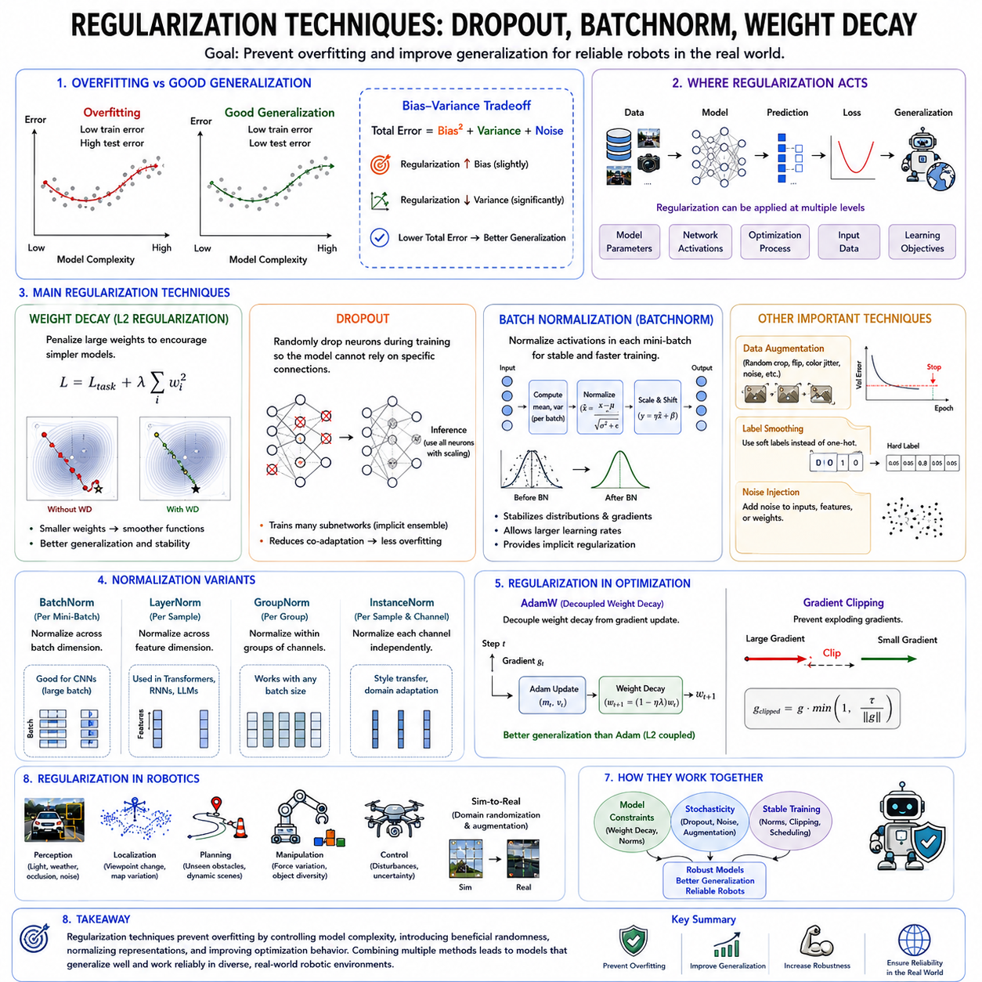
Regularization techniques are fundamental components of modern machine learning because they enable models to learn meaningful patterns while preventing excessive memorization of training data. As neural networks become increasingly larger and more expressive, their ability to perfectly fit training datasets also increases. Although this enormous representational capacity allows models to solve highly complex problems, it simultaneously introduces the risk of overfitting, where the model captures random noise, dataset-specific artifacts, and accidental correlations rather than the underlying data distribution. Regularization provides a collection of mathematical and algorithmic techniques designed to improve model generalization by constraining the learning process. In robotics, where autonomous systems must operate reliably across changing environments, sensor conditions, and unforeseen situations, effective regularization is essential for producing robust perception, localization, planning, manipulation, and control models.
The primary objective of regularization is not to maximize training accuracy but to optimize performance on previously unseen data. A model that achieves nearly perfect accuracy during training may still fail in production if it has memorized irrelevant details unique to the training dataset. Good regularization encourages the model to learn stable, meaningful, and transferable representations rather than exploiting accidental statistical relationships. Consequently, regularization directly addresses the bias-variance tradeoff by slightly increasing model bias while significantly reducing variance, ultimately improving overall generalization performance.
Overfitting typically emerges when model capacity greatly exceeds the complexity of the available training data. Deep neural networks containing millions or billions of parameters can represent an enormous variety of functions, allowing them to interpolate almost any training dataset. Without appropriate constraints, optimization algorithms naturally minimize training loss by fitting every available observation, including measurement noise, annotation errors, sensor artifacts, and environmental peculiarities. Although training error approaches zero, testing error often increases because the learned representations fail to generalize beyond the observed examples.
Regularization techniques may operate at multiple levels throughout the machine learning pipeline. Some methods directly constrain model parameters, others modify optimization behavior, augment training data, introduce stochasticity into network activations, normalize intermediate representations, or impose additional learning objectives. Modern deep learning systems rarely rely upon a single regularization technique. Instead, multiple complementary approaches are typically combined to achieve optimal robustness and generalization.
Weight decay represents one of the oldest and most widely used regularization methods. The central idea is straightforward: discourage excessively large parameter values by introducing an additional penalty proportional to the magnitude of the network weights. During optimization, the objective becomes minimizing both prediction error and parameter magnitude simultaneously. Smaller weights generally correspond to smoother decision boundaries and less complex functions, reducing the likelihood of fitting random noise within the training dataset.
L2 regularization provides the mathematical foundation underlying conventional weight decay by adding the squared Euclidean norm of all trainable parameters to the loss function. Large weights receive increasingly severe penalties, encouraging distributed representations where many parameters contribute moderately rather than a few parameters dominating network behavior. L2 regularization improves numerical stability, reduces sensitivity to noisy observations, and frequently enhances generalization across vision, language, and robotics applications.
L1 regularization offers an alternative approach by penalizing the absolute magnitude of network weights rather than their squares. Unlike L2 regularization, L1 encourages sparse parameter distributions in which many weights become exactly zero. This sparsity naturally performs feature selection by eliminating less important connections, potentially reducing model complexity and improving interpretability. Although L1 appears less frequently than L2 in large deep learning models, it remains valuable in sparse learning, compressed neural networks, and feature selection applications.
Weight decay and L2 regularization are often discussed interchangeably, particularly within classical stochastic gradient descent optimization. However, adaptive optimizers such as Adam introduce subtle differences between coupled L2 penalties and true weight decay. AdamW resolves this discrepancy by decoupling weight decay from adaptive gradient updates, providing stronger regularization and improved generalization for transformer architectures and modern foundation models. Consequently, AdamW has become the standard optimization algorithm for many large-scale vision-language and robotics foundation models.
Dropout represents one of the most influential stochastic regularization techniques in deep learning. During training, Dropout randomly disables a subset of neurons with a predefined probability, temporarily removing them from the computational graph. Because different neurons disappear during every training iteration, the network cannot rely excessively on specific pathways or individual features. Instead, it must distribute learned representations across many alternative neurons, resulting in substantially improved robustness and reduced overfitting.
The conceptual intuition behind Dropout resembles training an ensemble of numerous slightly different neural networks that share parameters. Each mini-batch effectively trains a different subnetwork, while inference combines their collective knowledge using the complete network with appropriately scaled activations. This implicit ensemble effect significantly improves generalization without requiring multiple independently trained models, making Dropout computationally efficient despite its strong regularization capabilities.
Selecting appropriate Dropout probabilities requires careful consideration. Excessively small probabilities provide limited regularization, while excessively large probabilities remove too much information, slowing convergence and reducing representational capacity. Typical fully connected layers often employ Dropout probabilities around fifty percent, whereas convolutional architectures generally utilize substantially smaller values because spatial feature extraction already introduces strong structural constraints.
Although Dropout proved extremely successful in early deep convolutional networks, its importance has evolved with advances in modern architectures. Residual networks, transformers, normalization layers, and improved optimization techniques often require less aggressive Dropout than earlier architectures. Nevertheless, Dropout remains highly valuable for fully connected classification layers, transformer attention mechanisms, multimodal fusion modules, reinforcement learning policies, and robotics applications involving relatively limited datasets.
Batch Normalization represents another transformative innovation that simultaneously improves optimization stability and provides implicit regularization. Deep neural networks frequently suffer from changing activation distributions as parameters evolve throughout training, making optimization increasingly difficult. Batch Normalization addresses this challenge by normalizing intermediate feature distributions within each mini-batch before applying learnable scaling and shifting operations. This normalization stabilizes gradient propagation, accelerates convergence, and permits significantly larger learning rates during optimization.
Beyond optimization benefits, Batch Normalization introduces mild stochasticity because each mini-batch possesses slightly different statistical properties. Consequently, the normalized activations vary subtly across training iterations even when identical samples appear repeatedly. This randomness acts as an implicit regularizer, reducing overfitting while improving model robustness. In many convolutional neural networks, Batch Normalization substantially reduces dependence upon Dropout because its normalization process already provides meaningful regularization.
Batch Normalization computes feature statistics independently for every mini-batch during training. Running estimates of feature means and variances are simultaneously accumulated for deployment. During inference, these accumulated statistics replace mini-batch estimates, ensuring deterministic predictions independent of batch composition. Correctly managing this transition between training and inference modes is essential for reliable production deployment.
Although Batch Normalization revolutionized deep learning, certain limitations remain. Small batch sizes produce unreliable statistical estimates, reducing normalization quality and occasionally destabilizing optimization. Robotics applications frequently encounter this challenge because high-resolution sensor inputs, large transformer models, or GPU memory limitations often require relatively small mini-batches. Alternative normalization techniques have therefore emerged to address these scenarios.
Layer Normalization normalizes activations across feature dimensions within individual samples rather than across mini-batches. Consequently, its behavior remains independent of batch size, making Layer Normalization particularly suitable for recurrent neural networks, transformers, and language models. Vision-Language Models, Large Language Models, and Vision-Language-Action architectures almost universally employ Layer Normalization rather than Batch Normalization because transformer attention mechanisms naturally benefit from sample-wise normalization.
Group Normalization divides feature channels into several groups before performing normalization independently within each group. This approach maintains stable behavior regardless of batch size while preserving many advantages of Batch Normalization. Robotics perception systems processing high-resolution images frequently adopt Group Normalization when GPU memory constraints prevent sufficiently large training batches.
Instance Normalization performs normalization independently for every feature channel within each individual sample. Originally developed for image generation and style transfer, Instance Normalization effectively removes instance-specific contrast information while preserving structural content. Robotics applications involving domain adaptation, synthetic-to-real transfer, or visual appearance normalization occasionally benefit from this specialized normalization strategy.
Data augmentation represents another powerful form of regularization by artificially increasing dataset diversity. Rather than modifying the neural network directly, augmentation transforms training examples through rotations, scaling, cropping, color perturbations, illumination changes, Gaussian noise, random occlusions, geometric distortions, or synthetic sensor artifacts. These transformations expose the model to broader environmental variability, encouraging invariant feature learning and significantly improving generalization.
Robot perception particularly benefits from aggressive data augmentation because deployment environments naturally contain changing illumination, weather, viewpoints, motion blur, sensor noise, partial occlusions, and environmental dynamics. Synthetic augmentation therefore approximates many real-world conditions without requiring expensive manual data collection. Simulation environments further extend this concept through domain randomization, generating highly diverse synthetic experiences supporting robust Sim-to-Real transfer.
Early stopping provides a simple yet highly effective optimization-based regularization strategy. During training, performance is continuously evaluated on an independent validation dataset. Although training error generally decreases monotonically, validation error eventually begins increasing once overfitting emerges. Early stopping terminates optimization before this degradation becomes substantial, preserving parameter configurations exhibiting the strongest generalization. This technique frequently complements weight decay and Dropout within practical deep learning workflows.
Label smoothing regularizes classification models by replacing perfectly certain target labels with slightly softened probability distributions. Rather than assigning absolute probability one to the correct class, label smoothing distributes a small amount of probability mass across incorrect classes. This modification discourages excessive prediction confidence, improves calibration, and enhances robustness against annotation errors. Modern transformer architectures commonly employ label smoothing during large-scale supervised training.
Noise injection introduces controlled randomness into various stages of neural network training. Noise may be added to input data, intermediate activations, gradients, or even network parameters themselves. Learning under noisy conditions encourages stable representations that remain effective despite measurement uncertainty or environmental disturbances. Since robotics inherently involves noisy sensors and uncertain physical interactions, noise-based regularization naturally aligns with deployment conditions encountered in real-world autonomous systems.
Modern foundation models frequently combine numerous regularization techniques simultaneously. A typical Vision-Language-Action model may employ AdamW optimization with decoupled weight decay, Layer Normalization, Dropout within transformer attention layers, extensive multimodal data augmentation, label smoothing, gradient clipping, early stopping during fine-tuning, and self-supervised pretraining objectives. Each technique addresses different sources of overfitting while collectively improving robustness and transferability.
Regularization also extends beyond supervised learning. Reinforcement learning incorporates entropy regularization to encourage exploration rather than premature convergence toward deterministic policies. Contrastive self-supervised learning introduces representation-level regularization through embedding similarity constraints. Multi-task learning implicitly regularizes individual tasks by sharing representations across multiple objectives. Continual learning applies parameter regularization to prevent catastrophic forgetting when sequentially acquiring new knowledge.
For robotics, regularization has particularly significant practical implications. Autonomous robots continuously encounter environmental conditions absent from training datasets, including novel objects, changing weather, sensor degradation, lighting variation, unexpected obstacles, and evolving operational requirements. Models trained without sufficient regularization often exhibit brittle behavior under these conditions, potentially compromising safety and reliability. Effective regularization therefore contributes directly to dependable autonomous operation rather than merely improving benchmark accuracy.
As machine learning evolves toward increasingly capable Physical AI systems, regularization remains indispensable despite growing model sizes. Large foundation models possess extraordinary representational capacity that must be carefully controlled to ensure robust learning rather than memorization. Modern regularization techniques including weight decay, Dropout, Batch Normalization, Layer Normalization, data augmentation, early stopping, and numerous complementary approaches collectively enable deep neural networks to acquire meaningful, transferable knowledge applicable across diverse robotic tasks. Together, these methods provide the foundation for building intelligent systems that not only perform exceptionally well during training but also generalize safely and reliably throughout long-term deployment in the real world.

01.06 Data Splits Cross Validation for Robot Datasets [w/Code]
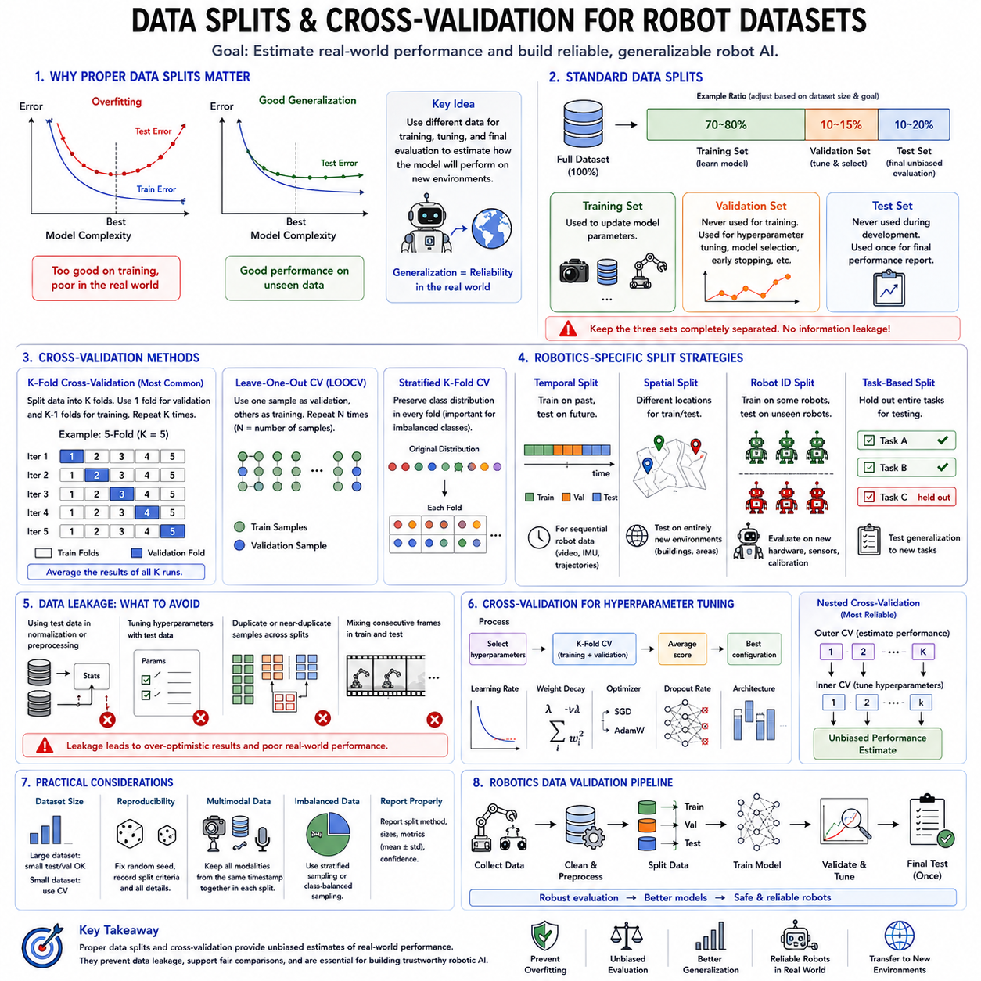
Data splitting and cross-validation are fundamental components of machine learning experimentation because they provide objective methods for estimating how well a trained model will perform on previously unseen data. The ultimate objective of machine learning is not to achieve high accuracy on the data used for training, but to develop models that generalize reliably to new environments, sensors, objects, and operating conditions. Without proper evaluation methodology, a model may appear highly accurate during development while failing completely after deployment. This issue becomes especially important in robotics, where autonomous systems must operate safely in dynamic real-world environments that inevitably differ from the training dataset. Proper dataset partitioning and validation strategies therefore serve as the foundation for trustworthy machine learning research, reproducible experimentation, and reliable robotic AI deployment.
Machine learning datasets generally consist of a finite collection of observations sampled from a much larger unknown data distribution. Since only limited examples are available during development, it is impossible to directly evaluate future deployment performance. Instead, machine learning estimates generalization capability by separating available data into independent subsets that serve different purposes throughout the learning process. These subsets typically include training data, validation data, and testing data. Maintaining strict separation among these datasets is one of the most important principles in experimental machine learning because any unintended information leakage can produce unrealistically optimistic performance estimates.
The training dataset is the portion used directly for learning model parameters. During every optimization step, the neural network processes training samples, computes prediction errors through the selected loss function, and updates its parameters using backpropagation and an optimization algorithm such as SGD, Adam, or AdamW. The model repeatedly observes the training dataset over multiple epochs until convergence. Since parameter optimization explicitly minimizes training loss, performance measured on the training set alone provides little information about future generalization capability.
The validation dataset serves a fundamentally different purpose. Unlike training data, validation samples are never used to update model parameters. Instead, they evaluate model performance throughout training and support important engineering decisions such as hyperparameter tuning, optimizer selection, learning rate scheduling, architecture comparison, regularization strategy selection, and early stopping. Validation performance provides an estimate of how well the model generalizes beyond the training data while remaining available throughout model development.
The testing dataset represents the final unbiased evaluation set. Test samples remain completely isolated throughout model development and should never influence architectural decisions, hyperparameter optimization, feature engineering, or training procedures. Only after the final model has been selected should testing performance be measured. This strict separation ensures that reported evaluation metrics accurately estimate future deployment performance rather than reflecting optimization toward the testing dataset itself.
A common data partition strategy allocates approximately seventy to eighty percent of available data for training, ten to fifteen percent for validation, and the remaining ten to twenty percent for testing. However, these proportions depend upon dataset size, application domain, and experimental objectives. Extremely large datasets may reserve relatively small validation and testing subsets while still containing millions of examples. Conversely, robotics applications frequently possess limited datasets, requiring more careful allocation strategies to maximize statistical reliability.
Data leakage represents one of the most serious threats to reliable machine learning evaluation. Leakage occurs whenever information from validation or testing datasets inadvertently influences model training. Examples include performing normalization using statistics computed from the complete dataset, selecting hyperparameters based upon testing performance, duplicating nearly identical samples across different subsets, or allowing temporally adjacent observations to appear simultaneously in both training and testing datasets. Such leakage artificially inflates reported performance while concealing poor real-world generalization.
Cross-validation addresses limitations associated with fixed train-validation-test splits by repeatedly partitioning the available dataset into multiple complementary subsets. Rather than relying upon one particular partition, cross-validation trains and evaluates multiple models using different combinations of training and validation data. Performance statistics are subsequently averaged across all evaluation rounds, providing more reliable estimates of expected future performance while reducing dependence upon any individual data split.
K-fold cross-validation represents the most widely used validation methodology. The complete dataset is divided into K approximately equal subsets called folds. During each iteration, one fold serves as the validation dataset while the remaining K-1 folds constitute the training dataset. This procedure repeats until every fold has served once as the validation set. Final evaluation metrics are computed by averaging results across all folds. Five-fold and ten-fold cross-validation remain particularly popular because they balance computational efficiency with statistical reliability.
Leave-One-Out Cross-Validation represents an extreme form of K-fold validation where every individual sample serves once as the validation dataset while all remaining samples constitute the training dataset. Although this approach maximizes training data utilization and provides nearly unbiased performance estimates, computational cost increases dramatically because one model must be trained for every available observation. Consequently, Leave-One-Out Cross-Validation is generally reserved for relatively small datasets rather than large-scale deep learning applications.
Stratified cross-validation extends conventional K-fold validation by preserving class distributions across every fold. Classification datasets frequently exhibit class imbalance, where certain categories occur much more frequently than others. Random partitioning may accidentally produce folds lacking sufficient representation for rare classes, leading to unreliable evaluation. Stratified sampling ensures that every fold approximately reflects the overall class distribution, improving statistical consistency throughout evaluation.
Robotics introduces unique challenges that distinguish dataset splitting from conventional computer vision or natural language processing tasks. Robot datasets typically contain strong temporal correlations because sensor observations are collected continuously while robots move through environments. Consecutive camera frames, LiDAR scans, IMU measurements, and localization estimates often differ only slightly. Randomly distributing these highly correlated observations across training and testing datasets produces severe information leakage because nearly identical samples appear in both subsets.
Temporal splitting provides one solution for sequential robotics datasets. Rather than randomly assigning observations, earlier portions of recorded sequences become training data while later portions become validation and testing datasets. This methodology more accurately reflects deployment conditions where future observations differ temporally from historical training experiences. Temporal validation is particularly important for autonomous driving, mobile robot navigation, predictive maintenance, and sequential sensor processing applications.
Spatial splitting represents another important consideration for robotics. Autonomous robots frequently operate across multiple buildings, warehouses, factories, hospitals, agricultural fields, or outdoor environments. Randomly mixing observations from all locations within every dataset partition may overestimate generalization because environmental characteristics remain shared across training and testing subsets. More realistic evaluation assigns entire locations exclusively to training, validation, or testing datasets, measuring the model's ability to generalize across entirely new environments.
Robot identity splitting becomes essential for fleet learning applications involving multiple physical platforms. Different robots often possess unique sensor calibration characteristics, mechanical wear, camera positions, actuator dynamics, and hardware variations. Randomly mixing observations from all robots may conceal hardware-specific overfitting. Holding out entire robots for testing provides more realistic estimates of fleet-wide deployment performance and supports scalable robotic intelligence across heterogeneous platforms.
Task-based splitting similarly improves evaluation realism for multi-task robotic learning. Rather than randomly distributing demonstrations, entire manipulation tasks, navigation missions, assembly operations, or inspection procedures remain isolated within testing datasets. This strategy evaluates whether learned representations transfer successfully toward previously unseen robotic tasks rather than merely interpolating between familiar demonstrations.
Distribution shift represents one of the greatest challenges facing robotic AI deployment. Environmental conditions inevitably evolve through changing illumination, weather, seasons, sensor aging, moving obstacles, new object categories, and operational variations. Consequently, robotics researchers increasingly evaluate models under intentionally shifted testing distributions that differ substantially from training conditions. Such evaluation better reflects practical deployment scenarios than conventional independent and identically distributed assumptions common in traditional machine learning.
Cross-validation also plays an important role during hyperparameter optimization. Different neural architectures, learning rates, regularization coefficients, optimizer configurations, augmentation strategies, and loss function weightings can be evaluated systematically across multiple validation folds. Rather than selecting hyperparameters based upon one fortunate dataset partition, cross-validation identifies configurations demonstrating consistently strong performance across diverse training-validation combinations.
Nested cross-validation further improves evaluation reliability by separating hyperparameter optimization from final performance estimation. An outer cross-validation loop estimates generalization performance while an independent inner loop performs hyperparameter optimization. This hierarchical methodology prevents optimistic bias arising when hyperparameter selection and performance evaluation share identical validation data. Although computationally expensive, nested cross-validation provides highly reliable estimates for scientific benchmarking and algorithm comparison.
Deep learning presents additional practical considerations regarding validation methodology. Training modern foundation models often requires enormous computational resources, making repeated cross-validation prohibitively expensive. Consequently, large-scale vision transformers, language models, and multimodal foundation models frequently rely upon fixed validation datasets while performing repeated experiments using different random initialization seeds instead of full cross-validation. Statistical confidence is then estimated through repeated independent training runs.
Robot datasets increasingly integrate multiple sensing modalities including RGB images, depth maps, LiDAR point clouds, radar measurements, inertial data, tactile sensing, force sensing, audio recordings, GPS trajectories, and robot state variables. Proper dataset partitioning must ensure synchronized multimodal observations remain together throughout all splits. Separating different modalities from identical physical events across training and testing datasets introduces severe leakage that invalidates evaluation results.
Simulation environments introduce further opportunities for systematic validation. Synthetic datasets generated through physics simulation allow precise control over environmental diversity, weather conditions, sensor noise, object distributions, and domain randomization parameters. Researchers may deliberately construct increasingly challenging testing environments to evaluate robustness before transferring learned models into physical robotic systems through Sim-to-Real methodologies.
Evaluation protocols should always document dataset partition methodology explicitly to ensure reproducibility. Scientific publications should specify dataset sizes, splitting criteria, temporal boundaries, spatial partitions, robot identities, random seeds, augmentation procedures, preprocessing pipelines, validation strategies, and statistical confidence intervals. Transparent reporting enables meaningful comparison across competing algorithms while facilitating independent verification of published results.
Modern benchmark datasets often define standardized training, validation, and testing partitions to ensure fair algorithm comparison. Researchers evaluating autonomous driving, manipulation, semantic segmentation, object detection, visual localization, or robot navigation algorithms typically follow official benchmark protocols rather than constructing arbitrary data splits. Standardization improves reproducibility while encouraging objective progress across the robotics research community.
As robotics evolves toward increasingly capable Physical AI systems and foundation models, dataset design and validation methodology become even more important than raw dataset size alone. Future robotic intelligence must generalize across diverse embodiments, sensors, environments, tasks, and human interactions rather than merely memorizing fixed datasets. Proper data splitting, rigorous cross-validation, careful leakage prevention, and realistic evaluation protocols therefore remain indispensable engineering practices for developing trustworthy AI systems capable of reliable long-term autonomous operation in the complexity of the real world.

01.07 ML Experiment Design Ablation Hyperparameter Study
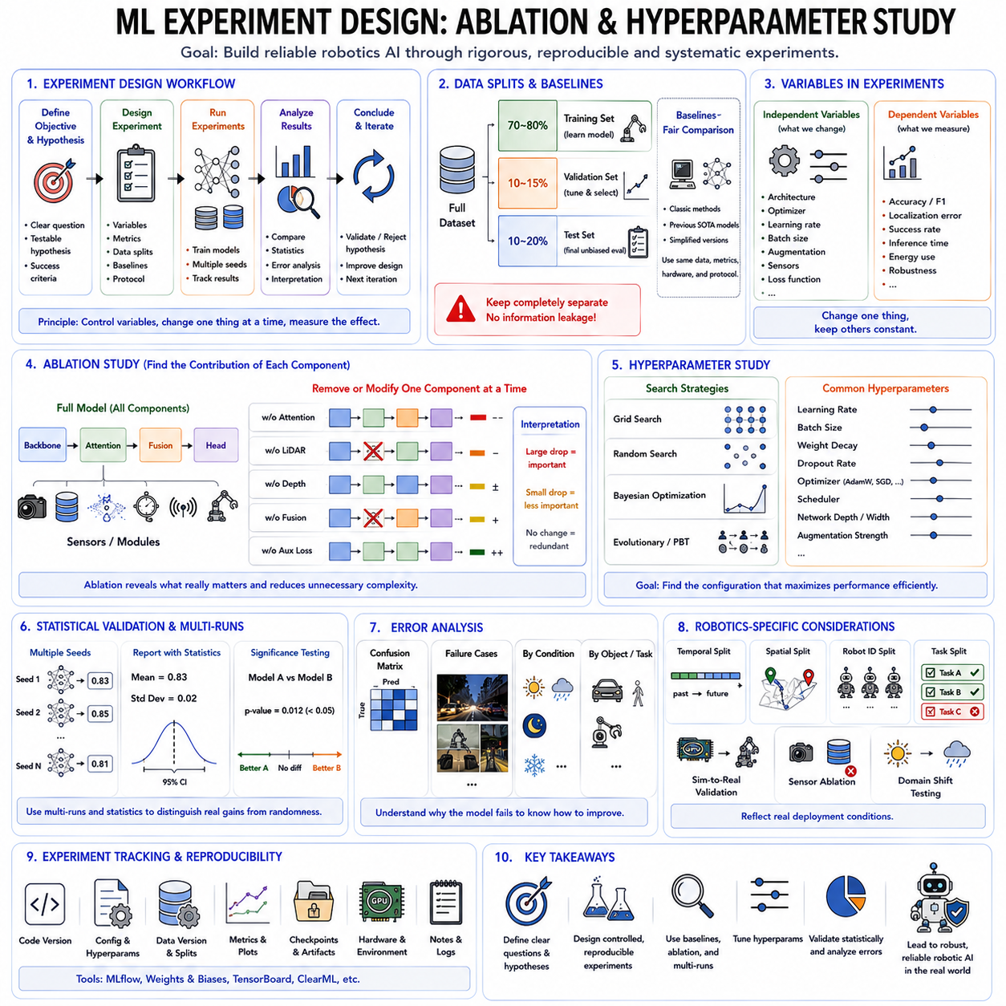
Machine learning experiment design provides the scientific framework for developing, evaluating, and improving intelligent models in a systematic and reproducible manner. Unlike conventional software engineering, where functionality is explicitly programmed, machine learning systems learn behavior from data through iterative optimization. Consequently, model performance depends not only on the algorithm itself but also on numerous experimental factors, including dataset composition, preprocessing strategies, network architecture, optimization algorithms, hyperparameter settings, regularization techniques, initialization methods, and evaluation protocols. Without carefully designed experiments, it becomes impossible to determine which factors genuinely improve performance and which merely produce accidental gains resulting from random variation. In robotics, where autonomous systems must operate safely and reliably under diverse environmental conditions, rigorous experiment design is essential for developing trustworthy perception, localization, planning, manipulation, and control systems.
A well-designed machine learning experiment begins with a clearly defined research objective. Every experiment should address a specific scientific or engineering question rather than simply attempting to maximize benchmark accuracy. Researchers may investigate whether a new neural architecture improves object detection, whether additional sensor modalities enhance localization accuracy, whether a different optimizer accelerates convergence, or whether a new loss function increases robustness under adverse environmental conditions. Clearly defined hypotheses enable meaningful interpretation of experimental outcomes and prevent unnecessary exploration of irrelevant design variations.
The experimental hypothesis forms the conceptual foundation of scientific machine learning research. A hypothesis represents a testable statement predicting how modifying one or more system components will influence model performance. For example, a robotics researcher might hypothesize that incorporating LiDAR together with RGB cameras improves perception under poor illumination, or that self-supervised pretraining increases generalization across multiple warehouse environments. Experiments are subsequently designed to validate or reject these hypotheses using objective quantitative evidence rather than subjective observations.
Controlled experimentation requires careful isolation of independent and dependent variables. Independent variables represent the factors intentionally modified during experiments, including network architecture, optimizer selection, learning rate, augmentation strategy, batch size, or sensor configuration. Dependent variables correspond to measured outcomes such as accuracy, precision, recall, localization error, navigation success rate, inference latency, energy consumption, or task completion efficiency. Maintaining all remaining conditions constant ensures that observed performance differences originate from the intended experimental modification rather than unrelated confounding factors.
Baseline models provide essential reference points for meaningful comparison. Every newly proposed algorithm should be evaluated against strong existing methods rather than in isolation. Baselines may include classical computer vision algorithms, previous deep learning architectures, published state-of-the-art models, or simplified versions of the proposed approach. Without appropriate baselines, improvements cannot be interpreted objectively because no meaningful performance reference exists. Fair comparison further requires identical datasets, evaluation metrics, preprocessing pipelines, hardware environments, and experimental protocols.
Reproducibility represents one of the most important principles of scientific machine learning. Independent researchers should be capable of reproducing published results using identical datasets, architectures, training procedures, and evaluation protocols. Achieving reproducibility requires careful documentation of software versions, random initialization seeds, hardware configurations, dataset partitions, preprocessing methods, optimization settings, hyperparameters, evaluation metrics, and implementation details. Transparent reporting strengthens scientific credibility while facilitating collaborative research and industrial deployment.
Randomness influences nearly every aspect of deep learning experimentation. Weight initialization, data shuffling, mini-batch construction, augmentation operations, dropout masks, GPU execution order, and stochastic optimization all introduce variability into training outcomes. Consequently, evaluating a model using only one experimental run may produce misleading conclusions because performance differences may arise purely from random variation. Modern machine learning therefore frequently reports average performance together with standard deviations computed across multiple independent training runs using different random seeds.
Hyperparameters differ fundamentally from trainable model parameters because they are specified before training rather than learned automatically from data. Examples include learning rate, batch size, optimizer selection, weight decay coefficient, dropout probability, network depth, hidden layer dimensions, augmentation strength, scheduler configuration, and training duration. Although hyperparameters remain fixed throughout individual training runs, their selection strongly influences convergence speed, optimization stability, computational efficiency, and final generalization performance.
Hyperparameter tuning seeks configurations producing optimal model performance. Historically, researchers manually adjusted hyperparameters through experience and intuition. Although expert knowledge remains valuable, systematic optimization strategies increasingly replace purely manual exploration. Grid search evaluates every combination within predefined parameter ranges, providing exhaustive coverage but becoming computationally prohibitive as dimensionality increases. Random search samples hyperparameter configurations randomly, often discovering competitive solutions while requiring substantially fewer experiments than exhaustive grid evaluation.
Bayesian optimization represents a more sophisticated hyperparameter search methodology. Rather than evaluating configurations independently, Bayesian optimization constructs probabilistic surrogate models estimating the relationship between hyperparameters and performance. Future experiments are selected intelligently by balancing exploration of uncertain parameter regions against exploitation of promising configurations. This adaptive strategy substantially reduces computational cost while identifying highly effective hyperparameter settings, particularly for expensive robotics experiments requiring lengthy training procedures.
Population-based optimization methods further extend hyperparameter search through evolutionary principles. Multiple candidate configurations evolve simultaneously according to observed performance, exchanging successful characteristics while discarding weaker solutions. Evolutionary algorithms, genetic algorithms, particle swarm optimization, and population-based training have demonstrated strong performance for complex machine learning optimization problems involving numerous interacting hyperparameters.
Learning rate frequently represents the single most influential hyperparameter in deep learning. Excessively large learning rates destabilize optimization, while excessively small values slow convergence dramatically. Consequently, learning rate schedules, warmup procedures, cosine annealing, cyclical learning rates, and adaptive scheduling strategies receive extensive experimental investigation. Hyperparameter studies often begin by identifying suitable learning rate ranges before optimizing secondary parameters.
Batch size similarly influences optimization dynamics, computational efficiency, and generalization. Small batches introduce noisy gradients that sometimes improve generalization by preventing convergence toward sharp minima. Large batches exploit GPU parallelism more efficiently but occasionally reduce model robustness. Modern robotics foundation models frequently balance these competing considerations according to available hardware resources, dataset size, and optimization objectives.
Ablation studies constitute one of the most important experimental methodologies in machine learning research. The fundamental objective of an ablation study is to determine the contribution of individual system components by systematically removing, replacing, or modifying them while keeping all remaining aspects unchanged. Rather than evaluating only the complete final model, ablation experiments reveal precisely which architectural decisions produce measurable performance improvements.
The term “ablation” originates from scientific disciplines where removing specific biological structures helps determine their functional roles. Machine learning adopts the same philosophy by selectively eliminating network modules, attention mechanisms, normalization layers, auxiliary losses, sensor modalities, or optimization techniques. If performance deteriorates substantially after removing one component, that component contributes significantly to overall system effectiveness. Conversely, negligible performance changes suggest limited practical importance despite increased implementation complexity.
Neural architecture ablation commonly investigates contributions from residual connections, attention mechanisms, transformer blocks, convolutional modules, feature fusion strategies, skip connections, activation functions, normalization layers, positional encodings, or decoder structures. Such experiments guide architectural refinement by identifying modules providing genuine value rather than unnecessary complexity.
Loss function ablation examines how different optimization objectives influence learning behavior. Researchers may compare Cross-Entropy Loss, Focal Loss, Dice Loss, Huber Loss, contrastive objectives, reinforcement learning rewards, or multi-task weighting strategies. These experiments frequently reveal that apparently minor modifications to optimization objectives produce substantial improvements in robustness, calibration, or task performance.
Sensor ablation is particularly important for robotics. Autonomous systems frequently integrate RGB cameras, depth sensors, LiDAR, radar, IMUs, GPS receivers, tactile sensors, force sensors, microphones, and proprioceptive measurements. Ablation experiments systematically remove individual sensing modalities to quantify their contributions under different operational conditions. Such analysis supports cost-effective hardware design by identifying sensors providing maximum practical value relative to computational and financial costs.
Feature ablation investigates learned representations rather than hardware components. Individual feature channels, embedding dimensions, latent variables, temporal history windows, memory mechanisms, or contextual information sources may be selectively removed. Understanding which information sources dominate decision making improves model interpretability while supporting efficient architecture simplification.
Hyperparameter studies and ablation experiments complement one another but address different scientific questions. Hyperparameter optimization seeks the best-performing configuration within a fixed architectural design, whereas ablation studies evaluate whether individual architectural components deserve inclusion at all. Together, these methodologies provide comprehensive understanding of both optimization behavior and structural design decisions.
Statistical significance becomes increasingly important when performance differences remain relatively small. Reporting only average accuracy without uncertainty estimates may exaggerate trivial improvements arising from random variability. Confidence intervals, hypothesis testing, paired statistical comparisons, bootstrap estimation, and multiple independent experimental repetitions strengthen scientific conclusions by distinguishing genuine improvements from stochastic fluctuations.
Evaluation metrics should align closely with deployment objectives. Robotics experiments frequently require multiple complementary metrics rather than relying upon overall accuracy alone. Autonomous navigation may evaluate success rate, collision frequency, trajectory smoothness, energy consumption, localization accuracy, computational latency, and safety margin simultaneously. Manipulation experiments may assess grasp success, completion time, positional precision, force stability, and recovery capability. Comprehensive evaluation therefore reflects practical system performance rather than isolated benchmark metrics.
Error analysis represents another essential component of experiment design. Aggregate accuracy values rarely explain why failures occur. Researchers therefore investigate confusion matrices, failure cases, uncertainty estimates, environmental conditions, sensor degradation, object categories, trajectory deviations, and temporal behavior to identify systematic weaknesses. Such analysis frequently reveals opportunities for targeted improvements that remain invisible through summary statistics alone.
Robotics introduces additional experimental complexity because physical hardware exhibits wear, calibration drift, battery variation, actuator aging, environmental disturbances, and stochastic interactions absent from simulation. Consequently, many robotics experiments combine simulation-based evaluation with controlled physical validation. Sim-to-Real experiments investigate whether models trained in simulation successfully transfer toward physical robots operating under realistic conditions. Domain randomization, synthetic data generation, and adaptive fine-tuning frequently accompany these evaluations.
Large foundation models introduce new experimental challenges due to enormous computational requirements. Comprehensive hyperparameter searches become impractical when individual training runs require weeks of distributed GPU computation. Researchers therefore increasingly perform extensive hyperparameter optimization on smaller proxy models before transferring successful configurations toward large-scale pretraining. Fine-tuning experiments similarly isolate downstream adaptation strategies while preserving expensive pretrained representations.
Experiment tracking platforms have become indispensable for managing modern machine learning research. Systems such as MLflow, Weights & Biases, TensorBoard, ClearML, and similar frameworks automatically record hyperparameters, training curves, evaluation metrics, hardware utilization, model checkpoints, dataset versions, and experiment metadata. Such infrastructure enables systematic comparison among hundreds or thousands of experiments while preventing accidental loss of valuable research information.
As robotics advances toward increasingly capable Physical AI systems, experimental methodology becomes as important as algorithmic innovation itself. Reliable autonomous intelligence cannot emerge from isolated benchmark improvements unsupported by rigorous scientific evidence. Carefully designed experiments, reproducible evaluation protocols, comprehensive ablation studies, systematic hyperparameter optimization, statistical validation, and transparent reporting collectively establish confidence that observed performance improvements reflect genuine advances rather than accidental experimental artifacts. These principles provide the scientific foundation for developing trustworthy robotic AI systems capable of robust long-term deployment across diverse real-world environments.

01.08 Model Selection and Evaluation Metrics
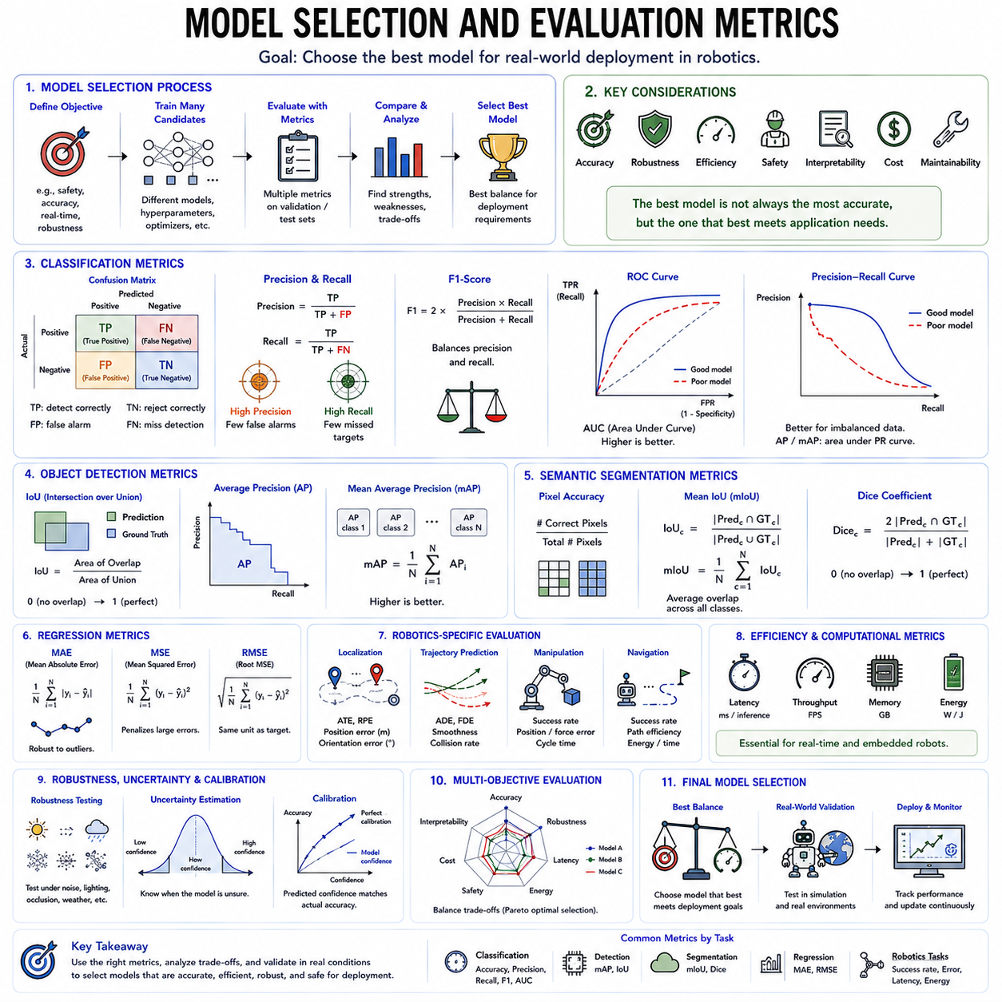
Model selection and evaluation metrics constitute the final decision-making stage of the machine learning development pipeline, determining whether a trained model is suitable for deployment in real-world applications. Although modern machine learning algorithms can achieve remarkable performance during training, successful deployment requires selecting models that balance prediction accuracy, robustness, computational efficiency, safety, interpretability, and generalization. A model with the highest training accuracy is not necessarily the best model for practical use. Instead, model selection requires comprehensive evaluation across multiple performance criteria that reflect actual operational requirements. In robotics, where autonomous systems must perceive, reason, plan, and act safely under continuously changing environmental conditions, appropriate model selection and evaluation methodologies are fundamental for building trustworthy Physical AI systems.
Model selection refers to the systematic process of choosing the most appropriate machine learning model among multiple candidate architectures, training configurations, or optimization strategies. Throughout machine learning development, researchers often train numerous models using different neural architectures, hyperparameter settings, optimizers, regularization methods, data augmentation strategies, and initialization schemes. Each candidate exhibits different strengths and weaknesses. Some models converge rapidly but generalize poorly, while others achieve excellent accuracy at the cost of increased computational complexity. Effective model selection therefore requires balancing multiple objectives rather than optimizing a single numerical metric.
The model selection process begins with clearly defining deployment objectives. Different applications prioritize different evaluation criteria depending upon operational requirements. Autonomous driving emphasizes safety, low latency, and robustness against environmental changes. Industrial inspection prioritizes defect detection accuracy and false negative minimization. Collaborative robots require predictable behavior, low computational latency, and reliable human interaction. Medical robotics demands extremely high diagnostic sensitivity while maintaining explainability and regulatory compliance. Consequently, evaluation metrics should always reflect deployment objectives rather than abstract benchmark performance alone.
Classification tasks represent one of the most common categories of machine learning problems. The simplest evaluation metric for classification is accuracy, defined as the proportion of correctly classified samples relative to the total number of observations. Accuracy provides intuitive interpretation and remains appropriate when class distributions are approximately balanced. However, many real-world robotics datasets exhibit severe class imbalance, making accuracy alone potentially misleading. A perception system identifying ninety-nine percent background pixels while completely missing pedestrians may still report extremely high accuracy despite catastrophic practical performance.
Confusion matrices provide considerably richer information regarding classification behavior. A confusion matrix summarizes prediction outcomes by counting true positives, true negatives, false positives, and false negatives for every class. Rather than reporting only overall accuracy, confusion matrices reveal which categories are frequently confused and whether particular error types dominate system behavior. In robotics, understanding confusion between humans and obstacles, safe and unsafe regions, or normal and abnormal operating conditions often proves more valuable than aggregate accuracy values.
Precision measures the proportion of positive predictions that are actually correct. High precision indicates that when the model predicts the presence of an object or event, the prediction is usually accurate. Robotics applications involving hazardous environments frequently prioritize precision because false alarms may interrupt operations, waste computational resources, or unnecessarily trigger emergency procedures. Industrial quality inspection similarly values high precision to minimize unnecessary rejection of acceptable products.
Recall measures the proportion of actual positive samples correctly identified by the model. High recall ensures that important events rarely remain undetected. Autonomous driving, medical robotics, human detection, fire monitoring, security surveillance, and collision avoidance frequently prioritize recall because missing a critical event may produce severe consequences. False negatives therefore become considerably more dangerous than false positives in many safety-critical robotics applications.
Precision and recall frequently exhibit competing behavior. Increasing decision sensitivity generally improves recall while reducing precision because additional positive predictions introduce more false alarms. Conversely, stricter decision thresholds increase precision while missing additional true events. Selecting appropriate operating points therefore requires careful consideration of application-specific risk profiles rather than maximizing either metric independently.
The F1-score combines precision and recall into a single harmonic mean, providing balanced evaluation when both error types possess comparable importance. Because harmonic averaging penalizes substantial imbalance between precision and recall, the F1-score discourages models achieving excellent performance in one metric while performing poorly in the other. Robotics perception benchmarks commonly report F1-scores alongside precision and recall to provide comprehensive evaluation of object detection, semantic segmentation, anomaly detection, and human recognition systems.
Receiver Operating Characteristic curves further characterize binary classification performance across varying decision thresholds. Rather than evaluating one operating point, ROC curves visualize the tradeoff between true positive rates and false positive rates across all possible classification thresholds. The Area Under the ROC Curve summarizes overall discriminative capability independently of specific threshold selection. Models achieving larger ROC-AUC values generally distinguish positive and negative classes more effectively under diverse operating conditions.
Precision-Recall curves often provide more informative evaluation than ROC curves for highly imbalanced robotics datasets. Since rare event detection commonly dominates robotics applications, Precision-Recall analysis focuses specifically on positive class behavior without being overwhelmed by abundant negative observations. Average Precision and mean Average Precision consequently became standard evaluation metrics for modern object detection benchmarks including autonomous driving, industrial inspection, warehouse automation, and robotic manipulation.
Object detection requires evaluating both classification accuracy and localization quality simultaneously. Intersection over Union, commonly abbreviated IoU, measures geometric overlap between predicted bounding boxes and ground truth annotations. Higher IoU values indicate more accurate localization. Detection systems typically classify predictions as correct only when both category labels and IoU exceed predefined thresholds. This dual evaluation ensures that detected objects are not only correctly identified but also accurately localized within the scene.
Mean Average Precision has become the dominant evaluation metric for object detection. Average Precision computes the area under the Precision-Recall curve for individual object categories, while mean Average Precision averages these values across all classes. Contemporary detection benchmarks frequently evaluate mAP across multiple IoU thresholds, encouraging models to produce increasingly precise object localization rather than merely coarse detections. Robotics perception systems commonly optimize toward these benchmark metrics before deployment.
Semantic segmentation requires pixel-level evaluation because every image pixel receives an independent category prediction. Pixel accuracy measures the percentage of correctly classified pixels but suffers from class imbalance similar to classification accuracy. Mean Intersection over Union therefore represents the preferred segmentation metric by averaging overlap ratios across all semantic categories. Dice coefficients similarly evaluate regional overlap and remain particularly valuable for thin structures, navigable free space, medical robotics, and robotic grasp region prediction.
Regression problems require different evaluation methodologies because predictions represent continuous numerical values rather than discrete classes. Mean Absolute Error computes average absolute prediction errors and provides intuitive physical interpretation. Mean Squared Error penalizes large deviations more strongly through quadratic error accumulation. Root Mean Squared Error expresses errors using original measurement units, facilitating engineering interpretation for localization, depth estimation, force prediction, battery health estimation, and trajectory forecasting.
Robotics frequently evaluates localization accuracy using translational and rotational errors simultaneously. Position estimation may employ Euclidean distance errors measured in centimeters or meters, while orientation estimation utilizes angular differences measured in degrees or radians. Simultaneous Localization and Mapping systems frequently report Absolute Trajectory Error and Relative Pose Error to evaluate both global consistency and local motion estimation accuracy across complete navigation trajectories.
Trajectory prediction introduces additional temporal evaluation considerations. Average Displacement Error measures mean positional deviations throughout predicted trajectories, while Final Displacement Error evaluates terminal prediction accuracy. Smoothness metrics assess acceleration continuity, jerk minimization, curvature consistency, and dynamic feasibility. Collision rates, path efficiency, energy consumption, and navigation success rates further characterize practical robotic motion performance beyond purely geometric accuracy.
Control systems require task-oriented evaluation rather than isolated prediction accuracy. Robot manipulators may evaluate end-effector positioning precision, grasp success rates, force regulation stability, assembly completion accuracy, and cycle times. Mobile robots frequently report navigation success rates, obstacle avoidance performance, mission completion times, localization robustness, battery consumption, and recovery behavior following unexpected disturbances. Practical robotics evaluation therefore extends considerably beyond conventional machine learning metrics.
Inference latency represents one of the most important deployment metrics for robotics. High prediction accuracy becomes meaningless if inference requires excessive computational time preventing real-time decision making. Autonomous vehicles, drones, collaborative robots, and industrial automation frequently require inference frequencies exceeding tens or hundreds of predictions per second. Consequently, evaluation commonly includes latency measurements, throughput, frames per second, GPU utilization, CPU utilization, memory consumption, and energy efficiency alongside predictive performance.
Model complexity also influences deployment feasibility. Large foundation models frequently achieve superior benchmark performance while requiring enormous computational resources. Embedded robotic platforms, however, often possess limited GPU memory, power budgets, thermal constraints, and real-time processing requirements. Model selection therefore balances predictive accuracy against computational efficiency, deployment cost, maintainability, and hardware compatibility. Techniques including pruning, quantization, knowledge distillation, and neural architecture optimization frequently support efficient deployment without excessive performance degradation.
Robustness evaluation has become increasingly important for Physical AI systems. Models should maintain reliable performance despite changing illumination, weather, sensor noise, partial occlusions, motion blur, hardware degradation, environmental dynamics, and adversarial disturbances. Robustness benchmarks intentionally introduce controlled perturbations to evaluate model resilience under realistic deployment conditions. Distribution shift testing similarly examines performance when testing environments differ substantially from training distributions.
Uncertainty estimation provides another valuable evaluation dimension beyond prediction accuracy. Bayesian neural networks, Monte Carlo Dropout, deep ensembles, evidential learning, and probabilistic foundation models estimate confidence associated with each prediction. Reliable uncertainty estimation enables autonomous robots to recognize situations requiring additional sensing, human intervention, slower navigation, or conservative decision making. Safety-critical robotics increasingly integrates uncertainty-aware evaluation alongside conventional predictive metrics.
Calibration measures whether predicted probabilities accurately reflect true event frequencies. Well-calibrated models assign approximately ninety percent confidence only when predictions remain correct approximately ninety percent of the time. Poor calibration may cause robots to become excessively confident during uncertain situations, potentially increasing operational risk. Expected Calibration Error and reliability diagrams therefore provide valuable supplementary evaluation for autonomous decision-making systems.
Multi-objective evaluation increasingly dominates modern robotics because no single metric adequately characterizes autonomous system performance. Practical deployment simultaneously requires high accuracy, low latency, minimal energy consumption, robust generalization, uncertainty awareness, safety, interpretability, maintainability, and computational efficiency. Pareto optimization frequently visualizes tradeoffs among competing objectives, allowing engineers to select balanced models appropriate for specific deployment constraints.
Benchmark datasets play an essential role in objective model comparison. Public benchmarks provide standardized datasets, predefined training-validation-testing splits, official evaluation metrics, and consistent reporting protocols. Autonomous driving, robotic manipulation, semantic segmentation, visual localization, embodied AI, and multimodal robotics research all rely upon benchmark leaderboards to facilitate fair comparison across competing methodologies. Nevertheless, benchmark success alone should never replace extensive evaluation under realistic deployment conditions.
Model selection should ultimately consider the complete system lifecycle rather than isolated predictive performance. Training cost, inference cost, deployment complexity, maintenance requirements, continual learning capability, interpretability, regulatory compliance, cybersecurity, hardware scalability, and long-term operational reliability all influence practical engineering decisions. The optimal model is therefore not necessarily the one achieving the highest benchmark score but rather the model providing the best balance across all relevant operational objectives.
As robotics progresses toward increasingly capable Physical AI and foundation models, evaluation methodology continues evolving beyond traditional accuracy-based benchmarks. Future intelligent robots must perceive complex environments, reason across multimodal information, plan long-horizon behaviors, interact safely with humans, adapt continuously to changing environments, and operate autonomously for extended periods. Comprehensive model selection therefore requires integrating classical machine learning metrics with robustness evaluation, uncertainty estimation, safety validation, computational efficiency, and real-world deployment testing. These multidimensional evaluation principles provide the foundation for developing intelligent robotic systems that perform reliably not only in laboratory benchmarks but also throughout sustained operation in the complexity of the physical world.

01.09 Probabilistic ML Bayesian Inference for Robots
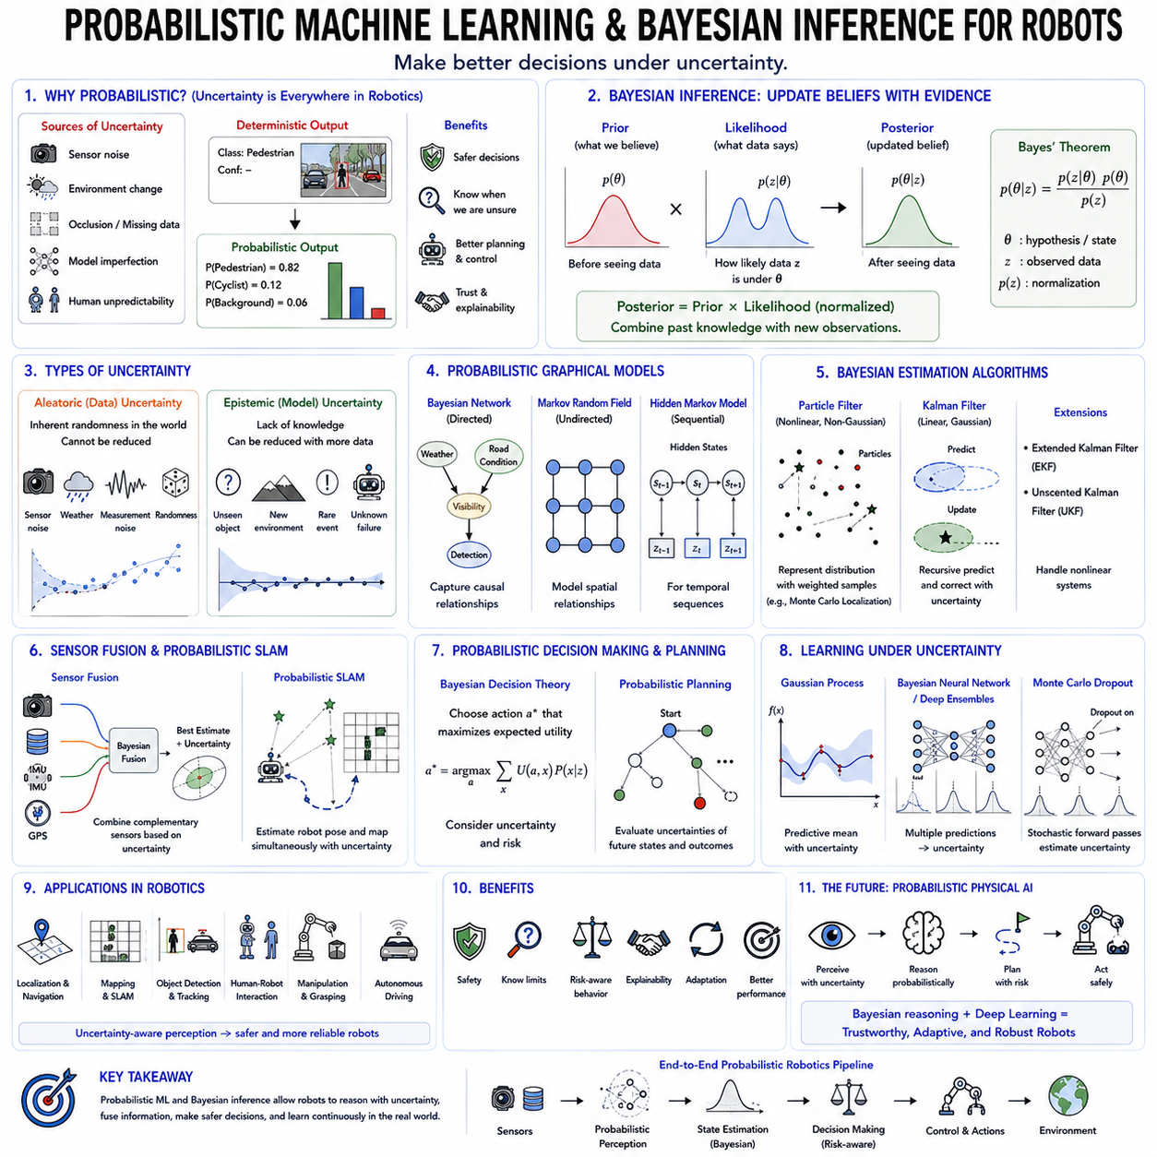
Probabilistic Machine Learning represents a paradigm shift from traditional deterministic learning by explicitly modeling uncertainty throughout the learning and decision-making process. Instead of producing a single fixed prediction, probabilistic models estimate distributions over possible outcomes, allowing intelligent systems to reason about uncertainty, confidence, ambiguity, and incomplete information. This capability is particularly important in robotics because robots operate in dynamic, partially observable, and inherently uncertain environments where sensor noise, environmental changes, imperfect perception, and unpredictable human behavior continuously influence decision making. Bayesian inference provides the mathematical foundation for probabilistic machine learning by combining prior knowledge with observed evidence to continuously update beliefs about the world. As robotics advances toward Physical AI, probabilistic reasoning has become an essential component for developing autonomous systems that are not only intelligent but also reliable, explainable, and safe under real-world uncertainty.
Classical machine learning often assumes that training data perfectly represents the underlying environment and that model predictions are sufficiently accurate for decision making. In practice, however, every robotic system encounters uncertainty at multiple levels. Cameras suffer from changing illumination, LiDAR sensors experience measurement noise, inertial sensors accumulate drift, GPS signals degrade in urban environments, and object recognition models occasionally misclassify unfamiliar objects. Even highly accurate neural networks inevitably make prediction errors because real-world environments are infinitely more complex than finite training datasets. Probabilistic machine learning acknowledges these limitations by explicitly representing uncertainty instead of ignoring it.
Probability theory provides the mathematical language used to represent uncertainty. Rather than assigning absolute truth values to events, probability assigns numerical values between zero and one representing degrees of belief. These probabilities may describe the likelihood that an object belongs to a particular category, the confidence associated with a localization estimate, the expected success of a planned trajectory, or the probability that a sensor measurement has been corrupted by noise. By treating uncertainty as an integral component of reasoning rather than an undesirable side effect, probabilistic models produce more reliable and interpretable decisions.
Bayesian inference lies at the heart of probabilistic reasoning. The central idea is remarkably intuitive. Before receiving new observations, an intelligent agent possesses prior knowledge about the environment represented as a prior probability distribution. As new sensor measurements become available, this prior belief is updated using observed evidence through Bayes' theorem, producing a posterior distribution that reflects both previous knowledge and newly acquired information. Instead of replacing old information with new observations, Bayesian inference continuously integrates both sources of knowledge into a unified probabilistic representation.
Bayes' theorem mathematically expresses this updating process. The posterior probability is proportional to the likelihood of observing the evidence under a particular hypothesis multiplied by the prior probability assigned to that hypothesis. The likelihood measures how well the observed data agrees with the hypothesis, while the prior represents previously accumulated knowledge. A normalization constant ensures that all posterior probabilities sum to one. Although conceptually simple, this equation forms the mathematical foundation underlying numerous robotics algorithms including localization, mapping, sensor fusion, object tracking, and probabilistic planning.
The distinction between prior, likelihood, and posterior distributions provides valuable intuition. The prior captures knowledge before observing new data. The likelihood measures consistency between observations and hypothetical world states. The posterior represents the updated belief after combining both information sources. As additional observations accumulate over time, each posterior distribution naturally becomes the prior for subsequent inference, enabling continuous learning throughout long-term robot operation.
Uncertainty in robotics generally originates from two fundamentally different sources. Aleatoric uncertainty arises from inherent randomness within observations and cannot be eliminated through additional data collection. Examples include sensor noise, environmental variability, measurement inaccuracies, lighting fluctuations, and unpredictable human motion. Since these uncertainties originate from the physical world itself, probabilistic models explicitly quantify their influence rather than attempting to eliminate them.
Epistemic uncertainty represents uncertainty arising from incomplete knowledge rather than inherent randomness. Neural networks encounter epistemic uncertainty when observing situations absent from their training datasets, including unfamiliar objects, novel environments, unusual weather conditions, unexpected robot failures, or previously unseen manipulation tasks. Unlike aleatoric uncertainty, epistemic uncertainty decreases as additional representative data becomes available. Recognizing epistemic uncertainty allows autonomous robots to identify situations requiring additional sensing, cautious behavior, or human supervision.
Probabilistic graphical models provide structured representations for complex probabilistic relationships among multiple variables. Bayesian Networks employ directed graphs where nodes represent random variables and edges encode conditional dependencies. These models efficiently represent causal relationships among perception, localization, environmental state, robot actions, and sensor observations. Bayesian Networks have been successfully applied to fault diagnosis, decision support, human activity recognition, and autonomous planning because they naturally integrate expert knowledge with observed data.
Markov Random Fields provide an alternative undirected graphical representation emphasizing local probabilistic interactions rather than causal relationships. These models frequently appear in image segmentation, occupancy grid mapping, spatial reasoning, and environmental modeling where neighboring variables exhibit strong statistical dependencies. Conditional Random Fields further extend these ideas toward discriminative structured prediction, particularly for semantic segmentation and sequence labeling problems.
Hidden Markov Models represent one of the earliest probabilistic sequence modeling techniques. A Hidden Markov Model assumes that hidden system states evolve according to Markovian dynamics while generating observable measurements probabilistically. Since robot operating states often remain partially observable, Hidden Markov Models became widely adopted for speech recognition, gesture recognition, activity recognition, localization, fault detection, and sequential sensor interpretation. Although deep learning has largely replaced classical Hidden Markov Models in many domains, their probabilistic formulation continues influencing modern sequential learning architectures.
Particle Filters provide powerful Bayesian estimation methods for nonlinear and non-Gaussian systems frequently encountered in robotics. Instead of representing probability distributions analytically, Particle Filters approximate posterior distributions using large collections of weighted samples called particles. Each particle represents one hypothetical robot state, while particle weights indicate consistency with current sensor observations. During every iteration, particles propagate through motion models, receive likelihood-based weight updates, and undergo resampling to concentrate computational resources on highly probable hypotheses. Monte Carlo Localization represents one of the most successful robotics applications of Particle Filtering.
Kalman Filters represent another cornerstone of probabilistic robotics. The classical Kalman Filter assumes linear system dynamics and Gaussian probability distributions, providing computationally efficient recursive state estimation through alternating prediction and correction stages. During prediction, motion models estimate future robot states together with associated uncertainty. During correction, new sensor observations refine these predictions by balancing model expectations against measurement reliability. This recursive Bayesian estimation framework remains fundamental for navigation, tracking, localization, sensor fusion, and control.
Real robotic systems frequently violate the linear assumptions underlying classical Kalman Filters. Extended Kalman Filters address nonlinear dynamics by locally linearizing system models around current operating points. Unscented Kalman Filters instead propagate carefully selected representative samples through nonlinear transformations, often providing superior estimation accuracy without requiring explicit Jacobian computations. These advanced Bayesian filters remain widely deployed across autonomous vehicles, aerial drones, industrial robots, and mobile service robots.
Sensor fusion exemplifies one of the most important applications of Bayesian inference in robotics. Individual sensors possess complementary strengths and weaknesses. Cameras provide rich semantic information but suffer under poor illumination. LiDAR delivers accurate geometry while lacking color information. IMUs measure rapid motion yet accumulate drift. GPS provides global positioning but becomes unreliable indoors or among tall buildings. Bayesian fusion combines these heterogeneous information sources according to their respective uncertainties, producing state estimates substantially more accurate and reliable than any individual sensor could achieve independently.
Probabilistic Simultaneous Localization and Mapping similarly relies heavily upon Bayesian inference. Autonomous robots continuously estimate both their own pose and the surrounding environment despite uncertainty affecting every sensor observation and control action. Modern SLAM algorithms maintain probability distributions over robot trajectories, landmark positions, or occupancy maps rather than assuming deterministic estimates. Graph-based optimization, factor graphs, pose graph optimization, and probabilistic occupancy mapping all emerge from Bayesian estimation principles.
Bayesian decision theory extends probabilistic reasoning toward autonomous action selection. Rather than choosing actions solely according to predicted outcomes, Bayesian decision making evaluates expected utility while accounting explicitly for uncertainty. Actions producing highly uncertain outcomes may be avoided even when potentially beneficial, whereas safer alternatives become preferable when uncertainty remains large. This risk-aware decision making naturally improves safety during autonomous navigation, manipulation, human-robot collaboration, and industrial automation.
Bayesian optimization provides an efficient strategy for optimizing expensive objective functions encountered during robotics development. Hyperparameter tuning, controller parameter optimization, calibration procedures, and experimental design frequently require numerous costly evaluations. Bayesian optimization constructs probabilistic surrogate models estimating unknown objective functions while intelligently selecting future experiments balancing exploration of uncertain parameter regions against exploitation of promising solutions. Consequently, excellent performance can often be achieved using relatively few experimental trials.
Gaussian Processes provide elegant nonparametric Bayesian models capable of estimating both function values and associated predictive uncertainty. Rather than learning fixed parameter vectors, Gaussian Processes define probability distributions over infinitely many possible functions. Every prediction therefore includes both an expected value and confidence interval. Robotics applications include terrain modeling, motion prediction, system identification, grasp stability estimation, manipulation learning, and model predictive control. Although computational complexity limits scalability for extremely large datasets, Gaussian Processes remain highly valuable whenever reliable uncertainty estimation outweighs raw computational efficiency.
Deep Bayesian Learning integrates probabilistic reasoning with modern deep neural networks. Bayesian Neural Networks treat network weights themselves as probability distributions rather than deterministic parameters, enabling prediction uncertainty estimation directly from learned models. Since exact Bayesian inference remains computationally intractable for deep architectures, practical implementations employ approximate methods including variational inference, Monte Carlo Dropout, Laplace approximations, stochastic variational inference, and deep ensembles. These techniques allow large neural networks to quantify confidence alongside predictions.
Monte Carlo Dropout represents one particularly practical approximation to Bayesian inference. During inference, Dropout remains active while multiple stochastic forward passes generate different predictions for identical inputs. Prediction variance across these repeated evaluations estimates model uncertainty without requiring explicit Bayesian weight distributions. Monte Carlo Dropout therefore provides computationally efficient uncertainty estimation compatible with existing deep learning architectures and has become popular in robotics perception systems.
Deep Ensembles offer another powerful uncertainty estimation approach. Multiple independently initialized neural networks learn identical tasks using different random seeds or training subsets. Agreement among ensemble members indicates high confidence, whereas disagreement reveals uncertain situations. Despite increased computational cost, Deep Ensembles consistently achieve excellent uncertainty calibration and robustness across numerous robotics applications including object detection, semantic segmentation, and autonomous navigation.
Large Vision-Language Models and Vision-Language-Action models increasingly incorporate probabilistic reasoning to improve decision reliability. Foundation models operating in open-world environments inevitably encounter unfamiliar objects, ambiguous instructions, incomplete observations, and unexpected situations. Uncertainty estimation enables these systems to recognize their own limitations, request clarification, gather additional information, slow execution, or transfer control to human operators when confidence becomes insufficient. Such self-awareness represents an essential capability for trustworthy Physical AI.
Probabilistic reasoning also plays a central role in reinforcement learning. Bayesian Reinforcement Learning models uncertainty regarding environment dynamics, reward functions, and state transitions. Instead of assuming perfectly known environments, Bayesian agents balance exploration against exploitation according to current uncertainty estimates. Highly uncertain regions encourage information gathering, whereas well-understood situations prioritize reward optimization. This principled exploration significantly improves sample efficiency for robotic learning.
Explainability constitutes another important advantage of probabilistic machine learning. Deterministic models often produce predictions without indicating confidence, making failures difficult to anticipate. Bayesian systems instead provide explicit probability distributions supporting transparent interpretation of model confidence, alternative hypotheses, and decision uncertainty. Such explanations improve debugging, safety certification, regulatory compliance, and human trust in autonomous robotic systems.
The future of Physical AI increasingly depends upon integrating deterministic deep learning with probabilistic reasoning. While deep neural networks provide powerful representation learning capabilities, Bayesian inference contributes principled uncertainty estimation, continuous belief updating, sensor fusion, risk-aware planning, and explainable decision making. Together, these complementary paradigms enable intelligent robots to operate safely despite incomplete knowledge, noisy observations, and continuously changing environments. Rather than viewing uncertainty as an undesirable limitation, probabilistic machine learning transforms uncertainty into actionable information that guides more robust perception, reasoning, planning, and autonomous behavior. As autonomous systems continue expanding into increasingly complex real-world applications, Bayesian inference and probabilistic learning will remain indispensable foundations for trustworthy, adaptive, and resilient robotic intelligence.

01.10 ML Toolchain PyTorch JAX TensorFlow for Robotics [w/Code]
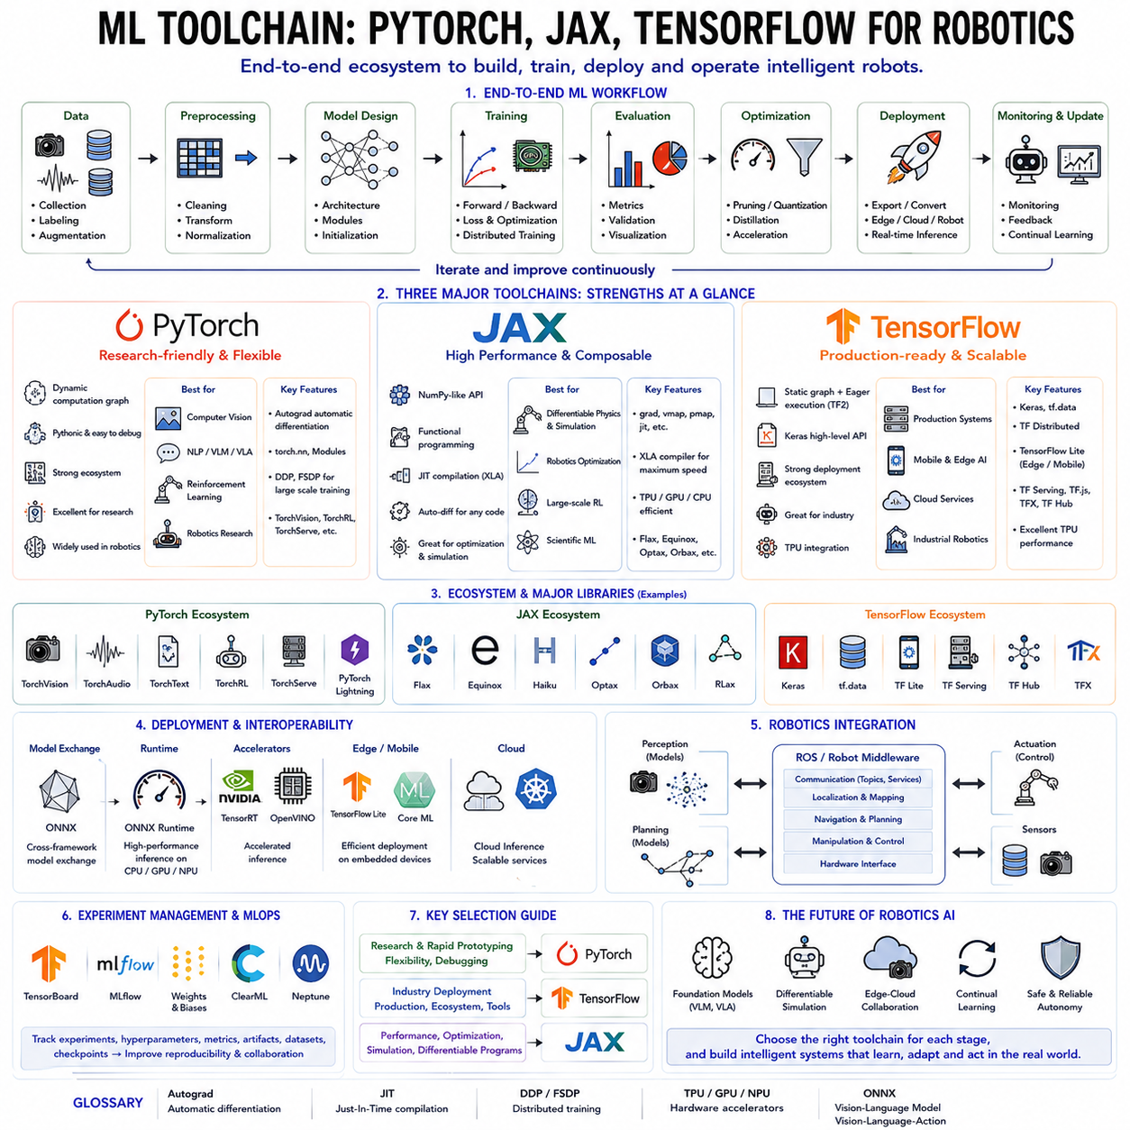
Machine learning toolchains provide the complete software ecosystem required to develop, train, evaluate, optimize, and deploy artificial intelligence models. While machine learning algorithms define how intelligent systems learn from data, toolchains provide the practical infrastructure that transforms theoretical concepts into real-world applications. A modern machine learning workflow typically includes data preprocessing, model definition, automatic differentiation, optimization, distributed training, experiment management, model compression, inference acceleration, deployment, monitoring, and continual learning. In robotics, where AI models must interact with sensors, control systems, embedded computers, cloud servers, and real-time operating environments, selecting an appropriate machine learning framework significantly influences development efficiency, computational performance, scalability, and long-term maintainability. Among the numerous frameworks available today, PyTorch, JAX, and TensorFlow have emerged as the three dominant ecosystems supporting modern robotics and Physical AI development.
The evolution of machine learning frameworks reflects the rapid growth of deep learning over the past decade. Early machine learning libraries primarily focused on implementing statistical algorithms with limited support for automatic differentiation or GPU acceleration. As deep neural networks became increasingly complex, researchers required frameworks capable of constructing computational graphs, computing gradients automatically, exploiting parallel GPU computation, and supporting distributed optimization across large computing clusters. Modern toolchains therefore integrate numerical computation, compiler optimization, automatic differentiation, hardware acceleration, visualization tools, deployment utilities, and production infrastructure into unified development environments.
A machine learning framework generally consists of several fundamental components. The computational backend performs efficient numerical operations on CPUs, GPUs, TPUs, and specialized AI accelerators. Automatic differentiation computes gradients required for optimization without manually deriving mathematical expressions. Neural network libraries provide reusable building blocks including convolutional layers, transformer modules, recurrent architectures, normalization layers, activation functions, and attention mechanisms. Optimization modules implement algorithms such as SGD, Adam, AdamW, RMSProp, and learning rate schedulers. Additional ecosystem tools support distributed training, experiment tracking, model serialization, visualization, inference optimization, and deployment across heterogeneous hardware platforms.
PyTorch has become the most widely adopted framework for deep learning research and modern robotics development. Originally developed by Meta AI, PyTorch emphasizes simplicity, flexibility, and intuitive programming through dynamic computational graphs. Unlike earlier static graph frameworks, PyTorch constructs computational graphs dynamically during execution, allowing researchers to debug models using conventional programming techniques while rapidly experimenting with new architectures. This flexibility significantly accelerated innovation across computer vision, natural language processing, reinforcement learning, and robotics.
Dynamic computation graphs represent one of PyTorch's defining characteristics. Every forward computation immediately creates corresponding gradient computation structures, enabling developers to modify network architectures interactively without requiring separate graph compilation stages. Complex control flow including loops, conditional statements, recursive structures, variable-length sequences, and adaptive computation naturally integrates with ordinary Python programming. Consequently, PyTorch closely resembles conventional software development, reducing implementation complexity for experimental research.
Automatic differentiation in PyTorch relies upon the Autograd engine. Every tensor may optionally track computational history, allowing gradients to propagate automatically through arbitrary mathematical operations during backpropagation. Researchers therefore focus on model design rather than manually deriving gradient equations. This automatic differentiation capability extends beyond conventional neural networks toward differentiable physics simulation, optimization layers, probabilistic inference, and robotic control algorithms.
PyTorch provides extensive neural network functionality through the torch.nn module. Standard components including convolutional layers, transformers, recurrent networks, multilayer perceptrons, embedding layers, normalization techniques, activation functions, attention mechanisms, and loss functions integrate seamlessly into modular architectures. Researchers may combine predefined components with custom differentiable operations to develop novel robotics algorithms without sacrificing optimization efficiency.
The PyTorch ecosystem extends far beyond the core framework. TorchVision supports computer vision datasets, pretrained models, image transformations, and object detection utilities. TorchAudio provides speech processing capabilities, while TorchText supports natural language processing. TorchRL addresses reinforcement learning, TorchRec focuses on recommendation systems, and TorchServe facilitates production deployment. These integrated libraries substantially accelerate application development across numerous AI domains.
Distributed training has become increasingly important as robotics foundation models continue growing in scale. PyTorch Distributed Data Parallel enables synchronized optimization across multiple GPUs and computing nodes, supporting efficient large-scale model training. Fully Sharded Data Parallel and model parallelism further extend scalability toward extremely large transformer architectures requiring hundreds or thousands of GPUs. Such infrastructure now underpins numerous Vision-Language Models and Vision-Language-Action foundation models for robotics.
PyTorch Lightning and similar high-level frameworks simplify large machine learning projects by separating research logic from engineering infrastructure. Training loops, checkpoint management, distributed execution, mixed precision optimization, logging, and experiment reproducibility become standardized, allowing researchers to concentrate on algorithm development rather than implementation details. Robotics research increasingly benefits from these abstractions when managing complex multi-stage training pipelines.
TensorFlow represents another major machine learning ecosystem developed originally by Google. TensorFlow initially popularized static computational graphs, where complete execution graphs were defined before computation began. Although this architecture initially appeared less intuitive than PyTorch's dynamic execution model, static graphs enabled extensive compiler optimization, graph transformation, deployment portability, and production scalability. TensorFlow therefore became widely adopted across industrial AI systems requiring robust production infrastructure.
TensorFlow 2 significantly simplified development by introducing eager execution, making program behavior substantially more similar to conventional Python programming while preserving graph optimization capabilities through optional graph compilation. Researchers may therefore develop interactively while still obtaining optimized execution during deployment. This hybrid execution model combines flexibility with production efficiency across diverse application domains.
The Keras high-level API has become TensorFlow's preferred interface for constructing neural networks. Keras emphasizes concise, readable code while supporting rapid prototyping through modular layer composition. Researchers define neural architectures declaratively using reusable building blocks rather than low-level tensor operations. This abstraction lowers development complexity, particularly for beginners and industrial teams emphasizing productivity and maintainability.
TensorFlow provides one of the industry's most comprehensive deployment ecosystems. TensorFlow Lite enables efficient execution on embedded processors, smartphones, and edge AI devices. TensorFlow Serving supports scalable cloud inference, TensorFlow Extended provides production machine learning pipelines, TensorFlow.js executes models within web browsers, and TensorFlow Hub distributes pretrained models across numerous application domains. These deployment tools make TensorFlow particularly attractive for commercial AI systems spanning cloud, edge, and embedded environments.
Google's Tensor Processing Units integrate closely with TensorFlow, providing highly efficient hardware acceleration for transformer architectures and large foundation models. TPUs deliver exceptional performance for large-scale distributed optimization, making TensorFlow particularly attractive for organizations leveraging Google's cloud infrastructure. Although GPU support remains excellent, TensorFlow maintains especially strong optimization for TPU-based computation.
JAX has emerged as one of the fastest-growing machine learning frameworks, particularly within advanced AI research. Developed by Google Research, JAX combines familiar NumPy programming semantics with automatic differentiation, just-in-time compilation, vectorized computation, and distributed execution. Unlike traditional deep learning frameworks emphasizing neural network abstractions, JAX focuses on composable mathematical transformations applicable to arbitrary numerical programs. This functional programming philosophy provides remarkable flexibility for scientific computing, optimization, robotics, and differentiable simulation.
Automatic differentiation in JAX extends naturally through arbitrary numerical computations using transformation operators such as grad, value_and_grad, jacobian, and hessian. Researchers therefore differentiate not only neural networks but also optimization procedures, physical simulations, control algorithms, trajectory planners, probabilistic inference systems, and entire computational pipelines. Such capabilities prove particularly valuable for robotics research integrating machine learning with classical optimization and physics.
The XLA compiler represents one of JAX's greatest strengths. XLA analyzes complete numerical programs before execution, aggressively optimizing computations through operator fusion, memory optimization, parallel scheduling, and hardware-specific code generation. Consequently, JAX frequently achieves outstanding computational performance across GPUs, TPUs, and emerging AI accelerators without requiring manual optimization by developers.
Just-in-time compilation further enhances JAX performance. Rather than interpreting every Python operation individually, JAX compiles complete computational functions into highly optimized executable programs. Although initial compilation introduces startup overhead, repeated execution becomes substantially faster than interpreted implementations. Large-scale robotics simulation, reinforcement learning, trajectory optimization, and differentiable control particularly benefit from these optimizations.
Vectorization provides another distinguishing capability within JAX. Operations originally written for individual samples automatically generalize toward entire batches through vectorization transformations without requiring explicit programming changes. Parallel mapping similarly distributes computations across multiple accelerators efficiently. These functional transformations simplify distributed robotics simulation, policy optimization, sensor processing, and large-scale foundation model training.
The JAX ecosystem continues expanding rapidly. Flax provides neural network abstractions comparable to PyTorch modules, Equinox emphasizes lightweight object-oriented model construction, Haiku offers alternative neural architecture development, Optax implements optimization algorithms, Orbax manages checkpointing, and RLax supports reinforcement learning. Collectively, these libraries enable sophisticated AI development while preserving JAX's functional programming philosophy.
Modern robotics increasingly integrates differentiable physics simulation with machine learning. Frameworks including Brax, MuJoCo integration, Isaac Lab research workflows, and differentiable simulation environments frequently leverage JAX because automatic differentiation naturally propagates through physical simulations. Consequently, researchers optimize robot morphology, locomotion policies, manipulation strategies, and controller parameters directly through gradient-based optimization rather than relying exclusively on reinforcement learning.
Selecting an appropriate framework depends strongly upon project objectives rather than absolute superiority. PyTorch generally provides the greatest flexibility for experimental research, extensive community support, abundant educational resources, and widespread adoption throughout modern AI literature. TensorFlow offers comprehensive industrial deployment infrastructure, mature production tooling, and strong integration with cloud services and embedded platforms. JAX emphasizes computational efficiency, mathematical composability, differentiable programming, and cutting-edge research involving optimization, simulation, and large-scale scientific machine learning.
Interoperability has become increasingly important within modern AI ecosystems. The Open Neural Network Exchange format enables models trained in one framework to execute within another deployment environment. ONNX Runtime accelerates inference across diverse hardware platforms including CPUs, GPUs, NPUs, and specialized AI accelerators. TensorRT further optimizes inference performance for NVIDIA hardware, while TensorFlow Lite, Core ML, and other deployment frameworks target embedded robotics platforms. Consequently, researchers often train models using one framework while deploying optimized inference through entirely different execution environments.
Robotics development rarely relies upon machine learning frameworks alone. Robot Operating System integrates perception, localization, navigation, manipulation, communication, and hardware interfaces independently of the underlying deep learning framework. Machine learning components developed using PyTorch, TensorFlow, or JAX therefore communicate naturally with robot middleware, sensor drivers, motion planners, and embedded controllers. This modular architecture enables AI capabilities to integrate seamlessly into complete robotic systems.
Experiment management has become an indispensable aspect of contemporary machine learning development. TensorBoard, MLflow, Weights & Biases, ClearML, Neptune, and similar platforms record hyperparameters, training curves, evaluation metrics, checkpoints, hardware utilization, dataset versions, and experiment metadata. Effective experiment tracking substantially improves reproducibility, collaborative research, and long-term project maintenance, particularly for robotics organizations managing hundreds of large-scale AI experiments.
As Physical AI continues evolving toward increasingly capable Vision-Language-Action foundation models, machine learning toolchains are converging toward unified ecosystems supporting large-scale distributed training, differentiable simulation, multimodal learning, efficient deployment, continual adaptation, and edge-cloud collaboration. PyTorch currently dominates academic research and robotics foundation model development, TensorFlow maintains exceptional industrial deployment capabilities, and JAX increasingly drives frontier research in differentiable programming and large-scale optimization. Rather than competing as mutually exclusive alternatives, these frameworks collectively provide complementary strengths supporting the diverse computational requirements of next-generation intelligent robotic systems. The future of robotics will likely involve seamless integration among these toolchains, allowing researchers and engineers to select the most appropriate technologies for each stage of the AI development lifecycle while maintaining interoperability across increasingly complex Physical AI ecosystems.

