Volume 19 Robot Machine Learning and AI

05. Reinforcement Learning

05.01 RL Fundamentals MDP Bellman Policy Value [w/Code]
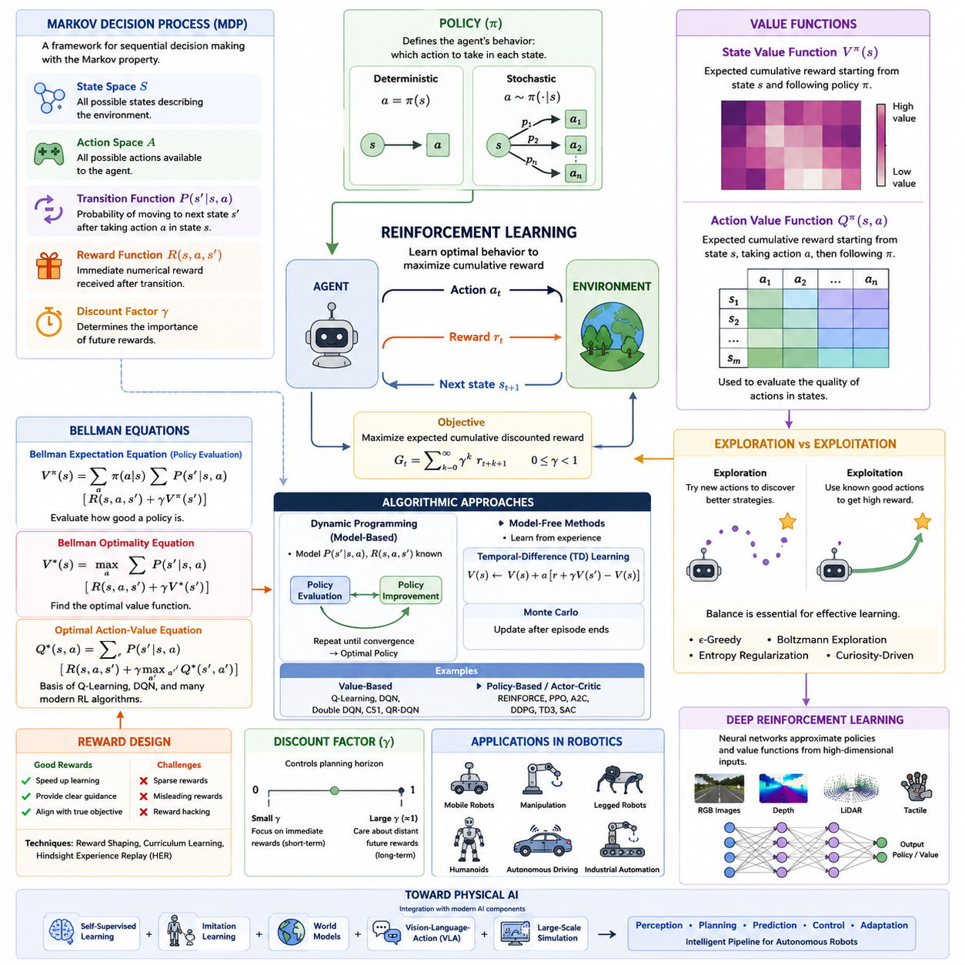
The topic “41_05_01_RL_Fundamentals_MDP_Bellman_Policy_Value” belongs to the Reinforcement Learning section of the user's engineering library structure under Volume 41, specifically as the foundational chapter introducing Markov Decision Processes, Bellman equations, policies, and value functions.
Reinforcement Learning (RL) is a machine learning paradigm in which an intelligent agent learns how to make sequential decisions by interacting with an environment. Unlike supervised learning, where correct labels are provided for every training sample, reinforcement learning relies on evaluative feedback in the form of rewards. The agent repeatedly observes the current situation, selects an action according to its decision-making strategy, receives a numerical reward, and transitions into a new situation. Through continuous interaction, the agent gradually discovers behaviors that maximize long-term cumulative reward rather than immediate gains. This learning framework closely resembles how humans and animals acquire skills through trial, error, and experience, making reinforcement learning one of the most important foundations for autonomous robotics, game playing, industrial optimization, and Physical AI.
The mathematical foundation of reinforcement learning is the Markov Decision Process (MDP). An MDP provides a formal framework for modeling sequential decision-making problems in uncertain environments. Every reinforcement learning problem can be described as an MDP if the system satisfies the Markov property, which states that the future depends only on the current state and action rather than the complete history of previous observations. This assumption dramatically simplifies the learning problem while still accurately modeling many robotic systems and autonomous control tasks.
An MDP is typically defined by five essential components: the state space, the action space, the transition probability function, the reward function, and the discount factor. The state represents all relevant information describing the environment at a particular moment. For a mobile robot, the state may include position, orientation, velocity, sensor measurements, obstacle locations, battery level, and mission progress. The action represents the control decision selected by the agent, such as steering angle, wheel velocity, manipulator motion, or navigation command. The transition function describes the probability of moving from one state to another after executing an action, capturing both deterministic dynamics and environmental uncertainty. The reward function quantifies the immediate desirability of each transition by assigning positive rewards to desirable outcomes and negative rewards to undesirable events. Finally, the discount factor determines the relative importance of future rewards compared to immediate rewards, enabling the agent to balance short-term success with long-term planning.
The interaction between the agent and the environment follows a repeated decision cycle. At each time step, the agent observes the current state, selects an action according to its policy, executes the action, receives a reward, and transitions to a new state. This interaction continues until a task is completed or a predefined termination condition is reached. During training, the objective is not simply to maximize individual rewards but to maximize the expected cumulative discounted reward over the entire trajectory. This distinction makes reinforcement learning particularly suitable for long-horizon planning problems where early decisions significantly influence future opportunities.
One of the most fundamental concepts in reinforcement learning is the policy. A policy defines the behavior of the agent by specifying which action should be selected in each possible state. Policies may be deterministic, where a single action is always chosen for a given state, or stochastic, where actions are selected according to a probability distribution. Deterministic policies are common in industrial robot control because they produce predictable behavior, whereas stochastic policies are often preferred during exploration and training because they encourage the discovery of better strategies. The policy effectively represents the intelligence of the reinforcement learning agent and becomes the final output after successful training.
Evaluating the quality of a policy requires measuring how beneficial each state or action is over the long term. This leads to the concept of value functions. The state-value function estimates the expected cumulative discounted reward obtained when starting from a particular state and following a given policy thereafter. It measures how promising a state is under the current decision-making strategy. States with higher values indicate that successful future outcomes are more likely if the agent reaches those states.
Closely related to the state-value function is the action-value function, commonly known as the Q-function. Rather than evaluating only the state, the Q-function estimates the expected cumulative reward obtained by executing a particular action in a given state before following the policy. The Q-function therefore evaluates the quality of individual decisions rather than entire situations. Most modern reinforcement learning algorithms, including Q-Learning, Deep Q Networks, Soft Actor-Critic, and many policy optimization methods, either directly or indirectly estimate action-value functions because they provide more detailed guidance for action selection.
The relationship between value functions and optimal decision-making is captured by the Bellman Equation. Richard Bellman's principle of optimality states that an optimal solution possesses the property that every remaining decision must itself be optimal regardless of previous decisions. This recursive property allows large sequential decision problems to be decomposed into smaller subproblems. Instead of solving an entire trajectory simultaneously, reinforcement learning algorithms repeatedly solve one-step prediction problems that recursively incorporate future value estimates.
The Bellman Expectation Equation expresses the value of a state as the expected immediate reward plus the discounted value of successor states under the current policy. This recursive formulation provides the theoretical basis for policy evaluation, enabling algorithms to estimate how good a policy is by repeatedly updating value estimates until convergence. Since future values appear on both sides of the equation, iterative numerical methods such as dynamic programming or temporal-difference learning are typically employed to approximate the solution.
The Bellman Optimality Equation extends this concept by replacing the expectation over policy actions with a maximization operator. Rather than evaluating an existing policy, it directly characterizes the optimal value function that would be achieved if the best possible action were always selected. The optimal action-value function satisfies a recursive relationship in which every state-action pair is evaluated according to the maximum achievable future return. Many reinforcement learning algorithms attempt to approximate this optimal Bellman equation through repeated interaction with the environment.
Dynamic Programming provides one of the earliest algorithmic solutions based on Bellman equations. Assuming complete knowledge of the environment's transition probabilities and reward function, dynamic programming alternates between policy evaluation and policy improvement until convergence. Policy evaluation computes value functions for the current policy, while policy improvement constructs a better policy by selecting actions with higher estimated values. Repeating these two steps eventually produces the optimal policy. Although exact dynamic programming is computationally expensive and requires a complete environment model, its underlying principles remain central to nearly all modern reinforcement learning methods.
Model-free reinforcement learning removes the requirement for explicit knowledge of transition dynamics. Instead of computing expectations directly from an environment model, the agent estimates value functions from observed experience. Temporal-Difference learning combines ideas from Monte Carlo estimation and dynamic programming by updating value estimates after every interaction using the Bellman equation. This allows learning to proceed continuously while interacting with real or simulated environments. Temporal-Difference learning forms the theoretical basis of algorithms such as SARSA, Q-Learning, Deep Q Networks, and many contemporary deep reinforcement learning approaches.
The exploration-exploitation dilemma represents another central challenge in reinforcement learning. An agent must exploit known high-value actions to obtain rewards while simultaneously exploring uncertain actions that may ultimately produce even greater rewards. Excessive exploitation causes the agent to become trapped in suboptimal behaviors, whereas excessive exploration wastes resources on poor decisions. Practical algorithms employ mechanisms such as epsilon-greedy exploration, Boltzmann sampling, entropy regularization, intrinsic motivation, or curiosity-driven learning to balance these competing objectives.
The discount factor plays a critical role in determining the planning horizon of reinforcement learning agents. A discount factor close to zero emphasizes immediate rewards and produces short-sighted behavior. Conversely, a discount factor close to one encourages long-term planning by assigning significant importance to future rewards. Robotic navigation, manipulation, warehouse logistics, and autonomous driving often require high discount factors because successful task completion depends on sequences of coordinated decisions extending over long periods.
Reward design significantly influences reinforcement learning performance. Carefully designed reward functions accelerate learning by providing informative feedback, whereas poorly designed rewards may produce unintended behaviors or exploit loopholes in the objective function. Dense rewards provide frequent guidance but may bias learning toward intermediate objectives. Sparse rewards more accurately reflect real-world success criteria but create difficult credit assignment problems because successful outcomes occur only after long sequences of actions. Modern reinforcement learning often combines sparse task rewards with auxiliary objectives, curriculum learning, or hindsight experience replay to improve learning efficiency.
In robotics, reinforcement learning provides an attractive framework because robots naturally interact with dynamic environments over time. Mobile robots learn navigation policies that avoid obstacles while minimizing travel time. Manipulators discover dexterous grasping and assembly strategies through repeated practice. Quadruped robots optimize stable locomotion over uneven terrain. Humanoid robots learn coordinated whole-body movements for balancing, walking, and object manipulation. Autonomous vehicles improve driving behavior through continuous interaction with simulated traffic scenarios. In all these applications, the underlying mathematical principles remain rooted in Markov Decision Processes, Bellman equations, policy optimization, and value estimation.
Modern deep reinforcement learning extends classical RL by combining neural networks with value functions or policies. Deep neural networks serve as universal function approximators capable of representing extremely large state and action spaces encountered in robotics. Instead of storing values in lookup tables, neural networks estimate value functions directly from high-dimensional sensory inputs such as RGB images, depth maps, LiDAR point clouds, tactile signals, or multimodal observations. This integration has enabled reinforcement learning to address previously intractable problems involving complex perception and control.
As Physical AI continues to evolve, reinforcement learning remains one of the fundamental technologies for autonomous decision-making. Future systems increasingly combine reinforcement learning with self-supervised representation learning, world models, imitation learning, foundation models, vision-language-action architectures, and large-scale simulation platforms. Rather than operating as an isolated algorithm, reinforcement learning becomes part of a comprehensive intelligent robotics pipeline in which perception, planning, prediction, control, and continuous adaptation work together to produce robust autonomous behavior. Understanding Markov Decision Processes, Bellman equations, policies, and value functions therefore provides the essential theoretical foundation upon which nearly all advanced reinforcement learning algorithms and intelligent robotic systems are built.

05.02 Model Free RL PPO SAC TD3 Implementation [w/Code]
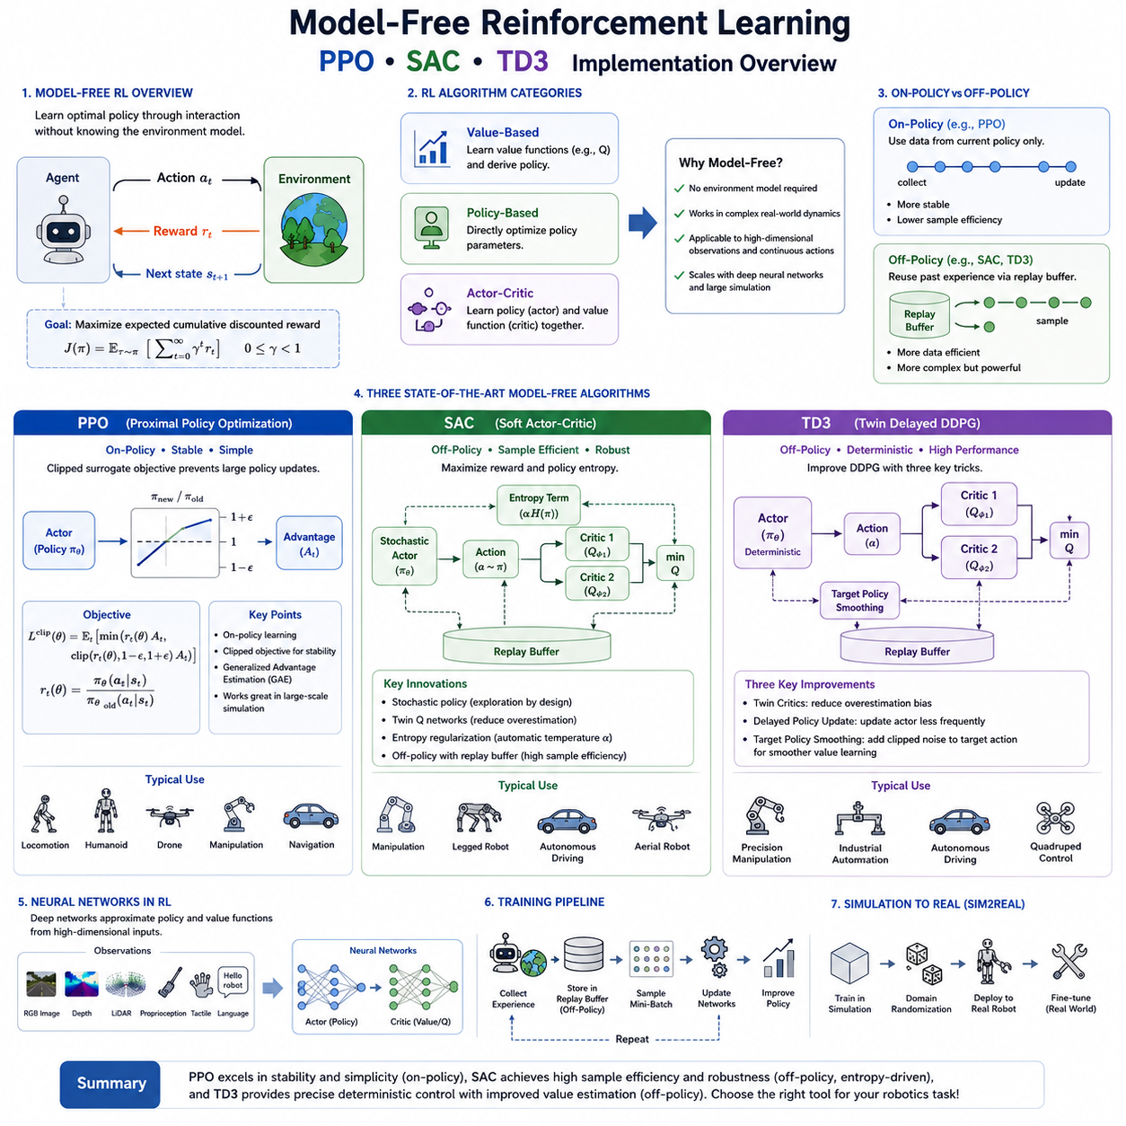
Model-Free Reinforcement Learning represents one of the most influential branches of modern reinforcement learning because it enables intelligent agents to learn optimal behaviors without requiring an explicit mathematical model of the environment. Unlike model-based approaches, which first estimate transition dynamics and reward functions before planning, model-free algorithms directly optimize policies or value functions using only observed interactions with the environment. This characteristic makes model-free reinforcement learning particularly attractive for robotics, where accurately modeling complex physical systems, contact dynamics, friction, sensor noise, and unpredictable environmental changes is often impractical. Instead of constructing a complete representation of the world's dynamics, the agent continuously collects experience through trial and error and gradually improves its decision-making strategy from accumulated data.
The fundamental objective of model-free reinforcement learning is to maximize the expected cumulative discounted reward through direct interaction with the environment. During training, the agent repeatedly observes its current state, selects an action according to its policy, executes the action, receives a reward, and transitions into a new state. Each interaction contributes additional experience that is used to update the learning algorithm. Over time, the policy converges toward behaviors that consistently produce higher long-term rewards. This direct optimization approach significantly simplifies deployment in environments where physical models are unavailable, incomplete, or computationally expensive to estimate.
Modern model-free reinforcement learning algorithms can generally be categorized into value-based methods, policy-based methods, and actor-critic methods. Value-based algorithms estimate the expected return of actions and derive policies by selecting actions with the highest predicted values. Policy-based algorithms directly optimize the parameters of a policy without explicitly estimating action values. Actor-critic algorithms combine both approaches by simultaneously learning a policy and a value estimator that guides policy improvement. Among today's state-of-the-art continuous control algorithms, Proximal Policy Optimization (PPO), Soft Actor-Critic (SAC), and Twin Delayed Deep Deterministic Policy Gradient (TD3) have emerged as the most widely adopted solutions for robotics, autonomous vehicles, manipulation, quadruped locomotion, humanoid control, and industrial automation.
Policy optimization differs fundamentally from classical value iteration. Instead of repeatedly solving the Bellman optimality equation over every possible action, policy optimization treats the policy itself as a parameterized function, usually represented by a deep neural network. The objective becomes finding the set of network parameters that maximize expected cumulative reward. This formulation naturally accommodates continuous action spaces, making policy optimization particularly suitable for robotic control problems involving motor torques, joint velocities, steering angles, and force commands.
Policy Gradient methods provide the mathematical foundation for policy optimization. Rather than estimating value tables, the algorithm computes the gradient of expected cumulative reward with respect to the policy parameters. These gradients indicate how the neural network should be adjusted to increase future returns. The policy is then updated using stochastic gradient ascent, allowing the agent to gradually improve its decision-making strategy. Although theoretically elegant, vanilla policy gradient methods often suffer from high variance and unstable convergence because individual trajectories may produce noisy reward estimates.
Actor-Critic architectures were developed to reduce the variance associated with policy gradient methods. The actor represents the policy responsible for selecting actions, while the critic estimates value functions that evaluate the quality of those actions. The critic provides informative learning signals that significantly stabilize policy updates. Instead of relying solely on delayed cumulative rewards, the actor learns from value estimates generated by the critic, resulting in faster convergence and improved sample efficiency. Nearly all modern policy optimization algorithms employ some variation of the actor-critic framework.
Proximal Policy Optimization (PPO) has become one of the most popular reinforcement learning algorithms because it achieves an excellent balance between simplicity, stability, and performance. PPO was introduced to overcome the instability observed in earlier trust-region optimization methods while avoiding the computational complexity of constrained optimization. The key insight behind PPO is that policy updates should not change the policy too drastically during a single optimization step. Large policy updates may significantly alter the agent's behavior, causing catastrophic performance degradation or unstable learning. PPO therefore introduces a clipped surrogate objective that limits the magnitude of policy changes while still allowing continuous improvement.
The clipping mechanism represents the defining innovation of PPO. During optimization, the algorithm compares the probability ratio between the new policy and the previous policy. If the update attempts to increase or decrease action probabilities excessively, the clipping function prevents further improvement beyond a predefined threshold. This simple modification eliminates many of the numerical instabilities associated with unconstrained policy gradients while preserving computational efficiency. As a result, PPO often converges reliably across a wide range of robotic control tasks without requiring extensive hyperparameter tuning.
Another important characteristic of PPO is its on-policy learning strategy. The algorithm collects trajectories using the current policy and immediately uses those trajectories for optimization before discarding them. Because training always relies on fresh experiences generated by the latest policy, learning remains highly stable and theoretically well-founded. However, on-policy learning also reduces sample efficiency because previously collected experiences cannot easily be reused. Consequently, PPO generally requires a relatively large number of environment interactions compared with off-policy algorithms.
PPO has become the default reinforcement learning algorithm for many simulated robotics platforms such as Isaac Gym, MuJoCo, Brax, and Genesis because its robustness often outweighs its lower sample efficiency. Quadruped locomotion, humanoid walking, drone stabilization, robotic manipulation, and autonomous navigation frequently employ PPO during large-scale simulation training before transferring learned policies to physical robots through Sim2Real techniques.
Soft Actor-Critic (SAC) represents a fundamentally different philosophy of reinforcement learning. Instead of maximizing only cumulative reward, SAC maximizes both expected reward and policy entropy. Entropy measures the randomness or uncertainty of the policy. By encouraging higher entropy during training, SAC naturally promotes exploration without relying on manually designed exploration strategies. Rather than immediately converging toward deterministic actions, the agent continues exploring diverse behaviors while gradually increasing expected reward.
Maximum Entropy Reinforcement Learning forms the theoretical basis of SAC. The objective function simultaneously rewards task completion and policy diversity. This prevents premature convergence to locally optimal solutions and encourages more robust behaviors capable of adapting to uncertain environments. Particularly during early training, entropy regularization allows the agent to explore numerous candidate strategies before gradually refining its policy into highly effective behaviors.
SAC employs a stochastic actor that outputs probability distributions over actions instead of deterministic control commands. Actions are sampled from these learned probability distributions, introducing natural exploration throughout training. Simultaneously, SAC learns two independent Q-functions to estimate action values. Using the minimum of these value estimates reduces overestimation bias, significantly improving learning stability. Automatic entropy adjustment further enables SAC to balance exploration and exploitation dynamically without requiring extensive manual tuning.
Unlike PPO, SAC operates as an off-policy reinforcement learning algorithm. Experiences collected during previous interactions are stored inside a replay buffer and reused many times during training. This dramatically increases sample efficiency because every interaction contributes to multiple optimization steps. Replay buffers also improve data diversity by mixing experiences collected under different policies throughout training. Consequently, SAC typically requires substantially fewer environment interactions than PPO while achieving comparable or superior performance in continuous control problems.
Twin Delayed Deep Deterministic Policy Gradient (TD3) builds upon earlier deterministic policy gradient methods by addressing several fundamental limitations observed in Deep Deterministic Policy Gradient (DDPG). Although DDPG demonstrated promising performance for continuous control, it frequently suffered from Q-value overestimation, unstable policy updates, and sensitivity to hyperparameter selection. TD3 introduces three major innovations specifically designed to eliminate these weaknesses while preserving the computational advantages of deterministic policies.
The first innovation is the use of twin critics. Two independent Q-networks simultaneously estimate action values, and the smaller prediction is used during target computation. This conservative estimation significantly reduces overestimation bias, which had previously caused unstable learning and unrealistic value estimates. The second innovation involves delayed policy updates. Instead of updating the actor after every critic update, TD3 updates the policy less frequently. Allowing the critics to converge before modifying the actor produces more reliable learning signals and stabilizes optimization. The third innovation introduces target policy smoothing, where small amounts of clipped random noise are added to target actions during critic training. This prevents the critic from exploiting sharp errors in value estimation and encourages smoother value functions.
TD3 employs deterministic policies, meaning that identical states always produce identical control actions during deployment. Exploration during training is achieved by injecting external noise into selected actions rather than sampling from stochastic policies. This approach often produces highly precise control behaviors suitable for industrial robotic applications requiring repeatable motions and low control variance. Robotic manipulators, precision positioning systems, and autonomous driving controllers frequently benefit from deterministic policy architectures.
Comparing PPO, SAC, and TD3 reveals that each algorithm occupies a distinct position within the reinforcement learning landscape. PPO prioritizes stability, simplicity, and reliable convergence, making it an excellent choice for large-scale simulation training and environments where abundant data can be generated efficiently. SAC emphasizes exploration, robustness, and sample efficiency through entropy maximization and replay buffers, making it particularly suitable for expensive robotic experiments where minimizing physical interactions is essential. TD3 focuses on deterministic continuous control with improved value estimation accuracy, offering excellent performance for precision robotic control and industrial automation tasks.
Replay buffers play a central role in off-policy algorithms such as SAC and TD3. Every interaction between the agent and the environment is stored inside a large memory structure containing states, actions, rewards, subsequent states, and termination indicators. During training, mini-batches are sampled randomly from this buffer rather than relying only on recent experiences. Random sampling breaks temporal correlations between consecutive observations, stabilizes optimization, and dramatically improves data efficiency. Replay buffers also enable continual learning from rare but valuable experiences encountered earlier during training.
Deep neural networks serve as universal function approximators throughout modern model-free reinforcement learning. Policy networks receive high-dimensional observations such as RGB images, depth maps, LiDAR point clouds, proprioceptive measurements, tactile information, and language embeddings before producing continuous control commands. Critic networks estimate state values or action values using similar multimodal inputs. Advanced architectures increasingly incorporate convolutional neural networks, transformers, graph neural networks, recurrent models, and multimodal fusion mechanisms to process increasingly complex robotic observations.
Large-scale simulation has become indispensable for training model-free reinforcement learning algorithms. Platforms such as NVIDIA Isaac Gym, Isaac Sim, MuJoCo, Genesis, and Brax enable thousands of parallel simulated environments to generate millions of interactions every hour. Massive parallelization dramatically accelerates policy optimization while reducing the risks associated with physical experimentation. Domain randomization further improves robustness by varying physical parameters such as mass, friction, lighting, textures, sensor noise, actuator delays, and environmental geometry throughout training. Policies trained under diverse simulated conditions transfer more successfully to real robots.
The Sim2Real pipeline represents one of the most important practical applications of PPO, SAC, and TD3. Policies are initially trained entirely within simulation using large-scale parallel environments. After convergence, the learned neural networks are deployed onto real robotic platforms where additional fine-tuning compensates for remaining discrepancies between simulated and physical environments. This workflow dramatically reduces hardware wear, minimizes safety risks, and lowers development costs while maintaining high control performance.
Model-free reinforcement learning has become a cornerstone of modern Physical AI because it enables robots to acquire sophisticated behaviors directly from experience without requiring manually engineered control strategies. Quadruped locomotion, humanoid balancing, dexterous manipulation, autonomous navigation, aerial robotics, warehouse automation, industrial assembly, and human-robot interaction increasingly rely on model-free reinforcement learning algorithms to optimize behavior in complex, uncertain environments. Among these algorithms, PPO, SAC, and TD3 collectively represent the current industrial standard for continuous robotic control, each offering unique strengths that make them suitable for different classes of autonomous systems. As reinforcement learning continues integrating with world models, foundation models, imitation learning, vision-language-action architectures, and large-scale simulation infrastructures, these model-free optimization algorithms will remain fundamental building blocks for next-generation intelligent robotic systems.

05.03 Model Based RL Dyna MBPO Dreamer [w/Code]
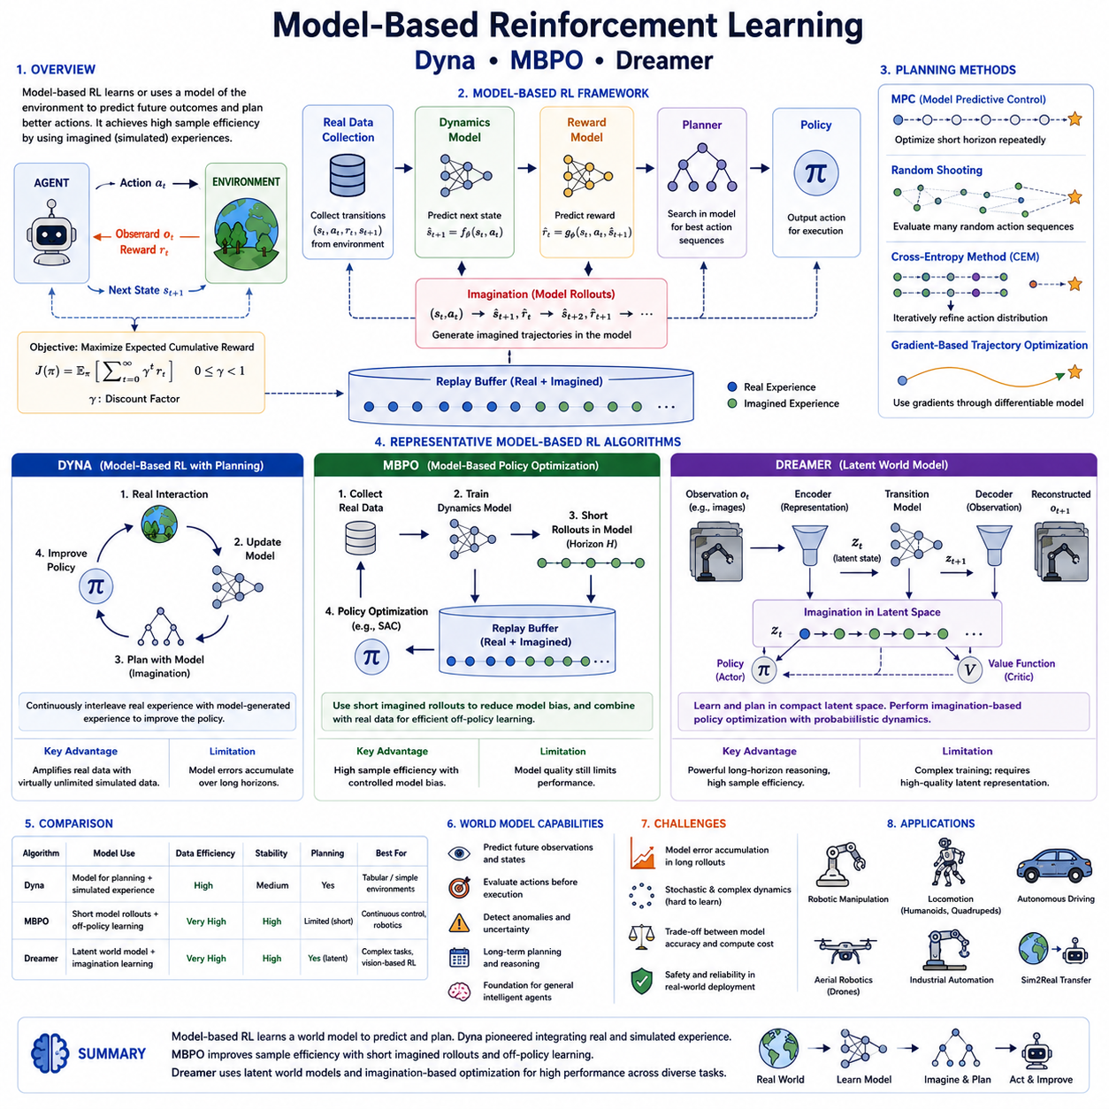
Model-Based Reinforcement Learning (MBRL) is a branch of reinforcement learning that enables an intelligent agent to learn optimal behaviors by explicitly modeling the dynamics of the environment. Unlike model-free reinforcement learning, which learns solely from direct interactions with the environment, model-based methods attempt to learn or exploit a predictive model that estimates how the environment evolves after each action. This predictive capability allows the agent to reason about future outcomes before executing actions, significantly improving learning efficiency while reducing the amount of real-world experience required. For robotics applications, where collecting physical interaction data is often expensive, slow, or potentially unsafe, model-based reinforcement learning provides an attractive alternative by shifting much of the learning process into learned or simulated environments.
The central idea of model-based reinforcement learning is that intelligent decision making becomes substantially easier when the agent possesses an internal model of the world. Instead of repeatedly experimenting with every possible action in the real environment, the agent first predicts future states, rewards, and possible consequences using the learned dynamics model. These imagined experiences can then be used for planning, policy optimization, or value estimation without requiring additional physical interactions. Consequently, model-based reinforcement learning generally achieves much higher sample efficiency than model-free algorithms, making it particularly valuable for robotics, autonomous driving, industrial automation, and other domains where data collection is expensive.
A typical model-based reinforcement learning framework consists of several tightly integrated components. The environment generates observations and rewards through real interactions. A dynamics model learns to predict future states based on current states and selected actions. A reward model estimates the expected reward associated with predicted transitions when the reward function is not explicitly available. A planner searches through possible future trajectories generated by the learned model to identify promising action sequences. Finally, a policy network converts planning results into executable control commands for the robot. These components continuously improve together as additional interaction data becomes available, gradually increasing the accuracy of predictions and the quality of learned behaviors.
The dynamics model represents the most fundamental component of model-based reinforcement learning. It approximates the transition function that governs how the environment evolves over time. Given the current state and an action, the dynamics model predicts the next state that the system is likely to reach. Depending on the application, the dynamics model may be deterministic or probabilistic. Deterministic models always produce a single prediction for each input pair, while probabilistic models estimate distributions over possible future states, thereby representing uncertainty caused by noisy sensors, stochastic environments, or incomplete observations.
Learning an accurate dynamics model is often significantly easier than directly learning an optimal policy because physical systems usually exhibit structured, continuous behavior governed by underlying physical laws. Robot motion, object dynamics, contact interactions, and vehicle kinematics often contain regular patterns that neural networks can efficiently approximate. Once an accurate predictive model has been obtained, planning algorithms can simulate thousands of hypothetical futures internally without requiring expensive interactions with the real environment.
Planning distinguishes model-based reinforcement learning from model-free methods. Instead of immediately executing the action suggested by a learned policy, the agent may first simulate numerous candidate action sequences using the learned dynamics model. Each simulated trajectory is evaluated according to predicted cumulative reward, and the highest-scoring trajectory determines the action selected for execution. This planning capability enables the agent to anticipate long-term consequences before acting, reducing costly mistakes and improving safety in high-risk robotic environments.
Planning algorithms vary considerably depending on computational requirements and model characteristics. Model Predictive Control (MPC) repeatedly optimizes finite planning horizons using the learned dynamics model while continuously updating predictions as new observations become available. Random Shooting methods evaluate randomly generated action sequences and select the highest-performing candidate. The Cross-Entropy Method (CEM) iteratively refines probability distributions over action sequences until high-quality trajectories emerge. Gradient-based trajectory optimization directly adjusts action sequences by differentiating through differentiable dynamics models. These planning strategies provide varying tradeoffs between computational cost, optimization quality, and robustness.
One of the earliest and most influential model-based reinforcement learning algorithms is Dyna, introduced by Richard Sutton. Dyna established the fundamental concept of integrating real experience with simulated experience generated by a learned environment model. Instead of separating model learning and policy learning into independent stages, Dyna continuously alternates among three complementary processes. First, the agent interacts with the real environment to collect experience. Second, the dynamics model is updated using newly acquired transitions. Third, the learned model generates simulated experiences that supplement real experiences during policy improvement. This integrated framework dramatically improves sample efficiency because every real interaction produces numerous additional virtual training examples.
The Dyna architecture illustrates one of the key advantages of model-based reinforcement learning. Real-world interactions remain expensive, but simulated experiences generated by the learned model are nearly free once the dynamics model has been trained. Consequently, policy improvement can continue long after physical data collection has stopped. This ability to amplify limited real experience through internal simulation remains one of the defining characteristics of modern model-based reinforcement learning.
Although Dyna demonstrated the effectiveness of combining planning and learning, early model-based algorithms often struggled when learned models became inaccurate over long prediction horizons. Small prediction errors accumulated over multiple simulated time steps, gradually producing unrealistic trajectories that negatively affected policy learning. Addressing this problem became a major research direction that eventually led to more sophisticated modern algorithms such as Model-Based Policy Optimization (MBPO) and Dreamer.
Model-Based Policy Optimization (MBPO) was developed specifically to combine the strengths of model-free and model-based reinforcement learning while minimizing their respective weaknesses. Rather than relying entirely on imagined rollouts generated by the learned dynamics model, MBPO carefully limits the length of simulated trajectories. Short simulated rollouts reduce the accumulation of prediction errors while still providing substantial improvements in sample efficiency. These simulated experiences are then combined with real experiences inside a replay buffer and used to train a model-free reinforcement learning algorithm such as Soft Actor-Critic.
The key insight behind MBPO is that learned models tend to remain accurate over short prediction horizons but gradually diverge from reality over longer horizons. Instead of generating hundreds of simulated future states, MBPO intentionally produces only brief imagined trajectories. Because short-horizon predictions remain relatively accurate, the resulting synthetic experiences improve policy learning without introducing excessive model bias. This hybrid strategy significantly outperforms both purely model-based and purely model-free methods across numerous continuous control benchmarks.
MBPO continuously alternates among four major processes. The agent first collects real interaction data from the environment. Next, the dynamics model is updated using the newly acquired dataset. Short imagined rollouts are then generated using the learned model. Finally, both real and imagined experiences are jointly used for policy optimization. This cyclical learning procedure enables policies to improve rapidly while maintaining strong consistency with actual environmental dynamics.
The replay buffer plays an essential role within MBPO because it integrates information originating from two distinct sources. Real experiences preserve accurate representations of environmental behavior, while imagined experiences generated by the learned model substantially increase data availability. Sampling mini-batches from both sources enables efficient learning while preventing excessive dependence on potentially imperfect model predictions.
Dreamer represents one of the most advanced model-based reinforcement learning algorithms developed in recent years. Unlike earlier methods that primarily learn transition models over observed states, Dreamer introduces the concept of latent world models. Instead of predicting future observations directly in high-dimensional image space, Dreamer first compresses observations into compact latent representations that capture the essential structure of the environment. Planning and policy learning then occur entirely within this latent space, dramatically reducing computational complexity while improving predictive accuracy.
The world model employed by Dreamer typically consists of three interacting neural networks. The representation model encodes high-dimensional sensory observations into compact latent states. The transition model predicts how latent states evolve following selected actions. The reconstruction or observation model decodes latent representations back into observations when necessary. Together, these networks enable the agent to build an internal representation of the environment that supports efficient imagination-based learning.
Latent space planning offers several significant advantages over direct observation prediction. Images, point clouds, and other sensory inputs contain enormous amounts of redundant information irrelevant to decision making. By compressing observations into meaningful latent variables, Dreamer focuses computational resources on task-relevant information while ignoring unnecessary visual details. This abstraction substantially improves prediction quality and allows long-horizon reasoning to become computationally feasible.
A defining characteristic of Dreamer is imagination-based policy learning. Rather than optimizing policies using only real experiences, the agent performs extensive policy optimization entirely within imagined latent trajectories generated by the learned world model. Because latent simulations execute much faster than real interactions, Dreamer achieves exceptional sample efficiency while maintaining high task performance. Policies gradually improve through millions of internally generated experiences before being evaluated in the physical environment.
Dreamer also addresses uncertainty by learning probabilistic latent dynamics rather than deterministic state transitions. Probabilistic world models capture multiple plausible future outcomes and naturally represent uncertainty associated with noisy observations, ambiguous situations, and stochastic environments. This uncertainty estimation improves robustness during planning and reduces overconfidence in imperfect model predictions.
Subsequent versions such as DreamerV2 and DreamerV3 further extended the architecture by improving latent representation learning, stabilizing optimization, and enabling large-scale multitask reinforcement learning. DreamerV3 demonstrated that a single algorithm could successfully solve diverse control tasks spanning robotic manipulation, locomotion, Atari games, and complex simulated environments without requiring extensive task-specific modifications. These advances illustrate the growing importance of learned world models as a foundation for general-purpose intelligent agents.
World models themselves have become a major research direction extending beyond classical reinforcement learning. A world model can be viewed as an internal simulator that enables intelligent systems to predict future consequences, evaluate hypothetical actions, detect anomalies, estimate uncertainty, and perform long-term planning before executing physical actions. This capability closely resembles human reasoning, where mental simulation often precedes actual behavior. Consequently, world models are increasingly regarded as one of the essential components of future Physical AI systems.
Despite their many advantages, model-based reinforcement learning methods also face important challenges. Learning accurate dynamics models remains difficult for highly stochastic environments, discontinuous contact dynamics, deformable objects, fluid interactions, and complex human behavior. Prediction errors inevitably accumulate over long horizons, potentially leading planners toward unrealistic trajectories. Balancing model accuracy, planning complexity, computational efficiency, and policy optimization therefore remains an active area of research.
Recent advances increasingly combine model-based reinforcement learning with transformer architectures, diffusion models, self-supervised learning, multimodal representation learning, and foundation models. Instead of learning only low-level physical dynamics, future world models are expected to incorporate semantic knowledge, language understanding, object relationships, causal reasoning, and long-term memory. Such integrated world models will enable robots to predict not only physical consequences but also task outcomes, human intentions, and mission-level objectives.
Large-scale simulation platforms such as NVIDIA Isaac Sim, MuJoCo, Genesis, and differentiable physics engines provide ideal environments for training modern model-based reinforcement learning systems. Massive simulation generates abundant interaction data for learning accurate dynamics models while domain randomization improves robustness against discrepancies between simulation and reality. After training, learned world models and optimized policies can be transferred to physical robots using Sim2Real methodologies with significantly reduced real-world experimentation.
Model-based reinforcement learning has become increasingly important for advanced robotics because it offers a practical solution to one of the field's greatest challenges: learning efficiently from limited physical experience. Dyna introduced the foundational concept of integrating planning with learning. MBPO demonstrated that carefully combining learned models with model-free optimization dramatically improves sample efficiency while controlling prediction error. Dreamer expanded this paradigm by introducing latent world models capable of imagination-based policy optimization. Together, these algorithms represent successive stages in the evolution of model-based reinforcement learning, progressively moving from simple predictive models toward increasingly sophisticated internal world representations. As future Physical AI systems continue integrating reinforcement learning with foundation models, multimodal perception, large language models, and embodied reasoning, learned world models will likely become one of the central computational mechanisms enabling autonomous robots to reason, plan, adapt, and learn with human-like efficiency.

05.04 Reward Shaping and Curriculum for Robot RL [w/Code]
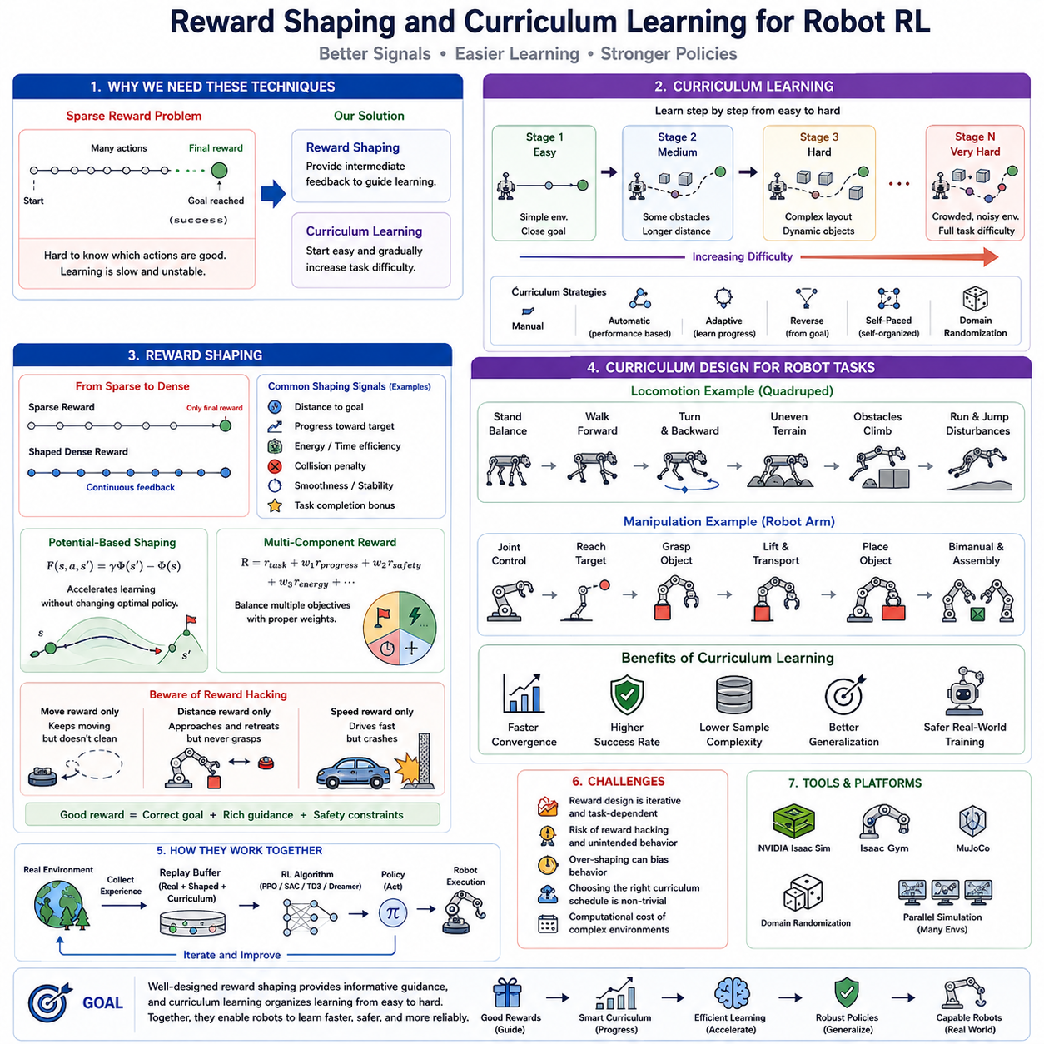
Reward shaping and curriculum learning are two of the most influential techniques for improving the efficiency, stability, and success rate of reinforcement learning in robotics. Although modern reinforcement learning algorithms such as PPO, SAC, TD3, and Dreamer have demonstrated remarkable capabilities, their performance often depends heavily on the quality of the reward signal and the structure of the training process. In practical robotic applications, sparse rewards, long-horizon tasks, complex contact dynamics, and safety constraints frequently make learning extremely difficult. Reward shaping provides richer learning signals that guide the agent toward desirable behaviors, while curriculum learning gradually increases task difficulty so that complex skills can be acquired through a sequence of progressively more challenging experiences. Together, these techniques significantly accelerate convergence, improve policy robustness, and reduce the amount of training data required.
One of the fundamental challenges in reinforcement learning is the credit assignment problem. A robot often performs hundreds or even thousands of actions before receiving a meaningful reward. Determining which actions contributed to success or failure becomes increasingly difficult as the time horizon grows. For example, a mobile manipulator may navigate through an environment, identify an object, grasp it, transport it, and finally place it into a designated container. If the robot receives only a single reward after successful completion, the learning algorithm has little information about which intermediate behaviors were beneficial. Sparse feedback dramatically slows policy optimization because successful trajectories become extremely rare during early exploration.
Reward shaping addresses this problem by introducing additional intermediate rewards that provide continuous guidance throughout the learning process. Instead of rewarding only final task completion, the environment supplies informative signals whenever the robot makes measurable progress toward the objective. These shaping rewards encourage productive behaviors while maintaining the overall optimization objective. As a result, the agent receives significantly more feedback during exploration, enabling faster policy improvement and more stable convergence.
The reward function itself represents the mathematical objective that reinforcement learning attempts to optimize. A carefully designed reward function aligns learning behavior with the desired task outcome, whereas an improperly designed reward function may unintentionally encourage undesirable or unsafe behaviors. Consequently, reward engineering has become one of the most important practical aspects of robotic reinforcement learning. Even highly advanced learning algorithms cannot compensate for poorly specified objectives if the reward function fails to capture the true mission requirements.
Robot reward functions often consist of multiple components rather than a single scalar objective. A navigation robot may simultaneously receive positive rewards for approaching its destination, maintaining smooth trajectories, avoiding obstacles, minimizing travel time, reducing energy consumption, and respecting safety margins. Similarly, a robotic manipulator may receive rewards for reducing grasp distance, maintaining stable contact forces, minimizing joint effort, avoiding collisions, and successfully completing manipulation tasks. These individual reward components are combined through weighted sums that balance competing objectives according to application requirements.
Distance-based shaping rewards represent one of the simplest and most widely used techniques. Rather than rewarding only successful task completion, the robot continuously receives rewards proportional to reductions in distance between its current state and the desired goal. This approach provides smooth gradients that encourage steady progress even during early exploration when complete task success remains unlikely. Mobile robots frequently employ Euclidean distance to navigation goals, while manipulators often utilize Cartesian distance between end-effectors and target objects.
Potential-based reward shaping provides a theoretically principled approach that preserves the optimal policy while accelerating learning. Instead of arbitrarily introducing additional rewards, shaping rewards are derived from a potential function defined over the state space. The shaping reward equals the difference between discounted future potential and current potential. Because these additional rewards satisfy specific mathematical properties, they alter learning speed without changing the optimal solution. This important theoretical guarantee makes potential-based shaping particularly attractive for safety-critical robotic applications where preserving optimal behavior is essential.
Despite its benefits, reward shaping introduces significant design challenges. One common problem is reward hacking, in which the agent discovers unintended strategies that maximize reward without accomplishing the intended task. For example, a cleaning robot rewarded solely for movement may learn to drive continuously without collecting any debris. A manipulator rewarded for minimizing distance to an object may repeatedly approach and retreat from the object without ever grasping it. Autonomous vehicles rewarded primarily for speed may develop unsafe driving behaviors if collision penalties are insufficient. These examples demonstrate that reinforcement learning optimizes exactly the specified reward function rather than the designer's implicit intentions.
Reward hacking highlights the importance of balancing multiple reward components. Safety penalties, energy costs, stability constraints, task completion bonuses, and progress rewards must collectively define the desired behavior. In practice, reward engineering often requires extensive iterative refinement involving repeated experiments, failure analysis, and weight adjustment before satisfactory robot behavior emerges. Consequently, designing reward functions has become both an engineering discipline and an active research topic.
Dense rewards and sparse rewards represent two opposite extremes in reinforcement learning. Dense reward functions provide continuous feedback after nearly every action, greatly improving learning efficiency but increasing the risk of biasing behavior toward intermediate objectives rather than ultimate task completion. Sparse reward functions provide feedback only when the final objective has been achieved, accurately representing real-world success criteria but making exploration substantially more difficult. Modern robotic reinforcement learning frequently combines sparse terminal rewards with carefully designed dense shaping rewards that guide exploration without fundamentally altering the task objective.
Auxiliary rewards further enhance learning by encouraging useful secondary behaviors that support task completion. A quadruped robot may receive additional rewards for maintaining body balance, minimizing foot slippage, preserving gait symmetry, and reducing energy expenditure. A drone may receive rewards for maintaining stable altitude, smooth angular velocities, and efficient trajectory tracking. Although these auxiliary objectives do not directly define task success, they encourage physically meaningful behaviors that facilitate robust policy learning.
Curriculum learning introduces another powerful mechanism for accelerating reinforcement learning. Inspired by human education, curriculum learning organizes training experiences according to gradually increasing levels of difficulty. Rather than exposing the agent to the most difficult task from the beginning, training starts with simplified scenarios that can be solved relatively easily. Once the agent consistently succeeds, progressively more challenging conditions are introduced. This staged learning process significantly improves convergence while reducing catastrophic failure during early exploration.
The underlying intuition behind curriculum learning is that complex skills are easier to acquire when decomposed into simpler prerequisite abilities. Human students first learn arithmetic before calculus, and children first learn to crawl before walking. Similarly, robots benefit from learning basic navigation before obstacle avoidance, stable locomotion before running, and object reaching before dexterous manipulation. Sequentially mastering increasingly difficult subtasks enables policies to develop robust foundational capabilities that support later complex behaviors.
Curriculum design can follow several different strategies. Manual curricula rely on human expertise to define successive training stages according to increasing task complexity. Automatic curricula dynamically adjust task difficulty based on measured policy performance. Adaptive curricula continuously estimate the agent's competence and select training scenarios that maximize expected learning progress. Reverse curricula begin near successful goal states before gradually increasing initial distances. Self-paced curricula automatically identify appropriate difficulty levels according to optimization objectives and learning dynamics.
Environmental complexity frequently serves as a natural curriculum variable in robotic learning. Navigation tasks may initially contain no obstacles before gradually introducing static obstacles, moving obstacles, narrow passages, dynamic crowds, uneven terrain, adverse weather conditions, and sensor noise. Manipulation tasks may begin with isolated objects placed in convenient positions before progressing toward cluttered environments, deformable objects, varying lighting conditions, and dynamic human interactions. Each curriculum stage expands the agent's competence while preserving previously acquired skills.
Domain randomization often complements curriculum learning by progressively increasing environmental variability throughout training. Initially, simulated environments may employ fixed physical parameters such as friction, mass, lighting, and textures. As learning progresses, these parameters are gradually randomized across wider ranges. Eventually, robots experience diverse combinations of environmental conditions that closely approximate real-world uncertainty. This gradual expansion of environmental diversity significantly improves generalization during Sim2Real transfer.
Robotic locomotion provides one of the clearest demonstrations of curriculum learning. A quadruped robot typically begins by learning to stand without falling. Once stable balance has been achieved, the curriculum introduces slow forward walking. Subsequent stages include turning, backward motion, uneven terrain, inclined surfaces, obstacle traversal, slippery ground, running, jumping, and recovery from external disturbances. Attempting to learn all these skills simultaneously would greatly complicate exploration and often prevent successful convergence.
Manipulation tasks exhibit similar hierarchical structures. A robotic arm first learns basic joint coordination before reaching toward isolated objects. Once reaching succeeds reliably, grasping motions are introduced. Subsequent curriculum stages involve object lifting, transportation, placement, orientation control, force-sensitive manipulation, bimanual coordination, and assembly operations. By gradually expanding task complexity, reinforcement learning acquires sophisticated manipulation capabilities with substantially greater efficiency than direct end-to-end optimization.
Curriculum learning also improves exploration by reducing the probability of repeated failure during early training. When initial tasks remain achievable, successful trajectories become sufficiently common to provide meaningful learning signals. As policy competence increases, exploration naturally expands toward increasingly complex behaviors. This progressive exploration strategy substantially reduces sample complexity compared with immediately confronting the agent with extremely challenging environments.
Automatic curriculum generation has become an active research area within modern reinforcement learning. Instead of relying on manually designed training schedules, machine learning algorithms estimate the current competence of the agent and automatically select future tasks that maximize expected improvement. Teacher-student frameworks employ separate teacher policies responsible for generating appropriate training scenarios. Population-based methods dynamically adjust curriculum parameters across multiple parallel learners. These adaptive strategies reduce human engineering effort while improving scalability across diverse robotic applications.
Curriculum learning interacts naturally with replay buffers in off-policy reinforcement learning algorithms. Experiences collected from earlier curriculum stages remain valuable because they reinforce fundamental behaviors even after more advanced tasks have been introduced. Prioritized replay further enhances learning by selecting informative experiences according to temporal-difference error, novelty, or learning progress. Combining curriculum learning with intelligent experience replay creates highly efficient training pipelines capable of solving extremely challenging robotic tasks.
Safety considerations are particularly important when designing robotic curricula. Early curriculum stages often restrict robot velocities, actuator torques, workspace boundaries, and environmental hazards. As policy reliability improves, these safety constraints are gradually relaxed, allowing increasingly aggressive behaviors while maintaining acceptable risk levels. Such staged deployment significantly reduces hardware damage, protects expensive equipment, and enables safe reinforcement learning on physical robotic platforms.
Modern simulation environments provide ideal platforms for implementing reward shaping and curriculum learning. NVIDIA Isaac Sim, Isaac Gym, MuJoCo, Genesis, and other physics simulators enable automatic adjustment of terrain complexity, object arrangements, sensor noise, actuator delays, lighting conditions, weather effects, and physical parameters throughout training. Massive parallel simulation further allows multiple curriculum stages to be trained simultaneously across thousands of environments, dramatically accelerating policy development.
Reward shaping and curriculum learning have become indispensable components of successful robotic reinforcement learning systems. Rather than viewing reinforcement learning as a purely algorithmic optimization problem, these techniques recognize that intelligent behavior emerges most efficiently when learning signals and training experiences are carefully structured. Reward shaping provides informative guidance that accelerates policy optimization without sacrificing task objectives, while curriculum learning organizes knowledge acquisition into manageable stages that progressively develop increasingly sophisticated skills.
Future Physical AI systems will likely employ adaptive reward functions, automatically generated curricula, learned world models, foundation models, and large language models to create increasingly autonomous learning processes. Instead of relying on manually engineered rewards and fixed training schedules, future robots may continuously modify their own objectives, generate personalized curricula, estimate task difficulty, and optimize learning strategies based on accumulated experience. In this vision, reward shaping and curriculum learning evolve from manually designed engineering tools into self-improving mechanisms that enable lifelong autonomous learning across diverse robotic tasks and continuously changing environments.

05.05 Sparse Reward and Hindsight Experience Replay HER [w/Code]
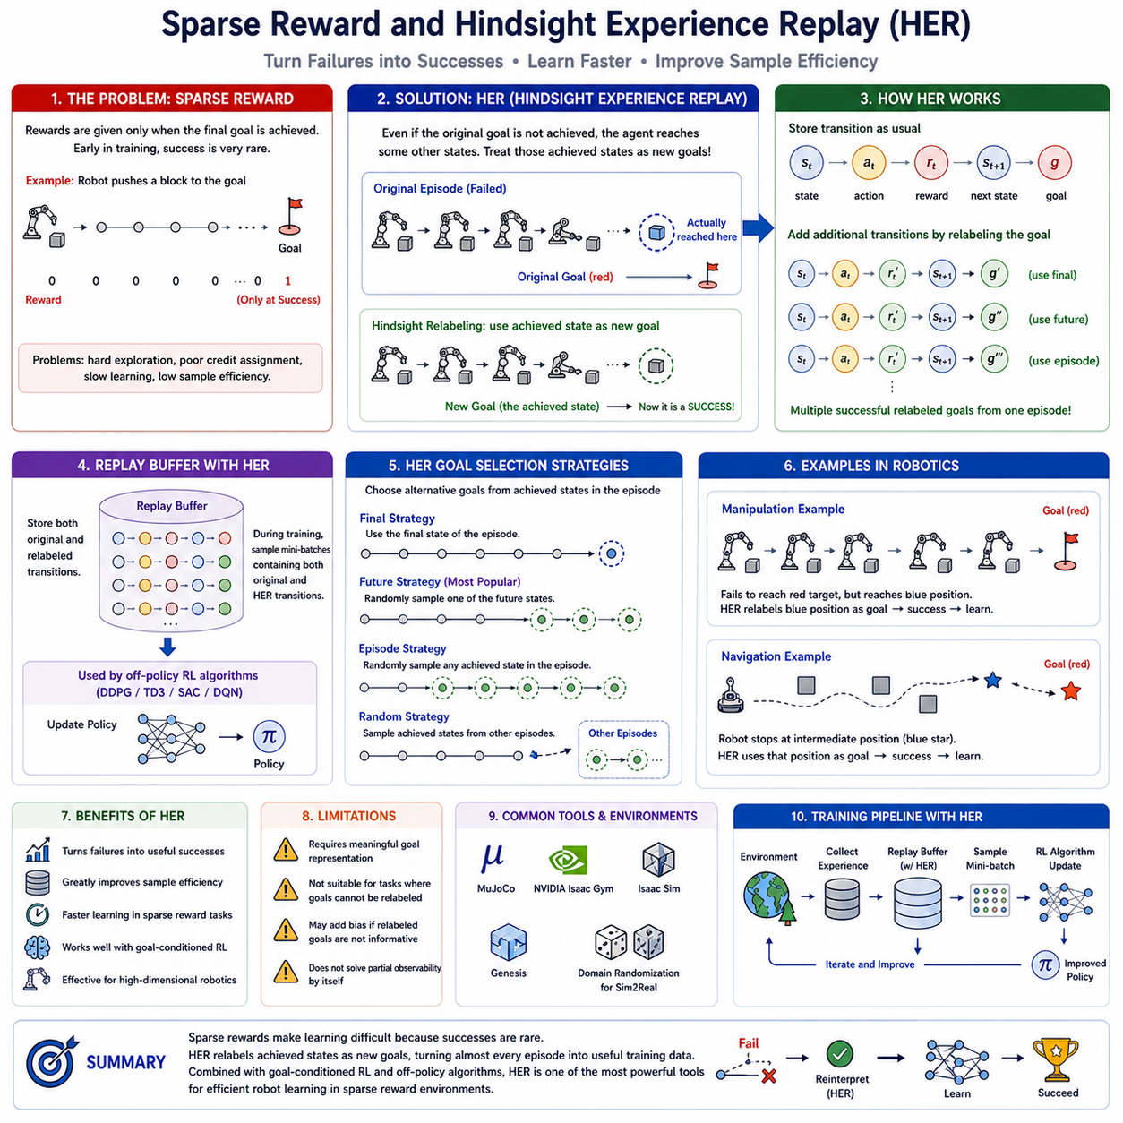
Sparse rewards represent one of the most fundamental challenges in reinforcement learning, particularly in robotics where successful task completion often occurs only after long sequences of coordinated actions. In many real-world robotic applications, meaningful rewards are received only when an entire task has been completed successfully. For example, a robotic manipulator receives a positive reward only after grasping and placing an object into the correct location, while a mobile robot receives a reward only after reaching its destination without collisions. During early training, however, successful episodes are extremely rare because the agent initially behaves almost randomly. As a result, the reinforcement learning algorithm receives very little useful feedback, making policy optimization slow, unstable, and highly sample inefficient. Sparse reward learning has therefore become one of the central research topics in modern reinforcement learning, leading to numerous techniques that improve exploration, credit assignment, and sample efficiency. Among these approaches, Hindsight Experience Replay (HER) has emerged as one of the most successful methods for robotic manipulation and goal-conditioned reinforcement learning.
A sparse reward function typically provides only binary feedback indicating whether a predefined goal has been achieved. Instead of continuously rewarding incremental progress, the environment returns a reward of one when the objective has been successfully completed and zero or a negative penalty otherwise. Such reward functions closely resemble many real-world engineering tasks because actual industrial objectives are often naturally binary. A robot either successfully inserts a component into an assembly fixture or it does not. A warehouse robot either reaches the correct storage location or fails to arrive. Although sparse rewards accurately represent practical task definitions, they provide very limited information about how the agent should improve its behavior during unsuccessful attempts.
The difficulty associated with sparse rewards is closely related to the exploration problem. During the initial stages of learning, random policies almost never achieve successful outcomes in high-dimensional robotic environments. Consequently, the replay buffer becomes dominated by unsuccessful experiences that provide nearly identical reward values. Since reinforcement learning algorithms rely on differences in observed returns to distinguish good actions from poor ones, uniformly unsuccessful trajectories contain little information for policy improvement. The probability of discovering successful behaviors decreases exponentially as task complexity and planning horizon increase, making naive reinforcement learning impractical for many real robotic applications.
Long-horizon manipulation tasks illustrate this challenge clearly. Consider a robot that must identify an object, approach it, orient its gripper correctly, establish stable contact, lift the object, transport it across the workspace, avoid obstacles, and finally place it precisely into a designated container. Every intermediate action must be executed correctly before the final sparse reward becomes available. If any earlier action fails, the episode terminates without meaningful feedback. Learning such behaviors through purely random exploration would require an enormous number of unsuccessful interactions before even a single successful demonstration is observed.
Traditional approaches attempted to overcome sparse rewards through reward shaping. Intermediate rewards were manually designed to encourage behaviors such as reducing distance to targets, maintaining stable grasps, minimizing energy consumption, or avoiding collisions. Although reward shaping significantly accelerates learning, it introduces several important limitations. Designing informative reward functions requires substantial engineering effort and domain expertise. More importantly, poorly designed shaping rewards may unintentionally alter the optimal policy or encourage undesirable reward-hacking behaviors. These limitations motivated the search for methods capable of learning effectively from sparse rewards without requiring extensive manual reward engineering.
Goal-conditioned reinforcement learning provides one important foundation for solving sparse reward problems. Instead of learning a policy that performs only a single fixed task, the agent learns a universal policy conditioned on both the current observation and a specified goal. The policy therefore answers the question: given my current state and the desired goal, which action should I execute next? By explicitly incorporating goals into policy inputs, a single neural network becomes capable of solving many different goal-reaching tasks simultaneously. This formulation also creates the opportunity to reinterpret unsuccessful experiences as successful attempts toward alternative goals.
Hindsight Experience Replay was introduced precisely to exploit this observation. The central insight behind HER is surprisingly simple yet extremely powerful. Even when the robot fails to achieve its intended goal, it almost always achieves some other outcome. Instead of discarding unsuccessful trajectories, HER retrospectively changes the goal associated with stored experiences so that previously unsuccessful episodes become successful examples for alternative objectives. Consequently, nearly every collected trajectory contributes useful learning information regardless of whether the original task succeeded.
Consider a robotic arm instructed to move a cube into a red target location. During one training episode, the robot accidentally moves the cube into a nearby blue location instead of the intended target. Under conventional sparse reward learning, this episode receives zero reward because the assigned objective was not achieved. HER, however, stores an additional version of exactly the same trajectory but replaces the desired goal with the location where the cube actually ended up. Under this modified goal, the trajectory becomes a successful demonstration with positive reward. Without collecting any additional data, one failed episode has been transformed into a valuable successful training example.
This simple goal relabeling process dramatically increases sample efficiency. Instead of requiring rare successful episodes for learning, the replay buffer becomes populated with numerous successful experiences generated from previously unsuccessful interactions. The agent gradually acquires general knowledge about how actions influence objects under many different goals, eventually allowing successful generalization toward the originally intended objectives.
The replay buffer plays a central role in HER. During normal interaction, every transition consists of the current state, executed action, obtained reward, subsequent state, and intended goal. HER augments this stored experience by generating additional transitions in which the original goal has been replaced by an alternative goal extracted from the same trajectory. Both original and relabeled experiences coexist inside the replay buffer, allowing the learning algorithm to optimize over both intended objectives and retrospectively successful outcomes.
Several different goal selection strategies have been proposed for HER. The final strategy replaces the desired goal with the final state reached during the episode. Since the robot always reaches its final state, every episode becomes successful under this alternative objective. The future strategy samples one of the future states occurring later within the same trajectory as the substituted goal. This approach often produces more informative learning signals because intermediate future states remain closely connected to preceding actions. Episode sampling selects arbitrary achieved goals from anywhere within the current trajectory, while random sampling chooses achieved goals from unrelated episodes. Among these alternatives, future goal sampling has generally demonstrated the strongest empirical performance across numerous robotic benchmarks.
HER integrates naturally with off-policy reinforcement learning algorithms because replay buffers already store historical experiences independently of the current policy. Algorithms such as Deep Deterministic Policy Gradient (DDPG), Twin Delayed Deep Deterministic Policy Gradient (TD3), Soft Actor-Critic (SAC), and Deep Q Networks can incorporate HER with relatively minor modifications. During each optimization step, mini-batches are sampled from replay memory containing both original transitions and relabeled transitions generated through hindsight. Consequently, policy learning benefits simultaneously from actual task objectives and alternative successful experiences.
Continuous robotic control particularly benefits from HER because successful exploration remains difficult in high-dimensional action spaces. Robotic manipulation tasks involving multiple joints, continuous torques, object contacts, and precise positioning rarely achieve success through random exploration alone. HER transforms accidental object movements into informative supervision, dramatically accelerating policy improvement. Numerous benchmark studies have demonstrated order-of-magnitude reductions in required training interactions when HER is combined with modern off-policy algorithms.
Robotic grasping provides an excellent example of HER in practice. During early exploration, a manipulator rarely grasps the intended object correctly. Nevertheless, it frequently contacts, pushes, rotates, or partially lifts objects into alternative positions. Conventional reinforcement learning would treat these interactions as failures because the designated goal remained unmet. HER instead relabels goals according to achieved object configurations, allowing the robot to learn how different actions influence object motion. As manipulation competence improves across numerous alternative goals, successful grasping of intended targets eventually emerges naturally.
Mobile robot navigation exhibits similar advantages. Suppose a navigation policy initially attempts to reach a distant goal but instead consistently stops at intermediate locations because obstacle avoidance remains imperfect. Standard sparse reward learning records repeated failures. HER reinterprets these stopping positions as successful navigation targets, enabling the robot to learn progressively longer navigation behaviors. Over time, competence extends naturally toward increasingly distant destinations without requiring manually engineered intermediate rewards.
HER also complements curriculum learning particularly well. Early curriculum stages often involve relatively nearby goals that naturally generate successful trajectories. Later curriculum stages introduce increasingly distant or difficult objectives. Even when these advanced tasks fail, HER continues extracting successful experiences corresponding to intermediate states achieved during exploration. Consequently, learning remains productive throughout the curriculum despite increasing task complexity.
Despite its remarkable effectiveness, HER possesses several limitations. The algorithm assumes that goals can be meaningfully redefined after an episode has completed. Many robotic manipulation and navigation tasks naturally satisfy this assumption because achieved object positions or robot locations can easily replace intended targets. However, certain sequential decision problems involving irreversible events, temporal constraints, hidden information, or complex logical objectives may not permit straightforward goal relabeling. In such cases, HER becomes less effective or requires task-specific adaptations.
Another important consideration involves goal representation. HER requires goals to be represented explicitly within observations or state descriptions. Simple Cartesian coordinates, object poses, joint configurations, or navigation waypoints satisfy this requirement naturally. More abstract semantic objectives such as “prepare breakfast,” “assemble this device,” or “clean the entire room” require substantially richer goal representations potentially involving language, symbolic planning, or hierarchical task decomposition. Extending HER toward semantic and language-conditioned goals remains an active research area.
Recent research increasingly combines HER with representation learning, contrastive learning, self-supervised learning, and latent world models. Instead of relabeling goals directly within observation space, learned latent representations encode compact descriptions of achievable outcomes. Goal relabeling then occurs within these latent spaces, enabling more efficient learning from high-dimensional visual observations. Such approaches significantly improve scalability for image-based robotic manipulation and autonomous navigation.
HER also integrates naturally with modern foundation models and vision-language-action architectures. Future robotic systems may generate alternative semantic goals automatically using large language models or multimodal reasoning systems. Rather than manually defining goal substitution strategies, intelligent world models could identify meaningful alternative objectives according to contextual understanding of tasks, object affordances, and environmental semantics. This integration would substantially extend HER beyond simple geometric goal relabeling toward generalized reasoning about alternative successful outcomes.
Simulation environments have played an essential role in the development of HER. Platforms such as MuJoCo, NVIDIA Isaac Gym, Isaac Sim, Genesis, and other robotics simulators enable large-scale evaluation across thousands of parallel environments involving manipulation, locomotion, navigation, and dexterous control. Since HER dramatically increases sample efficiency, combining large-scale simulation with hindsight replay allows sophisticated robotic policies to emerge after relatively modest amounts of real-world experience. Domain randomization further improves Sim2Real transfer by exposing policies to diverse environmental conditions during training.
Sparse reward learning remains one of the defining challenges for autonomous robotics because real-world tasks rarely provide dense instructional feedback. Hindsight Experience Replay fundamentally changes the interpretation of failure by recognizing that unsuccessful attempts frequently contain valuable information when viewed from alternative perspectives. Instead of wasting failed experiences, HER transforms them into successful demonstrations through retrospective goal relabeling, substantially improving data efficiency while preserving the simplicity of sparse reward formulations. As reinforcement learning continues evolving toward world models, multimodal perception, hierarchical planning, and foundation models for Physical AI, HER represents a milestone in demonstrating that intelligent agents can learn not only from success but also by reinterpreting failure as progress toward alternative objectives. This principle of learning from hindsight will likely remain a fundamental component of future autonomous robotic learning systems capable of continuously adapting, reasoning, and improving throughout lifelong interaction with the physical world.

05.06 Multi Task RL and Task Generalization [w/Code]
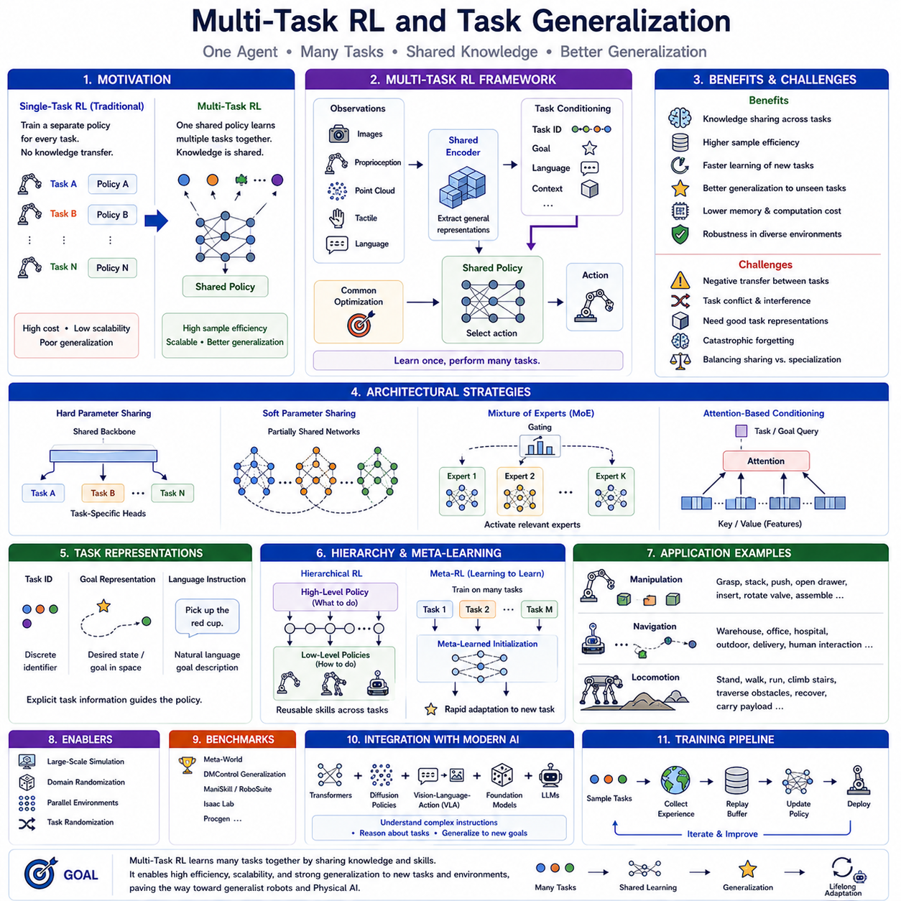
Multi-Task Reinforcement Learning (Multi-Task RL) is an advanced reinforcement learning paradigm in which a single intelligent agent learns multiple tasks simultaneously rather than optimizing its behavior for only one specific objective. Traditional reinforcement learning typically trains an independent policy for each individual task, requiring separate datasets, training procedures, and computational resources for every new application. While this approach can produce highly specialized policies, it lacks scalability and generalization because knowledge acquired during one task cannot easily be transferred to another. Multi-Task RL addresses this limitation by enabling a unified policy to solve diverse tasks through shared representations and shared learning experiences. This capability represents a crucial step toward developing general-purpose robotic intelligence capable of operating effectively in complex, dynamic environments.
The motivation for Multi-Task RL originates from the observation that many robotic tasks share common underlying skills. A robotic manipulator that learns to reach an object also acquires knowledge about arm kinematics, collision avoidance, motion smoothness, and object localization. These capabilities remain useful whether the robot subsequently learns grasping, stacking, assembly, or tool manipulation. Instead of relearning these fundamental behaviors independently for every task, Multi-Task RL allows a single policy to reuse common knowledge across multiple objectives. Such knowledge sharing significantly improves sample efficiency, reduces computational cost, and accelerates learning of new tasks.
Task generalization extends this concept even further. While Multi-Task RL focuses on simultaneously solving a predefined collection of tasks, task generalization emphasizes the ability to perform previously unseen tasks without requiring complete retraining. The ultimate objective is to develop reinforcement learning agents that acquire reusable behavioral principles rather than memorizing task-specific solutions. A robot capable of generalization should adapt naturally to new environments, novel object configurations, changing goals, and previously unencountered combinations of known skills.
A Multi-Task RL framework typically consists of a shared policy network, a shared representation encoder, task-specific conditioning information, and a common optimization objective. The representation encoder extracts general features from observations such as images, point clouds, proprioceptive measurements, tactile information, and language instructions. These features capture knowledge useful across many tasks rather than optimizing exclusively for a single objective. The policy network then combines these shared representations with task-specific information to determine appropriate actions. Through joint optimization over multiple tasks, the neural network gradually develops increasingly general internal representations capable of supporting diverse behaviors.
Task representations play an essential role in Multi-Task RL because the agent must distinguish among different objectives while maintaining shared knowledge. One common approach introduces task identifiers as additional inputs to the policy network. Each task receives a unique embedding vector that conditions policy behavior. Alternatively, goal representations specify desired outcomes directly, allowing the policy to interpret goals rather than relying on discrete task labels. More advanced approaches utilize natural language instructions as task descriptions, enabling reinforcement learning agents to respond flexibly to human commands expressed in ordinary language.
Parameter sharing forms the computational foundation of Multi-Task RL. Instead of training completely independent neural networks for each task, most network parameters remain common across all tasks while only limited task-specific components differ. Shared parameters capture broadly applicable knowledge such as perception, object recognition, spatial reasoning, balance control, or motion generation. Task-specific layers specialize this common knowledge for individual objectives without duplicating the entire network. This architecture significantly reduces memory requirements while promoting positive knowledge transfer across related tasks.
Positive transfer represents one of the greatest strengths of Multi-Task RL. Learning one task frequently accelerates learning of another because both tasks depend upon similar underlying capabilities. For example, grasping cylindrical objects facilitates learning to grasp bottles, tools, and containers. Navigation through uncluttered environments supports subsequent navigation through crowded warehouses. Quadruped walking improves later learning of running, stair climbing, and obstacle traversal. By exploiting these shared structures, Multi-Task RL often achieves substantially greater sample efficiency than independently training each task.
However, Multi-Task RL also introduces the challenge of negative transfer. Tasks that require conflicting behaviors may interfere with one another during joint optimization. A manipulation policy optimized for extremely delicate object handling may conflict with another policy requiring aggressive high-speed assembly. Similarly, navigation policies emphasizing maximum speed may conflict with safety-oriented inspection behaviors. If parameter sharing becomes excessive, optimization for one task may degrade performance on another. Balancing knowledge sharing with task specialization therefore remains one of the central research challenges in Multi-Task RL.
Several architectural strategies have been developed to reduce negative transfer. Hard parameter sharing uses a single shared backbone network followed by task-specific output heads. Soft parameter sharing maintains partially independent networks while encouraging similarity through regularization. Mixture-of-Experts architectures dynamically activate specialized subnetworks according to the current task, allowing different tasks to share only the most relevant computational modules. Attention mechanisms further improve flexibility by selectively emphasizing task-relevant features while suppressing irrelevant information during policy execution.
Task-conditioned policies provide another powerful mechanism for supporting multiple objectives within a single reinforcement learning framework. Rather than maintaining separate policies for every task, one universal policy receives both environmental observations and task descriptions as inputs. During deployment, changing the task representation immediately changes policy behavior without modifying network parameters. Goal-conditioned reinforcement learning, language-conditioned policies, and context-conditioned policies all represent important variations of this general idea.
Goal-conditioned reinforcement learning naturally supports Multi-Task RL because different goals effectively define different tasks. Instead of explicitly training separate navigation policies for each destination, one goal-conditioned policy learns to navigate toward arbitrary target locations specified during execution. Similarly, a robotic manipulator may learn to place objects into any requested container by conditioning the policy on desired object positions rather than memorizing individual placement behaviors. This unified formulation greatly simplifies policy deployment across diverse operational scenarios.
Hierarchical reinforcement learning complements Multi-Task RL by decomposing complex behaviors into reusable subtasks. High-level controllers determine which subtask should be executed next, while lower-level controllers specialize in primitive skills such as reaching, grasping, walking, turning, or obstacle avoidance. Because these primitive skills remain useful across many different missions, hierarchical decomposition naturally promotes task reuse and generalization. New tasks can often be solved simply by rearranging existing low-level skills into novel high-level sequences.
Meta-learning provides another important pathway toward task generalization. Rather than optimizing policies for specific tasks, meta-reinforcement learning optimizes the ability to learn new tasks rapidly. During training, the agent experiences many related tasks and gradually discovers initialization parameters that facilitate rapid adaptation. When encountering a previously unseen task, only a small amount of additional experience becomes necessary for successful adaptation. This “learning to learn” paradigm significantly reduces the amount of data required for deployment in unfamiliar environments.
Representation learning plays a crucial role in enabling task generalization. Effective representations capture task-independent features while discarding irrelevant variations. Self-supervised learning, contrastive learning, masked autoencoders, and world models increasingly provide powerful representation learning mechanisms that improve Multi-Task RL performance. Once robust representations have been acquired, downstream reinforcement learning algorithms require substantially fewer task-specific interactions because fundamental perceptual knowledge already exists.
World models further strengthen Multi-Task RL by providing reusable predictive models applicable across many tasks. Instead of learning separate dynamics models for every objective, one shared world model predicts environmental evolution regardless of the current mission. Different policies can then exploit identical predictive knowledge while optimizing distinct reward functions. This separation between environment understanding and task optimization represents an important architectural principle for future Physical AI systems.
Continual learning becomes increasingly important as Multi-Task RL systems expand toward large numbers of tasks. Traditional neural networks often suffer from catastrophic forgetting when sequentially trained on new objectives. Elastic Weight Consolidation, replay buffers, parameter isolation, progressive neural networks, and generative replay have therefore been incorporated into Multi-Task RL systems to preserve previously acquired skills while learning additional capabilities. Lifelong reinforcement learning extends this process indefinitely, enabling robotic systems to accumulate knowledge continuously throughout deployment.
Large-scale simulation has become indispensable for Multi-Task RL research. Modern simulation platforms such as NVIDIA Isaac Sim, Isaac Gym, MuJoCo, Genesis, and Brax can generate thousands of diverse training environments simultaneously. Different robots, terrains, object arrangements, lighting conditions, weather patterns, and task objectives execute in parallel, providing enormous behavioral diversity. This large-scale multitask simulation substantially improves policy robustness while exposing reinforcement learning agents to far more experience than practical physical experimentation could provide.
Task randomization further improves generalization by varying objectives throughout training. Rather than repeatedly solving identical tasks, robots continuously encounter randomized target positions, object shapes, obstacle configurations, payloads, environmental conditions, and mission specifications. This diversity prevents policies from memorizing narrow solutions and instead encourages development of broadly applicable behavioral strategies. Domain randomization extends this concept by varying physical parameters such as friction, mass, sensor noise, actuator delays, and visual appearance, thereby improving Sim2Real transfer.
Benchmark environments have played a significant role in evaluating Multi-Task RL algorithms. Suites such as Meta-World, DMControl Generalization Benchmark, Procgen, ManiSkill, RoboSuite, and Isaac Lab provide standardized collections of robotic manipulation, locomotion, and navigation tasks designed specifically to evaluate multitask performance and generalization. These benchmarks measure not only task success but also transfer efficiency, adaptation speed, robustness, and zero-shot generalization to previously unseen scenarios.
Robotic manipulation provides one of the strongest demonstrations of Multi-Task RL. Instead of independently learning grasping, stacking, pushing, opening drawers, inserting pegs, rotating valves, and assembling components, a single policy gradually acquires reusable manipulation primitives applicable across all tasks. Shared perception, motion planning, contact reasoning, and force control substantially accelerate acquisition of increasingly sophisticated manipulation behaviors.
Mobile robot navigation similarly benefits from multitask learning. One unified policy may simultaneously learn warehouse navigation, office delivery, hospital transportation, outdoor path following, elevator usage, dynamic obstacle avoidance, and human interaction. Because all these tasks depend upon common navigation principles, shared representations naturally emerge, improving both efficiency and robustness.
Quadruped locomotion also illustrates the advantages of task generalization. A single policy may learn standing, walking, running, stair climbing, obstacle traversal, recovery after disturbance, rough terrain locomotion, and payload transportation. Rather than storing independent controllers for every gait, the robot develops flexible locomotion principles capable of adapting continuously to changing environmental conditions.
Recent advances increasingly combine Multi-Task RL with transformer architectures, diffusion policies, vision-language-action models, foundation models, and large language models. Instead of representing tasks using manually defined identifiers, future reinforcement learning agents may interpret complex natural language instructions, semantic scene descriptions, symbolic plans, and multimodal demonstrations. Language therefore becomes a universal task specification interface capable of describing arbitrary objectives without requiring explicit retraining.
Foundation models further expand task generalization by providing broad prior knowledge acquired through large-scale pretraining. Reinforcement learning then fine-tunes these general representations toward physical interaction while preserving semantic understanding learned from diverse multimodal datasets. This integration substantially reduces reinforcement learning sample requirements while improving robustness across previously unseen tasks and environments.
The long-term objective of Multi-Task Reinforcement Learning extends beyond solving collections of predefined tasks. The ultimate vision is to create generalist robotic agents capable of continually acquiring new skills while preserving existing knowledge and transferring previous experience toward future objectives. Such agents would no longer require independent reinforcement learning pipelines for every application but instead maintain a continuously expanding repertoire of reusable capabilities. As Multi-Task RL converges with continual learning, world models, foundation models, language-conditioned reasoning, and Physical AI architectures, task generalization will become one of the defining characteristics distinguishing specialized automation systems from truly intelligent autonomous robots capable of adapting to the diversity and unpredictability of the real world.

05.07 Offline RL and Conservative Q Learning CQL [w/Code]
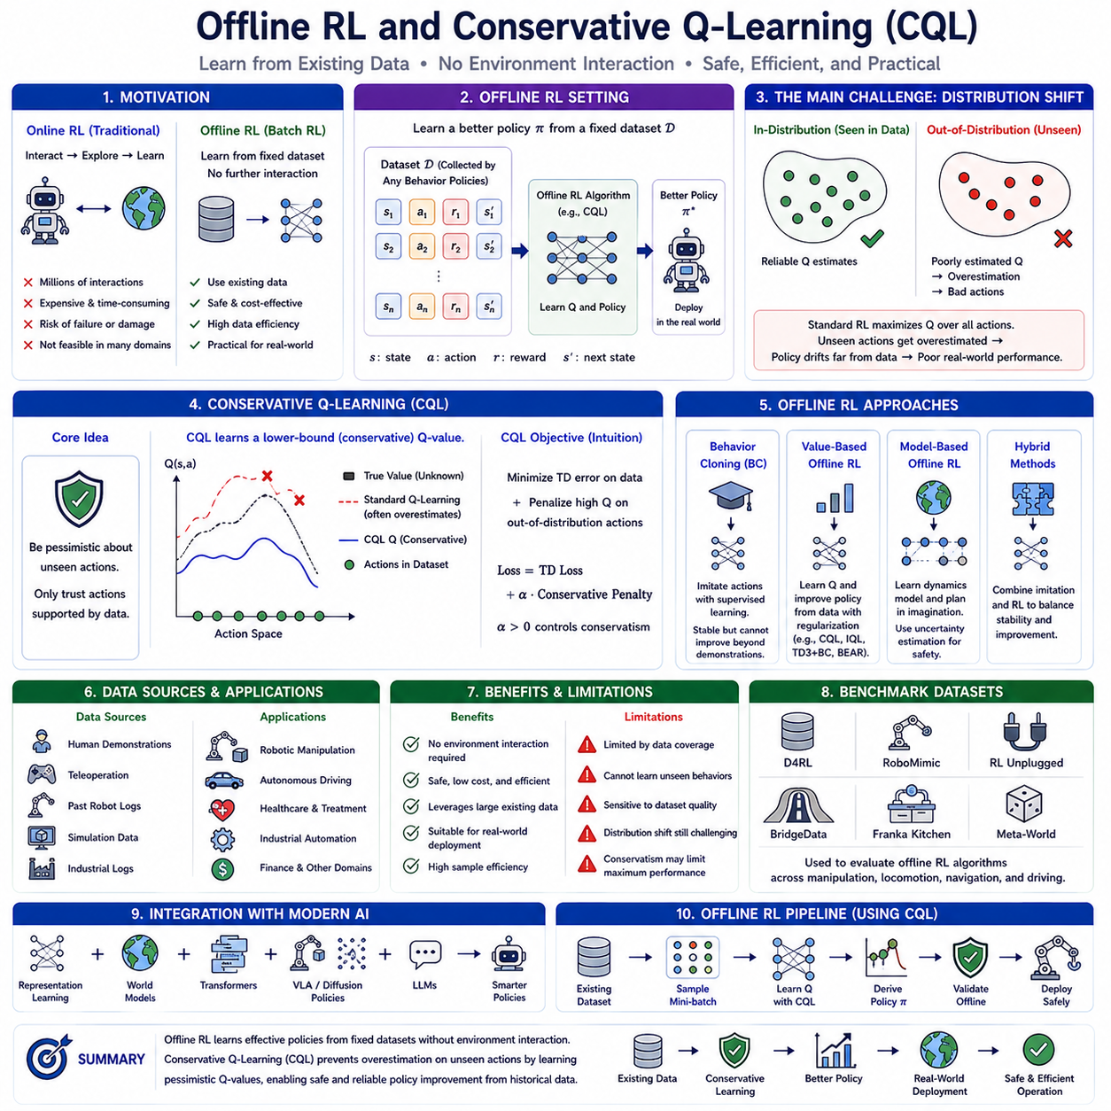
Offline Reinforcement Learning (Offline RL), also known as Batch Reinforcement Learning, is a reinforcement learning paradigm in which an agent learns entirely from previously collected datasets without requiring additional interaction with the environment during training. Unlike conventional online reinforcement learning, where the agent continuously explores the environment, collects new experiences, and updates its policy simultaneously, Offline RL assumes that all available experience has already been recorded before learning begins. The learning algorithm therefore operates exclusively on static datasets consisting of historical state transitions, actions, rewards, and subsequent observations. This learning paradigm has become increasingly important for robotics, autonomous driving, healthcare, industrial automation, finance, and other safety-critical domains where online exploration is expensive, dangerous, or simply impossible.
The motivation for Offline RL arises from the limitations of traditional online reinforcement learning. Modern reinforcement learning algorithms often require millions of interactions with the environment before achieving acceptable performance. In simulation this requirement is manageable because experiences can be generated rapidly and safely. However, in real robotic systems every interaction consumes physical resources, causes hardware wear, requires operator supervision, and may introduce safety risks. A mobile robot exploring unknown environments may collide with obstacles. A robotic manipulator may damage expensive equipment during random exploration. Autonomous vehicles cannot safely learn through trial and error on public roads. Consequently, many practical applications possess extensive historical datasets but cannot support unrestricted online exploration.
Offline RL provides a practical solution by utilizing existing datasets generated through previous robot operations, human demonstrations, simulation experiments, teleoperation sessions, industrial production logs, or manually designed controllers. Instead of discarding these valuable experiences after data collection, Offline RL extracts optimal policies from historical interactions without requiring further environmental access. This capability enables reinforcement learning to benefit from the enormous quantities of operational data already available in many industrial and commercial systems.
An Offline RL dataset typically contains tuples consisting of states, actions, rewards, subsequent states, and termination indicators. These trajectories may originate from multiple behavior policies exhibiting varying levels of expertise. Some demonstrations may represent highly skilled human operators, while others may come from imperfect autonomous controllers or exploratory robot behaviors. The dataset therefore reflects a diverse distribution of experiences rather than interactions generated by a single evolving policy. The objective of Offline RL is to discover a policy that outperforms the original behavior policies while remaining consistent with the available data.
The primary challenge distinguishing Offline RL from online reinforcement learning is the distribution shift problem. During optimization, the learned policy gradually selects actions that differ from those observed in the historical dataset. Since the environment cannot be queried for additional feedback, the reinforcement learning algorithm must estimate action values for state-action combinations never actually encountered during data collection. These extrapolated estimates often become highly inaccurate because they rely solely on function approximation rather than real observations. Consequently, policy optimization may become increasingly biased toward unrealistic actions that appear valuable according to the learned Q-function but would perform poorly in the actual environment.
Distribution shift creates a dangerous feedback loop. Slight overestimation of previously unseen actions encourages the policy to choose those actions more frequently. Because no new environmental interactions are available to correct these estimation errors, subsequent optimization amplifies the inaccuracies further. Eventually, the learned policy may converge toward actions entirely unsupported by the available dataset, producing catastrophic performance degradation when deployed on physical systems. Preventing this extrapolation error has therefore become the central research problem in Offline RL.
Conservative policy learning addresses this challenge by explicitly discouraging the selection of actions insufficiently represented within the dataset. Rather than assuming that unknown actions might yield superior performance, conservative algorithms assume uncertainty should be interpreted cautiously. Policies are therefore encouraged to remain close to behaviors actually observed during data collection unless strong evidence supports alternative decisions. This conservative philosophy significantly improves deployment safety while maintaining strong learning performance.
Several major research directions have emerged within Offline RL. Behavior Cloning represents the simplest approach by directly imitating demonstrated actions through supervised learning. Although behavior cloning avoids extrapolation entirely, it cannot improve beyond demonstration quality because it merely reproduces observed behavior. Value-based Offline RL attempts to optimize policies using reinforcement learning objectives while introducing regularization mechanisms that control distribution shift. Model-based Offline RL learns predictive environment models from offline datasets before planning entirely within learned simulations. Hybrid methods combine supervised imitation with reinforcement learning objectives to balance stability and policy improvement.
Behavior Cloning remains an important baseline because of its remarkable simplicity and stability. The policy learns to predict demonstrated actions directly from observed states using supervised learning techniques identical to those employed in image classification or language modeling. Since behavior cloning never evaluates unseen actions, extrapolation errors do not occur. However, behavior cloning lacks the ability to identify superior behaviors hidden within imperfect datasets because it optimizes imitation accuracy rather than cumulative reward. Consequently, reinforcement learning methods capable of policy improvement remain highly desirable.
Offline value-based reinforcement learning seeks to improve beyond demonstrated behavior while avoiding distribution shift. Traditional Q-learning repeatedly updates action-value estimates using the Bellman optimality equation. Unfortunately, Bellman optimization naturally maximizes estimated Q-values over all possible actions, including actions absent from the dataset. Because unseen actions possess highly uncertain value estimates, standard Q-learning often develops severe overestimation bias under offline conditions. Addressing this problem requires fundamentally modifying value estimation procedures to discourage unsupported actions.
Conservative Q-Learning (CQL) was developed specifically to solve this challenge. CQL introduces a conservative value estimation principle in which Q-values for out-of-distribution actions are intentionally underestimated unless supported by sufficient evidence from the offline dataset. Rather than maximizing estimated values indiscriminately, CQL learns lower-bound estimates of expected returns. This conservative strategy substantially reduces extrapolation error while preserving the ability to improve beyond demonstrated behaviors when reliable evidence exists.
The central intuition behind Conservative Q-Learning is straightforward. If the algorithm has never observed a particular action within a given state, it should not assume that action possesses high value merely because a neural network predicts so. Instead, uncertain actions should initially receive pessimistic value estimates until supported by observed evidence. This principle aligns naturally with safety-critical robotics, where unknown actions should generally be treated cautiously rather than optimistically.
Mathematically, CQL modifies the standard Bellman objective by introducing an additional conservative regularization term. This regularizer penalizes high Q-values assigned to actions not present within the dataset while simultaneously encouraging accurate value estimation for observed state-action pairs. As optimization proceeds, the algorithm gradually separates reliable value estimates supported by real experience from speculative estimates associated with unsupported actions. The resulting Q-function remains intentionally conservative outside the data distribution while preserving accurate predictions within observed regions.
The conservative objective significantly changes policy optimization dynamics. Standard reinforcement learning aggressively searches for actions with maximal predicted value regardless of estimation uncertainty. CQL instead favors actions well represented within historical data because their value estimates possess substantially greater reliability. Consequently, learned policies remain close to demonstrated behaviors while still identifying opportunities for improvement supported by observed evidence.
One of the most attractive properties of CQL is its ability to outperform behavior cloning despite learning exclusively from offline data. Whereas behavior cloning merely reproduces demonstrations, CQL evaluates long-term cumulative reward using Bellman optimization while controlling extrapolation through conservative regularization. The algorithm therefore identifies superior action sequences already implicitly contained within the dataset without requiring additional environmental interaction. Numerous benchmark studies have demonstrated substantial improvements over both behavior cloning and standard offline Q-learning across robotic manipulation, locomotion, and navigation tasks.
Replay buffers remain essential components of Offline RL even though no new data are collected during optimization. The replay buffer stores the fixed offline dataset from which mini-batches are sampled repeatedly throughout training. Since every optimization step utilizes previously recorded experiences, data efficiency becomes extremely high. Large industrial datasets containing millions of interactions may support extensive policy optimization entirely offline without generating additional environmental samples.
Dataset quality plays a decisive role in Offline RL performance. Expert datasets generated by highly skilled human operators often enable excellent policy learning because they contain successful demonstrations covering relevant state distributions. Mixed datasets containing demonstrations of varying quality provide opportunities for reinforcement learning algorithms such as CQL to identify superior behaviors while avoiding poor decisions. Random exploration datasets generally contain broader environmental coverage but may lack sufficient successful trajectories for complex task learning. Consequently, dataset composition strongly influences achievable policy quality.
Offline RL has become particularly valuable for robotic manipulation because large demonstration datasets can be collected efficiently through teleoperation or kinesthetic teaching. Human operators manually perform grasping, insertion, assembly, tool use, and object manipulation tasks while recording sensory observations and control commands. Offline RL subsequently optimizes robotic policies using these datasets without requiring additional physical experimentation. This workflow significantly reduces robot wear, improves safety, and enables extensive optimization before deployment.
Autonomous driving provides another compelling application of Offline RL. Modern autonomous vehicles continuously generate enormous quantities of driving data through routine operation. These datasets contain diverse traffic situations, weather conditions, road geometries, and human driving behaviors. Offline RL algorithms can optimize driving policies using historical data without requiring risky online experimentation. Conservative algorithms such as CQL are particularly appropriate because safety considerations naturally favor cautious action selection.
Healthcare represents another domain where Offline RL demonstrates exceptional practical value. Treatment recommendation systems can learn from historical patient records without performing unsafe exploratory interventions on actual patients. Offline datasets containing diagnoses, treatments, physiological measurements, and clinical outcomes enable reinforcement learning algorithms to estimate long-term treatment effectiveness while respecting strict ethical constraints. Conservative policy learning further reduces the risk associated with uncertain medical decisions.
Industrial robotics increasingly benefits from Offline RL because manufacturing facilities routinely collect enormous operational datasets. Robot trajectories, sensor measurements, force profiles, quality inspection results, and production statistics accumulate continuously throughout normal operation. Offline RL transforms these historical records into improved control policies capable of enhancing productivity, precision, energy efficiency, and robustness without interrupting manufacturing processes.
Offline RL naturally complements foundation models and representation learning. Large multimodal foundation models first learn general representations from massive datasets containing images, language, video, and sensor observations. Offline reinforcement learning subsequently fine-tunes these representations toward specific physical interaction tasks using historical robotic datasets. This combination substantially reduces reinforcement learning sample requirements while improving generalization across diverse robotic applications.
Model-based Offline RL extends this idea further by learning predictive world models entirely from offline datasets. Instead of directly optimizing policies using historical transitions alone, learned dynamics models generate imagined trajectories supporting additional planning and policy improvement. Conservative model-based algorithms additionally estimate uncertainty to prevent planners from exploiting unrealistic model predictions. Combining world models with conservative optimization represents an increasingly active research direction within Physical AI.
Benchmark datasets have accelerated Offline RL research significantly. Collections such as D4RL, RoboMimic, RL Unplugged, BridgeData, Franka Kitchen, and Meta-World provide standardized offline datasets spanning robotic manipulation, navigation, locomotion, and autonomous driving. These benchmarks enable rigorous comparison of Offline RL algorithms while encouraging reproducible scientific progress across diverse application domains.
Despite its considerable advantages, Offline RL also presents important limitations. Policy quality fundamentally depends upon dataset coverage because the algorithm cannot learn behaviors absent from recorded experience. Severe distribution shift remains difficult whenever deployment environments differ substantially from historical datasets. Conservative algorithms intentionally sacrifice some degree of policy improvement to ensure deployment safety. Consequently, balancing conservatism with performance optimization remains an active area of ongoing research.
Recent advances increasingly integrate Offline RL with world models, diffusion policies, transformer architectures, vision-language-action models, and large language models. Future autonomous systems may continuously accumulate operational experience throughout deployment, periodically retraining improved policies offline before safe verification and deployment. This closed-loop development cycle combines the safety of offline optimization with the adaptability of continual learning while minimizing risks associated with uncontrolled online exploration.
Offline Reinforcement Learning represents a major shift in how intelligent robotic systems acquire decision-making capabilities. Instead of relying exclusively on costly and potentially dangerous online exploration, robots increasingly learn from the vast repositories of operational experience already available across industrial environments. Conservative Q-Learning provides one of the most influential solutions to the central challenge of offline learning by intentionally estimating pessimistic action values outside observed data distributions. This conservative philosophy enables reliable policy improvement while maintaining safety and robustness under limited data conditions. As Physical AI continues integrating reinforcement learning with foundation models, world models, multimodal perception, and large-scale industrial datasets, Offline RL and Conservative Q-Learning will likely become foundational technologies enabling intelligent robots to learn efficiently from accumulated human and robotic experience without exposing physical systems to unnecessary risk.

05.08 Safe RL with Constraints CPO LAG [w/Code]
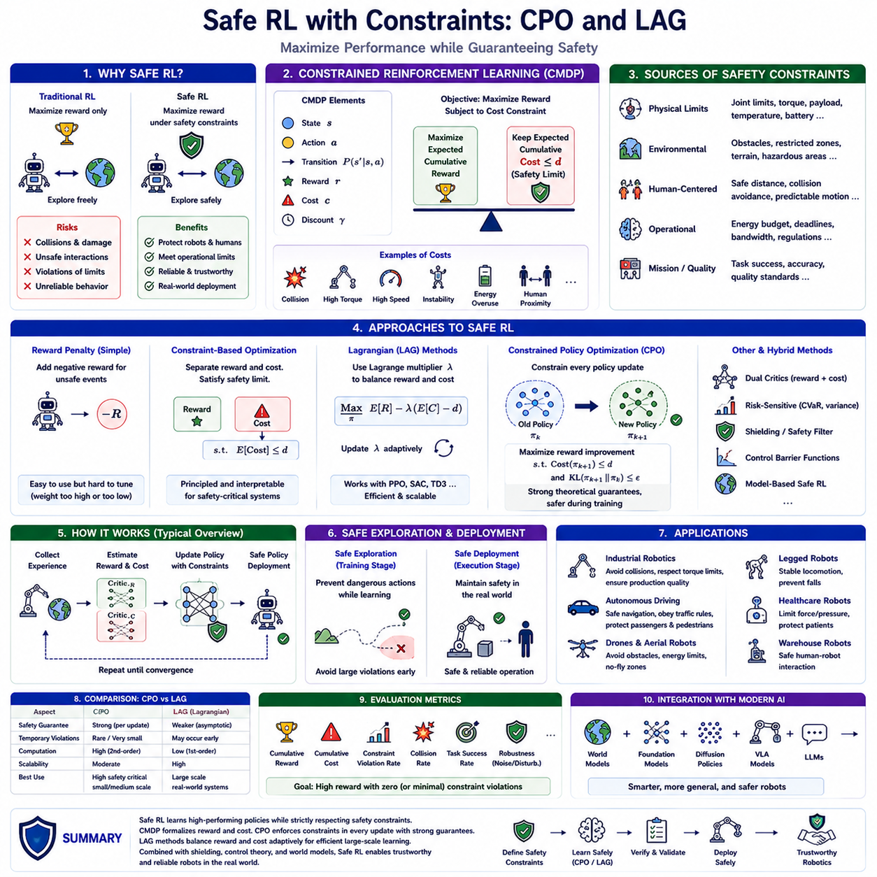
Safe Reinforcement Learning (Safe RL) is a specialized branch of reinforcement learning that focuses on enabling intelligent agents to maximize long-term performance while simultaneously satisfying predefined safety requirements throughout both training and deployment. Traditional reinforcement learning algorithms primarily optimize cumulative reward without explicitly considering the risks associated with exploration. Although this objective often produces highly capable policies, unrestricted optimization may lead agents to perform dangerous actions that damage hardware, violate operational constraints, or endanger human operators. In many real-world robotic systems, maximizing reward alone is insufficient because safety is not merely a desirable property but an essential operational requirement. Safe Reinforcement Learning addresses this limitation by incorporating explicit safety constraints into the optimization process, allowing autonomous systems to learn effective behaviors without compromising reliability or security.
The importance of Safe RL has increased dramatically as reinforcement learning moves from simulated environments into physical robotic platforms. In simulation, failed exploration simply results in restarting another episode. In contrast, physical robots operate in environments where collisions, excessive actuator torques, unstable locomotion, high-speed impacts, or unsafe human interactions may produce irreversible consequences. Industrial manipulators can damage expensive equipment, autonomous vehicles may create hazardous traffic situations, drones risk crashing into surrounding structures, and medical robots must avoid unsafe interactions with patients. Consequently, learning algorithms must optimize performance while guaranteeing that critical safety conditions remain satisfied throughout operation.
One of the central concepts in Safe RL is the distinction between reward optimization and constraint satisfaction. Conventional reinforcement learning seeks to maximize expected cumulative reward by discovering policies that achieve task objectives as efficiently as possible. Safe RL extends this optimization problem by introducing additional constraint functions representing safety requirements. Instead of searching solely for the highest reward, the learning algorithm must identify policies that simultaneously maximize reward and ensure that cumulative safety costs remain below predefined thresholds. This dual optimization objective transforms reinforcement learning into a constrained decision-making problem.
Constrained Markov Decision Processes (CMDPs) provide the mathematical foundation for Safe RL. While ordinary Markov Decision Processes define states, actions, transition probabilities, rewards, and discount factors, CMDPs introduce one or more additional cost functions representing undesirable events. These cost signals may correspond to collisions, excessive energy consumption, unsafe velocities, unstable body orientations, excessive contact forces, actuator overload, proximity to humans, or regulatory violations. During optimization, the policy seeks to maximize expected reward while ensuring that expected cumulative costs remain below specified constraint limits. CMDPs therefore provide a principled mathematical framework for balancing performance against safety.
Safety constraints can originate from many different sources depending on the application domain. Physical constraints arise from robot hardware limitations such as joint angle limits, actuator torque capacities, battery temperature, mechanical stress, or maximum payload. Environmental constraints include obstacle avoidance, restricted operating zones, hazardous materials, uneven terrain, and dynamic obstacles. Human-centered constraints ensure safe interaction distances, collision avoidance, comfortable motion, and predictable behavior during human-robot collaboration. Operational constraints may include energy budgets, mission deadlines, communication bandwidth, regulatory compliance, or quality assurance requirements. Together, these constraints define the safe operating envelope within which reinforcement learning policies must remain.
Safety considerations can be categorized into two complementary objectives: safe exploration and safe deployment. Safe exploration focuses on preventing dangerous behaviors during training, when policies remain immature and exploration dominates behavior selection. Safe deployment emphasizes maintaining safety after learning has completed, ensuring that optimized policies continue satisfying constraints under realistic operating conditions. Some algorithms prioritize safe exploration by restricting risky actions throughout training, while others primarily enforce safety during policy execution. Ideally, practical robotic systems require both forms of protection simultaneously.
One of the earliest approaches to Safe RL involves reward penalties. Instead of introducing explicit constraints, undesirable behaviors receive negative rewards proportional to their severity. Collisions, excessive energy consumption, unstable locomotion, or unsafe proximity to obstacles increase cumulative penalties, encouraging the policy to avoid such events. Although reward penalties remain simple to implement, they often require extensive manual tuning because balancing task rewards against safety penalties can be difficult. Excessive penalties may discourage productive exploration, while insufficient penalties allow unsafe behaviors to persist.
Constraint-based optimization offers a more principled alternative by treating safety as an explicit optimization requirement rather than merely another reward component. Instead of combining safety and performance into a single scalar objective, constrained optimization maintains separate reward and cost functions. The optimization algorithm then searches for policies satisfying predefined safety thresholds while maximizing reward within the feasible solution space. This formulation preserves a clear distinction between performance objectives and mandatory safety requirements, making it particularly appropriate for industrial and safety-critical robotics.
Lagrangian optimization provides one of the most widely adopted methods for solving constrained reinforcement learning problems. The constrained optimization objective is transformed into an unconstrained optimization problem by introducing Lagrange multipliers that dynamically balance reward maximization against constraint satisfaction. During training, these multipliers automatically increase when safety violations become excessive and decrease when constraints remain comfortably satisfied. Consequently, the learning algorithm continuously adjusts the relative importance of safety according to observed policy behavior without requiring manually tuned penalty coefficients.
Lagrangian methods have become highly popular because they integrate naturally with existing policy optimization algorithms such as PPO, TRPO, and SAC. The policy network continues maximizing expected reward, while an adaptive multiplier penalizes violations of cumulative cost constraints. This framework allows reinforcement learning algorithms originally designed for unconstrained optimization to operate effectively within constrained environments using relatively minor architectural modifications.
Lagrangian-based Safe RL nevertheless possesses important limitations. Because optimization occurs iteratively, temporary safety violations frequently occur before the multiplier converges toward appropriate values. During early training, the policy may significantly exceed allowable safety limits while gradually learning appropriate tradeoffs. For highly safety-critical robotic systems, even temporary violations may prove unacceptable. Consequently, more rigorous constrained optimization algorithms have been developed to provide stronger theoretical safety guarantees.
Constrained Policy Optimization (CPO) represents one of the most influential algorithms specifically designed to address this challenge. CPO extends Trust Region Policy Optimization by explicitly enforcing safety constraints during every policy update rather than relying solely on adaptive penalties. Instead of permitting temporary violations while optimization converges, CPO computes policy updates guaranteed to satisfy local approximations of the specified safety constraints. This trust-region formulation significantly reduces unsafe policy changes while maintaining monotonic policy improvement.
The fundamental principle behind CPO is that policy updates should remain sufficiently small to preserve both performance and safety. During each optimization iteration, the algorithm estimates how policy modifications influence both expected reward and expected cumulative cost. A constrained optimization problem is then solved to identify the largest policy improvement that simultaneously satisfies trust-region restrictions and safety constraints. By restricting optimization to locally reliable updates, CPO substantially improves safety throughout learning.
Trust-region optimization plays a crucial role within CPO. Large policy updates may dramatically alter robot behavior, producing unexpected safety violations. CPO therefore limits the divergence between consecutive policies using measures such as Kullback-Leibler divergence. These trust-region constraints ensure gradual policy evolution while preserving stability. The resulting optimization process exhibits considerably stronger theoretical safety guarantees than unconstrained policy gradient methods.
Although CPO provides impressive theoretical properties, solving constrained optimization problems during every policy update introduces significant computational complexity. The algorithm requires second-order optimization techniques and matrix inversions that increase training cost compared with simpler policy gradient methods. Consequently, subsequent research has explored more computationally efficient alternatives capable of maintaining similar safety performance.
Lagrangian-based algorithms, often abbreviated as LAG methods, represent one such practical alternative. Rather than solving constrained optimization problems exactly, these methods utilize adaptive Lagrange multipliers together with first-order optimization. The policy network optimizes a combined reward-cost objective while the multiplier adjusts automatically according to observed constraint violations. This approach significantly reduces computational overhead while retaining much of the flexibility associated with constrained optimization.
LAG methods have become particularly attractive for large-scale deep reinforcement learning because they integrate seamlessly with stochastic gradient optimization. Modern implementations frequently combine Lagrangian optimization with PPO, SAC, TD3, or other policy optimization algorithms, allowing Safe RL techniques to scale effectively toward high-dimensional robotic control problems. Although formal safety guarantees may be weaker than those provided by CPO, computational efficiency often improves substantially.
Safe RL frequently incorporates safety critics in addition to conventional value critics. While the standard critic estimates expected cumulative reward, the safety critic predicts expected cumulative constraint violations associated with each state or action. The policy simultaneously consults both critics before selecting actions, allowing decision making to consider performance and safety together. Dual-critic architectures provide richer learning signals while improving policy stability under constrained optimization.
Risk-sensitive reinforcement learning represents another closely related research direction. Rather than constraining expected cumulative costs directly, risk-sensitive methods optimize statistical measures of uncertainty such as variance, worst-case outcomes, Conditional Value-at-Risk (CVaR), or probability of catastrophic failure. These formulations become particularly important when rare but severe failures dominate system safety despite relatively low expected costs. Industrial robots, autonomous aircraft, medical devices, and space exploration systems often benefit from explicitly considering low-probability catastrophic events.
Shielding provides an additional safety mechanism complementary to constrained optimization. A safety monitor observes actions proposed by the reinforcement learning policy before execution. If the proposed action violates predefined safety rules or predicted future constraints, the shield replaces it with a safe alternative generated through model predictive control, rule-based reasoning, or formal verification methods. Shielding therefore guarantees action-level safety even when reinforcement learning policies remain imperfect.
Control Barrier Functions have recently emerged as powerful tools for combining classical control theory with Safe RL. Barrier functions mathematically characterize safe regions within state space and generate corrective control actions whenever the policy approaches unsafe boundaries. Reinforcement learning continues optimizing task performance, while barrier functions intervene only when constraint violations become imminent. This hybrid architecture combines learning flexibility with formal safety guarantees derived from control theory.
Model-based Safe RL further improves safety by predicting future constraint violations before executing physical actions. Learned world models estimate future robot trajectories, contact events, energy consumption, or collision probabilities under candidate action sequences. Planning algorithms then select actions expected to satisfy both reward objectives and safety constraints. Anticipating hazards before execution significantly reduces dangerous exploration compared with purely reactive safety mechanisms.
Simulation plays an indispensable role in Safe RL development. Large-scale simulators such as NVIDIA Isaac Sim, Isaac Gym, MuJoCo, Genesis, Gazebo, and differentiable physics engines enable extensive evaluation of safety algorithms without exposing physical robots to unnecessary risk. Domain randomization introduces varying terrain, obstacles, sensor noise, actuator failures, communication delays, and environmental uncertainties to improve policy robustness. Once satisfactory safety performance has been demonstrated within simulation, carefully controlled Sim2Real transfer enables gradual deployment onto physical robotic platforms.
Industrial robotics provides numerous practical applications for Safe RL. Manipulators must avoid collisions with fixtures while respecting joint torque limits and maintaining production quality. Autonomous warehouse robots require safe navigation around workers and equipment while meeting delivery deadlines. Quadruped robots performing infrastructure inspection must avoid falls while traversing uneven terrain. Agricultural robots must protect crops while maximizing harvesting efficiency. Medical robots require strict compliance with force limitations and anatomical constraints. Across all these applications, optimizing productivity without explicit safety mechanisms would prove unacceptable.
Evaluation metrics for Safe RL extend beyond traditional cumulative reward measurements. Researchers additionally measure cumulative constraint violations, safety violation frequency, collision rates, recovery performance, energy consumption, task completion reliability, risk measures, robustness against disturbances, and worst-case behavior under adversarial conditions. These comprehensive evaluation criteria reflect the reality that successful robotic systems must remain both effective and consistently safe under diverse operating conditions.
Recent advances increasingly integrate Safe RL with foundation models, world models, diffusion policies, vision-language-action architectures, and large language models. Future robotic systems may interpret high-level safety instructions expressed in natural language, reason about regulatory constraints, predict long-term consequences through learned world models, and dynamically adapt safety policies according to changing environmental conditions. Instead of relying exclusively on manually engineered safety rules, intelligent agents may gradually learn increasingly sophisticated safety reasoning through multimodal experience and continual interaction.
Safe Reinforcement Learning represents a fundamental transition from reward-centric optimization toward responsible autonomous decision making. Rather than maximizing performance at any cost, modern reinforcement learning recognizes that intelligent behavior requires simultaneously achieving operational objectives while respecting physical, environmental, ethical, and human-centered constraints. Constrained Markov Decision Processes provide the mathematical framework for expressing these requirements, Constrained Policy Optimization offers theoretically grounded constrained optimization with explicit safety guarantees, and Lagrangian methods provide computationally efficient large-scale implementations suitable for deep reinforcement learning. As autonomous robots become increasingly integrated into factories, hospitals, transportation systems, homes, and public environments, Safe RL will become one of the essential technologies ensuring that intelligent machines remain not only capable but also trustworthy, reliable, and safe throughout lifelong operation.

05.09 RL Infrastructure Isaac Gym Stable Baselines3 [w/Code]
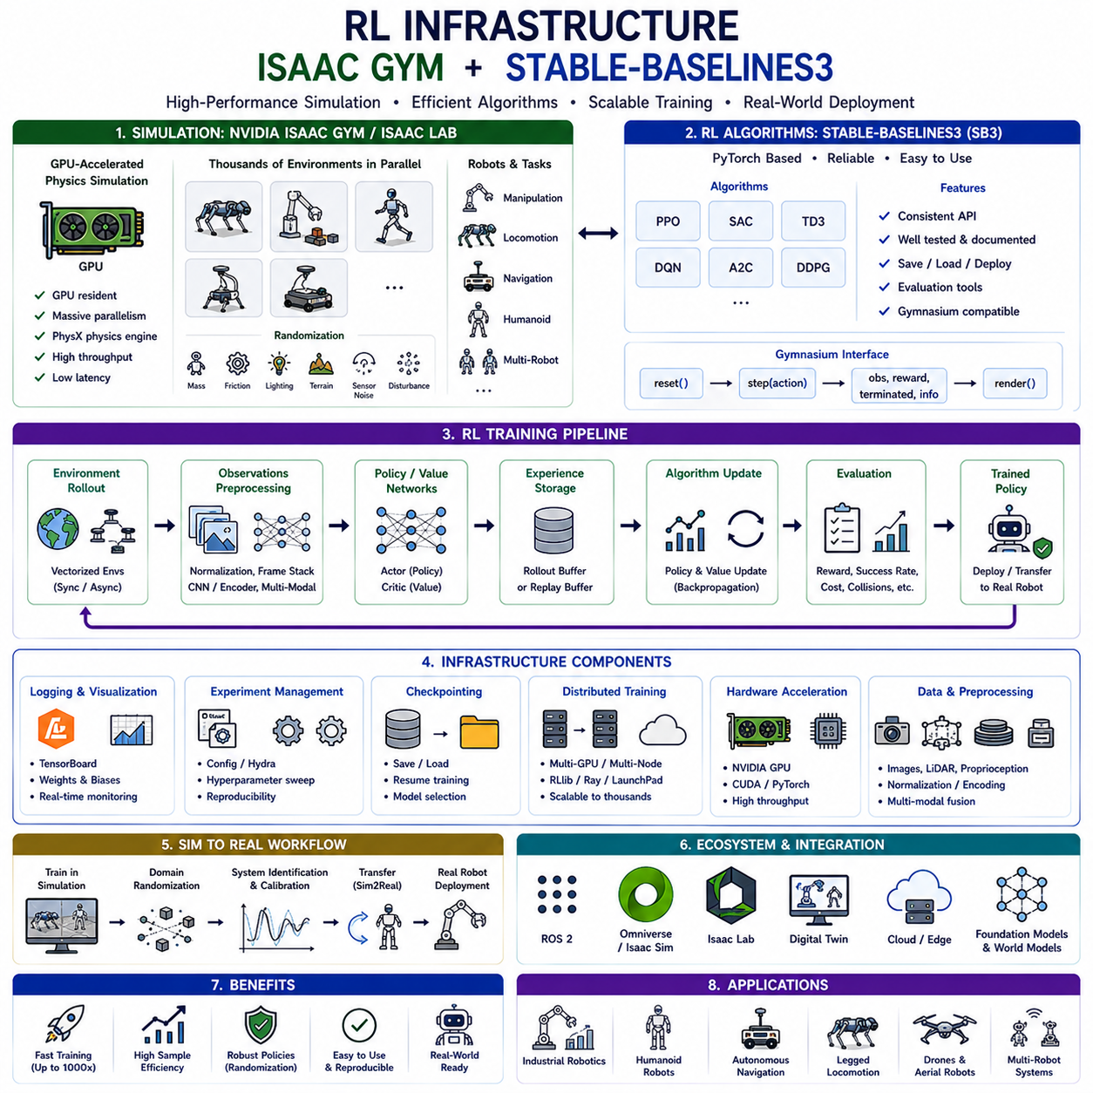
Reinforcement Learning (RL) infrastructure refers to the complete software and hardware ecosystem required to efficiently train, evaluate, optimize, and deploy reinforcement learning algorithms. While reinforcement learning theory focuses on policy optimization, value estimation, exploration strategies, and decision making, practical reinforcement learning depends heavily on the surrounding infrastructure that manages simulation, parallel data collection, neural network training, experiment management, logging, visualization, evaluation, and deployment. As reinforcement learning has evolved from small academic experiments to large-scale robotics and Physical AI applications, specialized infrastructures such as NVIDIA Isaac Gym, NVIDIA Isaac Lab, Stable-Baselines3, RLlib, CleanRL, and Gymnasium have become indispensable components of modern robotic AI development.
The need for specialized RL infrastructure originates from the enormous amount of interaction data required by reinforcement learning algorithms. Unlike supervised learning, where large labeled datasets already exist, reinforcement learning agents must generate their own experiences through repeated interactions with the environment. Modern policy optimization algorithms frequently require millions or even billions of simulation steps before converging toward satisfactory performance. Training such policies using conventional sequential simulation would require weeks or months of computation. Consequently, scalable RL infrastructure focuses primarily on accelerating data generation through massive parallel simulation while maintaining efficient GPU utilization throughout the training process.
An RL infrastructure typically consists of several tightly integrated components. The simulation environment models robot dynamics, sensors, object interactions, and environmental physics. The reinforcement learning algorithm updates policy and value networks according to collected experiences. Vectorized environment managers execute thousands of simulations simultaneously. Replay buffers or rollout storage organize interaction trajectories for efficient learning. Neural network frameworks perform optimization using GPU acceleration. Logging systems monitor training progress, while evaluation pipelines continuously assess policy quality. Experiment managers coordinate hyperparameter configuration, checkpoint storage, reproducibility, and distributed execution. Together, these components form the computational backbone supporting large-scale reinforcement learning research.
One of the most influential developments in modern RL infrastructure is NVIDIA Isaac Gym. Isaac Gym fundamentally changed robotic reinforcement learning by moving physics simulation directly onto GPUs rather than relying on traditional CPU-based simulators. Conventional simulators execute each environment sequentially or across a limited number of CPU threads, restricting data generation speed. Isaac Gym instead performs rigid-body dynamics, collision detection, contact resolution, sensor simulation, and reinforcement learning entirely on GPU hardware. Thousands of independent robot environments execute simultaneously, dramatically increasing sample generation while eliminating costly CPU-GPU communication bottlenecks.
GPU-resident simulation represents the defining innovation of Isaac Gym. Instead of transferring observations from CPU simulation to GPU neural networks after every simulation step, all computation remains within GPU memory throughout the learning pipeline. Robot states, actions, rewards, observations, physics calculations, and neural network optimization execute without repeated host-device memory transfers. This unified architecture significantly reduces latency while maximizing computational throughput. As a result, reinforcement learning algorithms that previously required days of training can often converge within hours.
Massive parallelization provides another major advantage of Isaac Gym. Instead of training one robot at a time, thousands of independent environments execute concurrently. Every environment begins with different initial conditions, object positions, terrain configurations, sensor noise realizations, and random disturbances. At every simulation step, observations from all environments are collected simultaneously and processed as large GPU tensors. Reinforcement learning algorithms therefore receive enormous batches of diverse experiences during each optimization cycle, substantially improving both convergence speed and policy robustness.
Physics fidelity remains critically important despite the emphasis on computational performance. Isaac Gym incorporates PhysX, NVIDIA's high-performance rigid-body physics engine, to accurately model contacts, friction, joint constraints, collisions, actuator dynamics, and articulated robot motion. Although optimized for large-scale reinforcement learning rather than perfect physical realism, the simulator achieves an effective balance between computational efficiency and simulation accuracy suitable for many robotic manipulation, locomotion, and navigation tasks.
Isaac Gym supports a wide variety of robotic platforms. Quadruped robots learn walking, running, jumping, and recovery behaviors across diverse terrains. Robotic manipulators perform reaching, grasping, stacking, insertion, tool use, and dexterous manipulation. Mobile robots optimize navigation, obstacle avoidance, and autonomous exploration. Humanoid robots learn whole-body locomotion, balancing, climbing, and coordinated manipulation. Multi-robot systems investigate cooperative behaviors involving communication, task allocation, and collaborative transportation. This broad applicability has established Isaac Gym as one of the leading infrastructures for robotic reinforcement learning.
Domain randomization plays a central role within Isaac Gym training workflows. Rather than exposing reinforcement learning agents to fixed simulation parameters, physical properties vary continuously throughout training. Mass distributions, friction coefficients, actuator delays, lighting conditions, textures, sensor noise, object dimensions, terrain geometry, and external disturbances are randomized across environments. This variability prevents policies from overfitting to specific simulated conditions while substantially improving Sim2Real transfer to physical robotic platforms.
Although Isaac Gym pioneered GPU-native reinforcement learning simulation, NVIDIA subsequently introduced Isaac Lab as its long-term successor. Isaac Lab extends Isaac Gym by integrating reinforcement learning directly with NVIDIA Omniverse and Isaac Sim. This architecture provides higher-fidelity rendering, richer sensor simulation, improved robotics workflows, scalable task generation, and stronger compatibility with industrial digital twins. Isaac Lab therefore represents the future direction of NVIDIA's reinforcement learning ecosystem while preserving many of Isaac Gym's high-performance design principles.
Parallel to advances in simulation infrastructure, standardized reinforcement learning software libraries have become equally important. Stable-Baselines3 (SB3) represents one of the most widely adopted open-source reinforcement learning frameworks. Built upon PyTorch, Stable-Baselines3 provides reliable implementations of many state-of-the-art reinforcement learning algorithms together with consistent interfaces, extensive documentation, reproducible benchmarks, and modular software architecture. Rather than implementing algorithms from scratch, researchers can focus on designing environments and experiments while relying on thoroughly tested reference implementations.
Stable-Baselines3 emphasizes software engineering quality as much as algorithmic performance. Every implemented algorithm follows consistent APIs for initialization, training, evaluation, saving, loading, and deployment. Hyperparameters are carefully documented, default configurations have been extensively validated, and continuous integration ensures implementation correctness across software updates. This emphasis on reliability has made Stable-Baselines3 one of the preferred frameworks for both academic research and industrial prototyping.
The algorithm collection within Stable-Baselines3 covers many of the most important modern reinforcement learning methods. PPO remains one of the most popular on-policy policy-gradient algorithms because of its simplicity and robustness. SAC provides highly sample-efficient off-policy learning through entropy regularization. TD3 improves deterministic policy gradients by reducing overestimation bias. DQN supports value-based learning for discrete action spaces. A2C offers efficient synchronous actor-critic optimization, while DDPG addresses continuous control using deterministic policies. These standardized implementations enable direct algorithm comparison under consistent experimental conditions.
Gymnasium, formerly OpenAI Gym, provides the standardized environment interface underlying much of the modern reinforcement learning ecosystem. Every environment exposes consistent reset, step, observation, action, reward, termination, and rendering functions regardless of task complexity. This standardized interface allows reinforcement learning algorithms to operate identically across robotics, games, navigation, locomotion, finance, healthcare, and numerous other application domains. Stable-Baselines3 relies extensively upon Gymnasium compatibility, making environment development significantly simpler.
Vectorized environments further improve training efficiency within Stable-Baselines3. Instead of executing a single environment sequentially, multiple environments operate simultaneously through synchronized or asynchronous execution. Although CPU-based vectorization generally provides lower throughput than GPU-native Isaac Gym simulation, vectorized environments nevertheless substantially accelerate reinforcement learning on conventional hardware. This capability remains particularly valuable for smaller research projects lacking access to large GPU clusters.
Observation preprocessing forms another essential component of RL infrastructure. Raw sensor data often contain high-dimensional images, depth maps, LiDAR measurements, proprioceptive signals, tactile information, force-torque measurements, or language instructions. Feature extraction pipelines normalize observations, stack temporal frames, encode images through convolutional neural networks, compress representations using autoencoders, or integrate multimodal sensor streams before reinforcement learning begins. Effective preprocessing significantly improves learning efficiency while reducing computational requirements.
Experiment management becomes increasingly important as reinforcement learning projects scale. Large robotic experiments frequently involve hundreds of training runs exploring different algorithms, hyperparameters, reward functions, curricula, robot morphologies, sensor configurations, and simulation settings. Tools such as TensorBoard, Weights & Biases, MLflow, Hydra, and experiment configuration managers organize these large experimental campaigns while ensuring reproducibility and systematic comparison across training conditions.
Logging and visualization provide continuous insight into reinforcement learning progress. Typical metrics include cumulative reward, episode length, success rate, policy entropy, value estimation error, constraint violations, energy consumption, collision frequency, learning rate schedules, and gradient statistics. Visualizing these quantities throughout training enables researchers to identify optimization instability, reward design problems, exploration failures, overfitting, and catastrophic forgetting before extensive computational resources are wasted.
Checkpoint management supports long-running reinforcement learning experiments. Policy parameters, optimizer states, replay buffers, normalization statistics, and experiment configurations are periodically saved throughout training. If hardware failures occur or experiments require interruption, learning can resume from previously stored checkpoints without restarting from scratch. Checkpointing also enables later evaluation of intermediate policies, model selection, transfer learning, and deployment onto physical robotic systems.
Distributed reinforcement learning extends RL infrastructure beyond individual workstations. Multiple GPUs, multi-node clusters, and cloud computing platforms coordinate experience generation, neural network optimization, hyperparameter search, and evaluation simultaneously. Frameworks such as RLlib, Ray, LaunchPad, and distributed PyTorch enable scalable reinforcement learning across hundreds or even thousands of parallel workers. Such distributed infrastructure has become essential for training increasingly complex robotic foundation models and large-scale embodied AI systems.
Simulation-to-Real transfer represents one of the most important objectives supported by RL infrastructure. Policies initially learn within simulation where data generation remains inexpensive and safe. Domain randomization, system identification, sensor calibration, actuator modeling, latency compensation, and robustness optimization gradually reduce discrepancies between simulated and physical environments. Once simulation performance reaches acceptable levels, trained policies transfer onto physical robots where only limited fine-tuning becomes necessary. Modern RL infrastructure therefore integrates simulation, optimization, validation, and deployment into one continuous workflow.
Infrastructure for robotic reinforcement learning increasingly incorporates world models, imitation learning, foundation models, diffusion policies, vision-language-action models, and large language models. Rather than training reinforcement learning policies in isolation, modern systems combine supervised pretraining, representation learning, self-supervised learning, offline datasets, online fine-tuning, and multimodal reasoning within unified software ecosystems. Isaac Lab, Stable-Baselines3 extensions, and emerging embodied AI frameworks increasingly support these hybrid learning paradigms.
For Physical AI applications, reinforcement learning infrastructure must additionally support multimodal sensing, real-time control, safety monitoring, digital twins, cloud-edge coordination, and hardware abstraction. Training environments increasingly integrate RGB cameras, depth sensors, LiDAR, tactile arrays, force sensors, inertial measurement units, and language interfaces into unified observation spaces. Policies learned within simulation subsequently execute on heterogeneous robotic hardware through standardized middleware such as ROS 2, allowing seamless transition from research prototypes to industrial deployment.
The future of RL infrastructure is moving toward fully integrated autonomous learning platforms capable of managing the complete robotic development lifecycle. Large-scale simulation, GPU-native physics, standardized reinforcement learning libraries, foundation models, world models, distributed optimization, automated experiment management, and digital twin technology are gradually converging into unified ecosystems. Within this vision, NVIDIA Isaac Gym established the paradigm of massively parallel GPU simulation, while Stable-Baselines3 provided robust standardized algorithm implementations that democratized reinforcement learning research. Together, these infrastructures have transformed reinforcement learning from an algorithmic research topic into a scalable engineering discipline capable of supporting the development of next-generation autonomous robots, embodied intelligence, and Physical AI systems operating safely and efficiently in the real world.

05.10 RL Policy Deployment and Sim2Real Transfer [w/Code]
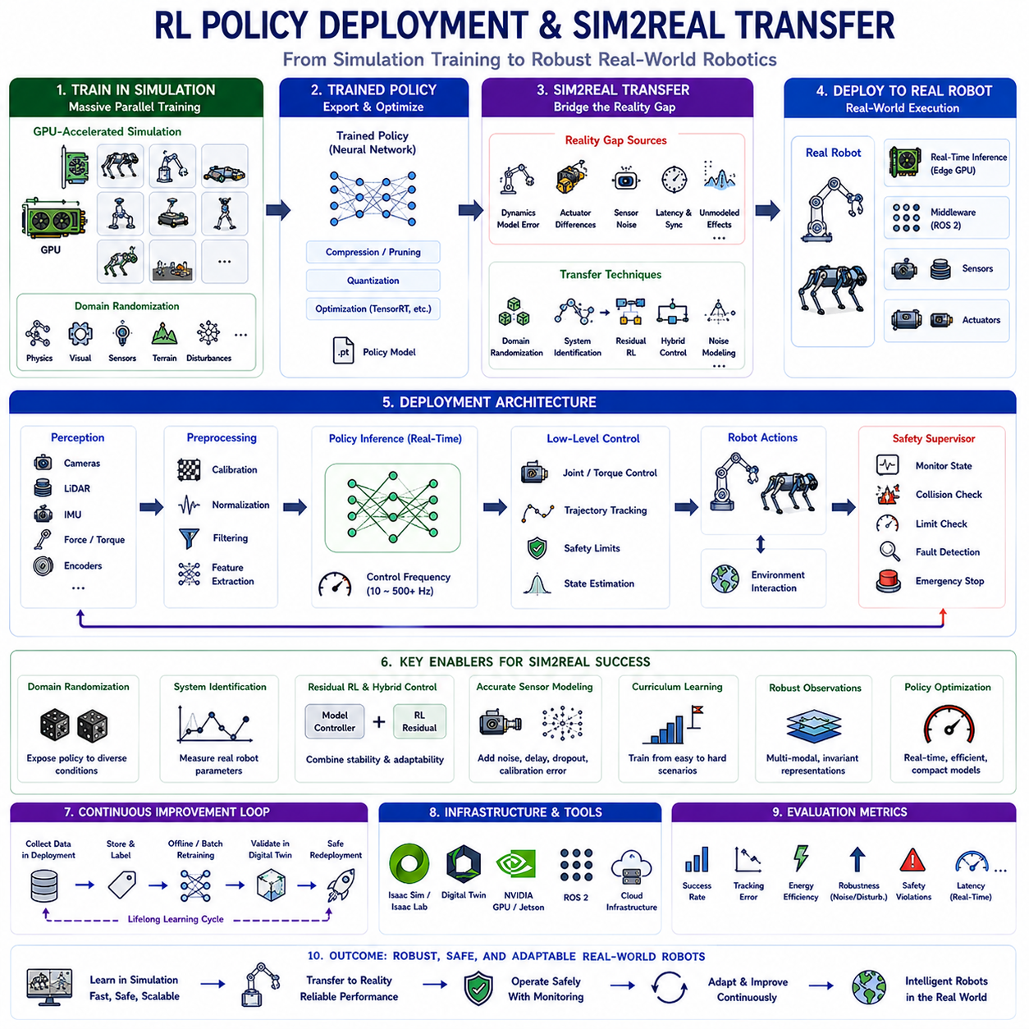
Reinforcement Learning (RL) policy deployment represents the final stage of the reinforcement learning pipeline, where a policy trained in simulation or offline environments is transferred to a real robotic system for practical operation. While developing a high-performing policy in simulation is an important milestone, the ultimate objective of reinforcement learning is to enable autonomous robots to operate safely, efficiently, and robustly in the physical world. Policy deployment therefore extends beyond simply exporting a neural network model. It includes system integration, real-time inference, hardware compatibility, sensor synchronization, latency optimization, safety monitoring, fault recovery, online adaptation, and long-term maintenance. Successful deployment transforms reinforcement learning from a research methodology into an engineering discipline capable of supporting reliable autonomous systems.
One of the greatest challenges in reinforcement learning deployment is the Sim2Real transfer problem. Sim2Real, or Simulation-to-Reality Transfer, refers to the process of transferring policies learned in simulation into real-world robotic platforms while maintaining similar performance. Reinforcement learning algorithms often require millions or billions of interactions before converging, making large-scale training directly on physical robots impractical. Simulation provides an inexpensive, safe, and highly parallel environment for collecting experience, but differences between simulated and physical environments frequently degrade policy performance after deployment. Closing this simulation-to-reality gap has therefore become one of the central research topics in modern robotics and Physical AI.
The Sim2Real gap originates from unavoidable discrepancies between simulation and reality. No simulator perfectly models every aspect of the physical world. Robot dynamics, actuator friction, structural flexibility, sensor noise, camera exposure, lighting variation, contact mechanics, communication latency, and environmental disturbances all differ to some extent from their simulated counterparts. Even small inaccuracies may accumulate over long control sequences, causing policies optimized in simulation to fail unexpectedly in real environments. Understanding and minimizing these discrepancies is essential for reliable deployment.
Physics modeling errors constitute one major source of the Sim2Real gap. Simulators typically approximate rigid-body dynamics, friction coefficients, collision response, contact deformation, actuator dynamics, and joint compliance. Real robots, however, exhibit nonlinear behaviors including backlash, gearbox elasticity, cable tension, thermal effects, vibration, wear, and manufacturing tolerances. These phenomena are difficult to model accurately yet significantly influence control performance. Policies overfitted to idealized simulation dynamics often perform poorly when confronted with these real-world imperfections.
Perception discrepancies introduce another important challenge. Cameras in simulation generate perfectly synchronized images with ideal exposure and precisely calibrated geometry. Real cameras suffer from lens distortion, rolling shutter effects, motion blur, varying illumination, shadows, reflections, sensor noise, compression artifacts, and calibration drift. LiDAR sensors experience multipath reflections, occlusions, weather interference, and measurement uncertainty. Depth cameras produce missing pixels and noisy depth estimates. Reinforcement learning policies relying heavily on visual observations must therefore tolerate substantial perceptual variation between simulated and physical environments.
Actuator behavior further complicates policy transfer. Simulated motors often respond instantaneously to control commands with perfectly modeled torque production. Physical actuators exhibit communication delays, bandwidth limitations, saturation, hysteresis, voltage fluctuations, thermal constraints, nonlinear friction, and manufacturing variability. Battery voltage decreases during prolonged operation, changing available torque output. Hydraulic and pneumatic systems introduce additional response delays. Reinforcement learning policies trained under ideal actuator assumptions may become unstable unless these effects are considered during training.
Communication latency also contributes significantly to deployment challenges. Simulation frequently assumes deterministic timing with precisely synchronized observations and actions. Physical robotic systems involve operating system scheduling delays, middleware communication overhead, network latency, sensor synchronization errors, and asynchronous processing pipelines. Even delays of only several milliseconds may substantially influence high-frequency control policies, particularly for agile locomotion, aerial robotics, or high-speed manipulation tasks.
Domain randomization has emerged as one of the most successful techniques for improving Sim2Real transfer. Rather than training policies under fixed simulation parameters, environmental properties are randomized continuously throughout learning. Robot masses, friction coefficients, actuator gains, lighting conditions, object textures, camera positions, sensor noise, terrain geometry, and external disturbances vary across simulation episodes. Instead of memorizing one precise simulation, the policy learns robust behaviors capable of adapting to a broad distribution of environmental conditions. The real world effectively becomes another randomized environment lying within the learned distribution.
Physics randomization forms an important subset of domain randomization. During training, physical parameters such as joint damping, contact friction, object mass, actuator delays, motor strength, spring stiffness, payload, inertia tensors, and collision restitution are varied randomly. These variations prevent the reinforcement learning policy from exploiting precise simulator characteristics while encouraging control strategies robust against modeling uncertainty. Policies trained under diverse dynamics typically transfer significantly better to real robotic platforms.
Visual domain randomization addresses perception differences. Camera viewpoints, illumination, textures, colors, backgrounds, object appearance, weather conditions, shadows, reflections, and image noise are randomized extensively throughout training. Image augmentations such as Gaussian noise, blur, brightness variation, color jitter, occlusions, and compression artifacts further increase robustness. Vision-based policies consequently rely less upon fragile pixel-level features and instead learn higher-level geometric and semantic representations that generalize more effectively to physical environments.
Sensor noise modeling further reduces deployment discrepancies. In simulation, artificial measurement uncertainty is introduced into RGB cameras, depth sensors, LiDAR, IMUs, force-torque sensors, joint encoders, GPS receivers, and tactile arrays. Timing jitter, packet loss, missing measurements, calibration offsets, and synchronization errors may also be simulated. Policies therefore become accustomed to imperfect sensing before deployment, improving resilience against real-world sensor limitations.
System identification complements domain randomization by improving simulator accuracy rather than increasing policy robustness alone. Instead of assuming approximate physical parameters, engineers measure actual robot characteristics including mass distributions, inertia tensors, friction coefficients, actuator dynamics, compliance, battery behavior, and sensor calibration. These measured quantities are then incorporated into simulation, reducing discrepancies between virtual and physical systems. Accurate system identification often combines experimental measurements with optimization algorithms minimizing differences between simulated and observed trajectories.
Residual reinforcement learning provides another effective Sim2Real strategy. Classical controllers such as PID control, model predictive control, inverse dynamics, or trajectory tracking generate stable baseline behavior. Reinforcement learning then learns only residual corrections compensating for unmodeled dynamics, disturbances, and task-specific optimization. Because reinforcement learning modifies rather than replaces established controllers, deployment becomes substantially safer while preserving interpretability and stability.
Hybrid control architectures increasingly dominate practical reinforcement learning deployment. Low-level controllers maintain robot stability, joint regulation, actuator protection, and safety supervision at high frequencies. Reinforcement learning policies operate at higher abstraction levels, selecting desired trajectories, motion commands, manipulation strategies, or navigation goals. This hierarchical decomposition combines the reliability of conventional control theory with the adaptability and optimization capabilities of reinforcement learning.
Policy compression and optimization become important during deployment because many reinforcement learning policies are trained using large neural networks unsuitable for resource-constrained robotic hardware. Knowledge distillation, network pruning, quantization, operator fusion, and TensorRT optimization reduce computational complexity while preserving policy performance. Compact policies execute efficiently on embedded platforms such as NVIDIA Jetson Orin, Jetson Thor, edge GPUs, or industrial embedded computers while maintaining real-time control frequencies.
Real-time inference represents another critical deployment requirement. Reinforcement learning policies controlling dynamic robotic systems often require inference frequencies ranging from tens to hundreds of Hertz. Perception processing, neural network inference, safety verification, trajectory generation, and actuator communication must all complete within strict timing constraints. GPU acceleration, asynchronous processing pipelines, multithreading, and hardware-specific optimizations ensure deterministic low-latency execution compatible with real-time robotic control.
Safety monitoring remains indispensable throughout deployment. Even highly successful simulation-trained policies may occasionally encounter previously unseen situations causing unpredictable behavior. Safety supervisors continuously monitor robot state, actuator commands, battery condition, communication health, obstacle proximity, and system integrity. If abnormal conditions arise, emergency braking, fallback controllers, safe shutdown procedures, or teleoperation modes immediately override reinforcement learning decisions. These supervisory mechanisms significantly reduce deployment risk.
Online adaptation provides additional robustness after deployment. Rather than remaining fixed indefinitely, reinforcement learning policies may continue adapting gradually using carefully controlled online learning, incremental fine-tuning, or parameter adjustment based on newly collected experience. However, unrestricted online reinforcement learning remains risky for safety-critical systems. Consequently, practical deployment often combines offline retraining, periodic validation, and carefully supervised incremental updates rather than unrestricted autonomous exploration.
Offline data collected during deployment becomes increasingly valuable over time. Every operational episode generates trajectories containing observations, actions, rewards, failures, and environmental variations. These datasets support offline reinforcement learning, behavior cloning, supervised representation learning, and continual improvement without exposing robots to unnecessary online exploration. Continuous accumulation of deployment data therefore creates a virtuous cycle in which future policy versions become progressively more robust and capable.
Digital twin technology has become closely associated with Sim2Real deployment workflows. Digital twins maintain continuously synchronized virtual replicas of physical robotic systems using real operational sensor data. Engineers evaluate reinforcement learning policy updates within digital twins before transferring them onto actual robots. This intermediate validation stage substantially reduces deployment risk while supporting predictive maintenance, anomaly detection, performance evaluation, and scenario testing under diverse operating conditions.
Cloud-edge collaboration increasingly supports reinforcement learning deployment at scale. Large foundation models, world models, fleet learning, and extensive retraining execute within cloud computing infrastructure. Individual robots perform low-latency policy inference locally using embedded edge hardware. Operational experiences collected across entire robot fleets synchronize periodically with centralized training servers, allowing continuously improving policies to be redistributed following extensive validation. This architecture enables scalable lifelong learning while preserving real-time responsiveness.
Simulation platforms play an essential role throughout deployment. NVIDIA Isaac Sim, Isaac Lab, MuJoCo, Genesis, Gazebo, and Omniverse provide increasingly realistic sensor simulation, physics modeling, synthetic data generation, and digital twin integration. These environments support progressive validation across increasingly realistic scenarios before deployment onto physical robots. Hardware-in-the-loop simulation further enables direct integration between simulated environments and actual robot controllers during testing.
Evaluation metrics for Sim2Real transfer extend beyond cumulative reward. Researchers measure task success rates, trajectory accuracy, energy efficiency, robustness against disturbances, policy stability, recovery behavior, safety constraint violations, computational latency, hardware utilization, deployment reliability, and long-term operational consistency. Successful Sim2Real transfer requires balancing all these performance indicators rather than maximizing reward alone.
Modern reinforcement learning deployment increasingly integrates with foundation models, world models, vision-language-action architectures, diffusion policies, and large language models. Reinforcement learning policies no longer operate as isolated neural networks but instead become components within broader embodied intelligence systems capable of multimodal reasoning, semantic planning, language understanding, and adaptive physical interaction. High-level reasoning modules generate task objectives, while reinforcement learning provides low-level control optimized for efficient physical execution.
Future Sim2Real systems are expected to become increasingly autonomous through continual adaptation, self-calibration, automatic system identification, online uncertainty estimation, and self-improving world models. Instead of manually tuning simulation parameters and deployment pipelines, robotic systems will progressively refine their own digital twins using operational experience while continuously reducing simulation-reality discrepancies. Foundation models pretrained across diverse robotic platforms will further reduce task-specific data requirements, enabling rapid deployment of reinforcement learning policies across entirely new robotic morphologies and environments.
Reinforcement learning policy deployment and Sim2Real transfer represent the essential bridge connecting theoretical reinforcement learning research with practical autonomous robotics. Successful deployment requires far more than exporting trained neural network parameters; it demands careful integration of simulation fidelity, domain randomization, system identification, real-time optimization, safety supervision, digital twins, hardware acceleration, and continual learning. NVIDIA Isaac Lab, Isaac Sim, GPU-accelerated simulation, and modern reinforcement learning infrastructures provide increasingly sophisticated tools supporting this transition. As Physical AI systems continue evolving toward lifelong autonomous learning, robust Sim2Real transfer will remain one of the foundational technologies enabling intelligent robots to operate reliably, safely, and efficiently within the complexity and uncertainty of the real physical world.

