Volume 19 Robot Machine Learning and AI

11. AI Safety and Robustness

11.01 AI Safety in Robotics Failure Modes and Risks
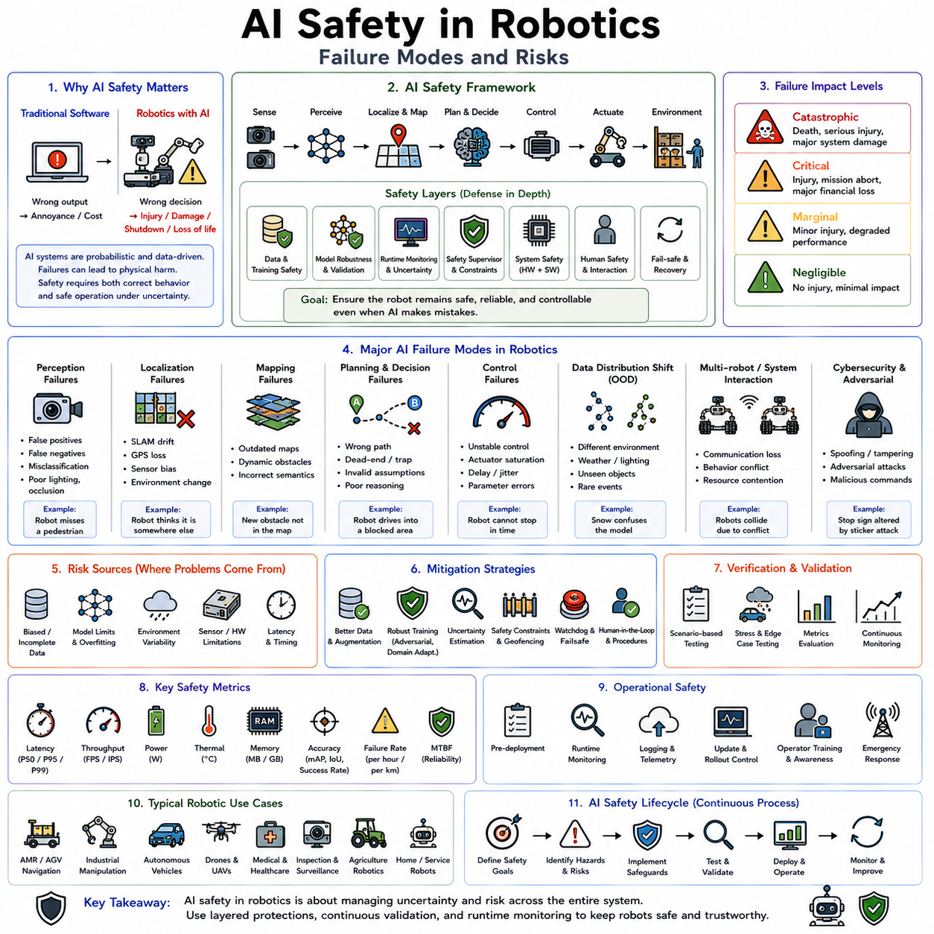
Artificial intelligence safety in robotics is the discipline concerned with ensuring that intelligent robotic systems operate reliably, predictably, and without causing unacceptable harm to humans, property, infrastructure, the environment, or themselves. Unlike conventional software safety, which primarily focuses on deterministic algorithms executing predefined logic, AI safety must address learning systems whose behavior emerges from statistical models trained on large datasets. Neural networks, reinforcement learning policies, vision-language models, foundation models, and autonomous planning systems often produce behaviors that are highly capable yet inherently probabilistic. As robots increasingly leave controlled industrial environments and enter warehouses, hospitals, homes, roads, construction sites, farms, and public spaces, ensuring AI safety becomes one of the central engineering challenges in modern robotics.
The importance of AI safety stems from the unique characteristics of physical robots. A software error in an online recommendation system may produce an incorrect suggestion or reduce user satisfaction. An identical level of error in a robotic system can result in collisions, injuries, damaged equipment, production shutdowns, environmental hazards, or even loss of life. The consequences of incorrect AI decisions are amplified because robots directly influence the physical world through motors, manipulators, mobile platforms, and autonomous actuators. Every perception error, planning mistake, or control failure has the potential to become a physical safety incident.
Traditional robotic safety relied heavily on deterministic control algorithms, carefully validated state machines, fixed safety zones, emergency stop circuits, and certified industrial controllers. These systems behaved predictably because every possible control path was explicitly designed by engineers. Artificial intelligence fundamentally changes this paradigm. Deep neural networks learn decision boundaries from data rather than explicit programming. Their internal reasoning often cannot be completely explained, and their responses may vary significantly when presented with unfamiliar inputs. Consequently, AI safety extends beyond conventional functional safety and requires new approaches to verification, validation, monitoring, uncertainty estimation, and runtime supervision.
One of the foundational concepts in AI safety is the distinction between functional safety and intelligent behavior. Functional safety concerns whether hardware and software operate correctly according to their specifications. Intelligent behavior concerns whether the decisions themselves are appropriate under changing environmental conditions. A perception network may function exactly as designed while still making an incorrect prediction because an object falls outside its training distribution. From the software perspective the system is operating correctly, but from the operational perspective the robot may behave unsafely. AI safety therefore addresses both implementation correctness and decision correctness.
Failure modes describe the various ways intelligent robotic systems may fail during operation. Unlike conventional hardware failures, AI failures often occur gradually, probabilistically, or under rare environmental conditions rather than through obvious component breakdowns. Understanding these failure modes forms the basis for designing robust autonomous systems.
Perception failures represent one of the most common categories of AI risk. Robots rely heavily on cameras, LiDAR, radar, ultrasonic sensors, depth cameras, IMUs, GPS receivers, tactile sensors, microphones, and force sensors to understand their surroundings. AI models interpret these sensor signals to identify objects, estimate distances, classify environments, detect humans, recognize obstacles, and understand semantic context. If perception fails, all downstream planning and control decisions become compromised.
False positive detections occur when the AI system incorrectly identifies an object that does not exist. A warehouse robot may mistakenly detect an obstacle where none exists, unnecessarily stopping production or taking inefficient routes. Although false positives primarily reduce efficiency, excessive false alarms eventually reduce operator trust and may encourage dangerous workarounds.
False negatives generally pose greater safety risks. Here the AI fails to detect an object that actually exists. An autonomous forklift overlooking a pedestrian, a delivery robot failing to recognize a staircase, or a collaborative manipulator missing a human hand can produce severe accidents because the robot continues operating under the false assumption that the environment is safe.
Classification errors constitute another perception failure mode. The robot detects an object correctly but assigns the wrong semantic category. A medical robot may misidentify surgical instruments, an agricultural robot may confuse crops with weeds, or an autonomous vehicle may classify construction equipment as ordinary roadside objects. Incorrect semantic understanding often propagates into unsafe planning decisions.
Localization failures also present significant operational risks. Autonomous robots continuously estimate their position relative to maps, landmarks, or global coordinates. Errors may originate from degraded GPS signals, accumulated SLAM drift, sensor calibration inaccuracies, dynamic environmental changes, or feature-poor surroundings. Localization errors may cause robots to navigate into hazardous areas, collide with infrastructure, or fail to complete assigned tasks safely.
Mapping failures similarly influence navigation reliability. Static maps gradually become outdated as environments change. Construction sites evolve daily, warehouses reorganize inventory, hospitals relocate equipment, and outdoor environments experience seasonal variation. AI systems relying on obsolete environmental representations may generate unsafe navigation plans despite apparently accurate localization.
Prediction failures arise when AI systems incorrectly estimate future environmental states. Autonomous robots increasingly predict pedestrian movement, vehicle trajectories, obstacle behavior, and human intentions. Prediction errors may cause inappropriate collision avoidance, unsafe overtaking maneuvers, or incorrect coordination with nearby agents.
Planning failures occur when decision-making algorithms generate unsafe or suboptimal action sequences despite receiving accurate environmental information. Reinforcement learning policies may exploit unintended strategies, optimization algorithms may converge toward unsafe local optima, or language-based planners may misunderstand task objectives. Planning failures often emerge from complex interactions among multiple decision-making components rather than isolated perception errors.
Control failures involve incorrect execution of planned actions. Motion controllers, trajectory generators, manipulation policies, balance controllers, and whole-body coordination systems translate AI decisions into physical actuator commands. Numerical instability, actuator saturation, communication delays, mechanical limitations, or inaccurate dynamic models may prevent safe execution even when planning remains correct.
Sensor failures represent another major source of AI risk. Cameras may become obscured by dust, rain, fog, snow, or direct sunlight. LiDAR performance deteriorates under heavy precipitation. GPS signals become unreliable near tall buildings or indoors. IMUs accumulate drift over time. AI systems must recognize degraded sensor quality rather than blindly trusting corrupted measurements.
Sensor fusion provides one approach for mitigating individual sensor failures. Multiple sensing modalities complement one another because their failure characteristics differ. Cameras provide rich semantic information but suffer under poor illumination. LiDAR measures geometry accurately but struggles with certain reflective surfaces. Radar penetrates adverse weather yet offers lower spatial resolution. Combining these sensors increases overall robustness while reducing dependence upon any single sensing modality.
Environmental uncertainty further complicates AI safety. Training datasets inevitably capture only a limited subset of real-world conditions. Robots deployed into previously unseen environments may encounter unusual lighting, unfamiliar objects, adverse weather, unexpected human behavior, damaged infrastructure, sensor contamination, or rare combinations of environmental factors. AI models frequently exhibit degraded performance when operating outside their training distribution.
Out-of-distribution inputs represent one of the most extensively studied AI safety challenges. Neural networks generally assume future inputs resemble training data. When presented with unfamiliar situations, prediction confidence may remain artificially high despite increasing error probability. Detecting these out-of-distribution conditions has therefore become a major research area within safe robotics.
Distribution shift occurs gradually over time as operational environments evolve. Manufacturing processes change, new products appear, warehouse layouts evolve, roads undergo maintenance, vegetation grows, lighting conditions vary seasonally, and sensor hardware ages. Continuous monitoring and periodic retraining help maintain model reliability under these changing conditions.
Dataset bias introduces another important source of safety risk. Training data often underrepresent rare events, unusual environments, minority object categories, or extreme operating conditions. Consequently, AI systems may perform exceptionally well under common circumstances while failing during precisely those rare situations requiring maximum reliability. Safety-critical robotics therefore demands intentionally diverse datasets covering both typical and exceptional operating scenarios.
Adversarial inputs represent another unique AI vulnerability. Carefully crafted perturbations may cause neural networks to produce incorrect predictions despite appearing nearly unchanged to humans. Although deliberate adversarial attacks remain relatively uncommon in most industrial robotics, naturally occurring sensor noise, reflections, compression artifacts, or environmental interference may produce similar effects.
Human interaction introduces additional safety complexity. Collaborative robots, service robots, healthcare assistants, delivery systems, and autonomous vehicles operate alongside people whose behavior is inherently unpredictable. Humans may move unexpectedly, violate assumed safety rules, become distracted, intentionally interfere with robot operation, or misunderstand robot intentions. AI systems must therefore anticipate uncertainty in human behavior rather than assuming perfectly cooperative environments.
Human intention prediction remains particularly challenging. Robots increasingly estimate where people intend to move, what objects they will manipulate, or how they may respond to robot actions. These predictions influence navigation, collision avoidance, manipulation planning, and collaborative task execution. Incorrect intention estimation may create dangerous interactions even when perception remains accurate.
Shared autonomy further complicates safety analysis. Many robotic systems combine autonomous AI decisions with human supervision. Operators may override recommendations, intervene during execution, or assume manual control during emergencies. Effective shared autonomy requires carefully designed interfaces that communicate system confidence, uncertainty, limitations, and recommended actions clearly to human supervisors.
Overreliance on automation presents another operational risk. As AI systems become increasingly capable, human operators may become complacent, reducing vigilance and assuming the robot will identify all hazards automatically. This phenomenon, often called automation bias, may delay appropriate human intervention when AI eventually encounters unfamiliar situations.
Explainability contributes significantly to operational safety. Engineers, operators, regulators, and maintenance personnel often require insight into why AI systems reached particular decisions. Complete interpretability remains difficult for deep neural networks, but visualization techniques, attention maps, saliency analysis, confidence estimation, feature attribution, and decision logging improve understanding of system behavior.
Uncertainty estimation has become one of the most important AI safety mechanisms. Rather than producing only predictions, safe AI systems estimate confidence associated with those predictions. High uncertainty may trigger additional sensing, slower robot motion, human intervention, conservative planning, or safe shutdown procedures. Knowing when the AI is uncertain often proves as valuable as the prediction itself.
Runtime monitoring continuously evaluates AI behavior during operation. Instead of assuming neural networks always function correctly, monitoring systems inspect predictions for anomalies, inconsistent outputs, confidence degradation, timing irregularities, sensor failures, and unexpected operating conditions. When abnormalities appear, safety supervisors intervene before hazardous actions occur.
Safety supervisors operate independently from primary AI systems. These deterministic modules enforce hard operational constraints regardless of AI recommendations. Maximum speed limits, collision avoidance boundaries, workspace restrictions, emergency braking, joint torque limits, battery protection, thermal constraints, and communication watchdogs remain under deterministic supervision even when AI components fail.
Redundancy provides another essential safety strategy. Independent perception pipelines, duplicate sensors, alternative localization methods, backup communication channels, redundant power supplies, and secondary control computers increase fault tolerance. Diversity among redundant systems further improves robustness because independent implementations are less likely to fail simultaneously.
Graceful degradation distinguishes robust robotics systems from brittle ones. Rather than experiencing catastrophic failure when one subsystem becomes unavailable, robots progressively reduce functionality while maintaining safe operation. A navigation robot losing GPS may transition to visual SLAM. A failed camera may increase reliance on LiDAR. A degraded perception system may reduce maximum operating speed rather than shutting down immediately.
Emergency stop mechanisms remain indispensable despite increasing AI sophistication. Hardware emergency stop circuits operate independently of AI software, immediately removing actuator power when activated. Functional safety standards require these mechanisms because software failures must never prevent emergency intervention.
Safe state transitions define robot behavior following detected faults. Depending on application requirements, safe states may involve controlled braking, actuator locking, manipulator retraction, power reduction, stationary waiting, return-to-home procedures, or human assistance requests. Selecting appropriate safe states depends upon operational context and hazard analysis.
Hazard analysis provides the systematic foundation for AI safety engineering. Engineers identify potential hazards, estimate likelihood and severity, evaluate risk, design mitigation strategies, verify implementation, and continuously reassess operational safety throughout the system lifecycle. Hazard analysis extends beyond individual AI models to encompass complete robotic systems interacting within realistic environments.
Failure Mode and Effects Analysis remains widely used for systematic risk identification. Each subsystem, including perception, localization, planning, communication, power management, sensing, and control, is analyzed according to possible failure mechanisms, operational consequences, detection methods, and mitigation strategies. AI-specific failure modes increasingly complement traditional hardware reliability analysis.
Fault Tree Analysis examines combinations of failures leading to hazardous events. Rather than considering isolated component failures independently, fault trees analyze interactions among perception errors, sensor degradation, communication failures, software faults, and human actions. This systems-level perspective proves particularly valuable for complex autonomous robots.
Simulation plays a central role in AI safety validation. Rare hazardous scenarios difficult or dangerous to reproduce physically can be evaluated repeatedly within high-fidelity simulation environments. Engineers generate unusual weather conditions, unexpected pedestrian behavior, sensor failures, communication interruptions, and hardware faults to evaluate system robustness before real-world deployment.
Scenario-based testing has become increasingly important for autonomous systems. Rather than relying solely on aggregate accuracy metrics, AI safety validation examines specific operational scenarios representing critical edge cases. These include emergency braking, obstacle emergence, pedestrian crossings, construction zones, equipment failures, adverse weather, sensor degradation, and complex human interactions.
Formal verification remains an active research area. Traditional software verification methods struggle with neural networks because of their high-dimensional nonlinear behavior. Nevertheless, researchers increasingly develop mathematical techniques verifying robustness properties, bounded behavior, collision avoidance guarantees, and safety constraints for specific classes of AI systems.
Regulatory standards increasingly recognize AI-specific safety challenges. Traditional functional safety standards such as IEC 61508 and ISO 13849 provide foundations for deterministic safety engineering. Newer standards including ISO 26262 for automotive systems, ISO 21448 concerning Safety of the Intended Functionality, IEC 61508 extensions, ISO 10218 for industrial robots, ISO/TS 15066 for collaborative robotics, and emerging AI governance frameworks address machine learning components more directly.
Continuous monitoring after deployment has become equally important as predeployment validation. AI performance gradually evolves because environments change, hardware ages, software updates occur, and operational conditions expand beyond original assumptions. Fleet monitoring systems collect operational statistics, identify emerging failure patterns, detect performance degradation, and guide future model improvements.
Incident reporting contributes significantly to long-term safety improvement. Near misses, unexpected behaviors, operator interventions, abnormal sensor conditions, planning anomalies, and unusual environmental situations provide valuable information even when no accident occurs. Systematic analysis of these events strengthens future AI reliability.
Future AI safety research increasingly focuses on foundation models, embodied intelligence, multimodal reasoning, lifelong learning, collaborative autonomy, and adaptive robotic behavior. These systems promise dramatically increased capability but simultaneously introduce new verification challenges because their behavior evolves continuously through interaction with the environment.
Ultimately, AI safety in robotics is not achieved through any single algorithm, sensor, or certification process. It emerges from a comprehensive engineering philosophy integrating reliable perception, robust planning, deterministic control, uncertainty estimation, runtime monitoring, redundancy, formal safety mechanisms, extensive validation, continuous operational monitoring, and disciplined systems engineering. As autonomous robots become increasingly integrated into manufacturing, logistics, healthcare, transportation, infrastructure inspection, agriculture, and public environments, understanding failure modes and systematically mitigating operational risks becomes as important as improving intelligence itself. Safe robotic intelligence therefore depends not only on making AI more capable but also on ensuring that every capability remains predictable, trustworthy, transparent, resilient, and aligned with the fundamental objective of protecting human life, preserving infrastructure, maintaining operational reliability, and enabling responsible deployment of Physical AI throughout society.

11.02 Adversarial Robustness Attacks and Defenses [w/Code]
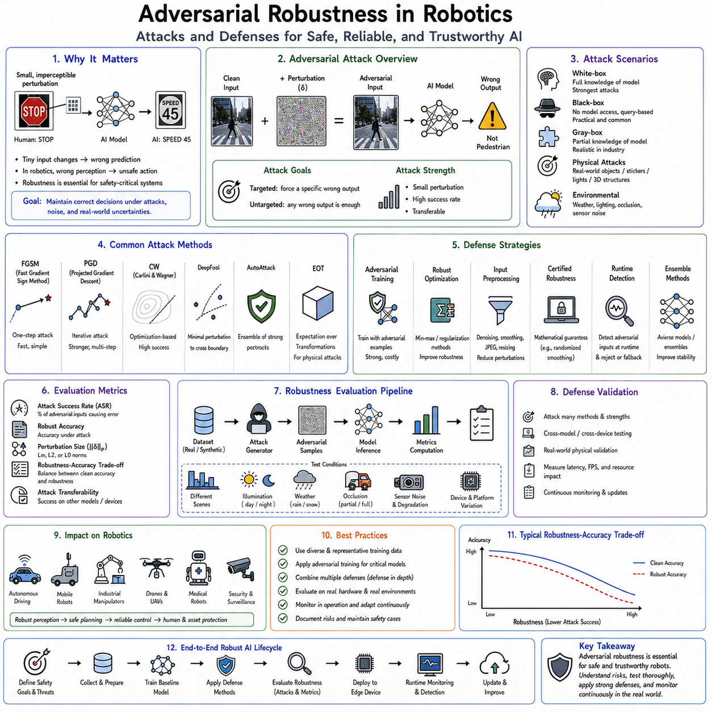
Adversarial robustness is the field of artificial intelligence that studies how machine learning systems behave when confronted with inputs intentionally or unintentionally designed to produce incorrect predictions. Unlike ordinary model errors that arise from insufficient training data or natural environmental variation, adversarial failures occur when small perturbations to the input cause a neural network to generate dramatically different outputs despite the changes being nearly imperceptible to humans. In robotics, autonomous driving, industrial automation, medical robotics, warehouse logistics, and defense systems, adversarial robustness has become one of the central pillars of AI safety because perception errors directly influence planning, control, and physical interaction with the environment. A robust robotic AI system must therefore maintain reliable performance not only under ideal operating conditions but also in the presence of noise, environmental disturbances, sensor degradation, malicious manipulation, and unexpected real-world variations.
The concept of adversarial examples emerged from the surprising observation that deep neural networks often possess decision boundaries that differ significantly from human perception. A carefully designed perturbation added to an image can cause a state-of-the-art classifier to mistake a stop sign for a speed limit sign, classify a pedestrian as background, or recognize completely unrelated objects while the image appears visually unchanged to human observers. This vulnerability reveals an important distinction between statistical pattern recognition and semantic understanding. Neural networks optimize mathematical decision boundaries within high-dimensional feature spaces, whereas humans rely on holistic reasoning, contextual understanding, and prior knowledge. Consequently, neural networks may exploit subtle numerical features that humans never consciously perceive.
The importance of adversarial robustness increases substantially in robotics because AI predictions influence physical actions. A conventional image classifier producing an incorrect label may simply display inaccurate information to a user. A robotic perception system making the same error may cause an autonomous vehicle to ignore traffic signals, a warehouse robot to collide with shelving, a collaborative manipulator to mishandle equipment, or a medical robot to misidentify surgical instruments. The physical consequences of incorrect AI predictions elevate adversarial robustness from an academic research topic to a critical engineering requirement.
Adversarial attacks are generally classified according to the attacker's knowledge, capabilities, objectives, and interaction with the target system. Understanding these categories provides the foundation for designing appropriate defensive mechanisms.
White-box attacks assume the attacker possesses complete knowledge of the target model. This includes network architecture, parameters, gradients, training procedures, optimization methods, and preprocessing pipelines. Because all internal information is available, white-box attacks often produce the strongest adversarial examples and serve as the standard benchmark for evaluating robustness. Although complete model access is uncommon in practical robotic deployments, white-box evaluation establishes an upper bound on model vulnerability.
Black-box attacks represent more realistic deployment scenarios. Here the attacker has no direct access to model internals but can observe inputs and outputs. By repeatedly querying the system or constructing substitute models, attackers estimate the target's decision boundaries and generate transferable adversarial examples. Since commercial robotic systems rarely expose internal model parameters, black-box robustness receives considerable attention in production environments.
Gray-box attacks occupy an intermediate position. Attackers possess partial knowledge regarding model architecture, deployment hardware, training datasets, preprocessing methods, or optimization strategies but lack complete access to internal parameters. Many practical industrial security analyses assume gray-box threat models because partial implementation details frequently become publicly available.
Targeted attacks seek to force a neural network toward one specific incorrect prediction. An attacker may intentionally attempt to cause a perception system to recognize one traffic sign as another, identify unauthorized personnel as authorized workers, or misclassify dangerous machinery as harmless background. Targeted attacks generally require more optimization than untargeted attacks because they pursue a particular incorrect outcome.
Untargeted attacks simply seek any incorrect prediction regardless of its specific category. Their objective is merely to reduce model accuracy rather than forcing a predetermined classification. These attacks often require smaller perturbations because numerous incorrect predictions satisfy the attack objective.
Digital adversarial attacks manipulate data directly before inference. Images, sensor streams, point clouds, audio signals, or language inputs are modified numerically before entering the neural network. Such attacks commonly appear in academic research because they provide precise experimental control and facilitate reproducible evaluation.
Physical adversarial attacks prove especially relevant for robotics because they manipulate real-world objects rather than digital data. Stickers applied to traffic signs, modified road markings, unusual clothing patterns, specially designed objects, projected light patterns, reflective materials, or three-dimensional structures may influence AI perception while remaining physically realizable. Since robots interact directly with the physical world, robustness against physical attacks represents a critical deployment requirement.
One of the earliest and most influential attack methods is the Fast Gradient Sign Method. This approach computes the gradient of the loss function with respect to the input image and perturbs each pixel slightly in the direction that maximally increases prediction error. Despite its conceptual simplicity, this method demonstrated that neural networks possess surprisingly fragile decision boundaries vulnerable to extremely small perturbations.
Projected Gradient Descent extends this concept through iterative optimization. Rather than applying a single perturbation, multiple gradient updates gradually refine the adversarial example while constraining perturbation magnitude within predefined limits. Projected Gradient Descent remains one of the strongest first-order adversarial attacks and serves as a standard benchmark for robustness evaluation.
Iterative optimization methods generally produce more effective adversarial examples than single-step attacks because repeated gradient updates better approximate optimal perturbations. However, increased computational cost makes them less suitable for real-time attack scenarios.
Optimization-based attacks formulate adversarial example generation as constrained mathematical optimization problems. The objective minimizes perturbation magnitude while maximizing prediction error subject to perceptual similarity constraints. These methods often produce highly effective attacks but require substantially greater computational effort.
Decision-based attacks operate without gradient information. Instead of analyzing internal model derivatives, they observe output predictions and gradually modify inputs until classification changes. Such attacks demonstrate that robustness cannot rely solely upon hiding model parameters.
Transfer attacks exploit the observation that adversarial examples generated for one neural network frequently fool different models trained for the same task. Attackers construct surrogate models locally, generate adversarial examples, and deploy them against unknown target systems. Transferability presents a significant practical concern because production models need not be directly accessible for successful attacks.
Universal adversarial perturbations introduce another remarkable phenomenon. Instead of constructing unique perturbations for individual images, researchers discovered perturbations capable of misleading neural networks across numerous unrelated inputs. Although generating such perturbations remains computationally demanding, they reveal structural vulnerabilities shared across entire datasets.
Adversarial patches represent physically realizable localized perturbations. Rather than modifying every image pixel, small printed patterns placed within camera view may dominate neural network attention and influence predictions. Since these patches remain effective under varying viewing angles and illumination conditions, they demonstrate the practical feasibility of physical adversarial manipulation.
Three-dimensional adversarial objects further extend physical attack concepts. Object geometry, surface texture, reflectance properties, or printed patterns may be optimized so that perception systems consistently misclassify them despite natural viewpoint variation. Autonomous robots interacting with physical environments must therefore consider adversarial object design alongside digital attacks.
Point cloud attacks have become increasingly important as LiDAR-based perception expands throughout autonomous robotics. Rather than modifying image pixels, attackers perturb three-dimensional point distributions by inserting, deleting, moving, or altering points. Such perturbations may influence object detection, localization, mapping, obstacle recognition, or navigation planning.
Sensor-specific attacks extend beyond computer vision. Radar interference, GPS spoofing, ultrasonic signal manipulation, inertial sensor corruption, audio perturbations, electromagnetic interference, and communication attacks all influence AI perception indirectly by modifying sensor observations before inference begins.
Language model attacks represent another emerging research area. Prompt injection, instruction manipulation, adversarial dialogue, context poisoning, retrieval manipulation, and multimodal prompt attacks target increasingly capable language-based robotic systems. Robots integrating vision-language models or foundation models must therefore consider linguistic robustness alongside visual robustness.
Adversarial robustness becomes especially challenging because many attacks exploit legitimate mathematical properties of neural networks rather than software bugs. The models continue operating exactly as designed while producing incorrect predictions because optimization objectives fail to capture all aspects of human semantic understanding. Consequently, robustness improvements generally require modifying learning algorithms rather than simply correcting implementation errors.
Defense strategies may be categorized according to when protection occurs. Some defenses improve model robustness during training, others detect attacks during inference, while additional mechanisms monitor complete robotic systems at runtime.
Adversarial training represents the most widely studied defense approach. During model optimization, adversarial examples generated dynamically become part of the training dataset. The neural network therefore learns to classify both ordinary and adversarial inputs correctly. This procedure significantly improves robustness against attacks similar to those encountered during training.
The central idea behind adversarial training is to transform adversarial perturbations from unexpected inputs into ordinary training examples. Rather than avoiding difficult cases, the optimization process explicitly learns robust decision boundaries capable of resisting small perturbations.
Although adversarial training substantially improves robustness, it introduces tradeoffs. Training becomes computationally expensive because adversarial examples must be generated repeatedly throughout optimization. Robust models also occasionally sacrifice a small amount of clean-data accuracy in exchange for increased stability under attack.
Robust optimization extends adversarial training by directly minimizing worst-case prediction error within specified perturbation bounds. Instead of optimizing average performance alone, robust optimization seeks models maintaining acceptable behavior even under the strongest allowable perturbations.
Data augmentation provides another layer of robustness. Images undergo geometric transformations, illumination variation, weather simulation, blur, noise injection, compression artifacts, sensor distortion, occlusion, and environmental modifications during training. Although standard augmentation does not eliminate adversarial vulnerability, it improves general robustness against naturally occurring disturbances frequently encountered in robotic environments.
Randomized smoothing introduces controlled randomness into inference. Multiple noisy versions of each input are evaluated, and predictions are aggregated statistically. Because adversarial perturbations must remain effective across many random variations, attack difficulty increases substantially. Randomized smoothing additionally provides formal robustness guarantees under certain mathematical assumptions.
Input preprocessing attempts to remove adversarial perturbations before inference. Image denoising, compression, filtering, super-resolution, color normalization, geometric correction, frequency-domain transformation, and feature reconstruction may reduce attack effectiveness. However, adaptive attackers frequently design perturbations surviving these preprocessing operations.
Feature denoising operates within internal neural representations rather than directly on input images. Intermediate feature maps are cleaned using learned denoising mechanisms before subsequent layers process them. This approach targets perturbation propagation throughout the computational hierarchy.
Ensemble learning improves robustness through model diversity. Multiple independently trained neural networks evaluate identical inputs, and predictions are combined using voting or probabilistic aggregation. Successful attacks must therefore deceive several distinct models simultaneously, increasing attack complexity.
Architectural diversity further strengthens ensemble defenses. Combining convolutional networks, transformers, graph neural networks, probabilistic models, and classical computer vision algorithms reduces correlated vulnerabilities because different architectures often exploit different feature representations.
Confidence estimation provides another important defense mechanism. Robust systems evaluate not only predicted classes but also associated uncertainty. Low-confidence predictions may trigger additional sensing, slower robot motion, human supervision, or conservative planning rather than immediate action.
Out-of-distribution detection complements adversarial defense by identifying inputs inconsistent with training distributions. Since many adversarial examples occupy unusual regions of feature space, out-of-distribution detection frequently identifies suspicious observations before unsafe decisions occur.
Runtime anomaly detection continuously monitors prediction consistency, feature statistics, temporal stability, sensor agreement, and decision evolution. Sudden unexplained prediction changes may indicate adversarial manipulation, sensor degradation, or environmental anomalies requiring additional verification.
Sensor fusion naturally improves robustness because independent sensing modalities exhibit different failure characteristics. Cameras may become vulnerable to visual perturbations, while LiDAR continues measuring geometry accurately. Radar remains largely unaffected by optical attacks. Combining multiple sensors substantially increases resilience against modality-specific attacks.
Temporal consistency checking exploits sequential observations. Real-world environments evolve continuously rather than changing arbitrarily between consecutive frames. Predictions violating temporal continuity may indicate adversarial manipulation, sensor malfunction, or inference instability.
World models provide additional semantic verification. Rather than accepting isolated predictions independently, robots maintain internal representations of environmental dynamics. Predictions inconsistent with physical laws, object permanence, or environmental constraints receive reduced confidence or trigger additional validation.
Classical computer vision algorithms remain valuable complements to deep learning. Geometric verification, feature matching, optical flow estimation, simultaneous localization and mapping, and model-based tracking provide independent information sources that frequently resist adversarial perturbations affecting neural networks.
Formal robustness verification seeks mathematical guarantees regarding neural network behavior within specified perturbation limits. Researchers develop algorithms proving that no adversarial examples exist inside bounded input regions. Although currently limited to relatively small models, formal verification continues advancing toward practical deployment.
Certified defenses extend this concept by providing provable robustness guarantees rather than empirical resistance alone. Unlike heuristic defenses evaluated only experimentally, certified methods establish mathematically verified prediction stability under defined perturbation magnitudes.
Benchmarking adversarial robustness requires standardized evaluation protocols. Models should be tested against multiple attack methods, perturbation magnitudes, threat models, physical scenarios, transfer attacks, and adaptive attackers. Evaluating robustness against only one attack frequently produces misleading conclusions because defenses effective against one strategy may fail against others.
Adaptive attacks deserve particular attention. Attackers aware of deployed defenses modify optimization strategies specifically to circumvent protective mechanisms. Robustness evaluation must therefore assume intelligent adversaries rather than static benchmark attacks.
Robotic systems require application-specific robustness evaluation beyond conventional image classification benchmarks. Autonomous navigation, manipulation, collaborative robotics, industrial inspection, healthcare assistance, warehouse automation, and autonomous driving each introduce unique operational risks and attack surfaces.
Industrial robots operating inside factories primarily face accidental perturbations, sensor degradation, illumination changes, dust accumulation, mechanical vibration, and production variability rather than deliberate adversarial attacks. Nevertheless, robustness against natural perturbations significantly improves overall operational reliability.
Autonomous vehicles require protection against both environmental disturbances and intentional manipulation. Road signs, lane markings, traffic signals, pedestrians, vehicles, construction zones, and navigation landmarks all influence safety-critical decisions. Robust perception therefore becomes a central requirement for safe autonomous driving.
Collaborative robots interacting closely with humans require especially conservative robustness strategies. Whenever uncertainty increases or suspicious observations occur, systems should reduce operating speed, expand safety margins, request human confirmation, or temporarily suspend autonomous operation.
Healthcare robots similarly prioritize conservative behavior. Diagnostic uncertainty, instrument recognition ambiguity, patient movement, imaging artifacts, or sensor anomalies should always favor safe intervention rather than confident but potentially incorrect autonomous action.
The emergence of multimodal foundation models introduces additional robustness challenges. Vision-language-action systems integrate images, text, proprioception, force sensing, memory, planning, and reasoning within unified architectures. Adversarial interactions may therefore occur across modalities rather than within individual sensory channels alone.
Future research increasingly focuses on robust embodied intelligence rather than isolated perception models. Robots must remain reliable despite changing environments, novel tasks, evolving sensor configurations, hardware degradation, adversarial manipulation, communication failures, and continual learning. Achieving such robustness requires integrating perception, reasoning, uncertainty estimation, runtime monitoring, sensor fusion, formal verification, and adaptive planning into unified safety architectures.
Ultimately, adversarial robustness is not merely a defensive mechanism against malicious attacks but a comprehensive engineering discipline aimed at ensuring reliable AI behavior under all forms of uncertainty. Every robotic deployment encounters sensor noise, environmental variation, unexpected objects, lighting changes, weather conditions, mechanical wear, calibration drift, and operational anomalies. Techniques originally developed for adversarial defense therefore contribute broadly to building more reliable, trustworthy, and resilient robotic intelligence. As autonomous systems increasingly assume responsibility for transportation, manufacturing, healthcare, infrastructure inspection, logistics, agriculture, and public services, adversarial robustness becomes an essential foundation supporting safe, dependable, and responsible deployment of Physical AI in the real world.

11.03 Out of Distribution OOD Detection for Robots [w/Code]
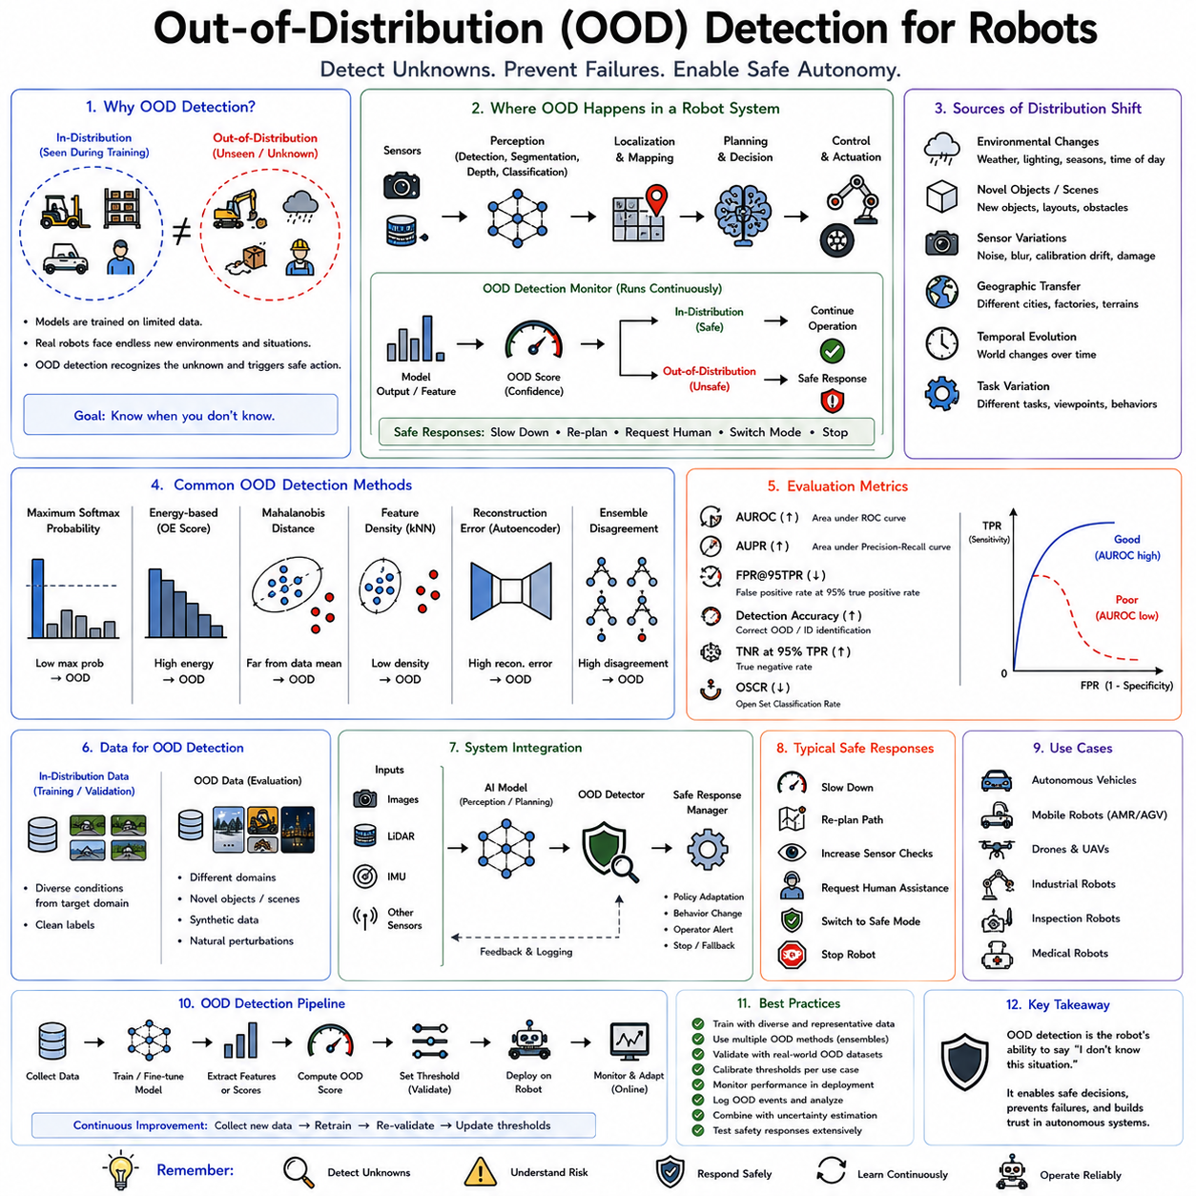
Out-of-Distribution (OOD) detection is a fundamental safety mechanism in modern artificial intelligence that enables a robot to recognize when its current observations differ significantly from the data on which its AI models were trained. Traditional machine learning systems implicitly assume that future inputs originate from the same statistical distribution as the training dataset. In real-world robotics, however, this assumption rarely holds over long periods of operation. Autonomous robots continuously encounter new environments, unfamiliar objects, changing weather conditions, damaged infrastructure, sensor degradation, novel human behaviors, unexpected lighting, and previously unseen task variations. OOD detection provides the capability to recognize these unfamiliar situations and respond safely rather than making highly confident but potentially incorrect predictions. As autonomous robots become increasingly deployed in factories, hospitals, warehouses, public roads, homes, construction sites, agricultural fields, and disaster environments, OOD detection has become one of the most important components of AI safety, reliability, and trustworthy autonomous operation.
The motivation for OOD detection originates from one of the most fundamental limitations of supervised learning. During training, neural networks optimize their parameters using finite datasets collected under specific operating conditions. Although these datasets may contain millions of examples, they can never represent every possible situation encountered during deployment. Consequently, the learned decision boundaries accurately describe only a limited region of the enormous real-world state space. When the robot encounters observations outside this learned region, conventional neural networks often continue producing confident predictions despite having little meaningful knowledge about the situation. OOD detection aims to identify precisely these situations before incorrect predictions propagate into planning and control decisions.
To understand the concept of distribution shift, consider an autonomous warehouse robot trained using images collected inside a modern logistics center. During deployment, the same robot may later operate in older warehouses with different shelf designs, damaged lighting systems, unusual floor markings, seasonal inventory, construction equipment, or emergency evacuation scenarios. Although these environments remain recognizable to humans, they may differ substantially from the statistical properties of the training data. The robot's perception system therefore operates outside its intended distribution even though it continues receiving apparently normal camera images.
The distinction between in-distribution and out-of-distribution data forms the conceptual foundation of OOD detection. In-distribution samples resemble the examples observed during training with respect to appearance, sensor characteristics, semantic content, environmental conditions, and statistical properties. Out-of-distribution samples differ sufficiently that the neural network cannot reliably generalize its learned representations. The challenge lies in recognizing these differences automatically before unsafe decisions occur.
OOD conditions arise from numerous sources in robotic systems. Environmental variation represents one of the most common causes. Outdoor robots experience changing weather, snow, rain, fog, dust, seasonal vegetation, nighttime operation, direct sunlight, reflections, and construction activity. Indoor robots encounter furniture rearrangement, temporary obstacles, changing inventory, altered lighting, and dynamic human activity. Even gradual environmental evolution may eventually move observations beyond the model's training distribution.
Novel object appearance represents another important source of distribution shift. Industrial robots may encounter newly introduced products, unfamiliar tools, replacement machinery, damaged components, or modified packaging. Service robots operating in homes may observe new household objects, decorations, furniture, pets, or assistive devices never included in their original training datasets.
Sensor variation also contributes significantly to OOD conditions. Camera aging, lens contamination, focus changes, calibration drift, exposure variation, motion blur, dead pixels, compression artifacts, or hardware replacement gradually alter sensor observations. LiDAR sensors accumulate dust, radar performance changes under adverse weather, and inertial measurement units experience calibration drift. Although these changes may appear minor individually, their cumulative effect may substantially alter input distributions.
Geographical transfer presents another common challenge. Autonomous robots trained in one city, factory, hospital, or agricultural region often experience reduced performance when deployed elsewhere. Road markings, building architecture, vegetation, equipment layouts, signage, construction materials, cultural practices, and environmental characteristics vary geographically, producing natural distribution shifts that require detection.
Temporal evolution further complicates deployment. AI models may remain unchanged while the surrounding world evolves continuously. Warehouses reorganize inventory, hospitals renovate facilities, factories introduce new production lines, agricultural fields change throughout growing seasons, and cities undergo infrastructure maintenance. OOD detection enables robots to recognize these gradual environmental changes rather than assuming operational conditions remain constant indefinitely.
Task variation introduces additional uncertainty. A manipulation robot trained to handle specific product categories may later receive unfamiliar objects with different materials, shapes, textures, weights, or mechanical properties. Navigation robots may receive new mission objectives requiring operation within previously unexplored facility regions. These task changes often produce observations outside the original training distribution.
OOD detection differs fundamentally from ordinary classification. Conventional neural networks attempt to assign every input to one of several predefined categories regardless of familiarity. OOD detection introduces an additional capability: recognizing that the current observation does not belong to any familiar category. Instead of forcing uncertain observations into inappropriate classifications, the system explicitly identifies unfamiliarity itself.
One of the simplest approaches relies on prediction confidence. Neural networks frequently produce probability distributions across output classes using the softmax function. Intuitively, highly uncertain predictions should correspond to unfamiliar inputs. Unfortunately, conventional neural networks often remain overconfident even when presented with entirely unrelated data. Consequently, raw confidence scores alone provide unreliable OOD detection.
Confidence calibration attempts to improve this behavior by aligning predicted confidence with actual prediction reliability. Temperature scaling, probability calibration, Bayesian inference, ensemble averaging, and uncertainty estimation reduce excessive confidence while preserving classification accuracy. Better-calibrated confidence estimates improve OOD detection but rarely eliminate the problem entirely.
Maximum Softmax Probability represents one of the earliest practical OOD detection methods. Inputs producing unusually low maximum prediction probabilities are considered potentially out-of-distribution. Although computationally efficient, this approach struggles because neural networks frequently assign extremely high confidence to unfamiliar observations.
Energy-based detection improves upon probability-based methods by evaluating neural network logits before softmax normalization. Energy scores often separate in-distribution and out-of-distribution samples more effectively than normalized probabilities because they preserve richer information regarding model confidence.
Feature-space methods examine internal neural representations rather than final predictions. Deep networks progressively transform raw sensor data into increasingly abstract feature embeddings. In-distribution samples generally occupy well-defined regions of feature space, whereas unfamiliar observations often produce feature representations distant from known clusters. Measuring distances within latent feature space therefore provides an effective mechanism for detecting OOD inputs.
Mahalanobis distance represents one widely used feature-space metric. Rather than measuring simple Euclidean distance, Mahalanobis distance accounts for feature covariance, producing more accurate estimates of how unusual an embedding appears relative to known training distributions. Samples lying far from learned feature clusters receive elevated OOD scores.
Nearest-neighbor approaches similarly evaluate similarity between current observations and stored training representations. If no sufficiently similar examples exist within feature space, the observation is classified as potentially out-of-distribution. Approximate nearest-neighbor algorithms enable efficient implementation even for large datasets.
Density estimation methods attempt to model the probability distribution of training data directly. Inputs assigned extremely low probability under this learned distribution become OOD candidates. Gaussian mixture models, normalizing flows, autoregressive models, and energy-based generative models all support various forms of density estimation.
Autoencoders provide another widely studied approach. During training, autoencoders learn to reconstruct familiar inputs accurately while compressing them into lower-dimensional latent representations. When presented with unfamiliar observations, reconstruction quality often deteriorates because the learned latent space cannot represent novel structures efficiently. Reconstruction error therefore serves as an OOD indicator.
Variational Autoencoders extend this idea through probabilistic latent representations. Instead of learning deterministic encodings, latent variables follow learned probability distributions. Samples producing unlikely latent representations may indicate out-of-distribution conditions while simultaneously providing uncertainty estimates.
Generative Adversarial Networks also contribute to OOD detection. Adversarial training encourages generators to reproduce training distributions accurately. Inputs difficult for the generator or discriminator to explain often correspond to unfamiliar observations requiring additional caution.
Normalizing flows offer exact likelihood estimation through invertible neural network transformations. Unlike approximate generative methods, normalizing flows compute precise probability densities, making them attractive for probabilistic OOD detection despite increased computational complexity.
Bayesian neural networks represent another important family of OOD methods. Instead of learning fixed network parameters, Bayesian approaches estimate probability distributions over parameters themselves. During inference, parameter uncertainty propagates into prediction uncertainty, providing richer information regarding unfamiliar inputs.
Monte Carlo Dropout approximates Bayesian inference using repeated stochastic forward passes. By enabling dropout during inference and evaluating multiple predictions, the model estimates epistemic uncertainty arising from limited knowledge rather than inherent environmental randomness. Elevated epistemic uncertainty frequently indicates out-of-distribution conditions.
Deep ensembles constitute one of the most reliable uncertainty estimation methods. Multiple independently trained neural networks evaluate identical inputs, and prediction disagreement provides an estimate of uncertainty. Since different models typically respond differently to unfamiliar observations, ensemble variance serves as an effective OOD indicator.
Evidential deep learning directly predicts probability distributions over class probabilities rather than single deterministic predictions. This framework distinguishes uncertainty arising from conflicting evidence from uncertainty resulting from insufficient evidence, providing more informative confidence estimates.
Foundation models introduce new opportunities for OOD detection. Large-scale self-supervised pretraining produces rich semantic representations spanning broad visual, linguistic, and multimodal domains. These representations often generalize substantially better than task-specific supervised models, reducing sensitivity to moderate distribution shifts. Nevertheless, even foundation models encounter unfamiliar situations requiring explicit uncertainty estimation.
Vision-language models further improve semantic understanding by integrating textual knowledge with visual perception. A robot encountering unfamiliar objects may recognize semantic relationships through language descriptions even when exact visual appearances differ from training examples. Such multimodal reasoning complements traditional OOD detection rather than replacing it.
Temporal consistency provides another powerful source of information. Robotic systems continuously observe evolving environments rather than isolated images. Consecutive observations should generally change smoothly according to physical dynamics. Abrupt unexplained prediction changes, inconsistent object identities, or discontinuous semantic interpretations often indicate distribution shifts, sensor failures, or unexpected environmental conditions.
Sensor fusion significantly strengthens OOD robustness. Independent sensing modalities exhibit distinct failure characteristics. Cameras suffer under poor illumination, while LiDAR continues measuring geometry accurately. Radar penetrates adverse weather, and inertial sensors provide reliable motion estimates independent of visual conditions. Combining multiple modalities allows robots to distinguish genuine environmental novelty from isolated sensor failures.
World models provide higher-level semantic verification. Rather than evaluating observations independently, robots maintain internal models describing object permanence, physical dynamics, environmental constraints, and causal relationships. Observations violating learned physical consistency may indicate unfamiliar situations requiring additional caution.
Runtime monitoring integrates OOD detection into complete robotic systems. Instead of merely assigning OOD labels, monitoring systems continuously evaluate prediction confidence, feature distributions, sensor consistency, computational anomalies, environmental conditions, and historical operational behavior. Suspicious situations trigger appropriate safety responses according to application requirements.
Safe response strategies are equally important as OOD detection itself. Recognizing unfamiliarity provides little benefit unless the robot responds appropriately. Depending upon operational context, responses may include reducing motion speed, increasing obstacle clearance margins, requesting additional sensor observations, switching to conservative planning algorithms, notifying human supervisors, activating redundant perception systems, or transitioning into predefined safe states.
Autonomous vehicles provide one of the most demanding OOD deployment scenarios. Road construction, emergency vehicles, unusual weather, damaged infrastructure, temporary traffic signs, accidents, pedestrians behaving unexpectedly, and unfamiliar vehicle types all introduce distribution shifts potentially affecting safety-critical perception. OOD detection enables autonomous driving systems to increase caution rather than assuming standard operating conditions.
Industrial robots similarly encounter evolving manufacturing environments. New product designs, altered packaging, modified conveyor systems, maintenance activities, temporary workstations, replacement equipment, and changing lighting conditions all create unfamiliar observations. OOD detection allows production systems to maintain safety despite ongoing process evolution.
Warehouse robots experience continuous inventory turnover. Seasonal products, temporary storage arrangements, pallet variations, packaging redesigns, temporary construction barriers, and varying human traffic patterns naturally produce distribution shifts. Robust OOD detection improves operational reliability while reducing unnecessary interruptions.
Healthcare robotics presents additional challenges because patient populations vary substantially. Anatomical variation, medical equipment updates, unusual clinical presentations, emergency situations, and evolving treatment protocols introduce unfamiliar operating conditions. Conservative OOD detection becomes particularly valuable where patient safety remains paramount.
Agricultural robotics faces naturally changing environments. Plant growth, seasonal weather, disease progression, soil variation, irrigation changes, harvest conditions, and evolving crop appearance continually modify visual observations. OOD detection supports adaptive operation throughout agricultural production cycles.
Benchmarking OOD detection requires carefully designed evaluation protocols. Standard image classification accuracy proves insufficient because models must recognize unfamiliarity rather than simply classify known categories. Benchmarks therefore evaluate true positive detection rates, false positive rates, area under receiver operating characteristic curves, precision-recall relationships, calibration quality, uncertainty estimation accuracy, and computational overhead.
False positive OOD detections reduce operational efficiency because familiar situations become unnecessarily classified as unfamiliar. Excessive false alarms may encourage operators to ignore warnings, reducing overall system effectiveness. Balancing sensitivity against operational practicality therefore represents an important engineering consideration.
False negatives generally pose greater safety risks. Here genuinely unfamiliar observations remain undetected, allowing overconfident predictions to influence robot behavior. Minimizing false negatives therefore receives particular emphasis in safety-critical robotics despite occasional increases in false positive rates.
Computational efficiency also influences deployment practicality. Many sophisticated OOD algorithms require multiple forward passes, ensemble evaluation, or complex probabilistic computations incompatible with strict real-time constraints. Embedded robotic platforms therefore favor methods balancing detection quality with computational cost.
Future research increasingly investigates continual OOD adaptation. Rather than merely detecting unfamiliar observations, robots will gradually incorporate validated experiences into evolving knowledge bases while preserving safety throughout the learning process. This integration of OOD detection with lifelong learning promises robots capable of expanding operational competence without sacrificing reliability.
Multimodal embodied intelligence introduces additional research challenges. Future robots will integrate vision, language, force sensing, audio, tactile perception, proprioception, world models, and long-term memory within unified architectures. OOD detection must therefore evaluate unfamiliarity across multiple interacting modalities rather than treating each sensor independently.
Ultimately, Out-of-Distribution detection represents a fundamental transition from assuming that artificial intelligence always understands its environment to explicitly recognizing the limits of learned knowledge. Rather than forcing every observation into predefined categories, safe robotic systems acknowledge uncertainty, detect unfamiliar situations, and adapt their behavior accordingly. By combining uncertainty estimation, probabilistic modeling, feature-space analysis, generative learning, sensor fusion, temporal consistency, runtime monitoring, and conservative safety policies, OOD detection enables autonomous robots to recognize when they are operating beyond their experience. This capability forms a cornerstone of trustworthy Physical AI, allowing intelligent machines to remain reliable, cautious, and safe while navigating the enormous diversity and unpredictability of the real world.

11.04 Uncertainty Quantification Bayesian Ensemble [w/Code]
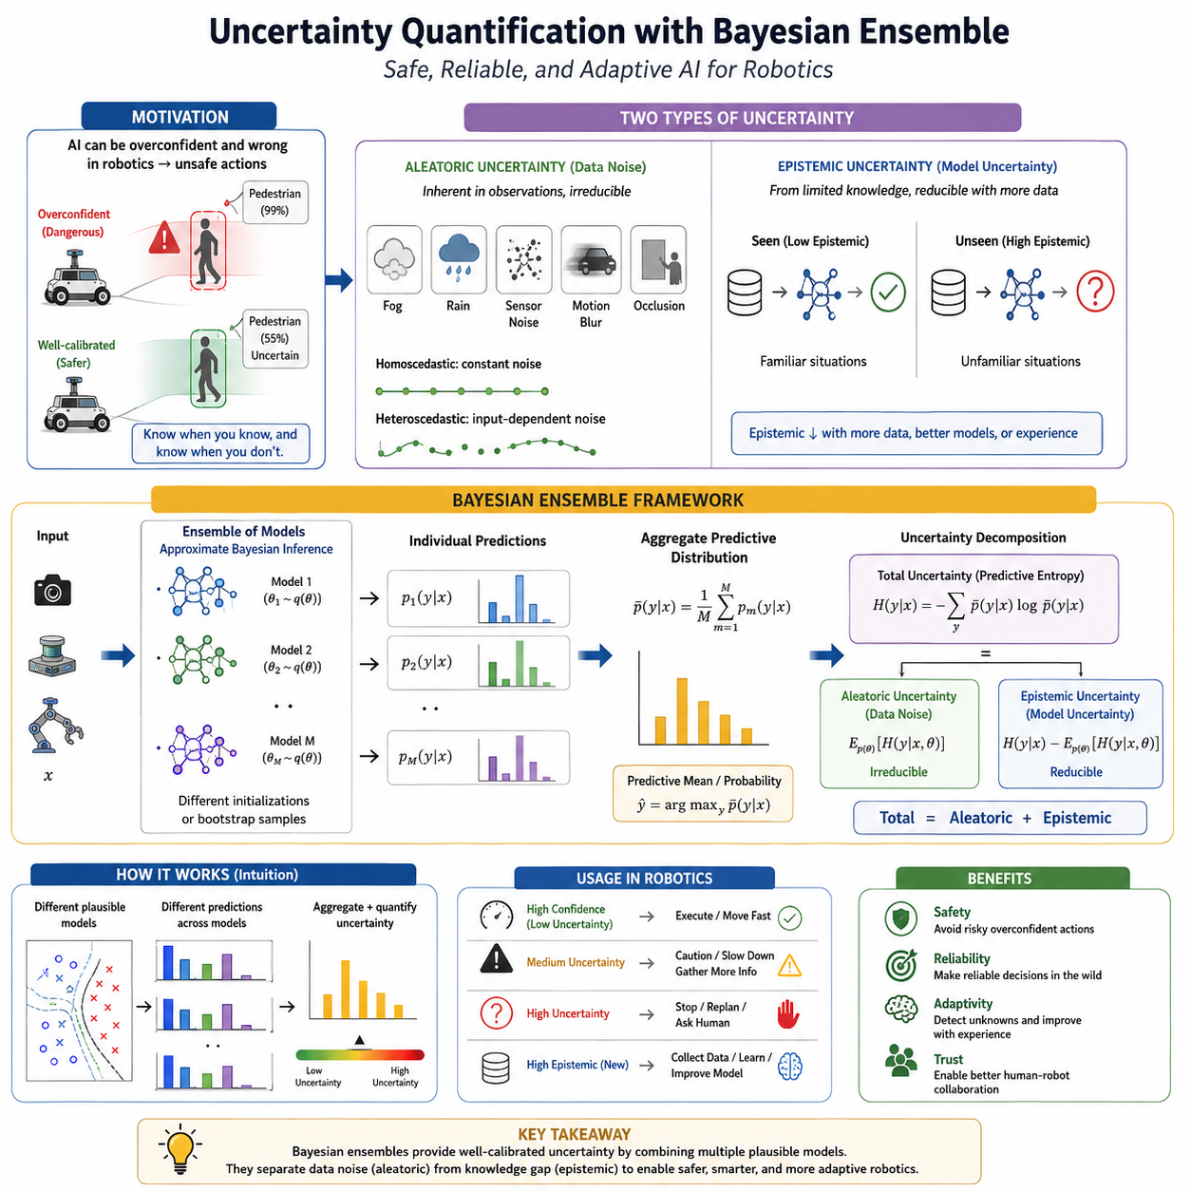
Uncertainty quantification is one of the foundational technologies for safe and trustworthy artificial intelligence in robotics because it enables a robot to estimate not only what it believes but also how confident it should be in those beliefs. Traditional deep neural networks typically produce a single prediction, such as an object category, depth estimate, navigation command, or control action, without explicitly expressing the reliability of that prediction. In many applications this limitation is acceptable, but in autonomous robotics, incorrect predictions made with excessive confidence can lead directly to unsafe physical behavior. An autonomous mobile robot that confidently misidentifies a pedestrian, a medical robot that incorrectly classifies anatomical structures, or an industrial manipulator that overestimates the certainty of object pose estimation may produce hazardous actions. Uncertainty quantification addresses this problem by attaching meaningful confidence estimates to AI predictions, allowing robotic systems to recognize situations in which additional sensing, slower operation, human intervention, or conservative planning becomes necessary.
The motivation for uncertainty quantification arises from the distinction between intelligence and reliability. A highly accurate neural network may still occasionally produce severe errors, particularly when operating outside its training distribution or under unusual environmental conditions. Conventional neural networks often generate extremely confident predictions even when they have never encountered similar inputs during training. This phenomenon, commonly referred to as overconfidence, represents one of the major safety concerns in modern artificial intelligence. Reliable robotic systems must therefore distinguish between predictions supported by strong evidence and predictions based upon limited or uncertain knowledge.
Uncertainty differs fundamentally from prediction accuracy. Accuracy measures how often a model produces correct outputs on benchmark datasets. Uncertainty measures the model's own awareness of the limits of its knowledge. An ideal AI system produces high confidence when predictions are reliable and low confidence when uncertainty is substantial. Such calibrated behavior allows downstream planning, control, and human supervision systems to make informed decisions regarding operational safety.
Two primary forms of uncertainty are generally recognized in machine learning: aleatoric uncertainty and epistemic uncertainty. Understanding the distinction between these two uncertainty sources is central to uncertainty-aware robotics because they arise from fundamentally different causes and require different mitigation strategies.
Aleatoric uncertainty represents uncertainty inherent in the observed data itself. It originates from measurement noise, sensor limitations, environmental variability, motion blur, lighting changes, weather conditions, occlusions, communication noise, and other sources of randomness that cannot be eliminated even with unlimited training data. For example, a camera operating in dense fog naturally produces ambiguous images. A LiDAR scanning heavy rain encounters noisy reflections. A force sensor measuring contact during manipulation experiences mechanical vibration. These uncertainties arise from the physical world rather than from deficiencies in the learning algorithm.
Aleatoric uncertainty may be homoscedastic or heteroscedastic. Homoscedastic uncertainty remains approximately constant across all observations. A camera sensor with fixed measurement noise provides one example. Heteroscedastic uncertainty varies depending upon the input itself. Images captured under bright daylight may exhibit low uncertainty, whereas identical scenes observed at night or during heavy rain become substantially more uncertain. Modern neural networks frequently learn to estimate input-dependent uncertainty directly, allowing robots to adapt their behavior according to environmental conditions.
Epistemic uncertainty represents uncertainty arising from incomplete knowledge. Unlike aleatoric uncertainty, epistemic uncertainty can theoretically be reduced by collecting additional training data or improving the model. It reflects the model's ignorance regarding regions of the input space insufficiently represented during learning. When a warehouse robot encounters a completely new type of pallet, or an autonomous vehicle observes unfamiliar road infrastructure, epistemic uncertainty becomes high because the model lacks prior experience with similar situations.
The distinction between these uncertainty types has important operational implications. Aleatoric uncertainty generally cannot be eliminated through additional training because it originates from irreducible environmental variability. Epistemic uncertainty, however, identifies opportunities for model improvement through additional data collection, retraining, or continual learning.
Probabilistic machine learning provides the mathematical foundation for uncertainty quantification. Instead of producing only deterministic predictions, probabilistic models estimate probability distributions over possible outcomes. Rather than predicting that an object belongs exclusively to one category, the model estimates probabilities associated with multiple possible interpretations while also expressing uncertainty regarding those probabilities.
Bayesian inference represents one of the most principled approaches to probabilistic reasoning. Classical neural networks optimize fixed parameter values during training and subsequently treat these parameters as certain. Bayesian neural networks instead represent model parameters as probability distributions. Rather than assuming each weight possesses one precise value, Bayesian methods estimate distributions describing plausible parameter values consistent with observed training data.
This probabilistic interpretation fundamentally changes inference. Predictions no longer arise from a single deterministic model but instead integrate over many possible parameter configurations weighted according to their posterior probabilities. The resulting predictive distribution naturally incorporates uncertainty arising from limited knowledge.
Bayes' theorem provides the mathematical basis for this approach. Prior distributions represent knowledge before observing training data, likelihood functions describe how probable observed data appear under different parameter values, and posterior distributions combine both sources of information into updated beliefs. Bayesian learning therefore continuously refines uncertainty as additional evidence becomes available.
Exact Bayesian inference remains computationally intractable for modern deep neural networks because contemporary models often contain millions or billions of parameters. Calculating complete posterior distributions over such enormous parameter spaces exceeds practical computational capabilities. Consequently, practical Bayesian deep learning relies upon various approximation methods.
Variational Bayesian inference approximates complex posterior distributions using simpler parameterized distributions optimized to resemble the true posterior as closely as possible. Instead of calculating exact probabilities, optimization minimizes divergence between approximate and exact distributions. Variational methods provide tractable Bayesian approximations suitable for large neural networks.
Markov Chain Monte Carlo methods represent another classical Bayesian approximation technique. Rather than explicitly representing the posterior distribution, these algorithms generate samples whose long-term distribution approximates the desired posterior. Although theoretically attractive, MCMC methods generally remain computationally expensive for large-scale deep learning deployment.
Monte Carlo Dropout offers one of the simplest practical approximations to Bayesian inference. Dropout layers, originally introduced as regularization during training, remain active during inference. Multiple stochastic forward passes produce slightly different predictions because different neurons are randomly disabled each time. The resulting prediction variability approximates epistemic uncertainty while requiring only modest architectural modifications.
The elegance of Monte Carlo Dropout lies in its practicality. Existing neural networks often require only minimal modifications, making Bayesian uncertainty estimation accessible without completely redesigning model architectures. Repeated inference produces predictive distributions whose variance reflects uncertainty regarding model knowledge.
Deep ensembles have emerged as one of the most effective uncertainty estimation techniques for practical robotics. Instead of training a single neural network, multiple independently initialized models are trained using identical datasets. Although architectures remain the same, stochastic optimization causes each network to converge toward different local optima within parameter space.
During inference, every ensemble member evaluates the same input independently. Final predictions arise from averaging individual outputs, while disagreement among ensemble members provides a direct estimate of epistemic uncertainty. When all models agree strongly, confidence remains high. When predictions diverge substantially, uncertainty increases because different plausible models interpret the observation differently.
One remarkable property of deep ensembles is that they frequently outperform more theoretically sophisticated Bayesian approximations despite their conceptual simplicity. Independent optimization naturally captures model diversity without requiring complex posterior estimation algorithms. Consequently, deep ensembles have become a practical standard for uncertainty-aware robotics.
Model diversity plays a critical role in ensemble effectiveness. If all ensemble members remain nearly identical, uncertainty estimates become uninformative. Diversity arises naturally through random parameter initialization, shuffled training data, stochastic gradient optimization, data augmentation, or architectural variation. Greater diversity generally improves uncertainty estimation while increasing computational requirements.
Snapshot ensembles reduce computational cost by exploiting different optimization states of a single training process. Instead of training multiple networks independently, parameters are periodically saved during optimization and later combined into an ensemble. Although diversity decreases somewhat compared with independently trained models, computational efficiency improves substantially.
Bootstrap aggregation, commonly known as bagging, further enhances ensemble diversity. Each network trains on a slightly different subset of the available data sampled with replacement. Consequently, models develop distinct representations reflecting different training experiences. Prediction disagreement therefore better captures uncertainty arising from limited data availability.
Bayesian last-layer methods provide another compromise between computational efficiency and uncertainty estimation quality. Rather than modeling uncertainty across all neural network parameters, only the final prediction layer receives Bayesian treatment while earlier feature extraction layers remain deterministic. This significantly reduces computational complexity while preserving meaningful predictive uncertainty.
Probabilistic output layers extend deterministic neural networks by directly predicting probability distributions instead of single numerical values. Regression networks may estimate both predicted values and associated variances. Classification models may predict confidence distributions reflecting uncertainty regarding class membership.
Gaussian processes represent another important probabilistic modeling approach. Unlike neural networks that learn fixed parameterized functions, Gaussian processes define distributions over possible functions themselves. Predictions therefore naturally include uncertainty estimates increasing with distance from observed training data. Although computational complexity limits large-scale deployment, Gaussian processes remain valuable for many robotics applications involving moderate dataset sizes.
Deep Gaussian processes combine neural network representation learning with Gaussian process uncertainty estimation. These hybrid architectures attempt to capture both expressive nonlinear feature extraction and principled probabilistic inference, although computational demands remain significant.
Evidential deep learning introduces an alternative framework inspired by evidence theory. Rather than directly predicting class probabilities, the network estimates evidence supporting each possible class. Total available evidence determines prediction confidence, allowing the model to distinguish between uncertainty arising from conflicting observations and uncertainty resulting from insufficient information.
Dirichlet distributions frequently appear in evidential classification because they naturally represent uncertainty over categorical probability distributions. Instead of producing single probability vectors, predictions become distributions over possible probability vectors, providing substantially richer uncertainty information.
Calibration represents another essential aspect of uncertainty quantification. Well-calibrated models produce confidence values matching empirical prediction accuracy. For example, predictions assigned ninety percent confidence should prove correct approximately ninety percent of the time. Poor calibration undermines operational safety because confidence values become misleading.
Temperature scaling provides one of the simplest calibration techniques. Before applying the softmax function, network logits are divided by a learned temperature parameter optimized using validation data. Proper temperature selection often significantly improves probability calibration without affecting classification accuracy.
Platt scaling and isotonic regression provide additional post-training calibration methods. These techniques transform predicted confidence values into better-calibrated probabilities while preserving model predictions. They prove particularly useful when retraining large production models becomes impractical.
Reliability diagrams visualize calibration quality by comparing predicted confidence with observed accuracy across multiple confidence intervals. Perfect calibration corresponds to agreement between predicted and empirical probabilities. Deviations reveal systematic overconfidence or underconfidence requiring correction.
Expected Calibration Error summarizes calibration quality numerically. Smaller values indicate better correspondence between confidence estimates and actual prediction reliability. Alongside classification accuracy, calibration error has become a standard evaluation metric for safety-critical artificial intelligence.
Uncertainty quantification integrates naturally with Out-of-Distribution detection. Observations differing substantially from training data should generally produce elevated epistemic uncertainty. Consequently, uncertainty estimation often serves as one component of broader OOD detection systems, complementing feature-space analysis, density estimation, and anomaly detection.
Robotic perception systems benefit significantly from uncertainty-aware inference. Object detectors estimate not only object identities but also confidence regarding localization and classification. Semantic segmentation networks assign uncertainty to individual pixels, allowing navigation systems to avoid poorly understood regions. Depth estimation models predict confidence intervals alongside geometric measurements, improving obstacle avoidance and manipulation planning.
Autonomous navigation relies extensively on uncertainty estimates. Localization systems combine sensor observations probabilistically, weighting measurements according to estimated reliability. Path planning algorithms account for environmental uncertainty by maintaining larger safety margins when confidence decreases. Motion controllers reduce operating speed under uncertain conditions rather than executing aggressive maneuvers.
Manipulation systems similarly exploit uncertainty information. Object pose estimation uncertainty influences grasp planning, contact force control, insertion strategies, and manipulation sequencing. Rather than attempting difficult manipulations under uncertain perception, robots may reposition sensors, request human assistance, or select alternative grasp configurations.
Autonomous vehicles represent one of the most demanding applications of uncertainty quantification. Perception uncertainty influences obstacle detection, lane estimation, traffic sign recognition, pedestrian prediction, behavior planning, and collision avoidance. Every major autonomous driving platform incorporates multiple uncertainty estimation mechanisms to support safe decision making.
Medical robotics likewise depends heavily upon reliable uncertainty estimates. Surgical navigation systems, anatomical segmentation models, diagnostic image analysis, and robotic assistance platforms must recognize situations where predictions become unreliable. Conservative behavior under uncertainty protects patient safety while supporting appropriate clinical decision making.
Industrial inspection systems employ uncertainty to identify ambiguous defects requiring human review. Rather than automatically accepting uncertain classifications, manufacturing quality assurance systems forward difficult cases to experienced inspectors while allowing high-confidence predictions to proceed autonomously.
Multi-sensor fusion naturally complements uncertainty quantification. Bayesian filtering, Kalman filters, particle filters, factor graphs, and probabilistic SLAM all integrate observations according to estimated uncertainty. Reliable uncertainty estimates therefore improve overall system performance even when individual sensors remain imperfect.
Decision making under uncertainty often relies upon probabilistic planning algorithms. Rather than assuming perfect environmental knowledge, planners consider multiple possible future states weighted according to estimated probabilities. Such approaches generally produce safer and more robust robot behavior under uncertain operating conditions.
Risk-aware reinforcement learning extends these concepts into autonomous control. Policies optimize not only expected rewards but also uncertainty regarding future outcomes. Robots therefore learn conservative behavior when operating under uncertain environmental conditions while remaining efficient under familiar circumstances.
Benchmarking uncertainty quantification requires specialized evaluation metrics beyond conventional prediction accuracy. Negative log-likelihood measures probabilistic prediction quality, Brier scores evaluate probability estimation, calibration error measures confidence reliability, predictive entropy quantifies uncertainty magnitude, and out-of-distribution detection accuracy assesses unfamiliarity recognition.
Computational efficiency remains an important practical consideration. Bayesian inference, ensemble evaluation, and repeated stochastic forward passes increase computational cost compared with deterministic inference. Embedded robotic systems therefore balance uncertainty estimation quality against latency, memory consumption, power requirements, and real-time constraints.
Recent research increasingly investigates uncertainty estimation for foundation models, vision-language-action architectures, multimodal reasoning systems, world models, and embodied artificial intelligence. As robotic systems become more capable and autonomous, uncertainty estimation must extend beyond individual perception models toward comprehensive reasoning pipelines encompassing language understanding, planning, memory, and long-horizon decision making.
Future robotic systems are expected to integrate uncertainty estimation throughout every layer of intelligent behavior. Perception modules will estimate observation confidence, localization systems will maintain probabilistic maps, planners will reason over uncertain futures, manipulation policies will adapt according to grasp confidence, and language models will recognize ambiguous instructions. Rather than functioning as isolated safety mechanisms, uncertainty estimates will become fundamental information flows supporting every autonomous decision.
Ultimately, uncertainty quantification transforms artificial intelligence from systems that merely generate predictions into systems that understand the limits of their own knowledge. Bayesian inference, probabilistic reasoning, deep ensembles, Monte Carlo methods, evidential learning, calibration techniques, and uncertainty-aware decision making provide robots with the essential capability to distinguish confidence from ignorance. This self-awareness enables safer navigation, more reliable manipulation, better human collaboration, more robust perception, and more trustworthy autonomous behavior. As Physical AI continues advancing toward increasingly capable autonomous systems operating in complex real-world environments, uncertainty quantification will remain one of the indispensable foundations supporting reliable, explainable, and safety-conscious robotic intelligence.

11.05 Certified Robustness for Safety Critical Robot AI [w/Code]
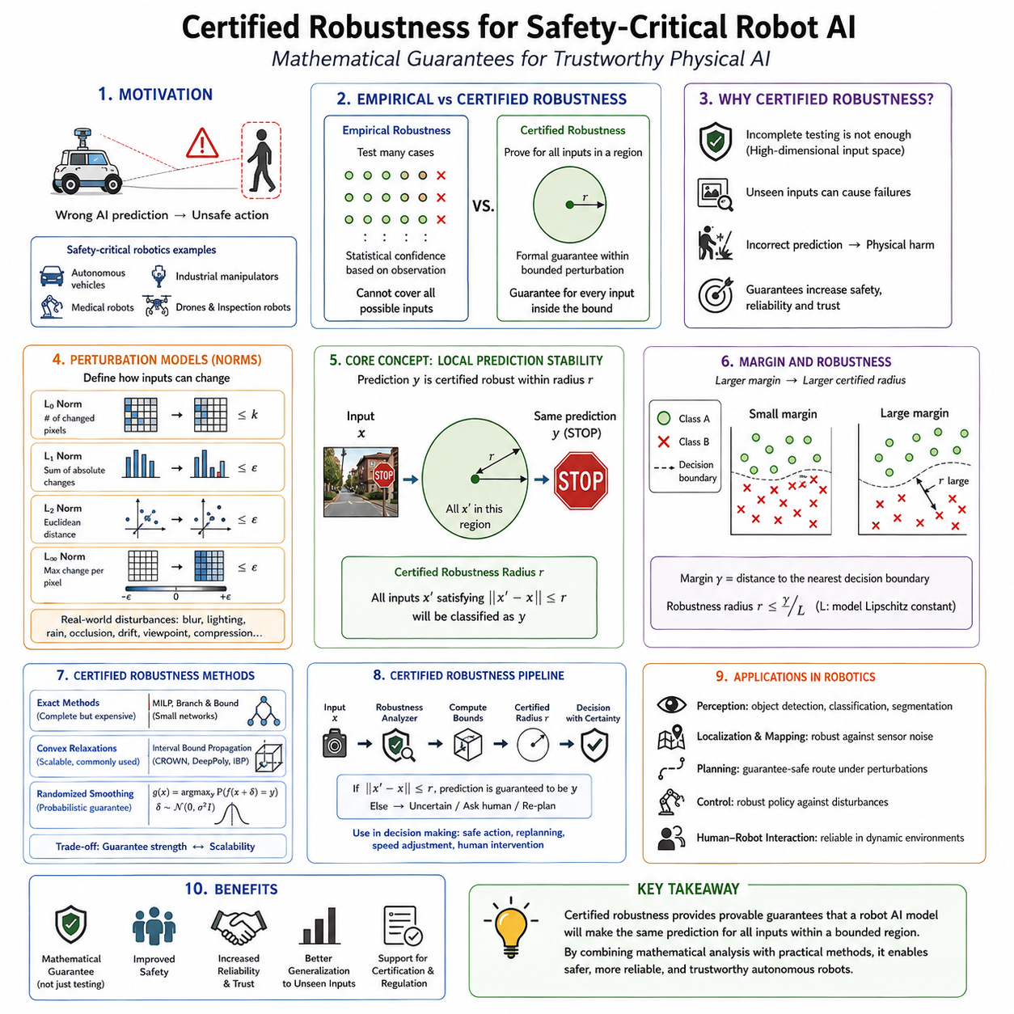
Certified robustness is a branch of trustworthy artificial intelligence that seeks to provide mathematically provable guarantees about the behavior of machine learning models under specified conditions. Unlike empirical robustness, which evaluates a model by testing it against many adversarial examples or benchmark datasets, certified robustness attempts to prove that a neural network will remain stable within well-defined perturbation bounds. In safety-critical robotics, where perception and decision-making directly influence physical actions, such guarantees are highly valuable because they provide confidence that an AI system will behave predictably even when sensor inputs are partially corrupted, noisy, or intentionally manipulated. As autonomous robots become increasingly responsible for transportation, healthcare, industrial automation, infrastructure inspection, collaborative manufacturing, and public services, certified robustness has emerged as one of the foundational technologies for achieving trustworthy Physical AI.
The motivation for certified robustness originates from the limitations of conventional testing. No matter how many test cases engineers evaluate, they can never exhaustively examine every possible input a robot may encounter during years of autonomous operation. Deep neural networks operate within extremely high-dimensional input spaces, making complete empirical validation impossible. A camera image with one million pixels represents an astronomical number of possible input combinations. Even millions of test images explore only a tiny fraction of this space. Consequently, passing benchmark evaluations cannot guarantee safe behavior under unseen conditions. Certified robustness addresses this challenge by replacing exhaustive testing with mathematical reasoning, proving that entire regions of the input space satisfy desired safety properties.
This distinction between empirical robustness and certified robustness is fundamental. Empirical robustness answers the question of whether the model survived a particular collection of attacks or test cases. Certified robustness instead asks whether every possible perturbation inside a mathematically defined region preserves the desired prediction. The first approach provides statistical confidence based on observation, while the second provides formal guarantees derived through mathematical analysis. Although certified guarantees often apply only within bounded perturbation ranges, they eliminate uncertainty inside those bounds and therefore provide a significantly stronger level of assurance.
Safety-critical robotics demands this stronger assurance because incorrect AI predictions may lead to physical harm. An autonomous vehicle misclassifying a traffic sign, a medical robot incorrectly identifying anatomical structures, an industrial manipulator failing to detect a nearby worker, or an autonomous drone misunderstanding environmental obstacles may produce dangerous physical actions. Unlike conventional software applications, robotic AI interacts directly with the physical world. Every perception error has the potential to propagate through planning, motion generation, and control into hazardous behavior. Mathematical guarantees therefore become particularly valuable where human safety depends upon reliable autonomous operation.
Certified robustness is closely related to formal verification, although the two concepts differ slightly. Formal verification generally refers to mathematically proving that a software or hardware system satisfies specified properties. Certified robustness focuses specifically on proving that neural network predictions remain stable under bounded perturbations or environmental uncertainties. In practice, certified robustness forms one specialized branch within the broader discipline of formal verification for intelligent systems.
The fundamental property studied in certified robustness is local prediction stability. Consider an image correctly classified by a robot's perception system. Rather than asking whether this individual image is classified correctly, certified robustness asks whether every image sufficiently similar to the original also receives the same classification. If all nearby inputs produce identical outputs, the prediction possesses a certified robustness radius describing the maximum allowable perturbation before classification could change.
Perturbation regions are generally defined using mathematical distance metrics. The most common formulations involve L0, L1, L2, and L∞ norms, each representing different assumptions regarding possible input variation. L0 perturbations count the number of modified elements regardless of magnitude. L1 perturbations constrain the sum of absolute changes. L2 perturbations limit Euclidean distance, while L∞ perturbations restrict the maximum change applied to any individual input dimension. Different norms correspond to different physical assumptions regarding sensor noise, adversarial attacks, or environmental variation.
The L∞ norm has become particularly common in adversarial robustness research because it models small bounded changes applied independently to every pixel. Although mathematically convenient, no single norm perfectly captures every real-world robotic disturbance. Practical robotic systems encounter motion blur, lighting variation, rain, snow, sensor drift, geometric transformations, partial occlusions, compression artifacts, and viewpoint changes that extend beyond simple norm-bounded perturbations. Consequently, certified robustness increasingly investigates more realistic perturbation models tailored to robotic deployment.
Margin theory provides important intuition regarding robustness. A neural network classifies inputs by partitioning feature space into decision regions separated by boundaries. Predictions located far from decision boundaries exhibit greater robustness because substantial perturbations are required before classification changes. Predictions lying close to boundaries become fragile because even small perturbations may cross into neighboring regions. Certified robustness therefore estimates lower bounds on the distance from each input to the nearest decision boundary.
Lipschitz continuity plays a central role in many certification techniques. A function satisfying a Lipschitz condition cannot change arbitrarily rapidly. Specifically, output changes remain bounded relative to input perturbations by a finite constant. Smaller Lipschitz constants correspond to smoother neural network behavior and generally imply improved robustness. Numerous certification algorithms therefore estimate or constrain Lipschitz constants throughout neural network architectures.
Interval Bound Propagation represents one of the simplest certification techniques. Instead of evaluating single numerical inputs, the method propagates intervals representing all possible perturbations simultaneously through every network layer. Each layer computes conservative upper and lower output bounds, ensuring that all possible perturbed inputs remain contained within these intervals. If output intervals remain sufficiently separated, the prediction receives a formal robustness certificate.
The simplicity of interval propagation makes it computationally attractive for large neural networks. However, conservative interval approximations may accumulate excessive uncertainty as network depth increases, reducing certification tightness. Researchers continue developing improved interval arithmetic methods that balance computational efficiency with stronger guarantees.
Linear relaxation techniques provide another important family of certification algorithms. Nonlinear neural network operations such as ReLU activations are approximated using carefully constructed linear upper and lower bounds. These relaxations transform otherwise intractable nonlinear verification problems into linear optimization problems solvable using established mathematical programming techniques.
Convex relaxation extends this concept further by approximating neural network behavior through convex optimization. Convex problems possess globally optimal solutions computable efficiently using modern optimization algorithms. Although relaxations introduce some conservatism, they frequently provide practical certification for networks substantially larger than those amenable to exact verification.
Mixed Integer Linear Programming offers exact verification for many piecewise linear neural networks. Activation functions such as ReLU naturally admit mixed-integer formulations describing their behavior precisely. Optimization algorithms then determine whether adversarial examples exist within specified perturbation regions. While exact verification provides exceptionally strong guarantees, computational complexity grows rapidly with network size, limiting scalability.
Branch-and-bound algorithms improve scalability by recursively partitioning verification problems into smaller subproblems. Regions easily verified are processed efficiently, while computational effort concentrates upon difficult boundary cases. Modern branch-and-bound methods have significantly expanded the size of networks amenable to formal certification.
Satisfiability Modulo Theories solvers represent another verification approach. Neural network computations are translated into logical constraints solved using automated reasoning systems. These methods prove whether safety properties always hold or identify explicit counterexamples violating specified requirements.
Abstract interpretation originates from classical program analysis and has recently become important for neural network verification. Rather than analyzing individual executions, abstract interpretation reasons about entire sets of possible executions simultaneously using conservative mathematical abstractions. This framework naturally extends to uncertainty propagation within neural networks.
Symbolic analysis provides another formal reasoning strategy. Instead of evaluating concrete numerical inputs, symbolic variables represent entire input ranges. Mathematical manipulation of symbolic expressions then derives output constraints guaranteeing robustness under specified perturbations.
Randomized smoothing represents one of the most influential certified robustness methods. Instead of directly verifying neural network behavior, randomized smoothing constructs a new classifier by averaging predictions across numerous noisy input samples. Statistical analysis proves that this smoothed classifier remains robust within calculable perturbation radii. Unlike many verification techniques limited to relatively small models, randomized smoothing scales effectively to modern deep neural networks.
The intuition behind randomized smoothing is straightforward. If predictions remain consistent despite repeated random perturbations, then sufficiently small adversarial perturbations cannot alter the majority vote. Mathematical concentration inequalities translate this empirical consistency into formal robustness certificates.
Certified adversarial training integrates verification objectives directly into model optimization. Rather than training solely for prediction accuracy, optimization explicitly maximizes certifiable robustness. Loss functions incorporate robustness bounds alongside classification objectives, encouraging neural networks to develop smoother decision boundaries supporting stronger certificates.
Regularization techniques similarly improve certifiability. Weight decay, spectral normalization, Lipschitz regularization, Jacobian penalties, and gradient constraints reduce sensitivity to input perturbations while simultaneously facilitating mathematical verification.
Architectural design significantly influences certified robustness. Some neural network structures naturally admit stronger certification than others. Piecewise linear activation functions simplify verification, while certain normalization methods complicate formal analysis. Consequently, safety-critical robotics increasingly considers verifiability during architecture design rather than treating certification as a purely post-training procedure.
Graph neural networks, transformers, recurrent architectures, diffusion models, and foundation models introduce new certification challenges because their computational structures differ substantially from traditional convolutional neural networks. Current research seeks scalable verification techniques suitable for these increasingly sophisticated architectures.
Perception systems represent one of the most important application domains for certified robustness. Object detection, semantic segmentation, lane recognition, traffic sign classification, human detection, defect inspection, and medical image analysis all influence downstream robotic behavior. Formal guarantees regarding perception stability substantially strengthen overall system safety.
Autonomous driving provides particularly demanding certification requirements. Cameras, LiDAR, radar, GPS, inertial sensors, occupancy prediction, behavior prediction, trajectory planning, and control all interact within tightly coupled decision pipelines. Certifying isolated perception models provides only partial assurance. Increasingly, researchers investigate certification across integrated perception-planning-control architectures.
Mobile robot navigation similarly benefits from certified robustness. Obstacle detectors, traversability estimators, localization modules, semantic mapping systems, and path planners all contribute to navigation safety. Mathematical guarantees regarding environmental interpretation reduce collision risk while improving operational reliability.
Industrial robotics presents somewhat different certification priorities. Manufacturing environments remain more structured than public roads but still contain dynamic workers, changing equipment, maintenance activities, and evolving production layouts. Certified robustness supports reliable human detection, object recognition, manipulation planning, and safety monitoring under controlled yet continuously operating conditions.
Medical robotics demands exceptionally strong assurance because patient safety remains paramount. Anatomical segmentation, instrument recognition, surgical navigation, image registration, and diagnostic support systems increasingly incorporate machine learning. Formal robustness guarantees complement conventional medical device validation by reducing uncertainty regarding AI behavior.
Collaborative robots operating alongside humans require certified perception of worker locations, gestures, body posture, protective equipment, and shared workspaces. Verified detection stability supports safe speed control, collision avoidance, and human-robot interaction.
Uncertainty estimation naturally complements certified robustness. Mathematical guarantees typically apply only within explicitly defined perturbation bounds. Outside these certified regions, probabilistic uncertainty estimates provide additional guidance regarding prediction reliability. Combining formal verification with Bayesian uncertainty estimation therefore yields stronger overall safety than either approach independently.
Out-of-distribution detection similarly complements certification. Certified robustness assumes perturbations remain inside predefined regions surrounding familiar observations. Entirely novel environmental conditions lie outside these assumptions. OOD detection identifies such unfamiliar situations, allowing robots to invoke conservative safety behaviors beyond certified operating regions.
Runtime monitoring extends certification beyond static verification. Sensors continually evaluate environmental conditions, prediction confidence, system health, computational timing, and safety constraints. When runtime observations violate certification assumptions, monitoring systems trigger fallback strategies preserving operational safety.
Safe fallback behavior represents an essential component of practical certified AI. Mathematical guarantees alone cannot anticipate every conceivable environmental condition. Robots therefore require deterministic supervisory controllers capable of reducing speed, increasing safety margins, requesting human assistance, switching sensing modalities, or entering predefined safe states whenever certified assumptions no longer hold.
Certification itself introduces computational tradeoffs. Exact verification often becomes prohibitively expensive for large modern neural networks containing millions or billions of parameters. Consequently, practical systems balance certification strength against computational tractability. Conservative approximations may sacrifice tightness while enabling verification of substantially larger models.
Scalability remains one of the central research challenges. Foundation models, vision-language-action systems, world models, multimodal reasoning architectures, and transformer networks dramatically exceed the scale originally considered by verification algorithms. Extending certified robustness toward these emerging architectures represents an active and rapidly evolving research area.
Benchmarking certified robustness differs significantly from conventional AI evaluation. Rather than measuring only prediction accuracy, benchmarks evaluate certified accuracy, average certified radius, verification time, computational cost, memory requirements, scalability, and robustness under realistic perturbation models. These metrics provide objective comparisons among competing certification algorithms.
Certification standards increasingly influence regulatory frameworks for autonomous systems. Safety standards governing automotive systems, medical devices, industrial automation, aviation, railway transportation, and collaborative robotics increasingly recognize formal verification as an important complement to empirical testing. Although comprehensive AI certification standards remain under development, certified robustness aligns naturally with broader trends toward mathematically grounded safety assurance.
Future robotic systems will likely integrate multiple complementary assurance mechanisms rather than relying exclusively on one technique. Certified robustness will provide mathematical guarantees within well-defined operating regions. Bayesian uncertainty estimation will quantify confidence beyond certified boundaries. Out-of-distribution detection will recognize unfamiliar environments. Runtime monitoring will supervise operational behavior continuously. Formal safety controllers will enforce deterministic constraints independently of learned AI components. Together these mechanisms will create layered safety architectures substantially more reliable than any individual approach.
Advances in hardware acceleration may further improve practical certification. Dedicated verification processors, parallel optimization algorithms, symbolic reasoning accelerators, and AI-specific theorem provers could eventually support real-time certification alongside inference itself. Such developments would enable continuous verification as environmental conditions evolve rather than limiting certification to offline analysis.
Certified robustness also encourages a broader philosophical shift within artificial intelligence engineering. Traditional machine learning emphasizes maximizing predictive performance on benchmark datasets. Safety-critical robotics instead prioritizes predictable behavior, mathematically supported reliability, bounded uncertainty, and provable operational guarantees. Intelligence alone becomes insufficient; trustworthy intelligence requires demonstrable evidence that autonomous decisions remain reliable under clearly specified conditions.
Ultimately, certified robustness represents one of the strongest available approaches for building trustworthy AI in safety-critical robotic systems. By replacing purely empirical confidence with mathematically provable guarantees, it establishes rigorous foundations for reliable autonomous operation despite sensor noise, bounded environmental variation, and adversarial perturbations. Although significant research challenges remain regarding scalability, multimodal architectures, transformer verification, and real-world perturbation modeling, certified robustness has already become an indispensable component of modern AI safety. Combined with uncertainty quantification, runtime monitoring, out-of-distribution detection, deterministic safety supervision, and comprehensive systems engineering, certified robustness provides the formal assurance necessary for deploying autonomous robots responsibly in transportation, manufacturing, healthcare, infrastructure inspection, agriculture, public services, and the next generation of Physical AI systems.

11.06 Dataset Bias Detection and Mitigation [w/Code]
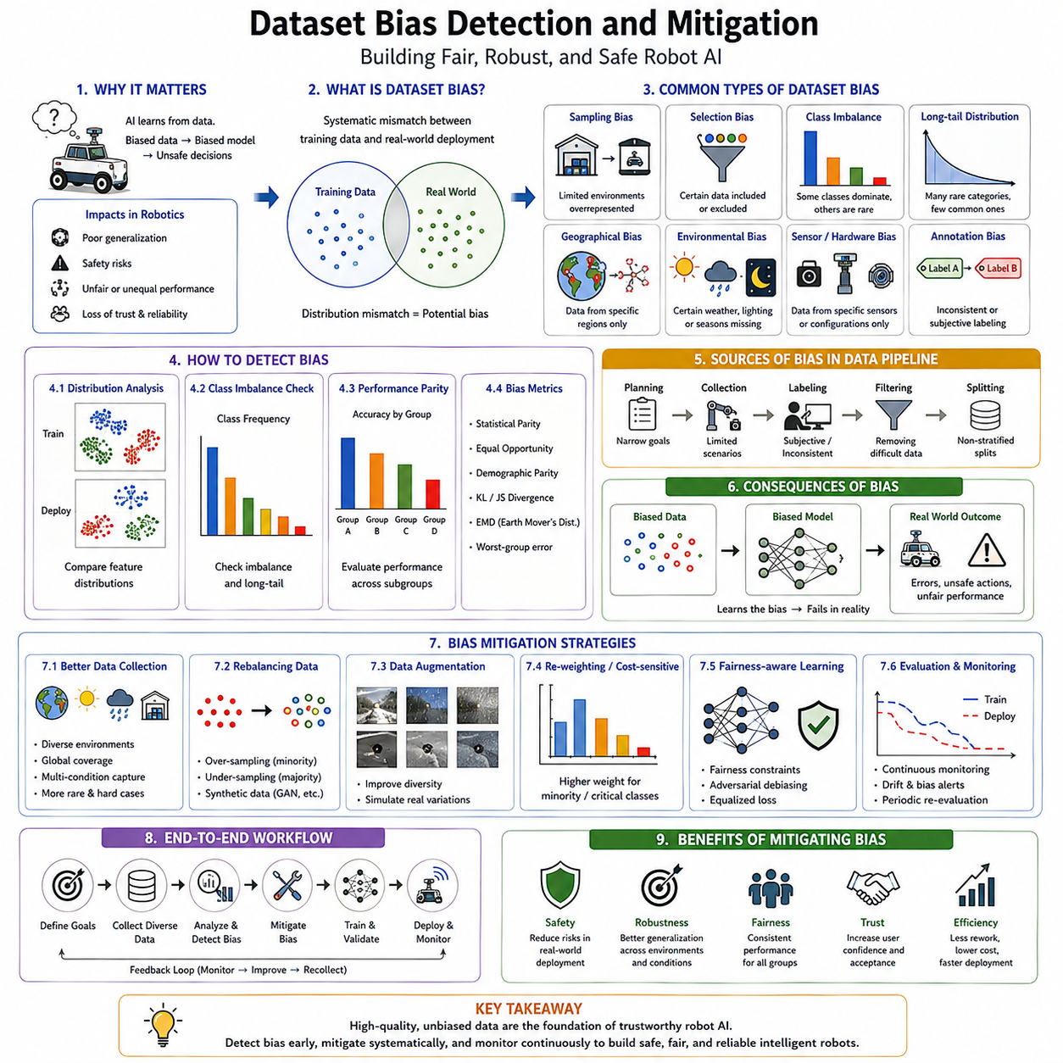
Dataset bias is one of the most significant challenges in modern artificial intelligence because every machine learning model ultimately learns from the data it is provided. Regardless of how sophisticated a neural network architecture may be, its understanding of the world is fundamentally constrained by the quality, diversity, balance, and representativeness of its training dataset. In robotics, autonomous vehicles, industrial automation, medical robotics, warehouse logistics, and intelligent manufacturing, biased datasets can lead to systematic errors that remain hidden during laboratory testing but become critical safety risks during deployment. Dataset bias detection and mitigation therefore form an essential component of AI safety, model reliability, and trustworthy robotic intelligence. Rather than treating bias as merely an ethical concern, robotics engineers increasingly recognize it as an engineering problem directly affecting perception accuracy, navigation reliability, manipulation success, long-term robustness, and operational safety.
The importance of dataset bias originates from the statistical nature of machine learning. Unlike conventional software, which follows explicitly programmed rules, deep learning systems discover patterns from examples. If those examples overrepresent certain environments while underrepresenting others, the resulting model naturally becomes specialized for the dominant conditions and performs poorly elsewhere. The model is not intentionally biased in the human sense; instead, it faithfully learns the statistical structure presented during training. Consequently, improving model reliability requires improving the dataset itself rather than relying solely on more sophisticated neural network architectures.
The concept of dataset bias is broader than simple class imbalance. Any systematic mismatch between the training data distribution and the deployment environment constitutes a potential source of bias. This mismatch may involve object categories, environmental conditions, geographical regions, sensor configurations, weather patterns, illumination, seasonal variation, robot hardware, task diversity, human behavior, operational frequency, or even annotation practices. Every stage of the data lifecycle contributes to the final statistical characteristics learned by the model.
Sampling bias represents one of the earliest and most common forms of dataset bias. It occurs when collected data fail to represent the intended deployment environment adequately. For example, an autonomous warehouse robot trained primarily in modern logistics centers may perform poorly when deployed in older warehouses containing narrower aisles, different shelving systems, lower lighting quality, or unusual storage layouts. Although the robot has learned valid perception strategies, its experience covers only a limited portion of the environments encountered in practice.
Selection bias arises when certain examples are systematically included or excluded during dataset construction. Engineers frequently collect data under convenient conditions because difficult environments require greater effort and expense. Outdoor robots may therefore receive abundant daytime images while relatively few nighttime examples. Medical imaging datasets may contain mostly common diseases while underrepresenting rare conditions. Industrial inspection datasets often emphasize normal products while containing relatively few examples of manufacturing defects. Such imbalances naturally influence the resulting AI model.
Class imbalance represents one of the most familiar manifestations of dataset bias. Some categories appear far more frequently than others, causing optimization algorithms to prioritize dominant classes during training. In robotic perception, common objects such as walls, floors, vehicles, or shelves may dominate datasets, whereas emergency equipment, unusual obstacles, maintenance tools, damaged infrastructure, or rare safety hazards appear infrequently. As a result, models become highly accurate for common categories while exhibiting poor recognition performance precisely for the rare events often most important for operational safety.
Long-tail distributions illustrate this challenge particularly well. Real-world environments naturally contain many frequently occurring objects alongside numerous rare categories. Autonomous vehicles regularly observe roads, buildings, and passenger cars but encounter construction machinery, emergency responders, unusual vehicles, or fallen obstacles relatively infrequently. Warehouse robots repeatedly detect pallets and shelving while only occasionally observing damaged goods, maintenance personnel, or emergency equipment. Effective AI systems must therefore perform reliably across both common and rare situations.
Geographical bias occurs when training data originate primarily from specific locations. Road markings, traffic signs, architectural styles, vegetation, weather conditions, manufacturing equipment, warehouse layouts, hospital designs, agricultural fields, and cultural practices vary substantially across regions. Models trained within one geographical area frequently experience degraded performance elsewhere despite apparently similar tasks. Robots deployed internationally therefore require datasets reflecting global operational diversity rather than local convenience.
Environmental bias constitutes another major concern for robotics. Lighting conditions, seasonal changes, weather phenomena, dust, fog, rain, snow, smoke, reflections, shadows, and background clutter all influence sensor observations. Datasets collected primarily under favorable environmental conditions fail to prepare AI systems for realistic deployment where operating conditions continually evolve. Since robots often function continuously throughout changing environments, environmental diversity becomes essential for robust perception.
Temporal bias emerges because data collection typically occurs over limited time intervals. Factories introduce new equipment, warehouses reorganize inventory, hospitals renovate facilities, roads undergo maintenance, vegetation grows, agricultural fields change seasonally, and urban infrastructure evolves continuously. Models trained using historical datasets gradually become outdated as deployment environments change over time. Continuous dataset maintenance therefore becomes necessary for long-term robotic reliability.
Sensor bias reflects differences among sensing hardware. Camera resolution, lens characteristics, color calibration, exposure settings, dynamic range, LiDAR beam patterns, radar frequency, GPS accuracy, inertial measurement quality, and depth sensing technology all influence collected data. A model trained using one sensor configuration may generalize poorly when deployed using slightly different hardware. Sensor diversity during dataset construction therefore improves deployment robustness across hardware platforms.
Annotation bias represents another critical but often overlooked challenge. Human annotators inevitably introduce subjective interpretation into labeled datasets. Different individuals may disagree regarding object boundaries, semantic categories, action labels, navigation affordances, manipulation success, or environmental interpretation. Inconsistent labeling creates ambiguous supervision signals that limit achievable model accuracy regardless of network architecture.
Label noise further complicates dataset quality. Human fatigue, misunderstanding, annotation software limitations, ambiguous images, difficult environmental conditions, or simple mistakes produce incorrect labels. Since supervised learning assumes labels accurately describe ground truth, label noise directly influences learned decision boundaries. Large datasets often contain thousands of labeling errors that remain unnoticed without systematic quality assurance procedures.
Confirmation bias may also influence annotation processes. Annotators aware of expected outcomes sometimes unconsciously reinforce preconceived assumptions rather than objectively interpreting observations. Blind annotation protocols and independent review processes reduce such effects while improving overall dataset reliability.
Automation bias increasingly affects semi-automatic annotation workflows. Modern labeling systems frequently employ pretrained AI models to accelerate annotation, after which human reviewers correct predicted labels. Although efficient, reviewers often accept incorrect AI suggestions more readily than independently generated annotations, allowing systematic errors to propagate throughout datasets.
Measurement bias originates from imperfections in sensing systems themselves. Camera distortion, calibration errors, synchronization problems, communication latency, motion blur, GPS drift, LiDAR reflection artifacts, and environmental interference influence recorded observations. Unless datasets capture these realistic imperfections, deployed models may fail under practical operating conditions despite excellent laboratory performance.
Simulation bias has become increasingly important as synthetic datasets expand. High-fidelity simulators generate enormous quantities of labeled data for autonomous driving, manipulation, locomotion, warehouse automation, and drone navigation. However, simulated environments inevitably differ from physical reality. Differences in lighting, textures, physics, sensor noise, material properties, human behavior, or environmental complexity create sim-to-real gaps influencing deployment performance.
Task bias occurs when datasets emphasize only a subset of intended operational objectives. A manipulation dataset focusing primarily on grasping rigid objects may provide insufficient experience with deformable materials, transparent containers, articulated mechanisms, flexible cables, or hazardous equipment. Similarly, navigation datasets emphasizing obstacle avoidance may underrepresent long-term planning or human interaction.
Behavioral bias frequently appears in imitation learning. Human demonstrations collected from expert operators may represent only preferred strategies while omitting alternative yet equally valid solutions. Consequently, learned policies inherit demonstration preferences rather than discovering broader behavioral flexibility. Collecting demonstrations from multiple operators with diverse strategies improves policy generalization.
Reinforcement learning datasets introduce additional bias through exploration strategies. Agents naturally encounter states favored by their current policies while rarely exploring unusual or difficult situations. Offline reinforcement learning therefore depends strongly on dataset diversity because unseen state-action combinations cannot be learned after deployment.
Foundation models present new dataset challenges because training data originate from enormous internet-scale collections. Although such datasets provide exceptional diversity, they also contain duplicated content, noisy labels, inconsistent quality, historical artifacts, and domain imbalances. Robotics applications often require additional domain-specific fine-tuning to overcome these broad statistical biases.
Detecting dataset bias begins with comprehensive statistical analysis. Class frequency distributions reveal imbalance among object categories, environmental conditions, task types, and operational scenarios. Simple visualization often exposes substantial disparities requiring correction before model training begins.
Data visualization techniques provide intuitive understanding of dataset composition. Histograms, confusion matrices, embedding projections, clustering analyses, dimensionality reduction methods, and similarity graphs reveal hidden statistical structures difficult to identify through numerical summaries alone. Feature-space visualization frequently uncovers clusters representing underrepresented deployment conditions.
Distribution comparison forms another essential detection strategy. Statistical tests compare training datasets with validation data, operational logs, simulation environments, or deployment observations. Significant distribution differences indicate potential bias requiring further investigation. Distance metrics such as Kullback-Leibler divergence, Jensen-Shannon divergence, Wasserstein distance, and Maximum Mean Discrepancy quantify distribution differences mathematically.
Coverage analysis evaluates how completely datasets represent intended deployment scenarios. Engineers define operational design domains describing expected environmental conditions, sensor configurations, weather patterns, geographic regions, task types, object categories, and human interactions. Dataset coverage is then measured relative to these requirements, identifying underrepresented operational conditions.
Rare-event analysis receives particular attention in safety-critical robotics. Hazardous situations often occur infrequently yet carry severe consequences. Emergency vehicles, equipment failures, damaged infrastructure, medical emergencies, unusual obstacles, construction zones, and extreme weather require explicit representation despite their rarity. Dataset audits therefore examine not only common scenarios but also low-frequency high-consequence events.
Bias detection increasingly incorporates model behavior rather than dataset statistics alone. Performance stratification measures prediction accuracy separately across environmental conditions, object categories, weather, illumination, geographical regions, or operational scenarios. Significant performance variation frequently indicates underlying dataset bias.
Confusion matrix analysis identifies systematic prediction errors associated with specific categories or operating conditions. Repeated misclassification patterns often reveal insufficient representation of particular classes during training.
Feature embedding analysis provides additional insight. Deep neural networks transform raw observations into high-dimensional feature representations. Clustering algorithms applied to these embeddings reveal whether deployment data occupy regions well represented during training or extend into previously unexplored areas.
Mitigating dataset bias generally begins with improved data collection rather than algorithmic modification. The most effective solution often involves acquiring additional examples representing underrepresented environments, object categories, weather conditions, sensor configurations, or operational scenarios. Expanding dataset diversity directly improves model generalization by exposing learning algorithms to broader statistical variation.
Balanced sampling constitutes one of the simplest mitigation techniques. During training, underrepresented classes receive proportionally greater sampling frequency while dominant classes are sampled less aggressively. Balanced mini-batches prevent optimization algorithms from focusing excessively on common categories.
Weighted loss functions further compensate for class imbalance. Prediction errors involving rare classes receive greater optimization weight than errors involving common categories. Consequently, the learning algorithm allocates more capacity toward difficult or underrepresented situations without requiring perfectly balanced datasets.
Data augmentation artificially increases dataset diversity through controlled transformations. Images may undergo rotation, translation, scaling, illumination variation, blur, weather simulation, occlusion, color modification, geometric distortion, or sensor noise injection. Although augmentation cannot replace genuine environmental diversity, it substantially improves robustness against moderate distribution variation.
Domain randomization extends augmentation into simulation environments. Rather than generating visually realistic scenes, simulation parameters vary aggressively across textures, lighting, object placement, physics, weather, sensor characteristics, and environmental appearance. Models trained under extensive randomization often generalize surprisingly well to physical deployment because they learn robust invariant representations.
Synthetic data generation has become increasingly important for robotics. Simulation platforms generate rare hazardous scenarios, unusual environmental conditions, diverse object arrangements, and perfectly labeled sensor observations difficult or expensive to collect physically. Synthetic datasets complement real-world data by filling coverage gaps while reducing annotation costs.
Active learning provides another effective mitigation strategy. Instead of collecting data randomly, active learning identifies observations expected to provide maximum information for improving model performance. Human annotation resources therefore focus specifically on uncertain, rare, or underrepresented examples rather than abundant familiar situations.
Continual learning further addresses evolving dataset bias after deployment. Operational robots continuously encounter new environments and scenarios unavailable during initial training. Carefully validated deployment data may be incorporated into subsequent retraining cycles, gradually expanding model competence while preserving previously acquired knowledge.
Human-in-the-loop systems support ongoing dataset improvement. Operators review uncertain predictions, correct labeling errors, identify novel situations, and validate automatically collected data. This collaborative approach combines autonomous data collection with expert supervision, maintaining dataset quality throughout long-term deployment.
Dataset version control has become increasingly important for production AI systems. Every dataset revision, annotation update, collection procedure, preprocessing step, and quality improvement should be tracked systematically. Version management enables reproducible experiments while supporting regression analysis when unexpected model behavior emerges.
Data governance establishes organizational processes ensuring long-term dataset quality. Collection protocols, annotation standards, validation procedures, metadata management, privacy protection, documentation requirements, and lifecycle maintenance all contribute to sustainable AI development.
Benchmarking dataset quality extends beyond measuring dataset size alone. Diversity, balance, annotation consistency, environmental coverage, sensor variation, geographical representation, temporal stability, rare-event frequency, and operational relevance all influence deployment success. Modern robotics increasingly evaluates datasets according to these multidimensional quality metrics.
Foundation models introduce opportunities for reducing dataset bias through large-scale pretraining. Rich self-supervised representations learned from diverse multimodal datasets often generalize substantially better than task-specific supervised models. Nevertheless, robotics applications still require carefully curated domain-specific datasets capturing operational environments accurately.
Future robotic systems will likely employ continuously evolving datasets maintained throughout operational lifecycles. Autonomous data collection, online validation, continual learning, active sampling, simulation augmentation, foundation model adaptation, and human oversight will cooperate to reduce bias progressively as robots accumulate operational experience.
Ultimately, dataset bias detection and mitigation represent far more than data preprocessing tasks. They constitute fundamental engineering disciplines determining the reliability, safety, robustness, fairness, and long-term operational success of artificial intelligence systems. Every neural network reflects the statistical properties of its training data, making dataset quality inseparable from model quality. By systematically identifying sampling bias, class imbalance, environmental gaps, annotation inconsistencies, sensor variation, temporal drift, and deployment mismatches, robotics engineers create AI systems capable of reliable operation across diverse real-world environments. Combined with uncertainty estimation, out-of-distribution detection, continual learning, adversarial robustness, runtime monitoring, and comprehensive safety engineering, careful dataset bias management provides one of the essential foundations for trustworthy Physical AI and the next generation of intelligent autonomous robotic systems.

11.07 AI Model Interpretability GradCAM SHAP [w/Code]
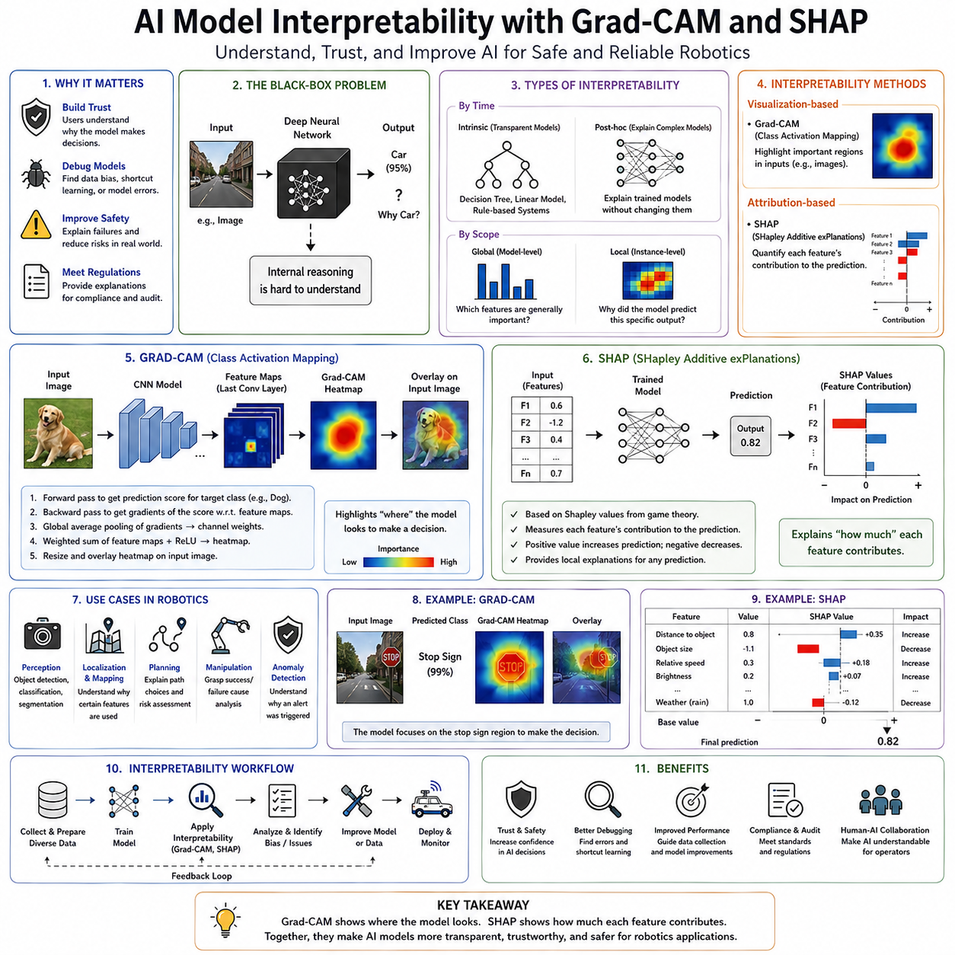
AI model interpretability is the field of artificial intelligence that seeks to explain how and why machine learning models produce their predictions. While modern deep neural networks have achieved remarkable performance across computer vision, natural language processing, robotics, autonomous driving, medical diagnosis, industrial inspection, and scientific discovery, they often operate as highly complex nonlinear systems whose internal reasoning is difficult for humans to understand. In safety-critical robotics, this lack of transparency presents significant challenges because engineers, operators, regulators, and users must trust that autonomous systems make decisions for appropriate reasons rather than relying on accidental correlations or hidden biases. AI model interpretability therefore has become a fundamental component of trustworthy artificial intelligence, complementing model accuracy, robustness, uncertainty estimation, and formal verification by providing insight into the internal decision-making process.
The motivation for interpretability arises from the difference between predictive performance and human understanding. A neural network may consistently classify objects correctly while providing no explanation regarding which image regions influenced its decision. Similarly, a reinforcement learning policy may navigate complex environments successfully without revealing the internal reasoning behind specific motion choices. Although such systems demonstrate impressive capability, engineers cannot easily determine whether the model has learned meaningful semantic concepts or merely exploited statistical shortcuts within the training data. Interpretability provides the tools needed to investigate these internal representations and evaluate whether model behavior aligns with human expectations.
Traditional machine learning algorithms often possess relatively high interpretability. Linear regression models explicitly associate each input variable with a learned coefficient describing its influence on the output. Decision trees reveal hierarchical decision paths that humans can inspect directly. Rule-based expert systems consist of explicit logical statements understandable by domain experts. Deep neural networks, however, may contain millions or even billions of parameters organized across hundreds of nonlinear layers. Their learned representations emerge through optimization rather than manual design, making direct interpretation extremely difficult.
This challenge is commonly described as the “black-box” problem. Inputs enter the model, outputs emerge after complex computation, but the internal transformations remain largely opaque to human observers. Although every mathematical operation inside the network is known precisely, the enormous complexity of modern architectures prevents intuitive understanding. AI interpretability attempts to illuminate these hidden computational processes using visualization, attribution, sensitivity analysis, probabilistic reasoning, and explanatory algorithms.
Interpretability serves several important objectives within robotics. The first is trust. Human operators supervising autonomous robots naturally seek explanations when systems make unexpected decisions. A warehouse robot selecting an unusual route, an autonomous vehicle braking unexpectedly, or a collaborative manipulator rejecting an apparently valid grasp all raise questions requiring understandable explanations. Transparent models increase operator confidence because unusual behavior can be investigated rather than simply accepted.
The second objective is debugging. Neural networks occasionally learn unintended strategies during training. Rather than recognizing meaningful semantic features, they may exploit background textures, lighting artifacts, camera positioning, annotation errors, or dataset biases. Without interpretability tools, these hidden shortcuts remain invisible until deployment failures occur. Visualization techniques allow engineers to identify such undesirable behavior early in development.
Safety represents another major motivation. Autonomous robots interact directly with the physical world through motion, manipulation, navigation, and human collaboration. Understanding why a perception system failed to detect an obstacle or why a planning network selected a risky trajectory enables systematic improvement while reducing future operational risks.
Interpretability also supports regulatory compliance. Medical devices, autonomous vehicles, industrial automation systems, and safety-critical robotics increasingly require evidence that AI decisions remain understandable and auditable. Regulatory authorities often demand explanations supporting automated decisions before approving deployment in high-risk environments.
Interpretability methods are generally categorized into intrinsic interpretability and post-hoc interpretability. Intrinsically interpretable models possess architectures naturally understandable by humans. Linear models, decision trees, sparse rule systems, and generalized additive models belong to this category. Their internal structure directly reveals decision logic without requiring additional explanation algorithms.
Deep learning systems generally require post-hoc interpretability because their internal representations remain too complex for direct inspection. Post-hoc methods analyze trained models after optimization, generating explanations without modifying the underlying architecture. These methods seek to explain model behavior rather than simplifying the model itself.
Interpretability methods may also be categorized according to scope. Global interpretability attempts to explain the overall behavior of an entire model. Engineers investigate which features the model generally considers important, how decision boundaries are organized, or how internal representations evolve across layers. Local interpretability instead explains individual predictions, identifying precisely why one specific decision occurred for one particular input.
Feature attribution constitutes one of the most widely used interpretability approaches. Rather than explaining complete neural computations, attribution methods estimate how strongly each input feature contributes to the final prediction. In computer vision, attribution identifies influential image regions. In robotics, attribution may reveal which LiDAR measurements, camera pixels, force sensor readings, or proprioceptive observations guided autonomous decisions.
Gradient-based methods represent one major family of attribution techniques. Neural networks are differentiable mathematical functions, allowing gradients to describe how sensitive predictions remain to small input changes. Features producing large gradients generally exert greater influence on final predictions than features associated with small gradients.
Saliency maps provide one of the earliest gradient-based visualization methods. The gradient of the predicted class score with respect to every input pixel is calculated, producing an importance map highlighting regions most strongly influencing classification. Bright regions indicate pixels where small modifications significantly alter prediction confidence.
Although conceptually simple, raw saliency maps frequently appear noisy because gradients fluctuate substantially across neighboring pixels. Various smoothing and regularization techniques improve visualization quality while preserving meaningful attribution information.
Guided backpropagation extends ordinary saliency analysis by modifying gradient propagation through activation functions. Negative gradients are selectively suppressed, producing cleaner visualizations emphasizing features positively contributing to predictions. Although visually appealing, guided backpropagation sacrifices certain theoretical properties for improved interpretability.
Integrated Gradients address several limitations of conventional gradient methods. Rather than evaluating gradients only at the observed input, gradients are integrated along a continuous path connecting a baseline reference input to the actual observation. This procedure accumulates feature importance throughout the interpolation trajectory, producing more stable and theoretically grounded attribution scores.
One attractive property of Integrated Gradients is completeness. The sum of all feature attributions equals the difference between the model output for the actual input and the baseline input. This mathematical property improves interpretability by ensuring all contributions collectively explain the prediction.
SmoothGrad further improves gradient visualization through statistical averaging. Multiple noisy versions of the input are generated, gradients are calculated independently, and the results are averaged. Random noise cancels unstable gradient fluctuations while reinforcing consistently important features, producing clearer attribution maps.
Among all interpretability methods developed for convolutional neural networks, Gradient-weighted Class Activation Mapping, commonly known as Grad-CAM, has become one of the most influential and widely adopted techniques. Grad-CAM provides intuitive visual explanations by identifying image regions responsible for specific predictions while preserving the spatial structure of the original image.
The central idea behind Grad-CAM is remarkably elegant. Instead of analyzing gradients with respect to individual input pixels, Grad-CAM examines gradients flowing into the final convolutional feature maps. These feature maps retain rich spatial information describing object locations and semantic structures extracted throughout earlier network layers.
For a given predicted class, Grad-CAM computes gradients of the class score with respect to every feature map in the final convolutional layer. Global average pooling summarizes the importance of each feature map into scalar weights representing their contribution to the prediction. These weights are then used to compute a weighted combination of the feature maps themselves, producing a coarse localization map highlighting regions responsible for the prediction.
The resulting heatmap identifies areas the neural network considered most important when making its decision. Unlike pixel-level gradient methods, Grad-CAM naturally emphasizes semantically meaningful object regions because final convolutional layers encode high-level visual concepts rather than low-level image details.
Grad-CAM possesses several important advantages. It remains architecture independent for convolutional neural networks, requires only gradient computation without model retraining, produces intuitive visualizations understandable by non-experts, and preserves sufficient spatial resolution for practical debugging. Consequently, Grad-CAM has become a standard interpretability tool throughout computer vision research.
Grad-CAM++ extends the original formulation by improving localization when multiple object instances contribute simultaneously to predictions. Modified weighting strategies produce more accurate attribution maps, particularly for images containing several objects of the same category.
Score-CAM eliminates gradient computation entirely by evaluating feature importance through forward inference. Individual activation maps mask the original input, and resulting prediction changes determine feature significance. Although computationally more expensive than Grad-CAM, Score-CAM avoids certain gradient-related artifacts while improving localization quality.
Layer-CAM generalizes class activation mapping across multiple network layers simultaneously. Lower layers contribute fine spatial detail, while deeper layers encode semantic concepts. Combining information across scales produces richer explanations capturing both precise localization and high-level understanding.
Transformer architectures require new interpretability techniques because they replace convolutional feature maps with self-attention mechanisms. Attention visualization displays relationships among image patches or language tokens, revealing how information propagates throughout transformer computations. Although attention weights do not always correspond directly to causal importance, they provide valuable insight into model reasoning.
Attention rollout aggregates attention matrices across transformer layers, tracing information flow throughout deep architectures. This technique reveals long-range dependencies difficult to visualize using individual attention layers independently.
Beyond gradient-based visualization, perturbation methods explain predictions by systematically modifying inputs and observing output changes. Features whose removal significantly alters predictions receive greater importance than features producing little effect.
Occlusion sensitivity exemplifies this approach. Small regions of the input image are masked sequentially while recording prediction confidence. If covering a particular region substantially reduces confidence, that region likely contributes strongly to the prediction. Although computationally intensive, occlusion analysis provides intuitive causal evidence supporting feature importance.
Local Interpretable Model-Agnostic Explanations, commonly abbreviated as LIME, represents one of the most influential model-agnostic interpretability methods. Rather than analyzing neural network internals directly, LIME approximates local model behavior using simple interpretable surrogate models.
The procedure begins by generating numerous perturbed versions of the input through random feature modifications. The original black-box model predicts outputs for each perturbed sample. A weighted linear regression model then approximates the relationship between perturbed inputs and predictions within the local neighborhood surrounding the original observation.
Because linear models remain inherently interpretable, feature coefficients reveal local importance despite the underlying model remaining highly nonlinear. LIME therefore provides explanations applicable to virtually any predictive model regardless of architecture.
Although highly flexible, LIME explanations depend upon perturbation sampling strategies, neighborhood definitions, and surrogate model selection. Different parameter choices occasionally produce different explanations, highlighting the importance of careful experimental design.
SHAP, which stands for SHapley Additive exPlanations, provides one of the most theoretically rigorous interpretability frameworks currently available. SHAP derives feature importance from cooperative game theory, specifically the concept of Shapley values originally developed for allocating rewards among cooperating players.
Within machine learning, each input feature corresponds to a player participating in the prediction game. The overall prediction represents the collective reward generated by feature cooperation. Shapley values quantify the average marginal contribution of every feature across all possible subsets of collaborating features.
The mathematical elegance of SHAP arises from several desirable theoretical properties. Efficiency ensures that feature contributions sum exactly to the model prediction difference relative to a baseline. Symmetry guarantees equal attribution for equally important features. Dummy features receive zero importance, and additivity supports combining explanations across multiple models.
Exact Shapley value computation requires evaluating every possible feature subset, producing exponential computational complexity impractical for high-dimensional neural networks. Consequently, practical SHAP implementations employ approximation algorithms specialized for different model classes.
Kernel SHAP provides a model-agnostic approximation applicable to virtually any predictive system. Sampling strategies estimate Shapley values without requiring exhaustive subset evaluation. Although computationally demanding, Kernel SHAP supports broad applicability across diverse machine learning models.
Deep SHAP combines DeepLIFT with Shapley approximation principles specifically for deep neural networks. Gradient information accelerates computation while preserving many desirable theoretical characteristics.
Tree SHAP exploits decision tree structure to compute exact Shapley values efficiently. Although primarily designed for tree-based models, its success demonstrates the importance of architecture-specific optimization within interpretability research.
SHAP visualizations provide rich insight into model behavior. Summary plots reveal globally important features across entire datasets. Force plots illustrate how individual features push predictions toward different outcomes. Dependence plots show how feature importance varies across different feature values. Decision plots visualize cumulative feature contributions throughout prediction formation.
Robotics applications benefit substantially from SHAP because autonomous decisions frequently depend upon numerous interacting sensor measurements. Camera features, LiDAR returns, inertial observations, force measurements, localization estimates, battery status, environmental variables, and historical context all contribute simultaneously to planning decisions. SHAP decomposes these complex interactions into understandable feature contributions.
Interpretability also supports reinforcement learning. Policy networks mapping observations directly into actions often appear particularly opaque because intermediate reasoning remains implicit. Attribution techniques reveal environmental features influencing policy decisions, enabling engineers to detect undesirable strategies or unintended reward exploitation.
World models and foundation models introduce additional interpretability challenges because they integrate multimodal perception, memory, planning, reasoning, and language understanding. Individual attention maps or feature attributions provide only partial explanations for these highly interconnected architectures. Consequently, research increasingly investigates concept-based explanations representing higher-level semantic reasoning rather than individual feature importance.
Concept Activation Vectors represent one promising direction. Rather than attributing importance to pixels or numerical features, concepts such as doors, humans, obstacles, road boundaries, or graspable objects become interpretable semantic units. This aligns explanations more closely with human reasoning.
Counterfactual explanations provide another complementary approach. Instead of identifying influential features, counterfactual methods answer questions regarding what minimal changes would alter the prediction. For example, an autonomous robot might explain that increasing obstacle distance or improving illumination would change a navigation decision.
Interpretability also assists dataset bias detection. Visualization methods frequently reveal models focusing on irrelevant background textures, camera artifacts, watermarks, timestamps, or annotation inconsistencies rather than meaningful semantic content. Correcting these hidden biases significantly improves generalization.
Model debugging benefits substantially from explanation techniques. Engineers investigate prediction failures by comparing attribution maps across successful and unsuccessful cases. Unexpected feature importance often reveals architectural weaknesses, insufficient training diversity, annotation errors, or preprocessing problems.
Interpretability nevertheless possesses important limitations. Explanations frequently approximate rather than exactly represent internal reasoning. Different interpretability methods occasionally produce inconsistent feature attributions. Human interpretation of visualization results introduces additional subjectivity. Consequently, explanations should complement rather than replace rigorous empirical evaluation.
Computational overhead also influences practical deployment. SHAP, perturbation analysis, occlusion sensitivity, and ensemble explanation methods often require substantially greater computation than ordinary inference. Offline debugging generally tolerates these costs, whereas real-time robotic deployment may require simplified explanation mechanisms.
Future research increasingly emphasizes inherently interpretable foundation models, causal explanations, concept-level reasoning, multimodal interpretability, explanation consistency, uncertainty-aware explanations, and human-centered explanation interfaces. As robotic intelligence becomes increasingly sophisticated, explanations must evolve beyond isolated feature attribution toward comprehensive descriptions of planning, memory, reasoning, and long-term decision processes.
Ultimately, AI model interpretability transforms deep learning from purely predictive systems into systems whose reasoning can be investigated, validated, improved, and trusted. Techniques such as Grad-CAM, SHAP, Integrated Gradients, LIME, attention visualization, perturbation analysis, and concept-based explanations provide complementary perspectives on neural network behavior. Rather than replacing predictive accuracy, interpretability strengthens trustworthy artificial intelligence by enabling engineers to understand why models succeed, diagnose why they fail, identify hidden biases, improve robustness, support regulatory compliance, and establish human confidence in autonomous systems. As Physical AI continues advancing toward increasingly capable robots operating within safety-critical environments, interpretability will remain an indispensable foundation for transparent, explainable, accountable, and reliable intelligent robotic behavior.

11.08 Runtime Safety Monitor for AI Outputs [w/Code]
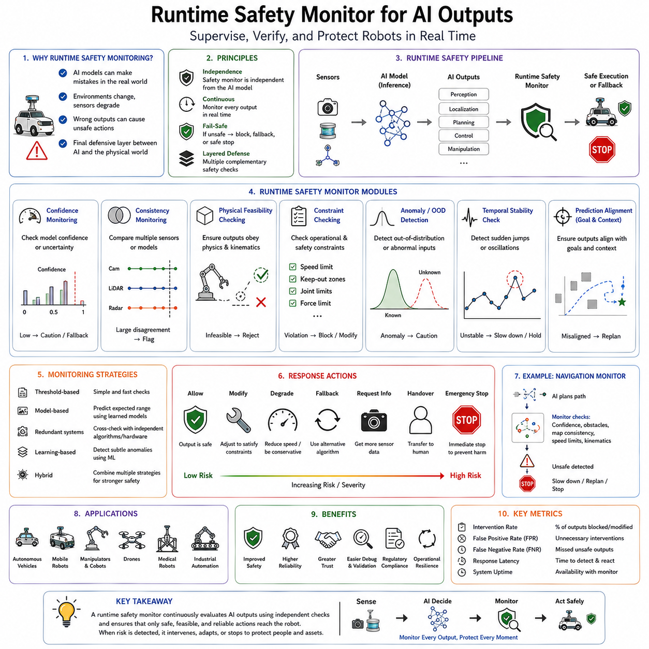
A Runtime Safety Monitor for AI outputs is a supervisory system that continuously observes the predictions, decisions, and actions generated by artificial intelligence models during robot operation and determines whether those outputs remain safe before they are allowed to influence the physical world. Unlike offline validation, model testing, or simulation-based verification performed before deployment, runtime safety monitoring operates continuously while the robot is actively executing tasks. Every perception result, localization estimate, navigation command, manipulation action, trajectory, language instruction, or autonomous decision passes through one or more safety monitors before reaching actuators. This additional supervisory layer acts as the final defensive barrier between intelligent decision-making and physical execution, ensuring that unexpected AI behavior does not immediately translate into hazardous robot actions. As autonomous robots become increasingly capable through deep learning, reinforcement learning, foundation models, vision-language-action architectures, and multimodal reasoning systems, runtime safety monitoring has become one of the most essential components of trustworthy Physical AI.
The need for runtime monitoring arises because no artificial intelligence model can be proven correct for every possible real-world situation. Training datasets inevitably remain incomplete, deployment environments evolve over time, sensors degrade, hardware ages, communication delays occur, and unexpected events continually arise. Even highly accurate AI systems occasionally produce incorrect predictions or unstable decisions when confronted with unfamiliar situations. Since robots operate within dynamic physical environments where incorrect outputs may endanger people, equipment, or infrastructure, every autonomous decision must be evaluated continuously while the robot remains operational.
Traditional robotics relied primarily on deterministic control systems. Engineers designed explicit state machines, rule-based planners, collision detection algorithms, emergency stop circuits, and hardware safety interlocks whose behavior could be analyzed mathematically. Artificial intelligence fundamentally changes this engineering paradigm because learned models generate decisions statistically rather than through explicitly programmed logic. While AI dramatically improves perception, planning, manipulation, and adaptation, it simultaneously introduces uncertainty regarding internal decision processes. Runtime safety monitors compensate for this uncertainty by independently supervising AI outputs rather than trusting them unconditionally.
One of the central principles of runtime safety monitoring is architectural separation. The safety monitor should remain logically independent from the AI model it supervises. If the same neural network both generates and validates decisions, systematic failures may propagate through both functions simultaneously. Instead, deterministic algorithms, independent sensors, redundant perception systems, formally verified controllers, or simplified rule-based safety modules evaluate AI outputs before physical execution occurs. This separation significantly increases system robustness because failures within the primary AI model do not necessarily compromise the safety supervisor.
Runtime monitoring differs fundamentally from ordinary model evaluation. Offline testing examines performance using previously collected datasets under controlled laboratory conditions. Runtime monitoring instead evaluates live operational behavior continuously as environmental conditions evolve. Every sensor update, every navigation command, every manipulation trajectory, and every planning decision becomes an opportunity to detect abnormal behavior before unsafe execution occurs.
The runtime safety pipeline generally begins immediately after AI inference. Sensor data first pass through perception models, localization algorithms, semantic understanding modules, or policy networks. Instead of directly commanding motors or manipulators, these outputs enter one or more monitoring modules responsible for evaluating confidence, consistency, physical feasibility, operational constraints, and safety requirements. Only outputs satisfying predefined safety criteria proceed toward execution. Otherwise, corrective actions, fallback behaviors, or emergency responses become activated.
Confidence monitoring represents one of the simplest runtime safety mechanisms. Modern AI models increasingly estimate confidence alongside predictions. Low-confidence outputs indicate uncertainty regarding the model's interpretation of the current situation. Rather than executing uncertain decisions directly, robots may reduce speed, request additional sensor observations, invoke alternative algorithms, or transfer control to human operators. Confidence thresholds therefore provide an initial layer of runtime risk management.
However, confidence alone rarely provides sufficient protection. Deep neural networks frequently produce overconfident predictions, particularly under out-of-distribution conditions. Consequently, runtime monitors combine confidence estimates with numerous additional safety criteria rather than relying upon probability values alone.
Consistency monitoring evaluates agreement among multiple information sources. A robot equipped with cameras, LiDAR, radar, inertial sensors, GPS, wheel encoders, force sensors, and depth cameras receives overlapping descriptions of the environment. Significant disagreement among these sensors often indicates sensor failure, environmental anomalies, calibration drift, or AI prediction errors. Runtime monitors therefore compare independent sensor estimates continuously, detecting inconsistencies requiring further investigation.
Temporal consistency provides another important monitoring mechanism. Physical environments generally evolve continuously rather than changing abruptly between consecutive observations. Object identities, robot position, obstacle locations, and environmental geometry should vary smoothly according to physical motion. Sudden discontinuities in AI predictions frequently indicate perception failures, sensor corruption, or unstable inference rather than genuine environmental change.
Spatial consistency similarly constrains AI outputs. Objects cannot occupy physically impossible positions, penetrate solid surfaces, violate geometric relationships, or disappear instantaneously without explanation. Runtime safety monitors evaluate predictions against known physical constraints before permitting execution. Such reasoning often detects errors that individual neural networks overlook.
Physical feasibility checking extends this principle into robot control. Planned trajectories, manipulator motions, wheel velocities, joint accelerations, actuator torques, battery usage, thermal loads, and dynamic stability must all satisfy physical limitations imposed by the robot itself. Even if an AI planner proposes an apparently reasonable trajectory, deterministic safety controllers verify that actuators can execute it safely within hardware constraints.
Kinematic monitoring evaluates joint positions, velocities, accelerations, singularities, workspace boundaries, collision margins, and reachability constraints. Manipulation systems continuously verify that generated trajectories remain mechanically feasible before commanding actuators. Inverse kinematics failures, excessive joint motion, or workspace violations trigger corrective intervention before execution.
Dynamic monitoring considers forces, torques, momentum, inertia, balance, and contact interactions. Mobile robots evaluate stability margins during navigation, legged robots monitor balance during locomotion, and manipulators estimate contact forces during grasping. Dynamic violations indicate increased operational risk even when geometric constraints remain satisfied.
Collision monitoring constitutes one of the most critical runtime safety functions. AI perception systems identify obstacles, while deterministic collision checking independently evaluates planned trajectories against geometric models of the environment. Safety margins account for localization uncertainty, sensor latency, actuation delays, and environmental unpredictability. If predicted collisions exceed acceptable thresholds, execution halts regardless of AI recommendations.
Constraint monitoring enforces predefined operational boundaries throughout robot operation. Speed limits, workspace restrictions, prohibited zones, human safety distances, battery limits, thermal thresholds, communication availability, payload capacity, and environmental restrictions all define safe operating envelopes. Runtime monitors continuously compare AI outputs against these constraints, overriding unsafe decisions whenever necessary.
Safety envelopes provide a practical implementation of constrained operation. Rather than permitting unrestricted AI behavior, robots operate within dynamically adjustable safe regions determined by environmental conditions, human proximity, operational mode, and system health. Autonomous behavior remains flexible inside these envelopes while deterministic safety mechanisms prevent excursions beyond acceptable boundaries.
Rule-based monitoring complements learning-based intelligence effectively. Simple deterministic rules often capture critical safety requirements more reliably than neural networks. Examples include maintaining minimum distances from humans, avoiding excessive manipulator velocities, prohibiting entry into restricted areas, limiting battery discharge, enforcing communication watchdog timers, and preventing simultaneous conflicting commands. These rules remain understandable, verifiable, and computationally efficient.
Watchdog mechanisms provide another classical runtime monitoring strategy adapted successfully to AI systems. Independent watchdog processes supervise computational timing, communication activity, sensor updates, processor utilization, memory consumption, and inference completion. Delayed or missing outputs frequently indicate software failures requiring immediate intervention before autonomous operation continues.
Heartbeat monitoring extends watchdog concepts across distributed robotic architectures. Perception modules, localization systems, planning algorithms, control software, communication interfaces, and hardware controllers periodically transmit status messages confirming normal operation. Missing heartbeats trigger degraded operating modes or emergency shutdown procedures.
Out-of-distribution detection integrates naturally with runtime safety monitoring. If incoming sensor observations differ substantially from training data, uncertainty increases regardless of prediction confidence. Runtime monitors therefore evaluate OOD scores alongside ordinary AI predictions. Elevated unfamiliarity frequently triggers conservative behavior such as slower motion, increased sensing, or human supervision.
Uncertainty quantification similarly enhances runtime decision making. Bayesian inference, deep ensembles, Monte Carlo dropout, evidential learning, and probabilistic reasoning estimate prediction uncertainty explicitly. Runtime monitors incorporate these uncertainty estimates when deciding whether AI outputs remain sufficiently reliable for physical execution.
Anomaly detection provides another complementary monitoring strategy. Rather than identifying specific failure types, anomaly detectors recognize deviations from expected operational behavior. Unusual sensor patterns, abnormal feature embeddings, unexpected control sequences, or atypical prediction distributions all indicate possible system degradation requiring investigation.
Autoencoder-based anomaly detection reconstructs familiar observations accurately while producing larger reconstruction errors for unfamiliar inputs. Elevated reconstruction error therefore signals operational anomalies potentially affecting AI reliability. Such detectors frequently operate independently from primary perception models, improving overall robustness.
Predictive monitoring compares observed system evolution with predictions generated by internal world models. Robots continuously anticipate future sensor observations, environmental changes, and control outcomes. Significant discrepancies between prediction and observation suggest perception failures, environmental disturbances, or unexpected system dynamics requiring corrective action.
World models therefore become valuable safety supervisors. Instead of evaluating individual predictions independently, internal models reason about physical consistency across time. Predictions violating conservation laws, object permanence, causal relationships, or known environmental dynamics receive reduced confidence or trigger safety interventions.
Human monitoring remains essential for many safety-critical applications. Runtime safety systems frequently include interfaces presenting confidence estimates, anomaly alerts, uncertainty indicators, explanation visualizations, sensor health information, and recommended interventions. Human supervisors retain ultimate authority under exceptional conditions where autonomous reasoning becomes unreliable.
Shared autonomy benefits significantly from runtime monitoring. Rather than choosing exclusively between full autonomy and manual control, monitoring systems dynamically adjust the balance according to operational confidence. High-confidence situations permit autonomous execution, while increasing uncertainty gradually transfers authority toward human operators.
Fallback strategies define robot behavior following detected anomalies. Instead of immediately shutting down upon every irregularity, robots transition through progressively more conservative operating modes. Motion speed decreases, safety margins expand, sensor fusion becomes more conservative, alternative perception systems activate, or navigation simplifies. Graceful degradation preserves useful functionality while maintaining safety.
Safe-state transitions represent an important design principle. Every monitored failure condition corresponds to predefined safe responses appropriate for the application. Industrial manipulators may stop immediately, autonomous vehicles may perform controlled braking, warehouse robots may move toward safe waiting areas, drones may initiate emergency landing, and healthcare robots may request clinician assistance.
Emergency stop systems remain indispensable despite sophisticated AI monitoring. Hardware emergency circuits operate independently from all software components, immediately removing actuator power whenever critical hazards arise. Runtime monitors complement rather than replace these deterministic safety mechanisms.
Redundancy significantly strengthens runtime monitoring architectures. Multiple perception systems, independent localization methods, duplicate processors, diverse sensing modalities, parallel planning algorithms, and redundant communication channels reduce the probability that individual failures compromise overall safety. Diversity among redundant systems further improves robustness because independently developed algorithms rarely fail identically.
Voting mechanisms aggregate outputs from multiple AI models. Majority voting, weighted averaging, confidence fusion, Bayesian combination, and consensus reasoning reduce prediction variance while identifying disagreements requiring additional caution. Ensemble monitoring therefore provides both improved accuracy and increased operational reliability.
Formal safety supervisors integrate mathematical verification with runtime execution. Barrier certificates, control barrier functions, reachability analysis, invariant sets, and formally verified controllers guarantee satisfaction of critical safety properties regardless of AI behavior. Learned policies operate freely within mathematically certified safe regions while formal controllers intervene whenever necessary.
Control Barrier Functions have become particularly influential in autonomous robotics. These mathematical constructs define safe operating regions within state space. If AI-generated control commands threaten to leave certified safe regions, barrier functions minimally modify commands while preserving task performance whenever possible.
Reachability analysis predicts future robot states under current control inputs and environmental uncertainties. Rather than evaluating only immediate actions, runtime monitors estimate whether planned trajectories may eventually violate safety constraints. Early prediction enables smoother intervention than reactive emergency braking.
Runtime verification extends concepts from formal methods into continuous operation. Logical specifications describing acceptable system behavior are evaluated online against actual execution traces. Violations trigger immediate intervention while simultaneously generating diagnostic information supporting post-event analysis.
Logging and traceability constitute another important monitoring function. Every significant AI prediction, confidence estimate, sensor observation, supervisory intervention, and safety decision should be recorded systematically. Operational logs support debugging, certification, accident investigation, regulatory compliance, continual learning, and future system improvement.
Performance monitoring continuously evaluates AI behavior beyond immediate safety. Prediction latency, processor utilization, memory consumption, communication bandwidth, thermal conditions, battery usage, and inference throughput all influence long-term reliability. Performance degradation frequently precedes functional failures, allowing preventive maintenance before critical incidents occur.
Cybersecurity monitoring increasingly integrates with runtime safety systems. Unauthorized software modifications, malicious sensor inputs, communication attacks, adversarial examples, spoofed localization signals, and compromised control commands all threaten AI reliability. Security monitors therefore complement functional safety mechanisms within comprehensive operational supervision.
Industrial robotics presents one of the most mature application domains for runtime monitoring. Collaborative robots continuously supervise worker proximity, manipulator speed, contact forces, workspace occupancy, tool status, emergency signals, and equipment health. AI perception supports flexible automation, while deterministic monitoring preserves human safety.
Autonomous driving similarly employs layered runtime supervision. Independent monitoring systems evaluate perception consistency, localization accuracy, obstacle predictions, vehicle dynamics, driver availability, communication health, and environmental conditions continuously throughout vehicle operation.
Medical robotics requires exceptionally conservative monitoring strategies. Surgical guidance systems supervise anatomical segmentation confidence, instrument tracking reliability, patient movement, force sensing, imaging quality, and hardware health before permitting autonomous assistance.
Future robotic systems will increasingly combine runtime safety monitoring with foundation models, multimodal reasoning, continual learning, and adaptive world models. Rather than supervising isolated neural networks, monitoring architectures will evaluate complete cognitive pipelines including perception, memory, planning, language understanding, reasoning, and long-horizon decision making.
Artificial intelligence will also contribute directly to monitoring itself. Meta-learning systems may recognize emerging failure patterns, predict hardware degradation, identify novel operational anomalies, and recommend adaptive safety strategies while remaining supervised by deterministic safety mechanisms.
Ultimately, runtime safety monitoring represents the final protective layer between intelligent computation and physical action. Regardless of model accuracy, formal verification, simulation testing, or offline validation, autonomous robots must continuously evaluate the safety of every AI output under real-world operating conditions. By integrating confidence estimation, uncertainty quantification, sensor consistency analysis, anomaly detection, physical constraint checking, formal safety verification, runtime monitoring, deterministic supervision, and graceful fallback strategies, runtime safety monitors transform powerful yet imperfect AI models into trustworthy components suitable for deployment within safety-critical robotic systems. As Physical AI expands into transportation, healthcare, manufacturing, infrastructure inspection, logistics, agriculture, and public environments, runtime safety monitoring will remain one of the indispensable engineering foundations ensuring that autonomous intelligence remains reliable, predictable, explainable, and consistently safe throughout long-term real-world operation.

11.09 AI Failure Analysis Root Cause and Correction
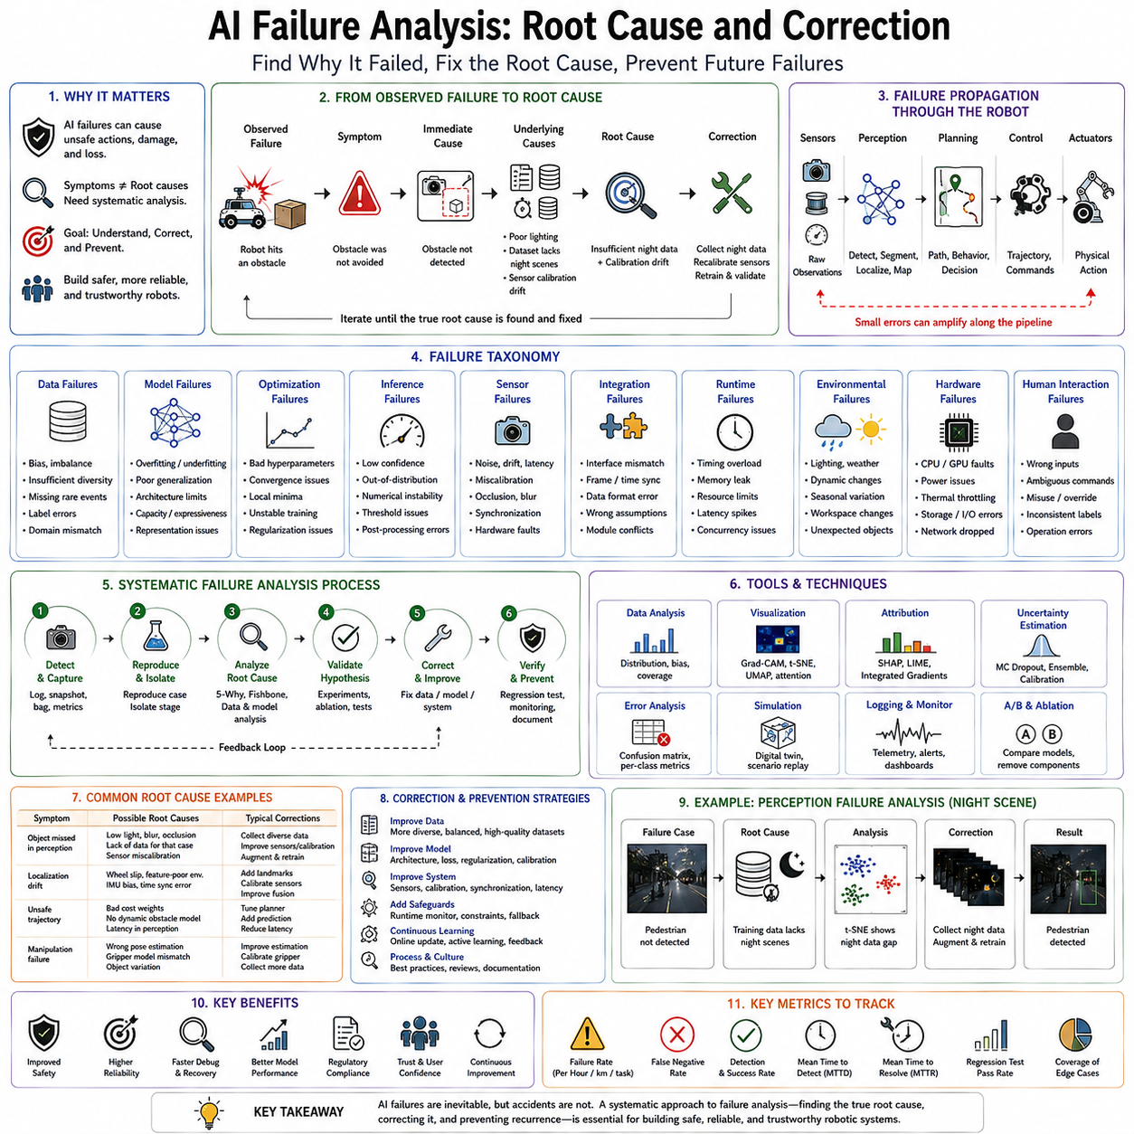
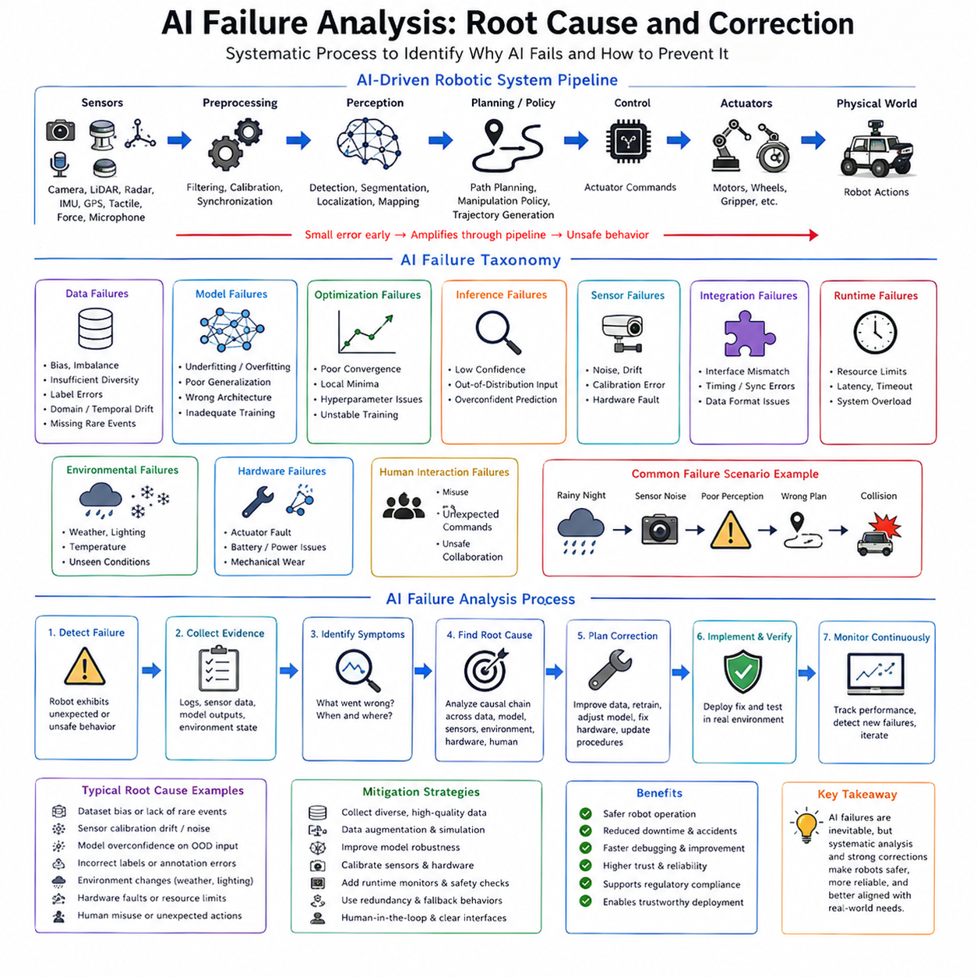
Artificial Intelligence failure analysis is the systematic engineering process of identifying, understanding, explaining, and correcting the causes of unexpected or unsafe behavior produced by AI systems. In robotics, autonomous vehicles, industrial automation, medical robotics, warehouse logistics, and intelligent manufacturing, AI failure analysis extends far beyond simply identifying incorrect predictions. It seeks to determine why a failure occurred, how it propagated through the complete robotic system, what underlying conditions enabled the failure, and how future occurrences can be prevented. Unlike conventional software debugging, where failures often originate from deterministic programming errors, AI failures emerge from complex interactions among datasets, model architectures, optimization processes, sensor systems, environmental conditions, hardware limitations, deployment pipelines, and operational uncertainty. Consequently, effective AI failure analysis requires a multidisciplinary systems engineering approach combining machine learning, robotics, software engineering, control theory, statistics, safety engineering, and human factors.
The importance of AI failure analysis grows directly with the increasing autonomy of robotic systems. Traditional industrial robots followed predefined trajectories generated by deterministic controllers. When failures occurred, engineers could often trace the problem to explicit programming mistakes, mechanical failures, sensor faults, or communication errors. Modern AI-powered robots, however, rely on deep neural networks, reinforcement learning policies, vision-language models, world models, multimodal perception, and autonomous planners whose internal behavior emerges through statistical optimization rather than explicit programming. While these models provide remarkable adaptability, they also introduce new classes of failures that cannot be understood solely through conventional debugging techniques.
One of the most important principles of AI failure analysis is distinguishing symptoms from root causes. The visible failure observed during robot operation rarely represents the true origin of the problem. A mobile robot colliding with an obstacle may appear to have failed because obstacle detection malfunctioned. Detailed investigation may instead reveal that sensor calibration drift degraded perception accuracy, that insufficient nighttime images existed within the training dataset, that preprocessing introduced unexpected artifacts, or that localization errors caused incorrect obstacle association. Effective failure analysis therefore investigates the complete causal chain rather than focusing only on the final incorrect behavior.
A failure in an AI-driven robotic system typically propagates through multiple interconnected components. Raw sensor observations are captured by cameras, LiDAR, radar, inertial measurement units, GPS receivers, tactile sensors, force sensors, or microphones. These observations undergo preprocessing before entering perception networks responsible for object detection, semantic segmentation, localization, mapping, or scene understanding. Perception outputs become inputs for planning algorithms, navigation systems, manipulation policies, trajectory generators, and control loops. Finally, actuator commands influence the physical robot. A small error introduced during early perception stages may amplify through subsequent processing until it eventually produces unsafe physical behavior. Failure analysis therefore examines the entire information pipeline rather than isolated subsystems.
Failure taxonomy provides a structured framework for categorizing AI failures. Broad classification simplifies diagnosis by grouping failures according to common mechanisms and corresponding mitigation strategies. Most AI failures fall into several major categories including data failures, model failures, optimization failures, inference failures, sensor failures, integration failures, runtime failures, environmental failures, hardware failures, and human interaction failures. Although individual incidents frequently involve multiple categories simultaneously, systematic classification accelerates root cause investigation.
Data-related failures represent one of the largest sources of AI performance degradation. Since machine learning systems derive behavior directly from training data, deficiencies within datasets naturally propagate into deployed models. Dataset bias, insufficient diversity, annotation errors, missing rare events, class imbalance, domain mismatch, temporal drift, geographical limitations, sensor inconsistencies, and corrupted samples all contribute to systematic prediction errors. Data failures often remain hidden during laboratory evaluation because benchmark datasets share similar statistical properties with training data while real deployment environments differ substantially.
Dataset coverage analysis frequently reveals previously unnoticed weaknesses. Engineers compare operational failures against training distributions to determine whether problematic situations were adequately represented during model development. If failures consistently occur during rain, nighttime operation, unusual warehouse layouts, or unfamiliar manufacturing conditions, insufficient dataset diversity rather than model architecture may represent the true underlying cause.
Label quality constitutes another common data-related issue. Human annotation errors, inconsistent labeling guidelines, ambiguous object boundaries, incorrect semantic categories, or synchronization mistakes introduce conflicting supervision during optimization. Neural networks faithfully learn these inconsistencies, producing unstable predictions difficult to correct through architectural modification alone. Careful dataset auditing therefore forms an essential component of failure analysis.
Model-related failures originate from limitations of neural network architecture, representational capacity, or learned internal representations. Models may overfit training data, underfit complex tasks, memorize spurious correlations, develop unstable feature representations, or fail to capture important environmental relationships. Such failures often require architectural redesign, additional regularization, modified optimization strategies, or entirely different learning paradigms.
Overfitting represents one of the most familiar model failures. The neural network memorizes training examples rather than learning generalizable concepts. Consequently, excellent benchmark performance coexists with poor real-world reliability. Failure analysis identifies overfitting through validation performance gaps, sensitivity to minor environmental changes, and excessive dependence upon irrelevant background features.
Underfitting produces the opposite behavior. Models lack sufficient representational capacity to capture task complexity, resulting in poor performance across both training and deployment data. Increasing model capacity, improving feature extraction, extending training duration, or modifying optimization procedures generally addresses such failures.
Shortcut learning has become one of the most actively studied failure mechanisms in modern deep learning. Rather than learning intended semantic concepts, neural networks exploit unintended statistical correlations within training datasets. A robot intended to recognize manufacturing defects may instead learn background lighting conditions associated with defective products. An autonomous vehicle may associate road signs with surrounding scenery rather than the signs themselves. Interpretability methods frequently reveal these hidden shortcuts during failure investigation.
Optimization failures arise during model training rather than deployment. Inappropriate learning rates, unstable gradient propagation, poor initialization, inadequate regularization, optimizer selection, batch normalization behavior, numerical instability, or insufficient convergence all influence final model quality. Although optimization problems may remain invisible after training, they significantly affect deployment robustness.
Loss function design also contributes to failure analysis. Training objectives sometimes optimize quantities only loosely related to operational requirements. A perception model minimizing average classification error may still perform poorly on rare but safety-critical events because common examples dominate optimization. Revising objective functions frequently improves operational behavior more effectively than architectural changes.
Inference failures occur during real-time execution despite apparently successful training. Quantization errors, numerical precision reduction, compiler optimizations, hardware-specific implementations, memory corruption, synchronization problems, runtime scheduling, or software integration issues may alter prediction behavior compared with laboratory evaluation. Deployment pipelines therefore require validation independent of training environments.
Sensor failures constitute another major category within robotic AI systems. Cameras may become dirty, scratched, or miscalibrated. LiDAR sensors experience reflection artifacts or reduced performance during heavy rain. GPS signals become unreliable indoors or near tall buildings. Inertial measurement units accumulate drift over time. Even if AI models remain mathematically correct, degraded sensor observations inevitably reduce prediction quality.
Sensor fusion analysis often assists diagnosis because independent sensing modalities provide complementary information. If camera predictions deteriorate while LiDAR remains reliable, investigators focus on optical sensing rather than downstream planning. Conversely, consistent degradation across multiple sensors may indicate environmental changes or computational problems.
Localization failures frequently propagate into seemingly unrelated perception or planning errors. Incorrect robot position estimates distort map alignment, obstacle association, semantic interpretation, and navigation decisions. Root cause analysis therefore considers localization accuracy whenever autonomous behavior becomes inconsistent despite apparently correct perception.
Environmental failures emerge because deployment conditions inevitably differ from laboratory assumptions. Illumination changes, weather, dust, fog, snow, seasonal vegetation, dynamic obstacles, unfamiliar infrastructure, electromagnetic interference, vibrations, temperature variation, or operational wear gradually shift input distributions beyond training conditions. These distribution shifts frequently explain sudden performance degradation despite unchanged software.
Out-of-distribution analysis has become an essential component of modern failure investigation. Engineers determine whether failed observations differ statistically from training data using uncertainty estimation, embedding visualization, feature-space analysis, or density estimation. Elevated OOD scores frequently indicate that failures result from environmental novelty rather than incorrect model implementation.
Adversarial conditions represent another important source of failures. Although deliberate adversarial attacks remain relatively uncommon in industrial robotics, naturally occurring sensor artifacts may resemble adversarial perturbations. Reflections, compression artifacts, repetitive textures, unusual lighting, projected patterns, or unexpected object configurations occasionally exploit hidden vulnerabilities within neural network decision boundaries.
Integration failures arise from interactions among individually correct subsystems. Perception, localization, planning, control, communication, and hardware components may each function correctly when tested independently yet produce failures when combined. Timing mismatches, inconsistent coordinate systems, synchronization delays, incompatible assumptions, interface inconsistencies, or software version conflicts commonly contribute to integration failures.
Time synchronization deserves particular attention in robotics. Cameras, LiDAR, inertial sensors, GPS receivers, wheel encoders, force sensors, and actuators operate at different frequencies. Even small timestamp errors produce inconsistent environmental representations, confusing perception algorithms and degrading downstream planning.
Coordinate transformation errors represent another common integration problem. Sensor observations expressed within different reference frames require precise geometric calibration. Small calibration errors accumulate throughout perception pipelines, eventually producing inaccurate localization, object detection, or manipulation planning.
Communication failures similarly influence AI behavior. Packet loss, delayed sensor updates, network congestion, distributed processing latency, or middleware scheduling irregularities introduce inconsistencies between perception and control. Failure analysis therefore examines communication logs alongside AI predictions.
Human factors contribute significantly to AI failures despite increasing automation. Operators may misunderstand system capabilities, provide incorrect supervisory commands, ignore uncertainty warnings, misinterpret interface displays, or intervene inappropriately during autonomous operation. Human-centered failure analysis therefore investigates interactions between operators and intelligent systems rather than considering AI independently.
Root cause analysis provides the systematic methodology for identifying fundamental failure mechanisms. Rather than stopping once immediate causes become apparent, investigators repeatedly ask why each contributing factor occurred until reaching underlying organizational, technical, procedural, or design limitations. This structured investigation prevents superficial corrections that merely address symptoms without eliminating recurring problems.
The Five Whys methodology illustrates this principle effectively. If an autonomous robot collides with an obstacle, investigators first determine why the collision occurred. The obstacle was not detected. Why was it not detected? The perception model misclassified the object. Why did misclassification occur? Similar objects were absent from training data. Why were they absent? Data collection focused exclusively on daytime operation. Why? Original deployment requirements underestimated nighttime scenarios. The resulting corrective action therefore emphasizes improved operational requirements and dataset expansion rather than merely retraining the existing model.
Fishbone diagrams, also known as Ishikawa diagrams, organize potential failure causes into structured categories including people, processes, hardware, software, environment, measurement, data, algorithms, and communication. This visualization encourages comprehensive investigation rather than prematurely focusing on obvious explanations.
Failure Mode and Effects Analysis extends root cause analysis by systematically evaluating potential failures before deployment. Every subsystem receives structured examination regarding possible failure mechanisms, operational consequences, detection strategies, severity, likelihood, and mitigation procedures. AI-specific FMEA increasingly complements traditional hardware reliability analysis within autonomous robotics.
Fault Tree Analysis examines combinations of contributing events leading to hazardous outcomes. Instead of considering failures independently, fault trees capture interactions among perception errors, localization drift, sensor degradation, communication delays, hardware faults, and environmental conditions. Such systems-level reasoning proves particularly valuable for complex autonomous robots.
Runtime logging forms the foundation of effective failure investigation. Every significant sensor observation, AI prediction, confidence estimate, uncertainty value, localization update, planning decision, control command, hardware status, communication event, and supervisory intervention should be recorded systematically. Without comprehensive operational logs, reconstructing complex AI failures becomes extremely difficult.
Replay systems enable investigators to reproduce operational failures offline using recorded sensor streams. Engineers repeatedly execute identical scenarios while modifying algorithms, visualization settings, interpretability tools, or diagnostic instrumentation. Controlled replay substantially accelerates debugging while avoiding repeated real-world testing.
Interpretability methods greatly enhance failure analysis by revealing internal neural network reasoning. Grad-CAM, SHAP, Integrated Gradients, attention visualization, saliency maps, and feature attribution expose image regions, sensor measurements, or latent representations influencing incorrect predictions. Unexpected attribution frequently reveals hidden dataset biases, shortcut learning, or spurious feature dependence.
Counterfactual analysis further supports diagnosis by identifying minimal changes required to alter incorrect predictions. Understanding what modifications would have prevented failure guides targeted improvements more effectively than simply observing erroneous outputs.
Simulation provides another indispensable diagnostic environment. Engineers reproduce failures under controlled conditions while systematically varying weather, lighting, sensor noise, object placement, communication latency, localization accuracy, and environmental complexity. Such controlled experimentation isolates contributing factors difficult to manipulate safely in physical deployments.
Corrective actions following root cause identification vary according to failure type. Data failures generally require additional data collection, improved annotation, active learning, synthetic augmentation, or continual learning. Model failures may necessitate architectural redesign, revised loss functions, uncertainty estimation, or regularization improvements. Integration failures often require synchronization, calibration, interface standardization, or middleware refinement. Runtime failures may require improved monitoring, safety supervision, redundancy, or fallback strategies.
Verification of corrective actions remains equally important. Simply implementing modifications does not guarantee problem resolution. Engineers repeat validation using original failure scenarios alongside expanded benchmark suites, stress testing, simulation, field trials, uncertainty analysis, adversarial evaluation, and regression testing to ensure corrections eliminate root causes without introducing new weaknesses.
Regression prevention represents one of the most valuable outcomes of systematic failure analysis. Every investigated failure contributes new test cases, improved datasets, refined validation procedures, updated safety requirements, enhanced monitoring rules, and organizational knowledge. Mature AI engineering organizations continuously expand their validation infrastructure based upon accumulated operational experience.
Future AI failure analysis will increasingly incorporate autonomous diagnostic agents capable of monitoring operational behavior, identifying emerging anomalies, explaining causal relationships, recommending corrective actions, and supporting continual improvement. Foundation models may assist engineers by analyzing operational logs, interpreting failure patterns, correlating subsystem interactions, and generating comprehensive diagnostic reports while remaining supervised by human experts.
As robotics advances toward embodied intelligence, multimodal reasoning, lifelong learning, and adaptive autonomy, failure analysis will likewise evolve beyond isolated neural network debugging toward complete cognitive system investigation. Perception, memory, planning, reasoning, language understanding, world modeling, manipulation, navigation, and human interaction will all become integrated components of comprehensive diagnostic frameworks.
Ultimately, AI failure analysis is not merely the process of repairing malfunctioning models but the systematic engineering discipline that transforms operational experience into continually improving intelligent systems. By distinguishing symptoms from root causes, tracing failures across complete robotic architectures, identifying underlying technical and organizational factors, implementing targeted corrective actions, and continuously validating improvements, engineers progressively increase the reliability, robustness, safety, and trustworthiness of autonomous robots. Combined with uncertainty quantification, runtime monitoring, interpretability, formal verification, dataset quality management, and comprehensive systems engineering, AI failure analysis provides one of the essential foundations enabling safe, dependable, and continuously improving Physical AI throughout industrial automation, healthcare, transportation, logistics, infrastructure inspection, agriculture, and future autonomous robotic ecosystems.

11.10 AI Safety Standards ISO IEC 42001 EU AI Act

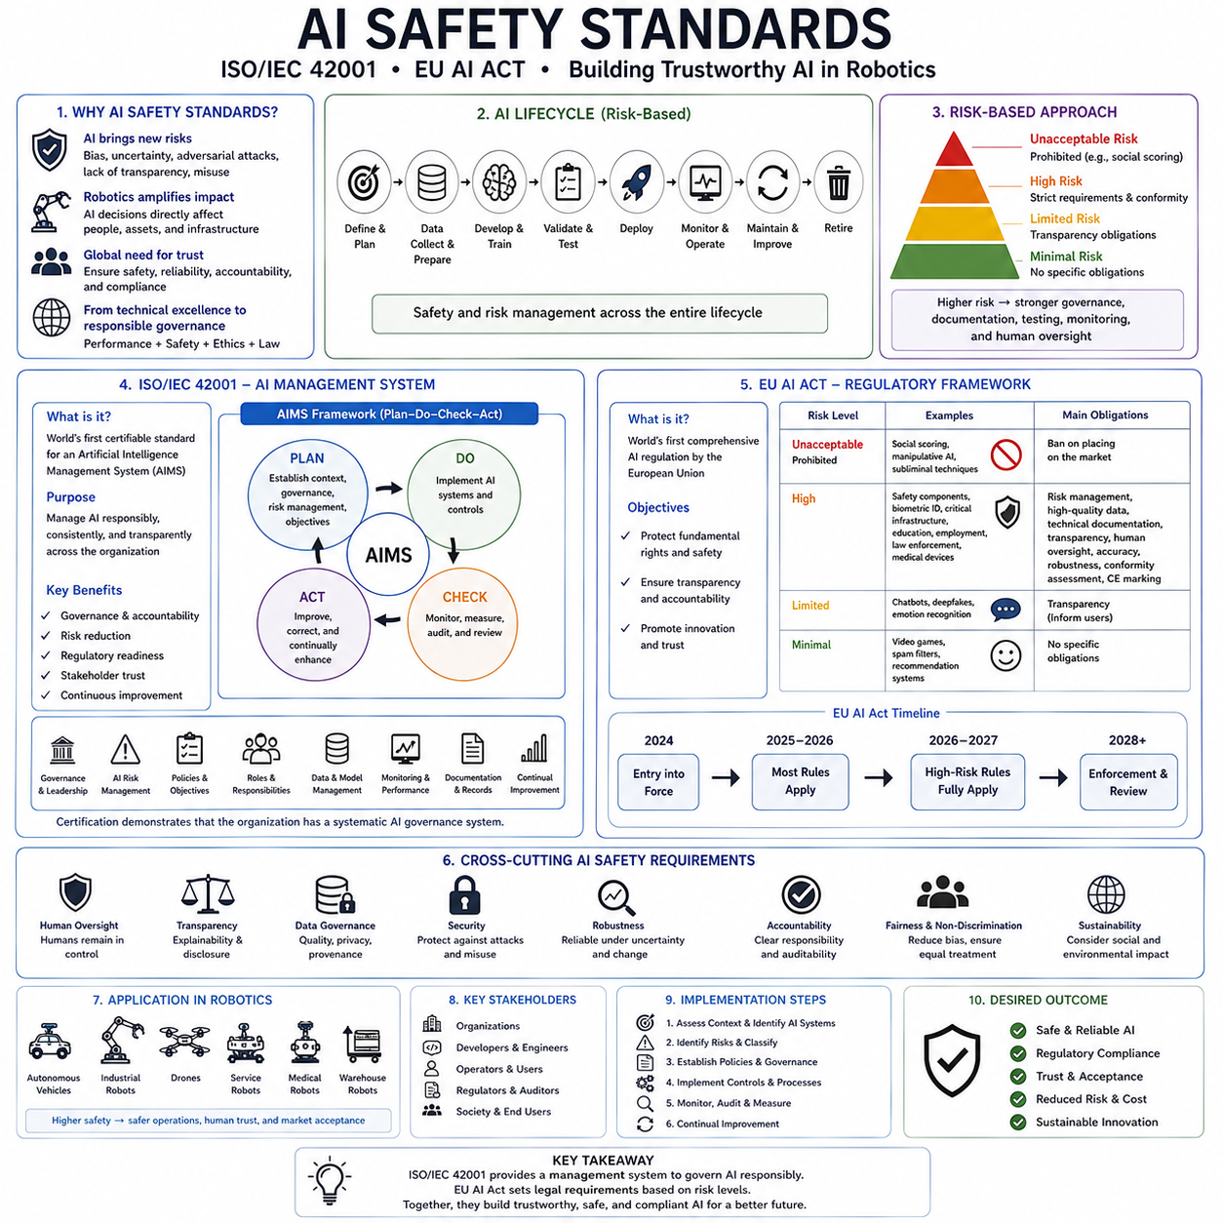
Artificial intelligence safety standards have become one of the most important foundations for the responsible development, deployment, operation, and governance of AI systems in robotics and other safety-critical industries. As AI evolves from research laboratories into autonomous vehicles, collaborative robots, medical devices, industrial automation, financial systems, critical infrastructure, public services, and defense applications, society increasingly requires not only high-performance algorithms but also systematic methods for ensuring safety, reliability, transparency, accountability, cybersecurity, and legal compliance. Technical excellence alone is no longer sufficient. Modern AI systems must also satisfy organizational, regulatory, ethical, and operational requirements that demonstrate responsible development throughout their entire lifecycle. International standards such as ISO/IEC 42001, the European Union AI Act, and numerous complementary standards provide structured frameworks that transform AI safety from an individual engineering effort into a comprehensive organizational management system.
The motivation for AI safety standards originates from the unique characteristics of artificial intelligence compared with conventional software. Traditional software systems generally execute explicitly programmed logic whose behavior can often be analyzed through deterministic verification and testing. Artificial intelligence systems, particularly those based on machine learning, derive behavior from statistical learning rather than direct programming. Their decisions depend upon training data, optimization procedures, neural network architectures, deployment environments, runtime inputs, and continual adaptation. Consequently, AI systems introduce new categories of risk that extend beyond traditional software engineering, including dataset bias, distribution shift, model uncertainty, adversarial vulnerability, explainability limitations, autonomous decision making, and evolving operational behavior.
Robotics amplifies these concerns because intelligent algorithms directly control physical machines interacting with people and infrastructure. A recommendation engine producing an incorrect suggestion may inconvenience users, whereas an autonomous vehicle making an incorrect decision may cause collisions. A collaborative robot misunderstanding human intention may create workplace hazards. A medical robot making an incorrect diagnosis or manipulation decision may directly affect patient safety. Therefore, AI governance for robotics must integrate machine learning quality, functional safety, systems engineering, cybersecurity, regulatory compliance, and organizational management into a unified framework.
One of the central principles underlying modern AI standards is lifecycle thinking. Artificial intelligence safety cannot be achieved by evaluating only the final deployed model. Instead, safety must be considered throughout every stage of development, including problem definition, requirements engineering, data collection, annotation, preprocessing, model development, validation, deployment, monitoring, maintenance, continual improvement, and eventual retirement. Risks introduced during early stages frequently remain hidden until deployment, making proactive lifecycle management essential.
Another foundational principle is risk-based governance. Not every AI application requires identical levels of control. A movie recommendation system presents substantially lower risk than an autonomous surgical robot or railway control system. Modern AI standards therefore classify applications according to potential consequences of failure and apply governance requirements proportionally. High-risk systems receive more extensive documentation, testing, monitoring, traceability, human oversight, and regulatory review than low-risk applications.
The concept of AI governance extends beyond technical implementation. Governance refers to the organizational structures, policies, responsibilities, decision-making processes, accountability mechanisms, documentation practices, and continuous oversight required to ensure responsible AI operation. While engineers develop algorithms, governance ensures that development follows repeatable, auditable, and accountable organizational processes aligned with business objectives, regulatory requirements, and societal expectations.
ISO/IEC 42001 represents one of the most significant milestones in international AI governance. Published jointly by the International Organization for Standardization and the International Electrotechnical Commission, ISO/IEC 42001 establishes the world's first certifiable Artificial Intelligence Management System standard. Rather than specifying individual AI algorithms or technical implementations, it defines how organizations should systematically manage AI throughout its lifecycle.
The philosophy of ISO/IEC 42001 resembles other ISO management standards such as ISO 9001 for quality management and ISO/IEC 27001 for information security management. Instead of prescribing detailed engineering solutions, it establishes organizational processes ensuring consistent planning, implementation, monitoring, evaluation, and continual improvement. Consequently, certification demonstrates that an organization possesses systematic AI governance rather than guaranteeing correctness of any individual AI model.
The Artificial Intelligence Management System, often abbreviated as AIMS, serves as the central organizational framework defined by ISO/IEC 42001. An AIMS provides structured procedures governing how AI systems are planned, developed, validated, deployed, monitored, documented, maintained, and improved. It emphasizes organizational responsibility rather than isolated technical excellence.
Leadership commitment represents one of the foundational requirements of ISO/IEC 42001. Executive management must actively support AI governance rather than delegating responsibility exclusively to technical teams. Leadership establishes organizational objectives, allocates resources, defines accountability, approves governance policies, and ensures continual oversight throughout the AI lifecycle.
Organizational context forms another important requirement. Before developing AI systems, organizations should understand internal objectives, external stakeholders, regulatory environments, operational domains, technological constraints, business priorities, ethical considerations, and societal expectations. AI development should therefore align with organizational strategy rather than occurring independently within isolated engineering teams.
Risk management occupies a central role within ISO/IEC 42001. Organizations systematically identify, evaluate, prioritize, mitigate, monitor, and review risks associated with AI systems. Risks include technical failures, cybersecurity vulnerabilities, privacy concerns, bias, discrimination, safety hazards, operational disruptions, regulatory noncompliance, reputational damage, and unintended societal consequences. Continuous risk assessment accompanies every stage of AI development rather than occurring only before deployment.
Documentation requirements significantly enhance organizational traceability. AI models should be accompanied by comprehensive records describing datasets, model architectures, optimization procedures, validation methods, deployment environments, assumptions, limitations, known risks, operational constraints, monitoring procedures, and maintenance plans. Such documentation supports auditing, debugging, regulatory review, incident investigation, and long-term system maintenance.
Data governance receives substantial attention within ISO/IEC 42001 because data quality fundamentally determines AI behavior. Organizations establish policies governing data collection, labeling, validation, privacy protection, storage, version control, access management, retention, and continual improvement. Data lineage should remain traceable throughout development so that every model can be associated with its underlying datasets.
Human oversight represents another essential organizational principle. Autonomous AI systems should not necessarily operate without meaningful human supervision, particularly in high-risk applications. Organizations define responsibilities regarding approval, intervention, monitoring, override authority, incident response, and operational decision making. Human oversight becomes increasingly important as system autonomy increases.
Operational monitoring continues throughout deployment. Organizations collect performance metrics, detect anomalies, monitor drift, evaluate safety, assess cybersecurity, review incidents, and initiate corrective actions whenever operational behavior deviates from expected performance. AI governance therefore extends beyond deployment into continuous operational management.
Continual improvement constitutes another core management principle inherited from broader ISO standards. Organizations periodically review governance effectiveness, update risk assessments, improve operational procedures, revise documentation, retrain models, expand datasets, strengthen monitoring, and incorporate lessons learned from operational experience.
Although ISO/IEC 42001 defines organizational governance, it intentionally avoids prescribing specific machine learning algorithms. Organizations remain free to employ supervised learning, reinforcement learning, foundation models, symbolic reasoning, hybrid AI, or future technologies provided governance principles remain satisfied.
For robotics companies, ISO/IEC 42001 integrates naturally with existing quality management systems. Manufacturers already certified under ISO 9001, ISO 14001, ISO/IEC 27001, or ISO 45001 can extend established management processes toward AI governance while maintaining organizational consistency across engineering disciplines.
Another major regulatory development is the European Union Artificial Intelligence Act, commonly known as the EU AI Act. Unlike ISO standards, which are voluntary management frameworks, the EU AI Act establishes legally binding regulatory requirements governing AI systems placed on or used within the European Union market. It represents the world's first comprehensive legal framework regulating artificial intelligence according to risk.
The EU AI Act adopts a risk-based regulatory philosophy. AI applications are classified into several categories according to potential societal impact and operational risk. Regulatory obligations increase with risk level, allowing innovation to continue while ensuring stronger protection for high-risk applications.
The first category includes unacceptable-risk AI systems. These applications are considered fundamentally incompatible with European values because they pose excessive risks to safety, fundamental rights, or democratic institutions. Such systems are generally prohibited from deployment within the European Union.
Limited-risk AI systems receive relatively modest transparency requirements. Examples include conversational agents or systems interacting directly with users. Organizations must ensure that individuals understand when they are interacting with artificial intelligence rather than humans.
Most significant for robotics are high-risk AI systems. These include AI integrated into products already regulated under European safety legislation, such as medical devices, machinery, vehicles, railway systems, aviation equipment, and critical infrastructure. Autonomous robots deployed within these domains frequently fall into the high-risk category because incorrect decisions may directly affect human safety.
High-risk AI systems must satisfy extensive regulatory requirements before deployment. Risk management systems must be implemented throughout the AI lifecycle. Data quality must be carefully controlled. Technical documentation must be comprehensive. Operational logs must support traceability. Transparency measures must assist users in understanding system behavior. Human oversight mechanisms must remain available. Accuracy, robustness, cybersecurity, and reliability must satisfy defined operational expectations.
Technical documentation plays an especially important role under the EU AI Act. Developers must demonstrate how systems operate, which assumptions were made during development, how risks were identified and mitigated, how datasets were collected, what limitations remain, and how ongoing monitoring will occur. Documentation therefore becomes both a technical engineering artifact and a regulatory compliance requirement.
Data governance requirements emphasize relevance, representativeness, completeness, and quality. Training, validation, and testing datasets should adequately reflect intended deployment conditions while minimizing systematic bias. Dataset management therefore becomes both a technical requirement and a legal compliance obligation.
Human oversight receives explicit regulatory attention. High-risk AI systems should support meaningful human intervention whenever necessary. Operators should understand system capabilities, recognize operational limitations, monitor autonomous behavior, and retain authority to override unsafe decisions. Human oversight therefore becomes an integral component of regulatory compliance rather than an optional engineering feature.
Robustness and cybersecurity requirements address operational resilience. AI systems should maintain reliable performance despite environmental variation, hardware faults, communication failures, adversarial attacks, sensor degradation, and evolving operational conditions. Protective mechanisms include runtime monitoring, uncertainty estimation, redundancy, anomaly detection, fallback strategies, and cybersecurity safeguards.
Post-market monitoring extends regulatory responsibility beyond deployment. Organizations continue collecting operational data, reporting serious incidents, monitoring performance degradation, implementing corrective actions, and maintaining regulatory compliance throughout system operation. AI therefore remains subject to continuous oversight rather than one-time certification.
Incident reporting represents another major regulatory requirement. Significant failures affecting safety or fundamental rights must be documented and communicated to appropriate authorities according to established reporting procedures. Organizations therefore require operational monitoring infrastructures capable of detecting, recording, analyzing, and responding to AI-related incidents.
Although ISO/IEC 42001 and the EU AI Act differ substantially in legal status, they complement one another effectively. ISO/IEC 42001 provides organizational management structures supporting systematic AI governance, while the EU AI Act establishes legal obligations governing specific high-risk applications. Organizations implementing robust management systems often find regulatory compliance substantially easier because governance processes already exist.
Robotics companies typically integrate these AI-specific standards with numerous existing engineering standards. Functional safety remains governed by standards such as IEC 61508 for programmable electronic safety systems. Industrial robotics commonly follows ISO 10218, while collaborative robots employ ISO/TS 15066. Automotive systems implement ISO 26262, and intended functionality receives additional guidance through ISO 21448, commonly known as Safety of the Intended Functionality. Medical robotics integrates standards governing medical devices, software lifecycle management, and risk management. AI governance therefore complements rather than replaces traditional safety engineering.
Cybersecurity standards similarly interact closely with AI governance. Connected robots increasingly exchange sensor data, software updates, cloud services, fleet management information, and operational telemetry. Cybersecurity frameworks such as ISO/IEC 27001, IEC 62443 for industrial automation, and automotive cybersecurity standards support protection against malicious attacks capable of compromising AI behavior.
Quality management remains another essential foundation. AI systems ultimately become components within broader engineering organizations responsible for design control, supplier management, configuration management, verification, validation, maintenance, and continual improvement. Existing quality management systems therefore provide valuable organizational infrastructure supporting AI governance.
Model lifecycle management becomes increasingly important under these regulatory frameworks. Organizations maintain complete traceability connecting datasets, preprocessing procedures, model versions, training configurations, validation results, deployment environments, monitoring records, operational incidents, corrective actions, and software updates. Such traceability enables rapid investigation whenever unexpected behavior emerges during deployment.
Explainability and transparency also receive increasing regulatory attention. While not every AI system requires complete interpretability, organizations should understand sufficient aspects of model behavior to support debugging, auditing, user trust, and safety assessment. Techniques including Grad-CAM, SHAP, Integrated Gradients, uncertainty estimation, confidence reporting, and operational logging therefore support broader governance objectives.
Foundation models introduce new governance challenges because they serve multiple downstream applications with capabilities extending beyond their original training objectives. Regulatory frameworks increasingly distinguish between general-purpose AI models and application-specific deployments, recognizing that responsibility may be shared among foundation model developers, system integrators, and final product manufacturers.
Future AI governance will likely continue evolving toward internationally harmonized standards integrating technical robustness, organizational management, cybersecurity, privacy, sustainability, explainability, and ethical considerations within unified engineering frameworks. As autonomous robots become increasingly capable through multimodal reasoning, lifelong learning, world models, and embodied intelligence, governance systems must likewise evolve to supervise increasingly adaptive autonomous behavior.
Ultimately, AI safety standards establish that trustworthy artificial intelligence depends not only upon advanced algorithms but also upon disciplined organizational processes governing the entire AI lifecycle. ISO/IEC 42001 provides a comprehensive management framework ensuring systematic AI governance, while the European Union AI Act establishes legally enforceable requirements proportional to application risk. Together with complementary standards for functional safety, quality management, cybersecurity, medical devices, industrial automation, and autonomous systems, these frameworks transform AI safety from isolated technical optimization into comprehensive organizational responsibility. For robotics, where artificial intelligence directly controls physical machines operating alongside humans, such governance provides the essential foundation for building autonomous systems that are not only intelligent but also safe, reliable, transparent, accountable, legally compliant, and worthy of long-term public trust.

