Volume 19 Robot Machine Learning and AI

07. Online Robot Learning

07.01 Online Learning Concepts Incremental Adaptation
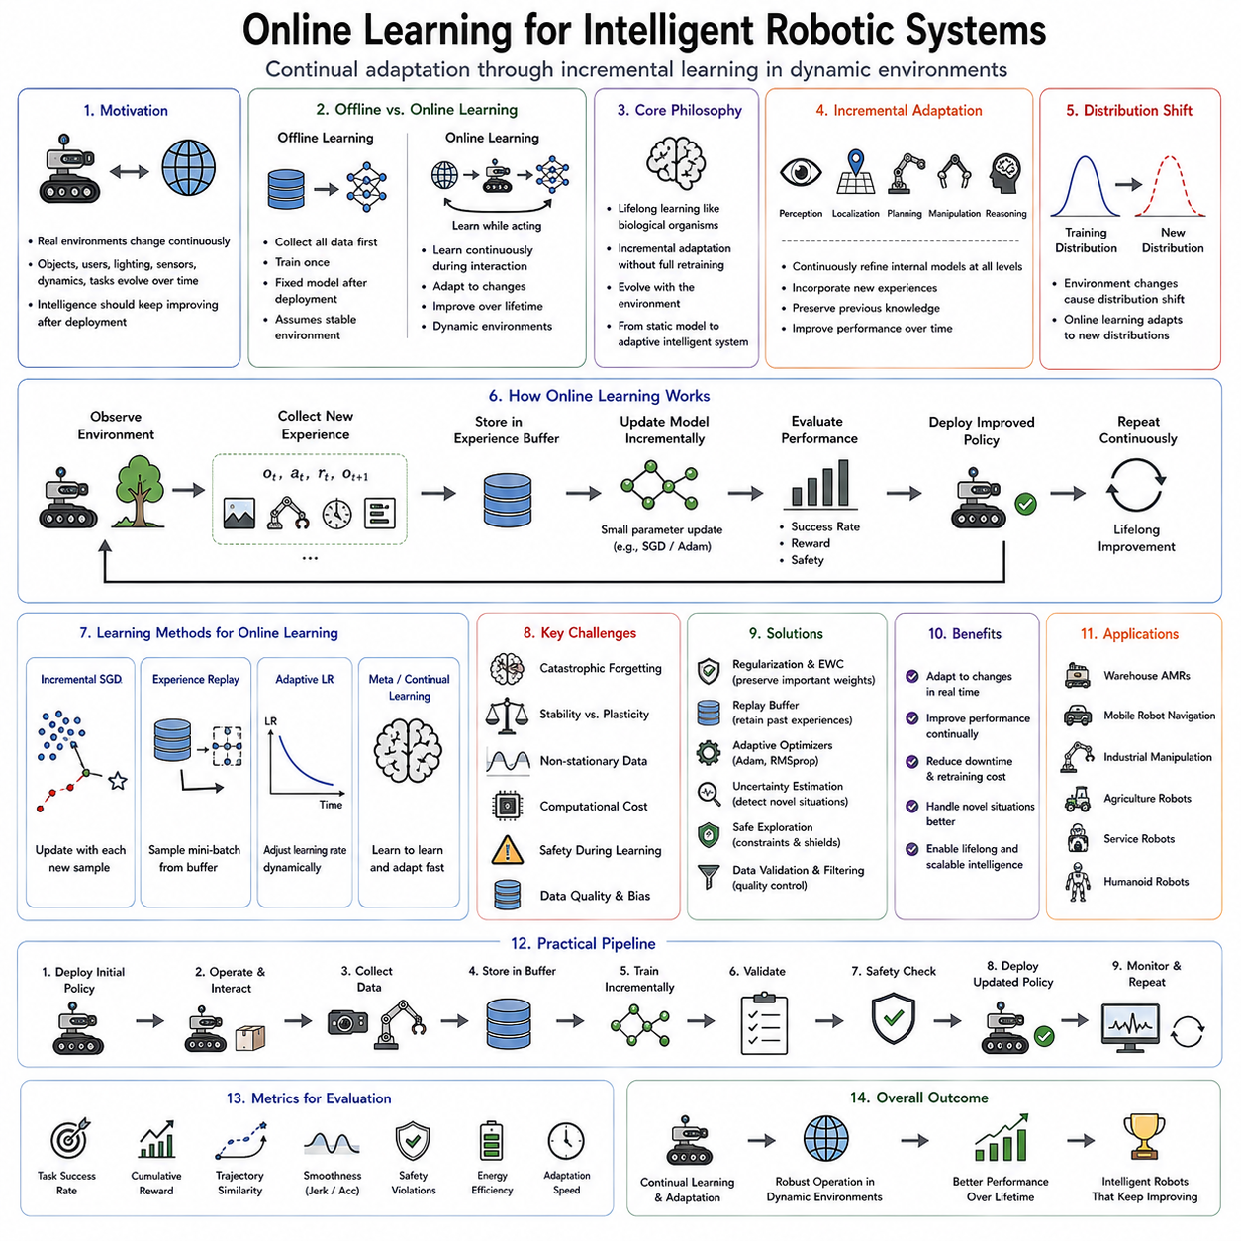
Online learning represents a fundamental shift from the traditional paradigm of machine learning in which models are trained once using a fixed dataset and subsequently deployed without further modification. In conventional offline learning, all available training data are collected before optimization begins, the model parameters are learned through repeated iterations over the complete dataset, and the resulting policy remains unchanged during deployment. While this approach has achieved remarkable success in many domains, it assumes that the environment remains relatively stable after training. Real-world robotic systems, however, operate in continuously changing environments where objects, users, sensors, lighting conditions, physical dynamics, and operational requirements evolve over time. Online learning addresses this challenge by allowing an intelligent system to continue learning while interacting with its environment, enabling continual adaptation without requiring complete retraining from scratch.
The core philosophy of online learning is that intelligence should not stop improving after deployment. Biological organisms continuously acquire new knowledge throughout their lifetime rather than freezing their learning capabilities upon reaching adulthood. Humans adapt to unfamiliar environments, develop new motor skills, recognize novel objects, and improve task performance through ongoing experience. Similarly, an intelligent robotic system should continuously refine its internal representations, policies, and world models while performing real tasks. This lifelong improvement transforms artificial intelligence from a static predictive model into an adaptive cognitive system capable of evolving alongside its operating environment.
Incremental adaptation forms the central mechanism enabling online learning. Instead of replacing the entire model after collecting a new dataset, incremental learning incorporates new experiences gradually into existing knowledge. Each newly observed sample contributes a small update to the learned representation while preserving previously acquired capabilities. This continuous accumulation of knowledge enables the system to respond rapidly to environmental changes without incurring the enormous computational cost associated with complete retraining. Incremental adaptation therefore combines computational efficiency with behavioral flexibility, making it particularly suitable for autonomous robots operating continuously in dynamic environments.
The distinction between offline and online learning extends beyond training schedules. Offline learning assumes access to independent and identically distributed data sampled from a fixed probability distribution. Online learning abandons this assumption because incoming observations often reflect changing environmental conditions. The statistical distribution governing observations may shift gradually or abruptly due to seasonal changes, equipment aging, new user behaviors, sensor recalibration, or unexpected environmental events. Consequently, online learning algorithms must remain effective even when the underlying data distribution evolves continuously.
Distribution shift represents one of the primary motivations for incremental adaptation. A warehouse robot initially trained under controlled lighting conditions may later operate during nighttime shifts with different illumination. An autonomous agricultural robot encounters crops at varying growth stages throughout the season. Medical service robots interact with different patients exhibiting diverse movement patterns and behaviors. Industrial manipulators experience tool wear, mechanical drift, and changing product geometries over extended operation. Each of these scenarios introduces data distributions differing from those present during initial training. Online learning continuously updates internal models to accommodate these evolving conditions.
Incremental adaptation occurs at multiple levels within an intelligent robotic system. The perception subsystem gradually improves visual recognition by incorporating newly observed appearances, lighting conditions, and object categories. Localization algorithms refine environmental maps as infrastructure changes over time. Motion planning adjusts trajectory optimization according to observed terrain conditions and actuator performance. Manipulation policies improve grasping strategies through repeated interaction with diverse objects. Higher-level reasoning modules expand semantic knowledge and task understanding based on accumulated operational experience. Together, these adaptations create an integrated learning architecture that evolves continuously during deployment.
One of the simplest forms of online learning involves incremental parameter updates using stochastic optimization. Rather than processing the complete training dataset repeatedly, new observations immediately contribute gradient updates modifying the model parameters. Stochastic Gradient Descent naturally supports this paradigm because each incoming sample directly influences optimization. Mini-batch variants extend the approach by accumulating small groups of recent observations before parameter updates occur. These incremental optimization strategies maintain computational efficiency while enabling continual learning from streaming data.
Learning rate selection becomes particularly important during incremental adaptation. Excessively large parameter updates may overwrite previously acquired knowledge, causing unstable behavior or catastrophic forgetting. Conversely, extremely small learning rates may prevent meaningful adaptation to changing environments. Adaptive optimization methods dynamically regulate parameter updates according to observed gradients, uncertainty estimates, or environmental change rates, balancing stability with responsiveness throughout continuous learning.
Streaming data distinguishes online learning from conventional dataset-based optimization. Rather than assuming all observations are simultaneously available, streaming algorithms process each sample sequentially as it arrives. Memory constraints frequently prevent storing the complete observation history, requiring algorithms to summarize previous experience efficiently. Consequently, online learning often emphasizes compact representations, recursive estimation, and sufficient statistics capable of preserving essential information without retaining every individual observation.
Recursive estimation provides an elegant mathematical framework for incremental adaptation. Classical recursive least squares, Kalman filtering, Bayesian updating, and particle filtering all demonstrate how estimates may be continuously refined as new observations become available. Modern deep learning extends these recursive principles toward high-dimensional representation learning, allowing neural networks to update complex internal structures through sequential experience accumulation.
Bayesian online learning naturally accommodates uncertainty during adaptation. Rather than representing model parameters as fixed values, Bayesian methods maintain probability distributions reflecting confidence in current estimates. Incoming observations update these distributions through Bayesian inference, gradually reducing uncertainty where evidence accumulates while preserving uncertainty in poorly observed regions. This probabilistic formulation enables intelligent systems to distinguish between well-established knowledge and newly emerging information requiring further experience.
Memory management represents a critical challenge because online learning systems cannot retain unlimited historical data indefinitely. Experience replay buffers address this problem by maintaining representative subsets of previous observations alongside recent experiences. During incremental training, new samples combine with replayed historical data, reducing catastrophic forgetting while allowing continual adaptation. Various sampling strategies prioritize rare events, informative experiences, or high-error observations to maximize learning efficiency.
Experience replay originated within reinforcement learning but has become equally valuable for supervised and imitation-based online adaptation. Random replay approximates stationary training distributions, while prioritized replay emphasizes observations contributing most strongly to prediction error. Reservoir sampling maintains unbiased historical subsets despite unlimited data streams. More sophisticated memory systems organize experiences according to semantic similarity, temporal relevance, or task identity, enabling efficient retrieval during continual learning.
Incremental representation learning extends adaptation beyond task-specific policies. Feature extractors themselves gradually evolve as new sensory experiences accumulate. Visual encoders expand their ability to recognize previously unseen objects, textures, and environmental conditions. Language representations incorporate novel terminology encountered during deployment. Multimodal embeddings strengthen associations among vision, language, tactile sensing, and motor behavior through repeated interaction. Such representation-level adaptation often proves more valuable than merely refining downstream decision policies.
Concept drift represents a particularly challenging form of environmental evolution. Unlike random noise or temporary disturbances, concept drift reflects systematic changes in the relationship between observations and desired outputs. Manufacturing robots encounter new product designs. Service robots adapt to changing user preferences. Autonomous vehicles experience seasonal weather transitions. Online learning systems therefore require drift detection mechanisms capable of identifying when previous knowledge becomes partially obsolete. Statistical monitoring, uncertainty estimation, prediction error analysis, and distribution comparison techniques commonly detect emerging concept drift before significant performance degradation occurs.
Different forms of concept drift require distinct adaptation strategies. Sudden drift occurs abruptly following equipment replacement or environmental reconfiguration. Gradual drift develops slowly through wear, aging, or seasonal variation. Recurring drift repeatedly alternates among previously encountered operating conditions. Incremental drift introduces continuous subtle changes over extended periods. Robust online learning architectures recognize these different temporal patterns and adjust adaptation speed accordingly.
Catastrophic forgetting remains one of the most significant obstacles to effective incremental learning. Neural networks often overwrite previously acquired knowledge while adapting to new data, causing dramatic performance degradation on earlier tasks. Human cognition rarely exhibits such severe forgetting because biological memory systems consolidate important knowledge while integrating new experiences. Artificial systems therefore require explicit mechanisms preserving prior capabilities during continual adaptation.
Regularization-based approaches reduce catastrophic forgetting by restricting parameter changes affecting previously learned knowledge. Elastic Weight Consolidation estimates parameter importance using Fisher information, penalizing modifications to weights critical for earlier tasks. Synaptic Intelligence and Memory Aware Synapses similarly identify essential parameters whose stability should be preserved throughout continual learning. These methods allow adaptation while protecting established competencies.
Architectural approaches provide an alternative solution by allocating new computational resources whenever substantially different knowledge must be acquired. Progressive Neural Networks preserve previous parameters while adding new network components for emerging tasks. Dynamic architectures expand representation capacity incrementally as environmental complexity increases. Such methods eliminate catastrophic forgetting but require careful management of computational growth during long-term deployment.
Replay-based methods remain among the most practical solutions for continual adaptation. Historical experiences stored within replay memories periodically reappear during training alongside recent observations. This joint optimization simultaneously reinforces previous knowledge while incorporating new information. Generative replay further extends this idea by synthesizing representative historical experiences using generative models rather than storing original observations explicitly.
Incremental adaptation becomes particularly important for robotic perception. Camera calibration gradually changes due to mechanical vibration. Lens contamination alters image characteristics. Lighting conditions evolve throughout the day. Objects appear with previously unseen textures or packaging. Online perception systems continuously refine feature representations to accommodate these evolving visual conditions without requiring manual recalibration or complete retraining.
Robotic manipulation similarly benefits from continual adaptation. Grippers experience mechanical wear. Friction coefficients vary among object materials. Force sensors drift gradually over time. Different operators organize workspaces differently. Incremental policy updates allow manipulation strategies to accommodate these subtle physical changes, maintaining precision despite evolving hardware and environmental characteristics.
Navigation systems require continuous adaptation because environments rarely remain static. Furniture moves, shelves relocate, construction modifies pathways, temporary obstacles appear, and human traffic patterns evolve. Simultaneous Localization and Mapping naturally embodies online learning principles by continuously updating environmental representations while preserving accumulated spatial knowledge. Modern world models increasingly integrate mapping, prediction, and semantic understanding into unified adaptive representations.
Online learning also plays a central role within autonomous driving systems. Traffic patterns change according to time of day. Weather influences road appearance and vehicle dynamics. Construction modifies lane geometry. Driver behaviors vary across geographic regions. Fleet learning aggregates experiences from thousands of vehicles, allowing continual improvement through shared online adaptation at unprecedented scale.
Human-robot interaction introduces additional adaptation requirements because individual users exhibit distinct preferences, communication styles, physical capabilities, and task expectations. Personalization algorithms gradually construct user-specific models reflecting these individual differences. Rather than requiring explicit customization before deployment, online learning enables robots to personalize behavior naturally through repeated interaction with each user.
Federated online learning further extends incremental adaptation across distributed robotic systems. Multiple robots learn independently while periodically exchanging model updates instead of raw sensory data. Central aggregation combines these distributed experiences into improved global models subsequently redistributed throughout the robotic fleet. Federated learning preserves privacy, reduces communication bandwidth, and accelerates collective knowledge acquisition across geographically dispersed deployments.
Cloud robotics provides complementary infrastructure supporting large-scale continual learning. Operational data collected across many robots accumulate within centralized repositories where extensive retraining, validation, and knowledge distillation occur. Updated models subsequently deploy back to individual robots. Hybrid architectures increasingly combine local online adaptation with periodic cloud-based consolidation, balancing rapid responsiveness against large-scale knowledge integration.
Safety considerations become especially important because online learning modifies policy behavior during deployment. Unconstrained adaptation may produce unsafe actions before sufficient validation occurs. Safe online learning therefore incorporates constrained optimization, uncertainty estimation, runtime verification, and supervisory controllers preventing dangerous policy updates. Conservative adaptation strategies initially restrict learning to low-risk operating regions before gradually expanding autonomy as confidence increases.
Human supervision often remains integrated throughout incremental adaptation. Operators provide corrective demonstrations whenever undesirable behavior occurs, allowing DAgger-style intervention during real deployment. Human feedback also supplies preference labels, semantic corrections, or natural language explanations guiding continual improvement beyond purely autonomous experience accumulation. Such collaborative learning combines human expertise with autonomous adaptation throughout system operation.
Evaluation of online learning differs fundamentally from static benchmark testing. Performance must remain stable throughout continuous adaptation rather than merely after final convergence. Metrics therefore include adaptation speed, forgetting rate, memory efficiency, computational cost, sample efficiency, robustness under concept drift, cumulative task success, and long-term operational reliability. Lifelong evaluation emphasizes sustained performance across months or years rather than isolated experimental episodes.
Recent advances in foundation models increasingly complement incremental adaptation. Large pretrained visual, language, and multimodal representations provide robust initial knowledge acquired from enormous datasets. Online learning subsequently specializes these general representations toward specific deployment environments through lightweight fine-tuning, parameter-efficient adaptation, retrieval augmentation, or continual representation refinement. This combination dramatically reduces required deployment data while preserving broad generalization capabilities.
World models further enhance online learning by constructing predictive internal simulations continuously refined through real experience. Rather than merely adapting reactive policies, world models update internal representations of environmental dynamics, object interactions, and causal relationships. Improved prediction subsequently enables better planning, safer exploration, and more efficient adaptation using imagined experiences generated within internal simulations.
The convergence of online learning, continual adaptation, world models, diffusion policies, Vision-Language-Action architectures, robot foundation models, and fleet learning represents a major step toward Artificial General Intelligence for embodied systems. Future robots will no longer rely primarily on fixed policies trained before deployment. Instead, they will function as continuously evolving intelligent agents capable of learning throughout their operational lifetime, sharing knowledge across fleets, adapting to individual users, anticipating environmental change, and improving autonomously through ongoing interaction with the physical world.
Online learning and incremental adaptation therefore represent essential foundations for lifelong robotic intelligence. By enabling continuous knowledge acquisition, efficient parameter updating, robust handling of distribution shift, protection against catastrophic forgetting, and safe adaptation during deployment, these techniques transform robots from static automation systems into continuously improving Physical AI platforms. As autonomous systems become increasingly integrated into manufacturing, healthcare, logistics, agriculture, domestic assistance, and scientific exploration, online learning will remain one of the defining capabilities enabling intelligent machines to operate successfully within the dynamic, uncertain, and ever-changing environments of the real world.

07.02 Online Supervised Learning Incremental Update [w/Code]
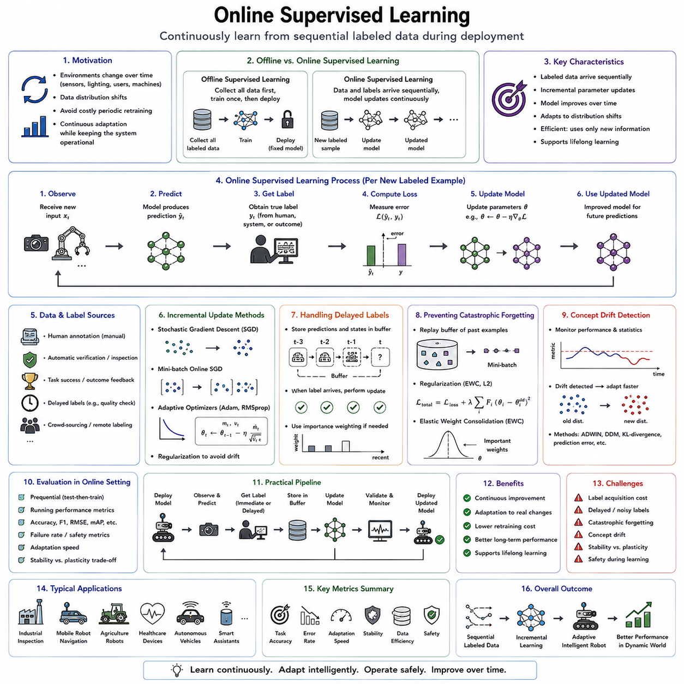
Online Supervised Learning extends the traditional supervised learning paradigm by allowing a model to continue updating its parameters while new labeled data arrive sequentially during deployment. Unlike conventional offline supervised learning, where all labeled examples are collected before training begins and the resulting model remains fixed afterward, online supervised learning assumes that labeled information becomes available continuously over time. Each new observation contributes additional knowledge that incrementally improves the model without requiring complete retraining from the beginning. This capability is particularly valuable for robotic systems, autonomous vehicles, industrial automation, healthcare devices, and intelligent assistants operating in dynamic environments where new experiences constantly emerge. Online supervised learning therefore serves as one of the fundamental building blocks for lifelong machine learning and continuously adaptive Physical AI.
The motivation for online supervised learning arises from the observation that real-world environments rarely remain static. Sensors gradually drift, lighting conditions change throughout the day, machines experience mechanical wear, users adopt new behaviors, products evolve, and operational environments continuously transform. A model trained only once inevitably becomes increasingly outdated as the underlying data distribution changes. Rather than periodically stopping the system for expensive retraining cycles, online supervised learning enables continuous adaptation while maintaining uninterrupted operation. The model gradually incorporates newly labeled examples into its existing knowledge, allowing performance to improve throughout deployment.
The defining characteristic of supervised learning is the availability of labeled data. Every training example consists of an input observation paired with a correct target label. In image recognition, the label identifies the object category. In regression tasks, the label specifies a continuous numerical value. In robotic perception, labels may represent object locations, semantic classes, grasp poses, navigation waypoints, defect categories, or force measurements. Online supervised learning preserves this supervised structure while changing the temporal organization of learning. Labels arrive one sample or one mini-batch at a time rather than as one complete dataset.
Incremental updating forms the computational core of online supervised learning. After receiving a new labeled sample, the model computes its prediction, compares that prediction with the correct label, calculates an error through an appropriate loss function, and updates its parameters using gradient-based optimization. Instead of repeating optimization over millions of historical examples, only the newly acquired information contributes directly to parameter adjustment. The updated model immediately becomes available for future predictions while remaining ready to incorporate subsequent observations.
This sequential learning process closely resembles how humans acquire expertise. A technician does not relearn every engineering principle after encountering one unfamiliar machine. Instead, the new experience modifies existing knowledge while preserving previously acquired skills. Similarly, an experienced physician continually improves diagnostic accuracy through new patient encounters without forgetting earlier medical knowledge. Online supervised learning seeks to reproduce this gradual accumulation of expertise within artificial learning systems.
One of the most significant advantages of incremental updates lies in computational efficiency. Complete retraining requires repeatedly processing the entire historical dataset, demanding substantial computational resources, memory capacity, storage bandwidth, and training time. Online learning instead processes only newly arriving samples, dramatically reducing computational cost. This efficiency becomes especially important for autonomous robots operating continuously over months or years, where frequent complete retraining would be impractical or economically prohibitive.
Streaming data provides the natural input format for online supervised learning. Sensors continuously produce images, depth maps, LiDAR scans, force measurements, tactile signals, inertial observations, temperature readings, audio streams, and other multimodal information. Whenever reliable labels become available through human annotation, automated inspection, downstream verification, or delayed task outcomes, these streaming observations immediately become training examples. The learning process therefore proceeds concurrently with operational deployment.
Different labeling mechanisms support online supervised learning depending on the application domain. Human experts may manually annotate observations through graphical interfaces. Industrial inspection systems generate labels automatically based on downstream quality verification. Warehouse robots receive confirmation after successful package delivery. Medical systems incorporate physician diagnoses after patient evaluation. Autonomous vehicles receive labels through high-definition map updates or human intervention during exceptional situations. These diverse supervision sources continuously expand the training dataset throughout deployment.
Delayed labeling presents an important practical challenge. Many applications cannot immediately determine the correct output associated with a newly observed input. For example, an industrial robot assembling electronic components may not learn whether insertion succeeded until quality inspection occurs several minutes later. Similarly, an agricultural robot may receive confirmation regarding fruit quality only after harvesting and sorting. Online supervised learning therefore frequently separates data acquisition from parameter updates, temporarily storing unlabeled observations until corresponding labels become available.
Mini-batch online learning provides a compromise between purely sequential updates and conventional offline optimization. Rather than updating parameters after every individual observation, small groups of newly collected labeled examples accumulate before optimization occurs. Mini-batch processing reduces gradient variance, improves computational efficiency on modern parallel hardware, and often yields more stable optimization while still preserving rapid adaptation to environmental changes.
Stochastic Gradient Descent naturally supports incremental learning because each optimization step depends upon only one or a few training examples. Every incoming labeled observation generates a gradient describing how the model should change to reduce prediction error. Adaptive optimization methods including Adam, RMSProp, AdaGrad, and AdaDelta further regulate incremental parameter updates by adjusting learning rates according to observed gradient statistics. These optimizers balance adaptation speed against long-term stability throughout continual operation.
Learning rate selection strongly influences online supervised learning performance. Large learning rates allow rapid adaptation to newly emerging conditions but risk overwriting previously acquired knowledge. Extremely small learning rates preserve historical information yet may prevent meaningful adaptation to changing environments. Dynamic learning rate scheduling addresses this tradeoff by adjusting optimization strength according to prediction confidence, detected distribution shifts, uncertainty estimates, or environmental stability.
Distribution shift remains one of the primary motivations for online adaptation. Consider an industrial vision system initially trained to detect manufacturing defects under factory lighting. Seasonal illumination changes, camera aging, lens contamination, new product designs, or sensor recalibration gradually alter the visual appearance of inspected components. Offline models increasingly misclassify these evolving observations. Online supervised learning continuously incorporates newly labeled inspection examples, restoring classification accuracy without interrupting production.
Medical diagnostic systems similarly benefit from incremental supervised updates. New imaging devices introduce different image characteristics, clinical protocols evolve, disease prevalence changes, and novel treatment methods appear over time. Online adaptation enables diagnostic models to incorporate contemporary medical knowledge while maintaining historical expertise. Such continual improvement becomes increasingly valuable as healthcare technologies rapidly evolve.
Autonomous driving provides another compelling application. Traffic signs change, road markings deteriorate, weather conditions vary seasonally, construction modifies infrastructure, and sensor hardware gradually ages. Human interventions during deployment provide valuable labeled examples identifying situations where previous predictions proved inadequate. Incremental supervised updates enable perception systems to adapt continuously to these evolving operating conditions while preserving previously acquired driving knowledge.
Industrial defect detection increasingly relies upon online supervised learning because manufacturing processes evolve continuously. New product variants, material batches, production equipment, tooling configurations, and quality requirements all introduce visual changes absent from initial training datasets. Quality inspectors naturally generate labels during routine production, providing continuous supervision for adaptive defect detection systems. Such online learning substantially reduces manual dataset reconstruction whenever production conditions change.
Incremental supervised learning also plays a central role within warehouse automation. Object appearance changes as packaging evolves, inventory expands, suppliers introduce new products, and environmental conditions vary throughout daily operations. Barcode verification, inventory management systems, and human corrections provide reliable labels supporting continuous adaptation. Warehouse robots therefore improve recognition performance while remaining operational throughout evolving logistics workflows.
Memory management becomes particularly important because indefinitely storing every historical observation is generally impossible. Experience replay buffers preserve representative subsets of earlier labeled examples, allowing joint optimization over historical and recent data. Without replay, models often overfit newly arriving observations while forgetting previous knowledge. Carefully balanced replay strategies therefore stabilize incremental learning while limiting storage requirements.
Replay strategies vary according to application requirements. Random replay approximates stationary data distributions by sampling uniformly from stored experiences. Prioritized replay emphasizes examples exhibiting high prediction error or significant learning potential. Reservoir sampling maintains statistically representative historical subsets despite unbounded data streams. Class-balanced replay preserves rare categories vulnerable to forgetting. These memory management techniques significantly improve long-term learning stability.
Catastrophic forgetting remains one of the central challenges facing online supervised learning. Neural networks frequently overwrite previously learned representations while adapting to new data, causing performance degradation on earlier examples. Biological memory systems largely avoid such severe forgetting through consolidation processes distributed across multiple brain regions. Artificial systems therefore require explicit computational mechanisms preserving historical knowledge throughout continual adaptation.
Regularization-based methods mitigate catastrophic forgetting by identifying parameters essential for previous tasks. Elastic Weight Consolidation estimates parameter importance through Fisher Information, penalizing changes affecting critical weights. Memory Aware Synapses and Synaptic Intelligence similarly constrain modifications to previously important parameters while allowing flexible adaptation elsewhere within the network. These approaches maintain historical competence without preventing meaningful learning.
Knowledge distillation offers another effective strategy for preserving prior knowledge. A previously trained teacher model generates soft target predictions representing historical expertise. During incremental learning, the updated student model simultaneously learns from new labeled data while matching teacher outputs on representative historical examples. This dual optimization preserves established knowledge while incorporating newly acquired information.
Dynamic neural architectures provide structural solutions to continual adaptation. Rather than modifying existing parameters indefinitely, additional network capacity becomes available whenever substantially different knowledge must be acquired. Progressive Neural Networks, dynamically expandable architectures, and modular neural systems preserve historical representations while allocating specialized computational resources for emerging concepts. Although computational complexity gradually increases, catastrophic forgetting becomes significantly reduced.
Representation learning plays a particularly important role because feature extractors themselves evolve during online adaptation. Visual encoders gradually recognize previously unseen textures, lighting conditions, object categories, and environmental structures. Language encoders incorporate newly emerging terminology. Multimodal representations strengthen relationships among vision, language, tactile sensing, force feedback, and proprioception through repeated supervised experience. These continually improving representations often transfer beneficially across multiple downstream tasks.
Concept drift introduces additional complexity because the relationship between inputs and labels changes over time. A medical image previously classified as healthy according to outdated diagnostic criteria may later receive a different label under revised clinical guidelines. Manufacturing defects evolve as production tolerances change. User preferences shift throughout long-term human-robot interaction. Detecting concept drift therefore becomes essential before meaningful adaptation can occur.
Statistical drift detection methods monitor prediction error distributions, feature statistics, uncertainty estimates, confidence calibration, and label frequencies to identify evolving operating conditions. Sudden increases in prediction error often indicate significant environmental change requiring accelerated adaptation. More subtle gradual drift requires long-term statistical monitoring capable of distinguishing systematic evolution from ordinary observational noise.
Confidence estimation further improves incremental supervised learning. Modern neural networks increasingly estimate prediction uncertainty alongside classification outputs. Bayesian neural networks, Monte Carlo Dropout, ensemble methods, evidential deep learning, and probabilistic calibration techniques quantify confidence associated with each prediction. Low-confidence observations become valuable candidates for human annotation because additional labels provide maximal information for future learning.
Active learning naturally complements online supervised adaptation. Rather than requesting labels for every observation, the system selectively queries human experts only for highly informative examples exhibiting uncertainty, novelty, disagreement among ensemble models, or suspected distribution shift. This selective labeling dramatically reduces annotation effort while maximizing incremental learning efficiency. Human expertise therefore focuses upon the observations contributing greatest long-term benefit.
Human-in-the-loop supervision remains indispensable in many safety-critical applications. Industrial operators verify uncertain defect classifications. Medical specialists confirm difficult diagnoses. Autonomous vehicle supervisors intervene during unusual traffic scenarios. Robotic operators correct manipulation failures. These human corrections generate highly informative labeled examples directly addressing current model weaknesses. Online supervised learning therefore creates an ongoing collaborative relationship between artificial intelligence and human expertise.
Cloud infrastructure increasingly supports large-scale online supervised learning across fleets of robots. Individual robots perform local inference while periodically uploading newly labeled experiences to centralized training servers. Global models incorporate aggregated knowledge from thousands of distributed systems before optimized parameters return to individual robots. Fleet learning dramatically accelerates knowledge acquisition because every robot benefits from experiences collected throughout the entire deployment network.
Federated supervised learning extends this concept while preserving privacy. Instead of transmitting raw sensor data, individual devices exchange only parameter updates or compressed gradient information. Central aggregation combines these distributed updates into improved global models without exposing sensitive operational data. Such privacy-preserving collaboration becomes particularly important within healthcare, manufacturing, defense, and consumer robotics.
Evaluation of online supervised learning extends beyond conventional classification accuracy. Researchers measure adaptation speed following environmental change, forgetting rate on historical tasks, computational efficiency, memory utilization, sample efficiency, uncertainty calibration, robustness under distribution shift, annotation efficiency, and long-term cumulative performance. Unlike static benchmarks evaluating final model accuracy, online evaluation emphasizes sustained improvement throughout continuous operation.
Deployment introduces additional engineering considerations. Models must update safely without disrupting ongoing operation. Incremental updates frequently occur during scheduled maintenance intervals, low-activity periods, or dedicated background computation threads. Runtime safety monitors verify updated models before autonomous control resumes. Version management tracks parameter evolution, training data, hyperparameters, and deployment history to ensure reproducibility and reliable rollback if unexpected behavior emerges.
Edge deployment further constrains online supervised learning because embedded processors possess limited computational resources. Efficient optimization algorithms, lightweight architectures, parameter-efficient fine-tuning, quantization-aware learning, and hardware acceleration enable continual adaptation within practical energy and latency constraints. These optimizations allow intelligent robots to learn directly on embedded hardware without depending exclusively on cloud connectivity.
Foundation models increasingly reshape online supervised learning by providing powerful pretrained representations requiring only modest incremental adaptation. Instead of learning entirely from scratch, deployment-specific supervision fine-tunes existing multimodal representations using relatively small quantities of labeled data. Parameter-efficient adaptation techniques such as adapters, low-rank adaptation, prompt tuning, and retrieval augmentation further reduce computational requirements while preserving broad pretrained knowledge.
World models complement supervised incremental learning by continuously refining predictive internal representations of environmental dynamics. Newly labeled observations improve not only immediate prediction tasks but also broader causal understanding, enabling more accurate simulation, planning, and decision-making. Online supervised learning therefore contributes simultaneously to perception, reasoning, and model-based control within increasingly integrated cognitive architectures.
The future of online supervised learning will likely combine continual adaptation, active learning, foundation models, world models, federated optimization, multimodal reasoning, uncertainty estimation, and human collaborative supervision into unified lifelong learning systems. Rather than treating deployment as the endpoint of machine learning, intelligent robots will continue acquiring labeled knowledge throughout their operational lifetime, gradually improving perception, prediction, reasoning, and control through every meaningful interaction with the physical world.
Online supervised learning and incremental updating therefore represent essential technologies for adaptive artificial intelligence operating under continuously changing real-world conditions. By integrating streaming labeled data, efficient optimization, memory management, concept drift detection, catastrophic forgetting prevention, uncertainty-aware learning, and human-guided supervision, these methods transform static supervised models into continuously evolving intelligent systems. As Physical AI expands across manufacturing, healthcare, logistics, agriculture, transportation, and domestic robotics, online supervised learning will remain a foundational capability enabling robots to learn safely, efficiently, and continuously throughout their entire operational lifetime.

07.03 Online RL Real Time Policy Gradient [w/Code]
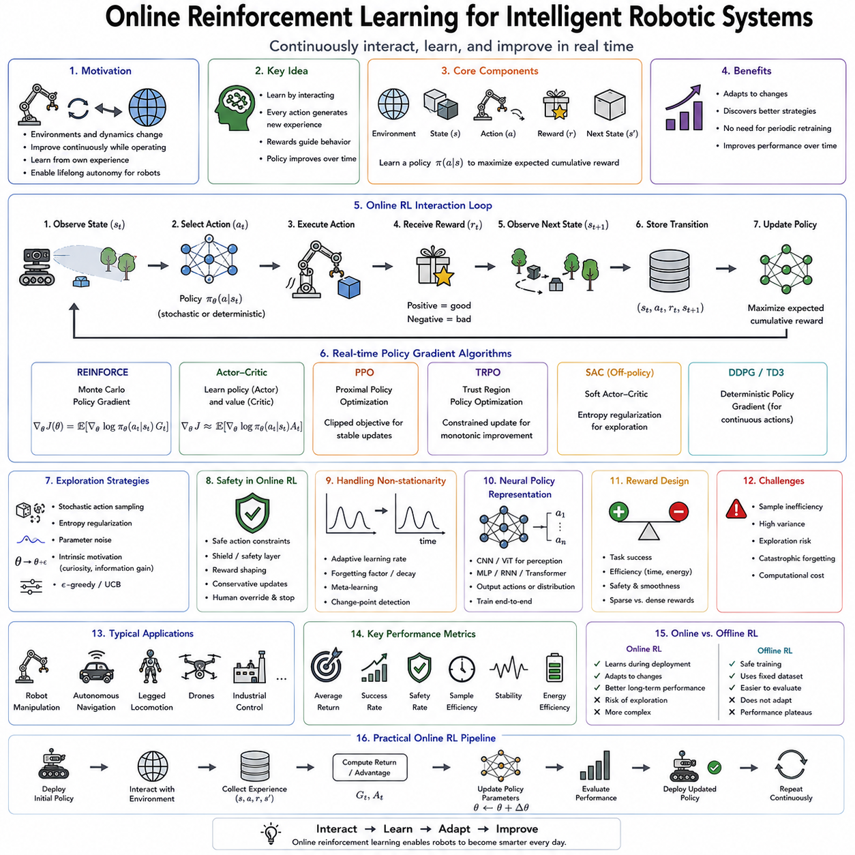
Online Reinforcement Learning extends classical reinforcement learning by allowing an intelligent agent to continuously improve its policy while interacting with the real environment in real time. Unlike offline reinforcement learning, where a policy is trained using previously collected datasets before deployment, online reinforcement learning performs learning and decision making simultaneously. Every action executed by the agent generates new experiences that immediately contribute to future policy improvement. This continuous interaction enables autonomous systems to adapt to changing environments, unknown dynamics, evolving objectives, and unexpected disturbances without requiring repeated offline retraining. As robotics moves toward lifelong autonomy and Physical AI, online reinforcement learning has become one of the fundamental technologies enabling robots to improve continuously throughout deployment.
The fundamental idea behind online reinforcement learning is that experience itself is the primary source of intelligence. Rather than relying exclusively on demonstrations or historical datasets, the agent learns directly from the consequences of its own actions. Every observation, action, reward, and state transition contributes new information regarding the environment. Successful behaviors become increasingly reinforced while unsuccessful behaviors gradually disappear through continual optimization. The robot therefore becomes progressively more competent simply by interacting with the world.
Real-time policy gradient methods represent one of the most important classes of online reinforcement learning algorithms. Instead of estimating action values first and deriving policies indirectly, policy gradient methods optimize the policy itself by directly adjusting the parameters governing action selection. The objective is to maximize the expected cumulative reward obtained through future interactions. Because the policy continuously receives fresh experience during deployment, its parameters evolve incrementally as the robot encounters new situations, allowing behavior to improve while operation continues.
A policy in reinforcement learning defines a probability distribution over actions conditioned on the current state. Given sensory observations including images, force measurements, LiDAR scans, joint positions, language commands, or environmental maps, the policy determines which action should be executed next. In deterministic policies, identical observations always produce identical actions. Stochastic policies instead produce probability distributions, allowing controlled exploration of alternative behaviors. Online policy gradient methods frequently employ stochastic policies because exploration remains essential for discovering improved strategies during continual learning.
The reinforcement learning interaction cycle naturally supports online adaptation. The robot observes the current state of the environment, selects an action according to its policy, executes that action, receives a reward from the environment, and transitions into a new state. This transition immediately becomes additional training data. Unlike supervised learning, where labeled examples must be provided externally, reinforcement learning generates its own supervision through environmental feedback. Consequently, learning proceeds continuously without requiring explicit human annotation.
Policy gradients estimate how policy parameters should change in order to increase future cumulative rewards. Every observed trajectory contributes gradient information indicating whether selected actions improved or reduced long-term performance. Positive outcomes increase the probability of similar actions under comparable future conditions, while negative outcomes reduce their likelihood. Through repeated interaction, the policy gradually converges toward behaviors maximizing expected returns under the current operating conditions.
The policy gradient theorem provides the mathematical foundation underlying these algorithms. Rather than differentiating the unknown environmental dynamics directly, the theorem expresses the policy gradient entirely through observed trajectories and policy probabilities. This property enables optimization even when the environment remains partially unknown, highly nonlinear, or physically impossible to model analytically. As a result, policy gradient methods have become particularly valuable for robotics, where accurate physical models rarely capture the full complexity of real-world interaction.
One of the defining characteristics of online reinforcement learning is continuous exploration. The agent cannot simply repeat previously successful behaviors indefinitely because environmental conditions evolve over time. New objects appear, terrain changes, sensors degrade, and task objectives shift. Controlled exploration enables discovery of improved strategies while maintaining acceptable operational performance. Balancing exploration with exploitation therefore becomes one of the central challenges of real-time reinforcement learning.
Exploration strategies vary considerably depending upon application requirements. Stochastic action sampling naturally introduces behavioral diversity during policy execution. Entropy regularization explicitly encourages broader action distributions, preventing premature convergence toward overly deterministic behaviors. Parameter noise perturbs policy weights directly, producing consistent exploratory behaviors across multiple time steps. Intrinsic motivation methods reward novelty, uncertainty reduction, or information gain, encouraging agents to investigate unfamiliar regions of the environment beyond immediate task rewards.
Safety significantly constrains exploration within real robotic systems. Unlike simulation, physical robots cannot freely execute arbitrary actions because unsafe exploration may damage equipment, harm humans, or interrupt industrial production. Safe reinforcement learning therefore incorporates explicit safety constraints alongside reward optimization. Collision avoidance, joint limits, force thresholds, workspace boundaries, and emergency stop conditions restrict exploration to physically acceptable regions while still permitting meaningful policy improvement.
Constrained policy optimization provides one important framework for safe online learning. Instead of maximizing reward alone, optimization simultaneously satisfies predefined safety constraints throughout learning. The resulting policy remains within acceptable operational limits while gradually improving task performance. Such constrained optimization has become increasingly important for collaborative robotics, autonomous vehicles, healthcare systems, and industrial automation where safety cannot be sacrificed for learning efficiency.
Real-time policy updates require careful computational design because learning occurs concurrently with robot operation. The inference process generating control commands must satisfy strict timing requirements while optimization executes asynchronously in the background. Modern robotic systems frequently separate these two processes using parallel computational pipelines. Fast inference threads maintain deterministic control frequencies while lower-priority optimization threads incorporate newly collected experiences whenever computational resources become available.
On-policy algorithms naturally support online policy gradient learning because optimization depends directly upon trajectories generated by the current policy. REINFORCE introduced the earliest policy gradient formulation using Monte Carlo trajectory returns. Actor-Critic architectures significantly improved efficiency by introducing value function estimation that reduces gradient variance. Advantage Actor-Critic further estimates relative action quality, accelerating convergence through lower-variance policy updates. Proximal Policy Optimization later stabilized online optimization by constraining excessively large policy changes between successive updates.
Actor-Critic methods have become especially influential for real-time robotics because they separate decision making from evaluation. The actor generates actions according to the current policy, while the critic estimates expected future rewards associated with observed states or state-action pairs. This dual architecture provides lower variance gradient estimates, improved sample efficiency, and smoother policy improvement than pure Monte Carlo methods. Continuous interaction continually refines both components simultaneously.
Advantage estimation further improves online learning efficiency by comparing observed returns against expected baseline values. Actions producing better-than-expected outcomes receive positive reinforcement, while less successful actions become less probable. This relative evaluation substantially reduces optimization variance while preserving unbiased policy gradient estimates. Consequently, modern online reinforcement learning frequently combines advantage estimation with actor-critic architectures.
Sample efficiency remains one of the greatest practical challenges facing online reinforcement learning. Collecting physical robot experience is considerably slower, more expensive, and riskier than generating simulated trajectories. Every trial consumes time, mechanical wear, electrical energy, and operational opportunity. Efficient policy gradient methods therefore maximize information extracted from each interaction. Experience replay, model-based prediction, world models, and learned simulators increasingly complement real experience to reduce physical sample requirements.
World models significantly enhance online reinforcement learning by learning predictive internal representations of environmental dynamics. Rather than relying exclusively upon physical interaction, the robot performs imagined rollouts within its learned world model, evaluating hypothetical actions before executing them physically. This combination of real experience and internal simulation dramatically improves sample efficiency while reducing operational risk.
Model-based reinforcement learning extends this principle further by explicitly incorporating learned dynamics models into planning and policy optimization. The agent predicts future state transitions resulting from candidate actions, allowing gradient optimization to consider long-term consequences before actual execution. Hybrid architectures combining policy gradients with learned predictive models increasingly dominate modern robot learning due to their superior efficiency.
Continuous control represents one of the principal application domains for online policy gradients. Robotic manipulators, quadrupeds, humanoids, drones, underwater vehicles, and autonomous cars all operate within continuous action spaces where discrete action-value methods become less suitable. Policy gradient algorithms naturally generate continuous motor commands, enabling smooth trajectories, precise manipulation, stable locomotion, and agile navigation under continuously changing environmental conditions.
Humanoid robotics particularly benefits from online reinforcement learning because locomotion dynamics remain difficult to model precisely. Small differences in terrain, friction, payload, actuator behavior, or mechanical wear significantly influence stability. Online adaptation enables walking policies to refine balance strategies continuously according to observed environmental conditions. Recovery from slips, uneven terrain, or unexpected disturbances gradually improves through repeated real-world experience.
Manipulation tasks likewise require continual adaptation. Grasp success depends upon object geometry, surface friction, compliance, weight distribution, and contact dynamics that often differ from simulation assumptions. Online reinforcement learning continuously refines grasp strategies based upon observed outcomes, improving manipulation reliability without requiring explicit analytical models for every object category encountered during deployment.
Industrial robotics increasingly employs online reinforcement learning for process optimization. Welding parameters, polishing trajectories, assembly forces, machining strategies, and quality inspection procedures may all improve gradually through operational feedback. Production systems continuously adjust policies to maximize product quality, minimize cycle time, reduce energy consumption, and compensate for equipment aging while maintaining uninterrupted manufacturing operations.
Human feedback increasingly complements environmental rewards within online reinforcement learning. Human operators provide preference labels, corrective interventions, natural language instructions, or evaluative feedback whenever undesirable behaviors occur. Reinforcement Learning from Human Feedback extends conventional environmental rewards by incorporating subjective human preferences into policy optimization. Such collaborative learning significantly accelerates adaptation while improving alignment with human expectations.
Reward design remains one of the most influential factors determining online learning performance. Sparse rewards provide feedback only after complete task success, making optimization difficult because intermediate actions receive little guidance. Dense rewards provide continuous evaluation throughout task execution but require careful engineering to avoid unintended behaviors exploiting poorly designed objectives. Reward shaping therefore introduces intermediate incentives encouraging progress toward final goals while preserving optimal policy structure.
Automatic reward learning increasingly reduces reliance on manually engineered reward functions. Inverse Reinforcement Learning infers hidden objectives from expert demonstrations. Preference learning estimates rewards directly from human comparisons. Contrastive representation learning constructs intrinsic objectives supporting self-supervised improvement. These approaches simplify deployment because explicit reward engineering often becomes impractical for complex real-world tasks.
Real-time reinforcement learning also benefits from hierarchical architectures. High-level policies determine long-term goals or task decomposition, while lower-level controllers optimize detailed motor execution. Each layer learns at different temporal scales, improving stability, interpretability, and sample efficiency. Hierarchical reinforcement learning therefore supports increasingly complex long-horizon robotic behaviors including assembly, warehouse logistics, household assistance, and autonomous exploration.
Multi-agent online reinforcement learning introduces additional complexity because multiple adaptive agents learn simultaneously. Warehouse robot fleets coordinate transportation tasks. Autonomous vehicles negotiate traffic interactions. Drone swarms perform collaborative surveillance. Industrial robots cooperate during manufacturing. Every agent continually adapts while influencing the environment experienced by others, creating highly non-stationary learning dynamics. Communication protocols, shared world models, centralized critics, and decentralized execution increasingly address these coordination challenges.
Cloud robotics enables fleet-level online reinforcement learning by aggregating experiences collected across many distributed robots. Individual robots perform local adaptation while periodically sharing compressed policy updates or selected experiences with centralized learning infrastructure. Improved global policies subsequently redistribute throughout the fleet, allowing every robot to benefit from collective operational knowledge accumulated across diverse environments.
Federated reinforcement learning further protects operational privacy by exchanging only policy parameters rather than raw sensor observations. Medical robots, industrial facilities, defense systems, and consumer devices collaboratively improve reinforcement learning policies without revealing sensitive operational data. Federated optimization therefore combines large-scale collective learning with practical privacy preservation.
Monitoring and evaluation remain essential because online policies continue changing throughout deployment. Unlike static models, continuously adapting policies require ongoing performance assessment. Success rate, cumulative reward, sample efficiency, adaptation speed, exploration efficiency, energy consumption, computational latency, safety violations, intervention frequency, robustness, and long-term stability all contribute to evaluating deployment quality. Continuous monitoring detects performance degradation before operational reliability becomes compromised.
Version management becomes increasingly important as policies evolve through continual updates. Every policy version records associated experiences, optimization parameters, software dependencies, hardware configurations, safety validation results, and deployment history. Complete traceability enables reproducible experimentation, safe rollback after unexpected behavior, and rigorous regulatory documentation within industrial applications.
Foundation models increasingly integrate with online reinforcement learning. Large pretrained multimodal models provide rich representations acquired through enormous offline datasets, while online policy gradients specialize these general capabilities toward specific deployment environments. Parameter-efficient adaptation techniques, retrieval augmentation, prompt optimization, and lightweight fine-tuning dramatically reduce the quantity of online interaction required for successful adaptation.
The convergence of online reinforcement learning, world models, policy gradients, foundation models, Vision-Language-Action architectures, continual learning, cloud robotics, and human collaborative supervision represents a major step toward lifelong embodied intelligence. Future autonomous systems will not rely upon fixed policies learned before deployment. Instead, they will continuously refine their behavior through every interaction, accumulate knowledge across years of operation, share experiences across fleets, personalize behavior for individual users, and safely adapt to evolving environments without interrupting ongoing tasks.
Online reinforcement learning and real-time policy gradient methods therefore constitute foundational technologies for continuously improving autonomous systems. By enabling policies to optimize directly through real-world interaction, incorporate new experiences incrementally, balance exploration with exploitation, satisfy safety constraints, leverage predictive world models, and collaborate with human supervisors, these methods transform reinforcement learning from an offline optimization procedure into a lifelong adaptive intelligence framework. As Physical AI expands into manufacturing, logistics, healthcare, agriculture, scientific exploration, domestic robotics, and autonomous transportation, online reinforcement learning will remain one of the essential mechanisms enabling intelligent machines to learn, adapt, and improve continuously throughout their operational lifetime.

07.04 Meta Learning MAML for Fast Robot Adaptation [w/Code]
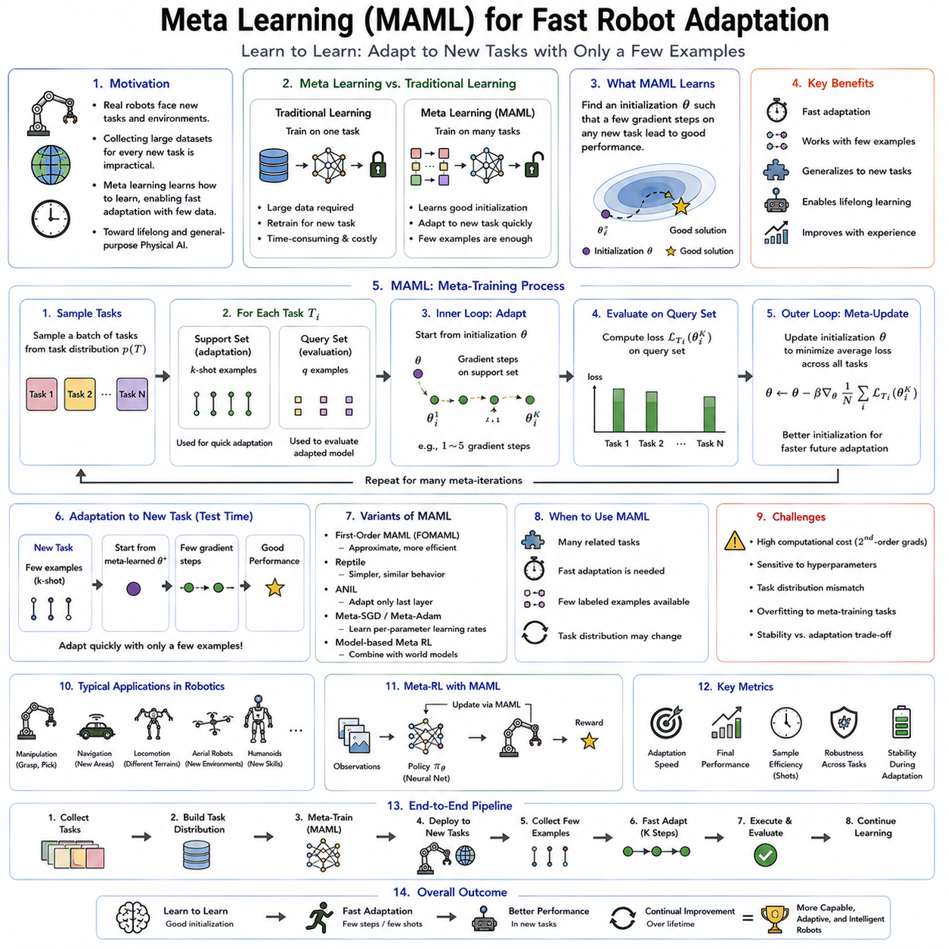
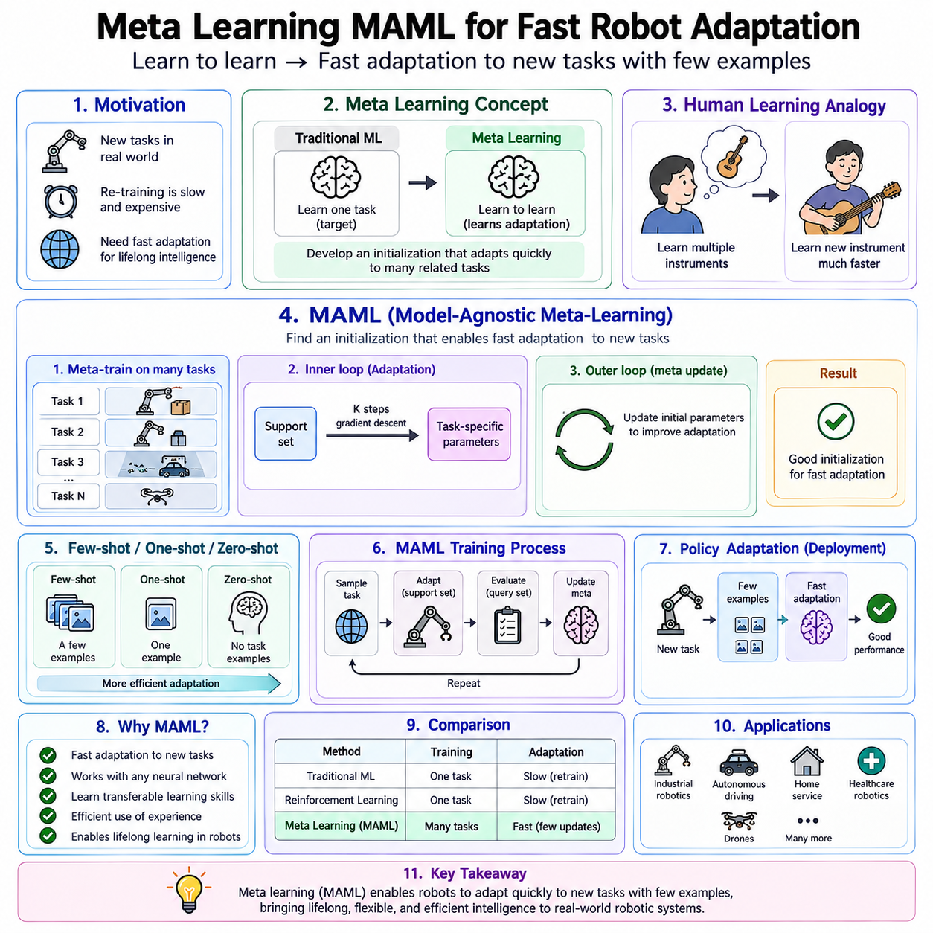
Meta learning, often described as “learning to learn,” represents one of the most significant advances toward creating adaptive artificial intelligence capable of acquiring new skills rapidly from limited experience. Traditional machine learning focuses on optimizing a model for a specific task using large amounts of task-specific data. Once training is complete, adapting the model to a new task often requires collecting another extensive dataset and repeating the optimization process. Such retraining is computationally expensive, time-consuming, and impractical for robots operating in dynamic real-world environments. Meta learning addresses this limitation by training models that acquire the ability to adapt efficiently to previously unseen tasks using only a small number of examples. Rather than learning a single solution, the model learns how learning itself should occur. For autonomous robots expected to operate continuously in changing environments, this capability represents a fundamental requirement for lifelong intelligence and constitutes an important step toward general-purpose Physical AI.
The central philosophy of meta learning differs fundamentally from conventional supervised learning or reinforcement learning. Standard learning algorithms optimize parameters to perform one particular task as accurately as possible. Meta learning instead optimizes the learning process itself. During training, the system repeatedly encounters many related tasks rather than one fixed objective. Through this repeated exposure, it discovers parameter initializations, optimization strategies, representations, or adaptation mechanisms that enable rapid improvement whenever a new task appears. Consequently, the model acquires transferable learning capabilities instead of memorizing task-specific knowledge.
Human learning provides a useful analogy for understanding meta learning. A person who has learned multiple musical instruments often acquires a new instrument much more quickly than someone learning music for the first time. Similarly, an experienced engineer adapts more rapidly to unfamiliar equipment because previous experience has taught general principles extending beyond individual machines. Children also demonstrate remarkable meta-learning ability by acquiring entirely new concepts from only a handful of examples. Meta learning seeks to reproduce this remarkable flexibility within artificial learning systems.
Rapid adaptation represents the defining objective of meta learning. Real robotic systems frequently encounter situations unavailable during initial training. New tools appear within manufacturing facilities. Household service robots enter unfamiliar homes. Agricultural robots operate on different crops. Medical robots interact with diverse patients. Search-and-rescue robots navigate previously unseen disaster environments. Rather than requiring thousands of additional training examples, meta learning enables robots to adapt after only a few demonstrations, a few minutes of interaction, or even a handful of reinforcement learning episodes.
Few-shot learning naturally complements meta learning because both address adaptation under limited data availability. Few-shot learning emphasizes achieving acceptable performance from only a small number of labeled examples, while meta learning provides the mechanisms enabling such rapid adaptation. One-shot learning extends this challenge further by requiring successful adaptation from only a single example. Zero-shot learning represents an even more ambitious objective, where general prior knowledge enables competence without observing any task-specific training data. Meta learning provides a common conceptual framework connecting these increasingly efficient forms of adaptation.
Model-Agnostic Meta-Learning, commonly abbreviated as MAML, represents one of the most influential meta-learning algorithms developed for deep neural networks. The term “model-agnostic” reflects one of its greatest strengths: MAML does not depend upon any particular network architecture. Convolutional neural networks, recurrent networks, transformers, graph neural networks, reinforcement learning policies, diffusion policies, and multimodal foundation models may all employ the same underlying optimization principle. This architectural flexibility has made MAML one of the foundational algorithms for fast adaptation across diverse machine learning domains.
The central insight behind MAML is deceptively simple. Instead of learning parameters that solve one particular task optimally, MAML learns parameters that can be rapidly adapted toward many different tasks using only a few gradient updates. During meta-training, optimization searches for an initialization point from which gradient descent quickly reaches good solutions across an entire distribution of related tasks. Consequently, deployment no longer begins from random initialization but from a parameter configuration already optimized for rapid adaptation.
Meta-training differs substantially from conventional optimization. Instead of repeatedly sampling independent training examples, MAML repeatedly samples complete learning tasks. Each task contains a support set used for temporary adaptation and a query set used to evaluate the quality of that adaptation. During each meta-training iteration, the model first performs several gradient updates using the support data, producing task-specific adapted parameters. The resulting model is then evaluated on the query data. Meta-optimization subsequently updates the original initialization so that future adaptation becomes increasingly effective across all sampled tasks.
This nested optimization process produces two interconnected learning loops. The inner loop performs ordinary gradient descent adapting the model toward one specific task. The outer loop optimizes the initial parameters governing how efficiently inner-loop adaptation occurs across many tasks. These nested optimization processes distinguish MAML from conventional machine learning because the objective is no longer task performance alone but adaptation efficiency itself.
Gradient-based meta learning naturally extends familiar optimization algorithms. Standard gradient descent minimizes prediction error for one task. MAML instead differentiates through the adaptation process itself, estimating how modifications to initial parameters influence future adaptation quality after several gradient updates. Although computationally more demanding than ordinary supervised learning, this higher-order optimization enables remarkably rapid adaptation once meta-training has completed.
The support-query separation plays a fundamental conceptual role within MAML. The support set represents the limited information available when encountering a new task during deployment. The query set evaluates how successfully the adapted model generalizes beyond those few examples. Meta-training therefore explicitly simulates future deployment conditions where adaptation must occur under severe data limitations. This realistic optimization objective contributes significantly to MAML's practical effectiveness.
Fast robot adaptation represents one of the most compelling applications of MAML. Consider a robotic manipulator trained to grasp hundreds of household objects. Traditional learning may require extensive retraining whenever a new object appears. A meta-trained manipulator instead begins from an initialization specifically optimized for rapid adaptation. After grasping the unfamiliar object only several times, the robot refines its policy sufficiently to manipulate the new object reliably. Such rapid adaptation dramatically reduces operational downtime while increasing deployment flexibility.
Locomotion provides another important application. Walking robots frequently encounter surfaces differing from those experienced during initial training. Grass, gravel, sand, snow, mud, metal flooring, and uneven terrain each exhibit distinct physical characteristics affecting stability. Rather than requiring lengthy retraining whenever terrain changes, meta-learned locomotion policies adapt after only a small number of interactions, allowing continuous mobility across diverse environments.
Industrial robotics similarly benefits from rapid adaptation. Production facilities regularly introduce new products, tooling configurations, assembly procedures, and manufacturing tolerances. Meta-trained assembly policies quickly adjust insertion forces, manipulation trajectories, or grasp configurations using only limited calibration data collected during production setup. Such rapid adaptation significantly reduces commissioning time while increasing manufacturing flexibility.
Robot perception also benefits from meta learning. Camera characteristics, illumination conditions, object appearances, and environmental backgrounds vary substantially across deployment locations. Meta-trained perception systems rapidly adapt feature representations using only a few labeled observations collected after installation. Consequently, visual recognition remains accurate despite changing environmental conditions without requiring complete dataset reconstruction.
Meta reinforcement learning extends these principles beyond supervised learning toward sequential decision making. Rather than learning policies directly, the system learns how reinforcement learning itself should adapt across related tasks. During deployment, only a few episodes of environmental interaction suffice for substantial policy improvement. Meta reinforcement learning therefore significantly reduces exploration requirements compared with conventional reinforcement learning, making real-world robotic deployment considerably more practical.
Context-based meta learning provides an alternative adaptation mechanism. Instead of explicitly updating network parameters through gradient descent, recurrent neural networks, transformers, or latent variable models infer task identity directly from recent observations. Hidden internal states gradually encode task-specific information, allowing rapid behavioral adaptation without modifying model parameters explicitly. Such implicit adaptation often proves computationally more efficient than gradient-based optimization during deployment.
Optimization-based, memory-based, and model-based meta learning represent three major categories of meta-learning algorithms. Optimization-based methods including MAML learn favorable parameter initializations. Memory-based approaches employ external memory structures storing prior experiences available for rapid retrieval during adaptation. Model-based approaches modify internal architectures enabling fast inference of task-specific behavior through learned latent representations. Contemporary research increasingly combines these complementary mechanisms into unified adaptive learning architectures.
Representation learning plays an essential role within meta learning because transferable features often contribute more significantly than task-specific parameters. Visual representations capturing object geometry, texture, physical affordances, and semantic relationships remain useful across numerous robotic tasks. Meta training therefore encourages representations supporting efficient adaptation rather than merely maximizing immediate task accuracy. Large multimodal foundation models increasingly provide such transferable representations before deployment-specific meta adaptation begins.
Task diversity strongly influences meta-learning performance. Meta-training must encompass sufficiently varied tasks to expose common structural regularities without becoming so diverse that meaningful shared knowledge disappears. Robotic manipulation datasets therefore frequently include grasping, pushing, stacking, insertion, opening, tool use, and deformable object interaction. Exposure to broad task distributions enables robust adaptation toward previously unseen combinations encountered during deployment.
Simulation has become indispensable for meta learning because collecting thousands of physical adaptation tasks would prove prohibitively expensive. High-fidelity simulators generate enormous task distributions through domain randomization, procedural environment generation, object variation, and physical parameter sampling. Meta-trained policies subsequently transfer toward physical robots using comparatively limited real-world adaptation. This combination substantially reduces development cost while maintaining strong adaptation capability.
Domain randomization naturally complements meta learning by exposing models to extensive environmental diversity before deployment. Object appearances, lighting conditions, textures, dynamics, sensor noise, friction coefficients, camera positions, and actuator characteristics vary continuously throughout simulation. Meta optimization consequently discovers parameter initializations robust across broad operating conditions, improving sim-to-real transfer significantly.
Catastrophic forgetting remains relevant within meta learning because continual adaptation may overwrite previously acquired knowledge. Memory replay, regularization, parameter isolation, and modular architectures therefore frequently complement MAML during long-term deployment. The resulting systems preserve broad adaptation capabilities while continually incorporating newly encountered experiences throughout operational lifetime.
Online meta learning extends MAML toward lifelong adaptation. Rather than ending meta optimization before deployment, robots continue refining their adaptation mechanisms while interacting with the real world. Every newly encountered task contributes not only task-specific knowledge but also improved understanding of how future adaptation should proceed. Consequently, the robot gradually becomes progressively better at learning itself, not merely at performing individual tasks.
Uncertainty estimation further enhances fast adaptation. Bayesian meta learning maintains probability distributions over parameters, enabling robots to distinguish familiar situations requiring little adaptation from highly uncertain environments demanding additional exploration. Confidence-aware adaptation reduces unnecessary parameter updates while directing learning resources toward genuinely novel operating conditions.
Human guidance significantly accelerates meta adaptation. Demonstrations, corrective interventions, preference feedback, language instructions, and semantic explanations all provide highly informative adaptation signals. Human supervisors therefore function not merely as data annotators but as teachers shaping the robot's adaptation process itself. Such collaborative meta learning combines human expertise with autonomous optimization throughout deployment.
Vision-Language-Action models increasingly integrate meta-learning principles. Large pretrained multimodal representations provide broad general knowledge regarding objects, language, physical interactions, and manipulation strategies. MAML-style adaptation subsequently specializes these representations toward individual robots, users, environments, and tasks using remarkably small quantities of task-specific experience. This combination dramatically reduces adaptation time while preserving broad generalization capabilities.
Diffusion policies likewise benefit from meta learning. Rather than training diffusion models separately for every manipulation task, meta optimization produces initial diffusion parameters rapidly adaptable toward novel manipulation objectives. Fine motor behaviors therefore emerge after comparatively few demonstrations, making diffusion-based robot control increasingly practical for real-world deployment.
Cloud robotics extends fast adaptation beyond individual robots toward collective intelligence. Multiple robots independently encounter diverse tasks while periodically sharing adaptation experiences through centralized cloud infrastructure. Meta optimization aggregates these distributed learning episodes into improved global initialization parameters redistributed throughout the fleet. Every robot consequently benefits from adaptation experiences accumulated across the entire deployment network, substantially accelerating collective learning.
Evaluation of meta-learning systems differs from conventional supervised learning benchmarks. Success depends not only upon final task performance but also upon adaptation speed, sample efficiency, computational cost, memory usage, robustness across unseen tasks, transfer capability, and long-term operational stability. Standard evaluation protocols therefore measure performance after one, five, or ten adaptation steps rather than only after complete optimization convergence.
The convergence of meta learning, continual learning, online reinforcement learning, foundation models, world models, diffusion policies, Vision-Language-Action architectures, and cloud robotics represents an important milestone toward Artificial General Intelligence for embodied systems. Future robots will no longer depend upon extensive retraining whenever new tasks emerge. Instead, they will rapidly adapt existing knowledge toward unfamiliar situations, continually improving their own learning strategies through every deployment experience while sharing adaptation knowledge collectively across entire robotic fleets.
Meta learning and MAML therefore represent foundational technologies enabling fast robot adaptation under realistic operational constraints. By optimizing learning itself rather than individual tasks, discovering parameter initializations supporting rapid gradient-based adaptation, leveraging transferable representations, integrating continual online improvement, and combining human guidance with autonomous optimization, these methods transform robotic learning from slow task-specific optimization into a flexible lifelong adaptation framework. As Physical AI advances toward truly general-purpose autonomous intelligence, meta learning will remain one of the essential mechanisms allowing robots to acquire new capabilities quickly, efficiently, and safely throughout their entire operational lifetime.

07.05 Few Shot Online Adaptation to New Environments [w/Code]
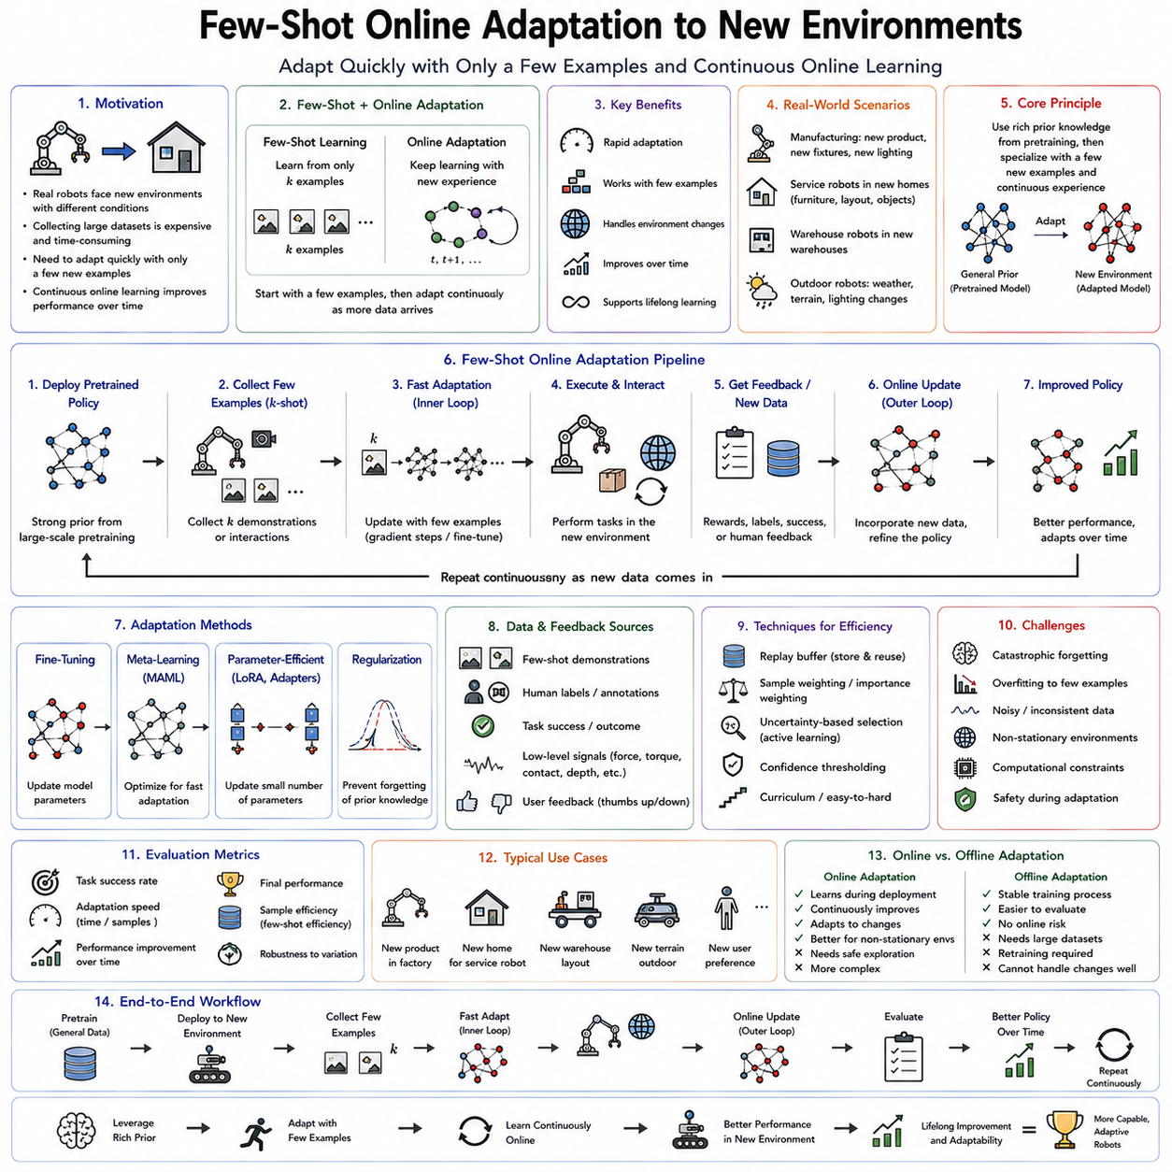
Few-shot online adaptation represents one of the most important capabilities required for intelligent robots operating in dynamic real-world environments. It combines two complementary ideas that have emerged from modern machine learning. Few-shot learning enables a model to acquire new knowledge from only a small number of examples, while online adaptation allows learning to continue during deployment as new experiences become available. Together, these concepts allow robotic systems to enter unfamiliar environments, observe only a handful of demonstrations or interactions, and rapidly adjust their behavior without requiring extensive retraining. As autonomous systems increasingly operate outside carefully controlled laboratory settings, few-shot online adaptation has become a cornerstone technology for lifelong learning, embodied intelligence, and Physical AI.
Traditional machine learning assumes that the training dataset sufficiently represents the deployment environment. After optimization is complete, the learned model is expected to generalize to future situations without significant modification. Although this assumption has been successful for many benchmark problems, it rarely holds in practical robotics. Every deployment environment introduces unique combinations of objects, lighting conditions, surface properties, human behaviors, sensor characteristics, weather conditions, and operational constraints. Collecting large labeled datasets for every new environment is both expensive and time-consuming. Few-shot online adaptation addresses this challenge by enabling continuous learning from a very limited number of new observations collected directly after deployment.
The motivation for few-shot adaptation becomes particularly clear when considering real industrial robots. A robotic manipulator trained in one manufacturing facility may later be installed in another factory producing slightly different products. The camera positions differ, lighting conditions change, conveyor speeds vary, fixtures are modified, and operators organize workstations differently. Although the overall task remains similar, these seemingly minor environmental differences can significantly reduce the performance of a fixed policy. Instead of collecting thousands of additional demonstrations, a few-shot adaptation system requires only a small number of calibration examples before restoring high performance.
The same principle applies to service robotics. A domestic robot trained in one apartment may later enter a completely different home containing unfamiliar furniture layouts, decorations, floor materials, lighting conditions, and household objects. While the robot already understands general manipulation and navigation principles, it must adapt its perception, planning, and control policies to these new surroundings. Few-shot online adaptation allows this adjustment to occur naturally through limited interaction during the first hours of deployment rather than requiring lengthy retraining procedures.
Few-shot online adaptation differs fundamentally from conventional transfer learning. Transfer learning typically assumes that adaptation occurs before deployment using a predefined adaptation dataset collected specifically for the target domain. Online adaptation instead performs learning continuously during operation. New observations immediately contribute to parameter updates while the robot remains actively performing tasks. Consequently, adaptation becomes an ongoing process rather than a separate training stage preceding deployment.
This continuous adaptation capability closely resembles biological learning. Humans rarely require thousands of repeated experiences before functioning effectively within new environments. Upon entering an unfamiliar building, individuals rapidly learn door locations, lighting conditions, room layouts, and navigation paths after only limited exploration. Drivers quickly adapt to different vehicles after several minutes of operation. Musicians adjust to unfamiliar instruments after playing only a few passages. Few-shot online adaptation seeks to reproduce this remarkable efficiency within artificial learning systems.
The success of few-shot adaptation depends heavily upon previously acquired prior knowledge. The robot does not begin learning from random initialization after deployment. Instead, it starts from rich representations developed through extensive pretraining across diverse environments, tasks, and object categories. These pretrained representations capture general principles regarding geometry, physics, semantics, manipulation, navigation, and perception. Few-shot adaptation subsequently specializes these broad capabilities toward the specific deployment environment using only limited additional experience.
Representation quality therefore becomes more important than simply maximizing benchmark accuracy. Highly transferable representations enable rapid adaptation because they separate general environmental structure from deployment-specific details. Visual representations capturing object geometry remain useful despite changing textures. Language representations generalize across different instructions expressing similar intentions. Manipulation representations encode grasp affordances transferable across related object categories. Such reusable abstractions dramatically reduce the amount of adaptation data required.
Foundation models have significantly accelerated progress in few-shot adaptation. Large-scale pretrained vision models, language models, multimodal models, and Vision-Language-Action architectures already possess broad knowledge acquired from enormous datasets. Instead of learning basic concepts during deployment, robots only adjust these existing representations toward local environmental characteristics. Parameter-efficient adaptation techniques such as adapters, low-rank adaptation, prompt tuning, and lightweight fine-tuning further reduce computational requirements while preserving previously acquired knowledge.
Online adaptation occurs at multiple levels within the robotic system. Perception modules gradually improve recognition accuracy under local lighting conditions. Localization systems refine environmental maps as new observations become available. Navigation policies learn local traffic patterns, floor friction, and obstacle configurations. Manipulation controllers adapt grasp forces, insertion trajectories, and contact models according to observed physical interactions. Higher-level reasoning modules acquire semantic knowledge regarding user preferences, workspace organization, and task-specific conventions. Together these adaptations produce an increasingly personalized and efficient robotic system.
Few-shot adaptation may involve supervised, self-supervised, reinforcement, or imitation learning depending upon available feedback. Supervised adaptation incorporates limited labeled examples provided by human operators. Self-supervised adaptation exploits consistency among multimodal observations without requiring explicit labels. Reinforcement learning improves behavior through reward signals generated by successful task completion. Imitation learning adapts policies from only several demonstrations performed by experienced users. Modern robotic systems increasingly integrate all these learning paradigms simultaneously within unified adaptation frameworks.
Self-supervised adaptation has become particularly attractive because obtaining labeled data during deployment is often impractical. Instead of requiring human annotation, robots exploit temporal consistency, geometric constraints, sensor agreement, predictive modeling, or cross-modal correspondence as intrinsic supervisory signals. A robot repeatedly observing the same object from different viewpoints gradually improves its visual representation without receiving explicit category labels. Such autonomous adaptation substantially reduces deployment cost while enabling continual improvement.
Contrastive learning provides another powerful mechanism supporting few-shot adaptation. Representations learned through contrastive objectives naturally organize semantically similar observations nearby within latent space while separating unrelated experiences. During deployment, only a handful of new examples suffice to reorganize local latent structure around unfamiliar environmental features. Consequently, downstream recognition, retrieval, planning, and control modules rapidly benefit from improved representations despite limited adaptation data.
Parameter-efficient adaptation has become increasingly important because updating every parameter within modern foundation models is computationally expensive. Low-Rank Adaptation introduces compact trainable matrices modifying frozen pretrained weights without changing the original parameters directly. Adapters insert lightweight modules throughout pretrained networks, allowing deployment-specific learning while preserving global representations. Prompt tuning modifies only learned prompts guiding existing models rather than retraining complete architectures. These techniques enable online adaptation even on embedded robotic hardware possessing limited computational resources.
Meta learning naturally complements few-shot adaptation because both emphasize rapid learning from limited experience. During meta-training, robots encounter diverse tasks specifically chosen to encourage efficient future adaptation. Algorithms such as Model-Agnostic Meta-Learning optimize parameter initializations supporting fast gradient-based specialization. Consequently, deployment adaptation requires only a few examples because meta-training has already optimized the learning process itself rather than merely solving individual tasks.
Memory systems further improve online adaptation. Instead of immediately overwriting existing knowledge, robots maintain episodic memories containing representative deployment experiences. Similar situations encountered later retrieve relevant historical examples supporting more informed adaptation. Semantic memory gradually accumulates generalized knowledge extracted from repeated experiences, while episodic memory preserves individual deployment events. This hierarchical memory organization closely resembles biological cognition and substantially enhances long-term adaptation.
Experience replay reduces catastrophic forgetting during continual adaptation. Recent observations combine with carefully selected historical examples during optimization, preserving previously acquired competencies while incorporating new environmental information. Prioritized replay emphasizes informative experiences producing large prediction errors or significant uncertainty. Reservoir sampling maintains representative historical subsets despite unlimited data streams. Such memory management strategies stabilize adaptation throughout prolonged deployment.
Environmental variability introduces diverse adaptation challenges. Illumination changes influence visual perception. Temperature affects sensor calibration. Humidity modifies friction coefficients. Dust accumulates on camera lenses. Mechanical wear gradually alters actuator characteristics. Human users reorganize workspaces. Furniture moves. Seasonal weather changes terrain conditions. Successful few-shot adaptation must accommodate all these evolving factors without sacrificing previously acquired capabilities.
Distribution shift provides the theoretical framework describing these changes. The statistical relationship between observations and desired outputs evolves after deployment, violating assumptions underlying conventional supervised learning. Few-shot adaptation estimates how pretrained models should change to accommodate new distributions while preserving broad generalization ability. Detecting distribution shift therefore becomes essential before meaningful adaptation can begin.
Uncertainty estimation plays a central role because robots must distinguish familiar situations from genuinely novel environments. Bayesian neural networks, ensemble models, evidential learning, Monte Carlo dropout, and probabilistic calibration estimate confidence associated with current predictions. Low-confidence observations indicate unfamiliar operating conditions requiring additional adaptation. High-confidence predictions instead suggest existing knowledge remains adequate without unnecessary parameter updates.
Active learning further improves adaptation efficiency by selecting the most informative observations for human annotation. Rather than requesting labels indiscriminately, robots identify uncertain examples, surprising observations, ambiguous object categories, or situations exhibiting substantial disagreement among multiple predictive models. Human supervision therefore focuses upon experiences expected to maximize future adaptation quality while minimizing annotation effort.
Human feedback provides exceptionally valuable adaptation signals. Operators correct grasp failures, demonstrate preferred manipulation strategies, explain task objectives through natural language, or provide preference comparisons among alternative behaviors. Reinforcement Learning from Human Feedback extends this concept by converting human evaluations into reward signals guiding policy optimization. Such collaborative learning dramatically accelerates adaptation while improving alignment with human expectations.
World models significantly enhance few-shot adaptation by maintaining predictive internal simulations of environmental dynamics. Rather than relying exclusively upon physical interaction, robots perform imagined experiments within learned world models before executing adapted policies. Internal simulation predicts consequences of alternative adaptation strategies, reducing physical trial requirements while improving safety. World models therefore increase sample efficiency substantially during deployment adaptation.
Simulation remains essential before real deployment because broad environmental diversity can be generated efficiently through domain randomization. Simulated environments vary lighting, textures, object geometries, physical parameters, sensor noise, weather conditions, and actuator properties across millions of training episodes. Robots consequently acquire highly transferable representations supporting robust few-shot adaptation after transitioning toward physical environments. Sim-to-real transfer therefore benefits significantly from combining simulation diversity with online specialization.
Robotic manipulation provides one of the strongest demonstrations of few-shot adaptation. Grasping unfamiliar objects traditionally required collecting extensive demonstration datasets covering every possible object category. Modern adaptive systems instead leverage pretrained representations combined with online adaptation. After several successful or unsuccessful grasp attempts, manipulation policies rapidly refine contact locations, force profiles, finger coordination, and wrist trajectories appropriate for the new object category.
Navigation systems similarly benefit from rapid environmental adaptation. Indoor service robots entering unfamiliar buildings quickly learn local map corrections, obstacle distributions, elevator behavior, door dynamics, and pedestrian traffic patterns. Outdoor autonomous vehicles adapt to regional driving conventions, road surface characteristics, weather conditions, and construction zones. Rather than rebuilding navigation systems entirely, few-shot adaptation incrementally specializes existing policies toward local operating conditions.
Agricultural robotics illustrates another compelling application. Crops differ across farms, seasons, growth stages, and geographic regions. Fruit appearance changes with maturity, weather, and disease conditions. Soil properties influence vehicle dynamics. Irrigation systems alter terrain accessibility. Few-shot adaptation enables agricultural robots to specialize toward local farming conditions after observing only limited examples, dramatically reducing calibration effort before productive operation begins.
Medical robotics also benefits from rapid adaptation because every patient presents unique anatomical characteristics, physiological responses, and movement patterns. Surgical robots adjust tissue interaction models through limited intraoperative observations. Rehabilitation robots personalize assistance according to individual patient capability after only several therapy sessions. Diagnostic systems adapt imaging representations toward local hospital equipment using relatively few annotated examinations.
Cloud robotics extends adaptation beyond individual robots toward collective intelligence. Every deployed robot encounters different environments, users, and operational conditions. Adaptation experiences collected across the fleet aggregate within centralized learning infrastructure, producing increasingly effective initialization models redistributed to all robots. Consequently, adaptation performed by one robot benefits every future deployment throughout the entire fleet.
Federated adaptation preserves privacy while supporting collaborative learning. Rather than sharing raw sensory observations, robots exchange compressed parameter updates, adaptation statistics, or learned representations. Central aggregation combines these updates into improved global models without exposing sensitive deployment data. Federated few-shot learning therefore enables large-scale collective adaptation across hospitals, factories, homes, and industrial facilities while respecting privacy constraints.
Safety remains a primary concern because adaptation occurs during active deployment. Unconstrained parameter updates may temporarily degrade policy performance before improvement occurs. Conservative adaptation strategies therefore combine uncertainty estimation, safety monitoring, constrained optimization, runtime verification, and fallback controllers. Learning progresses gradually while independent safety mechanisms ensure reliable operation even when adaptation remains incomplete.
Evaluation of few-shot online adaptation differs substantially from conventional machine learning benchmarks. Performance depends not only upon final task accuracy but also upon adaptation speed, sample efficiency, computational cost, robustness under distribution shift, forgetting resistance, uncertainty calibration, energy consumption, and long-term operational reliability. Standard evaluation protocols frequently report performance after one, five, ten, or twenty adaptation examples rather than only after complete convergence.
Recent advances increasingly integrate few-shot adaptation with continual learning, meta learning, online reinforcement learning, imitation learning, world models, diffusion policies, Vision-Language-Action architectures, and multimodal foundation models. Rather than functioning as isolated research areas, these technologies collectively support robots capable of continuously improving throughout deployment while requiring remarkably little new data. Future intelligent systems will simultaneously perceive, reason, adapt, plan, and learn from every meaningful interaction with the physical world.
Few-shot online adaptation to new environments therefore represents a foundational capability for next-generation autonomous robots. By combining transferable representations, parameter-efficient optimization, continual online learning, uncertainty-aware adaptation, human collaborative supervision, predictive world models, and fleet-level knowledge sharing, intelligent systems become capable of entering unfamiliar environments and achieving reliable performance after only minimal experience. As Physical AI continues evolving toward lifelong embodied intelligence, few-shot online adaptation will remain one of the essential mechanisms enabling robots to operate robustly, efficiently, and safely across the enormous diversity of real-world environments without depending upon exhaustive retraining for every new deployment.

07.06 Contextual Bandit for Online Robot Decision [w/Code]
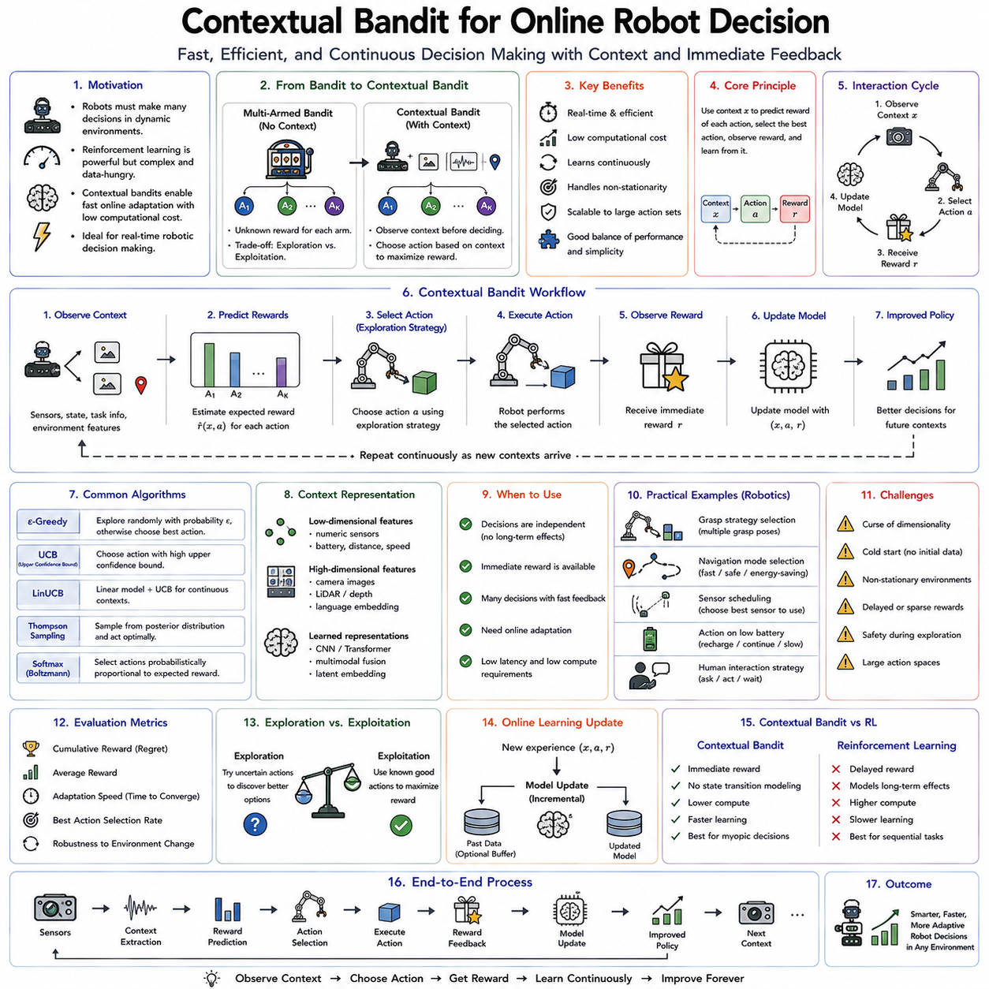
Contextual Bandits represent one of the most practical and computationally efficient online learning frameworks for real-time robotic decision making. They occupy an important position between supervised learning and full reinforcement learning by allowing an intelligent agent to continuously improve its action-selection strategy based on contextual information while avoiding the complexity of long-horizon sequential planning. Unlike conventional supervised learning, where the correct action is explicitly provided, or reinforcement learning, where delayed future rewards must be optimized across multiple time steps, contextual bandits focus on selecting the best immediate action given the current context and learning directly from the observed outcome. This simplified decision-making framework makes contextual bandits particularly attractive for robotic systems that require fast online adaptation, low computational overhead, and continuous improvement during deployment.
The conceptual origin of contextual bandits lies in the classical multi-armed bandit problem. Imagine a gambler standing before several slot machines, each producing uncertain rewards according to unknown probability distributions. The gambler must repeatedly decide which machine to play in order to maximize total reward over time. Choosing only the machine currently believed to be best may prevent discovering even better alternatives, while excessive experimentation wastes opportunities for immediate reward. The central challenge therefore becomes balancing exploration of uncertain options against exploitation of currently successful choices. Contextual bandits extend this classical problem by introducing additional information describing the current situation before each decision.
The context fundamentally changes the decision process. Instead of selecting actions solely according to historical rewards, the agent first observes relevant information describing the current environment. For a robot, context may include camera images, depth maps, LiDAR measurements, force sensor readings, joint positions, battery level, weather conditions, object properties, user preferences, semantic maps, task descriptions, or language instructions. The optimal action depends not only on historical experience but also upon these contextual observations. Consequently, identical actions may produce very different rewards under different environmental conditions.
This contextual dependency closely resembles intelligent human decision making. A person choosing transportation does not always select the same option. Weather, traffic, available time, destination, luggage, and personal preferences all influence the decision. Similarly, a service robot deciding whether to grasp an object, navigate through a hallway, ask for human assistance, or recharge its battery depends upon its current sensory observations rather than following a fixed policy. Contextual bandits formalize this adaptive decision process mathematically while maintaining computational simplicity suitable for real-time applications.
Unlike full reinforcement learning, contextual bandits assume that each decision is independent of future state transitions. After selecting an action and receiving its immediate reward, the interaction ends. The next decision begins with a new independently observed context. This assumption eliminates the need to estimate long-term cumulative rewards, future value functions, or environmental dynamics. Consequently, contextual bandits require substantially less data, lower computational cost, and simpler optimization procedures than general reinforcement learning while remaining highly effective for numerous practical robotic decision problems.
The interaction cycle within a contextual bandit framework consists of several straightforward steps. The robot first observes the current context describing the environment. Based on this context, the decision model predicts expected rewards associated with available actions. One action is selected according to an exploration strategy. The environment subsequently provides an immediate reward reflecting action quality. Finally, the decision model updates its parameters using this newly acquired experience before the next context arrives. This continuous cycle enables lifelong online adaptation without requiring expensive retraining procedures.
Context representation plays a critical role because decision quality depends directly upon the information available before action selection. Low-dimensional contexts may contain numerical sensor measurements, battery voltage, environmental temperature, object distance, or task identifiers. More complex robotic systems employ high-dimensional representations extracted from camera images, multimodal sensor fusion, semantic scene understanding, language embeddings, or learned latent representations generated by deep neural networks. Rich contextual representations enable more informed decisions but simultaneously increase computational complexity and data requirements.
Feature engineering historically dominated contextual bandit applications. Human experts manually designed informative variables describing relevant environmental properties. Modern deep learning increasingly replaces handcrafted features with learned representations optimized directly from raw sensory inputs. Convolutional neural networks process camera images, transformers encode language instructions, graph neural networks represent relational environments, and multimodal encoders combine heterogeneous sensor modalities into unified contextual embeddings supporting efficient decision making.
Expected reward estimation forms the computational core of contextual bandit algorithms. Given the observed context, the model predicts the reward likely to result from each candidate action. Different learning algorithms employ various function approximators including linear regression, kernel methods, decision trees, Gaussian processes, neural networks, Bayesian models, and ensemble techniques. Continuous online updates gradually improve these reward estimates as additional experience accumulates during deployment.
One of the defining characteristics of contextual bandits is the exploration-exploitation dilemma. Exploitation selects actions currently predicted to maximize reward according to existing knowledge. Exploration instead chooses uncertain actions that may reveal superior alternatives. Excessive exploitation prevents discovering better strategies, while excessive exploration sacrifices immediate performance unnecessarily. Effective contextual bandit algorithms therefore balance these competing objectives throughout continual operation.
The epsilon-greedy strategy provides one of the simplest exploration mechanisms. Most decisions exploit the currently best predicted action, while a small probability epsilon selects random alternatives regardless of predicted reward. Although computationally efficient, purely random exploration often wastes opportunities by evaluating actions already known to perform poorly. More sophisticated exploration methods therefore consider prediction uncertainty when selecting exploratory actions.
Upper Confidence Bound algorithms explicitly incorporate uncertainty into decision making. Rather than selecting actions solely according to expected reward, they consider optimistic estimates reflecting both predicted performance and uncertainty regarding those predictions. Actions with limited historical experience therefore receive temporary exploration bonuses encouraging further evaluation. As additional observations reduce uncertainty, exploration naturally shifts toward genuinely promising alternatives without requiring arbitrary random behavior.
Thompson Sampling represents another influential Bayesian exploration strategy. Instead of maintaining single deterministic reward estimates, Bayesian models maintain probability distributions describing uncertainty regarding each action. Before every decision, one possible reward estimate is sampled from these distributions, and the action with highest sampled reward becomes the selected action. Over time, uncertainty gradually decreases as evidence accumulates, producing an elegant balance between exploration and exploitation rooted in Bayesian inference.
Linear contextual bandits assume that expected rewards vary approximately linearly with contextual features. Algorithms such as LinUCB and Linear Thompson Sampling have achieved widespread success because they combine computational efficiency with strong theoretical guarantees. Many industrial robotic applications naturally satisfy these assumptions when contextual representations remain relatively low dimensional or when deep neural networks first generate compact feature embeddings before linear decision layers estimate rewards.
Deep contextual bandits extend these principles toward high-dimensional perception. Deep neural networks transform complex sensory observations into informative latent representations while simultaneously estimating expected rewards for available actions. Online gradient updates continuously refine both representations and reward predictors during deployment. Deep contextual bandits therefore combine the representational power of modern deep learning with the computational simplicity of contextual decision making.
Robotic manipulation illustrates a particularly valuable application. Consider a robot selecting among several possible grasp strategies for unfamiliar objects. Context includes object geometry, estimated weight, surface texture, camera observations, and gripper configuration. Available actions correspond to candidate grasp poses. Successful grasps produce positive rewards while failures receive lower rewards. Online contextual bandit learning gradually identifies which grasp strategies perform best under different object characteristics without requiring explicit physical modeling.
Navigation systems similarly benefit from contextual decision making. Autonomous mobile robots frequently choose among alternative routes differing in travel time, congestion, energy consumption, safety, or terrain difficulty. Context includes obstacle locations, pedestrian density, battery level, weather conditions, floor friction, and task urgency. Immediate rewards reflect navigation efficiency rather than long-term planning objectives. Contextual bandits therefore provide computationally efficient route selection without requiring complete reinforcement learning formulations.
Human-robot interaction provides another compelling application. Service robots continually decide how to communicate with individual users. Context includes user identity, emotional state, previous interactions, environmental conditions, conversation history, and task requirements. Possible actions include different communication styles, assistance levels, dialogue strategies, or recommendation choices. Human responses naturally generate immediate feedback enabling continual personalization through contextual online learning.
Industrial robotics increasingly employs contextual bandits for adaptive process optimization. Manufacturing systems choose among alternative machining parameters, welding settings, polishing trajectories, assembly forces, or inspection configurations according to current production conditions. Context captures material properties, machine status, environmental conditions, tooling wear, and product specifications. Production quality immediately provides reward signals enabling continuous optimization without interrupting manufacturing operations.
Energy management represents another important application. Autonomous robots must balance computational performance against battery consumption throughout extended missions. Context includes remaining battery capacity, terrain difficulty, processing workload, communication quality, and mission urgency. Actions involve selecting computational modes, sensor activation strategies, navigation speeds, or processor frequencies. Immediate rewards combine task performance with energy efficiency, allowing adaptive resource management throughout deployment.
Adaptive sensor selection also naturally fits the contextual bandit framework. Modern robots often possess multiple sensing modalities including RGB cameras, depth sensors, thermal cameras, LiDAR, radar, tactile arrays, microphones, and inertial sensors. Activating every sensor continuously consumes excessive computational resources and electrical power. Contextual bandits dynamically determine which sensor combinations provide the greatest expected benefit under current operating conditions, optimizing perception efficiency without compromising task performance.
Cloud robotics extends contextual decision making across distributed robotic fleets. Individual robots independently accumulate contextual experiences during deployment while periodically transmitting compressed learning updates toward centralized cloud infrastructure. Aggregated experiences improve global contextual decision models subsequently redistributed throughout the fleet. Every robot therefore benefits from operational knowledge collected across diverse environments while retaining local online adaptation capabilities.
Federated contextual learning further preserves privacy by exchanging only model updates instead of raw sensor observations. Hospitals, manufacturing facilities, warehouses, and domestic robots collaboratively improve contextual decision policies without exposing sensitive operational data. This privacy-preserving collaboration becomes increasingly important as robotic systems enter healthcare, defense, industrial automation, and consumer applications.
Contextual bandits integrate naturally with supervised learning. Pretrained perception systems first transform raw sensory observations into semantic representations describing the environment. Contextual decision layers subsequently optimize action selection using online reward feedback. This modular architecture separates representation learning from decision optimization, simplifying continual deployment while reducing computational cost.
Meta learning further enhances contextual adaptation. Instead of learning contextual reward estimation from scratch within every deployment, meta-trained initialization parameters enable rapid adaptation toward new environments after only limited interaction. Consequently, contextual decision systems become increasingly efficient at learning across diverse deployment conditions, reducing exploration requirements while accelerating convergence.
World models provide additional opportunities for contextual optimization. Learned predictive models estimate likely outcomes associated with alternative actions before physical execution. Contextual bandits then combine predicted rewards with observed uncertainty to guide exploration more intelligently. Imagined interactions generated within world models reduce reliance on expensive real-world experimentation while maintaining continual online improvement.
Foundation models increasingly influence contextual decision making by providing powerful multimodal contextual representations. Large vision-language models encode semantic understanding regarding objects, environments, user intentions, and physical interactions. Contextual bandits subsequently optimize immediate action selection using these pretrained representations without requiring complete end-to-end retraining. This combination substantially improves data efficiency during deployment.
Safety considerations remain essential because online exploration occurs during physical robot operation. Unsafe exploratory actions may damage equipment or endanger nearby humans. Safe contextual bandits therefore incorporate action constraints, uncertainty thresholds, supervisory controllers, runtime verification, and fallback policies ensuring exploration remains within acceptable operational limits. Conservative exploration strategies initially prioritize safety before gradually expanding behavioral diversity as confidence increases.
Evaluation of contextual bandit systems differs from conventional classification benchmarks. Cumulative reward measures long-term decision quality across deployment. Regret quantifies performance lost compared with an ideal policy possessing complete knowledge beforehand. Adaptation speed measures how rapidly decision quality improves after environmental changes. Sample efficiency evaluates how much interaction is required before reliable performance emerges. Computational latency, memory usage, uncertainty calibration, energy efficiency, robustness, and operational safety further characterize deployment quality.
The convergence of contextual bandits with continual learning, online supervised learning, reinforcement learning, meta learning, world models, foundation models, Vision-Language-Action architectures, cloud robotics, and human feedback represents an important evolution toward adaptive embodied intelligence. Future robotic systems will continuously interpret complex contextual information, personalize behavior for individual users, optimize immediate decisions through lifelong experience, and share contextual knowledge collectively across robotic fleets while maintaining safe real-time operation.
Contextual bandits therefore provide an elegant balance between computational simplicity and adaptive intelligence. By focusing on immediate contextual decision making rather than long-horizon sequential optimization, they enable efficient online learning under realistic deployment constraints. Their ability to combine rich contextual understanding, continual adaptation, uncertainty-aware exploration, parameter-efficient optimization, and real-time decision making makes contextual bandits one of the most practical frameworks for next-generation Physical AI systems operating across manufacturing, logistics, healthcare, service robotics, autonomous transportation, agriculture, and domestic assistance. As intelligent robots become increasingly integrated into everyday environments, contextual bandits will remain an essential mechanism allowing autonomous systems to learn continuously from experience while making fast, informed, and adaptive decisions in the face of constantly changing real-world conditions.

07.07 Memory Augmented Networks for Online Learning [w/Code]
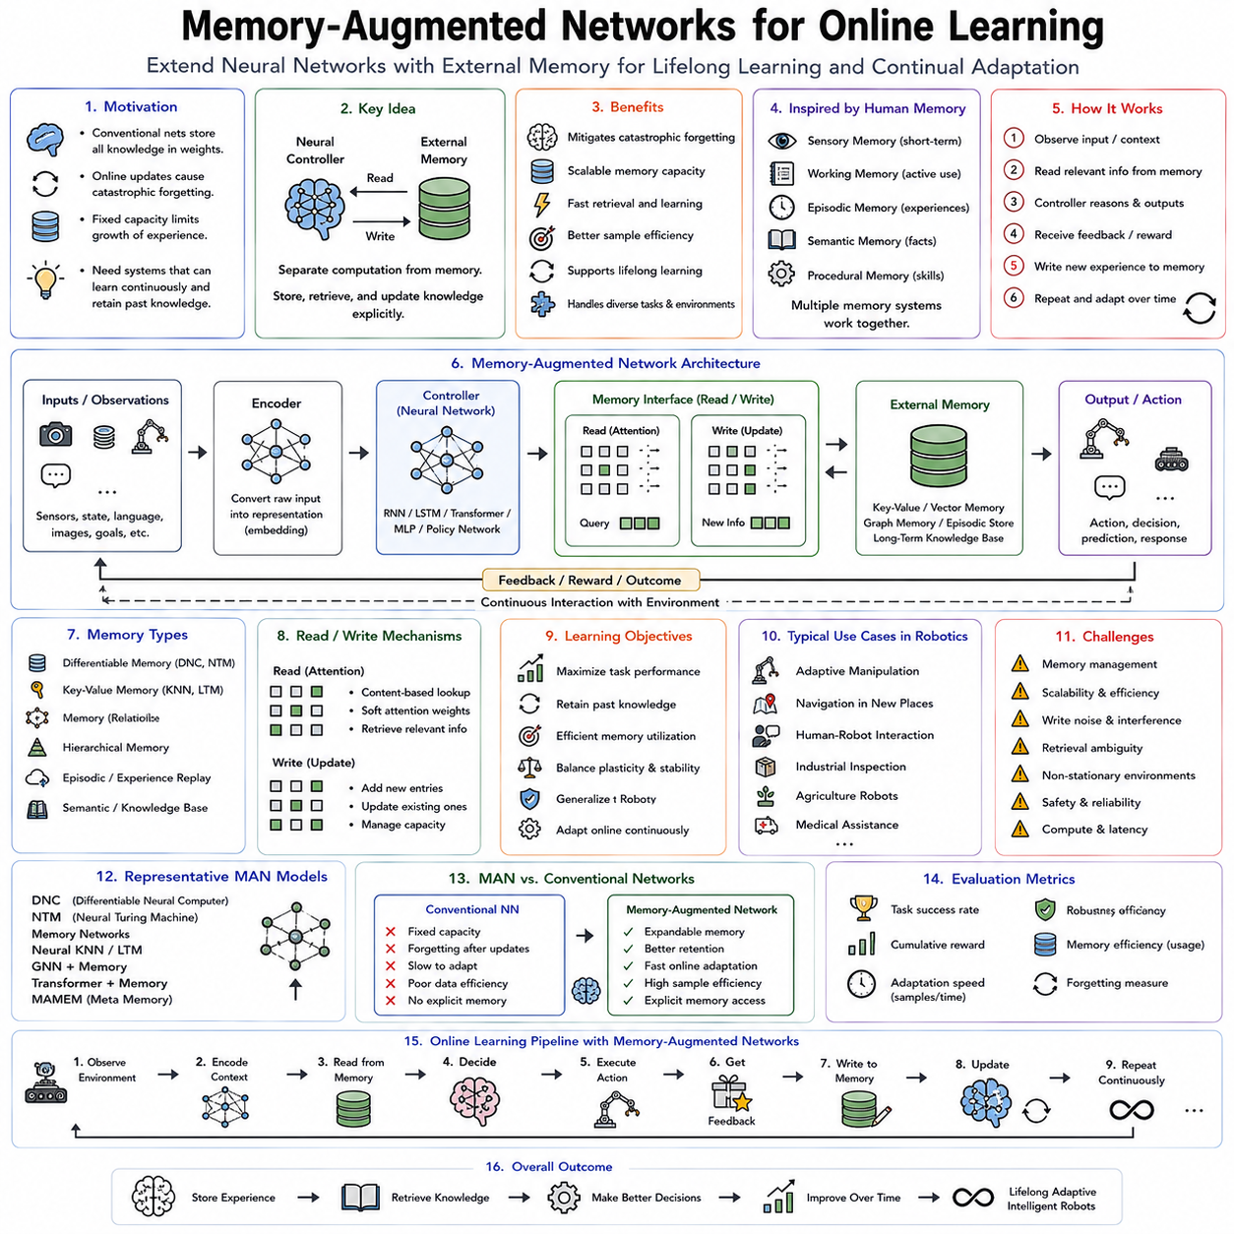
Memory-Augmented Networks (MANs) represent a major advancement in artificial intelligence by extending conventional neural networks with explicit external memory systems that support long-term knowledge retention, rapid information retrieval, and continual adaptation. Traditional deep neural networks encode learned knowledge primarily within their parameters. Although this approach has achieved remarkable success across perception, language understanding, and control, it also introduces significant limitations. Updating model parameters during online learning often causes previously acquired knowledge to be overwritten, leading to catastrophic forgetting. Furthermore, storing every new experience solely within fixed network weights becomes increasingly inefficient as the number of tasks, environments, and observations grows over time. Memory-Augmented Networks address these limitations by separating computation from memory. Neural networks perform reasoning and decision making, while dedicated memory structures store experiences, facts, representations, and task-specific information that can be accessed dynamically during learning and inference. This architectural separation provides one of the fundamental mechanisms enabling lifelong learning, continual adaptation, and increasingly general embodied intelligence.
The motivation for memory augmentation originates from biological cognition. Human intelligence does not rely exclusively on slowly changing neural connections. Instead, the brain combines multiple forms of memory operating over different time scales. Sensory memory briefly stores incoming observations. Working memory maintains information relevant to current reasoning. Episodic memory preserves personal experiences together with temporal context. Semantic memory accumulates general knowledge independent of individual events. Procedural memory encodes motor skills and habitual behaviors. Together, these interacting memory systems enable humans to learn continuously throughout life while retaining knowledge acquired years or even decades earlier. Memory-Augmented Networks seek to reproduce these complementary capabilities within artificial learning systems.
Conventional neural networks compress all learned knowledge into distributed parameter representations. While this implicit memory allows remarkable generalization, modifying network weights during online learning inevitably affects previously learned representations. When new experiences differ significantly from earlier training data, parameter updates may degrade performance on earlier tasks. This phenomenon, known as catastrophic forgetting, remains one of the central challenges in continual learning. Memory-Augmented Networks reduce this problem by storing newly acquired information separately from permanent model parameters, allowing adaptation without immediately overwriting existing knowledge.
The central architectural idea is straightforward. A neural controller performs perception, reasoning, planning, or decision making, while an external memory module stores structured information independently of network weights. During inference, the controller reads relevant information from memory, integrates retrieved knowledge with current observations, generates appropriate outputs, and optionally writes new experiences back into memory. Consequently, knowledge acquisition becomes an explicit operation rather than occurring solely through slow gradient-based parameter optimization.
External memory dramatically increases the effective capacity of learning systems. Instead of requiring increasingly larger neural networks as operational experience grows, robots continuously expand their knowledge base by storing representative observations, successful strategies, environmental maps, language interactions, manipulation trajectories, failure cases, calibration data, and user preferences within dedicated memory structures. The neural controller remains relatively compact while memory grows according to deployment requirements.
Memory organization strongly influences learning performance. Some architectures employ fixed-size differentiable memory matrices optimized jointly with neural networks through gradient descent. Others utilize key-value memories storing representations alongside associated information. Graph memories preserve relational structures among objects, places, and events. Hierarchical memory systems organize information according to temporal scales or semantic abstraction. Hybrid architectures increasingly combine several complementary memory forms supporting different cognitive functions within one integrated framework.
Differentiable Neural Computers represent one of the earliest influential memory-augmented architectures. Building upon Neural Turing Machines, these systems combine recurrent neural controllers with differentiable external memory arrays. Specialized attention mechanisms determine where information should be written and how previously stored content should be retrieved. Because every operation remains differentiable, the entire architecture can be optimized end-to-end through gradient descent. These pioneering models demonstrated that neural networks could learn algorithmic reasoning, graph traversal, sequence manipulation, and relational inference by explicitly interacting with external memory.
Neural Turing Machines introduced the foundational concept of differentiable memory access. Inspired by classical Turing machines, they separated computation from storage while replacing discrete read-write operations with differentiable attention mechanisms. Instead of explicitly programming memory management rules, gradient optimization automatically learned efficient memory utilization strategies. Although practical deployment initially proved challenging due to optimization instability, Neural Turing Machines established many principles underlying modern memory-augmented architectures.
Working memory plays a particularly important role within online robotic systems. During task execution, robots must temporarily retain recently observed information relevant to current reasoning. A manipulation robot assembling furniture remembers recently identified components, current assembly progress, and temporary grasp configurations. Autonomous vehicles maintain nearby traffic participants, predicted trajectories, and recent navigation decisions. Working memory therefore supports coherent reasoning across multiple consecutive observations rather than treating every sensory frame independently.
Episodic memory stores complete experiences together with temporal context. Every episode records observations, actions, rewards, environmental conditions, user interactions, and task outcomes. When robots later encounter similar situations, retrieval mechanisms identify related historical experiences supporting rapid adaptation without extensive retraining. Episodic memory therefore serves as a valuable repository of deployment knowledge accumulated throughout operational lifetime.
Semantic memory differs fundamentally from episodic memory because it captures generalized concepts rather than individual experiences. Repeated interactions gradually transform episodic observations into abstract knowledge describing object categories, physical properties, language meanings, manipulation affordances, environmental regularities, and user preferences. Semantic memory enables robots to reason beyond specific historical events while maintaining broad generalization capability.
Procedural memory encodes motor skills and behavioral routines developed through repeated practice. Walking strategies, grasp controllers, insertion trajectories, balancing behaviors, navigation heuristics, and communication patterns gradually become procedural knowledge requiring little conscious reasoning during execution. Memory-Augmented Networks increasingly distinguish procedural representations from declarative factual knowledge, mirroring biological cognition more closely.
Reading from external memory requires effective retrieval mechanisms. Content-based addressing identifies stored information semantically similar to current observations. Location-based addressing accesses memory according to temporal or spatial organization. Associative retrieval exploits relationships among stored experiences. Attention mechanisms dynamically weight memory entries according to relevance for current reasoning. Modern transformer architectures have significantly advanced memory retrieval by introducing highly efficient attention-based search across large knowledge repositories.
Writing new experiences into memory presents equally important challenges. Every observation cannot remain permanently stored because memory capacity eventually becomes limited. Intelligent memory management therefore decides which experiences deserve long-term preservation. Novel events, rare failures, uncertain observations, highly informative demonstrations, and successful recovery strategies frequently receive higher storage priority than repetitive routine experiences. Such selective storage substantially improves long-term memory efficiency.
Memory consolidation gradually transforms short-term experiences into stable long-term knowledge. Biological sleep provides one well-known mechanism supporting consolidation by replaying neural activity patterns acquired during daily experience. Artificial learning systems similarly employ experience replay, offline optimization, representation compression, and hierarchical abstraction to integrate episodic memories into increasingly generalized semantic knowledge while preserving important historical information.
Experience replay has become one of the most influential memory-based learning techniques. Instead of training exclusively on recent observations, online learning repeatedly revisits representative historical experiences stored within replay buffers. New experiences combine with previously collected examples during optimization, substantially reducing catastrophic forgetting. Replay buffers therefore stabilize continual learning while preserving long-term performance across evolving environments.
Replay strategies vary considerably depending upon application requirements. Uniform replay samples experiences randomly, approximating stationary data distributions. Prioritized replay emphasizes experiences exhibiting large prediction errors or high learning potential. Class-balanced replay preserves rare categories vulnerable to forgetting. Reservoir sampling maintains statistically representative historical subsets despite unbounded data streams. Adaptive replay policies increasingly optimize memory utilization automatically throughout deployment.
Memory retrieval also supports few-shot learning. Upon encountering unfamiliar tasks, robots search memory for similar previous experiences rather than learning entirely from scratch. Retrieved examples provide valuable prior information enabling rapid adaptation using only limited additional data. Consequently, Memory-Augmented Networks naturally complement meta learning, few-shot learning, and continual adaptation frameworks by providing reusable deployment knowledge accumulated across previous tasks.
Robotic manipulation illustrates these principles clearly. Suppose a robot encounters a previously unseen household object requiring grasping. Rather than estimating grasp strategies solely through current perception, the robot retrieves memory entries associated with geometrically similar objects manipulated successfully in the past. Previous grasp poses, force profiles, wrist orientations, tactile feedback, and failure cases guide current decision making. Consequently, adaptation becomes substantially faster and more reliable than relying exclusively on parameterized neural policies.
Navigation systems similarly benefit from explicit memory. Autonomous mobile robots operating repeatedly within large facilities gradually accumulate maps, obstacle locations, traffic patterns, charging station positions, elevator behaviors, restricted zones, and user preferences. Memory retrieval enables efficient route planning using accumulated operational experience while adapting continuously as environments evolve. Dynamic maps therefore complement real-time perception instead of replacing it.
Long-term human-robot interaction particularly depends upon memory. Service robots interacting with families, patients, or industrial operators should remember names, preferences, routines, communication styles, physical limitations, schedules, and previous conversations across weeks or months. Such personalized interaction becomes impossible without persistent memory extending beyond temporary dialogue context. Memory-Augmented Networks therefore play a central role in socially intelligent robotics.
Language models increasingly incorporate external memory to overcome finite context limitations. Conventional transformer architectures process only limited input windows, causing earlier information to disappear from attention. Retrieval-augmented architectures instead store historical conversations, documents, procedural knowledge, and factual information externally, retrieving relevant content whenever needed. Such retrieval augmentation substantially improves factual consistency, personalization, and long-term conversational coherence.
Retrieval-Augmented Generation demonstrates the growing importance of explicit memory within language reasoning. Instead of requiring every factual detail to reside permanently within model parameters, external document collections provide dynamically retrievable knowledge. Language generation consequently combines pretrained linguistic competence with deployment-specific memory, producing more accurate and updatable responses. Similar principles increasingly extend toward embodied robotic reasoning.
World models naturally integrate with memory systems. Predictive models estimate future environmental dynamics while memory stores previous state transitions, environmental configurations, and planning outcomes. When planning future actions, robots retrieve analogous historical situations, compare predicted consequences with previous experiences, and refine decision making accordingly. Memory therefore strengthens model-based reasoning by grounding predictions within accumulated operational history.
Graph memories have emerged as powerful structures for organizing relational knowledge. Objects, locations, tasks, users, tools, and semantic concepts become graph nodes connected through learned relationships. Graph neural networks propagate information across these relational structures, supporting reasoning requiring multiple interconnected facts. Industrial assembly, household assistance, warehouse logistics, and scientific exploration particularly benefit from graph-based memory organization because relational structure strongly influences intelligent decision making.
Memory-Augmented Networks also enhance reinforcement learning. Instead of estimating policies solely from current observations, agents retrieve historical trajectories similar to present situations. Previous rewards, successful actions, environmental transitions, and exploration outcomes guide current policy improvement. Memory-based reinforcement learning therefore significantly improves sample efficiency while reducing redundant exploration.
Online learning particularly benefits because memory enables adaptation without immediately modifying long-term parameters. New experiences first enter temporary memory, where retrieval supports improved behavior almost immediately. Parameter optimization subsequently consolidates frequently useful knowledge gradually into permanent representations. This two-stage learning process separates rapid adaptation from stable long-term learning, reducing catastrophic forgetting while maintaining continual improvement.
Memory also supports uncertainty-aware reasoning. When current observations differ substantially from stored experiences, retrieval confidence decreases, indicating unfamiliar operating conditions. Robots may consequently increase exploration, request human assistance, or initiate additional learning procedures. Conversely, highly similar memory retrieval provides confidence supporting decisive autonomous action. Memory similarity therefore contributes naturally to confidence estimation.
Cloud robotics extends memory beyond individual robots toward collective intelligence. Every robot continuously contributes experiences to centralized cloud memory repositories. Other robots subsequently retrieve relevant experiences accumulated across geographically distributed deployments. A manipulation strategy learned in one factory may later benefit robots deployed elsewhere. Collective memory therefore dramatically accelerates knowledge sharing across entire robotic fleets.
Federated memory architectures preserve privacy while supporting collaborative learning. Instead of exchanging raw observations, robots communicate compressed memory representations, learned embeddings, or encrypted retrieval structures. Central aggregation combines distributed memories into globally useful knowledge without revealing sensitive operational details. Such privacy-preserving memory sharing becomes increasingly important within healthcare, industrial automation, and domestic robotics.
Memory management becomes increasingly challenging as deployment duration extends over months or years. Unlimited memory growth eventually becomes computationally impractical. Compression algorithms, hierarchical abstraction, semantic summarization, redundancy elimination, importance estimation, and selective forgetting therefore maintain efficient long-term operation. Effective memory systems preserve highly informative experiences while discarding redundant observations producing minimal future benefit.
Evaluation of Memory-Augmented Networks extends beyond conventional prediction accuracy. Researchers assess memory retrieval quality, storage efficiency, adaptation speed, catastrophic forgetting resistance, sample efficiency, computational overhead, latency, scalability, long-term retention, semantic organization, personalization capability, and robustness under continual environmental change. Comprehensive evaluation therefore reflects memory performance throughout prolonged deployment rather than isolated benchmark tasks.
Recent advances increasingly integrate Memory-Augmented Networks with foundation models, Vision-Language-Action architectures, world models, continual learning, meta learning, diffusion policies, reinforcement learning, retrieval augmentation, and multimodal reasoning. Instead of functioning as isolated memory modules, external knowledge systems become deeply intertwined with perception, planning, language understanding, manipulation, navigation, and social interaction. Future embodied intelligence will likely rely upon rich memory ecosystems combining episodic experience, semantic abstraction, procedural skills, predictive world models, and collaborative cloud knowledge into unified cognitive architectures.
Memory-Augmented Networks therefore represent a foundational technology for lifelong online learning. By separating computation from explicit knowledge storage, preserving experiences across extended operational lifetimes, enabling rapid retrieval of relevant historical information, supporting continual adaptation without catastrophic forgetting, and facilitating collective knowledge sharing across robotic fleets, these architectures overcome many limitations of conventional parameter-only neural networks. As Physical AI evolves toward increasingly autonomous, personalized, and continuously learning robotic systems, Memory-Augmented Networks will remain one of the essential mechanisms enabling intelligent machines to accumulate experience, remember the past, adapt to the present, and prepare effectively for future challenges.

07.08 Online Learning System Architecture on Robot [w/Code]
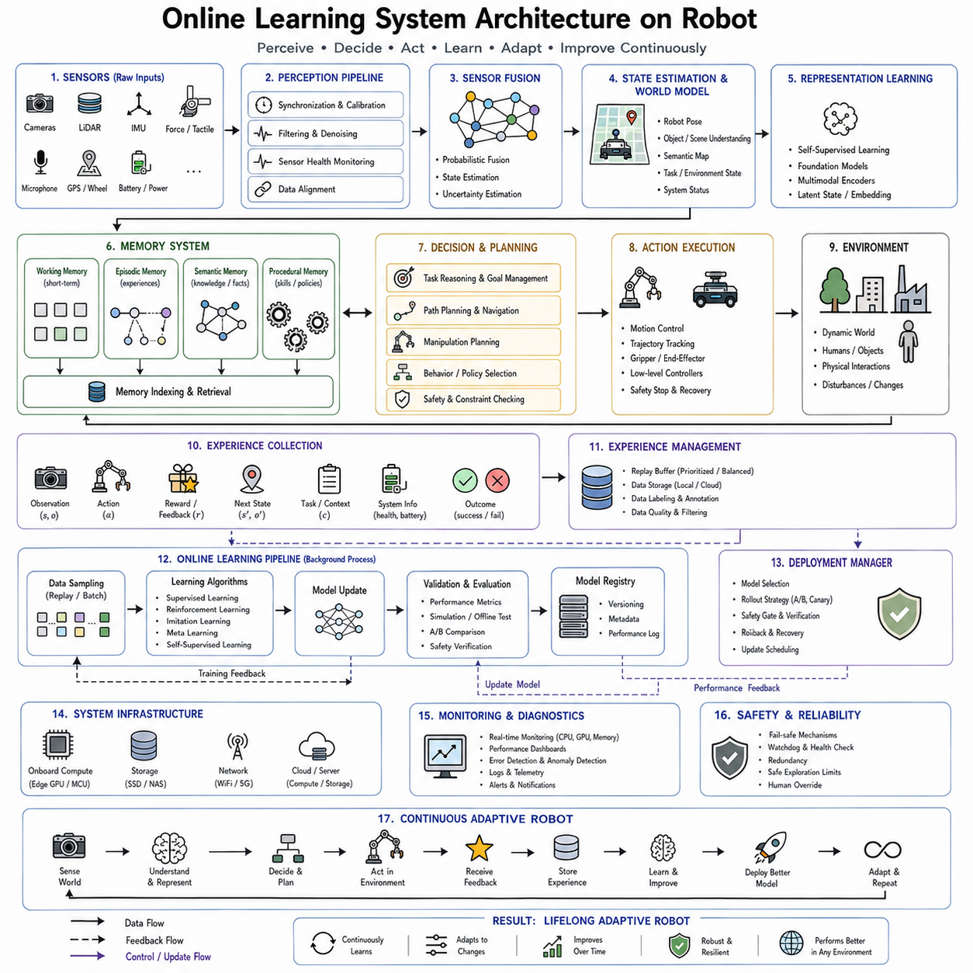
An online learning system architecture for robots is the integrated computational framework that enables a robotic platform to perceive, reason, learn, adapt, and improve continuously while operating in the real world. Unlike traditional robotic systems, where learning occurs offline before deployment and the resulting models remain largely fixed during operation, an online learning architecture allows the robot to update its internal models, policies, memories, and knowledge representations throughout its operational lifetime. This capability transforms robots from static automation systems into continuously evolving intelligent agents capable of adapting to environmental changes, user preferences, hardware degradation, new tasks, and unforeseen situations. As Physical AI advances toward lifelong autonomy and Artificial General Intelligence, online learning architectures become one of the foundational infrastructures supporting adaptive intelligence.
The fundamental design philosophy of an online learning architecture is the separation of real-time operation from continuous improvement. A deployed robot cannot simply stop functioning whenever new information becomes available. It must continue executing tasks safely while simultaneously collecting data, evaluating performance, updating internal knowledge, validating improvements, and deploying new models when appropriate. Consequently, modern architectures consist of multiple interconnected subsystems operating asynchronously yet cooperatively. Fast control loops maintain safe real-time behavior, while slower learning processes continuously optimize future performance in the background.
The architecture begins with the perception layer, which serves as the robot's interface with the external world. Cameras, LiDAR, radar, microphones, tactile sensors, force sensors, IMUs, GPS receivers, encoders, environmental sensors, and physiological sensors continuously generate multimodal observations describing the robot's surroundings and internal condition. Raw sensor streams undergo synchronization, calibration, filtering, timestamp alignment, and noise reduction before higher-level processing begins. High-quality perception is essential because every subsequent learning component depends upon accurate environmental observations.
Sensor fusion constitutes the second major component of perception. Individual sensors provide incomplete or noisy information, but combining multiple sensing modalities produces significantly more robust environmental understanding. Visual information complements depth sensing. IMU measurements stabilize localization. Force sensors improve manipulation. Language inputs provide semantic context. Probabilistic fusion algorithms, Bayesian estimation, Kalman filtering, graph optimization, and deep multimodal fusion networks integrate heterogeneous sensory streams into coherent state representations suitable for downstream learning and decision making.
The state estimation module transforms fused sensory information into structured representations describing the current situation. Robot pose, object locations, environmental maps, semantic scene understanding, task progress, human intentions, battery condition, actuator health, and environmental uncertainty become unified state variables available throughout the architecture. These state representations provide the common information interface connecting perception with planning, learning, memory, and control.
Representation learning plays an increasingly important role because raw sensor measurements are often too complex for efficient decision making. Deep neural networks, transformers, multimodal encoders, self-supervised learning, contrastive learning, and foundation models compress high-dimensional observations into informative latent representations preserving semantic structure while eliminating irrelevant variation. These learned representations improve sample efficiency, transfer learning, and continual adaptation throughout the robot's operational lifetime.
Memory systems form another essential architectural component. Online learning requires preserving information accumulated across thousands or millions of interactions without overwriting previously acquired knowledge. Modern architectures therefore incorporate multiple complementary memory structures. Working memory temporarily stores information required for current reasoning. Episodic memory preserves individual experiences together with temporal context. Semantic memory gradually accumulates generalized knowledge extracted from repeated interactions. Procedural memory stores motor skills and learned behaviors. Together these memory systems enable continual learning while mitigating catastrophic forgetting.
Experience management serves as the gateway connecting operation with learning. Every interaction generates experiences containing observations, actions, rewards, predictions, failures, successes, user feedback, environmental conditions, and system diagnostics. Rather than immediately modifying neural network parameters after every observation, experiences enter structured replay buffers, databases, cloud storage, or memory hierarchies. Experience management organizes these data according to importance, novelty, uncertainty, temporal order, and learning priority.
Replay buffers have become one of the most influential mechanisms supporting online learning. Historical experiences remain available for repeated optimization, preventing catastrophic forgetting during continual adaptation. Uniform replay approximates stationary distributions, prioritized replay emphasizes informative failures, balanced replay preserves rare classes, while reservoir sampling maintains representative historical subsets despite unlimited operational duration. Effective replay management significantly stabilizes continual learning performance.
The world model constitutes one of the central reasoning components within advanced online learning architectures. Rather than reacting only to immediate sensory observations, the robot constructs an internal predictive model describing environmental dynamics, object behavior, human interaction, physical constraints, and future state evolution. World models enable imagination, counterfactual reasoning, planning, anomaly detection, uncertainty estimation, and sample-efficient reinforcement learning. Online learning continuously refines these predictive models as additional operational experience becomes available.
Knowledge representation extends beyond raw memory storage by organizing information into reusable semantic structures. Object ontologies, scene graphs, task graphs, causal models, symbolic knowledge bases, semantic maps, relational graphs, language embeddings, and multimodal representations collectively support reasoning across perception, planning, manipulation, and communication. Structured knowledge allows robots to generalize beyond individual experiences while supporting explainable decision making.
Decision making occupies the architectural center where perception, memory, prediction, and task objectives converge. The decision module receives current state estimates, retrieves relevant memories, queries predictive world models, evaluates uncertainty, considers safety constraints, and selects actions maximizing expected task performance. Depending upon application requirements, decision making may employ supervised learning, contextual bandits, reinforcement learning, model predictive control, diffusion policies, transformer-based planners, or hybrid neuro-symbolic reasoning.
Policy learning continuously improves action selection using accumulated operational experience. Unlike fixed policies deployed once after offline training, online architectures allow policies to evolve throughout deployment. Reinforcement learning updates policies using environmental rewards. Supervised learning incorporates human corrections. Imitation learning integrates demonstrations. Meta learning accelerates future adaptation. Parameter-efficient fine-tuning specializes foundation models toward deployment-specific conditions. Together these mechanisms enable lifelong behavioral improvement.
Online optimization must satisfy strict computational constraints because robots continue operating while learning occurs. Background optimization threads update neural networks asynchronously without interfering with deterministic control loops. Incremental gradient descent, mini-batch optimization, adaptive learning rates, parameter-efficient adaptation, distributed optimization, and mixed-precision computation reduce computational overhead while preserving continuous learning capability.
Model validation forms a critical safety layer separating learning from deployment. Newly updated models cannot immediately replace operational controllers because incorrect updates may degrade performance or compromise safety. Validation modules evaluate updated policies within simulation, historical replay datasets, shadow execution, or sandbox environments before deployment. Performance metrics including task success, uncertainty calibration, energy efficiency, robustness, collision avoidance, and safety compliance determine whether updated models satisfy operational requirements.
Shadow mode deployment provides particularly effective validation. Newly learned policies execute in parallel with active production controllers but do not directly control the robot. Their predicted actions are compared against operational behavior under identical environmental conditions. Once sufficient confidence accumulates demonstrating superior performance, validated policies gradually replace previous controllers through staged deployment strategies.
Safety supervision operates continuously throughout every architectural layer. Independent safety monitors verify action feasibility, enforce joint limits, prevent collisions, monitor thermal conditions, supervise battery health, detect sensor failures, and activate emergency procedures whenever necessary. Online learning never bypasses these fundamental safety mechanisms. Instead, learning operates within explicitly defined safety boundaries ensuring reliable operation despite continual adaptation.
Uncertainty estimation contributes substantially to architectural robustness. Modern learning systems estimate confidence alongside predictions using Bayesian neural networks, ensemble methods, evidential learning, Monte Carlo dropout, conformal prediction, or probabilistic calibration. High uncertainty triggers additional sensing, human intervention, conservative planning, or exploration depending upon operational context. Confidence-aware decision making prevents overconfident behavior in unfamiliar situations.
Human-in-the-loop integration remains indispensable for many real-world deployments. Human operators provide demonstrations, corrective interventions, preference feedback, semantic explanations, natural language instructions, and task verification throughout deployment. Rather than functioning solely during offline data collection, human expertise becomes continuously available whenever uncertainty, failure, novelty, or safety concerns arise. Such collaborative architectures significantly accelerate adaptation while improving reliability.
Learning orchestration coordinates numerous adaptation processes operating simultaneously. Different models update at different temporal frequencies according to computational cost, data availability, safety requirements, and operational urgency. Perception networks may update daily. Calibration models adapt hourly. Contextual bandits update after every interaction. Memory structures evolve continuously. Fleet-level foundation models synchronize weekly through cloud infrastructure. Orchestration ensures these heterogeneous learning processes remain coherent and mutually consistent.
Cloud robotics extends online learning beyond individual robots toward collective intelligence. Local robots perform real-time inference and limited adaptation while periodically uploading experiences, compressed gradients, or learned representations to centralized cloud servers. Global learning aggregates experiences collected across thousands of robots operating in diverse environments. Improved models subsequently return to local robots, allowing every deployment to benefit from fleet-wide operational knowledge.
Federated learning further enhances collaborative architectures while preserving privacy. Rather than transmitting raw sensory observations, robots exchange encrypted parameter updates, compressed gradients, or low-dimensional embeddings. Central aggregation combines distributed learning without exposing sensitive industrial, medical, military, or domestic data. Federated architectures therefore enable large-scale continual learning across geographically distributed deployments while satisfying privacy and regulatory requirements.
Edge computing remains equally important because many robotic decisions require millisecond latency unavailable through cloud communication. High-frequency perception, control, obstacle avoidance, manipulation, localization, and safety monitoring execute entirely on embedded processors including GPUs, NPUs, FPGAs, or dedicated AI accelerators. Cloud resources support computationally expensive retraining, large-scale optimization, fleet analytics, and foundation model updates. Hybrid edge-cloud architectures therefore balance responsiveness with computational scalability.
Communication infrastructure coordinates information exchange among architectural components. High-bandwidth middleware such as ROS 2, DDS, ZeroMQ, gRPC, MQTT, or custom distributed communication frameworks transmit sensor streams, learned representations, model updates, memory synchronization, diagnostics, and cloud coordination messages while maintaining deterministic real-time performance. Time synchronization protocols ensure consistent temporal relationships across distributed sensing and computation.
Monitoring and diagnostics continuously evaluate architectural health. Learning curves, inference latency, memory utilization, processor load, thermal conditions, battery status, network quality, sensor reliability, model drift, prediction uncertainty, reward trends, and task success statistics collectively describe system performance throughout deployment. Automated anomaly detection identifies abnormal behavior before operational reliability deteriorates significantly.
Model lifecycle management governs continuous evolution throughout deployment. Every model version records training datasets, hyperparameters, software dependencies, hardware compatibility, validation metrics, deployment history, rollback procedures, and safety certification status. Version control ensures reproducibility, regulatory compliance, systematic experimentation, and rapid recovery whenever unexpected behavior emerges following online updates.
Continual learning mechanisms prevent catastrophic forgetting while incorporating newly acquired knowledge. Elastic Weight Consolidation, Synaptic Intelligence, Memory Aware Synapses, replay buffers, parameter isolation, modular neural architectures, progressive networks, knowledge distillation, and retrieval augmentation collectively preserve previous competencies during continual adaptation. Such mechanisms remain essential because operational environments evolve continuously throughout long-term deployment.
Foundation models increasingly function as central knowledge engines within online learning architectures. Large pretrained vision-language-action models provide broad semantic understanding, reasoning capabilities, manipulation knowledge, and multimodal representations before deployment begins. Online learning subsequently specializes these models toward deployment-specific environments using parameter-efficient adaptation techniques including LoRA, adapters, prompt tuning, retrieval augmentation, and lightweight fine-tuning. This combination dramatically reduces adaptation time while preserving broad general knowledge.
The emergence of Vision-Language-Action architectures further unifies perception, reasoning, language understanding, and motor control within one integrated online learning framework. Language instructions influence planning. Visual observations update semantic memory. Retrieved knowledge guides manipulation. Online experience continually refines multimodal representations connecting sensory information with physical action. Such integrated architectures increasingly resemble unified cognitive systems rather than collections of independent machine learning modules.
Evaluation of online learning architectures extends beyond isolated algorithmic benchmarks. Comprehensive assessment considers adaptation speed, long-term retention, computational efficiency, energy consumption, scalability, robustness, safety, uncertainty calibration, human collaboration, deployment reliability, maintainability, cloud synchronization efficiency, and operational lifetime performance. Success depends not merely upon learning accuracy but upon sustained autonomous improvement under realistic deployment conditions.
The future evolution of online learning architectures will likely integrate world models, Memory-Augmented Networks, continual learning, reinforcement learning, contextual decision making, foundation models, multimodal reasoning, cloud robotics, federated learning, digital twins, human collaboration, and self-improving cognitive systems into unified lifelong intelligence frameworks. Rather than separating perception, planning, memory, learning, and control into loosely connected modules, future robots will employ tightly integrated cognitive architectures where every interaction simultaneously supports immediate task execution and long-term knowledge acquisition.
An online learning system architecture therefore represents far more than a software framework for updating neural networks. It is the complete cognitive infrastructure enabling robots to perceive continuously, remember experiences, predict future outcomes, reason under uncertainty, collaborate with humans, share knowledge across fleets, validate new capabilities safely, and improve throughout years of deployment. As Physical AI progresses toward increasingly autonomous and general-purpose embodied intelligence, robust online learning architectures will become the foundational operating systems supporting lifelong robotic adaptation across manufacturing, logistics, healthcare, agriculture, scientific exploration, domestic assistance, and countless future applications.

07.09 Safety Constraints During Online Learning
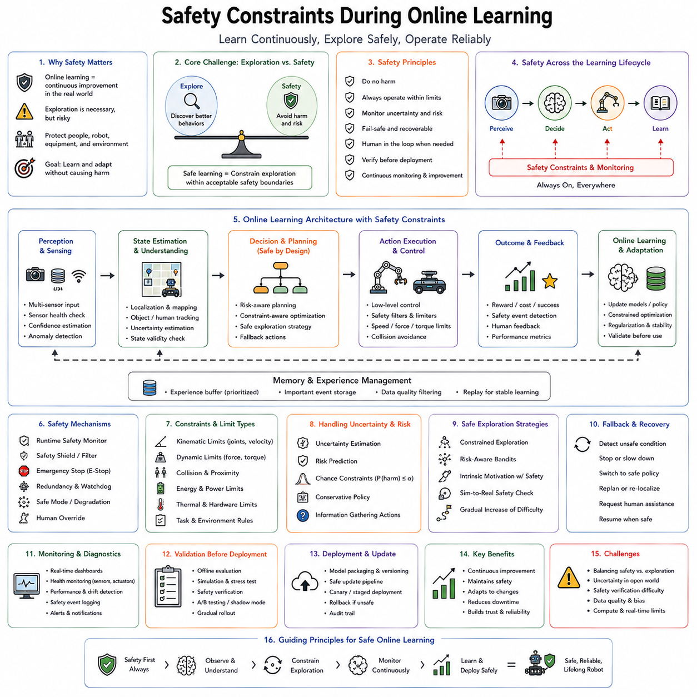
Safety constraints during online learning represent one of the most fundamental challenges in the development of intelligent robotic systems. Online learning allows robots to continuously improve their models, policies, and decision-making capabilities while interacting with the physical world. However, unlike offline learning, every exploratory action performed by a robot has immediate consequences for people, equipment, infrastructure, and the environment. A learning algorithm that behaves safely in simulation may become dangerous when deployed on a physical robot capable of generating significant forces, moving autonomously, manipulating heavy objects, or interacting closely with humans. Consequently, safety cannot be treated as an additional feature layered on top of online learning. Instead, safety constraints must be embedded throughout the entire learning architecture, governing perception, planning, exploration, optimization, execution, memory management, and model deployment. As Physical AI evolves toward increasingly autonomous lifelong learning systems, maintaining safety while enabling continual adaptation becomes one of the defining engineering and scientific problems.
The fundamental conflict arises because learning requires exploration, while safety generally requires predictability. Every intelligent system must occasionally try unfamiliar behaviors to discover improved strategies, adapt to changing environments, or recover from unexpected situations. Excessive caution prevents meaningful learning, causing the robot to repeat conservative behaviors indefinitely. Conversely, unrestricted exploration may lead to collisions, unstable motions, equipment damage, or human injury. The objective of safe online learning is therefore not to eliminate exploration entirely but to constrain exploration within carefully defined safety boundaries where improvement remains possible without unacceptable risk.
This trade-off resembles human learning throughout life. Children learn to walk by repeatedly losing balance, yet responsible caregivers prevent catastrophic falls. Apprentice mechanics gradually gain experience using dangerous tools while supervised by experts. Medical residents perform increasingly complex procedures under careful guidance before practicing independently. In every case, learning progresses through controlled exposure to manageable risk rather than unrestricted experimentation. Safe online learning architectures seek to reproduce this principle computationally by providing protective mechanisms allowing robots to improve continuously without endangering surrounding people or infrastructure.
One of the most important distinctions is between functional safety and learning safety. Functional safety addresses failures caused by hardware malfunctions, electrical faults, communication errors, sensor breakdowns, or software crashes. These problems have long been studied within industrial robotics and autonomous systems. Learning safety introduces a fundamentally different challenge. Here the hardware functions correctly, but the learning algorithm itself intentionally modifies behavior during operation. Even correctly functioning software may temporarily reduce performance while adapting to new experiences. Safe online learning therefore focuses on constraining behavioral evolution rather than merely preventing mechanical failures.
Safety constraints begin with perception. Every subsequent decision depends upon accurate environmental understanding. Sensor failures, calibration errors, synchronization problems, adverse weather, lighting variation, occlusion, electromagnetic interference, dust, vibration, and mechanical degradation may all produce incorrect observations. Before online learning modifies any policy, the architecture must evaluate the reliability of incoming sensory information. Confidence estimation, sensor redundancy, multimodal fusion, anomaly detection, and self-calibration continuously verify whether environmental observations remain trustworthy. Learning based upon corrupted sensory inputs may rapidly produce unsafe behavior even if optimization algorithms themselves function correctly.
State estimation also requires explicit safety monitoring. Robots never observe the true world directly. Instead, internal state estimators reconstruct robot position, object locations, environmental structure, human motion, and system status from noisy sensor measurements. Safety constraints therefore monitor estimation uncertainty alongside estimated values. High uncertainty may indicate poor localization, ambiguous object recognition, or degraded environmental awareness. Under such conditions, robots reduce motion speed, increase sensing frequency, request additional observations, or transfer control to more conservative policies before continuing adaptation.
Uncertainty estimation has become one of the central components of safe online learning. Traditional neural networks frequently produce highly confident predictions even for unfamiliar situations. Such overconfidence creates significant safety risks because robots may execute unreliable actions without recognizing their own uncertainty. Bayesian neural networks, ensemble methods, evidential learning, Monte Carlo dropout, conformal prediction, Gaussian processes, and probabilistic calibration estimate confidence associated with predictions. Whenever uncertainty exceeds predefined thresholds, learning systems activate protective mechanisms including additional sensing, conservative planning, human intervention, or temporary suspension of autonomous adaptation.
Constraint-based optimization provides one of the most widely used mathematical frameworks for safe learning. Instead of maximizing task performance without restriction, optimization algorithms explicitly incorporate safety constraints describing acceptable operating regions. Joint limits, velocity limits, acceleration limits, force limits, torque limits, battery conditions, thermal limits, workspace boundaries, collision margins, visibility constraints, communication quality, and stability requirements become mathematical inequalities that learning algorithms must satisfy throughout optimization. Consequently, even exploratory actions remain confined within physically acceptable operating envelopes.
Control Barrier Functions have emerged as powerful tools for enforcing safety constraints in continuous control systems. Rather than replacing learned controllers entirely, barrier functions mathematically guarantee that system trajectories remain inside predefined safe sets. Whenever learned policies approach dangerous operating conditions, barrier functions minimally modify control outputs to prevent safety violations while preserving as much learning-driven behavior as possible. This architecture allows online adaptation without sacrificing formal safety guarantees.
Control Lyapunov Functions complement barrier functions by ensuring system stability. While barrier functions prevent unsafe states, Lyapunov functions guide robot trajectories toward stable equilibrium conditions. Combining both approaches enables simultaneous optimization of task performance, stability, and safety throughout continual learning. Modern safe control architectures increasingly integrate reinforcement learning policies with control-theoretic safety layers providing mathematical guarantees unavailable through purely data-driven approaches.
Model Predictive Control naturally supports safe online learning because optimization explicitly predicts future system behavior before executing actions. Every candidate action sequence undergoes evaluation according to learned environmental models while simultaneously satisfying physical and safety constraints. If predicted trajectories violate collision avoidance, actuator limits, or stability requirements, optimization rejects those solutions before execution. Online learning subsequently improves predictive models while model predictive control maintains immediate operational safety.
Safe reinforcement learning extends conventional reinforcement learning by optimizing rewards subject to explicit safety requirements. Rather than maximizing cumulative reward alone, constrained reinforcement learning simultaneously minimizes expected constraint violations. Cost functions quantify undesirable events including collisions, excessive forces, unsafe proximity to humans, unstable motions, energy overconsumption, or environmental damage. Policy optimization therefore balances task performance against operational risk throughout learning.
Risk-sensitive optimization further recognizes that average performance alone provides insufficient safety guarantees. Two policies achieving identical expected rewards may differ dramatically in worst-case behavior. Safe online learning therefore increasingly optimizes coherent risk measures such as Conditional Value at Risk, worst-case regret, distributional robustness, or probabilistic safety guarantees rather than average reward alone. Such approaches emphasize consistent reliability across rare but potentially catastrophic situations.
Exploration strategies require particular attention because unsafe exploration remains one of the greatest challenges in continual learning. Random action perturbations commonly employed during reinforcement learning become unacceptable for physical robots operating near humans or valuable equipment. Safe exploration instead employs uncertainty-guided action selection, conservative policy improvement, demonstration-guided exploration, curriculum learning, world model simulation, and constrained policy optimization. Exploration occurs deliberately within regions where safety confidence remains sufficiently high.
Human supervision remains indispensable throughout many online learning scenarios. Human operators intervene whenever uncertainty becomes excessive, unexpected situations arise, or safety boundaries approach violation. Shared autonomy allows humans and autonomous controllers to collaborate dynamically according to confidence estimates. Teleoperation temporarily replaces autonomous control whenever learning systems encounter unfamiliar conditions beyond current competence. Human demonstrations additionally provide safe examples guiding future autonomous behavior while reducing dangerous exploration.
Human preferences also influence safe adaptation. Beyond avoiding physical harm, robots must respect social norms, personal comfort, privacy, cultural expectations, and ethical constraints. Learning purely from task success may inadvertently produce behaviors perceived as unsafe or uncomfortable despite achieving technical objectives. Human feedback therefore increasingly shapes reward functions, policy evaluation, and deployment decisions throughout continual learning.
Simulation serves as one of the most effective mechanisms for reducing physical risk during online adaptation. High-fidelity digital twins replicate robot dynamics, environmental interactions, sensor characteristics, actuator behavior, and operational scenarios. Candidate policy updates first undergo extensive evaluation within simulation before physical deployment. Domain randomization, stochastic disturbances, and adversarial testing expose learned policies to diverse conditions unlikely to appear during ordinary operation. Simulation therefore substantially reduces dangerous real-world experimentation.
World models extend simulation by enabling internal imagination during deployment. Rather than immediately executing exploratory actions physically, robots first predict likely consequences using learned environmental models. Alternative policies, recovery strategies, and adaptation updates undergo virtual evaluation before interacting with the external environment. Although learned world models remain imperfect, combining predictive simulation with uncertainty estimation significantly reduces unnecessary physical risk.
Shadow mode deployment provides another powerful safety mechanism. Newly learned policies receive identical sensory inputs alongside production controllers but do not directly control robot actuators. Instead, predicted actions are logged and compared against operational behavior over extended periods. Performance, safety margins, uncertainty calibration, and robustness undergo comprehensive evaluation before learned policies gradually replace existing controllers. This staged deployment process prevents unsafe policy updates from immediately influencing physical behavior.
Incremental deployment further reduces operational risk. Rather than replacing complete control architectures simultaneously, individual components undergo gradual updates beginning with low-risk subsystems. Parameter-efficient adaptation techniques such as LoRA, adapters, or modular policy updates modify only limited portions of pretrained models. Small behavioral changes become easier to validate, explain, monitor, and reverse than complete end-to-end retraining.
Runtime monitoring continuously evaluates policy behavior after deployment. Safety supervisors independently verify commanded actions before execution, checking collision avoidance, actuator limits, stability conditions, communication integrity, battery status, thermal conditions, localization confidence, and environmental awareness. Runtime verification therefore functions independently from learned controllers, ensuring that learning cannot bypass essential protective mechanisms.
Fallback controllers provide immediate recovery whenever learned policies become unreliable. Classical controllers, rule-based planners, certified safety algorithms, or previously validated policy versions remain available throughout deployment. If anomaly detection identifies abnormal behavior, excessive uncertainty, repeated failures, or unexpected environmental conditions, control immediately transfers toward these verified fallback systems. Learning subsequently continues under supervision until sufficient confidence supports autonomous operation again.
Memory systems contribute significantly to safety by preserving knowledge regarding previous failures and hazardous situations. Instead of forgetting unsuccessful experiences, Memory-Augmented Networks explicitly retain collision cases, unstable trajectories, sensor anomalies, recovery strategies, environmental hazards, and operator interventions. Future decision making retrieves these experiences whenever similar situations arise, reducing repeated mistakes throughout lifelong learning.
Experience replay similarly improves safe adaptation. Rare safety-critical events often occur infrequently during deployment. Without replay, learning algorithms may gradually forget these important experiences while optimizing recent routine behavior. Prioritized replay therefore intentionally revisits safety-related observations more frequently, ensuring hazardous situations remain influential throughout continual optimization.
Anomaly detection identifies unexpected situations beyond normal operating experience. Statistical monitoring, autoencoders, density estimation, one-class classification, reconstruction error analysis, and foundation model embeddings distinguish familiar operating conditions from novel environments. Detected anomalies trigger conservative behaviors including reduced speed, increased sensing, human notification, additional planning, or temporary suspension of online learning until further information becomes available.
Formal verification provides mathematical guarantees regarding specific safety properties. Reachability analysis, temporal logic verification, hybrid system analysis, theorem proving, and certified optimization verify whether learned policies satisfy predefined safety specifications under all admissible operating conditions. Although complete verification remains computationally challenging for large neural networks, hybrid verification approaches increasingly combine formal methods with machine learning to strengthen deployment confidence.
Cybersecurity represents another important safety dimension. Online learning architectures continuously exchange sensor data, model updates, cloud synchronization messages, and software components. Adversarial attacks, malicious model updates, poisoned training data, spoofed sensors, compromised communication channels, or unauthorized memory modification may indirectly produce unsafe physical behavior. Secure communication, authentication, encrypted model updates, trusted execution environments, and anomaly detection therefore become integral components of safe learning architectures.
Fleet learning introduces additional opportunities and challenges. Experiences collected across numerous robots accelerate collective adaptation, but erroneous updates propagated throughout cloud infrastructure may simultaneously affect entire fleets. Robust aggregation algorithms, distributed validation, consensus mechanisms, federated verification, staged rollout procedures, and regional deployment testing reduce this systemic risk while preserving collaborative learning benefits.
Regulatory compliance increasingly shapes safe online learning architectures. Medical robots, autonomous vehicles, industrial manipulators, collaborative robots, aviation systems, and defense platforms operate under strict certification requirements. Learning architectures must therefore maintain detailed audit trails documenting model versions, training data, validation procedures, deployment history, human interventions, safety metrics, and rollback capability. Explainability and traceability become essential not only for engineering but also for legal accountability.
Evaluation of safe online learning extends beyond traditional machine learning benchmarks. Researchers assess collision frequency, intervention rate, constraint satisfaction, recovery capability, uncertainty calibration, adaptation speed, robustness under distribution shift, catastrophic failure probability, formal safety guarantees, human trust, computational overhead, energy efficiency, and long-term operational reliability. Success depends upon sustaining continual improvement while maintaining consistently safe behavior throughout prolonged deployment.
The future of safe online learning will increasingly integrate foundation models, world models, digital twins, Memory-Augmented Networks, continual learning, safe reinforcement learning, formal verification, human feedback, cloud robotics, federated learning, uncertainty-aware reasoning, and neuro-symbolic safety mechanisms within unified cognitive architectures. Rather than viewing safety as an external monitoring system restricting intelligent behavior, future Physical AI will treat safety as an intrinsic property emerging from integrated perception, prediction, reasoning, memory, planning, and continual adaptation.
Safety constraints during online learning therefore represent far more than operational limitations placed upon intelligent robots. They provide the architectural principles allowing autonomous systems to improve continuously without sacrificing reliability, human trust, or physical security. By embedding safety into every layer of perception, memory, optimization, planning, control, validation, deployment, and lifelong learning, future robotic systems will become capable of exploring intelligently, adapting responsibly, and learning continuously while remaining dependable partners within complex human environments. Such architectures will form one of the essential foundations supporting trustworthy Artificial General Intelligence embodied in the physical world.

07.10 Online Learning Production Monitoring and Rollback
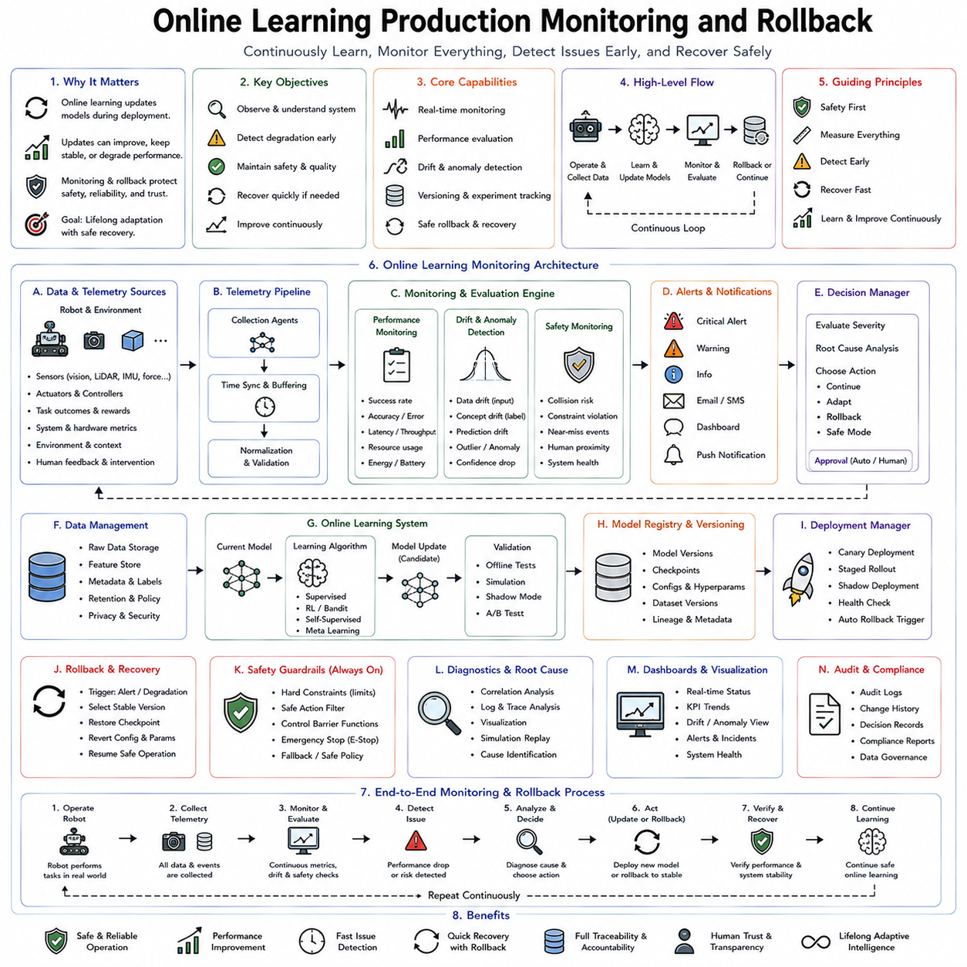
Online learning fundamentally changes the lifecycle of robotic intelligence. Traditional robotic systems are trained offline, validated extensively, deployed into production, and expected to behave consistently until the next scheduled software update. Online learning replaces this static lifecycle with continuous adaptation, where perception models, decision policies, world models, memory structures, and optimization parameters evolve throughout deployment. While this capability enables robots to improve autonomously, it also introduces an entirely new class of operational challenges. Every model update performed during deployment carries the possibility of improving performance, maintaining existing capability, or unintentionally degrading system behavior. Consequently, production monitoring and rollback become essential architectural components rather than optional maintenance features. A truly autonomous robot must not only learn continuously but also detect when learning becomes harmful, diagnose the source of degradation, recover safely, and continue operating without compromising reliability or human trust. Production monitoring and rollback therefore form the operational safety infrastructure supporting lifelong online learning in Physical AI systems.
The central principle behind production monitoring is that every deployed learning system must continuously evaluate its own behavior. Unlike offline evaluation, where fixed benchmark datasets measure model accuracy before deployment, production monitoring observes real-world performance during actual operation. The robot continuously measures task success, prediction confidence, environmental changes, computational performance, hardware status, human feedback, safety indicators, and resource utilization. Instead of assuming that a validated model will remain optimal indefinitely, the architecture treats deployment as an ongoing experiment in which every action contributes evidence regarding system quality.
Monitoring begins with observation rather than intervention. Before modifying any learning algorithm, the system establishes comprehensive visibility into its own operation. Every perception module, planning algorithm, control policy, memory subsystem, communication interface, and hardware component generates telemetry describing its current state. Cameras report image quality, localization modules estimate positional uncertainty, planners record decision latency, controllers measure tracking error, batteries report remaining capacity, processors monitor utilization, and learning modules track parameter updates. Together these observations create a continuously evolving operational picture of the robot's internal health.
Telemetry represents the foundation of production monitoring. Modern robotic systems generate enormous volumes of operational data describing both physical behavior and computational processes. Sensor streams, actuator commands, inference latency, GPU utilization, memory consumption, communication bandwidth, battery discharge rates, thermal conditions, navigation trajectories, manipulation outcomes, environmental maps, confidence scores, learning losses, gradient statistics, and policy updates collectively characterize system behavior. Rather than treating these measurements independently, production monitoring integrates them into a unified observability framework capable of identifying subtle interactions among hardware, software, and learning components.
Observability extends beyond traditional logging by emphasizing understanding rather than simply recording events. Logs capture discrete occurrences, metrics summarize numerical trends, and traces reconstruct complete execution paths across distributed components. Together these complementary information sources allow engineers and autonomous monitoring systems to reconstruct why particular decisions occurred, how model updates influenced behavior, and where unexpected performance degradation originated. Comprehensive observability becomes increasingly important as online learning architectures incorporate dozens of interconnected adaptive modules operating simultaneously.
Performance monitoring evaluates whether learning genuinely improves operational capability. Task completion rates provide one obvious measure, but production environments require considerably richer evaluation. Navigation systems monitor path efficiency, obstacle avoidance frequency, localization accuracy, and travel time. Manipulation systems evaluate grasp success, insertion precision, contact stability, force regulation, and recovery performance. Human-robot interaction measures dialogue quality, user satisfaction, response latency, and intervention frequency. Learning systems therefore optimize multidimensional performance rather than single benchmark metrics.
Prediction quality requires continuous assessment because learned models gradually encounter environments differing from previous experience. Classification confidence, regression residuals, trajectory prediction accuracy, object detection reliability, semantic segmentation quality, and language understanding consistency all contribute valuable information regarding model health. Production monitoring identifies situations where prediction confidence decreases despite unchanged environmental complexity, suggesting distribution shift, sensor degradation, or emerging model failure.
Model drift represents one of the most important phenomena requiring continuous monitoring. Distribution drift occurs when environmental observations gradually differ from historical training data. Concept drift arises when relationships between observations and desired outputs change over time. Sensor drift results from gradual calibration changes, hardware aging, or environmental influences. Policy drift reflects evolving behavioral characteristics caused by continual online adaptation. Detecting these subtle changes early prevents gradual performance degradation before catastrophic failures occur.
Data drift detection employs statistical comparison between historical and current operating distributions. Feature distributions, latent representations, semantic embeddings, prediction uncertainty, reconstruction error, clustering structure, and density estimation collectively reveal whether the robot now operates under conditions significantly different from previous experience. Distribution monitoring therefore provides early warning before visible task failures emerge.
Concept drift presents greater challenges because environmental inputs may remain statistically similar while correct decisions gradually change. Manufacturing processes evolve, user preferences shift, traffic regulations change, equipment wears, and organizational workflows adapt over time. Production monitoring therefore evaluates not only sensory distributions but also relationships between observations, actions, and outcomes. Continual validation ensures learned policies remain aligned with current operational requirements rather than outdated historical assumptions.
Behavioral monitoring evaluates the robot itself rather than only internal models. Motion smoothness, acceleration profiles, energy efficiency, trajectory consistency, interaction safety, manipulation stability, and navigation patterns collectively describe external behavior observable within the physical environment. Even if prediction metrics remain acceptable, unusual behavioral patterns may reveal emerging problems requiring investigation. Behavioral monitoring therefore complements internal computational diagnostics.
Safety monitoring operates independently from performance evaluation. A robot may achieve excellent task efficiency while simultaneously violating operational safety constraints. Collision margins, emergency stop frequency, joint limit violations, excessive contact forces, thermal conditions, battery health, communication integrity, localization confidence, obstacle clearance, and human proximity remain continuously supervised regardless of task success. Safety metrics always receive higher priority than productivity measures throughout deployment.
Human feedback provides an additional monitoring channel unavailable through purely autonomous evaluation. Operators report unusual behavior, reduced usability, discomfort, communication failures, preference changes, or task inefficiencies difficult to quantify automatically. Preference learning, reinforcement learning from human feedback, correction demonstrations, and natural language explanations supplement quantitative monitoring with qualitative operational knowledge. Human observations frequently identify subtle problems before automated metrics detect significant degradation.
Anomaly detection serves as the automated early warning system within production monitoring. Statistical models, autoencoders, one-class classifiers, density estimation, Bayesian inference, foundation model embeddings, and reconstruction error analysis distinguish normal operational behavior from unexpected observations. Anomalies may originate from hardware faults, software bugs, cyber attacks, sensor failures, environmental novelty, learning instability, or unforeseen interactions among system components. Early anomaly detection enables preventive intervention before operational failures escalate.
Root cause analysis follows anomaly detection by identifying underlying mechanisms responsible for observed degradation. Distributed robotic architectures contain perception pipelines, localization systems, planners, controllers, memory modules, communication networks, cloud synchronization, and continual learning processes interacting simultaneously. Diagnosing which component initiated observed failures requires causal reasoning supported by comprehensive telemetry, execution traces, dependency graphs, temporal correlation analysis, and probabilistic diagnosis models.
Model versioning provides the structural foundation supporting reliable rollback. Every deployed model receives a unique version identifier associated with training datasets, software dependencies, hardware compatibility, hyperparameters, validation results, deployment timestamps, operational metrics, and safety certification records. Complete version histories ensure that every behavioral change remains traceable throughout the robot's operational lifetime. Version management therefore enables reproducibility, regulatory compliance, scientific experimentation, and rapid recovery following unsuccessful updates.
Continuous deployment within online learning differs fundamentally from traditional software release cycles. Instead of infrequent manually supervised updates, learning systems may generate numerous incremental model revisions daily or even hourly. Production architectures therefore require automated deployment pipelines validating each update before release. Candidate models undergo simulation testing, replay evaluation, uncertainty analysis, safety verification, resource profiling, and compatibility checking before reaching production systems.
Shadow deployment provides one of the safest validation mechanisms. Newly trained models receive identical sensory inputs alongside production controllers but never directly command physical actuators. Their predicted actions, confidence estimates, computational latency, and resource consumption are compared continuously against operational models under identical environmental conditions. Extended shadow evaluation reveals subtle weaknesses impossible to detect through offline benchmarks alone. Only after demonstrating consistent superiority does the candidate model progress toward active deployment.
Canary deployment extends this principle across robotic fleets. Rather than updating every robot simultaneously, new models initially deploy to a small subset of carefully selected platforms operating under representative conditions. Production monitoring evaluates fleet-wide metrics comparing updated robots against unchanged control groups. If unexpected degradation emerges, deployment immediately stops while unaffected robots continue operating normally. Canary deployment therefore limits operational risk during continual improvement.
Progressive rollout further reduces deployment risk by gradually increasing the proportion of robots receiving updated models. Monitoring continuously evaluates cumulative evidence supporting or rejecting wider deployment. Statistical significance testing, confidence intervals, Bayesian evaluation, and operational thresholds determine whether rollout proceeds, pauses, or reverses. Progressive deployment therefore transforms model release into a continuously monitored decision process rather than a single irreversible event.
Rollback mechanisms constitute the final protective layer preserving operational reliability. Whenever monitoring identifies unacceptable degradation, the architecture restores previously validated models without requiring manual intervention. Rollback may occur automatically according to predefined safety thresholds or under human supervision depending upon application requirements. The objective is not merely reversing software changes but restoring complete operational capability including policies, memory structures, configuration parameters, calibration information, and supporting metadata.
Rollback strategies vary according to deployment architecture. Immediate rollback replaces entire models with previous versions whenever severe failures occur. Incremental rollback selectively restores only problematic subsystems while preserving beneficial adaptations elsewhere. Parameter rollback reverts recently modified weights without discarding accumulated memory. Feature rollback disables newly introduced representations while maintaining existing controllers. Hybrid rollback increasingly combines these approaches according to diagnosed failure mechanisms.
Memory-aware rollback presents unique challenges because online learning modifies both model parameters and accumulated knowledge. Simply restoring earlier neural network weights may produce inconsistencies with updated episodic memory, semantic knowledge, replay buffers, or world models. Modern rollback architectures therefore coordinate restoration across multiple learning components, ensuring memories remain compatible with restored computational models while preserving valuable operational experience whenever possible.
Checkpointing provides the infrastructure supporting rapid recovery. Throughout deployment, robotic systems periodically preserve complete execution snapshots including neural network parameters, optimizer states, replay buffers, memory contents, configuration files, calibration data, world models, policy versions, and software environments. Checkpoints enable deterministic restoration following unexpected failures, ensuring recovery occurs within seconds rather than requiring complete retraining from historical data.
Digital twins significantly strengthen production monitoring by maintaining continuously synchronized virtual replicas of deployed robots. Operational telemetry updates corresponding simulation models reflecting current hardware conditions, environmental structure, sensor calibration, and learned behavior. Candidate policy updates undergo evaluation within synchronized digital twins before affecting physical systems. Monitoring therefore compares simulated predictions against observed reality, identifying discrepancies indicating model degradation or environmental change.
Cloud robotics enables fleet-level monitoring impossible for isolated robots. Centralized infrastructure aggregates telemetry across thousands of deployments operating under diverse conditions. Statistical analysis identifies emerging failure patterns invisible within individual robots. Successful adaptations propagate throughout the fleet, while problematic updates become isolated before widespread deployment. Fleet intelligence therefore accelerates improvement while simultaneously increasing operational robustness.
Federated monitoring extends collaborative evaluation without compromising privacy. Instead of transmitting raw operational data, robots exchange anonymized metrics, encrypted gradients, compressed embeddings, anomaly statistics, and model performance summaries. Central aggregation identifies global trends while preserving confidential industrial, medical, or domestic information. Federated monitoring therefore supports large-scale continual improvement under strict privacy constraints.
Cybersecurity monitoring becomes increasingly important because online learning systems continuously receive model updates, cloud synchronization messages, and external data. Adversarial attacks, poisoned training samples, unauthorized parameter modification, communication spoofing, malicious firmware, and compromised cloud services may all influence learned behavior. Secure monitoring therefore verifies model integrity, authenticates updates, validates software signatures, detects anomalous communication patterns, and isolates compromised components before physical behavior becomes affected.
Regulatory compliance requires comprehensive operational records throughout continual deployment. Safety-critical industries including healthcare, aviation, manufacturing, autonomous transportation, and defense require detailed audit trails documenting model evolution, validation procedures, deployment history, operational performance, rollback events, human interventions, safety incidents, and software provenance. Production monitoring therefore supports not only engineering reliability but also legal accountability and certification requirements.
Evaluation of production monitoring architectures extends far beyond simple uptime statistics. Detection latency, false positive rates, anomaly localization accuracy, rollback speed, recovery quality, deployment success rate, monitoring overhead, computational efficiency, scalability, fleet coordination, cybersecurity resilience, operator workload, and long-term operational reliability collectively determine architectural effectiveness. Successful monitoring systems identify genuine problems rapidly while avoiding unnecessary rollback triggered by harmless operational variation.
The future of online learning production infrastructure will increasingly integrate foundation models, digital twins, world models, continual learning, Memory-Augmented Networks, federated learning, cloud robotics, autonomous DevOps, explainable AI, uncertainty-aware monitoring, self-healing software systems, and predictive maintenance into unified operational intelligence platforms. Rather than separating development, deployment, monitoring, adaptation, and recovery into independent engineering activities, future robotic systems will manage their own operational lifecycle through continuous self-observation, self-evaluation, self-correction, and safe autonomous evolution.
Online learning production monitoring and rollback therefore represent far more than operational maintenance tools. They constitute the adaptive nervous system governing how intelligent robots evolve throughout years of deployment while preserving reliability, safety, explainability, and human trust. By continuously observing behavior, detecting degradation, validating improvements, coordinating deployment, preserving version history, recovering from failure, and enabling safe continual adaptation, these architectures transform online learning from an experimental capability into a dependable engineering discipline suitable for large-scale deployment of Physical AI across manufacturing, logistics, healthcare, agriculture, service robotics, autonomous transportation, and future general-purpose robotic intelligence.

