Volume 19 Robot Machine Learning and AI

02. Deep Learning for Robotics

02.01 CNN Architectures ResNet EfficientNet for Robots [w/Code]
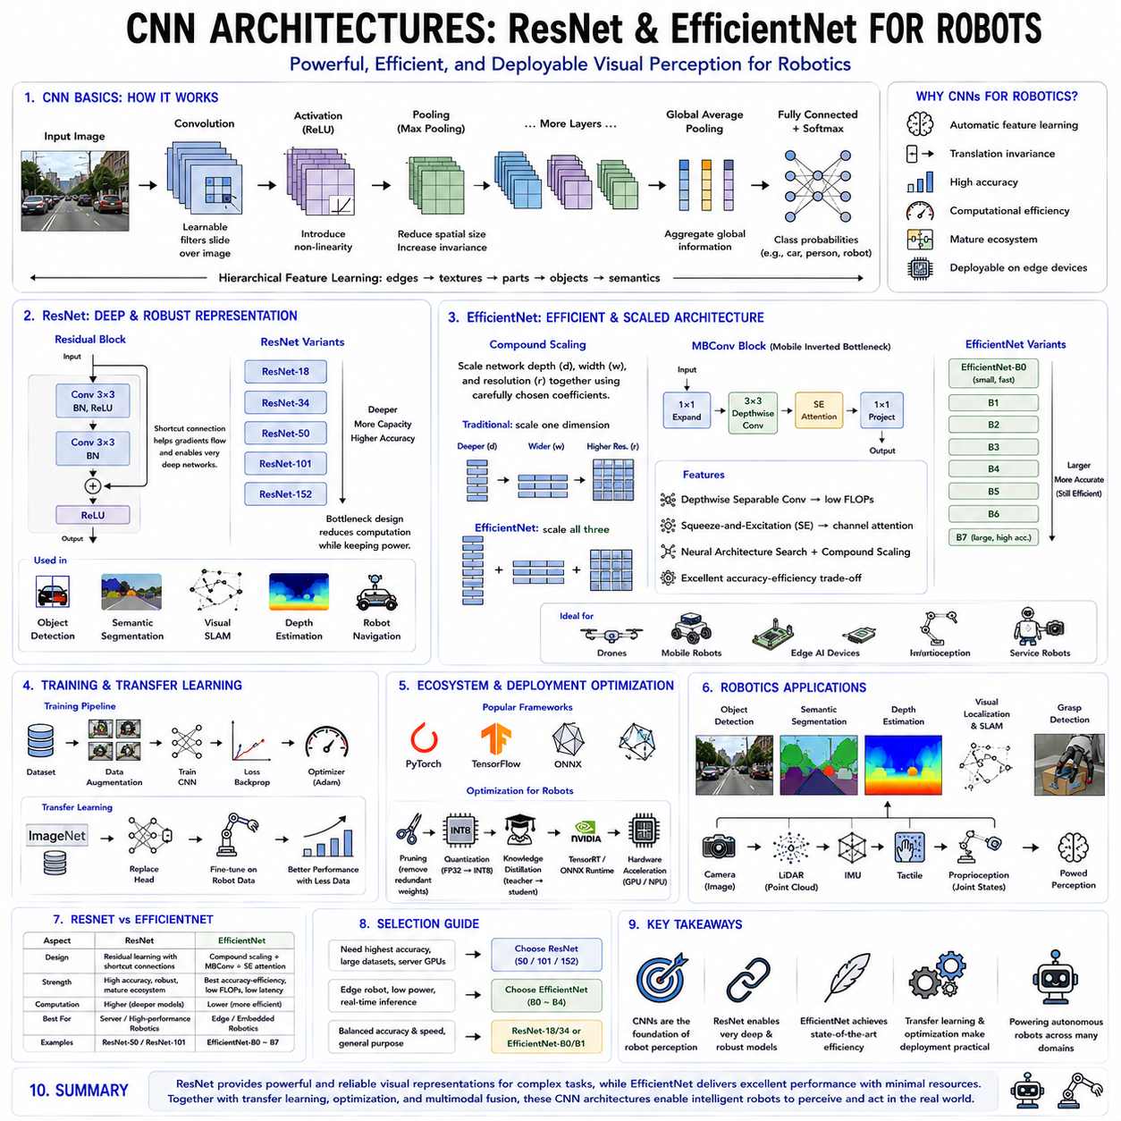
Convolutional Neural Networks (CNNs) have become one of the most influential architectures in modern artificial intelligence, particularly for computer vision and robotic perception. Before the emergence of transformer-based vision models, CNNs dominated nearly every visual recognition benchmark and established the foundation for autonomous perception in robotics. Even today, despite the rapid growth of Vision Transformers and multimodal foundation models, CNN architectures remain indispensable for many robotic applications because of their computational efficiency, strong feature extraction capability, mature deployment ecosystem, and excellent compatibility with embedded computing platforms. Mobile robots, industrial inspection systems, autonomous vehicles, drones, service robots, and humanoid robots continue to rely heavily on CNN-based perception pipelines, especially for real-time inference on edge devices where computational resources and power consumption remain constrained.
The fundamental strength of CNNs originates from their ability to automatically learn hierarchical visual representations directly from raw image data. Traditional computer vision systems depended heavily on handcrafted feature descriptors such as SIFT, SURF, HOG, and ORB. These manually designed algorithms required expert knowledge and often struggled to generalize across diverse environments. CNNs fundamentally changed this paradigm by learning task-specific visual features through end-to-end optimization. Rather than explicitly programming edge detectors, texture extractors, or object templates, CNNs automatically discover increasingly abstract visual representations during supervised learning. Early convolutional layers typically learn simple edges, gradients, and corners, intermediate layers capture textures and object parts, while deeper layers recognize semantic concepts such as vehicles, humans, tools, or obstacles.
The core operation within a CNN is the convolution operation. Unlike fully connected neural networks, where every neuron connects to every input, convolution applies small learnable kernels across local image regions. These kernels slide over the image while sharing identical parameters across different spatial locations. Parameter sharing dramatically reduces computational complexity while simultaneously improving translation invariance. Since identical visual patterns may appear anywhere within an image, shared convolution kernels efficiently recognize these patterns regardless of their spatial position. This property is particularly valuable for robotic perception because objects continuously move relative to robot cameras during navigation and manipulation.
Local receptive fields further distinguish convolutional architectures from fully connected networks. Individual neurons initially observe only small neighborhoods within input images, gradually expanding their receptive fields through successive convolutional layers. This hierarchical processing closely resembles biological visual systems, where local edge detection gradually combines into increasingly complex object representations. Hierarchical feature extraction enables CNNs to recognize highly complicated objects despite variations in pose, illumination, scale, viewpoint, partial occlusion, and background clutter frequently encountered in robotic environments.
Pooling operations complement convolution by reducing spatial resolution while preserving important semantic information. Max pooling selects the strongest activation within local neighborhoods, whereas average pooling computes local averages. Pooling decreases computational cost, increases receptive field size, suppresses minor image perturbations, and improves robustness against small translations. Although recent architectures increasingly replace explicit pooling using strided convolutions, the underlying principle of progressively compressing spatial information while preserving semantic content remains fundamental throughout modern convolutional networks.
Early CNN architectures including LeNet demonstrated the feasibility of end-to-end handwritten digit recognition using convolutional feature extraction. Subsequent architectures such as AlexNet revolutionized large-scale image recognition by successfully exploiting GPU acceleration, Rectified Linear Unit activations, dropout regularization, and extensive data augmentation. AlexNet's remarkable success on the ImageNet benchmark triggered the modern deep learning revolution, inspiring rapid development of increasingly sophisticated convolutional architectures throughout computer vision and robotics.
VGG networks emphasized architectural simplicity by constructing deep models entirely from repeated three-by-three convolution layers separated by occasional pooling operations. Although computationally expensive, VGG demonstrated that increasing network depth substantially improved representation quality. The homogeneous architecture also facilitated transfer learning, making pretrained VGG models highly influential across robotics research before more efficient architectures emerged.
As CNNs became deeper, optimization difficulties increasingly limited performance improvements. Very deep networks frequently suffered from vanishing gradients, preventing effective parameter updates throughout early layers. Residual Networks fundamentally addressed this challenge by introducing shortcut connections allowing gradients to propagate directly across multiple layers. Rather than learning complete transformations, residual blocks learn residual corrections relative to identity mappings. This elegant architectural innovation dramatically simplified optimization while enabling neural networks containing hundreds or even thousands of layers.
Residual learning provides several important advantages beyond optimization stability. Shortcut connections improve gradient propagation, accelerate convergence, reduce degradation associated with increasing network depth, and facilitate feature reuse across multiple hierarchical levels. Residual representations naturally encourage incremental feature refinement rather than repeatedly reconstructing complete representations from scratch. Consequently, Residual Networks consistently achieve superior accuracy while remaining comparatively straightforward to optimize.
ResNet architectures rapidly became standard feature extraction backbones throughout robotics. Object detection systems including Faster R-CNN, Mask R-CNN, RetinaNet, Cascade R-CNN, and numerous semantic segmentation frameworks frequently adopt ResNet variants because they provide excellent representational quality together with mature implementation support. Mobile robots similarly employ ResNet backbones for scene understanding, obstacle detection, visual localization, terrain classification, and human recognition due to their strong generalization capability across diverse environments.
Multiple ResNet variants accommodate different computational requirements. ResNet-18 and ResNet-34 provide relatively lightweight architectures suitable for embedded robotics platforms, while ResNet-50, ResNet-101, and ResNet-152 progressively increase representational capacity for demanding perception tasks. Bottleneck residual blocks within deeper variants reduce computational complexity by compressing feature dimensions before expensive convolutions and subsequently restoring higher-dimensional representations. This design enables substantially deeper networks without proportional increases in computational cost.
Although Residual Networks significantly improved accuracy, they also increased computational requirements as model depth expanded. Efficient deployment on embedded robotic platforms therefore motivated development of architectures explicitly balancing predictive performance against computational efficiency. EfficientNet represents one of the most influential outcomes of this research direction by introducing principled compound model scaling.
Traditional CNN development often increased only one architectural dimension at a time. Researchers independently expanded network depth, width, or input resolution, frequently producing suboptimal resource allocation. EfficientNet proposed compound scaling, simultaneously increasing all three dimensions according to carefully optimized scaling coefficients. Rather than arbitrarily enlarging networks, compound scaling allocates computational resources systematically across architectural dimensions, producing significantly better accuracy-efficiency tradeoffs.
The baseline EfficientNet architecture emerged through Neural Architecture Search, where automated optimization discovered highly efficient building blocks satisfying predefined computational constraints. Compound scaling subsequently generated progressively larger variants including EfficientNet-B0 through EfficientNet-B7 by proportionally expanding network depth, channel width, and input resolution. This unified scaling methodology consistently outperformed manually designed architectures while requiring substantially fewer parameters and floating-point operations.
EfficientNet relies heavily upon Mobile Inverted Bottleneck Convolution blocks originally developed for MobileNet architectures. These blocks expand low-dimensional feature representations into higher-dimensional spaces, perform computationally efficient depthwise convolutions independently across channels, and subsequently project features back toward lower-dimensional representations. Depthwise separable convolution dramatically reduces computational complexity compared with conventional convolution while preserving strong representational capability.
Squeeze-and-Excitation attention further enhances EfficientNet by adaptively emphasizing informative feature channels. Rather than treating all channels equally, global feature statistics determine channel-specific importance weights that selectively amplify useful representations while suppressing less informative responses. Channel attention improves representational efficiency without introducing excessive computational overhead, particularly benefiting fine-grained recognition tasks frequently encountered in robotic inspection and manipulation.
EfficientNet demonstrates exceptional performance across resource-constrained robotic platforms. Embedded GPUs including NVIDIA Jetson Orin, Jetson Xavier, Jetson Thor, ARM processors, and various edge AI accelerators frequently deploy EfficientNet variants because they provide excellent accuracy within strict power, memory, and latency constraints. Autonomous drones, mobile robots, wearable devices, agricultural robots, and industrial inspection systems particularly benefit from EfficientNet's favorable efficiency characteristics.
Selecting between ResNet and EfficientNet depends primarily upon application requirements rather than absolute superiority. ResNet generally provides outstanding robustness, mature ecosystem support, extensive pretrained models, and excellent compatibility with numerous downstream vision frameworks. EfficientNet emphasizes computational efficiency, reduced parameter counts, lower inference latency, and improved energy consumption while maintaining competitive recognition accuracy. Consequently, large server-based perception systems frequently prefer deeper ResNet variants, whereas embedded robotic platforms often adopt EfficientNet.
Transfer learning represents another major advantage of modern CNN architectures. Large convolutional networks pretrained on extensive image datasets including ImageNet learn generic visual representations transferable across numerous downstream robotics applications. Rather than training from random initialization, robotic perception systems frequently fine-tune pretrained CNN backbones using relatively modest domain-specific datasets. Transfer learning substantially reduces annotation requirements, accelerates convergence, improves generalization, and enables practical deployment despite limited robotics data availability.
Modern robotics rarely employs CNNs solely for image classification. Convolutional backbones integrate into larger perception systems supporting object detection, semantic segmentation, instance segmentation, monocular depth estimation, optical flow prediction, visual simultaneous localization and mapping, place recognition, terrain classification, visual servoing, grasp detection, and multimodal sensor fusion. CNN feature extractors therefore serve as foundational components supporting numerous autonomous perception capabilities rather than isolated recognition tasks.
CNNs also play an essential role within multimodal robotic intelligence. Visual features extracted through convolutional networks combine naturally with LiDAR point clouds, radar measurements, inertial sensing, tactile feedback, proprioceptive information, language embeddings, and robot state variables. Feature fusion modules subsequently integrate these heterogeneous representations into unified perception models supporting navigation, manipulation, inspection, and human-robot interaction. Even Vision-Language-Action architectures frequently incorporate convolutional feature extractors within specialized perception pipelines requiring computational efficiency.
Deployment optimization remains particularly important for robotics because embedded systems possess limited computational resources. Model pruning removes redundant parameters while preserving predictive accuracy. Quantization converts floating-point computations into lower-precision integer arithmetic, significantly reducing memory requirements and inference latency. Knowledge distillation transfers information from large teacher networks toward compact student models suitable for edge deployment. TensorRT optimization, ONNX conversion, hardware-specific compilation, and operator fusion further accelerate CNN inference across NVIDIA GPUs, NPUs, and specialized robotics accelerators.
Real-time robotic perception introduces additional evaluation criteria beyond conventional benchmark accuracy. Autonomous systems require predictable inference latency, deterministic execution, memory efficiency, thermal stability, fault tolerance, and long-term reliability. Consequently, CNN architecture selection frequently considers frames per second, GPU utilization, energy consumption, memory footprint, and deployment robustness alongside recognition accuracy. Lightweight EfficientNet variants, quantized ResNet models, and compressed convolutional backbones often provide superior overall system performance despite slightly lower benchmark accuracy.
Although Vision Transformers increasingly dominate large-scale image recognition research, convolutional architectures continue maintaining important advantages within robotics. CNNs generally require fewer training samples, exhibit stronger inductive biases for local spatial reasoning, achieve excellent computational efficiency, and deploy effectively on embedded hardware. Hybrid architectures increasingly combine convolutional feature extraction with transformer attention mechanisms, leveraging complementary strengths from both paradigms. Such hybrid perception systems frequently outperform purely convolutional or purely transformer-based approaches across practical robotic applications.
As Physical AI evolves toward increasingly capable embodied intelligence, CNN architectures remain foundational components within comprehensive robotic perception systems. Residual Networks continue providing highly reliable general-purpose visual feature extraction, while EfficientNet establishes state-of-the-art efficiency for embedded deployment. Together with transfer learning, multimodal fusion, edge optimization, and integration into larger Vision-Language-Action frameworks, these convolutional architectures continue supporting autonomous navigation, manipulation, industrial inspection, medical robotics, service robotics, and collaborative human-robot interaction. Rather than being replaced by newer architectures, CNNs are evolving into efficient perception modules within increasingly sophisticated multimodal AI systems, ensuring their continued importance throughout the next generation of intelligent robotics.

02.02 Transformer Architecture for Robot Learning [w/Code]
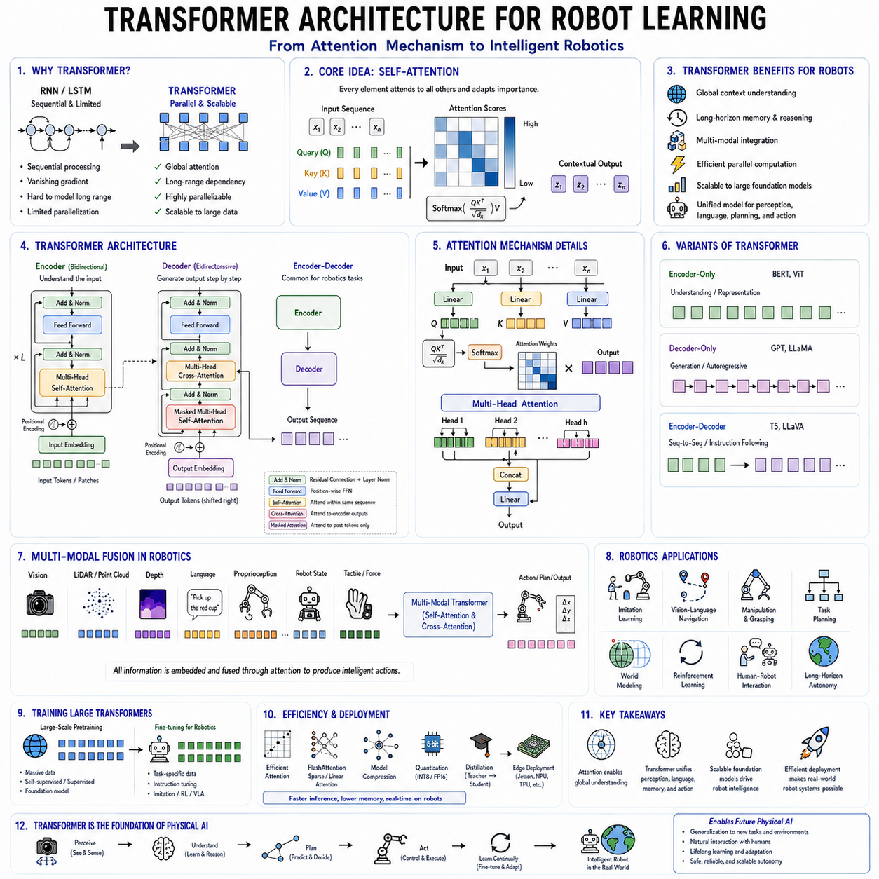
Transformer architecture has fundamentally reshaped modern artificial intelligence by replacing traditional sequential processing mechanisms with scalable attention-based computation capable of modeling long-range dependencies across extremely large datasets. Originally introduced for natural language processing, the Transformer rapidly expanded into computer vision, multimodal learning, reinforcement learning, robotics, and Physical AI. Today, nearly every state-of-the-art foundation model, including Large Language Models (LLMs), Vision Transformers (ViTs), Vision-Language Models (VLMs), and Vision-Language-Action (VLA) models, is built upon the Transformer architecture. For robotics, Transformers represent a major technological transition because they enable robots to integrate perception, language understanding, planning, memory, and action generation within a unified neural architecture. Instead of treating perception, reasoning, and control as isolated modules, Transformer-based systems learn end-to-end representations capable of understanding complex relationships among observations, instructions, environmental context, and robot behaviors.
Before Transformers became dominant, most sequence modeling tasks relied upon Recurrent Neural Networks (RNNs), Long Short-Term Memory networks (LSTMs), or Gated Recurrent Units (GRUs). These architectures processed information sequentially, updating hidden states one step at a time. Although recurrent models successfully captured temporal dependencies, they suffered from several limitations including vanishing gradients, difficulty modeling very long sequences, limited parallelization, and increasing computational cost as sequence length grew. These shortcomings became particularly problematic for robotics, where autonomous systems frequently process long video sequences, complex sensor streams, extended manipulation trajectories, and lengthy natural language instructions simultaneously.
The Transformer architecture addressed these challenges by introducing self-attention as the primary computational mechanism. Rather than processing sequential information one element at a time, self-attention enables every element within a sequence to interact directly with every other element regardless of their relative positions. Consequently, long-range dependencies become significantly easier to model, while computations may execute in parallel across modern GPUs and specialized AI accelerators. This architectural innovation dramatically improved both computational efficiency and representation quality, enabling the rapid development of increasingly capable foundation models.
The central idea underlying self-attention is remarkably intuitive. Every token, image patch, sensor observation, or robot state dynamically determines which other elements within the input sequence deserve attention. Instead of assuming nearby elements always possess greater importance, self-attention learns adaptive relationships directly from data. A robot observing an object may simultaneously consider distant visual features, previous observations, language instructions, environmental context, and historical actions when generating the next decision. Such global contextual reasoning significantly exceeds the representational capability of conventional convolutional or recurrent architectures.
Self-attention relies upon three learned representations commonly known as Query, Key, and Value. Each input element generates corresponding query, key, and value vectors through learned linear projections. Queries represent information requests, keys describe available information, and values contain the information ultimately exchanged among sequence elements. Attention scores are computed by measuring similarity between queries and keys, after which normalized attention weights determine how strongly values contribute toward updated representations. Through this mechanism, every element selectively aggregates information from all relevant sequence components.
Scaled dot-product attention represents the mathematical core of Transformer computation. Dot products measure similarity between query and key vectors, while scaling stabilizes optimization by preventing excessively large values during training. A softmax operation converts similarity scores into normalized probability distributions describing relative attention allocation across all sequence elements. Finally, weighted combinations of value vectors produce context-aware output representations integrating globally relevant information. This elegant computational framework enables adaptive information flow throughout the entire sequence.
Multi-head attention further enhances representational capacity by performing several independent attention operations simultaneously. Rather than computing one global relationship, multiple attention heads specialize in different semantic aspects of the input. Individual heads may focus upon spatial relationships, temporal dependencies, object interactions, linguistic context, manipulation goals, navigation constraints, or environmental semantics. Combining multiple complementary attention patterns significantly enriches learned representations while improving robustness and interpretability across diverse robotics applications.
Positional encoding addresses an important limitation of self-attention. Because attention mechanisms treat input elements as unordered sets, Transformers require explicit information describing sequence order. Positional encodings inject location-dependent representations into input embeddings, allowing models to distinguish temporal ordering, spatial arrangement, or sequential progression. Early Transformers employed sinusoidal positional encodings, while later architectures increasingly utilize learned positional embeddings, rotary positional embeddings, relative position encoding, or more sophisticated spatial representations depending upon application requirements.
Transformer layers combine multiple computational components into highly structured processing blocks. Multi-head self-attention first aggregates contextual information across the input sequence. Residual connections preserve gradient flow and facilitate optimization, while layer normalization stabilizes activation distributions. Position-wise feedforward networks subsequently perform nonlinear feature transformation independently for every sequence element. A second residual connection and normalization stage complete the Transformer block. Repeating these blocks dozens or hundreds of times enables progressively richer hierarchical representation learning.
Encoder-only Transformers focus primarily upon representation learning by processing complete input sequences bidirectionally. Every element attends simultaneously to preceding and following context, producing highly informative contextual embeddings. Bidirectional Encoder Representations from Transformers demonstrated the remarkable effectiveness of this architecture for language understanding. Similar encoder architectures later inspired Vision Transformers, multimodal encoders, perception systems, and robotics representation learning.
Decoder-only Transformers instead specialize in autoregressive sequence generation. Causal masking restricts attention exclusively toward previously generated elements, enabling sequential prediction without accessing future information. Large Language Models employ decoder-only architectures because language generation naturally proceeds one token at a time. Robotics increasingly adopts autoregressive decoding for trajectory generation, action prediction, manipulation planning, and sequential policy learning where future robot actions depend upon preceding observations and previously executed commands.
Encoder-decoder Transformers integrate both architectural paradigms within unified systems. Encoders first construct contextual representations from input observations, after which decoders generate corresponding output sequences while attending both previously generated outputs and encoded contextual information. Machine translation originally motivated this architecture, but robotics increasingly applies encoder-decoder models for instruction following, task planning, multimodal reasoning, scene understanding, and language-conditioned action generation.
Vision Transformers extended Transformer architectures toward image understanding by treating images as sequences of fixed-size patches rather than continuous pixel grids. Each image patch becomes analogous to a language token, enabling self-attention across the complete visual scene. Unlike convolutional neural networks emphasizing local receptive fields, Vision Transformers naturally capture long-range spatial relationships throughout entire images. Consequently, object interactions, global scene context, and large-scale spatial reasoning become considerably easier to model.
Although Vision Transformers initially required enormous datasets for competitive performance, improvements in pretraining strategies, regularization methods, data augmentation, and architectural design have substantially improved sample efficiency. Modern Vision Transformers now achieve state-of-the-art performance across image classification, object detection, semantic segmentation, depth estimation, visual localization, and robotic perception benchmarks. Hybrid CNN-Transformer architectures further combine efficient local feature extraction with powerful global contextual reasoning.
Robotics introduces unique multimodal challenges extending beyond conventional computer vision. Autonomous systems simultaneously process RGB images, depth maps, LiDAR point clouds, radar measurements, inertial sensing, tactile feedback, force sensing, proprioception, language instructions, robot state variables, and environmental maps. Transformer architectures naturally integrate these heterogeneous modalities by representing every observation within a common embedding space before applying multimodal self-attention. Cross-modal interactions therefore emerge automatically through end-to-end learning rather than manually engineered sensor fusion pipelines.
Cross-attention enables information exchange between different modalities. Language tokens may selectively attend visual features describing referenced objects, while visual representations simultaneously incorporate semantic guidance from textual instructions. Robot state variables may attend environmental observations during manipulation planning, whereas force measurements influence visual reasoning throughout contact-rich tasks. Cross-attention therefore provides flexible multimodal integration supporting increasingly sophisticated embodied intelligence.
Memory represents another important capability emerging naturally within Transformer architectures. Long sequences preserve historical observations, previous actions, dialogue history, environmental changes, and accumulated task context throughout extended interactions. Rather than relying upon manually designed memory modules, Transformers learn adaptive memory utilization through attention mechanisms selecting relevant historical information according to current decision requirements. Such memory capabilities prove particularly valuable during long-horizon manipulation, navigation, human-robot collaboration, and autonomous exploration.
Long-context reasoning constitutes one of the defining strengths of modern Transformers. Large foundation models increasingly process hundreds of thousands or even millions of tokens simultaneously. Robotics similarly benefits from extended context windows supporting prolonged missions, multi-stage assembly procedures, lifelong navigation histories, persistent semantic mapping, and continuous interaction with human operators. Efficient attention algorithms including FlashAttention, sparse attention, linear attention, and memory-efficient implementations increasingly enable such large-scale contextual reasoning within practical computational budgets.
Transformer-based imitation learning has become one of the most active research directions in robotics. Rather than learning isolated control policies, Transformers model complete demonstration sequences collected from expert operators. Given observations and historical actions, the model predicts future control commands through autoregressive sequence modeling. Decision Transformer, Behavior Transformer, RT-1, RT-2, OpenVLA, and related architectures demonstrate that large Transformer models can successfully acquire complex manipulation and navigation behaviors directly from diverse demonstration datasets.
Large Vision-Language-Action models represent a particularly significant application of Transformer architectures. These models integrate visual perception, language understanding, world knowledge, reasoning, planning, and robot action generation within unified neural systems. Language instructions first become embedded through pretrained language encoders. Visual observations produce image embeddings through Vision Transformers or hybrid perception backbones. Multimodal attention subsequently fuses these representations before action decoders generate robot control commands. End-to-end optimization enables robots to directly translate natural language instructions into physical actions.
Transformers also play an increasingly important role within reinforcement learning. Attention mechanisms efficiently represent high-dimensional state spaces while capturing long-term temporal dependencies unavailable to conventional policy networks. World models, trajectory prediction, return estimation, exploration strategies, and model-based planning increasingly exploit Transformer architectures. Long-horizon decision making particularly benefits from attention-based memory capable of reasoning across extended interaction histories.
Training Transformer models requires substantial computational resources because self-attention complexity grows quadratically with sequence length. Large foundation models therefore rely heavily upon distributed optimization, mixed precision computation, gradient checkpointing, activation recomputation, and sophisticated parallelization strategies. FlashAttention significantly reduces memory requirements while accelerating attention computation, making large-scale Transformer training increasingly practical for robotics research.
Deployment on robotic platforms introduces additional optimization challenges. Edge robots frequently possess limited computational resources compared with cloud infrastructure. Model compression techniques including quantization, pruning, knowledge distillation, low-rank adaptation, sparse attention, and efficient Transformer variants reduce computational cost while preserving predictive performance. Hardware accelerators such as NVIDIA TensorRT, embedded NPUs, Jetson platforms, and specialized AI processors increasingly optimize Transformer inference for real-time robotics deployment.
Interpretability remains an active research topic within Transformer architectures. Attention maps provide valuable insights regarding information flow by visualizing relationships among input elements. Although attention does not fully explain internal reasoning, examining attention distributions often reveals object interactions, language grounding, task decomposition, navigation planning, and multimodal correspondence. Such visualization supports debugging, safety validation, human trust, and explainable robotic decision making.
As Physical AI advances toward increasingly capable embodied intelligence, Transformer architectures continue evolving beyond their original language processing origins. Future robots will require unified reasoning across perception, language, memory, planning, simulation, world modeling, manipulation, navigation, and human collaboration. Transformer architectures provide the scalable computational foundation supporting this integration by learning generalized representations spanning diverse modalities, tasks, and environments. Rather than functioning merely as sequence processors, Transformers are becoming universal reasoning engines capable of coordinating complex cognitive processes required for autonomous robotic intelligence. Combined with large-scale pretraining, multimodal learning, efficient deployment, continual adaptation, and probabilistic reasoning, Transformer architectures will remain one of the central technologies driving the next generation of intelligent robots and Physical AI systems.

02.03 Graph Neural Networks for Robot Scene Graphs [w/Code]
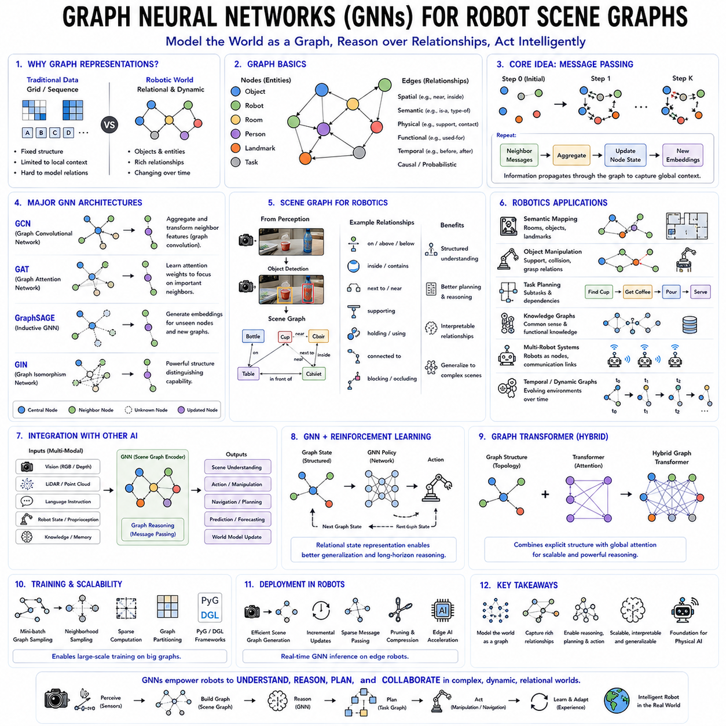
Graph Neural Networks (GNNs) represent a major advancement in machine learning by extending deep learning beyond traditional Euclidean data structures such as images, audio signals, and sequential text toward graph-structured data. While Convolutional Neural Networks excel at processing regular image grids and Transformers efficiently model long sequential dependencies, many real-world robotic environments are inherently relational rather than grid-based. Objects interact with one another through spatial, semantic, physical, functional, and temporal relationships that cannot be adequately represented using regular matrices or fixed-length sequences alone. Graph Neural Networks address this limitation by explicitly modeling entities as interconnected nodes and relationships as edges, enabling intelligent systems to reason directly over structured environments. As robotics advances toward Physical AI, Graph Neural Networks have become increasingly important for scene understanding, semantic mapping, multi-object interaction, task planning, manipulation reasoning, and world modeling.
A graph is one of the most fundamental mathematical structures used to represent relationships among entities. Formally, a graph consists of a collection of nodes connected by edges. Nodes represent individual entities such as objects, robots, rooms, landmarks, people, tools, or navigation goals, while edges describe relationships between those entities. Relationships may represent physical contact, spatial proximity, semantic association, communication links, manipulation dependencies, temporal transitions, or causal interactions. Unlike conventional image or sequence representations, graphs naturally preserve relational structure regardless of the number or arrangement of entities present within the environment.
Robotic environments are naturally graph-structured because autonomous systems rarely operate on isolated objects. A mobile robot navigating a warehouse simultaneously reasons about shelves, pallets, workers, forklifts, charging stations, obstacles, and navigation corridors. A household robot recognizes tables supporting dishes, cabinets containing cups, chairs surrounding dining tables, doors connecting rooms, and humans interacting with objects. These relationships frequently determine appropriate robot behavior more strongly than individual object appearances alone. Graph-based reasoning therefore enables substantially richer environmental understanding than purely visual perception.
Traditional deep learning architectures struggle to process graph-structured data because graph connectivity varies dynamically across different environments. Unlike images containing fixed rectangular grids, graphs may contain arbitrary numbers of nodes with irregular connectivity patterns. Standard convolution assumes neighboring pixels always occupy consistent geometric positions, whereas graph neighbors differ for every node. Graph Neural Networks overcome this challenge by learning directly over graph topology, allowing information to propagate adaptively along graph edges regardless of structural complexity.
The fundamental principle underlying Graph Neural Networks is message passing. Rather than processing nodes independently, every node repeatedly exchanges information with neighboring nodes through graph edges. During each message-passing iteration, neighboring nodes generate messages describing their current states, these messages are aggregated using learnable functions, and node representations update accordingly. Repeated propagation gradually expands each node's receptive field, enabling local observations to incorporate increasingly global contextual information throughout the graph.
Node embeddings provide the primary internal representation learned by Graph Neural Networks. Initially, each node possesses feature vectors describing local properties such as object category, visual appearance, geometric location, physical attributes, semantic labels, or sensor measurements. Through successive message-passing operations, node embeddings gradually incorporate information originating from neighboring nodes and eventually distant graph regions. Consequently, learned embeddings simultaneously capture both intrinsic object characteristics and surrounding relational context.
Edge representations are equally important within many robotics applications. Edges frequently encode distances between objects, relative orientations, physical constraints, visibility relationships, grasp dependencies, communication links, temporal transitions, or interaction probabilities. Advanced Graph Neural Networks learn not only node representations but also adaptive edge embeddings reflecting evolving relational semantics throughout inference. Dynamic edge representations significantly improve reasoning over complex robotic manipulation, navigation, and interaction tasks.
Graph Convolutional Networks represent one of the earliest and most influential Graph Neural Network architectures. Graph convolutions generalize conventional convolution operations toward irregular graph structures by aggregating neighboring node information according to graph connectivity. Instead of sliding fixed convolution kernels across regular image grids, Graph Convolutional Networks repeatedly average or transform neighboring feature vectors using adjacency relationships. This operation efficiently propagates contextual information while preserving graph topology.
Graph Attention Networks further enhance graph representation learning by replacing uniform neighbor aggregation with adaptive attention mechanisms. Rather than treating all neighboring nodes equally, attention weights determine which neighboring entities contribute most significantly toward updated node representations. For example, during robotic manipulation planning, objects physically contacting the manipulated item may receive substantially greater attention than distant unrelated objects. Attention therefore improves both representational flexibility and interpretability.
GraphSAGE introduced inductive graph learning by enabling Graph Neural Networks to generalize toward previously unseen graphs without requiring retraining. Instead of learning fixed embeddings exclusively for known nodes, GraphSAGE learns aggregation functions capable of generating representations dynamically for new graph structures. This inductive capability proves especially valuable for robotics because autonomous systems continuously encounter novel environments containing unfamiliar object arrangements and spatial configurations.
Graph Isomorphism Networks investigated the theoretical expressive power of Graph Neural Networks by demonstrating architectures capable of distinguishing increasingly complex graph structures. Strong representational capability becomes particularly important when robots reason about subtle structural differences among environments, assembly configurations, manipulation sequences, or semantic scene organizations. Such expressive graph models improve detailed structural understanding beyond simple neighborhood averaging.
Scene graphs represent one of the most important robotics applications of Graph Neural Networks. Rather than describing environments merely as collections of isolated detected objects, scene graphs explicitly encode relationships among all recognized entities. Every detected object becomes a graph node, while edges represent spatial relationships such as above, below, inside, supporting, adjacent, touching, containing, connected, or blocking. Scene graphs therefore transform raw perception into structured semantic world representations supporting higher-level reasoning.
Robotic scene understanding extends beyond object detection by interpreting environmental structure. Consider a service robot entering a kitchen. Conventional object detection identifies tables, cups, cabinets, refrigerators, sinks, and humans independently. Scene graphs instead represent relationships indicating that a cup rests on a table, the refrigerator stands beside the cabinet, utensils remain inside drawers, and humans interact with kitchen appliances. Such relational understanding substantially improves planning, navigation, manipulation, and instruction following.
Semantic mapping similarly benefits from graph representations. Traditional occupancy grids primarily represent free space and obstacles geometrically. Semantic maps enrich these geometric representations by incorporating object identities, room categories, functional regions, navigational affordances, and environmental relationships. Graph Neural Networks reason directly over these semantic maps, enabling robots to understand both spatial layout and functional organization simultaneously.
Object manipulation frequently requires relational reasoning rather than isolated perception. Removing a cup from a shelf may require recognizing supporting objects, neighboring obstacles, grasp accessibility, container relationships, and potential collisions. Manipulation planning therefore depends heavily upon object interaction graphs describing physical constraints among surrounding entities. Graph Neural Networks naturally propagate contextual information across these interaction networks, improving grasp planning, sequential manipulation, and task execution.
Task planning also benefits substantially from graph-based reasoning. Complex household tasks rarely consist of isolated actions. Preparing coffee requires locating cups, identifying coffee machines, obtaining water, operating appliances, and placing objects appropriately according to functional relationships. Graph representations encode dependencies among subtasks, enabling robots to reason systematically about execution order, prerequisite actions, resource availability, and environmental constraints. Task graphs therefore provide structured representations supporting long-horizon planning.
Knowledge graphs extend scene graphs by incorporating abstract semantic knowledge acquired beyond immediate sensory observations. Knowledge graphs connect objects through functional, causal, taxonomic, and commonsense relationships accumulated from previous experience or external knowledge sources. For example, robots may understand that mugs typically contain beverages, refrigerators preserve food, keys open doors, and charging stations replenish batteries despite never directly observing every relationship during training. Integrating Graph Neural Networks with knowledge graphs substantially improves reasoning under incomplete observations.
Multi-robot systems naturally form communication graphs where individual robots become graph nodes and communication links define graph edges. Graph Neural Networks enable distributed coordination by allowing robots to exchange learned information efficiently while respecting communication topology. Swarm robotics, collaborative mapping, distributed exploration, cooperative transportation, and multi-agent reinforcement learning increasingly exploit graph-based communication policies improving scalability and coordination efficiency.
Temporal graphs further extend graph representations by incorporating time-dependent relationships. Robotic environments evolve continuously as humans move, objects relocate, doors open, vehicles navigate, and tasks progress. Dynamic Graph Neural Networks update graph structure throughout operation, allowing autonomous systems to maintain accurate world models despite changing environments. Temporal graph reasoning supports activity recognition, trajectory prediction, behavior forecasting, anomaly detection, and continual environment understanding.
Graph Neural Networks integrate naturally with reinforcement learning. Graph representations encode relational state information, while graph-based policy networks reason over object interactions during decision making. Reinforcement learning agents therefore exploit relational structure rather than processing raw observations independently. Manipulation planning, multi-agent coordination, navigation, assembly tasks, and combinatorial optimization all demonstrate improved performance through graph-enhanced reinforcement learning.
Transformers and Graph Neural Networks increasingly complement one another within modern robotics. Transformers excel at modeling long-range global relationships through attention, whereas Graph Neural Networks explicitly preserve structural topology and relational inductive biases. Hybrid Graph Transformer architectures combine graph connectivity with attention mechanisms, enabling scalable reasoning across large relational environments while maintaining explicit structural representations. Such hybrid models increasingly appear within multimodal robotic foundation models.
Large Vision-Language-Action systems similarly benefit from graph representations. Visual perception identifies environmental entities, language instructions specify relational goals, and Graph Neural Networks organize these observations into structured world models supporting reasoning and planning. Rather than relying exclusively upon implicit attention mechanisms, graph representations provide interpretable relational structures facilitating complex manipulation, navigation, and human-robot collaboration.
Training Graph Neural Networks presents unique computational challenges because graph sizes, connectivity patterns, and neighborhood structures vary dynamically across datasets. Large graphs may contain millions of nodes and billions of edges, making naive message passing computationally expensive. Mini-batch graph sampling, neighborhood sampling, hierarchical pooling, graph partitioning, sparse computation, and efficient graph libraries including PyTorch Geometric and Deep Graph Library significantly improve scalability while preserving representational quality.
Deployment within robotic systems requires additional optimization because graph construction itself often dominates computational cost. Efficient scene graph generation, incremental graph updates, sparse message passing, hardware acceleration, graph pruning, and dynamic graph maintenance all contribute toward real-time robotic reasoning. Edge AI platforms increasingly support optimized Graph Neural Network inference suitable for autonomous mobile robots and embedded perception systems.
Interpretability represents another important advantage of graph-based reasoning. Unlike opaque feature tensors, graph representations explicitly describe relationships among recognized entities. Engineers may visualize object interactions, communication pathways, manipulation dependencies, navigation constraints, and semantic relationships directly within learned scene graphs. Such transparency improves debugging, safety validation, explainability, and human understanding of autonomous robot decision making.
As Physical AI progresses toward increasingly sophisticated world models, Graph Neural Networks are becoming essential components for structured environmental reasoning. Future robots must understand not only which objects exist but also how they interact physically, functionally, temporally, and semantically. Scene graphs, semantic graphs, knowledge graphs, task graphs, communication graphs, and dynamic relational world models collectively provide the structured representations necessary for this understanding. Combined with Transformer architectures, multimodal perception, probabilistic reasoning, reinforcement learning, and large foundation models, Graph Neural Networks enable robots to reason over the relational complexity of the physical world rather than merely recognizing isolated sensory patterns. This capability represents a critical step toward truly intelligent embodied systems capable of understanding, planning, collaborating, and acting within rich real-world environments.

02.04 Recurrent Networks LSTM GRU for Temporal Robot Data [w/Code]
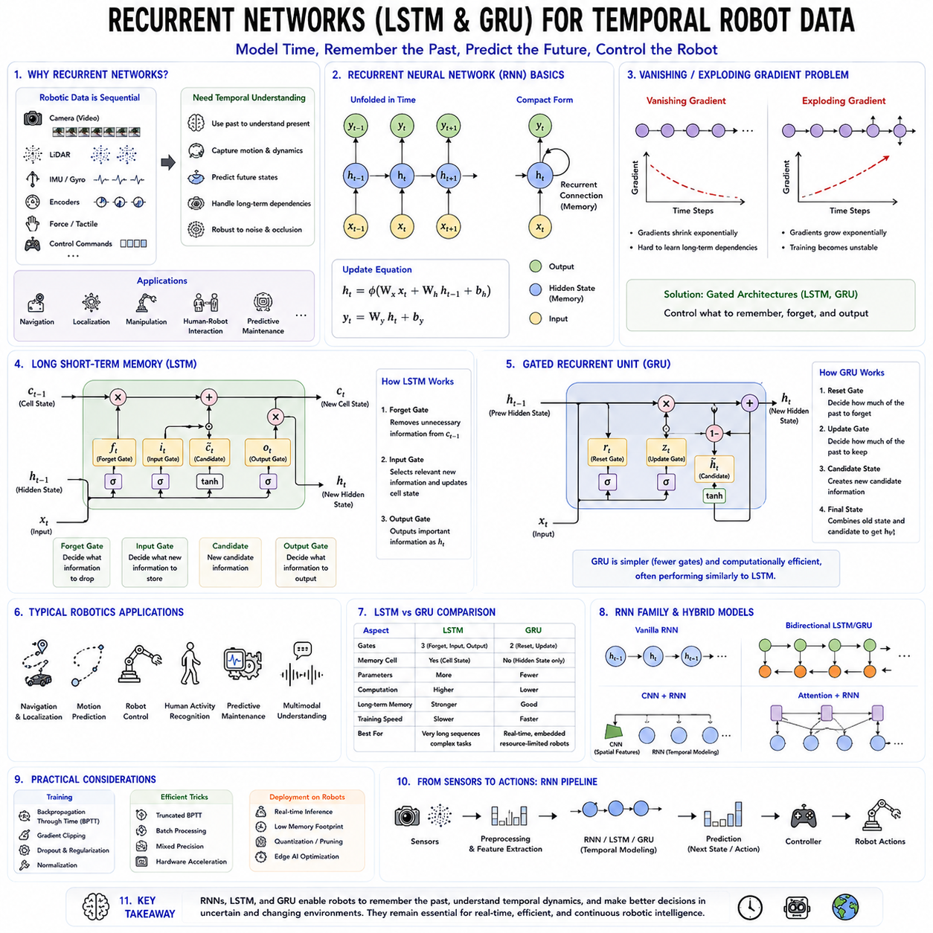
Recurrent Neural Networks (RNNs) represent one of the earliest deep learning architectures specifically designed to process sequential and temporal data. Unlike conventional feedforward neural networks, which assume that every input is independent, recurrent networks introduce an internal memory mechanism that allows information from previous time steps to influence current predictions. This capability makes recurrent models particularly suitable for robotics, where sensor observations, control commands, environmental states, and robot behaviors naturally evolve over time. Before the emergence of Transformer architectures, Recurrent Neural Networks and their improved variants, Long Short-Term Memory (LSTM) networks and Gated Recurrent Units (GRUs), formed the foundation of sequential learning across speech recognition, machine translation, autonomous navigation, human activity recognition, predictive maintenance, and robot control. Even though Transformer-based models now dominate many large-scale AI applications, recurrent architectures remain highly valuable for embedded robotic systems requiring efficient temporal modeling under limited computational resources.
Time-dependent information plays a central role in robotics because autonomous systems rarely make decisions from isolated observations. A robot continuously receives streams of camera images, LiDAR scans, IMU measurements, wheel encoder readings, tactile feedback, force sensor values, and control commands. Every new observation depends strongly on previous observations, and successful decision making requires understanding temporal evolution rather than analyzing individual sensor readings independently. A robot navigating through a corridor must recognize movement trends, estimate future motion, detect dynamic obstacles, and maintain localization despite temporary sensor failures. Recurrent neural networks were specifically developed to capture these temporal dependencies through recursive state updates.
The defining characteristic of a Recurrent Neural Network is the hidden state, which functions as an internal memory summarizing previous observations. At every time step, the network receives both the current input and the hidden state generated during the previous step. These two sources of information combine to produce an updated hidden state together with the network output. Consequently, information propagates naturally through time, allowing earlier observations to influence future predictions. Unlike feedforward neural networks, recurrent models therefore possess an explicit mechanism for modeling temporal context.
Mathematically, recurrent processing repeatedly applies identical network parameters across successive time steps. Parameter sharing dramatically reduces model complexity while enabling variable-length sequence processing. Regardless of whether an input sequence contains ten observations or ten thousand, the same recurrent computation repeats throughout the entire sequence. This characteristic makes recurrent architectures particularly attractive for robotics because mission duration, navigation trajectories, manipulation sequences, and sensor streams frequently vary considerably between different operational scenarios.
Despite their conceptual simplicity, conventional Recurrent Neural Networks suffer from a major optimization difficulty known as the vanishing gradient problem. During backpropagation through time, gradients repeatedly multiply across many sequential operations. Since most gradient values remain smaller than one, repeated multiplication gradually drives gradients toward zero. As gradients disappear, early network layers receive little learning signal, preventing effective learning of long-term dependencies. Conversely, excessively large gradients may also produce unstable optimization through exploding gradients. These limitations significantly restricted the practical capability of early recurrent architectures.
The vanishing gradient problem proved particularly problematic in robotics because autonomous systems often require remembering events occurring hundreds or even thousands of time steps earlier. Consider a robot exploring a building while remembering previously visited rooms, human interactions, navigation landmarks, or manipulation goals established several minutes earlier. Conventional Recurrent Neural Networks struggle to preserve such long-term contextual information because memory gradually deteriorates throughout extended sequences.
Long Short-Term Memory networks were specifically developed to overcome these limitations by introducing explicit memory cells together with adaptive gating mechanisms. Rather than allowing hidden representations to evolve freely, LSTM architectures regulate information flow through carefully designed gates controlling memory storage, memory preservation, and memory retrieval. These gating mechanisms dramatically improve optimization stability while enabling long-term temporal reasoning across extended sequences.
The central component of an LSTM is the cell state, representing persistent long-term memory maintained separately from the hidden state. Whereas hidden states primarily capture short-term contextual information required for immediate predictions, the cell state stores important information across substantially longer temporal intervals. Carefully designed gating mechanisms determine which information enters the cell state, which information remains preserved, and which information becomes forgotten. Consequently, LSTMs selectively maintain relevant historical knowledge while discarding unnecessary observations.
The forget gate determines which information should be removed from long-term memory. Incoming observations together with previous hidden states produce forget probabilities between zero and one for every memory dimension. Values approaching zero erase corresponding information from memory, whereas values approaching one preserve existing knowledge. This selective forgetting mechanism allows robots to discard outdated environmental observations while retaining persistent task-relevant information throughout extended missions.
The input gate controls which newly observed information enters long-term memory. Rather than storing every incoming observation indiscriminately, the input gate evaluates the importance of current sensor measurements relative to existing contextual knowledge. Relevant observations become integrated into the memory cell, whereas unimportant fluctuations remain ignored. This adaptive filtering substantially improves robustness against sensor noise, temporary disturbances, and irrelevant environmental changes frequently encountered during robotic operation.
The output gate determines which portions of long-term memory contribute toward immediate hidden representations and network predictions. Long-term knowledge therefore influences current decision making only when appropriate for ongoing tasks. Such selective memory retrieval enables robots to access relevant historical context while avoiding unnecessary interference from unrelated past experiences. Collectively, the forget, input, and output gates provide powerful adaptive memory management supporting stable long-term sequence learning.
LSTM networks rapidly became standard architectures across numerous robotics applications involving temporal reasoning. Speech recognition systems employ LSTMs to interpret spoken commands by modeling temporal dependencies among acoustic features. Human activity recognition similarly exploits LSTM memory to distinguish walking, running, sitting, falling, or collaborative manipulation through continuous sensor observations. Robot localization algorithms integrate sequential visual, inertial, and odometry measurements using recurrent state estimation. Predictive maintenance systems analyze equipment sensor histories to anticipate future failures before catastrophic breakdown occurs.
Navigation represents one of the most important robotics applications of recurrent architectures. Autonomous robots rarely navigate using isolated observations because localization depends strongly upon previous robot motion, accumulated sensor measurements, environmental landmarks, and historical trajectory information. LSTM-based localization models naturally integrate these sequential observations, improving robustness when temporary sensor failures, occlusions, or ambiguous environments reduce immediate perception quality. Recurrent temporal integration therefore complements conventional probabilistic localization methods.
Robot control also benefits significantly from recurrent learning. Dynamic control systems exhibit temporal behavior where current actuator commands influence future robot states through physical dynamics. LSTM controllers therefore model complex nonlinear temporal relationships connecting previous control signals, observed states, environmental disturbances, and future system responses. Adaptive robot control, force regulation, compliant manipulation, locomotion stabilization, and trajectory tracking increasingly incorporate recurrent architectures to capture dynamic system behavior unavailable through purely feedforward controllers.
Industrial robotics frequently applies recurrent models to predictive maintenance. Manufacturing equipment continuously generates vibration signals, motor currents, temperatures, acoustic emissions, hydraulic pressures, and operational logs. LSTM networks analyze these multivariate temporal sequences to identify abnormal patterns preceding mechanical failures. Early fault prediction substantially reduces maintenance costs while improving equipment reliability and production efficiency.
Human-robot interaction naturally involves temporal communication extending across multiple observations rather than isolated commands. Spoken conversations, gestures, facial expressions, gaze direction, body posture, and collaborative manipulation evolve continuously over time. Recurrent architectures therefore provide valuable temporal context supporting natural interaction. Service robots, healthcare assistants, educational robots, and collaborative industrial systems frequently employ LSTM models for multimodal interaction understanding.
Bidirectional LSTM architectures further improve temporal representation by processing sequences simultaneously in both forward and backward directions. Every observation therefore incorporates both preceding historical context and subsequent future context during representation learning. Although unsuitable for real-time prediction requiring causal inference, bidirectional processing significantly improves offline sequence labeling, activity recognition, speech transcription, semantic segmentation, and sequential data analysis where complete sequences remain available before inference begins.
Although highly successful, LSTM architectures remain relatively computationally expensive because multiple gating mechanisms increase parameter count and computational complexity. Gated Recurrent Units were subsequently introduced as simplified recurrent architectures preserving most advantages of LSTMs while reducing implementation complexity. GRUs combine hidden state and memory representation into a unified internal state while employing only reset and update gates instead of three separate gating mechanisms.
The update gate within a GRU determines how much previous information should remain preserved relative to newly observed inputs. The reset gate controls the influence of historical information when computing candidate hidden representations. Eliminating separate memory cells and output gates substantially reduces computational requirements while maintaining strong temporal modeling capability. Consequently, GRUs frequently achieve predictive performance comparable to LSTMs despite requiring fewer parameters and less computation.
GRUs prove especially attractive for embedded robotics where computational efficiency remains critically important. Mobile service robots, autonomous drones, wearable devices, agricultural robots, inspection robots, and Internet-of-Things systems often operate using resource-constrained processors with strict power limitations. Reduced computational complexity enables GRU models to execute efficiently while still capturing important temporal relationships across sequential sensor data.
Selecting between LSTM and GRU depends primarily upon application characteristics rather than universal superiority. LSTMs generally provide stronger long-term memory management through explicit cell states, making them particularly suitable for extremely long sequences requiring persistent contextual reasoning. GRUs emphasize computational efficiency, faster training, lower memory consumption, and simpler implementation while frequently achieving comparable predictive accuracy. Many embedded robotics applications therefore prefer GRUs, whereas large-scale sequence modeling tasks may continue favoring LSTMs.
Recurrent architectures integrate naturally with convolutional neural networks for spatiotemporal perception. CNN layers first extract spatial visual features from individual camera frames, after which recurrent networks model temporal evolution across consecutive images. Such CNN-LSTM architectures have been widely applied to action recognition, autonomous driving, gesture understanding, visual localization, surveillance, and dynamic obstacle prediction. Similar hybrid models combine recurrent temporal reasoning with LiDAR processing, radar perception, and multimodal sensor fusion.
Attention mechanisms have also enhanced recurrent architectures by enabling adaptive focus upon particularly important temporal observations. Rather than compressing entire sequences into fixed-size hidden states, attention selectively retrieves relevant historical information according to current prediction requirements. Attention-augmented recurrent models therefore partially overcome information bottlenecks associated with conventional recurrent memory while preserving efficient sequential processing suitable for embedded systems.
Although Transformers increasingly replace recurrent models for large-scale sequence learning, recurrent architectures continue maintaining important practical advantages. Recurrent processing naturally supports streaming inference because only current observations and previous hidden states require storage. Memory consumption therefore remains independent of sequence length, unlike conventional self-attention mechanisms requiring simultaneous processing of complete sequences. This property proves highly valuable for real-time robotics continuously receiving long-duration sensor streams.
Online learning similarly benefits from recurrent architectures. Autonomous robots operating continuously within dynamic environments receive observations incrementally rather than in complete batches. Recurrent networks update internal memory immediately as new data arrives, supporting continual adaptation without repeatedly reprocessing entire observation histories. Such streaming capability aligns naturally with real-world robotic operation.
Modern robotics increasingly combines recurrent architectures with Transformer models rather than treating them as competing alternatives. Transformers provide powerful global reasoning across long observation windows, whereas recurrent modules efficiently maintain continuously evolving internal states during real-time deployment. Hybrid architectures integrate efficient recurrent memory with attention-based contextual reasoning, balancing computational efficiency against representational power according to application requirements.
As Physical AI progresses toward increasingly intelligent embodied systems, temporal reasoning remains fundamentally important regardless of architectural evolution. Robots must understand how environments change, predict future events, remember previous experiences, adapt to ongoing interactions, and generate temporally consistent behaviors. Long Short-Term Memory networks and Gated Recurrent Units established many foundational concepts underlying modern sequential learning by demonstrating how neural networks could effectively preserve and manipulate temporal memory. Although Transformers now dominate foundation model development, recurrent architectures continue serving critical roles within embedded robotics, streaming perception, online control, predictive maintenance, multimodal interaction, and efficient temporal modeling. Their computational simplicity, causal processing, and efficient memory utilization ensure that recurrent neural networks will remain valuable components within future intelligent robotic systems, particularly when real-time operation, limited computational resources, and continuous temporal adaptation are primary design requirements.

02.05 Generative Models VAE GAN Diffusion for Robots [w/Code]
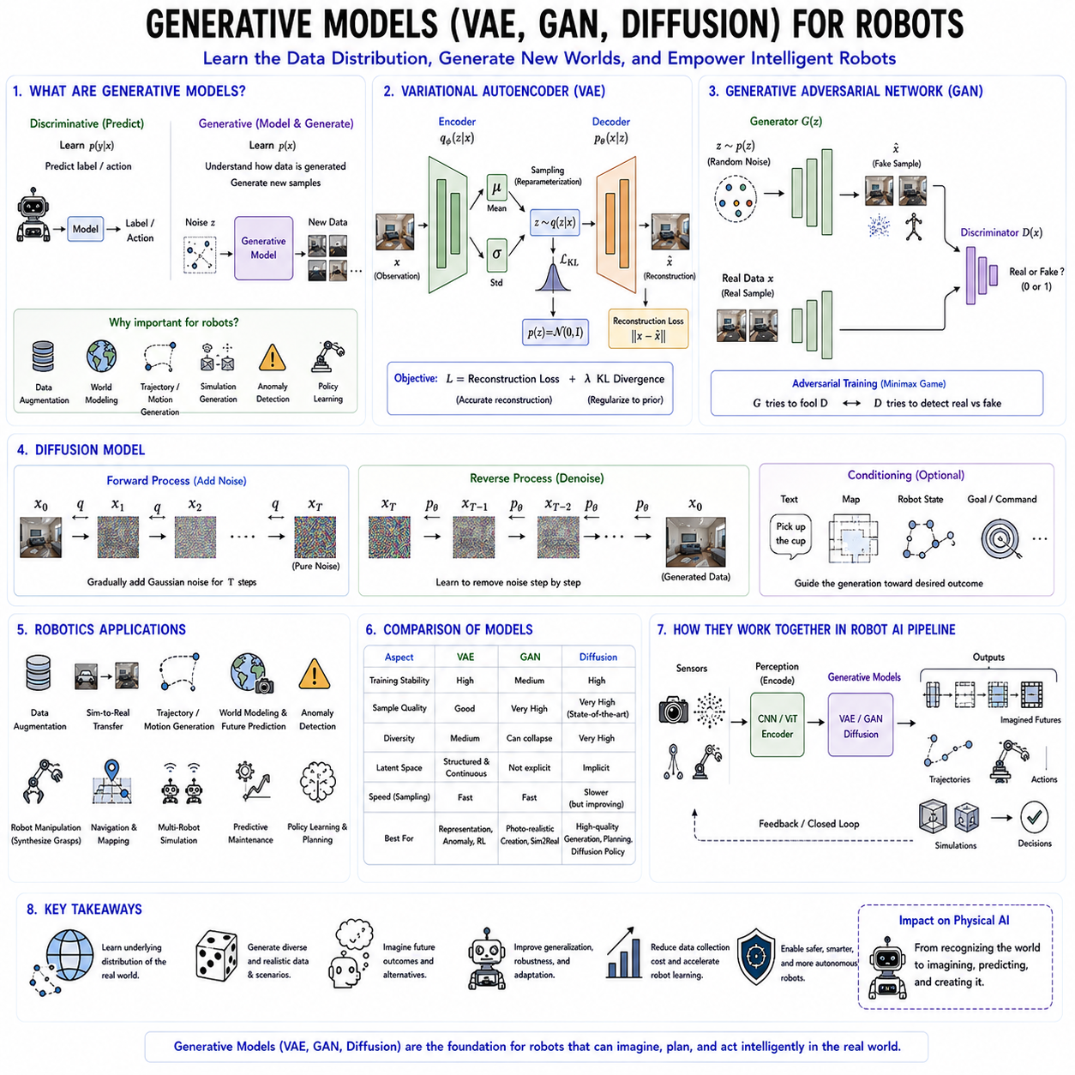
Generative models represent one of the most transformative advances in modern artificial intelligence because they enable machines not only to recognize existing data but also to generate entirely new data that follows the statistical properties of the observed world. Traditional discriminative models focus on predicting labels, classifications, or control actions from input data, whereas generative models learn the underlying probability distribution of the data itself. Once this distribution has been learned, the model can synthesize realistic images, sensor measurements, trajectories, speech, robot motions, environmental maps, or even complete simulation environments. For robotics, generative models provide capabilities that extend far beyond content creation. They support data augmentation, world modeling, motion synthesis, simulation generation, uncertainty estimation, anomaly detection, trajectory prediction, policy learning, and autonomous planning. As Physical AI continues to evolve, generative learning is becoming a core technology that enables robots to imagine possible future states, generate alternative action sequences, and continuously adapt to previously unseen environments.
The central objective of generative learning is to approximate the probability distribution of real-world observations. Rather than simply identifying whether an object belongs to a certain class, the model attempts to understand how the data itself is generated. Once the underlying distribution is captured, new samples can be produced by drawing from the learned latent space. This capability is fundamentally different from conventional supervised learning because the model acquires an internal representation of the world's structure instead of memorizing input-output relationships. Such representations are especially valuable for robotics, where robots frequently encounter situations that differ from their training datasets and must reason beyond previously observed examples.
One of the earliest successful deep generative models is the Variational Autoencoder (VAE). VAEs extend classical autoencoders by introducing probabilistic latent variables that represent compressed distributions rather than deterministic feature vectors. A conventional autoencoder consists of an encoder that compresses high-dimensional observations into compact latent representations and a decoder that reconstructs the original input from these compressed features. Although useful for dimensionality reduction and feature learning, traditional autoencoders do not naturally generate new samples because their latent space lacks probabilistic structure.
The Variational Autoencoder addresses this limitation by learning a continuous probability distribution within the latent space. Instead of producing a single latent vector, the encoder estimates the mean and variance of a probability distribution describing each input observation. During training, latent variables are sampled from these distributions through the reparameterization trick, enabling gradient-based optimization while maintaining stochastic latent representations. The decoder subsequently reconstructs observations from sampled latent vectors. As a result, nearby points within latent space correspond to semantically similar observations, allowing smooth interpolation and realistic sample generation.
The VAE objective combines two complementary optimization terms. The reconstruction loss encourages accurate recovery of input observations, ensuring that the decoder faithfully reconstructs the original data. Simultaneously, the Kullback-Leibler divergence regularizes latent distributions toward a predefined prior, typically a standard Gaussian distribution. This regularization produces organized latent spaces where new samples may be generated by randomly sampling latent variables and decoding them into realistic outputs. The resulting latent manifold provides valuable semantic representations for robotics applications.
Latent spaces learned by VAEs often exhibit remarkable continuity and interpretability. Similar robot poses, object shapes, environmental layouts, or manipulation trajectories occupy neighboring regions within latent space, enabling interpolation between known examples. Robots can therefore generate intermediate motions, synthesize unseen object configurations, predict future states, or explore alternative action strategies simply by traversing latent representations. Such continuous world representations prove highly valuable for planning, simulation, and model-based control.
VAEs have found numerous applications throughout robotics. Autonomous systems employ VAEs for anomaly detection by identifying observations poorly reconstructed by learned generative models. Robot navigation systems compress high-dimensional sensor data into compact latent representations supporting efficient localization and planning. Manipulation systems generate feasible grasp configurations through latent interpolation, while simulation environments synthesize diverse training scenarios improving policy generalization. Furthermore, latent representations learned by VAEs frequently serve as compact state representations for reinforcement learning.
Generative Adversarial Networks introduced an entirely different approach toward generative modeling by framing learning as an adversarial game between two competing neural networks. Rather than explicitly modeling probability distributions, GANs consist of a generator attempting to synthesize realistic samples and a discriminator attempting to distinguish generated samples from genuine observations. Through continuous competition, both networks improve simultaneously until generated outputs become nearly indistinguishable from real data.
The generator receives random latent vectors sampled from simple probability distributions and transforms them into synthetic observations such as images, point clouds, trajectories, or robot motions. Initially, generated outputs appear unrealistic because the generator possesses little knowledge regarding the underlying data distribution. The discriminator subsequently evaluates both genuine and generated samples, producing probabilities indicating whether each observation originated from the real dataset or the generator. Feedback from the discriminator guides generator optimization toward increasingly realistic outputs.
Adversarial training creates a minimax optimization process. The discriminator seeks to maximize classification accuracy by correctly separating authentic and synthetic samples, while the generator minimizes this accuracy by producing increasingly convincing observations capable of deceiving the discriminator. Equilibrium occurs when generated samples become statistically indistinguishable from real data, causing discriminator predictions to approach random guessing. This adversarial learning mechanism enables GANs to generate remarkably realistic images despite lacking explicit probabilistic likelihood functions.
GAN architectures have evolved substantially beyond the original formulation. Deep Convolutional GANs introduced convolutional architectures specifically optimized for image generation. Conditional GANs incorporate auxiliary information such as class labels, semantic maps, robot states, or language instructions, enabling controlled generation according to specified conditions. CycleGAN performs unpaired image-to-image translation without requiring aligned training examples, making it particularly valuable for robotic domain adaptation. StyleGAN introduced unprecedented image quality through disentangled latent representations and adaptive style modulation, demonstrating extraordinary realism across numerous visual domains.
Robotics applications of GANs extend well beyond image synthesis. Autonomous vehicles employ GANs for domain adaptation, translating simulated images into realistic sensor observations while preserving semantic consistency. Industrial inspection systems synthesize defective components augmenting limited failure datasets. Mobile robots generate realistic environmental variations supporting robust navigation policies, while service robots augment manipulation datasets through synthetic object appearances. Medical robotics similarly benefits from synthetic medical image generation addressing limited annotated datasets.
Simulation-to-real transfer represents one of the most important robotics applications of GANs. Training robotic policies exclusively within simulation often suffers from substantial appearance differences between simulated and real environments. GAN-based image translation reduces this reality gap by transforming simulated observations into photorealistic images closely matching real sensor data. Consequently, policies trained within simulation generalize more effectively toward physical robotic platforms without requiring extensive real-world data collection.
Despite their impressive capabilities, GANs present several optimization challenges. Adversarial training often becomes unstable because generator and discriminator objectives continuously compete rather than converge cooperatively. Mode collapse represents another common problem where generators produce only limited subsets of the data distribution, sacrificing diversity despite maintaining high visual quality. Numerous stabilization techniques including Wasserstein GANs, spectral normalization, gradient penalties, progressive growing, and improved optimization strategies have significantly mitigated these issues, although GAN training generally remains more delicate than alternative generative approaches.
Diffusion models have recently emerged as one of the most powerful and stable generative modeling paradigms. Rather than generating observations directly through adversarial competition, diffusion models learn to reverse a gradual stochastic corruption process. During training, noise is progressively added to real observations until all structure disappears. The neural network subsequently learns the reverse denoising process, predicting how to reconstruct clean observations from noisy intermediate states. Once trained, completely random noise gradually transforms into highly realistic generated samples through iterative denoising.
The diffusion process consists of two complementary stages. The forward process incrementally injects Gaussian noise into training observations according to a predefined schedule until only random noise remains. This corruption process is mathematically simple and requires no learning. The reverse process, however, requires learning because the model must estimate how to remove noise progressively while recovering realistic underlying structure. Denoising neural networks therefore approximate reverse diffusion dynamics across multiple intermediate noise levels.
Unlike GANs, diffusion models optimize straightforward reconstruction objectives rather than adversarial games, substantially improving training stability. Since every training sample contributes directly toward denoising optimization, mode collapse rarely occurs. Diffusion models consequently generate highly diverse samples faithfully representing the complete underlying data distribution. Although iterative sampling initially required relatively long inference times, recent acceleration techniques have dramatically improved generation efficiency while preserving sample quality.
Conditional diffusion models further extend generative flexibility by incorporating external guidance throughout the denoising process. Text prompts, semantic maps, robot states, object locations, trajectories, force measurements, or environmental observations guide sample generation toward desired outcomes. This conditioning capability has become fundamental for modern multimodal generative systems where robots generate actions according to natural language instructions, visual observations, or high-level task specifications.
Diffusion models have rapidly become influential within robotics because they naturally model complex multimodal probability distributions. Robot motion planning rarely possesses unique optimal solutions. Multiple feasible trajectories frequently satisfy identical task objectives while differing in timing, geometry, energy consumption, safety margins, or obstacle avoidance strategies. Diffusion policies therefore generate distributions over possible actions rather than deterministic control outputs, enabling robots to explore multiple feasible behaviors before selecting appropriate execution strategies.
Diffusion Policy represents one of the most significant recent developments in robot learning. Instead of directly predicting a single control command, diffusion policies iteratively denoise action trajectories conditioned upon sensory observations and task goals. This generative process captures multimodal manipulation strategies, smooth motion generation, contact-rich interactions, and long-horizon sequential planning more effectively than conventional deterministic policy networks. Numerous robotic manipulation benchmarks demonstrate state-of-the-art performance using diffusion-based action generation.
Trajectory generation constitutes another major robotics application. Rather than optimizing trajectories explicitly through classical optimization, diffusion models learn distributions over expert demonstrations and subsequently generate realistic, dynamically feasible trajectories satisfying environmental constraints. Autonomous vehicles, mobile robots, drone navigation, humanoid locomotion, and industrial manipulators increasingly exploit diffusion-based trajectory synthesis for robust planning under uncertainty.
World modeling similarly benefits from generative learning. Instead of merely predicting immediate sensor observations, robots construct internal generative models capable of simulating future environmental evolution under hypothetical action sequences. Such learned world models enable planning through imagination, where robots evaluate alternative futures before executing physical actions. VAEs provide compact latent representations, GANs synthesize realistic environmental variations, and diffusion models generate highly accurate future observations supporting predictive decision making.
Generative models also play a critical role in data augmentation. Robotics datasets remain expensive because collecting diverse sensor measurements, manipulation demonstrations, navigation trajectories, and annotated environments requires substantial human effort. Synthetic data generated through VAEs, GANs, and diffusion models dramatically expands available training datasets while improving robustness against rare events, lighting variations, weather changes, object diversity, and environmental complexity. Modern autonomous systems increasingly combine real and synthetic data throughout large-scale pretraining.
Foundation models further integrate generative architectures into multimodal robotics. Vision-language-action systems require generating future actions, predicting environmental evolution, imagining object interactions, synthesizing intermediate plans, and reasoning over hypothetical scenarios. Generative latent representations therefore complement perception modules by enabling predictive reasoning rather than reactive recognition alone. Such imagination capabilities increasingly distinguish Physical AI from conventional robotic control systems.
Selecting among VAEs, GANs, and diffusion models depends strongly upon application requirements. VAEs emphasize interpretable latent representations, efficient probabilistic encoding, and stable optimization, making them well suited for representation learning, anomaly detection, and latent world modeling. GANs prioritize photorealistic generation, domain adaptation, and simulation-to-real transfer, although they require careful adversarial optimization. Diffusion models currently provide the highest generation quality, excellent diversity, stable training, and remarkable flexibility for conditional generation, making them increasingly dominant across modern generative AI.
As Physical AI progresses toward increasingly autonomous embodied intelligence, generative models will become indispensable components of robotic cognition. Future robots must not only perceive the world but also imagine future outcomes, generate alternative strategies, synthesize missing information, anticipate uncertainty, create realistic simulations, and continuously adapt through self-generated experience. Variational Autoencoders, Generative Adversarial Networks, and Diffusion Models collectively establish the theoretical and practical foundations for this capability. Rather than merely recognizing the physical world, next-generation robots will increasingly learn to model, predict, simulate, and generate it, enabling far more adaptive, creative, and intelligent autonomous behavior across diverse real-world environments.

02.06 3D Deep Learning PointNet VoxNet for Robots [w/Code]
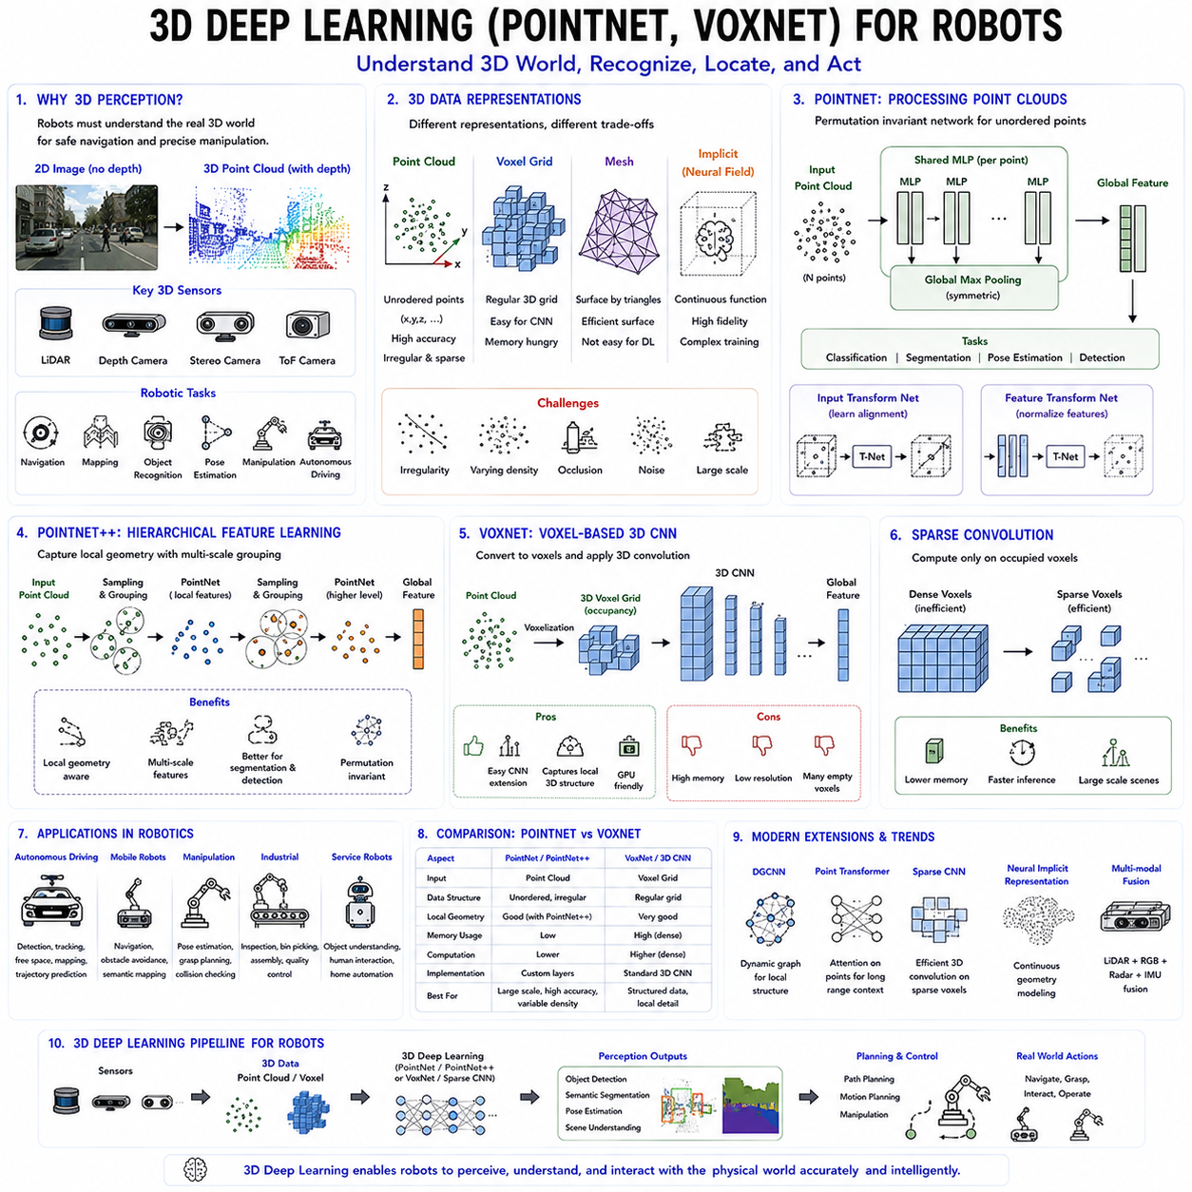
Three-dimensional deep learning has become one of the most important technologies in modern robotics because autonomous systems must perceive and understand the physical world in its true three-dimensional form rather than relying solely on two-dimensional images. Cameras provide rich color and texture information, but they inherently lose depth information due to perspective projection. In contrast, sensors such as LiDAR, depth cameras, stereo vision systems, structured-light cameras, and Time-of-Flight sensors directly capture the three-dimensional geometry of the environment. These sensors generate point clouds, voxel grids, meshes, and other spatial representations that describe the real-world structure surrounding a robot. As Physical AI continues to evolve, three-dimensional deep learning enables robots to recognize objects, estimate poses, understand scenes, navigate safely, manipulate objects, and build semantic world models with significantly greater accuracy than conventional image-based perception.
Unlike two-dimensional images, three-dimensional data is fundamentally irregular. Images consist of regularly spaced pixels arranged on rectangular grids, allowing convolutional neural networks to apply fixed convolution kernels efficiently across every location. Point clouds, however, contain unordered collections of points with varying density, irregular sampling, missing regions, sensor noise, and nonuniform spatial distributions. Consequently, directly applying conventional convolution operations to point clouds is impossible because neighboring relationships differ for every point. Three-dimensional deep learning therefore required entirely new neural network architectures specifically designed for irregular geometric data.
Robotic perception relies heavily upon three-dimensional sensing because many autonomous tasks require accurate geometric reasoning. Mobile robots must detect obstacles, estimate traversable terrain, identify navigable free space, recognize dynamic objects, and maintain localization within complex environments. Industrial manipulators require precise object pose estimation, grasp planning, collision avoidance, and workspace understanding. Autonomous vehicles continuously interpret surrounding traffic participants using LiDAR point clouds. Service robots similarly depend upon three-dimensional scene understanding for household manipulation and human interaction. These diverse applications have driven rapid development of specialized three-dimensional learning architectures.
Several representations exist for three-dimensional data, each offering distinct advantages and limitations. Point clouds directly represent measured sensor observations as sets of three-dimensional coordinates, optionally accompanied by color, intensity, normal vectors, or semantic labels. Voxel grids discretize continuous space into volumetric cells analogous to three-dimensional pixels. Polygon meshes describe surfaces using connected vertices and triangles, while implicit neural representations encode continuous geometry through learned functions. Choosing an appropriate representation significantly influences computational efficiency, memory consumption, geometric fidelity, and learning performance.
Point clouds represent perhaps the most natural output of modern robotic sensors because LiDAR and depth cameras directly measure discrete three-dimensional points. Unlike voxel grids, point clouds preserve geometric precision without introducing discretization artifacts. However, point clouds lack explicit ordering, exhibit varying density depending upon sensor distance, and frequently contain missing observations caused by occlusions. Designing neural networks capable of processing unordered point sets therefore became one of the earliest challenges in three-dimensional deep learning.
PointNet introduced a revolutionary solution by demonstrating that neural networks could process unordered point sets directly without requiring voxelization or mesh construction. Instead of converting point clouds into regular grids, PointNet treats every point independently during initial feature extraction while employing symmetric aggregation functions that remain invariant to point ordering. This elegant architecture established the foundation of modern point-based deep learning and significantly influenced subsequent three-dimensional perception research.
The central insight behind PointNet is permutation invariance. Since point clouds represent unordered sets rather than sequences, rearranging point order should never alter network predictions. Conventional neural networks generally assume fixed input ordering, making them unsuitable for point clouds. PointNet overcomes this limitation by applying identical multilayer perceptrons independently to every point before aggregating features using a symmetric pooling operation such as maximum pooling. Because maximum operations remain independent of input order, the resulting global representation becomes invariant to point permutations.
Each point initially passes through a shared multilayer perceptron that transforms raw coordinates into increasingly expressive local feature representations. Parameter sharing ensures identical feature extraction regardless of point position within the input set while substantially reducing model complexity. After independent processing, global max pooling aggregates the strongest activation across every feature dimension, producing a compact global descriptor representing the complete object or scene. This descriptor subsequently supports classification, segmentation, pose estimation, or downstream robotic perception tasks.
PointNet also incorporates transformation networks that improve robustness against geometric variations. Input transformation networks learn affine alignment matrices normalizing point cloud orientation before feature extraction. Feature transformation networks similarly align intermediate representations, improving invariance toward rotations, translations, and other geometric transformations. These learned alignment mechanisms significantly improve generalization across diverse object poses frequently encountered during robotic operation.
Although PointNet demonstrated remarkable conceptual simplicity, processing every point independently limits its ability to capture local geometric structure. Neighboring points forming surfaces, edges, corners, or object boundaries often contain highly informative relational information unavailable through independent processing. PointNet therefore performs exceptionally well for global object recognition but exhibits comparatively weaker performance on tasks requiring detailed local geometry understanding.
PointNet++ addressed this limitation by introducing hierarchical feature learning analogous to convolutional neural networks. Rather than processing entire point clouds simultaneously, PointNet++ recursively partitions point sets into local neighborhoods using spatial sampling and grouping operations. Independent PointNet modules subsequently learn increasingly complex local geometric features before progressively integrating them into higher-level representations. This hierarchical architecture substantially improves segmentation, object detection, and scene understanding performance while preserving permutation invariance.
Hierarchical feature extraction enables PointNet++ to recognize fine-grained geometric structures including corners, surfaces, object parts, and local shape variations. Early layers capture simple geometric primitives, intermediate layers integrate neighboring structures into meaningful object components, while deeper layers construct semantic object representations spanning larger spatial regions. Such multiscale learning significantly enhances robotic manipulation, grasp planning, and environmental understanding where local geometry strongly influences task success.
Point cloud segmentation represents one of the most important applications of PointNet architectures. Semantic segmentation assigns category labels to every individual point, distinguishing floors, walls, furniture, vegetation, vehicles, pedestrians, or machinery. Instance segmentation further separates individual object instances belonging to identical semantic classes. Fine-grained segmentation enables robots to understand complex environments at object-level resolution, supporting navigation, manipulation, and semantic mapping simultaneously.
Object classification similarly benefits from point-based learning. Rather than recognizing objects solely from two-dimensional appearance, PointNet identifies objects according to three-dimensional geometric shape. Shape-based recognition often proves substantially more robust against lighting variation, texture changes, and viewpoint differences than image-based classification alone. Industrial robotics, warehouse automation, autonomous vehicles, and service robots therefore increasingly incorporate point-based recognition alongside conventional visual perception.
Pose estimation constitutes another major robotics application. Accurate manipulation requires estimating six-degree-of-freedom object pose describing three-dimensional position and orientation. PointNet-derived architectures extract robust geometric features supporting pose estimation despite partial occlusions, clutter, and incomplete observations. Reliable pose estimation subsequently enables grasp planning, assembly, visual servoing, and precision manipulation within industrial automation.
While PointNet processes point clouds directly, another influential family of architectures represents three-dimensional environments using voxel grids. Voxels extend image pixels into volumetric space by discretizing continuous geometry into regularly spaced cubic cells. Voxelization transforms irregular point clouds into structured tensors compatible with conventional three-dimensional convolutional neural networks. This regular representation enables straightforward extension of mature convolutional architectures toward volumetric perception.
VoxNet pioneered voxel-based deep learning for object recognition by combining voxelized point clouds with three-dimensional convolutional neural networks. Instead of processing unordered points directly, VoxNet converts sparse point clouds into occupancy grids indicating whether each voxel contains observed geometry. Three-dimensional convolutions subsequently extract volumetric features describing object shape throughout the voxelized representation. Despite its conceptual simplicity, VoxNet demonstrated highly competitive performance across numerous three-dimensional recognition benchmarks.
Three-dimensional convolution operates similarly to conventional image convolution except that kernels slide across volumetric space rather than two-dimensional grids. Each convolution simultaneously aggregates neighboring information along width, height, and depth dimensions, enabling extraction of complex volumetric features. Stacking multiple convolutional layers gradually increases receptive field size while learning hierarchical geometric representations analogous to conventional computer vision architectures.
Voxel representations provide several practical advantages. Regular tensor structures facilitate efficient GPU acceleration using highly optimized convolution libraries. Spatial neighborhoods remain explicitly defined, simplifying geometric reasoning. Integration with existing convolutional architectures becomes straightforward, enabling transfer of numerous innovations originally developed for image recognition. Consequently, voxel-based networks became early standards for three-dimensional object recognition and semantic mapping.
However, voxelization introduces several important limitations. High-resolution voxel grids require enormous memory because computational complexity increases cubically with spatial resolution. Most real-world environments remain largely empty, causing sparse occupancy patterns where the overwhelming majority of voxels contain no information. Consequently, naive dense voxel representations waste substantial computational resources processing empty space rather than meaningful geometry.
Sparse convolutional neural networks address this limitation by performing convolution exclusively within occupied voxels. Rather than computing activations across complete volumetric grids, sparse convolutions dynamically track active spatial locations while ignoring empty regions. This optimization dramatically reduces memory consumption and computational cost, enabling practical processing of large-scale outdoor LiDAR scenes used in autonomous driving and mobile robotics.
Point-based and voxel-based architectures each offer complementary advantages. PointNet preserves exact geometric precision while avoiding voxelization artifacts and excessive memory consumption. VoxNet and related voxel architectures naturally capture local volumetric structure through convolution but sacrifice resolution due to discretization. Hybrid architectures increasingly combine both representations, exploiting precise point features together with efficient volumetric reasoning according to application requirements.
Modern robotic perception frequently integrates three-dimensional deep learning with multimodal sensing. RGB cameras provide texture and color information, LiDAR captures accurate geometry, thermal cameras detect temperature distributions, radar senses long-range obstacles, and inertial sensors estimate robot motion. Multimodal fusion networks combine complementary sensor modalities, producing significantly more robust perception than any individual sensor alone. Point-based neural networks increasingly serve as geometric backbones within these integrated perception systems.
Autonomous vehicles represent one of the largest application domains for three-dimensional deep learning. LiDAR point clouds support object detection, lane understanding, free-space estimation, obstacle tracking, semantic mapping, and trajectory prediction. Modern autonomous driving systems frequently employ PointNet derivatives, voxel-based detectors, sparse convolutional networks, and transformer-based point cloud models simultaneously within comprehensive perception pipelines capable of understanding complex urban environments.
Indoor mobile robots similarly exploit three-dimensional learning for navigation and semantic mapping. Point cloud segmentation distinguishes traversable floors from obstacles, identifies furniture, recognizes rooms, and constructs semantic maps supporting long-term autonomous operation. Service robots additionally estimate object poses for household manipulation while continuously updating world models according to newly observed environmental changes.
Industrial robotics increasingly relies upon three-dimensional perception for automated inspection, precision assembly, bin picking, quality control, and dimensional measurement. Point-based networks accurately recognize randomly oriented objects within cluttered containers, estimate grasp poses, identify manufacturing defects, and reconstruct high-precision surface geometry. Such capabilities substantially improve automation flexibility compared with traditional rule-based vision systems.
Recent research extends PointNet and VoxNet concepts through increasingly sophisticated architectures including Dynamic Graph CNNs, Point Transformers, sparse attention mechanisms, neural implicit representations, and graph-based geometric reasoning. Transformer architectures now model long-range relationships among point features, while graph neural networks capture local geometric connectivity unavailable through independent point processing. These advances continue improving accuracy across large-scale scene understanding and robotic perception benchmarks.
Deployment optimization remains critically important because robotic platforms frequently operate under strict computational constraints. Point cloud compression, quantization, pruning, sparse computation, TensorRT optimization, and hardware acceleration enable real-time inference on embedded platforms including NVIDIA Jetson, edge GPUs, and specialized AI accelerators. Efficient implementation ensures three-dimensional perception remains compatible with autonomous navigation, manipulation, and inspection under practical real-world latency requirements.
As Physical AI evolves toward increasingly capable embodied intelligence, three-dimensional deep learning will remain a fundamental perception technology enabling robots to understand the geometry of the physical world. PointNet established the feasibility of directly learning from unordered point clouds, while VoxNet demonstrated the effectiveness of volumetric convolutional reasoning. Together with newer point transformers, sparse convolutional architectures, multimodal perception systems, and world models, these approaches enable robots to perceive, localize, manipulate, inspect, navigate, and interact with complex three-dimensional environments. Rather than simply recognizing images, future intelligent robots will build rich geometric and semantic representations of the physical world, providing the foundation for autonomous reasoning, planning, and action across increasingly diverse real-world applications.

02.07 Depth Estimation and Normal Prediction Networks [w/Code]
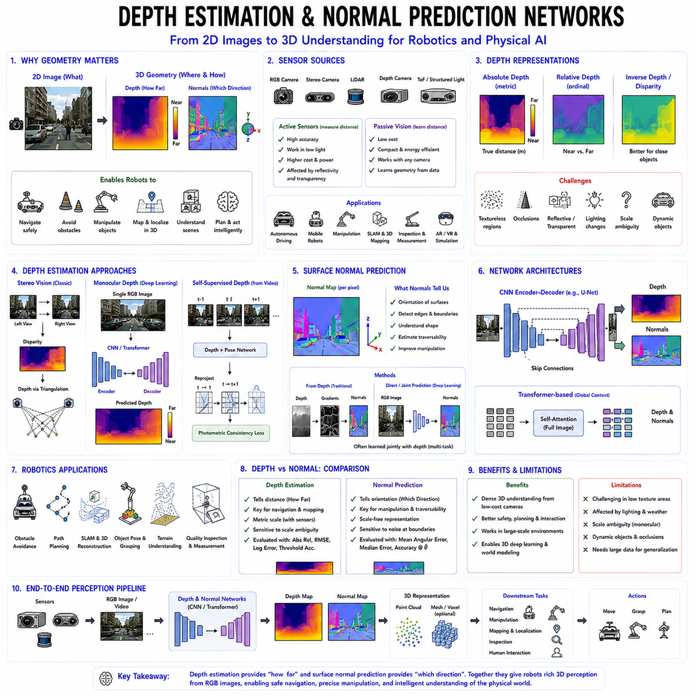
Depth estimation and normal prediction are two of the most fundamental perception tasks in modern computer vision and robotics because they enable intelligent systems to reconstruct the three-dimensional structure of the physical world from visual observations. While conventional image recognition identifies what objects are present within an image, depth estimation determines how far every visible point lies from the observing camera, and surface normal prediction estimates the orientation of every visible surface. Together, these two tasks transform two-dimensional images into rich geometric representations that support autonomous navigation, manipulation, obstacle avoidance, semantic mapping, scene reconstruction, and Physical AI. As robots increasingly operate in unstructured real-world environments, the ability to infer accurate geometric information directly from visual sensors has become an essential capability for autonomous decision making.
Human vision naturally combines binocular perception, motion, shading, texture, perspective, and prior experience to estimate three-dimensional scene geometry. Robots attempt to replicate this capability using cameras, depth sensors, LiDAR, stereo vision systems, structured-light sensors, and neural networks capable of learning geometric relationships from visual observations. Although active depth sensors directly measure distances, they increase system cost, power consumption, and hardware complexity. Furthermore, adverse lighting conditions, reflective materials, transparent surfaces, and long sensing distances often degrade sensor reliability. Consequently, learning-based depth estimation from ordinary RGB images has become an increasingly important research area because it allows robots to infer three-dimensional geometry using inexpensive passive cameras.
Depth estimation seeks to predict a dense depth value for every pixel within an image. The resulting depth map assigns each pixel a distance from the camera, effectively recovering scene geometry from visual appearance. Unlike sparse range measurements produced by some sensors, dense depth estimation provides continuous geometric information across the entire visible scene. Such dense representations enable robots to identify obstacles, estimate traversable terrain, understand object dimensions, calculate collision-free trajectories, and interact safely with surrounding environments.
Depth itself may be represented in several forms depending upon application requirements. Absolute depth describes the true physical distance between the camera and observed surfaces, typically measured in meters. Relative depth instead predicts ordinal relationships indicating which regions are nearer or farther without requiring exact metric scale. Inverse depth, often called disparity in stereo vision, provides numerically stable representations particularly useful for nearby objects because depth resolution naturally decreases with increasing distance. Choosing appropriate depth parameterization influences optimization stability and downstream robotic performance.
Stereo vision represents one of the earliest approaches toward depth estimation. Two horizontally separated cameras simultaneously observe identical scenes from slightly different viewpoints. Corresponding image features exhibit horizontal displacement known as disparity, whose magnitude depends directly upon object distance. Triangulation subsequently converts disparity into metric depth using known camera geometry. Stereo vision remains widely employed throughout robotics because it provides accurate metric depth without active illumination while maintaining compatibility with passive imaging systems.
Despite its effectiveness, stereo vision introduces several practical limitations. Reliable correspondence matching becomes difficult within textureless regions, repetitive patterns, reflective materials, transparent surfaces, motion blur, or changing illumination. Furthermore, stereo systems require careful camera calibration and synchronized image acquisition. Large camera baselines improve distant depth accuracy but increase correspondence difficulty for nearby objects. Small baselines simplify matching but reduce long-range precision. Learning-based depth estimation partially overcomes these limitations by incorporating semantic understanding together with geometric reasoning.
Monocular depth estimation presents an even more challenging problem because only a single image is available. From a purely geometric perspective, infinitely many three-dimensional scenes may produce identical two-dimensional projections. Nevertheless, deep neural networks successfully estimate depth by learning statistical relationships among perspective cues, object sizes, shading, occlusions, textures, atmospheric effects, semantic context, and prior knowledge accumulated from extensive training datasets. Rather than explicitly reconstructing geometry through triangulation, neural networks infer plausible depth according to learned visual experience.
Deep convolutional neural networks originally dominated monocular depth estimation research. Encoder-decoder architectures first compress input images into hierarchical semantic representations before progressively reconstructing high-resolution depth maps through learned upsampling operations. Skip connections preserve fine spatial details by directly transferring low-level image features from encoder layers toward corresponding decoder stages. Such architectures effectively combine global semantic understanding with precise local boundary preservation.
Residual networks significantly improved monocular depth estimation by enabling substantially deeper feature extraction without optimization difficulties. Deep residual encoders capture increasingly abstract scene semantics including object categories, structural layout, environmental context, and perspective relationships. Decoder networks subsequently integrate these semantic features into accurate dense depth predictions preserving both global scene consistency and local geometric precision.
U-Net architectures have become particularly influential for dense geometric prediction tasks. Originally developed for biomedical image segmentation, U-Net employs symmetric encoder-decoder structures connected through skip pathways preserving fine image details. Skip connections prove especially valuable for depth estimation because accurate geometric boundaries frequently coincide with visual edges. Consequently, U-Net architectures generate detailed depth maps exhibiting sharp object boundaries while maintaining globally coherent scene geometry.
Recent Transformer architectures further advance depth estimation by capturing long-range spatial dependencies unavailable to purely convolutional models. Self-attention mechanisms allow every image region to interact directly with every other region regardless of spatial separation. Global contextual reasoning improves depth consistency across large surfaces, repetitive structures, complex indoor environments, and outdoor scenes containing distant objects. Vision Transformers therefore increasingly complement convolutional feature extraction within state-of-the-art monocular depth estimation systems.
Self-supervised learning has dramatically expanded monocular depth estimation by eliminating dependence upon expensive ground-truth depth annotations. Rather than directly supervising depth values, self-supervised methods jointly learn depth and camera motion from consecutive video frames. Predicted depth maps together with estimated camera poses reconstruct neighboring images through differentiable view synthesis. Reconstruction errors subsequently supervise network optimization. Such approaches enable robots to continuously improve geometric understanding simply by observing their own visual experience during exploration.
Multi-view geometry remains central to self-supervised depth learning. Consecutive video frames naturally observe identical scenes from different viewpoints as robots move through environments. Neural networks exploit photometric consistency across these viewpoints to infer depth while simultaneously estimating ego-motion. Dynamic object handling, occlusion reasoning, illumination variation, and geometric consistency losses further improve prediction quality. Continuous online adaptation therefore becomes feasible throughout long-term robotic operation.
Scale ambiguity represents one of the principal challenges in monocular depth estimation. Since single images lack explicit metric information, predicted depth often remains accurate only up to unknown scaling factors. Additional information including inertial measurements, wheel odometry, stereo supervision, known object dimensions, camera height, or probabilistic sensor fusion frequently resolves absolute scale during robotic deployment. Integrating multiple sensing modalities therefore substantially improves practical navigation performance.
Depth prediction serves numerous robotic applications. Autonomous navigation requires accurate obstacle distances supporting collision avoidance and safe trajectory planning. Simultaneous Localization and Mapping systems utilize dense depth for three-dimensional reconstruction and semantic mapping. Robotic manipulation estimates object positions and workspace geometry before grasp planning. Autonomous vehicles continuously monitor surrounding traffic geometry using monocular, stereo, and LiDAR-assisted depth estimation. Service robots similarly exploit dense depth for household interaction, object retrieval, and human-aware navigation.
Surface normal prediction complements depth estimation by estimating the orientation of every visible surface rather than merely its distance. A surface normal is a three-dimensional unit vector perpendicular to a local surface. Whereas depth describes where surfaces exist, normals describe how surfaces are oriented within three-dimensional space. Together, these complementary geometric representations enable detailed understanding of object shape, environmental structure, and physical interaction possibilities.
Surface normals encode valuable geometric information unavailable through depth alone. Flat floors exhibit upward-facing normals, walls possess horizontal normals, tabletops maintain nearly constant orientations, while curved objects demonstrate continuously varying normal directions. Robots therefore exploit normal maps to identify traversable surfaces, estimate object geometry, detect structural boundaries, and infer manipulation affordances directly from visual observations.
Traditional computer vision estimated surface normals by differentiating depth maps or fitting local geometric planes. However, noisy depth measurements frequently produced unstable normal estimates, particularly near object boundaries or missing observations. Modern neural networks instead predict surface normals directly from RGB images or jointly estimate depth and normals through multi-task learning. Joint optimization improves geometric consistency because depth and normals obey strong physical relationships describing identical underlying surfaces.
Multi-task learning has become increasingly important for geometric perception. Shared encoder networks simultaneously support depth estimation, normal prediction, semantic segmentation, edge detection, optical flow estimation, and camera pose prediction. Because these tasks share common geometric structure, joint learning improves generalization while reducing computational redundancy. Robots therefore increasingly employ unified perception networks producing multiple complementary geometric representations from identical sensory observations.
Geometric consistency constraints further improve learning quality. Predicted surface normals should remain compatible with estimated depth gradients according to differential geometry. Likewise, neighboring pixels belonging to smooth surfaces should exhibit similar normal directions while preserving discontinuities across object boundaries. Such physically motivated regularization encourages coherent geometric predictions beyond purely data-driven supervision.
Surface normal prediction plays a particularly important role in robotic manipulation. Successful grasp planning depends not only upon object position but also upon local surface orientation. Parallel grippers require approximately opposing surface normals for stable grasping, suction grippers seek nearly planar surfaces oriented appropriately relative to approach direction, and dexterous robotic hands exploit detailed surface geometry during contact planning. Accurate normal estimation therefore directly improves manipulation reliability.
Navigation systems similarly benefit from normal prediction. Traversable terrain generally exhibits upward-facing normals within acceptable slope limits, whereas steep walls, obstacles, staircases, or hazardous terrain produce significantly different orientations. Combining depth and normal information enables more reliable terrain classification than either representation independently. Legged robots, planetary rovers, agricultural machines, and autonomous construction equipment particularly exploit normal estimation when traversing uneven environments.
Industrial robotics frequently applies surface normals to quality inspection and dimensional measurement. Manufacturing defects often produce subtle local orientation changes invisible through conventional intensity images alone. Normal estimation therefore improves surface defect detection, weld inspection, precision machining verification, and reverse engineering applications requiring accurate geometric reconstruction.
Recent research increasingly integrates depth estimation with three-dimensional deep learning. Predicted depth maps convert naturally into point clouds supporting PointNet, sparse convolutional networks, graph neural networks, and transformer-based geometric reasoning. Dense geometric predictions therefore provide foundational representations connecting conventional image processing with modern three-dimensional perception systems. Vision-language-action models similarly incorporate learned depth representations supporting embodied reasoning about physical environments.
Foundation models increasingly extend geometric perception beyond individual tasks toward unified spatial understanding. Large multimodal models jointly reason about images, language, geometry, semantics, and robot actions while internally constructing structured world representations. Depth estimation and normal prediction become intermediate geometric reasoning components supporting navigation, manipulation, instruction following, scene understanding, and predictive world modeling rather than isolated perception objectives.
Deployment on embedded robotic platforms introduces additional computational constraints. Real-time perception requires efficient encoder architectures, lightweight decoders, model quantization, TensorRT optimization, mixed-precision inference, and hardware acceleration on platforms such as NVIDIA Jetson, edge GPUs, and dedicated neural processing units. Balancing geometric accuracy against computational efficiency remains essential for practical autonomous operation.
Evaluation metrics for depth estimation include absolute relative error, root mean squared error, logarithmic error, scale-invariant metrics, and threshold accuracy measuring prediction quality across different distance ranges. Surface normal prediction commonly evaluates angular deviation between predicted and ground-truth normals, mean angular error, median error, and percentages of predictions lying within specified angular thresholds. Comprehensive evaluation across indoor, outdoor, synthetic, and real-world datasets ensures robust generalization under diverse robotic operating conditions.
As Physical AI advances toward increasingly intelligent embodied systems, geometric perception will remain one of the foundational capabilities supporting autonomous interaction with the physical world. Depth estimation provides metric understanding of spatial structure, while surface normal prediction reveals local geometric orientation essential for manipulation and terrain reasoning. Together with three-dimensional deep learning, multimodal sensor fusion, probabilistic world modeling, and foundation-scale perception architectures, these technologies enable robots to transform ordinary visual observations into rich geometric knowledge supporting safe navigation, intelligent planning, dexterous manipulation, and adaptive interaction within complex real-world environments. Rather than merely interpreting images, future robotic perception systems will continuously reconstruct, understand, and reason about the complete three-dimensional geometry of the surrounding physical world.

02.08 Temporal Fusion Sequence Models for Robot Tasks [w/Code]
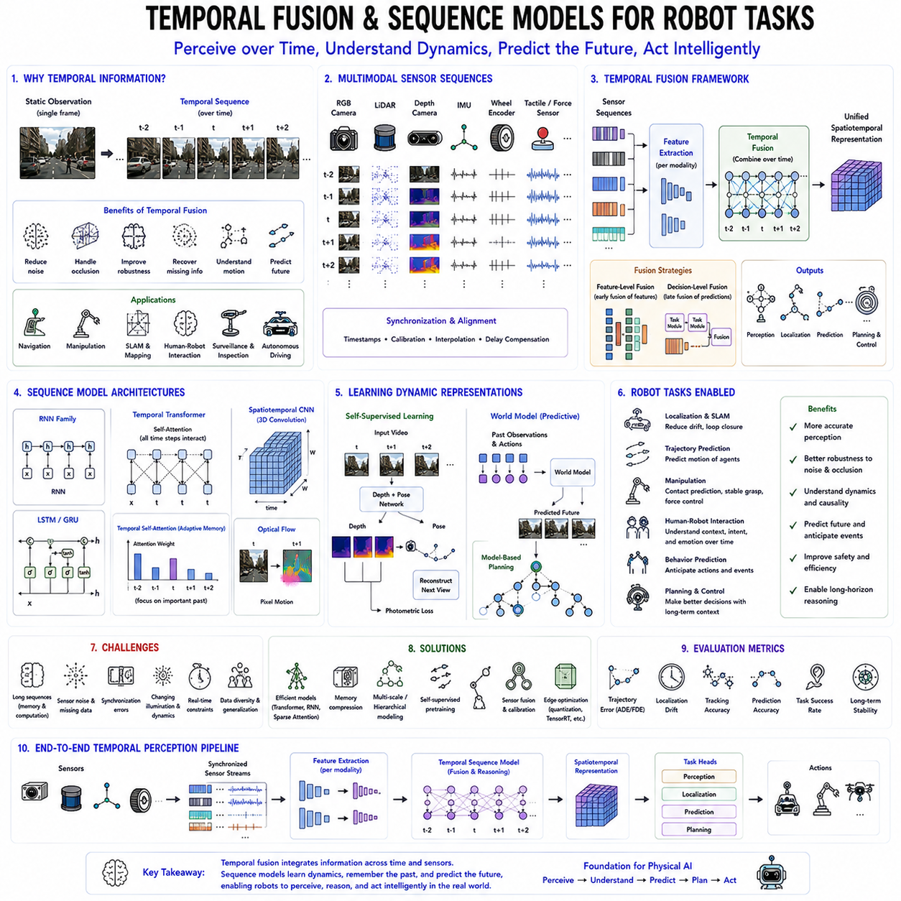
Temporal fusion and sequence modeling represent essential capabilities for intelligent robotic systems because real-world environments evolve continuously over time rather than existing as isolated static observations. A single camera frame or one LiDAR scan provides only an instantaneous snapshot of the environment, but autonomous robots must understand motion, continuity, causality, and long-term behavioral patterns across sequences of observations. Humans naturally integrate visual information over time, remembering previous events while anticipating future outcomes. Similarly, robots require temporal reasoning to perform reliable navigation, manipulation, human interaction, surveillance, industrial inspection, and autonomous decision making. Temporal fusion enables multiple observations collected at different time steps to be integrated into coherent internal representations, while sequence models learn dynamic relationships governing how the environment changes over time. Together, these technologies form the foundation of modern robot intelligence and Physical AI, enabling machines to perceive not only what currently exists but also how the world is changing and what is likely to happen next.
Unlike static image recognition, robotics almost always involves sequential sensor streams. Mobile robots continuously receive RGB images, depth maps, LiDAR scans, IMU measurements, wheel encoder data, GPS signals, force measurements, tactile feedback, and actuator states. Every observation is influenced by previous robot motion, environmental dynamics, and historical interactions. Consequently, treating each observation independently often results in inconsistent perception, unstable localization, and unreliable decision making. Temporal fusion addresses this limitation by combining information collected across multiple time steps into a unified representation that is significantly more robust than any individual observation.
Temporal information is particularly valuable because individual sensor measurements frequently contain uncertainty. Camera images may suffer from motion blur, lighting variation, temporary occlusions, or adverse weather conditions. LiDAR measurements may contain sparse observations or missing regions due to reflective or transparent surfaces. IMU sensors accumulate drift over long durations, while GPS signals become unreliable in urban canyons or indoor environments. Integrating observations over time allows robots to compensate for temporary sensor degradation, reduce noise, and recover missing information through temporal consistency.
Temporal fusion can be viewed as the process of accumulating evidence across time. Rather than immediately making decisions from single observations, the robot continuously updates an internal representation using both newly acquired sensor measurements and previously accumulated knowledge. This incremental integration resembles Bayesian filtering, where every new observation refines existing beliefs about the environment. Deep learning extends this concept by learning complex nonlinear temporal relationships directly from data instead of relying solely on handcrafted probabilistic models.
One of the earliest temporal fusion techniques in robotics involves recursive state estimation. Classical algorithms such as the Kalman Filter and Extended Kalman Filter combine previous state estimates with current sensor measurements to produce improved estimates while accounting for uncertainty. Particle Filters extend these methods to nonlinear, multimodal probability distributions. Although these algorithms remain highly successful, modern deep learning increasingly complements or replaces handcrafted filtering through learned temporal representations capable of modeling significantly more complex dynamics.
Sequence models provide the neural network architectures responsible for learning temporal dependencies. Rather than processing observations independently, sequence models explicitly maintain information across time using internal memory or attention mechanisms. Their objective is not merely to classify individual frames but to understand the evolution of observations, identify temporal patterns, predict future events, and support long-term decision making. Such capabilities are essential for autonomous robots operating within dynamic environments where future actions depend heavily upon past experience.
Recurrent Neural Networks originally provided the first neural architecture specifically designed for sequence modeling. Hidden states propagated through time served as internal memory summarizing previous observations. However, standard recurrent networks struggled to preserve information across long sequences due to vanishing gradients. Long Short-Term Memory networks and Gated Recurrent Units subsequently introduced gated memory mechanisms capable of maintaining relevant information throughout extended temporal intervals, significantly improving robotic sequence learning.
While recurrent architectures remain valuable, Transformer-based sequence models have increasingly become the dominant approach for temporal learning. Instead of compressing all historical information into fixed-size hidden states, temporal Transformers employ self-attention mechanisms allowing every observation to interact directly with every other observation regardless of temporal distance. Long-range temporal dependencies therefore become significantly easier to model. Robots can simultaneously reason about recent sensor measurements, historical observations collected minutes earlier, and future planning objectives within unified attention-based representations.
Temporal self-attention enables adaptive selection of relevant historical information. Rather than treating all previous observations equally, attention weights identify which time steps contribute most significantly toward current decision making. For example, during autonomous navigation, observations immediately preceding temporary occlusions may receive high attention because they contain critical localization information. Similarly, manipulation tasks may emphasize observations immediately before object contact while reducing attention toward unrelated earlier events. Such adaptive memory improves both prediction accuracy and interpretability.
Temporal fusion extends beyond single sensor modalities toward multimodal sequence integration. Autonomous robots typically receive synchronized information from cameras, LiDAR, radar, inertial sensors, wheel encoders, microphones, tactile arrays, and proprioceptive measurements. Each modality captures complementary aspects of the environment. Visual sensors recognize semantic appearance, LiDAR provides precise geometry, IMUs estimate robot motion, and tactile sensors measure physical interaction. Temporal fusion combines these heterogeneous information streams into unified spatiotemporal representations supporting comprehensive environmental understanding.
Sensor synchronization plays a critical role in successful temporal fusion. Measurements originating from different sensors often arrive at different frequencies with varying communication delays and timestamp uncertainties. Accurate synchronization ensures corresponding observations represent identical physical events despite originating from heterogeneous sensing devices. Precision Time Protocol, hardware triggering, timestamp interpolation, and temporal calibration therefore remain fundamental infrastructure supporting deep sequence learning within robotics.
Feature-level temporal fusion represents one common integration strategy. Individual sensor streams first undergo independent feature extraction using specialized neural networks optimized for each sensing modality. Temporal sequence models subsequently integrate these extracted features across time, learning dynamic relationships among multiple sensor modalities simultaneously. This modular architecture simplifies system design while enabling efficient multimodal learning and scalable deployment across diverse robotic platforms.
Decision-level temporal fusion adopts a different strategy by allowing individual perception modules to generate intermediate predictions before combining their outputs over time. Object detectors, semantic segmentation networks, localization modules, and tracking algorithms each produce independent estimates subsequently fused using probabilistic or learned temporal reasoning. Decision-level fusion frequently improves robustness because failures within individual modules may be compensated through complementary information originating from other subsystems.
Spatiotemporal feature learning extends conventional visual perception by jointly modeling spatial structure and temporal evolution. Rather than processing every image independently, three-dimensional convolutional neural networks apply convolution across both spatial and temporal dimensions simultaneously. Such architectures directly capture object motion, dynamic interactions, human activities, and environmental evolution. Video understanding, gesture recognition, industrial inspection, and surveillance robotics frequently employ spatiotemporal convolution for efficient sequence processing.
Optical flow provides another important temporal representation describing apparent pixel motion between consecutive images. Optical flow estimation measures how visual features move across image sequences, revealing dynamic object motion, camera movement, and environmental changes. Robots exploit optical flow for visual odometry, obstacle avoidance, human activity recognition, drone stabilization, autonomous landing, and dynamic scene understanding. Deep optical flow networks significantly improve robustness under challenging visual conditions while enabling dense motion estimation.
Temporal fusion is equally important for simultaneous localization and mapping. Individual sensor observations often contain ambiguity due to repetitive environments, temporary occlusions, or sensor noise. Integrating observations across time enables robust map construction while maintaining globally consistent localization. Loop closure detection further exploits long-term temporal memory by recognizing previously visited locations despite substantial appearance changes occurring over extended time intervals.
Robot manipulation similarly depends heavily upon temporal reasoning. Grasp planning, contact detection, force regulation, and dexterous manipulation all involve continuously evolving interactions between robot and environment. Sequence models learn manipulation dynamics by observing complete demonstrations rather than isolated actions. Temporal context therefore enables prediction of contact events, object motion, grasp stability, and future manipulation outcomes with significantly greater reliability than frame-based approaches.
Human-robot interaction naturally requires sequence understanding because communication unfolds continuously through speech, gestures, facial expressions, gaze direction, and body movement. Individual observations rarely convey complete meaning. Sequence models integrate multimodal observations across time, recognizing conversational context, emotional progression, collaborative intent, and human behavioral patterns. Such temporal understanding enables more natural, responsive, and socially aware robotic interaction.
Behavior prediction represents another major application of temporal sequence learning. Autonomous vehicles anticipate pedestrian trajectories, warehouse robots predict worker motion, collaborative manipulators estimate human intentions, and service robots forecast user activities. Predictive models trained on sequential observations enable robots to anticipate future events rather than merely reacting to current situations. Anticipation substantially improves safety, efficiency, and collaborative performance within dynamic environments.
Trajectory prediction similarly benefits from temporal fusion. Instead of planning solely according to instantaneous observations, robots learn dynamic movement patterns describing vehicles, pedestrians, other robots, manipulated objects, and environmental agents. Sequence models generate probabilistic future trajectories supporting collision avoidance, cooperative navigation, autonomous driving, drone coordination, and crowd-aware path planning.
Temporal world models represent one of the most advanced developments in modern robot learning. Rather than simply memorizing previous observations, world models learn predictive representations describing environmental dynamics under hypothetical future actions. These learned models enable planning through imagination, allowing robots to simulate multiple possible futures internally before selecting appropriate actions. Temporal sequence learning therefore becomes the foundation of model-based reinforcement learning, predictive planning, and embodied intelligence.
Foundation models increasingly integrate temporal fusion into multimodal robot learning. Vision-language-action systems process sequences of images, language instructions, proprioceptive observations, and robot actions simultaneously. Rather than understanding isolated commands, these systems interpret complete task histories, environmental evolution, and behavioral context before generating coherent action sequences. Long temporal context significantly improves instruction following, manipulation planning, and autonomous task execution.
Large-scale robotic datasets further emphasize temporal learning. Modern datasets contain millions of sequential demonstrations collected across diverse robots performing manipulation, navigation, locomotion, and interaction tasks. Learning from complete trajectories rather than isolated images enables sequence models to discover long-term behavioral regularities transferable across tasks, robots, and environments. Such large-scale temporal pretraining increasingly supports general-purpose robotic foundation models.
Training temporal models introduces several optimization challenges. Long sequences require substantial GPU memory while increasing computational complexity. Gradient propagation across extended temporal horizons may remain difficult despite improved architectures. Sequence truncation, curriculum learning, hierarchical temporal modeling, memory compression, recurrent attention, and efficient transformer variants help address these challenges while preserving long-range temporal reasoning capability.
Deployment within embedded robotic systems imposes additional real-time constraints. Temporal fusion must process continuous sensor streams with minimal latency while operating under limited computational resources. Efficient memory management, sliding-window inference, streaming transformers, recurrent attention mechanisms, quantization, TensorRT optimization, and specialized hardware acceleration enable practical deployment on edge AI platforms including NVIDIA Jetson, embedded GPUs, and dedicated neural processing units.
Evaluation of temporal sequence models extends beyond conventional frame-level accuracy. Metrics frequently include trajectory prediction error, sequence consistency, long-term stability, temporal smoothness, tracking accuracy, localization drift, behavior prediction accuracy, planning success rate, manipulation completion rate, and cumulative task performance. Comprehensive evaluation across extended operational scenarios ensures robust generalization under realistic robotic conditions involving dynamic environments and prolonged autonomous operation.
As Physical AI progresses toward increasingly intelligent embodied systems, temporal fusion and sequence modeling will become indispensable components of robotic cognition. Future robots must continuously integrate multimodal sensory information, remember historical experience, predict future environmental evolution, anticipate human behavior, and generate temporally coherent action sequences. Temporal fusion transforms isolated observations into persistent world understanding, while sequence models provide the computational mechanisms necessary for learning dynamic relationships governing real-world interaction. Combined with multimodal perception, world models, probabilistic reasoning, reinforcement learning, and foundation-scale architectures, temporal sequence learning enables robots to perceive not only the current state of the world but also its continuous evolution through time. This capability forms one of the essential foundations of autonomous intelligence, allowing future robots to behave proactively, adaptively, and safely within the complex, continuously changing physical environments in which they operate.

02.09 Neural Architecture Search NAS for Edge Robots [w/Code]
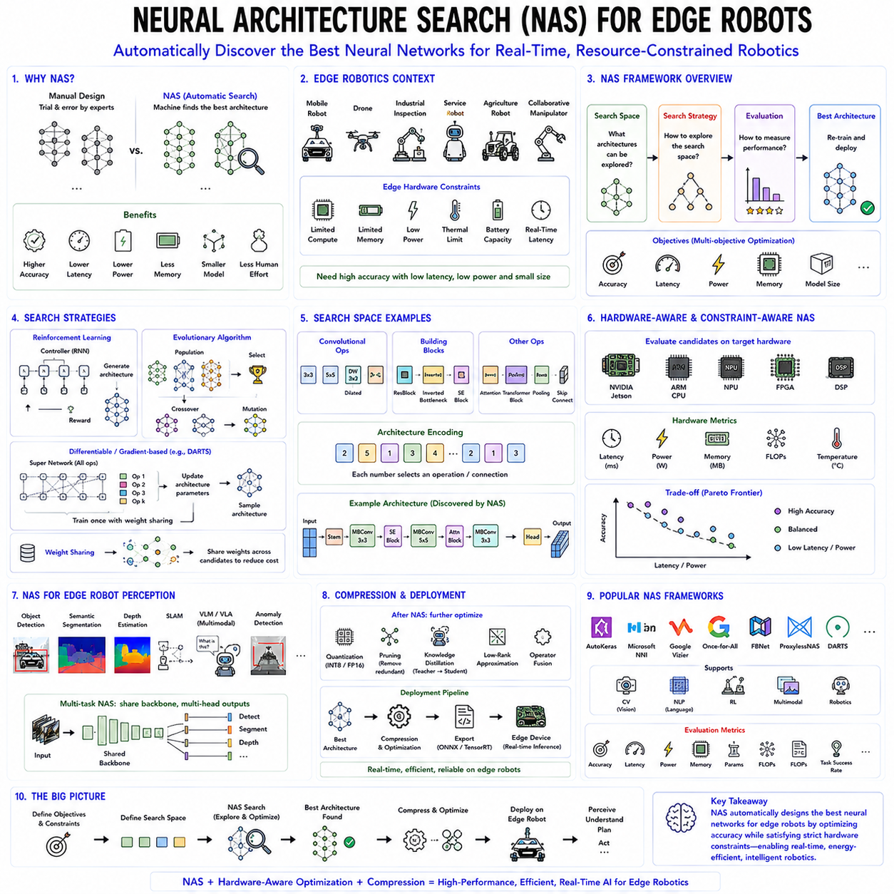
Neural Architecture Search (NAS) has emerged as one of the most influential technologies in modern artificial intelligence because it enables machines to automatically design high-performance neural network architectures rather than relying solely on human expertise. Traditionally, deep neural networks such as AlexNet, VGG, ResNet, MobileNet, EfficientNet, and Vision Transformers were manually designed by researchers through years of experimentation and intuition. Although these architectures achieved remarkable success, manual architecture design is time-consuming, computationally expensive, and often suboptimal for specific hardware platforms or robotic applications. Neural Architecture Search addresses this challenge by treating neural network design itself as an optimization problem, allowing automated algorithms to discover architectures that maximize predictive accuracy while satisfying constraints on computational cost, memory consumption, latency, power efficiency, and model size. For edge robotics, where computational resources are severely limited, NAS has become an essential technology for developing efficient AI models capable of real-time autonomous operation.
Edge robots differ fundamentally from cloud-based AI systems because they perform inference locally using embedded computing platforms rather than relying upon remote servers. Autonomous mobile robots, service robots, drones, industrial inspection systems, agricultural robots, collaborative manipulators, and wearable robotic devices frequently operate with strict limitations on processing power, battery capacity, thermal dissipation, and available memory. Unlike data center GPUs capable of executing extremely large neural networks, embedded processors such as NVIDIA Jetson, ARM CPUs, NPUs, FPGAs, and microcontrollers require compact architectures carefully optimized for computational efficiency. Consequently, maximizing accuracy alone is insufficient; practical robotic intelligence requires balanced optimization across multiple hardware constraints simultaneously.
Traditional neural network development typically follows a manual trial-and-error process. Engineers select backbone architectures, determine layer depths, choose convolutional kernel sizes, specify activation functions, define skip connections, adjust channel dimensions, and repeatedly evaluate different configurations through extensive experimentation. This iterative process becomes increasingly difficult as architecture complexity grows because the number of possible design combinations increases exponentially. Even experienced researchers cannot realistically explore the enormous architectural search space available within modern deep learning.
Neural Architecture Search automates this design process by defining architecture optimization as a search problem. Instead of manually constructing neural networks, NAS algorithms systematically explore large architecture spaces, evaluate candidate networks, compare their performance, and gradually identify increasingly effective designs. The resulting architectures frequently outperform manually engineered models while satisfying hardware-specific deployment requirements. This automated optimization has significantly accelerated neural network innovation across computer vision, natural language processing, robotics, and multimodal artificial intelligence.
A Neural Architecture Search system generally consists of three primary components: the search space, the search strategy, and the performance evaluation mechanism. The search space defines all candidate architectures that may be explored, including possible layer types, connectivity patterns, kernel sizes, channel widths, attention modules, activation functions, normalization layers, and network depths. The search strategy determines how candidate architectures are selected during optimization, while the evaluation mechanism estimates model quality according to predefined objectives including accuracy, latency, energy efficiency, or hardware utilization.
The search space fundamentally determines NAS flexibility. A restricted search space accelerates optimization but may exclude highly effective architectures, whereas extremely large search spaces provide greater flexibility while substantially increasing computational cost. Search spaces frequently include convolutional blocks, residual connections, inverted bottlenecks, squeeze-and-excitation modules, transformer blocks, graph neural network operators, recurrent layers, and multimodal fusion components. Modern NAS frameworks increasingly support heterogeneous search spaces combining multiple architectural paradigms simultaneously.
Search strategies have evolved considerably since the earliest NAS algorithms. Reinforcement learning originally dominated architecture search by treating neural network design as a sequential decision-making problem. A controller network generated candidate architectures, trained them, evaluated validation performance, and subsequently updated architecture generation policies according to observed rewards. Although reinforcement learning demonstrated impressive capability for automatic architecture discovery, early methods required enormous computational resources because thousands of candidate networks often required independent training.
Evolutionary algorithms represent another influential NAS approach inspired by biological evolution. Candidate architectures behave analogously to individuals within evolving populations. High-performing architectures survive and reproduce through mutation and crossover operations, while less effective architectures gradually disappear. Evolutionary NAS naturally explores diverse architecture designs while avoiding premature convergence toward suboptimal solutions. Furthermore, population-based optimization adapts well to multi-objective optimization balancing accuracy, latency, model size, and energy efficiency simultaneously.
Gradient-based Neural Architecture Search dramatically reduced computational cost by transforming discrete architecture selection into continuous optimization. Differentiable Architecture Search introduced learnable architecture parameters optimized jointly with network weights through conventional gradient descent. Instead of training thousands of independent networks separately, gradient-based methods optimize architecture distributions within a single overparameterized supernetwork. This continuous relaxation significantly accelerates architecture discovery while maintaining competitive search quality.
Differentiable search methods introduced the concept of supernetworks, where numerous candidate operations coexist simultaneously within shared computational graphs. Individual architecture choices correspond to different activation pathways through the supernetwork. Weight sharing allows candidate architectures to reuse common parameters, dramatically reducing training cost because individual architectures no longer require independent optimization from random initialization. Once search concludes, the highest-performing architecture is extracted and retrained independently for final deployment.
Weight-sharing NAS represents another major computational improvement. Instead of training every candidate architecture separately, multiple architectures share subsets of network parameters throughout optimization. Shared weights enable rapid architecture evaluation without complete retraining, reducing computational requirements by several orders of magnitude compared with early reinforcement learning approaches. Weight-sharing has become a standard component of modern NAS frameworks targeting practical engineering deployment.
Performance evaluation remains one of the most computationally demanding aspects of NAS because candidate architectures traditionally require extensive training before reliable comparison becomes possible. Various approximation techniques therefore accelerate evaluation by training candidate networks for fewer epochs, employing surrogate performance predictors, sharing learned weights, or estimating final accuracy through low-cost proxy metrics. Efficient evaluation enables practical architecture search even within moderate computational budgets suitable for industrial development.
Multi-objective optimization plays a particularly important role for edge robotics because practical deployment requires balancing numerous competing objectives simultaneously. Increasing network depth generally improves recognition accuracy but also increases inference latency, energy consumption, memory usage, and thermal output. NAS therefore optimizes Pareto frontiers representing architectures achieving optimal trade-offs among multiple conflicting objectives rather than maximizing a single performance metric.
Latency-aware NAS explicitly incorporates hardware execution time into optimization objectives. Candidate architectures are evaluated not only according to predictive accuracy but also according to inference latency measured on target deployment hardware. Architectures optimized for desktop GPUs frequently perform poorly on embedded processors due to different computational bottlenecks. Hardware-aware optimization therefore directly evaluates candidate networks on platforms including NVIDIA Jetson, ARM processors, mobile NPUs, DSP accelerators, or FPGA implementations to ensure practical deployment efficiency.
Energy-aware Neural Architecture Search extends optimization beyond computational speed toward battery consumption and thermal efficiency. Mobile robots often operate for many hours using limited battery capacity while maintaining strict thermal constraints within enclosed chassis. Efficient neural architectures therefore minimize power consumption while preserving acceptable predictive performance. Such optimization directly improves robot operational endurance, system reliability, and deployment feasibility within battery-powered autonomous platforms.
Memory-aware optimization similarly becomes essential for embedded robotics because edge devices frequently possess limited RAM and onboard storage. Large foundation models may exceed available memory despite providing excellent recognition performance. NAS therefore searches architectures satisfying strict memory budgets through optimized channel dimensions, parameter sharing, lightweight attention mechanisms, reduced activation storage, and compact feature representations. Efficient memory utilization enables sophisticated perception models to execute on resource-constrained robotic hardware.
Edge robotics particularly benefits from lightweight neural architectures discovered through NAS. MobileNet introduced depthwise separable convolutions significantly reducing computation compared with conventional convolutions. EfficientNet demonstrated compound scaling balancing network width, depth, and input resolution systematically. EfficientFormer, MobileViT, ShuffleNet, GhostNet, and TinyViT similarly emphasize efficient edge deployment. Many of these architectures incorporate NAS principles either directly through automated optimization or indirectly through architecture search methodologies guiding manual refinement.
Neural Architecture Search also increasingly optimizes transformer-based models. While Vision Transformers achieve remarkable predictive performance, their computational complexity often exceeds embedded hardware capabilities. NAS identifies lightweight transformer variants through optimized attention mechanisms, reduced token dimensions, sparse attention patterns, hierarchical representations, hybrid convolution-transformer blocks, and efficient feed-forward structures. Such optimization enables transformer deployment within practical robotic systems operating under real-time constraints.
Robotic perception frequently requires multiple neural networks executing simultaneously. Autonomous mobile robots commonly employ independent models for object detection, semantic segmentation, depth estimation, localization, navigation, visual-language understanding, anomaly detection, and human interaction. Running all models independently often exceeds available computational resources. Multi-task Neural Architecture Search therefore discovers shared backbone architectures supporting multiple perception tasks while minimizing redundant computation. Shared feature extraction significantly improves efficiency across complete robotic perception pipelines.
Hardware-software co-design has become another important NAS application. Rather than optimizing neural networks independently from hardware implementation, co-design simultaneously considers accelerator architecture, memory hierarchy, communication bandwidth, processing parallelism, and neural network topology. Joint optimization frequently produces significantly better performance than optimizing hardware and software separately. Future edge robots increasingly integrate custom AI accelerators specifically designed around NAS-discovered neural architectures.
Once optimal architectures have been identified, additional model compression techniques further improve deployment efficiency. Quantization reduces numerical precision while preserving predictive accuracy. Pruning removes redundant network connections. Knowledge distillation transfers knowledge from large teacher models toward compact student architectures. Low-rank approximation compresses parameter matrices, while operator fusion reduces computational overhead during inference. NAS frequently integrates these optimization techniques directly into architecture search objectives, producing deployment-ready networks without requiring extensive manual optimization afterward.
Neural Architecture Search also supports continual adaptation throughout robotic system evolution. Environmental conditions, sensing modalities, computational hardware, and operational requirements frequently change during product lifecycles. Rather than redesigning neural networks manually for every new platform, NAS automatically generates optimized architectures according to updated constraints. Such adaptability substantially reduces engineering effort while accelerating deployment across diverse robotic platforms.
Foundation models and Physical AI increasingly incorporate NAS principles for efficient deployment. Large multimodal models often require billions of parameters during pretraining, yet practical robotic deployment demands substantially smaller inference networks. NAS automatically discovers compact backbone architectures supporting vision-language-action reasoning while satisfying edge deployment requirements. Hybrid architectures combining convolution, attention, graph reasoning, temporal modeling, and multimodal fusion can similarly be optimized automatically according to robotic application requirements.
Evaluation of NAS extends beyond conventional recognition accuracy. Practical robotic assessment includes inference latency, energy consumption, thermal stability, peak memory usage, parameter count, floating-point operations, battery endurance, hardware utilization, robustness under varying environmental conditions, and overall mission performance. Comprehensive evaluation ensures discovered architectures satisfy both algorithmic excellence and practical deployment constraints encountered during long-term autonomous operation.
Several mature NAS frameworks now support industrial development, including AutoKeras, Microsoft NNI, Google Vizier, Once-for-All, FBNet, ProxylessNAS, DARTS, and numerous hardware-aware optimization toolchains integrated with PyTorch and TensorFlow ecosystems. These frameworks provide scalable architecture optimization supporting vision, language, multimodal learning, reinforcement learning, and robotic perception while significantly reducing manual engineering effort.
As Physical AI continues advancing toward increasingly autonomous embodied intelligence, Neural Architecture Search will become an indispensable component of robotic AI development. Future robots must execute increasingly sophisticated perception, reasoning, planning, and control algorithms within compact embedded computing platforms operating under strict power, thermal, and latency constraints. NAS transforms neural network design from an expert-driven manual process into an automated optimization framework capable of simultaneously maximizing intelligence and deployment efficiency. Combined with hardware-aware optimization, model compression, multimodal foundation models, and edge AI acceleration, Neural Architecture Search enables future robots to achieve cloud-level intelligence while operating entirely on resource-constrained onboard computing systems. This capability represents one of the critical technologies supporting the next generation of intelligent autonomous robots and scalable Physical AI deployment.

02.10 Deep Learning Debugging and Failure Analysis
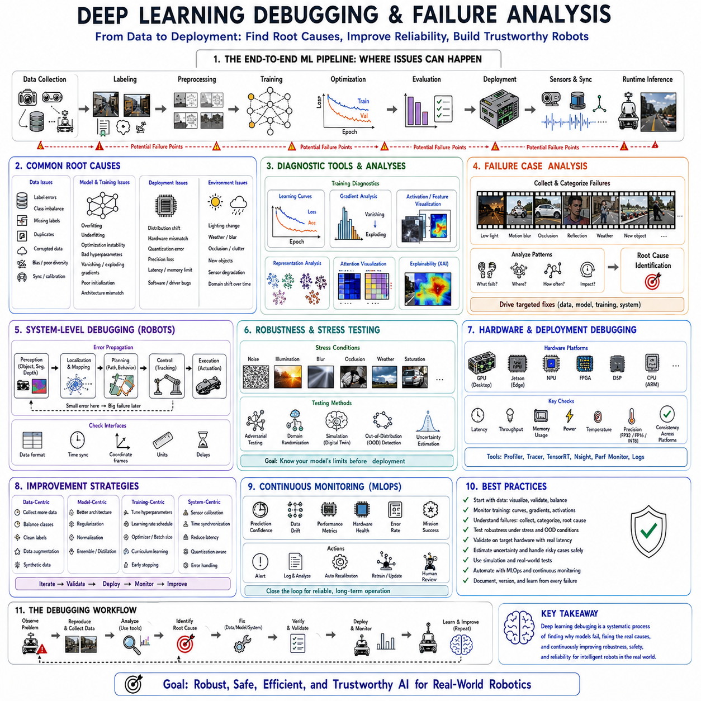
Deep learning debugging and failure analysis have become indispensable disciplines in modern artificial intelligence because achieving high benchmark accuracy alone does not guarantee reliable performance in real-world robotic systems. A neural network may demonstrate outstanding performance during laboratory evaluation yet fail unexpectedly when deployed in dynamic environments containing unseen objects, changing illumination, sensor degradation, hardware limitations, or complex human interactions. Unlike conventional software, where failures often originate from deterministic programming errors, deep learning systems may fail due to data quality, optimization instability, model bias, distribution shifts, hardware limitations, or emergent behaviors that are difficult to predict. Consequently, debugging neural networks requires a fundamentally different methodology that combines software engineering, statistics, optimization theory, machine learning, and robotics. For autonomous robots operating in safety-critical environments, systematic debugging and failure analysis are essential for improving reliability, robustness, interpretability, and long-term autonomous performance.
Traditional software debugging typically identifies explicit logical errors within source code. Developers trace execution paths, inspect variables, locate incorrect conditions, and correct deterministic programming mistakes. Deep learning systems, however, learn millions or even billions of parameters automatically from data rather than through explicit programming. Their internal decision processes emerge during optimization and are distributed across high-dimensional parameter spaces. As a result, incorrect predictions rarely correspond to a single identifiable bug. Instead, failures often arise from subtle interactions among datasets, model architecture, optimization dynamics, sensor characteristics, deployment conditions, and environmental uncertainty.
A comprehensive debugging process therefore begins by recognizing that model failures may originate from multiple layers of the complete machine learning pipeline. Errors may occur during data collection, annotation, preprocessing, feature extraction, training, optimization, evaluation, deployment, sensor synchronization, hardware acceleration, or runtime inference. Identifying the true root cause requires systematic investigation across every stage rather than assuming that the neural network architecture itself is responsible.
Data quality remains one of the most common sources of deep learning failures. Neural networks fundamentally learn statistical relationships present within training datasets. If collected data contains annotation errors, missing labels, class imbalance, duplicated samples, corrupted files, inaccurate sensor calibration, inconsistent timestamps, or biased environmental conditions, the resulting model inevitably inherits these deficiencies. Consequently, debugging frequently begins with comprehensive dataset inspection rather than immediate modification of network architectures.
Annotation consistency is particularly important for supervised learning. Object detection, semantic segmentation, pose estimation, and robotic manipulation datasets often require extensive human labeling. Small inconsistencies among annotators may significantly influence learning outcomes. Bounding boxes drawn differently by multiple annotators, ambiguous segmentation boundaries, inconsistent object classes, or incorrect robot trajectory labels introduce noise that limits achievable model performance regardless of optimization strategy. Careful visualization and statistical analysis of annotations therefore form essential components of debugging workflows.
Class imbalance presents another significant challenge. Robotic datasets frequently contain overwhelming numbers of common environmental observations while rare but safety-critical events appear only infrequently. Autonomous driving datasets may contain thousands of ordinary vehicles but relatively few emergency situations, unusual obstacles, or hazardous weather conditions. Industrial inspection systems similarly observe mostly normal products while defective examples remain scarce. Models trained on highly imbalanced datasets often achieve excellent average accuracy while performing poorly on precisely those rare situations requiring reliable detection.
Distribution shift represents one of the most difficult deployment challenges for deep learning systems. Training data rarely captures the complete diversity of real-world operating environments. Robots deployed in factories, hospitals, warehouses, agricultural fields, construction sites, or outdoor environments inevitably encounter conditions absent during training. Lighting changes, seasonal variation, sensor aging, camera replacement, weather effects, background clutter, unexpected obstacles, or new object categories gradually alter input distributions. Such distribution shifts frequently cause dramatic performance degradation despite unchanged network architectures.
Domain adaptation techniques help mitigate distribution shifts, but effective debugging requires identifying precisely when and why failures occur. Engineers frequently compare feature distributions between training and deployment environments using visualization techniques such as t-SNE, principal component analysis, feature embeddings, activation statistics, or latent representation clustering. Significant divergence often indicates insufficient training diversity requiring additional data collection, augmentation, or adaptation rather than architectural modification.
Training instability represents another common source of deep learning failure. Neural network optimization involves balancing numerous hyperparameters including learning rate, batch size, optimizer configuration, weight initialization, normalization strategy, regularization strength, gradient clipping, and scheduler design. Improper optimization frequently produces exploding gradients, vanishing gradients, oscillatory convergence, slow learning, numerical instability, or complete optimization failure. Monitoring training dynamics therefore constitutes an essential debugging activity throughout model development.
Learning curves provide valuable insight into optimization behavior. Simultaneously plotting training loss, validation loss, training accuracy, validation accuracy, learning rate schedules, gradient norms, and parameter statistics often reveals characteristic failure patterns. Overfitting typically appears as continuously improving training accuracy accompanied by deteriorating validation performance. Underfitting produces poor performance across both training and validation datasets. Diverging losses frequently indicate optimization instability, inappropriate learning rates, corrupted data, or implementation errors requiring immediate investigation.
Gradient analysis further improves optimization debugging. Monitoring gradient magnitudes throughout network layers identifies vanishing or exploding gradients preventing effective learning. Histograms of gradient distributions reveal inactive layers, saturated activation functions, unstable normalization, or inappropriate initialization schemes. Modern deep learning frameworks provide automated visualization tools enabling continuous inspection of optimization dynamics throughout extended training sessions.
Activation visualization similarly supports network diagnosis. Internal feature maps illustrate how neural networks process sensory observations at multiple abstraction levels. Early layers typically detect edges, textures, and local geometric patterns, while deeper layers encode object parts, semantic concepts, and task-specific representations. Visualizing activations identifies inactive neurons, dead filters, excessive sparsity, saturation effects, or unexpected feature collapse indicating architectural or optimization deficiencies.
Feature representation analysis provides additional debugging insight. Embedding visualization techniques project high-dimensional latent representations into lower-dimensional spaces where engineers inspect clustering behavior among semantic categories. Well-trained models generally organize similar objects into coherent feature clusters while maintaining clear separation between distinct classes. Poor clustering often indicates insufficient representation learning, inadequate supervision, or problematic dataset composition requiring corrective action.
Explainable artificial intelligence has become increasingly important for failure analysis. Deep neural networks often behave as black-box decision systems whose internal reasoning remains difficult to interpret. Visualization methods including saliency maps, Grad-CAM, integrated gradients, attention visualization, feature attribution, and concept activation vectors identify which image regions, sensor measurements, or latent features contribute most strongly toward individual predictions. Such explanations frequently reveal unexpected model behavior including excessive reliance upon background context, lighting artifacts, sensor noise, or irrelevant environmental features.
Attention visualization proves particularly valuable for transformer-based robotic perception models. Multi-head attention mechanisms explicitly indicate relationships among image regions, sensor observations, language instructions, or temporal sequences. Engineers inspect attention maps to determine whether models focus upon meaningful environmental structures or become distracted by irrelevant information. Misaligned attention frequently explains incorrect predictions despite apparently reasonable overall performance metrics.
Failure case collection represents one of the most productive debugging methodologies. Rather than evaluating only aggregate benchmark performance, engineers systematically collect individual examples where model predictions fail. Similar failure cases are subsequently grouped into categories including illumination changes, motion blur, occlusion, reflective surfaces, sensor noise, unusual object orientations, weather conditions, dynamic interactions, or domain shifts. Categorizing failures reveals recurring weaknesses guiding targeted improvements through additional training data, augmentation strategies, architectural modifications, or specialized modules.
Robotic systems frequently exhibit cascading failures where small perception errors propagate throughout complete autonomy pipelines. Slight localization inaccuracies may produce navigation failures. Minor object detection errors may lead to incorrect grasp planning. Imperfect depth estimation may generate unsafe trajectories. Consequently, debugging isolated perception modules alone often proves insufficient. Complete system-level analysis tracing error propagation across perception, localization, planning, control, and execution provides more comprehensive understanding of real-world failure mechanisms.
Sensor synchronization errors constitute another common deployment challenge. Cameras, LiDARs, inertial sensors, GPS receivers, force sensors, and wheel encoders frequently operate at different sampling frequencies with independent communication delays. Even millisecond-scale timestamp misalignment significantly degrades sensor fusion performance, particularly during high-speed robotic motion. Accurate hardware synchronization, Precision Time Protocol implementation, timestamp verification, and calibration validation therefore remain critical debugging procedures for multimodal robotic systems.
Numerical precision also influences deployment reliability. Models trained using high-precision floating-point arithmetic often undergo quantization before embedded deployment. Reduced numerical precision occasionally introduces unexpected prediction changes, particularly within attention mechanisms, normalization layers, or recurrent architectures. Comparing outputs before and after quantization identifies operations exhibiting excessive sensitivity requiring calibration or architecture refinement.
Hardware-specific debugging has become increasingly important for edge robotics. Embedded AI accelerators, GPUs, NPUs, DSPs, and FPGAs execute neural networks using hardware-specific optimization libraries that occasionally introduce implementation differences compared with training environments. TensorRT optimization, operator fusion, kernel selection, mixed-precision execution, memory management, and compiler optimizations all influence runtime behavior. Verifying numerical consistency across hardware platforms therefore forms an essential deployment validation procedure.
Profiling tools support hardware debugging by measuring latency, throughput, memory utilization, processor occupancy, bandwidth consumption, thermal behavior, and power usage throughout inference pipelines. Unexpected latency spikes frequently indicate inefficient operators, excessive memory transfers, synchronization overhead, or suboptimal scheduling. Hardware profiling consequently complements algorithmic debugging by identifying computational bottlenecks limiting real-time robotic performance.
Model robustness evaluation extends debugging beyond ordinary validation datasets. Engineers intentionally expose neural networks to adversarial conditions including sensor noise, illumination variation, weather effects, motion blur, compression artifacts, missing sensor modalities, occlusions, geometric distortions, and hardware faults. Controlled robustness testing identifies failure boundaries before deployment, enabling targeted improvements through augmentation, regularization, domain randomization, or robust optimization.
Simulation environments provide particularly valuable debugging platforms for robotics because failures may be reproduced repeatedly under controlled experimental conditions. Digital twins, photorealistic simulation, synthetic sensor generation, and domain-randomized environments enable systematic exploration of rare safety-critical situations difficult or dangerous to reproduce physically. Engineers iteratively modify environmental conditions while observing corresponding model behavior, substantially accelerating failure diagnosis.
Ablation studies further contribute to systematic debugging. Individual architectural components, training procedures, sensor modalities, augmentation strategies, loss functions, attention mechanisms, normalization layers, or optimization techniques are selectively removed while monitoring performance changes. Controlled ablation identifies which system components contribute positively, negatively, or redundantly toward final performance. Such analysis frequently reveals unexpected interactions among seemingly independent design choices.
Continuous monitoring remains essential following deployment because robotic environments evolve over time. Sensor aging, environmental changes, hardware degradation, software updates, operational drift, and evolving user behavior gradually influence model performance. Online monitoring systems continuously record prediction confidence, uncertainty estimates, anomaly detection signals, hardware statistics, and mission outcomes. Significant behavioral changes automatically trigger retraining, recalibration, or maintenance procedures before catastrophic failures occur.
Uncertainty estimation has become an increasingly important component of reliable robotic AI. Rather than always producing confident predictions, trustworthy systems estimate confidence alongside every decision. Bayesian neural networks, Monte Carlo dropout, deep ensembles, evidential learning, and probabilistic calibration enable robots to recognize uncertain situations requiring human intervention, additional sensing, or conservative decision making. Understanding when models lack confidence substantially improves operational safety.
Root cause analysis provides the final stage of comprehensive debugging. Engineers systematically investigate whether observed failures originate primarily from insufficient data diversity, annotation quality, optimization instability, architectural limitations, deployment mismatch, sensor malfunction, calibration errors, software implementation, hardware constraints, or environmental conditions. Correctly identifying underlying causes prevents ineffective modifications targeting symptoms rather than fundamental problems.
Modern machine learning operations increasingly integrate automated debugging into continuous development pipelines. Training logs, experiment tracking systems, dataset versioning, reproducibility frameworks, automated regression testing, continuous integration, performance dashboards, and deployment monitoring collectively enable systematic identification of behavioral changes throughout model lifecycles. Such infrastructure becomes increasingly important as robotic AI systems scale toward foundation models containing billions of parameters.
Large multimodal foundation models introduce additional debugging challenges because failures may emerge from complex interactions among vision, language, action, memory, reasoning, and planning modules. Understanding such systems requires multimodal attention visualization, chain-of-thought inspection, activation probing, representation analysis, behavioral testing, and comprehensive task-level evaluation rather than isolated component analysis. Future debugging methodologies will increasingly combine explainable AI, causal inference, uncertainty estimation, and automated diagnosis to support increasingly capable embodied intelligence.
As Physical AI advances toward autonomous robots operating continuously within complex real-world environments, deep learning debugging and failure analysis will become as important as model design itself. Reliable autonomy depends not only upon achieving high benchmark performance but also upon understanding why failures occur, identifying their underlying causes, measuring uncertainty, validating robustness, and continuously improving models throughout deployment. Combined with systematic experimentation, explainable artificial intelligence, hardware-aware optimization, probabilistic reasoning, and lifelong learning, comprehensive debugging methodologies provide the foundation for building trustworthy robotic systems capable of safe, adaptive, and dependable operation across diverse real-world applications.

