Volume 19 Robot Machine Learning and AI

03. Self Supervised Learning

03.01 Self Supervised Learning Principles and Pretext Tasks
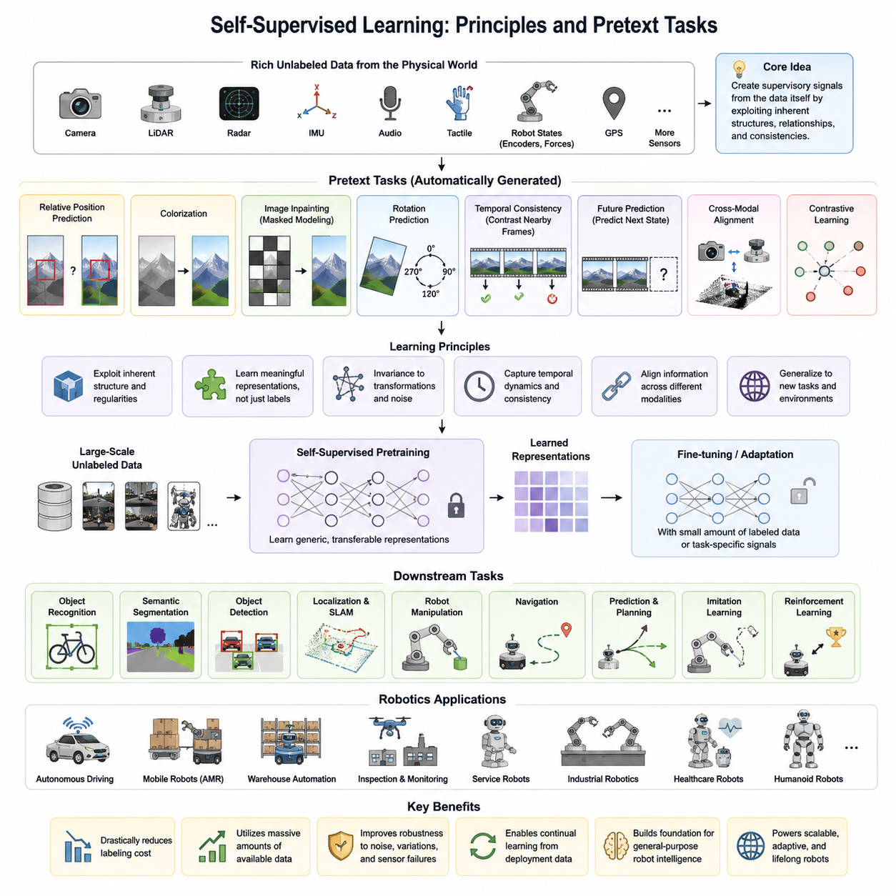
Self-supervised learning has become one of the most influential paradigms in modern machine learning because it enables neural networks to learn meaningful representations without requiring manually annotated labels. Instead of relying on expensive human supervision, self-supervised learning automatically generates supervisory signals directly from the raw data itself. The central idea is that every dataset contains inherent structures, relationships, temporal continuity, spatial consistency, and semantic regularities that can be exploited as supervision. By designing learning objectives that require the model to predict hidden, transformed, or future information, the network gradually acquires feature representations that generalize well across many downstream tasks. This capability is particularly valuable in robotics, where collecting sensor data is relatively inexpensive, but obtaining high-quality labels for perception, localization, manipulation, navigation, or human interaction is both labor-intensive and costly. Consequently, self-supervised learning has become a fundamental technology for robot foundation models, embodied intelligence, autonomous vehicles, and physical AI systems.
The philosophy behind self-supervised learning differs significantly from traditional supervised learning. Conventional supervised methods optimize a model to predict predefined labels, which often limits the learned representation to the specific annotation task. In contrast, self-supervised learning encourages the network to discover latent structures that exist naturally within the observations. Rather than memorizing categories or regression targets, the model develops an understanding of object appearance, spatial geometry, temporal dynamics, sensor correlations, and environmental context. These representations frequently transfer more effectively to a wide variety of downstream applications because they encode more fundamental properties of the physical world rather than narrowly defined semantic classes.
One of the defining characteristics of self-supervised learning is the use of pretext tasks. A pretext task is an automatically generated learning objective whose solution requires the model to understand meaningful characteristics of the input data. Although solving the pretext task itself may not be the final application, the internal representations learned during optimization become useful for numerous downstream tasks after fine-tuning or linear evaluation. Designing effective pretext tasks therefore represents one of the most important aspects of self-supervised learning research. Successful pretext tasks encourage the model to capture semantic relationships rather than trivial statistical shortcuts, thereby improving transferability across diverse robotic applications.
Early self-supervised learning approaches primarily focused on computer vision. One common pretext task involved predicting the relative positions of image patches. The network received two image regions and attempted to estimate their spatial relationship. Solving this problem required learning object shapes, boundaries, textures, and structural consistency rather than merely recognizing isolated pixels. Another popular approach involved image colorization, where grayscale images were presented as input and the network predicted plausible color channels. Since many objects exhibit characteristic colors associated with their semantic identities, successful color prediction encouraged the model to understand object categories and scene composition.
Image inpainting and context prediction also emerged as influential pretext tasks. In these methods, portions of an image were deliberately removed or masked, and the network learned to reconstruct the missing regions using surrounding contextual information. The model therefore developed an implicit understanding of object continuity, scene geometry, and semantic coherence. Similar concepts later evolved into masked image modeling, which now forms the basis of many modern vision foundation models and multimodal learning systems.
Rotation prediction represented another elegant example of self-supervision. Images were randomly rotated by predefined angles such as 0°, 90°, 180°, or 270°, and the neural network predicted the applied rotation. Although this objective appears simple, it forced the model to recognize object orientation, natural geometry, and scene structure. Networks trained using rotation prediction often learned surprisingly useful representations despite requiring no human annotations.
Temporal consistency provides another powerful source of supervision, particularly for robotics and video understanding. Consecutive frames captured by cameras contain highly correlated information because physical objects generally move continuously rather than instantaneously. Self-supervised learning algorithms exploit this property by encouraging nearby frames to produce similar feature representations while distinguishing temporally distant observations. Such objectives naturally teach models to understand motion, object persistence, and dynamic scene evolution. Robots navigating through buildings, warehouses, factories, or outdoor environments can therefore learn robust perception models directly from continuous operational data.
Predictive learning extends temporal self-supervision by requiring models to predict future observations or latent states from past information. Instead of simply reconstructing missing inputs, predictive models learn causal relationships governing environmental dynamics. A mobile robot observing pedestrians, vehicles, doors, or moving machinery gradually develops an internal predictive representation that estimates future system evolution. Such predictive capabilities form important building blocks for world models, model-based reinforcement learning, autonomous planning, and physical reasoning.
Cross-modal self-supervision has become increasingly important for robotics because autonomous systems typically operate with multiple sensor modalities simultaneously. Cameras, LiDAR, radar, IMUs, tactile sensors, force sensors, microphones, GPS receivers, and joint encoders all observe the same physical environment from different perspectives. These synchronized measurements naturally provide supervisory signals for each other. For example, visual features may be aligned with LiDAR point clouds, inertial measurements may verify camera motion estimates, or tactile feedback may confirm predicted grasp outcomes. Learning consistent representations across heterogeneous sensors significantly improves robustness under changing environmental conditions while reducing dependence on labeled multimodal datasets.
Contrastive learning has emerged as one of the most influential families of self-supervised learning methods. The central objective is to maximize similarity between multiple augmented views of the same underlying sample while minimizing similarity with unrelated samples. Carefully designed data augmentations preserve semantic identity while introducing appearance variations such as cropping, color distortion, geometric transformation, noise injection, or viewpoint changes. During optimization, the network learns invariant representations that capture semantic content rather than superficial image statistics. Contrastive objectives have demonstrated remarkable success across image recognition, video understanding, robot perception, speech processing, and multimodal learning, becoming foundational techniques for large-scale representation learning.
Not all self-supervised methods rely on explicit contrastive objectives. Non-contrastive approaches instead encourage consistency between multiple views while avoiding representational collapse through architectural constraints, predictor networks, stop-gradient operations, or redundancy reduction objectives. These methods often achieve competitive performance with reduced computational requirements since they eliminate the need for extremely large negative sample sets. Such approaches have become increasingly attractive for robotics applications where computational resources may be limited on embedded edge platforms.
Masked representation learning has further transformed self-supervised learning. Rather than comparing positive and negative pairs, masked modeling removes substantial portions of the input and trains the model to reconstruct the missing information. This strategy encourages holistic understanding because successful reconstruction requires integrating long-range contextual information across the entire observation. In robotic perception, masked learning supports efficient feature extraction from RGB images, depth maps, point clouds, occupancy grids, tactile arrays, and multimodal sensory streams while significantly reducing dependence on manual annotations.
The quality of learned representations depends heavily on pretext task design. Poorly designed objectives may allow the model to exploit trivial shortcuts that fail to capture meaningful semantics. Effective pretext tasks should require reasoning about high-level structure, object relationships, temporal consistency, spatial geometry, or physical interactions rather than low-level statistical artifacts. Careful selection of data augmentations, masking strategies, prediction targets, and optimization objectives therefore plays a central role in successful self-supervised learning systems.
Evaluation of self-supervised representations typically separates pretraining from downstream adaptation. During pretraining, models learn generic representations without human labels using large unlabeled datasets. Afterward, these frozen or partially fine-tuned representations are evaluated using downstream tasks such as image classification, semantic segmentation, object detection, visual localization, pose estimation, navigation, manipulation, or reinforcement learning. Linear probing, few-shot adaptation, transfer learning, and full fine-tuning provide complementary measurements of representation quality, allowing researchers to assess generalization across different domains and task complexities.
Robotics benefits particularly strongly from self-supervised learning because robots naturally generate enormous quantities of multimodal interaction data during everyday operation. Every navigation trajectory, manipulation episode, inspection mission, warehouse delivery, or human interaction produces synchronized streams of images, depth maps, inertial measurements, control commands, force signals, and localization information. Rather than discarding this operational data after deployment, self-supervised learning continuously transforms it into improved perception and representation models. This capability substantially reduces annotation costs while enabling continual adaptation to changing environments, new object categories, lighting conditions, weather variations, and evolving operational scenarios.
Large-scale robot foundation models increasingly integrate self-supervised learning as the primary pretraining mechanism before downstream specialization. Massive collections of robot trajectories, internet-scale image datasets, simulation-generated environments, synthetic sensor streams, and multimodal recordings are used to learn universal representations capable of supporting navigation, manipulation, scene understanding, language grounding, and embodied reasoning. Subsequent supervised fine-tuning, imitation learning, reinforcement learning, or task-specific optimization then adapts these pretrained representations to individual robotic applications with significantly reduced labeled data requirements.
As autonomous systems continue to operate in increasingly complex and dynamic environments, self-supervised learning is expected to become one of the foundational technologies underlying Physical AI. Future research will likely combine masked modeling, predictive world models, multimodal sensor alignment, contrastive objectives, generative modeling, and continual online adaptation into unified learning frameworks capable of lifelong autonomous improvement. These systems will continuously acquire knowledge from everyday interactions with the physical world, enabling robots to develop increasingly general, robust, and transferable intelligence while minimizing dependence on costly human supervision.

03.02 Contrastive Learning SimCLR MoCo for Robot Vision [w/Code]
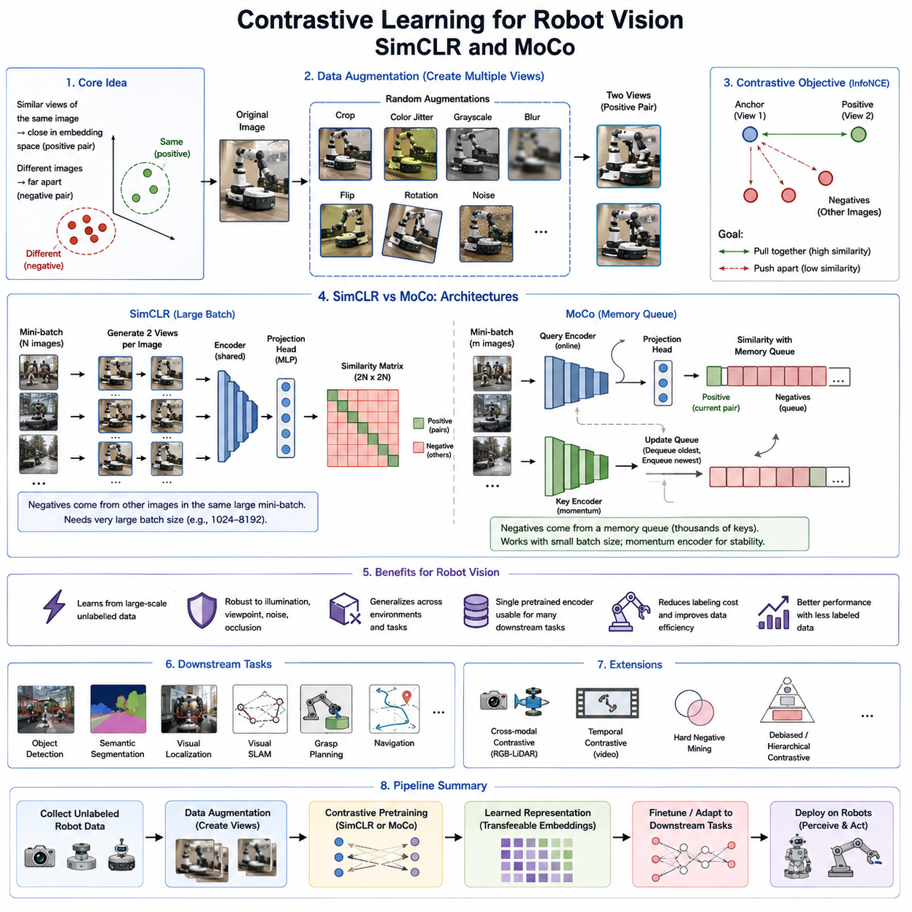
Contrastive learning has emerged as one of the most influential paradigms in self-supervised learning, fundamentally changing how visual representations are learned without manual annotations. Rather than relying on labeled datasets, contrastive learning enables neural networks to acquire discriminative feature representations by comparing similarities and differences among data samples. The underlying principle is intuitive: different views of the same object or scene should produce similar feature embeddings, while representations of different objects or unrelated scenes should remain distinguishable. This simple yet powerful learning objective has significantly advanced computer vision and has become a foundational technology for modern robot perception, autonomous navigation, manipulation, and physical AI systems. In robotics, where collecting vast quantities of unlabeled sensory data is relatively inexpensive but manual annotation is prohibitively costly, contrastive learning provides an efficient mechanism for leveraging continuous operational data to build highly transferable visual representations.
The core philosophy of contrastive learning is based on representation consistency. Instead of predicting explicit semantic labels, the model learns an embedding space in which semantically related observations are positioned close together while unrelated observations are pushed farther apart. During training, multiple augmented versions of the same image are generated through transformations such as random cropping, color jittering, Gaussian blur, horizontal flipping, random grayscale conversion, or geometric distortions. These transformed images are treated as positive pairs because they originate from the same underlying scene. Images originating from different scenes or objects are considered negative pairs. The neural network is optimized so that positive pairs exhibit high similarity while negative pairs remain well separated in the learned feature space.
The success of contrastive learning depends heavily on data augmentation. Unlike traditional augmentation strategies that simply increase dataset diversity, augmentations in contrastive learning define the semantic invariances that the model should learn. Appropriate augmentations preserve object identity while introducing appearance variations that encourage robustness. Excessive augmentation may alter semantic meaning and confuse the learning process, whereas insufficient augmentation may allow the network to exploit trivial pixel-level similarities. Consequently, selecting appropriate augmentation policies is one of the most critical aspects of successful contrastive learning. For robot vision systems, augmentations must carefully reflect realistic environmental variations such as illumination changes, viewpoint shifts, partial occlusions, sensor noise, weather conditions, and motion blur encountered during real-world operation.
The mathematical objective of contrastive learning typically relies on similarity measures computed within a latent embedding space. Images are first processed by an encoder network, often based on ResNet or Vision Transformer architectures, producing high-dimensional feature vectors. A projection head then maps these representations into a contrastive embedding space where similarity metrics such as cosine similarity are computed. The optimization objective encourages matching representations to maximize similarity while minimizing similarity between unrelated samples. The widely adopted normalized temperature-scaled cross entropy loss, commonly known as InfoNCE loss, provides an effective optimization framework by balancing attractive and repulsive forces among feature embeddings. The temperature parameter controls the sharpness of similarity distributions and significantly influences representation quality.
SimCLR represents one of the most influential milestones in contrastive learning research. Introduced by Google Research, SimCLR demonstrated that remarkably strong visual representations could be learned using a relatively simple framework without requiring specialized architectures or memory banks. The training pipeline begins by generating two independent augmentations from every image in the mini-batch. Both augmented views are processed through a shared encoder followed by a multilayer projection head. The resulting embeddings are compared using the InfoNCE objective, where the two augmentations of the same image form a positive pair while every other image within the mini-batch serves as a negative example. Through repeated optimization, the encoder gradually learns semantic representations that remain stable across appearance variations.
One of SimCLR's major contributions was demonstrating the importance of large batch sizes. Since negative samples are drawn directly from other images within the same mini-batch, increasing batch size naturally increases the diversity of negative examples. Larger numbers of negative samples improve representation discrimination by forcing the network to distinguish among many different semantic concepts simultaneously. However, this requirement also introduces computational challenges because extremely large GPU memory capacities become necessary to accommodate thousands of images during training. While large-scale cloud infrastructures can satisfy these requirements, embedded robotic platforms typically cannot, motivating subsequent research into more memory-efficient approaches.
Momentum Contrast, commonly known as MoCo, addresses the computational limitations associated with SimCLR while preserving the advantages of contrastive representation learning. Instead of relying exclusively on large mini-batches, MoCo introduces a dynamic memory queue containing feature representations generated during previous training iterations. This queue provides a large and continuously evolving collection of negative samples without requiring extremely large batch sizes. As a result, MoCo significantly reduces GPU memory requirements while maintaining competitive representation quality. This innovation greatly expanded the practicality of contrastive learning across research laboratories and industrial robotics applications.
The central innovation within MoCo is the use of two separate encoders. A query encoder processes the current mini-batch using standard backpropagation, while a key encoder generates representations stored within the memory queue. Rather than updating both encoders identically, the key encoder is updated using momentum-based parameter averaging. This slow-moving encoder produces stable feature representations that remain consistent over many training iterations, preventing rapid fluctuations that could destabilize contrastive optimization. The momentum update mechanism effectively maintains a smoothly evolving representation space while continuously refreshing the memory queue with newly encoded samples.
The memory queue itself serves as a dictionary of negative examples. Each training iteration removes the oldest embeddings and inserts newly generated feature vectors into the queue. Consequently, the model always compares current observations against thousands of previously observed examples without requiring simultaneous computation of all negative samples. This dictionary-based mechanism substantially reduces computational costs while preserving strong discriminative learning capabilities. MoCo therefore achieves representation quality comparable to large-batch SimCLR training using significantly smaller computational resources.
Both SimCLR and MoCo emphasize learning invariant feature representations rather than memorizing superficial image characteristics. The learned embeddings become robust against changes in viewpoint, illumination, object scale, sensor noise, and environmental conditions. Such robustness is particularly important for autonomous robots operating in dynamic environments where identical objects may appear under vastly different conditions. Warehouse robots experience varying lighting throughout the day, outdoor autonomous vehicles encounter weather changes, inspection robots observe equipment from different viewpoints, and service robots interact with humans exhibiting substantial appearance variability. Contrastive learning naturally addresses these challenges by encouraging semantic consistency across diverse visual observations.
Robot perception systems benefit substantially from contrastive pretraining because many downstream robotic tasks share common visual understanding requirements. Object detection, semantic segmentation, visual localization, loop closure detection, visual SLAM, grasp planning, obstacle recognition, and scene classification all require robust feature extraction. Instead of independently training separate models for every application using labeled datasets, a single contrastively pretrained encoder can provide transferable representations supporting numerous downstream tasks. Fine-tuning requires significantly fewer labeled examples, reducing annotation costs while improving generalization across previously unseen environments.
Contrastive learning has also proven highly effective for multimodal robotic perception. Cameras, LiDAR sensors, radar systems, depth cameras, tactile arrays, inertial measurement units, and force sensors simultaneously observe the same physical world from complementary perspectives. Cross-modal contrastive learning extends the traditional framework by encouraging representations from different sensing modalities to align within a common embedding space. For example, RGB images and corresponding LiDAR point clouds captured simultaneously should produce similar latent representations despite originating from entirely different sensor technologies. Such multimodal alignment enables more robust perception, sensor fusion, and cross-modal retrieval capabilities in autonomous robotic systems.
Temporal contrastive learning further exploits sequential observations collected during robot operation. Consecutive frames within navigation sequences generally depict similar environments, whereas temporally distant observations often represent different locations or events. Learning objectives therefore encourage nearby temporal observations to remain close within the embedding space while distinguishing observations separated by larger temporal intervals. Such temporal representation learning improves visual odometry, place recognition, trajectory estimation, and long-term localization without requiring manually annotated trajectory labels.
The quality of contrastive representations depends on careful hyperparameter selection. Batch size, queue length, momentum coefficient, projection head architecture, temperature scaling, augmentation strategy, embedding dimension, optimizer selection, and training duration all significantly influence downstream performance. Moreover, augmentation strategies should be adapted to the target robotic application. Excessive geometric transformations may negatively affect localization tasks requiring precise spatial reasoning, whereas stronger appearance augmentations may improve robustness for object recognition under varying illumination conditions. Successful deployment therefore requires balancing invariance against preservation of task-relevant information.
Despite its remarkable success, contrastive learning also presents several limitations. Large-scale pretraining remains computationally expensive, particularly for high-resolution images or multimodal sensory inputs. The effectiveness of learned representations depends strongly on augmentation quality and negative sample diversity. Improper augmentation policies may encourage shortcut learning or eliminate essential semantic information. Furthermore, selecting meaningful negative samples becomes increasingly challenging in datasets containing visually similar objects, repetitive industrial environments, or continuous robot trajectories where neighboring observations naturally share substantial semantic overlap.
Recent research has proposed numerous extensions to classical contrastive learning. Hard negative mining identifies particularly informative negative samples that accelerate discrimination. Debiased contrastive learning reduces biases introduced by false negative pairs representing semantically similar objects. Hierarchical contrastive learning captures multiple semantic scales simultaneously. Multi-view contrastive learning incorporates several synchronized sensors beyond conventional image pairs. Region-level contrastive objectives emphasize local object representations, while dense contrastive learning supports pixel-wise semantic understanding for segmentation and scene parsing tasks.
Within modern robot foundation models, contrastive learning often serves as the initial pretraining stage before downstream specialization through imitation learning, reinforcement learning, or supervised fine-tuning. Massive collections of robot trajectories, simulation environments, internet-scale image datasets, industrial inspection recordings, and autonomous driving sequences provide abundant unlabeled visual observations suitable for contrastive representation learning. Once pretrained, these encoders form the perceptual backbone supporting navigation, manipulation, task planning, language grounding, and embodied reasoning across numerous robotic domains.
As Physical AI systems continue evolving toward increasingly general intelligence, contrastive learning is expected to remain a cornerstone of representation learning. Future research will likely integrate contrastive objectives with masked image modeling, predictive world models, multimodal foundation models, continual learning, and generative architectures to produce richer and more transferable visual representations. Rather than functioning as an isolated learning paradigm, contrastive learning is becoming an integral component of unified self-supervised training frameworks capable of continuously learning from real-world robot experiences, enabling autonomous systems to achieve greater adaptability, robustness, and generalization across complex physical environments.

03.03 Masked Autoencoder MAE for Robot Data [w/Code]
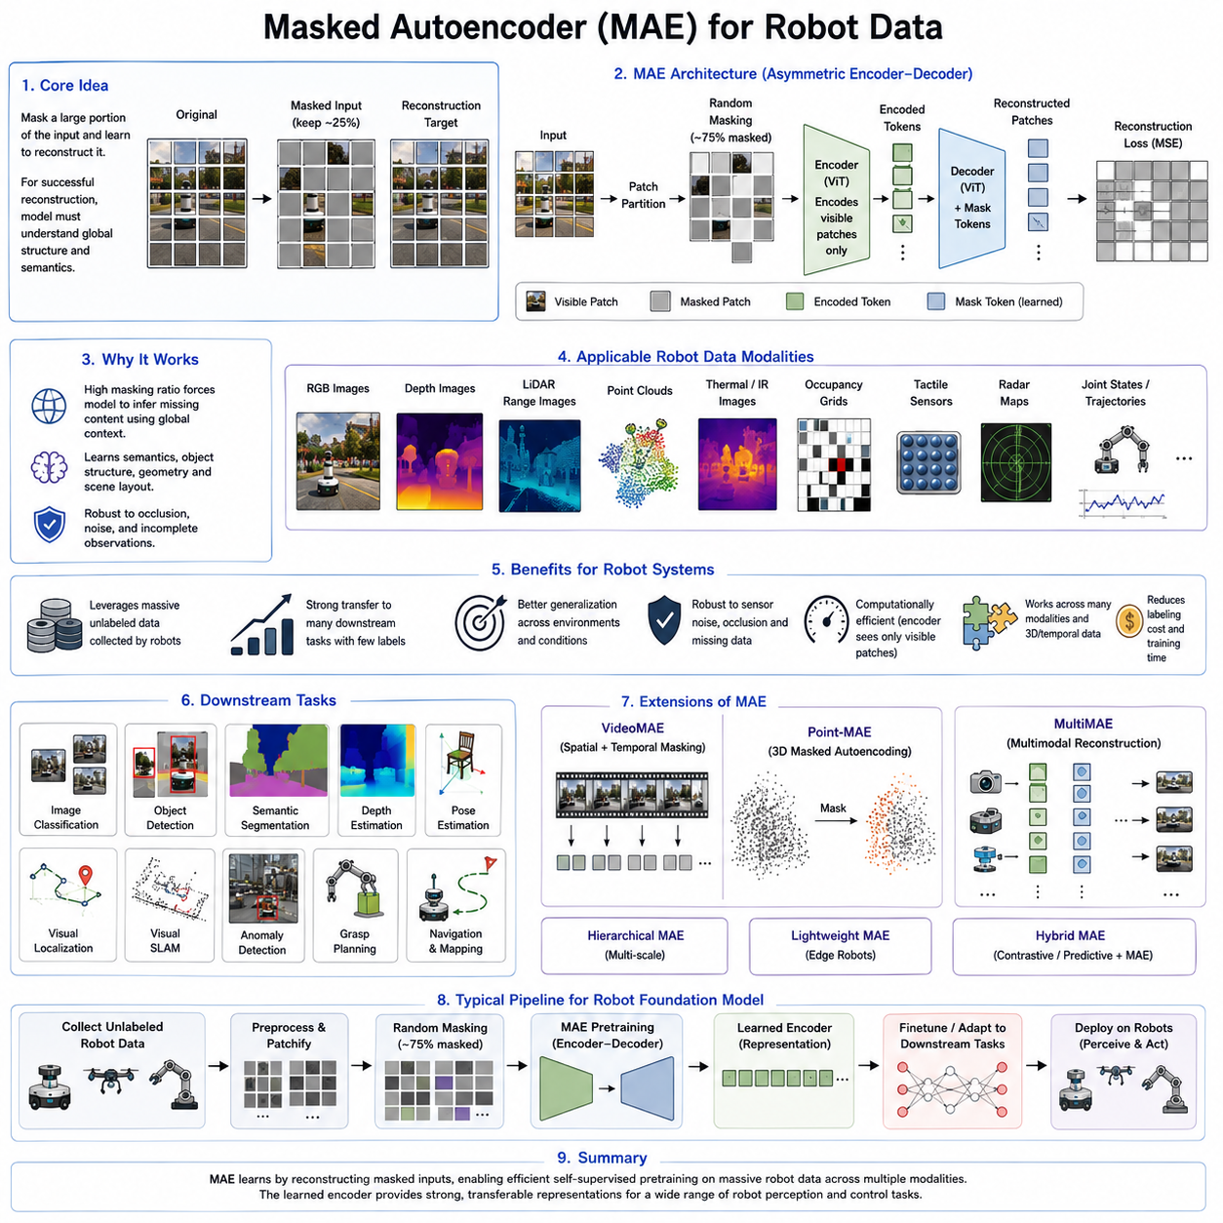
Masked Autoencoder (MAE) has become one of the most influential self-supervised learning techniques for large-scale representation learning, particularly in computer vision and robotics. Unlike contrastive learning methods that rely on positive and negative sample pairs, MAE learns meaningful representations by reconstructing missing portions of the input data. The central idea is remarkably simple: a significant fraction of the input is intentionally hidden, and the neural network is trained to recover the missing information using only the visible observations. Because successful reconstruction requires understanding global semantic structure rather than memorizing local pixel statistics, the encoder gradually learns highly transferable feature representations. This paradigm has proven especially effective for robot perception, where enormous volumes of unlabeled multimodal sensor data are continuously generated during autonomous operation. By exploiting naturally available sensory observations, MAE significantly reduces dependence on manually annotated datasets while providing strong initialization for downstream robotic applications.
The philosophy behind Masked Autoencoder differs fundamentally from traditional supervised learning. Conventional supervised models optimize their parameters using externally provided labels such as object categories, semantic segmentation masks, or pose annotations. In contrast, MAE generates its own supervisory signal directly from the input itself. During training, random portions of an image, depth map, point cloud, or other sensory input are masked, leaving only a subset of the original information visible to the encoder. The decoder then attempts to reconstruct the missing content. Since no human-generated labels are required, MAE naturally scales to massive datasets collected from robot fleets, industrial inspection systems, autonomous vehicles, warehouse robots, or simulation environments.
The inspiration for MAE originates from masked language modeling used in natural language processing. Language models such as BERT demonstrated that predicting masked words encourages deep contextual understanding of language. Researchers extended this concept to visual learning by masking image patches instead of words. However, visual reconstruction presents unique challenges because images contain substantially higher redundancy than textual sequences. Simply masking a small percentage of pixels often produces trivial learning tasks. MAE therefore employs aggressive masking strategies, typically removing approximately seventy-five percent of image patches, forcing the encoder to infer missing content using high-level semantic reasoning rather than local interpolation.
The architecture of Masked Autoencoder consists of two primary components: an asymmetric encoder and a lightweight decoder. The encoder processes only the visible image patches rather than the complete image. This significantly reduces computational complexity because the encoder receives only a fraction of the original input. Mask tokens are not introduced until the decoder stage. After the encoder extracts latent feature representations from the visible patches, the decoder combines these encoded features with mask tokens representing the hidden regions. The decoder then reconstructs the original image by predicting the missing pixel values or patch representations. This asymmetric design simultaneously improves computational efficiency and encourages richer semantic feature learning.
The masking strategy plays a crucial role in MAE performance. Random patch masking ensures that every training iteration presents a unique reconstruction challenge. Since most of the visual information is absent, the network cannot rely on neighboring pixels alone. Instead, it must understand object structure, geometric relationships, scene layout, texture consistency, and contextual dependencies across the entire observation. For example, reconstructing the hidden portion of a robotic manipulator requires understanding its articulated geometry, while reconstructing a warehouse shelf requires recognizing object arrangement, perspective, and spatial organization. Consequently, the learned representations capture semantic understanding rather than superficial image statistics.
Vision Transformers have become the preferred backbone architecture for MAE because their patch-based tokenization naturally aligns with masked reconstruction objectives. An image is first divided into fixed-size patches, each converted into an embedding vector before entering the transformer encoder. Visible patches alone participate in self-attention computations, greatly reducing computational cost. After latent representations are produced, the decoder receives both encoded visible tokens and learned mask tokens to reconstruct the complete image. This design allows large Vision Transformer models to pretrain efficiently on enormous unlabeled datasets while maintaining excellent scalability.
Although MAE was originally developed for RGB images, the underlying concept extends naturally to numerous robotic sensing modalities. Depth images, thermal images, infrared imagery, multispectral observations, occupancy grids, LiDAR range images, radar maps, tactile sensor arrays, force measurements, and even joint state trajectories can all be represented using masked reconstruction objectives. Each modality contains spatial or temporal structures that enable meaningful prediction of missing information. Consequently, MAE provides a unified self-supervised framework applicable across the diverse sensor ecosystem commonly found in modern autonomous robots.
Robot perception systems particularly benefit from MAE because robots continuously encounter incomplete or corrupted sensory observations. Cameras experience motion blur, partial occlusion, and changing illumination. LiDAR sensors generate sparse point clouds with missing returns. Radar measurements contain noise and multipath reflections. Tactile sensors may only contact small portions of manipulated objects. By repeatedly reconstructing missing observations during pretraining, MAE encourages models to become robust against sensor degradation, environmental uncertainty, and incomplete measurements. Such robustness directly improves perception reliability in real-world deployments.
Beyond robustness, MAE promotes efficient utilization of enormous unlabeled robotic datasets. Every autonomous navigation mission, warehouse delivery operation, industrial inspection routine, agricultural survey, or mobile manipulation episode generates terabytes of sensory observations without requiring human annotation. Traditional supervised learning would demand expensive labeling efforts before these datasets become useful. MAE instead immediately converts these raw observations into valuable self-supervised training resources. As robot fleets expand, continuously collected operational data naturally supports increasingly capable foundation models through large-scale masked pretraining.
MAE has demonstrated remarkable transferability across numerous downstream vision tasks. After self-supervised pretraining, the encoder can be fine-tuned for image classification, semantic segmentation, object detection, monocular depth estimation, pose estimation, visual localization, visual SLAM, anomaly detection, scene understanding, and robot manipulation. Because the encoder already possesses rich semantic representations acquired through reconstruction, downstream optimization requires significantly fewer labeled examples than training from scratch. This property substantially reduces annotation costs while improving generalization to previously unseen environments.
In robotic manipulation, MAE enables perception systems to learn object geometry, surface continuity, spatial relationships, and contextual scene organization without requiring manually labeled grasp annotations. During downstream learning, the pretrained encoder provides robust object representations supporting grasp planning, pose estimation, contact prediction, and manipulation policy learning. Similarly, mobile robots benefit from representations capable of understanding traversable regions, structural layouts, environmental semantics, and obstacle configurations despite substantial visual variation encountered during deployment.
Three-dimensional robotic perception has also adopted masked reconstruction principles. Instead of masking two-dimensional image patches, researchers randomly remove subsets of point cloud tokens or voxel representations before predicting the missing geometric structures. Such masked point cloud autoencoders encourage comprehensive understanding of object geometry, spatial topology, and environmental shape. Applications include autonomous driving, warehouse robotics, industrial inspection, construction monitoring, infrastructure maintenance, and service robotics where three-dimensional perception plays a central role.
Temporal masked modeling extends MAE concepts to sequential robotic observations. Rather than masking spatial image patches alone, temporal segments within video sequences or sensor trajectories are hidden and reconstructed. This objective encourages models to understand dynamic scene evolution, object motion, human activities, robot trajectories, and temporal dependencies. Such temporal representations prove valuable for action recognition, behavior prediction, trajectory forecasting, navigation planning, and long-horizon embodied reasoning.
Multimodal MAE represents another rapidly growing research direction. Modern robots simultaneously collect synchronized observations from cameras, LiDAR, radar, IMUs, force sensors, tactile arrays, microphones, GPS receivers, and joint encoders. Multimodal masked autoencoders randomly remove observations from one or multiple sensing modalities while reconstructing them using information from the remaining sensors. This cross-modal reconstruction encourages unified representations integrating complementary sensory information. Consequently, robots develop more comprehensive environmental understanding while maintaining robustness when individual sensors experience degradation or temporary failure.
The computational efficiency of MAE constitutes one of its greatest practical advantages. Because the encoder processes only visible patches rather than the entire input, computational complexity decreases substantially compared to conventional Vision Transformer training. High masking ratios dramatically reduce encoder workload while preserving strong learning performance. This efficiency enables large-scale pretraining on massive datasets without proportionally increasing computational costs. For organizations developing robot foundation models using millions of images or multimodal observations, MAE offers an attractive balance between scalability and representation quality.
Despite its numerous advantages, MAE also presents several challenges. Reconstruction objectives may occasionally emphasize low-level texture details rather than high-level semantic understanding if decoder capacity becomes excessively large. Selecting appropriate masking ratios, decoder architectures, patch sizes, reconstruction targets, and optimization schedules requires careful experimentation. Furthermore, reconstruction quality alone does not necessarily guarantee optimal downstream task performance. Consequently, many recent approaches combine masked reconstruction with complementary objectives such as contrastive learning, predictive coding, semantic consistency, or cross-modal alignment to further improve learned representations.
Recent research has produced numerous MAE variants tailored for different applications. VideoMAE extends masked reconstruction to video understanding by jointly masking spatial and temporal patches. Point-MAE applies masked autoencoding to three-dimensional point clouds for robotic perception. MultiMAE supports simultaneous multimodal reconstruction across diverse sensor inputs. Hierarchical masked autoencoders reconstruct representations at multiple semantic scales, while lightweight edge-oriented MAE architectures target deployment on resource-constrained robotic platforms. These innovations continue expanding the applicability of masked representation learning throughout robotics and embodied AI.
Within modern robot foundation models, Masked Autoencoder frequently serves as the initial large-scale pretraining mechanism before specialized downstream optimization. Massive collections of internet images, robot trajectories, synthetic simulation environments, industrial inspection recordings, warehouse operations, and autonomous driving datasets provide abundant unlabeled observations for masked learning. After pretraining, the encoder transfers efficiently to navigation, manipulation, perception, reinforcement learning, imitation learning, and vision-language-action models. This hierarchical training strategy significantly reduces labeled data requirements while improving robustness, generalization, and adaptation across diverse robotic domains.
As Physical AI continues evolving toward increasingly general-purpose autonomous systems, Masked Autoencoder is expected to remain one of the foundational technologies enabling scalable self-supervised representation learning. Future research will likely integrate masked reconstruction with world models, multimodal transformers, generative diffusion models, continual learning, predictive planning, and embodied reasoning into unified learning architectures. Rather than functioning solely as an image reconstruction algorithm, MAE is becoming a general framework for learning comprehensive representations from incomplete sensory observations, allowing robots to understand complex physical environments, adapt continuously to new experiences, and build increasingly capable foundation models for real-world autonomous intelligence.

03.04 DINO Self Distillation for Robot Feature Learning [w/Code]
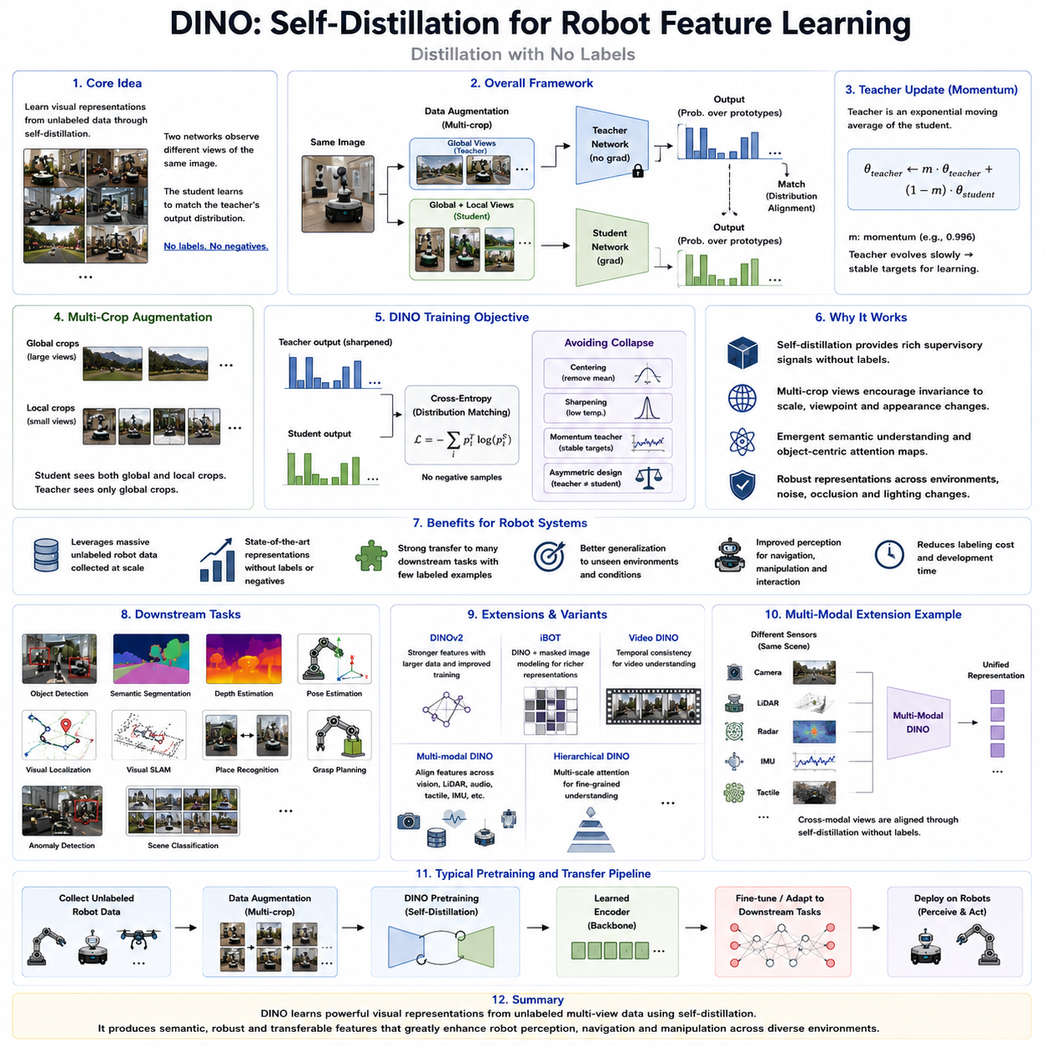
DINO, which stands for Distillation with No Labels, is one of the most influential self-supervised learning methods developed for visual representation learning. Unlike conventional supervised learning that relies on manually annotated labels, DINO enables neural networks to learn highly discriminative visual features directly from unlabeled data through a self-distillation process. The key innovation of DINO lies in replacing explicit contrastive objectives and negative sample comparisons with knowledge transfer between two neural networks that observe different views of the same image. This approach allows the model to develop semantic understanding without requiring human supervision while producing feature representations that exhibit remarkable transferability across a wide range of computer vision and robotic perception tasks. In robotics, where large volumes of sensor data are generated continuously but manual annotation remains prohibitively expensive, DINO has emerged as a highly effective pretraining technique for robot foundation models, autonomous navigation, manipulation, and embodied intelligence systems.
The fundamental philosophy of DINO is based on self-distillation rather than direct reconstruction or contrastive discrimination. Traditional knowledge distillation typically involves transferring information from a large pretrained teacher network to a smaller student network using labeled data. DINO extends this concept by eliminating both labels and an externally pretrained teacher. Instead, the teacher network is generated dynamically from the student itself through momentum parameter updates. Both networks process different augmented views of the same input image, and the student is trained to match the probability distribution generated by the teacher. Because both networks gradually improve together throughout training, meaningful visual representations emerge naturally without requiring manual supervision or explicit semantic annotations.
One of the most important characteristics of DINO is its teacher-student architecture. The student network is updated using standard backpropagation, while the teacher network does not receive gradients directly. Instead, the teacher parameters are updated as an exponential moving average of the student parameters. This momentum update mechanism creates a slowly evolving teacher that produces stable supervisory signals throughout training. Since the teacher changes more gradually than the student, it provides consistent learning targets that stabilize optimization and prevent rapid fluctuations in feature representations. The momentum encoder concept has similarities with Momentum Contrast, but DINO applies it within a self-distillation framework instead of a contrastive learning objective.
DINO completely removes the need for negative samples, which distinguishes it from earlier self-supervised learning methods such as SimCLR and MoCo. In contrastive learning, the network must simultaneously maximize similarity between positive pairs while minimizing similarity between negative examples. This often requires large batch sizes or extensive memory queues to obtain sufficient negative samples. DINO instead focuses entirely on matching the teacher's output distribution for different views of the same image. As a result, the computational complexity associated with negative sample management disappears, simplifying the learning pipeline while maintaining state-of-the-art representation quality.
Data augmentation remains a crucial component of DINO training. Multiple crops of varying resolutions are generated from each input image, including both global crops covering most of the image and smaller local crops focusing on specific regions. The teacher network processes only the global views, whereas the student network receives both global and local views. This multi-crop strategy encourages the student to associate fine local details with broader global scene semantics. Consequently, the learned representations become invariant to scale changes, viewpoint variations, partial occlusions, and appearance transformations commonly encountered during robot operation.
The learning objective in DINO is based on probability distribution matching rather than feature vector comparison. After processing the augmented images, both teacher and student networks generate probability distributions over latent prototypes. The student minimizes the cross-entropy between its predictions and the teacher's outputs. However, directly matching predictions could easily lead to representational collapse, where every input produces identical outputs. DINO avoids this undesirable solution through several carefully designed mechanisms including centering, sharpening, momentum updates, and asymmetric network optimization. Together, these techniques maintain diversity within the learned representations while preserving semantic consistency across different image views.
Centering plays a particularly important role in preventing collapse. The teacher outputs are normalized by subtracting a running average of previous predictions, preventing any single prototype from dominating the representation space. Sharpening further increases prediction confidence by reducing output entropy, encouraging the network to produce more discriminative semantic assignments. These mechanisms balance representation diversity against semantic consistency, allowing DINO to learn rich visual features without explicit contrastive objectives or reconstruction losses.
One of DINO's most remarkable discoveries is its ability to produce attention maps that naturally correspond to semantic object regions despite never being explicitly trained for segmentation. Vision Transformers pretrained with DINO frequently learn attention patterns that separate foreground objects from background scenes automatically. This phenomenon demonstrates that semantic object understanding can emerge purely from self-supervised learning objectives. For robotics, this capability is highly valuable because autonomous systems often require object-centric representations for manipulation, navigation, scene understanding, and human interaction without relying on manually annotated segmentation datasets.
Vision Transformers have become the dominant backbone architecture for DINO due to their ability to model long-range dependencies through self-attention mechanisms. Each image is divided into patches that are processed as individual tokens, allowing attention layers to capture global contextual relationships across the entire scene. During self-distillation, these transformer representations gradually organize themselves into semantically meaningful feature spaces. The resulting representations transfer effectively to numerous downstream tasks while exhibiting excellent robustness to environmental variation.
Robot perception systems particularly benefit from DINO because robotic environments often contain significant appearance variability. Lighting conditions change throughout the day, objects appear from different viewpoints, warehouses are frequently reorganized, outdoor environments experience weather variations, and industrial facilities evolve over time. Since DINO learns invariance across multiple augmented views rather than memorizing exact pixel patterns, the resulting feature representations remain stable despite these appearance changes. Consequently, robot perception becomes more reliable under realistic deployment conditions.
Another significant advantage of DINO lies in its ability to exploit enormous quantities of unlabeled robotic data. Autonomous mobile robots, industrial manipulators, warehouse systems, agricultural robots, service robots, and autonomous vehicles continuously collect images throughout daily operation. Rather than requiring expensive annotation pipelines, these datasets can directly support self-supervised DINO pretraining. As robot fleets expand over time, continuously collected operational data naturally contributes to increasingly capable foundation models through ongoing representation learning.
DINO representations have demonstrated exceptional transfer performance across numerous downstream robotic applications. Object detection, semantic segmentation, monocular depth estimation, visual localization, visual SLAM, place recognition, grasp planning, pose estimation, anomaly detection, and scene classification all benefit from DINO-pretrained encoders. Because the learned representations already capture semantic object relationships and scene structure, downstream fine-tuning requires substantially fewer labeled examples than training from random initialization. This characteristic significantly reduces development costs while improving generalization to unseen environments.
In robotic manipulation, DINO enables models to learn object-centric visual representations without explicit object annotations. The automatically emerging attention maps naturally highlight manipulable objects, supporting grasp planning, object tracking, pose estimation, and interaction reasoning. Rather than depending on manually segmented datasets, robots can gradually develop object understanding through continuous observation of their operational environments. Such object-centric perception forms an essential building block for autonomous manipulation and embodied intelligence.
Navigation systems also benefit substantially from DINO-based representations. Autonomous robots require consistent environmental understanding despite viewpoint changes, seasonal variations, moving obstacles, or illumination differences. DINO embeddings preserve semantic scene information while remaining robust to superficial appearance variations, improving visual localization, loop closure detection, place recognition, and long-term map consistency. These capabilities support reliable navigation across dynamic environments encountered in warehouses, hospitals, factories, campuses, and urban settings.
DINO naturally extends beyond RGB imagery into multimodal robot perception. Cameras, LiDAR sensors, radar systems, depth cameras, thermal imagers, tactile sensors, and inertial measurement units all provide complementary observations of the physical world. Cross-modal self-distillation encourages different sensing modalities to produce consistent semantic representations despite measuring entirely different physical quantities. Such multimodal feature learning improves sensor fusion robustness while enabling comprehensive environmental understanding across heterogeneous robotic sensing platforms.
Several extensions of DINO have further expanded its applicability. DINOv2 introduced substantially larger training datasets, improved optimization procedures, and stronger representation quality suitable for industrial-scale computer vision applications. iBOT combined masked image modeling with self-distillation to integrate reconstruction objectives into DINO training. Other variants incorporate temporal consistency for video understanding, multimodal alignment for cross-sensor learning, and hierarchical attention for fine-grained scene representation. These developments continue improving representation quality while broadening deployment across robotics and embodied AI.
Compared with other self-supervised learning methods, DINO occupies a distinctive position. Unlike SimCLR and MoCo, it eliminates dependence on negative samples. Unlike Masked Autoencoder, it does not reconstruct missing image patches. Instead, DINO focuses on matching semantic probability distributions generated by a momentum teacher network. This unique learning objective often produces representations exhibiting stronger semantic organization and more interpretable attention maps while maintaining computational efficiency and scalability.
Despite its remarkable success, DINO also presents several challenges. Stable training requires careful tuning of momentum schedules, temperature parameters, centering coefficients, learning rates, and augmentation policies. Training very large Vision Transformers still demands substantial computational resources and extensive unlabeled datasets. Furthermore, adapting DINO representations to specialized robotic sensing modalities such as LiDAR point clouds, tactile arrays, or force measurements often requires architectural modifications beyond conventional image transformers.
Modern robot foundation models increasingly integrate DINO into comprehensive self-supervised pretraining pipelines. Massive collections of robot trajectories, internet-scale images, simulation environments, industrial inspection recordings, warehouse operations, and autonomous driving datasets provide abundant visual observations for self-distillation. After pretraining, these representations support imitation learning, reinforcement learning, vision-language models, world models, and vision-language-action architectures. This hierarchical learning strategy significantly reduces labeled data requirements while improving robustness, transferability, and long-term adaptability across diverse robotic applications.
As Physical AI progresses toward increasingly autonomous and general-purpose robotic intelligence, DINO is expected to remain one of the core technologies for representation learning. Future research will likely combine self-distillation with masked modeling, multimodal transformers, world models, generative learning, continual adaptation, and embodied reasoning into unified foundation model architectures. Rather than functioning solely as a visual pretraining algorithm, DINO is evolving into a general framework for learning semantic representations directly from large-scale unlabeled interactions with the physical world, enabling robots to perceive, understand, and adapt to complex environments with minimal human supervision.

03.05 Self Supervised 3D Representation Learning [w/Code]
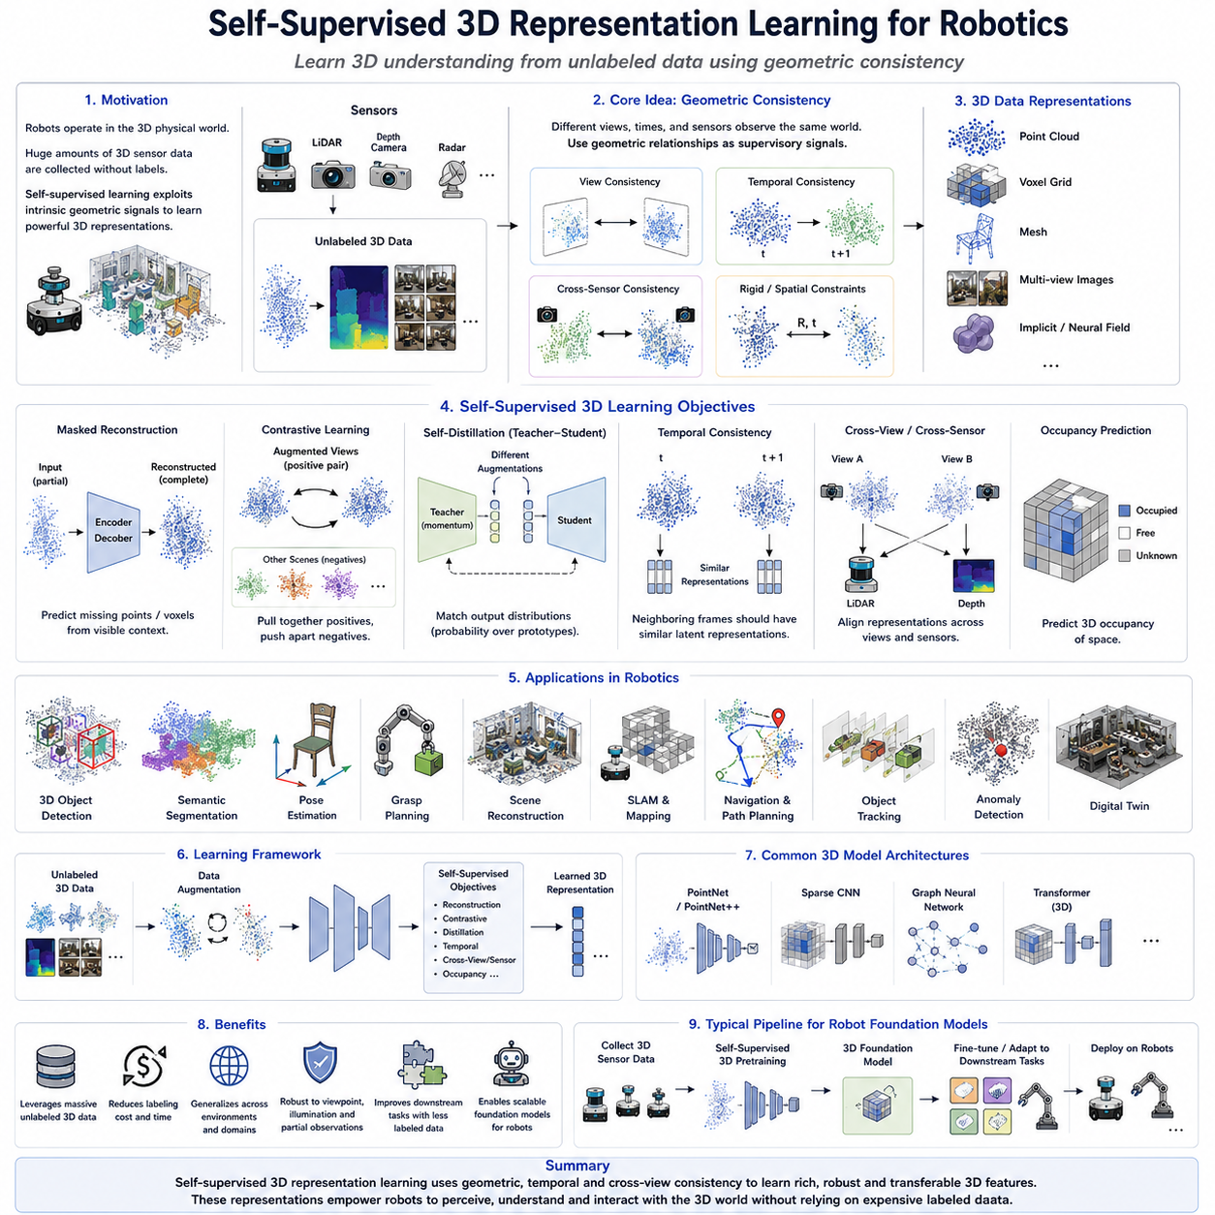
Self-supervised 3D representation learning has become one of the most important research directions in modern robotics because autonomous systems must understand the three-dimensional structure of the physical world without relying on expensive manually annotated datasets. Unlike conventional computer vision, which primarily processes two-dimensional images, robotic perception operates in a fundamentally three-dimensional environment where objects possess geometry, depth, orientation, volume, and spatial relationships. Cameras, LiDAR sensors, depth cameras, stereo vision systems, radar, and structured-light sensors continuously generate enormous quantities of unlabeled 3D observations during robot operation. Self-supervised learning enables these data streams to become valuable learning resources by exploiting intrinsic geometric consistency rather than externally provided labels. Consequently, self-supervised 3D representation learning has become a foundational technology for robot perception, autonomous navigation, manipulation, scene understanding, digital twins, and Physical AI systems.
The central philosophy of self-supervised 3D learning is that geometric information naturally contains supervisory signals. Every point cloud, depth image, voxel grid, mesh, or multi-view observation represents the same physical environment from different perspectives. Spatial continuity, rigid body transformations, temporal consistency, object permanence, and sensor alignment all provide natural constraints that allow neural networks to learn meaningful representations without human annotation. Rather than predicting manually assigned object categories, the model learns to understand geometry, surface structure, spatial organization, and environmental topology directly from raw sensory observations.
Three-dimensional representations can be expressed in several complementary forms depending on the sensing modality and robotic application. Point clouds represent environments as collections of spatial coordinates generated by LiDAR or depth sensors. Voxel grids discretize three-dimensional space into volumetric cells that encode occupancy or semantic information. Polygon meshes describe continuous surfaces through connected vertices and faces. Implicit neural representations model geometry as continuous mathematical functions. Multi-view images capture the same object or environment from multiple camera viewpoints. Each representation possesses unique advantages regarding computational efficiency, memory consumption, geometric precision, and suitability for downstream robotic tasks.
Point clouds have become one of the most widely used representations for autonomous robots because modern LiDAR sensors directly generate sparse three-dimensional measurements of surrounding environments. Unlike images organized on regular pixel grids, point clouds consist of unordered sets of spatial coordinates with irregular sampling densities. Learning effective point cloud representations therefore requires neural architectures capable of handling permutation invariance while preserving geometric relationships. Self-supervised learning methods exploit this geometric structure by reconstructing missing points, predicting transformations, matching multiple observations, or aligning different sensor viewpoints without requiring semantic labels.
Masked reconstruction has emerged as a highly effective approach for self-supervised point cloud learning. Similar to masked autoencoders developed for images, random subsets of points are removed from the input, and the network learns to reconstruct the missing geometry using only visible observations. Successful reconstruction requires understanding object shape, surface continuity, structural symmetry, and spatial context. Rather than memorizing individual points, the encoder gradually develops robust geometric representations that transfer effectively to object detection, segmentation, pose estimation, grasp planning, and navigation.
Contrastive learning has also been successfully extended into three-dimensional perception. Multiple augmented views of the same point cloud or object are generated through geometric transformations such as random rotation, translation, scaling, jittering, cropping, or point dropout. These transformed observations form positive pairs, while unrelated scenes constitute negative pairs. The network learns invariant geometric representations that remain stable across viewpoint changes and sensor variations. Such representations are particularly valuable for mobile robots operating in dynamic environments where objects are observed from continuously changing perspectives.
Self-distillation techniques similar to DINO have recently been adapted for three-dimensional representation learning. Teacher and student networks observe different augmented versions of identical point clouds or voxel representations while learning consistent latent embeddings through momentum-based optimization. These methods eliminate the need for explicit negative samples while encouraging semantic consistency across geometric transformations. As a result, three-dimensional object understanding improves without requiring manually labeled datasets, making self-distillation particularly attractive for large-scale robotic deployments.
Temporal consistency provides another powerful supervisory signal for three-dimensional robotic perception. Autonomous robots continuously collect sequences of LiDAR scans, depth maps, and multi-view observations while moving through their environments. Consecutive observations generally describe overlapping portions of the same physical scene despite changes in viewpoint or robot position. Self-supervised learning encourages nearby temporal observations to produce similar latent representations while preserving sensitivity to genuine environmental changes. This temporal learning strategy improves localization, loop closure detection, map construction, dynamic object tracking, and long-term environmental understanding.
Cross-view consistency further strengthens self-supervised three-dimensional learning. A physical object observed simultaneously by multiple cameras or LiDAR sensors should generate compatible latent representations despite substantial viewpoint differences. Learning objectives therefore encourage geometric consistency across multiple viewpoints while maintaining viewpoint invariance. Such cross-view learning supports robust object recognition, pose estimation, scene reconstruction, and sensor fusion within heterogeneous robotic sensing systems.
Sensor fusion represents another major application of self-supervised 3D representation learning. Modern autonomous robots simultaneously employ RGB cameras, LiDAR sensors, radar systems, depth cameras, inertial measurement units, tactile sensors, GPS receivers, and wheel encoders. Although these sensors measure different physical quantities, they all observe the same environment. Cross-modal self-supervised learning aligns representations generated by multiple sensing modalities into a unified latent space. Consequently, robots acquire comprehensive environmental understanding while maintaining robustness when individual sensors become degraded or temporarily unavailable.
Scene reconstruction constitutes one of the most fundamental objectives within self-supervised three-dimensional learning. Instead of merely recognizing individual objects, the model learns to reconstruct complete environmental geometry from incomplete observations. Partial LiDAR scans, sparse depth measurements, or limited camera viewpoints must be integrated into coherent three-dimensional scene representations. Such reconstruction capabilities support autonomous navigation, obstacle avoidance, digital twin generation, warehouse mapping, industrial inspection, and infrastructure monitoring without requiring manually created ground-truth models.
Occupancy prediction provides another valuable self-supervised objective. Rather than directly predicting semantic labels, the model estimates whether regions of three-dimensional space are occupied, free, or unknown. Occupancy grids naturally describe navigable environments while supporting collision avoidance, path planning, and volumetric mapping. Self-supervised occupancy prediction exploits geometric consistency among multiple observations to learn robust environmental representations that generalize effectively across diverse robotic platforms.
Object completion extends masked reconstruction toward semantic geometric understanding. Robots frequently observe only partial views of manipulated objects because of occlusions, limited sensor coverage, or constrained viewpoints. Self-supervised learning encourages models to infer complete object geometry from incomplete observations. Such capabilities significantly improve robotic manipulation by enabling grasp planning, pose estimation, contact reasoning, and object tracking even when only limited visual information is available.
Three-dimensional representation learning also supports robotic manipulation through understanding object affordances rather than merely recognizing object identities. By learning geometric relationships among surfaces, handles, edges, cavities, and support structures, self-supervised models naturally acquire representations useful for grasp synthesis, tool usage, insertion tasks, assembly operations, and dexterous manipulation. Because these representations originate from geometry itself rather than semantic annotations, they generalize more effectively across previously unseen object categories.
Autonomous navigation similarly benefits from robust three-dimensional representations. Mobile robots operating in warehouses, hospitals, factories, construction sites, underground tunnels, forests, or urban environments require accurate geometric understanding despite changing weather, illumination, seasonal variation, and moving obstacles. Self-supervised three-dimensional representations capture stable structural properties of environments while remaining invariant to superficial appearance changes. Consequently, localization, mapping, obstacle avoidance, terrain assessment, and route planning become significantly more reliable under realistic deployment conditions.
Simulation environments have become increasingly important sources of self-supervised three-dimensional training data. Modern simulation platforms generate unlimited synthetic point clouds, depth images, occupancy maps, semantic scenes, and robot trajectories without manual annotation costs. Self-supervised objectives transfer naturally between simulated and real environments because they rely on intrinsic geometric consistency rather than dataset-specific labels. Combined with domain adaptation techniques, simulation-based pretraining substantially reduces dependence on expensive real-world data collection while accelerating robot development.
Foundation models for robotics increasingly integrate self-supervised three-dimensional representation learning as a core pretraining strategy. Massive collections of internet-scale three-dimensional datasets, autonomous driving logs, warehouse operations, industrial inspection recordings, construction monitoring, aerial mapping, and simulated environments collectively provide billions of geometric observations suitable for representation learning. These pretrained models subsequently transfer to object detection, semantic segmentation, manipulation, reinforcement learning, vision-language-action systems, and embodied reasoning with significantly reduced supervised data requirements.
Several specialized neural architectures have emerged for self-supervised three-dimensional learning. Point-based networks directly process unordered point clouds through permutation-invariant operations. Voxel-based networks exploit regular three-dimensional grid structures suitable for convolutional processing. Sparse convolutional networks improve computational efficiency by focusing only on occupied spatial regions. Graph neural networks capture neighborhood relationships among geometric primitives, while transformer architectures model long-range spatial dependencies through self-attention mechanisms. Each architecture offers distinct tradeoffs between scalability, accuracy, computational complexity, and suitability for different robotic sensing modalities.
Despite remarkable progress, several challenges remain. Three-dimensional datasets are substantially larger than conventional images, increasing memory requirements and computational costs. Point cloud density varies significantly across sensing platforms, introducing representation inconsistencies. Dynamic environments containing moving people, vehicles, machinery, or manipulators complicate geometric consistency assumptions. Furthermore, multimodal alignment among cameras, LiDAR, radar, and tactile sensing remains an active research area requiring improved cross-modal learning objectives and more scalable foundation architectures.
Recent research increasingly combines multiple self-supervised objectives into unified learning frameworks. Masked point reconstruction, contrastive geometric alignment, self-distillation, temporal prediction, occupancy estimation, scene completion, and multimodal consistency are optimized simultaneously within large transformer-based architectures. These hybrid learning strategies capture complementary aspects of three-dimensional understanding while improving downstream performance across diverse robotic applications. Rather than relying on a single supervisory signal, future robot foundation models are expected to integrate numerous geometric constraints into comprehensive self-supervised learning systems.
As Physical AI advances toward increasingly autonomous and general-purpose robotic intelligence, self-supervised 3D representation learning will remain a cornerstone of perception and world understanding. Future robots will continuously learn from their own sensory experiences, constructing increasingly accurate internal models of three-dimensional environments through lifelong interaction with the physical world. By integrating geometric reasoning, multimodal perception, world models, foundation transformers, and continual adaptation, self-supervised three-dimensional learning will provide the perceptual foundation enabling robots to navigate, manipulate, inspect, collaborate, and reason within complex real-world environments while minimizing dependence on costly human supervision.

03.06 Predictive Coding and World Model Pretraining [w/Code]
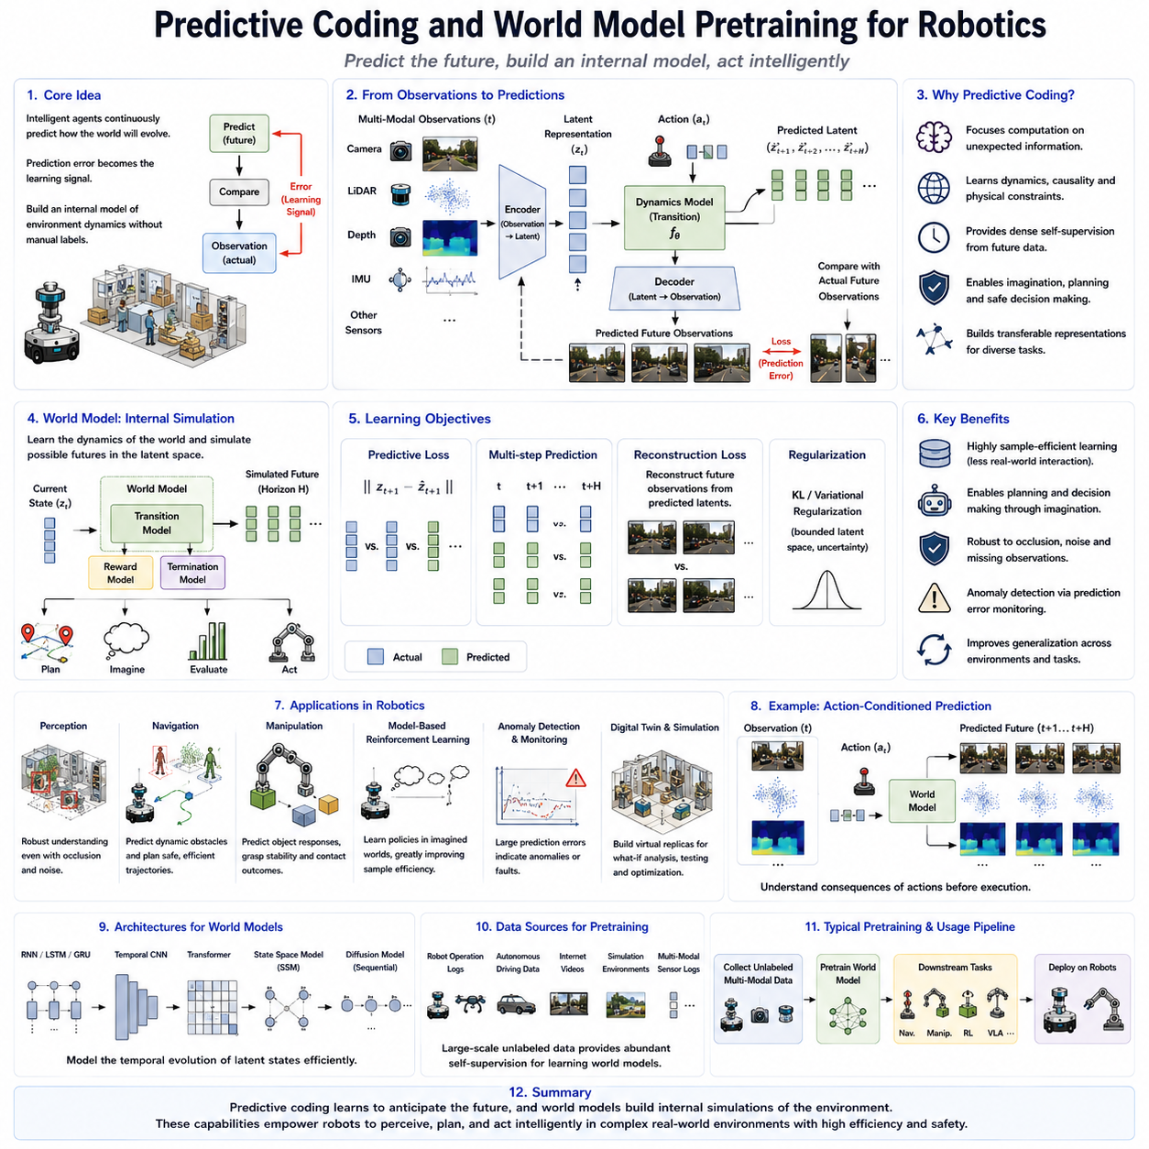
Predictive coding and world model pretraining have emerged as fundamental paradigms for building intelligent robotic systems capable of understanding, anticipating, and interacting with complex physical environments. Unlike traditional supervised learning approaches that focus primarily on recognizing objects or classifying observations, predictive learning emphasizes forecasting future states of the environment based on current sensory information and previous experiences. The central assumption is that intelligent agents should not merely perceive the world but should continuously predict how the world will evolve over time. Every prediction error becomes a valuable learning signal, enabling the system to gradually construct increasingly accurate internal models of environmental dynamics. This principle closely resembles biological intelligence, where humans and animals constantly anticipate future sensory inputs and update their internal beliefs whenever observations differ from expectations. In modern robotics, predictive coding has become a cornerstone of self-supervised learning because future observations naturally provide supervision without requiring manually annotated labels. Combined with world models, predictive coding enables robots to learn transferable representations supporting perception, planning, manipulation, navigation, and autonomous decision-making across diverse operational environments.
The theoretical foundation of predictive coding originates from neuroscience, where the human brain is believed to function as a hierarchical prediction machine. Rather than passively processing incoming sensory information, the brain continuously generates predictions about future sensory inputs using internal representations of the external world. Incoming observations are compared with these predictions, and only the prediction errors propagate through the hierarchical processing system to update internal beliefs. This mechanism allows biological intelligence to process enormous amounts of sensory information efficiently while focusing computational resources on unexpected events. Artificial intelligence adopts this same principle by training neural networks to predict future observations, latent representations, or environmental dynamics, thereby encouraging models to capture meaningful structures underlying the physical world instead of memorizing isolated observations.
Predictive coding differs fundamentally from conventional reconstruction-based self-supervised learning. Reconstruction methods such as autoencoders learn representations by restoring missing portions of the current observation. Predictive coding instead focuses on estimating future observations that have not yet occurred. This distinction is important because future prediction requires understanding causal relationships governing environmental dynamics rather than simply recovering missing visual information. A robot predicting the future position of a moving pedestrian, the trajectory of another vehicle, the motion of a robotic arm, or the deformation of an object must implicitly learn physical laws, temporal continuity, object interactions, and environmental constraints. Consequently, predictive coding naturally encourages deeper semantic and physical understanding than static reconstruction alone.
The predictive learning process generally begins by encoding current sensory observations into compact latent representations. These observations may originate from RGB cameras, depth sensors, LiDAR scanners, radar systems, tactile arrays, force sensors, inertial measurement units, or multimodal combinations of several sensing modalities. Rather than predicting raw sensory signals directly, many modern architectures predict future latent representations because latent spaces capture semantic information more efficiently while reducing computational complexity. Predicting latent representations also avoids unnecessary emphasis on high-frequency visual details that contribute little to downstream robotic decision-making.
Temporal consistency provides one of the strongest supervisory signals within predictive coding. Consecutive observations collected by autonomous robots typically exhibit smooth transitions governed by physical dynamics. Objects generally move continuously rather than instantaneously disappearing or reappearing elsewhere. Robot motion similarly follows continuous trajectories constrained by mechanical systems and environmental interactions. Predictive learning exploits these temporal regularities by encouraging latent representations to evolve consistently across sequential observations. Such temporal coherence significantly improves representation quality for navigation, localization, trajectory estimation, manipulation, and long-horizon reasoning.
World models extend predictive coding beyond short-term forecasting by constructing comprehensive internal representations of environmental dynamics. Rather than predicting only the next observation, a world model attempts to learn the underlying mechanisms governing state transitions within the physical environment. The learned model captures relationships among objects, actions, environmental changes, physical constraints, and temporal evolution. Consequently, robots equipped with accurate world models can mentally simulate future scenarios before executing real actions, enabling planning, risk assessment, decision optimization, and safer autonomous behavior.
The concept of a world model is closely related to internal simulation. Humans routinely imagine future outcomes before taking actions, mentally evaluating multiple alternatives without physically executing each possibility. World models provide robots with analogous capabilities. Instead of repeatedly interacting with the real environment, autonomous systems can simulate hypothetical future trajectories within their learned latent models. This capability substantially improves learning efficiency by reducing costly physical experimentation while enabling long-horizon planning under uncertain conditions.
Latent world models have become particularly important because predicting high-dimensional raw sensory observations remains computationally expensive. Rather than simulating every pixel within future images, latent world models encode observations into compact feature representations capturing semantic structure while discarding redundant details. Future predictions therefore occur within efficient latent spaces where planning, reinforcement learning, and policy optimization become significantly more tractable. Such latent simulation forms the foundation of many modern model-based reinforcement learning algorithms and embodied AI systems.
Several neural architectures have been proposed for predictive coding and world model learning. Recurrent neural networks, Long Short-Term Memory networks, Gated Recurrent Units, Temporal Convolutional Networks, Transformers, State Space Models, and diffusion-based sequential models have all demonstrated strong predictive capabilities. Transformer architectures have become particularly attractive because self-attention mechanisms naturally capture long-range temporal dependencies among observations. More recently, state-space sequence models provide computational efficiency suitable for continuous robot operation while maintaining strong predictive accuracy over extended time horizons.
Variational latent models represent another influential family of world model architectures. Variational Autoencoders encode observations into probabilistic latent variables describing environmental states. Transition models predict future latent states conditioned on previous observations and robot actions. Decoders reconstruct predicted sensory observations from these latent variables. Such probabilistic formulations naturally represent uncertainty within future predictions, enabling robots to distinguish highly predictable situations from inherently uncertain scenarios requiring additional caution or exploration.
Robot actions play a central role in predictive world modeling because future environmental states depend not only on current observations but also on decisions executed by the robot itself. Action-conditioned world models explicitly incorporate control commands into state transition predictions. For example, a mobile robot predicting future camera images must account for its planned steering and velocity commands. Similarly, robotic manipulators predict future object configurations based on planned arm movements and gripper actions. Learning these action-dependent transitions enables robots to understand the causal consequences of their own behaviors, supporting model-based planning and intelligent control.
Predictive coding naturally supports self-supervised representation learning because future observations serve as automatically generated supervision. Every sensor measurement collected during normal robot operation immediately becomes a prediction target for previous observations. Consequently, enormous robot datasets generated during warehouse operations, industrial inspection, autonomous driving, agricultural monitoring, hospital logistics, or service robotics continuously provide learning opportunities without requiring human annotation. As operational experience accumulates, predictive representations become increasingly accurate and transferable across diverse downstream tasks.
Robot perception benefits substantially from predictive world models. Instead of interpreting each observation independently, perception systems maintain continuously evolving beliefs regarding object identities, positions, motions, and interactions. Temporary sensor failures, partial occlusions, missing measurements, and noisy observations can often be compensated using predicted future states generated by the world model. Consequently, perception becomes more robust under challenging real-world conditions while supporting reliable navigation and manipulation despite incomplete sensory information.
Navigation systems similarly exploit predictive coding by forecasting future environmental changes before executing motion commands. Dynamic obstacles such as pedestrians, vehicles, forklifts, or collaborative robots exhibit continuous motion patterns that predictive models can estimate in advance. Anticipating future obstacle trajectories allows autonomous robots to generate safer, smoother, and more efficient navigation strategies compared with purely reactive control methods. Long-term trajectory optimization similarly benefits from latent simulations evaluating alternative future paths before physical execution.
Robotic manipulation presents another domain where predictive world models provide significant advantages. Successful manipulation requires anticipating how objects will respond to grasping, pushing, rotating, stacking, inserting, or deforming actions. Predictive models learn these physical interactions directly from experience, gradually acquiring intuitive knowledge regarding object dynamics, contact mechanics, friction, and stability. Instead of relying exclusively on analytical physical models, robots develop data-driven internal simulations capable of generalizing across diverse object categories and manipulation scenarios.
Model-based reinforcement learning represents one of the most successful applications of predictive world models. Traditional model-free reinforcement learning requires extensive interaction with physical environments, often demanding millions of experiences before achieving satisfactory performance. World models dramatically improve sample efficiency by enabling policies to learn within simulated latent environments generated by predictive models. Algorithms such as Dreamer, PlaNet, and related approaches demonstrate that high-quality predictive world models substantially accelerate reinforcement learning while reducing expensive real-world experimentation.
Predictive coding also supports anomaly detection within autonomous systems. Because predictive models continuously estimate expected future observations, unexpected discrepancies between predicted and actual sensory measurements naturally indicate anomalies. Such deviations may correspond to sensor failures, unexpected obstacles, environmental hazards, mechanical faults, or previously unseen situations. Prediction errors therefore provide valuable signals for runtime monitoring, fault diagnosis, uncertainty estimation, and safety-critical decision-making within deployed robotic systems.
Multimodal predictive world models further extend these capabilities by jointly modeling multiple sensing modalities. Cameras, LiDAR sensors, radar systems, tactile arrays, force sensors, microphones, GPS receivers, and inertial measurement units all contribute complementary information describing environmental dynamics. Predictive learning aligns these heterogeneous observations within unified latent spaces while forecasting their future evolution simultaneously. Such multimodal representations improve robustness, sensor fusion, and cross-modal reasoning across diverse robotic platforms.
Large-scale robot foundation models increasingly incorporate predictive coding as a primary pretraining objective. Massive datasets containing robot trajectories, internet-scale videos, autonomous driving sequences, simulation environments, industrial inspection recordings, and multimodal sensor logs provide abundant temporal observations supporting predictive learning. Rather than optimizing exclusively for recognition tasks, foundation models develop comprehensive internal world representations capable of supporting navigation, manipulation, language grounding, reinforcement learning, imitation learning, and embodied reasoning through shared predictive latent spaces.
Despite its substantial promise, predictive world modeling remains a challenging research area. Long-horizon predictions accumulate uncertainty over time, making accurate forecasting increasingly difficult as prediction horizons extend. Dynamic environments containing multiple interacting agents exhibit highly complex state transitions that challenge current neural architectures. Furthermore, efficiently representing uncertainty, causal reasoning, physical interactions, and rare events within learned world models remains an active area of investigation. Balancing model complexity against computational efficiency is particularly important for deployment on resource-constrained robotic hardware.
Current research increasingly combines predictive coding with complementary self-supervised learning objectives such as masked reconstruction, contrastive learning, self-distillation, multimodal alignment, diffusion modeling, and hierarchical representation learning. Hybrid training strategies enable models to simultaneously capture static appearance, temporal dynamics, geometric structure, semantic relationships, and physical interactions within unified foundation architectures. Such integrated learning frameworks promise richer and more transferable representations than any individual objective alone.
As Physical AI evolves toward increasingly autonomous, adaptive, and general-purpose intelligence, predictive coding and world model pretraining are expected to become fundamental components of robotic cognition. Future robots will continuously build, refine, and utilize internal simulations of the physical world through lifelong interaction with their environments. These predictive world models will support reasoning, planning, imagination, decision-making, failure recovery, and continual adaptation while minimizing dependence on manually labeled data. Rather than simply recognizing the present, intelligent robots will increasingly anticipate the future, evaluate hypothetical actions before execution, and construct increasingly accurate internal models of reality that enable robust autonomy across complex real-world environments.

03.07 Self Supervised Tactile and Force Representation [w/Code]
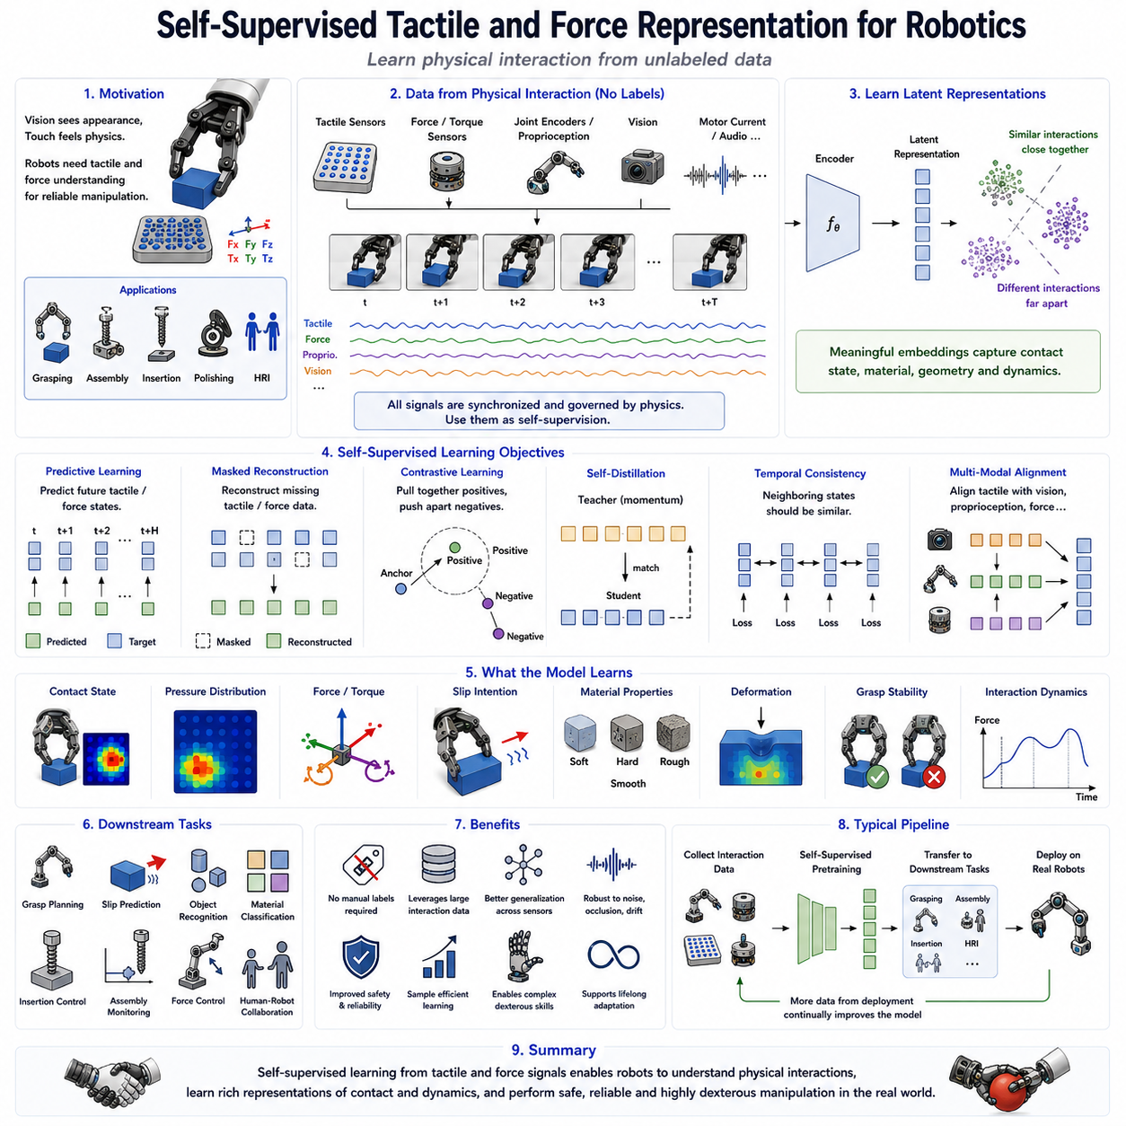
Self-supervised tactile and force representation learning has become an increasingly important research area in robotics because intelligent physical interaction requires far more than visual perception alone. While cameras and LiDAR sensors provide rich information about the external appearance of objects and environments, they cannot directly measure contact forces, surface textures, compliance, friction, slippage, deformation, or grasp stability. Humans naturally combine vision with touch to manipulate objects efficiently, adjusting grip force continuously based on tactile feedback. Similarly, autonomous robots require meaningful representations of tactile and force information to perform reliable manipulation, dexterous grasping, assembly, human-robot collaboration, and physical interaction in unstructured environments. Since collecting manually labeled tactile datasets is extremely expensive and time-consuming, self-supervised learning has emerged as an effective solution for exploiting the enormous quantities of unlabeled tactile and force data generated during everyday robot operation. By learning directly from physical interactions, robots gradually develop rich internal representations that improve manipulation performance while reducing dependence on manual annotation.
The fundamental philosophy of self-supervised tactile learning is that every physical interaction naturally generates supervision. Whenever a robotic gripper touches an object, presses against a surface, slides along a material, or manipulates a tool, multiple sensing modalities evolve together according to consistent physical laws. Tactile arrays measure pressure distributions, force-torque sensors record interaction forces, joint encoders monitor robot motion, cameras observe object movement, and motor currents reflect actuator loading. These synchronized observations inherently describe the same interaction process. Rather than requiring human annotations, self-supervised learning exploits these naturally occurring correlations to learn meaningful representations describing contact mechanics, material properties, object geometry, and manipulation dynamics.
Tactile sensing itself encompasses several complementary sensing technologies. Pressure-sensitive arrays measure distributed contact forces across soft sensing surfaces. Force-torque sensors capture six-dimensional interaction forces and torques at robot wrists or end effectors. Capacitive and piezoresistive tactile sensors estimate local pressure distributions with high spatial resolution. Optical tactile sensors use internal cameras to observe deformation patterns within compliant materials. Magnetic tactile sensors detect displacement using embedded magnets and Hall-effect devices. Flexible electronic skins provide distributed whole-body tactile perception across humanoid robots. Although each sensing technology measures different physical quantities, all contribute valuable information regarding contact interactions between robots and their environments.
Force sensing complements tactile perception by measuring global interaction dynamics rather than local surface pressure. Six-axis force-torque sensors estimate forces and moments applied during manipulation, assembly, insertion, polishing, grinding, and collaborative human interaction. These measurements reveal object weight, contact stability, frictional resistance, insertion alignment, collision events, and environmental constraints. Combining force sensing with tactile perception enables robots to simultaneously understand both local contact conditions and global interaction dynamics, producing substantially richer representations than either sensing modality alone.
Self-supervised representation learning begins by encoding raw tactile or force measurements into compact latent feature spaces. Rather than predicting manually defined object labels or contact categories, the neural network learns latent representations capable of describing underlying physical interactions. Similar contact conditions naturally produce similar latent embeddings, while fundamentally different interactions become separated within the representation space. These learned embeddings subsequently transfer to downstream manipulation tasks including grasp stability estimation, slip prediction, object recognition, material classification, insertion control, and force-based navigation.
Temporal consistency provides one of the strongest self-supervisory signals within tactile learning. Physical interactions evolve continuously over time as robotic hands close around objects, apply increasing force, detect incipient slip, and stabilize grasps. Consecutive tactile observations therefore exhibit strong temporal correlations governed by contact mechanics and object dynamics. Self-supervised learning encourages neighboring tactile states to produce consistent latent representations while preserving sensitivity to meaningful interaction changes. Such temporal representations significantly improve contact state estimation, manipulation monitoring, and sequential control.
Predictive learning represents another highly effective self-supervised objective. Rather than reconstructing current tactile measurements, predictive models estimate future tactile states conditioned on current observations and planned robot actions. Successfully predicting future contact distributions requires understanding physical relationships among applied forces, object geometry, compliance, friction, and robot motion. As predictive accuracy improves, the learned latent representations gradually encode increasingly sophisticated physical knowledge regarding manipulation dynamics and environmental interactions.
Masked reconstruction has also been successfully applied to tactile sensing. Portions of tactile sensor arrays are intentionally masked during training, requiring the neural network to reconstruct missing pressure distributions using surrounding observations. Similar approaches extend naturally to force trajectories by masking temporal segments within force signals. Reconstruction objectives encourage understanding of spatial pressure continuity, contact geometry, and force propagation throughout physical interactions. Such representations become particularly valuable when sensors experience partial failures, missing measurements, or noisy observations during real-world deployment.
Contrastive learning further enhances tactile representation quality by exploiting multiple observations describing identical interactions. Different tactile measurements acquired during repeated grasps of the same object under varying conditions form positive pairs, while unrelated interactions constitute negative pairs. Augmentations may include sensor noise injection, temporal cropping, pressure scaling, spatial perturbations, or force normalization. Learning invariant tactile representations improves robustness across sensor variations, object orientations, grasp configurations, and environmental conditions while preserving physically meaningful distinctions.
Self-distillation techniques inspired by DINO have recently been adapted for tactile learning. Teacher and student networks observe different augmentations of identical tactile measurements while learning consistent latent representations without relying on explicit negative samples. Momentum-based teacher updates stabilize optimization and encourage semantic consistency across varying contact conditions. These self-distillation approaches often produce highly transferable tactile representations suitable for numerous downstream robotic manipulation tasks.
Multimodal self-supervised learning plays an especially important role because tactile information rarely exists in isolation. During robotic manipulation, tactile sensing naturally complements vision, proprioception, force sensing, motor currents, joint encoders, and audio signals. Visual observations describe object appearance before contact, while tactile sensing reveals physical properties after contact occurs. Self-supervised multimodal learning aligns these heterogeneous sensory streams within unified latent spaces, allowing robots to associate visual appearance with expected tactile outcomes and vice versa. Such cross-modal representations significantly improve object recognition, manipulation planning, and interaction robustness.
Visual-tactile learning has become one of the most active research areas in embodied AI. Before grasping an object, robots estimate likely contact regions using visual perception. After contact occurs, tactile feedback verifies or corrects visual predictions regarding object pose, material properties, and grasp stability. Self-supervised learning exploits this sequential relationship by encouraging visual and tactile representations describing identical objects to converge within shared latent spaces. Consequently, robots develop integrated perceptual models combining appearance and physical interaction into unified object understanding.
Material recognition represents another important application of self-supervised tactile representation learning. Surface textures, compliance, elasticity, roughness, hardness, friction coefficients, and thermal conductivity generate distinctive tactile signatures during manipulation. Rather than manually labeling every material category, robots gradually learn latent material representations directly from repeated physical interactions. These representations subsequently support object handling, manufacturing automation, food processing, medical robotics, agricultural harvesting, and household service applications requiring delicate manipulation of diverse materials.
Slip prediction provides an excellent example of predictive tactile learning. Successful grasping requires recognizing incipient object motion before complete grasp failure occurs. Tactile sensors detect subtle pressure redistributions preceding visible object slip, while force sensors measure changing interaction dynamics. Self-supervised predictive models learn these relationships directly from experience by forecasting future slip events using current tactile observations. Such predictive capabilities enable robots to adjust grip forces proactively rather than reacting after failures occur, substantially improving manipulation reliability.
Assembly operations similarly benefit from self-supervised force representation learning. Precision insertion tasks, peg-in-hole assembly, connector insertion, screw tightening, and mechanical fitting all depend on interpreting subtle force signatures generated during contact. Rather than explicitly programming every possible contact scenario, robots learn interaction representations directly from repeated assembly experiences. These learned representations generalize across varying component geometries, tolerances, insertion angles, and manufacturing conditions while reducing manual engineering effort.
Collaborative robots operating alongside humans require particularly robust tactile representations for safe physical interaction. Whole-body tactile sensing enables robots to detect unintended human contact, distinguish intentional guidance from accidental collisions, estimate interaction forces, and adapt motion accordingly. Self-supervised learning continuously refines these representations throughout daily operation, improving safety, responsiveness, and human-robot collaboration without requiring manually labeled interaction datasets.
Simulation environments increasingly support tactile self-supervised learning despite historically limited tactile realism. Advances in differentiable physics simulation, soft-body modeling, contact mechanics, finite element methods, and tactile rendering now enable realistic synthetic tactile datasets describing diverse manipulation scenarios. Self-supervised objectives naturally transfer between simulation and physical robots because they rely on intrinsic physical consistency rather than manually assigned semantic labels. Domain adaptation further improves transfer across simulated and real tactile sensing.
Several neural architectures have demonstrated strong performance for tactile representation learning. Convolutional neural networks process tactile pressure maps similarly to images, while recurrent neural networks model sequential force trajectories. Transformer architectures capture long-range temporal dependencies among tactile observations. Graph neural networks describe distributed tactile sensing across flexible robotic skins. Multimodal transformers integrate tactile, visual, force, and proprioceptive information within unified attention-based architectures. Each design offers distinct advantages depending on sensor modality, computational constraints, and target robotic applications.
Despite substantial progress, important challenges remain. Tactile datasets remain significantly smaller than vision datasets because collecting physical interactions requires real robot execution. Sensor hardware varies considerably across manufacturers, limiting representation transferability. Contact dynamics exhibit high complexity involving nonlinear friction, deformation, hysteresis, compliance, and environmental uncertainty. Furthermore, tactile sensing often suffers from limited spatial resolution, sensor drift, wear, calibration variability, and hardware durability issues. Developing robust foundation models capable of generalizing across diverse tactile sensing platforms therefore remains an active research area.
Recent research increasingly combines tactile self-supervision with predictive world models, reinforcement learning, imitation learning, diffusion policies, multimodal foundation models, and Vision-Language-Action architectures. Rather than treating tactile sensing as an isolated perception modality, these integrated frameworks incorporate physical interaction directly into robot cognition. Predictive tactile world models simulate future contact states, while multimodal foundation models jointly reason across visual appearance, language instructions, robot actions, and physical interaction outcomes. Such unified representations promise substantially more capable embodied intelligence than purely vision-based systems.
As Physical AI continues advancing toward human-level manipulation capabilities, self-supervised tactile and force representation learning will become increasingly indispensable. Future robots will continuously improve their understanding of contact mechanics, material behavior, object dynamics, and physical interaction through lifelong experience rather than manually labeled datasets. By integrating tactile perception with vision, proprioception, world models, predictive coding, and multimodal foundation architectures, autonomous systems will acquire increasingly sophisticated manipulation skills capable of supporting industrial automation, healthcare, service robotics, household assistance, scientific exploration, and collaborative human-robot interaction across complex real-world environments.

03.08 Self Supervised State Representation for RL [w/Code]
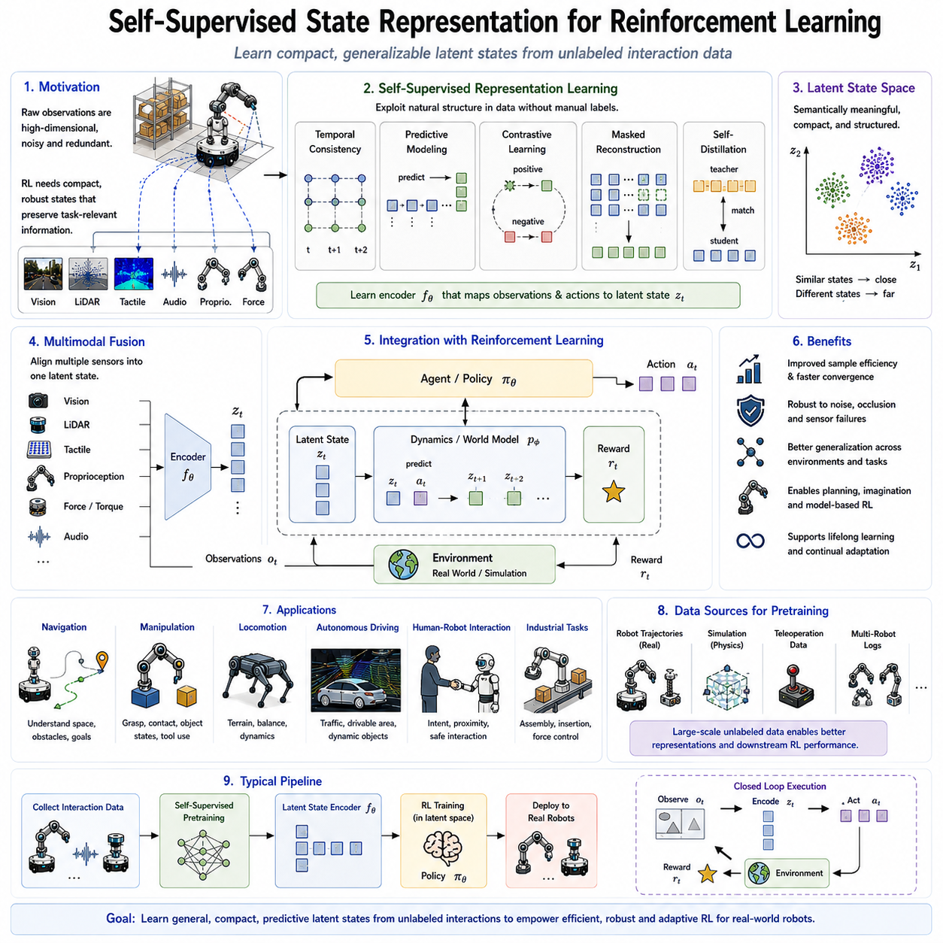
Self-supervised state representation learning has become one of the most important technologies for modern reinforcement learning because the quality of learned behaviors depends heavily on how efficiently an agent represents the surrounding environment. Traditional reinforcement learning often assumes that the state of the environment is directly observable or manually defined. However, real robotic systems operate in complex physical environments where the true state cannot be measured directly. Instead, robots receive high-dimensional sensory observations from cameras, LiDAR sensors, force sensors, tactile arrays, IMUs, microphones, and proprioceptive sensors. These observations contain enormous amounts of redundant information, sensor noise, irrelevant background details, and measurement uncertainty. Self-supervised state representation learning addresses this challenge by automatically transforming raw observations into compact latent state representations that preserve task-relevant information while discarding unnecessary details. Because these representations are learned directly from interaction data without requiring manually labeled supervision, they have become a fundamental component of robot foundation models, embodied intelligence, model-based reinforcement learning, and Physical AI systems.
The central objective of state representation learning is to identify a latent representation that captures all information necessary for decision making while remaining compact, robust, and computationally efficient. A reinforcement learning agent does not require every individual pixel from an RGB image or every point within a LiDAR scan. Instead, it requires an internal state describing object locations, robot pose, obstacle geometry, environmental dynamics, and interaction opportunities. Self-supervised learning enables these latent states to emerge automatically by exploiting temporal consistency, predictive relationships, sensor correlations, action effects, and environmental dynamics rather than relying on manually engineered state variables.
Traditional robotics often relied on handcrafted state representations designed by human engineers. Mobile robots manually combined localization estimates, obstacle maps, and velocity measurements into predefined state vectors. Manipulation systems explicitly encoded joint positions, object coordinates, and force measurements using carefully selected feature engineering. While effective for narrow applications, handcrafted representations frequently fail to generalize across diverse environments, sensing modalities, and task variations. Self-supervised representation learning replaces manual engineering with data-driven learning, allowing robots to automatically discover latent variables describing the underlying physical world through continuous interaction.
One of the fundamental principles underlying self-supervised state representation learning is temporal coherence. Consecutive observations collected during robot operation typically describe gradually evolving physical states rather than abrupt discontinuous changes. A robot moving through a warehouse observes continuous changes in viewpoint while object identities remain stable. A robotic arm gradually changes configuration while manipulating an object. Self-supervised learning exploits these temporal regularities by encouraging neighboring observations to produce similar latent state representations. Such temporal consistency naturally suppresses sensor noise while emphasizing meaningful environmental dynamics.
Predictive learning provides another powerful mechanism for state representation learning. Rather than simply encoding current observations, the neural network learns latent states capable of accurately predicting future observations or future latent states conditioned on robot actions. Successful prediction requires capturing underlying environmental dynamics, object interactions, and causal relationships governing state transitions. Consequently, predictive objectives encourage representations that encode meaningful physical information rather than superficial visual appearance. Such predictive state representations naturally support planning, decision making, and model-based reinforcement learning.
Action-conditioned learning further strengthens state representations by incorporating robot control commands into latent dynamics modeling. Environmental evolution depends not only on current observations but also on actions selected by the reinforcement learning agent. A mobile robot turning left produces different future observations than one moving forward. Similarly, a manipulator closing its gripper generates entirely different contact dynamics than one retracting its arm. Self-supervised state learning therefore jointly models observations and actions, enabling latent states to capture causal consequences of robot behavior. These action-aware representations significantly improve policy learning and long-term planning.
Contrastive learning has become one of the most successful approaches for self-supervised state representation learning. Multiple observations corresponding to identical underlying environmental states are encouraged to produce similar latent embeddings despite visual differences caused by illumination changes, viewpoint variations, sensor noise, or partial occlusions. Conversely, observations corresponding to genuinely different physical states are separated within the latent space. This contrastive organization creates robust state representations that generalize across environmental variability while preserving distinctions relevant for reinforcement learning policies.
Autoencoder-based representation learning also contributes significantly to reinforcement learning. Variational Autoencoders, Masked Autoencoders, and related reconstruction-based methods compress high-dimensional observations into compact latent vectors before reconstructing sensory inputs. Although reconstruction itself is not the final objective, successful compression requires latent representations to capture essential environmental structure. When combined with reinforcement learning, these compressed state representations substantially reduce computational complexity while improving sample efficiency and policy optimization.
Self-distillation methods such as DINO further enhance reinforcement learning representations by encouraging semantic consistency across multiple augmented observations. Teacher and student networks process different views of identical environmental states while producing aligned latent representations without requiring explicit negative samples. Such self-distilled representations frequently exhibit improved robustness against visual appearance changes while preserving semantic information critical for robotic decision making. This property becomes especially valuable in dynamic environments where lighting, weather, background clutter, and sensor conditions continuously vary.
Multimodal state representation learning has become increasingly important because autonomous robots simultaneously employ numerous sensing modalities. Cameras capture visual appearance, LiDAR measures geometry, IMUs estimate motion, tactile sensors detect contact, force sensors monitor interaction dynamics, microphones record acoustic events, and proprioceptive sensors report robot configuration. Self-supervised learning aligns these heterogeneous observations within unified latent state spaces describing the same physical environment. Consequently, reinforcement learning policies operate on comprehensive state representations integrating complementary information from multiple sensing sources rather than relying upon isolated modalities.
Robot navigation illustrates the practical importance of self-supervised state representation learning. Instead of processing raw images directly, navigation policies operate on compact latent states encoding traversable regions, obstacle locations, robot pose, semantic landmarks, dynamic obstacles, and navigational goals. Because these latent representations suppress irrelevant visual details while preserving environmental structure, navigation becomes more robust against illumination changes, seasonal variations, weather conditions, sensor degradation, and environmental clutter encountered during long-term deployment.
Robotic manipulation similarly benefits from learned latent state representations. Successful manipulation requires understanding object geometry, grasp stability, contact conditions, tool relationships, environmental constraints, and robot configuration simultaneously. Raw sensory observations provide fragmented information distributed across multiple sensing modalities. Self-supervised learning integrates these observations into coherent latent representations describing the complete manipulation state. Reinforcement learning policies operating within these latent spaces learn more efficiently while generalizing across diverse object categories, grasp configurations, and manipulation tasks.
Model-based reinforcement learning particularly depends on high-quality state representations because predictive world models simulate future state transitions within latent spaces. Instead of predicting future pixels, latent dynamics models forecast future state embeddings conditioned on planned actions. Accurate latent state representations therefore directly determine planning quality, simulation fidelity, and reinforcement learning sample efficiency. Compact yet informative latent spaces reduce computational requirements while preserving essential environmental dynamics needed for decision optimization.
State abstraction represents another important objective of self-supervised representation learning. Many environmental details remain irrelevant for particular reinforcement learning tasks. For example, warehouse floor textures do not influence navigation decisions, while object color may be irrelevant for force-controlled insertion tasks. Self-supervised objectives encourage representations that automatically discard task-irrelevant information while preserving causal variables affecting future rewards. Such abstraction improves policy generalization, reduces overfitting, and accelerates reinforcement learning convergence.
Disentangled representation learning further extends state abstraction by separating independent environmental factors into distinct latent variables. Position, orientation, object identity, lighting, robot configuration, force distribution, and environmental dynamics become independently encoded whenever possible. Such disentangled representations facilitate transfer learning, policy reuse, hierarchical planning, causal reasoning, and interpretable robot behavior because individual latent dimensions correspond more closely to meaningful physical concepts.
Curiosity-driven reinforcement learning also benefits from self-supervised state representations. Intrinsic motivation algorithms often reward agents for visiting novel or unpredictable states rather than relying exclusively on externally provided rewards. Accurate latent state representations enable reliable novelty estimation by measuring distances within learned embedding spaces instead of raw observation spaces. Consequently, exploration becomes more purposeful and sample efficient, especially in sparse-reward robotic environments where external supervision remains limited.
Offline reinforcement learning increasingly relies upon self-supervised state representation learning because large collections of previously recorded robot trajectories provide abundant unlabeled interaction data. Before reinforcement learning begins, latent state encoders pretrain using temporal prediction, contrastive objectives, reconstruction losses, or multimodal alignment across extensive robot experience datasets. Policies subsequently optimize within these pretrained latent spaces using offline reinforcement learning algorithms. This two-stage approach significantly improves data efficiency while reducing costly real-world robot interaction requirements.
Simulation environments provide particularly valuable resources for self-supervised state representation pretraining. Physics simulators generate unlimited robot trajectories across diverse environments without requiring human annotation. Temporal consistency, action prediction, world modeling, and multimodal sensor alignment naturally support representation learning within simulated environments. Domain adaptation techniques subsequently transfer learned state representations from simulation to physical robots, accelerating policy learning while minimizing expensive real-world data collection.
Several neural architectures support self-supervised state representation learning. Convolutional neural networks efficiently process visual observations, recurrent neural networks capture temporal dependencies, transformers model long-range interactions among observations, graph neural networks describe relational structures, state-space models efficiently represent continuous dynamics, and multimodal transformers integrate heterogeneous sensing modalities. Recent robot foundation models frequently combine multiple architectural components into unified representation learning systems capable of supporting numerous downstream reinforcement learning applications simultaneously.
Despite remarkable progress, important research challenges remain. Learning state representations that generalize across multiple tasks without task-specific supervision remains difficult. Partial observability, sensor failures, dynamic environments, long-horizon dependencies, multimodal uncertainty, and causal reasoning continue challenging current representation learning methods. Furthermore, balancing compactness against information preservation requires careful architectural and objective design because excessively compressed latent spaces may discard critical task-relevant information while overly detailed representations reduce computational efficiency.
Recent research increasingly combines multiple self-supervised objectives within unified reinforcement learning frameworks. Contrastive learning, predictive coding, masked reconstruction, self-distillation, world models, multimodal alignment, temporal consistency, inverse dynamics prediction, forward dynamics modeling, and hierarchical abstraction are optimized jointly to produce comprehensive latent state representations. These hybrid learning approaches capture complementary aspects of environmental structure while substantially improving downstream reinforcement learning performance across navigation, manipulation, locomotion, autonomous driving, and embodied AI applications.
As Physical AI advances toward increasingly autonomous and general-purpose robotic intelligence, self-supervised state representation learning will become one of the foundational technologies enabling scalable reinforcement learning. Future robots will continuously refine their internal state representations through lifelong interaction with the physical world, integrating visual perception, tactile sensing, force feedback, language understanding, predictive world models, and multimodal reasoning into unified latent representations supporting intelligent decision making. Rather than depending upon manually engineered state variables or expensive labeled datasets, autonomous systems will increasingly learn rich, transferable, and interpretable state representations directly from experience, enabling robust adaptation across diverse environments, tasks, and robotic platforms while dramatically improving learning efficiency and long-term autonomy.

03.09 SSL Evaluation Linear Probe Few Shot Protocol [w/Code]
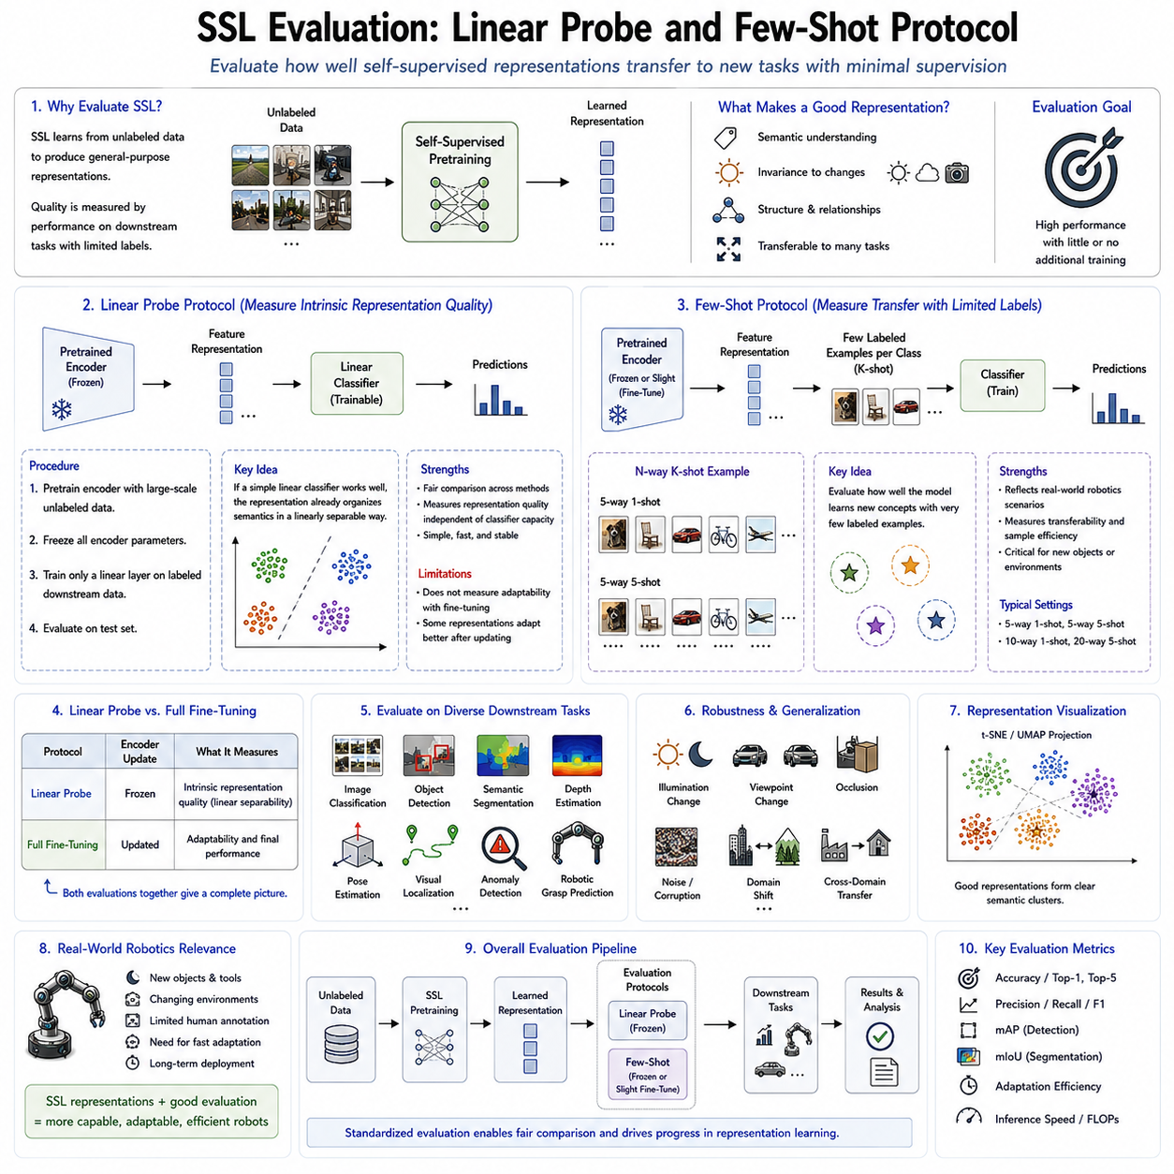
Evaluating self-supervised learning models presents a unique challenge because these models are trained without manually annotated labels. Unlike supervised learning, where classification accuracy directly reflects how well a model has learned predefined categories, self-supervised learning aims to acquire general-purpose representations that can be transferred to numerous downstream tasks. Consequently, the quality of a self-supervised model cannot be judged solely by its pretraining objective, such as reconstruction loss, contrastive loss, or predictive accuracy. Instead, evaluation focuses on measuring how effectively the learned representations support new tasks with minimal additional supervision. Among the numerous evaluation methodologies proposed over the past decade, the Linear Probe protocol and the Few-Shot Learning protocol have become two of the most widely accepted benchmarks for measuring representation quality. These evaluation strategies have become standard practices in computer vision, robot perception, multimodal learning, embodied AI, and robot foundation model development because they provide objective measurements of representation generalization independent of specific downstream architectures.
The primary objective of self-supervised learning is not to solve a single task directly but rather to learn transferable feature representations that encode meaningful semantic information about the surrounding environment. A high-quality representation should preserve object identity, geometric structure, spatial relationships, temporal dynamics, and physical interactions while remaining invariant to irrelevant variations such as illumination, viewpoint changes, sensor noise, and background clutter. Because these properties cannot be measured directly, downstream evaluation becomes the practical mechanism for assessing representation quality. The better the representation transfers to new tasks under limited supervision, the more successful the self-supervised learning algorithm is considered.
Linear Probe evaluation has become the most widely used benchmark because it isolates representation quality from classifier complexity. After self-supervised pretraining is completed, the feature extraction network is completely frozen. None of the encoder parameters are allowed to change during evaluation. Instead, only a simple linear classifier is trained on top of the frozen feature representations using labeled downstream data. Since the encoder remains unchanged, the linear classifier can only exploit information already embedded within the learned latent representations. If the linear classifier achieves high accuracy despite its simplicity, the encoder must already organize semantic information into highly discriminative feature spaces.
The philosophy behind Linear Probe evaluation is based on linear separability. A well-trained representation should naturally cluster semantically similar objects close together while separating different categories in latent space. Under these conditions, a simple linear decision boundary becomes sufficient for classification. Conversely, if meaningful semantic information is poorly organized, even powerful nonlinear classifiers may struggle without extensive fine-tuning. Linear Probe therefore measures whether semantic concepts have already emerged naturally during self-supervised pretraining rather than being created later through supervised optimization.
The standard Linear Probe evaluation procedure consists of several sequential stages. First, the encoder undergoes large-scale self-supervised pretraining using unlabeled datasets. Second, all encoder parameters are frozen permanently. Third, labeled downstream datasets are introduced while only a single fully connected linear layer is optimized. Finally, classification accuracy, precision, recall, F1-score, or task-specific evaluation metrics are measured on held-out test sets. Because only the linear classifier learns during evaluation, improvements primarily reflect representation quality rather than optimization capacity.
One of the major strengths of Linear Probe evaluation is fairness across different self-supervised algorithms. Since every method uses the identical frozen encoder protocol and identical linear classifier architecture, performance differences arise almost exclusively from representation quality. Consequently, methods such as SimCLR, MoCo, BYOL, DINO, MAE, iBOT, VICReg, Barlow Twins, and numerous other self-supervised approaches are commonly compared using standardized Linear Probe benchmarks. This consistency has enabled rapid progress within representation learning research by providing objective evaluation standards across different architectures and datasets.
However, Linear Probe also possesses several important limitations. Because the encoder remains frozen, the evaluation does not measure how effectively representations adapt during downstream fine-tuning. Some representations may initially exhibit modest linear separability while adapting exceptionally well once limited gradient updates become available. Others may perform well under frozen evaluation yet adapt poorly to specialized downstream tasks. Consequently, Linear Probe measures intrinsic representation quality but does not fully characterize practical deployment performance.
To complement Linear Probe evaluation, researchers frequently perform Full Fine-Tuning experiments. In this protocol, the pretrained encoder parameters are allowed to update together with the downstream prediction head. Full Fine-Tuning measures adaptation capability rather than pure representation quality. Comparing Linear Probe and Full Fine-Tuning results provides valuable insights regarding representation robustness, transferability, optimization stability, and downstream learning efficiency. Strong self-supervised models generally achieve competitive performance under both evaluation protocols.
Few-Shot Learning evaluation addresses another fundamental challenge encountered by real-world robotic systems. Unlike benchmark datasets containing thousands of labeled examples per category, practical robotic applications often possess only a handful of labeled observations. Industrial inspection, warehouse automation, medical robotics, agricultural manipulation, underwater exploration, and space robotics frequently encounter novel objects or environments where collecting extensive annotations is impractical. Few-Shot evaluation therefore measures how effectively pretrained representations generalize under extremely limited supervision.
Few-Shot protocols typically provide only one, five, ten, or twenty labeled examples for each downstream category. The pretrained representation remains either frozen or undergoes very limited fine-tuning depending on the evaluation protocol. Performance under these highly constrained conditions directly reflects representation transferability. If semantic information has already been captured during self-supervised pretraining, only minimal labeled supervision becomes necessary for learning new categories. Consequently, Few-Shot performance has become one of the strongest indicators of representation quality for real-world deployment.
The relationship between Few-Shot evaluation and robot learning is particularly significant. Autonomous robots continuously encounter previously unseen objects, tools, materials, people, and environmental conditions throughout long-term operation. Expecting human operators to annotate every newly encountered object is unrealistic. Instead, robots must rapidly adapt using only limited supervision. Self-supervised representations supporting strong Few-Shot generalization therefore dramatically reduce operational costs while improving adaptability across dynamic environments.
Several Few-Shot evaluation protocols have been proposed within the machine learning community. N-way K-shot classification represents the most common benchmark. The model receives N object categories with K labeled examples per category during adaptation, followed by evaluation on previously unseen query examples. Common settings include five-way one-shot, five-way five-shot, ten-way one-shot, and twenty-way five-shot evaluations. These standardized protocols facilitate direct comparison across diverse representation learning methods.
Meta-learning techniques frequently intersect with Few-Shot evaluation. Although self-supervised learning focuses on acquiring transferable representations, meta-learning emphasizes rapid adaptation mechanisms. Combining self-supervised pretraining with meta-learning algorithms often produces highly sample-efficient robotic learning systems capable of generalizing rapidly across new tasks. Such hybrid approaches have become increasingly important for embodied intelligence where environmental diversity continually expands beyond predefined training distributions.
Beyond classification accuracy, comprehensive evaluation increasingly includes multiple downstream tasks reflecting broader representation capabilities. Object detection, semantic segmentation, monocular depth estimation, pose estimation, visual localization, place recognition, anomaly detection, robotic grasp prediction, manipulation planning, and navigation all provide complementary perspectives regarding learned representation quality. Robot foundation models are expected to support diverse downstream applications rather than excelling at only a single benchmark. Consequently, multi-task evaluation has become increasingly important for comprehensive SSL assessment.
Representation visualization provides additional qualitative insight into learned feature spaces. Dimensionality reduction techniques such as t-SNE and UMAP project high-dimensional latent representations into two-dimensional visualizations illustrating semantic clustering behavior. Well-trained self-supervised representations typically organize objects into coherent semantic groups despite receiving no category labels during pretraining. Although visualization does not replace quantitative evaluation, it offers intuitive understanding regarding feature organization, class separation, and representation structure.
Robustness evaluation constitutes another essential component of self-supervised representation assessment. Real robotic systems encounter changing illumination, weather conditions, viewpoint variations, sensor failures, motion blur, partial occlusions, compression artifacts, environmental clutter, and hardware noise. High-quality representations should remain stable under these perturbations. Accordingly, evaluation increasingly includes corrupted datasets, adversarial perturbations, domain shifts, synthetic noise, and cross-environment testing to measure representation robustness beyond standard classification accuracy.
Cross-domain transfer evaluation further examines generalization capability. Self-supervised models pretrained on internet-scale image collections may subsequently transfer to industrial inspection, warehouse robotics, autonomous driving, agricultural monitoring, medical imaging, or household manipulation. Successful transfer across substantially different domains indicates that representations capture universal semantic structure rather than dataset-specific statistical regularities. Such cross-domain adaptability represents one of the primary motivations underlying large-scale self-supervised pretraining.
Multimodal robot foundation models require even broader evaluation protocols. Representations learned jointly from vision, language, tactile sensing, force feedback, proprioception, LiDAR, radar, and audio must transfer consistently across heterogeneous downstream tasks. Evaluation therefore extends beyond conventional image classification toward multimodal alignment accuracy, cross-modal retrieval, sensor fusion performance, embodied reasoning, manipulation success rates, and long-horizon planning capability. Comprehensive benchmarking increasingly reflects the integrated nature of Physical AI systems rather than isolated perception tasks.
Computational efficiency has also become an important evaluation criterion. Practical robotic deployment requires representations supporting real-time inference on embedded hardware with constrained memory, computational power, and energy consumption. Consequently, evaluation increasingly reports encoder parameter count, inference latency, floating-point operations, memory usage, energy efficiency, and edge deployment performance alongside conventional accuracy metrics. Representation quality alone becomes insufficient if computational requirements exceed robotic platform limitations.
Large-scale benchmark datasets have significantly standardized self-supervised evaluation practices. ImageNet Linear Probe remains the most widely recognized benchmark for visual representation learning. Additional datasets spanning object recognition, autonomous driving, robotic manipulation, industrial inspection, medical imaging, satellite imagery, and embodied AI provide increasingly diverse evaluation scenarios. Robot-specific datasets containing multimodal sensory observations further extend these benchmarks toward practical robotic applications involving navigation, manipulation, and interaction.
Modern robot foundation models increasingly adopt hierarchical evaluation pipelines. Initial assessment typically begins with Linear Probe evaluation measuring intrinsic representation quality. Few-Shot evaluation subsequently measures adaptation efficiency under limited supervision. Full Fine-Tuning assesses maximum downstream performance after supervised optimization. Multi-task transfer evaluates generalization across heterogeneous robotic applications. Finally, real-world deployment validates robustness, efficiency, safety, and operational reliability under practical environmental conditions. This progressive evaluation strategy provides comprehensive understanding regarding representation quality from theoretical learning properties through practical autonomous system deployment.
Despite substantial progress, evaluating self-supervised learning remains an active research area. Existing benchmarks often emphasize classification while underrepresenting long-horizon reasoning, physical interaction, continual adaptation, causal understanding, and embodied intelligence. Future evaluation protocols will likely incorporate world models, predictive planning, multimodal reasoning, lifelong learning, simulation-to-real transfer, human-robot collaboration, and autonomous scientific discovery. Rather than measuring isolated perception accuracy alone, evaluation will increasingly assess comprehensive cognitive capabilities supporting intelligent autonomous behavior.
As Physical AI continues evolving toward increasingly capable robot foundation models, Linear Probe and Few-Shot protocols will remain indispensable tools for measuring representation quality. However, they will increasingly operate alongside broader evaluation frameworks assessing robustness, transferability, multimodal reasoning, planning capability, interaction intelligence, and lifelong adaptation. Together, these evaluation methodologies provide objective standards guiding the development of self-supervised representations capable of supporting truly general-purpose robotic intelligence across diverse physical environments while minimizing dependence on expensive manually labeled datasets.

03.10 SSL Pretraining for Robot Foundation Model Init
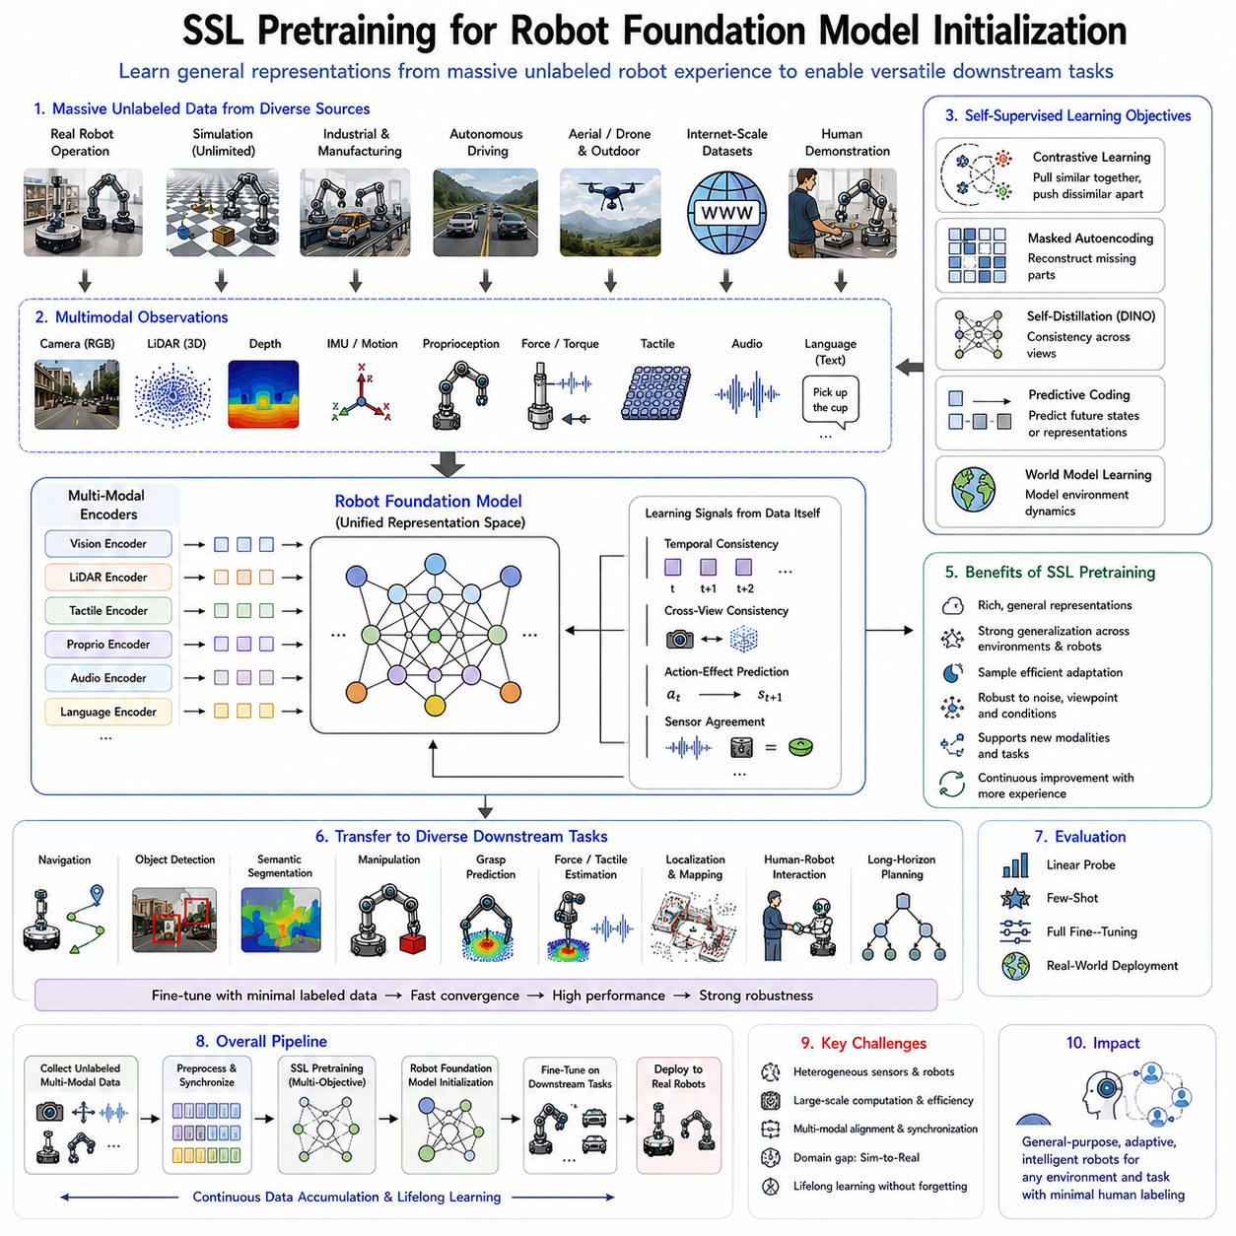
Self-supervised learning (SSL) pretraining has become one of the most critical stages in developing Robot Foundation Models because it enables robots to acquire broad and transferable knowledge before learning task-specific behaviors. Traditional robotic systems were typically trained for a single application using relatively small labeled datasets collected under carefully controlled conditions. Although these systems often achieved high performance within narrow domains, they struggled to generalize to new environments, unseen objects, changing lighting conditions, different robot platforms, or novel manipulation tasks. Robot Foundation Models aim to overcome these limitations by learning universal representations from massive amounts of unlabeled robotic experience. SSL pretraining serves as the initialization phase that allows these large-scale models to build rich perceptual, geometric, temporal, and physical representations before fine-tuning for downstream applications. Similar to how large language models first learn general language understanding before specialization, robot foundation models first learn general world representations through self-supervised learning before adapting to navigation, manipulation, inspection, human-robot collaboration, or autonomous decision-making tasks.
The primary objective of SSL pretraining is not to solve a specific robotic problem directly but to establish a comprehensive understanding of the physical world. During pretraining, robots observe enormous quantities of sensory data collected from real environments, simulations, industrial operations, autonomous driving, warehouse logistics, household activities, and human demonstrations. Since manual annotation of such datasets is prohibitively expensive, self-supervised learning generates supervisory signals automatically from the data itself. Consequently, foundation models gradually learn meaningful representations describing objects, geometry, motion, temporal consistency, physical interactions, spatial relationships, and environmental dynamics without requiring human-provided labels.
Robot Foundation Models differ fundamentally from conventional perception models because they must integrate multiple sensing modalities simultaneously. Cameras provide appearance and semantic information, LiDAR captures three-dimensional geometry, depth cameras estimate spatial structure, IMUs describe robot motion, force sensors measure interaction dynamics, tactile sensors detect physical contact, microphones capture acoustic information, and proprioceptive sensors report robot configuration. SSL pretraining aligns these heterogeneous sensory streams into unified latent representations where complementary information from multiple modalities becomes naturally integrated. Such multimodal representations significantly improve robustness, adaptability, and cross-domain generalization during downstream robotic tasks.
Large-scale robotic data collection has become one of the defining characteristics of SSL pretraining. Modern autonomous systems continuously generate enormous volumes of unlabeled observations during normal operation. Mobile robots produce navigation trajectories, industrial manipulators record assembly sequences, autonomous vehicles capture multimodal driving experiences, drones collect aerial observations, and humanoid robots accumulate interaction histories. Every observation contributes to self-supervised pretraining because future states, temporal continuity, sensor consistency, and action consequences naturally provide supervisory signals. As a result, robot foundation models improve continuously through accumulated operational experience rather than depending exclusively on manually curated datasets.
Several complementary SSL objectives are typically combined during robot foundation model initialization. Contrastive learning encourages semantically similar observations to occupy neighboring regions within latent space while separating unrelated observations. Masked Autoencoders reconstruct missing visual or geometric information, forcing encoders to understand global environmental structure. Self-distillation methods such as DINO encourage semantic consistency across multiple augmented observations without relying on negative samples. Predictive coding estimates future observations or latent representations, enabling models to capture temporal dynamics and causal relationships. World model pretraining extends predictive learning by constructing internal simulations describing environmental evolution. Together, these objectives produce comprehensive representations supporting diverse downstream robotic applications.
Vision-based SSL pretraining forms one of the foundational components of robot foundation models. Massive image collections acquired from industrial facilities, warehouses, construction sites, hospitals, homes, agricultural fields, autonomous vehicles, and internet-scale visual datasets provide billions of unlabeled observations. Rather than memorizing object categories, visual encoders learn invariant semantic representations robust to illumination changes, viewpoint variations, weather conditions, seasonal differences, and background clutter. These pretrained visual representations subsequently transfer effectively to object detection, semantic segmentation, pose estimation, visual localization, manipulation planning, and embodied reasoning.
Three-dimensional representation learning further expands foundation model capabilities beyond conventional image understanding. Point clouds generated by LiDAR sensors, depth maps, occupancy grids, and multi-view reconstructions provide geometric descriptions of physical environments. SSL objectives including masked point reconstruction, geometric contrastive learning, temporal consistency, and cross-view alignment enable robot foundation models to develop rich spatial understanding. These geometric representations support autonomous navigation, simultaneous localization and mapping, obstacle avoidance, terrain analysis, scene reconstruction, and manipulation planning across complex real-world environments.
Temporal representation learning represents another essential component of robot foundation model initialization. Robots interact with continuously evolving environments where objects move, humans act, robots manipulate tools, and physical processes unfold over time. Sequential observations therefore contain valuable temporal relationships unavailable within isolated images. SSL pretraining captures these temporal dependencies through predictive coding, sequence modeling, action prediction, future state estimation, and trajectory forecasting. Learned temporal representations subsequently support activity recognition, behavior prediction, long-horizon planning, manipulation sequencing, and autonomous decision-making.
Action-conditioned representation learning introduces robot behavior directly into the pretraining process. Unlike passive perception systems, robots actively influence future observations through their own actions. Consequently, foundation models learn not only environmental structure but also causal relationships between actions and resulting state transitions. Mobile robots learn how steering commands influence future visual observations, while manipulators learn how gripper movements alter object configurations and tactile feedback. Such action-aware representations establish the foundation for model-based reinforcement learning, imitation learning, behavior cloning, and autonomous planning.
Multimodal alignment has become one of the defining characteristics of next-generation robot foundation models. Self-supervised learning aligns visual, tactile, force, proprioceptive, geometric, and linguistic representations into unified embedding spaces where corresponding concepts naturally converge. For example, an object observed visually before grasping should correspond to tactile and force observations collected during manipulation. Language descriptions referring to actions or objects similarly become associated with corresponding sensor observations and robot behaviors. Such multimodal alignment enables robots to reason across heterogeneous information sources while supporting Vision-Language-Action architectures and embodied artificial intelligence.
Simulation environments play an increasingly important role during SSL pretraining because they generate virtually unlimited robot experiences under diverse conditions. Physics simulators produce synthetic images, point clouds, tactile observations, force measurements, navigation trajectories, manipulation episodes, and multimodal interaction sequences without requiring manual annotation. Self-supervised objectives naturally exploit these observations because they rely on intrinsic consistency rather than externally assigned labels. Domain randomization and simulation-to-real adaptation further improve transferability from virtual environments to physical robotic systems, substantially reducing real-world data collection requirements.
Internet-scale datasets have also become valuable resources for robot foundation model initialization. Large image repositories, video collections, three-dimensional reconstruction datasets, human activity recordings, instructional demonstrations, and multimodal internet content expose foundation models to enormous environmental diversity. Although these datasets may not originate directly from robots, they capture many visual and physical regularities shared with robotic environments. Combined with robot-specific operational data, internet-scale pretraining substantially improves representation generalization while accelerating downstream adaptation.
Embodied datasets generated through robot interaction represent another essential source of pretraining information. Unlike passive visual datasets, embodied experiences include robot actions, sensor observations, environmental responses, and task outcomes. Such interaction histories allow foundation models to learn causal relationships governing physical environments rather than merely recognizing static visual patterns. Continuous interaction enables robots to develop intuitive understanding of object dynamics, contact mechanics, manipulation affordances, navigation constraints, and environmental structure through direct experience.
Robot Foundation Models increasingly incorporate language during SSL pretraining. Language descriptions, task instructions, procedural documentation, maintenance manuals, demonstration captions, and conversational explanations become aligned with corresponding sensory observations and robot behaviors. Although language supervision often originates from externally generated text rather than purely self-supervised objectives, multimodal pretraining integrates linguistic understanding with self-supervised perception and action representations. This integration forms the basis for Vision-Language-Action models capable of executing natural language instructions within physical environments.
After SSL pretraining completes, the resulting Robot Foundation Model serves as a universal initialization for numerous downstream tasks. Instead of training each application independently from random initialization, developers begin with pretrained representations already containing broad knowledge regarding objects, geometry, motion, physics, temporal dynamics, multimodal relationships, and environmental structure. Fine-tuning then requires significantly fewer labeled examples while achieving faster convergence, improved robustness, stronger generalization, and higher overall performance across diverse robotic applications.
Industrial robotics particularly benefits from SSL-based initialization because labeled industrial datasets remain scarce and expensive to acquire. Manufacturing inspection, assembly automation, logistics, warehouse management, collaborative robotics, precision manipulation, and predictive maintenance all involve unique operational conditions difficult to annotate comprehensively. SSL pretraining allows foundation models to leverage vast quantities of unlabeled operational data collected continuously throughout industrial processes. Consequently, downstream industrial applications require substantially less manual annotation while adapting rapidly to changing production environments.
Autonomous driving similarly demonstrates the effectiveness of SSL initialization. Vehicles continuously collect synchronized camera images, LiDAR scans, radar observations, GPS trajectories, inertial measurements, and driver interactions across diverse weather conditions, road types, traffic patterns, and geographical regions. SSL pretraining exploits these multimodal observations to develop robust representations supporting perception, localization, prediction, planning, and safety-critical decision-making. Fine-tuning then specializes the pretrained model for lane detection, object recognition, trajectory prediction, semantic mapping, and autonomous navigation.
Evaluation of SSL-pretrained robot foundation models extends beyond conventional image classification benchmarks. Researchers increasingly measure transfer performance across navigation, manipulation, object detection, semantic segmentation, grasp prediction, force estimation, tactile understanding, localization, reinforcement learning, imitation learning, and long-horizon planning. Linear Probe evaluation assesses intrinsic representation quality, Few-Shot protocols measure adaptation under limited supervision, Full Fine-Tuning evaluates maximum downstream performance, while real-world deployment validates robustness, computational efficiency, and operational reliability. Together, these evaluation methodologies provide comprehensive assessment of foundation model initialization quality.
Despite remarkable progress, several challenges remain in SSL pretraining for robot foundation models. Robotic data exhibit significant heterogeneity across sensor configurations, robot embodiments, environmental conditions, and operational tasks. Temporal synchronization among heterogeneous sensors remains difficult, while multimodal alignment requires sophisticated representation learning strategies. Large-scale pretraining demands substantial computational resources and efficient distributed optimization. Furthermore, ensuring continual adaptation without catastrophic forgetting remains essential as robots accumulate new experiences throughout long-term deployment.
Current research increasingly integrates SSL pretraining with world models, predictive coding, diffusion models, hierarchical planning, multimodal transformers, reinforcement learning, imitation learning, and continual learning into unified robot foundation architectures. Rather than viewing perception, prediction, planning, and control as separate modules, future robot foundation models are expected to learn comprehensive world representations supporting all aspects of embodied intelligence simultaneously. These unified models promise substantially improved scalability, adaptability, sample efficiency, and cross-domain transferability compared with traditional task-specific robotic systems.
As Physical AI progresses toward increasingly autonomous and general-purpose robotic intelligence, SSL pretraining will remain the essential initialization stage for Robot Foundation Models. Future robots will continuously accumulate knowledge from billions of multimodal observations collected throughout lifelong interaction with the physical world. Self-supervised pretraining will transform these experiences into unified latent representations describing perception, geometry, dynamics, physical interaction, language grounding, and environmental reasoning. These pretrained representations will subsequently enable rapid adaptation to entirely new tasks, environments, and robot platforms while dramatically reducing dependence on manually labeled datasets. Consequently, SSL pretraining is expected to serve as the universal foundation upon which the next generation of intelligent, adaptive, and scalable robotic systems will be built.

