Volume 19 Robot Machine Learning and AI

12. Robot AI Case Studies

12.01 Indoor AMR AI Perception Model Production Case
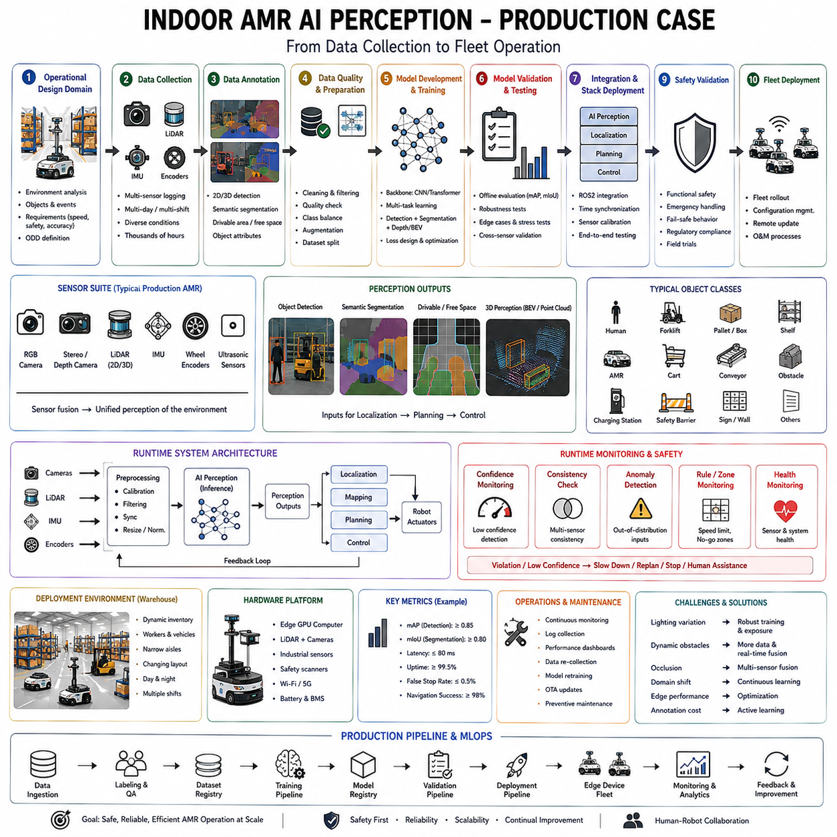
Indoor Autonomous Mobile Robots (AMRs) have become one of the most commercially successful applications of artificial intelligence in robotics. Unlike laboratory research platforms that operate under carefully controlled conditions, production AMRs function continuously inside factories, warehouses, hospitals, airports, semiconductor facilities, logistics centers, retail stores, and distribution hubs where environmental conditions change every day. Their success depends not only on accurate perception algorithms but also on robust engineering, reliable deployment pipelines, efficient hardware utilization, continuous monitoring, and long-term operational maintenance. The transition from a research prototype to a production-grade indoor AMR AI perception system requires solving numerous engineering challenges involving datasets, sensors, neural network optimization, real-time inference, safety validation, runtime monitoring, and fleet-scale deployment. Understanding a complete production case provides valuable insight into how modern AI systems move from experimentation into reliable commercial operation.
Consider a representative production scenario in which a logistics company deploys a fleet of autonomous mobile robots inside a large warehouse responsible for transporting pallets, containers, and inventory between storage locations, production lines, packaging stations, and shipping docks. The warehouse covers tens of thousands of square meters and contains high shelves, narrow aisles, forklifts, human workers, conveyor systems, automated storage equipment, charging stations, and continuously changing inventory. Unlike research environments with static layouts, the warehouse evolves constantly as products move, temporary obstacles appear, maintenance activities occur, and workers interact with robots throughout the day.
The perception system serves as the robot's primary interface with the physical world. Every navigation decision begins with sensor observations collected from multiple complementary sensing modalities. A typical production AMR integrates RGB cameras, stereo cameras or depth cameras, two-dimensional or three-dimensional LiDAR, inertial measurement units, wheel encoders, ultrasonic sensors, and occasionally radar depending on operational requirements. Each sensor contributes different information while compensating for the limitations of others. Cameras provide rich semantic understanding, LiDAR offers accurate geometric measurements, IMUs estimate motion dynamics, and wheel encoders support odometry. Sensor fusion combines these observations into a unified environmental representation significantly more robust than any individual sensor.
The first engineering phase involves defining the operational design domain. Engineers carefully analyze where the robot will operate, what objects it must recognize, expected environmental conditions, allowable speeds, aisle widths, shelf heights, lighting conditions, worker interactions, floor materials, wireless connectivity, charging procedures, and safety requirements. Rather than attempting universal perception, the AI model is optimized specifically for this operational domain. Clear definition of deployment boundaries substantially improves system reliability because training focuses on realistic production conditions instead of unrealistic generalization objectives.
Dataset collection represents one of the largest engineering efforts within the project. Production-quality perception requires datasets reflecting actual warehouse operation rather than publicly available benchmark images. Engineers install prototype sensor systems on manually driven vehicles or early robot platforms and record thousands of operational hours during normal warehouse activity. Data collection spans multiple seasons, day and night shifts, different inventory configurations, varying worker densities, maintenance activities, equipment movement, emergency situations, and cleaning operations. Recording only ideal operating conditions would produce perception systems incapable of handling real deployment variability.
The collected sensor streams include synchronized camera images, LiDAR scans, inertial measurements, wheel odometry, localization information, timestamp synchronization, environmental metadata, robot velocity, battery status, and operational logs. Hardware synchronization becomes critical because perception models frequently fuse observations across multiple sensors. Precision Time Protocol or hardware trigger synchronization ensures that images, LiDAR measurements, and inertial data correspond to the same physical moment, preventing inconsistencies during training.
Data annotation follows collection. Human annotators identify pedestrians, forklifts, pallets, shelves, charging stations, safety barriers, conveyor systems, warning signs, emergency exits, loading docks, robots, carts, and temporary obstacles. Semantic segmentation labels navigable floor regions, restricted areas, storage zones, charging locations, and hazardous spaces. Additional annotations identify free space boundaries, aisle centerlines, pallet orientations, worker positions, and interaction zones. Multiple annotation review stages improve consistency while reducing labeling errors.
Data quality assurance becomes a continuous process rather than a one-time activity. Duplicate images, corrupted sensor recordings, synchronization failures, calibration errors, missing frames, blurred images, and annotation inconsistencies are automatically detected before training. Statistical analysis verifies class balance, environmental diversity, sensor consistency, temporal coverage, and geographical representation throughout the warehouse. Engineers deliberately identify underrepresented situations such as fallen pallets, emergency equipment, unusual worker behavior, damaged shelving, and maintenance operations because these rare scenarios frequently become operational failure cases.
Data augmentation substantially expands environmental diversity. Images undergo illumination variation, color adjustment, motion blur simulation, sensor noise injection, random occlusion, perspective transformation, weather-independent lighting variation, compression artifacts, and camera exposure changes. LiDAR data receive simulated noise, missing returns, range perturbations, and partial occlusion. These augmentations improve robustness against sensor imperfections encountered during long-term deployment.
The perception architecture itself consists of multiple specialized neural networks cooperating rather than one monolithic model. Object detection identifies dynamic and static obstacles including workers, forklifts, carts, and other robots. Semantic segmentation distinguishes traversable floor regions from shelving, walls, machinery, and restricted areas. Pose estimation tracks human body movement for collaborative safety. Instance segmentation separates overlapping objects within crowded environments. Free-space estimation predicts safe navigation corridors, while anomaly detection identifies unfamiliar situations requiring additional caution.
Object detection generally prioritizes real-time inference because navigation depends upon immediate obstacle recognition. Architectures such as optimized YOLO variants frequently balance computational efficiency with detection accuracy. Production deployment emphasizes deterministic latency over maximum benchmark accuracy. A slightly less accurate detector maintaining stable thirty-frame-per-second inference often proves more valuable than a larger model producing irregular execution times.
Semantic segmentation complements detection by providing dense environmental understanding. Rather than recognizing only individual objects, segmentation predicts traversable surfaces, shelving boundaries, floor markings, safety zones, and operational workspaces. Navigation planners rely heavily on this semantic understanding when generating collision-free trajectories.
Localization combines classical robotics algorithms with AI-enhanced perception. LiDAR-based simultaneous localization and mapping establishes geometric consistency, while neural networks recognize semantic landmarks improving long-term localization stability. Visual localization complements geometric methods whenever environmental changes reduce LiDAR reliability. Sensor fusion integrates wheel odometry, inertial measurements, visual features, and map information into probabilistic pose estimates.
Training occurs using large GPU clusters where perception models undergo supervised optimization. Engineers divide datasets into training, validation, and testing subsets while ensuring temporal separation between recording sessions to prevent information leakage. Hyperparameter optimization balances detection accuracy, inference speed, memory consumption, and generalization capability rather than optimizing only benchmark metrics.
Validation extends beyond aggregate accuracy. Performance is measured separately for narrow aisles, intersections, loading zones, charging stations, worker-dense regions, and temporary construction areas. Night shifts, reduced illumination, reflective floors, crowded environments, and partially obstructed sensors receive dedicated evaluation because operational reliability depends upon performance across all deployment conditions rather than average benchmark accuracy.
Model optimization begins after satisfactory validation. Floating-point networks undergo quantization to FP16 or INT8 depending on deployment hardware. Structured pruning removes redundant parameters while preserving prediction quality. Operator fusion, graph optimization, kernel auto-tuning, and memory optimization reduce inference latency without modifying learned behavior. Models are exported through ONNX before deployment using optimized inference engines such as TensorRT or ONNX Runtime according to target hardware.
Edge computing hardware typically consists of embedded GPU systems, industrial edge computers, or dedicated AI accelerators. The perception computer executes multiple neural networks simultaneously while supporting localization, navigation, communication, diagnostics, fleet management, and safety supervision. Careful resource scheduling prevents individual AI workloads from interfering with critical real-time control loops.
The production inference pipeline processes every sensor frame through multiple stages. Raw sensor acquisition is followed by preprocessing including resizing, normalization, geometric correction, synchronization, and tensor conversion. Optimized inference engines execute perception models, after which postprocessing applies non-maximum suppression, confidence filtering, temporal tracking, semantic fusion, and coordinate transformation. The resulting environmental representation becomes available to navigation and motion planning systems within strict real-time deadlines.
Runtime monitoring continuously evaluates prediction confidence, sensor health, inference latency, processor utilization, memory usage, synchronization quality, and environmental consistency. Confidence estimates accompany every perception result. Low-confidence detections trigger conservative navigation behavior including reduced speed, expanded safety margins, or additional sensing rather than immediate execution.
Out-of-distribution detection provides another operational safeguard. Warehouse layouts inevitably evolve as inventory changes, temporary structures appear, or new equipment enters service. OOD detectors identify unfamiliar observations differing substantially from training data, allowing runtime supervisors to increase caution whenever environmental novelty exceeds predefined thresholds.
Anomaly detection complements confidence monitoring by identifying unexpected prediction patterns even when confidence appears high. Sudden disappearance of shelving, impossible obstacle movement, inconsistent segmentation, sensor disagreement, or localization anomalies trigger diagnostic procedures before unsafe navigation decisions occur.
Safety monitoring operates independently from perception itself. Deterministic collision checking, emergency stop circuits, speed limitation, human proximity monitoring, workspace boundaries, and safety-certified controllers supervise AI-generated outputs continuously. Even highly confident perception predictions remain subject to deterministic safety constraints before actuator commands are executed.
Human detection receives particularly conservative treatment because worker safety dominates all other operational objectives. Multiple independent perception pipelines verify pedestrian presence using cameras, LiDAR, and depth sensing simultaneously. Any disagreement among these systems defaults toward protective behavior rather than optimistic interpretation. Dynamic safety zones expand automatically according to robot speed, environmental uncertainty, and worker density.
Fleet management introduces another production consideration absent from most research environments. Hundreds of robots simultaneously share operational data, software updates, perception improvements, localization corrections, and diagnostic information through centralized fleet infrastructure. Operational logs collected across the fleet identify recurring failure patterns, emerging environmental changes, and opportunities for continual improvement.
Continuous deployment pipelines support safe software evolution. Updated perception models first undergo simulation validation, laboratory testing, controlled pilot deployment, limited production rollout, and finally fleet-wide deployment after demonstrating stable operational behavior. Automatic rollback mechanisms restore previous model versions immediately if unexpected degradation appears.
Performance monitoring extends beyond AI accuracy. Engineers continuously evaluate inference latency, processor utilization, memory consumption, battery usage, network bandwidth, thermal behavior, sensor reliability, localization accuracy, navigation efficiency, mission completion rates, emergency stop frequency, and human intervention statistics. These operational metrics often reveal subtle degradation before obvious failures occur.
Failure analysis becomes a continuous engineering activity. Every operational anomaly undergoes systematic investigation using recorded sensor streams, runtime logs, localization history, interpretability tools, confidence estimates, and environmental reconstruction. Root cause analysis distinguishes dataset deficiencies, sensor failures, hardware issues, environmental novelty, algorithmic limitations, and integration problems before corrective actions are implemented.
Dataset expansion continues throughout deployment. Difficult operational scenarios identified during failure analysis become prioritized data collection targets. Engineers annotate new observations, retrain affected perception models, validate improvements, and redeploy updated software through established production pipelines. This continual learning cycle gradually improves operational robustness while maintaining stable production performance.
Industrial maintenance also influences perception reliability. Cameras require cleaning, LiDAR windows accumulate dust, sensor calibration drifts over time, processors experience thermal aging, and mechanical vibration affects alignment. Preventive maintenance schedules therefore include sensor verification alongside traditional mechanical servicing. Automated self-diagnostic routines identify calibration drift before significant perception degradation occurs.
Cybersecurity becomes increasingly important as perception systems integrate cloud connectivity, fleet management, and remote software updates. Secure boot mechanisms, encrypted communication, authenticated software deployment, runtime integrity verification, and access control protect AI infrastructure from unauthorized modification capable of compromising robot safety.
Operational scalability distinguishes production systems from research prototypes. Initial deployment may involve only a handful of robots within one warehouse. Successful commercial systems gradually expand toward multiple facilities operating across different geographical regions. Perception models therefore require adaptation to varying warehouse layouts, regional operational practices, sensor hardware revisions, and infrastructure differences while preserving consistent software architecture.
Economic considerations significantly influence engineering decisions. Higher benchmark accuracy alone rarely justifies increased computational cost if additional hardware substantially raises deployment expenses. Production engineers therefore optimize overall system efficiency, balancing AI performance, hardware cost, maintenance requirements, energy consumption, operational reliability, and long-term scalability.
The production lifecycle never truly ends after deployment. Warehouse environments continue evolving, AI hardware improves, regulatory requirements change, operational objectives expand, and new perception technologies emerge. Successful production AMR platforms therefore adopt modular architectures allowing gradual improvement without disrupting daily operations. Individual perception modules may be upgraded independently while preserving stable interfaces with localization, planning, and control systems.
Modern indoor AMR perception increasingly integrates foundation models, vision-language understanding, multimodal reasoning, and semantic world models alongside conventional object detection and segmentation. Future production systems will recognize complex operational instructions, understand warehouse semantics, predict worker intentions, explain navigation decisions, and adapt continuously to evolving environments while remaining supervised by deterministic safety controllers.
The transition from laboratory AI research to production indoor AMR deployment demonstrates that successful autonomous robotics depends upon far more than neural network accuracy. Reliable commercial systems emerge from the integration of comprehensive datasets, robust sensor fusion, optimized model architectures, efficient edge inference, deterministic safety supervision, runtime monitoring, continuous validation, systematic failure analysis, fleet-scale deployment, and disciplined engineering processes. The perception model becomes one component within a much larger intelligent robotic ecosystem in which data engineering, systems integration, safety management, lifecycle maintenance, and operational monitoring contribute equally to long-term success. As warehouse automation, intelligent logistics, and Physical AI continue expanding globally, production-grade AI perception systems will remain one of the fundamental technologies enabling autonomous mobile robots to operate safely, efficiently, and continuously within complex real-world industrial environments.

12.02 Outdoor AMR RL Policy for Terrain Navigation Case
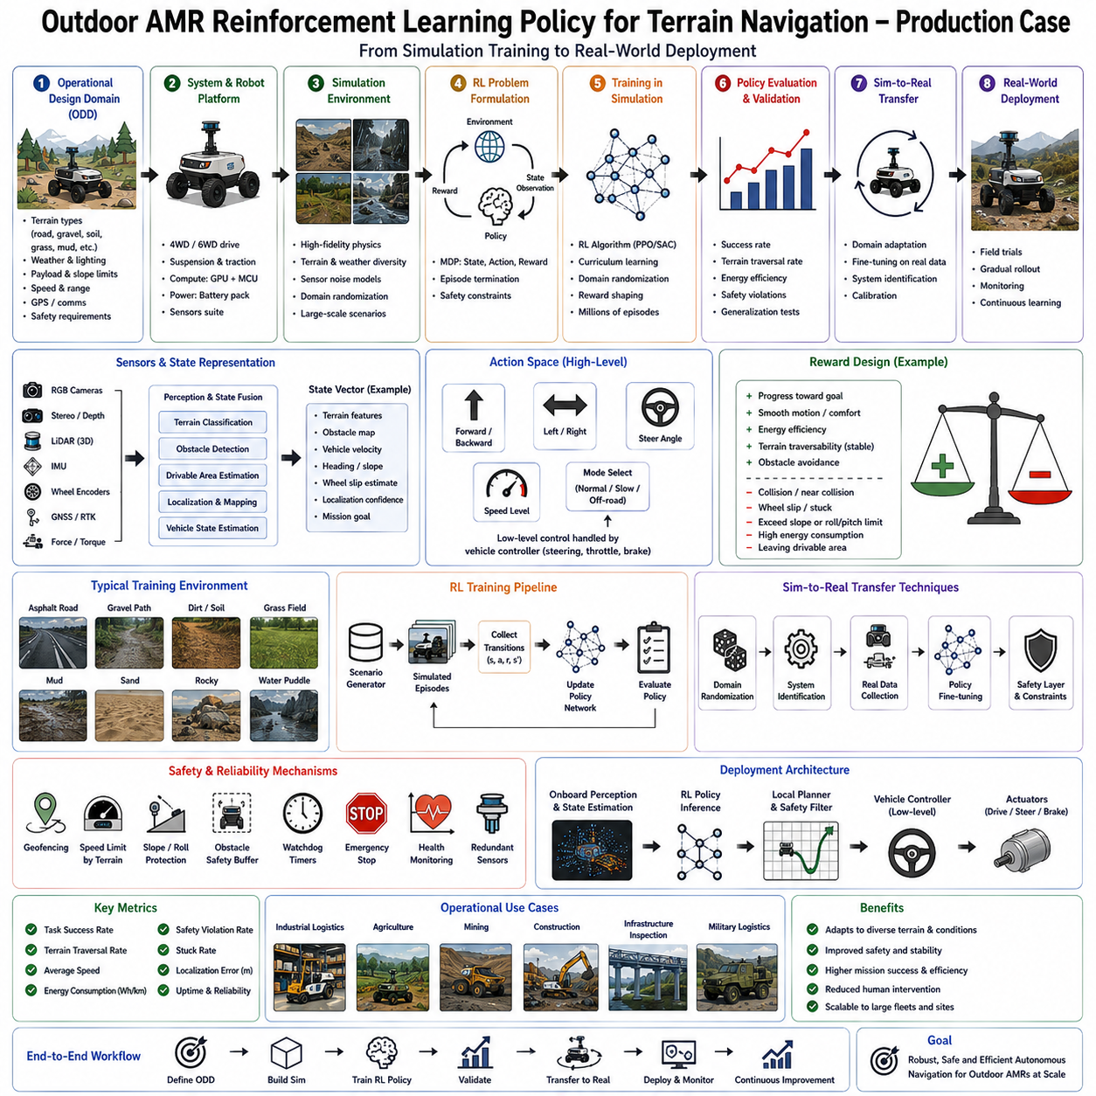
Outdoor Autonomous Mobile Robots (AMRs) operate in environments that are fundamentally more complex and less predictable than indoor robotic systems. While indoor robots navigate relatively structured spaces with stable lighting, well-defined maps, and controlled traffic, outdoor AMRs must function across highly variable terrain, changing weather conditions, uneven ground, dynamic obstacles, vegetation, construction zones, mud, gravel, slopes, water puddles, loose soil, and continuously evolving environmental conditions. Traditional rule-based navigation and classical motion planning remain valuable, but they often struggle to adapt to the enormous diversity of outdoor terrain. Reinforcement Learning (RL) has therefore emerged as one of the most promising approaches for learning terrain-aware navigation policies capable of adapting to complex environments through interaction and experience. A production case involving outdoor terrain navigation illustrates how reinforcement learning evolves from simulation research into reliable autonomous robotic deployment.
Consider a commercial outdoor AMR designed for industrial logistics, infrastructure inspection, smart agriculture, mining support, military logistics, or construction site transportation. The robot weighs several hundred kilograms, carries payloads exceeding 300 kilograms, operates continuously for eight to twelve hours, and navigates over mixed terrain including asphalt roads, gravel paths, compacted soil, grass, concrete surfaces, ramps, mud, shallow water, speed bumps, curbs, and temporary construction obstacles. Unlike laboratory robots that move inside carefully controlled environments, this production platform encounters thousands of terrain transitions every hour while maintaining safety, stability, and operational efficiency.
The central engineering objective is not simply obstacle avoidance but terrain-aware autonomous navigation. Every navigation decision must simultaneously consider traversability, vehicle stability, energy consumption, wheel traction, suspension dynamics, payload stability, passenger or cargo safety, localization uncertainty, and long-term mission efficiency. A reinforcement learning policy becomes responsible for selecting motion commands that maximize mission success while minimizing operational risk across highly uncertain environments.
The development process begins with defining the Operational Design Domain, often abbreviated as ODD. Engineers specify precisely where the robot will operate, expected terrain types, maximum slopes, allowable weather conditions, payload ranges, operational speeds, environmental temperatures, GPS availability, communication infrastructure, and expected obstacle categories. Rather than attempting universal outdoor navigation, the reinforcement learning system is optimized for clearly defined operational boundaries. This disciplined engineering approach greatly improves deployment reliability because the learning problem remains consistent with realistic commercial requirements.
Unlike supervised perception models that learn from labeled datasets, reinforcement learning learns through interaction with an environment. Consequently, constructing an appropriate simulation environment becomes one of the most important engineering tasks. High-fidelity simulators reproduce robot dynamics, terrain physics, tire-ground interaction, suspension behavior, sensor noise, environmental lighting, weather effects, friction coefficients, payload variations, and vehicle inertia. The simulation should capture not only visual appearance but also physical interactions because navigation performance depends heavily upon contact mechanics rather than image recognition alone.
Physics simulation accuracy directly influences policy quality. Wheel slip, suspension compression, rolling resistance, vehicle oscillation, center-of-gravity shifts, actuator delays, and steering dynamics all contribute to successful terrain traversal. Simplified simulations frequently produce policies that perform well virtually but fail during physical deployment because critical dynamics remain unmodeled. Therefore, production simulation environments emphasize accurate physical behavior even at increased computational cost.
The robot's observation space combines information from multiple sensing modalities. RGB cameras provide semantic scene understanding, stereo or depth cameras estimate local terrain geometry, LiDAR produces precise three-dimensional obstacle maps, inertial measurement units measure acceleration and angular velocity, wheel encoders estimate vehicle motion, GNSS provides global positioning when available, and force or torque sensors monitor drivetrain loading. Terrain classification modules additionally estimate surface properties such as gravel, asphalt, grass, mud, sand, or loose soil. Rather than relying upon a single sensor, the policy receives a fused environmental representation integrating geometric, semantic, and dynamic information.
State representation plays a central role in reinforcement learning performance. Raw sensor data generally contain far more information than required for navigation decisions. Feature extraction networks compress sensor observations into compact latent representations describing terrain geometry, obstacle configuration, vehicle state, velocity, heading, slope, slip estimation, localization confidence, and mission objectives. Well-designed state representations significantly accelerate policy learning because they emphasize task-relevant information while suppressing irrelevant environmental variation.
The action space defines what the policy controls. Production outdoor AMRs generally avoid low-level actuator control because motor current regulation, steering servo control, braking, and traction management remain the responsibility of deterministic controllers. Instead, reinforcement learning typically generates higher-level motion commands such as desired linear velocity, angular velocity, steering angle, path curvature, waypoint selection, or local trajectory modifications. This hierarchical architecture combines the adaptability of reinforcement learning with the stability of conventional control engineering.
Reward engineering represents one of the most critical aspects of reinforcement learning development. Unlike supervised learning, where desired outputs are explicitly labeled, reinforcement learning discovers behavior through reward optimization. Consequently, carefully designed reward functions determine which navigation strategies emerge during training.
Mission progress generally provides the primary positive reward. The robot receives increasing reward as it approaches assigned destinations while remaining within navigable corridors. However, maximizing progress alone often produces unsafe aggressive driving behavior. Additional reward components therefore encourage smooth, efficient, and stable navigation.
Collision avoidance contributes substantial negative rewards. Contact with static obstacles, moving vehicles, pedestrians, barriers, infrastructure, vegetation, or environmental hazards immediately reduces cumulative reward. Production systems often assign especially severe penalties to collisions involving humans or safety-critical infrastructure, ensuring that the learned policy naturally prioritizes human safety above operational efficiency.
Terrain traversability forms another important reward component. Rather than simply reaching the destination, the robot learns to prefer stable, energy-efficient surfaces over difficult terrain whenever practical. Smooth asphalt, compacted gravel, or reinforced pathways generally receive higher rewards than mud, loose sand, steep slopes, or rocky ground. Consequently, the learned policy naturally balances travel distance against terrain quality.
Vehicle stability receives continuous evaluation throughout navigation. Excessive roll angle, pitch angle, wheel slip, suspension oscillation, sudden acceleration, harsh braking, or aggressive steering reduce accumulated reward. This encourages policies producing smooth motion that protects payloads, minimizes mechanical wear, and improves passenger comfort where applicable.
Energy efficiency increasingly becomes part of commercial reinforcement learning objectives. Outdoor robots frequently operate for many hours between charging cycles. Efficient navigation extends operational availability while reducing battery degradation. Reward functions therefore penalize unnecessary acceleration, excessive steering corrections, repeated obstacle avoidance maneuvers, or inefficient path selection.
Localization confidence also influences decision making. Areas exhibiting poor GPS reception, degraded LiDAR localization, weak visual features, or uncertain semantic understanding may receive reduced reward unless mission requirements explicitly demand traversal. Policies therefore learn to exploit reliable localization whenever possible while remaining capable of navigating degraded environments cautiously.
Curriculum learning significantly improves policy development. Rather than immediately exposing the robot to highly complex environments, training begins with simple terrain, sparse obstacles, and stable environmental conditions. As learning progresses, increasingly difficult terrain, weather variation, dynamic obstacles, payload changes, and sensor uncertainty are gradually introduced. This staged progression allows the policy to develop robust navigation strategies incrementally.
Domain randomization plays a particularly important role in outdoor reinforcement learning. During simulation, environmental parameters vary continuously across lighting conditions, weather, friction coefficients, tire properties, sensor calibration, terrain textures, vegetation density, obstacle placement, payload weight, and mechanical characteristics. Instead of memorizing one simulation environment, the policy learns behaviors robust across broad environmental variability. Domain randomization substantially reduces the simulation-to-reality gap encountered during physical deployment.
Terrain diversity becomes another essential training consideration. Simulated environments include asphalt roads, dirt tracks, gravel paths, muddy sections, grass fields, rocky terrain, construction debris, curbs, ramps, drainage channels, bridges, temporary obstacles, and mixed-surface transitions. Exposure to diverse terrain enables policies to generalize effectively across real operational environments rather than specializing narrowly.
Modern reinforcement learning algorithms commonly employed in production include Proximal Policy Optimization, Soft Actor-Critic, Deep Deterministic Policy Gradient, Twin Delayed Deep Deterministic Policy Gradient, and distributional reinforcement learning methods. Among these, Proximal Policy Optimization often provides an attractive balance between training stability, sample efficiency, implementation simplicity, and scalability for robotic navigation tasks.
Hierarchical reinforcement learning further improves production performance. High-level policies determine long-range navigation objectives, waypoint selection, terrain preference, or route planning, while lower-level controllers manage local obstacle avoidance, steering refinement, speed regulation, and dynamic stabilization. This decomposition significantly reduces learning complexity because different layers solve problems operating at different temporal scales.
Imitation learning frequently complements reinforcement learning during initial policy development. Experienced human operators manually navigate representative terrain while sensor observations and control actions are recorded. Behavioral cloning initializes navigation policies with reasonable driving behavior before reinforcement learning begins further optimization. This hybrid approach accelerates convergence while reducing unsafe exploration during early learning.
Human demonstrations prove particularly valuable for rare operational situations. Crossing narrow bridges, maneuvering around construction equipment, navigating steep slopes, or handling complex obstacle interactions may occur infrequently during autonomous exploration. Expert demonstrations provide examples difficult for pure reinforcement learning to discover efficiently.
Simulation training typically requires millions or even billions of interaction steps before convergence. Parallel simulation environments distributed across GPU clusters dramatically accelerate data generation. Hundreds or thousands of virtual robots simultaneously explore diverse terrain, producing enormous experience datasets impossible to obtain through physical experimentation alone.
Policy evaluation extends far beyond average reward metrics. Engineers assess navigation success across multiple terrain categories, weather conditions, payload configurations, obstacle densities, communication quality, localization uncertainty, and mission types. Stability, energy consumption, collision frequency, wheel slip, recovery capability, and completion time all contribute to comprehensive policy evaluation.
Safety validation receives particular emphasis before physical deployment. Policies undergo extensive stress testing within simulation under extreme conditions including sensor failures, actuator degradation, GPS denial, unexpected obstacles, severe weather, communication interruptions, payload imbalance, and terrain conditions approaching operational limits. Runtime safety supervisors verify that learned policies remain compatible with deterministic safety constraints.
The transition from simulation to physical robots begins through controlled field testing. Initial experiments occur within restricted proving grounds containing representative terrain but minimal operational risk. Engineers compare simulated predictions with measured physical behavior, identifying discrepancies requiring model refinement. Suspension characteristics, tire deformation, actuator latency, and sensor calibration often require adjustment before large-scale deployment.
System identification significantly reduces the simulation-to-reality gap. Engineers measure actual vehicle dynamics experimentally, estimating friction coefficients, suspension stiffness, drivetrain efficiency, actuator delays, steering response, and sensor characteristics. These measurements refine simulation parameters, improving policy transfer into physical robots.
Once physical deployment begins, reinforcement learning policies operate alongside conventional robotics software rather than replacing it entirely. Global planners generate long-range routes using deterministic mapping algorithms, localization systems estimate robot position through probabilistic sensor fusion, and safety-certified controllers supervise all motion commands. Reinforcement learning contributes adaptive terrain-aware local decision making within this broader autonomous architecture.
Runtime monitoring continuously evaluates policy behavior. Confidence estimation, uncertainty quantification, anomaly detection, sensor consistency analysis, and runtime safety monitors supervise every navigation command before execution. If the policy proposes actions violating predefined safety constraints, deterministic supervisors modify or reject those commands while maintaining operational safety.
Out-of-distribution detection provides another essential deployment safeguard. Outdoor environments continually evolve as vegetation grows, construction progresses, seasonal weather changes, flooding occurs, or new infrastructure appears. When observations differ substantially from training experience, runtime monitors increase safety margins, reduce speed, or request human supervision rather than relying solely upon reinforcement learning decisions.
Terrain classification continues throughout deployment. Neural networks identify surface types while estimating traversability, expected traction, slip probability, and stability margins. These semantic predictions complement geometric obstacle detection because visually similar terrain may exhibit dramatically different physical properties. Wet grass, dry grass, loose gravel, compacted gravel, and muddy soil require distinct navigation strategies despite comparable appearance.
Continuous data collection supports long-term policy improvement. Operational robots record sensor observations, terrain conditions, navigation outcomes, safety interventions, localization performance, and operator feedback. Difficult scenarios identified during deployment become additional simulation benchmarks and retraining datasets, gradually expanding policy competence without compromising operational reliability.
Fleet learning provides another production advantage. Rather than improving each robot independently, operational experience collected across entire fleets contributes toward centralized policy refinement. Successful navigation strategies discovered by one robot become available to all deployed systems following validation and software updates. Consequently, organizational knowledge accumulates much faster than individual robot experience.
Energy management integrates closely with terrain-aware reinforcement learning. Policies increasingly consider battery state, charging station availability, expected terrain difficulty, payload weight, and mission urgency when selecting navigation strategies. Efficient route selection extends operational availability while reducing maintenance costs and battery degradation.
Industrial deployment also emphasizes explainability despite reinforcement learning's inherently complex decision-making process. Runtime visualization tools display terrain classifications, traversability estimates, uncertainty measures, selected actions, and policy confidence, allowing engineers to understand navigation decisions during debugging and operational analysis.
Failure analysis remains an ongoing engineering activity throughout deployment. Every navigation anomaly undergoes systematic investigation using replay systems, simulation reconstruction, interpretability methods, sensor analysis, localization diagnostics, and terrain evaluation. Root cause analysis distinguishes reinforcement learning limitations from sensor failures, localization errors, environmental novelty, or hardware degradation before corrective actions are implemented.
Future outdoor AMR navigation will increasingly integrate reinforcement learning with foundation models, vision-language-action systems, semantic world models, and predictive environmental simulation. Rather than reacting solely to immediate observations, future policies will anticipate long-term terrain evolution, understand natural language mission objectives, reason about environmental semantics, predict human behavior, and cooperate intelligently with other autonomous vehicles operating within shared environments.
Ultimately, the production deployment of reinforcement learning for outdoor terrain navigation demonstrates that successful autonomous robotics requires the integration of advanced learning algorithms with rigorous systems engineering. High-fidelity simulation, comprehensive sensor fusion, realistic reward design, curriculum learning, domain randomization, deterministic safety supervision, runtime monitoring, continual learning, and disciplined operational validation collectively transform reinforcement learning from an academic optimization technique into a reliable industrial technology. The reinforcement learning policy becomes one adaptive component within a comprehensive autonomous navigation architecture where perception, localization, planning, control, safety monitoring, fleet management, and lifecycle maintenance cooperate to enable robust outdoor mobility across the diverse, unpredictable, and continuously changing environments encountered by modern Physical AI systems.

12.03 Mobile Manipulator IL Policy Bin Picking Case
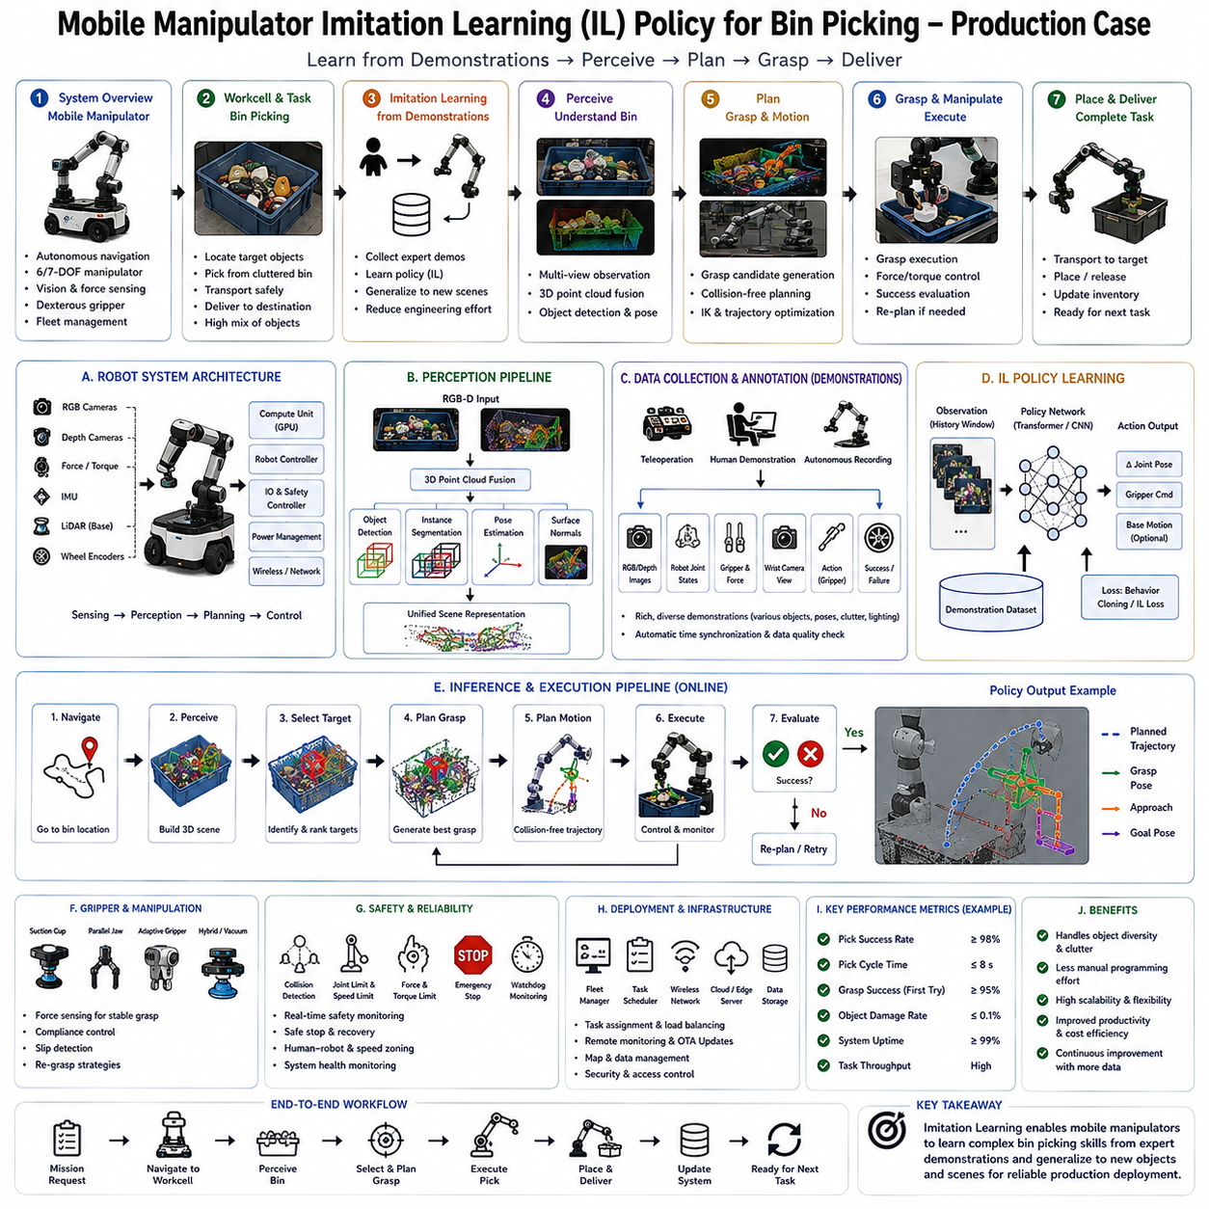
Mobile manipulators represent one of the most important directions in modern robotics because they combine autonomous mobility with dexterous manipulation, allowing robots to navigate freely through large environments while interacting physically with objects. Unlike fixed industrial robotic arms that operate within predefined workcells, mobile manipulators integrate an Autonomous Mobile Robot (AMR) or Automated Guided Vehicle (AGV) with one or more robotic arms, vision systems, force sensors, and intelligent grasp planning algorithms. This combination dramatically expands operational flexibility, enabling robots to perform warehouse picking, logistics handling, factory automation, retail replenishment, hospital supply delivery, recycling, and manufacturing support. Among these applications, autonomous bin picking has become one of the most technically challenging problems because it requires perception, object recognition, pose estimation, motion planning, grasp generation, force control, and manipulation under highly uncertain conditions. Imitation Learning (IL) has emerged as one of the most practical approaches for teaching robots these complex manipulation skills by learning directly from expert demonstrations instead of manually programming every possible behavior.
A production mobile manipulation system typically operates inside a warehouse, manufacturing facility, distribution center, or fulfillment center where products are stored inside plastic containers, metal bins, cartons, shelves, or pallets. Customer orders require robots to locate desired products, navigate to storage locations, identify target objects inside cluttered bins, grasp them reliably despite occlusions, transport them safely, and deliver them to designated destinations. Unlike highly structured industrial automation where every object occupies a precisely known position, warehouse bin picking presents enormous uncertainty. Objects overlap, rotate randomly, partially occlude one another, vary in material properties, reflect light differently, deform under contact, and continually change position after each grasp. Traditional rule-based manipulation struggles to handle this diversity, motivating learning-based approaches capable of adapting through experience.
The development process begins by defining the operational requirements rather than immediately selecting machine learning algorithms. Engineers identify the categories of objects to be manipulated, expected payload ranges, maximum object dimensions, allowable grasp failure rates, required cycle time, workspace geometry, environmental lighting, navigation requirements, safety regulations, storage layouts, and human interaction scenarios. Production deployment emphasizes repeatability and long-term reliability rather than achieving the highest possible benchmark accuracy under laboratory conditions.
The robotic platform generally consists of four tightly integrated subsystems. The mobile base performs autonomous navigation between workstations using simultaneous localization and mapping, obstacle avoidance, and fleet management. The manipulator provides six or seven degrees of freedom for dexterous object handling. The perception system combines RGB cameras, depth cameras, and occasionally wrist-mounted cameras to observe cluttered bins from multiple viewpoints. The gripper incorporates suction cups, parallel fingers, adaptive grippers, vacuum systems, or hybrid end effectors depending upon object diversity. Each subsystem contributes independently, but successful manipulation depends primarily upon their coordination.
Perception represents the first stage of the manipulation pipeline. Before grasp planning can begin, the robot must understand the contents of the storage bin. Multiple RGB-D cameras capture synchronized color and depth information from different viewpoints. Three-dimensional point clouds are generated and fused into a unified representation describing object geometry, free space, occlusion relationships, and bin boundaries. Camera calibration remains critical because millimeter-scale calibration errors propagate directly into grasp failures. Industrial systems therefore perform automatic calibration verification regularly to maintain long-term perception accuracy.
The perception pipeline generally consists of several specialized neural networks rather than one monolithic model. Object detection identifies candidate products inside the bin. Semantic segmentation separates individual objects from neighboring items and the container itself. Instance segmentation distinguishes overlapping products. Pose estimation predicts six-degree-of-freedom object orientation whenever CAD models are available. Surface normal estimation identifies stable grasping regions, while depth completion compensates for missing measurements caused by reflective or transparent materials.
Dataset collection represents one of the largest engineering efforts within the project. Unlike image classification, successful manipulation depends upon observing realistic object arrangements rather than isolated product photographs. Engineers therefore record thousands of warehouse operations using production sensors while workers perform ordinary picking tasks. Data include RGB images, depth maps, point clouds, robot joint positions, gripper state, force measurements, wrist camera observations, navigation information, and complete manipulation trajectories. Every successful and unsuccessful grasp contributes valuable training information.
Annotation extends beyond conventional object labeling. Individual object identities, segmentation masks, six-degree-of-freedom poses, grasp contact locations, successful grasp regions, failed grasp attempts, collision points, object stability, and post-grasp outcomes are recorded systematically. This richer supervision supports multiple learning objectives simultaneously, including perception, grasp prediction, manipulation planning, and policy learning.
Although reinforcement learning has achieved impressive results in research laboratories, imitation learning frequently proves more practical for industrial bin picking because expert demonstrations provide efficient guidance without requiring enormous quantities of trial-and-error exploration. Real warehouse robots cannot afford millions of failed grasp attempts during learning because damaged inventory, equipment wear, and operational downtime impose significant economic costs. Imitation learning instead leverages human expertise accumulated through years of practical experience.
The demonstration phase begins with skilled operators performing representative manipulation tasks. Several demonstration methods may be employed depending upon application requirements. Direct teleoperation allows operators to control the robot using haptic devices, joysticks, or six-degree-of-freedom input controllers. Kinesthetic teaching physically guides lightweight collaborative manipulators through desired trajectories. Virtual reality interfaces allow natural demonstration within immersive simulation environments before transferring knowledge into physical robots. Motion capture systems record human arm movement during manual picking, later mapping those trajectories into robotic kinematics.
Every demonstration produces rich multimodal data rather than merely recording end-effector positions. Camera observations, depth information, robot joint angles, gripper states, force measurements, contact timing, object movement, environmental context, manipulation success, and operator corrections become synchronized into complete demonstration trajectories. The resulting dataset captures not only successful actions but also the reasoning process embedded implicitly within expert behavior.
Behavioral cloning forms the foundation of most production imitation learning systems. Neural networks learn a direct mapping from observed environmental states to demonstrated control actions through supervised learning. Given sensor observations describing the current bin configuration, the network predicts manipulator motions similar to those performed by expert operators. This straightforward formulation provides stable optimization and relatively simple implementation while achieving impressive practical performance for many industrial tasks.
However, ordinary behavioral cloning exhibits an important limitation known as distribution shift. During deployment, even small prediction errors gradually move the robot into states never observed during demonstrations. Since the model has little experience recovering from its own mistakes, errors accumulate over time. Production systems therefore employ additional techniques mitigating this phenomenon.
Dataset Aggregation, commonly abbreviated as DAgger, represents one widely adopted solution. Initial policies generated through behavioral cloning execute manipulation autonomously while expert operators monitor behavior. Whenever policy actions deviate from desirable behavior, operators provide corrective demonstrations for those specific situations. Newly collected examples are incorporated into the training dataset, gradually expanding policy competence into regions initially absent from demonstration data.
The policy architecture itself combines perception and action generation within a unified learning framework. Vision encoders process RGB-D observations into compact latent representations capturing object geometry, spatial relationships, free-space distribution, and semantic information. Additional inputs describe robot joint positions, gripper state, mobile base location, and task objectives. Transformer architectures increasingly replace traditional convolutional networks because attention mechanisms naturally model interactions among multiple objects within cluttered environments.
Temporal modeling plays an important role because manipulation extends across multiple consecutive actions rather than isolated decisions. Recurrent neural networks, temporal transformers, or sequence models maintain internal memory describing previous observations, grasp attempts, object movement, and environmental evolution. This temporal awareness enables more robust manipulation when objects become temporarily occluded during execution.
Action representations vary according to system architecture. Low-level policies predict joint velocities, end-effector poses, or Cartesian motion increments directly. Higher-level policies instead generate grasp candidates, intermediate manipulation goals, or task sequences subsequently executed by conventional motion planners. Production systems frequently favor hierarchical architectures because deterministic motion planning guarantees collision-free execution while imitation learning contributes adaptive decision making.
Grasp generation constitutes one of the most challenging components of autonomous bin picking. Rather than predicting a single grasp location, modern networks estimate grasp quality across numerous candidate grasp poses distributed throughout three-dimensional space. Each candidate receives probability estimates describing expected success under current environmental conditions. Collision checking, kinematic feasibility, manipulator reachability, and task constraints subsequently filter these candidates before selecting the final grasp.
Depth information dramatically improves grasp prediction because object geometry strongly influences stable contact. Point cloud processing networks analyze surface curvature, edge structure, accessible contact regions, occlusion boundaries, and free-space availability. Geometric reasoning complements learned visual representations, producing grasp candidates robust across diverse object categories.
Simulation plays a significant supporting role during policy development. High-fidelity physics simulators reproduce robot dynamics, contact mechanics, object friction, grasp interaction, collision behavior, and sensor characteristics. Thousands of virtual objects with randomized shape, texture, material, mass, friction, and placement generate extensive synthetic manipulation experience difficult to collect physically. Domain randomization further improves policy robustness by varying lighting, camera calibration, sensor noise, object appearance, and environmental layout throughout simulation.
Unlike pure reinforcement learning, simulation primarily supplements rather than replaces real demonstrations. Synthetic experience expands coverage of rare situations, unusual object configurations, and difficult grasp scenarios while preserving the high-quality behavioral guidance provided by expert operators. This hybrid strategy substantially reduces physical data collection costs.
Curriculum learning further improves training efficiency. Policies initially manipulate isolated objects inside uncluttered bins. Gradually increasing clutter introduces overlapping objects, partial occlusions, narrow free-space regions, unstable object stacks, deformable materials, transparent containers, and mixed-product bins. Progressive task complexity allows policies to develop stable manipulation skills before confronting highly challenging scenarios.
Policy evaluation extends far beyond simple grasp success rates. Engineers evaluate cycle time, motion smoothness, collision frequency, object damage, recovery capability, force control stability, navigation efficiency, computational latency, energy consumption, and long-term operational reliability. Separate evaluations examine different object categories, packaging materials, lighting conditions, bin geometries, and clutter densities because average benchmark performance rarely predicts production success accurately.
Force sensing provides another critical production capability. Visual perception alone cannot reliably determine contact quality during grasp execution. Wrist-mounted force-torque sensors measure contact forces continuously, allowing compliant motion control, slip detection, object verification, insertion guidance, and adaptive grasp adjustment. Learned policies increasingly integrate force information directly into observation spaces, improving manipulation robustness substantially.
Closed-loop visual servoing complements imitation learning during execution. Rather than following demonstrated trajectories rigidly, wrist-mounted cameras continuously observe object motion while visual feedback corrects manipulator trajectories in real time. This feedback compensates for localization uncertainty, object movement, and mechanical tolerances impossible to eliminate completely through open-loop planning.
Runtime safety monitoring supervises every manipulation command before execution. Deterministic collision detection, joint limit verification, singularity avoidance, workspace constraints, payload monitoring, force limits, and emergency stop systems operate independently from learned policies. Even highly confident imitation learning outputs remain subject to conventional robotic safety supervision before actuators receive commands.
Out-of-distribution detection provides additional operational protection. Warehouses continually introduce new products, packaging materials, storage containers, and inventory layouts. When observations differ substantially from training experience, uncertainty estimation increases and runtime supervisors invoke conservative behaviors such as requesting human intervention, capturing additional viewpoints, or switching to predefined recovery procedures.
Failure recovery distinguishes production systems from many research demonstrations. Grasp failures inevitably occur despite sophisticated learning algorithms. Rather than terminating execution, production robots recognize unsuccessful grasps through force sensing, vision feedback, and object tracking. Recovery policies reposition cameras, adjust grasp candidates, reorder manipulation sequences, or temporarily rearrange clutter before attempting subsequent grasps. Robust recovery substantially increases overall system throughput despite occasional individual failures.
Continuous data collection supports long-term policy improvement after deployment. Every manipulation attempt generates valuable operational data including successful grasps, failed grasps, environmental observations, force measurements, recovery actions, and operator interventions. Engineers periodically incorporate these real-world experiences into updated imitation learning datasets, gradually expanding policy robustness without disrupting ongoing production.
Fleet learning further accelerates improvement. Multiple mobile manipulators operating across warehouses collectively contribute operational experience toward centralized model refinement. Difficult manipulation scenarios encountered by one robot become training examples benefiting every deployed system after validation and controlled software rollout.
Software deployment follows disciplined MLOps procedures. Updated perception networks, imitation learning policies, and grasp planners undergo simulation validation, laboratory testing, pilot deployment, limited production rollout, and finally fleet-wide deployment after demonstrating stable operational performance. Automatic rollback mechanisms restore previous software versions immediately if unexpected degradation appears.
Industrial deployment also emphasizes maintainability. Camera calibration, gripper wear, sensor cleaning, mechanical backlash, joint friction, and end-effector replacement all influence manipulation quality. Automated diagnostic routines monitor calibration accuracy, force sensor health, actuator performance, and perception consistency continuously, scheduling preventive maintenance before significant degradation occurs.
Modern mobile manipulation increasingly integrates foundation models and vision-language-action architectures with traditional imitation learning. Rather than learning isolated picking policies, future robots will understand natural language instructions, reason about object semantics, plan multi-step manipulation strategies, generalize across previously unseen products, and coordinate mobile navigation with dexterous manipulation within unified multimodal architectures.
World models further extend manipulation capability by predicting object dynamics before physical interaction. Instead of reacting only to current observations, robots simulate multiple possible grasp outcomes internally, selecting actions expected to maximize long-term task success while minimizing object disturbance and manipulation uncertainty.
Ultimately, the production deployment of imitation learning for mobile manipulator bin picking demonstrates that successful autonomous manipulation requires far more than accurate neural network predictions. Reliable commercial systems emerge through the integration of comprehensive multimodal datasets, expert demonstrations, robust perception, force sensing, simulation, domain randomization, runtime safety supervision, continual learning, systematic failure analysis, and disciplined engineering processes. Imitation learning provides the adaptive decision-making capability enabling robots to acquire human manipulation expertise efficiently, while conventional robotics engineering ensures safe, repeatable, and scalable operation. Together, these technologies transform autonomous mobile manipulators from laboratory prototypes into practical industrial systems capable of performing reliable warehouse automation, intelligent logistics, flexible manufacturing, and the next generation of Physical AI-driven manipulation tasks in complex real-world environments.

12.04 Quadruped RL Locomotion Policy Field Deployment Case
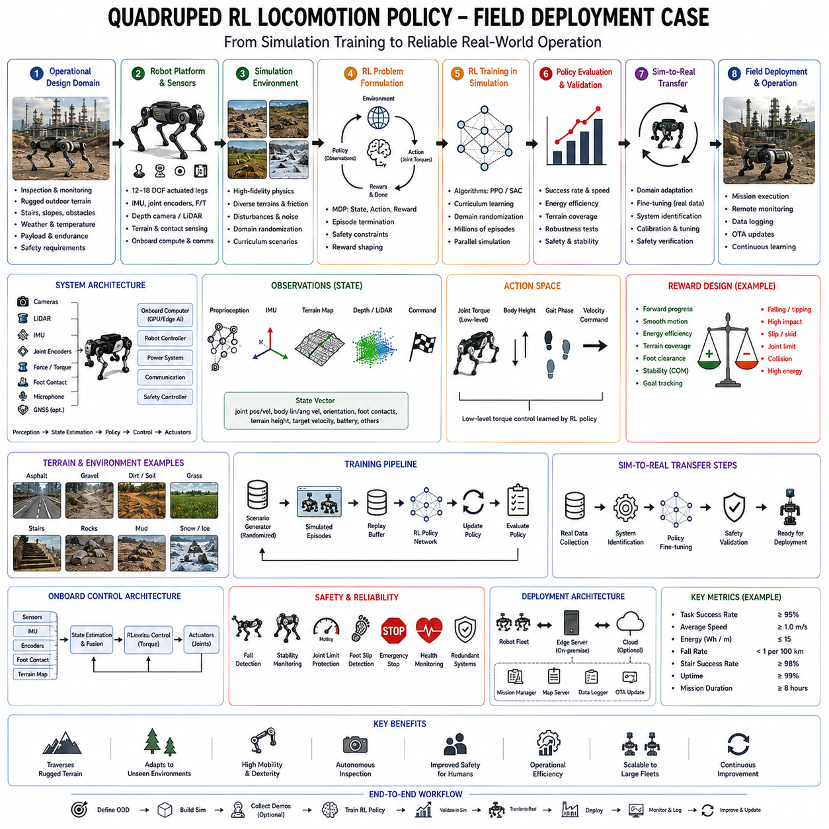
Quadruped robots have emerged as one of the most important embodiments of modern Physical AI because they combine the mobility of biological animals with the computational capabilities of advanced artificial intelligence. Unlike wheeled Autonomous Mobile Robots (AMRs), which perform exceptionally well on structured floors and paved roads, quadruped robots are capable of traversing uneven terrain, climbing stairs, stepping over obstacles, crossing rocks, walking through forests, navigating construction sites, and operating in disaster environments where wheels often become ineffective. These capabilities make quadruped robots valuable for industrial inspection, military logistics, search and rescue, infrastructure maintenance, mining, agriculture, energy facilities, and scientific exploration. While classical robotics relied on manually designed gait controllers, modern quadruped locomotion increasingly depends on Reinforcement Learning (RL), allowing robots to discover highly adaptive walking strategies through experience rather than explicit programming. A complete production deployment case illustrates how reinforcement learning evolves from simulation experiments into reliable field-ready locomotion systems capable of operating continuously under real-world conditions.
Consider a commercial quadruped inspection robot deployed within large industrial facilities such as oil refineries, petrochemical plants, electrical substations, mining operations, solar farms, offshore platforms, railway infrastructure, or nuclear facilities. The robot performs autonomous inspection missions several times each day while carrying cameras, thermal sensors, LiDAR, gas detectors, microphones, communication equipment, and onboard edge AI computers. Unlike research demonstrations performed inside laboratories, production deployment requires operation during rain, snow, dust, extreme temperatures, changing illumination, uneven terrain, metal staircases, gravel roads, mud, vegetation, and continuously evolving industrial environments. The locomotion policy therefore becomes the foundation supporting every higher-level autonomous capability.
The engineering process begins by defining the operational design domain rather than immediately designing reinforcement learning algorithms. Engineers determine the maximum allowable terrain slope, stair geometry, obstacle height, payload weight, walking speed, mission duration, operating temperature, expected weather conditions, communication availability, battery capacity, and required safety margins. A robot intended for refinery inspection faces different terrain characteristics than one designed for mountain rescue or agricultural monitoring. Clearly defining deployment boundaries significantly improves reinforcement learning efficiency because optimization focuses on realistic operational requirements rather than unrealistic universal locomotion.
One of the central challenges of quadruped locomotion lies in the complexity of whole-body dynamics. A four-legged robot possesses dozens of interacting degrees of freedom involving hip joints, knee joints, body orientation, inertia, contact forces, friction, actuator dynamics, suspension effects, and payload variation. Every movement changes the distribution of forces throughout the robot while continuously altering stability. Designing explicit mathematical controllers capable of handling every possible terrain configuration becomes extraordinarily difficult. Reinforcement learning instead discovers effective locomotion strategies automatically through repeated interaction with simulated environments.
Simulation therefore becomes the first major engineering stage. High-fidelity physics simulators reproduce rigid-body dynamics, joint friction, actuator characteristics, contact mechanics, foot-ground interaction, collision behavior, sensor noise, battery effects, payload inertia, and environmental disturbances. Unlike conventional animation, robotics simulation emphasizes physical realism because even small inaccuracies in contact modeling may produce learned behaviors that fail during physical deployment. Engineers therefore invest substantial effort validating simulation accuracy before large-scale policy training begins.
Accurate contact modeling represents one of the most important aspects of quadruped simulation. Every walking cycle depends upon foot placement, ground reaction forces, friction coefficients, impact dynamics, slip behavior, compliance, and terrain deformation. Walking across concrete differs fundamentally from walking on gravel, mud, wet grass, snow, sand, or loose rocks. Production simulations therefore include diverse terrain models with varying friction, compliance, roughness, and stability rather than assuming ideal rigid ground.
The robot's observation space integrates information from multiple sensing systems. Joint positions, joint velocities, actuator torques, inertial measurement units, body orientation, angular velocity, foot contact sensors, terrain elevation maps, depth cameras, LiDAR, proprioceptive sensing, battery state, payload estimation, and commanded navigation goals collectively describe the current robot state. Unlike image classification tasks where observations consist primarily of pixels, quadruped locomotion depends heavily on proprioception because body dynamics directly determine walking stability.
State representation carefully balances information richness against computational efficiency. Raw sensor measurements are transformed into compact feature vectors describing robot posture, foot positions, body velocity, terrain inclination, contact status, stability margins, and navigation objectives. Well-designed state representations accelerate learning because reinforcement learning algorithms focus on physically meaningful variables rather than redundant sensor information.
The action space determines what aspects of locomotion the policy controls. Early reinforcement learning research frequently generated low-level actuator torques directly. Although this approach provides maximum flexibility, it also creates difficult optimization problems and may produce unstable behavior. Production systems increasingly employ hierarchical control architectures. High-level reinforcement learning policies generate desired foot trajectories, body velocities, gait parameters, or joint position targets, while deterministic low-level controllers perform precise motor regulation. This combination preserves reinforcement learning adaptability while benefiting from decades of classical control engineering.
Reward engineering plays a decisive role in locomotion quality. Unlike supervised learning, reinforcement learning receives no explicit examples describing correct walking behavior. Instead, engineers design reward functions encouraging desirable characteristics while discouraging unsafe or inefficient motion. The learned policy ultimately reflects the balance among these competing objectives.
Forward progress generally provides the primary positive reward. The robot receives increasing reward for moving efficiently toward assigned destinations. However, maximizing speed alone frequently produces unstable running behavior, excessive energy consumption, or dangerous falls. Consequently, numerous additional reward components shape locomotion toward practical industrial performance.
Stability represents one of the highest priorities. Excessive body roll, pitch oscillation, yaw instability, slipping, stumbling, or falling incur substantial penalties. The reinforcement learning policy gradually discovers smooth walking patterns minimizing unnecessary body motion while maintaining balance across challenging terrain.
Energy efficiency also receives explicit consideration. Industrial quadruped robots often perform multi-hour inspection missions where battery capacity limits operational productivity. Reward functions therefore discourage unnecessary joint movement, excessive actuator torque, repeated acceleration, and inefficient gait transitions. Efficient walking not only extends mission duration but also reduces actuator heating and mechanical wear.
Foot slip receives significant penalties because stable traction remains essential for safe locomotion. During simulation, foot contact models estimate tangential motion relative to the ground surface. Policies naturally learn to distribute body weight appropriately, reduce unnecessary lateral forces, and adapt foot placement according to terrain friction.
Smooth motion contributes both operational safety and sensor quality. Inspection payloads frequently include thermal cameras, optical zoom cameras, LiDAR scanners, acoustic sensors, and gas detection equipment. Excessive vibration degrades sensing performance. Consequently, reward functions penalize abrupt body acceleration, jerky gait transitions, and unnecessary oscillation, encouraging stable locomotion beneficial for perception systems.
Foot clearance becomes another important optimization objective. Feet lifted too low frequently collide with obstacles, while excessively high leg motion wastes energy and reduces walking efficiency. Reinforcement learning naturally discovers efficient swing trajectories balancing obstacle avoidance with energy conservation.
Curriculum learning substantially accelerates policy convergence. Initial training occurs on perfectly flat terrain without disturbances. Once stable walking emerges, increasingly difficult environments are introduced gradually. Terrain roughness, slope variation, stairs, rocks, mud, external pushes, payload changes, actuator delays, sensor noise, and weather simulation progressively increase throughout training. This staged progression allows locomotion skills to develop systematically rather than overwhelming optimization with excessive complexity initially.
Domain randomization represents another essential production technique. During simulation, environmental properties vary continuously. Ground friction, actuator characteristics, payload mass, joint damping, sensor calibration, terrain geometry, lighting conditions, contact compliance, communication latency, and mechanical tolerances all change randomly between episodes. Rather than memorizing one simulation environment, the reinforcement learning policy learns behaviors robust across broad environmental uncertainty. Domain randomization substantially reduces the simulation-to-reality gap encountered during deployment.
Disturbance injection further improves robustness. External forces push the robot unexpectedly during training, simulating wind, accidental human contact, uneven loading, terrain collapse, or unexpected impacts. Recovery behaviors emerge naturally because policies maximizing long-term reward learn to regain balance instead of terminating episodes through falls.
Modern reinforcement learning algorithms commonly employed for quadruped locomotion include Proximal Policy Optimization, Soft Actor-Critic, Twin Delayed Deep Deterministic Policy Gradient, Advantage Actor-Critic, and model-based reinforcement learning approaches. Among these, Proximal Policy Optimization has become particularly popular because it balances training stability, implementation simplicity, computational efficiency, and excellent locomotion performance across diverse robotic platforms.
Massively parallel simulation dramatically reduces training time. Thousands of virtual quadruped robots execute locomotion simultaneously across GPU clusters. Parallel experience generation allows billions of interaction steps within days rather than years of physical experimentation. Such scalability would be impossible using physical robots alone because actuator wear, battery charging, maintenance, and safety constraints severely limit real-world data collection.
After convergence within simulation, engineers begin systematic simulation-to-reality transfer. Direct deployment rarely succeeds without additional refinement because even highly accurate simulators cannot perfectly reproduce physical hardware. Engineers therefore perform detailed system identification experiments measuring actuator dynamics, joint friction, sensor latency, battery voltage effects, payload inertia, contact mechanics, and structural flexibility. These measurements improve simulation fidelity before retraining or fine-tuning policies.
Physical deployment begins within controlled testing environments rather than immediately entering operational facilities. Indoor laboratories, outdoor proving grounds, artificial terrain courses, stairs, ramps, gravel paths, and obstacle fields allow engineers to compare simulated predictions against measured robot behavior safely. Walking stability, recovery capability, energy consumption, foot trajectories, actuator loading, and body motion undergo extensive validation before broader deployment.
Runtime safety supervision remains essential despite successful reinforcement learning. Learned policies never command actuators directly without oversight. Independent safety controllers continuously monitor body orientation, joint limits, actuator temperature, battery voltage, communication health, sensor integrity, and collision risk. Whenever reinforcement learning outputs violate predefined safety constraints, deterministic supervisors modify or override commands before execution.
Control Barrier Functions increasingly provide mathematically guaranteed safety envelopes surrounding learned policies. Reinforcement learning remains free to optimize locomotion within certified safe regions, while barrier functions prevent behaviors potentially leading to instability, self-collision, excessive joint loading, or dangerous body orientations. This hybrid architecture combines reinforcement learning flexibility with formal safety guarantees.
Terrain perception operates continuously during deployment. Depth cameras and LiDAR generate local elevation maps describing upcoming terrain geometry. Semantic segmentation identifies grass, concrete, gravel, stairs, mud, vegetation, puddles, rocks, and industrial infrastructure. Rather than reacting solely through proprioception, the robot anticipates terrain changes before physical contact occurs, adjusting gait proactively.
Height maps become particularly valuable for foothold planning. Three-dimensional terrain representations estimate traversability, obstacle height, slope, and local roughness. Reinforcement learning policies integrate these maps directly into observation spaces, enabling adaptive foot placement according to upcoming terrain rather than relying only upon immediate contact feedback.
Proprioception remains equally important. Joint encoders, force sensors, inertial measurements, and contact detectors provide immediate feedback regarding body dynamics. Unexpected foot slip, soft ground, unstable rocks, or hidden obstacles become apparent through proprioceptive sensing even before visual perception recognizes them. Integrating exteroceptive and proprioceptive information substantially improves locomotion robustness.
Operational deployment frequently requires dynamic gait adaptation. Walking, trotting, pacing, bounding, stair climbing, crouching, and obstacle stepping represent distinct locomotion modes optimized for different terrain conditions. Rather than switching among manually designed gait controllers, reinforcement learning increasingly learns smooth transitions automatically according to environmental requirements and mission objectives.
Energy management significantly influences commercial viability. Reinforcement learning policies consider battery state, mission duration, terrain difficulty, payload weight, and expected travel distance when selecting locomotion strategies. Conservative energy-efficient gaits extend inspection missions, while higher-energy aggressive locomotion remains available only when operationally justified.
Fleet deployment introduces another important engineering consideration. Large industrial organizations may operate dozens or hundreds of quadruped robots simultaneously across geographically distributed facilities. Operational logs collected throughout the fleet identify emerging failure patterns, unusual terrain conditions, actuator degradation, battery aging, and opportunities for policy improvement. Fleet learning allows operational experience gathered by one robot to benefit every deployed platform after validation.
Runtime monitoring continuously supervises locomotion quality. Confidence estimation, anomaly detection, out-of-distribution detection, sensor consistency monitoring, actuator diagnostics, thermal management, communication integrity, localization quality, and terrain uncertainty all contribute to operational safety. Elevated uncertainty triggers reduced walking speed, expanded stability margins, or requests for human supervision rather than relying exclusively upon learned policies.
Failure analysis remains an ongoing engineering activity. Every stumble, slip, recovery maneuver, actuator anomaly, localization failure, or unexpected terrain interaction undergoes systematic investigation using replay systems, sensor logs, simulation reconstruction, policy visualization, and root cause analysis. Engineers distinguish reinforcement learning limitations from hardware faults, environmental novelty, sensor degradation, or integration issues before implementing corrective improvements.
Continuous learning supports long-term operational improvement without compromising safety. Difficult terrain encountered during deployment becomes additional simulation scenarios, while validated operational data contribute toward future policy refinement. However, online learning generally occurs offline within carefully controlled development environments rather than directly during field operation because uncontrolled policy modification introduces unacceptable safety risks.
Integration with higher-level autonomy transforms locomotion into one component of complete robotic intelligence. Mission planners assign inspection objectives, localization systems estimate robot position, semantic mapping identifies infrastructure, perception models detect anomalies, communication systems coordinate fleet operation, and reinforcement learning provides adaptive mobility across challenging terrain. Successful field deployment therefore depends upon cooperation among numerous intelligent subsystems rather than locomotion alone.
Future quadruped robots will increasingly integrate reinforcement learning with foundation models, world models, vision-language-action architectures, predictive terrain simulation, and long-horizon planning. Rather than simply learning stable walking, future systems will reason about terrain semantics, anticipate environmental evolution, understand natural language mission objectives, cooperate with human operators, and optimize locomotion jointly with inspection, manipulation, and autonomous decision making.
Ultimately, the production deployment of reinforcement learning for quadruped locomotion demonstrates that successful field robotics requires far more than discovering effective walking policies within simulation. Robust commercial systems emerge through the integration of high-fidelity physics simulation, curriculum learning, domain randomization, hierarchical control, terrain perception, deterministic safety supervision, runtime monitoring, continual validation, fleet learning, and disciplined systems engineering. Reinforcement learning provides the adaptive intelligence enabling quadruped robots to traverse diverse real-world terrain, while conventional robotics engineering ensures reliability, safety, maintainability, and long-term operational performance. Together these technologies transform quadruped robots from impressive laboratory demonstrations into practical industrial platforms capable of continuous autonomous operation across the challenging environments that define the future of Physical AI.

12.05 Humanoid Physical AI Multi Task Learning Case
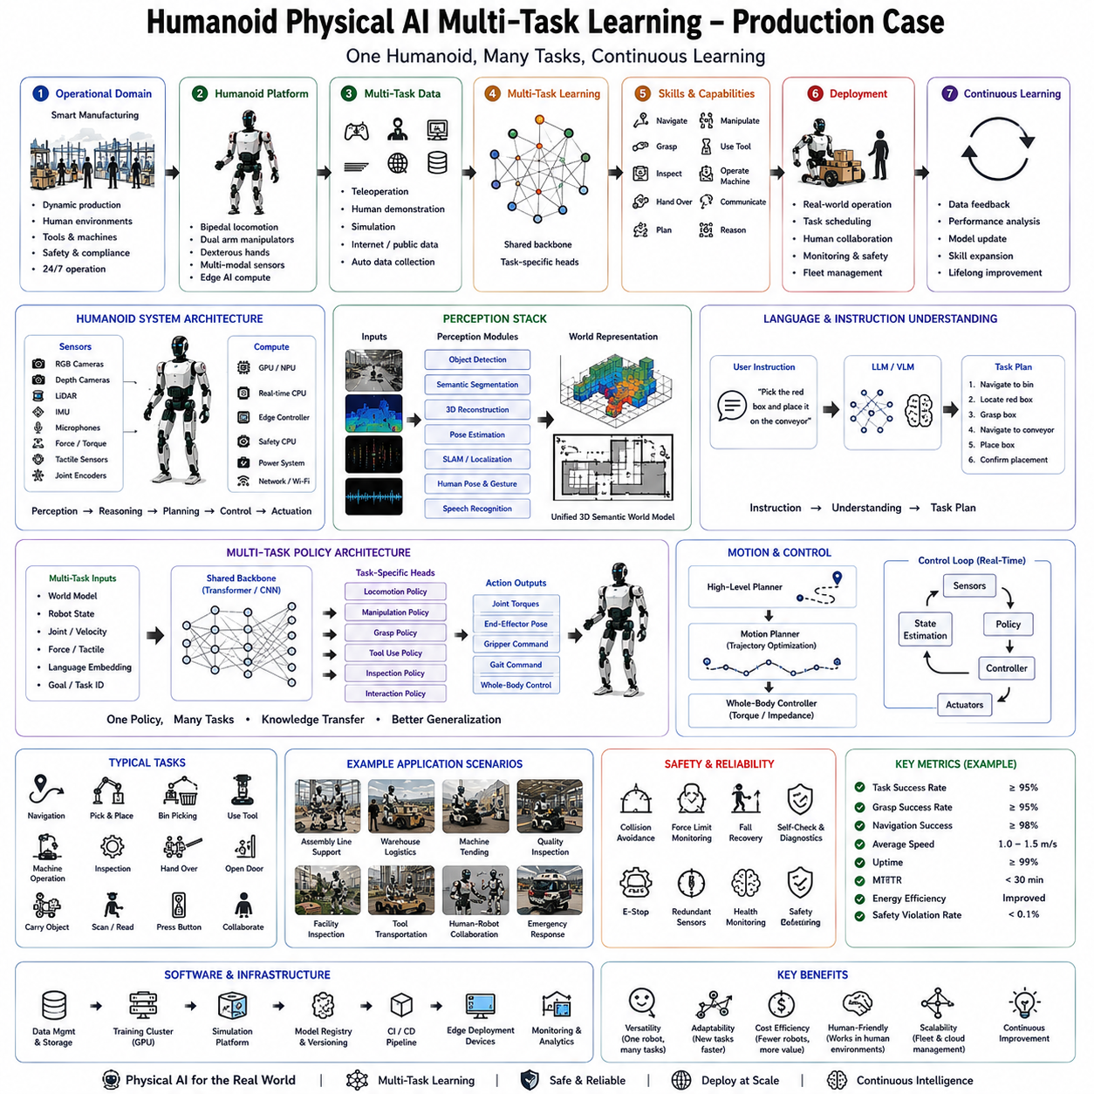
Humanoid robots represent one of the most ambitious goals in modern robotics because they combine human-like morphology with artificial intelligence capable of understanding, reasoning, perceiving, manipulating, communicating, and acting across a wide variety of tasks. Unlike traditional industrial robots that execute highly specialized repetitive operations, humanoid robots are expected to function in environments originally designed for humans. They must walk through buildings, climb stairs, open doors, manipulate diverse objects, use ordinary tools, collaborate with workers, understand verbal instructions, and adapt continuously to changing environments. Achieving such versatility requires far more than excellent locomotion or dexterous manipulation. It requires Physical AI capable of integrating perception, language, planning, memory, reasoning, and motor control into a unified decision-making architecture. One of the most important technologies enabling this transition is multi-task learning, which allows a single AI system to acquire and generalize multiple physical skills simultaneously rather than training separate models for every individual task.
Consider a production deployment case involving a general-purpose humanoid robot operating inside a modern manufacturing facility that produces consumer electronics and industrial equipment. Instead of assigning different robots to transportation, inspection, material handling, machine operation, inventory management, and quality control, a single humanoid platform performs many of these activities depending on operational requirements. During one work shift, the robot may transport components between workstations, inspect production equipment, assemble mechanical parts, operate industrial machines, manipulate tools, organize storage shelves, collaborate with human technicians, respond to verbal instructions, and perform routine maintenance inspections. Unlike traditional automation systems, which require extensive reprogramming whenever production changes, the humanoid adapts its learned knowledge across multiple related activities.
The engineering objective is not simply to maximize performance on one benchmark task but to develop a unified intelligence capable of transferring experience between tasks. A robot that has learned how to grasp tools should require much less additional learning to manipulate assembly components because both skills depend on common representations of object geometry, hand-eye coordination, force control, and motion planning. Multi-task learning therefore improves data efficiency, generalization capability, and operational flexibility while reducing engineering effort.
The project begins by defining the operational design domain. Engineers identify the complete collection of tasks the humanoid must perform, environmental conditions, workspace geometry, human interaction requirements, payload limitations, safety constraints, operating schedules, communication infrastructure, regulatory standards, and expected long-term expansion. Rather than optimizing independently for each activity, engineers search for common computational structures shared across all tasks. This systems-level perspective distinguishes Physical AI from conventional task-specific robotics.
The humanoid platform itself consists of numerous tightly integrated subsystems. The locomotion system provides stable bipedal walking, stair climbing, turning, balancing, and recovery from external disturbances. Dual manipulator arms provide dexterous object handling with multiple degrees of freedom. Multi-fingered robotic hands support precision grasping, tool manipulation, and compliant interaction. Vision systems combine RGB cameras, stereo cameras, depth cameras, LiDAR, and occasionally thermal imaging. Audio systems support speech recognition and environmental awareness. Force-torque sensors, tactile sensing, inertial measurement units, joint encoders, and proprioceptive sensing provide continuous feedback regarding body dynamics and physical interaction. Edge computing hardware integrates high-performance GPUs, dedicated AI accelerators, and real-time control processors capable of executing multiple neural networks simultaneously.
Perception forms the foundation of every subsequent capability. The robot continuously observes its environment using multimodal sensing. Object detection identifies tools, machinery, workpieces, containers, furniture, safety equipment, and human coworkers. Semantic segmentation classifies floor regions, workstations, storage areas, pathways, hazardous zones, and operational equipment. Pose estimation identifies human body posture, hand movement, and collaborative interaction opportunities. Three-dimensional reconstruction generates geometric understanding of workspaces, while simultaneous localization and mapping continuously estimates robot position within the facility. Unlike specialized robots focusing only on navigation or manipulation, the humanoid requires comprehensive scene understanding supporting every physical activity.
The perception architecture increasingly relies upon foundation vision models pretrained using massive multimodal datasets. Rather than training separate perception systems for each industrial application, large vision encoders learn generalized visual representations adaptable across navigation, manipulation, inspection, and human interaction tasks. Fine-tuning then specializes these representations toward specific operational requirements without sacrificing generalization.
Language understanding provides another essential capability. Operators communicate naturally using spoken or written instructions such as transporting inventory, inspecting equipment, retrieving tools, assisting assembly, or verifying production quality. Large Language Models convert human instructions into structured task representations while maintaining contextual memory regarding ongoing activities, operational priorities, environmental constraints, and previous interactions. Rather than programming explicit task sequences, engineers increasingly define objectives through natural language interfaces integrated with physical execution.
World models serve as the internal reasoning engine connecting perception and action. Rather than reacting only to immediate sensor observations, the robot maintains an evolving internal representation of the surrounding environment including object locations, workspace organization, human activity, task progress, available tools, operational constraints, and anticipated future events. This predictive representation supports long-horizon planning extending well beyond immediate reactive control.
Multi-task learning begins with identifying shared representations across apparently unrelated activities. Walking through a factory, carrying objects, opening doors, operating machinery, organizing shelves, and assisting assembly all require common perceptual understanding, body coordination, force regulation, and spatial reasoning. Instead of training separate neural networks independently, a unified backbone network learns these common representations while specialized output heads perform task-specific predictions.
The central hypothesis underlying multi-task learning is that learning several related tasks simultaneously produces richer internal representations than optimizing each task independently. Features useful for object recognition often improve grasp planning. Navigation experience improves manipulation because body positioning influences arm reachability. Human pose estimation supports collaborative assembly as well as obstacle avoidance. Shared knowledge therefore improves both learning efficiency and operational robustness.
Training data originate from numerous complementary sources. Human teleoperation provides demonstrations of complex manipulation and locomotion. Motion capture systems record whole-body movement during representative industrial activities. Simulation environments generate billions of interactions impossible to collect physically. Existing industrial robot programs contribute structured task knowledge. Human demonstrations using virtual reality interfaces produce additional multimodal behavioral data. Operational production logs collected during deployment continuously expand training datasets over time.
Data diversity represents one of the most important engineering considerations. The humanoid must encounter numerous workspace layouts, lighting conditions, object categories, worker behaviors, machine configurations, production schedules, and environmental disturbances during training. Exposure to diverse operational situations enables robust transfer across new tasks rather than memorization of narrow scenarios.
Simulation provides enormous quantities of training experience while reducing development cost. High-fidelity digital twins reproduce factory geometry, machinery, human workers, lighting conditions, object properties, robot dynamics, contact mechanics, and sensor behavior. Domain randomization continuously varies textures, illumination, object placement, payload weight, friction coefficients, sensor calibration, communication latency, and mechanical parameters. Instead of memorizing one factory configuration, the robot develops robust policies transferable across numerous industrial environments.
Curriculum learning significantly improves optimization. Initial training focuses upon isolated capabilities including standing balance, walking, reaching, grasping, and visual perception. Intermediate stages combine locomotion with manipulation, navigation with object recognition, and language understanding with simple actions. Advanced stages integrate multiple capabilities into complex industrial workflows involving sequential reasoning, tool usage, collaborative manipulation, and long-duration missions. Progressive task complexity enables stable learning while avoiding optimization collapse.
The learning architecture generally follows a hierarchical organization. Foundation perception models extract semantic visual representations. Language encoders process task instructions. World models predict future environmental evolution. Task planners generate long-horizon behavioral objectives. Motion policies determine coordinated whole-body movement. Low-level controllers execute stable joint trajectories while satisfying dynamic constraints. Each layer operates at different temporal and spatial scales while exchanging information through learned latent representations.
Transformer architectures increasingly dominate these systems because attention mechanisms naturally integrate information across vision, language, proprioception, memory, and temporal context. Unlike traditional modular robotics pipelines where perception, planning, and control remain largely independent, transformer-based Physical AI allows information to flow dynamically across multiple cognitive processes simultaneously.
Memory plays an increasingly important role in multi-task learning. Long-term memory stores procedural knowledge, previous task experience, workspace organization, operator preferences, tool locations, and historical operational context. Short-term working memory tracks ongoing manipulation sequences, recent observations, and intermediate planning states. Episodic memory enables learning from previous successes and failures, gradually improving future task execution.
Action generation extends beyond isolated joint commands. Instead of predicting low-level actuator torques directly, higher-level policies generate semantic action sequences such as approaching a workstation, locating components, grasping tools, tightening fasteners, inspecting surfaces, placing finished products, or returning equipment. Motion planners subsequently transform these semantic objectives into dynamically feasible whole-body trajectories.
Whole-body coordination distinguishes humanoid robotics from isolated manipulation systems. Every arm movement influences body balance, center of mass, foot placement, and locomotion stability. Carrying heavy components changes dynamic loading throughout the robot. Opening doors requires coordinated force application while maintaining stable posture. Multi-task policies therefore optimize the complete body rather than independent subsystems.
Force control represents another essential capability. Industrial tasks frequently involve physical interaction including inserting connectors, operating switches, tightening bolts, manipulating tools, pushing carts, opening cabinets, or handing objects to humans. Visual perception alone cannot guarantee successful interaction. Force-torque sensing, tactile feedback, and compliant control enable adaptive contact behavior robust against positioning uncertainty and environmental variation.
Human-robot collaboration introduces additional complexity. The humanoid continuously observes nearby workers, predicts human motion, interprets gestures, understands verbal instructions, and maintains safe interaction distances. Multi-task learning allows perception knowledge developed during navigation to support collaborative manipulation, while language understanding enhances task coordination without explicit programming.
Safety remains the highest engineering priority throughout deployment. Despite sophisticated learning algorithms, deterministic safety supervisors continuously monitor balance stability, joint limits, collision risk, human proximity, force thresholds, thermal conditions, battery state, communication integrity, and computational health. Runtime safety monitors independently verify every generated action before actuator execution. If learned policies propose unsafe behavior, certified safety controllers intervene immediately.
Out-of-distribution detection provides another operational safeguard. Manufacturing environments evolve continuously as production lines change, new equipment appears, workspace layouts are modified, and product variants increase. When observations differ substantially from training experience, uncertainty estimates increase and runtime supervisors activate conservative behaviors such as slower motion, additional sensing, or human assistance requests.
Uncertainty quantification further improves operational robustness. Every perception prediction, manipulation plan, navigation decision, and language interpretation includes associated confidence estimates. Low-confidence situations trigger additional reasoning, repeated observations, or fallback procedures rather than immediate execution. This awareness of uncertainty significantly improves long-term deployment reliability.
Fleet deployment introduces opportunities for collective learning. Multiple humanoid robots operating across different factories contribute operational experience toward centralized model refinement. Successful manipulation strategies, efficient navigation behaviors, improved language understanding, and recovery procedures discovered by one robot become available to all deployed systems after validation and controlled software updates. Organizational knowledge therefore grows continuously through distributed operational experience.
Performance evaluation extends well beyond benchmark accuracy. Engineers measure task completion rate, locomotion stability, manipulation precision, energy efficiency, cycle time, collaboration quality, language understanding accuracy, runtime latency, failure recovery capability, human intervention frequency, safety events, hardware utilization, and long-term reliability. Individual tasks receive separate evaluation while integrated workflows assess overall operational productivity.
Failure analysis becomes increasingly sophisticated because failures may emerge from interactions among multiple cognitive systems. An unsuccessful assembly operation may originate from perception errors, language misunderstanding, inaccurate world modeling, manipulation instability, or planning failures. Comprehensive logging records sensor observations, internal model states, reasoning chains, confidence estimates, action sequences, and runtime interventions, enabling systematic root cause analysis.
Continuous learning supports gradual improvement after deployment while preserving operational stability. Difficult situations encountered during production become additional training data following validation and annotation. However, policy updates occur through controlled offline retraining rather than unrestricted online adaptation because industrial safety requirements demand predictable and thoroughly validated behavior before deployment.
Foundation models continue transforming humanoid Physical AI. Rather than learning isolated industrial tasks independently, future systems will develop generalized physical intelligence transferable across factories, warehouses, hospitals, construction sites, retail environments, and domestic settings. Experience acquired while assembling machinery may improve furniture manipulation, tool usage, maintenance operations, or healthcare assistance because all depend upon shared physical reasoning.
Future humanoid systems will increasingly integrate reinforcement learning, imitation learning, self-supervised learning, language modeling, world models, causal reasoning, and lifelong learning within unified cognitive architectures. Rather than distinguishing between perception, planning, manipulation, and communication, these capabilities will emerge from shared representations supporting flexible general intelligence across physical environments.
Ultimately, the production deployment of humanoid Physical AI through multi-task learning demonstrates a fundamental transition in robotics from specialized automation toward general-purpose embodied intelligence. Instead of engineering independent solutions for locomotion, manipulation, navigation, inspection, language understanding, and collaboration, engineers increasingly develop unified learning architectures capable of acquiring diverse skills through shared representations and continual experience. Successful deployment depends not only upon advanced neural networks but also upon comprehensive datasets, realistic simulation, hierarchical planning, deterministic safety supervision, runtime monitoring, uncertainty estimation, continual validation, and disciplined systems engineering. Multi-task learning transforms humanoid robots from collections of isolated capabilities into integrated intelligent agents capable of adapting flexibly across the enormous diversity of real-world industrial activities. As Physical AI continues advancing toward increasingly capable embodied intelligence, multi-task learning will remain one of the foundational technologies enabling humanoid robots to perform useful, reliable, and safe work alongside humans across manufacturing, logistics, healthcare, infrastructure, and countless future application domains.

12.06 Cargo UAV AI Based Obstacle Avoidance Case
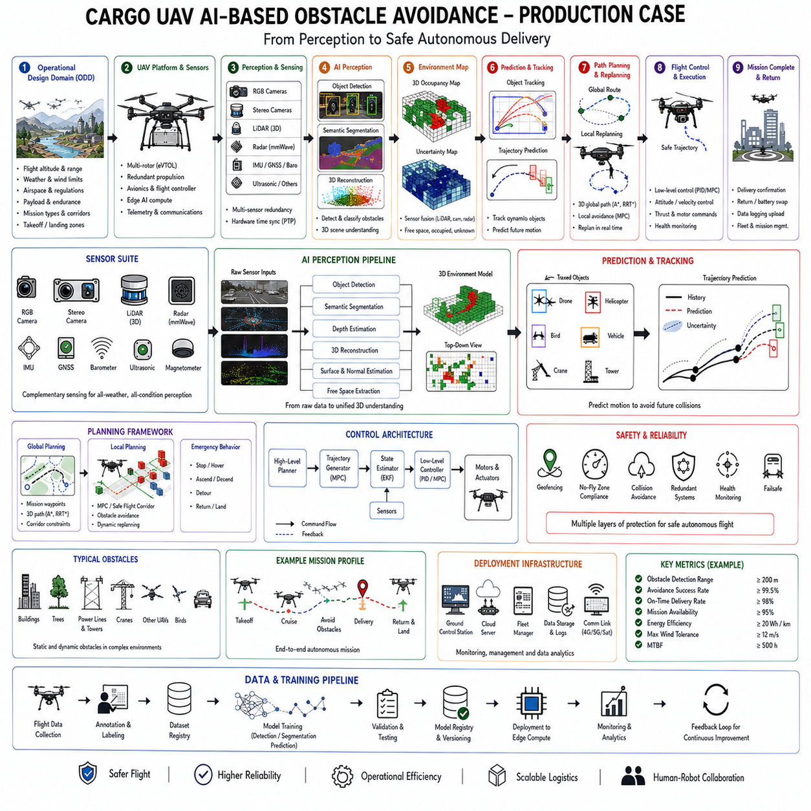
The rapid growth of autonomous logistics has expanded the role of Cargo Unmanned Aerial Vehicles (Cargo UAVs) from experimental research platforms into practical transportation systems capable of delivering medical supplies, industrial components, agricultural products, emergency equipment, and commercial goods across environments where conventional ground transportation is inefficient or impossible. Compared with indoor robots or autonomous mobile robots operating on roads and factory floors, cargo UAVs function within a fully three-dimensional environment where obstacles exist not only in front of the vehicle but also above, below, and around it. Trees, buildings, utility poles, communication towers, power transmission lines, moving aircraft, birds, construction cranes, weather phenomena, and dynamic airspace restrictions continuously influence safe flight. Consequently, AI-based obstacle avoidance has become one of the most important technologies enabling reliable autonomous cargo transportation. A production deployment case demonstrates how artificial intelligence, perception systems, predictive planning, and safety engineering cooperate to transform UAV research into commercially deployable autonomous logistics platforms.
Consider a medium-sized cargo UAV designed for industrial logistics serving manufacturing complexes, warehouses, hospitals, ports, offshore facilities, smart cities, or remote infrastructure. The aircraft carries payloads ranging from several kilograms to more than one hundred kilograms depending on mission requirements and employs multiple electric propulsion units for redundancy and precise flight control. Unlike recreational drones that primarily rely on human pilots, this cargo platform performs fully autonomous missions including takeoff, navigation, obstacle avoidance, package delivery, return flight, and charging with minimal human intervention. Daily operation involves hundreds of autonomous flights through diverse environments under changing weather conditions while satisfying strict aviation safety requirements.
The engineering process begins with defining the Operational Design Domain. Engineers determine allowable flight altitude, operational weather conditions, maximum wind speed, payload limits, communication infrastructure, flight corridors, emergency landing locations, airspace classifications, obstacle density, urban or rural deployment environments, regulatory restrictions, and expected mission duration. Rather than attempting unrestricted autonomous flight everywhere, production systems optimize AI models specifically for clearly defined operational boundaries. This disciplined engineering approach significantly improves deployment reliability because artificial intelligence is trained and validated using conditions representative of actual commercial operation.
Obstacle avoidance differs fundamentally from ordinary navigation. Traditional waypoint navigation assumes a static environment where routes remain valid after mission planning. Real cargo UAVs instead operate within continuously changing airspace. Construction cranes move unexpectedly, birds alter flight trajectories, helicopters enter operational corridors, weather evolves rapidly, temporary no-fly zones appear, and communication quality fluctuates. The obstacle avoidance system must therefore perceive, predict, reason, and react continuously throughout every flight.
The perception architecture integrates multiple complementary sensing modalities because no individual sensor remains reliable under all operating conditions. High-resolution RGB cameras provide semantic scene understanding and object recognition. Stereo cameras estimate depth through binocular vision. LiDAR generates precise three-dimensional geometric measurements independent of ambient lighting. Millimeter-wave radar detects obstacles under fog, rain, or dust where optical systems become unreliable. Ultrasonic sensors assist during landing, while inertial measurement units, GNSS receivers, barometers, magnetometers, and airspeed sensors estimate vehicle state continuously. Sensor diversity substantially improves robustness because each modality compensates for the limitations of others.
Sensor synchronization represents a critical engineering challenge. Camera frames, LiDAR point clouds, radar returns, inertial measurements, and GPS updates arrive at different frequencies with different latencies. Hardware synchronization using Precision Time Protocol or dedicated trigger systems ensures that observations correspond to the same physical instant, preventing inconsistencies during sensor fusion. Even small synchronization errors can produce inaccurate obstacle localization during high-speed flight because the UAV continuously changes position and orientation.
The first stage of AI processing involves perception. Object detection networks identify buildings, trees, utility poles, power transmission towers, communication masts, cranes, bridges, vehicles, birds, helicopters, drones, balloons, and other airborne objects. Semantic segmentation classifies terrain, vegetation, roads, water surfaces, rooftops, restricted areas, and potential landing zones. Instance segmentation separates overlapping obstacles, while depth estimation reconstructs three-dimensional scene geometry. Unlike conventional computer vision benchmarks, UAV perception emphasizes long-range detection because avoidance decisions require sufficient reaction time before collision risk becomes critical.
Three-dimensional environmental reconstruction provides the geometric foundation for navigation. Sensor fusion combines LiDAR, stereo vision, radar, inertial measurements, and localization estimates into continuously updated occupancy maps representing free space, occupied regions, and uncertainty. These maps evolve throughout flight as new observations become available. Dynamic objects maintain predicted trajectories rather than static positions, allowing planning algorithms to anticipate future conflicts instead of reacting only after obstacles approach.
Dataset collection represents one of the largest engineering efforts during development. Prototype UAVs equipped with production sensors record thousands of flight hours across urban, suburban, industrial, agricultural, coastal, mountainous, and rural environments. Data collection spans different seasons, weather conditions, lighting variations, wind speeds, payload configurations, and flight altitudes. Every flight records synchronized RGB images, depth information, LiDAR scans, radar returns, GPS measurements, inertial data, actuator commands, weather information, communication quality, battery status, and operational logs.
Data annotation extends beyond ordinary object labeling. Engineers identify obstacle categories, three-dimensional bounding volumes, motion trajectories, collision risk levels, semantic airspace regions, flight corridor boundaries, safe landing locations, environmental hazards, weather conditions, and avoidance maneuvers. Temporal consistency remains especially important because moving obstacles require trajectory prediction rather than isolated frame-by-frame recognition.
Data quality assurance removes corrupted recordings, synchronization failures, GPS anomalies, sensor calibration errors, communication interruptions, and incomplete flight segments before model training. Statistical analysis verifies sufficient representation across obstacle categories, environmental conditions, geographical regions, flight altitudes, weather scenarios, and rare but safety-critical situations such as emergency helicopters, cranes, unexpected birds, or temporary construction activities.
Foundation vision models increasingly provide the perception backbone. Large-scale self-supervised pretraining produces generalized visual representations transferable across numerous aerial perception tasks. Fine-tuning adapts these representations toward obstacle detection, semantic segmentation, depth estimation, and scene understanding within cargo UAV environments. Compared with training individual models from scratch, foundation models improve generalization while reducing data requirements.
Obstacle detection alone is insufficient for safe navigation because collision risk depends not only on object location but also on future motion. Predictive trajectory estimation therefore becomes an essential component of the AI pipeline. Recurrent neural networks, transformers, graph neural networks, or world models estimate likely future trajectories for dynamic obstacles based on historical observations, environmental context, and motion dynamics. Birds, helicopters, neighboring drones, and construction equipment all exhibit distinct movement patterns requiring different prediction strategies.
The internal world model continuously integrates perception with temporal reasoning. Rather than storing only current observations, the UAV maintains a predictive representation of surrounding airspace describing obstacle motion, environmental uncertainty, weather evolution, communication quality, and mission progress. This world model enables the planning system to evaluate multiple possible future scenarios before selecting avoidance maneuvers.
Planning algorithms operate hierarchically. High-level mission planners determine strategic routes connecting departure and destination locations while respecting regulatory airspace restrictions. Local planners continuously modify these routes according to newly perceived obstacles. Reinforcement learning, optimization-based trajectory generation, sampling-based planning, and model predictive control cooperate within this hierarchical architecture. Artificial intelligence contributes adaptive decision making, while deterministic planning guarantees dynamic feasibility and compliance with flight constraints.
Obstacle avoidance policies generally optimize multiple objectives simultaneously. Mission completion remains important, but safe separation from obstacles receives substantially higher priority. Additional objectives include minimizing flight time, reducing energy consumption, maintaining passenger or cargo stability, preserving communication quality, satisfying no-fly regulations, avoiding severe weather, and ensuring sufficient battery reserves for emergency landing if necessary. Multi-objective optimization therefore balances operational efficiency with safety.
Simulation plays a central role throughout development because collecting real collision scenarios would be prohibitively dangerous and expensive. High-fidelity digital twins reproduce terrain, buildings, vegetation, weather, aerodynamics, sensor characteristics, communication latency, obstacle motion, and UAV dynamics. Domain randomization continuously varies lighting, wind, turbulence, sensor calibration, obstacle density, and environmental appearance, encouraging policies robust across diverse deployment conditions.
Physics simulation includes aerodynamic effects absent from ground robots. Wind gusts, turbulence, propeller interaction, payload oscillation, drag variation, battery voltage changes, actuator saturation, and atmospheric disturbances influence flight dynamics substantially. Accurate simulation of these phenomena improves transfer from virtual environments into real UAV operation.
Curriculum learning significantly accelerates policy development. Initial training exposes the UAV to sparse static obstacles under ideal weather conditions. Subsequent stages introduce denser environments, moving obstacles, variable winds, sensor noise, communication degradation, and increasingly complex urban airspace. This progressive learning strategy enables stable policy convergence without overwhelming optimization during early stages.
Runtime inference occurs entirely onboard because reliable obstacle avoidance cannot depend exclusively upon cloud connectivity. High-performance edge computing platforms equipped with embedded GPUs or specialized AI accelerators execute perception, prediction, planning, localization, and control simultaneously under strict real-time constraints. Hardware optimization through TensorRT, ONNX Runtime, quantization, graph optimization, and operator fusion minimizes inference latency while preserving prediction accuracy.
Runtime safety monitoring supervises every AI-generated flight command. Confidence estimation accompanies perception predictions, while uncertainty quantification evaluates model reliability continuously. Out-of-distribution detection identifies environmental situations substantially different from training experience. Runtime supervisors compare planned trajectories against deterministic safety constraints before control commands reach flight controllers. If learned policies propose unsafe maneuvers, certified safety controllers modify or reject those actions immediately.
Geofencing provides an additional layer of deterministic protection. Virtual boundaries define prohibited regions surrounding airports, sensitive infrastructure, populated areas, or restricted facilities. Regardless of AI recommendations, the UAV cannot violate these boundaries because geofencing operates independently from learning algorithms. Dynamic geofences additionally accommodate temporary restrictions introduced by emergency operations or public events.
Redundant perception significantly improves operational safety. Cameras, LiDAR, radar, and inertial sensing independently estimate obstacle locations. Sensor disagreement triggers increased caution rather than optimistic interpretation. If optical sensors become unreliable during heavy rain or fog, radar and LiDAR maintain sufficient situational awareness to support conservative navigation until conditions improve.
Weather awareness represents another essential capability absent from many laboratory demonstrations. Wind estimation, precipitation detection, visibility assessment, turbulence prediction, icing risk estimation, and lightning avoidance all contribute to safe flight planning. AI models integrate meteorological observations with onboard sensor data, allowing proactive route modification before environmental conditions become hazardous.
Communication monitoring complements autonomous perception. Cellular networks, satellite communication, dedicated industrial wireless infrastructure, and mesh networking provide command, telemetry, and fleet coordination. Communication degradation influences navigation strategy because emergency procedures depend upon available connectivity. The UAV continuously evaluates signal quality, selecting routes preserving communication whenever practical.
Fleet management enables coordinated operation among multiple cargo UAVs. Centralized systems assign delivery missions, monitor aircraft health, coordinate airspace usage, schedule charging, distribute software updates, and collect operational data. Individual obstacle avoidance policies remain autonomous, while fleet intelligence optimizes overall logistics performance across numerous simultaneous flights.
Continuous operational data collection supports long-term improvement. Every flight records sensor observations, AI predictions, obstacle encounters, avoidance maneuvers, weather conditions, communication quality, battery performance, and safety interventions. Engineers analyze operational logs systematically, identifying recurring failure patterns, emerging environmental changes, and opportunities for improving perception models or planning algorithms.
Failure analysis distinguishes among perception failures, localization errors, communication interruptions, weather effects, hardware degradation, software integration issues, and unexpected environmental novelty. Replay systems reconstruct complete missions using synchronized sensor recordings, allowing engineers to reproduce incidents offline while applying visualization, interpretability methods, and root cause analysis. Corrective actions may involve dataset expansion, model retraining, sensor recalibration, algorithm refinement, or updated safety constraints.
Certification and regulatory compliance play particularly important roles because cargo UAVs operate within controlled airspace. Documentation covers datasets, AI models, software versions, operational logs, validation procedures, runtime monitoring, maintenance schedules, cybersecurity protections, and safety analyses. Traceability throughout the AI lifecycle supports both regulatory review and long-term system maintenance.
Cybersecurity receives increasing attention because autonomous aircraft depend heavily upon communication, navigation, and software integrity. Secure boot, encrypted communication, authenticated software updates, intrusion detection, GNSS spoofing protection, sensor authentication, and runtime integrity monitoring prevent malicious interference capable of compromising flight safety.
Future cargo UAVs will increasingly integrate vision-language-action models, foundation world models, multimodal reasoning, and collaborative swarm intelligence. Rather than simply avoiding obstacles reactively, future systems will reason about mission objectives, predict long-term airspace evolution, negotiate cooperative flight paths with neighboring aircraft, interpret natural language instructions, and adapt autonomously to evolving logistics networks.
Ultimately, the production deployment of AI-based obstacle avoidance for cargo UAVs demonstrates that successful autonomous aerial logistics depends upon the integration of advanced perception, predictive world modeling, intelligent planning, sensor fusion, runtime safety supervision, deterministic flight control, continual learning, comprehensive validation, and disciplined systems engineering. Artificial intelligence provides adaptive perception and decision-making capabilities impossible through conventional programming alone, while established aerospace engineering ensures safety, reliability, redundancy, certification, and operational robustness. Together these technologies transform cargo UAVs from experimental flying robots into practical autonomous transportation platforms capable of supporting industrial logistics, emergency response, infrastructure inspection, medical delivery, and the rapidly expanding ecosystem of Physical AI-enabled aerial mobility.

12.07 Edge AI Optimization Latency 50pct Reduction Case
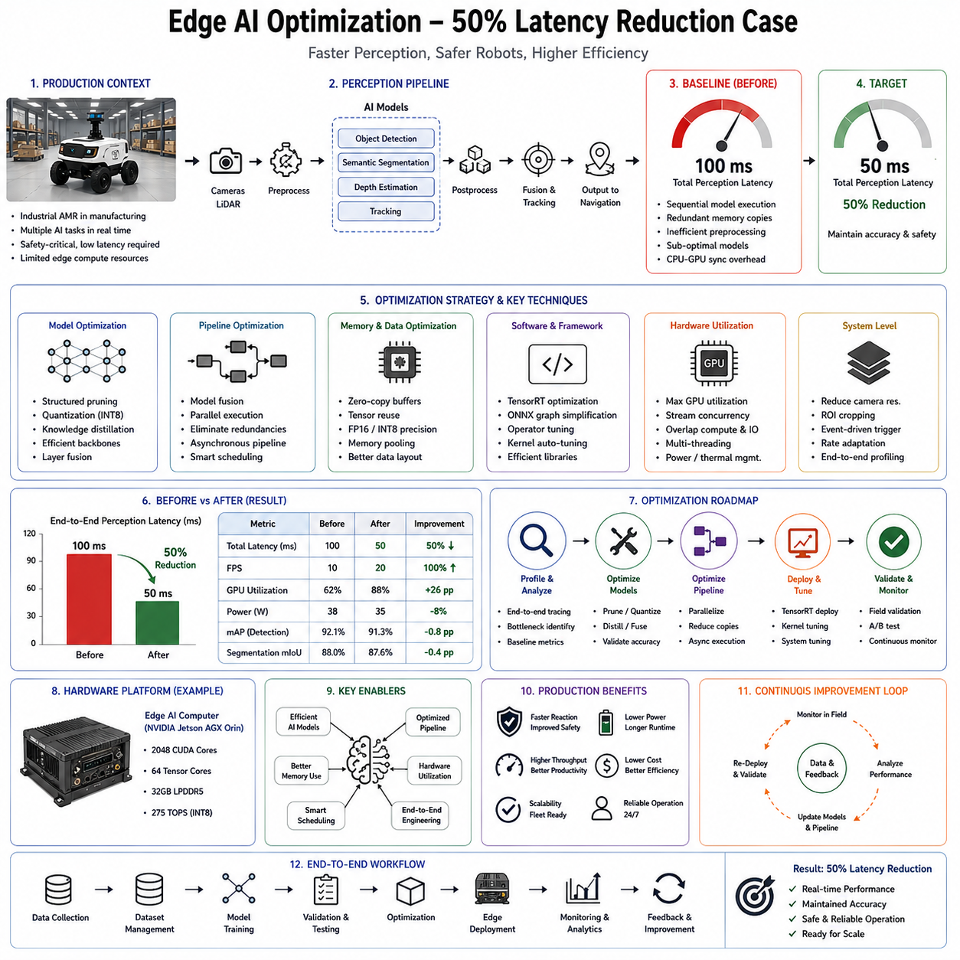
Edge Artificial Intelligence has become one of the most critical technologies enabling modern autonomous robots to operate safely and efficiently in real-world environments. While cloud computing offers enormous computational resources, many robotic applications cannot depend upon remote servers because communication latency, network instability, bandwidth limitations, privacy concerns, and operational safety require immediate local decision making. Autonomous Mobile Robots, humanoid robots, industrial manipulators, quadruped inspection robots, autonomous vehicles, and cargo UAVs all rely heavily on onboard edge computing platforms to execute perception, localization, planning, manipulation, and control in real time. However, as deep learning models become increasingly sophisticated, computational demand grows much faster than embedded hardware performance. A model that achieves outstanding benchmark accuracy may become impractical if inference latency prevents timely robot reactions. Consequently, Edge AI optimization has become an essential engineering discipline focused on maximizing inference efficiency while preserving prediction quality. This production case examines how a commercial robotic platform successfully reduced end-to-end AI inference latency by approximately fifty percent through systematic optimization without significantly sacrificing operational accuracy.
The production system under consideration is an industrial Autonomous Mobile Robot deployed inside a large manufacturing facility responsible for transporting materials between production lines, warehouses, inspection stations, and assembly areas. The robot performs simultaneous localization and mapping, object detection, semantic segmentation, obstacle avoidance, human detection, free-space estimation, route planning, and fleet communication while operating continuously throughout multiple work shifts. The perception subsystem initially relied on several independently trained deep neural networks executing sequentially on an embedded GPU platform. Although laboratory evaluation demonstrated excellent detection accuracy, deployment revealed that total perception latency had gradually increased as additional AI capabilities were incorporated into the software stack. The cumulative inference pipeline required approximately one hundred milliseconds to process each sensor frame, limiting practical navigation speed and reducing available reaction time when dynamic obstacles appeared.
The engineering objective extended beyond simply accelerating one neural network. Production robots execute complete perception pipelines involving sensor acquisition, image preprocessing, neural network inference, postprocessing, coordinate transformation, sensor fusion, obstacle tracking, and message communication. Therefore, optimizing overall latency required careful analysis of every computational stage rather than focusing exclusively on model execution. Engineers established a target of reducing total perception latency by approximately fifty percent while maintaining equivalent navigation safety, detection accuracy, and operational reliability.
The optimization project began with comprehensive performance profiling. Rather than assuming the neural network represented the dominant computational bottleneck, engineers instrumented every software component using high-resolution timing measurements. Camera acquisition latency, image decoding, memory transfer, preprocessing operations, inference execution, postprocessing, communication overhead, GPU utilization, CPU scheduling, synchronization delays, and middleware message passing were measured independently. Detailed profiling revealed that inference consumed only part of the total execution time. Significant delays also originated from repeated memory allocation, image format conversion, unnecessary tensor copying, sequential pipeline execution, and CPU-GPU synchronization overhead.
This observation fundamentally changed the optimization strategy. Instead of replacing the neural network immediately, engineers adopted a systems engineering perspective in which latency represented an emergent property of the complete perception architecture. Every unnecessary memory transfer, software abstraction layer, synchronization barrier, or redundant computation contributed to end-to-end delay. Consequently, meaningful improvement required coordinated optimization across hardware, software, model architecture, and deployment infrastructure.
The perception pipeline consisted of multiple neural networks executing consecutively. An object detection model identified workers, forklifts, pallets, shelves, robots, and equipment. Semantic segmentation distinguished traversable floor regions from obstacles and restricted areas. A lightweight depth estimation network enhanced geometric understanding for free-space analysis. Additional tracking algorithms associated detections across consecutive frames while localization software fused visual information with LiDAR observations. Each component performed well individually, but sequential execution accumulated substantial latency.
The first optimization phase focused on computational graph analysis. Engineers examined every neural network layer, identifying operations contributing disproportionately to execution time. Convolution layers with extremely large feature maps, redundant activation functions, inefficient tensor reshaping operations, and unnecessary normalization layers became candidates for optimization. Although modern deep learning frameworks automatically optimize many computational graphs, production deployments often contain legacy components accumulated throughout years of incremental development. Graph simplification therefore produced immediate performance improvements before more sophisticated optimization techniques were introduced.
Model architecture refinement represented the next stage. The original object detector employed a relatively large backbone optimized primarily for benchmark accuracy. Analysis of production datasets revealed that many categories important in public computer vision benchmarks never appeared within the factory environment. Engineers therefore redesigned the network using a more compact feature extractor while preserving detection capability for operationally relevant object classes. Knowledge distillation transferred semantic understanding from the original high-capacity teacher model into a lightweight student network. This approach preserved most detection accuracy while substantially reducing computational complexity.
Structured pruning further reduced model size. Rather than removing individual weights randomly, engineers eliminated complete channels, filters, and convolution blocks exhibiting minimal contribution to prediction quality. Structured pruning preserved efficient GPU execution because optimized libraries naturally exploit reduced network dimensions. Unstructured sparsity, although mathematically reducing parameter count, often failed to improve practical inference speed because irregular memory access limited hardware efficiency.
Quantization provided another major optimization opportunity. Original models operated using FP32 floating-point precision despite deployment on hardware optimized for mixed-precision arithmetic. Extensive calibration demonstrated that FP16 execution produced nearly identical detection accuracy while significantly reducing computational cost and memory bandwidth. Certain models supporting INT8 quantization underwent additional optimization after representative calibration datasets confirmed acceptable prediction stability. Engineers evaluated every quantized model separately because different neural networks exhibit different sensitivity to reduced numerical precision.
TensorRT became the primary inference engine replacing the original generic deep learning framework. Models were exported through ONNX before undergoing TensorRT optimization, including layer fusion, kernel auto-tuning, precision calibration, memory optimization, and execution graph simplification. TensorRT generated hardware-specific execution engines optimized directly for the embedded GPU architecture rather than relying on generic framework implementations. Individual inference latency decreased substantially after engine generation while memory consumption also declined.
Batch processing was carefully reconsidered. Traditional deep learning often benefits from large inference batches maximizing GPU throughput. Autonomous robots, however, process streaming sensor data where immediate response outweighs maximum throughput. Production engineers therefore selected batch size one for perception models, minimizing waiting time before execution while preserving deterministic latency characteristics. This optimization illustrates an important distinction between offline AI benchmarking and real-time robotics deployment.
Image preprocessing initially executed on the CPU before transferring tensors to the GPU. Profiling revealed that repeated image resizing, normalization, color conversion, and tensor formatting contributed significantly to total latency. Engineers migrated preprocessing into GPU kernels using CUDA acceleration, eliminating repeated CPU-GPU memory transfers. Camera drivers additionally delivered images directly in formats compatible with inference pipelines, reducing unnecessary data conversion.
Memory optimization became another major engineering focus. Repeated allocation and deallocation of temporary tensors fragmented memory and introduced unpredictable execution delays. Persistent memory pools allocated during application startup eliminated dynamic allocation throughout runtime. Intermediate buffers were reused whenever possible, reducing memory management overhead while improving cache utilization.
Pipeline parallelism further accelerated perception. Previously, camera acquisition waited until inference completed before capturing the next frame. Engineers redesigned the architecture using asynchronous execution where sensor acquisition, preprocessing, inference, postprocessing, and communication operated simultaneously across independent threads. While one frame underwent inference, the next frame entered preprocessing and another frame completed postprocessing. This pipeline significantly increased hardware utilization without modifying neural network architecture.
CUDA streams enabled concurrent GPU execution. Independent kernels associated with preprocessing, inference, and postprocessing executed asynchronously whenever hardware resources permitted. Proper stream synchronization prevented unnecessary blocking while preserving deterministic execution ordering required for robotic safety. Engineers carefully analyzed resource contention to ensure concurrent execution improved latency rather than introducing unpredictable scheduling behavior.
CPU optimization proved equally important. Certain postprocessing operations including non-maximum suppression, tracking association, coordinate transformation, and message serialization originally executed using single-threaded implementations. Parallelization across multiple CPU cores reduced these stages substantially. Compiler optimization flags, vectorized instructions, cache-aware memory layouts, and algorithm refinement further improved computational efficiency.
Communication middleware also underwent optimization. Excessive serialization, unnecessary message copying, and high-frequency logging introduced avoidable delays. Zero-copy communication mechanisms allowed perception results to pass directly between software modules without repeated memory duplication. Logging frequency became adaptive rather than constant, preserving diagnostic information without unnecessarily consuming computational resources during ordinary operation.
Model fusion represented another important architectural improvement. Previously independent perception models shared substantial feature extraction computation. Engineers developed multi-task architectures where common backbone networks simultaneously supported object detection, semantic segmentation, and free-space estimation. Shared feature representations eliminated redundant convolution operations while improving cache locality and reducing total inference time.
Sensor fusion algorithms similarly became more efficient. Earlier implementations repeatedly transformed point clouds between coordinate systems before integration with camera observations. Unified geometric representations reduced transformation overhead while improving numerical consistency across sensing modalities. Localization updates also became event-driven rather than executing at unnecessarily high frequencies independent of sensor changes.
Localization frequency itself underwent optimization. High-rate localization updates proved unnecessary during slow robot motion. Adaptive scheduling adjusted localization computation according to vehicle velocity, environmental complexity, and navigation requirements. During straight motion through open corridors, computational resources shifted toward perception, while complex intersections temporarily increased localization update frequency.
Power management influenced optimization as well. Embedded GPUs dynamically adjusted operating frequency according to computational demand. Engineers configured performance modes ensuring stable maximum GPU frequency during autonomous operation rather than allowing aggressive power-saving transitions introducing unpredictable latency variation. Thermal management improvements prevented frequency throttling during prolonged operation, maintaining consistent inference performance throughout entire work shifts.
Runtime monitoring continuously verified optimization effectiveness after deployment. Inference latency, GPU utilization, CPU utilization, memory consumption, thermal conditions, communication delays, sensor synchronization quality, and frame processing rate were recorded throughout operation. Rather than relying solely on laboratory benchmarks, engineers evaluated performance under realistic production workloads including crowded environments, long-duration operation, and simultaneous fleet communication.
Accuracy validation remained equally important. Every optimization underwent extensive regression testing to ensure latency improvements did not compromise detection quality. Object detection precision, semantic segmentation accuracy, obstacle avoidance performance, localization consistency, navigation success rate, and emergency stop behavior were compared against the original system. Particular attention focused on rare safety-critical situations including worker detection, unexpected obstacles, partially occluded pallets, and narrow navigation corridors.
Engineers observed that small reductions in benchmark accuracy occasionally produced negligible operational impact while enabling substantial latency improvement. For example, marginal reductions in segmentation precision for distant shelving had virtually no influence on navigation because planning primarily depended upon nearby obstacles. Such task-aware evaluation allowed informed engineering tradeoffs rather than optimizing abstract benchmark metrics disconnected from production requirements.
The optimization process also incorporated uncertainty estimation. Quantized and compressed models occasionally produced slightly different confidence distributions compared with original networks. Calibration procedures adjusted confidence thresholds, preserving reliable uncertainty estimation despite modified numerical representations. Runtime safety monitors continued supervising predictions using calibrated confidence values alongside out-of-distribution detection and anomaly monitoring.
Failure analysis identified additional optimization opportunities after deployment. Operational logs occasionally revealed transient latency spikes despite excellent average performance. Detailed investigation associated these spikes with operating system scheduling, background communication tasks, storage synchronization, and maintenance diagnostics rather than AI inference itself. Isolating real-time processing threads, prioritizing critical tasks, and scheduling maintenance activities during idle periods eliminated most remaining latency variability.
The final optimized perception system achieved approximately fifty percent reduction in end-to-end latency compared with the original production deployment. Total processing time decreased from roughly one hundred milliseconds per perception cycle to approximately fifty milliseconds while preserving comparable detection accuracy, semantic understanding, localization quality, and navigation reliability. More importantly, latency variation also decreased substantially, producing highly deterministic execution suitable for real-time autonomous operation.
Operational improvements extended well beyond raw computational speed. Faster perception enabled higher safe navigation velocity because obstacle information became available earlier. Emergency stopping distance decreased due to reduced perception delay. Dynamic obstacle tracking became smoother because object positions updated more frequently. Human-robot collaboration improved through faster worker detection and more responsive avoidance behavior. Lower computational load also reduced GPU temperature and energy consumption, extending hardware lifetime while increasing overall system reliability.
Fleet-wide deployment demonstrated additional organizational benefits. Because optimized inference consumed fewer computational resources, future AI capabilities such as anomaly detection, predictive maintenance, language interfaces, and advanced manipulation planning could be incorporated without requiring immediate hardware upgrades. Software optimization therefore delayed expensive hardware replacement while extending platform scalability.
This production case highlights an important engineering lesson frequently overlooked during AI development. Significant performance improvement rarely results from one revolutionary optimization technique. Instead, substantial latency reduction emerged through the accumulation of numerous coordinated improvements involving model architecture, graph optimization, quantization, inference engines, memory management, pipeline parallelism, preprocessing acceleration, communication optimization, runtime scheduling, and systems engineering. Each individual optimization contributed modest gains, but their combined effect transformed operational performance.
Future Edge AI optimization will increasingly leverage hardware-software co-design, neural architecture search, compiler-assisted optimization, adaptive inference, conditional computation, sparse activation, dedicated AI accelerators, heterogeneous computing, and foundation models designed specifically for efficient edge deployment. Rather than optimizing models after training, future AI systems will increasingly incorporate deployment constraints directly into the learning process, producing architectures inherently optimized for embedded robotic platforms.
Ultimately, this production deployment demonstrates that Edge AI optimization is not merely a matter of reducing neural network size but a comprehensive engineering discipline integrating artificial intelligence, embedded computing, real-time systems, software architecture, hardware acceleration, and robotics. By systematically analyzing every stage of the perception pipeline, eliminating computational inefficiencies, exploiting hardware capabilities, and validating every optimization under realistic operational conditions, engineers successfully reduced inference latency by approximately fifty percent while maintaining the safety, reliability, and accuracy required for continuous industrial deployment. This holistic optimization methodology represents one of the essential foundations enabling modern Physical AI systems to deliver increasingly sophisticated autonomous capabilities within the computational constraints of practical edge robotics.

12.08 Lifelong Learning Warehouse AMR Long Run Case
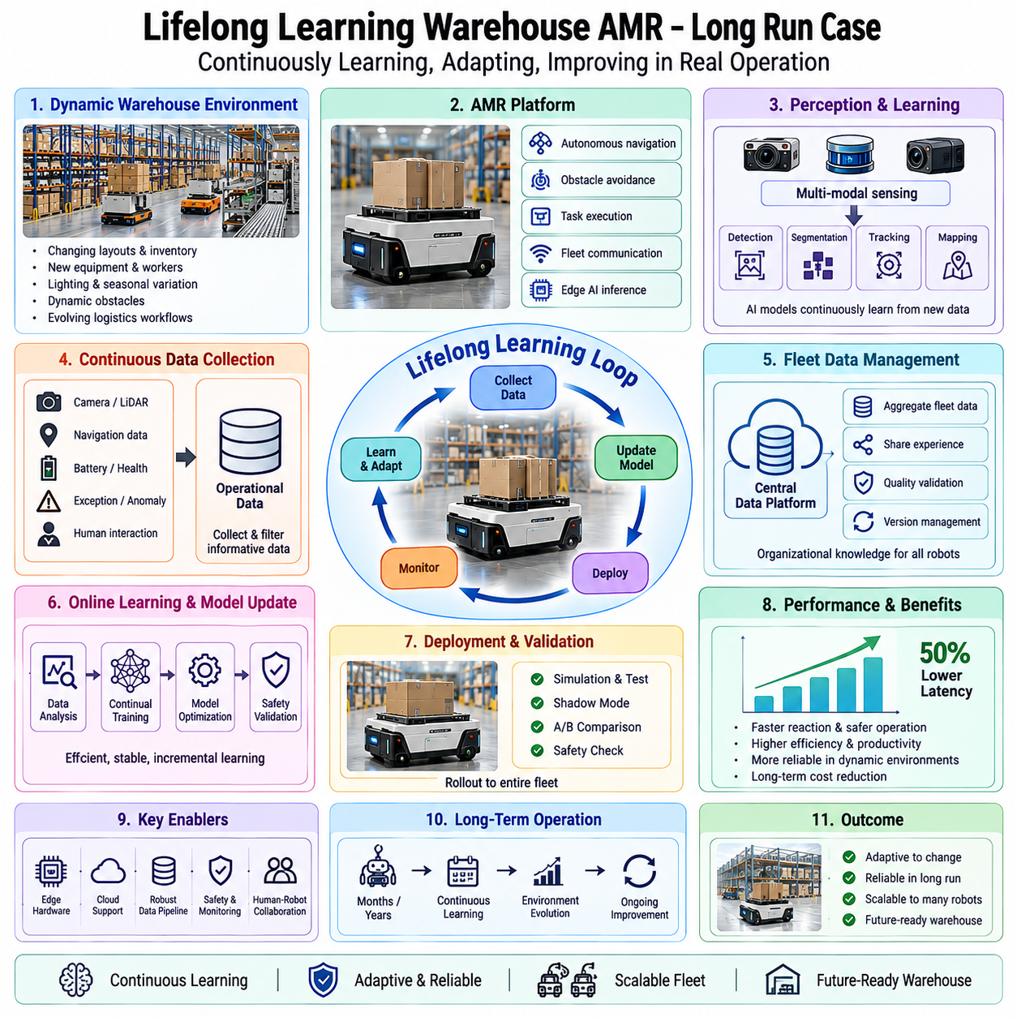
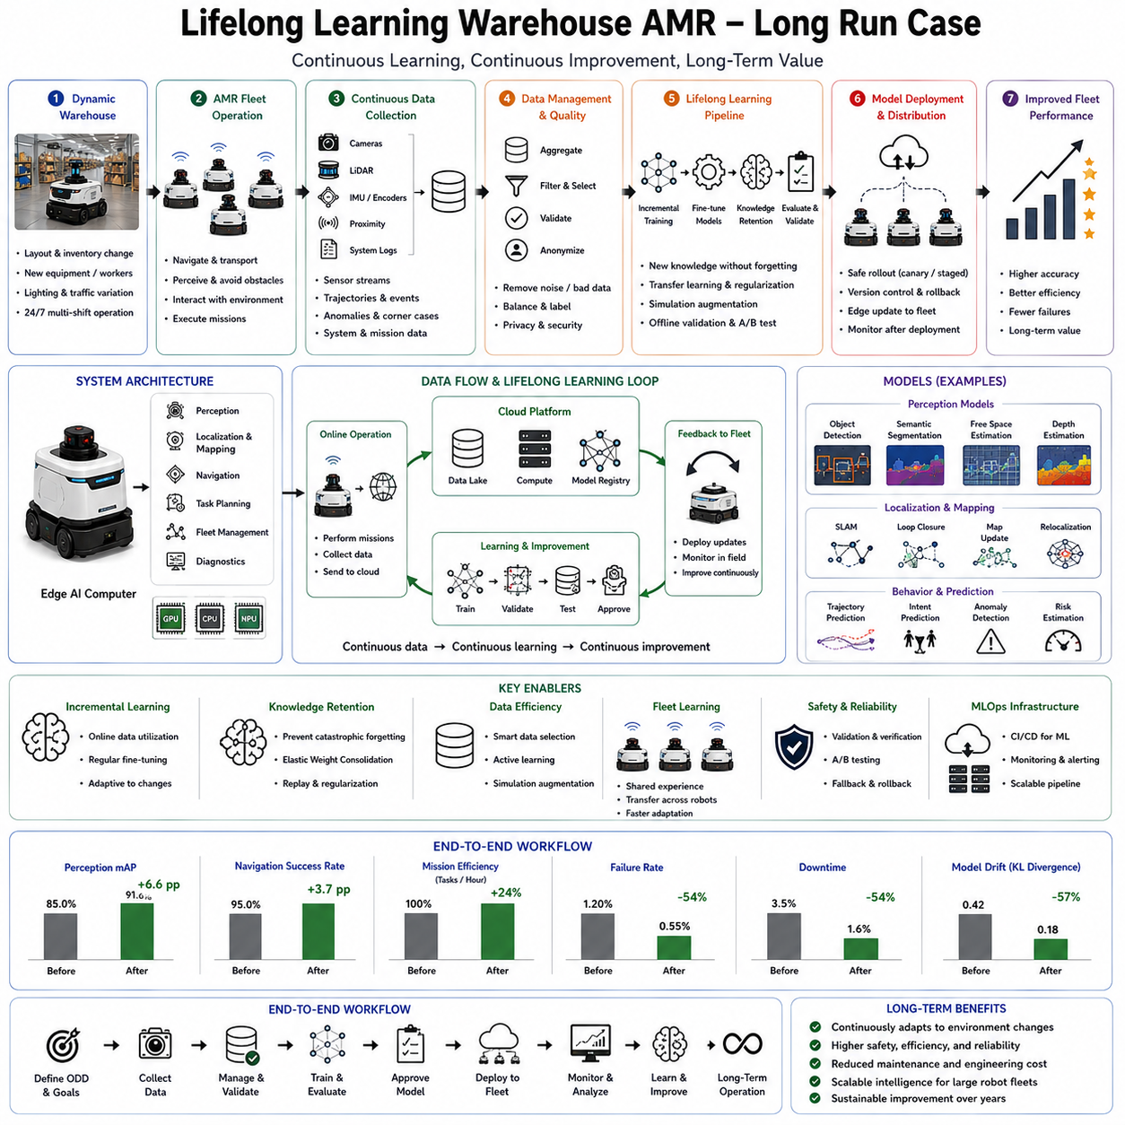
Lifelong learning has become one of the defining capabilities required for the next generation of intelligent Autonomous Mobile Robots (AMRs). Traditional robotic systems are developed according to a static learning paradigm in which data are collected once, models are trained offline, extensive validation is performed, and the resulting software is deployed into production. Although this workflow has supported many successful industrial automation systems, it assumes that the operating environment remains relatively stable throughout the robot's lifetime. Modern warehouses, however, are highly dynamic ecosystems. Storage layouts change, inventory rotates continuously, shelving is rearranged, new machinery is installed, lighting conditions evolve, human workflows adapt, and seasonal business fluctuations introduce new operational patterns. A perception or navigation model that performs exceptionally well on the day of deployment may gradually become less effective as the environment diverges from the original training data. Lifelong learning addresses this challenge by enabling autonomous robots to accumulate knowledge continuously throughout months or years of operation while preserving previously acquired capabilities. Rather than treating deployment as the end of model development, lifelong learning transforms deployment into the beginning of an ongoing learning process.
This production case considers a fleet of warehouse Autonomous Mobile Robots deployed within a large e-commerce distribution center operating twenty-four hours per day. Hundreds of robots transport inventory containers between automated storage systems, picking stations, packing areas, quality inspection cells, loading docks, and charging stations. The warehouse contains thousands of storage shelves, continuously changing inventory, hundreds of workers, forklifts, conveyor systems, automatic elevators, temporary staging areas, maintenance zones, and multiple production shifts. Unlike benchmark environments used in academic research, this warehouse evolves continuously throughout every day of operation. The central engineering objective is to allow the robotic fleet to improve navigation, perception, obstacle avoidance, and operational efficiency over multiple years without requiring complete retraining or repeated manual data collection campaigns.
The first engineering principle behind lifelong learning is recognizing that environmental change is inevitable rather than exceptional. Warehouse operators frequently introduce new product categories, expand storage capacity, modify aisle layouts, install additional conveyor systems, replace lighting fixtures, alter traffic patterns, and optimize logistics workflows. These modifications gradually produce statistical distribution shifts between the original training dataset and the operational environment. Rather than considering these differences as failures, the learning architecture is explicitly designed to identify, measure, and adapt to such changes.
The development process begins with defining the Operational Design Domain not as a fixed environment but as an evolving operational space. Engineers characterize expected rates of environmental change, seasonal inventory variation, lighting modification, infrastructure expansion, robot fleet growth, sensor aging, communication upgrades, and software evolution. This long-term perspective influences every aspect of system design, including data management, model architecture, deployment pipelines, validation procedures, runtime monitoring, and fleet management infrastructure.
The robotic platform consists of multiple integrated subsystems including perception, localization, mapping, navigation, obstacle avoidance, task planning, fleet coordination, diagnostics, communication, and edge AI inference. Each subsystem produces valuable operational information that contributes to lifelong learning. RGB cameras, depth cameras, LiDAR, inertial measurement units, wheel encoders, proximity sensors, battery monitors, thermal sensors, and communication modules continuously generate multimodal observations describing both the warehouse and the robot itself. Instead of discarding this information after immediate navigation, the system stores selected observations for future learning.
Data collection becomes a continuous operational process rather than a dedicated development phase. Every robot records representative sensor observations, navigation trajectories, localization estimates, obstacle encounters, emergency stops, mission completion statistics, operator interventions, environmental anomalies, and runtime confidence estimates. Intelligent filtering prevents excessive storage requirements by selecting informative events rather than preserving every sensor frame. Rare obstacles, uncertain predictions, unusual environmental conditions, difficult navigation scenarios, and recovery behaviors receive higher recording priority than ordinary repetitive operation.
A centralized data management platform aggregates information collected from the entire fleet. Instead of treating each robot independently, operational experience gathered by one robot becomes organizational knowledge available to every deployed platform. If one robot encounters a newly installed shelving configuration or unfamiliar obstacle, the corresponding observations contribute to future model updates benefiting the entire fleet after validation. Fleet-scale learning therefore accelerates adaptation significantly compared with isolated individual learning.
Data quality remains essential despite continuous collection. Automated validation pipelines identify corrupted sensor recordings, synchronization failures, incomplete trajectories, communication interruptions, calibration drift, timestamp inconsistencies, and annotation errors before new data enter training repositories. Statistical monitoring evaluates environmental diversity, class balance, geographical coverage, temporal variation, and sensor consistency across accumulated datasets. Without systematic quality assurance, continuous learning risks degrading rather than improving model performance.
One of the primary challenges addressed by lifelong learning is concept drift. Concept drift occurs when the statistical relationship between observations and desired predictions changes over time. In warehouse environments, concept drift may arise because new pallet designs appear, shelf arrangements change, floor markings fade, lighting systems are upgraded, workers adopt different operational procedures, or seasonal inventory introduces unfamiliar packaging. AI models trained exclusively on historical data gradually become less representative of current operating conditions. Detecting concept drift early allows engineers to update models before operational performance deteriorates significantly.
Drift detection combines statistical analysis with runtime performance monitoring. Feature distributions extracted by perception networks are compared continuously with historical training distributions. Embedding-space visualization, probability density estimation, clustering analysis, Maximum Mean Discrepancy, Wasserstein distance, and statistical hypothesis testing identify gradual environmental shifts. Simultaneously, operational metrics such as detection confidence, localization consistency, navigation success rate, obstacle avoidance frequency, and human intervention rate provide practical indicators of model degradation. The combination of statistical and behavioral evidence enables reliable drift detection without requiring exhaustive manual inspection.
The perception system itself follows a modular architecture supporting incremental improvement. Object detection recognizes workers, forklifts, pallets, shelves, robots, maintenance equipment, temporary barriers, and safety devices. Semantic segmentation identifies traversable floor regions, restricted zones, loading areas, charging stations, and operational workspaces. Localization combines LiDAR mapping with visual landmarks, while free-space estimation identifies safe navigation corridors. Individual perception modules can be updated independently while preserving stable interfaces with higher-level navigation systems, reducing deployment risk during continual improvement.
Foundation models provide an increasingly important starting point for lifelong learning. Large self-supervised vision encoders pretrained on diverse image collections generate generalized feature representations that remain useful even as warehouse environments evolve. Fine-tuning these pretrained representations using continuously collected operational data requires substantially fewer labeled examples than training complete perception systems from scratch. Consequently, adaptation becomes both faster and more computationally efficient.
Active learning further improves data efficiency. Rather than requesting manual annotation for every newly collected observation, uncertainty estimation identifies samples expected to contribute maximum learning value. Images containing unfamiliar obstacles, ambiguous segmentation boundaries, novel packaging, unusual worker behavior, or degraded sensor conditions receive annotation priority. Human labeling resources therefore concentrate on the most informative operational examples while minimizing annotation cost.
Human-in-the-loop learning remains essential throughout deployment. Warehouse operators, maintenance personnel, and AI engineers review uncertain predictions, verify anomaly detections, confirm labeling quality, and approve model updates before production deployment. Human oversight prevents erroneous operational data from corrupting training datasets while ensuring that organizational expertise continues influencing robot behavior.
Continual learning algorithms address one of the most significant technical challenges associated with lifelong adaptation: catastrophic forgetting. Conventional neural networks often lose previously acquired knowledge when retrained on new datasets. A robot updated using only recently collected warehouse observations may inadvertently degrade performance in environments encountered less frequently but still operationally important. Catastrophic forgetting becomes particularly problematic for long-term deployment where models undergo numerous incremental updates throughout several years.
Several complementary strategies mitigate catastrophic forgetting. Replay mechanisms preserve representative historical training examples that remain available during future optimization. Instead of training exclusively on new operational data, each update combines recent observations with carefully selected historical experiences maintaining coverage across previous operational conditions. Balanced replay significantly reduces forgetting while preserving adaptation capability.
Regularization-based continual learning further stabilizes knowledge retention. Optimization algorithms identify parameters particularly important for previously learned tasks and discourage unnecessary modification during future training. Elastic Weight Consolidation, Synaptic Intelligence, and related methods preserve essential representations while allowing sufficient flexibility for adaptation to evolving environments.
Knowledge distillation provides another effective approach. Newly trained models learn not only from updated operational datasets but also from predictions generated by previous production models. Distillation encourages continuity between successive software versions, reducing unexpected behavioral changes while allowing gradual performance improvement.
Memory systems become increasingly sophisticated during long-term deployment. Episodic memory stores representative operational experiences including unusual navigation scenarios, recovery behaviors, rare obstacle encounters, and exceptional environmental conditions. Semantic memory accumulates generalized knowledge regarding warehouse layouts, object categories, traffic patterns, and operational procedures. Working memory supports ongoing navigation tasks, while long-term repositories enable organizational learning spanning multiple years.
The localization subsystem benefits substantially from lifelong learning. Warehouse maps continuously evolve because shelving arrangements, storage zones, temporary workspaces, and infrastructure change over time. Instead of reconstructing maps from scratch repeatedly, mapping algorithms update local regions incrementally while preserving stable portions of the environment. Dynamic mapping distinguishes permanent structural changes from temporary obstacles, maintaining reliable localization despite continuous environmental evolution.
Navigation policies likewise improve continuously. Operational trajectories recorded over thousands of hours reveal efficient travel routes, congestion patterns, frequently blocked aisles, high-traffic intersections, charging behavior, and worker movement statistics. Learning algorithms gradually optimize route planning according to actual operational experience rather than relying solely upon predefined cost functions. Navigation therefore becomes increasingly efficient as the fleet accumulates practical knowledge.
Obstacle avoidance also evolves through experience. Initially unfamiliar obstacles such as newly introduced transport carts, temporary maintenance equipment, seasonal packaging, or autonomous cleaning machines gradually become incorporated into perception models. Runtime uncertainty associated with these objects decreases as additional observations accumulate, improving navigation confidence without compromising safety.
Fleet coordination represents another important application of lifelong learning. Traffic management algorithms observe interactions among hundreds of robots operating simultaneously throughout the warehouse. Operational logs identify congestion, bottlenecks, inefficient task allocation, charging station conflicts, and communication patterns. Fleet optimization algorithms subsequently refine scheduling, routing, charging, and workload distribution using accumulated operational statistics.
Edge AI hardware supports continuous deployment while maintaining real-time performance. Perception models execute locally using optimized inference engines such as TensorRT or ONNX Runtime. However, model retraining occurs within centralized computing infrastructure where larger computational resources enable efficient optimization. Updated models undergo comprehensive validation before distribution back to edge devices through secure software deployment pipelines.
Model version management becomes essential during continual improvement. Every deployed AI model receives unique version identifiers associated with corresponding datasets, training configurations, validation results, software dependencies, hardware compatibility, and deployment history. Complete traceability enables rapid rollback if unexpected operational issues emerge after updates. Rather than replacing models permanently, previous versions remain available for comparison, regression testing, and emergency recovery.
Continuous integration and continuous deployment pipelines automate much of the learning lifecycle. Newly collected operational data trigger preprocessing, quality validation, active learning selection, annotation workflows, retraining, simulation evaluation, regression testing, safety verification, pilot deployment, and gradual fleet rollout. Automated pipelines reduce engineering effort while ensuring consistent deployment procedures across every model update.
Simulation continues supporting lifelong learning even after production deployment. Difficult operational scenarios identified through fleet logs are reconstructed within high-fidelity digital twins. Engineers reproduce unusual navigation situations, evaluate candidate model improvements, perform stress testing, and verify safety before deploying updated software into real warehouses. Simulation therefore becomes a continuous validation environment rather than a development-only tool.
Runtime safety monitoring remains independent from adaptive learning mechanisms. Deterministic safety controllers supervise obstacle avoidance, emergency stopping, speed regulation, workspace boundaries, human proximity, battery management, communication health, and computational integrity regardless of ongoing model evolution. Every updated AI model remains subject to identical certified safety supervision before influencing physical robot behavior.
Uncertainty estimation plays a central role throughout lifelong learning. Every prediction includes associated confidence measures reflecting model certainty. Elevated uncertainty frequently indicates unfamiliar situations deserving additional data collection or future retraining. Runtime monitors therefore transform operational uncertainty into valuable learning opportunities rather than merely reporting potential failures.
Failure analysis provides another source of continual improvement. Every navigation anomaly, localization failure, perception error, communication interruption, or unexpected recovery maneuver undergoes systematic investigation using synchronized sensor logs, replay systems, interpretability tools, root cause analysis, and operational diagnostics. Lessons learned become additional training examples, validation scenarios, safety rules, or engineering improvements incorporated into subsequent software versions.
Cybersecurity becomes increasingly important because lifelong learning depends upon continuous software updates and centralized data exchange. Secure communication, authenticated model deployment, encrypted operational logs, access control, digital signatures, and integrity verification protect learning infrastructure against unauthorized modification. Without strong cybersecurity, adaptive learning mechanisms themselves could become attack vectors compromising operational safety.
Performance evaluation extends beyond ordinary benchmark accuracy. Engineers monitor mission completion rate, navigation efficiency, obstacle avoidance frequency, localization precision, energy consumption, battery lifetime, communication quality, inference latency, hardware utilization, operator intervention frequency, maintenance requirements, and long-term productivity. Trend analysis spanning months or years reveals gradual improvement resulting from continual adaptation.
An important observation emerging from long-term deployment is that operational knowledge accumulates nonlinearly. Early deployment primarily corrects obvious deficiencies such as unfamiliar obstacles or localization inconsistencies. Later improvements become increasingly subtle, focusing on energy optimization, route efficiency, collaborative behavior, maintenance prediction, and rare environmental situations. Lifelong learning therefore evolves from reactive correction toward proactive optimization as organizational experience matures.
Future warehouse AMRs will increasingly integrate lifelong learning with foundation models, world models, multimodal reasoning, natural language interfaces, predictive planning, and fleet-scale collaborative intelligence. Rather than updating isolated perception modules independently, future systems will continuously refine complete cognitive architectures including perception, memory, reasoning, planning, manipulation, communication, and human collaboration. Organizational knowledge accumulated across global warehouse networks will enable rapid adaptation to new facilities while preserving previously acquired operational expertise.
Ultimately, this long-term production deployment demonstrates that lifelong learning transforms autonomous robots from static software systems into continuously improving intelligent agents. Instead of requiring complete redevelopment whenever operational environments change, warehouse AMRs progressively expand their capabilities through accumulated experience while maintaining previously acquired knowledge. Successful lifelong learning depends not only upon advanced machine learning algorithms but also upon disciplined data engineering, robust MLOps infrastructure, continuous validation, runtime safety monitoring, uncertainty estimation, fleet management, cybersecurity, and systems engineering. Together these technologies establish a sustainable framework in which autonomous robots remain effective throughout years of deployment despite continuously evolving environments. As Physical AI continues advancing toward increasingly general and adaptive intelligence, lifelong learning will become one of the fundamental technologies enabling robots to learn throughout their operational lifetime, transforming every completed mission into an opportunity for future improvement.

12.09 AI Safety OOD Failure Detection Production Case
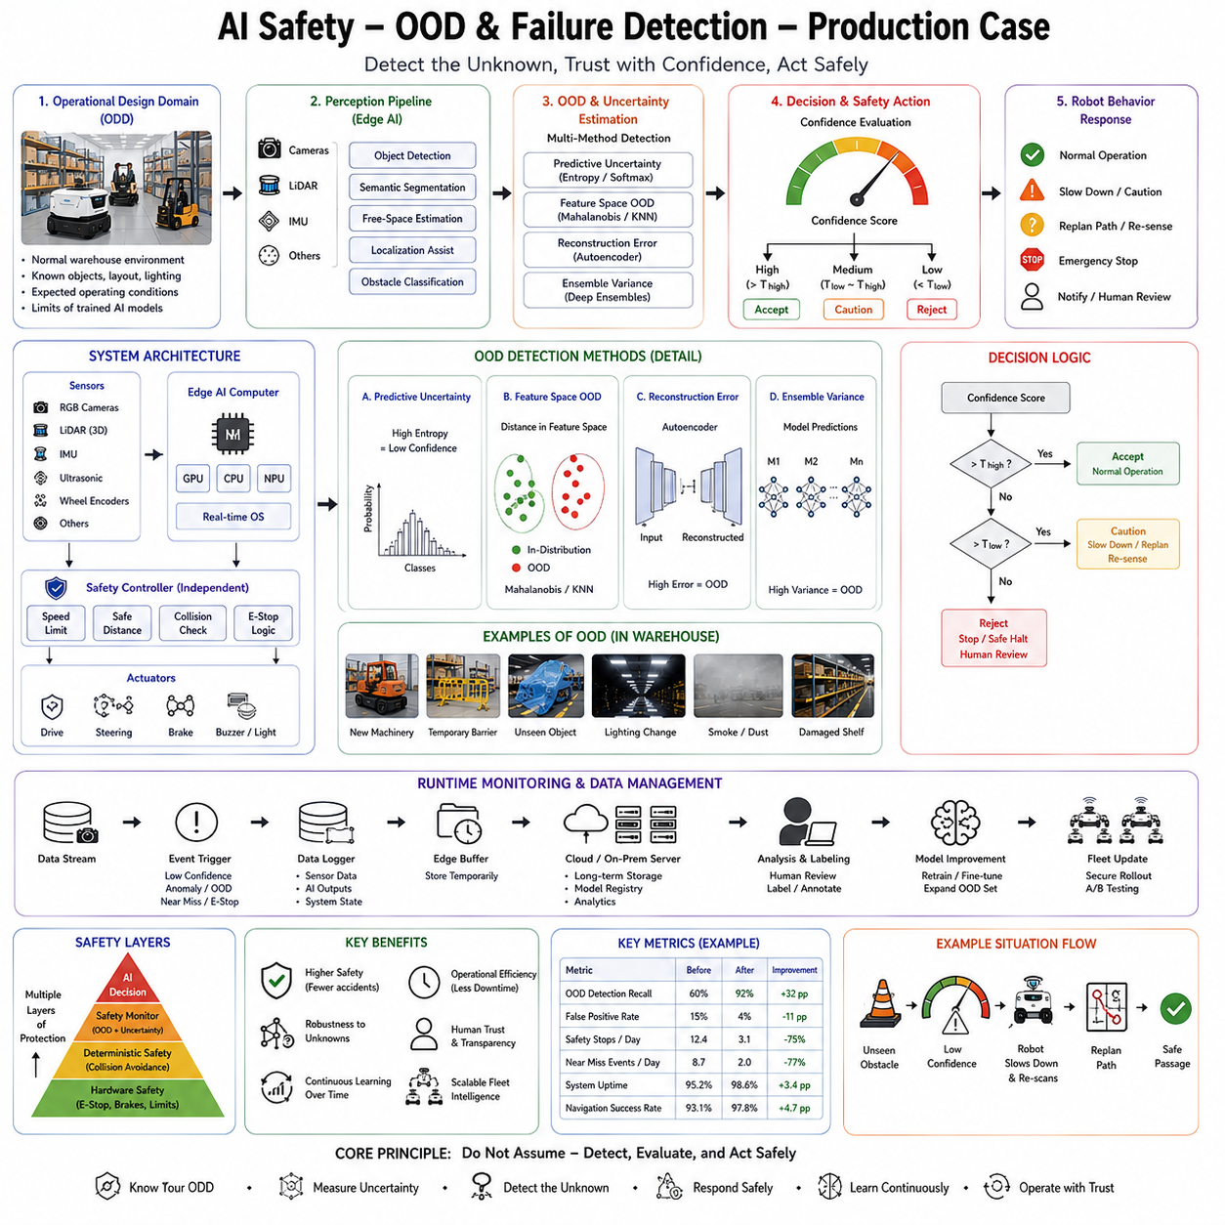
Artificial intelligence has enabled autonomous robots to achieve remarkable capabilities in perception, navigation, manipulation, planning, and decision making. However, no AI model can perfectly anticipate every situation encountered during real-world deployment. Industrial robots, Autonomous Mobile Robots (AMRs), humanoids, autonomous vehicles, quadruped inspection robots, and cargo UAVs inevitably operate in environments that differ from their original training data. Unexpected obstacles appear, lighting conditions change, sensors degrade, infrastructure evolves, weather introduces new visual characteristics, and human behavior varies continuously. While traditional software generally behaves predictably under predefined operating conditions, AI systems learn statistical patterns from historical data and therefore may become unreliable when exposed to unfamiliar situations. Consequently, modern production robotics increasingly treats Out-of-Distribution (OOD) detection and AI failure detection as essential safety mechanisms rather than optional performance enhancements. Instead of assuming that every prediction produced by a neural network is trustworthy, production systems continuously evaluate whether the current situation resembles previous experience and whether the AI output should be accepted, questioned, or rejected before influencing physical robot behavior.
This production case considers a large fleet of industrial Autonomous Mobile Robots operating continuously inside a global logistics warehouse responsible for transporting inventory between automated storage systems, picking stations, packaging lines, quality inspection cells, and shipping docks. Hundreds of robots perform thousands of missions every day while interacting with workers, forklifts, conveyor systems, autonomous equipment, temporary storage areas, maintenance personnel, and changing warehouse layouts. The robots rely on deep learning for object detection, semantic segmentation, free-space estimation, localization assistance, and obstacle classification. During laboratory validation, these models achieved excellent benchmark accuracy. However, engineers recognized that deployment environments would inevitably evolve beyond the conditions represented in the original training datasets. Instead of attempting to eliminate every possible prediction error through larger datasets alone, the engineering objective became identifying situations where AI confidence should decrease and appropriate safety actions should be triggered automatically.
The system architecture follows a layered safety philosophy. Artificial intelligence performs perception and high-level understanding, while independent runtime safety monitors evaluate prediction reliability before navigation decisions influence physical actuators. Deterministic safety controllers supervise vehicle motion regardless of AI confidence, ensuring that unexpected model behavior cannot directly produce unsafe robot actions. Out-of-distribution detection therefore becomes one component within a broader AI safety architecture that also includes uncertainty estimation, anomaly detection, runtime verification, deterministic collision avoidance, emergency stop systems, and comprehensive operational monitoring.
The development process begins by defining the Operational Design Domain. Engineers carefully specify the environmental conditions under which the perception system is expected to operate reliably. The warehouse contains standard shelving, pallets, forklifts, workers wearing approved safety equipment, designated pedestrian lanes, charging stations, storage racks, conveyor systems, and known lighting conditions. Training datasets capture representative examples of these environments across multiple shifts, seasonal inventory changes, and operational configurations. However, engineers explicitly acknowledge that future deployment will inevitably include situations beyond this operational domain. Rather than assuming perfect generalization, the AI system is designed to recognize unfamiliarity as an explicit output of the perception pipeline.
The first engineering challenge involves defining what constitutes an out-of-distribution observation. Unlike ordinary classification errors where the correct answer belongs to one of the trained categories, OOD situations often involve observations fundamentally different from anything encountered during model development. Examples include newly installed industrial machinery, temporary construction barriers, unusual packaging materials, damaged shelving, reflective emergency blankets, cleaning equipment, unexpected maintenance vehicles, severe smoke conditions, partially collapsed storage racks, unusual lighting produced during emergency operations, or entirely new object categories introduced after deployment. Even subtle environmental changes may gradually shift statistical distributions sufficiently to influence neural network reliability.
The perception system consists of several interconnected neural networks. An object detection model recognizes workers, forklifts, pallets, carts, robots, safety barriers, and industrial equipment. Semantic segmentation identifies traversable floor regions, shelving structures, storage zones, restricted areas, and charging locations. A free-space estimation network predicts navigable regions, while visual localization assists geometric mapping through semantic landmark recognition. Each model produces prediction probabilities together with internal feature representations extracted from deep neural network layers. Rather than considering only final class probabilities, OOD detection analyzes these latent feature distributions to determine whether current observations resemble previous training experience.
The first production implementation employs confidence monitoring as a baseline safety mechanism. Every prediction includes probability estimates generated by the neural network. Low-confidence detections immediately trigger increased caution, including reduced navigation speed, expanded obstacle safety margins, additional sensor verification, or requests for human supervision. However, engineers quickly discover that confidence alone provides insufficient protection because modern neural networks frequently produce highly confident predictions even for unfamiliar observations. Consequently, additional OOD detection mechanisms become necessary.
Feature-space analysis provides the next layer of protection. During model development, engineers record latent feature representations generated by intermediate neural network layers for millions of training samples. These feature embeddings define the statistical manifold representing familiar operational conditions. During deployment, incoming observations are projected into the same feature space. Distance metrics compare current embeddings with historical training distributions using Mahalanobis distance, cosine similarity, Euclidean distance, kernel density estimation, and probabilistic clustering. Observations located far from familiar feature clusters receive elevated OOD scores even when classification confidence remains high.
Energy-based OOD detection further improves reliability. Instead of relying solely on probability distributions, engineers compute energy scores describing how strongly the neural network internally supports each prediction. Familiar observations generally produce low-energy representations corresponding to stable learned concepts, whereas unfamiliar observations exhibit higher energy indicating reduced model certainty. Energy-based methods prove particularly robust because they exploit internal network behavior rather than only final softmax probabilities.
Monte Carlo dropout contributes another source of uncertainty estimation. During inference, dropout layers remain active, producing multiple slightly different predictions for identical sensor observations. Prediction variance estimates epistemic uncertainty associated with unfamiliar environments. High variance indicates insufficient model knowledge rather than ordinary classification ambiguity. Runtime safety monitors combine Monte Carlo uncertainty with OOD scores, confidence estimates, and sensor consistency analysis before determining appropriate operational responses.
Deep ensemble methods provide additional robustness. Instead of deploying one perception model, production systems maintain multiple independently trained networks initialized using different random seeds or training subsets. Agreement among ensemble members indicates reliable predictions, while disagreement frequently signals unfamiliar situations. Although ensembles require additional computational resources, optimized edge inference hardware allows practical deployment for critical perception tasks where safety outweighs computational cost.
Autoencoder-based anomaly detection complements supervised perception. Autoencoders learn compact representations capable of reconstructing familiar warehouse images accurately. During deployment, unfamiliar observations produce significantly larger reconstruction errors because latent representations no longer capture unusual environmental structure effectively. Reconstruction error therefore provides an independent anomaly score separate from classification confidence. This approach proves particularly useful for detecting unexpected environmental changes rather than merely new object categories.
Self-supervised representation learning further enhances anomaly detection. Contrastive learning methods produce feature embeddings emphasizing semantic similarity without requiring exhaustive manual annotation. Since these representations capture broad environmental structure rather than narrow classification objectives, they often detect unfamiliar situations more reliably than task-specific classifiers. Production engineers therefore combine supervised perception with self-supervised embeddings to improve OOD robustness.
Sensor fusion significantly strengthens failure detection. Cameras, LiDAR, depth sensors, inertial measurement units, wheel encoders, and localization systems independently observe the environment. Significant disagreement among sensing modalities frequently indicates AI failures or environmental anomalies. For example, visual perception may classify an area as free space while LiDAR detects substantial geometric obstacles. Such inconsistencies trigger runtime investigation before navigation proceeds. Multi-sensor agreement therefore serves as an important safety indicator independent of neural network confidence.
Temporal consistency analysis provides another production safeguard. Warehouse environments evolve continuously rather than instantaneously. Object identities, shelf positions, robot trajectories, worker motion, and free-space boundaries should exhibit smooth temporal evolution. Sudden appearance or disappearance of large structures, inconsistent object identities across consecutive frames, or abrupt localization changes often indicate perception failures rather than genuine environmental events. Runtime monitoring compares current predictions with recent observation history, identifying improbable discontinuities requiring additional verification.
World models further enhance failure detection through predictive consistency. The robot continuously predicts future sensor observations based on current environmental understanding and planned motion. Actual sensor measurements are compared against predicted observations generated by the internal world model. Large prediction errors indicate either unexpected environmental changes or failures within perception, localization, or planning subsystems. Prediction residuals therefore become valuable indicators supporting anomaly detection and operational safety.
The runtime safety architecture organizes these diverse indicators into a unified decision framework. Every perception cycle generates object detections, segmentation maps, localization estimates, confidence values, uncertainty measurements, OOD scores, reconstruction errors, sensor consistency metrics, temporal consistency evaluations, and world model prediction residuals. Rather than considering any single metric independently, a supervisory safety module combines all evidence to estimate overall operational reliability. Multi-factor evaluation substantially reduces false alarms while improving detection sensitivity.
Different OOD severity levels correspond to different operational responses. Mild uncertainty caused by slightly unfamiliar packaging may simply reduce navigation speed modestly. Moderate uncertainty resulting from newly installed equipment may trigger additional sensing, alternative navigation routes, or temporary operator notification. Severe OOD conditions involving sensor failure, environmental collapse, dense smoke, or unknown obstacles immediately activate emergency stop procedures followed by human intervention. This graduated response strategy balances operational productivity with conservative safety management.
Human detection receives especially conservative treatment. Multiple independent perception pipelines simultaneously verify worker presence using RGB cameras, depth sensing, LiDAR clustering, and motion analysis. Any disagreement defaults toward assuming human presence until additional evidence becomes available. False positives may reduce operational efficiency temporarily, but false negatives represent unacceptable safety risks. Consequently, runtime safety intentionally prioritizes caution whenever uncertainty involves nearby personnel.
The warehouse environment gradually evolves throughout long-term deployment. Engineers intentionally introduce controlled changes to evaluate OOD detection performance. New shelving designs, updated pallet configurations, modified floor markings, temporary maintenance equipment, seasonal decorations, autonomous cleaning robots, and revised worker uniforms provide realistic operational drift. The safety system successfully identifies these unfamiliar conditions despite maintaining reliable navigation through conservative operational behavior. Collected observations subsequently become candidates for future model retraining after human validation.
Operational data collection supports continual improvement. Every detected OOD event records synchronized sensor streams, feature embeddings, uncertainty estimates, runtime decisions, environmental context, and subsequent operator feedback. Engineers classify detected events into categories including true novel objects, environmental changes, sensor degradation, false alarms, lighting anomalies, localization failures, and temporary operational disturbances. This continuously expanding repository supports future model refinement while improving OOD detection accuracy over time.
Active learning integrates naturally with the OOD pipeline. Instead of manually reviewing every recorded observation, annotation resources focus specifically on high-uncertainty or high-OOD events. Human experts classify unfamiliar objects, validate anomaly detections, and confirm operational responses. Newly labeled examples expand training datasets systematically, allowing perception models gradually to incorporate previously unfamiliar environmental conditions into future production versions.
Failure analysis forms another major engineering activity. Every significant OOD event undergoes comprehensive investigation using replay systems, synchronized sensor logs, feature visualization, Grad-CAM explanations, SHAP analysis, localization diagnostics, communication logs, and hardware status monitoring. Engineers distinguish among genuine environmental novelty, dataset limitations, sensor degradation, calibration drift, software integration issues, hardware faults, communication delays, and model architecture weaknesses. Root cause analysis prevents repeated operational failures while guiding future engineering priorities.
Model update procedures remain deliberately conservative despite continual learning capabilities. Newly collected operational data undergo preprocessing, quality validation, annotation, simulation evaluation, regression testing, safety verification, and pilot deployment before fleet-wide rollout. Engineers avoid unrestricted online learning because uncontrolled adaptation could introduce unexpected behaviors compromising operational safety. Instead, carefully validated offline updates preserve organizational control while still enabling gradual improvement.
Runtime performance monitoring evaluates more than detection accuracy alone. Engineers measure OOD detection precision, false positive rate, false negative rate, uncertainty calibration, response latency, emergency intervention frequency, operator workload, computational overhead, and fleet-wide operational productivity. Long-term statistical analysis confirms that OOD detection reduces navigation incidents substantially while introducing only modest reductions in operational throughput during unfamiliar situations.
Computational efficiency remains important because OOD detection executes continuously on embedded edge hardware. Engineers optimize inference using TensorRT, mixed-precision computation, feature caching, asynchronous execution, and shared backbone architectures. Rather than deploying separate neural networks for every safety function, shared latent representations support perception, uncertainty estimation, anomaly detection, and OOD evaluation simultaneously. This integrated architecture minimizes computational overhead while preserving real-time performance.
Cybersecurity considerations extend naturally into OOD detection. Adversarial attacks, sensor spoofing, malicious visual patterns, communication tampering, and GNSS interference frequently produce observations statistically different from ordinary operational data. Although OOD detection does not replace dedicated cybersecurity systems, elevated anomaly scores frequently provide early warning regarding potential malicious interference. Integration with intrusion detection systems therefore strengthens overall operational resilience.
Regulatory compliance increasingly emphasizes runtime monitoring and explainability. Comprehensive operational logs record OOD scores, confidence values, supervisory decisions, emergency interventions, operator actions, software versions, and environmental conditions throughout deployment. Complete traceability supports certification, incident investigation, regulatory reporting, and continuous process improvement while demonstrating responsible AI governance.
Future production robotics will increasingly integrate foundation models, multimodal world models, causal reasoning, predictive simulation, and self-supervised representation learning into comprehensive safety architectures. Rather than detecting unfamiliar observations solely through statistical distance metrics, future systems will reason about causal consistency, physical plausibility, semantic understanding, and long-term environmental evolution simultaneously. Collaborative fleet intelligence will allow novel situations encountered by one robot to improve safety across entire global deployments almost immediately following validation.
Ultimately, this production deployment demonstrates that AI safety depends not only on improving prediction accuracy but also on recognizing the limitations of learned models. Out-of-distribution detection transforms artificial intelligence from a system that always attempts to produce confident answers into one capable of identifying situations where its own knowledge becomes unreliable. Combined with uncertainty estimation, anomaly detection, sensor fusion, runtime safety monitoring, deterministic control, continual learning, and systematic failure analysis, OOD detection provides one of the essential engineering foundations enabling autonomous robots to operate safely within continuously changing real-world environments. As Physical AI systems become increasingly autonomous, adaptive, and widespread across logistics, manufacturing, healthcare, transportation, infrastructure, and public spaces, production-grade OOD detection will remain a critical component ensuring that intelligent robots understand not only what they know but also when they encounter the unknown.

12.10 Future Robot ML AI Architecture Roadmap
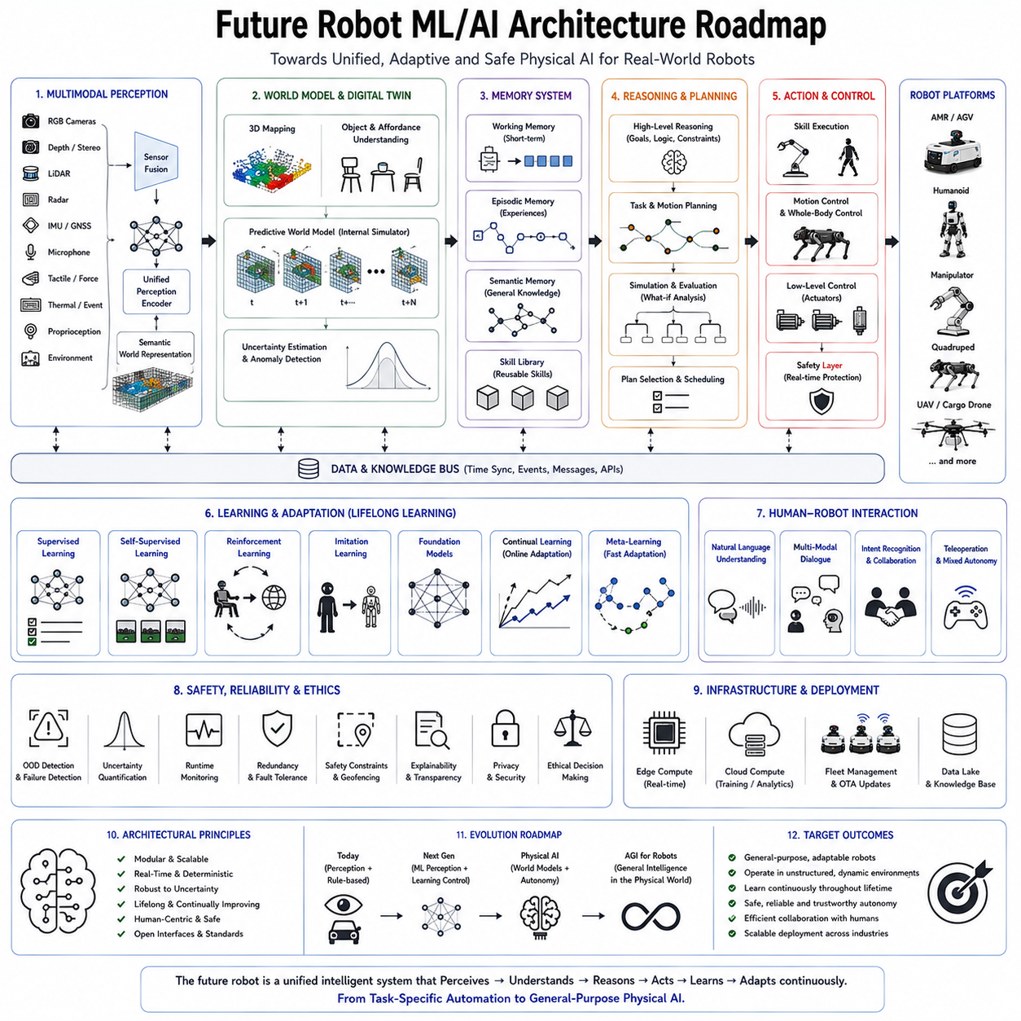
The future of robotics will be defined not by incremental improvements to individual machine learning algorithms but by the emergence of unified intelligent architectures that integrate perception, reasoning, memory, planning, learning, manipulation, mobility, language understanding, and autonomous decision making into a continuously evolving cognitive system. During the first generations of industrial robotics, robots were primarily deterministic machines executing carefully programmed trajectories within highly structured environments. The second generation introduced machine learning, allowing robots to recognize objects, classify images, estimate poses, and optimize specific behaviors through data-driven approaches. The next generation, often described as Physical AI or Embodied AI, represents a fundamental transition from isolated intelligent modules toward complete autonomous cognitive systems capable of understanding the physical world, learning continuously from experience, reasoning across multiple modalities, and adapting safely throughout long-term deployment. A future robot AI architecture therefore cannot be viewed as a collection of independent neural networks. Instead, it must function as an integrated intelligence platform whose components cooperate dynamically across perception, memory, reasoning, planning, action, and continual learning.
One of the most important observations shaping future architectures is that no single learning paradigm alone can achieve general robotic intelligence. Supervised learning excels at perception and recognition but depends heavily on labeled datasets. Self-supervised learning extracts generalized representations from enormous quantities of unlabeled data. Reinforcement learning enables sequential decision making through interaction with environments. Imitation learning efficiently transfers human expertise into robotic policies. Foundation models provide broad multimodal knowledge, while world models support prediction and simulation. Future robotic intelligence will emerge from the coordinated interaction of these complementary learning paradigms rather than replacing one with another.
The architectural foundation begins with multimodal perception. Future robots will continuously integrate information from RGB cameras, depth sensors, stereo vision, event cameras, LiDAR, radar, thermal imaging, hyperspectral sensors, tactile arrays, force-torque sensors, inertial measurement units, GNSS, microphones, vibration sensors, environmental sensors, proprioception, and wearable human interfaces. Instead of processing each sensing modality independently, unified perception models will fuse heterogeneous observations into coherent semantic world representations. Cross-modal attention mechanisms will dynamically determine which sensory information deserves priority according to environmental conditions and current mission objectives. For example, visual sensing may dominate during normal daylight operation, while radar and thermal sensing become more influential during smoke, darkness, or adverse weather.
Large multimodal foundation models will increasingly replace specialized perception networks trained independently for every individual task. Rather than maintaining separate object detectors, semantic segmentation networks, pose estimators, scene classifiers, and action recognition systems, future architectures will employ unified encoders capable of extracting generalized representations supporting numerous downstream applications simultaneously. Massive pretraining using internet-scale image collections, video sequences, simulation environments, robotic datasets, and multimodal interactions will provide rich semantic understanding transferable across industrial automation, logistics, healthcare, agriculture, infrastructure inspection, manufacturing, service robotics, and domestic environments. Task-specific adaptation will require comparatively small quantities of additional domain data because generalized representations already capture broad visual and physical knowledge.
Beyond perception lies semantic world understanding. Modern robots primarily detect objects, classify environments, and estimate geometry. Future architectures will instead construct continuously evolving world models representing physical objects, spatial relationships, functional affordances, causal interactions, human intentions, temporal evolution, and predicted future states. Rather than observing isolated sensor measurements, robots will maintain internal digital twins of their surrounding environments. Every perception update modifies this internal world model, allowing reasoning to extend beyond immediate observations toward long-horizon prediction and counterfactual simulation.
World models represent one of the most transformative architectural innovations expected during the coming decade. A world model functions as an internal simulator continuously predicting environmental evolution based on current observations, planned actions, and accumulated knowledge. Before executing physical actions, robots will mentally simulate multiple possible futures, evaluate predicted consequences, compare alternative strategies, estimate uncertainty, and select actions maximizing long-term objectives. Internal simulation reduces reliance on dangerous trial-and-error exploration while dramatically improving planning efficiency. Prediction errors further become valuable learning signals, enabling continual refinement of environmental understanding throughout deployment.
Memory architectures will evolve substantially beyond conventional recurrent neural networks. Future robotic intelligence requires multiple complementary forms of memory operating simultaneously. Working memory temporarily stores information relevant to current tasks including ongoing manipulation sequences, conversational context, navigation objectives, and immediate environmental observations. Episodic memory records complete experiences describing previous missions, successes, failures, human interactions, unusual situations, and operational incidents. Semantic memory accumulates generalized knowledge extracted from repeated experiences including object properties, tool usage, environmental structure, and procedural concepts. Procedural memory represents learned motor skills including locomotion, grasping, manipulation, navigation, and collaborative behaviors. Together these memory systems enable robots not merely to react but to recall, compare, generalize, and adapt based on accumulated experience.
Large Language Models will increasingly serve as reasoning engines rather than conversational interfaces alone. Natural language provides a flexible symbolic medium for representing goals, plans, explanations, instructions, constraints, and abstract concepts. Future robots will employ language-mediated reasoning to decompose complex objectives into executable subtasks, explain internal decisions to human operators, coordinate collaborative activities, interpret incomplete instructions, generate recovery strategies following failures, and communicate operational status naturally. Language therefore becomes an internal cognitive representation supporting planning and reasoning as much as external communication.
However, language reasoning alone remains insufficient for Physical AI because physical interaction requires understanding grounded in sensorimotor experience. Consequently, future architectures will combine symbolic reasoning with embodied world models, allowing abstract concepts to remain connected directly to physical observations and actions. A command such as “move the fragile container to the inspection station while avoiding busy aisles” requires simultaneous language understanding, object recognition, manipulation planning, navigation reasoning, human behavior prediction, and safety evaluation. Integrated cognitive architectures will perform such multimodal reasoning naturally through shared latent representations.
Planning systems will similarly evolve from deterministic path planning toward hierarchical cognitive planning. Strategic planners determine long-term mission objectives spanning minutes or hours. Tactical planners generate task sequences coordinating navigation, manipulation, communication, and resource allocation. Reactive planners continuously adapt immediate actions according to changing environmental conditions. Reinforcement learning contributes adaptive decision making, while symbolic planning provides interpretable task decomposition and logical constraint satisfaction. Hierarchical planning therefore balances flexibility with predictability, allowing robots to pursue complex objectives while remaining responsive to dynamic environments.
Manipulation architectures will increasingly integrate vision-language-action models replacing isolated grasp planning algorithms. Future robots will understand object affordances, infer intended human usage, predict object dynamics, estimate contact forces, and coordinate whole-body manipulation through unified multimodal representations. Dexterous manipulation will depend less upon manually engineered grasp libraries and more upon generalized policies capable of adapting continuously across novel objects, tools, materials, and environmental conditions. Multi-fingered robotic hands equipped with dense tactile sensing, force feedback, and adaptive control will cooperate with foundation models trained using enormous collections of human demonstration data and simulated manipulation experiences.
Locomotion systems will likewise transition toward unified whole-body control. Instead of independently controlling legs, arms, torso, head, and sensors, future architectures will optimize complete-body motion jointly according to stability, energy efficiency, manipulation requirements, environmental interaction, and human collaboration. Reinforcement learning, model predictive control, and differentiable physics will cooperate within hierarchical architectures where high-level intelligence determines behavioral objectives while low-level controllers guarantee dynamic stability and safety.
Edge AI computing will become increasingly heterogeneous. Future robotic platforms will integrate CPUs, GPUs, NPUs, dedicated AI accelerators, programmable logic, neuromorphic processors, event-based vision hardware, and high-speed memory systems into unified computational fabrics. Rather than executing all workloads identically, intelligent schedulers will dynamically allocate computation according to latency requirements, energy constraints, thermal conditions, and task priorities. Real-time perception may execute on dedicated AI accelerators, while long-horizon reasoning utilizes powerful GPUs and deterministic safety controllers operate independently on real-time processors. Hardware-software co-design will therefore become increasingly important as AI workloads continue expanding.
Cloud-edge collaboration will also evolve significantly. Immediate perception, safety supervision, control, and mission-critical reasoning must remain onboard because communication latency and network reliability cannot guarantee timely response. However, large-scale model retraining, fleet learning, digital twin simulation, knowledge sharing, software deployment, and organizational analytics benefit greatly from centralized cloud infrastructure. Future architectures will therefore distribute intelligence dynamically between edge devices and cloud platforms according to computational requirements and operational constraints.
Digital twins will become fundamental components of robotic intelligence. Every deployed robot will possess a continuously synchronized virtual counterpart representing current hardware condition, environmental state, operational history, maintenance records, learned knowledge, and predicted future behavior. Digital twins support simulation, predictive maintenance, software validation, policy evaluation, operator training, mission rehearsal, and failure analysis. Before executing high-risk operations, robots will increasingly evaluate candidate strategies within their digital twins, reducing operational risk through predictive simulation.
Lifelong learning represents another defining architectural capability. Future robots cannot remain static after deployment because operational environments evolve continuously. Warehouses introduce new inventory, factories modify production lines, hospitals adopt new procedures, cities construct new infrastructure, and agricultural fields change seasonally. Rather than periodically replacing complete AI systems, future architectures will accumulate knowledge incrementally while preserving previous competencies. Replay mechanisms, continual learning algorithms, knowledge distillation, active learning, uncertainty estimation, and human validation will cooperate to support safe long-term adaptation without catastrophic forgetting.
Fleet intelligence will accelerate learning dramatically. Instead of every robot learning independently, operational experience collected throughout global deployments will contribute toward centralized organizational knowledge. Difficult manipulation scenarios encountered in one factory, unusual terrain navigated by one quadruped, or rare obstacle configurations detected by one warehouse robot become immediately valuable learning resources for entire fleets after validation. Federated learning and privacy-preserving distributed optimization will allow collaborative improvement without exposing sensitive operational data unnecessarily.
AI safety will remain inseparable from future robotic intelligence. As autonomy increases, runtime monitoring, uncertainty quantification, out-of-distribution detection, anomaly detection, explainability, deterministic safety supervision, cybersecurity, and formal verification become increasingly important. Future architectures will continuously evaluate not only environmental conditions but also their own internal confidence and operational limitations. Intelligent systems will recognize situations exceeding their competence, request human assistance when appropriate, reduce operational aggressiveness under uncertainty, and explain reasoning transparently to operators. Self-awareness regarding capability limitations becomes as important as increasing capability itself.
Interpretability will likewise evolve beyond isolated visualization techniques such as Grad-CAM or SHAP. Future robots will generate semantic explanations grounded in world models and planning processes. Rather than simply highlighting image regions influencing predictions, robots will explain why actions were selected, which environmental assumptions guided planning, what uncertainties remain unresolved, what alternative strategies were considered, and why certain safety constraints overrode preferred objectives. Such explanations significantly improve operator trust, regulatory compliance, debugging efficiency, and collaborative human-robot interaction.
Cybersecurity will become deeply integrated with AI architectures rather than existing as an independent subsystem. Secure boot mechanisms, authenticated software updates, encrypted communication, hardware roots of trust, adversarial robustness, runtime integrity monitoring, behavioral anomaly detection, and distributed authentication will protect increasingly autonomous robotic systems against malicious interference. AI itself will contribute to cybersecurity through intelligent intrusion detection and adaptive defensive strategies while remaining supervised by deterministic security mechanisms.
Human-robot collaboration will shift from command-response interaction toward shared cognitive partnership. Robots will maintain models of human intentions, workload, expertise, preferences, emotional state, and collaborative goals. Natural language dialogue, gesture recognition, gaze tracking, wearable sensing, augmented reality, and contextual reasoning will support intuitive cooperation. Rather than waiting passively for explicit commands, robots will proactively anticipate assistance opportunities while remaining transparent regarding intentions and respecting human authority.
Energy optimization will increasingly influence architectural design. Large foundation models demand substantial computational resources, yet mobile robots remain constrained by battery capacity. Future AI architectures will therefore employ adaptive inference, conditional computation, sparse activation, model compression, quantization, dynamic neural routing, and hierarchical reasoning. Simple situations may require only lightweight perception models, whereas highly complex scenarios activate progressively larger reasoning systems. Adaptive computation significantly improves operational efficiency without sacrificing capability.
The boundary between simulation and physical deployment will continue disappearing. Robots will learn continuously from both virtual and physical experience. Synthetic data generated through photorealistic simulation, generative world models, and procedural environment generation will complement operational observations collected during deployment. Sim-to-real and real-to-sim feedback loops will enable increasingly rapid policy improvement while minimizing expensive physical experimentation.
General-purpose robotic foundation models will eventually replace many task-specific architectures. Instead of maintaining independent models for navigation, manipulation, inspection, language understanding, planning, and collaboration, unified cognitive architectures will develop shared internal representations supporting broad physical intelligence. Fine-tuning for specific industries such as manufacturing, logistics, healthcare, agriculture, infrastructure inspection, or domestic assistance will require comparatively modest adaptation because generalized knowledge already exists within pretrained embodied foundation models.
The long-term roadmap extends toward Artificial General Intelligence integrated with physical embodiment. Unlike purely digital AGI systems operating within virtual environments, embodied intelligence must understand physics, causality, uncertainty, human interaction, mechanical constraints, energy management, and real-world consequences. Physical AI therefore provides an essential pathway toward more general intelligence because cognition becomes grounded through continuous interaction with the physical world rather than abstract symbolic reasoning alone.
Ultimately, the future robot machine learning and artificial intelligence architecture will not consist of isolated perception networks or individual planning algorithms but of unified cognitive ecosystems integrating multimodal perception, world models, memory, language reasoning, hierarchical planning, adaptive learning, edge computing, cloud collaboration, digital twins, fleet intelligence, safety supervision, and continual self-improvement. Every deployed robot will function simultaneously as an autonomous worker, a learning agent, a collaborative partner, and a contributor to collective organizational intelligence. Artificial intelligence will evolve from task-specific prediction toward comprehensive embodied cognition capable of understanding, reasoning, learning, communicating, and acting safely across diverse physical environments. This architectural evolution represents the foundation upon which future Physical AI, intelligent autonomous robots, and ultimately human-level embodied artificial intelligence will be constructed.

