Volume 19 Robot Machine Learning and AI

08. Lifelong Learning

08.01 Lifelong Learning Challenges Catastrophic Forgetting
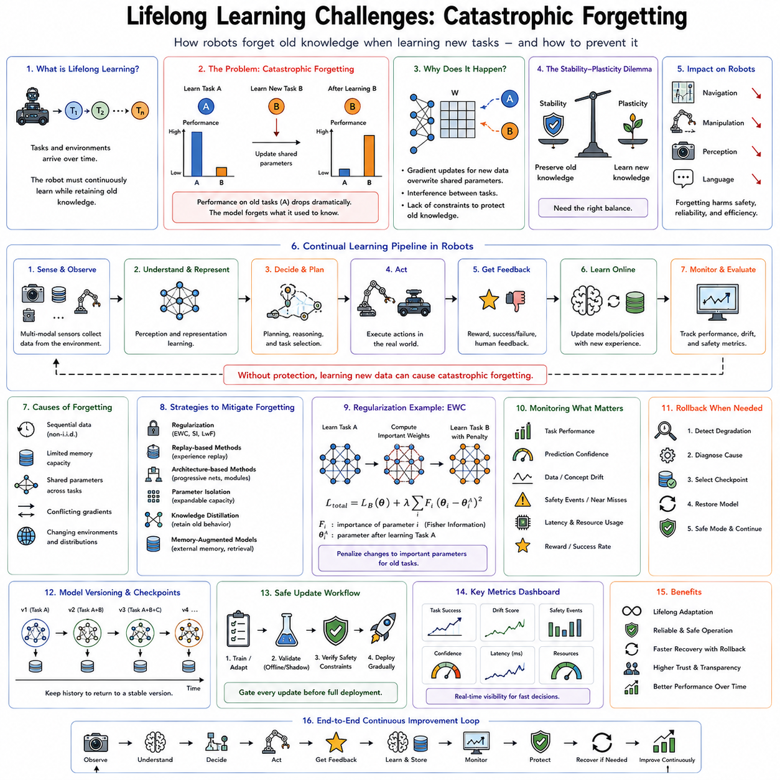

Lifelong learning represents one of the defining capabilities required for truly intelligent robotic systems. Unlike conventional machine learning, where a model is trained once on a fixed dataset and then deployed without significant modification, lifelong learning assumes that the robot continues acquiring knowledge throughout its operational lifetime. Every new environment, every new task, every interaction with humans, and every unexpected event becomes an opportunity to improve future performance. This learning process resembles biological intelligence, where knowledge accumulates over years rather than being completely reconstructed whenever something new is encountered.
However, this seemingly natural capability exposes one of the most fundamental weaknesses of modern deep neural networks: catastrophic forgetting. While humans generally retain previously acquired skills after learning new ones, artificial neural networks often overwrite old knowledge when optimizing for new tasks. A robot that learns to manipulate unfamiliar objects may unexpectedly lose its ability to grasp objects that it previously handled perfectly. A navigation model adapted to a new warehouse may suddenly perform worse in buildings it previously mastered. This instability presents one of the greatest obstacles preventing autonomous robots from continuously improving after deployment.
Catastrophic forgetting occurs because gradient-based optimization modifies shared network parameters. During training, stochastic gradient descent and its variants attempt to minimize the loss associated with the current dataset. The optimization process has no intrinsic understanding that some parameters encode valuable knowledge from previous experiences. If the gradients generated by new data conflict with gradients that originally produced successful behavior, optimization gradually destroys previously learned representations. The result is not merely slower adaptation but complete replacement of earlier knowledge.
This problem becomes increasingly severe as neural networks grow larger and tasks become more diverse. Modern robot foundation models may contain billions of parameters shared across perception, reasoning, language understanding, planning, manipulation, and navigation. While parameter sharing promotes generalization and efficient learning, it also increases interference between tasks. Updating parameters for improved manipulation may unintentionally alter visual representations that navigation depends upon. Fine-tuning language understanding may degrade motion planning. The greater the parameter sharing, the greater the possibility of destructive interference.
Traditional supervised learning largely ignores this challenge because datasets are typically assumed to be independently and identically distributed. Training data are randomly shuffled, and all examples remain available throughout optimization. Once training finishes, evaluation occurs on a static benchmark. Real robotic systems violate every one of these assumptions. Data arrive sequentially, environments evolve continuously, sensors change over time, hardware ages, users introduce novel tasks, and previously collected data may no longer be accessible due to storage limitations, privacy regulations, or communication constraints.
Consider an autonomous warehouse robot operating continuously for several years. During deployment, warehouse layouts change, product packaging evolves, lighting conditions vary seasonally, shelves are rearranged, new obstacles appear, and software updates introduce additional capabilities. Every modification requires learning. Yet the robot must continue recognizing thousands of products learned months earlier while simultaneously adapting to newly introduced inventory. Without mechanisms preventing catastrophic forgetting, continual updates eventually erase essential operational knowledge.
The stability-plasticity dilemma provides a useful framework for understanding this challenge. Plasticity refers to the ability of a learning system to rapidly incorporate new information. Stability refers to preserving previously acquired knowledge despite ongoing adaptation. Highly plastic systems learn quickly but forget easily. Highly stable systems preserve memory but resist learning. Lifelong learning seeks an appropriate balance where both properties coexist. Biological nervous systems demonstrate remarkable stability while remaining adaptable throughout decades of experience, suggesting that artificial systems may require similarly sophisticated mechanisms.
Human learning illustrates why catastrophic forgetting appears unnatural from a cognitive perspective. A person learning to drive a truck does not suddenly forget how to ride a bicycle. Learning a new language rarely destroys knowledge of one's native language. Professional surgeons continually acquire new procedures while retaining decades of previous expertise. Although humans may experience interference under certain circumstances, accumulated knowledge generally persists because biological learning incorporates multiple complementary memory systems operating across different time scales.
Neuroscience suggests that the brain separates rapidly changing episodic memories from gradually consolidated semantic knowledge. The hippocampus rapidly stores new experiences, while long-term cortical consolidation slowly integrates information without disrupting existing memories. Sleep, replay, synaptic consolidation, and selective plasticity contribute to maintaining this balance. Many continual learning algorithms borrow inspiration from these biological mechanisms, attempting to reproduce similar memory preservation within artificial neural networks.
In robotics, catastrophic forgetting affects every stage of the perception-to-action pipeline. Visual perception models may forget previously recognized object categories after learning new ones. Semantic segmentation networks may lose performance on earlier environments while adapting to different terrain. Localization systems may gradually lose familiarity with previously mapped buildings. Manipulation policies may become specialized for recent tools while losing general grasping abilities. Language-conditioned planners may forget instruction patterns encountered during earlier deployments. Because robotic intelligence depends on tightly integrated subsystems, forgetting within one module often propagates throughout the entire decision-making pipeline.
The problem becomes particularly difficult for embodied AI because learning occurs through interaction rather than static observation. Actions influence future observations, creating feedback loops between learning and behavior. If a robot forgets how to safely navigate narrow passages, it may stop entering certain regions entirely, reducing opportunities to relearn forgotten behaviors. Incorrect adaptation therefore changes future experience distributions, potentially accelerating performance degradation.
Distribution shift further amplifies catastrophic forgetting. Environmental statistics rarely remain constant after deployment. Seasonal lighting changes alter camera images. Sensor calibration gradually drifts. Mechanical wear changes actuator dynamics. Different users produce different interaction styles. New products appear while older ones disappear. Machine learning systems must distinguish meaningful long-term changes requiring adaptation from temporary fluctuations that should be ignored. Excessive adaptation increases forgetting, whereas insufficient adaptation reduces performance under changing conditions.
Task boundaries represent another important consideration. Some continual learning benchmarks clearly separate tasks, providing explicit signals indicating when learning objectives change. Real robots rarely receive such information. A household robot may transition gradually between cleaning, object retrieval, conversation, manipulation, and navigation without clearly defined boundaries. The learning system must determine whether observed changes represent entirely new tasks, natural variations of existing tasks, or temporary anomalies. Incorrect task identification may either prevent useful transfer or increase catastrophic forgetting.
Several categories of continual learning scenarios have therefore emerged. Task-incremental learning assumes task identity remains available during both training and inference. Domain-incremental learning assumes the task remains constant while input distributions change over time. Class-incremental learning introduces entirely new object categories without revealing task boundaries during inference. Online continual learning removes repeated access to historical datasets, requiring immediate adaptation from streaming observations. Robots deployed in the real world frequently combine all these scenarios simultaneously.
Memory limitations create additional engineering challenges. Storing every sensor observation throughout years of robot operation quickly becomes impractical. Autonomous vehicles generate terabytes of data daily. Industrial inspection robots collect high-resolution images, point clouds, thermal data, force measurements, and diagnostic information continuously. Humanoid robots operating for months accumulate enormous multimodal datasets. Since complete historical storage is impossible, continual learning algorithms must decide which experiences deserve long-term retention and which may safely be discarded.
Knowledge representation strongly influences forgetting behavior. Distributed representations, where many parameters contribute jointly to multiple concepts, support efficient generalization but increase interference. Sparse representations reduce overlap between tasks, limiting destructive updates. Modular architectures separate knowledge into semi-independent components, allowing localized adaptation. Hierarchical representations organize knowledge across abstraction levels, preserving fundamental concepts while adapting specialized behaviors. Choosing an appropriate representation therefore becomes central to lifelong learning system design.
Robot foundation models introduce additional opportunities and challenges. Large-scale pretraining produces highly general visual, linguistic, and behavioral representations that exhibit remarkable transfer across downstream tasks. Because these representations already capture broad statistical regularities, fine-tuning often requires relatively small parameter updates. Smaller updates reduce forgetting compared with training from scratch. Nevertheless, aggressive fine-tuning or prolonged sequential adaptation can still significantly degrade pretrained capabilities if protective mechanisms are absent.
Evaluation of catastrophic forgetting requires metrics beyond conventional accuracy. Researchers commonly measure average accuracy across all previously learned tasks, backward transfer indicating whether learning new tasks improves or degrades earlier performance, forward transfer measuring benefits for future learning, forgetting scores quantifying performance loss after subsequent training, adaptation speed, memory efficiency, computational cost, and long-term stability. Since robotic deployment emphasizes continuous operation rather than isolated benchmarks, evaluation increasingly focuses on cumulative performance over extended operational lifetimes.
Simulation environments have become indispensable for studying continual learning because they allow controlled manipulation of task sequences, environmental complexity, and distribution shifts. Robotic simulators can gradually introduce lighting changes, weather conditions, terrain modifications, novel objects, sensor failures, and mechanical degradation while providing reproducible evaluation conditions. However, simulation cannot fully reproduce the richness and unpredictability of long-term real-world deployment, making field experiments equally important.
Industrial robotics provides numerous practical examples. Manufacturing robots frequently receive software updates introducing new product variants while remaining responsible for existing production lines. Logistics robots continuously adapt to warehouse expansion, changing inventory, and modified traffic patterns. Agricultural robots experience seasonal environmental variation affecting perception and manipulation. Medical robots require continuous software improvement while preserving certified behaviors. Every application illustrates the same central challenge: improving capabilities without sacrificing previously validated performance.
Safety considerations significantly increase the importance of catastrophic forgetting in robotics. A recommendation system that forgets user preferences may simply reduce customer satisfaction. A robot that forgets collision avoidance behavior can damage equipment or injure people. Forgetting safe manipulation trajectories may produce hazardous motions. Degraded localization can cause navigation failures in crowded environments. Consequently, continual learning for safety-critical robots must include rigorous verification procedures, rollback mechanisms, confidence estimation, and runtime monitoring to detect harmful knowledge degradation before deployment.
Cloud robotics offers one partial solution by separating local adaptation from centralized knowledge consolidation. Individual robots collect experiences during deployment and periodically upload selected data to centralized training infrastructure. Fleet-wide optimization produces updated models incorporating experiences from many robots while preserving broad performance across diverse environments. Updated models then return to individual robots after extensive validation. Although this architecture reduces local forgetting, it introduces communication, privacy, synchronization, and version management challenges.
Recent developments in parameter-efficient fine-tuning have also influenced lifelong learning research. Instead of modifying every parameter within a large neural network, adaptation may occur through relatively small auxiliary modules, low-rank parameter updates, prompts, adapters, or specialized routing mechanisms. Restricting parameter modification reduces interference with existing knowledge while enabling efficient specialization. These methods have become particularly attractive for edge robots where computational resources and memory remain limited.
Another promising direction involves explicit memory systems integrated with neural computation. Rather than expecting parametric weights to store all knowledge permanently, robots may maintain external memories containing episodic experiences, semantic facts, environmental maps, demonstration trajectories, or retrieved observations. Neural networks learn how to access and utilize these memories instead of encoding every detail internally. This hybrid architecture reduces pressure on shared parameters and thereby alleviates catastrophic forgetting.
Foundation models combined with retrieval mechanisms further support continual adaptation. Instead of permanently modifying internal parameters after every new experience, robots may retrieve relevant historical information from external databases whenever required. Newly encountered situations enrich external memory while leaving core representations relatively stable. Such retrieval-augmented architectures increasingly resemble cognitive systems that distinguish between long-term knowledge, working memory, episodic recollection, and procedural skills.
Theoretical research continues investigating why catastrophic forgetting emerges from optimization dynamics. Parameter importance varies across tasks, gradient conflicts create destructive interference, representation drift gradually alters learned features, and sequential Bayesian inference accumulates uncertainty over time. Understanding these mechanisms mathematically enables principled algorithm design rather than heuristic solutions. Although no universal theory yet explains all observed behaviors, optimization geometry, information theory, Bayesian learning, and neuroscience collectively provide valuable insights.
The following chapters examine concrete techniques developed to address catastrophic forgetting. Elastic Weight Consolidation protects parameters considered important for previous tasks by selectively limiting future updates. Progressive Neural Networks avoid interference through architectural expansion and lateral knowledge transfer. Replay-based methods preserve representative historical experiences during training. Parameter isolation techniques dedicate subsets of network capacity to different tasks. Generative replay reconstructs previous experiences using learned generative models rather than explicit storage. Lifelong SLAM addresses continual adaptation in mapping and localization, while evaluation methodologies quantify stability, plasticity, and long-term learning efficiency. Together these approaches represent the current foundation of continual learning research, bringing robotic intelligence closer to systems capable of learning throughout years of autonomous operation without sacrificing the knowledge accumulated from their past experiences.

08.02 Elastic Weight Consolidation EWC Implementation [w/Code]
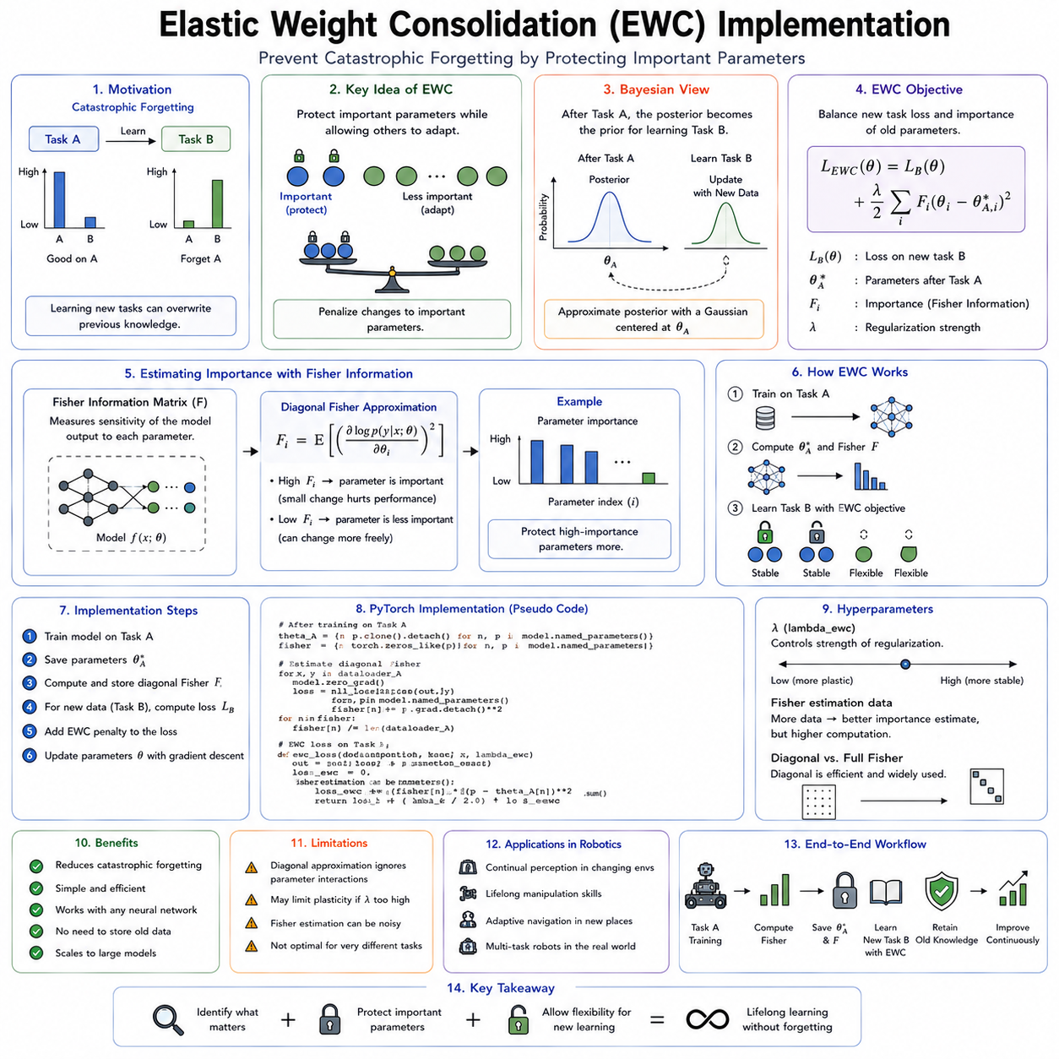

Elastic Weight Consolidation (EWC) is one of the most influential approaches developed to address catastrophic forgetting in continual and lifelong learning. Rather than preventing a neural network from learning new tasks, EWC allows learning to continue while selectively protecting the knowledge that has already proven valuable. The central idea is remarkably intuitive: not every parameter inside a neural network contributes equally to previously learned skills. Some parameters are essential for preserving important knowledge, while others may be modified with relatively little consequence. By identifying which parameters are most important and constraining only those during future optimization, a model can remain sufficiently flexible to acquire new capabilities without catastrophically overwriting existing ones.
The motivation for EWC emerged from the observation that standard stochastic gradient descent treats every parameter identically. During optimization, gradients update all trainable weights according to the current objective function regardless of their historical significance. A parameter that encodes fundamental visual representations learned over millions of images receives exactly the same update rule as another parameter that contributes only marginally to a specific task. Consequently, optimization for a new task often destroys information that required enormous computational effort to acquire previously. EWC introduces a mechanism for distinguishing between parameters that should remain stable and those that may continue adapting.
The inspiration for EWC originates from neuroscience, particularly theories of biological synaptic consolidation. Human memory is believed to preserve important knowledge by strengthening certain synaptic connections after learning. Newly acquired memories initially remain plastic and susceptible to interference, but repeated activation gradually consolidates them into more stable long-term representations. Future learning therefore modifies some neural connections extensively while leaving others relatively unchanged. EWC attempts to reproduce a similar behavior mathematically by assigning different levels of protection to different parameters according to their estimated importance.
Unlike traditional regularization techniques such as L2 weight decay, which simply penalize large parameter values, EWC penalizes deviations from previously learned parameter values. The distinction is fundamental. Weight decay encourages parameters to remain near zero regardless of their function. EWC instead encourages parameters to remain close to the values that successfully solved earlier tasks. The objective is not minimizing parameter magnitude but preserving accumulated knowledge.
Suppose a neural network has completed training on an object recognition task for warehouse robots. After deployment, the robot begins learning to recognize newly introduced products. Standard fine-tuning modifies the network to improve performance on the new inventory, but many of the same parameters also encode representations for products learned months earlier. Without protection, optimization gradually overwrites these representations. EWC first estimates which parameters are essential for the original recognition capability. During training on new products, changes to highly important parameters become increasingly expensive, while less important parameters remain free to adapt.
The mathematical foundation of EWC combines Bayesian inference with constrained optimization. Rather than viewing learning as repeatedly solving independent optimization problems, Bayesian learning interprets continual learning as sequential posterior estimation. After completing one task, the learned parameters represent the most probable explanation of the observed data. When a new task arrives, the previous posterior becomes the prior for future learning. Ideally, optimization should discover parameter values that explain both historical and newly observed data simultaneously.
Direct Bayesian inference over billions of neural network parameters is computationally intractable. EWC therefore approximates the posterior distribution using a Gaussian centered around the previously learned parameter values. Each parameter receives its own uncertainty estimate represented by the inverse variance of the Gaussian. Parameters estimated with high confidence become difficult to modify because even small deviations significantly reduce posterior probability. Parameters with greater uncertainty remain relatively unconstrained and can adapt more freely.
Estimating parameter importance constitutes the central technical contribution of EWC. Rather than relying on heuristic assumptions, EWC employs the Fisher Information Matrix as an approximation of parameter sensitivity. The Fisher Information Matrix measures how strongly changes in each parameter influence the probability distribution of model predictions. Intuitively, if a small modification to a parameter substantially changes prediction likelihood, that parameter must be important for the learned task. Conversely, parameters whose perturbations produce little effect contribute relatively little to current performance.
The complete Fisher Information Matrix is extremely large for modern neural networks because it contains pairwise relationships between every parameter. Even relatively modest networks contain millions of parameters, making the full matrix computationally impossible to store or invert. EWC therefore adopts a diagonal approximation that assumes parameter independence. Although this approximation ignores interactions between parameters, it dramatically reduces computational complexity while remaining surprisingly effective across many continual learning benchmarks.
After training Task A, the network performs a pass over representative training data while computing gradients of the log-likelihood with respect to each parameter. Squared gradients averaged across the dataset approximate the diagonal entries of the Fisher Information Matrix. Large gradient magnitudes indicate parameters that strongly influence prediction quality, resulting in high Fisher values. Small gradients indicate parameters that can change without substantially affecting performance.
Once parameter importance has been estimated, future optimization incorporates an additional regularization term into the loss function. The standard task loss measuring performance on the current dataset remains unchanged. EWC simply augments this objective with a quadratic penalty proportional to both parameter importance and deviation from previously learned values. Parameters associated with large Fisher values experience strong resistance to modification, whereas parameters associated with small Fisher values receive little additional constraint.
The regularization strength itself becomes an important hyperparameter. Excessively weak regularization provides insufficient protection, allowing catastrophic forgetting to occur almost as rapidly as ordinary fine-tuning. Excessively strong regularization prevents meaningful adaptation because optimization becomes unable to modify parameters even when genuine environmental changes require learning. Selecting an appropriate regularization coefficient therefore balances stability against plasticity, reflecting the central dilemma of continual learning.
An intuitive interpretation compares EWC to springs connecting parameters to their previously learned positions. Every parameter is attached to its historical value by an elastic spring. The stiffness of each spring corresponds to the estimated Fisher Information. Highly important parameters possess extremely stiff springs requiring substantial optimization force before moving. Less important parameters possess flexible springs that allow considerable displacement. During training, optimization naturally modifies whichever parameters produce the greatest improvement while paying the least regularization cost.
This selective constraint distinguishes EWC from freezing entire network layers. Layer freezing assumes that all parameters within selected layers possess equal importance, preventing any adaptation inside those components. EWC instead operates at the individual parameter level. Even neighboring weights inside the same convolutional filter may receive entirely different importance estimates. Consequently, useful adaptation remains possible without unnecessarily sacrificing model flexibility.
Implementation of EWC within modern deep learning frameworks is conceptually straightforward. Training begins exactly like conventional supervised learning until completion of the initial task. The resulting model parameters are copied and stored as reference values. The Fisher Information Matrix is then estimated using representative data from the completed task. During future training, each optimization step computes both the ordinary task loss and the EWC penalty before backpropagation. Automatic differentiation naturally incorporates both objectives into parameter updates.
Despite its conceptual simplicity, several practical implementation details influence performance significantly. The dataset used for Fisher estimation should represent the original task accurately because biased samples produce misleading importance estimates. Excessively small datasets underestimate parameter importance, whereas unnecessarily large datasets increase computational cost without proportional benefit. In practice, relatively modest representative subsets often produce satisfactory approximations.
Computational overhead remains one of the primary practical considerations. Fisher estimation requires an additional forward and backward pass after completing each task. Storing previous parameter values approximately doubles memory consumption for trainable weights. Large foundation models containing billions of parameters therefore require substantial storage even when using diagonal Fisher approximations. Nevertheless, compared with retraining entire models from scratch, the additional cost remains relatively modest.
Robotic applications illustrate the strengths of EWC particularly well. Consider an autonomous warehouse robot deployed across multiple facilities. Initially, the perception system learns object recognition within one warehouse. Later deployments introduce different packaging, lighting conditions, shelving arrangements, and product inventories. Rather than rebuilding the perception model from the beginning for every location, EWC enables sequential adaptation while preserving general visual understanding acquired previously. Frequently encountered objects maintain recognition accuracy even as new inventory categories are incorporated.
Manipulation learning provides another compelling example. A robotic arm may first learn grasping strategies for rigid industrial components. Later deployments require manipulation of flexible packaging, delicate medical instruments, or irregular agricultural products. Standard fine-tuning often sacrifices earlier manipulation abilities while specializing toward recent experiences. EWC protects fundamental motor representations and contact models while allowing adaptation primarily through less critical parameters. The resulting policy retains broad manipulation competence across multiple object categories.
Autonomous navigation similarly benefits from parameter consolidation. A mobile robot initially trained inside office buildings may subsequently learn warehouse navigation, hospital operation, outdoor logistics, or factory environments. Core geometric reasoning, obstacle avoidance, localization, and path planning should remain stable despite environmental variation. EWC protects these foundational capabilities while permitting adaptation to domain-specific visual appearances and navigation conventions.
Foundation models for robotics introduce additional opportunities for EWC. Large multimodal models already contain broad visual, linguistic, and behavioral knowledge acquired through extensive pretraining. Fine-tuning these models for specialized robotic applications risks destroying valuable general representations. EWC selectively preserves pretrained knowledge while permitting domain adaptation. Instead of replacing general intelligence with narrow specialization, the model incrementally accumulates expertise across successive applications.
One important limitation of classical EWC appears when learning long sequences of tasks. Each completed task introduces another set of parameter constraints. As more tasks accumulate, the network gradually exhausts available flexibility because increasing numbers of parameters become heavily protected. Eventually optimization cannot identify parameter configurations satisfying all previous constraints simultaneously. Performance on new tasks therefore deteriorates even though catastrophic forgetting decreases.
Online EWC was introduced to address this scalability problem. Rather than storing separate Fisher Information Matrices for every historical task, Online EWC incrementally combines parameter importance estimates into a single consolidated representation. Older importance values gradually decay while recent knowledge receives greater emphasis. This reduces memory consumption and prevents indefinite accumulation of regularization terms while still preserving important long-term knowledge.
Several extensions further improve the original formulation. Some approaches estimate parameter importance using alternative sensitivity measures instead of the Fisher Information Matrix. Others employ structured approximations capturing limited parameter interactions beyond the diagonal assumption. Bayesian neural networks naturally represent parameter uncertainty, potentially providing richer importance estimates. Meta-learning approaches optimize regularization strength automatically rather than relying on manually selected hyperparameters.
EWC also combines naturally with replay-based continual learning. Experience replay periodically revisits representative historical data while EWC simultaneously protects important parameters. Replay addresses representation drift by refreshing historical examples, whereas EWC prevents unnecessary parameter modification. Together these mechanisms often outperform either approach individually because they address complementary aspects of catastrophic forgetting.
Parameter-efficient fine-tuning methods similarly integrate well with EWC. Low-Rank Adaptation (LoRA), adapters, prompt tuning, and other parameter-efficient techniques already restrict optimization to relatively small parameter subsets. Applying EWC within these adaptable components further reduces interference while preserving the large pretrained backbone almost entirely unchanged. This combination has become increasingly attractive for edge robotics where memory and computational resources remain constrained.
Evaluation of EWC extends beyond simple accuracy measurements. Researchers analyze average continual learning accuracy, forgetting metrics, backward transfer, forward transfer, adaptation efficiency, computational overhead, memory requirements, convergence behavior, and robustness under distribution shift. Ablation studies commonly compare ordinary fine-tuning, full parameter freezing, replay methods, architectural expansion techniques, and EWC across identical task sequences. Such evaluations reveal that EWC typically provides substantial forgetting reduction while maintaining competitive adaptation performance.
Industrial deployment requires additional engineering considerations beyond algorithmic performance. Robots operating in safety-critical environments require mechanisms verifying that consolidated knowledge remains valid after each update. Validation datasets representing previous operational scenarios should accompany continual learning pipelines. Rollback procedures remain essential if newly adapted models unexpectedly degrade established behaviors despite EWC protection. Continuous monitoring detects gradual performance drift that may indicate insufficient parameter preservation.
The relationship between EWC and the stability-plasticity dilemma illustrates its broader conceptual significance. Rather than choosing between complete stability and unrestricted plasticity, EWC distributes stability unevenly across the parameter space. Important knowledge receives strong protection while less essential knowledge remains adaptable. This selective allocation reflects how intelligent biological systems appear to balance memory preservation with lifelong adaptation.
Nevertheless, EWC is not a universal solution. It assumes that parameter importance estimated after one task remains relevant for future learning. Significant domain shifts, contradictory objectives, or fundamentally different task requirements may invalidate earlier importance estimates. The diagonal Fisher approximation ignores parameter interactions that often characterize deep neural networks. Furthermore, tasks requiring substantial architectural reorganization cannot be accommodated solely through parameter regularization. Consequently, modern continual learning systems frequently combine EWC with replay mechanisms, modular architectures, dynamic network expansion, external memory systems, or retrieval-based learning.
Despite these limitations, Elastic Weight Consolidation remains one of the foundational algorithms in continual learning research. It introduced the influential idea that parameters possess unequal importance and that selective protection can substantially reduce catastrophic forgetting without preventing future learning. Nearly every subsequent continual learning method either builds upon, extends, compares against, or conceptually relates to EWC. For robotics, where autonomous systems must accumulate knowledge across months or years of deployment while preserving previously validated behaviors, EWC represents an essential component in the transition from static machine learning models toward truly lifelong intelligent systems.

08.03 Progressive Neural Networks Lateral Connections [w/Code]
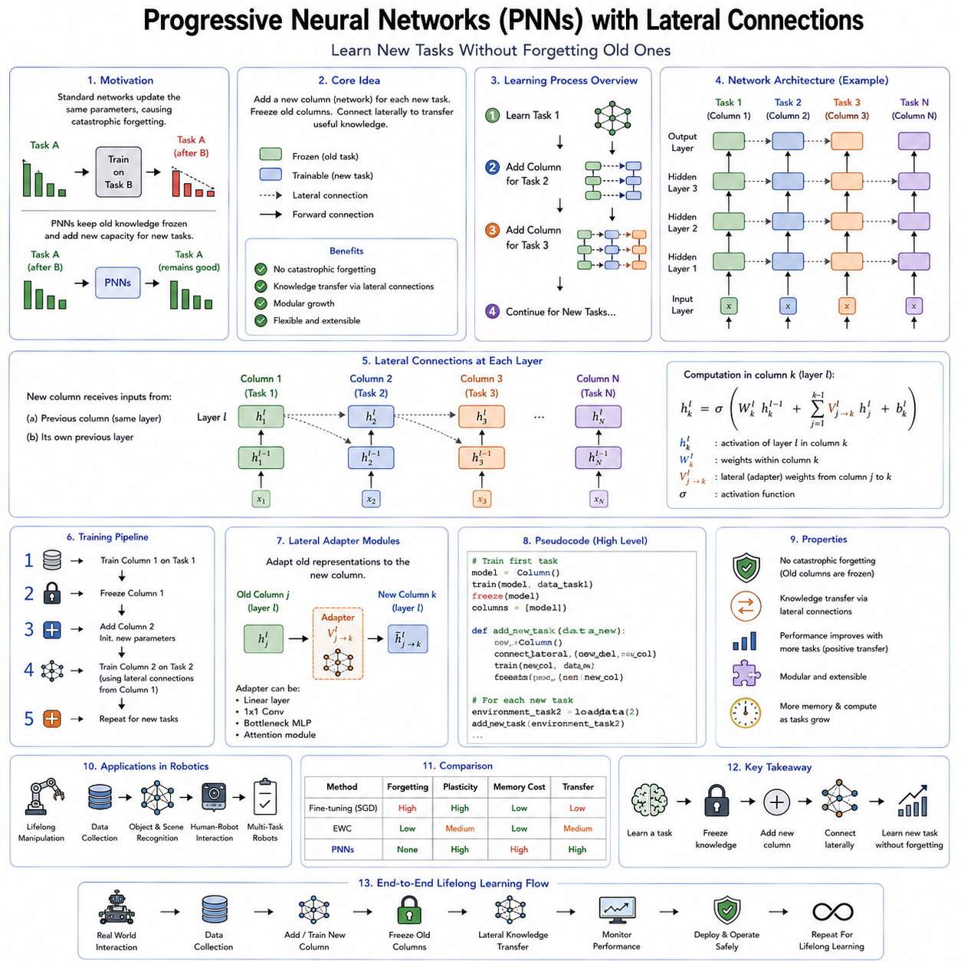

Progressive Neural Networks (PNNs) represent one of the most distinctive architectural approaches to continual and lifelong learning. Unlike regularization-based methods such as Elastic Weight Consolidation (EWC), which attempt to preserve previously learned knowledge by constraining parameter updates, Progressive Neural Networks eliminate catastrophic forgetting by preventing previously learned parameters from changing altogether. Instead of continually modifying a single neural network throughout its lifetime, Progressive Neural Networks expand the architecture whenever a new task is introduced. Existing knowledge remains frozen, while newly allocated network components learn the new task. Communication between old and new knowledge occurs through carefully designed lateral connections that transfer useful representations without overwriting established capabilities.
The motivation behind Progressive Neural Networks originates from a fundamental observation about catastrophic forgetting. The majority of forgetting occurs because multiple tasks compete for the same network parameters. Standard neural networks assume that one shared set of weights should simultaneously represent every learned capability. While parameter sharing promotes generalization, it also creates destructive interference whenever optimization for one task conflicts with representations required by previous tasks. Progressive Neural Networks remove this competition by allocating dedicated computational resources for each new learning problem while still allowing previously acquired knowledge to assist future learning.
The central architectural concept is remarkably simple. The first task is learned using a conventional neural network referred to as the first column. Once training finishes, every parameter within this column becomes permanently frozen. No subsequent optimization modifies these weights. When a second task arrives, an entirely new neural network column is initialized with randomly generated parameters. This new column learns the second task independently while receiving additional information from the frozen first column through lateral connections. When a third task appears, another column is added. The previous two columns remain frozen while their learned representations become available through additional lateral pathways. This process continues throughout the learning lifetime.
Unlike traditional transfer learning, where pretrained weights are often fine-tuned for new tasks, Progressive Neural Networks never alter knowledge that has already been acquired. Every previously learned representation remains exactly as it existed after completing its original task. Consequently, catastrophic forgetting becomes mathematically impossible because earlier parameters never change. Any degradation in previous performance can only arise from external factors such as sensor drift or environmental changes rather than parameter interference.
The architectural organization resembles the accumulation of expertise within an expanding library. Each completed task contributes a new volume to the library. Existing books remain unchanged, preserving their original information indefinitely. New books may reference earlier volumes extensively, but they never rewrite their contents. As knowledge accumulates, future learning benefits from an increasingly rich collection of reusable representations without risking the destruction of previous expertise.
Lateral connections constitute the defining innovation of Progressive Neural Networks. Simply freezing previous networks would eliminate forgetting but would also prevent knowledge transfer. Every new task would require learning entirely from scratch, sacrificing one of the greatest advantages of deep learning: representation reuse. Lateral connections solve this problem by allowing activations computed within previous columns to become additional inputs for corresponding layers in the newly created column.
Suppose the first network has already learned robust visual features for indoor object recognition. When learning warehouse inspection, the second column need not rediscover basic edge detectors, texture representations, geometric features, or object boundaries. Instead, lateral connections allow intermediate feature maps from the frozen visual encoder to flow directly into corresponding layers of the new network. The second column combines these mature representations with newly learned features specialized for warehouse inspection. General knowledge transfers automatically while task-specific specialization develops independently.
Mathematically, each layer within a new column receives two sources of information. The first source consists of activations produced by earlier layers within the same column, exactly as in conventional feedforward neural networks. The second source consists of transformed activations arriving from corresponding layers of all previously learned columns. These lateral inputs are typically processed through trainable adaptation layers before being combined with locally generated representations. Consequently, the new column determines automatically how much useful information should be extracted from historical knowledge.
The adaptation layers associated with lateral connections perform an essential function. Representations learned for different tasks rarely possess identical statistical properties or semantic interpretations. Directly combining activations from separate tasks may produce incompatible feature distributions. Adapter modules transform historical representations into forms more suitable for the current learning objective. During optimization, the new column learns which transferred features remain useful, which require modification, and which should be largely ignored.
Knowledge transfer through lateral connections differs fundamentally from parameter sharing. Parameter sharing assumes multiple tasks utilize identical weights simultaneously. Lateral transfer instead shares intermediate representations while maintaining separate parameter sets. This distinction dramatically reduces interference because each task retains independent optimization trajectories despite benefiting from previously discovered features.
Progressive Neural Networks also provide valuable interpretability advantages. Since each task occupies its own dedicated network column, researchers can analyze how representations evolve throughout the learning process. Transfer efficiency between tasks becomes directly observable through the strength and utilization of lateral connections. Visualization techniques reveal which earlier tasks contribute most significantly to current learning, providing insights into relationships among learned capabilities.
Consider a service robot undergoing long-term deployment. Initially, the robot learns indoor navigation inside office environments. A dedicated network column develops representations for hallways, doors, elevators, corridors, obstacles, and localization cues. After deployment in hospitals, a second column learns medical facility navigation while utilizing office navigation features through lateral connections. Later, warehouse operation introduces another column incorporating representations from both previous environments. Eventually, the robot develops a hierarchy of increasingly specialized navigation expertise while preserving perfect performance on every earlier deployment environment.
Manipulation learning illustrates similar advantages. A robotic arm first acquires grasping skills for rigid industrial components. The resulting representations capture geometric reasoning, force control, contact dynamics, and motion planning. Subsequent learning involving deformable materials, surgical instruments, household objects, or agricultural products creates new columns that reuse fundamental manipulation knowledge while developing specialized handling strategies appropriate for each object category. Previously mastered manipulation behaviors remain permanently intact.
Reinforcement learning presents another domain where Progressive Neural Networks have demonstrated significant benefits. Reinforcement learning often requires enormous computational effort because agents must discover effective policies through extensive trial-and-error interaction. Losing previously acquired policies through catastrophic forgetting therefore wastes substantial experience. Progressive Neural Networks preserve every successful policy while accelerating future learning through transferred representations. Later tasks frequently converge more rapidly because previously learned perception, value estimation, or action representations provide informative initialization.
Transfer learning efficiency depends strongly upon task similarity. Closely related tasks benefit extensively from lateral knowledge transfer because previously learned features remain highly relevant. Distantly related tasks may utilize only limited portions of historical representations. Progressive Neural Networks naturally accommodate both situations because adaptation layers learn automatically which transferred information improves performance. Irrelevant historical features receive negligible weighting without affecting optimization.
One of the most attractive characteristics of Progressive Neural Networks is the elimination of stability-plasticity tradeoffs. Regularization-based methods continually balance protecting existing knowledge against permitting new adaptation. Excessive protection impedes learning, whereas insufficient protection permits forgetting. Progressive Neural Networks avoid this compromise entirely because frozen columns guarantee complete stability while newly allocated columns provide unrestricted plasticity. Knowledge preservation and adaptation occur independently rather than competing within shared parameters.
However, this architectural strategy introduces different engineering challenges. The most obvious limitation involves continual network growth. Every newly learned task requires allocating an additional network column. Over long operational lifetimes, computational complexity, memory consumption, storage requirements, and inference latency increase approximately linearly with the number of learned tasks. A robot expected to operate continuously for many years may eventually accumulate hundreds or thousands of network columns, making unrestricted architectural expansion impractical.
Memory consumption becomes particularly significant for modern foundation models containing billions of parameters. Replicating entire transformer architectures for every new task quickly exceeds available hardware resources. Even edge robots equipped with powerful embedded GPUs possess limited memory budgets. Consequently, applying classical Progressive Neural Networks directly to large-scale foundation models requires substantial architectural modifications or parameter-efficient adaptations.
Inference efficiency also becomes increasingly challenging as network size expands. Predictions for new tasks typically require forward propagation through all previous columns because lateral connections depend upon historical activations. Although earlier columns remain frozen, their computations still consume processing time. Real-time robotic systems operating under strict latency constraints cannot tolerate indefinitely increasing inference complexity.
Researchers have therefore proposed numerous architectural extensions addressing these scalability concerns. Selective lateral connections activate only the most relevant previous columns rather than every historical network. Sparse routing mechanisms determine dynamically which expertise contributes to current predictions. Shared backbone architectures reduce redundancy while preserving task-specific specialization. Lightweight adapter columns replace complete network replication. Parameter-efficient expansion strategies introduce only relatively small additional modules rather than duplicating entire models.
Column pruning represents another promising optimization strategy. Some learned columns eventually become redundant because later representations subsume their functionality. Compression techniques identify highly similar expertise across multiple columns and merge redundant knowledge while preserving performance. Distillation methods further compress accumulated expertise into smaller architectures capable of maintaining comparable capabilities without linear parameter growth.
Progressive Neural Networks have demonstrated particular effectiveness in robotics because many robotic tasks naturally build upon previously acquired competencies. Object manipulation depends upon visual perception. Navigation benefits from geometric reasoning. Human-robot interaction relies upon language understanding, perception, and action planning. Rather than relearning these foundational abilities repeatedly, successive network columns inherit increasingly sophisticated representations through lateral transfer.
Multi-modal robotic systems illustrate additional advantages. Vision, language, tactile sensing, proprioception, audio perception, and force feedback often exhibit different adaptation rates. Progressive architectures permit independent specialization across modalities while still enabling cross-modal information sharing. A newly introduced tactile manipulation task may leverage visual object recognition from previous columns without modifying established vision representations.
Simulation-to-real transfer offers another compelling application. Robots commonly undergo extensive training within simulation before deployment into physical environments. Classical fine-tuning risks overwriting valuable simulation-acquired knowledge during real-world adaptation. Progressive Neural Networks instead preserve simulation expertise completely while allocating additional capacity specifically for real-world corrections. Lateral connections allow physical deployment to exploit simulation knowledge without sacrificing previously learned capabilities.
The relationship between Progressive Neural Networks and transfer learning deserves careful consideration. Conventional transfer learning generally initializes a model using pretrained weights before subsequent fine-tuning modifies the entire network. Progressive Neural Networks instead maintain permanent access to every pretrained representation throughout future learning. Transfer therefore remains continuously available rather than occurring only during initialization. Newly learned tasks may utilize historical expertise dynamically at every stage of optimization and inference.
From a biological perspective, Progressive Neural Networks resemble theories suggesting that human expertise expands through the recruitment of additional neural circuits rather than complete reorganization of existing knowledge. Although biological brains certainly exhibit greater flexibility than rigidly frozen artificial networks, accumulating specialized functional modules while preserving established competencies appears consistent with many observations from cognitive neuroscience.
Evaluation of Progressive Neural Networks extends beyond conventional task accuracy. Researchers analyze transfer efficiency, knowledge reuse, parameter growth, computational overhead, inference latency, memory consumption, adaptation speed, and scalability across long task sequences. Transfer metrics quantify how much earlier knowledge accelerates subsequent learning compared with independent training. Resource metrics determine whether architectural expansion remains practical for realistic deployment scenarios.
Comparisons with Elastic Weight Consolidation highlight complementary strengths and weaknesses. EWC maintains constant model size while selectively constraining parameter updates. Progressive Neural Networks eliminate forgetting completely but require increasing architectural capacity. EWC permits shared representations to evolve gradually across tasks, whereas Progressive Neural Networks preserve historical knowledge exactly as originally learned. Neither approach universally dominates because application requirements determine the preferred balance between memory efficiency and knowledge preservation.
Replay-based continual learning methods present another interesting contrast. Replay algorithms preserve historical experience by storing representative data or generating synthetic samples. Progressive Neural Networks require no historical data whatsoever after completing training because knowledge remains embedded permanently within frozen columns. This property proves particularly valuable when privacy regulations, storage limitations, or proprietary restrictions prevent retaining historical datasets.
Modern foundation models have inspired hybrid approaches combining Progressive Neural Networks with parameter-efficient fine-tuning. Rather than replicating entire transformer architectures, only adapters, LoRA modules, prompt embeddings, or lightweight expert layers expand progressively. Frozen backbone representations remain shared while specialized adaptation modules accumulate over time. Such architectures preserve the conceptual advantages of Progressive Neural Networks while substantially reducing resource requirements.
Mixture-of-Experts architectures exhibit conceptual similarities as well. Both approaches distribute computation across specialized modules instead of relying upon one monolithic parameter set. However, Progressive Neural Networks organize specialization chronologically according to learning history, whereas Mixture-of-Experts typically organize specialization according to input characteristics. Combining these ideas may produce adaptive systems capable of selecting historical expertise dynamically according to current context.
Industrial robotics increasingly demands exactly the properties provided by Progressive Neural Networks. Manufacturing systems receive new product variants regularly while remaining responsible for previous production lines. Warehouse robots expand into new facilities without forgetting earlier layouts. Medical robots incorporate additional procedures while preserving certified operational behaviors. Autonomous inspection systems continually learn novel defect categories without sacrificing recognition accuracy for existing faults. In each case, preserving validated capabilities remains as important as acquiring new ones.
Safety-critical applications particularly benefit from immutable historical knowledge. Once a navigation policy or manipulation strategy has undergone extensive verification and certification, modifying its parameters introduces additional validation requirements. Progressive Neural Networks avoid this problem because certified columns remain untouched. New capabilities develop within separate architectural components that can undergo independent testing before deployment.
Despite their advantages, Progressive Neural Networks are not intended to replace every continual learning algorithm. Their resource requirements make them less suitable for environments where hardware constraints dominate. Tasks requiring deep integration rather than modular accumulation may benefit more from regularization or replay approaches. Consequently, current research increasingly explores hybrid architectures that combine progressive expansion, selective replay, parameter consolidation, dynamic routing, retrieval-augmented memory, and foundation model adaptation into unified lifelong learning systems.
Progressive Neural Networks introduced an influential shift in continual learning research by demonstrating that catastrophic forgetting need not be treated solely as an optimization problem. Instead, it can be addressed architecturally through systematic expansion and controlled knowledge transfer. The concept of preserving immutable expertise while accumulating specialized capabilities through lateral communication has influenced numerous subsequent lifelong learning algorithms. As robotic intelligence progresses toward increasingly autonomous systems capable of decades of continuous operation, Progressive Neural Networks remain one of the most important architectural foundations for enabling stable, transferable, and continually expanding machine intelligence.

08.04 Continual Learning with Replay Buffer [w/Code]
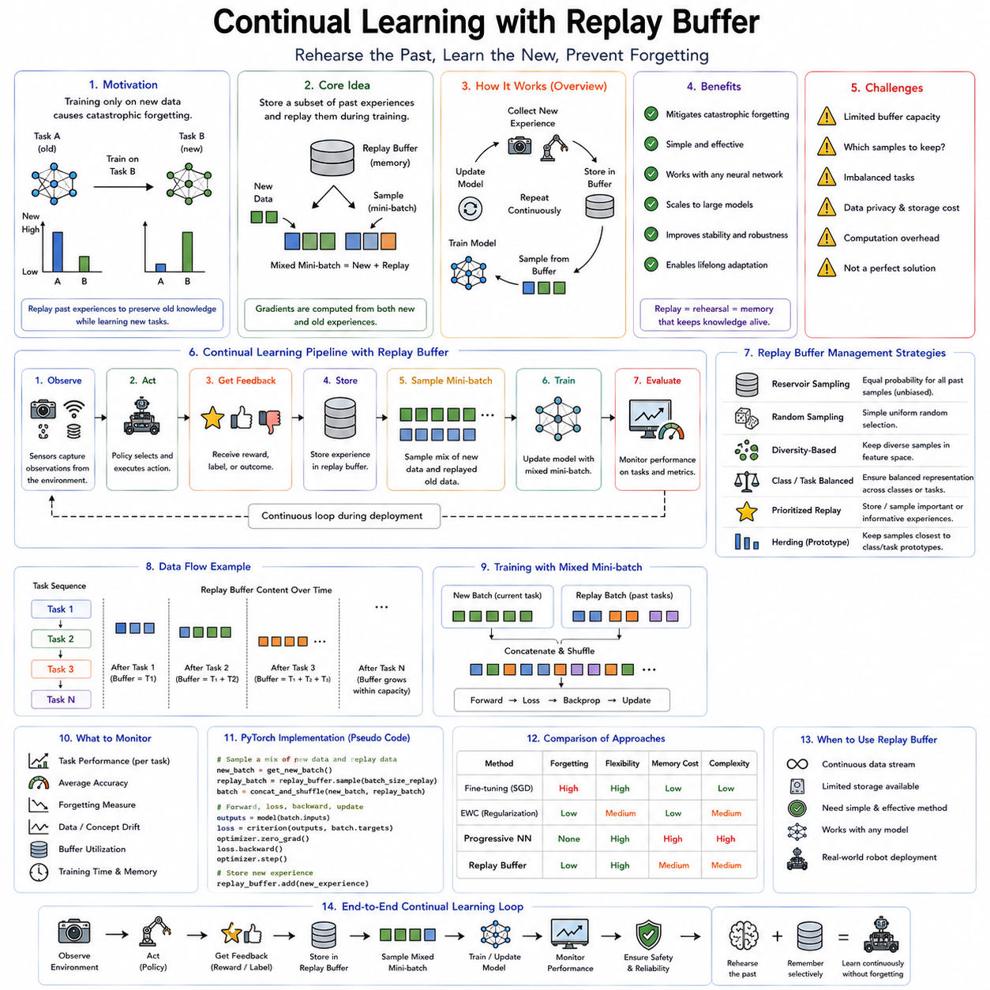

Continual learning with a replay buffer is one of the most practical and effective approaches for mitigating catastrophic forgetting in lifelong learning systems. Rather than attempting to protect previously learned parameters directly, replay-based methods preserve past knowledge by periodically revisiting representative experiences from earlier tasks while learning new ones. The central idea is straightforward: forgetting occurs because neural networks optimize only on recently observed data. If carefully selected examples from previous experiences continue to appear during training, the optimization process naturally maintains performance on both old and new tasks. Instead of relying solely on architectural constraints or parameter regularization, replay methods preserve knowledge through continuous rehearsal.
The underlying intuition closely resembles biological memory. Humans rarely retain important knowledge simply because the brain permanently freezes synaptic connections. Instead, memories become stronger through repeated recall and rehearsal. Students review previously learned material before examinations, musicians repeatedly practice earlier compositions while learning new pieces, and professional athletes continually revisit fundamental skills throughout their careers. Replay-based continual learning adopts a similar philosophy. Previously learned experiences are not assumed to remain permanently stable after a single training session. Instead, they are periodically reintroduced into the learning process so that the neural network continually refreshes important representations.
Catastrophic forgetting emerges because gradient descent optimizes model parameters according to the current training distribution. When only new data are available, optimization gradually shifts feature representations, decision boundaries, and internal embeddings toward recently observed patterns. Earlier knowledge receives no reinforcement, causing representations associated with previous tasks to drift over time. Replay buffers counteract this drift by ensuring that gradients generated during optimization reflect both historical and newly acquired knowledge simultaneously.
The replay buffer itself serves as an external memory containing representative samples collected from previous learning experiences. Unlike the model parameters, which implicitly encode knowledge within distributed numerical weights, the replay buffer explicitly stores observations, labels, trajectories, demonstrations, rewards, sensor measurements, or other training examples. During future learning, mini-batches contain both current experiences and replayed historical samples. Consequently, optimization continually revisits earlier tasks without requiring complete retraining from scratch.
The concept appears deceptively simple, yet the design of an effective replay system involves numerous engineering decisions. One of the first considerations concerns buffer capacity. In theory, storing every historical observation would eliminate forgetting entirely because future training could reproduce the original dataset. In practice, robots operating continuously for months or years generate enormous quantities of data. Autonomous vehicles may collect terabytes of sensor information every day. Industrial inspection systems produce millions of high-resolution images. Humanoid robots continuously record multimodal streams including vision, force sensing, proprioception, audio, language interactions, and motion trajectories. Unlimited storage quickly becomes infeasible.
Buffer management therefore becomes a central research problem. Rather than storing every experience, replay systems attempt to preserve a compact subset representing the diversity of historical knowledge. The objective is maximizing future learning value while minimizing storage requirements. A well-designed replay buffer captures the essential statistical properties of previous tasks using only a tiny fraction of the original data.
The simplest strategy employs reservoir sampling. Every newly observed example possesses an equal probability of entering the replay buffer regardless of when it was collected. As additional experiences accumulate, older samples may be replaced according to probabilistic selection rules. Reservoir sampling guarantees that every historical observation has an equal chance of remaining within the fixed-size memory regardless of dataset length. This unbiased representation makes reservoir sampling attractive for long-term continual learning where future task sequences remain unknown.
Alternative strategies emphasize diversity rather than uniform probability. Random sampling occasionally produces redundant observations while neglecting rare but important situations. Diversity-based replay attempts to maximize coverage across the feature space. Samples exhibiting unique visual appearances, unusual object configurations, rare environmental conditions, or distinctive robot behaviors receive greater priority because they contribute information unavailable elsewhere within the memory.
Task-balanced replay addresses another common challenge. Real deployment often produces highly imbalanced experience distributions. A warehouse robot may spend ninety percent of its operating time transporting common inventory while rarely encountering emergency situations or unusual obstacles. If replay memory reflects only raw frequency, uncommon yet safety-critical experiences gradually disappear. Balanced replay explicitly allocates memory across tasks, object categories, environments, or operational scenarios, preserving sufficient representation for every important capability regardless of natural occurrence frequency.
Class-balanced replay becomes particularly important for incremental object recognition. As new object categories are introduced over time, earlier classes gradually become underrepresented. Replay systems therefore maintain approximately equal numbers of examples for each known category. During optimization, every mini-batch includes representative samples spanning the complete object vocabulary, reducing bias toward recently introduced classes.
Robotic applications frequently benefit from trajectory replay rather than isolated observations. Individual sensor measurements often lack sufficient context for sequential decision-making. Navigation policies depend upon temporal relationships among observations, actions, and rewards. Manipulation tasks require continuous motion trajectories rather than independent grasp images. Reinforcement learning algorithms similarly rely upon sequences of state transitions. Replay buffers therefore commonly store complete episodes or partial trajectories instead of individual frames.
Experience replay originally gained prominence within reinforcement learning through Deep Q-Networks (DQN). Reinforcement learning observations arrive sequentially and exhibit strong temporal correlations. Direct optimization on consecutive experiences often destabilizes learning because neighboring observations contain highly similar information. Randomly sampling historical transitions from replay memory decorrelates training data, producing more stable optimization. Although originally introduced for optimization stability rather than continual learning, experience replay subsequently became one of the foundational techniques for mitigating catastrophic forgetting.
The distinction between ordinary experience replay and continual learning replay deserves careful attention. Classical reinforcement learning replay typically stores recent experiences collected during a single task. Continual learning replay intentionally preserves representative experiences across multiple historical tasks throughout extended learning lifetimes. The replay objective therefore shifts from stabilizing optimization toward preserving accumulated knowledge.
Sampling strategy significantly influences replay effectiveness. Uniform random sampling treats every stored example equally. Prioritized replay instead assigns greater selection probability to experiences estimated as more informative. Examples generating larger prediction errors, higher uncertainty, stronger gradients, or greater novelty appear more frequently during optimization. This prioritization allows limited replay capacity to concentrate computational resources on historically important experiences.
However, prioritization introduces its own tradeoffs. Continuously replaying difficult examples improves performance on challenging situations but risks neglecting routine experiences that collectively define normal operating behavior. Excessive prioritization may also overfit unusual observations while underrepresenting common environmental statistics. Practical replay systems therefore balance informative sampling with representative coverage.
Replay ratio constitutes another important hyperparameter. Some systems replay one historical example for every newly observed sample. Others employ substantially larger or smaller proportions depending upon available computational resources and expected forgetting severity. Excessive replay slows adaptation because optimization becomes dominated by historical data. Insufficient replay permits catastrophic forgetting because new gradients overwhelm previous representations. Selecting an appropriate replay ratio requires balancing knowledge preservation against learning efficiency.
Memory compression techniques become increasingly important as robotic datasets expand. Instead of storing raw sensor observations, replay buffers may preserve compressed feature embeddings extracted from pretrained encoders. Image compression, point cloud downsampling, trajectory simplification, latent representations, or learned memory encodings substantially reduce storage requirements while retaining essential learning information. Compression inevitably sacrifices some detail, making representation quality another important design consideration.
Multi-modal robotic systems present additional replay challenges. Modern robots often integrate cameras, LiDAR, radar, force sensors, tactile arrays, inertial measurements, language instructions, robot states, and action histories. Effective replay must preserve synchronization among these heterogeneous information sources. Replaying only visual observations without corresponding proprioceptive measurements or control commands may destroy temporal consistency necessary for learning embodied behaviors.
Replay also interacts naturally with supervised, self-supervised, reinforcement, and imitation learning. In supervised continual learning, replay maintains classification boundaries across previously learned categories. Self-supervised representation learning benefits from historical observations maintaining stable feature spaces despite changing environments. Reinforcement learning replay preserves successful policies while continuing exploration. Imitation learning retains expert demonstrations acquired from earlier deployments while incorporating newly collected behavioral examples.
One particularly important robotic application involves autonomous navigation across evolving environments. A delivery robot deployed over several years encounters seasonal lighting changes, renovated buildings, modified floor layouts, temporary construction, and newly introduced obstacles. Pure online adaptation risks forgetting navigation behaviors effective under previous conditions. Replay buffers preserve representative observations from earlier environments, allowing localization, perception, and planning models to maintain competence across the complete operational history.
Manipulation systems similarly benefit from replay. Industrial robots continuously encounter new product designs while remaining responsible for older manufacturing processes. Household robots learn new appliances while retaining familiarity with existing furniture. Agricultural robots adapt to seasonal crop variations while preserving handling strategies for previous harvests. Replay ensures optimization repeatedly encounters representative manipulation examples spanning the robot's entire accumulated experience.
Replay methods also address distribution shift more effectively than parameter-only regularization approaches. Environmental distributions rarely change abruptly from one task to another. Instead, gradual drift occurs through seasonal variation, sensor aging, mechanical wear, lighting differences, and evolving user behavior. Replay buffers preserve historical distributions alongside recent observations, allowing neural representations to remain stable despite continuous environmental evolution.
Cloud robotics introduces interesting extensions to replay-based continual learning. Individual robots maintain local replay buffers containing deployment-specific experiences while periodically transmitting representative samples to centralized infrastructure. Fleet-wide replay memory integrates experiences from hundreds or thousands of robots operating across diverse environments. Centralized retraining produces generalized models benefiting from broad operational diversity before updated models return to individual robots. Such collaborative replay substantially increases experience diversity beyond what any single robot could accumulate independently.
Privacy considerations influence replay system design as well. Directly storing historical sensor observations may violate regulations governing personal information, medical imagery, or proprietary industrial data. Hospitals, manufacturing facilities, and public service robots frequently operate under strict privacy constraints preventing indefinite retention of raw observations. Consequently, replay systems increasingly employ anonymization, feature extraction, encrypted storage, federated replay, or synthetic data generation to preserve learning value while respecting privacy requirements.
Replay buffer maintenance requires continual updating. Static buffers eventually become outdated as environments evolve. Dynamic replacement policies determine which historical samples remain valuable and which may safely be discarded. Least recently used replacement, importance-based replacement, diversity-preserving replacement, clustering approaches, and novelty-driven updates all attempt to maximize long-term knowledge retention within limited storage capacity.
Another important distinction concerns episodic versus semantic replay. Episodic replay preserves individual historical experiences exactly as originally observed. Semantic replay instead stores abstract representations, prototypes, object models, environmental maps, or learned concepts summarizing multiple observations. Episodic replay provides high fidelity but greater storage requirements. Semantic replay offers greater efficiency while potentially sacrificing fine-grained detail.
Hybrid replay systems combine explicit memory with architectural or regularization techniques. Elastic Weight Consolidation protects important parameters while replay simultaneously refreshes historical representations. Progressive Neural Networks preserve frozen expertise whereas replay enhances transfer across evolving task sequences. External memory architectures retrieve historical knowledge dynamically during inference while replay supports continual parameter optimization. Such hybrid approaches frequently outperform individual methods because they address complementary aspects of catastrophic forgetting.
Foundation models introduce new replay opportunities. Large pretrained models already possess broad visual and linguistic representations requiring only moderate adaptation for many robotic tasks. Replay buffers maintain representative downstream experiences encountered during deployment, preventing specialized fine-tuning from eroding general pretrained capabilities. Rather than repeatedly revisiting enormous pretraining datasets, relatively small replay memories preserve task-specific knowledge accumulated after deployment.
Generative replay represents an important evolution beyond classical replay buffers. Instead of storing historical observations explicitly, generative models learn to synthesize representative examples approximating previous data distributions. During continual learning, synthetic observations replace stored memories, dramatically reducing storage requirements while alleviating privacy concerns. Although generative replay introduces additional modeling complexity, it addresses one of the principal limitations of explicit replay memory. The following chapter explores this approach in detail.
Computational efficiency remains an important practical consideration. Replay increases training cost because historical examples require repeated processing. Buffer management, sampling, compression, synchronization, and memory transfers introduce additional overhead. Fortunately, replay typically remains substantially less expensive than retraining models from scratch whenever new tasks appear. Carefully engineered replay systems therefore provide an attractive compromise between computational efficiency and knowledge preservation.
Evaluation of replay-based continual learning extends beyond ordinary prediction accuracy. Researchers analyze average continual learning performance, forgetting metrics, backward transfer, forward transfer, memory utilization, storage efficiency, computational overhead, replay diversity, adaptation speed, robustness under distribution shift, and long-term operational stability. Ablation studies frequently investigate buffer size, sampling strategy, replay ratio, replacement policy, and compression method to understand their individual contributions.
Industrial deployment introduces additional engineering requirements. Replay buffers should integrate naturally with data versioning systems, robot fleet management platforms, MLOps pipelines, and continuous deployment infrastructure. Monitoring systems detect when replay memories no longer represent current operating conditions. Validation procedures verify that replay-enhanced models preserve previously certified behaviors before deployment. Rollback mechanisms remain available whenever unexpected degradation occurs despite replay protection.
Replay-based continual learning reflects a broader philosophy regarding machine intelligence. Knowledge should not simply be stored once and assumed permanent. Instead, valuable experiences require continual reinforcement through selective rehearsal. Biological memory, educational practice, skill acquisition, and human expertise all demonstrate the importance of repeated retrieval for long-term retention. Replay buffers translate this principle into machine learning by allowing neural networks to revisit carefully selected historical experiences while simultaneously acquiring new knowledge.
Although replay alone does not completely solve every continual learning challenge, it remains one of the most effective and widely adopted approaches for mitigating catastrophic forgetting. Its conceptual simplicity, compatibility with nearly every machine learning paradigm, applicability across supervised and reinforcement learning, and straightforward integration into existing robotic learning pipelines have made replay buffers a foundational component of modern lifelong learning systems. As robots increasingly operate continuously across changing environments over periods of months or years, replay-based continual learning will remain an essential mechanism for ensuring that newly acquired capabilities enhance rather than replace the knowledge accumulated throughout a robot's operational lifetime.

08.05 PackNet Parameter Isolation for Tasks [w/Code]
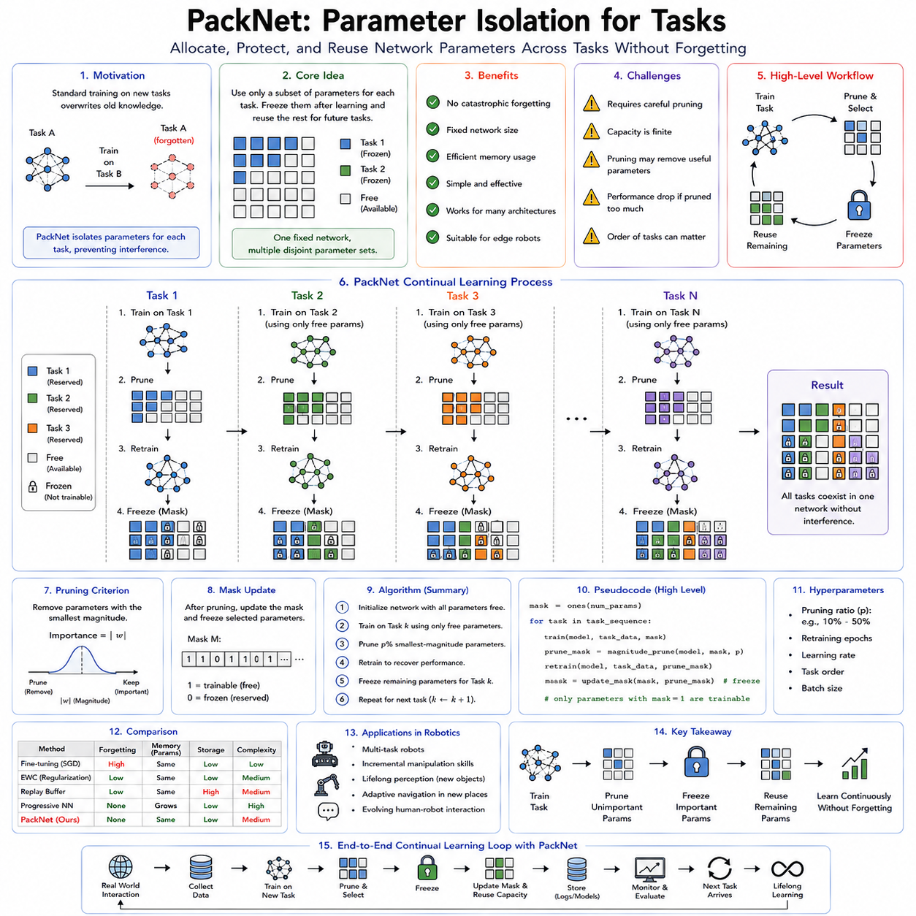
PackNet is a continual learning framework that addresses catastrophic forgetting through parameter isolation rather than parameter regularization or replay. Instead of attempting to protect important parameters while allowing limited updates, PackNet explicitly allocates different subsets of a neural network's parameters to different tasks. Once a task has been learned, the parameters essential to that task are permanently reserved and excluded from future optimization. New tasks are then trained using only the remaining unallocated parameters. This simple yet powerful idea allows multiple tasks to coexist within a single neural network while eliminating destructive interference between them.
The motivation behind PackNet originates from an important observation regarding overparameterized deep neural networks. Modern deep learning models frequently contain far more parameters than are strictly necessary for solving a particular problem. Numerous studies have shown that large neural networks often possess significant redundancy. Many parameters contribute little to final performance, while only a relatively small subset is truly essential. This redundancy suggests that unused network capacity can be gradually reclaimed and reassigned to future learning tasks instead of constructing entirely new neural networks or continuously modifying existing parameters.
Traditional continual learning methods typically follow one of three strategies. Regularization-based approaches such as Elastic Weight Consolidation attempt to estimate parameter importance and discourage modification of valuable weights. Replay-based methods preserve historical data and periodically retrain previous knowledge alongside new experiences. Architectural approaches such as Progressive Neural Networks allocate entirely new network modules for every task. PackNet introduces a fundamentally different perspective. Rather than protecting all previously learned parameters or expanding network size indefinitely, it recycles unused network capacity by partitioning the existing parameter space into isolated regions dedicated to different tasks.
The core idea is based on iterative pruning and retraining. Initially, a neural network is trained normally on the first task until satisfactory performance is achieved. After training, the network undergoes parameter pruning. Parameters contributing least to performance are removed according to a predefined pruning criterion. The remaining parameters represent the compressed knowledge necessary for the completed task. These surviving parameters become permanently frozen and assigned to the first task. The pruned parameters are then reset and become available for learning the next task.
This process repeats throughout the continual learning sequence. Every newly introduced task uses only parameters that remain unallocated after previous pruning stages. Once learning finishes, another pruning operation identifies the parameters required for preserving the newly acquired capability. Those parameters are also frozen, while the remaining free capacity becomes available for future tasks. Gradually, the network becomes partitioned into task-specific parameter subsets, each permanently preserving knowledge from a different stage of learning.
Unlike Progressive Neural Networks, PackNet does not expand the architecture. The total number of parameters remains fixed throughout the entire learning lifetime. Instead of adding new computational resources, PackNet reorganizes existing resources more efficiently. The neural network effectively becomes a shared hardware substrate whose individual parameters are assigned to different tasks over time. Memory consumption therefore remains nearly constant, making PackNet particularly attractive for resource-constrained edge devices and embedded robotic systems.
The pruning stage plays a central role in the PackNet algorithm. Deep neural network pruning has long been studied as a model compression technique for reducing computational complexity. PackNet repurposes pruning for continual learning rather than deployment optimization. After completing each task, parameters with the smallest absolute magnitudes are typically selected for removal. The underlying assumption is that small-magnitude weights contribute less to prediction accuracy than larger weights. Although magnitude pruning represents the simplest strategy, alternative importance measures can also be employed.
Following pruning, retraining becomes essential. Removing parameters inevitably degrades model performance because useful information disappears together with discarded weights. Retraining allows the remaining parameters to compensate for this loss by redistributing learned representations across the reduced parameter set. Once retraining restores performance, the compressed network contains a more efficient encoding of the learned task. This compact representation requires fewer parameters, leaving greater unused capacity available for subsequent learning.
The freeze operation distinguishes PackNet from ordinary pruning. After retraining, every retained parameter becomes permanently immutable. Future optimization ignores these weights entirely. Backpropagation updates only parameters that have not yet been assigned to previous tasks. Consequently, catastrophic forgetting becomes impossible because no future task can modify the parameters responsible for earlier knowledge. Every task retains exclusive ownership of its allocated parameter subset.
Task masks provide the mechanism for managing parameter ownership. Every parameter within the neural network receives an associated mask indicating whether it belongs to a particular task or remains available for future learning. During training, optimization updates only parameters whose masks indicate availability. During inference, the appropriate mask activates exactly the parameters corresponding to the desired task while ignoring others. These binary masks introduce only modest storage overhead because each parameter requires only a small amount of additional metadata.
An intuitive analogy compares PackNet to allocating offices within a large building. Initially, the building is completely empty. The first organization occupies part of the available office space while leaving the remainder unused. Once the first organization settles permanently, its offices become reserved. The next organization occupies some of the remaining empty offices without disturbing existing tenants. Eventually, the building houses many independent organizations sharing one physical structure while maintaining complete separation of their working environments.
Task isolation provides several important advantages beyond preventing catastrophic forgetting. Since each task owns independent parameter subsets, optimization for one task cannot negatively influence any previous task. Validation, debugging, certification, and performance analysis also become simpler because each task possesses clearly defined computational resources. Safety-critical robotic applications particularly benefit from this isolation because previously verified behaviors remain completely unchanged throughout future learning.
PackNet naturally exploits the substantial redundancy found within modern deep learning models. Image classification networks, transformer architectures, and reinforcement learning policies frequently contain many parameters that can be removed with minimal accuracy degradation. By repeatedly compressing learned representations, PackNet transforms this redundancy into long-term learning capacity. Instead of viewing overparameterization as computational waste, the algorithm interprets unused capacity as future memory for continual learning.
Robotic perception provides an illustrative example. Consider an autonomous mobile robot initially trained for indoor office navigation. After deployment, the robot expands into hospitals, warehouses, shopping centers, factories, and airports. Traditional fine-tuning risks forgetting previously learned visual representations whenever new environments are introduced. PackNet instead compresses the office navigation model, reserves the essential parameters, and allocates unused capacity for hospital navigation. Later deployments continue this process, allowing one neural network to accumulate specialized visual expertise across many environments without sacrificing earlier performance.
Manipulation systems exhibit similar characteristics. A robotic manipulator may first learn grasping strategies for industrial components. Subsequent deployments introduce household objects, agricultural products, laboratory instruments, surgical tools, and fragile materials. Each manipulation domain receives its own isolated parameter subset while sharing the same overall network architecture. Previously mastered manipulation skills remain completely intact regardless of future specialization.
Reinforcement learning also benefits from parameter isolation. Policies acquired through extensive exploration often require enormous computational investment. Losing these policies through catastrophic forgetting wastes considerable experience. PackNet permanently preserves successful policies by freezing the parameters responsible for learned behaviors. Future reinforcement learning proceeds exclusively within unused network capacity, allowing robots to accumulate increasingly diverse behavioral repertoires over long operational lifetimes.
Compared with Elastic Weight Consolidation, PackNet adopts a fundamentally different philosophy. EWC assumes every parameter remains potentially useful for future tasks but constrains updates according to estimated importance. PackNet instead partitions parameters into permanently protected and completely available subsets. No intermediate protection levels exist. Parameters either belong exclusively to previous tasks or remain entirely free for future optimization. This binary separation eliminates the need to estimate parameter importance continuously during learning.
Compared with replay-based continual learning, PackNet requires no historical training data after task completion. Once parameter allocation finishes, previous datasets may be discarded entirely because the preserved parameters themselves constitute the stored knowledge. This property proves particularly valuable when privacy regulations prohibit long-term storage of historical observations or when large robotic datasets exceed available storage resources.
Compared with Progressive Neural Networks, PackNet maintains fixed architectural size. Progressive Neural Networks continuously expand computational resources by adding new network columns. PackNet instead reuses existing capacity through compression. Consequently, PackNet offers superior scalability with respect to memory consumption while sacrificing the unlimited capacity available through architectural expansion.
Nevertheless, PackNet introduces several important limitations. The most obvious constraint concerns finite network capacity. Since the total number of parameters remains constant, available learning capacity gradually decreases as more tasks are learned. Eventually, insufficient unallocated parameters remain for accurately representing additional tasks. At this point, learning performance deteriorates because new tasks compete for increasingly limited computational resources.
Pruning strategy significantly influences long-term performance. Aggressive pruning preserves greater capacity for future tasks but risks degrading current task accuracy. Conservative pruning maintains higher immediate performance while reducing future learning capacity. Selecting an appropriate pruning ratio therefore represents an important design decision balancing present accuracy against future adaptability.
Retraining cost also deserves consideration. Every completed task requires at least two optimization phases: initial training followed by retraining after pruning. Although retraining typically converges more rapidly than initial learning, total computational cost nevertheless exceeds ordinary supervised learning. Large foundation models containing billions of parameters make repeated pruning and retraining computationally expensive.
Mask management introduces additional implementation complexity. During inference, the system must identify the correct task mask before generating predictions. Some continual learning benchmarks explicitly provide task identity during inference, simplifying mask selection. Real robotic systems often encounter ambiguous situations where task boundaries remain unclear. Automatically identifying which parameter subset should become active represents an additional research challenge.
Several extensions have been proposed to address these limitations. Dynamic pruning strategies adapt compression ratios according to task complexity rather than employing fixed percentages. Structured pruning removes entire neurons, channels, attention heads, or transformer blocks instead of individual weights, improving hardware efficiency. Adaptive mask learning optimizes parameter allocation automatically rather than relying upon predetermined pruning schedules. Soft masking approaches permit limited parameter sharing between closely related tasks while maintaining strong isolation elsewhere.
Sparse neural networks naturally complement the PackNet philosophy. Sparse architectures already contain many inactive parameters, reducing computational overhead while preserving representational power. Integrating PackNet with sparse training allows continual learning systems to allocate parameter subsets even more efficiently because inactive connections require minimal computational resources during both training and inference.
Transformer architectures present interesting opportunities for parameter isolation. Rather than allocating individual weights, modern implementations often assign complete attention heads, feed-forward modules, adapter layers, or low-rank adaptation matrices to different tasks. Such structured isolation reduces implementation complexity while maintaining the conceptual advantages of PackNet. Parameter-efficient fine-tuning methods such as LoRA further increase the practicality of task-specific parameter allocation within foundation models.
Multi-modal robotic systems introduce additional possibilities. Different sensing modalities often evolve independently throughout deployment. Visual perception, tactile sensing, language understanding, force control, proprioception, and audio processing may require different adaptation rates. PackNet allows modality-specific parameter allocation while preserving existing expertise within other sensory channels. Such selective adaptation reduces unnecessary interference across heterogeneous robotic subsystems.
Cloud robotics provides another practical application. Edge robots possess limited computational resources and therefore benefit from fixed-size continual learning architectures. PackNet enables long-term deployment without continually increasing memory requirements. Fleet-wide updates generated in cloud infrastructure can allocate parameter subsets consistently across multiple robots while preserving deployment-specific expertise within each individual platform.
Industrial robotics particularly benefits from parameter isolation because manufacturing environments frequently require certification and validation of deployed models. Once a parameter subset supporting a certified manufacturing process has been validated, freezing those parameters guarantees that future learning cannot accidentally invalidate previously approved behaviors. New production lines occupy different parameter subsets and undergo independent certification before deployment.
Safety-critical systems similarly benefit from immutable parameter allocation. Medical robots, autonomous vehicles, collaborative industrial manipulators, and infrastructure inspection robots often operate under strict regulatory requirements. Parameter isolation simplifies verification because previously validated parameter subsets remain mathematically unchanged regardless of subsequent learning. Regulatory compliance therefore becomes easier to maintain throughout long deployment lifetimes.
Theoretical interpretations of PackNet relate closely to the lottery ticket hypothesis. This hypothesis suggests that large neural networks contain numerous sparse subnetworks capable of solving learning problems independently. PackNet effectively discovers and reserves these subnetworks sequentially throughout continual learning. Each task identifies its own sparse computational pathway within the larger network while leaving alternative pathways available for future tasks. Although the relationship remains an active research topic, both perspectives emphasize the hidden computational capacity embedded within overparameterized neural networks.
Evaluation of PackNet extends beyond conventional prediction accuracy. Researchers measure average continual learning performance, forgetting metrics, parameter utilization efficiency, pruning ratios, remaining network capacity, computational cost, retraining overhead, memory consumption, inference latency, and scalability across long task sequences. Resource efficiency becomes particularly important because PackNet explicitly trades available network capacity for lifelong learning capability.
Hybrid approaches increasingly combine PackNet with complementary continual learning strategies. Replay buffers refresh historical representations while parameter isolation prevents destructive interference. Elastic Weight Consolidation protects shared parameters that remain active across multiple tasks. Dynamic architectural expansion activates only after remaining capacity falls below predefined thresholds. External memory systems complement parameter allocation by storing episodic experiences separately from neural representations. Such hybrid systems attempt to combine the strengths of multiple continual learning paradigms while minimizing their individual limitations.
PackNet introduced an important conceptual shift within continual learning research by demonstrating that catastrophic forgetting can be prevented through explicit ownership of neural parameters. Instead of asking how existing parameters should change safely, PackNet asks which parameters should belong permanently to each learned capability. This perspective transforms continual learning from a problem of optimization into one of intelligent resource allocation. As robotic systems become increasingly autonomous and accumulate knowledge throughout years of deployment, parameter isolation strategies such as PackNet provide an efficient and practical mechanism for preserving valuable expertise while continuing to learn within fixed computational budgets.

08.06 Generative Replay for Continual Robot Learning [w/Code]
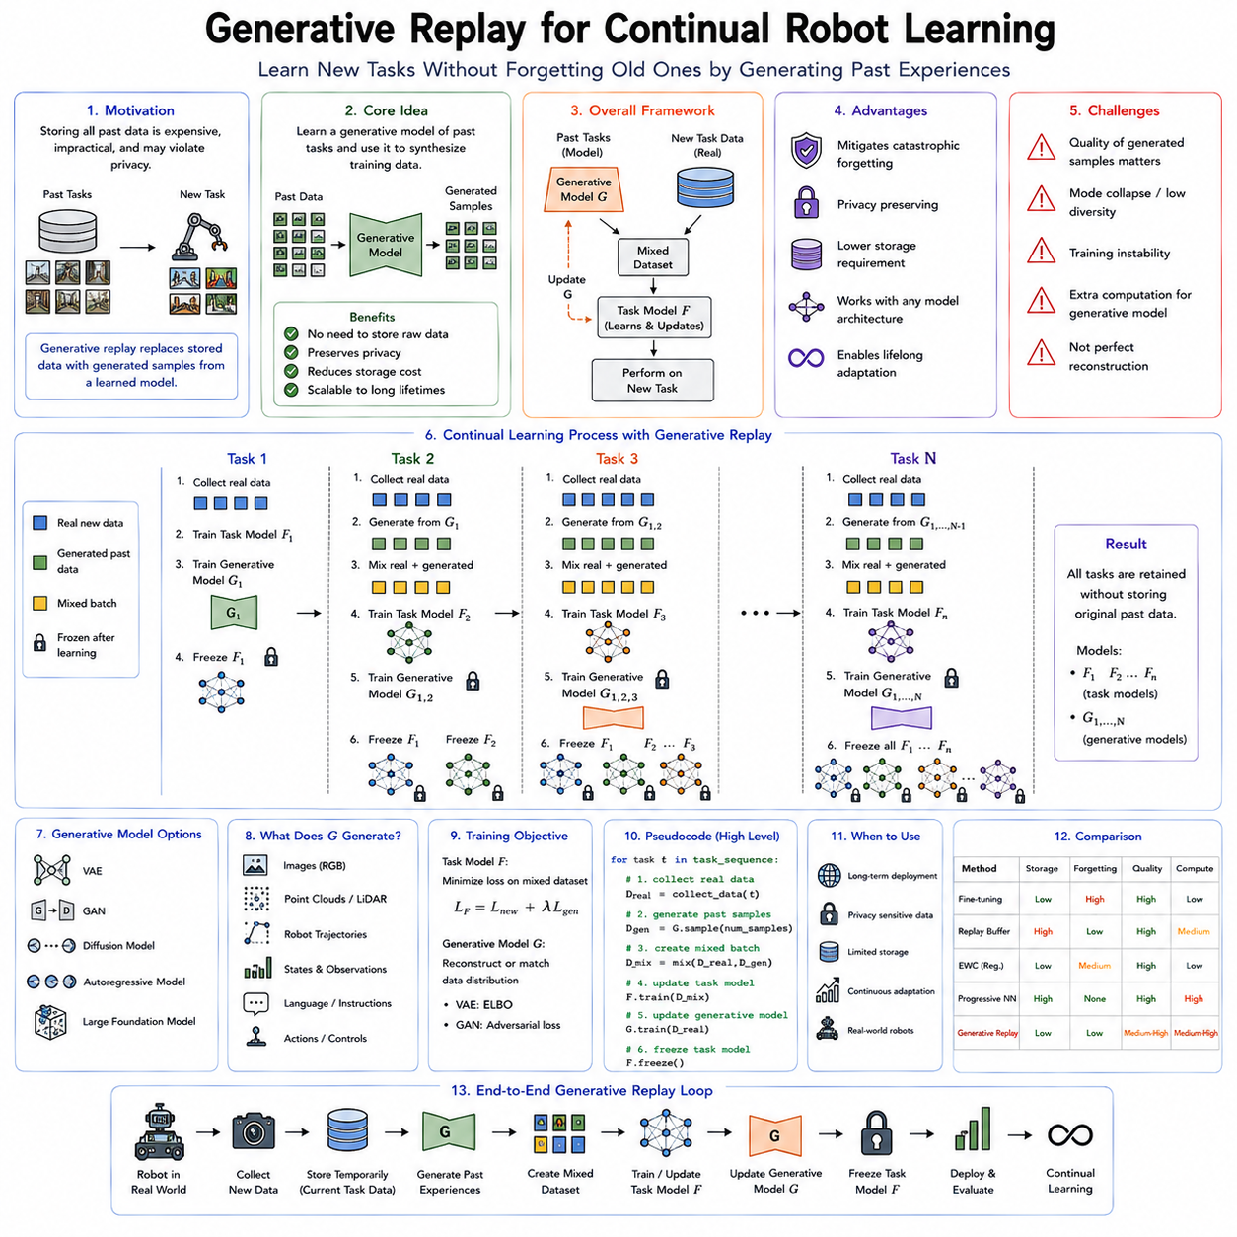
Generative Replay is one of the most elegant solutions to catastrophic forgetting in continual learning because it replaces the need to store historical training data with the ability to recreate representative experiences through a generative model. Instead of maintaining a replay buffer containing real observations collected during previous tasks, the system learns a model capable of synthesizing realistic samples that approximate earlier data distributions. Whenever a new task is introduced, these generated samples are mixed with the new training data, allowing the learning algorithm to preserve previous knowledge while acquiring new capabilities. In this way, Generative Replay combines the advantages of replay-based continual learning with reduced storage requirements and improved privacy protection.
The motivation for Generative Replay originates from one of the major limitations of conventional replay buffers. Classical replay methods require explicit storage of historical observations, images, trajectories, demonstrations, or sensor measurements. Although replay is highly effective at preventing catastrophic forgetting, long-term robotic deployment quickly produces enormous quantities of data. Autonomous vehicles may collect terabytes of multimodal sensor information every day. Warehouse robots continuously capture images, LiDAR scans, navigation trajectories, and manipulation logs. Humanoid robots record visual observations, language interactions, tactile feedback, proprioceptive measurements, and action sequences throughout their operational lifetime. Maintaining all of these data becomes computationally expensive and often practically impossible.
Storage limitations are not the only concern. Many robotic applications involve sensitive information that cannot legally or ethically be preserved indefinitely. Service robots operating inside homes capture personal living spaces. Hospital robots observe patients and medical procedures. Industrial inspection robots collect proprietary manufacturing information. Public service robots interact with identifiable individuals. Regulations governing privacy, intellectual property, and data ownership frequently prohibit permanent storage of raw observations. Even when storage capacity is available, retaining complete historical datasets may violate organizational policies or legal requirements.
Generative Replay addresses these challenges by storing knowledge in a fundamentally different form. Rather than preserving every historical observation, the system learns a generative model capable of approximating the probability distribution from which those observations originated. During future training, synthetic examples sampled from this learned distribution replace the original data. The learning algorithm therefore experiences representative examples from previous tasks without requiring direct access to the historical dataset itself.
The underlying concept closely resembles aspects of human memory. Humans rarely remember every sensory detail of every past experience. Instead, memory reconstructs approximate representations of previous events when they become relevant. Recalled memories are often incomplete, generalized, and influenced by semantic knowledge accumulated over time. Despite these imperfections, reconstructed experiences remain sufficiently informative to reinforce existing knowledge. Generative Replay follows a similar principle. The generated samples need not perfectly reproduce every original observation. They simply need to preserve the statistical structure necessary for maintaining previously learned representations.
The overall architecture of Generative Replay typically consists of two interacting models. The first is the primary task model responsible for perception, control, planning, or decision-making. The second is a generative model responsible for producing synthetic training examples representing previous tasks. Whenever a new task arrives, the generative model produces artificial samples from earlier tasks while real data are collected for the current task. The task model then trains on the combined dataset, preserving historical knowledge while adapting to newly observed information.
Various types of generative models can support this framework. Variational Autoencoders (VAEs) provide efficient latent representations capable of reconstructing diverse observations. Generative Adversarial Networks (GANs) produce highly realistic images by learning adversarial objectives between generators and discriminators. Diffusion Models iteratively denoise random samples into high-quality synthetic observations while capturing complex probability distributions. Autoregressive generative models sequentially predict observations one element at a time. More recently, large multimodal foundation models have demonstrated impressive generative capabilities extending beyond images to language, audio, robot trajectories, and action sequences.
Variational Autoencoders became one of the earliest practical choices for Generative Replay because they simultaneously compress observations into latent representations and reconstruct them with relatively low computational complexity. During continual learning, the encoder learns compact latent variables describing historical experiences. The decoder reconstructs representative samples from these latent variables whenever replay becomes necessary. Since latent representations require significantly less storage than raw observations, VAEs naturally combine memory compression with synthetic data generation.
Generative Adversarial Networks offer higher visual fidelity than many early VAE implementations. A GAN-based replay system learns to generate realistic sensor observations indistinguishable from genuine historical data. During future training, these generated images serve as replay samples maintaining visual recognition capabilities across multiple tasks. However, GAN training often suffers from instability, mode collapse, and sensitivity to hyperparameter selection, making robust continual learning more challenging than with simpler generative architectures.
Diffusion Models have recently emerged as particularly promising candidates for Generative Replay because of their remarkable ability to model complex high-dimensional distributions. Diffusion-based replay systems progressively reconstruct synthetic observations from random noise through iterative denoising processes. These models generally produce higher sample quality, greater diversity, and improved training stability than many earlier generative methods. Their ability to generate realistic robot observations, manipulation scenes, and multimodal sensory inputs has attracted increasing attention within robotic continual learning research.
The continual learning procedure follows a sequential cycle. Initially, both the task model and the generative model train using data from the first task. Once learning completes, the original dataset may be discarded because the generative model now approximates its distribution. When the second task begins, the generative model synthesizes representative samples from the first task while real observations are collected for the second. Both datasets train the task model simultaneously. The generative model itself is then updated to capture the combined distribution of both tasks. This process repeats as additional tasks arrive throughout the learning lifetime.
An important distinction exists between exact replay and generative replay. Exact replay reproduces historical observations without modification because stored data remain available. Generative replay instead reconstructs approximations. Consequently, sample quality becomes critically important. If generated observations differ substantially from the original distribution, replay may fail to preserve previous knowledge effectively. The success of Generative Replay therefore depends heavily upon the fidelity, diversity, and representational accuracy of the underlying generative model.
One challenge concerns accumulation of reconstruction errors. Every continual learning cycle updates the generative model using both genuine observations from the current task and synthetic observations generated from previous models. Small inaccuracies introduced during one generation stage may propagate and amplify over subsequent generations. After many tasks, generated samples may gradually drift away from the original data distribution. This phenomenon, sometimes described as generational degradation, represents one of the principal limitations of long-term Generative Replay systems.
Researchers have proposed several strategies to reduce this degradation. Improved generative architectures produce more accurate reconstructions. Knowledge distillation transfers historical generative knowledge between successive models more faithfully. Hybrid replay combines limited real memory with generated samples, allowing authentic observations to periodically recalibrate synthetic distributions. Regularization techniques stabilize latent representations across continual learning stages. Such methods substantially improve long-term replay quality compared with naïve generation alone.
Robotic perception provides numerous practical applications for Generative Replay. Consider an autonomous inspection robot deployed across multiple factories over several years. Different facilities contain distinct machinery, lighting conditions, floor materials, product types, and environmental appearances. Rather than storing millions of historical inspection images, a generative model synthesizes representative observations from earlier deployments whenever new factories are introduced. The perception system therefore preserves recognition capabilities across all environments while requiring only the generative model rather than complete image archives.
Manipulation learning presents similar opportunities. A robot initially learns grasping strategies for industrial tools before expanding to household objects, laboratory equipment, agricultural products, and medical instruments. Instead of storing demonstrations for every previously encountered object indefinitely, the generative model produces synthetic manipulation scenes approximating historical experiences. Replay through generated demonstrations helps preserve manipulation competence across diverse object categories without maintaining enormous demonstration datasets.
Autonomous navigation also benefits significantly. Mobile robots experience continual environmental changes including seasonal variation, altered building layouts, construction zones, lighting differences, and evolving traffic patterns. Generative Replay reconstructs representative navigation observations from earlier operational environments while learning new locations. Localization, mapping, obstacle detection, and path planning models thereby maintain broad environmental competence throughout long deployment periods.
Generative Replay becomes particularly attractive for multimodal robotic systems. Modern robots integrate visual perception, LiDAR, radar, tactile sensing, force measurements, proprioception, language instructions, robot states, and action trajectories. Storing synchronized multimodal histories rapidly exceeds practical storage capacities. Generative models capable of reconstructing coherent multimodal observations substantially reduce memory requirements while preserving cross-modal relationships essential for embodied intelligence.
Action generation extends replay beyond passive perception. Robot learning frequently requires preserving behavioral trajectories rather than only sensory observations. Generative sequence models learn distributions over state-action trajectories, motor commands, manipulation sequences, navigation paths, or human demonstrations. During replay, synthetic trajectories reinforce previously acquired policies without retaining original execution logs. This capability proves particularly valuable for imitation learning and reinforcement learning applications.
Language-conditioned robotics introduces additional opportunities. Foundation models increasingly connect language understanding with perception and robot control. Historical language instructions, dialogue contexts, semantic plans, and associated actions may all be generated synthetically during continual learning. Consequently, robots preserve communication capabilities across evolving task domains without storing every previous human interaction explicitly.
Privacy preservation represents one of the strongest practical arguments supporting Generative Replay. Since raw observations need not remain permanently stored, sensitive information may be removed after the generative model has learned representative distributions. Properly designed generative models reconstruct statistical properties rather than exact personal records. Although privacy guarantees require careful evaluation, synthetic replay generally reduces exposure compared with maintaining complete historical datasets.
Cloud robotics provides another compelling deployment scenario. Individual robots continuously upload operational experiences to centralized cloud infrastructure where generative foundation models learn increasingly comprehensive environmental distributions. Rather than transmitting enormous replay buffers back to every robot, compact generative models distribute synthetic replay capability efficiently across entire robot fleets. Individual robots then generate representative historical experiences locally while continuing lifelong adaptation.
Foundation models significantly expand the scope of Generative Replay. Large multimodal generative models already possess remarkable abilities to synthesize images, text, videos, three-dimensional scenes, robotic actions, and world models. Rather than training dedicated replay generators from scratch for every deployment, future continual learning systems may adapt general-purpose foundation models to generate representative historical experiences conditioned upon specific tasks, environments, or operational contexts.
Evaluation of Generative Replay extends beyond conventional continual learning metrics. Researchers measure generation quality using metrics such as Fréchet Inception Distance, reconstruction accuracy, sample diversity, latent space consistency, and distribution similarity. Continual learning performance remains equally important, including average accuracy, forgetting metrics, backward transfer, forward transfer, adaptation speed, computational efficiency, and long-term stability. Successful replay requires both high-quality generation and effective preservation of downstream task performance.
Computational cost represents another important consideration. Training generative models introduces additional optimization beyond the primary task network. High-capacity diffusion models may require substantial computational resources during both training and sample generation. Nevertheless, this cost often remains significantly smaller than storing and processing complete historical datasets collected over many years of robotic deployment. Continued advances in efficient generative architectures further improve the practicality of replay generation.
Comparison with explicit replay buffers highlights complementary strengths and weaknesses. Explicit replay stores authentic historical observations, guaranteeing perfect sample fidelity but requiring increasing storage capacity and potentially violating privacy constraints. Generative Replay dramatically reduces storage requirements and enhances privacy while introducing approximation errors through synthetic generation. Neither approach universally dominates. Practical deployment often depends upon available memory, computational resources, regulatory requirements, and acceptable levels of approximation.
Hybrid replay architectures increasingly combine explicit and generative memory. Small replay buffers preserve especially important or difficult examples while generative models synthesize the remaining historical distribution. This combination reduces storage requirements while limiting long-term degradation caused by repeated synthetic generation. Adaptive memory management determines automatically which observations merit explicit preservation and which may safely rely upon generative reconstruction.
Generative Replay also integrates naturally with parameter regularization and parameter isolation techniques. Elastic Weight Consolidation protects important network parameters while synthetic replay reinforces historical representations. PackNet isolates parameter subsets dedicated to earlier tasks while generated observations strengthen shared components. Progressive Neural Networks accumulate specialized architectures while generative replay enhances knowledge transfer across frozen network columns. Such combinations frequently outperform individual methods because they address different mechanisms underlying catastrophic forgetting.
Theoretical interpretations connect Generative Replay with distribution matching rather than memory preservation. The objective is not remembering individual examples but maintaining the underlying probability distributions governing previous experiences. If generated samples accurately approximate those distributions, optimization receives gradients nearly identical to those produced by the original data. This probabilistic perspective explains why imperfect synthetic observations may nevertheless preserve task performance effectively.
Future research increasingly explores world models as generalized replay mechanisms. Instead of generating isolated observations, future systems may simulate complete interactive environments where robots revisit previous experiences dynamically. Such simulated worlds preserve temporal structure, causal relationships, physical interactions, and long-horizon behaviors beyond what static replay examples can provide. World-model-based replay therefore represents a natural evolution from sample generation toward full experiential reconstruction.
As Physical AI systems continue evolving toward long-term autonomous operation, Generative Replay will likely become an increasingly important component of continual learning architectures. Robots operating continuously across changing environments require mechanisms preserving accumulated knowledge without storing unlimited historical data. By transforming explicit memories into generative models capable of reconstructing representative experiences on demand, Generative Replay provides an elegant compromise among storage efficiency, privacy preservation, lifelong adaptation, and catastrophic forgetting mitigation. Although challenges such as generative fidelity, computational cost, and long-term distribution drift remain active research topics, Generative Replay has established itself as one of the foundational techniques enabling robots to learn continuously throughout years of deployment while preserving the valuable knowledge accumulated from their past experiences.

08.07 Task Incremental and Class Incremental Learning [w/Code]
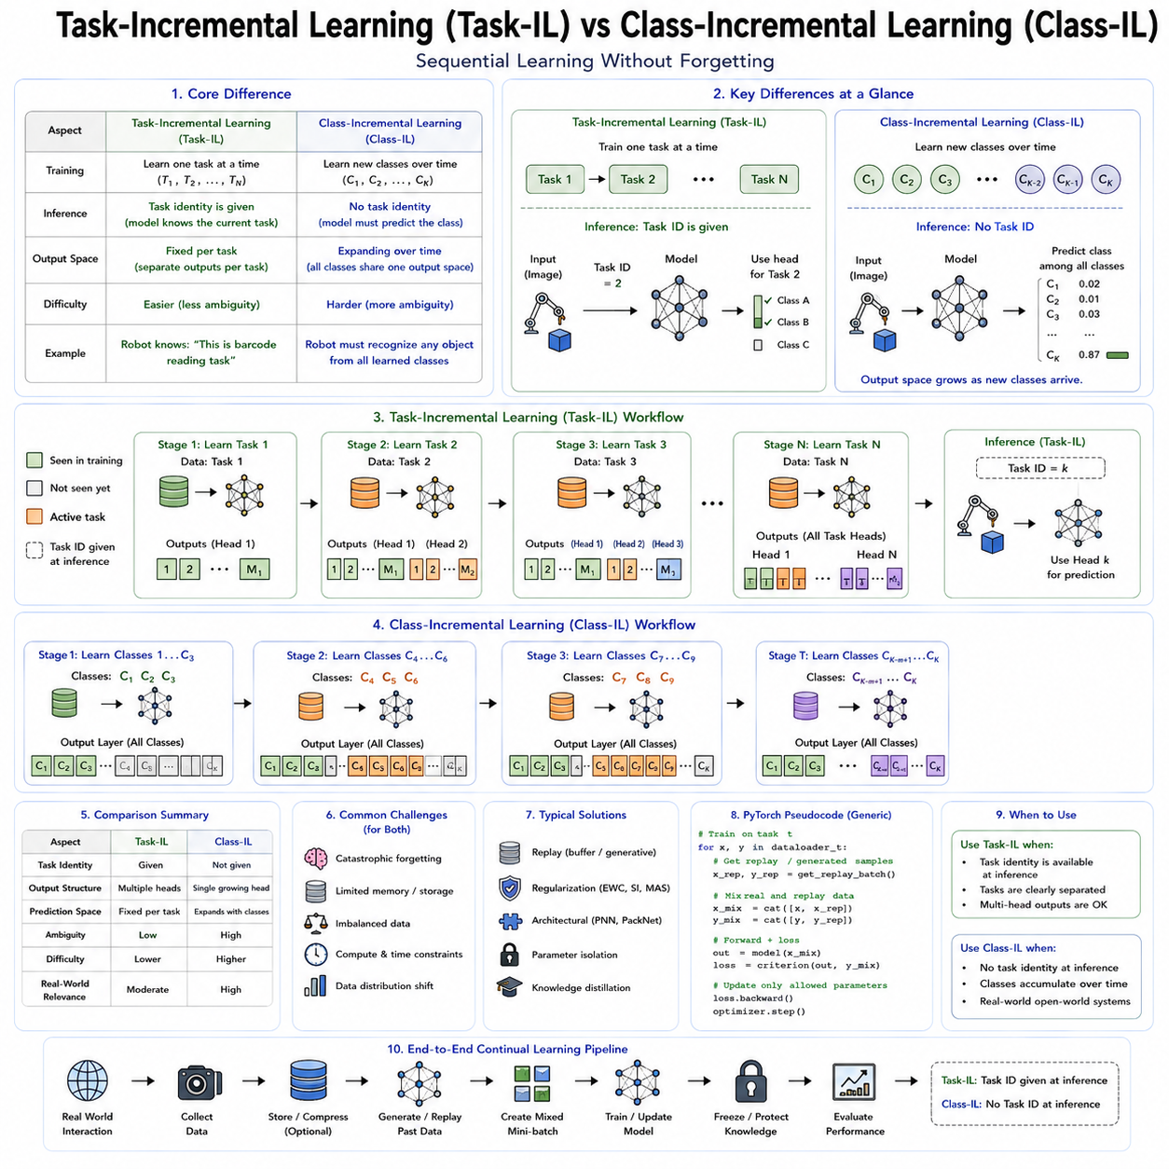
Task-Incremental Learning (Task-IL) and Class-Incremental Learning (Class-IL) are two of the most fundamental learning scenarios in continual learning and lifelong learning research. They define how an intelligent system receives new knowledge over time and determine the assumptions available during both training and inference. Although both settings require sequential learning without catastrophic forgetting, they differ significantly in what information the model is allowed to use, how predictions are made, and how difficult the learning problem becomes. Understanding the distinction between these two paradigms is essential because they represent different levels of autonomy that real robotic systems encounter during long-term deployment.
Traditional machine learning assumes that all training data are available simultaneously. Images, sensor observations, demonstrations, trajectories, labels, and rewards are collected into a single dataset before optimization begins. The learning algorithm repeatedly accesses every sample until convergence, and evaluation occurs on a fixed benchmark that remains unchanged throughout the lifetime of the model. This setting is convenient for research but unrealistic for autonomous robots. Robots operating in factories, hospitals, homes, warehouses, agricultural fields, and public environments continuously encounter new objects, tasks, users, and environmental conditions after deployment. Consequently, knowledge arrives sequentially rather than simultaneously.
Continual learning formalizes this sequential acquisition of knowledge by dividing the learning process into multiple stages. Instead of one large training session, the robot receives Task 1, then Task 2, followed by Task 3, and so forth. After completing each stage, the system should preserve previous knowledge while learning new information. The specific assumptions regarding task identity during training and inference determine whether the problem belongs to Task-Incremental Learning, Class-Incremental Learning, Domain-Incremental Learning, or other continual learning formulations.
Task-Incremental Learning represents the most structured continual learning scenario. During training, the system receives data belonging to one task at a time. More importantly, during inference, the identity of the current task is explicitly provided. The model therefore knows which task-specific knowledge should be applied when making predictions. Since the task boundary is available, the learning algorithm can maintain separate representations, specialized output heads, or independent decision modules for each task while still sharing lower-level representations when appropriate.
Consider a warehouse robot initially trained to recognize storage containers. Later, the robot learns package identification, followed by pallet inspection, barcode reading, and equipment monitoring. In a Task-Incremental setting, the robot always knows which recognition problem it is solving. If instructed to inspect barcodes, the inference system activates the barcode recognition component. If assigned pallet inspection, it switches to the corresponding output head. The task identity removes ambiguity regarding which prediction space should be considered.
The availability of task identity simplifies continual learning considerably. Since tasks remain explicitly separated, different output layers may coexist without competing against one another. A classifier responsible for warehouse packages never needs to distinguish hospital equipment because those belong to different task contexts. Catastrophic forgetting still occurs if shared parameters are modified carelessly, but output interference becomes significantly less severe than in more challenging continual learning settings.
Task-Incremental Learning therefore serves as an important benchmark for evaluating continual learning algorithms under relatively favorable assumptions. Many early methods, including Elastic Weight Consolidation, Progressive Neural Networks, and PackNet, initially demonstrated effectiveness within Task-Incremental scenarios before being extended to more difficult settings.
The architectural design for Task-Incremental Learning often includes multiple output heads. Shared feature extractors process sensory observations into general representations, while task-specific classifiers or policy heads generate predictions appropriate for the active task. During inference, the known task identifier selects the correct output head automatically. Such modular architectures reduce competition among unrelated prediction spaces while promoting transfer through shared feature representations.
In contrast, Class-Incremental Learning represents a considerably more realistic and significantly more difficult continual learning problem. Like Task-Incremental Learning, training occurs sequentially across multiple tasks. However, during inference, task identity is no longer available. The model receives only the input observation and must simultaneously determine both what object or concept it represents and which previously learned class it belongs to. The prediction space therefore expands continuously throughout the learning lifetime.
Imagine a household service robot learning object recognition. Initially, it recognizes cups, plates, and bowls. Later, it learns bottles, books, and remote controls. Subsequently, it encounters medicine containers, cleaning supplies, electronic devices, and food packages. During deployment, the robot observes an unfamiliar object without being told which learning stage introduced it. The recognition system must classify the observation among every object category learned throughout its lifetime. No external signal indicates whether the object belongs to the first, second, or fifth training stage.
This absence of task identity fundamentally changes the learning problem. The classifier must continually expand its decision boundaries while preserving previously established class relationships. Every newly introduced category competes directly with all earlier categories because the final prediction considers the complete accumulated vocabulary rather than a task-specific subset. Consequently, catastrophic forgetting becomes substantially more severe than in Task-Incremental Learning.
Output layer design illustrates this distinction clearly. Task-Incremental Learning often allocates separate classifiers for different tasks, each responsible only for its own label space. Class-Incremental Learning instead requires one continuously expanding classifier capable of distinguishing every class encountered throughout the robot's operational lifetime. New classes enlarge the output dimension rather than creating independent prediction modules.
The growing classification space introduces several challenges simultaneously. First, the model must preserve decision boundaries separating previously learned classes. Second, it must establish new boundaries incorporating recently introduced categories. Third, representation learning must remain sufficiently general to distinguish objects spanning many sequential learning stages. Finally, optimization occurs using only current task data unless replay or other continual learning mechanisms compensate for missing historical observations.
Bias toward recently learned classes represents one of the most significant problems in Class-Incremental Learning. Since optimization primarily processes current data, feature representations gradually become specialized for newly introduced categories. Older classes receive progressively fewer updates, causing their decision boundaries to deteriorate. The classifier consequently exhibits increasing preference for predicting recent classes while underestimating earlier categories. This phenomenon frequently appears even when catastrophic forgetting has been partially mitigated through regularization or replay.
Calibration therefore becomes particularly important. Output probabilities should remain comparable across classes learned at different times. Without proper calibration, confidence scores for recent categories systematically exceed those for historical classes regardless of actual observation quality. Balanced replay, bias correction, knowledge distillation, and classifier normalization have all been proposed to address this issue.
Knowledge distillation has proven especially valuable for Class-Incremental Learning. Previous versions of the model generate soft probability distributions describing historical knowledge. During continual learning, the updated model attempts not only to classify new data correctly but also to reproduce historical prediction distributions. Distillation therefore preserves relative relationships among previously learned classes even when original training data are unavailable.
Replay methods likewise play a central role. Representative historical observations periodically reappear during optimization, preventing decision boundaries from drifting excessively toward recent classes. Balanced replay strategies ensure that every class remains adequately represented despite sequential data acquisition. Hybrid methods combining replay with parameter regularization frequently achieve state-of-the-art performance across challenging Class-Incremental benchmarks.
Task-Incremental and Class-Incremental Learning also differ significantly regarding transfer learning opportunities. Task-Incremental settings often encourage modular specialization because task boundaries remain explicit. Different output heads optimize independently while sharing lower-level features. Class-Incremental Learning instead emphasizes unified representations capable of distinguishing all categories simultaneously. Consequently, feature extractors must remain increasingly general as the number of learned classes expands.
Robotic perception provides numerous practical examples illustrating these differences. Industrial inspection robots may operate under Task-Incremental assumptions when switching explicitly between weld inspection, surface defect detection, dimensional measurement, and barcode verification. The current inspection objective remains known before inference begins. Conversely, warehouse inventory robots often operate under Class-Incremental conditions because they encounter products from many learning stages without receiving explicit task identifiers. Every observed object must be recognized from the complete accumulated inventory.
Manipulation systems exhibit similar distinctions. A robot instructed explicitly to perform grasping, pouring, assembly, or insertion operates within a Task-Incremental framework because the active manipulation task remains known. A general-purpose household robot observing an arbitrary object requiring identification before manipulation instead faces a Class-Incremental recognition problem where every learned object category competes simultaneously.
Autonomous driving demonstrates additional complexity. Traffic sign recognition frequently resembles Class-Incremental Learning because new sign categories appear gradually while inference lacks explicit task boundaries. Meanwhile, separate perception modules for lane detection, pedestrian detection, semantic segmentation, and traffic light recognition often resemble Task-Incremental structures because each subsystem addresses a distinct prediction objective despite operating simultaneously.
The relationship between these learning scenarios and robotic autonomy is particularly important. Lower levels of autonomy frequently rely upon explicit task specifications provided by human operators, making Task-Incremental Learning sufficient. As autonomy increases, robots receive increasingly abstract goals rather than detailed task identifiers. General-purpose embodied agents must determine both task context and object identity independently, gradually shifting toward Class-Incremental or even task-free continual learning scenarios.
Evaluation protocols differ accordingly. Task-Incremental benchmarks typically provide task identifiers during testing and evaluate prediction accuracy within task-specific output spaces. Class-Incremental benchmarks remove task identity entirely, requiring predictions across the complete accumulated class set. Average accuracy therefore decreases substantially because the prediction problem becomes significantly more difficult despite identical underlying datasets.
Several benchmark datasets illustrate these scenarios. Split versions of MNIST, CIFAR-100, ImageNet, CORe50, and various robotic perception datasets partition classes across sequential tasks. Researchers evaluate identical continual learning algorithms under Task-Incremental, Class-Incremental, and Domain-Incremental protocols to understand how performance changes as assumptions become increasingly realistic. Results consistently demonstrate that Class-Incremental Learning remains substantially more challenging than Task-Incremental Learning.
Output expansion mechanisms become essential for Class-Incremental systems. Whenever new classes appear, additional output neurons must be introduced while preserving compatibility with existing predictions. Weight initialization, normalization, bias correction, and classifier balancing significantly influence continual learning performance. Poor initialization may immediately favor new classes or destabilize historical decision boundaries even before optimization begins.
Memory management strategies also differ. Task-Incremental Learning often stores task-specific knowledge separately because task identity remains available. Class-Incremental Learning instead prioritizes maintaining representative samples spanning all learned classes. Balanced replay buffers, prototype memories, exemplar selection, and class-aware sampling become especially important because every historical class participates directly in future predictions.
Representation learning constitutes another major distinction. Task-Incremental architectures may tolerate partially task-specific feature spaces because separate output heads resolve final predictions independently. Class-Incremental systems require increasingly universal representations supporting discrimination among all accumulated categories simultaneously. Self-supervised pretraining, foundation models, and contrastive learning therefore often provide substantial advantages by producing highly transferable representations before continual adaptation begins.
Foundation models have significantly influenced both learning paradigms. Large pretrained visual encoders already contain broad representations spanning numerous object categories. Task-Incremental adaptation frequently requires only lightweight task-specific output heads. Class-Incremental Learning benefits because pretrained representations reduce feature drift during continual optimization, allowing new classes to integrate into existing representation spaces with fewer destructive updates.
Multi-modal robotics introduces additional dimensions. Language-conditioned robots may receive explicit textual task descriptions supporting Task-Incremental reasoning. Alternatively, they may infer task identity implicitly from environmental context while recognizing arbitrary objects from continually expanding vocabularies. Vision-language-action models increasingly blur traditional distinctions because language itself becomes a dynamic source of task specification.
Industrial deployment highlights practical implications. Manufacturing robots commonly receive explicit production schedules specifying active operations, naturally supporting Task-Incremental organization. Consumer service robots interacting with unpredictable environments rarely receive such structured guidance. Instead, they must identify objects, infer user intentions, recognize environments, and determine appropriate actions autonomously, closely resembling Class-Incremental Learning or even more general continual learning settings.
Cloud robotics offers another perspective. Fleet-wide learning may aggregate experiences from numerous robots operating across diverse environments. Centralized continual learning systems often preserve explicit task labels during model development while deployed robots perform Class-Incremental inference under uncertain conditions. Bridging these different operational assumptions remains an active research area.
Beyond these two paradigms lies Task-Free Continual Learning, where even task boundaries during training disappear entirely. Data arrive as uninterrupted streams without segmentation into distinct tasks. The system must detect distribution shifts, identify emerging concepts, allocate memory, and update representations autonomously. Although Task-Incremental and Class-Incremental Learning remain the dominant research benchmarks, task-free learning more closely approximates the conditions expected for future long-term autonomous robots.
Modern continual learning research increasingly develops algorithms performing well across all incremental learning scenarios rather than optimizing exclusively for one benchmark. Replay buffers, parameter regularization, parameter isolation, dynamic architectures, knowledge distillation, foundation models, retrieval mechanisms, and external memory systems all contribute complementary strengths. Hybrid approaches combining multiple techniques generally achieve greater robustness because they address different aspects of sequential learning simultaneously.
Task-Incremental Learning and Class-Incremental Learning should therefore be viewed not as competing algorithms but as progressively more demanding formulations of lifelong learning. Task-Incremental Learning assumes that intelligent systems receive explicit contextual guidance during inference, simplifying continual adaptation through modular organization. Class-Incremental Learning removes this assumption, requiring unified representations capable of recognizing every previously encountered category without external assistance. Together they provide the conceptual foundation for evaluating continual learning algorithms and represent important milestones on the path toward fully autonomous robotic intelligence capable of accumulating knowledge continuously throughout years of real-world operation while preserving everything it has previously learned.

08.08 Lifelong SLAM and Environment Adaptation [w/Code]
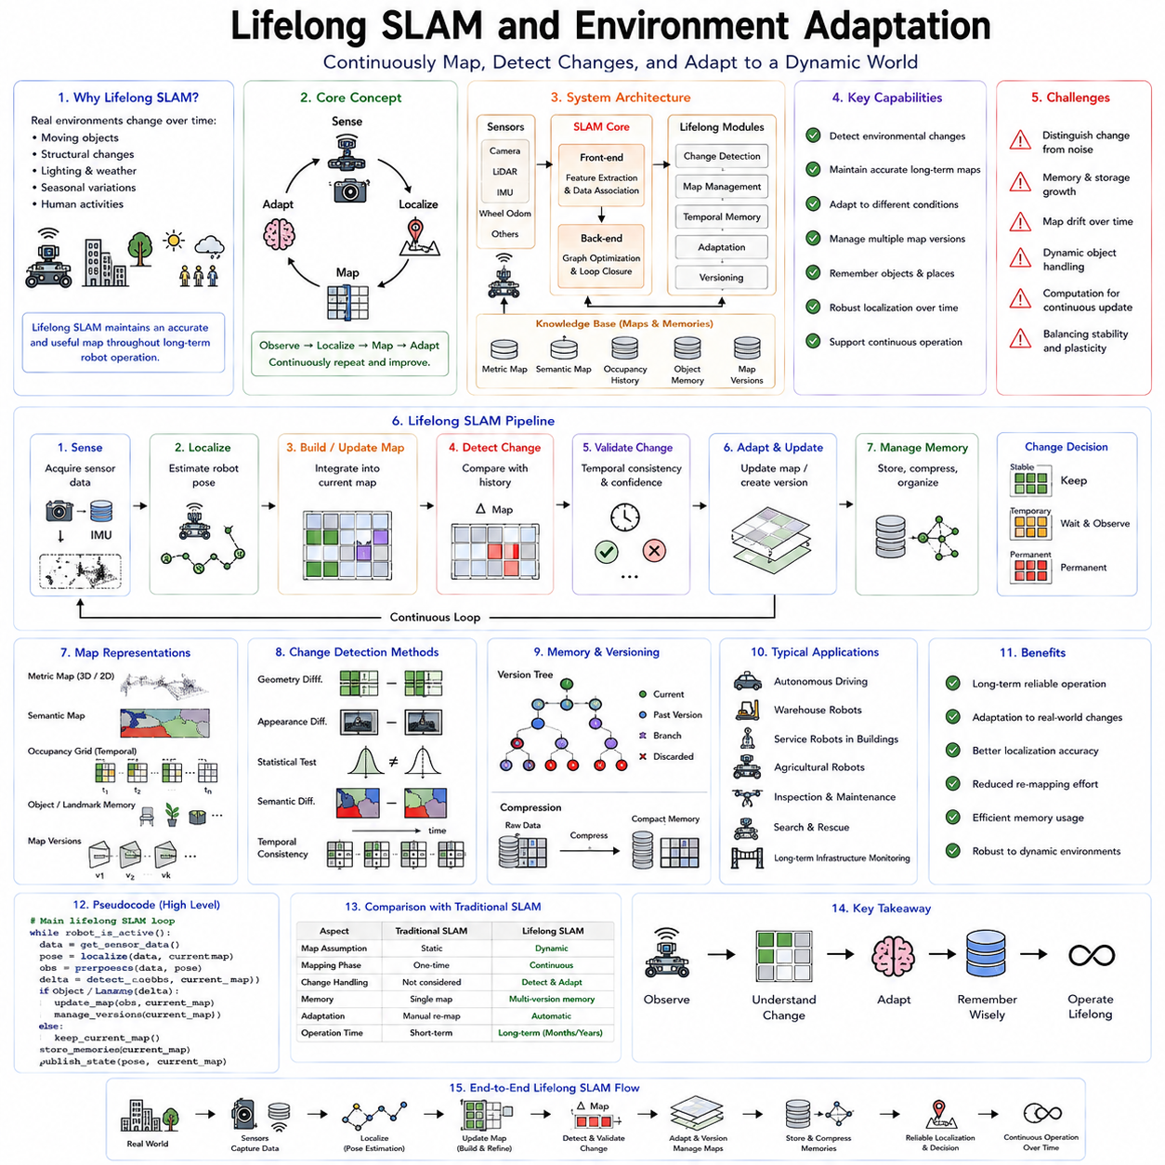
Simultaneous Localization and Mapping (SLAM) has traditionally been viewed as a robotics problem concerned with estimating a robot's position while simultaneously constructing a map of an unknown environment. Classical SLAM algorithms assume that mapping begins when the robot enters an unfamiliar space, continues until an accurate map is constructed, and then largely concludes. The resulting map is often treated as a relatively static representation of the environment. While this assumption is sufficient for short-term missions or controlled laboratory experiments, it becomes inadequate for robots expected to operate continuously for months or years. Real environments evolve. Buildings are renovated, furniture moves, warehouses reorganize inventory, roads undergo construction, lighting conditions change, vegetation grows, weather alters appearances, and people constantly modify the world. Lifelong SLAM extends traditional SLAM by transforming mapping from a one-time estimation problem into a continuous learning process that enables robots to adapt their internal world representations throughout long operational lifetimes.
The concept of Lifelong SLAM emerges naturally from the broader principles of continual learning. A robot deployed in the real world cannot assume that its environment remains fixed after the initial mapping phase. Instead, every observation provides an opportunity to refine, update, validate, or even discard portions of its internal map. The challenge is no longer simply building a map but maintaining an accurate and useful representation despite continuous environmental evolution. This requires balancing two competing objectives. The robot must preserve reliable long-term structural knowledge while remaining flexible enough to incorporate genuine environmental changes. This balance mirrors the stability-plasticity dilemma encountered throughout continual learning.
Traditional SLAM systems generally separate operation into front-end and back-end components. The front-end extracts features, matches observations, estimates motion, and detects loop closures. The back-end optimizes poses, landmarks, and map consistency through graph optimization or probabilistic inference. Lifelong SLAM preserves this general architecture but augments it with mechanisms for temporal reasoning, environmental change detection, memory management, map versioning, and adaptive learning. The mapping system becomes not merely a geometric estimator but an evolving memory capable of distinguishing persistent structures from temporary changes.
One of the fundamental assumptions challenged by Lifelong SLAM concerns environmental permanence. Classical algorithms frequently interpret inconsistent observations as sensor noise, localization error, or feature mismatching. However, inconsistencies often arise because the world itself has changed. A corridor previously containing storage shelves may now be empty. A construction site may replace an open parking lot. Furniture may be rearranged overnight. Seasonal vegetation can completely alter outdoor visual appearance. Lifelong SLAM must determine whether differences originate from localization uncertainty or genuine environmental evolution.
This distinction introduces one of the central research problems in lifelong mapping: change detection. The robot continuously compares current observations against historical map representations. Significant discrepancies trigger hypotheses regarding possible environmental changes. However, not every discrepancy justifies modifying the map. Moving people, passing vehicles, temporary obstacles, shadows, lighting variations, weather conditions, and sensor artifacts should not permanently alter the robot's world model. The system must therefore distinguish transient phenomena from persistent structural modifications.
Temporal consistency provides an important criterion for change validation. If a newly observed obstacle appears only briefly before disappearing, it likely represents a temporary object rather than a permanent environmental modification. Conversely, if multiple observations collected across hours, days, or weeks consistently indicate the same structural difference, confidence increases that the environment itself has genuinely changed. Lifelong SLAM therefore integrates temporal evidence accumulated across extended operational histories rather than relying upon isolated observations.
Memory organization becomes significantly more sophisticated than in conventional SLAM. Instead of maintaining only one global map, Lifelong SLAM frequently stores multiple representations corresponding to different temporal states or environmental conditions. Seasonal maps, daytime and nighttime maps, weather-specific maps, occupancy histories, semantic object memories, and structural layers may coexist simultaneously. During localization, the robot selects or combines the representations most consistent with current observations rather than assuming a single universal map.
Map versioning represents another important capability. Similar to software version control systems, Lifelong SLAM may preserve historical map states instead of overwriting previous information immediately. Earlier versions remain available whenever future observations indicate that temporary changes have disappeared. For example, temporary construction barriers eventually vanish. Holiday decorations appear seasonally before being removed. Warehouse layouts may alternate according to production schedules. Maintaining multiple historical versions enables rapid adaptation without rebuilding maps repeatedly.
Probabilistic occupancy mapping naturally extends into lifelong environments through temporal occupancy models. Rather than assigning each location a single occupancy probability, the robot estimates how occupancy evolves over time. Bayesian updating incorporates both recent observations and long-term historical evidence. Frequently occupied regions gradually become stable structural elements. Highly variable regions receive greater uncertainty reflecting their dynamic nature. Such probabilistic representations enable more robust planning under changing environmental conditions.
Semantic understanding dramatically enhances Lifelong SLAM beyond purely geometric mapping. Traditional SLAM often represents environments as points, lines, planes, or occupancy grids without understanding their meaning. Semantic SLAM identifies objects such as chairs, tables, doors, vehicles, shelves, machinery, trees, and people. Lifelong adaptation benefits because semantic knowledge provides expectations regarding object persistence. Walls rarely move. Chairs frequently change position. Vehicles move constantly. Construction equipment appears temporarily. Integrating semantic reasoning enables more intelligent decisions regarding which observations should permanently modify the map.
Object permanence becomes a particularly useful concept. Structural elements including walls, floors, ceilings, support columns, staircases, and building geometry typically remain stable over long periods. Furniture, inventory, vehicles, robots, and people exhibit varying levels of mobility. Lifelong SLAM assigns different adaptation rates according to object semantics. Highly permanent structures require overwhelming evidence before modification, whereas dynamic objects update readily. This selective adaptation reduces unnecessary map instability.
Localization itself benefits from lifelong adaptation. Classical localization algorithms often fail when environmental appearance differs substantially from the original mapping session. Seasonal changes, nighttime illumination, weather conditions, or interior renovations reduce feature matching reliability. Lifelong SLAM continuously expands its representation of environmental variability. Instead of storing only one appearance for each location, the robot accumulates multiple visual, geometric, and semantic descriptions corresponding to different conditions. Localization therefore remains robust despite significant appearance variation.
Loop closure detection also becomes more challenging in lifelong environments. Traditional loop closure assumes previously visited locations appear essentially unchanged. However, substantial environmental evolution complicates feature matching across long temporal intervals. Learned descriptors, semantic features, place recognition networks, and foundation model embeddings increasingly replace handcrafted feature descriptors because they exhibit greater robustness to environmental change. Modern place recognition systems recognize locations despite significant alterations in illumination, viewpoint, seasonal appearance, or structural modification.
Visual SLAM particularly benefits from deep learning representations. Classical feature detectors such as SIFT, SURF, ORB, and FAST often degrade under severe appearance changes. Learned visual descriptors extracted from convolutional neural networks or vision transformers provide greater invariance across lighting, weather, and seasonal conditions. Foundation vision models pretrained on diverse environments further improve long-term place recognition by learning generalized representations beyond handcrafted geometric features.
LiDAR-based Lifelong SLAM introduces complementary advantages. Geometric structure generally changes more slowly than visual appearance. Three-dimensional point clouds remain relatively stable despite illumination variation, shadows, or color changes. Nevertheless, construction, vegetation growth, infrastructure modifications, and accumulated environmental wear gradually alter geometric structure as well. Lifelong LiDAR mapping therefore combines geometric consistency with temporal adaptation to preserve accurate three-dimensional world models.
Multi-modal SLAM increasingly combines cameras, LiDAR, radar, inertial measurements, GNSS, wheel odometry, tactile sensing, and semantic perception. Different sensing modalities respond differently to environmental changes. Cameras capture rich semantic information but remain sensitive to lighting. LiDAR measures geometry accurately but may struggle with reflective surfaces. Radar performs robustly during adverse weather but provides lower spatial resolution. Multi-modal fusion allows Lifelong SLAM to distinguish true environmental changes from sensor-specific artifacts by comparing evidence across multiple sensing channels.
Neural scene representations have recently introduced new opportunities for lifelong mapping. Neural Radiance Fields (NeRFs), Gaussian Splatting, implicit neural representations, and learned world models encode environments continuously rather than discretely. Lifelong adaptation updates these neural representations incrementally as environments evolve. Instead of modifying explicit occupancy grids or landmark databases, optimization refines continuous scene representations capable of generating novel viewpoints, predicting future observations, and supporting high-fidelity simulation.
Continual learning principles become directly applicable within Lifelong SLAM. Map updates resemble incremental learning tasks. Historical environments correspond to previous knowledge requiring preservation. Newly observed structural modifications represent new information requiring integration. Catastrophic forgetting occurs if aggressive adaptation destroys reliable long-term maps. Conversely, excessive conservatism prevents adaptation to genuine environmental evolution. Replay mechanisms, parameter regularization, memory consolidation, and adaptive architectures therefore increasingly appear within modern mapping systems.
Replay-based mapping illustrates this connection clearly. Historical observations remain available for periodic re-optimization whenever substantial environmental changes occur. Representative past trajectories prevent optimization from drifting excessively toward recent observations. Map consistency therefore benefits from continual rehearsal analogous to replay buffers in neural continual learning. However, storing complete historical sensor streams remains computationally expensive, motivating compressed representations and selective memory strategies.
Generative world models provide another intriguing direction. Instead of storing every historical observation, learned generative models reconstruct representative environmental appearances under varying temporal conditions. During localization, predicted observations generated from these models supplement current sensor measurements, improving robustness across seasonal or structural changes. Such generative mapping combines world modeling with continual adaptation.
Cloud robotics significantly expands Lifelong SLAM capabilities. Individual robots operating within different buildings, cities, or countries continuously upload environmental observations to centralized mapping infrastructure. Cloud systems integrate experiences across entire robot fleets, producing globally consistent maps reflecting collective knowledge. Updated maps subsequently distribute back to individual robots, allowing every platform to benefit from environmental changes observed by others. Collaborative lifelong mapping therefore dramatically accelerates adaptation compared with isolated robots learning independently.
Fleet learning introduces additional challenges concerning map synchronization. Different robots may observe conflicting environmental states because changes occur asynchronously. One robot may detect temporary construction barriers while another visits after construction concludes. Version control, temporal reasoning, confidence estimation, and distributed consensus algorithms become essential for integrating multiple observations into coherent shared maps without introducing inconsistencies.
Autonomous driving presents one of the largest-scale applications of Lifelong SLAM. High-definition maps supporting autonomous vehicles require continual updating as road markings change, construction modifies intersections, traffic signs evolve, and infrastructure expands. Mapping vehicles continuously monitor road networks while cloud infrastructure integrates updates into globally maintained digital twins. Vehicles therefore operate using maps reflecting current environmental conditions rather than outdated surveys.
Warehouse robotics provides another compelling example. Inventory locations, shelving arrangements, temporary storage zones, charging stations, workcells, and transportation routes evolve regularly according to operational demands. Lifelong SLAM enables autonomous mobile robots to adapt continuously without requiring complete remapping after every warehouse reconfiguration. Semantic understanding further distinguishes movable inventory from permanent structural infrastructure.
Agricultural robotics faces especially dynamic environments. Crops grow, fields change seasonally, irrigation alters terrain, weather modifies appearance, and harvesting transforms landscapes dramatically. Classical static maps become obsolete rapidly. Lifelong SLAM continuously updates plant locations, terrain geometry, obstacle distributions, and navigable pathways while preserving stable geographical references such as field boundaries and irrigation infrastructure.
Service robots operating inside homes encounter similarly dynamic conditions. Furniture moves frequently. Household objects appear and disappear daily. Lighting changes throughout the day. Decorations vary seasonally. Human occupants introduce unpredictable environmental modifications. Lifelong SLAM allows domestic robots to maintain useful spatial knowledge despite continuous household evolution while avoiding unnecessary remapping.
Human-robot interaction further benefits from adaptive environmental understanding. Robots capable of remembering user preferences, commonly used object locations, habitual movement patterns, and frequently visited areas provide more personalized assistance over time. Such personalized spatial memories extend beyond geometric mapping toward long-term semantic understanding integrated with continual learning.
Evaluation of Lifelong SLAM differs substantially from classical SLAM benchmarks. Conventional metrics emphasize localization accuracy, trajectory error, mapping precision, and loop closure performance over relatively short sequences. Lifelong evaluation additionally measures long-term map consistency, adaptation speed, environmental change detection accuracy, memory efficiency, computational scalability, semantic persistence, localization robustness under environmental evolution, and recovery following substantial structural modifications. Benchmark datasets increasingly include repeated traversals collected across seasons, years, weather conditions, and changing environments to evaluate long-term adaptation capabilities.
Computational efficiency remains a significant engineering concern. Lifelong operation generates enormous quantities of observations requiring storage, indexing, retrieval, optimization, and temporal reasoning. Hierarchical memory systems, map compression, sparse representations, selective observation retention, and adaptive optimization schedules reduce computational burden while preserving mapping quality. Efficient memory management becomes as important as localization accuracy itself.
Digital twins represent an emerging extension of Lifelong SLAM. Instead of maintaining only navigation maps, robots continuously construct high-fidelity virtual replicas reflecting current physical environments. These digital twins integrate geometry, semantics, object states, operational history, environmental dynamics, and predictive models. Continuous synchronization between physical and digital worlds enables advanced simulation, predictive maintenance, planning, and collaborative decision-making. Lifelong SLAM therefore becomes a foundational component of persistent digital world modeling.
The future of Lifelong SLAM increasingly converges with world models, foundation models, continual learning, and embodied artificial intelligence. Rather than functioning solely as localization algorithms, future mapping systems will become continuously evolving cognitive memories integrating geometry, semantics, temporal reasoning, prediction, simulation, and adaptive learning. Robots will not merely remember where objects are located but will understand how environments evolve, anticipate future changes, reason about long-term dynamics, and update internal world models accordingly.
Lifelong SLAM ultimately transforms mapping from a static estimation problem into a continuous cognitive process. The robot no longer builds a map once and assumes permanence. Instead, mapping becomes an ongoing dialogue between perception, memory, reasoning, and adaptation. By integrating continual learning principles with robust localization, semantic understanding, temporal memory, and environmental prediction, Lifelong SLAM provides one of the essential foundations for autonomous robots capable of operating reliably throughout years of deployment in dynamic, ever-changing real-world environments.

08.09 Lifelong Learning Evaluation Stability Plasticity
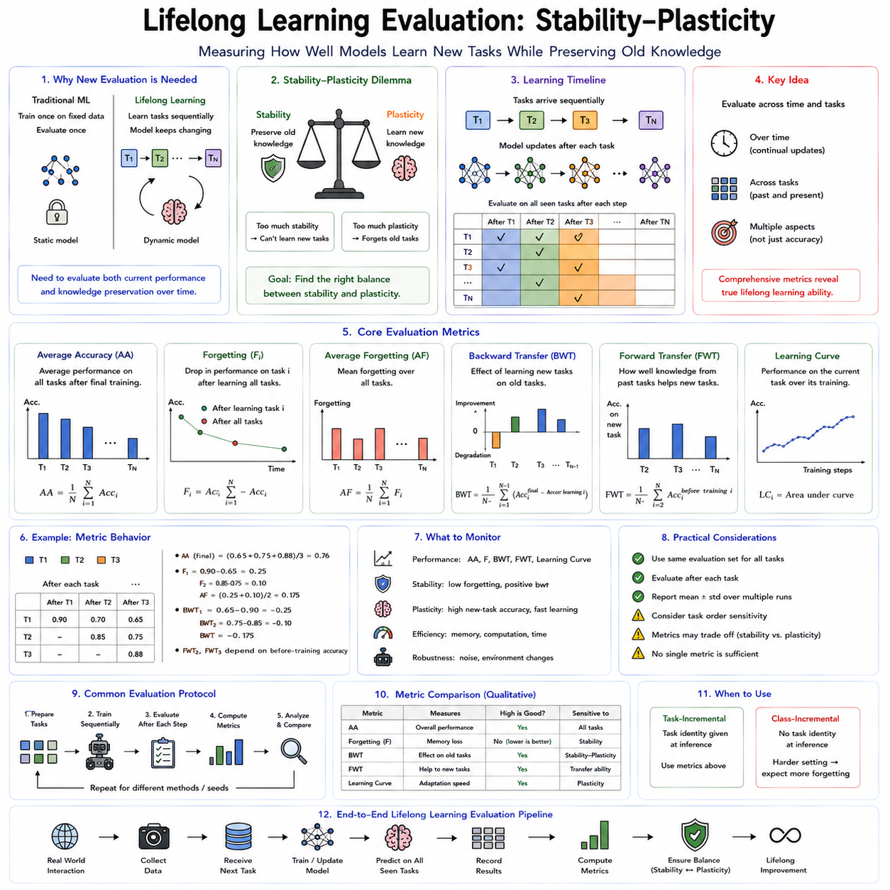
Lifelong learning is fundamentally different from conventional machine learning because success is measured not only by how well a model learns new knowledge but also by how effectively it preserves previously acquired capabilities. Traditional machine learning evaluation assumes that a model is trained once on a fixed dataset and then tested on an independent evaluation set drawn from the same distribution. Once training is complete, model parameters remain unchanged, and the evaluation simply measures prediction accuracy, precision, recall, F1 score, mean average precision, or task-specific performance metrics. Lifelong learning introduces an entirely different perspective. The model continuously changes throughout its operational lifetime, receives new tasks sequentially, adapts to changing environments, and must preserve accumulated knowledge while continuing to improve. Consequently, evaluating lifelong learning requires measuring not only current performance but also the dynamic interaction between learning and memory over extended periods of operation.
The central challenge underlying lifelong learning evaluation is the stability-plasticity dilemma. Stability refers to the ability of a learning system to preserve previously acquired knowledge despite future learning. Plasticity refers to the ability of the same system to acquire new knowledge efficiently when novel experiences become available. These two objectives naturally compete with one another. A system exhibiting extremely high stability may resist parameter changes so strongly that learning new tasks becomes nearly impossible. Conversely, a highly plastic system may rapidly master every new task while catastrophically forgetting everything learned previously. Effective lifelong learning therefore requires balancing these opposing properties rather than maximizing either one independently.
The stability-plasticity dilemma has been recognized for decades in neuroscience, psychology, cognitive science, and artificial intelligence. Biological nervous systems appear remarkably successful at maintaining this balance. Humans continuously acquire new knowledge throughout life while preserving skills learned years earlier. Children learn mathematics without forgetting how to walk. Adults acquire new languages while retaining native speech. Professional musicians master new compositions without forgetting previous performances. The biological brain therefore demonstrates both remarkable stability and extraordinary adaptability. Artificial learning systems aspire to achieve similar long-term behavior, making stability-plasticity evaluation one of the most important research topics in continual learning.
Understanding this dilemma begins by examining the extreme cases. Consider a neural network whose parameters become permanently frozen immediately after learning the first task. Such a system exhibits perfect stability because no future optimization can modify previously learned knowledge. However, plasticity becomes zero because the model cannot adapt to any subsequent task. At the opposite extreme, imagine a model that always optimizes exclusively for the newest data without preserving historical information. Learning proceeds rapidly, demonstrating excellent plasticity, yet catastrophic forgetting quickly destroys earlier capabilities. Neither extreme represents useful lifelong intelligence. Practical systems must instead occupy an intermediate operating region where both memory preservation and continual adaptation coexist.
Evaluation protocols therefore measure multiple performance dimensions simultaneously rather than relying upon single accuracy values. Average task accuracy remains important because the robot should perform well across all learned tasks. However, average accuracy alone cannot distinguish between different learning behaviors. Two systems may achieve identical final accuracy despite exhibiting dramatically different forgetting patterns throughout learning. Consequently, continual learning research employs specialized evaluation metrics that characterize knowledge preservation, adaptation efficiency, transfer learning, computational efficiency, memory utilization, and long-term robustness.
Average Accuracy represents one of the most widely reported continual learning metrics. After sequentially learning multiple tasks, performance is evaluated on every task encountered throughout the learning lifetime. The average of these individual task accuracies provides a global measure of accumulated competence. High average accuracy indicates that the model successfully preserves broad capability across the entire task sequence rather than specializing exclusively in recent experiences. Nevertheless, average accuracy alone does not reveal how performance evolved during learning, making complementary metrics essential.
Forgetting measures quantify how much performance deteriorates on previously learned tasks after subsequent learning occurs. One common approach compares the highest accuracy achieved for each task immediately after learning with its accuracy following completion of all later tasks. The difference represents the amount of forgetting experienced by that task. Averaging forgetting across all tasks provides an overall measure of catastrophic forgetting. Lower forgetting values indicate greater stability because previously acquired knowledge remains preserved despite continual adaptation.
Backward Transfer evaluates whether learning new tasks improves or degrades performance on earlier tasks. Positive backward transfer occurs when later learning enhances representations useful for previous tasks, increasing historical performance without explicit retraining. Negative backward transfer corresponds to catastrophic forgetting, where later optimization damages earlier knowledge. Measuring backward transfer therefore reveals whether continual learning creates constructive interactions among tasks or destructive interference between competing representations.
Forward Transfer examines the opposite direction of knowledge flow. It measures whether learning previous tasks accelerates acquisition of future tasks. A robot learning warehouse navigation may subsequently master hospital navigation more rapidly because previously acquired spatial reasoning transfers effectively. Positive forward transfer indicates successful knowledge reuse, whereas negligible forward transfer suggests that earlier experience contributes little to future learning. Forward transfer therefore evaluates the cumulative value of lifelong experience rather than isolated task performance.
Learning efficiency represents another important evaluation dimension. Lifelong learning systems should ideally require fewer training samples, less computational effort, or shorter adaptation times as accumulated knowledge increases. If every new task requires complete retraining from scratch despite previous experience, the practical advantages of lifelong learning become limited. Measuring sample efficiency, convergence speed, optimization iterations, and computational cost therefore complements traditional accuracy-based evaluation.
Memory efficiency becomes particularly significant for robotic systems operating under hardware constraints. Replay-based methods require storage of historical observations. Progressive architectures expand network size continuously. Parameter isolation gradually consumes available capacity. External memory systems introduce additional storage requirements. Evaluating memory consumption alongside predictive performance provides a more realistic assessment of deployment feasibility than accuracy alone. A method achieving slightly lower accuracy while requiring dramatically less memory may prove preferable for embedded robotic platforms.
Computational efficiency similarly influences practical deployment. Lifelong learning algorithms often introduce additional optimization steps, replay operations, generative sampling, architectural expansion, parameter importance estimation, or memory retrieval. Evaluation therefore includes training time, inference latency, energy consumption, processor utilization, and scalability across long operational lifetimes. Autonomous robots frequently operate under strict real-time constraints where excessive computational overhead becomes unacceptable regardless of predictive accuracy.
Task order sensitivity constitutes another important evaluation consideration. Continual learning algorithms frequently exhibit different performance depending upon the sequence in which tasks appear. Learning object recognition before manipulation may produce different outcomes than learning manipulation first. Benchmark evaluations therefore often average results across multiple randomized task sequences to reduce dependence upon arbitrary ordering. Robust lifelong learning systems should perform consistently regardless of experience sequence whenever possible.
Distribution shift introduces additional complexity beyond discrete task boundaries. Real robotic environments rarely change abruptly between clearly defined tasks. Instead, environmental statistics evolve gradually through seasonal variation, sensor aging, changing illumination, mechanical wear, user behavior, or operational modifications. Evaluation protocols increasingly incorporate continuous distribution shifts rather than only discrete task transitions. Measuring adaptation under gradually changing conditions better reflects realistic robotic deployment than artificial benchmark sequences.
Open-world evaluation extends lifelong learning further by introducing entirely novel concepts during deployment. Classical benchmarks assume predefined task sequences known before evaluation begins. Open-world systems encounter previously unseen objects, environments, behaviors, or goals unexpectedly. Evaluation therefore includes novelty detection, uncertainty estimation, autonomous task discovery, and incremental incorporation of new concepts into existing knowledge structures. Such capabilities become increasingly important as robots operate autonomously in unpredictable environments.
Robotic lifelong learning introduces domain-specific evaluation criteria beyond conventional machine learning metrics. Navigation systems require long-term localization accuracy despite environmental evolution. Manipulation systems must preserve grasping competence while adapting to new object categories. Human-robot interaction demands retention of personalized user preferences across months or years. Autonomous vehicles must maintain safe driving behavior despite continuously changing road conditions. Consequently, evaluation integrates traditional continual learning metrics with application-specific operational measures.
Safety represents one of the most critical considerations for physical robots. A learning algorithm achieving excellent average accuracy may nevertheless become unsuitable if adaptation temporarily produces unsafe behaviors. Evaluation therefore includes safety violations, collision frequency, constraint satisfaction, operational reliability, recovery following failure, and robustness under unexpected conditions. Stable lifelong learning should improve performance without compromising previously validated safety properties.
Robustness measures evaluate performance under uncertainty, sensor noise, adversarial conditions, hardware degradation, missing observations, or partial system failures. Lifelong learning should ideally increase robustness by accumulating diverse experiences rather than becoming overly specialized toward recent environments. Long-term deployment naturally exposes robots to increasing variability, making robustness evaluation increasingly important over extended operational periods.
Generalization remains another essential evaluation objective. Lifelong learning should not merely memorize sequential tasks but should develop increasingly abstract representations transferable across novel situations. Researchers therefore evaluate zero-shot performance, few-shot adaptation, transfer learning efficiency, representation quality, and out-of-distribution generalization. Foundation models have substantially improved such capabilities by providing broad pretrained representations before continual adaptation begins.
Representation analysis offers deeper insight into lifelong learning dynamics beyond external performance metrics. Visualization techniques examine latent feature spaces, embedding stability, neuron activation patterns, attention distributions, and parameter evolution throughout learning. Stable representations preserve meaningful organization despite continual adaptation, whereas unstable representations exhibit excessive drift corresponding to catastrophic forgetting. Such analyses reveal internal learning mechanisms invisible through prediction accuracy alone.
Parameter dynamics likewise provide valuable diagnostic information. Regularization methods estimate parameter importance. Parameter isolation allocates ownership across tasks. Progressive architectures expand computational resources. Sparse training identifies critical subnetworks. Monitoring parameter evolution helps explain why certain continual learning algorithms succeed or fail under different conditions. Stable-plasticity balance becomes observable through the distribution of parameter updates rather than only final predictive performance.
Benchmark datasets play a central role in lifelong learning evaluation. Classical image datasets such as MNIST, CIFAR-100, Tiny ImageNet, ImageNet, and CORe50 have been adapted into continual learning protocols by partitioning classes or tasks sequentially. Robotic benchmarks include navigation datasets, manipulation demonstrations, reinforcement learning environments, embodied AI simulations, and long-term visual localization datasets. Increasingly, researchers recognize that synthetic academic benchmarks should complement rather than replace realistic long-duration robotic evaluations.
Simulation provides important advantages for evaluation because complete environmental control enables reproducible experiments across many algorithms. Simulated robots can experience years of continual learning within compressed computational time while generating standardized benchmark comparisons. However, simulation rarely captures the full complexity of real-world deployment. Consequently, many researchers advocate combined evaluation across simulation and physical robotic platforms to validate long-term adaptation under realistic operational conditions.
Long-term field deployment represents the ultimate evaluation scenario. Service robots operating continuously in hospitals, warehouses, airports, offices, or homes provide valuable evidence regarding practical lifelong learning performance. Such deployments expose algorithms to genuine environmental evolution, human interaction, hardware aging, sensor degradation, maintenance events, and operational uncertainty impossible to reproduce fully within laboratory settings. Although expensive and time-consuming, long-term deployment studies provide the strongest validation of lifelong learning systems.
Human-centered evaluation becomes increasingly important as robots interact more closely with people. Personalized assistance requires remembering individual preferences while adapting to changing user behavior. Evaluation therefore includes user satisfaction, interaction consistency, personalization quality, trust, explainability, and long-term acceptance. A robot that repeatedly forgets user preferences despite strong benchmark performance would perform poorly in practical human environments.
The stability-plasticity balance can also be analyzed mathematically. Let stability represent the preservation of previous task performance and plasticity represent adaptation to current tasks. Maximizing one objective often reduces the other because parameter updates simultaneously modify historical representations. Multi-objective optimization frameworks therefore attempt to identify Pareto-optimal operating points balancing these competing objectives. Rather than seeking one universally optimal algorithm, continual learning increasingly recognizes that different applications require different stability-plasticity tradeoffs.
For example, medical diagnostic systems prioritize stability because previously validated clinical knowledge should rarely change without overwhelming evidence. Recommendation systems emphasize plasticity because user preferences evolve rapidly. Warehouse robots require balanced adaptation because infrastructure changes gradually while core navigation principles remain stable. Autonomous vehicles similarly preserve fundamental driving rules while adapting continuously to local traffic patterns and environmental conditions. Evaluation criteria should therefore reflect application-specific operational priorities rather than assuming identical objectives across every domain.
Foundation models introduce new perspectives on lifelong learning evaluation. Large pretrained models already contain extensive prior knowledge before deployment. Continual adaptation therefore modifies an existing knowledge base rather than constructing representations entirely from sequential experience. Evaluation increasingly measures retention of pretrained capabilities alongside acquisition of deployment-specific expertise. Forgetting within foundation models may involve degradation of broad visual, linguistic, or reasoning capabilities extending far beyond individual downstream tasks.
Multi-agent and fleet robotics further expand evaluation complexity. Knowledge sharing among robots introduces collaborative learning dynamics absent from single-agent benchmarks. Evaluation includes communication efficiency, collective adaptation speed, distributed memory utilization, shared representation quality, and robustness against inconsistent observations across multiple robots. Fleet-wide continual learning aims not merely to improve individual robots but to optimize collective intelligence across entire autonomous systems.
Emerging research increasingly investigates self-evaluation within lifelong learning. Instead of relying solely upon externally defined benchmarks, future intelligent robots may monitor their own knowledge quality, detect uncertainty, recognize forgetting, estimate adaptation requirements, and schedule replay or retraining autonomously. Meta-learning, self-reflection, confidence estimation, and intrinsic motivation contribute toward this objective. A truly lifelong intelligent system should eventually evaluate and regulate its own stability-plasticity balance without continuous human supervision.
The future of lifelong learning evaluation extends beyond static benchmark scores toward continuous operational assessment. Digital twins, world models, simulation environments, cloud robotics, and embodied foundation models will provide ongoing feedback regarding learning quality throughout deployment. Rather than evaluating algorithms only after training concludes, future systems will monitor knowledge preservation, adaptation success, safety, computational efficiency, environmental understanding, and user interaction continuously during operation.
Lifelong learning evaluation therefore represents far more than measuring prediction accuracy. It is the systematic assessment of how intelligent systems accumulate, preserve, organize, transfer, and refine knowledge throughout extended operational lifetimes. The stability-plasticity dilemma provides the conceptual framework connecting all continual learning research because every adaptive system must balance preserving valuable experience against embracing new information. Effective evaluation captures this balance through complementary metrics describing memory retention, adaptation efficiency, transfer learning, computational practicality, safety, robustness, and long-term operational success. As autonomous robots progress toward decades of continuous real-world deployment, rigorous evaluation of stability and plasticity will remain one of the defining foundations for developing truly lifelong artificial intelligence capable of learning indefinitely without forgetting the knowledge that experience has already provided.

08.10 Lifelong Learning System for Deployed Robot Fleet
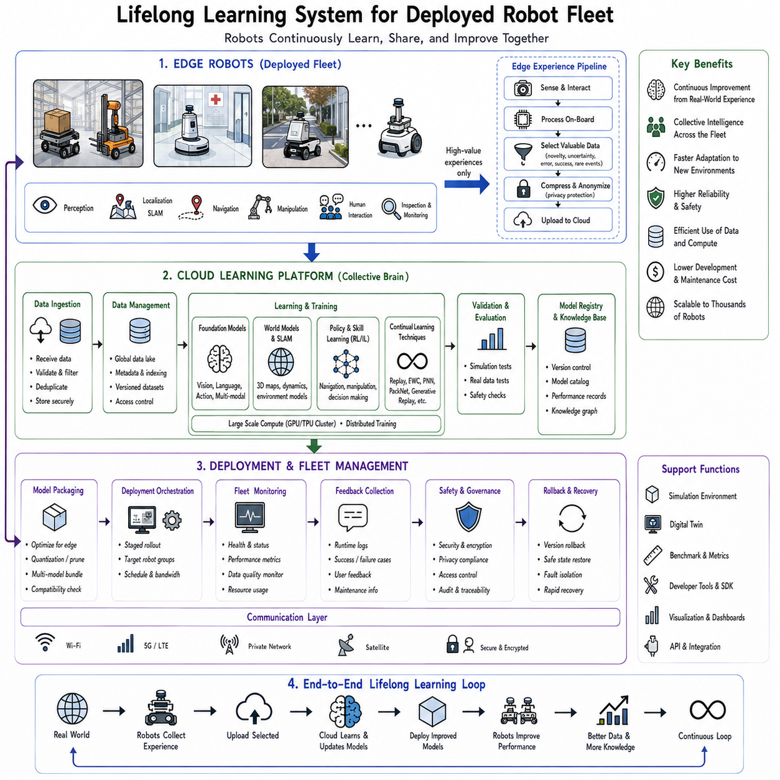
A lifelong learning system for a deployed robot fleet represents the transition from isolated continual learning algorithms to a complete operational intelligence infrastructure capable of supporting hundreds, thousands, or even millions of robots throughout years of deployment. Earlier chapters discussed individual techniques such as replay buffers, Elastic Weight Consolidation, Progressive Neural Networks, PackNet, Generative Replay, and Lifelong SLAM. Each of these methods addresses specific aspects of continual learning within a single robot. However, real industrial and commercial robotic systems rarely operate in isolation. Modern warehouses, factories, hospitals, airports, farms, logistics centers, and smart cities deploy fleets of autonomous robots that continuously collect experience from diverse environments. The challenge therefore extends beyond enabling one robot to learn continuously. The objective becomes enabling an entire fleet to accumulate collective knowledge safely, efficiently, and continuously while maintaining operational reliability across all deployed platforms.
Traditional robotics follows a centralized development cycle. Engineers collect data, develop algorithms, train models offline, validate performance, deploy software updates, and repeat the process whenever improvements become necessary. Although effective for static environments, this workflow becomes increasingly inefficient as robot fleets expand. Every deployed robot encounters unique environmental conditions, unexpected obstacles, user behaviors, sensor variations, hardware aging, and operational scenarios that may never have appeared during laboratory development. Waiting months before incorporating these experiences into the next software release significantly limits adaptation speed. A lifelong fleet learning system transforms every deployed robot into an active contributor to the continuous improvement of collective intelligence.
The central philosophy behind fleet lifelong learning resembles distributed biological evolution combined with collective human learning. Individual humans gain unique experiences throughout life, but societies accumulate knowledge by sharing discoveries, teaching new generations, documenting procedures, and collaboratively refining understanding. Likewise, each robot experiences different operational conditions while contributing valuable knowledge to a shared learning infrastructure. Rather than every robot independently solving identical problems repeatedly, successful experiences become collective assets benefiting the entire fleet.
The overall architecture typically consists of three interacting layers. The first layer contains deployed edge robots operating directly within physical environments. These robots perform perception, localization, planning, manipulation, navigation, human interaction, inspection, or other application-specific tasks while continuously collecting operational experience. The second layer consists of cloud infrastructure responsible for large-scale data aggregation, model training, validation, simulation, and knowledge management. The third layer coordinates deployment, monitoring, version control, rollback, security, and lifecycle management across the complete robot fleet. Together these layers create an adaptive learning ecosystem rather than a collection of independent autonomous machines.
Edge robots serve as the primary source of lifelong experience. Every navigation trajectory, manipulation attempt, obstacle encounter, localization correction, human interaction, sensor measurement, failure event, maintenance activity, and environmental observation contributes potential learning information. However, transmitting every observation directly to centralized servers quickly becomes impractical. High-resolution cameras, LiDAR sensors, radar, force sensors, tactile arrays, inertial measurements, audio streams, and language interactions generate enormous data volumes. A single autonomous vehicle or industrial robot may produce terabytes of sensor data each day. Fleet-wide deployments multiply these quantities by hundreds or thousands of robots, making unrestricted transmission impossible.
Consequently, edge intelligence performs the first stage of knowledge selection. Rather than uploading every observation, robots identify informative experiences requiring collective learning. Novel environmental conditions, unexpected failures, rare object categories, localization anomalies, successful recovery strategies, uncertain predictions, unusual human interactions, and previously unseen operational scenarios receive higher priority for transmission. Routine experiences already well represented within the global knowledge base remain primarily local, reducing communication requirements substantially.
Novelty detection therefore becomes a key component of fleet lifelong learning. Robots continuously estimate whether current observations differ significantly from previously encountered situations. Statistical anomaly detection, uncertainty estimation, out-of-distribution detection, embedding similarity analysis, Bayesian confidence estimation, and foundation model representations all contribute toward identifying experiences likely to improve collective intelligence. Upload bandwidth is allocated preferentially to information possessing high expected learning value.
Cloud infrastructure functions as the collective memory and learning center of the robot fleet. Experiences arriving from geographically distributed robots become integrated into centralized knowledge repositories. Unlike individual robots constrained by limited onboard computation, cloud systems utilize powerful GPU clusters capable of training foundation models, world models, reinforcement learning policies, multimodal perception systems, and generative models using enormous aggregated datasets. Collective experience therefore produces capabilities exceeding what any individual robot could acquire independently.
Data management within cloud infrastructure extends far beyond simple storage. Raw observations undergo validation, synchronization, anonymization, compression, semantic labeling, quality assessment, and version control before becoming eligible for training. Duplicate observations are removed. Corrupted sensor measurements are filtered. Privacy-sensitive information undergoes anonymization or encryption. Metadata describing environmental conditions, robot hardware, software versions, geographic locations, timestamps, operational contexts, and task identities accompanies every retained observation. This structured knowledge base enables efficient retrieval for future continual learning.
Foundation models increasingly serve as the central knowledge representation within fleet learning systems. Large multimodal models pretrained on diverse visual, linguistic, spatial, and robotic datasets provide general-purpose representations before deployment. Fleet experiences subsequently specialize these representations toward application-specific environments while preserving broad general capabilities. Rather than training entirely new models for every deployment, continual adaptation refines existing foundation models using collective operational experience gathered across the robot fleet.
World models further extend centralized learning. Instead of merely recognizing objects or predicting actions, world models learn latent representations describing environmental dynamics, causal relationships, physical interactions, semantic structures, and long-term consequences of robot behavior. Experiences collected by thousands of robots contribute to increasingly accurate predictive models capable of simulating future situations before deployment. Such simulation significantly accelerates continual learning by allowing extensive virtual evaluation prior to updating physical robots.
Simulation environments occupy a central role in fleet lifelong learning. Newly trained models rarely deploy directly into operational robots without extensive validation. Instead, cloud infrastructure evaluates candidate models across digital twins, physics simulators, historical replay environments, synthetic scenarios, and adversarial test cases. Simulated evaluation identifies regressions, safety violations, localization failures, navigation errors, manipulation mistakes, and performance degradation before deployment. Consequently, continual learning becomes safer and more reliable than direct online adaptation.
Digital twins significantly enhance validation quality. Every deployed environment gradually acquires a continuously updated virtual representation reflecting geometry, semantics, operational history, environmental changes, infrastructure modifications, and robot interactions. Candidate learning algorithms operate inside these digital twins before physical deployment. Since digital twins closely approximate real environments, evaluation results provide strong evidence regarding expected field performance while eliminating operational risk.
Safety validation remains one of the most important stages of the learning pipeline. Unlike recommendation systems or search engines, physical robots directly influence the real world. Incorrect updates may produce collisions, equipment damage, production interruptions, or human injuries. Consequently, every newly trained model undergoes extensive verification before release. Automated testing evaluates perception accuracy, localization robustness, obstacle avoidance, manipulation stability, human interaction quality, planning reliability, recovery behavior, emergency responses, and compliance with operational safety constraints. Only models satisfying predefined acceptance criteria proceed toward deployment.
Model versioning provides another essential capability. Lifelong learning generates numerous successive model updates throughout deployment. Every released model receives unique version identifiers, associated training datasets, evaluation reports, hyperparameter configurations, simulation results, safety certifications, and deployment histories. Complete version traceability enables engineers to identify precisely which knowledge contributed to any observed behavior while supporting regulatory compliance in safety-critical industries.
Incremental deployment strategies reduce operational risk further. Instead of updating the entire fleet simultaneously, new models initially deploy to small subsets of robots operating under controlled conditions. Performance monitoring compares updated robots against stable baseline systems. Successful deployments gradually expand to larger fleet segments. Unexpected degradation immediately triggers rollback procedures restoring previous validated models. Such staged deployment substantially reduces the impact of unforeseen learning failures.
Rollback mechanisms constitute indispensable components of practical lifelong learning. Even extensively validated models occasionally perform unexpectedly under previously unobserved field conditions. Fleet management infrastructure therefore maintains previous software versions alongside deployment histories, enabling rapid restoration whenever necessary. Rollback decisions may occur automatically based upon predefined safety thresholds or manually following engineering review. Lifelong learning emphasizes continuous improvement rather than irreversible adaptation.
Monitoring systems continuously evaluate deployed model performance after every update. Localization accuracy, navigation success, manipulation completion rates, obstacle avoidance, battery consumption, computation latency, sensor health, network connectivity, user satisfaction, maintenance frequency, and safety incidents all contribute toward operational health assessment. Continuous monitoring detects gradual performance drift, emerging environmental changes, hardware degradation, or previously unrecognized failure modes requiring future learning updates.
Feedback loops distinguish lifelong learning systems from conventional software deployment pipelines. Operational monitoring identifies weaknesses requiring improvement. Relevant experiences enter centralized learning infrastructure. Updated models undergo simulation and validation before redeployment. Newly deployed robots generate additional operational experience, initiating another improvement cycle. This closed-loop architecture enables continuous accumulation of operational intelligence throughout years of deployment.
Different robots frequently possess heterogeneous hardware configurations requiring adaptive learning strategies. Some robots utilize stereo cameras, whereas others employ LiDAR, radar, event cameras, thermal imaging, or different robotic manipulators. Computational resources likewise vary from embedded processors to high-performance GPU workstations. Fleet lifelong learning therefore separates hardware-independent knowledge from hardware-specific adaptation. Shared representations transfer broadly across platforms while lightweight adaptation modules specialize models for individual robot configurations.
Federated learning introduces another dimension to distributed lifelong learning. Certain environments prohibit centralized collection of raw operational data because of privacy regulations, commercial confidentiality, or communication limitations. Instead of transmitting observations directly, individual robots perform local optimization before sharing only parameter updates or compressed representations with centralized aggregation servers. Federated continual learning therefore combines distributed optimization with lifelong adaptation while preserving sensitive local information.
Privacy preservation has become increasingly important as robots operate inside hospitals, homes, offices, schools, and public spaces. Lifelong learning systems incorporate anonymization, encrypted communication, secure aggregation, differential privacy, access control, audit logging, and synthetic data generation to protect personal information throughout the learning lifecycle. Compliance with international regulations governing medical records, industrial intellectual property, and personal privacy remains essential for large-scale deployment.
Knowledge organization extends beyond raw machine learning models. Modern fleet learning systems increasingly maintain structured knowledge graphs connecting objects, locations, tasks, environments, robot capabilities, maintenance records, user preferences, semantic concepts, and operational procedures. Such structured representations support reasoning, explainability, planning, retrieval, and continual knowledge expansion beyond statistical pattern recognition alone.
Large language models further enhance fleet lifelong learning by providing semantic interfaces connecting robot experience with human knowledge. Engineers describe operational failures in natural language. Maintenance procedures become searchable documentation. User feedback integrates directly into continual learning objectives. Language-grounded reasoning enables robots to relate newly encountered situations to previously documented experiences without relying exclusively upon numerical representations.
Retrieval-Augmented Generation (RAG) also becomes increasingly valuable. Rather than storing every operational experience directly within model parameters, external knowledge repositories preserve maintenance logs, operational procedures, troubleshooting guides, environment descriptions, and historical observations. During inference, robots retrieve relevant information dynamically according to current context. Such architectures reduce catastrophic forgetting while improving interpretability and enabling continual knowledge expansion without repeated retraining.
Lifelong SLAM naturally integrates with fleet learning. Robots collectively construct continuously evolving maps reflecting changing environments across multiple facilities, cities, or countries. Shared mapping infrastructure merges observations from many platforms into unified digital world models while preserving temporal history and semantic understanding. Individual robots therefore benefit immediately from environmental updates discovered by others, reducing redundant exploration while improving localization robustness.
Reinforcement learning likewise benefits from fleet-scale experience sharing. Individual robots collect trajectories representing successful and unsuccessful behaviors under diverse operating conditions. Centralized policy optimization combines these experiences into increasingly capable control policies subsequently redistributed across the fleet. Off-policy reinforcement learning, imitation learning, inverse reinforcement learning, and preference learning all become substantially more effective through large-scale collective experience.
Human feedback provides another valuable source of continual learning. Operators, maintenance personnel, customers, and domain experts continuously interact with deployed robots, generating corrections, preferences, demonstrations, evaluations, and explanations. Human-in-the-loop learning integrates this feedback into centralized knowledge refinement while maintaining appropriate safety supervision. Over time, robots become increasingly aligned with operational expectations through accumulated human guidance.
Scalability becomes one of the defining engineering requirements. A lifelong learning architecture supporting ten robots differs fundamentally from one supporting one hundred thousand autonomous platforms distributed globally. Distributed databases, cloud-native microservices, container orchestration, asynchronous communication, hierarchical knowledge management, streaming data pipelines, distributed training, and elastic computational resources all contribute toward scalable fleet intelligence. System architecture must support continual growth without proportional increases in operational complexity.
Evaluation of fleet lifelong learning extends beyond individual robot performance. Researchers measure collective learning efficiency, fleet-wide adaptation speed, knowledge transfer effectiveness, communication overhead, computational scalability, deployment reliability, rollback frequency, safety incidents, operational availability, maintenance reduction, energy efficiency, and long-term economic impact. Improvements should benefit the entire fleet rather than isolated robots while maintaining stable operation across heterogeneous deployment environments.
Future lifelong robot fleets will likely incorporate autonomous curriculum learning, self-supervised representation learning, foundation world models, cloud-edge collaboration, generative simulation, retrieval-augmented memory, and embodied reasoning within unified cognitive architectures. Robots will continuously identify their own learning opportunities, prioritize valuable experiences, request additional demonstrations when uncertainty becomes excessive, validate candidate improvements through simulation, and contribute newly acquired knowledge back to the collective intelligence shared across the entire fleet.
Ultimately, a lifelong learning system for a deployed robot fleet represents far more than continual optimization of machine learning models. It is a comprehensive cognitive infrastructure that transforms individual operational experiences into continuously expanding collective intelligence. Every deployed robot becomes simultaneously a learner, a teacher, a data source, and a beneficiary of shared knowledge. Through continual experience collection, distributed knowledge integration, safe validation, incremental deployment, persistent monitoring, and collaborative adaptation, the fleet evolves as a unified intelligent organism whose capabilities improve throughout years of real-world operation without forgetting the valuable knowledge accumulated by previous generations of experience. Such systems provide one of the essential technological foundations for the future of Physical AI, large-scale autonomous robotics, and persistent embodied intelligence operating across dynamic real-world environments.

