Volume 20. Vision Language Action (VLA) Models

Chapter 7. Embodied AI

7.1 Foundations of Embodied AI
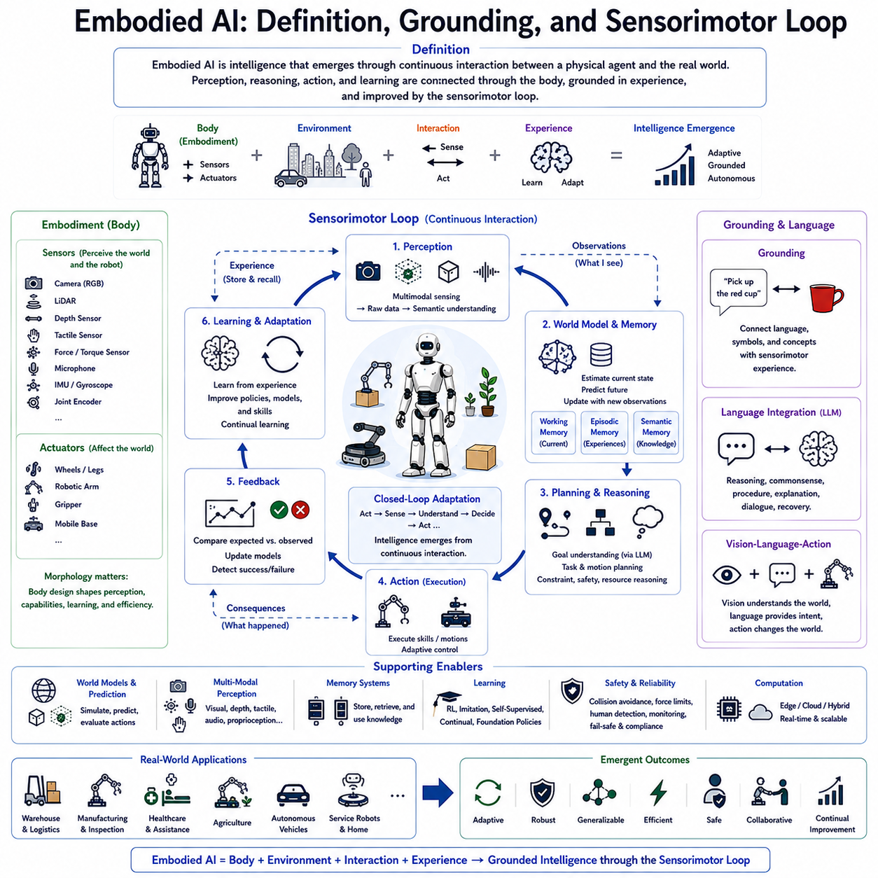
Embodied Artificial Intelligence represents one of the most significant paradigm shifts in modern robotics because intelligence is no longer viewed as a purely computational process but as a capability emerging from continuous interaction between an intelligent agent and the physical world. Unlike traditional Artificial Intelligence systems that primarily process symbolic information or digital data, Embodied AI emphasizes that perception, reasoning, action, and learning are fundamentally connected through a physical body equipped with sensors and actuators. Intelligence therefore develops through experience gained while interacting with real environments rather than existing solely within abstract computational models. This perspective forms the theoretical foundation of modern Physical AI, autonomous robots, humanoid systems, autonomous vehicles, and next-generation Vision-Language-Action (VLA) architectures.
Traditional Artificial Intelligence systems often treated perception, reasoning, and execution as largely independent modules. Images were processed separately from language, planning occurred independently from execution, and learning was frequently performed using static datasets collected offline. Although these approaches achieved remarkable performance in image recognition, language understanding, recommendation systems, and strategic reasoning, they struggled when deployed in open-world environments where uncertainty, physical interaction, incomplete observations, and changing conditions continuously influenced decision making. Embodied AI addresses these limitations by treating intelligence as an ongoing interaction between an agent and its surrounding environment.
The concept of embodiment emphasizes that an intelligent system possesses a physical form capable of sensing and acting upon its environment. Cameras, LiDAR, depth sensors, tactile sensors, force sensors, microphones, inertial measurement units, joint encoders, and other sensing devices continuously collect multimodal information describing both the external environment and the robot's internal state. At the same time, actuators controlling wheels, legs, robotic arms, grippers, mobile platforms, and articulated mechanisms transform computational decisions into physical actions. Intelligence emerges through the continuous relationship between sensing and acting rather than through isolated information processing.
Grounding represents another essential concept within Embodied AI. Traditional language models manipulate symbolic representations whose meanings are derived primarily from statistical relationships among words. Embodied systems instead associate language, concepts, and abstract reasoning with physical experiences obtained through perception and interaction. A concept such as “grasp,” “push,” “walk,” “door,” or “container” is not merely a textual description but becomes grounded through repeated physical encounters with objects and environments. Grounding therefore establishes meaningful connections between symbolic knowledge and real-world experiences.
Sensorimotor grounding extends this principle by linking perception directly to action. Every sensory observation influences future motor behavior, while every executed action generates new sensory experiences. This bidirectional relationship continuously updates the robot's internal understanding of both itself and its environment. Rather than treating perception as an independent recognition task, Embodied AI integrates sensing, interpretation, prediction, action, and feedback into one continuous cognitive process. As experience accumulates, robots develop increasingly accurate internal models supporting more reliable decision making.
The sensorimotor loop forms the operational core of Embodied AI. This loop begins when sensors observe the surrounding environment and the robot's current physical state. Perception modules transform raw sensor measurements into semantic representations describing objects, obstacles, human activities, environmental conditions, and robot status. World models integrate these observations with prior knowledge and previous experiences to estimate the current state of the environment. Planning systems then generate actions intended to achieve specific objectives while considering environmental constraints, safety requirements, and available resources. Executed actions modify the environment, creating new observations that initiate the next iteration of the loop. Intelligence therefore emerges through continuous interaction rather than isolated computation.
Unlike open-loop robotic architectures, sensorimotor loops continuously adapt to environmental changes. Every movement, manipulation, or interaction immediately generates new observations that may confirm or contradict previous predictions. Differences between expected and observed outcomes refine internal world models, improve planning accuracy, and enable adaptive behavior under uncertainty. Continuous feedback therefore allows robots to maintain robust performance even within dynamic environments containing moving objects, changing layouts, unpredictable human behavior, or incomplete information.
Perception within Embodied AI extends beyond conventional computer vision. Multimodal sensing integrates visual observations, depth information, force measurements, tactile feedback, proprioception, inertial sensing, localization estimates, environmental monitoring, and auditory information into unified environmental representations. Each sensing modality contributes complementary information that reduces uncertainty and improves robustness. Multimodal perception enables robots to understand not only what objects exist but also how they behave, how they can be manipulated, and how environmental changes influence future actions.
Motor control similarly extends beyond deterministic trajectory execution. Modern embodied systems continuously adjust movement according to changing sensory observations, contact conditions, environmental disturbances, and task progress. Adaptive control algorithms modify trajectories, velocities, force profiles, balance strategies, and manipulation behaviors in real time. This continuous adjustment enables robots to operate safely within environments that cannot be perfectly modeled in advance.
Learning represents another defining characteristic of Embodied AI. Rather than relying exclusively on static datasets collected offline, embodied agents continuously acquire new knowledge through interaction with the environment. Every navigation task, manipulation attempt, human interaction, success, failure, or recovery contributes additional experience supporting future improvement. Reinforcement learning, imitation learning, self-supervised learning, continual learning, and foundation robot policies all exploit sensorimotor experiences to improve future decision making without requiring exhaustive manual programming.
Memory systems significantly enhance embodied intelligence. Working memory maintains current observations, active goals, and temporary reasoning during task execution. Episodic memory stores previous experiences describing successful actions, encountered failures, environmental conditions, and recovery strategies. Semantic memory preserves long-term knowledge regarding object properties, environmental layouts, operational procedures, and physical relationships. Together, these complementary memory systems enable embodied agents to reason about current situations using accumulated experience rather than isolated observations.
World models provide predictive capabilities essential for efficient sensorimotor control. Rather than reacting solely to current observations, embodied systems continuously estimate future environmental evolution resulting from both robot actions and external events. Predictive simulation allows candidate actions to be evaluated internally before physical execution begins. Anticipating object movement, human activity, environmental changes, and system dynamics substantially improves planning efficiency while reducing operational risk.
Language integration distinguishes modern Embodied AI from earlier reactive robotic systems. Large Language Models provide semantic reasoning, commonsense knowledge, procedural understanding, and natural human communication capabilities. Language no longer functions merely as an input interface but becomes integrated throughout perception, planning, execution, explanation, recovery, and learning. Grounded language enables robots to associate abstract verbal concepts with concrete sensorimotor experiences, thereby supporting intuitive human-robot collaboration.
Vision-Language-Action architectures extend embodied intelligence by integrating multimodal perception with semantic reasoning and physical execution. Visual observations provide environmental understanding, language specifies objectives and contextual knowledge, while action modules generate executable motor behavior. Continuous sensorimotor feedback synchronizes these components into a unified cognitive architecture capable of operating across complex real-world environments. This integration represents one of the central technological directions for future Physical AI systems.
Embodied AI also emphasizes morphology as part of intelligence. Physical body structure influences sensing capabilities, mobility, manipulation strategies, energy consumption, environmental accessibility, and learning efficiency. Different embodiments such as humanoids, quadrupeds, wheeled robots, aerial vehicles, manipulators, underwater robots, and industrial autonomous mobile robots acquire different experiences despite executing similar cognitive algorithms. Consequently, embodiment itself contributes directly to intelligent behavior rather than serving merely as a mechanical platform.
Safety naturally emerges as a continuous component of the sensorimotor loop. Collision monitoring, force limitation, balance control, human detection, workspace supervision, equipment diagnostics, and regulatory compliance continuously influence planning and execution decisions. Rather than functioning as isolated emergency systems, safety mechanisms participate actively within continuous perception-action cycles, ensuring adaptive behavior never compromises operational integrity.
Industrial deployment demonstrates the practical importance of embodied intelligence. Autonomous warehouse robots continuously perceive inventory, human workers, obstacles, and operational priorities while coordinating transportation tasks. Inspection robots adapt sensing strategies according to observed equipment conditions. Agricultural robots modify harvesting behavior based on crop characteristics and environmental variability. Healthcare assistants adjust interaction according to patient behavior and clinical context. Across these diverse applications, intelligence consistently emerges through ongoing sensorimotor interaction rather than static programmed behavior.
Evaluation of Embodied AI extends beyond conventional benchmark accuracy. Researchers assess sensorimotor coordination, environmental adaptability, grounding consistency, multimodal integration, long-horizon planning, learning efficiency, generalization across unseen environments, robustness under uncertainty, recovery capability, energy efficiency, human collaboration quality, and long-term autonomous operation. Comprehensive evaluation therefore measures how effectively embodied systems integrate perception, reasoning, action, and learning into coherent adaptive behavior.
Future Embodied AI systems are expected to integrate increasingly sophisticated world models, multimodal foundation models, continual learning, cognitive memory, distributed reasoning, digital twins, cloud-edge collaboration, and large-scale robot foundation policies into unified adaptive architectures. Intelligence will emerge through continuous interaction among language, perception, memory, prediction, reasoning, and physical execution operating within dynamic environments. The sensorimotor loop will remain the fundamental mechanism connecting these components, enabling robots to continuously refine their understanding of the world while improving their ability to accomplish increasingly complex real-world tasks. Embodied AI therefore represents not simply another branch of robotics but a comprehensive framework for developing autonomous systems capable of learning, reasoning, adapting, and acting intelligently through sustained physical interaction with the world.

7.2 Embodied Question Answering (with Code)
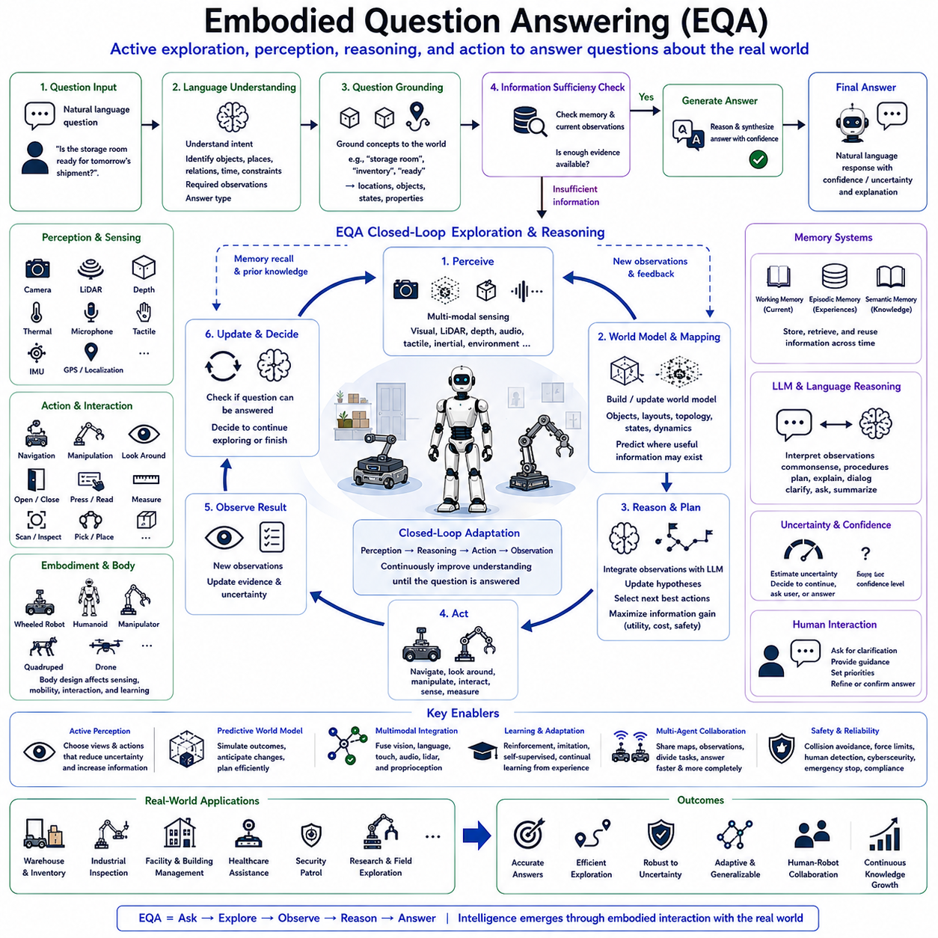
Embodied Question Answering (EQA) is an emerging research area within Embodied Artificial Intelligence and Vision-Language-Action (VLA) systems that extends conventional question answering beyond static perception toward active interaction with the physical world. Unlike traditional Visual Question Answering (VQA), where a model answers questions based on a single image, EQA requires an intelligent embodied agent to navigate through an unknown environment, gather missing information using its own sensors, interact with objects when necessary, and generate accurate answers based on real-world observations. Intelligence therefore arises not only from reasoning over existing information but also from deciding what information must be collected through purposeful physical exploration.
Traditional question answering systems assume that all relevant information is already available before reasoning begins. Large Language Models answer questions using textual knowledge, while Vision-Language Models analyze one or more provided images. However, real-world environments rarely provide complete information from a single viewpoint. A robot asked, “How many emergency exits are on this floor?” cannot answer immediately unless it actively searches the building. Similarly, a question such as “Is the storage room ready for tomorrow's shipment?” requires inspection of inventory, workspace organization, equipment status, and environmental conditions before an informed response can be generated. Embodied Question Answering therefore integrates perception, navigation, reasoning, and action into one unified cognitive process.
The defining characteristic of EQA is active information acquisition. Instead of passively processing existing observations, an embodied agent determines which observations are missing, plans actions that maximize useful information, and continuously updates its understanding as exploration progresses. This capability transforms question answering into a sequential decision-making problem where sensing and acting become integral components of reasoning. Every movement produces new observations that influence future exploration strategies until sufficient evidence has been accumulated to answer the original question confidently.
An EQA system typically begins with natural language understanding. Large Language Models interpret the user's question by identifying semantic intent, referenced objects, spatial relationships, temporal constraints, required observations, and expected answer types. Rather than directly generating an answer, the system first determines whether sufficient information already exists within memory or current sensor observations. If available evidence proves insufficient, the system initiates embodied exploration to collect the missing knowledge required for reliable reasoning.
Question grounding represents an essential stage within EQA. Natural language concepts must be associated with physical entities, locations, or environmental properties observable by the robot. For example, understanding the question “Is the conference room projector working?” requires grounding the concepts “conference room,” “projector,” and “working” into navigable locations, identifiable objects, and observable operational states. Grounding connects symbolic language with real sensorimotor experiences, enabling semantic reasoning to guide physical exploration.
Task planning within EQA differs from conventional navigation because movement is driven by information value rather than destination alone. Instead of minimizing travel distance, planners maximize expected information gain while considering environmental uncertainty, available sensing capabilities, battery constraints, time limitations, and safety requirements. Active perception strategies therefore determine which viewpoints, sensor configurations, or object interactions provide the greatest improvement in answering confidence. Efficient exploration minimizes unnecessary movement while maximizing relevant environmental observations.
Perception plays a central role throughout embodied question answering. Cameras, LiDAR, depth sensors, thermal imagers, microphones, tactile sensors, localization systems, and environmental sensors continuously collect multimodal observations supporting semantic understanding. Visual recognition identifies objects, text, equipment, people, and structural elements. Scene understanding establishes spatial relationships among observed entities. Object state estimation determines whether equipment is operating correctly, containers are full, doors are open, or warning indicators are active. These observations collectively contribute evidence supporting question resolution.
World models significantly enhance exploration efficiency by providing predictive environmental representations. Rather than treating each observation independently, the robot continuously integrates sensor information into a structured internal model describing objects, room layouts, semantic relationships, navigation topology, and environmental dynamics. Predictive world models estimate where relevant information is likely to exist, reducing unnecessary exploration while improving answer accuracy. As new observations become available, the world model updates continuously to reflect changing environmental conditions.
Memory systems provide another critical capability within EQA. Working memory maintains active observations, temporary hypotheses, navigation goals, and ongoing reasoning processes throughout exploration. Episodic memory stores previous exploration experiences, allowing robots to recall earlier visits to relevant locations without repeated navigation. Semantic memory preserves long-term knowledge regarding object functions, building layouts, operational procedures, and environmental semantics. Efficient memory retrieval often eliminates unnecessary exploration by reusing previously acquired information when appropriate.
Embodied Question Answering naturally incorporates closed-loop reasoning. Rather than committing to fixed exploration plans, robots continuously reevaluate collected evidence after every observation. Newly acquired information may confirm existing hypotheses, eliminate alternative explanations, reveal unexpected conditions, or indicate additional information requirements. Exploration strategies adapt dynamically according to evolving environmental understanding, ensuring efficient evidence collection despite uncertainty and changing conditions.
Large Language Models contribute semantic reasoning throughout the exploration process. Rather than merely generating final textual responses, LLMs interpret intermediate observations, formulate exploration hypotheses, identify missing evidence, prioritize candidate search locations, explain reasoning decisions, and integrate multimodal information into coherent answers. Commonsense knowledge further guides exploration by predicting likely object locations, functional relationships, organizational procedures, and human behavior patterns. Language reasoning therefore complements perception and navigation throughout embodied cognition.
Uncertainty estimation plays a particularly important role within EQA because incomplete exploration may lead to incorrect conclusions. Every observation, localization estimate, object recognition result, and reasoning step includes associated confidence measurements. When uncertainty exceeds acceptable thresholds, the robot continues gathering evidence instead of prematurely answering the question. Alternatively, the system may communicate uncertainty directly to human users, explaining what additional information would improve answer reliability. Confidence-aware reasoning significantly increases trustworthiness within practical deployments.
Human interaction extends naturally beyond simple question answering. During exploration, robots may request clarification when questions remain ambiguous or multiple interpretations appear equally plausible. Users may refine objectives, provide contextual information, specify priorities, or restrict exploration areas through natural dialogue. This collaborative interaction reduces unnecessary exploration while improving semantic understanding and operational transparency. Communication therefore becomes an integral component of embodied reasoning rather than a separate interface.
Embodied Question Answering also supports interaction with physical objects whenever passive observation proves insufficient. Opening cabinet doors, pressing control buttons, reading instrument displays, scanning identification labels, measuring environmental conditions, or manipulating equipment may all become necessary for answering complex operational questions. Safe object interaction therefore extends perception beyond purely visual observation into active environmental investigation.
Multi-agent EQA represents an important extension for large-scale environments. Multiple robots may cooperatively answer complex questions by distributing exploration tasks according to location, sensing capabilities, mobility, or available resources. Shared world models, synchronized semantic memories, distributed perception, and collaborative reasoning significantly reduce exploration time while improving answer completeness. Such cooperative intelligence becomes particularly valuable within warehouses, hospitals, airports, industrial facilities, and smart cities.
Industrial deployment highlights the practical value of embodied question answering. Maintenance robots can answer questions regarding equipment status by inspecting machinery directly. Warehouse robots verify inventory conditions before reporting stock availability. Inspection robots investigate infrastructure integrity following natural language requests from engineers. Healthcare assistants assess patient environments before answering safety-related questions. Security robots verify facility conditions during patrols. Across these diverse applications, answers are generated from firsthand environmental experience rather than static databases alone.
Safety remains fundamental throughout embodied exploration. Navigation, manipulation, environmental sensing, and human interaction operate under deterministic safety supervision independent of semantic reasoning. Collision avoidance, force limitation, workspace restrictions, human detection, cybersecurity validation, regulatory compliance, and emergency stopping procedures continuously constrain exploration behavior. Consequently, information gathering never compromises operational safety regardless of task complexity.
Evaluation of Embodied Question Answering extends beyond conventional language benchmarks. Researchers assess navigation efficiency, exploration quality, information acquisition effectiveness, semantic grounding accuracy, object localization performance, answer correctness, reasoning consistency, uncertainty estimation, memory utilization, computational efficiency, multimodal integration, generalization across unseen environments, human interaction quality, and long-horizon autonomous behavior. Comprehensive evaluation therefore measures how effectively embodied agents integrate perception, action, memory, reasoning, and language into unified cognitive intelligence.
Future EQA systems are expected to integrate multimodal foundation models, predictive world models, continual learning, cognitive memory, digital twins, cloud-edge collaboration, foundation robot policies, and advanced Large Language Models into increasingly capable autonomous reasoning architectures. Rather than simply answering isolated questions, future embodied agents will proactively identify missing information, anticipate user needs, conduct autonomous investigations, collaborate with human experts, coordinate multiple robotic platforms, and continuously expand their environmental knowledge through lifelong interaction. Embodied Question Answering will therefore become a fundamental capability enabling intelligent robots to serve as active information-gathering partners across manufacturing, logistics, healthcare, infrastructure inspection, scientific exploration, and numerous other real-world applications where reliable answers depend upon direct physical experience rather than passive observation alone.

7.3 ObjectNav and Visual Navigation (with Code)
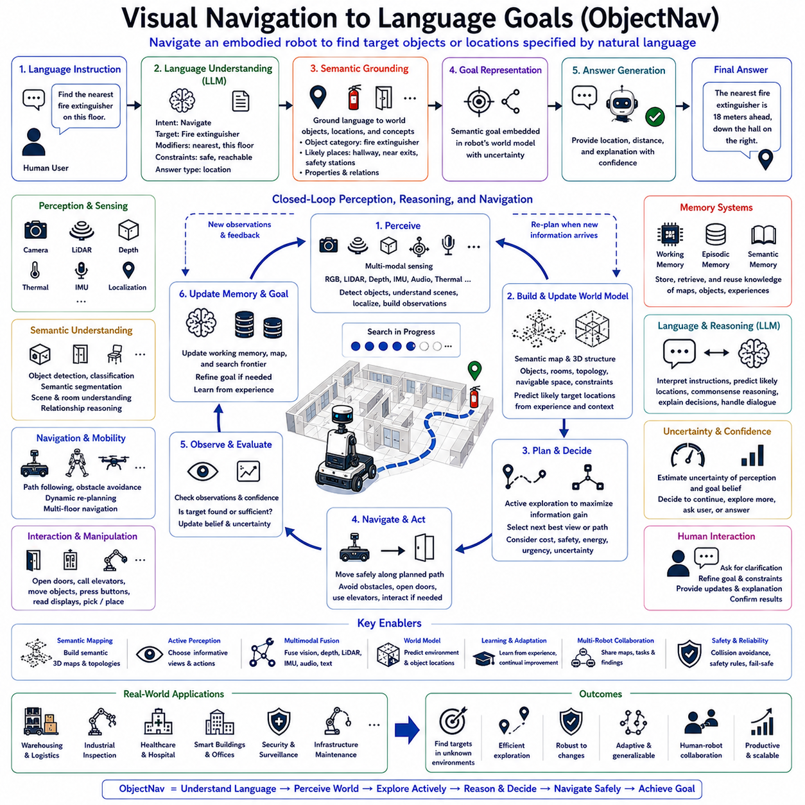
Visual Navigation to Language Goals, commonly referred to as ObjectNav, is an important research direction within Embodied Artificial Intelligence, Vision-Language-Action (VLA), and Physical AI. Unlike conventional autonomous navigation systems that move toward predefined coordinates or previously mapped destinations, ObjectNav enables an intelligent robot to navigate toward semantic goals specified through natural language. The destination is therefore described by meaningful concepts such as “the nearest fire extinguisher,” “the coffee machine in the kitchen,” “the inspection panel inside the control room,” or “the empty charging station,” rather than explicit geometric locations. This capability allows robots to understand human intentions more naturally while operating effectively in dynamic and previously unseen environments.
Traditional mobile robots generally relied on simultaneous localization and mapping (SLAM), occupancy grids, waypoint planning, and metric navigation. These approaches require either predefined maps or manually assigned target coordinates before navigation begins. Although such systems perform reliably in structured industrial environments, they become increasingly limited when humans communicate using semantic language instead of numerical coordinates. A maintenance engineer rarely instructs a robot to navigate to coordinate (12.4, 7.8); instead, instructions typically reference objects, rooms, equipment, or functional locations. ObjectNav bridges this gap by connecting language understanding with visual perception and autonomous navigation.
The first stage of an ObjectNav system begins with natural language interpretation. Large Language Models analyze user instructions to identify navigation intent, referenced objects, spatial modifiers, environmental context, operational priorities, and implicit constraints. Expressions such as “closest,” “largest,” “available,” “emergency,” or “next to the entrance” require semantic reasoning rather than simple keyword matching. Language understanding therefore converts human instructions into structured semantic navigation goals suitable for downstream planning modules.
Semantic grounding forms the foundation of language-guided navigation. Abstract linguistic concepts must be associated with observable entities within the physical environment. Words such as “chair,” “inspection cabinet,” “charging dock,” or “conference room” become linked to visual object categories, expected spatial locations, functional relationships, and environmental context. Grounding enables robots to search for objects based on meaning rather than relying exclusively on stored coordinates. As a result, navigation remains effective even when object locations change over time.
Visual perception continuously supports navigation throughout task execution. RGB cameras, depth sensors, LiDAR, thermal imagers, inertial measurement units, localization systems, and environmental sensors collectively construct an evolving representation of the surrounding environment. Object detection identifies candidate navigation targets, semantic segmentation classifies environmental regions, scene understanding recognizes functional spaces, while visual localization estimates the robot's position relative to observed landmarks. These perception modules operate continuously during movement rather than only at the destination.
Object recognition within ObjectNav extends beyond identifying isolated objects. The robot must understand contextual relationships among objects, rooms, furniture, equipment, and architectural structures. For example, locating a printer often involves recognizing office furniture, desks, and workstations, while searching for medical equipment requires identifying hospital rooms, storage cabinets, and treatment areas. Semantic scene understanding therefore substantially improves search efficiency by exploiting contextual knowledge regarding object co-occurrence and environmental organization.
World models play a central role by integrating observations collected throughout exploration into coherent environmental representations. Instead of navigating using isolated sensor measurements, robots continuously construct semantic maps containing object identities, spatial topology, navigable regions, environmental constraints, and functional relationships. Predictive world models further estimate probable object locations based on accumulated experience, allowing robots to prioritize promising search regions before complete exploration becomes necessary.
Navigation planning within ObjectNav differs significantly from conventional path planning because target locations may initially remain unknown. Rather than computing a shortest path toward fixed coordinates, planners simultaneously explore the environment while searching for semantic targets. Exploration policies maximize expected information gain by selecting viewpoints likely to reveal relevant objects. Active perception therefore becomes an integral component of navigation itself. The robot continuously balances exploration efficiency, navigation cost, sensing quality, energy consumption, and mission urgency.
Closed-loop perception continuously updates navigation decisions during execution. Every movement generates new observations that may confirm target hypotheses, eliminate incorrect assumptions, reveal unexpected obstacles, or identify superior navigation opportunities. As perception evolves, planning algorithms revise trajectories dynamically rather than following predetermined routes. This adaptive sensorimotor loop enables reliable navigation within environments containing moving people, relocated equipment, temporary obstructions, or incomplete prior knowledge.
Memory systems substantially improve long-term navigation performance. Working memory maintains current observations, temporary search hypotheses, and active navigation objectives throughout exploration. Episodic memory stores previous navigation experiences, successful search trajectories, encountered obstacles, and visited locations. Semantic memory preserves long-term knowledge regarding building layouts, room functions, object categories, organizational procedures, and environmental regularities. Efficient memory retrieval reduces unnecessary exploration by reusing previously acquired environmental knowledge whenever applicable.
Large Language Models contribute semantic reasoning throughout navigation. Rather than functioning solely as instruction interpreters, LLMs assist in predicting probable object locations using commonsense knowledge, organizational rules, functional relationships, and previous observations. For example, if instructed to locate an emergency medical kit, semantic reasoning predicts likely placement near first-aid stations, laboratories, safety cabinets, or industrial work areas rather than arbitrary locations. Language reasoning therefore guides visual exploration by narrowing candidate search regions.
ObjectNav frequently operates under uncertainty because target objects may be occluded, relocated, temporarily unavailable, or visually ambiguous. Confidence estimation therefore accompanies every perception result, localization estimate, and navigation decision. When uncertainty remains high, robots actively gather additional evidence through viewpoint changes, closer inspection, alternative sensing modalities, or extended exploration. Confidence-aware navigation prevents premature conclusions while improving overall mission reliability.
Human interaction naturally complements autonomous navigation. If multiple objects satisfy the same description or language remains ambiguous, robots initiate dialogue requesting clarification. Users may specify additional constraints, provide contextual hints, redefine priorities, or modify navigation objectives while execution remains in progress. This collaborative communication significantly reduces search complexity while increasing user confidence in autonomous system behavior.
ObjectNav also supports interaction with dynamic environments. Doors may need to be opened, elevators operated, temporary barriers bypassed, or movable objects displaced before target locations become accessible. Consequently, navigation extends beyond pure locomotion toward integrated mobile manipulation and environmental interaction. Vision-Language-Action systems coordinate perception, reasoning, navigation, manipulation, and communication within one unified cognitive architecture supporting complex real-world missions.
Multi-robot ObjectNav extends semantic navigation across collaborative robotic teams. Multiple autonomous agents share semantic maps, object observations, navigation experiences, and exploration responsibilities through distributed communication networks. Robots coordinate search regions, avoid redundant exploration, exchange discovered object locations, and dynamically redistribute navigation tasks according to sensing capabilities, mobility constraints, and operational priorities. Collaborative navigation substantially improves scalability within warehouses, airports, hospitals, factories, and smart infrastructure.
Industrial deployment demonstrates the practical significance of language-guided ObjectNav. Warehouse robots locate specific inventory requested through natural language. Inspection robots navigate toward designated equipment described semantically rather than geometrically. Healthcare assistants deliver supplies to patient rooms identified by functional descriptions. Security robots investigate suspicious objects reported verbally by operators. Infrastructure maintenance robots locate valves, electrical panels, fire extinguishers, or emergency exits using natural language instructions. Across these applications, semantic navigation dramatically simplifies human-robot interaction while increasing operational flexibility.
Safety remains fundamental throughout visual navigation. Collision avoidance, human detection, speed regulation, workspace restrictions, localization integrity monitoring, cybersecurity validation, emergency stopping procedures, and regulatory compliance continuously supervise every navigation decision. Semantic reasoning never overrides deterministic safety controllers. Instead, adaptive navigation operates within verified safety boundaries, ensuring robust performance without compromising operational integrity.
Evaluation of ObjectNav extends beyond traditional navigation benchmarks. Researchers assess semantic grounding accuracy, language understanding quality, object localization success, navigation efficiency, exploration effectiveness, path optimality, perception robustness, uncertainty estimation, memory utilization, multimodal integration, computational efficiency, energy consumption, human interaction quality, adaptation to unseen environments, and long-horizon mission success. Comprehensive evaluation therefore measures the complete cognitive pipeline rather than isolated navigation performance.
Future Visual Navigation to Language Goals systems will integrate multimodal foundation models, predictive world models, continual learning, cognitive memory, cloud-edge collaboration, digital twins, foundation robot policies, and advanced Large Language Models into unified embodied navigation architectures. Rather than simply traveling toward requested objects, future autonomous robots will anticipate user intentions, predict object availability, coordinate multiple robotic agents, continuously update semantic world knowledge, and proactively optimize navigation strategies through lifelong interaction with dynamic environments. ObjectNav will therefore become a foundational capability enabling truly intelligent Physical AI systems to understand human language, interpret visual environments, and autonomously navigate toward meaningful real-world objectives across manufacturing, logistics, healthcare, infrastructure inspection, smart buildings, and numerous other practical robotic applications.

7.4 Embodied Instruction Following (with Code)
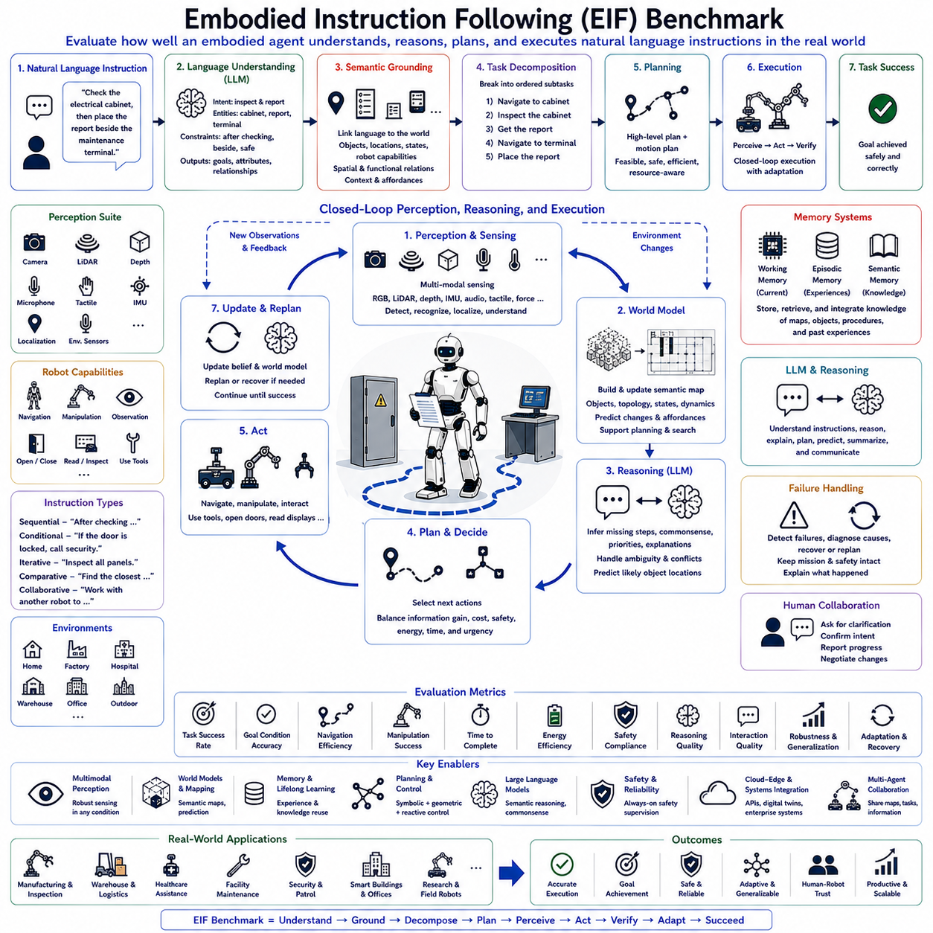
Embodied Instruction Following (EIF) Benchmark is a fundamental evaluation framework for modern Embodied Artificial Intelligence, Vision-Language-Action (VLA), and Physical AI systems. Unlike conventional robotics benchmarks that evaluate isolated capabilities such as navigation, manipulation, or object recognition independently, EIF measures how effectively an embodied agent understands, interprets, plans, and executes natural language instructions within dynamic physical environments. The benchmark emphasizes complete cognitive integration, requiring robots to combine language understanding, multimodal perception, semantic reasoning, planning, memory, sensorimotor control, and adaptive decision making into one coherent autonomous behavior. As intelligent robots become increasingly capable of operating in homes, factories, hospitals, warehouses, and public infrastructure, instruction-following performance has become one of the most important indicators of practical robotic intelligence.
Traditional robotic systems were generally programmed using predefined task scripts or manually engineered behavior trees. Every operational sequence had to be explicitly designed by human engineers before deployment. While such approaches provided reliable execution within structured environments, they lacked flexibility whenever users issued new instructions or environmental conditions changed unexpectedly. Embodied Instruction Following replaces rigid procedural programming with language-driven autonomy, allowing robots to interpret human commands directly and convert them into adaptive physical behavior without requiring handcrafted execution scripts for every possible scenario.
The EIF benchmark begins with natural language instruction understanding. Human commands often contain incomplete information, ambiguous references, implicit assumptions, spatial descriptions, temporal relationships, procedural dependencies, and contextual knowledge that extend far beyond simple keyword recognition. Large Language Models analyze these instructions to identify semantic intent, operational objectives, referenced entities, environmental constraints, safety requirements, execution priorities, and expected outcomes. Successful instruction following therefore depends on deep semantic interpretation rather than syntactic language processing alone.
Semantic grounding forms the second essential component of EIF evaluation. Language instructions must be connected to observable objects, physical locations, environmental properties, and robot capabilities. For example, an instruction such as “Place the inspection report beside the maintenance terminal after checking the electrical cabinet” requires grounding multiple concepts including documents, terminals, inspection equipment, sequential task ordering, and spatial relationships. Grounding enables robots to associate abstract language with concrete sensorimotor experiences that guide physical execution.
Task decomposition represents another central evaluation criterion. Complex instructions rarely specify every intermediate operation required for successful completion. Robots must automatically divide high-level objectives into logically consistent subtasks while preserving dependency relationships among them. Intermediate goals may include navigation, perception, object search, manipulation, inspection, verification, reporting, or communication. Evaluation therefore measures whether the robot correctly infers implicit procedural knowledge while maintaining semantic consistency with the original instruction.
Planning evaluation extends beyond symbolic task generation into physically executable behavior. Task planners determine logical action sequences, while motion planners generate collision-free trajectories satisfying robot kinematics, environmental constraints, energy limitations, and safety requirements. Continuous coordination between symbolic reasoning and geometric feasibility ensures that generated plans remain practical under real operating conditions. The EIF benchmark therefore evaluates planning robustness, computational efficiency, adaptability, and execution feasibility simultaneously.
Multimodal perception serves as a critical foundation throughout instruction execution. Cameras, LiDAR, depth sensors, force sensing, tactile sensing, localization systems, inertial measurements, microphones, and environmental sensors collectively provide continuous situational awareness. Evaluation considers object recognition, scene understanding, semantic segmentation, pose estimation, localization accuracy, multimodal consistency, uncertainty estimation, and perception robustness under changing environmental conditions. Effective instruction following requires perception systems capable of supporting semantic reasoning rather than isolated visual recognition alone.
Embodied Instruction Following differs fundamentally from static language benchmarks because robots must actively acquire missing information during execution. If required objects are initially invisible, target locations remain unknown, or environmental conditions change unexpectedly, robots must autonomously explore, gather additional observations, and update execution plans. Active perception therefore becomes an integral evaluation criterion measuring information acquisition efficiency rather than passive sensing performance alone.
World models substantially improve instruction execution by maintaining predictive environmental representations. Instead of responding only to immediate sensor observations, robots continuously integrate new information into structured semantic maps describing object locations, spatial topology, functional relationships, environmental constraints, and dynamic changes. Predictive world models estimate future environmental evolution, allowing robots to anticipate obstacles, human movement, resource availability, and operational conflicts before they occur. Benchmark evaluation therefore includes world model consistency, prediction accuracy, and planning support capability.
Memory systems provide another important dimension within EIF evaluation. Working memory maintains current execution context, temporary hypotheses, active goals, and ongoing reasoning processes. Episodic memory stores previous task experiences, successful execution histories, and encountered failures. Semantic memory preserves long-term knowledge regarding object properties, building layouts, organizational procedures, safety regulations, and functional relationships. Efficient retrieval and integration of these complementary memory systems significantly improve instruction-following performance during long-horizon missions.
Closed-loop execution distinguishes embodied instruction following from traditional sequential task execution. Every action generates new sensory observations that are compared with predicted outcomes. Deviations trigger world model updates, localized replanning, additional perception, or recovery behaviors before mission failure occurs. Evaluation therefore measures adaptation speed, execution stability, semantic consistency, feedback quality, and recovery effectiveness throughout continuous autonomous operation rather than only final task completion.
Large Language Models contribute semantic reasoning throughout execution rather than functioning solely as language interpreters. LLMs infer missing procedural steps, explain decision-making processes, interpret unexpected environmental conditions, prioritize competing objectives, resolve ambiguities, predict object locations using commonsense reasoning, and communicate naturally with human users. The benchmark evaluates reasoning quality, explanation consistency, contextual awareness, procedural inference, and the ability to integrate language with perception and action.
Failure handling represents another critical benchmark component. Real-world instruction following inevitably encounters unexpected obstacles, missing objects, communication interruptions, localization uncertainty, sensor degradation, or changing user objectives. EIF evaluates failure detection accuracy, diagnosis quality, recovery planning, execution resilience, mission preservation, and explanation capability. Rather than terminating execution after encountering errors, intelligent embodied systems are expected to adapt autonomously while preserving overall task objectives whenever possible.
Human-robot collaboration naturally complements autonomous instruction execution. Robots may request clarification when instructions remain ambiguous, confirm uncertain interpretations, explain execution progress, or negotiate modified objectives when environmental conditions change. Evaluation therefore considers dialogue quality, collaborative reasoning, contextual communication, user satisfaction, transparency, and trustworthiness. Effective instruction following requires continuous interaction rather than one-way command execution.
Multi-agent instruction following extends the benchmark toward collaborative autonomous systems. Multiple robots receive shared high-level instructions and coordinate task allocation, navigation, manipulation, communication, sensing, and recovery through distributed semantic reasoning. Shared world models, synchronized memories, collaborative planning, and dynamic workload balancing enable efficient execution across warehouses, manufacturing facilities, hospitals, airports, and smart infrastructure. Evaluation includes coordination efficiency, communication quality, task distribution, synchronization accuracy, and overall fleet productivity.
Industrial deployment introduces additional evaluation dimensions beyond laboratory research. Manufacturing Execution Systems (MES), Enterprise Resource Planning (ERP), Warehouse Management Systems (WMS), Digital Twins, maintenance databases, production schedules, quality management platforms, and inventory systems continuously influence instruction interpretation and execution priorities. The EIF benchmark therefore evaluates enterprise integration, workflow compatibility, operational reliability, regulatory compliance, maintenance efficiency, and long-term deployment stability under realistic industrial conditions.
Safety remains an independent supervisory mechanism throughout every stage of instruction execution. Collision avoidance, force limitation, workspace monitoring, human detection, cybersecurity validation, emergency stopping procedures, localization integrity monitoring, and regulatory compliance operate independently from semantic reasoning. Adaptive instruction following never overrides deterministic safety controllers, ensuring reliable operation within certified industrial environments. Benchmark evaluation therefore includes both task performance and uncompromised safety behavior.
Generalization represents one of the most challenging objectives of Embodied Instruction Following. High-performing systems must execute previously unseen instructions within unfamiliar environments containing novel objects, different robot embodiments, changing sensor configurations, evolving operational procedures, and unexpected environmental dynamics. Evaluation therefore measures zero-shot reasoning, few-shot adaptation, cross-domain transfer, cross-platform portability, and robustness under distribution shifts. Strong generalization indicates genuine embodied intelligence rather than memorization of benchmark scenarios.
Future EIF benchmarks are expected to evolve toward increasingly realistic long-horizon evaluations integrating multimodal foundation models, predictive world models, continual learning, cognitive memory, cloud-edge collaboration, digital twins, foundation robot policies, and advanced Large Language Models. Rather than evaluating isolated robotic skills, future benchmarks will measure complete cognitive autonomy across extended real-world missions requiring perception, language understanding, reasoning, planning, manipulation, navigation, collaboration, recovery, lifelong learning, and adaptive decision making. Embodied Instruction Following Benchmark will therefore become one of the most comprehensive standards for evaluating next-generation Physical AI systems capable of understanding human intentions and transforming them into reliable autonomous behavior across diverse industrial, commercial, and public environments.

7.5 Simulation Platforms: Habitat and AI2-THOR (with Code)
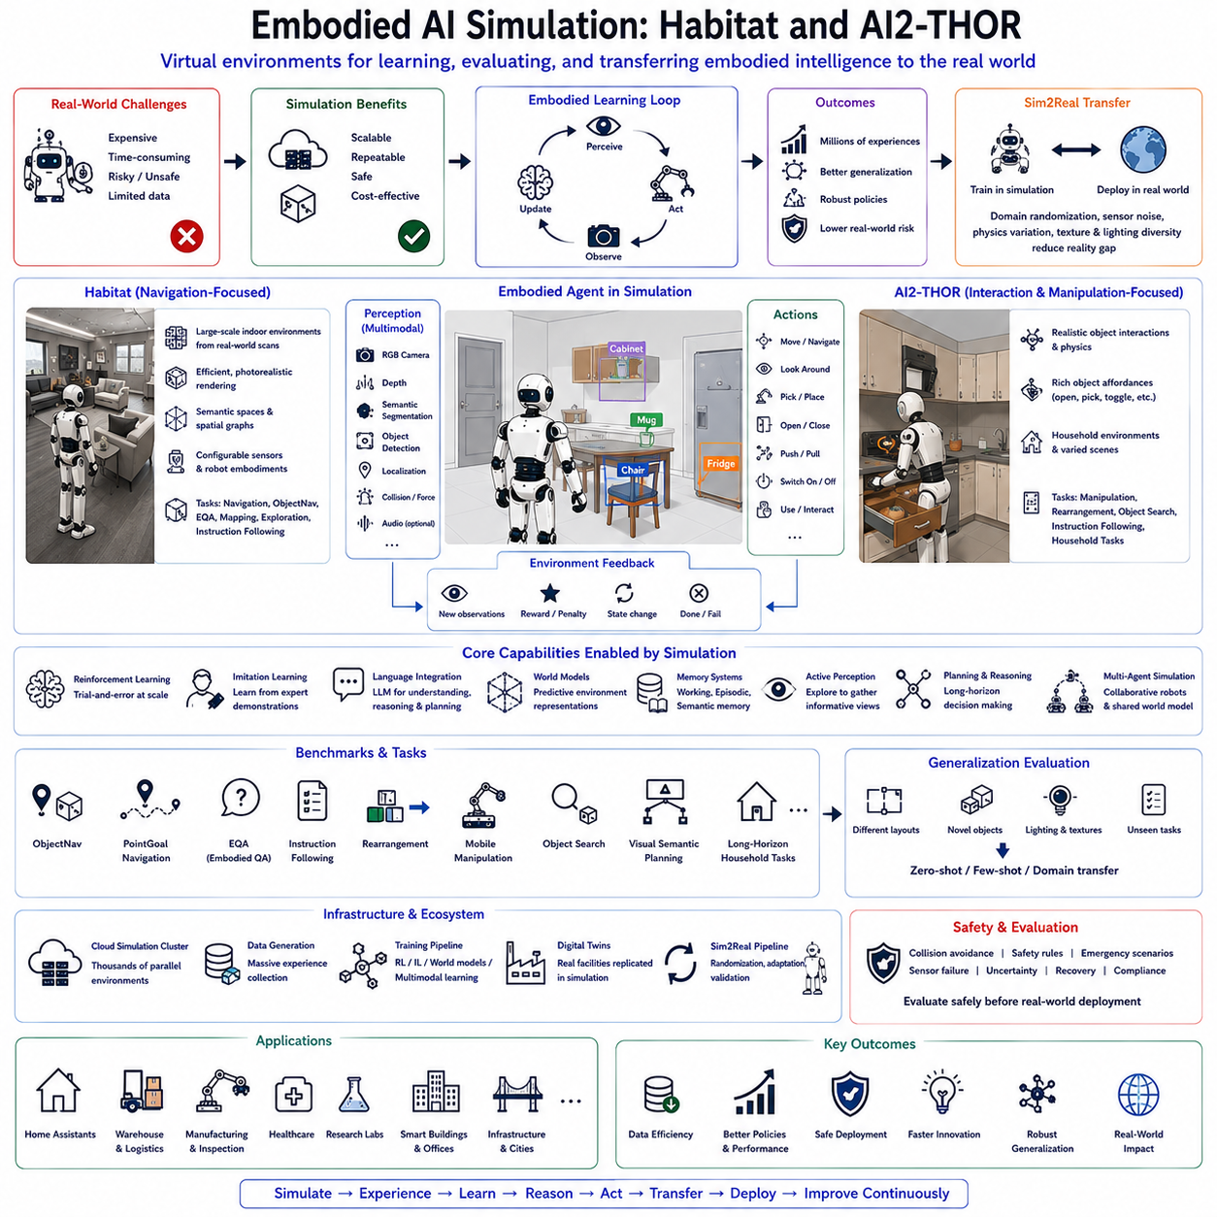
Embodied AI Simulation has become an indispensable component of modern Embodied Artificial Intelligence, Vision-Language-Action (VLA), and Physical AI research because intelligent robots require enormous amounts of interaction experience before they can safely operate in real-world environments. Unlike traditional machine learning, where models are trained using static datasets, embodied intelligence develops through continuous perception, action, feedback, and learning. Collecting such experience directly from physical robots is extremely expensive, time-consuming, and potentially unsafe. Simulation environments therefore provide scalable, repeatable, and controllable platforms where autonomous agents can acquire millions of interaction experiences before deployment. Among the most influential simulation platforms, Habitat and AI2-THOR have emerged as foundational benchmarks supporting navigation, manipulation, language understanding, embodied reasoning, and multimodal learning.
The primary objective of embodied simulation is not merely visual rendering but realistic interaction between intelligent agents and dynamic environments. A simulated robot continuously observes its surroundings using virtual sensors, selects actions through planning or learned policies, modifies the environment through physical interaction, and receives updated observations reflecting environmental changes. This closed sensorimotor loop closely resembles real robotic operation while enabling experiments that would otherwise require extensive physical infrastructure. Consequently, simulation has become an essential stage for developing foundation robot models capable of generalizing across diverse environments.
Habitat, developed primarily for embodied navigation research, emphasizes efficient large-scale simulation supporting visual exploration and long-horizon navigation. It provides photorealistic indoor environments generated from real-world building scans together with accurate physics, configurable sensors, and flexible agent embodiments. Researchers can evaluate navigation algorithms, semantic mapping, localization, exploration strategies, embodied question answering, language-guided navigation, and instruction following within standardized benchmark environments. Habitat's computational efficiency allows thousands of parallel simulation instances, making it highly suitable for reinforcement learning requiring billions of interaction steps.
Habitat organizes environments as interconnected semantic spaces rather than isolated images. Individual rooms, corridors, furniture, structural components, and navigable areas collectively form spatial graphs supporting both metric and semantic reasoning. Robots therefore learn not only geometric navigation but also functional relationships among environmental entities. A kitchen contains appliances, cabinets, and dining furniture; offices contain desks, computers, and meeting spaces. Such semantic regularities significantly improve language grounding and world model learning for embodied agents.
AI2-THOR provides another influential simulation platform emphasizing active interaction with household environments. Unlike navigation-focused simulators, AI2-THOR enables robots to manipulate numerous everyday objects through realistic physics-based interactions. Cabinets may be opened, drawers closed, appliances activated, containers moved, lights switched, doors operated, and objects picked or placed. This extensive interaction capability supports research on embodied manipulation, task planning, instruction following, household robotics, visual reasoning, and language-conditioned action generation. AI2-THOR therefore extends embodied learning beyond locomotion toward complete perception-action integration.
One of AI2-THOR's greatest strengths lies in modeling object affordances. Objects are not represented merely by appearance but by the actions they support. A chair may be approached, a refrigerator opened, a microwave activated, a faucet rotated, and a cabinet inspected. Learning these affordances allows robots to associate language instructions with meaningful physical interactions rather than simple object recognition. Such affordance-centered representations closely resemble human understanding of functional environments and significantly improve language-grounded planning.
Both Habitat and AI2-THOR provide multimodal sensory interfaces supporting RGB cameras, depth sensing, semantic segmentation, instance segmentation, object detection, localization, collision feedback, and various environmental observations. Some research extensions additionally integrate audio simulation, tactile sensing, force estimation, and physics measurements. These multimodal observations enable robots to learn rich environmental representations supporting perception, navigation, manipulation, and semantic reasoning simultaneously. The resulting sensorimotor experiences form the basis of modern embodied learning algorithms.
Embodied simulation plays an essential role in reinforcement learning because autonomous agents require repeated trial-and-error interaction to optimize long-horizon decision making. Simulation allows robots to experience successful behaviors, execution failures, unexpected obstacles, environmental changes, and recovery strategies millions of times without damaging physical hardware. Reward functions evaluate navigation efficiency, task completion, manipulation success, energy consumption, exploration quality, safety, and overall mission performance. Reinforcement learning algorithms continuously improve policies based on accumulated simulated experience.
Imitation learning also benefits significantly from simulation environments. Expert demonstrations generated by human operators, scripted policies, or planning algorithms provide high-quality behavioral trajectories that robots imitate through supervised learning. Habitat and AI2-THOR enable large-scale collection of expert demonstrations across diverse environments, tasks, and object configurations. These datasets support pretraining of embodied policies capable of transferring successfully to unseen environments after further adaptation.
Language integration represents one of the most important recent developments within embodied simulation. Large Language Models interpret natural language instructions, generate semantic goals, explain environmental observations, infer missing procedural knowledge, and support long-horizon planning throughout simulated missions. Simulation environments provide safe platforms for evaluating language grounding, instruction following, embodied question answering, semantic navigation, dialogue-based collaboration, and language-guided manipulation before transferring these capabilities to physical robots.
World model learning has become increasingly dependent upon simulation. Rather than memorizing isolated observations, embodied agents continuously construct predictive environmental representations describing object locations, room topology, functional relationships, environmental dynamics, and future state evolution. Habitat and AI2-THOR provide controlled environments where prediction accuracy, planning quality, exploration efficiency, and semantic consistency can be evaluated systematically under reproducible experimental conditions. World models learned in simulation subsequently support robust planning within physical deployments.
Memory systems are naturally integrated into embodied simulation workflows. Working memory maintains current observations, active goals, and temporary reasoning during simulated execution. Episodic memory records previous exploration trajectories, successful manipulation strategies, encountered failures, and recovery experiences. Semantic memory gradually accumulates knowledge regarding object functions, environmental organization, procedural rules, and commonsense relationships. Long-duration simulated interaction significantly enriches these complementary memory systems while avoiding the practical limitations of continuous physical experimentation.
Embodied benchmarks built upon Habitat and AI2-THOR evaluate numerous research tasks beyond simple navigation. Object Navigation (ObjectNav), PointGoal Navigation, Embodied Question Answering (EQA), Instruction Following, Rearrangement, Mobile Manipulation, Interactive Object Search, Visual Semantic Planning, and Long-Horizon Household Tasks collectively measure increasingly sophisticated embodied intelligence. These benchmarks require simultaneous integration of perception, language, planning, memory, navigation, manipulation, and adaptive reasoning rather than isolated algorithmic performance.
Generalization remains one of the principal research objectives supported by embodied simulation. Training environments intentionally differ from testing environments with respect to room layouts, object arrangements, lighting conditions, textures, navigation topology, and environmental dynamics. Successful embodied agents must transfer acquired knowledge toward previously unseen environments rather than memorizing specific maps. Simulation therefore provides controlled evaluation of zero-shot reasoning, few-shot adaptation, domain transfer, robustness under uncertainty, and lifelong learning capabilities.
Simulation-to-Real transfer, commonly known as Sim2Real, represents a major challenge within embodied robotics. Models trained exclusively within simulation frequently encounter performance degradation after deployment because physical sensors, lighting, friction, object appearance, dynamics, and environmental variability differ from simulated assumptions. Habitat and AI2-THOR therefore support domain randomization, physics randomization, sensor noise modeling, texture variation, illumination diversity, and environmental perturbations designed to reduce this reality gap. Such techniques improve the robustness of embodied policies before physical deployment.
Modern embodied simulation increasingly incorporates digital twins representing real industrial facilities. Instead of generic household environments, digital twins accurately reproduce factories, warehouses, hospitals, laboratories, airports, office buildings, and infrastructure assets. Robots trained within these high-fidelity virtual environments acquire operational knowledge directly applicable to corresponding physical facilities. Continuous synchronization between digital twins and real environments further supports predictive maintenance, operational planning, and large-scale autonomous fleet management.
Cloud computing has dramatically expanded the scale of embodied simulation. Distributed simulation clusters execute thousands of virtual environments simultaneously while centralized learning servers continuously update foundation robot models. Massive parallel interaction accelerates reinforcement learning, imitation learning, world model construction, and multimodal representation learning beyond what would be possible using individual physical robots. Cloud-edge collaboration therefore enables efficient development of increasingly capable embodied intelligence.
Safety evaluation benefits substantially from simulation because dangerous scenarios can be reproduced without risking human operators or expensive equipment. Emergency situations, equipment failures, communication interruptions, sensor degradation, unexpected obstacles, and human interactions can all be generated repeatedly under controlled conditions. Researchers evaluate collision avoidance, recovery planning, uncertainty estimation, emergency procedures, and regulatory compliance before transferring autonomous behaviors into operational environments. Simulation therefore significantly reduces deployment risk while improving system reliability.
Future embodied simulation platforms are expected to integrate multimodal foundation models, predictive world models, continual learning, cognitive memory, advanced physics engines, photorealistic rendering, cloud-edge collaboration, digital twins, and increasingly sophisticated Large Language Models into unified development ecosystems. Rather than serving only as training environments, future simulations will become comprehensive cognitive laboratories supporting lifelong robot learning, collaborative multi-agent reasoning, semantic world modeling, human-robot interaction, autonomous planning, and industrial-scale deployment validation. Habitat, AI2-THOR, and their future successors will therefore remain foundational infrastructures enabling the development of increasingly capable Physical AI systems that learn efficiently in virtual environments before acting safely and intelligently within the real world.

7.6 Cognitive Architectures (with Code)
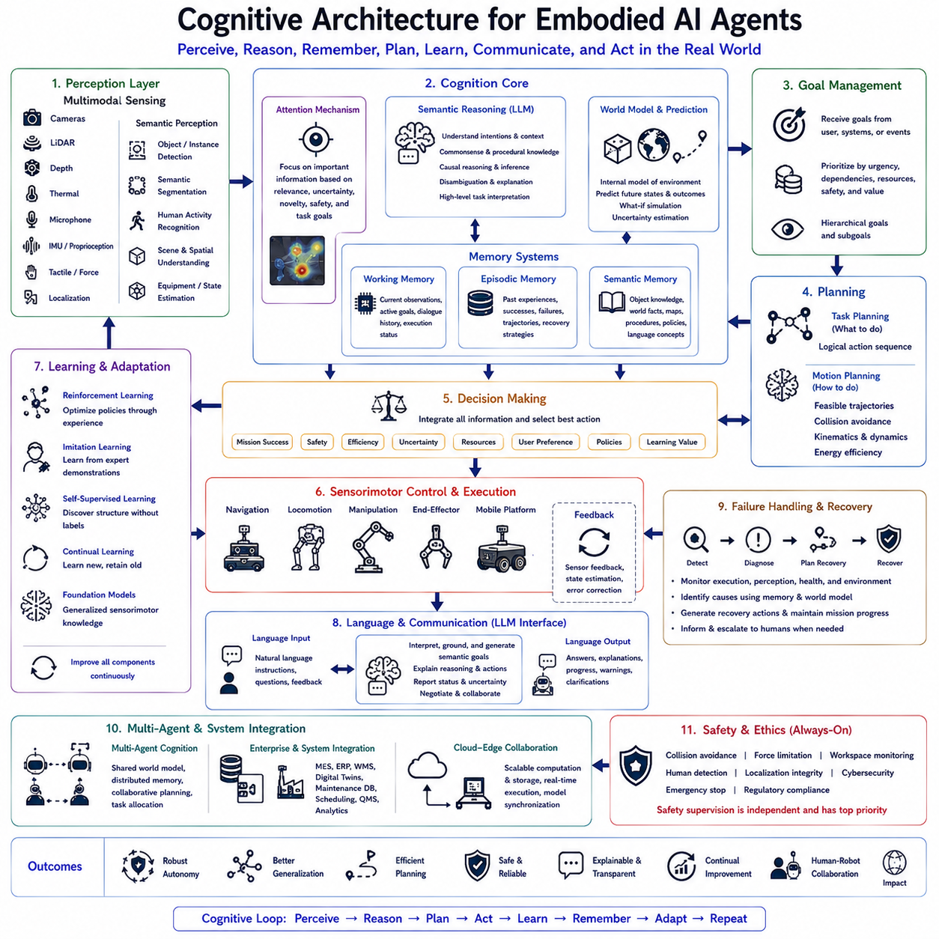
Cognitive Architecture for Embodied AI Agents provides the fundamental organizational framework that enables intelligent robots to perceive, reason, remember, learn, plan, communicate, and act autonomously within complex physical environments. Unlike traditional robotic control architectures that primarily connect perception directly to action through predefined pipelines, cognitive architectures introduce higher-level reasoning, memory, prediction, decision making, and continual adaptation into the control loop. Intelligence is therefore viewed not as a collection of isolated algorithms but as the coordinated interaction of multiple cognitive components operating continuously within a unified system. This architecture serves as the foundation for modern Physical AI, Vision-Language-Action (VLA) systems, autonomous mobile robots, humanoids, service robots, and collaborative industrial platforms.
Conventional robotics frequently separates perception, planning, localization, manipulation, navigation, and control into independent software modules connected through predefined interfaces. While this modular organization provides engineering simplicity, it often limits adaptive behavior when robots encounter unfamiliar environments, incomplete information, ambiguous human instructions, or unexpected physical events. Embodied cognitive architectures address these limitations by allowing perception, reasoning, memory, prediction, and action to interact continuously rather than sequentially. Every observation influences reasoning, every decision updates memory, and every action generates new experiences that improve future behavior.
At the center of the cognitive architecture lies perception, which continuously transforms raw sensory measurements into meaningful semantic representations. Cameras, LiDAR, depth sensors, thermal imagers, tactile sensors, force sensors, microphones, localization systems, inertial measurement units, and proprioceptive sensing collectively observe both the external environment and the robot's internal physical condition. Rather than producing isolated detections, perception modules construct integrated scene representations describing objects, spatial relationships, human activities, environmental dynamics, equipment status, and task-relevant context. These semantic representations provide the foundation for every higher-level cognitive process.
Attention mechanisms regulate information flow throughout the architecture. Physical environments generate far more sensory information than can be processed simultaneously. Attention systems therefore prioritize observations according to task relevance, uncertainty, novelty, safety significance, and operational objectives. Dynamic attention enables robots to allocate computational resources efficiently while maintaining situational awareness across continuously changing environments. Instead of processing every observation equally, embodied agents selectively focus on information most valuable for current decision making.
Semantic reasoning forms the cognitive layer connecting perception with planning. Large Language Models and multimodal reasoning models interpret observations using commonsense knowledge, procedural understanding, environmental context, and user intentions. Semantic reasoning infers object functions, predicts causal relationships, resolves ambiguities, explains unexpected events, and generates high-level task interpretations. Rather than reacting directly to sensor observations, embodied agents reason about what observations mean and how they influence future actions.
Memory represents one of the defining components of cognitive architectures. Working memory temporarily maintains active observations, reasoning results, task objectives, dialogue history, and execution status throughout ongoing missions. Episodic memory stores previous experiences, successful task executions, encountered failures, environmental conditions, and recovery strategies. Semantic memory preserves long-term knowledge describing object properties, building layouts, operational procedures, physical principles, organizational policies, and language concepts. Together these complementary memory systems enable robots to utilize accumulated experience instead of relying solely upon immediate observations.
World models provide predictive internal representations of the environment. Rather than describing only the current state, world models estimate future environmental evolution resulting from robot actions, human activities, object motion, equipment operation, and external events. Predictive simulation allows candidate decisions to be evaluated internally before physical execution begins. Anticipating future consequences significantly improves planning efficiency while reducing operational risk and unnecessary trial-and-error behavior.
Goal management organizes high-level mission objectives throughout execution. Human instructions, enterprise workflows, environmental events, or autonomous discoveries may all generate competing goals requiring prioritization. Goal management continuously evaluates urgency, dependencies, resource availability, safety constraints, and operational value before selecting active objectives. Hierarchical goal structures enable long-horizon missions to be divided into manageable subtasks while preserving consistency with strategic mission intent.
Planning transforms cognitive objectives into executable behavior. Task planners generate logical action sequences satisfying semantic requirements, while motion planners compute physically feasible trajectories considering robot kinematics, dynamic obstacles, environmental constraints, and energy efficiency. Cognitive architectures continuously coordinate symbolic planning with physical execution so that high-level reasoning remains grounded in practical robotic capabilities. Whenever environmental changes invalidate existing plans, replanning occurs dynamically without interrupting overall mission objectives.
Decision making integrates information originating from perception, memory, reasoning, planning, prediction, and safety supervision. Rather than optimizing isolated objectives, cognitive architectures evaluate multiple competing criteria simultaneously, including mission success, operational efficiency, safety, uncertainty, computational resources, human preferences, organizational policies, and long-term learning opportunities. Multi-objective decision processes enable robust autonomous behavior across highly dynamic environments where no single optimization criterion remains sufficient.
Sensorimotor control forms the execution layer connecting cognitive decisions with physical behavior. Navigation, manipulation, locomotion, force control, balance regulation, mobile platforms, robotic arms, end-effectors, and other actuators execute planned behaviors while continuously receiving sensory feedback. Adaptive controllers compensate for modeling errors, environmental disturbances, object variability, and dynamic interactions. Continuous sensorimotor feedback therefore closes the cognitive loop between reasoning and physical experience.
Learning continuously improves every architectural component throughout deployment. Reinforcement learning optimizes long-term decision policies through interaction experience. Imitation learning transfers expert behavior into autonomous execution. Self-supervised learning extracts environmental structure without extensive manual labeling. Continual learning incorporates newly acquired knowledge while preserving previously learned capabilities. Foundation robot models accumulate generalized sensorimotor knowledge supporting increasingly capable embodied intelligence across diverse environments.
Language serves as an essential cognitive interface connecting humans with embodied agents. Natural language instructions specify objectives, modify execution priorities, request explanations, provide contextual knowledge, and facilitate collaborative decision making. Large Language Models translate human communication into semantic goals while simultaneously explaining robot reasoning, execution progress, uncertainty estimates, and recovery strategies. Language therefore functions not merely as an input modality but as an integral cognitive representation supporting planning, memory, reasoning, and learning.
Closed-loop cognition continuously synchronizes every architectural component during operation. New sensory observations update semantic perception, world models revise environmental predictions, reasoning modules reinterpret current situations, planners adjust future actions, memory records accumulated experience, and learning algorithms refine internal representations. Rather than executing predetermined behavioral sequences, cognitive architectures maintain continual adaptation throughout extended autonomous missions. This dynamic integration distinguishes embodied cognition from traditional reactive robotics.
Failure detection and recovery operate as permanent cognitive functions rather than isolated exception handlers. Cognitive architectures monitor execution progress, perception consistency, localization confidence, hardware status, communication integrity, environmental changes, and task completion quality. When failures occur, diagnostic reasoning identifies probable causes using accumulated observations, historical experiences, and predictive world models. Recovery planners generate corrective actions preserving completed mission progress whenever possible while communicating relevant information to human supervisors if necessary.
Human-robot collaboration emerges naturally within cognitive architectures because reasoning processes remain explicitly represented rather than hidden inside opaque control policies. Robots explain decisions, request clarification, negotiate task priorities, justify recovery actions, and communicate uncertainty through natural dialogue. Shared semantic understanding enables humans and robots to coordinate complex tasks while maintaining transparency, trust, and operational efficiency across collaborative environments.
Multi-agent cognition extends individual architectures toward distributed autonomous systems. Multiple embodied agents share semantic world models, distributed memories, collaborative planning processes, environmental observations, task allocations, and execution status through networked communication. Collective reasoning enables coordinated exploration, collaborative manipulation, distributed inspection, cooperative logistics, and intelligent fleet management across large industrial facilities. Distributed cognition therefore scales embodied intelligence beyond individual robots toward integrated autonomous ecosystems.
Enterprise integration provides another defining capability of production cognitive architectures. Manufacturing Execution Systems, Enterprise Resource Planning platforms, Warehouse Management Systems, Digital Twins, maintenance databases, production scheduling software, quality management systems, and operational analytics continuously exchange information with cognitive agents. Enterprise knowledge influences planning priorities, resource allocation, workflow coordination, and decision making, ensuring autonomous robots operate as intelligent participants within larger organizational systems rather than isolated automation devices.
Safety supervision remains independent throughout every cognitive process. Collision avoidance, force limitation, workspace monitoring, human detection, localization integrity, cybersecurity validation, emergency stopping procedures, and regulatory compliance operate continuously regardless of high-level reasoning outcomes. Cognitive intelligence therefore enhances flexibility while deterministic safety mechanisms preserve operational reliability under all circumstances.
Evaluation of cognitive architectures extends beyond isolated algorithmic performance. Researchers assess semantic reasoning quality, perception robustness, memory utilization, planning efficiency, prediction accuracy, learning capability, sensorimotor coordination, language understanding, recovery effectiveness, human collaboration, computational efficiency, energy consumption, generalization across unseen environments, long-horizon autonomy, and continual adaptation. Comprehensive evaluation measures the effectiveness of the complete cognitive system rather than individual software modules.
Future cognitive architectures for embodied agents will increasingly integrate multimodal foundation models, predictive world models, cognitive memory, continual learning, cloud-edge collaboration, digital twins, distributed reasoning, lifelong adaptation, and advanced Large Language Models into unified intelligent systems. Rather than functioning as collections of independent robotics algorithms, future embodied agents will possess integrated cognitive capabilities enabling perception, understanding, prediction, reasoning, communication, planning, learning, and autonomous action to operate together continuously within dynamic physical environments. Such cognitive architectures will provide the essential foundation for next-generation Physical AI systems capable of reliable long-term autonomy across manufacturing, logistics, healthcare, infrastructure inspection, service robotics, scientific exploration, and countless other real-world applications.

7.7 Memory and Episodic Recall (with Code)
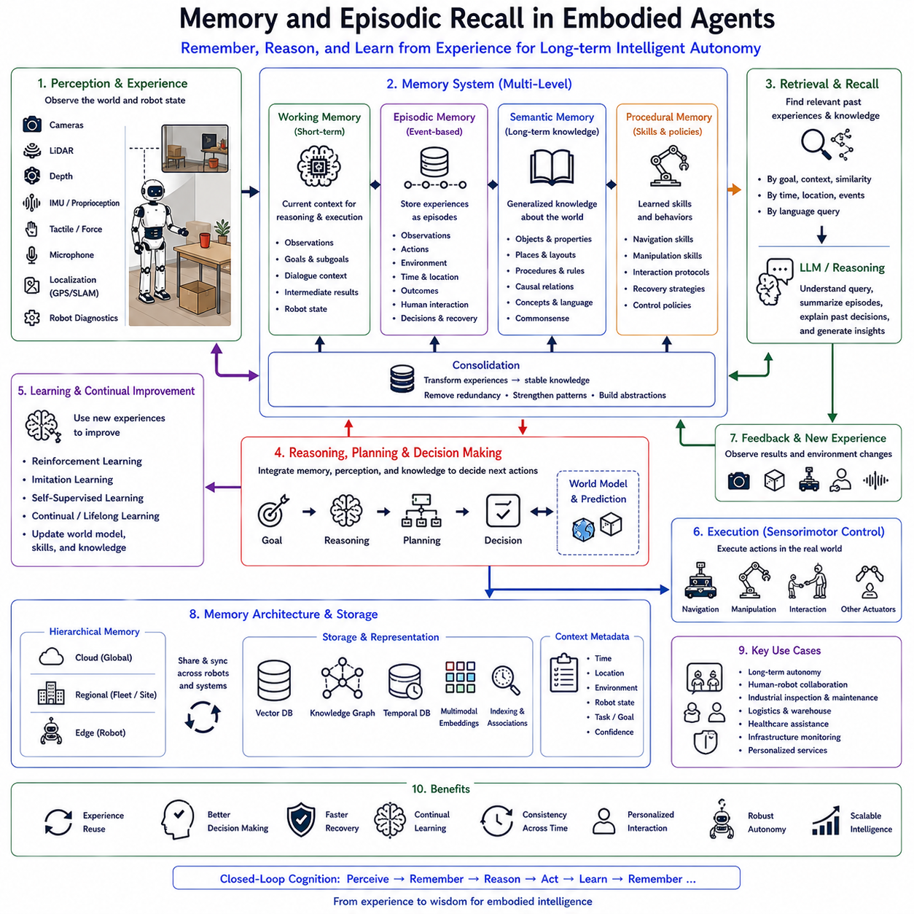
Memory and Episodic Recall are fundamental cognitive capabilities that enable embodied artificial intelligence systems to accumulate experience, reason over past events, and continuously improve behavior throughout long-term interaction with the physical world. Unlike conventional robotic systems that process each task independently and discard previous execution history, embodied agents maintain persistent memories describing observations, actions, outcomes, environmental changes, and human interactions. These memories allow robots to behave consistently across extended missions while adapting their future decisions according to accumulated experience. Memory therefore transforms autonomous robots from reactive machines into continually learning cognitive agents capable of understanding temporal relationships within dynamic environments.
Traditional robotic architectures generally relied upon short-lived internal states that disappeared after task completion. Once navigation, manipulation, or inspection finished, the system retained only minimal operational logs while discarding rich contextual information. Such stateless behavior limited long-term autonomy because robots repeatedly solved identical problems without benefiting from previous experience. Embodied AI introduces persistent memory systems that preserve semantic knowledge, execution history, environmental context, and procedural experience across multiple tasks, allowing intelligent behavior to improve naturally over time.
Memory within embodied agents is organized into multiple complementary components, each supporting different aspects of cognition. Working memory maintains information required for current reasoning and task execution. Episodic memory stores individual experiences together with temporal context. Semantic memory accumulates long-term factual knowledge about objects, environments, procedures, and language. Procedural memory preserves motor skills and learned action policies. Together these memory systems create an integrated cognitive infrastructure supporting perception, planning, reasoning, learning, and decision making across long-horizon autonomous missions.
Working memory functions as the robot's temporary cognitive workspace. Incoming sensor observations, language instructions, active goals, intermediate reasoning results, dialogue context, navigation status, and manipulation states remain accessible while current tasks are executed. Working memory continuously updates as new information becomes available and removes obsolete information after task completion. Efficient working memory enables coherent reasoning across multiple perception cycles without overwhelming computational resources.
Episodic memory represents one of the defining characteristics of embodied intelligence. Every meaningful interaction experienced by the robot becomes an episode containing observations, executed actions, environmental conditions, timestamps, encountered objects, human interactions, decision rationales, task outcomes, and recovery events. Rather than storing isolated sensor data, episodic memory preserves coherent narratives describing complete experiences. This temporal organization enables robots to answer questions such as where an object was previously observed, which recovery strategy succeeded under similar conditions, or how environmental conditions evolved throughout earlier missions.
Semantic memory gradually accumulates generalized knowledge extracted from repeated experiences. Individual episodes describing similar observations become consolidated into stable conceptual representations. The robot learns object categories, functional relationships, building layouts, operational procedures, safety regulations, environmental regularities, and commonsense knowledge independent of individual events. Semantic memory therefore supports reasoning beyond direct experience by enabling inference using abstract concepts rather than isolated observations.
Procedural memory preserves learned behaviors and execution skills acquired through reinforcement learning, imitation learning, supervised learning, or continual adaptation. Navigation strategies, grasping techniques, manipulation policies, inspection procedures, recovery behaviors, and interaction protocols gradually become robust procedural knowledge requiring little explicit reasoning during execution. Procedural memory therefore improves efficiency while reducing computational complexity during repeated tasks.
Memory formation begins immediately after perception. Cameras, LiDAR, depth sensors, tactile sensing, microphones, localization systems, inertial sensors, and internal robot diagnostics continuously generate multimodal observations describing both external environments and internal system status. Cognitive modules identify meaningful events worthy of long-term storage by evaluating novelty, task relevance, uncertainty, safety significance, human interaction, emotional importance, or mission outcome. Selective encoding prevents unnecessary accumulation of redundant information while preserving valuable experiences.
Encoding transforms raw observations into structured memory representations. Visual features become semantic object descriptions. Spatial observations become topological relationships. Natural language interactions become symbolic dialogue records. Actions become executable behavioral sequences linked with observed outcomes. Contextual metadata describing time, location, environmental conditions, robot state, task objectives, and execution confidence accompany every stored episode. Rich contextual encoding substantially improves future memory retrieval accuracy.
Memory consolidation continuously converts temporary experiences into durable long-term knowledge. During consolidation, repeated observations strengthen consistent semantic relationships while inconsistent or noisy information receives reduced importance. Similar episodes become clustered according to shared objects, environments, procedures, or mission objectives. Consolidation therefore reduces storage redundancy while increasing knowledge abstraction, enabling efficient lifelong learning across extended deployments.
Memory retrieval plays an equally important role within embodied cognition. Rather than searching entire databases exhaustively, cognitive architectures retrieve relevant experiences according to current goals, environmental context, semantic similarity, spatial location, temporal relationships, human requests, or operational conditions. Vector databases, semantic embeddings, graph memories, associative indexing, and attention mechanisms collectively support efficient retrieval of knowledge directly applicable to ongoing decision making.
Large Language Models significantly enhance episodic recall through semantic reasoning. Instead of retrieving memories using exact keyword matching, language models interpret user questions, infer missing contextual information, identify semantically related experiences, summarize multiple episodes, explain previous decisions, and generate coherent natural language responses describing accumulated robotic experience. Episodic recall therefore becomes a reasoning process rather than simple database lookup.
World models interact closely with memory systems. Episodic experiences continuously update predictive environmental models describing object permanence, spatial organization, human behavior, environmental dynamics, and causal relationships. Conversely, world models provide contextual guidance during memory retrieval by predicting which previous experiences remain relevant under current environmental conditions. This bidirectional interaction substantially improves long-term planning and adaptive decision making.
Memory also supports continual learning throughout deployment. Newly acquired experiences refine semantic representations, update procedural knowledge, improve prediction accuracy, strengthen successful recovery strategies, and eliminate outdated assumptions. Rather than retraining complete models from scratch, embodied agents incrementally incorporate new information while preserving previously acquired capabilities. Effective continual learning therefore depends upon robust memory management mechanisms capable of balancing stability with adaptability.
Human-robot interaction benefits substantially from episodic recall. Robots remembering previous conversations, completed tasks, operator preferences, frequently visited locations, maintenance history, or recurring operational procedures provide more natural and efficient collaboration. Users expect intelligent embodied agents to maintain contextual continuity across multiple interactions rather than behaving as memoryless automation systems. Episodic recall therefore enhances trust, transparency, personalization, and collaborative efficiency.
Memory systems become particularly valuable during long-duration industrial operations. Autonomous inspection robots remember previously detected defects and compare them against current observations to identify degradation trends. Warehouse robots remember temporary obstacles, preferred navigation routes, inventory movement patterns, and operational schedules. Healthcare assistants remember patient preferences, medication routines, equipment locations, and previous interactions while respecting privacy and security requirements. Infrastructure maintenance robots preserve historical inspection records supporting predictive maintenance and asset lifecycle management.
Failure recovery relies heavily upon episodic memory. When unexpected situations occur, robots retrieve previous failures exhibiting similar environmental conditions, execution histories, sensor anomalies, or hardware behaviors. Successful recovery procedures extracted from earlier episodes guide corrective action while avoiding previously unsuccessful strategies. Experience-based recovery significantly improves operational robustness compared with predefined exception handling alone.
Memory architectures increasingly employ hierarchical organization. Local memories remain on edge computing platforms supporting low-latency decision making during active missions. Regional memories synchronize across robot fleets operating within shared facilities. Cloud memory systems preserve global organizational knowledge accumulated from thousands of robots across multiple deployment sites. Hierarchical synchronization enables individual experience to become collective organizational intelligence while respecting communication bandwidth and computational constraints.
Modern memory implementations often integrate vector databases, knowledge graphs, temporal databases, multimodal embeddings, graph neural representations, and semantic retrieval systems. Vector embeddings capture conceptual similarity across language, vision, and action representations. Knowledge graphs preserve explicit relationships among objects, tasks, environments, and procedures. Temporal indexing supports chronological reasoning while graph structures facilitate relational inference. Together these complementary storage mechanisms provide scalable cognitive memory suitable for increasingly sophisticated embodied agents.
Evaluation of memory systems extends beyond storage capacity alone. Researchers measure episodic recall accuracy, semantic retrieval quality, retrieval latency, contextual consistency, memory consolidation effectiveness, long-term retention, catastrophic forgetting resistance, continual learning capability, planning improvement, reasoning support, recovery performance, human interaction quality, computational efficiency, storage scalability, and knowledge transfer across environments. Effective memory therefore contributes directly to overall embodied intelligence rather than serving merely as passive information storage.
Future embodied memory architectures will increasingly integrate multimodal foundation models, predictive world models, lifelong learning, semantic knowledge graphs, distributed cloud-edge memory, cognitive reasoning engines, digital twins, and advanced Large Language Models into unified cognitive memory systems. Rather than remembering isolated events, future embodied agents will construct continuously evolving autobiographical knowledge describing their complete operational history, accumulated expertise, collaborative interactions, environmental understanding, and procedural competence. Such memory-driven cognition will become one of the defining capabilities enabling next-generation Physical AI systems to achieve reliable long-term autonomy across manufacturing, logistics, healthcare, service robotics, infrastructure inspection, scientific exploration, and other complex real-world domains.

7.8 Social Intelligence for Human-Robot Interaction (with Code)
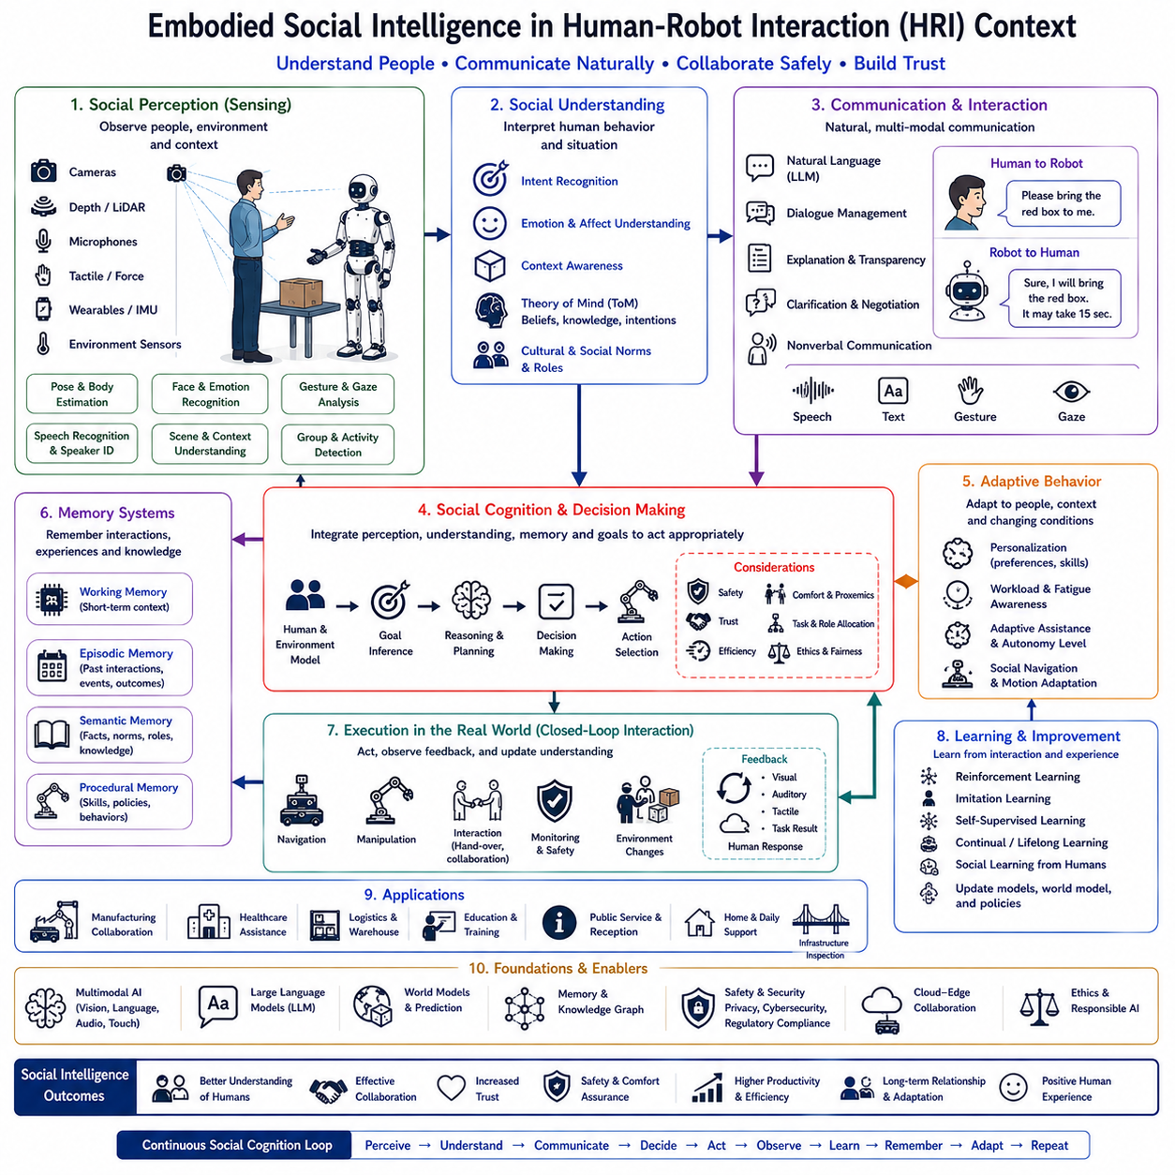
Embodied Social Intelligence represents one of the most significant research directions in modern Embodied Artificial Intelligence, Vision-Language-Action (VLA), and Physical AI because autonomous robots are increasingly expected to work alongside humans rather than operate in isolation. Traditional robotic systems primarily focused on mechanical precision, navigation accuracy, and task execution efficiency, assuming that human interaction was limited to issuing commands or supervising operations. However, future intelligent robots must understand human intentions, interpret social cues, adapt to changing interpersonal situations, communicate naturally, and collaborate safely within shared environments. Social intelligence therefore becomes an essential cognitive capability enabling embodied agents to function effectively in homes, hospitals, factories, offices, warehouses, public infrastructure, and service industries.
Unlike conventional automation systems that execute predefined procedures, socially intelligent embodied agents continuously interpret both physical and social environments. Human activities, emotional expressions, gestures, speech, gaze direction, body posture, interpersonal distance, collaborative intentions, and cultural expectations all become meaningful components of environmental understanding. The robot therefore perceives not only objects and obstacles but also human behavior, communication patterns, and social context. This broader perception allows autonomous systems to behave appropriately while maintaining effective collaboration with nearby people.
Human-Robot Interaction (HRI) provides the primary application domain for embodied social intelligence. HRI studies how robots and humans cooperate, communicate, share workspaces, exchange information, and establish mutual understanding throughout extended interaction. Rather than treating people as external operators, embodied agents recognize humans as active collaborative partners whose intentions, preferences, abilities, and behaviors continuously influence decision making. Successful HRI therefore requires integrated perception, reasoning, language understanding, planning, memory, and adaptive behavioral control.
Social perception forms the first layer of embodied social intelligence. Cameras, depth sensors, LiDAR, microphones, wearable devices, tactile sensors, force sensors, and environmental sensors continuously observe human presence and activity. Computer vision algorithms estimate body pose, hand gestures, facial expressions, gaze direction, walking trajectories, group formation, and interaction dynamics. Audio processing recognizes speech, speaker identity, emotional tone, conversation context, and environmental sounds. These multimodal observations collectively construct rich representations of human social behavior.
Intent recognition enables robots to anticipate human actions before explicit instructions are provided. Rather than reacting only after commands are spoken, embodied agents infer probable objectives from observed behavior, movement patterns, object interactions, environmental context, and previous collaboration history. For example, if a worker repeatedly approaches an inspection station carrying tools, the robot may predict that inspection assistance will soon be required. Anticipatory reasoning improves collaboration efficiency while reducing unnecessary communication.
Natural language serves as the principal communication channel between humans and embodied agents. Large Language Models interpret spoken or written instructions, answer questions, explain robot decisions, negotiate task priorities, clarify ambiguous requests, and maintain coherent dialogue throughout long-duration interactions. Unlike command-based interfaces, conversational interaction allows humans to express goals naturally while robots provide transparent explanations regarding execution status, uncertainty, safety constraints, and alternative strategies.
Context awareness significantly enhances social intelligence. Identical verbal instructions may require different interpretations depending upon environmental conditions, organizational policies, user preferences, cultural conventions, or current operational objectives. For example, “Please move this box” requires understanding which box is referenced, whether it contains fragile materials, whether nearby workers occupy the destination area, and whether production schedules impose additional constraints. Context-sensitive reasoning therefore prevents inappropriate or unsafe behavior while improving communication quality.
Embodied social intelligence relies heavily upon memory systems. Episodic memory records previous interactions, completed collaborative tasks, user preferences, communication history, recurring operational procedures, and successful cooperation strategies. Semantic memory stores organizational knowledge, social conventions, workplace rules, object ownership, and human roles. Remembering previous interactions enables personalized collaboration, allowing robots to adapt communication style, task allocation, and assistance strategies according to accumulated experience with individual users.
Theory of Mind represents an advanced cognitive capability increasingly explored within embodied AI research. Rather than modeling only the physical environment, socially intelligent agents estimate what nearby humans know, believe, intend, expect, or misunderstand. Such reasoning allows robots to explain missing information, avoid redundant communication, predict misunderstandings, and coordinate actions more effectively. Although current systems remain limited compared with human social cognition, computational Theory of Mind significantly improves collaborative behavior within complex team environments.
Adaptive behavior distinguishes socially intelligent embodied agents from fixed automation systems. Human expertise, workload, emotional state, fatigue, environmental complexity, and operational urgency vary continuously throughout daily activities. Cognitive architectures therefore adjust communication frequency, assistance level, navigation behavior, manipulation speed, interpersonal distance, and task allocation dynamically according to observed human conditions. Adaptive interaction promotes efficiency while maintaining comfort, trust, and safety.
Nonverbal communication plays a crucial role within human-robot collaboration. Facial displays, head orientation, gaze behavior, arm movement, navigation direction, gesture timing, speed modulation, body posture, and physical positioning all communicate robot intentions before explicit language becomes necessary. Predictable nonverbal behavior improves human understanding while reducing uncertainty regarding future robot actions. Consequently, socially intelligent robots coordinate verbal explanations with consistent physical behavior throughout interaction.
Trust forms one of the most important objectives of embodied social intelligence. Humans naturally collaborate more effectively with autonomous systems that demonstrate predictable behavior, explain decisions transparently, acknowledge uncertainty honestly, recover gracefully from failures, and consistently prioritize safety. Trust emerges gradually through repeated successful interaction rather than isolated demonstrations. Cognitive architectures therefore monitor trust-related indicators while continuously improving communication clarity, behavioral consistency, and collaborative reliability.
Multi-human interaction introduces additional complexity beyond individual collaboration. Hospitals, factories, warehouses, airports, and public facilities often contain numerous people simultaneously pursuing different objectives. Socially intelligent robots identify multiple participants, distinguish conversational groups, prioritize requests, coordinate collaborative activities, resolve conflicting instructions, and maintain awareness of group dynamics. Effective social reasoning therefore extends from individual interaction toward collective human collaboration.
Social navigation represents another important capability within embodied intelligence. Unlike geometric navigation focused solely on obstacle avoidance, socially aware navigation respects interpersonal distance, walking conventions, shared workspace etiquette, crowd behavior, accessibility requirements, and cultural expectations. Robots predict pedestrian trajectories, avoid interrupting conversations, yield appropriately in narrow corridors, and position themselves naturally during collaborative activities. Social navigation therefore integrates physical motion planning with human behavioral understanding.
Ethical reasoning increasingly influences embodied social intelligence. Robots frequently encounter situations involving privacy, fairness, transparency, consent, confidentiality, and organizational policy. Cognitive architectures therefore evaluate not only task efficiency but also ethical implications of autonomous decisions. Responsible behavior requires respecting personal information, explaining automated decisions, obtaining appropriate authorization, and maintaining fairness across diverse users while complying with legal and organizational requirements.
Industrial Human-Robot Collaboration demonstrates the practical value of embodied social intelligence. Collaborative robots assist workers during assembly, inspection, maintenance, logistics, material handling, and quality assurance. Intelligent assistants recognize operator intentions, deliver appropriate tools proactively, monitor worker safety, explain production information, and coordinate shared workflows. Such collaboration increases productivity while reducing physical workload and cognitive burden placed upon human operators.
Healthcare applications similarly depend upon advanced social intelligence. Service robots communicate with patients, assist healthcare professionals, deliver medical supplies, monitor environmental conditions, and provide daily support for elderly individuals. Successful deployment requires empathy-aware communication, respectful interpersonal behavior, adaptive assistance, privacy protection, and individualized interaction based on patient preferences and previous experiences. Social cognition therefore becomes as important as mechanical capability within medical environments.
Education and training also benefit from embodied social intelligence. Educational robots observe student engagement, recognize confusion, adjust instructional strategies, answer questions, encourage participation, and personalize learning experiences. Long-term memory enables individualized educational support while multimodal interaction creates engaging collaborative learning environments. Such systems illustrate how embodied cognition extends beyond industrial automation toward human-centered knowledge transfer.
Safety remains an independent supervisory mechanism throughout every social interaction. Collision avoidance, force limitation, human detection, personal space monitoring, emergency stopping, cybersecurity validation, privacy protection, localization integrity, and regulatory compliance continuously constrain autonomous behavior regardless of conversational objectives or collaborative demands. Social intelligence therefore enhances interaction quality without compromising deterministic safety guarantees.
Evaluation of embodied social intelligence extends far beyond traditional robotic performance metrics. Researchers assess communication quality, language understanding, intent recognition accuracy, trust development, collaboration efficiency, context awareness, adaptation capability, nonverbal communication consistency, social navigation quality, ethical compliance, memory utilization, explanation transparency, recovery effectiveness, user satisfaction, long-term relationship maintenance, computational efficiency, and generalization across diverse social environments. Comprehensive evaluation therefore measures complete human-centered embodied cognition rather than isolated robotic functionality.
Future embodied social intelligence will integrate multimodal foundation models, predictive world models, lifelong memory, continual learning, cognitive reasoning, emotional understanding, cloud-edge collaboration, digital twins, distributed multi-agent cognition, and increasingly capable Large Language Models into unified human-centered cognitive architectures. Rather than functioning as autonomous machines executing predefined tasks, future embodied agents will become collaborative partners capable of understanding human intentions, adapting to changing social contexts, communicating naturally, learning from long-term relationships, and participating safely within complex human organizations. Such socially intelligent embodied systems will become foundational technologies for next-generation Physical AI across manufacturing, healthcare, logistics, education, public services, scientific research, and numerous other real-world domains where effective collaboration between humans and intelligent robots is essential.

7.9 Evaluation Benchmarks (with Code)
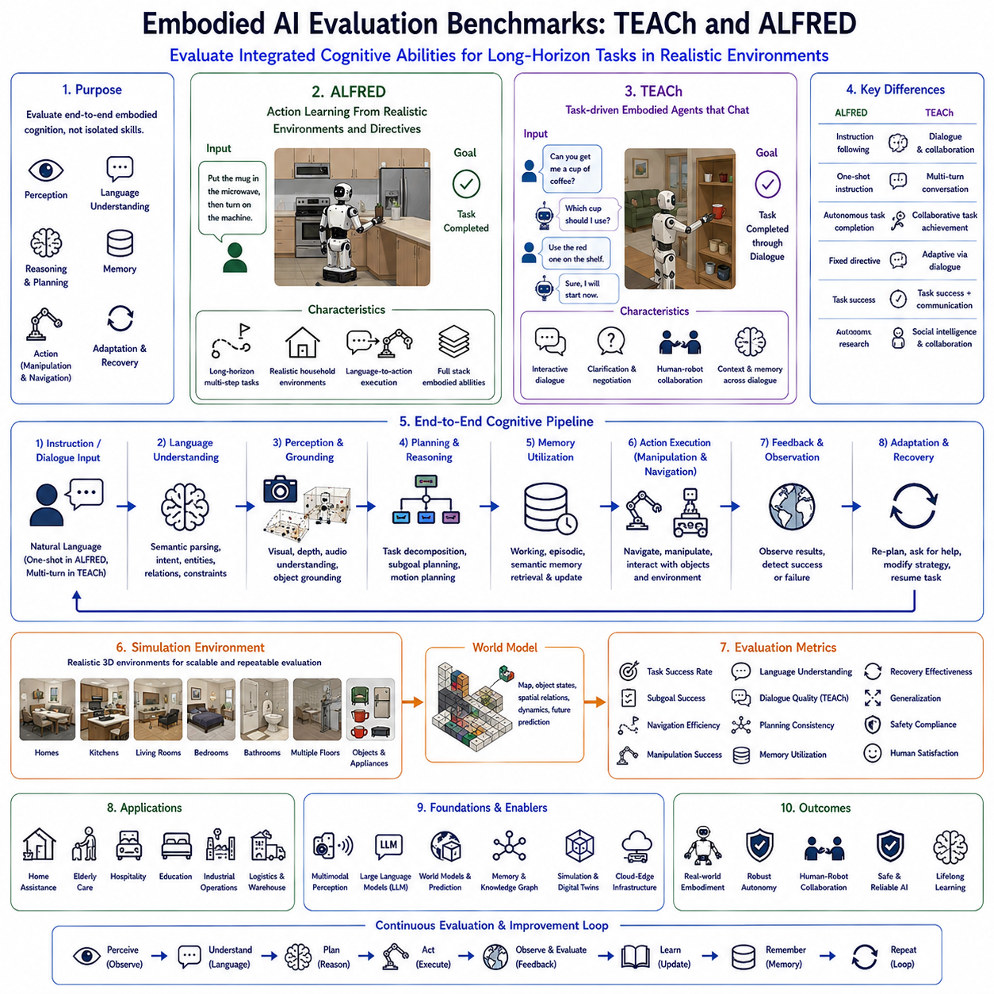
Embodied AI Evaluation Benchmarks provide standardized methodologies for measuring the cognitive capabilities of intelligent robots operating within dynamic physical environments. As Embodied Artificial Intelligence, Vision-Language-Action (VLA), and Physical AI systems become increasingly sophisticated, evaluating isolated capabilities such as object recognition or navigation is no longer sufficient. Modern embodied agents must integrate perception, language understanding, reasoning, memory, planning, manipulation, navigation, and adaptive decision making into coherent long-horizon behavior. Benchmarks such as TEACh and ALFRED were developed to evaluate these integrated cognitive abilities under realistic interactive environments where robots must continuously interpret human intentions while accomplishing complex multi-step tasks.
Traditional robotics benchmarks primarily measured individual algorithmic performance. Navigation datasets focused on localization accuracy, manipulation benchmarks evaluated grasp success, and vision datasets measured object detection precision. Although these evaluations remain valuable, they cannot fully represent the complexity of real-world embodied intelligence, where autonomous agents must simultaneously perceive, reason, communicate, remember previous experiences, and adapt to continuously changing environments. TEACh and ALFRED therefore shift evaluation toward complete cognitive task execution instead of isolated functional performance.
ALFRED, which stands for Action Learning From Realistic Environments and Directives, was developed to evaluate whether embodied agents can successfully translate natural language instructions into long sequences of physical actions within realistic household environments. Rather than executing predefined action scripts, robots receive high-level language directives such as preparing food, organizing household objects, retrieving items, or cleaning rooms. Successfully completing these tasks requires integrating language understanding, visual perception, navigation, object manipulation, memory, and sequential planning into a unified decision-making process.
One distinguishing characteristic of ALFRED is its emphasis on long-horizon task execution. Instructions rarely correspond to a single action. Instead, a command may require navigating through multiple rooms, locating previously unseen objects, opening cabinets, moving containers, operating appliances, manipulating several objects in sequence, and finally verifying successful completion. Every intermediate action depends upon previous observations and influences future planning. Consequently, ALFRED evaluates whether embodied agents maintain coherent reasoning across extended action sequences rather than optimizing isolated behaviors.
Language understanding represents the first stage of ALFRED evaluation. Large Language Models or multimodal language encoders interpret human instructions by identifying semantic goals, object references, temporal ordering, spatial relationships, procedural dependencies, and implicit constraints. Instructions frequently omit low-level execution details, requiring embodied agents to infer intermediate steps through commonsense reasoning and accumulated environmental knowledge. Successful instruction interpretation therefore depends on semantic understanding rather than syntactic parsing alone.
Visual perception continuously supports execution throughout ALFRED tasks. Cameras, semantic segmentation models, object detection algorithms, instance recognition, depth estimation, and scene understanding collectively identify navigable areas, target objects, environmental context, and manipulation opportunities. Unlike static image recognition benchmarks, perception operates continuously during movement while new observations dynamically update environmental understanding. Embodied perception therefore remains tightly coupled with planning and execution.
Task planning within ALFRED requires hierarchical reasoning. High-level language objectives become decomposed into logically consistent subtasks including exploration, navigation, object search, manipulation, placement, verification, and recovery. Motion planning simultaneously ensures physically feasible trajectories satisfying environmental constraints and collision avoidance requirements. Evaluation therefore measures both symbolic planning quality and physical execution success under realistic interactive conditions.
Memory plays a central role because long-horizon tasks frequently require recalling previous observations. An agent may discover an object early during exploration but manipulate it much later after completing several intermediate objectives. Working memory maintains current execution context while episodic memory stores previous environmental observations, visited locations, manipulated objects, and successful action sequences. Effective memory utilization significantly improves planning efficiency and reduces unnecessary exploration.
TEACh, which stands for Task-driven Embodied Agents that Chat, extends embodied evaluation beyond instruction following by introducing natural human-robot dialogue into long-horizon collaborative tasks. Rather than executing fully specified instructions independently, embodied agents interact continuously with human users throughout task execution. Humans provide incremental guidance, answer clarification questions, correct misunderstandings, modify objectives, and collaborate with autonomous agents while tasks remain in progress. Communication therefore becomes an active component of task completion rather than merely an initial input modality.
Dialogue fundamentally distinguishes TEACh from conventional embodied benchmarks. Human instructions frequently remain incomplete, ambiguous, or context dependent. Robots must recognize uncertainty, request missing information, verify assumptions, explain current progress, negotiate alternative strategies, and communicate execution status naturally. Language interaction therefore supports continual collaboration instead of one-time command interpretation. TEACh consequently evaluates conversational intelligence alongside physical task execution.
Context awareness represents another important evaluation objective within TEACh. Human dialogue often references previously mentioned objects, shared experiences, environmental context, or implicit assumptions rather than explicit descriptions. Embodied agents must maintain dialogue history, conversational memory, environmental context, and evolving task objectives simultaneously. Successful communication therefore depends upon integrating linguistic understanding with ongoing physical interaction.
Embodied collaboration forms the conceptual foundation of TEACh. Humans and robots jointly solve tasks through complementary capabilities rather than functioning independently. Humans contribute high-level reasoning, preferences, and contextual knowledge, while robots provide autonomous perception, navigation, manipulation, and environmental exploration. Evaluation therefore measures collaborative efficiency, communication quality, mutual adaptation, and shared problem-solving effectiveness rather than isolated robotic autonomy alone.
World models significantly enhance benchmark performance across both TEACh and ALFRED. Predictive environmental representations describe object locations, room topology, spatial relationships, manipulation history, environmental dynamics, and future state predictions. Continuous updates derived from perception and executed actions allow robots to anticipate consequences before physical execution begins. World models therefore improve planning robustness, reduce redundant exploration, and support efficient long-horizon reasoning.
Large Language Models increasingly function as central reasoning engines within these benchmarks. Rather than merely interpreting instructions, LLMs infer missing procedural knowledge, explain environmental observations, prioritize competing objectives, resolve ambiguities, retrieve relevant episodic memories, predict object locations using commonsense reasoning, and generate natural dialogue throughout collaborative interaction. Integration between language reasoning and embodied perception therefore represents one of the defining research directions evaluated by modern benchmarks.
Failure recovery constitutes another critical evaluation component. During long-horizon execution, robots inevitably encounter missing objects, blocked pathways, unsuccessful manipulations, localization uncertainty, communication misunderstandings, or environmental changes. Intelligent embodied agents detect execution failures, diagnose probable causes, request clarification when necessary, modify plans dynamically, and preserve completed progress while continuing toward overall mission objectives. Recovery performance therefore provides an important indicator of practical cognitive robustness.
Generalization remains one of the principal goals of embodied evaluation. High-performing systems must operate successfully within previously unseen environments containing unfamiliar layouts, novel object arrangements, varying illumination conditions, different task combinations, and changing human communication styles. Benchmark performance therefore reflects genuine embodied intelligence only when learned knowledge transfers beyond specific training scenarios. Zero-shot reasoning, few-shot adaptation, and cross-domain generalization have consequently become increasingly important evaluation metrics.
Simulation environments provide the operational foundation for both TEACh and ALFRED. Interactive household simulators accurately model rooms, furniture, appliances, manipulable objects, navigation constraints, and realistic physics while supporting repeatable experimentation under standardized conditions. Simulation enables large-scale evaluation across thousands of diverse scenarios while avoiding the cost, safety concerns, and logistical limitations associated with physical robot deployments.
Industrial relevance continues to increase as embodied benchmarks evolve beyond household environments. Future evaluation scenarios are expected to incorporate manufacturing facilities, warehouses, hospitals, laboratories, airports, logistics centers, and infrastructure inspection tasks. Enterprise workflows involving Manufacturing Execution Systems, Warehouse Management Systems, Digital Twins, predictive maintenance platforms, and collaborative industrial robotics will increasingly influence benchmark design. Consequently, embodied evaluation will become progressively aligned with practical deployment requirements.
Safety remains an independent supervisory objective throughout benchmark evaluation. Collision avoidance, manipulation safety, human awareness, workspace restrictions, localization integrity, emergency stopping, cybersecurity validation, and regulatory compliance operate continuously regardless of task objectives. Successful benchmark performance therefore requires balancing autonomous intelligence with deterministic operational safety rather than maximizing task completion alone.
Evaluation metrics extend far beyond simple success rates. Researchers assess language understanding quality, semantic grounding accuracy, dialogue effectiveness, navigation efficiency, object search performance, manipulation success, planning consistency, memory utilization, reasoning quality, uncertainty estimation, recovery effectiveness, collaboration efficiency, computational cost, energy efficiency, long-horizon stability, generalization capability, and human satisfaction. Comprehensive evaluation therefore measures the complete embodied cognitive pipeline rather than isolated algorithmic components.
Future embodied AI benchmarks will continue evolving toward increasingly realistic cognitive evaluations integrating multimodal foundation models, predictive world models, lifelong memory, continual learning, cloud-edge collaboration, digital twins, distributed multi-agent coordination, and advanced Large Language Models. Rather than evaluating isolated robotic functions, future benchmarks will assess complete autonomous cognition across perception, language, reasoning, planning, memory, communication, manipulation, navigation, collaboration, recovery, and lifelong adaptation. TEACh, ALFRED, and their future successors will therefore remain foundational evaluation frameworks guiding the development of next-generation Physical AI systems capable of operating intelligently, safely, and collaboratively within complex real-world environments.

7.10 Deployment on Physical Robots (with Code)
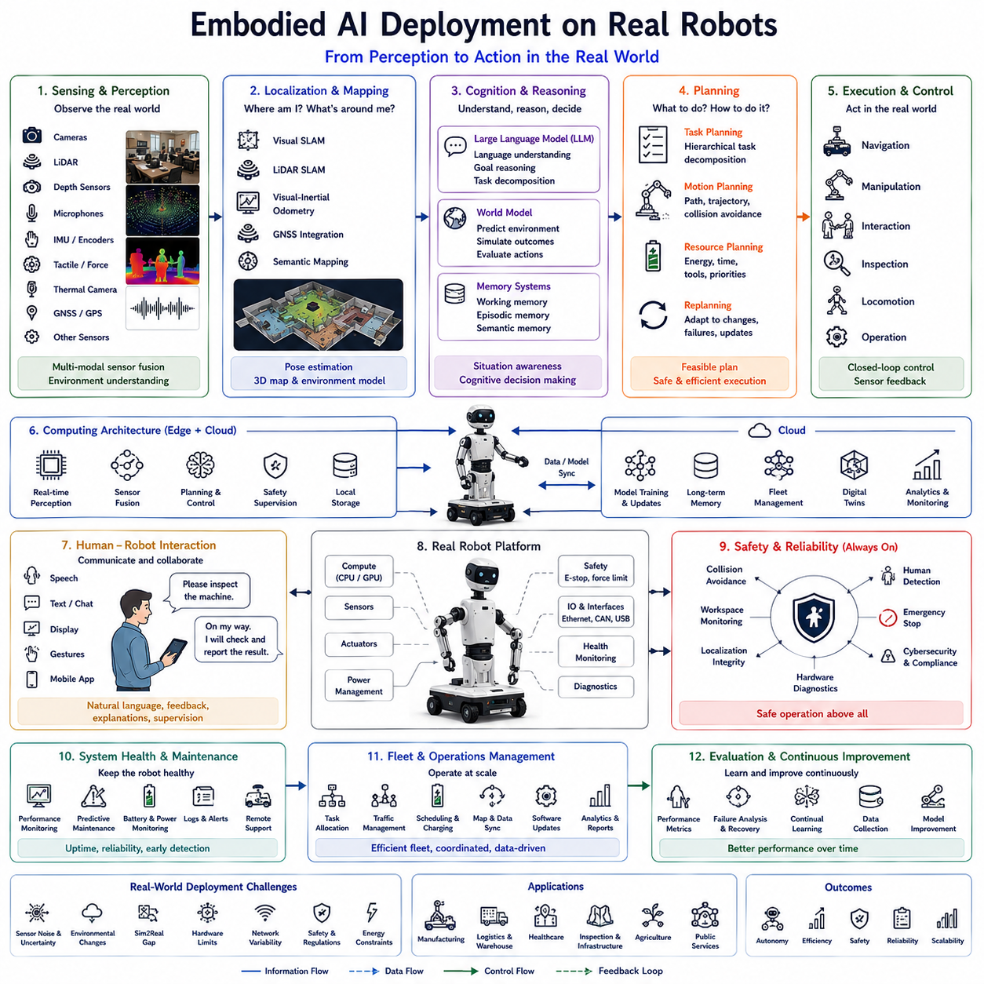
Deploying Embodied Artificial Intelligence on real robotic platforms represents the final and most challenging stage of the complete Vision-Language-Action (VLA) development pipeline. While simulation environments enable rapid algorithm development and large-scale data collection, real-world deployment introduces physical uncertainty, sensor imperfections, hardware limitations, environmental variability, safety constraints, and long-term operational requirements that cannot be fully replicated in simulation. Successful deployment therefore requires much more than transferring trained neural networks onto robotic hardware. It demands the integration of perception, cognition, planning, memory, communication, motion control, safety supervision, computing infrastructure, and system engineering into a reliable autonomous robotic platform capable of operating continuously in real environments.
Embodied AI deployment begins by recognizing that intelligence emerges through continuous interaction between computation and physical embodiment. Cameras, LiDAR, depth sensors, tactile sensors, force sensors, inertial measurement units, wheel encoders, microphones, thermal cameras, GNSS receivers, and numerous additional sensing modalities provide real-time observations describing both the external environment and the robot's internal operational state. Unlike simulation, these sensors generate noisy, incomplete, delayed, and occasionally inconsistent measurements. Robust deployment therefore requires perception systems capable of filtering uncertainty while maintaining reliable situational awareness under continuously changing conditions.
Sensor calibration forms one of the most critical stages before deployment. Intrinsic calibration ensures that individual sensors accurately represent physical measurements, while extrinsic calibration establishes precise spatial relationships among multiple sensing devices. Temporal synchronization further guarantees that observations collected from different sensors correspond to the same physical moment. Inaccurate calibration or synchronization frequently produces localization errors, degraded perception, unstable mapping, and unreliable decision making. Consequently, calibration becomes a foundational engineering requirement for every embodied robotic platform.
Localization and mapping remain essential during real-world deployment. Simultaneous Localization and Mapping (SLAM), Visual SLAM, LiDAR SLAM, Visual-Inertial Odometry, GNSS integration, and semantic mapping cooperate to estimate robot position while constructing continuously updated environmental representations. Unlike laboratory demonstrations, deployment environments contain moving people, temporary obstacles, lighting variation, weather changes, reflective surfaces, and evolving infrastructure. Robust localization therefore combines multiple sensing modalities with probabilistic estimation techniques to maintain reliable operation despite environmental uncertainty.
Real-world perception extends beyond object recognition toward comprehensive environmental understanding. Cameras identify semantic objects and human activities, LiDAR measures three-dimensional geometry, depth sensors estimate surface structure, microphones capture spoken instructions and environmental sounds, thermal sensors detect temperature anomalies, while force and tactile sensors monitor physical interaction during manipulation. Multimodal sensor fusion combines these complementary observations into coherent world representations supporting navigation, manipulation, inspection, communication, and decision making.
Computing architecture plays a decisive role during deployment because embodied intelligence requires substantial computational resources under strict latency constraints. Edge computing platforms perform real-time perception, sensor fusion, planning, and control directly on the robot, minimizing communication delay while preserving operational autonomy. Cloud computing supports large-scale model updates, long-term knowledge management, fleet coordination, digital twins, and computationally intensive learning tasks. Hybrid cloud-edge architectures therefore balance responsiveness with scalable intelligence, allowing robots to continue operating safely even when network connectivity becomes unavailable.
Large Language Models increasingly function as cognitive reasoning engines during deployment rather than remaining offline research tools. Natural language instructions are translated into semantic goals, task decompositions, execution plans, and recovery strategies while maintaining awareness of environmental context, safety constraints, organizational policies, and user preferences. However, deterministic execution remains separated from language reasoning. High-level cognitive decisions generated by language models are validated by symbolic planners, motion planners, safety supervisors, and hardware controllers before physical execution begins. This layered architecture ensures both flexibility and operational reliability.
World models provide predictive environmental understanding throughout deployment. Instead of reacting solely to immediate observations, embodied agents maintain continuously evolving internal representations describing object locations, environmental topology, dynamic obstacles, human activities, equipment states, and future environmental evolution. Predictive simulation enables candidate actions to be evaluated internally before execution, reducing operational risk while improving planning quality. World models therefore become central components supporting long-horizon autonomy within real environments.
Memory systems significantly enhance long-term deployment capability. Working memory maintains current observations, active goals, dialogue context, and execution status. Episodic memory records operational history, encountered failures, successful recovery procedures, environmental changes, and collaborative interactions. Semantic memory stores organizational knowledge, operational procedures, object properties, facility layouts, and safety regulations. These complementary memory systems enable robots to accumulate experience continuously rather than repeating identical reasoning throughout successive missions.
Task planning during deployment integrates symbolic reasoning with physical feasibility. High-level objectives become decomposed into executable subtasks involving navigation, perception, manipulation, inspection, communication, verification, and reporting. Motion planning simultaneously generates collision-free trajectories respecting robot kinematics, environmental constraints, energy limitations, human safety, and operational priorities. Dynamic replanning occurs whenever environmental changes invalidate existing plans, allowing autonomous missions to continue despite unexpected events.
Embodied deployment requires robust sensorimotor control capable of executing cognitive decisions safely within uncertain physical environments. Mobile platforms, robotic manipulators, end-effectors, locomotion systems, balance controllers, force controllers, and compliant interaction mechanisms continuously adapt to modeling errors, terrain variation, object uncertainty, and external disturbances. Closed-loop feedback from onboard sensors ensures that execution remains synchronized with actual environmental conditions rather than relying solely upon predictive models.
Human-robot interaction becomes substantially more important after deployment because autonomous systems rarely operate without human presence. Natural language communication allows operators to specify goals, request explanations, modify execution priorities, clarify ambiguities, and supervise long-duration missions. Robots similarly communicate execution progress, uncertainty estimates, detected anomalies, safety warnings, recovery strategies, and mission summaries through multimodal interfaces combining speech, text, visual displays, gestures, and mobile applications. Transparent communication significantly improves trust and operational acceptance.
Safety supervision remains independent from cognitive reasoning throughout deployment. Collision avoidance, force limitation, workspace monitoring, human detection, emergency stopping, localization integrity monitoring, cybersecurity validation, power management, hardware diagnostics, and regulatory compliance continuously constrain robot behavior regardless of autonomous decision making. Functional safety architectures therefore guarantee that failures within higher-level reasoning modules cannot directly compromise human safety or equipment protection.
System health monitoring represents another essential deployment capability. Internal diagnostics continuously observe processor utilization, GPU workload, memory consumption, communication latency, battery condition, motor temperatures, sensor health, storage capacity, network quality, and actuator status. Predictive maintenance algorithms identify gradual degradation before failures occur, allowing maintenance scheduling without interrupting critical operational missions. Health monitoring therefore extends embodied cognition beyond external perception toward comprehensive self-awareness.
Fleet management becomes increasingly important as organizations deploy multiple autonomous robots simultaneously. Fleet management systems coordinate task allocation, traffic control, charging schedules, software updates, map synchronization, operational analytics, digital twin integration, and cloud-based memory sharing. Individual robots therefore contribute experience toward collective organizational intelligence while maintaining decentralized autonomy during local mission execution.
Simulation-to-Real transfer remains a fundamental engineering challenge because models trained within virtual environments frequently encounter unexpected physical conditions after deployment. Domain randomization, sensor noise modeling, photorealistic simulation, physics randomization, continual learning, online adaptation, and digital twin synchronization collectively reduce discrepancies between simulated and physical environments. Nevertheless, continuous real-world learning remains essential because operational environments evolve throughout deployment.
Industrial deployment introduces integration requirements extending beyond robotic subsystems alone. Manufacturing Execution Systems, Enterprise Resource Planning platforms, Warehouse Management Systems, inspection databases, maintenance scheduling systems, production planning software, digital twins, quality management platforms, and enterprise cybersecurity policies all influence robotic decision making. Embodied AI therefore functions as one component within a much larger industrial information ecosystem rather than an isolated autonomous machine.
Performance evaluation during deployment extends beyond laboratory accuracy metrics. Organizations assess operational availability, mission completion rate, mean time between failures, recovery effectiveness, navigation efficiency, manipulation success, human collaboration quality, energy consumption, computational efficiency, maintenance requirements, cybersecurity resilience, software reliability, user satisfaction, regulatory compliance, and overall return on investment. Long-term deployment success therefore depends equally upon engineering reliability and cognitive capability.
Continual learning enables deployed robots to improve autonomously throughout operational life. New environmental observations refine world models, successful task executions strengthen procedural knowledge, repeated interactions personalize communication behavior, and accumulated experience enhances planning efficiency. Learning mechanisms carefully preserve previously acquired knowledge while incorporating new information without catastrophic forgetting. This lifelong adaptation allows embodied agents to remain effective despite evolving facilities, changing workflows, and shifting operational objectives.
Future embodied AI deployment will increasingly combine multimodal foundation models, predictive world models, lifelong memory, continual learning, digital twins, cloud-edge computing, distributed fleet intelligence, advanced Large Language Models, and cognitive reasoning architectures into unified autonomous robotic ecosystems. Rather than functioning as isolated automation devices, future embodied robots will become continuously learning cognitive partners capable of understanding language, reasoning about complex environments, collaborating naturally with people, coordinating across multiple robotic platforms, and adapting safely throughout years of real-world operation. Such deployment architectures will define the next generation of Physical AI systems across manufacturing, logistics, healthcare, infrastructure inspection, agriculture, scientific exploration, public services, and many other industries where long-term autonomous intelligence provides measurable operational value.

