Volume 20. Vision Language Action (VLA) Models

Chapter 9. Generalist Robot Policies

9.1 Generalist Policies Across Tasks and Embodiments
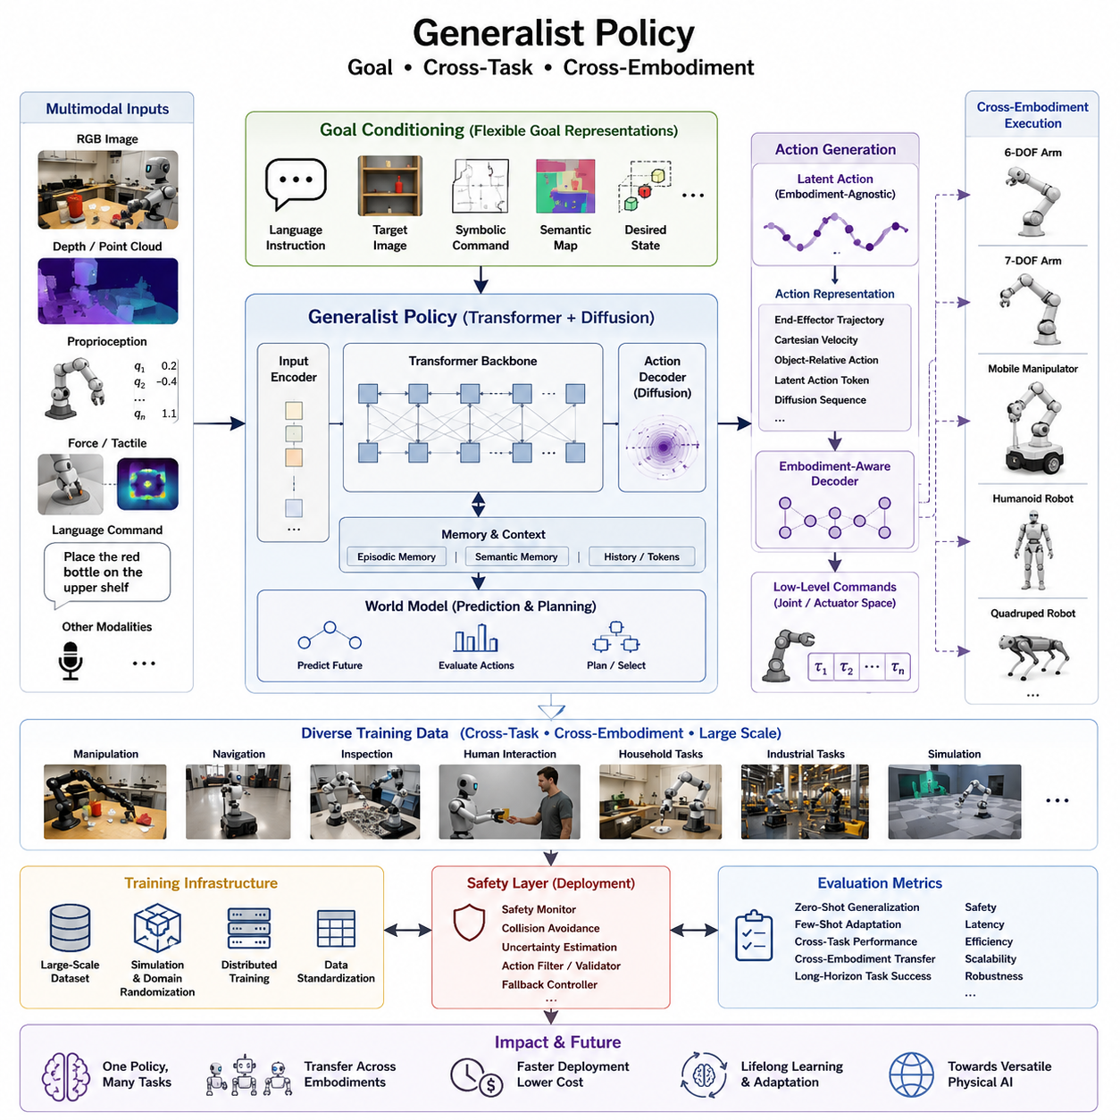
Generalist robot policies represent a major shift in robotics intelligence by moving away from task-specific control systems toward unified policies capable of solving a wide variety of manipulation, navigation, inspection, and interaction problems using a single neural architecture. Instead of developing and maintaining separate policies for every robot and every application, a generalist policy learns universal representations of perception, reasoning, and action that can be transferred across different tasks, environments, and robotic embodiments. This paradigm is strongly inspired by the success of foundation models in natural language processing and computer vision, where a single pretrained model can be adapted to many downstream applications with minimal additional training. In robotics, the same concept enables robots with different mechanical structures to share a common understanding of goals while producing embodiment-specific actions.
The fundamental objective of a generalist policy is to map observations and goals directly into executable robot actions regardless of the specific task being performed. The policy receives multimodal sensory information including RGB images, depth maps, point clouds, proprioceptive measurements, force sensing, tactile information, and language instructions. These heterogeneous inputs are transformed into a shared latent representation that captures both semantic understanding and physical interaction constraints. Instead of reasoning only about low-level actuator commands, the model develops higher-level concepts such as objects, affordances, spatial relationships, task progress, and environmental context. These abstract representations provide a common language that enables knowledge learned in one domain to improve performance in many others.
Goal conditioning is one of the defining characteristics of modern generalist policies. Rather than encoding a fixed task into the network architecture, the desired objective is provided dynamically during inference. Goals may be represented as natural language instructions, target images, symbolic commands, semantic maps, desired object states, or combinations of multiple modalities. A language instruction such as “place the red bottle into the upper shelf” provides semantic intent, while an accompanying image may specify the exact target arrangement. The policy interprets these goal representations and continuously aligns current observations with the desired outcome throughout task execution.
Cross-task generalization refers to the ability of a single policy to perform many different tasks without requiring independent retraining. Traditional robotic systems typically contain separate controllers for grasping, navigation, pick-and-place operations, inspection, obstacle avoidance, or manipulation. A generalist policy instead integrates these behaviors within one unified decision-making framework. During training, the model encounters a broad distribution of demonstrations covering hundreds or even thousands of tasks. Rather than memorizing individual solutions, the network discovers reusable behavioral primitives such as reaching, approaching, rotating, lifting, pushing, opening, closing, inserting, aligning, and transporting. Complex tasks naturally emerge as compositions of these reusable motion primitives.
Task diversity plays a critical role in developing robust generalization capabilities. Training datasets intentionally include variations in object geometry, lighting conditions, backgrounds, sensor noise, camera viewpoints, robot velocities, workspace configurations, and interaction sequences. The model gradually learns invariances that allow it to recognize the same underlying task despite superficial environmental differences. As dataset diversity increases, policy robustness also improves because the learned representations become less dependent on individual examples and more reflective of fundamental physical relationships.
Cross-embodiment learning extends generalization beyond tasks into the physical structure of robots themselves. Robots differ substantially in their numbers of joints, workspace dimensions, payload capacities, locomotion mechanisms, sensing configurations, actuator dynamics, and kinematic constraints. Historically, each embodiment required an entirely separate control policy because joint commands from one robot were meaningless for another. Generalist policies overcome this limitation by learning embodiment-independent latent action representations while simultaneously incorporating embodiment-specific information during action decoding.
Embodiment information may include robot morphology, kinematic chains, joint limits, actuator characteristics, end-effector descriptions, sensor placement, wheel configurations, or mobility constraints. During inference, the policy first reasons about the desired physical behavior independently of hardware details. Only in the final stages of computation are these high-level intentions translated into robot-specific commands through embodiment-aware decoding modules. This separation enables robots with fundamentally different structures to share substantial portions of the same learned intelligence.
Cross-embodiment policy transfer dramatically reduces the amount of training data required for new robotic platforms. Instead of collecting millions of demonstrations for every new robot, developers can fine-tune an existing generalist policy using a relatively small dataset specific to the target embodiment. The pretrained model already understands concepts such as object permanence, grasp stability, obstacle avoidance, and task sequencing. Fine-tuning primarily adapts motion generation to the unique physical characteristics of the new platform while preserving the previously acquired semantic knowledge.
A major challenge in cross-embodiment learning arises from the mismatch between action spaces. One manipulator may possess six degrees of freedom, another seven, while a humanoid robot may control dozens of joints simultaneously. Mobile manipulators combine locomotion and manipulation into a single action space, whereas quadruped robots must coordinate balance with navigation. Generalist policies therefore avoid directly predicting joint commands whenever possible. Instead, they frequently operate within intermediate representations such as end-effector trajectories, Cartesian velocities, object-relative actions, latent motion tokens, or diffusion-generated action sequences before translating these abstractions into hardware-specific control signals.
Large-scale robot datasets have become essential for training generalist policies. Modern datasets aggregate demonstrations collected from laboratories, industrial facilities, homes, warehouses, simulation environments, and teleoperation platforms. Data may originate from multiple robot manufacturers with varying sensor suites and mechanical designs. Careful normalization procedures transform these heterogeneous datasets into unified representations that preserve task semantics while minimizing embodiment-specific inconsistencies. Data standardization significantly improves transfer learning across organizations and research groups.
Simulation plays an equally important role because collecting real-world demonstrations at sufficient scale remains expensive and time-consuming. Physics simulators generate billions of interaction samples under highly diverse environmental conditions. Domain randomization introduces variations in textures, lighting, friction coefficients, object masses, camera calibration, sensor latency, and actuator uncertainty. These randomized experiences encourage policies to focus on physically meaningful features rather than environment-specific details. Sim2Real adaptation techniques subsequently bridge the remaining differences between simulated and physical robots.
Transformer architectures have emerged as the dominant foundation for generalist policies due to their ability to integrate multimodal information over long temporal horizons. Self-attention mechanisms allow visual observations, language instructions, proprioceptive states, historical actions, and memory tokens to interact within a unified computational framework. The resulting contextual embeddings encode both immediate sensory information and long-term task dependencies. Temporal attention also enables policies to reason over extended manipulation sequences rather than relying solely on instantaneous observations.
Diffusion-based action generation has recently demonstrated remarkable improvements in producing smooth, multimodal robot motions. Instead of predicting a single deterministic action, diffusion policies iteratively refine noisy motion trajectories into physically plausible behaviors that satisfy task constraints. This probabilistic framework naturally models uncertainty, supports multiple valid solutions, and generates more robust motions in cluttered or ambiguous environments. Diffusion-based policies have therefore become an increasingly important component of generalist robot intelligence.
Memory mechanisms further enhance long-horizon decision making. Complex household, warehouse, and industrial tasks often require remembering previous observations, completed subtasks, object locations, or earlier failures. Episodic memory modules allow policies to retain relevant information across extended interaction sequences, while semantic memory stores reusable knowledge accumulated from previous experiences. These memory systems significantly improve planning efficiency and reduce redundant exploration.
Generalist policies increasingly integrate world models that predict future environmental states before executing physical actions. Instead of reacting only to current observations, the robot internally simulates multiple possible futures and evaluates the consequences of alternative action sequences. Predictive world models improve planning accuracy, enhance safety, reduce collision risks, and support more sophisticated reasoning under uncertainty. This predictive capability becomes particularly valuable for long-horizon manipulation tasks involving dynamic environments.
Safety remains a critical consideration when deploying generalist policies in real-world systems. Because the policy operates across many tasks and embodiments, failures may propagate into previously unseen situations. Practical deployments therefore incorporate safety monitors, rule-based validators, collision avoidance systems, uncertainty estimation, action filtering, and fallback controllers. Human supervision mechanisms may interrupt or override policy outputs whenever confidence falls below predefined thresholds. These layered safety architectures ensure that the flexibility of generalist intelligence does not compromise operational reliability.
Evaluation of generalist policies requires benchmarks extending beyond traditional task-specific success rates. Researchers measure zero-shot generalization, few-shot adaptation, cross-domain robustness, embodiment transfer efficiency, long-horizon task completion, safety performance, computational efficiency, inference latency, and scalability. Successful policies demonstrate not only high accuracy on familiar tasks but also the ability to solve entirely new problems using previously acquired knowledge. Benchmark suites increasingly include heterogeneous robots operating across laboratories, homes, warehouses, factories, and outdoor environments to assess genuine generalization rather than memorization.
Industrial adoption of generalist policies is expected to transform robot deployment workflows. Manufacturers will increasingly distribute pretrained foundation policies instead of highly specialized application software. System integrators will adapt these foundation models to customer requirements using modest quantities of demonstration data. This approach substantially reduces engineering costs, shortens deployment timelines, and simplifies maintenance across diverse robot fleets. Organizations operating heterogeneous robots can maintain a common intelligence platform while supporting multiple embodiments and application domains.
The future direction of generalist robot policies lies in scaling training datasets, expanding embodiment diversity, improving multimodal reasoning, strengthening world model integration, and enabling continual learning during deployment. Future systems will progressively evolve from collections of isolated task-specific controllers into unified cognitive architectures capable of understanding goals, transferring experience across embodiments, collaborating with humans, and autonomously adapting to entirely new environments. Such generalist policies form one of the foundational technologies supporting the long-term vision of versatile Physical AI systems capable of operating reliably across the full spectrum of real-world robotic applications.

9.2 Open X-Embodiment Dataset (with Code)
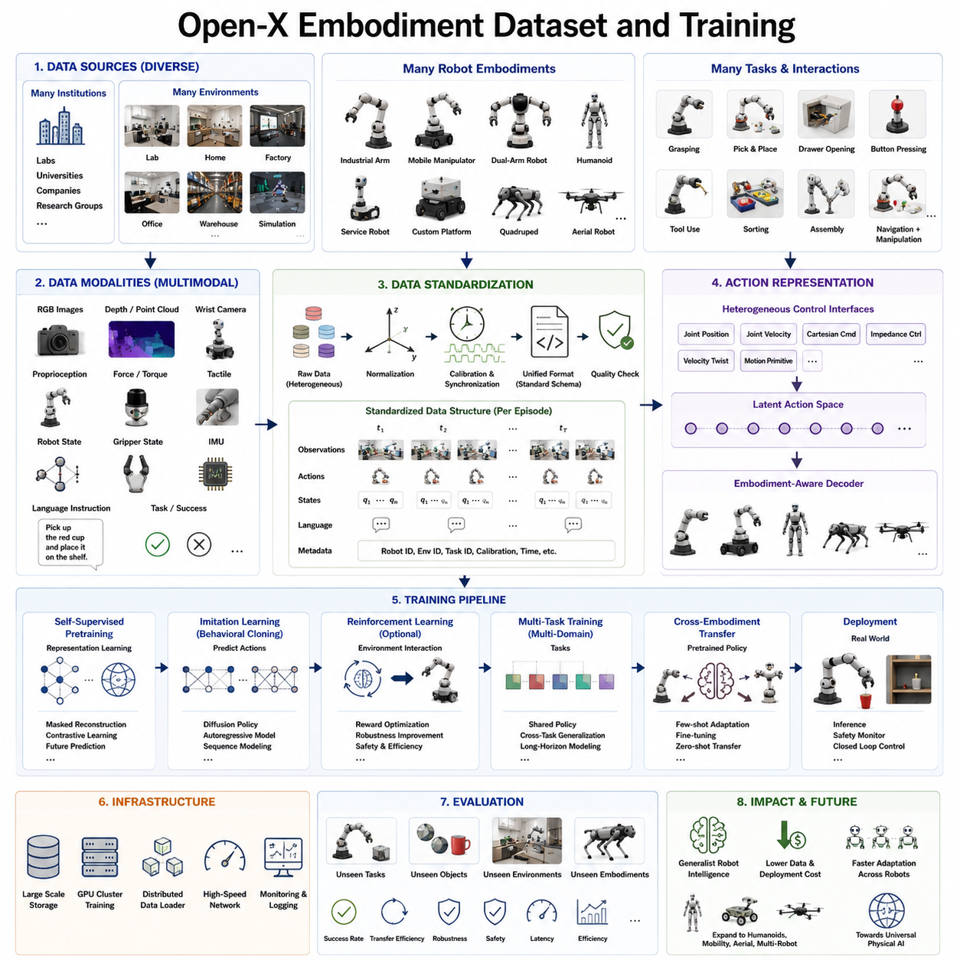
The Open-X Embodiment Dataset represents one of the most significant milestones in the evolution of general-purpose robotic intelligence. Rather than collecting demonstrations from a single laboratory or a single robot platform, the Open-X initiative aggregates robot interaction data from numerous research institutions, robot embodiments, environments, and manipulation tasks into a unified large-scale dataset. The primary objective is to enable the development of generalist robot policies capable of transferring knowledge across tasks, environments, and physical embodiments. Inspired by the scaling success of large language models and foundation vision models, Open-X Embodiment applies the same philosophy to robotics by emphasizing diversity, scale, and standardized data representation.
Traditional robot learning datasets were usually limited to a specific manipulator, a fixed workspace, or a narrow set of manipulation skills. While these datasets were sufficient for solving isolated research problems, they lacked the diversity required for robust generalization. A robot trained only to stack blocks inside a laboratory often struggled when deployed in unfamiliar environments or on different robot hardware. Open-X Embodiment addresses this limitation by combining demonstrations collected from many robot systems operating under different physical conditions. The resulting dataset exposes learning algorithms to far richer distributions of observations, actions, object categories, environmental layouts, and interaction patterns.
A defining characteristic of the Open-X Embodiment Dataset is embodiment diversity. Participating datasets originate from robotic systems with substantially different mechanical structures, including fixed industrial manipulators, mobile manipulators, dual-arm robots, humanoids, research platforms, service robots, and custom laboratory systems. These robots possess different numbers of joints, actuator configurations, end-effectors, sensor placements, payload capacities, workspaces, and control interfaces. Instead of treating these differences as obstacles, Open-X considers embodiment diversity as a valuable source of transferable knowledge. The dataset encourages models to discover abstract action representations that remain useful despite hardware differences.
Task diversity is equally important. Demonstrations include grasping, pick-and-place operations, drawer opening, cabinet manipulation, button pressing, object sorting, tool usage, container organization, kitchen assistance, tabletop assembly, navigation-assisted manipulation, object relocation, and numerous household activities. Many tasks are intentionally represented with multiple execution strategies, allowing models to learn that several different action sequences may successfully accomplish the same objective. This multimodal characteristic improves policy flexibility during deployment.
Environmental diversity further strengthens generalization capability. Data are collected under varying lighting conditions, camera viewpoints, background textures, object arrangements, workspace geometries, and sensor noise levels. Some demonstrations occur inside highly controlled research laboratories, while others originate from realistic homes, industrial facilities, offices, or simulated environments. The resulting variability reduces overfitting and encourages policies to focus on semantic understanding rather than superficial visual appearance.
Sensor diversity constitutes another important dimension of the dataset. Robots contribute RGB images, stereo vision, depth cameras, point clouds, wrist-mounted cameras, force sensing, tactile measurements, proprioceptive joint states, end-effector poses, gripper status, inertial measurements, and language annotations. Not every robot provides identical sensing modalities, requiring the learning architecture to operate under partially observable conditions. Robust multimodal fusion therefore becomes an essential capability rather than an optional enhancement.
Language supervision plays an increasingly important role within Open-X Embodiment. Natural language descriptions accompany many demonstrations, providing semantic interpretations of robot behavior. Language instructions specify task objectives, object identities, spatial relationships, desired outcomes, and interaction constraints. Rather than learning only from motion trajectories, the model simultaneously develops associations between visual observations, linguistic concepts, and physical actions. This multimodal alignment enables language-conditioned robot behavior and supports zero-shot instruction following.
Data standardization is one of the largest engineering challenges within Open-X Embodiment. Individual laboratories often employ different coordinate systems, camera calibrations, timestamp conventions, robot control frequencies, joint naming schemes, and action representations. Before unified training becomes possible, heterogeneous datasets must be converted into standardized formats that preserve semantic consistency while minimizing information loss. Common metadata structures define observations, actions, robot configurations, calibration parameters, task descriptions, timestamps, and episode boundaries. Standardization enables models to interpret demonstrations from different institutions without requiring dataset-specific modifications.
Action representation deserves particular attention because robots possess fundamentally different control interfaces. Some robots expose joint positions, others provide joint velocities, Cartesian end-effector commands, impedance controllers, velocity twists, or high-level motion primitives. Open-X Embodiment encourages learning algorithms to discover latent action spaces that abstract away embodiment-specific interfaces. During inference, embodiment-aware decoders translate these latent actions into robot-specific commands suitable for each hardware platform.
Temporal consistency is carefully preserved throughout the dataset. Every demonstration is organized as a sequence of observations, actions, rewards or success indicators, and environmental transitions. Synchronization across multiple sensors ensures that vision, proprioception, force sensing, and language annotations remain temporally aligned. Accurate temporal alignment is particularly important for transformer architectures that model long-range dependencies across complete interaction sequences.
Data quality directly influences policy performance. Open-X therefore emphasizes demonstration validation, sensor calibration, synchronization accuracy, trajectory completeness, and annotation reliability. Demonstrations containing corrupted sensor streams, missing timestamps, inconsistent coordinate frames, or physically impossible actions are removed or corrected before inclusion. High-quality demonstrations reduce optimization instability and improve downstream policy robustness.
Large-scale distributed training forms the computational foundation of Open-X Embodiment. Training datasets frequently contain millions of trajectories and billions of individual observations, requiring GPU clusters capable of sustained high-throughput optimization. Distributed data loading, gradient synchronization, mixed-precision computation, activation checkpointing, and efficient storage systems enable practical training of transformer-based foundation policies. High-bandwidth storage infrastructure becomes equally important because robotics datasets are significantly larger than traditional image datasets due to continuous sensor streams.
Self-supervised learning significantly expands the value of the dataset. Instead of relying exclusively on manually labeled demonstrations, representation learning objectives exploit temporal consistency, cross-modal prediction, masked token reconstruction, contrastive learning, and future state prediction. These objectives enable models to learn meaningful physical representations even from demonstrations lacking explicit task annotations. Self-supervised pretraining often provides substantial improvements before supervised policy optimization begins.
Imitation learning serves as the primary optimization strategy for many Open-X policies. The model predicts expert actions directly from observed demonstrations, gradually learning to reproduce successful behaviors across many tasks. Behavioral cloning provides stable optimization while preserving the diversity of expert trajectories. More advanced methods incorporate diffusion policies, autoregressive action generation, sequence modeling, or latent action prediction to better capture multimodal behavior distributions.
Reinforcement learning can further refine pretrained policies after imitation learning converges. Starting from a generalist initialization learned from Open-X demonstrations, reinforcement learning optimizes task-specific performance, robustness, safety, or energy efficiency through environmental interaction. Because the policy already possesses broad manipulation knowledge, reinforcement learning requires significantly fewer interactions than training entirely from scratch.
Simulation contributes additional training diversity by generating synthetic demonstrations beyond those collected in the real world. Physics simulators provide unlimited opportunities to explore rare events, dangerous scenarios, or extreme environmental conditions that would be impractical or unsafe to reproduce physically. Domain randomization varies lighting, textures, object masses, friction coefficients, camera parameters, actuator delays, and environmental layouts, improving robustness during subsequent deployment.
Cross-embodiment transfer represents one of the primary scientific objectives of Open-X training. After learning from numerous robot embodiments, the policy acquires generalized representations of manipulation, navigation, perception, and interaction that transfer efficiently to previously unseen hardware. Instead of requiring millions of new demonstrations for every robot platform, only modest adaptation datasets may be sufficient for fine-tuning. This dramatically reduces deployment costs for industrial robotics.
Evaluation protocols emphasize true generalization rather than memorization. Models are tested on unseen tasks, unseen object categories, unfamiliar environments, and previously unavailable robot embodiments. Success rates alone are insufficient; researchers also evaluate adaptation speed, robustness to sensor failures, embodiment transfer efficiency, long-horizon task completion, language understanding, computational efficiency, and inference latency. Comprehensive evaluation ensures that learned policies possess genuine transferable intelligence.
Open-X Embodiment also promotes reproducible robotics research through open data formats, shared evaluation protocols, standardized benchmarks, and publicly accessible training methodologies. Researchers from different institutions can compare algorithms under consistent experimental conditions, accelerating scientific progress while reducing duplicated engineering effort. The open ecosystem encourages collaboration among academia, industry, and open-source communities.
Industrial applications are expected to benefit substantially from Open-X-trained foundation policies. Manufacturing robots, warehouse automation systems, logistics platforms, household assistants, service robots, inspection robots, agricultural machines, and healthcare robotics can all leverage pretrained generalist models as strong initialization points. System integrators may only need limited customer-specific demonstrations to adapt these policies to new applications, reducing engineering costs and shortening deployment schedules.
Future research will likely expand Open-X Embodiment beyond manipulation into full-body humanoid control, mobile navigation, aerial robotics, quadruped locomotion, multi-robot collaboration, and autonomous driving. Larger multimodal datasets combining video, language, force sensing, tactile perception, world models, and long-horizon planning will continue to improve policy generalization. As dataset scale, embodiment diversity, and model capacity continue to increase together, Open-X Embodiment is expected to become one of the foundational infrastructures supporting universal robot intelligence and the next generation of scalable Physical AI systems.

9.3 Cross-Embodiment Policy Transfer (with Code)
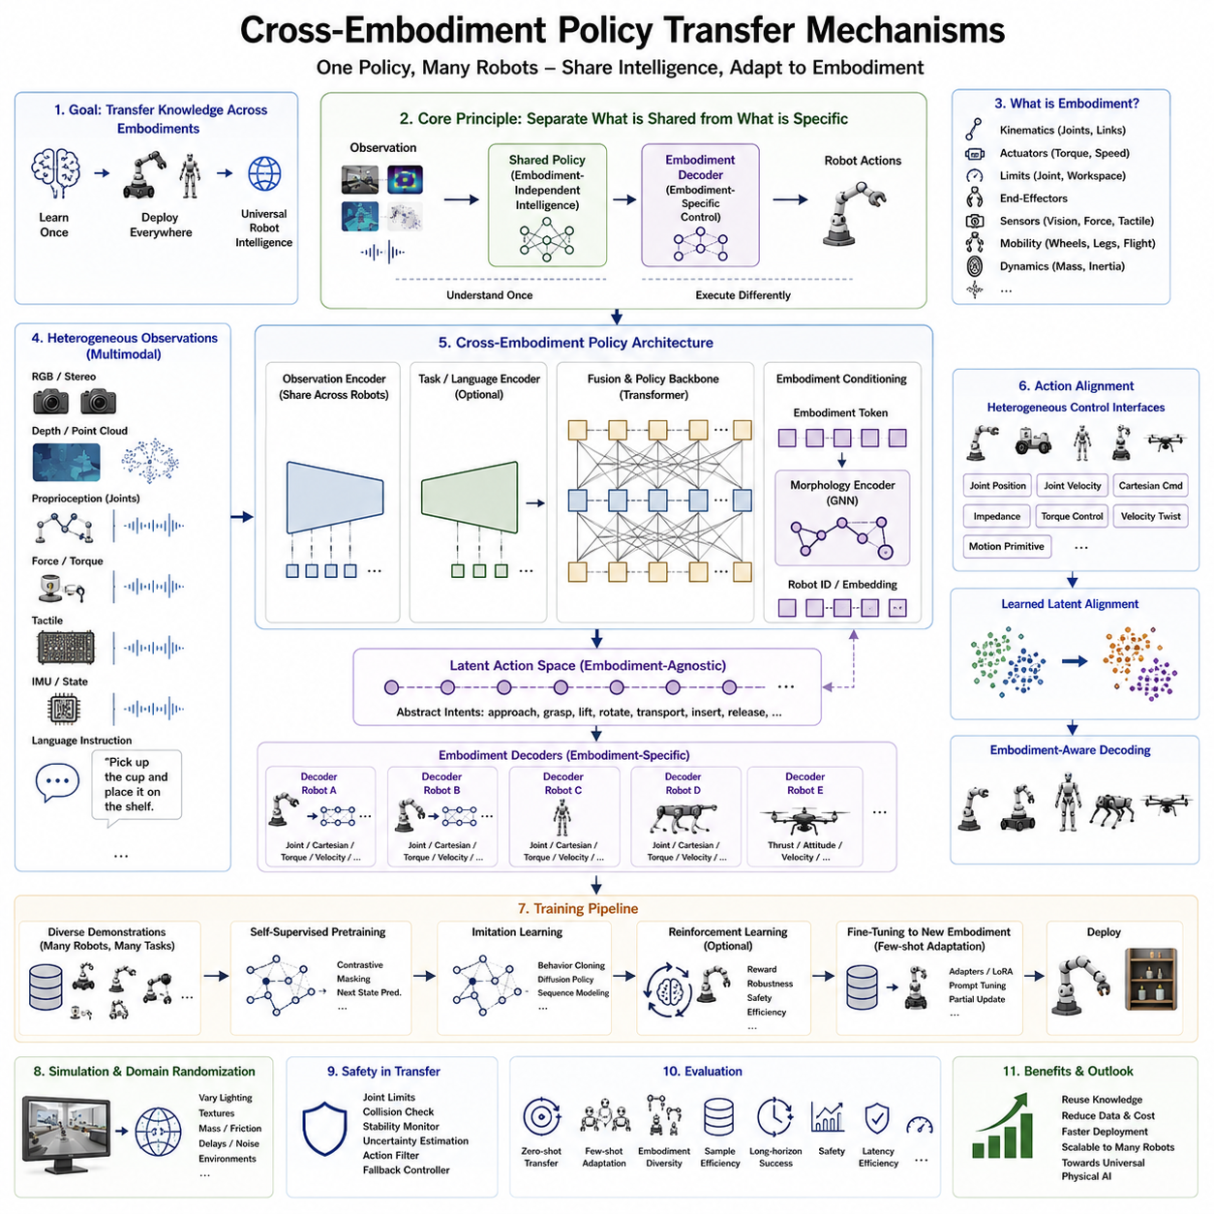
Cross-Embodiment Policy Transfer represents one of the most important research directions in modern robot learning because it enables a single learned policy to operate across robots with substantially different physical structures. Instead of training an entirely new controller whenever a new robot platform is introduced, transfer mechanisms allow previously acquired knowledge to be reused efficiently. This capability dramatically reduces data collection costs, shortens deployment time, and moves robotics closer to the long-term vision of universal robot intelligence. Similar to how large language models transfer linguistic knowledge across many downstream applications, cross-embodiment transfer seeks to develop robot policies whose understanding of manipulation, navigation, perception, and interaction is independent of any single robot morphology.
Traditional robot controllers are tightly coupled to specific hardware. Joint-space trajectories, controller gains, actuator dynamics, kinematic constraints, and sensor configurations are usually designed specifically for one robot platform. Even small mechanical changes often require extensive retraining or controller redesign. A six-degree-of-freedom industrial manipulator cannot directly execute joint trajectories generated for a seven-degree-of-freedom collaborative robot, while a quadruped robot cannot simply reuse locomotion commands developed for a wheeled mobile platform. These differences create significant engineering barriers that limit the scalability of robotic deployment.
Cross-embodiment transfer addresses this limitation by separating embodiment-independent intelligence from embodiment-specific control. Rather than learning low-level actuator commands directly, modern foundation policies first develop abstract representations describing task objectives, object interactions, environmental constraints, spatial relationships, and intended physical behaviors. These high-level latent representations remain largely independent of robot morphology. Only during the final stages of inference are abstract intentions translated into robot-specific control commands through embodiment-aware decoding modules.
Embodiment itself encompasses all physical characteristics that distinguish one robot from another. These characteristics include kinematic structures, numbers of joints, link lengths, joint limits, actuator properties, payload capacities, workspace geometry, mobility mechanisms, end-effectors, sensor placement, camera viewpoints, force sensing capabilities, and dynamic response characteristics. Two robots performing identical manipulation tasks may therefore require entirely different motion trajectories despite sharing the same semantic objective.
The key concept behind transfer learning is that semantic understanding should remain invariant while motor execution adapts to hardware differences. For example, the concept of grasping a cup remains identical whether performed by a dual-arm humanoid, an industrial manipulator, or a mobile service robot. Although each robot executes different joint trajectories, they all share common perceptual understanding, object recognition, spatial reasoning, grasp planning, and task sequencing. Cross-embodiment policies exploit this separation by preserving shared intelligence while adapting motion generation to individual embodiments.
Latent action spaces provide one of the most effective mechanisms for embodiment transfer. Instead of predicting joint commands directly, the policy generates compressed latent action representations encoding intended physical behaviors. These latent actions describe concepts such as approaching an object, establishing contact, lifting, rotating, transporting, inserting, or releasing. Individual embodiment decoders subsequently transform these abstract action representations into hardware-specific joint trajectories. Because only the decoder depends on robot morphology, much of the policy can be shared across numerous robot platforms.
Embodiment tokens have recently emerged as another powerful mechanism for transfer learning. During training, each robot platform is represented by a learned embedding vector describing its physical characteristics. These embeddings capture information regarding joint topology, mobility type, actuator capabilities, workspace dimensions, sensor configuration, and other structural properties. Transformer-based policies condition their predictions on these embodiment tokens, allowing a single neural network to adapt its behavior dynamically according to the target robot without changing the underlying architecture.
Morphology-aware encoders further improve transfer performance by explicitly incorporating robot structural information into representation learning. Instead of treating every robot identically, these encoders receive graph representations describing kinematic trees, joint connectivity, link relationships, and actuator topology. Graph neural networks and transformer architectures process these structural descriptions alongside sensory observations, enabling policies to reason jointly about environmental context and robot morphology. This integrated representation significantly improves transfer across robots with very different mechanical configurations.
Observation alignment is equally important because different robots perceive the environment through different sensor arrangements. Camera locations, field of view, image resolution, depth sensing accuracy, tactile coverage, force sensing, and proprioceptive measurements vary considerably between embodiments. Cross-embodiment policies therefore learn observation encoders capable of extracting invariant semantic representations despite these sensing differences. Self-supervised representation learning and multimodal fusion help bridge observation gaps by emphasizing common physical concepts rather than sensor-specific details.
Action alignment presents an even greater challenge. Robots expose diverse control interfaces including joint positions, joint velocities, Cartesian end-effector commands, impedance control, torque control, velocity twists, and learned motion primitives. Direct correspondence rarely exists between these action spaces. Instead of forcing exact action matching, modern transfer methods learn intermediate representations where similar physical intentions occupy nearby latent regions regardless of their final actuator implementation. This shared latent geometry greatly simplifies adaptation across embodiments.
Demonstration diversity significantly influences transfer quality. Training data should include numerous robot embodiments performing similar tasks using different execution strategies. Exposure to diverse demonstrations encourages policies to distinguish task semantics from embodiment-specific motion patterns. Large datasets such as Open-X Embodiment illustrate how multi-robot demonstrations enable models to discover transferable manipulation concepts that generalize beyond individual hardware platforms.
Multi-task learning naturally complements cross-embodiment transfer. When robots simultaneously learn manipulation, navigation, inspection, assembly, tool usage, and object organization, shared representations become increasingly robust. Features useful across many tasks tend to capture higher-level physical principles instead of memorizing individual behaviors. Consequently, transfer performance improves because learned representations emphasize universal interaction patterns rather than specialized motor sequences.
Foundation policy pretraining has become the dominant paradigm for embodiment transfer. Large transformer models are pretrained using massive heterogeneous robot datasets containing millions of demonstrations collected from numerous institutions. During this stage, policies acquire broad perceptual understanding, language grounding, temporal reasoning, object affordance recognition, and manipulation strategies. Deployment on new robots then requires only lightweight fine-tuning focused primarily on embodiment adaptation rather than learning entirely new skills.
Fine-tuning strategies vary according to available data and computational resources. Full-model fine-tuning updates every network parameter but requires substantial computational effort. Parameter-efficient approaches such as adapters, Low-Rank Adaptation (LoRA), prompt tuning, or lightweight decoder optimization preserve most pretrained knowledge while adapting only small portions of the network. These methods reduce computational cost and minimize catastrophic forgetting of previously acquired capabilities.
Simulation provides an efficient environment for embodiment transfer research because new robot morphologies can be generated rapidly without hardware manufacturing. Physics-based simulators support procedural generation of manipulators, mobile robots, humanoids, quadrupeds, aerial robots, and hybrid systems with varying dimensions, actuator characteristics, and sensor configurations. Policies pretrained across thousands of simulated embodiments often demonstrate improved generalization when transferred to physical robots.
Domain randomization further strengthens transfer robustness by varying textures, lighting, object masses, friction coefficients, actuator delays, camera calibration, sensor noise, and environmental layouts throughout training. Instead of overfitting to a specific simulator configuration, policies learn representations emphasizing stable physical relationships that remain valid across real-world deployments.
World models increasingly contribute to embodiment transfer by predicting future environmental evolution independently of robot morphology. Instead of learning only reactive control policies, robots internally simulate the consequences of candidate actions before execution. Because world models primarily describe external physical dynamics rather than robot-specific mechanics, they provide transferable planning capabilities applicable across multiple embodiments. Embodiment-specific decoders subsequently determine how each robot should realize those predicted interactions.
Safety becomes particularly important during embodiment transfer because behaviors learned on one robot may produce unsafe motions on another. Joint limits, collision boundaries, actuator saturation, payload restrictions, stability margins, and contact dynamics differ substantially across embodiments. Safe deployment therefore incorporates constraint-aware action filtering, uncertainty estimation, collision prediction, stability monitoring, and fallback controllers. Hardware validation layers ensure transferred policies never generate commands exceeding embodiment-specific physical limits.
Evaluation protocols must assess transfer quality comprehensively rather than measuring isolated task success. Researchers evaluate zero-shot transfer without additional training, few-shot adaptation using limited demonstrations, sample efficiency, robustness across embodiment diversity, computational overhead, inference latency, safety compliance, long-horizon task completion, and performance degradation relative to embodiment-specific expert policies. Strong transfer methods achieve high task success while requiring minimal adaptation data.
Industrial applications stand to benefit significantly from reliable cross-embodiment transfer mechanisms. Manufacturers can develop foundation policies once and deploy them across multiple product families, including collaborative manipulators, warehouse robots, inspection systems, healthcare assistants, logistics platforms, agricultural robots, and humanoids. System integrators can customize pretrained policies using relatively small customer-specific datasets, dramatically reducing engineering effort and deployment costs. Maintenance also becomes simpler because improvements learned on one robot platform may propagate across entire product ecosystems.
Future research will continue expanding transfer mechanisms toward increasingly heterogeneous robotic systems. Unified policies capable of controlling wheeled robots, quadrupeds, humanoids, aerial vehicles, underwater robots, and mobile manipulators within a single architecture represent a long-term objective. Advances in world models, multimodal reasoning, foundation policies, graph neural representations, self-supervised learning, and scalable robot datasets will further improve embodiment transfer efficiency. Ultimately, cross-embodiment policy transfer is expected to become one of the foundational technologies enabling universal Physical AI systems capable of acquiring knowledge once and applying it seamlessly across virtually any robotic embodiment.

9.4 Multi-Task Policy Learning (with Code)
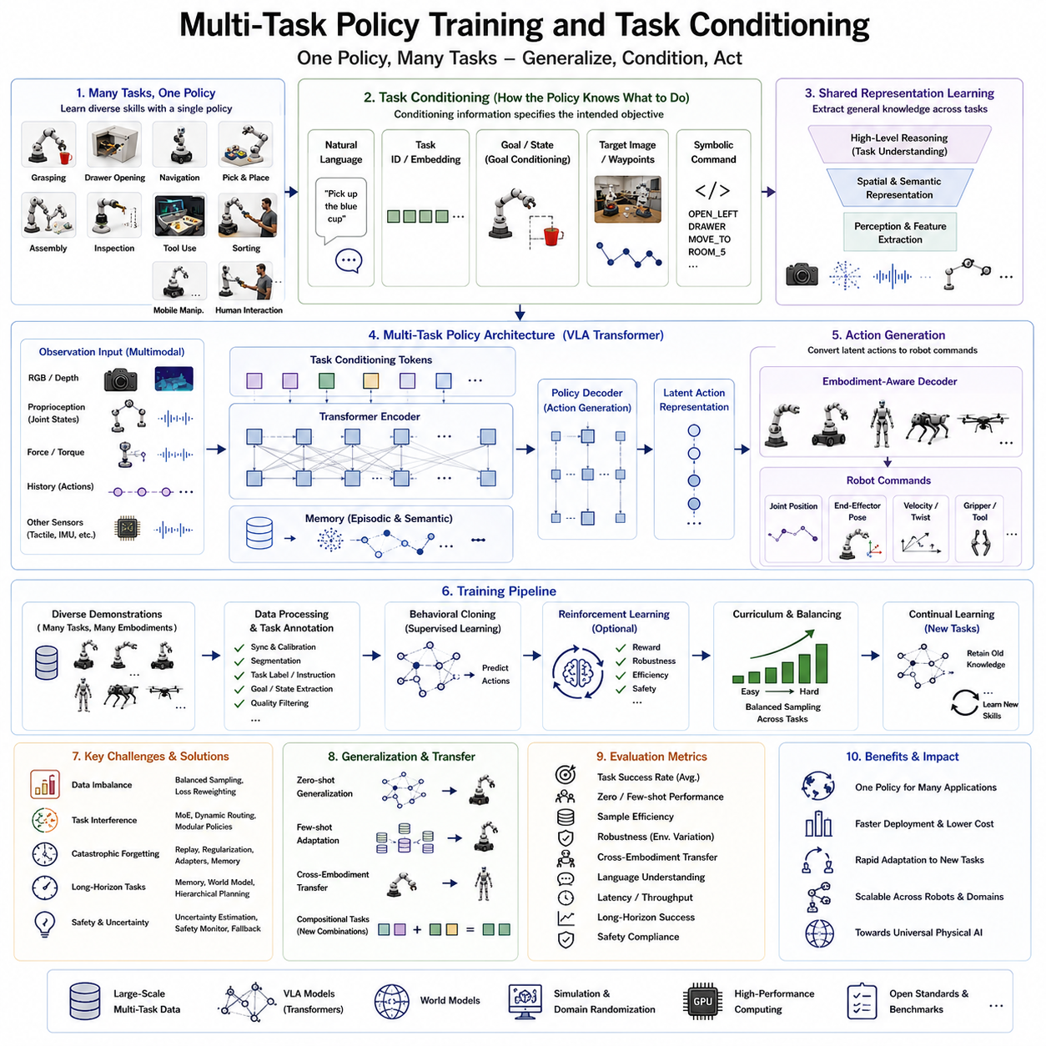
Multi-Task Policy Training represents one of the fundamental technologies enabling general-purpose robot intelligence by allowing a single policy to learn and execute numerous robotic tasks simultaneously. Instead of constructing separate neural networks for grasping, navigation, manipulation, inspection, assembly, or human interaction, a unified policy is optimized using demonstrations collected from many different tasks. The resulting model develops shared representations of perception, reasoning, planning, and action generation that can be reused across application domains. As robot foundation models continue to scale, multi-task learning has become a cornerstone of modern Vision-Language-Action (VLA) systems, enabling robots to solve increasingly diverse problems without requiring task-specific architectures.
Traditional robot learning typically focused on a single task under tightly controlled conditions. A model trained to stack blocks, open drawers, or navigate through a hallway often performed poorly when confronted with new objectives because its learned representations were specialized for one application. Every new capability required collecting another dataset, designing another network, and training another controller. Such isolated development approaches became increasingly expensive as robots were expected to perform hundreds of practical tasks in homes, warehouses, hospitals, and industrial facilities. Multi-task learning addresses this scalability challenge by exposing one policy to a wide spectrum of robotic experiences during training.
The central idea behind multi-task learning is that many robotic tasks share common physical principles. Nearly every manipulation problem requires object detection, spatial reasoning, motion planning, collision avoidance, grasp generation, trajectory optimization, and closed-loop feedback. Instead of learning these capabilities repeatedly for each task, a unified policy develops shared internal representations that capture universal interaction knowledge. Individual tasks differ primarily in their goals rather than in the fundamental mechanics of physical interaction. This observation allows knowledge acquired during one task to accelerate learning in many others.
Task conditioning provides the mechanism through which a single policy distinguishes among multiple objectives. Rather than hard-coding individual task behaviors into separate models, task information is supplied as an additional input during inference. The policy receives sensory observations together with explicit task descriptions that define the desired objective. Conditioning information may take many forms, including natural language instructions, task identifiers, symbolic commands, semantic goals, target images, desired object states, waypoint sequences, or combinations of multiple modalities. This flexible conditioning mechanism enables one neural architecture to generate different behaviors depending on the requested task.
Natural language has become one of the most powerful conditioning modalities because it naturally expresses high-level human intentions. Instructions such as “pick up the blue cup,” “open the left drawer,” “inspect the pipeline,” or “deliver this package to room five” directly specify desired robot behavior without requiring specialized programming. Vision-Language-Action models jointly process visual observations and language instructions, allowing semantic reasoning to guide physical action generation. As language models become more capable, robots increasingly interpret complex multi-step instructions using the same conditioning framework.
Task identifiers represent a simpler conditioning strategy commonly used during supervised learning. Each task is assigned a unique embedding vector learned jointly with the policy network. During inference, the corresponding task embedding informs the network which behavior should be generated. Although less expressive than natural language, learned task embeddings provide efficient conditioning for large-scale multi-task datasets containing hundreds or thousands of predefined robotic skills.
Goal-conditioned learning extends task conditioning by representing desired future states instead of predefined task categories. Rather than specifying “pick up the object,” the goal may be expressed as the final pose of an object, a target image showing the completed arrangement, or a semantic world state describing the desired outcome. Goal-conditioned policies therefore learn general strategies for achieving arbitrary objectives rather than memorizing fixed task definitions. This formulation greatly improves flexibility when robots encounter previously unseen combinations of goals.
Shared representation learning lies at the heart of successful multi-task policies. Early layers of the network learn general-purpose visual features, spatial relationships, object affordances, geometric reasoning, and temporal dynamics that remain useful across nearly all tasks. Higher layers progressively integrate task-specific conditioning information to determine which aspects of the shared representation should influence action generation. This hierarchical organization balances knowledge sharing with task specialization, improving both learning efficiency and final performance.
Transformer architectures have become particularly well suited for multi-task policy learning because self-attention mechanisms naturally integrate multimodal observations with conditioning information. Visual tokens, language embeddings, proprioceptive measurements, historical actions, task embeddings, and memory states interact through attention layers to produce context-dependent action representations. Unlike earlier recurrent architectures, transformers effectively capture long-range dependencies across extended manipulation sequences while maintaining flexibility across highly diverse tasks.
Data diversity is essential for effective multi-task learning. Training datasets intentionally include manipulation, navigation, assembly, inspection, tool usage, object sorting, container organization, mobile manipulation, human interaction, and collaborative operations. Each task is further diversified through variations in object appearance, workspace geometry, environmental conditions, sensor noise, lighting, robot embodiments, and execution strategies. Rich task diversity prevents policies from overfitting to narrow behaviors while encouraging discovery of reusable physical concepts.
Task balancing presents an important optimization challenge because datasets often contain highly unequal numbers of demonstrations for different tasks. Common household activities may contribute millions of training samples, whereas specialized industrial operations provide only limited demonstrations. Without careful balancing, optimization becomes dominated by large datasets, causing underrepresented tasks to perform poorly. Modern training pipelines employ weighted sampling, curriculum scheduling, adaptive loss scaling, and balanced minibatch construction to ensure all tasks contribute meaningfully throughout optimization.
Curriculum learning further improves training stability by gradually increasing task complexity. Policies initially learn simple reaching, grasping, and object manipulation before progressing toward long-horizon assembly, collaborative operations, and multi-stage planning. This progressive training strategy reduces optimization difficulty while encouraging robust feature development. Curriculum design may also consider embodiment diversity, environmental complexity, sensor uncertainty, or language ambiguity as additional dimensions of learning progression.
Behavioral cloning remains the most widely used optimization objective for supervised multi-task learning. Expert demonstrations collected through teleoperation, scripted controllers, or human supervision provide target action sequences that the policy learns to imitate. Diffusion policies, autoregressive sequence models, transformer decoders, and latent action representations have significantly improved behavioral cloning by capturing multimodal action distributions rather than predicting only deterministic trajectories. These probabilistic formulations naturally accommodate multiple valid execution strategies for the same task.
Reinforcement learning complements supervised learning by refining pretrained multi-task policies through environmental interaction. Rather than learning every capability from sparse rewards, reinforcement learning begins from a strong initialization already possessing broad manipulation and navigation skills. Policy optimization subsequently improves task efficiency, robustness, energy consumption, safety margins, or long-term planning while preserving previously acquired knowledge. Fine-tuning using reinforcement learning often requires substantially fewer interactions than learning individual tasks from scratch.
Continual learning becomes increasingly important as robots acquire new skills after deployment. Instead of retraining complete models whenever additional tasks become available, continual learning algorithms integrate new knowledge while preserving previously learned behaviors. Catastrophic forgetting remains a major research challenge because neural networks tend to overwrite older representations during optimization. Regularization techniques, replay buffers, parameter isolation, adapter modules, and memory-based learning mechanisms help maintain long-term multi-task competence.
Task interference represents another significant challenge. Closely related tasks often benefit from shared representations, whereas conflicting objectives may degrade one another during joint optimization. For example, manipulation requiring rapid motion may conflict with delicate assembly demanding high precision. Multi-task optimization therefore seeks balanced representations capable of supporting diverse objectives without excessive negative transfer. Dynamic routing, mixture-of-experts architectures, adaptive attention mechanisms, and modular policy components provide promising solutions for mitigating task interference.
Cross-task generalization measures the ability of multi-task policies to solve previously unseen tasks by combining knowledge acquired from related experiences. Rather than memorizing individual demonstrations, successful policies infer underlying physical principles governing object interactions, spatial reasoning, tool usage, and sequential planning. This compositional understanding allows robots to execute novel task combinations that were never explicitly demonstrated during training.
Memory mechanisms significantly enhance multi-task learning, particularly for long-horizon activities requiring persistent contextual awareness. Episodic memory stores recent observations, completed subtasks, intermediate object locations, and previous decisions, while semantic memory captures reusable knowledge accumulated across many training experiences. Together, these memory systems improve planning consistency, reduce redundant exploration, and support complex multi-stage manipulation sequences extending over hundreds of action steps.
World models increasingly integrate with multi-task policies to provide predictive reasoning capabilities. Instead of reacting solely to immediate observations, robots internally simulate future environmental evolution under alternative action sequences. Task conditioning influences these simulations by defining desired future outcomes, allowing planning algorithms to evaluate multiple candidate strategies before physical execution. Predictive reasoning substantially improves performance on long-horizon tasks involving delayed consequences or complex object interactions.
Safety remains essential when deploying unified multi-task policies because one network controls many different robot behaviors. Runtime safety monitors verify that generated actions satisfy embodiment constraints, collision avoidance requirements, workspace limitations, actuator capabilities, and operational regulations. Uncertainty estimation identifies unfamiliar situations where policy confidence becomes low, enabling fallback controllers or human intervention before unsafe actions occur. Safety layers therefore complement learned policies rather than replacing classical engineering principles.
Evaluation of multi-task policies extends far beyond measuring individual task success rates. Researchers assess average performance across all tasks, adaptation speed to new objectives, zero-shot generalization, few-shot learning efficiency, robustness under environmental variation, cross-embodiment transfer capability, language understanding accuracy, computational efficiency, inference latency, memory utilization, and long-horizon planning performance. Comprehensive benchmarks provide realistic assessments of whether learned policies exhibit genuine general intelligence rather than memorizing isolated demonstrations.
Industrial deployment of multi-task policies offers significant practical advantages. Manufacturers can distribute a single foundation policy supporting hundreds of robotic applications instead of maintaining independent software stacks for every product. Customers adapt pretrained policies using modest amounts of application-specific data, substantially reducing engineering effort, deployment cost, and maintenance complexity. Warehouses, factories, hospitals, logistics centers, service robotics, agriculture, and household robotics all benefit from shared intelligence capable of rapidly adapting to changing operational requirements.
Future research will continue expanding multi-task policy learning toward increasingly scalable robot foundation models capable of integrating language reasoning, multimodal perception, world models, continual learning, cross-embodiment adaptation, and collaborative multi-agent intelligence. As datasets continue growing and model architectures become more capable, multi-task policy training combined with flexible task conditioning is expected to become the primary paradigm for building universal Physical AI systems capable of understanding human goals and executing a vast range of real-world robotic tasks through a single unified policy.

9.5 Zero-Shot Transfer Evaluation (with Code)
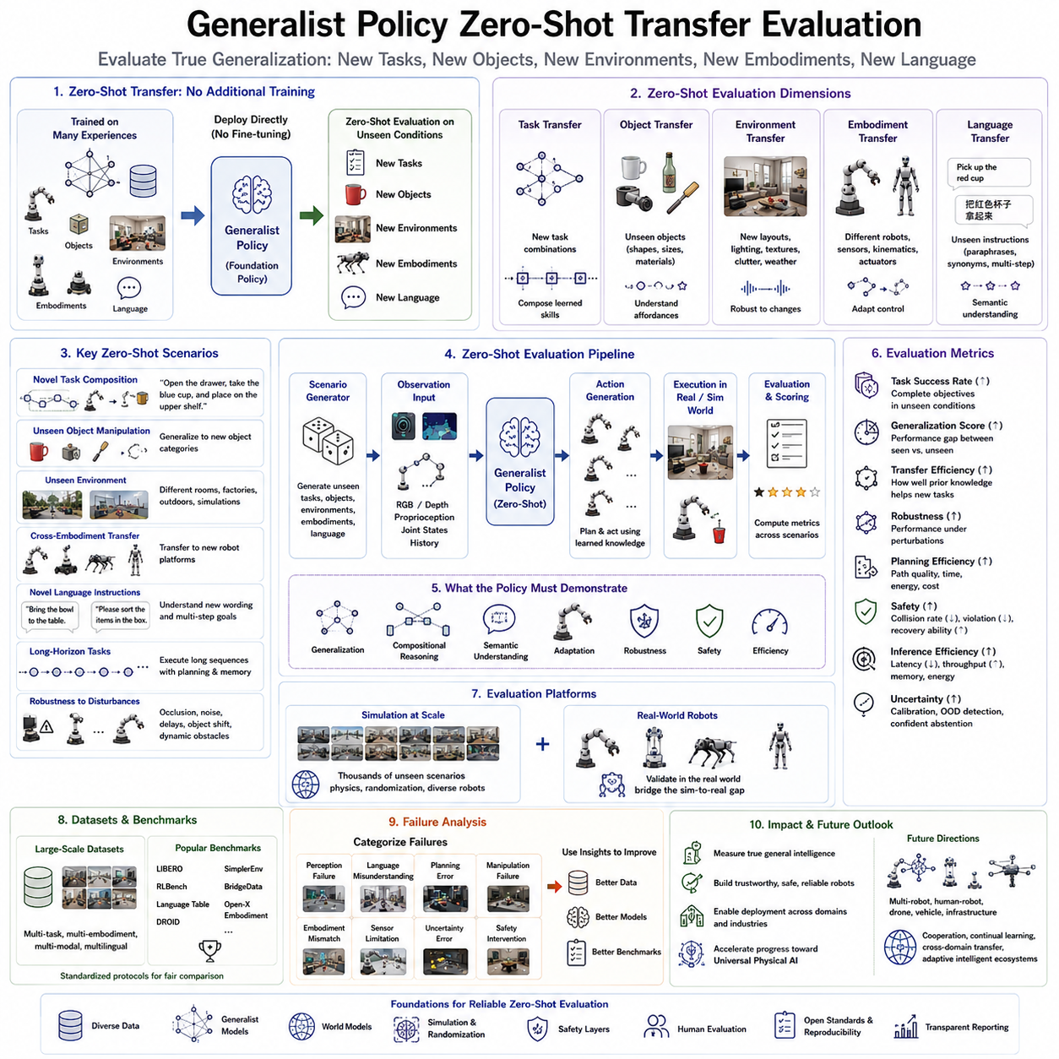
Zero-shot transfer evaluation is one of the most important methodologies for measuring the true intelligence of modern generalist robot policies. Unlike traditional robot evaluation, which measures performance on tasks encountered during training, zero-shot evaluation examines whether a policy can successfully solve entirely new tasks, operate in unfamiliar environments, or control previously unseen robot embodiments without requiring additional training or fine-tuning. This evaluation philosophy reflects the long-term objective of Physical AI, where robots are expected to generalize knowledge rather than memorize demonstrations. A successful zero-shot policy demonstrates that learned representations capture fundamental physical principles and semantic understanding instead of merely reproducing previously observed behaviors.
Historically, robotic learning systems were evaluated using closed benchmark datasets in which training and testing conditions were highly similar. While such evaluation provided useful information regarding optimization quality, it often overestimated practical performance because robots rarely encounter identical conditions after deployment. Real-world environments constantly introduce unseen objects, changing layouts, different lighting conditions, sensor noise, unexpected human interactions, and novel task combinations. Consequently, evaluation methodologies have shifted from measuring memorization toward assessing genuine generalization capability.
Generalist policies are specifically designed to acquire transferable knowledge applicable across many domains. Therefore, their evaluation must measure the ability to reuse previously acquired knowledge rather than task-specific optimization. Zero-shot transfer directly assesses whether a policy can interpret unfamiliar situations using existing representations and produce meaningful actions despite the absence of explicit training examples. This property distinguishes foundation policies from conventional task-specific controllers.
Zero-shot transfer can be evaluated across multiple dimensions. Task transfer measures whether a policy can perform previously unseen tasks using knowledge acquired from related activities. Object transfer evaluates whether manipulation skills generalize to unfamiliar object categories with different shapes, materials, sizes, or appearances. Environment transfer examines performance within previously unseen rooms, factories, warehouses, homes, outdoor locations, or simulation environments. Embodiment transfer measures adaptation to new robot platforms possessing different kinematic structures, sensors, or actuator configurations. Language transfer evaluates whether previously unseen natural language instructions can be interpreted correctly through semantic reasoning rather than memorization.
Task-level zero-shot evaluation focuses on novel combinations of familiar skills. For example, a robot trained separately on grasping cups, opening drawers, and placing objects onto shelves may receive a previously unseen instruction such as “open the drawer, retrieve the blue cup, and place it on the upper shelf.” Although this exact sequence never appeared during training, a successful generalist policy should compose previously learned primitives into a coherent solution. Such compositional reasoning demonstrates a deeper understanding of task structure beyond individual demonstrations.
Object-level transfer examines semantic understanding independent of object identity. A robot trained using bottles, mugs, bowls, and boxes may encounter entirely new household items during evaluation. Instead of recognizing only previously observed objects, the policy must infer appropriate manipulation strategies based on geometry, affordances, physical properties, and contextual relationships. Successful transfer indicates that the learned policy represents functional object characteristics rather than memorizing visual appearances.
Environmental transfer provides another important evaluation criterion because deployment environments often differ substantially from training conditions. Evaluation scenarios intentionally introduce new lighting, furniture arrangements, textures, backgrounds, workspace geometries, clutter distributions, weather conditions, or sensor viewpoints. Robust policies maintain stable performance despite these environmental variations because they rely on invariant physical reasoning rather than superficial environmental cues.
Cross-embodiment zero-shot transfer represents one of the most challenging evaluation problems. Policies trained using industrial manipulators, collaborative robots, or mobile manipulators are deployed directly onto different robotic embodiments without retraining. Although actuator interfaces, joint topology, workspace dimensions, and dynamic characteristics differ significantly, successful policies preserve semantic understanding while adapting action generation through embodiment-aware representations. Strong cross-embodiment performance demonstrates that intelligence has become largely independent of hardware implementation.
Language-conditioned zero-shot evaluation has become increasingly important with the emergence of Vision-Language-Action models. Instead of selecting from predefined task identifiers, robots receive entirely new natural language instructions containing unfamiliar wording, paraphrases, synonyms, or multi-step descriptions. Evaluation measures whether semantic reasoning enables correct task execution despite linguistic variability. This capability is particularly valuable for real-world human-robot interaction where users naturally express identical intentions using different language.
Temporal generalization extends zero-shot evaluation toward long-horizon reasoning. Rather than evaluating isolated manipulation actions, robots must successfully execute extended sequences requiring memory, planning, subgoal decomposition, and adaptive recovery. Tasks involving dozens or hundreds of consecutive decisions expose weaknesses that may remain hidden during short-horizon evaluation. Long-horizon zero-shot benchmarks therefore provide more realistic assessments of autonomous intelligence.
Robustness testing complements zero-shot evaluation by introducing controlled disturbances throughout execution. Visual occlusions, sensor failures, communication delays, actuator uncertainty, object displacement, dynamic obstacles, environmental noise, and partial observations challenge the policy's ability to recover using previously learned knowledge. Robust zero-shot policies maintain acceptable performance despite these unexpected disruptions, demonstrating resilience suitable for deployment in practical environments.
Evaluation datasets increasingly emphasize diversity rather than scale alone. Modern benchmarks intentionally include heterogeneous robot platforms, varied object categories, multiple sensing modalities, multilingual language instructions, dynamic environments, and diverse human interactions. Rich benchmark diversity prevents overfitting while providing more representative measurements of general-purpose robot intelligence.
Simulation plays a central role in zero-shot evaluation because it enables systematic testing across thousands of controlled scenarios that would be prohibitively expensive in physical laboratories. Physics simulators generate unseen environments, novel robot morphologies, randomized object collections, and dynamic interaction sequences automatically. Massive simulation-based evaluation provides statistically meaningful measurements while exposing policies to rare edge cases difficult to reproduce experimentally.
However, simulation alone cannot fully replace real-world evaluation because simulated environments inevitably differ from physical deployment. Consequently, modern evaluation protocols combine simulation benchmarks with real-robot experiments. Successful policies demonstrate consistent performance across both domains, indicating that learned representations capture genuine physical principles instead of simulator-specific artifacts.
Several quantitative metrics are commonly employed during zero-shot evaluation. Task success rate measures the percentage of successfully completed objectives under unseen conditions. Generalization score compares performance between familiar and unfamiliar tasks. Transfer efficiency quantifies how effectively previously acquired knowledge supports new objectives without additional learning. Robustness metrics evaluate performance degradation under environmental variation. Planning efficiency measures trajectory quality, execution time, energy consumption, and computational cost. Safety metrics quantify collision frequency, constraint violations, unstable motions, and recovery behavior.
Inference efficiency also becomes increasingly important because generalist foundation policies often contain billions of parameters. Evaluation therefore measures inference latency, GPU utilization, memory consumption, throughput, and energy efficiency alongside task performance. Practical deployment requires balancing model capability with real-time computational constraints imposed by embedded robotic platforms.
Uncertainty estimation represents another essential evaluation dimension. Generalist policies should recognize situations lying outside their experience rather than confidently producing unsafe actions. Modern evaluation therefore measures confidence calibration, uncertainty prediction accuracy, out-of-distribution detection, and appropriate fallback behavior. Reliable uncertainty estimation significantly improves deployment safety in open-world environments.
Human evaluation complements quantitative metrics by assessing behavioral quality that may be difficult to measure numerically. Human observers evaluate motion smoothness, naturalness, predictability, cooperation, communication effectiveness, and overall task quality. Especially for collaborative robots and service robotics, subjective human perception strongly influences practical usability despite identical objective success rates.
Benchmark suites such as LIBERO, RLBench, Language Table, DROID, SimplerEnv, BridgeData, Open X-Embodiment, and other large-scale evaluation frameworks increasingly emphasize standardized zero-shot protocols. These benchmarks provide common tasks, datasets, environments, evaluation metrics, and reporting procedures that enable fair comparison across different research groups. Standardized benchmarks accelerate scientific progress by reducing inconsistencies in experimental methodology.
Industrial deployment introduces additional evaluation criteria extending beyond laboratory benchmarks. Policies must demonstrate reliability across prolonged operation, adaptation to changing production conditions, compatibility with existing automation systems, compliance with safety regulations, maintenance simplicity, and scalability across large robot fleets. Industrial zero-shot evaluation therefore considers operational stability over weeks or months rather than isolated experimental episodes.
Failure analysis forms an equally important component of zero-shot evaluation. Researchers systematically categorize unsuccessful executions into perception failures, language misunderstandings, planning errors, manipulation failures, embodiment mismatches, sensor limitations, uncertainty estimation errors, and safety interventions. Understanding failure modes provides valuable guidance for improving future foundation policies and benchmark design.
The emergence of world models further expands zero-shot evaluation by enabling predictive reasoning assessment. Instead of evaluating only executed actions, researchers examine whether internal world representations accurately predict future environmental evolution under unseen conditions. Better predictive models generally correlate with stronger planning capability and higher zero-shot generalization performance.
Future zero-shot evaluation protocols will likely extend beyond individual robots toward collaborative Physical AI systems involving multiple heterogeneous robots, humans, autonomous vehicles, aerial platforms, and intelligent infrastructure. Evaluation will increasingly measure cooperative reasoning, distributed planning, long-term adaptation, continual learning, and cross-domain knowledge transfer within unified intelligent ecosystems. As foundation policies continue evolving toward universal robot intelligence, rigorous zero-shot transfer evaluation will remain one of the most critical methodologies for determining whether robots truly understand the physical world or merely reproduce patterns observed during training.

9.6 Fine-Tuning Foundation Policies (with Code)
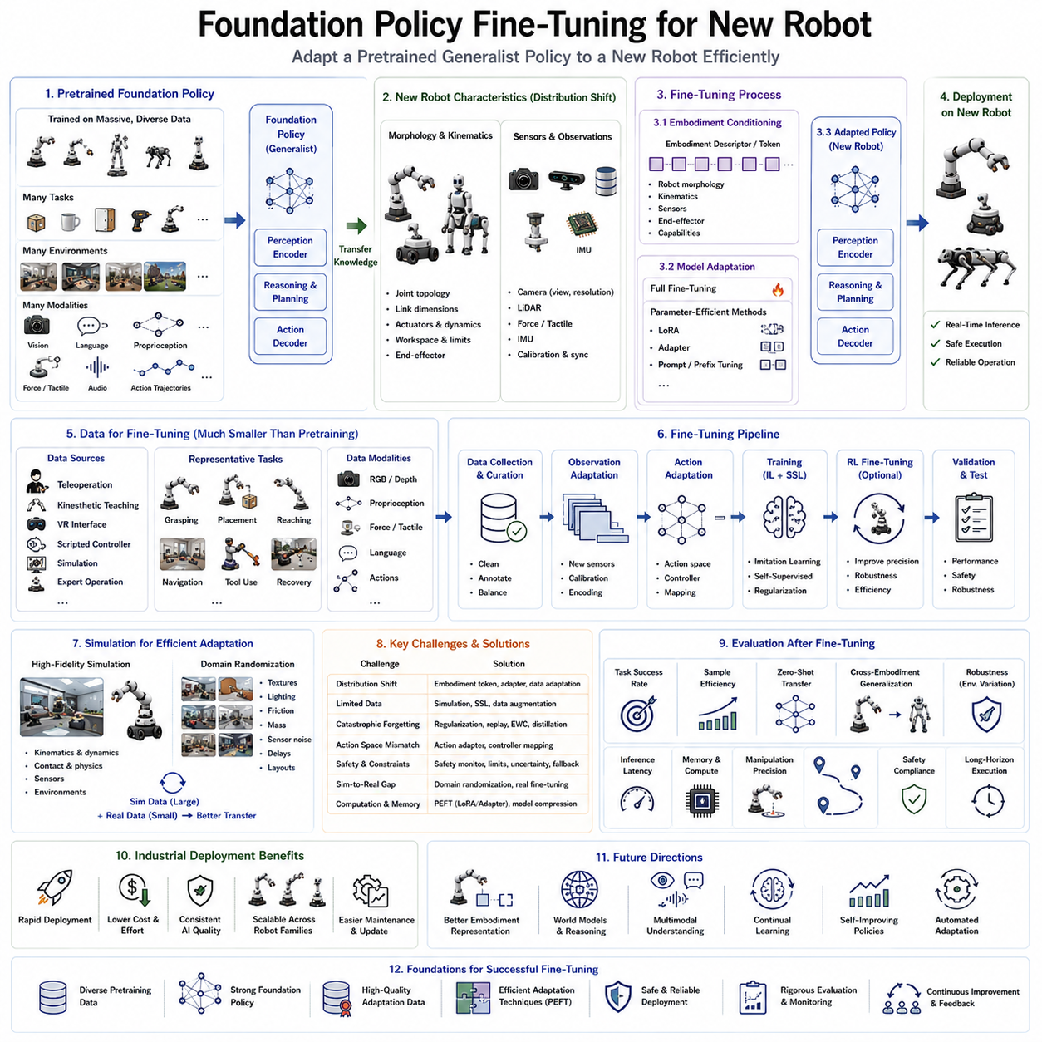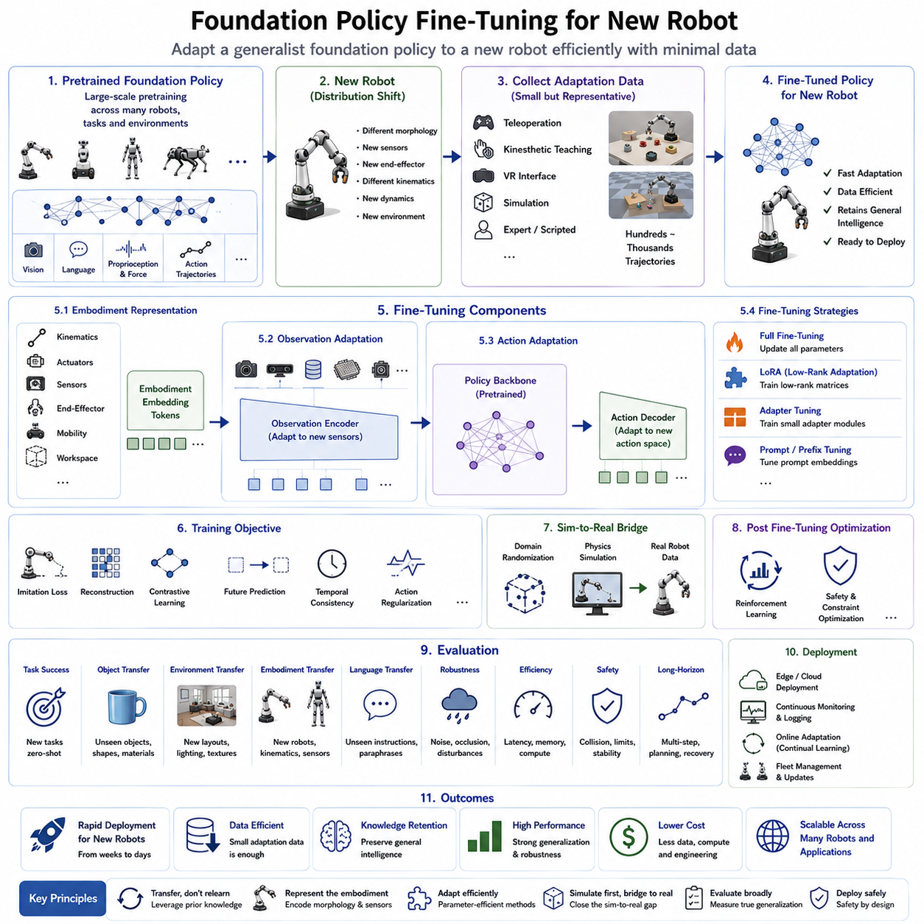
Foundation policy fine-tuning for a new robot is the process of adapting a large pretrained robot foundation model to a specific robotic platform while preserving the broad knowledge acquired during large-scale pretraining. Rather than training an entirely new policy from scratch, developers begin with a generalist policy that has already learned perception, reasoning, manipulation, navigation, language understanding, and action generation from millions of demonstrations collected across diverse robots, tasks, and environments. Fine-tuning allows this universal knowledge to be efficiently transferred to a newly introduced robot with minimal additional data, computational cost, and engineering effort. This paradigm has become one of the most important principles of modern Physical AI because it enables scalable deployment across continuously expanding robot families.
Traditional robot development relied on collecting large task-specific datasets for every new robot platform. Engineers designed individual perception modules, planning algorithms, control systems, and manipulation policies independently for each embodiment. Even robots with similar mechanical structures often required months of data collection and extensive retraining before reaching acceptable performance. Such development pipelines were expensive, difficult to maintain, and fundamentally limited the scalability of intelligent robotic systems. Foundation policy fine-tuning replaces this workflow with a transfer-learning paradigm in which general robot intelligence is learned once and adapted many times.
The effectiveness of fine-tuning depends largely on the quality of the pretrained foundation policy. During pretraining, the model is exposed to large multimodal datasets containing visual observations, language instructions, proprioceptive measurements, force sensing, tactile information, action trajectories, and environmental interactions collected from numerous robot embodiments. Through this large-scale learning process, the policy acquires generalized knowledge regarding object affordances, spatial reasoning, temporal planning, manipulation strategies, obstacle avoidance, semantic understanding, and task composition. These representations remain useful even when transferred to previously unseen robots.
Introducing a new robot usually involves several sources of distribution shift. Mechanical morphology may differ in joint topology, link dimensions, payload capacity, actuator dynamics, kinematic constraints, and workspace geometry. Sensor configurations may include different camera placements, LiDAR systems, force sensors, tactile arrays, or inertial measurement units. End-effectors may range from parallel grippers to dexterous robotic hands, suction systems, specialized industrial tools, or multi-finger manipulators. Environmental deployment conditions may also vary considerably. Fine-tuning adapts the foundation policy to these embodiment-specific characteristics while preserving higher-level reasoning capabilities.
The first stage of adaptation typically focuses on embodiment representation. The robot's physical structure is encoded through embodiment descriptors that summarize joint configuration, kinematic chains, actuator specifications, sensor layout, mobility mechanisms, workspace limits, and end-effector capabilities. Modern transformer-based policies often incorporate embodiment tokens or morphology embeddings that condition the policy according to robot-specific properties. These embeddings allow a single neural architecture to support multiple robot platforms while dynamically adapting action generation during inference.
Observation adaptation represents another critical component of fine-tuning. Different robots observe the environment through heterogeneous sensing systems with varying resolutions, viewpoints, modalities, calibration parameters, and synchronization characteristics. The observation encoder must therefore learn to process the new sensor configuration while preserving semantic consistency with previously learned representations. In many cases, only the initial perception layers require significant adaptation because higher-level reasoning remains largely independent of the specific sensing hardware.
Action adaptation is generally the most embodiment-specific stage of fine-tuning. Although the foundation policy may generate abstract action representations, these latent actions must ultimately be translated into executable robot commands. New robots frequently employ different action spaces, including joint positions, joint velocities, Cartesian end-effector trajectories, torque commands, impedance control, mobile base velocities, or hybrid manipulation commands. Fine-tuning adjusts action decoders to accurately map latent intentions into hardware-compatible control outputs while preserving the underlying behavioral strategy.
Data collection for fine-tuning is substantially smaller than that required for pretraining. Instead of gathering millions of demonstrations, developers often require only several hundred to several thousand high-quality trajectories covering representative tasks for the target robot. Demonstrations may be collected through teleoperation, kinesthetic teaching, virtual reality interfaces, scripted controllers, simulation, or expert operators. Because the foundation policy already understands general manipulation concepts, these adaptation datasets primarily teach the policy how the new embodiment executes familiar behaviors rather than introducing entirely new skills.
Task selection during fine-tuning is equally important. Rather than attempting to cover every possible application, adaptation datasets typically include a carefully chosen collection of representative tasks spanning grasping, object placement, reaching, manipulation, navigation, obstacle avoidance, tool usage, and recovery behaviors. These representative tasks provide sufficient information for the policy to infer broader embodiment characteristics while minimizing data collection effort. Task diversity therefore becomes more valuable than dataset size alone.
Several fine-tuning strategies have emerged depending on computational resources and deployment requirements. Full fine-tuning updates every parameter within the foundation policy, providing maximum adaptation capability but requiring considerable computational resources and increasing the risk of catastrophic forgetting. Parameter-efficient fine-tuning methods modify only selected components while freezing most pretrained weights. These approaches significantly reduce computational cost while preserving general knowledge acquired during large-scale pretraining.
Low-Rank Adaptation (LoRA) has become one of the most widely adopted parameter-efficient techniques. Instead of modifying entire weight matrices, LoRA introduces small trainable low-rank matrices into selected transformer layers. During fine-tuning, only these lightweight parameters are optimized while the original foundation model remains unchanged. This approach dramatically reduces memory consumption, accelerates optimization, and simplifies deployment across multiple robot platforms sharing the same pretrained backbone.
Adapter layers provide another effective adaptation mechanism. Small neural modules are inserted between transformer blocks, allowing embodiment-specific knowledge to be learned without modifying the original network parameters. Different robots may therefore maintain independent adapter modules while sharing a common foundation policy. This modular design greatly simplifies maintenance for organizations operating diverse robotic fleets because improvements to the shared backbone benefit all platforms simultaneously.
Prompt tuning and prefix tuning extend parameter-efficient adaptation to language-conditioned robot policies. Instead of modifying internal network weights, trainable prompt embeddings guide policy behavior toward the target embodiment or application domain. These approaches require extremely few trainable parameters while maintaining competitive adaptation performance, making them attractive for resource-constrained robotic platforms.
Simulation plays a major role during fine-tuning because physical data collection remains expensive and time-consuming. High-fidelity simulators replicate robot kinematics, dynamics, sensing systems, contact interactions, and environmental conditions. Large quantities of synthetic demonstrations are generated before limited real-world fine-tuning bridges the remaining sim-to-real gap. Domain randomization further improves transfer robustness by varying textures, lighting, friction coefficients, object masses, sensor noise, actuator delays, and environmental layouts throughout simulation.
Self-supervised objectives frequently complement supervised imitation learning during adaptation. Reconstruction losses, contrastive representation learning, masked observation prediction, future state prediction, temporal consistency objectives, and cross-modal alignment enable the policy to adapt efficiently even when labeled demonstrations remain limited. These auxiliary learning signals strengthen representation quality while reducing dependence on extensive human supervision.
Reinforcement learning can further optimize fine-tuned policies after initial adaptation has converged. Rather than discovering manipulation strategies from scratch, reinforcement learning begins with a strong initialization provided by the foundation policy. Environmental interaction then improves precision, robustness, safety, energy efficiency, task completion speed, and long-horizon planning performance. This staged optimization pipeline combines the stability of imitation learning with the performance improvements offered by reinforcement learning.
Avoiding catastrophic forgetting remains one of the most important challenges during fine-tuning. Excessive adaptation may overwrite previously acquired general knowledge, reducing the policy's ability to perform tasks outside the adaptation dataset. Various regularization methods preserve important pretrained parameters while allowing embodiment-specific specialization. Replay buffers containing representative pretraining samples, elastic weight consolidation, knowledge distillation, adapter isolation, and continual learning techniques all contribute to maintaining broad generalization capability.
Safety considerations become increasingly important when adapting foundation policies to physical robots. Newly fine-tuned policies must satisfy embodiment-specific joint limits, velocity constraints, collision boundaries, payload restrictions, stability requirements, thermal limitations, and actuator capabilities. Runtime safety monitors continuously validate generated actions before execution. Uncertainty estimation identifies unfamiliar operating conditions where confidence decreases, allowing fallback controllers or human supervision to intervene when necessary.
Evaluation following fine-tuning extends beyond measuring task success alone. Researchers assess adaptation speed, sample efficiency, zero-shot transfer to additional tasks, cross-embodiment generalization, inference latency, computational efficiency, memory utilization, robustness under environmental variation, language understanding, manipulation precision, navigation accuracy, safety compliance, and long-horizon execution capability. These comprehensive evaluations ensure that fine-tuning improves embodiment adaptation without sacrificing previously acquired general intelligence.
Industrial deployment increasingly relies on foundation policy fine-tuning because manufacturers often release multiple robot models sharing similar software architectures but differing mechanical configurations. A single pretrained foundation policy may therefore support collaborative manipulators, industrial robots, mobile manipulators, warehouse robots, inspection systems, healthcare assistants, agricultural platforms, and humanoid robots through lightweight embodiment-specific adaptation. This dramatically reduces engineering effort while improving consistency across product lines.
Future research is expected to make fine-tuning progressively more efficient through better embodiment representations, scalable world models, multimodal reasoning, continual learning, self-improving policies, and automated adaptation pipelines. Eventually, newly manufactured robots may require only a few demonstrations—or potentially none at all—to become fully operational by leveraging increasingly capable robot foundation models. As foundation policies continue evolving toward universal Physical AI, efficient fine-tuning for new robots will remain one of the essential technologies enabling rapid deployment, scalable commercialization, and lifelong adaptation across diverse robotic ecosystems.

9.7 Octo Generalist Policy (with Code)
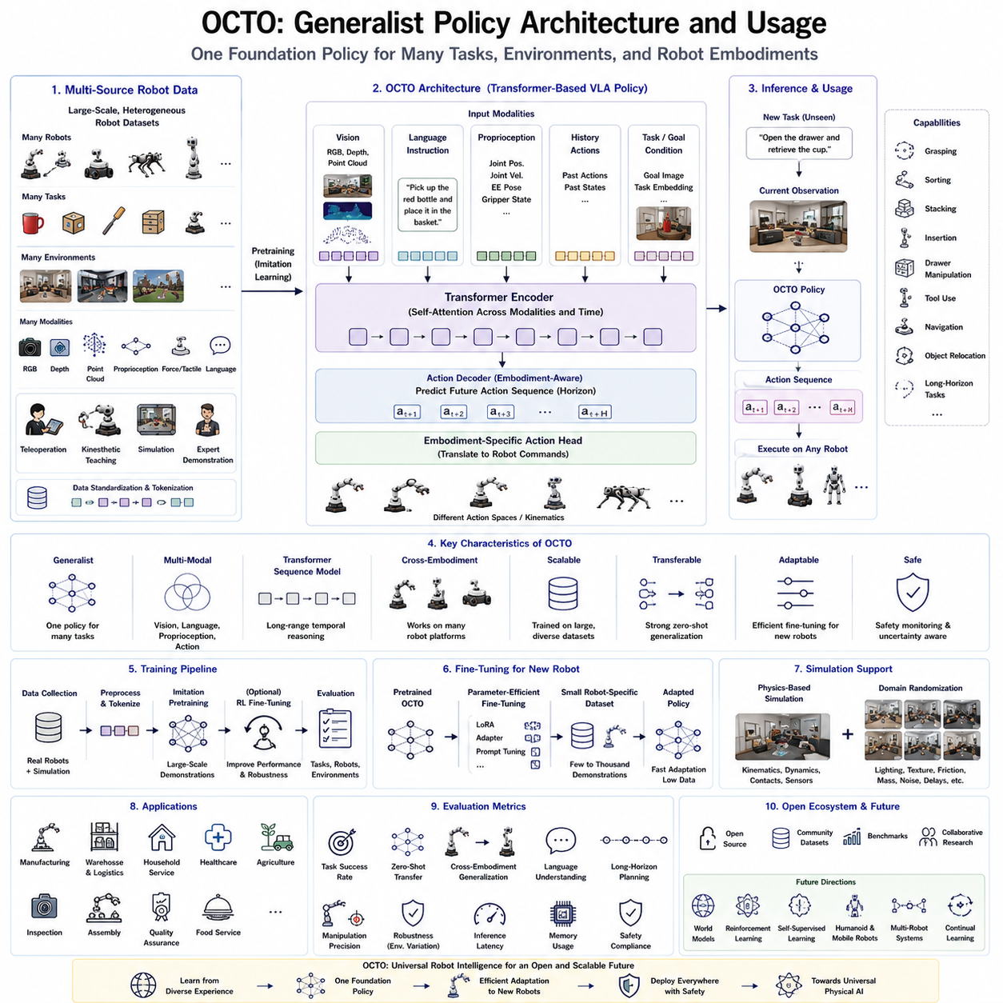
Octo is a large-scale robot foundation policy designed to provide a unified learning framework for general-purpose robotic manipulation across diverse tasks, environments, and robot embodiments. Developed as an open and scalable foundation model, Octo demonstrates how transformer-based architectures combined with large heterogeneous robot datasets can produce highly transferable robot intelligence. Rather than optimizing a separate neural network for every manipulation task, Octo learns a single policy capable of interpreting multimodal observations, understanding task objectives, and generating appropriate robot actions across numerous robotic platforms. Its development represents an important milestone in the transition from task-specific robot controllers toward universal Vision-Language-Action (VLA) systems.
The fundamental philosophy behind Octo is that robotic intelligence should be learned once and reused repeatedly across different applications. Instead of treating every robot and every manipulation problem as an independent engineering project, Octo regards all robotic interaction data as contributing to a common representation of physical intelligence. By learning from demonstrations collected across laboratories, research institutions, robot manufacturers, and application domains, the policy acquires generalized knowledge that extends beyond any single robot embodiment or individual task. This transfer-oriented design significantly reduces the amount of new data required when deploying robots in previously unseen environments.
Octo is built upon a transformer-based sequence modeling architecture capable of processing heterogeneous multimodal information within a unified computational framework. Similar to transformer architectures used in large language models, self-attention mechanisms enable visual observations, proprioceptive measurements, language instructions, historical actions, and task information to interact through shared latent representations. This unified architecture allows information from different modalities to complement one another while preserving long-range temporal dependencies across extended manipulation sequences.
Visual perception constitutes one of the primary input modalities for Octo. RGB images, depth observations, wrist-mounted cameras, external cameras, point clouds, and other visual sensors provide detailed information regarding object appearance, geometry, spatial relationships, and environmental context. Visual encoders transform raw sensor observations into compact latent representations suitable for transformer processing. Rather than relying solely on handcrafted feature extraction, the visual backbone learns semantic object representations directly from large-scale robot interaction data, enabling improved generalization across diverse manipulation scenarios.
Language conditioning plays a central role in Octo's flexibility. Human users specify desired robot behavior through natural language instructions rather than predefined symbolic commands. Instructions such as “pick up the red bottle,” “place the screwdriver inside the toolbox,” or “open the drawer and retrieve the cup” are embedded into semantic language representations and fused with visual observations. This multimodal integration enables robots to understand high-level task intent while grounding linguistic concepts within physical environmental observations.
Robot proprioception provides internal information describing the robot's current physical configuration. Joint positions, joint velocities, end-effector poses, gripper states, force sensing, tactile feedback, inertial measurements, and actuator status collectively describe the robot's embodiment state during task execution. Integrating proprioceptive information with external sensory observations significantly improves manipulation accuracy, motion consistency, and closed-loop control stability.
Temporal sequence modeling distinguishes Octo from traditional feedforward robot policies. Manipulation tasks frequently require long sequences of coordinated actions extending over many time steps. Opening containers, assembling components, organizing objects, or operating tools often depend upon information observed several seconds earlier. Transformer attention mechanisms allow Octo to maintain contextual awareness across extended temporal horizons, supporting coherent planning throughout complex multi-stage manipulation tasks.
One of Octo's defining characteristics is its compatibility with heterogeneous robot embodiments. Training data originate from numerous manipulators, mobile manipulators, research robots, collaborative robots, and custom laboratory systems possessing different kinematic structures, action spaces, sensor configurations, and mechanical properties. Rather than treating these embodiment differences as obstacles, Octo learns shared latent representations describing task semantics independently from hardware implementation. Robot-specific action decoders subsequently translate abstract intentions into embodiment-compatible control commands.
Large-scale data aggregation represents another foundational component of Octo. Demonstrations are collected from multiple institutions participating in collaborative robot learning initiatives such as Open X-Embodiment. These datasets include manipulation trajectories, language annotations, sensory observations, proprioceptive measurements, and robot metadata collected under highly diverse operating conditions. Data standardization procedures unify heterogeneous demonstrations into consistent formats suitable for foundation policy training. The resulting diversity substantially improves policy robustness and transfer capability.
Task conditioning enables a single Octo policy to solve numerous robotic applications without architecture modification. Conditioning information may include natural language instructions, task embeddings, goal images, desired object configurations, or semantic task descriptions. During inference, the conditioning signal directs policy behavior toward the requested objective while preserving common representations shared across all tasks. Consequently, one foundation model can support grasping, sorting, stacking, insertion, drawer manipulation, object relocation, tool usage, and many other manipulation skills.
Octo primarily employs imitation learning during large-scale pretraining. Expert demonstrations collected through teleoperation, kinesthetic teaching, scripted controllers, simulation, or experienced operators provide target action trajectories that the policy learns to reproduce. Instead of memorizing individual demonstrations, the transformer architecture extracts reusable manipulation principles applicable across many tasks. This broad behavioral prior subsequently supports efficient adaptation to new robotic platforms using comparatively small fine-tuning datasets.
Action generation within Octo typically operates over prediction horizons rather than generating isolated instantaneous commands. Instead of deciding one action at a time without context, the model predicts coherent sequences of future robot actions. Horizon-based prediction improves trajectory smoothness, temporal consistency, motion efficiency, and robustness against sensor noise. Receding horizon execution continuously updates these predictions as new observations become available, enabling responsive closed-loop behavior during manipulation.
Fine-tuning constitutes an important stage in practical deployment. Although Octo provides strong general capabilities immediately after pretraining, individual robots often require modest adaptation to accommodate unique kinematics, sensors, workspace geometry, actuator dynamics, or application-specific tasks. Parameter-efficient fine-tuning methods such as Low-Rank Adaptation (LoRA), adapter modules, prompt tuning, and embodiment-specific decoders enable efficient specialization without retraining the entire foundation model. These techniques preserve general knowledge while minimizing computational requirements.
Simulation provides an effective environment for expanding Octo's experience beyond physically collected demonstrations. Physics-based simulation generates large quantities of additional manipulation trajectories under randomized environmental conditions. Domain randomization varies lighting, textures, object geometry, friction coefficients, camera calibration, actuator delays, and sensor noise throughout training. Policies exposed to these diverse simulated experiences generally exhibit improved robustness when transferred to real robotic systems.
Safety considerations remain essential during Octo deployment. Although foundation policies possess impressive generalization capability, real-world robotic systems must satisfy strict operational constraints regarding collision avoidance, joint limits, workspace boundaries, payload capacity, actuator saturation, and human safety. Runtime safety monitors validate generated actions before execution while uncertainty estimation identifies unfamiliar situations requiring conservative behavior or human intervention. These additional safety layers complement learned intelligence with deterministic engineering safeguards.
Evaluation of Octo extends far beyond simple task success rates. Researchers assess zero-shot transfer to previously unseen tasks, cross-embodiment generalization, language understanding, long-horizon planning, manipulation precision, robustness under environmental variation, computational efficiency, inference latency, memory utilization, and safety compliance. Successful foundation policies demonstrate strong performance across all these dimensions while maintaining efficient deployment on practical robotic hardware.
Industrial applications of Octo span a broad range of robotic domains. Manufacturing robots benefit from flexible assembly, inspection, material handling, and quality assurance. Warehouse automation systems leverage generalized object manipulation, sorting, packing, and logistics operations. Household service robots perform cleaning, organization, cooking assistance, and object retrieval. Healthcare robots support patient assistance, laboratory automation, and medical logistics. Agricultural platforms apply foundation policies to harvesting, crop monitoring, and precision farming. Across all these domains, the same pretrained policy provides a common intelligence backbone requiring only limited application-specific adaptation.
The open-source nature of Octo significantly accelerates robotics research by enabling laboratories worldwide to reproduce experiments, compare algorithms under consistent conditions, and contribute additional datasets, benchmarks, and improvements. Open access encourages rapid iteration, collaborative development, and standardized evaluation across the robotics community. As larger datasets and improved transformer architectures continue to emerge, Octo serves as an extensible platform for future foundation policy research rather than a fixed standalone model.
Octo also illustrates the broader transition occurring throughout Physical AI. Instead of viewing robot intelligence as collections of isolated perception modules, planning algorithms, and task-specific controllers, foundation policies integrate perception, language understanding, reasoning, memory, planning, and action generation into unified end-to-end architectures. This integration simplifies software engineering while improving transfer learning and long-term scalability.
Future versions of Octo are expected to expand beyond manipulation toward whole-body humanoid control, mobile manipulation, quadruped locomotion, aerial robotics, collaborative multi-robot systems, and lifelong continual learning. Integration with world models, multimodal reasoning, reinforcement learning, large-scale simulation, self-supervised learning, and autonomous data collection will further improve adaptability and generalization. As robot foundation models continue increasing in scale, capability, and embodiment diversity, Octo represents one of the foundational architectures demonstrating how universal robot intelligence can be learned from heterogeneous experience and efficiently deployed across a rapidly growing ecosystem of intelligent robotic systems.

9.8 Policies for AMRs, Manipulators, and Legged Robots (with Code)
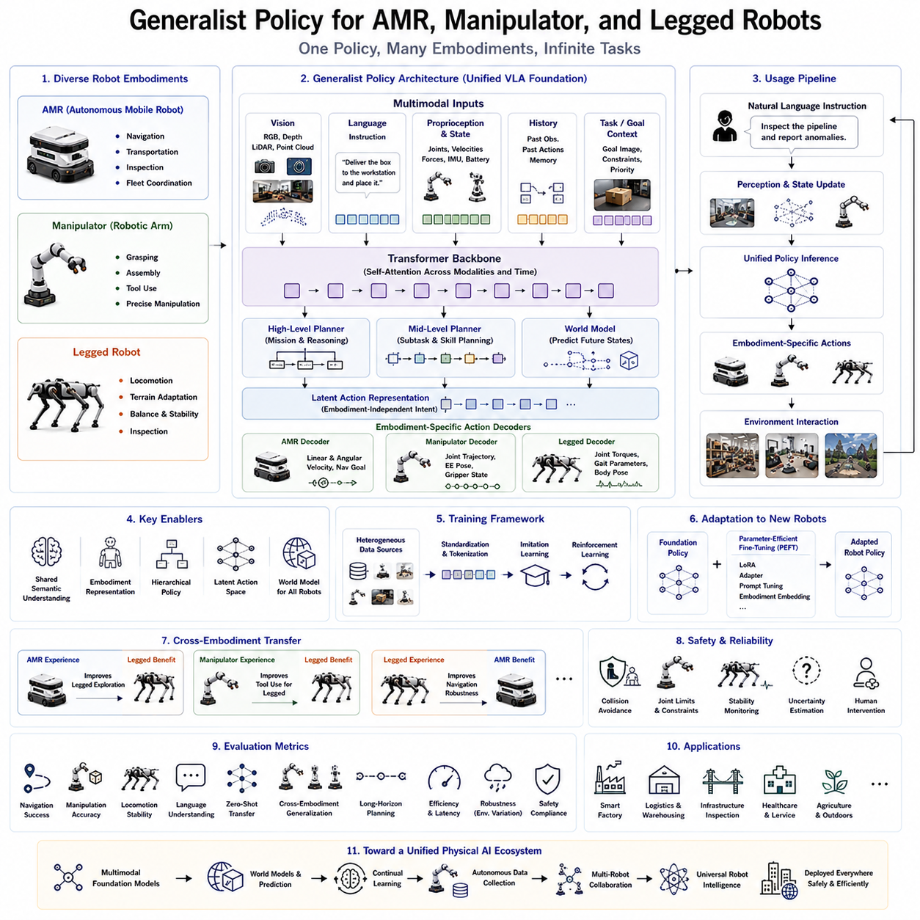
Generalist robot policies are transforming robotics by enabling a single intelligent policy to control multiple categories of robots that differ significantly in morphology, mobility, sensing, and task execution. Instead of developing independent control architectures for Autonomous Mobile Robots (AMRs), robotic manipulators, and legged robots, modern foundation policies aim to learn universal representations of perception, reasoning, planning, and action that can be transferred across all embodiments. This unified approach reduces engineering complexity, accelerates deployment, and creates a common software foundation capable of supporting heterogeneous robotic fleets operating in dynamic real-world environments. As Vision-Language-Action (VLA) models continue to evolve, the distinction between different robot platforms becomes increasingly abstract, allowing high-level intelligence to remain shared while embodiment-specific controllers translate intentions into executable actions.
Autonomous Mobile Robots primarily focus on navigation, transportation, inspection, and environmental interaction. Their operational intelligence depends on localization, mapping, obstacle avoidance, path planning, fleet coordination, and mission execution. Manipulators, in contrast, concentrate on precise object interaction, grasping, assembly, tool usage, and dexterous manipulation. Legged robots introduce an entirely different set of challenges involving dynamic balance, terrain adaptation, whole-body coordination, compliant locomotion, and physical stability. Historically, each robot category required completely different software architectures because their control objectives, sensor configurations, action spaces, and dynamic behaviors differed substantially.
Generalist policies challenge this traditional separation by recognizing that many aspects of robotic intelligence remain independent of physical embodiment. Understanding objects, interpreting language instructions, recognizing spatial relationships, reasoning about task objectives, predicting future environmental states, and planning long-horizon activities are largely common across robot categories. Whether the robot reaches an object using wheels, legs, or articulated arms, the semantic reasoning required to understand the goal remains fundamentally identical. Consequently, foundation policies separate cognitive intelligence from embodiment-specific motion generation.
The architecture of a unified generalist policy typically begins with multimodal observation encoding. Visual information from RGB cameras, stereo vision systems, depth sensors, LiDAR, thermal cameras, event cameras, and point clouds provides perception of the surrounding environment. Internal robot states include proprioceptive measurements such as joint positions, joint velocities, wheel encoders, actuator temperatures, battery conditions, force sensing, tactile feedback, and inertial measurements. Language instructions specify task objectives, constraints, priorities, and interaction goals. Historical observations, previous actions, memory states, and environmental context complete the multimodal input representation processed by a shared transformer backbone.
Vision plays a particularly important role because nearly every robot embodiment depends upon visual understanding. AMRs recognize corridors, doors, obstacles, docking stations, and navigation landmarks. Manipulators identify grasp points, object orientations, assembly features, and tool locations. Legged robots perceive terrain geometry, foothold quality, slopes, stairs, gaps, and dynamic obstacles. Rather than learning separate visual representations for each platform, a generalist policy develops shared semantic understanding that supports all three robot categories simultaneously.
Language grounding provides another unifying mechanism across heterogeneous embodiments. Human operators naturally express objectives using task-oriented instructions rather than low-level control commands. Statements such as “deliver this package,” “pick up the toolbox,” “inspect the pipeline,” “climb the stairs,” or “return to the charging station” describe semantic goals independent of the robot's physical structure. The foundation policy interprets these instructions using a common language representation before generating embodiment-specific action sequences appropriate for each robot platform.
Task decomposition becomes increasingly important when supporting heterogeneous robots. High-level missions are divided into multiple subtasks that may involve different embodiments. For example, an AMR may transport materials across a warehouse before positioning itself near a workstation. A robotic manipulator mounted on the AMR subsequently performs object handling and assembly operations. A legged robot may then inspect hazardous areas inaccessible to wheeled platforms. Although each embodiment executes different physical behaviors, all share a common planning framework generated by the same generalist policy.
Embodiment representation enables the policy to distinguish between different robot morphologies. Each robot provides structured descriptions of its kinematic topology, mobility mechanism, workspace limits, actuator characteristics, payload capacity, sensor configuration, dynamic constraints, and end-effector capabilities. Transformer architectures frequently encode this information using embodiment tokens or morphology embeddings that condition action generation according to robot-specific characteristics while preserving shared reasoning across all platforms.
Action representation constitutes one of the greatest challenges in unified robot policies because different embodiments expose fundamentally different action spaces. AMRs generate translational and rotational velocity commands together with navigation objectives. Manipulators control joint trajectories, Cartesian end-effector poses, gripper states, impedance parameters, and force profiles. Legged robots coordinate dozens of joints simultaneously while maintaining balance, stability, and gait synchronization. Instead of directly predicting hardware-specific commands, generalist policies often generate latent action representations describing intended physical behavior. Robot-specific decoders subsequently translate these latent actions into executable control signals.
Hierarchical policy architectures naturally support heterogeneous embodiments by separating decision making into multiple abstraction levels. High-level planning modules determine mission objectives, task sequencing, semantic reasoning, and long-term strategy independent of robot type. Mid-level planners generate navigation goals, manipulation targets, locomotion objectives, and behavioral primitives. Low-level embodiment controllers convert these intermediate plans into wheel velocities, joint torques, end-effector trajectories, gait parameters, or actuator commands specific to each robot. This hierarchical decomposition allows substantial knowledge sharing while preserving precise embodiment control.
World models significantly enhance coordination among different robot embodiments. Instead of reacting solely to immediate observations, the policy constructs predictive internal models describing future environmental evolution. AMRs predict dynamic obstacle movement and traffic flow. Manipulators anticipate object motion, contact interactions, and grasp stability. Legged robots estimate terrain deformation, balance recovery, and foothold reliability. Because these predictions describe environmental physics rather than embodiment-specific mechanics, a common world model can support multiple robot categories simultaneously.
Large-scale heterogeneous datasets provide the foundation for training unified policies. Data originate from warehouse robots, factory manipulators, household service robots, quadrupeds, humanoids, autonomous inspection systems, research platforms, simulation environments, and teleoperation demonstrations. Standardized representations convert diverse observations and actions into common formats while preserving embodiment-specific information. Such heterogeneous training data encourage policies to discover transferable physical concepts rather than memorizing platform-specific behaviors.
Simulation plays an essential role because collecting balanced datasets across all robot categories remains expensive. Physics simulators generate millions of navigation trajectories, manipulation episodes, locomotion behaviors, and multi-robot coordination scenarios. Domain randomization continuously varies lighting conditions, terrain geometry, object properties, weather, sensor noise, actuator delays, and environmental layouts. Policies trained under these randomized conditions exhibit stronger transfer performance during real-world deployment across multiple embodiments.
Imitation learning provides the primary optimization objective during large-scale pretraining. Expert demonstrations collected through teleoperation, scripted controllers, kinesthetic teaching, virtual reality interfaces, and autonomous exploration teach the policy how different embodiments accomplish diverse tasks. Reinforcement learning subsequently refines these pretrained capabilities by optimizing task efficiency, robustness, safety, energy consumption, and long-horizon planning through environmental interaction.
Parameter-efficient fine-tuning enables rapid adaptation of the unified foundation policy to newly introduced robot platforms. Instead of retraining the complete model, lightweight adaptation techniques such as Low-Rank Adaptation (LoRA), adapter modules, prompt tuning, embodiment embeddings, or specialized action decoders modify only a small subset of parameters. This significantly reduces computational cost while preserving the broad knowledge acquired during foundation model pretraining.
Cross-embodiment transfer represents one of the principal advantages of unified policies. Knowledge acquired through manipulation can improve legged robot interaction with tools. Navigation experience learned from AMRs enhances exploration strategies for quadrupeds. Visual representations learned during warehouse logistics contribute to industrial inspection tasks. Rather than remaining isolated within individual robot categories, learned knowledge becomes transferable throughout the entire robotic ecosystem.
Safety remains essential when controlling heterogeneous robot fleets using a common foundation policy. Runtime validation verifies embodiment-specific constraints including wheel slip, joint limits, collision avoidance, payload capacity, stability margins, thermal conditions, actuator saturation, and terrain safety. Uncertainty estimation identifies unfamiliar situations requiring conservative behavior or human supervision. Safety monitors operate independently from learned policies to ensure reliable deployment under diverse operating conditions.
Evaluation protocols extend beyond measuring isolated task performance. Unified policies are assessed using navigation success, manipulation accuracy, locomotion stability, language understanding, zero-shot transfer, cross-embodiment generalization, long-horizon planning, computational efficiency, inference latency, memory utilization, robustness to environmental variation, multi-robot coordination, and operational safety. Comprehensive benchmarks provide realistic measurements of whether a single policy truly supports heterogeneous robot platforms.
Industrial applications increasingly demand unified policies capable of coordinating multiple robot embodiments within shared operational environments. Smart factories employ AMRs for material transportation, manipulators for assembly and packaging, and quadrupeds for equipment inspection. Logistics centers combine mobile robots, robotic arms, and autonomous inventory systems. Infrastructure maintenance integrates wheeled inspection robots, climbing robots, aerial drones, and dexterous manipulators. A common foundation policy simplifies software maintenance while enabling seamless knowledge transfer across these diverse systems.
Cloud-edge collaborative deployment further enhances practical usability. Large foundation policies may execute high-level reasoning, language understanding, and world modeling within cloud infrastructure equipped with powerful GPUs. Edge computers mounted on AMRs, manipulators, or legged robots perform real-time perception, local planning, safety monitoring, and low-latency control. This hybrid architecture balances computational efficiency with responsiveness while maintaining unified policy behavior across distributed robotic fleets.
Future development of generalist policies will likely expand toward complete robotic ecosystems integrating wheeled robots, humanoids, quadrupeds, manipulators, aerial vehicles, autonomous vehicles, and intelligent infrastructure within a single cognitive architecture. Advances in multimodal foundation models, scalable world models, continual learning, autonomous data collection, self-supervised learning, and collaborative multi-agent reasoning will further reduce the distinction between robot embodiments. Instead of developing separate intelligence for each robot category, future Physical AI systems will learn universal knowledge once and dynamically express that intelligence through embodiment-specific motion generation, creating a unified foundation for the next generation of intelligent robotic platforms.

9.9 Safety and Operational Boundaries
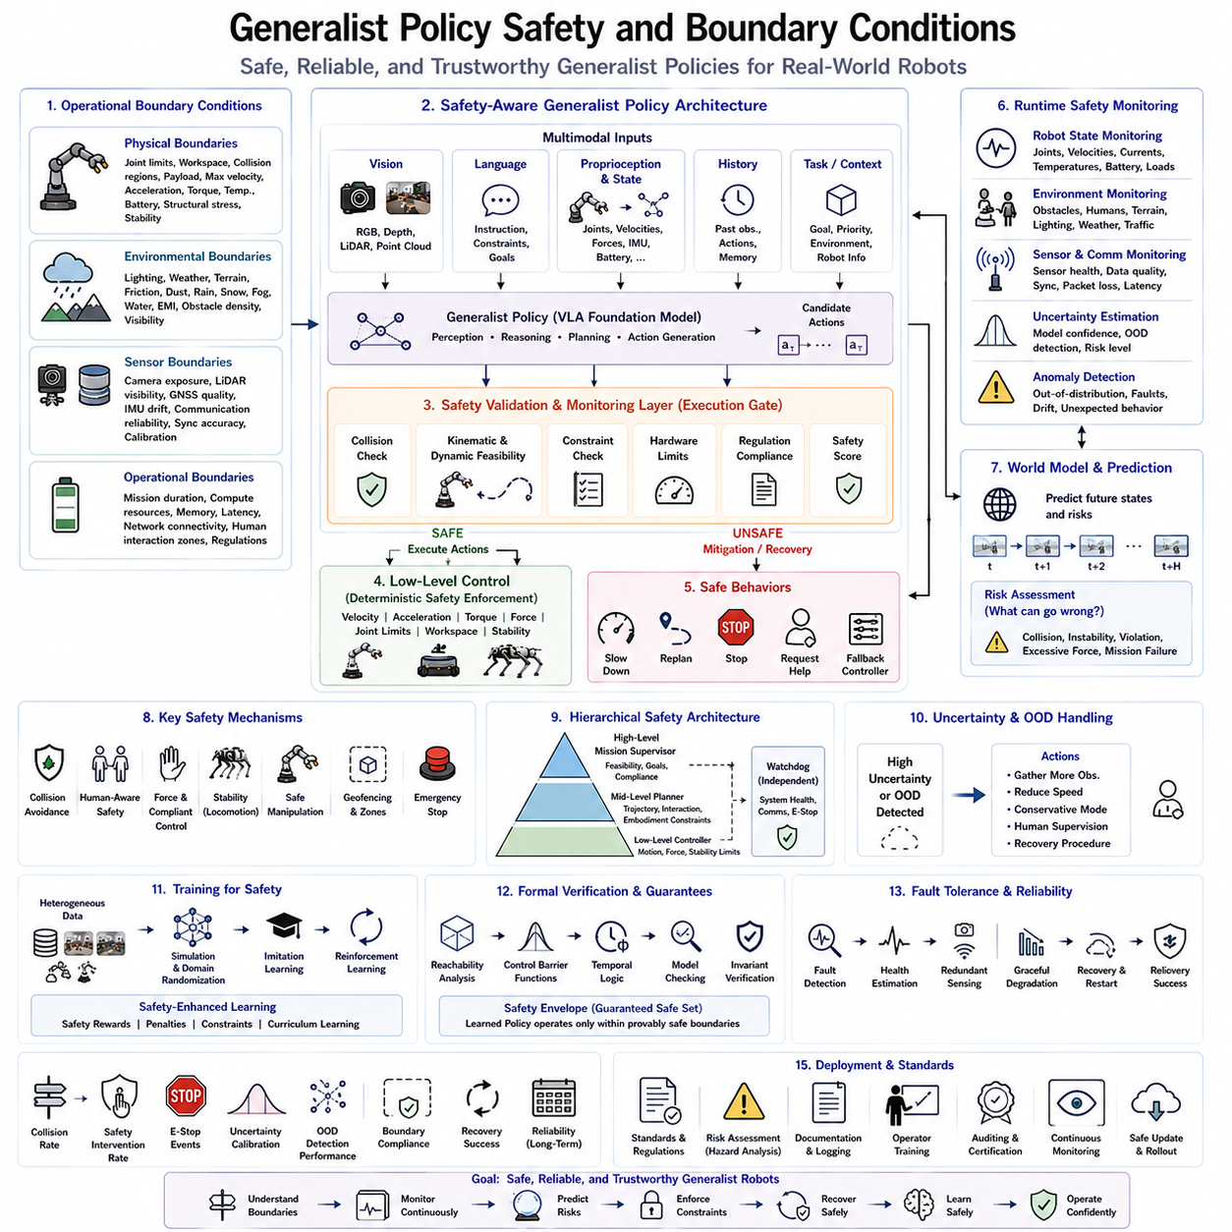
Generalist robot policies have introduced a new paradigm in robotics by enabling a single intelligent model to perform a wide variety of tasks across multiple robot embodiments. While this capability greatly improves flexibility, scalability, and deployment efficiency, it also introduces significant safety challenges. Unlike traditional robot controllers that are carefully engineered for a limited operating domain, generalist policies are expected to function under highly diverse environments, tasks, and physical configurations. Consequently, ensuring safe operation requires more than simply optimizing task performance. A comprehensive safety framework must define clear operational boundary conditions, continuously monitor policy behavior, estimate uncertainty, enforce physical constraints, and provide deterministic fallback mechanisms whenever learned behavior becomes unreliable. Safety therefore becomes an integral component of the overall policy architecture rather than an external feature added after deployment.
Traditional industrial automation achieves safety primarily through deterministic programming and carefully validated control logic. Every robot motion is predefined, every workspace is restricted, and every environmental condition is tightly controlled. Foundation policies fundamentally change this paradigm because robot actions are generated through neural inference rather than explicitly programmed trajectories. Although this enables remarkable adaptability, it also increases uncertainty regarding behavior under previously unseen situations. Generalist policies therefore require new methodologies capable of combining learning-based intelligence with deterministic engineering principles.
The concept of operational boundary conditions defines the range of environments, tasks, hardware configurations, and physical interactions within which a policy is expected to operate safely. Every robot possesses limits regarding joint motion, actuator torque, payload capacity, battery condition, thermal behavior, communication latency, localization accuracy, terrain difficulty, obstacle density, and environmental visibility. Safety-aware foundation policies explicitly represent these operational boundaries and continuously verify that generated actions remain within acceptable limits. Whenever operating conditions approach predefined safety thresholds, corrective behaviors are initiated before hazardous situations develop.
Boundary conditions may be categorized into several complementary domains. Physical boundaries include joint limits, workspace geometry, collision regions, payload restrictions, maximum velocity, acceleration limits, actuator temperature, battery voltage, structural stress, and mechanical stability. Environmental boundaries describe lighting conditions, weather, terrain roughness, floor friction, dust, rain, snow, fog, water exposure, electromagnetic interference, and obstacle complexity. Sensor boundaries define acceptable ranges for camera exposure, LiDAR visibility, GNSS quality, IMU drift, communication reliability, synchronization accuracy, and sensor calibration. Operational boundaries describe mission duration, computational resources, memory availability, latency requirements, network connectivity, and human interaction zones.
One of the central principles of safe generalist policies is the separation between decision intelligence and execution authority. Foundation policies generate candidate actions based upon perception, reasoning, language understanding, and planning. However, these actions are not executed directly. Instead, runtime validation systems evaluate every predicted action before it reaches low-level controllers. Safety validation layers verify collision-free motion, kinematic feasibility, dynamic stability, hardware compatibility, operational constraints, and regulatory compliance. Only validated actions are transmitted to the robot actuators. This layered architecture prevents unsafe neural predictions from directly controlling physical hardware.
Runtime safety monitoring operates continuously throughout task execution. Unlike offline verification performed during development, runtime monitors observe both environmental conditions and internal robot states in real time. Joint velocities, motor currents, battery temperature, actuator loads, localization confidence, obstacle proximity, force sensing, and communication quality are continuously evaluated against predefined safety models. If abnormal behavior is detected, the monitor immediately modifies, slows, or interrupts execution before failures propagate into dangerous situations.
Uncertainty estimation plays a particularly important role because foundation policies inevitably encounter situations beyond their training experience. Neural networks naturally produce predictions even when confidence should be low. Reliable deployment therefore requires explicit estimation of prediction uncertainty. Bayesian neural networks, ensemble methods, Monte Carlo dropout, evidential learning, confidence calibration, and latent density estimation all provide mechanisms for quantifying uncertainty during inference. Policies with high uncertainty may request additional observations, reduce operating speed, invoke human supervision, or transition to conservative recovery behaviors.
Out-of-distribution detection extends uncertainty estimation by identifying observations fundamentally different from the training data. Previously unseen objects, unfamiliar environments, novel robot configurations, unexpected lighting, damaged sensors, severe weather, or rare physical interactions may all lie outside the learned data distribution. Rather than attempting confident predictions under these conditions, robust policies recognize distribution shifts and activate specialized safety procedures. Out-of-distribution awareness significantly improves deployment reliability within open-world environments.
Collision avoidance remains one of the most fundamental safety mechanisms across all robot embodiments. Generalist policies integrate visual perception, LiDAR sensing, depth estimation, occupancy mapping, semantic scene understanding, and motion prediction to maintain collision-free trajectories. Dynamic obstacles including humans, vehicles, animals, and other robots require predictive collision avoidance rather than purely reactive behavior. Future trajectory prediction enables proactive planning that minimizes both collision probability and unnecessary motion interruption.
Human-aware safety introduces additional complexity because collaborative robots increasingly share workspaces with people. Generalist policies must recognize human presence, estimate human motion, predict future behavior, respect personal space, interpret gestures, understand verbal instructions, and maintain safe interaction distances. Human detection therefore extends beyond simple obstacle avoidance toward semantic understanding of collaborative intent. Safety constraints become adaptive, allowing efficient cooperation without compromising human protection.
Motion constraints provide deterministic guarantees independent of learned policy behavior. Velocity limits, acceleration bounds, jerk constraints, torque saturation, force thresholds, workspace boundaries, joint limits, and stability margins are enforced by low-level controllers regardless of high-level policy output. These physical constraints ensure that even erroneous policy predictions cannot produce mechanically hazardous robot behavior. Classical control engineering therefore remains essential despite advances in foundation model intelligence.
Manipulation safety becomes especially important during physical interaction with objects. Foundation policies must regulate grasp force, contact pressure, insertion speed, manipulation torque, tool orientation, and compliance characteristics according to object properties. Fragile items require gentle manipulation while heavy industrial components demand stronger grasping strategies. Force sensing, tactile feedback, impedance control, and compliant manipulation collectively reduce the likelihood of damaging either manipulated objects or surrounding equipment.
Mobile robot safety introduces additional boundary conditions associated with navigation. Autonomous Mobile Robots must monitor localization uncertainty, wheel slip, terrain traversability, dynamic traffic, emergency exits, restricted areas, docking alignment, and pedestrian behavior. Outdoor deployments additionally require consideration of weather, uneven terrain, slopes, mud, gravel, vegetation, and varying illumination. Navigation safety therefore combines geometric planning with semantic environmental understanding.
Legged robots introduce unique safety challenges associated with dynamic balance and terrain interaction. Safe locomotion requires continuous evaluation of foothold quality, center-of-mass stability, contact forces, gait synchronization, terrain deformation, slip probability, and recovery capability. Foundation policies supporting legged robots frequently incorporate predictive stability models capable of evaluating future balance conditions before executing body motions. This predictive capability significantly reduces fall probability during challenging locomotion tasks.
World models increasingly contribute to safety by enabling predictive risk assessment before physical execution. Rather than evaluating only immediate actions, internal simulation predicts future environmental evolution under candidate behaviors. Potential collisions, instability, dead ends, blocked paths, excessive force, or mission failures are identified before execution begins. The policy subsequently selects safer alternatives without requiring costly physical trial-and-error. Predictive reasoning therefore transforms safety from reactive intervention toward proactive prevention.
Hierarchical safety architectures distribute responsibility across multiple abstraction levels. High-level mission supervisors verify task feasibility, operational objectives, and regulatory compliance. Mid-level planners evaluate trajectory safety, environmental interactions, and embodiment constraints. Low-level controllers enforce deterministic physical limits regarding motion, force, stability, and actuator protection. Independent watchdog systems monitor computational health, communication integrity, and emergency conditions. This layered organization prevents single-point failures while improving overall system robustness.
Formal verification methods increasingly complement data-driven learning. Reachability analysis, control barrier functions, temporal logic, model checking, invariant verification, and mathematically provable safety constraints establish guarantees regarding policy behavior under specified operating conditions. Although complete verification of large neural networks remains difficult, hybrid verification frameworks combining learned policies with formally verified safety envelopes provide practical deployment strategies for safety-critical applications.
Simulation serves as an essential platform for safety validation because dangerous edge cases can be explored without risking physical hardware or human operators. Domain randomization systematically varies weather, lighting, terrain, sensor failures, actuator faults, communication delays, obstacle behavior, and environmental disturbances. Millions of simulated safety scenarios expose rare failure modes that would be impractical or unsafe to reproduce experimentally. Safety policies refined through extensive simulation generally demonstrate improved robustness during real-world deployment.
Fault tolerance extends safety beyond normal operation by considering hardware and software failures. Sensor degradation, actuator malfunction, battery faults, network interruption, memory corruption, processor overload, localization failure, and environmental disturbances require graceful degradation rather than catastrophic failure. Redundant sensing, diagnostic monitoring, health estimation, fail-safe controllers, emergency stopping, and autonomous recovery behaviors collectively improve operational resilience.
Continual learning introduces unique safety considerations because policies evolve after deployment. Newly acquired knowledge should improve robot capability without degrading previously validated safety behavior. Safe continual learning therefore combines controlled adaptation with replay buffers, regularization techniques, safety validation datasets, and staged deployment procedures. Updates are extensively evaluated within simulation before limited real-world rollout under human supervision.
Evaluation of safety-aware generalist policies extends beyond conventional task success metrics. Researchers assess collision frequency, safety intervention rate, emergency stop occurrence, uncertainty calibration accuracy, out-of-distribution detection performance, boundary condition compliance, recovery success, hardware fault tolerance, human interaction quality, operational reliability, and long-term deployment stability. Comprehensive evaluation ensures that increased intelligence never compromises dependable operation.
Industrial deployment demands strict adherence to international safety standards and regulatory requirements. Collaborative robots, autonomous mobile robots, medical systems, warehouse automation, industrial inspection platforms, and service robots each operate under different certification frameworks. Foundation policies therefore integrate learning-based intelligence with deterministic safety architectures capable of satisfying existing industrial regulations while preserving the flexibility of modern AI-driven robotics.
Future research will likely focus on self-verifying foundation policies capable of explaining their own decisions, estimating risk before every action, predicting long-term safety consequences, adapting operational boundaries dynamically, and cooperating with humans through transparent reasoning. Integration of multimodal perception, world models, continual learning, formal verification, uncertainty estimation, and hierarchical safety supervision will gradually transform generalist policies into trustworthy autonomous systems capable of operating safely across diverse robots, environments, and applications. Ultimately, safety and clearly defined boundary conditions will remain indispensable foundations for universal Physical AI, ensuring that increasingly capable robot intelligence can be deployed responsibly, reliably, and at global scale.

9.10 Industrial Deployment Case Studies (with Code)
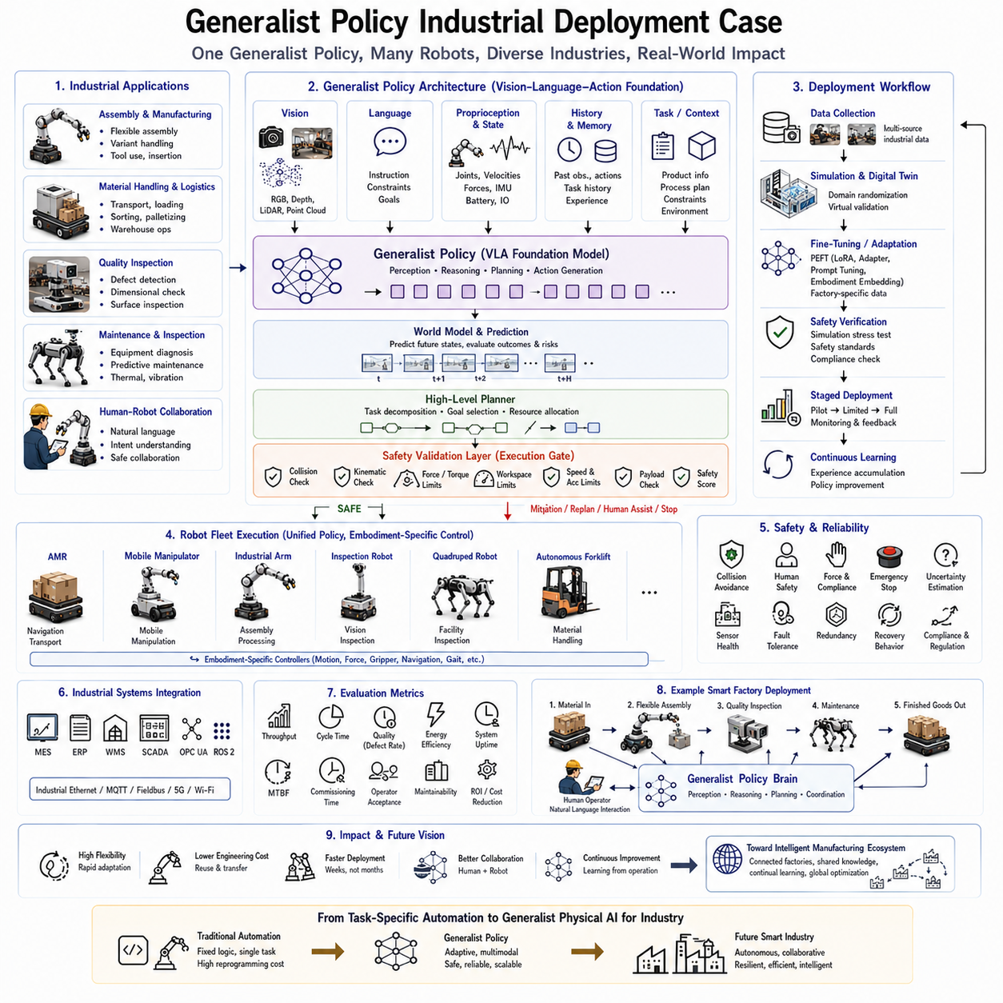
The industrial deployment of generalist robot policies represents a major transition from traditional automation toward intelligent Physical AI systems capable of operating across multiple production environments with minimal reconfiguration. Unlike conventional industrial robots that execute narrowly defined repetitive tasks through carefully programmed trajectories, generalist policies provide adaptable intelligence capable of understanding changing production requirements, interpreting natural language instructions, reasoning about complex environments, and generating appropriate actions for diverse robotic platforms. This deployment paradigm significantly improves manufacturing flexibility, reduces engineering costs, shortens commissioning time, and enables factories to respond rapidly to changing customer demands without extensive software redevelopment.
Traditional industrial automation has been highly successful in environments characterized by fixed layouts, standardized products, and repetitive manufacturing processes. Automotive assembly lines, semiconductor production, pharmaceutical manufacturing, and electronics assembly have achieved remarkable productivity through deterministic programming and specialized robotic workcells. However, increasing product diversity, shorter production cycles, customized manufacturing, labor shortages, and rapidly changing market demands expose the limitations of highly specialized automation systems. Every product modification often requires new programming, system integration, calibration, validation, and operator training. Generalist foundation policies address these challenges by enabling robots to transfer previously acquired knowledge across different industrial applications.
A generalist industrial policy begins with a foundation model pretrained using heterogeneous datasets collected from multiple industrial domains. These datasets include visual observations, language instructions, manipulation trajectories, navigation data, force sensing, tactile interaction, quality inspection results, assembly sequences, maintenance procedures, logistics operations, and human demonstrations gathered from factories worldwide. Through large-scale multimodal learning, the foundation policy develops generalized representations describing industrial objects, manufacturing processes, spatial reasoning, operational constraints, and physical interaction principles rather than memorizing individual production tasks.
One of the greatest advantages of industrial foundation policies is rapid deployment across new production lines. Instead of developing entirely new robot software for every manufacturing process, engineers begin with a pretrained generalist policy and perform lightweight fine-tuning using relatively small datasets collected from the target production environment. Adaptation typically focuses on factory-specific equipment, tooling, product geometry, workspace layout, and embodiment characteristics while preserving the extensive industrial knowledge already learned during pretraining. Consequently, deployment times may decrease from several months to only a few weeks.
Manufacturing assembly provides an excellent example of industrial deployment. Modern assembly operations involve continuously changing product variants, component tolerances, and workstation configurations. Generalist policies understand semantic assembly objectives rather than memorizing individual assembly sequences. Human operators may specify instructions through natural language such as “assemble the updated housing,” “install the revised connector,” or “inspect the new valve configuration.” The policy combines visual perception, language understanding, prior manufacturing knowledge, and current environmental observations to generate appropriate manipulation strategies even when encountering modified product designs.
Material handling represents another important industrial application. Autonomous Mobile Robots (AMRs), mobile manipulators, warehouse robots, forklifts, and collaborative transportation systems frequently operate within shared logistics environments. A unified generalist policy enables coordinated transportation, inventory movement, pallet handling, loading, unloading, sorting, and warehouse optimization using common semantic planning rather than individually programmed workflows. Cross-platform knowledge sharing further improves operational efficiency because navigation experience learned by one robot category benefits other mobile systems throughout the facility.
Quality inspection increasingly benefits from foundation policy deployment because modern manufacturing requires flexible inspection procedures capable of adapting to changing products. Rather than programming inspection sequences manually for every production variant, generalist policies interpret engineering drawings, inspection instructions, CAD models, digital twins, and language descriptions to determine appropriate inspection strategies. Vision systems identify defects, dimensional deviations, missing components, surface damage, assembly errors, corrosion, contamination, or structural anomalies while continuously adapting inspection priorities according to production requirements.
Industrial maintenance provides another compelling deployment scenario. Maintenance robots operating within factories, power plants, oil refineries, chemical facilities, tunnels, warehouses, and transportation infrastructure encounter highly variable environments where deterministic programming becomes impractical. Generalist policies integrate visual inspection, thermal imaging, acoustic sensing, vibration monitoring, language instructions, maintenance documentation, and historical service records to diagnose equipment condition, recommend corrective actions, and autonomously execute inspection routines. Knowledge acquired from one facility may transfer effectively to similar equipment deployed elsewhere.
Collaborative robotics demonstrates the importance of semantic reasoning within industrial deployment. Human workers naturally communicate using high-level objectives rather than explicit robot commands. Statements such as “bring the next assembly,” “hold this component,” “inspect the damaged section,” or “prepare the welding station” require contextual understanding beyond conventional robot programming. Foundation policies grounded in Vision-Language-Action architectures interpret these instructions while considering current environmental conditions, production schedules, worker intentions, and operational priorities. This natural interaction significantly improves human productivity while reducing training requirements.
Industrial deployment increasingly involves heterogeneous robot fleets consisting of AMRs, articulated manipulators, mobile manipulators, inspection robots, quadrupeds, autonomous forklifts, and specialized service robots. Rather than maintaining independent software stacks for each embodiment, generalist policies provide a unified cognitive architecture supporting shared perception, reasoning, planning, language understanding, and task decomposition. Robot-specific controllers subsequently translate high-level decisions into embodiment-compatible motion commands. This software unification dramatically simplifies maintenance, updates, debugging, cybersecurity management, and long-term system evolution.
Factory digital twins significantly enhance deployment efficiency by providing realistic virtual environments where foundation policies may be adapted before physical installation. Simulation platforms reproduce production equipment, conveyor systems, machine tools, robots, sensors, workpieces, human operators, and environmental dynamics. Domain randomization exposes the policy to diverse lighting conditions, object variations, machine tolerances, sensor noise, and unexpected operational events. Successful adaptation within simulation substantially reduces commissioning time and minimizes production interruption during physical deployment.
Fine-tuning strategies play an important role in industrial deployment because every factory possesses unique equipment, workflows, and production constraints. Parameter-efficient adaptation methods such as Low-Rank Adaptation (LoRA), adapter modules, prompt tuning, and embodiment embeddings allow engineers to customize foundation policies without retraining billions of parameters. This reduces computational requirements while preserving the broad industrial knowledge acquired through large-scale pretraining. Multiple factories may therefore share a common foundation model while maintaining independent lightweight adaptation modules.
Safety remains the highest priority throughout industrial deployment. Generalist policies operate within environments containing expensive machinery, hazardous materials, autonomous vehicles, collaborative robots, and human workers. Runtime safety validation continuously verifies collision avoidance, speed limits, workspace boundaries, payload restrictions, emergency stopping capability, actuator health, localization confidence, force constraints, and regulatory compliance before every executed action. Independent safety supervisors maintain deterministic control authority regardless of learned policy output, ensuring reliable operation even when unexpected situations occur.
Uncertainty estimation further improves industrial reliability by allowing foundation policies to recognize unfamiliar operating conditions. Newly introduced products, damaged components, sensor failures, unexpected lighting, communication interruptions, or rare machine faults may fall outside previous training experience. Rather than generating overconfident predictions, uncertainty-aware policies reduce operating speed, request additional observations, consult human supervisors, or activate conservative fallback behaviors. This adaptive safety mechanism significantly improves trustworthiness within continuously changing manufacturing environments.
Industrial deployment increasingly leverages cloud-edge collaborative computing architectures. High-level reasoning, production scheduling, multimodal reasoning, knowledge retrieval, world model simulation, and fleet optimization execute within centralized GPU servers or private cloud infrastructure. Edge computers mounted on individual robots perform low-latency perception, local planning, sensor fusion, safety monitoring, and real-time motion control. This distributed architecture balances computational efficiency with deterministic responsiveness while maintaining consistent policy behavior across the factory.
Industrial communication standards become increasingly important as foundation policies integrate with existing manufacturing infrastructure. Generalist policies exchange information through industrial Ethernet, OPC UA, MQTT, ROS 2, fieldbus protocols, Manufacturing Execution Systems (MES), Enterprise Resource Planning (ERP), Warehouse Management Systems (WMS), and Supervisory Control and Data Acquisition (SCADA) platforms. Seamless interoperability enables intelligent robots to participate naturally within established industrial ecosystems without requiring complete infrastructure replacement.
Evaluation during industrial deployment extends beyond laboratory benchmarks. Engineers assess production throughput, cycle time, product quality, defect rate, energy consumption, maintenance cost, system availability, mean time between failures, commissioning duration, operator acceptance, software maintainability, cybersecurity resilience, and long-term operational stability. Generalist policies must demonstrate measurable business value alongside technical performance before large-scale industrial adoption becomes economically justified.
One representative deployment scenario involves an advanced smart manufacturing facility producing multiple product variants. Autonomous Mobile Robots transport materials from warehouses to assembly stations. Mobile manipulators perform flexible assembly operations using language-guided work instructions. Inspection robots verify dimensional accuracy through multimodal vision systems. Quadruped robots inspect utility infrastructure inaccessible to wheeled platforms. Human operators supervise production while communicating naturally with robotic coworkers. A unified foundation policy coordinates perception, planning, scheduling, and task allocation across the entire heterogeneous robotic fleet while embodiment-specific controllers execute individual physical behaviors. This integrated architecture significantly increases production flexibility without sacrificing safety or operational reliability.
Another practical deployment example involves infrastructure inspection and maintenance. Inspection robots equipped with high-resolution cameras, thermal imagers, LiDAR, ultrasonic sensors, and manipulation capabilities navigate industrial facilities autonomously. The generalist policy interprets maintenance manuals, identifies equipment anomalies, prioritizes inspection targets, generates repair recommendations, and coordinates human maintenance personnel. Historical maintenance knowledge transfers across multiple facilities, continuously improving predictive maintenance capability through accumulated operational experience.
Large logistics centers similarly benefit from unified foundation policies coordinating warehouse transportation, inventory inspection, robotic picking, pallet handling, container loading, and automated inventory verification. Semantic understanding enables robots to adapt rapidly to changing warehouse layouts, seasonal inventory fluctuations, and new product categories without extensive reprogramming. Fleet-wide knowledge sharing further improves navigation efficiency, congestion management, and operational resilience.
Future industrial deployment will likely extend beyond isolated factories toward globally connected manufacturing ecosystems. Foundation policies operating across geographically distributed facilities will continuously exchange knowledge regarding production optimization, equipment maintenance, defect detection, energy management, safety improvement, and process innovation while respecting data privacy and intellectual property constraints. Continual learning mechanisms will progressively improve industrial intelligence without requiring complete system retraining after every operational update.
As Physical AI continues to mature, generalist foundation policies will increasingly become the common intelligence layer underlying industrial robotics. Instead of maintaining separate software solutions for every production process, manufacturers will deploy unified cognitive architectures capable of supporting diverse robot embodiments, rapidly adapting to changing operational requirements, collaborating naturally with human workers, and continuously improving through accumulated industrial experience. This transition will fundamentally reshape industrial automation by replacing isolated task-specific programming with scalable, transferable, and continually evolving robot intelligence suitable for next-generation smart manufacturing.

