Volume 20. Vision Language Action (VLA) Models

Chapter 12. Future Vision-Language-Action Systems

12.1 Future Trends in VLA
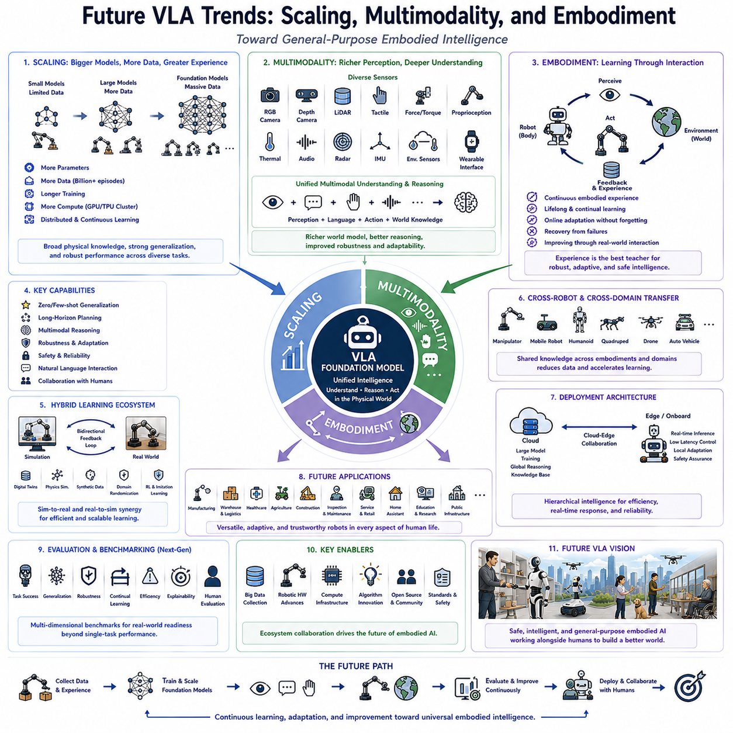
The future of Vision-Language-Action (VLA) systems is expected to be defined by three closely connected technological trends: scaling, multimodality, and embodiment. These trends collectively represent the transition from specialized robotic intelligence toward general-purpose embodied artificial intelligence capable of understanding the physical world, reasoning across multiple information modalities, and performing increasingly complex tasks through continuous interaction with dynamic environments. While current VLA models have already demonstrated impressive capabilities in language-conditioned manipulation, navigation, and multimodal reasoning, future research is expected to significantly expand their scale, learning efficiency, reasoning depth, and adaptability. As a result, VLA systems will gradually evolve from task-oriented robotic controllers into comprehensive cognitive systems capable of autonomous decision-making across diverse physical domains.
Scaling has become one of the strongest driving forces behind recent advances in artificial intelligence. Similar to the evolution of large language models, robot foundation models increasingly benefit from larger neural architectures, larger training datasets, longer training durations, and greater computational resources. Early robotic learning systems were typically trained on relatively small datasets collected within individual laboratories, limiting their ability to generalize beyond narrowly defined tasks. Future VLA models are expected to be trained using billions of multimodal observations collected from robots operating across industrial facilities, warehouses, hospitals, homes, laboratories, construction sites, agricultural environments, and public spaces. This enormous increase in training diversity will allow models to learn highly transferable representations of objects, physical interactions, human behavior, and environmental dynamics.
Model scaling extends beyond simply increasing parameter count. Future architectures are expected to scale simultaneously along several dimensions, including dataset diversity, task complexity, multimodal representation richness, temporal reasoning capability, and embodied interaction experience. Researchers increasingly recognize that balanced scaling across these dimensions produces more reliable improvements than enlarging model size alone. Consequently, future robot foundation models will likely combine billions of parameters with extensive multimodal datasets, long-horizon interaction sequences, continuous environmental feedback, and large-scale real-world robotic demonstrations to produce more robust embodied intelligence.
The rapid growth of computational infrastructure will further accelerate model scaling. Next-generation GPU clusters, specialized AI accelerators, distributed training frameworks, and cloud-edge collaborative computing will enable training workloads that were previously impractical. Large-scale distributed optimization techniques will support continuous learning from massive multimodal datasets collected by heterogeneous robotic platforms operating worldwide. Such infrastructure will enable foundation models to acquire broad physical knowledge comparable to the diversity currently observed in large language model training.
Multimodality represents another defining characteristic of future VLA systems. Current robotic policies primarily integrate RGB vision, natural language, and low-dimensional robot state information. Future architectures are expected to incorporate substantially richer sensory inputs, including depth perception, LiDAR, radar, tactile sensing, force-torque measurements, proprioception, thermal imaging, event cameras, audio, environmental sensors, physiological monitoring devices, and wearable human interfaces. Rather than treating these information sources independently, future VLA systems will develop unified multimodal representations capable of reasoning across heterogeneous sensory channels simultaneously.
The integration of multimodal perception will significantly improve environmental understanding. Vision provides geometric and semantic information, language conveys abstract goals and instructions, tactile sensing reveals physical contact properties, force measurements estimate interaction dynamics, audio detects environmental events, while thermal sensing identifies invisible physical processes. Combining these complementary modalities enables robots to construct significantly richer world models than those achievable through vision alone. Such comprehensive perception is expected to improve manipulation reliability, navigation safety, anomaly detection, collaborative interaction, and adaptive decision-making.
Language itself is expected to evolve beyond simple instruction interpretation. Future VLA systems will increasingly engage in extended dialogue, collaborative planning, question answering, explanation generation, procedural teaching, and interactive reasoning with human users. Rather than receiving isolated commands, robots will participate in continuous conversations that refine objectives, negotiate alternative solutions, explain uncertainty, request clarification, and provide progress updates. Language will become an active reasoning interface connecting human intentions with physical robot behavior throughout long-duration collaborative tasks.
Multimodal reasoning will also become substantially more sophisticated. Instead of processing perception and language independently before generating actions, future architectures are expected to perform joint reasoning across visual observations, environmental memory, semantic knowledge, physical dynamics, and temporal context. Such integrated reasoning enables robots to infer hidden object properties, predict future environmental changes, estimate human intentions, and proactively adapt task execution before failures occur. These capabilities will significantly improve long-horizon planning under uncertain operating conditions.
Embodiment represents perhaps the most fundamental trend shaping future robotic intelligence. Unlike purely digital artificial intelligence systems, embodied intelligence emerges through continuous interaction between physical agents and their surrounding environments. Future VLA systems will increasingly learn not only from static datasets but also through lifelong interaction with the real world. Every successful manipulation, navigation episode, collaboration event, environmental observation, and recovery experience will contribute to continuously improving internal representations of physical reality.
Continuous embodied learning will gradually replace isolated offline training paradigms. Instead of periodically retraining models using fixed datasets, future robotic systems will accumulate experience throughout deployment while preserving previously acquired knowledge. Online adaptation, continual learning, incremental representation refinement, and experience replay mechanisms will enable robots to improve autonomously without catastrophic forgetting. This transition toward lifelong embodied learning represents one of the most important milestones in the development of general-purpose physical intelligence.
Simulation will remain an essential component of future VLA development but will increasingly function as one element within broader hybrid learning ecosystems. High-fidelity digital twins, physics simulation, synthetic data generation, domain randomization, procedural environment generation, and reinforcement learning will complement large-scale real-world experience rather than replacing it. Bidirectional simulation-to-real and real-to-simulation feedback loops will continuously improve both virtual training environments and deployed robotic policies.
Foundation models specifically designed for robotics are expected to emerge as universal physical reasoning engines. Rather than developing separate models for navigation, manipulation, perception, planning, and dialogue, future VLA architectures will unify these capabilities within shared multimodal foundation models capable of supporting numerous downstream robotic applications through lightweight task adaptation. Such unified architectures will substantially reduce development cost while improving transfer learning, zero-shot generalization, and cross-domain knowledge sharing.
Cross-robot knowledge transfer represents another promising direction. Future robot foundation models may simultaneously support manipulators, mobile robots, humanoids, quadrupeds, autonomous vehicles, drones, underwater robots, agricultural machines, medical assistants, and industrial automation systems. Shared physical knowledge acquired by one embodiment may accelerate learning within another through transferable multimodal representations. This capability would significantly reduce the amount of task-specific data required for newly introduced robotic platforms.
Generalization will remain a central research objective. Future VLA systems are expected to demonstrate increasingly strong zero-shot, few-shot, and open-world adaptation capabilities. Rather than requiring extensive retraining for every new task, robots will leverage previously acquired semantic knowledge, physical reasoning, and multimodal understanding to perform unfamiliar tasks using only natural language instructions or limited demonstrations. Such generalization represents one of the defining characteristics of future embodied foundation models.
Robustness will become increasingly important as autonomous robots transition into safety-critical environments. Future evaluation will emphasize resilience under changing lighting conditions, cluttered workspaces, sensor degradation, hardware failures, communication interruptions, dynamic human activity, uncertain terrain, adverse weather, and unexpected environmental events. Models capable of maintaining stable performance across these challenging conditions will demonstrate true deployment readiness rather than laboratory optimization.
Human-centered collaboration is expected to become one of the primary application domains for advanced VLA systems. Future robots will operate alongside workers, patients, students, customers, and family members rather than functioning as isolated automation devices. Consequently, social intelligence, natural communication, shared decision-making, explainability, trust calibration, adaptive assistance, and personalized interaction will become integral components of embodied intelligence rather than optional features.
Safety, transparency, and ethical reasoning will receive growing attention as robot autonomy increases. Future VLA systems will require mechanisms capable of explaining decisions, estimating uncertainty, detecting anomalous behavior, respecting human preferences, complying with regulatory constraints, and safely resolving conflicting objectives. Trustworthy artificial intelligence will become a prerequisite for large-scale deployment across healthcare, transportation, manufacturing, education, public infrastructure, and domestic environments.
Edge intelligence will evolve alongside cloud-based foundation models. While large centralized models provide extensive reasoning capability, real-time robotic control demands low-latency local inference. Future VLA architectures will therefore employ hierarchical computing frameworks combining cloud-scale reasoning, edge inference acceleration, onboard adaptation, and distributed collaborative learning. Such architectures balance computational efficiency with operational responsiveness while reducing communication dependency during mission-critical operations.
Evaluation methodologies will likewise evolve to reflect increasing model capability. Future benchmark suites will assess not only task completion but also continual learning, long-term adaptation, multimodal reasoning, collaborative intelligence, safety certification, energy efficiency, environmental robustness, explainability, social interaction quality, and real-world deployment performance. Comprehensive multidimensional evaluation will replace isolated benchmark scores as the primary measure of embodied intelligence progress.
Industrial adoption is expected to accelerate as scalable foundation models reduce development complexity. Instead of engineering separate perception, planning, and control systems for every application, organizations will increasingly customize pretrained VLA foundation models through domain-specific adaptation. Manufacturing automation, warehouse logistics, precision agriculture, autonomous inspection, healthcare assistance, laboratory automation, construction robotics, retail services, hospitality, and domestic assistance will all benefit from this scalable development paradigm.
Ultimately, the future of Vision-Language-Action systems will be defined by the convergence of large-scale foundation models, comprehensive multimodal perception, and continuously evolving embodied intelligence. Scaling will provide increasingly powerful representations, multimodality will enable richer environmental understanding, and embodiment will ground abstract reasoning within physical interaction. Together, these three technological pillars will transform autonomous robots from narrowly specialized machines into adaptive cognitive agents capable of learning, reasoning, communicating, and acting effectively across the diverse physical environments encountered throughout everyday human life. As these trends mature over the coming decade, VLA systems are expected to become the core technological foundation supporting the next generation of trustworthy, general-purpose Physical AI operating safely and intelligently alongside people in nearly every sector of society.

12.2 Video Prediction and World Models
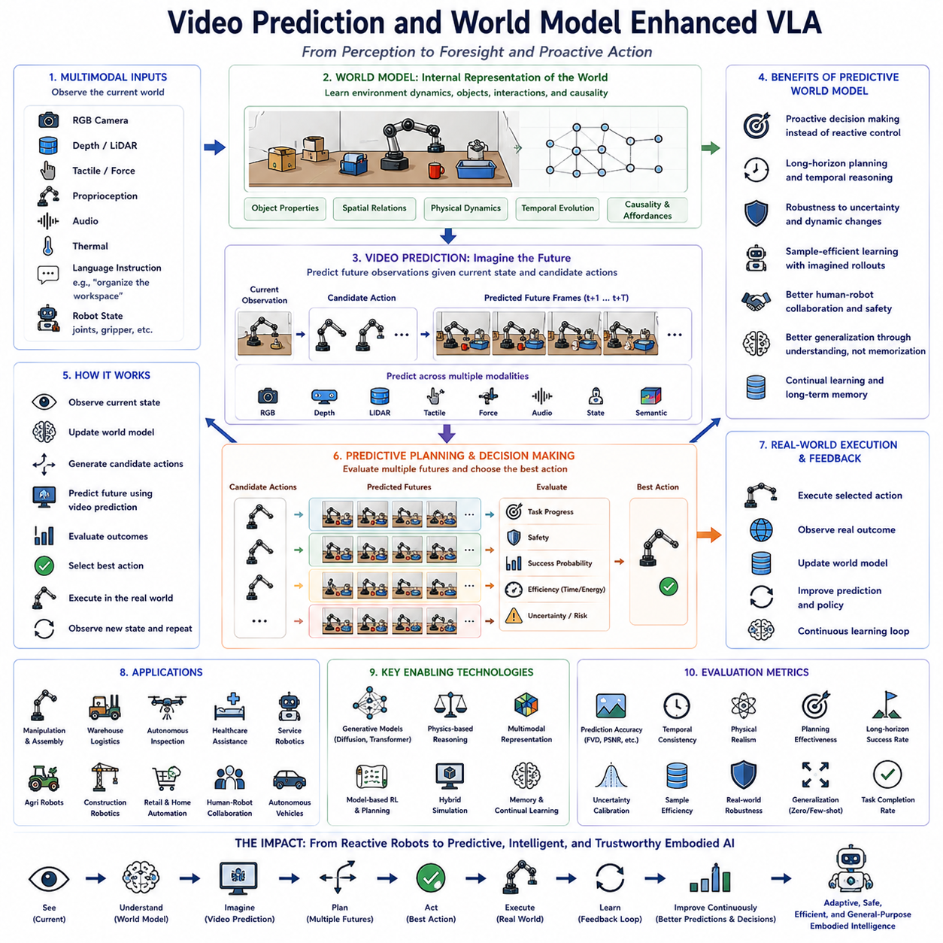
The future evolution of Vision-Language-Action (VLA) systems is expected to be significantly influenced by advances in video prediction and world models. While current VLA architectures primarily react to the robot's current observations, next-generation systems will increasingly predict future environmental states before executing actions. This transition represents a fundamental shift from reactive intelligence toward predictive embodied intelligence, enabling robots to anticipate environmental changes, evaluate multiple possible action sequences, and select behaviors that maximize long-term task success. Video prediction and world models therefore serve as essential cognitive components that transform perception into foresight and planning. As these technologies mature, VLA systems will gradually evolve from action execution engines into autonomous reasoning systems capable of understanding how the physical world changes over time.
A world model is an internal computational representation that enables a robot to simulate future environmental dynamics without physically interacting with the environment. Instead of relying solely on immediate sensor observations, the robot constructs an internal model describing object properties, physical interactions, spatial relationships, temporal dynamics, and causal dependencies. This internal representation allows the robot to estimate how the environment is likely to evolve after each potential action. Rather than repeatedly performing trial-and-error interactions, the robot can mentally evaluate alternative strategies before selecting the safest and most efficient behavior. World models therefore significantly improve decision quality while reducing unnecessary physical experimentation.
Video prediction complements world models by forecasting future visual observations based on the current scene and candidate robot actions. Given a sequence of previous camera frames and an intended action, the prediction model estimates what future camera images are expected to look like over the next several seconds. Unlike traditional image recognition systems that analyze only the present, video prediction explicitly models temporal evolution. This capability allows robots to anticipate object motion, human movement, environmental changes, and the consequences of manipulation before those events actually occur. Predictive visual modeling therefore extends perception beyond observation into future expectation.
The integration of video prediction within Vision-Language-Action architectures enables proactive decision making rather than reactive control. Traditional robotic systems typically observe the environment, generate an action, execute it, and then wait for new observations before planning again. Future VLA systems equipped with predictive models instead evaluate multiple hypothetical futures simultaneously. Candidate actions are simulated inside the world model, future observations are predicted through video generation, and expected task outcomes are compared before any physical movement begins. The selected action therefore reflects long-term consequences rather than immediate reward alone.
Temporal reasoning becomes substantially stronger when prediction is incorporated into embodied intelligence. Many robotic tasks extend over dozens or hundreds of sequential decisions where immediate observations provide only partial information about future success. Long-horizon manipulation, autonomous inspection, warehouse logistics, service robotics, healthcare assistance, household organization, and collaborative manufacturing all require anticipation of future environmental states. Video prediction enables robots to maintain consistent plans across extended time horizons by continuously estimating how current decisions influence later observations.
Future world models are expected to represent significantly more than visual appearance. Rather than predicting only future RGB images, they will integrate multimodal information including depth maps, LiDAR observations, tactile feedback, force measurements, proprioceptive states, thermal images, audio signals, semantic scene graphs, object affordances, and physical interaction dynamics. This unified representation provides a comprehensive understanding of environmental evolution across multiple sensing modalities. Such multimodal world models allow robots to reason simultaneously about geometry, semantics, contact physics, human activity, and environmental uncertainty.
Physical consistency represents one of the defining characteristics of future predictive models. Successful world models should generate physically plausible future states that obey object permanence, collision constraints, gravity, friction, momentum, articulated motion, and manipulation dynamics. Predicting visually realistic images alone is insufficient if generated futures violate fundamental physical principles. Consequently, future VLA research increasingly combines neural generative modeling with explicit physical reasoning to improve predictive reliability during robot interaction.
Language understanding also benefits substantially from predictive world models. Natural language instructions frequently describe desired future outcomes rather than immediate actions. Commands such as “organize the workspace,” “prepare the table for dinner,” or “arrange the components for assembly” require robots to imagine future environmental configurations before planning individual manipulations. World models enable robots to translate high-level language objectives into predicted future states and then generate action sequences that gradually transform the current environment toward those desired configurations.
Video prediction further improves manipulation planning by allowing robots to anticipate object motion before physical contact occurs. During grasping, pushing, opening, stacking, or assembly operations, predicted visual sequences estimate whether objects are likely to slip, rotate, collide, or become unstable. Robots can therefore adjust grasp positions, motion trajectories, contact forces, and execution timing before errors occur. Such predictive planning substantially increases manipulation robustness while reducing trial-and-error exploration.
Human-robot collaboration also benefits from predictive environmental modeling. Human motion is inherently dynamic and often difficult to interpret using instantaneous observations alone. Video prediction enables robots to estimate future human movement, anticipated workspace occupancy, gesture completion, object handover timing, and collaborative interaction opportunities. Rather than reacting after people move, robots proactively adapt trajectories to maintain safety, improve efficiency, and produce smoother collaborative behavior.
World models provide an efficient mechanism for reinforcement learning by reducing dependence on expensive physical interaction. Instead of collecting every experience directly through real robotic execution, policies can be optimized inside learned world models where millions of simulated trajectories are generated computationally. Model-based reinforcement learning therefore significantly improves sample efficiency while reducing mechanical wear, operational cost, and safety risk associated with extensive real-world exploration. Future VLA systems will likely combine model-free policies with model-based planning to exploit the advantages of both learning paradigms.
Simulation also becomes substantially more powerful when integrated with learned world models. Traditional physics simulators require manually designed object models, material properties, and environmental parameters. Learned predictive models instead infer environmental dynamics directly from large-scale multimodal experience. Hybrid simulation frameworks combining analytical physics with neural world models are expected to generate increasingly realistic training environments that better reflect authentic deployment conditions while supporting efficient large-scale policy optimization.
Foundation models for robotics will likely incorporate world modeling as a central architectural component. Rather than treating perception, planning, and action generation as independent modules, future unified architectures will jointly learn visual representations, language understanding, environmental prediction, physical reasoning, and policy optimization within shared latent spaces. Such integrated foundation models enable consistent reasoning across perception, imagination, planning, and execution while improving transfer learning across multiple robotic domains.
Generalization capability is expected to improve substantially through predictive learning. Robots capable of modeling underlying environmental dynamics acquire causal understanding instead of memorizing demonstration trajectories. Consequently, they adapt more effectively to unfamiliar objects, novel environments, alternative task sequences, and previously unseen manipulation scenarios. World models therefore contribute directly to zero-shot and few-shot task generalization by learning transferable physical principles applicable across diverse operational contexts.
Robustness under uncertainty represents another important advantage of predictive VLA systems. Real environments continuously introduce sensor noise, lighting variation, object displacement, communication delay, actuator uncertainty, and unexpected human behavior. Predictive world models estimate multiple possible future trajectories instead of assuming deterministic outcomes. Decision making therefore incorporates uncertainty estimation, confidence prediction, and risk-aware planning, enabling robots to select actions that remain reliable even when future observations cannot be predicted perfectly.
Memory and long-term experience become naturally integrated within predictive architectures. World models continuously accumulate information about environmental structure, object behavior, user preferences, task history, and previous interaction outcomes. This persistent memory allows robots to improve prediction accuracy over time while supporting continual learning and personalized assistance. Long-term environmental knowledge also enables faster adaptation when revisiting previously encountered locations or users.
Evaluation methodologies for predictive VLA systems will necessarily evolve beyond traditional task completion metrics. Future benchmarks are expected to measure prediction accuracy, temporal consistency, physical realism, planning effectiveness, uncertainty calibration, simulation fidelity, imagination quality, causal reasoning capability, long-horizon success, and real-world deployment robustness. Video prediction quality will increasingly be evaluated according to its contribution to downstream robotic performance rather than visual appearance alone.
Industrial applications stand to benefit significantly from world-model-enhanced VLA systems. Autonomous inspection robots can predict equipment degradation before failure becomes visible. Warehouse robots anticipate traffic flow and optimize navigation accordingly. Agricultural robots forecast crop growth and harvesting conditions. Healthcare assistants predict patient movement and adapt supportive actions proactively. Manufacturing robots estimate assembly outcomes before execution, reducing production errors and improving operational efficiency. These predictive capabilities transform robots from reactive automation devices into intelligent operational partners.
The emergence of generative artificial intelligence further accelerates world-model research. Diffusion models, autoregressive transformers, latent video generation architectures, and multimodal generative foundation models increasingly demonstrate the ability to synthesize physically coherent future observations. Future VLA architectures are expected to integrate these generative capabilities directly into robotic planning, enabling increasingly sophisticated imagination-driven reasoning before physical execution.
Ultimately, Video Prediction and World Model Enhanced VLA represents one of the most important directions in the evolution of embodied artificial intelligence. By enabling robots to predict future environmental states, mentally simulate alternative actions, understand physical causality, anticipate human behavior, integrate multimodal perception, and optimize long-term planning before acting, predictive world models fundamentally transform robotic intelligence from reactive execution into proactive reasoning. As large-scale multimodal foundation models continue advancing alongside increasingly accurate predictive architectures, future Vision-Language-Action systems will become capable of understanding not only what the world currently is, but also what it is likely to become. This predictive capability will serve as a cornerstone for the next generation of trustworthy, adaptive, and general-purpose Physical AI operating safely and intelligently across complex real-world environments.

12.3 Reasoning-Enhanced VLA Systems
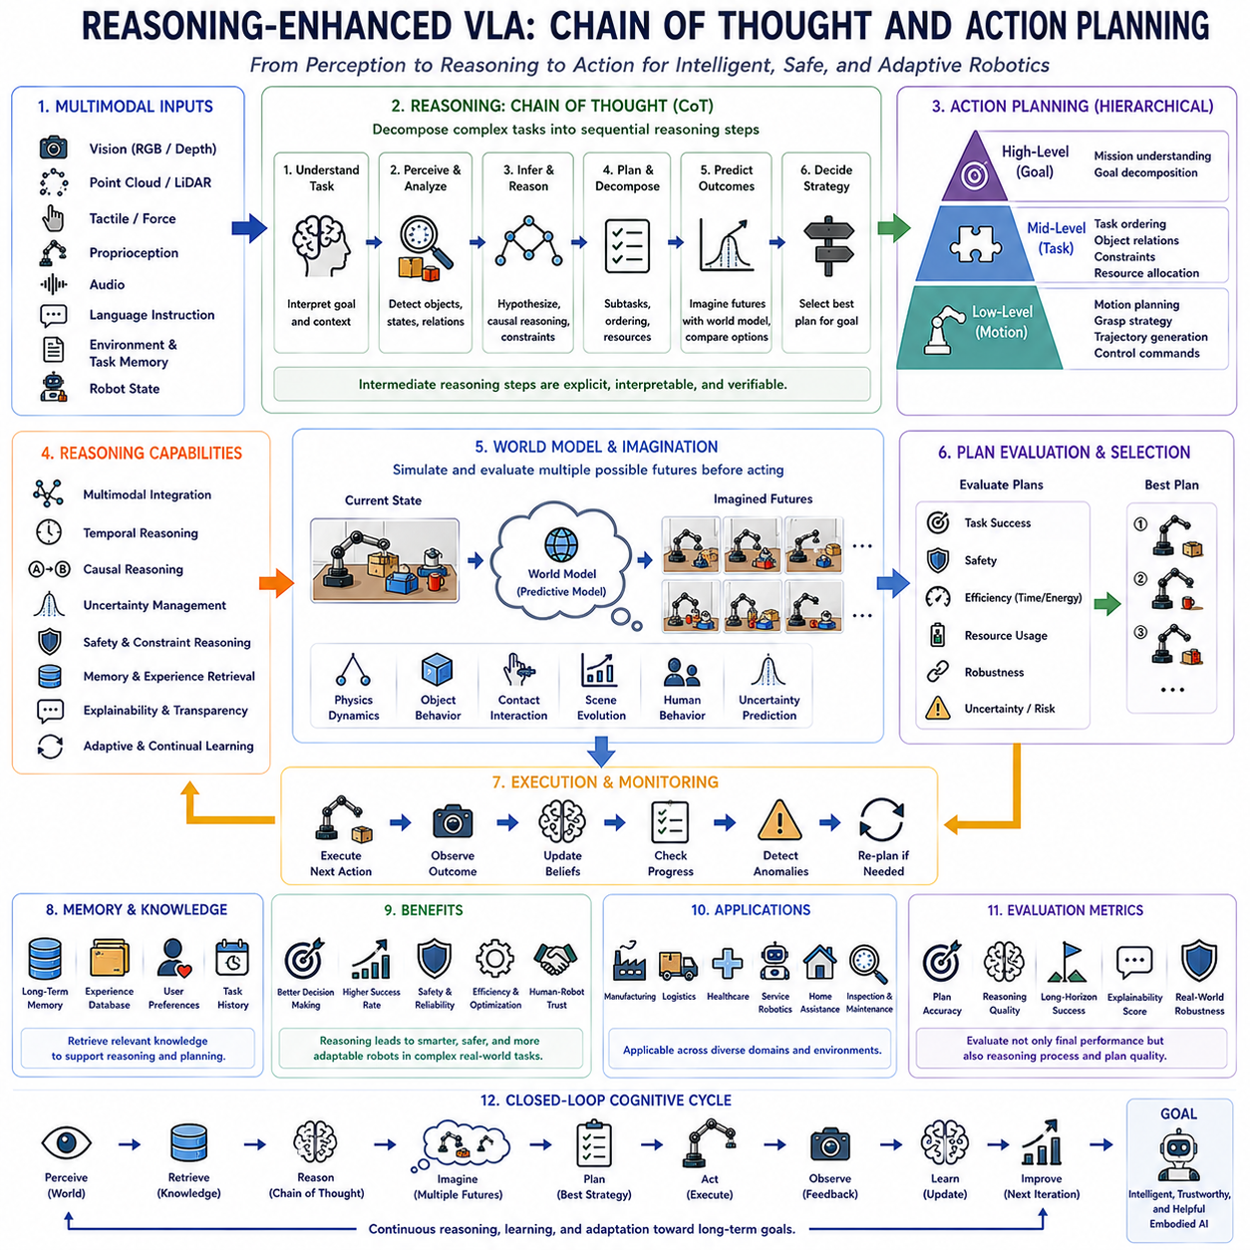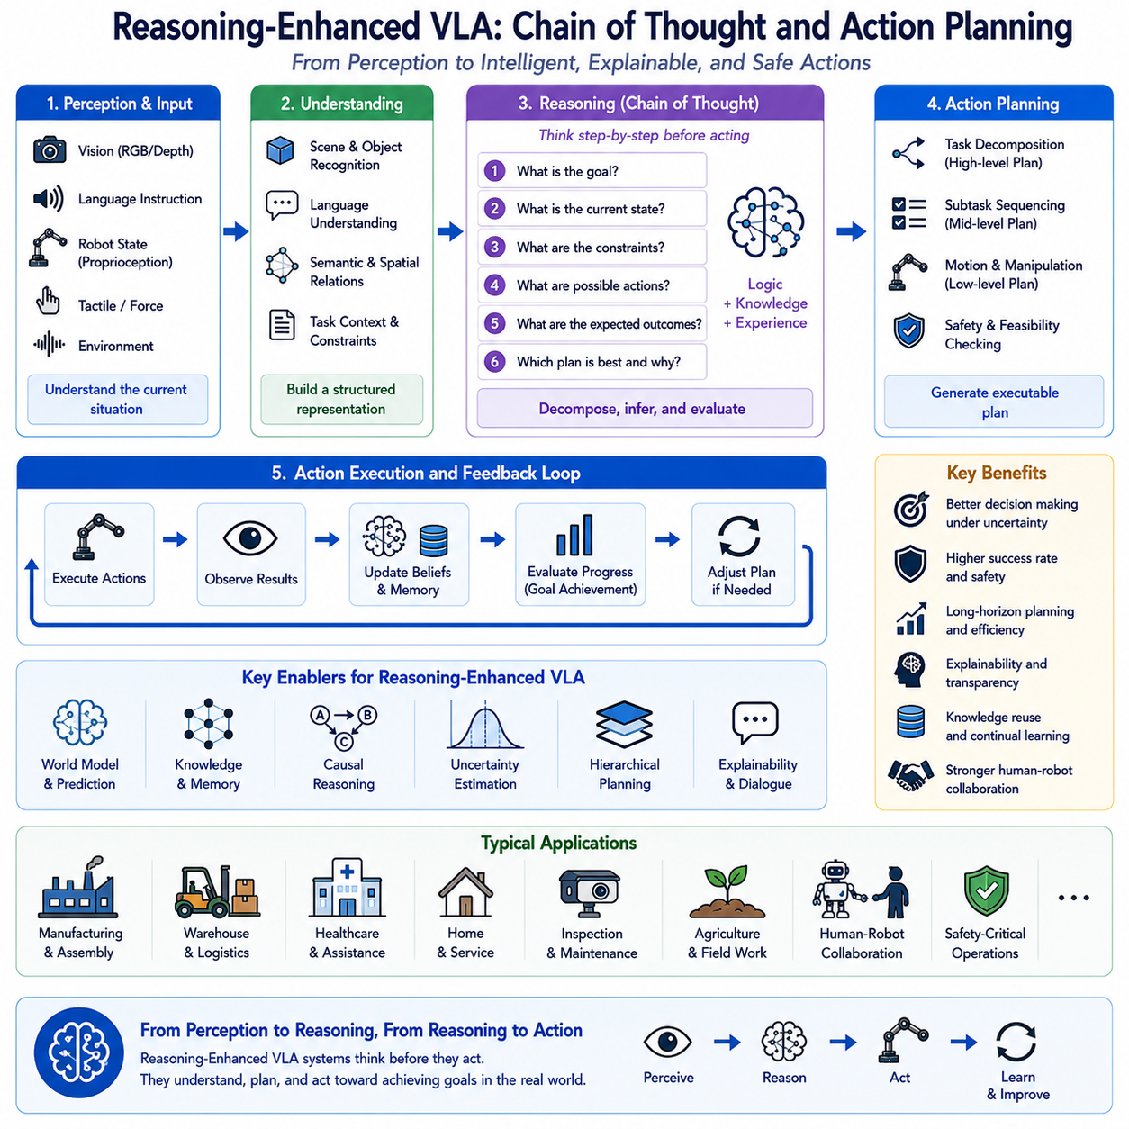
The next generation of Vision-Language-Action (VLA) systems is expected to evolve beyond perception-driven action generation toward reasoning-centered embodied intelligence. While current VLA models have demonstrated remarkable capability in understanding multimodal inputs and producing appropriate robotic actions, many practical tasks require considerably deeper reasoning before action execution. Complex manipulation, long-horizon planning, collaborative robotics, autonomous inspection, household assistance, industrial automation, and healthcare applications often involve uncertain environments where multiple possible action sequences exist. Under such conditions, selecting the optimal behavior depends not only on perception and language understanding but also on structured reasoning that evaluates alternative strategies before execution. Consequently, reasoning-enhanced VLA systems introduce explicit cognitive processes that bridge perception, language understanding, planning, and physical action through sequential logical inference. This evolution represents an important transition from reactive robotic policies toward intelligent decision-making systems capable of understanding why actions should be performed before determining how they should be executed.
Reasoning serves as the cognitive layer connecting multimodal perception with physical interaction. Traditional robotic control pipelines generally transform observations directly into control commands using learned policies. Although such approaches achieve impressive performance on many benchmark tasks, they often struggle when confronted with ambiguous instructions, unexpected environmental changes, conflicting objectives, or tasks requiring long-term planning. Reasoning introduces an intermediate decision-making process in which the robot interprets environmental context, evaluates multiple hypotheses, predicts possible outcomes, identifies constraints, and constructs coherent plans before initiating movement. This cognitive layer enables more reliable and explainable robot behavior across increasingly complex operational scenarios.
Chain of Thought reasoning has emerged as one of the most influential concepts in modern artificial intelligence because it encourages models to decompose complex problems into smaller, logically connected intermediate reasoning steps. Rather than generating immediate responses directly from input observations, the reasoning process incrementally develops an internal understanding of the task by considering sequential relationships among observations, goals, constraints, and possible actions. Within Vision-Language-Action systems, this concept extends naturally into embodied reasoning, where intermediate reasoning supports physical planning instead of textual response generation. Instead of simply predicting the next robotic action, the system progressively constructs an executable strategy that considers environmental conditions, physical feasibility, safety, efficiency, and task objectives simultaneously.
Action planning therefore becomes the physical counterpart of cognitive reasoning. Every robotic mission can be viewed as a sequence of interconnected decisions rather than isolated control commands. A service robot instructed to prepare a workspace must identify relevant objects, determine an efficient manipulation sequence, avoid collisions, preserve object stability, anticipate future workspace configurations, and satisfy user intentions. Each decision influences subsequent environmental observations, making planning inherently sequential. Reasoning-enhanced VLA systems explicitly analyze these dependencies before execution, reducing unnecessary movement while improving overall mission efficiency and robustness.
Hierarchical reasoning represents another important characteristic of future embodied intelligence. High-level reasoning interprets human intentions, decomposes complex objectives into manageable subtasks, and establishes long-term planning goals. Mid-level reasoning determines task ordering, object dependencies, environmental constraints, and resource allocation. Low-level reasoning selects precise manipulation strategies, navigation trajectories, grasp configurations, and actuator commands. Organizing reasoning across multiple abstraction levels enables robots to solve highly complex missions while maintaining computational efficiency and behavioral consistency throughout execution.
Multimodal reasoning substantially enriches this planning process by simultaneously integrating visual perception, natural language, environmental memory, proprioceptive information, tactile feedback, semantic knowledge, and physical interaction history. Instead of treating these information sources independently, future VLA systems construct unified reasoning graphs that capture relationships among objects, actions, goals, and environmental states. Such multimodal integration enables robots to infer hidden object properties, identify causal relationships, recognize implicit task requirements, and resolve ambiguity using complementary information obtained from multiple sensing modalities.
Environmental context plays a central role in reasoning-enhanced action generation. Human instructions rarely specify every procedural detail explicitly because people naturally assume contextual understanding. Commands such as “prepare the meeting room,” “clean the workstation,” or “organize the storage shelf” contain abstract objectives rather than detailed action sequences. Reasoning enables robots to interpret these high-level goals using environmental observations, previous interaction history, organizational conventions, and physical constraints. The resulting action plans therefore reflect practical situational understanding rather than literal interpretation of isolated language commands.
Temporal reasoning becomes increasingly important as robotic tasks extend over longer durations. Many industrial, medical, logistics, and household applications involve dozens or hundreds of sequential decisions spanning extended operational periods. Immediate observations alone rarely determine optimal behavior because current actions influence future opportunities and constraints. Reasoning-enhanced VLA systems therefore maintain persistent representations of mission progress, anticipated future states, intermediate objectives, and environmental evolution. Such temporal awareness enables coherent planning throughout long-horizon tasks while reducing cumulative error accumulation.
Causal reasoning further strengthens embodied intelligence by allowing robots to understand why particular actions produce specific environmental changes. Instead of merely associating observations with successful demonstrations, causal reasoning identifies underlying physical relationships governing object interaction, manipulation dynamics, human behavior, and environmental evolution. Understanding causal structure enables robots to adapt learned knowledge to unfamiliar situations where superficial visual similarity may be limited but underlying physical principles remain consistent. Such capability substantially improves transfer learning and zero-shot generalization.
Reasoning also supports uncertainty management during autonomous operation. Real-world environments continuously present incomplete information, sensor noise, ambiguous observations, communication limitations, and unpredictable human behavior. Rather than assuming deterministic environmental states, reasoning-enhanced VLA systems explicitly estimate uncertainty, evaluate multiple competing hypotheses, and update internal beliefs as additional observations become available. Decision-making therefore becomes probabilistic rather than purely reactive, allowing robots to select robust strategies even when complete environmental knowledge is unavailable.
Safety benefits significantly from explicit reasoning processes. Before executing potentially hazardous actions, reasoning modules evaluate collision risk, human proximity, object stability, environmental constraints, mechanical limitations, and regulatory requirements. Multiple alternative plans can be simulated and compared according to safety criteria before selecting the final execution strategy. Such deliberative planning substantially reduces accidental failures while improving human trust during collaborative robotic operation.
Explainability emerges naturally from structured reasoning because intermediate planning stages provide interpretable descriptions of why specific actions were selected. Instead of functioning as opaque action generators, reasoning-enhanced VLA systems can communicate task interpretation, identified constraints, considered alternatives, predicted outcomes, and expected execution sequences. Human operators therefore gain insight into robot decision-making, facilitating supervision, debugging, collaborative planning, and regulatory validation within safety-critical applications.
Memory integration significantly expands reasoning capability. Future embodied systems will continuously accumulate long-term knowledge regarding environmental layouts, object behaviors, user preferences, previous task outcomes, procedural experience, and operational history. Rather than reasoning solely from current observations, robots will retrieve relevant experiences, compare analogous situations, and incorporate historical knowledge into ongoing planning processes. This combination of memory and reasoning supports continual learning while improving adaptation to familiar environments.
World models provide an additional foundation for reasoning-enhanced planning by enabling mental simulation of hypothetical future scenarios. Candidate action sequences can be evaluated inside learned predictive models before physical execution, allowing robots to compare expected outcomes, identify potential failures, estimate resource requirements, and optimize long-term mission success. The combination of world modeling and structured reasoning transforms robotic planning from immediate reaction toward imagination-driven decision making that closely resembles human cognitive problem solving.
Reasoning-enhanced VLA architectures are expected to employ increasingly sophisticated planning representations. Graph-based reasoning captures object relationships and task dependencies. Tree search explores alternative decision sequences. Latent planning models optimize high-dimensional action spaces. Transformer-based reasoning integrates multimodal context across extended temporal windows. Neuro-symbolic reasoning combines learned representations with explicit logical constraints. Hybrid cognitive architectures integrating these complementary approaches are likely to define future embodied foundation models.
Foundation models specifically optimized for embodied reasoning will likely become central components of future robotic intelligence. Rather than learning isolated perception or manipulation capabilities independently, unified multimodal foundation models will jointly acquire visual understanding, language comprehension, physical reasoning, world modeling, memory retrieval, action planning, and execution policies within shared latent representations. Such integration enables efficient transfer across diverse robotic domains while substantially reducing task-specific engineering effort.
Evaluation methodologies must also evolve to measure reasoning capability directly rather than relying exclusively on final task success. Future benchmark suites are expected to assess planning consistency, reasoning accuracy, intermediate decision quality, causal understanding, uncertainty calibration, long-horizon optimization, action explainability, memory utilization, recovery planning, and adaptive strategy selection. Human evaluation will likely complement automated metrics by assessing whether generated reasoning appears coherent, interpretable, and aligned with human expectations.
Industrial deployment stands to benefit substantially from reasoning-enhanced Vision-Language-Action systems. Manufacturing robots will optimize assembly strategies before execution. Warehouse robots will coordinate inventory movement while anticipating traffic congestion. Healthcare assistants will adapt care procedures according to patient condition and environmental context. Inspection robots will prioritize maintenance tasks based on predicted operational risk. Agricultural robots will integrate weather forecasts, crop conditions, and resource availability into long-term cultivation planning. These applications illustrate how reasoning transforms robotic systems from reactive automation devices into intelligent operational partners capable of strategic decision making.
As multimodal foundation models continue advancing, reasoning is expected to become increasingly integrated with perception, prediction, planning, memory, and execution rather than functioning as an isolated module. Future embodied intelligence will likely operate through continuous cognitive cycles in which robots perceive their surroundings, retrieve relevant knowledge, reason about environmental context, imagine multiple future possibilities, evaluate competing action plans, execute optimal behaviors, observe resulting consequences, and update internal knowledge for future reasoning. This closed cognitive loop represents a significant step toward truly autonomous physical intelligence.
Ultimately, Reasoning-Enhanced Vision-Language-Action systems represent one of the most important directions for the future of embodied artificial intelligence. By integrating structured reasoning, Chain of Thought planning principles, multimodal understanding, causal inference, world models, memory, uncertainty estimation, explainability, and hierarchical action planning into unified robotic foundation models, future VLA architectures will move beyond simple perception-to-action mappings toward comprehensive cognitive systems capable of deliberate, adaptive, and trustworthy decision making. As these technologies mature, autonomous robots will increasingly demonstrate the ability not only to understand the world and execute actions but also to reason systematically about why specific actions should be taken, how they should be organized, and how they contribute to achieving long-term human objectives across diverse real-world environments.

12.4 Multi-Agent Collaborative VLA Systems
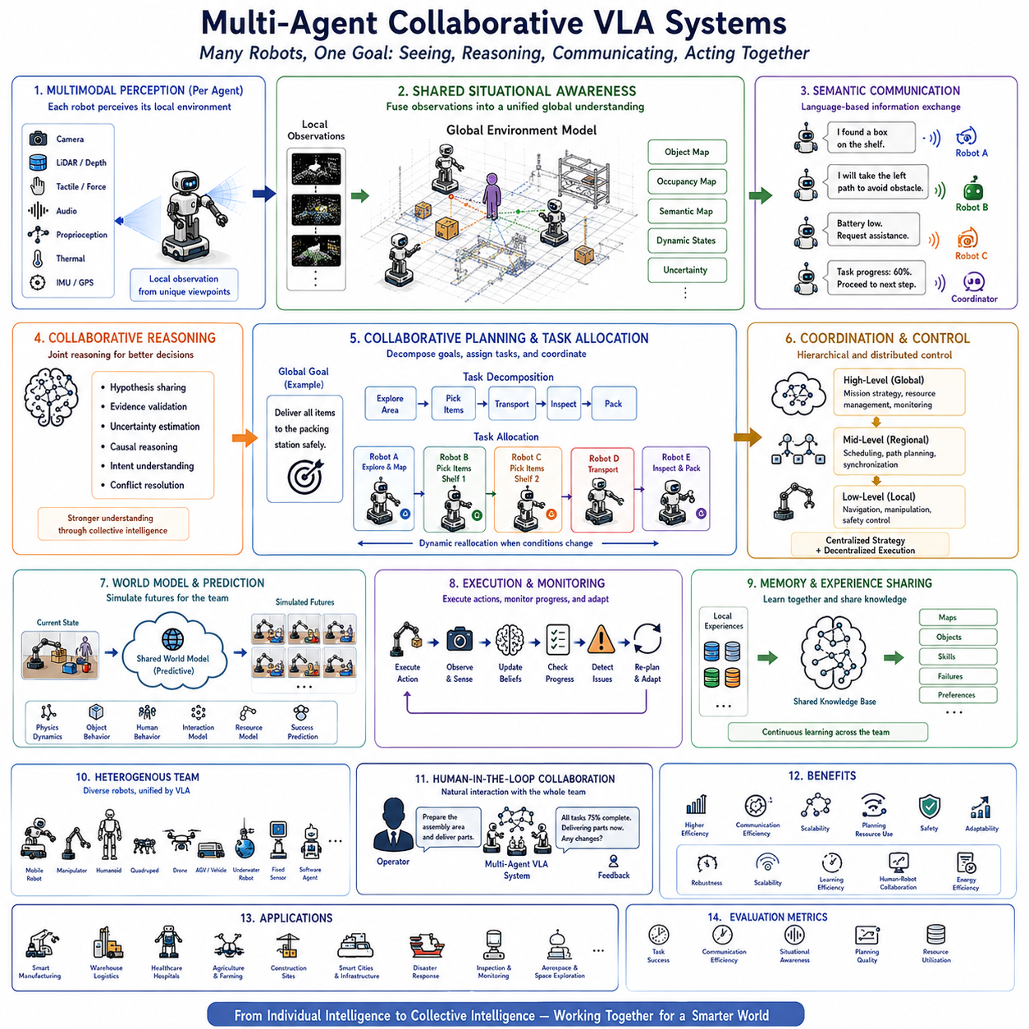
The future of Vision-Language-Action (VLA) systems is expected to extend beyond individual autonomous robots toward collaborative multi-agent intelligence capable of coordinating perception, reasoning, planning, and physical actions across multiple robotic platforms. While current VLA research has primarily focused on enabling a single robot to understand natural language, interpret visual observations, and execute manipulation or navigation tasks, many real-world applications require groups of robots working together toward common objectives. Warehouses, manufacturing facilities, hospitals, airports, construction sites, agricultural fields, smart cities, disaster response operations, and planetary exploration all involve environments where no single robot possesses sufficient sensing capability, computational resources, physical reach, or operational endurance to complete every task independently. Multi-Agent Collaborative VLA Systems therefore represent an important evolutionary step from isolated embodied intelligence toward distributed physical intelligence operating through coordinated cooperation.
Multi-agent collaboration fundamentally changes how robotic intelligence is organized. Instead of viewing each robot as a fully independent decision-making entity, future systems increasingly treat multiple robots as members of a unified cognitive ecosystem. Each robot contributes unique sensing capabilities, computational resources, mobility characteristics, manipulation skills, and environmental observations while continuously exchanging information with other agents. The collective intelligence emerging from this cooperation enables the robotic team to solve significantly more complex problems than any individual robot could accomplish alone.
Vision-Language-Action models provide a natural foundation for multi-agent collaboration because language serves as a universal communication interface between robots, human operators, and autonomous software agents. Rather than relying exclusively on low-level communication protocols, future robotic systems will increasingly exchange high-level semantic information expressed through structured natural language representations. Robots may communicate discovered objects, environmental hazards, task progress, resource availability, planning updates, uncertainty estimates, and collaborative requests using language-grounded reasoning rather than purely numerical state variables. This semantic communication significantly improves flexibility while reducing coordination complexity across heterogeneous robotic teams.
Shared situational awareness represents one of the defining characteristics of collaborative VLA systems. Every robot continuously observes its local environment using cameras, LiDAR, tactile sensors, force sensors, proprioception, audio, thermal imaging, and other multimodal sensing technologies. Instead of maintaining isolated local maps, collaborative systems integrate these distributed observations into a continuously evolving global environmental representation accessible to all participating agents. Shared perception substantially improves environmental understanding because observations from multiple viewpoints reduce occlusion, improve localization accuracy, increase object detection reliability, and provide broader contextual awareness than any individual sensor platform.
Collaborative perception naturally extends into collaborative reasoning. Rather than independently interpreting observations, multiple robots jointly analyze environmental information, compare hypotheses, validate object identities, estimate uncertainty, and infer hidden environmental structure through distributed reasoning processes. For example, one robot may observe partial visual evidence while another contributes complementary depth information or tactile confirmation. By integrating these heterogeneous observations through shared reasoning frameworks, the collective system generates more accurate environmental understanding than isolated perception alone.
Task allocation becomes a central component of multi-agent embodied intelligence. Real-world missions frequently consist of numerous interconnected subtasks requiring different capabilities, resources, and physical locations. Collaborative VLA systems decompose high-level objectives into executable subtasks before assigning responsibilities according to each robot's current location, available resources, manipulation capability, sensing quality, computational workload, battery status, and operational expertise. Intelligent task allocation improves mission efficiency while minimizing redundant effort and unnecessary resource consumption throughout large-scale operations.
Dynamic task allocation further enhances operational flexibility under changing environmental conditions. Unexpected obstacles, hardware failures, communication interruptions, human intervention, weather variation, or evolving mission priorities continuously modify operational requirements during deployment. Future collaborative VLA systems therefore re-evaluate task assignments in real time, redistributing responsibilities whenever environmental changes render previous plans suboptimal. Such adaptive coordination enables resilient mission execution despite uncertainty and operational disturbances.
Hierarchical coordination architectures are expected to dominate future collaborative robotic systems. High-level coordination agents interpret global mission objectives, allocate resources, establish collaborative strategies, and monitor overall mission progress. Mid-level coordination manages regional task distribution, local scheduling, information sharing, and inter-robot synchronization. Individual robots then perform autonomous low-level perception, navigation, manipulation, and control while continuously reporting progress back to the collaborative coordination framework. This hierarchical organization balances centralized planning with decentralized execution, improving scalability while preserving local autonomy.
Distributed decision making represents another defining characteristic of future multi-agent systems. Instead of relying exclusively on centralized controllers vulnerable to communication failure or computational bottlenecks, collaborative VLA architectures increasingly distribute reasoning capability across participating agents. Each robot maintains local decision autonomy while contributing to collective planning through information exchange, negotiation, consensus formation, and distributed optimization. Such decentralized intelligence significantly improves fault tolerance, scalability, and operational robustness during large-scale deployments.
World models become substantially richer within collaborative environments because multiple robots jointly construct predictive environmental representations. Distributed world models integrate observations from heterogeneous sensors, maintain synchronized environmental memory, estimate future system evolution, and predict collaborative action outcomes across the entire robotic team. Instead of imagining only individual future trajectories, collaborative world models simulate coordinated multi-agent behaviors while evaluating communication constraints, resource allocation, environmental dynamics, and mission success probabilities before execution begins.
Communication efficiency plays a critical role in collaborative embodied intelligence. Continuous transmission of raw sensor data quickly exceeds available network bandwidth, particularly for high-resolution video streams, LiDAR point clouds, or multimodal observations. Future collaborative VLA systems therefore prioritize semantic communication in which robots exchange compressed environmental knowledge, symbolic object representations, task intentions, uncertainty estimates, reasoning summaries, and predicted future states rather than transmitting complete sensor streams. This knowledge-centric communication dramatically reduces bandwidth requirements while preserving essential collaborative information.
Reasoning-enhanced collaboration further improves team performance by enabling robots to explain intentions, justify decisions, negotiate responsibilities, request assistance, and resolve conflicts through structured reasoning. Rather than blindly following predetermined coordination rules, collaborative VLA systems analyze mission objectives, compare alternative strategies, estimate cooperative benefits, and adapt coordination policies according to evolving operational requirements. Such cognitive collaboration more closely resembles human teamwork than traditional distributed robotic control.
Human operators naturally become collaborative members within future multi-agent VLA ecosystems. Instead of supervising individual robots independently, humans interact with the collective robotic team using high-level natural language instructions, mission objectives, strategic guidance, and interactive feedback. The collaborative system interprets these instructions, distributes responsibilities across available agents, coordinates execution, monitors progress, and communicates summarized mission status back to human supervisors. This human-centered collaboration substantially reduces operator workload while improving mission transparency and overall operational effectiveness.
Multi-agent reinforcement learning is expected to play an increasingly important role in collaborative VLA development. Rather than optimizing policies for isolated robots, future learning algorithms simultaneously optimize cooperative behaviors across multiple interacting agents. Robots learn communication strategies, collaborative planning, resource sharing, coordinated navigation, joint manipulation, conflict resolution, and adaptive teamwork through repeated multi-agent experience. Such learning produces emergent cooperative behaviors that exceed manually engineered coordination strategies in both efficiency and adaptability.
Heterogeneous robot collaboration significantly expands operational capability. Future collaborative systems will increasingly integrate mobile robots, manipulators, humanoids, quadrupeds, aerial drones, autonomous vehicles, underwater robots, fixed sensing infrastructure, and intelligent software agents within unified cooperative frameworks. Each platform contributes specialized capabilities while sharing common multimodal representations, semantic communication protocols, and collaborative planning architectures. Such heterogeneous integration enables comprehensive physical intelligence across diverse operational environments.
Long-horizon collaborative planning introduces additional challenges beyond individual robot planning. Team coordination requires synchronization of multiple parallel task sequences, shared resource utilization, conflict avoidance, communication scheduling, transportation logistics, environmental access management, and coordinated recovery following unexpected failures. Future collaborative VLA systems therefore combine hierarchical planning, predictive world models, distributed optimization, and continual reasoning to maintain coherent long-duration mission execution despite evolving environmental uncertainty.
Safety becomes increasingly important as collaborative robot populations expand. Multiple autonomous agents simultaneously operating within shared environments introduce additional collision risks, communication dependencies, resource conflicts, and coordination failures. Future collaborative architectures therefore integrate distributed safety reasoning, cooperative collision avoidance, shared situational awareness, conflict detection, emergency coordination protocols, and collaborative recovery planning to maintain safe operation under complex multi-robot conditions.
Memory sharing substantially enhances collective intelligence. Individual robots continuously accumulate operational experience, environmental knowledge, object interaction history, user preferences, failure cases, and procedural expertise. Collaborative memory systems synchronize relevant knowledge across the robotic team, enabling newly deployed agents to benefit immediately from experiences acquired by others. This distributed knowledge base supports continual learning while significantly reducing redundant exploration across repeated missions.
Cloud-edge collaboration further strengthens multi-agent intelligence by combining centralized foundation models with distributed edge inference. Cloud infrastructure performs computationally intensive reasoning, global optimization, long-term memory management, and foundation model adaptation, while edge computing supports real-time perception, local planning, manipulation control, and low-latency safety monitoring. Hybrid cloud-edge architectures therefore balance computational efficiency, communication latency, operational autonomy, and system scalability across geographically distributed robotic deployments.
Evaluation methodologies for collaborative VLA systems necessarily extend beyond individual robot performance. Future benchmarks are expected to measure collaborative task completion, communication efficiency, shared situational awareness, resource utilization, planning coordination, robustness under communication failure, distributed reasoning quality, adaptive task allocation, collective learning efficiency, scalability, energy consumption, fault tolerance, and human-robot collaboration effectiveness. These multidimensional metrics provide comprehensive assessment of distributed embodied intelligence operating under realistic deployment conditions.
Industrial applications illustrate the transformative potential of collaborative VLA systems. Manufacturing facilities employ coordinated robotic teams for assembly, inspection, logistics, and quality assurance. Warehouses integrate autonomous mobile robots with robotic manipulators to optimize inventory movement and order fulfillment. Hospitals coordinate service robots, medication delivery systems, cleaning robots, and patient assistance platforms. Agricultural operations combine drones, autonomous tractors, field robots, and sensing stations for precision farming. Smart cities integrate autonomous vehicles, inspection robots, environmental monitoring systems, and infrastructure maintenance platforms through unified collaborative intelligence. Disaster response teams deploy heterogeneous robotic agents capable of jointly performing search, mapping, rescue, communication, and environmental assessment under hazardous conditions.
Ultimately, Multi-Agent Collaborative Vision-Language-Action Systems represent one of the most significant directions in the future evolution of embodied artificial intelligence. By integrating distributed perception, semantic communication, collaborative reasoning, hierarchical planning, shared world models, adaptive task allocation, distributed memory, multi-agent reinforcement learning, heterogeneous robot cooperation, cloud-edge intelligence, and human-centered collaboration into unified cognitive ecosystems, future VLA architectures will transcend the limitations of individual autonomous robots. Instead of isolated intelligent machines, the next generation of Physical AI will consist of cooperative robotic societies capable of collectively perceiving, reasoning, communicating, learning, and acting across large-scale dynamic environments. Such distributed embodied intelligence will provide the technological foundation for highly scalable, resilient, trustworthy, and efficient autonomous systems operating collaboratively alongside human society across virtually every industrial and public domain.

12.5 Continual Learning During Deployment
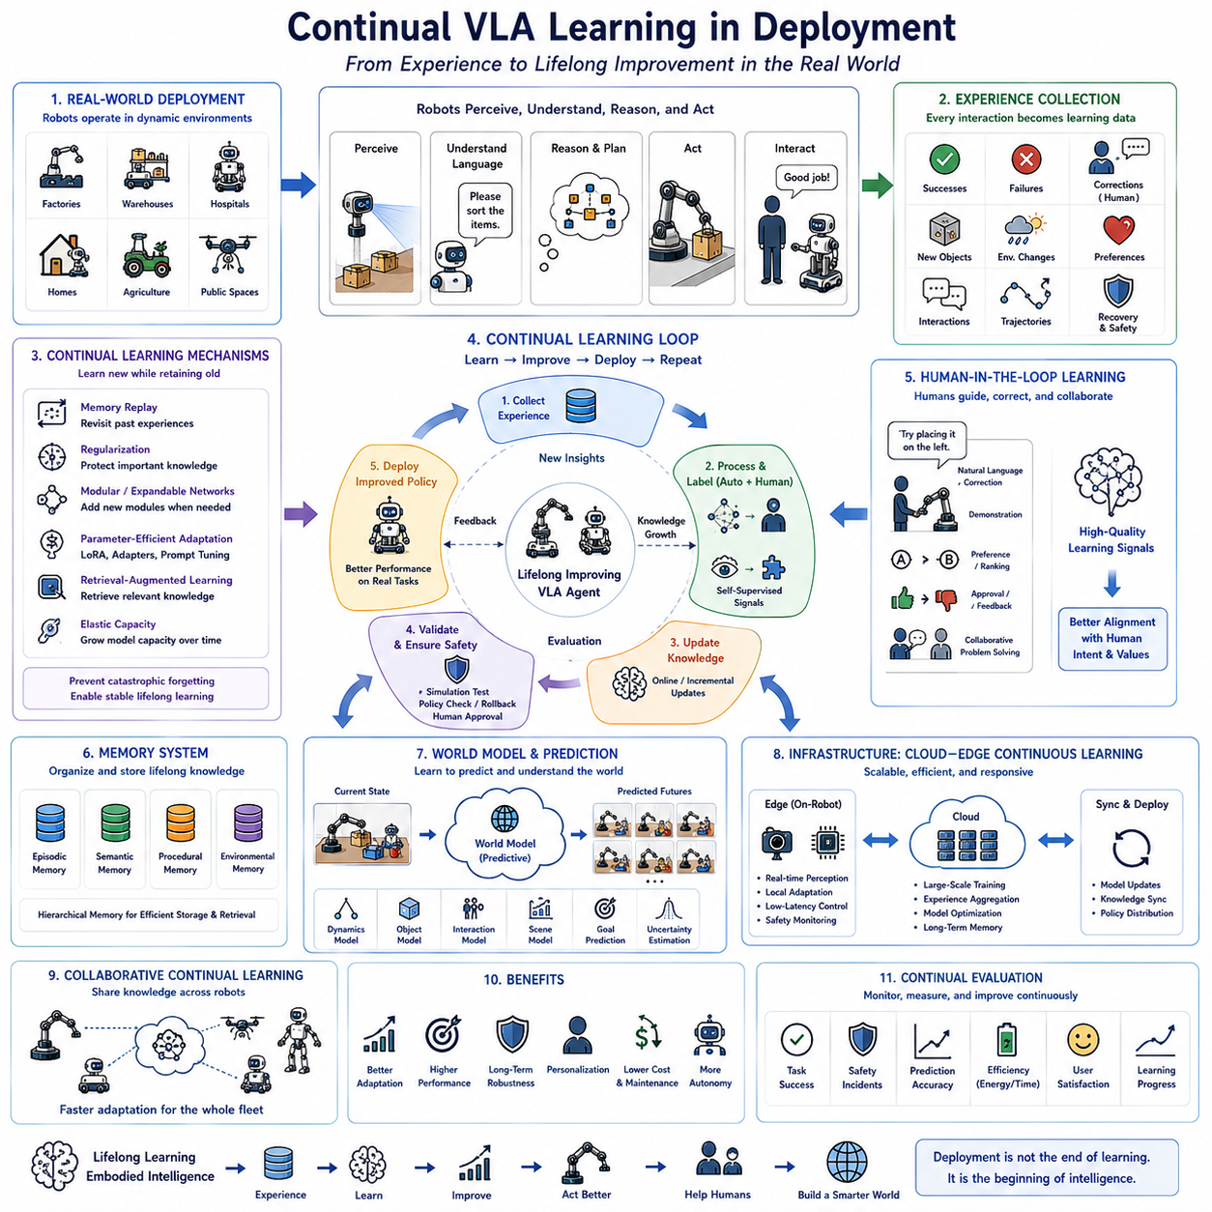
The next stage in the evolution of Vision-Language-Action (VLA) systems is expected to move beyond static pre-trained models toward continuously improving embodied intelligence capable of learning throughout real-world deployment. Most existing VLA models are trained offline using large-scale datasets and are subsequently deployed with fixed parameters. Although these models often demonstrate impressive generalization capabilities, real operational environments continuously change due to new objects, evolving workflows, environmental variation, user preferences, and unforeseen situations that were not represented during initial training. Consequently, future VLA systems must become lifelong learning agents that continuously acquire new knowledge while maintaining previously learned capabilities. Continual learning during deployment therefore represents one of the most important technological foundations for scalable Physical AI capable of long-term autonomous operation across diverse real-world environments.
Traditional machine learning follows a train-then-deploy paradigm in which the learning process ends before practical operation begins. Data are collected, models are trained offline, evaluation is performed using benchmark datasets, and the resulting models are frozen before deployment. While this approach simplifies validation and certification, it prevents robotic systems from adapting to changing operational conditions. In contrast, continual VLA learning extends the learning process into deployment itself. Every interaction with the environment becomes a valuable learning opportunity, allowing robots to continuously improve perception, reasoning, language understanding, manipulation skills, navigation strategies, and collaborative behavior through accumulated operational experience.
Continual learning fundamentally transforms the relationship between robots and their environments. Rather than treating deployment as the final stage of development, future embodied intelligence systems regard deployment as the primary source of knowledge acquisition. Every successful task, failed manipulation, unexpected obstacle, human correction, environmental change, and recovery procedure contributes new information that gradually improves internal representations of the physical world. This continuous adaptation enables robots to remain effective despite evolving operational requirements without requiring complete retraining from scratch.
One of the central challenges in continual learning is catastrophic forgetting. Neural networks optimized for newly acquired tasks often lose performance on previously learned knowledge because parameter updates overwrite existing representations. This problem becomes particularly significant in long-term robotic deployment where thousands of new experiences accumulate over extended operational periods. Future VLA systems therefore require learning mechanisms capable of integrating new information while preserving existing competencies. Memory replay, parameter regularization, modular architectures, dynamic network expansion, and retrieval-augmented learning represent promising approaches for balancing adaptation with long-term knowledge retention.
Experience replay provides one effective solution by storing representative historical experiences within long-term memory. During subsequent learning updates, previously acquired examples are periodically revisited alongside newly collected data, preventing older knowledge from disappearing. Replay memories may include successful manipulations, navigation trajectories, language interactions, environmental observations, safety-critical situations, and recovery procedures. Intelligent experience selection further improves efficiency by prioritizing informative or rare events rather than indiscriminately storing every observation generated during deployment.
Memory organization becomes increasingly important as robots accumulate years of operational experience. Future VLA systems are expected to maintain hierarchical memory structures combining episodic memory, semantic memory, procedural memory, and environmental memory. Episodic memory records individual experiences, semantic memory stores generalized knowledge about objects and environments, procedural memory captures learned manipulation and navigation skills, while environmental memory maintains persistent maps and contextual information. Together these complementary memory systems enable continual adaptation while supporting efficient retrieval of relevant knowledge during future reasoning and planning.
Foundation models provide an effective basis for continual adaptation because large-scale pretrained representations already encode broad semantic and physical knowledge acquired from extensive multimodal datasets. Rather than retraining complete models after every deployment experience, future VLA systems will likely perform lightweight adaptation using parameter-efficient fine-tuning, low-rank adaptation techniques, adapter modules, prompt optimization, or latent representation refinement. Such approaches significantly reduce computational requirements while preserving the general capabilities of the underlying foundation model.
Online learning represents another essential component of continual deployment. Instead of waiting until sufficient data accumulate for periodic offline retraining, robots incrementally update selected components while remaining operational. Carefully designed online optimization strategies allow perception modules, language grounding components, world models, manipulation policies, and planning systems to improve continuously without interrupting mission execution. This capability enables rapid adaptation to newly introduced objects, changing environmental layouts, evolving user preferences, and modified operational procedures.
Human feedback plays a particularly valuable role during continual learning. Operators naturally provide corrections, demonstrations, verbal explanations, preferences, and task refinements while interacting with deployed robots. Rather than treating these interactions merely as supervisory control, future VLA systems interpret human guidance as high-quality learning signals that improve future performance. Natural language corrections, physical demonstrations, approval feedback, ranking preferences, and collaborative problem solving all contribute to progressively aligning robotic behavior with human expectations. Human-in-the-loop continual learning therefore accelerates adaptation while improving safety and trustworthiness.
Self-supervised learning substantially expands the quantity of useful deployment data by enabling robots to learn from unlabeled observations. Every navigation sequence, object interaction, sensor measurement, environmental change, and multimodal observation contributes predictive learning signals without requiring manual annotation. Future VLA systems are expected to continuously refine visual representations, environmental models, temporal predictions, and physical understanding through self-supervised objectives integrated directly into routine autonomous operation. This approach dramatically increases learning efficiency while minimizing annotation cost.
World models further enhance continual learning by allowing robots to compare predicted environmental evolution with actual observations collected during deployment. Prediction errors identify deficiencies within current internal representations, highlighting areas requiring additional adaptation. Robots therefore improve not only through explicit task success or failure but also through continuous refinement of predictive accuracy. As predictive models become increasingly accurate, planning, manipulation, navigation, and collaborative decision making all benefit from progressively improved environmental understanding.
Simulation and real-world deployment increasingly complement one another within continual learning frameworks. Experiences collected during practical operation are transferred back into simulation to improve virtual training environments, while synthetic scenarios generated in simulation prepare robots for future real-world situations that have not yet been encountered. This bidirectional simulation-to-real learning cycle enables efficient large-scale optimization without exposing physical systems to unnecessary operational risk. Hybrid learning environments therefore accelerate continual adaptation while maintaining deployment safety.
Collaborative continual learning extends these concepts across multiple robots operating simultaneously. Rather than learning independently, distributed robotic teams exchange newly acquired knowledge through shared cloud infrastructure or decentralized communication networks. When one robot learns to manipulate a previously unseen object or adapt to a novel environmental condition, this knowledge becomes immediately available to other robots facing similar situations. Collective learning therefore accelerates adaptation across entire robotic fleets while reducing redundant exploration and repeated mistakes.
Cloud-edge collaboration provides the computational infrastructure necessary for scalable continual learning. Edge computing supports low-latency perception, local adaptation, and real-time control directly on deployed robots, while cloud infrastructure performs computationally intensive model optimization, large-scale experience aggregation, long-term memory management, and foundation model refinement. Periodic synchronization between cloud and edge systems enables continuous deployment of improved capabilities without interrupting ongoing autonomous operation. This hybrid architecture balances responsiveness with large-scale learning efficiency.
Safety remains a primary concern during continual adaptation because autonomous learning directly influences future robot behavior. Consequently, future continual learning systems incorporate verification mechanisms, confidence estimation, anomaly detection, policy validation, simulation-based testing, rollback capability, and human approval before newly learned behaviors become fully operational. Safety-aware learning ensures that adaptation improves performance without introducing unacceptable operational risk. Such controlled adaptation is particularly important for healthcare, manufacturing, transportation, and public service applications where reliability remains essential.
Continual evaluation accompanies continual learning throughout deployment. Rather than relying exclusively on static benchmark datasets collected before deployment, future evaluation frameworks continuously monitor task performance, prediction accuracy, manipulation reliability, navigation quality, energy efficiency, human satisfaction, safety incidents, recovery success, language understanding, and collaborative effectiveness. Performance trends reveal whether learning produces genuine long-term improvement or unintended degradation. Continuous evaluation therefore becomes an integral component of autonomous system maintenance.
Personalization emerges naturally through deployment-based learning. Different users often possess unique preferences regarding communication style, task execution, workspace organization, interaction frequency, safety margins, and collaborative behavior. Continual learning enables robots to gradually adapt these characteristics without sacrificing general capability. Personalized assistance significantly improves user satisfaction while supporting long-term human-robot relationships across domestic, industrial, medical, educational, and service environments.
Industrial deployment demonstrates the practical importance of continual VLA learning. Manufacturing robots adapt to evolving production processes, new components, and changing assembly procedures. Warehouse robots continuously optimize navigation according to traffic patterns and inventory organization. Agricultural robots refine crop management strategies using seasonal observations. Healthcare assistants personalize support according to patient behavior and clinical routines. Autonomous inspection robots improve anomaly detection as new equipment conditions emerge over years of operation. In each application, continual adaptation substantially extends operational lifetime while reducing maintenance cost.
Future research is expected to integrate continual learning with reasoning, world models, multimodal perception, memory systems, collaborative intelligence, and foundation model adaptation within unified embodied cognitive architectures. Rather than functioning as isolated learning modules, these components will continuously exchange information throughout perception, planning, execution, evaluation, and knowledge refinement. Every completed task contributes additional experience, every prediction improves future reasoning, and every interaction expands collective understanding of the physical world.
Ultimately, Continual VLA Learning in Deployment represents a fundamental transition from static robotic intelligence toward continuously evolving Physical AI. Instead of viewing deployment as the endpoint of development, future Vision-Language-Action systems will treat deployment as an ongoing learning process through which perception, language understanding, reasoning, manipulation, navigation, collaboration, and decision making continuously improve. By integrating lifelong learning, memory organization, self-supervised adaptation, human feedback, world models, cloud-edge collaboration, collective knowledge sharing, safety-aware optimization, and continuous evaluation into unified foundation models, future embodied intelligence will become increasingly adaptive, resilient, personalized, and capable of operating autonomously for extended periods across diverse real-world environments. Continuous learning will therefore serve as one of the defining capabilities distinguishing next-generation autonomous robotic systems from the static AI models of today.

12.6 Beyond Manipulation: Navigation and Autonomous Driving
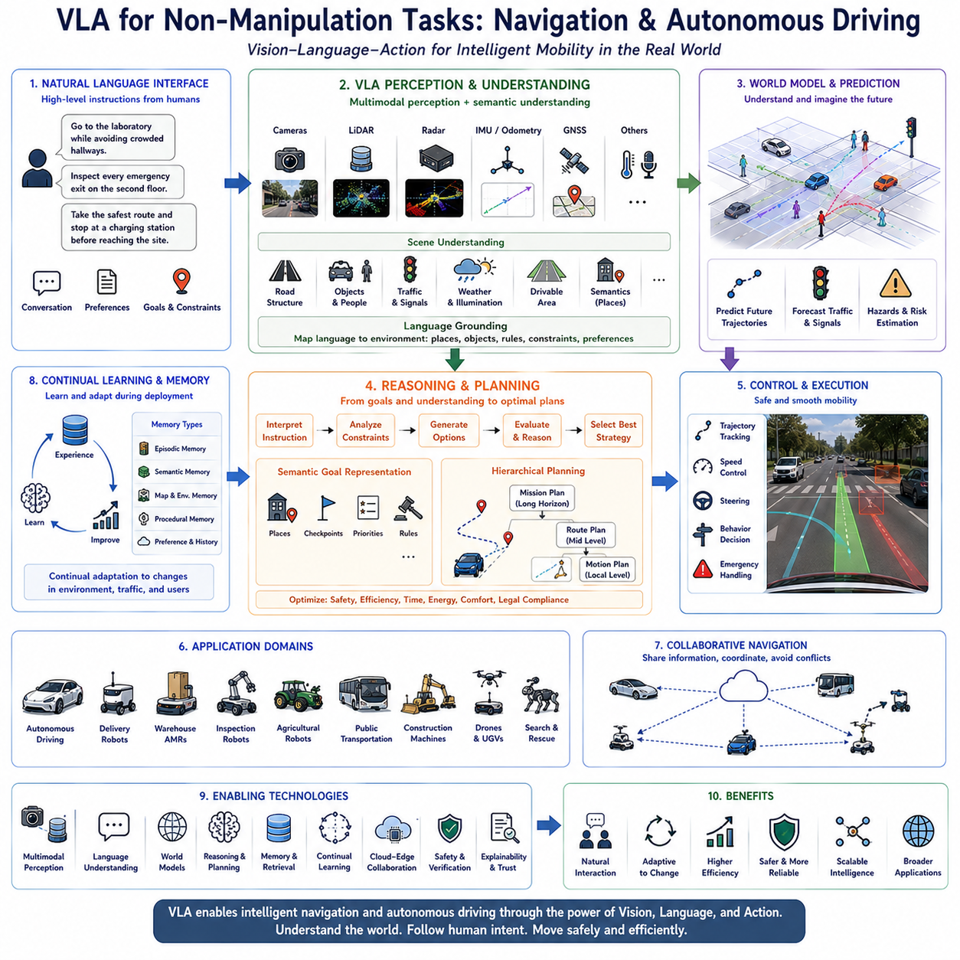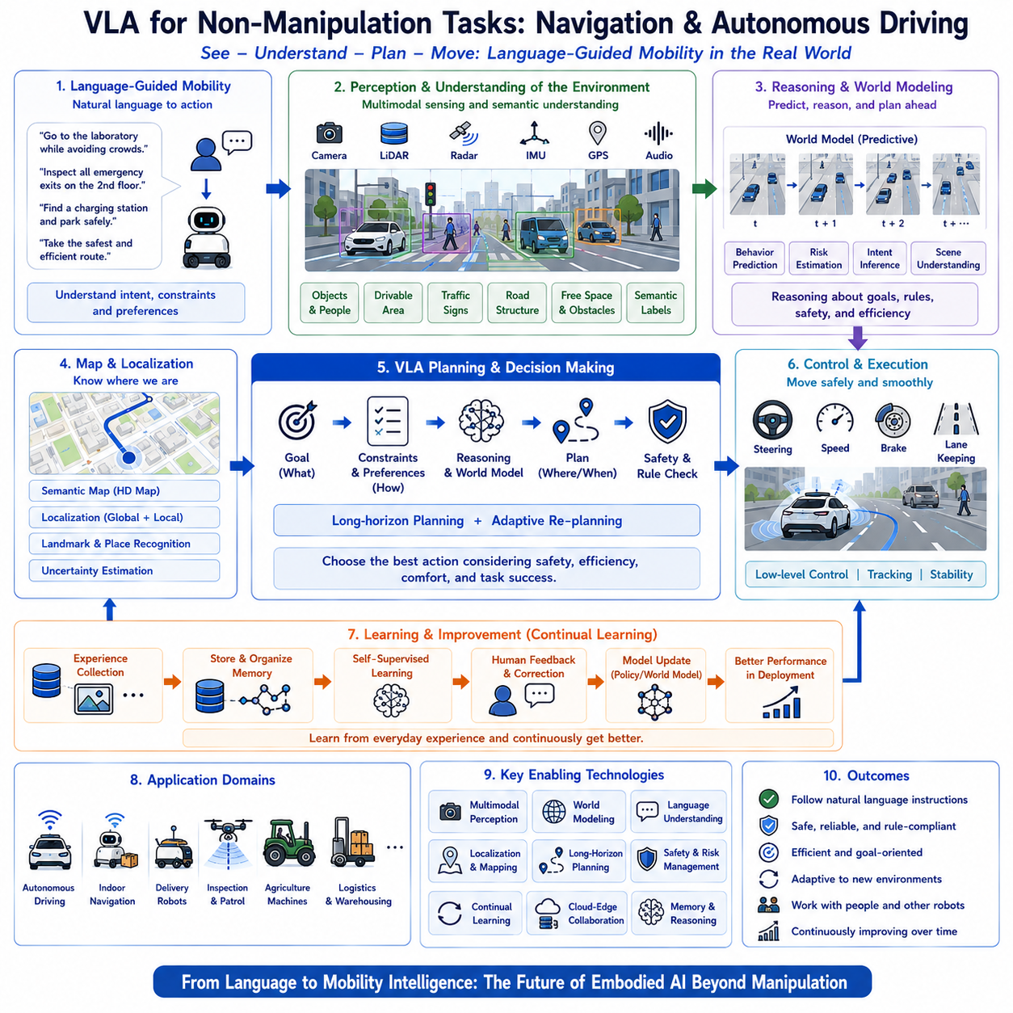
Vision-Language-Action (VLA) systems have traditionally been associated with robotic manipulation tasks such as object grasping, assembly, pick-and-place operations, and household assistance. These applications emphasize dexterous interaction between robotic manipulators and physical objects under language guidance. However, the future of embodied artificial intelligence extends far beyond manipulation. A significant portion of real-world robotic intelligence is devoted to mobility, navigation, autonomous driving, exploration, inspection, logistics, surveillance, transportation, and collaborative movement through complex environments. Consequently, next-generation VLA systems are expected to become comprehensive mobility intelligence platforms capable of integrating perception, language understanding, reasoning, planning, and vehicle control for autonomous navigation across indoor, outdoor, structured, and unstructured environments. This evolution transforms VLA from manipulation-oriented intelligence into a universal embodied cognitive architecture supporting virtually every category of autonomous mobile system.
Navigation fundamentally differs from manipulation because decisions must continuously account for dynamic environmental changes over extended spatial and temporal scales. While manipulation often focuses on precise interactions within localized workspaces, navigation requires understanding large environments, predicting future traffic conditions, maintaining localization, avoiding obstacles, optimizing routes, and continuously adapting to changing surroundings. Future VLA systems therefore require significantly stronger world understanding, temporal reasoning, environmental memory, and predictive planning than those developed solely for manipulation benchmarks.
Language becomes an increasingly powerful interface for navigation-oriented robots. Human operators naturally express navigation objectives using high-level instructions such as “inspect every emergency exit on the second floor,” “deliver these supplies to the laboratory while avoiding crowded hallways,” “search the parking area for available charging stations,” or “drive to the maintenance site using the safest available route.” Rather than specifying explicit coordinates or predefined trajectories, language describes semantic goals, operational constraints, environmental preferences, and mission priorities. Future VLA systems translate these natural instructions into executable navigation strategies through integrated reasoning across language, perception, mapping, localization, and motion planning.
Semantic navigation represents one of the defining capabilities of navigation-oriented VLA systems. Traditional autonomous navigation relies heavily on metric maps containing geometric information regarding walls, corridors, obstacles, and free space. Future VLA architectures enrich these representations with semantic understanding that associates locations with functional meaning. Instead of navigating toward numerical coordinates, robots recognize concepts such as offices, conference rooms, loading docks, charging stations, storage areas, emergency exits, elevators, staircases, parking zones, hazardous regions, and collaborative workspaces. Such semantic understanding enables significantly more intuitive human-robot interaction while improving mission flexibility across unfamiliar environments.
Scene understanding becomes substantially more sophisticated when navigation is integrated with multimodal foundation models. Future VLA systems simultaneously interpret geometric structure, object identity, human activity, environmental affordances, traffic flow, weather conditions, road characteristics, and operational context using unified multimodal representations. Rather than identifying isolated obstacles, robots understand complete environmental situations involving moving pedestrians, interacting vehicles, construction zones, temporary barriers, changing terrain, and evolving mission objectives. Comprehensive situational awareness enables proactive navigation decisions instead of reactive obstacle avoidance alone.
Localization remains one of the fundamental challenges in autonomous navigation. Conventional localization algorithms estimate robot position using LiDAR, cameras, GNSS, IMUs, wheel odometry, or map matching independently. Future VLA systems increasingly combine these sensing modalities with semantic reasoning and language understanding. Robots recognize meaningful landmarks described by human instructions, associate observed scenes with previously learned environmental memories, and maintain robust localization despite sensor degradation or environmental changes. Language-guided localization further enables intuitive human assistance when autonomous positioning uncertainty becomes excessive.
World models significantly enhance navigation capability by allowing robots to predict future environmental evolution before selecting trajectories. Instead of planning only according to current observations, predictive VLA systems estimate pedestrian movement, vehicle trajectories, traffic congestion, environmental accessibility, weather influence, and dynamic obstacle behavior several seconds or minutes ahead. Candidate navigation strategies are mentally simulated inside learned world models before execution, allowing robots to choose routes optimizing safety, efficiency, energy consumption, and mission completion probability under uncertain operating conditions.
Long-horizon planning represents another essential characteristic of navigation-oriented embodied intelligence. Real missions frequently involve dozens of sequential destinations, resource constraints, charging requirements, collaborative interactions, inspection schedules, delivery priorities, and environmental uncertainties. Rather than repeatedly generating short local trajectories, future VLA systems construct hierarchical mission plans spanning extended operational periods while continuously adapting intermediate navigation decisions according to evolving environmental conditions. This capability closely resembles human route planning during complex travel or logistics operations.
Reasoning substantially strengthens navigation performance under ambiguous conditions. Human instructions often specify abstract objectives rather than explicit routes. Commands such as “avoid noisy areas,” “take the safest route,” “stay near the inspection targets,” or “minimize pedestrian disturbance” require contextual interpretation rather than deterministic execution. Reasoning-enhanced VLA systems evaluate multiple navigation hypotheses, estimate expected outcomes, analyze environmental constraints, and balance competing objectives before selecting optimal movement strategies. Such cognitive planning enables significantly greater operational flexibility than purely reactive path planning algorithms.
Autonomous driving represents one of the most demanding application domains for navigation-oriented Vision-Language-Action systems. Road environments exhibit highly dynamic interactions among vehicles, pedestrians, cyclists, traffic infrastructure, weather conditions, and regulatory constraints. Future driving-oriented VLA architectures integrate multimodal perception, language understanding, traffic rule reasoning, predictive world models, long-horizon planning, and continuous environmental adaptation within unified cognitive systems. Rather than treating perception, prediction, planning, and control as isolated software modules, foundation models increasingly unify these capabilities through shared multimodal representations.
Language-guided autonomous driving introduces entirely new interaction paradigms between passengers and intelligent vehicles. Instead of selecting destinations through conventional interfaces, users naturally communicate intentions such as “find a scenic route,” “avoid highways,” “stop at an electric charging station before reaching the destination,” “drive carefully because the road may be icy,” or “prioritize fuel efficiency over travel time.” Future VLA systems interpret these preferences while continuously integrating traffic conditions, environmental observations, energy management, and safety requirements into adaptive driving strategies.
Predictive perception becomes particularly valuable during autonomous driving because successful navigation depends on anticipating future events rather than reacting to current observations. World models estimate future pedestrian crossing behavior, vehicle lane changes, traffic signal transitions, road hazards, weather evolution, and infrastructure conditions. Continuous prediction enables smoother driving, earlier risk mitigation, reduced emergency braking, and improved passenger comfort while maintaining regulatory compliance and operational safety.
Collaborative navigation extends mobility intelligence beyond individual autonomous vehicles. Multiple robots, delivery platforms, warehouse vehicles, inspection systems, agricultural machines, autonomous trucks, drones, and public transportation systems increasingly coordinate through shared situational awareness and distributed planning. Collaborative VLA architectures exchange semantic information regarding traffic conditions, environmental hazards, resource availability, mission priorities, charging infrastructure, and operational constraints. Such distributed coordination significantly improves fleet efficiency while reducing congestion and redundant movement across large operational environments.
Indoor navigation presents different challenges from outdoor autonomous driving but benefits equally from VLA integration. Hospitals, factories, airports, warehouses, office buildings, shopping centers, laboratories, hotels, and educational campuses contain dynamic human activity, temporary obstacles, changing layouts, restricted areas, elevators, narrow corridors, and collaborative workspaces. Navigation-oriented VLA systems interpret natural language instructions while simultaneously understanding semantic building structure, operational workflows, and human behavioral patterns. Such contextual intelligence supports reliable long-term deployment in complex indoor environments where conventional mapping alone proves insufficient.
Off-road navigation further expands the applicability of Vision-Language-Action systems. Agricultural fields, forests, mines, construction sites, disaster zones, military operations, planetary exploration, and environmental monitoring involve highly unstructured terrain lacking conventional road infrastructure. Future VLA systems combine visual terrain analysis, language-guided mission planning, predictive world modeling, environmental reasoning, and adaptive mobility control to navigate safely across uncertain natural environments. Continuous adaptation to changing terrain conditions significantly enhances operational robustness under extreme deployment scenarios.
Multimodal perception forms the sensory foundation of navigation-oriented VLA architectures. Cameras provide semantic understanding, LiDAR captures precise geometry, radar operates under adverse weather, GNSS supports global positioning, IMUs estimate motion, wheel odometry measures local displacement, thermal imaging identifies invisible hazards, audio detects environmental events, and communication networks supply infrastructure information. Rather than processing these sensors independently, future foundation models construct unified multimodal representations enabling holistic environmental understanding supporting navigation, reasoning, and decision making simultaneously.
Memory plays a central role in intelligent navigation because robots frequently revisit previously explored environments. Persistent environmental memory stores semantic maps, operational history, traffic patterns, charging station availability, user preferences, frequently encountered hazards, and historical mission outcomes. Instead of repeatedly exploring familiar locations, robots retrieve accumulated knowledge to improve planning efficiency while continuously refining environmental understanding through new deployment experiences. Such lifelong navigation memory significantly improves long-term operational performance.
Continual learning naturally complements navigation because environmental conditions continuously evolve after deployment. Construction modifies road layouts, furniture rearranges indoor spaces, seasonal vegetation changes agricultural environments, weather alters terrain accessibility, and human behavior evolves over time. Navigation-oriented VLA systems therefore continuously update semantic maps, world models, traffic predictions, localization strategies, and mobility policies using newly acquired operational experience. Continuous adaptation enables sustained performance despite dynamic environmental evolution throughout years of autonomous deployment.
Safety remains the highest priority throughout autonomous navigation and driving applications. Future VLA systems integrate uncertainty estimation, collision prediction, risk-aware planning, regulatory reasoning, ethical decision making, emergency response strategies, redundancy management, and explainable decision processes into unified safety architectures. Instead of optimizing only navigation efficiency, robots explicitly balance mission objectives against operational risk while maintaining transparent reasoning supporting certification and regulatory compliance.
Cloud-edge collaborative intelligence provides the computational infrastructure necessary for advanced navigation. Edge computing performs real-time perception, localization, obstacle avoidance, and motion control directly onboard autonomous platforms, while cloud infrastructure supports large-scale map construction, fleet coordination, foundation model refinement, traffic prediction, long-term memory management, and collaborative knowledge sharing. Hybrid architectures therefore combine low-latency responsiveness with continuously improving large-scale cognitive capability.
Evaluation methodologies for navigation-oriented VLA systems extend well beyond conventional path-following accuracy. Future benchmarks measure semantic navigation capability, language instruction following, localization robustness, long-horizon planning quality, traffic rule compliance, prediction accuracy, collaborative coordination, energy efficiency, passenger comfort, environmental adaptability, continual learning performance, and safe operation under diverse real-world conditions. Comprehensive evaluation ensures that future embodied intelligence reflects practical deployment requirements rather than isolated laboratory metrics.
Industrial applications illustrate the broad impact of navigation-focused Vision-Language-Action systems. Autonomous logistics vehicles optimize warehouse transportation through semantic route planning. Inspection robots navigate industrial facilities while understanding maintenance priorities expressed in natural language. Agricultural robots coordinate field operations according to crop conditions and weather forecasts. Autonomous buses communicate naturally with passengers while adapting routes dynamically. Delivery robots interpret customer instructions regarding preferred drop-off locations. Mining vehicles optimize extraction routes under continuously changing terrain conditions. Search-and-rescue robots navigate hazardous environments while collaborating with human emergency responders through language-guided mission coordination.
Ultimately, Vision-Language-Action systems for navigation and autonomous driving represent a major expansion of embodied artificial intelligence beyond robotic manipulation. By integrating multimodal perception, semantic navigation, language understanding, predictive world models, hierarchical planning, continual learning, collaborative intelligence, autonomous driving, environmental memory, reasoning, cloud-edge computing, and safety-aware decision making into unified cognitive architectures, future VLA systems will enable intelligent mobility across virtually every physical domain. These technologies will transform autonomous robots, vehicles, drones, industrial platforms, and public transportation systems into adaptive cognitive agents capable of understanding complex environments, communicating naturally with humans, continuously improving through experience, and navigating safely through the dynamic physical world.

12.7 Human-Robot Collaborative Architectures
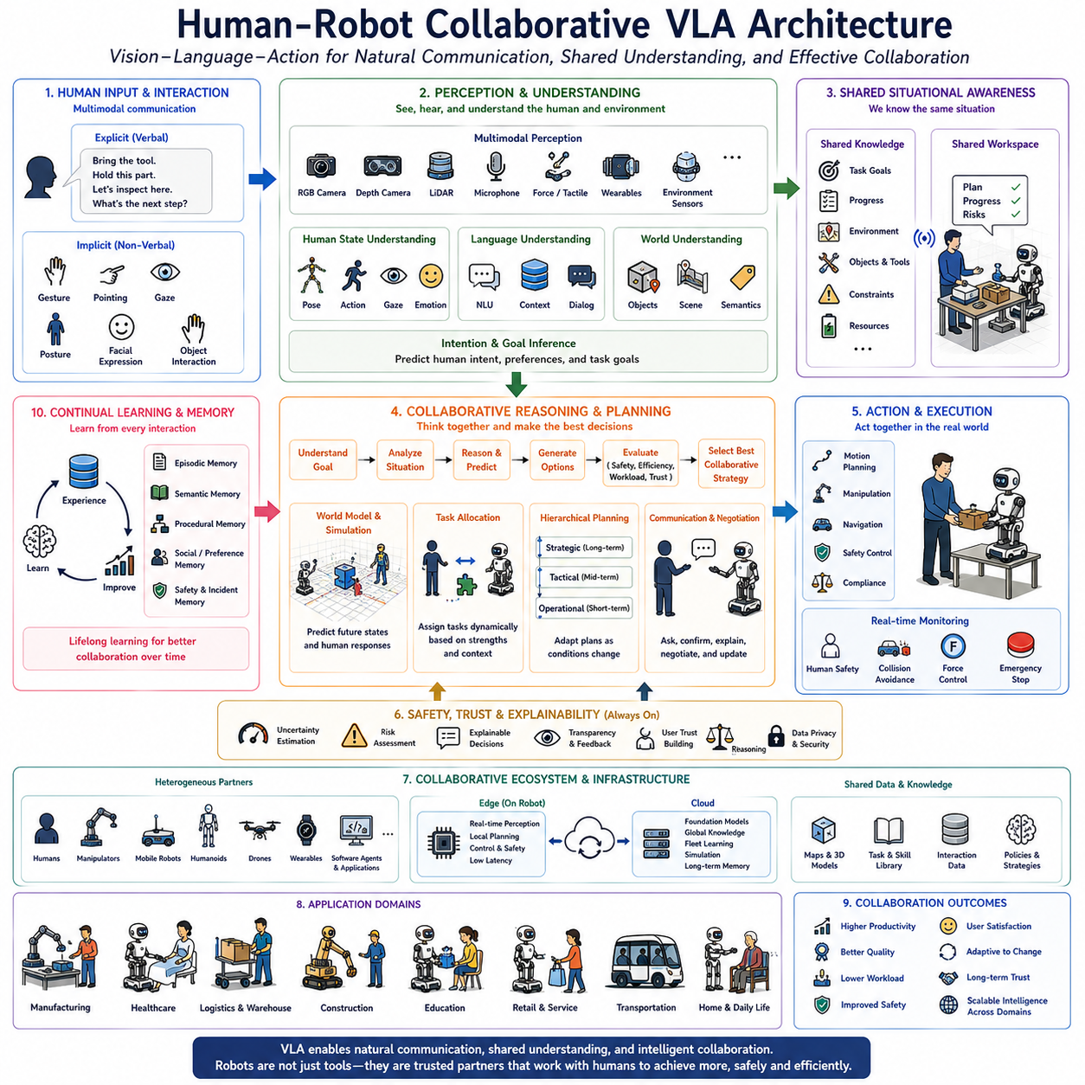
Human-Robot Collaborative Vision-Language-Action (VLA) Architecture represents one of the most significant future directions in embodied artificial intelligence, where autonomous robots are designed not merely to execute predefined tasks independently but to function as intelligent partners capable of understanding, communicating, reasoning, and collaborating naturally with human users. While conventional industrial robots traditionally operate within isolated workspaces separated from people for safety reasons, the next generation of Physical AI systems is expected to share environments with workers, patients, customers, students, engineers, and family members. Consequently, future VLA architectures must integrate multimodal perception, language understanding, cognitive reasoning, intention modeling, adaptive planning, safety mechanisms, and continuous interaction into a unified collaborative intelligence framework. The objective is no longer simple automation but effective human-robot teamwork in complex, dynamic, and uncertain real-world environments.
Human-robot collaboration fundamentally differs from autonomous task execution because both humans and robots continuously influence each other's behavior throughout task performance. Human actions modify environmental conditions, introduce new objectives, create unexpected constraints, and communicate implicit intentions that may not be explicitly verbalized. Likewise, robot actions affect human decision making, workload, situational awareness, and operational efficiency. Future collaborative VLA systems therefore require bidirectional interaction models capable of continuously interpreting human behavior while simultaneously adapting robotic actions to evolving collaborative contexts. Rather than treating humans as external supervisors, collaborative architectures increasingly consider people as integral components of the overall cognitive system.
Vision-Language-Action provides an ideal foundation for human-centered collaboration because it naturally integrates visual understanding, linguistic communication, and physical behavior. Vision enables robots to observe human posture, gestures, facial expressions, gaze direction, object manipulation, and environmental context. Language provides a rich communication interface for exchanging instructions, questions, explanations, preferences, warnings, and collaborative planning. Action generation converts shared understanding into coordinated physical behavior. The combination of these three capabilities enables robots to participate in collaborative workflows using communication methods that closely resemble natural human interaction rather than specialized programming interfaces.
Human intention understanding represents one of the central capabilities required for collaborative VLA architectures. Human instructions are frequently incomplete, ambiguous, or context dependent because people naturally assume shared understanding. Commands such as “help me organize these materials,” “hold this while I assemble it,” “bring the appropriate tools,” or “prepare everything for inspection” require robots to infer implicit objectives, recognize environmental context, estimate human preferences, and predict future task evolution. Future VLA systems therefore combine multimodal perception, contextual reasoning, historical interaction memory, and world models to estimate human intentions beyond literal language interpretation.
Natural language communication becomes substantially more sophisticated within collaborative environments. Rather than receiving isolated commands, future robots engage in continuous dialogue throughout task execution. They ask clarification questions when instructions are ambiguous, explain reasoning behind selected actions, provide progress updates, report uncertainty, request assistance, negotiate task allocation, and confirm safety-critical decisions before execution. Such conversational interaction significantly improves transparency, user trust, and operational efficiency while reducing misunderstandings during collaborative missions.
Multimodal perception enables robots to interpret nonverbal communication naturally occurring during teamwork. Humans communicate intentions not only through spoken language but also through gestures, pointing, gaze direction, body posture, facial expressions, movement trajectories, hand motions, and object interaction patterns. Future collaborative VLA architectures integrate RGB cameras, depth sensing, skeletal tracking, eye gaze estimation, tactile sensing, audio processing, force sensing, wearable devices, physiological monitoring, and environmental context into unified multimodal representations. These complementary sensing modalities enable comprehensive understanding of human activity beyond verbal instructions alone.
Shared situational awareness forms another essential component of collaborative intelligence. Humans and robots must maintain consistent understanding of task progress, environmental conditions, object locations, safety constraints, resource availability, and mission objectives throughout joint operation. Collaborative VLA systems continuously synchronize environmental knowledge through multimodal perception, semantic mapping, language interaction, and shared memory. Rather than maintaining isolated internal representations, both human operators and robotic teammates contribute to an evolving shared cognitive workspace supporting coordinated decision making.
Reasoning plays an increasingly important role in collaborative architectures because human requests frequently involve conflicting objectives, uncertain conditions, or incomplete information. Collaborative reasoning enables robots to evaluate alternative strategies, estimate consequences, identify constraints, prioritize competing goals, and recommend optimal collaborative actions before execution. Rather than simply obeying commands, reasoning-enhanced VLA systems actively participate in problem solving by proposing safer, more efficient, or more practical alternatives while respecting human authority and operational objectives.
Task allocation within collaborative teams becomes dynamic rather than predetermined. Future VLA systems continuously evaluate human workload, robot capability, environmental complexity, resource availability, and operational efficiency before assigning responsibilities. Tasks requiring dexterity, creativity, ethical judgment, or contextual understanding may remain under human control, while repetitive, hazardous, physically demanding, or computationally intensive activities are delegated to robotic partners. Dynamic collaboration therefore maximizes collective team performance by leveraging complementary strengths of both humans and autonomous systems.
Adaptive planning further strengthens collaborative operation under changing conditions. Human priorities may shift unexpectedly during task execution due to environmental changes, operational emergencies, newly discovered information, or evolving mission objectives. Future collaborative VLA systems continuously revise plans according to updated human instructions while preserving previously completed work and minimizing unnecessary interruption. Hierarchical planning architectures support rapid adaptation across strategic, tactical, and operational decision levels throughout long-duration collaborative missions.
World models significantly improve collaborative decision making by allowing robots to mentally simulate both environmental evolution and potential human responses before selecting actions. Candidate collaborative strategies are evaluated according to expected task success, human workload, safety implications, communication requirements, resource utilization, and operational efficiency. Predictive reasoning enables proactive assistance rather than reactive response, allowing robots to prepare tools, reposition equipment, anticipate requested materials, or avoid interfering with ongoing human activity before explicit instructions become necessary.
Human preference modeling becomes increasingly valuable during long-term collaboration. Different users often exhibit distinct communication styles, preferred workflows, risk tolerance, organizational habits, interaction frequency, physical capabilities, and assistance preferences. Future VLA systems accumulate personalized knowledge through continual interaction, enabling adaptive behavior that aligns with individual working styles without sacrificing general operational capability. Personalized collaboration substantially improves user satisfaction, productivity, and long-term acceptance of autonomous robotic assistants.
Trust represents one of the most important requirements for successful human-robot collaboration. Users must understand why robots behave in particular ways, predict future robotic actions, and maintain confidence in autonomous decision making under uncertain conditions. Explainable VLA architectures therefore communicate reasoning processes, anticipated outcomes, identified risks, confidence estimates, and planning assumptions using natural language and intuitive visual interfaces. Transparent decision making significantly improves user trust while supporting collaborative supervision and regulatory validation.
Safety remains the highest priority throughout collaborative operation. Unlike isolated industrial automation, collaborative robots operate in close physical proximity to people, requiring continuous monitoring of human location, posture, movement intention, environmental hazards, and mechanical interaction forces. Future collaborative VLA architectures integrate real-time human detection, collision prediction, force limitation, emergency intervention, adaptive speed control, uncertainty estimation, and safety-aware reasoning into every stage of perception, planning, and execution. Rather than functioning as independent safety modules, these mechanisms become deeply integrated within the overall cognitive architecture.
Continual learning naturally enhances collaborative intelligence because every interaction provides opportunities to improve future teamwork. Human corrections, demonstrations, verbal explanations, approval feedback, workflow adaptations, and operational experience gradually refine language understanding, intention prediction, task allocation, planning strategies, and personalized assistance. Future VLA systems therefore continuously improve collaborative performance throughout deployment while preserving previously acquired knowledge using lifelong learning mechanisms.
Memory organization supports effective long-term collaboration by storing procedural knowledge, environmental layouts, object histories, user preferences, previous conversations, completed tasks, collaborative strategies, and safety incidents. Episodic memory records individual interaction experiences, semantic memory captures generalized collaborative knowledge, procedural memory maintains learned teamwork skills, while social memory models relationships among users, roles, preferences, and communication patterns. These complementary memory systems enable increasingly natural long-term partnerships between humans and autonomous robots.
Cloud-edge collaboration provides scalable computational infrastructure supporting collaborative VLA architectures. Edge computing performs real-time perception, language interaction, manipulation control, safety monitoring, and local planning directly onboard robotic platforms. Cloud infrastructure supports foundation model refinement, shared knowledge management, long-term memory, collaborative fleet learning, simulation, and computationally intensive reasoning. Hybrid cloud-edge architectures therefore balance low-latency responsiveness with continuously improving large-scale intelligence while preserving operational reliability.
Collaborative VLA architectures are expected to support heterogeneous robotic ecosystems involving mobile robots, manipulators, humanoids, autonomous vehicles, drones, wearable devices, environmental sensors, intelligent software agents, and cloud services operating alongside human teams. Shared semantic representations, multimodal communication protocols, distributed reasoning, collaborative planning, and synchronized world models enable these diverse systems to function as unified cognitive partners rather than isolated automation components. Such heterogeneous integration substantially expands operational capability across industrial, medical, commercial, educational, and public service environments.
Evaluation methodologies for collaborative embodied intelligence extend beyond traditional task completion metrics. Future benchmarks assess human intention understanding, communication quality, shared situational awareness, collaborative efficiency, adaptive planning, trust development, explanation quality, safety performance, workload reduction, user satisfaction, personalization, recovery from misunderstandings, and long-term teamwork effectiveness. Human-centered evaluation therefore becomes equally important as technical performance when assessing future collaborative VLA systems.
Industrial applications illustrate the broad potential of collaborative architectures. Manufacturing workers collaborate with robotic assistants during assembly and inspection. Healthcare professionals coordinate with service robots for patient care, medication delivery, rehabilitation, and clinical logistics. Warehouse employees work alongside autonomous logistics platforms handling transportation and inventory organization. Construction teams coordinate robotic equipment for material handling and site inspection. Educational environments employ collaborative robots as teaching assistants. Domestic robots support elderly care, household management, and personalized assistance through continuous interaction with family members. Across each domain, robots function not as replacements for human workers but as intelligent teammates enhancing safety, productivity, and quality of life.
Future research is expected to integrate multimodal perception, language understanding, intention modeling, world models, reasoning, continual learning, personalized memory, explainability, collaborative planning, cloud-edge intelligence, and foundation models into unified Human-Robot Collaborative VLA Architectures. Rather than developing isolated perception, communication, planning, and control modules independently, future embodied intelligence will emerge from tightly integrated cognitive systems capable of understanding human goals, adapting to changing environments, learning from continuous interaction, and participating naturally in complex collaborative workflows.
Ultimately, Human-Robot Collaborative Vision-Language-Action Architecture represents one of the defining directions in the evolution of Physical AI. By combining natural communication, multimodal perception, shared situational awareness, collaborative reasoning, adaptive planning, personalized learning, predictive world models, lifelong memory, safety-aware decision making, explainable intelligence, and cloud-edge collaboration into unified cognitive architectures, future VLA systems will transform robots from autonomous tools into trusted collaborative partners. These intelligent systems will work alongside people across manufacturing, healthcare, logistics, education, transportation, public infrastructure, and domestic environments, enabling highly productive, safe, adaptive, and human-centered collaboration that significantly expands the capabilities of both humans and machines.

12.8 Neuro-Symbolic Integration
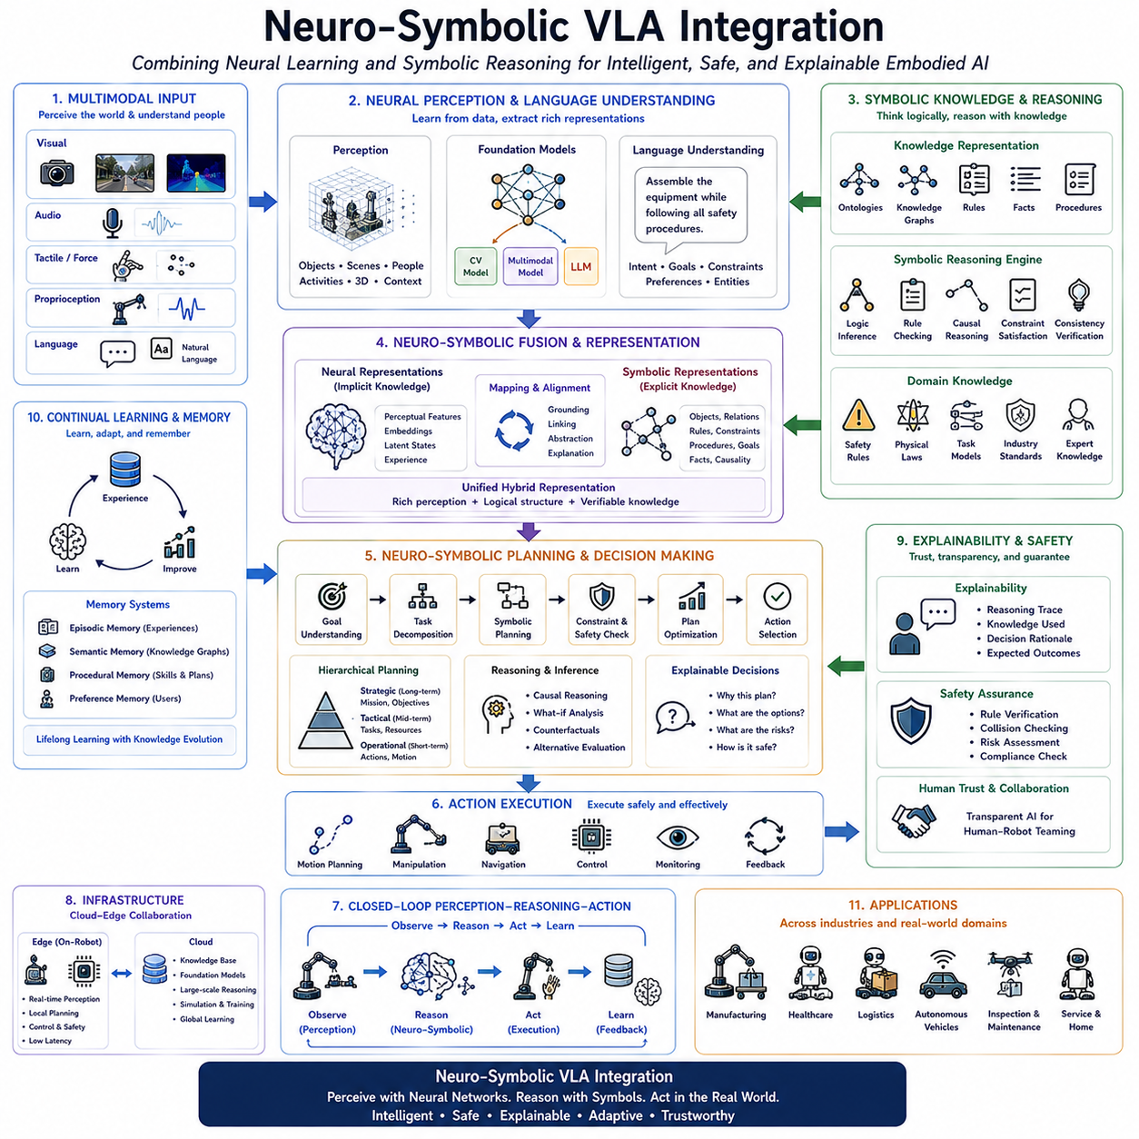
The future evolution of Vision-Language-Action (VLA) systems is expected to combine the powerful learning capabilities of deep neural networks with the structured reasoning mechanisms of symbolic artificial intelligence. While modern foundation models have demonstrated remarkable performance in visual perception, language understanding, and embodied control through large-scale data-driven learning, they still face significant challenges when dealing with logical reasoning, explicit knowledge representation, long-horizon planning, safety verification, explainability, and rule-based decision making. Conversely, symbolic AI provides interpretable knowledge structures, formal logic, causal inference, and deterministic planning but lacks the adaptability and perception capabilities necessary for complex real-world environments. Neuro-Symbolic VLA Integration seeks to combine these complementary strengths into a unified embodied intelligence architecture capable of simultaneously perceiving, reasoning, learning, planning, and acting within dynamic physical environments.
Deep neural networks excel at extracting complex patterns from high-dimensional sensory inputs such as images, video, audio, tactile signals, and natural language. Through self-supervised learning, imitation learning, reinforcement learning, and multimodal foundation model pretraining, neural systems acquire rich latent representations capable of supporting robust perception and flexible behavior generation. However, purely neural approaches frequently operate as opaque black-box models whose internal reasoning processes remain difficult to interpret or formally verify. In safety-critical robotic applications such as manufacturing, healthcare, transportation, and infrastructure inspection, these limitations restrict deployment because operators require confidence that autonomous decisions satisfy explicit operational rules and safety constraints.
Symbolic artificial intelligence offers a fundamentally different computational paradigm. Knowledge is represented explicitly using logical predicates, semantic graphs, ontologies, production rules, knowledge bases, planning operators, and causal relationships. Instead of learning solely through statistical association, symbolic reasoning manipulates structured representations according to formal inference mechanisms. Such reasoning enables deterministic planning, rule verification, logical consistency checking, explainable decision making, constraint satisfaction, and explicit incorporation of human expertise. These properties make symbolic systems highly valuable for applications where correctness, transparency, accountability, and regulatory compliance remain essential.
Neuro-Symbolic VLA architectures integrate these complementary approaches by assigning perception-oriented tasks to neural foundation models while delegating logical reasoning, symbolic planning, knowledge management, and rule verification to symbolic reasoning engines. Visual perception extracts objects, scenes, relationships, human activities, and environmental context from raw sensory observations. Language understanding converts human instructions into semantic representations describing intentions, goals, constraints, and operational preferences. Symbolic reasoning then transforms these semantic representations into structured task models that support planning, constraint checking, causal inference, and policy generation before actions are executed by robotic control systems.
Knowledge representation becomes significantly richer within neuro-symbolic embodied intelligence. Neural models encode statistical knowledge implicitly inside distributed latent representations, capturing complex correlations difficult to specify manually. Symbolic systems complement this capability by explicitly representing object categories, physical properties, spatial relationships, temporal sequences, procedural knowledge, safety regulations, task hierarchies, manufacturing processes, and domain-specific operational rules. Combining implicit and explicit knowledge enables robots to generalize from experience while preserving interpretable reasoning supporting human supervision and certification.
Scene understanding illustrates the advantages of neuro-symbolic integration. Neural perception models accurately identify objects, estimate poses, recognize human activities, and reconstruct three-dimensional environments from multimodal sensor data. Symbolic reasoning subsequently interprets these observations using semantic relationships describing functional object roles, physical affordances, environmental constraints, and task-relevant interactions. Rather than merely detecting objects independently, robots understand structured environments containing workstations, storage areas, assembly components, transportation pathways, restricted regions, collaborative workspaces, and safety boundaries. Such semantic interpretation substantially improves planning quality while supporting explainable environmental understanding.
Language understanding similarly benefits from hybrid reasoning. Neural language models excel at interpreting natural human communication, resolving ambiguity, translating multilingual instructions, and capturing contextual semantics. Symbolic reasoning converts these interpretations into formal task specifications, logical constraints, executable plans, and verifiable action sequences. Human commands such as “assemble the equipment while following all safety procedures” require robots not only to understand language but also to interpret procedural regulations, operational dependencies, equipment compatibility, and mandatory safety requirements. Neuro-symbolic architectures bridge this gap by integrating statistical language understanding with formal procedural reasoning.
Task planning becomes considerably more reliable through symbolic reasoning. Purely neural action generation often predicts plausible next actions based on learned statistical patterns but may overlook hidden logical dependencies, resource constraints, or operational prerequisites. Symbolic planners explicitly verify preconditions, evaluate causal relationships, optimize task ordering, allocate resources, enforce safety constraints, and guarantee logical consistency before execution begins. Neural perception continuously updates environmental information while symbolic planning dynamically revises execution strategies according to newly observed conditions. This hybrid planning process combines flexibility with formal correctness.
Hierarchical reasoning naturally emerges within neuro-symbolic VLA architectures. High-level symbolic planners interpret mission objectives, decompose complex goals into executable subtasks, enforce logical dependencies, and maintain procedural consistency across long-horizon operations. Mid-level reasoning coordinates resource allocation, scheduling, collaborative task distribution, and workflow optimization. Low-level neural controllers generate manipulation trajectories, navigation commands, visual servoing behaviors, and motor control using learned sensorimotor representations. This hierarchical organization separates abstract reasoning from continuous control while maintaining seamless interaction between symbolic cognition and neural execution.
World models become substantially more expressive when integrating symbolic knowledge with neural prediction. Neural world models learn predictive environmental dynamics from multimodal experience, estimating future object movement, human activity, physical interactions, and environmental evolution. Symbolic reasoning enriches these predictions by incorporating explicit causal knowledge, physical laws, operational procedures, and domain-specific constraints. Consequently, robots evaluate hypothetical future scenarios not only according to learned statistical likelihood but also according to logical feasibility, regulatory compliance, safety policies, and mission objectives before selecting execution strategies.
Causal reasoning represents another significant advantage of neuro-symbolic integration. Neural networks often learn statistical correlations without explicitly distinguishing causal mechanisms from coincidental associations. Symbolic reasoning provides structured causal models describing how actions influence environmental states, object relationships, human responses, and mission outcomes. Understanding causality enables robots to transfer learned knowledge more effectively across novel situations while improving intervention planning, failure diagnosis, recovery strategies, and counterfactual reasoning. Such capabilities become increasingly important for autonomous operation in unpredictable real-world environments.
Explainability naturally improves because symbolic reasoning generates interpretable decision traces. Instead of functioning as opaque black-box predictors, neuro-symbolic VLA systems communicate logical reasoning steps, identified constraints, inferred causal relationships, selected planning alternatives, expected outcomes, and safety justifications using structured natural language. Human supervisors therefore understand why specific actions were selected, facilitating collaborative operation, debugging, validation, certification, and regulatory approval. Explainable embodied intelligence significantly strengthens trust between autonomous systems and human operators.
Safety verification becomes substantially more rigorous within neuro-symbolic architectures. Before executing potentially hazardous actions, symbolic reasoning modules verify compliance with operational constraints, collision avoidance policies, workspace boundaries, human safety regulations, equipment limitations, and mission-specific requirements. Neural perception continuously monitors dynamic environmental changes while symbolic verification determines whether updated conditions still satisfy execution constraints. Such continuous verification provides stronger operational guarantees than purely learned control policies, particularly in high-risk industrial environments.
Memory organization benefits from integrating symbolic knowledge bases with neural representation learning. Neural memory stores high-dimensional perceptual experience, multimodal embeddings, and continuous environmental observations. Symbolic memory maintains explicit task procedures, object relationships, manufacturing rules, maintenance histories, user preferences, operational documentation, and semantic knowledge graphs. Together these complementary memory systems enable efficient retrieval of both experiential knowledge and structured domain expertise throughout planning and decision making.
Continual learning further strengthens neuro-symbolic VLA systems during long-term deployment. Neural models continuously refine perceptual representations, language grounding, manipulation policies, and predictive world models through accumulated operational experience. Symbolic knowledge bases simultaneously evolve by incorporating newly discovered procedural rules, validated causal relationships, updated safety regulations, and refined operational workflows. Unlike purely neural adaptation, symbolic updates remain interpretable and verifiable, allowing controlled knowledge expansion without catastrophic forgetting or unintended behavioral degradation.
Human-robot collaboration benefits significantly from symbolic reasoning because collaborative tasks frequently require explicit communication regarding responsibilities, procedural sequences, safety constraints, and organizational policies. Neural models interpret multimodal human communication while symbolic reasoning manages task negotiation, collaborative planning, workflow synchronization, and regulatory compliance. Human intentions become formal collaborative objectives supporting transparent decision making and predictable teamwork across complex operational environments.
Cloud-edge computing provides practical infrastructure supporting neuro-symbolic embodied intelligence. Edge computing executes latency-sensitive perception, language understanding, manipulation control, navigation, and local reasoning directly onboard robotic platforms. Cloud infrastructure manages large-scale knowledge graphs, symbolic rule repositories, foundation model refinement, collaborative learning, simulation, and computationally intensive reasoning. Synchronization between cloud and edge systems enables continuously evolving knowledge while preserving real-time operational responsiveness.
Evaluation methodologies for neuro-symbolic VLA systems necessarily extend beyond traditional perception and task completion metrics. Future benchmark suites are expected to assess logical consistency, symbolic reasoning accuracy, knowledge utilization, causal inference quality, planning correctness, explainability, regulatory compliance, safety verification, continual knowledge integration, reasoning robustness, collaborative decision quality, and hybrid perception-reasoning performance. These multidimensional evaluation frameworks provide comprehensive assessment of embodied intelligence capable of integrating statistical learning with formal symbolic cognition.
Industrial applications clearly demonstrate the value of neuro-symbolic integration. Manufacturing robots combine learned perception with formal production rules and quality assurance procedures. Healthcare assistants integrate multimodal patient understanding with explicit clinical protocols and regulatory guidelines. Autonomous vehicles combine neural environmental perception with symbolic traffic regulations and ethical driving policies. Warehouse robots integrate object recognition with inventory management rules and logistics optimization. Infrastructure inspection robots combine visual anomaly detection with engineering knowledge bases describing maintenance procedures and structural safety requirements. Across these diverse domains, neuro-symbolic integration significantly improves reliability, transparency, adaptability, and operational safety.
Future research is expected to move toward unified foundation architectures in which neural and symbolic reasoning operate cooperatively rather than as independent software modules. Shared multimodal representations, differentiable reasoning mechanisms, neural knowledge graphs, symbolic memory systems, explainable planning, retrieval-augmented cognition, world models, continual learning, and human-centered interaction will increasingly become integrated components of comprehensive embodied cognitive systems. Rather than separating perception from reasoning, future VLA architectures will continuously exchange information across neural learning, symbolic inference, planning, memory, and action generation throughout the entire perception-to-action cycle.
Ultimately, Neuro-Symbolic Vision-Language-Action Integration represents one of the most promising directions for the future of Physical AI. By combining the perceptual flexibility and learning capability of neural foundation models with the interpretability, logical consistency, causal reasoning, explicit knowledge representation, formal planning, and safety verification provided by symbolic artificial intelligence, future embodied systems will overcome many limitations of purely data-driven architectures. These hybrid cognitive systems will be capable of understanding complex environments, communicating naturally with humans, reasoning transparently, adapting continuously through experience, verifying their own decisions, and executing reliable physical actions across manufacturing, healthcare, logistics, autonomous transportation, infrastructure inspection, scientific exploration, and countless other real-world applications. Neuro-symbolic integration therefore provides a powerful foundation for the next generation of trustworthy, explainable, and highly intelligent autonomous robotic systems.

12.9 Hardware–Software Co-Design for VLA Accelerators
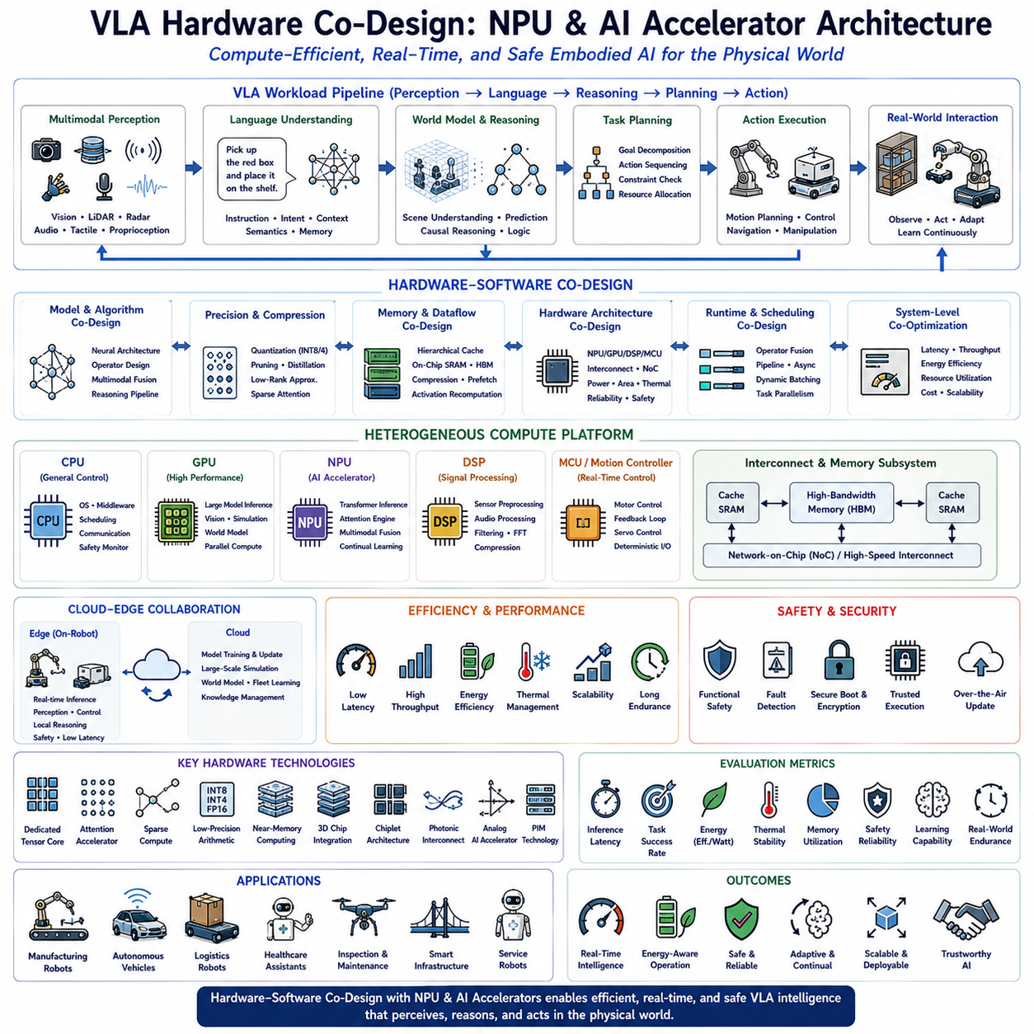
The rapid advancement of Vision-Language-Action (VLA) systems has significantly increased the computational requirements of embodied artificial intelligence, creating a growing need for hardware architectures specifically optimized for multimodal perception, language understanding, reasoning, planning, and real-time robotic control. Traditional robotic computing platforms have relied primarily on general-purpose CPUs and GPUs, which provide flexibility but often suffer from high power consumption, memory bandwidth limitations, latency constraints, and inefficient utilization when executing increasingly large foundation models. As VLA models continue to scale toward billions of parameters while simultaneously supporting real-time interaction with dynamic physical environments, software optimization alone becomes insufficient. Future embodied intelligence therefore requires a tightly integrated hardware-software co-design approach in which neural architectures, inference algorithms, memory hierarchies, communication infrastructure, and specialized AI accelerators are jointly optimized to maximize computational efficiency, energy utilization, and deployment scalability.
Hardware co-design fundamentally changes the conventional relationship between AI algorithms and computing platforms. Historically, AI software has been developed independently before being optimized for existing hardware architectures. In contrast, future VLA systems increasingly adopt a co-design philosophy in which neural network architectures, transformer operators, multimodal fusion mechanisms, reasoning pipelines, scheduling algorithms, memory layouts, and accelerator hardware are designed simultaneously. Such integrated optimization enables significantly higher inference throughput, reduced energy consumption, lower latency, and improved resource utilization compared with independent hardware and software development.
The computational characteristics of Vision-Language-Action models differ substantially from those of conventional computer vision or language processing systems. VLA architectures must simultaneously process high-resolution camera streams, LiDAR point clouds, radar measurements, tactile sensing, proprioception, audio signals, natural language instructions, environmental memory, world models, planning modules, reasoning engines, and continuous robot control loops. These heterogeneous workloads require diverse computational patterns involving dense matrix multiplication, sparse attention mechanisms, graph reasoning, sequence modeling, probabilistic inference, sensor fusion, and low-latency control. General-purpose processors rarely optimize all these workloads efficiently, motivating the development of specialized heterogeneous accelerator architectures.
Neural Processing Units (NPUs) have emerged as one of the most promising hardware platforms for future embodied intelligence. Unlike traditional CPUs optimized for sequential instruction execution or GPUs optimized for large-scale parallel graphics computation, NPUs are specifically designed for neural network inference and training workloads. Dedicated tensor processing engines, optimized matrix multiplication units, high-bandwidth memory interfaces, low-precision arithmetic support, and specialized scheduling mechanisms enable NPUs to execute transformer-based foundation models with significantly higher energy efficiency than conventional processors. These characteristics make NPUs particularly attractive for mobile robots operating under strict power and thermal constraints.
Future VLA hardware platforms are expected to integrate multiple heterogeneous computing engines rather than relying on a single processor architecture. CPUs continue managing operating systems, middleware, scheduling, communication, safety monitoring, and deterministic control logic. GPUs provide high-performance execution for large multimodal foundation models, visual perception, language understanding, simulation, and world model inference. NPUs accelerate transformer inference, attention computation, multimodal fusion, and lightweight continual learning. Digital Signal Processors handle sensor preprocessing, audio analysis, and communication processing, while dedicated motion controllers execute real-time motor control and feedback stabilization. Such heterogeneous architectures enable each computational task to execute on the hardware most suitable for its workload characteristics.
Memory architecture represents one of the most significant bottlenecks in future embodied AI systems. Modern transformer models frequently spend more energy transferring data between memory and compute units than performing arithmetic operations themselves. Consequently, future accelerator architectures increasingly optimize memory locality through hierarchical cache structures, on-chip SRAM, high-bandwidth memory, shared memory pools, unified address spaces, memory compression, intelligent data prefetching, and activation recomputation techniques. Efficient memory co-design substantially improves inference performance while reducing overall system energy consumption.
Model compression plays a central role in hardware co-design because many foundation models exceed the computational capacity of edge robotic platforms. Quantization reduces numerical precision from floating-point representations to INT8, INT4, or even binary computation while preserving acceptable inference accuracy. Structured pruning removes redundant network parameters without significantly degrading performance. Knowledge distillation transfers capabilities from large teacher models into smaller student architectures optimized for edge deployment. Low-rank approximation reduces transformer complexity through efficient matrix factorization. These complementary optimization techniques enable increasingly sophisticated VLA capabilities to execute efficiently on resource-constrained robotic hardware.
Attention mechanisms dominate computational cost within transformer-based VLA models. Hardware accelerators therefore increasingly implement dedicated attention processing units capable of executing self-attention, cross-attention, sparse attention, sliding-window attention, grouped attention, and multimodal attention operations directly in specialized hardware. By reducing unnecessary memory movement and exploiting fine-grained parallelism, dedicated attention accelerators significantly improve transformer inference throughput while lowering latency for real-time robotic applications.
Multimodal fusion introduces additional hardware design challenges because different sensing modalities exhibit highly diverse temporal characteristics, bandwidth requirements, precision levels, and computational demands. Camera streams require high-throughput visual feature extraction, LiDAR processing emphasizes sparse geometric computation, language understanding depends upon sequential transformer execution, while robot control loops require deterministic low-latency response. Future accelerator architectures increasingly incorporate asynchronous processing pipelines capable of simultaneously executing heterogeneous workloads while maintaining synchronized multimodal representations supporting integrated reasoning and action generation.
Real-time inference remains a defining requirement for embodied intelligence. Unlike cloud-based language models where several seconds of latency may be acceptable, robotic systems frequently require perception-to-action cycles below tens of milliseconds. Obstacle avoidance, manipulation control, autonomous driving, collaborative interaction, and dynamic balancing all demand deterministic low-latency computation. Hardware-software co-design therefore optimizes scheduling, operator fusion, pipeline execution, asynchronous computation, dynamic batching, and parallel task execution to minimize end-to-end inference delay throughout complete VLA processing pipelines.
Energy efficiency becomes particularly critical for mobile robots operating from battery-powered platforms. Every additional watt consumed by onboard computing directly reduces operational endurance, increases cooling requirements, and limits payload capacity. Future AI accelerators therefore prioritize performance-per-watt rather than raw computational throughput alone. Near-threshold voltage operation, adaptive frequency scaling, workload-aware power management, dynamic voltage adjustment, sparse computation, approximate arithmetic, and hardware sleep mechanisms contribute to substantial improvements in energy efficiency while maintaining real-time performance.
Thermal management increasingly influences hardware architecture because advanced AI accelerators generate significant heat under sustained transformer inference workloads. Passive cooling solutions often become insufficient for large multimodal foundation models operating continuously within enclosed robotic platforms. Future VLA hardware therefore integrates intelligent thermal-aware scheduling, dynamic workload migration, adaptive clock scaling, liquid cooling for high-performance edge servers, heat pipe technologies, advanced vapor chamber cooling, and thermal simulation during hardware design. Effective thermal co-design ensures stable long-duration operation without performance throttling.
Cloud-edge collaboration significantly extends hardware capability beyond onboard computation alone. Edge platforms execute latency-sensitive perception, language interaction, navigation, manipulation, safety monitoring, and local reasoning directly within robots. Cloud infrastructure performs computationally intensive foundation model refinement, large-scale world modeling, distributed fleet learning, simulation, collaborative planning, and long-term knowledge management. Hardware co-design therefore considers communication bandwidth, model partitioning, distributed inference scheduling, network latency, and workload migration when allocating computational tasks across heterogeneous cloud-edge environments.
Hardware support for continual learning represents another emerging research direction. Future NPUs increasingly incorporate accelerator units supporting parameter-efficient fine-tuning, adapter updates, retrieval-augmented learning, memory management, incremental knowledge integration, and lightweight online adaptation without requiring complete model retraining. Such capabilities enable robots to continuously improve throughout deployment while maintaining computational efficiency appropriate for edge hardware.
Functional safety becomes increasingly important as AI accelerators directly influence autonomous robotic decision making. Hardware architectures therefore integrate redundant computation pathways, fault detection, error-correcting memory, secure execution environments, hardware monitoring units, watchdog processors, deterministic scheduling, and safety-certified control channels. These mechanisms ensure that accelerator failures cannot compromise safe robot operation, particularly within collaborative manufacturing, healthcare, autonomous transportation, and public service environments.
Security considerations similarly influence future accelerator design. Hardware root-of-trust mechanisms, secure boot processes, encrypted model storage, confidential inference, trusted execution environments, hardware authentication, secure communication engines, and tamper-resistant architectures protect proprietary foundation models while preventing malicious modification of autonomous behavior. Secure hardware becomes essential as embodied AI increasingly performs safety-critical and commercially valuable operations.
Open hardware ecosystems are expected to accelerate innovation in embodied intelligence. Standardized accelerator interfaces, modular AI computing platforms, interoperable runtime environments, portable inference frameworks, open compiler toolchains, and hardware abstraction layers enable researchers and industrial developers to deploy VLA models across diverse computing architectures without extensive platform-specific optimization. Such standardization promotes rapid adoption while reducing engineering complexity throughout the robotics ecosystem.
Future robotic computing platforms will likely incorporate multiple specialized NPUs distributed throughout the robotic architecture. Vision processors near camera sensors perform early visual feature extraction. Manipulation accelerators execute local control and grasp planning near robotic arms. Navigation processors optimize localization and motion planning within mobile platforms. Central AI processors integrate multimodal reasoning, language understanding, and world models. Distributed hardware architectures reduce communication overhead while improving scalability across increasingly sophisticated robotic systems.
Evaluation methodologies for hardware-software co-design extend beyond conventional benchmark metrics such as TOPS or FLOPS. Future evaluation increasingly emphasizes end-to-end robotic performance including inference latency, perception accuracy, planning responsiveness, task completion rate, energy efficiency, thermal stability, memory utilization, safety reliability, continual learning capability, multimodal synchronization, cloud-edge scalability, and real-world operational endurance. Such holistic evaluation better reflects the practical requirements of embodied intelligence than isolated computational benchmarks.
Industrial applications clearly demonstrate the importance of hardware co-design. Manufacturing robots require deterministic low-latency inspection and manipulation under strict thermal constraints. Autonomous logistics vehicles demand energy-efficient navigation over extended operational periods. Healthcare assistants balance real-time perception with secure patient data processing. Autonomous vehicles integrate high-throughput sensor fusion with functional safety certification. Infrastructure inspection robots perform large-scale multimodal analysis under battery-powered deployment conditions. Across all these domains, optimized accelerator architectures directly determine achievable intelligence, operational reliability, and commercial viability.
Future research is expected to converge toward fully integrated embodied computing platforms where foundation models, multimodal perception, world models, reasoning engines, symbolic inference, continual learning, safety verification, communication infrastructure, and specialized accelerator hardware are co-designed as unified systems rather than independent software and hardware components. Advances in three-dimensional chip integration, chiplet architectures, photonic interconnects, near-memory computing, analog AI accelerators, processing-in-memory technologies, and next-generation NPU architectures will further improve computational density and energy efficiency. These innovations will enable increasingly sophisticated VLA foundation models to execute entirely onboard autonomous robotic platforms while maintaining real-time responsiveness.
Ultimately, VLA Hardware Co-design integrating Neural Processing Units and specialized AI accelerators represents one of the foundational technologies enabling the next generation of Physical AI. By jointly optimizing neural architectures, multimodal foundation models, transformer execution, memory systems, communication infrastructure, cloud-edge computation, continual learning, safety mechanisms, and heterogeneous accelerator hardware, future robotic platforms will overcome the computational limitations constraining today's embodied intelligence systems. These co-designed architectures will deliver highly efficient, low-latency, energy-aware, secure, scalable, and trustworthy computing foundations capable of supporting autonomous robots operating continuously across manufacturing, healthcare, logistics, autonomous transportation, scientific exploration, smart infrastructure, and countless other real-world environments. Hardware-software co-design will therefore become as essential to future embodied intelligence as foundation models themselves, forming the computational backbone upon which truly general-purpose autonomous robotic systems will be built.

12.10 Hills Robotics VLA Roadmap and Strategy
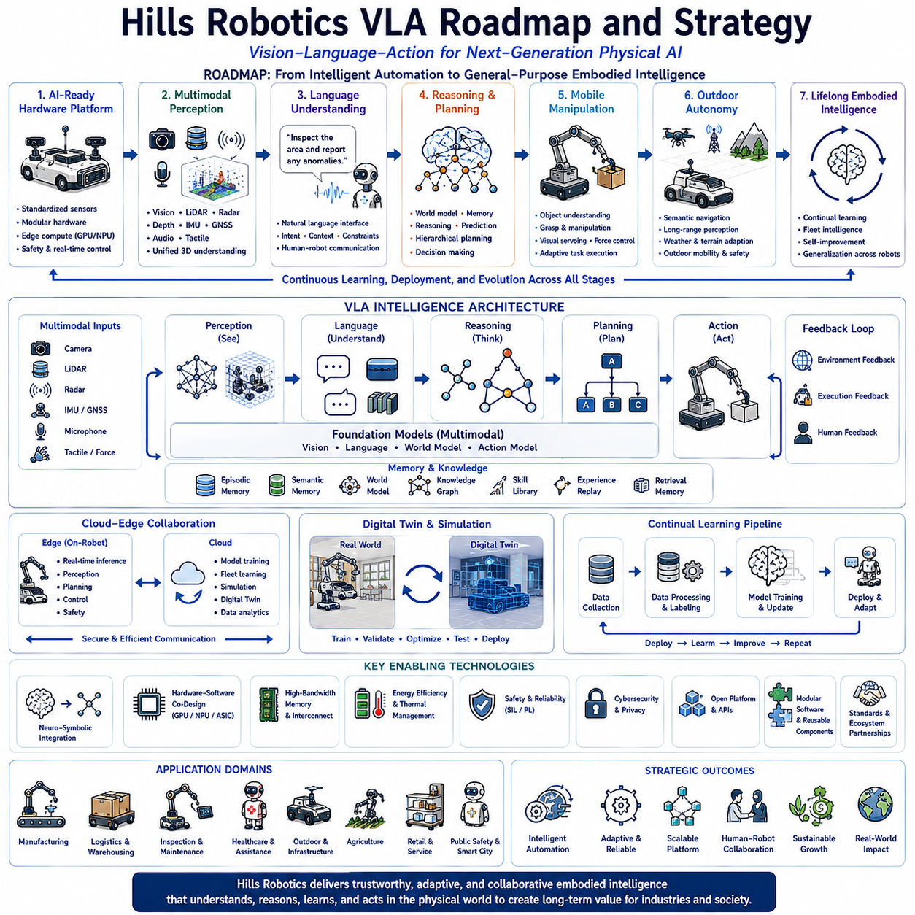
The future competitiveness of autonomous robotics will be determined not only by advances in individual artificial intelligence models but also by the ability to integrate Vision-Language-Action (VLA) technologies into scalable robotic platforms capable of operating reliably across diverse real-world environments. For Hills Robotics, VLA is not simply another software component but the central intelligence architecture that will define the company's long-term transition from conventional autonomous mobile robots toward next-generation Physical AI systems. Rather than focusing exclusively on navigation, manipulation, or perception as independent technologies, the company's strategic vision is to build an integrated embodied intelligence platform where perception, language understanding, reasoning, planning, learning, and physical interaction operate as a unified cognitive system. This roadmap establishes a progressive evolution from intelligent automation to general-purpose embodied intelligence while maintaining practical industrial deployment throughout every stage of development.
The strategic objective of Hills Robotics is to develop an AI-native robotic platform that combines robust hardware engineering, scalable software architecture, multimodal foundation models, and cloud-edge intelligence into a unified ecosystem supporting indoor robots, outdoor autonomous vehicles, inspection robots, logistics platforms, healthcare assistants, and future humanoid systems. Instead of building separate AI solutions for each product category, the roadmap emphasizes a common VLA foundation capable of supporting multiple robotic embodiments through shared perception models, reasoning engines, planning systems, and deployment infrastructure. Such architectural unification significantly reduces development complexity while enabling continuous knowledge transfer across different robotic platforms.
The first stage of the roadmap focuses on establishing a stable AI-ready robotic hardware platform. Reliable autonomous intelligence requires high-quality sensing, deterministic control, synchronized communication, scalable compute resources, and modular mechanical architecture before advanced reasoning capabilities can be deployed effectively. During this phase, Hills Robotics standardizes sensor interfaces, power systems, onboard networking, synchronization mechanisms, safety architectures, and modular computing platforms capable of supporting progressively larger AI workloads. Edge computing platforms integrating GPUs, NPUs, and heterogeneous accelerators become the computational backbone supporting future VLA deployment.
Following hardware standardization, the second development stage introduces advanced multimodal perception. Vision, LiDAR, radar, GNSS, IMU, depth sensing, thermal imaging, tactile sensing, and audio inputs are integrated into unified perception pipelines capable of constructing comprehensive environmental understanding. Rather than processing each sensing modality independently, multimodal foundation models generate shared latent representations describing objects, people, infrastructure, terrain, dynamic obstacles, semantic relationships, and environmental context. Robust multimodal perception provides the sensory foundation upon which all higher-level reasoning and autonomous decision making depend.
The third phase expands robotic capability through natural language understanding and human-centered interaction. Conventional robots typically require predefined graphical interfaces, mission scripts, or manually programmed workflows. Future Hills Robotics platforms instead interpret high-level natural language instructions describing objectives, operational constraints, task priorities, environmental preferences, and collaborative requirements. Language therefore evolves from a user interface into the primary communication channel between humans and autonomous robotic systems. This capability substantially simplifies deployment while enabling more flexible operation across changing industrial environments.
Reasoning becomes the defining capability of the fourth strategic phase. Rather than reacting solely to sensory observations, robots begin interpreting environmental situations, estimating hidden relationships, evaluating multiple planning alternatives, predicting future outcomes, and selecting optimal actions according to mission objectives and operational constraints. World models, symbolic reasoning, hierarchical planning, retrieval-augmented memory, and multimodal foundation models collectively support increasingly sophisticated cognitive behavior extending beyond traditional reactive robotics. This transition marks the evolution from autonomous execution toward genuine embodied intelligence.
The fifth phase introduces autonomous manipulation integrated with mobile robotics. Instead of separating navigation platforms from robotic manipulators, Hills Robotics develops unified mobile manipulation systems capable of understanding language instructions, navigating complex environments, identifying task-relevant objects, planning manipulation sequences, and adapting continuously during execution. Visual servoing, grasp planning, force control, semantic scene understanding, and multimodal reasoning operate cooperatively within shared VLA architectures. Mobile manipulation significantly expands application domains including manufacturing, logistics, inspection, maintenance, healthcare, and service robotics.
Outdoor autonomy represents another major strategic direction. Building upon indoor autonomous mobile robot technology, Hills Robotics extends VLA architectures toward autonomous outdoor platforms supporting logistics, infrastructure inspection, agriculture, construction, public safety, mining, defense support, and smart city applications. Outdoor deployment requires robust localization, semantic navigation, weather adaptation, terrain understanding, predictive world models, long-range perception, and multimodal sensor fusion under continuously changing environmental conditions. Unified VLA intelligence enables consistent cognitive capability across both indoor and outdoor operational domains.
Cloud-edge collaboration constitutes a foundational element throughout the roadmap. Edge computing performs real-time perception, planning, manipulation, navigation, and safety-critical control directly onboard robotic platforms. Cloud infrastructure manages foundation model refinement, distributed learning, fleet coordination, digital twins, simulation, knowledge management, large-scale analytics, and continual model improvement. This hybrid architecture enables robots to respond immediately to local events while continuously benefiting from globally accumulated knowledge across deployed robotic fleets.
Digital twin technology plays an increasingly important role as VLA capability expands. High-fidelity simulation environments replicate robotic hardware, sensors, environments, workflows, and operational scenarios, enabling large-scale training, verification, optimization, and safety validation before physical deployment. Bidirectional synchronization between physical robots and virtual environments continuously improves both simulation accuracy and deployed operational performance. Digital twins therefore become essential infrastructure supporting continual learning, predictive maintenance, fleet management, and large-scale embodied AI development.
Foundation models gradually become the central software layer across the entire Hills Robotics ecosystem. Initially supporting perception and language understanding, foundation models progressively expand toward reasoning, planning, memory management, manipulation, navigation, collaboration, and continual learning. Rather than maintaining numerous task-specific AI models, Hills Robotics adopts unified multimodal foundation architectures capable of transferring knowledge across industrial applications while remaining adaptable through parameter-efficient fine-tuning and domain-specific specialization.
The roadmap also emphasizes continual learning throughout deployment. Every robot operating within customer environments contributes valuable operational experience supporting future system improvement. Perception errors, successful task executions, recovery procedures, environmental changes, user preferences, maintenance records, and collaborative interactions become continuous learning signals. Cloud-based knowledge aggregation combined with edge adaptation enables deployed systems to improve throughout their operational lifetime while maintaining safety, reliability, and regulatory compliance.
Human-robot collaboration forms another strategic pillar. Future Hills Robotics platforms function as intelligent teammates rather than isolated automation systems. Natural language communication, multimodal perception, intention understanding, explainable reasoning, adaptive planning, personalized interaction, and shared situational awareness enable productive collaboration between humans and autonomous robots across manufacturing, logistics, healthcare, education, inspection, and public infrastructure. Human-centered design therefore becomes a core architectural principle rather than an application-specific feature.
Neuro-symbolic integration further strengthens the roadmap by combining neural foundation models with explicit symbolic reasoning. Neural architectures provide robust perception, language understanding, and multimodal representation learning, while symbolic reasoning contributes formal planning, logical consistency, knowledge representation, causal reasoning, safety verification, and explainability. Hybrid cognitive architectures significantly improve reliability, transparency, and regulatory acceptance across safety-critical industrial applications where autonomous decisions require both adaptability and formal correctness.
Hardware-software co-design represents another essential long-term strategy. Future VLA models require computational architectures optimized specifically for multimodal transformer inference, continual learning, memory-intensive reasoning, and low-latency robot control. Hills Robotics therefore progressively integrates GPUs, NPUs, AI accelerators, heterogeneous processors, high-bandwidth memory systems, energy-efficient edge computing, and cloud infrastructure into unified computing platforms supporting increasingly sophisticated embodied intelligence while maintaining practical deployment constraints regarding power, thermal management, size, reliability, and operational cost.
Safety remains central throughout every stage of technological evolution. Functional safety, cybersecurity, explainable decision making, uncertainty estimation, fault detection, redundancy management, human-aware motion planning, regulatory compliance, and continuous verification become deeply integrated architectural components rather than independent safety modules. Future autonomous robots must not only operate intelligently but also demonstrate trustworthy behavior under uncertain real-world conditions throughout long-duration deployment.
The roadmap recognizes that robotics increasingly evolves toward platform ecosystems rather than isolated products. Standardized APIs, modular software architecture, reusable AI components, cloud services, digital twin infrastructure, developer toolchains, simulation environments, application frameworks, and fleet management systems collectively create an expandable ecosystem supporting customers, researchers, industrial partners, universities, and third-party developers. Open architecture significantly accelerates innovation while reducing engineering effort required for future product expansion.
Industrial deployment serves as the primary validation mechanism for every stage of the roadmap. Manufacturing automation, mobile inspection, warehouse logistics, autonomous transportation, healthcare assistance, infrastructure monitoring, agricultural automation, semiconductor production, public safety, and smart city operations provide progressively challenging deployment environments through which VLA capability continuously matures. Practical deployment remains tightly coupled with research activity, ensuring that technological innovation consistently addresses genuine industrial requirements rather than isolated laboratory benchmarks.
The long-term vision extends beyond current autonomous mobile robots toward comprehensive Physical AI platforms capable of supporting diverse robotic embodiments. Mobile robots, mobile manipulators, humanoids, autonomous vehicles, collaborative industrial robots, service platforms, healthcare assistants, inspection systems, educational robots, and intelligent infrastructure agents increasingly share common cognitive foundations despite significant differences in physical embodiment. Unified VLA architectures therefore enable scalable expansion across future product portfolios without fundamental redesign of core intelligence systems.
International collaboration constitutes another important strategic direction. Partnerships with universities, research institutes, semiconductor vendors, cloud infrastructure providers, industrial manufacturers, AI companies, and global robotics organizations accelerate technology development while promoting interoperability across international ecosystems. Collaborative research strengthens access to advanced foundation models, simulation technologies, specialized hardware, benchmark datasets, and emerging standards governing future embodied intelligence.
Future technological milestones gradually progress from perception-centered intelligence toward reasoning-centered autonomy and ultimately toward continually learning embodied cognitive systems. Early development emphasizes robust multimodal perception and autonomous navigation. Intermediate phases integrate language understanding, manipulation, reasoning, and collaborative intelligence. Long-term objectives include world models, continual learning, neuro-symbolic reasoning, digital twins, fleet intelligence, generalized embodiment, and adaptive lifelong autonomy operating across diverse physical environments with minimal human intervention.
Ultimately, the Hills Robotics Vision-Language-Action Roadmap represents a comprehensive strategy for transforming conventional robotics into scalable Physical AI platforms capable of understanding, reasoning, communicating, learning, and acting within complex real-world environments. By integrating multimodal foundation models, cloud-edge intelligence, digital twins, continual learning, neuro-symbolic reasoning, hardware-software co-design, collaborative autonomy, explainable intelligence, and unified embodied architectures into a single long-term technological vision, Hills Robotics positions itself to evolve from a manufacturer of autonomous robotic systems into a provider of intelligent cognitive platforms supporting the next generation of industrial, commercial, healthcare, logistics, infrastructure, and service robotics. This roadmap establishes a sustainable pathway toward trustworthy, adaptive, scalable, and general-purpose embodied intelligence capable of operating continuously across the physical world while creating long-term technological and commercial value.

