Volume 20. Vision Language Action (VLA) Models

Chapter 5. Vision-Language Models

5.1 VLM Architecture Overview
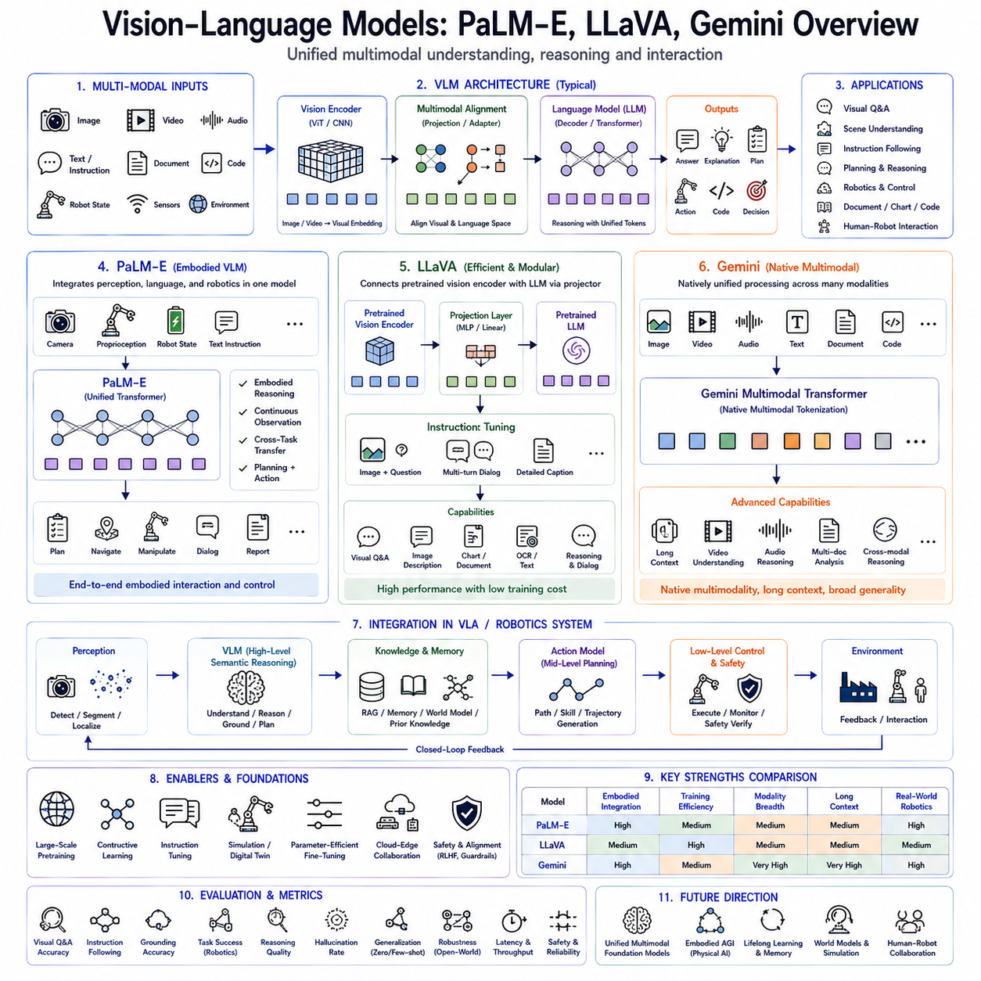
Vision-Language Models (VLMs) represent one of the most significant technological advances in modern Artificial Intelligence because they enable machines to understand visual information and natural language within a unified reasoning framework. Unlike traditional computer vision systems that primarily recognize objects or classify images, Vision-Language Models integrate perception, semantic reasoning, contextual understanding, and multimodal knowledge into a single foundation architecture capable of supporting complex human-like interaction. As robotics evolves toward Physical AI, VLMs have become a fundamental component of Vision-Language-Action (VLA) systems by providing high-level scene understanding, semantic reasoning, task planning, and environment interpretation. Architectures such as PaLM-E, LLaVA, and Gemini represent different evolutionary stages toward general-purpose multimodal intelligence capable of reasoning across images, language, video, audio, documents, and eventually physical interaction.
The emergence of Vision-Language Models reflects an important limitation of conventional artificial intelligence. Traditional computer vision algorithms excel at identifying objects, estimating depth, detecting human poses, or segmenting images, but they struggle to explain why objects are important, infer hidden relationships, understand human intentions, or answer complex questions regarding visual scenes. Similarly, Large Language Models demonstrate exceptional reasoning ability but originally lacked direct access to visual information. Vision-Language Models bridge these complementary capabilities by enabling language reasoning to operate directly upon visual perception.
Human cognition naturally integrates multiple sensory modalities. When people observe a scene, they do not separately process vision and language. Instead, visual perception, linguistic knowledge, memory, commonsense reasoning, and prior experience continuously interact to produce coherent understanding. A person entering an unfamiliar factory immediately recognizes machines, understands operational workflows, predicts potential hazards, and interprets written instructions without consciously separating these cognitive processes. Vision-Language Models attempt to replicate this integrated multimodal reasoning architecture through large-scale neural foundation models.
Early computer vision systems generally relied upon handcrafted features such as SIFT, SURF, HOG, and edge descriptors before the emergence of deep learning. Convolutional Neural Networks later revolutionized image recognition by automatically learning hierarchical visual representations from large datasets. Simultaneously, transformer-based language models demonstrated unprecedented capability in natural language understanding and generation. The convergence of these two research directions naturally produced Vision-Language Models capable of jointly learning visual and linguistic representations.
A modern Vision-Language Model generally consists of several interconnected computational components. The visual encoder transforms images into compact latent feature representations describing objects, geometry, texture, color, spatial relationships, and scene context. The language model processes natural language instructions, questions, documents, dialogue history, and semantic reasoning. Between these components resides a multimodal alignment mechanism that maps visual features into a representation space understandable by the language model. The integrated architecture subsequently performs reasoning using both visual and textual information simultaneously.
Visual encoders typically employ Vision Transformers, convolutional neural networks, hybrid transformer architectures, masked image modeling, contrastive pretraining, or self-supervised representation learning. Input images are divided into patches or processed through convolutional feature extractors before being transformed into high-dimensional embeddings representing local appearance together with global scene structure. These visual embeddings become analogous to language tokens processed by transformer architectures.
Language components generally utilize decoder-only or encoder-decoder transformer architectures pretrained on extremely large text corpora. Large Language Models contribute commonsense reasoning, procedural knowledge, semantic understanding, mathematical reasoning, dialogue generation, logical inference, and contextual memory. Rather than replacing language models, Vision-Language Models extend their reasoning capability toward multimodal understanding by introducing visually grounded representations.
Cross-modal alignment represents one of the defining innovations of Vision-Language Models. Visual features and language tokens initially occupy distinct representation spaces with incompatible statistical properties. Alignment mechanisms learn mappings allowing semantically corresponding images and textual descriptions to occupy neighboring regions within a shared latent embedding space. Consequently, visual observations become interpretable by language reasoning modules without requiring handcrafted symbolic interfaces.
Contrastive learning has played a central role in multimodal alignment. During pretraining, corresponding image-text pairs become embedded closely together while unrelated pairs remain separated. Large-scale internet datasets containing billions of image-caption pairs enable models to associate visual appearance with semantic concepts across diverse domains. Contrastive objectives therefore establish foundational multimodal representations supporting downstream reasoning tasks.
Instruction tuning further improves practical capability by training Vision-Language Models using multimodal dialogue datasets. Instead of merely associating images with captions, instruction tuning teaches models to answer questions, explain visual observations, interpret diagrams, perform reasoning, summarize documents, compare objects, identify anomalies, and engage in extended multimodal conversations. Such supervised refinement substantially enhances interactive performance for real-world applications.
PaLM-E represents one of the earliest large-scale efforts to integrate robotics directly with foundation language models. Rather than treating images as isolated perception inputs, PaLM-E incorporates continuous sensory observations, robot state information, environmental measurements, and visual embeddings directly into the language model input sequence. Robot proprioception, camera images, manipulation state, navigation information, and natural language instructions become unified multimodal tokens processed by a shared transformer architecture.
A defining characteristic of PaLM-E is embodied multimodal reasoning. Instead of reasoning exclusively about static images, the model continuously incorporates real-world robot observations throughout task execution. This enables semantic planning grounded in physical interaction rather than abstract language reasoning alone. Robot actions become influenced simultaneously by visual perception, environmental feedback, language instructions, and accumulated operational context.
PaLM-E also demonstrates positive transfer across heterogeneous tasks. Visual understanding, language reasoning, robotic manipulation, navigation, and embodied interaction mutually reinforce one another because shared transformer parameters learn generalized multimodal representations transferable across domains. Consequently, improvements in one modality frequently enhance performance in others without task-specific architectural redesign.
LLaVA represents another influential Vision-Language architecture emphasizing practical multimodal instruction following. Rather than jointly training enormous multimodal foundation models from scratch, LLaVA combines pretrained visual encoders with existing Large Language Models using relatively lightweight projection layers. Visual features extracted from pretrained vision backbones become transformed into language-compatible embeddings subsequently processed by powerful decoder-only language models.
This modular design significantly reduces computational cost while leveraging existing pretrained foundation models. Vision encoders retain high-quality perceptual capability acquired through image recognition pretraining, whereas language models preserve sophisticated reasoning learned from large textual corpora. Instruction tuning subsequently aligns multimodal interaction without requiring prohibitively expensive end-to-end foundation model training.
LLaVA demonstrates remarkable conversational visual reasoning despite comparatively efficient training. Users may ask detailed questions regarding images, diagrams, charts, industrial equipment, handwritten notes, scientific figures, or natural scenes. The model generates coherent explanations combining visual evidence with commonsense reasoning, demonstrating that modular multimodal architectures can achieve highly competitive performance.
Projection layers within LLaVA perform an essential alignment function. Visual encoder outputs generally possess feature dimensions incompatible with language embeddings. Lightweight multilayer perceptrons or linear projection networks transform visual representations into token embeddings understandable by the downstream language model. Despite architectural simplicity, these learned projections successfully bridge vision and language domains.
Gemini represents a more comprehensive multimodal foundation model designed from the outset for native multimodal reasoning. Rather than treating vision as an extension of language processing, Gemini integrates images, video, audio, code, documents, mathematical notation, and natural language within a unified multimodal architecture. Native multimodality enables richer cross-domain reasoning while reducing dependence upon externally aligned feature representations.
A distinguishing characteristic of Gemini lies in multimodal tokenization. Diverse information sources become represented using unified computational abstractions enabling joint reasoning across heterogeneous modalities. Images, audio waveforms, video frames, documents, diagrams, source code, and textual conversation contribute jointly toward contextual understanding. Such integrated token processing substantially expands reasoning capability beyond traditional image-language interaction.
Gemini further emphasizes long-context reasoning. Industrial documentation, engineering manuals, maintenance procedures, technical drawings, inspection histories, operational logs, and lengthy multimodal conversations frequently exceed conventional transformer context limits. Extended context processing enables comprehensive reasoning across large multimodal information collections supporting enterprise-scale robotics applications.
Video understanding similarly distinguishes Gemini from earlier Vision-Language Models. Sequential visual observations capture temporal relationships unavailable within isolated images. Robot operation, human activity recognition, assembly monitoring, inspection procedures, and environmental evolution all require temporal reasoning across extended visual sequences. Native video processing therefore substantially broadens practical applicability.
Audio integration further enhances multimodal capability. Spoken dialogue, environmental sound, machinery vibration, acoustic anomalies, verbal instructions, and conversational interaction contribute additional contextual information unavailable through vision alone. Integrated audio-language-vision reasoning enables richer human-robot collaboration while supporting industrial monitoring and assistive robotics.
Document understanding constitutes another important capability. Engineering drawings, technical manuals, maintenance records, production schedules, forms, invoices, laboratory reports, and scientific publications frequently combine textual content with figures, tables, diagrams, mathematical notation, and graphical annotations. Native multimodal document reasoning significantly improves enterprise knowledge utilization compared with isolated optical character recognition.
Within robotics, Vision-Language Models increasingly function as semantic reasoning engines rather than low-level controllers. Perception systems identify objects, humans, infrastructure, and environmental conditions. VLMs subsequently interpret semantic relationships, infer human intent, explain observations, answer questions, generate plans, retrieve relevant knowledge, and provide contextual understanding supporting downstream Action Models. This hierarchical organization separates high-level cognition from deterministic real-time control.
Scene understanding represents one of the most important robotic applications. Instead of merely detecting objects, Vision-Language Models interpret functional relationships among objects, estimate task affordances, recognize operational workflows, identify hazards, understand human activities, and predict likely future interactions. Such semantic scene understanding substantially improves autonomous decision making.
Visual grounding further enables robots to associate natural language references with corresponding physical entities. Instructions such as “Pick up the wrench beside the red toolbox” require simultaneous language understanding, object recognition, spatial reasoning, and reference resolution. Vision-Language Models naturally perform such grounding through unified multimodal reasoning.
Affordance reasoning extends beyond object recognition toward functional understanding. Instead of recognizing that an object is a chair, the model understands that the chair supports sitting. A toolbox contains tools. A charging station replenishes battery energy. A pallet supports transported goods. Such functional reasoning significantly improves robot planning because actions depend upon object functionality rather than visual appearance alone.
Robotic manipulation increasingly benefits from multimodal reasoning. Before grasp generation, Vision-Language Models identify target objects, interpret task objectives, understand manipulation constraints, predict suitable grasp regions, retrieve procedural knowledge, and generate semantic task descriptions. Low-level Action Models subsequently translate these high-level representations into executable trajectories.
Navigation similarly benefits from semantic understanding. Rather than following purely geometric maps, robots understand corridors, entrances, workstations, storage areas, hazardous zones, emergency exits, inspection checkpoints, and collaborative workspaces. Semantic navigation therefore combines localization with contextual reasoning regarding operational objectives.
Retrieval-Augmented Generation naturally complements Vision-Language Models. Enterprise databases, digital twins, CAD drawings, maintenance manuals, inspection records, production schedules, historical mission logs, software repositories, and engineering documentation provide external knowledge supporting multimodal reasoning. When internal model knowledge becomes insufficient, dynamically retrieved information augments decision making without requiring parameter updates.
Memory systems further enhance multimodal capability. Episodic memory recalls previous missions and execution history. Semantic memory stores factual knowledge regarding objects, facilities, procedures, and regulations. Procedural memory preserves reusable robotic skills. Working memory maintains dialogue context, task progress, intermediate reasoning, and current environmental observations. Integrated memory substantially improves long-duration autonomous operation.
World Models increasingly integrate with Vision-Language architectures. Instead of interpreting only current observations, predictive simulation estimates future environmental evolution including object motion, human behavior, battery consumption, traffic patterns, weather changes, and equipment degradation. Future-aware reasoning enables proactive planning rather than purely reactive decision making.
Hierarchical Action Models naturally consume outputs generated by Vision-Language Models. High-Level Policies receive semantic goals, interpreted instructions, environmental understanding, retrieved knowledge, and contextual reasoning. Mid-Level planners generate navigation strategies, manipulation plans, and skill sequences. Low-Level controllers execute deterministic motor commands while maintaining safety and real-time responsiveness. This layered organization separates cognitive reasoning from physical execution.
Simulation has become indispensable for Vision-Language development because multimodal robotics datasets remain relatively limited compared with internet-scale image-text collections. Digital twins generate synchronized visual observations, language descriptions, robot trajectories, semantic annotations, environmental dynamics, and operational scenarios spanning manufacturing, logistics, agriculture, healthcare, and autonomous inspection. Simulation therefore bridges the gap between internet pretraining and physical deployment.
Parameter-efficient fine-tuning enables adaptation toward specialized industrial domains. Lightweight adapters, low-rank adaptation, prompt tuning, prefix tuning, and modular projection layers specialize pretrained Vision-Language Models for factory automation, warehouse logistics, precision agriculture, medical robotics, infrastructure inspection, or autonomous vehicles without retraining complete foundation models. Such efficient adaptation substantially reduces computational cost while preserving generalized multimodal reasoning.
Cloud-edge collaboration has become the dominant deployment strategy. Cloud infrastructure executes computationally intensive multimodal reasoning, retrieval, long-context processing, world modeling, and foundation model inference. Edge platforms perform perception, sensor fusion, localization, obstacle detection, safety verification, and deterministic control locally. Hybrid architectures therefore balance computational capability with real-time responsiveness.
Safety remains independent from multimodal reasoning. Although Vision-Language Models generate sophisticated semantic understanding, deterministic safety supervisors continue verifying collision avoidance, workspace constraints, force limits, emergency stopping, cybersecurity, regulatory compliance, and runtime monitoring before physical execution. Semantic intelligence therefore complements rather than replaces traditional safety engineering.
Evaluation extends far beyond image captioning accuracy. Modern Vision-Language Models are assessed according to visual question answering, instruction following, multimodal reasoning, grounding accuracy, retrieval performance, hallucination frequency, robustness under distribution shift, long-context understanding, document interpretation, video reasoning, robotic task success, generalization, computational efficiency, uncertainty calibration, and real-world deployment reliability. Comprehensive benchmarking therefore reflects complete multimodal capability rather than isolated perception performance.
Future Vision-Language Models are expected to evolve toward unified multimodal foundation architectures integrating images, video, language, audio, tactile sensing, force sensing, proprioception, environmental memory, world models, retrieval systems, simulation, and embodied interaction within a single computational framework. Rather than functioning as isolated perception modules, these models will increasingly serve as cognitive operating systems for Physical AI, continuously reasoning across heterogeneous sensory information while coordinating planning, learning, communication, and autonomous behavior.
As embodied artificial intelligence progresses toward general-purpose robotic autonomy, Vision-Language Models such as PaLM-E, LLaVA, and Gemini illustrate successive stages in the evolution of multimodal cognition. PaLM-E demonstrates the integration of language reasoning with embodied robotic perception, LLaVA illustrates efficient modular alignment between visual encoders and pretrained language models, and Gemini advances toward native multimodal foundation intelligence spanning images, video, audio, documents, code, and long-context reasoning. Together these architectures establish the conceptual foundation for next-generation Vision-Language-Action systems capable of integrating perception, semantic reasoning, memory, retrieval, world modeling, hierarchical planning, and physical execution into scalable intelligent robotic platforms operating safely, efficiently, and adaptively across manufacturing, logistics, healthcare, agriculture, autonomous inspection, service robotics, collaborative automation, and future universal Physical AI ecosystems.

5.2 PaLM-E: Embodied Multimodal Language Model (with Code)
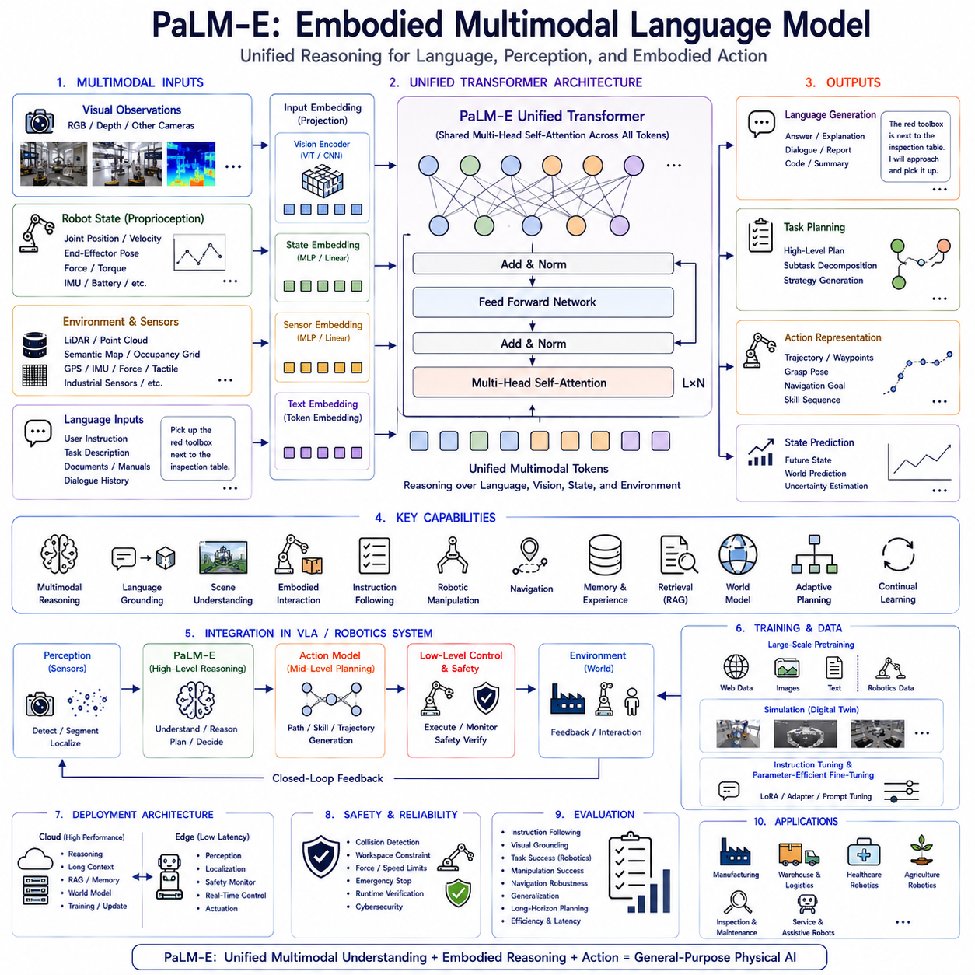
PaLM-E (Pathways Language Model for Embodied Intelligence) represents one of the earliest and most influential attempts to extend Large Language Models beyond purely textual reasoning into the domain of embodied intelligence. Unlike conventional language models that process only natural language tokens, PaLM-E integrates visual perception, robot state information, environmental observations, and language into a unified transformer architecture capable of supporting real-world robotic interaction. The model demonstrates that language understanding, multimodal perception, and physical control can be treated as different manifestations of a common representation learning problem rather than separate computational modules. This concept has significantly influenced the evolution of Vision-Language-Action (VLA) systems and modern Physical AI architectures.
The motivation behind PaLM-E originates from a fundamental limitation of conventional Large Language Models. Although language models possess remarkable reasoning capabilities, they originally lacked direct interaction with the physical world. They could answer questions about robotics, describe manipulation procedures, or explain navigation algorithms, yet they had no access to real sensory observations. Conversely, robotic perception systems could recognize objects, estimate positions, and execute trajectories but possessed little semantic reasoning capability. PaLM-E was designed to bridge these complementary strengths by embedding multimodal sensory information directly into the language reasoning process.
Human intelligence naturally integrates language, perception, memory, and physical interaction into a unified cognitive system. People continuously combine visual observations, tactile sensations, auditory information, body awareness, previous experiences, and linguistic knowledge while interacting with the environment. When someone enters a manufacturing facility, they immediately identify machines, understand operational workflows, recognize safety hazards, interpret written instructions, and predict future events without consciously separating perception from reasoning. PaLM-E attempts to approximate this embodied cognition through a unified transformer-based architecture.
Traditional robotic software often follows a modular pipeline consisting of perception, localization, mapping, planning, decision making, and control. Each subsystem exchanges symbolic information through predefined interfaces. Although modularity improves engineering maintainability, semantic information frequently becomes fragmented during processing. High-level reasoning cannot easily exploit low-level sensor uncertainty, and perception modules cannot benefit from language-based contextual reasoning. PaLM-E instead promotes end-to-end multimodal representation learning where semantic information remains continuously available throughout the reasoning process.
The core innovation of PaLM-E lies in treating non-linguistic observations as additional input tokens compatible with transformer computation. Camera images, robot proprioception, manipulation state, localization estimates, environmental measurements, and natural language instructions are all converted into learned embeddings occupying a shared latent representation space. Rather than creating separate neural networks for every modality, a common transformer architecture reasons jointly over heterogeneous sensory information.
The visual component of PaLM-E typically begins with a pretrained Vision Transformer or comparable visual encoder. Images captured by RGB cameras, depth cameras, or other visual sensors are transformed into dense embedding vectors representing object appearance, geometry, texture, illumination, spatial arrangement, and scene context. Instead of producing symbolic object labels, the visual encoder generates continuous latent representations preserving rich semantic information suitable for downstream reasoning.
Robot state information constitutes another essential modality. Joint positions, joint velocities, end-effector pose, force measurements, wheel encoder readings, localization estimates, inertial sensor outputs, battery status, actuator conditions, and other proprioceptive variables become embedded using learned projection layers. These numerical observations provide continuous awareness of the robot's physical embodiment, allowing language reasoning to remain grounded in actual hardware capabilities.
Environmental observations may further include semantic maps, obstacle locations, navigation graphs, occupancy grids, GPS measurements, LiDAR features, force feedback, tactile sensing, temperature readings, or industrial sensor measurements. Each modality contributes complementary information regarding the robot's surroundings. Instead of manually designing interfaces among these sensors, PaLM-E allows the transformer to discover meaningful relationships through large-scale multimodal learning.
Natural language remains a central modality within PaLM-E. User instructions, procedural documentation, conversational interaction, task descriptions, maintenance manuals, operational constraints, production schedules, and previous dialogue history all enter the model as standard language tokens. Since every modality shares a common transformer architecture, semantic reasoning naturally combines textual knowledge with physical observations.
Embedding heterogeneous information into a unified token sequence required one of the most significant architectural innovations. Continuous sensor values cannot simply be interpreted as language tokens. Projection networks therefore transform each modality into embedding vectors having compatible dimensionality with the language model. Visual embeddings, proprioceptive embeddings, environmental embeddings, and language embeddings become interchangeable computational elements processed through identical self-attention mechanisms.
The transformer architecture itself remains largely unchanged compared with large language models. Multi-head self-attention enables every token to attend dynamically toward every other token regardless of modality. Language tokens may focus upon visual observations, robot state variables may influence semantic reasoning, and environmental context may alter future planning. This unified attention mechanism eliminates rigid boundaries between perception and cognition.
Cross-modal reasoning emerges naturally through attention rather than explicit programming. When instructed to “Pick up the red toolbox beside the inspection station,” language tokens corresponding to “red toolbox” automatically attend toward visual embeddings representing matching objects. Simultaneously, robot state embeddings influence whether the object remains physically reachable. Navigation context contributes spatial understanding, while memory provides previous experience regarding similar manipulation tasks. Such integrated reasoning would require complex handcrafted pipelines within traditional robotic architectures.
PaLM-E also demonstrates positive transfer learning across heterogeneous tasks. Improvements in language understanding often enhance robotic planning because richer semantic reasoning supports better task decomposition. Enhanced visual perception improves language grounding because object recognition becomes more reliable. Manipulation experience improves environmental reasoning because physical interaction reinforces semantic understanding. Shared transformer parameters therefore encourage mutually beneficial knowledge transfer among modalities.
One of the defining concepts introduced by PaLM-E is embodied multimodal reasoning. Conventional Vision-Language Models primarily analyze static images or isolated multimodal examples. PaLM-E instead reasons continuously throughout ongoing physical interaction. Every new sensory observation updates the transformer context, allowing language reasoning to evolve dynamically according to changing environmental conditions. Robot intelligence therefore becomes an active closed-loop process rather than an offline prediction problem.
Continuous perception significantly distinguishes embodied intelligence from static multimodal analysis. During navigation, the robot continuously observes changing scenes, moving humans, dynamic obstacles, lighting variation, and evolving workspace conditions. PaLM-E updates internal representations throughout execution, enabling adaptive planning according to real-time observations instead of relying exclusively upon initial environmental assumptions.
Grounding language within physical embodiment constitutes another fundamental contribution. Words such as “left,” “behind,” “above,” “inside,” “grasp,” “push,” or “carry” obtain meaning only through physical interaction. PaLM-E associates linguistic concepts with actual sensor observations and robot actions, allowing abstract language to acquire operational significance. This embodied grounding substantially improves instruction following and semantic interpretation.
Scene understanding extends beyond conventional object recognition. Rather than merely identifying tools, machines, or workpieces, PaLM-E infers functional relationships among objects, predicts possible interactions, identifies task-relevant regions, recognizes human activity, and estimates future environmental evolution. Such semantic scene understanding provides richer contextual information supporting downstream Action Models.
Task planning similarly benefits from integrated multimodal reasoning. High-level instructions frequently require decomposition into multiple intermediate objectives. Language understanding identifies overall mission goals, visual perception recognizes relevant objects, environmental context determines feasible navigation routes, robot state estimates current capabilities, and previous experience guides action sequencing. PaLM-E jointly reasons across these information sources while generating coherent execution strategies.
Manipulation tasks particularly illustrate embodied reasoning. Before grasp generation, the model identifies candidate objects, estimates accessibility, evaluates affordances, considers manipulation constraints, predicts grasp stability, recalls procedural knowledge, and verifies task completion requirements. The resulting semantic representation subsequently guides deterministic trajectory generation performed by lower-level Action Models.
Navigation also becomes semantically enriched. Instead of following purely geometric maps, PaLM-E understands operational meaning associated with corridors, inspection stations, charging locations, production cells, hazardous areas, storage racks, loading docks, and collaborative workspaces. Semantic navigation therefore supports more intelligent route planning than geometry alone.
Memory plays an increasingly important role within embodied intelligence. Although the original PaLM-E primarily emphasizes multimodal transformer reasoning, subsequent architectural evolution integrates episodic memory, semantic memory, procedural memory, and working memory. Previous execution experiences become available during future reasoning, allowing continuous improvement through accumulated operational history rather than isolated inference.
Retrieval-Augmented Generation naturally complements PaLM-E architecture. Enterprise knowledge stored within maintenance manuals, digital twins, CAD drawings, software repositories, engineering documentation, production databases, and historical inspection records can be retrieved dynamically during multimodal reasoning. External knowledge therefore extends transformer capability beyond parameters learned during pretraining while preserving up-to-date operational information.
World Models further expand embodied reasoning. Rather than interpreting only current observations, predictive simulation estimates future environmental evolution including object motion, human trajectories, battery consumption, weather variation, traffic patterns, equipment degradation, and mission progress. Future-aware reasoning enables proactive planning instead of purely reactive behavior.
Simulation has proven indispensable for PaLM-E development because collecting large-scale multimodal robotics datasets remains expensive. Digital twins generate synchronized visual observations, robot trajectories, sensor measurements, language descriptions, environmental dynamics, and semantic annotations covering manufacturing, logistics, agriculture, healthcare, warehouse automation, and autonomous inspection. Simulation therefore provides scalable training data supporting multimodal foundation learning.
Sim-to-real transfer represents another major research challenge addressed through PaLM-E. Policies trained within simulated environments frequently encounter domain discrepancies when deployed on physical robots. Domain randomization, multimodal pretraining, self-supervised representation learning, adaptive fine-tuning, and continual learning all contribute toward reducing the simulation-to-reality performance gap.
Instruction tuning substantially improves practical usability. After large-scale multimodal pretraining, supervised instruction datasets teach the model to follow robotic commands, answer operational questions, interpret sensor observations, explain planning decisions, summarize environmental conditions, identify anomalies, and collaborate naturally with human operators. Instruction tuning therefore transforms general multimodal representations into interactive embodied intelligence.
Parameter-efficient fine-tuning further enables deployment across specialized industrial domains. Lightweight adaptation methods including Low-Rank Adaptation, adapters, prompt tuning, and prefix tuning customize pretrained PaLM-E models for warehouse logistics, industrial inspection, precision agriculture, healthcare robotics, construction automation, autonomous mining, and service robotics without retraining complete foundation models.
Cloud-edge collaboration provides practical deployment architecture. Cloud infrastructure executes computationally intensive multimodal reasoning, long-context processing, retrieval, world modeling, and continual learning. Edge platforms perform sensor fusion, localization, obstacle avoidance, safety monitoring, and deterministic low-latency control. Hybrid deployment balances computational capability with real-time responsiveness required by physical interaction.
PaLM-E naturally integrates into hierarchical Vision-Language-Action architectures. The multimodal transformer performs high-level semantic reasoning, instruction interpretation, contextual understanding, and strategic planning. Mid-level Action Models convert semantic goals into trajectories, manipulation sequences, navigation plans, or skill hierarchies. Low-level controllers execute motor commands while ensuring stability, precision, and safety. This layered architecture separates cognitive reasoning from deterministic physical execution.
Safety remains independent from transformer reasoning. Although PaLM-E generates semantically meaningful plans, runtime verification, collision detection, workspace monitoring, force limitation, cybersecurity monitoring, emergency stopping, and regulatory compliance continue operating as deterministic supervisory systems. Semantic intelligence therefore complements rather than replaces established robotic safety engineering.
Evaluation extends far beyond conventional language benchmarks. PaLM-E is assessed through multimodal reasoning accuracy, instruction following, visual grounding, robotic task completion, manipulation success, navigation robustness, generalization to novel environments, transfer learning capability, computational efficiency, long-horizon planning, uncertainty estimation, and real-world deployment reliability. Comprehensive evaluation reflects embodied intelligence rather than isolated language understanding.
Industrial applications increasingly demonstrate the value of embodied multimodal reasoning. Manufacturing robots interpret production instructions while monitoring assembly progress. Warehouse robots combine inventory databases with visual perception during autonomous logistics. Agricultural platforms integrate crop imagery, weather information, and natural language planning. Healthcare robots understand patient interaction while monitoring environmental context. Infrastructure inspection robots combine visual analysis, engineering documentation, and navigation planning during autonomous operation.
One of the broader conceptual contributions of PaLM-E lies in redefining robotics as a multimodal reasoning problem rather than a collection of isolated engineering subsystems. Perception, language, memory, planning, manipulation, navigation, and environmental interaction become different manifestations of a shared representation learning framework. This conceptual shift has strongly influenced subsequent Vision-Language-Action research, including embodied foundation models, world models, multimodal planning architectures, and Physical AI systems.
Many later architectures inherit ideas introduced by PaLM-E while extending capability toward native multimodality, larger context windows, retrieval integration, diffusion-based Action Models, hierarchical planning, and embodied continual learning. The notion that robots should reason directly over multimodal observations instead of symbolic abstractions has become one of the defining principles of next-generation embodied artificial intelligence.
Future research is expected to expand PaLM-E concepts by integrating multimodal memory systems, lifelong learning, adaptive world models, uncertainty-aware reasoning, multi-agent collaboration, predictive simulation, retrieval-augmented cognition, heterogeneous sensor fusion, tactile perception, force reasoning, audio understanding, and scalable cloud-edge deployment. Unified foundation models capable of simultaneously reasoning over vision, language, proprioception, touch, memory, environmental dynamics, and physical interaction are expected to become the cognitive operating systems of future autonomous robots.
As Physical AI continues progressing toward general-purpose embodied intelligence, PaLM-E remains a foundational milestone demonstrating that language reasoning can be deeply integrated with perception and physical embodiment. By embedding visual observations, robot state information, environmental sensing, and natural language within a common transformer architecture, PaLM-E established a unified computational framework where multimodal perception, semantic reasoning, task planning, memory, and embodied interaction cooperate continuously. This architecture has profoundly influenced the development of Vision-Language-Action systems and provides the conceptual foundation upon which future intelligent robots will integrate cognition, perception, learning, and autonomous action across manufacturing, logistics, healthcare, agriculture, infrastructure inspection, collaborative robotics, service automation, and the broader ecosystem of universal Physical AI.

5.3 LLaVA for Robotic Instruction Following (with Code)
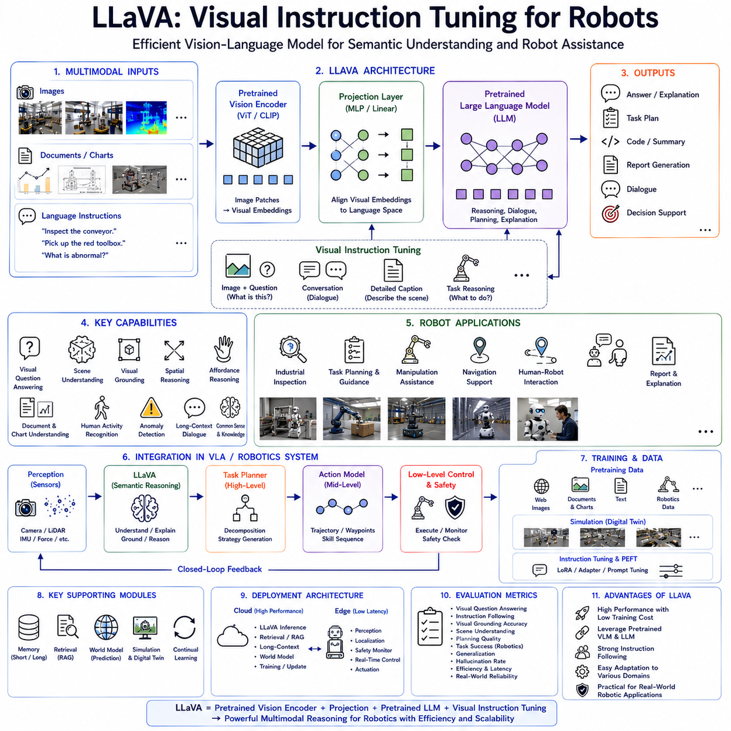
LLaVA (Large Language and Vision Assistant) represents one of the most influential milestones in the evolution of Vision-Language Models because it demonstrated that powerful multimodal reasoning can be achieved without training an entirely new foundation model from scratch. Instead of building a massive multimodal architecture like PaLM-E, LLaVA connects a pretrained visual encoder to a pretrained Large Language Model through a lightweight projection module and then performs multimodal instruction tuning. This elegant architecture dramatically reduces training cost while preserving the reasoning capabilities of modern language models. Within robotics, LLaVA has become an important foundation for high-level semantic understanding, scene interpretation, visual dialogue, instruction following, and environment-aware decision support, making it one of the most practical Vision-Language Models for modern Vision-Language-Action (VLA) systems.
The motivation behind LLaVA originates from the observation that large language models already possess extensive reasoning capability acquired from trillions of textual tokens. Likewise, modern visual encoders already learn highly discriminative image representations through large-scale computer vision pretraining. Building another giant multimodal foundation model would require enormous computational resources while duplicating existing knowledge. LLaVA instead asks a fundamentally different question: can existing visual intelligence and language intelligence simply be connected through an efficient alignment mechanism? The answer demonstrated by LLaVA is remarkably positive.
Human cognition similarly develops through knowledge integration rather than complete relearning. A person who already understands language does not relearn language from the beginning after learning vision. Instead, visual experiences gradually become associated with linguistic concepts through continual interaction. Children first recognize objects visually, then associate those objects with words, and finally use language to reason about visual observations. LLaVA follows this cognitive principle by aligning independently pretrained visual and language representations into a unified reasoning framework.
Traditional robotic perception systems frequently separate image recognition from language understanding. Object detectors identify visual entities, semantic segmentation labels pixels, localization systems estimate positions, and separate planning algorithms interpret user commands. Although this modular design remains effective for structured industrial applications, it often struggles with open-ended visual reasoning, flexible human interaction, ambiguous instructions, or previously unseen environments. LLaVA provides a semantic reasoning layer capable of integrating visual observations directly into natural language understanding without manually engineered symbolic interfaces.
The overall architecture of LLaVA remains surprisingly simple. Three major components define the entire system. The first component is a pretrained visual encoder responsible for extracting high-dimensional visual features from images. The second component is a pretrained Large Language Model responsible for reasoning, dialogue, planning, explanation, and language generation. Between these components lies a relatively lightweight projection module that aligns visual embeddings with language token representations. Despite its architectural simplicity, this design achieves impressive multimodal reasoning performance.
The visual encoder generally consists of a Vision Transformer or comparable foundation vision model. Images are divided into patches, transformed into embedding vectors, and processed through deep transformer layers producing hierarchical visual representations. These representations encode object identity, geometry, texture, illumination, spatial arrangement, scene context, and semantic relationships while preserving rich visual information unavailable through symbolic labels alone.
Unlike traditional robotic vision systems that produce object categories as discrete outputs, LLaVA retains continuous visual embeddings throughout the reasoning pipeline. Continuous representations preserve subtle appearance variations, contextual relationships, object ambiguity, environmental uncertainty, and fine-grained geometric information. The downstream language model therefore reasons directly over dense visual semantics instead of simplified symbolic descriptions.
The language model typically remains unchanged from its original pretrained configuration. Existing Large Language Models contribute commonsense reasoning, procedural knowledge, mathematical capability, logical inference, dialogue generation, contextual memory, planning ability, and semantic understanding. Since these capabilities are acquired through extensive language pretraining, LLaVA avoids retraining them from scratch. Instead, multimodal alignment enables visual observations to participate naturally within existing reasoning processes.
One of the defining innovations of LLaVA is the projection layer connecting vision and language. Visual encoder outputs generally possess feature dimensions incompatible with language token embeddings. A lightweight multilayer perceptron or linear transformation learns to map visual embeddings into the latent representation space expected by the language model. Although computationally inexpensive, this projection module becomes the bridge allowing language reasoning to understand visual information.
Projection learning requires relatively few trainable parameters compared with complete foundation model training. Most visual encoder parameters remain frozen, and the majority of language model parameters likewise remain unchanged during initial alignment. Consequently, training cost becomes dramatically lower while preserving previously acquired knowledge within both modalities. This efficiency has made LLaVA particularly attractive for academic research and industrial deployment.
Instruction tuning represents the second major innovation introduced by LLaVA. Rather than training only on image-caption pairs, the model learns through multimodal conversations involving visual questions, descriptive reasoning, object comparison, procedural explanation, scene interpretation, anomaly detection, document understanding, and task-oriented dialogue. The resulting model behaves more like an intelligent assistant than a conventional image recognition system.
Visual instruction tuning teaches the model how humans naturally discuss images. Instead of merely describing visual appearance, users ask questions such as “What is happening in this factory?”, “Which object should the robot pick first?”, “Why is this assembly step incorrect?”, or “Is there anything unsafe in this environment?” The model therefore learns to integrate perception with reasoning rather than performing isolated visual recognition.
Within robotics, instruction tuning significantly expands practical capability. Human operators naturally communicate using high-level language rather than low-level control commands. A technician may instruct, “Inspect the conveyor system and report abnormal components,” or “Find the leaking pipe near the cooling equipment.” LLaVA interprets these semantic instructions while simultaneously analyzing visual observations, greatly simplifying human-robot interaction.
Scene understanding constitutes one of the most valuable robotic applications. LLaVA does not merely identify individual objects but explains relationships among machines, operators, tools, infrastructure, workpieces, obstacles, safety equipment, and environmental conditions. The model understands functional context rather than isolated visual appearance, supporting higher-level decision making.
Visual grounding represents another essential capability. Language references must become associated with corresponding visual entities within complex environments. Instructions such as “Pick up the wrench beside the blue toolbox” require identifying the toolbox, locating nearby objects, distinguishing multiple similar tools, and resolving spatial relationships simultaneously. LLaVA naturally performs such grounding through integrated multimodal reasoning.
Spatial reasoning similarly benefits from multimodal instruction tuning. Relative object positions including left, right, above, below, behind, inside, outside, near, far, and between become meaningful through joint visual-language learning. Robots therefore understand natural spatial instructions without manually programmed coordinate transformations or symbolic rule systems.
Affordance reasoning further extends scene understanding toward functional interpretation. Rather than recognizing that an object is a screwdriver, LLaVA understands that screwdrivers tighten screws. A charging dock replenishes battery energy. Emergency buttons stop machinery. Pallets support transported goods. Conveyors move products. Such functional knowledge significantly improves robotic planning because action selection depends upon object purpose rather than visual appearance alone.
Human activity recognition also benefits from multimodal reasoning. Instead of detecting human presence alone, LLaVA interprets ongoing activities including assembly operations, inspection procedures, maintenance work, material handling, collaborative interaction, or hazardous behavior. Semantic understanding of human actions enables safer and more intelligent human-robot collaboration.
Industrial inspection represents one practical application where LLaVA demonstrates considerable value. Camera systems capture equipment images while the language model explains observed conditions, identifies anomalies, references maintenance documentation, suggests possible failure causes, and generates inspection reports. Visual reasoning therefore becomes integrated with engineering knowledge rather than limited to anomaly detection alone.
Document understanding provides another important capability. Industrial environments frequently involve technical manuals, engineering drawings, inspection reports, maintenance procedures, safety instructions, labels, control panels, and production schedules combining textual and graphical information. LLaVA learns to interpret these multimodal documents through visual instruction tuning, enabling robots to access operational knowledge directly from visual documentation.
Chart understanding similarly extends robotic reasoning. Manufacturing dashboards, quality control statistics, production graphs, energy consumption charts, warehouse inventories, and operational reports become understandable through multimodal reasoning. Instead of relying solely upon structured databases, robots may interpret visual business intelligence interfaces directly.
Visual question answering forms the basis of interactive robot assistance. Operators ask questions regarding current observations, equipment condition, environmental safety, inventory status, assembly progress, or navigation conditions. LLaVA generates contextually grounded answers combining visual evidence with language reasoning. Such conversational interaction substantially improves usability compared with conventional graphical interfaces.
Task planning increasingly benefits from multimodal understanding. Instead of generating trajectories directly, LLaVA produces high-level semantic plans describing objectives, required tools, procedural steps, environmental considerations, and safety constraints. Dedicated Action Models subsequently transform these semantic plans into executable robot trajectories. This hierarchical separation improves interpretability while simplifying system integration.
Navigation also becomes semantically enriched. Rather than following purely geometric maps, robots recognize workstations, storage locations, charging areas, emergency exits, inspection checkpoints, restricted zones, collaborative spaces, and operational workflows. Semantic navigation supports more intelligent path planning because movement decisions consider environmental meaning alongside geometric distance.
Memory integration further enhances visual instruction following. Previous dialogue, earlier observations, completed tasks, historical equipment conditions, user preferences, and procedural experience become available throughout extended interaction. Long-term contextual memory enables coherent conversations spanning entire work shifts rather than isolated image interpretation sessions.
Retrieval-Augmented Generation naturally complements LLaVA architecture. Maintenance manuals, engineering documentation, CAD models, digital twins, production databases, inspection records, software repositories, and operational procedures provide external knowledge retrieved dynamically during reasoning. Retrieved information supplements visual observations, enabling robots to explain unfamiliar equipment, identify rare failures, or follow updated procedures without retraining.
World Models increasingly integrate with visual instruction tuning. Instead of interpreting only present observations, predictive simulation estimates future environmental evolution, equipment behavior, human movement, traffic conditions, weather changes, or battery consumption. Future-aware reasoning therefore supports proactive planning rather than reactive decision making.
Simulation has become indispensable for robotic LLaVA development because collecting large-scale multimodal robotics dialogue datasets remains expensive. Digital twins generate synchronized images, semantic annotations, language instructions, robot trajectories, environmental variation, and operational scenarios covering manufacturing, logistics, healthcare, agriculture, warehouse automation, and autonomous inspection. Simulation substantially expands training diversity while reducing data collection cost.
Parameter-efficient fine-tuning has further increased LLaVA's practical importance. Methods such as Low-Rank Adaptation, adapters, prompt tuning, prefix tuning, and quantized fine-tuning allow organizations to specialize general-purpose LLaVA models toward factory automation, autonomous inspection, precision agriculture, warehouse logistics, healthcare robotics, or service robotics using relatively small domain-specific datasets.
Cloud-edge collaboration represents the preferred deployment strategy. Cloud infrastructure executes computationally intensive visual reasoning, long-context dialogue, retrieval, document interpretation, and continual learning. Edge computers perform image acquisition, sensor fusion, localization, obstacle detection, runtime monitoring, and deterministic robot control. This distributed architecture balances computational efficiency with real-time responsiveness.
One important distinction between LLaVA and PaLM-E concerns embodiment. PaLM-E directly integrates robot state, proprioception, and continuous sensory observations into transformer reasoning, emphasizing embodied cognition. LLaVA instead emphasizes multimodal instruction understanding using images and language while relying upon downstream robotic systems for low-level embodiment. Consequently, LLaVA excels as a semantic reasoning engine supporting robotic cognition rather than replacing deterministic robot controllers.
Compared with larger native multimodal models such as Gemini, LLaVA demonstrates that practical multimodal capability does not necessarily require enormous computational resources. Efficient architectural alignment combined with high-quality instruction tuning achieves surprisingly competitive performance despite substantially lower training cost. This efficiency has accelerated widespread research adoption throughout academia and industry.
Safety remains independent from visual reasoning. Although LLaVA generates semantically rich understanding, deterministic safety supervisors continue verifying collision avoidance, force limitations, workspace constraints, cybersecurity, emergency stopping, runtime monitoring, and regulatory compliance before physical execution. Semantic intelligence therefore complements established robotic safety engineering rather than replacing it.
Evaluation of robotic LLaVA systems extends beyond conventional image captioning benchmarks. Researchers measure visual question answering, instruction following, grounding accuracy, scene understanding, document interpretation, planning quality, anomaly explanation, manipulation assistance, navigation support, retrieval effectiveness, hallucination frequency, computational efficiency, robustness under distribution shift, and real-world deployment reliability. Comprehensive evaluation reflects practical embodied usefulness rather than isolated multimodal prediction accuracy.
Industrial applications continue expanding rapidly. Manufacturing robots employ LLaVA for quality inspection, assembly guidance, equipment monitoring, and production reporting. Warehouse robots use visual dialogue for inventory management and logistics planning. Agricultural robots interpret crop imagery together with farming instructions. Healthcare robots analyze clinical environments while assisting medical personnel. Infrastructure inspection systems explain observed defects using engineering terminology grounded in maintenance documentation.
LLaVA has also significantly influenced subsequent Vision-Language-Action research by demonstrating the effectiveness of modular multimodal architectures. Many later systems adopt similar projection-based alignment mechanisms, multimodal instruction tuning procedures, parameter-efficient adaptation techniques, and hierarchical reasoning structures. Its success established visual instruction tuning as one of the central methodologies within modern embodied artificial intelligence.
Future development is expected to extend LLaVA through deeper multimodal integration including video understanding, audio reasoning, tactile sensing, force perception, world models, adaptive memory systems, retrieval-augmented cognition, continual learning, uncertainty estimation, multi-agent collaboration, and embodied action prediction. Increasingly capable multimodal assistants will gradually evolve into comprehensive cognitive operating systems supporting every stage of robotic perception, reasoning, planning, learning, communication, and physical interaction.
As Physical AI advances toward general-purpose embodied intelligence, LLaVA remains one of the most practical and influential Vision-Language architectures because it demonstrated that efficient multimodal alignment and instruction tuning can transform existing foundation models into highly capable visual reasoning systems. By connecting pretrained visual encoders with powerful language models through lightweight projection layers and multimodal instruction learning, LLaVA established a scalable framework enabling robots to understand scenes, interpret human instructions, explain observations, retrieve knowledge, support planning, and collaborate naturally with people across manufacturing, logistics, healthcare, agriculture, infrastructure inspection, autonomous service robotics, and the broader ecosystem of future Vision-Language-Action systems.

5.4 Gemini for Robotics (with Code)
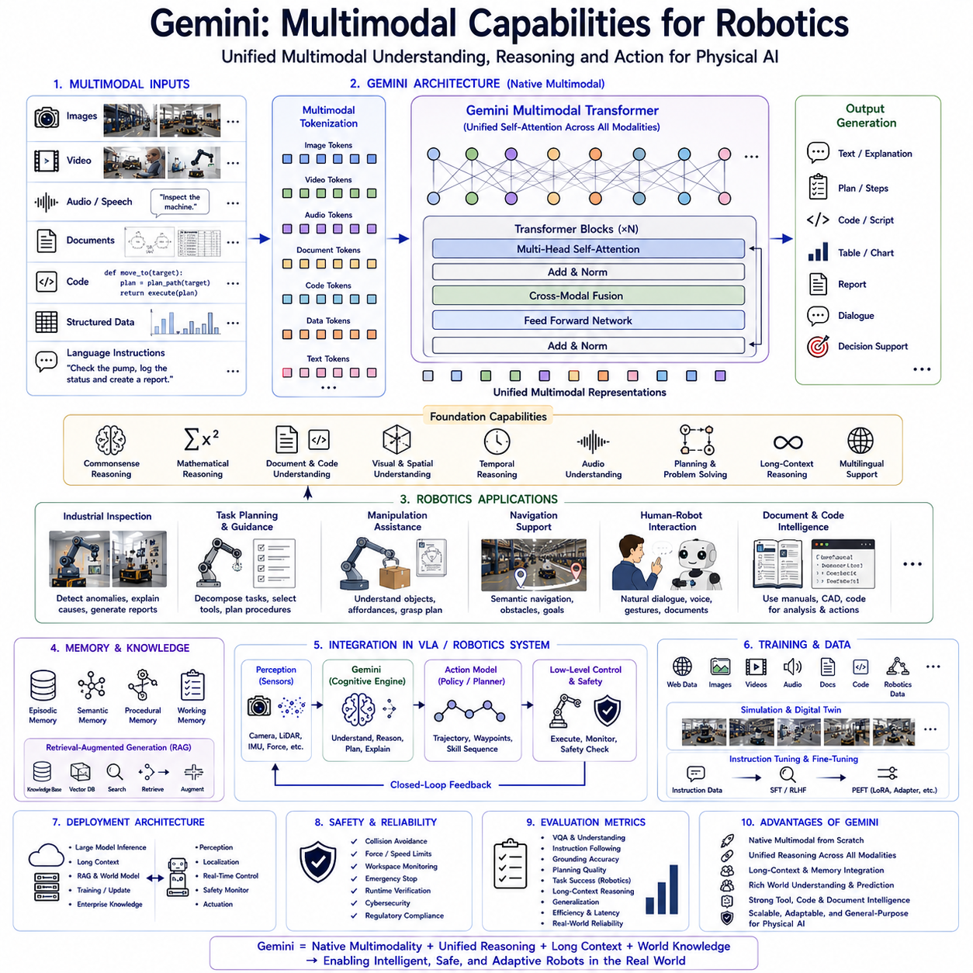
Gemini represents one of the most advanced generations of multimodal foundation models, designed from its inception to process and reason over multiple data modalities within a unified architecture. Unlike earlier Vision-Language Models that extended pretrained language models by attaching visual encoders, Gemini was developed as a natively multimodal system capable of understanding images, videos, audio, documents, source code, structured data, and natural language simultaneously. This design philosophy fundamentally changes how artificial intelligence interacts with the physical world because it enables robots to perceive, understand, reason, communicate, and plan using heterogeneous sensory information without relying on isolated processing pipelines. As robotics evolves toward Physical AI, Gemini provides a comprehensive cognitive foundation that supports Vision-Language-Action systems operating in dynamic and unstructured environments.
The motivation for Gemini originates from the observation that real-world intelligence is inherently multimodal. Humans rarely rely upon a single sensory modality when making decisions. Visual perception, auditory information, tactile feedback, language, prior experience, procedural memory, and environmental awareness continuously interact to produce coherent reasoning. When an engineer enters a manufacturing plant, visual inspection, equipment sounds, warning signs, maintenance history, spoken instructions, and previous operational knowledge are integrated almost instantly. Gemini attempts to approximate this natural cognitive process through a unified multimodal transformer architecture capable of jointly processing diverse information sources.
Earlier Vision-Language Models successfully demonstrated the benefits of combining visual perception with natural language understanding. However, many of these systems remained fundamentally language-centric architectures augmented by external visual encoders. Gemini instead adopts a native multimodal design where every supported modality becomes a first-class component of the model's reasoning process. Images, videos, speech, diagrams, engineering drawings, programming code, mathematical expressions, and textual instructions are represented through compatible tokenization strategies, allowing the transformer to reason across all modalities simultaneously.
One of Gemini's defining characteristics is multimodal tokenization. Traditional language models process discrete word tokens, while computer vision systems typically operate on continuous image embeddings. Gemini introduces a unified computational representation where heterogeneous inputs are transformed into compatible multimodal tokens before entering the transformer network. This unified representation allows visual observations, spoken language, technical documentation, and environmental information to participate equally within attention-based reasoning, eliminating artificial boundaries between perception and cognition.
The visual processing subsystem of Gemini extends well beyond conventional image recognition. Instead of merely identifying objects or classifying scenes, the model interprets semantic relationships, functional context, spatial arrangements, temporal dynamics, object affordances, environmental conditions, and human activities. Vision therefore becomes an information source supporting higher-level reasoning rather than an isolated perception module. For robotics, this semantic understanding enables more intelligent decision making because actions depend upon contextual interpretation rather than object recognition alone.
Video understanding represents another major advancement. Many robotic applications involve continuous interaction with dynamic environments where temporal evolution carries critical information. Manufacturing processes, warehouse logistics, collaborative assembly, agricultural operations, traffic monitoring, and infrastructure inspection all require reasoning across sequences of observations rather than isolated frames. Gemini processes video as an integrated temporal modality, allowing the model to understand motion patterns, activity progression, procedural workflows, and future environmental evolution.
Audio reasoning significantly expands robotic perception. Industrial environments contain valuable acoustic information including machine vibration, motor noise, alarms, spoken instructions, environmental sounds, fluid leakage, structural resonance, and equipment degradation. Gemini interprets audio together with visual observations and language, allowing robots to recognize abnormal machinery sounds, understand verbal communication, identify environmental events, and combine auditory evidence with visual inspection during decision making.
Document understanding constitutes another core capability highly relevant to industrial robotics. Modern factories, warehouses, hospitals, and infrastructure facilities rely extensively upon engineering documentation, CAD drawings, maintenance manuals, quality reports, production schedules, operating procedures, safety regulations, and inspection records. Gemini processes complex multimodal documents containing text, tables, diagrams, mathematical equations, technical illustrations, and graphical annotations within a unified reasoning framework. Consequently, robots gain direct access to operational knowledge embedded inside technical documentation without requiring separate document analysis systems.
Source code understanding further distinguishes Gemini from earlier multimodal models. Autonomous robots increasingly interact with software repositories, middleware configurations, ROS packages, PLC programs, automation scripts, simulation environments, API specifications, and embedded firmware. Gemini can analyze software together with documentation, diagrams, runtime logs, and engineering notes, enabling AI-assisted debugging, software maintenance, system integration, and autonomous code generation for robotic applications.
Mathematical reasoning remains essential for engineering and robotics. Kinematics, dynamics, optimization, control theory, sensor fusion, probabilistic estimation, and trajectory generation frequently involve mathematical expressions integrated within engineering documentation. Gemini understands mathematical notation alongside natural language explanations, allowing unified reasoning across symbolic equations and descriptive text. This capability supports engineering analysis, technical education, scientific research, and autonomous problem solving.
The transformer architecture underlying Gemini extends conventional self-attention mechanisms toward multimodal reasoning. Every modality contributes tokenized representations processed through shared attention layers. Images attend to language, language attends to documents, documents attend to diagrams, audio attends to video, and all modalities collectively influence generated responses. Rather than sequentially processing modalities through independent subsystems, Gemini performs integrated multimodal reasoning where information continuously flows across heterogeneous sensory representations.
Large context windows represent another defining characteristic. Robotic systems frequently require simultaneous access to maintenance histories, operational logs, previous dialogue, environmental maps, inspection records, sensor observations, engineering manuals, software documentation, and current task descriptions. Gemini processes extremely long multimodal contexts, enabling coherent reasoning across information collections far exceeding traditional transformer limitations. This capability is particularly valuable for enterprise robotics where operational knowledge spans thousands of pages and millions of sensor observations.
Context persistence further improves robotic interaction. Extended missions often involve prolonged dialogue, repeated observations, evolving environmental conditions, and changing operational objectives. Gemini maintains coherent understanding across long-duration conversations while continuously incorporating new sensory information into its contextual memory. This enables robots to collaborate naturally with human operators throughout extended operational periods rather than treating every interaction independently.
Scene understanding becomes substantially richer under multimodal reasoning. Instead of identifying isolated objects, Gemini interprets complete operational environments including machine relationships, workflow organization, human collaboration, safety equipment, production state, material flow, infrastructure layout, environmental hazards, and procedural context. Such holistic understanding significantly improves high-level planning because robot decisions depend upon overall situational awareness rather than localized perception alone.
Visual grounding naturally extends semantic understanding toward actionable robot behavior. Natural language instructions frequently reference objects through spatial relationships, functional roles, colors, shapes, procedural context, or previous dialogue. Gemini associates these linguistic references with corresponding physical entities while considering surrounding environmental structure. Grounded multimodal reasoning enables robots to interpret ambiguous instructions using contextual information unavailable through symbolic rule systems.
Affordance reasoning plays an increasingly important role in Physical AI. Beyond recognizing objects, robots must understand how objects can be manipulated and what functional roles they serve. Gemini identifies potential interactions by combining visual appearance, prior knowledge, engineering documentation, procedural instructions, and environmental context. A valve becomes something that regulates flow, a charging station replenishes battery energy, a conveyor transports materials, and a safety barrier restricts hazardous access. Functional reasoning therefore complements conventional object recognition.
Task planning benefits considerably from Gemini's multimodal capability. User instructions, environmental observations, engineering constraints, previous execution history, maintenance documentation, digital twins, and operational objectives become integrated during planning. Rather than generating actions directly, Gemini produces semantically rich task decompositions, identifies required resources, predicts operational challenges, evaluates alternative strategies, and explains planning decisions. Dedicated Action Models subsequently transform these semantic plans into executable robotic behavior.
Human-robot interaction becomes significantly more natural through multimodal dialogue. Operators communicate using speech, gestures, diagrams, images, documents, handwritten annotations, photographs, or verbal instructions. Gemini integrates these communication channels while maintaining awareness of the robot's operational context. Consequently, collaborative interaction resembles human teamwork rather than conventional command-based robot programming.
Industrial inspection represents one of the most valuable robotic applications. Camera observations identify physical equipment conditions while Gemini simultaneously analyzes maintenance manuals, historical inspection reports, engineering drawings, sensor measurements, and operational documentation. The model explains observed anomalies, predicts possible failure mechanisms, recommends inspection procedures, generates maintenance reports, and supports engineering decision making using comprehensive multimodal reasoning.
Warehouse automation similarly benefits from integrated multimodal intelligence. Inventory databases, barcode images, warehouse maps, shipment documentation, robot localization, customer orders, voice communication, and visual observations collectively contribute toward intelligent logistics planning. Gemini coordinates these heterogeneous information sources while supporting autonomous inventory management, order fulfillment, exception handling, and operational optimization.
Agricultural robotics presents another compelling application. Crop imagery, weather forecasts, soil measurements, irrigation schedules, satellite observations, machinery status, agronomic documentation, and farmer instructions become integrated into unified reasoning. Robots therefore perform precision agriculture supported by comprehensive environmental understanding rather than isolated visual crop analysis.
Healthcare robotics similarly requires multimodal cognition. Medical imaging, patient records, physician instructions, monitoring devices, laboratory reports, environmental observations, and spoken interaction contribute toward clinical assistance. Gemini supports healthcare personnel by integrating heterogeneous medical information while preserving contextual awareness throughout patient care workflows.
Infrastructure inspection benefits from long-context multimodal reasoning. Bridges, tunnels, railways, pipelines, electrical substations, and industrial facilities generate large quantities of imagery, engineering documentation, sensor measurements, inspection history, maintenance procedures, and structural analysis reports. Gemini correlates these information sources to identify degradation patterns, prioritize maintenance activities, and generate technically grounded inspection summaries.
Memory integration significantly expands Gemini's robotic capability. Episodic memory stores previous missions and operational experience. Semantic memory maintains engineering knowledge, facility information, and environmental understanding. Procedural memory preserves reusable robotic skills and maintenance procedures. Working memory tracks current dialogue, ongoing tasks, sensor observations, and intermediate reasoning throughout extended missions. Together these memory systems enable lifelong contextual learning supporting continuous operational improvement.
Retrieval-Augmented Generation naturally complements Gemini architecture. Enterprise knowledge stored in digital twins, CAD repositories, software documentation, maintenance databases, production systems, regulatory standards, quality manuals, and operational archives becomes dynamically retrievable during reasoning. External retrieval allows robots to access continuously updated organizational knowledge without retraining foundation model parameters, improving both adaptability and factual reliability.
World Models increasingly integrate with Gemini to support predictive reasoning. Rather than interpreting only current observations, robots estimate future environmental evolution including human movement, equipment wear, traffic flow, weather conditions, battery consumption, and production progress. Predictive simulation enables proactive planning, resource allocation, maintenance scheduling, and risk mitigation before operational problems emerge.
Simulation remains indispensable for multimodal robotic training. Digital twins generate synchronized images, videos, audio, sensor measurements, engineering documentation, robot trajectories, environmental dynamics, and language interactions across diverse operational scenarios. Simulation provides scalable multimodal datasets spanning manufacturing, logistics, agriculture, mining, healthcare, construction, autonomous vehicles, warehouse automation, and service robotics while reducing dependence upon costly real-world data collection.
Parameter-efficient adaptation allows Gemini to specialize toward domain-specific robotics applications. Techniques including Low-Rank Adaptation, adapters, prompt tuning, instruction tuning, retrieval customization, and modular specialization enable organizations to deploy multimodal intelligence across industrial sectors without retraining complete foundation models. Such adaptation substantially reduces computational requirements while preserving broad generalization capability.
Cloud-edge deployment architecture provides practical scalability. Cloud infrastructure performs computationally intensive multimodal reasoning, long-context processing, retrieval, continual learning, world modeling, and enterprise knowledge integration. Edge computers perform sensor acquisition, perception, localization, obstacle avoidance, safety monitoring, low-latency inference, and deterministic control. This hybrid architecture balances computational power with real-time responsiveness required by physical interaction.
Safety remains a separate engineering discipline despite Gemini's advanced reasoning capability. Semantic understanding alone cannot guarantee safe operation. Runtime verification, collision avoidance, force limitation, workspace monitoring, emergency stopping, cybersecurity protection, regulatory compliance, and deterministic control continue operating independently from multimodal cognition. Gemini therefore enhances decision quality while safety supervisors validate physical execution before actuator commands reach robotic hardware.
Evaluation of Gemini-based robotic systems extends beyond traditional multimodal benchmarks. Researchers assess visual question answering, document interpretation, video understanding, audio reasoning, instruction following, planning quality, grounding accuracy, retrieval effectiveness, long-context reasoning, collaborative dialogue, world model prediction, task success, computational efficiency, uncertainty calibration, robustness under distribution shift, and real-world deployment reliability. Comprehensive evaluation reflects complete embodied intelligence rather than isolated perception or language performance.
Compared with PaLM-E, Gemini expands beyond embodied robot state integration toward comprehensive multimodal intelligence encompassing nearly every information source relevant to intelligent robotics. Compared with LLaVA, Gemini provides native multimodal reasoning rather than projection-based alignment between pretrained components. While LLaVA demonstrates remarkable efficiency and PaLM-E emphasizes embodied interaction, Gemini pursues unified multimodal cognition supporting broad enterprise-scale robotic intelligence across heterogeneous information domains.
Future developments are expected to integrate tactile sensing, force perception, event cameras, hyperspectral imaging, radar, LiDAR, biosignals, collaborative multi-agent reasoning, adaptive world models, lifelong learning, autonomous scientific discovery, and self-improving memory systems within increasingly unified multimodal foundation architectures. Robots will gradually evolve from isolated autonomous machines into continuously learning cognitive agents capable of understanding, communicating, predicting, planning, and acting through seamless integration of diverse sensory information.
As Physical AI advances toward universal embodied intelligence, Gemini demonstrates how native multimodal foundation models can become comprehensive cognitive operating systems for robotics. By integrating images, video, audio, language, documents, code, mathematics, memory, retrieval, prediction, and contextual reasoning within a unified transformer architecture, Gemini establishes a scalable foundation for future Vision-Language-Action systems capable of supporting manufacturing, logistics, healthcare, agriculture, autonomous inspection, infrastructure maintenance, collaborative robotics, service automation, scientific exploration, and the next generation of intelligent robotic ecosystems operating safely, adaptively, and autonomously within complex real-world environments.

5.5 GPT-4V API Integration for Robotics (with Code)
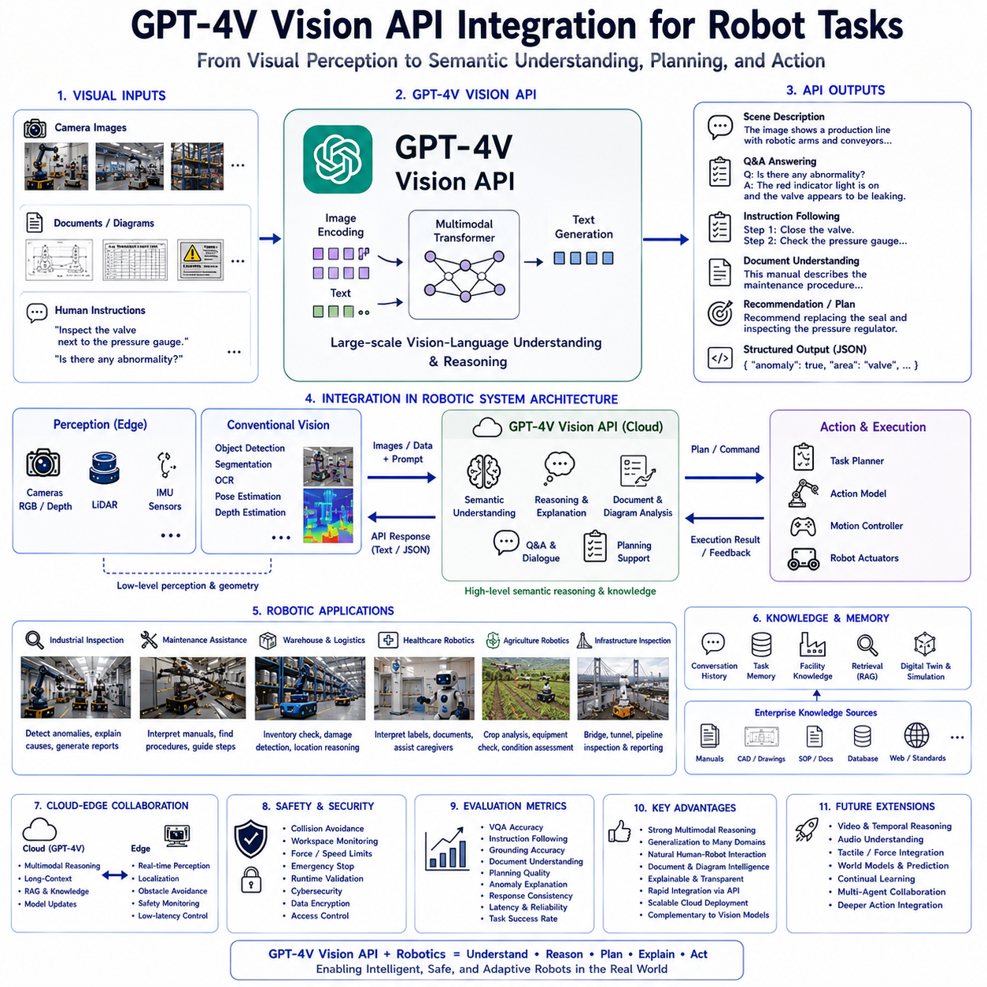
GPT-4V Vision API represents a significant milestone in the evolution of multimodal artificial intelligence by enabling Large Language Models to directly interpret visual information through standardized application programming interfaces. Rather than functioning solely as a conversational language model, GPT-4V extends language reasoning into the visual domain, allowing robots to perceive images, understand scenes, analyze documents, recognize objects, interpret diagrams, and answer visual questions through natural language interaction. For modern robotics, GPT-4V serves as a high-level cognitive engine that transforms raw visual observations into semantic understanding, task planning, decision support, and contextual explanations. This capability bridges the gap between low-level robotic perception and high-level cognitive reasoning, making GPT-4V an important component in Vision-Language-Action architectures designed for Physical AI.
The motivation for integrating GPT-4V into robotics originates from the limitations of conventional computer vision systems. Traditional perception pipelines generally perform object detection, semantic segmentation, optical character recognition, depth estimation, and pose estimation through independent algorithms. While these techniques achieve high numerical accuracy within narrowly defined tasks, they often lack contextual understanding and semantic reasoning. A robot may successfully detect a wrench, a machine, and a toolbox, yet remain unable to understand why the wrench is important, whether maintenance is currently required, or what sequence of actions should follow. GPT-4V introduces semantic interpretation that complements deterministic perception by reasoning about relationships, intentions, operational context, and procedural knowledge.
Human perception naturally combines vision with language, memory, experience, and common sense. An engineer entering an industrial facility immediately identifies machinery, recognizes warning signs, interprets operator activities, recalls maintenance procedures, understands production status, and predicts potential hazards. These cognitive processes occur simultaneously rather than through isolated computational modules. GPT-4V attempts to approximate this integrated reasoning process by combining visual understanding with large-scale language knowledge acquired during foundation model training.
Unlike dedicated robotic perception networks trained for individual recognition tasks, GPT-4V functions as a general-purpose multimodal reasoning engine. Instead of producing only bounding boxes or classification labels, the model generates semantic descriptions, explains observations, answers questions, interprets diagrams, analyzes documents, compares images, summarizes environments, and proposes task-oriented recommendations. This versatility makes GPT-4V particularly attractive for robotics because many real-world operations require flexible reasoning rather than fixed perception pipelines.
The GPT-4V Vision API provides standardized interfaces allowing robotic software to communicate with multimodal foundation models through cloud-based services. Images captured by onboard cameras are transmitted through secure API requests together with textual prompts describing the desired reasoning objective. The model processes visual observations alongside user instructions and returns structured natural language responses or machine-readable outputs suitable for downstream robotic systems. API-based deployment enables rapid integration without requiring organizations to train or maintain massive multimodal models locally.
Within a typical robotic architecture, cameras remain responsible for acquiring visual observations while conventional perception algorithms continue performing low-level feature extraction when deterministic measurements are required. GPT-4V operates above these perception layers, interpreting images using semantic reasoning rather than replacing geometric vision algorithms. This hierarchical design preserves the reliability of established robotic perception while adding flexible cognitive interpretation capable of supporting complex operational decision making.
Visual understanding within GPT-4V extends significantly beyond object recognition. The model analyzes object relationships, spatial organization, scene context, environmental conditions, human activities, operational workflows, safety hazards, functional interactions, and procedural implications. Instead of merely recognizing that several machines appear in an image, GPT-4V may explain which production stage is currently active, identify abnormal operating conditions, recognize maintenance opportunities, and infer likely future actions based upon contextual evidence.
Scene interpretation represents one of the most valuable capabilities for autonomous robots. Industrial facilities, warehouses, hospitals, construction sites, agricultural fields, laboratories, and infrastructure inspection environments contain numerous interacting entities whose relationships determine operational meaning. GPT-4V explains these relationships using natural language, providing robots with contextual understanding unavailable through isolated object detection. Such semantic awareness significantly improves planning because robot actions depend upon situational context rather than individual object identities alone.
Visual grounding naturally supports instruction following. Human operators frequently issue commands referencing visual objects through spatial descriptions, functional roles, colors, relative positions, or contextual relationships. Instructions such as “Inspect the valve beside the pressure gauge” or “Move the damaged package near the loading dock” require associating linguistic references with physical entities. GPT-4V performs this multimodal grounding through integrated language and visual reasoning, simplifying human-robot interaction across complex operational environments.
Document understanding represents another important capability enabled through the Vision API. Industrial robots frequently encounter maintenance manuals, engineering drawings, assembly instructions, operating procedures, inspection reports, equipment labels, electrical schematics, production schedules, and handwritten notes. GPT-4V interprets these documents directly from camera images without requiring dedicated document processing pipelines. Text, diagrams, tables, illustrations, annotations, and graphical layouts become integrated into unified semantic reasoning supporting autonomous robotic operation.
Optical character recognition remains an important component of document understanding, yet GPT-4V extends beyond text extraction by interpreting semantic meaning. Rather than simply reading a warning label, the model understands operational implications. Instead of extracting numerical values from an inspection report, it explains maintenance significance. This semantic interpretation enables robots to utilize engineering documentation more intelligently than conventional OCR-based systems.
Diagram interpretation significantly benefits robotic engineering workflows. Process flow diagrams, piping schematics, electrical circuits, CAD drawings, factory layouts, warehouse maps, inspection templates, and digital twin visualizations contain structured graphical information difficult to interpret through traditional computer vision algorithms. GPT-4V combines visual understanding with engineering knowledge, allowing robots to analyze technical diagrams, explain structural relationships, identify inconsistencies, and support engineering decision making.
Visual question answering forms the foundation of interactive robot assistance. Human operators naturally ask questions regarding observed environments, equipment conditions, production progress, inventory status, safety concerns, maintenance requirements, or navigation challenges. GPT-4V generates grounded responses using visual evidence together with extensive language knowledge. Such conversational interaction greatly improves operational usability because personnel communicate through natural dialogue instead of specialized programming interfaces.
Task planning benefits substantially from semantic visual understanding. GPT-4V does not generate low-level motor trajectories directly. Instead, it interprets user objectives, analyzes environmental observations, identifies relevant objects, explains procedural requirements, predicts operational challenges, and proposes high-level execution plans. Dedicated Action Models subsequently transform these semantic plans into deterministic robotic behavior. This separation between cognitive reasoning and physical execution improves transparency, maintainability, and safety.
Industrial inspection represents one of the strongest application domains. Camera systems continuously capture equipment imagery while GPT-4V analyzes mechanical conditions, identifies visible anomalies, explains potential failure mechanisms, references maintenance procedures, compares observations against engineering expectations, and generates structured inspection reports. Maintenance personnel therefore receive semantically meaningful explanations rather than isolated anomaly scores, improving diagnostic efficiency and operational decision making.
Warehouse robotics similarly benefits from Vision API integration. Inventory images, shipping labels, damaged packages, storage locations, barcode regions, pallet conditions, loading operations, and logistics documentation become semantically interpretable through multimodal reasoning. GPT-4V assists warehouse management by explaining inventory discrepancies, identifying packaging damage, interpreting operational workflows, and supporting autonomous logistics planning through contextual understanding.
Healthcare robotics provides another valuable application area. Medical imaging, patient documentation, medication labels, clinical environments, monitoring equipment, rehabilitation activities, and caregiver interaction all involve rich multimodal information. GPT-4V supports healthcare personnel by integrating visual observations with medical terminology and procedural knowledge, enabling context-aware assistance while complementing specialized diagnostic systems.
Agricultural robotics increasingly relies upon multimodal understanding. Crop images, irrigation infrastructure, equipment condition, pest damage, soil characteristics, weather documentation, operational logs, and farmer instructions become jointly interpretable through Vision API reasoning. Rather than merely recognizing crop appearance, GPT-4V explains agricultural conditions, recommends inspection priorities, and assists farm management through integrated contextual analysis.
Infrastructure inspection similarly benefits from semantic interpretation. Bridges, railways, tunnels, pipelines, substations, industrial facilities, construction sites, and transportation systems generate extensive visual data requiring engineering expertise. GPT-4V analyzes structural conditions, explains visible deterioration, interprets inspection documentation, identifies maintenance priorities, and summarizes infrastructure status using technically grounded natural language.
Image comparison introduces another valuable capability. Robots frequently inspect manufactured products against reference images, compare current equipment condition with historical observations, monitor environmental changes over time, or verify assembly correctness relative to design specifications. GPT-4V performs semantic comparison by explaining differences, identifying deviations, estimating operational significance, and recommending appropriate corrective actions.
Temporal reasoning becomes increasingly important when Vision API integration extends across sequential observations. Although GPT-4V primarily analyzes individual requests, robotic systems may combine consecutive visual analyses with external memory modules, allowing long-duration monitoring of equipment behavior, environmental evolution, production progress, human activities, or maintenance procedures. Such temporal integration expands static image understanding toward continuous situational awareness.
Memory integration further enhances practical deployment. Previous dialogue history, earlier observations, completed inspection reports, historical maintenance records, user preferences, facility knowledge, and operational objectives become available through external memory systems surrounding the Vision API. GPT-4V therefore reasons within broader operational context despite maintaining stateless API interactions internally. This architectural separation provides flexibility while preserving scalable cloud deployment.
Retrieval-Augmented Generation naturally complements Vision API integration. Enterprise documentation including maintenance manuals, CAD repositories, digital twins, production databases, quality standards, software documentation, regulatory requirements, engineering procedures, and inspection archives can be retrieved dynamically before multimodal reasoning. GPT-4V combines retrieved knowledge with current visual observations, producing responses grounded in both organizational knowledge and real-time environmental perception.
World Models provide additional predictive capability when integrated with GPT-4V. Current visual observations become combined with predictive simulation estimating future environmental evolution, equipment degradation, human movement, battery consumption, traffic conditions, production schedules, or weather changes. Predictive reasoning enables proactive planning rather than reactive response, improving operational robustness across long-duration robotic missions.
Cloud deployment offers major advantages for multimodal robotics. GPT-4V Vision API provides continuous access to state-of-the-art multimodal intelligence without requiring local deployment of extremely large foundation models. Organizations benefit from centralized model improvements, scalable computational resources, simplified maintenance, and rapid capability updates. Robots equipped with relatively modest edge hardware therefore gain access to advanced cognitive reasoning unavailable through local inference alone.
Nevertheless, cloud integration introduces engineering considerations including network latency, communication reliability, cybersecurity, privacy protection, bandwidth limitations, operational cost, and offline robustness. Consequently, many robotic architectures adopt hybrid cloud-edge deployment strategies. Deterministic perception, localization, navigation, obstacle avoidance, and safety monitoring remain on edge devices, while GPT-4V performs computationally intensive semantic reasoning requiring broader contextual knowledge.
This division of responsibility aligns naturally with hierarchical robotic architectures. Edge systems execute real-time control loops operating at millisecond frequencies. Conventional perception algorithms estimate geometry, localization, and obstacle positions. GPT-4V provides higher-level interpretation, planning assistance, explanation generation, document understanding, anomaly reasoning, and conversational interaction operating over longer temporal horizons. Such architectural separation preserves deterministic safety while expanding cognitive flexibility.
Security remains essential throughout API integration. Images transmitted to cloud services may contain sensitive industrial information including proprietary equipment, production processes, facility layouts, customer products, or operational documentation. Secure communication channels, authentication mechanisms, encryption, access control, auditing, and organizational governance therefore become integral components of practical deployment architectures. Responsible data handling ensures that multimodal intelligence enhances operational capability without compromising confidentiality.
Safety engineering similarly remains independent from semantic reasoning. GPT-4V recommendations should never directly command actuators without verification. Collision avoidance, workspace monitoring, force limitation, emergency stopping, runtime validation, cybersecurity monitoring, regulatory compliance, and deterministic controllers continue operating as independent supervisory layers. Semantic intelligence supports human understanding and robotic planning while safety systems validate physical execution before motor commands reach hardware.
Evaluation of GPT-4V Vision API integration extends beyond conventional image recognition metrics. Researchers assess visual question answering, document interpretation, scene understanding, instruction following, image comparison, anomaly explanation, planning support, grounding accuracy, retrieval integration, contextual consistency, response reliability, computational latency, operational robustness, user satisfaction, and real-world task success. Comprehensive evaluation reflects practical robotic usefulness rather than isolated multimodal prediction accuracy.
One particularly valuable property of GPT-4V lies in explainability. Instead of producing opaque numerical outputs, the model explains why observations matter, references visual evidence supporting conclusions, discusses alternative interpretations, identifies uncertainty, and recommends follow-up actions. Such transparency significantly improves trust between human operators and autonomous robotic systems because reasoning becomes inspectable through natural language dialogue.
Compared with specialized robotic vision networks, GPT-4V emphasizes generalization rather than narrow optimization. A single multimodal reasoning engine supports manufacturing, logistics, healthcare, agriculture, construction, scientific laboratories, infrastructure inspection, warehouse automation, and collaborative robotics without requiring separate task-specific perception architectures for every operational scenario. This flexibility reduces engineering complexity while accelerating deployment across diverse application domains.
Future developments are expected to integrate GPT-4V Vision API with increasingly sophisticated multimodal memory systems, world models, retrieval infrastructures, digital twins, simulation environments, Action Models, reinforcement learning policies, uncertainty estimation, continual learning, collaborative multi-agent reasoning, and autonomous software engineering. Rather than functioning solely as an image interpretation service, Vision APIs will become integral cognitive components coordinating perception, reasoning, planning, explanation, communication, and enterprise knowledge management throughout intelligent robotic ecosystems.
As Physical AI continues evolving toward general-purpose embodied intelligence, GPT-4V Vision API demonstrates how cloud-accessible multimodal foundation models can transform robotic cognition. By combining visual understanding, language reasoning, document interpretation, contextual planning, conversational interaction, enterprise knowledge retrieval, and semantic explanation within standardized API interfaces, GPT-4V establishes a scalable framework enabling robots to understand complex environments, collaborate naturally with people, support engineering workflows, interpret operational documentation, explain observations, and contribute intelligently across manufacturing, logistics, healthcare, agriculture, infrastructure inspection, scientific research, and the next generation of autonomous robotic systems operating safely and effectively within the real world.

5.6 Qwen-VL and InternVL (with Code)
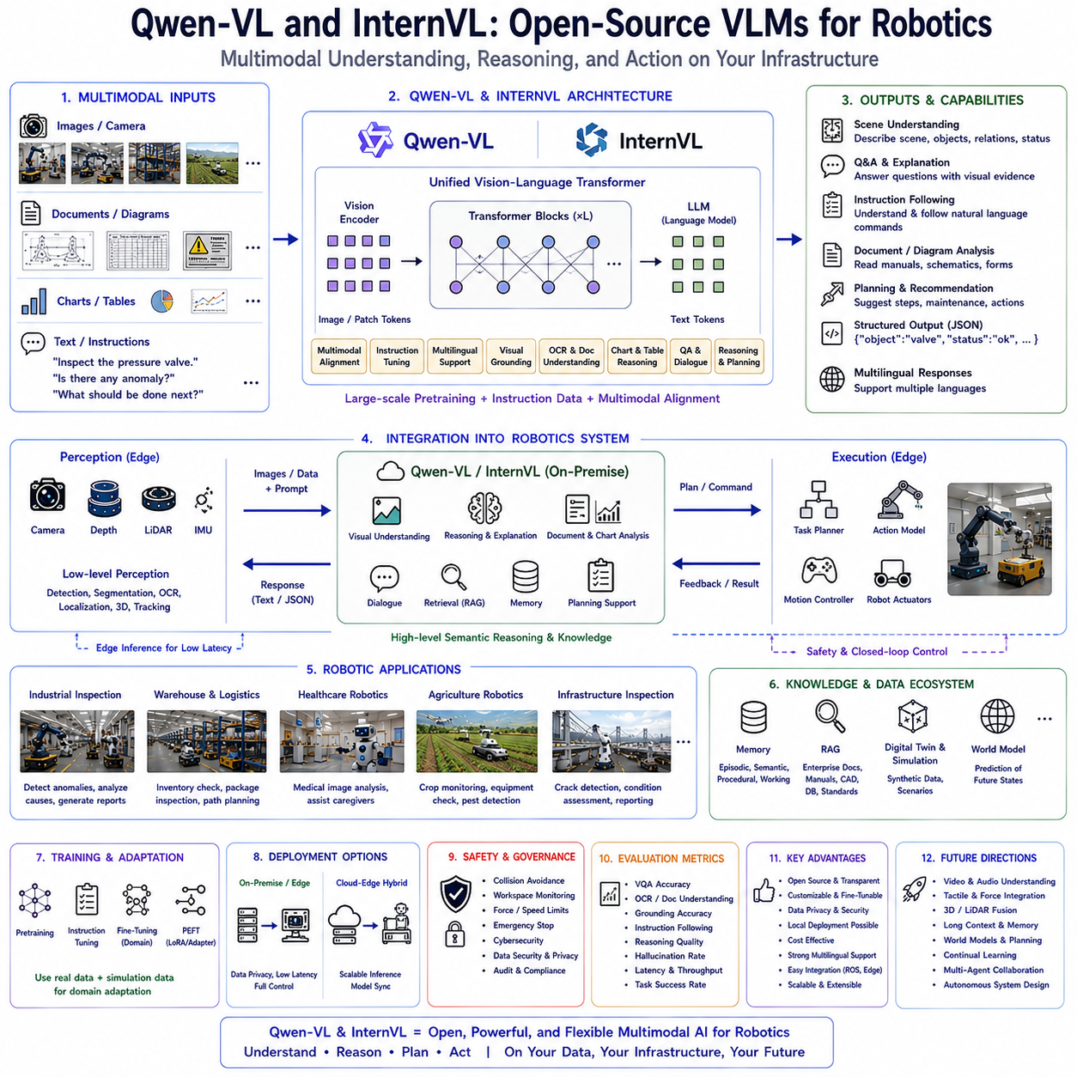
Open-source Vision-Language Models (VLMs) have become one of the most important driving forces behind the democratization of multimodal artificial intelligence. While proprietary systems such as GPT-4V and Gemini demonstrate remarkable multimodal reasoning capabilities through cloud-based services, open-source models provide researchers, universities, startups, and industrial organizations with complete control over deployment, customization, optimization, and domain-specific adaptation. Among the rapidly growing ecosystem of open-source multimodal foundation models, Qwen-VL and InternVL have emerged as two of the most influential architectures because they combine competitive multimodal reasoning performance with practical deployability, extensibility, and support for local inference. For robotics, these models provide an attractive alternative to proprietary cloud services by enabling on-premise multimodal cognition suitable for industrial automation, autonomous inspection, warehouse robotics, healthcare systems, agricultural robots, and privacy-sensitive enterprise environments.
The growing importance of open-source Vision-Language Models originates from several practical limitations associated with proprietary multimodal APIs. Cloud-based services require continuous network connectivity, introduce communication latency, incur recurring operational costs, and often involve privacy concerns when sensitive industrial images must be transmitted outside organizational infrastructure. Manufacturing facilities, defense applications, medical institutions, critical infrastructure, and confidential research laboratories frequently require complete local control over AI systems. Open-source models address these concerns by allowing organizations to deploy multimodal intelligence entirely within private computing environments while maintaining ownership of both models and operational data.
Human intelligence itself is inherently adaptable rather than fixed. Individuals continuously acquire specialized knowledge depending upon their profession, workplace, environment, and accumulated experience. Engineers develop technical expertise, physicians acquire medical reasoning, farmers understand agricultural environments, and logistics specialists master warehouse operations. Open-source Vision-Language Models follow a similar philosophy by allowing organizations to fine-tune foundation models toward highly specialized robotic domains without depending upon external service providers. This adaptability represents one of their greatest strengths for Physical AI.
Traditional robotic perception systems typically consist of independent object detectors, segmentation networks, optical character recognition modules, localization algorithms, and planning software connected through manually engineered interfaces. Although effective for narrowly defined applications, such architectures often struggle when robots encounter ambiguous environments, novel situations, incomplete information, or natural human interaction. Open-source Vision-Language Models introduce semantic reasoning capable of integrating perception, language understanding, document interpretation, contextual memory, and environmental knowledge within a unified multimodal framework while remaining fully customizable.
Qwen-VL represents one of the most advanced open-source multimodal foundation model families developed to support visual understanding integrated with large-scale language reasoning. Rather than constructing entirely new multimodal architectures from scratch, Qwen-VL builds upon strong pretrained language foundations while incorporating visual encoders and multimodal alignment mechanisms enabling unified reasoning across images and natural language. The resulting architecture demonstrates competitive performance across visual question answering, image captioning, document understanding, chart interpretation, OCR, diagram reasoning, grounding, and instruction following while remaining openly available for local deployment and customization.
One defining characteristic of Qwen-VL lies in its emphasis on practical usability. The model supports multilingual understanding, flexible image resolution, instruction following, visual grounding, document analysis, and conversational multimodal interaction using standardized transformer architectures familiar to the broader open-source machine learning community. This compatibility simplifies integration into existing robotic software stacks including ROS, edge AI platforms, cloud orchestration systems, and industrial automation frameworks.
The visual subsystem of Qwen-VL generally employs modern Vision Transformer architectures pretrained on large-scale visual datasets. Images become transformed into dense visual embeddings preserving object identity, texture, geometry, illumination, semantic relationships, and environmental context. These embeddings subsequently enter multimodal projection modules aligning visual information with language representations before unified transformer reasoning occurs. Unlike conventional robotic perception systems producing discrete symbolic outputs, continuous multimodal embeddings preserve richer contextual information supporting high-level semantic interpretation.
Language reasoning within Qwen-VL benefits from extensive pretraining across diverse multilingual textual corpora. Commonsense reasoning, procedural knowledge, mathematical capability, dialogue generation, planning, explanation, contextual understanding, and semantic inference remain available during multimodal interaction. Consequently, robots equipped with Qwen-VL can combine visual observations with extensive language knowledge while supporting multilingual industrial environments where operators communicate using different natural languages.
Instruction tuning plays an essential role within Qwen-VL development. Instead of training exclusively on image-caption pairs, multimodal instruction datasets teach the model how humans naturally discuss visual information. Questions regarding industrial equipment, maintenance procedures, warehouse organization, infrastructure inspection, scientific diagrams, technical documentation, healthcare imagery, and agricultural environments become integrated into conversational reasoning. This instruction-oriented learning significantly improves practical robotic interaction because operators naturally communicate through semantic goals rather than low-level commands.
Visual grounding represents another major capability of Qwen-VL. Human instructions frequently reference objects through relative position, appearance, function, procedural context, or previous dialogue. Commands such as “Inspect the pressure valve beside the red pipe” or “Move the damaged package near the loading area” require associating language with corresponding visual entities. Qwen-VL performs this multimodal grounding using integrated attention mechanisms supporting intuitive human-robot collaboration.
Document understanding has become particularly important for industrial robotics, and Qwen-VL demonstrates strong capability in this domain. Technical manuals, CAD drawings, inspection reports, engineering diagrams, production schedules, maintenance records, operating procedures, and equipment labels frequently combine graphical layouts with textual information. Qwen-VL interprets these multimodal documents holistically rather than treating OCR and language understanding as independent processing stages. Such capability enables robots to utilize engineering knowledge directly from visual documentation during autonomous operation.
Chart and table interpretation similarly enhance industrial intelligence. Manufacturing dashboards, warehouse inventories, quality statistics, financial summaries, production reports, maintenance schedules, and engineering graphs become understandable through multimodal reasoning. Rather than extracting isolated numerical values, Qwen-VL explains trends, relationships, operational significance, and procedural implications supporting higher-level decision making.
InternVL represents another highly influential open-source Vision-Language architecture emphasizing scalable multimodal learning across increasingly large model configurations. Developed through systematic multimodal pretraining strategies, InternVL integrates powerful visual encoders with transformer-based language models using sophisticated multimodal alignment techniques. The architecture demonstrates competitive performance across image understanding, OCR, visual dialogue, scientific reasoning, document analysis, chart interpretation, mathematical understanding, and multimodal instruction following while remaining openly accessible for research and industrial deployment.
One distinguishing feature of InternVL is its focus on scalable multimodal representation learning. Rather than optimizing exclusively for benchmark performance, the architecture investigates efficient methods for integrating visual and linguistic knowledge across increasingly large foundation models. Progressive scaling demonstrates that multimodal reasoning improves systematically with larger datasets, stronger visual encoders, richer instruction tuning, and improved alignment mechanisms. These insights significantly contribute to future development of open-source multimodal robotics.
InternVL typically employs advanced Vision Transformer variants capable of extracting highly detailed visual representations preserving local appearance together with global scene structure. Dense visual embeddings become projected into language-compatible representations subsequently processed through shared transformer reasoning. The resulting multimodal architecture supports semantic understanding extending well beyond conventional image recognition.
Multilingual capability constitutes another important advantage shared by both Qwen-VL and InternVL. International manufacturing, global logistics, multinational healthcare organizations, collaborative research laboratories, and worldwide robotics deployments frequently require multilingual interaction. Open-source Vision-Language Models supporting multiple languages reduce engineering complexity while improving accessibility across diverse operational environments. Robots therefore understand instructions, documentation, and conversational interaction without requiring separate language-specific AI systems.
Local deployment significantly distinguishes open-source models from proprietary cloud services. Organizations maintain complete control over hardware infrastructure, software configuration, security policies, inference optimization, model updates, fine-tuning procedures, and operational data. Sensitive industrial images remain entirely within organizational networks, supporting compliance with privacy regulations, intellectual property protection, national security requirements, and enterprise governance policies.
Edge deployment further expands practical robotics applications. Modern edge computing platforms including NVIDIA Jetson, industrial GPU workstations, embedded AI accelerators, and specialized robotics computers increasingly possess sufficient computational capability for optimized Vision-Language inference. Quantization, model pruning, knowledge distillation, Flash Attention, speculative decoding, KV cache optimization, tensor parallelism, and compiler optimization significantly improve deployment efficiency while preserving competitive multimodal reasoning capability.
Cloud-edge collaboration nevertheless remains valuable even with open-source deployment. Large multimodal models perform computationally intensive reasoning within centralized servers while optimized edge variants provide low-latency local inference supporting navigation, perception, manipulation, inspection, and human interaction. Shared model architectures simplify synchronization between cloud training infrastructure and deployed robotic platforms.
Fine-tuning represents perhaps the greatest advantage of open-source Vision-Language Models. Organizations may adapt Qwen-VL or InternVL toward factory automation, warehouse logistics, autonomous inspection, precision agriculture, construction robotics, healthcare assistance, laboratory automation, educational robotics, service robotics, or defense applications using relatively small domain-specific datasets. Parameter-efficient techniques including Low-Rank Adaptation, adapters, prompt tuning, instruction tuning, and retrieval customization dramatically reduce adaptation cost while preserving general multimodal capability.
Synthetic data generation through simulation further accelerates domain adaptation. Digital twins create synchronized images, annotations, engineering documentation, sensor measurements, language instructions, robot trajectories, environmental dynamics, and operational scenarios spanning numerous industrial applications. Fine-tuning on simulation-generated multimodal datasets significantly improves robotic performance while minimizing expensive real-world data collection.
Retrieval-Augmented Generation naturally complements open-source Vision-Language Models. Enterprise documentation including maintenance manuals, software repositories, digital twins, CAD drawings, quality standards, production databases, inspection archives, engineering procedures, and regulatory documents become dynamically retrievable during multimodal reasoning. Retrieved information extends model knowledge without parameter updates, supporting continuously evolving industrial environments.
Memory integration similarly enhances robotic cognition. Episodic memory records previous missions, semantic memory stores engineering knowledge, procedural memory preserves robotic skills, and working memory maintains current dialogue, task progress, environmental observations, and intermediate reasoning. Open-source deployment allows organizations to design customized memory architectures tailored toward specific operational requirements rather than relying upon externally managed infrastructure.
World Models increasingly integrate with Vision-Language reasoning. Current visual observations combine with predictive simulation estimating future equipment degradation, human activity, environmental evolution, battery consumption, production schedules, weather conditions, and traffic patterns. Predictive multimodal reasoning supports proactive robotic planning instead of reactive response, improving operational robustness across long-duration autonomous missions.
Industrial inspection demonstrates the practical value of Qwen-VL and InternVL. Camera observations become integrated with engineering documentation, maintenance history, CAD models, digital twins, operational procedures, and inspection standards. Robots identify anomalies, explain observations, retrieve maintenance knowledge, recommend corrective actions, and generate comprehensive inspection reports while preserving complete local data ownership.
Warehouse robotics similarly benefits from open-source multimodal cognition. Inventory management, package inspection, barcode interpretation, warehouse mapping, logistics planning, shipment verification, damaged goods assessment, and autonomous inventory auditing all combine visual reasoning with enterprise documentation and procedural knowledge. Local deployment ensures confidential logistics information never leaves organizational infrastructure.
Healthcare robotics presents another important application. Hospitals frequently require strict privacy protection for patient data, medical imagery, clinical documentation, and healthcare workflows. Open-source Vision-Language Models allow medical institutions to deploy multimodal intelligence entirely within secure hospital infrastructure while customizing models toward institution-specific procedures, terminology, and operational requirements.
Agricultural robotics also benefits substantially. Crop imagery, machinery inspection, irrigation infrastructure, pest monitoring, weather observations, satellite imagery, farming documentation, and operational planning become integrated within multimodal reasoning customized for regional agricultural conditions. Fine-tuned open-source models therefore achieve stronger specialization than generic cloud services across local farming environments.
Scientific research increasingly employs Qwen-VL and InternVL for laboratory automation, experiment documentation, microscopy analysis, instrument monitoring, publication interpretation, engineering design, software development, and educational robotics. Open-source availability enables reproducible research while encouraging rapid innovation across academic communities worldwide.
Safety remains independent from multimodal reasoning despite local deployment advantages. Vision-Language Models provide semantic understanding, document interpretation, planning support, explanation, and contextual reasoning, while deterministic safety supervisors continue enforcing collision avoidance, workspace monitoring, force limitation, emergency stopping, runtime verification, cybersecurity protection, and regulatory compliance before physical execution occurs.
Evaluation of open-source Vision-Language Models extends across diverse benchmarks including visual question answering, document understanding, OCR accuracy, chart interpretation, grounding performance, multilingual reasoning, instruction following, planning quality, retrieval integration, hallucination frequency, computational efficiency, edge deployment performance, robustness under distribution shift, and real-world robotic task success. Enterprise evaluation additionally considers privacy, maintainability, customization flexibility, infrastructure compatibility, operational cost, and deployment scalability.
Compared with proprietary multimodal APIs, Qwen-VL and InternVL emphasize transparency, extensibility, reproducibility, and deployment flexibility. Organizations inspect model architectures, modify training procedures, optimize inference engines, integrate custom retrieval systems, specialize domain knowledge, and maintain complete ownership of operational infrastructure. This openness significantly accelerates innovation while reducing dependence upon external cloud providers.
Future development of open-source Vision-Language Models is expected to integrate video understanding, audio reasoning, tactile sensing, force perception, event cameras, LiDAR fusion, world models, continual learning, autonomous software engineering, collaborative multi-agent reasoning, digital twins, simulation-guided adaptation, uncertainty estimation, lifelong memory systems, and increasingly efficient edge deployment. As multimodal open-source ecosystems continue maturing, organizations will gain unprecedented capability to construct highly specialized Physical AI platforms tailored toward unique industrial requirements.
As robotics advances toward general-purpose embodied intelligence, Qwen-VL and InternVL demonstrate that open-source Vision-Language Models can provide competitive multimodal cognition while preserving organizational independence, privacy, customization, and deployment flexibility. By combining visual understanding, language reasoning, document interpretation, multilingual communication, retrieval integration, parameter-efficient adaptation, simulation-driven learning, and scalable local inference within transparent transformer architectures, these models establish a practical foundation for future Vision-Language-Action systems supporting manufacturing, logistics, healthcare, agriculture, infrastructure inspection, scientific research, collaborative robotics, autonomous service systems, and the broader ecosystem of secure, customizable, and intelligent Physical AI.

5.7 Scene Description and Visual Question Answering (with Code)
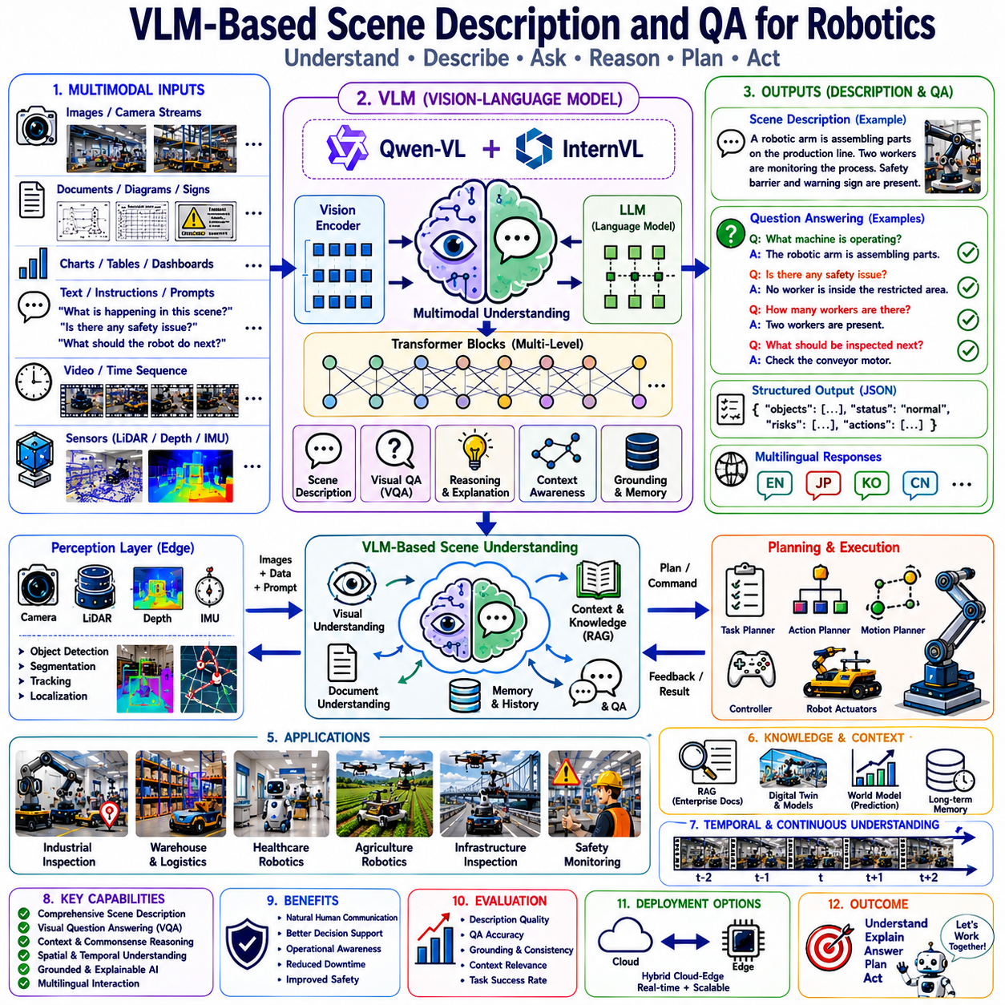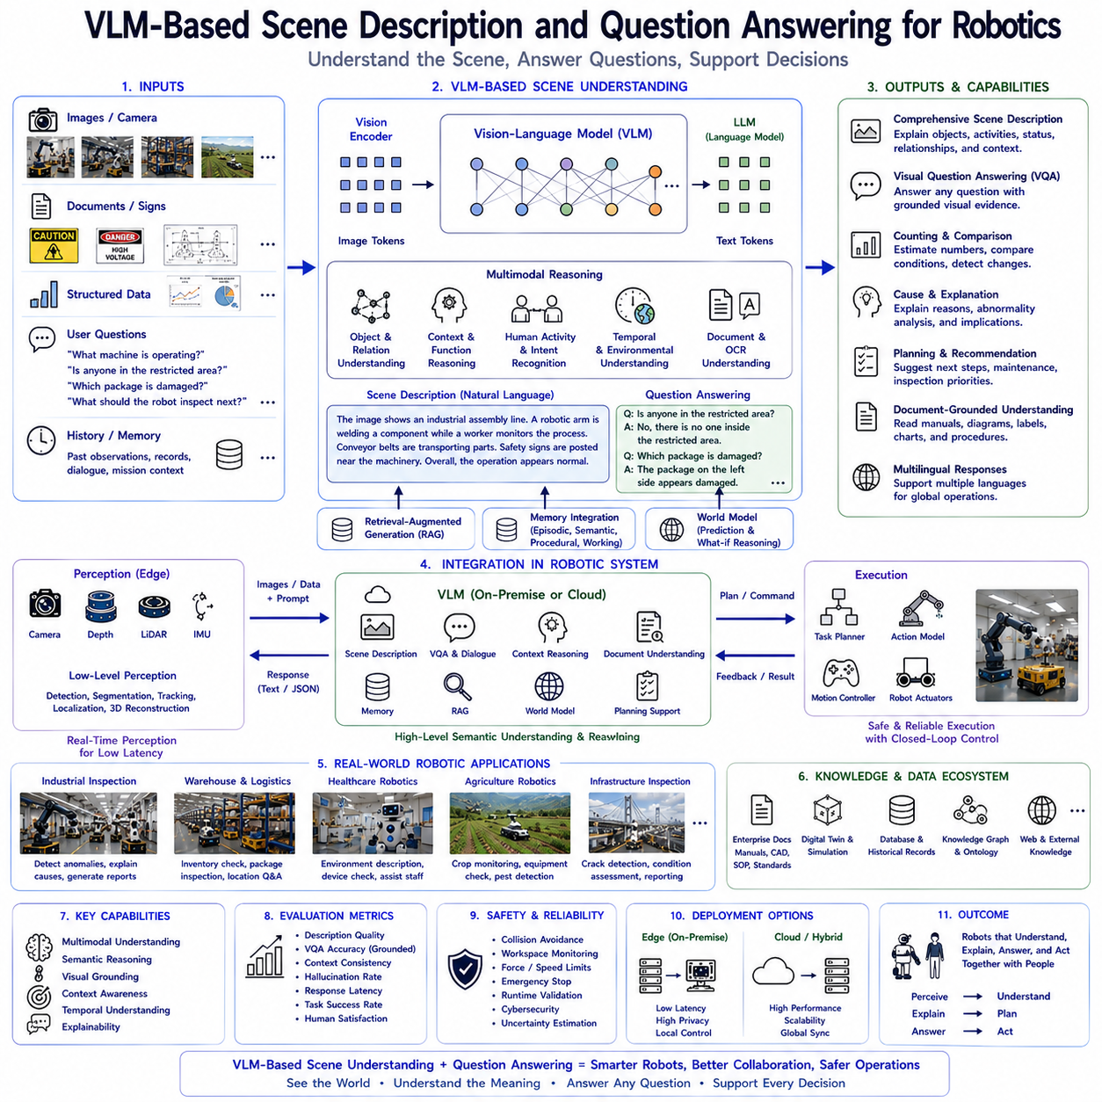
Vision-Language Models have fundamentally transformed robotic perception by enabling machines to understand visual environments through semantic reasoning rather than isolated object recognition. Traditional computer vision systems primarily identify objects, estimate positions, segment images, or detect predefined categories. While these capabilities remain indispensable for autonomous navigation and manipulation, they rarely provide a complete understanding of what is actually happening inside an environment. Vision-Language Models extend robotic perception beyond geometric interpretation by generating comprehensive scene descriptions, contextual explanations, visual question answering, and semantic reasoning based on multimodal understanding. Within modern Physical AI systems, VLM-based scene description and question answering constitute one of the most important cognitive layers because they bridge low-level sensory perception with high-level human communication, decision support, and autonomous planning.
The motivation behind VLM-based scene understanding originates from the observation that humans perceive environments through semantic interpretation rather than isolated visual recognition. When a person enters a manufacturing facility, they immediately understand not only which machines are present, but also which production process is underway, whether operators are following procedures, where safety risks exist, and what actions should occur next. This understanding emerges from integrating visual perception, prior knowledge, language, memory, and contextual reasoning. Vision-Language Models attempt to replicate this integrated cognitive process by combining visual representations with extensive linguistic knowledge acquired through foundation model pretraining.
Traditional robotic perception pipelines consist of multiple independent subsystems including object detection, semantic segmentation, pose estimation, depth reconstruction, simultaneous localization and mapping, optical character recognition, and activity recognition. Each subsystem performs a specialized function with remarkable numerical precision, yet none individually understands the complete semantic meaning of an environment. VLM-based scene understanding introduces a higher cognitive layer that integrates outputs from these perception systems into coherent natural language explanations describing the current operational situation.
Scene description represents one of the most fundamental multimodal capabilities. Instead of producing structured numerical outputs alone, Vision-Language Models generate comprehensive textual descriptions explaining observed environments, object relationships, human activities, operational workflows, environmental conditions, equipment status, and contextual implications. Such descriptions allow robots to communicate environmental understanding naturally with human operators while simultaneously supporting downstream planning modules requiring semantic context rather than isolated measurements.
Unlike conventional image captioning, robotic scene description emphasizes operational relevance instead of visual aesthetics. General image captioning may simply describe visible objects, whereas robotic scene understanding explains which equipment appears active, whether maintenance may be required, which safety procedures are being followed, what operational stage is currently underway, and which environmental factors influence future actions. This distinction reflects the practical requirements of autonomous systems operating within real-world industrial environments.
Context awareness significantly improves scene interpretation. Individual objects rarely possess sufficient meaning independently. A wrench lying on a workbench suggests ordinary maintenance preparation, whereas the same wrench lying beneath rotating machinery may indicate a potentially hazardous situation. Similarly, a pallet positioned inside storage represents normal warehouse organization, while a pallet obstructing an emergency exit constitutes a safety violation. Vision-Language Models infer such contextual relationships by integrating visual observations with commonsense reasoning acquired through multimodal pretraining.
Spatial relationship understanding constitutes another essential capability. Robots frequently encounter instructions referencing relative positions including left, right, above, below, inside, outside, behind, between, near, and far. VLMs understand these spatial concepts semantically rather than through manually engineered geometric rules alone. Scene descriptions therefore naturally include relationships among machines, operators, tools, infrastructure, inventory, safety equipment, and environmental landmarks supporting intuitive human communication and autonomous task planning.
Temporal context further enriches scene understanding. Although individual images capture only single moments, robotic systems continuously observe evolving environments. Successive visual observations combined with external memory systems enable Vision-Language Models to describe environmental changes, production progress, equipment behavior, human activities, and operational transitions over time. Such temporal reasoning transforms isolated image interpretation into continuous situational awareness supporting long-duration autonomous missions.
Scene description also incorporates functional understanding. Vision-Language Models recognize not only object identities but also likely operational purposes. A robotic manipulator assembling components, a conveyor transporting materials, a charging station replenishing batteries, a warning light indicating machine status, or a technician inspecting equipment all become interpretable through functional reasoning. Such affordance-oriented understanding greatly improves robotic decision making because future actions depend upon functional context rather than appearance alone.
Visual Question Answering extends scene understanding toward interactive communication. Rather than passively describing images, Vision-Language Models answer arbitrary questions grounded in visual evidence. Human operators naturally ask questions such as “What machine is currently operating?”, “Is anyone inside the restricted area?”, “Which package appears damaged?”, “How many workers are present?”, “What caused this alarm?”, or “What should the robot inspect next?” The model generates responses integrating visual observations with extensive semantic knowledge while remaining grounded in the observed environment.
The interactive nature of Visual Question Answering significantly enhances human-robot collaboration. Operators no longer require specialized programming interfaces or symbolic query languages. Instead, natural conversational dialogue becomes sufficient for accessing complex environmental information. Robots therefore communicate using human-centered explanations rather than low-level sensor outputs, reducing operational complexity while improving accessibility for non-technical personnel.
Grounding represents a fundamental requirement for reliable question answering. Responses must remain directly connected to observable visual evidence rather than relying upon unsupported assumptions. Vision-Language Models therefore associate linguistic references with corresponding visual entities while considering spatial relationships, contextual information, previous dialogue, and environmental structure. Proper grounding minimizes hallucination and increases trustworthiness during industrial deployment.
Question answering encompasses multiple reasoning categories. Descriptive questions request object identification, scene summaries, or environmental descriptions. Relational questions examine spatial organization, object interactions, and contextual relationships. Counting questions estimate quantities of people, machines, inventory, or operational components. Comparative questions identify differences between objects, equipment conditions, or production states. Explanatory questions investigate potential causes, operational significance, and procedural implications. Predictive questions estimate likely future developments based upon current observations and accumulated contextual knowledge.
Industrial inspection provides one of the strongest application domains for scene description and visual question answering. Camera systems continuously observe production equipment while Vision-Language Models describe machinery condition, identify visible abnormalities, explain probable failure mechanisms, reference maintenance documentation, compare observations against historical records, and answer engineering questions posed by maintenance personnel. Such semantic interpretation significantly improves diagnostic efficiency beyond conventional anomaly detection systems.
Warehouse automation similarly benefits from multimodal scene understanding. Vision-Language Models describe inventory organization, loading operations, storage utilization, package conditions, logistics workflows, human activities, and navigation obstacles. Warehouse personnel interact conversationally with robotic systems by asking questions regarding inventory status, shipment progress, damaged goods, storage locations, or operational bottlenecks. Natural language communication substantially improves usability compared with traditional warehouse management interfaces.
Healthcare robotics increasingly employs scene description for clinical assistance. Hospital environments contain medical equipment, healthcare personnel, patients, monitoring devices, medication containers, mobility aids, and procedural documentation requiring integrated understanding. Vision-Language Models describe patient surroundings, identify medical devices, explain environmental conditions, answer caregiver questions, and support healthcare workflows through semantically meaningful visual interpretation while complementing specialized medical diagnostic systems.
Agricultural robotics similarly requires semantic environmental understanding extending beyond crop recognition. Vision-Language Models describe field conditions, machinery operation, irrigation infrastructure, crop growth stages, weed distribution, environmental changes, weather impacts, and farming activities. Farmers communicate naturally with autonomous systems through visual questions regarding crop health, irrigation requirements, harvesting priorities, equipment condition, or pest monitoring, enabling more intuitive agricultural decision support.
Infrastructure inspection presents another compelling application. Bridges, tunnels, railways, pipelines, power substations, industrial facilities, and transportation systems generate extensive visual observations requiring engineering interpretation. Vision-Language Models describe structural conditions, identify visible deterioration, explain maintenance significance, answer inspection questions, summarize operational status, and support engineering reporting through grounded multimodal reasoning integrated with technical documentation.
Human activity understanding substantially enriches scene descriptions. Rather than merely detecting human presence, Vision-Language Models identify collaborative assembly, equipment maintenance, warehouse loading, inspection procedures, safety compliance, laboratory experimentation, material handling, cleaning operations, or hazardous behavior. Such semantic activity recognition improves autonomous planning because robot behavior depends heavily upon surrounding human intentions and operational context.
Safety monitoring represents another valuable application. Vision-Language Models describe hazardous conditions including blocked emergency exits, missing protective equipment, unauthorized personnel, unsafe object placement, fluid leakage, excessive clutter, damaged infrastructure, or improper machine operation. Operators may ask targeted safety questions regarding compliance status, emergency preparedness, evacuation routes, or operational risks. Although deterministic safety systems remain primary safeguards, semantic explanations significantly improve situational awareness and preventive maintenance.
Document-grounded scene understanding further expands robotic capability. Industrial environments frequently contain equipment labels, warning signs, operating procedures, engineering drawings, maintenance instructions, production schedules, inspection checklists, and digital displays. Vision-Language Models integrate document interpretation with environmental observation, allowing robots to explain operational procedures while simultaneously analyzing surrounding physical conditions. Such multimodal integration reduces dependence upon separate OCR and document processing systems.
Memory integration greatly improves long-duration interaction. Previous observations, completed inspections, historical dialogue, maintenance history, operational objectives, user preferences, and environmental changes become accessible through external memory architectures surrounding Vision-Language Models. Consequently, robots answer questions within broader mission context rather than treating each visual interaction independently. Long-term contextual consistency significantly enhances collaborative operation during extended industrial missions.
Retrieval-Augmented Generation naturally complements scene description. External enterprise knowledge including maintenance manuals, CAD repositories, digital twins, quality standards, engineering documentation, inspection archives, production databases, regulatory guidelines, and software repositories becomes dynamically retrievable during multimodal reasoning. Retrieved information enriches visual interpretation while ensuring responses remain consistent with organizational procedures and continuously updated knowledge.
World Models introduce predictive reasoning into scene understanding. Current observations become integrated with learned environmental dynamics estimating future equipment behavior, human movement, inventory changes, production progress, battery consumption, traffic flow, weather evolution, or infrastructure degradation. Predictive scene descriptions therefore support proactive robotic planning instead of reactive environmental interpretation, improving operational robustness across long-duration autonomous deployments.
Cloud-edge collaboration provides practical deployment flexibility. Edge computing platforms perform deterministic perception including localization, obstacle detection, segmentation, object tracking, sensor fusion, and real-time control. Vision-Language Models operating either locally or through cloud infrastructure generate semantic scene descriptions, answer operator questions, interpret documents, explain observations, and support planning. Such hierarchical architectures balance computational efficiency with real-time responsiveness while preserving deterministic robotic control.
Local deployment has become increasingly feasible through optimized open-source Vision-Language Models including Qwen-VL and InternVL. Organizations requiring privacy, regulatory compliance, low communication latency, or confidential industrial operation may execute scene understanding entirely within enterprise infrastructure. Quantization, model compression, efficient attention mechanisms, and optimized inference engines enable practical deployment on modern edge GPU platforms supporting autonomous robotics.
Multilingual capability significantly expands global applicability. Manufacturing facilities, logistics centers, research laboratories, hospitals, and agricultural operations frequently employ multilingual personnel. Vision-Language Models supporting multiple natural languages describe scenes and answer questions consistently across linguistic boundaries, improving accessibility while reducing engineering complexity associated with maintaining separate language-specific AI systems.
Evaluation of scene description extends beyond conventional image captioning metrics. Researchers assess factual correctness, contextual completeness, grounding accuracy, relational understanding, temporal consistency, operational usefulness, explanation quality, planning relevance, linguistic coherence, computational efficiency, hallucination frequency, robustness under environmental variation, and human interpretability. Practical robotics evaluation additionally measures operator satisfaction, maintenance efficiency, decision support quality, collaborative interaction, and autonomous task success resulting from multimodal scene understanding.
Visual Question Answering similarly requires comprehensive evaluation. Response correctness, grounding reliability, reasoning depth, contextual consistency, uncertainty estimation, explanation quality, retrieval integration, multilingual capability, robustness across diverse question categories, computational latency, and real-world operational utility all contribute toward comprehensive assessment. Benchmark accuracy alone proves insufficient because practical deployment emphasizes trustworthy decision support under complex industrial conditions.
Safety remains fundamentally independent from semantic scene understanding. Vision-Language Models provide explanations, recommendations, planning assistance, and environmental interpretation, while deterministic safety systems continue enforcing collision avoidance, workspace monitoring, force limitation, emergency stopping, cybersecurity protection, runtime verification, and regulatory compliance before physical actions occur. Semantic cognition therefore complements rather than replaces established robotic safety engineering principles.
One particularly valuable property of Vision-Language Models lies in explainability. Instead of producing opaque numerical outputs, scene descriptions explicitly explain observed evidence, reasoning processes, operational implications, uncertainty, and recommended follow-up actions. Human operators therefore understand why robotic systems reach particular conclusions, improving trust, transparency, debugging efficiency, regulatory acceptance, and collaborative decision making.
Future development of VLM-based scene understanding will increasingly integrate video reasoning, audio understanding, tactile sensing, force perception, event cameras, LiDAR fusion, digital twins, simulation-guided learning, collaborative multi-agent perception, lifelong memory, retrieval augmentation, continual learning, uncertainty-aware reasoning, world models, and autonomous software engineering. Scene descriptions will gradually evolve from static environmental summaries toward continuously updated cognitive world models supporting comprehensive robotic intelligence.
As Physical AI advances toward general-purpose embodied intelligence, VLM-based scene description and visual question answering establish a crucial bridge connecting robotic perception with human communication and semantic reasoning. By integrating visual understanding, natural language dialogue, contextual memory, document interpretation, retrieval-augmented knowledge, predictive world models, and grounded multimodal reasoning, Vision-Language Models enable robots not only to perceive environments accurately but also to explain observations, answer complex questions, support engineering workflows, collaborate naturally with people, and provide intelligent situational awareness across manufacturing, logistics, healthcare, agriculture, infrastructure inspection, scientific research, autonomous service systems, and the next generation of Vision-Language-Action architectures operating safely and effectively within complex real-world environments.

5.8 Spatial Grounding Using VLMs (with Code)
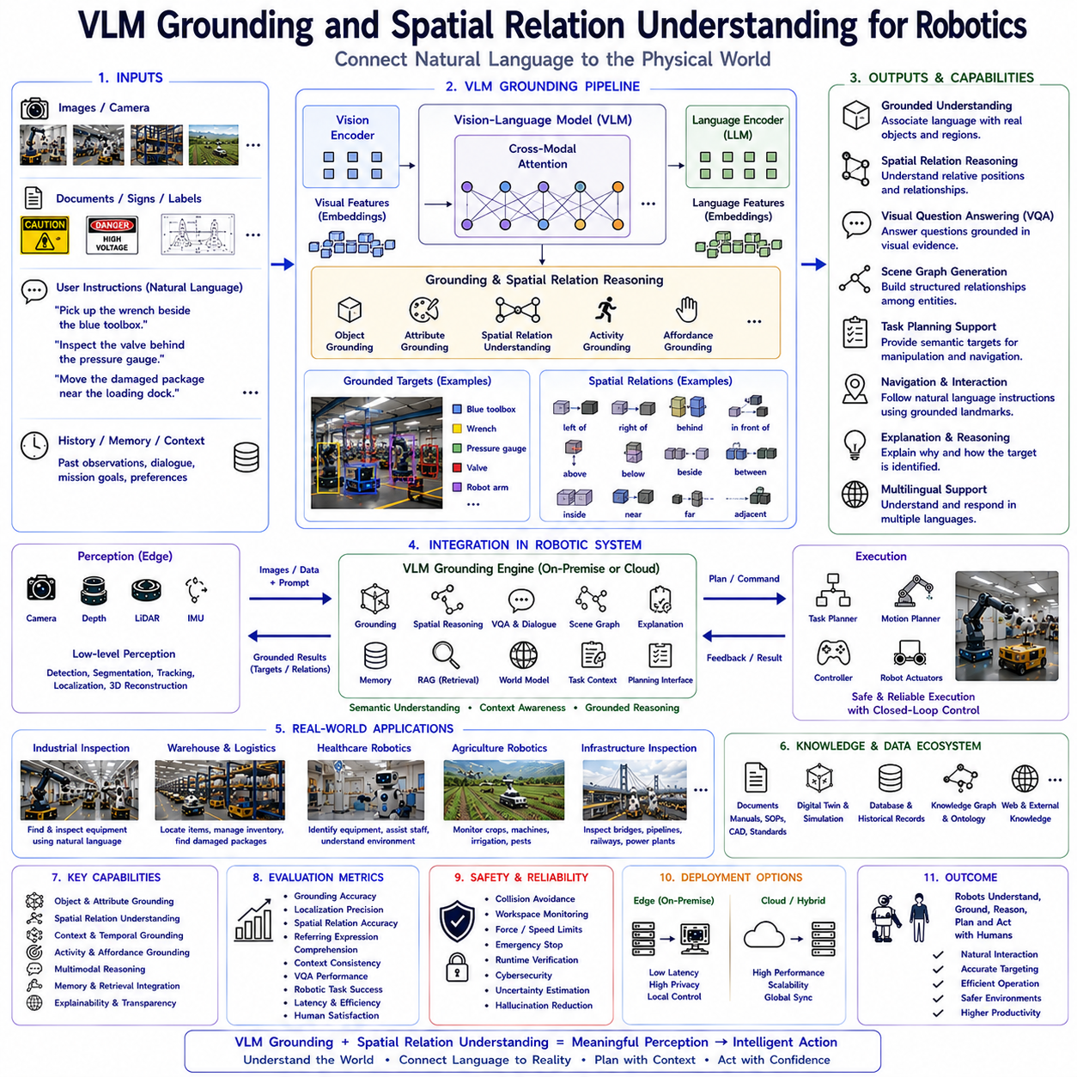
Vision-Language Models have significantly advanced robotic perception by enabling machines to associate natural language with physical environments through semantic grounding and spatial reasoning. Traditional computer vision systems excel at detecting objects, estimating depth, identifying categories, and calculating geometric coordinates, yet they often struggle to understand how linguistic descriptions correspond to real-world entities. Humans naturally describe environments using relative positions, contextual references, object functions, and semantic relationships rather than numerical coordinates. Vision-Language Models bridge this gap by learning to connect visual observations with language while simultaneously understanding spatial relationships, object interactions, and environmental context. Within modern Vision-Language-Action architectures, grounding and spatial relation understanding form one of the most critical cognitive components because every robotic manipulation, navigation, inspection, and human-robot interaction task ultimately depends upon correctly associating language with physical reality.
The motivation for visual grounding originates from the observation that human communication rarely references absolute coordinates. When instructing another person, one naturally says, “Pick up the wrench beside the blue toolbox,” “Inspect the valve behind the pressure gauge,” or “Move the damaged package near the loading dock.” Such instructions depend upon semantic descriptions, contextual references, and spatial relationships rather than Cartesian coordinates. Human cognition automatically connects these linguistic expressions to corresponding physical objects through visual perception and accumulated experience. Vision-Language Models attempt to reproduce this capability by jointly learning language representations and visual representations within unified multimodal embedding spaces.
Traditional robotic manipulation systems frequently require precisely defined object identifiers, preconfigured workspaces, fiducial markers, or manually programmed coordinate transformations. Although such methods achieve high precision in structured industrial environments, they become increasingly difficult to maintain as environments become dynamic, cluttered, unstructured, or shared with humans. Vision-Language grounding introduces greater flexibility by allowing robots to identify targets using natural language descriptions grounded directly in visual observations. This capability significantly reduces manual engineering effort while improving adaptability across diverse operational scenarios.
Grounding refers to the process of associating linguistic expressions with corresponding entities observed within the physical environment. Rather than interpreting language independently from perception, grounded models identify which visual regions, objects, activities, or environmental structures correspond to words appearing within natural language instructions. Consequently, abstract language becomes connected to observable reality, allowing robots to execute semantically meaningful tasks rather than merely processing symbolic commands.
Visual grounding generally begins with multimodal representation learning. Images captured by robotic cameras are processed through visual encoders producing dense feature embeddings representing appearance, geometry, texture, semantic categories, contextual relationships, and environmental structure. Simultaneously, natural language instructions become transformed into language embeddings encoding grammatical structure, semantic meaning, procedural intent, spatial descriptions, and commonsense knowledge. Projection layers subsequently align visual and linguistic representations into compatible embedding spaces where corresponding concepts become closely associated through multimodal training.
Attention mechanisms play a central role during grounding. Transformer attention enables language tokens to attend selectively toward visually relevant image regions while visual representations simultaneously attend toward linguistically significant concepts. Words describing objects, colors, spatial relationships, actions, and contextual attributes gradually become associated with corresponding visual evidence. These attention distributions effectively identify which image regions support particular linguistic expressions, providing interpretable grounding between language and perception.
Object grounding constitutes the most fundamental capability. Individual nouns such as wrench, pallet, robot, conveyor, pressure gauge, safety barrier, forklift, charging station, storage rack, or emergency button become associated with corresponding visual entities. Unlike conventional object detection systems trained upon predefined categories, Vision-Language Models utilize semantic understanding allowing recognition of considerably broader object vocabularies through language supervision. Consequently, robots identify previously unseen objects using descriptive language rather than requiring dedicated category-specific detectors.
Attribute grounding extends beyond object identity by associating descriptive properties with visual appearance. Humans naturally reference color, size, material, shape, texture, condition, orientation, operational status, or functional characteristics during communication. Instructions such as “Move the large red container,” “Inspect the cracked pipe,” or “Retrieve the stainless steel wrench” require simultaneously grounding both object identity and descriptive attributes. Vision-Language Models integrate these multiple semantic constraints during object localization.
Spatial relation understanding represents one of the defining strengths of Vision-Language Models. Rather than relying exclusively upon geometric coordinates, robots understand relative concepts including left, right, above, below, inside, outside, behind, in front of, between, near, far, adjacent, surrounding, overlapping, aligned, attached, supported, and enclosed. Such relational reasoning enables intuitive human communication because people naturally describe environments using relative spatial concepts instead of numerical measurements.
Relative spatial reasoning depends upon contextual interpretation rather than absolute geometry alone. The expression “left of the machine” refers to different physical locations depending upon observer viewpoint, environmental orientation, and conversational context. Vision-Language Models learn viewpoint-aware spatial representations enabling consistent interpretation despite changing camera perspectives or robot positions. Such adaptability proves essential for autonomous robots continuously navigating dynamic environments.
Egocentric and allocentric reference frames further complicate spatial reasoning. Egocentric descriptions reference positions relative to the robot or observer, whereas allocentric descriptions reference relationships among environmental objects independent of observer location. Humans seamlessly transition between these reference frames during conversation. Vision-Language Models similarly learn to interpret spatial expressions under varying contextual reference systems, improving robustness across diverse robotic applications.
Context substantially influences grounding accuracy. Consider the instruction “Pick up the box beside the conveyor.” Multiple boxes may appear within the image, yet only one satisfies the specified contextual relationship. Vision-Language Models evaluate object identity together with surrounding environmental structure, neighboring entities, functional relationships, and conversational history before selecting the appropriate grounding target. Such contextual reasoning significantly reduces ambiguity during human-robot collaboration.
Temporal grounding extends visual grounding across continuous observations. Robotic environments evolve as people move, equipment operates, inventory changes, or production progresses. External memory systems integrated with Vision-Language Models maintain temporal context allowing language references to previously observed objects, completed actions, historical equipment conditions, or ongoing operational workflows. Temporal grounding therefore supports coherent long-duration interaction rather than isolated image interpretation.
Human activity grounding introduces another important capability. Rather than grounding only physical objects, Vision-Language Models identify activities including assembling, inspecting, transporting, cleaning, repairing, loading, unloading, welding, measuring, collaborating, or maintaining equipment. Natural language instructions referencing ongoing activities become associated with observed human behavior, improving collaborative robotics and workplace awareness.
Affordance grounding further extends semantic interpretation toward functional reasoning. Objects become grounded not only according to appearance but also according to possible interactions. A charging station becomes associated with battery replenishment, a valve regulates fluid flow, a conveyor transports materials, a toolbox stores maintenance equipment, and a fire extinguisher supports emergency response. Functional grounding significantly improves robotic planning because appropriate actions depend upon object purpose rather than appearance alone.
Visual grounding directly supports manipulation planning. Once language references become associated with physical objects, downstream robotic systems estimate grasp poses, collision-free trajectories, manipulation sequences, force constraints, and execution timing. Vision-Language Models therefore function as semantic front ends translating human instructions into grounded environmental representations subsequently processed by deterministic Action Models and motion planners.
Navigation similarly benefits from grounding. Humans naturally provide navigation instructions including “Go to the room beside the laboratory,” “Move toward the charging station behind the warehouse,” or “Wait near the inspection robot.” Such commands require understanding landmarks, environmental topology, and relative positioning. Vision-Language Models associate linguistic references with visual landmarks supporting intuitive semantic navigation beyond conventional metric mapping.
Scene graph generation represents another important consequence of grounding. Rather than describing environments as isolated objects, Vision-Language Models construct relational representations where entities become connected through semantic relationships including ownership, support, containment, proximity, interaction, hierarchy, and operational dependency. Scene graphs provide structured knowledge supporting planning, reasoning, retrieval, and long-term environmental understanding throughout robotic missions.
Document grounding further expands multimodal capability. Industrial environments frequently contain maintenance manuals, equipment labels, warning signs, operating procedures, engineering diagrams, digital displays, production dashboards, and printed instructions. Vision-Language Models associate textual content appearing inside documents with corresponding physical equipment visible within surrounding environments. Such multimodal grounding enables robots to connect engineering documentation directly to observed infrastructure.
Grounded Visual Question Answering represents one of the most practical applications. Questions such as “Which machine is located beside the conveyor?”, “What object blocks the emergency exit?”, “Is anyone standing behind the robot?”, or “Which package should be inspected next?” require responses explicitly supported by visual evidence. Grounded reasoning reduces hallucination because answers remain constrained by observable environmental information rather than unconstrained language generation.
Industrial inspection demonstrates substantial practical value. Maintenance engineers naturally reference equipment through spatial descriptions including “Inspect the pump below the pressure vessel” or “Examine the valve beside the cooling pipe.” Vision-Language Models ground these descriptions within visual observations, allowing inspection robots to identify appropriate equipment without requiring manually labeled coordinate databases. Such flexibility simplifies deployment across diverse industrial facilities.
Warehouse automation similarly benefits from grounding. Inventory locations frequently change while human workers describe storage positions through semantic landmarks rather than fixed coordinates. Instructions including “Retrieve the damaged carton near loading dock three” or “Move the pallet beside the refrigeration unit” become executable through grounded multimodal reasoning integrated with robotic navigation and manipulation systems.
Healthcare robotics presents additional grounding challenges. Hospital environments contain patients, caregivers, medical devices, medication containers, diagnostic equipment, and procedural documentation requiring careful semantic interpretation. Vision-Language Models associate medical terminology with observed equipment while understanding spatial relationships among patients, monitoring devices, mobility aids, and clinical workspaces. Such grounding supports context-aware healthcare assistance without replacing specialized diagnostic systems.
Agricultural robotics similarly relies upon semantic grounding. Farmers naturally reference crops, irrigation systems, machinery, storage areas, weeds, pests, and environmental landmarks through relative spatial descriptions. Vision-Language Models interpret these references while integrating crop imagery, environmental context, farming procedures, and operational objectives supporting intuitive agricultural automation.
Infrastructure inspection introduces large-scale grounding requirements. Bridges, tunnels, railways, substations, pipelines, and industrial facilities contain numerous structurally similar components. Natural language references including “Inspect the second support beam beneath the western platform” or “Check the transformer beside the maintenance access road” require combining spatial reasoning, engineering terminology, environmental topology, and visual perception within unified grounding systems.
Memory integration substantially enhances grounding reliability. Previous dialogue, historical inspections, user preferences, operational objectives, facility knowledge, completed tasks, and environmental observations remain accessible through external memory architectures surrounding Vision-Language Models. Consequently, ambiguous references become resolvable using conversational history rather than isolated visual information. Memory therefore improves continuity throughout extended robotic interaction.
Retrieval-Augmented Generation naturally complements grounding by providing organizational knowledge supporting interpretation. Maintenance manuals, CAD models, engineering documentation, quality standards, software repositories, digital twins, production databases, inspection records, and regulatory procedures become retrievable during multimodal reasoning. Retrieved knowledge clarifies object identities, functional relationships, operational procedures, and environmental semantics beyond purely visual evidence.
World Models further extend grounding toward predictive reasoning. Current grounded observations become integrated with learned environmental dynamics estimating future object motion, equipment degradation, human activity, traffic evolution, battery consumption, production progress, or weather conditions. Predictive grounding therefore supports proactive robotic planning rather than merely interpreting current observations.
Cloud-edge deployment architectures balance computational efficiency with real-time responsiveness. Edge systems perform deterministic perception including localization, depth estimation, obstacle detection, tracking, sensor fusion, and low-level geometric reasoning. Cloud or local Vision-Language Models perform semantic grounding, spatial interpretation, contextual reasoning, dialogue, retrieval integration, and planning support. Such hierarchical architectures preserve deterministic robotic performance while adding flexible cognitive capability.
Open-source Vision-Language Models including Qwen-VL and InternVL increasingly enable local grounding on enterprise infrastructure. Organizations requiring privacy, cybersecurity, regulatory compliance, or offline capability deploy optimized multimodal models within private GPU servers or embedded edge platforms. Quantization, model compression, efficient attention algorithms, speculative decoding, Flash Attention, and compiler optimization significantly improve grounding performance under practical computational constraints.
Evaluation of grounding extends beyond conventional object detection accuracy. Researchers measure grounding precision, localization accuracy, referring expression comprehension, phrase grounding performance, spatial reasoning capability, contextual consistency, multilingual robustness, grounding under occlusion, hallucination frequency, explanation quality, computational latency, and downstream robotic task success. Practical deployment additionally evaluates user satisfaction, interpretability, adaptability, privacy compliance, and integration with existing robotic software ecosystems.
Spatial reasoning evaluation similarly encompasses diverse benchmarks measuring relative position understanding, viewpoint invariance, object relationship interpretation, scene graph accuracy, manipulation support, navigation effectiveness, human instruction comprehension, temporal consistency, uncertainty estimation, and collaborative interaction quality. Such comprehensive evaluation reflects the practical requirements of embodied intelligence operating within dynamic real-world environments.
Safety remains independent from semantic grounding despite its importance for robotic cognition. Grounded language understanding identifies intended objects and environmental relationships, while deterministic safety systems continue enforcing collision avoidance, workspace monitoring, force limitation, emergency stopping, runtime verification, cybersecurity protection, and regulatory compliance. Semantic reasoning therefore complements rather than replaces established robotic safety engineering.
Explainability represents another important advantage of Vision-Language grounding. Instead of simply identifying selected objects, models explain why particular visual regions correspond to specific linguistic expressions, discuss contextual relationships supporting grounding decisions, identify uncertainty, and reference visual evidence underlying conclusions. Such transparency increases trust between human operators and autonomous robotic systems while facilitating debugging, validation, and regulatory acceptance.
Future development of grounding research is expected to integrate video understanding, audio grounding, tactile perception, force sensing, LiDAR fusion, event cameras, digital twins, world models, continual learning, collaborative multi-agent perception, lifelong memory, uncertainty-aware reasoning, simulation-guided adaptation, and autonomous software engineering. Grounding will gradually evolve from associating language with static images toward maintaining continuously updated semantic representations of complex dynamic environments shared among multiple intelligent agents.
As Physical AI advances toward general-purpose embodied intelligence, Vision-Language grounding and spatial relation understanding become indispensable foundations connecting natural language, visual perception, contextual reasoning, and robotic action. By integrating multimodal representation learning, semantic grounding, relational reasoning, contextual memory, retrieval-augmented knowledge, predictive world models, and explainable spatial understanding, Vision-Language Models enable robots to interpret human instructions naturally, identify intended environmental entities accurately, understand complex spatial relationships, collaborate effectively with people, support intelligent planning, and execute meaningful actions safely across manufacturing, logistics, healthcare, agriculture, infrastructure inspection, scientific research, autonomous service robotics, and the next generation of Vision-Language-Action systems operating within complex real-world environments.

5.9 Fine-Tuning VLMs for Robot Tasks (with Code)
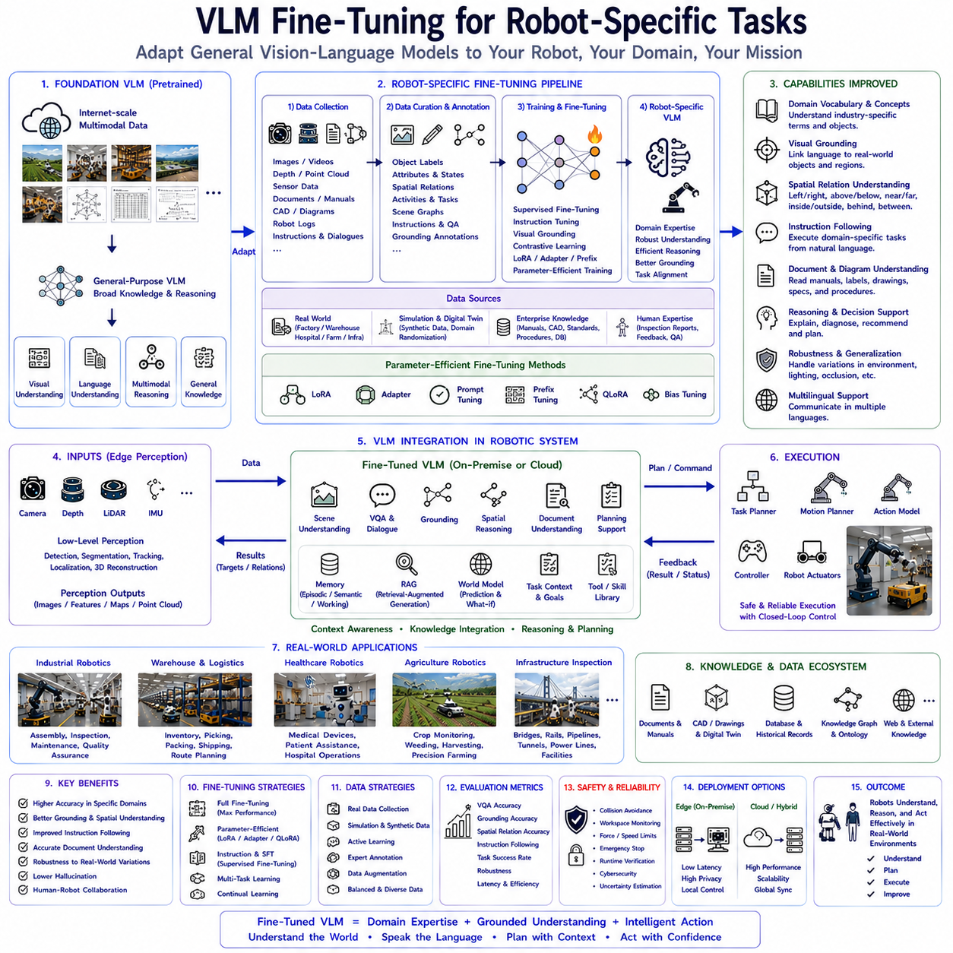
Vision-Language Models have demonstrated remarkable generalization capabilities across diverse multimodal reasoning tasks, yet real-world robotic applications frequently require domain-specific expertise extending beyond the knowledge acquired during foundation model pretraining. Manufacturing robots must understand industrial equipment, warehouse robots require logistics knowledge, agricultural robots need crop-specific reasoning, healthcare robots interact with medical devices, and infrastructure inspection robots analyze engineering structures under highly specialized operational constraints. Although large Vision-Language Models possess broad visual and linguistic understanding, they often lack the detailed procedural knowledge, vocabulary, operational workflows, and environmental familiarity necessary for reliable deployment within individual robotic domains. Vision-Language Model fine-tuning addresses this challenge by adapting foundation models toward specialized robotic applications while preserving their broad multimodal reasoning capabilities. Within modern Physical AI systems, robot-specific VLM fine-tuning has become one of the most important technologies enabling practical industrial deployment because it transforms general-purpose multimodal intelligence into highly specialized cognitive systems optimized for specific robotic missions.
The motivation for robot-specific fine-tuning originates from the difference between general intelligence and professional expertise. Human intelligence develops through progressive specialization. While everyone acquires general knowledge during education, engineers later master manufacturing systems, physicians specialize in medical diagnosis, agricultural experts understand crop management, and logistics professionals optimize warehouse operations. The same principle applies to Vision-Language Models. Foundation models provide extensive general knowledge, yet practical robotic deployment requires additional adaptation toward industry-specific environments, terminology, procedures, regulations, equipment, and operational objectives.
General-purpose Vision-Language Models are trained using enormous multimodal datasets containing internet images, captions, documents, conversations, diagrams, scientific publications, and instructional material spanning diverse topics. Such pretraining creates broad semantic understanding and excellent generalization across numerous visual reasoning tasks. However, industrial robotic environments differ substantially from internet-scale training data. Manufacturing facilities contain specialized equipment, proprietary production processes, technical documentation, domain-specific terminology, safety procedures, engineering drawings, and unique operational workflows rarely represented sufficiently within public datasets. Fine-tuning bridges this knowledge gap.
Robot-specific adaptation involves modifying pretrained Vision-Language Models using carefully curated multimodal datasets representing target deployment environments. Rather than learning fundamental visual perception or natural language understanding from scratch, the model refines existing knowledge through exposure to domain-specific images, technical documents, maintenance procedures, operational dialogues, inspection reports, human instructions, environmental observations, and robotic task demonstrations. This approach dramatically reduces computational requirements while preserving valuable general multimodal capabilities acquired during foundation model pretraining.
Fine-tuning typically begins with comprehensive data collection. Robotic datasets extend beyond ordinary image-caption pairs because practical robotic reasoning depends upon multiple complementary information sources. Camera observations capture operational environments while depth maps, segmentation masks, object annotations, engineering drawings, CAD models, maintenance manuals, inspection reports, workflow descriptions, human instructions, digital twin simulations, sensor measurements, and robot execution logs collectively provide multimodal supervision. Such heterogeneous data enables Vision-Language Models to learn relationships among perception, language, documentation, and robotic behavior.
Industrial manufacturing provides one of the richest environments for robot-specific adaptation. Production lines contain robotic manipulators, conveyors, machine tools, industrial sensors, programmable controllers, assembly stations, inspection systems, autonomous mobile robots, quality assurance procedures, maintenance schedules, and safety regulations requiring integrated multimodal understanding. Fine-tuned Vision-Language Models learn manufacturing terminology, operational workflows, equipment relationships, production stages, inspection criteria, and maintenance procedures unavailable within generic foundation model knowledge.
Warehouse automation similarly requires specialized adaptation. General Vision-Language Models recognize boxes, shelves, forklifts, and people, yet practical warehouse operation requires understanding inventory organization, storage optimization, logistics workflows, shipment verification, barcode interpretation, damaged package assessment, pallet configurations, transportation priorities, and warehouse management procedures. Fine-tuning enables multimodal reasoning aligned with actual logistics operations while preserving broad language understanding and visual perception.
Healthcare robotics introduces even greater specialization. Hospital environments contain medical imaging devices, patient monitoring systems, mobility aids, medication containers, surgical equipment, rehabilitation tools, clinical documentation, healthcare terminology, procedural guidelines, and privacy regulations fundamentally different from general internet knowledge. Domain-specific adaptation allows Vision-Language Models to interpret medical environments more accurately while supporting healthcare professionals through context-aware multimodal assistance rather than replacing specialized diagnostic systems.
Agricultural robotics represents another important fine-tuning domain. Crop imagery, irrigation infrastructure, agricultural machinery, weather observations, pest monitoring, fertilizer management, harvesting operations, soil analysis, and regional farming practices vary significantly across geographic locations and crop species. Fine-tuned Vision-Language Models acquire agricultural vocabulary, seasonal knowledge, environmental interpretation, operational procedures, and localized expertise supporting precision agriculture and autonomous farming systems.
Infrastructure inspection similarly benefits from domain adaptation. Bridges, railways, tunnels, pipelines, substations, wind turbines, industrial facilities, transportation systems, and civil engineering structures require specialized understanding of structural components, inspection procedures, deterioration mechanisms, maintenance documentation, engineering standards, regulatory requirements, and operational safety. Fine-tuning enables robots to reason using engineering concepts grounded in infrastructure-specific multimodal knowledge.
The quality of fine-tuning depends fundamentally upon dataset construction. High-quality robotic datasets require accurate annotations, balanced environmental diversity, representative operational scenarios, comprehensive multimodal coverage, consistent terminology, realistic task instructions, expert supervision, and sufficient variation to prevent overfitting. Poor dataset quality often limits adaptation performance regardless of model architecture or computational resources. Consequently, dataset engineering has become one of the most important aspects of practical Vision-Language Model deployment.
Multimodal annotation extends beyond conventional object labeling. Robotic datasets frequently include object identities, spatial relationships, manipulation affordances, navigation landmarks, activity descriptions, operational status, maintenance conditions, procedural instructions, safety observations, environmental context, scene graphs, temporal transitions, task completion labels, and natural language explanations. Rich multimodal supervision enables Vision-Language Models to learn semantic relationships supporting practical robotic cognition rather than isolated perception tasks.
Instruction tuning plays an especially important role during robot-specific adaptation. Human operators naturally communicate using procedural language describing objectives rather than low-level motor commands. Training datasets therefore include diverse instructions such as inspection requests, navigation goals, manipulation tasks, maintenance procedures, quality assurance questions, inventory operations, and collaborative workflows. Fine-tuned Vision-Language Models consequently develop conversational competence aligned with practical robotic interaction instead of generic image description alone.
Visual grounding datasets significantly improve robotic reliability. Language expressions become explicitly associated with corresponding visual objects, environmental regions, equipment components, landmarks, activities, and operational structures. Such grounding reduces ambiguity during task execution because human instructions become directly connected to observable physical entities rather than abstract symbolic references. Robot-specific grounding datasets therefore contribute substantially toward robust human-robot collaboration.
Spatial reasoning adaptation further enhances robotic capability. Manufacturing facilities, warehouses, hospitals, laboratories, farms, and infrastructure environments all contain domain-specific spatial relationships unfamiliar to generic Vision-Language Models. Fine-tuning teaches models to interpret specialized environmental layouts, equipment configurations, navigation pathways, operational zones, storage organization, inspection routes, and safety boundaries relevant to target deployment scenarios.
Simulation has become an increasingly valuable source of fine-tuning data. Digital twins generate synchronized images, depth maps, segmentation masks, object annotations, language descriptions, robot trajectories, sensor measurements, environmental dynamics, and procedural interactions spanning enormous operational diversity. Simulation enables cost-effective generation of multimodal datasets covering hazardous, rare, or difficult-to-observe scenarios while reducing dependence upon expensive real-world data collection. Domain randomization further improves robustness by exposing models to diverse lighting conditions, weather, object appearances, camera viewpoints, and environmental configurations.
Real-world adaptation nevertheless remains essential because simulation inevitably differs from physical deployment. Sensor noise, lighting variation, equipment aging, environmental clutter, unexpected human behavior, weather conditions, mechanical wear, and operational variability introduce complexities absent from simulated environments. Hybrid training combining simulation with carefully collected real-world observations generally provides the strongest adaptation performance while balancing scalability and realism.
Parameter-efficient fine-tuning techniques have dramatically reduced adaptation cost. Traditional full-model fine-tuning updates every parameter within extremely large foundation models, requiring enormous computational resources and memory capacity. Modern approaches including Low-Rank Adaptation, adapters, prompt tuning, prefix tuning, instruction tuning, and bias optimization modify only relatively small subsets of model parameters while preserving the majority of pretrained weights. Such techniques enable practical domain adaptation using modest computational infrastructure available to industrial organizations.
Low-Rank Adaptation has become particularly popular because it inserts compact trainable matrices into transformer layers while freezing original foundation model parameters. This approach significantly reduces GPU memory requirements, accelerates training, simplifies deployment, and allows multiple task-specific adaptations to coexist within a shared foundation model. Robotic organizations therefore maintain specialized Vision-Language capabilities for manufacturing, logistics, healthcare, agriculture, and inspection without duplicating enormous pretrained models.
Continual learning represents another important direction for robot-specific adaptation. Industrial environments evolve continuously through equipment upgrades, procedural changes, new products, software updates, facility expansion, seasonal variation, regulatory modifications, and operational experience. Rather than periodically retraining complete models from scratch, continual learning enables Vision-Language Models to incrementally incorporate new multimodal knowledge while preserving previously acquired expertise. Such lifelong adaptation more closely resembles human professional development.
Memory systems naturally complement fine-tuning. Episodic memory records previous robotic missions, semantic memory stores engineering knowledge, procedural memory preserves learned operational skills, and working memory maintains current task context. Fine-tuned Vision-Language Models interact with external memory architectures supporting long-duration robotic missions requiring accumulated experience beyond static pretrained parameters. Memory therefore extends adaptation from parameter optimization toward continuously evolving operational intelligence.
Retrieval-Augmented Generation further reduces fine-tuning requirements by dynamically providing relevant enterprise knowledge during multimodal reasoning. Maintenance manuals, CAD repositories, digital twins, engineering standards, inspection records, production databases, quality documentation, software repositories, regulatory procedures, and organizational policies become retrievable at inference time. Instead of embedding all knowledge permanently within model parameters, retrieval systems provide continuously updated contextual information supporting adaptive robotic reasoning across evolving industrial environments.
World Models increasingly integrate with fine-tuned Vision-Language Models. Current observations become interpreted using predictive environmental representations estimating future equipment behavior, human movement, inventory evolution, production progress, weather conditions, battery consumption, traffic flow, and infrastructure degradation. Fine-tuning therefore extends beyond static perception toward predictive multimodal cognition supporting proactive robotic planning and long-term autonomous operation.
Cloud-edge collaboration enables scalable deployment of fine-tuned Vision-Language Models. Large centralized servers perform computationally intensive adaptation using extensive multimodal datasets while optimized edge versions execute inference on embedded robotic hardware. Shared architectural foundations simplify synchronization between training infrastructure and deployed robotic platforms. Organizations therefore combine cloud scalability with low-latency local operation appropriate for autonomous systems.
Open-source Vision-Language Models including Qwen-VL and InternVL have greatly accelerated robot-specific adaptation because organizations maintain complete control over training procedures, deployment infrastructure, optimization strategies, security policies, and operational data. Fine-tuning becomes possible entirely within enterprise environments without transmitting confidential industrial imagery to external cloud providers. Such privacy preservation proves particularly important for manufacturing, healthcare, defense, and critical infrastructure applications.
Evaluation of robot-specific fine-tuning extends beyond traditional multimodal benchmarks. Researchers assess visual grounding accuracy, instruction following, scene understanding, document interpretation, question answering, spatial reasoning, manipulation support, navigation assistance, planning quality, hallucination frequency, computational efficiency, robustness under environmental variation, multilingual capability, domain generalization, and real-world robotic task success. Practical industrial evaluation additionally considers maintenance efficiency, operator satisfaction, deployment cost, adaptation scalability, privacy compliance, and long-term operational reliability.
Generalization remains a central challenge during fine-tuning. Excessive specialization risks overfitting toward narrow deployment conditions, reducing performance when robots encounter new environments, unseen equipment, changing operational procedures, or unexpected situations. Successful adaptation therefore balances domain specialization with preservation of broad multimodal reasoning acquired during foundation model pretraining. Carefully designed datasets, regularization strategies, diverse training scenarios, and parameter-efficient adaptation methods all contribute toward maintaining this balance.
Safety continues operating independently from multimodal adaptation. Fine-tuned Vision-Language Models improve semantic understanding, planning assistance, document interpretation, dialogue, and contextual reasoning, yet deterministic robotic safety systems remain responsible for collision avoidance, workspace monitoring, force limitation, emergency stopping, runtime verification, cybersecurity protection, and regulatory compliance before physical execution occurs. Semantic adaptation therefore complements rather than replaces established robotic control architectures.
Explainability provides another important benefit of robot-specific adaptation. Fine-tuned models learn industry terminology, procedural reasoning, engineering documentation, and operational workflows familiar to domain experts. Consequently, generated explanations become more technically accurate, contextually appropriate, and operationally useful than those produced by generic foundation models. Engineers, operators, inspectors, clinicians, and logistics personnel therefore interact with robotic systems using language naturally aligned with professional practice.
Future development of robot-specific Vision-Language fine-tuning is expected to integrate multimodal reinforcement learning, autonomous data collection, self-supervised continual adaptation, collaborative multi-robot learning, simulation-guided curriculum learning, uncertainty-aware optimization, world models, digital twins, retrieval-enhanced lifelong learning, and automated dataset generation. Rather than relying exclusively upon manually curated training datasets, future robotic systems will progressively improve multimodal understanding through accumulated operational experience while maintaining safety and explainability.
As Physical AI evolves toward increasingly capable embodied intelligence, Vision-Language Model fine-tuning will remain a foundational technology transforming broad multimodal foundation models into specialized cognitive engines optimized for real robotic deployment. By combining domain-specific adaptation, parameter-efficient optimization, multimodal supervision, simulation-guided learning, retrieval-augmented knowledge, lifelong memory, predictive world models, explainable reasoning, and scalable deployment architectures, robot-specific fine-tuning enables Vision-Language Models to understand specialized environments, communicate naturally with human experts, support intelligent planning, interpret technical documentation, execute complex robotic missions, and continuously improve performance across manufacturing, logistics, healthcare, agriculture, infrastructure inspection, scientific research, service robotics, and the broader ecosystem of next-generation Vision-Language-Action systems operating safely and effectively within complex real-world environments.

5.10 Edge Deployment, Compression, and Distillation (with Code)
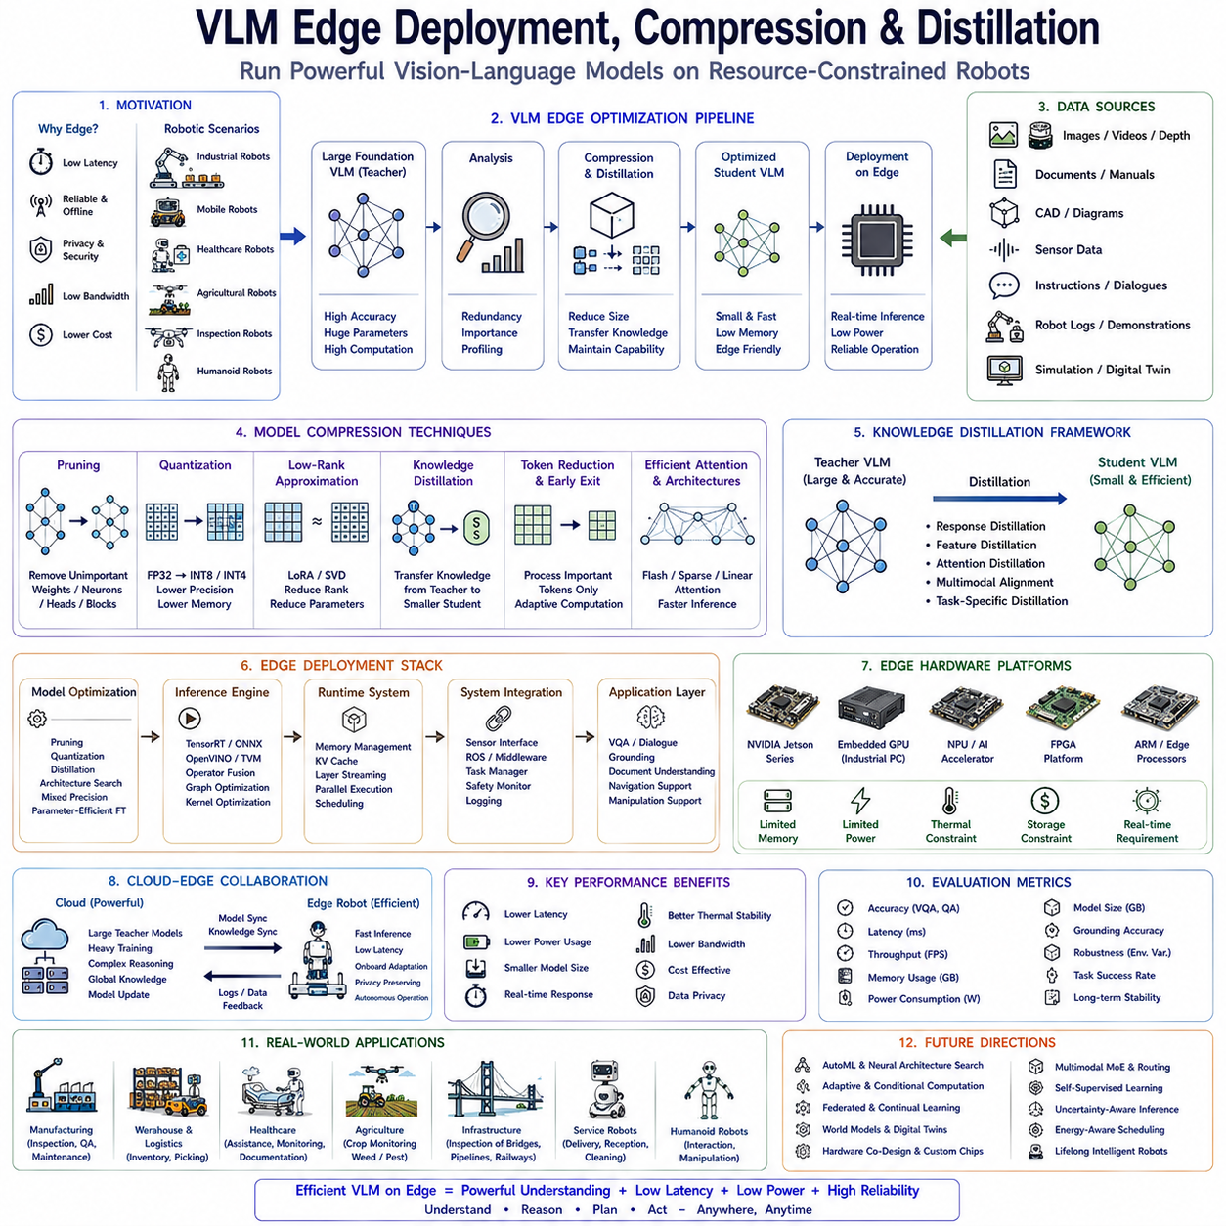
Vision-Language Models have rapidly become one of the core cognitive components of modern robotic intelligence by providing semantic scene understanding, visual reasoning, natural language interaction, document interpretation, and multimodal decision support. However, the majority of state-of-the-art Vision-Language Models contain billions of parameters and require considerable computational resources for inference. Such computational demands are easily satisfied within cloud data centers equipped with large GPU clusters, but they present significant challenges for autonomous robots operating under strict constraints on power consumption, latency, thermal dissipation, memory capacity, communication bandwidth, and physical size. Industrial robots, autonomous mobile robots, healthcare assistants, agricultural robots, inspection platforms, service robots, and humanoid systems frequently rely on embedded computing platforms that must deliver reliable real-time performance while consuming limited electrical power. Consequently, efficient edge deployment has become one of the most important research directions in multimodal robotics. Model compression, knowledge distillation, quantization, architecture optimization, and hardware-aware deployment collectively enable Vision-Language Models to operate directly on robotic edge computers without sacrificing essential reasoning capability.
The motivation for edge deployment originates from practical characteristics of real-world robotic systems. Unlike cloud-based software services, autonomous robots continuously interact with dynamic physical environments where perception, reasoning, planning, and control must occur within predictable timing constraints. A manufacturing robot cannot suspend operation while waiting several seconds for cloud communication. A mobile robot navigating crowded environments cannot tolerate unpredictable network latency before avoiding pedestrians. A healthcare assistant cannot depend upon unreliable wireless connectivity while supporting patients. Therefore, semantic reasoning increasingly moves from centralized cloud infrastructure toward distributed edge intelligence located directly inside robotic platforms.
Cloud-based Vision-Language inference offers enormous computational capability but introduces communication latency, bandwidth consumption, operational cost, cybersecurity concerns, and privacy limitations. Industrial facilities often prohibit transmission of proprietary production data outside organizational networks. Hospitals restrict access to patient information. Defense systems require complete offline capability. Infrastructure inspection frequently occurs in remote locations without reliable communication. Agricultural robots operate in environments where network coverage fluctuates significantly. Local edge deployment eliminates many of these operational constraints by executing multimodal reasoning directly within robotic hardware.
Edge computing fundamentally differs from cloud computing in available computational resources. Edge platforms such as NVIDIA Jetson, embedded GPU modules, industrial AI computers, ARM-based processors, AI accelerators, field-programmable gate arrays, and dedicated neural processing units possess significantly lower computational capacity than large GPU servers. Memory availability, power budgets, cooling capability, storage bandwidth, and processor frequency all become constrained. Consequently, direct deployment of extremely large Vision-Language Models often proves impractical without substantial optimization.
Model compression seeks to reduce computational complexity while preserving task performance. Rather than constructing entirely new architectures, compression techniques transform existing foundation models into smaller, faster, and more efficient versions suitable for embedded deployment. Successful compression minimizes parameter count, memory footprint, computational operations, inference latency, storage requirements, and energy consumption while maintaining acceptable multimodal reasoning capability across target robotic applications.
Parameter reduction represents one of the simplest forms of compression. Extremely large transformer models frequently contain redundant representations learned during massive pretraining. Careful analysis reveals that numerous parameters contribute relatively little to downstream inference quality. Compression algorithms identify and remove unnecessary model components while preserving important representations responsible for semantic understanding, visual reasoning, and language generation. Such parameter optimization significantly reduces computational requirements without proportionally degrading performance.
Structured pruning removes entire neurons, attention heads, transformer blocks, channels, or network layers according to importance criteria determined through optimization analysis. Because structured pruning eliminates complete computational components rather than individual numerical weights, resulting architectures remain compatible with standard hardware acceleration libraries. Robotic deployment therefore benefits from genuine inference speed improvements rather than merely reducing theoretical parameter counts.
Unstructured pruning removes individual network weights judged unnecessary for inference. Extremely sparse neural networks emerge after extensive pruning, often retaining competitive reasoning performance despite dramatic parameter reduction. Although unstructured sparsity presents hardware acceleration challenges, modern sparse computing architectures increasingly exploit such representations efficiently. Future robotic AI accelerators will likely provide native support for sparse Vision-Language inference.
Quantization represents one of the most widely adopted optimization techniques for edge deployment. Conventional foundation models typically employ thirty-two-bit floating-point arithmetic requiring substantial memory bandwidth and computational resources. Quantization replaces high-precision numerical representations with lower-precision formats including sixteen-bit floating point, eight-bit integer, four-bit integer, mixed precision, or even binary approximations. Reduced numerical precision dramatically lowers memory consumption while accelerating arithmetic operations across embedded processors.
Post-training quantization performs numerical compression after completing model training without requiring additional optimization. Calibration datasets estimate numerical distributions allowing efficient conversion into lower-precision representations while minimizing accuracy degradation. Because post-training quantization requires minimal computational effort, it has become highly attractive for industrial deployment where retraining foundation models remains impractical.
Quantization-aware training further improves deployment performance by simulating reduced numerical precision throughout optimization. Instead of compressing models after training concludes, numerical constraints become incorporated directly into parameter optimization. Consequently, learned representations naturally compensate for quantization effects, yielding higher inference accuracy following deployment on embedded hardware.
Mixed-precision computation combines multiple numerical formats within different network components according to computational importance. Sensitive layers maintain higher precision while computationally intensive but less critical operations utilize aggressively compressed arithmetic. Such adaptive precision allocation balances reasoning quality with computational efficiency, making mixed precision especially attractive for complex Vision-Language Models deployed on robotic edge devices.
Knowledge distillation represents another fundamental approach toward efficient deployment. Rather than compressing existing parameters directly, knowledge distillation transfers behavioral competence from large teacher models into smaller student models. The teacher generates rich supervisory signals including probability distributions, intermediate representations, attention patterns, reasoning trajectories, multimodal embeddings, and semantic relationships. Student models subsequently learn to reproduce teacher behavior using substantially fewer parameters.
The concept resembles human education. An experienced expert conveys knowledge accumulated over decades into concise educational material understandable by students possessing fewer cognitive resources. Similarly, enormous Vision-Language foundation models serve as teachers guiding compact edge-oriented student architectures capable of approximating sophisticated multimodal reasoning despite dramatically reduced computational complexity.
Response distillation trains student models to reproduce teacher outputs across diverse multimodal tasks including visual question answering, scene description, object grounding, document understanding, reasoning, instruction following, and dialogue generation. Intermediate feature distillation transfers hidden representations instead of final outputs alone, allowing student networks to acquire deeper semantic structure underlying multimodal cognition. Attention distillation further aligns transformer attention distributions between teacher and student architectures, improving reasoning consistency.
Multimodal distillation presents unique challenges because Vision-Language Models integrate visual perception with language reasoning. Student architectures must preserve visual embeddings, cross-modal attention, semantic grounding, spatial reasoning, document interpretation, conversational capability, and contextual understanding simultaneously. Effective distillation therefore transfers both unimodal expertise and multimodal interaction patterns governing integrated cognitive behavior.
Task-specific distillation further specializes compact models toward individual robotic applications. Manufacturing inspection robots require engineering terminology and anomaly interpretation. Warehouse robots emphasize inventory understanding and logistics reasoning. Agricultural robots prioritize crop interpretation and environmental analysis. Healthcare robots focus on medical environments and patient assistance. Rather than preserving every capability of enormous foundation models, task-oriented distillation selectively transfers knowledge most relevant to target deployment scenarios.
Architecture optimization complements compression and distillation. Vision transformers frequently dominate computational cost because self-attention complexity increases quadratically with input sequence length. Efficient attention mechanisms including sparse attention, window attention, hierarchical attention, linear attention, grouped attention, and memory-efficient attention significantly reduce computational complexity while preserving important multimodal reasoning capability.
Flash Attention has become particularly influential because it reorganizes transformer computation to maximize memory efficiency and hardware utilization without modifying underlying model behavior. By minimizing expensive memory transfers while exploiting modern GPU architecture, Flash Attention substantially accelerates Vision-Language inference on edge devices equipped with compatible hardware accelerators.
Key-value cache optimization further improves autoregressive language generation. During sequential decoding, transformer architectures repeatedly reuse historical attention information. Efficient cache management reduces redundant computation while minimizing memory bandwidth requirements. Such optimization significantly decreases latency during conversational robotic interaction requiring continuous language generation.
Speculative decoding introduces additional inference acceleration by allowing lightweight auxiliary models to predict probable future tokens before verification by larger primary models. Accepted predictions bypass expensive computation while rejected predictions incur minimal overhead. This collaborative decoding strategy improves response speed without compromising output quality, making it especially attractive for interactive robotic dialogue.
Token reduction techniques decrease computational complexity by processing only visually important image regions rather than uniformly analyzing every visual token. Salient object selection, adaptive patch merging, dynamic resolution allocation, semantic region extraction, and hierarchical visual encoding all reduce unnecessary computation while preserving information relevant for robotic reasoning tasks.
Early exit architectures permit intermediate transformer layers to terminate inference once sufficient confidence has been achieved. Simple observations require fewer computational steps than highly ambiguous scenes. Adaptive computation therefore allocates processing resources according to task complexity rather than executing complete transformer depth for every observation. Such dynamic inference significantly improves average computational efficiency across realistic robotic workloads.
Hardware-aware optimization represents another essential deployment consideration. Efficient Vision-Language inference depends not only upon model architecture but also upon computational hardware characteristics. GPU tensor cores, AI accelerators, neural processing units, FPGA architectures, memory bandwidth, cache organization, processor scheduling, and compiler optimization collectively influence deployment performance. Models optimized without considering target hardware frequently underperform despite strong theoretical efficiency.
Compiler technologies including TensorRT, ONNX Runtime, TVM, OpenVINO, MLIR, and vendor-specific optimization frameworks automatically transform neural networks into hardware-efficient execution graphs. Operator fusion, memory scheduling, kernel optimization, graph simplification, tensor layout transformation, and precision management collectively improve inference speed while reducing energy consumption. Such deployment frameworks have become indispensable for industrial robotic systems.
Edge deployment also requires careful memory management. Large multimodal models frequently exceed available GPU memory on embedded platforms. Layer streaming, parameter offloading, memory sharing, activation recomputation, and dynamic tensor allocation enable larger Vision-Language Models to execute within constrained memory budgets. Efficient memory orchestration therefore becomes equally important as computational optimization.
Power efficiency remains critical for mobile robotics. Autonomous robots operate using batteries with finite energy reserves. Computational workloads directly influence operational endurance because embedded GPUs often consume substantial electrical power during continuous inference. Compression techniques reducing arithmetic operations consequently extend mission duration by decreasing processor utilization and thermal generation. Efficient multimodal reasoning therefore contributes simultaneously toward computational performance and overall robotic autonomy.
Thermal management further constrains deployment. Edge computers enclosed within robotic platforms frequently operate without large cooling systems available inside data centers. Excessive computational intensity increases processor temperature, causing thermal throttling that reduces inference speed unpredictably. Compressed Vision-Language Models requiring lower computational effort maintain stable operating temperatures supporting reliable long-duration autonomous operation.
Cloud-edge collaboration remains valuable even with efficient local deployment. Compact student models perform low-latency inference onboard robotic platforms while larger cloud-based teacher models execute computationally intensive reasoning when communication permits. Robots therefore balance autonomy with access to advanced cognitive capability. Synchronization between cloud knowledge and local edge models enables continual improvement without sacrificing operational independence during disconnected missions.
Retrieval-Augmented Generation complements compressed Vision-Language Models by reducing parameter requirements. Rather than embedding every piece of enterprise knowledge permanently within compact edge models, maintenance manuals, CAD repositories, digital twins, engineering documentation, quality standards, inspection records, and organizational databases become retrieved dynamically when required. Retrieval compensates for reduced model capacity while preserving specialized industrial knowledge.
Continual learning further enhances compressed deployment. Compact student models incrementally incorporate operational experience gathered during robotic missions without complete retraining. Parameter-efficient adaptation techniques including Low-Rank Adaptation, adapters, prompt tuning, and lightweight optimization enable continual specialization toward evolving environments while preserving computational efficiency suitable for embedded deployment.
Open-source Vision-Language Models including Qwen-VL, InternVL, SmolVLM, and related multimodal architectures have accelerated edge deployment research because organizations gain complete control over compression strategies, distillation procedures, optimization frameworks, compiler integration, hardware adaptation, and deployment pipelines. Industrial organizations therefore customize multimodal systems according to specific robotic platforms while preserving privacy and cybersecurity.
Evaluation of edge deployment extends far beyond benchmark accuracy. Practical robotic deployment requires simultaneous assessment of inference latency, memory consumption, power efficiency, thermal stability, throughput, startup time, multitasking capability, robustness under environmental variation, multimodal reasoning quality, grounding accuracy, visual question answering performance, document interpretation, navigation support, manipulation assistance, and long-duration reliability. Operational success ultimately depends upon balancing cognitive capability with computational practicality rather than maximizing benchmark performance alone.
Generalization remains essential following compression. Aggressive optimization occasionally removes subtle representations supporting rare reasoning scenarios, causing reduced robustness under unfamiliar environmental conditions. Effective deployment therefore balances computational efficiency with preservation of semantic understanding, multimodal alignment, contextual reasoning, and spatial grounding acquired during foundation model pretraining.
Safety considerations remain independent from computational optimization. Compressed Vision-Language Models support semantic understanding, scene interpretation, planning assistance, dialogue, and document analysis, while deterministic robotic safety systems continue enforcing collision avoidance, workspace monitoring, emergency stopping, runtime verification, cybersecurity, and regulatory compliance before physical execution. Optimization therefore improves cognitive efficiency without replacing established safety architectures.
Future development of edge Vision-Language deployment will likely integrate adaptive neural architectures, neural architecture search, dynamic computation graphs, multimodal mixture-of-experts routing, collaborative multi-agent inference, federated learning, distributed edge intelligence, world models, simulation-guided optimization, uncertainty-aware compression, and automated hardware co-design. Rather than deploying static compressed models, future robotic systems will continuously optimize themselves according to operational conditions, available computational resources, mission priorities, and accumulated experience.
As Physical AI advances toward increasingly capable embodied intelligence, efficient Vision-Language deployment on robotic edge platforms will become indispensable. Through the combination of model compression, structured pruning, quantization, knowledge distillation, efficient attention mechanisms, hardware-aware optimization, compiler acceleration, retrieval-augmented knowledge integration, continual adaptation, and cloud-edge collaboration, compact Vision-Language Models will provide sophisticated multimodal reasoning directly within autonomous robots operating under strict computational constraints. These technologies establish the practical foundation enabling manufacturing robots, warehouse systems, healthcare assistants, agricultural platforms, infrastructure inspection robots, scientific exploration systems, service robots, and future humanoid machines to perceive, understand, communicate, reason, and act intelligently while remaining computationally efficient, energy aware, privacy preserving, and capable of reliable long-duration operation in complex real-world environments.

