Volume 20. Vision Language Action (VLA) Models

Chapter 2. Vision Encoders

2.1 Role of Vision Encoders in VLA Feature Extraction
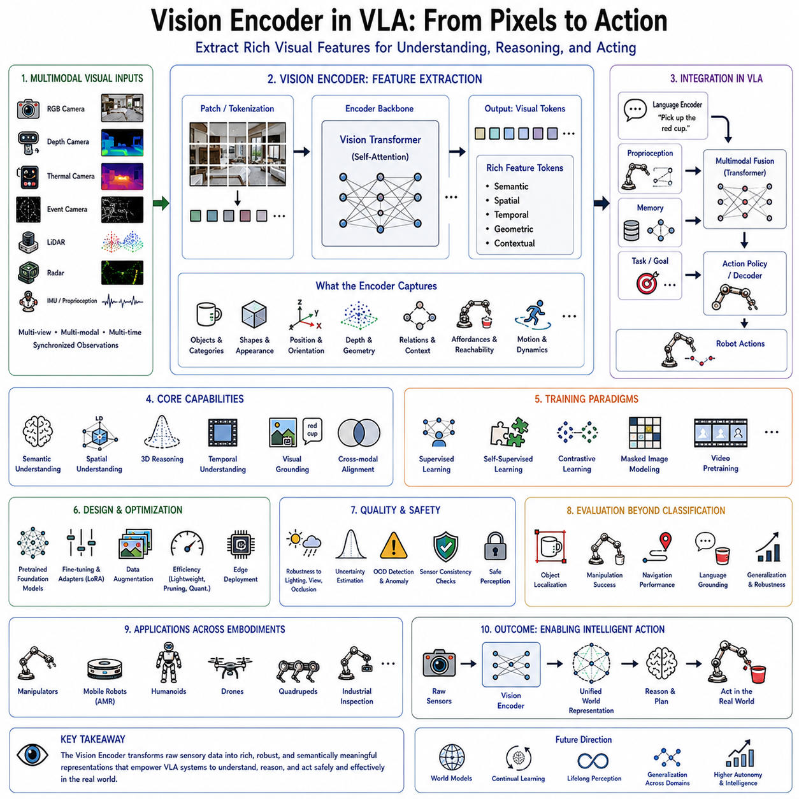
The Vision Encoder serves as the perceptual foundation of every Vision-Language-Action (VLA) system. Just as the human visual cortex transforms raw photons into meaningful representations that enable recognition, reasoning, and interaction with the surrounding world, a Vision Encoder converts raw sensor observations into structured feature representations that can be understood by downstream neural modules. Without an effective visual representation, even the most sophisticated language model or action policy cannot understand the environment in which the robot operates. Consequently, the Vision Encoder is widely regarded as the “eyes” of an embodied artificial intelligence system, providing the semantic understanding necessary for perception, reasoning, planning, and physical interaction.
In modern robotic foundation models, perception is no longer considered an isolated computer vision problem. Instead, it represents the first stage of a unified multimodal intelligence pipeline. The visual encoder receives observations from one or more sensing modalities and produces compact latent representations that preserve both semantic meaning and spatial structure. These representations are subsequently integrated with language embeddings, robot proprioception, memory, world models, and task objectives before the VLA policy generates executable robot actions. Therefore, the quality of visual features directly influences every downstream component of the entire robotic intelligence stack.
Historically, robotic perception relied heavily on manually engineered feature extraction methods. Early robotic vision systems utilized edge detectors, corner detectors, texture descriptors, color histograms, geometric templates, and handcrafted local descriptors such as SIFT, SURF, ORB, and HOG. These techniques were computationally efficient and mathematically interpretable but struggled under varying illumination, viewpoint changes, partial occlusion, object deformation, and large-scale semantic variation. Because handcrafted features represented only limited visual characteristics, robotic systems frequently failed when encountering environments significantly different from those anticipated during development.
The emergence of deep convolutional neural networks fundamentally changed robotic perception. Instead of relying upon manually designed features, convolutional architectures automatically learned hierarchical representations directly from data. Lower network layers detected simple visual primitives such as edges and textures, intermediate layers recognized object parts and geometric structures, while deeper layers captured semantic concepts including complete objects, scene categories, and contextual relationships. This hierarchical learning capability substantially improved robustness across diverse operating conditions while eliminating the need for extensive manual feature engineering.
Although convolutional neural networks significantly advanced robotic perception, they also introduced architectural limitations. Convolution naturally emphasizes local receptive fields, requiring many stacked layers before long-range dependencies become available. Understanding relationships between distant image regions therefore becomes computationally challenging. In robotic manipulation and navigation, however, long-range spatial relationships frequently determine successful behavior. A robot must understand not only individual objects but also their relative positions, accessibility, spatial arrangements, and interactions within the surrounding environment.
Vision Transformers represent the next major evolution in robotic visual representation. Inspired by the transformer architecture originally developed for natural language processing, Vision Transformers divide images into fixed-size patches and process these patches using self-attention mechanisms. Rather than restricting computation to local neighborhoods, self-attention enables every image region to interact directly with every other region, allowing the network to capture global contextual relationships throughout the entire visual scene. This capability is particularly valuable for robotic reasoning because manipulation, navigation, and interaction often depend upon understanding the complete environmental context rather than isolated image fragments.
The fundamental objective of a Vision Encoder is not merely to compress visual information but to produce latent feature embeddings that preserve all information relevant for downstream robotic tasks while discarding irrelevant variations. Raw images contain enormous quantities of redundant information, including lighting fluctuations, sensor noise, minor texture variations, and background clutter. Effective feature extraction transforms these high-dimensional pixel arrays into compact representations emphasizing semantic content, geometric structure, object identity, spatial configuration, and interaction affordances while suppressing nuisance variables that unnecessarily complicate decision making.
Feature extraction therefore serves as a dimensionality reduction process guided by semantic preservation rather than simple compression. Two visually different observations corresponding to the same physical situation should ideally produce similar latent representations. Conversely, subtle visual differences that significantly alter robotic behavior must remain distinguishable within the embedding space. Designing representations satisfying these competing requirements constitutes one of the central challenges of modern robotic perception.
Within Vision-Language-Action systems, the output of the visual encoder generally consists of high-dimensional feature tokens rather than explicit object labels or segmentation maps. These feature tokens preserve rich semantic information while remaining sufficiently flexible for integration with language models and action policies. Instead of manually specifying which visual concepts should be extracted, downstream transformer layers learn to interpret feature embeddings according to current task objectives. Consequently, the same visual representation may support object recognition, scene understanding, manipulation planning, navigation, anomaly detection, and human interaction simultaneously.
Modern Vision Encoders frequently process multiple sensing modalities rather than conventional RGB images alone. Depth cameras provide geometric information describing three-dimensional scene structure. Thermal cameras reveal temperature distributions useful for inspection, search-and-rescue, and industrial monitoring. Event cameras capture rapid motion under challenging lighting conditions. LiDAR generates accurate three-dimensional point clouds supporting outdoor navigation. Radar operates reliably under adverse weather. Multispectral and hyperspectral imaging extends perception beyond visible wavelengths. Each sensing modality contributes complementary information regarding the physical environment.
Multimodal perception requires the Vision Encoder to integrate heterogeneous sensory observations into unified latent representations. Fusion may occur at early stages by combining raw sensor measurements, at intermediate stages through feature-level integration, or at later stages by merging independently encoded modality-specific embeddings. The choice of fusion strategy depends upon sensor characteristics, computational constraints, synchronization accuracy, and downstream application requirements. Regardless of implementation details, the objective remains consistent: constructing coherent environmental representations more informative than any individual sensing modality alone.
Spatial understanding represents one of the defining responsibilities of the Vision Encoder within robotic intelligence. Unlike image classification tasks emphasizing semantic recognition alone, robots must understand where objects are located, how they relate geometrically, whether they are reachable, and how they may be manipulated safely. Feature representations therefore encode not only appearance but also position, orientation, scale, depth, surface geometry, occlusion relationships, free space, traversability, and physical affordances supporting subsequent action planning.
Three-dimensional reasoning becomes increasingly important as robots transition from laboratory demonstrations toward complex real-world environments. Flat two-dimensional images often fail to capture critical geometric information required for grasp planning, obstacle avoidance, manipulation, and locomotion. Modern Vision Encoders increasingly incorporate stereo vision, depth estimation, point cloud processing, neural radiance fields, Gaussian representations, and volumetric scene encoding to construct richer spatial representations supporting embodied interaction.
Temporal perception constitutes another essential capability. Real-world robotic operation occurs continuously rather than through isolated image snapshots. Motion conveys valuable information regarding object dynamics, human intentions, robot egomotion, and environmental change. Vision Encoders therefore increasingly process image sequences instead of individual frames, learning temporal feature representations describing evolving visual observations across time. Video transformers, recurrent memory mechanisms, temporal attention, and spatiotemporal architectures capture these dynamic relationships supporting prediction and continuous decision making.
Motion understanding significantly influences robotic performance. Predicting future object trajectories enables proactive collision avoidance. Estimating human movement supports safe collaboration. Recognizing manipulation progress assists long-horizon task execution. Temporal visual representations additionally improve robustness under temporary occlusion because previously observed information remains available through memory. Consequently, modern VLA architectures frequently integrate temporal encoding directly into perception rather than treating video as independent image sequences.
Visual grounding establishes another critical connection between perception and language. Language instructions reference objects, locations, actions, colors, attributes, and spatial relationships present within the physical environment. The Vision Encoder therefore produces feature representations enabling language models to associate textual concepts with corresponding visual observations. Rather than independently recognizing every possible object category, grounding mechanisms align visual embeddings with semantic language representations, allowing robots to understand previously unseen objects described through natural language.
Cross-modal alignment has consequently become one of the most influential developments in multimodal artificial intelligence. Contrastive representation learning encourages visually similar semantic concepts to occupy nearby locations within shared embedding spaces regardless of modality. Images depicting cups become closely aligned with textual descriptions of cups, while images of chairs align with corresponding linguistic concepts. Such shared latent spaces greatly simplify multimodal reasoning because vision and language naturally communicate through compatible feature representations.
General-purpose visual foundation models have demonstrated remarkable transferability across numerous robotic applications. Models pretrained on massive Internet-scale image collections acquire surprisingly rich representations despite receiving no explicit robotic supervision. Rather than learning robotics-specific perception entirely from scratch, developers increasingly initialize Vision Encoders using these pretrained representations before adapting them toward domain-specific tasks through fine-tuning, adapter modules, prompt tuning, or low-rank parameter updates. This transfer learning paradigm dramatically reduces data requirements while improving generalization.
Feature transfer operates because many visual concepts remain consistent across domains. Edges, textures, shapes, materials, object categories, and geometric structures encountered during Internet-scale pretraining also appear within robotic environments. Although industrial robots, autonomous vehicles, service robots, and humanoids encounter specialized operating conditions, foundational visual representations nevertheless provide valuable initialization accelerating subsequent adaptation toward specific applications.
Robotic perception, however, introduces challenges absent from conventional computer vision benchmarks. Internet images typically emphasize aesthetically pleasing compositions captured from human viewpoints. Robots instead observe scenes from moving platforms, wrist-mounted cameras, unusual perspectives, changing illumination, motion blur, partial occlusion, sensor artifacts, and cluttered workspaces. Consequently, Vision Encoders frequently require additional adaptation before achieving reliable robotic performance. Domain-specific fine-tuning adjusts representations according to operational requirements while preserving broadly transferable semantic knowledge acquired during pretraining.
Data augmentation plays a major role in developing robust visual representations. Random cropping, rotation, scaling, color perturbation, illumination variation, blur simulation, noise injection, occlusion synthesis, geometric distortion, and domain randomization expose Vision Encoders to diverse visual conditions during training. Rather than memorizing narrow appearance distributions, models learn invariant semantic representations capable of generalizing across realistic environmental variability encountered during deployment.
Self-supervised learning has become particularly influential for Vision Encoder development because manually labeled robotic datasets remain relatively limited. Instead of relying exclusively upon expensive human annotations, self-supervised objectives exploit intrinsic image structure to learn useful representations automatically. Contrastive learning, masked image modeling, predictive coding, temporal consistency, clustering, and cross-view correspondence enable models to extract semantic features from enormous quantities of unlabeled visual data. Such approaches significantly reduce dependence upon manual dataset annotation while improving scalability.
The computational efficiency of Vision Encoders strongly influences practical robotic deployment. High-resolution cameras, multiple viewpoints, stereo imaging, and three-dimensional sensing dramatically increase computational complexity. Yet autonomous robots frequently operate under strict power, latency, and thermal constraints. Efficient architectures therefore balance representational quality against computational cost. Lightweight transformer variants, hierarchical attention mechanisms, token pruning, dynamic resolution adaptation, early exiting, and hardware-aware neural architecture search all contribute toward reducing inference latency while preserving feature quality.
Memory consumption presents another important engineering consideration. Vision feature maps often occupy substantial GPU memory, particularly when processing multiple cameras or extended temporal sequences. Feature compression, mixed-precision computation, activation checkpointing, memory-efficient attention, and quantized inference help reduce resource requirements without significantly degrading downstream robotic performance. Such optimizations become particularly valuable for edge deployment on mobile robotic platforms with limited onboard computational resources.
Interpretability remains an active area of Vision Encoder research. Although latent feature embeddings support powerful downstream reasoning, understanding precisely what information individual neurons or attention heads encode remains challenging. Visualization techniques including attention maps, feature inversion, activation maximization, token similarity analysis, and representation probing provide valuable insights into learned perception. Improved interpretability not only advances scientific understanding but also supports debugging, safety validation, regulatory compliance, and human trust.
Evaluation of Vision Encoders extends far beyond conventional image classification accuracy. Robotic perception must support object localization, manipulation success, navigation reliability, scene understanding, spatial reasoning, visual grounding, cross-domain generalization, robustness under environmental variation, computational efficiency, and downstream policy performance. Consequently, benchmarking increasingly emphasizes task-oriented evaluation measuring the practical contribution of visual representations toward complete robotic systems rather than isolated perception metrics.
Cross-embodiment transfer further highlights the importance of general visual representations. A Vision Encoder trained using one robotic platform should ideally remain useful across manipulators, autonomous mobile robots, quadrupeds, drones, humanoids, and industrial inspection systems despite differing viewpoints and sensing configurations. General visual understanding therefore becomes an enabling technology supporting reusable robotic intelligence independent of specific hardware embodiments.
Safety considerations also influence Vision Encoder design. Perception errors propagate directly toward planning and action generation, potentially creating hazardous behavior. Modern systems increasingly estimate uncertainty alongside feature extraction, allowing downstream modules to recognize unreliable observations. Multimodal redundancy, anomaly detection, confidence estimation, out-of-distribution recognition, sensor consistency verification, and continual monitoring collectively improve perception reliability under real-world operating conditions.
Continual learning represents another important research direction. Robotic environments evolve continuously as objects change appearance, facilities undergo modification, seasonal conditions vary, and operational procedures adapt. Static Vision Encoders trained once during development gradually become outdated. Continual adaptation allows perceptual representations to improve throughout deployment while avoiding catastrophic forgetting of previously acquired knowledge. Achieving stable lifelong perception remains a central objective of embodied artificial intelligence research.
The future of Vision Encoders will likely involve increasingly unified multimodal world representations rather than independent visual feature extraction. Perception will extend beyond recognizing current observations toward constructing persistent three-dimensional semantic world models integrating vision, language, memory, physics, interaction history, and predictive reasoning. Such world-centric representations will support long-horizon planning, causal reasoning, collaborative interaction, autonomous exploration, and generalized manipulation across highly diverse environments.
Ultimately, the Vision Encoder serves as the perceptual gateway connecting the physical world with intelligent reasoning inside Vision-Language-Action systems. Every subsequent stage of multimodal understanding depends fundamentally upon the quality, richness, robustness, and efficiency of extracted visual representations. By transforming raw sensory observations into meaningful semantic embeddings, Vision Encoders enable robots to recognize objects, understand spatial relationships, ground language, predict environmental dynamics, support reasoning, and generate purposeful physical actions. As robotic foundation models continue advancing toward increasingly capable embodied intelligence, Vision Encoders will remain one of the most fundamental components determining how effectively autonomous systems perceive, understand, and interact with the real world.

2.2 Vision Transformer (ViT) Architecture and Variants (with Code)
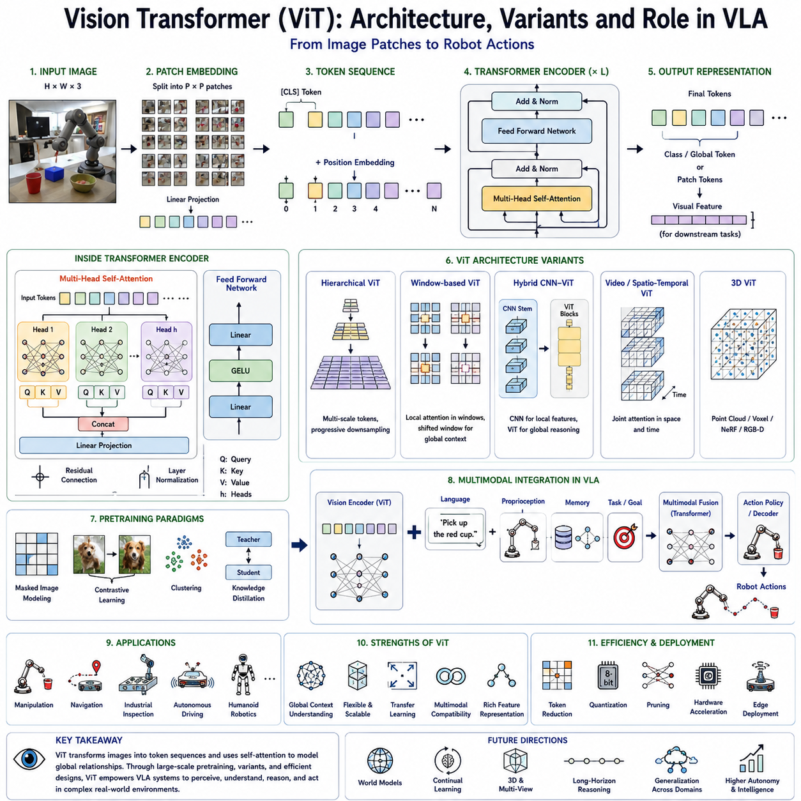
The Vision Transformer (ViT) represents one of the most significant milestones in the evolution of modern computer vision and has become a fundamental building block for Vision-Language-Action (VLA) systems. Originally inspired by the Transformer architecture developed for natural language processing, Vision Transformer fundamentally changed how visual information is represented, processed, and integrated into multimodal foundation models. Instead of relying on convolutional operations that dominated computer vision for more than two decades, ViT introduced the concept of treating an image as a sequence of visual tokens, allowing the same attention-based architecture that revolutionized language understanding to become equally effective for visual perception.
The introduction of Vision Transformer marked a conceptual shift rather than merely an architectural improvement. Traditional convolutional neural networks assumed that local spatial neighborhoods contained the most important visual information, gradually expanding receptive fields through deeper network layers. Vision Transformer removed this assumption entirely. Every image region can directly communicate with every other region through self-attention, enabling global contextual reasoning from the earliest stages of feature extraction. This ability has proven especially valuable for robotic perception because robots must reason about complete scenes rather than isolated objects.
Within Vision-Language-Action systems, Vision Transformer serves as the primary visual encoder responsible for converting raw images into semantic feature representations that can be fused with language embeddings, robot states, memory, and action policies. The quality of these visual representations largely determines how well downstream reasoning modules understand the physical environment. Consequently, ViT has become the default backbone for many state-of-the-art robotic foundation models, including multimodal VLMs, VLA systems, humanoid policies, and general-purpose robot learning frameworks.
The fundamental idea behind Vision Transformer is surprisingly elegant. Instead of processing pixels directly, an input image is first divided into a regular grid of fixed-size patches. Each patch is flattened into a one-dimensional vector and projected into a higher-dimensional embedding space using a learned linear projection. These projected vectors become visual tokens analogous to word embeddings in natural language models. Once converted into token embeddings, the remainder of the architecture closely resembles the original Transformer encoder used for language processing.
Patch embedding serves as the first stage of the Vision Transformer pipeline. Consider an image with a resolution of 224 by 224 pixels. If sixteen-by-sixteen patches are used, the image becomes fourteen-by-fourteen patches, resulting in a sequence of one hundred ninety-six visual tokens. Each token summarizes the visual content of one local image region while preserving spatial ordering through positional embeddings. The patch size significantly influences computational complexity, feature granularity, and recognition performance. Smaller patches preserve finer spatial detail but increase sequence length and computational cost. Larger patches reduce computation but may lose important visual structures necessary for manipulation and robotic perception.
Positional encoding is essential because Transformers themselves possess no inherent understanding of spatial relationships. Unlike convolutional layers, which naturally preserve neighborhood structure through local receptive fields, self-attention treats input tokens as unordered sets unless explicit positional information is provided. Learned positional embeddings or sinusoidal encodings are therefore added to every visual token before transformer processing. These embeddings enable the network to distinguish neighboring image patches and reason about relative spatial arrangements within the visual scene.
Following patch embedding, the visual tokens pass through multiple Transformer encoder blocks. Each block consists primarily of Multi-Head Self-Attention, feed-forward neural networks, residual connections, and layer normalization. These components collectively allow the network to learn increasingly abstract visual representations while maintaining stable optimization during large-scale training.
Multi-Head Self-Attention represents the defining innovation of Vision Transformer. Rather than processing each image region independently, self-attention computes relationships between every pair of visual tokens simultaneously. Each token dynamically determines which other image regions contain relevant contextual information. Consequently, a token representing a robotic gripper can directly attend to an object located on the opposite side of the image without requiring numerous intermediate convolutional layers. This global interaction dramatically improves contextual reasoning, especially for scenes involving multiple interacting objects.
Multiple attention heads further enhance representational capacity. Different attention heads naturally specialize in different visual relationships. Some heads primarily capture object boundaries, others focus on semantic categories, while additional heads learn geometric structures, spatial configurations, textures, or contextual interactions. Together, these parallel attention mechanisms create rich hierarchical visual representations that support downstream reasoning and robotic action generation.
The feed-forward network following each attention layer further transforms token representations using nonlinear projections. Although self-attention determines how information flows between image regions, the feed-forward network increases representational capacity by learning complex nonlinear feature transformations independently for every token. Residual connections preserve information flow across deep networks, while layer normalization stabilizes optimization and accelerates convergence during training.
Unlike convolutional neural networks, Vision Transformers contain no explicit assumptions regarding locality or translation invariance. Instead, these properties emerge naturally through large-scale data-driven learning. Initially, researchers questioned whether removing convolution would degrade visual recognition. Surprisingly, sufficiently large datasets demonstrated that pure attention architectures often outperform convolutional networks once adequate training data becomes available. This discovery fundamentally reshaped computer vision research and influenced virtually every subsequent multimodal foundation model.
One important characteristic of Vision Transformer is its dependence upon large-scale pretraining. Convolutional neural networks naturally encode useful inductive biases, allowing effective learning from relatively modest datasets. Vision Transformers possess fewer built-in assumptions, requiring substantially more data before superior performance emerges. Consequently, ViT models are typically pretrained using millions or billions of images before adaptation toward downstream robotic tasks. Once pretrained, however, they exhibit remarkable transfer learning capabilities across diverse application domains.
Transfer learning has become one of the primary reasons for Vision Transformer's widespread adoption in robotics. Massive image datasets contain enormous visual diversity spanning objects, materials, textures, lighting conditions, environments, and viewpoints. During pretraining, ViT learns universal visual representations transferable to industrial inspection, warehouse automation, autonomous driving, household robotics, agricultural systems, medical robotics, and humanoid manipulation. Rather than collecting prohibitively expensive robotic datasets from scratch, researchers fine-tune pretrained Vision Transformers for specialized robotic applications.
Feature extraction within Vision Transformer differs fundamentally from traditional object recognition pipelines. Earlier computer vision systems frequently emphasized explicit detection, segmentation, or classification outputs. Modern ViT architectures instead produce high-dimensional latent embeddings preserving rich semantic information. These embeddings support numerous downstream tasks simultaneously without requiring separate feature engineering for each application. The same visual representation may therefore contribute to manipulation planning, navigation, language grounding, scene understanding, anomaly detection, and interaction reasoning.
Spatial reasoning represents one of Vision Transformer's greatest strengths within robotic systems. Since every visual token attends globally to every other token, long-range spatial dependencies naturally emerge throughout learned representations. A robot manipulating objects on a cluttered table benefits enormously from understanding relationships among distant objects, free workspace, obstacles, containers, and target destinations simultaneously. Such global awareness substantially improves task planning compared with purely local visual processing.
However, the quadratic computational complexity of self-attention introduces significant engineering challenges. Every visual token interacts with every other token, causing computational and memory requirements to increase quadratically with sequence length. High-resolution images therefore become computationally expensive. For example, doubling image resolution approximately quadruples the number of patches while increasing attention computations by roughly sixteen times. Efficient architectural variants have consequently become essential for practical robotic deployment.
Numerous Vision Transformer variants have emerged to address these computational challenges while preserving representational quality. One of the earliest improvements introduced hierarchical feature extraction. Rather than maintaining fixed token resolution throughout the network, hierarchical architectures progressively merge neighboring tokens into larger semantic representations, reducing computational complexity while preserving multi-scale information. Such approaches resemble feature pyramids traditionally used in convolutional neural networks but retain attention-based processing throughout the architecture.
Window-based attention represents another influential optimization. Instead of computing attention globally across the entire image, local attention windows restrict interactions to nearby regions. Neighboring windows periodically exchange information through shifted partitioning strategies, allowing global context to emerge gradually while dramatically reducing computational cost. This approach enables efficient processing of higher-resolution images suitable for dense robotic perception tasks.
Hybrid architectures combining convolution and attention have also proven successful. Early convolutional layers efficiently extract local textures and edges before transformer blocks perform higher-level contextual reasoning. Such hybrid designs exploit the complementary strengths of both paradigms. Convolutions provide computational efficiency and strong local inductive biases, whereas transformers contribute flexible global reasoning. Many practical robotic systems adopt such hybrid visual backbones to balance accuracy with computational constraints.
Hierarchical Vision Transformers have become particularly important for robotic perception because they naturally produce multi-scale representations. Early layers preserve fine spatial details useful for grasp planning and precise localization, while deeper layers encode increasingly abstract semantic concepts supporting task reasoning and language grounding. Multi-scale features also facilitate integration with downstream perception modules performing object detection, segmentation, depth estimation, or simultaneous localization and mapping.
Self-supervised pretraining has profoundly influenced Vision Transformer development. Rather than relying exclusively upon manually labeled datasets, self-supervised objectives encourage networks to learn meaningful visual representations directly from unlabeled images. Masked image modeling, contrastive learning, predictive coding, clustering, and teacher-student distillation enable ViT architectures to acquire transferable semantic knowledge without expensive annotation. Such approaches significantly improve scalability while reducing dependence upon curated datasets.
Contrastive representation learning has become especially influential. During training, different augmented views of the same image are encouraged to produce similar embeddings, whereas unrelated images occupy distant regions within latent space. This objective naturally learns robust semantic features invariant to lighting, viewpoint, cropping, color variation, and moderate geometric transformations. Such invariance proves extremely valuable for robots operating under continuously changing environmental conditions.
Masked image modeling represents another important training paradigm. Random image patches are hidden during training, and the Vision Transformer learns to reconstruct missing visual information from surrounding context. This objective encourages deep semantic understanding because successful reconstruction requires reasoning about object structure, scene composition, and contextual relationships rather than merely memorizing pixel patterns. Models trained using masked prediction often demonstrate exceptional transfer learning performance across downstream robotic applications.
Knowledge distillation has further improved Vision Transformer efficiency. Large teacher models transfer representational knowledge toward smaller student architectures suitable for edge deployment. Distilled Vision Transformers preserve much of the semantic capability of substantially larger networks while reducing computational cost sufficiently for onboard robotic inference. Such lightweight models enable practical deployment on autonomous mobile robots, drones, collaborative manipulators, and embedded edge platforms.
Vision Transformer also integrates naturally with multimodal learning. Since both visual patches and language tokens are represented as sequences of embeddings, images and text may be processed using highly similar transformer architectures. Cross-attention layers align visual tokens with linguistic concepts, enabling multimodal reasoning across perception and language. This architectural compatibility explains why ViT rapidly became the preferred visual backbone for multimodal systems including CLIP, PaLM-E, LLaVA, GPT-4V, Gemini, Qwen-VL, InternVL, RT-2, and numerous robotic foundation models.
In Vision-Language-Action architectures, ViT typically functions as the perception module responsible for encoding RGB observations, wrist camera images, stereo vision, overhead cameras, or multi-camera systems into unified visual embeddings. These embeddings are subsequently fused with language instructions, proprioceptive measurements, force sensing, memory representations, and task objectives. The resulting multimodal latent space supports high-level reasoning before action policies generate executable robot behaviors.
Multi-camera robotic perception particularly benefits from Vision Transformer architectures. Mobile manipulators often employ head-mounted cameras, wrist cameras, side cameras, and depth sensors simultaneously. Each viewpoint captures complementary information regarding object geometry, occlusion, manipulation affordances, and environmental context. Vision Transformers efficiently integrate these heterogeneous visual observations into coherent scene representations through attention-based feature fusion rather than manually engineered sensor integration pipelines.
Temporal Vision Transformers extend these concepts toward video understanding. Instead of processing isolated images, temporal architectures jointly attend across both spatial and temporal dimensions. Such models capture motion patterns, object trajectories, human activities, manipulation progress, and environmental dynamics essential for long-horizon robotic tasks. Video-based feature extraction increasingly supports embodied reasoning by providing persistent contextual awareness unavailable from individual frames.
Three-dimensional Vision Transformers represent another rapidly advancing research direction. Rather than restricting attention to two-dimensional image patches, specialized architectures process point clouds, voxel grids, neural radiance fields, Gaussian representations, or multimodal RGB-depth observations directly. These models learn spatial representations more closely aligned with physical geometry, improving robotic manipulation, navigation, inspection, and autonomous interaction within three-dimensional environments.
Interpretability has become an active area of Vision Transformer research. Attention visualization provides valuable insight into how models distribute computational focus across visual scenes. Researchers analyze attention maps, feature embeddings, token similarity, activation trajectories, and representation geometry to understand learned perception. Although attention alone does not fully explain network reasoning, these visualization techniques significantly improve debugging, safety validation, and scientific understanding.
Robotic deployment introduces additional optimization requirements beyond conventional computer vision. Edge platforms impose strict limitations regarding latency, memory consumption, energy efficiency, and thermal management. Vision Transformer inference therefore frequently incorporates quantization, pruning, token reduction, mixed-precision arithmetic, compiler optimization, hardware-aware scheduling, and specialized transformer accelerators. These optimizations preserve visual quality while satisfying real-time operational constraints.
Future Vision Transformer development will likely emphasize increasingly unified world representations rather than isolated visual encoding. Instead of merely extracting features from individual images, next-generation architectures will construct persistent semantic world models integrating visual observations across time, viewpoints, sensor modalities, and physical interaction. Such representations will support causal reasoning, predictive simulation, memory, planning, and continual learning within embodied artificial intelligence systems.
Ultimately, Vision Transformer has transformed robotic perception by replacing manually engineered local feature extraction with globally contextualized semantic representation learning. Its ability to encode visual information as rich token sequences naturally compatible with language models has established it as the dominant visual backbone for modern Vision-Language-Action systems. Through self-attention, large-scale pretraining, transfer learning, multimodal fusion, and increasingly efficient architectural variants, Vision Transformer enables robots to perceive complex environments with unprecedented flexibility and generalization. As multimodal foundation models continue advancing toward increasingly capable embodied intelligence, Vision Transformer and its successors will remain central technologies connecting visual perception with language understanding, reasoning, and autonomous physical action.

2.3 CLIP Visual Encoder for Language-Aligned Features (with Code)
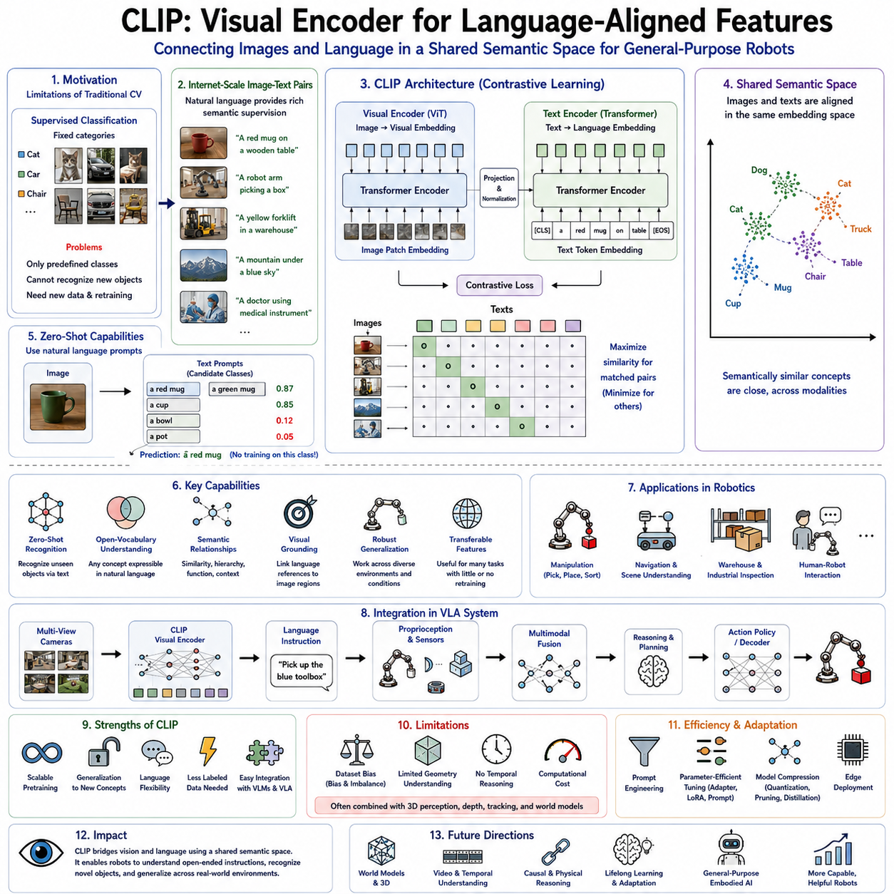
Contrastive Language-Image Pretraining (CLIP) represents one of the most influential milestones in the development of multimodal artificial intelligence and has fundamentally transformed how robots connect visual perception with natural language understanding. Before CLIP, computer vision and natural language processing largely evolved as separate research fields. Vision models learned to recognize predefined object categories using manually annotated datasets, while language models learned textual relationships independently from visual perception. The connection between these two domains typically required carefully engineered pipelines or task-specific datasets. CLIP introduced a radically different paradigm by learning a shared semantic representation directly from image-text pairs collected at Internet scale. This innovation enabled visual concepts and linguistic concepts to occupy the same latent embedding space, allowing machines to understand images through language and language through images without requiring explicit supervision for every individual task.
Within modern Vision-Language-Action (VLA) systems, CLIP has become one of the most important visual foundation models because it provides semantically meaningful feature representations rather than merely recognizing predefined object categories. Instead of predicting one label from a fixed taxonomy, CLIP learns relationships between arbitrary visual observations and natural language descriptions. Consequently, robots equipped with CLIP-based visual encoders can interpret open-ended instructions, identify previously unseen objects through textual descriptions, reason about semantic similarities, and transfer knowledge across entirely new environments without requiring additional object-specific training.
The motivation behind CLIP emerged from recognizing the limitations of conventional supervised computer vision. Traditional image classification models relied heavily on manually labeled datasets in which each image corresponded to one predefined category. While such datasets achieved remarkable performance on benchmark tasks, they imposed severe restrictions on generalization. A classifier trained to recognize one thousand object categories could not naturally identify objects outside those categories. Furthermore, adding new object classes required collecting additional labeled data and retraining the entire network. Such limitations made conventional supervised perception unsuitable for general-purpose robotics, where robots continuously encounter novel objects, environments, and user instructions.
Natural language, however, already contains extraordinarily rich semantic supervision. Every image published on the Internet is frequently accompanied by captions, descriptions, surrounding text, or metadata describing visual content. Rather than manually assigning categorical labels, CLIP leverages these naturally occurring image-text pairs to learn multimodal representations. Millions and eventually hundreds of millions of image-caption pairs provide diverse supervision spanning virtually every object category, environment, activity, profession, geographic location, material, and visual concept encountered in everyday life.
The central idea of CLIP is conceptually elegant. Instead of training a model to classify images into predefined labels, two separate neural networks are trained simultaneously. One network processes images using a visual encoder, while the other processes text using a language encoder. During training, the image corresponding to a caption is encouraged to produce an embedding close to the embedding generated from its matching textual description. Simultaneously, unrelated image-text pairs are pushed apart within the shared latent space. Through this contrastive learning objective, both visual and linguistic representations gradually align into a common semantic embedding space where similar concepts naturally cluster together regardless of modality.
Contrastive learning fundamentally distinguishes CLIP from traditional supervised learning. Rather than predicting explicit labels, the objective focuses on measuring similarity between paired observations. Given a batch of image-text pairs, every image should become most similar to its corresponding caption while remaining dissimilar from all other captions within the batch. Likewise, every caption should align closely with its associated image while separating from unrelated images. This symmetric optimization encourages robust semantic alignment without requiring manually designed classification outputs.
The visual encoder within CLIP may employ different backbone architectures depending upon computational requirements and intended applications. Early implementations utilized both convolutional neural networks and Vision Transformers, demonstrating that either architecture could effectively support multimodal representation learning. Over time, Vision Transformer became the dominant visual backbone because of its superior scalability, global contextual reasoning, and compatibility with transformer-based language models. Modern robotic systems almost universally adopt transformer-based CLIP visual encoders due to their outstanding transfer learning performance across diverse downstream tasks.
The language encoder processes textual descriptions using transformer architectures similar to those employed in natural language processing. Sentences describing images are tokenized, embedded, and transformed into semantic feature vectors representing linguistic meaning. Importantly, the language encoder does not simply memorize object names. Instead, it learns contextual representations incorporating attributes, relationships, actions, materials, colors, spatial concepts, and descriptive semantics. Consequently, textual prompts such as “a red ceramic coffee mug on a wooden table” produce substantially richer representations than isolated category labels.
During contrastive pretraining, image embeddings and text embeddings gradually converge toward a unified semantic space. Images depicting similar objects naturally occupy nearby locations regardless of illumination, viewpoint, background clutter, or minor appearance variation. Likewise, textual descriptions referring to semantically related concepts become similarly organized. Because both modalities share the same latent geometry, similarity can be computed directly through simple cosine distance between image and language embeddings. This elegant representation enables numerous downstream applications requiring no additional task-specific supervision.
Zero-shot classification became one of CLIP's most celebrated capabilities. Instead of retraining classifiers for new object categories, users simply describe candidate classes using natural language prompts. Image embeddings are compared directly against textual embeddings corresponding to category descriptions, and the most similar description becomes the predicted classification. Consequently, CLIP can recognize thousands of categories never explicitly encountered during supervised training. This remarkable generalization capability fundamentally changed expectations regarding visual foundation models and demonstrated the extraordinary power of language-aligned representations.
For robotics, zero-shot recognition provides enormous practical value. Robots deployed within homes, factories, hospitals, warehouses, or agricultural environments inevitably encounter previously unseen objects. Rather than requiring extensive retraining whenever new inventory arrives or operating conditions change, CLIP enables robots to identify novel objects through textual descriptions alone. A user may simply instruct a robot to “pick up the blue toolbox,” “inspect the cracked pipe,” or “find the emergency exit sign,” even if those specific object categories never appeared within robotic training datasets.
Semantic understanding extends well beyond object recognition. CLIP embeddings naturally capture relationships among concepts including similarity, hierarchy, functionality, and contextual association. Images of chairs, sofas, and benches cluster together because they all represent seating furniture. Kitchen utensils exhibit semantic proximity despite substantial visual variation. Industrial equipment groups according to operational function rather than purely visual appearance. Such semantic organization supports higher-level reasoning unavailable from conventional categorical classifiers.
Visual grounding represents another major application of CLIP within Vision-Language-Action architectures. Human instructions frequently reference objects using descriptive language rather than predefined symbolic identifiers. Commands such as “move the green container beside the toolbox” require robots to associate linguistic concepts with visual observations. Because CLIP aligns images and language within a shared embedding space, grounding naturally emerges through embedding similarity rather than manually engineered object-language mappings. Consequently, robots interpret flexible natural language while remaining robust to linguistic variation.
Spatial reasoning also benefits indirectly from language-aligned visual features. Although CLIP primarily learns semantic rather than geometric representations, semantic understanding significantly enhances downstream spatial reasoning. Recognizing that a microwave is typically located within kitchens or that cups commonly appear upon tables provides contextual knowledge supporting navigation, manipulation, and task planning. When integrated with geometric perception modules, CLIP contributes rich semantic priors improving overall embodied intelligence.
Feature transfer constitutes one of CLIP's greatest strengths. The learned visual encoder produces highly general semantic representations applicable across numerous downstream applications including object detection, semantic segmentation, robotic manipulation, anomaly detection, visual navigation, scene understanding, industrial inspection, autonomous driving, healthcare robotics, and human-robot interaction. Rather than training perception independently for every task, developers increasingly initialize robotic systems using pretrained CLIP encoders before performing lightweight domain adaptation.
Fine-tuning strategies vary according to application requirements. Complete end-to-end fine-tuning updates all network parameters but requires substantial computational resources and large robotic datasets. Parameter-efficient approaches instead freeze most pretrained weights while learning only lightweight adapter modules, prompt embeddings, low-rank updates, or task-specific projection layers. Such methods preserve broadly transferable semantic knowledge while adapting efficiently toward specialized robotic domains including manufacturing, warehouse automation, healthcare, agriculture, and service robotics.
Prompt engineering has emerged as an unexpectedly powerful mechanism for improving CLIP performance. Since classification depends upon textual descriptions, carefully designed prompts significantly influence recognition accuracy. Instead of using isolated object names, richer contextual prompts such as “a photograph of a robotic gripper,” “an industrial conveyor belt,” or “a medical instrument used during surgery” often produce superior results because they better match natural language distributions encountered during pretraining. Automatic prompt optimization and learned prompt tuning further improve domain-specific performance without modifying the underlying visual encoder.
Robotic manipulation particularly benefits from language-aligned visual representations. Traditional manipulation systems often relied upon precise object detection pipelines trained specifically for individual object categories. CLIP enables more flexible interaction by representing objects according to semantic meaning rather than rigid categorical identities. A robot instructed to “pick up something suitable for writing” may identify pens, pencils, or markers through semantic similarity even if the exact object category differs from previous demonstrations. Such conceptual reasoning substantially increases robotic adaptability.
Open-vocabulary perception represents another major advantage. Conventional detectors recognize only predefined categories, whereas CLIP-based systems potentially recognize any concept expressible through natural language. This capability has inspired numerous open-vocabulary detection and segmentation architectures extending CLIP representations toward precise object localization. Robots therefore combine semantic flexibility with geometric precision, enabling robust operation across diverse real-world environments containing constantly evolving object inventories.
Scene understanding similarly benefits from multimodal representations. Instead of merely identifying isolated objects, CLIP captures broader semantic context including activities, environments, relationships, and functional interactions. Images depicting laboratories, kitchens, factories, offices, warehouses, hospitals, or agricultural fields naturally occupy distinct semantic regions within embedding space. Such contextual awareness supports higher-level planning, navigation, and task selection within embodied artificial intelligence systems.
Human-robot interaction becomes substantially more natural when robots share semantic representations with human language. Rather than requiring rigid command syntax, users communicate through ordinary descriptive language. CLIP enables robots to interpret references, synonyms, attributes, and contextual descriptions with remarkable flexibility. This linguistic compatibility reduces engineering complexity while improving accessibility for non-technical users interacting with intelligent robotic systems.
CLIP has also profoundly influenced robotic dataset construction. Earlier datasets emphasized carefully balanced object categories accompanied by categorical annotations. Modern multimodal datasets increasingly collect free-form textual descriptions together with visual observations, demonstrations, and robotic actions. Rich language annotations capture semantic information far exceeding conventional labels, enabling foundation models to acquire broader conceptual understanding supporting general-purpose robotic intelligence.
Despite its remarkable capabilities, CLIP possesses several important limitations. Since training data originates primarily from Internet image-text pairs, learned representations reflect biases present within publicly available online content. Certain object categories, cultural contexts, geographic regions, occupations, and demographic groups may be overrepresented or underrepresented. Such distributional biases can influence downstream robotic behavior unless carefully addressed through additional training, evaluation, and responsible deployment practices.
Geometric understanding represents another limitation. CLIP primarily optimizes semantic alignment rather than precise spatial reasoning. Although embeddings capture conceptual similarity exceptionally well, they provide relatively limited information regarding object pose, depth, physical dimensions, graspability, collision geometry, or manipulation affordances. Practical robotic systems therefore frequently combine CLIP semantic features with specialized geometric perception modules including depth estimation, stereo vision, point cloud processing, or simultaneous localization and mapping.
Temporal reasoning similarly lies outside CLIP's original design. Individual images are processed independently without explicit modeling of motion, object dynamics, or temporal continuity. Robots operating continuously within dynamic environments require additional architectures processing video sequences, recurrent memory, temporal transformers, or predictive world models. Nevertheless, CLIP embeddings frequently serve as foundational semantic representations within such extended temporal architectures.
Computational efficiency has become increasingly important for edge robotic deployment. Original CLIP models often require substantial GPU resources unsuitable for mobile robotic platforms. Researchers have therefore developed compressed variants using knowledge distillation, quantization, pruning, lightweight transformer architectures, and efficient visual backbones. These optimizations preserve much of CLIP's semantic capability while satisfying latency, energy, and memory constraints characteristic of embedded robotic systems.
CLIP naturally integrates with modern Vision-Language Models (VLMs). Numerous multimodal foundation models adopt CLIP-derived visual encoders before connecting them with increasingly powerful language models through cross-attention, projection layers, or multimodal transformers. Consequently, CLIP serves not merely as an independent perception model but as foundational infrastructure supporting conversational agents, embodied assistants, robotic planners, multimodal reasoning systems, and Vision-Language-Action architectures.
Within VLA systems, CLIP visual encoders typically produce semantic feature embeddings that are fused with robot proprioception, force sensing, language instructions, memory representations, environmental maps, and task objectives. Higher-level reasoning modules subsequently interpret these multimodal embeddings before generating executable action policies. Rather than directly controlling robot actuators, CLIP provides the semantic perception upon which intelligent decision making depends.
Future developments will likely extend CLIP beyond static semantic alignment toward richer world-centric representations integrating vision, language, three-dimensional geometry, temporal memory, causal reasoning, and physical interaction. Rather than merely understanding what objects are present, next-generation language-aligned visual encoders will understand how objects behave, how they can be manipulated, how environments evolve, and how language instructions translate into long-horizon physical behavior. Such unified representations will form the perceptual foundation for increasingly capable embodied artificial intelligence.
Ultimately, CLIP fundamentally transformed visual representation learning by demonstrating that semantic alignment between images and language provides a far more scalable foundation than conventional supervised classification. Its contrastive learning paradigm, shared multimodal embedding space, remarkable transfer learning capability, and open-vocabulary understanding have made it one of the most influential visual encoders in modern artificial intelligence. For Vision-Language-Action systems, CLIP serves as the essential bridge connecting visual perception with natural language understanding, enabling robots to interpret flexible human instructions, recognize previously unseen objects, reason semantically about their environments, and operate effectively across diverse real-world domains. As robotic foundation models continue evolving toward increasingly general embodied intelligence, language-aligned visual representations pioneered by CLIP will remain central components of future multimodal robotic architectures.

2.4 DINOv2 Self-Supervised Vision Encoder (with Code)
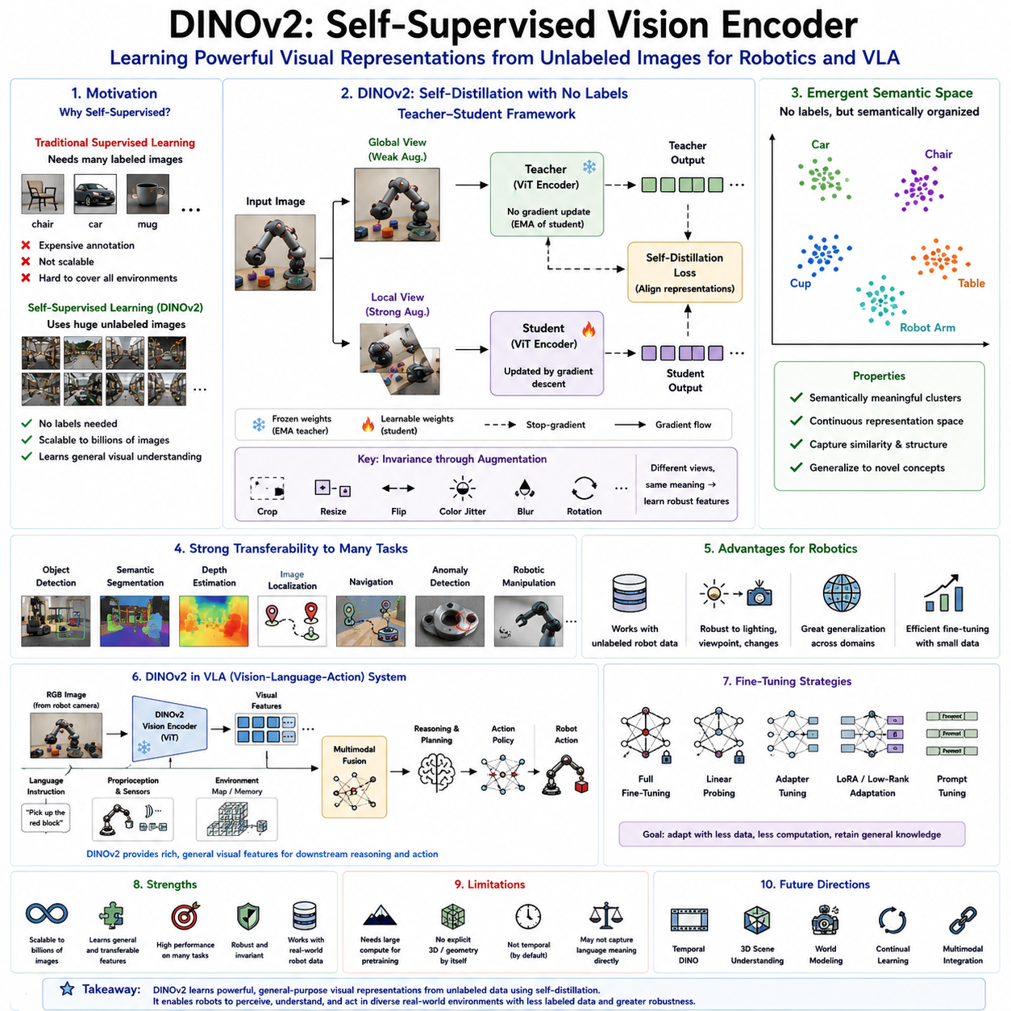
DINOv2 represents one of the most significant advances in self-supervised visual representation learning and has become one of the most powerful vision foundation models available for modern robotics and Vision-Language-Action (VLA) systems. Unlike traditional supervised computer vision models that depend heavily on manually annotated datasets, DINOv2 learns rich semantic visual representations directly from large collections of unlabeled images. This capability fundamentally changes how robots acquire visual understanding because collecting massive quantities of unlabeled images is considerably easier, less expensive, and more scalable than producing carefully annotated datasets. As robotic systems continue expanding into increasingly diverse environments, self-supervised learning has emerged as one of the most promising approaches for building general-purpose visual intelligence.
The motivation behind DINOv2 originates from a fundamental observation regarding natural perception. Humans do not require explicit labels for every object they observe throughout life. Infants learn visual concepts by continuously observing the surrounding world, discovering regularities, similarities, and structures without receiving category names for every visual experience. Similarly, robots operating continuously in factories, warehouses, hospitals, homes, agricultural fields, and urban environments generate enormous quantities of visual observations. Instead of requiring human engineers to manually annotate every image, self-supervised learning enables robots to extract meaningful representations directly from these observations.
Traditional supervised learning has achieved remarkable success across numerous computer vision tasks. However, its dependence on labeled datasets introduces several limitations for robotic applications. Manual annotation is expensive, time-consuming, and often inconsistent. Industrial environments frequently contain specialized equipment, custom components, unique products, and proprietary manufacturing processes unavailable within public datasets. Furthermore, robotic environments evolve continuously as new objects, layouts, tools, and operating procedures are introduced. Constantly maintaining fully annotated datasets becomes impractical at industrial scale.
Self-supervised learning addresses these challenges by replacing manual supervision with automatically generated learning objectives. Rather than predicting human-provided labels, the model learns internal representations by solving surrogate tasks constructed directly from the input data itself. The objective is not classification but representation learning. Once high-quality visual representations have been learned, these representations can be transferred efficiently toward numerous downstream robotic tasks including object detection, segmentation, navigation, manipulation, localization, anomaly detection, inspection, and multimodal reasoning.
DINO, which stands for Self-DIstillation with NO labels, introduced an elegant teacher-student learning paradigm that fundamentally influenced modern self-supervised computer vision. DINOv2 extends and significantly improves this approach through larger datasets, improved optimization strategies, more robust architectures, superior scaling behavior, and higher-quality learned representations. The resulting model demonstrates remarkable transfer learning performance across a wide variety of visual tasks without requiring task-specific supervision during pretraining.
The central principle underlying DINOv2 is knowledge distillation performed without human annotations. Instead of learning directly from labeled examples, a student network learns to match the representations generated by a teacher network observing different augmented versions of the same image. Because both teacher and student receive distinct visual transformations of identical underlying content, successful learning requires discovering invariant semantic properties rather than memorizing superficial appearance. Through repeated optimization across millions of images, increasingly robust visual representations gradually emerge.
Teacher-student learning represents one of the defining characteristics of DINOv2. During training, two neural networks process separate augmentations of the same image. The teacher network produces stable target representations, while the student network attempts to predict these representations despite receiving different image views. Importantly, the teacher parameters are not optimized directly through gradient descent. Instead, they evolve gradually using an exponential moving average of the student parameters. This momentum update mechanism provides stable learning targets and prevents representational collapse.
Image augmentation plays a crucial role throughout DINOv2 training. Different crops, scales, rotations, color perturbations, brightness changes, contrast variations, Gaussian blur, and other visual transformations generate multiple views of each image. Although these augmented observations differ substantially at the pixel level, they correspond to identical underlying semantic content. The student therefore learns invariant representations preserving semantic meaning while ignoring irrelevant appearance variation. Such invariance is particularly valuable for robotics because operating environments naturally exhibit changing illumination, viewpoint, weather, sensor characteristics, and partial occlusion.
Unlike contrastive learning approaches requiring explicit negative examples, DINOv2 avoids pairwise comparison between unrelated images. Earlier self-supervised methods frequently optimized similarity between positive pairs while simultaneously pushing apart negative samples. Although effective, negative sampling introduced computational complexity and potential optimization difficulties. DINOv2 instead relies upon self-distillation, allowing representations to organize naturally without explicitly constructing negative relationships. This simplification contributes to improved scalability and representation quality.
Vision Transformers serve as the primary backbone architecture for DINOv2. Their attention-based design naturally supports learning rich global representations from large-scale image collections. Since self-attention enables every image region to communicate directly with every other region, the resulting features capture long-range semantic dependencies, object relationships, scene composition, and contextual information essential for robotic perception. Transformer scalability also facilitates efficient pretraining across billions of image patches.
One remarkable property of DINOv2 representations is their ability to preserve semantic structure without explicit supervision. Images depicting visually similar concepts naturally cluster together within embedding space despite receiving no human-provided labels during training. Objects sharing similar geometry, materials, functions, or contextual environments occupy neighboring regions, while semantically distinct concepts separate automatically. This emergent organization demonstrates that high-level semantic understanding can arise purely from self-supervised representation learning.
Feature quality constitutes one of DINOv2's greatest strengths. Rather than optimizing specifically for image classification, DINOv2 learns highly general-purpose representations transferable across diverse downstream applications. The same pretrained encoder may subsequently support robotic manipulation, autonomous navigation, industrial inspection, semantic segmentation, object detection, depth estimation, visual localization, visual place recognition, scene understanding, human activity recognition, and multimodal foundation models with minimal adaptation.
Transfer learning has therefore become the dominant deployment strategy for DINOv2 within robotics. Large-scale self-supervised pretraining captures universal visual knowledge spanning objects, textures, materials, environments, geometric structures, lighting conditions, and scene composition. Robotic developers subsequently fine-tune these representations using relatively modest task-specific datasets. Because much visual understanding has already been acquired during pretraining, downstream optimization requires substantially fewer labeled examples while achieving significantly improved generalization.
One particularly valuable characteristic of DINOv2 involves its strong dense prediction capabilities. Intermediate feature representations preserve detailed spatial information supporting pixel-level reasoning rather than merely global image classification. Consequently, DINOv2 performs exceptionally well when adapted toward semantic segmentation, instance segmentation, surface understanding, and dense correspondence estimation. Such capabilities prove extremely important for robotic manipulation, autonomous navigation, and interaction with complex physical environments.
Robotic manipulation demands visual representations capable of distinguishing subtle geometric differences while remaining invariant to irrelevant appearance changes. DINOv2 naturally satisfies these competing requirements. Fine-grained object geometry remains encoded within feature representations, enabling precise grasp planning, pose estimation, and manipulation reasoning. Simultaneously, variations in illumination, camera viewpoint, and background clutter exert relatively limited influence upon learned semantic embeddings. This balance significantly improves manipulation robustness under realistic operating conditions.
Navigation similarly benefits from self-supervised visual representations. Mobile robots must recognize previously visited locations despite seasonal variation, furniture rearrangement, changing lighting, dynamic obstacles, and differing camera trajectories. DINOv2 embeddings exhibit remarkable viewpoint invariance while preserving environmental distinctiveness, making them particularly effective for visual localization, place recognition, loop closure detection, and long-term autonomous navigation.
Industrial inspection presents another compelling application domain. Manufacturing facilities frequently contain products, components, and assembly processes unavailable within public datasets. Acquiring fully annotated inspection datasets is often prohibitively expensive. DINOv2 enables inspection systems to learn general visual representations from unlabeled factory imagery before adapting efficiently toward specialized anomaly detection, defect recognition, quality assurance, predictive maintenance, and process monitoring applications.
Anomaly detection benefits substantially from self-supervised learning because defective products often occur rarely within industrial datasets. Traditional supervised classifiers struggle when abnormal examples remain scarce. DINOv2 instead learns comprehensive representations of normal visual appearance through abundant unlabeled observations. Deviations from these learned representations naturally indicate potential anomalies requiring further inspection. Such approaches reduce dependence upon extensive collections of defective training samples.
Depth estimation and three-dimensional scene understanding also leverage DINOv2 representations effectively. Although DINOv2 itself processes primarily RGB imagery, learned semantic features correlate strongly with object boundaries, surface continuity, structural organization, and scene composition. Downstream depth estimation networks initialized using DINOv2 frequently outperform models trained from random initialization because semantic understanding provides valuable contextual information supporting geometric inference.
Visual localization constitutes another important robotic capability enhanced by DINOv2. Autonomous systems continuously estimate their position relative to previously observed environments. Since DINOv2 embeddings remain relatively invariant to lighting, weather, viewpoint, and seasonal variation, localization systems achieve improved robustness across extended deployment periods. Such stability becomes increasingly valuable for long-term autonomous operation in dynamic real-world environments.
One notable advantage of DINOv2 involves its exceptional cross-domain transfer capability. Models pretrained using natural images often generalize surprisingly well toward industrial manufacturing, medical imaging, agriculture, remote sensing, autonomous driving, and robotic perception. This broad transferability demonstrates that self-supervised learning captures universal visual structures extending far beyond individual application domains.
Feature visualization reveals interesting properties of DINOv2 representations. Attention maps naturally highlight semantically meaningful object regions despite receiving no object annotations during training. Internal feature clusters frequently correspond to coherent semantic concepts including materials, textures, shapes, object parts, and scene categories. Such emergent organization illustrates that high-level perception arises naturally from large-scale self-supervised optimization.
Unlike supervised classifiers emphasizing predefined category boundaries, DINOv2 learns continuous representation spaces preserving nuanced semantic relationships. Similar objects remain close while gradually transitioning across conceptual boundaries. This continuous geometry better reflects natural visual organization and supports downstream reasoning tasks requiring similarity measurement, retrieval, clustering, and open-world recognition rather than discrete classification alone.
Multi-camera robotic systems particularly benefit from DINOv2. Wrist cameras, head-mounted cameras, stereo pairs, overhead cameras, inspection cameras, and panoramic sensors frequently observe identical environments from substantially different viewpoints. Self-supervised invariance enables DINOv2 to generate consistent representations across these diverse perspectives, simplifying sensor fusion and multimodal perception within complex robotic platforms.
Memory efficiency and computational scalability remain important engineering considerations. Large Vision Transformer architectures require significant computational resources during pretraining, often utilizing hundreds or thousands of GPUs across extended training periods. However, once pretrained, frozen DINOv2 encoders may be deployed efficiently using optimized inference frameworks, quantization, mixed-precision computation, and hardware acceleration suitable for industrial robotic platforms.
Fine-tuning strategies vary depending upon downstream objectives. Full network optimization maximizes task-specific performance but increases computational cost and risks catastrophic forgetting. Parameter-efficient adaptation techniques including adapter modules, prompt tuning, low-rank adaptation, and lightweight projection heads preserve pretrained representations while minimizing optimization complexity. Such approaches have become increasingly popular within robotics because labeled datasets often remain relatively limited.
Continual learning represents an exciting future direction for DINOv2-inspired research. Robots deployed continuously within changing environments should ideally refine visual representations over time without forgetting previously acquired knowledge. Integrating self-supervised online adaptation with stable foundation representations may eventually enable lifelong visual learning supporting increasingly autonomous robotic systems capable of continuous improvement throughout deployment.
DINOv2 also complements multimodal foundation models exceptionally well. Although originally developed purely for visual representation learning, its semantically rich embeddings integrate naturally with language models, world models, memory systems, planning architectures, and Vision-Language-Action policies. Rather than replacing language-aligned models such as CLIP, DINOv2 frequently provides complementary visual representations emphasizing structural understanding, dense perception, and geometric consistency.
Within Vision-Language-Action systems, DINOv2 commonly functions as the visual encoder responsible for extracting robust feature embeddings from RGB observations. These features are subsequently fused with language instructions, proprioceptive measurements, force sensing, environmental memory, semantic maps, and robot state information before action policies generate executable behavior. Because downstream reasoning depends critically upon representation quality, DINOv2 contributes substantially to overall robotic intelligence despite operating solely within the perception stage.
One distinguishing characteristic of DINOv2 involves its independence from language supervision. Whereas CLIP explicitly aligns images with textual descriptions, DINOv2 learns exclusively from visual consistency. Consequently, DINOv2 often produces stronger geometric and structural representations, while CLIP provides superior semantic language alignment. Many advanced robotic architectures therefore combine both encoders, exploiting DINOv2 for dense visual perception and CLIP for multimodal semantic grounding. Such complementary integration frequently yields superior performance compared with either model individually.
The emergence of DINOv2 demonstrates that manually labeled datasets are no longer the only path toward powerful visual intelligence. Self-supervised learning has shown that sufficiently large collections of unlabeled images contain enormous intrinsic supervisory signals capable of producing highly transferable representations. This realization fundamentally changes robotic perception because future autonomous systems will continuously generate vast quantities of visual experience during normal operation. Rather than discarding these observations, robots may increasingly leverage them for continual self-improvement through scalable self-supervised learning.
Looking forward, future generations of DINO-inspired visual foundation models will likely incorporate temporal consistency, three-dimensional scene understanding, physical interaction, world modeling, multimodal reasoning, and lifelong adaptation. Rather than learning static visual representations alone, next-generation self-supervised systems will construct persistent semantic world models integrating appearance, geometry, dynamics, causality, memory, and action. Such unified representations will provide increasingly powerful perceptual foundations for general-purpose embodied artificial intelligence.
Ultimately, DINOv2 represents a major milestone in the evolution of visual representation learning by demonstrating that large-scale self-supervised optimization can produce semantic features rivaling or surpassing those learned through conventional supervised methods. Its teacher-student architecture, transformer backbone, robust transfer learning capability, dense visual representations, and exceptional cross-domain generalization have established DINOv2 as one of the most influential visual encoders for modern robotics and Vision-Language-Action systems. As embodied artificial intelligence continues progressing toward increasingly capable autonomous agents, self-supervised visual foundation models pioneered by DINOv2 will remain essential technologies enabling robots to perceive, understand, and interact intelligently with the complex physical world.

2.5 SigLIP: Sigmoid Loss for Vision-Language Pretraining (with Code)
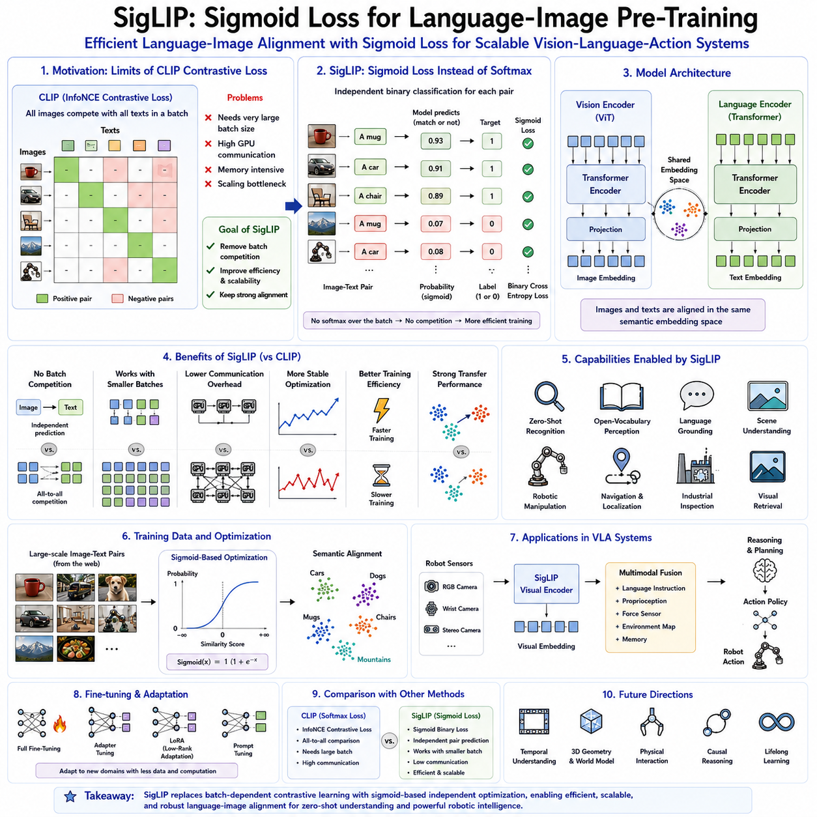
SigLIP, which stands for Sigmoid Loss for Language-Image Pre-training, represents a significant advancement in multimodal representation learning and serves as an evolution of the language-image alignment paradigm introduced by CLIP. While CLIP demonstrated that visual and textual representations could be successfully aligned using contrastive learning over large-scale image-text pairs, SigLIP introduced a fundamentally different optimization objective that improves scalability, training stability, computational efficiency, and transfer learning performance. Rather than relying on batch-wise softmax normalization across all image-text pairs, SigLIP reformulates language-image alignment as an independent binary classification problem optimized with sigmoid loss. This seemingly modest modification has profound implications for training very large vision-language foundation models and has made SigLIP one of the most influential visual encoders for modern Vision-Language-Action (VLA) systems.
The motivation behind SigLIP originates from the limitations of traditional contrastive learning. CLIP employs the InfoNCE contrastive objective, where every image competes against every text sample inside the same mini-batch. During optimization, positive image-text pairs are encouraged to become similar while all remaining image-text combinations within the batch become negative examples. Although this approach has proven remarkably successful, its performance depends strongly upon batch size because larger batches naturally provide more negative examples. Consequently, training large CLIP models typically requires extremely large distributed batches spanning thousands of GPUs. Such computational requirements significantly increase infrastructure complexity, communication overhead, synchronization costs, and memory consumption.
As multimodal foundation models continued scaling toward billions of parameters and hundreds of millions of image-text pairs, researchers recognized that the dependence upon large global batches had become a major bottleneck. Large distributed training requires continuous communication among GPUs to compute batch-wide similarity matrices. As cluster sizes increase, synchronization latency and communication bandwidth begin limiting overall training efficiency. Furthermore, maintaining extremely large batches may not always improve optimization quality because gradients become increasingly correlated while hardware utilization becomes more difficult to optimize.
SigLIP addresses these limitations by fundamentally changing the learning objective. Instead of treating image-text alignment as a ranking problem normalized over an entire mini-batch, each image-text pair is evaluated independently using binary logistic regression. Every positive pair receives a positive target, while every negative pair receives a negative target. The model predicts whether an image and text belong together, and optimization minimizes independent sigmoid cross-entropy losses across all sampled pairs. Because predictions no longer require normalization across the complete batch, the dependence upon large batch sizes is dramatically reduced.
This modification appears mathematically simple but produces important practical advantages. Unlike softmax normalization, sigmoid activation computes probabilities independently for every image-text pair. Consequently, optimization no longer depends upon relative comparisons against every other sample within the batch. Each training example contributes independently toward representation learning. This independence substantially reduces synchronization requirements across distributed hardware and enables more flexible batch construction strategies suitable for extremely large-scale pretraining.
The central architecture of SigLIP closely resembles CLIP in terms of overall model design. Two separate encoders operate simultaneously throughout training. The visual encoder transforms images into high-dimensional semantic feature embeddings, while the language encoder converts textual descriptions into corresponding language embeddings. Both modalities ultimately project into a shared latent embedding space where semantically related concepts occupy nearby regions. The principal difference lies not within network architecture but within the optimization objective connecting these representations.
The visual encoder generally adopts Vision Transformer architectures due to their excellent scalability, global contextual reasoning, and compatibility with multimodal transformer systems. Images are divided into patches, embedded as visual tokens, processed through multiple transformer encoder layers, and finally projected into a semantic embedding space. These representations preserve object identity, scene context, texture, material properties, spatial organization, and high-level semantic concepts necessary for downstream robotic perception.
The language encoder similarly employs transformer architectures capable of generating contextual sentence embeddings. Rather than representing isolated object labels, textual descriptions encode semantic relationships, attributes, actions, spatial references, materials, colors, affordances, and contextual information. Rich language representations substantially improve multimodal alignment because images frequently correspond to complex natural language descriptions rather than single categorical labels.
Shared embedding spaces remain central to SigLIP's representation learning philosophy. Images depicting visually similar concepts naturally cluster together, while semantically related textual descriptions occupy corresponding regions within the same latent space. Since both modalities become directly comparable through embedding similarity, robots can interpret language instructions, retrieve visual concepts, identify previously unseen objects, and reason across modalities without requiring specialized task-specific architectures.
The sigmoid loss distinguishes SigLIP fundamentally from previous multimodal learning approaches. In CLIP, similarity scores between every image and every text within a batch are normalized using softmax, creating competition among samples. SigLIP instead evaluates each image-text relationship independently through sigmoid activation followed by binary cross-entropy optimization. Positive image-text pairs maximize agreement while negative pairs minimize similarity without requiring global normalization. This formulation improves optimization efficiency while preserving semantic alignment.
One important consequence of independent pairwise optimization is improved scalability across varying batch sizes. Traditional contrastive objectives often exhibit degraded performance when batch sizes become relatively small because fewer negative samples participate during optimization. SigLIP demonstrates substantially greater robustness under moderate batch sizes since each pair contributes independently regardless of total batch composition. Such flexibility simplifies practical training across diverse hardware configurations while reducing infrastructure requirements.
Training efficiency has therefore become one of SigLIP's most celebrated advantages. Eliminating global batch normalization significantly reduces inter-device communication during distributed optimization. Large GPU clusters no longer require continuous synchronization of full similarity matrices spanning every image-text pair within enormous distributed batches. Reduced communication overhead directly improves hardware utilization, shortens training time, and lowers computational cost while maintaining excellent representation quality.
Optimization stability also benefits from the sigmoid objective. Softmax normalization inherently couples all samples together, meaning that changes affecting one example influence gradients associated with every other sample within the same batch. SigLIP removes much of this interdependence, allowing optimization to proceed using more localized learning signals. Reduced gradient interference often produces smoother convergence, particularly during large-scale multimodal pretraining involving diverse Internet-scale datasets.
Large-scale data remains essential despite changes in optimization. SigLIP continues leveraging enormous collections of naturally paired images and textual descriptions collected from publicly available multimodal sources. These datasets span countless objects, activities, environments, geographic regions, materials, artistic styles, professions, scientific concepts, and everyday scenes. Such diversity enables learned representations to generalize effectively across numerous downstream robotic applications.
Semantic alignment remains the ultimate objective throughout pretraining. Images depicting coffee mugs become closely aligned with descriptions referring to cups, beverages, kitchens, ceramic containers, or drinking utensils. Vehicles naturally cluster according to semantic relationships rather than purely visual similarity. Animals organize according to biological concepts. Industrial equipment groups according to functional purpose. Such emergent semantic organization provides robots with conceptual understanding extending beyond conventional categorical recognition.
Zero-shot recognition remains one of SigLIP's most valuable capabilities. Since language descriptions occupy the same embedding space as visual observations, robots can identify previously unseen objects through textual descriptions alone. Instead of retraining classifiers whenever new equipment, products, tools, or components appear, engineers simply describe target objects using natural language. The robot identifies visual observations whose embeddings most closely match corresponding textual representations.
Open-vocabulary perception similarly benefits from SigLIP representations. Conventional supervised classifiers recognize only predefined categories available during training. SigLIP instead supports arbitrary linguistic concepts expressible through natural language. Consequently, robotic systems become significantly more adaptable across changing operational environments where novel objects continuously appear. Industrial manufacturing, warehouse logistics, healthcare robotics, household assistance, and agricultural automation all benefit substantially from open-world perception.
Robotic manipulation increasingly relies upon semantically meaningful visual features rather than rigid categorical labels. Consider an instruction such as “pick up something suitable for tightening screws.” Traditional perception systems require explicit object categories such as screwdriver. SigLIP instead captures conceptual relationships linking screwdrivers, repair tools, maintenance equipment, and associated functional descriptions. Such semantic flexibility enables robots to reason conceptually rather than merely recognizing predefined object identities.
Language grounding constitutes another critical application. Human operators rarely communicate using symbolic identifiers. Instructions instead reference objects through descriptive attributes including color, shape, material, location, or functional purpose. Commands such as “move the blue plastic container beside the conveyor belt” require robots to associate natural language with visual observations. SigLIP provides robust multimodal alignment enabling direct grounding of language within visual perception.
Scene understanding extends naturally from semantic embeddings. Entire environments including factories, laboratories, warehouses, hospitals, kitchens, offices, retail stores, agricultural fields, and residential homes become organized within shared semantic space. Consequently, robots acquire contextual understanding supporting navigation, planning, task selection, anomaly detection, and autonomous decision making. Rich environmental semantics significantly improve long-horizon robotic reasoning.
Transfer learning represents one of SigLIP's greatest strengths. Once pretrained using large multimodal datasets, visual representations transfer effectively toward numerous downstream applications including object detection, semantic segmentation, robotic grasping, visual localization, defect inspection, autonomous navigation, human activity recognition, visual retrieval, scene classification, and embodied reasoning. Fine-tuning typically requires substantially fewer labeled examples because general semantic knowledge has already been acquired during foundation model pretraining.
Parameter-efficient adaptation techniques further improve practical deployment. Rather than retraining complete multimodal models, developers frequently employ adapter modules, prompt tuning, low-rank adaptation, or lightweight projection layers preserving most pretrained representations. Such methods reduce computational cost while maintaining excellent transfer performance across specialized robotic domains characterized by relatively limited labeled datasets.
Prompt engineering continues influencing language-image alignment performance. Rich natural language descriptions generally produce stronger semantic embeddings than isolated object names. Domain-specific prompts describing industrial tools, medical equipment, warehouse inventory, manufacturing components, or agricultural machinery significantly improve robotic perception because they better reflect operational contexts encountered during deployment. Learned prompt optimization further enhances adaptation without modifying pretrained encoders.
SigLIP integrates naturally into modern Vision-Language Models. Many multimodal foundation models adopt SigLIP visual encoders before connecting them with increasingly capable large language models through projection layers, cross-attention mechanisms, or unified transformer architectures. Consequently, SigLIP functions not merely as an isolated perception model but as foundational infrastructure supporting multimodal conversational agents, robotic planners, embodied assistants, and Vision-Language-Action systems.
Within VLA architectures, SigLIP typically provides semantic visual embeddings serving as inputs to downstream reasoning modules. Visual observations from RGB cameras, wrist-mounted cameras, stereo systems, or multi-camera arrays become encoded into shared semantic representations. These embeddings subsequently fuse with language instructions, proprioceptive measurements, force sensing, memory representations, environmental maps, and task objectives before higher-level planning modules generate executable robotic actions.
Compared with CLIP, SigLIP frequently demonstrates improved computational efficiency during pretraining while achieving comparable or superior downstream performance across numerous evaluation benchmarks. The elimination of large-batch softmax normalization simplifies distributed optimization and improves scalability. Nevertheless, both models remain fundamentally similar regarding overall architectural philosophy and representation quality. In practice, selection often depends upon infrastructure requirements, computational resources, training objectives, and desired deployment characteristics.
Compared with self-supervised models such as DINOv2, SigLIP emphasizes semantic language alignment rather than purely visual consistency. DINOv2 excels at learning geometric structure, dense visual correspondence, and robust visual representations without textual supervision. SigLIP instead explicitly aligns visual observations with natural language, enabling zero-shot recognition, language grounding, and multimodal reasoning. Many advanced robotic architectures therefore combine both approaches, leveraging DINOv2 for structural perception and SigLIP for semantic understanding.
Computational deployment on edge robotic platforms introduces additional optimization challenges. Large Vision Transformers consume considerable memory and computational resources. Practical robotic systems therefore frequently employ quantization, mixed-precision inference, pruning, token reduction, compiler optimization, and specialized AI accelerators including TensorRT, NPUs, and edge GPUs. Such optimizations preserve semantic capability while satisfying latency, energy, and thermal constraints characteristic of autonomous mobile robots.
Interpretability remains an active research area. Attention visualization, embedding projection, feature similarity analysis, and semantic clustering reveal how SigLIP organizes multimodal knowledge internally. Understanding these representations improves debugging, safety validation, bias analysis, failure diagnosis, and trustworthy deployment of robotic systems operating within safety-critical environments including healthcare, manufacturing, logistics, and public spaces.
Despite its many strengths, SigLIP still inherits limitations associated with large Internet-derived multimodal datasets. Distributional biases, incomplete coverage of specialized industrial concepts, inconsistent textual descriptions, cultural variation, and potential annotation noise may influence learned representations. Domain adaptation, continual learning, active data collection, and human feedback therefore remain important components of robust robotic deployment strategies.
Future developments will likely extend SigLIP beyond static image-language alignment toward richer multimodal world representations incorporating temporal dynamics, three-dimensional geometry, physical interaction, causal reasoning, episodic memory, and lifelong adaptation. Rather than merely determining whether images correspond to textual descriptions, future language-aligned visual encoders will understand object behavior, manipulation affordances, environmental dynamics, and long-horizon task execution within embodied physical environments.
As robotic foundation models continue evolving, language-image pretraining will increasingly become only one component within comprehensive multimodal learning systems integrating vision, language, action, simulation, memory, planning, and world modeling. SigLIP provides an important step toward this future by demonstrating that carefully designed optimization objectives can substantially improve the efficiency and scalability of multimodal representation learning without sacrificing semantic understanding.
Ultimately, SigLIP represents a major advancement in language-image foundation models by replacing traditional batch-dependent contrastive optimization with independent sigmoid-based learning. Its scalable optimization strategy, robust semantic alignment, excellent transfer learning capability, efficient distributed training, and strong multimodal representations have established SigLIP as one of the leading visual encoders for Vision-Language-Action systems. By enabling robots to associate visual perception directly with natural language while reducing computational barriers to large-scale multimodal pretraining, SigLIP contributes significantly to the development of increasingly capable embodied artificial intelligence capable of understanding, reasoning about, and interacting intelligently with the physical world.

2.6 Spatial Feature Extraction for Robotic Manipulation (with Code)
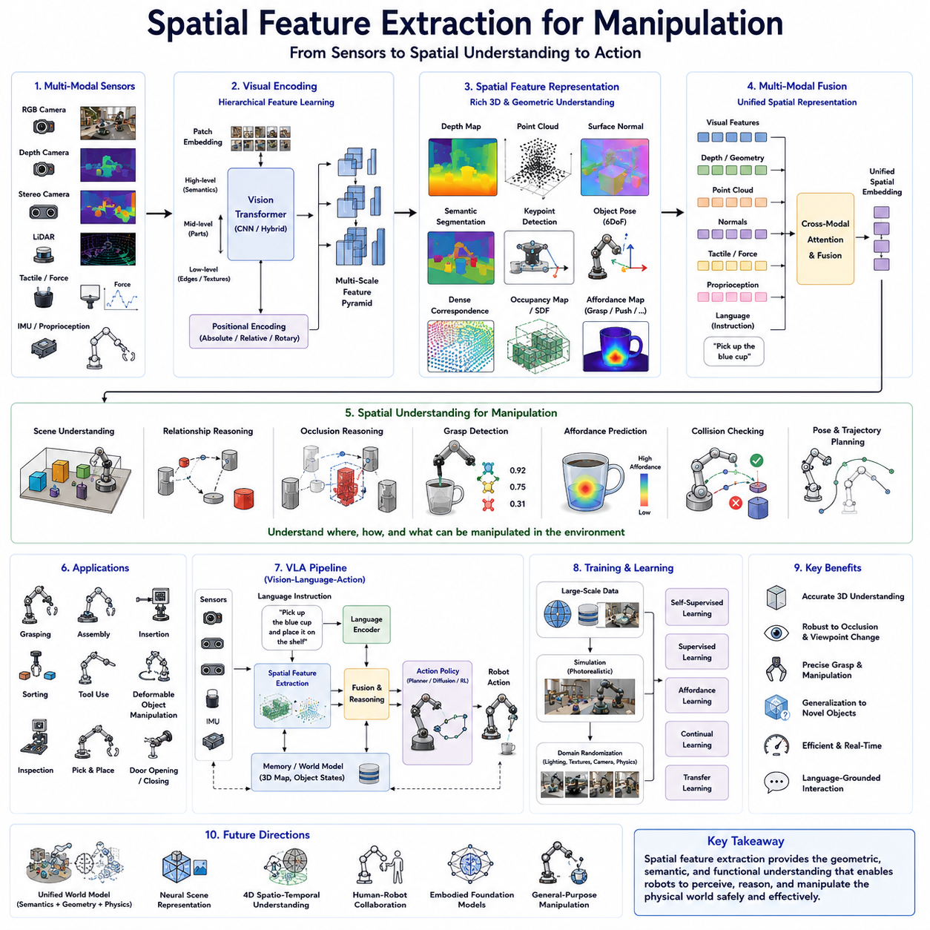
Spatial feature extraction is one of the most fundamental components of robotic manipulation and serves as the bridge between visual perception and physical interaction. While conventional image recognition focuses primarily on identifying what objects are present within a scene, manipulation-oriented perception must additionally understand where objects are located, how they are oriented, how they relate to surrounding objects, and how they can be physically manipulated. Vision-Language-Action (VLA) systems therefore require spatial representations that preserve not only semantic information but also geometric structure, three-dimensional relationships, physical affordances, and interaction constraints. The quality of these spatial features directly determines whether a robot can successfully grasp, assemble, sort, inspect, or manipulate objects in complex real-world environments.
The importance of spatial understanding becomes immediately apparent when comparing image classification with robotic manipulation. A traditional image classifier may successfully identify a coffee mug regardless of its location, orientation, or accessibility. However, a robot attempting to grasp that mug requires substantially richer information. It must estimate the mug's precise position, determine its orientation, identify the handle location, evaluate grasp stability, avoid nearby obstacles, and plan a collision-free trajectory. Thus, manipulation requires perception that extends far beyond semantic recognition toward detailed geometric understanding.
Spatial feature extraction refers to the process of transforming raw sensor observations into structured representations describing the geometry, topology, relationships, and physical properties of objects within the environment. These representations provide downstream action policies with sufficient information to reason about contact, motion, force application, grasp planning, and object interaction. Rather than simply encoding visual appearance, spatial features preserve the physical organization of the surrounding world.
Modern robotic perception integrates multiple sensing modalities to construct comprehensive spatial representations. RGB cameras provide rich texture, color, and semantic information. Depth cameras estimate object distance and surface geometry. Stereo vision reconstructs three-dimensional structures through binocular disparity. LiDAR generates accurate point cloud measurements over large environments. Structured-light sensors capture dense depth maps for indoor manipulation. Event cameras provide high-speed motion information, while tactile and force sensors complement visual perception during physical interaction. Together, these sensors produce multimodal observations supporting robust spatial reasoning.
Within Vision-Language-Action architectures, spatial feature extraction typically begins with visual encoding. Images acquired from multiple cameras are processed using Vision Transformers, convolutional neural networks, or hybrid architectures capable of extracting hierarchical feature representations. Early layers preserve low-level visual characteristics including edges, corners, textures, gradients, and local patterns. Intermediate layers gradually capture object parts, surface structures, and spatial configurations. Higher layers encode semantic object representations together with contextual relationships necessary for manipulation planning.
Unlike image classification, robotic manipulation requires preserving spatial correspondence throughout feature extraction. Downstream grasp planners must determine exactly where object boundaries occur, where contact surfaces exist, and how object geometry influences feasible manipulation strategies. Consequently, manipulation-oriented visual encoders frequently maintain higher spatial resolution than classification models while minimizing information loss caused by excessive pooling or downsampling operations.
Feature pyramids have become important components within spatial perception systems. Different feature resolutions capture complementary information across multiple spatial scales. Fine-resolution features preserve detailed geometric structure including grasp points, object boundaries, and small components. Intermediate resolutions capture object parts and local configurations. Coarse representations encode overall scene organization and long-range contextual relationships. Multi-scale fusion combines these complementary representations, enabling simultaneous reasoning about local precision and global context.
Vision Transformers provide several advantages for manipulation-oriented perception because self-attention naturally captures long-range spatial dependencies across entire images. Unlike convolutional filters constrained by local receptive fields, attention mechanisms allow every image patch to communicate directly with every other patch. Consequently, transformers learn object relationships, spatial context, scene organization, and interaction constraints extending across complex environments. Such capabilities significantly improve manipulation planning involving multiple objects or cluttered scenes.
Positional encoding plays an essential role in transformer-based spatial feature extraction. Since transformer architectures process unordered token sequences, explicit positional information must be introduced to preserve spatial arrangement. Absolute positional embeddings assign unique coordinates to every image patch. Relative positional encoding captures distances and orientations between neighboring regions. Rotary positional embeddings preserve rotational relationships. These encoding strategies ensure that learned representations remain sensitive to geometric structure despite transformer permutation invariance.
Depth perception dramatically enhances manipulation performance by introducing explicit three-dimensional geometric information unavailable from monocular RGB images alone. RGB images accurately capture appearance but cannot directly determine object distance or depth ordering. Depth sensors provide metric measurements enabling robots to estimate object pose, surface orientation, grasp approach direction, collision avoidance, and workspace geometry. Modern manipulation systems therefore increasingly combine RGB semantics with depth geometry to generate robust spatial representations.
RGB-D perception has become one of the dominant paradigms within robotic manipulation. RGB channels contribute semantic object recognition, texture understanding, material appearance, and language grounding. Depth channels contribute geometric structure, object boundaries, surface normals, and precise distance measurements. Fusion architectures integrate both modalities throughout feature extraction, producing unified representations simultaneously encoding semantic and geometric information. Such multimodal fusion substantially improves manipulation robustness under diverse environmental conditions.
Point clouds provide another powerful representation for spatial feature extraction. Rather than projecting three-dimensional environments onto two-dimensional image planes, point clouds directly represent physical geometry through collections of three-dimensional coordinates. Each point corresponds to a measured surface location within Cartesian space. Additional attributes including color, intensity, surface normals, semantic labels, or confidence scores further enrich these geometric representations. Point cloud processing enables robots to reason directly within physical three-dimensional environments.
Processing point clouds presents unique computational challenges because points lack regular grid structure characteristic of images. Specialized architectures including PointNet, PointNet++, Dynamic Graph CNN, Point Transformer, sparse voxel networks, and graph neural networks have therefore been developed specifically for irregular geometric data. These architectures learn permutation-invariant representations while preserving local geometric relationships necessary for robotic manipulation.
Surface normal estimation represents another important component of spatial feature extraction. Surface normals describe local orientation at every point on an object's surface. Knowledge of surface orientation significantly improves grasp planning because robotic grippers typically approach objects perpendicular to stable contact surfaces. Surface normals additionally support object reconstruction, collision avoidance, insertion tasks, assembly operations, and force planning. Many manipulation systems explicitly incorporate surface normal estimation within perception pipelines.
Object pose estimation provides six-degree-of-freedom representations describing object position and orientation relative to the robot coordinate system. Accurate pose estimation enables precise grasp execution, insertion operations, assembly tasks, tool manipulation, and industrial automation. Spatial feature extraction therefore frequently incorporates pose prediction networks jointly estimating translation and rotation directly from visual observations. Multi-view perception further improves pose accuracy by reducing occlusion and viewpoint ambiguity.
Keypoint detection offers another effective strategy for manipulation-oriented perception. Rather than modeling complete object geometry, robots identify semantically meaningful landmark points including handles, corners, edges, insertion holes, grasp regions, hinges, or articulation joints. Keypoint representations significantly simplify downstream planning because manipulation policies may operate directly upon meaningful geometric references instead of dense visual observations. Learned keypoint detectors increasingly outperform manually engineered feature extraction methods.
Affordance learning extends spatial feature extraction beyond geometry toward functional understanding. Affordances describe how objects may be manipulated rather than merely what objects are. Handles afford grasping. Buttons afford pressing. Knobs afford rotation. Doors afford pulling or pushing. Containers afford filling. Such functional representations emerge through learning associations between visual appearance, geometry, and successful manipulation outcomes. Modern Vision-Language-Action systems increasingly predict affordance maps highlighting regions supporting specific actions.
Dense correspondence estimation plays an important role when manipulating deformable objects, articulated mechanisms, or previously unseen instances. Dense correspondence establishes pixel-level or point-level mappings between observed objects and reference models. Such mappings enable robots to transfer grasp strategies across object instances, estimate deformation, track manipulation progress, and perform precise assembly. Self-supervised representation learning has substantially improved dense correspondence quality over recent years.
Semantic segmentation contributes significantly toward manipulation by assigning semantic labels to every pixel within visual observations. Rather than merely recognizing entire objects, segmentation identifies precise object boundaries separating manipulable items from surrounding environments. Instance segmentation further distinguishes multiple objects belonging to identical categories. Such detailed spatial understanding facilitates collision avoidance, object isolation, grasp planning, and task decomposition within cluttered workspaces.
Occlusion reasoning represents another essential aspect of spatial perception. Real-world manipulation frequently occurs within cluttered environments where objects partially obstruct one another. Successful manipulation requires reasoning about hidden surfaces, depth ordering, visibility constraints, and reachable grasp configurations. Multi-view cameras, active perception, probabilistic occupancy maps, and neural scene representations increasingly enable robots to infer partially occluded object geometry supporting robust manipulation despite incomplete observations.
Spatial attention mechanisms allow perception systems to prioritize visually relevant regions while suppressing irrelevant background information. Manipulation tasks frequently involve only one or several target objects among numerous distractors. Attention modules focus computational resources upon grasp candidates, manipulation targets, tool interfaces, or language-referenced objects. Language-conditioned attention further directs perception toward objects specified through natural language instructions, enabling flexible human-robot interaction.
Multi-camera perception substantially improves spatial feature quality by reducing viewpoint ambiguity and increasing environmental coverage. Head-mounted cameras observe global scene organization. Wrist-mounted cameras provide detailed close-range manipulation views. Stereo pairs estimate local depth accurately. Overhead cameras monitor workspace organization. Fusing observations from multiple viewpoints generates more complete spatial representations while improving robustness against occlusion, sensor noise, and limited viewing angles.
Three-dimensional scene reconstruction extends spatial perception beyond individual observations toward persistent world models. Simultaneous Localization and Mapping systems accumulate observations across time to construct globally consistent geometric maps. Neural radiance fields, Gaussian splatting, signed distance fields, occupancy networks, and implicit neural representations further enhance scene reconstruction quality. Such persistent spatial models enable long-horizon manipulation planning extending beyond immediate sensor observations.
Temporal consistency becomes increasingly important for manipulation involving moving objects, dynamic environments, or continuous interaction. Individual frames often contain ambiguous or incomplete information. Temporal feature integration accumulates observations across multiple time steps, improving robustness against sensor noise, occlusion, motion blur, and transient perception failures. Recurrent neural networks, temporal transformers, memory modules, and state estimation algorithms provide mechanisms for maintaining coherent spatial understanding throughout manipulation sequences.
Robotic grasp detection represents one of the most extensively studied applications of spatial feature extraction. Given visual observations, grasp detection networks predict feasible gripper positions, orientations, widths, approach directions, and grasp quality scores. Modern grasp prediction increasingly combines semantic object understanding with dense geometric representations derived from RGB-D images, point clouds, surface normals, and transformer-based visual features. Such integrated representations significantly outperform purely appearance-based approaches.
Manipulation involving deformable objects introduces additional complexity because object geometry changes continuously throughout interaction. Fabrics, cables, ropes, food products, biological tissues, and flexible packaging require spatial representations capable of modeling deformation dynamics. Traditional rigid-body assumptions become insufficient. Learned neural representations incorporating temporal geometry, physical simulation, and differentiable deformation models increasingly support manipulation of flexible materials.
Industrial robotics frequently demands sub-millimeter spatial precision during assembly, insertion, welding, inspection, or semiconductor manufacturing. High-resolution spatial features combined with calibrated camera systems, structured lighting, laser triangulation, and force sensing enable extremely accurate geometric perception. Such precision supports insertion tolerances, alignment correction, quality inspection, and automated manufacturing operations requiring exceptional positional accuracy.
Language grounding increasingly influences spatial feature extraction within Vision-Language-Action architectures. Instructions such as “grasp the screwdriver beside the blue toolbox” require perception systems to associate semantic language with precise spatial locations. Language-conditioned visual encoders generate spatial attention maps identifying objects referenced within natural language descriptions. Consequently, robots combine semantic reasoning with geometric localization when executing human instructions.
Foundation vision models including DINOv2, CLIP, SigLIP, SAM, and other transformer-based architectures increasingly provide pretrained spatial representations transferable toward robotic manipulation. Rather than learning perception entirely from robotic datasets, developers initialize manipulation systems using large-scale visual foundation models before adapting representations toward specialized manipulation tasks. Such transfer learning significantly improves generalization while reducing annotation requirements.
Simulation has become an indispensable component of spatial feature learning. High-fidelity simulation environments generate unlimited synthetic manipulation data including RGB images, depth maps, segmentation labels, object poses, contact information, force measurements, and successful demonstrations. Domain randomization introduces variations in lighting, textures, materials, camera parameters, and object arrangements. Models pretrained in simulation subsequently transfer effectively toward real-world robotic manipulation through sim-to-real adaptation techniques.
Feature fusion represents a central design principle throughout manipulation perception. Semantic embeddings derived from visual foundation models combine with geometric representations obtained from depth sensors, point clouds, proprioception, tactile sensing, force feedback, and environmental maps. Cross-modal attention mechanisms integrate these heterogeneous information sources into unified representations supporting comprehensive manipulation reasoning. Such multimodal fusion increasingly defines state-of-the-art robotic perception architectures.
Computational efficiency remains a critical engineering consideration because manipulation requires real-time perception operating within closed-loop control systems. Excessive inference latency directly reduces manipulation accuracy, particularly during dynamic interaction. Efficient transformer architectures, sparse attention mechanisms, token pruning, quantization, hardware acceleration, TensorRT optimization, and edge AI deployment strategies enable high-quality spatial feature extraction while satisfying strict real-time constraints imposed by robotic control.
Robustness across varying operating conditions constitutes another essential requirement. Manipulation systems must tolerate changing illumination, reflective surfaces, transparent materials, sensor noise, partial occlusion, clutter, viewpoint variation, motion blur, and environmental uncertainty. Self-supervised learning, data augmentation, domain adaptation, continual learning, uncertainty estimation, and multimodal sensing collectively improve spatial feature robustness throughout long-term robotic deployment.
Future research directions increasingly emphasize unified spatial representations integrating semantics, geometry, physics, language, memory, and action within a single foundation architecture. Rather than treating perception, planning, and manipulation as independent components, next-generation Vision-Language-Action systems will construct comprehensive world models representing object identity, spatial organization, physical behavior, manipulation affordances, temporal evolution, and causal relationships simultaneously. Such integrated representations will enable robots to reason about complex manipulation tasks with human-like flexibility and generalization.
Ultimately, spatial feature extraction forms the perceptual foundation upon which intelligent robotic manipulation is built. Accurate semantic recognition alone is insufficient for physical interaction. Robots must understand geometry, depth, pose, affordances, contact surfaces, object relationships, temporal dynamics, and environmental structure in order to manipulate the physical world safely and effectively. Modern transformer-based vision encoders, multimodal fusion architectures, self-supervised foundation models, and three-dimensional perception systems collectively provide increasingly powerful spatial representations supporting sophisticated manipulation capabilities across industrial automation, service robotics, healthcare, logistics, agriculture, and general-purpose embodied artificial intelligence.

2.7 Multi-Camera Vision Encoding: Wrist, Head, and Stereo Cameras (with Code)
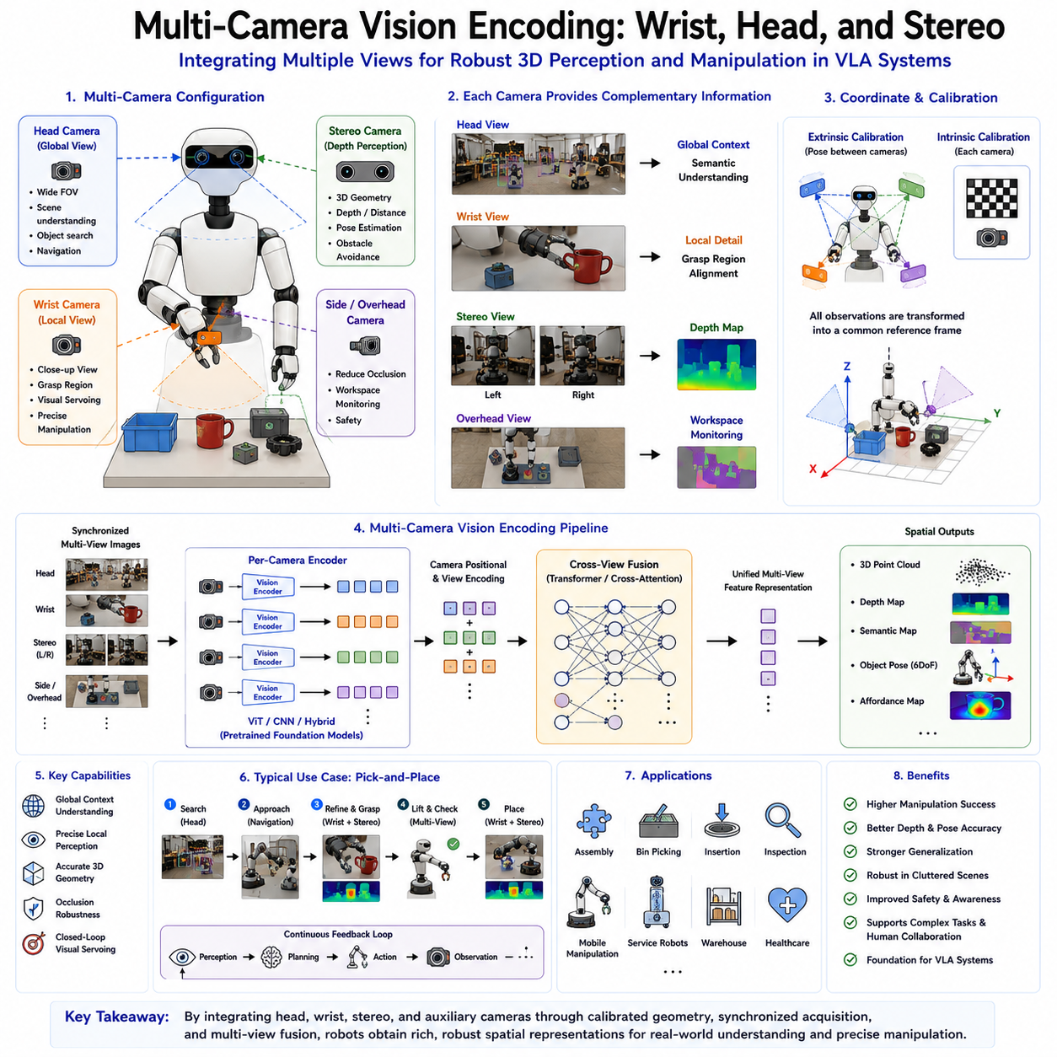
Multi-camera vision encoding has become one of the most important technologies in modern robotic perception because no single camera can provide complete visual information for complex manipulation and autonomous operation. Human vision naturally combines multiple viewpoints through two eyes while simultaneously coordinating head movements, body posture, and hand-eye coordination to understand three-dimensional environments. Modern robots adopt a similar strategy by integrating multiple cameras positioned at different locations on the robot, such as head-mounted cameras, wrist-mounted cameras, stereo camera pairs, side cameras, overhead cameras, and environmental cameras. Together, these sensors provide complementary visual information that enables robust perception, spatial reasoning, manipulation, navigation, and interaction with dynamic environments. In Vision-Language-Action (VLA) systems, multi-camera vision encoding has evolved into a fundamental perception architecture that supplies comprehensive spatial representations for downstream language understanding, reasoning, planning, and action generation.
The motivation for multi-camera vision originates from the inherent limitations of single-view perception. A single RGB camera captures only one projection of a three-dimensional world, resulting in unavoidable ambiguity regarding depth, occlusion, hidden surfaces, object geometry, and spatial relationships. Objects may become partially invisible behind obstacles, important grasp regions may remain hidden, and lighting conditions may degrade visual quality. These limitations significantly reduce manipulation success and navigation robustness. Multiple synchronized cameras provide complementary observations from different viewpoints, dramatically reducing uncertainty while improving overall environmental understanding.
Human manipulation demonstrates the importance of multi-view perception. When reaching for an object, humans continuously integrate information from both eyes, head movement, peripheral vision, and proprioception. Eye-hand coordination allows continuous refinement of grasp trajectories as hands approach target objects. Similarly, robotic manipulation benefits substantially from combining global scene observations with close-range local views. Head-mounted cameras monitor workspace organization, while wrist-mounted cameras provide detailed observations during grasp execution. Stereo cameras estimate metric depth, and additional environmental cameras monitor surrounding obstacles. Together these observations support significantly more reliable manipulation than any individual sensor could achieve independently.
Within Vision-Language-Action architectures, multi-camera systems generally include several complementary camera configurations. Head cameras provide broad environmental awareness resembling human vision. Wrist cameras observe manipulation targets from close range during grasping. Stereo camera pairs estimate three-dimensional geometry through binocular disparity. Side cameras improve coverage around manipulators, while overhead cameras monitor global workspace organization. Mobile robots additionally incorporate forward navigation cameras, rear cameras, panoramic systems, and occasionally downward-facing cameras supporting terrain understanding. The exact configuration depends upon robotic embodiment and intended operational tasks.
Head-mounted cameras function as the primary source of global scene understanding. Positioned near the robot's upper body or head, these cameras observe large portions of the surrounding environment. Their field of view includes multiple objects, navigation pathways, obstacles, workstations, human collaborators, and contextual scene information. Since head cameras remain relatively distant from manipulation targets, they emphasize semantic understanding, object localization, task planning, environmental awareness, and navigation rather than fine geometric detail.
Global perception provided by head cameras supports numerous high-level cognitive functions. Object detection identifies candidate manipulation targets throughout the environment. Semantic segmentation distinguishes furniture, equipment, workstations, containers, and free space. Scene understanding recognizes kitchens, warehouses, laboratories, hospitals, offices, or manufacturing cells. Human detection supports collaborative robotics and safety monitoring. Navigation modules estimate traversable pathways while simultaneously identifying obstacles and landmarks supporting localization. Consequently, head cameras provide essential contextual information guiding overall robotic behavior.
Wrist-mounted cameras complement global perception by providing detailed close-range observations during manipulation. Mounted directly on robotic end effectors or near grippers, these cameras continuously observe target objects from perspectives closely matching manipulation geometry. Because wrist cameras move together with robot arms, they naturally maintain visibility of grasp targets even as manipulators approach objects. This active viewpoint significantly improves grasp precision, insertion accuracy, assembly operations, and visual servoing.
The importance of wrist cameras becomes particularly evident during precision manipulation tasks. Head cameras often lose visibility when robotic arms occlude target objects during reaching motions. Wrist cameras remain positioned immediately beside the gripper, continuously monitoring contact surfaces, insertion holes, assembly interfaces, object boundaries, and grasp regions throughout manipulation. Such detailed observations enable closed-loop control correcting positioning errors during execution. Consequently, industrial assembly, connector insertion, bin picking, precision inspection, and tool manipulation increasingly depend upon wrist-mounted visual sensing.
Visual servoing represents one of the primary applications of wrist camera perception. Rather than executing open-loop trajectories computed before movement begins, robots continuously update motion commands based upon real-time visual feedback acquired from wrist-mounted sensors. Small positioning errors caused by calibration uncertainty, object movement, mechanical tolerance, or environmental disturbance become corrected dynamically throughout manipulation. Closed-loop visual servoing substantially improves manipulation precision compared with purely kinematic control.
Stereo vision introduces explicit three-dimensional perception by exploiting binocular geometry. Two calibrated cameras observe identical scenes from slightly different viewpoints. Corresponding image points appear displaced between left and right images due to perspective differences. This disparity allows triangulation algorithms to estimate metric depth for every visible surface. Stereo perception therefore transforms two-dimensional image observations into dense three-dimensional geometric representations supporting manipulation, navigation, collision avoidance, and scene reconstruction.
Depth estimation derived from stereo vision provides numerous advantages compared with monocular perception. Object distance becomes directly measurable rather than inferred indirectly through learned priors. Surface orientation, object dimensions, workspace geometry, obstacle locations, and free-space boundaries become explicitly available. Such geometric information dramatically improves grasp planning, manipulation safety, autonomous navigation, and spatial reasoning. Modern robotic systems increasingly integrate stereo depth with semantic understanding generated by foundation vision models.
Stereo matching constitutes the computational core of binocular perception. Corresponding image features must be identified across both camera views before triangulation estimates three-dimensional coordinates. Classical stereo algorithms relied upon handcrafted feature descriptors and block matching. Contemporary systems instead employ deep neural networks learning dense stereo correspondence directly from data. Transformer-based stereo architectures further improve correspondence accuracy while remaining robust against illumination changes, repetitive textures, reflective surfaces, and partial occlusion.
Calibration represents a critical prerequisite for successful multi-camera perception. Intrinsic calibration estimates individual camera parameters including focal length, principal point, lens distortion, and pixel geometry. Extrinsic calibration determines relative positions and orientations among all cameras mounted throughout the robotic platform. Accurate calibration ensures observations acquired from different viewpoints remain geometrically consistent, allowing reliable sensor fusion and spatial reasoning. Even small calibration errors may significantly degrade manipulation accuracy, particularly during precision industrial operations.
Temporal synchronization is equally important because multiple cameras frequently observe dynamic scenes containing moving robots, humans, or manipulated objects. Unsynchronized image acquisition produces inconsistent observations that complicate sensor fusion. Hardware triggering, Precision Time Protocol synchronization, Global Navigation Satellite System timing, and deterministic Ethernet communication increasingly provide sub-millisecond synchronization across complex robotic sensor networks. Consistent timestamps ensure observations correspond to identical physical moments despite distributed sensing architectures.
Coordinate transformation enables observations from multiple cameras to be integrated within common reference frames. Every camera initially measures objects relative to its own coordinate system. Transformation matrices derived during calibration convert all observations into robot-centered, world-centered, or manipulation-centered coordinate frames. Such unified spatial representations permit downstream planning modules to reason consistently across heterogeneous sensing modalities regardless of original observation viewpoint.
Multi-camera feature fusion represents one of the central challenges within modern robotic perception. Each camera generates distinct feature embeddings emphasizing different aspects of environmental structure. Head cameras contribute semantic context. Wrist cameras provide detailed manipulation geometry. Stereo cameras estimate depth. Side cameras reduce occlusion. Simply concatenating these features often proves insufficient because viewpoints differ substantially. Advanced fusion architectures therefore learn optimal integration strategies through neural attention mechanisms, transformer cross-attention, graph reasoning, or hierarchical multimodal fusion.
Cross-attention has become particularly effective for multi-camera feature integration. Features generated from one camera attend selectively toward complementary information extracted by other viewpoints. Head camera representations identify manipulation targets globally, while wrist camera features refine local geometry. Stereo depth enhances semantic segmentation by supplying geometric context. Cross-attention dynamically exchanges information across viewpoints, producing unified representations richer than individual camera observations alone.
Hierarchical fusion strategies integrate multi-camera information gradually across multiple representation levels. Early fusion combines raw image features before substantial semantic processing. Intermediate fusion exchanges information between partially processed feature maps. Late fusion integrates high-level semantic embeddings generated independently by each camera. Hybrid architectures combine multiple fusion stages simultaneously, exploiting complementary advantages associated with different integration strategies. Selection depends upon computational constraints, available training data, sensor configuration, and application requirements.
Transformer architectures naturally support multi-camera perception because self-attention mechanisms operate upon arbitrary token collections regardless of originating viewpoint. Visual tokens extracted from multiple cameras become jointly processed within shared transformer layers, allowing direct information exchange among all observations. Learned positional encodings distinguish camera identities while preserving geometric relationships. Such unified transformer architectures increasingly dominate multi-camera robotic perception because they scale naturally toward complex multimodal sensing systems.
Spatial consistency remains an important objective throughout feature fusion. Different cameras observing identical objects should ultimately generate coherent representations despite viewpoint variation. Self-supervised learning, contrastive objectives, geometric constraints, and multi-view consistency losses encourage viewpoint-invariant semantic embeddings while preserving spatial accuracy. Consequently, robots recognize identical objects consistently regardless of observing camera, approach direction, or manipulation stage.
Occlusion handling represents one of the greatest practical advantages of multi-camera perception. Real-world manipulation frequently occurs within cluttered environments where individual viewpoints become partially blocked by robot arms, containers, neighboring objects, or environmental structures. Multiple cameras dramatically reduce visibility loss because surfaces hidden from one viewpoint often remain observable elsewhere. Fusion algorithms combine visible regions into complete object representations supporting robust manipulation despite partial occlusion.
Manipulation planning benefits substantially from viewpoint diversity. Head cameras identify target objects and estimate initial approach trajectories. Wrist cameras refine grasp alignment during final approach. Stereo perception verifies obstacle clearance and grasp geometry. Side cameras monitor neighboring objects preventing unintended collisions. Integrated perception therefore supports hierarchical planning progressing smoothly from global task reasoning toward precise local execution.
Pick-and-place operations illustrate the complete multi-camera perception pipeline. Head cameras first detect target objects within cluttered workspaces while generating semantic understanding. Navigation systems position manipulators appropriately. Stereo cameras estimate object depth and pose. Wrist cameras refine grasp alignment during final approach using visual servoing. During lifting, wrist cameras monitor object stability while head cameras verify successful removal. During placement, stereo and wrist observations jointly guide precise positioning. Throughout execution, multiple viewpoints continuously update world models supporting closed-loop control.
Industrial assembly further demonstrates the necessity of multi-camera encoding. Insertion tasks frequently require sub-millimeter precision exceeding capabilities of single-view perception. Head cameras guide coarse manipulator positioning. Stereo systems estimate assembly geometry. Wrist cameras identify connector alignment immediately before insertion. Visual servoing corrects small positioning errors while force sensors monitor contact. Such coordinated sensing dramatically improves assembly success under manufacturing conditions characterized by mechanical tolerance variation and environmental uncertainty.
Autonomous mobile manipulation introduces additional complexity because navigation and manipulation occur simultaneously. Forward-facing cameras observe navigation pathways while head cameras identify manipulation targets. Stereo systems estimate obstacle geometry. Wrist cameras support object interaction. Environmental cameras monitor shared workspaces containing humans and other robots. Coordinating these heterogeneous observations requires sophisticated perception architectures maintaining consistent world models despite continuous robot movement.
Foundation vision models have significantly improved multi-camera representation learning. Vision Transformers pretrained using large-scale datasets extract semantically meaningful features transferable across diverse viewpoints. Models including DINOv2, CLIP, SigLIP, Segment Anything Model, and emerging multimodal foundation architectures increasingly initialize individual camera encoders before downstream multi-view adaptation. Such transfer learning substantially reduces robotic dataset requirements while improving generalization across diverse operating environments.
Simulation plays an increasingly important role during multi-camera training. Photorealistic simulation environments generate synchronized observations from arbitrary camera configurations together with accurate depth maps, segmentation labels, object poses, correspondence annotations, and successful manipulation demonstrations. Domain randomization introduces variation in lighting, camera placement, materials, textures, weather, and sensor characteristics, improving sim-to-real transfer. Large-scale simulated multi-camera datasets therefore accelerate development while reducing dependence upon expensive physical data collection.
Edge deployment introduces important computational considerations because processing multiple high-resolution camera streams simultaneously requires substantial computational resources. Efficient transformer architectures, shared backbone encoders, feature compression, token pruning, hardware acceleration, mixed-precision inference, TensorRT optimization, and neural processing units collectively reduce latency while preserving perception quality. Real-time manipulation generally requires perception pipelines operating comfortably within closed-loop control frequencies, motivating continual optimization of multi-camera inference efficiency.
Memory management similarly becomes increasingly important as camera count grows. Rather than storing full-resolution observations from every viewpoint indefinitely, modern architectures maintain compact latent world representations integrating information across cameras and time. Episodic memory modules preserve task-relevant observations while discarding redundant visual information. Such compact representations improve long-horizon reasoning without excessive computational overhead.
Uncertainty estimation provides additional robustness throughout multi-camera perception. Individual cameras may experience temporary degradation due to lighting variation, motion blur, lens contamination, or hardware failure. Bayesian inference, confidence estimation, probabilistic sensor fusion, and ensemble representations allow robots to quantify uncertainty associated with each viewpoint. Fusion algorithms subsequently weight observations according to estimated reliability, improving resilience under challenging environmental conditions.
Future research increasingly emphasizes unified perception architectures simultaneously processing images, depth, tactile sensing, proprioception, language instructions, memory, and world models within shared transformer frameworks. Rather than treating each camera independently, future robotic foundation models will construct persistent three-dimensional semantic representations continuously updated through observations from all available sensors. Such integrated world models will support increasingly sophisticated manipulation, navigation, collaboration, and long-horizon reasoning.
Another important research direction involves adaptive viewpoint selection. Instead of relying exclusively upon fixed camera configurations, robots will actively reposition cameras through head movement, arm motion, mobile platforms, or pan-tilt mechanisms to maximize information gain. Active perception combines planning and sensing, allowing robots to reduce uncertainty by selecting optimal viewpoints before executing manipulation. Such adaptive sensing more closely resembles human visual exploration during complex manual tasks.
Ultimately, multi-camera vision encoding provides the perceptual foundation required for reliable robotic manipulation in complex real-world environments. Individual cameras inevitably suffer from limited field of view, occlusion, depth ambiguity, and viewpoint dependency. Combining head cameras, wrist cameras, stereo vision, environmental sensing, and multimodal fusion overcomes these limitations by generating comprehensive spatial representations integrating global context, local geometry, semantic understanding, and precise three-dimensional structure. As Vision-Language-Action systems continue evolving toward increasingly capable embodied intelligence, multi-camera vision encoding will remain an essential technology enabling robots to perceive, understand, reason about, and safely manipulate the physical world with human-like flexibility and robustness.

2.8 3D Vision Encoding Using Depth and Point Clouds (with Code)
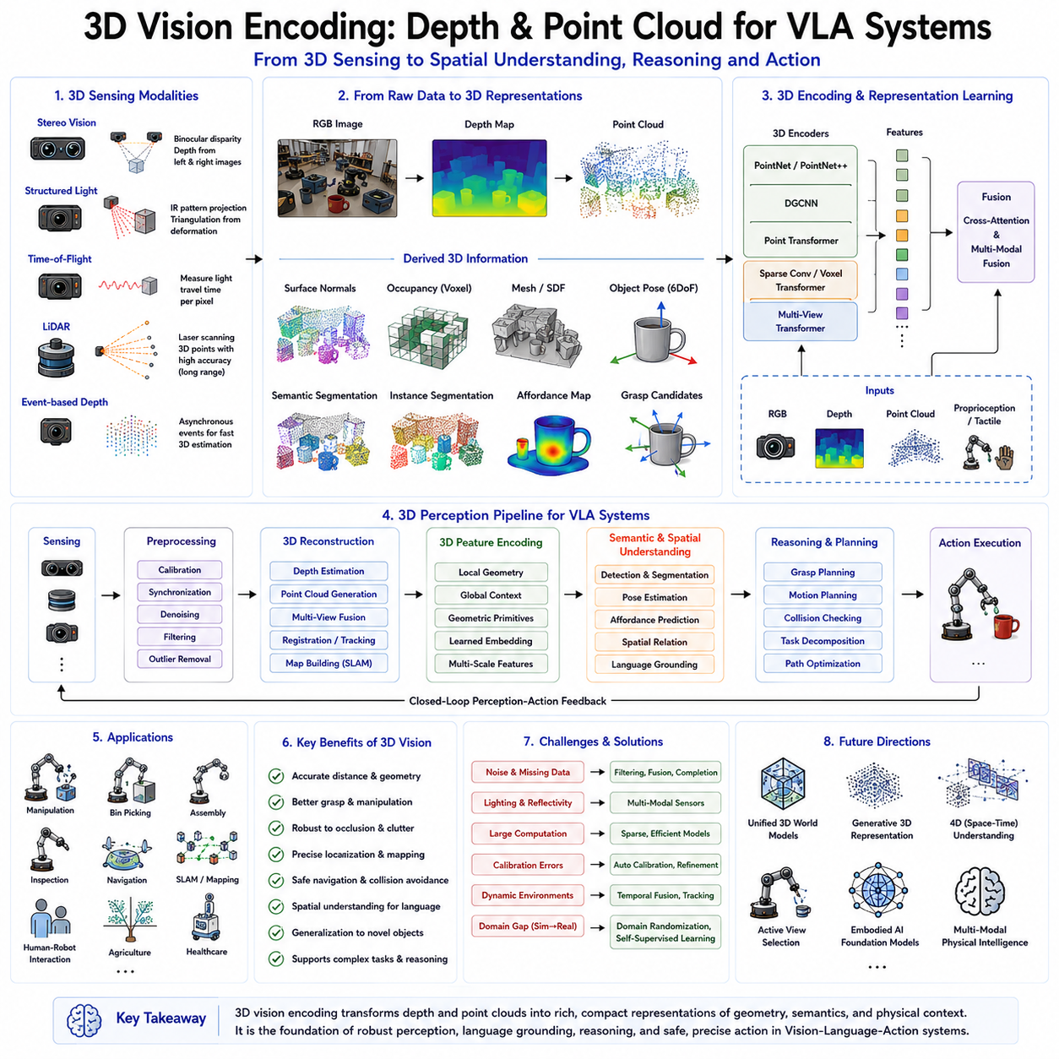
Three-dimensional vision encoding has become one of the most essential technologies in modern robotics because intelligent interaction with the physical world fundamentally requires understanding three-dimensional geometry rather than merely recognizing two-dimensional images. While conventional computer vision primarily analyzes color, texture, and semantic appearance from RGB images, robotic systems must additionally perceive object depth, surface geometry, spatial relationships, physical dimensions, and environmental structure in order to manipulate objects safely and accurately. Vision-Language-Action (VLA) systems therefore increasingly rely on three-dimensional vision encoding to transform raw depth measurements and point cloud data into compact semantic representations that can support perception, reasoning, planning, and physical interaction. The integration of three-dimensional geometry with multimodal foundation models represents one of the most important directions in the evolution of embodied artificial intelligence.
The necessity of three-dimensional perception originates from the limitations of two-dimensional imaging. A conventional RGB image represents the projection of a three-dimensional world onto a two-dimensional image plane. During this projection process, depth information is lost, making it impossible to directly determine object distance, physical size, relative elevation, or surface orientation from a single image. Humans overcome this limitation through binocular vision, motion parallax, prior knowledge, and continuous interaction with the environment. Robots must similarly reconstruct three-dimensional information before executing reliable manipulation, navigation, inspection, or autonomous decision making.
Depth perception provides the missing geometric dimension required for physical interaction. Rather than representing only horizontal and vertical image coordinates, every pixel becomes associated with an estimated distance from the camera. This additional information enables robots to estimate object pose, compute collision-free trajectories, evaluate grasp feasibility, reconstruct surrounding environments, and understand the physical arrangement of objects within three-dimensional space. Consequently, depth sensing has become a standard component of modern autonomous robots, industrial manipulators, service robots, warehouse automation systems, medical robots, agricultural machines, and humanoid platforms.
Several sensing technologies are capable of measuring depth information. Stereo vision estimates depth through binocular disparity between two synchronized cameras. Structured-light cameras project known infrared patterns onto objects and recover depth from pattern deformation. Time-of-flight sensors measure the travel time of emitted infrared light reflected from surrounding surfaces. LiDAR systems estimate distance using laser pulse timing and scanning mechanisms. Event-based depth sensors combine asynchronous measurements with geometric reconstruction. Each sensing modality offers different trade-offs regarding accuracy, range, computational complexity, environmental robustness, power consumption, and cost.
Stereo vision remains one of the most widely adopted approaches because it resembles natural human binocular perception while requiring relatively inexpensive hardware. Two calibrated cameras simultaneously observe identical scenes from slightly different viewpoints. Corresponding image features appear displaced according to object distance. Stereo matching algorithms identify corresponding pixels and triangulate three-dimensional coordinates. The resulting depth maps provide dense geometric information suitable for manipulation, navigation, and obstacle avoidance. Recent deep learning-based stereo matching networks significantly outperform traditional handcrafted correspondence algorithms, especially under challenging lighting conditions, reflective materials, repetitive textures, and partial occlusion.
Structured-light sensing provides highly accurate short-range depth estimation by projecting known infrared patterns onto observed surfaces. Distortion of these projected patterns reveals surface geometry through triangulation. Structured-light cameras achieve excellent precision indoors and are commonly deployed within industrial inspection, robotic manipulation, human tracking, and augmented reality systems. However, strong ambient sunlight may interfere with infrared projection, limiting outdoor applicability.
Time-of-flight cameras estimate depth using the propagation time of emitted infrared illumination. Every image pixel measures distance independently by calculating light travel time between the sensor and observed surfaces. Compared with structured-light systems, time-of-flight cameras generally provide higher acquisition speed and improved robustness under moderate environmental variation. Their compact size, dense depth output, and real-time operation make them particularly suitable for robotic perception, autonomous navigation, and gesture recognition.
LiDAR technology provides another important source of three-dimensional information. Rather than generating dense image-like depth maps, LiDAR measures discrete three-dimensional points by scanning laser beams across surrounding environments. Each laser return directly represents a physical point within Cartesian space. Modern spinning LiDAR systems generate millions of three-dimensional measurements every second, enabling highly accurate mapping, localization, terrain understanding, and obstacle detection. Solid-state LiDAR technologies continue reducing cost, size, and mechanical complexity while improving reliability for large-scale robotic deployment.
Depth maps represent one of the simplest three-dimensional visual encodings. Every pixel contains a scalar value corresponding to distance from the imaging sensor. Such representations naturally align with conventional RGB images, simplifying multimodal fusion between semantic appearance and geometric structure. Many Vision-Language-Action architectures process RGB and depth observations simultaneously through shared or parallel visual encoders before integrating multimodal representations for downstream reasoning and action generation.
Although depth maps capture geometric information efficiently, they remain viewpoint-dependent image representations. Point clouds instead directly represent the physical geometry of surrounding environments. Every point consists of three-dimensional spatial coordinates, typically expressed within Cartesian reference frames. Additional attributes including color, surface normals, intensity, semantic labels, timestamps, confidence scores, and sensor provenance further enrich point cloud representations. Unlike two-dimensional images, point clouds describe real three-dimensional structures independently of viewing perspective.
Point cloud generation occurs through several sensing modalities. LiDAR directly produces point measurements through laser ranging. Stereo vision reconstructs three-dimensional coordinates from binocular disparity. RGB-D cameras combine color imagery with depth estimation to generate colored point clouds. Structured-light sensors similarly recover dense geometric surfaces. Multiple observations acquired over time may additionally accumulate into globally consistent point cloud maps representing complete environments beyond instantaneous sensor fields of view.
Processing point clouds presents unique computational challenges because points lack regular grid organization characteristic of images. Conventional convolutional neural networks assume structured pixel arrangements unsuitable for irregular geometric data. Specialized neural architectures have therefore emerged specifically for point cloud processing. PointNet introduced permutation-invariant feature extraction by independently processing points before global aggregation. PointNet++ extended this concept through hierarchical local neighborhood modeling. Dynamic Graph CNN learned relationships among neighboring points using graph structures. Point Transformer incorporated self-attention directly within three-dimensional geometric representations. Sparse convolutional networks and voxel transformers further improved scalability for large environments.
Voxelization provides another common approach for encoding three-dimensional geometry. Rather than processing individual points directly, surrounding space becomes discretized into small volumetric cells called voxels. Each voxel stores occupancy, density, semantic labels, color statistics, or learned feature embeddings. Three-dimensional convolutional neural networks then process voxel grids analogously to two-dimensional image convolutions. Although voxelization simplifies neural computation, spatial resolution increases cubically with environment size, motivating sparse representations and adaptive hierarchical voxel structures.
Surface reconstruction transforms discrete point measurements into continuous geometric models suitable for manipulation planning and simulation. Triangular meshes explicitly represent object surfaces through connected vertices and polygons. Signed distance fields encode implicit geometric boundaries. Occupancy networks estimate continuous spatial occupancy probabilities. Neural radiance fields reconstruct photorealistic volumetric scenes. Gaussian splatting efficiently approximates complex surfaces using probabilistic primitives. Such continuous representations improve collision checking, grasp planning, simulation fidelity, and physical interaction.
Surface normal estimation constitutes another essential component of three-dimensional vision encoding. Surface normals describe local orientation at every observed point, providing valuable geometric information supporting manipulation and navigation. Stable robotic grasps frequently require approaching surfaces approximately perpendicular to local normals. Surface orientation additionally assists insertion operations, assembly alignment, contact modeling, terrain understanding, and object reconstruction. Many modern perception pipelines estimate normals jointly with depth and semantic representations.
Object pose estimation represents one of the primary downstream applications of three-dimensional vision encoding. Six-degree-of-freedom pose describes object translation and rotation relative to robot coordinate systems. Accurate pose estimation enables grasp planning, assembly, tool manipulation, quality inspection, and autonomous interaction. Three-dimensional representations generally produce substantially higher pose estimation accuracy than monocular RGB perception because explicit geometry reduces ambiguity associated with object orientation and spatial configuration.
Three-dimensional semantic segmentation extends pixel-wise labeling into volumetric environments. Rather than assigning semantic classes solely within image space, every point or voxel receives semantic labels describing objects, surfaces, structures, or environmental regions. Such representations support navigation, manipulation, inventory management, infrastructure inspection, autonomous construction, agricultural monitoring, and environmental understanding. Foundation models increasingly integrate semantic segmentation with language grounding, enabling robots to identify arbitrary concepts specified through natural language.
Point cloud registration enables integration of multiple observations acquired from different viewpoints or time instances. Iterative Closest Point algorithms traditionally estimated rigid transformations aligning overlapping point clouds. Modern learning-based registration methods instead predict correspondences directly through neural feature embeddings. Successful registration supports simultaneous localization and mapping, object tracking, multi-camera fusion, long-term environment reconstruction, and collaborative multi-robot perception.
Simultaneous Localization and Mapping systems rely heavily upon three-dimensional vision encoding. Mobile robots continuously estimate their position while incrementally constructing environmental maps from accumulated depth observations. Three-dimensional point clouds provide highly accurate geometric constraints supporting localization despite changing viewpoints, partial occlusion, and dynamic environments. Loop closure detection, pose graph optimization, and semantic mapping further improve long-term mapping consistency. Modern autonomous mobile robots frequently combine LiDAR, stereo vision, inertial measurements, wheel odometry, and global navigation systems within tightly coupled three-dimensional state estimation frameworks.
Three-dimensional perception dramatically improves robotic manipulation by explicitly modeling physical object geometry. Grasp planners evaluate candidate contact points using surface orientation, curvature, accessibility, and collision constraints derived directly from geometric representations. Manipulation strategies adapt automatically to object size, orientation, and surrounding obstacles. Dynamic regrasp planning becomes possible when environmental geometry changes during execution. Such geometric reasoning significantly improves manipulation robustness compared with appearance-only perception.
Language grounding increasingly incorporates three-dimensional representations within Vision-Language-Action architectures. Human instructions frequently reference spatial relationships including above, below, beside, inside, behind, in front of, or between. Two-dimensional images often provide ambiguous interpretations of such relationships. Three-dimensional geometry enables precise spatial reasoning by explicitly representing relative object positions within physical space. Consequently, robots more accurately interpret language instructions requiring spatial understanding.
Affordance learning also benefits substantially from three-dimensional geometry. Rather than recognizing objects solely by visual appearance, robots identify physically meaningful interaction regions based upon geometric structure. Handles afford grasping because of their shape. Flat horizontal surfaces afford placement. Cylindrical knobs afford rotation. Cavities afford insertion. Such functional understanding emerges naturally when semantic reasoning integrates with geometric representation learning.
Foundation vision models increasingly extend beyond conventional RGB processing toward multimodal three-dimensional perception. Vision Transformers originally developed for image classification now incorporate depth channels, point cloud tokens, voxel embeddings, and geometric attention mechanisms. Cross-modal transformers integrate RGB appearance with three-dimensional geometry through learned fusion layers. Such multimodal encoders produce unified semantic representations simultaneously capturing appearance, geometry, and spatial context. These representations provide increasingly powerful foundations for Vision-Language-Action systems.
Multi-camera systems further enhance three-dimensional vision encoding by reducing viewpoint ambiguity. Head-mounted cameras provide global environmental awareness. Wrist cameras observe manipulation targets from close range. Stereo pairs estimate local depth accurately. Overhead cameras monitor workspace organization. Fusion of synchronized observations generates richer geometric representations than individual sensors alone. Cross-view attention mechanisms exchange information among camera viewpoints while maintaining geometric consistency throughout learned feature spaces.
Temporal integration constitutes another important aspect of three-dimensional perception. Individual depth observations often contain noise, missing regions, motion blur, or temporary occlusion. Accumulating observations across time produces denser and more complete environmental models. Temporal transformers, recurrent neural networks, differentiable memory systems, and probabilistic occupancy maps maintain persistent world representations supporting long-horizon reasoning. Such temporal consistency significantly improves manipulation reliability within dynamic environments.
Simulation plays an increasingly important role in three-dimensional representation learning. High-fidelity simulators generate perfect depth maps, point clouds, semantic labels, surface normals, object poses, contact information, and manipulation demonstrations unavailable through physical data collection alone. Domain randomization introduces variation in lighting, sensor characteristics, object textures, materials, weather conditions, and geometric configurations. Sim-to-real adaptation subsequently transfers learned representations toward physical robotic systems while minimizing performance degradation.
Computational efficiency remains an important engineering consideration because three-dimensional perception frequently processes millions of spatial measurements every second. Point cloud sparsity, adaptive voxelization, hierarchical attention, efficient transformer architectures, mixed-precision inference, hardware acceleration, neural compression, and tensor optimization collectively reduce computational requirements. Edge robotic platforms increasingly perform sophisticated three-dimensional perception using specialized AI accelerators while satisfying strict latency and energy constraints necessary for real-time autonomous operation.
Robustness under challenging environmental conditions continues motivating active research. Reflective surfaces, transparent materials, adverse weather, dust, fog, rain, snow, direct sunlight, sparse textures, dynamic obstacles, and sensor interference all influence three-dimensional measurement quality. Multimodal sensor fusion combining RGB, LiDAR, radar, thermal imaging, inertial sensing, tactile feedback, and proprioception substantially improves perception robustness. Probabilistic uncertainty estimation further quantifies confidence associated with geometric observations, enabling safer autonomous decision making.
Three-dimensional world models represent one of the most promising future directions for embodied artificial intelligence. Rather than processing isolated sensor observations independently, robots will maintain persistent volumetric representations continuously updated through perception and interaction. Such world models will encode geometry, semantics, physical properties, object dynamics, affordances, temporal evolution, and causal relationships within unified latent spaces. Language reasoning, planning, memory retrieval, and action generation will all operate upon these shared three-dimensional representations.
Another emerging direction involves integrating three-dimensional vision encoding with generative foundation models. Instead of merely reconstructing observed geometry, future systems will predict unobserved surfaces, infer hidden object structures, estimate physical dynamics, and simulate future environmental evolution. Generative world models combining language, vision, geometry, and physics may eventually enable robots to anticipate manipulation outcomes before executing physical actions, dramatically improving planning efficiency and operational safety.
Humanoid robots particularly depend upon advanced three-dimensional perception because they operate within environments originally designed for humans. Stair climbing, door opening, object carrying, collaborative manipulation, tool usage, and human interaction all require accurate understanding of complex three-dimensional geometry. Multiple synchronized cameras combined with depth sensing, point cloud processing, and foundation vision models provide the perceptual capabilities necessary for achieving human-level manipulation flexibility across diverse real-world environments.
General-purpose robotic foundation models increasingly treat three-dimensional geometry as a first-class information modality rather than optional supplementary input. Future Vision-Language-Action systems will naturally integrate RGB appearance, depth perception, point cloud geometry, tactile sensing, force feedback, proprioception, memory, language understanding, and physical reasoning within unified multimodal transformer architectures. Such comprehensive representations will allow robots to perceive and understand the physical world with unprecedented fidelity while supporting robust manipulation, navigation, collaboration, and lifelong learning.
Ultimately, three-dimensional vision encoding forms the geometric foundation of embodied intelligence by enabling robots to perceive the physical structure of their environments beyond two-dimensional visual appearance. Depth maps provide dense metric distance information, while point clouds directly represent three-dimensional geometry suitable for manipulation, navigation, mapping, and interaction. Modern transformer-based perception architectures, multimodal foundation models, efficient geometric neural networks, and large-scale self-supervised learning have collectively transformed three-dimensional perception into one of the central enabling technologies for Vision-Language-Action systems. As robotics continues advancing toward increasingly capable autonomous agents, three-dimensional vision encoding will remain indispensable for enabling safe, reliable, and intelligent interaction with the complex physical world.

2.9 Fine-Tuning Vision Encoders for Robotic Applications (with Code)
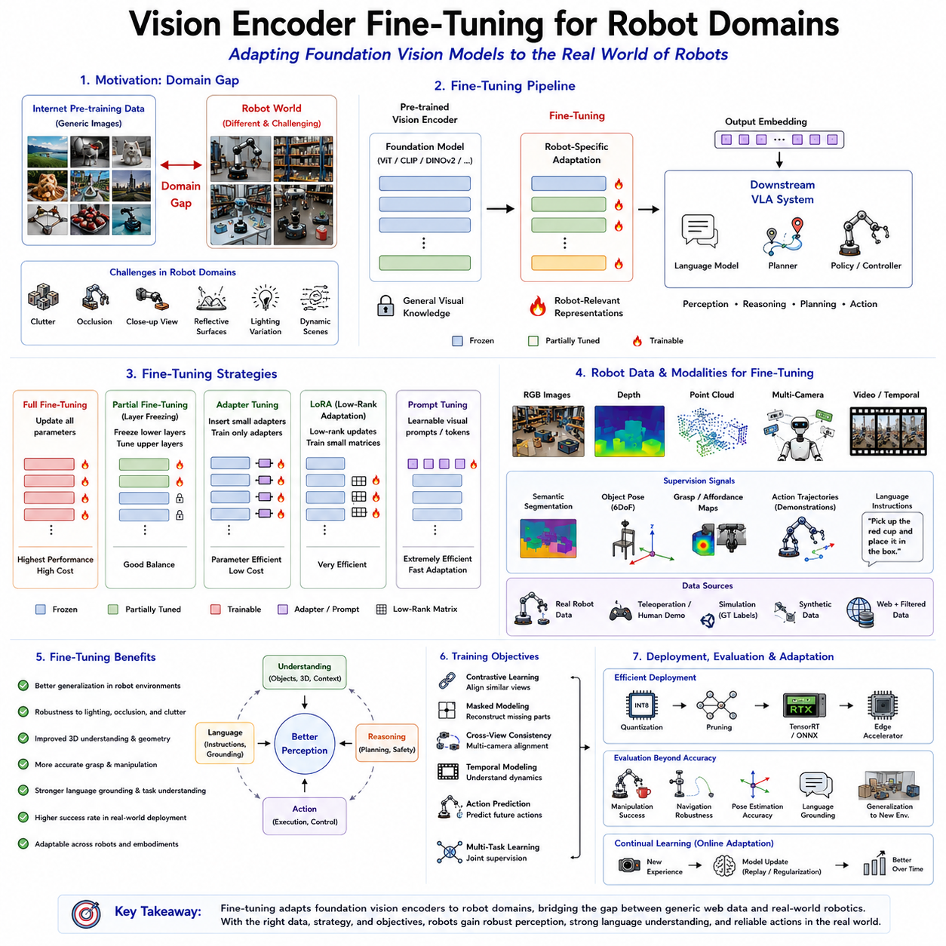
Vision encoders have become one of the fundamental building blocks of modern Vision-Language-Action (VLA) systems because they transform raw visual observations into compact semantic representations that can be understood by language models, planning modules, and robot control policies. Large-scale foundation vision models such as Vision Transformer (ViT), CLIP, DINOv2, SigLIP, Segment Anything Model (SAM), EVA, ConvNeXt, and numerous multimodal encoders are typically pre-trained using billions of natural images collected from the Internet. These foundation models demonstrate remarkable generalization across many visual recognition tasks. However, robotic environments differ substantially from Internet image datasets. Industrial workcells, warehouses, laboratories, hospitals, agricultural fields, construction sites, autonomous vehicles, and household environments contain visual characteristics that are rarely represented during large-scale pre-training. Consequently, directly applying generic vision encoders often results in reduced performance for robotic perception, manipulation, navigation, and embodied intelligence. Vision encoder fine-tuning has therefore emerged as one of the most critical techniques for adapting foundation vision models to robot-specific domains while preserving their powerful general visual knowledge.
The primary objective of vision encoder fine-tuning is not to retrain an entire visual model from scratch but rather to adapt its learned representations toward robotic operating environments. Large-scale pre-training already provides excellent low-level feature extraction capabilities including edges, textures, colors, shapes, object categories, semantic relationships, and contextual understanding. Fine-tuning modifies only selected portions of these representations so that visual embeddings become more sensitive to robot-relevant information including manipulation affordances, object pose, spatial geometry, tool interaction, task context, environmental structure, and dynamic scene understanding.
One of the major reasons fine-tuning becomes necessary is the substantial domain gap between Internet-scale datasets and robotic perception. Internet photographs typically emphasize aesthetically pleasing viewpoints, centered objects, balanced lighting, and visually distinctive scenes. Robotic cameras instead frequently observe cluttered workspaces, unusual viewing angles, partial occlusions, reflective materials, transparent objects, repetitive industrial components, motion blur, varying illumination, and close-range perspectives. Wrist-mounted cameras often capture highly zoomed-in views of manipulation targets. Mobile robots continuously observe changing environments while moving. These characteristics differ significantly from conventional computer vision benchmarks, requiring specialized adaptation.
Robotic vision also differs fundamentally in terms of objectives. Traditional computer vision often focuses upon image classification, object recognition, semantic segmentation, caption generation, or visual question answering. Robotic perception instead supports downstream physical interaction. The encoder must therefore preserve geometric consistency, object boundaries, graspable regions, contact surfaces, insertion points, tool interfaces, free space, collision constraints, and manipulation affordances. Features optimized solely for semantic classification may neglect precisely those geometric details essential for successful robotic action.
Fine-tuning strategies can generally be categorized into full fine-tuning, partial fine-tuning, parameter-efficient fine-tuning, adapter-based learning, prompt tuning, low-rank adaptation, continual adaptation, and task-specific specialization. Each strategy balances computational cost, memory requirements, catastrophic forgetting risk, deployment constraints, and expected performance improvements.
Full fine-tuning updates every trainable parameter within the vision encoder using robot-specific datasets. This approach provides maximum adaptation flexibility because all learned representations gradually specialize toward the target domain. Industrial manipulation datasets, warehouse perception datasets, agricultural imagery, medical robotics data, and autonomous driving observations may all reshape feature hierarchies throughout the network. Although full fine-tuning often produces the highest task-specific accuracy, it requires substantial computational resources, large datasets, extended training time, and careful optimization to avoid catastrophic forgetting of previously learned visual knowledge.
Catastrophic forgetting represents one of the principal challenges during robotic fine-tuning. Excessive specialization toward narrow robotic datasets may unintentionally destroy general semantic knowledge acquired during foundation pre-training. Models that previously recognized thousands of object categories may overfit toward limited industrial environments, reducing robustness when encountering unfamiliar situations. Modern fine-tuning strategies therefore seek balanced adaptation preserving both general visual understanding and domain-specific specialization simultaneously.
Partial fine-tuning addresses this challenge by updating only selected layers within the vision encoder. Early layers generally learn universal low-level features including edges, gradients, textures, and primitive visual patterns applicable across nearly all domains. These representations rarely require modification. Higher transformer blocks instead capture increasingly task-specific semantic concepts, contextual relationships, and object interactions. Updating only later layers significantly reduces computational requirements while preserving robust foundational visual knowledge.
Layer freezing constitutes one of the simplest yet most effective fine-tuning strategies. Lower transformer layers remain completely frozen throughout training, while upper layers gradually adapt toward robotic perception tasks. Different freezing schedules may update only the final transformer block, several upper layers, intermediate representations, normalization parameters, or attention modules. Careful selection depends upon dataset size, computational resources, domain similarity, and desired generalization performance.
Parameter-efficient fine-tuning has become particularly attractive for robotics because embedded systems frequently possess limited computational resources. Rather than updating billions of foundation model parameters, parameter-efficient methods introduce small trainable components while preserving original backbone weights. Such approaches dramatically reduce memory consumption, training cost, storage requirements, and deployment complexity while achieving competitive adaptation performance.
Adapter modules represent one of the most successful parameter-efficient techniques. Small bottleneck neural networks are inserted between transformer layers without modifying original model weights. During fine-tuning only adapter parameters become trainable, leaving pretrained visual representations intact. Different robot domains may employ different adapters while sharing identical foundation backbones. Industrial robots, agricultural robots, warehouse systems, medical manipulators, and humanoid robots can therefore maintain specialized perception capabilities using compact domain-specific adapters.
Low-Rank Adaptation further reduces trainable parameter counts by representing weight updates through low-rank matrix decompositions. Rather than directly modifying large transformer weight matrices, low-dimensional update matrices capture essential domain adaptation information. Such representations often require less than one percent of original parameter counts while maintaining excellent performance. Low-Rank Adaptation has consequently become widely adopted throughout both language models and multimodal robotic foundation architectures.
Prompt tuning provides another lightweight adaptation mechanism inspired by large language model prompting. Instead of modifying transformer weights, learnable visual prompt tokens become prepended to image representations before transformer processing. These prompts guide internal attention mechanisms toward robot-relevant visual concepts including grasp regions, tool interfaces, object geometry, safety boundaries, or task-specific semantic cues. Prompt tuning significantly reduces computational overhead while enabling rapid adaptation across multiple robotic applications.
Instruction-aware visual fine-tuning increasingly integrates language supervision throughout adaptation. Rather than optimizing purely visual objectives, robot perception models jointly learn relationships among images, language instructions, action demonstrations, and environmental context. Vision encoders gradually produce embeddings naturally aligned with language models supporting downstream Vision-Language-Action reasoning. Such multimodal supervision substantially improves language grounding, task understanding, and embodied instruction following.
Data quality represents perhaps the single most important factor influencing successful robotic fine-tuning. High-quality robotic datasets should accurately reflect deployment environments including sensor configurations, camera viewpoints, lighting variation, object diversity, workspace organization, robot embodiments, manipulation trajectories, environmental dynamics, and operational constraints. Collecting representative robotic data frequently proves more valuable than merely increasing dataset size using irrelevant imagery.
Multi-camera datasets significantly enhance robotic fine-tuning because modern robots rarely rely upon individual viewpoints. Head-mounted cameras capture global environmental context. Wrist cameras observe manipulation targets from close range. Stereo cameras estimate depth geometry. Overhead cameras monitor workspace organization. Simultaneously adapting vision encoders across multiple synchronized viewpoints encourages viewpoint-invariant feature representations supporting robust perception despite changing camera perspectives.
Depth information increasingly participates directly within vision encoder fine-tuning. Conventional foundation models generally process only RGB imagery. Robotic perception instead benefits substantially from integrating RGB appearance with depth geometry. Multi-modal fine-tuning jointly optimizes visual encoders using color images, depth maps, point clouds, semantic segmentation labels, object poses, surface normals, and manipulation trajectories. Learned representations consequently capture both semantic appearance and physical geometry.
Point cloud supervision further enriches robotic visual adaptation. Three-dimensional geometry provides information unavailable from conventional RGB images including precise object shape, spatial relationships, surface orientation, grasp accessibility, collision constraints, and environmental topology. Cross-modal learning encourages visual features extracted from RGB images to align consistently with corresponding geometric point cloud representations. Such alignment improves three-dimensional reasoning despite relying upon monocular visual observations during deployment.
Temporal consistency has become increasingly important because robots continuously observe dynamic environments rather than isolated images. Fine-tuning therefore frequently incorporates sequential video observations rather than independent static frames. Temporal transformers, recurrent memory modules, and video foundation models learn representations preserving object identity, scene evolution, manipulation progress, and environmental dynamics throughout extended interaction sequences. Such temporally consistent features substantially improve long-horizon planning and action execution.
Self-supervised learning plays an increasingly important role during robotic adaptation because manually annotating large robotic datasets remains expensive and time consuming. Contrastive learning encourages visually similar observations to produce nearby feature embeddings despite viewpoint variation. Masked image modeling reconstructs missing visual regions from surrounding context. Cross-view consistency aligns synchronized observations acquired from different cameras. Predictive learning estimates future visual states following robot actions. Such objectives enable robots to learn meaningful domain representations without extensive manual labeling.
Demonstration learning provides another valuable supervision source. Human teleoperation, kinesthetic teaching, imitation learning, and autonomous data collection generate paired visual observations and successful manipulation trajectories. Vision encoders gradually specialize toward representations maximizing downstream action prediction rather than merely image recognition accuracy. Consequently, learned features naturally emphasize object affordances, contact surfaces, manipulation context, and physically meaningful environmental structure.
Task-specific fine-tuning further specializes vision encoders toward individual robotic capabilities. Grasp detection requires preserving fine geometric boundaries and object orientation. Visual servoing emphasizes continuous positional accuracy throughout manipulation. Inspection systems prioritize defect recognition under varying illumination. Autonomous navigation focuses upon traversable terrain, obstacle detection, and semantic mapping. Surgical robotics emphasizes tissue boundaries and instrument tracking. Each task introduces unique perceptual priorities influencing optimal representation learning.
Industrial robotics presents unique adaptation challenges because manufacturing environments frequently contain repetitive textures, metallic surfaces, transparent materials, highly similar components, changing lighting conditions, and strict precision requirements. Fine-tuned vision encoders learn to distinguish visually similar mechanical parts, detect manufacturing defects, estimate insertion alignment, recognize assembly states, and support high-precision automation despite challenging visual conditions.
Warehouse robotics similarly benefits from specialized adaptation. Inventory containers frequently exhibit repetitive appearance while varying substantially in size, packaging, labeling, and placement. Vision encoders fine-tuned using warehouse datasets become increasingly robust against stacked boxes, cluttered shelves, varying illumination, damaged packaging, barcode occlusion, and changing inventory arrangements. Such adaptation improves picking accuracy, inventory management, and autonomous logistics.
Agricultural robotics introduces additional domain complexity because natural environments continuously change throughout seasons, weather conditions, plant growth stages, soil appearance, and lighting variation. Generic Internet image datasets poorly represent these characteristics. Agricultural fine-tuning therefore adapts visual representations toward crop recognition, fruit localization, disease detection, weed identification, terrain understanding, and autonomous harvesting despite substantial environmental variability.
Medical robotics represents another highly specialized domain requiring careful visual adaptation. Surgical cameras observe biological tissues exhibiting appearance substantially different from natural images. Endoscopic procedures introduce unusual illumination, fluid reflections, anatomical variation, and instrument interaction. Fine-tuned vision encoders therefore emphasize tissue segmentation, anatomical landmark recognition, surgical tool tracking, and procedure-specific perception while satisfying strict safety and reliability requirements.
Humanoid robots require perhaps the broadest visual adaptation because they operate across diverse human environments including homes, offices, hospitals, factories, and public spaces. Vision encoders must simultaneously recognize household objects, human activities, furniture, appliances, tools, signage, gestures, environmental hazards, and social interactions. Fine-tuning therefore balances broad semantic understanding with robot-specific embodiment requirements supporting manipulation, navigation, communication, and collaboration.
Simulation has become indispensable for robotic vision adaptation. High-fidelity simulators generate unlimited labeled observations including RGB images, depth maps, semantic segmentation, object poses, point clouds, optical flow, manipulation trajectories, and environmental metadata. Domain randomization systematically varies textures, lighting, camera parameters, object arrangements, weather conditions, and sensor characteristics. Models first adapted within simulation subsequently transfer toward physical robots using comparatively limited real-world fine-tuning. This sim-to-real strategy substantially reduces expensive physical data collection while improving generalization.
Domain adaptation techniques explicitly address discrepancies between simulated and real environments. Feature alignment minimizes representation differences across domains. Adversarial adaptation encourages domain-invariant visual embeddings. Style transfer modifies simulated imagery to resemble real observations. Self-training gradually incorporates unlabeled real-world observations into adaptation pipelines. Such techniques reduce sim-to-real performance gaps while preserving benefits of large-scale simulated supervision.
Evaluation of fine-tuned vision encoders extends beyond conventional computer vision metrics. Classification accuracy alone insufficiently predicts robotic success. Practical evaluation instead considers manipulation success rate, grasp stability, navigation robustness, collision avoidance, task completion efficiency, spatial localization accuracy, language grounding performance, object pose estimation, generalization toward unseen environments, resilience under changing illumination, robustness against occlusion, and adaptation across novel embodiments. Ultimately, successful fine-tuning should improve overall robotic behavior rather than isolated perception benchmarks.
Computational efficiency remains a major consideration because robotic systems frequently operate upon embedded edge hardware. Fine-tuning strategies must therefore preserve inference speed while minimizing memory consumption. Quantization-aware training, mixed-precision computation, structured pruning, efficient attention mechanisms, neural compression, TensorRT optimization, ONNX deployment, and specialized AI accelerators collectively enable adapted vision encoders to execute within real-time control loops. Such optimization becomes particularly important for mobile robots, drones, humanoids, and collaborative manipulators requiring continuous perception under strict latency constraints.
Continual learning represents another emerging direction in robotic vision adaptation. Rather than performing a single offline fine-tuning stage, future robots will continuously refine perception models throughout deployment. New environments, objects, tasks, lighting conditions, seasonal variation, and operational experience gradually improve visual representations over time. Continual adaptation requires preventing catastrophic forgetting while safely incorporating newly acquired knowledge. Replay memory, parameter isolation, adaptive regularization, and modular expansion architectures increasingly support lifelong robotic learning.
Foundation robotic models increasingly unify visual adaptation with language understanding, world modeling, manipulation policy learning, and multimodal reasoning. Rather than independently fine-tuning separate visual encoders, future Vision-Language-Action architectures will jointly optimize perception, language grounding, planning, and action prediction using integrated multimodal objectives. Visual representations will naturally evolve toward features most beneficial for embodied intelligence rather than isolated recognition accuracy.
Another promising research direction involves cross-embodiment adaptation. Rather than specializing vision encoders for individual robots, future foundation models will learn generalized representations transferable across mobile robots, manipulators, humanoids, quadrupeds, aerial drones, underwater vehicles, and autonomous industrial systems. Fine-tuning will increasingly emphasize embodiment-invariant perception while allowing lightweight specialization for individual hardware configurations through modular adapters or low-rank updates.
Ultimately, vision encoder fine-tuning provides the critical bridge between powerful general-purpose foundation vision models and the highly specialized perceptual requirements of robotic systems operating in the physical world. Large-scale pre-training supplies broad semantic understanding, while domain-specific adaptation refines representations toward manipulation, navigation, spatial reasoning, safety, and embodied interaction. Through careful selection of adaptation strategies, representative robotic datasets, multimodal supervision, parameter-efficient learning, simulation-assisted transfer, and continual refinement, vision encoders become increasingly capable of supporting robust Vision-Language-Action systems across industrial automation, service robotics, autonomous vehicles, healthcare, logistics, agriculture, and future general-purpose embodied artificial intelligence.

2.10 Real-Time Vision Encoder Optimization (with Code)
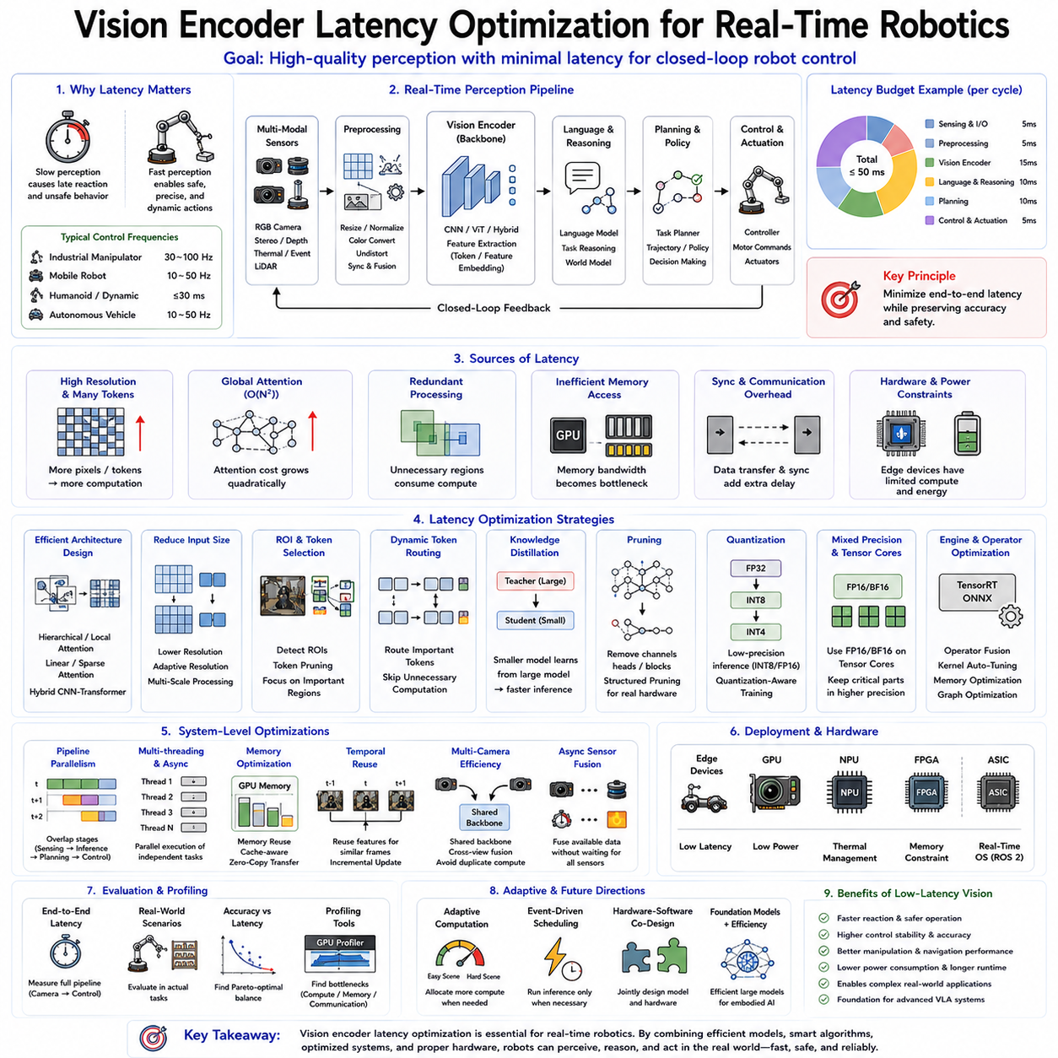
Real-time perception is one of the fundamental requirements for modern robotic systems because intelligent robots must continuously observe the environment, understand changing situations, reason about possible actions, and generate safe control commands within strict time constraints. Even the most accurate vision encoder becomes impractical if its inference latency exceeds the temporal requirements of robot control. A robot that recognizes an obstacle one second after it appears has already failed, regardless of how accurate its prediction may be. Consequently, latency optimization has become one of the most important engineering disciplines in Vision-Language-Action (VLA) systems, where perception, reasoning, planning, and action are tightly coupled into continuous feedback loops.
Vision encoders represent the front-end of nearly every VLA architecture. Their primary responsibility is to convert raw visual observations obtained from RGB cameras, stereo cameras, depth sensors, thermal cameras, event cameras, or LiDAR projections into compact semantic feature embeddings that downstream language models, world models, planning systems, and action policies can efficiently process. Since every downstream module depends upon these visual features, the latency introduced by the vision encoder directly affects the overall responsiveness of the robotic system. Optimizing vision encoder inference therefore provides one of the highest returns in improving end-to-end robot performance.
Unlike conventional computer vision applications where processing a single image may be acceptable, robotic systems operate under continuous closed-loop control. Cameras may generate thirty, sixty, or even hundreds of frames every second. Each frame potentially requires object detection, semantic segmentation, depth estimation, scene understanding, language grounding, and policy inference before the robot executes a new motion command. The available computational budget per frame is therefore extremely limited. If perception consumes excessive computation, downstream planning and control inevitably become delayed, causing degraded manipulation accuracy, unstable navigation, oscillatory behavior, and increased safety risks.
Latency optimization begins by understanding the overall perception pipeline. A typical robotic vision system receives images from multiple synchronized cameras. These images undergo preprocessing including resizing, normalization, color conversion, lens distortion correction, temporal synchronization, and sensor fusion. The processed images are then forwarded into the vision encoder where transformer layers or convolutional backbones extract hierarchical semantic representations. These feature embeddings subsequently enter language reasoning modules, task planners, world models, and action policies before final control commands reach robot actuators. Every stage contributes additional latency, making system-level optimization considerably more important than optimizing isolated neural networks.
Real-time robotic systems frequently distinguish between throughput and latency. Throughput measures how many images can be processed every second, while latency measures how long a single observation requires before producing useful output. Although these concepts are related, they represent different optimization objectives. Cloud inference systems often prioritize maximum throughput using large batch processing. Robots instead prioritize minimum latency because each control decision depends upon the most recent sensor observation. A robot processing one hundred images simultaneously may achieve excellent throughput while introducing unacceptable delays for individual control cycles.
Control frequency fundamentally determines acceptable perception latency. High-speed industrial manipulators frequently operate servo controllers at one kilohertz while visual feedback loops may execute between thirty and one hundred hertz. Mobile robots typically update navigation between ten and fifty hertz depending upon vehicle dynamics. Humanoid robots performing dynamic locomotion often require visual updates below thirty milliseconds to maintain stable balance. Autonomous vehicles similarly demand rapid perception under continuously changing environments. Consequently, practical vision encoder latency targets generally range from several milliseconds to several tens of milliseconds depending upon application requirements.
Model architecture represents the first major factor influencing inference latency. Early convolutional neural networks relied upon repeated convolution operations that scaled efficiently on specialized hardware but often exhibited limited global context modeling. Vision Transformers introduced self-attention mechanisms capable of capturing long-range semantic relationships, significantly improving representation quality. However, global self-attention scales quadratically with token count, increasing computational complexity for high-resolution images. Modern robotic vision encoders therefore seek architectural designs balancing representational capability with computational efficiency.
Image resolution directly influences computational cost because transformer token counts grow proportionally with image dimensions. Doubling image width and height approximately quadruples the number of image patches processed by the encoder while dramatically increasing attention computation. Selecting appropriate input resolution therefore represents one of the simplest latency optimization strategies. High-resolution perception should be reserved only for tasks requiring fine manipulation accuracy, while coarse navigation or obstacle avoidance often performs adequately using substantially smaller images.
Adaptive resolution strategies further improve efficiency by dynamically adjusting image resolution according to task requirements. During long-distance navigation, low-resolution perception sufficiently identifies corridors, obstacles, and navigation landmarks. As the robot approaches manipulation targets, higher-resolution processing becomes selectively activated only within regions requiring detailed geometric understanding. Such adaptive perception significantly reduces average computational cost without sacrificing manipulation accuracy.
Region-of-interest processing provides another effective optimization strategy. Rather than encoding entire images uniformly, robotic systems first identify candidate task regions through lightweight detectors or previous observations. High-capacity vision encoders subsequently process only these selected image regions at full resolution. Background areas receive minimal computation because they rarely influence immediate robot actions. This selective processing closely resembles human visual attention, where detailed perception focuses upon task-relevant objects rather than entire scenes simultaneously.
Patch selection mechanisms extend this concept within transformer architectures. Vision Transformers divide images into small patches before encoding them as tokens. However, not every patch contributes equally toward downstream robotic decisions. Token pruning algorithms estimate patch importance during early transformer stages and progressively remove uninformative tokens. Remaining computational resources concentrate upon visually significant regions including manipulated objects, obstacles, human collaborators, navigation landmarks, and task-relevant environmental structures.
Dynamic token routing has emerged as an important optimization technique for transformer-based vision encoders. Instead of processing every token through every transformer layer, adaptive routing mechanisms identify computationally important tokens while bypassing redundant processing for less informative regions. Such dynamic computation substantially reduces overall inference time while maintaining nearly identical recognition accuracy across many robotic perception tasks.
Knowledge distillation provides another powerful latency optimization strategy. Large teacher models possessing exceptional visual understanding supervise significantly smaller student networks during training. Student models gradually approximate teacher representations despite requiring dramatically fewer parameters and computational operations. Distilled vision encoders frequently achieve comparable robotic perception performance while reducing inference latency by several multiples, making them highly attractive for embedded robotic deployment.
Model pruning further reduces computational complexity by removing unnecessary parameters, channels, attention heads, neurons, or entire transformer blocks after training. Structured pruning eliminates complete computational components, allowing hardware accelerators to execute optimized inference efficiently. Unstructured pruning instead removes individual weights but often requires specialized sparse computation libraries to achieve practical acceleration. Modern robotic deployment generally favors structured pruning because it better aligns with existing inference hardware.
Quantization has become one of the most widely adopted deployment optimizations. Conventional neural networks perform computation using thirty-two-bit floating-point arithmetic. However, many robotic AI accelerators efficiently execute eight-bit integer operations while maintaining nearly identical prediction accuracy. Quantization reduces memory bandwidth, cache usage, energy consumption, and arithmetic complexity simultaneously. Advanced techniques including INT8, FP16, BF16, INT4, and mixed-precision inference enable increasingly efficient embedded perception without substantial performance degradation.
Quantization-aware training further improves deployment robustness by incorporating low-precision arithmetic directly during optimization. Rather than quantizing fully trained models afterward, training continuously simulates deployment precision throughout optimization. Learned parameters therefore naturally adapt toward quantized representations, minimizing accuracy degradation during real-world embedded inference.
Mixed-precision computation dynamically combines different numerical precisions throughout inference pipelines. Computationally intensive matrix multiplications frequently execute using sixteen-bit arithmetic, while sensitive normalization layers maintain higher precision where necessary. Tensor Core hardware available within modern GPUs significantly accelerates mixed-precision computation, enabling transformer-based vision encoders to achieve real-time robotic performance previously considered impractical.
TensorRT optimization has become an industry standard for deploying robotic deep learning models on NVIDIA platforms. TensorRT analyzes computational graphs, fuses adjacent operations, eliminates redundant memory transfers, optimizes tensor layouts, selects efficient kernels, and generates hardware-specific execution plans. Vision encoders optimized using TensorRT frequently demonstrate substantial latency reductions without modifying model architecture or prediction behavior.
Operator fusion represents one of the principal TensorRT optimizations. Multiple consecutive operations including convolution, normalization, activation functions, matrix multiplication, and residual connections become merged into single optimized computational kernels. This reduces intermediate memory allocation, cache misses, synchronization overhead, and kernel launch latency, producing significant improvements particularly within transformer architectures containing numerous sequential operations.
ONNX provides another important deployment framework supporting cross-platform optimization. Vision encoders exported into standardized computational graphs become deployable across diverse inference engines including TensorRT, OpenVINO, Qualcomm AI Engine, ARM Compute Library, Intel Neural Processing Units, and dedicated embedded AI accelerators. Such hardware abstraction simplifies deployment across heterogeneous robotic platforms while preserving optimized computational graphs.
Batch processing presents an interesting optimization trade-off. Large batch sizes maximize hardware utilization by processing numerous images simultaneously. However, robots typically require immediate processing of individual observations. Consequently, robotic systems generally operate using batch size one despite lower hardware utilization because minimizing response latency remains substantially more important than maximizing throughput. Specialized inference engines increasingly optimize explicitly for batch-one execution.
Pipeline parallelism improves system-level responsiveness by overlapping perception, reasoning, planning, and control rather than executing these stages sequentially. While the vision encoder processes the next camera frame, language reasoning simultaneously analyzes previous embeddings, planning modules optimize future trajectories, and controllers execute current actions. Carefully synchronized asynchronous pipelines maximize computational resource utilization while reducing overall control latency.
Multi-threaded execution further enhances performance by assigning independent perception components to separate CPU or GPU execution streams. Camera acquisition, image preprocessing, neural inference, sensor fusion, visualization, logging, localization, mapping, and control operate concurrently rather than sequentially. Proper thread synchronization prevents unnecessary waiting while maintaining deterministic real-time behavior required for safe robotic operation.
Memory optimization frequently proves equally important as arithmetic optimization. Transformer inference repeatedly accesses large parameter matrices and intermediate feature representations. Efficient memory allocation, tensor reuse, cache-aware scheduling, zero-copy communication, pinned host memory, unified memory architectures, and asynchronous data transfers significantly reduce latency by minimizing expensive memory operations rather than purely accelerating mathematical computation.
Feature caching provides another effective optimization when visual observations change slowly. Robots frequently observe relatively static environments across consecutive frames. Instead of recomputing complete visual representations repeatedly, intermediate transformer features may be partially reused when environmental changes remain limited. Such temporal feature reuse substantially reduces computation during stationary manipulation or slow navigation scenarios.
Temporal redundancy similarly motivates video-aware vision encoders. Consecutive video frames typically differ only slightly. Rather than independently processing every frame from scratch, recurrent architectures, temporal transformers, state-space models, and feature propagation mechanisms update previous visual representations using incremental information extracted from newly observed regions. Such temporal encoding dramatically reduces average inference cost across continuous robotic perception.
Multi-camera robotic systems introduce additional optimization challenges because numerous synchronized image streams simultaneously require processing. Processing each camera independently duplicates substantial computation. Shared backbone architectures therefore jointly encode observations acquired from head cameras, wrist cameras, stereo cameras, side cameras, and overhead cameras before branching toward task-specific representations. Cross-view attention further exchanges information across camera perspectives without requiring entirely separate visual encoders.
Sensor fusion timing also influences perception latency. RGB cameras, depth sensors, LiDAR, inertial measurement units, force sensors, tactile arrays, and proprioceptive observations frequently operate at different sampling frequencies. Waiting for complete synchronization unnecessarily increases latency. Modern robotic systems increasingly employ asynchronous sensor fusion where immediately available observations update world models continuously while delayed modalities contribute incrementally as new measurements arrive.
Edge computing introduces unique deployment constraints absent from cloud infrastructure. Mobile robots operate using limited battery capacity while carrying restricted computational hardware. Thermal management, power consumption, memory availability, hardware reliability, vibration resistance, and physical size all influence feasible vision encoder deployment. Efficient latency optimization therefore simultaneously reduces energy consumption, extending robot operating duration while maintaining responsive perception.
Dedicated AI accelerators increasingly address these deployment challenges. GPUs provide exceptional flexibility supporting diverse transformer architectures. Neural Processing Units optimize matrix multiplication and low-precision inference while consuming substantially lower power. Field-Programmable Gate Arrays enable highly customized perception pipelines with deterministic latency. Application-Specific Integrated Circuits maximize efficiency for fixed deployment scenarios. Selecting appropriate hardware therefore becomes an integral component of latency optimization rather than an independent engineering decision.
Robotic operating systems further influence end-to-end latency. ROS 2 communication introduces serialization, middleware transport, synchronization, scheduling, and callback overhead beyond pure neural inference. Zero-copy transport, shared memory communication, intra-process messaging, deterministic executors, real-time scheduling policies, and optimized Quality-of-Service configurations collectively reduce middleware latency throughout robotic perception pipelines.
Scheduling strategies significantly affect real-time responsiveness. Fixed-rate scheduling periodically executes perception regardless of environmental complexity. Event-driven scheduling activates vision encoders only when significant environmental changes occur. Adaptive scheduling dynamically adjusts perception frequency according to robot velocity, task difficulty, computational availability, and environmental uncertainty. Intelligent scheduling prevents unnecessary computation while preserving safety and responsiveness.
Latency optimization must always balance computational efficiency against perception quality. Excessive compression, aggressive pruning, extremely low precision, or insufficient spatial resolution may reduce inference time while simultaneously degrading recognition accuracy, manipulation reliability, navigation safety, and language grounding performance. Practical optimization therefore seeks Pareto-optimal operating points where latency reductions minimally affect downstream robotic capability.
Evaluation of real-time vision encoders extends beyond benchmark inference speed. Engineers must measure complete end-to-end perception latency including camera exposure, image acquisition, preprocessing, neural inference, feature transmission, language reasoning, policy execution, actuator command generation, and physical robot response. Real-world measurements frequently differ substantially from isolated neural network benchmarks because system integration introduces additional computational overhead.
Profiling tools play an essential role throughout optimization. GPU profilers identify computational bottlenecks within transformer layers. Memory analyzers reveal inefficient allocation patterns. Execution timelines expose synchronization delays among processing threads. Power monitors quantify energy consumption during continuous operation. Comprehensive profiling guides engineering effort toward components providing maximum practical latency improvements rather than speculative optimization.
Future research increasingly investigates adaptive computation within foundation vision models. Instead of executing identical computation for every observation, intelligent perception systems dynamically allocate computational resources according to environmental complexity, task urgency, uncertainty estimates, and available hardware capacity. Simple scenes receive lightweight processing while complex manipulation scenarios activate deeper reasoning pathways. Such adaptive intelligence closely resembles biological perception, where humans naturally devote greater attention toward challenging situations.
Another promising direction involves co-designing neural architectures with specialized robotic hardware. Rather than optimizing software independently from hardware platforms, future systems will jointly develop vision encoders, memory hierarchies, AI accelerators, communication architectures, and robotic operating systems as integrated computational ecosystems. Such hardware-software co-design promises substantial improvements in latency, energy efficiency, reliability, and scalability beyond conventional deployment optimization.
Ultimately, vision encoder latency optimization constitutes a multidisciplinary engineering challenge combining neural architecture design, model compression, hardware acceleration, efficient deployment frameworks, operating system optimization, memory management, asynchronous computation, sensor fusion, and real-time control principles. High-quality visual understanding alone is insufficient for embodied intelligence unless perception occurs rapidly enough to support continuous interaction with dynamic physical environments. By carefully balancing computational efficiency with representational quality through quantization, pruning, knowledge distillation, adaptive computation, TensorRT optimization, edge deployment strategies, and system-level pipeline optimization, modern Vision-Language-Action systems achieve the responsive perception necessary for industrial automation, autonomous navigation, mobile manipulation, humanoid robotics, and future general-purpose embodied artificial intelligence operating safely and effectively within the real world.

