Volume 20. Vision Language Action (VLA) Models

Chapter 1. VLA Fundamentals

1.1 VLA Definition: Vision-Language-Grounded Action
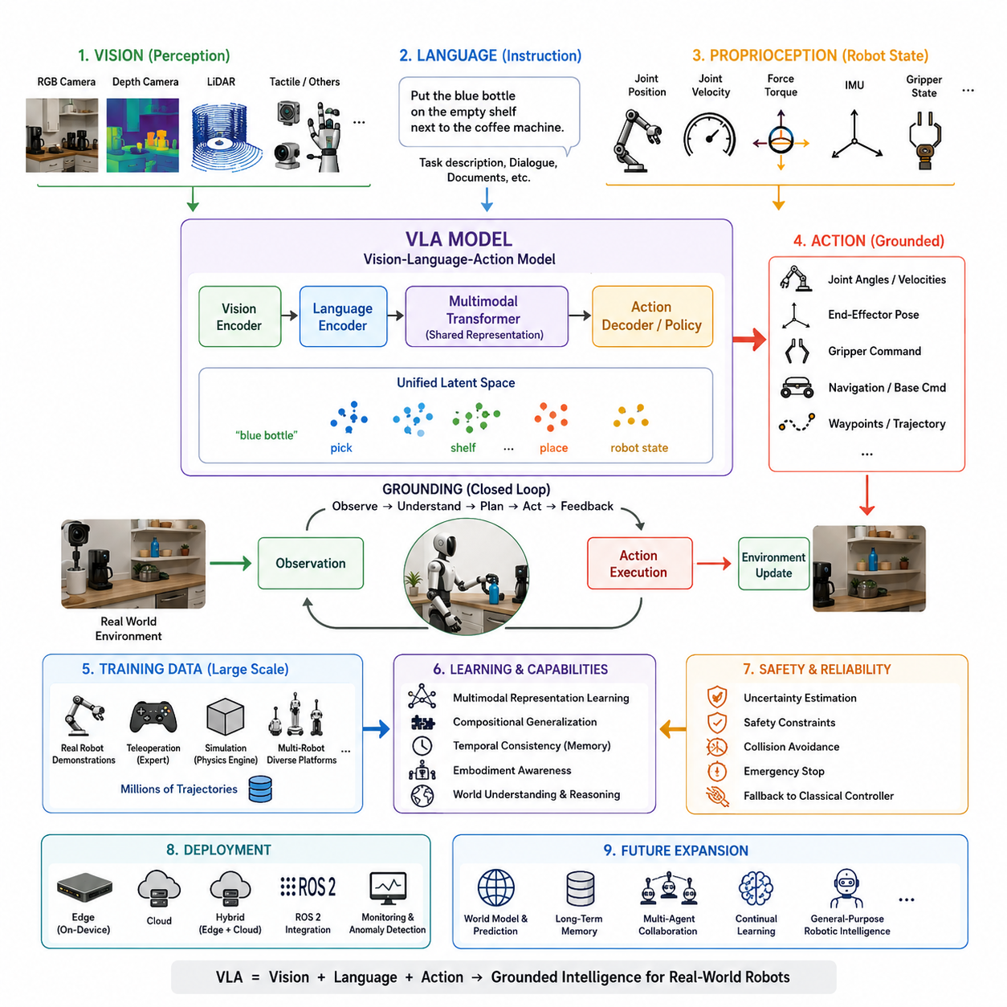
The emergence of Vision-Language-Action (VLA) models represents one of the most significant transitions in modern robotics since the introduction of autonomous navigation and deep learning. Traditional robotic systems have historically been designed as modular engineering pipelines in which perception, localization, planning, control, and execution are implemented as separate software components connected through carefully engineered interfaces. While this architecture has proven highly successful in industrial automation, warehouse robots, and autonomous mobile robots, it often struggles when robots encounter environments that differ from those anticipated during system design. VLA models introduce a fundamentally different paradigm by treating robotic intelligence as an end-to-end multimodal learning problem in which perception, language understanding, reasoning, and action generation are learned jointly within a unified neural architecture. Rather than explicitly programming every decision rule, the robot learns how observations, language instructions, and physical actions are related through massive datasets collected from both simulations and real-world interactions. This unified representation allows robots to generalize to unseen tasks, understand natural language instructions, and execute complex behaviors with significantly reduced manual engineering. The present chapter serves as the conceptual foundation for the remainder of this volume by introducing the principles, motivations, architectural components, and engineering implications of Vision-Language-Grounded Action systems.
The term Vision-Language-Action consists of three tightly integrated modalities. Vision refers to all perceptual information collected from the environment through cameras, depth sensors, LiDAR, event cameras, tactile vision systems, or any other sensing modality capable of representing the external world. Language represents semantic information originating from human instructions, task descriptions, documentation, symbolic knowledge, or previous conversations with users. Action denotes every physical command generated by the robot, including joint trajectories, end-effector motions, wheel velocities, locomotion commands, grasp parameters, or high-level behavioral decisions. The defining characteristic of a VLA model is that these three modalities are not processed independently. Instead, they are embedded into a common latent representation where semantic relationships between perception, language, and physical interaction can be learned simultaneously. This shared representation enables robots to interpret language within the visual context of their surroundings and generate actions that are physically grounded in the current state of the world.
Grounded action is the central concept that distinguishes VLA systems from conventional Vision-Language Models. Traditional multimodal AI systems are capable of describing images, answering questions about visual scenes, or generating textual explanations, but their outputs remain symbolic. They cannot directly influence the physical world. In contrast, VLA models generate outputs that correspond to executable robot behaviors. Every predicted action is conditioned not only on the observed environment but also on the intended objective expressed through language. Consequently, the generated behavior becomes grounded because it is directly constrained by physical observations, robot embodiment, environmental geometry, safety limitations, and task objectives simultaneously. Grounding therefore establishes the bridge between abstract reasoning and physical interaction, allowing robots to transform semantic understanding into real-world manipulation and navigation.
The necessity for grounded action becomes apparent when considering everyday robotic tasks. Imagine instructing a service robot to “place the blue bottle on the empty shelf beside the coffee machine.” A conventional robotics pipeline would require separate modules for object detection, semantic segmentation, language parsing, object localization, motion planning, collision avoidance, manipulation planning, inverse kinematics, and execution monitoring. Each module would communicate through carefully designed interfaces, and failures often arise when assumptions between modules become inconsistent. A VLA model instead observes the scene, understands the instruction, identifies the referenced bottle, reasons about the destination shelf, predicts feasible manipulation trajectories, and generates corresponding motor commands within a unified inference process. Although practical robotic systems still incorporate motion planning, safety supervision, and low-level controllers, the decision-making process becomes substantially more integrated than traditional modular architectures.
One of the most important characteristics of VLA models is multimodal representation learning. Instead of treating images and language as separate information sources, the model learns a common embedding space in which semantically related concepts become geometrically close. Images containing red apples, textual descriptions mentioning apples, and demonstrations showing grasping motions toward apples all contribute to similar latent representations. During pretraining, contrastive learning, masked prediction, autoregressive modeling, or multimodal alignment techniques gradually establish meaningful relationships between visual observations, linguistic concepts, and robotic actions. As a result, robots can infer reasonable behaviors even when they encounter combinations of objects, environments, or instructions that were never explicitly programmed.
The development of large transformer architectures has played a decisive role in enabling Vision-Language-Action systems. Transformers provide a unified computational framework capable of processing sequences regardless of whether those sequences originate from words, image patches, point clouds, robot joint states, or action tokens. Attention mechanisms dynamically determine which pieces of information are relevant for generating the next prediction. A robot instructed to “pick up the cup closest to the keyboard” automatically learns to attend simultaneously to the linguistic concept of “closest,” the visual locations of cups, and the spatial relationship between the keyboard and candidate objects. This capability emerges naturally from attention-based learning rather than being explicitly programmed using handcrafted rules.
Unlike classical robot programming, where engineers define explicit algorithms for every operational scenario, VLA systems rely heavily on statistical learning. During training, millions of demonstrations establish probabilistic relationships between observations and actions. The resulting policy does not memorize individual trajectories but instead learns generalized behavioral patterns. Consequently, robots become capable of executing novel combinations of known skills, adapting to unfamiliar environments, and responding appropriately to instructions that differ from those encountered during training. This capability is commonly referred to as compositional generalization, which represents one of the primary objectives of modern embodied artificial intelligence.
The notion of embodiment is another defining characteristic of Vision-Language-Action systems. Intelligence in robotics cannot exist independently of the physical body that interacts with the world. Every robot possesses unique kinematic constraints, actuator capabilities, sensor configurations, dynamic characteristics, payload limitations, and safety requirements. VLA models therefore learn behaviors that are inherently associated with a specific embodiment. A humanoid robot, a warehouse manipulator, a quadruped inspection robot, and an autonomous mobile robot may receive identical language instructions, yet their generated actions differ significantly because each embodiment provides different physical capabilities. Consequently, grounding extends beyond environmental perception to include the robot's own body representation, often referred to as proprioception.
Proprioceptive information forms an essential input modality for VLA systems. Joint positions, joint velocities, force-torque measurements, actuator currents, battery status, inertial measurements, wheel encoder readings, and end-effector states collectively describe the internal condition of the robot. While vision explains the external environment, proprioception informs the model about the robot's current physical configuration. Successful action prediction requires integrating both sources of information because feasible actions depend simultaneously on environmental opportunities and internal capabilities. A manipulator already holding an object should produce different actions from an identical manipulator with an empty gripper, even when both observe the same visual scene.
Temporal understanding also distinguishes Vision-Language-Action models from conventional perception systems. Robotic tasks unfold over time rather than within isolated images. A successful policy must understand action sequences, predict future consequences, maintain task progress, and remember previous interactions. Consequently, VLA architectures frequently process image sequences, action histories, and language contexts simultaneously. Memory mechanisms, recurrent attention, transformer histories, or latent world representations enable the robot to reason over extended time horizons. Rather than responding independently to each camera frame, the robot learns continuous behavioral policies that remain temporally coherent throughout complete task execution.
Action generation itself can be represented in multiple forms depending on the robot architecture and application domain. Some models directly regress continuous joint angles or joint velocities. Others generate Cartesian poses for end-effectors, mobile robot velocity commands, grasp parameters, or waypoint trajectories. More recent architectures discretize robot actions into action tokens, enabling autoregressive generation similar to language modeling. Diffusion-based policies and flow-matching approaches instead iteratively refine predicted actions through probabilistic denoising processes, producing smoother and more robust trajectories. Regardless of the chosen representation, the ultimate objective remains identical: transforming multimodal observations into executable robot behaviors.
An important distinction must also be made between VLA models and pure Vision-Language Models. A VLM such as those commonly used for visual question answering primarily produces textual outputs describing the observed scene. A VLA model extends this capability by incorporating an action generation module capable of controlling physical systems. Consequently, a VLM may correctly identify that a bottle is located beside a keyboard, whereas a VLA system must additionally determine whether the bottle is reachable, predict collision-free manipulation trajectories, coordinate grasping motions, and continuously adapt execution based on sensor feedback. Action therefore transforms passive scene understanding into active physical intelligence.
Training Vision-Language-Action models requires substantially larger datasets than traditional robotic learning methods. Modern VLA systems are trained using millions of robot demonstrations collected from simulations, teleoperation platforms, industrial robots, mobile manipulators, and collaborative robotic systems. Increasingly, heterogeneous datasets collected from multiple robot embodiments are combined into unified training corpora. This diversity enables foundation policies to generalize across manipulation tasks, navigation scenarios, industrial environments, household settings, and service robotics applications. The resulting policies demonstrate capabilities that extend beyond any individual dataset through transfer learning and cross-embodiment adaptation.
Simulation has become an indispensable component of VLA development because collecting large-scale real-world demonstrations remains expensive and time-consuming. Physics-based simulators provide safe environments for generating diverse manipulation experiences, navigation trajectories, synthetic sensor observations, and randomized environmental conditions. Domain randomization, photorealistic rendering, and sim-to-real transfer techniques reduce the discrepancy between simulated and physical environments, allowing models pretrained in simulation to perform effectively on real robots with relatively limited fine-tuning.
Safety occupies a central position within Vision-Language-Action systems because learned policies inevitably encounter uncertainty. Unlike deterministic industrial control software, neural policies produce probabilistic predictions whose confidence varies according to environmental familiarity. Modern VLA architectures therefore integrate uncertainty estimation, safety constraints, classical control fallbacks, collision avoidance systems, and human override mechanisms. Rather than replacing traditional robotics safety engineering, VLA models augment existing control architectures while remaining supervised by reliable deterministic controllers responsible for maintaining operational safety under unexpected conditions.
Another defining feature of VLA systems is continual improvement through data accumulation. Traditional software evolves through explicit programming, whereas VLA models improve by acquiring additional demonstrations, correcting previous failures, and incorporating newly collected operational experiences. Fleet learning enables robots deployed across multiple facilities to contribute anonymized experience datasets that continuously refine shared foundation policies. Consequently, the intelligence of future robotic systems is expected to improve progressively throughout deployment rather than remaining fixed after manufacturing.
The emergence of Vision-Language-Action models also changes the software engineering methodology used in robotics. Instead of constructing increasingly complicated decision trees, engineers increasingly focus on designing high-quality datasets, defining evaluation benchmarks, optimizing inference pipelines, validating safety constraints, and integrating foundation models with conventional robot software frameworks. The engineering emphasis shifts from manually specifying behavior toward building reliable learning systems capable of discovering robust behaviors from data.
As foundation models continue to scale, the distinction between perception, reasoning, planning, and control becomes progressively less rigid. Future robotic architectures will likely integrate world models, episodic memory, long-horizon reasoning, multimodal communication, and adaptive planning into unified embodied intelligence systems capable of operating across homes, hospitals, warehouses, factories, outdoor environments, and autonomous vehicles. Vision-Language-Action models therefore represent not merely another machine learning algorithm but a fundamental architectural transformation in robotics, analogous to the transition from rule-based artificial intelligence to deep learning. They establish a unified computational framework in which robots perceive the world, understand human intentions, reason about physical interactions, and generate grounded actions that directly influence their environment. This integration of vision, language, and action provides the technological foundation upon which the next generation of intelligent physical AI systems will be constructed, serving as the cornerstone for general-purpose robotic intelligence throughout the remainder of this volume.

1.2 Historical Evolution: From Behavioral Cloning to RT-2 and Pi0
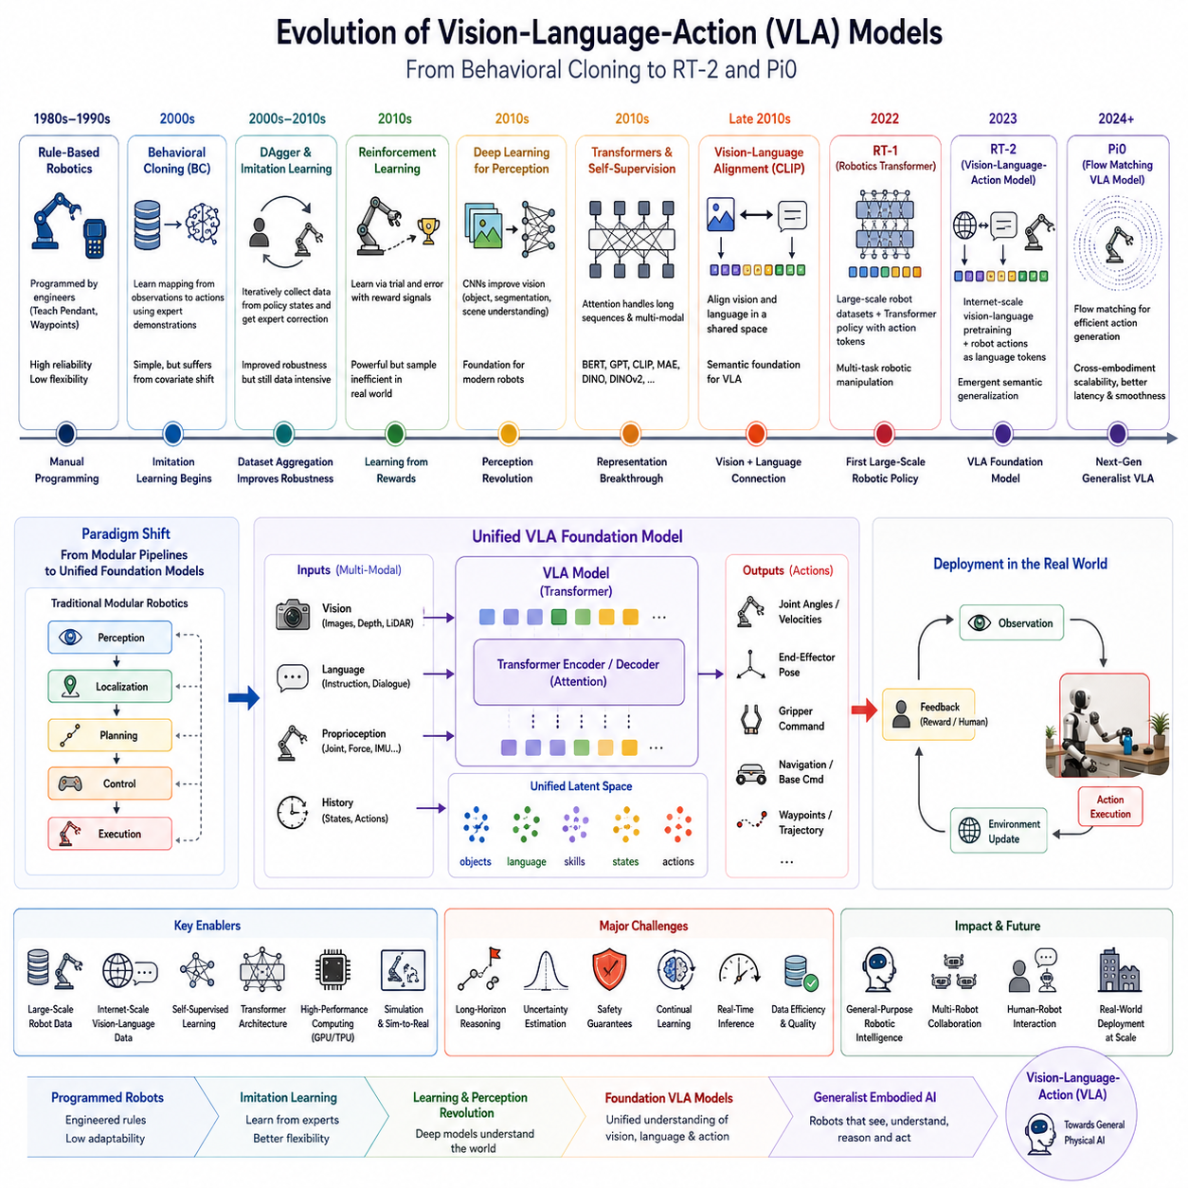
The history of Vision-Language-Action (VLA) models represents the convergence of several independent research disciplines that have evolved over more than four decades. Robotics, computer vision, machine learning, natural language processing, reinforcement learning, imitation learning, and large-scale foundation models each contributed critical technologies that eventually merged into the modern concept of embodied artificial intelligence. Unlike traditional robot control, which primarily relied on explicit mathematical modeling and handcrafted algorithms, VLA systems emerged from the realization that intelligent behavior could be learned directly from large-scale multimodal data. The evolution from early Behavioral Cloning (BC) methods to contemporary foundation models such as RT-2 and Pi0 illustrates not only increasing computational capability but also a profound transformation in how robotic intelligence is represented, trained, and deployed.
The earliest stage of learning-based robot control can be traced back to imitation learning, where robots learned to reproduce expert demonstrations rather than relying entirely on manually programmed control logic. During the 1980s and 1990s, industrial robots were typically programmed using teach pendants, waypoint recording, or carefully engineered control software. Every movement was explicitly specified by engineers, making robotic systems highly reliable but inflexible. Any environmental variation often required reprogramming the robot from scratch. Researchers therefore began investigating whether robots could instead learn directly from demonstrations provided by human operators.
Behavioral Cloning became one of the first successful machine learning approaches for robotic imitation. Inspired by supervised learning, Behavioral Cloning treated robot control as a regression problem. During training, expert demonstrations consisting of observations and corresponding actions were collected. A neural network or statistical model then learned a direct mapping from observed states to desired actions. Once trained, the robot simply predicted actions that resembled those demonstrated by human experts. This paradigm eliminated the need for explicit planning during execution because the learned policy directly generated control commands.
Although Behavioral Cloning demonstrated promising results, it suffered from a fundamental weakness known as covariate shift. During training, the robot only observed states encountered by the expert. During deployment, however, even minor prediction errors gradually accumulated, causing the robot to encounter states that were absent from the training dataset. Since the model had never learned how to recover from these unfamiliar situations, performance often deteriorated rapidly. Small deviations eventually resulted in catastrophic failures, making Behavioral Cloning unreliable for long-horizon robotic tasks.
To address these limitations, researchers developed Dataset Aggregation (DAgger), which iteratively collected additional demonstrations from states encountered by the learned policy. Instead of relying solely on expert trajectories, DAgger continuously corrected the robot's mistakes by allowing experts to provide actions whenever the policy entered unfamiliar situations. Over multiple iterations, the training dataset gradually expanded to include recovery behaviors, substantially improving robustness. Although DAgger represented an important milestone, it still depended heavily on human supervision and remained limited by relatively small demonstration datasets.
During the same period, reinforcement learning emerged as an alternative paradigm for robot learning. Instead of imitating experts, reinforcement learning allowed robots to discover behaviors through trial and error using reward signals. Algorithms such as Q-Learning, Deep Q Networks, Trust Region Policy Optimization, and later Proximal Policy Optimization demonstrated that robots could learn sophisticated manipulation and locomotion skills without explicit demonstrations. However, reinforcement learning required enormous amounts of interaction data, making purely real-world training prohibitively expensive. Simulation therefore became the primary environment for reinforcement learning research.
The introduction of deep learning transformed robot perception during the 2010s. Convolutional Neural Networks dramatically improved visual recognition, object detection, semantic segmentation, and scene understanding. Robots were no longer limited to handcrafted visual features but instead learned hierarchical representations directly from raw images. Simultaneously, GPU acceleration enabled neural networks to process increasingly larger datasets. These developments established the perception foundation upon which future Vision-Language-Action systems would eventually be constructed.
Around the same time, sequence modeling architectures also experienced rapid evolution. Recurrent Neural Networks and Long Short-Term Memory networks initially dominated sequence learning because they could process temporal information. Nevertheless, their ability to capture long-range dependencies remained limited. The publication of the Transformer architecture fundamentally changed machine learning by introducing attention mechanisms capable of modeling global relationships within sequences. Although Transformers were initially developed for natural language processing, researchers soon recognized that attention mechanisms could process images, robot trajectories, sensor measurements, and action sequences within a unified framework.
The success of Transformer architectures coincided with the emergence of large-scale self-supervised learning. Instead of requiring manually labeled datasets, models learned meaningful representations by predicting masked inputs or contrasting positive and negative examples. Models such as BERT, GPT, CLIP, DINO, MAE, and later DINOv2 demonstrated that enormous unlabeled datasets could produce highly transferable feature representations. These advances significantly reduced dependence on expensive human annotations while simultaneously improving generalization.
A major breakthrough occurred with the introduction of CLIP, which jointly learned image and language representations from hundreds of millions of image-text pairs collected from the Internet. Rather than training separate visual and linguistic models, CLIP aligned both modalities into a common embedding space. Images containing dogs became closely associated with textual descriptions of dogs, while unrelated concepts remained separated. This multimodal representation demonstrated that semantic alignment could emerge naturally from large-scale contrastive learning. Although CLIP itself did not perform robotic control, it established a critical foundation for later VLA architectures by showing that vision and language could share unified representations.
The rapid development of Large Language Models further accelerated robotics research. GPT demonstrated that scaling Transformer architectures with sufficiently large datasets produced remarkable reasoning, planning, and language understanding capabilities. Robots could now leverage these models to interpret complex instructions, generate plans, answer questions, and reason about tasks using natural language. Initially, language models remained disconnected from physical execution, serving primarily as planning assistants rather than direct control systems.
Researchers therefore began exploring methods for grounding language models within robotic environments. One influential approach was SayCan, which combined the reasoning capabilities of large language models with learned affordance functions. Instead of allowing language models to directly generate robot actions, SayCan first decomposed instructions into candidate skills and then evaluated which skills were physically feasible in the current environment. This combination of semantic reasoning and physical affordance represented one of the earliest successful integrations of language understanding with embodied execution.
Another important milestone was Code as Policies, where language models generated executable robot programs instead of continuous control commands. Rather than predicting motor actions directly, the language model produced structured Python code calling predefined robotic APIs. This approach leveraged the extensive programming knowledge contained within large language models while maintaining compatibility with existing robotics software architectures. Code generation also improved interpretability because engineers could inspect the generated programs before execution.
As multimodal foundation models continued to mature, researchers recognized that robots required tighter integration between perception, language, and action. Instead of sequentially connecting independent perception, planning, and execution modules, they proposed learning all three components jointly. This insight led to the emergence of Robotics Transformer architectures.
RT-1 represented one of the earliest large-scale Transformer policies trained on diverse robotic manipulation tasks. Developed using thousands of hours of real robot demonstrations collected across multiple manipulation scenarios, RT-1 demonstrated that a single Transformer architecture could generalize across numerous household tasks. Images, language instructions, and robot states served as inputs, while discretized action tokens represented outputs. The model achieved significantly improved multitask performance compared with individually trained task-specific policies, illustrating the potential of large-scale robotic foundation models.
Building upon RT-1, RT-2 introduced one of the most significant conceptual advances in embodied artificial intelligence. Rather than training exclusively on robotic demonstrations, RT-2 incorporated knowledge acquired during Internet-scale vision-language pretraining. By treating robot actions as another form of language token, RT-2 unified visual reasoning, semantic understanding, and robotic control within a single autoregressive Transformer. This architecture enabled robots to benefit from the vast conceptual knowledge contained within web-scale datasets while simultaneously learning physical manipulation skills from robot demonstrations.
One remarkable capability demonstrated by RT-2 was semantic generalization beyond direct robotic experience. For example, the model could infer that a soda can belongs in a recycling container despite never explicitly observing that precise manipulation task during robot training. Such reasoning emerged because Internet-scale language and vision pretraining had already established semantic relationships between recyclable objects and recycling concepts. RT-2 therefore illustrated that robotic intelligence could inherit abstract knowledge acquired outside the robotics domain.
Following RT-2, research increasingly shifted toward foundation policies capable of operating across multiple embodiments. Rather than training separate models for each robot, researchers began constructing policies using heterogeneous datasets collected from manipulators, mobile robots, dual-arm systems, and humanoids. Open X-Embodiment represented one of the largest collaborative efforts in this direction by aggregating robot demonstrations from numerous institutions into a unified dataset suitable for cross-embodiment learning.
The emergence of diffusion-based action policies further transformed robotic control. Instead of directly regressing deterministic actions, diffusion models generated actions through iterative denoising processes. This probabilistic formulation naturally represented multimodal action distributions, allowing robots to produce smoother trajectories and handle uncertain environments more effectively. Diffusion policies demonstrated impressive manipulation performance, particularly in tasks involving contact-rich interactions.
More recently, flow matching has been proposed as an efficient alternative to diffusion-based generation. Rather than iteratively reversing a diffusion process, flow matching directly learns continuous probability transport between simple and complex distributions. This approach substantially reduces inference latency while maintaining high action quality. Such developments are particularly important for real-time robotic control, where millisecond-level latency directly affects system stability.
Pi0 represents one of the newest generations of Vision-Language-Action foundation models. Instead of viewing robot control as isolated task execution, Pi0 emphasizes scalable multimodal learning across perception, language reasoning, temporal memory, and continuous action generation. Flow matching techniques, large-scale multimodal pretraining, and cross-embodiment datasets collectively enable Pi0 to generalize across diverse robotic platforms while maintaining efficient real-time inference. Compared with earlier Robotics Transformer architectures, Pi0 demonstrates improved long-horizon planning, smoother action generation, and greater adaptability to previously unseen tasks.
Another defining trend throughout VLA history has been the gradual shift from modular engineering toward foundation models. Early robotic systems consisted of independently designed perception, localization, planning, manipulation, and control modules. Modern VLA architectures increasingly replace these manually engineered interfaces with shared latent representations learned directly from multimodal data. Rather than specifying every intermediate computation, engineers train unified models capable of discovering efficient internal representations automatically.
Equally significant has been the transition from task-specific models toward general-purpose robotic intelligence. Earlier learning algorithms were typically designed for a single manipulation task, navigation behavior, or assembly operation. Contemporary VLA systems instead pursue universal policies capable of performing thousands of different tasks using a single model. This objective mirrors the evolution of natural language processing, where specialized models gradually gave way to foundation models capable of solving diverse downstream applications through prompting and fine-tuning.
Dataset scale has expanded dramatically throughout this historical progression. Behavioral Cloning often relied on hundreds of demonstrations. DAgger increased this number to thousands. Robotics Transformer projects collected tens of thousands of real-world trajectories. Open X-Embodiment now aggregates millions of demonstrations across numerous robot platforms, while Internet-scale vision-language datasets contribute billions of image-text relationships. The increasing diversity of training data has proven equally important as increasing model size, enabling broader generalization across environments, objects, embodiments, and instructions.
Computational infrastructure has also evolved alongside learning algorithms. Early Behavioral Cloning models could be trained on conventional workstations using relatively small neural networks. Modern Vision-Language-Action foundation models require distributed GPU clusters, high-speed storage systems, optimized Transformer inference engines, large-scale simulation environments, and sophisticated data pipelines. Advances in hardware acceleration, particularly Tensor Processing Units and modern GPU architectures, have therefore been essential enablers of recent progress.
Despite these remarkable advances, VLA research continues to face important challenges. Long-horizon reasoning, uncertainty estimation, safety guarantees, continual learning, energy-efficient deployment, and real-time inference remain active research topics. Existing foundation models still require extensive demonstrations and substantial computational resources. Furthermore, reliable deployment in safety-critical industrial environments demands deterministic safeguards that complement learned policies.
Looking forward, the historical evolution from Behavioral Cloning to RT-2 and Pi0 suggests that robotic intelligence is progressing toward increasingly unified, scalable, and generalizable architectures. Future generations of VLA systems will likely integrate world models, long-term episodic memory, multimodal reasoning, continual learning, multi-agent collaboration, and neuro-symbolic planning within a single embodied foundation model. Rather than representing isolated algorithmic improvements, the progression from Behavioral Cloning through Robotics Transformers to modern Vision-Language-Action foundation models reflects a fundamental shift in robotics—from programming individual behaviors toward learning general intelligence capable of perceiving, reasoning, communicating, and acting within the physical world.

1.3 VLA versus Classical Robot Control Architectures
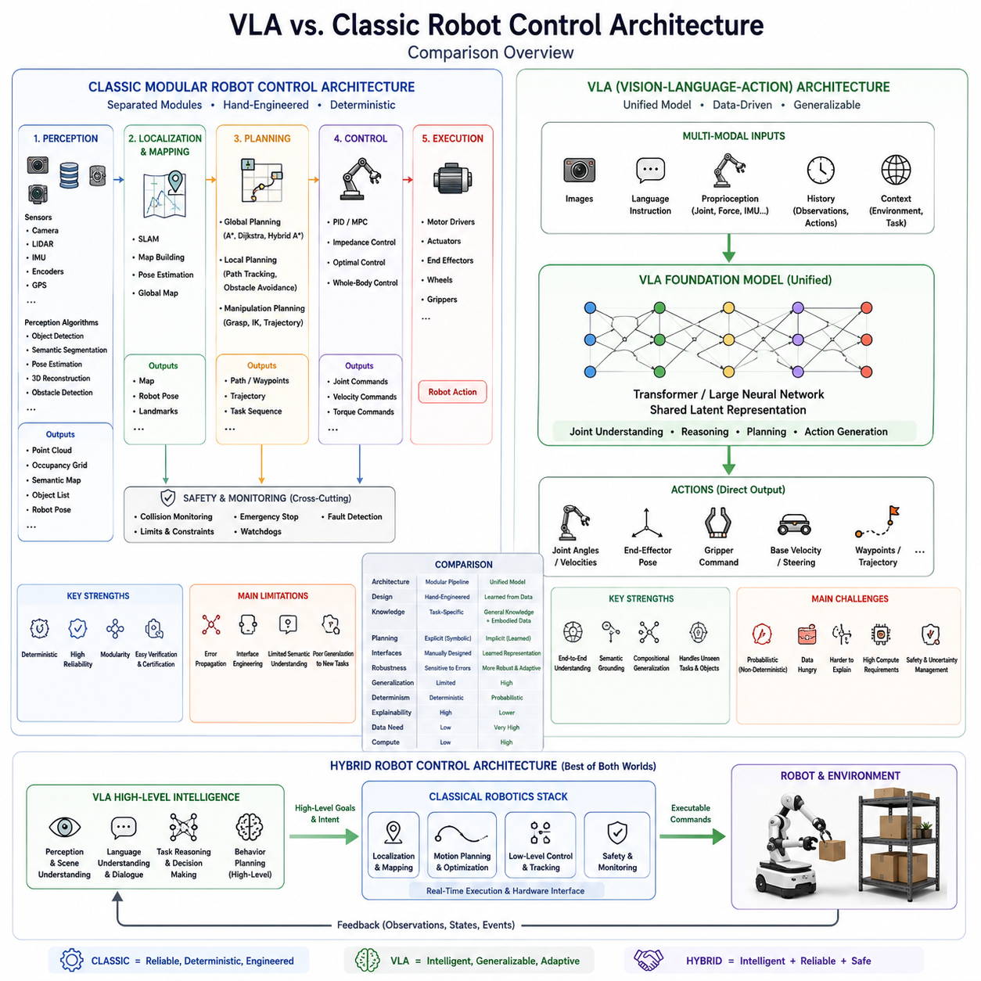
The evolution of robotics has historically been driven by advances in mechanical engineering, control theory, sensing technologies, embedded computing, and software engineering. For more than four decades, the dominant paradigm for robot system development has been the classical modular control architecture, where individual software components are designed independently and connected through clearly defined interfaces. This engineering methodology has produced highly reliable industrial robots, autonomous mobile robots, warehouse automation systems, surgical robots, and manufacturing equipment that operate safely and predictably in structured environments. However, as robots increasingly enter dynamic, unstructured, and human-centered environments, the limitations of purely modular architectures become increasingly apparent. Vision-Language-Action (VLA) models have emerged as an alternative architectural paradigm that integrates perception, reasoning, language understanding, and action generation into a unified learning-based framework. Rather than replacing every component of traditional robotics, VLA architectures fundamentally redefine how high-level robot intelligence is represented and executed.
Classical robot control architecture is primarily based on decomposition. Engineers divide the robotic system into independent functional modules, each responsible for a specific computational task. A typical autonomous robot contains separate perception systems for object detection and localization, mapping systems for environment representation, planning modules for path generation, motion planners for collision avoidance, controllers for trajectory tracking, hardware abstraction layers for actuator interfaces, and safety monitors for emergency handling. Every module receives standardized inputs, performs well-defined computations, and produces outputs consumed by downstream components. This layered organization greatly simplifies debugging, maintenance, certification, and software reuse.
The perception subsystem typically represents the first stage of a classical robotics pipeline. Cameras, LiDAR sensors, radar, depth cameras, inertial measurement units, wheel encoders, and GPS receivers continuously observe the surrounding environment. Individual perception algorithms estimate object positions, detect obstacles, segment semantic regions, classify terrain, estimate robot pose, and reconstruct three-dimensional geometry. The outputs of these perception algorithms are generally represented using explicit symbolic structures such as occupancy grids, point clouds, semantic maps, object lists, or coordinate frames.
Once perception produces an environmental representation, planning algorithms become responsible for decision making. Global planners calculate feasible routes through the environment using graph search algorithms such as A*, Dijkstra, or Hybrid A*. Local planners continuously refine trajectories to avoid moving obstacles while maintaining dynamic feasibility. Manipulation planners determine grasp poses, inverse kinematics solutions, collision-free arm trajectories, and grasp execution sequences. The planning subsystem therefore converts environmental knowledge into executable robot objectives.
The control subsystem executes these plans by generating low-level actuator commands. Classical controllers frequently rely on proportional-integral-derivative control, model predictive control, adaptive control, impedance control, whole-body control, or optimal control techniques depending on the application. These controllers are mathematically derived, highly deterministic, and extensively validated. Their behavior can often be analyzed theoretically using stability analysis, Lyapunov theory, controllability, and robustness criteria.
The modular architecture offers several important engineering advantages. Each subsystem can be independently developed, tested, replaced, and optimized without affecting unrelated components. Sensor failures remain localized within perception modules. Planning algorithms can evolve independently from motion controllers. Hardware upgrades generally require modifications only within abstraction layers rather than throughout the entire software stack. Such modularity has made classical architectures the dominant design methodology for industrial robotics.
Determinism represents another defining characteristic of classical robot architectures. Given identical sensor inputs and identical environmental conditions, deterministic algorithms produce identical outputs. This predictability greatly simplifies verification, validation, certification, and safety analysis. Industrial manufacturing, automotive production, semiconductor fabrication, and medical robotics depend heavily on deterministic execution because failures can have significant economic or safety consequences.
Despite these strengths, modular architectures exhibit several inherent limitations. The first limitation arises from error propagation across subsystem boundaries. Every module operates under assumptions regarding the quality and accuracy of incoming information. If perception incorrectly identifies an object's location, planning generates incorrect trajectories, and controllers faithfully execute incorrect commands. Since errors accumulate sequentially throughout the pipeline, even small perception inaccuracies may ultimately cause complete task failure.
Another limitation concerns interface engineering. Each subsystem communicates through manually designed representations. Engineers must explicitly determine which variables should be transmitted between perception, localization, planning, manipulation, and control modules. As robotic applications become increasingly complex, maintaining consistent interfaces becomes progressively more difficult. Modifying one subsystem frequently requires corresponding updates throughout the software architecture.
Classical systems also struggle with semantic understanding. A traditional robot may successfully detect a bottle, estimate its position, and calculate a grasp trajectory. However, understanding a natural language instruction such as “bring me the bottle beside the coffee machine but avoid disturbing the cups” requires reasoning about semantic relationships, human intentions, contextual knowledge, and task priorities that extend beyond conventional geometric planning. Such reasoning often requires manually designed symbolic reasoning systems layered above traditional robot software.
Generalization presents another major challenge. Classical robots perform exceptionally well within environments anticipated during system development. However, introducing new object categories, unseen environments, novel manipulation tasks, or unexpected instructions frequently requires software modifications, parameter tuning, or additional programming. The resulting engineering effort limits scalability across diverse application domains.
Vision-Language-Action architectures approach robot intelligence from an entirely different perspective. Instead of separating perception, reasoning, planning, and action into independent software modules, VLA models learn a unified mapping from multimodal observations directly to robot actions. Images, language instructions, proprioceptive states, temporal histories, and environmental context are jointly processed by large neural networks that produce executable robot behaviors. Rather than relying on explicitly designed intermediate representations, VLA models discover latent representations automatically during large-scale training.
The central architectural concept underlying VLA systems is the shared latent representation. Vision, language, robot state, and action sequences are embedded into a common feature space where semantically related concepts naturally become associated. Instead of separately estimating object locations, parsing language, constructing symbolic plans, and calculating action sequences, the model simultaneously reasons across all modalities through learned attention mechanisms. This integrated representation substantially reduces dependence on manually engineered interfaces.
Language understanding illustrates one of the clearest differences between both paradigms. Within classical robotics, language commands are typically processed using natural language parsers that convert sentences into symbolic task specifications. Additional planning systems subsequently transform symbolic goals into executable robot behaviors. VLA architectures instead directly associate language instructions with observed environments and corresponding actions. A command such as “pick up the blue bottle beside the coffee machine” becomes naturally grounded within visual observations without explicitly constructing symbolic intermediate representations.
Perception also differs fundamentally. Classical perception systems generally optimize individual computer vision tasks independently, including object detection, semantic segmentation, pose estimation, depth reconstruction, or scene classification. VLA perception instead optimizes visual representations specifically for downstream robotic behavior. Rather than maximizing image classification accuracy, visual encoders learn features that directly improve manipulation, navigation, reasoning, and action generation. Consequently, perception becomes task-aware rather than task-independent.
Planning within VLA architectures is often implicit rather than explicit. Classical planners generate intermediate trajectories before execution. VLA policies instead internalize planning through learned representations acquired during training. Temporal attention mechanisms, sequence modeling, and large-scale demonstrations enable models to predict coherent long-horizon behaviors without constructing explicit symbolic plans. Nevertheless, many practical robotic systems continue integrating traditional motion planners beneath VLA policies to ensure safety and dynamic feasibility.
Another important distinction concerns learning. Classical robot architectures rely predominantly on engineering knowledge encoded through algorithms designed by domain experts. VLA architectures rely primarily on statistical learning from large datasets. Engineers shift their focus from manually implementing decision rules toward designing training datasets, optimizing learning algorithms, evaluating model robustness, and ensuring safe deployment. The engineering challenge transitions from programming behavior to supervising learning.
Generalization represents perhaps the greatest advantage of Vision-Language-Action models. Since knowledge is learned from diverse multimodal datasets rather than manually specified algorithms, VLA systems can often execute previously unseen tasks through semantic reasoning and compositional understanding. A robot trained to grasp cups and bottles separately may successfully manipulate unfamiliar containers because learned representations capture broader physical concepts rather than memorizing individual trajectories.
Foundation model pretraining significantly amplifies this capability. Modern VLA systems frequently inherit visual knowledge from Internet-scale image datasets, linguistic reasoning from large language models, and manipulation skills from robotic demonstrations. Consequently, robots possess conceptual knowledge extending far beyond their direct physical experiences. This transfer of Internet-scale semantic understanding into embodied behavior represents one of the defining innovations distinguishing VLA systems from earlier robotic learning approaches.
Temporal reasoning also differs substantially. Classical robotic systems generally maintain explicit world models containing object locations, maps, task states, and planning graphs. VLA architectures instead encode temporal context within neural memory representations learned through sequential training. Historical observations, previous actions, dialogue context, and environmental evolution become integrated into transformer attention rather than manually maintained symbolic databases.
Despite these advantages, VLA architectures introduce new engineering challenges absent from classical systems. Neural network inference remains probabilistic rather than deterministic. Identical inputs may occasionally produce different outputs due to stochastic decoding or numerical variability. Explaining individual decisions becomes more difficult because reasoning emerges from distributed neural representations rather than explicit symbolic algorithms. Verification, validation, certification, and safety assurance therefore become substantially more challenging.
Data dependence constitutes another significant difference. Classical robotic software can often be developed using engineering knowledge alone. VLA systems require enormous quantities of high-quality multimodal training data. Images, robot trajectories, language instructions, force measurements, proprioceptive states, and environmental interactions must be collected, synchronized, cleaned, labeled when necessary, and continuously expanded. Data engineering therefore becomes a primary component of robotics development.
Computational requirements have similarly increased dramatically. Classical planning and control algorithms frequently execute efficiently on embedded processors or industrial controllers. Large Vision-Language-Action foundation models often require modern GPUs, specialized AI accelerators, optimized inference engines, model quantization, TensorRT optimization, or distributed cloud-edge deployment to achieve acceptable real-time performance. Efficient deployment therefore represents an active research area.
Safety engineering also differs significantly between the two paradigms. Classical safety systems primarily supervise deterministic algorithms whose operational boundaries are well understood. VLA policies, however, learn behaviors statistically and therefore require uncertainty estimation, confidence monitoring, fallback controllers, human override mechanisms, anomaly detection, and runtime verification to ensure reliable operation. Rather than replacing classical safety engineering, VLA systems generally coexist with traditional deterministic control architectures.
Consequently, modern industrial robotics increasingly adopts hybrid architectures combining both paradigms. Vision-Language-Action models provide high-level perception, semantic reasoning, task understanding, instruction interpretation, and behavioral planning. Classical robotics continues managing localization, trajectory optimization, collision avoidance, low-level control, actuator synchronization, hardware safety, and real-time execution. This layered integration leverages the complementary strengths of both approaches while mitigating their respective weaknesses.
A practical warehouse robot illustrates this hybrid architecture effectively. A VLA model interprets the instruction “retrieve the damaged package from the third shelf beside the loading dock.” It identifies the relevant package, reasons about semantic relationships, and determines the overall manipulation objective. Classical localization systems estimate robot position. Motion planners calculate collision-free trajectories. Controllers execute wheel velocities and manipulator motions. Safety systems monitor obstacle proximity and emergency conditions. Rather than replacing existing robotics infrastructure, the VLA model augments high-level intelligence while deterministic controllers maintain operational reliability.
The distinction between modular and unified architectures should therefore not be interpreted as a competition between old and new technologies. Classical robot control remains indispensable for achieving deterministic execution, precise motion control, functional safety, hardware integration, certification, and industrial reliability. Vision-Language-Action models complement these capabilities by introducing semantic understanding, multimodal reasoning, language interaction, compositional generalization, and foundation model intelligence. Together they form the basis of next-generation Physical AI systems.
Looking toward the future, robotics software architecture is expected to evolve toward increasingly integrated hybrid systems in which foundation models handle cognitive functions while classical controllers ensure safe physical execution. World models, multimodal memory, continual learning, simulation-based adaptation, distributed fleet intelligence, and cloud-assisted reasoning will gradually extend VLA capabilities beyond manipulation into navigation, autonomous driving, humanoid robotics, industrial inspection, healthcare, logistics, and collaborative manufacturing. Rather than replacing the principles of classical robotics, Vision-Language-Action architectures represent their natural evolution, combining decades of deterministic engineering with the adaptive intelligence enabled by modern foundation models. This convergence establishes a new architectural paradigm in which learning-based cognition and model-based control cooperate to produce robotic systems that are simultaneously intelligent, reliable, adaptable, and safe enough for widespread real-world deployment.

1.4 Input Modalities: RGB, Depth, Language, and Proprioception
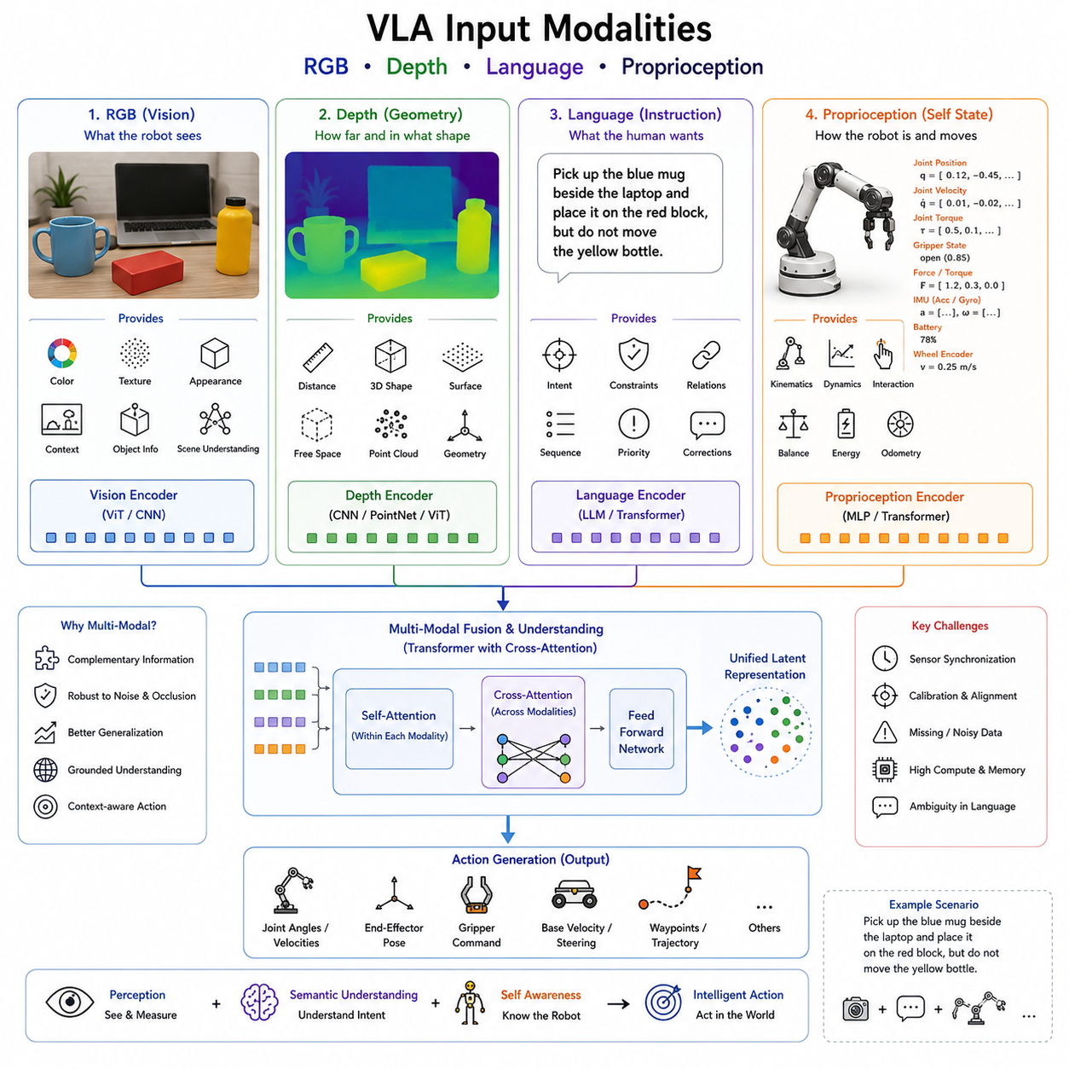
Vision-Language-Action (VLA) models distinguish themselves from traditional robotic control systems by their ability to simultaneously process multiple heterogeneous information sources within a unified neural architecture. Unlike classical robotic pipelines, where perception, language processing, localization, and control are implemented as independent software modules communicating through predefined interfaces, VLA models integrate diverse sensor modalities into a shared latent representation. This multimodal representation allows the robot to understand not only what exists in its environment but also what humans intend, what the robot itself is currently doing, and what actions should be performed next. The effectiveness of a VLA system therefore depends heavily on the quality, diversity, synchronization, and representation of its input modalities. Among the many possible inputs available to modern robotic systems, four modalities have emerged as the fundamental components of nearly every Vision-Language-Action architecture: RGB vision, depth perception, natural language, and proprioception. Together these modalities provide complementary information describing the external world, semantic intent, and internal robot state, enabling robots to generate grounded and context-aware actions.
The motivation for multimodal input originates from the observation that no individual sensing modality provides sufficient information for robust robotic intelligence. A conventional RGB camera can capture texture, color, and appearance but cannot directly measure geometric distance. A depth camera accurately estimates three-dimensional structure but provides limited semantic information. Natural language expresses human intentions but lacks precise environmental grounding unless combined with perception. Proprioceptive sensors accurately describe the robot's internal configuration yet provide no knowledge about external surroundings. Each modality therefore contains only partial information regarding the complete robot-environment interaction. Vision-Language-Action systems achieve superior performance by learning how these complementary information sources interact and reinforce one another during decision making.
RGB images remain the primary visual modality for most modern robotic foundation models. Cameras provide dense two-dimensional observations containing color, texture, illumination, edges, object appearance, shadows, reflections, and environmental context. Human vision itself relies predominantly on color imagery, making RGB observations particularly suitable for learning semantic representations transferable from Internet-scale image datasets. Large Vision Transformers, CLIP, SigLIP, DINOv2, and numerous other vision encoders have demonstrated remarkable capability in extracting high-level semantic features from RGB images. Consequently, most VLA systems inherit visual representations from foundation vision models pretrained on billions of Internet images before fine-tuning for robotic applications.
RGB imagery provides several distinct advantages. Color differences allow robots to distinguish visually similar objects that differ only by appearance. Texture patterns enable material recognition, supporting decisions involving grasping, manipulation, and navigation. High-resolution imagery captures small visual details necessary for industrial inspection, defect detection, object recognition, and human interaction. Contextual relationships between objects also emerge naturally from RGB observations, allowing robots to infer semantic information such as tables supporting cups, shelves containing books, or keyboards located beside computer monitors.
However, RGB cameras also possess important limitations. Since monocular images represent only two-dimensional projections of three-dimensional environments, estimating object distance, scale, and spatial relationships becomes inherently ambiguous. Changes in lighting conditions, shadows, reflections, weather, and camera exposure may significantly affect recognition performance. Occlusions frequently hide important objects, while transparent and reflective materials introduce additional visual challenges. Consequently, RGB perception alone rarely provides sufficient geometric accuracy for reliable robotic manipulation or autonomous navigation.
Depth sensing addresses these limitations by explicitly measuring three-dimensional geometry. Modern robotic systems employ various depth sensing technologies including structured light cameras, stereo vision, time-of-flight sensors, LiDAR systems, active infrared cameras, and laser range finders. Unlike RGB images, depth measurements directly encode the distance between sensor and observed surfaces. Every pixel or point therefore contains explicit geometric information describing the physical structure of the environment.
Depth information significantly improves manipulation performance because grasp planning depends fundamentally on object geometry rather than appearance alone. Surface normals, object boundaries, volumetric structure, and free-space estimation become considerably more accurate when depth measurements are available. Mobile robots similarly benefit from reliable obstacle detection, traversability estimation, terrain analysis, and collision avoidance using geometric information unavailable from monocular vision alone.
Three-dimensional perception further enables point cloud generation, volumetric scene reconstruction, occupancy mapping, and object pose estimation. These representations support sophisticated robotic behaviors including bin picking, warehouse manipulation, pallet handling, assembly automation, autonomous driving, and humanoid interaction. Modern VLA architectures increasingly integrate depth information directly into transformer-based visual representations, allowing geometric reasoning to emerge alongside semantic understanding.
Depth sensing nevertheless introduces additional engineering challenges. Many depth sensors exhibit reduced accuracy under bright sunlight, making outdoor deployment difficult. Transparent surfaces, reflective materials, dark objects, and long-distance measurements frequently produce noisy observations or missing values. Furthermore, depth cameras generally possess lower spatial resolution than RGB cameras, requiring effective sensor fusion techniques to combine both modalities. LiDAR systems overcome many of these limitations but typically generate sparse point clouds requiring specialized processing architectures.
Natural language constitutes the third fundamental modality within Vision-Language-Action systems. Language enables humans to communicate abstract goals, constraints, preferences, corrections, explanations, and task specifications without manually programming robot behaviors. Instead of explicitly defining sequences of motor commands, users simply express desired outcomes through spoken or written instructions. The robot must therefore interpret semantic meaning, resolve ambiguities, associate linguistic concepts with observed objects, and generate physically grounded actions consistent with human intent.
Language provides capabilities extending far beyond simple command interpretation. Humans naturally describe spatial relationships using expressions such as “next to,” “behind,” “closest to,” or “inside.” Temporal relationships including “before,” “after,” and “while” similarly guide sequential task execution. Language also conveys abstract concepts including fragility, ownership, cleanliness, urgency, or priority that cannot be directly observed through visual sensors. Consequently, natural language functions as the primary interface connecting human cognitive intentions with robotic physical behavior.
Modern VLA systems typically process language using Transformer-based token embeddings inherited from large language models. Sentences are converted into semantic representations capturing grammatical structure, contextual meaning, world knowledge, and task objectives. Cross-modal attention mechanisms subsequently associate linguistic concepts with corresponding visual observations. A phrase such as “pick up the blue mug beside the laptop” becomes grounded because attention links the linguistic tokens “blue,” “mug,” and “laptop” to specific visual regions observed by the robot.
Language also enables continual interaction throughout task execution rather than serving solely as an initial instruction. Humans may provide corrections such as “not that cup,” clarifications including “use the smaller box,” or updated objectives like “leave it on the second shelf instead.” Multi-turn dialogue therefore becomes an integral component of embodied intelligence, allowing robots to adapt continuously to changing human requirements.
Despite its expressive power, language introduces uncertainty absent from geometric sensing. Human instructions often contain ambiguity, incomplete information, implicit assumptions, and contextual references requiring commonsense reasoning. Different users may describe identical tasks using entirely different vocabulary. Cultural conventions, domain-specific terminology, and conversational context further complicate language understanding. Consequently, VLA systems rely heavily on visual grounding to resolve ambiguities through environmental observations.
The fourth essential modality is proprioception, representing the robot's internal awareness of its own physical state. While vision observes the external environment, proprioceptive sensors continuously measure the robot's embodiment including joint positions, joint velocities, actuator torques, force measurements, battery status, inertial motion, wheel encoder readings, gripper states, and other internal variables. Without proprioception, robots would possess detailed environmental knowledge yet remain unaware of their own physical capabilities and limitations.
Joint position measurements define the robot's current kinematic configuration, allowing action policies to account for reachability, singularities, joint limits, and motion continuity. Joint velocities describe dynamic behavior, supporting smooth trajectory generation and temporal consistency. Torque sensors estimate interaction forces occurring during manipulation, enabling compliant control, contact detection, and force-sensitive assembly operations. Force-torque sensors located near robot wrists further provide valuable information regarding grasp stability, insertion tasks, and physical interaction with surrounding objects.
Inertial Measurement Units contribute additional proprioceptive information by measuring linear acceleration and angular velocity. Mobile robots utilize inertial sensing for localization, slip detection, balance control, and motion estimation. Humanoid robots depend extensively upon IMU measurements to maintain postural stability during walking, climbing, and manipulation. Quadruped robots similarly integrate inertial sensing with joint feedback to achieve dynamic locomotion across uneven terrain.
Battery monitoring represents another important proprioceptive modality frequently overlooked in conceptual discussions. Remaining energy directly influences feasible task planning, navigation decisions, charging behavior, and mission scheduling. A robot instructed to transport packages across a large warehouse may select entirely different execution strategies depending on available battery capacity. Internal health monitoring therefore contributes directly to intelligent decision making.
Wheel encoder measurements similarly provide valuable state estimation for mobile robots. Encoder observations estimate traveled distance, wheel velocities, and odometry, supporting localization, navigation, and motion control. Combined with inertial measurements, wheel encoders improve robustness under conditions where visual localization becomes unreliable.
Gripper state measurements indicate whether objects have been successfully grasped, released, or manipulated. Finger positions, grasp forces, tactile sensing, and contact detection allow robots to verify successful task execution while adapting manipulation strategies during unexpected interactions. Emerging tactile sensors further extend proprioception by providing high-resolution contact information resembling biological touch perception.
Temporal history represents an additional implicit input modality increasingly incorporated into modern VLA architectures. Individual observations rarely provide sufficient context for long-horizon robotic behavior. Instead, sequences of previous images, language interactions, proprioceptive measurements, and executed actions collectively define the current task state. Transformer attention mechanisms naturally process these temporal sequences, enabling robots to maintain memory across extended manipulation tasks, navigation missions, and collaborative interactions.
Synchronization among modalities is critically important for effective multimodal learning. RGB images, depth observations, language commands, IMU measurements, joint states, force sensors, and action trajectories must correspond to identical physical moments whenever possible. Even small temporal misalignments may significantly degrade learning because visual observations become incorrectly associated with robot actions. Modern robotic systems therefore employ hardware triggering, Precision Time Protocol synchronization, timestamp alignment, and deterministic middleware to maintain temporal consistency across heterogeneous sensors.
Sensor calibration similarly influences multimodal performance. Camera intrinsic calibration, camera-to-robot extrinsic calibration, depth alignment, LiDAR registration, IMU calibration, and hand-eye calibration collectively determine whether observations from multiple modalities describe consistent physical geometry. Poor calibration introduces systematic errors propagating throughout downstream learning algorithms. Consequently, multimodal calibration constitutes a foundational prerequisite for successful Vision-Language-Action deployment.
Data representation also plays a central role in multimodal architectures. Images are commonly encoded through Vision Transformers or convolutional neural networks. Depth observations may be represented as depth maps, point clouds, voxels, signed distance fields, or learned geometric embeddings. Language becomes token embeddings processed by large language models. Proprioceptive signals are typically represented as continuous numerical vectors normalized according to robot-specific characteristics. Cross-modal projection layers subsequently transform all modalities into compatible embedding dimensions before fusion through transformer attention.
Fusion strategies vary considerably across different VLA architectures. Early fusion combines raw modality embeddings before extensive processing, allowing interactions to emerge throughout the network. Late fusion processes each modality independently before integrating high-level features. Hierarchical fusion introduces interactions at multiple network depths, balancing computational efficiency with representational richness. Cross-attention mechanisms remain particularly popular because they dynamically determine which modalities provide the most relevant information for each prediction.
Missing or degraded modalities represent unavoidable challenges in real-world deployment. Cameras may become occluded, depth sensors may fail under sunlight, language instructions may be incomplete, and proprioceptive sensors may temporarily malfunction. Robust Vision-Language-Action architectures therefore learn modality redundancy, allowing available sensors to compensate whenever individual inputs become unreliable. Self-supervised pretraining, multimodal consistency objectives, and uncertainty estimation further improve resilience under degraded sensing conditions.
The emergence of foundation models has further transformed multimodal learning. Instead of designing modality-specific algorithms independently, researchers increasingly pretrain unified architectures on enormous multimodal datasets containing Internet images, language corpora, robotic demonstrations, simulation trajectories, and sensor recordings. Such pretraining enables robots to acquire broad semantic understanding before specialization through robot-specific fine-tuning. The resulting representations exhibit significantly improved transfer learning, zero-shot generalization, and robustness across diverse tasks.
Future Vision-Language-Action systems will likely expand beyond the four primary modalities discussed here. Audio perception will enable speech interaction and environmental awareness. Tactile sensing will improve dexterous manipulation and physical interaction. Thermal imaging, hyperspectral sensing, event cameras, radar, chemical sensors, and physiological measurements may further enrich embodied perception depending on application requirements. World models, long-term episodic memory, environmental maps, digital twins, and cloud-based knowledge repositories may likewise become additional information modalities contributing to unified robotic intelligence.
Ultimately, the success of Vision-Language-Action architectures depends not upon any single sensing technology but upon their ability to integrate complementary modalities into coherent internal representations describing the complete robot-environment interaction. RGB images contribute semantic appearance, depth provides physical geometry, language expresses human intent, and proprioception defines embodiment. Together these modalities establish the perceptual foundation enabling robots to perceive the world, understand instructions, reason about physical interactions, and generate intelligent actions that remain grounded within both the external environment and the robot's own physical capabilities.

1.5 Output Representations: Joint Commands, Pose, Twist, and Delta Actions
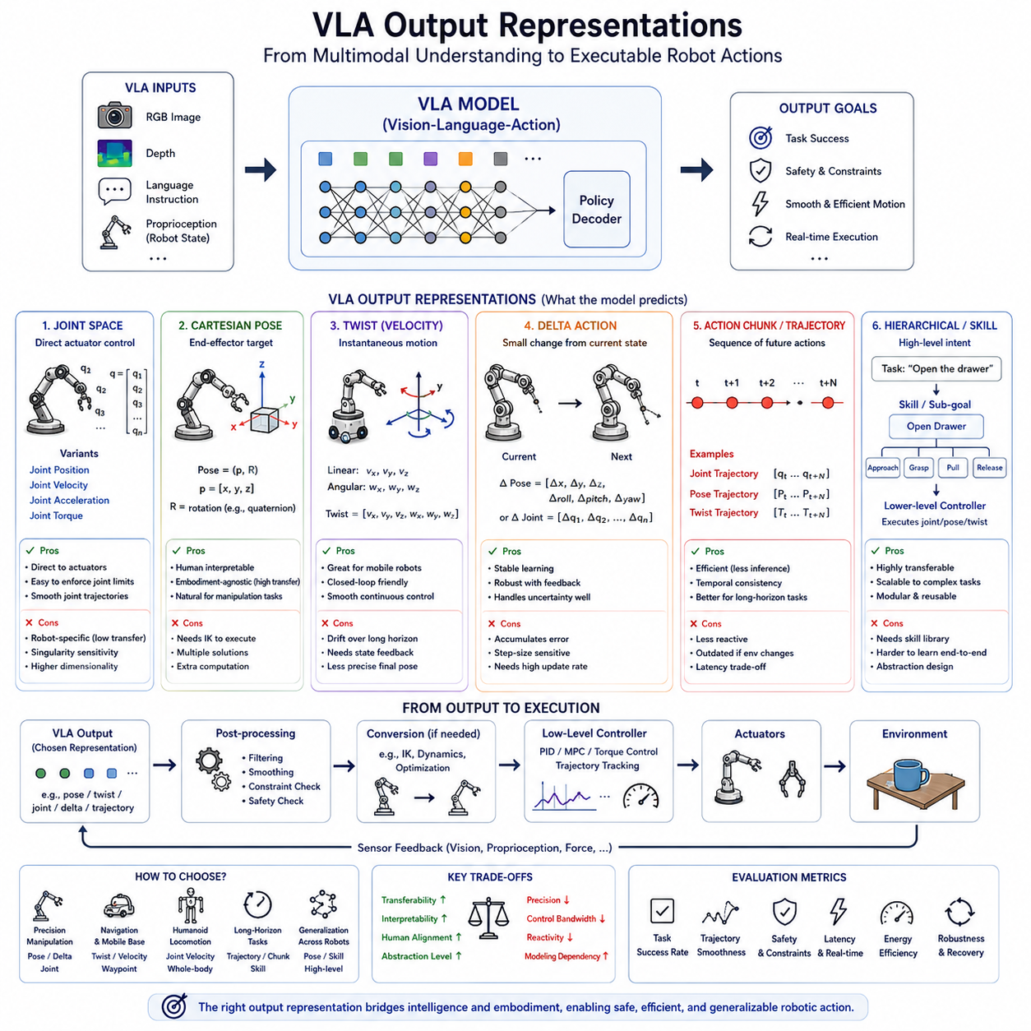
Vision-Language-Action (VLA) models are fundamentally designed to transform multimodal observations into executable robot behaviors. While much of the attention surrounding VLA research focuses on perception, language understanding, and multimodal reasoning, the ultimate purpose of every VLA architecture is the generation of actions that can be executed safely and effectively by a physical robot. Consequently, the design of action output representations plays an equally important role as the design of visual or language encoders. A robot may perfectly understand its environment and correctly interpret a human instruction, but if the generated output cannot be translated into meaningful motor commands, the intelligence of the system remains purely symbolic. Output representation therefore serves as the interface between learned cognition and physical execution. It determines how the internal latent representation of the VLA model is converted into robot movements that satisfy task objectives while respecting kinematic, dynamic, and safety constraints.
Unlike natural language models, whose outputs consist primarily of text tokens, Vision-Language-Action systems must produce outputs that correspond to continuous physical interactions with the environment. These outputs vary significantly depending on robot embodiment, application domain, control frequency, and system architecture. A mobile robot requires steering and velocity commands, while a manipulator requires arm joint trajectories and gripper commands. A humanoid robot simultaneously controls dozens of joints distributed across the entire body, whereas an autonomous vehicle predicts steering angles, acceleration, and braking commands. Consequently, no universal action representation exists that is optimal for every robotic platform. Modern VLA systems therefore employ several complementary output representations including joint-space commands, Cartesian poses, twists, delta actions, action tokens, trajectories, and hierarchical skill representations.
The selection of an appropriate action representation directly influences learning efficiency, inference stability, generalization capability, and deployment robustness. Low-level representations provide precise control but require large amounts of training data and often generalize poorly across different embodiments. High-level representations improve transferability but depend upon additional controllers to translate abstract intentions into executable motions. Understanding these trade-offs is therefore essential for designing practical Vision-Language-Action architectures.
Joint-space representation is among the most widely used output formats for robotic manipulation. In this formulation, the VLA model directly predicts desired joint positions, joint velocities, joint accelerations, or joint torques corresponding to each actuator of the robot. For an industrial manipulator possessing six revolute joints, the output may consist of six continuous numerical values representing target joint angles. Humanoid robots similarly predict values for dozens of joints distributed throughout the head, torso, arms, hands, legs, and feet. Since actuators ultimately execute joint-level commands, this representation establishes the most direct connection between neural inference and physical motion.
Predicting joint positions offers several advantages. Joint commands correspond naturally to existing robot controllers and can be transmitted directly to servo systems with minimal intermediate processing. Kinematic constraints such as joint limits are easily incorporated during training or post-processing. Smooth trajectories may be generated by predicting temporally consistent joint sequences. Furthermore, joint representations avoid ambiguities associated with inverse kinematics because every predicted configuration uniquely defines the robot's physical posture.
Nevertheless, joint-space outputs also possess important disadvantages. Joint values depend entirely upon robot embodiment, preventing direct transfer between different robot platforms. A seven-degree-of-freedom manipulator and a dual-arm humanoid possess entirely different joint configurations despite performing similar manipulation tasks. Consequently, foundation policies trained using joint representations often require embodiment-specific fine-tuning before deployment on new robots. Furthermore, small joint errors near kinematic singularities may produce disproportionately large end-effector deviations.
Joint velocity prediction represents another commonly employed representation. Instead of predicting absolute joint positions, the model generates desired angular velocities for each actuator. Velocity commands naturally support continuous closed-loop control because corrections may be applied incrementally at every control cycle. Dynamic robotic systems including mobile manipulators, quadrupeds, and humanoids frequently benefit from velocity control because motion remains smoother and more responsive to environmental feedback.
Torque prediction extends action generation to dynamic interaction with physical environments. Rather than specifying desired positions or velocities, the policy predicts actuator torques directly. Torque control enables compliant manipulation, force-sensitive assembly, physical interaction with humans, and dynamic locomotion across uneven terrain. However, torque prediction also requires significantly more accurate dynamic modeling and substantially higher control frequencies than position control. Consequently, relatively few current Vision-Language-Action models directly predict torques without additional low-level controllers.
Cartesian pose representation provides an alternative output formulation emphasizing task-space rather than joint-space behavior. Instead of predicting actuator configurations, the VLA model estimates the desired position and orientation of the robot end-effector relative to a specified coordinate frame. Position is commonly represented using three-dimensional Cartesian coordinates, while orientation may be represented using Euler angles, rotation matrices, axis-angle representations, or unit quaternions. The resulting six-degree-of-freedom pose directly specifies where the robot hand should move within physical space.
Pose-based outputs exhibit several important advantages for manipulation tasks. Human instructions naturally describe task objectives in Cartesian space rather than joint coordinates. A command such as “place the cup on the table” implicitly specifies a target pose rather than individual joint angles. Consequently, pose representations align closely with semantic task descriptions. Furthermore, Cartesian outputs remain largely independent of robot embodiment because different manipulators can achieve identical end-effector poses using different internal joint configurations.
Inverse kinematics algorithms subsequently convert desired poses into executable joint trajectories. Modern robotic software frameworks provide highly optimized inverse kinematics solvers capable of handling redundancy, joint constraints, collision avoidance, and optimization objectives. As a result, many industrial Vision-Language-Action systems predict Cartesian poses while relying upon deterministic inverse kinematics for execution.
Pose representations nevertheless introduce additional computational complexity. Multiple joint configurations may correspond to identical end-effector poses, requiring inverse kinematics algorithms to resolve ambiguity. Singular configurations may prevent certain orientations from being achieved. Computational latency introduced by inverse kinematics also increases overall inference time, particularly for robots possessing many degrees of freedom.
Twist representation extends Cartesian outputs by incorporating velocity information. Within robotics, a twist describes instantaneous linear and angular velocity simultaneously. Linear velocity specifies translational motion along three orthogonal axes, while angular velocity defines rotational motion around those same axes. Together they form a six-dimensional motion vector describing how the robot should move during the next control interval.
Twist outputs are particularly valuable for mobile robots, autonomous vehicles, quadrupeds, humanoids, and continuous manipulation tasks. Rather than predicting absolute positions, the VLA model continuously estimates desired motion commands. Differential drive robots commonly receive linear forward velocity together with angular rotational velocity. Omnidirectional platforms extend this representation by allowing independent lateral movement. Aerial robots similarly employ twists describing translational and rotational motion within three-dimensional space.
Continuous velocity control offers several advantages for closed-loop systems. Environmental feedback can immediately influence subsequent velocity predictions without requiring complete trajectory replanning. Dynamic obstacle avoidance becomes smoother because robots continuously adjust motion according to current observations. Twist representations also integrate naturally with classical feedback controllers that stabilize dynamic systems using velocity tracking.
Another increasingly popular output formulation is delta action representation. Instead of predicting absolute positions or velocities, the model estimates incremental changes relative to the current robot state. A delta pose may specify small translational displacements together with small rotational adjustments. Delta joint commands similarly indicate incremental changes in actuator positions. During execution, these deltas accumulate over time, gradually producing complete robot motions.
Delta representations significantly improve learning stability because neural networks predict relatively small corrections rather than globally accurate absolute states. Prediction errors therefore remain bounded, allowing closed-loop feedback to compensate during subsequent control cycles. Human teleoperation demonstrations similarly consist primarily of incremental adjustments, making delta representations naturally compatible with imitation learning datasets.
Modern manipulation policies frequently combine delta actions with high-frequency visual feedback. At each control cycle, the robot observes the current environment, predicts small motion corrections, executes those corrections, and immediately observes the updated scene. This closed-loop process enables robust manipulation despite modeling inaccuracies, calibration errors, or unexpected environmental disturbances. Consequently, delta representations have become particularly popular within diffusion policies and transformer-based manipulation models.
Action chunking introduces another important development in Vision-Language-Action output design. Rather than predicting a single action per inference cycle, the model generates short sequences of future actions simultaneously. For example, a policy may predict the next ten joint commands rather than only the immediate command. This approach substantially reduces computational overhead because inference need not be performed at every low-level control cycle. Furthermore, chunked actions naturally encourage temporal consistency and smoother trajectories.
Action chunking also improves robustness against temporary communication delays or computational latency. If inference requires several hundred milliseconds, precomputed action sequences maintain continuous robot motion until the next prediction becomes available. Nevertheless, excessively long action chunks reduce responsiveness because robots continue executing outdated predictions despite environmental changes. Practical systems therefore carefully balance computational efficiency with closed-loop adaptability.
Trajectory representation further generalizes action chunking by predicting complete future motion paths. Instead of estimating individual commands, the VLA model generates continuous trajectories parameterized over time. Mobile robots may predict navigation paths through obstacle fields, while manipulators generate complete end-effector trajectories from grasp approach through object placement. Trajectory outputs naturally integrate with optimization-based motion planning algorithms and facilitate dynamic feasibility verification before execution.
Hierarchical action representations separate high-level intentions from low-level motor execution. The VLA model predicts abstract skills such as “grasp object,” “open drawer,” “navigate to shelf,” or “place container,” while specialized skill controllers implement detailed motor behavior. This hierarchy substantially improves transfer learning because identical high-level skills remain applicable across different robot embodiments despite differing actuator configurations. Hierarchical representations therefore play an increasingly important role within general-purpose robotic foundation models.
Discrete action tokenization represents another influential development inspired by natural language modeling. Rather than generating continuous numerical values directly, continuous robot actions are discretized into finite action vocabularies resembling language tokens. Transformer decoders subsequently generate action tokens autoregressively using identical mechanisms employed for text generation. Robotics Transformer architectures including RT-1 and RT-2 demonstrated that action tokenization enables effective integration between language modeling and robotic control.
Although tokenization simplifies sequence modeling, discretization inevitably introduces approximation errors because continuous physical motion becomes represented by finite vocabulary elements. Token resolution therefore influences both action accuracy and computational complexity. Higher-resolution vocabularies improve precision but increase sequence length and inference cost. Practical systems carefully balance representational fidelity against computational efficiency.
Diffusion-based action policies introduce probabilistic output representations capable of modeling multimodal behaviors. Instead of predicting a single deterministic action, diffusion policies generate distributions over feasible future actions through iterative denoising processes. Such representations naturally capture uncertainty and multiple valid solutions for manipulation tasks possessing diverse feasible trajectories. Flow matching methods further improve computational efficiency by learning continuous probability transport rather than iterative reverse diffusion.
Output calibration constitutes another important consideration for Vision-Language-Action systems. Neural networks frequently exhibit overconfidence, producing highly certain predictions despite unfamiliar environments. Confidence estimation, uncertainty quantification, Bayesian inference, ensemble prediction, and probabilistic calibration therefore become valuable additions to output representations. Rather than transmitting only action commands, future robotic policies increasingly communicate both intended behaviors and associated confidence levels, allowing supervisory safety systems to intervene whenever uncertainty exceeds acceptable thresholds.
Robot embodiment strongly influences output representation design. Mobile robots primarily require base velocity commands, steering angles, and navigation waypoints. Industrial manipulators emphasize end-effector poses and gripper control. Humanoid robots simultaneously coordinate locomotion, manipulation, balance, gaze direction, and whole-body posture across dozens of actuators. Consequently, modern foundation policies increasingly pursue embodiment-agnostic representations emphasizing task objectives rather than platform-specific motor commands.
Hybrid architectures combining learned outputs with classical controllers represent the current industrial state of the art. Vision-Language-Action models generate semantic objectives, delta motions, desired poses, or high-level behaviors, while deterministic controllers ensure stability, trajectory tracking, collision avoidance, and hardware safety. This separation allows foundation models to focus upon cognition while proven robotics algorithms guarantee reliable physical execution.
Real-time deployment introduces additional constraints on output representations. Low-frequency semantic planning may occur at only one or two hertz, whereas motor controllers often operate at one hundred to one thousand hertz. Intermediate interpolation, trajectory generation, model predictive control, and feedback stabilization therefore bridge the temporal gap between cognitive inference and physical control. Efficient output representations minimize communication overhead while maintaining smooth continuous robot motion.
Evaluation of action representations extends beyond prediction accuracy alone. Successful output formulations should support smooth trajectories, low latency, embodiment transfer, robust generalization, uncertainty estimation, safety supervision, and computational efficiency simultaneously. Metrics including task success rate, trajectory smoothness, energy consumption, action consistency, recovery capability, and real-world execution reliability collectively determine practical usefulness.
Future Vision-Language-Action systems will likely employ increasingly adaptive output representations capable of dynamically selecting appropriate control abstractions according to task complexity. Fine manipulation may require delta Cartesian corrections, long-distance navigation may utilize semantic waypoints, collaborative tasks may emphasize language-grounded skills, and humanoid locomotion may combine whole-body trajectory generation with dynamic stabilization. Rather than relying upon a single universal representation, future foundation policies will intelligently coordinate multiple output formats within unified embodied intelligence architectures.
Ultimately, output representations constitute the final stage through which learned perception, language understanding, and reasoning become tangible physical behavior. Joint commands provide precise embodiment-specific control, Cartesian poses express spatial objectives, twists generate continuous motion, delta actions enable robust closed-loop adaptation, trajectories coordinate long-horizon behavior, and hierarchical skills facilitate generalization across robotic platforms. Together these complementary representations establish the essential interface connecting Vision-Language-Action foundation models with the physical world, transforming multimodal intelligence into safe, efficient, and purposeful robotic action.

1.6 Training Data Requirements: Scale, Diversity, and Quality
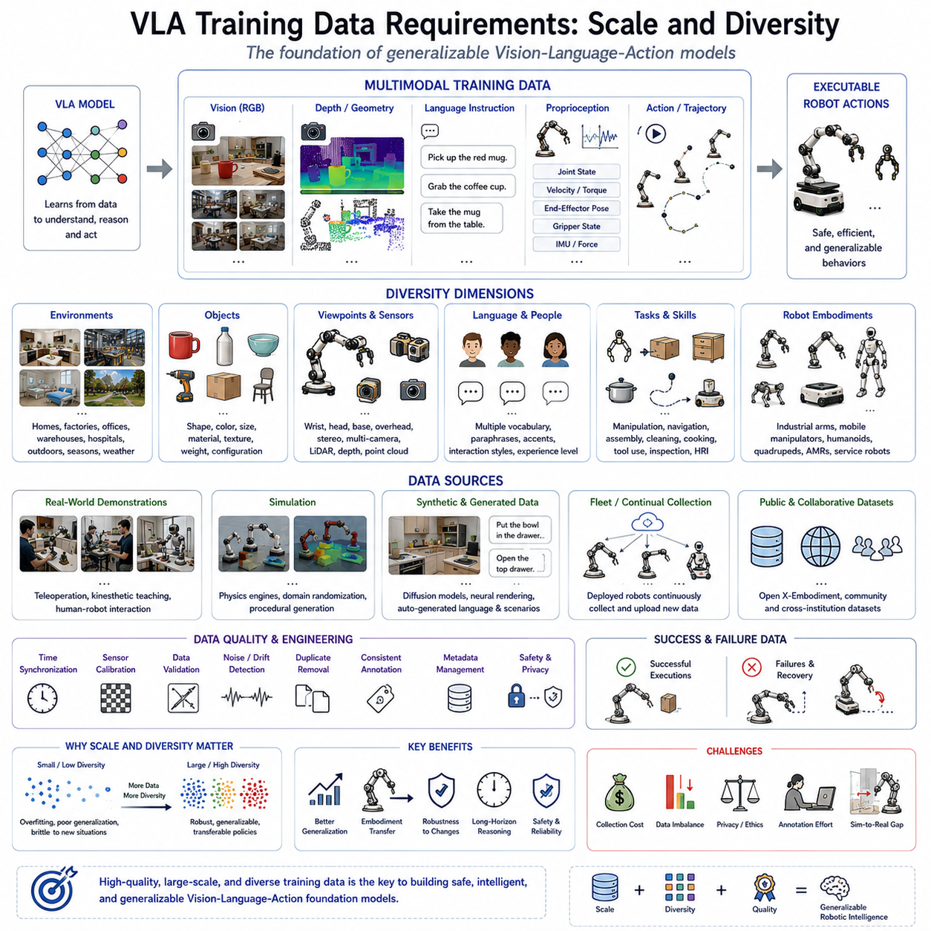
The success of modern Vision-Language-Action (VLA) models is determined not only by advances in neural network architectures but also, and perhaps more importantly, by the quality, scale, and diversity of the training data on which these models are developed. Throughout the history of artificial intelligence, improvements in model architecture have consistently been accompanied by corresponding increases in dataset size and variety. This trend is especially evident in robotics, where the transition from task-specific controllers to general-purpose robotic foundation models has fundamentally changed the role of data. In classical robotics, engineers manually designed perception algorithms, planning strategies, and control laws using mathematical models and expert knowledge. In contrast, VLA systems acquire much of their intelligence directly from multimodal datasets containing visual observations, language instructions, robot states, and demonstrated actions. Consequently, data has become one of the most valuable assets in embodied artificial intelligence, often determining model capability more strongly than network size alone.
The relationship between data and model performance follows a scaling principle that has become increasingly evident across modern foundation models. Early robotic learning systems often relied on hundreds or thousands of demonstrations collected within a single laboratory. Such datasets enabled robots to perform narrowly defined manipulation tasks but rarely generalized beyond their original environments. As dataset sizes expanded to tens of thousands, hundreds of thousands, and eventually millions of demonstrations, robotic policies began exhibiting behaviors that could not be explained simply as memorization. Instead, they developed the ability to transfer knowledge across tasks, objects, environments, and robot embodiments. This phenomenon reflects the emergence of generalized representations learned from statistical regularities present within large-scale multimodal experience.
Scale alone, however, does not guarantee successful learning. A dataset containing millions of nearly identical demonstrations contributes relatively little additional knowledge once repetitive patterns have been learned. Diversity therefore becomes equally important. A robust Vision-Language-Action model must encounter wide variations in objects, environments, viewpoints, lighting conditions, manipulation strategies, human instructions, robot embodiments, and task objectives during training. Diversity prevents models from overfitting to narrow operating conditions and encourages the discovery of invariant features that remain useful across unseen situations.
Modern VLA datasets therefore attempt to maximize both quantity and variability. Instead of collecting repeated demonstrations within controlled laboratory environments, researchers intentionally include multiple buildings, homes, warehouses, factories, hospitals, offices, kitchens, retail stores, and outdoor environments. Objects vary in shape, color, material, size, texture, weight, and configuration. Human operators provide instructions using different vocabulary, sentence structures, accents, and interaction styles. Robots perform identical tasks using multiple embodiments, grippers, sensors, and control systems. Together these variations expose learning algorithms to the broad statistical distribution encountered during real-world deployment.
Visual diversity represents one of the most critical components of robotic training data. Cameras observe objects under changing illumination, shadows, reflections, weather conditions, seasonal variations, sensor noise, motion blur, occlusions, and viewpoint changes. Objects may appear partially hidden, damaged, rotated, stacked, or surrounded by clutter. Robust visual representations emerge only when models learn invariant object characteristics despite these environmental variations. Foundation vision encoders such as Vision Transformers, CLIP, DINOv2, and SigLIP derive much of their success from pretraining on billions of diverse Internet images before adaptation to robotic domains.
For robotic applications, visual diversity extends beyond conventional image recognition. Cameras mounted on robot wrists, robot heads, mobile bases, overhead installations, stereo systems, and external monitoring stations each provide distinct perspectives of identical environments. Wrist-mounted cameras emphasize manipulation details, while head-mounted cameras capture broader scene context. Multi-camera systems therefore contribute complementary observations that significantly improve spatial reasoning and manipulation robustness. Consequently, many modern robotic datasets intentionally include synchronized observations from multiple camera viewpoints.
Depth information introduces another important dimension of data diversity. Modern Vision-Language-Action datasets increasingly incorporate stereo vision, structured light, time-of-flight cameras, LiDAR systems, and point clouds alongside RGB imagery. Three-dimensional geometry enables robots to reason about object shape, free space, surface orientation, grasp affordances, and navigable terrain. Since many robotic tasks fundamentally depend upon spatial geometry rather than appearance alone, multimodal datasets integrating RGB and depth information generally produce more capable manipulation policies than purely image-based collections.
Language diversity has become equally important following the integration of large language models into robotics. Human operators naturally describe identical tasks using numerous linguistic variations. One person may instruct a robot to “pick up the red mug,” while another says “grab the coffee cup,” “move the red cup,” or “take the mug from the table.” A successful Vision-Language-Action model must understand that these expressions often refer to identical physical objectives. Training datasets therefore benefit from collecting multiple paraphrases, dialogue interactions, corrections, explanations, and conversational contexts for identical robotic behaviors.
Language diversity also includes varying levels of abstraction. Some instructions specify detailed procedural steps, while others describe only high-level goals. A novice user may explain every intermediate action required to set a table, whereas an experienced operator simply requests “prepare the dining table.” Effective VLA models learn to bridge this abstraction gap by inferring missing procedural knowledge from previous demonstrations and foundation model pretraining.
Robot embodiment diversity represents another defining characteristic of modern robotic foundation datasets. Traditional imitation learning typically relied upon demonstrations collected using a single robot platform. Such policies rarely transferred successfully to different manipulators because actuator configurations, kinematic structures, sensor placements, and control interfaces differed substantially. Recent collaborative efforts instead aggregate demonstrations from numerous robot platforms including industrial manipulators, mobile manipulators, humanoids, quadrupeds, autonomous mobile robots, and service robots. Cross-embodiment learning enables foundation policies to discover task-level regularities independent of specific hardware implementations.
The Open X-Embodiment initiative exemplifies this philosophy by combining robotic demonstrations collected from multiple research laboratories using heterogeneous hardware. Rather than learning embodiment-specific motor behaviors, foundation policies gradually develop shared semantic understanding of manipulation tasks transferable across different robots. This transition from robot-specific datasets toward embodiment-agnostic learning represents one of the most significant trends in contemporary embodied artificial intelligence.
Task diversity further contributes to robust generalization. Early robotic datasets frequently contained demonstrations for only one manipulation behavior such as grasping blocks or inserting pegs. Modern datasets instead include thousands of distinct tasks encompassing object sorting, assembly, packaging, cleaning, cooking, warehouse logistics, drawer opening, cabinet manipulation, appliance operation, tool usage, navigation, collaborative interaction, and industrial inspection. Exposure to numerous related tasks enables models to recombine previously learned skills when encountering entirely novel objectives.
Environmental diversity similarly influences deployment robustness. Robots trained exclusively within laboratory environments frequently fail when deployed inside factories, hospitals, homes, or outdoor facilities because visual appearance, object distributions, illumination, and spatial layouts differ substantially. Consequently, high-quality VLA datasets intentionally include diverse buildings, furniture arrangements, floor materials, weather conditions, seasonal variations, and operational contexts. Simulation further extends environmental diversity by generating synthetic scenarios difficult or expensive to reproduce physically.
Temporal diversity also deserves careful consideration. Robotic tasks unfold continuously over time rather than consisting of isolated observations. Successful manipulation requires understanding action sequences, recovery behaviors, pauses, corrections, and dynamic interactions. Training datasets therefore increasingly preserve complete temporal trajectories rather than isolated image-action pairs. Sequence modeling architectures such as Transformers naturally exploit these temporal relationships, enabling long-horizon reasoning and action planning.
Human diversity constitutes another often overlooked factor. Different operators naturally exhibit distinct manipulation styles, grasp preferences, movement speeds, language usage, and decision strategies. Training exclusively on demonstrations from a single expert risks encoding personal biases that reduce deployment robustness. Collecting demonstrations from operators with varying experience levels, cultural backgrounds, physical characteristics, and interaction preferences encourages more generalized behavioral representations suitable for broader populations.
Failure data represents an especially valuable yet historically underutilized resource. Traditional datasets often contain only successful demonstrations because unsuccessful executions appear undesirable. However, failures provide critical information regarding unsafe behaviors, unstable grasps, incorrect trajectories, collision scenarios, and recovery strategies. Vision-Language-Action models trained using both successful and unsuccessful experiences develop significantly stronger error detection and recovery capabilities than models observing only optimal behavior. Consequently, modern robotic datasets increasingly preserve failed attempts together with corrective interventions.
Safety-related data similarly deserves explicit attention. Real-world deployment requires robots to recognize hazardous situations involving humans, fragile objects, restricted workspaces, unstable payloads, slippery surfaces, and emergency conditions. Datasets containing examples of safe stopping, obstacle avoidance, human yielding, collision prevention, and emergency recovery substantially improve operational reliability. Safety therefore becomes not merely a deployment consideration but an integral component of data collection strategy.
Simulation plays an increasingly central role in satisfying growing data requirements. Collecting millions of real-world demonstrations remains expensive, time-consuming, and physically demanding. High-fidelity simulators therefore generate enormous quantities of synthetic experience using physics engines, randomized environments, procedural object generation, domain randomization, and photorealistic rendering. Simulation enables robots to practice dangerous, repetitive, or extremely rare scenarios impractical to collect experimentally. Sim-to-real transfer techniques subsequently adapt these simulated experiences for physical deployment.
Domain randomization represents one particularly effective simulation strategy. Rather than constructing perfectly realistic virtual environments, researchers intentionally vary textures, lighting, object placement, camera parameters, physics properties, and environmental conditions across simulations. Models trained under extensive randomization often generalize surprisingly well to real environments because they learn robust invariant representations rather than memorizing specific visual appearances.
Synthetic data generation has expanded beyond conventional simulation through recent advances in generative artificial intelligence. Large diffusion models, neural rendering systems, Gaussian splatting, and video generation models increasingly produce realistic robotic training data supplementing physical demonstrations. Synthetic language instructions, automatically generated scene descriptions, simulated conversations, and procedurally generated manipulation tasks further increase dataset diversity while reducing annotation costs.
Data quality remains equally important as dataset scale. Incorrect timestamps, calibration errors, synchronization failures, inconsistent labeling, sensor drift, missing observations, and inaccurate demonstrations significantly degrade learning performance. Modern data engineering therefore includes rigorous validation pipelines ensuring temporal synchronization, sensor calibration, annotation consistency, duplicate removal, corruption detection, and metadata verification before training begins. Well-curated datasets frequently outperform substantially larger but poorly maintained collections.
Temporal synchronization deserves particular emphasis within multimodal robotics. RGB images, depth observations, joint states, force measurements, inertial data, language instructions, and executed actions must correspond accurately in time. Even relatively small synchronization errors may incorrectly associate observations with unrelated actions, preventing meaningful policy learning. Hardware triggering, Precision Time Protocol synchronization, deterministic middleware, and high-resolution timestamps therefore become essential infrastructure components supporting large-scale robotic datasets.
Annotation strategy also influences downstream learning capability. Traditional supervised learning relies heavily on manually labeled data, but robotics increasingly benefits from self-supervised and weakly supervised approaches. Automatic alignment between images, actions, and language substantially reduces annotation effort while enabling continuous dataset expansion. Foundation models pretrained through contrastive learning, masked prediction, or predictive modeling subsequently require relatively little task-specific supervision.
Privacy, ethics, and legal considerations become increasingly important as robotic datasets expand. Household robots observe private living spaces, healthcare robots interact with patients, industrial robots monitor proprietary manufacturing processes, and collaborative robots record human workers. Responsible dataset construction therefore requires anonymization, informed consent, secure storage, access control, bias analysis, and compliance with regional privacy regulations. Ethical data governance will become increasingly important as embodied AI systems transition toward widespread commercial deployment.
Another emerging trend involves continual dataset growth after deployment. Traditional machine learning concludes data collection before training begins. Vision-Language-Action systems increasingly support fleet learning, whereby deployed robots continuously contribute new experiences to centralized repositories. Difficult scenarios, novel environments, unusual failures, and successful recoveries become additional training examples improving future policy versions. This continual learning paradigm transforms operational deployment into an ongoing source of dataset expansion rather than the endpoint of development.
Scaling laws observed across modern foundation models suggest that future robotic intelligence will continue improving as datasets expand in both size and diversity. However, simply increasing data volume without careful consideration of representational balance, quality, and coverage may produce diminishing returns. Future dataset engineering will therefore emphasize intelligent sampling, active learning, curriculum learning, automatic data selection, uncertainty-driven collection, and multimodal balancing to maximize learning efficiency.
Ultimately, the training data requirements of Vision-Language-Action systems extend far beyond collecting large numbers of demonstrations. Effective robotic foundation models require carefully balanced combinations of multimodal sensing, diverse environments, heterogeneous embodiments, varied human interactions, long temporal sequences, successful and failed executions, high-quality synchronization, rigorous calibration, and continual expansion through real-world deployment. Scale enables statistical generalization, diversity promotes robustness, quality ensures reliability, and continual growth supports lifelong improvement. Together these characteristics establish the data foundation upon which the next generation of embodied intelligence and general-purpose robotic foundation models will be built.

1.7 Evaluation Protocols: Success Rate and Generalization
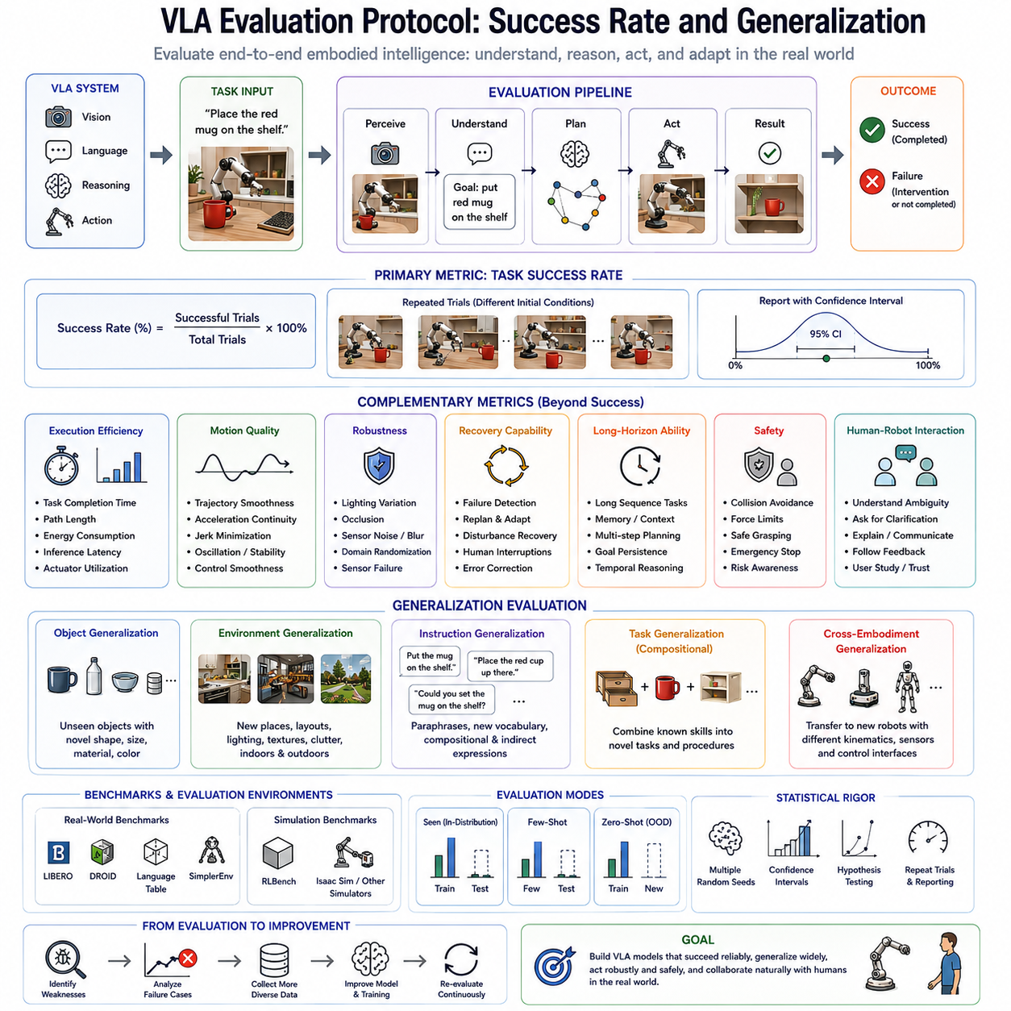
The development of Vision-Language-Action (VLA) models has fundamentally transformed how robotic intelligence is measured. Unlike traditional robotic systems, which were often evaluated using deterministic engineering metrics such as localization accuracy, path tracking error, controller stability, or positioning precision, modern VLA systems must be assessed across perception, reasoning, language understanding, action generation, adaptability, robustness, and long-horizon task execution simultaneously. Consequently, evaluation protocols have evolved from measuring isolated algorithmic performance toward assessing complete embodied intelligence. The primary objective of VLA evaluation is no longer determining whether a robot executes predefined motions accurately, but whether it can understand unfamiliar situations, interpret human intentions, generalize learned knowledge, and successfully complete real-world tasks under changing environmental conditions.
Evaluation plays multiple roles throughout the lifecycle of a Vision-Language-Action system. During research, evaluation enables objective comparison between competing architectures, training strategies, datasets, and foundation models. During development, evaluation identifies weaknesses requiring additional data collection or architectural refinement. During deployment, evaluation verifies operational reliability before robots enter human environments. Finally, during continuous learning, evaluation measures performance improvements achieved through newly collected experiences. Without rigorous evaluation protocols, apparent improvements in laboratory demonstrations may fail to translate into reliable real-world robotic behavior.
Historically, robotics evaluation focused primarily on subsystem performance. Computer vision researchers measured object detection accuracy, semantic segmentation quality, or localization error. Motion planning researchers compared trajectory length, planning time, collision rate, and computational efficiency. Control engineers evaluated tracking accuracy, overshoot, settling time, stability margins, and energy consumption. Although these metrics remain valuable, they fail to capture whether an integrated robot successfully accomplishes meaningful tasks in dynamic environments. A robot may perfectly detect objects while consistently failing to manipulate them, or execute flawless trajectories toward incorrectly interpreted goals. Vision-Language-Action evaluation therefore emphasizes end-to-end task completion rather than isolated component performance.
Task success rate has emerged as the most widely adopted primary metric for evaluating VLA systems. A task is considered successful when the robot completes the intended objective according to predefined criteria without human intervention. Unlike traditional accuracy metrics, success rate directly reflects practical usefulness because it measures complete task execution from initial perception through final action. A manipulation policy instructed to place a cup onto a shelf succeeds only if the cup reaches the correct location safely and stably. Similarly, a mobile robot instructed to deliver an object succeeds only if navigation, obstacle avoidance, localization, manipulation, and task completion all function correctly together.
Success rate is typically reported as the percentage of successful executions over repeated experimental trials. Since robotic environments naturally contain stochastic variation, identical tasks are repeated numerous times under varying initial conditions. Statistical confidence intervals frequently accompany reported success rates to account for experimental variability. Larger evaluation datasets generally produce more reliable estimates of actual deployment performance.
However, success rate alone does not fully characterize robot capability. Two models may achieve identical success rates while exhibiting dramatically different behaviors. One robot may complete tasks efficiently using smooth trajectories, whereas another repeatedly hesitates, performs unnecessary motions, or succeeds only after multiple recovery attempts. Consequently, modern evaluation protocols increasingly incorporate complementary metrics describing execution quality alongside binary task completion.
Execution efficiency represents one such metric. Robots operating within industrial facilities, hospitals, warehouses, and homes must complete tasks within acceptable time constraints. Evaluation therefore measures task completion time, path length, motion efficiency, computational latency, energy consumption, and actuator utilization. Efficient policies reduce operational cost while improving productivity and battery lifetime. Excessively cautious robots may eventually succeed but remain impractical for real-world deployment if execution requires substantially longer than human expectations.
Motion quality similarly influences practical deployment. Smooth trajectories reduce mechanical wear, improve human trust, increase manipulation precision, and enhance safety. Evaluation metrics therefore quantify trajectory smoothness, acceleration continuity, jerk minimization, oscillation frequency, and control stability. Human observers frequently perceive smoother robot behavior as more intelligent and predictable, improving acceptance within collaborative environments.
Generalization constitutes perhaps the defining capability distinguishing modern Vision-Language-Action systems from earlier robotic learning approaches. Rather than memorizing specific demonstrations, VLA models are expected to transfer learned knowledge toward previously unseen tasks, objects, environments, instructions, and robot embodiments. Consequently, evaluation protocols increasingly emphasize zero-shot and few-shot performance under novel conditions instead of repeated testing on familiar scenarios.
Object generalization measures whether robots successfully manipulate previously unseen objects sharing similar functional characteristics with training examples. A policy trained using ceramic mugs should ideally manipulate glass cups, metal containers, or plastic bottles despite never observing those exact objects during training. Successful object generalization indicates that the model has learned abstract manipulation principles rather than memorizing individual appearances.
Environmental generalization evaluates performance across unfamiliar physical spaces. Robots trained within laboratory environments should maintain competence when deployed inside offices, homes, warehouses, hospitals, or manufacturing facilities possessing different layouts, lighting conditions, furniture arrangements, background clutter, and environmental textures. Robust environmental generalization represents one of the greatest challenges facing embodied artificial intelligence because real-world variability substantially exceeds laboratory conditions.
Instruction generalization examines whether language understanding extends beyond memorized commands. Human users naturally express identical objectives using different vocabulary, sentence structures, abbreviations, and conversational styles. Evaluation therefore includes paraphrased instructions, indirect requests, incomplete descriptions, and compositional language combining familiar concepts into novel expressions. Successful language generalization demonstrates meaningful semantic understanding rather than superficial pattern matching.
Task generalization extends these principles further by introducing entirely new combinations of previously learned skills. Rather than repeating demonstrated procedures, robots must compose familiar manipulation primitives into novel action sequences. For example, a robot separately trained to open drawers, grasp objects, and close cabinets may subsequently receive the unseen instruction “retrieve the spoon from the drawer and place it inside the cabinet.” Successful execution demonstrates compositional reasoning characteristic of general-purpose robotic intelligence.
Cross-embodiment generalization represents another increasingly important evaluation criterion. Foundation policies trained using demonstrations collected from multiple robotic platforms should successfully transfer toward new embodiments possessing different kinematic structures, actuator configurations, sensor placements, and control interfaces. Rather than evaluating robot-specific performance, cross-embodiment protocols assess whether learned representations capture task semantics independent of particular hardware implementations.
Robustness evaluation measures policy stability under adverse operating conditions. Real-world environments inevitably contain sensor noise, lighting variation, moving obstacles, partial occlusions, calibration errors, communication delays, actuator uncertainty, and unexpected disturbances. Effective Vision-Language-Action systems must continue functioning despite such imperfections. Evaluation protocols therefore intentionally introduce controlled perturbations to quantify resilience under degraded sensing and uncertain environmental conditions.
Lighting robustness constitutes one frequently evaluated dimension. Images captured under bright sunlight, dim indoor illumination, colored lighting, shadows, reflections, or nighttime conditions may differ dramatically despite identical underlying scenes. Policies exhibiting strong visual invariance maintain consistent task success despite these appearance changes. Similar protocols evaluate robustness against camera motion blur, image noise, lens contamination, and partial sensor failures.
Occlusion robustness assesses behavior when important visual information becomes temporarily unavailable. Objects may become partially hidden behind obstacles, manipulated items may disappear beneath robot arms, or human collaborators may block camera viewpoints. Robust policies infer missing information from temporal context, geometric reasoning, and previous observations rather than immediately failing when visual conditions deteriorate.
Sensor failure evaluation has become increasingly relevant as robotic systems integrate numerous heterogeneous modalities. Cameras, depth sensors, inertial measurement units, force sensors, tactile arrays, microphones, and localization systems may each experience temporary malfunction during operation. Modern evaluation protocols intentionally disable individual sensing modalities to determine whether multimodal redundancy enables graceful performance degradation rather than catastrophic failure.
Recovery capability represents another defining characteristic of practical robotic intelligence. Unlike deterministic industrial automation operating under tightly controlled conditions, general-purpose robots inevitably encounter failures during deployment. Objects slip from grippers, humans interrupt execution, environmental conditions change unexpectedly, and instructions become ambiguous. Rather than measuring only initial success, modern evaluation increasingly assesses whether robots recognize failures, diagnose underlying causes, replan appropriately, and eventually complete assigned objectives.
Recovery evaluation typically introduces controlled disturbances during execution. Objects may be intentionally displaced after grasp planning, obstacles suddenly appear within navigation paths, or human operators issue corrective instructions mid-task. Successful recovery demonstrates adaptive intelligence extending beyond open-loop execution. Such evaluation has become particularly important for collaborative robots expected to operate continuously alongside humans.
Long-horizon evaluation addresses tasks requiring extended sequential reasoning rather than isolated manipulation episodes. Many practical activities involve dozens of intermediate decisions spanning several minutes or longer. Preparing meals, organizing warehouses, conducting industrial inspections, assembling products, or cleaning buildings require persistent memory, task planning, temporal reasoning, and adaptive execution. Evaluation therefore increasingly measures sustained performance across lengthy task sequences rather than isolated action predictions.
Memory evaluation similarly examines whether robots effectively utilize previous observations during prolonged interaction. Objects previously observed may become temporarily invisible, requiring memory-guided manipulation. Human dialogue may reference earlier instructions through pronouns or implicit context. Effective embodied intelligence therefore depends upon maintaining coherent internal representations throughout extended interactions.
Human-robot interaction introduces additional evaluation dimensions emphasizing communication quality rather than purely physical performance. Collaborative robots should interpret ambiguous instructions, request clarification appropriately, explain their intentions, acknowledge uncertainty, and adapt behavior according to human feedback. User studies therefore frequently accompany technical benchmarks, measuring perceived trustworthiness, naturalness, predictability, safety, and ease of interaction.
Human evaluation remains particularly valuable because many aspects of robotic behavior resist purely numerical measurement. Smoothness, confidence, collaboration quality, social appropriateness, and perceived intelligence often require subjective assessment by human participants. Standardized questionnaires, Likert scales, pairwise comparisons, and observational studies complement objective performance metrics to provide comprehensive evaluation.
Safety evaluation occupies a central position within industrial deployment protocols. Vision-Language-Action systems must avoid collisions, respect restricted areas, recognize human presence, maintain stable grasp forces, avoid hazardous actions, and safely recover from unexpected failures. Evaluation therefore includes obstacle avoidance, emergency stopping, collision prevention, force limitation, operational boundary compliance, and uncertainty-aware decision making. Safety metrics frequently determine deployment readiness more strongly than raw task success rates.
Benchmark datasets provide standardized evaluation environments enabling objective comparison across competing models. Several influential benchmarks have emerged specifically for embodied artificial intelligence. LIBERO evaluates lifelong robotic learning across multiple manipulation tasks while emphasizing continual skill acquisition and transfer. RLBench provides large collections of simulated manipulation scenarios supporting standardized policy comparison. Language Table focuses upon language-conditioned tabletop manipulation, evaluating grounding between natural language and physical behavior. DROID contributes large-scale real-world demonstrations collected across diverse households and manipulation settings. SimplerEnv emphasizes reproducible real-world grounded evaluation bridging simulation and physical deployment. Together these benchmarks establish common experimental protocols accelerating scientific progress through reproducible comparison.
Simulation remains indispensable for large-scale evaluation because physically repeating thousands of robotic experiments remains prohibitively expensive. High-fidelity simulators enable systematic variation of environmental conditions, object properties, lighting, sensor noise, and task parameters while maintaining reproducibility. Simulated evaluation further permits safe testing of hazardous failure scenarios impractical within physical laboratories. Nevertheless, simulation alone cannot fully predict real-world performance because subtle physical discrepancies persist despite increasingly realistic rendering and physics engines.
Real-world evaluation therefore remains the ultimate benchmark for Vision-Language-Action systems. Robots deployed within actual homes, factories, warehouses, hospitals, construction sites, or agricultural environments encounter complexities absent from simulation including unpredictable human behavior, sensor degradation, environmental wear, mechanical imperfections, and operational uncertainty. Practical robotic intelligence ultimately depends upon successful performance under these authentic deployment conditions.
Statistical rigor has become increasingly important as evaluation protocols mature. Reporting average performance without confidence intervals, variance estimates, or statistical significance testing may produce misleading conclusions. Modern robotics publications increasingly employ repeated randomized trials, hypothesis testing, bootstrap confidence estimation, cross-validation, and standardized experimental reporting to ensure reliable comparison between competing approaches. Transparent evaluation methodology supports scientific reproducibility while reducing exaggerated performance claims.
Continual evaluation extends beyond initial deployment. Foundation models increasingly improve through fleet learning, online adaptation, and continual dataset expansion. Performance must therefore be monitored continuously throughout operational life. Automatic evaluation systems detect degradation caused by environmental shifts, hardware aging, software updates, or changing task distributions. Continuous benchmarking enables timely retraining before significant operational failures emerge.
Future Vision-Language-Action evaluation will likely evolve toward increasingly holistic assessment encompassing cognitive reasoning, physical interaction, long-term autonomy, collaborative intelligence, ethical behavior, energy efficiency, sustainability, and societal acceptance. Rather than optimizing isolated performance metrics, future robotic foundation models will be judged according to their ability to function safely, reliably, transparently, and beneficially across diverse human environments over extended periods.
Ultimately, evaluation protocols define what robotic intelligence truly means. Success rate measures practical task completion, generalization assesses adaptability beyond memorized experience, robustness quantifies resilience under uncertainty, recovery capability reflects adaptive reasoning, efficiency determines operational usefulness, and safety establishes deployment readiness. Together these complementary evaluation dimensions provide a comprehensive framework for assessing Vision-Language-Action systems as integrated embodiments of perception, language understanding, reasoning, and physical action. As robotic foundation models continue advancing toward increasingly general intelligence, rigorous evaluation will remain essential for ensuring that impressive laboratory demonstrations translate into trustworthy, capable, and widely deployable real-world robotic systems.

1.8 Inference Latency Requirements for Real-Time Robot Control
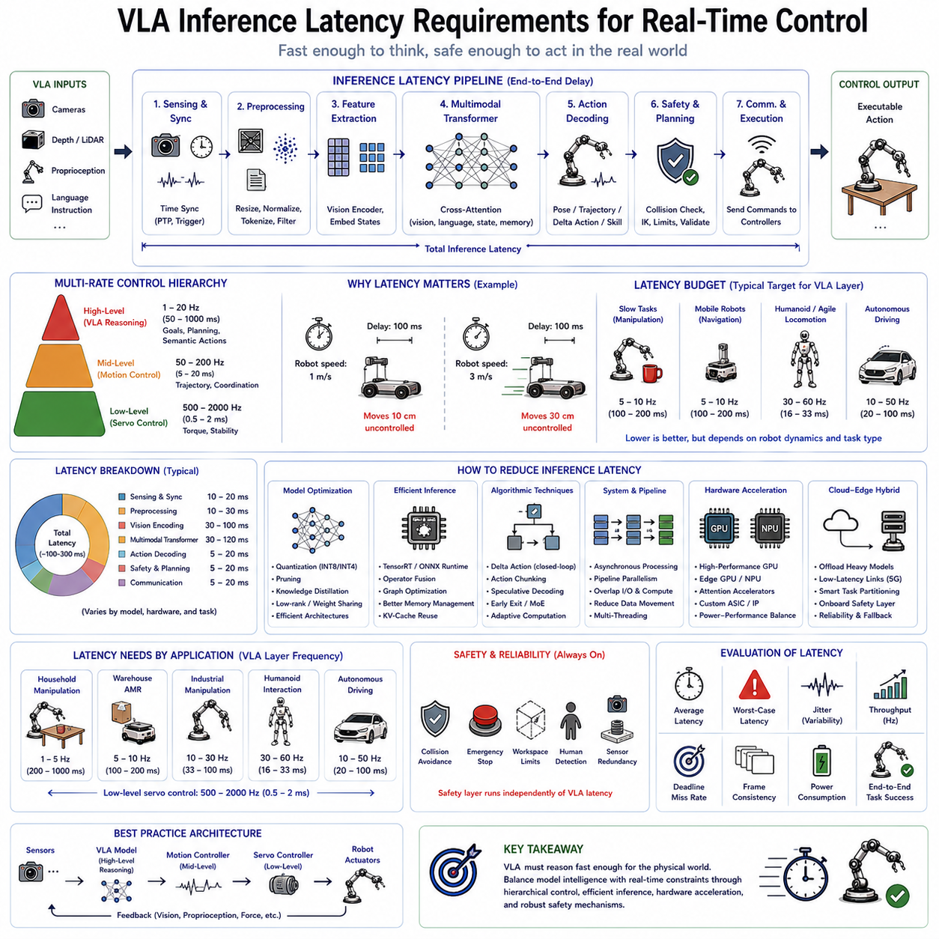
Vision-Language-Action (VLA) models have dramatically expanded the cognitive capabilities of robots by integrating perception, language understanding, reasoning, planning, and action generation into a unified foundation model. However, regardless of how intelligent a robotic model becomes, its practical usefulness ultimately depends on whether it can produce decisions within the strict timing constraints imposed by the physical world. Unlike text generation systems, where response times of several seconds are generally acceptable, robots interact continuously with dynamic environments where delays of even a few hundred milliseconds may significantly reduce performance or compromise safety. Consequently, inference latency has become one of the most critical engineering challenges in deploying VLA models for real-world robotic applications.
Inference latency refers to the total elapsed time between receiving new sensory information and producing an executable action command. This interval includes sensor acquisition, data synchronization, preprocessing, feature extraction, multimodal encoding, transformer inference, action decoding, safety verification, communication, and finally execution by the robot controller. Every stage contributes to the overall control delay experienced by the robot. Because physical systems operate continuously rather than discretely, cumulative latency directly influences responsiveness, stability, collision avoidance capability, manipulation precision, and overall operational safety.
Traditional industrial robots largely avoided this problem because deterministic controllers executed relatively simple mathematical computations at high frequencies. Servo controllers commonly operate at one thousand hertz, corresponding to one-millisecond control cycles. Motion planners update trajectories at tens of milliseconds, while localization algorithms often operate between ten and fifty hertz. These conventional systems were carefully engineered so that each computational module satisfied strict real-time deadlines. Modern Vision-Language-Action systems introduce substantially larger neural networks requiring billions of floating-point operations per inference, fundamentally changing computational requirements.
Large multimodal transformer architectures often require hundreds of milliseconds or even several seconds to process a single observation when executed without optimization. Such delays remain acceptable for conversational assistants but become problematic for robots interacting with moving humans, dynamic obstacles, fragile objects, or rapidly changing environments. A mobile robot traveling at one meter per second covers ten centimeters during a one-hundred-millisecond delay. At three meters per second, the same latency corresponds to thirty centimeters of uncontrolled movement. For high-speed manipulators or autonomous vehicles, these delays may exceed acceptable safety margins.
Latency therefore cannot be considered independently from robot dynamics. Different robotic platforms impose fundamentally different timing requirements depending upon their operating speeds, mechanical inertia, sensing frequency, and environmental uncertainty. Slow household manipulation tasks tolerate substantially longer inference times than agile quadruped locomotion or autonomous driving. Consequently, practical Vision-Language-Action deployment requires careful matching between model complexity and application-specific real-time constraints.
Robot control systems naturally operate across multiple temporal layers rather than using a single universal update frequency. Low-level servo control typically executes between five hundred and two thousand hertz to stabilize motors and enforce dynamic constraints. Mid-level motion controllers operate between fifty and two hundred hertz to generate smooth trajectories and coordinate joints. High-level planning systems generally update between one and twenty hertz because semantic reasoning evolves more slowly than physical motion. Vision-Language-Action models usually occupy this highest cognitive layer, producing semantic intentions rather than directly replacing deterministic motor controllers.
This hierarchical control architecture significantly relaxes latency requirements. Rather than generating individual motor torques every millisecond, the VLA model predicts desired poses, delta actions, semantic goals, trajectories, or skill selections at comparatively lower frequencies. Classical feedback controllers subsequently interpolate these high-level outputs into smooth continuous motor commands operating at real-time servo rates. Such hybrid architectures combine the reasoning capabilities of foundation models with the deterministic stability of conventional control systems.
The distinction between cognitive frequency and motor frequency represents one of the most important principles in practical VLA deployment. Human cognition exhibits similar hierarchical timing. Humans consciously decide to grasp an object over hundreds of milliseconds, while spinal reflexes continuously stabilize muscles within only a few milliseconds. Robots similarly benefit from separating high-level reasoning from low-level execution, allowing large neural networks to operate without violating strict physical control deadlines.
Manipulation tasks illustrate these timing relationships clearly. Consider a robotic arm assembling electronic components. Camera images may update at thirty frames per second, corresponding to approximately thirty-three milliseconds between observations. Vision encoders require several milliseconds for feature extraction. Multimodal transformers process visual observations, language instructions, and robot states before predicting desired actions. Finally, inverse kinematics, collision checking, and trajectory generation convert semantic actions into executable joint motions. If the total latency substantially exceeds camera update intervals, manipulation accuracy deteriorates because predicted actions correspond to outdated observations.
Delta action representations help mitigate this problem by predicting incremental corrections rather than complete trajectories. Instead of committing to long sequences of future actions, the robot continuously generates small adjustments based upon newly observed sensor information. Closed-loop visual feedback therefore compensates for moderate inference delays because each prediction corrects accumulated execution errors. This strategy has become increasingly popular within diffusion policies and transformer-based manipulation systems.
Autonomous mobile robots present different latency requirements. Navigation decisions generally evolve more slowly than dexterous manipulation because vehicle dynamics limit rapid directional changes. Nevertheless, obstacle avoidance demands timely reactions whenever humans, forklifts, or other robots unexpectedly enter navigation paths. Many mobile robotic systems therefore separate global route planning from local reactive control. Vision-Language-Action models determine navigation objectives and semantic destinations, while conventional local planners continuously generate collision-free velocity commands operating at significantly higher frequencies.
Humanoid robots introduce perhaps the most demanding latency constraints among current robotic platforms. Whole-body coordination simultaneously controls locomotion, balance, manipulation, gaze direction, and environmental interaction. Walking stability depends upon maintaining center-of-mass dynamics within narrow stability margins. Excessive inference delays may destabilize locomotion before corrective actions become available. Consequently, humanoid architectures increasingly employ dedicated locomotion controllers operating independently from slower semantic reasoning modules.
Quadruped robots exhibit similar hierarchical organization. High-frequency controllers stabilize leg dynamics, estimate terrain contact forces, and maintain body posture. Vision-Language-Action models instead determine navigation goals, obstacle negotiation strategies, semantic exploration objectives, and interaction behaviors. Separating cognitive reasoning from dynamic stabilization enables large multimodal foundation models to guide locomotion without directly compromising balance control.
Autonomous driving provides another instructive example. Perception systems continuously process camera images, LiDAR observations, radar measurements, GPS information, and inertial sensors. Low-level controllers maintain steering stability and velocity regulation at high frequencies. Behavioral planners decide lane changes, intersection negotiation, overtaking maneuvers, and destination routing over substantially longer time horizons. Future automotive VLA systems will likely occupy these higher semantic planning layers while preserving deterministic safety controllers responsible for vehicle stabilization.
Inference latency consists of numerous individual computational stages rather than a single monolithic operation. Sensor acquisition represents the first component. Cameras, depth sensors, inertial measurement units, force sensors, microphones, and robot joint encoders each operate at different frequencies requiring precise synchronization before neural inference begins. Hardware triggering and Precision Time Protocol synchronization minimize temporal inconsistency among heterogeneous sensing modalities.
Preprocessing constitutes the next stage. Images undergo resizing, normalization, color conversion, distortion correction, and occasionally compression before entering neural encoders. Point clouds require voxelization, filtering, or feature extraction. Language instructions undergo tokenization while robot states become normalized numerical vectors. Although individually inexpensive, preprocessing operations collectively contribute measurable latency within real-time systems.
Vision encoding frequently dominates computational cost. Modern Vision Transformers process hundreds of image patches through multiple self-attention layers generating rich semantic representations. High-resolution multi-camera systems proportionally increase computational complexity because each camera requires independent feature extraction before multimodal fusion. Efficient vision encoders therefore become essential for reducing overall latency.
Multimodal fusion follows visual encoding by integrating image features, language embeddings, proprioceptive measurements, memory representations, and temporal context within transformer architectures. Cross-attention operations enable information exchange among modalities but also increase computational complexity. Large multimodal transformers containing billions of parameters may require hundreds of milliseconds without specialized hardware acceleration.
Action decoding subsequently converts latent representations into executable robot outputs. Depending upon architectural design, outputs may consist of joint positions, Cartesian poses, velocity commands, delta actions, trajectories, or discrete action tokens. Safety verification, collision checking, inverse kinematics, and trajectory interpolation frequently occur before transmission toward robot controllers. Communication latency between onboard computers, distributed processors, and embedded motor controllers further contributes to end-to-end delay.
Because latency accumulates throughout every processing stage, optimization requires holistic system design rather than isolated neural network acceleration. Improvements achieved within one component may become insignificant if communication, synchronization, or preprocessing dominate total execution time. Comprehensive latency profiling therefore identifies true bottlenecks before optimization begins.
Hardware selection strongly influences achievable inference performance. Graphics Processing Units remain the dominant acceleration platform for contemporary Vision-Language-Action models due to their massive parallel computational capability. Data center accelerators provide extraordinary throughput but consume substantial electrical power unsuitable for mobile deployment. Edge GPUs balance computational performance against power consumption, making them attractive for autonomous mobile robots, industrial manipulators, and outdoor service robots.
Dedicated Neural Processing Units increasingly complement GPU acceleration by executing transformer operations more efficiently at reduced energy consumption. Future robotic processors will likely integrate specialized attention accelerators, sparse computation engines, and multimodal fusion hardware specifically optimized for foundation model inference. Such hardware-software co-design represents an important direction for enabling increasingly sophisticated embodied intelligence within practical power budgets.
Software optimization contributes equally significant latency reductions. Model quantization converts floating-point parameters into lower-precision representations such as INT8 or INT4 while preserving acceptable accuracy. Weight sharing, structured pruning, operator fusion, memory optimization, and compiler-level graph transformations further reduce computational cost. TensorRT, ONNX Runtime, TVM, and similar inference frameworks automatically optimize execution graphs for target hardware architectures.
Knowledge distillation provides another effective strategy by transferring capabilities from extremely large teacher models toward substantially smaller student networks. Student models often preserve much of the teacher's behavioral competence while reducing inference latency by several multiples. Edge deployment frequently relies upon distilled models satisfying strict real-time constraints unavailable to their larger counterparts.
Speculative decoding, originally developed for language generation, has recently attracted attention within robotic inference optimization. Small draft models predict likely future outputs subsequently verified by larger foundation models. Correct predictions avoid expensive recomputation, substantially reducing average inference latency. Similar hierarchical prediction mechanisms may become increasingly important for future Vision-Language-Action systems requiring rapid continuous decision making.
Action chunking further reduces computational frequency by predicting multiple future actions simultaneously. Rather than executing expensive transformer inference every control cycle, robots compute short sequences of actions reused over subsequent intervals. This approach decreases average computational load while maintaining continuous execution. Nevertheless, excessively long prediction horizons reduce adaptability because robots continue following outdated plans despite changing environmental conditions.
Asynchronous processing represents another important architectural principle. Different computational modules operate independently rather than waiting synchronously for complete pipeline execution. Vision encoders continuously process incoming images while language models reason about previous observations and controllers execute earlier actions simultaneously. Such pipelined execution substantially increases effective throughput despite unchanged individual module latency.
Memory management significantly affects transformer inference performance. Key-value cache reuse prevents repeated computation of previously processed temporal context, particularly during sequential decision making. Efficient memory allocation, cache locality optimization, and bandwidth-aware scheduling further improve real-time execution, especially for long-horizon tasks involving extensive historical observations.
Distributed computing architectures increasingly support demanding robotic workloads. Resource-intensive foundation models execute on nearby edge servers or cloud infrastructure while latency-critical controllers remain onboard the robot. Hybrid cloud-edge architectures dynamically allocate computations according to latency requirements, network conditions, privacy constraints, and available computational resources. However, communication delays and connectivity uncertainty require careful partitioning between onboard and remote inference components.
Safety considerations fundamentally constrain acceptable latency. Predictive intelligence cannot compensate indefinitely for delayed reactions when physical hazards emerge unexpectedly. Consequently, emergency behaviors remain implemented through deterministic safety controllers independent of Vision-Language-Action inference. Collision detection, emergency stopping, actuator saturation, workspace limits, and human safety monitoring operate continuously even if foundation models temporarily stall or become unavailable.
Performance evaluation therefore extends beyond average inference time. Worst-case latency, latency variance, jitter, throughput, frame consistency, deadline satisfaction, and computational reliability all influence deployment suitability. Real-time systems require deterministic timing guarantees rather than merely favorable average performance. Occasional latency spikes may prove more dangerous than consistently moderate delays because controllers cannot reliably predict future computational availability.
Application-specific latency budgets consequently vary substantially. Conversational household assistants performing slow manipulation may tolerate inference frequencies near one hertz. Warehouse mobile robots generally require semantic planning between five and ten hertz. Industrial manipulation commonly benefits from action generation around ten to thirty hertz combined with high-frequency servo interpolation. Humanoid interaction and agile locomotion often require cognitive updates approaching thirty to sixty hertz while maintaining dedicated balance controllers operating substantially faster. Low-level motor stabilization consistently remains within hundreds or thousands of hertz regardless of cognitive architecture.
Future Vision-Language-Action systems will increasingly pursue adaptive computation rather than fixed inference frequencies. Simple situations may require only lightweight reasoning while complex environments activate progressively larger cognitive models. Dynamic model selection, early exit transformers, mixture-of-experts architectures, and conditional computation promise significant reductions in average latency without sacrificing capability during difficult tasks.
Ultimately, inference latency defines the practical boundary between artificial intelligence and embodied intelligence. A robot must not only reason correctly but also reason quickly enough for the physical world it inhabits. Successful Vision-Language-Action deployment therefore depends upon balancing model complexity, computational efficiency, hierarchical control, hardware acceleration, software optimization, and deterministic safety mechanisms. Rather than attempting to replace established real-time controllers, modern VLA architectures integrate foundation models within carefully engineered hierarchical systems that combine deep semantic reasoning with reliable physical execution. As hardware accelerators, multimodal transformers, and inference optimization techniques continue advancing, future robotic foundation models will achieve increasingly sophisticated intelligence while satisfying the demanding temporal constraints required for safe, responsive, and trustworthy real-time autonomous operation.

1.9 Safety Considerations and Guardrails
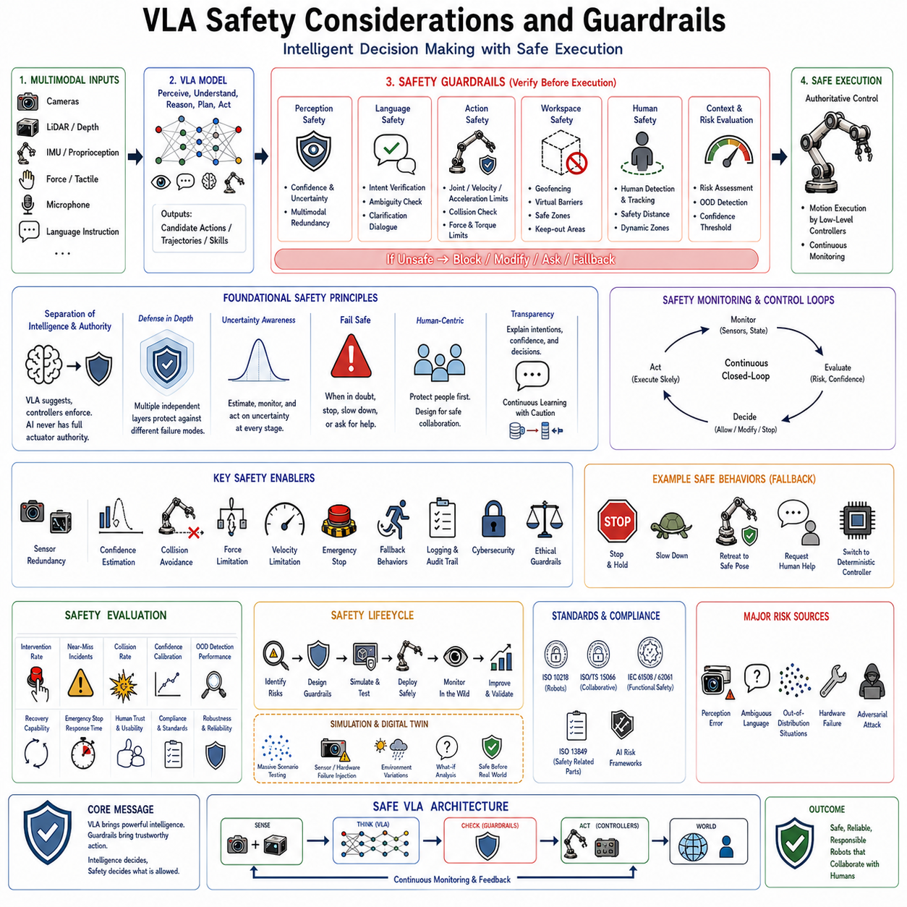
Vision-Language-Action (VLA) models represent one of the most significant advances in robotic intelligence by integrating perception, language understanding, reasoning, planning, and action generation into a unified neural architecture. Unlike conventional robotic systems that execute carefully engineered deterministic algorithms, VLA systems make decisions through learned representations derived from massive multimodal datasets. This shift dramatically expands robotic capability, enabling robots to perform tasks that were previously impossible using rule-based programming alone. However, the same flexibility that gives VLA models their remarkable generalization capability also introduces new safety challenges. Since these systems no longer rely exclusively on explicitly programmed rules, their behavior cannot always be predicted solely through software inspection. Consequently, safety becomes not merely a subsystem but a fundamental architectural principle governing every stage of model development, deployment, and operation.
Traditional industrial robots operated within highly structured environments separated from humans by physical safety cages. Robot motion was predetermined, repeatable, and mathematically verifiable. Safety certification primarily focused on deterministic hardware behavior, emergency stop systems, and controller reliability. Modern Vision-Language-Action robots operate under fundamentally different assumptions. They interact directly with people, navigate unstructured environments, manipulate unfamiliar objects, interpret natural language, and continuously adapt their behavior according to sensory observations. Such capabilities require learning-based decision making, introducing uncertainty that cannot be completely eliminated through conventional engineering approaches. Therefore, VLA safety requires combining deterministic robotic safety mechanisms with probabilistic artificial intelligence safeguards.
The concept of guardrails has emerged as a central design philosophy for modern AI-powered robotic systems. Guardrails are explicit constraints that restrict model behavior within safe operational boundaries regardless of the internal reasoning process. Instead of assuming that a foundation model will always generate correct actions, guardrails continuously verify whether proposed actions satisfy predefined physical, operational, ethical, and safety requirements before execution. The resulting architecture separates intelligent decision making from safety enforcement. The VLA model generates candidate behaviors, while independent supervisory systems determine whether those behaviors may actually be executed.
One of the most important principles in robotic safety is the separation between cognitive intelligence and physical authority. A Vision-Language-Action model may recommend actions, but it should not possess unrestricted authority over actuators. Low-level motor controllers remain deterministic and continuously enforce joint limits, velocity constraints, acceleration bounds, collision avoidance, workspace restrictions, emergency stop conditions, and hardware protection regardless of high-level decisions. This layered architecture ensures that even if the AI produces an inappropriate command, physical safety mechanisms prevent dangerous robot behavior.
Risk assessment begins by recognizing the multiple sources of uncertainty present within VLA systems. Visual perception may fail due to poor lighting, occlusions, reflections, sensor noise, adverse weather, or unexpected environmental conditions. Language understanding may misinterpret ambiguous instructions, incomplete requests, cultural differences, or contextual references. World models may contain incomplete or outdated knowledge. Neural policies themselves may exhibit uncertainty when encountering situations substantially different from training data. Furthermore, hardware components including cameras, depth sensors, inertial measurement units, communication links, and actuators may experience temporary malfunction during deployment. Effective safety architectures explicitly acknowledge these uncertainties rather than assuming perfect operation.
Perception safety represents the first defensive layer. Vision-Language-Action systems depend heavily upon multimodal perception to understand surrounding environments. Incorrect object recognition, inaccurate pose estimation, missed obstacle detection, or erroneous semantic interpretation may propagate throughout downstream decision making. Consequently, perception modules increasingly estimate confidence together with predictions. Rather than producing only object labels or segmentation masks, modern perception systems additionally report uncertainty estimates indicating the reliability of observed information. Low-confidence observations may trigger additional sensing, slower execution, human confirmation, or conservative fallback behavior.
Multimodal redundancy substantially improves perception safety. RGB cameras, depth sensors, LiDAR, radar, ultrasonic sensors, tactile sensing, force measurements, inertial sensors, and proprioception provide complementary information regarding both the robot and its environment. If one sensing modality becomes unreliable, others may compensate. For example, poor illumination affecting RGB cameras may leave LiDAR performance largely unchanged. Similarly, temporary visual occlusion may be mitigated through proprioceptive feedback or tactile sensing during manipulation. Safety therefore benefits significantly from sensor diversity rather than dependence upon any single modality.
Language safety introduces another unique challenge. Human instructions frequently contain ambiguity, incompleteness, conflicting objectives, or requests inconsistent with safe operation. A user might unknowingly issue commands leading toward collisions, unstable manipulation, or hazardous interactions with other people. Rather than blindly executing every instruction, Vision-Language-Action systems must evaluate commands against operational constraints before action generation. Requests violating safety policies should be rejected, modified, clarified, or escalated to human supervision whenever necessary.
Clarification dialogue becomes an important safety mechanism for language-grounded robotics. When instructions contain ambiguity or insufficient information, the robot should request additional clarification rather than making potentially unsafe assumptions. For example, an instruction such as “move the container over there” lacks sufficient spatial specification for reliable execution. Similarly, conflicting commands including “move quickly but carefully” may require negotiation regarding appropriate operational priorities. Interactive clarification reduces misunderstandings while improving user trust.
Action safety extends beyond perception and language toward physical execution itself. Every predicted action should undergo validation before transmission to actuators. Joint positions must remain within mechanical limits. Velocities should satisfy dynamic stability constraints. Accelerations must avoid excessive inertial forces. Manipulation trajectories should prevent collisions with surrounding objects, humans, or the robot itself. Grasp forces should remain appropriate for object fragility. Navigation commands must respect traversability constraints, traffic rules, and restricted operating zones. Such verification occurs independently from neural inference using deterministic algorithms specifically designed for safety-critical operation.
Workspace monitoring provides another essential protective mechanism. Every robotic platform possesses physically defined operational boundaries determined by mechanical reach, environmental obstacles, collaborative workspaces, and safety regulations. Vision-Language-Action policies should never generate commands causing motion beyond approved workspaces. Geofencing, virtual barriers, forbidden zones, and dynamic exclusion regions continuously constrain robot movement regardless of cognitive decisions. Industrial collaborative robots frequently employ dynamic safety zones adapting according to human proximity and current operational context.
Collision avoidance remains one of the most fundamental safety requirements for autonomous robots. Modern systems integrate geometric collision detection, predictive trajectory analysis, dynamic obstacle tracking, and human-aware navigation before executing planned actions. Rather than reacting only after contact occurs, predictive algorithms estimate future collision probability using anticipated robot motion together with environmental observations. Potential collisions trigger replanning, velocity reduction, or emergency stopping before hazardous situations develop.
Human detection receives particular emphasis because protecting people remains the highest priority within collaborative robotic environments. Cameras, depth sensors, LiDAR, thermal cameras, radar, and wearable localization systems collectively monitor nearby human presence. Human pose estimation further predicts likely future movement, enabling robots to proactively adjust behavior according to anticipated interactions. Personal protective zones dynamically expand around humans depending upon robot speed, payload, task type, and environmental conditions. Such adaptive safety margins significantly reduce collision risk during close collaboration.
Velocity limitation represents another widely adopted guardrail. Rather than operating continuously at maximum speed, robots dynamically adjust movement according to environmental risk. High-speed operation may remain acceptable within isolated workspaces, whereas collaborative environments require substantially slower motion. International safety standards frequently define allowable speed-force combinations ensuring collisions remain below injury thresholds. Vision-Language-Action systems therefore integrate context-aware velocity scaling as a fundamental safety mechanism.
Force limitation complements velocity control during physical interaction. Collaborative robots increasingly monitor actuator torques, force-torque sensors, motor currents, and tactile feedback to estimate interaction forces continuously. Excessive contact forces trigger immediate motion termination or compliant response. Force-controlled manipulation additionally prevents damage when handling fragile objects including glassware, electronic components, laboratory samples, or medical equipment. Compliance therefore improves both human safety and task reliability.
Emergency stop systems remain mandatory regardless of artificial intelligence capability. Hardware emergency buttons, safety relays, independent watchdog processors, redundant communication channels, and power isolation mechanisms provide deterministic shutdown independent from software operation. If Vision-Language-Action inference becomes unavailable, hardware malfunctions occur, or unexpected hazards emerge, emergency systems immediately override all intelligent behavior. This principle ensures that no artificial intelligence component possesses authority exceeding physical safety infrastructure.
Fallback behavior constitutes another essential guardrail for practical deployment. Foundation models inevitably encounter situations exceeding their training distribution. Rather than continuing uncertain execution, robots should transition toward predefined safe states whenever confidence falls below acceptable thresholds. Safe fallback behaviors include stopping motion, maintaining current posture, retreating to known configurations, requesting human assistance, switching to deterministic controllers, or entering monitored standby modes. Graceful degradation significantly improves operational robustness compared with attempting continued autonomous execution under uncertainty.
Confidence estimation plays a central role in adaptive safety. Neural networks often produce highly confident predictions even when incorrect, particularly under unfamiliar operating conditions. Modern Vision-Language-Action architectures increasingly incorporate Bayesian inference, ensemble prediction, Monte Carlo dropout, evidential learning, and calibration techniques estimating predictive uncertainty alongside generated actions. Rather than evaluating only predicted behavior, supervisory systems additionally consider confidence before authorizing execution. Low-confidence decisions naturally invoke increasingly conservative operational modes.
Out-of-distribution detection addresses scenarios where current observations differ substantially from training data. Unknown objects, unfamiliar environments, unusual lighting, unexpected sensor behavior, or novel tasks may invalidate learned representations. Dedicated anomaly detection algorithms monitor feature distributions, activation statistics, reconstruction errors, and embedding similarity to identify such situations. Detection of unfamiliar operating conditions typically initiates safe fallback behavior or requests human intervention before potentially hazardous actions occur.
Memory safety has become increasingly relevant as embodied foundation models incorporate long-term episodic memory. Stored experiences influence future decision making, making memory integrity essential for reliable operation. Incorrect memories, corrupted observations, outdated environmental maps, or malicious information may degrade future performance. Memory management therefore includes consistency verification, temporal validation, confidence weighting, and selective forgetting to maintain reliable knowledge representations throughout prolonged deployment.
Cybersecurity represents another emerging safety consideration. Network-connected robots receiving cloud updates, remote instructions, or distributed model synchronization become potential targets for malicious attacks. Unauthorized command injection, sensor spoofing, adversarial perception, model tampering, and communication interference may produce unsafe robotic behavior despite correct internal algorithms. Secure communication protocols, authenticated software updates, encrypted model distribution, hardware security modules, and runtime integrity verification therefore become integral components of modern VLA safety architectures.
Adversarial robustness extends cybersecurity toward machine learning itself. Carefully crafted visual perturbations, language prompts, or multimodal inputs may intentionally manipulate neural network behavior. Although such attacks often remain difficult to reproduce physically, robust foundation models should nevertheless resist manipulation through adversarial training, input sanitization, multimodal consistency verification, and confidence-aware decision making. Defensive learning techniques increasingly complement conventional robotics safety engineering.
Ethical guardrails further constrain robot behavior beyond purely physical safety. Vision-Language-Action systems interacting closely with humans inevitably encounter situations involving privacy, fairness, autonomy, transparency, and informed consent. Household robots observe private living spaces. Healthcare robots assist vulnerable patients. Educational robots interact with children. Industrial robots monitor human workers. Consequently, behavioral constraints should prevent unnecessary surveillance, inappropriate information disclosure, discriminatory treatment, or unauthorized decision making. Ethical considerations therefore become operational requirements rather than abstract philosophical principles.
Transparency significantly improves both safety and user trust. Rather than executing actions without explanation, robots should communicate intended behavior, current objectives, confidence levels, detected uncertainties, and reasons for requesting clarification. Explainable behavior enables human supervisors to detect inappropriate decisions before execution while increasing situational awareness during collaborative tasks. Although complete explanation of deep neural reasoning remains challenging, communicating high-level intentions substantially improves practical safety.
Human oversight remains indispensable despite advances in autonomous intelligence. Effective Vision-Language-Action deployment emphasizes collaborative autonomy rather than complete independence. Human supervisors retain authority to interrupt, modify, approve, or reject proposed robot behaviors whenever necessary. Adjustable autonomy further allows responsibility to shift dynamically between human operators and artificial intelligence according to environmental complexity, operational risk, and available expertise. Such shared control balances efficiency with accountability.
Simulation-based safety validation has become increasingly important before physical deployment. Large-scale simulation permits systematic testing across millions of scenarios impossible to reproduce experimentally. Researchers intentionally introduce sensor failures, communication delays, dynamic obstacles, hardware malfunctions, environmental disturbances, and unusual user instructions while observing robot behavior. Digital twins further enable continuous validation of updated foundation models before deployment within operational facilities. Simulation therefore significantly reduces real-world safety risks during iterative development.
Formal verification techniques provide complementary guarantees for deterministic safety modules. Although complete verification of large neural networks remains computationally challenging, critical guardrail components including collision avoidance, emergency stopping, workspace enforcement, velocity limitation, and actuator protection can be mathematically verified. Hybrid architectures intentionally reserve safety-critical responsibilities for formally verifiable algorithms while allowing foundation models to focus upon semantic reasoning and task planning.
Safety evaluation extends beyond measuring accident frequency alone. Comprehensive assessment includes intervention rate, near-miss incidents, confidence calibration accuracy, anomaly detection performance, recovery capability, emergency stop response time, human trust, operational compliance, false positive rates, false negative rates, and graceful degradation behavior. Continuous monitoring throughout deployment identifies emerging risks requiring retraining, software updates, or policy refinement. Safety therefore becomes an ongoing operational process rather than a one-time certification event.
International standards increasingly influence deployment requirements for intelligent robotic systems. Functional safety principles, collaborative robotics guidelines, industrial automation standards, and machine safety regulations establish baseline expectations regarding risk assessment, hazard mitigation, emergency procedures, validation, documentation, and operational monitoring. Although existing standards primarily address deterministic automation, future revisions will increasingly incorporate requirements specific to learning-enabled autonomous systems including Vision-Language-Action architectures.
Fleet learning introduces additional safety considerations because multiple deployed robots collectively contribute operational experience toward future model improvements. Shared learning accelerates capability growth but also increases the importance of rigorous validation before distributing updated policies. New model versions should undergo staged rollout, shadow evaluation, controlled deployment, continuous monitoring, and rollback capability whenever unexpected behaviors emerge. Safe fleet learning therefore combines continual improvement with conservative deployment strategies.
Future Vision-Language-Action systems will likely incorporate increasingly sophisticated guardrails through hierarchical safety architectures integrating symbolic reasoning, probabilistic uncertainty estimation, formal verification, predictive simulation, adaptive risk assessment, and human oversight. Rather than relying upon any single protective mechanism, robust safety will emerge from multiple independent defensive layers operating simultaneously. This defense-in-depth philosophy mirrors successful practices established within aviation, nuclear engineering, medical devices, and autonomous driving.
Ultimately, safety is not a limitation imposed upon intelligent robotics but an enabling technology that allows increasingly capable autonomous systems to operate confidently within human environments. Vision-Language-Action models provide unprecedented cognitive flexibility, while guardrails ensure that flexibility remains constrained within predictable and trustworthy operational boundaries. Perception confidence, multimodal redundancy, language verification, deterministic controllers, collision avoidance, workspace monitoring, uncertainty estimation, fallback behavior, emergency stopping, cybersecurity, ethical constraints, human oversight, and continual validation together establish a comprehensive safety framework. As robotic foundation models continue advancing toward general embodied intelligence, carefully engineered guardrails will remain essential for transforming powerful artificial intelligence into reliable, responsible, and societally acceptable autonomous robotic systems.

1.10 Open-Source and Commercial VLA Ecosystem
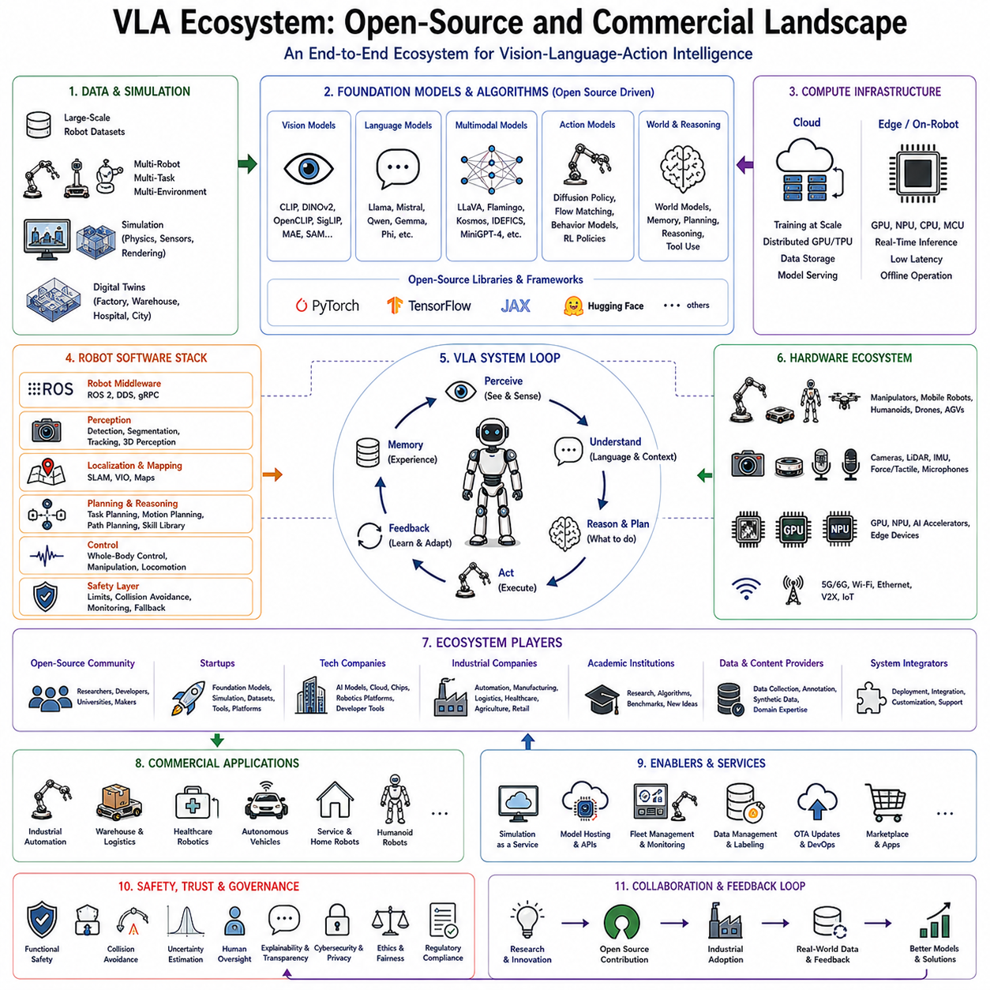
The Vision-Language-Action (VLA) ecosystem has rapidly evolved into one of the most dynamic research and industrial domains in modern artificial intelligence and robotics. Rather than being defined by a single model or software framework, the ecosystem consists of a diverse collection of foundation models, multimodal learning architectures, robotic middleware, simulation environments, large-scale datasets, hardware accelerators, cloud infrastructure, edge computing platforms, benchmarking systems, and commercial deployment solutions. Together, these components form an interconnected technology stack that enables robots to perceive the physical world, understand natural language, reason about complex tasks, and generate executable actions. As embodied artificial intelligence continues to mature, the VLA ecosystem is gradually becoming analogous to the software ecosystems that previously emerged around cloud computing, mobile operating systems, and large language models.
Historically, robotics development was fragmented across numerous independent disciplines. Computer vision researchers focused primarily on image understanding. Natural language processing researchers investigated language comprehension and generation. Control engineers designed deterministic motion controllers. Mechanical engineers optimized robot hardware. Artificial intelligence researchers developed planning algorithms and reinforcement learning techniques. Each community advanced independently, often using different software frameworks, datasets, evaluation metrics, and programming environments. Vision-Language-Action models represent a significant departure from this fragmented paradigm by integrating these previously isolated research directions into unified multimodal architectures.
The emergence of foundation models has accelerated this convergence. Instead of building separate perception, planning, and control modules connected through manually engineered interfaces, researchers increasingly train large multimodal models capable of learning cross-domain representations directly from diverse data. Vision encoders, language models, action decoders, memory modules, and reasoning systems now share common latent spaces that facilitate end-to-end learning. Consequently, the VLA ecosystem has become increasingly interdisciplinary, combining advances from computer vision, machine learning, robotics, cognitive science, distributed computing, hardware acceleration, and software engineering.
Open-source development has played a decisive role in this transformation. Many of the foundational technologies supporting Vision-Language-Action systems have been released under permissive licenses, allowing researchers and companies worldwide to reproduce experiments, extend architectures, and accelerate innovation. Open-source communities encourage transparent benchmarking, rapid iteration, collaborative debugging, and reproducible scientific research. As a result, academic laboratories, startups, established corporations, and independent developers contribute simultaneously to a continuously evolving technological ecosystem.
The open-source ecosystem begins with deep learning frameworks that provide computational foundations for training and deploying multimodal neural networks. Automatic differentiation systems, tensor computation libraries, distributed training frameworks, and hardware abstraction layers enable researchers to experiment with increasingly sophisticated architectures without implementing low-level numerical algorithms from scratch. These frameworks support heterogeneous computing environments spanning desktop workstations, cloud clusters, embedded GPUs, and specialized AI accelerators.
Transformer architectures have similarly benefited from open collaboration. Numerous implementations of Vision Transformers, multimodal encoders, language models, diffusion models, flow matching architectures, and attention optimization techniques are publicly available. Researchers frequently publish pretrained checkpoints together with training recipes, enabling subsequent projects to build upon existing representations rather than repeating computationally expensive pretraining. Such model sharing dramatically accelerates progress throughout the VLA community.
Vision foundation models constitute another major component of the ecosystem. General-purpose visual encoders pretrained on billions of Internet images provide transferable representations supporting robotic perception. Models trained using contrastive learning, self-supervised learning, masked image modeling, or multimodal alignment have become standard building blocks for robotic applications. Rather than collecting enormous robotic vision datasets from scratch, developers frequently initialize robotic systems using these pretrained visual representations before domain-specific adaptation.
Language foundation models similarly contribute semantic reasoning capabilities. General-purpose large language models understand instructions, generate explanations, decompose tasks, perform commonsense reasoning, and support interactive dialogue. When combined with visual perception and robotic action models, these language systems enable robots to interpret natural human communication without requiring manually designed symbolic planning rules. Open-source language models have therefore become increasingly important components within embodied artificial intelligence architectures.
The emergence of open multimodal models has further accelerated Vision-Language-Action research. Rather than independently integrating vision and language systems, researchers increasingly adopt pretrained multimodal architectures capable of jointly processing images, text, videos, and structured observations. These models provide rich semantic representations supporting scene understanding, object grounding, visual question answering, instruction following, and spatial reasoning. Robotic developers subsequently extend these capabilities toward physical action generation through imitation learning, reinforcement learning, or supervised fine-tuning.
Large-scale robotic datasets represent another defining feature of the modern ecosystem. Earlier robotics research frequently relied upon small laboratory-specific datasets that were difficult to reproduce or compare across institutions. Contemporary initiatives instead emphasize collaborative data sharing across numerous research laboratories and industrial partners. Multi-robot, multi-task, multi-environment datasets containing millions of demonstrations increasingly serve as common training resources for general-purpose robotic foundation models. Such collaborative data collection enables statistical scaling previously unattainable by individual laboratories.
Simulation platforms occupy a similarly central position. High-fidelity physics simulators permit safe, inexpensive generation of enormous quantities of robotic experience under highly controlled conditions. Modern simulators support realistic rigid-body dynamics, articulated robots, deformable objects, photorealistic rendering, sensor simulation, domain randomization, and procedural environment generation. Researchers train policies across millions of simulated interactions before transferring learned behaviors toward physical robots. Consequently, simulation has become an indispensable component of the VLA development pipeline.
Digital twin technology extends simulation beyond isolated research environments toward industrial deployment. Virtual replicas of factories, warehouses, hospitals, logistics facilities, and outdoor infrastructure enable developers to validate Vision-Language-Action systems before physical deployment. Robots interact with realistic digital environments while engineers evaluate navigation strategies, manipulation policies, safety procedures, and operational workflows. Continuous synchronization between physical robots and digital twins further supports predictive maintenance, fleet optimization, and continual policy improvement.
Robot middleware forms another essential layer connecting intelligent models with physical hardware. Middleware standardizes communication between sensors, controllers, perception modules, planning systems, and application software. Distributed publish-subscribe messaging, service interfaces, parameter management, lifecycle coordination, and hardware abstraction allow individual software components to evolve independently while maintaining interoperability. Standardized middleware significantly reduces engineering complexity by separating application logic from hardware-specific implementation details.
Edge computing has become increasingly important as foundation models continue growing in size. While cloud infrastructure provides extraordinary computational resources, robots frequently require onboard inference to satisfy latency, privacy, reliability, and safety requirements. Modern VLA deployments therefore increasingly employ heterogeneous computing architectures combining embedded GPUs, neural processing units, multicore CPUs, real-time microcontrollers, and dedicated inference accelerators. Such edge platforms enable sophisticated multimodal reasoning while maintaining autonomous operation despite intermittent network connectivity.
Cloud infrastructure nevertheless remains indispensable for large-scale model training, dataset management, distributed experimentation, fleet learning, and continual model improvement. Training modern robotic foundation models often requires thousands of GPU-hours distributed across high-performance computing clusters. Cloud platforms additionally support centralized monitoring, model version management, remote diagnostics, software deployment, and collaborative development among geographically distributed engineering teams. Consequently, practical Vision-Language-Action systems increasingly employ hybrid cloud-edge architectures balancing computational capability with operational responsiveness.
Hardware manufacturers have become major contributors to the ecosystem by developing specialized processors optimized specifically for transformer inference and multimodal artificial intelligence. Graphics Processing Units remain dominant acceleration platforms due to their exceptional parallel computational throughput. Dedicated neural accelerators increasingly provide lower power consumption suitable for embedded robotic deployment. Future robotic hardware will likely integrate attention accelerators, memory optimization engines, sparse computation units, and multimodal processing pipelines specifically designed for foundation model workloads.
The commercial ecosystem has expanded rapidly as numerous companies recognize the transformative potential of embodied artificial intelligence. Major technology corporations invest heavily in general-purpose robotic foundation models supporting household assistants, industrial automation, autonomous vehicles, warehouse logistics, healthcare robotics, and humanoid systems. Semiconductor manufacturers develop AI hardware platforms specifically optimized for robotics. Cloud providers offer distributed training infrastructure together with robotic simulation services. Enterprise software vendors integrate foundation models into industrial automation platforms supporting manufacturing, logistics, inspection, and predictive maintenance.
Industrial robotics companies increasingly adopt Vision-Language-Action technologies to reduce engineering effort associated with traditional automation. Instead of manually programming individual manipulation procedures, operators provide demonstrations or natural language instructions from which robots learn generalized behaviors. Such flexibility significantly decreases deployment cost while enabling rapid adaptation toward changing production requirements. Collaborative robots particularly benefit because natural language interfaces simplify interaction between human workers and robotic assistants.
Warehouse automation represents another rapidly expanding commercial domain. Autonomous mobile robots equipped with multimodal foundation models navigate dynamic facilities, identify inventory, understand operator instructions, coordinate collaborative transportation, and recover from unexpected operational disruptions. Rather than relying exclusively upon carefully structured warehouse layouts, future systems increasingly adapt autonomously to changing inventory arrangements, temporary obstacles, and evolving logistics workflows.
Healthcare robotics similarly benefits from Vision-Language-Action capabilities. Service robots assist healthcare professionals by transporting supplies, interacting naturally with patients, interpreting spoken requests, and navigating complex hospital environments. Surgical assistance systems employ multimodal reasoning for instrument recognition, workflow understanding, and procedural support. Rehabilitation robots personalize therapeutic exercises according to patient responses and clinical objectives. These applications emphasize not only technical capability but also safety, transparency, explainability, and regulatory compliance.
Household robotics represents perhaps the ultimate long-term commercial objective for the VLA ecosystem. Domestic environments contain extraordinary variability in object appearance, room layouts, human preferences, lighting conditions, and daily activities. Traditional rule-based automation performs poorly under such diversity. Foundation models capable of generalizing across unfamiliar situations therefore offer unprecedented opportunities for practical home assistants performing cleaning, organization, cooking assistance, elder care, and personalized interaction.
Humanoid robotics has become one of the most visible commercial frontiers. Numerous organizations pursue general-purpose humanoid platforms capable of performing tasks originally designed for human workers. Vision-Language-Action architectures naturally align with this objective because they combine visual understanding, language interaction, reasoning, and whole-body control within unified multimodal systems. Although significant engineering challenges remain regarding dexterous manipulation, locomotion, energy efficiency, and reliability, humanoid robots increasingly serve as flagship demonstrations of embodied foundation model capability.
The startup ecosystem surrounding Vision-Language-Action technologies has grown remarkably during recent years. Emerging companies specialize in robotic foundation models, simulation software, synthetic data generation, multimodal datasets, edge inference optimization, safety verification, cloud robotics, digital twins, robotic operating platforms, and autonomous fleet management. Venture investment has accelerated accordingly, reflecting widespread expectation that embodied artificial intelligence will fundamentally reshape numerous industrial sectors over coming decades.
Academic research laboratories continue providing many foundational innovations subsequently adopted commercially. Universities investigate novel transformer architectures, multimodal representation learning, imitation learning algorithms, reinforcement learning techniques, world models, diffusion policies, continual learning, and safety methodologies. Open publication culture ensures that many conceptual advances rapidly propagate throughout both open-source communities and industrial research organizations. This close interaction between academia and industry has become a defining characteristic of the VLA ecosystem.
Benchmarking initiatives further strengthen ecosystem development by establishing standardized evaluation protocols. Public leaderboards compare models across manipulation tasks, language understanding, navigation, long-horizon planning, cross-embodiment transfer, robustness, safety, and real-world deployment. Transparent benchmarking encourages reproducibility while providing objective performance metrics supporting scientific progress and commercial technology assessment.
Safety has emerged as a distinguishing factor separating research prototypes from commercially deployable systems. Commercial VLA platforms increasingly integrate deterministic safety controllers, uncertainty estimation, formal verification, collision avoidance, workspace monitoring, cybersecurity, human oversight, and regulatory compliance into complete deployment solutions. Rather than emphasizing raw benchmark performance alone, enterprise customers prioritize reliability, maintainability, explainability, lifecycle support, and operational risk management.
Interoperability has become another strategic priority. Customers rarely deploy entirely new robotic infrastructures from scratch. Instead, Vision-Language-Action systems must integrate with existing enterprise software including manufacturing execution systems, warehouse management systems, enterprise resource planning platforms, industrial communication protocols, fleet management software, and cloud analytics services. Open interfaces, standardized APIs, modular architectures, and middleware compatibility therefore significantly influence commercial adoption.
Business models within the VLA ecosystem continue evolving. Traditional robotics emphasized hardware sales accompanied by engineering services. Foundation model deployment increasingly introduces software subscriptions, cloud-based model updates, continuous learning services, simulation-as-a-service, robotic operating platforms, application marketplaces, and fleet intelligence management. Recurring software revenue gradually complements conventional hardware-centric business strategies, mirroring earlier transitions observed within enterprise computing.
Regulatory frameworks will increasingly shape future ecosystem development. Safety certification, cybersecurity requirements, data privacy legislation, artificial intelligence governance, functional safety standards, and ethical deployment guidelines establish operational boundaries for commercial embodied intelligence. Organizations capable of integrating regulatory compliance directly into technical architectures will likely achieve significant competitive advantages as intelligent robotic deployment expands across regulated industries.
Open-source and commercial ecosystems should not be viewed as competitors but rather as complementary components of technological progress. Open research accelerates innovation, education, transparency, and reproducibility. Commercial development provides engineering refinement, productization, customer support, long-term maintenance, certification, integration, and large-scale deployment. Many successful commercial platforms themselves incorporate substantial open-source technology while contributing improvements back to the broader research community.
The future Vision-Language-Action ecosystem will likely evolve toward increasingly unified robotic foundation platforms supporting multiple embodiments, application domains, hardware configurations, and deployment environments through shared multimodal intelligence. General-purpose perception, language understanding, world modeling, reasoning, memory, planning, and action generation will become reusable infrastructure analogous to modern cloud computing services. Individual robotic applications will increasingly differentiate themselves through specialized data, domain expertise, safety engineering, hardware optimization, and user experience rather than independently developing every component from first principles.
Ultimately, the Vision-Language-Action ecosystem represents far more than a collection of machine learning models. It is a comprehensive technological landscape integrating open-source communities, commercial enterprises, academic research, robotic hardware, simulation environments, multimodal datasets, cloud infrastructure, edge computing, safety engineering, benchmarking, and industrial deployment methodologies. Together these interconnected elements establish the foundation upon which future embodied artificial intelligence will evolve from experimental laboratory systems into reliable, scalable, and economically transformative robotic platforms operating throughout manufacturing, logistics, healthcare, transportation, agriculture, homes, and countless other domains.

