Volume 20. Vision Language Action (VLA) Models

Chapter 10. VLA Deployment and Inference

10.1 Edge-Cloud Hybrid Deployment
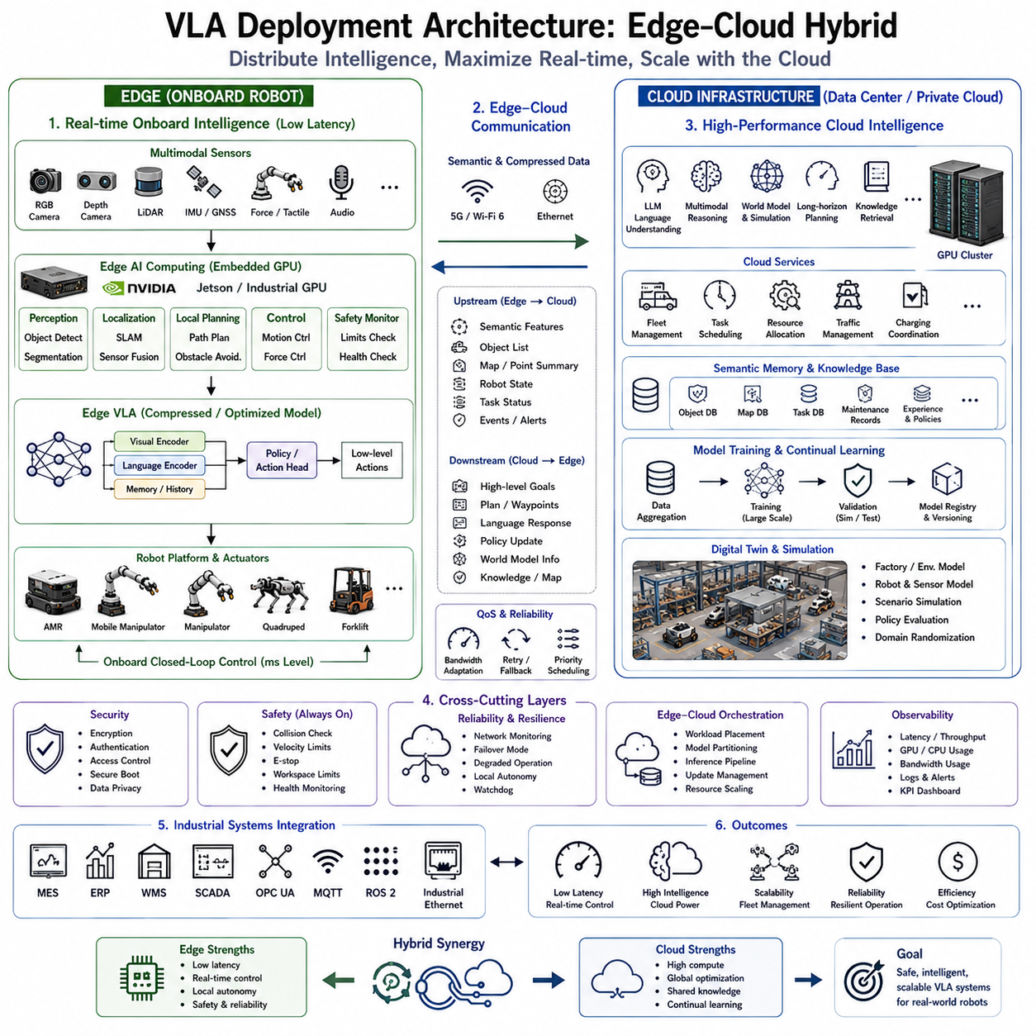
The deployment architecture of Vision-Language-Action (VLA) systems has become one of the most critical aspects of Physical AI because robot intelligence must balance computational capability, real-time responsiveness, reliability, scalability, and operational cost. Modern VLA models integrate multimodal perception, language understanding, semantic reasoning, world modeling, planning, and action generation within a unified framework. However, these capabilities require enormous computational resources that often exceed the capacity of embedded robotic hardware. Consequently, practical deployment increasingly adopts an Edge–Cloud Hybrid architecture in which intelligence is distributed across onboard edge computers and centralized cloud infrastructure. This collaborative architecture combines the low-latency execution of edge computing with the massive computational capability of cloud servers, enabling robots to operate safely and efficiently in complex real-world environments.
Traditional robotic systems generally relied on fully onboard computing because communication infrastructure was limited and network latency introduced unacceptable delays for closed-loop control. Every perception algorithm, localization module, planning system, and controller executed locally on embedded processors installed inside the robot. Although this architecture provided deterministic timing and communication independence, computational limitations restricted model complexity and prevented deployment of increasingly large multimodal foundation models. Recent advances in GPU technology, high-speed wireless communication, distributed AI frameworks, and cloud computing have fundamentally changed this design philosophy.
Modern VLA systems require substantial computational resources because they simultaneously process multiple sensor streams, language instructions, historical memory, semantic context, world models, and action policies. High-resolution RGB cameras, depth sensors, LiDAR, thermal imaging, force sensing, tactile arrays, GNSS, IMU measurements, and audio signals collectively generate enormous volumes of data every second. Large transformer architectures performing multimodal reasoning frequently contain billions of parameters, making continuous onboard inference impractical for many mobile robots operating under strict power and thermal constraints.
The Edge–Cloud Hybrid architecture addresses these challenges by partitioning intelligence according to computational requirements and latency sensitivity. Functions requiring immediate responses remain onboard the robot, while computationally intensive reasoning executes within centralized GPU servers. This separation enables efficient utilization of available computing resources without compromising operational safety or responsiveness. Rather than viewing edge and cloud as competing architectures, hybrid deployment recognizes that each environment provides complementary strengths supporting different stages of robotic cognition.
The edge computing subsystem forms the robot's primary real-time intelligence layer. Embedded computers process raw sensor observations, execute low-latency perception, perform localization, obstacle detection, sensor fusion, local planning, motion control, and safety monitoring. Real-time operating requirements demand deterministic execution independent of communication availability. Consequently, edge systems remain fully capable of maintaining safe navigation and basic manipulation even during temporary network interruptions.
Modern edge hardware typically includes embedded AI processors such as NVIDIA Jetson platforms together with industrial GPU computers equipped with workstation-class graphics processors. These systems execute compressed VLA inference models, object detection networks, semantic segmentation, visual odometry, SLAM, local trajectory generation, collision avoidance, force control, and embodiment-specific motion planning. Quantization, pruning, knowledge distillation, operator fusion, and optimized inference engines significantly reduce computational requirements while preserving acceptable reasoning performance.
Cloud infrastructure provides computational resources unavailable within mobile robotic platforms. Large GPU clusters execute high-capacity foundation models, multimodal reasoning, long-horizon planning, world model simulation, semantic memory retrieval, continual learning, fleet coordination, and large-scale optimization. Instead of performing every inference onboard, robots selectively transmit compressed semantic information to cloud services whenever additional reasoning capability is beneficial. Cloud computation therefore extends rather than replaces onboard intelligence.
One of the primary cloud responsibilities is language understanding and semantic reasoning. Large Language Models integrated with VLA architectures interpret complex user requests, decompose multi-stage objectives, retrieve relevant knowledge, generate execution strategies, and explain decision processes. High-level planning generated within cloud infrastructure is subsequently transmitted back to the robot as structured semantic goals rather than low-level motion commands. This separation minimizes communication bandwidth while preserving real-time execution locally.
World models represent another computationally demanding component well suited for cloud deployment. Internal simulation predicts future environmental evolution, evaluates multiple candidate action sequences, estimates long-term consequences, and assesses operational risk before execution. Running these predictive simulations onboard would exceed the computational budget of many robots. Cloud servers therefore execute large predictive models while edge controllers continue safe local operation based upon immediate environmental observations.
Fleet management naturally benefits from centralized cloud coordination. Industrial facilities frequently operate dozens or hundreds of heterogeneous robots including Autonomous Mobile Robots, mobile manipulators, collaborative robots, quadrupeds, inspection systems, forklifts, and service robots. Cloud infrastructure optimizes fleet scheduling, resource allocation, traffic management, charging coordination, workload balancing, maintenance planning, and mission assignment using global facility information unavailable to individual robots. Shared optimization substantially improves overall operational efficiency.
Semantic memory forms another important cloud service. Instead of storing all accumulated experience onboard every robot, centralized knowledge repositories maintain object databases, environment maps, maintenance records, operational procedures, language knowledge, task histories, inspection results, and learned policies. Robots retrieve only the relevant information needed for current operations while continuously contributing newly acquired knowledge back to the shared memory system. This collaborative learning framework allows experience gained by one robot to benefit the entire fleet.
Data transmission between edge and cloud must be carefully optimized because raw sensor streams frequently exceed practical communication bandwidth. Rather than transmitting complete camera images or dense point clouds continuously, edge processors perform feature extraction, object detection, semantic segmentation, compression, and event filtering before communication. Semantic representations require significantly lower bandwidth while preserving information necessary for high-level reasoning. Intelligent communication scheduling further prioritizes critical data during periods of limited network capacity.
Communication reliability becomes an essential architectural consideration because industrial wireless networks inevitably experience latency, congestion, temporary disconnection, and varying signal quality. Robust hybrid architectures therefore distinguish between latency-critical functions and delay-tolerant computation. Motion control, obstacle avoidance, emergency stopping, localization, and collision monitoring always execute locally. Cloud-assisted reasoning improves performance whenever communication permits but never becomes a prerequisite for maintaining operational safety.
Latency requirements differ significantly across robotic functions. Motor control typically requires response times below several milliseconds. Collision avoidance and local navigation generally require tens of milliseconds. Semantic reasoning, task planning, natural language interpretation, and knowledge retrieval often tolerate delays ranging from hundreds of milliseconds to several seconds. Hybrid deployment assigns computation according to these timing requirements, ensuring each subsystem executes within its appropriate latency budget.
Artificial intelligence model partitioning has become an active research area within hybrid VLA deployment. Large transformer models may be divided into multiple execution stages distributed across edge and cloud hardware. Early perception layers execute onboard to process raw sensor data. Intermediate semantic representations are transmitted efficiently to cloud servers where deeper reasoning layers perform high-level inference. Final task objectives return to onboard controllers responsible for embodiment-specific action generation. Such distributed inference balances computational load while reducing communication overhead.
Model compression plays an important role because even edge inference frequently exceeds embedded computational capacity. Quantization reduces numerical precision while maintaining acceptable accuracy. Knowledge distillation transfers reasoning capability from large cloud models into lightweight edge networks. Structured pruning removes redundant parameters, while neural architecture optimization produces compact models optimized for embedded GPUs. Together these techniques enable sophisticated VLA functionality within practical mobile robotic hardware.
Security becomes increasingly important as robots exchange operational data with cloud infrastructure. Communication channels require encryption, authentication, access control, secure boot mechanisms, trusted execution environments, and continuous cybersecurity monitoring. Sensitive industrial information including production schedules, facility maps, inspection records, maintenance procedures, and operational knowledge must remain protected throughout distributed computation. Private cloud deployment and on-premises AI infrastructure therefore remain preferred architectures for many industrial applications.
Safety architecture operates independently of communication availability. Dedicated runtime safety monitors continuously validate robot behavior using deterministic control algorithms executing entirely onboard. Joint limits, velocity constraints, collision boundaries, payload restrictions, emergency stopping, actuator health, localization confidence, and human safety remain under local supervision regardless of cloud connectivity. If communication fails unexpectedly, robots gracefully transition into autonomous local operation without compromising operational safety.
Continual learning significantly benefits from hybrid deployment. Edge robots collect operational experience during everyday activities, including sensor observations, successful task executions, failure cases, human feedback, and environmental changes. This data is periodically synchronized with centralized cloud infrastructure where large-scale retraining updates foundation models using experience aggregated from the entire fleet. Improved models are subsequently compressed, validated, and redeployed to edge devices through controlled software update pipelines.
Digital twins provide another valuable cloud capability supporting hybrid deployment. Virtual replicas of factories, warehouses, infrastructure, robots, sensors, and production equipment enable policy evaluation before physical deployment. Candidate updates undergo extensive simulation testing using randomized environmental conditions, hardware variations, communication disturbances, and rare failure scenarios. Only thoroughly validated models proceed toward physical deployment, substantially reducing operational risk.
Industrial deployment frequently integrates hybrid VLA systems with Manufacturing Execution Systems, Enterprise Resource Planning platforms, Warehouse Management Systems, Supervisory Control and Data Acquisition systems, industrial Ethernet networks, OPC UA servers, MQTT brokers, and ROS 2 middleware. Cloud services coordinate enterprise-level workflows while edge robots execute physical operations under deterministic timing constraints. This layered integration preserves compatibility with existing industrial infrastructure while introducing advanced AI capabilities.
Evaluation of hybrid deployment architectures extends beyond conventional robotic benchmarks. Engineers assess inference latency, communication bandwidth, network resilience, computational utilization, GPU efficiency, memory consumption, energy usage, deployment scalability, fleet coordination, task completion time, operational reliability, failover performance, cybersecurity resilience, maintainability, and total cost of ownership. Successful hybrid architectures demonstrate improvements across these dimensions simultaneously rather than optimizing only isolated performance metrics.
One representative industrial deployment involves a smart manufacturing facility operating hundreds of robots. Edge computers installed on each robot execute perception, localization, safety monitoring, manipulation control, and navigation. On-premises GPU clusters perform language understanding, production scheduling, multimodal reasoning, predictive maintenance, fleet optimization, and world model simulation. Manufacturing Execution Systems coordinate production orders while warehouse management software supervises inventory movement. Together, these interconnected components form a unified Physical AI infrastructure capable of adapting rapidly to changing production requirements.
Another deployment scenario involves large-scale infrastructure inspection. Mobile inspection robots perform autonomous navigation, visual inspection, thermal analysis, LiDAR mapping, and local anomaly detection entirely onboard. Suspicious observations are transmitted to cloud servers where foundation models perform detailed semantic diagnosis, compare findings against historical maintenance records, generate repair recommendations, and coordinate inspection scheduling across geographically distributed facilities. Hybrid intelligence enables efficient utilization of both local autonomy and centralized expertise.
Future Edge–Cloud Hybrid architectures will likely evolve toward fully distributed Physical AI ecosystems integrating edge robotics, private cloud GPU clusters, public cloud foundation models, digital twins, collaborative world models, continual learning systems, and intelligent industrial infrastructure. Advances in communication technology, embedded AI hardware, model compression, distributed transformers, semantic networking, and autonomous orchestration will further blur the distinction between onboard and remote intelligence. Rather than existing as isolated computing environments, edge and cloud will increasingly function as complementary components of a unified cognitive architecture, enabling scalable, reliable, and continuously improving Vision-Language-Action systems capable of supporting the next generation of intelligent robotic platforms.

10.2 Quantization Techniques (with Code)
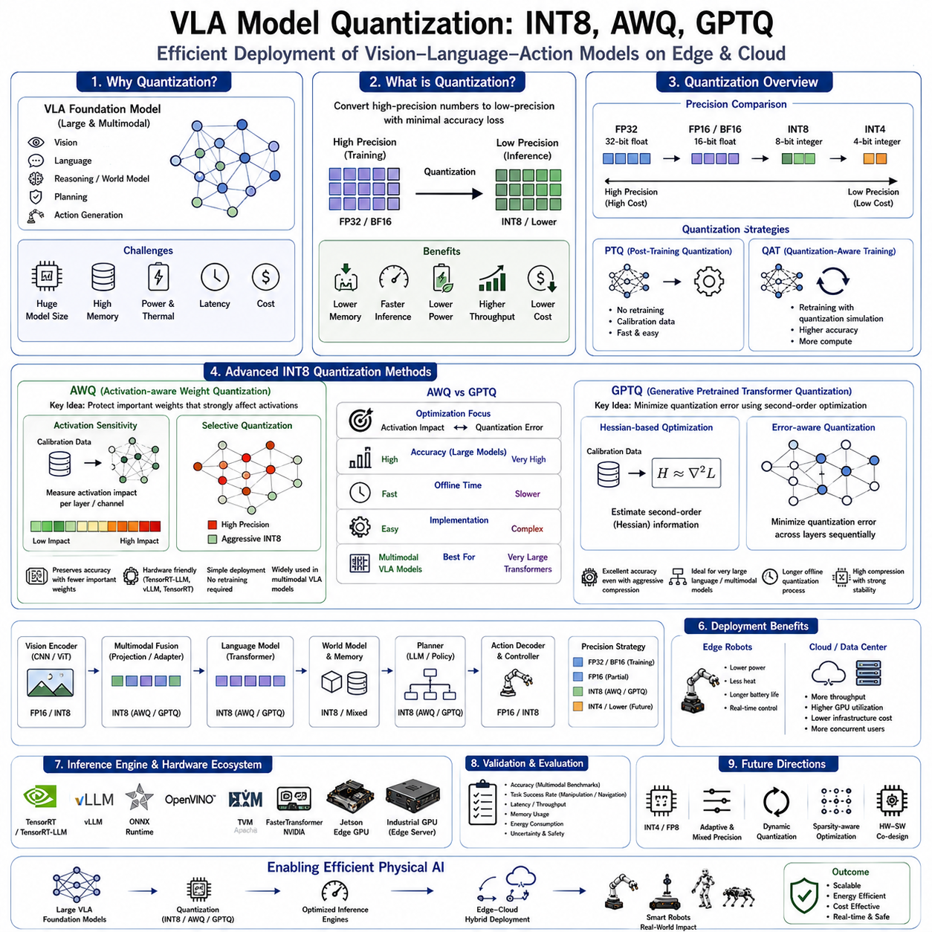
Vision-Language-Action (VLA) models have rapidly evolved into large-scale foundation models capable of integrating visual perception, natural language understanding, semantic reasoning, world modeling, task planning, and action generation within a unified neural architecture. While these models demonstrate remarkable capability across a wide variety of robotic tasks, their computational requirements present significant deployment challenges. Modern VLA models frequently contain billions of parameters and require hundreds of gigabytes of memory during inference, making direct deployment on edge robotic platforms impractical. Model quantization has therefore become one of the most important optimization techniques for enabling efficient execution of VLA models on embedded GPUs, industrial edge computers, mobile robots, and autonomous systems without requiring excessive computational resources.
Quantization is the process of converting neural network parameters and intermediate computations from high numerical precision into lower precision representations while preserving as much model accuracy as possible. Most foundation models are initially trained using FP32 (32-bit floating point) or BF16 (Brain Floating Point 16) precision because these formats provide stable optimization during large-scale distributed training. However, inference generally requires far less numerical precision than training. By reducing parameter precision from floating point representations to integer representations such as INT8 or even lower precision formats, significant reductions in memory consumption, computational cost, energy usage, and inference latency can be achieved.
The motivation for quantization is particularly strong in robotic systems because mobile platforms operate under strict constraints regarding power consumption, thermal dissipation, battery capacity, physical size, and hardware cost. Industrial Autonomous Mobile Robots, mobile manipulators, quadrupeds, humanoids, warehouse robots, and inspection systems cannot continuously execute extremely large transformer models using server-class GPU hardware. Instead, efficient inference must occur on embedded computing platforms such as NVIDIA Jetson devices or industrial edge GPU computers. Quantization enables increasingly sophisticated VLA models to operate within these practical deployment constraints while maintaining acceptable reasoning performance.
One of the primary advantages of quantization is reduced memory footprint. Neural network weights occupy a large proportion of inference memory. Converting FP16 weights into INT8 immediately halves memory usage, while more aggressive quantization techniques may reduce memory requirements even further. Lower memory consumption allows larger models to fit entirely within GPU memory, reducing costly memory transfers and improving overall inference throughput. Memory reduction also enables multiple models to coexist simultaneously on resource-constrained robotic platforms.
Computational efficiency represents another important benefit. Integer arithmetic generally executes faster than floating-point computation on modern AI accelerators because dedicated tensor cores and integer processing units have been extensively optimized for low-precision operations. Quantized models therefore require fewer computational resources per inference while simultaneously increasing throughput and reducing latency. These improvements directly enhance real-time robotic responsiveness, allowing more complex reasoning within fixed control cycle deadlines.
INT8 quantization has become one of the most widely adopted inference optimization techniques because it provides an excellent balance between efficiency and accuracy. In INT8 quantization, neural network weights and activations are represented using signed 8-bit integers rather than floating-point values. Scaling factors map integer values back into approximate floating-point ranges during computation. Most transformer architectures preserve nearly identical inference accuracy under carefully calibrated INT8 quantization while achieving substantial reductions in computational cost and memory usage. Consequently, INT8 has become a standard deployment format across numerous industrial AI inference frameworks.
Several different INT8 quantization strategies exist depending upon deployment requirements. Post-Training Quantization (PTQ) converts pretrained floating-point models into lower precision representations without additional model retraining. Calibration datasets estimate activation distributions and determine appropriate scaling factors for each layer. PTQ offers rapid deployment with minimal engineering effort but may experience slight accuracy degradation for particularly sensitive models.
Quantization-Aware Training (QAT) incorporates simulated quantization effects directly into model training. During optimization, the neural network learns to compensate for reduced numerical precision while maintaining predictive performance. Although QAT generally achieves higher accuracy than post-training quantization, it requires additional computational resources and access to the original training process. Foundation models containing billions of parameters often make full QAT prohibitively expensive, motivating continued research into more efficient post-training quantization techniques.
Activation-aware Weight Quantization (AWQ) has emerged as one of the most successful quantization algorithms for large transformer-based language and multimodal foundation models. Rather than treating every neural weight equally during quantization, AWQ recognizes that only a relatively small subset of weights significantly influences activation quality. These particularly important weights receive higher numerical protection while less sensitive parameters undergo more aggressive quantization. This selective optimization substantially preserves inference accuracy without requiring computationally expensive retraining.
The fundamental principle underlying AWQ is activation sensitivity analysis. Calibration data is passed through the pretrained model while measuring activation statistics across different transformer layers. Layers or channels demonstrating particularly strong influence upon downstream activations receive optimized quantization scales that minimize accumulated numerical error. Because transformer models naturally exhibit uneven parameter importance, protecting activation-critical weights yields significantly better accuracy compared with uniform quantization strategies.
Another important advantage of AWQ lies in its hardware compatibility. AWQ produces weight formats readily deployable using optimized inference engines such as TensorRT-LLM, vLLM, TensorRT, and numerous edge AI runtime environments. Consequently, AWQ has become particularly attractive for industrial robotics where deployment efficiency often outweighs absolute theoretical optimization performance. Modern edge GPU platforms frequently support AWQ inference with minimal additional engineering complexity.
GPTQ (Generative Pretrained Transformer Quantization) represents another highly influential post-training quantization algorithm specifically designed for large transformer models. Unlike simple layer-wise quantization approaches, GPTQ minimizes quantization error by approximating second-order optimization using Hessian information computed from representative calibration data. This mathematical formulation allows GPTQ to identify quantization solutions preserving model behavior remarkably well despite aggressive weight compression.
GPTQ processes neural network layers sequentially while estimating how quantization errors propagate throughout the transformer architecture. Rather than independently quantizing every parameter, GPTQ compensates for accumulated approximation errors by adjusting subsequent weight representations. This error correction mechanism substantially improves final inference accuracy, especially when reducing precision below conventional INT8 representations. GPTQ therefore enables practical deployment of very large language and multimodal models using limited GPU memory.
The computational requirements of GPTQ differ from AWQ. GPTQ typically requires somewhat longer offline quantization procedures because second-order approximations must be estimated during optimization. However, this additional preprocessing occurs only once before deployment. Runtime inference performance remains highly efficient because quantized weights execute using standard optimized low-precision operators. Consequently, GPTQ often represents an attractive choice when deployment quality outweighs offline preprocessing time.
Comparing AWQ and GPTQ reveals complementary strengths. AWQ emphasizes activation preservation and practical deployment simplicity, making it particularly suitable for multimodal transformer architectures frequently encountered within VLA systems. GPTQ focuses on mathematically minimizing quantization error through second-order optimization, often achieving excellent compression quality for extremely large transformer models. Both approaches significantly outperform conventional uniform post-training quantization while requiring no expensive retraining of foundation models.
Model quantization within VLA systems extends beyond language components alone. Vision encoders, multimodal fusion layers, world models, planning networks, action decoders, memory modules, and perception backbones may all undergo independent quantization according to their numerical sensitivity. Certain perception layers remain more sensitive to precision reduction because small numerical errors may propagate through subsequent semantic reasoning stages. Consequently, hybrid precision architectures frequently retain higher precision within selected components while aggressively quantizing computationally dominant transformer blocks.
Mixed-precision deployment has therefore become increasingly common within practical robotic systems. Vision backbones may execute using FP16 precision while language transformers operate using AWQ or GPTQ quantized weights. Critical safety modules, localization algorithms, force controllers, and low-level motion planners frequently remain in floating-point precision because deterministic numerical stability outweighs computational optimization. Such hybrid architectures balance efficiency with operational robustness.
Inference engines play an essential role in realizing practical quantization benefits. TensorRT, TensorRT-LLM, ONNX Runtime, OpenVINO, TVM, FasterTransformer, and vLLM provide highly optimized execution environments capable of exploiting low-precision arithmetic on modern GPU hardware. Kernel fusion, memory optimization, operator scheduling, tensor layout optimization, and hardware-specific compilation further improve performance beyond quantization alone. Quantization therefore functions most effectively when integrated within complete inference optimization pipelines.
Edge robotics particularly benefits from these optimizations. Embedded GPU platforms operating within limited power envelopes may achieve substantial improvements in inference throughput while reducing thermal output and extending battery life. Lower computational demand permits simultaneous execution of additional robotic functions including perception, localization, mapping, obstacle avoidance, sensor fusion, fleet communication, and safety monitoring without requiring larger hardware platforms.
Cloud deployment also benefits from quantization despite abundant computational resources. Large GPU clusters serving multiple robots simultaneously maximize throughput by executing compressed models requiring less GPU memory per inference request. Higher model density enables more concurrent robot sessions, reduces infrastructure costs, and improves overall resource utilization. Consequently, quantization contributes to scalability across both cloud and edge deployment architectures.
Model validation remains essential after quantization because numerical approximations may influence reasoning quality, language understanding, visual grounding, action generation, and long-horizon planning. Evaluation typically includes multimodal benchmark performance, robotic manipulation success, navigation accuracy, task completion rate, inference latency, memory utilization, throughput, energy consumption, uncertainty calibration, and safety validation. Particular attention is paid to safety-critical robotic behaviors where seemingly small numerical differences could influence physical execution.
Future research in VLA quantization will likely extend beyond INT8 toward increasingly sophisticated low-precision representations including INT4, FP8, adaptive mixed precision, activation compression, dynamic quantization, sparsity-aware optimization, and hardware-software co-design. Emerging quantization algorithms will become progressively aware of multimodal attention mechanisms, world models, memory architectures, and action generation pipelines rather than treating transformer layers independently. Automated optimization frameworks will dynamically determine appropriate precision for each network component according to runtime computational resources, task complexity, and safety requirements.
As Vision-Language-Action foundation models continue increasing in size and capability, efficient deployment will depend increasingly upon advanced quantization technologies. Techniques such as INT8 quantization, Activation-aware Weight Quantization (AWQ), and GPTQ provide practical pathways for executing sophisticated multimodal robot intelligence on embedded edge hardware without sacrificing real-time performance. Together with model compression, knowledge distillation, optimized inference engines, and hybrid Edge–Cloud architectures, quantization will remain one of the foundational technologies enabling scalable, energy-efficient, and economically viable deployment of next-generation Physical AI systems across industrial, commercial, and service robotics.

10.3 TensorRT-LLM Optimization (with Code)
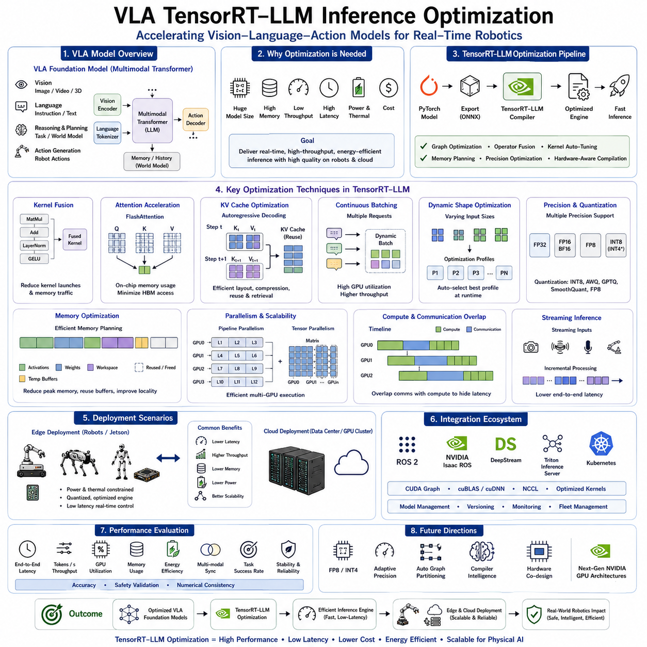
Vision-Language-Action (VLA) models have rapidly evolved into large-scale multimodal foundation models capable of integrating visual perception, natural language understanding, semantic reasoning, task planning, world modeling, and robotic action generation within a unified architecture. While these capabilities enable robots to perform increasingly complex physical tasks, they also introduce enormous computational requirements that challenge real-time deployment on practical robotic platforms. Large transformer architectures frequently contain billions of parameters and require extensive GPU memory, high computational throughput, and low-latency inference. TensorRT-LLM has emerged as one of the most important optimization frameworks for accelerating transformer inference, enabling sophisticated VLA models to operate efficiently on NVIDIA GPU platforms ranging from embedded edge devices to high-performance cloud servers.
Traditional deployment of transformer-based models often relies on general-purpose deep learning frameworks such as PyTorch or TensorFlow. Although these frameworks provide excellent flexibility during research and model development, they introduce considerable runtime overhead during inference. Dynamic computation graphs, generic kernel implementations, inefficient memory allocation, and non-optimized operator execution prevent GPUs from achieving their maximum computational efficiency. Real-time robotic systems require deterministic latency, predictable throughput, and efficient resource utilization, making inference-specific optimization essential for practical deployment.
TensorRT is NVIDIA's high-performance deep learning inference engine designed specifically to optimize neural network execution on NVIDIA GPUs. TensorRT-LLM extends this optimization capability toward transformer-based large language models and multimodal foundation models by introducing transformer-specific kernel optimizations, attention acceleration, memory management, operator fusion, parallel scheduling, and quantized execution. Rather than simply executing pretrained models directly, TensorRT-LLM transforms computational graphs into highly optimized inference engines specifically adapted to the target GPU architecture.
The optimization pipeline begins with model conversion. Foundation models trained in frameworks such as PyTorch are exported into intermediate representations before being compiled into TensorRT execution engines. During this compilation process, redundant operators are eliminated, computational graphs are simplified, tensor layouts are optimized, memory allocations are reorganized, and execution schedules are generated specifically for the underlying GPU hardware. These optimizations substantially reduce inference overhead while preserving numerical correctness.
Kernel fusion represents one of the most significant contributors to inference acceleration. Conventional deep learning execution often launches separate GPU kernels for each individual operation including matrix multiplication, normalization, activation functions, residual connections, and element-wise computations. Each kernel launch introduces scheduling overhead and unnecessary memory transfers. TensorRT-LLM combines multiple adjacent operations into single optimized GPU kernels, reducing memory traffic while increasing arithmetic intensity. This optimization significantly improves transformer execution efficiency because modern transformer blocks contain many repetitive computational patterns suitable for fusion.
Attention computation constitutes the computational bottleneck for nearly all transformer-based VLA models. Self-attention complexity grows rapidly with sequence length, making efficient implementation critical for real-time robotic reasoning. TensorRT-LLM incorporates highly optimized attention kernels including FlashAttention, masked attention optimization, multi-query attention support, grouped-query attention acceleration, and efficient key-value cache management. These techniques substantially reduce memory bandwidth requirements while improving overall attention throughput.
FlashAttention has become one of the most influential transformer optimization techniques integrated into TensorRT-LLM. Rather than materializing large intermediate attention matrices in GPU memory, FlashAttention reorganizes computation to maximize on-chip memory utilization while minimizing high-bandwidth memory access. This optimization simultaneously reduces memory consumption and increases computational throughput, enabling significantly longer context windows without proportional increases in computational cost. Long-context reasoning is particularly valuable for VLA systems performing extended robotic tasks involving historical memory and long-horizon planning.
Key-Value (KV) cache optimization provides another major performance improvement during autoregressive inference. Large language models repeatedly reuse attention information generated during previous decoding steps. Efficient caching avoids redundant computation by storing previously computed key and value tensors within GPU memory. TensorRT-LLM introduces optimized KV cache layouts, memory allocation strategies, cache compression techniques, and efficient retrieval mechanisms that substantially accelerate sequential token generation while minimizing GPU memory fragmentation.
Continuous batching further improves throughput in multi-request deployment environments. Traditional inference systems process each request independently, leaving GPU resources underutilized whenever requests vary in sequence length or arrive asynchronously. TensorRT-LLM dynamically groups compatible inference requests into continuously updated execution batches, maximizing GPU utilization while maintaining acceptable latency for individual robots. Industrial cloud deployments supporting multiple robots simultaneously particularly benefit from this scheduling strategy.
Dynamic shape optimization enables efficient execution across varying input dimensions. Robotic observations naturally exhibit variable image resolutions, sequence lengths, language instructions, sensor streams, and action histories. Rather than compiling independent inference engines for every possible input size, TensorRT-LLM generates optimized execution profiles covering practical operating ranges. Runtime execution automatically selects the most appropriate optimization profile according to current input characteristics, balancing flexibility with computational efficiency.
Precision optimization represents another critical capability. TensorRT-LLM supports FP32, TF32, FP16, BF16, FP8, INT8, and increasingly lower precision numerical formats depending upon hardware capabilities and deployment requirements. Lower precision arithmetic substantially increases inference throughput while reducing memory consumption and energy usage. For VLA deployment, mixed-precision execution often provides the best compromise between numerical accuracy and computational efficiency. Sensitive perception layers may retain higher precision while transformer attention and feedforward blocks execute using lower precision arithmetic.
Quantization integrates naturally with TensorRT-LLM optimization pipelines. Popular post-training quantization algorithms including INT8, Activation-aware Weight Quantization (AWQ), GPTQ, SmoothQuant, and FP8 quantization generate compressed weight representations compatible with TensorRT execution engines. During engine compilation, TensorRT-LLM automatically exploits low-precision tensor cores available within modern NVIDIA GPUs, significantly accelerating transformer inference without requiring expensive retraining procedures.
Memory optimization remains fundamental because transformer inference frequently becomes memory bandwidth limited rather than purely compute limited. TensorRT-LLM carefully manages activation buffers, workspace allocation, tensor reuse, and temporary storage throughout execution. Intermediate tensors no longer required by subsequent computation are immediately released or recycled, reducing peak memory consumption while enabling deployment of larger models on limited GPU hardware. Efficient memory planning also improves cache locality and reduces unnecessary memory transfers.
Pipeline parallelism and tensor parallelism provide scalable execution across multiple GPUs. Extremely large VLA foundation models exceeding the capacity of individual GPUs may be partitioned across multiple devices. Pipeline parallelism distributes sequential transformer layers across GPUs, while tensor parallelism divides large matrix computations among multiple processors. TensorRT-LLM coordinates communication efficiently using optimized collective operations that minimize synchronization overhead. Multi-GPU inference becomes particularly important within cloud infrastructure supporting industrial robotic fleets.
Overlap between computation and communication further improves distributed execution efficiency. Rather than waiting for all communication to complete before continuing computation, TensorRT-LLM schedules data transfers concurrently with independent GPU operations whenever dependencies permit. This asynchronous execution strategy hides communication latency behind useful computation, increasing overall throughput for distributed inference architectures.
Vision-language integration introduces additional optimization challenges because VLA systems process heterogeneous modalities simultaneously. Vision encoders produce high-dimensional feature representations subsequently fused with language embeddings before transformer reasoning begins. TensorRT-LLM optimizes these multimodal fusion operations through efficient tensor concatenation, projection fusion, attention scheduling, and memory management. Unified optimization across vision and language components reduces end-to-end latency compared with optimizing each subsystem independently.
Streaming inference becomes increasingly important for robotic applications requiring continuous environmental interaction. Rather than waiting for complete observation sequences before initiating inference, streaming execution processes sensor data incrementally as it becomes available. Cameras, LiDAR, audio streams, force sensors, tactile arrays, and language instructions may enter the inference pipeline asynchronously. TensorRT-LLM supports efficient streaming architectures that reduce end-to-end reaction time while preserving computational efficiency.
Edge deployment presents unique optimization priorities because embedded robotic computers operate under strict power, thermal, and memory constraints. NVIDIA Jetson platforms equipped with TensorRT-LLM execute compressed transformer models optimized using quantization, kernel fusion, reduced precision arithmetic, and efficient memory allocation. These optimizations allow sophisticated multimodal reasoning to execute within power budgets suitable for mobile robots, autonomous vehicles, quadrupeds, and humanoids operating away from data center infrastructure.
Cloud deployment emphasizes throughput and scalability rather than absolute power efficiency. Industrial GPU clusters simultaneously support multiple robots performing language reasoning, task planning, semantic retrieval, fleet coordination, predictive maintenance, and world model simulation. TensorRT-LLM maximizes GPU utilization through continuous batching, efficient scheduling, multi-GPU parallelism, optimized memory sharing, and high-density inference execution. Consequently, more concurrent robotic sessions may execute using the same hardware resources, substantially reducing infrastructure costs.
Safety considerations remain essential despite aggressive optimization. Numerical approximations introduced through quantization, reduced precision arithmetic, and fused operators must preserve inference correctness within acceptable tolerances. Safety-critical robotic functions including obstacle avoidance, collision detection, localization confidence estimation, force control, and emergency response require extensive validation before deployment. Optimized inference engines therefore undergo comprehensive benchmarking comparing numerical consistency against original reference implementations under representative robotic workloads.
Performance evaluation extends beyond simple token generation speed. Engineers measure end-to-end robotic response latency, transformer throughput, GPU utilization, memory consumption, energy efficiency, thermal behavior, scheduling overhead, communication latency, multimodal synchronization, action generation frequency, and overall task completion time. Industrial deployment additionally considers operational reliability, deterministic timing, scalability, maintainability, and total cost of ownership when selecting inference optimization strategies.
TensorRT-LLM integrates naturally with modern robotic software ecosystems. ROS 2 middleware, NVIDIA Isaac ROS, DeepStream pipelines, CUDA Graph execution, Triton Inference Server, Kubernetes orchestration, and cloud-edge deployment frameworks collectively enable scalable deployment across heterogeneous robotic platforms. Standardized deployment pipelines simplify software updates, version management, model validation, fleet monitoring, and continuous integration within industrial environments.
Future optimization research will likely extend toward increasingly intelligent inference engines capable of adapting execution dynamically according to available computational resources, environmental complexity, robot workload, and energy constraints. Adaptive precision scheduling, runtime operator specialization, automatic graph partitioning, compiler-guided multimodal optimization, hardware-aware transformer architectures, and AI-assisted inference compilation will further improve deployment efficiency. Emerging NVIDIA GPU architectures with dedicated transformer engines, larger shared memory, improved tensor cores, and enhanced communication fabrics will provide additional opportunities for optimization.
As Vision-Language-Action foundation models continue growing in capability, TensorRT-LLM will remain one of the foundational technologies enabling practical robotic deployment. Through kernel fusion, attention acceleration, quantization support, memory optimization, continuous batching, streaming inference, distributed execution, and hardware-specific compilation, TensorRT-LLM transforms computationally demanding transformer architectures into efficient inference engines suitable for real-time Physical AI systems. Combined with model compression, Edge–Cloud Hybrid deployment, optimized GPU hardware, and scalable robotic software infrastructure, TensorRT-LLM provides a critical bridge between state-of-the-art multimodal AI research and practical industrial robotics operating safely and efficiently in complex real-world environments.

10.4 Speculative Decoding (with Code)
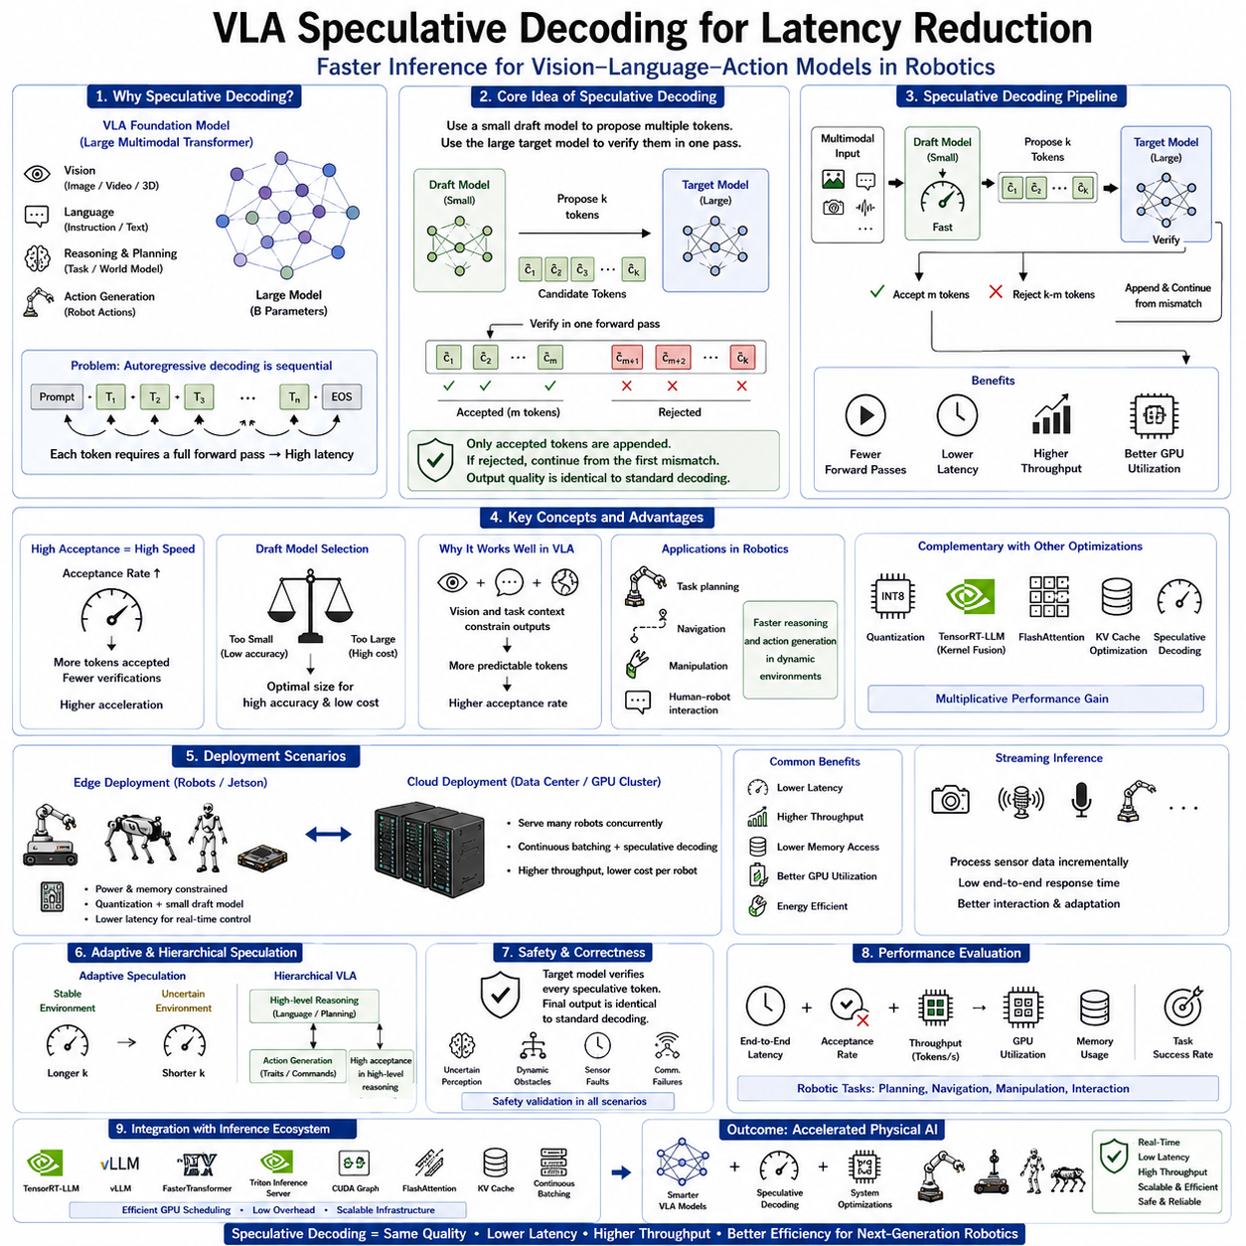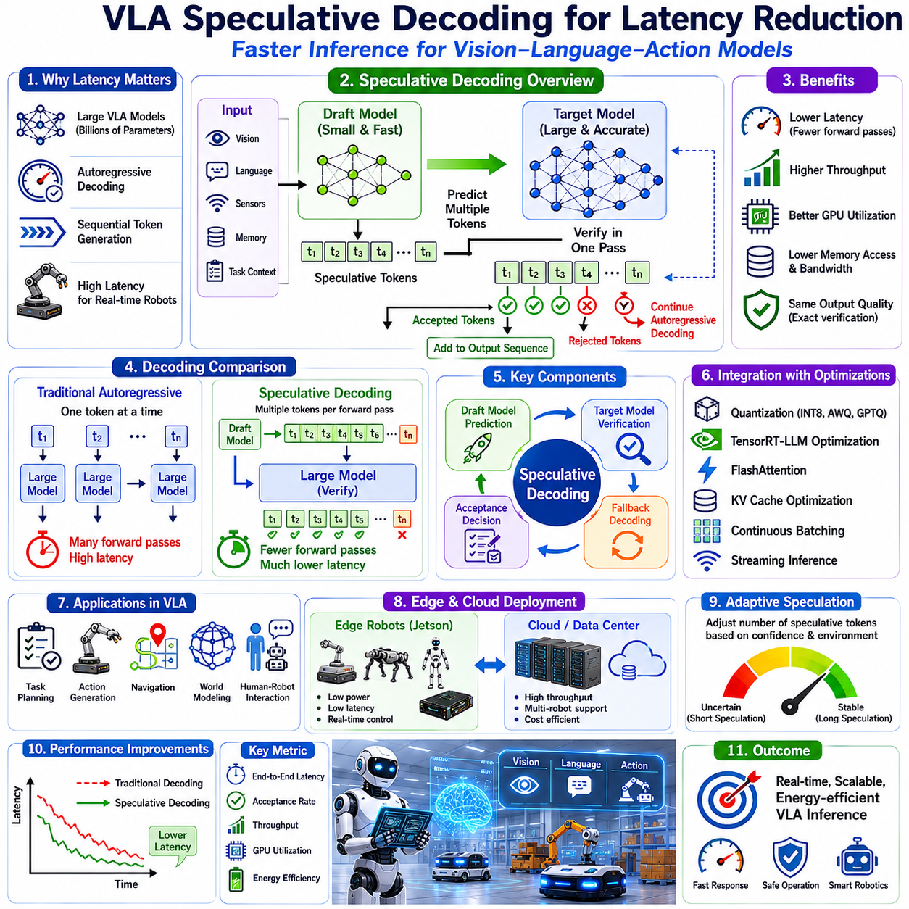
Vision-Language-Action (VLA) models have become increasingly powerful by integrating multimodal perception, natural language understanding, semantic reasoning, world modeling, task planning, and robotic action generation into unified transformer architectures. These capabilities enable robots to perform sophisticated manipulation, navigation, inspection, and human-robot interaction tasks with unprecedented flexibility. However, the increasing size of modern foundation models also introduces significant inference latency. Large transformer models often require autoregressive decoding, where every output token depends upon all previously generated tokens. This sequential dependency limits parallel execution and creates one of the primary bottlenecks preventing real-time deployment on robotic systems. Speculative decoding has emerged as one of the most promising techniques for reducing inference latency while preserving the output quality of large VLA foundation models.
Traditional autoregressive decoding generates one token at a time. After producing a single token, the transformer executes another complete forward pass to predict the next token. Although transformer computations within one forward pass are highly parallel, the decoding process itself remains fundamentally sequential. Every newly generated token requires another expensive execution through the entire transformer network. For very large language and multimodal models containing billions of parameters, this repeated computation dominates inference latency and limits robot responsiveness during interactive tasks.
Latency becomes particularly critical in Physical AI because robots continuously interact with dynamic environments. Navigation decisions, manipulation adjustments, obstacle avoidance, human communication, and task planning all require timely responses. A delay of several hundred milliseconds may be acceptable for high-level planning, but excessive inference latency quickly degrades interaction quality and may even compromise operational safety. Consequently, reducing transformer decoding latency has become a major research objective within practical VLA deployment.
Speculative decoding addresses this limitation by introducing a collaborative inference strategy involving two complementary neural networks. Instead of relying exclusively on the large foundation model for every decoding step, a much smaller draft model first predicts multiple candidate tokens rapidly. The larger target model subsequently verifies these predictions using a single forward pass. If the proposed tokens match the target model's preferred outputs, several tokens may be accepted simultaneously. This mechanism dramatically reduces the number of expensive executions required by the large transformer while preserving identical output quality.
The central insight underlying speculative decoding is that large foundation models frequently generate highly predictable token sequences. Much of the computational effort spent recomputing every individual token is therefore redundant. A lightweight draft model can often anticipate the next several tokens correctly because local language structure, semantic continuity, and contextual consistency make many predictions relatively straightforward. The larger model then focuses primarily on verification rather than generating every token independently.
The speculative decoding pipeline begins with input processing using the standard VLA architecture. Visual observations, language instructions, sensor data, historical memory, task context, and multimodal embeddings enter both the draft model and the target foundation model. The draft model rapidly predicts several future tokens rather than only the immediate next token. These speculative tokens are temporarily accepted as candidate outputs before validation by the larger model.
The target model subsequently performs a single forward pass evaluating the proposed token sequence. Rather than generating tokens independently, it computes the probability distribution associated with every speculative token simultaneously. Tokens matching the target model's predictions are immediately accepted into the final output sequence. If disagreement occurs, the target model rejects the remaining speculative predictions and resumes conventional autoregressive decoding from the divergence point. Consequently, correctness remains mathematically equivalent to standard decoding despite substantial reductions in computational cost.
Acceptance rate becomes one of the most important performance metrics governing speculative decoding efficiency. High acceptance rates indicate that the draft model accurately predicts future tokens, allowing many speculative tokens to bypass independent transformer execution. Low acceptance rates reduce acceleration because rejected predictions require additional verification. Designing draft models capable of maintaining consistently high acceptance across diverse multimodal reasoning tasks therefore represents an important optimization objective.
Draft model selection requires careful balancing between computational efficiency and predictive quality. Extremely small draft models generate predictions rapidly but may produce low acceptance rates due to limited reasoning capability. Larger draft models increase prediction accuracy but consume additional computational resources that partially offset acceleration benefits. Practical deployment therefore seeks an optimal intermediate model capable of producing sufficiently accurate speculative predictions while remaining substantially faster than the target foundation model.
Speculative decoding integrates naturally with transformer-based VLA systems because visual reasoning frequently establishes strong semantic constraints before language generation begins. Environmental observations, object recognition, scene understanding, task context, and world model predictions significantly reduce uncertainty regarding subsequent language outputs. Consequently, draft models often achieve higher acceptance rates within robotic applications than in unrestricted conversational language generation because multimodal observations constrain the prediction space.
Task planning provides an illustrative example. Suppose a robot receives the instruction, “Pick up the blue container from the second shelf and place it on the inspection table.” After visual perception identifies the environment and semantic planning begins, many subsequent reasoning tokens become highly predictable. The draft model rapidly proposes candidate planning sequences while the target model validates them. High acceptance rates enable significantly faster generation of action plans without altering final decision quality.
Action generation similarly benefits from speculative decoding. VLA models frequently produce structured robot commands describing trajectories, grasp parameters, navigation goals, manipulation sequences, or embodiment-specific actions. Because robotic action sequences exhibit strong temporal continuity, draft models accurately predict many successive action tokens. Target verification subsequently confirms these predictions, reducing overall action generation latency during real-time operation.
Speculative decoding complements existing transformer optimization techniques rather than replacing them. Quantization reduces computational cost per forward pass by lowering numerical precision. TensorRT-LLM optimizes GPU kernel execution through operator fusion and memory optimization. FlashAttention accelerates transformer attention computation. KV cache optimization reduces redundant attention calculations during autoregressive inference. Speculative decoding decreases the number of required forward passes altogether. Combining these techniques produces multiplicative rather than merely additive performance improvements.
Hardware utilization also improves through speculative decoding. GPU tensor cores remain occupied performing larger verification computations rather than repeatedly executing numerous small sequential decoding steps. Better workload consolidation increases arithmetic intensity, improves memory locality, reduces kernel launch overhead, and enhances overall GPU efficiency. Industrial inference servers supporting multiple robots simultaneously particularly benefit from these improvements because throughput increases alongside latency reduction.
Memory behavior changes favorably as well. Standard autoregressive decoding repeatedly accesses KV caches for every individual token generation step. Speculative decoding verifies multiple tokens within fewer transformer executions, reducing repeated memory accesses and improving cache efficiency. Combined with optimized KV cache layouts and memory scheduling, speculative decoding contributes to both lower latency and improved GPU memory utilization.
Edge deployment introduces additional considerations because embedded robotic platforms possess limited computational resources. Running both draft and target models simultaneously must remain computationally beneficial. Fortunately, compact draft models typically require only a small fraction of the computational budget consumed by large foundation models. On NVIDIA Jetson platforms and industrial edge GPUs, speculative decoding often produces measurable latency improvements despite limited hardware resources, particularly when combined with aggressive model quantization.
Cloud deployment emphasizes throughput across multiple concurrent robotic sessions. Centralized inference servers supporting dozens or hundreds of robots simultaneously may execute shared draft models alongside multiple target model instances. Continuous batching and speculative decoding interact synergistically because accepted speculative tokens reduce total transformer execution demand across the entire serving infrastructure. Consequently, cloud providers achieve improved scalability while reducing infrastructure cost per robot.
Streaming robotic inference represents another valuable application scenario. Cameras, LiDAR, microphones, tactile sensors, and language interactions generate continuous asynchronous data streams. As robots continually update environmental understanding, speculative decoding accelerates incremental reasoning without requiring complete regeneration of long response sequences. Reduced response latency significantly improves natural human-robot interaction and dynamic environmental adaptation.
Multimodal reasoning presents unique challenges compared with language-only generation. Visual observations occasionally introduce abrupt semantic changes requiring significant revisions to previously expected outputs. Unexpected obstacles, moving humans, newly detected objects, or sensor anomalies may reduce speculative acceptance rates because environmental context changes rapidly. Adaptive speculative decoding strategies therefore dynamically adjust speculative length according to current environmental uncertainty.
Adaptive speculation represents an active research direction. Rather than proposing a fixed number of future tokens, intelligent controllers estimate confidence based upon task complexity, environmental stability, model uncertainty, and recent acceptance history. Highly predictable reasoning permits longer speculative sequences, while uncertain situations trigger shorter speculation windows. Dynamic adaptation maximizes acceleration while minimizing unnecessary verification overhead.
Hierarchical VLA architectures further enhance speculative decoding opportunities. High-level reasoning modules generally produce more structured outputs exhibiting stronger semantic continuity than low-level motor controllers. Consequently, speculative decoding proves especially effective during language reasoning, task decomposition, semantic planning, and world model prediction. Low-level safety-critical control remains deterministic and frequently executes outside autoregressive transformer architectures altogether.
Safety considerations remain fundamental throughout deployment. Although speculative decoding modifies inference execution order, it does not alter the final probability distribution generated by the target foundation model. Every accepted token remains verified before becoming part of the final output sequence. Therefore, speculative decoding preserves the exact decoding behavior of the original model while merely reducing redundant computation. Safety validation nevertheless evaluates acceptance behavior under challenging robotic scenarios involving uncertain perception, dynamic obstacles, hardware faults, and communication interruptions.
Evaluation of speculative decoding extends beyond conventional token generation benchmarks. Researchers assess end-to-end robotic response latency, planning time, action generation frequency, navigation responsiveness, manipulation cycle time, GPU utilization, energy consumption, acceptance rate, speculative efficiency, memory bandwidth utilization, multimodal synchronization, and overall task completion performance. Industrial deployment additionally measures scalability across multiple robots, deterministic timing, infrastructure utilization, and operational reliability.
Implementation within modern inference frameworks continues to mature rapidly. TensorRT-LLM, vLLM, FasterTransformer, Triton Inference Server, CUDA Graph execution, and optimized transformer runtimes increasingly support speculative decoding through highly optimized GPU scheduling. Efficient synchronization between draft and target models minimizes communication overhead while preserving deterministic execution. Integration with quantized models, FlashAttention, KV cache optimization, continuous batching, and distributed inference further expands deployment flexibility.
Future research will likely extend speculative decoding beyond simple language token prediction toward multimodal speculative reasoning. Draft models may predict visual attention patterns, semantic scene interpretations, world model evolution, robot trajectories, manipulation plans, and long-horizon action sequences before verification by larger multimodal foundation models. Multi-stage speculation involving hierarchical reasoning modules may further reduce computational demand while maintaining exact inference quality.
As Vision-Language-Action foundation models continue increasing in scale and sophistication, speculative decoding will become an increasingly important optimization technology for real-time robotics. By allowing lightweight draft models to anticipate future reasoning while larger foundation models perform efficient verification, speculative decoding substantially reduces inference latency without compromising prediction quality. Combined with TensorRT-LLM optimization, quantization, FlashAttention, KV cache optimization, Edge–Cloud Hybrid deployment, and advanced GPU architectures, speculative decoding provides a practical pathway toward responsive, scalable, and energy-efficient Physical AI systems capable of supporting the next generation of intelligent autonomous robots.

10.5 Batch Inference and KV Cache Management (with Code)
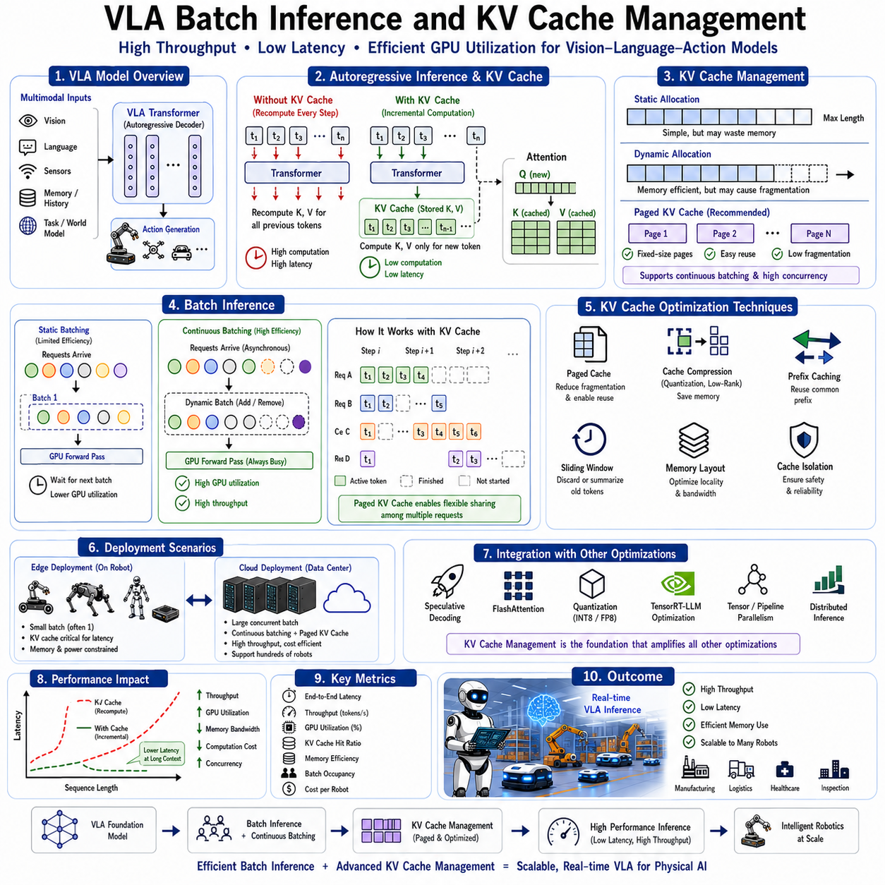
Vision-Language-Action (VLA) models have become the foundation of modern Physical AI by integrating visual perception, language understanding, semantic reasoning, world modeling, task planning, and action generation within unified transformer architectures. These models enable robots to interpret complex environments, understand natural language instructions, predict future states, and generate intelligent actions. However, their impressive capabilities come with substantial computational requirements. As model size grows from billions to tens of billions of parameters, inference efficiency becomes one of the most critical factors determining whether VLA systems can operate in real-time robotic environments. Among the numerous optimization techniques developed for transformer inference, batch inference and Key-Value (KV) cache management have emerged as two of the most influential technologies for improving throughput, reducing latency, and maximizing GPU utilization.
Transformer-based VLA models perform autoregressive inference during language reasoning, action generation, planning, and sequential decision making. Unlike conventional neural networks that process an entire output simultaneously, autoregressive transformers generate one token at a time, where each newly generated token depends on all previously generated tokens. This sequential dependency requires repeated execution of transformer attention layers throughout the decoding process. Without optimization, every decoding step recomputes attention across the entire history, resulting in rapidly increasing computational cost as sequence length grows.
The computational bottleneck primarily originates from the self-attention mechanism. During each decoding step, every token attends to all previously generated tokens through Query, Key, and Value representations. Recomputing Key and Value tensors for every previous token during every decoding iteration introduces enormous redundant computation. Large multimodal VLA models processing long language instructions, visual embeddings, world models, and task histories become particularly affected because sequence lengths may extend to thousands of tokens.
Key-Value cache management eliminates this redundancy by storing previously computed Key and Value tensors in GPU memory after each decoding step. Instead of recalculating historical attention information repeatedly, subsequent inference iterations reuse the cached representations while computing only the new Query corresponding to the latest token. The transformer then performs attention using the newly generated Query together with cached Key-Value tensors representing all previous context. This simple architectural optimization dramatically reduces computational complexity during autoregressive inference.
The KV cache fundamentally transforms transformer execution from repeated recomputation into incremental computation. During the first decoding step, the model computes Key and Value tensors for the initial prompt, visual observations, sensor information, and multimodal context. These tensors remain stored throughout the remainder of the inference session. Each subsequent decoding step computes only one additional Key-Value pair corresponding to the newly generated token, appending it to the existing cache. Consequently, computational workload grows linearly rather than repeatedly processing the complete history.
Memory management becomes a central consideration because KV caches may occupy substantial GPU memory. Modern transformer models contain numerous attention heads distributed across dozens or hundreds of transformer layers. Every generated token contributes additional Key and Value tensors for each attention head within every layer. Long-context reasoning therefore produces continuously growing cache memory requirements. Efficient KV cache allocation, organization, compression, and reuse become essential for supporting large-context VLA reasoning without exhausting available GPU memory.
Static KV cache allocation reserves memory before inference begins according to the maximum expected sequence length. This approach simplifies memory management because addresses remain fixed throughout execution, eliminating runtime allocation overhead. However, static allocation may waste GPU memory whenever actual sequence lengths remain significantly shorter than reserved capacity. Industrial robotic deployments serving multiple robots simultaneously often find this inefficiency unacceptable because unused cache memory reduces overall serving capacity.
Dynamic KV cache allocation provides greater memory efficiency by allocating storage incrementally as new tokens are generated. Rather than reserving maximum capacity upfront, memory grows according to actual sequence length. Dynamic allocation significantly improves GPU memory utilization, allowing larger numbers of concurrent inference sessions. Nevertheless, dynamic allocation introduces additional runtime complexity because memory fragmentation, allocation latency, and address management require careful optimization.
Paged KV cache management has emerged as one of the most successful solutions to these challenges. Instead of storing cache memory within one large contiguous allocation, the cache is divided into smaller fixed-size memory pages. Individual pages may be allocated, released, reused, or reorganized independently without relocating the entire cache. This virtual memory–inspired architecture substantially reduces fragmentation while enabling efficient sharing of GPU memory among multiple concurrent inference sessions.
Paged cache architectures also facilitate continuous batching. Multiple robotic inference requests arriving asynchronously may share GPU resources efficiently because cache pages remain independently managed. When one inference session finishes, its pages immediately become available for reuse by newly arriving requests. Consequently, GPU memory utilization improves substantially while reducing allocation overhead and enabling scalable multi-robot cloud inference.
Batch inference itself represents another critical optimization strategy. Rather than processing one robotic inference request at a time, multiple independent requests execute simultaneously within a single GPU forward pass. Matrix operations naturally benefit from larger batch dimensions because GPU tensor cores achieve higher arithmetic utilization when processing many samples concurrently. Consequently, throughput increases significantly while reducing average computational cost per request.
Traditional static batching groups requests only when they arrive simultaneously before execution begins. Although effective for offline processing, static batching performs poorly in interactive robotic environments where requests arrive continuously and unpredictably. Robots performing navigation, manipulation, inspection, human interaction, and planning generate inference requests asynchronously depending on environmental events rather than synchronized schedules.
Continuous batching overcomes this limitation by dynamically inserting newly arriving requests into already executing inference batches whenever computational dependencies permit. Instead of waiting for existing batches to complete, continuous scheduling maximizes GPU occupancy by maintaining an almost constant stream of transformer computation. Modern inference frameworks such as TensorRT-LLM and vLLM extensively employ continuous batching together with paged KV cache management to achieve exceptionally high serving efficiency.
Continuous batching introduces additional scheduling challenges because different robots generate sequences of varying lengths. One robot may require only a short response while another performs long-horizon reasoning involving thousands of generated tokens. Efficient schedulers dynamically rearrange batch composition after every decoding iteration, removing completed requests while admitting newly arriving sessions. KV cache management must therefore support flexible page ownership without interrupting ongoing transformer execution.
Vision-Language-Action systems particularly benefit from these optimizations because robotic fleets naturally generate concurrent inference workloads. Multiple Autonomous Mobile Robots, mobile manipulators, humanoids, quadrupeds, warehouse robots, inspection systems, and collaborative robots simultaneously submit language reasoning, semantic planning, manipulation planning, and action generation requests to centralized inference servers. Batch inference substantially improves GPU utilization while reducing infrastructure costs across the entire robotic fleet.
Edge deployment presents different optimization priorities. Embedded GPU platforms such as NVIDIA Jetson devices generally serve only one robot at a time. Batch sizes therefore remain relatively small, but KV cache optimization continues providing substantial latency improvements because autoregressive decoding dominates computational cost regardless of batch size. Efficient cache management enables embedded systems to support longer context windows while remaining within strict memory and power constraints.
Cloud deployment emphasizes maximum throughput across large numbers of robots. Industrial GPU clusters may simultaneously serve hundreds of independent inference sessions distributed across multiple facilities. Batch inference, continuous scheduling, paged KV caches, tensor parallelism, and pipeline parallelism collectively maximize computational efficiency while minimizing infrastructure cost per robot. Cloud inference therefore achieves substantially higher resource utilization than isolated robot-local execution.
Multimodal VLA models introduce additional cache management complexity because attention mechanisms process heterogeneous modalities including visual embeddings, language tokens, task history, semantic memory, and world model representations. Different modalities frequently possess different sequence lengths and update frequencies. Visual observations may remain relatively static while language reasoning continues generating new tokens. Efficient KV cache management therefore distinguishes between persistent multimodal context and continuously growing autoregressive sequences.
Prefix caching provides another important optimization. Many robotic tasks begin from similar system prompts, safety instructions, environmental descriptions, or operational policies. Rather than recomputing identical prompt representations repeatedly, shared prefixes remain cached and reused across multiple inference sessions. Prefix reuse significantly reduces initialization latency while improving GPU efficiency for repetitive industrial workloads involving standardized operating procedures.
Cache compression represents an active research area aimed at extending effective context length. Quantized KV caches reduce memory consumption by storing Key and Value tensors using lower numerical precision such as FP8 or INT8 while preserving acceptable attention quality. Other approaches compress historical representations using low-rank approximations, sparsity exploitation, or learned memory summarization. These techniques enable increasingly long-context reasoning without proportional increases in GPU memory consumption.
Sliding-window attention further improves cache scalability. Extremely old tokens frequently contribute relatively little to current reasoning compared with recent context. Instead of retaining every historical token indefinitely, attention mechanisms may discard or compress distant history while preserving local context in full precision. Long-term semantic information remains summarized within dedicated memory modules rather than individual attention tokens. Such hierarchical memory architectures reduce cache growth during extended robotic operation.
Memory locality significantly influences inference performance. Efficient KV cache layouts organize tensors according to GPU access patterns, minimizing memory bandwidth bottlenecks during attention computation. Cache-aware scheduling ensures sequential GPU memory access whenever possible, improving cache coherence and reducing latency associated with scattered memory retrieval. Hardware-specific optimization therefore complements algorithmic improvements.
Batch inference also interacts closely with speculative decoding, FlashAttention, quantization, TensorRT-LLM optimization, and distributed transformer execution. Speculative decoding reduces the number of decoding iterations. FlashAttention accelerates individual attention computations. Quantization decreases memory bandwidth requirements. TensorRT-LLM optimizes kernel execution and operator fusion. Efficient KV cache management supports all these techniques simultaneously, producing multiplicative rather than additive improvements in inference efficiency.
Reliability remains particularly important for robotic deployment. Cache corruption, synchronization errors, stale memory references, or inconsistent batching could directly influence robotic decision making. Robust inference systems therefore include cache validation, consistency checking, memory protection, session isolation, and deterministic scheduling mechanisms ensuring every inference session receives correct contextual information regardless of concurrent workload.
Performance evaluation extends beyond simple token generation throughput. Engineers measure end-to-end robotic response latency, GPU utilization, memory bandwidth utilization, KV cache hit ratio, cache allocation efficiency, batch occupancy, inference throughput, energy consumption, thermal behavior, context length scalability, scheduling overhead, and task completion performance. Industrial deployments additionally evaluate multi-robot scalability, infrastructure utilization, deterministic response timing, and operational cost.
Future VLA inference architectures will likely integrate increasingly sophisticated memory hierarchies combining paged KV caches, adaptive cache compression, hierarchical semantic memory, multimodal context caching, distributed cache sharing, and hardware-aware scheduling. Emerging GPU architectures providing larger on-chip memory, higher bandwidth, transformer-specific execution engines, and intelligent memory management will further improve inference efficiency. AI-assisted runtime schedulers may dynamically optimize cache allocation and batch composition according to workload characteristics, robot priorities, network conditions, and available computational resources.
As Vision-Language-Action foundation models continue growing in capability and context length, efficient batch inference and KV cache management will remain indispensable enabling technologies for real-time Physical AI deployment. By eliminating redundant computation, maximizing GPU utilization, reducing memory overhead, supporting long-context reasoning, and enabling scalable multi-robot inference, these optimization techniques provide the computational foundation necessary for deploying increasingly capable VLA systems across industrial automation, autonomous mobility, collaborative robotics, logistics, infrastructure inspection, healthcare robotics, and future intelligent physical systems.

10.6 ROS 2 Integration (with Code)
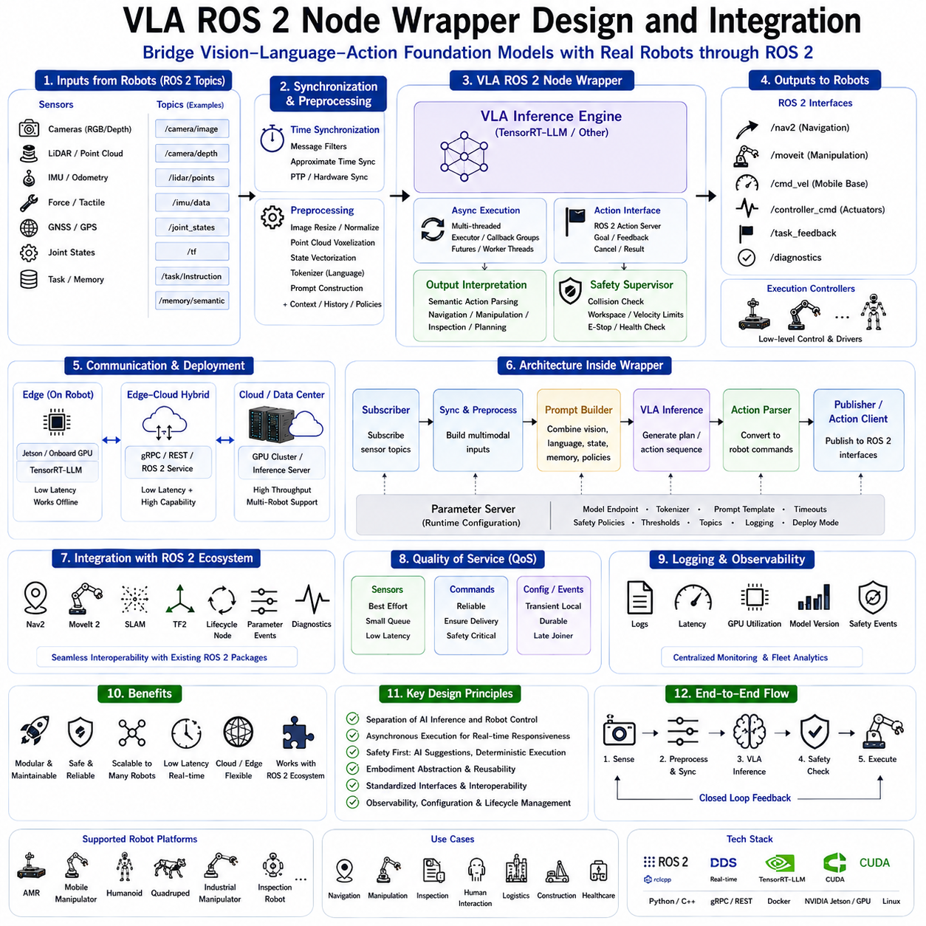
The deployment of Vision-Language-Action (VLA) models into real robotic systems requires more than high-performing artificial intelligence models. While foundation models demonstrate remarkable capabilities in multimodal reasoning, semantic understanding, task planning, and action generation, they cannot directly interact with robotic hardware without an appropriate software integration framework. Robot Operating System 2 (ROS 2) has become the de facto middleware standard for modern robotics, providing standardized communication, modular software architecture, distributed execution, hardware abstraction, and real-time coordination. Consequently, an effective ROS 2 Node Wrapper serves as the critical interface between large VLA foundation models and physical robotic platforms, enabling intelligent reasoning to operate safely and efficiently within production robotic systems.
Unlike conventional perception or control algorithms that perform narrowly defined computations, VLA models consume heterogeneous multimodal information including camera images, depth maps, LiDAR observations, robot states, force sensing, language instructions, semantic memory, world models, and historical task context before producing high-level action policies. The wrapper architecture must therefore translate between the asynchronous, distributed communication model of ROS 2 and the computational requirements of transformer-based multimodal AI systems. This translation layer isolates AI inference from hardware-specific implementation while maintaining compatibility with existing robotic software ecosystems.
A ROS 2 Node Wrapper functions as an intermediary software component responsible for receiving sensor information from the robotic platform, preprocessing multimodal inputs, invoking the VLA inference engine, interpreting generated outputs, validating action safety, and publishing robot commands back into the ROS 2 communication graph. Instead of embedding transformer inference directly within hardware controllers, the wrapper establishes a modular interface that separates perception, reasoning, planning, execution, and safety supervision into independently maintainable software components.
The overall architecture generally follows a layered design. Hardware drivers interface directly with cameras, LiDAR sensors, IMUs, GNSS receivers, force sensors, tactile arrays, motor controllers, and robot manipulators. These hardware nodes publish standardized ROS 2 messages through topics such as image streams, point clouds, odometry, joint states, and sensor measurements. The VLA wrapper subscribes selectively to relevant information while synchronizing multiple sensor streams into coherent multimodal observations suitable for transformer inference.
Sensor synchronization becomes particularly important because multimodal reasoning depends upon temporally consistent observations. Camera images, depth measurements, LiDAR scans, robot poses, IMU data, and force sensing frequently arrive at different frequencies with independent timestamps. The wrapper employs ROS 2 message filters, approximate time synchronization, hardware timestamps, Precision Time Protocol (PTP), or synchronized triggering mechanisms to align sensor observations before constructing unified multimodal input representations. Accurate synchronization substantially improves reasoning consistency during dynamic robotic operation.
Input preprocessing transforms raw ROS 2 messages into representations compatible with the VLA foundation model. RGB images undergo resizing, normalization, cropping, and tensor conversion. Point clouds may be voxelized or projected into learned feature spaces. Robot joint states become structured numerical vectors describing embodiment configuration. Language instructions are tokenized according to the pretrained tokenizer associated with the foundation model. World state information, semantic memory, and previous task history are encoded into standardized prompt structures before inference begins.
Prompt construction represents one of the most influential responsibilities of the wrapper. Rather than passing isolated sensor data directly into the transformer, the wrapper assembles complete multimodal prompts combining visual observations, robot state, environmental context, historical memory, safety constraints, operational policies, and user instructions. Carefully structured prompting substantially improves reasoning consistency because the foundation model receives sufficient contextual information to generate physically meaningful robotic actions rather than isolated language responses.
The wrapper communicates with the VLA inference engine through several possible deployment architectures. Embedded edge deployment invokes locally hosted TensorRT-LLM engines executing directly on onboard GPUs. Cloud-edge hybrid deployment forwards compressed multimodal observations to centralized GPU servers using gRPC, REST APIs, ROS 2 services, or custom communication middleware. On-premises inference clusters frequently expose standardized AI inference interfaces allowing multiple robots to share common foundation models while maintaining independent ROS 2 execution environments.
Asynchronous execution constitutes another essential architectural requirement. Transformer inference frequently requires substantially more computation than conventional robotic control loops. Directly blocking ROS 2 callback execution while waiting for AI inference would disrupt deterministic system responsiveness. Consequently, wrapper implementations employ asynchronous execution using callback groups, multithreaded executors, futures, action servers, or independent inference worker threads. Robot communication continues uninterrupted while large foundation models generate reasoning outputs in parallel.
ROS 2 Actions provide an especially appropriate communication mechanism for long-duration VLA tasks. Navigation missions, manipulation sequences, inspection routines, and multi-stage workflows frequently require extended execution times accompanied by intermediate feedback. Rather than representing these operations as simple request-response services, ROS 2 Actions enable goal submission, progress monitoring, cancellation, and result reporting. The wrapper naturally converts high-level VLA plans into structured ROS 2 Action goals while preserving interactive supervision throughout execution.
Action interpretation transforms VLA outputs into executable robotic behaviors. Foundation models generally generate semantic action descriptions rather than direct actuator commands. Statements such as “navigate to the inspection station,” “grasp the blue container,” or “inspect the damaged pipeline” require conversion into embodiment-specific control sequences. The wrapper therefore invokes downstream navigation planners, manipulation planners, inverse kinematics solvers, motion generators, trajectory optimizers, or behavior trees responsible for executing the requested physical operations.
Embodiment abstraction represents one of the principal advantages of wrapper-based integration. A single VLA foundation model may support Autonomous Mobile Robots, mobile manipulators, humanoids, quadrupeds, warehouse robots, industrial manipulators, and inspection systems. The wrapper translates common semantic intentions into embodiment-specific ROS 2 interfaces appropriate for each robotic platform. Consequently, high-level reasoning remains independent of hardware implementation while individual robot controllers preserve platform-specific optimization.
Safety supervision remains entirely independent of foundation model reasoning. Before any generated action reaches low-level controllers, dedicated safety modules verify collision avoidance, workspace boundaries, velocity limits, payload restrictions, actuator health, localization confidence, communication integrity, and emergency stop conditions. The wrapper therefore operates as a secure gateway ensuring that AI-generated plans remain physically executable and compliant with operational safety constraints. Deterministic safety controllers always retain ultimate authority regardless of transformer predictions.
Behavior Trees integrate naturally with VLA wrapper architectures because they separate high-level decision making from deterministic execution. The VLA model generates semantic task objectives and adaptive planning recommendations. Behavior Tree nodes subsequently execute navigation, manipulation, inspection, docking, recovery, and fault-handling procedures using well-tested deterministic controllers. This hybrid architecture combines AI flexibility with predictable robotic execution suitable for industrial deployment.
Lifecycle node support significantly improves operational reliability. ROS 2 Lifecycle Nodes define managed execution states including unconfigured, inactive, active, finalized, and error conditions. The wrapper initializes GPU resources, loads transformer weights, verifies communication channels, performs health checks, and establishes inference sessions before entering active execution. Controlled state transitions simplify software deployment, maintenance, fault recovery, and fleet-wide software updates.
Parameter management allows runtime adaptation without recompiling software. ROS 2 parameters configure inference endpoints, tokenizer selection, prompt templates, model precision, confidence thresholds, timeout values, safety policies, topic names, synchronization tolerances, logging behavior, and deployment modes. Dynamic parameter updates permit engineers to optimize system performance according to changing operational requirements while preserving software modularity.
Logging and observability play important roles during industrial deployment. The wrapper records inference latency, GPU utilization, communication delays, prompt structures, generated actions, confidence estimates, model versions, execution outcomes, safety interventions, and error conditions. Standard ROS 2 logging integrates naturally with centralized monitoring systems supporting fleet-wide diagnostics, predictive maintenance, software debugging, and operational analytics.
Quality of Service (QoS) configuration directly influences wrapper reliability. High-frequency sensor streams typically employ best-effort reliability with small message queues to minimize latency. Critical command topics require reliable delivery ensuring every motion command reaches downstream controllers. Parameter events, diagnostics, and configuration updates often use transient local durability allowing newly started nodes to retrieve previously published information. Appropriate QoS selection balances communication robustness against real-time responsiveness.
Distributed deployment represents another important design consideration. Large robotic systems increasingly distribute perception, reasoning, planning, execution, and monitoring across multiple computing devices connected through Ethernet, Wi-Fi, or industrial communication networks. The wrapper transparently supports local inference, edge server deployment, cloud inference, or hybrid execution without requiring modification to surrounding ROS 2 applications. Standardized message interfaces preserve interoperability regardless of inference location.
Integration with ROS 2 Navigation (Nav2) illustrates this modular philosophy. The VLA model determines semantic navigation objectives based on natural language instructions, visual understanding, and world models. The wrapper converts these objectives into Nav2 action goals while existing localization, mapping, obstacle avoidance, and trajectory following components continue executing deterministic navigation algorithms. Similar integration patterns apply to MoveIt for manipulation planning, perception pipelines for object recognition, and SLAM systems for environmental mapping.
Memory management becomes increasingly important because VLA inference often involves large multimodal tensors and long conversational histories. The wrapper efficiently manages GPU memory allocation, multimodal buffer reuse, KV cache initialization, image preprocessing pipelines, and tensor lifetime management to minimize latency while preventing memory fragmentation. Streaming inference architectures further reduce memory overhead by processing sensor data incrementally rather than buffering complete observation histories.
Security considerations become increasingly significant as robots connect to centralized AI infrastructure. The wrapper authenticates communication endpoints, encrypts inference requests, validates received responses, isolates robot sessions, protects operational logs, and enforces authorization policies governing access to cloud-based foundation models. Industrial deployments frequently combine ROS 2 DDS security mechanisms with enterprise authentication systems and private AI infrastructure.
Performance optimization extends throughout the wrapper implementation. Sensor preprocessing pipelines exploit GPU acceleration whenever available. Image conversion, normalization, tokenization, tensor formatting, and message serialization execute asynchronously alongside transformer inference. TensorRT-LLM engines, quantized foundation models, FlashAttention, KV cache optimization, continuous batching, and speculative decoding collectively minimize end-to-end robotic response latency while maximizing computational efficiency.
Testing and validation remain fundamental throughout wrapper development. Unit tests verify message conversion, synchronization, parameter handling, prompt construction, action translation, and communication interfaces. Integration tests evaluate interaction with navigation stacks, manipulation systems, perception pipelines, and hardware drivers. Hardware-in-the-loop simulation using digital twins validates complete robotic workflows before deployment into production environments. Continuous integration pipelines automatically verify compatibility across evolving ROS 2 distributions and foundation model versions.
Future ROS 2 wrapper architectures will likely evolve toward increasingly intelligent orchestration layers coordinating multiple foundation models simultaneously. Specialized perception models, language reasoning engines, world models, planning systems, safety supervisors, and embodiment-specific controllers may operate collaboratively through standardized ROS 2 interfaces. AI orchestrators will dynamically allocate computational resources between edge devices and cloud infrastructure while optimizing latency, energy consumption, communication bandwidth, and operational reliability according to current mission requirements.
As Vision-Language-Action systems mature into the primary intelligence layer for Physical AI, ROS 2 Node Wrapper architectures will become essential enabling infrastructure rather than simple software adapters. By providing standardized multimodal integration, hardware abstraction, asynchronous execution, safety supervision, distributed deployment, and seamless interoperability with existing robotic software ecosystems, well-designed ROS 2 wrappers enable powerful foundation models to transition from research prototypes into reliable industrial robotic systems operating safely, efficiently, and collaboratively across diverse real-world environments.

10.7 Monitoring and Anomaly Detection (with Code)
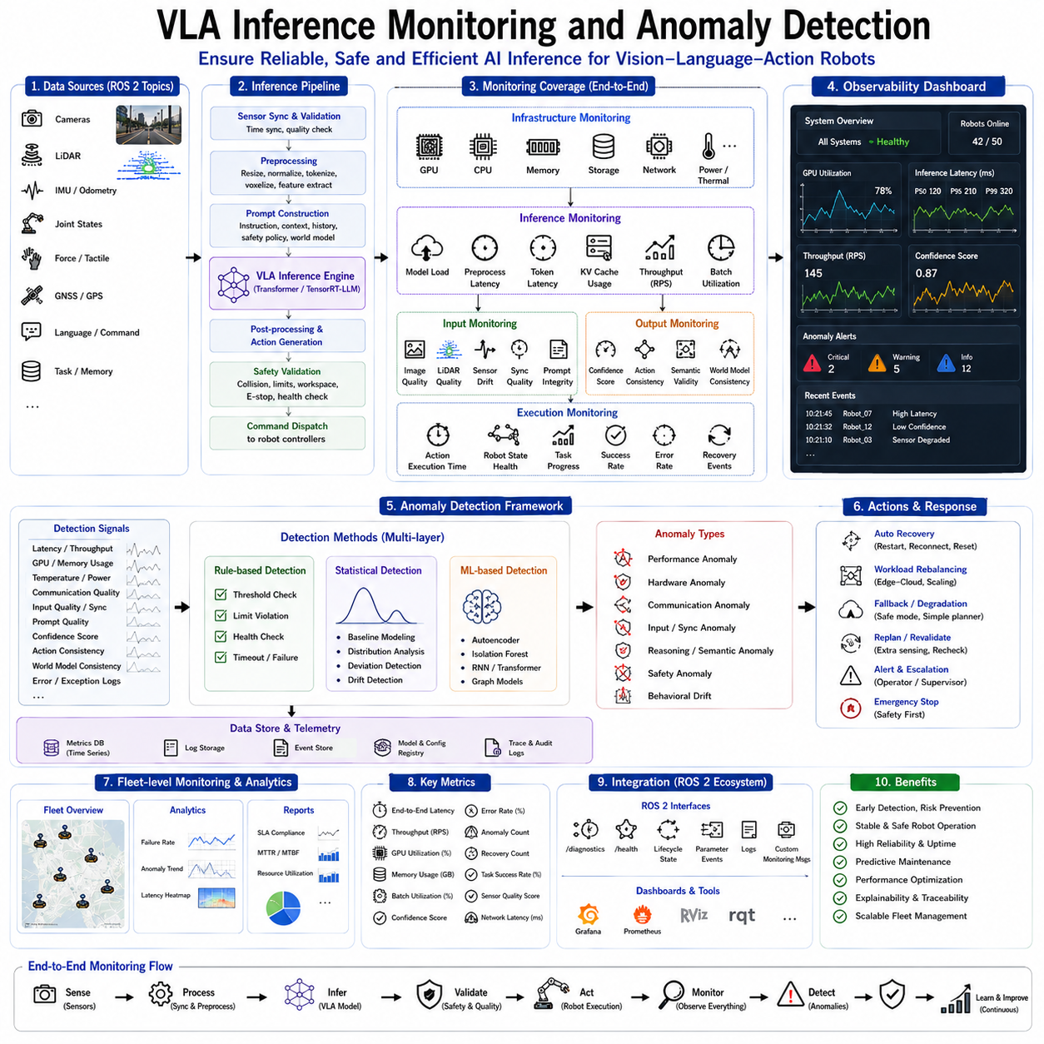
Vision-Language-Action (VLA) models are becoming the core intelligence layer for next-generation Physical AI systems by integrating visual perception, language understanding, semantic reasoning, world modeling, task planning, and robotic action generation into a unified transformer architecture. As these foundation models transition from research laboratories to industrial deployment, ensuring reliable and observable inference becomes as important as improving model accuracy or computational efficiency. Unlike offline artificial intelligence systems, robotic VLA models continuously interact with dynamic physical environments where incorrect inference, delayed responses, hardware failures, communication problems, or abnormal model behavior may directly affect operational safety and mission success. Consequently, inference monitoring and anomaly detection have become essential components of modern VLA deployment architectures.
Inference monitoring refers to the continuous observation of the complete AI inference pipeline, including model execution, computational resource utilization, communication status, input quality, output consistency, latency, confidence estimation, and hardware health. Rather than monitoring only the transformer model itself, industrial VLA systems observe the entire end-to-end reasoning process from sensor acquisition through multimodal preprocessing, transformer inference, action generation, safety validation, and robotic execution. Comprehensive monitoring provides operators and autonomous supervisory systems with sufficient information to detect abnormal behavior before it propagates into unsafe robotic actions.
Industrial robotic systems require significantly higher reliability than conventional conversational AI because robots directly influence the physical world. An incorrect language response may inconvenience a user, whereas an incorrect manipulation command may damage equipment, interrupt manufacturing processes, or endanger nearby personnel. Monitoring therefore extends beyond conventional software debugging toward operational safety assurance, predictive maintenance, runtime diagnostics, and intelligent fault management.
A typical monitoring architecture follows a layered design. The lowest layer monitors hardware resources including GPU utilization, CPU load, memory consumption, storage bandwidth, thermal behavior, power usage, network connectivity, and hardware health. Above the infrastructure layer, inference monitoring observes transformer execution including model loading, preprocessing latency, token generation speed, KV cache utilization, attention performance, quantization status, TensorRT-LLM execution, and speculative decoding efficiency. Higher layers monitor semantic reasoning quality, action generation consistency, safety validation, and overall mission execution.
GPU monitoring represents one of the most important components because VLA inference depends heavily upon accelerator performance. Continuous observation includes GPU utilization percentage, memory allocation, tensor core occupancy, streaming multiprocessor activity, memory bandwidth, cache hit rates, kernel execution time, power consumption, and temperature. Unexpected utilization drops may indicate communication bottlenecks, scheduling inefficiencies, model loading failures, or software deadlocks. Conversely, sustained utilization near one hundred percent combined with increasing latency may indicate resource saturation requiring workload redistribution.
Memory monitoring remains equally important because transformer inference relies heavily upon GPU memory allocation for model weights, activations, multimodal embeddings, KV caches, intermediate tensors, and temporary workspaces. Progressive memory fragmentation, allocation failures, excessive swapping, or cache overflow may gradually degrade inference performance before complete system failure occurs. Runtime monitoring therefore continuously evaluates available memory, allocation efficiency, cache utilization, fragmentation statistics, and memory bandwidth consumption.
Inference latency constitutes another fundamental performance indicator. Industrial robots frequently operate under deterministic timing constraints requiring responses within predefined deadlines. Monitoring systems measure preprocessing latency, model execution time, token generation latency, multimodal synchronization delay, communication overhead, action interpretation time, safety verification latency, and complete end-to-end response time. Statistical analysis identifies gradual performance degradation long before latency exceeds operational requirements.
Throughput monitoring complements latency observation. Edge robots typically prioritize low latency for immediate responsiveness, whereas cloud inference infrastructure emphasizes serving multiple robots simultaneously. Monitoring therefore evaluates requests processed per second, concurrent inference sessions, batch utilization, continuous batching efficiency, speculative decoding acceptance rates, TensorRT execution efficiency, and GPU occupancy. Dynamic scheduling algorithms use these measurements to optimize computational resource allocation.
Communication monitoring becomes particularly important within distributed Edge-Cloud Hybrid architectures. Cameras, LiDAR sensors, robot controllers, edge servers, cloud inference clusters, and fleet management systems continuously exchange information through ROS 2, DDS, Ethernet, Wi-Fi, 5G, gRPC, or industrial communication protocols. Monitoring detects packet loss, communication latency, bandwidth utilization, synchronization drift, message queue growth, network congestion, and intermittent connectivity problems that could influence inference quality or robotic responsiveness.
Input monitoring evaluates the quality of multimodal observations entering the VLA foundation model. Camera images may become blurred, overexposed, underexposed, or partially obstructed. LiDAR sensors may produce incomplete point clouds due to adverse weather or reflective surfaces. IMU measurements may drift. Force sensors may become saturated. Language instructions may contain ambiguities or recognition errors. Rather than blindly trusting incoming data, monitoring systems continuously estimate sensor quality and data validity before initiating expensive transformer inference.
Sensor synchronization monitoring verifies temporal consistency among multimodal observations. Cameras, LiDAR systems, GNSS receivers, IMUs, tactile arrays, force sensors, and robot joint states frequently operate at different update frequencies. Timestamp discrepancies, synchronization failures, hardware trigger errors, Precision Time Protocol drift, or dropped messages may significantly reduce multimodal reasoning accuracy. Continuous synchronization monitoring detects such inconsistencies before they influence semantic interpretation.
Prompt monitoring has recently emerged as an important component of VLA observability. Since foundation models rely heavily upon prompt construction, monitoring verifies prompt completeness, context availability, token length, system instruction integrity, safety policy inclusion, historical memory consistency, and multimodal formatting correctness. Unexpected prompt modifications, truncated context, or missing safety instructions may substantially alter model behavior despite unchanged neural network parameters.
Model confidence estimation provides another important monitoring signal. Modern VLA systems estimate output confidence using token probabilities, entropy measurements, uncertainty estimation, ensemble agreement, Monte Carlo sampling, or calibration techniques. Low-confidence outputs do not necessarily indicate incorrect reasoning but frequently warrant additional verification before execution. Safety supervisors may request supplementary perception, alternative planning strategies, or human intervention whenever confidence falls below operational thresholds.
Output consistency monitoring evaluates generated actions before physical execution. Consecutive inference results should generally exhibit semantic continuity unless environmental changes justify abrupt modifications. Monitoring compares newly generated plans with previous action sequences, world model predictions, safety policies, operational constraints, and embodiment capabilities. Sudden contradictory decisions, physically impossible commands, or logically inconsistent task sequences trigger anomaly detection mechanisms before reaching robot actuators.
Anomaly detection extends beyond threshold monitoring toward intelligent behavioral analysis. Traditional rule-based monitoring identifies explicit violations such as excessive latency, high GPU temperature, communication failure, or memory exhaustion. Modern AI-driven anomaly detection additionally learns normal operational behavior from historical deployment data and automatically detects previously unseen abnormal patterns without manually defined thresholds.
Statistical anomaly detection techniques establish baseline distributions for latency, utilization, memory consumption, confidence scores, synchronization quality, and action generation frequency. Significant deviations from learned statistical behavior indicate potential abnormalities even when absolute thresholds remain within nominal operating ranges. Such early detection enables preventive intervention before operational failures occur.
Machine learning–based anomaly detection further improves monitoring capability. Autoencoders, recurrent neural networks, transformer-based sequence models, Gaussian mixture models, isolation forests, graph neural networks, and probabilistic state estimation learn complex relationships among multiple monitoring variables simultaneously. Rather than evaluating independent metrics separately, these models detect correlated anomalies arising from interactions between computation, communication, sensing, reasoning, and robotic execution.
Semantic anomaly detection focuses specifically on AI reasoning quality. Although hardware may operate normally, foundation models occasionally generate hallucinations, logically inconsistent plans, invalid object references, impossible manipulations, contradictory instructions, or unsafe behavioral recommendations. Semantic monitoring verifies generated actions against environmental constraints, robot embodiment limitations, operational policies, symbolic knowledge bases, and task specifications before permitting execution.
World model consistency checking provides another valuable monitoring mechanism. The VLA system continuously maintains an internal representation of the surrounding environment. Newly generated actions should remain consistent with this representation unless updated observations justify revisions. Significant discrepancies between predicted and observed environmental states may indicate perception failures, localization errors, outdated memory, or incorrect reasoning requiring additional verification.
Behavioral drift monitoring becomes increasingly important during long-term deployment. Foundation models updated through fine-tuning, continual learning, retrieval augmentation, or evolving operational data may gradually modify inference characteristics over time. Monitoring compares current behavior against validated historical baselines, identifying unexpected performance degradation, reasoning shifts, calibration changes, or altered safety characteristics following software updates.
Fleet-level monitoring extends observability beyond individual robots. Industrial deployments frequently involve hundreds of autonomous systems sharing centralized AI infrastructure. Fleet monitoring aggregates latency distributions, anomaly frequencies, GPU utilization, communication performance, mission success rates, confidence statistics, failure modes, and maintenance indicators across all deployed robots. Centralized analytics identify systemic infrastructure problems impossible to observe from isolated robots alone.
ROS 2 integration provides standardized observability interfaces through diagnostics topics, lifecycle state transitions, logging infrastructure, parameter events, health monitoring services, and custom monitoring messages. Dedicated monitoring nodes subscribe to inference statistics, hardware diagnostics, communication metrics, safety events, and execution feedback while publishing consolidated health summaries accessible throughout the robotic software ecosystem.
Visualization dashboards transform monitoring data into operational awareness. Engineers observe GPU utilization, inference latency, memory consumption, communication health, sensor status, confidence estimates, anomaly alerts, fleet locations, task progress, and hardware temperatures through centralized monitoring platforms. Historical trend analysis supports predictive maintenance, software optimization, capacity planning, and infrastructure scaling.
Alert management converts detected anomalies into actionable operational responses. Minor deviations may simply generate warning logs. Moderate anomalies trigger automatic workload redistribution, inference restarts, sensor recalibration, or fallback planning algorithms. Critical failures immediately activate emergency stop procedures, safety supervisors, redundant control systems, or human operator notification. Intelligent escalation policies minimize unnecessary interruptions while preserving operational safety.
Root cause analysis assists post-event investigation by correlating hardware metrics, software logs, communication traces, inference outputs, environmental observations, and robot behavior preceding abnormal events. Comprehensive event reconstruction significantly accelerates debugging while improving future system robustness through continuous operational learning.
Security monitoring increasingly overlaps with inference monitoring. Unauthorized model modifications, adversarial sensor inputs, communication tampering, malicious prompt injection, abnormal authentication attempts, and unusual network behavior all influence inference reliability. Integrated cybersecurity monitoring therefore complements operational diagnostics within modern industrial AI deployments.
Future VLA monitoring architectures will increasingly incorporate self-healing capabilities. Intelligent supervisory agents will continuously analyze computational resources, model confidence, environmental complexity, communication quality, robot health, and mission priorities before autonomously reconfiguring inference pipelines. Edge-cloud workload migration, adaptive model selection, dynamic precision adjustment, automatic cache optimization, redundant inference activation, and predictive failure avoidance will collectively improve long-term system resilience.
As Vision-Language-Action foundation models become central intelligence engines for Physical AI, inference monitoring and anomaly detection will evolve from auxiliary debugging utilities into fundamental operational infrastructure. Through comprehensive observation of hardware, software, communication, multimodal perception, transformer inference, semantic reasoning, action generation, and safety validation, these monitoring systems ensure that increasingly capable robotic intelligence remains reliable, explainable, observable, and trustworthy throughout continuous operation in complex real-world industrial environments.

10.8 A/B Testing and Gradual Rollout (with Code)
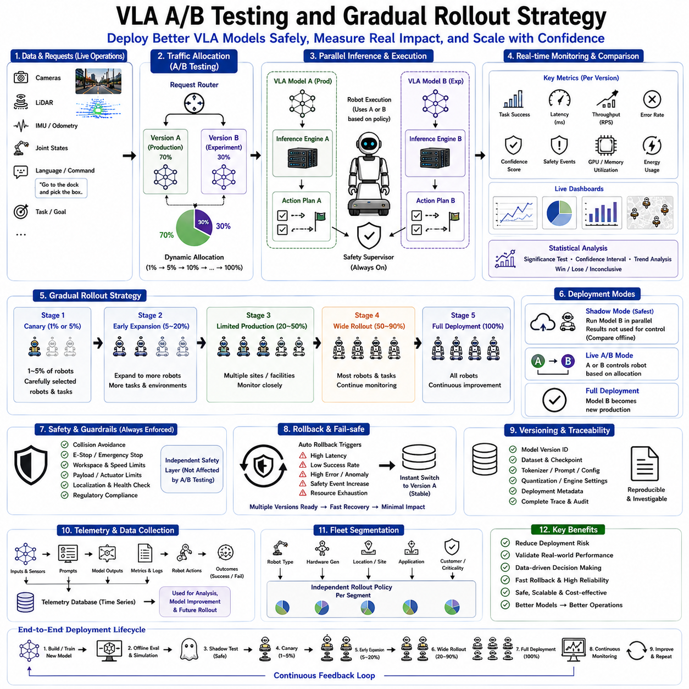
Vision-Language-Action (VLA) foundation models are rapidly transforming modern robotics by integrating perception, language understanding, semantic reasoning, world modeling, task planning, and action generation into unified multimodal intelligence systems. As these models mature from research prototypes into production-grade industrial solutions, the deployment process itself becomes a critical engineering challenge. Unlike conventional software systems where incorrect updates may only affect digital services, VLA models directly influence robot behavior in physical environments. A newly deployed model can alter navigation behavior, manipulation strategies, human-robot interaction, inspection quality, or autonomous decision making. Consequently, safe deployment requires systematic validation methodologies capable of evaluating new model versions under realistic operational conditions while minimizing risks to personnel, equipment, and ongoing production. A/B testing and gradual rollout strategies have therefore become fundamental deployment techniques for modern Physical AI systems.
Traditional software deployment often follows an all-at-once replacement strategy in which an older software version is immediately replaced by a newer release across every production system. Although this approach simplifies software distribution, it introduces considerable operational risk for autonomous robotic systems. Even thoroughly validated VLA models may exhibit unexpected behaviors when exposed to unseen environments, novel object configurations, unusual language instructions, changing lighting conditions, hardware variability, or long-duration autonomous missions. Deploying an entirely new foundation model simultaneously across an entire robotic fleet therefore represents an unacceptable operational risk for most industrial environments.
A/B testing provides a structured experimental methodology for comparing two competing inference systems under equivalent operating conditions. Rather than assuming that a newly trained VLA model automatically outperforms its predecessor, controlled experiments expose both models to comparable robotic tasks while collecting detailed operational metrics. Statistical analysis subsequently determines whether observed performance improvements represent genuine capability gains or merely random variation caused by environmental differences.
Within VLA deployment, Version A typically represents the currently validated production model responsible for ongoing industrial operations. Version B corresponds to a newly optimized foundation model incorporating architectural improvements, additional training data, refined prompting strategies, updated world models, improved multimodal reasoning, quantization optimization, or enhanced planning capabilities. Both models remain operational simultaneously while selected robotic tasks are distributed between them according to predefined experimental policies.
One of the principal objectives of A/B testing is minimizing deployment uncertainty. Offline benchmark evaluations provide valuable information regarding model accuracy, reasoning capability, and generalization performance, but laboratory benchmarks rarely capture the complexity of real industrial environments. Actual deployment involves dynamic obstacles, changing environmental conditions, sensor noise, communication delays, hardware variability, operator interactions, unexpected task sequences, and evolving operational requirements. Controlled online experimentation therefore complements offline evaluation by measuring actual production performance.
Traffic allocation forms the foundation of every A/B testing strategy. Rather than exposing every robot to the experimental model immediately, only a predefined fraction of inference requests utilize Version B while the remaining requests continue executing the stable production model. Initial deployment frequently begins with extremely conservative allocations such as one percent or five percent of operational workload. If monitoring confirms satisfactory performance, allocation gradually increases toward complete deployment.
Several allocation strategies exist depending upon operational objectives. Random allocation distributes inference requests probabilistically across available model versions, minimizing statistical bias. Robot-based allocation permanently assigns individual robots to one model version throughout the evaluation period, simplifying long-term behavioral comparison. Task-based allocation directs specific mission categories toward different model versions, allowing focused evaluation of navigation, manipulation, inspection, or conversational reasoning independently. Geographic allocation assigns different facilities or operational zones to separate model versions while preserving local consistency.
Canary deployment represents one of the safest rollout methodologies. Rather than deploying experimental models across an entire robotic fleet, only a very small subset of carefully selected robots initially receives the updated VLA model. These canary robots operate under continuous monitoring while engineers evaluate inference quality, safety behavior, hardware compatibility, latency, resource utilization, and mission success. Because only limited operational exposure occurs during early deployment, unexpected failures remain contained without affecting broader production activities.
Shadow deployment provides an even lower-risk evaluation strategy. During shadow testing, the new VLA model executes inference using live production sensor data but its generated actions never reach physical robot controllers. Instead, only the production model governs actual robot behavior while experimental predictions remain recorded for offline comparison. Engineers evaluate semantic reasoning, planning quality, action generation, latency, confidence estimation, and resource utilization without introducing any operational safety risk. Shadow deployment frequently represents the first production validation stage before live A/B testing begins.
Digital twin simulation further complements A/B testing by providing realistic virtual environments reproducing industrial operating conditions. Simulated warehouses, manufacturing facilities, inspection sites, hospitals, construction environments, logistics centers, and outdoor navigation scenarios expose competing VLA models to identical conditions under perfectly repeatable experimental settings. Although simulation cannot replace physical validation entirely, it substantially reduces deployment risk by identifying many potential weaknesses before real-world exposure.
Performance evaluation within VLA A/B testing extends well beyond conventional machine learning metrics. Engineers measure navigation success rate, manipulation accuracy, task completion time, trajectory smoothness, obstacle avoidance performance, language understanding accuracy, semantic reasoning quality, planning efficiency, robot idle time, mission interruption frequency, recovery success, safety intervention rate, energy consumption, GPU utilization, inference latency, communication overhead, and operator satisfaction. Comprehensive evaluation captures both AI quality and operational effectiveness.
Inference quality monitoring remains particularly important because foundation model improvements frequently involve tradeoffs among multiple objectives. A model demonstrating higher reasoning accuracy may require longer inference latency. Aggressive quantization may improve throughput while slightly reducing semantic precision. Expanded context windows may improve planning quality but increase memory consumption. A/B testing quantifies these multidimensional tradeoffs using statistically meaningful operational evidence.
Statistical significance analysis distinguishes genuine performance improvements from random environmental variation. Robotic deployment naturally encounters fluctuating workloads, changing weather, varying operator behavior, sensor uncertainty, and hardware variability. Apparent improvements observed during limited testing may simply reflect favorable operating conditions rather than superior model capability. Statistical hypothesis testing, confidence intervals, Bayesian inference, sequential analysis, and bootstrapping techniques ensure deployment decisions remain supported by rigorous quantitative evidence.
Safety monitoring remains completely independent of experimental evaluation. Every robot continues operating under deterministic safety supervision regardless of assigned VLA model version. Collision avoidance, emergency stop systems, workspace boundaries, velocity limits, payload restrictions, localization verification, hardware diagnostics, and regulatory compliance remain enforced by dedicated safety controllers. Experimental foundation models influence only high-level reasoning while deterministic safety systems preserve operational integrity.
Rollback mechanisms provide essential operational protection. Whenever monitoring detects unacceptable degradation involving inference latency, task completion, anomaly frequency, communication reliability, hardware compatibility, or safety behavior, deployment automatically reverts affected robots to the previously validated production model. Automated rollback occurs without requiring manual software reinstallation because multiple model versions remain simultaneously available throughout the rollout process. Rapid recovery minimizes operational disruption while preserving production continuity.
Version management therefore becomes a central infrastructure requirement. Every deployed VLA model receives unique version identifiers associated with training datasets, foundation model checkpoints, tokenizer versions, quantization configurations, TensorRT optimization settings, prompt templates, inference engine revisions, and deployment metadata. Complete version traceability enables precise reproduction of historical deployment conditions whenever unexpected behavior requires investigation.
Continuous monitoring supports dynamic rollout decisions. Real-time dashboards aggregate inference latency, GPU utilization, memory consumption, confidence estimation, anomaly detection, communication quality, safety events, mission success, task completion time, and fleet-wide operational statistics separately for every deployed model version. Engineers observe evolving deployment performance continuously rather than relying exclusively upon post-deployment analysis.
Gradual rollout extends beyond simple traffic allocation toward adaptive deployment policies. Initial deployment may involve one laboratory robot, followed by several engineering robots, limited warehouse operations, selected production facilities, regional deployments, national deployments, and eventually global fleet adoption. Advancement between rollout stages depends upon predefined performance criteria rather than fixed schedules. Deployment therefore proceeds according to demonstrated operational maturity rather than calendar deadlines.
Fleet segmentation significantly improves deployment flexibility. Robots may be grouped according to embodiment type, hardware generation, geographical location, operational environment, customer organization, application domain, or mission criticality. Different rollout schedules apply independently to each fleet segment because identical foundation model updates may perform differently across heterogeneous robotic platforms. Segmented deployment minimizes operational risk while enabling focused optimization for individual robot categories.
ROS 2 infrastructure naturally supports A/B deployment through modular node replacement, lifecycle management, parameter configuration, namespace isolation, and distributed execution. Wrapper nodes dynamically redirect inference requests toward selected model versions while preserving identical message interfaces for surrounding robotic software. Existing navigation, manipulation, localization, perception, and safety components remain unchanged regardless of active foundation model selection.
Cloud-edge hybrid deployment introduces additional rollout flexibility. Cloud-hosted inference services may deploy updated VLA models centrally without immediately modifying onboard robotic software. Edge devices request inference from selected model versions according to rollout policies managed by centralized orchestration systems. Such architectures enable immediate rollback, dynamic traffic allocation, and real-time deployment adjustment without requiring physical access to deployed robots.
Human oversight remains valuable during early rollout stages. Operators review generated action plans, semantic interpretations, mission recommendations, and safety assessments before autonomous execution whenever deployment uncertainty remains elevated. Progressive confidence gained through successful operation gradually reduces supervisory requirements until fully autonomous deployment becomes appropriate.
Telemetry collection provides the empirical foundation supporting continual deployment improvement. Every inference request records multimodal inputs, prompt structures, model versions, generated outputs, execution latency, confidence scores, hardware utilization, communication quality, anomaly events, safety interventions, mission outcomes, and operator feedback. Historical deployment databases subsequently guide future model optimization, infrastructure planning, safety validation, and operational best practices.
Cost-benefit analysis represents another important deployment consideration. Larger foundation models frequently improve reasoning capability but require increased GPU resources, memory consumption, network bandwidth, and operational cost. A/B testing therefore evaluates not only absolute model performance but also computational efficiency, energy consumption, hardware utilization, infrastructure scalability, and total cost of ownership. Production deployment ultimately seeks optimal operational value rather than maximum benchmark performance alone.
Future rollout strategies will likely become increasingly autonomous through AI-assisted deployment management. Intelligent orchestration systems will continuously analyze fleet health, inference quality, environmental complexity, customer requirements, hardware capability, communication quality, and operational risk before automatically determining appropriate rollout speed for each deployment segment. Reinforcement learning, predictive analytics, Bayesian optimization, and adaptive experimentation may optimize rollout policies dynamically while minimizing deployment uncertainty.
As Vision-Language-Action foundation models become increasingly central to industrial Physical AI, A/B testing and gradual rollout strategies will evolve into indispensable operational infrastructure rather than optional engineering practices. Through controlled experimentation, continuous monitoring, rigorous statistical evaluation, safety-first deployment policies, rapid rollback mechanisms, and progressive fleet-wide adoption, these methodologies enable organizations to introduce increasingly capable robotic intelligence while preserving operational stability, production continuity, regulatory compliance, and human safety across complex real-world autonomous systems.

10.9 Fallback to Classical Controllers (with Code)
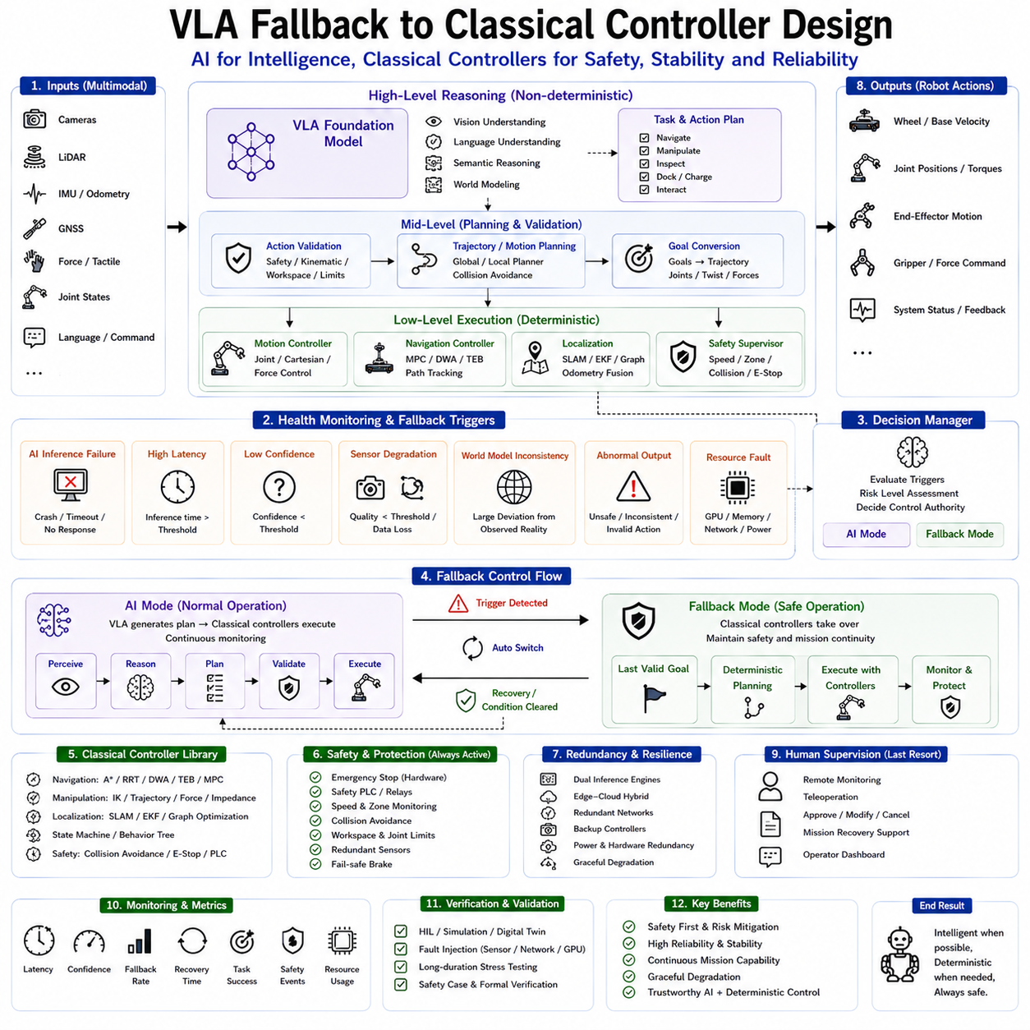
Vision-Language-Action (VLA) foundation models have fundamentally transformed modern robotics by enabling robots to integrate visual perception, natural language understanding, semantic reasoning, world modeling, task planning, and action generation within unified multimodal transformer architectures. These models allow robots to perform increasingly complex tasks that previously required manually designed software pipelines. However, despite their remarkable intelligence, VLA systems remain probabilistic learning models rather than deterministic control algorithms. Their outputs are generated through statistical inference over learned representations instead of mathematically guaranteed control laws. Consequently, while VLA models excel at high-level reasoning and adaptive decision making, they cannot completely replace classical control systems responsible for guaranteeing safe, predictable, and stable physical behavior. A robust fallback architecture therefore becomes an essential component of every industrial VLA deployment.
The fundamental principle behind fallback design is that artificial intelligence should augment deterministic robotic control rather than replace it entirely. Classical controllers such as PID controllers, Model Predictive Control (MPC), trajectory tracking algorithms, motion planners, finite state machines, behavior trees, safety PLCs, collision avoidance systems, and emergency stop mechanisms have been validated through decades of industrial deployment. Their behavior is mathematically predictable, formally analyzable, and highly reliable under well-defined operating conditions. VLA models should therefore function as intelligent supervisory systems that generate semantic objectives while deterministic controllers remain responsible for executing low-level physical actions.
Industrial robotic systems already employ hierarchical control architectures separating high-level planning from low-level execution. VLA naturally occupies the highest reasoning layer, interpreting natural language commands, understanding environmental context, generating semantic task plans, selecting manipulation strategies, and coordinating complex missions. Below the reasoning layer, conventional robotic software converts these semantic objectives into trajectories, velocity commands, joint motions, force control references, or navigation goals. The fallback mechanism operates between these layers, continuously determining whether AI-generated outputs remain sufficiently trustworthy for execution or whether deterministic controllers should temporarily assume control.
Several operational conditions may trigger fallback activation. The most obvious situation involves complete AI inference failure caused by hardware malfunction, GPU failure, software crashes, communication interruptions, corrupted model weights, or unavailable cloud inference services. However, industrial deployment requires fallback mechanisms capable of handling more subtle degradation scenarios including excessive inference latency, reduced confidence estimation, abnormal model outputs, inconsistent planning behavior, unexpected environmental complexity, or unreliable multimodal perception. Intelligent fallback decisions therefore depend upon comprehensive runtime monitoring rather than simple binary failure detection.
Inference latency frequently serves as one of the earliest indicators of system degradation. Real-time robotic control requires deterministic timing guarantees, whereas transformer inference latency may fluctuate according to computational workload, GPU utilization, communication delays, batch scheduling, or memory pressure. When latency exceeds predefined operational limits, the semantic planning layer may no longer respond rapidly enough for dynamic environments. Instead of waiting indefinitely for delayed AI reasoning, the fallback system immediately transfers authority to deterministic controllers capable of maintaining safe operation while inference resources recover.
Confidence estimation provides another important trigger for fallback activation. Modern VLA systems estimate uncertainty using probabilistic decoding, entropy analysis, ensemble agreement, calibration techniques, Monte Carlo sampling, or Bayesian uncertainty estimation. Low confidence does not necessarily indicate incorrect reasoning, but it often signifies unfamiliar environmental conditions, ambiguous instructions, insufficient sensory information, or distribution shifts beyond the model's training experience. Rather than executing uncertain actions directly, fallback mechanisms invoke deterministic planners or request additional perception before continuing autonomous operation.
Sensor degradation represents another common fallback condition. Vision-language-action reasoning depends heavily upon reliable multimodal perception including RGB cameras, depth sensors, LiDAR systems, IMUs, GNSS receivers, force sensing, tactile perception, and proprioceptive measurements. Environmental factors such as rain, fog, smoke, dust, darkness, reflective surfaces, sensor contamination, communication noise, or hardware degradation may substantially reduce input quality. Continuous sensor monitoring therefore evaluates observation validity before permitting AI-generated actions to influence robotic behavior. Whenever perception reliability falls below acceptable thresholds, classical navigation, localization, or manipulation algorithms temporarily assume operational responsibility.
World model inconsistency frequently indicates reasoning uncertainty. The VLA foundation model continuously maintains an internal semantic representation describing object locations, environmental structure, task progress, robot state, and future predictions. Significant disagreement between observed reality and internal world model predictions may arise from localization drift, sensor failure, dynamic environmental changes, or hallucinated reasoning. Fallback mechanisms compare AI predictions against independent localization systems, mapping algorithms, symbolic representations, and deterministic state estimators before accepting generated action plans.
Action validation constitutes another critical architectural component. Rather than forwarding AI-generated commands directly toward robot actuators, the fallback framework first evaluates every proposed action against deterministic safety constraints. Collision avoidance systems verify obstacle clearance. Workspace monitors confirm spatial boundaries. Velocity supervisors enforce speed limitations. Manipulator controllers verify joint limits, torque constraints, singularity avoidance, and payload capacity. Mobile robot controllers validate traversability, localization confidence, and braking distance. Any action violating deterministic safety policies is automatically rejected regardless of AI confidence.
Behavior Trees integrate naturally with fallback architectures because they already separate high-level decision making from deterministic execution. VLA models generate semantic objectives describing desired robot behavior, while Behavior Tree nodes execute validated navigation, manipulation, inspection, docking, recovery, and fault-handling procedures using conventional robotic algorithms. When fallback activates, control authority shifts seamlessly toward predefined recovery branches already present within the Behavior Tree structure. Existing industrial robotic software therefore requires minimal architectural modification.
Finite State Machines (FSMs) similarly provide robust fallback execution. Many industrial robotic systems operate according to explicitly defined operational states including initialization, idle, navigation, manipulation, inspection, charging, emergency stop, recovery, maintenance, and shutdown. VLA reasoning determines transitions among high-level operational goals, whereas deterministic FSM logic guarantees valid state transitions under every operational condition. During fallback operation, the FSM continues executing validated recovery procedures independently of foundation model availability.
Classical navigation algorithms provide particularly strong fallback capability. Simultaneous Localization and Mapping (SLAM), graph-based path planning, A*, Dijkstra search, Hybrid A*, Rapidly-exploring Random Trees (RRT), Dynamic Window Approach (DWA), Timed Elastic Band (TEB), Model Predictive Control, and Pure Pursuit remain highly reliable for structured environments. When semantic reasoning becomes unavailable, robots continue navigating toward previously validated objectives using deterministic planners while awaiting restoration of AI functionality.
Manipulator fallback strategies operate similarly. Instead of relying upon transformer-generated joint trajectories, deterministic inverse kinematics solvers, trajectory generators, Cartesian motion planners, force controllers, impedance control, and grasp libraries execute previously validated manipulation primitives. The robot therefore retains essential operational capability even when semantic reasoning temporarily becomes unavailable.
Localization systems also maintain independent operation throughout fallback execution. Particle filters, Extended Kalman Filters, graph optimization, scan matching, wheel odometry, inertial navigation, GNSS fusion, and visual localization continue estimating robot pose regardless of AI inference status. Because localization remains deterministic and continuously updated, robots preserve spatial awareness throughout degraded operational modes.
Emergency stop systems always remain entirely independent of AI software. Hardware safety relays, certified programmable logic controllers, redundant braking systems, safety-rated motor controllers, laser safety scanners, protective field monitoring, and human emergency buttons bypass every AI component within the control hierarchy. Neither VLA models nor fallback software may override these certified safety mechanisms. Functional safety therefore remains guaranteed even during catastrophic AI failure.
Redundant architecture further improves fallback reliability. Multiple inference engines, duplicate GPU servers, edge-cloud hybrid deployment, replicated communication channels, distributed localization systems, redundant perception sensors, and backup control computers collectively minimize single points of failure. Intelligent supervisory software dynamically selects among available computational resources while preserving deterministic robotic control throughout hardware failures.
ROS 2 naturally supports fallback implementation through lifecycle nodes, modular node composition, parameter reconfiguration, topic remapping, service redirection, action cancellation, and distributed execution. The VLA wrapper node publishes semantic action goals while classical navigation and manipulation nodes remain continuously active. Supervisory nodes monitor inference health, communication quality, and safety status before dynamically selecting which controller currently possesses execution authority. Transition between AI reasoning and deterministic fallback therefore occurs transparently without disrupting surrounding robotic software.
Cloud-edge hybrid deployment introduces additional fallback flexibility. Robots operating with centralized cloud inference continuously maintain local deterministic controllers onboard. Whenever communication latency, bandwidth limitations, network interruptions, or cloud availability degrade below acceptable levels, onboard navigation, obstacle avoidance, and manipulation algorithms immediately assume control. Cloud connectivity may subsequently recover without interrupting safe autonomous operation.
Human supervisory control represents the highest fallback level. If deterministic controllers cannot safely resolve unusual situations involving unexpected obstacles, ambiguous instructions, severe sensor failures, or novel environmental conditions, control authority transfers to remote operators or nearby personnel. Human intervention may include teleoperation, supervisory approval, task modification, mission cancellation, or direct recovery assistance. Hierarchical fallback therefore extends beyond software into human operational oversight.
Performance monitoring continuously evaluates fallback effectiveness using operational metrics including activation frequency, recovery duration, mission completion rate, safety intervention count, controller transition latency, localization continuity, navigation success, manipulation accuracy, communication reliability, and operator workload. Frequent fallback activation may indicate underlying AI limitations requiring additional training data, improved perception, refined prompting strategies, or enhanced hardware resources rather than controller deficiencies.
Verification and validation remain essential throughout fallback development. Hardware-in-the-loop simulation, digital twins, fault injection testing, communication failure simulation, GPU shutdown experiments, sensor degradation scenarios, adversarial environmental conditions, and long-duration autonomous missions collectively verify that fallback transitions occur safely under every anticipated operational condition. Formal verification techniques further analyze controller switching logic to guarantee absence of unstable transition behavior.
Future fallback architectures will likely become increasingly adaptive through intelligent supervisory systems capable of continuously estimating AI reliability, environmental uncertainty, computational resource availability, hardware health, communication quality, and operational risk. Instead of binary switching between AI and deterministic control, future systems may dynamically blend semantic reasoning with classical controllers according to continuously varying confidence levels. Reinforcement learning, probabilistic risk estimation, Bayesian decision theory, and adaptive autonomy frameworks may optimize controller authority allocation throughout ongoing robotic missions.
As Vision-Language-Action foundation models become the cognitive layer for next-generation Physical AI, deterministic fallback architectures will remain indispensable for industrial deployment. Rather than representing competing technologies, VLA reasoning and classical robotic control complement one another within hierarchical autonomous systems. High-level semantic intelligence enables flexible adaptation, natural communication, and generalized reasoning, while deterministic controllers guarantee predictable execution, certified safety, operational stability, and continuous mission availability. Together they establish a balanced architecture capable of combining the creativity and adaptability of foundation models with the reliability and trustworthiness required for safe industrial robotics operating in complex real-world environments.

10.10 Production Latency Benchmarking
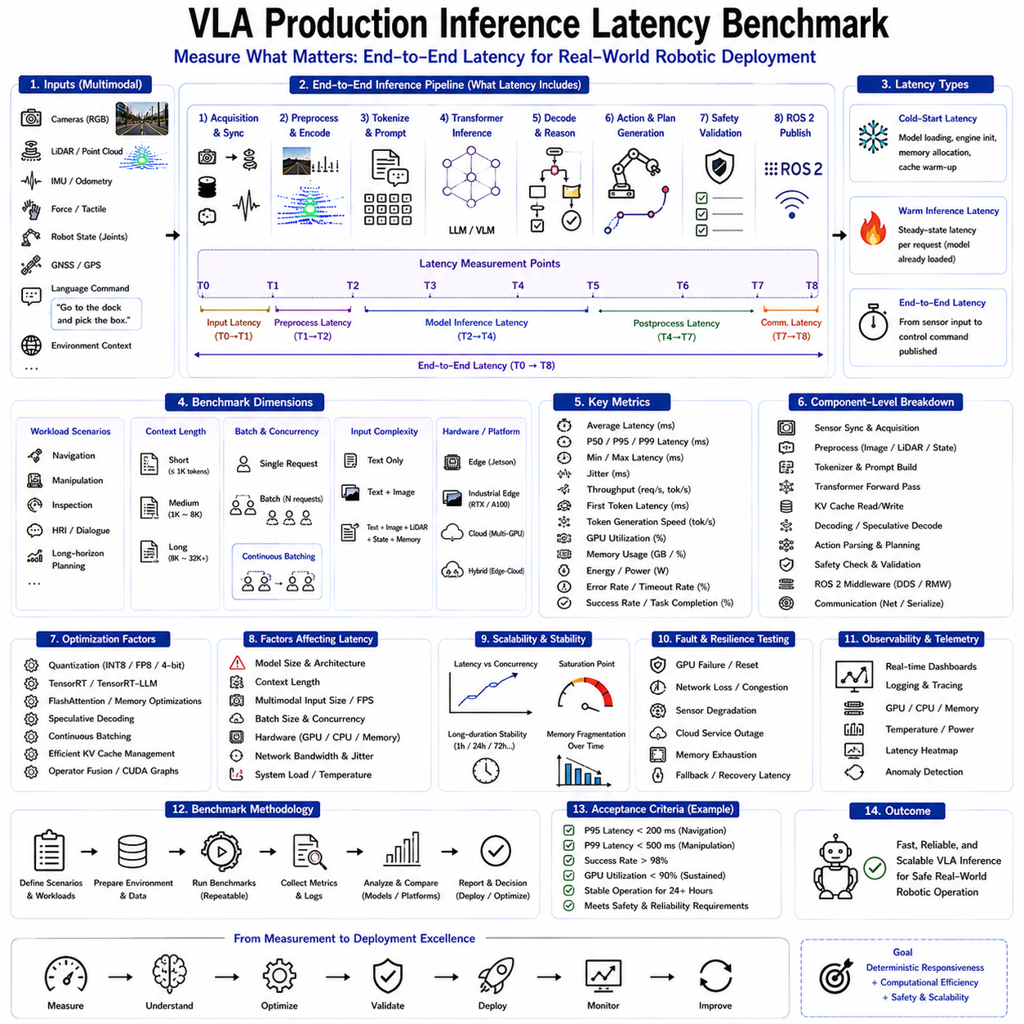
Vision-Language-Action (VLA) foundation models have become the computational core of modern Physical AI by integrating visual perception, language understanding, semantic reasoning, world modeling, task planning, and robotic action generation within unified transformer architectures. As these multimodal foundation models continue to increase in capability, parameter count, and reasoning complexity, inference latency has become one of the primary factors determining whether they can be successfully deployed in real industrial robotic systems. While benchmark datasets frequently evaluate model accuracy, reasoning quality, and task success rates, production deployment requires a different perspective in which deterministic responsiveness, computational efficiency, resource utilization, and operational predictability become equally important. Production inference latency benchmarking therefore serves as a fundamental engineering methodology for evaluating the real-world deployment readiness of Vision-Language-Action systems.
Inference latency refers to the elapsed time between receiving multimodal inputs and producing executable robotic outputs. Unlike offline machine learning evaluation, production latency includes every computational stage involved in robotic reasoning. Camera image acquisition, LiDAR processing, sensor synchronization, multimodal preprocessing, tokenizer execution, prompt construction, transformer inference, KV cache operations, action decoding, trajectory generation, safety validation, communication overhead, and ROS 2 message publication collectively contribute to the total end-to-end response time. Consequently, latency benchmarking measures complete operational performance rather than isolated neural network execution.
Real-time robotics imposes deterministic timing constraints that differ substantially from conventional conversational AI systems. Interactive language models tolerate occasional response delays because users naturally expect several seconds of reasoning before receiving complex answers. Industrial robots, however, continuously interact with dynamic physical environments requiring immediate responses to moving obstacles, changing sensor observations, human interactions, and evolving task conditions. Excessive inference latency directly influences navigation accuracy, manipulation precision, operational safety, and mission completion efficiency. Therefore, latency benchmarking must evaluate responsiveness under realistic production workloads rather than idealized laboratory conditions.
Production benchmarking generally distinguishes several latency categories according to operational requirements. Cold-start latency measures the delay required to initialize inference infrastructure, including model loading, TensorRT engine initialization, GPU memory allocation, tokenizer preparation, KV cache initialization, and communication establishment. Although cold-start performance affects deployment initialization rather than continuous operation, minimizing startup time significantly improves maintenance procedures, system recovery, and elastic cloud deployment.
Warm inference latency represents the primary operational metric. Once the model remains fully initialized and GPU resources are allocated, benchmarking measures the average time required to process new multimodal requests. Warm latency excludes initialization overhead while accurately reflecting steady-state production performance. Most industrial robotic deployments operate continuously for extended periods, making warm latency substantially more representative than startup measurements.
End-to-end latency extends beyond transformer execution by including every processing stage throughout the robotic inference pipeline. Input acquisition begins with synchronized camera images, LiDAR observations, robot states, force measurements, IMU data, GNSS information, and language instructions. Preprocessing transforms raw observations into normalized tensors and structured prompts suitable for transformer inference. Following neural network execution, generated semantic actions undergo validation, planning, embodiment conversion, safety verification, and ROS 2 communication before physical execution begins. End-to-end latency therefore provides the most meaningful benchmark for evaluating actual robotic responsiveness.
Component-level benchmarking complements end-to-end evaluation by isolating individual processing stages. Engineers independently measure sensor synchronization latency, image preprocessing time, tokenizer execution, prompt construction, transformer forward pass duration, KV cache management overhead, speculative decoding efficiency, output parsing, trajectory generation, safety validation, communication latency, and ROS 2 middleware performance. Component analysis identifies optimization opportunities that remain hidden within aggregate measurements.
Transformer inference typically dominates computational cost, particularly for large multimodal foundation models. Benchmarking therefore records first-token latency, token generation speed, total decoding time, speculative decoding acceptance rates, attention computation duration, FlashAttention performance, TensorRT kernel execution efficiency, quantization overhead, and KV cache utilization. Detailed transformer profiling enables precise optimization of the most computationally expensive inference stages.
Batch inference significantly influences production latency characteristics. Single-request latency measures immediate responsiveness for individual robots operating independently. Batch latency evaluates throughput-oriented execution supporting multiple concurrent robotic inference sessions. Continuous batching further modifies latency by dynamically inserting new requests into executing transformer batches. Benchmarking therefore examines latency distributions across varying batch sizes, concurrent robot populations, and scheduling policies rather than relying upon isolated measurements.
Hardware configuration strongly influences inference latency. Embedded edge platforms such as NVIDIA Jetson systems prioritize low power consumption while accepting moderate computational capability. Industrial edge computers equipped with discrete GPUs provide substantially greater throughput with correspondingly higher power requirements. Cloud inference clusters maximize computational efficiency through multi-GPU execution, tensor parallelism, pipeline parallelism, and continuous batching. Comprehensive benchmarking therefore evaluates latency separately for edge, on-premises, cloud, and hybrid deployment architectures.
GPU utilization provides valuable context when interpreting latency measurements. Low GPU utilization accompanied by high latency often indicates communication bottlenecks, CPU preprocessing limitations, inefficient batching, memory fragmentation, or software scheduling problems rather than insufficient computational capability. Conversely, sustained utilization approaching one hundred percent combined with increasing latency frequently indicates computational saturation requiring workload redistribution or infrastructure scaling.
Memory behavior substantially affects inference responsiveness. Modern VLA foundation models consume GPU memory for model weights, activations, multimodal embeddings, temporary tensors, KV caches, and communication buffers. Memory allocation latency, fragmentation, cache management efficiency, bandwidth utilization, paging behavior, and quantized cache performance all influence total inference time. Production benchmarks therefore include comprehensive memory profiling alongside computational performance measurement.
Communication latency becomes particularly significant within distributed Edge-Cloud Hybrid architectures. Sensor observations may traverse Ethernet, Wi-Fi, 5G, DDS middleware, ROS 2 communication, gRPC interfaces, or REST APIs before reaching centralized inference servers. Following AI reasoning, generated actions return through corresponding communication pathways before reaching robotic controllers. Benchmarking therefore measures network latency, packet loss, bandwidth utilization, serialization overhead, synchronization delay, and communication jitter independently from transformer execution.
Multimodal input complexity also influences inference latency. Simple language-only reasoning generally requires substantially less computation than integrated visual understanding, point cloud processing, semantic memory retrieval, and world model reasoning. Benchmark scenarios therefore evaluate representative workloads including navigation planning, manipulation planning, object recognition, human-robot interaction, infrastructure inspection, collaborative assembly, and long-horizon mission planning. Each workload exhibits distinct computational characteristics requiring separate performance analysis.
Context length represents another critical benchmark variable. Modern VLA systems frequently process extensive operational histories, semantic memories, retrieval-augmented documents, previous task sequences, environmental descriptions, and multimodal observations simultaneously. Increasing context length directly affects attention computation, KV cache growth, memory bandwidth requirements, and decoding efficiency. Benchmark reports therefore characterize latency across varying prompt sizes rather than presenting single average values.
Optimization technologies substantially influence benchmark outcomes. Quantization reduces computational precision while improving execution speed and memory efficiency. TensorRT-LLM optimizes GPU kernels through operator fusion, CUDA Graph execution, memory scheduling, and transformer-specific acceleration. FlashAttention minimizes attention memory movement. Speculative decoding reduces autoregressive decoding iterations. Continuous batching improves GPU occupancy. Efficient KV cache management eliminates redundant computation. Benchmark methodologies therefore evaluate both isolated and combined optimization effects to identify optimal production configurations.
Latency distributions provide significantly more information than average measurements alone. Industrial robotic systems require deterministic responsiveness rather than merely favorable average performance. Production benchmarks therefore report minimum latency, maximum latency, median latency, ninety-fifth percentile latency, ninety-ninth percentile latency, standard deviation, and jitter characteristics. Tail latency proves particularly important because occasional extreme delays may disrupt real-time robotic control despite acceptable average performance.
Workload scalability constitutes another essential benchmark objective. Modern robotic fleets increasingly involve dozens or hundreds of autonomous systems sharing centralized AI infrastructure. Production benchmarks therefore evaluate latency as concurrent inference sessions increase. Engineers identify saturation points where computational resources become insufficient, enabling proactive infrastructure scaling before operational degradation affects deployed robots.
Long-duration stability testing extends benchmarking beyond short laboratory experiments. Continuous inference execution over many hours or days reveals thermal throttling, memory fragmentation, cache accumulation, communication degradation, resource leakage, GPU clock variation, and operating system scheduling effects that remain invisible during brief evaluations. Stable latency throughout prolonged operation represents a critical production deployment requirement.
Fault tolerance benchmarking evaluates system responsiveness under abnormal operating conditions. Simulated GPU failures, communication interruptions, degraded sensors, network congestion, cloud service unavailability, memory exhaustion, and hardware throttling test whether fallback controllers maintain acceptable operational latency during infrastructure failures. Production benchmarking therefore includes resilience evaluation alongside nominal performance measurement.
ROS 2 integration contributes measurable latency throughout robotic execution. Message serialization, DDS transport, Quality of Service scheduling, callback execution, action server communication, lifecycle transitions, and distributed node synchronization collectively influence end-to-end responsiveness. Dedicated ROS 2 profiling isolates middleware overhead from AI inference, enabling independent optimization of robotic software architecture.
Observability plays an important role throughout benchmarking. Telemetry systems continuously record GPU utilization, CPU load, memory consumption, power usage, temperature, inference latency, token generation speed, communication performance, cache utilization, confidence estimation, anomaly frequency, and mission completion statistics. Rich operational telemetry enables engineers to correlate latency behavior with underlying infrastructure conditions and optimization strategies.
Benchmark reproducibility requires standardized evaluation methodology. Identical hardware configurations, software versions, TensorRT engines, quantization settings, tokenizer revisions, prompt templates, optimization parameters, environmental conditions, communication infrastructure, and workload definitions ensure meaningful comparison across model versions and deployment platforms. Version-controlled benchmarking frameworks provide objective evidence supporting deployment decisions.
Production acceptance criteria ultimately determine deployment readiness. Maximum allowable latency depends upon application domain, robot embodiment, safety requirements, environmental dynamics, and operational objectives. Warehouse logistics, collaborative manipulation, autonomous inspection, healthcare robotics, construction automation, agricultural robotics, and autonomous vehicles each require different responsiveness thresholds. Benchmark results therefore remain meaningful only when interpreted within specific operational contexts rather than universal numerical targets.
Future latency benchmarking will increasingly incorporate intelligent adaptive evaluation frameworks. AI-driven benchmarking systems will automatically generate representative robotic workloads, identify computational bottlenecks, recommend optimization strategies, predict infrastructure scaling requirements, and estimate deployment readiness under evolving operational conditions. Hardware-aware optimization, workload prediction, dynamic scheduling, adaptive batching, automated cache tuning, and continuous production monitoring will gradually merge benchmarking into ongoing operational optimization rather than isolated engineering evaluation.
As Vision-Language-Action foundation models continue becoming the cognitive infrastructure of industrial Physical AI, production inference latency benchmarking will remain indispensable for successful deployment. Comprehensive evaluation extending from multimodal sensing through transformer execution, communication infrastructure, safety validation, robotic control, and long-term operational stability enables engineers to optimize increasingly sophisticated AI systems while preserving deterministic responsiveness, computational efficiency, scalability, safety, and reliability across real-world autonomous robotic environments.

