Volume 20. Vision Language Action (VLA) Models

Chapter 6. Language-to-Action Pipelines

6.1 Pipeline Architecture Overview
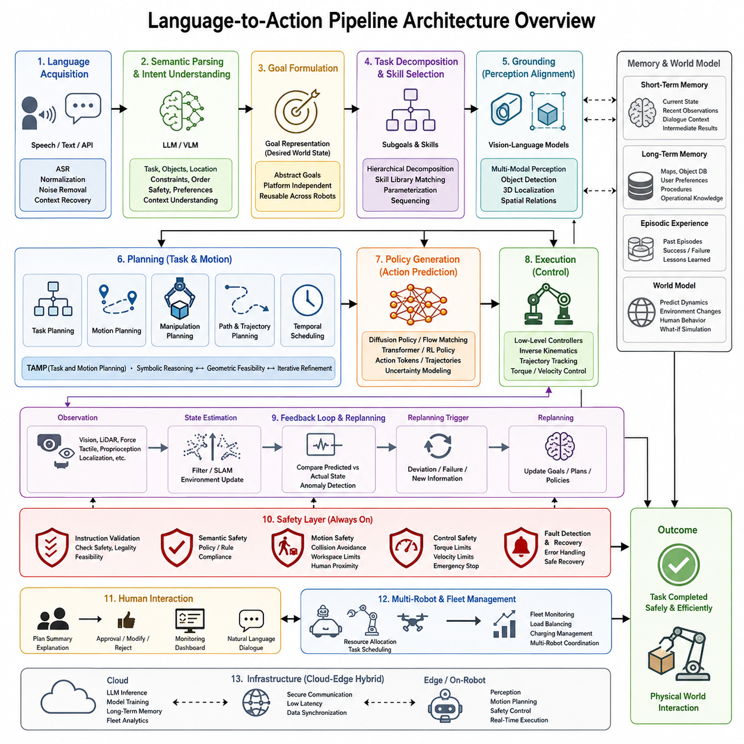
A Language-to-Action (L2A) pipeline represents one of the most important architectural foundations of modern Vision-Language-Action (VLA) systems. Unlike traditional robotic control pipelines that directly map sensor observations into predefined control algorithms, an L2A architecture transforms high-level human language into executable robot behaviors through a hierarchy of semantic understanding, reasoning, planning, perception grounding, policy generation, and low-level control. It serves as the bridge between natural communication and physical interaction, allowing robots to interpret human intent while adapting their actions to continuously changing environments.
The fundamental motivation behind the Language-to-Action pipeline is that humans naturally communicate using abstract goals rather than explicit robot commands. A user may request, “Bring me the blue toolbox from the workshop,” rather than specifying coordinates, joint trajectories, grasp poses, obstacle avoidance strategies, or manipulation sequences. The pipeline must therefore convert ambiguous human language into concrete robot actions while preserving safety, efficiency, and robustness.
A modern Language-to-Action architecture is fundamentally hierarchical. At the highest level, natural language instructions are interpreted to identify user intent. This semantic representation is then transformed into executable task goals, decomposed into intermediate subgoals, grounded within the robot's perceived environment, converted into motion or manipulation plans, validated through safety constraints, and finally executed by robot controllers operating at real-time frequencies.
The first stage of the pipeline is language acquisition. Human commands may originate from speech recognition systems, text interfaces, multimodal dialogue systems, cloud APIs, or collaborative industrial software. Regardless of the input source, the instruction must first be normalized into a consistent textual representation. Noise removal, punctuation recovery, ambiguity correction, and contextual normalization improve downstream reasoning performance. Modern robotic systems often integrate Automatic Speech Recognition (ASR) with large language models to recover incomplete or grammatically imperfect instructions.
Once language has been acquired, semantic parsing becomes the primary objective. Large Language Models analyze the instruction to identify the requested task, relevant objects, target locations, environmental constraints, temporal ordering, safety considerations, and implied assumptions. Rather than producing immediate robot commands, the system generates an internal semantic representation describing the user's actual intent.
Intent understanding is considerably more complex than keyword matching. Human language frequently contains implicit knowledge, omitted information, and contextual references. For example, “Clean the inspection table” requires identifying which table is currently active, determining the definition of “clean,” selecting appropriate cleaning tools, recognizing obstacles on the surface, and understanding organizational procedures. A capable Language-to-Action architecture therefore incorporates contextual reasoning supported by environment memory and domain knowledge.
After semantic understanding, the pipeline performs goal formulation. Rather than controlling motors directly, the robot establishes a structured mission description. Goals define desired environmental states rather than explicit robot movements. Examples include placing an object into a designated container, navigating to a charging station, inspecting all shelves within a warehouse aisle, or delivering medical supplies to a specified room. Goal representations remain independent of specific robot hardware, enabling portability across different robotic platforms.
The next architectural layer is task decomposition. High-level objectives are recursively divided into smaller executable subgoals. Complex activities such as warehouse picking may require navigation, object localization, pose estimation, grasp planning, manipulation execution, transportation, placement verification, and confirmation reporting. Hierarchical decomposition enables modular planning, incremental execution, and localized failure recovery without repeating the entire mission.
Task decomposition naturally leads to skill selection. Modern robots maintain reusable libraries of parameterized skills such as NavigateTo(), OpenDoor(), PickObject(), PressButton(), InspectSurface(), DockToStation(), or CaptureImage(). Rather than generating every motor trajectory from scratch, Language-to-Action systems select, parameterize, and sequence reusable robot capabilities. This dramatically improves reliability while reducing computational complexity.
Grounding represents one of the defining characteristics of Language-to-Action systems. Language itself contains symbolic references that must be associated with physical entities observed by robot sensors. If instructed to “pick up the blue bottle beside the laptop,” the system must identify the corresponding objects within camera images, estimate their three-dimensional positions, infer spatial relationships, and resolve ambiguity when multiple candidate objects exist. Grounding therefore integrates language understanding with visual perception and environmental mapping.
Vision-Language Models play an essential role during grounding. Multi-camera RGB systems, depth sensors, LiDAR, tactile sensing, force feedback, and proprioceptive measurements collectively provide observations that are aligned with language representations. Modern multimodal encoders generate shared embedding spaces where visual features and textual descriptions occupy compatible semantic representations, enabling efficient object retrieval and spatial reasoning.
Following grounding, the pipeline enters the planning stage. Planning may include symbolic task planning, geometric motion planning, manipulation planning, navigation planning, and temporal scheduling. Task planners determine what should be executed, while motion planners determine how physical execution should occur safely within environmental constraints.
Task and Motion Planning (TAMP) has become an increasingly important component of Language-to-Action architectures because semantic decisions cannot be separated from geometric feasibility. Selecting an object may appear straightforward at the symbolic level, but geometric planning may reveal collisions, unreachable poses, or unstable grasps. Modern architectures therefore iterate continuously between symbolic reasoning and physical feasibility until consistent plans emerge.
Planning outputs are transformed into robot policies. A policy defines how observations are converted into robot actions over time. Traditional robotics relied heavily on handcrafted controllers, whereas modern VLA systems increasingly employ learned action models trained from large-scale robot demonstrations. Policy networks may generate joint positions, end-effector trajectories, velocity commands, Cartesian motions, action tokens, or diffusion-based action sequences depending on the underlying architecture.
Recent Language-to-Action pipelines frequently incorporate diffusion policies or flow matching action generators. Rather than predicting a single deterministic trajectory, these models iteratively refine candidate actions while accounting for uncertainty, multimodal solutions, and environmental variability. Such approaches significantly improve manipulation robustness for contact-rich tasks.
Temporal consistency is another critical architectural consideration. Robot actions cannot be generated independently at each control cycle because discontinuities may produce unstable or unsafe behavior. Action chunking, recurrent memory, transformer-based temporal attention, and predictive control mechanisms enable smooth long-horizon execution while maintaining responsiveness to environmental changes.
Execution occurs through the robot control stack. Generated actions are translated into platform-specific commands interpreted by navigation controllers, inverse kinematics solvers, whole-body controllers, manipulator controllers, mobile base controllers, or autonomous driving systems. The control layer operates at significantly higher frequencies than language reasoning, often reaching hundreds or thousands of Hertz to guarantee dynamic stability.
A distinguishing feature of modern Language-to-Action pipelines is the existence of continuous feedback loops. Execution is never considered complete after a single planning cycle. Instead, sensory observations continuously evaluate whether the environment remains consistent with predicted states. If deviations occur, replanning may be initiated automatically.
Feedback includes visual confirmation, force sensing, tactile perception, localization updates, obstacle detection, and task completion verification. For example, grasp execution may fail because the object slipped or another person moved it unexpectedly. Rather than terminating the mission, the robot detects the discrepancy, updates its world model, reasons about the new situation, and generates an alternative strategy.
Memory modules significantly enhance pipeline performance. Short-term memory stores the current mission state, recently observed objects, temporary dialogue context, and intermediate planning results. Long-term memory maintains semantic maps, object databases, historical experiences, user preferences, operational procedures, and learned environmental knowledge. Episodic memory further enables robots to reuse previous successful solutions when similar situations recur.
World models increasingly occupy the center of advanced Language-to-Action architectures. Instead of reacting solely to instantaneous observations, robots maintain predictive internal models representing object dynamics, environmental evolution, human behavior, and physical interactions. These predictive capabilities enable planning beyond immediate sensory information and improve long-horizon reasoning.
Safety mechanisms operate across every layer of the pipeline rather than existing as isolated components. Instruction validation ensures that unsafe, illegal, or impossible requests are rejected before execution. Semantic safety verifies whether requested actions violate operational policies. Motion safety validates collision avoidance, dynamic constraints, workspace boundaries, and human proximity. Controller-level safety continuously supervises torque limits, velocity limits, emergency stopping conditions, and fault detection.
Human supervision remains an essential architectural component, particularly within industrial and collaborative robotics. Language-to-Action systems frequently provide interpretable reasoning traces, mission summaries, predicted execution sequences, and confidence estimates before initiating high-risk operations. Human operators may approve, modify, or reject generated plans prior to execution.
Scalability is another major design objective. Large industrial deployments often coordinate hundreds of robots simultaneously. Individual Language-to-Action pipelines operate locally while fleet management systems allocate resources, coordinate shared environments, schedule charging operations, balance workloads, and optimize mission assignments across multiple autonomous agents.
Cloud-edge hybrid architectures further improve scalability. Computationally intensive language reasoning, model updating, long-term memory management, and fleet analytics may execute within cloud infrastructure, while perception, motion planning, safety supervision, and real-time control remain at the edge to satisfy latency requirements. Hybrid deployment achieves both computational efficiency and deterministic execution.
The emergence of foundation models has significantly simplified Language-to-Action system design. Instead of independently engineering perception modules, planners, symbolic reasoning engines, and action generators, unified VLA models increasingly learn end-to-end mappings from multimodal observations and language instructions directly to executable robot actions. Nevertheless, production systems typically preserve modular safety layers, deterministic controllers, and interpretable planning components to guarantee reliability.
Evaluation of Language-to-Action architectures extends beyond simple task success. Important metrics include instruction following accuracy, semantic grounding precision, planning efficiency, execution latency, policy robustness, manipulation success rate, navigation reliability, recovery capability, energy efficiency, generalization to unseen environments, cross-embodiment transfer, and overall human satisfaction. Comprehensive evaluation requires both simulation benchmarks and real-world deployments under diverse operating conditions.
Industrial adoption continues to expand rapidly across warehouse automation, autonomous inspection, manufacturing, logistics, healthcare, construction, agriculture, hospitality, and service robotics. In these applications, Language-to-Action pipelines enable intuitive human-robot collaboration by allowing operators to communicate naturally while relying on intelligent systems to perform complex reasoning and autonomous execution.
Looking toward the future, Language-to-Action architectures are expected to evolve into fully integrated cognitive systems combining multimodal perception, world modeling, long-term memory, continual learning, embodied reasoning, foundation policies, and self-improving robot intelligence. Future robots will not simply translate language into isolated actions but will maintain persistent understanding of tasks, environments, collaborators, organizational objectives, and physical constraints across extended periods of autonomous operation. As Vision-Language-Action models continue to mature, the Language-to-Action pipeline will become the central software architecture that unifies human communication, machine intelligence, and reliable physical interaction into a single scalable framework for next-generation autonomous robotic systems.

6.2 Instruction Parsing and Grounding (with Code)
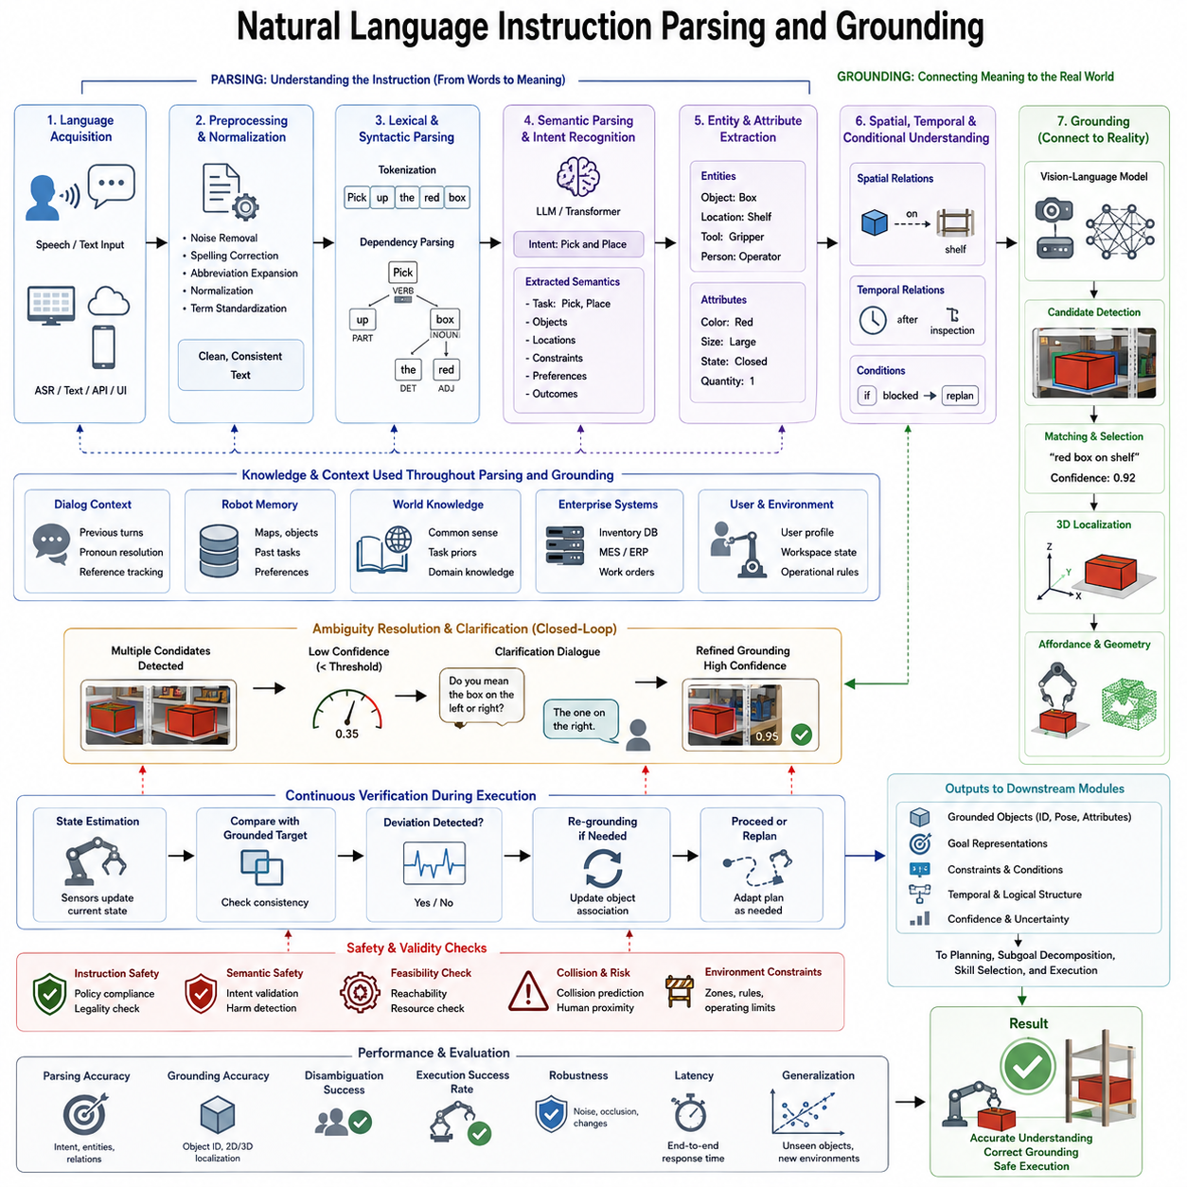
Natural Language Instruction Parsing and Grounding represents one of the most critical components of modern Vision-Language-Action (VLA) systems because it establishes the connection between human communication and physical robot behavior. While previous generations of robotic systems required structured programming languages, predefined command syntax, or manually designed task scripts, contemporary Physical AI systems are expected to understand natural human language with flexibility similar to human collaborators. This capability enables operators with no robotics expertise to interact with autonomous systems using ordinary spoken or written language, significantly lowering the barrier to deploying intelligent robots across industrial, commercial, healthcare, logistics, and domestic environments.
Natural language is inherently ambiguous, context-dependent, incomplete, and often imprecise. Humans routinely omit information that is considered obvious within a shared environment. A person may simply say, “Bring me the screwdriver,” assuming that the robot understands which screwdriver is intended, where it is located, who is making the request, and whether multiple screwdrivers exist within the workspace. The primary objective of instruction parsing is therefore not merely translating words into commands, but recovering the complete semantic intention behind human communication.
Instruction parsing begins with language acquisition. Commands may originate from speech recognition systems, graphical user interfaces, industrial supervisory software, collaborative workstations, mobile applications, cloud services, or multimodal conversational agents. Regardless of the communication channel, incoming instructions must first be normalized into a unified textual representation. This preprocessing stage removes recognition errors, resolves punctuation inconsistencies, expands abbreviations, standardizes terminology, and converts colloquial expressions into machine-understandable forms while preserving the original semantic meaning.
Speech-based robotic systems introduce additional challenges because automatic speech recognition frequently encounters pronunciation variations, background noise, multiple speakers, industrial machinery interference, and incomplete utterances. Modern systems therefore integrate confidence estimation with language models capable of correcting transcription errors using contextual reasoning. Rather than relying solely on literal transcription, the parser attempts to infer the most probable user intention based on environmental knowledge, dialogue history, and task context.
Once normalized language has been obtained, lexical analysis identifies the fundamental linguistic elements contained within the instruction. Words are separated into tokens representing verbs, nouns, adjectives, spatial prepositions, temporal expressions, quantities, conditional clauses, and descriptive modifiers. Unlike traditional natural language processing pipelines that focused primarily on grammatical correctness, robotic instruction parsing emphasizes operational semantics. Every linguistic component is evaluated according to how it influences physical robot behavior rather than purely syntactic structure.
Syntactic parsing constructs grammatical relationships among individual tokens. Dependency parsing, constituency parsing, and transformer-based contextual encoding identify which objects belong to which actions, how modifiers affect target entities, and how multiple clauses interact within a single instruction. Consider the instruction, “Pick up the blue container beside the inspection table and place it on the empty shelf near the entrance.” The parser must recognize two sequential actions, associate each object with the correct action, preserve pronoun references, and maintain temporal ordering throughout execution.
Semantic parsing extends beyond grammatical structure by identifying task-relevant concepts. The instruction is converted into an abstract semantic representation describing goals, objects, locations, constraints, preferences, priorities, and expected outcomes. Rather than preserving every linguistic detail, semantic representations focus on information required for autonomous decision making. Irrelevant conversational expressions such as politeness markers or emotional emphasis are filtered unless they influence operational behavior.
Intent recognition constitutes another fundamental objective. Human language frequently communicates objectives indirectly. An operator stating, “This floor looks dirty,” may actually be requesting a cleaning task rather than merely making an observation. Similarly, the statement, “We are running low on parts,” could imply an inventory inspection mission. Large Language Models equipped with contextual reasoning capabilities infer implicit intentions by combining linguistic evidence with environmental knowledge and organizational workflows.
Modern instruction parsers increasingly rely on transformer-based language models instead of manually engineered grammatical rules. Pretrained Large Language Models possess extensive world knowledge, allowing them to understand synonyms, paraphrases, indirect requests, contextual references, and domain-specific terminology. Fine-tuning further adapts these models to industrial robotics by exposing them to specialized vocabulary related to manufacturing equipment, warehouse operations, medical environments, logistics systems, and inspection procedures.
Entity extraction identifies all relevant physical and abstract objects referenced within the instruction. These entities include manipulable objects, workstations, rooms, equipment, people, tools, machines, storage locations, containers, inspection targets, navigation destinations, temporal references, and numerical quantities. Each entity receives semantic labels describing category, attributes, ownership, relationships, and expected operational roles.
Attribute extraction further enriches entity descriptions. Human instructions often distinguish objects using colors, sizes, materials, shapes, textures, serial numbers, or functional characteristics. Expressions such as “the large red toolbox,” “the second pallet,” “the damaged component,” or “the nearest charging station” require the parser to identify descriptive attributes that later support visual grounding within the perceived environment.
Spatial language represents one of the most challenging aspects of robotic instruction parsing. Humans naturally describe object locations using relative references rather than absolute coordinates. Expressions including “next to,” “behind,” “between,” “inside,” “under,” “on top of,” “to the left of,” and “closest to” require interpretation based on three-dimensional environmental relationships. Spatial reasoning modules therefore transform linguistic descriptions into geometric constraints compatible with robot perception systems.
Temporal understanding is equally important. Human instructions frequently specify execution order, concurrency, waiting conditions, deadlines, or repeated behaviors. Statements such as “Inspect the warehouse after loading finishes,” “Move both boxes simultaneously,” or “Check every shelf until the battery reaches twenty percent” introduce temporal dependencies that significantly influence planning and execution. Parsing these temporal structures enables robots to generate logically consistent task schedules.
Conditional reasoning expands robotic flexibility by interpreting instructions containing logical constraints. Users often specify alternative behaviors such as “If the package is damaged, notify the supervisor,” or “If the charging station is occupied, continue inspecting nearby shelves.” Parsing these conditional statements produces branching execution graphs rather than linear task sequences, allowing robots to respond adaptively to changing environments.
Dialogue context substantially improves parsing accuracy. Human conversations rarely consist of isolated instructions. Users frequently refer to previous statements using pronouns, abbreviated expressions, or implied references. After requesting “Bring the inspection report,” a subsequent command such as “Place it on my desk” requires maintaining contextual memory to resolve the pronoun correctly. Dialogue history therefore becomes an essential component of modern instruction understanding.
Contextual grounding extends beyond language into the physical environment. The parser combines linguistic information with robot memory, semantic maps, inventory databases, user profiles, operational procedures, and historical interactions. If multiple objects satisfy the same linguistic description, contextual information assists disambiguation. For example, if maintenance personnel typically use a particular toolbox, the robot may prioritize that object when receiving a generic instruction.
Grounding transforms symbolic language into physical reality. Whereas parsing determines linguistic meaning, grounding associates linguistic entities with observable environmental objects. Every referenced object must be matched with sensor observations acquired through cameras, depth sensors, LiDAR, tactile sensors, force sensors, localization systems, and robot proprioception. Without grounding, language remains disconnected from executable robotic behavior.
Visual grounding constitutes the most common grounding strategy. Vision-Language Models generate shared semantic embedding spaces in which textual descriptions and visual observations occupy compatible representations. Object detection systems first identify candidate objects, after which multimodal encoders compare linguistic embeddings against visual embeddings to determine the best correspondence. This process enables robots to identify requested objects even when exact appearances differ from training examples.
Three-dimensional grounding further estimates precise object geometry required for manipulation. After identifying the correct object, the robot computes its position, orientation, dimensions, accessibility, grasp affordances, and surrounding obstacles. Grounding therefore bridges semantic understanding and physical interaction by transforming descriptive language into measurable geometric information.
Grounding also incorporates relational reasoning. Instructions frequently specify objects through relationships rather than intrinsic properties. Expressions such as “the box beside the printer” or “the pallet behind the forklift” require identifying multiple objects simultaneously before evaluating their spatial configuration. Graph-based scene representations allow robots to model relational structures that remain robust under viewpoint changes and partial occlusions.
Dynamic environments introduce additional grounding challenges. Objects may move after instructions are issued, humans may relocate equipment, and previously visible targets may become temporarily occluded. Continuous grounding updates ensure that semantic references remain synchronized with current environmental observations. Rather than assuming static conditions, the robot repeatedly validates grounded entities throughout execution.
Ambiguity resolution represents another essential capability. Human instructions frequently correspond to multiple candidate interpretations. If two blue bottles are visible, the instruction “Pick up the blue bottle” lacks sufficient specificity. Modern systems evaluate confidence scores associated with each interpretation and may initiate clarification dialogue when ambiguity exceeds acceptable thresholds. Asking “Do you mean the bottle on the left or the one near the monitor?” often prevents costly execution errors.
Confidence estimation improves overall system reliability. Every parsing and grounding decision is accompanied by probabilistic confidence values representing model uncertainty. Downstream planning modules incorporate these uncertainty estimates when selecting execution strategies. High-confidence interpretations proceed autonomously, whereas uncertain cases trigger additional perception, clarification, or human confirmation before execution begins.
Memory plays a fundamental role throughout grounding. Semantic memory stores knowledge about object categories, functional relationships, industrial terminology, and operational procedures. Episodic memory records previous interactions, enabling robots to recognize recurring users, preferred object locations, habitual workflows, and successful task execution strategies. Working memory maintains active dialogue context and currently grounded entities during ongoing missions.
World models significantly enhance grounding performance by predicting environmental evolution. Instead of grounding instructions solely against instantaneous observations, predictive world models estimate future object positions, human motion, and environmental changes. Anticipatory grounding enables robots to initiate planning before all sensory evidence becomes available, improving responsiveness in dynamic collaborative settings.
Multi-modal grounding extends beyond visual information. Force sensing confirms successful grasping, tactile sensing verifies contact conditions, audio sensing detects machine status, thermal cameras identify temperature anomalies, and localization systems establish global spatial context. Integrating multiple sensing modalities produces more robust grounding than relying exclusively on visual perception.
Industrial robotics imposes additional grounding requirements involving structured environments, standardized procedures, inventory databases, digital twins, enterprise resource planning systems, and manufacturing execution systems. Language references such as production orders, machine identifiers, barcode numbers, inspection sequences, or warehouse addresses must be grounded against enterprise information systems in addition to physical observations. This integration enables seamless interaction between autonomous robots and digital industrial infrastructure.
Grounding quality directly influences downstream planning performance. Incorrect grounding leads to incorrect object selection, navigation errors, manipulation failures, inefficient task execution, and potential safety hazards. Consequently, grounding modules typically operate within closed-loop verification frameworks that continuously compare predicted object identities with ongoing sensory observations throughout mission execution.
Safety considerations remain central throughout parsing and grounding. Instructions that violate operational constraints, safety regulations, ethical guidelines, or legal requirements must be rejected before physical execution. Semantic safety filters analyze user intentions independently of literal wording, preventing unsafe interpretations that might otherwise satisfy linguistic requirements. Grounding additionally verifies whether requested actions remain physically feasible under current environmental conditions.
Evaluation of instruction parsing and grounding extends beyond traditional natural language processing metrics. Robotic systems must be assessed according to instruction following accuracy, semantic consistency, grounding precision, object localization accuracy, ambiguity resolution success, dialogue efficiency, execution success rate, robustness under environmental changes, generalization to unseen objects, cross-domain adaptability, and computational latency. Real-world evaluation remains particularly important because laboratory benchmarks often underestimate the complexity of practical deployments.
Future research directions increasingly emphasize unified multimodal foundation models capable of jointly performing language understanding, visual reasoning, spatial grounding, temporal planning, and action prediction within a single architecture. Instead of designing independent parsing, grounding, and planning modules, next-generation Vision-Language-Action systems are expected to learn integrated representations connecting language, perception, memory, reasoning, and physical interaction through end-to-end optimization. Nevertheless, production-grade robotic platforms will likely continue incorporating explicit verification, safety supervision, interpretable reasoning, and modular validation layers to ensure predictable behavior in safety-critical environments. As autonomous robots become more deeply integrated into human society, Natural Language Instruction Parsing and Grounding will remain one of the foundational technologies enabling intuitive, reliable, and trustworthy communication between humans and intelligent physical systems.

6.3 Semantic Goal Specification (with Code)
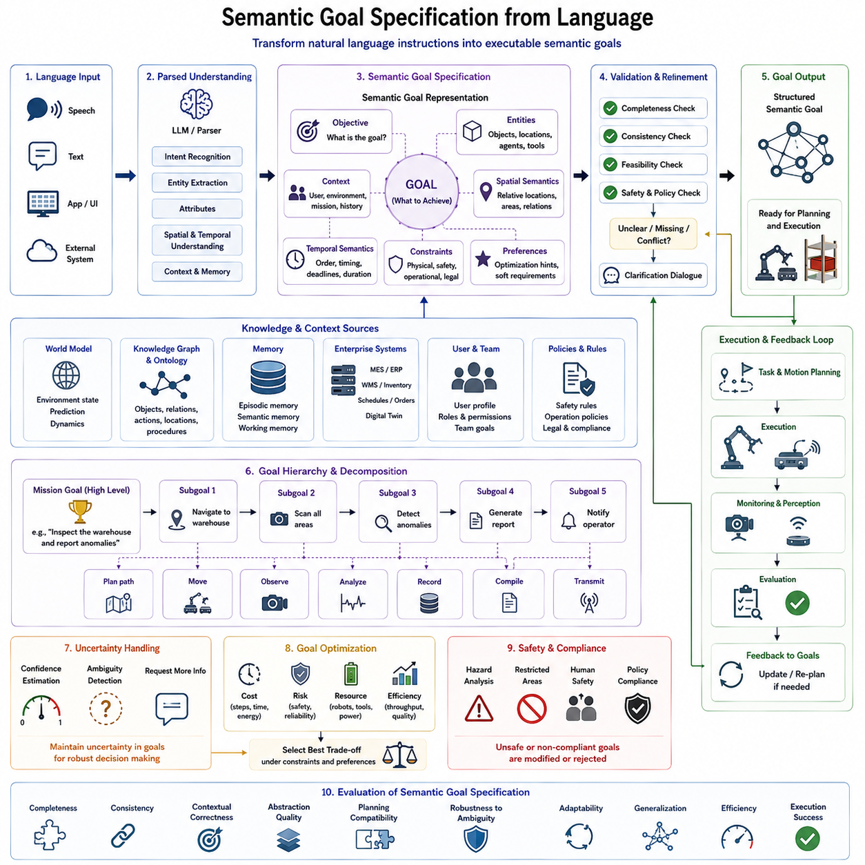
Semantic Goal Specification from Language is a fundamental component of modern Vision-Language-Action (VLA) systems because it transforms human language into machine-interpretable objectives that can guide autonomous robot behavior. While natural language provides a convenient communication interface for humans, robots cannot directly execute linguistic instructions. Instead, language must first be converted into structured semantic goals that clearly define the desired outcome, environmental constraints, task priorities, and success conditions. Semantic goal specification therefore serves as the bridge between language understanding and task planning, enabling robots to reason about what should be achieved before determining how the task should be executed.
Unlike traditional robotic systems that relied on predefined command sets or manually programmed workflows, modern Physical AI systems receive high-level objectives expressed in natural language. Instructions such as “Deliver this package to the laboratory,” “Inspect all emergency exits,” or “Organize the tools on the workbench” describe desired end states rather than explicit motion commands. The robot must therefore infer the underlying objectives, identify relevant entities, understand contextual assumptions, and formulate a goal representation that remains independent of any particular planning or control algorithm.
The first step in semantic goal specification is transforming parsed language into an abstract task representation. Rather than preserving every word of the original sentence, the system extracts only the semantic information necessary for autonomous decision making. This representation typically includes the primary objective, involved objects, target locations, environmental conditions, temporal constraints, user preferences, and operational priorities. The resulting goal description functions as an intermediate representation that separates human communication from robot execution.
A key characteristic of semantic goals is their abstraction. Human instructions often describe intentions rather than physical operations. For example, the command “Prepare the inspection station” may involve clearing obstacles, arranging equipment, activating sensors, checking power supplies, and notifying operators. None of these individual actions are explicitly mentioned by the user, yet they collectively contribute to achieving the desired goal. Semantic goal specification therefore focuses on representing the intended outcome instead of prematurely defining execution details.
Goal abstraction also improves platform independence. The same semantic objective should be executable by different robotic embodiments despite variations in hardware capabilities. A mobile manipulator, a humanoid robot, or an autonomous mobile robot equipped with specialized tools may all interpret the same goal while generating different execution strategies. By separating goals from implementation, semantic representations promote interoperability across heterogeneous robotic systems.
Modern semantic representations frequently organize goals hierarchically. High-level mission objectives are progressively decomposed into intermediate objectives and eventually into executable subtasks. For example, the mission “Inspect the warehouse” may be divided into navigation, localization, environmental scanning, anomaly detection, report generation, and completion verification. Each subgoal inherits relevant constraints while maintaining sufficient independence to support modular planning and localized failure recovery.
Intent modeling further enriches semantic goals by distinguishing between explicit instructions and implicit expectations. Human operators rarely specify every operational detail because they assume robots possess common procedural knowledge. When instructed to “Deliver the medical supplies,” the robot must recognize that safe transportation, collision avoidance, package protection, and destination verification are implicit requirements. These inferred objectives become integral components of the semantic goal despite never appearing explicitly within the original instruction.
Context plays an essential role throughout semantic goal specification. The same linguistic instruction may correspond to different goals depending on environmental conditions, organizational procedures, user identity, or mission history. The command “Return to base” could indicate a charging station, a maintenance area, a storage location, or a mobile command vehicle depending on operational context. Context-aware semantic modeling therefore integrates language understanding with environmental knowledge and long-term memory to resolve ambiguities.
Object semantics form another important element of goal specification. Rather than representing objects solely through visual appearance, semantic goals capture functional properties, relationships, ownership, operational roles, and expected interactions. A toolbox is not merely recognized as a physical container but also as equipment associated with maintenance operations, containing specialized instruments, and potentially assigned to specific personnel. Such semantic enrichment enables more intelligent planning and decision making.
Spatial semantics further describe where desired outcomes should occur. Human instructions commonly reference relative locations instead of precise coordinates. Expressions including “near the loading dock,” “inside the storage cabinet,” or “beside the inspection table” are converted into symbolic spatial relationships that can later be grounded within environmental maps. This separation allows planning algorithms to adapt automatically when environments change while preserving the original semantic intention.
Temporal semantics specify when goals should be achieved and how different objectives relate over time. Some tasks require sequential execution, while others permit parallel operations. Deadlines, waiting conditions, recurring inspections, synchronization with human workers, and resource availability all influence temporal goal specification. Representing these temporal relationships explicitly enables planners to generate schedules that satisfy operational constraints while maximizing efficiency.
Constraint modeling is another essential aspect of semantic goal specification. Every real-world task operates under physical, operational, organizational, and safety constraints. Payload limits, battery capacity, restricted areas, human safety zones, equipment availability, regulatory requirements, and environmental conditions all influence feasible execution strategies. Rather than embedding constraints directly into planning algorithms, semantic goal representations maintain them as explicit components that remain accessible throughout the decision-making process.
Preference modeling extends semantic goals beyond mandatory requirements. Human operators often express preferred behaviors without requiring absolute compliance. Instructions such as “Use the nearest elevator if possible,” “Avoid interrupting ongoing production,” or “Minimize energy consumption” introduce optimization objectives rather than strict constraints. Distinguishing preferences from mandatory requirements allows planners to balance competing objectives while preserving operational flexibility.
Goal validation ensures that semantic objectives remain logically consistent, physically achievable, and operationally meaningful before planning begins. Validation examines missing information, contradictory constraints, impossible objectives, unavailable resources, and policy violations. If inconsistencies are detected, clarification dialogue or automatic goal refinement may be initiated before execution proceeds. Early validation significantly reduces downstream planning failures.
Semantic goal specification also incorporates uncertainty representation. Human instructions may intentionally remain vague or incomplete, while perception systems may possess limited confidence regarding environmental observations. Instead of forcing deterministic interpretations, modern systems associate confidence estimates with semantic entities, constraints, and inferred objectives. Planning algorithms subsequently incorporate these uncertainty estimates when selecting execution strategies or requesting additional information.
World models substantially improve semantic goal quality by providing predictive environmental understanding. Instead of defining goals solely with respect to the current state, predictive world models estimate future object locations, human activities, environmental dynamics, and resource availability. This predictive capability enables robots to formulate goals that remain valid despite changing operating conditions and supports proactive decision making rather than purely reactive behavior.
Knowledge graphs and semantic ontologies further enrich goal representations by organizing relationships among objects, locations, actions, and operational concepts. Hierarchical knowledge structures enable reasoning across different abstraction levels, allowing robots to generalize previously learned knowledge to unfamiliar situations. For example, understanding that a wrench belongs to the category of maintenance tools allows the robot to infer its likely storage location and operational usage even without prior experience involving that specific object.
Memory integration significantly enhances semantic goal specification. Episodic memory stores previous task executions, successful strategies, encountered failures, and user preferences. Semantic memory maintains persistent knowledge regarding object categories, environmental layouts, standard operating procedures, and organizational policies. Working memory preserves active mission context throughout ongoing interactions. Together, these complementary memory systems enable semantic goals to reflect both current observations and accumulated experience.
In collaborative environments, semantic goals frequently involve multiple autonomous agents operating simultaneously. Multi-robot goal specification therefore includes coordination relationships, resource sharing, task allocation constraints, synchronization requirements, communication dependencies, and collective success criteria. Rather than optimizing isolated robot behavior, semantic representations support cooperative mission execution across heterogeneous robotic teams.
Industrial applications introduce additional complexity because semantic goals must align with enterprise information systems. Production schedules, manufacturing execution systems, warehouse management platforms, inventory databases, digital twins, and maintenance records provide contextual information that influences task objectives. Integrating enterprise knowledge into semantic goal specification enables autonomous robots to participate seamlessly within broader industrial workflows.
Safety remains a foundational principle throughout semantic goal specification. Desired objectives are evaluated against ethical policies, operational regulations, legal requirements, cybersecurity restrictions, and human safety guidelines before planning begins. Unsafe, contradictory, or unauthorized goals are rejected or modified regardless of their linguistic correctness. This separation between semantic understanding and safety validation provides an essential safeguard for deploying autonomous systems within real-world environments.
Evaluation of semantic goal specification extends beyond conventional language understanding metrics. Effective systems are measured according to goal completeness, semantic consistency, contextual correctness, abstraction quality, planning compatibility, robustness under ambiguity, adaptability to changing environments, cross-domain generalization, computational efficiency, and downstream execution success. Because semantic goals directly influence every subsequent stage of autonomous behavior, their quality strongly determines overall system performance.
As Vision-Language-Action systems continue to evolve, semantic goal specification is expected to become increasingly integrated with multimodal reasoning, foundation models, world modeling, continual learning, and cognitive memory architectures. Future Physical AI platforms will generate adaptive semantic objectives that evolve continuously in response to environmental changes, human collaboration, and mission progress. Rather than serving as static intermediate representations, semantic goals will become dynamic cognitive structures capable of supporting long-horizon reasoning, collaborative decision making, and autonomous mission management across diverse robotic embodiments and complex real-world operating environments.

6.4 Task and Motion Planning (TAMP) (with Code)
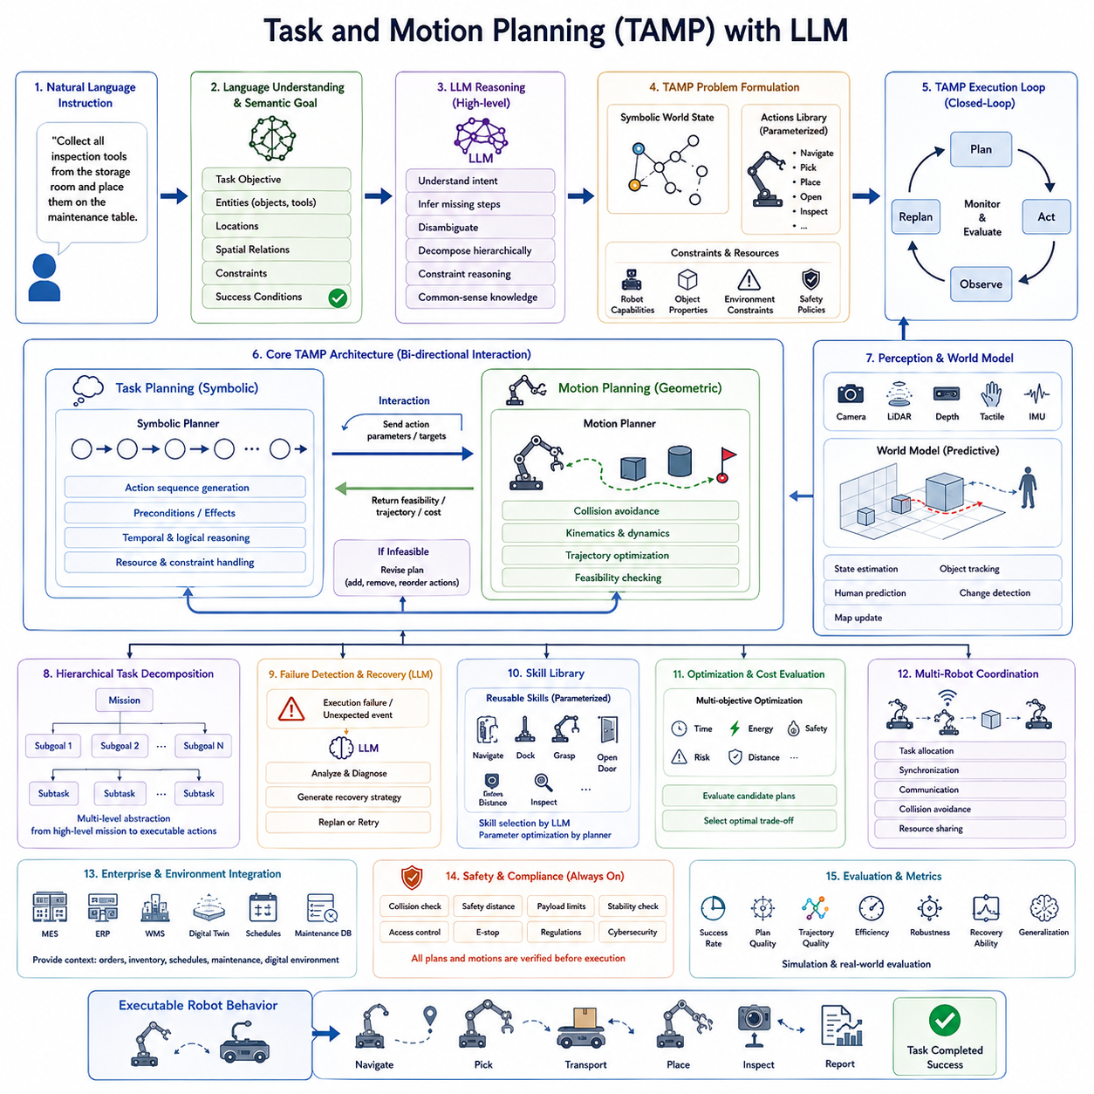
Task and Motion Planning (TAMP) with Large Language Models (LLMs) represents one of the most significant developments in modern Vision-Language-Action (VLA) systems, combining symbolic reasoning with continuous motion generation to enable robots to execute complex tasks in dynamic environments. Traditional robotics often treated task planning and motion planning as separate problems. Task planners generated symbolic action sequences such as “navigate,” “pick,” and “place,” while motion planners independently computed collision-free trajectories for each action. Although effective for structured environments, this separation frequently resulted in inconsistencies because symbolic plans were generated without fully considering physical feasibility. TAMP addresses this limitation by integrating high-level reasoning and low-level motion generation into a unified planning framework, while LLMs provide powerful semantic reasoning capabilities that significantly improve flexibility, adaptability, and human-robot interaction.
The primary objective of TAMP is to transform an abstract task goal into executable robot behavior while ensuring that every symbolic decision is physically achievable. Rather than assuming that a selected action can always be executed, the planner continuously evaluates whether the robot can reach target objects, avoid obstacles, satisfy manipulation constraints, maintain balance, and complete the mission safely. This iterative interaction between symbolic planning and geometric reasoning enables robots to solve problems that neither planning layer could address independently.
Modern TAMP systems begin with semantic goals generated from natural language understanding modules. After a user provides an instruction such as “Collect all inspection tools from the storage room and place them on the maintenance table,” previous stages of the Language-to-Action pipeline produce structured semantic goals containing task objectives, relevant objects, spatial relationships, operational constraints, and success conditions. TAMP receives these semantic representations as inputs and converts them into executable planning problems.
Large Language Models contribute primarily to high-level reasoning rather than numerical motion generation. LLMs analyze semantic goals, infer missing procedural knowledge, interpret contextual information, resolve ambiguities, and generate hierarchical task decompositions. Their extensive pre-trained world knowledge enables them to understand complex instructions that would otherwise require manually designed planning rules. Rather than replacing classical planning algorithms, LLMs complement them by providing intelligent reasoning and decision support.
Task planning focuses on determining what actions should be executed. It represents problems symbolically using actions, preconditions, effects, resources, temporal relationships, and logical dependencies. Each action changes the world state by satisfying certain objectives while enabling subsequent operations. Symbolic planners search through possible action sequences until they identify one capable of transforming the initial state into the desired goal state. This planning process resembles classical artificial intelligence planning but incorporates significantly richer semantic representations generated by language understanding systems.
Motion planning addresses an entirely different problem. Once a symbolic action has been selected, the robot must determine how to move safely within its physical environment. Collision avoidance, joint limitations, vehicle kinematics, obstacle avoidance, velocity constraints, acceleration limits, and dynamic stability all influence motion generation. Motion planners therefore compute continuous trajectories that satisfy both robot dynamics and environmental constraints while minimizing execution cost.
The defining characteristic of TAMP is the continuous interaction between these two planning domains. Symbolic plans are repeatedly verified against geometric feasibility. If a motion planner determines that an object cannot be reached because another object blocks the manipulator, the symbolic planner revises its action sequence by inserting additional operations such as moving the obstacle before attempting the original task. This bidirectional communication enables planners to converge toward solutions that are both logically correct and physically executable.
Hierarchical planning naturally emerges within TAMP architectures. High-level missions are recursively decomposed into progressively smaller planning units. A warehouse inspection mission may first divide the facility into inspection zones, then assign navigation tasks, identify required sensing operations, schedule report generation, and finally generate detailed manipulation trajectories for individual inspection procedures. Each planning level operates at an appropriate level of abstraction while exchanging information with neighboring layers.
LLMs significantly enhance hierarchical decomposition by reasoning about common-sense task structures. Human instructions often omit procedural details because people assume shared knowledge. For example, the instruction “Prepare the laboratory for inspection” implicitly includes opening access doors, activating lighting systems, positioning sensors, clearing workspaces, and verifying equipment readiness. LLMs infer these hidden subtasks using learned world knowledge, allowing symbolic planners to begin with much richer task representations than would be possible through manually defined rules alone.
Constraint reasoning represents another important contribution of LLM-enhanced TAMP systems. Real-world robotic operations involve numerous physical, operational, organizational, and safety constraints. Some constraints are explicitly stated by users, while others originate from enterprise policies, environmental conditions, or robot capabilities. LLMs assist by interpreting natural language descriptions of constraints, identifying implicit operational assumptions, and organizing these constraints into structured planning representations compatible with downstream optimization algorithms.
Modern TAMP systems frequently incorporate world models to improve planning quality. Instead of assuming static environments, predictive world models estimate future object movements, human behavior, environmental changes, and resource availability. Planners therefore optimize actions not only for the current environment but also for anticipated future conditions. Predictive planning significantly improves robustness in collaborative workspaces where humans and robots continuously interact.
Perception plays an equally important role throughout the planning process. Motion planning cannot rely solely on initial observations because environments frequently change during execution. Cameras, LiDAR, depth sensors, tactile sensors, force sensors, and localization systems continuously update the robot's understanding of the workspace. These observations refine environmental models and allow planners to adapt trajectories whenever unexpected changes occur.
Closed-loop planning distinguishes modern TAMP architectures from traditional offline planning systems. Rather than generating an entire plan once before execution, robots repeatedly observe, evaluate, and update their plans throughout task execution. Every completed action produces new environmental information that may influence subsequent planning decisions. If obstacles appear, objects move unexpectedly, or human operators intervene, the planning system immediately reevaluates the remaining task sequence.
Failure recovery has become one of the strongest applications of LLM-assisted planning. Classical planners often terminate execution after encountering unexpected failures because predefined recovery strategies are unavailable. LLMs instead analyze execution history, environmental changes, and task objectives to generate alternative planning strategies. If grasping fails because an object rotated unexpectedly, the planner may recommend repositioning the manipulator, approaching from another direction, selecting an alternative grasp, or temporarily moving neighboring objects before retrying the original task.
Skill libraries further improve planning efficiency by providing reusable motion primitives. Instead of computing every action from first principles, planners select parameterized skills such as navigation, docking, grasping, opening doors, pressing buttons, visual inspection, or manipulation. LLMs assist by selecting appropriate skills according to semantic task requirements while motion planners optimize execution parameters for current environmental conditions.
Optimization plays an essential role within TAMP because multiple feasible solutions often exist for the same task. Planning algorithms therefore evaluate candidate plans according to travel distance, execution time, energy consumption, collision risk, manipulation complexity, resource utilization, and overall mission efficiency. Multi-objective optimization enables robots to balance competing objectives while respecting mandatory operational constraints.
Multi-robot planning introduces additional complexity. Collaborative robots frequently share workspaces, manipulate common resources, and execute complementary tasks simultaneously. TAMP architectures therefore extend symbolic planning to include task allocation, synchronization, communication scheduling, collision avoidance among robots, and shared resource management. LLMs contribute by reasoning about cooperative task decomposition and communication strategies, while geometric planners ensure physical coordination among multiple agents.
Industrial deployment requires integration with enterprise information systems. Manufacturing Execution Systems (MES), Enterprise Resource Planning (ERP), Warehouse Management Systems (WMS), Digital Twins, production schedules, maintenance databases, and inventory systems continuously provide contextual information affecting planning decisions. TAMP therefore becomes part of a much larger cyber-physical ecosystem where symbolic reasoning extends beyond robot behavior into enterprise operations.
Safety supervision remains active throughout the planning pipeline. Every symbolic action and every generated trajectory undergo independent safety verification before execution. Collision prediction, workspace restrictions, human proximity monitoring, payload limitations, stability analysis, regulatory compliance, cybersecurity policies, and emergency procedures collectively ensure that generated plans remain safe under all anticipated operating conditions. Importantly, safety mechanisms remain external to LLM reasoning so that deterministic validation can override incorrect or unsafe model outputs whenever necessary.
Performance evaluation for TAMP extends beyond conventional planning metrics. Researchers measure task completion rate, planning success, trajectory quality, execution efficiency, recovery capability, computational latency, robustness to environmental uncertainty, generalization across tasks, cross-embodiment transfer, human collaboration efficiency, and overall operational reliability. Because TAMP directly influences every physical action performed by autonomous robots, evaluation must include both simulation-based benchmarking and extensive real-world validation under diverse operating conditions.
As Vision-Language-Action systems continue to mature, Task and Motion Planning with Large Language Models is expected to evolve into an increasingly unified cognitive architecture. Future planning systems will integrate semantic reasoning, predictive world models, multimodal perception, continual learning, episodic memory, collaborative intelligence, and foundation robot policies into a single adaptive decision-making framework. Rather than treating task planning, motion planning, perception, and execution as separate modules, next-generation Physical AI systems will continuously reason about goals, environment dynamics, robot capabilities, and human intentions within one integrated planning architecture. This evolution will enable autonomous robots to perform increasingly sophisticated long-horizon missions while maintaining the flexibility, safety, and robustness required for deployment in complex real-world environments.

6.5 Subgoal Decomposition (with Code)
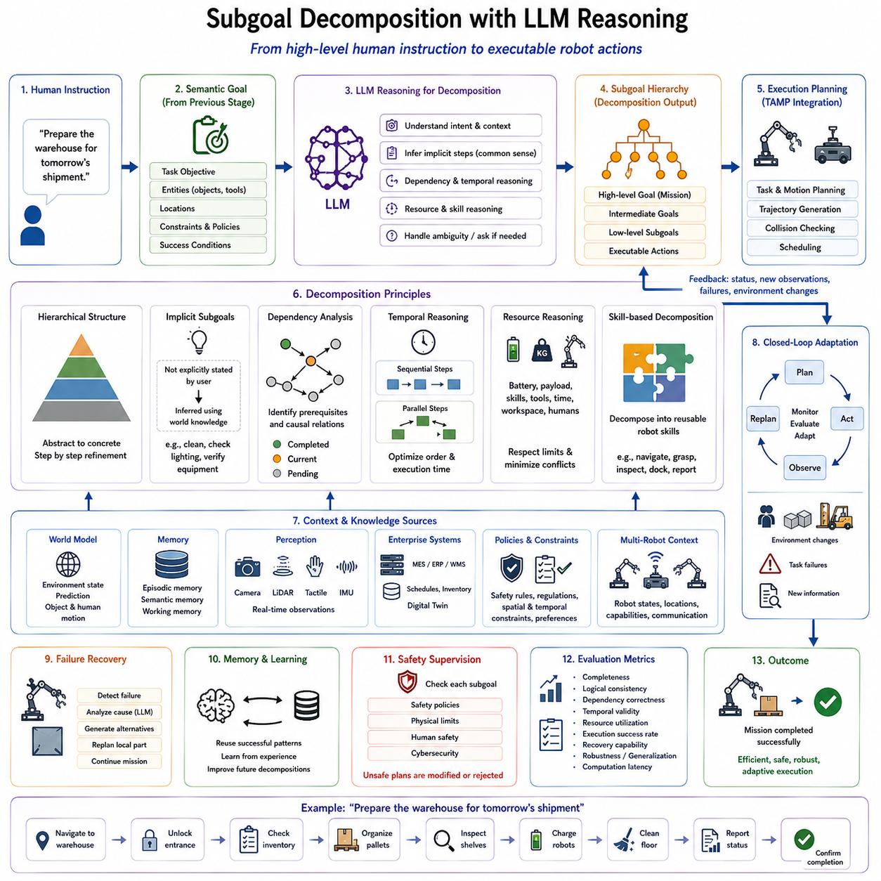
Subgoal Decomposition with Large Language Model (LLM) reasoning is one of the defining capabilities of modern Vision-Language-Action (VLA) systems because it enables autonomous robots to transform high-level human objectives into a structured hierarchy of executable tasks. Humans naturally describe goals in an abstract manner, expecting intelligent agents to infer the intermediate steps required for successful completion. A command such as “Prepare the warehouse for tomorrow's shipment” does not explicitly specify navigation routes, inventory verification, pallet organization, charging schedules, or inspection procedures. Instead, the robot must interpret the intent, identify hidden dependencies, and generate an ordered collection of subgoals that collectively satisfy the original objective. Subgoal decomposition therefore bridges semantic understanding and autonomous execution by converting abstract intentions into operational planning structures.
Traditional robotic systems relied on manually engineered task trees or predefined finite-state machines to decompose complex missions. Although effective in repetitive industrial environments, these approaches were limited by their inability to generalize beyond predefined workflows. Every new task required engineers to design additional planning logic, making deployment expensive and inflexible. Modern LLM-based decomposition replaces handcrafted procedural rules with reasoning capabilities learned from large-scale textual and multimodal knowledge. Instead of relying solely on explicit programming, the system infers missing procedural knowledge using common-sense reasoning, domain expertise, and contextual understanding acquired during pretraining.
The decomposition process begins after semantic goals have been generated by previous stages of the Language-to-Action pipeline. Rather than planning directly from a high-level mission, the LLM first analyzes the overall objective to identify its logical structure. It determines whether the mission consists of independent activities, sequential operations, conditional branches, or collaborative subtasks. This initial structural understanding establishes the foundation upon which all subsequent planning decisions are constructed.
A well-designed decomposition hierarchy separates strategic objectives from operational procedures. High-level goals define what should ultimately be achieved, while intermediate goals describe meaningful milestones that progressively reduce mission complexity. Lower levels contain executable robot actions such as navigation, manipulation, inspection, sensing, communication, or reporting. This hierarchical organization allows each planning layer to reason at an appropriate level of abstraction while maintaining consistency across the entire mission.
One of the greatest advantages of LLM reasoning is its ability to infer implicit subgoals. Human instructions rarely enumerate every required operation because people naturally assume shared procedural knowledge. When instructed to “Set up the conference room,” the robot must recognize that arranging chairs, preparing presentation equipment, checking lighting, ensuring cleanliness, verifying environmental conditions, and confirming readiness may all be necessary despite never being explicitly mentioned. Such hidden procedural reasoning significantly improves autonomous behavior without requiring manually specified workflows.
Context awareness plays a central role during decomposition. The same instruction may require different subgoal structures depending on environmental conditions, available resources, user preferences, or organizational policies. Preparing a laboratory differs substantially from preparing a warehouse even if both commands use similar linguistic structures. LLMs combine semantic understanding with contextual information obtained from world models, digital maps, enterprise databases, and episodic memory to generate subgoal hierarchies appropriate for the current operational environment.
Dependency analysis is another critical component of subgoal decomposition. Certain operations cannot begin until prerequisite tasks have been completed. A robot cannot inspect shelves before reaching the designated storage area, nor can it transport equipment before successfully grasping the required objects. LLM reasoning identifies these logical dependencies and organizes subtasks into directed execution graphs that preserve causal relationships throughout mission execution. Such dependency-aware planning reduces execution failures while improving overall operational efficiency.
Temporal reasoning further enriches decomposition quality. Some subtasks must occur sequentially, whereas others can be executed concurrently to reduce completion time. For example, battery charging, environmental monitoring, and report preparation may proceed simultaneously while navigation and manipulation remain sequentially constrained. LLMs analyze temporal relationships expressed within language together with operational knowledge to identify opportunities for parallel execution without violating safety or resource constraints.
Resource reasoning also contributes significantly to intelligent decomposition. Every robot possesses finite computational capacity, battery energy, payload limits, sensing capabilities, and manipulation skills. Enterprise environments additionally impose constraints involving equipment availability, shared workspaces, production schedules, and human operators. LLMs consider these resource limitations when generating subgoal hierarchies, ensuring that each proposed task remains compatible with available capabilities while minimizing resource conflicts.
Skill-based decomposition has become increasingly important within modern robotic software architectures. Rather than decomposing missions into primitive motor commands, LLMs organize plans around reusable robot skills such as navigation, localization, grasping, docking, inspection, obstacle avoidance, object recognition, visual verification, or reporting. These reusable skills represent modular capabilities that can be parameterized according to individual mission requirements. The resulting decomposition remains hardware independent while supporting diverse robotic embodiments through standardized skill interfaces.
Modern subgoal decomposition also incorporates semantic constraints generated during previous stages of language understanding. Safety policies, operational regulations, spatial restrictions, timing requirements, user preferences, and organizational procedures remain attached to relevant subgoals throughout planning. Maintaining these semantic annotations prevents important contextual information from being lost as increasingly detailed execution plans are generated.
Large Language Models demonstrate particular strength in handling ambiguous or incomplete instructions. When users omit important information, the LLM may infer reasonable assumptions using world knowledge or generate clarification requests before decomposition proceeds. For example, if instructed to “Deliver the package,” the system may identify the missing destination and request additional information only when contextual inference proves insufficient. This balance between autonomous reasoning and interactive clarification improves both usability and operational reliability.
Subgoal decomposition naturally supports failure recovery because mission objectives remain organized hierarchically rather than as fixed execution sequences. If one subgoal fails, the planning system can reevaluate only the affected branch without reconstructing the entire mission. For example, if an inspection robot cannot access one storage aisle because of temporary obstruction, alternative navigation strategies or reordered inspection schedules may be generated while preserving the remaining mission structure. Hierarchical decomposition therefore increases resilience in dynamic environments.
Memory integration substantially enhances decomposition quality. Episodic memory stores successful task decompositions from previous missions, allowing similar objectives to reuse proven planning structures. Semantic memory provides knowledge regarding object functions, operational procedures, environmental layouts, and organizational workflows. Working memory maintains active dialogue context and mission state throughout ongoing execution. Together, these complementary memory systems enable increasingly efficient decomposition as robots accumulate operational experience.
World models provide predictive information that further improves decomposition strategies. Rather than considering only the current environmental state, predictive models estimate future object locations, human activities, traffic patterns, equipment availability, and environmental changes. LLMs exploit these predictions when determining optimal subgoal ordering, enabling proactive planning that anticipates future events instead of merely reacting to current observations.
Multi-robot systems introduce additional decomposition challenges because missions must be divided across multiple autonomous agents. Instead of assigning every subgoal to a single robot, LLM reasoning partitions tasks according to robot capabilities, physical locations, available resources, and estimated completion times. Cooperative decomposition enables parallel execution while minimizing unnecessary communication and movement. Such collaborative planning is particularly valuable in warehouses, manufacturing facilities, logistics centers, and large-scale inspection operations.
Industrial deployment frequently requires decomposition to incorporate enterprise workflows in addition to physical robot behavior. Manufacturing Execution Systems (MES), Enterprise Resource Planning (ERP), Warehouse Management Systems (WMS), Digital Twins, inventory databases, and maintenance schedules all provide information that influences task organization. LLMs integrate these enterprise constraints into subgoal hierarchies so that robot activities remain synchronized with broader organizational operations.
Safety supervision remains active throughout decomposition. Every generated subgoal is evaluated against operational policies, physical limitations, cybersecurity requirements, regulatory standards, and human safety rules before execution planning begins. Unsafe decomposition strategies are rejected regardless of their logical correctness, ensuring that autonomous reasoning remains constrained by deterministic safety mechanisms. Human operators may additionally review generated subgoal structures for high-risk missions before execution proceeds.
Evaluation of LLM-based subgoal decomposition extends beyond traditional language understanding benchmarks. Important performance metrics include decomposition completeness, logical consistency, dependency correctness, temporal validity, planning efficiency, resource utilization, execution success rate, recovery capability, robustness to ambiguous instructions, generalization across task domains, and computational latency. Ultimately, the quality of decomposition is measured by its ability to simplify complex missions while improving autonomous execution reliability.
As Vision-Language-Action systems continue to evolve, subgoal decomposition is expected to become increasingly adaptive, dynamic, and self-improving. Future LLMs will combine multimodal perception, world models, continual learning, cognitive memory, and foundation robot policies to generate decomposition strategies that evolve continuously during mission execution. Instead of producing static task hierarchies before execution begins, next-generation Physical AI systems will maintain living mission graphs that reorganize themselves in response to environmental changes, human collaboration, resource availability, and operational priorities. This capability will transform subgoal decomposition from a planning utility into a central cognitive process that enables autonomous robots to perform long-horizon, open-world tasks with significantly greater flexibility, robustness, and intelligence.

6.6 Skill Libraries and Language-Conditioned Primitives (with Code)
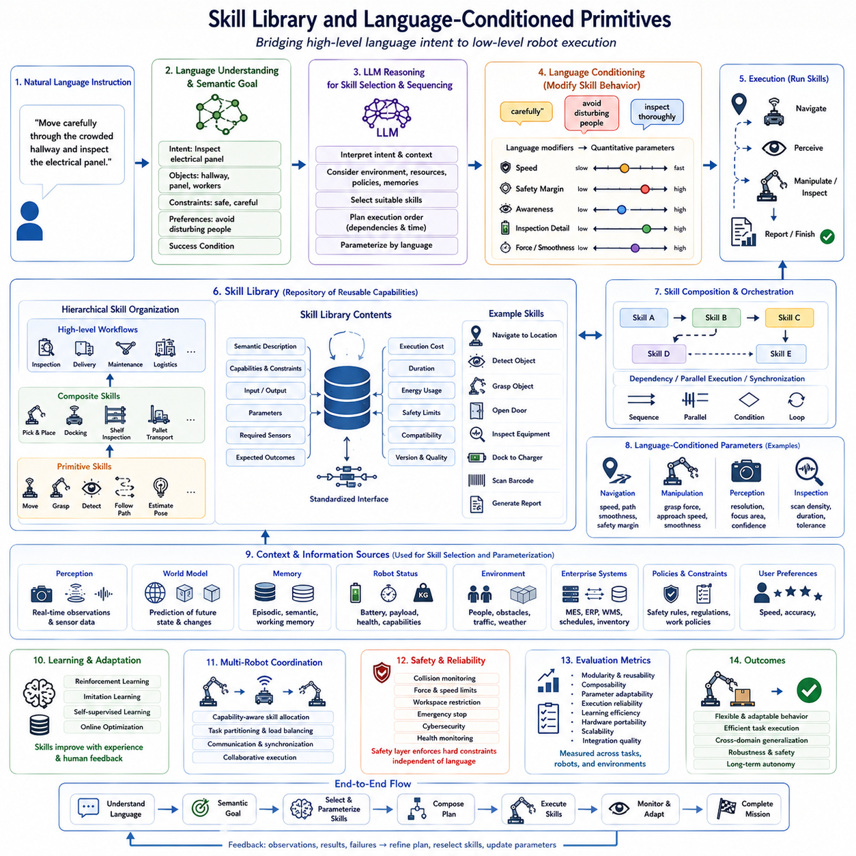
Skill Library and Language-Conditioned Primitives constitute one of the most important architectural components of modern Vision-Language-Action (VLA) systems because they establish the interface between high-level reasoning and low-level robot execution. While Large Language Models (LLMs) excel at interpreting human intentions and generating semantic task plans, they do not directly control motors or compute continuous trajectories. Instead, autonomous robots rely on reusable robotic skills that encapsulate proven execution strategies for navigation, manipulation, perception, communication, and interaction. Language-conditioned primitives enable these skills to be dynamically selected and parameterized according to natural language instructions, allowing robots to adapt their behavior without requiring handcrafted programming for every new task.
Traditional robotic systems implemented behaviors using fixed procedural programs designed for specific applications. Every manipulation sequence, navigation routine, or inspection procedure was manually programmed by engineers and tightly coupled to particular hardware platforms. Although this approach achieved high reliability in repetitive industrial environments, it lacked flexibility when new tasks, new environments, or different robot embodiments were introduced. Modern Physical AI systems instead organize robot capabilities as reusable modular skills that can be combined, adapted, and sequenced automatically according to semantic goals generated by language understanding systems.
A robotic skill represents a reusable functional capability rather than an individual motor command. Examples include navigating to a target location, detecting an object, grasping a tool, opening a door, docking with a charging station, inspecting equipment, pressing a button, carrying an object, scanning a barcode, or generating a status report. Each skill encapsulates perception algorithms, motion planning, control strategies, error handling, and safety supervision behind a standardized interface. This abstraction enables higher-level planning systems to reason about capabilities instead of hardware-specific implementations.
The Skill Library serves as a structured repository containing all executable capabilities available to the robot. Beyond storing executable software modules, the library maintains semantic descriptions, capability constraints, parameter definitions, required sensors, expected outcomes, execution costs, estimated durations, energy consumption, safety limitations, and compatibility information. As a result, planning systems can intelligently compare multiple candidate skills before selecting the most appropriate one for a given mission.
Language-conditioned primitives extend traditional skill libraries by allowing natural language to influence skill selection and execution parameters. Rather than invoking a navigation routine with manually specified coordinates, an instruction such as “Move carefully through the crowded hallway” modifies navigation behavior by emphasizing obstacle avoidance, lower speed, smoother trajectories, and increased human awareness. Similarly, “Quickly inspect the loading dock” encourages faster movement and prioritizes inspection efficiency over energy optimization. Language therefore becomes a mechanism for adjusting behavioral characteristics without modifying underlying control algorithms.
Semantic parameterization is central to language-conditioned execution. Natural language frequently expresses qualitative concepts such as “carefully,” “quickly,” “gently,” “precisely,” “securely,” or “efficiently.” These linguistic modifiers are translated into quantitative control parameters governing velocity limits, acceleration profiles, manipulation force, camera exposure, inspection resolution, localization accuracy, safety margins, or controller gains. The mapping from qualitative language to numerical parameters enables intuitive human interaction while preserving deterministic robot control.
Modern skill libraries are typically organized hierarchically. Primitive skills represent low-level capabilities such as following trajectories, controlling grippers, estimating poses, or detecting objects. Composite skills combine multiple primitives into reusable procedures including pick-and-place operations, autonomous docking, shelf inspection, pallet transportation, or equipment maintenance. Higher-level workflows integrate composite skills into complete industrial processes supporting logistics, manufacturing, healthcare, agriculture, or service robotics. This hierarchical organization promotes scalability, maintainability, and efficient knowledge reuse.
Skill composition represents another essential capability. Most real-world missions require combining numerous individual skills into coherent execution sequences. For example, autonomous package delivery involves localization, navigation, obstacle avoidance, object recognition, grasp planning, manipulation, transportation, destination verification, user interaction, and completion reporting. Rather than designing every workflow manually, planning systems dynamically compose appropriate skills according to semantic task requirements generated by Language-to-Action pipelines.
Large Language Models significantly improve skill selection through semantic reasoning. Instead of matching keywords to predefined procedures, LLMs interpret the underlying intention behind user instructions and identify which robot capabilities best satisfy mission objectives. This reasoning process considers contextual information, environmental conditions, available resources, previous experiences, organizational policies, and user preferences. Consequently, identical language instructions may produce different skill sequences under different operational circumstances while preserving the same semantic objective.
Context-aware skill selection further enhances adaptability. Environmental observations, battery status, payload conditions, weather information, workspace occupancy, sensor health, and enterprise scheduling systems all influence which skills should be selected. If a manipulator becomes unavailable because of maintenance, the planning system may substitute alternative transportation skills or coordinate another robot possessing equivalent capabilities. Dynamic skill selection therefore improves operational resilience within complex environments.
Perception-driven skills occupy a particularly important position within Physical AI systems. Rather than executing blindly, modern robots continuously observe their surroundings before, during, and after every action. Skills responsible for object recognition, semantic segmentation, visual localization, pose estimation, anomaly detection, depth perception, and scene understanding provide the situational awareness necessary for adaptive behavior. Language-conditioned perception further enables robots to prioritize observations relevant to current mission objectives. An instruction requesting inspection of electrical panels directs perception modules toward switches, indicators, cables, and warning labels instead of unrelated environmental features.
Manipulation skills demonstrate the importance of combining semantic reasoning with precise physical execution. A command such as “Handle the glass container carefully” influences grasp force, approach velocity, contact monitoring, collision sensitivity, and release behavior. Similarly, “Stack the heavy boxes efficiently” emphasizes stability, payload optimization, and placement precision. Language-conditioned manipulation therefore integrates semantic interpretation directly into low-level control strategies while maintaining safety and robustness.
Navigation skills likewise benefit from language conditioning. Human instructions often specify behavioral preferences rather than explicit routes. Requests such as “Avoid disturbing nearby workers,” “Take the safest path,” or “Use the fastest available route” require balancing multiple optimization objectives including travel time, energy efficiency, human comfort, obstacle avoidance, and operational priorities. Language-conditioned navigation enables autonomous robots to adapt these objectives dynamically without modifying underlying planning algorithms.
Memory integration substantially improves skill execution quality. Episodic memory stores successful execution histories, enabling robots to reuse previously effective parameter settings under similar conditions. Semantic memory maintains knowledge regarding object properties, environmental layouts, standard operating procedures, and organizational workflows. Working memory preserves current task context, active goals, and recent observations throughout execution. These complementary memory systems allow skills to become progressively more efficient through accumulated operational experience.
World models further enhance skill selection by predicting future environmental conditions. Instead of reacting exclusively to current observations, predictive models estimate object movements, human activities, traffic congestion, equipment availability, and environmental evolution. Skill planners use these predictions to schedule actions proactively, reducing unnecessary waiting, avoiding conflicts, and improving overall mission efficiency. Predictive skill scheduling becomes particularly valuable within dynamic industrial environments involving continuous interaction between humans and autonomous systems.
Learning-based skill adaptation represents an important direction for next-generation robotics. Rather than treating skills as fixed software modules, modern systems continuously refine execution strategies using reinforcement learning, imitation learning, self-supervised learning, and online optimization. Language feedback from human operators provides additional supervisory information describing desired behavioral improvements. Consequently, skill libraries evolve over time while preserving standardized interfaces compatible with existing planning architectures.
Multi-robot systems require coordinated skill allocation across heterogeneous robotic platforms. Individual robots may possess complementary sensing capabilities, manipulation hardware, payload capacities, or mobility characteristics. Skill libraries therefore include capability descriptions allowing planning systems to assign appropriate subtasks to the most suitable robot. Language-conditioned coordination further enables natural human supervision of collaborative robot teams through high-level mission descriptions rather than individual robot commands.
Industrial deployment requires close integration between skill libraries and enterprise software infrastructure. Manufacturing Execution Systems (MES), Enterprise Resource Planning (ERP), Warehouse Management Systems (WMS), Digital Twins, inventory databases, maintenance records, production schedules, and quality management systems continuously influence skill availability and execution priorities. Language-conditioned primitives therefore operate within broader cyber-physical ecosystems where robotic actions remain synchronized with organizational workflows and operational objectives.
Safety supervision remains inseparable from every executable skill. Each primitive incorporates collision monitoring, force limitations, workspace restrictions, emergency stopping procedures, cybersecurity validation, regulatory compliance, and health monitoring independent of high-level planning. Language instructions may modify behavioral preferences but cannot override mandatory safety constraints. Deterministic safety controllers therefore remain responsible for guaranteeing secure execution even when semantic reasoning generates unexpected task sequences.
Evaluation of skill libraries extends beyond measuring individual execution accuracy. Researchers assess modularity, reusability, composability, parameter adaptability, semantic consistency, execution reliability, learning efficiency, hardware portability, computational performance, scalability across robot embodiments, and integration quality within Language-to-Action pipelines. The effectiveness of a skill library is ultimately determined by how efficiently complex missions can be constructed from reusable components while maintaining predictable behavior across diverse operational environments.
As Vision-Language-Action systems continue to advance, Skill Libraries and Language-Conditioned Primitives are expected to evolve into increasingly intelligent and self-organizing capability repositories. Future systems will automatically discover new reusable skills from autonomous experience, optimize skill composition through continual learning, adapt execution parameters using predictive world models, and coordinate heterogeneous robot teams through unified semantic interfaces. Rather than functioning as static collections of predefined behaviors, next-generation skill libraries will become adaptive knowledge systems that continuously expand, refine, and reorganize robotic capabilities according to accumulated operational experience. This evolution will significantly enhance the scalability, flexibility, and long-term autonomy of Physical AI systems operating in complex real-world environments.

6.7 Closed-Loop Language-to-Action Feedback (with Code)
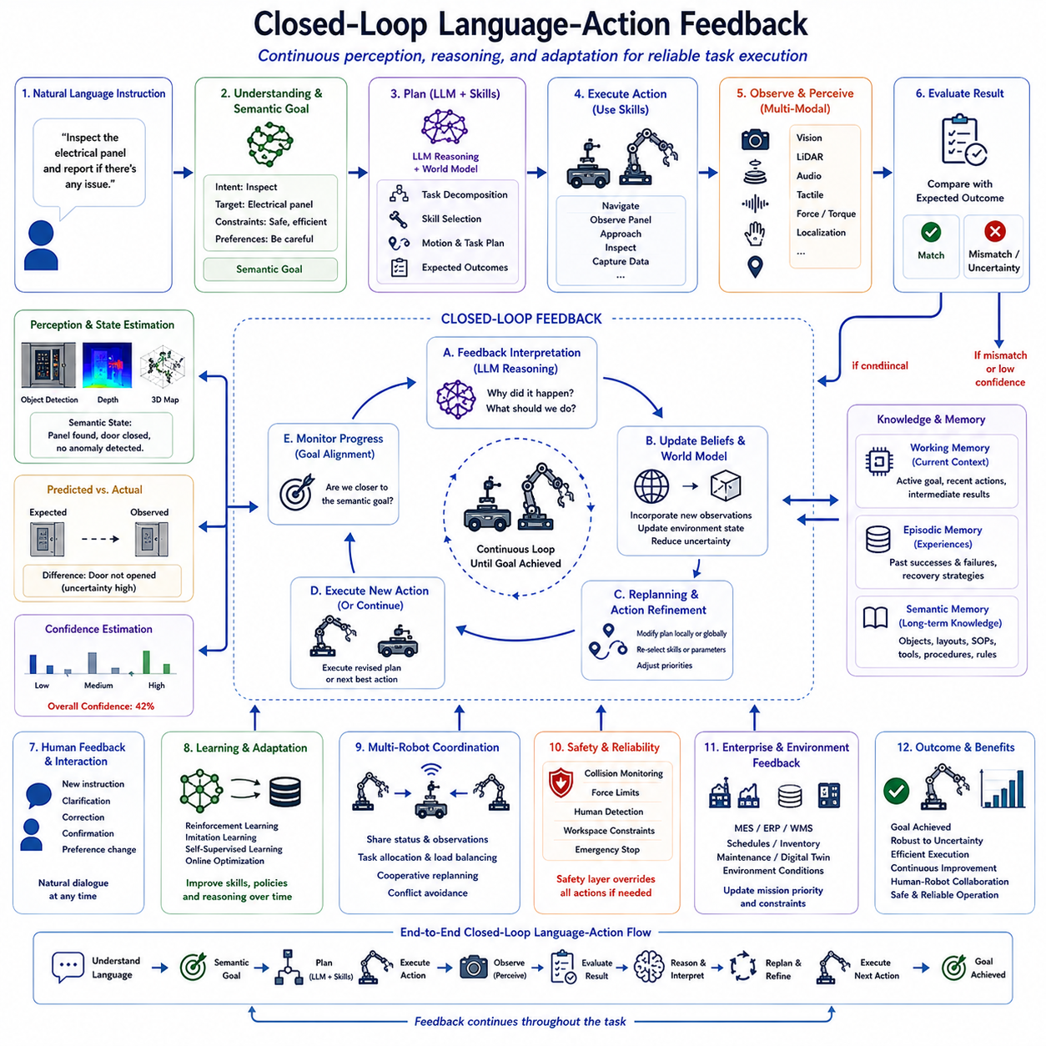
Closed-Loop Language-Action Feedback is one of the defining characteristics of advanced Vision-Language-Action (VLA) systems because it enables autonomous robots to continuously evaluate, interpret, and refine their behavior throughout task execution. Unlike traditional robotic systems that generate a plan once and execute it without further reasoning, modern Physical AI systems continuously compare intended goals with observed outcomes. Every executed action produces new sensory information that influences future decisions, allowing robots to adapt dynamically to changing environments, unexpected events, and human interactions. The Language-to-Action pipeline therefore becomes a continuous feedback process rather than a one-directional execution pipeline.
Traditional robotic architectures were largely based on open-loop execution. Once a planner generated an action sequence, the robot attempted to complete every operation according to the predefined schedule. Such systems performed well in highly structured environments but often failed when objects moved unexpectedly, sensors produced noisy observations, or humans modified the workspace. Even minor environmental changes could invalidate an entire execution plan because the robot lacked mechanisms for continuously reevaluating its decisions.
Closed-loop architectures fundamentally change this paradigm by treating every action as an opportunity to acquire additional knowledge. After each movement, manipulation, inspection, or interaction, perception systems collect updated environmental observations. Cameras, LiDAR, depth sensors, force sensors, tactile sensors, localization systems, and proprioceptive measurements continuously monitor the current state of both the robot and its surroundings. These observations are compared against expected outcomes, allowing the system to determine whether execution remains consistent with the original semantic goal.
Language remains central throughout the feedback process. Rather than disappearing after initial instruction parsing, semantic task descriptions continue guiding execution evaluation. The robot continuously measures progress relative to the user's original intent rather than simply verifying whether predefined motor commands have completed successfully. This distinction enables semantic reasoning during execution. A robot may determine that although a planned grasp failed, the overall objective remains achievable through an alternative strategy that still satisfies the user's request.
Feedback begins with observation validation. Every executed action generates predicted environmental changes that can be compared with actual sensor measurements. If the observed state matches the predicted outcome within acceptable uncertainty limits, execution proceeds normally. However, discrepancies indicate that the environment has changed, an execution error has occurred, or the original world model requires updating. Early detection of inconsistencies significantly improves system robustness by preventing small errors from propagating into larger mission failures.
Semantic state estimation plays an important role in feedback interpretation. Rather than monitoring only low-level variables such as joint positions or wheel velocities, modern VLA systems estimate high-level semantic states describing task progress. Examples include whether an object has been successfully grasped, whether a room has been inspected, whether a delivery has been completed, or whether maintenance procedures satisfy operational requirements. Semantic state estimation enables reasoning directly at the task level instead of relying exclusively on hardware measurements.
World models provide predictive context for interpreting feedback. Before executing an action, the system predicts expected environmental evolution based on previous observations, learned dynamics, and current plans. After execution, observed outcomes are compared with these predictions. Differences between predicted and observed states update the internal world model, allowing future planning decisions to incorporate newly acquired environmental knowledge. Continuous model refinement enables progressively more accurate long-horizon reasoning.
Large Language Models contribute to closed-loop feedback primarily through semantic interpretation rather than numerical control. When execution deviates from expectations, LLMs analyze task history, environmental context, user intent, and accumulated observations to determine why discrepancies occurred. Instead of simply detecting failure, the system attempts to explain the underlying cause. For example, an unsuccessful grasp may result from object movement, incorrect localization, occlusion, inadequate grasp selection, or external human intervention. Understanding these causes enables more intelligent recovery strategies.
Language-based reasoning further supports adaptive replanning. Rather than restarting the entire mission after encountering unexpected events, the robot identifies only those portions of the task hierarchy affected by environmental changes. If an intended pathway becomes blocked, navigation subtasks may be modified while preserving all completed manipulation operations. Similarly, if an object becomes unavailable, the robot may infer acceptable substitutes based on semantic similarity, organizational policies, or user preferences without requiring complete mission reconstruction.
Memory integration substantially improves feedback quality. Working memory maintains the current execution context, active goals, recent observations, and temporary planning information. Episodic memory records previous execution histories, including successful recoveries from similar situations. Semantic memory stores persistent knowledge regarding object functions, environmental layouts, standard operating procedures, and organizational rules. Together, these memory systems allow robots to interpret current feedback using accumulated operational experience rather than isolated observations.
Human interaction represents another important feedback channel. Autonomous robots frequently receive additional verbal instructions, corrections, confirmations, or preference adjustments during execution. Rather than treating language as an initial command only, closed-loop architectures continuously integrate ongoing dialogue into planning and execution. A user may interrupt an ongoing delivery by requesting a higher-priority task or modifying the destination. Language understanding modules incorporate these updated instructions while preserving completed work whenever possible.
Multi-modal feedback significantly improves reliability compared with single-sensor monitoring. Visual perception confirms object locations, tactile sensing verifies successful contact, force sensing detects grasp quality, audio sensing identifies machine operation, localization systems estimate robot position, and environmental sensors monitor surrounding conditions. Combining these heterogeneous information sources reduces uncertainty and enables more accurate evaluation of execution success under diverse operating conditions.
Confidence estimation represents another essential feedback mechanism. Every perception result, semantic interpretation, localization estimate, and planning decision includes associated uncertainty measurements. As uncertainty increases, the robot may request additional observations, slow execution, perform redundant verification, or seek human confirmation before continuing. Confidence-aware feedback therefore balances autonomous efficiency against operational reliability.
Closed-loop architectures naturally support continual learning. Every completed mission contributes additional knowledge regarding successful strategies, environmental characteristics, failure patterns, and recovery procedures. Reinforcement learning, imitation learning, self-supervised learning, and online optimization algorithms incorporate execution feedback to improve future performance. Large Language Models further refine reasoning capabilities by integrating newly acquired procedural knowledge into future planning and decision making.
Failure recovery becomes substantially more effective within closed-loop systems because execution is continuously monitored rather than evaluated only after mission completion. Local failures trigger localized recovery procedures whenever possible. If recovery proves unsuccessful, alternative task decompositions, modified motion plans, additional perception actions, or human assistance requests may be generated automatically. Hierarchical recovery minimizes unnecessary replanning while preserving completed work.
Closed-loop feedback also improves energy efficiency and operational productivity. Continuous monitoring identifies unnecessary movements, redundant sensing operations, inefficient navigation routes, and excessive manipulation attempts. Optimization algorithms exploit this feedback to reduce travel distance, execution time, computational workload, battery consumption, and mechanical wear while maintaining task quality and safety.
Industrial deployment requires feedback mechanisms extending beyond physical robot behavior. Manufacturing Execution Systems (MES), Enterprise Resource Planning (ERP), Warehouse Management Systems (WMS), Digital Twins, production schedules, inventory databases, and maintenance records provide enterprise-level feedback influencing mission priorities. If production schedules change or equipment availability is modified, robots dynamically update execution plans to remain synchronized with organizational objectives.
Multi-robot systems rely heavily on closed-loop feedback for coordination. Individual robots continuously exchange status information regarding task completion, resource utilization, environmental observations, communication quality, and estimated completion times. Shared situational awareness enables cooperative replanning whenever unexpected events affect one or more robots. Dynamic coordination improves overall fleet efficiency while reducing conflicts and redundant work.
Safety supervision operates continuously throughout the feedback cycle. Collision monitoring, force limitations, human proximity detection, workspace restrictions, cybersecurity validation, equipment diagnostics, and regulatory compliance checks remain active independently of semantic reasoning. Safety controllers immediately override planned actions whenever hazardous conditions emerge, ensuring deterministic protection even during highly adaptive autonomous behavior.
Evaluation of closed-loop Language-Action feedback extends beyond conventional control metrics. Important performance indicators include semantic task completion accuracy, feedback latency, perception consistency, recovery success rate, adaptation speed, planning efficiency, robustness under environmental uncertainty, dialogue effectiveness, learning improvement, energy efficiency, and long-term operational reliability. These metrics collectively measure how effectively robots transform continuous environmental feedback into increasingly intelligent autonomous behavior.
As Vision-Language-Action systems continue to evolve, closed-loop feedback will become increasingly cognitive rather than purely reactive. Future Physical AI platforms are expected to integrate multimodal perception, predictive world models, episodic memory, continual learning, foundation robot policies, collaborative reasoning, and advanced Large Language Models into unified adaptive architectures. Instead of merely correcting execution errors, these systems will anticipate future failures, proactively reorganize task strategies, negotiate with human collaborators, coordinate heterogeneous robot teams, and continuously refine their understanding of complex environments. Closed-Loop Language-Action Feedback will therefore become the central mechanism enabling long-horizon autonomy, robust human-robot collaboration, and reliable deployment of intelligent robotic systems across open-world environments.

6.8 Failure Detection and Recovery (with Code)
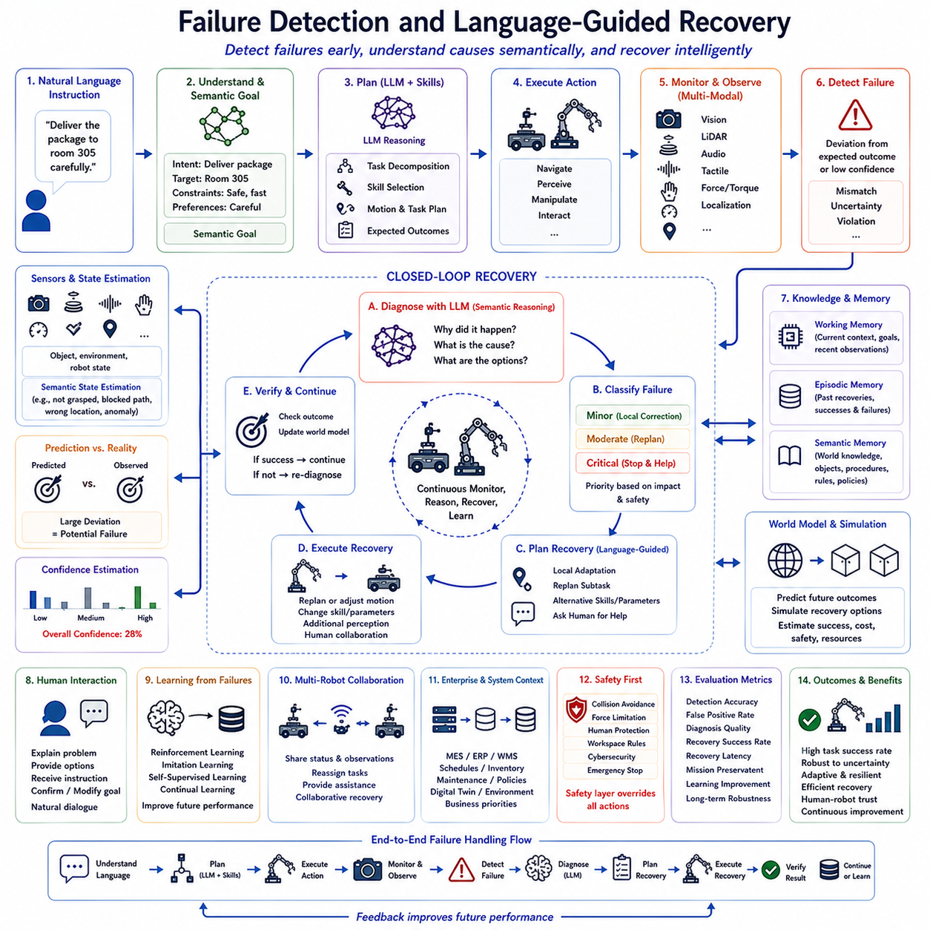
Failure Detection and Language-Guided Recovery represent essential capabilities of modern Vision-Language-Action (VLA) systems because autonomous robots operating in real-world environments inevitably encounter unexpected situations that cannot be completely predicted during planning. Unlike conventional robotic systems designed for highly structured industrial settings, Physical AI platforms must function in dynamic, uncertain, and continuously changing environments where perception errors, object movement, human intervention, sensor degradation, communication delays, and hardware limitations can all influence task execution. Rather than treating failures as exceptional events that terminate execution, modern VLA architectures consider failures as valuable sources of information that trigger adaptive reasoning, replanning, and continuous learning. Language-guided recovery enables robots not only to detect execution problems but also to understand their semantic causes, communicate with human operators when necessary, and generate intelligent recovery strategies that preserve mission objectives.
Traditional robotic systems generally relied on deterministic error handling procedures. Engineers manually defined error codes and associated recovery routines for anticipated failures such as grasp failure, obstacle detection, localization loss, or communication timeout. Although these predefined recovery mechanisms performed reliably within known operating conditions, they lacked flexibility when encountering previously unseen situations. Every new failure scenario required additional engineering effort, making maintenance increasingly difficult as system complexity grew. Modern Physical AI systems instead leverage semantic reasoning capabilities provided by Large Language Models (LLMs) to interpret unexpected situations using contextual knowledge rather than relying solely on predefined recovery rules.
Failure detection begins with continuous monitoring of execution consistency throughout the entire Language-to-Action pipeline. Every stage, including language understanding, semantic goal generation, task planning, motion planning, perception, manipulation, navigation, and interaction, produces expected outcomes together with confidence estimates. During execution, sensor observations are continuously compared against these predicted states. Significant deviations indicate potential failures requiring additional analysis before corrective actions are initiated. This continuous verification process allows failures to be identified immediately rather than only after complete mission failure has occurred.
Perception-driven failure detection represents one of the most common sources of execution monitoring. Cameras, LiDAR, depth sensors, tactile sensors, force sensors, inertial measurement units, localization systems, and proprioceptive feedback collectively provide a comprehensive description of robot behavior and environmental state. If visual observations indicate that an intended object has not been grasped, localization estimates drift beyond acceptable thresholds, collision forces exceed safety limits, or environmental conditions differ from expected predictions, the system recognizes that execution no longer corresponds to planned behavior. Multi-modal sensing significantly improves failure detection accuracy by reducing dependence on any individual sensor modality.
Semantic failure detection extends beyond low-level sensor monitoring by evaluating task-level objectives rather than individual hardware measurements. Instead of determining only whether a manipulator successfully closed its gripper, semantic reasoning evaluates whether the intended object has actually been secured for transportation. Similarly, navigation success is measured not solely by reaching a coordinate but by determining whether the robot has arrived at the correct semantic destination capable of supporting subsequent mission objectives. This task-oriented evaluation enables failures to be interpreted according to user intent rather than isolated mechanical events.
Large Language Models contribute significantly by interpreting failure causes through contextual reasoning. Rather than merely identifying that execution deviated from expectations, LLMs analyze environmental observations, execution history, world knowledge, task dependencies, previous recovery attempts, and user objectives to infer why failures occurred. An unsuccessful inspection may result from inadequate illumination, sensor occlusion, equipment malfunction, incorrect positioning, environmental changes, or incomplete task decomposition. Semantic reasoning distinguishes among these possibilities, allowing recovery procedures to address underlying causes instead of superficial symptoms.
Failure classification enables recovery strategies to be selected according to severity and operational impact. Minor execution deviations such as temporary localization uncertainty or small trajectory errors may require only local motion correction. Moderate failures involving unsuccessful grasps, navigation blockages, or temporary communication interruptions typically initiate local replanning. Critical failures affecting robot safety, hardware integrity, regulatory compliance, or human well-being require immediate execution suspension followed by comprehensive diagnosis before operation resumes. Hierarchical failure classification prevents unnecessary replanning while ensuring appropriate responses to genuinely hazardous situations.
Context awareness substantially improves recovery quality. The same observable failure may require different corrective actions depending on environmental conditions, mission priorities, organizational policies, available resources, or user preferences. A blocked corridor during routine inventory inspection may justify selecting an alternative route, whereas identical conditions during emergency response may require removing the obstruction or requesting human assistance. Language-guided reasoning incorporates these contextual factors into recovery planning rather than relying exclusively on sensor observations.
Language itself becomes an active recovery interface throughout autonomous operation. When uncertainty exceeds acceptable limits or semantic ambiguity prevents reliable recovery, robots communicate naturally with human operators. Rather than displaying numerical error codes, the system generates meaningful explanations describing observed problems, probable causes, available recovery options, and expected consequences. Human operators may provide clarification, modify mission objectives, authorize alternative procedures, or request additional diagnostic information through ordinary conversational language. This collaborative dialogue significantly improves transparency and operational trust.
Recovery planning frequently begins with local adaptation instead of complete mission reconstruction. If only a single subgoal fails, the planner attempts to repair the affected portion of the task hierarchy while preserving all previously completed work. Motion trajectories may be regenerated, grasp parameters adjusted, alternative viewpoints selected, or additional perception actions inserted without modifying unrelated portions of the mission. Such localized recovery minimizes computational cost while improving execution efficiency.
Task decomposition plays a critical role during language-guided recovery. Hierarchical task structures generated earlier in the planning pipeline naturally isolate failures within specific branches of the execution graph. Because dependencies among subtasks remain explicitly represented, planning systems can determine precisely which future operations require modification while leaving independent branches unaffected. This structured reasoning substantially reduces recovery complexity for long-horizon missions.
Memory integration further enhances recovery effectiveness. Working memory preserves the current execution context, temporary hypotheses, and recent observations during diagnosis. Episodic memory stores historical recovery experiences, including successful strategies and unsuccessful interventions encountered during previous missions. Semantic memory provides persistent knowledge regarding object properties, operational procedures, environmental characteristics, and organizational policies. Together, these complementary memory systems enable increasingly sophisticated recovery decisions as operational experience accumulates over time.
World models provide predictive support for recovery planning by estimating future environmental evolution. Rather than responding exclusively to current failures, predictive simulation evaluates alternative recovery strategies before physical execution begins. Multiple hypothetical action sequences can be tested within the internal world model to estimate success probability, execution cost, safety implications, resource consumption, and mission impact. Recovery planners therefore select solutions that maximize long-term mission success instead of merely correcting immediate errors.
Skill libraries also contribute significantly to adaptive recovery. Instead of developing specialized procedures for every possible failure, planning systems reuse existing robotic skills with modified parameters or alternative sequencing. Navigation may employ different path-planning algorithms, manipulation may select alternative grasp configurations, perception may request additional viewpoints, or communication skills may initiate human collaboration. Language-conditioned primitives allow recovery behavior to remain flexible while preserving standardized execution interfaces.
Learning from failures represents one of the greatest advantages of closed-loop Physical AI systems. Every detected failure contributes valuable information regarding environmental uncertainty, sensor limitations, planning assumptions, execution robustness, and human preferences. Reinforcement learning, imitation learning, self-supervised learning, and continual learning algorithms incorporate these experiences into future decision making. Large Language Models similarly improve semantic reasoning by integrating newly observed recovery knowledge into subsequent planning tasks.
Multi-robot systems introduce additional recovery opportunities through collaborative assistance. If one robot experiences hardware degradation, battery limitations, sensor failure, or workspace obstruction, neighboring robots may assume unfinished subtasks, provide additional observations, transport required resources, or establish communication relays. Language-guided coordination enables cooperative recovery by allowing multiple autonomous agents to negotiate task redistribution using shared semantic mission representations.
Industrial deployment requires recovery mechanisms extending beyond physical robot behavior into enterprise operations. Manufacturing Execution Systems (MES), Enterprise Resource Planning (ERP), Warehouse Management Systems (WMS), Digital Twins, maintenance databases, production schedules, and inventory management systems continuously provide organizational context influencing recovery decisions. Equipment maintenance priorities, production deadlines, inventory availability, and operational policies all contribute to selecting appropriate recovery strategies consistent with enterprise objectives.
Safety remains the highest priority throughout every recovery process. Recovery planning never overrides deterministic safety controllers responsible for collision avoidance, force limitation, human protection, workspace restrictions, cybersecurity validation, regulatory compliance, and emergency shutdown procedures. Even when semantic reasoning suggests potentially effective recovery actions, deterministic safety mechanisms independently verify their physical feasibility before execution begins. This separation ensures that adaptive intelligence never compromises operational safety.
Evaluation of failure detection and language-guided recovery extends beyond simple recovery success rates. Comprehensive assessment includes detection accuracy, false positive frequency, diagnosis quality, recovery latency, mission preservation, planning efficiency, semantic explanation quality, human collaboration effectiveness, computational performance, adaptability to unseen failures, learning improvement, and long-term operational robustness. The overall objective is not merely recovering from isolated failures but maintaining reliable autonomous operation throughout extended missions in dynamic real-world environments.
As Vision-Language-Action systems continue to evolve, failure detection and language-guided recovery are expected to become increasingly predictive, collaborative, and self-improving. Future Physical AI architectures will integrate multimodal perception, predictive world models, continual learning, cognitive memory, foundation robot policies, digital twins, and advanced Large Language Models into unified resilience frameworks capable of anticipating failures before they occur. Instead of reacting after execution deviations become visible, autonomous robots will proactively recognize emerging risks, reorganize task strategies, negotiate with human collaborators, coordinate distributed robotic teams, and continuously strengthen their operational knowledge through accumulated experience. Failure Detection and Language-Guided Recovery will therefore become a foundational capability supporting trustworthy, resilient, and long-horizon autonomy across complex open-world robotic applications.

6.9 Multi-Step Evaluation (with Code)
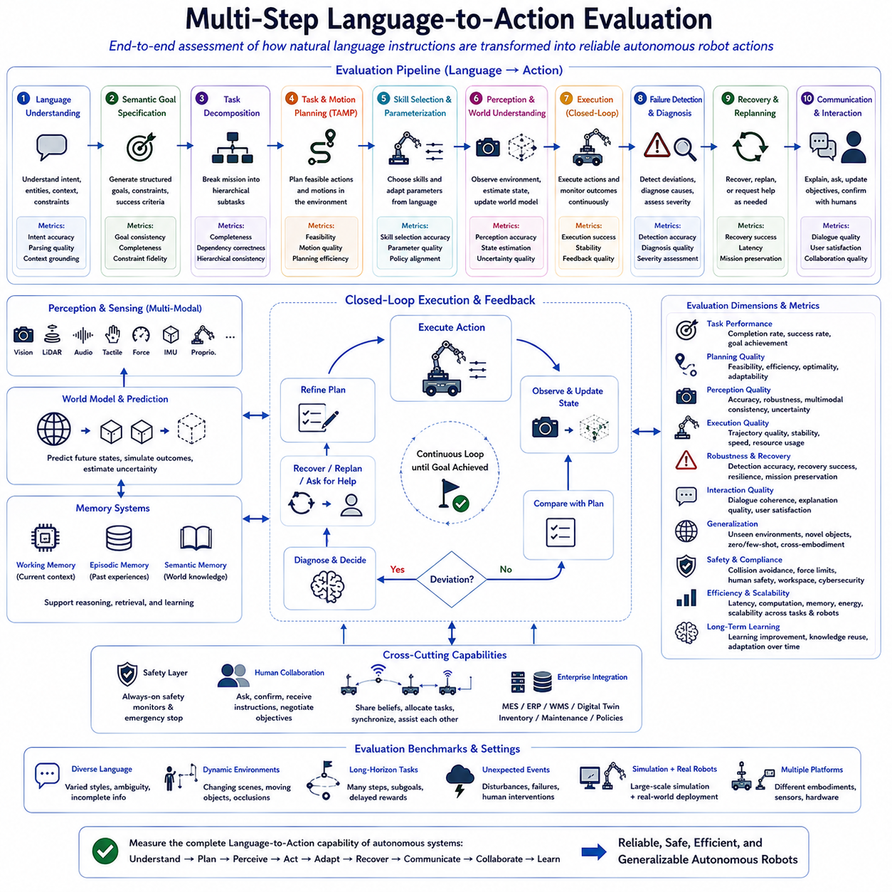
Multi-Step Language-to-Action Evaluation is a critical research area within modern Vision-Language-Action (VLA) systems because it measures how effectively autonomous robots transform complex natural language instructions into reliable long-horizon physical behaviors. Unlike conventional robotics benchmarks that evaluate isolated perception models, navigation algorithms, or manipulation accuracy independently, Language-to-Action evaluation examines the complete cognitive pipeline from language understanding to physical execution. Since real-world robotic missions involve multiple reasoning stages, dynamic environments, and continuous interaction with humans, evaluation must assess the entire decision-making process rather than individual components. Comprehensive evaluation enables researchers to identify weaknesses within integrated autonomous systems and provides measurable evidence for improving future Physical AI architectures.
Traditional robotics evaluation focused primarily on task completion rates under highly controlled laboratory conditions. Navigation systems were evaluated by localization accuracy and travel efficiency, manipulation algorithms by grasp success rates, and perception models by object detection metrics. Although these measurements remain valuable, they fail to capture how semantic reasoning, task planning, world modeling, language understanding, and adaptive execution collectively influence mission success. Modern VLA systems therefore require evaluation methodologies capable of measuring interactions among multiple cognitive modules operating simultaneously.
Multi-step evaluation begins with language understanding. The first objective is determining whether the system correctly interprets user intent rather than merely recognizing individual words. Human instructions frequently contain ambiguity, implicit assumptions, incomplete descriptions, contextual references, and conversational expressions. Evaluation therefore examines semantic parsing accuracy, intent recognition, entity extraction, spatial understanding, temporal reasoning, constraint interpretation, and contextual grounding. Successful interpretation provides the foundation upon which all subsequent planning and execution stages depend.
The second evaluation stage measures semantic goal specification. After language has been interpreted, the robot must generate structured task representations describing desired outcomes, environmental constraints, operational priorities, success criteria, and expected interactions. Evaluation assesses whether generated semantic goals faithfully preserve user intent while remaining sufficiently structured for downstream planning algorithms. Metrics include semantic consistency, abstraction quality, completeness, constraint preservation, and compatibility with planning systems.
Task decomposition represents the third major evaluation component. High-level missions must be transformed into logically consistent hierarchies of executable subtasks. Evaluation examines decomposition completeness, dependency correctness, hierarchical consistency, temporal ordering, resource allocation, and procedural reasoning. Since human instructions rarely specify every intermediate step explicitly, evaluation also measures the system's ability to infer implicit procedural knowledge using semantic reasoning and common-sense understanding.
Task and Motion Planning (TAMP) introduces another important evaluation dimension. Generated symbolic plans must remain physically executable throughout dynamic environments. Evaluation therefore considers planning feasibility, motion quality, collision avoidance, trajectory smoothness, computational efficiency, resource utilization, and adaptability to environmental constraints. Successful planning requires continuous interaction between symbolic reasoning and geometric feasibility rather than independent optimization of each planning layer.
Skill selection and language-conditioned execution constitute the next stage of evaluation. Modern robots possess libraries of reusable skills capable of supporting navigation, manipulation, perception, communication, and interaction. Evaluation determines whether appropriate skills are selected according to semantic goals, environmental conditions, user preferences, operational policies, and robot capabilities. Parameter adaptation is equally important because natural language frequently modifies behavioral characteristics through qualitative expressions such as carefully, efficiently, gently, or rapidly. Successful evaluation therefore includes both skill selection accuracy and parameter optimization quality.
Perception evaluation extends beyond conventional computer vision benchmarks by emphasizing semantic relevance instead of isolated recognition performance. Cameras, LiDAR, depth sensors, tactile sensing, force sensing, localization systems, and proprioception collectively contribute to understanding task progress. Evaluation measures semantic object grounding, environmental awareness, scene understanding, pose estimation accuracy, multimodal consistency, uncertainty estimation, and robustness under changing environmental conditions. Reliable perception remains essential for supporting closed-loop autonomous behavior.
Closed-loop execution introduces continuous evaluation throughout mission performance. Instead of verifying only final outcomes, modern evaluation frameworks monitor intermediate task progress after every action. Robots repeatedly compare predicted states with observed sensor measurements, update internal world models, and refine execution strategies whenever discrepancies emerge. Evaluation therefore measures adaptation speed, feedback quality, replanning efficiency, environmental responsiveness, semantic state estimation, and execution stability throughout long-horizon missions.
Failure detection and recovery represent indispensable evaluation components because real-world autonomy requires robust behavior under uncertainty. Rather than assuming perfect execution, benchmark environments deliberately introduce unexpected disturbances including moved objects, blocked pathways, sensor degradation, communication interruptions, localization failures, hardware limitations, and human intervention. Evaluation examines detection accuracy, diagnosis quality, recovery latency, recovery success rate, mission preservation, explanation quality, and overall resilience. Effective autonomous systems recover gracefully without unnecessary mission interruption.
Human-robot interaction introduces additional evaluation criteria emphasizing communication quality rather than purely physical performance. Robots must explain their reasoning, request clarification, confirm uncertain interpretations, provide progress updates, and negotiate changing objectives using natural language. Evaluation therefore measures dialogue coherence, contextual consistency, explanation accuracy, user satisfaction, interaction efficiency, and collaborative decision quality. Transparent communication significantly increases user trust in autonomous robotic systems.
Memory utilization has become increasingly important within advanced Physical AI architectures. Working memory supports ongoing reasoning, episodic memory stores previous experiences, and semantic memory maintains long-term knowledge regarding objects, environments, procedures, and organizational policies. Evaluation measures memory retrieval accuracy, contextual relevance, knowledge consistency, long-term adaptation, and the ability to reuse previous experiences during novel tasks. Memory-aware evaluation reflects the growing cognitive capabilities of intelligent robots.
World model evaluation focuses on predictive understanding rather than reactive perception alone. Modern robots continuously estimate future environmental evolution, object movement, human behavior, resource availability, and operational constraints. Evaluation therefore considers prediction accuracy, simulation fidelity, uncertainty propagation, planning support, environmental consistency, and long-term forecasting capability. Accurate predictive world models significantly improve planning robustness and operational efficiency.
Multi-robot evaluation extends these concepts to collaborative autonomous systems. Rather than measuring isolated robot performance, evaluation considers cooperative task allocation, communication efficiency, synchronization quality, shared situational awareness, collaborative recovery, workload balancing, conflict avoidance, and overall fleet productivity. Effective multi-robot evaluation reflects the increasing importance of distributed Physical AI operating across logistics, manufacturing, inspection, agriculture, and infrastructure maintenance.
Industrial deployment requires evaluation beyond laboratory environments. Enterprise systems including Manufacturing Execution Systems (MES), Enterprise Resource Planning (ERP), Warehouse Management Systems (WMS), Digital Twins, inventory databases, maintenance scheduling systems, and production management platforms continuously influence robot behavior. Evaluation therefore includes enterprise integration quality, workflow compatibility, regulatory compliance, operational reliability, maintenance efficiency, and long-term deployment performance under realistic industrial conditions.
Safety evaluation remains independent from cognitive reasoning throughout every execution stage. Autonomous systems must consistently satisfy collision avoidance, force limitation, human detection, workspace restrictions, cybersecurity validation, regulatory compliance, emergency stopping procedures, and equipment health monitoring regardless of semantic planning decisions. Evaluation therefore verifies that deterministic safety mechanisms reliably override unsafe behaviors while minimizing unnecessary operational interruptions.
Generalization has become one of the most important research objectives within Language-to-Action evaluation. Modern VLA systems should perform successfully across previously unseen environments, novel objects, unfamiliar instructions, different robot embodiments, changing sensor configurations, and evolving operational policies. Evaluation therefore emphasizes robustness under distribution shifts, zero-shot reasoning, few-shot adaptation, cross-domain transfer, and cross-platform portability. Generalization determines whether autonomous intelligence extends beyond narrowly defined benchmark datasets.
Benchmark design itself represents an active research topic. Effective evaluation datasets must contain realistic language diversity, dynamic environments, long-horizon missions, multimodal perception, collaborative tasks, unexpected failures, changing objectives, and continuous interaction rather than isolated static scenarios. Synthetic simulation environments provide large-scale reproducibility, while physical robot deployments validate transferability to real-world operations. Combining both evaluation paradigms provides comprehensive understanding of system capabilities.
Computational performance also plays a significant role in practical evaluation. Language understanding, semantic reasoning, planning, perception, world modeling, and feedback processing must operate within real-time computational constraints imposed by onboard robotic hardware. Evaluation therefore measures inference latency, memory consumption, computational efficiency, energy utilization, scalability across hardware platforms, and responsiveness under increasing task complexity.
Ultimately, Multi-Step Language-to-Action Evaluation seeks to measure complete autonomous intelligence rather than isolated algorithmic performance. Successful Physical AI systems must understand language, generate semantic goals, decompose tasks, select appropriate skills, perceive changing environments, execute robustly, recover from failures, communicate naturally with humans, coordinate with other robots, and continually improve through accumulated experience. Evaluating these capabilities as an integrated cognitive pipeline provides significantly more meaningful insight than independently measuring individual modules. As Vision-Language-Action systems continue to evolve toward increasingly capable general-purpose robotic intelligence, comprehensive multi-step evaluation will become an indispensable foundation for benchmarking, certification, safety validation, industrial deployment, and trustworthy long-term autonomous operation across complex real-world environments.

6.10 Production Deployment Case Study (with Code)
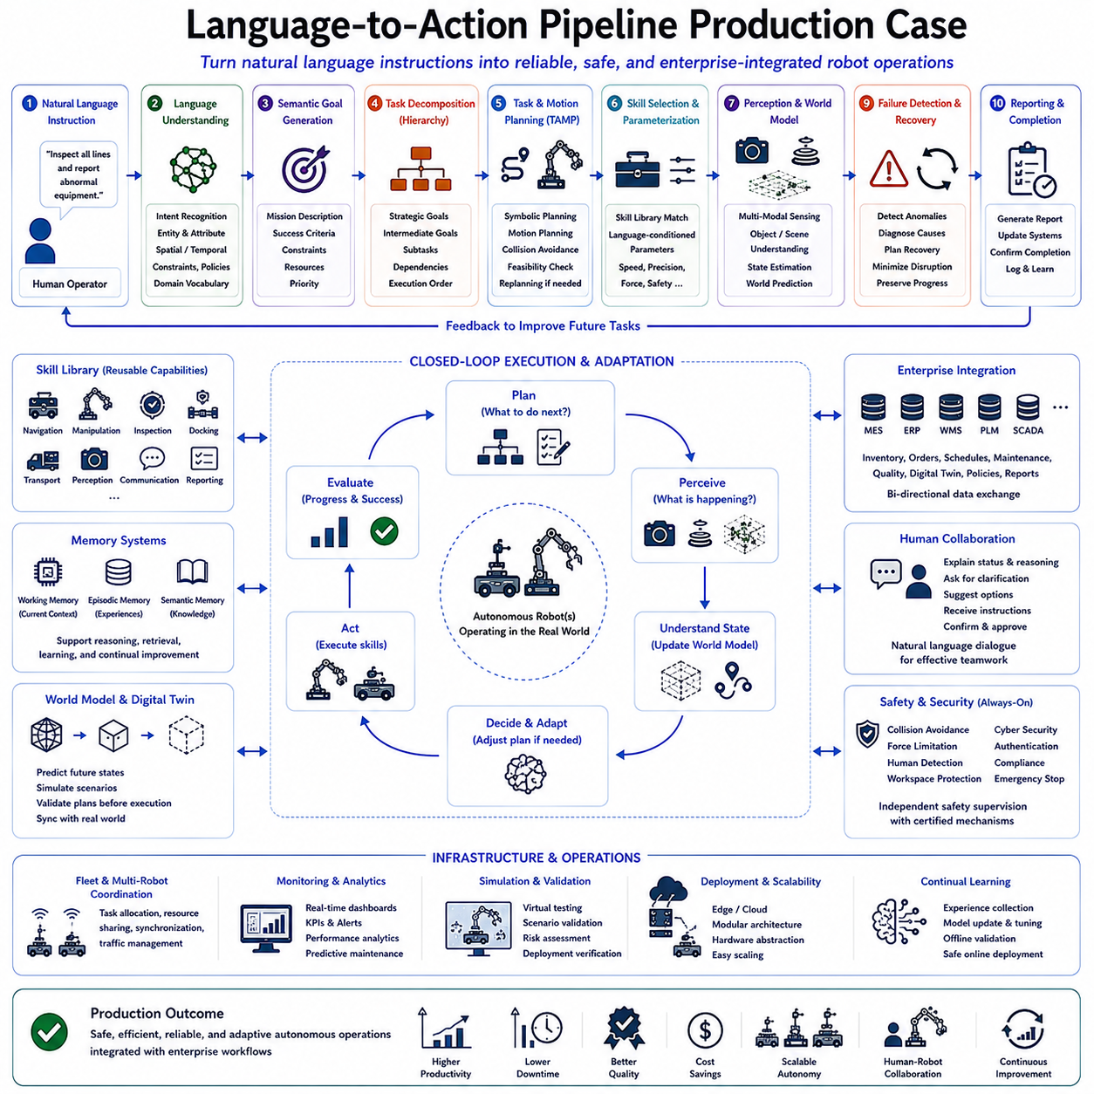
The Language-to-Action Pipeline Production Case demonstrates how modern Vision-Language-Action (VLA) technologies are deployed within real industrial environments to transform natural language instructions into reliable, safe, and autonomous physical operations. While previous chapters introduced the individual components of language understanding, semantic reasoning, task decomposition, planning, skill execution, feedback control, recovery, and evaluation, this chapter focuses on integrating these technologies into production-grade robotic systems. The objective is not merely to demonstrate algorithmic capability in laboratory settings, but to establish a complete end-to-end architecture capable of supporting continuous industrial operation under real-world constraints involving dynamic environments, enterprise systems, safety regulations, and long-term maintenance.
A production-ready Language-to-Action system begins with a human operator expressing high-level objectives using natural language. Instead of programming individual robot actions or manually creating mission scripts, operators communicate using ordinary instructions such as “Inspect all production lines and report abnormal equipment,” “Move completed pallets to the shipping area while avoiding active workers,” or “Prepare the warehouse for the afternoon shipment.” These instructions become the entry point of an intelligent robotic workflow that automatically converts human intent into executable autonomous behavior.
The first production component performs natural language understanding. Large Language Models analyze the incoming instruction to identify user intent, operational objectives, referenced objects, spatial relationships, temporal requirements, safety constraints, organizational policies, and expected outcomes. Domain-specific terminology used within manufacturing, logistics, healthcare, or infrastructure inspection is interpreted using enterprise knowledge bases and specialized semantic vocabularies. Rather than translating language directly into robot commands, the system first constructs a structured semantic representation that serves as the common interface for downstream planning modules.
Semantic goal generation transforms interpreted language into machine-readable objectives. These structured goals contain mission descriptions, success criteria, operational constraints, required resources, environmental assumptions, and priority levels. Production systems frequently maintain standardized semantic schemas so that planning modules, execution engines, enterprise software, and monitoring systems share a consistent understanding of mission intent. This semantic abstraction layer significantly simplifies interoperability among heterogeneous robotic platforms.
Task decomposition subsequently converts high-level objectives into hierarchical execution plans. Rather than producing one long sequence of robot actions, the system organizes missions into strategic goals, intermediate objectives, and executable subtasks. For example, an industrial inspection mission may first divide the facility into inspection zones, assign navigation objectives, schedule sensor operations, perform anomaly detection, validate observations, and finally generate maintenance reports. Hierarchical decomposition enables modular planning, localized recovery, and efficient execution monitoring throughout extended missions.
Task and Motion Planning integrates symbolic reasoning with physical feasibility analysis. Symbolic planners determine logical execution sequences while motion planners compute collision-free trajectories satisfying kinematic constraints, environmental obstacles, dynamic safety requirements, and robot capabilities. Continuous interaction between these planning layers ensures that generated task sequences remain executable under real operational conditions. If physical constraints invalidate symbolic plans, planning algorithms revise execution strategies until both logical correctness and physical feasibility are simultaneously satisfied.
Production systems organize robot capabilities through standardized skill libraries. Navigation, manipulation, perception, inspection, docking, transportation, communication, and reporting are implemented as reusable modular skills with clearly defined interfaces. Large Language Models select appropriate skills according to semantic objectives while language-conditioned parameterization adjusts execution behavior based on qualitative instructions. Commands requesting careful inspection, rapid transportation, energy-efficient navigation, or precise manipulation modify execution parameters without changing underlying software implementations.
Perception represents one of the most critical components within production environments because industrial facilities continuously evolve during operation. Cameras, LiDAR, depth sensors, force sensing, tactile sensing, thermal imaging, localization systems, inertial measurement units, and environmental sensors collectively maintain an accurate representation of current operating conditions. Semantic perception algorithms identify relevant objects, equipment status, human workers, production materials, safety zones, and environmental anomalies. These continuously updated observations support adaptive planning and reliable autonomous execution.
World models provide predictive understanding extending beyond immediate observations. Production environments involve moving vehicles, changing inventories, scheduled maintenance, production cycles, temporary workspace restrictions, and human activities. Predictive world models estimate future environmental evolution, enabling robots to anticipate congestion, resource conflicts, equipment availability, and operational bottlenecks before they occur. Such predictive reasoning substantially improves planning efficiency while reducing unnecessary interruptions.
Enterprise integration distinguishes production deployments from research prototypes. Manufacturing Execution Systems (MES), Enterprise Resource Planning (ERP), Warehouse Management Systems (WMS), Product Lifecycle Management (PLM), Digital Twins, inventory databases, quality management systems, maintenance platforms, scheduling software, and supervisory control systems continuously exchange information with the Language-to-Action pipeline. Robot missions therefore become synchronized with broader organizational workflows rather than operating as isolated automation components.
Closed-loop execution continuously validates task progress throughout operation. Every executed action produces new sensory observations that are compared against predicted semantic states. Differences between expected and observed outcomes trigger world model updates, localized replanning, additional perception actions, or recovery procedures. Continuous feedback transforms execution into an adaptive decision-making process rather than a predetermined sequence of fixed robot commands. This capability becomes particularly important in facilities where humans, robots, forklifts, and autonomous vehicles simultaneously share operational spaces.
Failure detection operates continuously across every stage of execution. Sensor inconsistencies, localization drift, unsuccessful manipulations, communication interruptions, environmental changes, hardware degradation, unexpected obstacles, and policy violations are detected before mission integrity becomes compromised. Rather than simply reporting failures, semantic reasoning determines probable root causes by combining execution history, environmental observations, world knowledge, and organizational context. Recovery planning then selects corrective actions minimizing disruption while preserving completed mission progress whenever possible.
Language-guided recovery introduces collaborative intelligence into production systems. When autonomous recovery becomes uncertain, robots communicate naturally with supervisors using conversational explanations instead of numerical error codes. Operators receive concise descriptions of observed problems, likely causes, available recovery options, and estimated operational consequences. Human instructions may modify priorities, authorize alternative procedures, provide missing information, or assign additional resources. This collaborative dialogue significantly improves operational transparency while maintaining efficient human oversight.
Memory systems support continual improvement across long-term industrial deployment. Working memory maintains active mission context during execution. Episodic memory stores historical task experiences, successful recovery strategies, and operational observations. Semantic memory preserves knowledge regarding facility layouts, equipment characteristics, organizational procedures, safety regulations, and standard operating practices. As robots accumulate operational experience, future missions benefit from increasingly refined reasoning, planning, and execution strategies without requiring complete system redesign.
Multi-robot coordination becomes increasingly important within large-scale production facilities. Autonomous mobile robots, inspection robots, robotic manipulators, inventory systems, and collaborative robotic platforms share semantic mission representations while coordinating resource allocation, task distribution, communication schedules, navigation priorities, and recovery procedures. Language-to-Action pipelines provide a unified reasoning framework enabling heterogeneous robotic platforms to collaborate using common semantic objectives rather than independent procedural scripts.
Cybersecurity and functional safety remain fundamental architectural requirements throughout production deployment. Language understanding, planning, perception, execution, communication, and enterprise integration all operate under deterministic safety supervision. Collision avoidance, force limitation, workspace protection, cybersecurity validation, authentication, regulatory compliance, emergency shutdown procedures, and equipment health monitoring remain active independently of semantic reasoning. Adaptive intelligence therefore enhances operational flexibility without compromising certified safety mechanisms.
Performance monitoring extends beyond simple task completion statistics. Production operators require continuous visibility into execution efficiency, mission reliability, planning quality, resource utilization, computational latency, energy consumption, fleet coordination, safety compliance, maintenance status, and overall operational productivity. Interactive dashboards aggregate semantic execution information with enterprise operational metrics, providing supervisors comprehensive situational awareness supporting strategic decision making and continuous optimization.
Scalability represents another defining requirement for production deployment. The same Language-to-Action architecture should support individual service robots, warehouse fleets, manufacturing cells, inspection systems, healthcare assistants, outdoor autonomous vehicles, and infrastructure maintenance platforms. Modular semantic interfaces, standardized skill libraries, hardware abstraction layers, and distributed computing architectures allow organizations to expand robotic capabilities incrementally while preserving software compatibility across multiple robot embodiments and operational domains.
Simulation and Digital Twin technologies play an essential role before deployment. Candidate planning strategies, language interpretations, recovery procedures, resource schedules, and multi-robot coordination algorithms are validated within virtual environments that accurately represent physical facilities. World models synchronize simulated and real environments, allowing engineers to evaluate system behavior under normal operation, equipment failures, emergency scenarios, and changing production requirements before introducing updates into live industrial systems. Continuous synchronization between simulation and reality significantly reduces deployment risk.
Long-term operation requires continual learning without sacrificing reliability. New operational knowledge acquired during production is incorporated through supervised validation, offline retraining, reinforcement learning, imitation learning, and foundation model refinement. Rather than immediately modifying certified operational behavior, production systems carefully validate learned improvements before controlled deployment. This disciplined learning process balances innovation with the stringent reliability requirements expected within industrial environments.
The complete Language-to-Action Production Pipeline ultimately represents a unified cognitive architecture that transforms natural language into dependable industrial autonomy. Human intentions are interpreted semantically, converted into structured goals, decomposed into executable tasks, validated through motion planning, executed using reusable robotic skills, monitored through continuous perception, refined through closed-loop feedback, recovered using language-guided reasoning, integrated with enterprise systems, and improved through accumulated operational experience. This end-to-end architecture demonstrates how modern Physical AI extends beyond laboratory demonstrations to become a practical foundation for intelligent manufacturing, logistics, infrastructure inspection, healthcare, agriculture, and numerous other real-world autonomous robotic applications.

