Volume 20. Vision Language Action (VLA) Models

Chapter 3. Language Models for Robotics

3.1 The Role of Large Language Models in Robotics
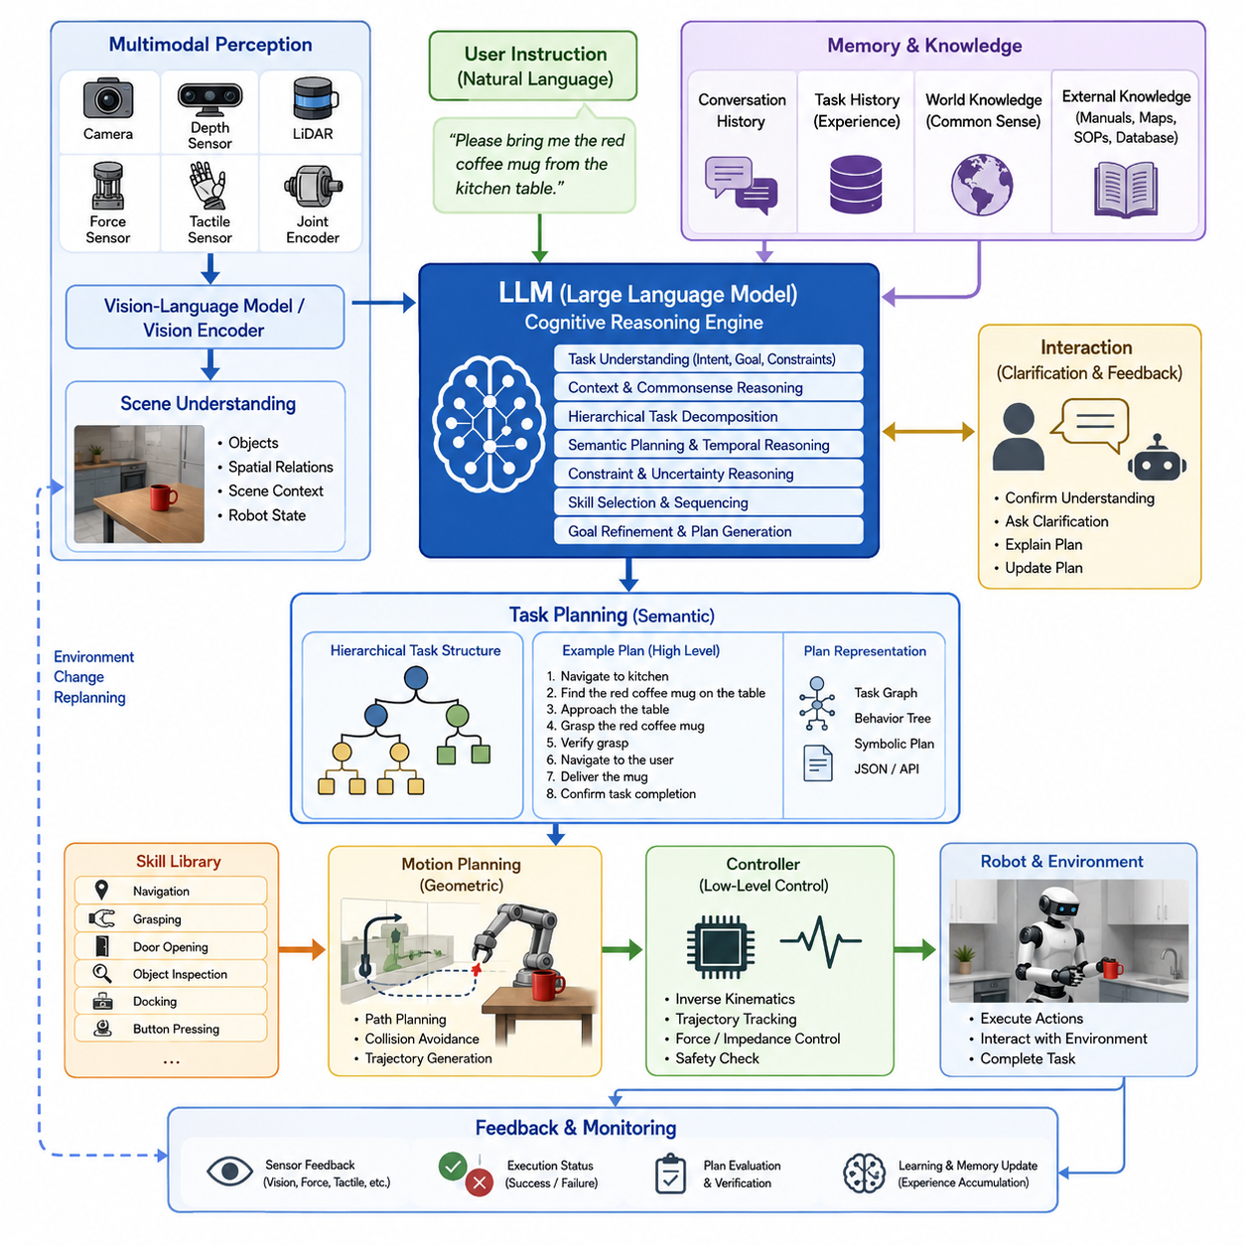
`42_03_01_LLM_Role_in_Robotics_Task_Understanding_Planning` is an appropriate chapter under Volume 42 → 42.03 Language Models for Robotics, focusing on how Large Language Models serve as cognitive reasoning engines within Vision-Language-Action (VLA) systems for robotic task understanding and planning. This aligns with the uploaded library structure.
Large Language Models have fundamentally changed the role of artificial intelligence in robotics by enabling robots to understand human intentions, reason about complex tasks, generate executable plans, and communicate naturally with users. Unlike traditional robotic software, where every task must be explicitly programmed as a sequence of predefined operations, LLM-powered robots interpret high-level natural language instructions and transform them into structured plans that can ultimately be executed by robot control systems. This capability bridges the long-standing gap between human language and robotic actions, making robots significantly more flexible, adaptive, and capable of operating in dynamic environments.
In modern Vision-Language-Action architectures, the Large Language Model functions primarily as a cognitive planning module rather than a low-level controller. The LLM does not directly generate motor torques or servo commands. Instead, it receives multimodal information from perception modules, interprets user intentions, reasons about the current environment, determines an appropriate sequence of actions, and generates semantic task plans that are later translated into executable robot skills by downstream planning and control systems.
The overall robotic cognitive pipeline begins with multimodal perception. Cameras, depth sensors, LiDAR systems, force sensors, tactile sensors, joint encoders, and environmental maps continuously provide information describing the robot's surroundings and internal state. Vision encoders transform raw sensor observations into compact semantic embeddings that describe objects, spatial relationships, scene context, and environmental conditions. These representations become part of the prompt provided to the Large Language Model together with user instructions and robot status information.
Human instructions are generally expressed in natural language rather than robot programming languages. A user may instruct a robot to bring a bottle of water from the kitchen, inspect a warehouse shelf, organize scattered tools, or deliver a package to a specific location. Such instructions are inherently ambiguous because humans naturally omit assumptions that other humans easily infer from context. The LLM serves as an interpreter that fills these missing semantic gaps by leveraging its extensive prior knowledge acquired during pretraining.
Task understanding begins by identifying the user's primary objective. Rather than interpreting words individually, the LLM analyzes the complete instruction, extracting task intent, desired outcomes, constraints, environmental assumptions, temporal ordering, and implicit requirements. It identifies verbs representing actions, nouns representing target objects, adjectives describing properties, locations indicating spatial goals, and conditions that constrain execution.
For example, the instruction “Please bring me the red coffee mug from the kitchen table” requires considerably more reasoning than a simple object detection task. The robot must understand that the final goal is delivering the mug to the user rather than merely locating it. The phrase “red coffee mug” specifies semantic object properties, while “kitchen table” provides spatial context. The LLM organizes these concepts into a structured representation that later guides perception, navigation, manipulation, and interaction.
Context understanding represents another important responsibility of the LLM. Human instructions frequently depend on shared context rather than explicit descriptions. Commands such as “Pick up the one I used yesterday” or “Return it to where you found it” require memory of previous interactions. By maintaining conversational history and contextual information, the LLM allows robots to perform long-term reasoning across multiple interactions rather than treating each instruction independently.
Modern robotic systems also require commonsense reasoning that cannot easily be encoded using traditional programming. Humans naturally understand that fragile objects should be handled carefully, liquids should remain upright, doors must be opened before passing through, and heavy objects require stable grasps. LLMs possess extensive commonsense knowledge acquired during large-scale language pretraining, allowing robots to infer many of these unstated requirements during task planning.
After understanding user intent, the LLM proceeds to hierarchical task decomposition. Complex missions rarely consist of a single robotic action. Instead, they are decomposed into a sequence of smaller subgoals that collectively achieve the desired objective. A household cleaning task may involve locating cleaning supplies, navigating to multiple rooms, identifying dirty surfaces, selecting appropriate cleaning tools, performing cleaning operations, verifying completion, and returning equipment to storage. The LLM organizes these subtasks into an ordered plan while preserving dependencies among individual operations.
Hierarchical planning significantly improves robustness because each subgoal can be independently monitored, verified, and corrected if necessary. Rather than attempting to solve an entire mission as one monolithic optimization problem, robots incrementally accomplish smaller objectives that gradually converge toward the overall task goal.
Semantic planning differs fundamentally from geometric planning. Traditional motion planners compute collision-free trajectories through configuration space using mathematical optimization techniques. LLMs instead reason about semantic relationships among tasks, objects, and goals. They determine what should be done rather than precisely how every joint should move. This separation of responsibilities enables the LLM to operate at a high level while lower-level planning algorithms generate feasible robot trajectories.
The planning process frequently incorporates external knowledge. Many robotic tasks require understanding of objects, environments, or procedures beyond what can be directly observed. LLMs integrate world knowledge, procedural knowledge, and commonsense reasoning to generate more intelligent plans. A warehouse robot, for example, understands that fragile packages require gentle handling, refrigerated products belong in cold storage, hazardous materials require special precautions, and heavy objects should be transported using appropriate equipment.
Environmental understanding also plays a crucial role. The LLM reasons about scene descriptions generated by Vision-Language Models or visual encoders, allowing it to understand spatial relationships such as “the box is under the table,” “the screwdriver is next to the toolbox,” or “the charging station is behind the robot.” These semantic relationships support more effective planning than relying solely on numerical coordinates.
Constraint reasoning represents another essential capability. Robot tasks often include physical, temporal, safety, or operational constraints. The LLM considers these constraints while generating plans. Battery capacity, payload limitations, joint range restrictions, collision avoidance requirements, workspace boundaries, human safety regulations, and task priorities all influence the resulting action sequence.
Temporal reasoning enables robots to execute tasks in appropriate order. Certain operations cannot begin until prerequisite actions have completed successfully. A robot cannot place an object before grasping it, cannot inspect an enclosed container before opening it, and cannot navigate through a closed door without first opening it. The LLM naturally captures these dependencies through sequential reasoning.
Goal refinement frequently occurs during planning. Human instructions are often intentionally brief because people assume contextual understanding. The LLM expands these abbreviated requests into complete operational objectives. A request such as “Set the table” becomes a structured plan involving plate placement, utensil arrangement, cup positioning, napkin organization, and verification of completion according to learned dining conventions.
The LLM also generates intermediate symbolic representations that simplify downstream processing. Instead of directly producing motor commands, it creates structured task graphs, behavior trees, symbolic action sequences, planning trees, JSON representations, or domain-specific planning languages that subsequent software modules can interpret and execute.
Task planning increasingly incorporates uncertainty estimation. Real-world environments contain incomplete observations, ambiguous language, occluded objects, and dynamic changes. Modern LLM-based planning systems explicitly identify uncertain assumptions and request additional information when necessary. Rather than making unsupported decisions, the robot may ask clarification questions such as “Which blue box do you mean?” or “Should I place the package inside the room or outside the door?”
Interactive planning significantly improves overall system reliability. Human-robot collaboration becomes a dialogue rather than a one-way command interface. The robot explains its interpretation of the task, requests clarification when ambiguity exists, confirms critical decisions, and updates plans as new information becomes available.
Modern robotic systems often employ retrieval-augmented planning. Rather than relying exclusively on pretrained knowledge, the LLM retrieves documentation, robot capabilities, environmental maps, equipment specifications, previous task histories, or company operating procedures from external databases. This retrieval process greatly improves planning accuracy while reducing hallucination.
Skill selection represents another major responsibility of the LLM. Robots typically possess libraries containing reusable motion primitives such as navigation, grasping, opening doors, pressing buttons, docking, visual inspection, object recognition, or charging. The LLM selects appropriate skills based on task requirements and determines the optimal execution sequence.
Task planning also integrates closely with behavior trees and hierarchical finite state machines. The LLM generates semantic task structures that are subsequently converted into executable robotic workflows. This combination preserves the flexibility of language-based reasoning while maintaining the deterministic execution characteristics required for industrial robotics.
Reasoning over multiple objectives is increasingly important in autonomous robots. A service robot may simultaneously optimize task completion time, energy consumption, safety, user comfort, and operational efficiency. The LLM evaluates these competing objectives and generates plans that balance multiple optimization criteria rather than pursuing a single metric.
In collaborative robotics, the LLM reasons about human intentions, predicts future human actions, and coordinates robot behavior accordingly. It determines when humans should perform specific subtasks, when robots should assist, when communication is required, and how responsibilities should be distributed among team members.
Dynamic replanning is another critical capability. Real-world environments continuously change due to moving people, relocated objects, unexpected obstacles, or equipment failures. The LLM monitors execution progress and updates task plans whenever environmental conditions deviate significantly from original assumptions. Rather than restarting the entire mission, the planner modifies only the affected portions of the execution sequence.
Memory plays an increasingly important role in long-duration robotic missions. Episodic memory records previous experiences, semantic memory stores general knowledge, procedural memory captures learned skills, and working memory maintains current task context. Together, these memory systems enable robots to improve planning quality across repeated interactions.
Modern VLA architectures frequently employ a hierarchical reasoning framework in which perception modules describe the environment, the LLM performs semantic reasoning, task planners generate executable workflows, motion planners compute feasible trajectories, controllers produce actuator commands, and feedback systems continuously monitor execution outcomes. This layered organization separates cognitive reasoning from physical control while maintaining efficient information flow between abstraction levels.
Despite remarkable progress, several challenges remain. LLMs may occasionally generate logically plausible but physically impossible plans, overlook safety constraints, misunderstand spatial relationships, or hallucinate nonexistent objects. Consequently, modern robotic systems incorporate verification modules, affordance estimation, geometric validation, simulation testing, and safety controllers that validate LLM-generated plans before execution.
Latency also presents practical challenges for real-time robotics. Large foundation models may require hundreds of milliseconds or even seconds to generate responses. Consequently, many robotic systems employ hierarchical architectures in which the LLM performs relatively infrequent high-level planning while low-latency local controllers execute continuous feedback control loops independently.
Future robotic systems are expected to integrate increasingly capable multimodal foundation models capable of jointly reasoning over language, images, depth maps, point clouds, audio, tactile feedback, force sensing, robot state, environmental memory, and long-term mission history. Rather than functioning as isolated language processors, these models will become comprehensive cognitive engines capable of understanding complex environments, predicting future events, coordinating multiple robots, adapting to unfamiliar situations, and generating robust long-horizon plans. As Vision-Language-Action systems continue to evolve, the Large Language Model will remain the central reasoning component that transforms human intentions into structured, executable robotic behaviors, enabling autonomous robots to operate safely, intelligently, and collaboratively across industrial, commercial, service, healthcare, logistics, construction, agricultural, and domestic environments.

3.2 LLM-Based Task Planning and Chain-of-Thought (with Code)
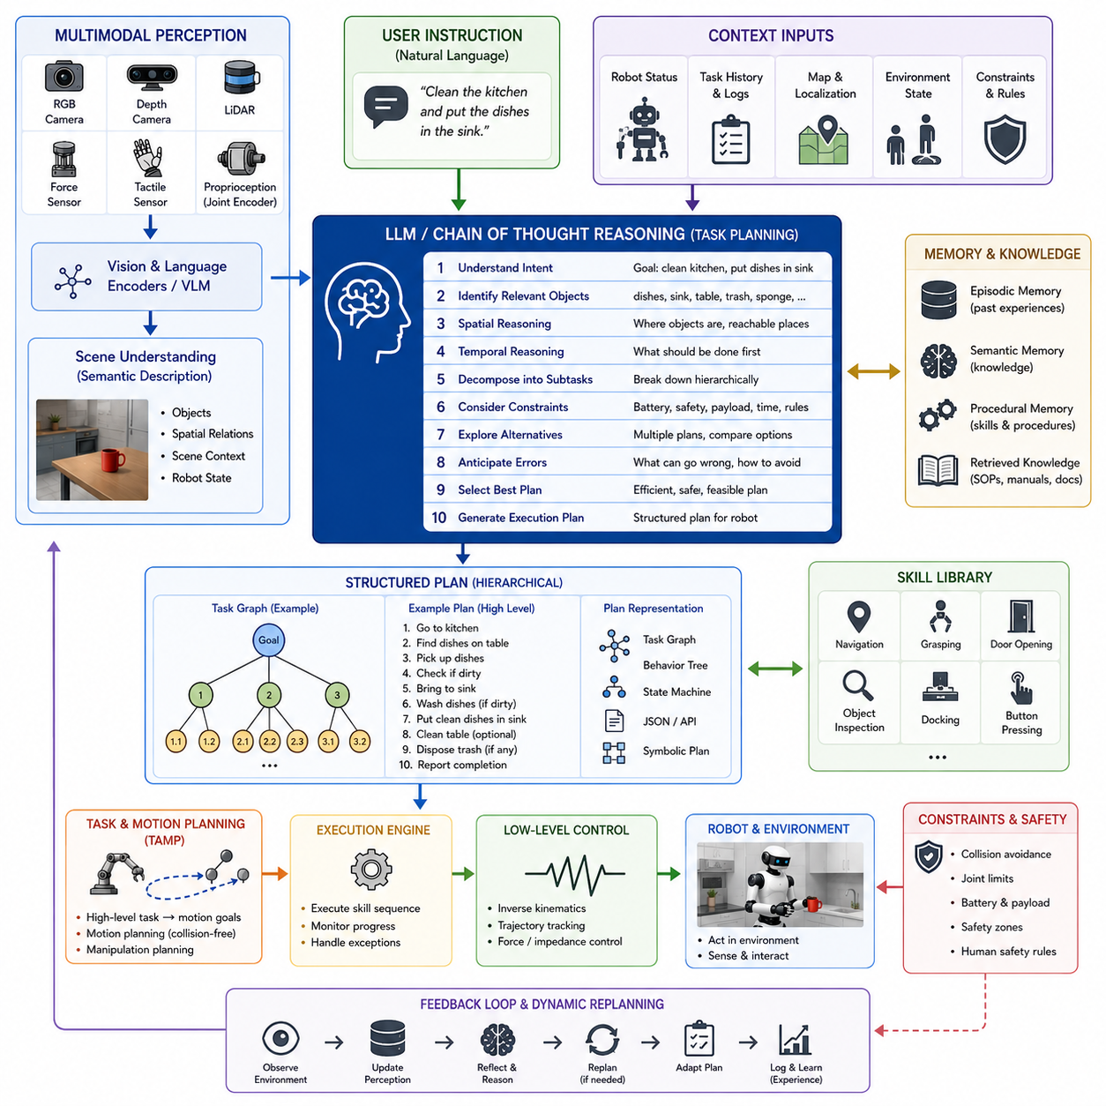
Large Language Models (LLMs) have significantly expanded the capabilities of autonomous robotic systems by enabling robots to reason about complex tasks instead of merely reacting to predefined commands. Traditional robotic task planners primarily rely on manually engineered state machines, symbolic planners, or behavior trees in which every possible situation must be explicitly represented by human engineers. While these methods provide deterministic behavior, they often struggle when robots encounter ambiguous instructions, unfamiliar environments, or situations requiring common-sense reasoning. LLM-based task planning introduces a fundamentally different paradigm in which robots perform semantic reasoning before generating executable plans. One of the most influential concepts supporting this capability is Chain of Thought (CoT) reasoning, which enables the model to decompose complicated problems into logically connected intermediate reasoning steps before producing a final decision.
Chain of Thought reasoning does not simply produce an answer directly from an input instruction. Instead, it encourages the model to perform structured internal reasoning that gradually transforms an abstract user request into an executable sequence of robotic actions. Rather than treating task planning as a direct language-to-action mapping, CoT allows the robot to reason about goals, environmental conditions, constraints, object relationships, temporal dependencies, and alternative solutions before deciding which actions should be executed.
Within modern Vision-Language-Action architectures, the LLM serves as the cognitive planning engine operating above perception, mapping, localization, motion planning, and low-level control systems. The perception subsystem continuously produces semantic descriptions of the environment using RGB cameras, depth cameras, LiDAR, force sensors, tactile sensors, proprioceptive measurements, and environmental maps. Vision encoders transform these heterogeneous observations into high-dimensional semantic embeddings, while Vision-Language Models generate natural language scene descriptions. These representations become inputs to the LLM together with user instructions, robot status information, task history, memory, and operational constraints.
The first stage of Chain of Thought planning begins with comprehensive instruction interpretation. Human instructions are rarely complete specifications of robotic behavior. Instead, users naturally omit details that humans normally infer from common sense. A command such as “Clean the kitchen” leaves numerous questions unanswered. Which surfaces should be cleaned first? Which cleaning tools are appropriate? Should fragile objects be moved beforehand? Should dishes be washed before wiping countertops? A conventional robot controller cannot answer these questions without explicit programming, whereas an LLM employing Chain of Thought reasoning systematically fills these gaps using prior knowledge and contextual understanding.
Intent recognition forms the foundation of the reasoning process. The LLM first determines the user's primary objective rather than immediately considering possible actions. It identifies whether the task involves navigation, manipulation, inspection, transportation, cleaning, assembly, interaction, or multiple combined objectives. The desired outcome becomes the anchor that guides all subsequent reasoning stages.
Following intent recognition, the model identifies relevant objects mentioned explicitly or implicitly within the instruction. Objects are analyzed not only according to their names but also according to their functional roles, affordances, semantic categories, physical properties, expected locations, and interaction requirements. The LLM understands that a coffee mug is graspable, contains liquid, should remain upright during transportation, and is commonly located in kitchens, offices, or dining rooms. This semantic knowledge dramatically improves planning robustness.
Spatial reasoning constitutes another major component of Chain of Thought planning. Robot tasks almost always involve spatial relationships among objects, humans, and environmental structures. Rather than reasoning only about Cartesian coordinates, the LLM interprets qualitative spatial concepts such as “next to,” “inside,” “behind,” “above,” “under,” and “near.” These semantic spatial relationships complement metric localization produced by mapping systems and greatly simplify high-level planning.
Temporal reasoning naturally emerges during the reasoning sequence. Many robotic tasks involve prerequisite relationships between actions. A robot cannot place an object before grasping it, cannot inspect the contents of a cabinet before opening the cabinet door, and cannot recharge its battery before reaching the charging station. Chain of Thought reasoning explicitly identifies these dependencies and organizes them into coherent execution sequences.
Task decomposition is perhaps the most visible characteristic of Chain of Thought planning. Instead of attempting to solve an entire mission in one step, the LLM recursively divides the problem into manageable subtasks. Each subtask may itself be further decomposed until it becomes executable by existing robot skills. This hierarchical reasoning process closely resembles how experienced human operators naturally approach complicated tasks.
Consider a warehouse inspection robot receiving the instruction, “Inspect all damaged pallets in Zone B and report the results.” Rather than producing a single action, the LLM reasons through multiple planning stages. It identifies the inspection objective, determines the destination, plans navigation to Zone B, identifies pallet detection as a prerequisite, filters damaged pallets from normal ones, generates an efficient inspection sequence, performs visual inspection, records observations, aggregates results, and finally generates an inspection report. Each of these stages may itself involve additional reasoning regarding navigation safety, battery capacity, sensor visibility, and environmental conditions.
Constraint reasoning represents another essential element of Chain of Thought planning. Robots operate under numerous physical, computational, operational, and safety constraints. Battery limitations, payload capacity, joint limits, sensor visibility, communication bandwidth, collision avoidance, human safety regulations, and mission deadlines all influence the planning process. Rather than treating constraints as independent filters, the LLM integrates them into the reasoning sequence itself, producing plans that are feasible from the beginning rather than requiring extensive post-processing.
Chain of Thought planning also incorporates commonsense reasoning acquired during large-scale language pretraining. Humans naturally understand that glass objects require careful handling, slippery floors reduce stability, doors should be opened before passing through, and liquids should remain upright during transportation. These facts rarely appear explicitly within robot programming languages but significantly improve practical performance. The LLM leverages this implicit knowledge to generate safer and more realistic plans.
One particularly important capability is ambiguity resolution. Human instructions often contain incomplete references, vague descriptions, or underspecified objectives. When ambiguity cannot be resolved confidently using context, Chain of Thought reasoning allows the LLM to identify uncertainty rather than making unsupported assumptions. The robot may ask clarification questions, request additional visual observations, or consult stored task history before continuing execution. This interactive planning strategy greatly reduces execution failures.
Environmental reasoning extends beyond object recognition into understanding scene dynamics. The LLM reasons about movable obstacles, crowded environments, temporary access restrictions, changing lighting conditions, and dynamic human activities. Rather than assuming a static environment, the planner continuously evaluates whether previously generated plans remain valid as new observations arrive.
Memory plays an increasingly important role throughout the reasoning process. Episodic memory stores previous task executions, semantic memory contains factual knowledge, procedural memory stores robot skills, and working memory maintains the current planning context. Chain of Thought reasoning frequently retrieves relevant memories to improve decision quality. A service robot delivering items in a hospital, for example, remembers previously visited patient rooms, preferred navigation routes, equipment locations, and historical delivery schedules.
Hierarchical planning generated by Chain of Thought naturally integrates with robot skill libraries. Most robots possess reusable action primitives such as navigation, grasping, docking, opening doors, pressing buttons, object inspection, charging, or elevator operation. Rather than inventing entirely new motor behaviors, the LLM selects appropriate skills and determines the sequence in which they should be executed. This separation between semantic reasoning and motor execution greatly improves modularity.
The reasoning process frequently produces symbolic intermediate representations including task graphs, behavior trees, finite-state machines, planning graphs, JSON execution plans, or domain-specific planning languages. These representations allow deterministic execution systems to verify and execute the generated plans while preserving the flexibility of natural language reasoning.
Chain of Thought planning is particularly effective when integrated with Task and Motion Planning frameworks. High-level reasoning determines what objectives should be achieved, while classical optimization algorithms determine how individual motions should be executed. For example, the LLM may determine that a robot should retrieve an object from a shelf, while a motion planner computes collision-free arm trajectories and navigation paths satisfying physical constraints.
Modern robotic systems increasingly employ Retrieval-Augmented Generation to strengthen Chain of Thought reasoning. Rather than relying exclusively on pretrained knowledge, the LLM retrieves relevant documentation, facility maps, equipment specifications, maintenance procedures, previous execution logs, operating manuals, and enterprise databases. Retrieved information becomes part of the reasoning context, enabling more accurate planning for specialized industrial environments.
Multi-step planning often requires evaluating alternative execution strategies. Chain of Thought reasoning naturally supports comparison among competing plans. The LLM may analyze multiple navigation routes, different manipulation sequences, or alternative task allocations before selecting the most appropriate solution according to safety, efficiency, energy consumption, completion time, or operational priorities.
Error anticipation represents another valuable capability. During reasoning, the model predicts potential execution failures before they occur. It may recognize that an object is likely too heavy for the robot, that a corridor is unusually narrow, that battery capacity may become insufficient, or that lighting conditions may reduce perception accuracy. By anticipating these issues during planning rather than after execution begins, robots become substantially more reliable.
Dynamic replanning extends Chain of Thought reasoning beyond initial plan generation. Real-world environments continuously evolve as humans move, objects change locations, equipment becomes unavailable, or weather conditions change. The LLM continuously incorporates new observations into its reasoning process, modifying only affected portions of the execution plan while preserving completed work whenever possible.
Human-robot collaboration benefits greatly from explicit reasoning. The LLM determines not only what the robot should do but also when human intervention is appropriate. Certain tasks requiring fine dexterity, regulatory approval, or subjective judgment may be delegated to humans, while repetitive or physically demanding subtasks remain assigned to the robot. This collaborative reasoning enables efficient human-robot teamwork.
Industrial applications frequently require reasoning over standard operating procedures. Manufacturing robots must follow quality inspection protocols, logistics robots must satisfy warehouse regulations, healthcare robots must comply with clinical workflows, and infrastructure inspection robots must obey maintenance procedures. Chain of Thought reasoning incorporates these procedural constraints while adapting them to the current environment.
Safety remains a primary consideration throughout the reasoning process. Although Chain of Thought improves logical consistency, LLM-generated plans must never be executed without validation. Modern robotic architectures therefore employ multiple verification layers including geometric validation, affordance analysis, collision prediction, rule-based safety checking, simulation testing, formal verification where appropriate, and runtime monitoring. These mechanisms ensure that generated plans satisfy physical and operational safety requirements before execution.
One limitation of Chain of Thought planning is computational latency. Large reasoning models may require substantial inference time, making them unsuitable for high-frequency feedback control. Consequently, robotic systems adopt hierarchical architectures in which Chain of Thought reasoning operates at relatively low frequency for strategic planning, while reactive controllers, model predictive controllers, local planners, and safety monitors operate independently at real-time frequencies.
Another challenge involves reasoning reliability. Although Chain of Thought often improves logical coherence, it does not eliminate hallucinations or incorrect assumptions. Models may occasionally infer nonexistent objects, misunderstand spatial relationships, or generate physically impossible plans. Consequently, perception systems, symbolic validators, geometric planners, and execution monitors must continuously verify every generated decision.
Recent research explores internal reasoning optimization techniques that reduce unnecessary reasoning steps while preserving planning quality. Adaptive reasoning selectively increases reasoning depth only for difficult tasks while using shorter reasoning sequences for routine operations. This approach significantly reduces computational cost and improves real-time responsiveness.
Small Language Models optimized for robotics increasingly adopt distilled forms of Chain of Thought reasoning suitable for edge deployment. Rather than executing extremely large foundation models onboard robots, compressed reasoning models perform localized planning while cloud-based foundation models handle exceptionally complex reasoning tasks. This hierarchical deployment strategy balances computational efficiency, communication latency, and planning capability.
Future Vision-Language-Action systems are expected to extend Chain of Thought into multimodal reasoning that simultaneously considers language, images, videos, depth maps, point clouds, tactile observations, force measurements, robot proprioception, environmental dynamics, world models, and long-term episodic memory. Instead of reasoning only through textual representations, future robotic foundation models will reason directly over multimodal world representations that more accurately reflect physical reality.
As Physical AI continues to evolve, Chain of Thought reasoning will become a foundational cognitive capability enabling robots to transform ambiguous human instructions into structured, verifiable, adaptive, and executable task plans. By combining semantic reasoning, hierarchical decomposition, commonsense knowledge, environmental understanding, memory retrieval, uncertainty estimation, and continuous replanning, LLM-based task planning establishes a bridge between human intentions and autonomous robotic behavior. Rather than replacing traditional robotic planning algorithms, Chain of Thought complements them by providing high-level cognitive intelligence while allowing specialized motion planners, controllers, perception systems, and safety mechanisms to perform the deterministic computations required for reliable operation in complex real-world environments.

3.3 Code-as-Policies: Generating Robot Programs Using LLMs (with Code)
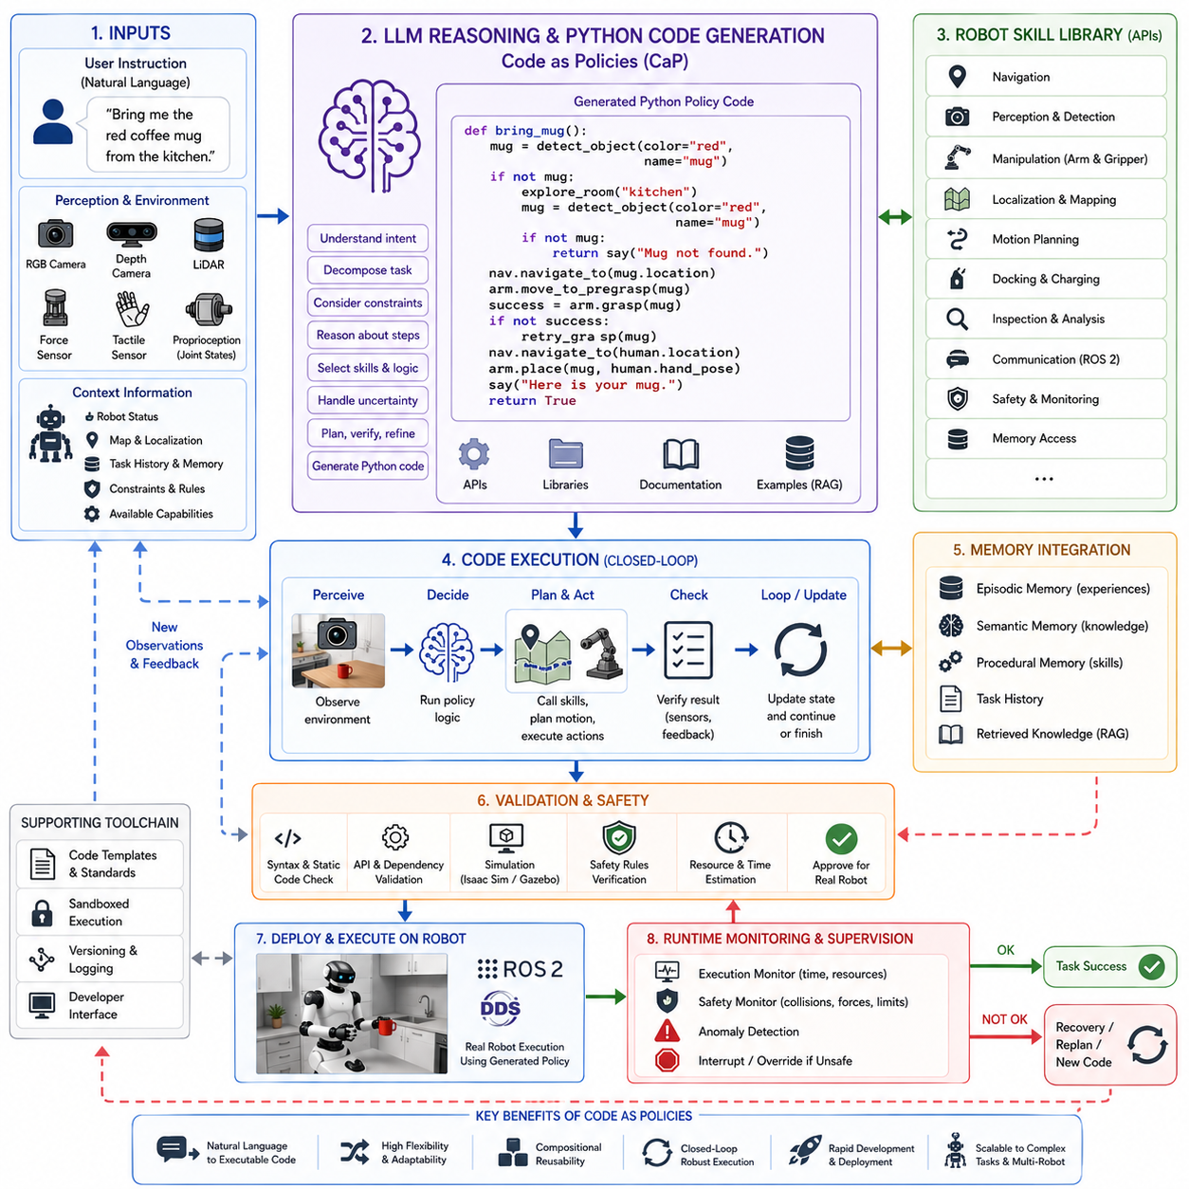
Code as Policies (CaP) represents one of the most influential advances in modern robot intelligence by transforming Large Language Models (LLMs) from passive language understanding systems into active robotic programming engines. Instead of generating only natural language responses or symbolic task descriptions, an LLM directly produces executable Python code that defines robotic behavior. This paradigm significantly reduces the gap between human instructions and autonomous robot execution by allowing robots to synthesize programs dynamically rather than relying solely on manually engineered behavior trees, state machines, or predefined motion scripts. Within Vision-Language-Action (VLA) systems, Code as Policies enables robots to translate natural language into structured software logic that can interact with perception modules, planning systems, robot middleware, and low-level controllers.
Traditional robot software development requires engineers to manually implement every task as source code before deployment. Navigation routines, manipulation sequences, inspection procedures, recovery behaviors, and exception handling must all be explicitly programmed, tested, and maintained. While this approach provides deterministic execution, it lacks flexibility when robots encounter new instructions, unfamiliar environments, or previously unseen task combinations. Code as Policies fundamentally changes this workflow by allowing robots to generate task-specific programs at runtime using the reasoning capability of LLMs.
The central idea behind Code as Policies is that natural language can be translated into executable policy functions. Instead of interpreting user commands through manually designed intent classifiers, the LLM generates Python functions that directly invoke robot APIs, perception modules, planning algorithms, and control interfaces. The resulting program serves as a policy describing how the robot should perceive, reason, decide, and act throughout task execution.
Within a modern VLA architecture, Code as Policies operates between high-level reasoning and robotic execution. Human instructions, perception results, semantic maps, robot status information, memory, environmental constraints, and available robot capabilities are provided as contextual inputs to the language model. The LLM analyzes this information and generates Python code that orchestrates robot behaviors using existing software components rather than attempting to replace them.
The generated Python code typically interacts with modular robot software libraries rather than implementing low-level algorithms from scratch. Navigation modules, manipulation APIs, perception services, localization systems, motion planners, inverse kinematics solvers, safety monitors, and communication interfaces remain independently developed components. The LLM simply generates the orchestration logic that coordinates these modules according to the current task.
Consider a service robot receiving the instruction, “Bring me the red coffee mug from the kitchen.” Instead of generating only a textual task description, the LLM may produce Python code that first invokes object detection to locate red mugs, then calls the navigation system to reach the kitchen, activates visual servoing for approach, invokes grasp planning, executes manipulation routines, verifies successful grasping using force feedback, navigates to the user, and finally performs safe object delivery. Every step is expressed as executable software logic.
One of the most important advantages of Code as Policies is compositionality. Rather than storing separate programs for every possible task, robots possess reusable software primitives that can be combined dynamically into entirely new behaviors. Existing APIs for navigation, object detection, manipulation, docking, charging, inspection, localization, and communication become software building blocks that the LLM assembles into task-specific programs. This greatly improves scalability because the number of achievable behaviors grows combinatorially as the skill library expands.
The generated code generally follows hierarchical software architecture principles. High-level policy functions describe overall task flow, intermediate functions coordinate subtasks, while lower-level functions call existing robot libraries responsible for perception, planning, and control. This layered organization preserves software modularity while allowing flexible task generation.
Perception plays a central role throughout the generated programs. Code as Policies does not assume complete knowledge of the environment before execution. Instead, generated Python code frequently performs perception-driven decision making by repeatedly invoking computer vision systems, object detectors, semantic segmentation networks, depth estimation modules, or Vision-Language Models. Decisions are therefore conditioned on current observations rather than static assumptions.
Closed-loop execution distinguishes Code as Policies from static action sequencing. Rather than producing a fixed sequence of actions, the generated Python program continuously evaluates environmental conditions during execution. Sensor feedback influences conditional branches, loop termination, error recovery, and dynamic replanning decisions. This feedback-driven execution significantly improves robustness in changing environments.
Conditional reasoning naturally emerges within generated code. Python provides expressive control structures including if statements, loops, exception handling, recursion, list comprehensions, asynchronous execution, and modular functions. The LLM exploits these language constructs to express sophisticated robotic decision logic that would otherwise require extensive manual programming.
Loop structures become particularly valuable for autonomous exploration and search tasks. Robots may repeatedly inspect candidate locations until a target object is found, continue cleaning until no dirt remains, repeatedly scan shelves until inventory verification completes, or patrol facilities continuously while monitoring for anomalies. These repetitive behaviors are naturally represented through program loops generated by the LLM.
Exception handling represents another major strength of Code as Policies. Real-world robotic execution inevitably encounters failures such as missing objects, blocked navigation paths, grasp failures, communication interruptions, localization uncertainty, or sensor malfunction. Generated Python programs incorporate try-except blocks, recovery procedures, timeout mechanisms, retry policies, fallback behaviors, and contingency planning. Instead of immediately terminating upon failure, robots adapt their behavior dynamically.
Memory integration significantly enhances generated policies. Programs may query episodic memory to retrieve previous object locations, semantic memory to obtain domain knowledge, procedural memory to identify appropriate skills, or task history databases to avoid redundant actions. This memory-aware programming enables long-term autonomy across extended missions.
Code as Policies also supports Retrieval-Augmented Generation. During code synthesis, the LLM may retrieve API documentation, software examples, operating procedures, environment maps, robot capability descriptions, or developer documentation. Retrieved information supplements the model's internal knowledge, enabling more accurate code generation for specialized robotic platforms.
Generated programs frequently invoke ROS 2 interfaces when operating within modern robotic middleware. Publishers, subscribers, services, actions, lifecycle nodes, parameter servers, TF transformations, and DDS communication mechanisms are coordinated through Python APIs generated by the LLM. Rather than replacing ROS 2, Code as Policies automates application development on top of existing middleware infrastructure.
Task decomposition naturally appears within generated programs through modular function definitions. Complex missions become collections of reusable helper functions, each responsible for specific subtasks such as locating objects, planning trajectories, verifying grasp quality, or updating execution status. This modular structure improves readability, debugging, verification, and future reuse.
Code as Policies frequently integrates with Task and Motion Planning systems. High-level generated Python code invokes symbolic planners to determine action sequences while motion planning libraries compute collision-free trajectories. This hybrid architecture combines semantic reasoning provided by the LLM with mathematically rigorous optimization algorithms responsible for physical execution.
Vision-Language Models increasingly complement Code as Policies by providing semantic scene descriptions directly to generated programs. Rather than relying exclusively on numerical perception outputs, generated Python code may query multimodal models using natural language prompts such as “Describe the objects on the table,” “Identify empty shelves,” or “Locate damaged equipment.” This greatly simplifies high-level perception integration.
Industrial robotics particularly benefits from Code as Policies because manufacturing environments frequently require customized workflows. Traditional automation requires extensive software engineering whenever production procedures change. With LLM-based code generation, robots dynamically synthesize updated task logic while continuing to use verified low-level software components. Production flexibility therefore increases without sacrificing execution reliability.
Warehouse automation provides another compelling example. Picking orders, inventory inspection, package sorting, pallet verification, shelf replenishment, and exception handling often require numerous workflow variations. Rather than manually implementing separate software pipelines for every situation, Code as Policies dynamically generates customized execution programs based on current inventory conditions, order requirements, and warehouse status.
Inspection robots similarly benefit from dynamic code generation. Inspection procedures often depend on asset type, detected anomalies, environmental conditions, customer requirements, regulatory standards, or previous maintenance records. Generated Python programs selectively invoke sensing routines, image processing algorithms, anomaly detection models, report generation functions, and cloud synchronization services according to current inspection objectives.
Outdoor autonomous robots also gain substantial flexibility through Code as Policies. Infrastructure inspection, agricultural monitoring, security patrol, construction surveying, environmental sampling, and utility maintenance frequently require adapting mission behavior according to weather, terrain, lighting, accessibility, equipment availability, or operational priorities. Generated programs dynamically integrate these contextual variables into execution logic.
Despite its flexibility, Code as Policies does not eliminate the need for software engineering discipline. Generated code must satisfy software quality requirements including readability, modularity, maintainability, robustness, determinism where appropriate, exception safety, resource management, concurrency control, and interface consistency. Consequently, many robotic systems constrain code generation using predefined software templates, approved APIs, coding standards, and static analysis tools.
Security considerations become increasingly important when robots execute dynamically generated code. Arbitrary code execution introduces significant cybersecurity risks if generated programs can access unrestricted system resources. Modern implementations therefore employ sandboxed execution environments, restricted Python interpreters, permission-controlled APIs, resource limitations, digital signatures, runtime monitoring, and policy enforcement mechanisms. Generated programs typically execute within carefully controlled software environments rather than receiving unrestricted operating system access.
Formal verification and code validation constitute additional safety mechanisms. Before execution, generated Python programs may undergo syntax checking, static code analysis, type verification, API validation, dependency analysis, simulation testing, safety rule verification, and execution tracing. These validation layers reduce the probability of unsafe or logically inconsistent behavior reaching physical hardware.
Simulation-first execution has become common practice for Code as Policies. Newly generated programs are first executed inside high-fidelity simulation environments such as Isaac Sim, Gazebo, MuJoCo, or custom digital twins. Simulation evaluates task correctness, collision risks, execution timing, resource consumption, and behavioral consistency before deployment on physical robots. This sim-to-real workflow significantly improves operational safety.
Runtime monitoring continues throughout execution. Dedicated supervisory systems observe generated programs for abnormal behavior including excessive execution time, unexpected API usage, unsafe trajectories, excessive force application, localization divergence, communication failures, or hardware anomalies. Supervisors retain authority to interrupt or override generated programs whenever safety conditions are violated.
One limitation of Code as Policies involves reasoning reliability. Large Language Models occasionally generate syntactically correct code that nevertheless contains logical errors, invalid API calls, unsupported assumptions, or hallucinated software interfaces. Therefore generated code should never be considered inherently correct without validation against actual robot software libraries and operational constraints.
Computational latency represents another practical challenge. Generating complete software programs using very large foundation models may require substantial inference time. Consequently, robots often combine cloud-based code generation for strategic tasks with lightweight onboard execution engines responsible for low-latency control. Once generated, Python programs execute locally while real-time controllers continue operating independently.
Recent research increasingly combines Chain of Thought reasoning with Code as Policies. Instead of directly generating source code, the LLM first reasons through task decomposition, environmental constraints, object relationships, safety considerations, and execution strategies before translating this reasoning into structured Python functions. This reasoning-first approach improves code quality, modularity, and execution reliability.
Another promising direction involves integrating Code as Policies with world models. Rather than generating code solely from current observations, future systems will reason over predictive simulations of future environmental states. Generated programs may proactively avoid anticipated failures, optimize long-horizon objectives, and coordinate multiple robots through predictive planning.
Multi-robot systems also benefit from code generation. LLMs may synthesize distributed coordination programs assigning complementary subtasks to multiple autonomous robots while managing communication, synchronization, resource allocation, and shared workspace safety. Python code becomes the orchestration layer governing collaborative robotic behavior across entire fleets.
Foundation models specifically trained on robotics software repositories are expected to substantially improve future code generation quality. Exposure to large-scale ROS packages, industrial automation frameworks, simulation environments, manipulation libraries, perception pipelines, and robot control software enables LLMs to produce increasingly reliable, efficient, and maintainable robotic programs.
As Physical AI continues evolving toward increasingly autonomous embodied intelligence, Code as Policies is likely to become one of the fundamental mechanisms connecting language understanding with executable robotic behavior. Instead of viewing programming as a manual engineering activity performed exclusively before deployment, future robotic systems will continuously synthesize, adapt, optimize, verify, and execute software throughout their operational lifetime. By combining semantic reasoning, multimodal perception, reusable software libraries, structured Python generation, formal validation, simulation-based verification, and runtime monitoring, Code as Policies establishes a practical pathway toward highly adaptive robots capable of converting human intentions directly into safe, verifiable, and executable software policies suitable for complex real-world environments.

3.4 Scene Reasoning and Spatial Understanding (with Code)
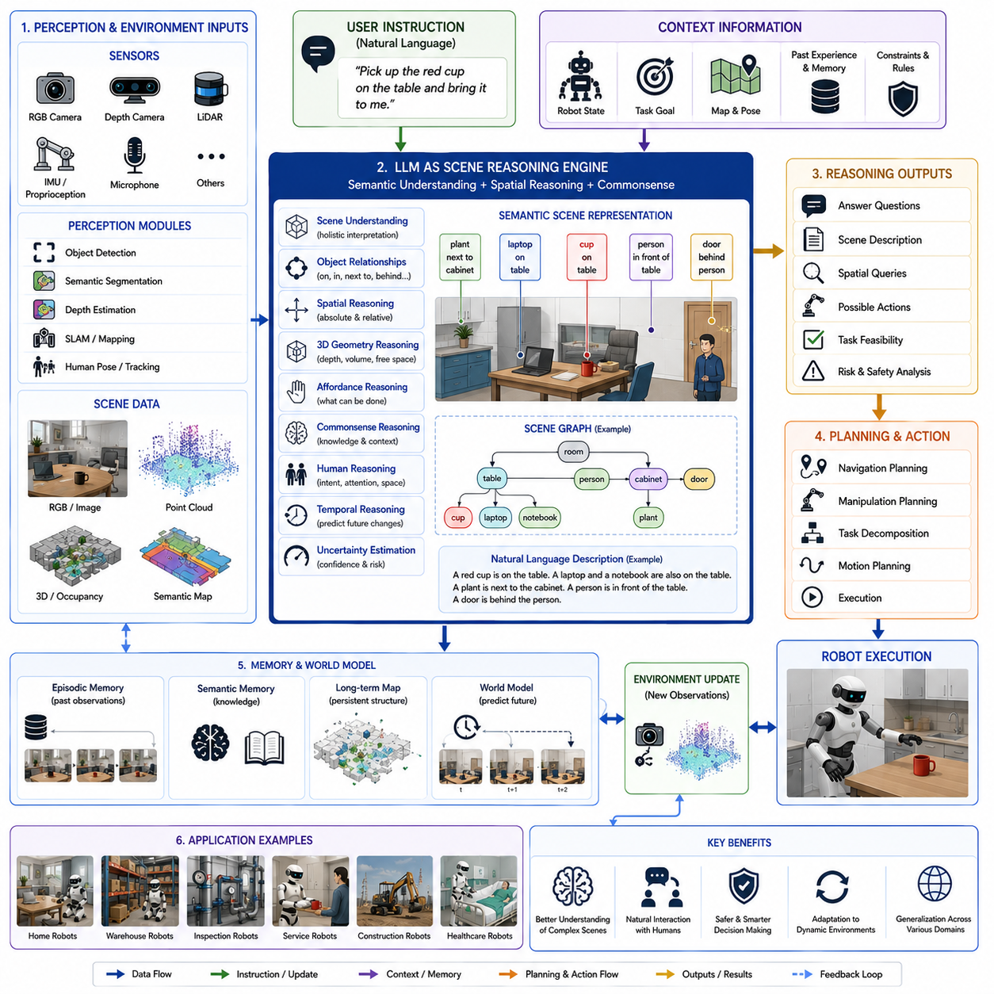
Scene reasoning and spatial understanding constitute two of the most fundamental cognitive capabilities required for intelligent robotic systems operating in real-world environments. While perception systems are responsible for detecting objects, estimating depth, recognizing semantic categories, and constructing environmental maps, these outputs alone are insufficient for autonomous decision making. Robots must also understand how objects relate to one another, how humans interact with their surroundings, how environmental structures constrain possible actions, and how spatial relationships influence task execution. Large Language Models (LLMs) significantly enhance robotic intelligence by providing high-level semantic reasoning over perception results, enabling robots to interpret complex scenes, infer hidden relationships, predict future interactions, and generate context-aware plans. Within modern Vision-Language-Action (VLA) architectures, scene reasoning transforms raw perception into actionable knowledge that supports planning, manipulation, navigation, and human-robot collaboration.
Traditional robotic perception pipelines primarily focus on recognizing individual objects using computer vision algorithms. Object detectors identify chairs, tables, cups, doors, people, and machines, while semantic segmentation assigns labels to image regions and depth estimation predicts three-dimensional geometry. Although these perception modules successfully identify environmental components, they generally provide limited understanding of how these objects relate to one another or how they should influence robot behavior. Scene reasoning extends perception beyond recognition by interpreting the semantic structure of the environment as a coherent whole rather than a collection of isolated objects.
Large Language Models operate as semantic reasoning engines positioned above perception systems. Instead of processing raw pixels directly, the LLM receives structured scene descriptions generated by vision encoders, Vision-Language Models, object detectors, semantic mapping systems, depth estimation algorithms, point cloud processors, simultaneous localization and mapping systems, and robot state estimators. These multimodal representations provide the contextual information required for higher-level reasoning regarding environmental organization, object functionality, task feasibility, and human intent.
Scene understanding begins with semantic scene representation. Rather than describing an environment solely through geometric coordinates, the robot constructs an interpretable semantic model identifying rooms, furniture, tools, obstacles, pathways, workspaces, storage locations, and interaction zones. Each detected object possesses attributes describing category, location, orientation, physical dimensions, affordances, accessibility, ownership, and contextual significance. The LLM integrates these attributes into a comprehensive representation of the environment.
Semantic scene representation also captures relationships among objects. Instead of recognizing only that a cup and a table exist, the robot understands that the cup is located on the table, near a laptop, beside a notebook, within arm's reach of a seated person, and partially occluded by another object. These relational descriptions provide significantly richer information than isolated detections because robotic actions frequently depend on object relationships rather than individual object identities.
Spatial understanding requires interpreting both absolute and relative positions. Absolute localization determines where objects exist within global coordinate systems using mapping and localization technologies. Relative spatial reasoning instead considers relationships such as left, right, above, below, behind, inside, outside, adjacent to, between, surrounding, aligned with, attached to, or supporting. Humans naturally communicate using these qualitative spatial concepts, making their interpretation essential for effective human-robot interaction.
Large Language Models naturally excel at reasoning over qualitative spatial relationships because they are extensively represented throughout natural language. Instructions such as “Pick up the wrench next to the toolbox,” “Inspect the valve beneath the pipe,” or “Move the pallet behind the forklift” require semantic spatial reasoning rather than precise numerical coordinates. The LLM translates these natural language descriptions into structured spatial constraints that guide perception and motion planning.
Three-dimensional reasoning further extends spatial understanding. Modern robotic systems frequently employ RGB-D cameras, stereo vision, LiDAR sensors, structured light cameras, time-of-flight sensors, and multi-view reconstruction techniques to generate dense three-dimensional scene representations. Rather than analyzing only two-dimensional images, the LLM reasons over volumetric spatial structures, free space, occupied regions, reachable workspaces, obstacle geometry, and manipulation feasibility.
Affordance reasoning represents another critical component of scene understanding. Affordances describe the possible interactions between robots and environmental objects. Chairs support sitting, handles enable pulling, buttons allow pressing, containers hold objects, shelves provide storage, doors permit passage after opening, and charging stations replenish batteries. The LLM combines visual observations with commonsense knowledge to infer object affordances even when they are not explicitly represented within perception outputs.
Commonsense reasoning substantially improves environmental interpretation. Human environments contain numerous implicit conventions that are rarely encoded within perception algorithms. Cups are typically found in kitchens or offices, books belong on shelves, tools are stored in toolboxes, dishes should remain upright, fragile objects require careful handling, and emergency exits should remain unobstructed. Large Language Models incorporate this world knowledge into robotic decision making, allowing robots to generate more realistic and contextually appropriate behaviors.
Context plays an essential role throughout scene reasoning. Identical objects may possess entirely different significance depending on the surrounding environment. A chair located in a meeting room supports seating, while a chair positioned beneath a high shelf may serve as a climbing aid, although climbing may violate robot safety policies. A box in a warehouse likely represents inventory, whereas an identical box inside a hospital corridor may obstruct emergency access. Scene reasoning therefore depends on contextual interpretation rather than object recognition alone.
Human presence introduces additional complexity into spatial reasoning. Robots must recognize not only human locations but also predicted human intentions, attention direction, activity context, reachable workspaces, and social interaction zones. A person reaching toward an object may soon occupy nearby space, requiring the robot to modify its navigation plan proactively. Similarly, personal space should remain respected during collaborative interactions even when no physical collision would occur.
Dynamic environments require continuous scene updating. Objects move, doors open and close, humans change locations, lighting conditions vary, temporary obstacles appear, and workspace organization evolves throughout robot operation. The LLM continuously incorporates updated perception results into its semantic representation, allowing planning systems to adapt without reconstructing the entire scene model from scratch.
Object permanence constitutes another important reasoning capability. Humans naturally understand that temporarily occluded objects continue existing even when invisible. Robots employing scene reasoning similarly infer that an object hidden behind a cabinet, under a table, or inside a container likely remains present unless evidence indicates otherwise. This capability significantly improves search efficiency and task continuity.
Occlusion reasoning further supports robust manipulation. Partial visibility frequently complicates robotic perception. Instead of requiring complete object observations, the LLM reasons about partially visible structures using contextual information, object priors, environmental constraints, and commonsense expectations. Such reasoning enables robots to manipulate cluttered environments more effectively than purely appearance-based approaches.
Scene graphs provide an increasingly common intermediate representation supporting LLM reasoning. A scene graph represents environmental entities as nodes while spatial, functional, and semantic relationships become graph edges. Objects, humans, rooms, tools, containers, pathways, and equipment form interconnected semantic networks describing environmental organization. Large Language Models reason naturally over these graph structures to answer spatial queries, generate plans, or explain environmental relationships.
Natural language scene descriptions generated by Vision-Language Models provide another valuable input. Instead of processing only numerical perception outputs, the LLM receives textual descriptions such as “A red toolbox is located beneath the workbench beside a blue storage cabinet.” These language-based representations align naturally with the pretrained reasoning capabilities of Large Language Models, improving semantic understanding without requiring specialized symbolic reasoning engines.
Spatial reasoning also supports navigation. Autonomous mobile robots must determine not only collision-free paths but also semantically appropriate routes. Hospital robots should avoid intensive care areas when possible, warehouse robots should respect designated pedestrian crossings, inspection robots should prioritize accessible equipment, and service robots should approach humans from socially acceptable directions. These navigation decisions require semantic scene understanding beyond geometric path planning.
Manipulation planning similarly benefits from spatial reasoning. Before grasping an object, the robot evaluates accessibility, grasp approach direction, neighboring obstacles, object stability, supporting surfaces, human proximity, and task objectives. The LLM integrates these factors into high-level reasoning while motion planners compute physically feasible trajectories satisfying these semantic constraints.
Task execution frequently depends upon spatial hierarchy. Objects belong to containers, containers exist within rooms, rooms belong to buildings, buildings form facilities, and facilities operate within larger organizational contexts. Hierarchical spatial representations enable robots to reason across multiple scales simultaneously. A command to retrieve equipment from Building A requires reasoning first at facility level, then room level, shelf level, container level, and finally object level.
Temporal scene reasoning extends spatial understanding into dynamic prediction. Rather than describing only current environmental states, the LLM anticipates future scene evolution. Humans walking through corridors, forklifts approaching intersections, elevators changing floors, automatic doors opening, and production lines advancing all influence future robot behavior. Predictive scene reasoning therefore supports safer and more efficient planning.
Memory substantially enhances scene reasoning quality. Episodic memory stores previous observations, semantic memory captures environmental knowledge, procedural memory identifies typical object arrangements, and long-term maps preserve persistent spatial structure. Robots remember previously visited locations, commonly used pathways, equipment positions, charging stations, restricted areas, and historical environmental changes. This accumulated experience improves future reasoning efficiency.
Scene reasoning frequently incorporates Retrieval-Augmented Generation. Facility documentation, building maps, operating procedures, maintenance records, digital twins, equipment databases, architectural drawings, and semantic maps provide additional contextual information extending beyond immediate perception. Retrieved knowledge supplements visual observations, allowing more informed reasoning regarding specialized industrial environments.
Industrial applications demonstrate the importance of semantic scene understanding. Manufacturing robots must distinguish workstations, safety zones, storage areas, production lines, maintenance equipment, hazardous materials, and quality inspection stations. Object recognition alone cannot identify appropriate operational procedures because environmental context determines permissible actions.
Warehouse automation similarly depends on spatial reasoning. Pallets, shelves, conveyors, loading docks, charging stations, pedestrian pathways, restricted zones, and inventory locations form complex semantic environments. Robots reason about accessibility, storage organization, traffic flow, package priority, and operational constraints while generating efficient logistics plans.
Inspection robots require detailed understanding of infrastructure layout. Bridges, pipelines, power stations, construction sites, industrial plants, and utility networks contain numerous interconnected components whose spatial organization directly influences inspection procedures. LLM-based scene reasoning interprets these structural relationships to generate systematic inspection strategies.
Outdoor autonomous robots encounter particularly challenging scene reasoning problems because environments remain highly dynamic and weakly structured. Terrain types, vegetation, roads, sidewalks, construction areas, weather conditions, temporary obstacles, and moving vehicles continuously alter spatial relationships. The LLM integrates perception, mapping, and world knowledge to interpret these changing environments.
Human-robot collaboration depends heavily on scene understanding. Collaborative robots reason about shared workspaces, tool ownership, human attention, task allocation, object handover locations, conversational context, and social interaction zones. Scene reasoning enables robots to behave predictably, safely, and naturally during cooperative activities.
Despite remarkable progress, scene reasoning remains fundamentally limited by perception quality. Incorrect object detection, inaccurate depth estimation, localization drift, incomplete maps, sensor noise, or ambiguous observations may propagate into high-level reasoning. Consequently, uncertainty estimation becomes an integral component of semantic reasoning. Rather than assuming perception is perfectly accurate, the LLM explicitly considers confidence estimates while generating plans.
Multi-camera perception significantly improves scene understanding. Head-mounted cameras, wrist cameras, panoramic cameras, overhead cameras, drone imagery, and fixed surveillance systems collectively provide complementary observations reducing occlusions and improving environmental coverage. LLMs integrate these heterogeneous viewpoints into unified semantic scene representations.
World models increasingly complement scene reasoning. Instead of reasoning exclusively about currently observed environments, future robotic systems maintain predictive internal models describing latent environmental dynamics. World models estimate hidden object states, predict future interactions, simulate hypothetical actions, and evaluate long-horizon consequences before physical execution. Large Language Models cooperate with these predictive models to support more sophisticated planning.
Foundation models trained jointly on language, vision, video, depth, three-dimensional geometry, manipulation demonstrations, and environmental interactions continue expanding robotic scene understanding capabilities. Rather than separately processing images, language, and spatial maps, future multimodal foundation models will generate unified world representations integrating appearance, geometry, semantics, temporal dynamics, and physical interactions within a single reasoning framework.
Recent research increasingly combines scene reasoning with Chain of Thought reasoning. Instead of directly answering spatial questions, the LLM incrementally analyzes object relationships, environmental constraints, human intentions, accessibility, safety considerations, and task objectives before producing conclusions. This structured reasoning substantially improves accuracy for complex manipulation and navigation tasks requiring multiple interconnected spatial inferences.
Scene reasoning also supports explainable robotic decision making. Rather than executing actions without explanation, robots may describe their reasoning process using natural language. For example, a robot may explain that it selected a particular grasp because another object blocked the preferred approach or that it avoided a hallway because emergency personnel were currently present. Such explanations improve user trust and facilitate collaborative operation.
Future Vision-Language-Action systems are expected to perform holistic spatial reasoning across multiple abstraction levels simultaneously. Instead of separately interpreting geometry, semantics, temporal dynamics, human activities, object affordances, and environmental constraints, next-generation embodied foundation models will integrate these information sources into unified cognitive world representations. These representations will enable robots to understand environments similarly to humans, supporting flexible task execution, long-horizon planning, natural communication, predictive reasoning, and continual adaptation across diverse industrial, commercial, domestic, healthcare, construction, agricultural, logistics, and service robotics applications. Scene reasoning and spatial understanding will therefore remain foundational cognitive capabilities underpinning the next generation of intelligent Physical AI systems capable of robust autonomous operation in complex real-world environments.

3.5 SayCan: Grounding Language Models with Affordances (with Code)
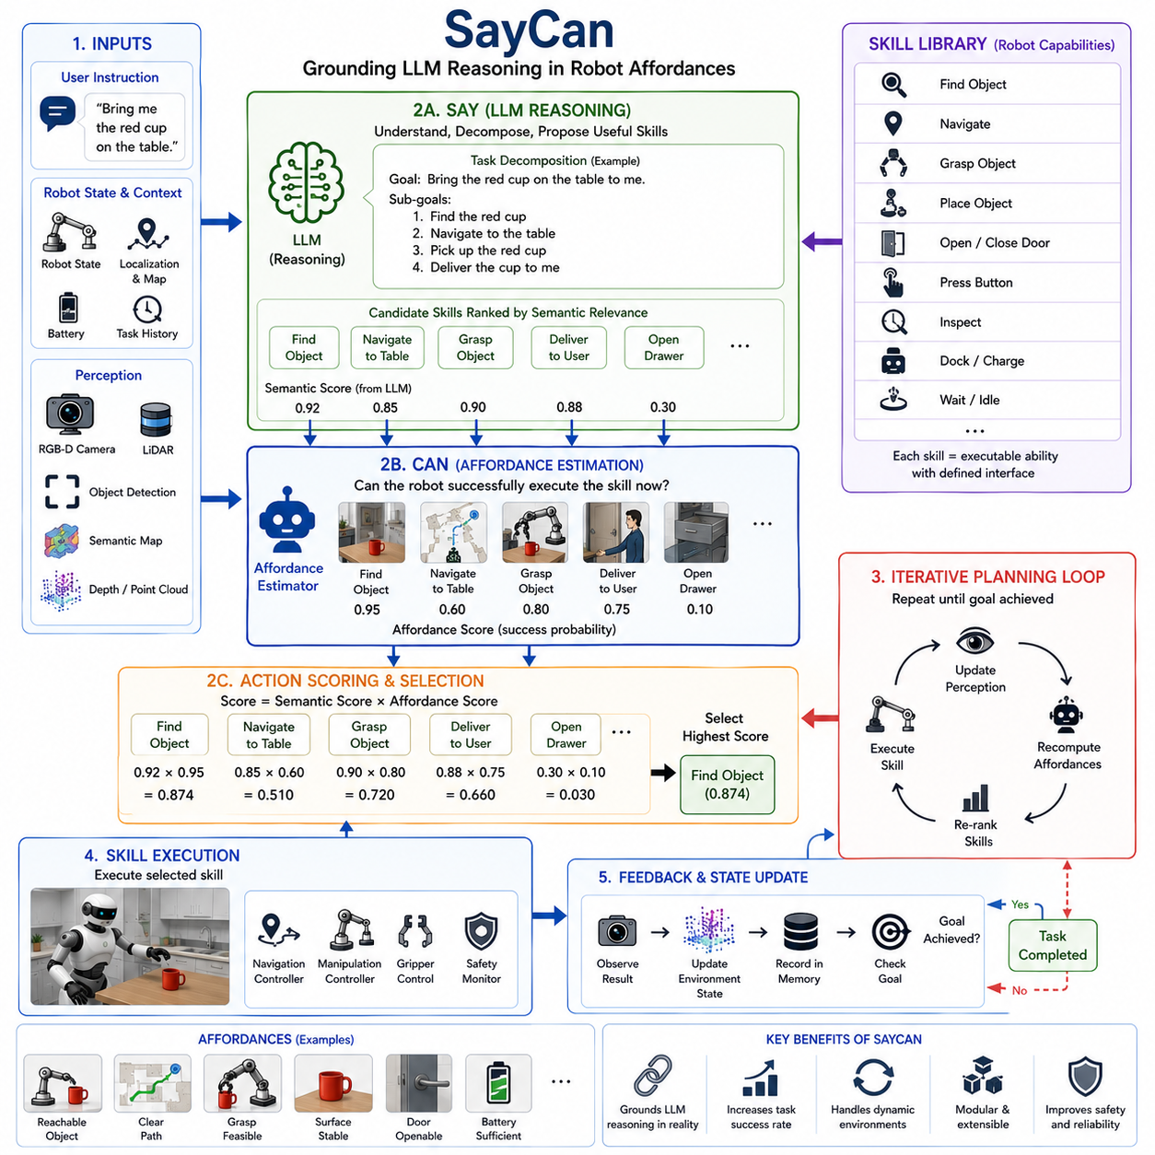
SayCan represents one of the most influential milestones in the evolution of intelligent robotic systems by demonstrating how Large Language Models (LLMs) can be effectively grounded in the physical capabilities of real robots. Before SayCan, LLMs exhibited remarkable language understanding and reasoning abilities but lacked awareness of whether the actions they proposed could actually be executed by a robot operating in the physical world. Conversely, traditional robotic control systems possessed precise knowledge of robot capabilities but lacked semantic reasoning and natural language understanding. SayCan bridges these complementary strengths by combining high-level language reasoning with low-level robot affordance estimation, enabling robots to generate plans that are both semantically meaningful and physically executable.
The name “SayCan” originates from the integration of two complementary concepts. The “Say” component represents the reasoning capability of a Large Language Model, which determines what actions should ideally be performed to satisfy a user's request. The “Can” component represents the robot's estimation of whether each candidate action can actually be executed successfully given the current environmental conditions, sensor observations, robot state, and available skills. Rather than selecting actions solely because they appear linguistically appropriate, SayCan chooses actions that maximize both semantic relevance and physical feasibility.
Traditional language-driven robotic systems frequently suffer from a disconnect between reasoning and execution. An LLM may generate an excellent high-level plan describing how to complete a task, yet individual actions may be impossible because the target object cannot be reached, the robot lacks the necessary manipulation skill, the object does not exist in the environment, or environmental constraints prevent successful execution. SayCan addresses this limitation by explicitly incorporating affordance estimation into every planning decision.
Within modern Vision-Language-Action architectures, SayCan occupies the interface between cognitive reasoning and robotic execution. Perception systems continuously provide semantic information describing the current environment through RGB cameras, depth sensors, LiDAR, force sensors, tactile sensors, localization systems, and semantic maps. Vision encoders transform these observations into high-level representations, while robot controllers estimate the likelihood of successfully executing each available skill. Simultaneously, the Large Language Model reasons about the user's instruction, decomposes the task into intermediate objectives, and predicts which robot skills are most semantically appropriate. SayCan combines these two information sources to determine the next action.
The central mathematical concept underlying SayCan is action scoring. Instead of selecting actions according to language probability alone, the system computes a combined score incorporating both semantic likelihood and affordance probability. The language model estimates how useful a particular skill would be for accomplishing the user's objective, while the affordance model estimates the probability that the robot can successfully execute that skill under current conditions. Actions receiving high scores in both dimensions become preferred candidates for execution.
Affordances represent the possible interactions available between a robot and its environment. A robot may be capable of grasping objects, opening drawers, pressing buttons, navigating between locations, operating elevators, placing objects onto shelves, docking with charging stations, or inspecting equipment. However, the success of these actions depends upon current environmental conditions. A grasp may fail because an object is outside the robot's workspace. A navigation action may become impossible because a corridor is blocked. A button cannot be pressed if another object obstructs access. SayCan explicitly evaluates these physical constraints before selecting actions.
One of the major innovations introduced by SayCan is separating semantic planning from physical execution while maintaining continuous interaction between the two. The Large Language Model remains responsible for understanding user intent, generating high-level task decomposition, and predicting useful skills. The robot skill execution system independently estimates execution feasibility. Rather than allowing either component to dominate planning decisions, SayCan combines both perspectives into a unified decision-making framework.
Task execution under SayCan proceeds iteratively rather than generating a complete plan at once. At each decision step, the robot evaluates all available skills within its library. The language model predicts which skills best advance the overall task objective, while affordance estimators evaluate current execution probability. The highest-scoring skill is selected and executed. Following execution, perception updates the environmental representation, affordance probabilities are recomputed, and the planning process repeats until task completion.
Skill libraries form an essential component of SayCan. Rather than generating arbitrary motor commands, robots possess predefined reusable skills representing atomic behaviors. These skills may include navigation, object detection, grasping, opening containers, closing doors, placing objects, activating switches, inspecting equipment, charging batteries, communicating with humans, or waiting for external events. The LLM reasons about which skill should be executed next without modifying the internal implementation of individual skills.
Semantic reasoning performed by the language model extends beyond simple keyword matching. The model interprets abstract human goals, understands commonsense knowledge, infers missing procedural details, and predicts intermediate objectives required for successful task completion. For example, if instructed to prepare a cup of tea, the language model recognizes that water must first be obtained, heated, poured, and combined with tea before serving, even though many of these steps remain unstated by the user.
Affordance estimation, however, grounds this reasoning within physical reality. Although preparing tea may require locating a kettle, the robot cannot perform this step if no kettle exists in the environment. Similarly, opening a cabinet becomes impossible if the cabinet door is locked or blocked. The affordance model therefore evaluates actual environmental conditions rather than relying solely upon abstract reasoning.
Perception continuously supports affordance estimation throughout execution. Object detection identifies candidate manipulation targets. Semantic segmentation estimates environmental structure. Depth estimation predicts object accessibility. Point cloud processing computes reachable workspaces. Force sensing monitors grasp success. Localization systems estimate robot position relative to navigation goals. Collectively, these perception modules provide the information necessary for accurate affordance prediction.
SayCan naturally supports long-horizon planning because tasks are decomposed into sequences of executable skills. Rather than attempting to predict every future action simultaneously, the robot repeatedly selects the most appropriate next skill given updated environmental observations. This incremental planning strategy substantially improves robustness within dynamic environments where future conditions remain uncertain.
Human instructions frequently contain ambiguity that requires contextual interpretation. Commands such as “Bring me something to drink” permit multiple valid solutions. The language model reasons about likely user intentions, while affordance estimation determines which candidate objects are currently available and accessible. If water is nearby while coffee supplies are unavailable, the combined reasoning process naturally selects water as the preferred solution.
Context awareness significantly improves planning quality. The robot considers user location, environmental state, object availability, battery capacity, task history, and current robot configuration when evaluating candidate actions. A robot carrying another object cannot immediately grasp a new object without first freeing its gripper. Similarly, low battery capacity may prioritize charging before initiating lengthy navigation tasks. Affordance estimation captures these contextual constraints naturally.
Memory further strengthens SayCan by preserving previous execution experience. Episodic memory records successful and failed task executions, semantic memory stores knowledge regarding object functions and environmental organization, procedural memory captures robot skills, and long-term environmental memory records frequently visited locations. These memories influence both language reasoning and affordance estimation during future planning episodes.
SayCan also supports adaptive replanning. Real-world environments frequently change unexpectedly due to moving humans, relocated objects, blocked pathways, equipment failures, or sensor uncertainty. After every executed skill, the robot updates its environmental understanding and reevaluates all remaining candidate actions. This continuous replanning capability allows the robot to recover gracefully from unexpected situations without abandoning the entire mission.
The framework naturally integrates with Vision-Language Models that generate semantic scene descriptions. Rather than reasoning exclusively over symbolic object labels, the language model may analyze textual descriptions such as “The refrigerator door is open, a milk carton is visible on the middle shelf, and a chair partially blocks the approach.” These rich semantic descriptions improve affordance estimation by providing contextual information unavailable through object detection alone.
Navigation tasks particularly benefit from affordance-aware planning. Multiple routes may connect identical start and destination locations, yet temporary obstacles, pedestrian traffic, restricted areas, or hazardous conditions influence which route remains executable. SayCan selects navigation behaviors balancing semantic task objectives with real-time environmental accessibility.
Manipulation planning similarly benefits from affordance reasoning. A requested object may exist but remain unreachable because another object blocks access. Rather than repeatedly attempting impossible grasps, SayCan first selects prerequisite actions such as moving obstructing objects, opening cabinets, repositioning the robot, or adjusting camera viewpoints before attempting the primary manipulation task.
Industrial robotics provides compelling applications for SayCan. Manufacturing environments contain numerous specialized tools, safety procedures, production workflows, and equipment configurations. The language model interprets high-level production goals while affordance estimation evaluates machine availability, workspace accessibility, robot tooling, material presence, and safety constraints. Consequently, generated plans remain grounded within actual factory conditions rather than idealized assumptions.
Warehouse automation similarly benefits from affordance-aware planning. Inventory availability, shelf accessibility, pallet occupancy, aisle congestion, charging status, and robot workload continuously influence operational decisions. SayCan enables warehouse robots to reason semantically about fulfillment objectives while respecting real-time logistical constraints.
Healthcare robotics presents another important application domain. Service robots assisting patients must interpret natural language requests while respecting patient safety, equipment availability, medical protocols, accessibility constraints, and environmental organization. Affordance-aware reasoning substantially reduces the probability of generating unsafe or infeasible actions within these highly sensitive environments.
Inspection robots operating in industrial facilities similarly require grounded reasoning. Inspection procedures frequently depend upon equipment accessibility, environmental safety conditions, operational status, lighting quality, sensor visibility, and regulatory requirements. SayCan dynamically selects inspection skills that remain executable under current conditions while satisfying overall inspection objectives.
One of SayCan's greatest strengths lies in its modularity. The language model, perception system, affordance estimator, skill library, navigation stack, manipulation planner, and robot controller remain independently developed software components communicating through well-defined interfaces. Improvements to one subsystem therefore benefit the overall architecture without requiring complete redesign.
Despite its advantages, SayCan also faces important limitations. Affordance estimation quality depends heavily upon perception accuracy. Incorrect object detection, localization errors, incomplete maps, sensor noise, or environmental uncertainty may cause inaccurate feasibility predictions. Consequently, robust perception remains essential for reliable grounded planning.
Language models themselves remain susceptible to hallucinations and incorrect commonsense reasoning. Although affordance estimation filters physically impossible actions, semantically incorrect planning decisions may still occur if the language model misunderstands user intent or generates inappropriate task decompositions. Additional validation layers therefore remain necessary for safety-critical applications.
Scalability presents another research challenge. As robot skill libraries continue expanding, evaluating affordance probabilities for hundreds or thousands of candidate actions becomes increasingly computationally expensive. Efficient retrieval mechanisms, hierarchical skill organization, learned embeddings, and approximate search algorithms therefore become important for maintaining real-time planning performance.
Recent research increasingly extends SayCan beyond single-robot operation. Multi-robot systems require affordance reasoning not only regarding individual robot capabilities but also regarding collaborative execution, resource sharing, task allocation, communication, synchronization, and collective workspace management. Language models coordinate high-level cooperation while affordance estimation evaluates each robot's individual ability to contribute toward shared objectives.
Another important extension incorporates world models into affordance reasoning. Instead of evaluating only the current environment, predictive world models estimate future environmental states resulting from candidate actions. Affordance estimation therefore becomes predictive rather than reactive, allowing robots to anticipate future opportunities and avoid impending failures before they occur.
Retrieval-Augmented Generation further enhances SayCan by providing access to external documentation, operating manuals, digital twins, maintenance databases, facility maps, enterprise knowledge bases, and previous execution logs. Retrieved information supplements language reasoning while improving affordance estimation within specialized industrial environments.
Chain of Thought reasoning also complements SayCan effectively. Rather than selecting skills immediately, the language model first performs structured reasoning regarding task decomposition, object relationships, temporal dependencies, environmental constraints, safety considerations, and intermediate goals. Affordance estimation then grounds each reasoning step within executable robot capabilities. This combination significantly improves planning quality for complex long-horizon tasks.
Future Vision-Language-Action architectures are expected to integrate SayCan with multimodal foundation models capable of jointly reasoning over language, vision, depth, video, tactile sensing, force measurements, proprioception, semantic maps, world models, and long-term episodic memory. Rather than combining independent language and affordance modules, future embodied foundation models will learn unified representations simultaneously encoding semantic understanding, physical interaction, environmental dynamics, and robot capabilities.
As Physical AI progresses toward increasingly autonomous embodied intelligence, SayCan remains one of the foundational architectural principles demonstrating how language reasoning can be successfully grounded within the realities of physical robot execution. By combining semantic planning, commonsense reasoning, perception, affordance estimation, reusable skill libraries, continuous replanning, and environmental feedback, SayCan establishes a practical framework for transforming natural language instructions into safe, feasible, adaptive, and executable robotic behaviors suitable for complex real-world environments.

3.6 Fine-Tuning LLMs for Robot Instruction Following (with Code)
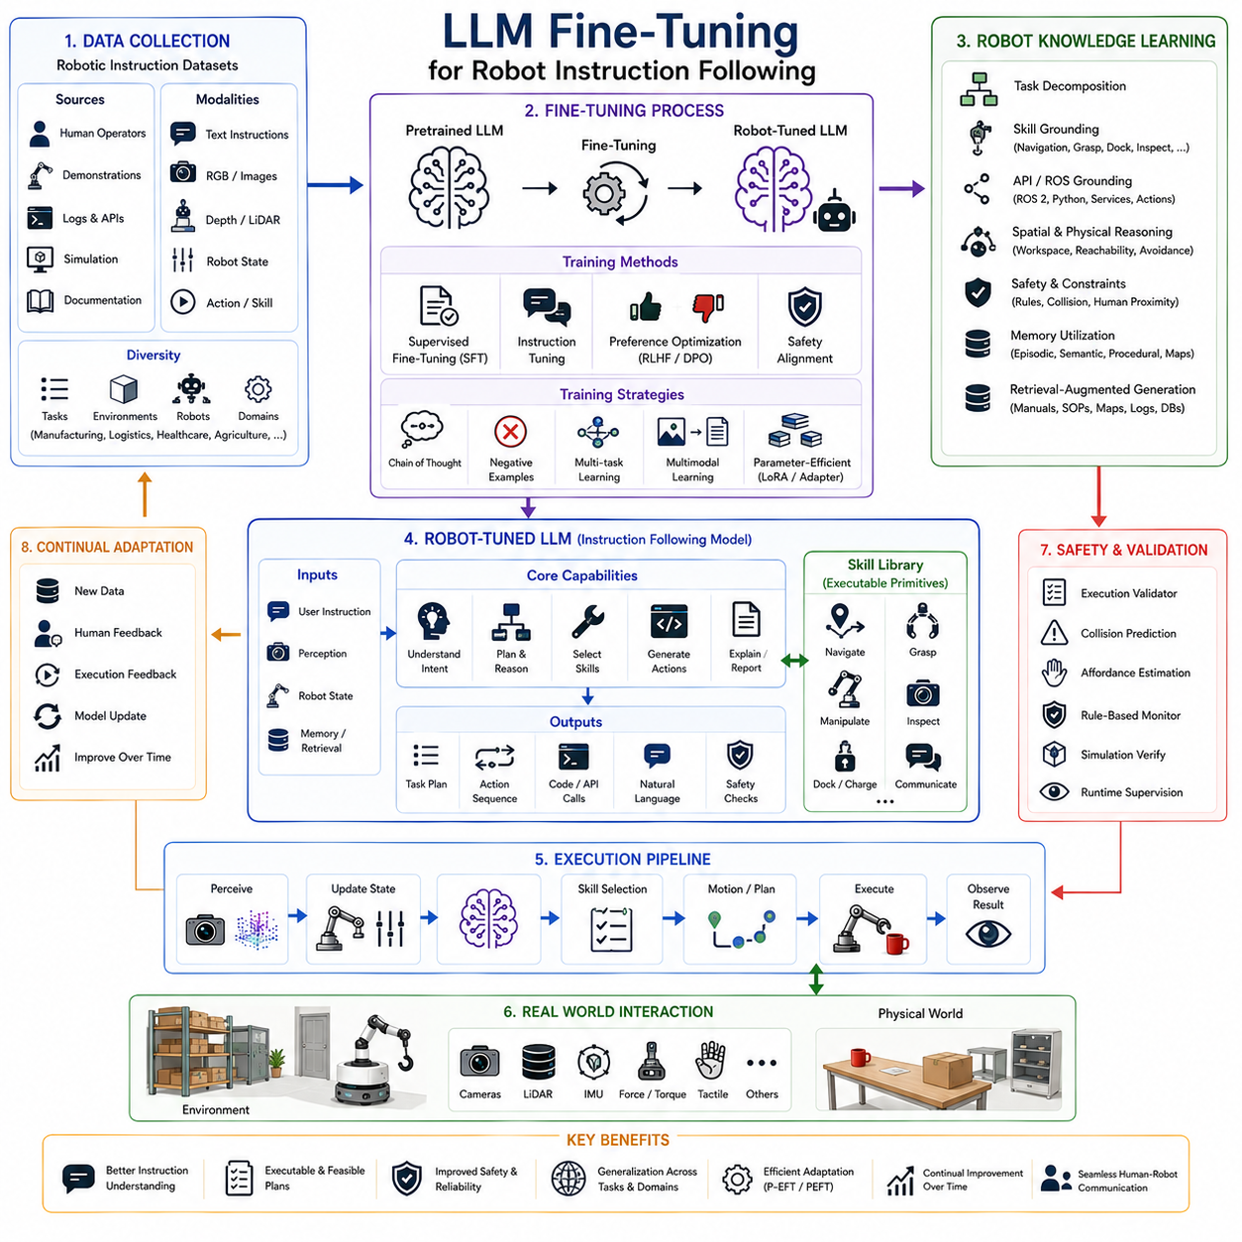
Large Language Models (LLMs) have demonstrated remarkable capabilities in natural language understanding, reasoning, planning, and code generation. However, foundation models trained on general internet-scale text are not inherently optimized for robotics. Although these models possess broad world knowledge, they often lack the specialized understanding required for robot instruction following, embodied interaction, physical constraints, robot APIs, safety policies, environmental dynamics, and real-time decision making. Fine-tuning has therefore become one of the most important techniques for adapting general-purpose language models into reliable robotic cognitive systems. Within modern Vision-Language-Action (VLA) architectures, fine-tuning enables LLMs to understand robotic tasks more accurately, generate physically feasible plans, follow operator instructions consistently, and interact naturally with both robots and human users.
Robot instruction following differs fundamentally from conventional conversational AI. Human conversations frequently tolerate ambiguity, multiple valid interpretations, and partially correct responses. In contrast, robotic systems require precise, deterministic, safe, and executable outputs because generated instructions ultimately influence physical actions. A misunderstanding that is acceptable in text generation may become dangerous when controlling autonomous machines. Consequently, robotic language models require significantly stronger alignment between language understanding and physical execution.
The primary objective of fine-tuning is to modify the pretrained language model so that it learns the linguistic patterns, operational procedures, safety constraints, task structures, and environmental knowledge specific to robotics. Rather than replacing the broad knowledge already contained within the foundation model, fine-tuning specializes that knowledge for embodied intelligence while preserving general reasoning capability.
Instruction following begins with understanding human intent rather than merely interpreting individual words. Human operators naturally issue commands such as “Bring the inspection camera to the maintenance room,” “Check whether any pallets are damaged,” or “Return to the charging station after completing today's inspection.” These instructions frequently contain implicit assumptions regarding environmental context, robot capabilities, temporal ordering, safety procedures, and operational priorities. Fine-tuned language models learn to infer these unstated requirements from examples collected during robotic operation.
The fine-tuning process generally begins with collecting high-quality robotic instruction datasets. These datasets consist of natural language commands paired with desired robot responses, task decompositions, action sequences, symbolic plans, Python policies, behavior trees, ROS command structures, or executable robot skills. Unlike general instruction tuning datasets, robotic datasets emphasize physical interactions, environmental reasoning, manipulation sequences, navigation decisions, perception requests, and safety-critical behaviors.
Dataset diversity plays a crucial role in successful adaptation. Robots operate across industrial manufacturing, logistics, healthcare, agriculture, construction, warehouse automation, infrastructure inspection, domestic assistance, service robotics, and collaborative workspaces. Each domain introduces unique terminology, workflows, equipment, operational constraints, and interaction styles. Fine-tuning datasets therefore benefit from broad coverage across multiple robotic applications while maintaining consistent annotation quality.
Task diversity is equally important. A practical robotic assistant must understand navigation, manipulation, object retrieval, inspection, assembly, charging, monitoring, cleaning, delivery, reporting, emergency response, fault recovery, maintenance procedures, and collaborative interactions. Fine-tuning exposes the language model to these varied task categories so that it learns generalized robotic reasoning rather than memorizing narrow procedural templates.
Multimodal instruction datasets increasingly replace purely textual datasets. Modern robotic systems integrate RGB images, depth maps, LiDAR observations, semantic maps, point clouds, tactile measurements, force sensing, joint positions, battery status, localization estimates, environmental metadata, and task history together with natural language instructions. Fine-tuning on multimodal representations enables the LLM to associate language with physical perception and robot state.
Supervised Fine-Tuning (SFT) remains the most widely used adaptation technique. During SFT, the model learns from manually curated instruction-response pairs demonstrating correct robotic behavior. Human experts create high-quality examples illustrating appropriate task decomposition, safety-conscious planning, correct API usage, error handling, and execution logic. The model gradually adjusts its parameters to reproduce these desired responses for similar instructions.
Instruction tuning extends supervised learning by emphasizing generalizable task understanding rather than memorization. Instead of learning individual robot commands independently, the model learns abstract relationships among goals, subtasks, environmental constraints, robot skills, and execution sequences. This abstraction significantly improves generalization toward previously unseen tasks.
Preference optimization has become increasingly important for robotic instruction following. Human evaluators compare alternative model responses according to correctness, safety, efficiency, interpretability, and execution quality. Methods such as Reinforcement Learning from Human Feedback, Direct Preference Optimization, and related preference-learning algorithms enable language models to align their behavior with expert robotic expectations while reducing undesirable outputs.
Safety alignment represents a particularly critical aspect of robotic fine-tuning. Unlike conversational assistants, robots interact directly with physical environments where unsafe decisions may damage equipment, injure people, or violate operational procedures. Training datasets therefore include numerous examples demonstrating safe navigation, collision avoidance, emergency stopping, hazardous material handling, human proximity management, equipment protection, and regulatory compliance.
Negative examples further improve robustness. Instead of learning exclusively from correct demonstrations, robotic language models benefit from observing incorrect plans, unsafe actions, infeasible manipulations, inappropriate API usage, impossible trajectories, and policy violations together with explanations describing why these outputs should be rejected. This contrastive learning significantly improves decision quality.
Chain of Thought supervision increasingly enhances robotic reasoning. Rather than providing only final answers, fine-tuning datasets include intermediate reasoning demonstrating how complex instructions are decomposed into executable subtasks. These structured reasoning examples teach the model to analyze goals, identify constraints, evaluate alternatives, estimate affordances, and generate logically coherent execution plans before selecting actions.
Fine-tuning also improves spatial reasoning. General-purpose language models possess broad spatial knowledge but frequently lack precision regarding robotic workspaces, object accessibility, manipulation feasibility, navigation constraints, and three-dimensional environmental organization. Exposure to robotics-specific spatial examples substantially improves reasoning about relative positions, reachability, obstacle avoidance, grasp planning, and workspace geometry.
Robot skill grounding constitutes another important adaptation objective. Rather than producing unrestricted natural language, fine-tuned models learn to map user instructions onto predefined robot skill libraries. Navigation, grasping, docking, charging, inspection, scanning, manipulation, perception, communication, and reporting become grounded semantic actions directly connected to executable robot capabilities.
API grounding similarly improves practical deployment. Many robotic systems expose Python APIs, ROS 2 services, action servers, middleware interfaces, hardware drivers, perception services, and planning libraries. Fine-tuning teaches the LLM to invoke these interfaces correctly while respecting parameter constraints, execution order, dependency management, and software architecture principles.
Memory utilization becomes more effective after robotics-specific adaptation. Fine-tuned models learn when to retrieve episodic memory describing previous task executions, semantic memory containing environmental knowledge, procedural memory representing robot skills, and long-term maps describing facility layouts. Effective memory retrieval significantly improves long-duration autonomous operation.
Retrieval-Augmented Generation integrates naturally with fine-tuned models. Rather than relying exclusively upon internal parameters, robotic LLMs retrieve facility documentation, maintenance manuals, operating procedures, digital twins, equipment specifications, inspection histories, software documentation, and enterprise knowledge bases. Fine-tuning teaches the model when retrieval is necessary and how retrieved information should influence subsequent reasoning.
Simulation-generated datasets increasingly supplement human demonstrations. High-fidelity simulators such as Isaac Sim, Gazebo, MuJoCo, Habitat, and digital twin environments enable large-scale generation of robot interactions under diverse environmental conditions. Millions of simulated instruction-following episodes provide valuable supervision while avoiding the cost and safety risks associated with physical robot experimentation.
Sim-to-real transfer becomes substantially more reliable when language models are fine-tuned using both simulated and real-world demonstrations. Simulation provides diversity and scale, while real robotic experience captures sensing noise, actuator uncertainty, environmental variability, and hardware limitations absent from virtual environments. Combining both data sources improves generalization across deployment conditions.
Foundation models specialized for robotics increasingly employ continual fine-tuning throughout operational deployment. Instead of remaining static after initial training, language models continually incorporate new demonstrations, operator corrections, successful task executions, environmental observations, and evolving robot capabilities. Continual adaptation enables robotic intelligence to improve over time without complete retraining.
Parameter-efficient fine-tuning techniques have become especially valuable because modern foundation models often contain tens or hundreds of billions of parameters. Methods such as Low-Rank Adaptation, adapters, prompt tuning, prefix tuning, and related lightweight adaptation strategies enable organizations to customize large language models for specific robotic platforms without retraining entire networks. These approaches significantly reduce computational requirements while preserving most pretrained knowledge.
Small Language Models similarly benefit from targeted fine-tuning. Rather than deploying extremely large foundation models onboard resource-constrained robots, lightweight models adapted specifically for navigation, manipulation, inspection, or warehouse operation achieve competitive performance while satisfying real-time computational requirements. Edge deployment therefore becomes practical for many robotic applications.
Industrial robotics particularly benefits from specialized instruction tuning. Manufacturing facilities possess unique terminology, production workflows, machine interfaces, quality inspection procedures, maintenance schedules, safety regulations, and operational standards. Fine-tuning allows language models to understand domain-specific vocabulary and generate instructions consistent with established industrial practices.
Warehouse automation introduces specialized linguistic patterns involving inventory management, pallet handling, order fulfillment, storage allocation, barcode scanning, shelf organization, autonomous transportation, and logistics optimization. Fine-tuned language models become significantly more accurate when interpreting these operational instructions compared with general-purpose foundation models.
Healthcare robotics requires another level of specialization. Clinical environments involve medical terminology, patient interaction protocols, accessibility considerations, hygiene requirements, medication handling procedures, emergency workflows, and privacy regulations. Robotics-specific fine-tuning enables language models to follow these domain-specific instructions more reliably while maintaining safe behavior.
Inspection robotics similarly requires specialized adaptation. Infrastructure inspection, utility maintenance, pipeline monitoring, bridge assessment, power station inspection, agricultural surveying, and environmental monitoring each involve specialized terminology, sensor usage, reporting formats, anomaly descriptions, and operational procedures. Fine-tuning aligns language understanding with these technical workflows.
Evaluation represents a critical component of robotic fine-tuning. Unlike conventional language benchmarks measuring factual accuracy or conversational quality, robotic evaluation emphasizes task success, instruction following accuracy, planning consistency, API correctness, safety compliance, affordance awareness, execution feasibility, robustness under uncertainty, and recovery from execution failures. Comprehensive evaluation therefore combines language metrics with embodied performance metrics collected during simulation and real-world deployment.
Safety verification remains essential before deployment. Even highly fine-tuned language models may occasionally generate unsafe, infeasible, or logically inconsistent outputs. Consequently, robotic architectures continue employing execution validators, geometric reasoning modules, collision prediction systems, affordance estimators, rule-based safety monitors, simulation verification, and runtime supervision. Fine-tuning complements rather than replaces these deterministic safety mechanisms.
One important challenge involves catastrophic forgetting. Excessive specialization may cause a language model to lose valuable general reasoning capabilities acquired during large-scale pretraining. Successful fine-tuning therefore balances domain adaptation with preservation of broad world knowledge. Parameter-efficient adaptation techniques often reduce catastrophic forgetting compared with full-model retraining.
Data quality remains more important than data quantity. Thousands of carefully curated demonstrations frequently outperform millions of noisy examples containing inconsistent annotations or unsafe behaviors. Expert robotic supervision, consistent labeling, standardized task representations, and accurate execution records therefore play central roles in successful model adaptation.
Future research increasingly explores multimodal fine-tuning integrating language, vision, depth, tactile sensing, force measurements, proprioception, semantic maps, world models, manipulation demonstrations, and long-term memory into unified embodied foundation models. Rather than adapting language alone, future robotic systems will jointly optimize perception, reasoning, planning, and action generation within integrated multimodal learning frameworks.
Another promising direction involves collaborative fine-tuning across robot fleets. Multiple autonomous robots operating in different environments continuously collect instruction-following experiences. Aggregating these experiences enables foundation models to learn broader operational knowledge while preserving adaptation to individual robot platforms through parameter-efficient personalization.
Federated learning also offers significant potential for industrial robotics. Instead of transmitting sensitive operational data to centralized servers, robots locally fine-tune shared foundation models while exchanging only learned parameter updates. This approach improves privacy, reduces communication bandwidth, and enables collaborative learning across geographically distributed robotic deployments.
World models will increasingly influence instruction fine-tuning by allowing language models to reason over predicted future environmental states rather than current observations alone. Fine-tuned LLMs will learn not only how to respond to instructions but also how current decisions influence future task success, energy consumption, safety, productivity, and collaborative efficiency.
As Physical AI evolves toward increasingly autonomous embodied intelligence, fine-tuning will remain one of the foundational technologies enabling reliable robot instruction following. By adapting general-purpose language models to understand robotic tasks, physical environments, perception outputs, safety constraints, reusable skills, software interfaces, multimodal observations, and execution feedback, fine-tuned LLMs establish a practical bridge between natural language communication and dependable robotic behavior. Rather than replacing classical robotics algorithms, fine-tuned language models augment perception, planning, manipulation, navigation, and control systems with high-level semantic intelligence, enabling robots to understand human intentions accurately and transform them into safe, efficient, and executable actions across diverse real-world environments.

3.7 Small Language Models (SLMs) for Edge Robots (with Code)
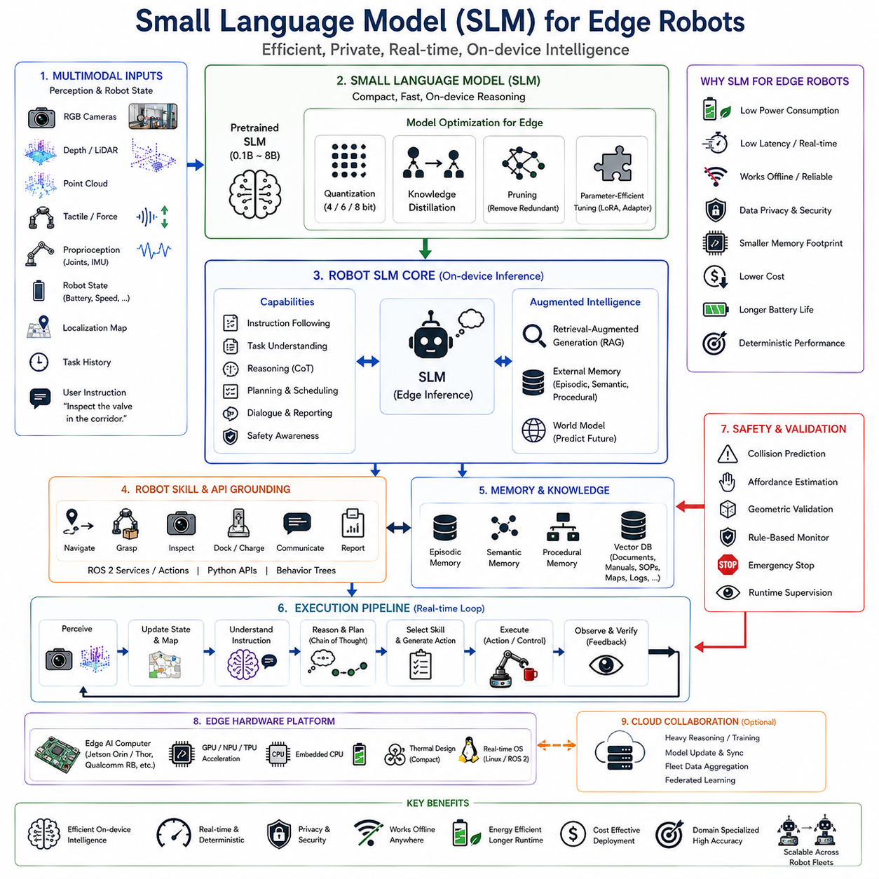
Small Language Models (SLMs) are becoming one of the most important enabling technologies for the next generation of intelligent edge robotics. While Large Language Models (LLMs) provide remarkable capabilities in natural language understanding, reasoning, planning, and code generation, their computational requirements often exceed the processing, memory, power, and latency constraints of autonomous mobile robots. Edge robots must continuously perceive their surroundings, perform localization, execute motion planning, maintain safety monitoring, and communicate with sensors while operating under limited onboard computational resources. Consequently, deploying extremely large language models directly on mobile robotic platforms is often impractical. Small Language Models address this challenge by providing efficient language reasoning specifically optimized for embedded robotic systems.
Unlike cloud-hosted foundation models containing hundreds of billions of parameters, Small Language Models generally contain hundreds of millions to several billion parameters. This dramatic reduction in model size enables deployment on embedded GPUs, AI accelerators, edge computers, and mobile robotic computing platforms while maintaining useful reasoning capability for domain-specific tasks. Rather than attempting to replicate every capability of extremely large models, SLMs prioritize efficiency, determinism, responsiveness, and specialization.
The emergence of SLMs represents a shift from universal intelligence toward task-oriented embodied intelligence. Most robots do not require comprehensive knowledge covering every domain represented on the internet. Instead, warehouse robots primarily require logistics knowledge, inspection robots require maintenance procedures, hospital robots require healthcare workflows, agricultural robots require crop management expertise, and autonomous mobile robots require navigation and manipulation reasoning. Small Language Models exploit this observation by specializing their capabilities for well-defined operational environments.
Edge robotics introduces several computational constraints rarely encountered by cloud-based artificial intelligence systems. Autonomous robots operate with limited electrical power supplied by batteries, restricted thermal dissipation due to compact mechanical designs, finite onboard memory capacity, and real-time response requirements measured in milliseconds rather than seconds. These constraints strongly influence language model architecture and deployment strategy.
Power consumption remains one of the most critical design considerations for edge robotics. Every watt allocated to language model inference reduces the power available for perception sensors, motor controllers, communication systems, onboard computers, environmental monitoring, and mission endurance. Large cloud-scale models requiring multiple high-performance GPUs cannot satisfy the energy budgets of battery-powered autonomous robots. Small Language Models significantly reduce computational demand while extending operational lifetime.
Latency presents another fundamental challenge. Robots interact with continuously changing physical environments where delayed decisions may compromise safety or operational performance. Cloud inference introduces unpredictable communication delays resulting from wireless networks, internet connectivity, congestion, packet loss, or temporary service interruptions. Edge-deployed Small Language Models eliminate network dependence by executing inference directly on onboard hardware, enabling deterministic response times suitable for safety-critical robotic applications.
Privacy and security further motivate edge deployment. Industrial robots frequently operate within factories containing confidential manufacturing processes, proprietary equipment configurations, production schedules, customer information, or intellectual property. Healthcare robots similarly encounter sensitive patient information protected by regulatory requirements. Running Small Language Models locally ensures that operational data remains within the robot rather than being transmitted to external cloud services.
Reliability also improves through onboard inference. Robots operating in underground facilities, remote construction sites, agricultural fields, military environments, offshore platforms, disaster zones, tunnels, mines, forests, or isolated infrastructure often experience intermittent or nonexistent network connectivity. Small Language Models enable continued autonomous operation regardless of communication availability because language understanding remains entirely local.
Modern edge robotic architectures typically separate computational responsibilities across multiple processing tiers. High-frequency perception, localization, control, obstacle avoidance, and safety monitoring execute continuously on real-time processors. Small Language Models operate at an intermediate cognitive layer responsible for language understanding, semantic reasoning, task interpretation, dialogue management, and high-level planning. Computationally intensive long-horizon reasoning or model retraining may optionally execute within cloud infrastructure when communication becomes available.
Hardware acceleration plays a central role in practical SLM deployment. Modern edge computers incorporate GPUs, NPUs, TPUs, AI accelerators, tensor processors, and specialized inference hardware optimized for transformer execution. Platforms such as NVIDIA Jetson Orin, Jetson Thor, Qualcomm Robotics RB series, Intel Core Ultra AI processors, AMD Ryzen AI processors, and dedicated neural accelerators provide sufficient computational performance to execute compressed language models while maintaining acceptable power consumption.
Model compression constitutes one of the most important technologies enabling Small Language Models. Compression techniques reduce memory requirements and computational complexity while preserving reasoning quality. Quantization represents the most widely adopted approach by reducing numerical precision from floating-point representations to lower-bit integer formats. Four-bit, six-bit, and eight-bit quantization substantially reduce model size and inference latency while maintaining acceptable language performance for robotic applications.
Knowledge distillation further improves deployment efficiency. Large teacher models transfer their reasoning capability into smaller student models trained to imitate high-quality outputs. Rather than learning directly from massive text corpora, distilled Small Language Models inherit specialized reasoning behavior while requiring only a fraction of the computational resources associated with the original foundation models.
Pruning provides another effective optimization strategy. Transformer networks frequently contain redundant neurons, attention heads, intermediate activations, and feed-forward parameters contributing minimally to final prediction quality. Structured pruning removes these unnecessary components while preserving essential reasoning pathways, resulting in smaller and faster inference models.
Parameter-efficient adaptation enables organizations to customize Small Language Models without modifying all pretrained parameters. Techniques such as Low-Rank Adaptation, adapters, prefix tuning, prompt tuning, and related methods allow robotics developers to specialize models for navigation, inspection, manipulation, warehouse automation, healthcare assistance, or industrial maintenance using relatively small task-specific datasets.
Fine-tuning plays an equally important role in SLM deployment. General-purpose compressed language models may possess broad linguistic capability but insufficient understanding of robotic terminology, sensor interfaces, environmental constraints, safety procedures, middleware APIs, or robot skill libraries. Fine-tuning aligns the model with operational requirements specific to particular robotic platforms while preserving computational efficiency.
Instruction following becomes significantly more reliable after robotics-specific adaptation. Small Language Models learn to interpret natural language commands according to available robot capabilities rather than generating unrestricted conversational responses. User requests become grounded within executable robot skills such as navigation, manipulation, docking, charging, inspection, communication, perception, and reporting.
Robot skill grounding represents a defining characteristic of successful SLM deployment. Rather than reasoning over arbitrary internet knowledge, edge models learn direct associations between linguistic expressions and robot software interfaces. Navigation controllers, manipulation libraries, perception pipelines, ROS 2 services, Python APIs, behavior trees, task planners, and execution managers become semantic primitives understood by the language model.
Memory utilization substantially enhances Small Language Model performance despite limited parameter capacity. Episodic memory stores previous robot experiences, semantic memory captures environmental knowledge, procedural memory records robot skills, and working memory maintains current task context. External memory systems compensate for reduced internal model capacity while improving long-duration autonomous behavior.
Retrieval-Augmented Generation becomes particularly valuable for Small Language Models. Instead of storing extensive factual knowledge internally, edge robots retrieve facility documentation, maintenance manuals, standard operating procedures, digital twins, equipment specifications, inspection histories, semantic maps, software documentation, and enterprise databases only when required. This retrieval mechanism significantly expands effective knowledge capacity without increasing model size.
Multimodal integration allows Small Language Models to reason beyond language alone. RGB images, depth maps, LiDAR observations, point clouds, tactile sensing, force measurements, robot state variables, battery condition, localization estimates, environmental maps, and semantic scene descriptions provide additional context supporting language reasoning. Multimodal inputs compensate for reduced language model capacity by providing explicit environmental information.
Vision-Language integration has become especially important for edge robotics. Instead of requiring the language model to infer visual context from textual descriptions alone, lightweight vision encoders generate semantic embeddings describing observed environments. Small Language Models combine these visual representations with natural language instructions to perform task planning, scene reasoning, object retrieval, and navigation decisions.
Chain of Thought reasoning can also be adapted for Small Language Models despite limited computational resources. Rather than performing unrestricted long-form reasoning, edge systems employ compact structured reasoning focusing on task decomposition, safety verification, environmental constraints, object relationships, and robot capability selection. Adaptive reasoning strategies dynamically adjust reasoning depth according to task complexity.
World models increasingly complement Small Language Models. Instead of relying exclusively upon language reasoning, predictive world models estimate future environmental evolution, object dynamics, robot motion outcomes, and interaction consequences. The language model reasons over these predictive representations while maintaining relatively small internal parameter counts.
Edge robots frequently employ hierarchical cognitive architectures combining multiple language models. Lightweight Small Language Models execute continuously onboard for routine interaction, task interpretation, and local planning. More capable cloud-hosted Large Language Models provide strategic reasoning, complex troubleshooting, software development, or long-horizon planning when communication becomes available. This hierarchical architecture balances responsiveness, capability, and computational efficiency.
Industrial manufacturing provides numerous applications well suited for Small Language Models. Production robots receive natural language work instructions, interpret maintenance requests, generate inspection reports, retrieve operating procedures, explain equipment status, coordinate material handling, and interact with factory personnel while executing entirely on local industrial edge computers.
Warehouse automation similarly benefits from compact language reasoning. Autonomous mobile robots interpret picking instructions, explain navigation decisions, summarize inventory status, coordinate fleet activities, retrieve storage information, generate logistics reports, and communicate with warehouse operators without requiring continuous cloud connectivity.
Inspection robots operating within power plants, factories, pipelines, construction sites, bridges, transportation infrastructure, or utility networks similarly benefit from edge language models. Local inference allows robots to interpret inspection procedures, explain detected anomalies, generate maintenance reports, retrieve historical inspection data, and recommend follow-up actions despite operating within communication-limited environments.
Healthcare robotics represents another important application domain. Service robots assisting patients within hospitals or elderly care facilities frequently process confidential medical information. Running Small Language Models entirely on local hardware preserves patient privacy while enabling natural language interaction, medication reminders, navigation assistance, patient monitoring, and healthcare workflow support.
Agricultural robotics increasingly adopts edge language reasoning. Autonomous field robots interpret farmer instructions, identify crop conditions, retrieve cultivation procedures, explain environmental observations, generate harvesting reports, and coordinate multiple field operations while operating far beyond reliable communication infrastructure.
Construction robotics similarly benefits from localized language intelligence. Autonomous inspection robots, surveying systems, material transport platforms, and construction assistants interpret project documentation, explain site observations, retrieve engineering procedures, generate progress reports, and coordinate worker interactions without depending upon continuous internet connectivity.
Safety remains a primary consideration throughout Small Language Model deployment. Although compact models provide efficient reasoning, they must never directly control low-level actuators without independent verification. Safety controllers, collision prediction systems, affordance estimators, geometric reasoning modules, emergency stop mechanisms, runtime monitors, and deterministic motion planners continue providing execution guarantees independent of language model outputs.
Evaluation methodologies for Small Language Models differ substantially from traditional natural language benchmarks. Robotics evaluation emphasizes instruction following accuracy, task completion success, planning consistency, response latency, energy consumption, memory utilization, execution feasibility, robustness under environmental uncertainty, recovery from failures, and long-duration operational stability. These embodied performance metrics better reflect practical deployment quality than purely linguistic evaluations.
One significant challenge involves balancing model size against reasoning capability. Excessive compression may degrade commonsense reasoning, instruction following accuracy, planning quality, and contextual understanding. Conversely, unnecessarily large models exceed edge hardware limitations. Successful deployment therefore requires careful optimization considering computational resources, task complexity, operational constraints, and acceptable performance tradeoffs.
Continual learning represents another important research direction. Rather than remaining static following deployment, future Small Language Models will incrementally learn from successful task executions, operator corrections, environmental observations, maintenance logs, and evolving operational procedures while avoiding catastrophic forgetting. Continuous adaptation allows robotic intelligence to improve throughout operational lifetime.
Federated learning further extends this concept across robot fleets. Multiple autonomous robots operating within different environments locally adapt shared Small Language Models while exchanging only compressed parameter updates rather than raw operational data. This collaborative learning strategy preserves privacy while accelerating collective improvement across distributed robotic systems.
Future developments will likely produce robotics-specific Small Language Models jointly trained on multimodal perception, manipulation demonstrations, navigation trajectories, robot software repositories, industrial documentation, simulation environments, world models, semantic maps, and long-term memory systems. Rather than compressing general-purpose conversational models, future architectures will be designed specifically for embodied intelligence from the beginning.
As Physical AI continues evolving toward increasingly autonomous edge intelligence, Small Language Models will become foundational cognitive components enabling efficient, private, reliable, and responsive robot behavior. By combining efficient transformer architectures, multimodal perception, robotics-specific fine-tuning, retrieval-augmented knowledge, compressed reasoning, onboard execution, external memory, and deterministic safety systems, Small Language Models establish a practical pathway toward intelligent autonomous robots capable of operating independently within complex real-world environments while satisfying the computational constraints of embedded robotic platforms.

3.8 Error Recovery and Replanning Using LLMs (with Code)
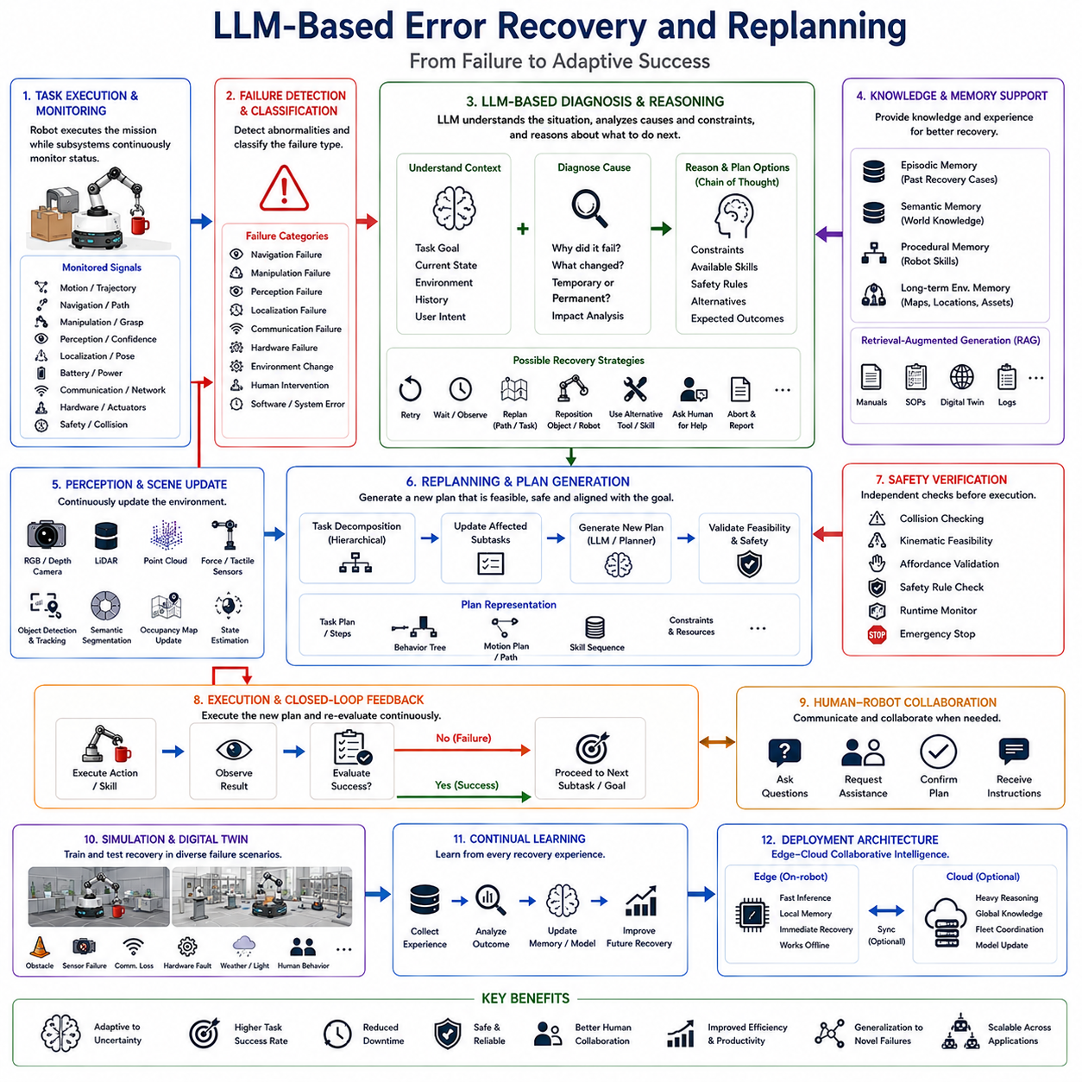
Error recovery and replanning have become fundamental capabilities for intelligent robotic systems operating in dynamic real-world environments. While perception, planning, and control enable robots to perform complex tasks autonomously, no robotic system can avoid unexpected failures entirely. Environmental uncertainty, sensor noise, hardware limitations, communication failures, localization drift, object movement, human intervention, actuator errors, and unforeseen obstacles inevitably introduce deviations from the original execution plan. Traditional robotic systems typically respond to these failures using manually engineered recovery procedures, predefined state machines, or fixed exception handlers. Although such methods provide reliable recovery for anticipated situations, they struggle to generalize when robots encounter novel failure modes. Large Language Models (LLMs) introduce a fundamentally different approach by enabling robots to understand failures semantically, analyze their underlying causes, reason about alternative solutions, and dynamically generate new execution plans. Within modern Vision-Language-Action (VLA) architectures, LLM-based error recovery transforms robotic autonomy from rigid execution into adaptive problem solving.
Traditional robotic control architectures generally assume that tasks progress according to predefined workflows. Navigation systems expect planned paths to remain accessible, manipulation systems assume target objects remain reachable, localization systems assume maps remain consistent, and communication systems assume stable network connectivity. Real-world environments rarely satisfy these assumptions continuously. Doors become unexpectedly closed, humans relocate target objects, temporary obstacles block navigation routes, equipment malfunctions occur, lighting conditions change, batteries discharge faster than expected, and perception systems encounter ambiguous observations. Autonomous robots must therefore treat failures as ordinary operational events rather than exceptional conditions.
The central principle of LLM-based recovery is semantic understanding of failure. Rather than simply detecting that an operation has failed, the robot attempts to understand why the failure occurred, how the surrounding environment has changed, what constraints now exist, and which alternative strategies remain feasible. This semantic interpretation enables adaptive recovery that extends beyond predefined exception handling rules.
Error recovery begins with failure detection. Multiple subsystems continuously monitor execution status throughout robotic operation. Motion controllers report trajectory deviations, navigation systems identify blocked paths, manipulation controllers detect unsuccessful grasps, perception systems estimate confidence levels, localization modules evaluate pose uncertainty, battery management systems monitor energy reserves, communication modules detect network interruptions, and safety systems identify hazardous conditions. These low-level monitoring components provide the raw information required for higher-level reasoning.
Failure classification constitutes the next processing stage. Instead of treating every error identically, the robotic cognitive system categorizes failures according to their underlying characteristics. Navigation failures may result from blocked corridors, localization uncertainty, moving obstacles, inaccessible destinations, or environmental changes. Manipulation failures may originate from inaccurate object detection, unstable grasps, object deformation, insufficient reachability, or unexpected object motion. Communication failures, hardware malfunctions, perception ambiguity, software exceptions, and human intervention similarly represent distinct categories requiring different recovery strategies.
Large Language Models significantly improve failure interpretation because they integrate environmental context, commonsense knowledge, previous task history, semantic scene understanding, and user intent into the diagnostic process. Instead of recognizing only that grasp execution failed, the LLM may infer that another object partially occluded the target, the object shifted during approach, lighting conditions degraded perception quality, or human interaction altered the environment. Such semantic diagnosis enables more intelligent recovery planning.
Context awareness plays a central role throughout recovery reasoning. Identical execution failures may require entirely different responses depending on environmental conditions. Failure to grasp a fragile glass container demands cautious manipulation adjustments, whereas failure to grasp a heavy industrial component may require changing grasp points, requesting human assistance, or selecting alternative tooling. LLMs naturally incorporate contextual reasoning into recovery planning because they possess broad world knowledge regarding object properties, environmental semantics, and task objectives.
Error recovery also requires distinguishing temporary failures from permanent failures. Temporary obstacles, moving humans, transient communication interruptions, or brief sensor occlusions frequently disappear after short delays. Permanent failures such as broken equipment, depleted batteries, inaccessible locations, missing objects, or damaged manipulators require substantial replanning rather than repeated retries. LLMs analyze environmental evidence to estimate whether observed failures likely represent temporary or persistent conditions.
Replanning differs fundamentally from simple retry mechanisms. Traditional systems frequently repeat identical actions following failure, assuming success may occur during subsequent attempts. LLM-based replanning instead modifies execution strategy according to newly acquired environmental knowledge. If a navigation route becomes blocked, the robot searches for alternative paths. If an object cannot be reached directly, intermediate actions reposition obstacles or alter robot configuration. If required tools are unavailable, substitute tools or modified procedures become considered.
Task decomposition substantially enhances recovery capability. Rather than viewing tasks as indivisible sequences, the LLM represents missions hierarchically using interconnected subtasks. Failures affecting individual subtasks need not invalidate entire missions. Instead, replanning focuses only upon affected task components while preserving successfully completed work. This localized adaptation improves efficiency while reducing unnecessary repetition.
Memory integration significantly strengthens error recovery. Episodic memory stores previous recovery experiences describing successful strategies applied under similar circumstances. Semantic memory provides general knowledge regarding object properties, environmental organization, operational procedures, and physical constraints. Procedural memory records robot skills together with historical execution performance. Long-term environmental memory captures persistent facility layouts, equipment locations, charging stations, restricted areas, and frequently encountered obstacles. LLMs retrieve relevant memories when constructing recovery strategies.
Retrieval-Augmented Generation further improves recovery quality. Rather than relying exclusively upon internal model knowledge, robots retrieve operating manuals, maintenance procedures, troubleshooting guides, equipment documentation, digital twins, facility maps, software logs, and previous execution records. Retrieved information supplements semantic reasoning, enabling recovery decisions tailored to specialized industrial environments.
Perception continuously updates environmental understanding throughout recovery. Vision systems identify newly appeared obstacles, relocated objects, changing lighting conditions, human activities, damaged equipment, or altered workspace organization. Depth sensing estimates accessibility, semantic segmentation identifies environmental structure, LiDAR updates occupancy maps, and force sensing monitors manipulation outcomes. These observations ensure recovery planning reflects current reality rather than outdated assumptions.
Scene reasoning plays an essential role during replanning. Rather than considering isolated objects, the LLM interprets the semantic organization of the environment. If a requested object disappears from its expected location, nearby containers, storage shelves, workbenches, transport carts, or human operators become plausible search locations according to contextual reasoning. Such scene-level understanding substantially improves recovery efficiency.
Affordance reasoning similarly supports adaptive behavior. Recovery planning evaluates not only desired actions but also which actions remain physically executable under current conditions. A blocked corridor eliminates navigation affordances. A damaged gripper limits manipulation affordances. Low battery reserves restrict long-distance travel. Affordance estimation grounds semantic reasoning within actual robot capabilities, ensuring generated recovery plans remain executable.
Chain of Thought reasoning increasingly complements recovery planning. Rather than immediately proposing corrective actions, the LLM first performs structured reasoning analyzing task objectives, completed subtasks, current failures, environmental constraints, available robot skills, safety requirements, alternative strategies, and expected consequences. This explicit reasoning process substantially improves recovery quality for complex long-horizon missions.
Closed-loop execution distinguishes intelligent recovery from static replanning. Following every corrective action, perception updates the environmental representation, execution status is reevaluated, and remaining recovery steps become adjusted according to new observations. Continuous feedback enables robots to adapt dynamically throughout extended recovery episodes rather than committing prematurely to fixed alternative plans.
Human interaction frequently contributes to recovery. Robots operating within collaborative environments may request clarification, confirmation, or assistance whenever autonomous recovery remains uncertain. Natural language communication allows operators to provide missing information, authorize modified procedures, identify relocated objects, or intervene directly when necessary. LLMs naturally facilitate these conversational recovery interactions.
Industrial manufacturing illustrates the importance of adaptive recovery. Production environments contain moving personnel, changing work orders, temporary equipment outages, maintenance activities, material shortages, and evolving production schedules. Rather than halting production whenever unexpected events occur, robots employing LLM-based replanning dynamically adjust task sequences while respecting operational priorities and safety constraints.
Warehouse automation similarly benefits from semantic recovery. Inventory locations frequently change, aisles become temporarily congested, pallets shift unexpectedly, forklifts interrupt transportation routes, charging stations become occupied, and urgent fulfillment requests modify operational priorities. LLMs continuously reinterpret these changing conditions while generating updated execution plans maximizing overall productivity.
Inspection robotics presents additional recovery challenges. Weather conditions, lighting variations, sensor contamination, restricted access, equipment vibration, environmental hazards, and changing operational status frequently disrupt inspection procedures. Rather than abandoning inspections after individual failures, semantic recovery enables robots to modify inspection order, substitute sensing modalities, revisit inaccessible assets later, or generate partial inspection reports documenting remaining limitations.
Healthcare robotics requires particularly cautious recovery behavior. Patient safety always overrides task completion. If requested medications become unavailable, pathways become crowded, elevators malfunction, or patients unexpectedly relocate, robots must generate safe alternative plans while clearly communicating status updates to healthcare personnel. LLMs support these context-sensitive recovery strategies using natural language reasoning.
Construction robotics similarly encounters highly dynamic environments characterized by evolving site layouts, temporary barriers, equipment relocation, weather changes, incomplete structures, and continuous human activity. Fixed planning rapidly becomes obsolete under such conditions. LLM-based replanning continuously adapts execution strategies according to current construction progress.
Agricultural robotics also benefits from adaptive recovery. Weather conditions, crop growth, terrain variability, equipment availability, animal movement, irrigation changes, and seasonal operations introduce substantial environmental uncertainty. Semantic reasoning allows robots to modify harvesting routes, inspection priorities, spraying procedures, or navigation strategies according to changing field conditions.
Software failures require semantic interpretation alongside physical failures. Middleware interruptions, unavailable services, API exceptions, synchronization problems, memory limitations, scheduling conflicts, or corrupted data may disrupt execution despite unchanged physical environments. LLMs analyze software logs, execution traces, and diagnostic messages to recommend corrective actions extending beyond conventional exception handling.
Multi-robot systems introduce additional recovery complexity. Failures affecting one robot influence task allocation, resource availability, communication patterns, and mission coordination throughout the entire fleet. LLMs support collaborative replanning by redistributing subtasks, reallocating resources, coordinating replacement robots, and updating collective execution schedules while minimizing overall mission disruption.
Cloud-edge collaboration enhances recovery capability without sacrificing responsiveness. Lightweight onboard language models provide immediate local diagnosis and short-term recovery planning. More computationally intensive cloud-based LLMs optionally perform comprehensive root-cause analysis, long-horizon optimization, software debugging, or fleet-wide coordination whenever communication infrastructure permits. Hierarchical reasoning balances computational efficiency with planning sophistication.
Simulation significantly improves recovery policy development. Digital twins and high-fidelity simulators expose robots to diverse failure scenarios impossible or unsafe to reproduce physically. Blocked pathways, sensor failures, communication outages, hardware degradation, adverse weather, unexpected human interactions, and equipment malfunctions become systematically incorporated into training datasets. Exposure to diverse simulated failures substantially improves real-world robustness.
Fine-tuning further specializes language models for recovery reasoning. General-purpose foundation models possess broad commonsense knowledge but limited understanding of robot diagnostics, industrial procedures, middleware architectures, manipulation failures, localization uncertainty, or hardware constraints. Robotics-specific fine-tuning teaches models to interpret execution failures according to actual robotic operational principles.
Safety remains the highest priority throughout recovery. LLM-generated recovery plans never execute directly without independent validation. Motion planners verify collision-free trajectories, affordance estimators evaluate physical feasibility, safety controllers enforce operational constraints, runtime monitors supervise execution, emergency stop mechanisms retain override authority, and deterministic control systems guarantee safe low-level behavior. LLM reasoning complements rather than replaces classical robotic safety mechanisms.
Evaluation of recovery performance differs substantially from conventional language benchmarks. Success metrics include recovery success rate, mission completion after failure, replanning efficiency, execution latency, resource consumption, human intervention frequency, safety compliance, task continuity, robustness under uncertainty, and operational productivity. These embodied performance measures better reflect practical robotic capability than conversational quality alone.
One significant challenge involves uncertainty estimation. Recovery decisions frequently rely upon incomplete or ambiguous perception data. Incorrect diagnosis may produce ineffective or unsafe corrective actions. Future robotic architectures increasingly integrate probabilistic reasoning, confidence estimation, Bayesian inference, and uncertainty-aware planning alongside language reasoning to improve decision reliability.
Another research direction explores predictive recovery through world models. Rather than reacting only after failures occur, predictive models estimate future environmental evolution, identify emerging risks, anticipate equipment degradation, forecast obstacle movement, and recommend preventive actions before failures manifest. LLMs reason over these predictive simulations to generate proactive rather than reactive recovery strategies.
Continual learning also enhances long-term recovery performance. Robots accumulate operational experience throughout deployment, recording successful recovery episodes, unsuccessful interventions, environmental changes, maintenance records, operator corrections, and evolving workflows. Incremental learning gradually expands recovery capability while adapting to organization-specific operational practices.
Future Vision-Language-Action systems are expected to integrate multimodal perception, semantic scene understanding, affordance reasoning, Chain of Thought planning, world models, external memory, retrieval-augmented knowledge, simulation experience, and continual learning into unified embodied cognitive architectures. Rather than treating failure recovery as an isolated software module, future Physical AI systems will view every unexpected event as an opportunity for reasoning, adaptation, and learning.
As autonomous robots increasingly operate across manufacturing, logistics, healthcare, agriculture, construction, infrastructure inspection, domestic service, and collaborative workplaces, LLM-based error recovery and replanning will become one of the defining capabilities distinguishing truly intelligent embodied systems from conventional automation. By combining semantic understanding, contextual reasoning, environmental awareness, reusable robot skills, memory retrieval, multimodal perception, adaptive planning, and deterministic safety verification, LLM-based recovery establishes a practical framework through which robots can continue operating safely and productively despite the uncertainty and unpredictability that characterize real-world environments.

3.9 Multi-Turn Human-Robot Dialogue (with Code)
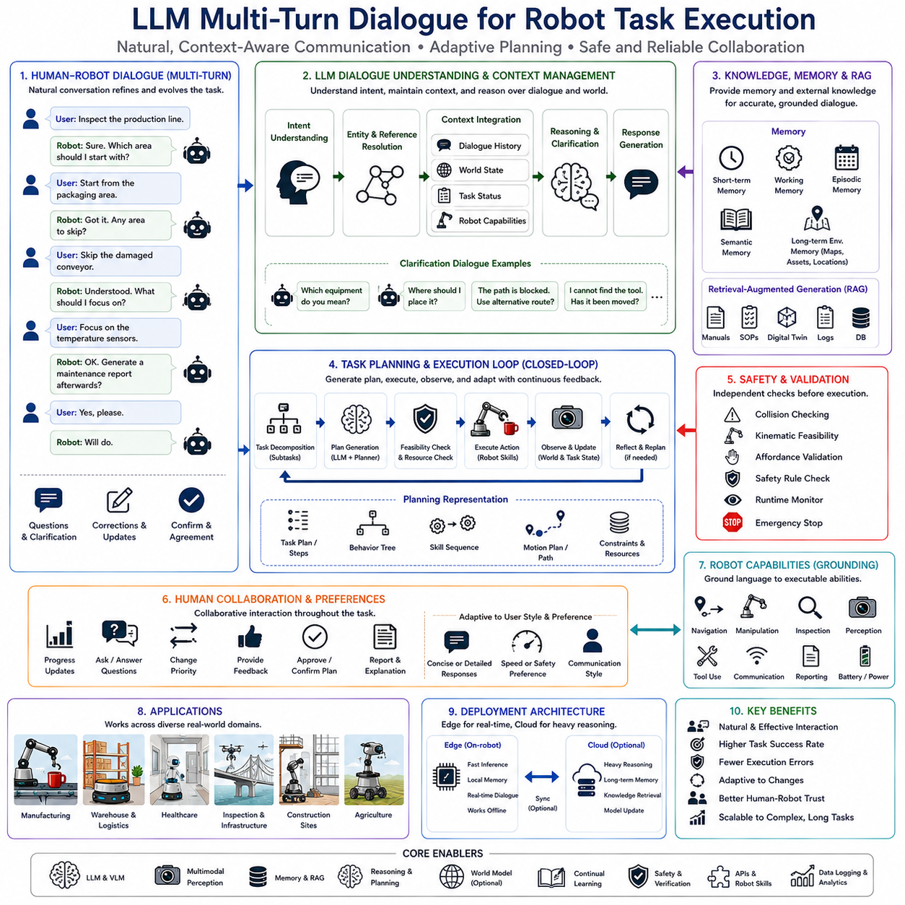
Multi-turn dialogue has become one of the most important capabilities for intelligent robotic systems as robots transition from executing isolated commands to participating in continuous human-robot collaboration. Traditional robot interfaces generally assume that users provide complete and unambiguous instructions before execution begins. However, real-world tasks rarely follow such simplified interaction patterns. Human operators naturally communicate through incremental conversations, refining goals, correcting misunderstandings, providing additional information, asking questions, changing priorities, and reacting to evolving environmental conditions. Large Language Models (LLMs) enable robots to participate in these extended conversational interactions while maintaining awareness of task context, dialogue history, environmental knowledge, robot capabilities, and execution status. Within modern Vision-Language-Action (VLA) architectures, multi-turn dialogue transforms robotic systems from command-driven automation into collaborative cognitive partners capable of long-term interactive task execution.
Human communication is inherently contextual. People rarely express every detail of a task in a single sentence. Instead, instructions evolve through dialogue. A user may initially request, “Inspect the production line,” followed by additional statements such as “Start with the packaging area,” “Skip the damaged conveyor,” “Focus on temperature sensors,” and “Generate a maintenance report afterward.” Each new utterance modifies the original task rather than replacing it entirely. A robot must therefore maintain conversational memory capable of integrating multiple instructions into a coherent evolving mission plan.
Unlike single-turn command processing, multi-turn dialogue requires persistent context management. Every conversational exchange influences future interpretation. Pronouns, implicit references, abbreviated expressions, and previously discussed objects become meaningful only when interpreted relative to accumulated dialogue history. If a user says, “Bring the inspection camera,” followed later by “Place it on the charging station,” the robot must recognize that “it” refers to the inspection camera rather than another recently mentioned object. Maintaining this contextual continuity represents one of the primary strengths of LLM-based dialogue systems.
Dialogue memory extends beyond linguistic history into environmental context. During execution, the robot continuously updates its understanding of object locations, navigation progress, task completion status, sensor observations, battery condition, human positions, environmental changes, and available resources. Conversational reasoning therefore combines spoken interaction with continuously evolving physical knowledge. Responses become grounded not only in previous dialogue but also in the robot's current understanding of the world.
Task-oriented dialogue differs substantially from general conversational AI. In ordinary conversation, the objective is information exchange. In robotics, dialogue directly influences physical behavior. Every conversational decision may modify navigation goals, manipulation plans, inspection procedures, scheduling priorities, or collaborative workflows. Consequently, robotic dialogue systems must produce responses that are semantically meaningful, operationally consistent, physically executable, and compliant with safety constraints.
Intent understanding represents the foundation of multi-turn interaction. Human instructions frequently contain ambiguity, incomplete specifications, or implicit assumptions. Instead of immediately executing uncertain commands, LLMs identify missing information and initiate clarification dialogues. If a user requests, “Move the equipment,” the robot may ask, “Which equipment would you like me to move?” or “Where should I place it?” Such clarification significantly reduces execution errors while improving overall task success.
Clarification dialogue demonstrates one of the most valuable characteristics of intelligent robotic communication. Traditional command systems often require perfectly formatted instructions before execution. LLMs instead engage in cooperative conversation, identifying ambiguities naturally and resolving them through incremental questioning. This interaction more closely resembles collaboration between human coworkers than interaction with conventional automation systems.
Dialogue management also supports dynamic task modification. Users frequently alter objectives during execution. For example, while the robot transports inspection equipment, the user may request that another urgent task receive higher priority. Rather than abandoning previous work entirely, the LLM analyzes existing task progress, completed subtasks, remaining objectives, environmental constraints, and scheduling implications before generating a revised execution plan. Multi-turn dialogue therefore becomes tightly integrated with dynamic task replanning.
Long-horizon tasks particularly benefit from conversational interaction. Industrial inspections, warehouse inventory management, hospital delivery services, agricultural monitoring, infrastructure maintenance, and construction site operations often require hours of continuous activity. Throughout these missions, human supervisors periodically request progress updates, modify priorities, provide additional instructions, answer robot questions, or respond to unexpected events. Multi-turn dialogue maintains collaborative continuity throughout these extended operational periods.
Dialogue memory generally consists of multiple complementary layers. Short-term conversational memory preserves recent exchanges necessary for interpreting ongoing discussion. Working memory stores active task variables, temporary decisions, unresolved questions, and current execution context. Episodic memory records completed conversations together with corresponding robot experiences. Semantic memory stores persistent knowledge regarding facilities, equipment, procedures, terminology, and object relationships. Collectively, these memory systems enable coherent long-term interaction.
Retrieval-Augmented Generation further enhances dialogue quality by providing access to external knowledge during conversation. Rather than relying exclusively upon internal model parameters, the robot retrieves maintenance manuals, operating procedures, equipment specifications, facility documentation, digital twins, software documentation, inspection histories, semantic maps, and enterprise databases whenever users ask domain-specific questions. Retrieved information becomes integrated naturally into ongoing dialogue while remaining grounded in authoritative documentation.
Multimodal perception significantly enriches conversational interaction. Rather than discussing abstract concepts alone, robots perceive surrounding environments through RGB cameras, depth sensors, LiDAR, tactile sensing, force measurements, semantic segmentation, localization systems, and object detection pipelines. When users ask questions such as “What is blocking the corridor?” or “Is the valve still leaking?” the robot combines visual perception with language reasoning to generate accurate responses describing current environmental conditions.
Vision-Language Models frequently complement multi-turn dialogue systems by generating semantic descriptions of observed scenes. These descriptions become part of the conversational context interpreted by the LLM. Rather than reasoning exclusively over raw sensor data, the language model receives structured semantic information describing objects, relationships, spatial organization, human activities, environmental changes, and potential hazards. This integration substantially improves dialogue quality within complex physical environments.
Reference resolution represents another critical capability. Human dialogue frequently includes expressions such as “that box,” “the previous pallet,” “the same room,” “the left shelf,” “our last inspection,” or “the damaged machine.” LLMs resolve these references using dialogue history, environmental observations, spatial reasoning, semantic memory, and previous execution records. Accurate reference resolution prevents misunderstandings during collaborative robotic operation.
Grounding language in robot capabilities remains essential throughout conversation. Not every requested action can be executed successfully. If users request physically impossible manipulations, inaccessible navigation goals, unavailable equipment, or unsupported robot functions, the LLM explains these limitations while suggesting feasible alternatives. Such grounded dialogue maintains realistic expectations regarding robot capabilities while supporting productive collaboration.
Dialogue also facilitates transparency and explainability. Rather than executing actions silently, robots communicate reasoning processes, execution status, environmental observations, detected anomalies, expected completion times, and recovery strategies. Users therefore remain informed regarding robot intentions, increasing trust, situational awareness, and operational confidence. Explainable dialogue becomes especially valuable within industrial, healthcare, and safety-critical environments.
Error recovery frequently depends upon conversational interaction. When autonomous recovery remains uncertain, robots initiate dialogue requesting clarification or assistance. Questions such as “I cannot locate the requested inspection tool. Has it been moved?” or “The planned route is blocked. Would you like me to take an alternative path?” enable collaborative decision making rather than unilateral autonomous behavior. LLMs naturally generate contextually appropriate recovery conversations.
Human preferences also emerge gradually through repeated dialogue. Some operators prefer concise status updates, whereas others request detailed explanations. Some prioritize speed, while others emphasize safety or inspection accuracy. Multi-turn dialogue enables LLMs to infer these interaction preferences and adapt communication style accordingly without requiring explicit configuration.
Task delegation becomes more effective through conversational planning. Rather than assigning rigid command sequences, supervisors describe objectives at varying levels of abstraction. The LLM decomposes these objectives into executable subtasks while periodically confirming major planning decisions through dialogue. This collaborative planning process combines human strategic judgment with robotic execution capability.
Industrial manufacturing provides numerous examples illustrating the importance of dialogue-based interaction. Production supervisors issue changing work orders, respond to equipment failures, adjust inspection priorities, coordinate maintenance schedules, authorize recovery actions, and monitor production progress throughout each shift. Multi-turn dialogue allows robots to participate naturally within these continuously evolving operational workflows.
Warehouse automation similarly benefits from conversational coordination. Supervisors redirect inventory transportation, prioritize urgent shipments, modify storage assignments, explain unexpected inventory discrepancies, coordinate multiple autonomous mobile robots, and resolve operational conflicts through continuous dialogue rather than isolated command execution.
Healthcare robotics requires particularly sophisticated conversational capability. Hospital personnel issue patient-specific instructions, update treatment priorities, modify delivery schedules, report changing patient conditions, clarify medication requirements, and coordinate emergency responses. LLM-based dialogue supports these sensitive interactions while maintaining awareness of patient safety, privacy requirements, medical terminology, and clinical workflows.
Inspection robotics also benefits substantially from multi-turn communication. Engineers discuss detected anomalies, request additional measurements, modify inspection procedures, review historical maintenance records, compare observations with previous inspections, authorize follow-up actions, and generate collaborative maintenance reports through ongoing dialogue with robotic inspection systems.
Construction robotics operates within rapidly changing environments where site layouts, work priorities, equipment availability, weather conditions, and human activities continuously evolve. Conversational interaction enables construction supervisors to communicate these changes naturally without repeatedly specifying complete task definitions from the beginning.
Agricultural robotics similarly benefits from long-term conversational collaboration. Farmers discuss crop conditions, weather forecasts, irrigation schedules, harvesting priorities, disease observations, fertilizer recommendations, equipment status, and seasonal planning while robots continuously adapt operational behavior according to evolving agricultural requirements.
Emotionally intelligent communication also contributes to effective collaboration. Although industrial robots need not simulate human emotions, they benefit from recognizing operator frustration, urgency, uncertainty, satisfaction, or confusion through linguistic patterns. Appropriate communication style adaptation improves usability, reduces misunderstandings, and strengthens long-term human-robot relationships.
Dialogue systems must also manage interruptions effectively. Human conversations naturally include topic changes, temporary suspensions, emergency requests, side questions, and resumed discussions. Multi-turn dialogue enables robots to pause ongoing conversational threads, address urgent issues, and later resume previous discussions without losing contextual continuity. This flexibility significantly improves operational realism.
Planning and dialogue increasingly operate as mutually supportive processes. Conversations influence planning decisions, while planning status influences subsequent conversations. Every completed task, detected obstacle, recovered failure, or environmental observation updates both execution state and dialogue context. The cognitive architecture therefore integrates language reasoning, memory, perception, planning, and execution within a continuously synchronized information model.
Small Language Models deployed on edge robots increasingly support local conversational interaction without requiring constant cloud connectivity. Lightweight onboard dialogue enables immediate responses, offline operation, privacy preservation, and deterministic latency. More computationally intensive cloud-based Large Language Models optionally provide deeper reasoning, extended planning, complex troubleshooting, multilingual translation, or comprehensive report generation whenever communication becomes available.
Retrieval systems further personalize dialogue by incorporating organization-specific terminology, operating procedures, technical documentation, maintenance records, facility layouts, robot software repositories, and enterprise knowledge bases. Rather than generating generic conversational responses, LLMs communicate using terminology and workflows familiar to local operators.
Safety remains the highest priority throughout conversational interaction. Language models never directly execute physical commands without independent verification. Motion planning, affordance estimation, collision prediction, runtime monitoring, emergency stopping, geometric validation, and deterministic control systems independently evaluate every proposed action before execution. Dialogue influences planning but does not bypass established robotic safety mechanisms.
Evaluation of multi-turn robotic dialogue differs significantly from conventional conversational benchmarks. Practical evaluation emphasizes instruction following accuracy, contextual consistency, dialogue coherence, task completion rate, clarification effectiveness, reference resolution accuracy, user satisfaction, execution success, planning adaptability, latency, robustness under interruptions, and collaborative efficiency. These embodied interaction metrics better reflect operational performance than purely linguistic measures.
Future developments increasingly integrate world models, multimodal perception, external memory, continual learning, retrieval-augmented reasoning, semantic scene understanding, affective communication, predictive planning, and collaborative multi-agent dialogue into unified cognitive architectures. Rather than functioning merely as conversational interfaces, future robotic dialogue systems will become persistent collaborative partners capable of maintaining months or years of accumulated interaction history while continuously adapting to evolving users, environments, workflows, and operational objectives.
As Physical AI advances toward fully embodied cognitive intelligence, LLM-based multi-turn dialogue will become a defining capability distinguishing intelligent collaborative robots from conventional automation. By integrating contextual memory, semantic reasoning, multimodal perception, grounded planning, explainable communication, adaptive interaction, task management, external knowledge retrieval, continual learning, and deterministic safety verification, multi-turn dialogue establishes a practical framework through which robots can collaborate naturally with humans across complex long-duration real-world tasks while maintaining both operational reliability and conversational fluency.

3.10 Real-Time LLM Inference Optimization (with Code)
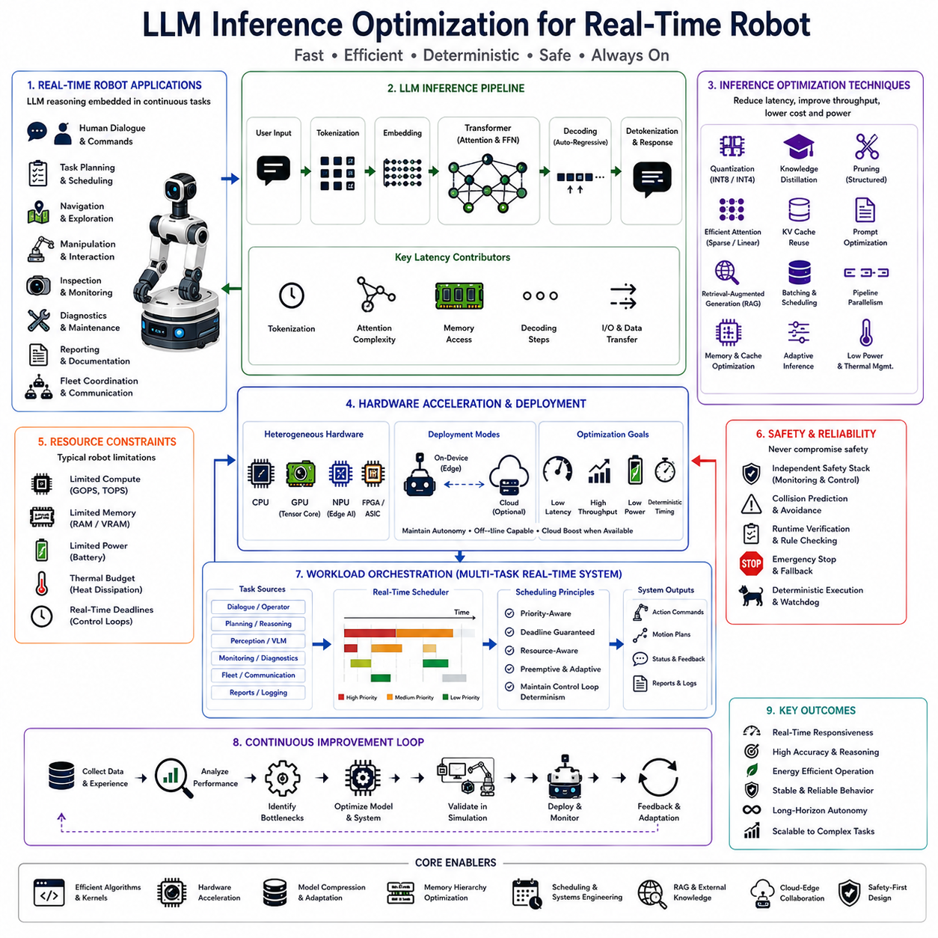
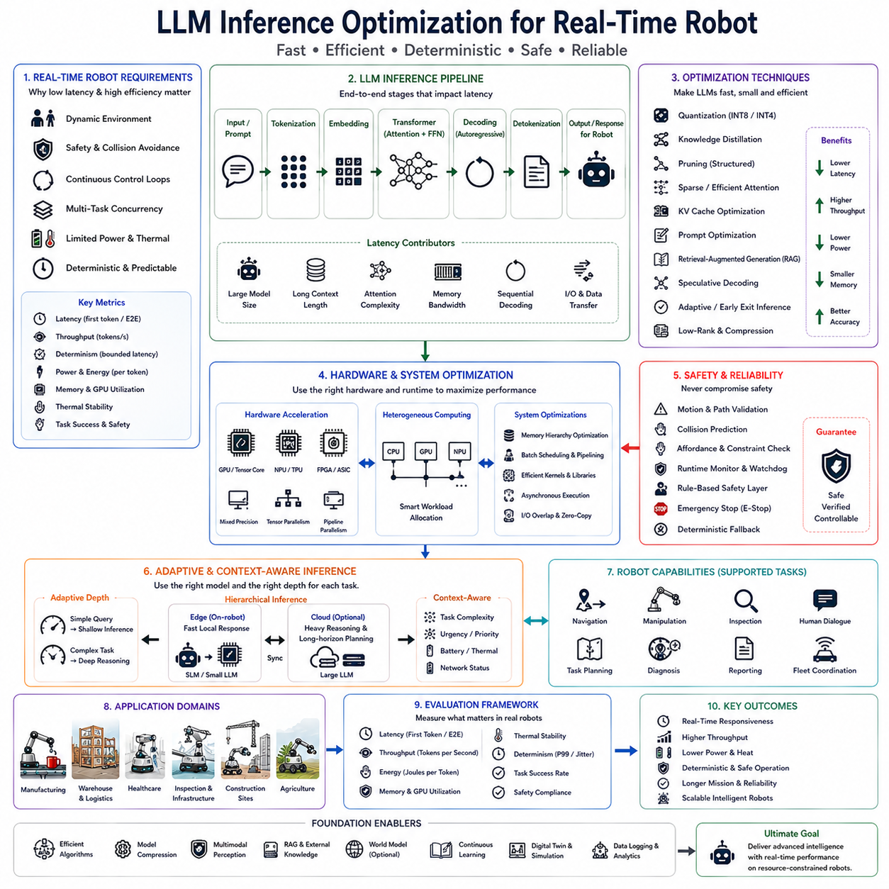
Real-time inference optimization has become one of the most critical research topics in modern Physical AI because the practical deployment of Large Language Models (LLMs) in robotic systems depends not only on reasoning quality but also on deterministic execution speed, predictable latency, efficient resource utilization, and continuous responsiveness. While recent foundation models demonstrate extraordinary capabilities in natural language understanding, planning, reasoning, and multimodal cognition, their computational complexity presents significant challenges for autonomous robots operating under strict power, thermal, memory, and timing constraints. Unlike cloud-based conversational systems that may tolerate response delays of several seconds, autonomous robots continuously interact with dynamic physical environments where delayed reasoning can directly influence safety, navigation accuracy, manipulation success, and human-robot collaboration. Consequently, inference optimization has become a foundational technology enabling the integration of advanced language intelligence into real-time robotic platforms.
Real-time robotics differs fundamentally from traditional cloud artificial intelligence. In cloud environments, language models typically process isolated requests independently, often utilizing large GPU clusters capable of accommodating substantial computational workloads. Robotic systems instead execute multiple concurrent workloads continuously throughout operation. Localization, perception, obstacle avoidance, motion planning, sensor fusion, control loops, navigation, mapping, object recognition, manipulation planning, communication, diagnostics, safety monitoring, and language reasoning all compete for limited onboard computational resources. Efficient inference therefore requires careful coordination between language processing and every other subsystem operating within the robotic architecture.
Latency represents one of the most important optimization objectives. In robotics, latency is not merely an inconvenience but frequently determines operational safety and task success. A robot receiving delayed reasoning output may continue following obsolete plans after environmental conditions have changed. Humans may enter the robot's workspace, obstacles may appear unexpectedly, target objects may move, communication may change task priorities, or emergency conditions may require immediate response. Minimizing end-to-end inference latency therefore directly improves robot adaptability and safety.
Inference latency consists of multiple sequential stages. Natural language instructions must first be tokenized before entering the transformer architecture. Embedding generation converts discrete tokens into continuous representations processed through attention mechanisms and feed-forward layers. Decoder operations generate output tokens autoregressively, followed by detokenization and response interpretation by downstream planning modules. Each stage contributes to overall response delay. Effective optimization therefore targets the complete inference pipeline rather than isolated computational kernels.
Throughput represents another critical performance metric. Modern robotic systems frequently process multiple simultaneous language interactions originating from human operators, autonomous planning modules, perception summaries, monitoring systems, maintenance diagnostics, and fleet coordination services. High-throughput inference enables the robotic cognitive architecture to handle concurrent reasoning tasks without introducing unacceptable scheduling delays or computational bottlenecks.
Deterministic execution distinguishes robotic inference from conventional language processing. Human users may tolerate variable response times during casual conversation, whereas robotic control systems require predictable execution timing. Motion planners, safety controllers, sensor fusion algorithms, and scheduling systems depend upon consistent computational behavior. Consequently, inference optimization emphasizes bounded latency rather than merely maximizing average computational performance.
Model architecture strongly influences inference efficiency. Transformer-based language models perform extensive matrix multiplications, attention computations, normalization operations, activation functions, and memory transfers throughout each decoding step. While these architectures achieve remarkable reasoning performance, they require careful optimization for deployment within embedded robotic computing platforms. Architectural modifications reducing computational complexity while preserving reasoning capability therefore represent active research areas.
Model compression constitutes one of the most widely adopted optimization strategies. Quantization reduces numerical precision from floating-point representations to lower-bit integer formats such as INT8, INT6, INT4, or mixed-precision representations. Quantized models consume significantly less memory, reduce bandwidth requirements, improve cache utilization, and accelerate tensor computations while preserving acceptable reasoning quality for robotic applications. Modern hardware accelerators increasingly provide native support for low-precision inference, making quantization particularly effective for edge deployment.
Knowledge distillation further enhances inference efficiency by transferring reasoning capability from large teacher models into compact student models. Rather than deploying extremely large foundation models directly onboard robots, smaller distilled models reproduce much of the teacher's reasoning behavior while requiring substantially fewer computational resources. This approach significantly improves inference speed without requiring complete redesign of downstream robotic software.
Structured pruning removes redundant parameters from transformer networks. Many attention heads, neurons, feed-forward dimensions, and intermediate activations contribute minimally to final prediction quality. Eliminating these unnecessary components reduces computational complexity, memory consumption, and execution latency while maintaining robust reasoning performance. Structured pruning generally produces more efficient hardware execution than unstructured sparsity because optimized kernels exploit regular computational patterns.
Attention optimization represents another major research direction. Conventional self-attention exhibits quadratic computational complexity with respect to sequence length, making long-context reasoning increasingly expensive. Numerous optimized attention mechanisms reduce computational complexity using sparse attention, local attention, grouped attention, sliding windows, linear approximations, or memory compression. These methods significantly improve inference performance for robotic dialogue, planning, and contextual reasoning tasks involving extended interaction histories.
Caching mechanisms substantially reduce repeated computation during autoregressive decoding. Key-value caches preserve intermediate attention representations generated during previous decoding steps, allowing subsequent tokens to reuse existing computations rather than recomputing entire attention matrices repeatedly. Efficient cache management significantly accelerates sequential response generation while reducing processor utilization.
Prompt optimization also contributes to inference efficiency. Rather than repeatedly providing lengthy contextual descriptions, robotic systems organize prompts hierarchically, separating persistent system instructions, environmental context, task objectives, safety constraints, and temporary conversational information. Carefully structured prompts minimize unnecessary token processing while preserving essential contextual knowledge.
Retrieval-Augmented Generation further reduces computational burden. Instead of embedding extensive factual knowledge directly within model parameters or repeatedly including large contextual prompts, robots retrieve maintenance manuals, semantic maps, operating procedures, equipment documentation, digital twins, inspection histories, software documentation, and enterprise knowledge bases only when necessary. Retrieval therefore decreases prompt length while simultaneously improving factual accuracy.
Memory hierarchy optimization plays an equally important role. Modern GPUs contain multiple memory levels including registers, shared memory, cache hierarchies, high-bandwidth memory, and host memory. Efficient placement of model parameters, activation tensors, attention caches, and intermediate computations minimizes costly memory transfers while maximizing arithmetic throughput. Memory bandwidth frequently becomes a greater performance limitation than raw computational capability during transformer inference.
Batch scheduling further improves hardware utilization. Robotic systems frequently execute multiple language requests simultaneously originating from dialogue management, task planning, perception reasoning, diagnostics, reporting, and fleet communication. Intelligent scheduling groups compatible inference requests into efficient execution batches while respecting individual latency requirements. Adaptive schedulers balance throughput against response time according to current operational priorities.
Pipeline parallelism enables different hardware components to process distinct inference stages concurrently. Tokenization, embedding generation, transformer execution, decoding, and output interpretation overlap through carefully coordinated execution pipelines. Such parallel processing significantly increases overall system responsiveness without increasing hardware resources proportionally.
Hardware acceleration remains indispensable for real-time robotic inference. Modern robotic computing platforms increasingly integrate GPUs, Neural Processing Units (NPUs), Tensor Processing Units (TPUs), dedicated AI accelerators, FPGA-based inference engines, tensor cores, and specialized transformer processors. These hardware architectures accelerate matrix operations, attention computation, low-precision arithmetic, and memory movement while reducing power consumption relative to general-purpose processors.
Edge robotic platforms such as NVIDIA Jetson Orin, Jetson Thor, Intel Core Ultra AI processors, AMD Ryzen AI processors, Qualcomm Robotics platforms, and custom embedded AI modules increasingly provide heterogeneous computing architectures combining CPUs, GPUs, NPUs, and dedicated inference engines. Effective inference optimization therefore includes intelligent workload distribution across heterogeneous computational resources according to each processor's strengths.
Power optimization directly influences robotic operational endurance. Autonomous mobile robots typically operate from battery-powered electrical systems where computational energy competes with locomotion, sensing, communication, lighting, environmental monitoring, and manipulation hardware. Efficient inference minimizes energy consumption per generated token, extending mission duration without sacrificing cognitive capability.
Thermal management similarly affects long-duration deployment. Continuous transformer inference generates substantial heat within embedded computing platforms. Excessive thermal accumulation triggers frequency throttling, reducing computational performance precisely when sustained reasoning becomes necessary. Thermal-aware scheduling, dynamic frequency scaling, workload balancing, and adaptive inference strategies therefore maintain stable long-term performance.
Adaptive inference has emerged as a particularly promising optimization approach. Rather than executing identical computational workloads for every request, robots dynamically adjust reasoning depth according to task complexity. Simple confirmation responses require minimal inference, whereas complex mission planning, failure recovery, or long-horizon reasoning activate more sophisticated computational pathways. Adaptive computation significantly reduces average inference cost while preserving high reasoning quality when necessary.
Hierarchical language architectures further improve efficiency. Lightweight Small Language Models continuously execute onboard, handling routine dialogue, task interpretation, local planning, and rapid decision making. Larger cloud-hosted models perform strategic reasoning, software development, complex diagnostics, and extensive report generation whenever communication infrastructure permits. This hierarchical approach balances responsiveness, capability, computational efficiency, and operational reliability.
Task-specific specialization reduces unnecessary computation. Rather than deploying a single universal language model responsible for every cognitive function, robotic architectures increasingly employ specialized reasoning modules optimized for navigation, manipulation, inspection, maintenance, human interaction, diagnostics, reporting, or software assistance. Specialized models frequently achieve superior latency while maintaining domain-specific reasoning quality.
Multimodal integration also benefits inference optimization. Vision encoders, semantic mapping systems, object detectors, localization modules, force sensing, tactile perception, and environmental monitoring preprocess raw sensory information before language reasoning begins. Providing structured semantic representations rather than raw sensor data significantly reduces language model computational requirements while improving reasoning quality.
Planning architectures increasingly separate symbolic reasoning from language reasoning. Deterministic planners efficiently compute geometric trajectories, collision-free paths, inverse kinematics, and motion optimization, while LLMs focus upon semantic interpretation, task decomposition, dialogue management, contextual reasoning, and high-level planning. This division of responsibility prevents expensive language inference from performing computations better suited to conventional robotics algorithms.
Continuous inference scheduling becomes essential within multitasking robotic systems. Language reasoning cannot monopolize computational resources because perception, localization, control, and safety monitoring operate under strict real-time deadlines. Modern robotic operating systems therefore employ priority-aware schedulers coordinating language inference alongside deterministic control tasks while guaranteeing timing requirements for safety-critical processes.
Cloud-edge collaboration provides another optimization strategy. Immediate local reasoning executes entirely onboard using compressed language models, whereas computationally intensive planning, retraining, fleet coordination, digital twin simulation, and large-scale knowledge retrieval execute within cloud infrastructure whenever communication becomes available. Local autonomy remains preserved during network outages while cloud resources augment cognitive capability opportunistically.
Fine-tuning substantially improves inference efficiency indirectly. Domain-specific language models require fewer reasoning steps because they understand robotic terminology, operational procedures, software interfaces, and environmental semantics more naturally than general-purpose models. Specialized knowledge therefore reduces prompt complexity, reasoning depth, and generated output length while improving overall response quality.
Continual learning further enhances efficiency over time. Robots accumulate operational experience describing frequently encountered tasks, environmental conditions, maintenance procedures, dialogue patterns, recovery strategies, and user preferences. Personalized adaptation gradually reduces computational effort required for routine interactions because previously learned patterns become increasingly familiar to the optimized model.
Simulation environments provide valuable platforms for optimization research. High-fidelity digital twins enable evaluation of latency, throughput, energy consumption, scheduling efficiency, thermal behavior, and recovery performance under diverse operational scenarios without risking physical hardware. Simulation supports systematic optimization before deployment within safety-critical industrial environments.
Industrial manufacturing particularly benefits from optimized inference. Production lines require deterministic cycle times, continuous inspection, maintenance coordination, quality assurance, and operator interaction. Efficient language inference enables robots to generate reports, interpret work orders, answer technical questions, coordinate production activities, and recover from failures without disrupting manufacturing throughput.
Warehouse automation similarly depends upon responsive cognitive processing. Inventory updates, transportation requests, fleet coordination, charging management, obstacle handling, and order fulfillment continuously generate language reasoning tasks. Optimized inference maintains low latency despite heavy operational workloads while preserving energy efficiency throughout extended autonomous operation.
Healthcare robotics introduces additional timing constraints because patient interaction frequently requires immediate conversational response while simultaneously maintaining navigation, medication delivery, monitoring, and safety supervision. Efficient inference ensures natural communication without compromising real-time robotic behavior.
Inspection robotics operating across industrial plants, infrastructure, utilities, construction sites, and agricultural environments similarly require rapid reasoning under challenging computational conditions. Robots continuously analyze anomalies, interpret sensor observations, retrieve maintenance documentation, generate reports, and respond to operator questions while maintaining autonomous navigation and environmental awareness.
Safety remains paramount throughout inference optimization. Faster reasoning must never compromise correctness, reliability, or deterministic verification. Motion planning, collision prediction, affordance estimation, runtime monitoring, emergency stopping, geometric validation, and rule-based safety controllers continue independently verifying every proposed robotic action regardless of language model inference speed. Optimization therefore complements rather than replaces classical safety architectures.
Evaluation of inference optimization extends beyond conventional language benchmarks. Practical robotic metrics include end-to-end latency, first-token latency, tokens per second, throughput, energy consumption, memory utilization, thermal stability, deterministic response timing, task completion rate, safety compliance, hardware utilization, recovery responsiveness, and long-duration operational reliability. These embodied performance measures more accurately reflect deployment readiness than isolated computational benchmarks.
Future Physical AI systems are expected to integrate adaptive transformer architectures, multimodal perception, hierarchical reasoning, retrieval-augmented knowledge, external memory, world models, predictive scheduling, heterogeneous hardware acceleration, continual learning, and dynamic computational scaling into unified cognitive frameworks. Rather than executing fixed computational pipelines, future robotic language systems will continuously optimize inference according to environmental complexity, operational urgency, available computational resources, battery status, thermal conditions, and mission objectives.
As intelligent autonomous robots become increasingly prevalent across manufacturing, logistics, healthcare, agriculture, infrastructure inspection, construction, domestic assistance, and collaborative industrial environments, LLM inference optimization will remain one of the defining technologies enabling practical real-time embodied intelligence. By combining model compression, hardware acceleration, adaptive computation, hierarchical reasoning, multimodal integration, efficient memory management, retrieval-augmented knowledge, cloud-edge collaboration, deterministic scheduling, and rigorous safety verification, optimized language inference establishes the computational foundation necessary for deploying advanced cognitive capabilities within resource-constrained robotic platforms operating safely and efficiently in complex real-world environments.

