Volume 06. Physical AI Hardware Software Co Design

Chapter 09. Case Studies

09.01. Indoor AMR Co Design
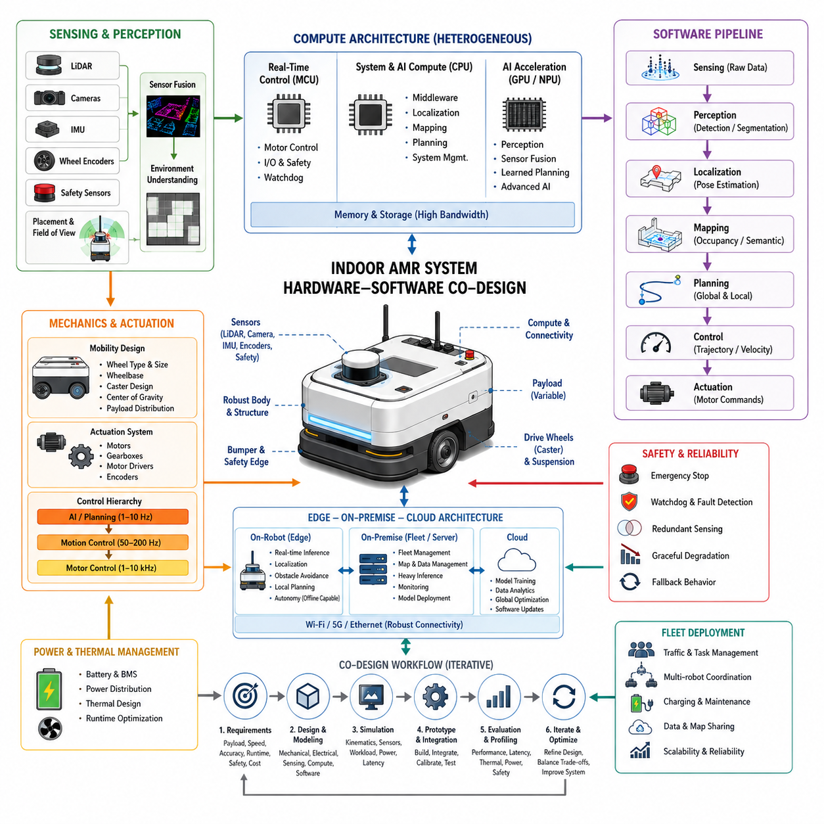
Indoor autonomous mobile robots are an instructive example of Physical AI co-design because navigation quality emerges from the interaction of mechanics, sensing, computation, software, and control rather than from any single subsystem. An indoor AMR must move reliably through corridors, warehouses, factories, hospitals, and logistics facilities while sharing space with people, vehicles, racks, doors, and dynamically changing obstacles. The design therefore begins with operational requirements rather than with an isolated AI model.
The mechanical platform defines the physical envelope within which autonomy must operate. Wheel configuration, wheelbase, caster placement, center of gravity, payload distribution, suspension, tire properties, and structural stiffness influence acceleration, turning behavior, vibration, odometry, and stopping distance. A navigation algorithm cannot completely compensate for poor mechanical stability or unpredictable wheel-ground interaction, so mobility hardware and autonomous-control requirements should be developed together.
Differential-drive architectures are common because they provide mechanical simplicity, low cost, compact packaging, and straightforward kinematic control. However, wheel diameter differences, motor asymmetry, floor friction, caster dynamics, payload shifts, and manufacturing tolerances can introduce heading errors. Closed-loop velocity control, encoder calibration, inertial feedback, localization correction, and suitable caster geometry must therefore be considered part of the mobility design rather than treated as independent software improvements.
Actuator selection is similarly coupled to autonomous behavior. Motor torque, gear ratio, wheel radius, drive efficiency, acceleration limits, braking capability, and controller bandwidth determine the feasible motion envelope presented to the planner. AI-generated velocity commands must remain inside these physical limits, while low-level motor controllers should execute commands at substantially higher frequencies than perception or planning. This layered architecture separates fast deterministic stabilization from slower intelligent decision making.
Sensor architecture should be derived from the environments and failure modes that the robot is expected to encounter. LiDAR can provide reliable geometric measurements, cameras can contribute semantic and visual information, wheel encoders provide local motion estimates, and an IMU captures rotational and inertial changes. Additional depth cameras, ultrasonic sensors, bumpers, or safety scanners may be incorporated when required by operational risk, environmental geometry, redundancy objectives, or human-robot interaction requirements.
Placement is as important as sensor type. Occlusion from the chassis, payload, forks, manipulators, or surrounding structures can create blind regions even when high-quality sensors are installed. Sensor height and field of view affect detection of low obstacles, pallets, table surfaces, glass structures, and nearby people. The resulting configuration should provide sufficient spatial coverage while controlling data bandwidth, computational demand, power consumption, wiring complexity, and hardware cost.
Localization combines these measurements into a consistent estimate of robot pose. Wheel odometry may provide high-rate local motion information but accumulates error through slip and calibration uncertainty. LiDAR-, vision-, or map-based localization can correct longer-term drift, while inertial measurements improve short-term orientation estimation. The important co-design principle is that localization accuracy depends on sensor quality, mechanical repeatability, synchronization, calibration, environmental observability, and compute latency simultaneously.
The perception pipeline converts raw measurements into representations useful for safe navigation. Depending on the AMR, these may include obstacle maps, occupancy grids, free-space estimates, semantic objects, traversability information, dynamic-object tracks, or learned environmental features. Increasing sensor resolution or adding modalities can improve environmental understanding, but it also increases memory traffic and inference workload. Sensor selection and AI architecture must therefore be evaluated against the available compute platform as a unified system.
Indoor navigation normally contains multiple timing layers. Motor current and velocity loops operate at relatively high frequencies, localization and obstacle processing run at intermediate rates, and global planning or higher-level reasoning may operate more slowly. What matters is not simply maximum processor throughput but predictable sensing-to-action latency. Excessive delay or jitter can make an otherwise accurate perception model operationally unsafe because the physical environment continues evolving while computation is performed.
This requirement favors heterogeneous computing. Microcontrollers or real-time processors can manage motor control, emergency interfaces, watchdogs, and deterministic I/O, while CPUs execute middleware, localization, mapping, and system management. GPUs or NPUs can accelerate deep perception, multimodal fusion, learned planning, or more advanced Physical AI models. Separating control compute from AI compute also provides fault containment: overload or failure of an intensive AI workload need not immediately destabilize basic vehicle control.
Compute sizing should be based on the complete workload rather than nominal accelerator performance. Camera decoding, point-cloud processing, localization, neural inference, map updates, planning, logging, visualization, communications, and safety monitoring compete for processor time, memory bandwidth, and storage bandwidth. Peak utilization should retain sufficient margin for transient workloads and degraded conditions. Otherwise, apparently adequate hardware can produce latency spikes precisely when environmental complexity increases.
Power and thermal design impose another physical boundary on AI capability. Drive motors usually dominate energy during motion, but processors, sensors, networking equipment, storage, and cooling create continuous electrical loads. A larger accelerator can enable more sophisticated models while reducing battery runtime and increasing cooling requirements. Sustained inference performance should therefore be evaluated thermally, because benchmark performance available for short periods may not be maintained inside an enclosed AMR during extended operation.
Safety architecture should remain functional even when advanced autonomy becomes unavailable. Emergency stopping, motor disable, protective sensing, speed limitation, watchdog supervision, communication-loss handling, and controlled fallback behavior should not depend exclusively on a large neural model. A useful design principle is graceful degradation: loss of a camera, GPU workload, network connection, or high-level planning component should move the robot toward a defined reduced-capability state rather than an uncontrolled system failure.
Connectivity can enhance an indoor AMR without becoming a prerequisite for immediate physical safety. On-robot computation should retain localization, obstacle avoidance, essential planning, and control capabilities required for autonomous operation. On-premise infrastructure can support fleet coordination, shared maps, heavier inference, data aggregation, monitoring, and model distribution, while cloud resources can provide large-scale training, analytics, and lifecycle management. This hierarchy allows workload placement according to latency and availability requirements.
Fleet deployment introduces additional co-design constraints because individually capable robots must coexist efficiently. Traffic management, intersection negotiation, charging schedules, task allocation, map consistency, network capacity, and congestion management affect both robot hardware utilization and autonomy software. Local collision avoidance should remain onboard, whereas broader traffic optimization can be performed by infrastructure with a longer decision horizon. The architecture consequently distributes intelligence according to the physical scope and timing of each decision.
Payload variation must also be included in the autonomy design. Added mass changes acceleration, braking distance, wheel loading, energy consumption, structural deflection, and sometimes sensor visibility. An AMR optimized only in an unloaded laboratory configuration may behave differently when carrying its rated payload. Motion constraints can therefore be parameterized by load state, allowing planners and controllers to reduce acceleration, cornering speed, or stopping assumptions when the physical configuration changes.
A practical co-design process iterates between requirements, physical modeling, simulation, prototype measurement, and software profiling. Engineers can establish target payload, speed, stopping distance, localization accuracy, runtime, perception range, compute latency, and cost, then allocate these requirements across mechanical, electrical, sensing, compute, and software subsystems. Measurements from prototypes reveal whether performance limitations originate from AI accuracy, actuator dynamics, sensor geometry, timing, power, thermal behavior, or interactions among them.
The resulting indoor AMR should therefore be understood as a cyber-physical intelligence platform rather than a mobile computer carrying sensors. Mechanical dynamics shape what can be controlled, sensors determine what can be observed, computation limits what can be inferred in time, and software determines how available information becomes action. Hardware-software co-design aligns these elements so that improvements in one subsystem translate into measurable improvements in complete-system autonomy.
This case also demonstrates why Physical AI architecture should be scalable rather than optimized for one fixed model. A well-designed AMR can evolve from classical localization and navigation toward learned perception, multimodal world representations, predictive models, and more capable reasoning without replacing every underlying subsystem. Modular sensors, heterogeneous compute, deterministic control boundaries, standardized data interfaces, and explicit resource budgets create the foundation for that evolution.

09.02. Outdoor AMR Co Design
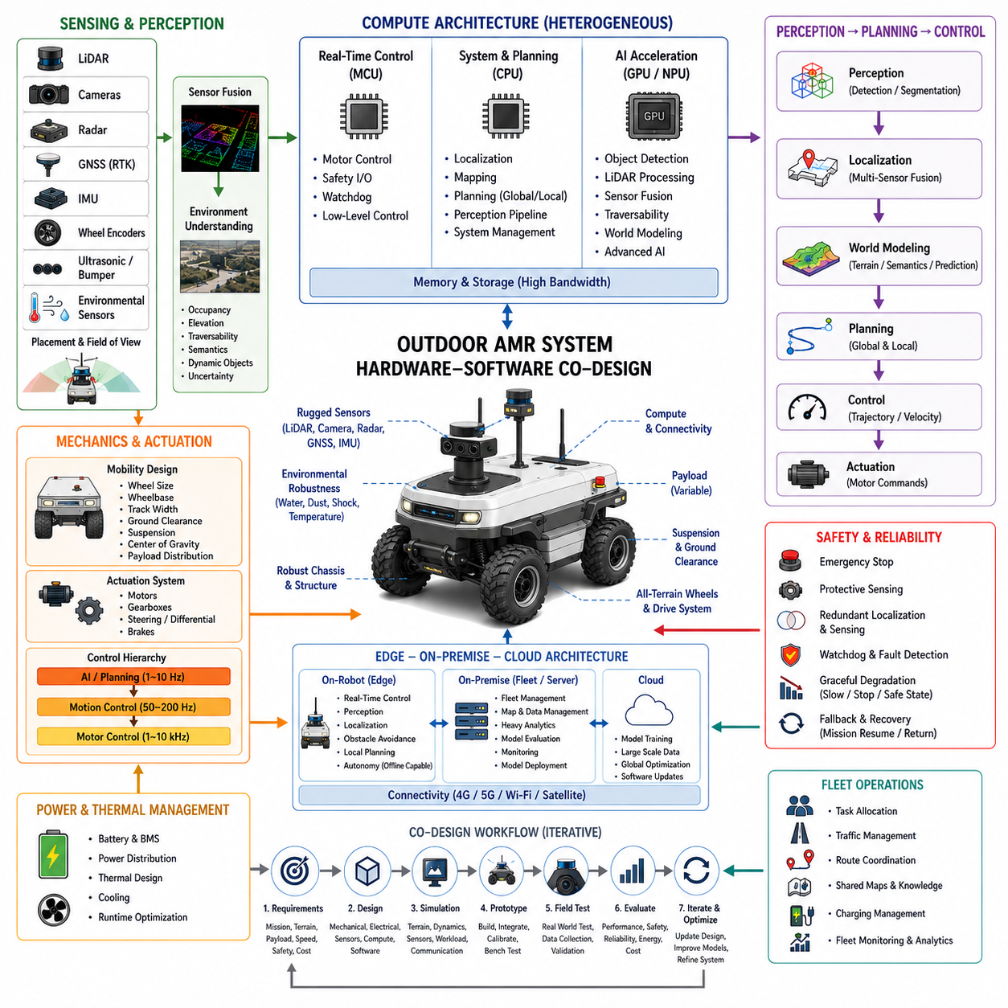
Outdoor autonomous mobile robots (Outdoor AMRs) represent a more demanding Physical AI co-design problem than indoor platforms because the robot must operate under continuously changing terrain, weather, lighting, connectivity, and localization conditions. Roads, construction sites, farms, campuses, industrial yards, and mixed outdoor environments introduce slopes, uneven surfaces, gravel, mud, water, vegetation, curbs, and unpredictable obstacles. Consequently, the system must be designed around the interaction between mobility hardware, sensing, computation, autonomy, energy, communication, and environmental robustness rather than treating outdoor navigation as an extension of indoor software.
The mechanical platform establishes the physical capabilities available to the autonomy system. Wheel diameter, wheelbase, track width, ground clearance, suspension, steering geometry, drive configuration, tire characteristics, chassis stiffness, and center of gravity determine how the robot responds to terrain. Payload distribution can further change traction, braking distance, rollover stability, and energy consumption. A planner cannot compensate indefinitely for inadequate mechanical capability, so terrain requirements, target speed, payload, obstacle height, slope, turning radius, and required ride stability must be considered simultaneously during platform design.
Outdoor actuation must tolerate substantially greater variation in wheel-ground interaction than indoor operation. Loose soil, gravel, wet pavement, grass, mud, and uneven terrain can produce wheel slip and rapidly changing traction. Motor torque, gearbox selection, differential or steering architecture, braking capability, suspension travel, and actuator control bandwidth therefore become part of the autonomy problem. Closed-loop wheel control should combine encoder information with inertial and localization feedback so that the controller can distinguish commanded motion from actual vehicle motion and provide reliable state information to higher-level planning.
Localization is one of the most important differences between outdoor and indoor AMRs. GNSS can provide global positioning, but multipath, signal obstruction, atmospheric effects, poor satellite geometry, and intentional or accidental interference can reduce reliability. High-precision RTK GNSS can improve absolute accuracy when correction services are available, while IMU and wheel odometry provide short-term continuity. LiDAR, cameras, landmarks, maps, and other localization methods can provide complementary information. A robust outdoor architecture therefore treats localization as a multi-source estimation problem rather than depending on one absolute positioning technology.
Outdoor perception must handle a much wider range of visual and geometric conditions. Sunlight, shadows, reflections, rain, fog, dust, snow, nighttime operation, vegetation, and rapidly changing backgrounds can affect cameras and other sensors. LiDAR provides useful geometric information but can also be influenced by weather and surface properties. Radar can contribute robustness for selected detection tasks, while cameras provide semantic information that geometric sensors alone may not capture. Sensor selection should therefore consider complementary failure modes, spatial coverage, update rate, bandwidth, compute requirements, and environmental protection.
Sensor placement becomes particularly important when the robot must detect terrain and obstacles rather than simply maintain a planar navigation map. Forward sensing should provide sufficient stopping distance at the intended speed, while downward or angled sensing can reveal potholes, steps, curbs, rocks, terrain discontinuities, and traversability changes. Sensor mounting must also protect the sensing system from vibration, contamination, water, dust, and mechanical impacts. Calibration and time synchronization are critical because small spatial or temporal errors can become significant when a moving robot fuses measurements from multiple sensors.
The perception and world-modeling stack should transform raw outdoor observations into representations that support both navigation and physical risk assessment. These representations may include occupancy, elevation, traversability, semantic objects, dynamic obstacles, terrain classes, predicted obstacle motion, and uncertainty. Unlike a simple indoor occupancy map, an outdoor world representation may need to distinguish between a visually open region that is physically traversable and one containing soft soil, steep terrain, standing water, vegetation, or an unsafe surface. The autonomy system therefore needs to connect perception with the physical capabilities of the platform.
Outdoor planning must account for vehicle dynamics as well as geometric feasibility. A path that is mathematically collision-free may still be unsuitable because of excessive slope, insufficient traction, high rollover risk, poor surface conditions, excessive vibration, or energy cost. Local planning should therefore incorporate vehicle speed, steering or differential-drive limits, braking capability, terrain confidence, and obstacle uncertainty. Global planning can optimize longer routes according to distance, time, terrain quality, energy, and mission priorities, while local control continuously adapts to the actual physical environment.
Computing architecture must support these workloads without compromising real-time control. A real-time controller can manage motor commands, safety interfaces, watchdog functions, and deterministic I/O, while CPU resources handle localization, mapping, planning, and system management. GPU or NPU resources can execute camera perception, LiDAR processing, sensor fusion, learned traversability estimation, object detection, and more advanced Physical AI models. Because outdoor environments can generate substantially more complex observations than controlled indoor environments, compute capacity should include margin for peak workloads and degraded operating conditions.
Outdoor AMRs also require a carefully designed edge and offboard computing relationship. Essential perception, localization, obstacle avoidance, planning, and control must remain available on the robot because connectivity may be intermittent or completely unavailable. On-premise infrastructure can support fleet management, shared maps, heavy analytics, model evaluation, and centralized monitoring, while cloud resources can support large-scale training and long-term data analysis. This separation allows the robot to preserve operational autonomy while using external computing resources whenever communication quality, latency, security, and mission requirements permit.
Power and thermal co-design become more significant as outdoor robots increase in size, speed, payload, and sensing capability. Larger motors consume substantial energy during acceleration and difficult terrain traversal, while GPUs, sensors, networking, and cooling systems create additional continuous loads. Battery capacity should therefore be evaluated together with mission distance, terrain resistance, payload, ambient temperature, compute workload, and charging strategy. Thermal design must also account for direct solar heating and outdoor temperature variation because sustained AI performance can decrease when processors reach thermal limits.
Safety and graceful degradation are essential because outdoor robots may operate farther from human supervision and in environments with greater physical uncertainty. Emergency stopping, protective sensing, communication-loss behavior, watchdog monitoring, redundant localization or sensing, and controlled fallback modes should remain functional when advanced AI components fail. If confidence in localization, perception, terrain classification, or communication falls below an acceptable threshold, the robot should reduce speed, restrict maneuvering, stop, or return to a predefined safe state rather than continuing with unjustified confidence.
Fleet operation introduces another layer of co-design because multiple outdoor AMRs must share roads, paths, work zones, charging resources, maps, and communication infrastructure. Task allocation, traffic management, route coordination, shared environmental knowledge, and fleet-level monitoring can improve utilization, but local collision avoidance and immediate safety decisions should remain available onboard. The overall architecture should allow individual robots to operate independently while exchanging useful information with the fleet. This creates a scalable transition from single-robot autonomy toward distributed Physical AI.
A practical outdoor AMR co-design process therefore proceeds iteratively from mission requirements to mechanical design, sensor architecture, compute allocation, autonomy software, simulation, prototype testing, and field validation. Simulation can evaluate terrain, dynamics, sensing, planning, and workload before physical deployment, while field testing reveals interactions that are difficult to model accurately. Measurements of localization error, traversability accuracy, stopping distance, latency, energy consumption, thermal behavior, communication reliability, and failure recovery should feed back into the next design iteration.
The resulting outdoor AMR should be understood as an integrated cyber-physical system whose intelligence is constrained by the physical environment and whose physical capability determines the useful operating range of its AI. Robust outdoor autonomy emerges when mechanics, actuation, sensing, localization, world representation, planning, control, computing, power, communication, and safety are designed together. The objective is not simply to install a more powerful AI model, but to create a platform in which available intelligence can be executed reliably, within physical limits, under real environmental uncertainty and over the complete operational lifecycle.

09.03. Mobile Manipulator Co Design
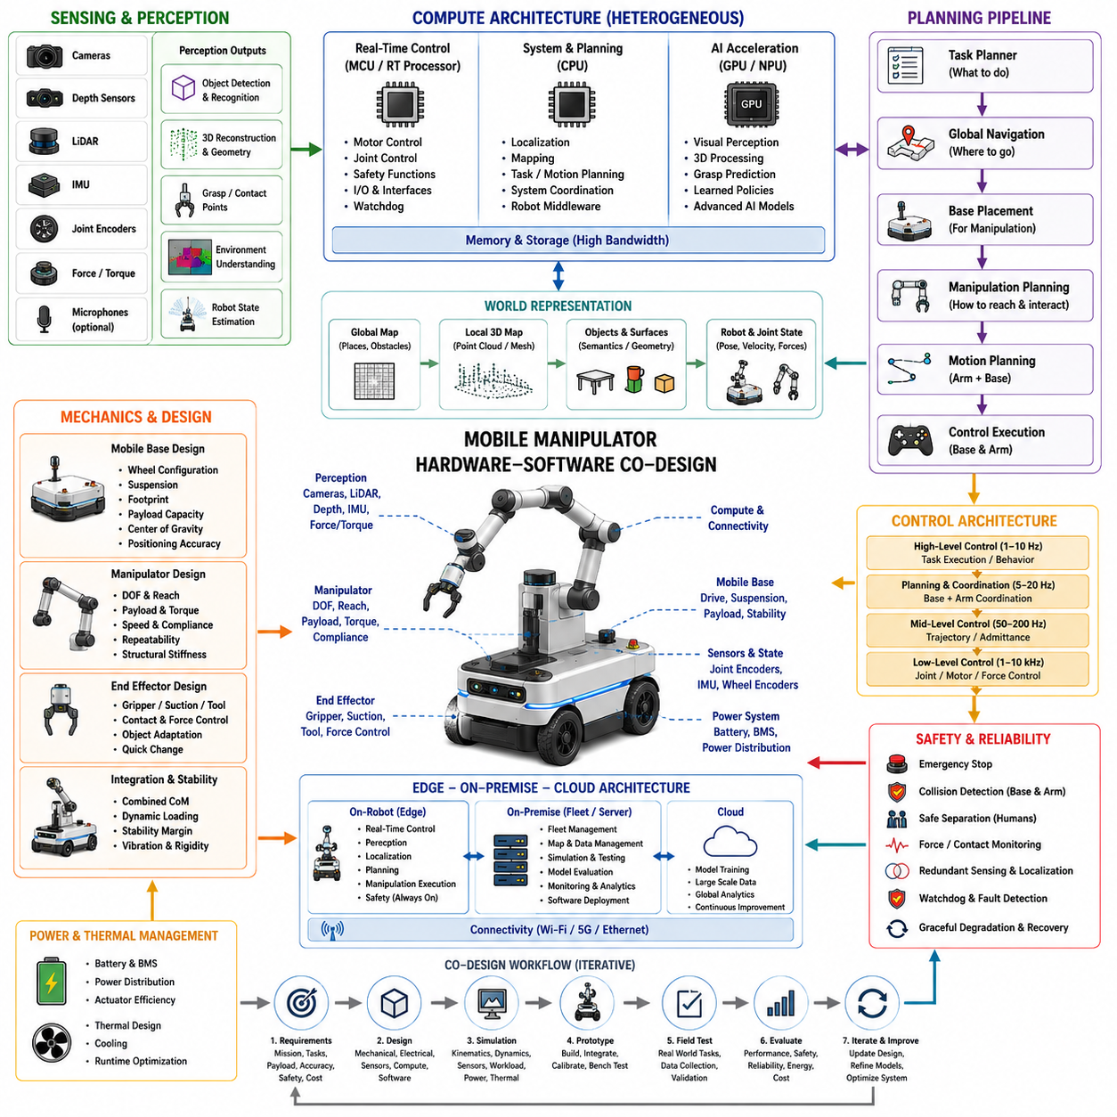
A mobile manipulator combines autonomous mobility with robotic manipulation, creating a Physical AI system in which the base, arm, end effector, sensors, computing platform, and control architecture must be designed as one integrated system. Unlike a fixed industrial manipulator, the robot must continuously account for changes in its position, orientation, payload, support conditions, and surrounding environment. The co-design problem therefore extends beyond achieving arm accuracy or navigation performance independently and focuses on how mobility and manipulation interact during complete task execution.
The mobile base determines the physical conditions under which manipulation can be performed. Wheel configuration, chassis stiffness, suspension behavior, footprint, payload capacity, center of gravity, and positioning accuracy influence the stability of the arm and the repeatability of end-effector motion. When the arm accelerates or carries a payload, reaction forces can affect the base, while uneven floors or small localization errors can change the manipulator workspace. Mechanical design must therefore consider the combined center of mass, dynamic loading, stability margin, and required manipulation accuracy rather than treating the base and arm as independent products.
Manipulator selection must be matched to the intended mobile tasks. Degrees of freedom, reach, payload, joint torque, joint speed, compliance, repeatability, and end-effector configuration determine which operations are physically achievable. A long-reach arm may provide greater workspace but can create larger moments on the mobile base and increase stability requirements. Conversely, a compact arm may simplify mechanical integration but restrict access to objects. The appropriate architecture is therefore determined by the relationship between task geometry, base mobility, manipulation workspace, payload, and required precision.
The end effector represents the final physical interface between AI decisions and the environment. Grippers, suction devices, tools, force-controlled interfaces, or application-specific mechanisms must be selected according to object shape, material, weight, contact conditions, and task requirements. Manipulation performance depends not only on the mechanical design of the end effector but also on perception, grasp planning, force estimation, and actuator control. A co-designed system should allow the AI to reason about what actions are physically executable instead of generating abstract manipulation commands without considering contact and grasp limitations.
Perception must cover both navigation and manipulation requirements. Cameras, depth sensors, LiDAR, force or torque sensing, joint encoders, and inertial sensors provide complementary information about the robot, objects, and environment. Navigation requires awareness of free space, obstacles, and robot pose, while manipulation requires accurate object localization, geometry, surface information, grasp points, and relative pose. Sensor placement is therefore a system-level optimization problem because sensors mounted for navigation may not provide sufficient visibility for close-range manipulation, while arm-mounted sensors may introduce vibration, occlusion, or changing viewpoints.
The world representation for a mobile manipulator must connect the global environment with local task geometry. A navigation system may maintain a map of rooms, corridors, obstacles, and reachable regions, while the manipulation system requires detailed representations of objects, surfaces, contact points, and arm configuration. These representations must remain spatially and temporally consistent as the robot moves. The system should understand not only where the robot is, but also where the target object is relative to the robot base, manipulator, and end effector at the moment an action is executed.
Planning consequently operates across multiple levels. A high-level task planner determines what sequence of actions is required, while navigation planning determines where the mobile base should move and manipulation planning determines how the arm should reach and interact with the target. These plans cannot be completely independent because the final manipulation pose may require a particular base position and orientation. Mobile base placement should therefore be treated as part of the manipulation problem, allowing the system to search for configurations that jointly satisfy reachability, collision avoidance, stability, visibility, and task accuracy.
Control must bridge these planning layers while respecting the dynamics of both the mobile base and manipulator. The base controller manages vehicle motion, while joint-level controllers regulate position, velocity, torque, or force at much higher frequencies. Coordinated control may be required when arm motion changes the robot's center of mass or when manipulation forces influence base stability. AI-generated actions should remain within actuator limits, joint limits, velocity constraints, collision boundaries, and stability margins. This layered structure allows high-level intelligence to operate at a slower rate while deterministic low-level control maintains physical stability.
Computing architecture should separate deterministic control workloads from computationally intensive AI workloads while maintaining sufficiently low end-to-end latency. Real-time processors can handle motor control, safety functions, joint control, and watchdog operations, while CPUs can support localization, planning, system coordination, and robot middleware. GPUs or NPUs can accelerate visual perception, object detection, 3D reconstruction, multimodal fusion, grasp prediction, learned policies, and more advanced Physical AI models. Memory bandwidth and data movement become particularly important because camera, depth, LiDAR, and joint data may need to be processed simultaneously.
Mobile manipulators also require careful edge and offboard computing partitioning. Essential perception, localization, collision avoidance, motion control, and manipulation execution should remain available on the robot so that the system can continue operating safely when network connectivity is limited. More computationally intensive model training, fleet analytics, large-scale data processing, simulation, and model evaluation can be performed on on-premise or cloud infrastructure. This architecture enables the robot to retain immediate physical autonomy while benefiting from centralized intelligence when communication and latency requirements permit.
Power and thermal constraints become more complicated because the platform must support both mobility and manipulation. Driving motors, arm actuators, sensors, compute accelerators, networking equipment, and cooling systems compete for the same energy resources. Manipulation can create short-duration peak loads, while continuous perception and AI inference generate sustained compute loads. Battery capacity, power distribution, actuator efficiency, thermal design, and runtime should therefore be evaluated together with mission duration and task frequency. The objective is not maximum instantaneous capability but predictable performance throughout the complete operating cycle.
Safety requires explicit coordination between mobility, manipulation, perception, and control. The robot must prevent collisions involving both its chassis and extended arm, maintain safe separation from humans, detect unexpected contact, and enter controlled fallback states when perception or planning becomes uncertain. Emergency stopping and low-level protective functions should not depend exclusively on complex AI models. When localization confidence decreases, an object is lost, communication fails, or the manipulation state becomes inconsistent, the system should reduce motion, stop the relevant subsystem, retract when safe, or transition to a predefined recovery behavior.
A practical mobile-manipulator co-design process therefore connects mission requirements, mechanical integration, sensing, compute allocation, manipulation planning, mobility planning, simulation, prototype testing, and field validation. Simulation can evaluate reachability, collision geometry, dynamics, sensor visibility, workload, and power behavior before physical integration. Prototype testing then exposes real effects such as vibration, cable routing, calibration drift, structural deformation, actuator backlash, wheel slip, and timing variation. Measurements should be fed back into the architecture so that each iteration improves the complete robot rather than optimizing isolated components.
The resulting mobile manipulator should be understood as an integrated cyber-physical intelligence system. Mobility determines where manipulation can occur, manipulation determines how the robot can interact with the environment, perception determines what can be observed, computing determines what can be inferred within the available time, and control determines whether the intended action can be physically executed. Hardware-software co-design aligns these elements so that navigation, manipulation, perception, planning, actuation, safety, power, and computing operate as one coherent Physical AI platform. This integrated approach provides a foundation for progressively more capable autonomous robots without sacrificing real-time behavior, physical feasibility, or operational reliability.

09.04. Quadruped Co Design
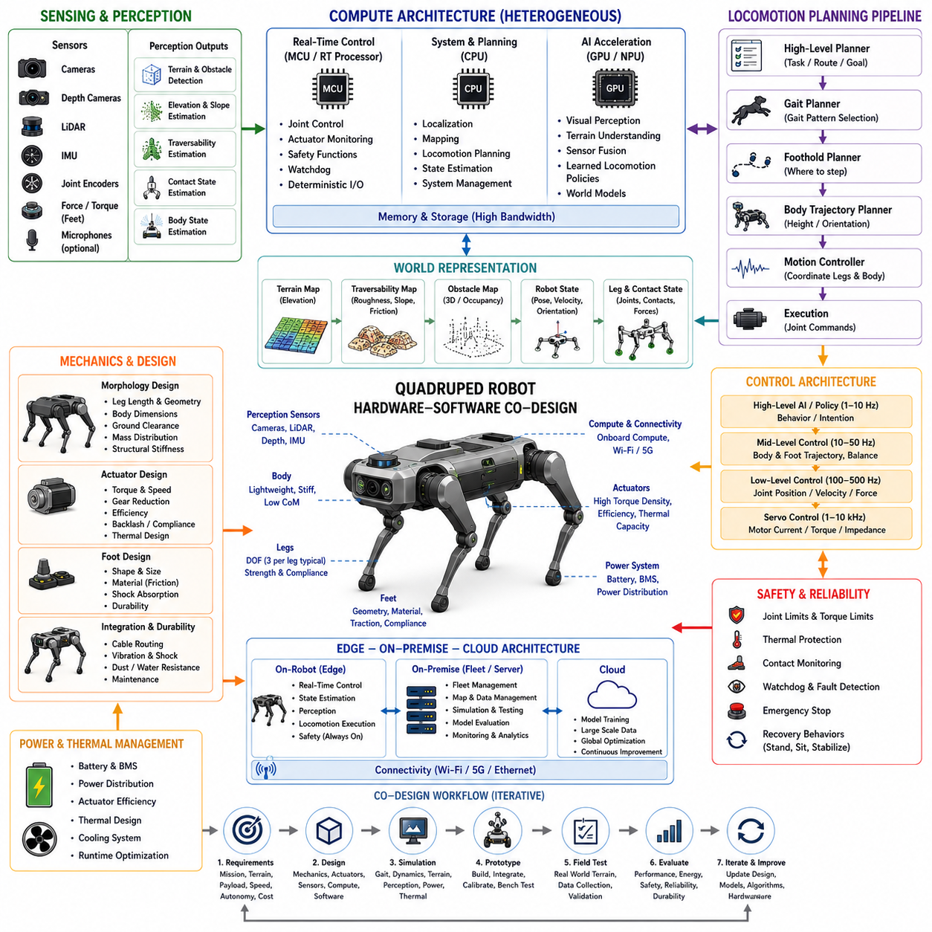
A quadruped robot represents a distinctive Physical AI co-design problem because locomotion depends on continuous interaction among morphology, actuators, sensors, computation, control, and terrain. Unlike wheeled platforms, a quadruped must actively regulate body posture and foot placement while maintaining dynamic balance. Its autonomy therefore cannot be separated from legged mechanics. The robot hardware determines the feasible motion space, while AI and control determine how that physical capability is exploited under changing environmental conditions.
The leg mechanism is the foundation of quadruped mobility. Leg length, joint arrangement, actuator placement, body dimensions, foot geometry, structural stiffness, and total mass influence gait stability, stride length, energy consumption, and obstacle negotiation. The distribution of mass is particularly important because the robot must repeatedly accelerate and decelerate individual legs while controlling the body. Mechanical design should therefore consider the relationship among payload, center of mass, joint torque, ground clearance, expected terrain, and required locomotion speed rather than optimizing the body and legs independently.
Actuator design is tightly coupled with locomotion intelligence. Each leg normally requires coordinated control of multiple joints, and the available joint torque and speed determine whether the robot can support its body, recover from disturbances, climb slopes, step over obstacles, or accelerate dynamically. Gear reduction, motor efficiency, torque density, thermal capacity, backlash, compliance, and control bandwidth all affect the achievable gait. AI-generated motion commands must remain within these physical limits, while low-level joint controllers provide fast and stable execution beneath higher-level locomotion policies.
Foot-ground interaction introduces another major co-design requirement. A foot may encounter hard floors, gravel, grass, mud, rocks, stairs, or irregular terrain, and the contact state can change rapidly. The robot must estimate whether a foot is securely supporting the body, slipping, colliding with an obstacle, or losing contact. Proprioceptive sensing from joint position, velocity, torque, and current measurements can be combined with inertial and external perception to estimate contact and body state. Reliable contact estimation is essential for stable gait generation and recovery behavior.
The sensing architecture must support both body-state estimation and environmental understanding. IMUs provide high-rate information about body orientation and acceleration, while joint encoders and actuator measurements describe the internal configuration of the robot. Cameras, depth sensors, LiDAR, and other external sensors provide information about terrain, obstacles, and traversability. Sensor placement must account for leg motion, body vibration, self-occlusion, dust, water, lighting variation, and changing viewpoints. The resulting architecture should provide sufficient observability without creating excessive compute, power, or communication demands.
A quadruped requires a world representation that combines terrain geometry with the robot's physical state. The system may need to estimate elevation, surface inclination, roughness, obstacles, free space, traversability, and uncertainty while simultaneously tracking body pose, joint configuration, foot positions, and contact states. A terrain that appears geometrically accessible may still be unsafe because of low friction, excessive slope, unstable ground, or insufficient foothold quality. The world model must therefore connect environmental perception with the robot's current locomotion capability.
Locomotion planning operates across multiple temporal and spatial levels. A high-level planner can determine the desired direction, route, or task objective, while a locomotion planner selects appropriate gait patterns, foothold locations, body trajectories, and movement speeds. Local control then continuously adapts these decisions to actual contact conditions and disturbances. The planning system should consider terrain confidence, energy consumption, stability margins, actuator limits, and predicted body motion rather than selecting paths solely from geometric maps. This creates a direct relationship between world modeling, gait planning, and physical execution.
Control architecture must coordinate body motion, leg motion, and contact forces. High-level AI or locomotion policies can generate desired behaviors, while intermediate controllers convert those behaviors into body trajectories, foot trajectories, joint targets, or desired forces. High-frequency joint-level controllers then regulate position, velocity, torque, or impedance. This hierarchy allows learned policies to operate at manageable frequencies while deterministic controllers preserve stability and actuator protection. When terrain conditions change rapidly, feedback from proprioception and contact estimation must be able to modify the motion before instability develops.
Computing architecture should separate safety-critical real-time control from computationally intensive perception and AI workloads. Real-time processors can execute joint control, actuator monitoring, safety functions, watchdog operations, and deterministic communication. CPUs can support localization, mapping, planning, and system coordination, while GPUs or NPUs can accelerate visual perception, terrain understanding, sensor fusion, learned locomotion policies, and advanced world models. Memory bandwidth and data movement become important because multiple sensors and many joint channels may need to be processed simultaneously with strict timing requirements.
Power and thermal constraints are particularly significant for quadrupeds because locomotion requires repeated actuator work even when the robot is not carrying a large external payload. Motors may experience high transient loads during jumping, climbing, rapid acceleration, or recovery from disturbances. Continuous computation for perception and learned control adds another energy demand. Battery capacity, actuator efficiency, motor thermal limits, power electronics, cooling, and compute workload should therefore be evaluated as one system. The objective is sustained locomotion capability rather than short-duration peak performance.
Safety requires the robot to remain controllable when perception, communication, or learned autonomy becomes uncertain. Joint limits, torque limits, thermal protection, emergency stopping, watchdog supervision, contact monitoring, and controlled recovery should be implemented independently enough that failure of an advanced AI component does not immediately cause uncontrolled motion. When terrain perception becomes unreliable or a leg loses expected contact, the robot should be capable of reducing speed, changing gait, stabilizing its body, stopping, or entering a predefined recovery state.
A practical quadruped co-design process connects mission requirements, morphology, actuator sizing, sensing, compute allocation, locomotion algorithms, simulation, prototype testing, and field validation. Simulation can evaluate gait stability, terrain interaction, actuator loads, energy consumption, sensor behavior, and AI workload before extensive physical testing. Real robots then reveal effects such as compliance variation, backlash, vibration, thermal accumulation, contact uncertainty, actuator aging, and terrain behavior that are difficult to model perfectly. These measurements should continuously feed back into both hardware and software design.
The resulting quadruped should be understood as an integrated cyber-physical intelligence system in which morphology, sensing, world modeling, locomotion planning, control, computation, power, and safety are inseparable. The robot's physical structure determines what motions are possible, sensors determine what can be observed, computing determines what can be inferred in time, and control determines whether the intended behavior can be executed safely. Hardware-software co-design therefore transforms quadruped autonomy from a collection of independent algorithms into a coordinated Physical AI platform capable of adapting its behavior to changing terrain, contact conditions, and mission requirements.

09.05. Humanoid Co Design
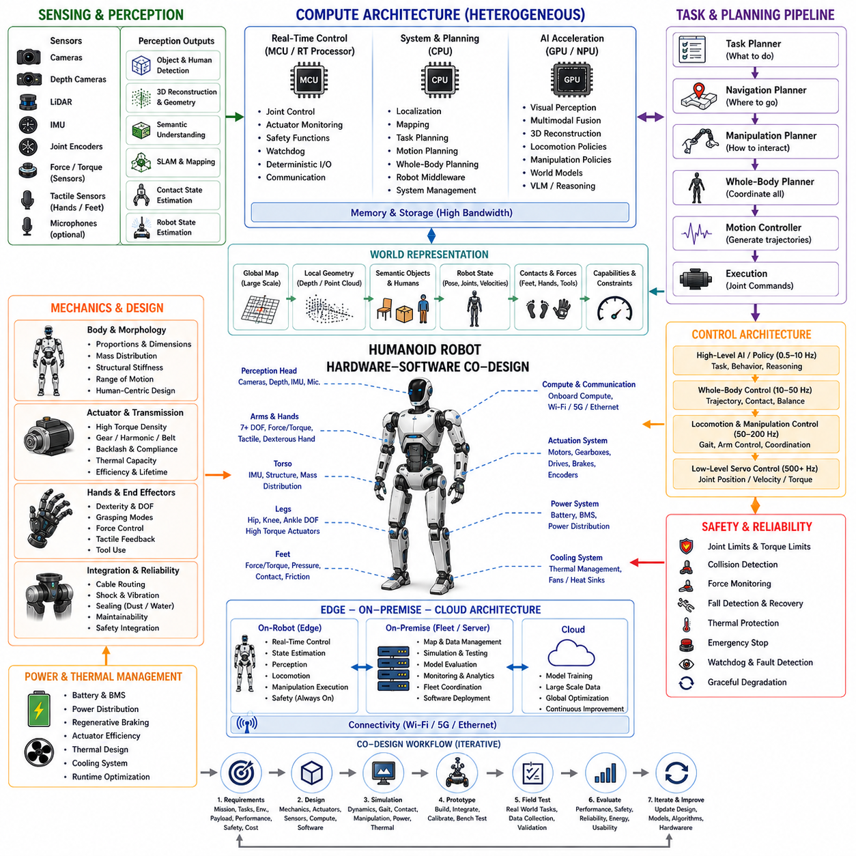
A humanoid robot represents one of the most comprehensive Physical AI co-design challenges because its mechanical structure, sensing, actuation, computation, control, and intelligence must operate together across a highly variable physical environment. Unlike specialized mobile robots, a humanoid is expected to move through spaces designed for humans, manipulate objects using human-scale interfaces, maintain balance on two legs, and coordinate many degrees of freedom simultaneously. The design problem therefore cannot be reduced to selecting a capable AI model or a powerful actuator. It requires an integrated architecture in which physical embodiment and artificial intelligence continuously constrain and complement one another.
The humanoid body establishes the physical capabilities available to the autonomy system. Body dimensions, joint arrangement, limb proportions, mass distribution, structural stiffness, joint range of motion, and foot geometry influence balance, reachability, energy consumption, manipulation capability, and collision behavior. A human-like morphology provides access to environments built around human tools, doors, shelves, stairs, and workstations, but it also introduces mechanical complexity and unstable dynamics. The co-design process must therefore determine which aspects of human morphology are essential for the intended tasks and which can be simplified or redesigned to improve reliability, efficiency, manufacturability, and maintainability.
Actuator architecture is especially important because a humanoid contains many independently controlled joints that must operate simultaneously under changing loads. Motors, gearboxes, harmonic drives, transmissions, bearings, brakes, encoders, and joint controllers determine the available torque, speed, compliance, precision, and thermal capacity. The actuator system must support standing, walking, turning, climbing, reaching, lifting, and recovering from disturbances. High torque density is valuable for reducing mass, but compact actuators can create thermal and maintenance challenges. Hardware selection should therefore consider the complete duty cycle rather than optimizing peak joint performance in isolation.
Bipedal locomotion creates a strong coupling between mechanical design and control intelligence. Unlike a wheeled robot, a humanoid must continuously regulate its center of mass relative to its support region while changing foot contacts. Walking therefore requires coordination among body posture, hip motion, knee and ankle control, foot placement, contact forces, and momentum. The robot must respond to disturbances such as uneven ground, unexpected contact, payload changes, and external forces. A suitable architecture combines high-level learned locomotion policies with deterministic lower-level control so that intelligent behavior can adapt while physical stability remains continuously supervised.
The feet and lower limbs form the physical interface between the humanoid and the ground. Foot size, sole material, contact geometry, ankle range, compliance, and force sensing influence stability and walking efficiency. The robot must determine whether each foot is securely supporting the body, transitioning between contacts, slipping, or encountering an unexpected obstacle. Force-torque sensing, joint torque estimation, motor current, encoders, and inertial measurements can provide complementary information about contact state. These signals are particularly valuable because reliable locomotion requires the robot to understand not only where its body is, but also how its body is physically coupled to the environment.
Perception for a humanoid must support both navigation and manipulation within environments that contain objects, people, furniture, tools, and dynamic activities. Cameras, depth sensors, LiDAR, IMUs, joint encoders, force sensors, and tactile interfaces can provide complementary observations. Vision can identify objects and semantic relationships, depth sensing can provide geometry, LiDAR can support spatial mapping, and proprioceptive sensors can estimate the robot's internal configuration. Sensor placement is a major co-design problem because the robot's moving arms, head, torso, and legs can create occlusions and rapidly changing viewpoints. The system must provide sufficient observability without excessive computation, power, weight, or wiring complexity.
The humanoid world representation must connect large-scale environmental understanding with detailed body and object state. A useful representation may include global maps, local geometry, semantic objects, humans, free space, terrain, robot pose, joint configuration, contact states, and task-relevant relationships. The system must understand not only where an object is located but whether the humanoid can physically reach it, approach it, grasp it, and manipulate it without losing balance. This makes the world model inherently embodiment-aware. Perception, geometry, physical capability, and uncertainty must be represented together so that planning can reason about what is actually achievable.
Manipulation introduces another layer of co-design because humanoids are often expected to use tools, operate doors, move objects, and interact with human-oriented interfaces. The arm, hand, wrist, torso, and lower-body system must cooperate to create stable manipulation configurations. A reaching motion may require repositioning the feet, shifting the center of mass, or changing torso orientation before the hand can safely contact the target. Consequently, manipulation planning should not treat the arms as isolated mechanisms. Base posture, whole-body balance, hand configuration, contact forces, object properties, and task constraints must be considered as one whole-body manipulation problem.
Planning therefore operates across task, navigation, locomotion, and manipulation layers. A high-level task planner can determine what the robot should accomplish, while a navigation planner determines where the humanoid should move and a manipulation planner determines how the robot should interact with objects. A whole-body planner must connect these decisions because many tasks require simultaneous movement and manipulation. The robot may need to walk while carrying an object, reach while maintaining balance, or reposition its feet while applying force through its hands. Planning should consequently optimize task success together with reachability, stability, collision avoidance, energy, and execution uncertainty.
The control architecture should provide clear separation between high-level intelligence and fast physical stabilization. High-level policies can generate desired behaviors, locomotion targets, manipulation goals, or whole-body actions, while intermediate controllers translate these objectives into body trajectories, foot trajectories, joint targets, impedance commands, or contact forces. High-frequency servo loops then regulate individual joints and actuators. This hierarchical structure allows advanced AI models to operate at computationally practical frequencies while real-time controllers continuously enforce joint limits, torque limits, balance constraints, collision boundaries, and actuator protection.
Humanoid computing requirements are correspondingly substantial. Real-time processors must maintain deterministic joint control, safety monitoring, watchdog functions, communication, and actuator supervision. CPUs can manage localization, mapping, task planning, motion coordination, and system middleware, while GPUs or NPUs can execute visual perception, multimodal fusion, 3D reconstruction, learned locomotion, manipulation policies, world models, and potentially vision-language-action models. Because many sensors and joints operate simultaneously, memory bandwidth, synchronization, data movement, and scheduling can become as important as raw accelerator performance. The compute architecture should therefore be designed around end-to-end workload and latency requirements.
Edge and offboard computing can extend humanoid intelligence without compromising immediate physical autonomy. Core perception, state estimation, balance, collision avoidance, locomotion, and manipulation execution must remain available onboard because network connectivity cannot be assumed during physical interaction. On-premise infrastructure can support large-scale simulation, model evaluation, fleet data management, training datasets, and centralized monitoring, while cloud infrastructure can provide additional training and analytics resources. The partition should be determined by latency, reliability, privacy, bandwidth, computational cost, and safety requirements rather than by an assumption that every AI workload should run locally or remotely.
Power and thermal management are major constraints for humanoids because many actuators, sensors, and compute devices operate simultaneously on a mobile battery. Walking continuously consumes energy through repeated acceleration and deceleration of the legs, while standing can also require sustained actuator effort. Manipulation adds additional loads, and advanced AI inference creates continuous electrical and thermal demand. Battery capacity, actuator efficiency, regenerative braking, power distribution, cooling, processor throttling, and mission duration must therefore be considered together. A humanoid that performs well for a short demonstration but overheats or exhausts its battery during extended operation is not a practically co-designed Physical AI system.
Safety must be integrated into every level of the humanoid architecture because the robot operates close to people and can generate significant forces through its arms and legs. Joint limits, torque limits, collision detection, force monitoring, emergency stopping, fall detection, thermal protection, communication-loss handling, and watchdog supervision should remain effective even when advanced AI components fail. The robot should also support graceful degradation. If perception becomes uncertain, localization is lost, a joint behaves abnormally, or a learned policy produces an unsafe command, the system should reduce motion, stabilize its posture, stop the relevant action, or enter a predefined recovery state rather than continuing with uncontrolled behavior.
A practical humanoid co-design process connects mission requirements, morphology, actuator selection, sensor architecture, compute sizing, locomotion, manipulation, whole-body planning, simulation, prototype testing, and field validation. Simulation is particularly valuable because humanoid dynamics are difficult and expensive to test exclusively on physical hardware. It can evaluate balance, gait transitions, contact forces, manipulation reachability, collision conditions, actuator loads, energy consumption, sensor configurations, and AI workload. Physical prototypes then reveal real-world effects such as structural deformation, actuator backlash, thermal accumulation, cable constraints, calibration drift, vibration, contact uncertainty, and manufacturing tolerances. These observations should continuously feed back into both hardware and software design.
The resulting humanoid should be understood as an integrated cyber-physical intelligence system rather than a collection of independent robotic subsystems. Morphology determines the physical workspace, actuators determine how forces and motion can be produced, sensors determine what the robot can observe, world models determine what it can understand and predict, computing determines what can be inferred within the available time, and control determines whether decisions can be executed safely. Hardware-software co-design aligns these elements so that locomotion, manipulation, perception, planning, whole-body control, power, thermal management, and safety operate as a unified Physical AI platform capable of adapting to human environments and progressively more complex tasks.

09.06. Autonomous Aerial Robot Co Design
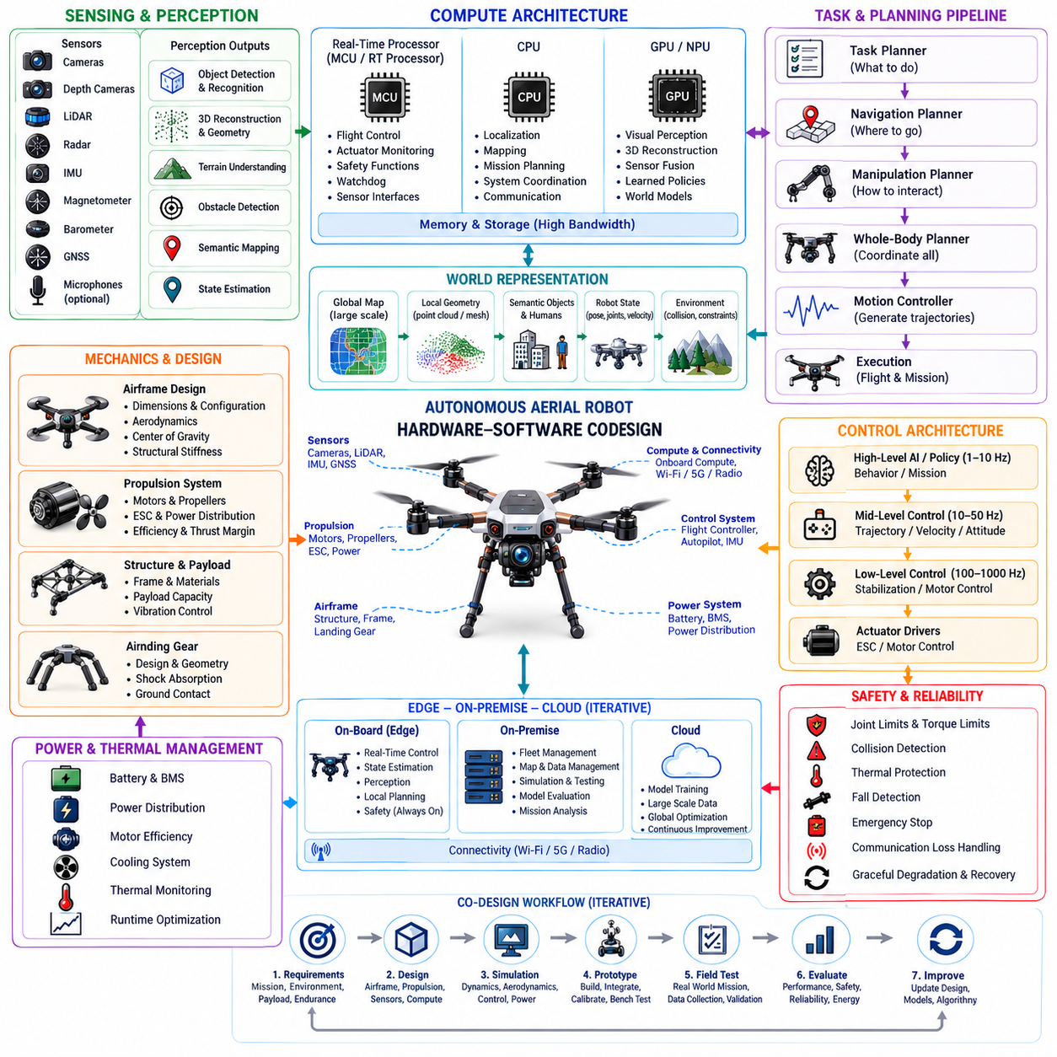
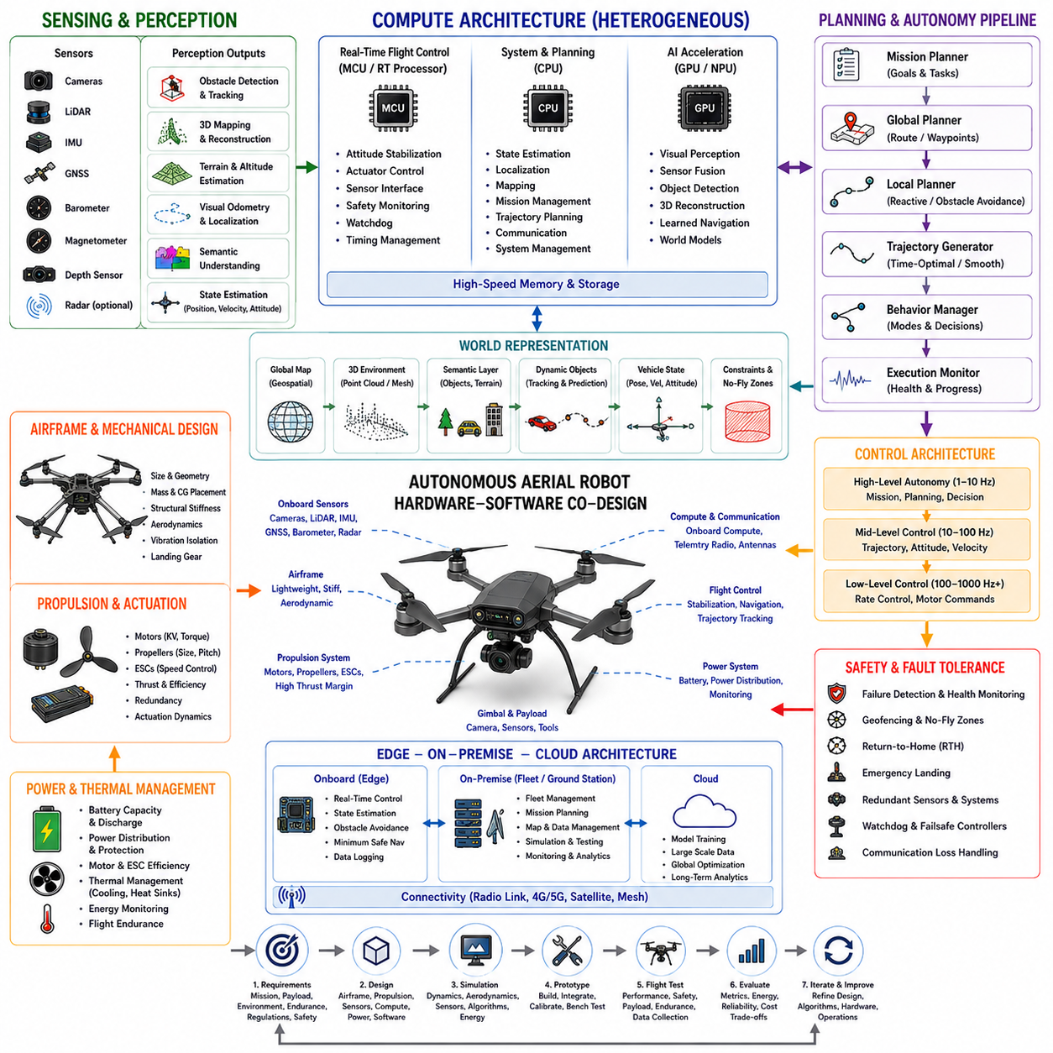
An autonomous aerial robot represents a distinctive Physical AI co-design problem because flight depends on the continuous interaction of morphology, propulsion, sensing, computation, control, energy, and the surrounding atmosphere. Unlike ground robots, an aerial platform cannot rely on a stable physical support surface and must continuously generate and regulate forces to remain airborne. Its autonomy therefore has to be designed together with aerodynamic capability, propulsion dynamics, flight stability, sensing range, computational latency, and energy availability.
The airframe establishes the physical envelope within which autonomous flight can operate. Vehicle mass, dimensions, aerodynamic configuration, rotor or propeller arrangement, center of gravity, structural stiffness, payload location, and landing-gear geometry influence stability, maneuverability, endurance, and disturbance response. A larger payload may increase mission capability but also changes thrust requirements, power consumption, and dynamic response. The airframe should therefore be designed around mission duration, payload, operating altitude, expected wind, maneuverability, environmental exposure, and required flight precision rather than optimizing structural characteristics independently.
The propulsion system forms the primary actuation layer of an aerial robot. Motors, propellers, electronic speed controllers, batteries, power distribution, and flight-control electronics must work together to generate the required thrust and moments. Available thrust margin determines whether the vehicle can climb, accelerate, reject disturbances, or compensate for payload and wind changes. Motor response time and control bandwidth also affect attitude stability. Propulsion selection should therefore consider efficiency, transient response, thermal behavior, acoustic characteristics, redundancy, and failure modes across the complete mission rather than focusing only on maximum thrust.
Flight control introduces a particularly strong coupling between hardware and AI. Aerial vehicles must continuously regulate roll, pitch, yaw, altitude, velocity, and position while responding to aerodynamic disturbances. Low-level controllers typically operate at high frequency to stabilize the vehicle, while higher-level autonomy determines trajectories, waypoints, behaviors, and mission objectives. AI-generated commands must remain within the available thrust, attitude, acceleration, velocity, and angular-rate limits. The control architecture should therefore provide a deterministic stabilization layer beneath higher-level learned or intelligent policies.
The sensing architecture must support both vehicle-state estimation and environmental understanding. IMUs provide high-rate measurements of acceleration and angular motion, while GNSS can provide global position when satellite signals are available. Cameras, depth sensors, LiDAR, radar, barometers, magnetometers, and other sensors can provide complementary information for navigation, obstacle detection, terrain understanding, and landing. Sensor placement must account for vibration, propeller interference, aerodynamic effects, changing viewpoints, sunlight, weather, and electromagnetic compatibility. Sensor redundancy becomes particularly important because the loss of a critical measurement can directly affect flight stability or navigation.
Localization for aerial robots is strongly dependent on operating conditions. GNSS-based positioning may provide effective global localization in open environments but can degrade because of signal blockage, multipath, poor satellite geometry, or interference. Visual-inertial odometry, LiDAR-based localization, map matching, and other relative-positioning methods can provide complementary information. The autonomy system should therefore maintain a consistent state estimate that combines available measurements according to their uncertainty and current reliability. Localization quality must also be considered together with vehicle speed and control latency because position errors become more consequential as flight dynamics become faster.
Aerial perception must account for the three-dimensional nature of flight. The robot may encounter buildings, trees, cables, poles, vehicles, aircraft, terrain, people, and other dynamic objects at different elevations. A two-dimensional navigation representation is therefore insufficient for many missions. The world representation may need to include three-dimensional geometry, free space, obstacles, semantic information, terrain elevation, dynamic-object estimates, and uncertainty. The system should connect these environmental representations with the physical flight envelope so that an apparently open route is not selected when it violates clearance, maneuverability, or braking constraints.
Trajectory planning should combine mission objectives with aerodynamic and vehicle constraints. A global planner can determine routes, waypoints, or mission sequences, while local planning continuously adjusts the trajectory according to obstacles, wind, localization confidence, vehicle state, and available maneuvering capability. The feasible trajectory depends not only on geometric clearance but also on acceleration, velocity, angular-rate, thrust, battery state, and disturbance-rejection limits. Energy-aware planning can become important for long missions because a geometrically shorter route may require aggressive maneuvering and consume more energy than a slightly longer but smoother trajectory.
Computing architecture should separate deterministic flight-critical workloads from computationally intensive AI workloads. Real-time flight-control processors can manage attitude stabilization, actuator commands, safety monitoring, watchdog functions, and sensor interfaces. CPUs can support state estimation, mission management, mapping, trajectory planning, and communications, while GPUs or NPUs can accelerate visual perception, three-dimensional reconstruction, sensor fusion, object detection, learned navigation, and advanced world models. The compute platform must be sized according to end-to-end latency and workload variability rather than peak accelerator performance alone, because delayed decisions can directly affect flight safety.
Edge and offboard computing can extend aerial intelligence while preserving immediate onboard autonomy. Essential flight control, state estimation, obstacle avoidance, and minimum safe navigation must remain onboard because wireless connectivity cannot be guaranteed during flight. On-premise infrastructure can support large-scale simulation, fleet monitoring, map management, data processing, model evaluation, and mission analysis, while cloud infrastructure can support large-scale training and long-term analytics. Workload placement should be determined by latency, connectivity, computational demand, data sensitivity, reliability, and safety rather than by assuming that all intelligence belongs either onboard or in the cloud.
Power and thermal management are fundamental constraints for aerial Physical AI because energy directly determines flight endurance. Propulsion typically represents a dominant portion of the energy budget, while compute, sensors, communication, storage, and cooling introduce additional loads. Increasing AI capability may improve perception and autonomy while simultaneously reducing endurance. Battery capacity, discharge characteristics, power electronics, motor efficiency, propeller efficiency, compute power, thermal conditions, payload, and mission profile should therefore be evaluated together. The objective is sustained mission capability rather than maximum instantaneous AI or propulsion performance.
Safety and fault tolerance are especially important because an aerial robot can lose physical support immediately when propulsion, control, localization, or power systems fail. Emergency behavior should therefore be defined across multiple failure conditions. Watchdogs, actuator monitoring, redundant sensors, health estimation, geofencing, controlled descent, return-to-home behavior, emergency landing, and communication-loss handling can provide layers of protection. Advanced AI should not be the only mechanism responsible for safe behavior. When perception confidence decreases, localization becomes unreliable, or computational resources are overloaded, the vehicle should transition toward a predictable and physically safer operating state.
Communication is another co-design element because aerial robots frequently depend on wireless links for mission updates, telemetry, fleet coordination, and remote supervision. However, communication availability and latency may vary with altitude, terrain, infrastructure, interference, and operating range. The onboard architecture should therefore distinguish between functions that require continuous communication and those that must remain autonomous. Data compression, prioritization, local logging, delayed synchronization, and resilient communication protocols can allow the robot to continue operating when connectivity is intermittent while preserving important mission and safety information.
Fleet operation introduces additional requirements when multiple aerial robots share airspace, charging resources, communication infrastructure, and mission objectives. Task allocation, trajectory coordination, airspace management, collision avoidance, battery-aware scheduling, shared mapping, and fleet monitoring must be coordinated without making every safety decision dependent on a central server. Each vehicle should retain local collision avoidance and flight stabilization while sharing appropriate information with fleet infrastructure. This architecture provides a path from single-vehicle autonomy toward distributed aerial Physical AI in which multiple robots can cooperate while remaining individually robust.
A practical aerial robot co-design process connects mission requirements, airframe design, propulsion sizing, sensor selection, compute allocation, flight-control architecture, autonomy software, simulation, prototype testing, and field validation. Simulation is particularly valuable because aerodynamic and flight dynamics can be evaluated before extensive physical testing. Digital environments can examine trajectories, disturbances, sensor visibility, perception workloads, energy consumption, communication behavior, and failure conditions. Physical testing then reveals real-world effects such as vibration, aerodynamic interference, thermal accumulation, calibration drift, sensor occlusion, wind disturbances, battery degradation, and actuator variation. These observations should continuously feed back into both hardware and software design.
The resulting autonomous aerial robot should be understood as an integrated cyber-physical intelligence system in which flight mechanics, propulsion, sensing, world modeling, planning, control, computing, power, communication, and safety are inseparable. The airframe determines the physical flight envelope, propulsion determines how forces can be generated, sensors determine what can be observed, computing determines what can be inferred within the available time, and control determines whether decisions can be executed safely. Hardware-software co-design therefore transforms aerial autonomy from a collection of independent algorithms into a unified Physical AI platform capable of adapting its flight behavior to changing environments, mission objectives, disturbances, and system conditions.

09.07. High Performance Edge AI Robot
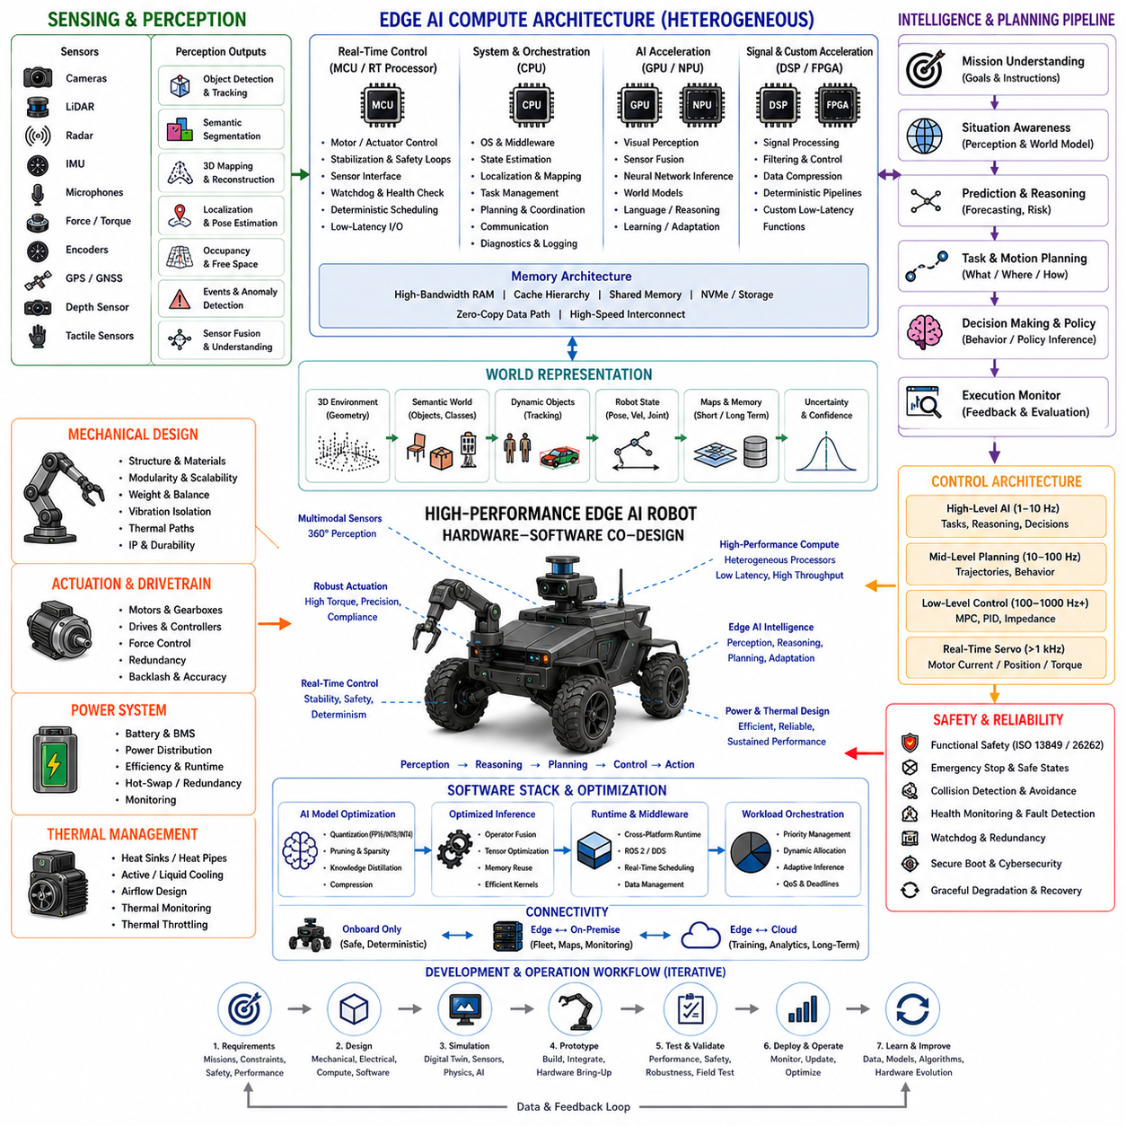
A high-performance Edge AI robot is a Physical AI platform designed to execute substantial perception, reasoning, planning, and control workloads directly on the robot while maintaining real-time responsiveness. Unlike conventional embedded systems that mainly execute predefined control logic, the platform must process multimodal sensor streams, construct environmental representations, infer situations, generate decisions, and convert those decisions into physical actions. The central design problem is therefore not simply selecting a faster processor, but balancing intelligence, latency, memory, power, thermal behavior, reliability, and physical robot requirements as one integrated architecture.
The defining characteristic of high-performance Edge AI is that computation remains close to the physical system. Cameras, LiDAR, radar, IMU, force sensors, encoders, and other sensors continuously generate data that must be transformed into actionable information. Local processing eliminates unnecessary round trips to remote servers and enables perception, localization, obstacle avoidance, planning, and control to operate with predictable timing. This is particularly important for robots because physical interactions evolve continuously, making delayed decisions potentially unsafe even when average computational throughput appears sufficient.
Latency should therefore be treated as an end-to-end system property rather than merely neural-network inference time. Sensor acquisition, preprocessing, synchronization, data transfer, model execution, postprocessing, planning, communication between software components, and actuator response all contribute to the perception-to-action delay. A system that normally responds rapidly but occasionally experiences large timing variations can be more problematic than a slightly slower system with predictable execution. Real-time operating systems, deterministic scheduling, dedicated accelerators, priority management, and carefully designed data paths are therefore essential for high-performance robotic Edge AI.
The compute architecture should be heterogeneous because different workloads have fundamentally different computational characteristics. CPUs are well suited to system management, middleware, communication, sequential logic, and general-purpose processing. GPUs provide massive parallelism for visual perception, point-cloud processing, multimodal fusion, neural inference, and world-model computation. NPUs can execute optimized neural networks efficiently at low power, while DSPs can handle signal-processing workloads and FPGAs can provide deterministic pipelines for selected latency-critical functions. Effective workload allocation across these processors can provide better overall performance than relying on a single processor.
Memory architecture becomes a first-class design consideration as AI models and sensor modalities increase. A robot may simultaneously process multiple camera streams, point clouds, radar data, inertial measurements, maps, historical observations, language instructions, and intermediate neural-network activations. Model parameters, activation tensors, input buffers, operating-system services, middleware, localization, mapping, and application software all compete for available memory. Consequently, AI model selection must consider total memory consumption and data movement rather than parameter count alone. High-bandwidth memory, caching, shared memory, asynchronous execution, and zero-copy data paths can substantially reduce processing overhead.
Model optimization is consequently a fundamental part of the hardware-software co-design process. Quantization can reduce numerical precision from FP32 toward FP16, INT8, INT4, or other compact representations, reducing memory consumption and computational demand. Structured pruning can remove redundant channels, layers, attention heads, or other components, while knowledge distillation can transfer capabilities from a large teacher model into a smaller student model. These approaches allow sophisticated perception and reasoning functions to operate within embedded resource limits while preserving an acceptable level of task performance.
The AI software stack must expose the capabilities of the hardware efficiently. Optimized inference frameworks can transform trained models into hardware-specific execution graphs, perform operator fusion, reuse memory, select optimized kernels, and apply precision-specific execution. Cross-platform runtimes can also provide portability across different CPU, GPU, NPU, and accelerator environments. This abstraction is important for Physical AI because the robot platform may evolve from one computing generation to another during its operational lifetime. Hardware acceleration should therefore be combined with modular software interfaces rather than tightly coupling the entire autonomy stack to a single processor architecture.
High-performance Edge AI must also support workload orchestration across multiple concurrent functions. A robot may need to execute object detection, semantic segmentation, localization, obstacle tracking, human perception, world-model updates, planning, diagnostics, communication, logging, and safety monitoring at the same time. These workloads have different priorities and timing requirements. Safety and control functions require deterministic execution, while less critical analytics can tolerate lower priority or reduced frequency. Dynamic scheduling can therefore allocate compute resources according to mission state, sensor complexity, model confidence, and available power without allowing background workloads to interfere with critical control loops.
The architecture should maintain a clear boundary between real-time control and high-level AI. Fast motor, actuator, stabilization, and safety loops should remain deterministic and should not depend directly on variable AI execution time. Higher-level Edge AI can provide perception, world modeling, prediction, task reasoning, motion planning, and policy inference at appropriate frequencies. This separation allows advanced models to improve robot intelligence without allowing unpredictable neural-network execution to destabilize the physical system. The same principle applies to safety monitoring, which should retain an independent mechanism for detecting invalid commands, collisions, abnormal states, and system failures.
Power consumption creates another fundamental constraint. Every watt consumed by Edge AI reduces the energy available for locomotion, manipulation, sensing, communication, or mission duration. High-performance desktop GPUs can provide exceptional inference performance but may consume hundreds of watts, while embedded accelerators can operate at substantially lower power with reduced computational throughput. The appropriate design therefore depends on the robot's mission. A continuously operating warehouse robot may prioritize energy efficiency and sustained performance, whereas a larger autonomous vehicle may accept substantially higher compute power in exchange for greater perception and reasoning capability.
Thermal design must be considered together with electrical power because sustained AI performance is often limited by heat rather than peak compute capability. Processor temperature affects reliability, stability, component lifetime, and ultimately inference performance. Edge platforms may require heat sinks, heat pipes, vapor chambers, active fans, liquid cooling, thermal throttling, or intelligent workload scheduling depending on their performance class and enclosure. The important metric is therefore sustained performance under realistic operating conditions rather than the maximum accelerator performance measured for a short benchmark.
High-performance Edge AI also benefits from adaptive inference and dynamic resource management. The robot does not need to execute every AI function at maximum complexity under every environmental condition. When observations are simple and stable, perception frequency, model size, resolution, or reasoning depth can sometimes be reduced. When the environment becomes complex or risk increases, additional computational resources can be allocated to perception, prediction, localization, or planning. This creates a closed relationship among environmental complexity, AI workload, power consumption, thermal state, and required response quality.
Edge and cloud computing should therefore be treated as complementary rather than competing architectures. Latency-critical perception, obstacle avoidance, localization, low-level planning, and physical control should remain local. More computationally intensive activities such as large-model reasoning, long-term analytics, fleet learning, digital-twin processing, model training, and large-scale optimization can be performed offboard when communication conditions permit. A hybrid architecture should degrade gracefully during communication loss, preserving the robot's essential autonomy while synchronizing additional information when connectivity returns.
Security, safety, and reliability must be integrated into the Edge AI platform rather than added after performance optimization. Secure boot, authentication, encryption, runtime integrity, process isolation, watchdogs, independent safety monitoring, collision prediction, emergency stopping, and controlled fallback behavior protect the robot when software or hardware behaves unexpectedly. The AI system should never be the sole authority responsible for determining whether an action is physically safe. High-performance intelligence is valuable only when it remains bounded by deterministic safety mechanisms and validated against the physical constraints of the robot.
The resulting high-performance Edge AI robot should therefore be understood as a tightly integrated computing and physical system in which sensing, memory, heterogeneous acceleration, AI models, real-time software, power, thermal management, safety, and robot control are co-designed. Its objective is not to maximize TOPS or model size in isolation, but to maximize useful intelligence delivered within deterministic latency, available energy, thermal limits, memory capacity, and physical safety constraints. This architecture provides a scalable foundation for increasingly capable Physical AI robots that can perceive, reason, plan, and act locally while remaining operationally reliable in real-world environments.

09.08. Edge On Premise Fleet AI
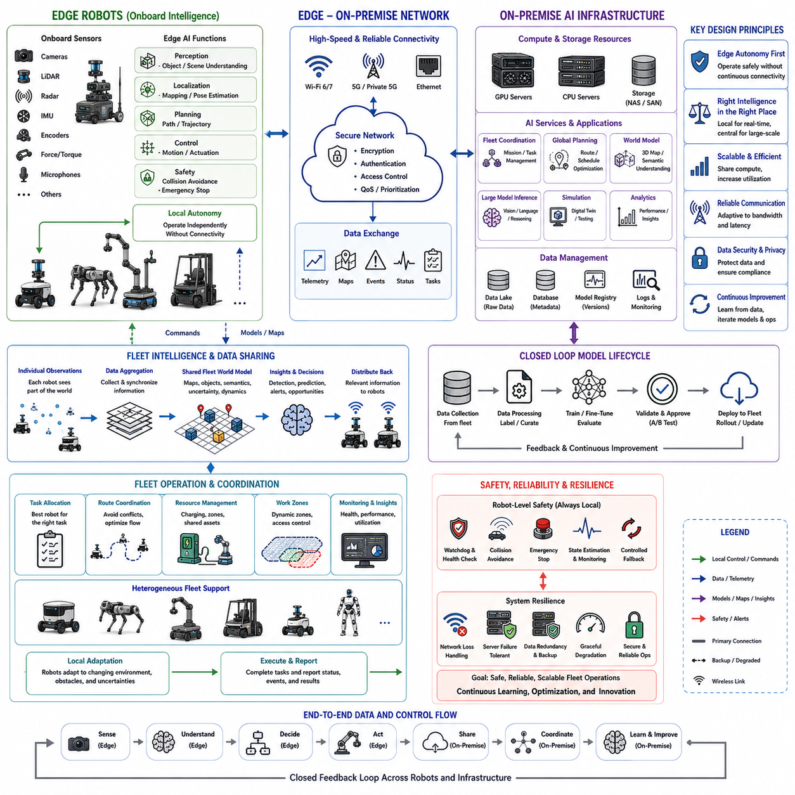
An Edge–On-Premise Fleet AI architecture extends individual robot intelligence into a coordinated multi-robot computing system. Each robot performs latency-sensitive perception, localization, planning, control, and safety functions at the edge, while an on-premise AI infrastructure provides shared computation, fleet coordination, data management, model evaluation, and large-scale analytics. The fundamental co-design problem is to determine which intelligence must remain physically onboard and which intelligence can be centralized without compromising autonomy, responsiveness, reliability, or operational safety.
The edge layer should preserve the minimum autonomous capability required for every robot to operate independently. Sensor processing, state estimation, obstacle avoidance, motion control, emergency behavior, and essential task execution should not depend on continuous network connectivity. This separation is particularly important when robots operate in environments where wireless communication can be intermittent, congested, or unavailable. The edge system therefore acts as the robot's immediate intelligence, providing deterministic responses while the on-premise layer extends rather than replaces local autonomy.
The on-premise layer provides computational capabilities that are difficult or inefficient to place on every individual robot. A shared GPU cluster can support large-scale world-model inference, complex perception, model evaluation, simulation, data processing, and fleet-level reasoning. Because computational resources are pooled, a fleet can achieve higher overall utilization than if every robot were equipped with maximum computing capacity. Workloads can be dynamically assigned according to mission requirements, robot state, available compute, network conditions, and computational priority.
Fleet intelligence emerges when individual robots share selected information through the on-premise system. Robot states, maps, detected objects, environmental changes, task progress, anomalies, and operational statistics can be aggregated into a common fleet representation. This shared information can improve task allocation, route coordination, map consistency, predictive maintenance, and environmental awareness. However, centralized knowledge should not imply centralized control of every physical action. Immediate collision avoidance and safety-critical decisions should remain local so that fleet coordination does not become a single point of failure.
The architecture should therefore establish clear boundaries among robot-level control, edge AI, fleet coordination, and on-premise intelligence. Low-level control and safety operate at deterministic real-time frequencies, while local AI performs perception, localization, prediction, and motion planning. The fleet layer coordinates missions, robots, shared resources, and global environmental information. The on-premise AI layer can perform computationally intensive reasoning, model inference, simulation, optimization, and learning support. These layers should exchange information through well-defined interfaces rather than tightly coupling every function.
Communication becomes a critical part of the physical AI architecture because information must move between robots and the shared computing infrastructure. High-bandwidth sensor streams do not necessarily need to be transmitted continuously if useful features, events, compressed representations, or selected observations can be processed locally. This reduces network load while preserving important information for centralized analysis. Communication policies should therefore consider latency, bandwidth, reliability, data priority, privacy, and mission criticality. When communication degrades, the system should automatically reduce dependence on centralized services while maintaining local operation.
A shared fleet world model can become one of the most valuable capabilities of an Edge–On-Premise architecture. Individual robots observe different locations and moments, allowing the infrastructure to combine their observations into a broader representation of the operating environment. Maps, semantic information, dynamic objects, traversability, uncertainty, and historical changes can be maintained at fleet scale. The resulting model can then be selectively distributed back to robots. This creates a continuous information loop in which local observations improve shared intelligence and shared intelligence improves subsequent local decisions.
Fleet task planning can also benefit from centralized computation while retaining local execution. An on-premise planner may allocate tasks according to robot capability, location, battery state, payload, current workload, and estimated completion time. It can coordinate routes, charging schedules, work zones, and shared resources across many robots. However, the robot should retain the ability to adapt when the real environment differs from the global plan. Local perception and planning must be able to modify or reject centrally generated decisions when physical conditions, safety constraints, or localization confidence make the original plan inappropriate.
Model lifecycle management becomes increasingly important as the number of robots grows. The on-premise system can collect operational data, identify difficult situations, evaluate model performance, retrain or fine-tune models, validate new versions, and distribute approved models to the fleet. This creates a closed development and deployment loop in which field experience continuously improves the AI system. Model versioning, dataset management, validation procedures, rollback mechanisms, and hardware-specific optimization are essential because an incorrect model update could propagate the same failure across many robots.
Power, compute, and thermal constraints should be optimized at the fleet level rather than only at the individual robot level. A robot with limited edge resources can request additional computation from the on-premise system when communication and latency permit, while another robot performing a safety-critical operation may retain all local resources for immediate execution. Fleet scheduling can therefore consider not only physical task allocation but also computational resource allocation. This enables heterogeneous robots with different edge capabilities to participate in one coordinated AI infrastructure.
Safety and reliability require deliberate fault containment between the edge and on-premise layers. Loss of the central server, network connection, shared map, or fleet coordinator should not cause every robot to become unsafe. Each robot should have local fallback behavior, watchdog functions, emergency stopping, collision avoidance, and sufficient state estimation to continue safely or transition to a controlled state. At the same time, the on-premise system should monitor robot health, communication quality, abnormal behavior, compute utilization, and fleet-level risks. This creates distributed resilience rather than dependence on a single computational authority.
The resulting Edge–On-Premise Fleet AI system should be understood as a distributed Physical AI architecture in which intelligence is intentionally divided according to latency, computation, safety, energy, communication, and coordination requirements. The edge provides immediate embodied intelligence, while on-premise infrastructure provides shared computational depth, global awareness, fleet optimization, model lifecycle management, and collective learning. The most effective architecture is therefore neither fully decentralized nor fully centralized; it is a hierarchical system in which each robot remains physically autonomous while the fleet becomes progressively more intelligent through shared computation, shared world knowledge, and continuous feedback.

09.09. World Model Ready Robot Architecture
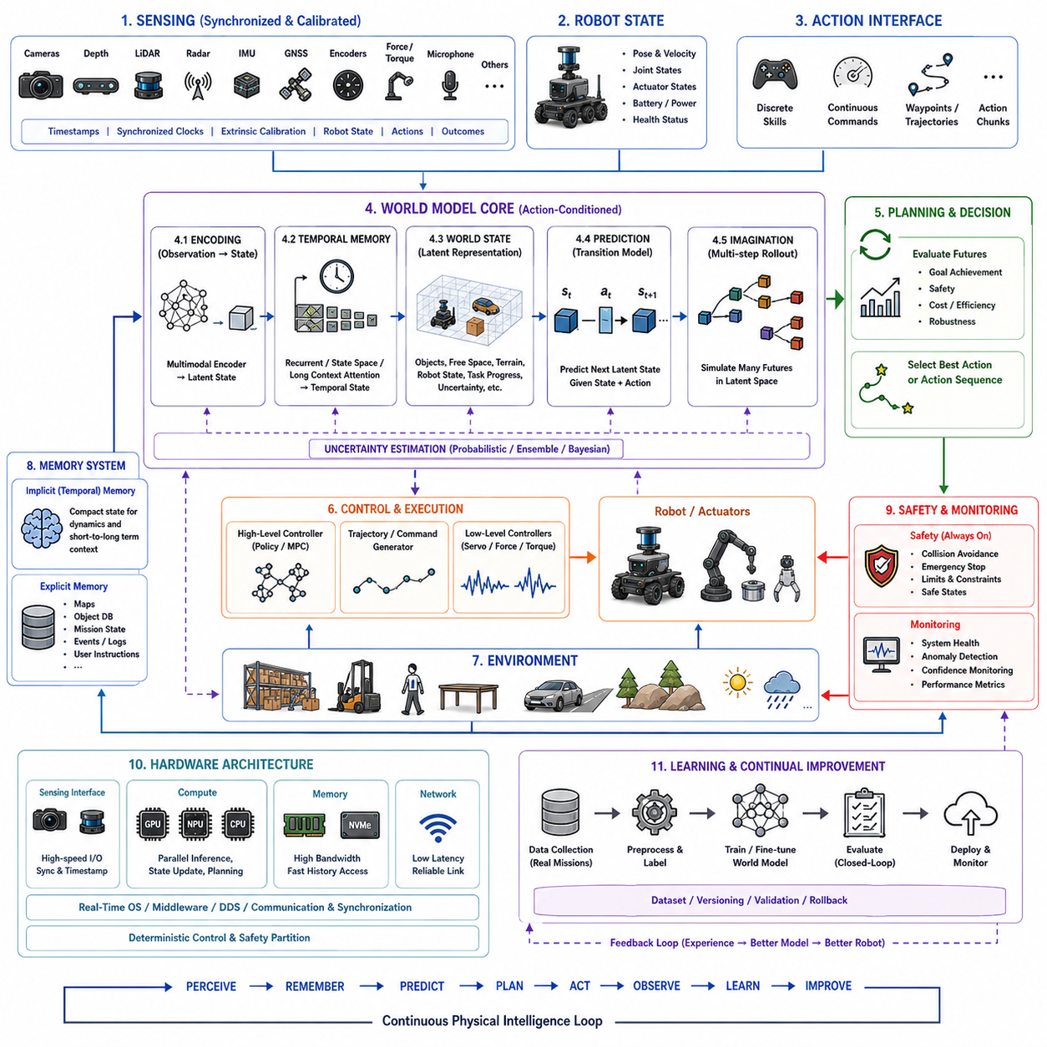
A world-model-ready robot is designed not merely to perceive the current environment, but to maintain an internal representation of how the robot and its surroundings evolve over time. The architecture must therefore connect multimodal sensing, robot state estimation, temporal memory, world representation, prediction, planning, and action execution as a continuous loop. The essential design principle is that observations should be transformed into a compact state that preserves information relevant to future decisions. This state must remain useful even when the environment is partially observable, noisy, dynamic, or temporarily occluded.
The sensing layer must provide synchronized information about both the external world and the robot itself. Cameras, depth sensors, LiDAR, radar, IMU, GNSS, joint encoders, force or torque sensors, and other modalities can contribute complementary observations. However, a world model cannot reliably learn dynamics from poorly aligned data. Sensor timestamps, synchronized clocks, calibrated extrinsic relationships, robot states, actions, and outcomes must therefore be preserved throughout the data pipeline. Temporal misalignment between an action and its resulting observation can cause the learned model to infer incorrect physical relationships.
The core representation should move beyond raw sensor observations toward a structured or latent world state. This state can encode robot pose, velocity, joint configuration, object positions, free space, terrain, contact conditions, task progress, environmental changes, and uncertainty. It does not necessarily need to reconstruct the complete physical world in pixel-level detail. For planning, control-relevant features such as object pose, free space, contact state, localization confidence, and task progress can be more valuable than photorealistic reconstruction. A compact representation also makes long-horizon prediction substantially more computationally practical.
Temporal memory is a defining requirement because a single observation rarely contains enough information to determine the state of a physical system. The robot may need to remember an object's previous position, a recent contact event, an earlier localization condition, a task instruction, or the consequences of an action several seconds earlier. Recurrent state-space models, long-context attention, explicit memory, semantic summaries, and structured mission-state representations can provide different forms of temporal continuity. The architecture should distinguish rapidly changing state from persistent context rather than treating every historical observation as equally important.
A world-model-ready architecture should support both implicit and explicit memory. A temporal model can maintain a compact internal state representing ongoing dynamics, while databases, semantic maps, mission-state machines, or other structured stores can preserve exact historical facts. This distinction is important because compressed temporal representations may capture trends effectively but can have difficulty retrieving an exact instruction or event from the distant past. A hybrid memory architecture therefore allows continuous dynamics to remain efficient while important mission constraints, object identities, maps, and operator instructions remain explicitly retrievable.
The world model itself should be action-conditioned rather than purely observational. Predicting what normally happens in an environment is insufficient for Physical AI because the robot actively changes the future through its own actions. Turning a vehicle, moving an arm, applying force, pushing an object, or changing gait can alter subsequent observations and physical states. An action-conditioned transition model estimates how the internal state will evolve when a particular action is applied. This transforms the world model from a passive forecasting mechanism into a predictive representation that can directly support planning and decision making.
Prediction should operate primarily in a compact state or latent space when real-time planning is required. A latent dynamics model can encode observations into latent variables and then predict future latent states under candidate actions. Because latent representations are much smaller than raw images, many hypothetical futures can be evaluated with substantially less computation and memory. This enables imagination-based planning, where the robot evaluates alternative action sequences before physically executing them. The world model therefore becomes an internal simulation mechanism that can reduce unnecessary trial and error in the real environment.
Planning should repeatedly use the world model rather than treating prediction as a one-time preprocessing stage. The robot can encode its latest observations, simulate candidate action sequences, estimate their future outcomes, and select an appropriate action. After executing part of the selected sequence, new observations are incorporated and the process is repeated. This receding-horizon structure is naturally compatible with Model Predictive Control because only the immediate portion of a predicted plan is executed before the future is reconsidered. It allows the robot to correct prediction errors as new evidence becomes available.
Uncertainty must be represented explicitly because world-model predictions become less reliable as the prediction horizon increases and because unfamiliar situations can produce misleadingly confident outputs. Probabilistic latent states, ensembles, Bayesian methods, variational approaches, or other confidence mechanisms can estimate uncertainty in future outcomes. Planning can then favor actions that remain safe under multiple plausible futures rather than selecting an action based on a single optimistic prediction. The world model should therefore guide risk-sensitive decision making while continuously correcting its internal predictions with real observations.
The action interface is equally important because a world model has value only when its predictions can influence physical behavior. Actions may be represented as discrete skills, continuous commands, waypoints, action chunks, trajectory segments, or other structured outputs depending on the robot. A practical architecture should usually separate high-level AI decisions from high-frequency servo control. The world-model system can generate task-level actions or short-horizon trajectories, while conventional controllers translate them into deterministic motor, actuator, or force commands. This separation preserves both learned intelligence and the timing guarantees required for physical control.
The hardware architecture must consequently expose the state and action interfaces required by the world model. High-speed sensor acquisition, accurate timestamping, synchronized clocks, sufficient memory bandwidth, accelerator resources, and fast access to recent state history are foundational capabilities. The compute system should support multimodal encoding, temporal state updates, latent prediction, planning, and monitoring without interfering with safety-critical control loops. GPU or NPU acceleration can support visual and multimodal processing, while CPU and real-time processors maintain system coordination and deterministic control. The architecture should therefore be designed around continuous state processing rather than isolated inference calls.
A world-model-ready robot should also support long-duration operation and continual learning. Real missions contain repetitive periods, rare events, failures, recoveries, environmental changes, charging interruptions, and operator interventions. Training and evaluation data should preserve these temporal structures instead of reducing robot experience to independent short samples. Successful and unsuccessful trajectories are both valuable because failures reveal how expected dynamics change when execution deviates from the nominal path. Closed-loop evaluation is especially important because prediction errors influence future observations once the model begins controlling the robot.
The resulting architecture should be understood as a continuous physical intelligence loop: sensing produces multimodal observations, state estimation constructs the current robot and environment state, temporal memory maintains context, the world model predicts action-conditioned futures, planning evaluates those futures, control executes the selected behavior, and new observations correct the internal model. The robot therefore becomes ready not simply for a particular world-model algorithm but for an evolving class of predictive Physical AI systems. A robust implementation can combine attention for flexible relational reasoning, state-space memory for efficient temporal continuity, explicit memory for exact information retrieval, learned world models for prediction, and deterministic control and safety mechanisms for physical guarantees.

09.10. VLA Ready Robot Architecture
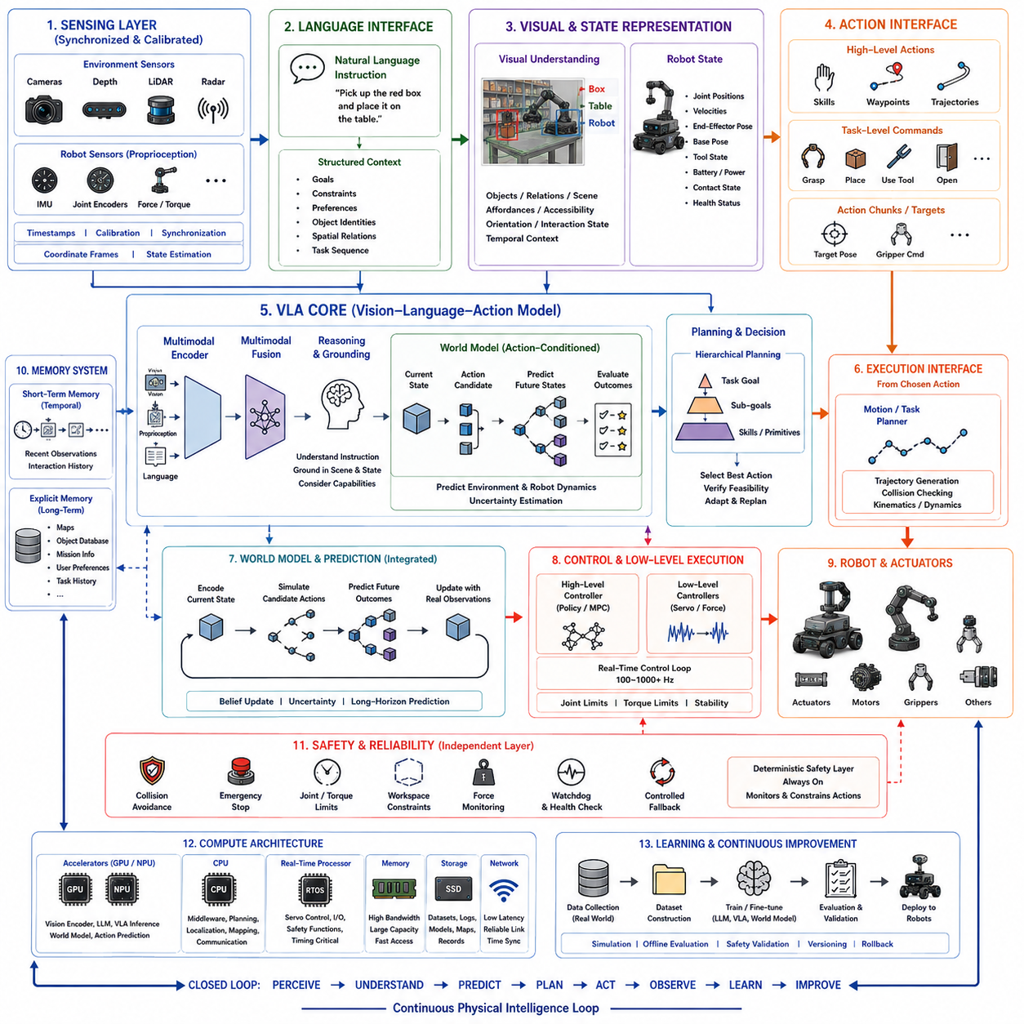
A VLA-ready robot is designed to connect visual perception, language understanding, reasoning, planning, and physical action within one integrated Physical AI architecture. Unlike a conventional robot that receives predefined commands from a task planner, a Vision-Language-Action model can interpret natural-language instructions together with visual observations and robot state, then generate actions appropriate to the physical situation. The robot architecture must therefore expose the right sensory, computational, memory, control, and action interfaces so that a VLA model can operate effectively without compromising real-time safety.
The sensing layer must provide synchronized visual and physical observations that can be converted into representations suitable for multimodal reasoning. Cameras, depth sensors, LiDAR, IMU, joint encoders, force or torque sensors, and other modalities can describe both the environment and the robot's own state. Visual information provides objects, scenes, and semantic context, while proprioceptive information describes posture, joint configuration, and physical state. Accurate timestamps, calibration, synchronization, and coordinate transformations are essential because a VLA model must associate language instructions with the correct objects, locations, and robot state.
The language interface provides the semantic entry point for human-robot interaction. Instructions may describe goals, constraints, preferences, object identities, spatial relationships, or task sequences. A VLA-ready robot should preserve these instructions as structured context rather than immediately reducing them to a fixed low-level command. Language can specify what should be achieved while perception determines the current situation and the robot's capabilities determine how the objective can physically be accomplished. This separation allows the same high-level instruction to produce different actions as the environment, robot state, or available tools change.
The visual representation should connect perception with language and action. A VLA model must identify not only individual objects but also relationships among objects, people, surfaces, tools, and the robot itself. Scene representations should preserve task-relevant information such as object identity, position, affordance, accessibility, orientation, and interaction state. The representation should also support temporal context because an object that was previously grasped, moved, or opened may have a different meaning in the current state. Visual understanding therefore becomes an intermediate representation between raw observations and physical decision making.
The robot state must be represented alongside visual and language information. Joint positions, velocities, actuator states, battery condition, current tool configuration, end-effector pose, base pose, and contact conditions can determine whether a proposed action is physically feasible. A VLA model that understands an instruction but ignores the robot's physical state may generate an action that cannot be executed safely. The architecture should therefore provide embodiment-aware state information so that multimodal reasoning can consider not only what the user wants and what the robot sees, but also what the robot can actually do at the current moment.
The action interface should allow the VLA system to generate meaningful physical behaviors without directly replacing deterministic low-level control. Actions can be represented as skills, waypoints, trajectories, action chunks, target poses, grasp commands, or other structured outputs. A high-level VLA model can decide that the robot should approach an object, grasp it, move it, or operate a tool, while intermediate planners translate this intention into executable motion. Real-time servo, force, and actuator controllers then enforce joint limits, collision constraints, torque limits, and other physical requirements.
A VLA-ready architecture should also connect naturally with the world model. Language provides the task objective, perception provides the current observation, and the world model provides a predictive representation of how the environment and robot may evolve. When an action is considered, the system can evaluate possible future states before execution. This allows the VLA layer to reason about consequences rather than simply mapping an instruction and current image directly to an action. The combination of language grounding, world modeling, and action-conditioned prediction can therefore support more reliable long-horizon physical behavior.
Planning should operate hierarchically between semantic goals and physical execution. The VLA model can determine task intent and select appropriate skills, while task planners, motion planners, navigation systems, and manipulation planners determine how those skills can be executed. This separation is particularly important for complex tasks in which a single language instruction may require many physical actions. The robot should be able to decompose a goal into intermediate objectives, verify progress, detect failure, and revise the plan when new observations differ from expectations.
Memory is also essential because many instructions depend on information that is not contained in the current image. A robot may need to remember the user's previous instruction, object identities, task progress, earlier failures, environmental constraints, or actions already performed. Short-term temporal memory can maintain the immediate interaction context, while explicit memory can preserve maps, object databases, mission information, and persistent preferences. A VLA-ready system should therefore combine multimodal context with structured memory rather than forcing the entire history into a single undifferentiated sequence.
Computing architecture must support the substantial workload created by multimodal AI while preserving deterministic control. GPUs or NPUs can accelerate visual encoders, language models, multimodal fusion, world-model inference, and action prediction. CPUs can manage middleware, planning, localization, communication, and system coordination, while real-time processors maintain actuator control and safety functions. Model optimization, quantization, memory management, batching, and workload scheduling are important because VLA models can be computationally expensive. The architecture should be designed around end-to-end latency rather than model inference speed alone.
Safety must remain independent from the generative intelligence of the VLA model. Language models and multimodal policies can produce unexpected outputs, particularly when instructions are ambiguous, visual observations are incomplete, or the environment differs from training conditions. Collision avoidance, emergency stopping, joint and torque limits, workspace constraints, force monitoring, watchdogs, and controlled fallback behaviors should therefore remain under deterministic mechanisms. The VLA system should propose or select actions within a defined safety envelope, while lower-level systems verify that those actions are physically permissible before execution.
A practical VLA-ready robot architecture should finally support continuous learning and model evolution. Real-world operation generates demonstrations, successful trajectories, failures, corrections, operator interventions, and new environmental situations that can improve future models. These data can be collected locally and transferred to on-premise infrastructure for evaluation, dataset construction, fine-tuning, simulation, and validation before approved models are deployed back to the robot fleet. The resulting architecture forms a continuous loop in which language provides goals, perception provides evidence, world models provide prediction, VLA reasoning selects behavior, deterministic control executes actions, and real-world experience progressively improves the robot's ability to understand and perform physical tasks.

09.11. End to End Physical AI Co Design Example [w/Code]
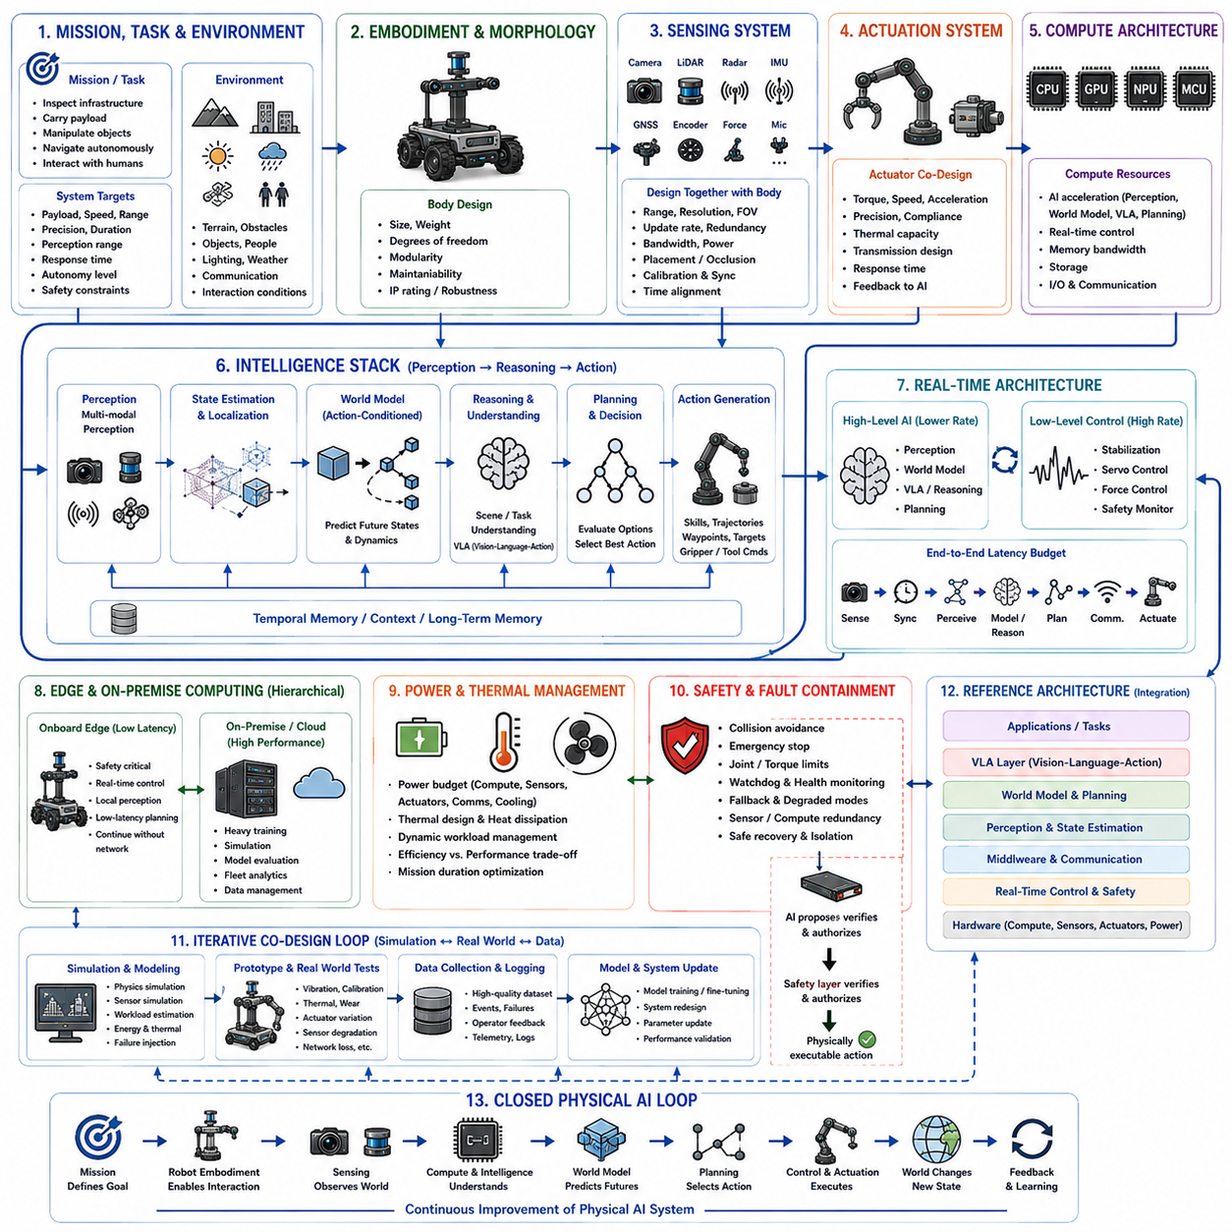
An end-to-end Physical AI co-design example brings together the principles of compute platforms, actuator and sensor co-design, hierarchical edge computing, real-time constraints, power and thermal management, reference architectures, world models, and VLA-ready robot design into one integrated development process. The objective is not to optimize any individual subsystem independently, but to begin with a physical task and trace its requirements through sensing, computation, intelligence, planning, control, actuation, energy, and safety. The resulting robot is therefore designed as one cyber-physical system rather than as separate hardware and AI components.
The process begins with the mission, task, and environment because these determine the fundamental requirements of the robot. The task defines what the robot must accomplish, while the environment determines terrain, obstacles, objects, people, lighting, weather, communication availability, and interaction conditions. These requirements are translated into measurable system targets such as payload, speed, precision, operating duration, perception range, response time, autonomy level, and safety constraints. Embodiment and morphology are then selected to make the physical platform capable of performing the required tasks while remaining compatible with the intended AI architecture.
The sensing system is co-designed from the information required by perception, localization, world modeling, and control. Cameras, LiDAR, radar, IMU, GNSS, encoders, force sensors, and other modalities are selected according to their required range, resolution, update rate, field of view, redundancy, bandwidth, and environmental robustness. Sensor placement is designed together with the robot body because mechanical structures can create occlusion, vibration, electromagnetic interference, and restricted viewpoints. Time synchronization and calibrated coordinate relationships are essential so that observations, robot states, and actions correspond to the same physical moment.
The actuator system is designed from the actions the AI must ultimately perform. Motor torque, speed, acceleration, compliance, precision, thermal capacity, transmission characteristics, and response time determine the feasible action space available to the intelligence. AI commands therefore cannot be treated as abstract decisions independent of physical capability. They must be mapped through a control hierarchy into executable actuator commands while respecting saturation, joint limits, force constraints, and dynamic behavior. Actuator feedback should also return to the AI system so that the robot can learn how its intended actions actually affect the physical world.
The compute architecture is then sized according to the complete sensing-to-action workload. CPU, GPU, NPU, real-time processors, memory, storage, and communication interfaces are allocated according to their respective responsibilities. High-level AI may require substantial acceleration for multimodal perception, world-model inference, VLA processing, prediction, and planning, while low-level control requires deterministic timing. Memory bandwidth and data movement are considered together with model size because a theoretically powerful accelerator can still become ineffective when sensor streams, neural activations, and intermediate representations cannot be moved efficiently through the system.
The intelligence stack connects perception, state estimation, world modeling, reasoning, planning, and action generation. Raw sensor observations are transformed into a representation of the robot and its environment, while temporal information preserves the evolution of that state. A world model can predict how candidate actions may change future states, allowing planning to evaluate alternatives before physical execution. A VLA layer can additionally connect visual observations and language instructions with task-level actions. The architecture should therefore support both predictive intelligence and semantic task understanding without allowing either to bypass physical constraints.
Real-time architecture provides the boundary between intelligent decision making and deterministic physical execution. High-level AI functions may operate at relatively low frequencies because they require substantial computation, whereas stabilization, servo control, force control, safety monitoring, and actuator protection must operate at much higher and more predictable rates. An end-to-end latency budget should account for sensing, synchronization, perception, world-model reasoning, planning, communication, and actuator response. Timing jitter and computational overload must be explicitly considered so that advanced AI cannot destabilize the robot.
Edge and on-premise computing can then be partitioned according to latency, computational demand, connectivity, and safety. Functions that directly affect physical survival and immediate behavior remain onboard, while computationally intensive reasoning, simulation, fleet analytics, model evaluation, and training can be moved to shared infrastructure when appropriate. The robot should continue operating safely during network degradation or complete disconnection. This creates a hierarchical computing architecture in which local intelligence provides immediate embodied autonomy and on-premise infrastructure provides additional computational depth and collective intelligence.
Power and thermal budgets must be evaluated simultaneously with compute and actuator requirements. AI inference, sensors, communication, motors, and cooling all consume resources from the same physical energy system. Increasing model complexity may improve perception or reasoning while reducing mission duration, whereas more capable actuators may improve mobility while increasing peak power and thermal loads. Dynamic workload management can therefore reduce unnecessary computation during simple conditions and allocate additional resources when environmental complexity or task risk increases. Sustained performance, rather than short benchmark performance, becomes the relevant design objective.
Safety and fault containment must cross every architectural layer. Deterministic safety mechanisms should monitor AI outputs, actuator commands, sensor health, thermal state, communication status, and robot dynamics. Collision avoidance, emergency stopping, watchdogs, fallback modes, degraded-sensor operation, compute redundancy, and controlled recovery should remain effective even when an AI component fails. The system should also distinguish between an AI prediction and a physically authorized action. High-level intelligence can propose behavior, but independent constraints and lower-level controllers must verify that the proposed behavior is safe and physically executable.
The complete development process should operate as an iterative simulation-to-real and data-feedback loop. Simulation can evaluate morphology, sensor placement, actuator loads, compute requirements, latency, world-model behavior, planning, energy consumption, and failure conditions before extensive physical testing. Physical experiments then reveal effects such as vibration, calibration error, thermal accumulation, actuator variation, sensor degradation, communication loss, and unexpected environmental interactions. These observations become new data for model evaluation, system redesign, and subsequent simulation. Co-design therefore progresses through repeated measurement rather than a one-time hardware selection followed by software development.
The final system can be viewed as a closed Physical AI loop in which mission requirements define the task, morphology enables physical interaction, sensors observe the world, compute transforms observations into intelligence, world models predict possible futures, planning selects actions, controllers translate decisions into physical commands, actuators change the environment, and new observations provide feedback. Power, thermal, communication, latency, and safety constraints continuously shape every stage of this loop. The central result of end-to-end co-design is therefore not merely a robot with advanced AI, but a scalable cyber-physical platform in which hardware, software, AI, control, energy, and safety are intentionally designed to function as one integrated Physical AI system.

