# Lab: HTTP BASICS

Problems for in-class lab for the [“Programming Fundamentals” course @ SoftUni](https://softuni.bg/trainings/3369/fundamentals-with-csharp-java-javascript-and-python-may-2021).

## Installing Needed Software

## Postman

You can download Postman from [here](https://www.getpostman.com/apps).

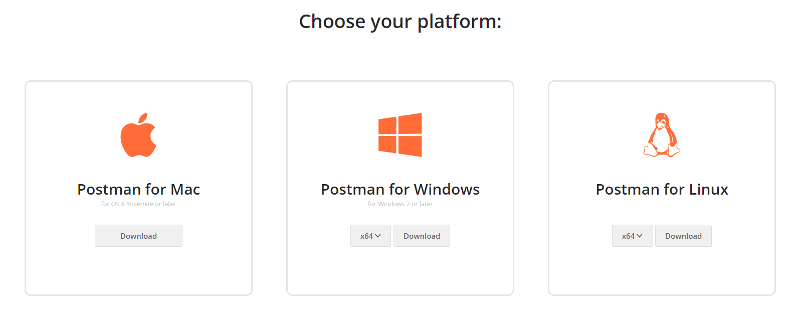

1. **Make Basic HTTP Requests**
2. **Get All Trips**

**Listing** all trips should be easy **with** the following request:  
<https://trips-48955.firebaseio.com/trips.json>

**Request**: 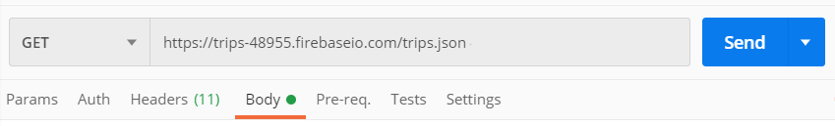

**Response**: 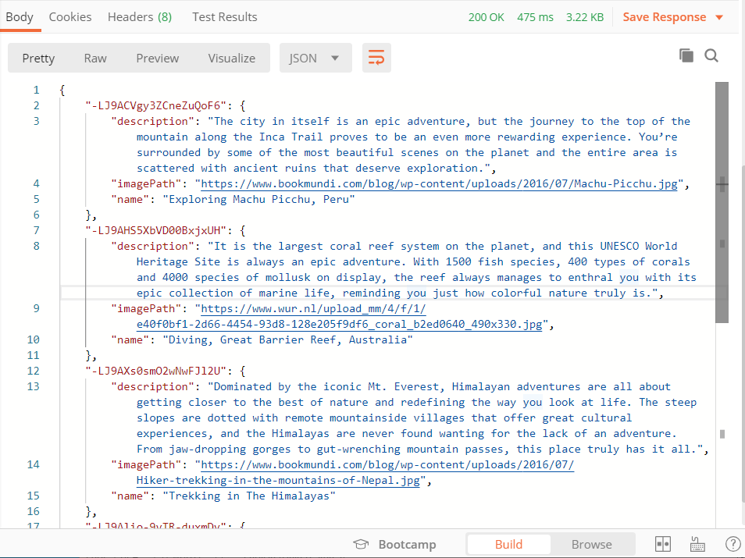

1. **Create New Trip**

Lets make a **"POST"** request to add a new destination to our firebase database. Use the following data:

**{**

**"description" : " October-November and February-March are the best times to see the northern lights. Dark skies yield better displays – avoid full moon. ",**

**"imagePath" : "https://www.aurora-nights.co.uk/wp-content/uploads/2019/07/norway-northern-lights-1500x587_c.jpg",**

**"name" : "Capture the Northern Lights on camera"**

**}**

**Request**:

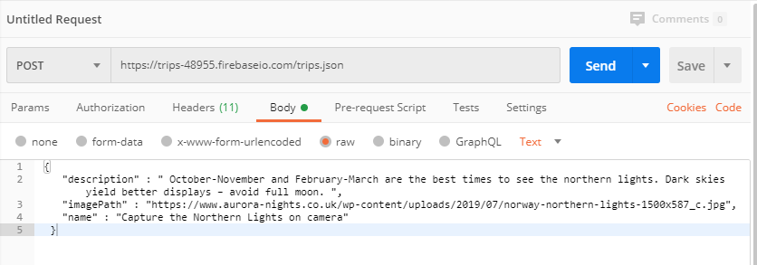

**Response**:

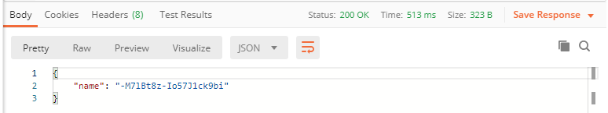

1. **Delete a Trip**

Now let us **delete** the **newly** created trip.

**REQUEST "DELETE":** [https://trips-48955.firebaseio.com/trips/**{postId}**.json](https://trips-48955.firebaseio.com/trips/%7bpostId%7d.json). The **postId** can be found from the JSON response of the **previous** task:

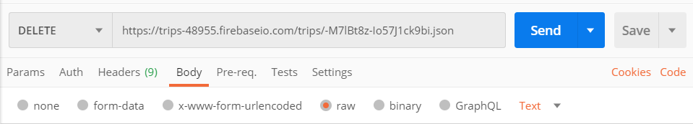

The "**DELETE**" request should get us **status 200** and the default response from this database is **null**:

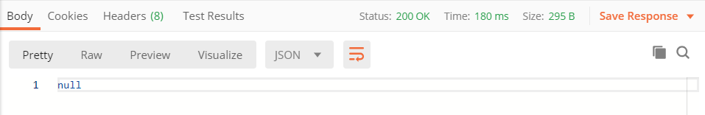

Now, when we get all trips we can notice that the trip **"Capture the Northern Lights on camera"** is not in the list.

1. **Edit a Trip**

Edit a trip with a "**PATCH**" request.

<https://trips-48955.firebaseio.com/trips/-MIJ0HydEYF0x6fljO55.json>

We will update the: **"Pyramids of Giza, Egypt"** trip changing the **"description"** and adding new field **"edit": "true"** using the following body:

**{**

**"description" : "Egypt welcomes you!",**

**"imagePath" : "https://www.karacitours.bg/public/thumbs/767x341/egipet/egipet-4_767x341_crop_542eb8694d.jpg",**

**"name" : "Pyramids of Giza, Egypt",**

**"edit": "true"**

**}**

**Request**:

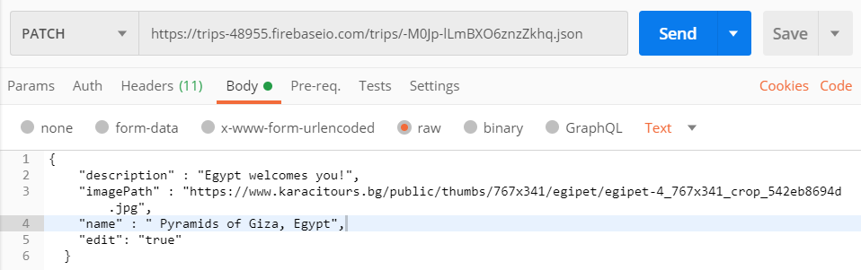

**Response**:

