**EFood-9**

*RESEARCH IN SIMILAR SITES*

*OPENING SCREENS :*

*e-food.gr*

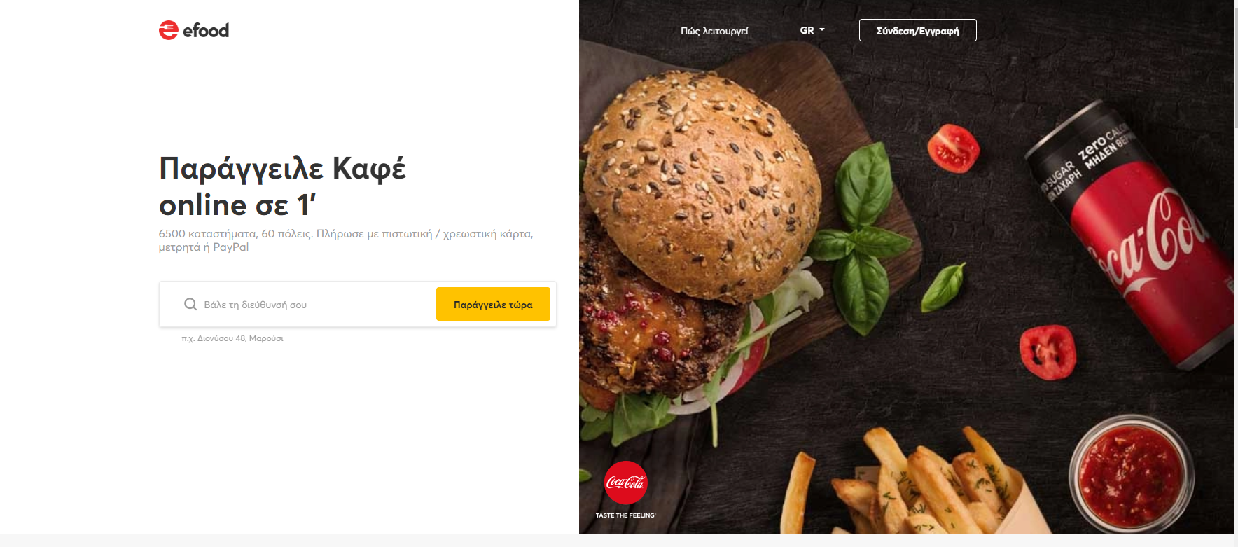

*deliveras.gr*

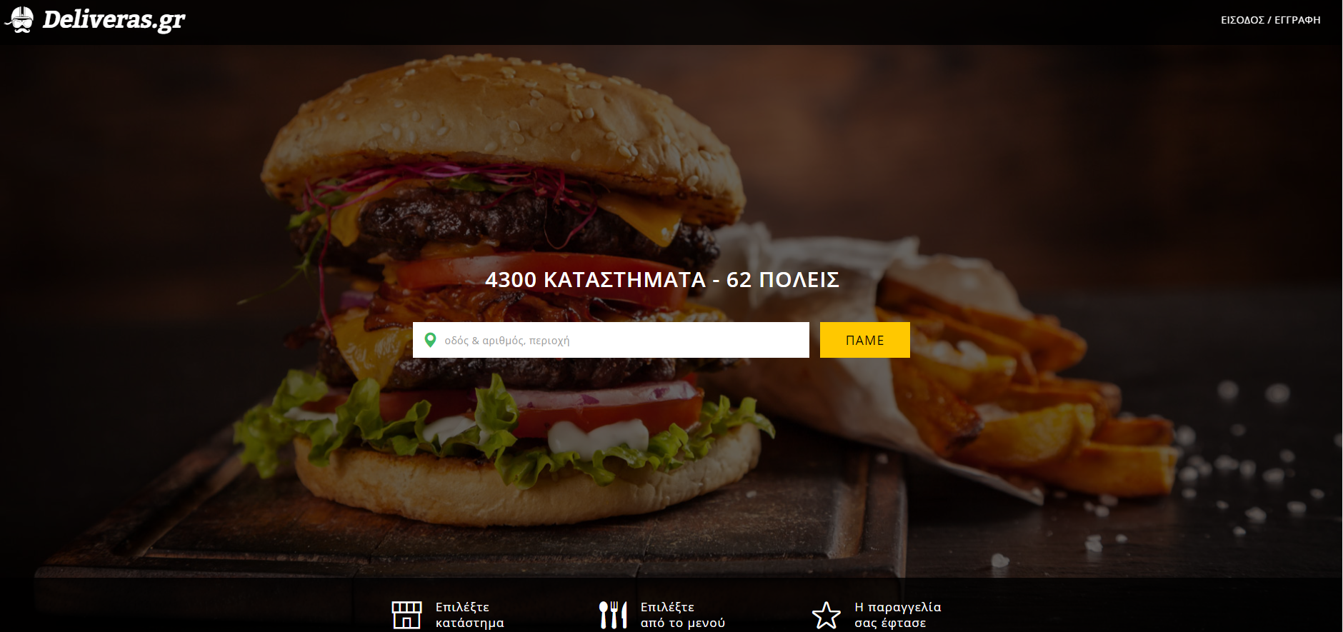

*LOG-IN FORMS :*

*e-food.gr*

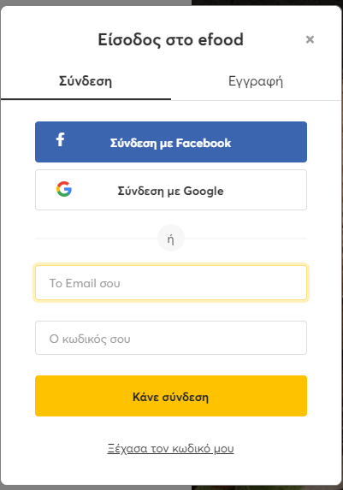

*Deliveras.gr*

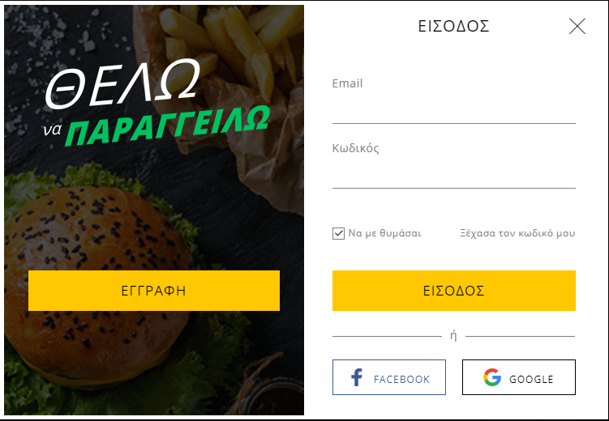

*SIGN-UP FORMS :*

*e-food.gr*

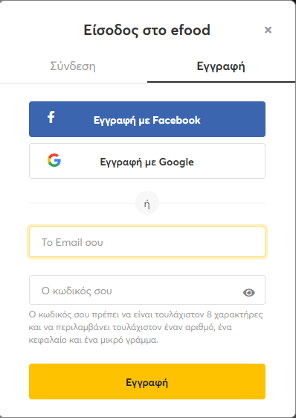

*deliveras.gr*

*(pops up in new screen)*

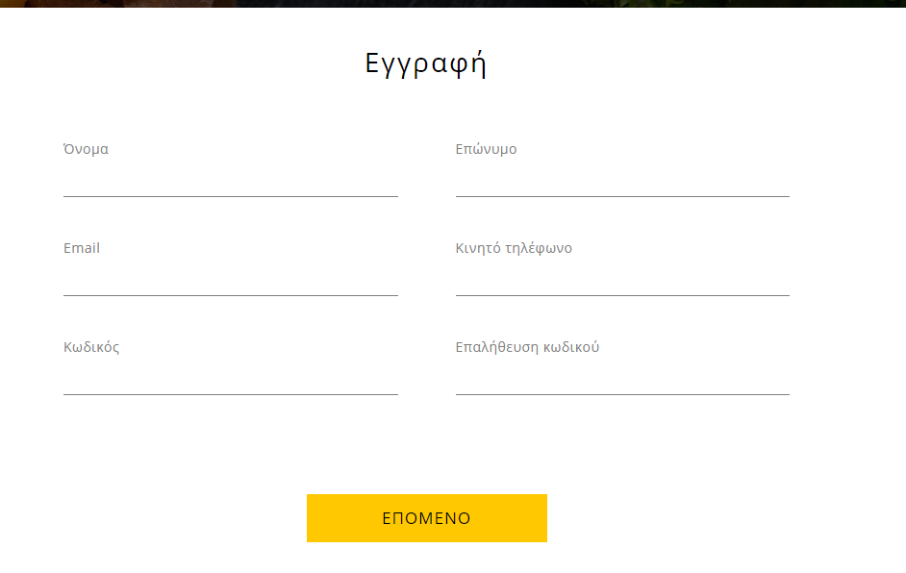

*Search Engine :*

*E-food.gr*

*(by typing name)*

*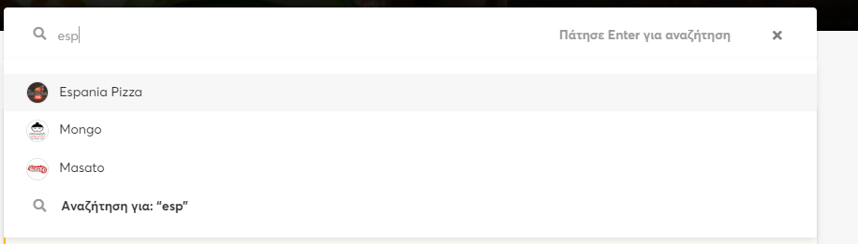(by filtering)*

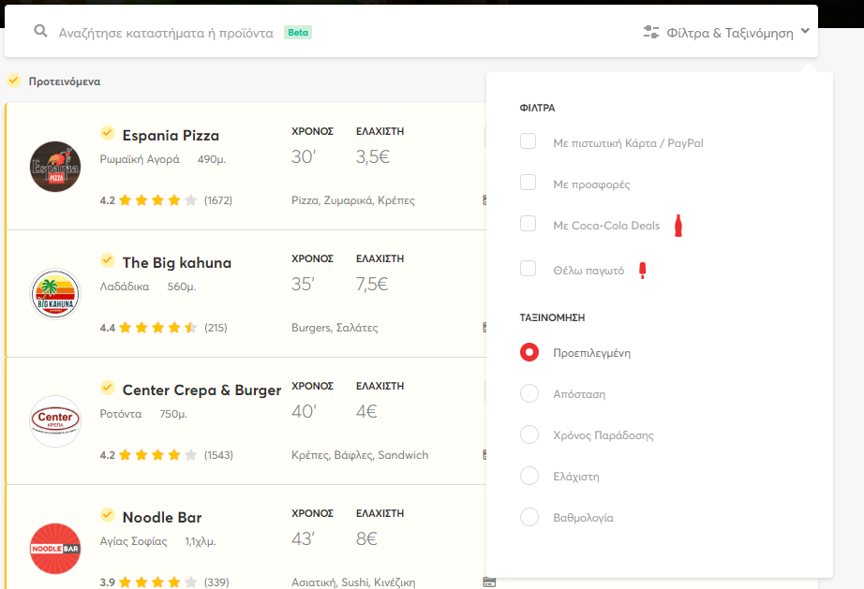

*Deliveras.gr*

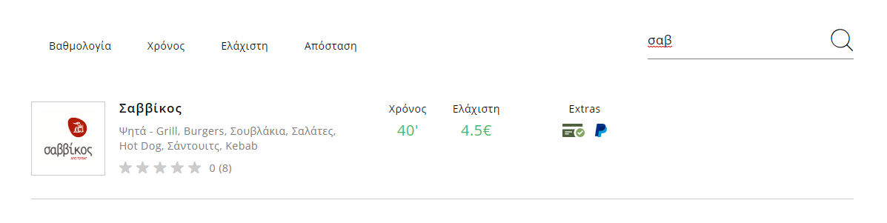

*User-Management :*

*e-food.gr*

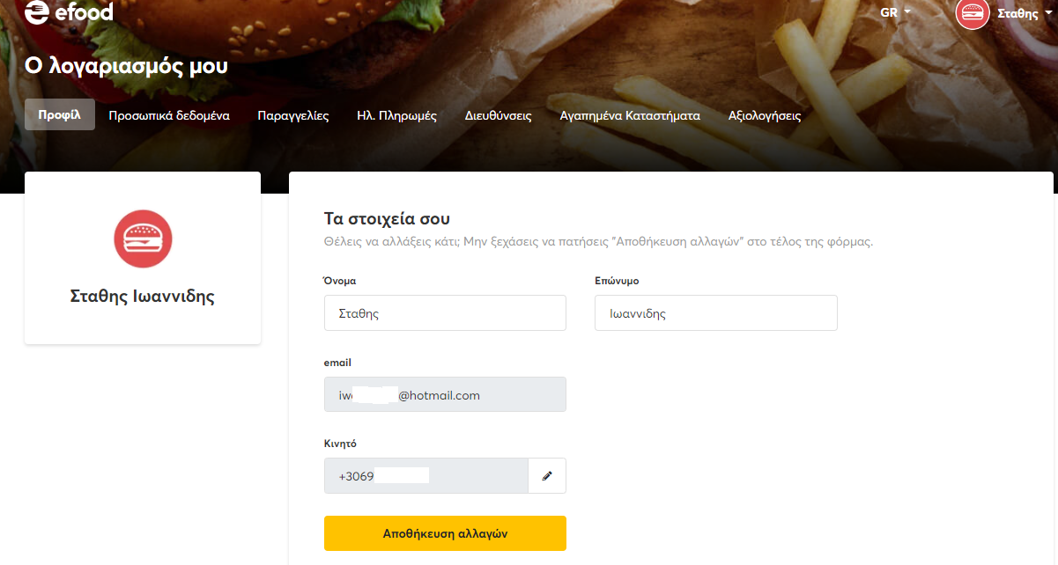

*Deliveras.gr*

