Week 2: Waterfall SDLC for course registrations (written in the first person)

Brendan McCullagh

American Military University

ENTD311: Summer

Professor Yurik

Abstract

Team, the University of Tacofornia’s President has approach us on her need of a new registration web based system. The client’s requirements are to develop a “system will need to contain information about students, faculty, and courses.  Students should be able to use the system to browse course descriptions and the schedule of classes for each semester, add classes to their schedule, and drop classes from their schedule” (Yurik 2020). We will use the Waterfall methodology of Software Development Life Cycle found here: <https://www.guru99.com/what-is-sdlc-or-waterfall-model.html> .

System analysis: The university is using the latest models of computers made by the Granny Smith Apples and Window-frame companies. They want the fastest connections to the system possible. This will require us to build a robust system in a fast language with the newest servers. The client requires the system to “contain information about students, faculty, and courses”, so there will need to be multiple layers to the system and ability to cross reference information. There are no Requests For Information (RFI) at this stage.

Design: The front end that the clients students and faculty will interface with will be web based HTML5 with a customizable CSS file. We will use ping the President on preferred color schemes and provide out own recommendations. While they President may want purple and yellow (the schools colors) background and text, the interface must be readable, and professional. The back end will be written in GO_lang. This is due to the universities desire for the fastest system possible since they are using the latest model everything. Go also affords ease of coding so we will be able to begin tests and deployment cycles sooner. The database will be encapsulated in Amazonianas web service. Version control will be handled by GITup via team leaders. We will create the system based on the entity relationship model (see below). RFIs; Color scheme for the sight.

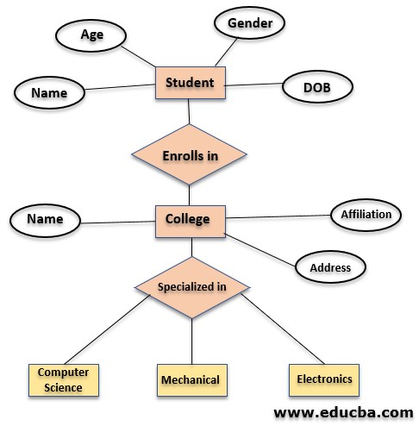

Implementation: All team leads will create the units necessary for their portion of the project. Testing at the lowest level during unit creation is essential prior to implementation and testing. All units which are functioning and already debugged will reduce implementation time and the issues of second and third order of effects. RFI; Should unit testing be done by unit, or as a whole once the project is complete; should we test against legacy equipment (older systems).

Integration and Testing: Once all units have passed their test and all RFIs have been answered, produced, and decisions made by the client, we will begin integration. Any issues found during implementation and testing will be handled by the unit creator team. RFIs: Will we test against legacy systems or slow internet in the event a student is from overseas? Will we have a mobile version in the future?

Deployment: Once deployed the team will monitor their product to ensure the environment is functioning as it’s intended to. If the client is happy, we will begin to pitch the idea of a mobile environment will similar ascetics and functionality.

Maintenance: Will be on-going. We will patch as the respective OS patches, the database patches. These will be monitored, and a patch should be produced in a week. Any major issue such as personal identifiable information leak, payment leak, or similar level events will be patched immediately. If a mobile app is desired by the client, we can easily deploy the mobile product via ap store, and release a patch to allow access and functionality similar to the original system.

Bibliography:

Entity-Relationship Model: Concise Guide To Entity Relationship Model. (2020, July 02). Retrieved July 18, 2020, from https://www.educba.com/entity-relationship-model/

SDLC - Overview. (n.d.). Retrieved July 18, 2020, from https://www.tutorialspoint.com/sdlc/sdlc_overview.htm

What is Waterfall Model in SDLC? Advantages & Disadvantages. (n.d.). Retrieved July 18, 2020, from https://www.guru99.com/what-is-sdlc-or-waterfall-model.html