**Instructions:**

User must first fill in a valid phone number in the space provided in E.164 format (eg. +61 8xx xxxx xxxx becomes 618xxxxxxxxxxx) before being able to send a message.

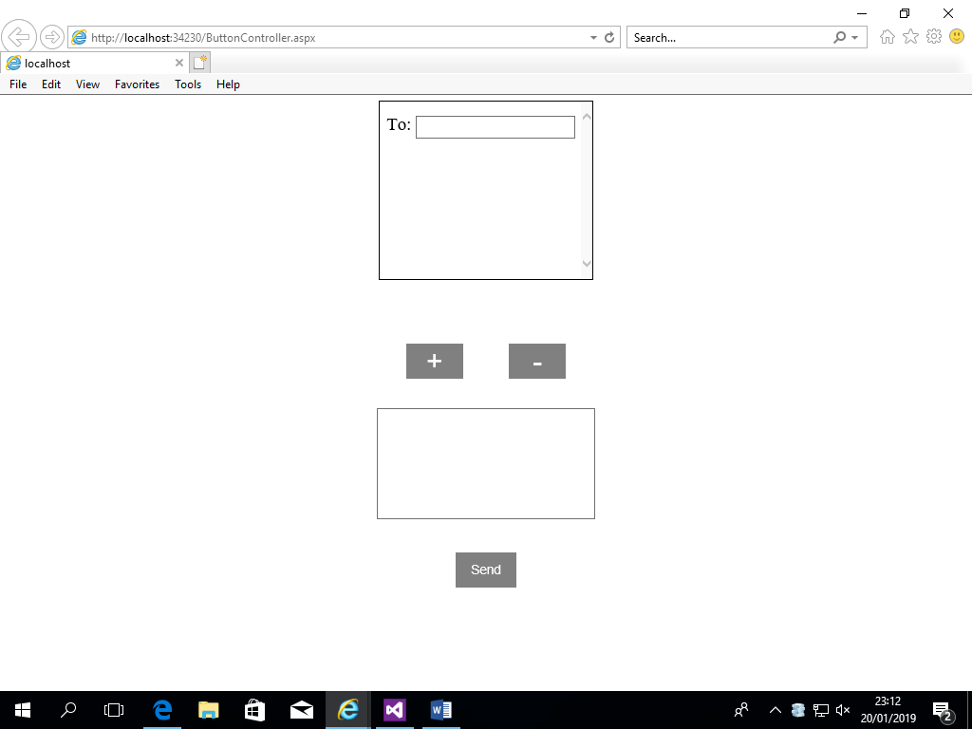 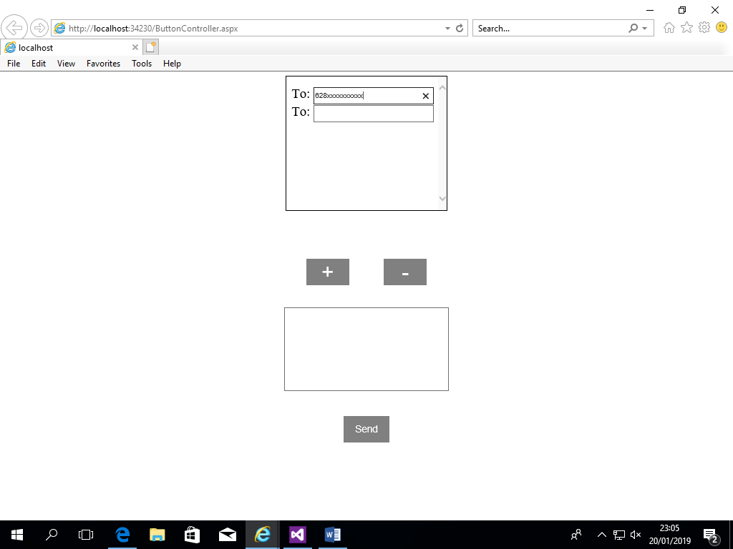

User can add more phone number by pressing the ‘+’ button; pressing the button will add another text field directly below the previous one. User can only add more phone numbers if the previous inputted number is valid and non-empty.

Pressing the ‘-‘ button removes the last number added however, user cannot remove the first phone number.



User can then input a message at the space provided and it can be of any length. User must input a message before pressing the send button.

The send button checks all typed phone numbers if they’re valid. It then log into a twilio account using provided SID and token. Afterwards, it iterates through all phone number and send them the inputted message. For each iteration, wait 2 seconds because Twilio can only send 1 message per second. Each text field is an entry of a list that is initialized when first loading the page. Updating a typed phone number will update the list.

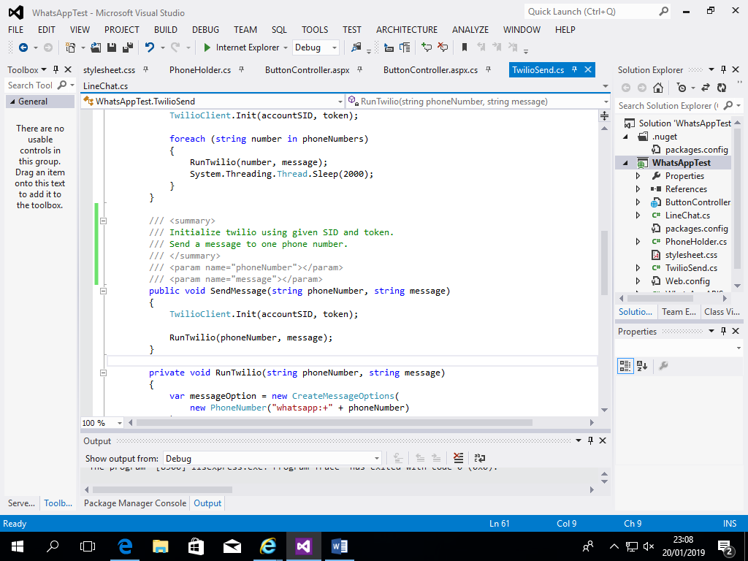

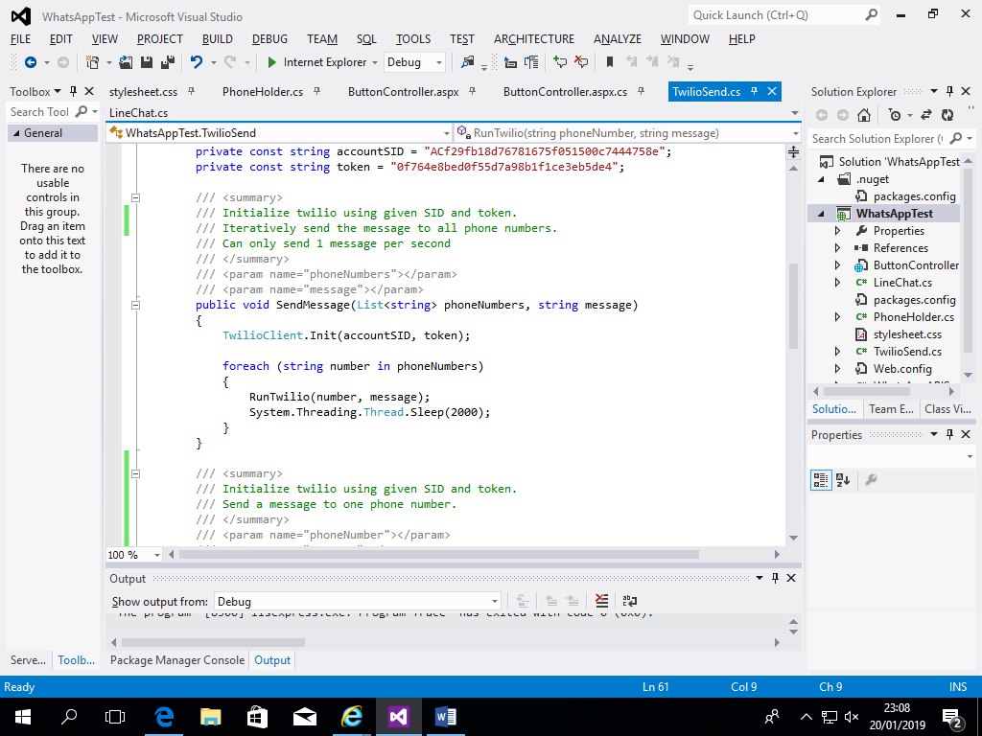

Inside TwilioSend contains 2 versions of SendMessage, it either takes a list of phone number or just one. It first initialize the Twilio Client by logging in with the given SID and Token. RunTwilio method uses a sample Twilio number to test messaging. When sending a message, any invalid phone number will be skipped.

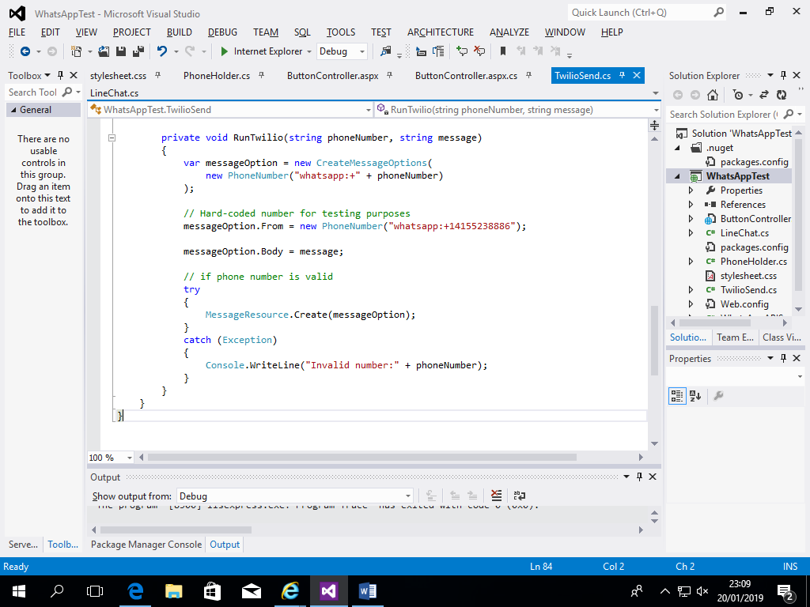

**Beberapa API untuk messaging:**

WhatsApp

+ Dengan mengunakan nomor telepon, anda bisa langsung mengirim pesan.

+

- WhatsApp tidak punya open-source API. WhatsApp mempunya Business API tapi membutuhkan pendaftaran.

- Alternatif adalah mengunakan API dari Twilio, tetapi perlu membayar untuk dapat nomor WhatsApp

LINE

+ Mempunyai API official dan tidak perlu bayar

- Untuk mengirim pesan, anda harus tahu User ID orang lain

Telegram

+ Open-sourced dan free

-