**Instructions:**

User must first fill in a valid phone number in the space provided in E.164 format (eg. If phone number is ‘+61 8xx xxxx xxxx’, then input ‘618xxxxxxxxxxx’) before being able to send a message.

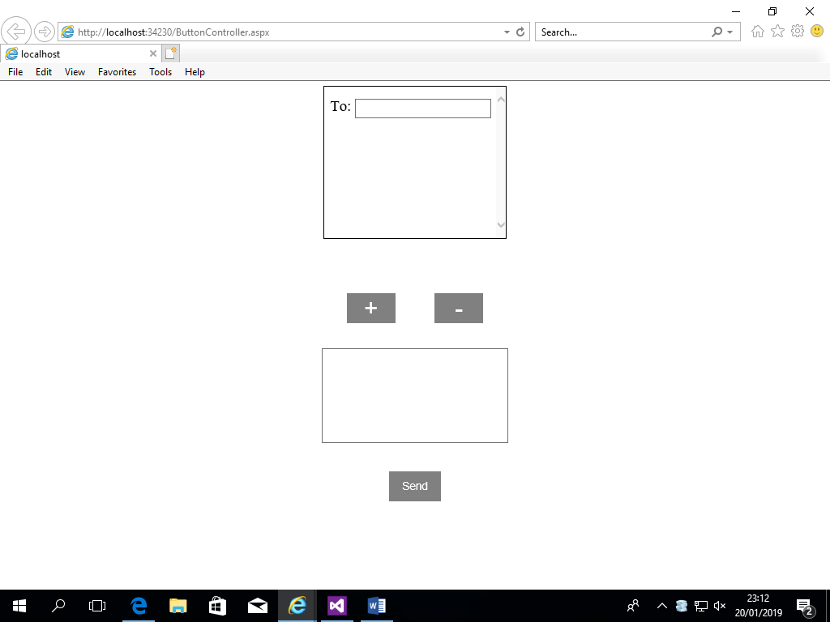 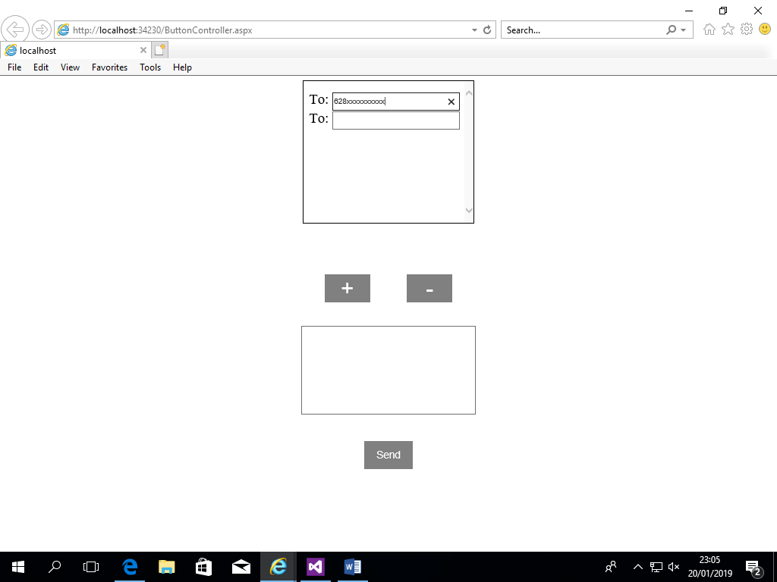

User can add more phone number by pressing the ‘+’ button; pressing the button will add another text field directly below the previous one. User can only add another phone numbers if the previous inputted number is valid and non-empty (Does not contain letters and symbols). A previously inputted number can be changed or removed.

Pressing the ‘-‘ button removes the text field starting from the bottom but it will not remove if there is only 1 text field remaining, it will just erase the text of the first text field.



User can then input a message at the space provided at any length as long as it is non-empty. User must input a message before pressing the send button.

The send button checks all typed phone numbers if they’re valid and sends the message iteratively. The page will prompt the user if there are any phone numbers that cannot get the message.