The LIMBS Framework
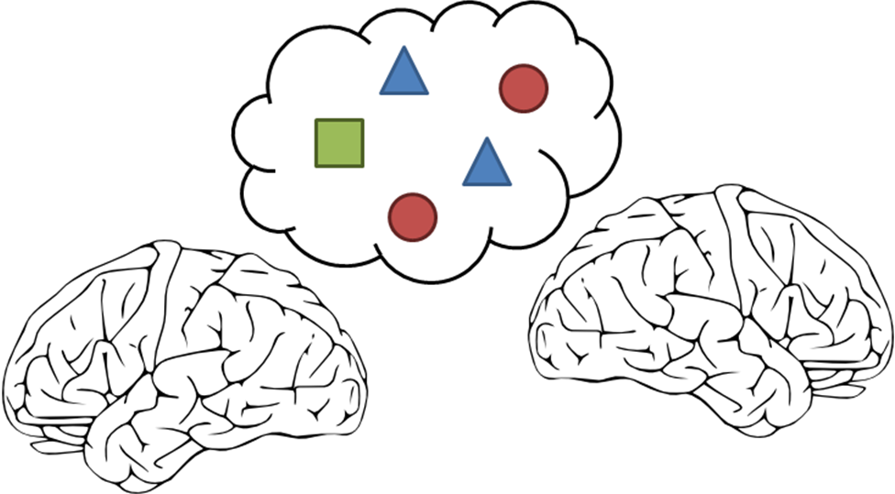
User Manual

Authors: John Baxter
Danielle Grenier
John Stevenson
Kevin Veloso
Version: v 1.0
Date: Dec 22nd 2010

What is the LIMBS Framework?

Locally Integrated Multi-Brain Systems (LIMBS) Framework is not just an agent based modelling framework, but a new way of thinking about the construction of agent based models and their application to integrating the social and cognitive sciences. So, what makes LIMBS so special? Well...

- Symbol-Based Graphical User Interface:

The LIMBS framework allows you to define agent based models on two levels: a system-wide level and an agent-internal level. By separating this two interfaces, both can act independently of the other, and both can act is a primarily visual framework, so constructing basic models will be as easy as dragging and dropping a few agents and groups in the system-wide interface, and customizing each agent using the agent-internal interface.

- Psychological Plausibility:

All implementations of the LIMBS framework come with a built-in HOTCO editor, allowing you to create agents leveraging the proven psychological plausibility of HOTCO 3 with a more flexible framework for communication, with more options for customizing emotional transfer, than standard HOTCO. That’s why the LIMBS framework does more than just multi-agent modelling, but multi-brain modelling.

- Open Source Modifiability:

The source code for the LIMBS framework is specifically designed to make adding your own single agent modelling frameworks as easy as possible, and still be integrated with the other agents. So you can have HOTCO agents discuss politics with Nengo agents, while a Production System and Fuzzy Logic System battle it out in an economics debate. The LIMBS framework allows you as the user to add whatever agent types you need for your simulation.

The LIMBS Framework provides an easy-to-use, intuitive way of designing and running agent based models, making psychological plausibility the default, bringing agent based models to every social or cognitive scientist, regardless of their computer literacy or programming background.

“So, what are you waiting for? Open up an instance of the LIMBS Framework and start a revolution in social science!”

Table of Contents

What is the LIMBS Framework? i
Table of Contents ii

Starting a New Model 1
Propositions, Agents and Groups 2
Grouping Agents and Propositions 4
Communication Links and Mechanisms 5
The Basic HOTCO Agent Interface 6
Running a Simulation 7
Saving and Opening Simulations 8

Advanced LIMBS Features 9
Copying and Pasting Agents 9
Emotional Transfer Mechanisms 10
The External Event Scheduling 11

Useful Model Structures: 12
The Free-For-All Model 12
The Diplomacy Model 13
The Corporation Model 14

Glossary of Terms 15
References 17

Starting a New Model

So, you are new to the LIMBS framework, and you’re not sure exactly where to start. Well, then you are in the same situation as our mutual friend, Susan, who is creating her first agent based model of her graduate studies to model how emotional transfer affects stock market booms and busts. She will occasionally be joining us during our exploration into the LIMBS framework, so don’t worry. You’re not alone.
The meeting went quicker than Susan had originally thought... and now she had another assignment to add to the pile.

Susan sat down at her desk and looked at the computer screen sitting in front of her. “Where to start... where to start?” She looked at the blank screen again and sighed. “Well, I guess I should probably turn the computer on first.”

So, once you have your computer started up and you’ve started running an instance of the LIMBS framework, you are ready to start creating a model. Creating a model relies on you following a design process, and although you are ultimately the only person who knows the correct design process for you, we recommend one that works pretty well for the LIMBS framework.

Design Process:
- Determine the Propositions, Agents and Groups in your model
- Arrange the Propositions and Agents into Groups
- Create communication links
- Customize your agents!
- Run your model
- Save your model for later

But before we get started, we’ll need to have a working knowledge of the different parts of the system-wide interface. There are three main areas in this workspace: the canvas, the toolkit and the properties field. The canvas is where you can see your model as it currently is. The toolkit bar at the top of the screen has all the entities like propositions, agents and groups, which you can add to the model by selecting them, then dragging and dropping them onto the canvas. Lastly, when you click on an entity on the canvas, the property field fills with all the properties and configurations of that one entity. Here you can edit each item’s name and maybe even some of its characteristics! When you are finished editing, remember to hit “Update!” just to make sure the changes really stick!

Now that you know the basics of the system-wide interface, you are ready to design your very first LIMBS model!

Propositions, Agents and Groups

On the system-wide level, we have three main entities: Propositions, Agents and Groups. This section explores what each of these entities is and how to add them to your simulation.

Propositions | Propositions are any type of information that agents can communicate to each other, which are often the major pieces of information relevant in making a decision. They are split into three subgroups: evidence, which are the factors used to make a decision; actions, which are the results of the decision; and goals, which are the concepts that each agent may want to maximize... or minimize!  Determining propositions is the first major step in understanding the breadth and scope of your model, but don’t worry right now about getting it definitely right, you can always go back and change the list as your understanding of the situation that you are trying to model changes! The goal of this stage is just to start populating the model without having to worry about fine tuning it!  Susan got out a pen and paper from the top drawer of her desk and started brainstorming. “What factors determine stock booms and busts?”  After a moment’s thought, she determined that the stock buying behaviour of individual people was really what she wanted to model more than the booms and busts themselves.  “What are the factors making up these decisions? Well, the general rule I’ve always heard is that you buy stocks when they are low and sell them when they are high, so STOCK HIGH and STOCK LOW should be pieces of evidence. Realistically, though, you want to buy stocks if they are going up, so GOING UP and GOING DOWN could also be evidence. Same with buyer OPTIMISM and PESSIMISM, at least according to my first year macroeconomics professor!”  “Now for actions, well, that’s easy! BUY STOCK and SELL STOCK! And since the only goal in the whole scheme is to MAKE MONEY, I’ll add that as a goal!”  Susan leaned back in her chair, beaming at the piece of paper on her desk. That model seemed to get closer and closer to completion the more she thought. She smiled.  To add propositions to the model, just drag and drop them on the canvas from the toolkit! Evidence are represented as red circles, actions as blue triangles and goals as green squares. Once you drag and drop them in, you can change their name using the properties bar. Just click on the object, and the right side of the interface should give you all the properties about it in the properties field. Just change the name field to whatever name you’ve given the proposition, and then hit “Update!” and it’s good to go!
Agents | Agents are the basic power-houses of your simulation. Eventually, you will learn how to customize each agent, giving them their own special way of thinking, making decisions and communicating with others. But don’t get too excited just yet, let’s focus on adding them to the system first!  To add an agent, simply go drag and drop them onto the canvas from the toolkit. To edit the agent’s name, click on the agent in the canvas, then use the properties field to update its name. Remember to hit “Update!” when you’re done!  As with propositions, don’t worry too much about getting everything about the agent’s just right yet. Focus on getting an appropriate number of agents instead.  “Agents,” thought Susan, “well, that’s easy! I’ll just put in a few artificial stock traders. That’ll do the trick. But how many?”  She paused.  “Seven. It’s dead wrong, but at least it is a pretty good starting point! Besides, I always liked that number.”
Groups | The last entity in the LIMBS framework that you need to think about are groups. Groups ask the question “How are agents and propositions organized?” This question can be answered in many ways depending on what you are trying to model. For example, if you are modelling an international negotiation, you may want a group for the negotiators, but you may also want a group for each country involved, so you can model the country giving its negotiators feedback on their decisions.  “Do I even have any groups?” Susan thought out loud. “How are these buyers all related?”  She paused again. Maybe modelling wasn’t going to be as easy as she originally thought. At least it isn’t as hard as she thought when she was given the assignment by her adviser less than an hour ago.  “Well, I’ll just have a single BUYERS group for now. If I need any more, I’ll add them later.”  An interesting thing about groups is that they may overlap. Taking the example of the international negotiators, each negotiator would be part of the negotiator group as well as the group for their respective country. So, each country can overlap with the negotiator group!  Once again, to add a group, simply select it from the toolkit and then drag and drop it onto the canvas. To rename it, just click on the group then use the properties field. Remember to hit “Update!”

Grouping Agents and Propositions

In the LIMBS framework, Groups are used to organize and structure the model on a system-wide level. Specifically, Groups are used to group together Agents which can communicate with each other and share some attributes as well as propositions that those Agents can communicate about. To put an Agent in a group, just drag and drop the agent into the Group box. Note that Groups can overlap, meaning that an Agent can be part of multiple groups.

The scope of a Proposition is also determined by the group it is in. A Proposition is accessible to every Agent in every Group that the Proposition is also in. This means that Propositions, like Agents, can be dragged and dropped into Group boxes to illustrate what Group they belong to, and also can belong to multiple groups.

Lastly, in the top left corner of the canvas is a specialized group of Propositions known as the “Global Group.” These Propositions are accessible to every Agent in the simulation, regardless of what Groups those Agents happen to be in. To add and remove Propositions from this Group, just drag and drop them! (Note that if you drag and drop an Agent into this Group, an error message will appear. This is a Proposition only Group!)

Communication Links and Mechanisms

The final thing to do in the system level interface (at least for simple simulations) is to define exactly who ‘talks’ to who in the model. The ability for two agents to communicate with one another is called a communication link, and the act of using one is referred to as ‘whispering’. Communication links can be formed by:
- clicking on one of the agents in the link
- pressing the “Communication Link” button (a straight line) in the toolkit and holding it
- dragging the link to the other agent

On top of communicating with just one agent, all agents by default have the ability to make an announcement to everyone in one of the groups that the agent is in. (We will commonly refer to this form of communication as ‘announcing.’)

To finish the communication side, you will need to go into the HOTCO interface. To do this, simply click on an agent, and press the modify button in the properties field. When you are in the HOTCO interface, select ‘Communication Rules’ from the ‘Agent Options’ menu at the top of the screen. This will open a small dialog with a list of communication rules, which are rules describing when and how the agent whispers and announces. You can create a new rule by pressing the “New Rule” button. A dialog box listing all the agent’s communication links and groups will appear, as well as a list of the agent’s internal HOTCO nodes. (More about those nodes in the next section!) The rule is that whenever all the HOTCO nodes are highly and positively activated, the agent will whisper to all the other agents added to the list, or announce to any groups added in the list. To remove these rules, just select a rule and press “Delete Rule.” If you want to modify a rule after creating it, you can always select a rule and press “Edit Rule” to open the editing dialog again.
Susan thought about the situation for a minute, tapping her pencil against the piece of paper lying on beside her mouse pad.

After breaking the tip of her pencil, the answer came to her. Susan decided to use the random default communication structure, making good use of the set of communication links she set up between all the stock market traders in the model.

For an initial attempt, it made more sense than trying to figure out when, why and how stock market traders ever talk to each other! And besides, that seemed, for the moment, beyond the scope of her current assignment.
If no communication rules can be used when an agent is trying to communicate during a simulation, the agent will simply randomly select a communication link, and whisper to that agent. This allows for the abstraction of communication mechanisms, especially if the reasoning behind choosing an agent to communicate with is unknown or complicated

Communication between agents in these two ways, whispering and announcing, allows you to extend models of individual cognition (HOTCO models) with higher level models of social organization and information, as described in the last few sections.

The Basic HOTCO Agent Interface
In an agent based model, like the ones you will be creating with the LIMBS Framework, the Agents are truly the powerhouses of computation, the mitochondria of the social cells. The HOTCO interface allows you to customize each Agent’s individual cognitive process, allowing Agents to think differently, reason based on different criteria, and overall, add depth and variety to your simulations!

HOTCO Models are made up of two things: nodes and links. Nodes represent Propositions, or concepts, or just about anything! (In fact, each Agent’s interface will be automatically populated with a set of nodes, each one representing a Proposition that the Agent has access to on the system level!) Nodes also have an activation value and an emotion vector attached to each of them. These four numbers represent:
- How true the Agent thinks what the node represents is (the activation value)
- How pleasant the emotional stance the Agent has on what the node represents (the emotional valence)
- How intense this emotional stance is (the emotional intensity)
- And how much control over the Agent feels, consciously or subconsciously) they have over what the node represents (the emotional potency)

Links connect to nodes together, representing how compatible they are. For example, the node named PARENTS may be very compatible with a node named LOVE, and thus have an excitatory link between them, but LIVER AND ONIONS may not be very compatible with DELICIOUS, and thus have an inhibitory link between them.

These links, as well as the initial activation value and emotional vector, determine how the Agent thinks. Overall, Agent’s will aim to maximize the coherence of the HOTCO model, meaning that nodes connected by an excitatory link will try to have as close to the same activation value as possible, and nodes connected by an inhibitory link will try to have as different an activation value as possible. The emotions factor in by increasing the activation of nodes with similar emotions (when you are happy, you are more likely to belief happy things) but even these are subject to coherence in a similar fashion.

Overall, to add a node to the HOTCO interface, just select one from the toolkit at the top of the interface, and drag and drop it onto the canvas. To delete them, just select a node and press the “Delete” key on your keyboard. (Note that you can’t delete nodes representing system level propositions!) To add a link, click on one of the nodes, then chose an excitatory or inhibitory link from the toolkit, and drag it onto the second node. To modify the initial and current values of each node, simply click on the node, and modify the eight number fields in the upper right corner of the interface.

Once you’re done here, you are ready to run your very first simulation!

Running a Simulation

So, you've created your simulation, and now you want to run it. Great! Running your simulation is quite simple. Just move your mouse pointer over the “Play” button in the top right-hand panel, and click once. The simulation should start shortly. You will be able to view the simulation progression in the main canvas.

Also, the simulation can be paused at any time using the “Pause” button. When you press “Play” again, the simulation will continue with all the messages, and agent states as it had when you paused. If you want to reset the simulation to its initial state, say, to show to a fellow researcher, you can press the “Reset” button during the paused simulation.

If you need to add/remove/modify any aspect of the application (agent, group, proposition, etc.), you will need to reset the simulation to the starting point, either by selecting “Pause”, then “Reset”, make your changes, then run the simulation again.

If you have missed a step in creating your simulation, a message screen will appear when you press “Play”, indicating which components of your simulation need work. You will need to fix these problems before the simulation can be run.

Saving and Opening Simulations
You can save your simulation at any time, regardless of whether it is finished or unfinished. Simply navigate to the “File” menu at the top left-hand corner and select “Save”. In the Save dialog, select the folder and filename under which you would like to save your simulation, then select “Save”. Note: If a simulation is currently running when you attempt to save, it will be stopped.

To open a previously saved simulation, navigate to the top left-hand corner and select “Open”. In the Open dialog, locate and select the simulation file you wish to open, then select “Open”. The simulation will be restored to the application, and whatever simulation is currently being used will be discarded.

Advanced LIMBS Features

Now that you’ve got a handle on the basic features of the LIMBS framework, you can start using some of the advanced features to augment your models. These advanced features will give you an additional degree of customizability in your simulation, as well as allow you to mimic external events.

Copying and Pasting Agents
In some larger simulations, you might find the need to have many agents that are very similar, or identical. In this case, it would be very tedious and time-consuming to create each agent separately. This is where the copy and paste feature comes in handy. In order to copy an agent, select the agent on the main canvas by clicking on it. Then, you can either right-click and select “Copy” from the drop-down menu, or navigate to Edit->Copy. To paste a copied agent, simply right click on a empty section of the canvas, right click, and select “Paste”. Alternatively, you can navigate to Edit->Paste.

When copying agents, all properties of the agent are copied except for the unique ID number. (Don’t worry. The copy will receive its own unique ID!) Keep this in mind when using the copy and paste feature.

Emotional Transfer Mechanisms

The section Communication Links and Mechanisms describes how communication links are created, as well as how to create communication rules for sending whispers and announcements. However, these rules do not describe how the agent receives these messages. Well, the receiver can receive messages via a range of emotional transfer mechanisms. These mechanisms are:
- Emotional Contagion
- Emotional Altruism
- Emotional Empathy

All of these mechanisms rely on the transferring of emotional vectors along with a certain set of propositions. Contagion transfers emotional information regarding actions. Altruism transfers emotional information regarding goals. Empathy transfers emotional information regarding evidence. These allow for common socio-emotional phenomena to occur through the spread of emotions as well as information in communication.

To access these mechanisms, once again, you must go to the HOTCO interface. Select “Emotional Transfer Rules” from the “Agent Options” menu at the top of the interface. This will open a dialog showing four text boxes. The first list, “Agents,” will include all the agents that one can communication with, as well as a DEFAULT person. To use emotional transfer mechanisms, just select an item from the “Agents” list, then click on the “Add” button below one of the other “Contagion,” Altruism,” and “Empathy” lists to add that agent to that list. Removing an agent works the same way. Just select the agent from the “Agents” list, and hit remove from below whatever list you want to remove the agent from. The DEFAULT agent will represent all agents that have not been placed in a list, allowing you to easily specify a default emotional transfer mechanism, but customize the mechanism for any communication link.
“Contagion,” Susan thought. Everyone in her department was talking about it, the phenomena of emotions spreading like wildfire through a social group...

“Perfect,” Susan thought as she moved the DEFAULT marker to contagion, and closing the dialogue right afterwards.

The External Event Scheduling

In many social modelling scenarios, external influences can act as the initialization of different social phenomena. For example, stock market crashes often require some small starting decrease in stock price, just due to random effects or the company’s success, for the crash to be initialized. After that initial decrease, stock owners sell their stocks, trying to sell high, which further decreases the stock price, hence a crash.

To include simplified models of these external influences, an external event scheduling mechanism is provided. To schedule an external event, go to the system level interface, and select “External Event Schedule” from the “Tools” menu. A dialog with a list of events will appear. To create a new event, just press on the “Add Event” button. An interface containing a list of propositions and two number fields will be displayed. Select the proposition which you want to involve in the external event. In the number field labelled “Activation” put a number between -1 and 1. This will force all HOTCO models to have that activation for the HOTCO node associated with the chosen proposition, reaching coherence with that additional constraint. The last number field, labelled “Iteration,” determines when in the simulation, specifically the iteration number, that this event occurs. To delete an event, just use the “Delete Event” button. Also, you can modify an event using the same interface if you press the “Edit Event” button.
Susan beamed at the model with a sense of accomplishment. It was nearly complete. The last addition would be to somehow turn the stock market bubble she planned to start with to a stock market crash. None of the agents themselves seemed to be able to do this, all of them believing that the stock would always rise, and therefore always buy it.

She looked through the LIMBS Framework User Manual again, skimming over the rather tedious and annoying blue boxes cluttering the pages. The last section was on external events. “Perfect!” She thought. “I’ll have an external event force the stock price down halfway through the simulation to get the crash I need!”

After scheduling the crash event, Susan pressed the “Run Simulation” button again, holding her breath, waiting excitedly for the results and hoping they would be good enough for her advisor.

Useful Model Structures:

There are many different types of models that you can create using the LIMBS framework, but if you are unsure where to start, you can always try applying one of the three generic model structures given in this section. These model structures are designed to be relatively general and application agnostic, so you may be able to apply them to several fields, ranging from economics to politics to sociology.

These generic models are not intended to solve every problem. They are just models that the creators of the LIMBS framework found immediately useful for modelling many human systems, such as stock markets (using the Free-For-All model), historic negotiations (using the Diplomacy model) and small conflict resolution (using the Corporation model). Also, these models are meant to be changed, to be tweaked and fiddled with, in order to best suit your simulation needs.

The Free-For-All Model

The Free-For-All model is all based around the concept of having a relatively unstructured collection of individuals where the communication links between the individuals may be blurry at best. In this case, it may be best to abstract away from complicated structures and mechanisms and rely on some of the LIMBS framework’s default settings.

In the Free-For-All model, every Agent and every Proposition are all members of one single Group, and every Agent has a communication link to every other agent. On a system wide level, this begins to look something like this:

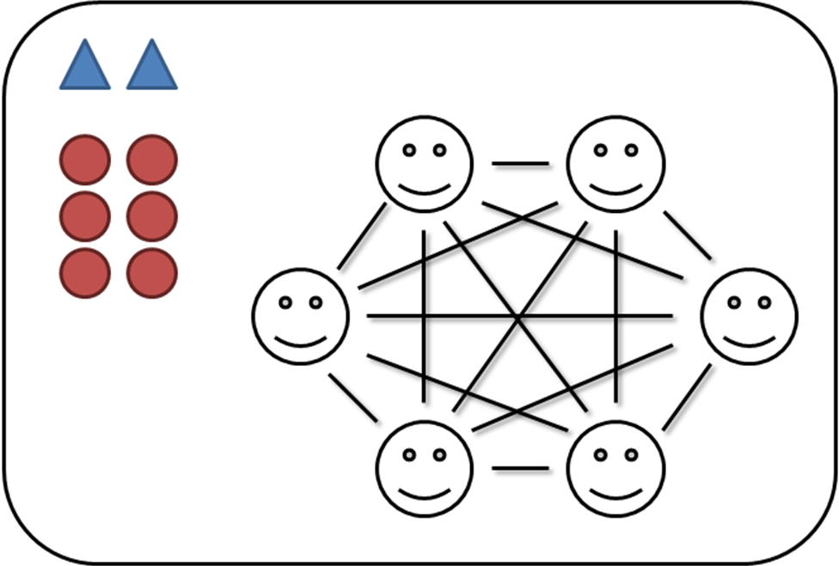
On the individual agent level, the communication mechanisms are left to the HOTCO default (assuming you are using HOTCO agents) which means that at every iteration, the agent will select another agent at random to communicate with, abstracting away any potentially complicated communication structures. Often, all of the agents may have exactly the same, or at least very similar, internal structure, so copying and pasting agents can save a lot of time. Additionally, an external events agent can be used to simulate events that change the entire environment, for every agent.

Ideal uses for this model may include...
- stock market booms and busts,
- crowd dynamics and mob mentality, and
- and any problem where there are many agents, but how the agents interact with each other is so complicated, it might as well be random.

The Diplomacy Model

The Diplomacy model is based on the notion of groups using representatives to ease communication with each other, or to make decisions on their behalf. The first step is to create a general “world group,” allowing everyone in the simulation to access necessary propositions such as the potential outcomes of the diplomacy. These are likely to all be either action nodes (in fact, in a pure Diplomacy model, all actions go here) or evidence nodes. In each group, you may add evidence and goal neurons to represent propositions known implicitly to that group but not the others. Examples of these would be sacred values. In the Diplomacy model, groups form a sort of flower pattern, with a core group with all the representatives, and attached groups, like petals, for the represented populations. Overall, the Diplomacy model may look like this:

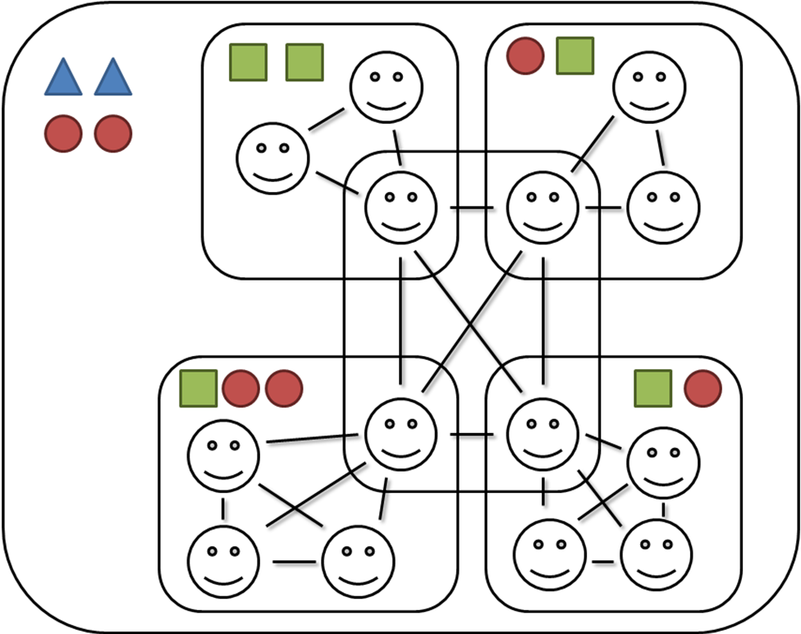
Each represented group looks a little bit like a Free-For-All model! This is intended, since the Diplomacy model abstracts away the complicated patterns of how all the members in a society communicate, and instead focuses on the diplomats communicating in the middle group. Now this model does make the assumption that there is no non-diplomat agent that is a member of two (or more!) groups. You have the ability to change this if you do so choose by making some of the represented groups overlap and putting those agents in the overlapping place.

Ideal uses for this model may include...
- international negotiation and diplomacy,
- democratic action with defined constituencies,
- and any problem where there are relatively few agents communicating with each other on behalf of a larger group of agents.

The Corporation Model

Another useful model is the Corporation model. Just as the Diplomacy model built on the Free-For-All model, the Corporation Model builds on the Diplomacy model! It does this by creating layers of Diplomacy models in a tree-like fashion, where each group of diplomats is considered a represented group for another group of diplomats. This creates a hierarchical structure where there is a top-most level of diplomats (think of a group composed of the CEO, CFO, etc... of an actual corporation) and each diplomat has a subgroup that they communicate with. This interleaving of Diplomat models allows for hierarchal organizations to be modelled. The Corporation model may look like this:

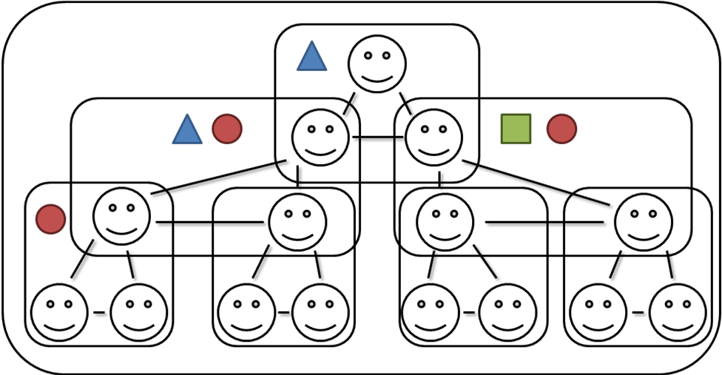

Ideal uses for this model may include...
- decision making in corporations,
- group dynamics within a bureaucracy,
- and any problem where there is a defined hierarchy where each level in the hierarchy only communicates with the ones above and below.

Glossary of Terms

Actions | A proposition that expresses a preference for an action such as “Watch a horror film.”
Agent | An individual, autonomous component of an agent based model, which performs basic processing as well as sending and receiving communication.
Agent Based Model | A computational model describing a system composed of multiple autonomous and simple subsystems (called agents) through
Altruism | A form of emotional transfer where the goal node emotion vectors are communicated as well as non-emotional information
Artificial Neural Network | A computational model where a series of neurons, or nodes, pass a small vector of information to nodes adjacent to them through a series of weighted synapses, or links.
Cold Thought | Cognition with no emotional component
Communication Rule | A model used to simplify determining who an agent is supposed to communicate with at what time by always communicating with a specific other agent or group when a predetermined set of HOTCO nodes are all highly positive activated.
Contagion | A form of emotional transfer where the action node emotion vectors are communicated as well as non-emotional information
Emotion Vector | A numeric vector that expresses the emotion associated with an individual node, or an individual agent
Emotional Intensity | A component of the emotion vector that expresses the strength or level of arousal associated with an emotion
Emotional Transfer | The communication of emotion through messages similar to the communication of non-emotional information such as Evidence, Action or Goals
Emotional Valence | A component of the emotion vector that expresses the level of pleasantness associated with an emotion
Empathy | A form of emotional transfer where the evidence node emotion vectors are communicated as well as non-emotional information
Evidence | A proposition that expresses a proposition of evidence or opinion, such as “Romantic comedies are not thrilling.”
Excitatory Synapse / Excitatory Link | A synapse or link in an artificial neural network that increases the activation of the adjacent nodes, often towards a fixed point or maximum
Goal | A proposition that expresses a goal to be achieved through actions or acceptance of evidence such as “Feel excited.”
Group | A collection of agents and propositions in a LIMBS model. Groups are used to organize communication, and the sharing and co-ordination of propositions across multiple agents.
Hot Thought | Cognition with an affect, or emotional, component
HOTCO | Acronym for “hot coherence.” A psychologically plausible, artificial neural network model of human cognition reliant on coherence between multiple competing propositions, each holding a truth value and emotional vector
Inhibitory Synapse / Inhibitory Link | A synapse or link in an artificial neural network that decreases the activation of the adjacent nodes, often towards a fixed point or minimum
Multi-Brain System | An agent based model where agents are all considered psychologically plausible
Node | A unit in an artificial neural network, specifically a HOTCO model in this case, which has an activation and an emotion vector
Psychological Plausibility | Explainable through and coherent with the current body of psychological knowledge
Proposition | The basic unit of communication and decision making from a system-wide level. Propositions are grouped into Evidence, Actions and Goals.

References

Findlay, S; Thagard, P. “Emotional Change in International Negotiation: Analyzing the Camp David Accords Using Cognitive Affective Maps.”

Sahdra, B; Thagard, P. “Self-Deception and Emotional Coherence”. Mind and Machines. Vol 13. 2003.

Thagard, P. Coherence in Thought and Action. Cambrige, MA: MIT Press, 2000.

Thagard, P. “Explaining Economic Crises: Are There Collective Representations?”. Episteme, the Journal of Social Epistemology. Vol 7, Iss 3. October, 2010.

Thagard, P. Hot Thought: Mechanisms and Applications of Emotional Cognition. Cambridge, MA: MIT Press. 2006.

