N | QUESTION | ANSWER
1 | With a population of nearly 15,000, what pearling and tourist town is the largest settlement in the Kimberley region of WA | Broome
2 | Pebble Beach in California is most famous as a venue for what sport | Golf
3 | What is the name of Hagrid's dog in the Harry Potter series | Fang
4 | Who had the 1975 hit song, The Newcastle Song – Ted Mulray, Ross, Ryan, Bob Hudson or Slim Dusty | Bob Hudson
5 | What is the capital city of Portugal | Lisbon
6 | What Rod Stewart hit song shares its name with an Olympic sport | Sailing
7 | Microsoft was founded by Paul Allen and which world-famous tech billionaire | Bill Gates (1975)
8 | What is the term for a person from Peru | Peruvian
9 | Who created the literary character Ebenezer Scrooge | Charles Dickens (1834 novel A Christmas Carol)
10 | In 1999, who had a hit with the song, Absolutely Everybody – Vanessa Amorosi, Christine Aguilera, Mariah Carey or Kylie Minogue | Vanessa Amorosi

N | QUESTION | ANSWER
1 | Which country was ruled in the 1970s and 1980s by dictator Ferdinand Marcos | Philippines
2 | The Whitsundays are made up of how many islands - 54, 64 or 74 | 74
3 | Which actress co-starred with Leonardo DiCaprio in the 1997 movie ‘Titanic’ | Kate Winslet
4 | What colour is the horizontal stripe at the top of the flag of the United Arab Emirates – black, white, green or blue | Green
5 | Which is closer to Uluru, Adelaide or Darwin | Adelaide 1602 kms (Darwin 1963kms)
6 | Caroline Chisholm appeared on What Australian Banknote | $5 note
7 | Which famous literary character is most closely associated with the address 17 Cherry Tree Lane - Mary Poppins, Eliza Doolittle, Dr Dolittle or Charlie Bucket | Mary Poppins
8 | ‘Don't leave home without it’ is a slogan for what credit card | American Express
9 | Which Shakespearean character has the most lines with 1422 | Hamlet
10 | What is the symbol of the chemical element thorium – Ka, T, Th or Na | Th

N | QUESTION | ANSWER
1 | What are the only three U.S. states with four letter names | Iowa Ohio Utah
2 | Astronauts Neil Armstrong and Buzz Aldrin were veterans of which war | Korean War (NA Navy Fighter Pilot, BA Air Force Pilot)
3 | What sport do the New York Knicks play | Basketball
4 | Which monarch of Scotland riding during the 14th century was known as Robert the Bruce - Robert I, Robert II, Robert III or none of these | Robert I
5 | Which two months of the year named after Roman the leaders | July and August (Julius Ceaser & Augustus)
6 | The volcano Mount Etna is located on what island | Sicily
7 | What is the average number of dimples on a golf ball – 136, 236, 336 or 446 | 336
8 | Vitamin B2 is also known by what name beginning with R | Riboflavin
9 | What type of online service does the Canadian subsidiary Plenty of Fish provide | Online dating
10 | South Pacific is a musical composed by which two people - Rodgers & Hammerstein, Gilbert & Sullivan, Lerner & Loewe or Ira & Geroge Gershwin | Rodgers and Hammerstein

N | QUESTION | ANSWER
1 | Saint Stephen's day is celebrated on the same day which other public holiday | Boxing Day
2 | Who's ‘choice’ won the 2024 Melbourne Cup | Knights Choice
3 | Which Shakespearean play features the line ‘A plague o’both your houses’ | Romeo and Juliet (express irritation or irony about a conflict between two parties)
4 | What was sold and dispensed in the first modern vending machine circa 1880 - Soft drink cans, Chocolates, Newspapers or Postcards | Postcards
5 | The biscuit, known as shortbread originate in which country | Scotland (12th century)
6 | Did Rwanda gain its independence from - Belgium, France, United Kingdom or Spain | Belgium (July 1962)
7 | Complete the band name: Pearl Harbour and the …….. what | Explosions
8 | What comic book did Black Panther debut in | Fantastic Four #52 (1966)
9 | Who designed the internal structure of the Statue of Liberty | (Alexander Gustav) Eiffel
10 | Which Gulf lies between Yemen and Somalia - Gulf of Riga, Persian Gulf, Gulf of Oman or Gulf of Aden | Gulf of Aden
N | QUESTION | ANSWER
1 | Name three of the four countries that begin with the letter B | Belgium, Belarus, Bosnia Herzegovina and Bulgaria
2 | What is the largest island entirely in Indonesia | Sumatra
3 | The former French penal colony of Devils Island is situated off the coast of which continent | South America (French Guiana)
4 | Lake Constance is situated in Germany, Austria and which other country – Luxembourg, Switzerland, Italy or France | Switzerland
5 | The delivery service platform Menulog was found in which city | Sydney
6 | Who wrote the Pulitzer Prize winning book Angela's Ashes (1996) | Frank McCourt
7 | What was the name of the rock'n'roll pioneer known as ‘The Killer’ | Jerry Lee Lewis
8 | What insect is printed on the theatrical release poster of The Silence of the Lambs | Moth
9 | During which war did the ‘Charge of the Light Brigade’ take place | Crimean War (British light cavalry against Russian forces during the Battle of Balaclava 1854)
10 | In December 2024, which country announced that it would phase out greyhound racing by 2026 - Australia, New Zealand, United Kingdom or Ireland | NZ

PROGRESSIVE – WHO AM I
6 POINTS
An American actor I was born in Somerville New Jersey in 1925, I died in 1989, age 64.

5 POINTS
At age 17, I obtained my high school diploma early in my senior year in order to enlist in the United States Navy in 1942.
After basic training in the naval fleet sound school, I was assigned to a submarine chaser, then a minesweeper, USS Incredible.
I worked as a Sonarman, served in the Caribbean and later the Mediterranean.
The USS Incredible then moved to the Black Sea, performing sweeping duties out of the Soviet base in Crimea.
By the time I was discharged in 1946, I had reached the rank of Sonarman, First Class. I was awarded the Bronze Star and the Good Conduct Medal.

4 POINTS
After the Navy I read a part in ‘Our Town’ in The Little Theatre group in New Jersey. I did other stage acts and impressed talent scouts with my stage presence and delivery.
My sinister features overlook my acting skills. It typecast me as a minor villain for almost a decade.
My screen debut came in Stanley Crimeans classic ‘High Noon’. I played the part of a silent gunslinger Jack Colby.
3 POINTS
I achieve stardom in spaghetti westerns such as ‘The Good, The Bad and the Ugly’, cast as the primary villain, Angel Eyes.
I was in For a Few Dollars More before appearing in films like Death Rides a Horse 1969, Saboteur 1969, and Kid Vengeance 1977.

2 POINTS
I was married three times. I have four children.
I died of a heart attack at home in California in 1989.
The inscription on my gravestone is ‘Best of the Bad’
My initials are LVC, I am LEE – LEE VAN CLEEF

WHO AM I
I'm a female Australian model actress and musician.
I was born in Melbourne in 1987. My mother Kerry is a psychologist. My father, Kim, played AFL for Richmond and Hawthorn,
In 2004, I won Australia's Girlfriend Model Search.
My rebellious side had me expelled from high school at the start of my final year.
Following several years of successful leading up to 2011 fashion season, V Magazine dubbed me a supermodel and Models.com an industry icon.
In 2012 I spent most of the year acting in ‘Mad Max Fury Road’,
I dropped using my surname Kershaw in 2015 and use my Christian names.
My initials are AL, I am ABBEY LEE

ADDITIONAL QUESTIONS
World Travel

Q The fermented meat of which fish is the national dish of Iceland
A Shark

Q What is unusual about the Manx cat, that originating on the Isle of Man
A No tails

Current

Q At what rate will the USA impose tariffs on world steel and aluminium, including Australia’s this week
A 25%

Q During what years was Malcolm Turnbull prime minister of Australia
A 2015-2018

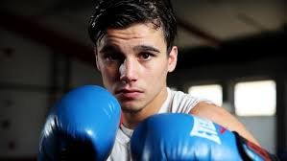
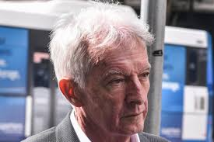
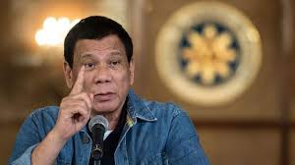
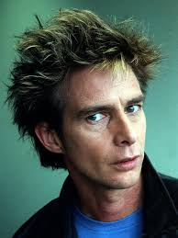

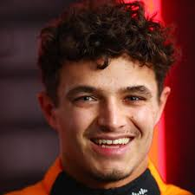
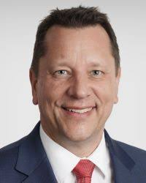

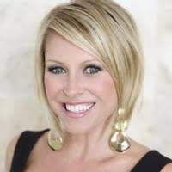
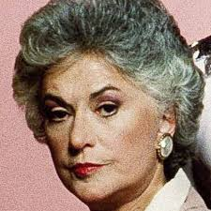
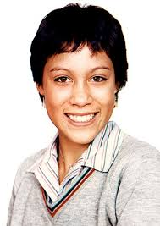
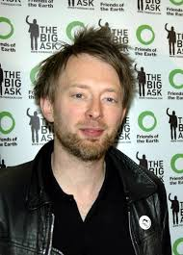

Australian actor from wacky films Young Einstein, Reckless Kelly and Mr Accident - Yahoo Serious
Former President of the Philippines (2016-22), facing crimes against humanity in the International Criminal Court for people killed during his crusade against drugs - Rodrigo Duterte
Sydney lawyer often seen around high-profile legal cases, re Alan Jones - Christopher Murphy
Australian boxer from ‘The Shire’ taking on American superstar Keith Thurman next week - Brock Jarvis
Prominent NSW State Planning Minister - Paul Scully
English Lead singer and main songwriter for rock band ‘Radiohead’ (Creep, Paranoid Android, Pyramid Song) - Thom Yorke
Teenage pic of Australian entertainer - Kate Ceberano
Late American actress and comedienne, one of the leading ladies in the sitcom The Golden Girls (1985-92) - Bea Arthur
Australian infomercial queen, now delving into a raunchier presentation on a subscription website - Roz Switzer
No1 driver at McLaren in front of Australian Oscar Piastri, in the Australian GP this Sunday - Lando Norris

