**Pac-Droid An Android clone of the classic Pac-Man game**

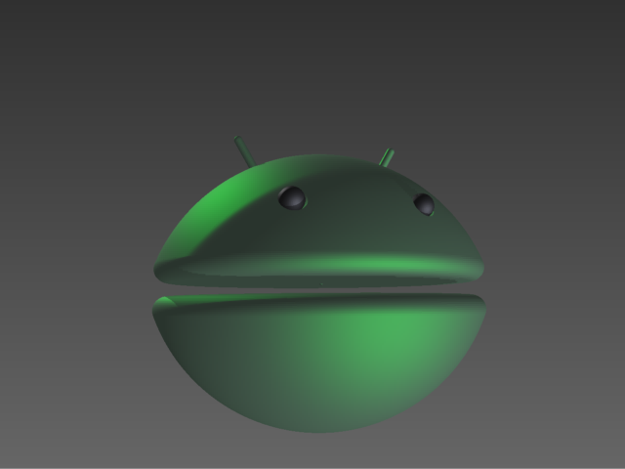

**Team Name:** StationSight

**Developers:** Elliot Gottfried, Tony Benson, Kevin Perkins

**Date:** January 23, 2013

**Proposal:** Our team intends to develop an Android clone of the classic Pac-Man video game.

**Description:** In this game, the player navigates Pac-Droid through a maze consuming pellets evenly distributed along the pathways of the maze until all pellets are consumed. The player must evade four enemy characters that will chase Pac-Droid. If the enemies come into contact with Pac-Droid then the player loses one of three initial lives and if all lives are lost the game is terminated. There is a distinguished pellet found in each corner of the maze that when consumed by Pac-Droid causes the enemies to flee and will allow the player to consume the enemies, increasing the player's score, for a limited period of time. If an enemy is consumed, the enemy will be relocated to its starting point in the center of the maze and will resume chasing Pac-Droid. Upon consuming all pellets of the maze, the player is promoted to the next level. Each level is progressively more difficult to advance through. This is accomplished by incrementally increasing the speed of both Pac-Droid's and the enemies' movement and decreasing the time span for which the enemies will flee and are vulnerable to consumption. If, when all Pac-Droid lives have been expended, the score is within range of the ten best scores the player will be prompted to enter their identity which will be displayed along with their score in a list of ten top scores. The game will be accentuated by various sounds, triggered by specific actions or events.

**Implementation:**

* The game will be developed for Android mobile devices.
* A device's touch screen will be utilized for tactile input and visual output.
* The game will be developed in Java, because it is the standard language for developing apps on the Android platform.
* Top scores may be stored locally on the device running the game. Ideally, they will be stored remotely on a web server, allowing players to gauge their skill against a larger pool of players.
* The game will feature modified graphics and characters.
* The game will include inter-level animations serving to make the game more interesting to users.
* Official and generic implementations of Pac-Man have all received several complaints concerning the poor response of player movement control, the touch screen joystick. We intend to correct this failing found in other games, to set our implementation apart and attract more users.

**Deliverables:**

First Deliverable:

* Duration: four weeks
* Requirements
* Specification
* Design
* Start implementing the games framework

Second Deliverable:

* Duration: four weeks
* Essential game play should be implemented and running on an Android device

Final Deliverable:

* Duration: six weeks
* Create quality graphics to replace temporary artwork place holders
* Create animations and interface artwork
* Create and implement sound effects
* Implement top score update and retrieval