PX-MAKE

Purpose

The purpose of PX-MAKE is to produce a file in the PX-fileformat for use with PC-AXIS, PX-MINI and PX-KONV on the basis of a table of data.

A PX-file consists of both data and a description of data called metadata. The description is made up of a number of keywords, some of which are compulsory. It is all done in plain ascii and can therefore be edited in a texteditor like Word.

When you start PX-MAKE you can

Files menu:

Create

Open a PX-file

Exit

View -Menu:

Search for Databases

Language

Help-Menu

About

Help

You get context sensitive on-line help in the StatusBar

### First time

Search for Databases

The first time you use PX-MAKE you need to let PX-MAKE know where databases can be found. For that purpose, you choose View, Search for Databases

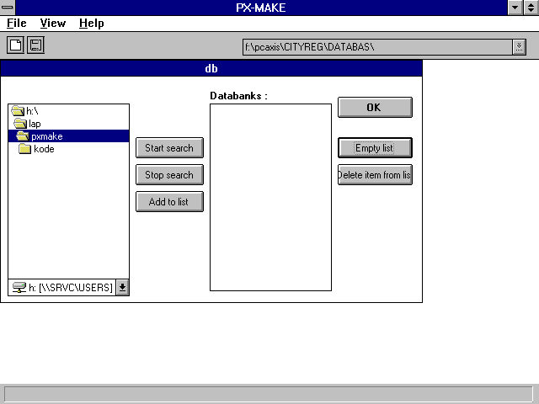

Next you can start the search for databases. Remember that the closer to a database you let the search begin the faster you.

In the next screen dump the search starts at the root of the nordic cd-rom.

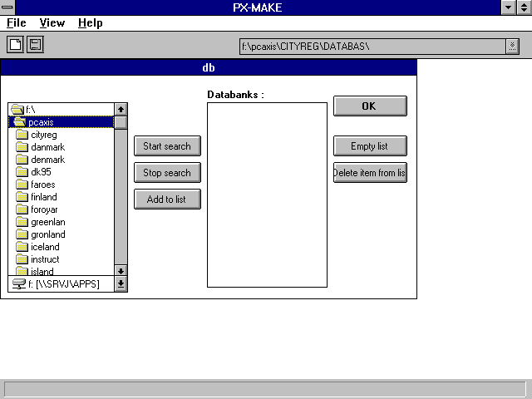

When you choose ‘OK’ information on the databases are stored in the PCAXIS.INI file.

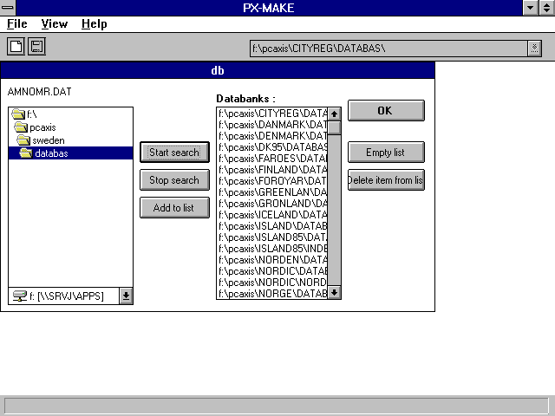

And now you can select a database from the toolbar.

### Create

In windows 3.1 you see two stars - one yellow (tabledata) and one red (Meta)

Metastar

In the red ‘metastar’ you set the px-keywords by chosing or adding information.

You add information about the following key-words after maximizing the metastar:

Subject-area, Subject-code, Matrix, Contents, Units, Decimals, Stub, Heading

Example 1

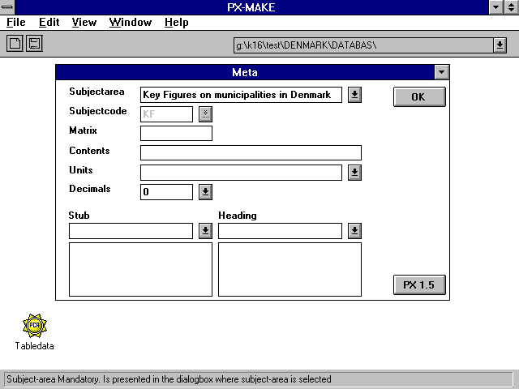

Names for variables in the file are either selected or written in the textbox for stub or heading followed by pressing [ENTER].

METHOD New information : Write the new text and press [ENTER]

After selecting [OK] a new container - symbolised with a red star - is created for each variable in the stub or heading listbox. *This action is irreversible in a session*. And the metastar has turned green.

Datastar

The yellow star (Tabledata) is a container for your table. From the file menu you can import your Excel or tabbed text files or you can paste your table from the edit menu. And you can also type the table directly into the grid.

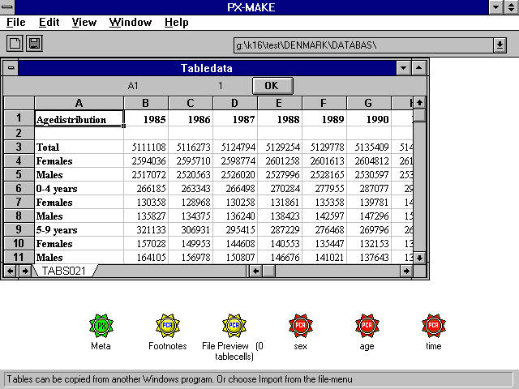

Next you need to descibe the values for each variable. So maximize every variable one at a time. First ‘Time’:

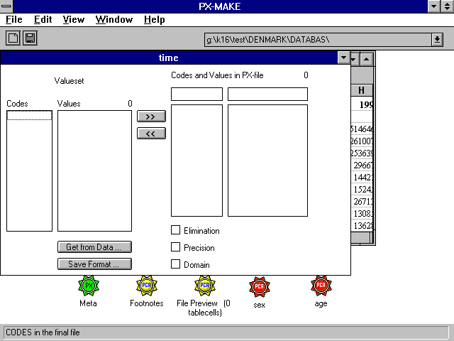

and click ‘Get from data’, which takes you to the tabledatasheet. In the tablesheet you select the the area in which you have texts that are reuseable as texts for the values. Next you select [OK]. This returns you to the definition of ‘time’ - only now you have a valueset.

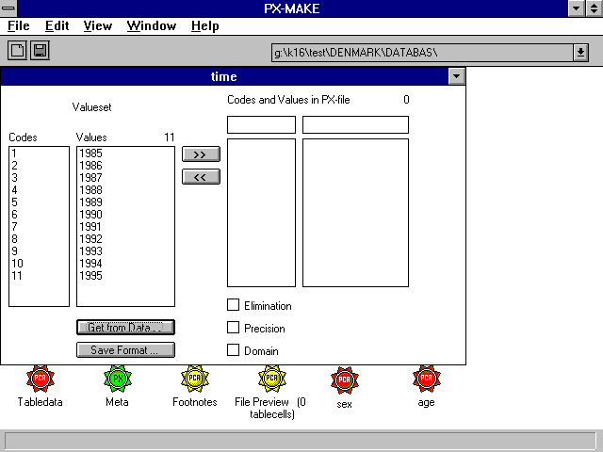

By clicking the values or the ‘>>‘ button you select the values that you want included in you PX-file.

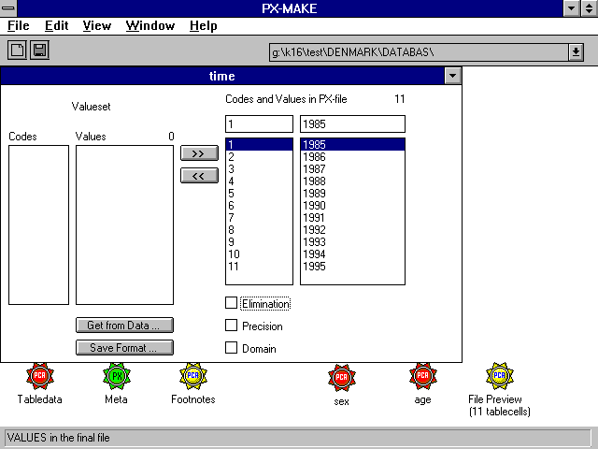

Here you can also set Variablespecific keywords like ‘ELIMINATION’, ‘PRECISION’ and ‘DOMAIN’.

When you have selected values for a variable and minimize the window the star has changes colour to green.

File preview

All through the process you can see how far you have come in defining the PX-file. In file preview you have an instant image of your work so far.

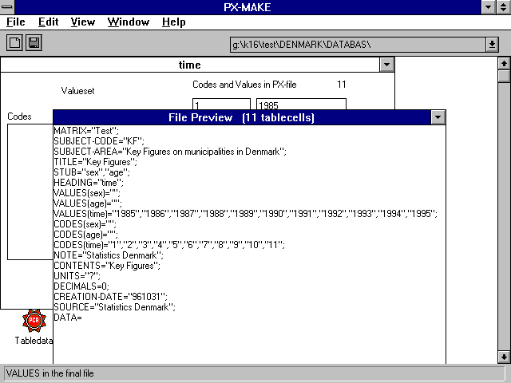

Tabledata - the datastar

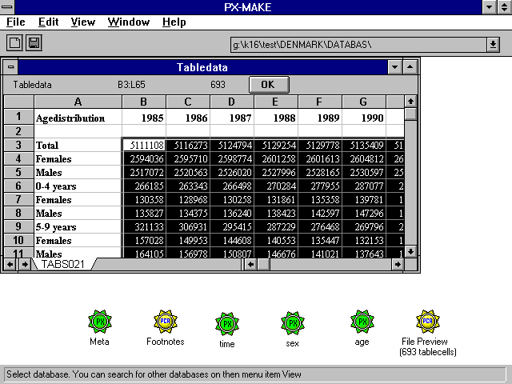

At last you select the area which holds your data. The selection can only be one area with no blanks. And select [OK].

You now only have Green or Yellow stars. And you can use the file preview to see if all is well.

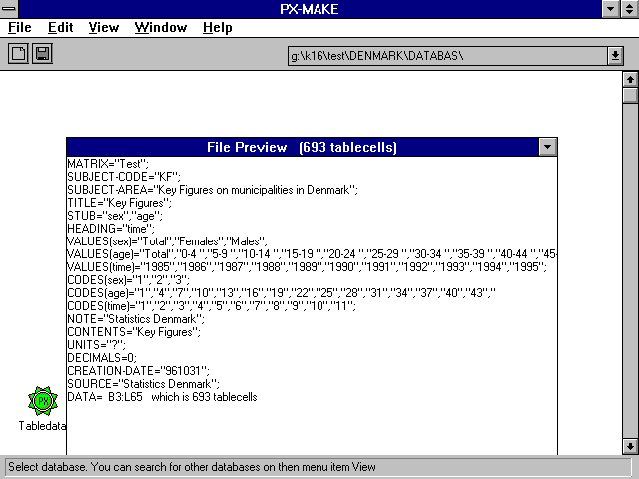

And finally use ‘Save as’ to save your work.

REMEMBER to import the PX file into PC-AXIS.

### Open a PX file - not ready

