New Zealand Health Survey

Annual update of key findings 2012/13



Citation: Ministry of Health. 2013. *New Zealand Health Survey: Annual update of key findings 2012/13*. Wellington: Ministry of Health.

Published in December 2013  
by the Ministry of Health  
PO Box 5013, Wellington 6145, New Zealand

ISBN: 978-0-478-41572-8 (online)  
HP 5774

This document is available at www.health.govt.nz



# Foreword

I am pleased to present the latest findings from the New Zealand Health Survey. This report provides information on the health of both adults and children from June 2012 to July 2013, together with historic trend data.

The New Zealand Health Survey became a continuous survey in 2011, enabling the publication of annual updates on the health of New Zealanders. This report provides an update to the 2011/12 New Zealand Health Survey publications: *The Health of New Zealand Adults 2011/12* and *The Health of New Zealand Children 2011/12*.

Having up-to-date information on the key health issues facing New Zealanders enables us to effectively monitor trends and identify changing patterns of disease. These findings will help us ensure health services in New Zealand are able to meet the current needs of our population and are better prepared to meet the challenges of the future.

For the first time, a number of indicators collected by the New Zealand Health Survey have been designated as key official statistics. These statistics, known as Tier 1 statistics, include smoking, obesity, self-rated health and mental health status (psychological distress). This report has therefore been produced, analysed and released according to the high statistical standards expected of producers of Tier 1 statistics.

The continuous nature of the survey enables us to combine multiple years of data allowing more detailed analysis at smaller population levels. In early 2014 we will be publishing District Health Board survey results for all 20 DHBs in New Zealand. This information will help us identify differing patterns of health across New Zealand and will help support local health service planning.

I would like to thank the many people who have been involved in the survey. I would also like to extend a special thank you to the many thousand New Zealanders who gave their time to take part in the survey. The information they have provided is critical in developing and monitoring health policy and services in New Zealand.

I hope you find this report of interest.

Chai Chuah

Acting Director-General of Health

Ministry of Health

# Authors

This report was written by Hilary Sharpe, with support from Robert Templeton, Michelle Liu, Maria Turley, Jackie Fawcett, Marie Ditchburn and Denise Hutana. All of the above are employed by Health and Disability Intelligence, Ministry of Health.

Input into the report was also provided by Deepa Weerasekera, Matt Cronin, Allison Chiu, Roimata Timutimu, Natalie Talamaivao, Jennie Darby, Kylie Mason and Kathryn Baldwin.

# Acknowledgements

The New Zealand Health Survey would not have been possible without the support and enthusiasm of many individuals. The following people have been instrumental to the success of the survey: Anne McNicholas, Niki Stefanogiannis, CBG Health Research Ltd, Robert Clark (University of Wollongong, Australia) and the members of the Ministry of Health Survey Governance Group.

Thank you also to the many thousands of New Zealanders who gave their time to participate in the New Zealand Health Survey. This report would not have been possible without your generosity.

Contents

Foreword iii

Authors iv

Acknowledgements iv

Executive summary vii

Introduction 1

Overview 1

Methodology 2

How are the results reported? 4

The health of New Zealand adults 5

Health status, health behaviours and risk factors 7

Health conditions 14

Access to health care 24

Oral health 33

The health of New Zealand children 38

Health status, health behaviours and risk factors 39

Health conditions 44

Access to health care 46

Oral health 55

Appendices

Appendix 1: NZ Health Survey key indicators 59

Appendix 2: Definitions and statistical methods 60

List of Tables

Table 1: Sample sizes for children and adults, by ethnic group, NZHS 2012/13 2

Table 2: Key survey results for adults (15 years and over) 6

Table 3: Key survey results for Māori adults 36

Table 4: Key survey results for Pacific adults 37

Table 5: Key survey results for children (aged 0–14 years) 38

Table 6: Key survey results for Māori children 57

Table 7: Key survey results for Pacific children 58

# Executive summary

Following is a summary of the key findings of the 2012/13 New Zealand Health Survey, including notable trends and differences between population groups.

* **Most New Zealanders report being in good health:** nine out of ten adults (90%) continue to rate their health as good, very good or excellent. Nearly all parents (98%) consider their children to be in good health.
* **Smoking rates continue to decline, but high rates persist for some groups:** the daily smoking rate in adults has dropped to 15.5%, down from 16.4% in 2011/12 and 18.3% in 2006/07. Although smoking rates have declined in most population groups, they remain much higher in others. Māori adults continue to have the highest smoking rates, with over a third (36%) of adults smoking daily in 2012/13. Smoking rates are also significantly higher in deprived areas: 28% of adults living in the most deprived areas are daily smokers, compared with 9% of adults living in the least deprived areas.
* **Some risk behaviours are improving in young people:** the low rate of youth smoking seen in 2011/12 has continued, with only 7% of 15–17-year-olds smoking daily in 2012/13. One in five (20%) young people aged 18–24 years smoked daily in 2012/13, down from one in four (24%) in 2011/12. Although hazardous drinking rates were highest in young people aged 15–24 years (25%), this is an improvement since 2006/07, when 35% were hazardous drinkers.
* **Hazardous drinking levels in adults are similar to last year**: one in six adults (15%) has a hazardous drinking pattern, a similar level to 2011/12. Hazardous drinking is much more common in men (22%) than in women (9%).
* **The childhood obesity rate is similar to last year, but there has been an increase in adult obesity:** three out of ten adults (31%) are now obese, up from 29% in 2011/12. One in nine (11%) children aged 2–14 years are obese, a similar level to 2011/12. This means that 1.2 million New Zealanders are obese. Obesity rates are significantly higher among New Zealanders living in socioeconomically deprived areas. In particular, children living in the most deprived areas are three times as likely to be obese as children living in the least deprived areas. This finding is not explained by differences in the sex, age or ethnic composition of the child population across areas of high and low deprivation.
* **Women and older adults are more likely to meet the recommendations for vegetable and fruit intake:** two out of three (66%) adults reported eating the recommended three or more servings of vegetables each day and 58% ate the recommended two or more servings of fruit each day – similar levels to previous surveys. Women and older adults are more likely to meet recommendations for vegetable and fruit intake.
* **Fewer young children are watching two or more hours of television each day:** just over half (52%) of children aged 2–14 years watch two or more hours of television each day. There was a significant decline in television watching among young children aged 2–4 years over the last year, from 53% to 43%.
* **Long-term health conditions are common in older adults:** the prevalence of most health conditions increases with age. For adults aged 75 years and over, common long-term conditions include medicated high blood pressure (53%), arthritis (51%), chronic pain (34%), medicated high cholesterol (33%), ischaemic heart disease (22%), diabetes (15%) and stroke (10%). Despite these conditions, over 80% of older adults reported that their health was good, very good or excellent.
* **Mental health varies across ethnic groups:** Māori and Pacific adults continue to have higher rates of psychological distress than other adults, with about one in ten affected. However, Māori and non-Māori have similar rates of being diagnosed with depressive and anxiety disorders during their lifetime, while the rate of diagnosed mental disorders among Pacific adults is one third that for other adults.
* **Boys are more likely than girls to be diagnosed with emotional and behavioural problems:** 4% of children have been diagnosed with emotional and behavioural problems, up from around 2% in 2006/07. Boys are almost twice as likely as girls to have been diagnosed with emotional and behavioural problems.
* **Over three million New Zealanders visited a GP in the past year:** most adults (79%) and children (75%) visited a GP in the past 12 months, similar rates to previous surveys. Young children and older adults are more likely to have visited a GP in the past year. The use of GPs shows little variation by ethnic group or neighbourhood deprivation.
* **Four out of five New Zealanders have confidence and trust in their GP:** in adults that had visited their GP in the last three months, most (81%) had confidence and trust in their GP. Results were similar for children, with 82% of parents having confidence and trust in the GP who saw their child in the last three months. Māori adults and the parents of Māori children are less likely than other people to have confidence and trust in their GP.
* **Unmet need for primary health care is more common in deprived areas:** one in four adults (27%) and one in five children (21%) reported one or more types of unmet need for primary health care in the past year. Unmet need takes various forms, including cost, being unable to get an appointment at their usual medical centre within 24 hours, and not going to a GP and/or after-hours services when they have a medical problem due to cost or a lack of transport.

Neighbourhood deprivation is strongly related to unmet need for primary health care, across all measures. About 35% of adults living in the most deprived areas had experienced one or more types of unmet need in the past year, compared with 23% in the least deprived areas.

* **There are low rates of unmet need due to cost among children aged less than six years:** only 2% of children aged less than six years experienced unmet need for a GP due to cost, similar levels to 2011/12. Cost was more likely to be a barrier to older children visiting a GP.
* **Fewer adults and children are missing out on prescriptions due to cost:** 6% of adults and 4% of children were unable to collect a prescription in the last year due to cost. For both adults and children this was a significant improvement compared with 2011/12.
* **Children are more likely than adults to visit dental health care workers:** four out of five (81%) children visited a dental health care worker in the past year, with little variation by ethnicity or deprivation. In contrast, only half (47%) of adults with natural teeth visited a dental health care worker in the past year, a similar rate to 2011/12.

About 30,000 children (3.6%) had a tooth removed in the last year due to decay, abscess or infection, with higher rates of tooth removal in Māori and Pacific children. One in fifteen (7%) adults had a tooth removed in the last year due to decay, abscess, infection or gum disease. Māori (8%) and Pacific (11%) adults were more likely have had a tooth removed than other adults.

* **Māori have poorer health and more unmet need for health care:** Māori adults have higher rates of most health conditions, with differences most notable for asthma, ischaemic heart disease, stroke and diabetes. Māori adults are also less likely than non-Māori adults to rate their health as good, very good or excellent.

Part of the reason for differences in health status may be barriers to accessing health care. Māori adults and children are more likely than non-Māori to report one or more types of unmet need for health care, including being unable to get an appointment at a medical centre within 24 hours; not visiting a GP or after-hours services when they have a medical problem due to cost or a lack of transport; and not being able to fill a prescription due to cost. Improving access to health care, and ensuring services are appropriate and responsive to Māori, will help improve health outcomes for Māori in the future.

* **Obesity and diabetes are major challenges for Pacific adults:** Pacific adults have comparatively high rates of obesity (68%) and diagnosed diabetes (13%). Pacific children also have high levels of obesity (27%), which is likely to increase their risk of developing diabetes as adults.

Pacific adults and children report relatively high levels of unmet need for primary health care. Cost is a key barrier to accessing GP services, after-hours services and filling prescriptions for Pacific adults and children.

* **Asian health is generally good, but diabetes is a concern:** overall, Asian adults are in good health. In particular, Asian adults have comparatively low levels of smoking, asthma, arthritis and chronic pain. However, Asian adults have relatively high levels of diagnosed diabetes (7%).

Asian adults generally report lower use of primary health services than other adults, possibly due to their better health status. They are also less likely to report unmet need for health care.

* **People living in more deprived areas have poorer health and report greater unmet need for health care:** adults living in the most socioeconomically deprived areas have significantly higher levels of all health risks, including smoking, hazardous drinking, inadequate vegetable and fruit intake, low physical activity and obesity. They also have higher levels of most health conditions, with rates of psychological distress and diabetes particularly high compared with adults living in the least deprived areas.

Children living in socioeconomically deprived areas also have higher levels of most health risks. For example, they are significantly less likely to eat breakfast at home every day, more likely to watch two or more hours of television each day, and more likely to be obese. These higher rates are not explained by differences in the ethnic, age or sex composition of the population.

Although adults and children living in the most deprived areas reported similar use of GPs over the last year, they had much higher levels of unmet need for health care, with cost being the main barrier. Of note, children living in the most deprived areas were seven times as likely as children living in the least deprived areas to have an unfilled prescription due to cost in the past year. These types of unmet need for health care are of particular concern where they affect people that already have poorer health.

# Introduction

## Overview

The New Zealand Health Survey (‘the survey’) involves conducting face-to-face interviews with more than 13,000 adults and the parents/caregivers of over 4000 children annually. The survey collects a wealth of information on the health and wellbeing of New Zealanders. Every year it includes a core set of questions, which help us to identify key issues and monitor trends.

Here we present the annual update of key findings from the 2012/13 New Zealand Health Survey. The report includes data for key survey indicators, which provide a snapshot of health behaviours, health status and access to health care for both adults and children. These key indicators help highlight at-risk groups and focus attention on important issues, as well as identifying areas for further research.

Data from the 2012/13 New Zealand Health Survey will be made available in a range of formats to suit the needs of different users, including:

* an annual update of key findings (this report)
* adult and child web-tables – detailed national results broken down by age, sex, ethnic group and deprivation (previous survey results are also provided for comparison)
* district health board (DHB) web-tables –adult and child results for each of the 20 DHBs in New Zealand (we have provided pooled data from the 2011/12 and 2012/13 surveys, together with modelled data based on national results)
* a new interactive mapping tool presenting key adult and child data for DHBs and public health units.

The 2012/13 New Zealand Health Survey publications are intended to answer three questions.

**1 What is the overall rate in the total population?**

* The 2012/13 rates (and the estimated number of adults/children) are presented for the key survey indicators.

**2 What is changing?**

* Where available we have presented the 2006/07 and 2011/12 rates for the key survey indicators, allowing comparisons to be made over time. Significant changes are highlighted in the data boxes and in the text.
* More detailed trend data are provided in the web-tables, including analyses by sex, age and ethnicity.

**3 Are the results the same for everyone? In particular, do indicators vary by sex, age, ethnicity, deprivation or geographical area?**

* Key survey indicators for Māori and Pacific people are provided at the end of the adult and child sections of the report.
* Rate ratios comparing male to female, Māori to non-Māori, Pacific to non-Pacific and high deprivation to low deprivation areas are provided for each of the key survey indicators. These rate ratios are adjusted for differences in the age, sex and ethnic structure of the population groups being compared.
* The age distribution of each indicator is summarised in a bar chart. Detailed results by age group are provided in the web-tables.
* Results by DHB will be made available in early 2014. Where there are sufficient survey respondents, these data will be presented by age and sex.

## Methodology

### Sample selection

The 2012/13 results provided in this report refer to the sample selected from 1 July 2012 to 30 June 2013. The survey results refer to the usually resident population of all ages living in permanent dwellings, aged-care facilities and student accommodation. Those not included in the survey were: people living in institutions (such as for long-term hospital care, hospital- and dementia-level care in aged-care facilities, and in prisons), the homeless, short-term visitors and tourists. Participants were randomly selected from throughout New Zealand, with trained surveyors from CBG Health Research Ltd carrying out the survey interviews.

### Sample size

Of those invited to participate in the survey, 80% of adults (13,000 adults) and 85% of parents/care givers (representing 4000 children) agreed to be interviewed. The following table provides a summary of the number of survey respondents by ethnic group. Please note that the data in the table are based on total response ethnicity, and so when summed the total is greater than the total number of respondents. Further information on total response ethnicity is provided in Appendix 2.

Table 1: Sample sizes for children and adults, by ethnic group, NZHS 2012/13

|  |  |  |
| --- | --- | --- |
| **Ethnic group (total response)** | **Adults** | **Children** |
| European/Other | 9650 | 2950 |
| Māori | 2650 | 1600 |
| Pacific | 780 | 630 |
| Asian | 1020 | 450 |

### Interview process

Data collection involved an interview, followed by measurement of height, weight, waist circumference and, in adults, blood pressure.

### Annual indicators from the survey

Appendix 2 provides a table of the annual indicators from the survey for children and adults. The annual indicators are either single survey questions or are derived indicators based on a number of questions. We have provided brief definitions for each indicator presented in this report. More detailed definitions of each indicator, including the wording of the survey questions, will be provided in the *New Zealand Health Survey Indicator Interpretation Guide*.

In addition to those included in this report, a number of supplementary indicators are included in the online web-tables.

### Definitions and statistical methods

Information on the statistical methods used in this report are provided in Appendix 2.

### Additional information

The following publications provide additional information about the NZHS:

* *New Zealand Health Survey Methodology* *Report 2013*
* *New Zealand Health Survey Indicator Interpretation* *Guide*
* *The New Zealand Health Survey Content Guide 2012–2013*.

### Revision of 2011/12 results

The 2011/12 results reported in this report have been revised since the publication of *The Health of New Zealand Children 2011/12* and *The Health of New Zealand Adults 2011/12* reports. The update is minor but reflects the inclusion of additional survey results that were not available at the time of publishing the 2011/12 results. The updated 2011/12 survey results should be used when making comparisons with the 2012/13 results.

## How are the results reported?

Results for each of the survey indicators are summarised in the format shown below.

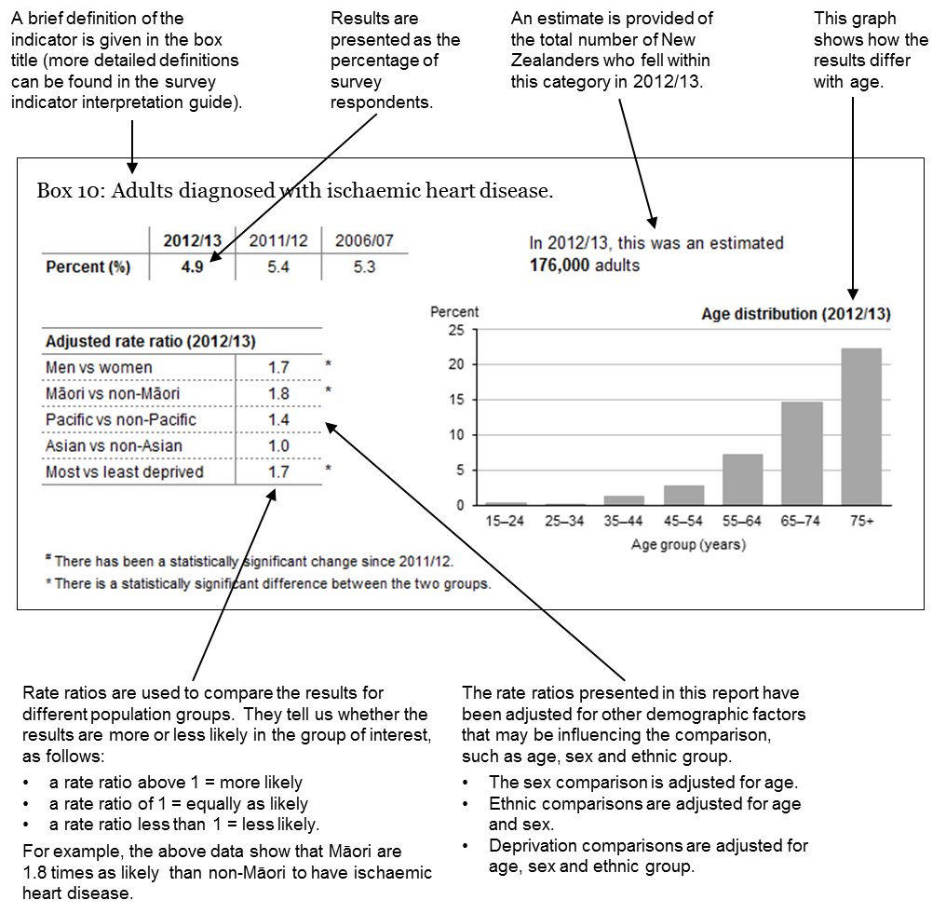

# The health of New Zealand adults

This section includes information on:

* health status, health behaviours and risk factors
* health conditions
* access to health care
* oral health
* key survey results for Māori adults
* key survey results for Pacific adults.

Table 2: Key survey results for adults (15 years and over)

|  |  |  |  |  |  |
| --- | --- | --- | --- | --- | --- |
| **Indicator** | **Percent 2012/13 (%)** | **Percent 2011/12 (%)** | **Percent 2006/07 (%)** | **Change since 2011/121** | **Change since 2006/071** |
| **Health status, health behaviours and risk factors** |  |  |  |  |  |
| Excellent, very good or good self-rated health | 89.6 | 89.3 | 89.6 | = | = |
| Current smoking | 17.6 | 18.4 | 20.1 | = | ▼ |
| Daily smoking | 15.5 | 16.4 | 18.3 | = | ▼ |
| Hazardous drinking | 15.4 | 15.1 | 18.0 | = | ▼ |
| Vegetable intake (3+ servings per day) | 66.3 | 68.2 | 63.9 | = | ▲ |
| Fruit intake (2+ servings per day) | 58.2 | 58.4 | 59.9 | = | ▼ |
| Physically active | 51.7 | 54.4 | 52.1 | = | = |
| Obesity | 31.3 | 28.6 | 26.5 | ▲ | ▲ |
| **Health conditions** |  |  |  |  |  |
| High blood pressure (medicated) | 15.9 | 15.8 | 13.8 | = | = |
| High cholesterol (medicated) | 11.0 | 10.5 | 8.4 | = | ▲ |
| Ischaemic heart disease (diagnosed) | 4.9 | 5.4 | 5.3 | = | ▼ |
| Stroke (diagnosed) | 2.0 | 1.8 | 1.9 | = | = |
| Diagnosed common mental disorder (depression, bipolar disorder and/or anxiety disorder) | 16.3 | 16.2 | 12.7 | = | ▲ |
| Psychological (mental) distress | 6.1 | 4.5 | 6.6 | ▲ | = |
| Diabetes (diagnosed) | 5.8 | 5.5 | 5.1 | = | = |
| Asthma (medicated) | 11.0 | 11.1 | 11.3 | = | = |
| Arthritis (diagnosed) | 15.1 | 15.0 | 14.9 | = | ▲ |
| Chronic pain | 17.7 | 16.1 | 17.0 | = | = |
| **Access to health care** |  |  |  |  |  |
| Visited a GP in the past 12 months | 78.8 | 78.5 | 81.3 | = | ▼ |
| Visited a practice nurse (without seeing a GP at the same visit) in the past 12 months | 30.1 | 30.2 | 28.7 | = | = |
| Visited an after-hours medical centre in the past 12 months | 12.0 | 12.8 | . | = | . |
| Experienced unmet need for primary health care in the past 12 months | 27.1 | 26.6 | . | = | . |
| * Unable to get appointment at usual medical centre within 24 hours1 | 15.6 | 15.4 | 17.6 | = | ▼ |
| * Unmet need for GP services due to cost | 14.5 | 13.8 | . | = | . |
| * Unmet need for after-hours services due to cost | 7.1 | 6.9 | . | = | . |
| * Unfilled prescription due to cost | 6.1 | 7.4 | . | ▼ | . |
| Had confidence and trust in GP | 81.4 | 84.1 | . | ▼ | . |
| **Oral health** |  |  |  |  |  |
| Visited a dental health care worker in the past 12 months2 | 47.5 | 48.6 | 51.5 | = | ▼ |
| Had any teeth removed due to decay, abscess, infection or gum disease in the past 12 months | 6.8 | 7.6 | . | ▼ | . |
| Usually only visits a dental health care worker for dental problems (or never visits)2 | 55.1 | 54.8 | 49.1 | = | ▲ |

**Key**: ▲ Statistically significant increase1 **=** No statistically significant change

▼ Statistically significant decrease **.** Data not available

1 Time trends are based on age-standardised rates.

2 Among adults with natural teeth.

## Health status, health behaviours and risk factors

### The majority of adults report that they are in good health

Box 1: Adults who rated their health as at least good (including excellent, very good or good)

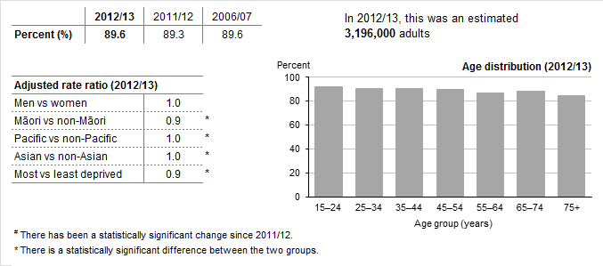

Nine out of ten adults (90%) reported being in good health, a similar percentage to previous surveys.

Māori adults were less likely to report being in good health (84%) than non-Māori adults.[1]†

After adjusting for age, sex and ethnic differences, adults living in the most deprived areas were less likely to report being in good health than those living in the least deprived areas.

### Smoking rates remain low in youths and are declining in young adults

Box 2: Adults who are either daily or current (smoke at least monthly, weekly or daily) smokers

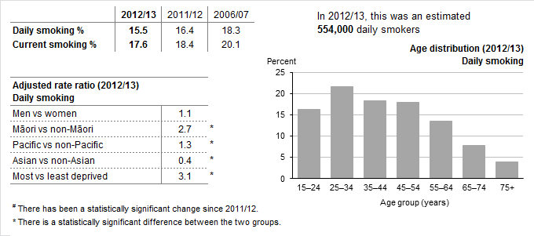

Around one in six adults (17.6%) were current smokers in 2012/13, including 15.5% who smoked daily. Both current and daily smoking levels have continued to decrease, but the decreases since 2011/12 were not statistically significant.

The low rate of youth smoking seen in 2011/12 continued, with only 7% of 15–17-year-olds smoking daily in 2012/13.[2]‡

There was a significant decrease in daily smoking among those aged 18–24 years, from 24% in 2011/12 to 20% in 2012/13.‡

Māori adults had the highest daily smoking rate, with over a third of adults smoking daily (36%). There was a small, but non-significant, decrease in daily smoking among Māori compared to 2011/12, when 38% reported smoking daily.[3]†

In the most deprived areas, 28% of adults smoked daily. After adjusting for age, sex and ethnic differences, adults in the most deprived areas were three times as likely to smoke daily as adults living in the least deprived areas.‡

### Hazardous drinking levels remain similar to last year but are falling among youths

Box 3: Adults who are hazardous drinkers (score 8 or more on an Alcohol Use Disorders Identification Test)

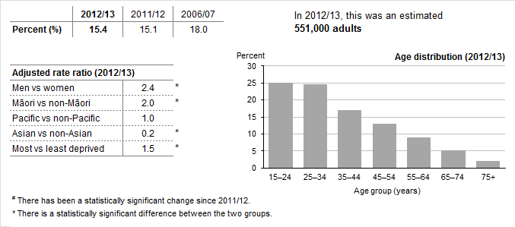

Fifteen percent of adults reported drinking alcohol at a level that was hazardous to their health, a similar rate to 2011/12. Hazardous drinking levels were much higher in men (22%) than in women (9%).[4]‡

Hazardous drinking rates were highest in young people, with one in four adults aged 15–24 years drinking at levels that were hazardous to their health. However, this is an improvement compared to 2006/07, when 35% were hazardous drinkers.‡

Hazardous drinking rates were also high in adults aged 25–34 years (24%) and have remained unchanged since 2006/07.‡

Almost a third of Māori adults (31%) reported drinking at hazardous levels. After adjusting for age and sex differences, Māori adults were twice as likely to drink at hazardous levels compared with non-Māori.[5]†

After adjusting for age, sex and ethnic differences, adults living in the most deprived areas were 1.5 times as likely to be hazardous drinkers as those living in the least deprived areas.

### Two out of three adults report that they eat at least three servings of vegetables per day

Box 4: Adults who eat at least three servings of vegetables per day, as recommended by the Ministry of Health

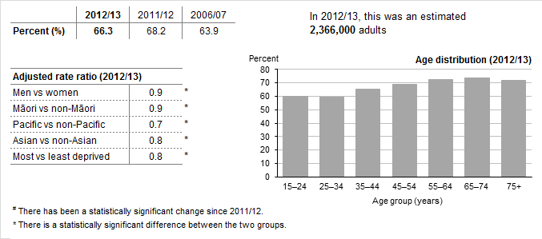

The percentage of adults who reported eating at least three servings of vegetables per day remained stable (66%). Vegetable consumption was higher in older adults, where almost three-quarters of 55–74-year-olds ate at least three servings of vegetables per day.

Women were more likely to report eating at least three servings of vegetables per day (69%) than men (64%).[6]‡

Vegetable consumption was lower in Māori, Pacific and Asian adults, with less than half of Pacific adults eating at least three servings of vegetables per day (47%).[7]†

Adults living in the most deprived areas (58%) were less likely to eat at least three servings of vegetables per day compared with adults living in the least deprived areas (72%).‡ After adjusting for age, sex and ethnic differences, adults living in the most deprived areas were significantly less likely to eat at least three servings of vegetables per day.

### Three out of five adults report that they eat at least two servings of fruit per day

Box 5: Adults who eat at least two servings of fruit per day, as recommended by the Ministry of Health

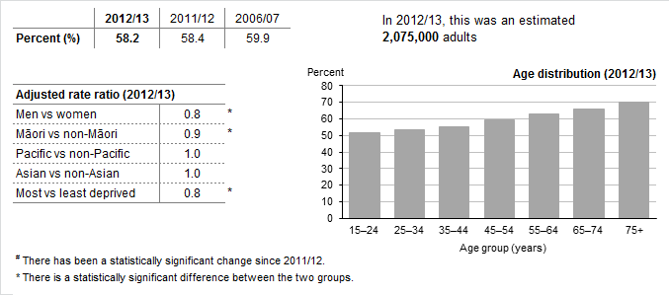

The percentage of adults who reported eating at least two servings of fruit per day remained stable (58%). Fruit consumption increased with age, with 70% of adults aged 75 years and above eating at least two servings of fruit per day, compared to 52% of 15–24-year-olds. Women were more likely to report eating at least two servings of fruit per day (64%) than men (52%).[8]‡

Adults living in the most deprived areas (51%) were less likely to eat at least two servings of fruit per day compared with adults living in the least deprived areas (64%).‡ After adjusting for age, sex and ethnic differences, adults living in the most deprived areas were significantly less likely to eat at least two servings of fruit per day.

### Just over half of adults are physically active, a similar level to 2011/12

Box 6: Adults who are physically active for at least 30 minutes on five or more days in the past week

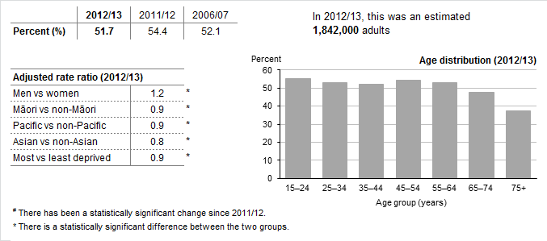

About half of all adults reported being physically active (52%), which is about 1,800,000 adults. Physical activity levels have remained relatively stable over recent years.

Men were more likely to be physically active (56%) than women (48%). Physical activity levels decreased with age, yet 38% of adults aged 75 years and over reported still being physically active.[9]‡

Physical activity levels were lower among Māori, Pacific and Asian adults. Physical activity levels had decreased significantly in Māori (47%) compared with 2011/12 (58%).[10]†

Please note: we are unclear why the NZHS data show such a large drop in physical activity among Māori. We recommend caution in using these data until there is further evidence to corroborate these findings.

### The number of obese adults continues to increase

Box 7: Adults who are obese, with a measured body mass index (BMI) of 30 or more

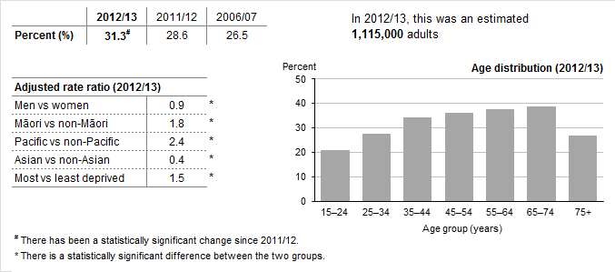

Three in ten adults (31%) were obese in 2012/13, over 1.1 million adults. The obesity rate has increased significantly since 2011/12 for all age, sex and ethnic groups, except Asian and Pacific. However, part of this increase may have been due to improved accuracy in BMI measurements.[11]

One-fifth (21%) of 15–24-year-olds were obese. The obesity rate increased with age, reaching 39% in adults aged 65–74 years.

Obesity rates were highest in Pacific adults, where over two-thirds (68%) were obese. Rates of obesity were also high among Māori adults, among whom almost half (48%) were obese.[12]†

After adjusting for age, sex and ethnic differences, adults living in the most deprived areas were 1.5 times as likely to be obese as those living in the least deprived areas.

## Health conditions

### Over half a million adults report taking medication for high blood pressure

Box 8: Adults diagnosed with high blood pressure and currently taking medication for this condition (excludes pregnant women)

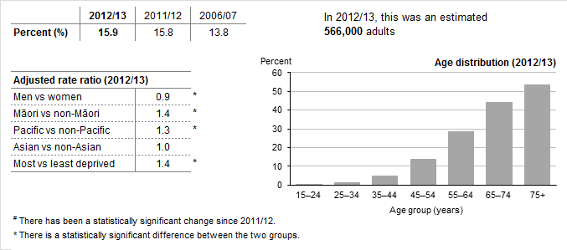

One in six adults (16%) reported taking medication for high blood pressure, which is around 566,ooo adults.

The rate of medicated high blood pressure increased steeply with age, with over half of adults aged 75 years and over (53%) taking medication for high blood pressure.

Māori and Pacific adults were more likely than other adults to be taking medication for high blood pressure, after adjusting for age and sex differences.

After adjusting for age, sex and ethnic differences, adults in the most deprived areas were 1.4 times as likely to take medication for high blood pressure compared with adults in the least deprived areas.

Please note: the New Zealand Health Survey has historically collected self-reported information on adults taking medication for high blood pressure. The 2012/13 New Zealand Health Survey included, for the first time, measured blood pressure. A separate short report examining the blood pressure results will be produced in 2014.

### One in nine adults report taking medication for high cholesterol

Box 9: Adults diagnosed with high cholesterol and currently taking medication for this condition

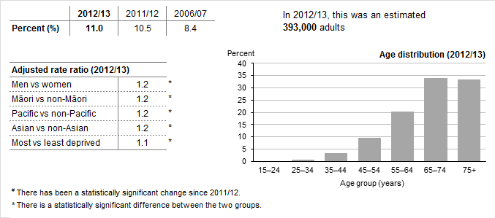

Eleven percent of adults reported taking medication for high cholesterol, which is around 393,000 adults. The rate of medicated high cholesterol had increased significantly since 2006/07.

The rate of medicated high cholesterol increased steeply with age, with a third of adults aged 65 years and over taking medication for high cholesterol.

### One in twenty adults have been diagnosed with ischaemic heart disease

Box 10: Adults diagnosed with ischaemic heart disease

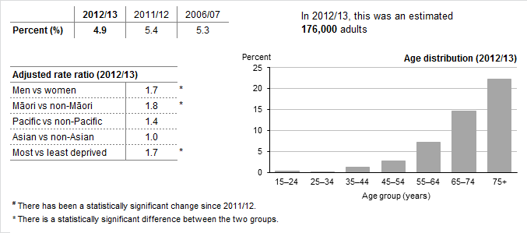

One in twenty adults (5%) had been diagnosed with ischaemic heart disease, which is around 176,000 adults.

Six percent of men had been diagnosed with ischaemic heart disease compared to 4% of women.[13]‡ After adjusting for age differences, men were 1.7 times as likely as women to have been diagnosed with ischaemic heart disease.

Rates of diagnosed ischaemic heart disease increased steeply with age, affecting over a fifth of those aged 75 years and over (22%).

Māori adults were 1.8 times as likely to have been diagnosed with ischaemic heart disease as non-Māori, after adjusting for age and sex differences.

After adjusting for age, sex and ethnic differences, people living in the most deprived areas were 1.7 times as likely to have been diagnosed with ischaemic heart disease as those living in the least deprived areas.

### One in ten adults aged 75 years and over have had a stroke and survived

Box 11: Adults diagnosed as having had a stroke, excluding transient ischaemic attacks (TIA)

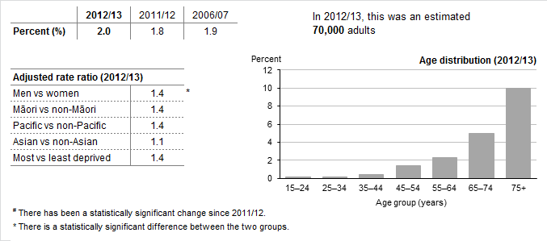

Two percent of adults reported having had a stroke during their lifetime, which is around 70,000 adults. This increased to 10% of adults aged 75 years and over.

The rate of stroke was higher in men (2.2%) than women (1.7%). After adjusting for age differences, men were 1.4 times as likely to have had a stroke as women.[14]‡

### One in eight Pacific adults report being diagnosed with diabetes

Box 12: Adults diagnosed with diabetes, excluding diabetes in pregnancy

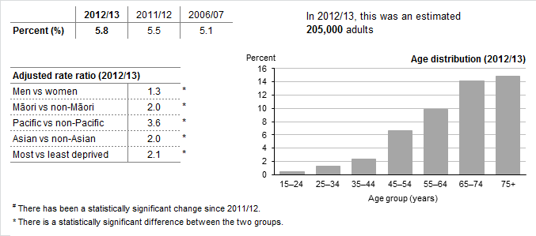

One in seventeen adults reported that they had been diagnosed with diabetes, which is around 205,000 adults. The rate of diagnosed diabetes had increased since 2006/07, but after adjusting for population age differences this increase was not significant.

The rate of diagnosed diabetes increased with age, affecting over one in seven adults aged 75 years and over (15%).

One in eight Pacific adults (13%) reported being diagnosed with diabetes.[15]† After adjusting for age and sex differences, the rate of diabetes was 3.6 times that of non-Pacific adults.

After adjusting for age and sex differences, the rate of diabetes was twice as high in Māori adults (7%) compared with non-Māori adults. Likewise for Asian adults, the rate of diabetes was twice as high (7%) compared with non-Asian adults.†

Nine percent of adults living in the most deprived areas reported that they had been diagnosed with diabetes.[16]‡ After adjusting for age, sex and ethnic differences, the rate of diabetes was twice as high in adults living in the most deprived areas compared with adults living in the least deprived areas.

### One in nine adults currently take medication for asthma

Box 13: Adults diagnosed with asthma and currently taking medication for this condition

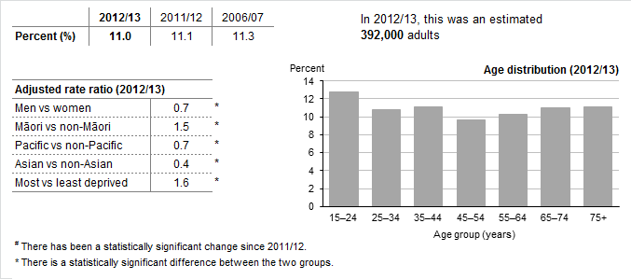

The asthma rate remained stable, affecting 11% of adults. Women were more likely to be taking medication for asthma (13%) compared with men (9%).[17]‡

Sixteen percent of Māori adults were taking medication for asthma.[18]† After adjusting for age and sex differences, Māori adults were 1.5 times as likely to be taking medication for asthma as non-Māori adults.

Adults living in the most deprived areas were more likely to be taking medication for asthma (14%).‡ After adjusting for age, sex and ethnic differences, adults in the most deprived areas were 1.6 times as likely to be taking medication for asthma as those in the least deprived areas.

### Over half a million adults have been diagnosed with arthritis

Box 14: Adults diagnosed with arthritis, including osteoarthritis, rheumatoid arthritis, gout, lupus and psoriatic arthritis

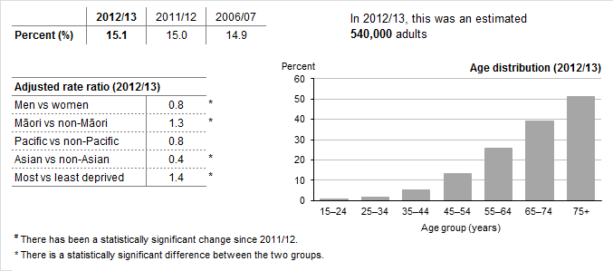

Almost one in six adults had been diagnosed with arthritis (15%), which is around 540,000 adults. The rate of diagnosed arthritis increased steeply with age, affecting half of adults aged 75 years and over (51%).

Rates of diagnosed arthritis were higher in women (17%) compared with men (13%).[19]‡

Thirteen percent of Māori adults had been diagnosed with arthritis.[20]† After adjusting for age and sex differences, Māori adults were 1.3 times as likely to have been diagnosed with arthritis as non-Māori adults.

After adjusting for age, sex and ethnic differences, adults in the most deprived areas were 1.4 times as likely to have diagnosed diabetes as those in the least deprived areas.

### One in six adults suffer from chronic pain

Box 15: Adults reporting chronic pain

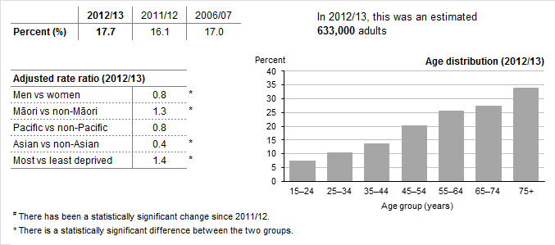

Eighteen percent of adults reported suffering from chronic pain, defined as pain that is present almost every day and has lasted, or is expected to last, more than six months. Experience of chronic pain increased steeply with age, affecting a third of adults aged 75 years and over (34%).

Women were more likely to report chronic pain (19%) than men (16%).[21]‡

One in five Māori adults (20%) reported chronic pain.[22]† This rate was 1.4 times as high as the rate for non-Māori, after adjusting for age and sex differences.

Rates of chronic pain were lower in Pacific (12%)† and Asian adults (8%).‡

After adjusting for age, sex and ethnic differences, adults living in the most deprived areas were 1.5 times as likely to experience chronic pain as adults living in the least deprived areas.‡

### One in six adults have been diagnosed with common mental disorders

Box 16: Adults diagnosed with a common mental disorder, including depression, bipolar and anxiety disorder

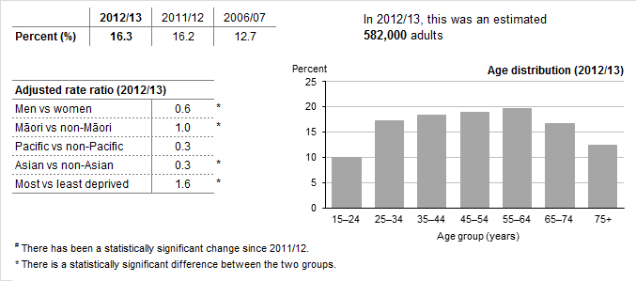

Sixteen percent of adults reported that they had been diagnosed with common mental disorders, which equates to around 582,000 adults.

Women were more likely to have been diagnosed with common mental disorders (20%) than men (13%).[23]‡

Rates of diagnosed common mental disorders were low among Pacific (4%) and Asian adults (6%).[24]†

After adjusting for age, sex and ethnic differences, adults in the most deprived areas were 1.6 times as likely to have ever been diagnosed with common mental disorders as adults in the least deprived areas.

### Over 200,000 adults experienced psychological distress in the four weeks preceding the interview

Box 17: Adults experiencing psychological distress in the last four weeks, with a score of 12 or over on the Kessler Psychological Distress Scale (K10)

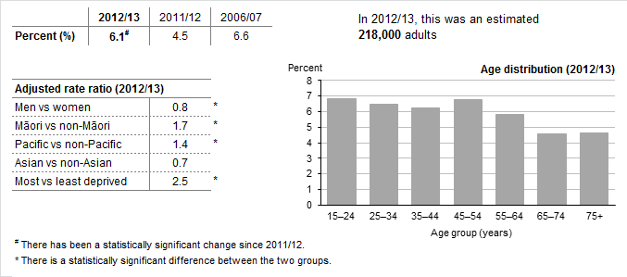

Six percent of adults had experienced high or very high levels of psychological distress, with men less likely to experience psychological distress (5%) than women (7%).[25]‡

Māori (10%) and Pacific (9%) adults were more likely to have experienced psychological distress.[26]† After adjusting for age and sex differences, Māori adults were 1.7 times as likely to have experienced psychological distress and Pacific adults were 1.4 times as likely to have experienced psychological distress as non-Māori and non-Pacific adults, respectively.

The rate of psychological distress was high in adults living in the most deprived areas (10%).‡ After adjusting for age, sex and ethnic differences, adults living in the most deprived areas were 2.5 times as likely to have experienced psychological distress as those living in the least deprived areas.

## Access to health care

### The majority of adults have visited a GP in past 12 months

Box 18: Adults who had visited a GP in the past 12 months

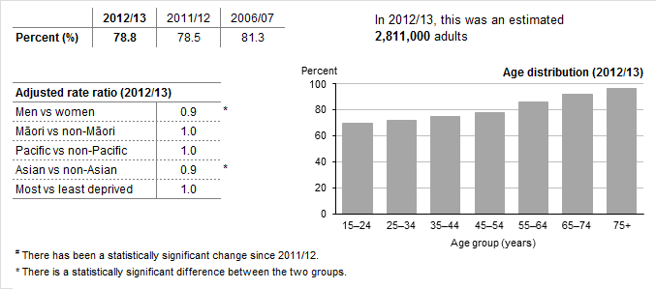

Four out of five adults (79%) had visited a GP in the past 12 months. This increased with age, with over 90% of adults aged 65 years and over having visited a GP in the past 12 months.

Women were more likely to have visited a GP in the past 12 months (83%) than men (74%).[27]‡

Fewer Asian adults had visited a GP in the past 12 months (65%) compared with non-Asian adults.‡

### Older adults are most likely to have visited a practice nurse in the past 12 months

Box 19: Adults who had visited a practice nurse in the past 12 months without seeing a GP at the same visit

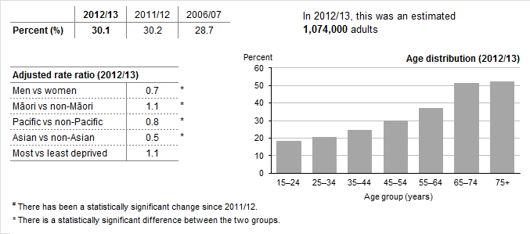

Thirty percent of adults had visited a practice nurse in the past 12 months without seeing a GP at the same visit. This increased to over 50% of adults aged 65 years and over.

Women were more likely to have visited a practice nurse in the last year (36%) than men (24%).[28]‡

Pacific (21%)[29]† and Asian adults (13%) were least likely to have visited a practice nurse in the past 12 months.‡

### One in eight adults visited an after-hours medical centre in the past 12 months

Box 20: Adults who had visited an after-hours medical centre in the past 12 months

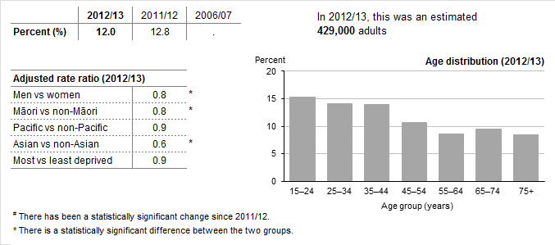

Twelve percent of adults had visited an after-hours medical centre in the past 12 months, a similar percentage to 2011/12.

Women were more likely to have visited an after-hours medical centre in the last year (13%) than men (10%).[30]‡

Young adults were more likely to have visited an after-hours medical centre than older age groups. Fewer than 10% of adults aged 55 years and over had visited an after-hours medical centre in the past 12 months.

Fewer Māori (10%)[31]† and Asian adults (9%) had visited an after-hours medical centre in the past 12 months.‡

### A quarter of adults had an unmet need for primary health care in the past 12 months

Box 21: Adults who have experienced one of more types of unmet need for primary health care in the past 12 months

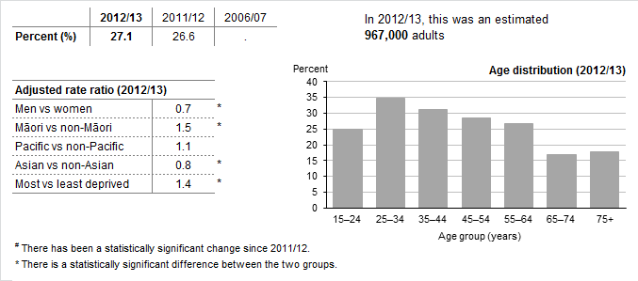

Twenty-seven percent of adults had experienced unmet need for primary care in the past 12 months. This includes unmet need for GP or after-hours services due to cost, transport or appointment availability

Women were more likely to have had an unmet need for primary care (32%) than men (22%).[32]‡

Māori adults (39%) were more likely to have had an unmet need for primary care.[33]† After adjusting for age and sex differences, Māori adults were 1.5 times as likely to have had an unmet need for primary care as non-Māori adults.

Adults living in the most deprived areas (35%) were more likely to have had an unmet need for primary care than adults living in the least deprived areas (23%).‡ After adjusting for age, sex and ethnic differences, adults in the most deprived areas were 1.4 times as likely to have had an unmet need for primary care.

### One in six adults are unable to get an appointment at their usual medical centre within 24 hours

Box 22: Adults who were unable to get an appointment at their usual medical centre within 24 hours, at any point in the last 12 months

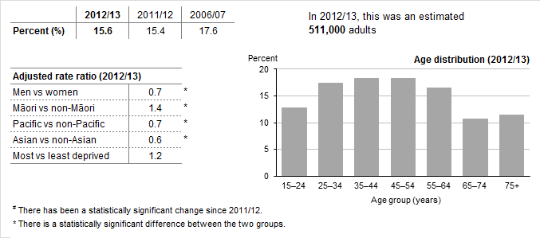

The percentage of adults unable to get an appointment at their usual medical centre within 24 hours (16%) was similar to 2011/12.

Over a fifth of Māori adults reported being unable to get an appointment at their usual medical centre within 24 hours.[34]†

Fewer Pacific (11%)† and Asian (11%) adults reported being unable to get an appointment at their usual medical centre within 24 hours.[35]‡

### One in seven adults report unmet need for GP services due to cost

Box 23: Adults who did not visit a GP because of cost, at any point in the last 12 months

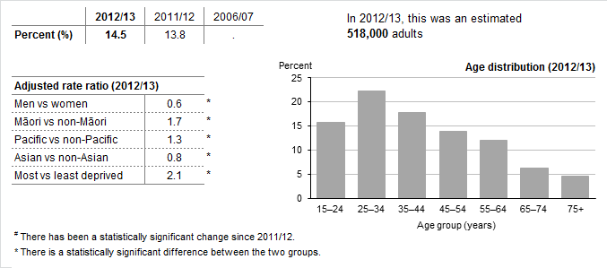

Fifteen percent of adults reported unmet need for GP services due to cost, a similar percentage to last year. Adults aged 25–34 years were more likely to report unmet need for GP services due to cost than other age groups.

A quarter of Māori adults (25%) and 21% of Pacific adults reported unmet need for GP services due to cost.[36]†

Over a fifth of adults (22%) living in the most deprived areas reported unmet need for GP services due to cost.[37]‡ After adjusting for age, sex and ethnic differences, adults living in the most deprived areas were twice as likely to report unmet need for GP services due to cost as adults living in the least deprived areas.

### Seven percent of adults report unmet need for after-hours services due to cost

Box 24: Adults who did not visit an after-hours medical centre due to cost, at any point in the last 12 months

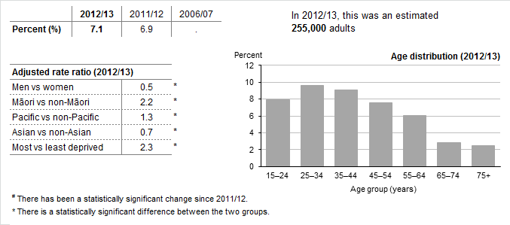

Levels of unmet need for after-hours services due to cost (7%) remained similar to 2011/12.

Māori adults were more likely to report unmet need for after-hours services due to cost (15%).[38]† This was twice as high as the rate of unmet need for non-Māori adults, after adjusting for age and sex differences.

Twelve percent of adults living in the most deprived areas reported unmet need for after-hours services due to cost.[39]‡ After adjusting for age, sex and ethnic differences, adults living in the most deprived areas were more than twice as likely to report unmet need as adults living in the least deprived areas.

### One in sixteen adults report being unable to collect a prescription due to cost

Box 25: Adults who had an unfilled prescription due to cost, at any point in the last 12 months

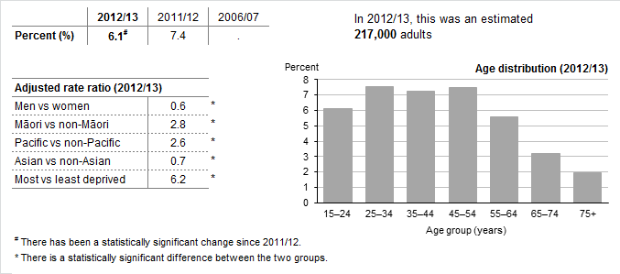

Six percent of adults reported that they were unable to collect a prescription due to cost in the last 12 months. While this was a significant decrease compared with 2011/12, more data are required to confirm this finding.

Māori (15%) and Pacific adults (15%) were significantly more likely to report being unable to collect a prescription due to cost.[40]†

Fourteen percent of adults living in the most deprived areas reported unfilled prescriptions due to cost, compared with 2% in the least deprived areas.[41]‡ After adjusting for age, sex and ethnic differences, adults living in the least deprived areas were six times as likely to report being unable to collect a prescription due to cost than adults living in the least deprived areas.

Please note: The 2012/13 survey results include responses from interviews conducted both before and after the cost for subsidised prescription items increased from $3 to $5 on 1 January 2013. The survey question also asks respondents to consider their experience over the past 12 months. Hence, we will not be able to compare rates of unfilled prescription before and after the policy change until we receive the 2013/14 NZHS results later in 2014.

### The majority of adults have confidence and trust in their GP

Box 26: Adults who had confidence and trust in the GP they last visited

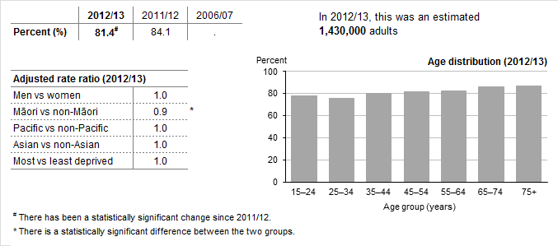

Four out of five adults who had visited their GP in the previous three months had confidence and trust in their GP (81%). This was a significant decrease compared with 2011/12, but more data are required to confirm whether this is a meaningful trend or random variation.

Older adults were more likely to report that they had confidence and trust in their GP.

Three-quarters of Māori adults had confidence and trust in their GP (76%).[42]† After adjusting for age and sex differences, Māori adults were found to be less likely to have confidence and trust in their GP than non-Māori adults.

## Oral health

### One out of two adults visited a dental health care worker in the last year

Box 27: Adults (with natural teeth) who had visited a dental health care worker in the past 12 months

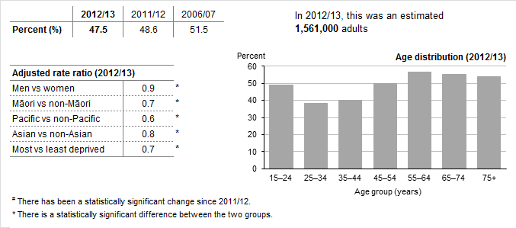

Almost half of all adults with natural teeth had visited a dental health care worker[43] in the past 12 months (47.5%). After adjusting for age differences, this was a significant decrease compared with 2006/07.

Women were more likely to have visited a dental health care worker in the past 12 months (51%) than men (44%).[44]‡

Māori (34%), Pacific (30%) and Asian (35%) adults were less likely to have visited a dental health care worker in the past 12 months.[45]†

Just over a third (35%) of adults living in the most deprived areas had visited a dental health care worker in the past 12 months, compared with over half (58%) of adults living in the least deprived areas.‡ After adjusting for age, sex and ethnic differences, adults living in the most deprived areas were significantly less likely to have visited a dental health care worker.

### Fewer adults had teeth removed in the last 12 months

Box 28: Adults who had any teeth removed in the last 12 months, due to decay, an abscess, infection or gum disease

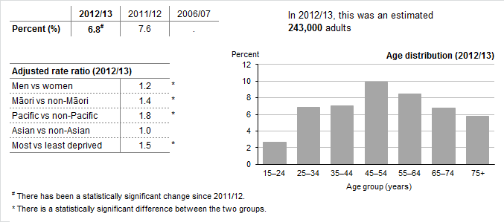

Seven percent of adults had one or more teeth removed in the last 12 months, which is around 240,000 adults. This is a significant decrease compared with 2011/12.

Māori (8%) and Pacific (11%) adults were more likely to have had teeth removed in the last 12 months.[46]†

Eight percent of adults living in the most deprived areas had teeth removed in the last 12 months.[47]‡ After adjusting for age, sex and ethnic differences, adults living in the most deprived areas were 1.5 times as likely to have had teeth removed in the last 12 months as adults in the least deprived areas.

### Over half of adults never visit a dental health care worker, or only visit for toothache

Box 29: Adults (with natural teeth) who never visit a dental health care worker, or only visit when they have dental problems

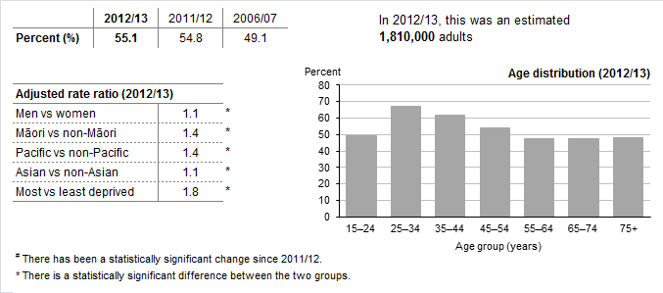

Over half of adults with natural teeth (55%) reported never visiting a dental health care worker or only visiting for toothache. After adjusting for age differences, this was a significant increase compared with 2006/07.

Three out of four Māori (76%) and Pacific (78%) adults reported never visiting a dental health care worker, or only visiting for toothache.

Three out of four adults living in the most deprived areas (74%) reported never visiting a dental health care worker, or only visiting for toothache.[48]‡ After adjusting for age, sex and ethnic differences, adults living in the most deprived areas were 1.8 times as likely to never visit a dental health care worker or only visit for toothache as adults in the least deprived areas.

Table 3: Key survey results for Māori adults

|  |  |  |  |
| --- | --- | --- | --- |
| **Indicator** | **Percent 2012/13 (%)** | **Percent 2011/12 (%)** | **Change since 2011/12** |
| **Health status, health behaviours and risk factors** |  |  |  |
| Excellent, very good or good self-rated health | 84.2 | 83.4 | = |
| Current smoking | 39.2 | 40.6 | = |
| Daily smoking | 36.1 | 38.0 | = |
| Hazardous drinking | 30.9 | 28.7 | = |
| Vegetable intake (3+ servings per day) | 61.0 | 64.0 | = |
| Fruit intake (2+ servings per day) | 49.3 | 49.0 | = |
| Physically active | 47.2 | 58.1 | ▼ |
| Obesity | 48.3 | 44.5 | ▲ |
| **Health conditions** |  |  |  |
| High blood pressure (medicated) | 13.5 | 13.3 | = |
| High cholesterol (medicated) | 9.1 | 8.0 | = |
| Ischaemic heart disease (diagnosed) | 4.8 | 5.1 | = |
| Stroke (diagnosed) | 1.6 | 2.1 | = |
| Diabetes (diagnosed) | 7.3 | 7.4 | = |
| Asthma (medicated) | 15.8 | 17.0 | = |
| Arthritis (diagnosed) | 12.5 | 11.6 | = |
| Chronic pain | 19.6 | 17.4 | = |
| Diagnosed common mental disorder | 15.7 | 16.1 | = |
| Psychological (mental) distress | 9.6 | 7.6 | = |
| **Access to health care** |  |  |  |
| Visited a GP in the past 12 months | 74.2 | 75.2 | = |
| Visited a practice nurse (without seeing a GP at the same visit) in the past 12 months | 29.3 | 29.9 | = |
| Visited an after-hours medical centre in the past 12 months | 10.3 | 13.3 | ▼ |
| Experienced unmet need for primary health care in the past 12 months | 38.9 | 39.1 | = |
| * Unable to get appointment at usual medical centre within 24 hours | 21.0 | 20.1 | = |
| * Unmet need for GP services due to cost | 25.1 | 22.8 | = |
| * Unmet need for after-hours services due to cost | 14.6 | 13.9 | = |
| Unfilled prescription due to cost | 14.6 | 18.0 | ▼ |
| Had confidence and trust in GP | 76.1 | 80.2 | ▼ |
| **Oral health** |  |  |  |
| Visited a dental health care worker in the past 12 months* | 33.7 | 37.6 | = |
| Had any teeth removed due to decay, abscess, infection or gum disease in the past 12 months | 8.4 | 11.7 | ▼ |
| Usually only visits a dental health care worker for dental problems (or never visits)* | 76.2 | 73.5 | = |

**Key**: ▲ Statistically significant increase **=** No statistically significant change

▼ Statistically significant decrease **.** Data not available

* Among adults with natural teeth.

Table 4: **Key survey results for Pacific adults**

|  |  |  |  |
| --- | --- | --- | --- |
| **Indicator** | **Percent 2012/13 (%)** | **Percent 2011/12 (%)** | **Change since 2011/12** |
| **Health status, health behaviours and risk factors** |  |  |  |
| Excellent, very good or good self-rated health | 87.6 | 86.6 | = |
| Current smoking | 24.7 | 26.2 | = |
| Daily smoking | 22.1 | 22.7 | = |
| Hazardous drinking | 17.8 | 0.0 | = |
| Vegetable intake (3+ servings per day) | 46.8 | 45.9 | = |
| Fruit intake (2+ servings per day) | 54.3 | 53.7 | = |
| Physically active | 46.7 | 47.4 | = |
| Obesity | 68.0 | 62.0 | = |
| **Health conditions** |  |  |  |
| High blood pressure (medicated) | 12.5 | 11.0 | = |
| High cholesterol (medicated) | 8.7 | 7.1 | = |
| Ischaemic heart disease (diagnosed) | 3.6 | 1.6 | = |
| Stroke (diagnosed) | 1.4 | 0.6 | = |
| Diabetes (diagnosed) | 12.5 | 10.3 | = |
| Asthma (medicated) | 8.3 | 9.2 | = |
| Arthritis (diagnosed) | 6.9 | 6.6 | = |
| Chronic pain | 11.5 | 13.6 | = |
| Diagnosed common mental disorder | 4.3 | 6.8 | ▼ |
| Psychological (mental) distress | 8.9 | 8.6 | = |
| **Access to health care** |  |  |  |
| Visited a GP in the past 12 months | 74.7 | 75.7 | = |
| Visited a practice nurse (without seeing a GP at the same visit) in the past 12 months | 20.8 | 20.4 | = |
| Visited an after-hours medical centre in the past 12 months | 12.0 | 13.3 | = |
| Experienced unmet need for primary health care in the past 12 months | 30.9 | 30.3 | = |
| * Unable to get appointment at usual medical centre within 24 hours | 10.9 | 14.9 | = |
| * Unmet need for GP services due to cost | 21.0 | 17.4 | = |
| * Unmet need for after-hours services due to cost | 10.3 | 10.0 | = |
| Unfilled prescription due to cost | 15.4 | 13.3 | = |
| Had confidence and trust in GP | 77.9 | 0.0 | = |
| **Oral health** |  |  |  |
| Visited a dental health care worker in the past 12 months* | 29.8 | 32.8 | = |
| Had any teeth removed due to decay, abscess, infection or gum disease in the past 12 months | 11.0 | 10.7 | = |
| Usually only visits a dental health care worker for dental problems (or never visits)* | 78.2 | 78.3 | = |

**Key**: ▲ Statistically significant increase **=** No statistically significant change

▼ Statistically significant decrease **.** Data not available

* Among adults with natural teeth.

# The health of New Zealand children

This section includes information on:

* health status, health behaviours and risk factors
* health conditions
* access to health care
* oral health
* key survey results for Māori children
* key survey results for Pacific children.

Table 5: Key survey results for children (aged 0–14 years)

|  |  |  |  |  |  |
| --- | --- | --- | --- | --- | --- |
| **Indicator** | **Percent 2012/13 (%)** | **Percent 2011/12 (%)** | **Percent 2006/07 (%)** | **Change since 2011/12** | **Change since 2006/07** |
| **Health status, health behaviours and risk factors** |  |  |  |  |  |
| Excellent, very good or good parent-perceived health | 98.1 | 97.9 | 97.6 | = | = |
| Given solid food before four months (0–4 years) | 10.2 | 9.2 | 15.8 | = | ▼ |
| Ate breakfast at home every day (2–14 years) | 86.6 | 87.3 | 87.7 | = | = |
| Usually watched 2+ hours of television each day (2–14 years) | 51.8 | 53.2 | . | = | . |
| Obesity (2–14 years) | 11.1 | 10.5 | 8.4 | = | ▲ |
| **Health conditions** |  |  |  |  |  |
| Asthma (medicated) (2–14 years) | 14.5 | 14.0 | 14.9 | = | = |
| Diagnosed emotional or behavioural problems (2–14 years) | 4.3 | 3.3 | 1.8 | = | ▲ |
| **Access to health care** |  |  |  |  |  |
| Visited a GP in the past 12 months | 74.5 | 74.1 | 79.2 | = | ▼ |
| Visited a practice nurse (without seeing a GP at the same visit) in the past 12 months | 25.1 | 26.0 | 22.8 | = | = |
| Visited an after-hours medical centre in the past 12 months | 21.4 | 21.8 | . | = | . |
| Experienced unmet need for primary health care in the past 12 months | 20.7 | 19.8 | . | = | . |
| * Unable to get appointment at usual medical centre within 24 hours | 12.8 | 13.6 | . | = | . |
| * Unmet need for GP services due to cost | 6.3 | 4.8 | . | ▲ | . |
| * Unmet need for after-hours services due to cost | 4.5 | 4.6 | . | = | . |
| * Unfilled prescription due to cost | 4.4 | 6.8 | . | ▼ | . |
| Parent had confidence and trust in GP | 82.3 | 82.5 | . | = | . |
| **Oral health** |  |  |  |  |  |
| Visited a dental health care worker in the past 12 months (1–14 years) | 81.3 | 78.6 | 75.7 | ▲ | ▲ |
| Had any teeth removed due to decay, abscess, infection or gum disease in the past 12 months (1–14 years) | 3.6 | 4.0 | . | = | . |

**Key**: ▲ Statistically significant increase **=** No statistically significant change

▼ Statistically significant decrease **.** Data not available

## Health status, health behaviours and risk factors

### Nearly all parents consider their children to be in good health

Box 30: Children with excellent, very good or good health, as rated by their parent

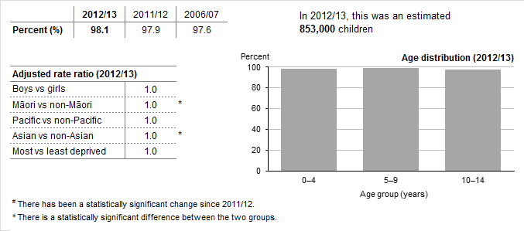

The majority of parents (98%) rated their child’s health as good, very good or excellent.

Parent-rated health status was similar for all age groups and all ethnic groups and did not differ by deprivation.

### One in ten children are given solid food before four months of age

Box 31: Children aged 0–4 years who were given solid foods before four months of age

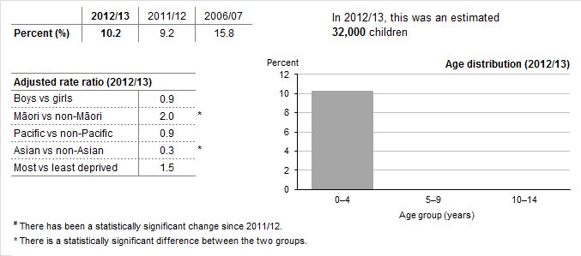

Ten percent of children were given solid foods before four months of age, a similar rate to 2011/12.

One in six Māori children (16%) were given solid food before four months of age.[49]† After adjusting for age and sex differences, Māori children were twice as likely to have been given solid foods before four months of age as non-Māori children.

Asian children were less likely to have been given solid food before four months of age (3%) than other children.[50]‡

### Nine out of ten children eat breakfast at home every day

Box 32: Children aged 2–14 years who had eaten breakfast at home every day in the past week

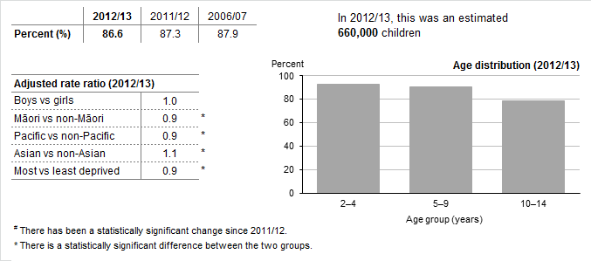

The majority of children (87%) had eaten breakfast at home every day in the past week.

Māori (81%) and Pacific children (80%) were less likely to eat breakfast at home every day.[51]†

Children living in the most deprived areas were less likely to have eaten breakfast at home every day in the past week (79%) than children living in the least deprived areas (92%).[52]‡

### One in two children watch two or more hours of television each day

Box 33: Children aged 2-14 years who watch two or more hours of television each day

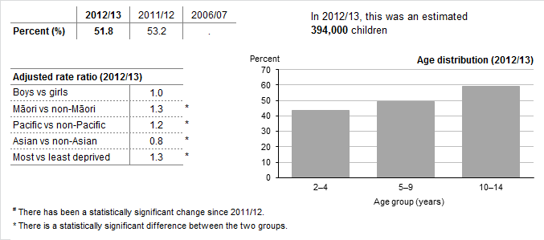

About half of New Zealand children (52%) usually watched two or more hours of television each day.

Television watching was more common in older children, among whom 59% of 10–14-year-olds watched two or more hours of television each day.

There was a significant decrease in reported television watching among young children aged  
2–4 years. In 2012/13, 43% of children aged 2–4 years watched two or more hours of television each day compared to 53% in 2011/12.[53]‡

Children living in the most deprived areas were more likely to watch two or more hours of television each day (60%) than children living in the least deprived areas (46%).‡ After adjusting for age, sex and ethnic differences, children in the most deprived areas were 1.3 times as likely to watch two or more hours of television.

Please note: this indicator does not include other screen time, for example, use of computer games or social media sites.

### One in nine children aged 2–14 years are obese

Box 34: Children aged 2-14 years who are obese

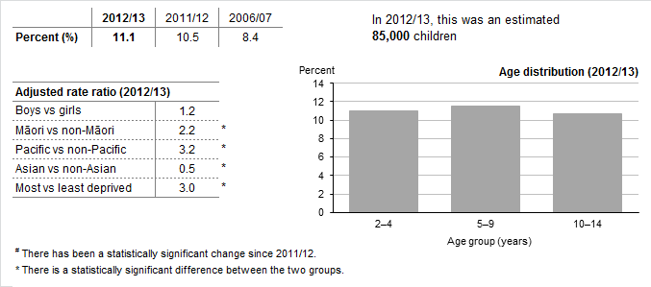

Eleven percent of children aged 2–14 years were obese, which is around 85,000 children. The childhood obesity rate was similar to 2011/12, but it had increased significantly since 2006/07.

One in four Pacific children were obese (27%).[54]† After adjusting for age and sex differences, Pacific children were more than three times as likely to be obese as non-Pacific children.

One in five Māori children were obese (19%).† After adjusting for age and sex differences, Māori children were more than twice as likely to be obese as non-Māori children.

The childhood obesity rate was much higher in children living in the most deprived areas (20%) than in children living in the least deprived areas (5%).[55]‡ After adjusting for age, sex and ethnic differences, children living in the most deprived areas were three times as likely to be obese as children living in the least deprived areas.

## Health conditions

### One in seven children take medication for asthma

Box 35: Children aged 2–14 years who have been diagnosed with asthma and are currently taking medication for this condition

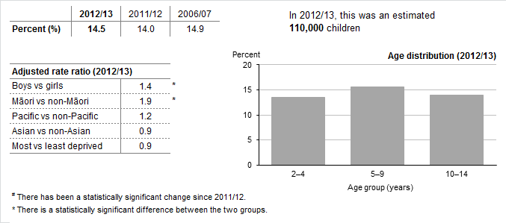

Around 110,000 children aged 2–14 years reported taking medication for asthma (14.5%).

Boys were more likely to have taken asthma medication (17%) than girls (12%).[56]‡

More than one in five Māori children took medication for asthma (22%).[57]† After adjusting for age and sex, Māori children were nearly twice as likely to have taken medication for asthma as non-Māori children.

### Boys are almost twice as likely to have been diagnosed with emotional and behavioural problems as girls

Box 36: Children aged 2-14 years who have been diagnosed with emotional and behavioural problems, including: depression, anxiety disorder, attention deficit disorder (ADD) and/or attention deficit and hyperactivity disorder (ADHD)

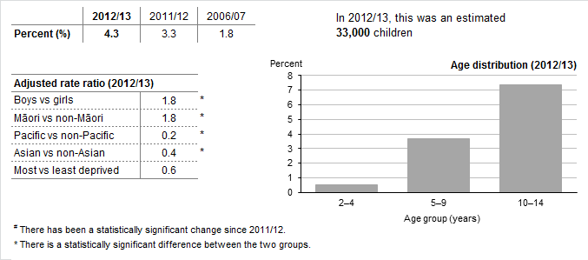

Around 33,000 children in New Zealand had been diagnosed with emotional and behavioural problems (4%). The rate of diagnosed emotional and behavioural problems has increased over time, but the increase since 2011/12 was not statistically significant.

Boys were almost twice as likely to have been diagnosed with emotional and behavioural problems as girls, after adjusting for age differences. Boys aged 10–14 years had the highest rate of diagnosed emotional and behavioural problems, with one in ten (10%) affected.

Six percent of Māori children had been diagnosed with emotional and behavioural problems, a significant increase from 2011/12 (3%).[58]† After adjusting for age and sex differences, Māori children were 1.8 times as likely to have been diagnosed with emotional and behavioural problems.

Pacific (1%) and Asian children (2%)[59]‡ were less likely to have been diagnosed with emotional and behavioural problems than other children.

## Access to health care

### Three out of four children have visited a GP in the past 12 months

Box 37: Children who had visited a GP in the past 12 months

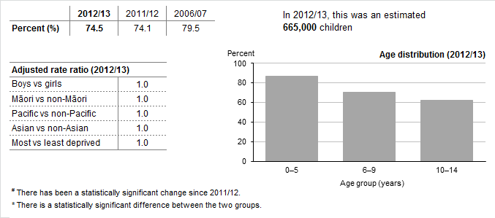

Three-quarters of children had visited a GP in the past 12 months, a similar percentage to last year. Children younger than six years were most likely to have visited a GP in the past 12 months (87%).[60]‡

The rate of GP visits was similar across all ethnic groups and did not vary with deprivation.

### One in four children have visited a practice nurse in the past 12 months

Box 38: Children who had visited a practice nurse in the past 12 months without seeing a GP at the same visit

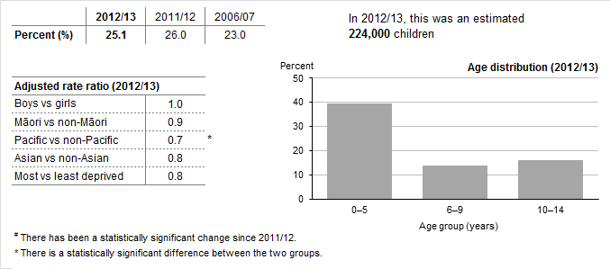

A quarter of children had visited a practice nurse in the past 12 months without seeing a GP at the same visit.

Children younger than six years were more likely than older children to have visited a practice nurse in the past 12 months (39%).[61]‡

Pacific children (19%) were less likely to have visited a practice nurse in the past 12 months than non-Pacific children.[62]†

### One in five children have visited an after-hours medical centre in the past 12 months

Box 39: Children who had visited an after-hours medical centre in the past 12 months

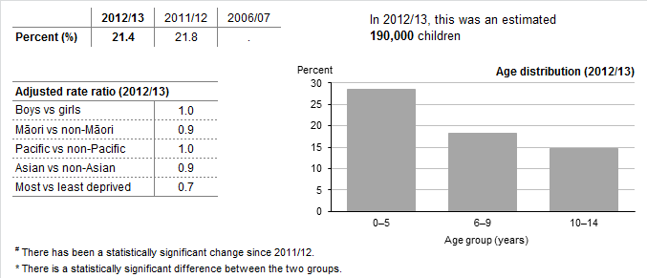

The percentage of children visiting an after-hours medical centre in the past 12 months (21%) was similar to 2011/12.

Children younger than six years were more likely than older children to have visited an after-hours medical centre in the past 12 months (29%).[63]‡

The rate of after-hours visits was similar across all ethnic groups and did not vary significantly with deprivation.

### One in five children had unmet need for primary health care in the past 12 months

Box 40: Children who have experienced one of more types of unmet need for primary care, at any point in the last 12 months

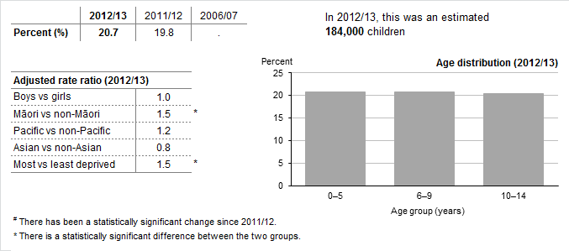

Twenty-one percent of children had an unmet need for primary health care in the past 12 months, which is around 184,000 children. This includes unmet need for GP or after-hours services due to cost, transport, childcare or appointment availability.

Levels of unmet need for primary health care were similar across the different age groups. However, there had been an increase in unmet need for primary care in older children aged  
10–14 years, with 20% experiencing unmet need compared with 16% in 2011/12.[64]‡

Levels of unmet need were higher in Māori children, among whom 28% had an unmet need for primary health care in the past 12 months.[65]†

Children living in the most deprived areas were more likely to experience unmet need for primary health care (26%) than those in the least deprived areas (16%).‡ After adjusting for age, sex and ethnic differences, children in the most deprived areas were 1.5 times as likely to experience unmet need for primary health care.

### One in eight children were unable to get an appointment at their usual medical centre within 24 hours

Box 41: Children who were unable to get an appointment at their usual medical centre within 24 hours, at any point in the last 12 months

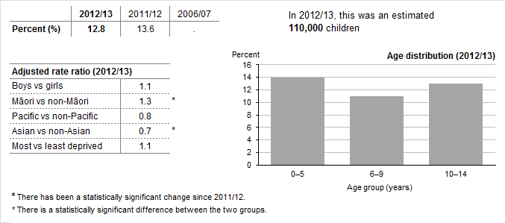

Thirteen percent of parents were unable to get their child an appointment at their usual medical centre within 24 hours.

The parents of Māori children had more difficulties getting an appointment for their child within 24 hours (16%).[66]†

### Unmet need for GP services due to cost has increased

Box 42: Children who did not visit a GP because of cost, at any point in the last 12 months

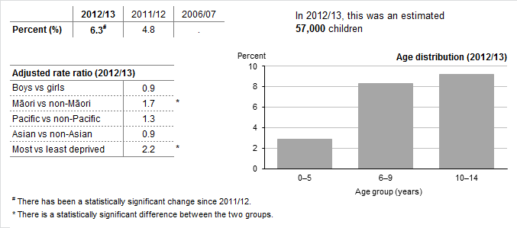

Around 57,000 children (6.3%) were unable to see a GP due to cost at some point in the past 12 months. This was a significant increase compared with 2011/12.

Very few children younger than six years had unmet need for GP services due to cost (2%).

Nine percent of Māori children were unable to visit a GP in the last 12 months due to cost.[67]† After adjusting for age and sex differences, Māori children were 1.7 times as likely to experience unmet need for GP services due to cost as non-Māori children.

Children living in the most deprived areas were more likely to experience unmet need for GP services due to cost (9%) than those in the least deprived areas (4%).[68]‡ After adjusting for age, sex and ethnic differences, children in the most deprived areas were over twice as likely to experience unmet need for GP services due to cost.

### One in twenty children had an unmet need for after-hours services due to cost

Box 43: Children who did not visit an after-hours medical centre due to cost, at any point in the last 12 months

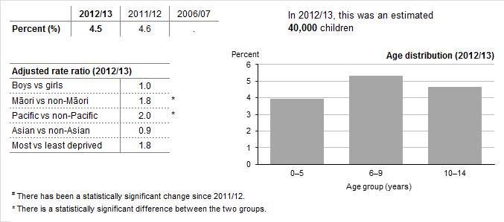

Around 40,000 children had unmet need for after-hours services due to cost (5%), a similar percentage to 2011/12.

Levels of unmet need for after-hours services due to cost were similar across all age groups.

Māori (7%) and Pacific children (8%) were more likely to experience unmet need for after-hours services due to cost.[69]†

### Children living in the most deprived areas are much more likely to have had an unfilled prescription due to cost

Box 44: Children who had an unfilled prescription due to cost, at any point in the last 12 months

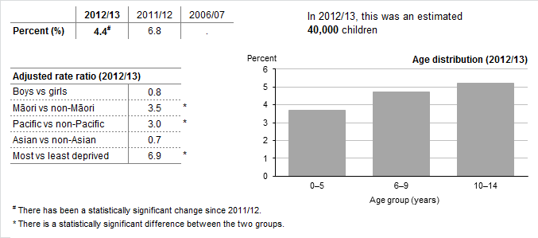

Four percent of children (4.4%) had an unfilled prescription due to cost in the past 12 months. This was a significant decrease compared with 2011/12, but more data are needed to confirm this finding.

The decrease in unfilled prescriptions due to cost was seen in children aged 0–9 years but not in older children.[70]‡

Māori (9%) and Pacific (10%) children were more likely to have missed out on a prescription due to cost in the past 12 months.[71]†

Unfilled prescriptions due to cost are more common in children living in the most deprived areas (11%) compared with those living in the least deprived areas (1%).‡ After adjusting for age, sex and ethnic differences, children living in the most deprived areas were seven times as likely to have missed out on a prescription due to cost in the past 12 months.

Please note: the 2012/13 survey results include responses from interviews conducted both before and after the cost for subsidised prescription items increased from $3 to $5 on 1 January 2013. The survey question also asks respondents to consider their experience over the past 12 months. Hence we will not be able to compare rates of unfilled prescription before and after the policy change until we receive the 2013/14 data NZHS results later in 2014.

### The majority of parents had confidence and trust in the GP who saw their child

Box 45: Parents who had confidence and trust in the GP their child last visited

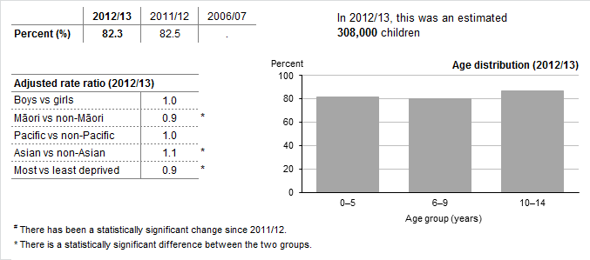

Five out of six (82%) parents had confidence and trust in the GP they last took their child to see.

Māori parents were less likely to report having confidence and trust in the GP who saw their child (74%).[72]† In contrast, 89% of Asian parents had confidence and trust in the GP who saw their child.[73]‡

Parents of children living in the most deprived areas were less likely to have confidence and trust in the GP who saw their child (76%) than the parents of children living in the least deprived areas (88%).‡

## Oral health

### More children have visited a dental health care worker in the past 12 months

Box 46: Children (aged 1–14 years) who had visited a dental health care worker in the past 12 months

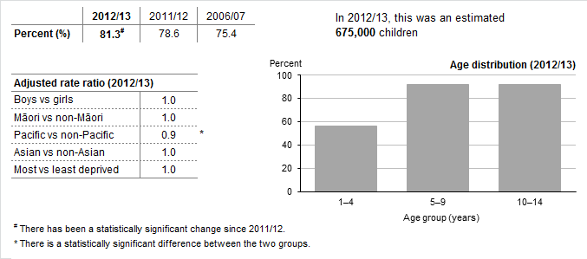

Four out of five children had visited a dental health care worker in the past 12 months (81%), a significant increase compared with 2011/12 (79%).

More boys had visited a dental health care worker in the past 12 months (81%) compared with 2011/12 (76%).[74]‡

Pacific children (73%) were less likely to have visited a dental health care worker in the past 12 months.[75]†

### Around 30,000 children had teeth extracted due to decay in the past 12 months

Box 47: Children (aged 1-14 years) who had any teeth removed in the last 12 months, due to decay, an abscess, infection or gum disease

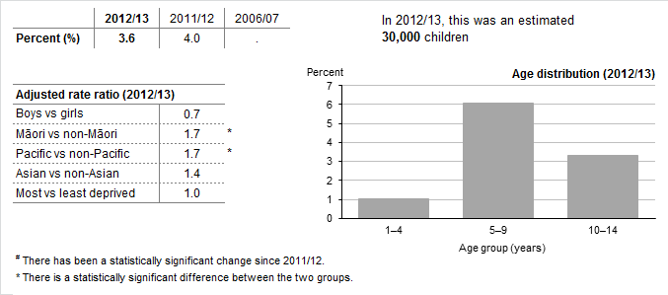

Four percent of children aged 1–14 years had one or more teeth removed due to decay, abscess or infection in the past 12 months.

Fewer boys had teeth extracted due to decay (3%) compared with 2011/12 (4.5%).[76]‡

Children aged 5–9 years were most likely to have had teeth removed due to decay in the past 12 months.

Māori (5%) and Pacific (5%) children were more likely to have had teeth removed due to decay in the past 12 months.[77]†

Table 6: **Key survey results for Māori children**

|  |  |  |  |
| --- | --- | --- | --- |
| **Description** | **Percent 2012/13 (%)** | **Percent 2011/12 (%)** | **Change since 2011/12** |
| **Health status, health behaviours and risk factors** |  |  |  |
| Excellent, very good or good parent-perceived health | 96.4 | 96.9 | = |
| Given solid food before four months (0–4 years) | 15.9 | 15.5 | = |
| Ate breakfast at home every day (2–14 years) | 81.2 | 82.2 | = |
| Usually watched 2+ hours of television each day (2–14 years) | 61.2 | 62.0 | = |
| Obesity (2–14 years) | 18.6 | 16.6 | = |
| **Health conditions** |  |  |  |
| Asthma (medicated) (2–14 years) | 22.4 | 19.1 | = |
| Diagnosed emotional or behavioural problems (2–14 years) | 6.1 | 3.2 | ▲ |
| **Access to health care** |  |  |  |
| Visited a GP in the past 12 months | 74.1 | 73.8 | = |
| Visited a practice nurse (without seeing a GP at the same visit) in the past 12 months | 24.9 | 24.2 | = |
| Visited an after-hours medical centre in the past 12 months | 19.9 | 21.2 | = |
| Experienced unmet need for primary health care in the past 12 months | 27.6 | 27.8 | = |
| * Unable to get appointment at usual medical centre within 24 hours | 15.8 | 17.5 | = |
| * Unmet need for GP services due to cost | 8.9 | 8.0 | = |
| * Unmet need for after-hours services due to cost | 6.7 | 8.5 | = |
| * Unfilled prescription due to cost | 9.3 | 12.5 | = |
| Parent had confidence and trust in GP | 74.1 | 77.9 | = |
| **Oral health** |  |  |  |
| Visited a dental health care worker in the past 12 months (1–14 years) | 78.2 | 74.9 | = |
| Had any teeth removed due to decay, abscess, infection or gum disease in the past 12 months (1–14 years) | 5.1 | 5.6 | = |

**Key**: ▲ Statistically significant increase **=** No statistically significant change

▼ Statistically significant decrease **.** Data not available

Table 7: **Key survey results for Pacific children**

|  |  |  |  |
| --- | --- | --- | --- |
| **Description** | **Percent 2012/13 (%)** | **Percent 2011/12 (%)** | **Change since 2011/12** |
| **Health status, health behaviours and risk factors** |  |  |  |
| Excellent, very good or good parent-perceived health | 98.5 | 98.0 | = |
| Given solid food before four months (0–4 years) | 9.3 | 13.4 | = |
| Ate breakfast at home every day (2–14 years) | 80.3 | 82.2 | = |
| Usually watched 2+ hours of television each day (2–14 years) | 59.2 | 58.8 | = |
| Obesity (2–14 years) | 27.1 | 25.3 | = |
| **Health conditions** |  |  |  |
| Asthma (medicated) (2–14 years) | 16.5 | 13.7 | = |
| Diagnosed emotional or behavioural problems (2–14 years) | 0.9 | 1.6 | = |
| **Access to health care** |  |  |  |
| Visited a GP in the past 12 months | 75.8 | 78.3 | = |
| Visited a practice nurse (without seeing a GP at the same visit) in the past 12 months | 19.4 | 18.4 | = |
| Visited an after-hours medical centre in the past 12 months | 21.4 | 21.9 | = |
| Experienced unmet need for primary health care in the past 12 months | 23.7 | 26.4 | = |
| * Unable to get appointment at usual medical centre within 24 hours | 11.0 | 16.0 | ▼ |
| * Unmet need for GP services due to cost | 7.7 | 6.9 | = |
| * Unmet need for after-hours services due to cost | 7.9 | 7.9 | = |
| * Unfilled prescription due to cost | 10.2 | 11.6 | = |
| Parent had confidence and trust in GP | 79.3 | 78.1 | = |
| **Oral health** |  |  |  |
| Visited a dental health care worker in the past 12 months (1–14 years) | 73.2 | 73.0 | = |
| Had any teeth removed due to decay, abscess, infection or gum disease in the past 12 months (1–14 years) | 5.5 | 6.0 | = |

**Key**: ▲ Statistically significant increase **=** No statistically significant change

▼ Statistically significant decrease **.** Data not available

# Appendix 1: NZ Health Survey key indicators

Note: Indicators in italics are included in the web-tables only.

|  |  |  |
| --- | --- | --- |
| **Topic** | **Child indicator** | **Adult indicator** |
| Health behaviours and risk factors | Introduction of solid food before 4 months  *Fast food consumption*  *Fizzy drink consumption*  Eating breakfast at home  Television watching  *Active travel*  Obesity (2–15 years)  *Overweight, healthy weight, underweight* | Current smoking  Daily smoking  Hazardous drinking (total population)  *Hazardous drinking (past-year drinkers)*  *Current drinker*  Vegetable intake (3+ servings per day)  Fruit intake (2+ servings per day)  Physically active  Obesity  *Overweight, healthy weight, underweight*  *Mean BMI, height and weight* |
| Health status and conditions | Good parent-rated health  Parent-rated health: full response breakdown  Asthma  Mental health  Diabetes  Rheumatic heart disease  Autism spectrum disorder | Good self-rated health  *Self-rated health: full response breakdown*  High blood pressure  High cholesterol  Ischaemic heart disease  Stroke  Common mental disorder  Psychological distress  Diabetes  Asthma  Arthritis  Chronic pain |
| Primary health care use | General practice  Practice nurse  After-hour medical centres | General practice  Practice nurse  After-hour medical centres |
| Barriers to accessing primary health care | Unmet need for primary health care  Unable to get an appointment at usual medical centre within 24 hours  Unmet need for GP services due to cost  Unmet need for after-hours due to cost  Unfilled prescription due to cost  Confidence and trust in GP | Unmet need for primary health care  Unable to get an appointment at usual medical centre within 24 hours  Unmet need for GP services due to cost  Unmet need for after-hours due to cost  Unfilled prescription due to cost  Confidence and trust in GP |
| Oral health status and service use | Teeth removed  Visited dental health care worker | Teeth removed  Visited dental health care worker  Usually visits dental health care worker for dental problems |

# Appendix 2: Definitions and statistical methods

This section gives some key information to aid interpretation of the survey results. For more details about the survey methodology, see the Methodology Report and Indicator Interpretation Guide.

### Results are representative of the total adult or child population

All results presented in this report are weighted so that they are representative of the total population of either adults (15 years and above) or children (0–14 years).

### Percentages refer to unadjusted values

Any percentages given in the text refer to the *unadjusted prevalence*;that is, the percentage of people affected in the population group of interest.

### Total response ethnicity

This report uses total response ethnicity to define ethnic groups. Total response ethnicity classifies a person in all the ethnic groups they identify with. This means that people can appear in more than one ethnic group.

### Statistical significance

Statistical significance is measured at the 5% significance level (that is, a *p*-value less than 0.05). If needed, we carried out a statistical test (a *t*-test) to confirm that the finding was statistically significant. Due to the large number of results included in this report, some results identified as significant could be chance findings.

### Survey results show associations, not cause-and-effect relationships

This survey presents a picture of the health of New Zealand adults and children at one point in time. The survey can be used to look at associations between different factors, such as health status and neighbourhood deprivation. However, we cannot conclude that the survey results show cause-and-effect relationships between these factors, in part because we do not know which factor occurred first.

For example, if the survey finds that a particular condition is more common in people living in deprived areas, an association has been identified. This association does not necessarily mean the condition is caused by living in deprived areas.

### Reliability of survey results

The survey results are likely to underestimate or overestimate some indicators due to the nature of self-reported information.

For example, many of the survey results assume that respondents can accurately recall previous events (such as a diagnosis by a doctor). Also, many indicators in this report are about *diagnosed* conditions, and not everyone with a particular condition will have had it diagnosed by a doctor. People may also over-report good behaviours or under-report risk behaviours based on what they consider to be socially desirable. The amount of error will vary by indicator, depending on a number of factors (including the age of the respondent).

Indicators about body size (such as obesity) are based on height and weight measurements taken by the interviewers, rather than self-reported information. These results are more reliable than self-reported information would have been.

1. † Results for Māori and Pacific adults are provided at the end of the adult section.
2. ‡ Results are available in the web-tables accompanying this report.
3. † Results for Māori and Pacific adults are provided at the end of the adult section.
4. ‡ Results are available in the web-tables accompanying this report.
5. † Results for Māori and Pacific adults are provided at the end of the adult section.
6. ‡ Results are available in the web-tables accompanying this report.
7. † Results for Māori and Pacific adults are provided at the end of the adult section.
8. ‡ Results are available in the web-tables accompanying this report.
9. ‡ Results are available in the web-tables accompanying this report.
10. † Results for Māori and Pacific adults are provided at the end of the adult section.
11. There has been an increase in the proportion of survey participants agreeing to have their height and weight measured. In 2012/13, 92% of survey participants agreed to have their height and weight measured, an increase from 87% in 2011/12. In 2012/13 the method of measuring height also changed from using a stadiometer to using a laser, providing more accurate readings of height. This has resulted in a small decrease in mean height and therefore a small increase in mean BMI.
12. † Results for Māori and Pacific adults are provided at the end of the adult section.
13. ‡ Results are available in the web-tables accompanying this report.
14. ‡ Results are available in the web-tables accompanying this report.
15. † Results for Māori and Pacific adults are provided at the end of the adult section.
16. ‡ Results are available in the web-tables accompanying this report.
17. ‡ Results are available in the web-tables accompanying this report.
18. † Results for Māori and Pacific adults are provided at the end of the adult section.
19. ‡ Results are available in the web-tables accompanying this report.
20. † Results for Māori and Pacific adults are provided at the end of the adult section.
21. ‡ Results are available in the web-tables accompanying this report.
22. † Results for Māori and Pacific adults are provided at the end of the adult section.
23. ‡ Results are available in the web-tables accompanying this report.
24. † Results for Māori and Pacific adults are provided at the end of the adult section.
25. ‡ Results are available in the web-tables accompanying this report.
26. † Results for Māori and Pacific adults are provided at the end of the adult section.
27. ‡ Results are available in the web-tables accompanying this report.
28. ‡ Results are available in the web-tables accompanying this report.
29. † Results for Māori and Pacific adults are provided at the end of the adult section.
30. ‡ Results are available in the web-tables accompanying this report.
31. † Results for Māori and Pacific adults are provided at the end of the adult section.
32. ‡ Results are available in the web-tables accompanying this report.
33. † Results for Māori and Pacific adults are provided at the end of the adult section.
34. † Results for Māori and Pacific adults are provided at the end of the adult section.
35. ‡ Results are available in the web-tables accompanying this report.
36. † Results for Māori and Pacific adults are provided at the end of the adult section.
37. ‡ Results are available in the web-tables accompanying this report.
38. † Results for Māori and Pacific adults are provided at the end of the adult section.
39. ‡ Results are available in the web-tables accompanying this report.
40. † Results for Māori and Pacific adults are provided at the end of the adult section.
41. ‡ Results are available in the web-tables accompanying this report.
42. † Results for Māori and Pacific adults are provided at the end of the adult section.
43. The term ‘dental health care worker’ refers to dentists and other dental health care workers, such as dental therapists, dental nurses, dental hygienists and dental health specialists such as orthodontists.
44. ‡ Results are available in the web-tables accompanying this report.
45. † Results for Māori and Pacific adults are provided at the end of the adult section.
46. † Results for Māori and Pacific adults are provided at the end of the adult section.
47. ‡ Results are available in the web-tables accompanying this report.
48. ‡ Results are available in the web-tables accompanying this report.
49. † Results for Māori and Pacific children are provided at the end of the child section.
50. ‡ Results are available in the web-tables accompanying this report.
51. † Results for Māori and Pacific children are provided at the end of the child section.
52. ‡ Results are available in the web-tables accompanying this report.
53. ‡ Results are available in the web-tables accompanying this report.
54. † Results for Māori and Pacific children are provided at the end of the child section.
55. ‡ Results are available in the web-tables accompanying this report.
56. ‡ Results are available in the web-tables accompanying this report.
57. † Results for Māori and Pacific children are provided at the end of the child section.
58. † Results for Māori and Pacific children are provided at the end of the child section.
59. ‡ Results are available in the web-tables accompanying this report.
60. ‡ Results are available in the web-tables accompanying this report.
61. ‡ Results are available in the web-tables accompanying this report.
62. † Results for Māori and Pacific children are provided at the end of the child section.
63. ‡ Results are available in the web-tables accompanying this report.
64. ‡ Results are available in the web-tables accompanying this report.
65. † Results for Māori and Pacific children are provided at the end of the child section.
66. † Results for Māori and Pacific children are provided at the end of the child section.
67. † Results for Māori and Pacific children are provided at the end of the child section.
68. ‡ Results are available in the web-tables accompanying this report.
69. † Results for Māori and Pacific children are provided at the end of the child section.
70. ‡ Results are available in the web-tables accompanying this report.
71. † Results for Māori and Pacific children are provided at the end of the child section.
72. † Results for Māori and Pacific children are provided at the end of the child section.
73. ‡ Results are available in the web-tables accompanying this report.
74. ‡ Results are available in the web-tables accompanying this report.
75. † Results for Māori and Pacific children are provided at the end of the child section.
76. ‡ Results are available in the web-tables accompanying this report.
77. † Results for Māori and Pacific children are provided at the end of the child section.