# Waaazap

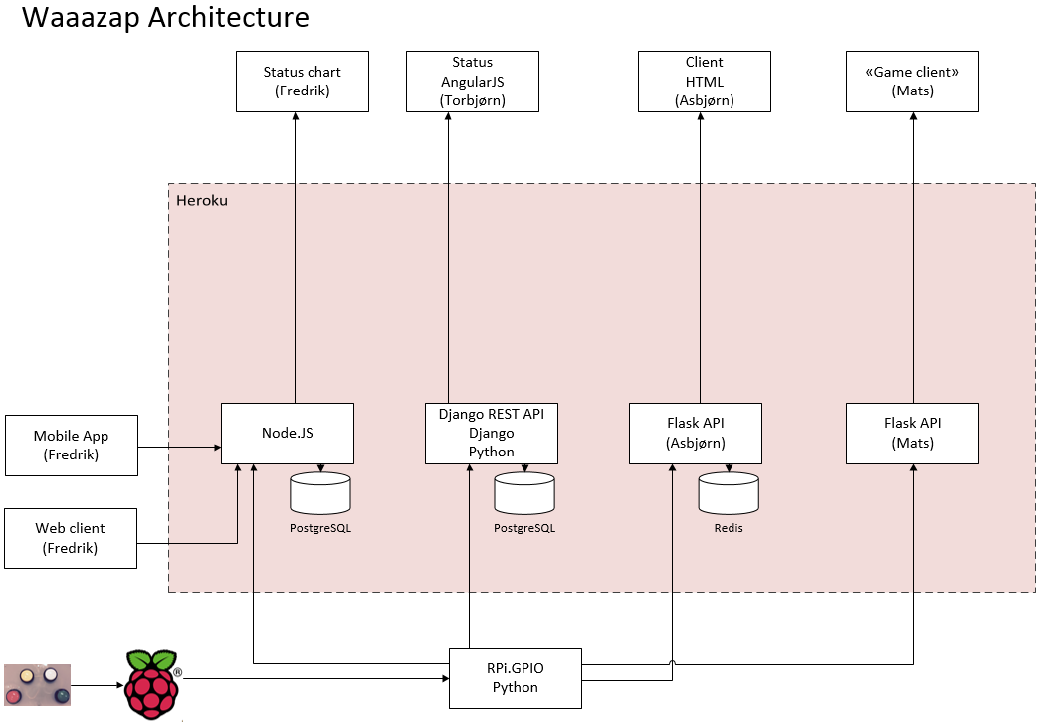

## Fredrik

Web input: <https://happymind.herokuapp.com/input>

Report: <https://happymind.herokuapp.com/report>

Report (WebSockets): <http://happymind.herokuapp.com/wsreport> (web socket rapport)

## Torbjørn

API Root: <http://toslhack.herokuapp.com/>

User: [hack@statoil.com](mailto:hack@statoil.com)

Pwd: test

Kun innloggede brukere får skrive data.

Result: <http://toslhack.herokuapp.com/hello/>

## Asbjørn

The Happy Meter: <https://waaazap.herokuapp.com/testws>

## Mats

Result: <http://showsmileys.herokuapp.com/>