STA210U — Statistics

II. Descriptive Statistics
D. Linear Correlation and Regression

In This Section
- Linear Correlation
- Cause and Effect
- Linear Regression

1. Linear Correlation

Quantifying Linear Correlation
Pearson Product-Moment Correlation Coefficient, r — describes the direction and strength of a linear relationship between two quantitative variables.

The value r describes only a linear relationship. Another type of relationship could still be present. You will not need to calculate r by hand, but the formula is:
$$r=\frac{SXY}{√(SSX SSY)}$$
$$SSX=Σ{(x−\underline{x})}^{2}=Σx^{2}−\frac{{Σx}^{2}}{n}$$
$$SSY=Σ{(y−\underline{y})}^{2}=Σy^{2}−\frac{{Σy}^{2}}{n}$$
$$SXY=Σ(x−\underline{x})(y−\underline{y})=Σxy−\frac{(Σx)(Σy)}{n}$$

Direction and Strength
Positive r means larger X values tend to occur with larger Y values. Negative r means larger values of one variable tend to occur with smaller values of the other. Strength describes how close the points are to a line.
$$−1 ≤ r ≤ 1$$
- r = 1: perfect positive linear correlation.
- r = −1: perfect negative linear correlation.
- r = 0: no linear relationship, although another type of relationship could still exist.
- In this course, a relationship is generally considered strong when |r| ≥ .75.
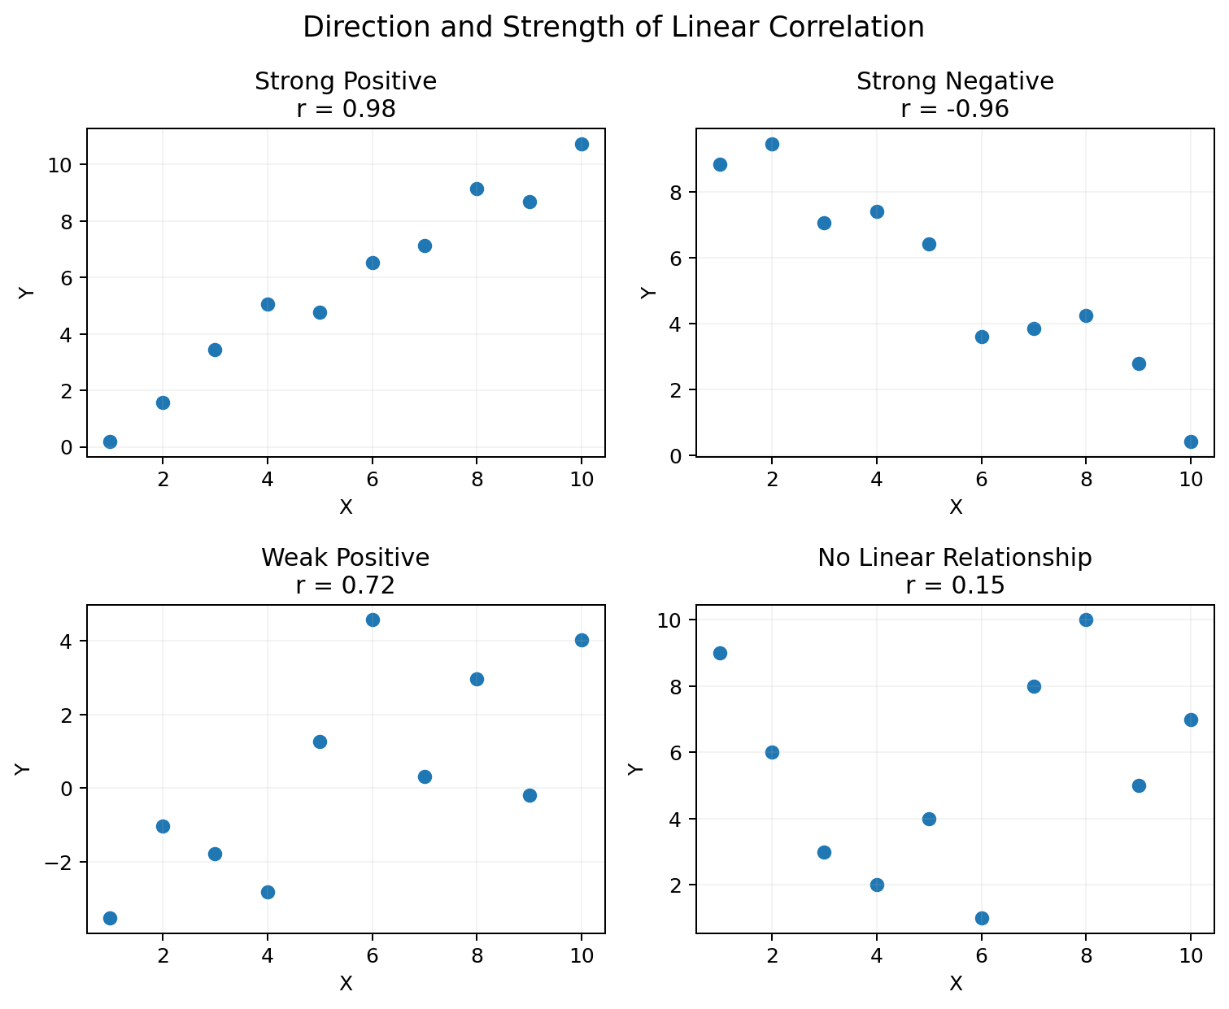
Direction and Strength of Linear Correlation

Drug Dosage Example
Dosage of Drug, X | Reduction in Blood Pressure, Y
100 | 10
200 | 18
300 | 32
400 | 44
500 | 56

The scatterplot indicates a very strong positive linear relationship.
$$r = .99728$$

R-Squared
R² — the percent of variation in Y explained by the model. In simple linear regression, R² = r².

$$0\% ≤ R² ≤ 100\%$$
$$R^{2}={(.99728)}^{2}≈.995=99.5\%$$

2. Cause and Effect
“Causal” Research — research whose objective is to determine whether one variable causes changes in another.

Correlation does not imply causation. It is never possible to prove causality just from the relationship between two variables.

Ice Cream and Assaults
The notes give an example of a strong correlation between ice cream consumption and assaults over the months of the year. This does not mean ice cream causes crime. Hot summer temperatures can increase both variables.

Criteria for Establishing a Causal Relationship
- Time order — the cause must occur before the effect.
- Co-variation — the graph and correlation coefficient must show a strong relationship.
- Rationale — there must be a logical and compelling explanation for the causal mechanism.
- Non-spuriousness — rival explanations must be ruled out.
The fourth criterion is especially difficult. Repeating studies under differing conditions can help rule out rival explanations.

3. Linear Regression
Deterministic View — once X is known, the exact value of Y is known.

Regression — a technique used to predict variables based on other variables.

Linear Regression — predicts Y, the response variable, from X, the explanatory variable, using a linear equation.

Prediction is not exact. The error is represented by the vertical distance between a point and the regression line.
$$Ŷ = b₀ + b₁X$$
- b₀ is the y-intercept.
- b₁ is the slope.
Before fitting a line, the scatterplot and r should indicate that a linear model is reasonable.

Method of Least Squares
Method of Least Squares — minimizes the sum of the squared vertical distances from the observed points to the regression line.

$$b₁=\frac{SXY}{SSX}$$
$$b₀=\underline{y}−b₁\underline{x}$$

Drug Dosage Regression
$$b₁ = .118 b₀ = −3.4$$
$$Ŷ = −3.4 + .118X$$
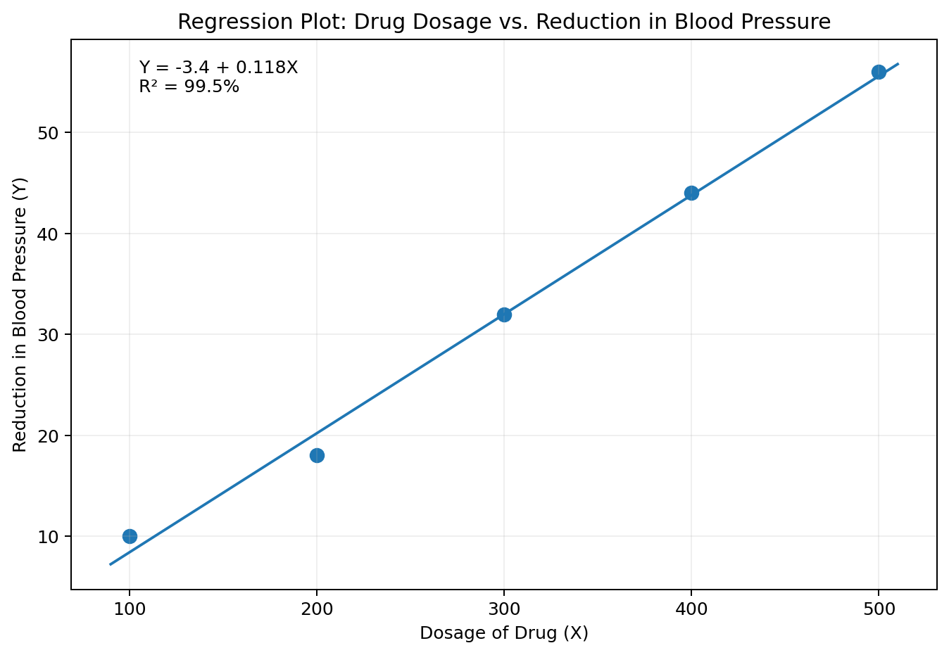
Regression Plot for Drug Dosage and Reduction in Blood Pressure
If R² is provided instead of r, take the square root of R² and use the sign of the slope to determine whether r is positive or negative.

Prediction Example
Predict reduction in blood pressure if dosage is 250.
$$Ŷ = −3.4 + .118(250) = 26.1$$

Automobile Weight and Gas Mileage
Weight, X (1000 lb) | Gas Mileage, Y (mpg)
2.5 | 40
3.0 | 43
4.0 | 30
3.5 | 35
2.7 | 42
4.5 | 19
3.8 | 32
2.9 | 39
5.0 | 15
2.2 | 44

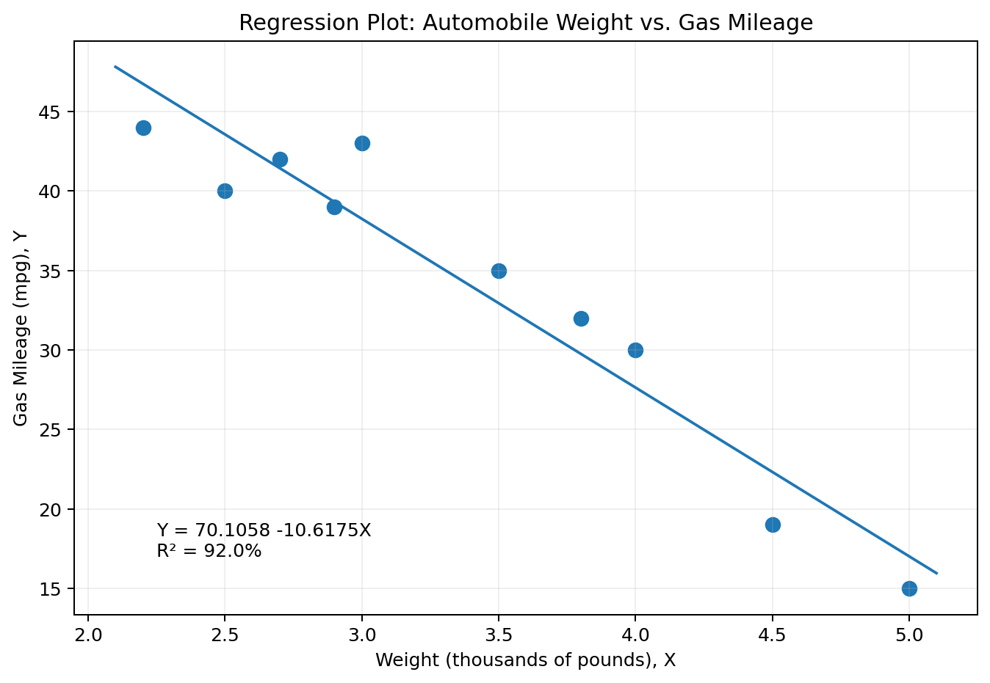
Regression Plot: Automobile Weight vs. Gas Mileage
$$R² = 92.0\%$$
$$Ŷ = 70.1058 − 10.6175X$$

Questions and Answers
1. Calculate r. Because the slope is negative:
$$r=−√(.92)≈−.959$$
2. Yes. Linear regression is justified because |r| ≥ .75 and the scatterplot is reasonably linear.
3. For a car weighing 4.2 thousand pounds:
$$Ŷ = 70.1058 − 10.6175(4.2) ≈ 25.512$$

Cautions with Regression
Interpolation — predicting Y for X values within the observed range.

Extrapolation — predicting Y for X values beyond the observed range. This should not be done with a basic regression model.

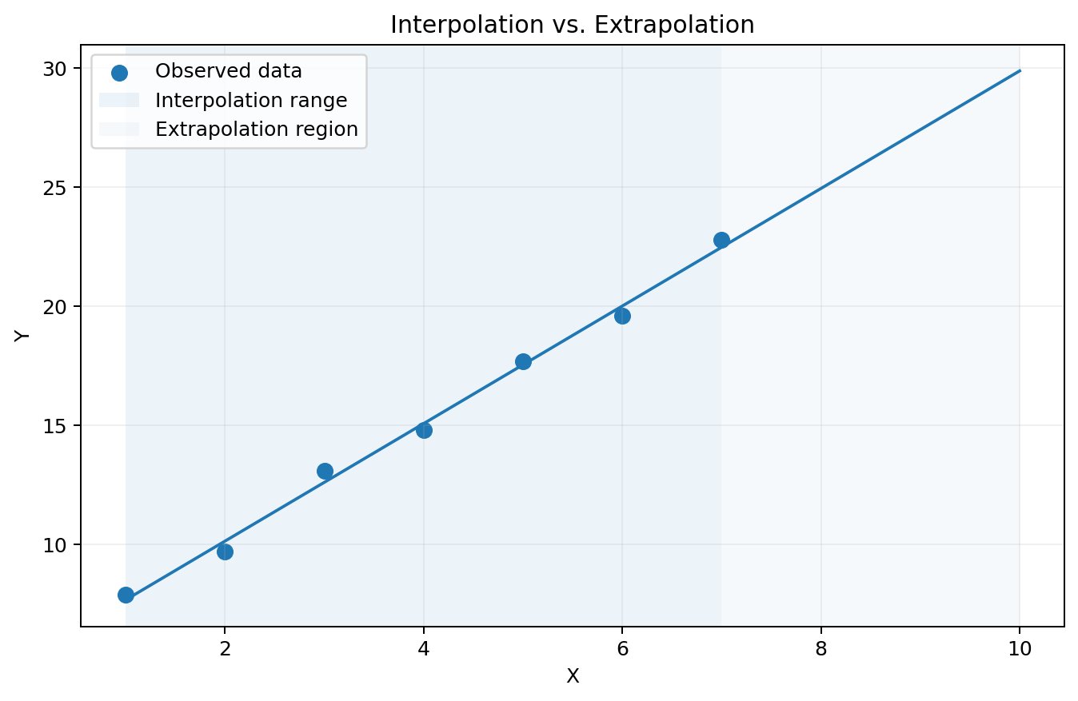
Interpolation vs. Extrapolation
In the drug example, X ranges from 100 to 500. Predicting within that range is reasonable. Predicting at X = 1000 assumes the relationship continues beyond the observed data.

Extreme Values Can Distort Regression
The least-squares line and r can be affected greatly by extreme data points. These two graphs recreate the teaching point because the original raw coordinates for the final example were not included in the extracted text.
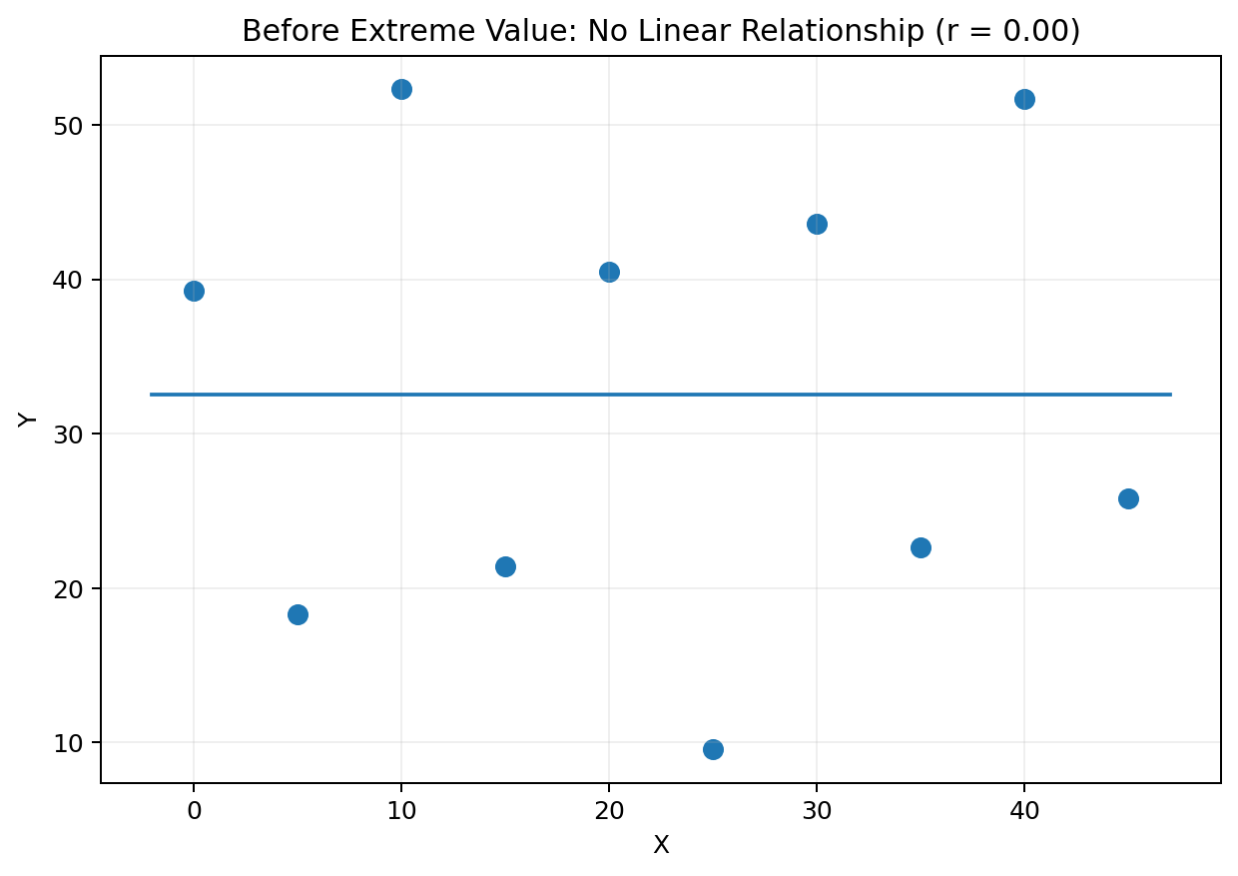
Before Adding an Extreme Value
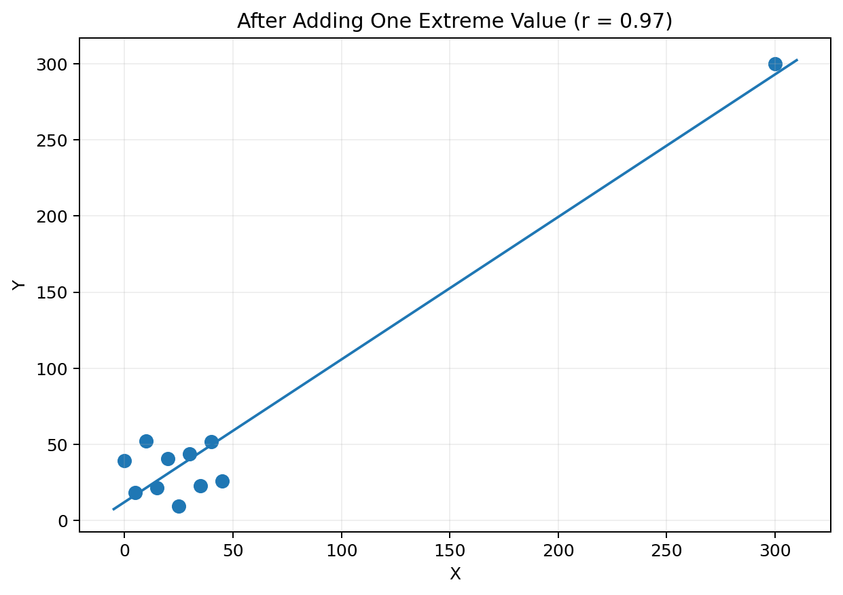
After Adding One Extreme Value
An influential extreme point can make the remaining observations look compressed and artificially close to a line. Remove an extreme value temporarily and check whether the relationship still exists before trusting the regression.

