STA210U — Statistics

II. Descriptive Statistics
C. Bivariate Data

In This Section
- Contingency Table (Cross Tabulation Table)
- Box and Whisker Plot
- Line Graph
- Scatter Plot

1. Contingency Table (Cross Tabulation Table)
Bivariate Data — two observations are made on each subject.

Examples
- Religious Preference and Political Preference
- Gender and Height
- Unemployment Rate and Year
- SAT Score and First Year College GPA
The decision of how to display the data depends on the number of variables—in this section, always two—and the type of those variables.
Contingency Table or Cross Tabulation Table — typically used to study the responses of two qualitative variables. Rows represent categories of the first variable and columns represent categories of the second variable.

With qualitative data, cells can contain frequencies or percentages. The first frequency cell below tells us that there are 5 male Liberal Arts majors.
Gender | Liberal Arts | Business Ad. | Technology | Row Total
Male | 5 | 6 | 7 | 18
Female | 6 | 4 | 2 | 12
Column Totals | 11 | 10 | 9 | 30

Percentages Based on Row Totals
The first cell tells us that 28% (5/18) of males are Liberal Arts majors.
Gender | Liberal Arts | Business Ad. | Technology | Row Total
Male | 28% | 33% | 39% | 100%
Female | 50% | 33% | 17% | 100%
Column Totals | 37% | 33% | 30% | 100%

Percentages Based on Column Totals
The first cell tells us that 45% (5/11) of Liberal Arts majors are male.
Gender | Liberal Arts | Business Ad. | Technology | Row Total
Male | 45% | 60% | 78% | 60%
Female | 55% | 40% | 22% | 40%
Column Totals | 100% | 100% | 100% | 100%

Percentages Based on Grand Total
The first cell tells us that 17% (5/30) of the people in the sample are both male and a Liberal Arts major.
Gender | Liberal Arts | Business Ad. | Technology | Row Total
Male | 17% | 20% | 23% | 60%
Female | 20% | 13% | 7% | 40%
Column Totals | 37% | 33% | 30% | 100%

2. Box and Whisker Plot
Box and whisker plots, also called boxplots, are used for bivariate data when one variable is qualitative and one is quantitative.
Group | Low | Q1 | Q2 (Median) | Q3 | High
Students | 0 | 1 | 5 | 7 | 10
Faculty | 10 | 15 | 25 | 31 | 73

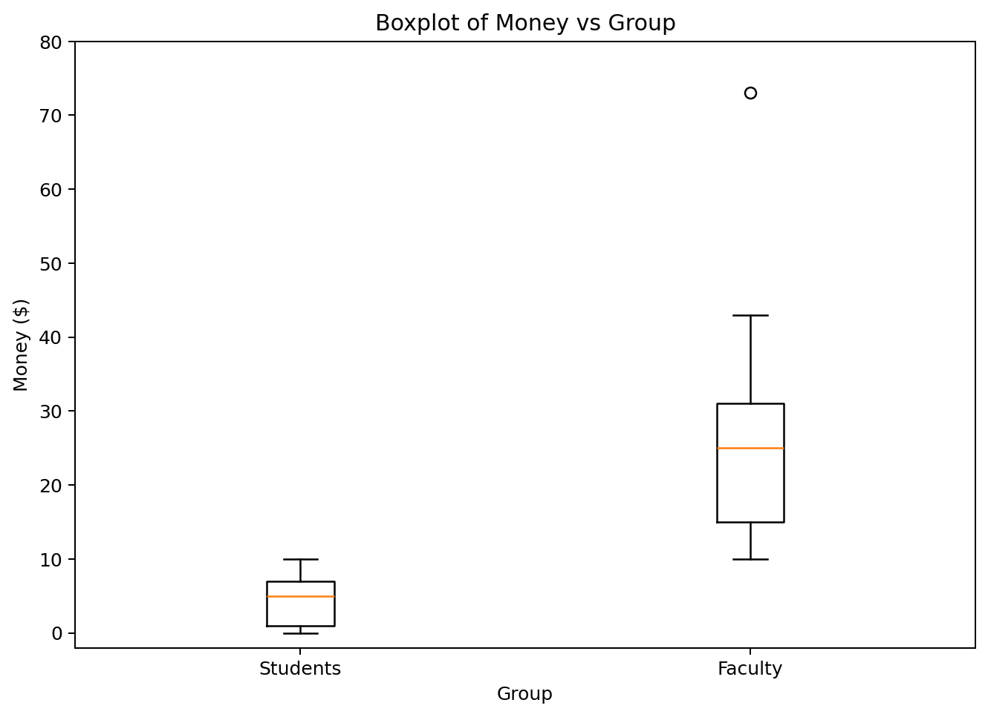
Boxplot of Money vs Group

Procedure for Creating a Box and Whisker Plot
- Draw a scale to include the lowest and highest data value.
- Draw a box from Q1 to Q3.
- Include a solid line through the box at the median level.
- If there are extreme values, identify them with an asterisk or dot.
- Draw whiskers from Q1 to the lowest non-extreme value and from Q3 to the highest non-extreme value.
For faculty, the box runs from Q1 = 15 to Q3 = 31, representing the middle 50% of the data. The median is Q2 = 25. The lower whisker reaches 10. Since 73 is an extreme value, it is plotted separately and the upper whisker reaches the next-highest value, 43.

Three Questions to Ask from a Boxplot
- Which group has the higher typical value?
- Which group has more or less variability?
- What is the shape of each distribution?
Faculty tended to have more money because their box and median are positioned higher. Students had more consistent values because their box is smaller and their whiskers are shorter.

Identifying Shape from Boxplots
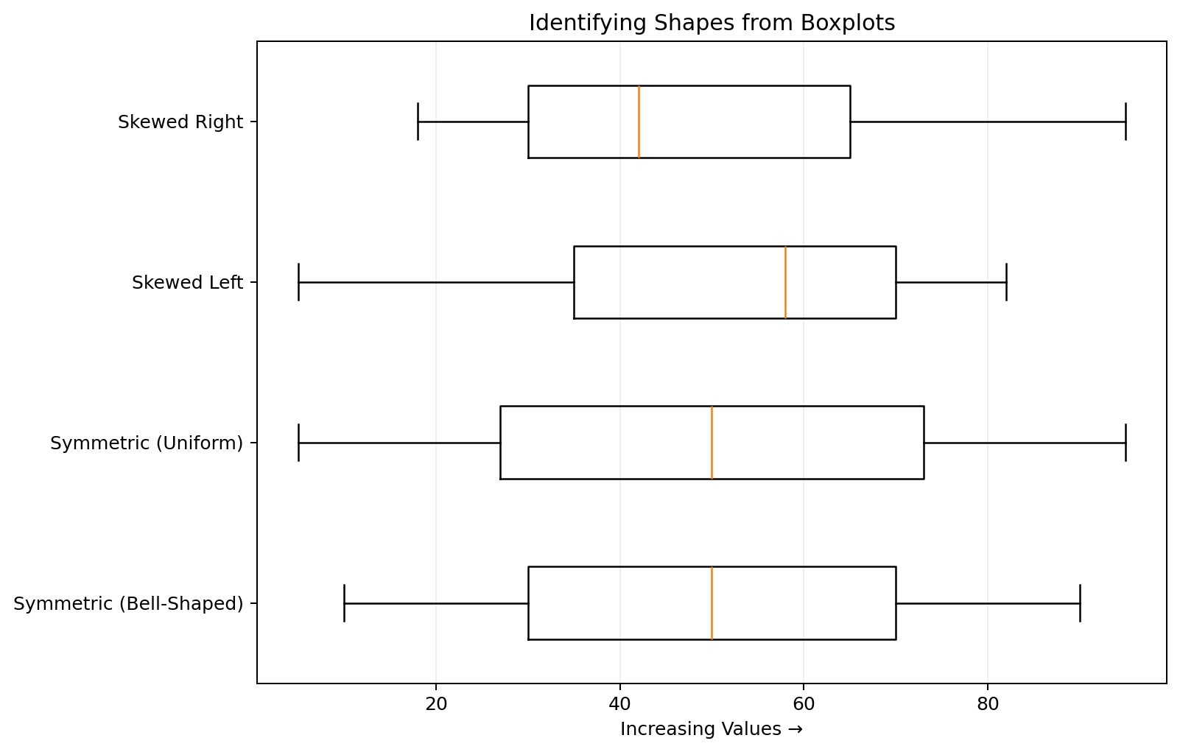
Identifying Shapes from Boxplots
For a symmetric distribution, the median is near the center of the box and the whiskers are similar in length. Both bell-shaped and uniform distributions can be symmetric. In a left-skewed distribution, the median is toward the higher-value side of the box and the lower-value whisker is longer. A right-skewed distribution is the opposite.

Stopping Distance and Tread Design
Qualitative variable: Tread Design (A, B, or C)
Quantitative variable: Stopping Distance
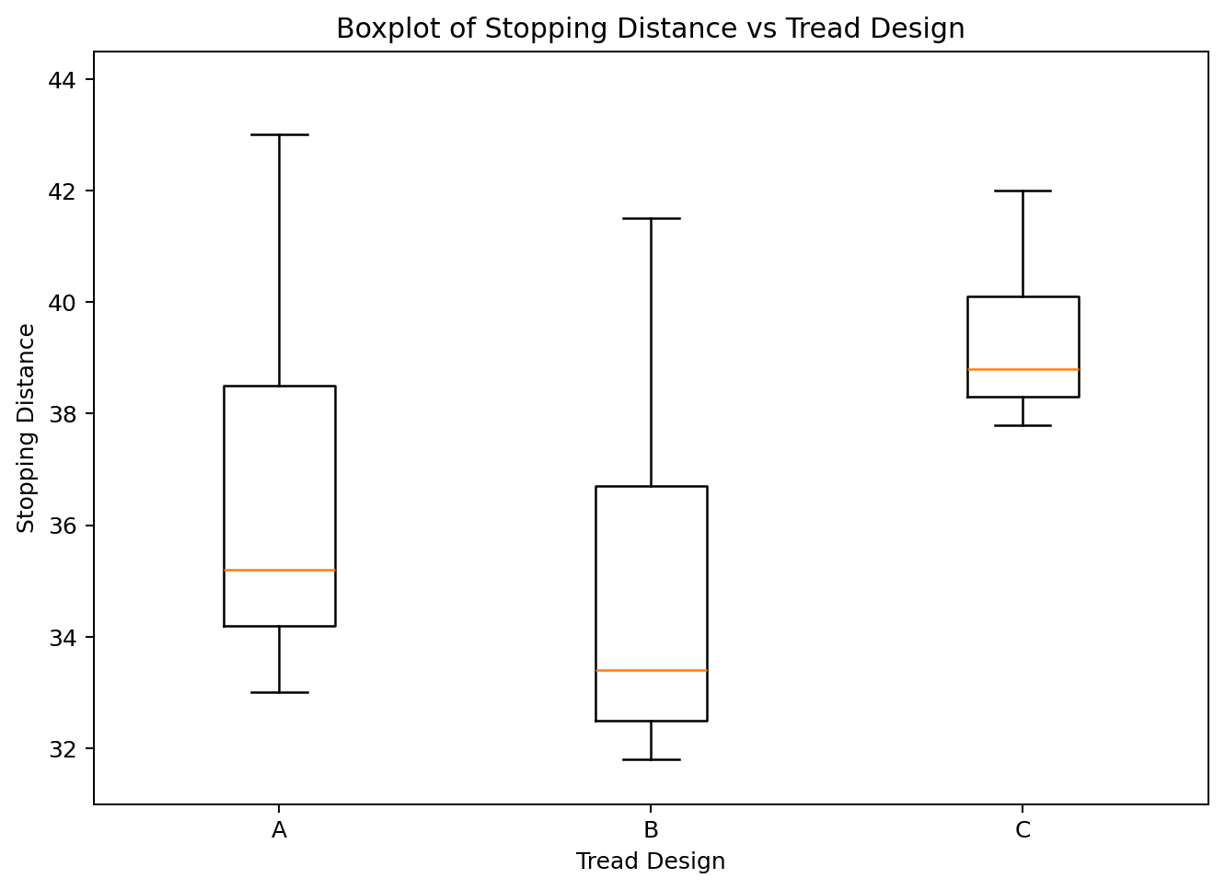
Boxplot of Stopping Distance vs Tread Design
- Best based on stopping distance: Tread design B, because lower stopping distances are better and its box and median are lower.
- Most consistent: Tread design C, because its box and whiskers are shortest.
- Shape: All three distributions are right skewed; the median is left of center and the upper/right tail is longer.

3. Line Graph
Line graphs, also called time plots, are typically used for bivariate data when one variable is quantitative and the other variable is time. The x-axis represents time and the y-axis represents the quantitative variable.

Example: Cell Phone Subscribers
Year | Subscribers (millions)
1990 | 0.9
1991 | 1.2
1992 | 2.1
1993 | 3.5
1994 | 5.3
1995 | 7.6
1996 | 11.0
1997 | 16.0
1998 | 24.1
1999 | 33.8
2000 | 44.0

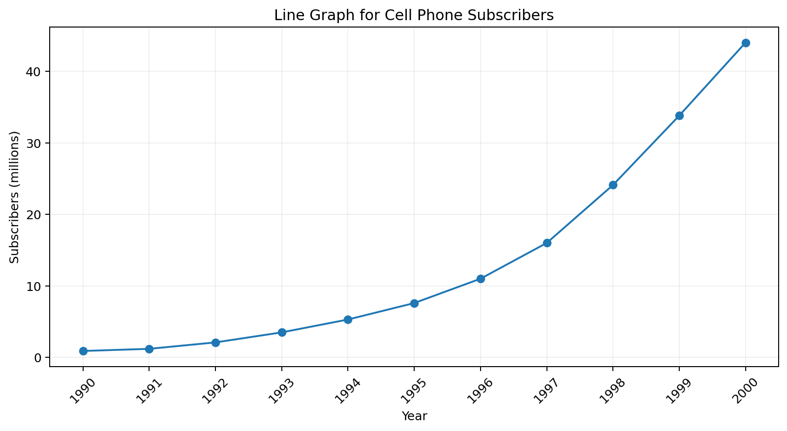
Line Graph for Cell Phone Subscribers
The main thing we typically look for in a line graph is the pattern. In this example there is a clear increasing pattern over time; technically, the number of subscribers is increasing exponentially.
Time Series — a record of a variable over time.

Trend — a steady change over time. A graph with trend will be increasing or decreasing.

Seasonal Component — a pattern in which a variable tends to be higher at certain recurring points in time and lower at others.

Irregular Cycles — increases or decreases that can be explained but do not follow a recurring pattern.

Random Fluctuation — fluctuation not accounted for by trend, seasonality, or irregular cycles.

You will be expected to identify trend and seasonal variation from a graph. Random fluctuation can be assumed to be present in essentially every time series.
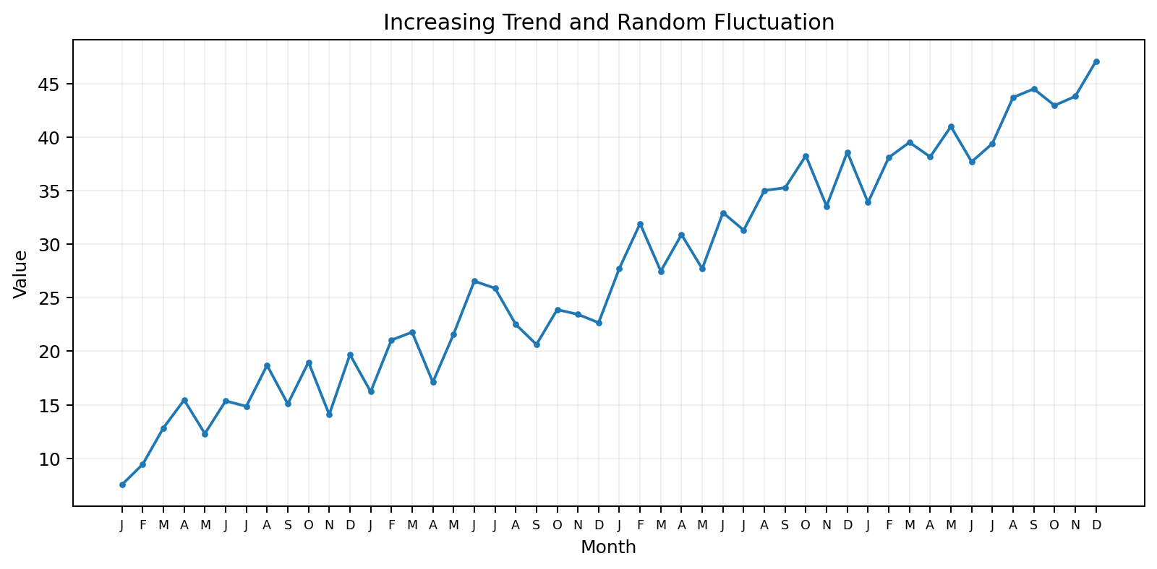
Increasing Trend and Random Fluctuation
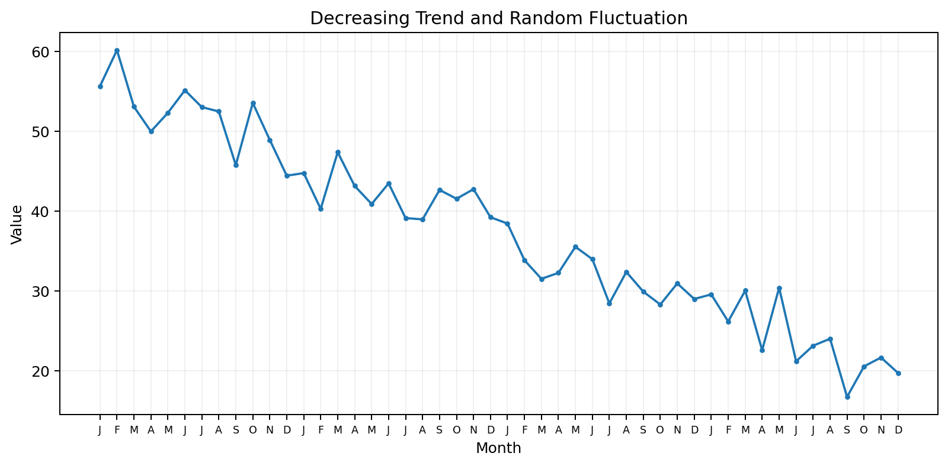
Decreasing Trend and Random Fluctuation
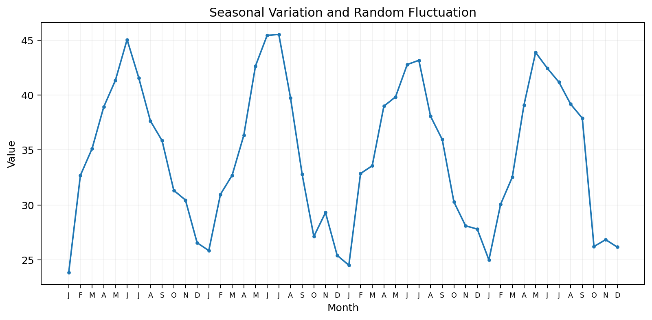
Seasonal Variation and Random Fluctuation
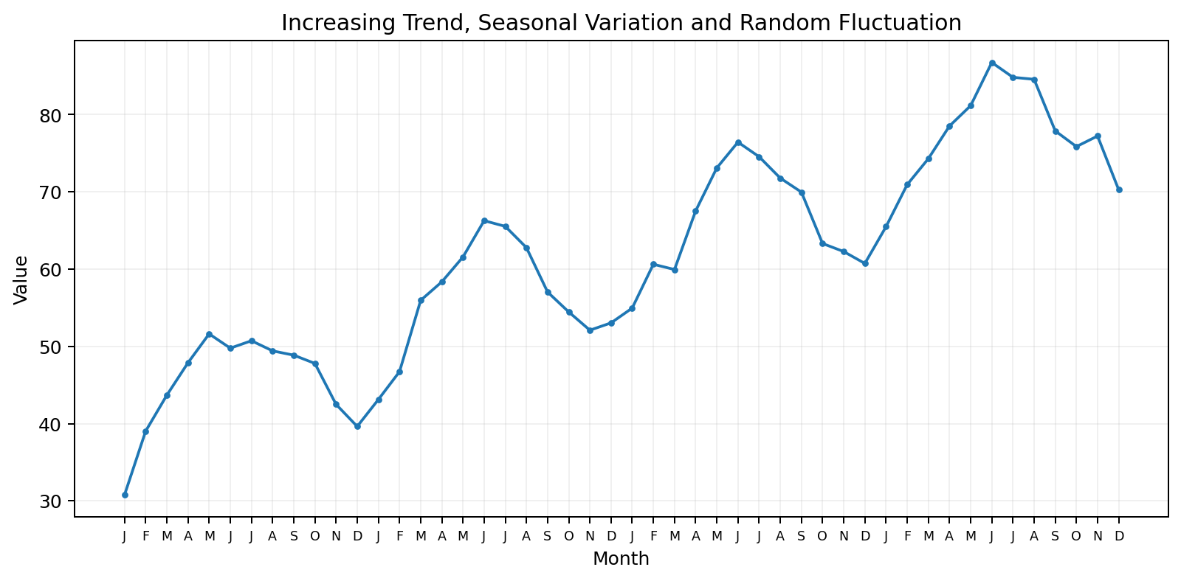
Increasing Trend, Seasonal Variation and Random Fluctuation
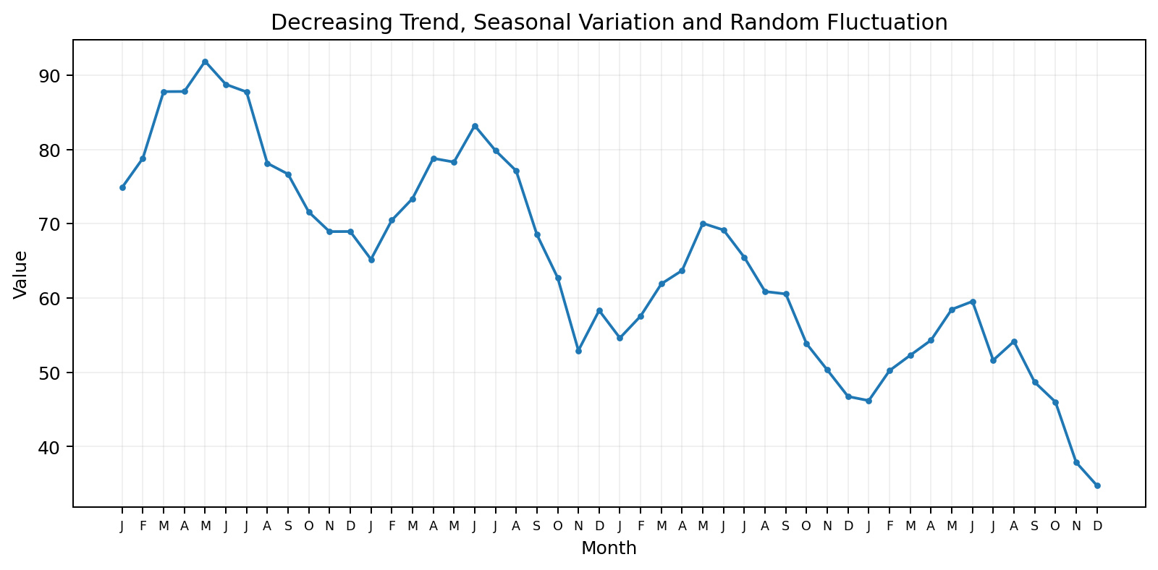
Decreasing Trend, Seasonal Variation and Random Fluctuation
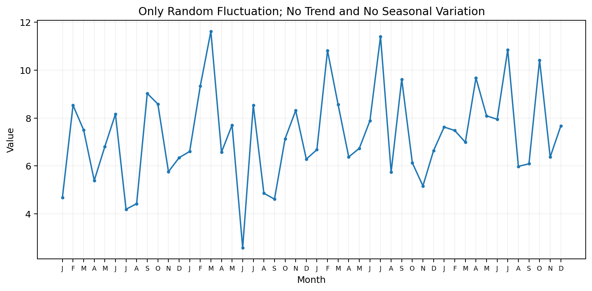
Only Random Fluctuation; No Trend and No Seasonal Variation

4. Scatter Plot
Scatter Plot or Scatter Diagram — displays the relationship between two quantitative variables.

- X-axis: independent variable or explanatory variable.
- Y-axis: dependent variable or response variable.
A scatter plot is set up similarly to graphing in algebra, but there is usually not a perfect pattern and the points should not be connected. We look for a pattern in the cloud of data points.
Correlation — an association or relationship between two variables.

Example: Drug Dosage and Reduction in Blood Pressure
Reduction in blood pressure is the Y variable because it depends on the dosage of the drug. Dosage is the X variable.
Dosage of Drug (X) | Reduction in Blood Pressure (Y)
100 | 10
200 | 18
300 | 32
400 | 44
500 | 56

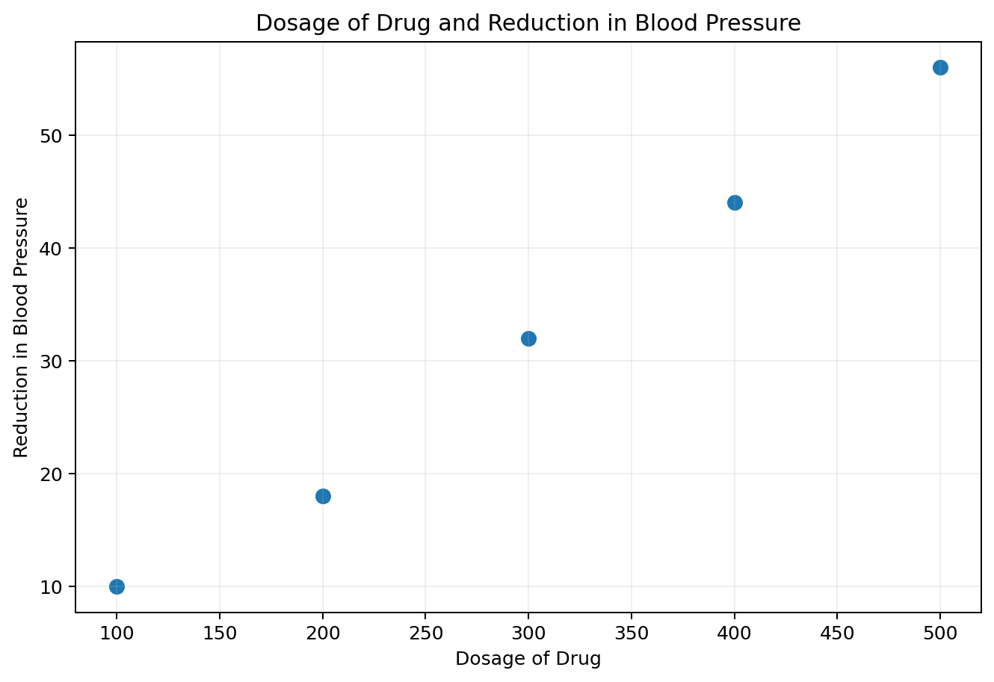
Dosage of Drug and Reduction in Blood Pressure
As dosage increases, reduction in blood pressure also increases. This is a positive relationship.

Identifying Correlation Graphically
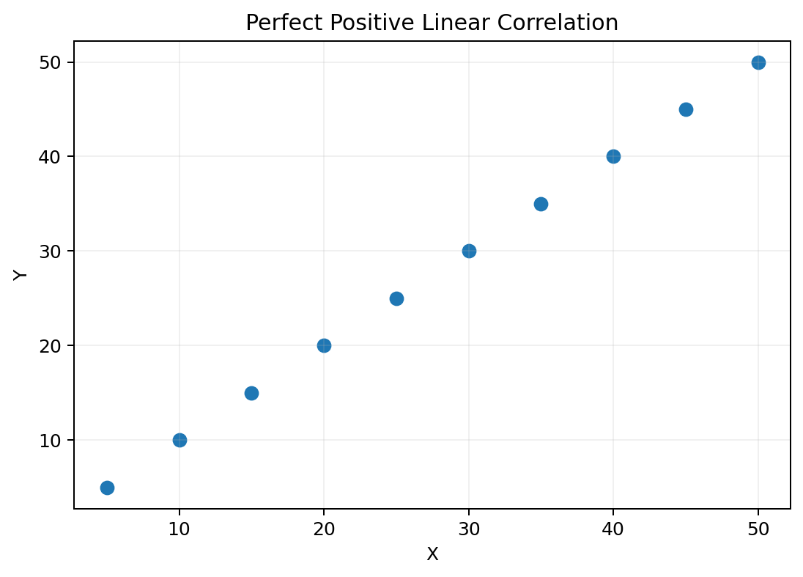
Perfect Positive Linear Correlation
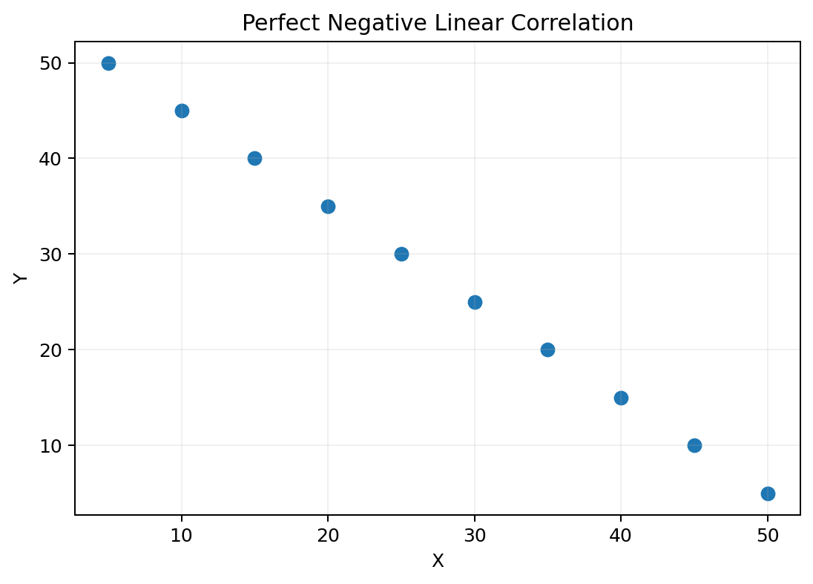
Perfect Negative Linear Correlation
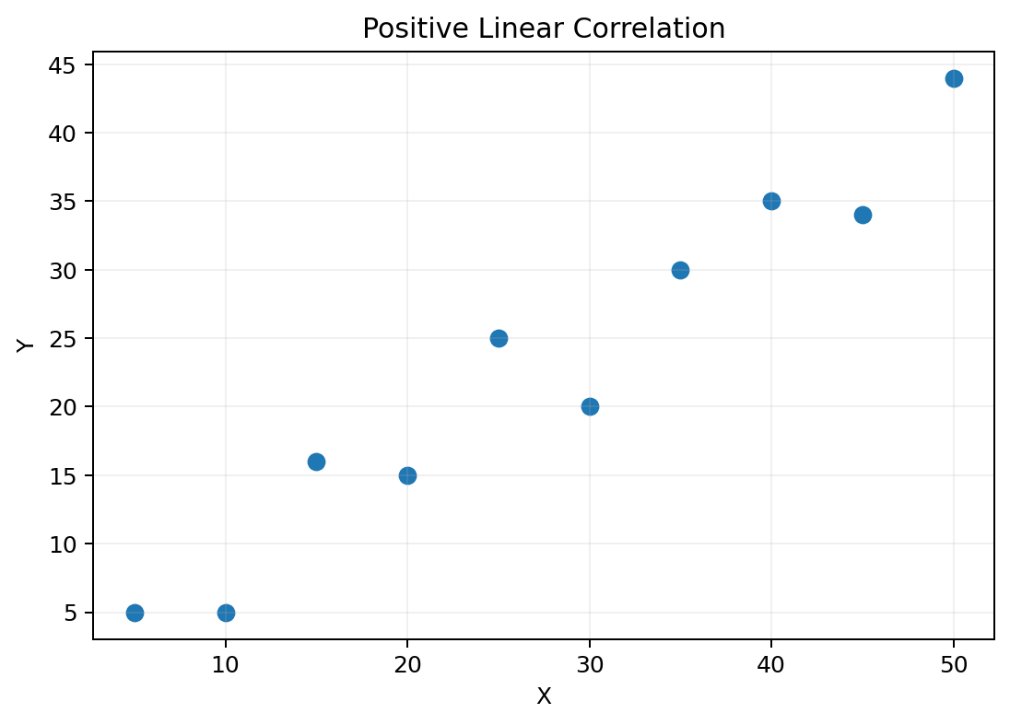
Positive Linear Correlation
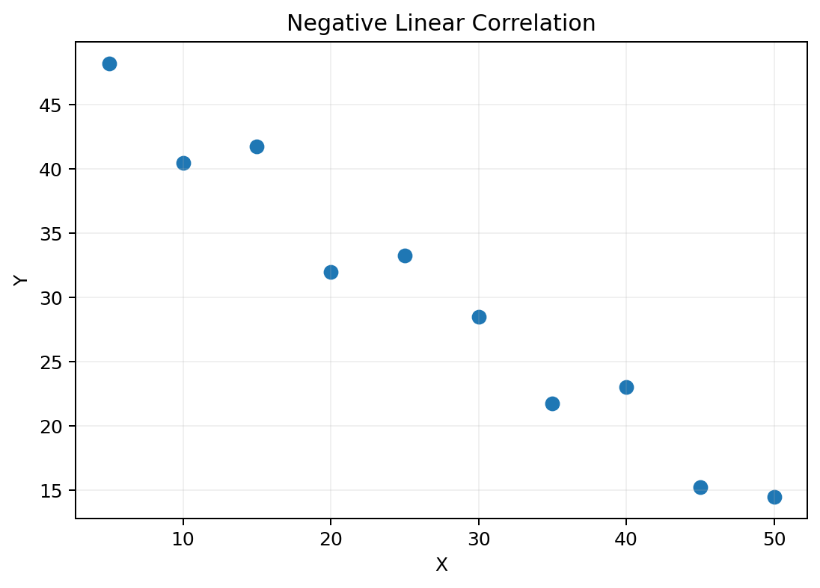
Negative Linear Correlation
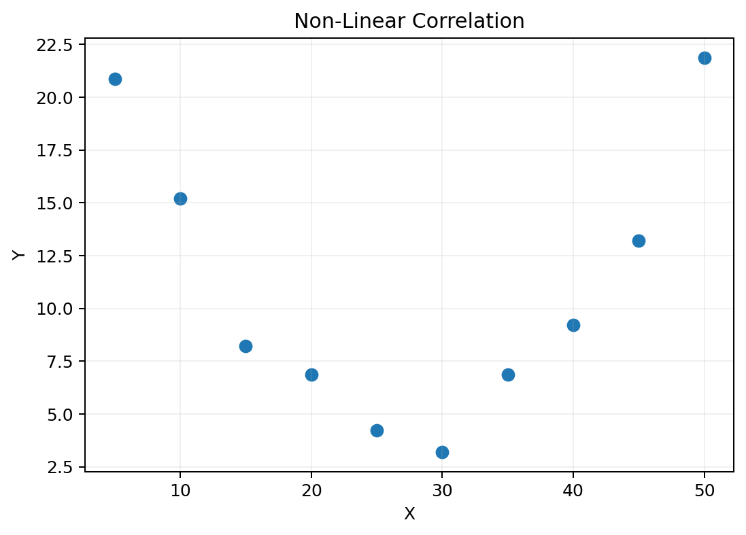
Non-Linear Correlation
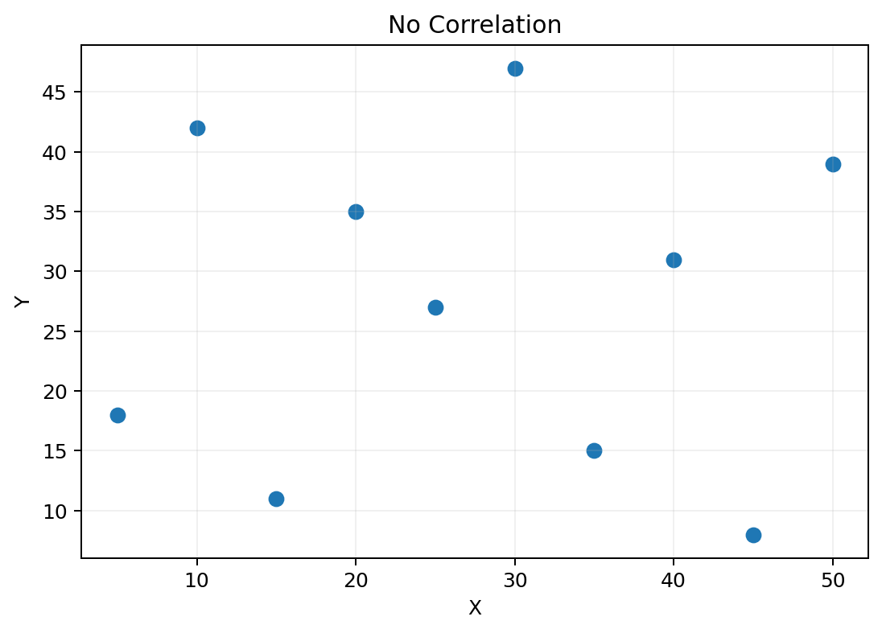
No Correlation
- Perfect positive linear correlation: all points lie exactly on a line with positive slope.
- Perfect negative linear correlation: all points lie exactly on a line with negative slope.
- Positive linear correlation: points follow an approximate line with positive slope.
- Negative linear correlation: points follow an approximate line with negative slope.
- Non-linear correlation: there is a pattern, but it is not linear.
- No correlation: there is no visible pattern or relationship.

