STA296U
Section 4: Probability
NOTES

Counting Rules
Before we discuss probability, some basic counting principles and the idea of factorials will be introduced. These concepts are useful at times when identifying the number of outcomes in an experiment and when probabilities are calculated.
Example
a. How many different ways are there to arrange the 6 letters in the word SUNDAY?
b. Suppose you have a lock with a three digit code. Each digit is a number 0 through 9. How many possible codes are there?
Answers
a. In this case we have 6 distinct letters. First, create a space for each letter (6 spaces). Next, fill in the spaces with the number of options from left to right. The first space has 6 options since any letter can go in that space. The second space has 5 options since one letter is already in the first space. Continue this pattern and then multiply to get the number of arrangements as seen below.
6 · 5 · 4 · 3 · 2 · 1 = 720
b. In this case we will have three spaces, one for each digit of the code. The first space has 10 options since it can be any number 0 to 9. Here, the second digit of the code can be the same as the first so the second space also has 10 options. Once the spaces are filled, multiply to get the number of possible codes.
10 · 10 · 10 = 10³ = 1000
Factorial - the product of an integer and all the integers below it

The symbol n!, read as “n factorial” is computed as follows:
0! = 1
1! = 1
2! = 2 · 1 = 2
3! = 3 · 2 · 1 = 6
4! = 4 · 3 · 2 · 1 = 24
and so on
Example
Evaluate each expression
a. 5! / 2!
b. 9! / 8!
c. 8! / (2! · 6!)
Answers
When simplifying expressions that include factorials, it is beneficial to rewrite the factorials so that you can cancel. Each of the simplifications below illustrate this idea.
a. 5! / 2! = (5 · 4 · 3 · 2!) / 2! = 5 · 4 · 3 = 60
b. 9! / 8! = (9 · 8!) / 8! = 9
c. 8! / (2! · 6!) = (8 · 7 · 6!) / (2 · 1 · 6!) = (8 · 7)/(2 · 1) = 4 · 7 = 28
Permutation - Ordered arrangements of distinct objects are called permutations. (order matters)

If we wish to know the number of r permutations of n distinct objects, it is denoted as
nPᵣ = n! / (n - r)!
Example
In how many ways can you select a president, vice president, treasurer, and secretary from a group of 10?
Answers
Notice here that order matters because person A being president and person B being vice-president is different.
10P₄ = 10! / (10 - 4)! = 10! / 6! = 10 · 9 · 8 · 7 = 5040
Combination - Unordered selections of distinct objects are called combinations. (order does not matter)

If we wish to know the number of r combinations of n distinct objects, it is denoted as
nCᵣ = n! / [r!(n - r)!]
Example
In how many ways can a committee of 5 senators be selected from a group of 8 senators?
Answers
Here order does not matter because it is a committee. It does not matter what order people are selected, it just matters which 5 people are on the committee
8C₅ = 8! / [5!(8 - 5)!] = 8! / (5!3!) = (8 · 7 · 6)/(3 · 2) = 8 · 7 = 56

Events, Sample Spaces, and Probability
Sample Space - the set of all possible outcomes from an experiment

Example
Identify the sample space for each of the following
a. Flip a coin
b. Roll a die
c. Measure heights of random people
Answers
a. sample space = {H, T}
b. sample space = {1, 2, 3, 4, 5, 6}
c. sample space = {height of shortest person to height of tallest person}
The above example illustrates a common way to denote a sample space. Notice that when you flip a coin you get a qualitative variable and when you roll a die you get a discrete quantitative variable. These are the types of variables we will deal with to introduce the basic ideas of probability in this section. In these cases, each outcome of the experiment can be listed using set notation as seen above. Feel free to abbreviate when appropriate as I did for the coin flip (H for head and T for tails). Notice when you measure the heights of random people, you get a continuous quantitative variable. In the case of continuous variables the outcomes cannot be listed because there is an infinite number of possible outcomes. Therefore, the sample space is represented as an interval. Probability for continuous random variables will be dealt with in later sections.
Event - a subset of the sample space

Example
Suppose you roll a die and event A is defined by getting an even number. We would represent this event as:
A = {2,4,6}
An event is said to occur when any outcome in the event occurs. Thus, if the Die is a 2 (or 4 or 6) in the example above, then event A has occurred.
Probability (of an event A) - denoted P(A), is the expected proportion of occurrences of A if the experiment were performed a large number of times (keep in mind A is just an example, we could call the event whatever we wanted)

Probability of an event = # of outcomes in the event / Total # of outcomes
Tree diagram - useful for determining a sample space when there is a series of operations

Example
Flip a Penny, Nickel, and a Dime
a. How many possible outcomes are there?
b. Identify the sample space.
c. Suppose A is the event of getting all three tails. Identify A. What is P(A)?
d. Suppose B is the event of getting exactly two tails. Identify B. What is P(B)?
e. Suppose C is the event of getting exactly one tail. Identify C. What is P(C)?
f. Suppose D is the event of getting no tails. Identify D. What is P(D)?
Answers
a. Use the counting principles introduced earlier. There are three operations (spaces to fill) and each has two possible outcomes (H or T).
2 · 2 · 2 = 8 possible outcomes
b. Tree diagram
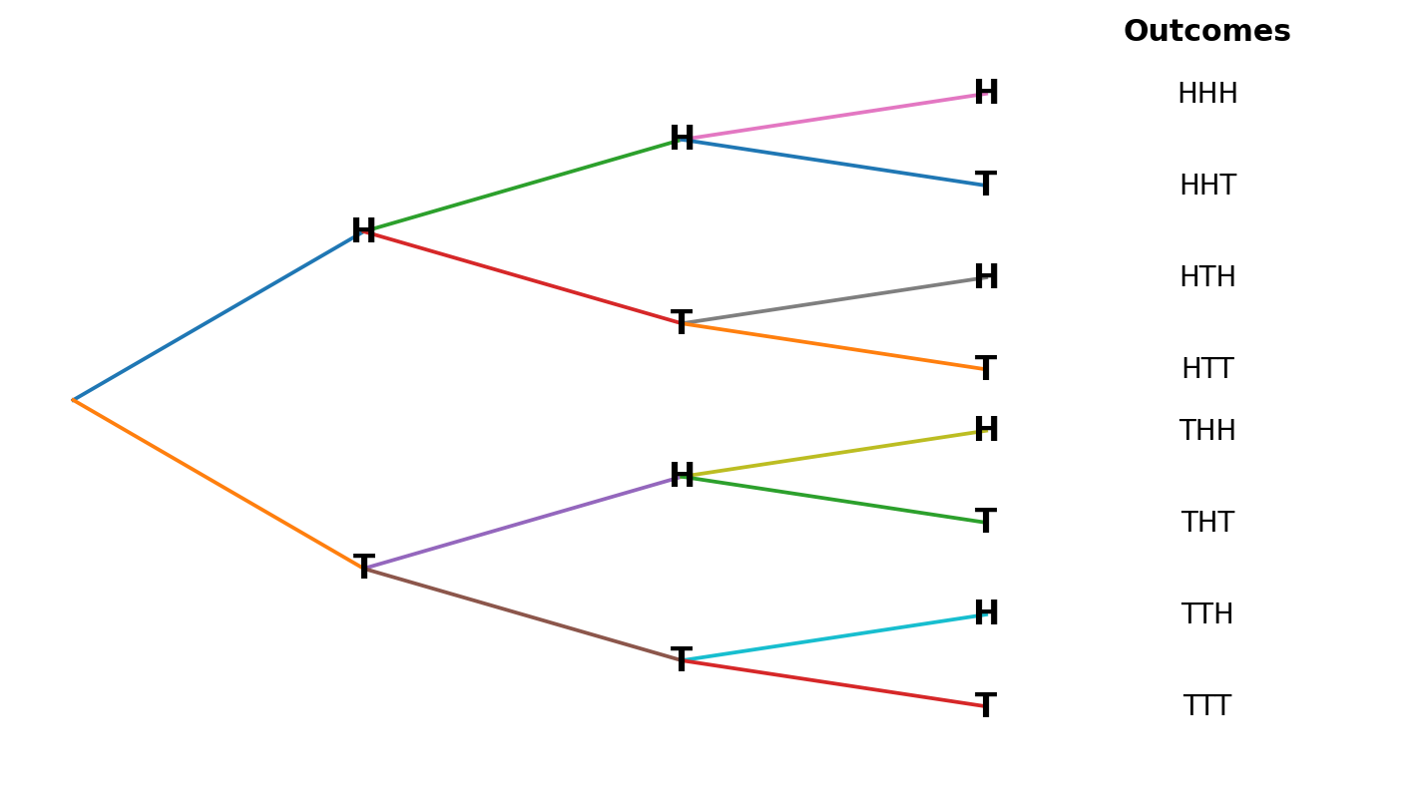
sample space = {HHH, HHT, HTH, HTT, THH, THT, TTH, TTT}
c. A = {TTT}
P(A) = 1/8 = 0.125
d. B = {HTT, THT, TTH}
P(B) = 3/8 = 0.375
e. C = {HHT, HTH, THH}
P(C) = 3/8 = 0.375
f. D = {HHH}
P(D) = 1/8 = 0.125
Characteristics of probability
- 0 ≤ P(A) ≤ 1 for any event A (all probabilities must be between 0 and 1)
- P(sample space) = 1 (the probability of getting an element from the sample space is always 1)
- The higher a probability (closer to 1), the more likely the event

Types of Probability
Simple Probability - the probability of an event

Joint Probability - an event that has two or more characteristics (event is created with a union or intersection)

The intersection of two events, denoted A ∩ B, is the event composed of outcomes from A and B. In other words, if both A and B occur, then it is said that A ∩ B occurred.
We say the events A and B are mutually exclusive or disjoint if they cannot occur together. When P(A ∩ B) = 0
The union of two events, denoted A ∪ B, is the event composed of outcomes from A or B. In other words, if A occurs, B occurs, or both A and B occur, then it is said that A ∪ B occurred.
The addition rule
P(A ∪ B) = P(A) + P(B) - P(A ∩ B)
If A and B are mutually exclusive, the last term of the addition rule is zero
Complement (of an event A) - denoted A̅, Aᶜ, or A′, is all sample points not in A

The complement rule
P(A̅) = 1 - P(A)
Conditional Probability (A conditioned on B) - denoted P(A|B), is when we are interested in knowing if event A occurred given that we know event B occurred

The conditional probability rule for A given B
P(A|B) = P(A ∩ B) / P(B)
Example
Roll a balanced green die and red die. Three events are defined below. Find the identified probabilities.
A = {sum of the dice is 7}
B = {both numbers ≤ 4}
C = {green die is 1}
We will look at the sample space in table form to illustrate the different types of probabilities introduced in this section. Also, the reasoning and application of the rules above will be demonstrated. We will first identify each event which is done in the three tables below. Notice when looking at the table, the outcomes are denoted as ordered pairs, (Green die, Red die). The highlights match each event.
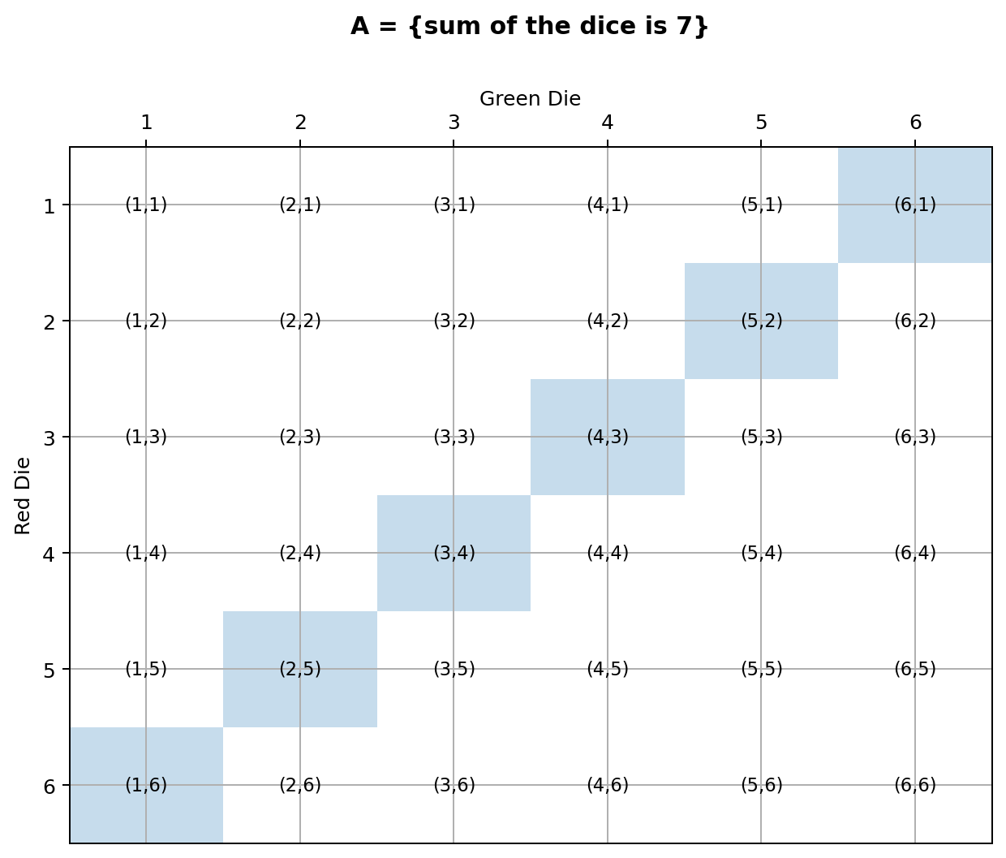
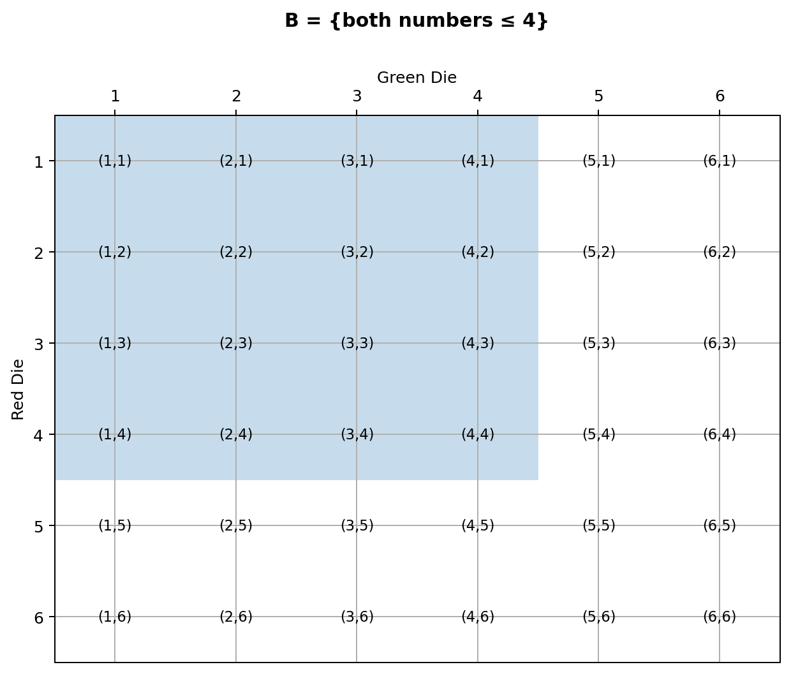
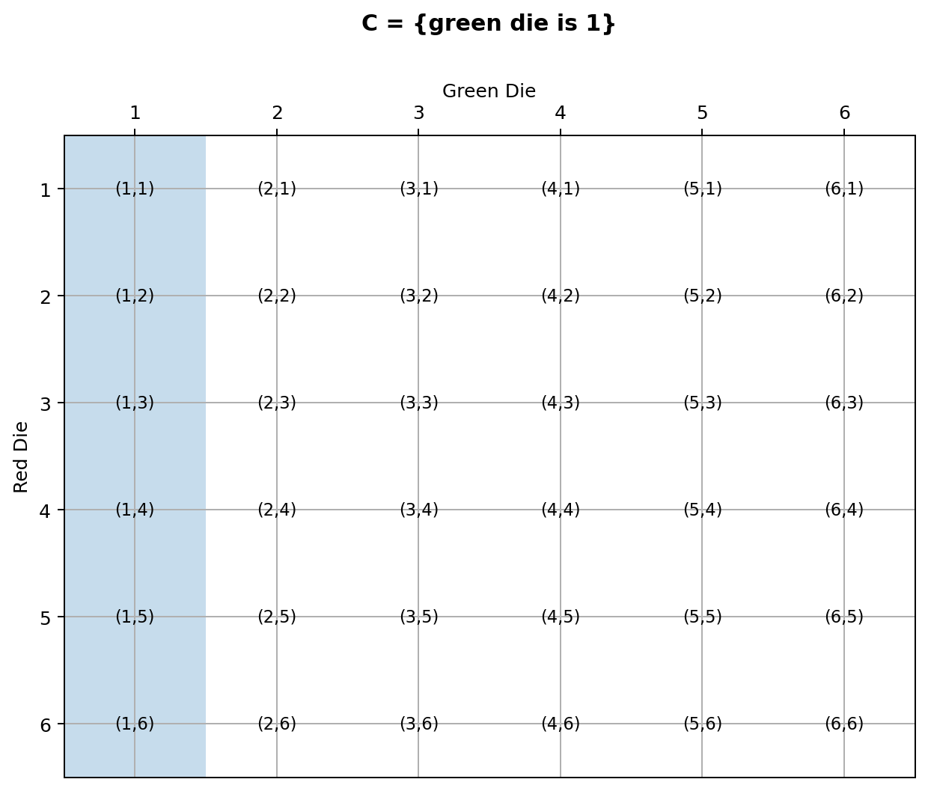

Simple Probabilities
Probability is the number of outcomes in the event over the total number of outcomes. In this scenario, there are 6 outcomes in event A and 36 outcomes in the sample space.
P(A) = 6/36 = 0.167
P(B) = 16/36 = 0.444
P(C) = 6/36 = 0.167

Intersections
Dealing with the intersection is like the simple probabilities except now the numerator is the number of elements that satisfy the intersection. The denominator is still the total number of outcomes. In this scenario, there are two outcomes, (3, 4) and (4, 3) that satisfy both A and B out of the 36 outcomes.
P(A ∩ B) = 2/36 = 0.056
P(A ∩ C) = 1/36 = 0.028
P(B ∩ C) = 4/36 = 0.111
It is important to note that finding P(B ∩ A) is the same as finding the P(A ∩ B). Either way you are finding the intersection of A and B.

Unions
When finding probability for a union, you have two options. You can use the sample space or this is commonly where the addition rule would be utilized. If using the sample space, you must be careful to not count the overlap twice. In this scenario, if you just add the 6 elements in event A with the 16 elements in event B you will not get the number of elements in the union. This is because there are two elements in both (the intersection) so you are counting these two elements twice. You must subtract this out which gives you the 20 elements in the union of A and B. If you look at the addition rule, you can see it works by adding the elements and then subtracting out the overlap.
P(A ∪ B) = 6/36 + 16/36 - 2/36 = 20/36 = 0.556
P(A ∪ C) = 6/36 + 6/36 - 1/36 = 11/36 = 0.306
P(B ∪ C) = 16/36 + 6/36 - 4/36 = 18/36 = 0.5
Just like with the intersection, the order of the union does not matter. The P(B ∪ A) is the same as P(A ∪ B).

Complements
The complement of an event is a simple but important idea. This is because sometimes it is easier to find the complement than the event itself. Since we know the total probability in any sample space is 1, we know the probability an event and its complement must sum to 1. So, it is easy to find the complement of a probability by subtracting from 1 (complement rule). In this scenario, if there are 6 elements in A then there are 30 elements not in A. Divide by 36 and you get the probability of the complement.
P(A̅) = 1 - P(A) = 1 - 6/36 = 30/36 = 0.833
P(B̅) = 1 - P(B) = 1 - 16/36 = 20/36 = 0.556
P(C̅) = 1 - P(C) = 1 - 6/36 = 30/36 = 0.833

Conditional Probabilities
Notice that all of the probabilities we have done so far has a denominator based on the number of elements in the sample space. This is always true except when dealing with a conditional probability. The condition changes the denominator. Therefore, you should always start with the condition and determine the denominator. Then out of the elements in the denominator ask how many satisfy the event of interest. In this scenario to find the probability of A given B, you start with the condition B. There are 16 elements in B so that is your denominator. Then out of the 16 elements, two are in A so the numerator is 2. Of course, you can also use the conditional probability rule which does the same thing. It puts the condition in the denominator and the overlap in the numerator.
P(A|B) = (2/36)/(16/36) = 2/16 = 0.125
P(B|A) = (2/36)/(6/36) = 2/6 = 0.333
P(A|C) = (1/36)/(6/36) = 1/6 = 0.167
P(C|A) = (1/36)/(6/36) = 1/6 = 0.167
P(B|C) = (4/36)/(6/36) = 4/6 = 0.667
P(C|B) = (4/36)/(16/36) = 4/16 = 0.25
Notice that for conditional probability the order matters because the denominator is based on the condition. So, typically, P(A|B) ≠ P(B|A). The only time these would be equal is when event A and event B have the same number of elements in them.
Sometimes it is necessary to use frequencies rather than outcomes to find probability. The idea of probability, however, is still the same. We take the number that satisfies the event over the total number.
Example
Select an individual at random from a population of drivers classified by gender and number of traffic tickets
 | 0 tickets | 1 ticket | 2 tickets | 3 or more tickets | Total
Female | 1192 | 321 | 72 | 15 | 1600
Male | 695 | 487 | 141 | 77 | 1400
Total | 1887 | 808 | 213 | 92 | 3000
Find each probability using events A and B below.
A = {selected driver is female}
B = {selected driver has at least 2 tickets}
a. P(A)
b. P(B)
c. P(A ∩ B)
d. P(A ∪ B)
e. P(A̅)
f. P(A|B)
Answers
a. P(A) = 1600/3000 = 0.53333
b. P(B) = (213 + 92)/3000 = 305/3000 = 0.10167
c. P(A ∩ B) = (72 + 15)/3000 = 87/3000 = 0.029
d. P(A ∪ B) = 0.53333 + 0.10167 - 0.029 = 0.606
e. P(A̅) = 1 - 0.53333 = 0.46667
f. P(A|B) = 0.029/0.10167 = 0.28524
Independent - two events are said to be independent if the occurrence (or nonoccurrence) of one does not affect the probability of occurrence of the other

If P(A) = P(A|B) then A and B are independent. Thinking about this relationship, we see that when given B, the probability of A has not changed from its original value. Or in other words, B occurring does not affect the probability of A.
Dependent - events that are not independent

If P(A) ≠ P(A|B) then A and B are dependent
Sometimes we perform a series of operations and want to know the probability that all of them have certain outcomes. The multiplication rule is utilized in these situations.
Multiplication rule - P(A ∩ B) = P(A)P(B|A)

The multiplication rule basically states that when you have a series of operations, you take the probability of the first, times the probability of the second, times the probability of the third (if there is a third), and so on. This is really not a new rule, it is just an algebraic manipulation of the conditional probability rule. If you take P(B|A) = P(A ∩ B)/P(A) and solve it for P(A ∩ B), you will get the multiplication rule.
Example
Suppose we are dealing with a standard deck of cards (52 cards and 4 aces). We will draw two cards without replacement (meaning after the first card is drawn, it will not be put back in the deck before drawing the second card).
A = {first card is an ace} B = {second card is an ace}
a. In this scenario are A and B dependent or independent?
b. Find the probability that both cards are an ace, P(A ∩ B)
Suppose we change the scenario and return the first card, thoroughly shuffle the deck, and then draw the second card. (draw with replacement)
c. With this change are A and B dependent or independent?
d. Find the probability that both cards are an ace, P(A ∩ B)
Answers
a. A and B are dependent. If the first card is an ace then the probability the second card is an ace is 3/51 but if the first card is not an ace then the probability the second card is an ace is 4/51. The probability of B depends on A.
b. Multiplication rule P(A ∩ B) = P(A) · P(B|A) = (4/52)(3/51) = 0.004525
c. A and B are independent. No matter what happens with the first draw, the probability the second card is an ace is 4/52. The probability of B does not depend on A.
d. P(A ∩ B) = P(A) · P(B|A) = (4/52)(4/52) = 0.00591
Example
Ask random person ‘live in the city?’ & ‘favor combining city and county government?’
C = {lives in the city}
F = {favors combining city and county government}
 | Favor (F) | Oppose | Total
City (C) | 80 | 40 | 120
Outside | 20 | 10 | 30
Total | 100 | 50 | 150
Find the following.
a. P(F)
b. P(C)
c. P(F ∩ C)
d. P(F ∪ C)
e. P(F̅)
f. P(C̅)
g. P(F|C)
h. Does living in the city have an effect on whether someone favors combining city and county government (are F and C dependent or independent)?
Answers
a. P(F) = 100/150 = 0.667
b. P(C) = 120/150 = 0.8
c. P(F ∩ C) = 80/150 = 0.533
d. P(F ∪ C) = P(F) + P(C) - P(F ∩ C) = 140/150 = 0.933
e. P(F̅) = 1 - P(F) = 50/150 = 0.333
f. P(C̅) = 1 - P(C) = 30/150 = 0.2
g. P(F|C) = P(F ∩ C)/P(C) = 80/120 = 0.667
h. No, living in the city does not have an effect on whether someone favors combining city and county government. We know that F and C are independent because P(F|C) = P(F). In these types of problems make sure you check to see if the probabilities are equal. If the numbers were different in the table here, the answer to this question could change.

