Workshop Output

Ian, Laura and Sylvain

27 February 2020

## Conception per 1,000 in Greater Manchester

This was a nightmare. We were going to do a shiny. Massive soz.

### Figure 1

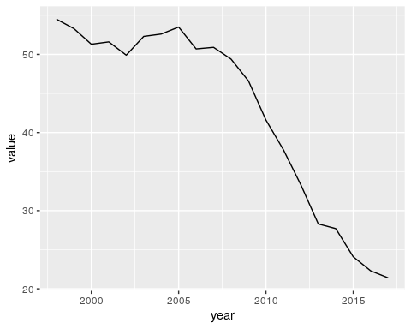

Thats quite a drop! Lets have a look as a map

### Figure 2

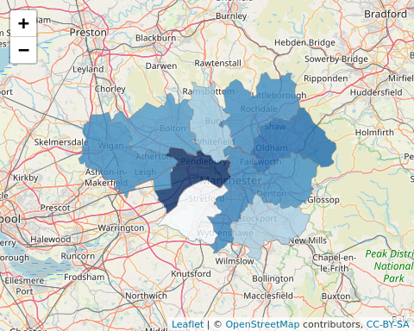

Again we’re really sorry.

We did our best x