Football is a team sport, and in order to win, players must cooperate with each other. Studying passing between players may help to quantitatively describe the level of teamwork and coordination in a team. To this end, a passing network data model has been established.

## Model

A network can be defined for any team's passing within a certain period of time in each game, where players serve as nodes, passes between players serve as edges, and the weight of each edge is determined by the number of successful passes between the two players.

By studying the network, the strategy and passing tactics of the team can be analyzed.

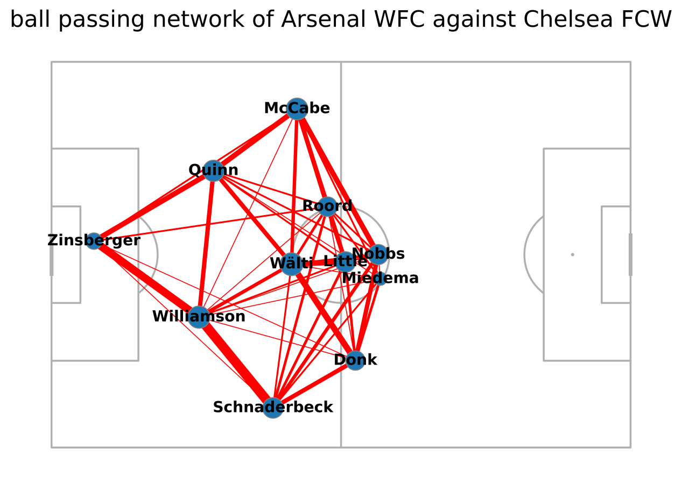

It is worth noting that during the match, there were instances of player substitutions. As the primary focus of study is the network, the data in the matrix only takes into account the match time before the first player substitution occurred. This is because the data of the new players after the substitution couguld potentially cause unexpected changes in the network and mess it up.

This image is a network visualization of 's (as the home team) passing network during a match against Chelsea FCW in the FA Women's Super League. The position of each player's node is determined by their average location during the game, while the thickness of the edges represents their weight.

From the picture, it can be seen that Arsenal WFC's network is more concentrated in the midfield, which may indicate that the team primarily attacked through the midfield in that game, with Lia Wälti and Jordan Nobbs linking up the attacks on the left and right wings, They may be the core of the team’s passing and possession. Additionally, the player on the team's right wing appears to have had more opportunities than the left wing, which may suggest that there was better breakthrough efficiency on the right side in the game. The players' average positions and the relative concentration of the network indicate that the team's strategy in this game leaned towards ball possession and defense.

## Quantitative analysis : PageRank

To explore the relationship between the passing network and the match results, it is necessary to quantify the parameters of the passing network. PageRank is one of the parameters worth considering.

PageRank is an algorithm for ranking web pages based on their importance. It abstracts web pages on the internet as a directed graph, with each web page being a node in the graph and hyperlinks between web pages being the edges of the graph. PageRank is based on a simple idea: if a web page is linked to by many other web pages, then it should be more important. The algorithm iteratively calculates the PageRank values of each web page until convergence. In calculating the PageRank values, each web page's PageRank value is determined by the number of inbound links it has, the PageRank values of those inbound web pages, and the contributions of each inbound link's PageRank value. By calculating the PageRank values of each web page, information about the ranking and importance of the web pages can be obtained. In this context, the PageRank algorithm is used for the passing network, with players being the nodes and successful passes being the edges of the directed graph, in order to analyze the importance of each player and their contribution to the team.

The following image is an adjacency matrix of the passing network of Arsenal WFC's players.

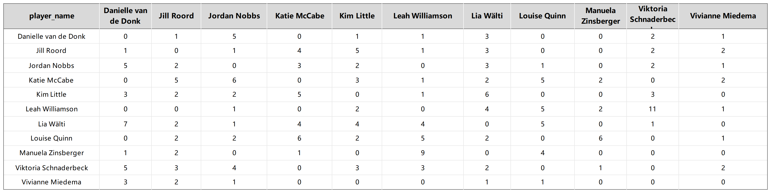

The following image is the transition probability matrix constructed from the adjacency matrix in the study of PageRank.

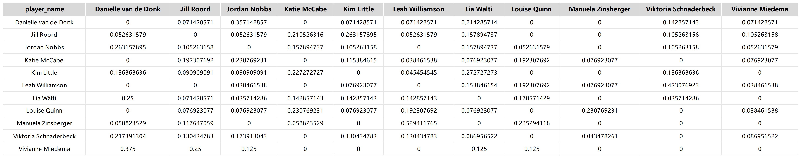

The PageRank of each player was calculated using a damping factor of 0.85 and an initial PR value of 1/N. After multiple iterations and reducing the error to 0.000000000001, the resulting PageRank of each player is shown in the following figure.

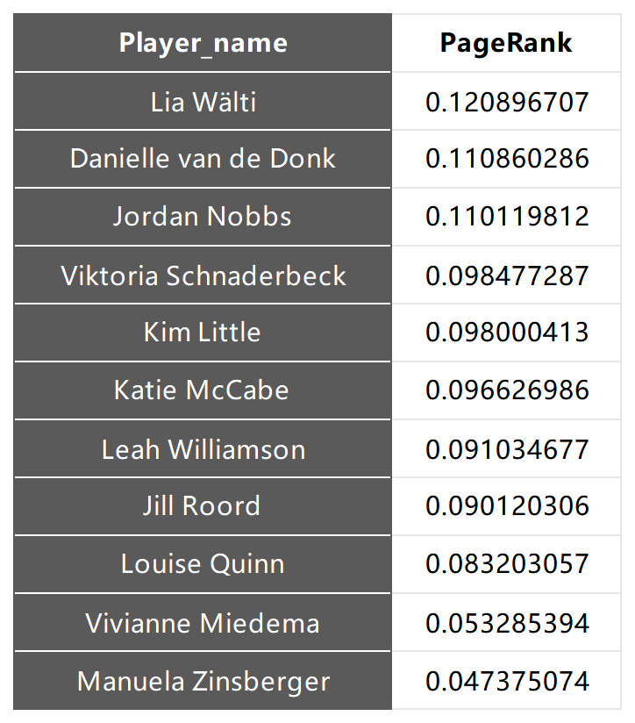

As shown in the figure, Lia Wälti has the highest PageRank value, which is consistent with the preliminary observation of the network. Combining with the network, it can be seen that the average PageRank value of right-wing attacking players is higher than that of left-wing players, indicating that the team's attacks are more biased towards right-wing.

## Directed Graph

The following figure shows the directed graph of passes among players in the team obtained during the analysis of PageRank. The circular nodes represent the starting position of a pass by a player, while the arrows represent the direction and distance of the pass.

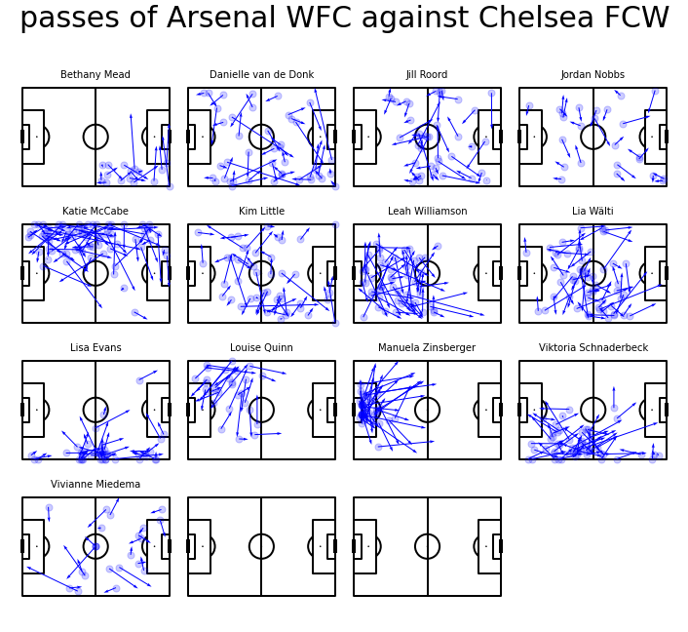

Based on the directed graph of passes and the distribution of the players' passing starting positions, some players in the team exhibited certain characteristics and styles in this match.

For example:

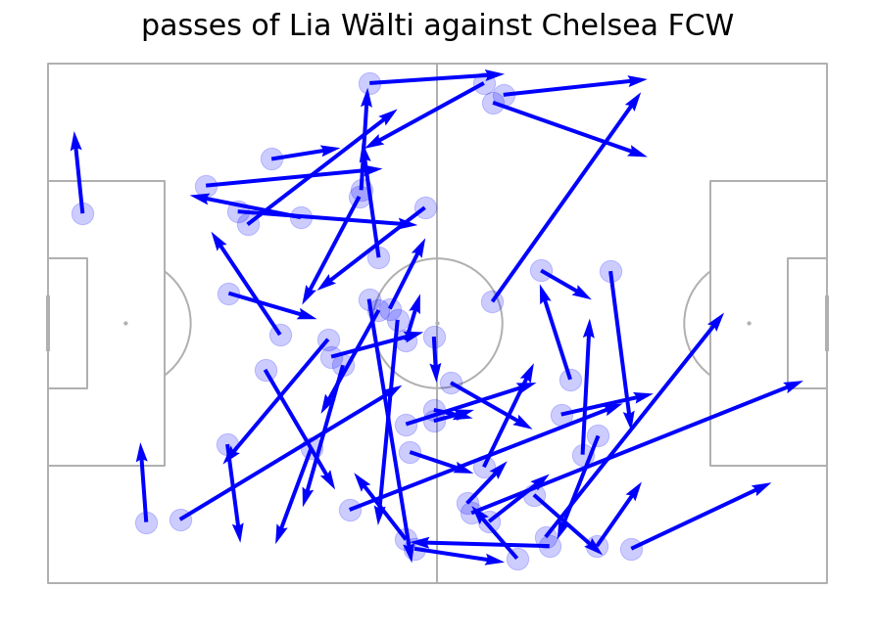

Looking at the directed graph of Lia Wälti, the core of ball possession for the team, her arrows are generally long, indicating that she often uses long passes to switch the ball. It can also be seen that her attacks on the right side are deeper and more aggressive, while she passes less frequently in the front left, which may be related to the team's strategy and the opponent's status in the game.

Furthermore, by observing the directed graph, many other things can be discovered: it can be observed that Donk played important linking roles; McCabe concentrated almost all the attacking routes w on the left wing and the right wing player Schnaderbeck did the same with the right wing; In the backcourt, Williamson was an important link connecting the left and right wings, responsible for linking the team's attack and defense.

## Conclusion

Based on these analyses, Arsenal WFC's strategy in this match was to use two cores of passing and possession in the midfield to link the attack and defense. Based on ball possession, open up attacks on both wings, and lean towards right-wing attack, which may have been determined by the opponent's defense.

Before a team plays a match, the coach and analysts should conduct similar analyses to study the characteristics of the opponent in recent games, including the tactical adjustments made by the opponent in terms of player lineups and offensive and defensive strategies when facing different teams. Similarly, they should also analyze the recent game situation of their own team to understand the characteristics of their players, in order to conduct targeted training and adjustments.

This analysis of a single match of Arsenal WFC can serve as an example of using network analysis, PageRank, and directed graphs to study a team's tactics. Similarly, analyzing small amounts of game data can provide insights into the team's recent form and tactical approach, while a comprehensive analysis of large amounts of game data can help to understand the team's playing style and the importance of individual players.

## Appendix:

## The six games’ network

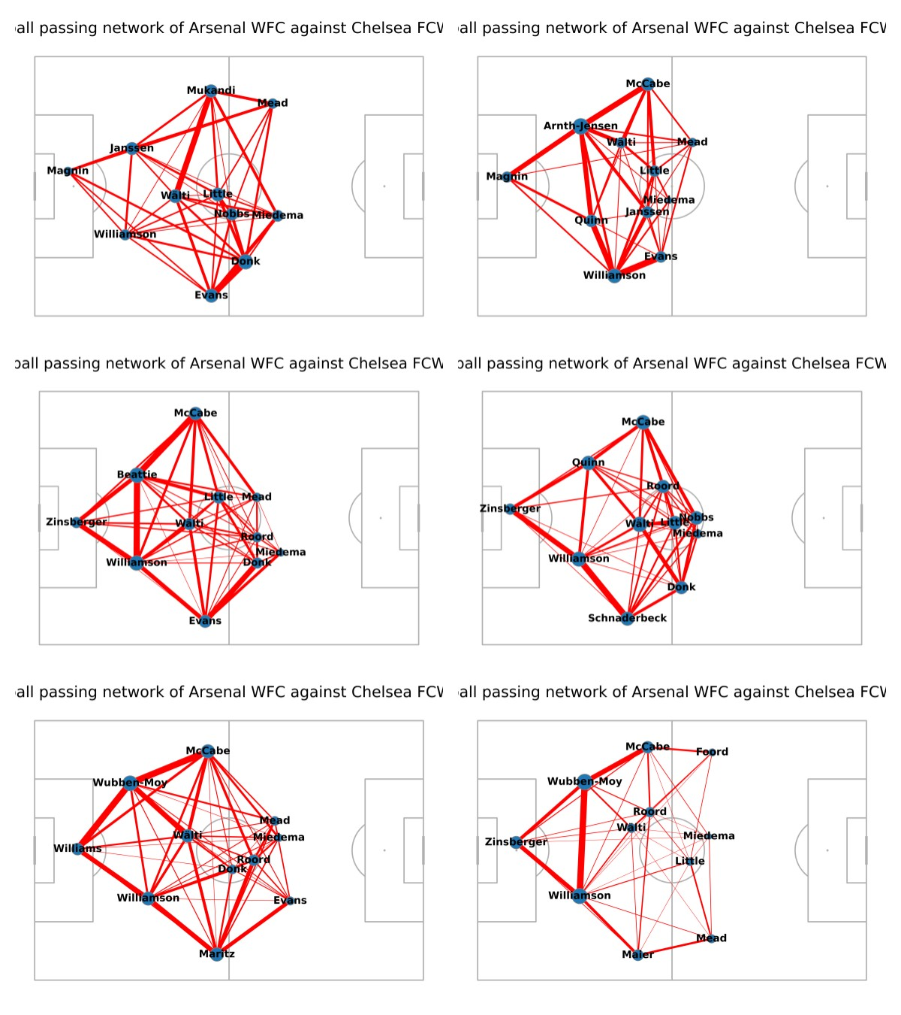

## The six games’ PageRanks:

## 6 games' pageranks

## The six games’ highest PageRank players:

## 6 games' highest PR players