

aSSIGNMeNT 1 DAtA VISUALIZATION



Arturs Stauers

GLA1 2022

Table of Contents

Task 1 Policies and Procedures 2

Laws which should be fallowed to protect users and their data: 2

Computer Misuse Act 1990​ 2

Police and Justice Act 2006 2

Copyright, Designs and Patents Act 1988​ 2

The Copyright (Computer Programs) ​Regulations 1992​ 2

The Health and Safety (Display Screen ​Equipment) Regulations 1992​ 3

Data Protection Act 2018​ 3

Consumer Rights Act 2015 3

Task 2 Excel 5

1. Set a password to protect the workbook 5

2. Highlight column C and change the data to display in British Pound symbol 5

3. Turn the GDP sheet into a table. 5

4. Filter the table to display only the information for 2019 6

5. Next create a chart that will only display the following data ‘Rank, Country and GDP - per capita (PPP). The chart can be anything as long as it is suitable. 6

6. Using your creative skills edit the chart 6

7. Move the chart to a new sheet tab and label with a suitable name 7

8. Create a sort for the top 20 highest ranking counties 7

9. Next create a new Bar chart to display the 20 highest ranking countries from your sort and then move the chart to be underneath the table, as shown below. 8

10. Colour the background by highlighting the area underneath the table as shown below. Find the add a fill colour icon and sellect a colour. 8

11. The next task is to create 3 macro buttons, print the sheet, Save the file and Copy the sheet. 8

12. Using the copy macro, copy the sheet and then paste it into a new word document keeping the formating. Give the page a title ‘GDP (Gross domestic product)’ 9

13. Save your document as ‘Word Gross domestic product report 1’ 9

14. Befor we finish with our excel table ‘Gross domestic product’ sheet, we will add a headder and footer to our table. Select the ‘View’ tab from the top and find the ‘workbook views’ area, as seen below: 9

15. In the headder enter your name and GLA DATA 1 in the three boxes 9

16. In the footer add todays date then Assignment 1 and lastly Data Visualisation. 9

3. Task Tableau 10

# Task 1 Policies and Procedures

## Laws which should be fallowed to protect users and their data:

### Computer Misuse Act 1990​

Computer misuse includes planting a virus which is intended to:

* Cause damage, such as destroying or altering data
* Slow down the operation of the computer
* Cause frequent computer crashes

It would also include accessing a company’s computer system and altering how the programs work

### Police and Justice Act 2006

This Act is largely concerned with policing reform, but contains ​some amendments to ​the Computer Misuse ​Act of 1990​, the amendments are designed to cover new forms of crime brought about by advances in technology over the previous 16 years​. The major amendments were:

* Making, owning or distributing hacking tools (viruses, worms, trojans, ransomware attacks, denial of service attacks) was made illegal if the person intends or believes it will be used for computer misuse
* Denial of Service attacks were made illegal with a penalty of up to 10 years in jail
* Denial-of-service attacks was made illegal. This was needed as the old law did not make clear whether DoS attacks were an offence.

### Copyright, Designs and Patents Act 1988​

It gives the creators of literary, ​dramatic, musical and artistic works ​the right to control the ways in which ​their material may be used​, it ensures that people are rewarded ​for their creative efforts and it gives them protection from people ​copying their work without permission. It is so easy to copy articles images, music and videos from the Internet that is easy to forget that in many circumstances this is unethical (plagiarism) or illegal (breach of copyright)​. When you use text or images​ from the Internet in your work, ​you should always​acknowledge the source​.

### The Copyright (Computer Programs) ​Regulations 1992​

These regulations updated the Copyright, Designs and Patent Act passed in1988. The amendment made it clear that ​computer software was also subject ​to copyright, it is illegal under this law to use ​copyrighted software without ​a license.

Open-source software allows people to view and change the source code which makes it work. Open-source licenses may have some restrictions, such as:

* Stating the names of the original authors
* A requirement that an altered copy has the same license ​as the original

### The Health and Safety (Display Screen ​Equipment) Regulations 1992​

There are regulations designed ​to protect employees who spend ​all day working at a computer​. The main points are:

* Employers must carry out a risk assessment of ​workstations used by employees to reduce risks​
* Employers must ensure that employees take ​regular breaks from looking at their screens​
* Employers must ensure that employees are ​aware of their entitlement to yearly eye tests, ​with the cost met by the employer​
* Employers must provide their computer users ​with health and safety training for any ​workstations that they use​

### Data Protection Act 2018​

A new Data Protection Act (2018) replaced the Data Protection Act (1998) in May 2018, previous data protection regulations had struggled to keep pace with rapid technological changes​. The new law enforces in the UK, the General Data Protection Regulation (GDPR), which came into force in Europe on 25 May 2018​.

This act are essentially ​about two points:

* The ethical use of ​personal data

1. used fairly, lawfully and transparently​
2. used for specified, explicit purposes​
3. only used where necessary

* Keeping every ​individual’s personal ​data secure

1. accurate and kept up to date​
2. kept for no longer than is necessary​
3. handled in a secure way, including ​protection against unlawful or ​unauthorized processing, access, ​loss or damage​

Your rights under the DPA 2018:

* be informed about how your data is being used​
* access your personal data​
* have incorrect data updated​
* have your personal data erased​
* stop or restrict the processing of your data in some situations​
* copy and reuse your data for ​
* different services​

### Consumer Rights Act 2015

Under this Act all products, whether digital or physical, must meet the following standards:

* Satisfactory quality – not faulty or damaged (taking into account, for example, that bargain bucket products won’t be held to as high a standard as luxury goods)
* Fit for purpose – for the purpose they are supplied for, or any purpose you made known to the shop when you bought them
* As described – matching any description given to you or samples shown to you at the time of purchase​

# Task 2 Excel

## Set a password to protect the workbook

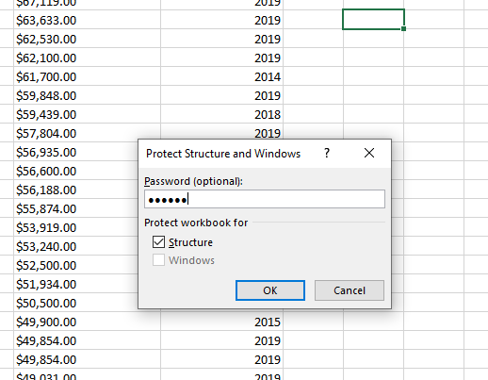To protect the workbook: Select ‘Review’ then choose ‘Protect Workbook’ and input password.

## Highlight column C and change the data to display in British Pound symbol

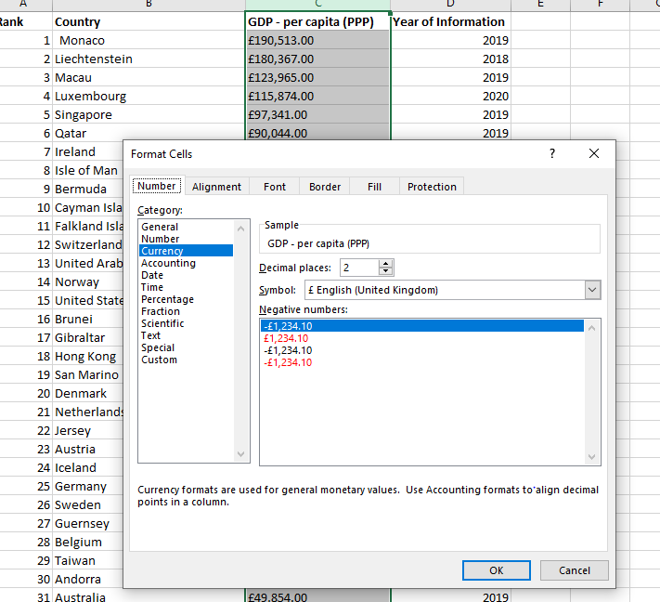

## Turn the GDP sheet into a table.

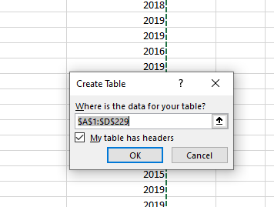To transfer sheet into a table, need to press ‘ctrl’ + ‘T’.

## Filter the table to display only the information for 2019

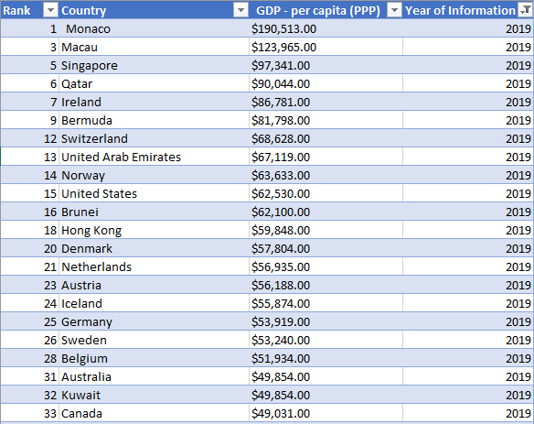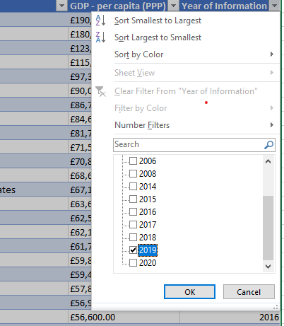

## Next create a chart that will only display the following data ‘Rank, Country and GDP - per capita (PPP). The chart can be anything as long as it is suitable.

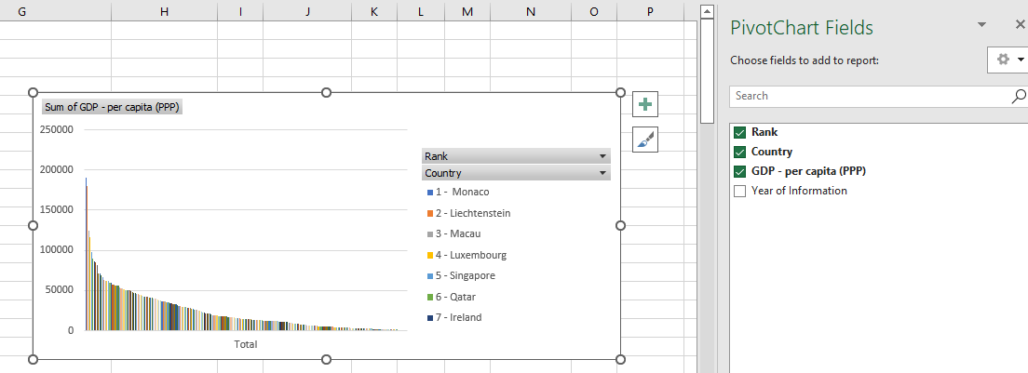

## Using your creative skills edit the chart

* 1. Add a title
  2. Add X and Y axis labels
  3. Make the chart visually pleasing

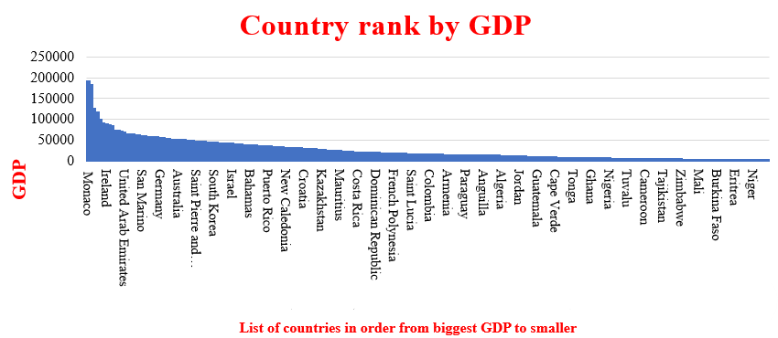

## Move the chart to a new sheet tab and label with a suitable name

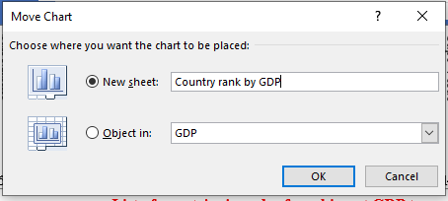

## Create a sort for the top 20 highest ranking counties

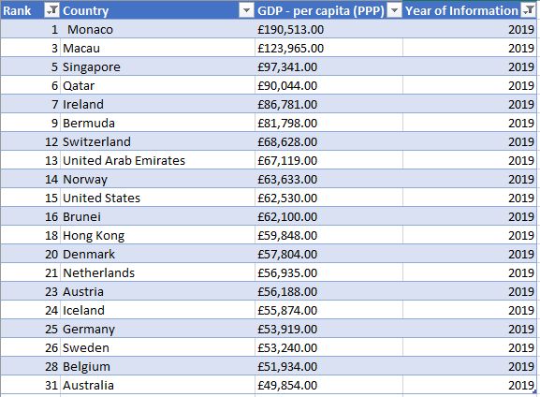

## Next create a new Bar chart to display the 20 highest ranking countries from your sort and then move the chart to be underneath the table, as shown below.

## Colour the background by highlighting the area underneath the table as shown below. Find the add a fill colour icon and sellect a colour.

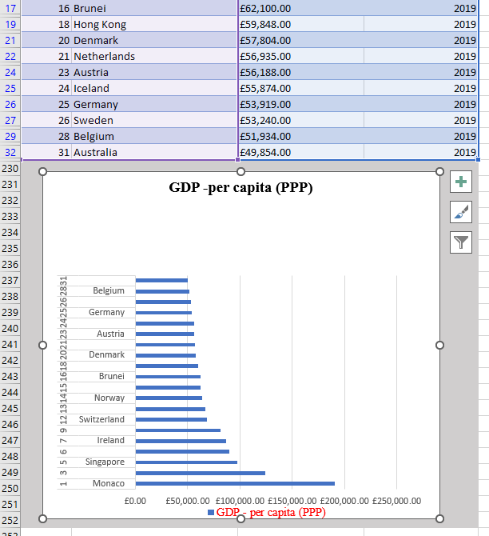

## The next task is to create 3 macro buttons, print the sheet, Save the file and Copy the sheet.

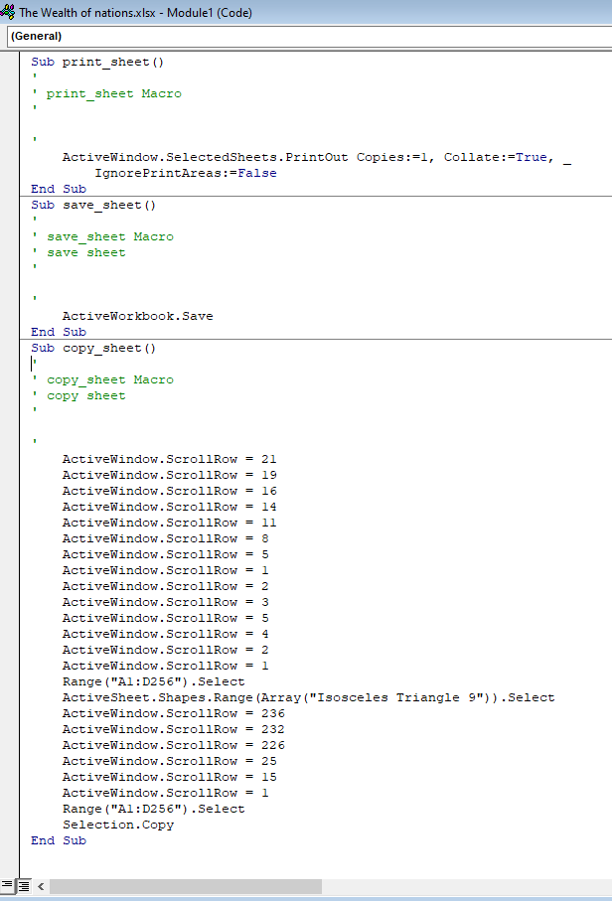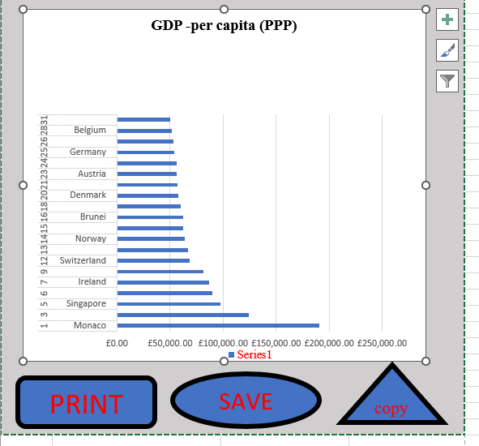

To create macros, we press ‘record macros’ than we do actions which we want to remember and after stop record. After draw a shape and when we do right click un on shape we can assign macros to the shape.

## Using the copy macro, copy the sheet and then paste it into a new word document keeping the formating. Give the page a title ‘GDP (Gross domestic product)’

## Save your document as ‘Word Gross domestic product report 1’

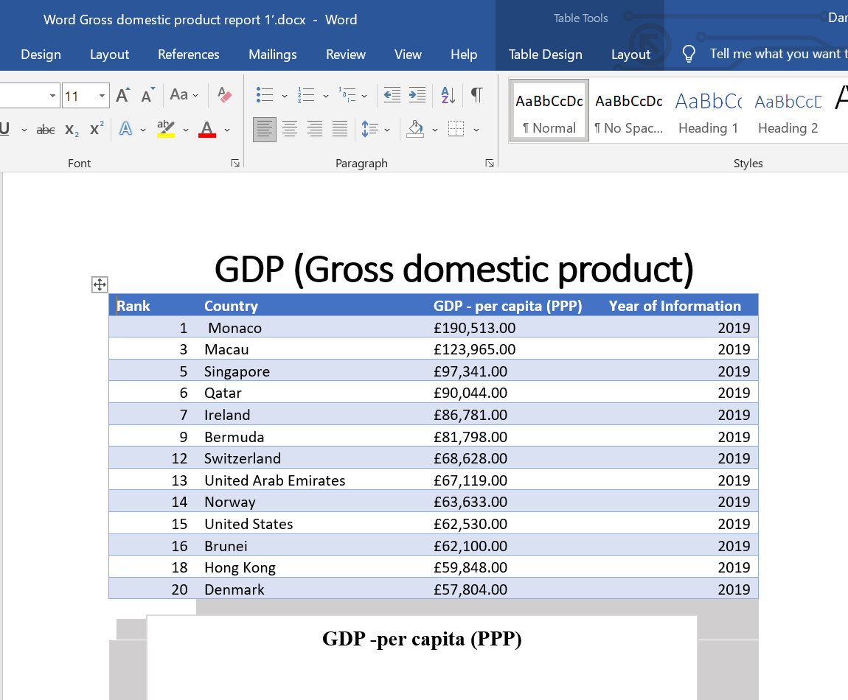

## Befor we finish with our excel table ‘Gross domestic product’ sheet, we will add a headder and footer to our table. Select the ‘View’ tab from the top and find the ‘workbook views’ area, as seen below:

## In the headder enter your name and GLA DATA 1 in the three boxes

## In the footer add todays date then Assignment 1 and lastly Data Visualisation.

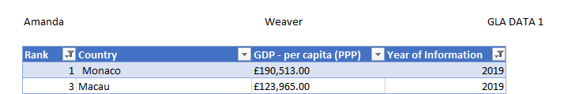

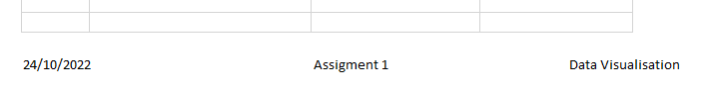

# 3. Task Tableau

Client Requirements

The client is color blind and requested you to bear this in mind when building your dashboard. The client is only interested in the top 20 highest ranking countries. All of your visuals should be for the top 20 highest ranking countries.

In screenshots you can see pictures with top 20 countries by GDP based on data from year 2019. We can see table with 20 countries by Life Expectancy, we can see quite a lot countries are in both tops, so we can say that on the factors on life expectancy is income. When we look the countries which are most smartphones users, we say that in 2020 the biggest factor for smartphones user in country is population.

