**Envirotech - DIY sensors for environmental research**

**Mid-semester project: monitor and log environmental conditions**

Stav Gil bar 311239560

**Introduction:**

The Negev Desert is characterized by its arid and hot climate, with significant temperature fluctuations between day and night. At the Sde Boker campus of Ben-Gurion University, building architecture is adapted to these desert conditions through features such as high ceilings and strategic ventilation. Motivated by this unique environment, I aimed to investigate the indoor temperature and relative humidity levels within my own house on campus.

In addition to these parameters, I was also interested in monitoring carbon dioxide (CO₂) concentration levels, measured in parts per million (PPM). This aspect of the experiment was particularly intriguing because of the changing occupancy in the house during the monitoring period: on the first day, there were two people present, on the second day only one, and on the final day the house was empty (at night there was one person sleeping in the house). Observing how CO₂ concentrations respond to these variations in occupancy provided an opportunity to explore indoor air quality dynamics in a desert home.

The experiment was conducted continuously over four days, from May 14th to May 18th. Given that this project was self-initiated and not funded by any grant, it was important to design a low-cost yet effective measurement system. To achieve this, I used an Arduino Uno board alongside affordable sensors and logged the data to an SD card. The system components and their costs are detailed in Table 1 (Bill of Materials). The connections and assembly are illustrated in Figure 1 (Wiring Diagram) and Figure 2 (Photo of the Assembled System).

After data collection, the measurements were visualized through graphs, allowing me to analyze trends and draw conclusions related to my initial questions.

Table 1- Bill of materials

| **Name** | **Image** | **Price** | **Link** |
| --- | --- | --- | --- |
| Adafruit SCD-40 - True CO2, Temperature and Humidity Sensor - STEMMA QT / Qwiic |  | $44.95 | <https://www.adafruit.com/product/5187> |
| Adafruit Sensirion SHTC3 Temperature & Humidity Sensor - STEMMA QT / Qwiic |  | $6.95 | <https://www.adafruit.com/product/4636> |
| SparkFun Level Shifting microSD Breakout |  | $6.50 | <https://www.sparkfun.com/sparkfun-level-shifting-microsd-breakout.html> |
| Arduino Uno Rev3 |  | ~$32.53 | <https://store.arduino.cc/products/arduino-uno-rev3?srsltid=AfmBOoqTVLRm5c-ZpTB0re44rvMfK4Eb1vRA7-Rq0xvqVTH1n-9Qgehd> |
| SanDisk Ultra Micro SDHC 32GB SDSDQUAN-032G | https://maordeal.co.il/wp-content/uploads/2024/09/b96de5d2fc89f64f322329a615069a1a.jpg | ~$5.37 | <https://www.bug.co.il/brand/sandisk/32gb/ultra/mic> rosdxc/120/mbs |

Fig 1 – wiring diagram

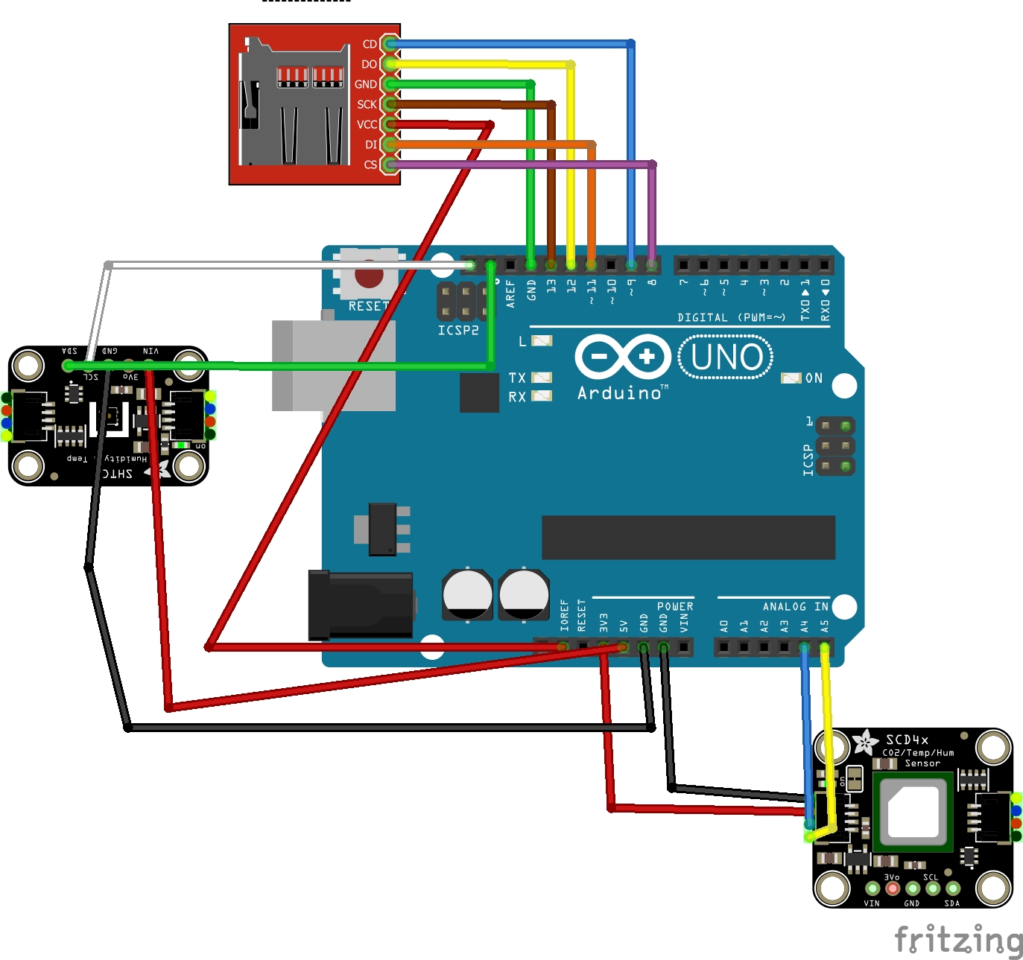

Fig 2 – image of the system

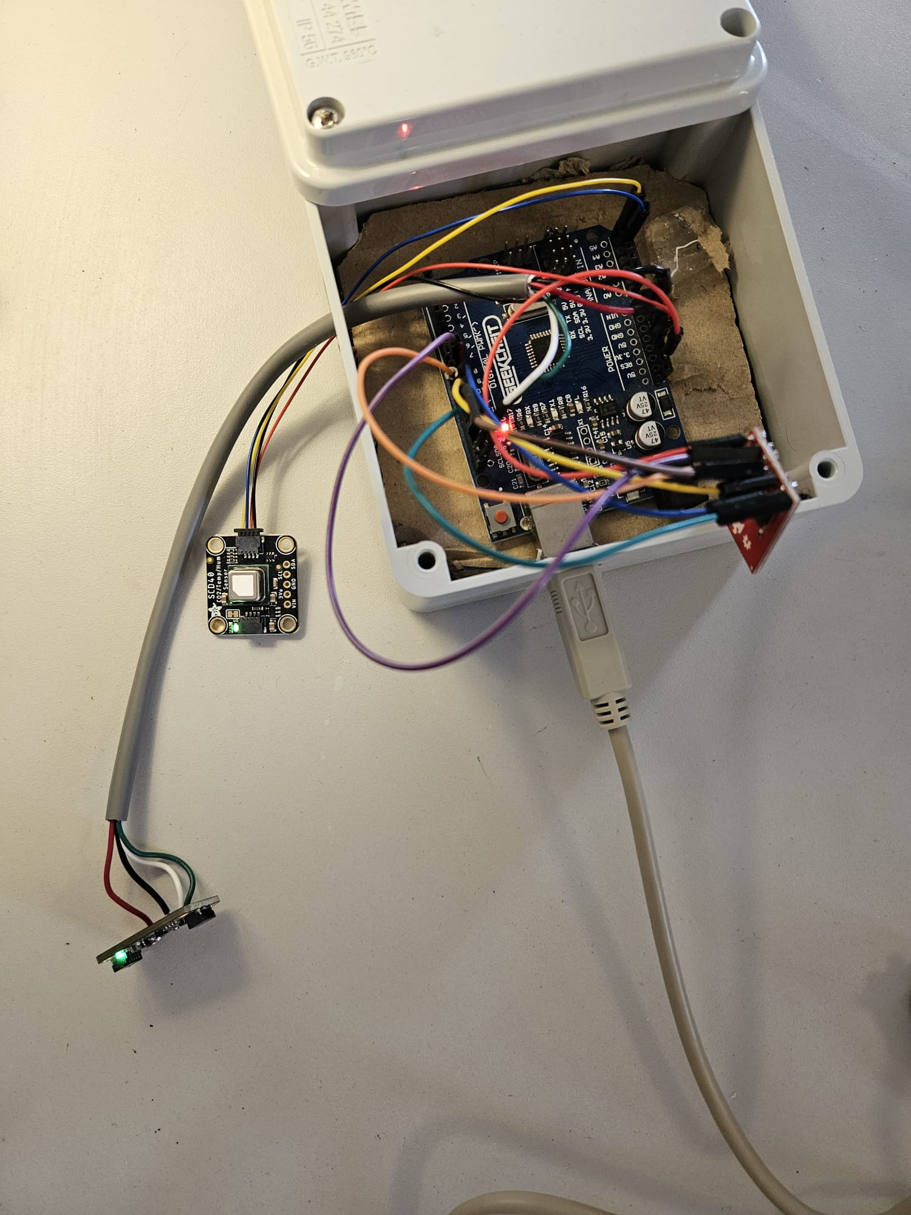

**Results:**

Since I wanted to check the differences between the different hours of the day, I implemented a code VIA Python using the 'datetime' package to convert the milliseconds into the time range that the system was working on. Bellow presented the graphs of the results.

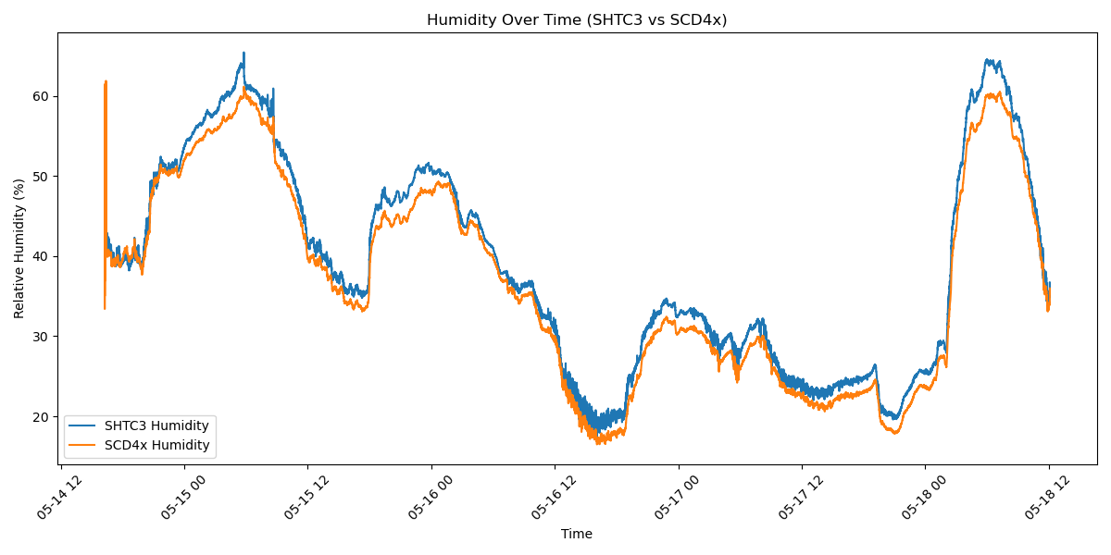

Fig 3 Humidity over time based on SHTC3 (blue) and SCD40 (orange)

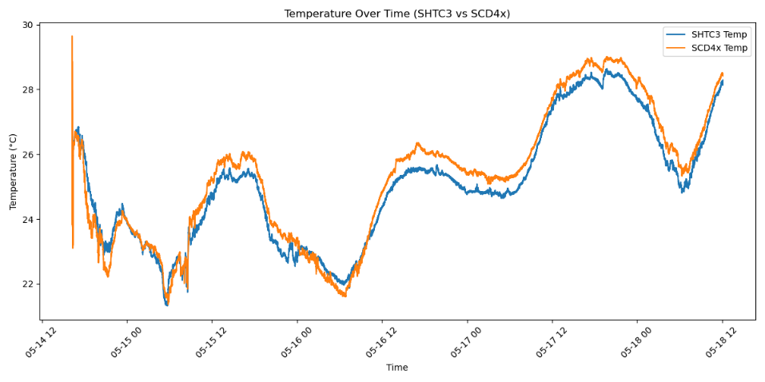

Fig 4 Temperature over time based on SHTC3 (blue) and SCD40 (orange)

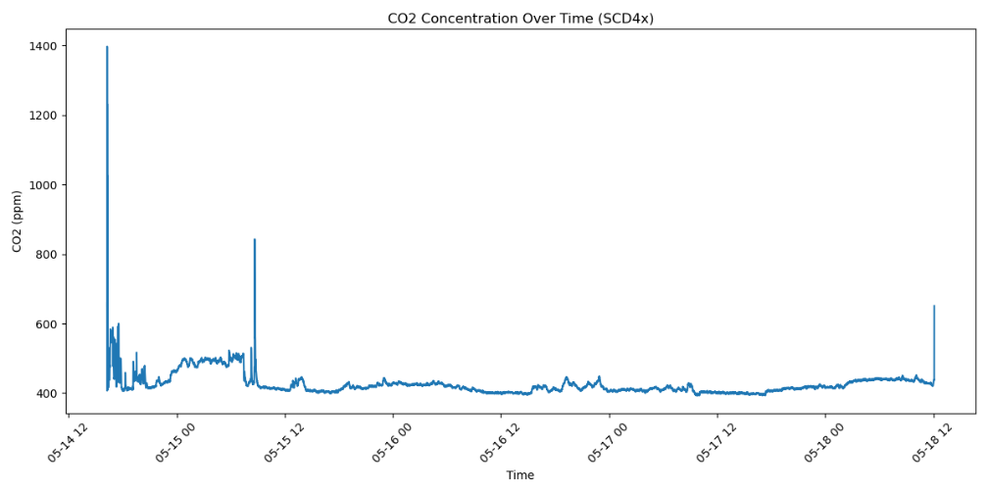

Fig 5 CO2 concentration over time based on SCD40 sensor

Fig 6 Humidity correlation between SHTC3 and SCD40 (A) and temperature correlation between SHTC3 and SCD40 (B)

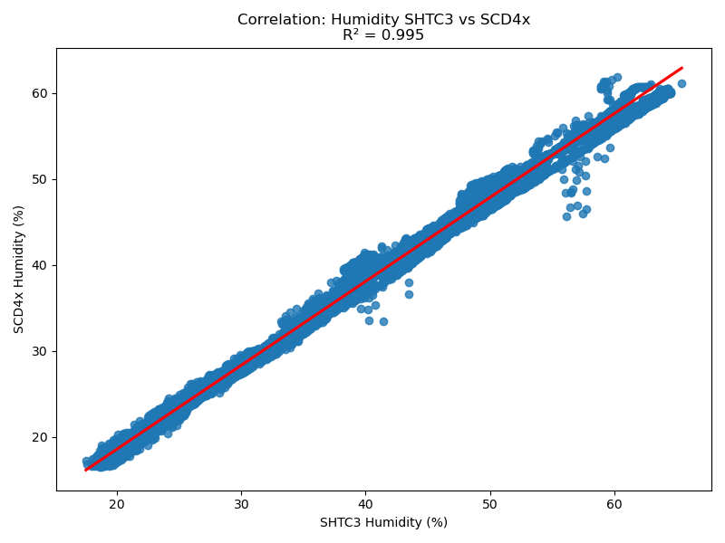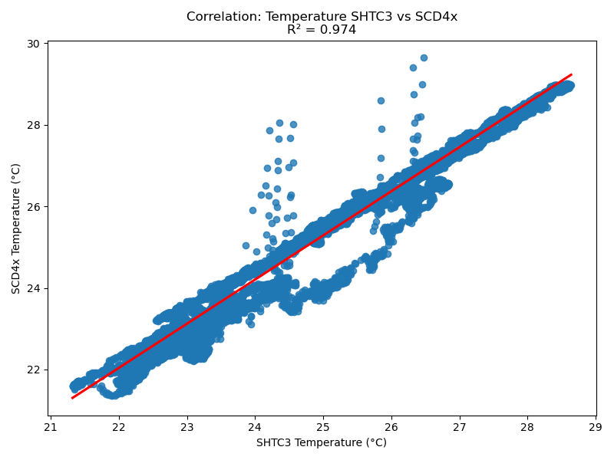

**A**

**B**

**Conclusion:**

As shown in Figure 6, the correlation between the two sensors was high (R² = 0.995 and 0.974), indicating that both sensors were reliable. Figures 3 and 4 demonstrate an inverse relationship between temperature and relative humidity—when the temperature increased, the relative humidity decreased, and vice versa. May 17th was the hottest day, which is clearly reflected in the graphs.

One of the goals of the experiment was to assess whether the indoor temperature remained lower than the outdoor temperature, as intended by the architectural design of the house. The outdoor temperature peaked at 34°C, 36°C, and 42°C during the measurement period, while indoor temperatures remained between 26°C and 28°C—confirming the building's effective insulation.

Regarding CO₂ concentration, levels were higher at night and peaked during the first night when two people were present. On the following nights, when only one person was in the house, the CO₂ levels remained relatively stable and lower compared to the first night. During the day, when the house was mostly unoccupied, CO₂ levels stayed low, likely due to the absence of human respiration. The three sharp peaks in the CO₂ graph are probably outliers and do not reflect actual indoor concentrations. Typical indoor CO₂ levels around 400 ppm are considered normal.

Overall, the system appeared to function properly, providing continuous and realistic data throughout the measurement period. This experiment demonstrates that it is possible to build a low-cost, reliable monitoring system for individuals interested in exploring environmental conditions on a limited budget.