

**Industrial Internship Report on**

**”Healthcare Data Management”**

**Prepared by**

**Stavan Mehta**

|  |
| --- |
| *Executive Summary* |
| This report provides details of the Industrial Internship provided by upskill Campus and The IoT Academy in collaboration with Industrial Partner UniConverge Technologies Pvt Ltd (UCT).  This internship was focused on a project/problem statement provided by UCT. We had to finish the project including the report in 6 weeks’ time.  My project was Healthcare Data Management.  This internship gave me a very good opportunity to get exposure to Industrial problems and design/implement solution for that. It was an overall great experience to have this internship. |



# Preface

Summary of the whole 6 weeks’ work.

**Week 1: Orientation and Planning**

* Attended onboarding sessions to understand the company's cloud infrastructure and healthcare data management requirements.
* Conducted a review of existing systems and documentation to identify integration points and potential challenges.

**Week 2: Infrastructure Setup**

* Set up cloud environments using AWS, configuring virtual machines, storage solutions, and network settings.
* Established initial security configurations, including Identity and Access Management (IAM) roles and policies.
* Started configuring databases for structured and unstructured data storage.

**Week 3: Data Integration and API Development**

* Developed APIs to integrate with existing Electronic Health Record (EHR) systems, ensuring compatibility with HL7 and FHIR standards.
* Conducted tests to verify data flow and ensure accurate data exchange between systems.

**Week 4: Security and Compliance Implementation**

* Enhanced data security measures, implementing encryption for data at rest and in transit.
* Conducted a security audit to identify and address potential vulnerabilities.
* Worked on documentation to ensure compliance with healthcare regulations such as HIPAA.

**Week 5: Analytics and Reporting**

* Deployed cloud-based analytics tools to process and analyze healthcare data.
* Created customizable dashboards and reports to provide insights for healthcare providers.

**Week 6: Testing, Documentation, and Handover**

* Performed comprehensive testing of the system to ensure reliability, performance, and security.
* Documented all configurations, processes, and procedures for future reference and maintenance.



About need of relevant Internship in career development.

• **Practical Experience:**

* Internships provide hands-on experience in a real-world environment, allowing you to apply theoretical knowledge gained during academic studies.
* Exposure to day-to-day operations helps you understand industry practices, tools, and technologies.

• **Skill Development:**

* Internships help in honing both technical and soft skills. You learn specific technical skills relevant to your field and also improve communication, teamwork, problem-solving, and time management skills.
* Gaining expertise in industry-specific tools and methodologies enhances your employability.

• **Networking Opportunities:**

* Internships offer opportunities to build professional relationships with colleagues, mentors, and industry professionals.
* Networking can lead to future job opportunities, recommendations, and valuable industry insights.

• **Career Exploration:**

* Internships allow you to explore different roles within an industry, helping you determine what career path aligns best with your interests and strengths.
* Exposure to various aspects of a profession can clarify your career goals and inform your future career decisions.

• **Resume Building:**

* Relevant internship experience makes your resume more attractive to potential employers by demonstrating that you have practical experience and a proactive approach to career development.
* Internships provide tangible examples of your abilities and achievements that you can discuss in job interviews.

• **Increased Employability:**

* ****Employers often prefer candidates with internship experience because it indicates that the candidate has a practical understanding of the industry and job role.
* Some internships lead to full-time job offers from the host company, providing a direct pathway to employment.

• **Confidence Building:**

* Successfully completing an internship can boost your confidence in your professional abilities and readiness for the workforce.
* Overcoming real-world challenges during an internship prepares you for future job-related challenges.

• **Understanding Workplace Culture:**

* Internships expose you to the professional environment and workplace culture, helping you learn how to navigate corporate structures and dynamics.
* Understanding workplace expectations and etiquette is crucial for seamless integration into future job roles.

• **Feedback and Improvement:**

* Internships provide opportunities for receiving constructive feedback from supervisors and peers, allowing you to identify areas for improvement.
* Learning from feedback helps in personal and professional growth, making you better prepared for future roles.

Brief about Your project/problem statement.

Healthcare organizations face significant challenges in managing patient data, medical records, and imaging due to the sheer volume of information and the need for secure, efficient, and compliant handling of sensitive data. Traditional on-premises systems often lack scalability, are costly to maintain, and can be vulnerable to data breaches.

To address these challenges, we propose a cloud-based solution leveraging platforms like AWS or Microsoft Azure. This solution aims to provide a robust and scalable infrastructure for storing, accessing, and sharing critical patient information securely and efficiently.

**Key Objectives:**

1. **Secure Data Storage:**
   * Implement a secure and scalable storage solution for patient data, medical records, and imaging files.
   * ****Ensure data encryption both at rest and in transit to protect patient privacy and comply with healthcare regulations such as HIPAA.
2. **Efficient Data Access and Sharing:**
   * Develop mechanisms for healthcare providers to access and share patient information seamlessly, facilitating better collaboration and patient care.
   * Implement role-based access control to ensure that only authorized personnel can access sensitive information.
3. **Scalability and Reliability:** 
   * Utilize cloud infrastructure to ensure the solution can scale with the growing data needs of healthcare organizations.
   * Implement disaster recovery and backup solutions to ensure data availability and resilience.
4. **Integration and Interoperability:**
   * Ensure the solution integrates smoothly with existing Electronic Health Record (EHR) systems and other healthcare applications.
   * Use industry standards such as HL7 and FHIR to facilitate interoperability and data exchange.
5. **Advanced Analytics:**
   * Enable advanced data analytics capabilities to derive actionable insights from patient data, improving decision-making and patient outcomes.
   * Provide customizable dashboards and reporting tools for healthcare providers.

By implementing this cloud-based solution, healthcare organizations can enhance their data management capabilities, improve patient care, and ensure compliance with regulatory requirements, all while reducing costs and increasing operational efficiency.

Opportunity given by USC/UCT.

• **Hands-on Experience:**

* Engage in real-world projects that provide practical experience and allow you to apply theoretical knowledge.
* Work with advanced technologies and tools specific to your field, such as cloud platforms like AWS and Azure.

• **Skill Development:**

* Develop both technical skills (e.g., cloud computing, data integration, cybersecurity) and soft skills (e.g., communication, teamwork, problem-solving).
* Participate in training sessions, workshops, and seminars to enhance your expertise.

• **Mentorship and Guidance:**

* ****Get insights into industry trends and best practices from seasoned professionals.

• **Career Exploration:**

* Explore various roles and departments within the company to understand different career paths and find your area of interest.
* Gain exposure to the company’s operations, culture, and values.

• **Resume Building:**

* Add meaningful experience to your resume, showcasing your practical skills and project involvement.
* Highlight specific accomplishments and projects completed during the internship.

• **Job Opportunities:**

* Access potential job openings within the company’s network or receive recommendations for other opportunities.

• **Personal Growth:**

* Build confidence in your abilities by successfully tackling real-world challenges and contributing to projects.
* Develop a sense of responsibility, time management, and professional work ethic.

• **Feedback and Improvement:**

* Receive constructive feedback on your performance, helping you identify strengths and areas for improvement.
* Learn from mistakes and successes, fostering continuous personal and professional growth.

• **Access to Resources:**

* Utilize the company’s resources, including research materials to enhance your learning experience.

How Program was planned

**Week 1: Orientation and Planning**

* Attended onboarding sessions to understand the company's cloud infrastructure and healthcare data management requirements.
* ****Conducted a review of existing systems and documentation to identify integration points and potential challenges.

**Week 2: Infrastructure Setup**

* Set up cloud environments using AWS, configuring virtual machines, storage solutions, and network settings.
* Established initial security configurations, including Identity and Access Management (IAM) roles and policies.
* Started configuring databases for structured and unstructured data storage.

**Week 3: Data Integration and API Development**

* Developed APIs to integrate with existing Electronic Health Record (EHR) systems, ensuring compatibility with HL7 and FHIR standards.
* Conducted tests to verify data flow and ensure accurate data exchange between systems.

**Week 4: Security and Compliance Implementation**

* Enhanced data security measures, implementing encryption for data at rest and in transit.
* Conducted a security audit to identify and address potential vulnerabilities.
* Worked on documentation to ensure compliance with healthcare regulations such as HIPAA.

**Week 5: Analytics and Reporting**

* Deployed cloud-based analytics tools to process and analyze healthcare data.
* Created customizable dashboards and reports to provide insights for healthcare providers.

**Week 6: Testing, Documentation, and Handover**

* Performed comprehensive testing of the system to ensure reliability, performance, and security.
* Documented all configurations, processes, and procedures for future reference and maintenance.

****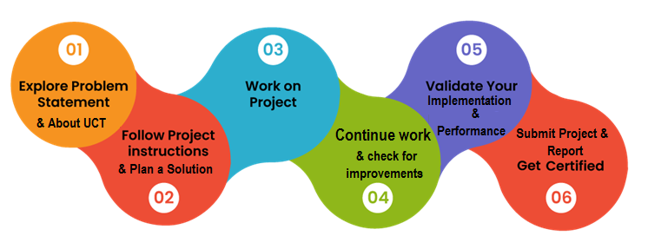

Your Learnings and overall experience.

### Learnings:

1. **Technical Skills:**
   * **Cloud Computing:** Hands-on experience with cloud platforms like AWS and Azure, including setting up and managing cloud infrastructure.
   * **Data Management:** Understanding of how to store, access, and secure patient data, medical records, and imaging in a cloud environment.
   * **Security:** Knowledge of implementing data encryption, role-based access control, and compliance with regulations such as HIPAA.
   * **Integration and Interoperability:** Skills in developing and using APIs to integrate different healthcare systems, ensuring seamless data exchange.
   * **Analytics:** Experience with cloud-based analytics tools for processing and deriving insights from healthcare data.
   * **Disaster Recovery:** Knowledge of setting up backup procedures and disaster recovery plans to ensure data availability and resilience.
2. **Project Management:**
   * **Planning and Execution:** Insights into project planning, setting milestones, and managing timelines.
   * **Problem-Solving:** Tackling real-world challenges and developing solutions, enhancing your critical thinking and problem-solving abilities.
3. **Professional Skills:**
   * **Communication:** Improved ability to communicate technical information to both technical and non-technical stakeholders.
   * **Networking:** Building relationships with colleagues, mentors, and industry professionals, expanding your professional network.
   * **Adaptability:** Learning to adapt to new tools, technologies, and methodologies quickly.
4. **Industry Knowledge:**
   * **Healthcare Regulations:** Understanding the regulatory environment of healthcare data management, including compliance requirements.
   * **Industry Best Practices:** Exposure to best practices in data security, cloud computing, and healthcare data management.

### Overall Experience:

1. **Real-World Application:**
   * Applying theoretical knowledge to real-world problems and seeing the impact of your work on the organization and its stakeholders.
2. **Mentorship and Guidance:**
   * Receiving feedback and guidance from experienced professionals, helping you grow and refine your skills.
3. **Career Clarity:**
   * Clarifying your career goals and interests by exploring different aspects of the field and determining which areas you are most passionate about.
4. **Accomplishments:**
   * Completing meaningful projects and tasks that you can showcase on your resume and discuss in future job interviews.
5. **Learning from Challenges:**
   * Facing and overcoming challenges that contribute to your growth, teaching you resilience and perseverance.

Thank to all, who have helped me directly or indirectly.

# Introduction

## About UniConverge Technologies Pvt Ltd

A company established in 2013 and working in Digital Transformation domain and providing Industrial solutions with prime focus on sustainability and RoI.

For developing its products and solutions it is leveraging various**Cutting Edge Technologies e.g. Internet of Things (IoT), Cyber Security, Cloud computing (AWS, Azure), Machine Learning, Communication Technologies (4G/5G/LoRaWAN), Java Full Stack, Python, Front end**etc.

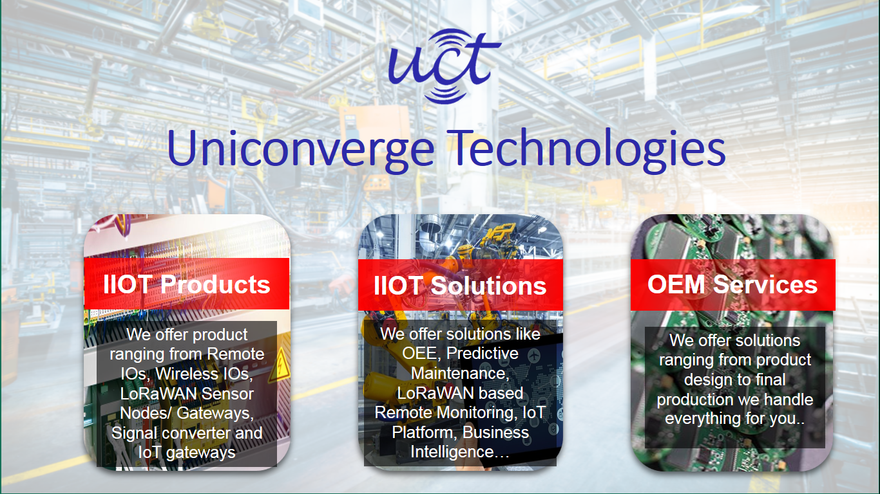

1. UCT IoT Platform **(****)**

**UCT Insight** is an IOT platform designed for quick deployment of IOT applications on the same time providing valuable “insight” for your process/business. It has been built in Java for backend and ReactJS for Front end. It has support for MySQL and various NoSql Databases.

* It enables device connectivity via industry standard IoT protocols - MQTT, CoAP, HTTP, Modbus TCP, OPC UA
* It supports both cloud and on-premises deployments.

****It has features to  
• Build Your own dashboard  
• Analytics and Reporting  
• Alert and Notification  
• Integration with third party application(Power BI, SAP, ERP)  
• Rule Engine

 



1. **Smart Factory Platform (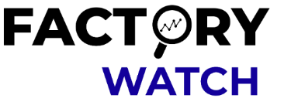)**

Factory watch is a platform for smart factory needs.

It provides Users/ Factory

* with a scalable solution for their Production and asset monitoring
* OEE and predictive maintenance solution scaling up to digital twin for your assets.
* to unleased the true potential of the data that their machines are generating and helps to identify the KPIs and also improve them.
* A modular architecture that allows users to choose the service that they what to start and then can scale to more complex solutions as per their demands.

Its unique SaaS model helps users to save time, cost and money.

 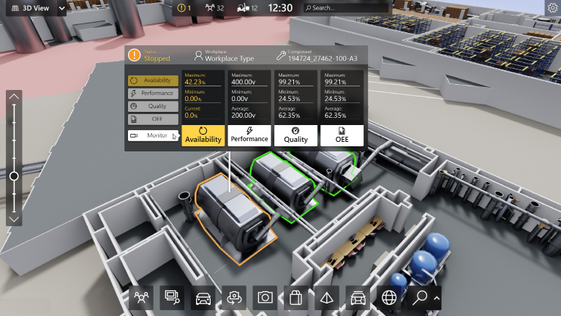

1. ****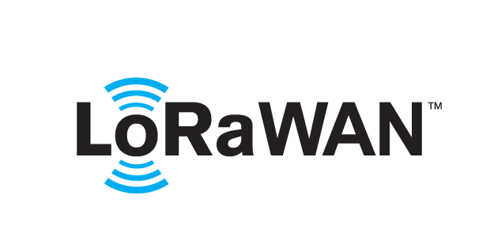 based Solution

UCT is one of the early adopters of LoRAWAN teschnology and providing solution in Agritech, Smart cities, Industrial Monitoring, Smart Street Light, Smart Water/ Gas/ Electricity metering solutions etc.

1. Predictive Maintenance

UCT is providing Industrial Machine health monitoring and Predictive maintenance solution leveraging Embedded system, Industrial IoT and Machine Learning Technologies by finding Remaining useful life time of various Machines used in production process.



## About upskill Campus (USC)

upskill Campus along with The IoT Academy and in association with Uniconverge technologies has facilitated the smooth execution of the complete internship process.

USC is a career development platform that delivers **personalized executive coaching** in a more affordable, scalable and measurable way.

****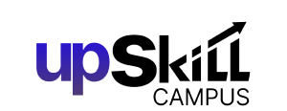

Seeing need of upskilling in self paced manner along-with additional support services e.g. Internship, projects, interaction with Industry experts, Career growth Services

<https://www.upskillcampus.com/>

upSkill Campus aiming to upskill 1 million learners in next 5 year

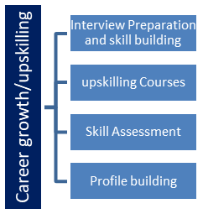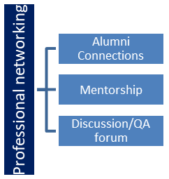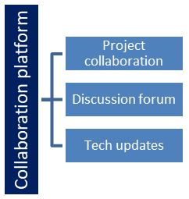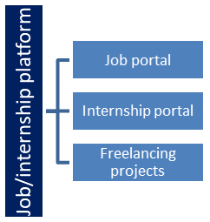

## The IoT Academy

The IoT academy is EdTech Division of UCT that is running long executive certification programs in collaboration with EICT Academy, IITK, IITR and IITG in multiple domains.

## Objectives of this Internship program

The objective for this internship program was to

 ☛ get practical experience of working in the industry.

 ☛ to solve real world problems.

 ☛ to have improved job prospects.

 ☛ to have Improved understanding of our field and its applications.

 ☛ to have Personal growth like better communication and problem solving.

# Problem Statement

In the assigned problem statement

Healthcare organizations face significant challenges in managing patient data, medical records, and imaging due to the sheer volume of information and the need for secure, efficient, and compliant handling of sensitive data. Traditional on-premises systems often lack scalability, are costly to maintain, and can be vulnerable to data breaches.

To address these challenges, we propose a cloud-based solution leveraging platforms like AWS or Microsoft Azure. This solution aims to provide a robust and scalable infrastructure for storing, accessing, and sharing critical patient information securely and efficiently.

**Key Objectives:**

1. **Secure Data Storage:**
   * Implement a secure and scalable storage solution for patient data, medical records, and imaging files.
   * Ensure data encryption both at rest and in transit to protect patient privacy and comply with healthcare regulations such as HIPAA.
2. **Efficient Data Access and Sharing:**
   * Develop mechanisms for healthcare providers to access and share patient information seamlessly, facilitating better collaboration and patient care.
   * Implement role-based access control to ensure that only authorized personnel can access sensitive information.
3. **Scalability and Reliability:**
   * Utilize cloud infrastructure to ensure the solution can scale with the growing data needs of healthcare organizations.
   * Implement disaster recovery and backup solutions to ensure data availability and resilience.
4. **Integration and Interoperability:**
   * Ensure the solution integrates smoothly with existing Electronic Health Record (EHR) systems and other healthcare applications.
   * Use industry standards such as HL7 and FHIR to facilitate interoperability and data exchange.
5. **Advanced Analytics:**
   * Enable advanced data analytics capabilities to derive actionable insights from patient data, improving decision-making and patient outcomes.
   * Provide customizable dashboards and reporting tools for healthcare providers.

By implementing this cloud-based solution, healthcare organizations can enhance their data management capabilities, improve patient care, and ensure compliance with regulatory requirements, all while reducing costs and increasing operational efficiency.

# 

## Code submission (Github link)

## Report submission (Github link) :

# My learnings

• **Technical Skills:**

* **Cloud Computing:** Hands-on experience with cloud platforms like AWS and Azure, including setting up and managing cloud infrastructure.
* **Data Management:** Understanding of how to store, access, and secure patient data, medical records, and imaging in a cloud environment.
* **Security:** Knowledge of implementing data encryption, role-based access control, and compliance with regulations such as HIPAA.
* **Integration and Interoperability:** Skills in developing and using APIs to integrate different healthcare systems, ensuring seamless data exchange.
* **Analytics:** Experience with cloud-based analytics tools for processing and deriving insights from healthcare data.
* **Disaster Recovery:** Knowledge of setting up backup procedures and disaster recovery plans to ensure data availability and resilience.

• **Project Management:**

* **Planning and Execution:** Insights into project planning, setting milestones, and managing timelines.
* **Collaboration:** Working effectively within a team, coordinating with different departments, and understanding the dynamics of teamwork.
* **Problem-Solving:** Tackling real-world challenges and developing solutions, enhancing your critical thinking and problem-solving abilities.

• **Professional Skills:**

* **Communication:** Improved ability to communicate technical information to both technical and non-technical stakeholders.
* **Networking:** Building relationships with colleagues, mentors, and industry professionals, expanding your professional network.
* **Adaptability:** Learning to adapt to new tools, technologies, and methodologies quickly.

• **Industry Knowledge:**

* **Healthcare Regulations:** Understanding the regulatory environment of healthcare data management, including compliance requirements.
* **Industry Best Practices:** Exposure to best practices in data security, cloud computing, and healthcare data management.