# Team Countries Pallet

This is a project build during the 2015 Hackathon in University of Houston.

A dashboard build to allow people learn more about other countries, their music, the most important twitter news and explore the globe.

It queries sites such as the World Health Organization (http://www.who.int/en/) to gather statistics for the countries and present them in a fun and educational way. We also fully implemented SPARQL database queries for DBpedia (http://dbpedia.org/sparql) to gather vital for our implementation information. The information included but was not limited to musicians and musical bands, similar artists, geo referencing, genre, official website. Heavy preprocessing of the data was applied to create a links between the databases as they did not have strong 1-1 relationships and to handle multiple missing values.

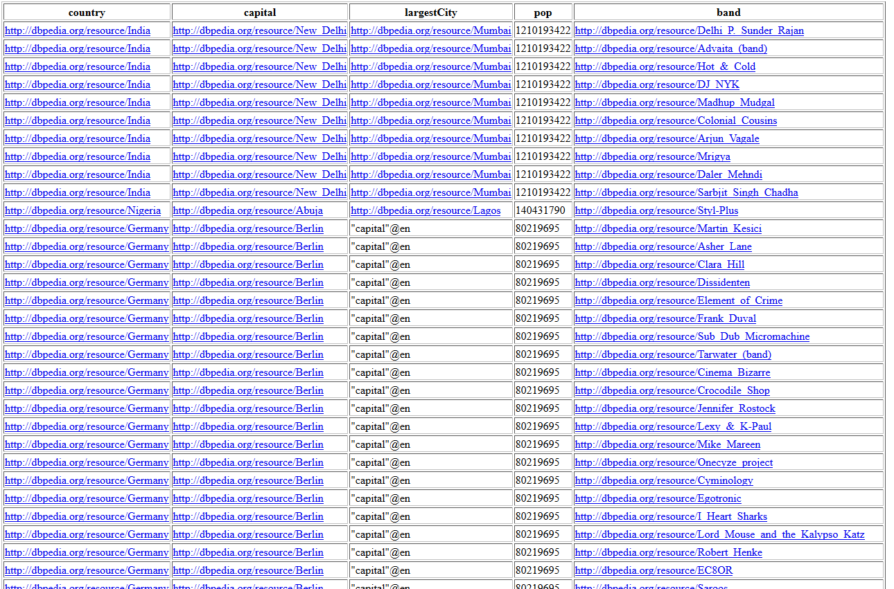

A simple DBpedia query result (original data).

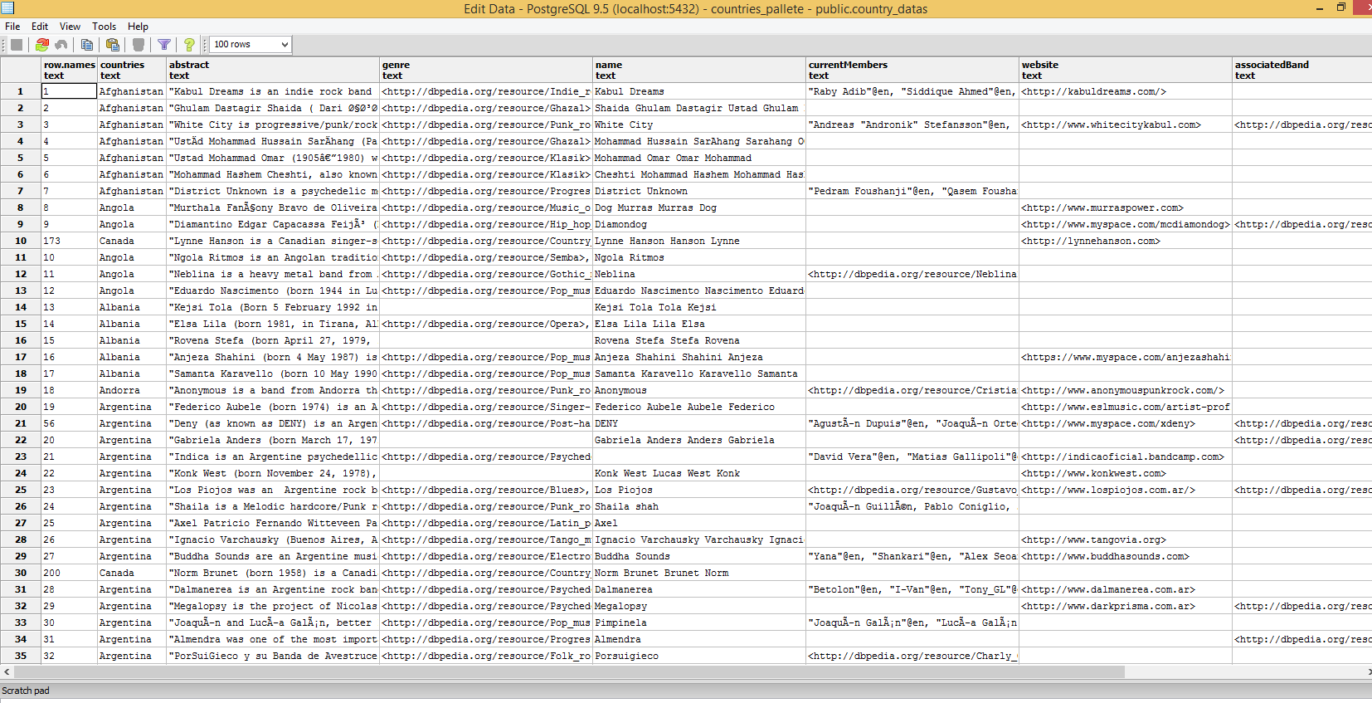

Example of the PostgreSQL database populated with the DBpedia data (our storage).

A live twitter feed was integrated into the project, providing up to date information to the user for each of the locations visited.

To make the experience remarkable our team integrated beautiful interactive world maps and implemented a search box for quick navigation.

Last but not least we implemented automatic Spotify music search for the most popular artists for each country in order to allow the user to experience the most representing sounds of the area.